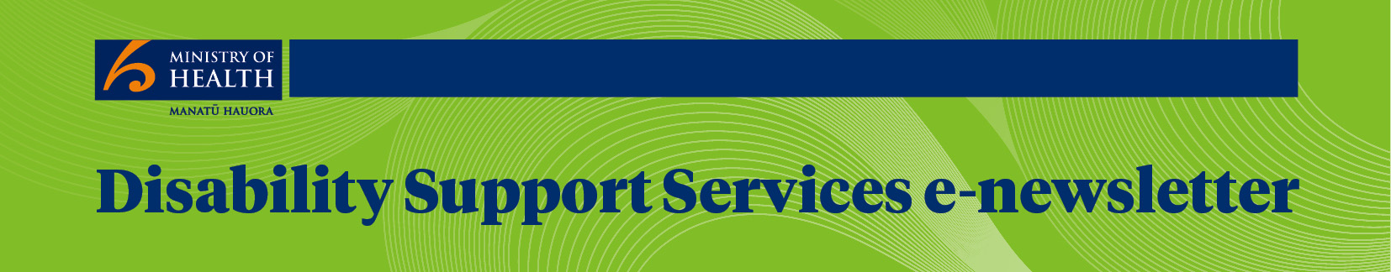
March 2016
Special edition
Welcome to this special edition of the DSS e-newsletter. Here we highlight how people and organisations demonstrate innovative practice in disability support services.

Achieving her dream
The Disability Resource Centre is a Charitable Trust who offer support for people living with disabilities. The Centre has a contract with the Federation of Disability Information Centres which is funded by the Ministry of Health.
Here’s how that funding and the Centre has helped Trudy become a published poet.
Trudy has a diabetes-related impairment and lives with left-side hemiplegia and speech problems after a three year coma.
Working one-on-one with Trudy, staff at the Centre discovered she wrote amazing poetry and encouraged her to publish a book.
The book was a labour of love, taking a year to go through the process of writing, illustrations, and printing.
‘This has been my dream for a long time. Poetry from a Quiet Body and a Screaming Mind is one way I can prove there is more to me than others might expect.’
Trudy used some of her own money and a fashion show was organised which raised $3,200 to help get the book onto the shelves.
Seeing the finished product for the first time was a proud moment for Trudy. ‘My heart stopped, it was like I was choking but I was so excited at the same time. I so appreciate the help and supportive push into achieving this dream,’ Trudy says.
The book sold out of its first print run of 100 books and a second print run of 50 books has been organised.
She’s now working on her second compilation of poems and has another goal in her sights – her driver’s licence.
Here’s Trudy’s favourite poem from her book:
Money, oh Money
Touch the mirror,
Break the surface of the water,
I saw my true self,
All the illusions shatter.
But does this really matter?
Money’s only paper, only ink,
Put it through the wash, it could turn pink.
We’ll destroy ourselves if we don’t agree.
Because you are you, and me, I’m me.
Money’s only paper, only hate.
But it feels like this is our fate.
The world we know will fall piece by piece.
While we all wait for our turn at eternal sleep.
You can buy electronic and hard copies of Poetry from a Quiet Body and a Screaming Mind on Amazon.

Building confidence through peer support
Community Connections in Palmerston North is proud of the peer support network they have helped establish.
Here’s how they are harnessing the strength of a group to empower individuals.
Eight people, who have learning disabilities, their families and a Community Living Worker together set up a group in 2013 to offer peer and mutual support by and for members.
Jo Mason, General Manager, says the aim is to encourage each member to use their strengths as connected and contributing citizens, in other words to develop self-reliance.
‘Community Connections based the network initiative on the KeyRing model of support in the United Kingdom. Members in the network choose what they’ll be involved with according to their own interests.’
By recognising and mapping their many individual talents and combining these into a set of group talents, members have supported and encouraged each other to do things they might not previously have thought possible.
‘People have grown in self-confidence, and been able to take on new roles such as volunteer, student and homeowner. Families comment that they have seen members become more confident, happier and more likely to speak in public.’
Members spoke at three conferences last year and their community contribution has been recognised by the mayor and by other community organisations. A highlight for the network in 2015 was winning a prize in the Palmerston North City Council PassionArt Awards.
‘We think the network model is a powerful way to assist people to support each other and take control of their own support,’ says Jo.

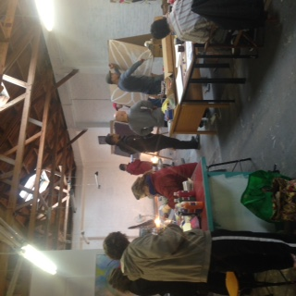 | 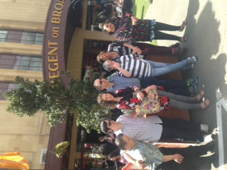
Network members creating work  for their art exhibition September 2015. | Network members receiving 2nd prize in the  Palmerston North City Council PassionArt Awards 2015.

Improving financial literacy for Pacific families
Vaka Tautua is helping Pacific families with a disabled family member to learn more about managing their money.
Here’s how this initiative is making a positive difference to the participating families:
Vaka Tautua’s eight-week Financial Literacy Programme has been held in Auckland, at Manurewa, Otara and Mangere and in Wellington at Porirua, Naenae and Lower Hutt.
Vui Mark Gosche, CEO, says the programme shows families how to repay debt and build a savings plan for their family’s future. Families might want to save for travel back to the islands or for a deposit on a home.
‘Pacific families with a disabled family member struggle under financial stress. At Vaka Tautua we understand disability – the demands on carers, the high cost of disability products, and that families are often unaware of the full disability entitlements available to them.’
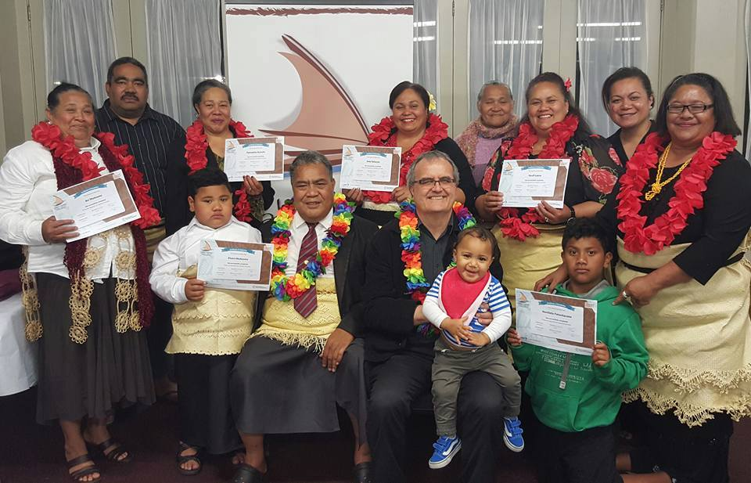
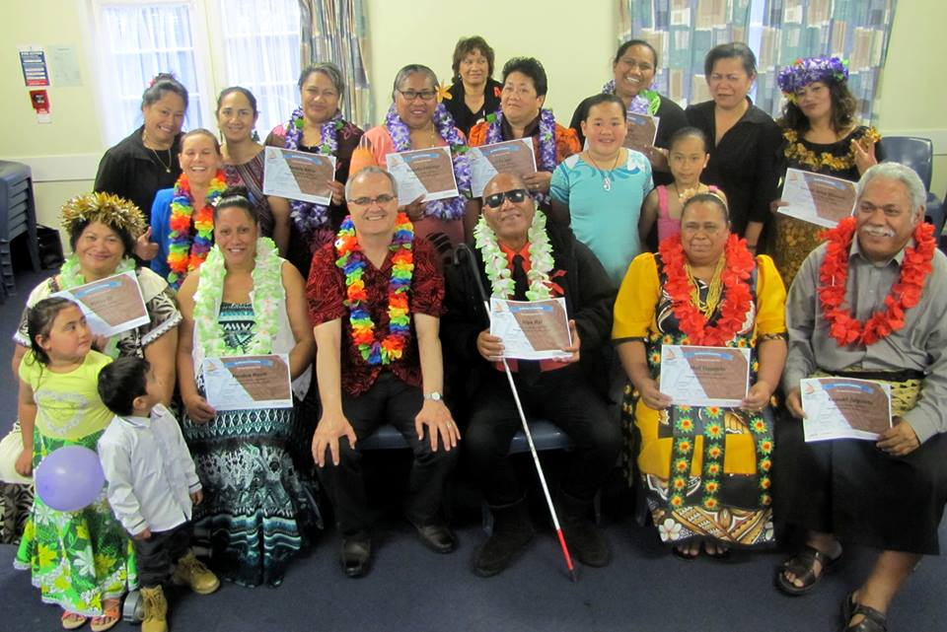
‘We’ve provided families with the information to make better choices about budgeting, including the costs of smoking, as well as healthy eating and physical exercise. The programme includes how to access supports for the disabled family member.’
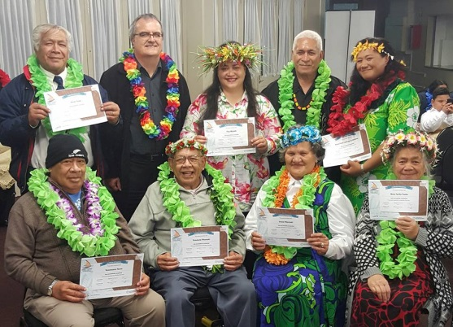
CEO Vui Mark Gosche pictured with Graduates of our Mangere and Otara Financial Literacy Programme.

Vui says the programme has been designed for Pacific families.
‘We cover our topics from a cultural perspective and with an understanding of obligations. We offer practical help to grow financial knowledge as a Pacific family living in New Zealand.’
Anyone who is interested in registering for future programmes should email money@vakatautua.co.nz or call us on 0800 825 252.

Innovative online learning
Te Roopu Taurima is the largest kaupapa Maori disability service in the country, providing residential and vocational support to clients of all ethnicities, known as tangata.

Here’s how it is developing innovative online learning resources under He Kakano (Seed of learning).

Te Roopu is based in Auckland, Northland, Midlands, and Christchurch with services that include out of family respite care, caregiver support, high and complex needs support, and awhi whanau (community support).

Tuaupiki, Project Facilitator, says He Kakano is an innovative project developing online learning resources for tangata.
‘Currently we’re developing a series of tri-lingual e-learning modules in Maori, English and New Zealand Sign Language. One e-learning module is complete and has been reviewed and evaluated by tangata. We are developing further modules in consultation with external disability and health providers.’

Cherie says He Kakano is also the name of the computer suite based in the Auckland region, which offers interactive e-learning in a friendly, safe environment.
‘The facility has computers and sensory activities, including puzzles, games, audio and CDs for tangata to use. We support them to use the computers and navigate programmes.’
‘He Kakano provides intellectual stimulation, fun learning and a place to socialise and Tangata have let us know how much they enjoy the interactive environment and the opportunity to engage and learn.’

Cherie says each month a newsletter is circulated highlighting the activities, achievements and photos of each tangata participating in their learning activity.

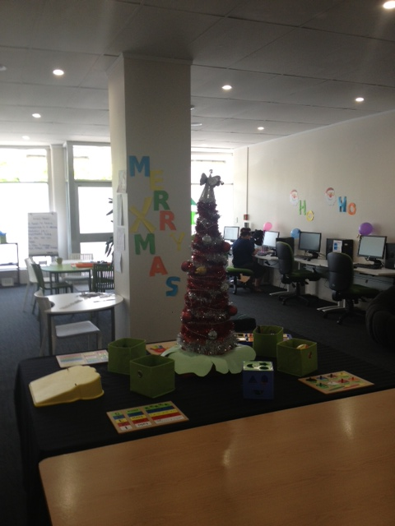 | 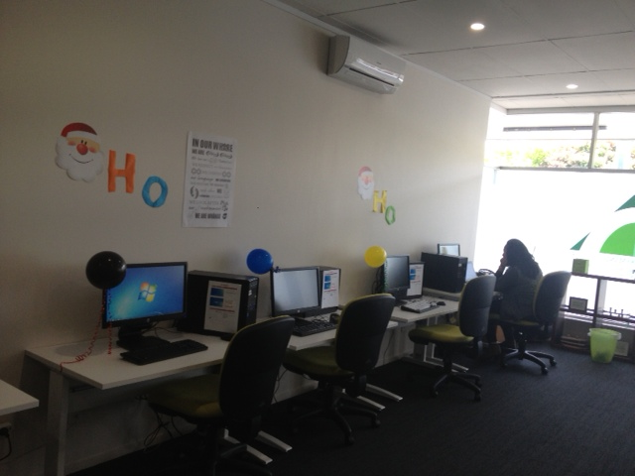

Training and skills for wheelchair users
Seating To Go provides wheelchair skills training in the Waikato, Bay of Plenty and Lakes regions.  One of the programme’s mentors, Robyn Chester, says it’s a very fulfilling way to help others:  ‘Four years ago I was invited by Seating To Go to join a team of proficient manual and power wheelchair users who would be mentors; providing wheelchair skills training for people new to wheelchairs, or those who wanted to upskill.’  That pilot scheme is now an established set of four to six programmes a year. | 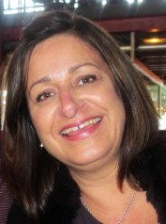

Robyn says she had been in a power chair full time for eight years.
‘I loved that I had been seen as someone who had something to offer and whose skills were worthy of payment.’
‘From a personal point of view there is something very purposeful about mentoring and helping children and adults gain the skills that have made a difference to my life, and to be able to do that in an open, safe, fun and encouraging environment.’

Robyn says the mentors work alongside and under the direction of the Seating to Go specialists and occupational therapists on the day in a two-hour session.
‘They are seriously full of laughter, vocal support and speed! We work together through a series of games and wheelchair exercises designed to build up skills. Sometimes it’s a group dynamic, sometimes one on one.’
‘I sometimes hear, and am able to relate to from my own experience, what is really difficult in the life of a wheelchair user or their family. Often this is not about how hard it is to manoeuvre a chair into a small space, but rather the greater human issue of feeling different in an able bodied world.’

Robyn says wheelchair users, and their carers leave the sessions not only upskilled but with a sense of community and belonging.
‘I go away with this too. Every time.’

Seating To Go receives funding from the Ministry of Health to provide wheelchair skills in its area. If you, or someone you know, would like to learn more, visit the website www.seatingtogo.co.nz or email: wheelchairskills@seatingtogo.co.nz

Opening up opportunities for Amber
Enabling Good Lives is a form of disability support provided by the Ministries of Health, Education, and Social Development and being trialled in Waikato and Canterbury to help people with disabilities live the best life possible.
Here’s how it’s helping 21-year-old Canterbury One Direction fanatic Amber.
Amber has Down Syndrome and is using her Enabling Good Lives funding through Manawanui (facilitator of individualised funding) to pursue her goals including securing part-time employment as a rest home carer.
‘For us it’s about finding the resources and making sure that Amber can have the same opportunities as if she was living in town. With this funding we have a lot more choice. It just opens up so many opportunities for Amber,’ her mum Pippa says.
‘We’ve been really lucky to find an employer who’s been really supportive of Amber and has treated her as an equal. As parents we wanted somewhere that we knew was a safe environment. She’s gained so many skills which have transferred to her home life – she’s more responsible and more part of her community,’ Pippa says.
Amber’s job includes her doing everything from helping residents with their meals to being a friendly face. ‘The best thing about my job is hanging out with the residents and taking them for walks around the gardens,’ Amber says.
Amber’s boss Michelle says she’s a great employee.
‘She’s got good rapport with the residents. She treats them with respect and explains what she is going to do for them. She also follows staff instructions really well.’
Outside of work Amber is studying caring for older people and working towards getting nationally recognised Unit Standards which will help her perform her job even better.
Enabling Good Lives funding also provides Amber with a support person to help with cooking and learn computer skills at a course run through Christchurch Polytechnic Institute of Technology.
For more information about Enabling Good Lives see www.incharge.org.nz
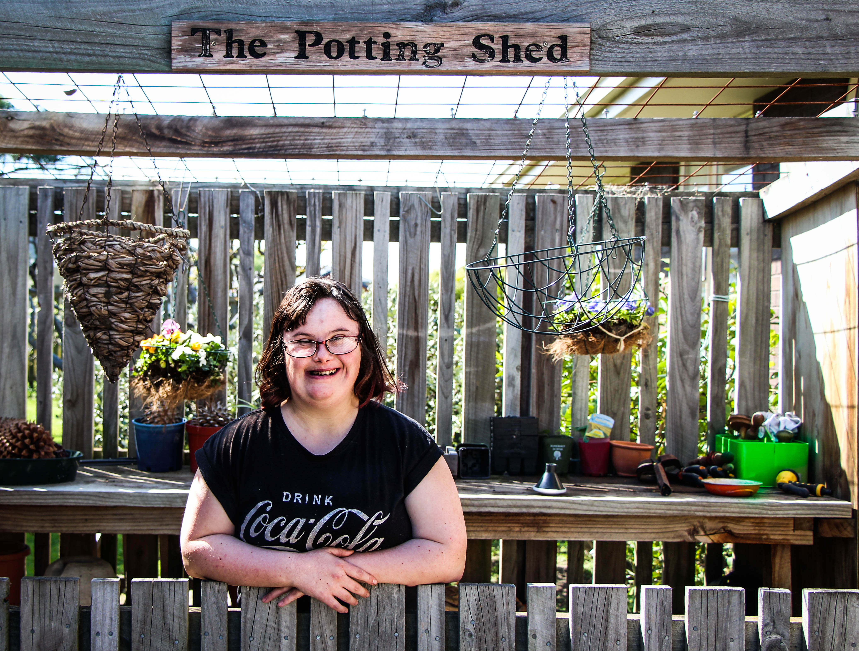

Catering business a success
The Laura Fergusson Trust has recently started a new social enterprise known as ‘CAN DO Catering’.

It began as in-house catering, but is now aiming to become a sustainable business during 2016.

Kathryn Jones, CEO, says Can Do catering was an idea that developed over a year ago when some residents were involved in the catering preparation for the Trustees Board meetings. About the same time, they had started growing vegetables, fruit and herbs in the organic garden and using them in the meals prepared on site.
Can Do Catering now employs six catering assistants who are also Laura Fergusson residential clients. The Catering Assistants all have formal employment agreements and are paid the adult minimum wage.  Since beginning operation in May 2015, the team has catered for over 30 different individuals and organisations and have received very positive feedback.  In August 2015, Nicky Wagner, the Minister for Disability Issues, officially launched the new business and the many guests and residents were treated to a superb spread of sweet and savoury dishes.  ‘Seeing the Can Do team proudly receive their first official pay cheque ever and observing their enthusiasm and commitment to their job has been extremely rewarding,’ says Kathryn. | 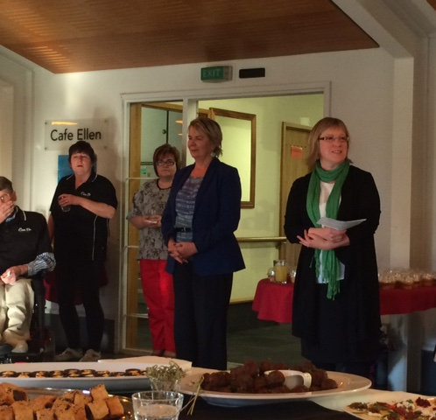  The Honorable Nicky Wagner, MP and Kathryn Jones (CEO Laura Fergusson Trust) at the launch of Can Do Catering

