Smokefree Environments and Regulated Products Act 1990

Proposals for regulations
Public consultation document

Issued 2021

Citation: Ministry of Health. 2021. Smokefree Environments and Regulated Products Act 1990 Proposals for regulations – Public Consultation Document. Wellington: Ministry of Health.

Published in January 2021 by the Ministry of Health
PO Box 5013, Wellington 6140, New Zealand
ISBN 978-1-99-002975-2 (online)
HP 7544

This document is available at health.govt.nz
This work is licensed under the Creative Commons Attribution 4.0 International licence. In essence, you are free to: share ie, copy and redistribute the material in any medium or format; adapt ie, remix, transform and build upon the material. You must give appropriate credit, provide a link to the licence and indicate if changes were made.

Contents
Introduction 1
Background 1
New Smokefree legislation 1
The purpose of this consultation document 2
The layout of this consultation document 3
How to provide feedback 3
Protection from commercial and other vested interests of the tobacco industry 4
Regulatory proposal 1: Defining an internal area 5
Description 5
Proposal 5
Consultation questions 6
Regulatory proposal 2: Specialist vape retailer approvals 7
Description 7
Proposal 7
Consultation questions 8
Regulatory proposal 3: Promotion, information and advice 9
3.1 Display of vaping products in retail settings 9
Description 9
Proposal 10
Consultation question 10
3.2 Price lists given to retailers for tobacco only 11
Description 11
Proposal 11
Consultation questions 11
3.3 Public health messages 12
Description 12
Proposal 12
Consultation question 12
3.4 Vaping product information in retail settings 13
Description 13
Proposal 13
Consultation questions 15
3.5 Product availability notices in retail premises 16
Description 16
Proposal 16
Consultation question 17
3.6 Point-of-sale information on purchase age 18
Description 18
Proposal 18
Consultation questions 18
3.7 Suitably qualified health workers 19
Description 19
Proposal 19
Consultation question 19
Regulatory proposal 4: Packaging 20
Description 20
Proposal 20
Timeframes for implementing proposed changes 24
Consultation questions 24
Regulatory proposal 5: Product notification and safety 25
5.1 Product notification requirements 25
Description 25
Proposal 25
Consultation questions 25
Consultation questions 26
5.2 Product safety requirements 27
Description 27
Proposal 27
Consultation questions 28
Regulatory proposal 6: Annual reporting and returns 29
Description 29
Proposal 29
Consultation questions 30
Regulatory proposal 7: Fees 31
Description 31
Proposal 31
Consultation questions 34
Consultation questions 34

Introduction

Background
Smoking rates have declined over recent decades. However, around 4,500 New Zealanders still die prematurely each year from smoking-related illnesses. In 2019/20, 11.6 percent of adults were daily smokers, with Māori and Pacific peoples being more likely to smoke daily than the rest of the population (28.7 percent and 18.3 percent, respectively).

Vaping has been increasing in New Zealand, a pattern seen in other countries. In 2019/20, 23.9 percent of New Zealanders had ever tried vaping, up from 16.2 percent in 2015/16. People aged 15 to 24 years old (49.6 percent) were more likely to report ever vaping than 25 to 34-year olds (37.4 percent), 35 to 44-year olds (22 percent), 45 to 54-year olds (21.3 percent), 55 to 64-year olds (11.0 percent), and people aged 65 to 74 years (5.1 percent).

Heavy use of vaping products is, however, low with 3.5 percent of New Zealanders vaping daily in 2019/20.

In 2018, 38 percent of young people (14 to 15-year olds) tried vaping – a 9 percent increase from 2016. Like adults, repeated use of vaping products amongst young people is low (1.9 percent vape daily, 8 percent vape at least monthly) and vaping status aligns closely with smoking status (current smokers had the highest vaping rates, never smokers had the lowest).

In 2019, the Youth19 Rangatahi Smart Survey (Youth 19) found that 38 percent of students (year 9-13 students) have tried vaping – 65 percent of students who ever vaped and 48 percent of regular vapers (those who vaped at least monthly) had never smoked cigarettes. The survey did not report on daily vaping.

New Smokefree legislation
In a commitment to better support smokers to switch to less harmful products, and to protect children and young people from the risks associated with these products, the Government agreed in November 2018 to introduce new legislation that would improve the regulation of vaping products in New Zealand.

The Smokefree Environments and Regulated Products (Vaping) Amendment Act 2020 came into force on 11 November 2020. This means that vaping products, in addition to tobacco products and herbal smoking products, are now regulated under the Smokefree Environments and Regulated Products Act 1990 (the Act).

The amended Act:
- extends current prohibitions on smoking to vaping, by prohibiting vaping in indoor workplaces, early childhood centres and schools
- enables a person who sells or proposes to sell vaping products from retail premises to apply to be a specialist vape retailer and exempts people from the prohibition on vaping within their approved retail premises
- allows vaping in work vehicles with the consent of users and in dedicated ventilated rooms in hospital care institutions, residential disability institutions, and rest homes
- largely extends the existing prohibition on advertising and sponsorship to vaping products
- prohibits the sale of vaping products to those under the age of 18 years
- prohibits vaping in cars carrying children and young people under the age of 18 years from 28 November 2021
- enables product safety requirements for vaping products and smokeless tobacco products (collectively, notifiable products) to be set in regulations
- requires notification of notifiable products before they can be offered for sale in New Zealand
- sets out processes for issuing health warnings and recalls of potentially harmful notifiable products
- limits the sale of flavoured vaping liquids to tobacco, menthol and mint by retailers other than approved specialist vape retailers
- requires manufacturers and importers of vaping products and specialist vape retailers to provide annual reports and returns to the Ministry of Health
- extends the powers of enforcement officers to all regulated products.
Regulations are needed to implement the amended Act. These relate mainly to the regulation of vaping and smokeless tobacco products, but one issue applies to all regulated products (ie, the definition of an internal area) and a further issue applies to tobacco products but not vaping products (ie, manufacturers price lists).

The purpose of this consultation document
The Ministry of Health is seeking your views on a number of regulatory proposals that will provide the operational detail to help achieve the intent of the new provisions of the Act. That intent is to:
- better support smokers to switch to regulated products that are less harmful than smoking
- protect children, young people and non-smokers from the risks associated with vaping and smokeless tobacco products.
The Act has a number of regulation-making powers but, at this stage, we do not propose to make all of the regulations that are possible under the Act. We will monitor and review the regulations regularly to ensure the intent of the Act is being achieved adequately.
The regulations must be workable for those they impact. Your feedback on the regulatory proposals is important because it will help shape the final regulations.

The layout of this consultation document
This consultation document consists of the following sections, reflecting the content of the Act:
- Defining an internal area (see Part 1 of the Act: Smoking and vaping prohibited in workplaces and public areas)
- Specialist vape retailer approvals (see Part 1 of the Act: Smoking and vaping prohibited in workplaces and public areas)
- Promotion, information and advice (see Part 2 of the Act: Restrictions on advertising, promotion, sale, and distribution of regulated products)
- Packaging (see Part 3 of the Act: Packaging, labelling, and constituents of regulated products)
- Product notification and safety (see Part 4 of the Act: Regulated products that must be notified)
- Annual reporting and returns (see Part 5 of the Act: Regulations, enforcement, and other matters)
- Fees (see Part 5 of the Act: Regulations, enforcement, and other matters).
Each section describes the regulatory proposals and asks a number of questions that will inform and shape the development of final regulations.

How to provide feedback
You can provide feedback in one of two ways.
- Use our online tool at https://consult.health.govt.nz/tobacco-control/vaping-regulations-consultation. This is our preferred way to receive feedback.
Note: With the online tool, you can complete your submission over a number of sessions and save it as you go. If you select ‘Save and come back later’, you will receive an email with a unique link that will let you return to edit and submit your response. You can share this link with your colleagues if you need them to contribute to or review the submission. Once you have completed your submission, you will be sent a pdf copy for your records
- Send an electronic submission to vaping@health.govt.nz using our downloadable Microsoft Word template from the Ministry of Health website at https://www.health.govt.nz/publication/vaping-regulations-consultation. If you have any issues with the template, please email us at vaping@health.govt.nz
The closing date for submissions is 15 March 2021 at 5 pm.

Note that your submission may be requested under the Official Information Act 1982. If this happens, the Ministry of Health will normally release your submission to the person who asks for it. If you consider there are good reasons to withhold it, please clearly indicate these in your submission.

We appreciate you taking the time to make a submission.

Protection from commercial and other vested interests of the tobacco industry
New Zealand has an obligation under Article 5.3 of the Framework Convention on Tobacco Control (FCTC) when ‘setting and implementing public health policies with respect to tobacco control … to protect these policies from the commercial and other vested interests of the tobacco industry’.

The internationally agreed Guidelines for Implementation of Article 5.3 recommend that parties to the treaty ‘should interact with the tobacco industry only when and to the extent strictly necessary to enable them to effectively regulate the tobacco industry and tobacco products.

While this consultation document largely focuses on the regulation of vaping products, some of its proposals are relevant to the tobacco industry and we expect to receive feedback from companies in this industry. We will consider all feedback when analysing submissions.

To help us meet our obligations under the FCTC and ensure transparency, all respondents are asked to disclose whether they have any direct or indirect links to, or receive funding from, the tobacco industry.

Regulatory proposal 1: Defining an internal area

Description
Under the Act, regulations can be made to define an internal area, which is an area where smoking and vaping are prohibited. In the absence of regulations, section 2 of the Act maintains the existing definition of an internal area as:
an area within or on the premises or vehicle that, when all its doors, windows and other closeable openings are closed, is completely or substantially enclosed by:
- a ceiling, roof, or similar overhead surface, and
- walls, sides, screens, or other similar surfaces, and
- those openings.
Some have concerns that this test does not provide clarity for business owners or enforcement officers to determine whether a space within a premise is an open area (where smoking and vaping are permitted) or an internal area (where smoking and vaping are prohibited). In addition, when this issue has been tested in court, judgments have been inconsistent.

Proposal
We are seeking views on the following options for the definition of an internal area.
- Option a: Keep the status quo, as outlined above.
- Option b: Define it as an area that is completely or partially enclosed with a roof or overhead structure of any kind, whether permanent or temporary. This means that if an area has any roof or overhead structure, regardless of how much the roof or overhead structure encloses the area, it will meet the definition of an internal area.
- Option c: Prescribe the maximum allowable percentage of the roof or wall coverage for any premise or structure. For example, a premise or structure could be considered an internal area if the total area of the roof and walls covered more than 50 percent of the perimeter.
- Option d: Include an assessment tool in regulations that takes into account air quality, as a way of helping to determine whether a space within a premise is an open area or an internal area.

Option b is the Ministry of Health’s preferred option because it is relatively simple to understand and administer.

Consultation questions
- Which option do you support for the definition of an internal area and why?
- If you support option c, or if option c were to proceed, would you support a 50 percent coverage threshold? If not, what threshold would you suggest and why?

Regulatory proposal 2: Specialist vape retailer approvals

Description
Under section 14A of the Act, the Director-General of Health (Director-General) must not give a person approval to be a specialist vape retailer unless satisfied that:
- the retail premises in which the vaping products are or will be sold are a fixed permanent structure, and
- at least:
- 70 percent of the person’s total sales from the retail premises are or will be from the sale of vaping products, or
- 60 percent of the person’s total sales from the retail premises are or will be from the sale of vaping products and the Director-General is satisfied that the lower threshold is appropriate in the circumstances, and
- any requirements in regulations have been met.
Section 14A(4) states that, in determining whether the lower threshold is appropriate in the circumstances, the Director-General must, in accordance with regulations (if any), have regard to:
- the geographic location of the retail premises, and
- the population in relation to which the retailer carries out their business, and
- any prescribed criteria.

Proposal
The lower threshold of 60 percent may be appropriate in rural locations where smokers may have difficulty accessing the range of goods and services that an approved specialist vape retailer can provide. Guidance for applicants could set this out.

We do not propose to make regulations at this stage, but we will keep this matter under review.

Consultation questions
- Do you agree that being in a rural location should be a factor in determining whether to approve an application to be a specialist vape retailer with the lower threshold of 60 percent of sales from vaping products?
- Are there any other criteria that should be considered when determining whether to approve an application to be a specialist vape retailer with the lower threshold of 60 percent of sales from vaping products?
- Do you agree that regulations are not necessary at this stage? If not, what do you propose should be put in regulations?

Regulatory proposal 3: Promotion, information and advice
The Act prohibits the publication of a regulated product advertisement. Its very broad definition of ‘regulated product advertisement and advertising’ is that it:
(a) means any words, whether written, printed, or spoken (including on film, video recording, or other medium, or broadcast or telecast), and any pictorial representation, design, or device, used to:
(i) encourage the use of a regulated product; or
(ii) notify the availability of a regulated product; or
(iii) promote the sale of a regulated product; or
(iv) promote smoking or vaping behaviour; and
(b) includes:
(i) any trade circular, any label, and any advertisement in any trade journal; and
(ii) any depiction of a regulated product or a regulated product trade mark in a film, video recording, telecast, or other visual medium where in return for that depiction any money is paid, or any valuable thing is given, to any person; and
(iii) the use of the company name of a regulated product manufacturer in any advertisement or promotion to the public where the company name or any part of it is used as, or is included in, a regulated product trade mark.
Section 24 of the Act also sets out exemptions to this prohibition. We outline regulatory proposals for these provisions in sections 3.1 to 3.4 below.

3.1 Display of vaping products in retail settings

Description
The Act allows the display of vaping products within any retail premises or any website, in accordance with any regulations that may be in force (section 24(1)(g)(i)).

In submissions to the Health Committee, some individuals and organisations raised concerns about the public visibility of vaping products. Some of these submitters made the following suggestions that could be incorporated into regulations.
- Do not allow vaping products to be visible from outside any retail premise, as a way of protecting children and young people from being attracted to them.
- Prohibit window displays of vaping products, as a way of protecting children and young people from being attracted to them.
- Put constraints on how vaping products may be displayed within retail stores (other than approved specialist vape premises). For example, prohibit them from being placed next to confectionery or limit large colourful displays that may be attractive to children and young people.

Proposal
The Ministry of Health considers that existing displays of vaping products within retail premises or on websites (which are now required to be R18) are not problematic. In forming this view, we have taken account of the need to balance protections for children and young people with policies to make it easier for smokers to switch to a less harmful alternative.

We do not, at this stage, propose to make regulations to control the display of vaping products. We will keep this matter under review.

Consultation question
- Do you agree that the display of vaping products should not be regulated at this stage? If you do not agree, what controls do you think should be put in place and why?

3.2 Price lists given to retailers for tobacco only

Description
Section 24(a) of the Act allows manufacturers to provide their price lists to retailers if the price list:
- complies with regulations
- includes the health messages required by or under Part 3.

This provision can apply to all regulated products. Its purpose is to prevent price lists from being used for promotional purposes (eg, to provide information to retailers on volume incentive schemes and product promotions).

Proposal
We propose making regulations restricting the information that a manufacturer’s price list for tobacco products can include to the:
- brand name
- brand variant
- quantity
- price
- required health warning (which must be displayed on a price list for any regulated product).

We do not propose to regulate manufacturers’ price lists to retailers for vaping products because vaping products are exempt from many of the restrictions on promotion that apply to tobacco products.

Consultation questions
- Do you support the proposal to restrict the information allowed on manufacturers’ price lists for tobacco products?
- Is there any other information that you consider should be allowed on manufacturers’ price lists for tobacco products? If so, what do you propose?

3.3 Public health messages

Description
Under the Act, a public service, or an individual or organisation that is funded (either wholly or partly and either directly or indirectly) by a public service, may publish a public health message issued by the Director-General of Health for the purposes of the Act or any of its parts (section 24(1)(f)).

The intent of this provision is to enable public messaging to support the purposes of the Act. Such purposes include supporting smokers to switch to regulated products that are less harmful than smoking and discouraging non-smokers, especially children and young people, from taking up vaping or using smokeless tobacco products.

Proposal
The Director-General of Health has issued the Vaping Facts website as a public health message under section 24(f) of the Act. This means that a public service or any individual or organisation that is publicly funded can publish messaging consistent with Vaping Facts.

To view Vaping Facts, go to: https://vapingfacts.health.nz/

Consultation question
- Do you consider that other information, beyond the information that Vaping Facts already outlines, should be designated as a public health message issued by the Director-General of Health for public services and any publicly funded individuals or organisations to use? If so, what do you propose?

3.4 Vaping product information in retail settings

Description
The Act allows for the provision of information (in any medium) relating to vaping products within retail premises or on retailers’ websites, in accordance with any regulations that may be in force (section 24(1)(g)(ii)).

In the absence of regulations, a retailer may provide information within their retail premises or on their website about vaping being a less harmful alternative to smoking (section 24(1)(g)(iii)).

Proposal
We propose making regulations that set out the following authorised harm-reduction statements that may be displayed within retail premises or on retailers’ websites:
- ‘If you are a smoker, switching completely to vaping is a much less harmful option.’
- ‘Switching completely from smoking to vaping will reduce harms to your health.’
- ‘Completely replacing your cigarette with a vape will reduce harms to your health.’

We also propose that the regulations restrict the format to written information, and to a black-and-white sign in lettering no larger than the Helvetica 70 pt typeface (which is consistent with current requirements for notices about tobacco products). The reason for specifying the format is to ensure that the information does not cross over into advertising.

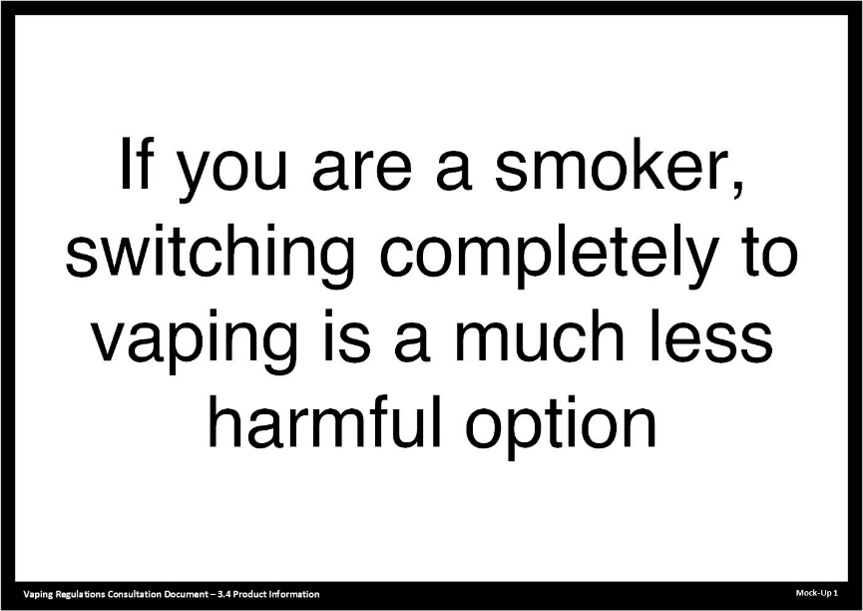
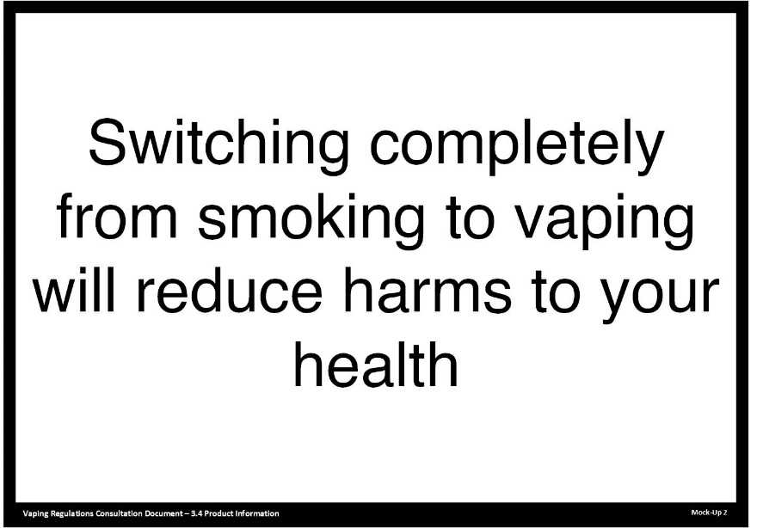

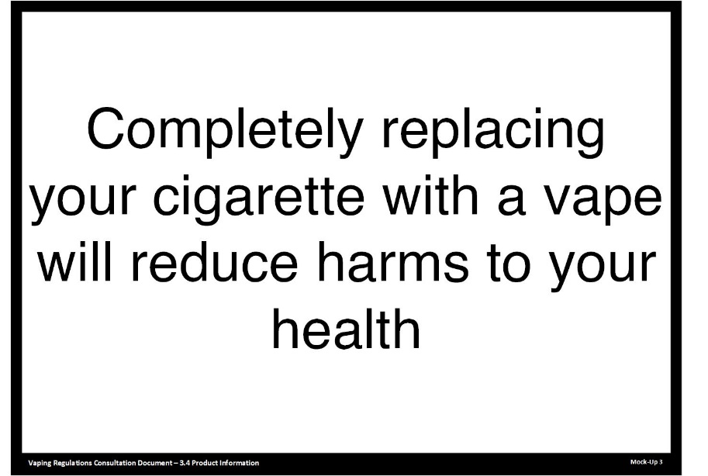

The intention of these regulations is to give smokers accurate information to support their transition from smoking to vaping.

This proposal does not impact oral communications within retail premises, provided they fall within the exemptions set out in section 27(3) of the Act. That is, the oral communications must fall into one of these categories:
- communications made in response to a product request that do no more than identify the regulated products available for purchase and indicate their price
- communications encouraging smokers to switch to a product that is less harmful than smoking
- any information by a specialist vape retailer to customers within their approved premises
- information by a specialist vape retailer relating to the safe use of regulated products available for purchase in their approved premises.
The Act allows regulations to be made for (c) and (d) above. However, the Ministry of Health considers doing so is unnecessary at this stage. We will keep this matter under review.

Consultation questions
- Do you support limiting information about vaping products in retail premises and on retailers’ websites to written authorised statements (other than permitted oral communications)? If not, what do you propose?
- Do you support the proposed statements? If not, what do you propose?
- Do you support limiting the format of these notices so that they are consistent with tobacco product notices? If not, what do you propose?

3.5 Product availability notices in retail premises

Description
The Act (section 25(1)(b)) allows retailers to display a notice for the public inside their place of business that:
- does no more than indicate, using only printed or written words, the fact that regulated products in general are available for purchase in that place and the location or locations where they may be purchased, and
- complies with any requirements in regulations.
Many retailers are likely to choose not to put up availability notices, as retail premises may display vaping products. However, some may wish to put up such notices.

Existing regulations under the Smokefree Environments and Regulated Products Act 1990 detail the requirements for availability notices for tobacco products.

Proposal
We propose aligning notices for vaping products with those for tobacco products, with amendments where necessary, by allowing:
- one A4 notice if the retailer’s place of business is less than 200 square metres in area
- no more than two A4 notices if the retailer’s place of business is 200 square metres or more, but no more than 500 square metres in area
- no more than three notices if the retailer’s place of business is more than 500 square metres in area.

The notice must contain only:
- the brand, brand variant and price of the product written in black lettering that is no larger than the Helvetica 16 pt typeface
- the relevant health warning statements in lettering no larger than the Helvetica 70 pt typeface
- the words ‘no sales to persons under the age of 18’ in lettering no smaller than the Helvetica 40 pt type face.

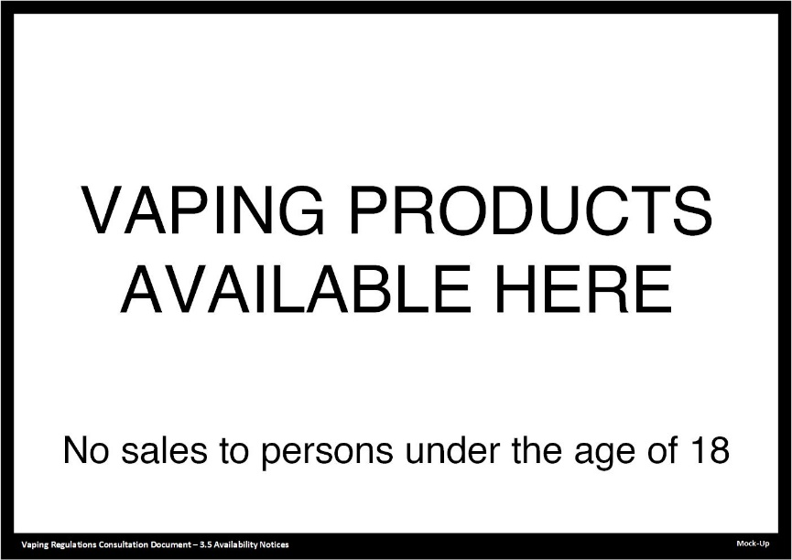

The intention of these regulations is to enable a business to indicate that a regulated product is available for purchase while ensuring that this does not cross over into advertising.

Consultation question
- Do you support the proposal to align availability notices for vaping products with those for tobacco products? If not, what do you propose?

3.6 Point-of-sale information on purchase age

Description
Under the Act, regulations may be made requiring retailers to display R18 notices at each point-of-sale at the person’s place of business and on their websites.
Tobacco products have no mandatory requirements for R18 notices at point-of-sale.

Proposal
We propose to have a mandatory requirement for retailers to display R18 notices at each point-of-sale for vaping products. This is because vaping products may be on display and accessible to children and young people under the age of 18 years.

The notice must be white with black lettering and contain only:
- the relevant health warning statements
- the words ‘no sales to persons under the age of 18’.

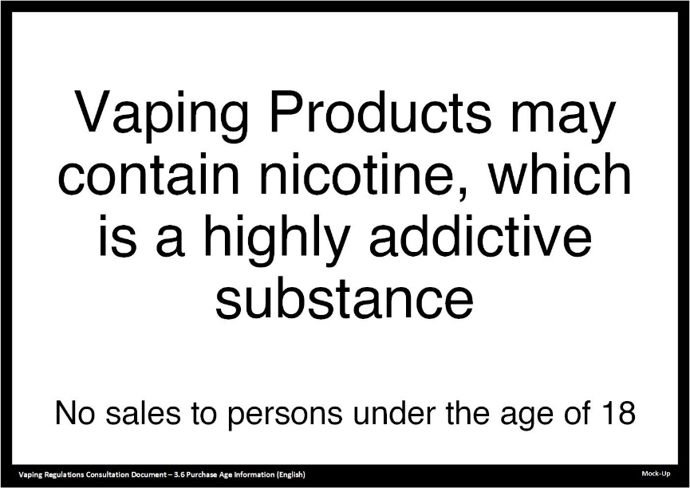

Consultation questions
- Do you agree there should be a requirement for retailers to display purchase age (R18) notices at each point-of-sale? If not, why not?
- Do you support the proposed wording and presentation requirements? If not, what do you propose?

3.7 Suitably qualified health workers

Description
Under the Act, a ‘suitably qualified health worker’ can provide any advice or messages to an individual or group for the purpose of supporting the individual or group to transition from smoking to vaping. A ‘suitably qualified health worker’ is defined in the Act (section 2(1)) as:
- a registered health practitioner, or
- a person who:
- has completed the Stop Smoking Practitioners Programme certified by the New Zealand Qualifications Authority (the programme), or
- is undertaking the programme and is being supervised by a person who has completed the programme, or
- is a peer support worker and is being supervised by a person who has completed the programme, or
- a person specified by the Director-General by notice in the Gazette.

Proposal
We do not propose adding any other category of person to the definition of ‘suitably qualified health worker’ at this stage. We will keep this matter under review.

Consultation question
- Do you agree that no additional category of person should be added to the definition of ‘suitably qualified health worker’? If you do not agree, which category do you think should be added and why?

Regulatory proposal 4: Packaging

Description
The Act requires the packaging of a regulated product to comply with any requirements set out in regulations (section 50).

New Zealand has standardised packaging requirements in place for tobacco products, which include pictorial health warnings. The Ministry of Health considers the existing requirements for tobacco products are not appropriate for products that are not smoked.

Proposal
We propose to set tailored requirements for vaping products and smokeless tobacco products that acknowledge the relatively low risk of these products compared with smoked tobacco products. The Government has publicly indicated its intention to follow the United Kingdom packaging requirements, which are based on the European Union Tobacco Products Directive (TPD).
A pictorial example is provided below:
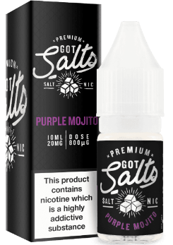
For the UK regulations, go to: https://www.legislation.gov.uk/uksi/2016/507/contents/made

For the TPD, go to:
https://ec.europa.eu/health//sites/health/files/tobacco/docs/dir_201440_en.pdf

Packaging requirements for vaping products
Health warning panel. We propose that any package of a vaping product that contains nicotine must carry the required health warning in English and te reo Māori. That health warning is:

This product contains nicotine which is a highly addictive substance.
He nikotīni kei roto i tēnei mea, he matū tino whakawara.
We propose that the health warning must:
- appear on both the front and the back surfaces of the package
- cover 32 percent of the area of each of those surfaces, calculated in relation to the area of the surface when the package is closed
- be in black Helvetica typeface on a white background
- be in a font size that makes the text occupy the greatest possible proportion of the surface area reserved for it
- appear at the centre of that area
- be parallel to the main text on the surface concerned.

Product presentation. In addition to the proposed health warning requirements, we propose that the package of a vaping product may not include any element or feature that:
- promotes a vaping product or encourages its consumption by creating an erroneous impression about its characteristics, health effects, risks or emissions
- suggests that a particular vaping product:
- is less harmful than other vaping products
- has vitalising, energising, healing, rejuvenating, natural or organic properties
- has other health or lifestyle benefits
- refers to taste, smell or other additives (except flavourings) or the absence of any such thing
- resembles a food or a cosmetic product
- suggests that a particular vaping product has improved biodegradability or other environmental advantages
- suggests economic advantage by including printed vouchers or offering discounts, free distribution, two-for-one or other similar offers.
The elements and features referred to in 1 to 6 above include (but are not limited to) text, symbols, names, trade marks, or figurative or other types of sign.

Product labelling. We propose that vaping substance containers must include specific information on their labels. Appendix A sets out our full proposal for product safety requirements.

Safety messaging. We propose that the label of vaping substance containers must include the following statements, or words with the same meaning:
- ‘CAUTION: Keep out of reach of children or pets.’
- ‘Wash contact area thoroughly if skin, eye or mouth contact with the substance occurs.’
- ‘Do not swallow. If taken into the mouth, rinse mouth thoroughly.’
- ‘Contact 0800 POISON (0800 764 766) for advice if swallowed.’
- ‘Seek medical advice if you feel unwell after contact with the substance or use of this product.’

Packaging requirements for smokeless tobacco products
Health warning panel. We propose that any package of a smokeless tobacco product must carry the required health warning in English and te reo Māori. That warning is:
This product damages your health and is addictive.
Ka patu tēnei mea i tō hauora, ka whakawara i a koe.
We propose that the health warning must:
- appear on both the front and the back surfaces of the package
- cover 32 percent of the area of each of those surfaces, calculated in relation to the area of the surface when the package is closed
- be in black Helvetica typeface on a white background
- be in a font size that makes the text occupy the greatest possible proportion of the surface area reserved for it
- appear at the centre of that area
- be parallel to the main text on the surface concerned
- cover the entire area that is reserved for it and not be commented on or paraphrased
- be in both English and te reo Māori
- be fully visible
- be indelible
- be irremovably printed
- be printed on the package, or on a sticker attached to the package provided the sticker is irremovable
- be surrounded by a black border of a width of 1 mm inside the area reserved for it
- remain intact when the package is opened.

The health warning must not:
- be partially or totally hidden or interrupted by wrappers, jackets or boxes, except where a unit package is presented inside a carton
- be partially or totally hidden or interrupted by any other item, such as a price mark
- partially or totally hide or interrupt any marking that is required under any enactment.

Product presentation. In addition to the proposed health warning requirements, we propose that the package of a smokeless tobacco product may not include any element or feature that:
- promotes a tobacco product or encourages people to consume it by creating a false impression about its characteristics, health effects, risks or emissions
- includes any information about the nicotine, tar or carbon dioxide of a tobacco product
- suggests that a particular tobacco product:
- is less harmful than others
- aims to reduce the effect of some harmful components of smoke
- has vitalising, energising, healing, rejuvenating, natural or organic properties
- has other health or lifestyle benefits
- refers to taste, smell or any flavourings or other additives, or the absence of any such thing
- resembles a food or a cosmetic product
- suggests that a particular tobacco product has improved biodegradability or other environmental advantages
- suggests economic advantage by including printed vouchers or offering discounts, free distribution, two-for-one or other similar offers.
The elements and features referred to in 1 to 7 include (but are not limited to) text, symbols, names, trade marks, or figurative or other types of sign.

Packaging instructions. We propose requiring that a notifiable product’s package includes enough information (whether on the package, container, label or package insert) to instruct the user about:
- correct use
- correct handling (including storage, refilling, recharging and disposal)
- consequences of incorrect use or what handling precautions to take before and during use.

Track and trace markings. Since May 2019, the European Union (EU) has required track and trace markings on tobacco products produced in the EU (including those destined for export). The aim of this requirement is to minimise illicit trade and ensure duties have been paid.

New Zealand’s regulations do not permit display of these track and trace markings. It is, therefore, unlawful to import, distribute or sell tobacco products displaying these markings.

We propose amending the Smoke-free Environments Regulations 2017 to permit the display of track and trace markings on regulated products. The amendments should also require the marking to be displayed on an area of the tobacco package other than the mandatory health warning panel.

Quantity of smokeless tobacco sticks in a package. The Act allows regulations to specify the number of smokeless tobacco sticks to include in a package (section 53(1)(c)). The intention of this requirement is to prevent retailers from selling smokeless tobacco sticks in smaller quantities (eg, selling a single smokeless tobacco stick).

We propose that only 20 or 25 smokeless tobacco sticks should be permitted in a package. These quantities are consistent with existing requirements for cigarettes.

Timeframes for implementing proposed changes
Businesses will need time to implement any changes to packaging. When the standardised packaging requirements for tobacco products came into force in March 2018, businesses had:
- nine months to comply from the time the regulations were made
- a further six weeks to distribute old stock down the supply chain
- a further six weeks for retailers to sell through old stock.
We propose similar timeframes for implementing the changes to requirements for packaging of vaping products and smokeless tobacco products.

Consultation questions
- Do you support the proposed wording of the health warning for vaping products? If not, what do you propose?
- Do you agree with the proposed requirements for the health warning panel for vaping products? If not, what do you propose?
- Do you support the proposed wording of the health warning for smokeless tobacco products? If not, what do you propose?
- Do you agree with the proposed requirements for the health warning panel for smokeless tobacco products? If not, what do you propose?
- Do you agree with the proposals for product presentation for vaping products? If not, what do you propose?
- Do you agree with the safety messaging statements? If not, what changes to them do you suggest?
- Do you agree with the proposals for product presentation for smokeless tobacco products? If not, what do you propose?
- How much time do you think smokeless tobacco product manufacturers should have before they need to comply with new packaging requirements? Please give reasons.
- Do you agree with the proposed instructions on and in the packaging? If not, what changes to them do you suggest?
- Do you agree with allowing track and trace markings? If not, why not?
- Do you support the proposal to restrict the quantity of smokeless tobacco sticks in a package to 20 or 25? If not, what do you propose?
- How much time do you think manufacturers of vaping products and smokeless tobacco products should have before they need to comply with new packaging requirements? Please give reasons.

Regulatory proposal 5: Product notification and safety

5.1 Product notification requirements

Description
The Act requires manufacturers and importers (collectively, notifiers) to notify the Ministry of Health of their intention to sell vaping products or smokeless tobacco products (notifiable products) before any retailer sells them in New Zealand.

Regulations are required to set out the ‘description of the product and its parts (including its ingredients)’ (section 63(1)(b)).

Proposal
We propose to base New Zealand’s regulations on the EU and UK legislation and guidance, as set out below.

Notifier details
The regulations would require a notifier to provide the following details when they register on the Ministry of Health’s database:
- the notifier’s contact details (including name, business name, company number/NZBN, address, phone numbers and email addresses)
- a declaration that the notifier meets the current requirements of the Act (eg, New Zealand resident, manufacturer or importer of regulated products for sale in New Zealand) and that the details provided are correct.

Consultation questions
- Do you agree that these are the right details for the Ministry of Health to collect for each notifier? If not, what changes would you make to the details collected?
- Do you agree that the notifier should declare that they meet the current requirements of the Act? If not, what approach to enforcing the provisions of the Act do you suggest?

Product details
The regulations would require a notifier to provide the following information for each combination of product type, brand and variant as part of their notification:
- product type – that is, whether it is a device, a vaping substance, a kit (which may comprise devices, substances and components), a smokeless tobacco product or another type
- product brand, variant and Universal Product Code (UPC)
- product details:
- for devices and kits: a list of components (for a device, a component is a part that is individually replaceable)
- for vaping substances:
- ingredients and their amounts (including flavours) listed by Chemical Abstracts Service number or International Union of Pure and Applied Chemistry name
- nicotine strength, container volume and propylene glycol/vegetable glycerine ratio (as applicable)
- where a notifiable product contains additives other than flavourings, such as preservatives or antioxidants, a justification for their use and a toxicological risk assessment
- for smokeless tobacco products:
- ingredients and their amounts (including flavours) listed by Chemical Abstracts Service number or International Union of Pure and Applied Chemistry name
- method of use
- package quantity
- where a notifiable product contains additives other than flavourings, such as preservatives or antioxidants, a justification for their use and a toxicological risk assessment
- a declaration that the product meets the current requirements of the Act (eg, it contains no colourings or prohibited flavours, and meets product safety requirements) and that the details supplied are correct.

Consultation questions
- Do you agree that these are the right details for the Ministry of Health to collect for each notifiable product? If not, what changes would you make to the details collected?
- Do you agree that the notifier should declare that each product meets the current requirements of the Act? If not, what approach to enforcing the provisions of the Act do you suggest?

5.2 Product safety requirements

Description
Under the Act, regulations can set out safety requirements for notifiable products.

Proposal
We propose to base New Zealand’s regulations on the EU and UK legislation and guidance, with appropriate adaptations for the New Zealand market, as set out below. Appendix A details our full proposal for product safety requirements.

Substances
Manufacturing. We propose reminding manufacturers of their health and safety obligations under the Health and Safety at Work Act 2015 and the Hazardous Substances and New Organisms Act 1996 when they are manufacturing with hazardous substances such as nicotine. We further propose requiring them to have suitable systems in place for complaints, adverse reactions, and recalls.

Labelling. We propose that vaping substance containers must include specific information on their labels.

Ingredients. We propose making notifiers responsible for ensuring that products contain only the ingredients that they have submitted as part of their notification. In addition, notifiers must justify the use of additives other than flavourings and they have an overarching responsibility to ensure their products do not pose an unacceptable risk.

Quality of ingredients. We propose minimum quality standards for nicotine, nicotine salts, propylene glycol, vegetable glycerine, alcohols, water, tobacco extracts, and flavourings.

Prohibited substances. We propose prohibiting notifiable products that contain any amount or more than trace amounts of certain substances that are considered hazardous.

Nicotine strength. We propose limiting the strength of nicotine allowed in vaping substances to not exceed 20mg/mL for free-base nicotine and 50mg/mL for nicotine salt. We also propose restricting the total amount of nicotine that may be present in a single container to 500mg.
Containers. We propose placing several restrictions on the composition of containers. These include restricting the grade of plastic used, child-resistant packaging, the maximum size that can be used for substances containing nicotine, and mechanisms against breakage, spillage or tampering.

Devices
We propose setting minimum standards for devices that align with standards for battery-operated electrical devices. We propose requirements to support the safe operation of devices. We also propose requiring devices to have serial or batch numbers so faulty products can be traced.

Vaping substance testing
We propose requiring regulated products to be tested to ensure they do not contain certain toxic compounds above prescribed concentrations.

Consultation questions
- Do you agree with our approach of basing product safety requirements on the EU and UK legislation and guidance? If not, what approach to our product safety requirements do you suggest we use?
- Do you agree with the product controls we are proposing to include in the product safety requirements? If not, what changes to the areas that the product safety requirements cover do you suggest?
- After reviewing our full proposal in Appendix A, do you agree with our proposed product safety requirements? If not, what changes to them do you suggest?

Regulatory proposal 6: Annual reporting and returns

Description
The Act requires manufacturers, importers and specialist vape retailers to provide an annual return to the Ministry of Health no later than 31 January each year, showing sales-related information for the previous calendar year (section 100(1)). This is consistent with existing requirements for tobacco products.

Proposal

Manufacturers and importers
We propose that the regulations modify the existing requirements for tobacco products, in setting the requirements for:
- brand and brand variant of a vaping device (including a heated tobacco device) and vaping liquid container (in units)
- recommended retail price by brand and brand variant of a vaping device (including a heated tobacco product) and vaping liquid container (in New Zealand dollars).
For vaping liquid, brand variant would include different flavours (such as menthol or vanilla), volume (such as 20 mL or 30 mL) and nicotine strength.

Specialist vape retailers
We propose that the regulations require specialist vape retailers to report, for each approved vaping premise and website:
- total sales in New Zealand dollars for:
- vaping products (including heated tobacco devices)
- other products
- for vaping products:
- brand and brand variant of a vaping device (including a heated tobacco device) and vaping liquid container (in units)
- recommended retail price by brand and brand variant of a vaping device (including a heated tobacco product) and vaping liquid container (in New Zealand dollars).
For vaping liquids, we propose defining brand variants by, for example, different flavours (such as menthol or vanilla), volumes (such as 20 mL or 30 mL) and different nicotine strengths. This reporting will provide useful information that gives the Ministry of Health a better understanding of product demand and that will inform any future review of the regulations.

We propose to provide a spreadsheet template that notifiers and specialist vape retailers can use in producing annual reports and returns.

We propose that the first annual returns will be for the scheme’s first full year of operation (the 2022 calendar year), and returns will be due to the Ministry of Health by 31 January 2023. Tobacco returns are unaffected: tobacco retailers must continue to provide them to the Ministry of Health by 31 January each year.

Consultation questions
- Do you support the proposals for manufacturers’ and importers’ annual sales reports? If not, what do you propose?
- Do you support the proposals for specialist vape retailers’ annual sales reports? If not, what do you propose?

Regulatory proposal 7: Fees

Description
The Act provides for recovering the costs of establishing and operating the regulatory scheme from the industry through fees and/or levies. It also allows regulations to specify these fees and levies.

The scheme is being designed to keep costs as low as possible while ensuring appropriate levels of safety and control for notifiable products. Fees will be collected by the Vaping Regulatory Authority in the Ministry of Health, which administers the scheme.

We expect to recover most of the costs through the product notification fee, which will cover the general cost of running the scheme. Fees for other low-volume services will be based on the estimated average cost to provide those services. We do not propose imposing any levies at this stage.

The proposed fees are based on an estimate of the number of product notifications we expect to receive. We have assumed there will be 10,000 products requiring notification each year once the scheme is fully operational. The product notification fee is highly sensitive to the number of notifications.

The Act requires a review of the fees and fee structure no more than three years after the Act comes into effect.

Proposal
We propose having fees for:
- notification of products (eg, devices, vaping substances and heated tobacco products)
- applications to be a specialist vape retailer
- applications for premises to be approved vaping premises
- applications for websites to be approved websites
- appeals against certain Vaping Regulatory Authority decisions made under the scheme.

The notifier or applicant must pay all the fees required before the Vaping Regulatory Authority will process their notification, application or appeal.

An easy-to-use online system will support all activities related to the fees, providing functionality for both the registered user (notifier or applicant) and the public.

Product notification fees
We propose making the product notification fee a fixed amount charged for each different product when it is notified and at each annual renewal. While we expect the direct cost of processing a standard notification will be minimal, notification fees will cover the cost of providing and maintaining the scheme (including both the online electronic system and its supporting non-electronic infrastructure).

Notifiers of products already on the market when the Act takes effect will have a transition period of six months to notify those products. Notifiers will be encouraged not to leave it to the last minute to notify their products, in order to avoid potential technical issues that can result when many people are trying to access the online system at the same time. Spreading initial notifications over the transition period would also allow the Ministry of Health to provide more help to notifiers during the process.

Application fees
We propose a one-off fee for each application.

Retailers must have at least one approved vaping premise (which must be a fixed permanent structure) to be approved as a specialist vape retailer. For this reason, all applicants will initially have to submit at least two applications: one to be an approved specialist vape retailer, and the other for their nominated premises to be approved vaping premises. They will also have to pay an application fee for each.

Retailers will be able to make as many additional or subsequent applications for approved vaping premises or approved websites as they wish. However, the Ministry of Health will only assess such an application if the applicant is approved to be a specialist vape retailer.
We propose that, if we decline an application, we refund any fees paid for applications that have not been assessed.

Example of how proposed refunding of application fees would work
A retailer applies to be a specialist vape retailer and makes two additional applications – one for an approved vaping premise and another for an approved website.
If the retailer does not meet the sales threshold to be a specialist vape retailer, then we would decline all three applications and refund the fees paid for the two additional applications as we will not have assessed either of them.
However, if the retailer meets the sales threshold to be a specialist vape retailer, but their premises do not meet the criteria for an approved vaping premise, we would decline all three applications and refund only the fee paid for the second additional application (for an approved website) as we will not have assessed it.

Appeal fees
We propose a one-off fee for each appeal, which we would usually refund in full if the appeal is successful. If an appeal is not successful or is only partially successful, then the appeals committee may direct the Ministry of Health to refund part or all of the fee if it considers that a refund is appropriate in the circumstances.

Types and amounts of fees
The table below sets out the types and amounts of fees we are proposing. The amounts indicated take into account the aim of recovering the relevant portion of the costs of establishing the regulatory scheme over five years.

Type of fee | Amount (excl. GST) | Activities funded
Product notification – notifiable products (per product, renewable annually) | $140 per year | Establishing and operating the regulatory scheme
Application to be a specialist vape retailer (per retailer) | $1,600 | Receiving and processing the application, investigating and assessing the application, notifying decisions and updating systems
Application for a premise to be an approved premise (per premise) | $600 | Receiving and processing the application, investigating and assessing the application, notifying decisions and updating systems
Application for a website to be an approved website (per site) | $600 | Receiving and processing the application, investigating and assessing the application, notifying decisions and updating systems
Appeal against Vaping Regulatory Authority decision (per appeal) | $350 | Processing the appeal, preparing advice for the Appeals Committee, convening the Committee and notifying the outcome

The estimate of each type of fee listed above is based on assumptions around the volume of work, which the following table describes.

Type of fee | Number assumed per year
Product notifications (vaping devices) | 800
Product notifications (vaping substances and smokeless tobacco products) | 9,200
Applications to be a specialist vape retailer | 150
Applications for approved vaping premises | 500
Applications for approved websites | 150
Appeals | 10

We anticipate that fees will be reviewed before the end of the first notification year, once actual volumes for each type are known.

Consultation questions
- Do you agree the Ministry of Health should charge for the activities identified? If not, what activities do you suggest we charge for?
- Do you agree with the way the fees are structured? If not, how should they be structured?
- Do you agree with the level of each of the fees? If not, how much do you suggest the Ministry of Health should charge?
- Do you agree with our assumptions on annual volumes of work? If not, what assumptions do you suggest we use?
- How many products do you anticipate notifying yourself?
- Are there additional issues relating to fees and charges that you would like us to consider?

Very low-volume products
Where products are sold in very low volumes, notification fees and other compliance costs might result in the loss of those products from the market. Examples of such products include:
- large ranges of catalogue products, each sold only in small numbers
- unprofitable service products, where supply is maintained for small numbers of long-term consumers
- products in their first year of supply (where sales may only have reached nominal levels).
It may be beneficial to reduce fees or exempt notifiers from fees in such situations.

Consultation questions
- Do you agree that we should reduce fees for very low-volume products? If not, how would you suggest the Ministry of Health handles very low-volume products?
- How would you suggest we define very low-volume products?
- Do you have suggestions for the design of any provisions, including suggestions for:
(a) limits on the number of products that any notifier can have fee exemptions for
(b) administrative efficiency
(c) any other issues that might be associated with low-volume products?

The Smokefree Environments and Regulated Products (Vaping) Amendment Act 2020 also changed the name of the Smoke-free Environments Act 1990 to the Smokefree Environments and Regulated Products Act 1990

