Te Mana Ola: The Pacific Health Strategy
2023

Citation: Ministry of Health. 2023. Te Mana Ola: The Pacific Health Strategy. Wellington: Ministry of Health.
Published in July 2023 by the Ministry of Health
PO Box 5013, Wellington 6140, New Zealand
ISBN 978-1-991075 (print)
ISBN 978-1-991075 (online)
HP 8801
This document is available at health.govt.nz
This work is licensed under the Creative Commons Attribution 4.0 International licence. In essence, you are free to: share ie, copy and redistribute the material in any medium or format; adapt ie, remix, transform and build upon the material. You must give appropriate credit, provide a link to the licence and indicate if changes were made.

‘To Live Powerfully’
Te Mana Ola is a term gifted for the Pacific Health Strategy by leaders of the Tokelau community in Aotearoa New Zealand. The Tokelauan word Mana is commonly used throughout Polynesia and is defined as divine power. Ola means life. Together, they culminate in the definition ‘to Live Powerfully’.
Te Mana Ola is aspirational and encourages not only Pacific peoples but all parts of the health system to value the physical, mental, and spiritual wellbeing of Pacific peoples for equitable health outcomes. Te Mana Ola empowers Pacific peoples to be in full control of their health and wellbeing.

Contents
Ministerial foreword 1
Acknowledgements 2
Glossary 3
Executive summary 6
Setting the long-term direction for Pacific health 9
Purpose of Te Mana Ola and the Pae Ora strategies 9
A commitment to Te Tiriti o Waitangi 10
Developing Te Mana Ola 10
Pacific peoples in the Pacific region 11
Structure of Te Mana Ola 12
Vision – pae ora 13
Pae ora (healthy futures) for Pacific peoples in Aotearoa New Zealand 13
Alignment with the All-of-Government Pacific Wellbeing Strategy 15
Current outcomes and trends in Pacific health 16
Pacific peoples in Aotearoa 16
Trends in the Pacific population 16
Socioeconomic determinants of health 19
Wai ora – healthy environments 21
Health outcomes 23
Access to health care 25
Health workforce 27
Data availability and quality 29
Priorities and opportunities for Pacific health improvement 30
Priority area 1: Vaqaqacotaka na yavutu ni tiko bulabula Population health 32
Priority area 2: Te pāruru‘anga, te apii‘anga, e te akateretere‘anga no te ora‘anga meitaki Disease prevention, health promotion and management of good health 35
Priority area 3: Soalaupule Autonomy and determination 39
Priority area 4: Haitiaaga moui malolo Access 42
Priority area 5: Kau ngāue Workforce 46
Turning Te Mana Ola into action 49
Roadmap 50
Implementation 50
Monitoring 51
Appendix: Summary of themes from Te Mana Ola fono 52
References 56

List of Figures
Figure 1: Soalaupule Ecosystem Framework 13
Figure 2: Age distribution of Pacific and total New Zealand 2021 population projections (Stats NZ 2018b) 17
Figure 3: Projected 2023 Regional Council distribution of Pacific peoples in Aotearoa (Stats NZ 2018e) 19
Figure 4: Life expectancy at birth, 2017–2019 (Stats NZ 2021) 23
Figure 5: Te Mana Ola priority areas 31
Figure 6: Key health system accountability and priority setting documents 49
Figure 7: Te Mana Ola timeline 50

List of Tables
Table 1: Population statistics for Pacific peoples in Aotearoa, current and future state 18
Table 2: Comparison of social and economic indicators for Pacific peoples and Europeans 20
Table 3: Key indicators of access to health care services in Aotearoa 25
Table 4: Pacific Health Workforce – regulated health care workers 27
Table 5: Pacific Health Workforce – regulated health care workers, with 10-year forecasts 28

Ministerial foreword
Te Mana Ola is the first-ever Pacific Health Strategy for Aotearoa New Zealand and signifies a historic turning point for Pacific peoples within our health and disability system.

Evidence shows that Pacific peoples experience longstanding and unacceptable health inequities. These inequities are strongly linked to the wider determinants of health such as education, employment, and housing, as well as inequities in access to health care.

Despite the health system not meeting the health needs of Pacific peoples, Pacific communities continue to demonstrate their strength and resilience. The way in which Pacific communities and service providers rallied quickly to respond to COVID-19 has demonstrated their potential to have a profoundly positive impact on the health and wellbeing of all people in Aotearoa.

The development of Te Mana Ola was strongly guided by the perspectives of diverse Pacific peoples and communities. Our 5 priority areas are the result of extensive and in-depth talanoa with the Pacific health sector and communities across Aotearoa. We want to sincerely thank everyone for their valuable contributions.

We acknowledge that Pacific peoples’ views of health go beyond the presence or absence of disease or injury. Health is seen as a state of physical, mental, social, spiritual and cultural wellbeing of Pacific whānau and communities.

As Te Mana Ola directs our health system over the next 10 years to enable Pacific peoples to achieve their full potential, we are confident that Pacific peoples’ contributions to the culture, economy and identity of Aotearoa will continue to be valued and grow in significance.

Addressing challenges in Pacific health will not be easy, but Te Mana Ola offers a long-awaited strategic solution. It seeks to maintain the momentum of the gains seen over
the years with previous national Pacific Health Action Plans. Te Mana Ola will require steadfast dedication, consistent effort, and investment over many years. It will require us all to work together.

We are confident that Te Mana Ola’s strategic goals are consistent with the Government’s expectation of achieving pae ora – healthy futures for Pacific peoples.

Hon Dr Ayesha Verrall
Minister of Health

Hon Barbara Edmonds
Associate Minister of Health
(Pacific Health)

“Health is seen as a state of physical, mental, social, spiritual and cultural wellbeing of Pacific whānau and communities.”

Acknowledgements
Manatū Hauora (the Ministry of Health) acknowledges the advice and guidance provided by the Pacific Health Strategy Advisory Group (the Advisory Group) chair Jean Mitaera and members Fuimaono Dr Karl Pulotu-Endemann, Tunumafono Fa‘amoetauloa Avaula Fa‘amoe, Papali‘i Johnny Siaosi, Moananu Dr Karaponi Okesene-Gafa, Dame Teuila Percival, Dr Hinamaha Lutui, Aiga Pouoa, Phylesha Brown-Acton, Safaato‘a Fereti, Siesina Latu, Diana Phone, Karl Vasau, Leilani Unasa and Namoe Tu‘ipulotu in the development of Te Mana Ola.

A special mention to the Pacific Expert Advisory Group chair Sir Collin Tukuitonga and members Vui Mark Gosche, Dr Api Talemaitoga, Debbie Sorensen, Dr Debbie Ryan, Faumuina Professor Fa‘afetai Sopoaga, Dr Viliami Tutone, Tevita Funaki, Dr Siro Fuata‘i, Safaato‘a Fereti, Hamish Crooks, Reverend Vaegaau Liko, Gerardine Clifford-Lidstone and Markerita Poutasi for the continued support and expertise shared in the development process.

This strategy was developed by members of the Pacific Health team of Te Pou Hauora Tūmatanui (the Public Health Agency), Manatū Hauora: Dr Corina Grey, Dr James Greenwell and David Pickering, supported by Tagaloa Dr Junior Ulu, Maryke Barnard,
Xavier Breed, Jasmine Wright, Lita Bourne, Lusi Abernethy, Mannfred Sofara and To‘e Lokeni.

The authors would like to extend our gratitude and acknowledge the feedback and insights from participants of our engagement fono, including Pacific community groups, regional groups, expert advisors, Pacific health providers and health care workers.

We would like to thank everyone who provided guidance with Gagana Tokelau, Vosa Vakaviti, Te Reo Māori Kūki ‘Āirani, Gagana Samoa, Vagahau Niue and Lea Faka-Tonga.

The contribution from each person, group and organisation in this process is greatly appreciated.

Meitaki ma‘ata. Vinaka vakalevu. Kam rabwa. Fakaaue lahi. Fakafetai lahi lele. Fa.ia.kse‘ea. Fakafetai lasi. Mālō ‘aupito. Fa‘afetai lava. Ngā mihi nui.

Glossary
Fa’afaletui (Gagana Samoa) | Culturally devised Samoan research framework used for decision making or reaching consensus. (Tamasese, Peteru et al. 2005).
Faifeau (Gagana Samoa) | Church minister(s).
Fono (Gagana Samoa/Lea Faka-Tonga/Tokelau/‘Gana Tuvalu) | Meeting(s).
Fonofale (Gagana Samoa) | A holistic model of health outlining Pacific approaches to health and wellbeing  (Pulotu-Endemann 2001).
Fonua (Lea Faka-Tonga) | A holistic framework outlining Tongan approaches to health and wellbeing  (Tu‘itahi, Watson et al. 2021).
GPS | Government Policy Statement
Haitiaaga moui malolo (Vagahau Niue) | Building and weaving positive pathways together, for high-quality services and best health outcomes.
Kakala (Lea Faka-Tonga) | A Tongan research framework utilising the Tongan kakala making process as a metaphor for engaging and co-designing alongside Pacific communities (Thaman 1993).
Kau ngāue (Lea Faka-Tonga) | Workforce.
LMC | Lead maternity carer.
LGBTQIA+ | Lesbian, gay, bisexual, transgender, intersex, queer/questioning, asexual and many other terms (such as non-binary and pansexual).
MVPFAFF+ | MVPFAFF+ is a term coined by Phylesha Brown-Acton. It stands for the names of the broad gender spectrum from across the Pacific region: mahu (Tahiti and Hawaii), vakasalewa (Fiji),  palopa (Papua New Guinea), fa‘afafine (Samoa), akava‘ine (Cook Islands) fakaleiti (leiti) (Tonga)  and fakafifine (Niue).
Nofo-a-kāinga (Lea Faka-Tonga) | Extended family.
Pae ora (Te Reo Māori) | Pae ora means healthy futures for all. Pae ora includes mauri ora (healthy individuals), whānau ora (healthy families) and wai ora (healthy nvironments).
Pasifika rainbow+ | An inclusive term that includes Pacific peoples who identify as part of the LGBTQIA+ and/or  MVPFAFF+ communities. Rainbow is a broad umbrella term that covers a diversity of sexual  orientations, gender identities and expressions and sex characteristics. It is a diverse population  group with a range of experiences and includes people who identify with terms such as gay,  lesbian, bisexual, queer, asexual, intersex, transgender, non-binary, takatāpui and MVPFAFF+.
Soalaupule (Gagana Samoa) | The traditional Samoan inclusive decision-making process by general consensus.
Tagata sa’ilimalo (Gagana Samoa) | Pacific disabled people, their families and carers.
Tautua (Gagana Samoa) | A servant, to serve, to be of service.
Te Mana Ola (Gagana Tokelau) | To live powerfully.
Te pāruru‘anga, te apii‘anga, e te akateretere‘anga no te ora‘anga meitaki  (Te Reo Māori Kūki ‘Āirani) | Disease prevention, health promotion and management for good health.
Te vaka atafaga (Gagana Tokelau) | A model of health in the context of Aotearoa outlining a Tokelau holistic approach to health and  wellbeing (Kupa 2009).
Tivaevae (Te Reo Māori Kūki ‘Āirani) | A Cook Islands research framework utilising the tivaevae (handmade quilt) making process  as a metaphor for conducting research through holistic and culturally sensitive practices and approaches (Futter-Puati and Maua-Hodges 2019).
Tā and Vā (Lea Faka-Tonga) | A Tongan and indigenous Pacific theory of time, space, and relatability between inanimate and  living things, respectively (Māhina 2002).A Tongan and indigenous Pacific theory of time, space,  and relatability between inanimate and living things, respectively (Māhina 2017).
Vanua (Vosa Vakaviti) | An indigenous Fijian methodology framework for ethically conducting research underpinned by  Fijian values, protocols of relationships, knowledge, and ways of knowing (Nabobo-Baba 2006).
Vaqaqacotaka na yavutu ni tiko bulabula (Vosa Vakaviti) | Maintaining strong foundations for health.
Whakapapa (Te Reo Māori) | Genealogy, lineage, or line of descent.
Whānau (Te Reo Māori) | Extended family, family group.

Executive summary
Te Mana Ola: The Pacific Health Strategy (Te Mana Ola) is 1 of 6 population health
strategies required under the Pae Ora (Healthy Futures) Act 2022 (the Pae Ora Act). The other strategies are the New Zealand Health Strategy, Pae Tū: Hauora Māori Strategy (Pae Tū), Health of Disabled People Strategy, Women’s Health Strategy and Rural Health Strategy. Together, these strategies provide a framework for achieving pae ora – healthy futures for all New Zealanders.

Te Mana Ola represents an important opportunity to set the key direction and long-term priorities to achieve equity in Pacific health and wellbeing outcomes over the next 10 years. Building on the foundations established by previous work, including Ola Manuia: Interim Pacific Health Plan July 2022–June 2024 (Ola Manuia), Te Mana Ola contributes to the All-of-Government Pacific Wellbeing Strategy and complements the Living Standards Framework.

Te Mana Ola was developed with the guidance and support of the Advisory Group and informed by an extensive community and health sector engagement process, with more than 40 fono (meetings) held throughout Aotearoa.

Pacific peoples in Aotearoa are diverse in their identities, geographical location and languages. In 2022, there were more than 450,000 people in Aotearoa who identified with at least one Pacific ethnicity (9% of the total population). With a median age of 23 years, youthfulness is seen as a strength by Pacific communities. The COVID-19 pandemic brought many challenges, but also highlighted the resiliency of Pacific peoples and natural support systems that contribute to collective wellbeing. Pacific providers and communities formed a cornerstone of the response to COVID-19, responding to the evolving needs of whānau and households. The successes of this response, as well as the responses to recent adverse weather events, provide a solid platform to build on the strengths of Pacific communities.

Pacific perspectives of health are holistic, encompassing the physical, mental, spiritual, social and economic wellbeing of the collective. Health inequities for Pacific peoples and whānau are well-documented across the life course. Life expectancy for Pacific peoples is 5.5 years lower than for Europeans. This, and other health inequities, are linked to differences in access to timely, high-quality health care and the socioeconomic determinants of health, which limit opportunities for Pacific peoples to achieve the best possible health for their whānau.

The 5 key priority areas of Te Mana Ola focus on and embrace the interconnection between:
    - population health, by working with communities to build, maintain and enable strong foundations for Pacific health and well-being
    - prioritising disease prevention, health promotion and good health and wellbeing throughout the life course
    - better understanding the needs of Pacific peoples and communities and enabling them to exercise authority over their health and wellbeing
    - ensuring that timely, high-quality services are reaching Pacific peoples, wherever they live
    - growing and supporting strong Pacific health leadership and a resilient health workforce that reflects the population it serves.

Implementing Te Mana Ola will include setting short-term priorities for the Government Policy Statement that link to strategic objectives, updating Ola Manuia
guided by pae ora objectives, establishing a Pacific health intelligence function within Manatū Hauora and Te Whatu Ora and finalising a Te Mana Ola outcomes framework
with monitoring indicators in collaboration with health and social sector government agencies.

Strategy overview
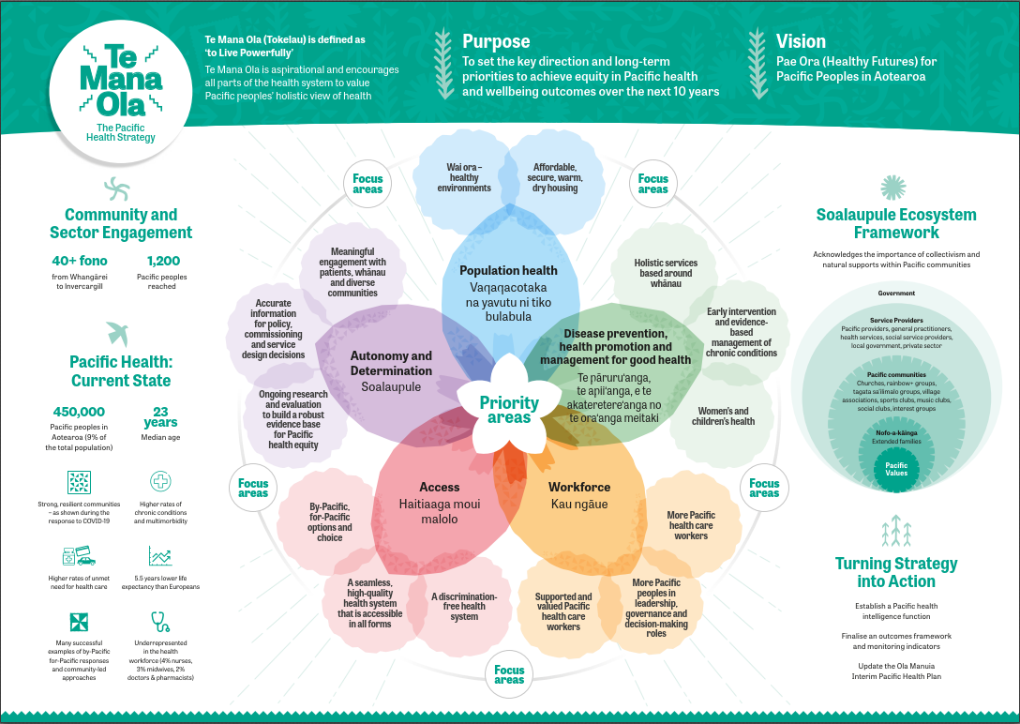

Setting the long-term direction for Pacific health

Purpose of Te Mana Ola and the Pae Ora strategies
Te Mana Ola: The Pacific Health Strategy (Te Mana Ola) is 1 of 6 population health strategies required under the Pae Ora (Healthy Futures) Act 2022 (the Pae Ora Act). The other strategies are the New Zealand Health Strategy, Pae Tū: Hauora Māori Strategy
(Pae Tū), Health of Disabled People Strategy, Women’s Health Strategy and Rural Health Strategy. Together, these strategies provide a framework for achieving pae ora – healthy futures for all New Zealanders.

The Pae Ora Act lays the foundation for transforming our health system to support all New Zealanders to live longer and have the best possible quality of life by:
- protecting, promoting, and improving the health of all New Zealanders
- achieving equity in health outcomes among New Zealand’s population groups, including by striving to eliminate health disparities, in particular for Māori
- building towards pae ora (healthy futures) for all New Zealanders.

Te Mana Ola presents an important opportunity to set the direction and long-term priorities to achieve equity in Pacific health and wellbeing outcomes over the next 10 years. Together with the other health strategies, it will help transform the health system by providing a framework and priorities to guide health entities to improve Pacific health outcomes in Aotearoa New Zealand. These priorities were developed by assessing current Pacific health outcomes, health sector performance and population health trends and engaging extensively with Pacific communities and the Pacific health sector.

“We should not be defined by the smallness of our islands, but by the greatness of our oceans. We are the sea, we are the ocean. Oceania is us.” Hauofa 1994

A commitment to Te Tiriti o Waitangi
There exists shared whakapapa, history, spirituality, culture, and geography between Pacific peoples and Māori. Te Mana Ola acknowledges this connection and actively uses te reo Māori, including the terms whānau, pae ora and wai ora, to reinforce these connections, which also aligns with indigenous Pacific worldviews of family and collectivism.

Te Mana Ola is committed to honouring Te Tiriti o Waitangi and the special relationship between Māori and the Crown. It recognises Te Tiriti as the constitutional foundation between Māori and Pacific peoples and the distinctive rights and roles of Māori across the health sector.

As outlined in Whakamaua: Māori Health Action Plan 2020–2025, the text of Te Tiriti and declarations made during its signing provide the enduring foundation of our approach to Te Tiriti and the principles, as articulated by the Courts and Waitangi Tribunal, guide the application of our approach.

The Crown, as the kaitiaki and steward of the health system (under article 1 of Te Tiriti), has the responsibility to enable Māori to exercise authority over their health and wellbeing (under article 2) and achieve equitable health outcomes for Māori (under article 3) in ways that enable Māori to live, thrive and flourish as Māori.

To give effect to the principles of Te Tiriti in health, the Minister of Health, Manatū Hauora and all health entities are guided by a series of principles recommended in the Waitangi Tribunal’s Hauora report. These are included in the health sector principles that are incorporated in section 7 of the Pae Ora Act and are aimed at improving the health system for Māori and improving hauora Māori outcomes. The principles include
tino rangatiratanga (self-determination), ōritetanga (equity), whakamaru (active protection), kōwhiringa (options) and pātuitanga (partnership).

The inter-connected elements of pae ora acknowledge the importance of mauri ora, whānau ora and wai ora to Māori health and wellbeing and the need to work collectively and in collaboration with the communities our system serves, with iwi, hapū and Māori communities, and with the wider organisations that contribute to the health and wellbeing of whānau. Our commitment to Te Tiriti o Waitangi and definition of pae ora are described in greater detail in Pae Tū.

Developing Te Mana Ola

Pacific Health Strategy Advisory Group
To support the development of Te Mana Ola, the Advisory Group was established in October 2022. The Advisory Group members included Pacific health experts and community leaders from diverse Pacific ethnic groups, different regions throughout Aotearoa and people working in the health, education, and community sectors. Members of the Advisory Group represented a wide variety of lived experience and perspectives, including tagata sa‘ilimalo, mental health and addictions, Pasifika rainbow+/LGBTQIA+/MVPFAFF+, rural communities, women and children’s health, research, social work, and education (Inside-Out 2021, Tōfā Mamao 2023). It also included representatives from the Pacific Health Group of Te Whatu Ora and the Ministry for Pacific Peoples.

Community and Sector Engagement
A fundamental part of developing Te Mana Ola was engaging with Pacific communities, health care workers and providers throughout Aotearoa to find out their priorities and the conditions needed for people to enjoy the best possible health and wellbeing. This engagement process was planned alongside and supported by the Advisory Group. In February and March 2023, more than 40 engagement fono were held throughout the country, spanning many Pacific communities and providers,
from Whangārei in the north to Invercargill in the south, and including the voices of diverse groups with a wide variety of lived experience.

The feedback from these engagements has been valuable in informing the priorities included in Te Mana Ola, and an in-depth report will be published later in 2023 detailing important themes from the fono. A summary of the key themes from the
engagement fono is provided in the Appendix.

Pacific peoples in the Pacific region
Te Mana Ola recognises the special relationship between Aotearoa and countries that make up the Pacific aspect of the Realm of New Zealand (the Realm) – the dependent territory of Tokelau and the self-governing states of the Cook Islands and Niue. In recognition of New Zealand’s obligations to these Realm countries, Te Mana Ola includes these Pacific peoples when they are in Aotearoa. It also acknowledges people from other Pacific Island nations, and their needs and aspirations for health and wellbeing while in Aotearoa.

Structure of Te Mana Ola
Te Mana Ola has 5 parts:
- Part 1: is an introduction to this document and describes the purpose and development of Te Mana Ola.
- Part 2: sets out the long-term vision of pae ora (healthy futures) for Pacific peoples in Aotearoa and the alignment of Te Mana Ola with other strategic government documents.
- Part 3: includes an assessment on the current state and trends in health outcomes and health sector performance for Pacific peoples.
- Part 4: sets out 5 key priority areas for Pacific health improvement over the next 10 years.
- Part 5: describes the steps that will be necessary to turn the priorities outlined in Te Mana Ola into actions.

Vision – pae ora

Pae ora (healthy futures) for Pacific peoples in Aotearoa New Zealand
Pacific peoples in Aotearoa represent a multitude of island nations, and while Pacific peoples share common world views and values, each nation adds their own specific identity. To achieve our vision of pae ora for Pacific peoples in Aotearoa, it is important to understand that Pacific health is broad and holistic. It incorporates physical, mental and spiritual wellbeing that is steeped in community and acknowledges the environment in which Pacific peoples live.

Figure 1: Soalaupule Ecosystem Framework
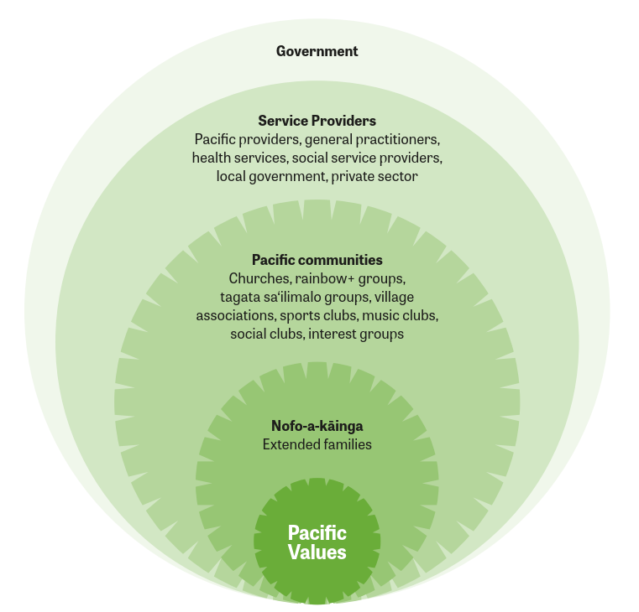

The Soalaupule Ecosystem Framework (figure 1) acknowledges the importance of collectivism and natural supports within Pacific communities. It recognises that when decisions are made, everyone who needs to be consulted is consulted, and the final decision is based on consensus (Tunumafono Fa‘amoetauloa Avaula Fa‘amoe 2023).

At the core of Soalaupule Ecosystem Framework are the Pacific values of family, collectivism, consensus, reciprocity, respect, spirituality, love and culture, which permeate through the ecosystem. ‘Nofo-a-kāinga’ acknowledges the strong extended families that collectively make up Pacific communities, with their various groups and clubs that operate within Pacific world views. Service providers, represented by health, social services and local governments, serve the diverse Pacific communities and
their ethnic-specific needs. Soalaupule exists as a mechanism for the government to work with Pacific peoples to achieve equitable health outcomes. Each layer of the ecosystem is connected.

The nationwide rapid response and significant increase in testing and vaccination results during the COVID-19 pandemic, as well as care provided in the community by Pacific peoples, can be attributed to Soalaupule Ecosystem Framework (Ioane, Percival et al. 2021). There is an opportunity to strengthen this ecosystem in Te Mana Ola. The vision is also positioned within existing indigenous Pacific knowledge frameworks. These frameworks are necessary and acknowledge the various ethnic groups that make up Pacific peoples, including:
- Kakala, Tonga (Thaman 1993)
- Fonofale, Samoa (Pulotu-Endemann 2001)
- Tā and Vā, Tonga (Māhina 2002)
- Fa‘afaletui, Samoa (Tamasese, Peteru et al. 2005)
- Vanua, Fiji (Nabobo-Baba 2006)
- Te Vaka Atafaga, Tokelau (Kupa 2009)
- ivaevae, Cook Islands (Futter-Puati and Maua-Hodges 2019)
- Fonua, Tonga (Tu‘itahi, Watson et al. 2021)
- Folauga, Pan-Pacific (Sopoaga 2021).

The Tagata Sa‘ilimalo Strategic Framework similarly provides a vision that is specific to Pacific peoples, in this instance Pacific disabled peoples, their families and carers (Tōfā Mamao 2023). The framework emphasises the importance of Pacific collectivism (including shared authority, responsibilities and outcomes) as an important mode for community mobilisation.

Alignment with the All-of-Government Pacific Wellbeing Strategy
The Government is committed to improving Pacific health and wellbeing outcomes in Aotearoa across a wide range of social and economic areas. Te Mana Ola acknowledges that achieving better health outcomes for Pacific peoples is a shared commitment and responsibility across government agencies and the health sector.

Te Mana Ola draws its lineage from the Ministry for Pacific Peoples Pacific Aotearoa Lalanga Fou report (Ministry for Pacific Peoples 2018). Lalanga Fou articulates Pacific peoples’ aspirations and lays the foundation for how we define success, prosperity and wellbeing for Pacific communities. It outlines a strategic vision for a confident, thriving, resilient and prosperous Pacific Aotearoa through system-level changes in decision-making for Pacific communities. Te Mana Ola contributes to the 4 Lalanga Fou goals, and particularly to goal 3 – resilient and healthy Pacific peoples.

Building on this foundation, Te Mana Ola contributes to the Ministry for Pacific Peoples’ All-of-Government Pacific Wellbeing Strategy (Ministry for Pacific Peoples 2022a). The All-of-Government Pacific Wellbeing Strategy reinforces the call for collective action and seeks to influence the broader determinants of Pacific wellbeing. It weaves together strategic leadership, advice, policies and programmes for Pacific wellbeing across the public sector to realise the goals of Lalanga Fou.

Te Mana Ola complements the Living Standards Framework (Treasury 2021), the Child and Youth Wellbeing Strategy (Department of the Prime Minister and Cabinet 2019), Better Later Life – He Oranga Kaumātua 2019 to 2034 (Ministry of Social Development 2019), Kia Manawanui Aotearoa – Long-term pathway to mental wellbeing (Ministry of Health 2021) and Te Aorerekura – The national strategy to eliminate family violence and sexual violence (Te Puna Aonui 2021). These strategies and frameworks capture many drivers of New Zealanders’ wellbeing, now and in the future. The priority areas of Te Mana Ola similarly help us understand the drivers of wellbeing and the impacts of strategic policy advice through a Pacific holistic view of health and wellbeing.

Pacific health inequities in Aotearoa are significant and longstanding. Te Mana Ola acknowledges the foundational work that has gone before to improve how the health system serves Pacific peoples. This includes building upon Faiva Ora 2016–2021 National Pasifika Disability Plan (Ministry of Health 2017), previous Pacific Health Action Plans and Ola Manuia: Interim Pacific Health Plan July 2022–June 2024 (Te Whatu Ora 2022d), which outlines priority outcomes and accompanying actions for the health and disability system.

Te Mana Ola also acknowledges Bula Sautu – A window on quality 2021: Pacific health in the year of COVID-19 (Bula Sautu) (HQSC 2021). Bula Sautu highlights the significant impact of COVID-19 on Pacific peoples in Aotearoa but more importantly emphasises new ways for the health system to work that reinforce the strengths of Pacific providers and communities.

Current outcomes and trends in Pacific health
This section contains a summary assessment of health outcomes, service access, workforce and information quality for Pacific peoples in Aotearoa. It is not exhaustive but attempts to balance demographic and cultural strengths succinctly and accurately against information availability and robustness for Pacific peoples. Manatū Hauora
intends to publish a more comprehensive report on Pacific health outcomes and health sector performance in 2024.

Pacific peoples in Aotearoa
‘Pacific peoples’ is a collective term for diverse ethnic groups who whakapapa (have ancestry) to Pacific Island countries. Stats NZ lists more than 17 different Pacific ethnicities under the level 4 category of Pacific peoples (demonstrating the diversity
of Pacific groups), with the 7 largest Pacific groups in Aotearoa being Samoan, Tongan, Cook Island, Niuean, Fijian, Tokelauan and Tuvaluan (Stats NZ 2018c, Stats NZ 2020). More than 60% of Pacific peoples in Aotearoa were born in this country, and of those born overseas, more than 60% have lived in Aotearoa for more than 10 years (Ministry for Pacific Peoples 2020).

Pacific peoples value tautua (service) and show this through contributions to their families and communities within Aotearoa and across the Pacific. Pacific culture is founded on relationships, hospitality and respect (Tamasese, Parsons et al. 2010, Thomsen, Tavita et al. 2018). The COVID-19 pandemic brought many challenges, but it also highlighted the resiliency and tautua of Pacific peoples. Pacific health providers and communities formed a cornerstone of the response to COVID-19, ensuring that whānau were protected and supported. The successes of the response to COVID-19, as well as adverse weather events in 2023, provide a solid platform from which to build on the strengths of Pacific communities (HQSC 2021). Language and culture are important to Pacific peoples’ sense of belonging and identity and contribute to wellbeing (Ministry for Pacific Peoples 2022c). Translating health messages into the range of Pacific languages during the COVID-19 response was important to ensure all Pacific communities were kept informed (Morgan, Koh et al. 2022).

Trends in the Pacific population
In 2022, there were estimated to be 459,200 people in Aotearoa who identified with at least one Pacific ethnicity (9% of the total population) (Stats NZ 2018e). Many Pacific peoples identify with more than one ethnic group (40%), and this proportion is growing (more than 50% of Pacific children aged 0–14 years identify with more than one ethnic group), which will have implications for the evolution of Pacific identities in Aotearoa. There are approximately 58,000 people in Aotearoa who identify as both Māori and Pacific, 50% of whom are younger than 15 years old (Ministry of Health 2022d).

The Pacific population has a much younger age structure than the country’s total population, as shown in figure 2. Approximately 33% of Pacific peoples in Aotearoa are younger than 15 years old and 50% are younger than 25 years old. The Pacific working-age population is projected to increase from almost 300,000 in 2023 to 420,000 by 2043 (Stats NZ 2018e).

Figure 2: Age distribution of Pacific and total New Zealand 2021 population projections (Stats NZ 2018b)
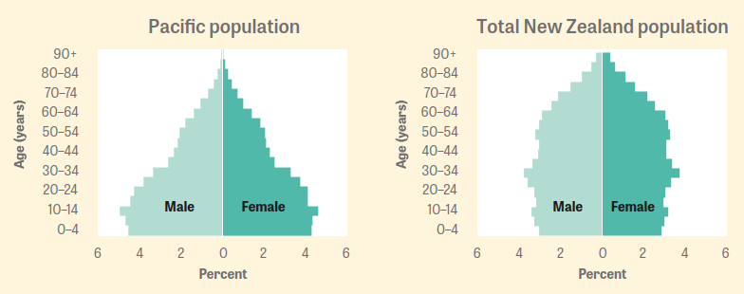

An overview of key population and wellbeing statistics in Aotearoa is given in table 1. The Pacific population is rapidly growing with specific health needs, particularly for chronic conditions (Howden-Chapman, Fyfe et al. 2021, HQSC 2021). Information on health outcome trends for Pacific peoples is limited and available projections may be unreliable due to quality of underlying data.

Table 1: Population statistics for Pacific peoples in Aotearoa, current and future state
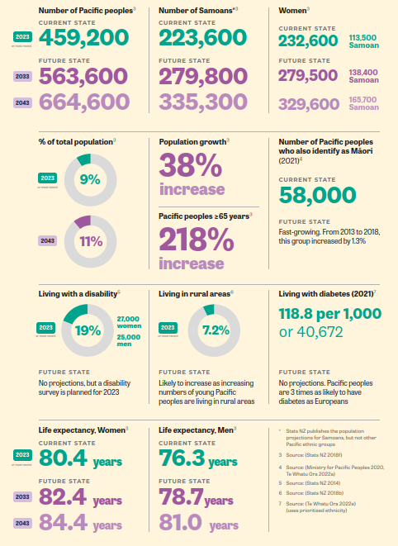
* Stats NZ publishes the population projections for Samoans, but not other Pacific ethnic groups

Pacific peoples are largely urban based. Approximately 66% live in the Auckland region (half of whom reside in the Counties Manukau district). However, there are increasing numbers of Pacific peoples living in rural areas, with distinct health needs and challenges related to health care access and limited numbers of Pacific health care workers. There are large Pacific populations in the following rural areas: Tokoroa, Taupō, Levin, Paraparaumu, Ashburton and Oamaru. Figure 3 shows the number of Pacific peoples across Aotearoa.

Figure 3: Projected 2023 Regional Council distribution of Pacific peoples in Aotearoa (Stats NZ 2018e)
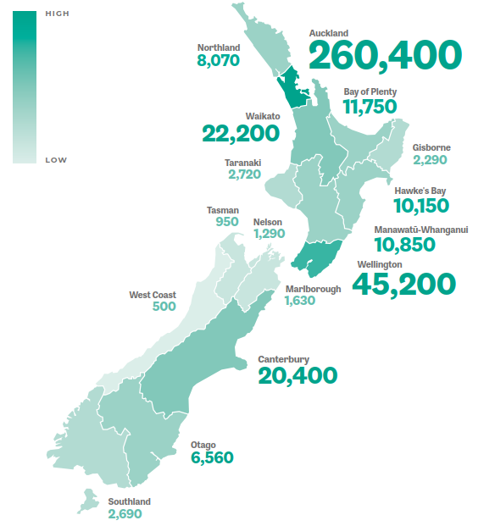

Socioeconomic determinants of health
Selected social and economic factors for Pacific peoples and Europeans are compared in table 2. While there are strengths, such as youth involvement in the community (56.5% for Pacific youth compared to 43.6% for European youth), there are also inequities in socioeconomic factors that limit a person’s ability to enjoy the best possible health and wellbeing (Ministry of Social Development 2022).
Table 2: Comparison of social and economic indicators for Pacific peoples and Europeans
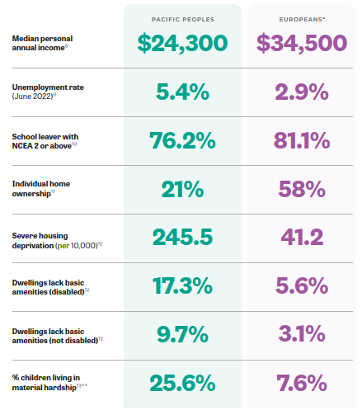
* Europeans are used as the comparison group because using the total New Zealand population would also include Pacific peoples, providing an inaccurate assessment of the equity gaps
** Material hardship defined as a DEP-17 score ≥6

Pacific peoples across their life course experience significant inequities in neighbourhood deprivation, home ownership, household crowding, education, income and unemployment in Aotearoa (Metadata Research Group 2022). Pacific whānau
throughout Aotearoa told us that the high and rising cost of living is a major stress, impacting on their mental and physical health, as well as their ability to access timely health care.

There is a well-documented pay equity gap (evident in all sectors, including health) between Pacific peoples and other ethnic groups that cannot be fully explained by qualifications and skill level (Theodore, Taumoepeau et al. 2018, Parker, Sayers et al. 2022, Ministry of Business 2023). In 2021, the gap in the median hourly earnings of Pacific men and women compared to European men was 18.8% and 25.1% respectively. Pacific women experience the largest pay equity gap of all groups in Aotearoa. In 2021, for the 55-64 year old age group, median individual Pacific net worth was $28,000, well below the $439,000 median for Europeans (Metadata Research Group 2022, Stats NZ 2022a).

The percentage of adults who report not having enough money to meet their everyday needs has been declining since 2010. However, Pacific peoples continue to have the highest levels of material deprivation (21% compared with 7% of Europeans). In 2022,
26% of Pacific children were reported to be living in households experiencing material hardship – a higher percentage than for any other groups in Aotearoa (Stats NZ 2023b).

Wai ora – healthy environments
Pacific peoples and communities are clear that they want to live, learn, work and spend their leisure time in environments that promote good health and wellbeing.

Housing is an important environmental determinant, particularly for children and older people. Damp and mouldy housing is associated with increased psychological distress and hospitalisation, including for rheumatic fever (Oliver, Pierse et al. 2017, Howden-Chapman, Fyfe et al. 2021). Among those living in dwellings with at least one major
problem 29% had poor overall mental wellbeing on the WHO-5 index, compared with 13% of Pacific peoples without major housing problems (Stats NZ 2023b). Furthermore, Pacific peoples are more likely to be exposed to adverse housing conditions (46% compared with 24% of the total Aotearoa population) and consequently have higher rates of potentially avoidable housing-related hospitalisations. Other challenges include homes that are:
- crowded (39% compared with 11% of the total population)
- in need of major repairs (10% compared with 4% of the total population)
- inadequately heated (41% compared with 18% of the total population) (Stats NZ 2023b).

An evaluation of the Healthy Homes Initiative, which focuses on warm, dry, healthy housing for low-income families, found that the programme prevented 20% of hospitalisations, 9,443 general practitioner (GP) visits and 8,784 filled prescriptions over 3 years were prevented (Howden-Chapman, Bennett et al. 2023). It also increased school attendance and employment (Pierse, White et al. 2019). Almost half (46%) of participants in the evaluation were Pacific peoples.

Home ownership is a way of securing intergenerational wealth and financial security and many Pacific peoples want to own their own homes (New Zealand Productivity Commission 2022). However, high house prices mean that home ownership is out of reach for many whānau. Pacific peoples have the lowest rates of home ownership in Aotearoa (Stats NZ 2023b). Renting is often the only choice for Pacific whānau, but rental accommodation is associated with insecure tenure, poor quality, inadequate and unsuitable housing. The rising costs of rental accommodation is also a concern for Pacific peoples, leaving limited funds for necessities and other expenses, including transport and health care.

Fale mo Aiga – Pacific Housing Strategy and Action Plan 2030 is a shared strategy between the Ministry for Pacific Peoples, Ministry of Housing and Urban Development and Kāinga Ora (Ministry for Pacific Peoples 2022b). This strategy is focused on supporting Pacific whānau into home ownership as a means of generating intergenerational wealth and achieving security of tenure, an aspiration expressed by many Pacific peoples as part of Lalanga Fou.

Pacific peoples and communities want to be supported and empowered to shape their environments and be part of decisions that affect their neighbourhoods. However, Pacific peoples have inequitable access to healthy food and active environments and often have limited choices for affordable, nutritious food and green spaces in which to exercise safely (Ministry of Health 2022a, Ministry of Health 2022c). Pacific peoples are disproportionally represented in areas of high deprivation and impacted by the clustering of fast-food outlets within these communities (Day and Pearce 2011).

Pacific children are also more likely than other children to live in households that experience food insecurity, an indicator of socioeconomic distress (Ministry of Health 2019). Pacific children make up 14% of the total child population in Aotearoa but 26% of all children in the ‘food insecure population’ and their parents are more likely to report psychological distress. Pasifika rainbow+ youth experience higher rates of housing instability (23%) compared with Pacific non-rainbow+ youth (20%) who in turn are at least twice as likely as European Rainbow youth (10%) to have this experience (Tiatia-Seath, Fleming et al. 2021).

Smoking also remains an important contributor to health loss for Pacific peoples. While there has been a significant decline in the number of people aged 15 years and older who are daily smokers, the decline in smoking has been lowest in Pacific peoples (23% down to 18% over the decade 2012 to 2022 compared with a decline from 14% to 7% for Europeans over the same decade) (Ministry of Health 2022b). Almost half of Pacific year 10 students in the 2022 ASH Year 10 Snapshot Survey reported ever trying vaping (ASH NZ 2023).

Health outcomes
There is a gap in life expectancy at birth for Pacific peoples (5.5 years lower than that for European females and 5.6 years lower than that for European males) (figure 4). This gap is largely driven by premature deaths that could have been prevented by improving environmental and socioeconomic factors and health system actions, including better access to preventive medications and early interventions (Walsh and Grey 2019). To achieve medicines access equity for gout prevention at younger ages, for example, around 8,700 more Pacific peoples need to be dispensed gout medication each year (Arnold, Masina et al. 2022).

Figure 4: Life expectancy at birth, 2017–2019 (Stats NZ 2021)
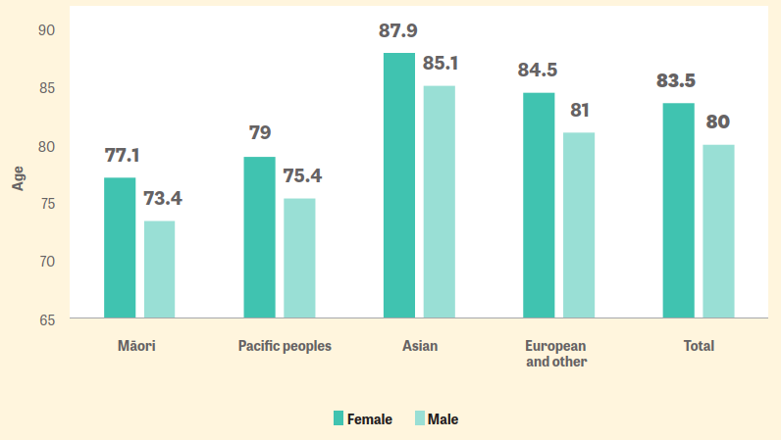

Pacific health inequities are seen throughout the life course, beginning with pregnant women. Although the proportion of women accessing maternity care in the first trimester is increasing, only 41% of Pacific women are enrolled with a lead maternity carer (LMC) in their first trimester, compared with 83% of European women. This has a direct impact on maternal and infant mortality: from 2006 to 2018, Pacific women had
a maternal mortality rate of 22.23 per 100,000 maternities, compared with 11.33 for European women. In 2020, the infant death rate for Pacific peoples was 7.1 per 1,000 live births (the highest of all ethnic groups), compared with 4.2 for Europeans (Te Whatu Ora 2022c).

Over the last few years Pacific childhood immunisation rates have declined, which has been linked to disease outbreaks, such as measles and pertussis (Tafea, Mowat et al. 2022). Higher hospitalisation rates for lower respiratory tract and influenza infections in Pacific children are associated with chronic lung and respiratory diseases, such as bronchiectasis and asthma, in later childhood and adulthood (Trenholme, Vogel et al. 2012, Trenholme, Best et al. 2017). Pacific children have high rates of rheumatic fever (a disease almost non-existent in non-Māori non-Pacific children and eliminated in most high-income countries). The consequences of rheumatic fever can be life-altering: a South Auckland study reported that up to 1 in 50 Pacific children may have rheumatic heart disease (damaged heart valves due to severe or repeated episodes of rheumatic
fever) (Webb, Culliford-Semmens et al. 2023).

In adulthood, Pacific peoples experience higher rates of chronic conditions (for example, gout, diabetes, cancer and cardiovascular disease). Pacific women experience higher rates of endometrial, breast and cervical cancers, but have lower survival rates, and this has been linked to inequities in access to diagnostic health care (Meredith, Sarfati et al. 2012, Brewer, Foliaki et al. 2022). Multimorbidity (the presence of 2 or more chronic conditions) is increasing in Pacific peoples, which makes holistic and responsive health services even more important (Gurney, Stanley et al. 2020, Murdoch, Jones et al. 2022). An estimated 14% of Pacific peoples aged 15–64 years (compared
with 7% of Europeans) have one chronic condition and a further 5% (compared with 2% of Europeans) have multimorbidity. In Pacific peoples aged 65 years and older, 32% (compared with 26% of Europeans) have one chronic condition and a further 35% (compared with 15% of Europeans) have multimorbidity.

What Pacific peoples and communities told us
Pacific communities told us they want a system that prioritises prevention and wellbeing at all stages of the life course. They want prevention to start with pregnant women and focus on the early years of life. Communities and community leaders (including faifeau [church ministers], tagata sa‘ilimalo, teachers and youth) would like to partner with health providers and organisations in prevention, health promotion and early intervention efforts.
Pacific peoples reported that current health services did not reflect their values (particularly the importance of collectivism and family) or meet their wellbeing needs holistically. People wanted to see ‘one-stop-shop’ services, where services are seamless, integrated and focused on their whole whānau. They expected to (but often did not) receive continuity of health care between services. However, current services have limited focus on prevention and tend to be focused on individuals and single issues, therefore poorly catering to Pacific whānau with multiple health and social needs.

Access to health care
There are well-documented inequities in access to health care services for Pacific peoples in Aotearoa, demonstrating system and service gaps. Key indicators on health care access are presented in table 3.
Table 3: Key indicators of access to health care services in Aotearoa
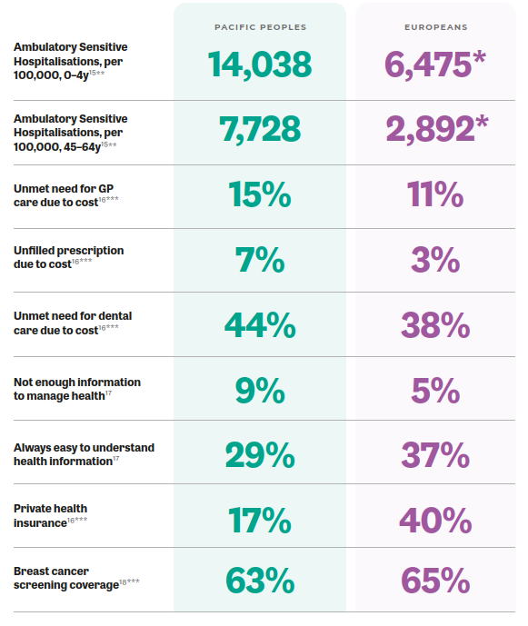
* Includes Europeans and other groups
** Ambulatory sensitive hospitalisations assume that better condition management within local communities and primary care can reduce the number of avoidable hospitalisations. This information uses prioritised ethnicity and the comparator is the European and other group
*** Data from 2020/21 was used, as only a small number of Pacific people participated in the 2021/22 survey and there are concerns about representation of data

What Pacific peoples and communities told us
Pacific communities reported multiple barriers to accessing health care across the entire health spectrum, from preventive services, screening and primary health care to specialist and hospital services. Many of these barriers are due to inequities in the socioeconomic determinants of health, such as cost, transport, availability of services (appropriate locations, opening hours), ability to take time off work to attend health care services and availability of adequate childcare services. There are also specific services that were highlighted as being particularly challenging to access, including maternity, mental health, dental, allied health and other community-based providers (for example, optometrists and audiologists).
Pacific communities told us that they find the health system, and the services within it, complex and difficult to navigate. People see the system as fragmented and confusing, and the system is even more difficult for people who do not have English as their first language. This is compounded by experiences of racism and other forms of discrimination when accessing health services. People told us they want more information about the services and supports that are available but do not know where to find this information. People and whānau with chronic conditions find it difficult to get sufficient information to manage their health and wellbeing independently. Short primary health care appointments compound this issue. Many people do not feel empowered or supported by the system to optimise their health and wellbeing.
Digital and technological innovations and platforms are increasingly being used in the health system, but there are inequities in accessing technology (for example, patient portals), which can further alienate people, particularly tagata sa‘ilimalo. Many Pacific peoples in rural areas reported that the increasing focus on telehealth has diminished their confidence in the care that they receive. Many people would like to be seen face-to-face by providers.

Health workforce
Pacific peoples are significantly underrepresented in the health workforce (table 4) with little change expected in the proportion of Pacific peoples working in different health disciplines that have forecasts available for the next 10 years (table 5).

Table 4: Pacific Health Workforce – regulated health care workers
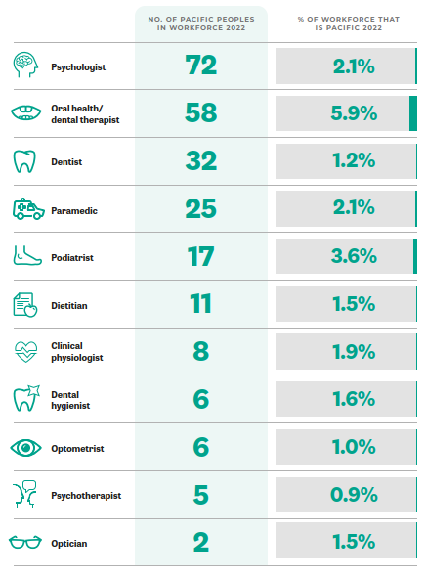
* Total response ethnicity – includes Pacific peoples who also identify as Māori

Table 5: Pacific Health Workforce – regulated health care workers, with 10-year forecasts
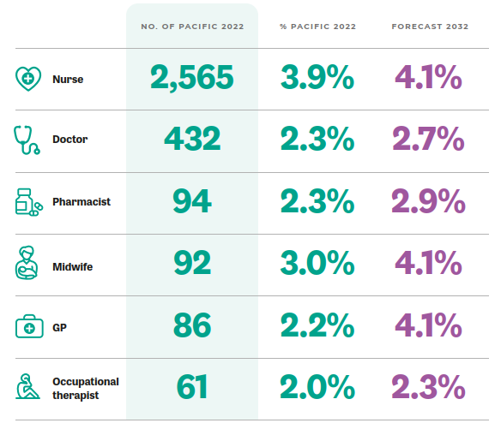
* Total response ethnicity – includes Pacific peoples who also identify as Māori

Non-regulated health care workers (for example, community support workers, Oranga Tamariki caregivers, health coaches, health care assistants and disability carers) play fundamental roles in caring for Pacific peoples and whānau, but information on these roles is limited.

What Pacific peoples and communities told us
Pacific communities told us they want to interact with more Pacific peoples in health care roles. In many communities, particularly in rural areas, there are limited options to see health care workers. Having more Pacific peoples in the health workforce would help shape workplace culture, embed Pacific values and encourage others into health professions.
Pacific educators saw a need for more Pacific science teachers and academics to encourage youth into sciences, increase enrolments in health studies and drive curriculum development.
Pacific peoples with lived experience of mental health and addictions, tagata sa‘ilimalo, people living in rural areas and people identifying with the Pasifika rainbow+ community want more opportunities to upskill, train in health care and work in Pacific health and community support roles.
Many Pacific health care workers reported that they did not feel valued or remunerated for the additional cultural and linguistic skills they bring. Pay equity for Pacific peoples is an ongoing issue. Pacific health care workers want more opportunities for continuing education and professional development. Many reported experiencing racism and cultural loading (where they are expected to ‘speak on behalf of all Pacific peoples’) in their workplaces. These experiences and the toll of COVID-19 have resulted in high levels of stress.
Pacific providers reported difficulties recruiting and retaining staff because they are often unable to offer the same level of remuneration as other organisations. They wanted secure, flexible, sustainable funding to address staffing and more support for ongoing professional development. There are many Pacific region-trained health professionals who have valuable skills and expertise that are not able to work in the health sector in Aotearoa due to the high demands and costs of undergoing New Zealand accreditation.
Growing Pacific health leadership and opportunities for taking up governance and decision-making roles is a priority for Pacific communities. More visible Pacific health leaders would prioritise Pacific health equity, wellbeing and resilience and help to drive change.

Data availability and quality
Accurate information and knowledge are necessary for making evidence-based decisions in the health sector. However, obtaining high-quality, timely information for
Pacific peoples is a persistent challenge. The system of data collection, analysis and dissemination systematically hinders and misunderstands Pacific peoples and their complexity (Tukuitonga, Bell et al. 2000, Anglemyer, Grey et al. 2022).

In a well-functioning health information system, data on Pacific health outcomes and Pacific peoples’ access to, experience with and receipt of quality care would be reported together on a regular basis. If numbers allowed, this data would be
reported by Pacific ethnic groups, as was the case during the COVID-19 vaccination drives. Ethnic-specific approaches recognise the diversity of Pacific groups and have been shown to be successful.

Official measures are also often focused on gaps and deficits, not strengths that can be built on. Although diverse, common values across Pacific communities draw on the many strengths and resiliencies of the collective, including high rates of volunteering, family wellbeing and social connectedness (Ministry for Pacific Peoples 2021, Treasury 2023). The limited data that we currently use do not adequately capture the strengths of Pacific peoples and communities.

Priorities and opportunities for Pacific health improvement
The guiding principles of a commitment to Te Tiriti and achieving equity underpin the
strategic priorities set forth in Te Mana Ola. The strategic framework sets out 5 key priority areas that embrace the interconnection between population health; disease prevention, health promotion and management of good health; autonomy and determination; access; and workforce (figure 5). Their inclusion in Te Mana Ola underscores the enduring importance of each priority area based on a review of current evidence and according to Pacific peoples’ own accounts.

These 5 priority areas are already part of many social and health sector work programmes. However, Te Mana Ola is the first Pacific Health Strategy for Aotearoa and there is a newly reformed health system resulting from the Pae Ora Act. With so many actors in the system accountable for Pacific health outcomes, Te Mana Ola aims to clarify expectations about what needs to happen.

Figure 5: Te Mana Ola priority areas
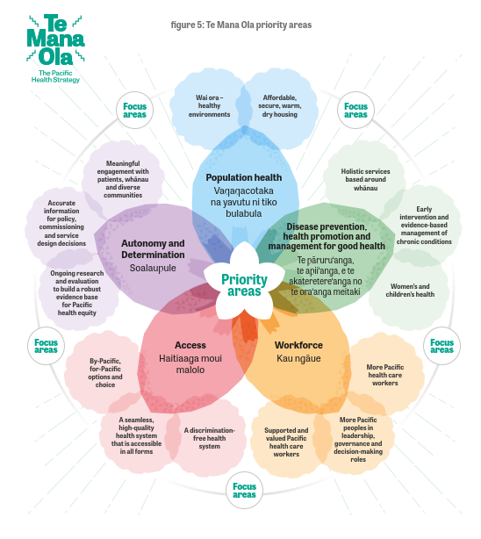

Priority area 1:
Vaqaqacotaka na yavutu ni tiko bulabula
Population health
The health system works with communities and government and non-government agencies to build, maintain and enable strong foundations for Pacific health and wellbeing.

Wai ora – healthy environments
- Ensuring the environments in which Pacific peoples and communities live, learn and work are inclusive, accessible for tagata sa‘ilimalo and promote and maximise health and wellbeing (including food and active environments; the supply of alcohol, gambling, cigarettes and youth vaping; and adapting and responding to the impacts of climate change).

Affordable, secure, warm, dry housing
- Ensuring Pacific peoples have access to affordable, stable and good-quality housing (warm, dry and with adequate space).

What we heard from Pacific peoples
“How do you expect us to be healthy when there are fast food outlets, alcohol and vape shops on every street corner in neighbourhoods where we live?”
“As tagata sa’ilimalo, we would like to have access to gyms and other places where we can exercise safely – options for us are very limited.”
“Many Pacific families are struggling with the high costs of rent and poor quality of housing.”

Why this is a priority
The Pae Ora Act requires the health sector to work collaboratively with other sectors to undertake health promotion and disease prevention efforts and address the wider determinants of health. The gap in life expectancy for Pacific peoples is largely driven by premature deaths preventable through improved environmental and socioeconomic factors. According to the New Zealand Productivity Commission, a barrier to addressing persistent disadvantage is the ‘fragmented and siloed nature of government’ (New Zealand Productivity Commission 2022). The Commission
challenges the idea that making improvements in individual sectors will be sufficient to address persistent disadvantage.

What it will look like in the future
Health entities work in partnership with other government and non-governmental agencies and alongside communities to address wider determinants of health.

Wai ora – healthy environments
- Pacific whānau and communities have improved access to clean green (and other) spaces that address mobility and promote physical and leisure activities regularly and safely, regardless ofdisability status.
- More Pacific children live in food-secure households and enjoy nutritious meals that support cultural wellbeing.
- Pacific communities live in healthy, safe environments and have control over the availability of fast food, alcohol, tobacco and vaping outlets in their neighbourhoods.
- Pacific communities and providers have increased support to mobilise quickly to respond to immediate climate impacts and are better able to adapt to and thrive in a changing climate.

Affordable, secure, warm, dry housing
- Pacific whānau have increased access to appropriate, high-quality and secure housing.
- More Pacific households can access the Healthy Homes Initiative.
- Preventable housing-related hospitalisations are reduced and ultimately eliminated.

What needs to change
This priority area requires health entities and providers to partner and work closely with other central and local government agencies, non-government organisations and
Pacific communities to ensure that Pacific peoples and whanau can live, work, learn and spend their leisure time in health-promoting environments. The All-of-Government Pacific Wellbeing Strategy and The Living Standards Framework provide important frameworks for agencies to work together in the areas of health, housing, income and employment.

Health may not be the lead sector for some of this work, but we are a key partner and must take an active support role to address the wider determinants of health, which
play a pivotal part in securing the wellbeing of current and future generations of Pacific peoples. Opportunities include strengthening regulatory environments, developing cross-government policy and commissioning structures and supporting community-led approaches.

Wai ora – healthy environments
- Work with local government bodies, non-governmental organisations and Pacific community groups to secure access to healthy food and active environments (including for tagata sa‘ilimalo), control the supply of alcohol, tobacco and vaping and limit access to gambling.
- Strengthen and enforce codes restricting how and when children can be targeted by advertising, marketing, and sponsorships.
- Work with the Ministry of Education to expand Ka Ora, Ka Ako – Healthy School Lunches Programme and implement policies to limit exposure to unhealthy food environments in schools (Ministry of Education 2020).
- Implement a food reformulation target work programme to reduce sodium and sugar in processed foods and improve food and nutrient intake at a population level.

Affordable, secure, warm, dry housing
- Expand the Healthy Homes Initiative targeting whānau at ris k of rheumatic fever and other interventions to increase reach to more Pacific households that require support with cold, damp, and mouldy housing.

Links to the other Pae Ora strategies
New Zealand Health Strategy | Partnerships for health and wellbeing
Pae Tū | Strengthening whole-of-government commitment to Māori health
Health of Disabled People Strategy | Ensure that the health system is part of a coherent cross-government system that addresses broader drivers of poor health and wellbeing
Women’s Health Strategy | Living well and ageing well
Rural Health Strategy | Prevention: Paving the path to a healthier future

Priority area 2:
Te pāruru‘anga, te apii‘anga, e te akateretere‘anga no te ora‘anga meitaki
Disease prevention, health promotion and management of good health
The health system prioritises disease prevention, health promotion and good
health and wellbeing through the life course.

Holistic services based around whānau
- Ensuring health services reflect Pacific values and address health holistically.
- Ensuring services provide social and practical supports and/or adequate pathways into these supports for whānau.

Women’s and children’s health
- Ensuring women are well and in good health, including before and during pregnancy, children get the best start in life and young people can learn and achieve to their full potential.

Early intervention and evidence-based management of chronic conditions
- Facilitating early identification and management of risk factors.
- Ensuring Pacific peoples can access high-quality care and evidence-based management for (and be empowered to self-manage) chronic conditions, including cancer, diabetes, gout and cardiovascular disease.

What we heard from Pacific peoples
“We want health issues to be prevented before they start…”
“The youthfulness of Pacific populations is a strength… let’s focus on making sure our children and young people are well. They are our future.”
“Women play important roles in our communities as leaders and caregivers. We need to prioritise the health of Pacific women to ensure they can continue to play these important roles.”

Why this is a priority
Current health services tend to be focused on individual health and the (often urgent rather than proactive) treatment of single health issues and conditions. Many chronic diseases have well-established guidelines for evidence-based care (for example, cardiovascular disease and gout), but there is a gap between the evidence and care that Pacific peoples receive.

Pacific peoples view health and wellbeing holistically and want to see a health system focused on prevention and early intervention (Ponton 2018). Wellbeing comprises spiritual, physical, and mental dimensions in addition to social and economic determinants (Pulotu-Endemann 2001). Wider determinants of health, including housing and income, have important impacts on health outcomes, but most health services do not routinely offer or facilitate access to social and other practical wellbeing
supports. Offering these supports alongside ‘traditional’ health care services should be seen as necessary and standard care.

Services focused on single diseases also fail to consider the increasing numbers of people with multimorbidity, which impacts on people’s ability to access high-quality services (due to potential gaps in care, and side effects from multiple medications). Shifting from a disease model to a focus on prevention will improve life expectancy and quality of life and save the health system money over the long term.

What it will look like in the future
The health system shifts resources to prioritise preventive, community-based and early intervention approaches, supporting people and whānau to be well and stay well
through the life course.

Holistic services based around whānau
- Services that are holistic and based around whānau are the usual standard of care.
- Pacific peoples accessing health services receive social and other practical supports needed for good health and wellbeing.
- Pacific peoples and whānau requiring mental health or addictions support receive timely care.
- Pacific peoples have equitable immunisation and screening rates.
- Pacific peoples have lower preventable hospitalisation rates, and mortality rates and improved life expectancy.

Women’s and children’s health
- Pacific women receive high-quality maternity care during pregnancy (increased LMC registration rates, decreased infant and maternal mortality rates).
- Pacific infants and children receive all routine health checks in infancy and childhood and are supported to access specialist care if necessary.
- Pacific women experience reduced rates of breast, cervical and endometrial cancer.

Early intervention and evidence-based management of chronic conditions
Pacific peoples with chronic diseases receive the evidence-based management they need to maintain good health and are empowered to self-manage their conditions. In particular, people with:
- diabetes experience optimal glycaemic control and can access regular kidney, eye, foot, nutrition support from dietitians and cardiovascular health checks.
- gout receive regular preventive medications and have fewer hospitalisations.
- cardiovascular disease receive appropriate preventive treatments.
- cancer can access timely treatment where they live.
- a history of rheumatic fever and related infections receive evidence-based screening, including in school settings, diagnosis and treatment to prevent rheumatic heart disease.

What needs to change
It is important that all levels of the system adapt and respond holistically to the health and wellbeing needs of Pacific whānau, as well as those living with multimorbidity.

The care provided in the community by Pacific providers and communities during the COVID-19 response reflects the Soalaupule Ecosystem Framework view of government working alongside Pacific peoples. Pacific communities and providers formed the backbone of the response for their communities because they were adequately resourced to design and deliver holistic health and social supports to best meet their communities’ needs. Lessons learned from these responses, as well as other effective services and approaches based on Pacific values and aspirations, need to be scaled up and built on.

Holistic services based around whānau
- Reallocate funding and better resource the workforce to reorient health services to a disease prevention and population health focus.
- Increase resources for services that are known to work for Pacific whānau.
- In line with Kia Manawanui, resource and expand mental health and addiction services specifically designed by and for Pacific peoples.
- Encourage health entities to work closely with social agencies to integrate funding, workflow and workforce.
- Closely monitor immunisation rates to ensure they remain high throughout the life course.
- Tailor breast, cervical and bowel screening programmes to the needs of Pacific communities.

Women’s and children’s health
- Resource maternity services tailored to the needs of Pacific women and babies.
- Fund child health services tailored to the needs of Pacific whānau.
- Establish guidelines and services that provide high-quality diagnostic and treatment services for endometrial cancer.
Early intervention and evidence-based management of chronic conditions
- Monitor the evidence-practice gap to better manage chronic conditions, starting with cardiovascular diseases, gout, diabetes and cancer.
- Monitor the management of children and whānau with a history of rheumatic fever.
- Fund specialist services to be delivered in community and primary care settings.

Links to the other Pae Ora strategies
New Zealand Health Strategy | A resilient and sustainable system
Pae Tū | Ensuring accountability for system performance for Māori health;  Enabling whānau, hapū, iwi and Māori community leadership, decision-making and governance at all levels
Health of Disabled People Strategy | Embed self-determination of disabled people and their whānau as the foundation of a person- and whānau-centred health system
Women’s Health Strategy | Better outcomes for mothers, whānau and future generations
Rural Health Strategy | Services are available closer to home for rural communities

Priority area 3:
Soalaupule
Autonomy and determination
The health system better understands the needs and aspirations of Pacific peoples and communities and enables them to exercise authority over their health and wellbeing.

Meaningful engagement with patients, whānau and diverse communities
- Amplifying and embedding the voices of Pacific peoples, whānau and communities in the health system by ensuring there are opportunities for regular engagement and Pacific voice, including patient and whānau; community; and diverse voices (ethnic-specific, youth, tagata sa‘ilimalo, Pasifika rainbow+, lived experience, rural communities).

Accurate information for policy, commissioning and service design decisions
- Ensuring that health entities, providers and communities have access to current, accurate and meaningful data that can be used for continuous quality improvement for developing solutions and monitoring progress in the system.

Ongoing research and evaluation to build a robust evidence base for Pacific health equity
- Ensuring Pacific peoples, whānau and communities can participate in and lead research and evaluations focused on maximising the health and wellbeing of Pacific peoples.

What we heard from Pacific peoples
“Accurate data lets us tell our stories in our own way. We need Pacific people in the system to help us do this.”
“For too long data has been used to paint Pacific people in a negative way. We need to use data to highlight our strengths and successes.”
“The Pasifika rainbow+ community has been left out of national discussions on rainbow health. We want our voices to be heard.”

Why this is a priority
High-quality data, evidence and insights from Pacific peoples and communities on what is needed and works supports successful service planning, monitoring of outcomes and by-Pacific for-Pacific solutions. The Pae Ora Act states that the health sector should provide choice of quality services that are culturally safe and culturally responsive to people’s needs. The Pae Ora Act also states that the health sector should engage with Pacific peoples to develop and deliver services that reflect their needs and aspirations. Effective implementation and management of policies to address
equity gaps relies on quality data to measure progress. Health services and communities can make better decisions on care when they can access information on health service performance and health outcomes.

What it will look like in the future
There are robust mechanisms in place for Pacific whānau and communities to input into the health system. We have Pacific health data that is meaningful, fit for purpose and used in a continuous improvement system.

Meaningful engagement with patients, whānau and diverse communities
- All health care services ensure Pacific patient and whānau voice
- Health entities and services have regular and meaningful engagement with Pacific communities in localities and regions.

Accurate information for policy, commissioning and service design decisions
- Accurate ethnic-specific health data is reported regularly.
- There is equitable representation of Pacific peoples in national surveys and statistics.
- Pacific health data is routinely used to inform commissioning and service design decisions.

Ongoing research and evaluation to build a robust evidence base for Pacific health equity
- There is more funding for research on Pacific health needs and aspirations and a Pacific Health Research Strategy.
- Recommendations from Pacific health research and evaluations are implemented in a timely manner.
- Pacific programmes, services and providers receive funding and support for evaluations to help with quality improvement.
- Health care services are evaluated for their responsiveness and effectiveness in achieving Pacific health equity.

What needs to change
This priority area reinforces the importance of health entities having meaningful engagement with Pacific patients, whānau, and communities to better understand their health needs and aspirations, consistent with the Soalaupule Ecosystem Framework. This includes ensuring that Pacific communities and providers can determine how data is collected, reported and interpreted to ensure continuous quality improvement of health policies and services.

Meaningful engagement with patients, whānau and diverse communities
- Establish robust mechanisms for Pacific whānau voice in health care services.
- Establish structures that enable regular, meaningful engagement and ongoing, reciprocal relationships with Pacific communities and localities.

Accurate information for policy, commissioning and service design decisions
- Establish a Pacific health intelligence function within Manatū Hauora to improve data collection and analysis methods. Regular reporting and robust monitoring will support coordination and oversight for community insights, innovation and research.
- Develop frameworks for commissioning and service design decisions that incorporate Pacific health evidence.

Ongoing research and evaluation to build a robust evidence base for Pacific health equity
- Develop a Pacific health research strategy to guide Manatū Hauora research commissioning decisions, ensure a systematic approach to developing Pacific health research capacity and capability and ensure research priorities align with the needs of Pacific communities and the health sector.
- Establish a Pacific health data and research hub to build a critical mass of Pacific health researchers and data experts.
- Ensure Pacific health equity considerations are included in assessments of evaluation and research proposals commissioned by the health sector.

Links to the other Pae Ora strategies
New Zealand Health Strategy | Creating a learning culture; Voice at the heart of the system
Pae Tū | Enabling whānau, hapū, iwi and Māori community leadership, decision-making and governance at all level
Health of Disabled People Strategy | Embed self-determination of disabled people and their whānau as the foundation of a person and whānau-centred health system; Increase the visibility of disabled people in health data, research and evidence, as part of an active learning system
Women’s Health Strategy | A health system that works for women
Rural Health Strategy | Considering rural communities as a priority group

Priority area 4:
Haitiaaga moui malolo
Access
The health system ensures that timely, high-quality services are reaching
Pacific peoples, wherever they live.

A seamless, high-quality health system that is accessible in all forms
- Removing barriers to care along the entire health care spectrum and across the full range of health services including primary, mental, dental and other specialist health care services.
- Ensuring the health system adheres to health literacy principles; that people, whānau and communities (including tagata sa‘ilimalo) can access and navigate the system; that all appropriate supports for effective communication (for example, interpreters, accessible formats) are available and that technology is used to overcome, not widen, gaps.

A discrimination-free health system
- Addressing all forms of discrimination in the health system (racism, gender bias, ableism, ageism, homophobia, transphobia).

By-Pacific for-Pacific options and choice
- Developing, adequately resourcing and supporting Pacific providers throughout the country, including increasing the number of Pacific providers in areas outside the main regions, particularly in rural areas.
- Ensuring that commissioning encourages collaboration rather than competition.
- Resourcing and supporting community-led solutions.

What we heard from Pacific peoples
“Many GPs have closed books. It was hard to find a GP that was taking on new patients.”
“Opening hours don’t suit people working shift work. Even urgent care is only open till 6pm on weeknights and till midday on Saturdays.”
“Dental care is so expensive. I have had problems with my teeth for years but can’t afford to get them fixed.”
“It costs too much to get glasses and hearing aids.”

Why this is a priority
The Pae Ora Act requires the health sector to use population health approaches to prevent, reduce and delay the onset of health care needs and achieve equity and pae ora. Access to high-quality, well-integrated and seamless services is essential to maintaining wellbeing, facilitating access to disease prevention and early intervention services (including screening and immunisation) and effectively manage acute and chronic conditions.

What it will look like in the future
Pacific peoples can access affordable, timely and high-quality health care that prioritises disease prevention and health promotion and addresses their health and social needs, whatever their income and wherever they live in Aotearoa.

A seamless, high-quality health system that is accessible in all forms
- Access barriers to care are removed.
- There is a decrease in unmet need for primary health care, dental care and unfilled prescriptions.
- Pacific peoples requiring mental health support can access appropriate timely services.
- The health system adheres to health literacy principles.
- Pacific peoples, including tagata sa‘ilimalo, find it easy to access the health system and understand the supports and services available.
- The health system empowers and supports people and whānau to manage their health.

A discrimination-free health system
- The health workforce is culturally safe and understands, reacts and responds to racism.
- People feel safe to access health care services, regardless of their ethnicity, age, gender, sexuality, disability and mental health status.
- The Pacific workforce is valued and their wellbeing is prioritised.

By-Pacific for-Pacific options and choice
- There is an increased number of Pacific providers, including in rural areas.
- Pacific providers receive equitable resourcing for example, funding and workforce.
- Pacific community groups are funded and resourced appropriately to enact their own solutions to maximise health and wellbeing.
- The Pacific workforce have choice to work in settings that reflect their worldviews and meet the needs of their communities.

What needs to change
Decisions about health care commissioning and service design and provision should address cost and other access barriers and ensure there is choice for by-Pacific for-Pacific options (both providers and community-led approaches). Consistent with
the Soalaupule Ecosystem Framework, there must be efforts to build health and digital literacy within the system so that Pacific peoples, whānau and communities are supported and enabled to receive the care they need, when they need it.

A seamless, high-quality health system that is accessible in all forms
- Invest in policies that systematically address known barriers to care, particularly cost, transport and availability of services.
- Deliver specialist services in the community, closer to where Pacific peoples are.
- Sustainably resource innovative modes of health care delivery, including partnering with Pacific churches and other community groups to ensure services are accessible and appropriate.
- Support and expand current work programmes to ensure equitable access to dental care for Pacific children and adolescents in Community Oral Health Services.
- Explore options to increase access to affordable dental care for adults, particularly pregnant women.
- Explore options to increase access to allied health and services in the community, including optometry, audiology and dietetics services.
- Develop consistent policies on collecting, recording and monitoring information on preferred language and provision of interpreting services (gold standard care).
- Develop consistent policies and delivery of care accessible for tagata sa‘ilimalo.
- Develop policies and services consistent with health literacy principles.
- Train the health workforce in health literacy principles.

A discrimination-free health system
- Support the implementation of Ao Mai Te Rā: the Anti-Racism Kaupapa (Ahuriri-Driscoll A 2022).
- Involve Pacific peoples in developing workforce safety regulations and requirements and workforce education and training to ensure the cultural safety of the health workforce is consistent.
- Develop other training programmes for the health workforce to ensure safe and appropriate care for Pasifika rainbow+, tagata sa‘ilimalo and people with lived experience of mental health conditions and addictions.
- Ensure working environments are inclusive and foster safe and collaborative practice for the Pacific workforce.

By-Pacific for-Pacific options and choice
- Commission and resource Pacific providers to encourage equitable outcomes.
- Develop high-trust commissioning models that work for Pacific community groups.
- Invest in models of care that incentivise the delivery of Pacific-specific care.

Links to the other Pae Ora strategies
New Zealand Health Strategy | Flexible, appropriate care
Pae Tū | Enabling culturally safe, whānau-centred and preventative primary health care
Health of Disabled People Strategy | Ensure the health system is designed by and accessible for disabled people and their whānau, and provides models of care that suit their needs
Women’s Health Strategy | Improving health care for issues specific to women
Rural Health Strategy | Rural communities are supported to access services at a distance

Priority area 5:
Kau ngāue
Workforce
The health system grows and supports strong Pacific health leadership and a resilient health care workforce that reflects the population it serves.

More Pacific health care workers
- Maximising educational opportunities for young Pacific peoples so health careers are a viable option; minimising debt burden and financial strain; training more Pacific peoples in regulated and non-regulated health workforce roles; mentoring and supporting people to enter training and remain in health careers.

Supported and valued Pacific health care workers
- Ensuring Pacific health workers and providers are valued and equitably remunerated for their community connections, language skills and cultural knowledge and competencies.

More Pacific peoples in leadership, governance and decision-making roles
- Increasing opportunities for Pacific peoples to take on leadership positions in the health sector.

What we heard from Pacific peoples
“I want to have the choice of seeing health workers that are from the same cultural background as me.”
“Care from trusted faces in trusted places.”
“COVID has resulted in so much burnout among the Pacific health workforce.”
“There are so many nurses and midwives leaving to go to Australia, where the pay and working conditions are so much better.”

Why this is a priority
A representative Pacific health workforce across professions and geographic areas provides choice for Pacific peoples and supports a culturally safe workforce that more broadly enables the health system to respond to Pacific health needs. Strong Pacific leadership is needed to ensure Pacific health equity remains a focus for the reformed health system.

What it will look like in the future
Pacific peoples are proportionally represented in the workforce; Pacific peoples have the option of seeing a Pacific health care worker and the entire health workforce is culturally safe.

More Pacific health care workers
- There is increased Pacific representation in the health workforce across localities and nationally.
- There is increased awareness among Pacific peoples of health careers and pathways.
- There is increased representation of Pacific peoples among tertiary graduates with a health qualification.
- There is a larger number of Pacific health care workers per population.

Supported and valued Pacific health care workers
- Pacific health care workers have more opportunities for professional development.
- The full set of cultural, language and technical skills that Pacific health care workers have are recognised, remunerated and valued in all health settings.
- Employers support and empower the Pacific workforce to grow and deliver care that meets the needs of their communities.

More Pacific peoples in leadership, governance and decision-making roles
- The health system prioritises Pacific representation in governance roles across workforce training and education, regulation, planning, and service design.
- There are more opportunities for Pacific peoples to access leadership programmes and scholarships in the health system.
- Crown entities have increased development and recruitment of Pacific in leadership roles.
- The workforce has the skills, capabilities and tools required to deliver responsive care to Pacific peoples.
- Pathways of care, infrastructure and digital tools are funded to empower the workforce to work in ways that meet the health needs of Pacific peoples.

What needs to change
Workforce gaps can be addressed by thinking more broadly about the work already happening within Pacific communities (a strength to build on) that not only subsidises health services but also creates the pathways to work within the health system. The Soalaupule Ecosystem Framework also highlights the Government’s role alongside Pacific peoples, nofo-a-kāinga and their communities to achieve equitable representation in the workforce.

More Pacific health care workers
- Progress policies that support the training of tagata sa‘ilimalo and people with lived experience of mental health conditions into health care and leadership roles.
- Health agencies work closely with the education sector to support young people into training for health careers, including through scholarships, earn-while-you-learn and apprenticeship programmes.
- Establish targeted programmes and scholarships for Pacific peoples to work in rural and other under-served communities.
- Continue and expand the focus on growing and developing the Pacific workforce as part of the mental health and addiction workforce development programme.
- Ensure there are mutually beneficial policies so that health professionals trained in the Pacific region living in Aotearoa are supported to work in health roles in Aotearoa without adversely impacting health systems in the Pacific region.

Supported and valued Pacific health care workers
- Develop recruitment policies that prioritise Pacific health care workers to obtain roles (including in leadership) in hospitals and health care services.
- Upskill Pacific health care workers so they can work at the highest scope of their discipline.
- Develop policies that address the ethnic and gender pay gaps for Pacific women and men and their wellbeing challenges in the health sector.
- Implement policies to ensure Pacific peoples in the health workforce are equitably remunerated for their language and cultural skills.

More Pacific peoples in leadership, governance and decision-making roles
- Ensure there is a sustained commitment to Pacific workforce planning, investment, and recruitment in Crown Entities.
- Involve Pacific peoples in determining employment and working conditions to ensure they reflect the realities of and support the Pacific workforce to deliver quality health care.
- Involve Pacific peoples in the design of health services and care pathways and determine investment priorities to incentivise the workforce to deliver care in ways that reflect the health needs of Pacific communities.
- Involve Pacific peoples in decisions about workforce safety and cultural safety and ensure training and education is updated to reflect these requirements.

Links to the other Pae Ora strategies
New Zealand Health Strategy | Valuing our workforce
Pae Tū | Growing the Māori health workforce and sector to match community needs
Health of Disabled People Strategy | Build health care workforce capacity and capability to meet the needs of disabled people and their whānau
Rural Health Strategy | A valued and flexible rural health workforce

Turning Te Mana Ola into action
One of the objectives of the health system reforms is to ensure clarity and coherence for short term priorities and expectations and long term strategic objectives. This new approach provides clear roles for key documents, underpinned by statutory requirements in the Pae Ora Act, as outlined in figure 6.

Figure 6: Key health system accountability and priority setting documents
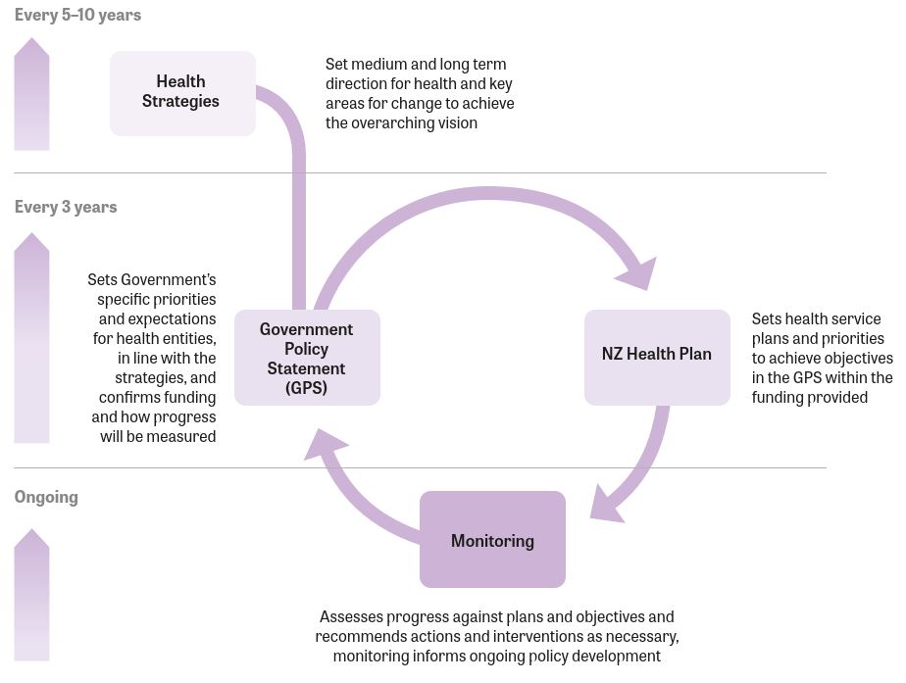

The health system reforms provide a clear pathway for translating strategies into action and monitoring the impact of system performance. The role of the Pae Ora strategies is critical to providing long term vision and prioritisation for decision making. As the Government determines the first GPS for 2024–2027, and in subsequent cycles, the strategies will be turned into clear expectations and actions.

Roadmap
The reformed system sets the long term government commitment to pae ora but will require a series of coordinated shorter term actions by health and social sector agencies and an interim review. More work is required to specify new coordination mechanisms, timelines, roles, and responsibilities for actions.

Supplements to Te Mana Ola will include:
- Summary and analysis of of key themes and quotes from the Te Mana Ola engagement process.
- An ongoing monitoring report to show progress against strategic priorities (figure 7).

Figure 7: Te Mana Ola timeline
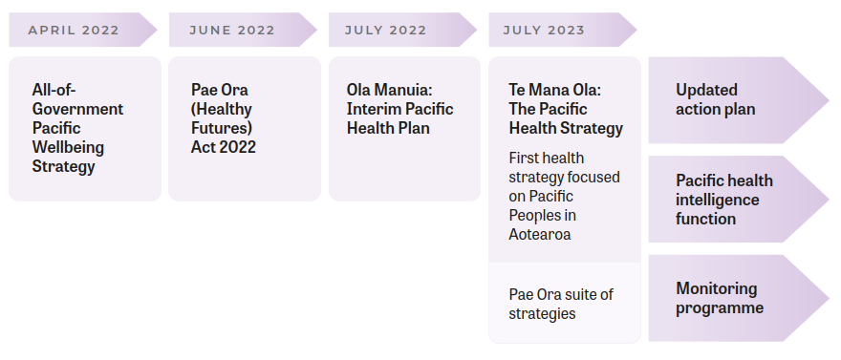

Implementation
The next phase of implementation will involve:
- setting short-term priorities for the GPS that link to strategic objectives
- updating the Ola Manuia Interim Pacific Health Action Plan
- establishing Pacific health intelligence functions within Manatū Hauora and Te Whatu Ora
- finalising a Te Mana Ola outcomes framework and monitoring indicators with health and social sector government agencies
- publishing supplements to Te Mana Ola.

A new Pacific health intelligence function would:
- monitor Pacific health outcomes and track health system changes over time to support decision making
- provide stakeholders and partners with timely and accurate information to support planning and accountability
- establish an ongoing publication programme
- influence the way government agencies collect, analyse and interpret information for Pacific peoples
- provide technical advice, oversight and guidance within Manatū Hauora
- enable a focus on knowledge gap areas.

Monitoring
Manatū Hauora will monitor and evaluate work undertaken by the health system and other government agencies to achieve Te Mana Ola priorities. Measures of health and equity of outcomes will be used to monitor progress at a sufficient quality and timeliness guided by the 5 strategic priorities.

The monitoring phase will also define clear roles and responsibilities to assess and characterise the burden of disease, assess the distribution of adverse health events,
recommend and prioritise actions, provide guidance to researchers and planners, and monitor health service provision that significantly impact Pacific peoples.

The analysis of public engagement feedback will also be shared widely to demonstrate the Pacific value of reciprocity, encourage continual learning and inform change.

Appendix: Summary of themes from Te Mana Ola fono
Priority Area
Population health
Vaqaqacotaka na yavutu ni tiko bulabula
Key theme:
Address the wider determinants of health

“The cost of living is a constant worry for me and my family.”

“There is a housing crisis… Pacific families are spending more than half their income on rent. They don’t have much left for bills and groceries.”
Key theme:
Enable healthy environments

“How do you expect us to be healthy when there are fast food outlets and vape shops on every street corner in neighbourhoods where we live?”

Prevention, promotion and management
Te pāruru‘anga, te apii‘anga, e te akateretere‘anga no te ora‘anga meitaki
Key theme:
Prioritise disease prevention, health promotion and managing conditions early

““We are sick of seeing the ambulance at the bottom of the cliff.”

“We want health issues to be prevented before they start…”

“The youthfulness of Pacific populations is a strength… let’s focus on making sure our
children and young people are well. They are our future.”

“Women play important roles in our communities as leaders and caregivers. We need to prioritise the health of Pacific women to ensure they can continue to play these important roles.”
Key theme:
Address the information gaps and complexity involved in navigating the health system

“We have a responsibility to encourage our own people to understand beyond what they know.”
Key theme:
Address climate change and its impacts on health

“We need to support our communities to prepare for climate emergencies to mitigate risk, danger, and distress in the face of climate crises.”

Workforce
Kau ngāue
Key theme:
Support and grow the Pacific health workforce

“I want to have the choice of seeing health workers who are from the same cultural background as me.”

“COVID has resulted in so much burnout among the Pacific health workforce.”

“Care from trusted faces in trusted places.”

“There are so many nurses and midwives leaving to go to Australia, where the pay and working conditions are so much better.”

Access
Haitiaaga moui malolo
Key theme:
Address barriers to accessing health care

“GP care is too expensive.”

“Many GPs have closed books. It was hard to find a GP that was taking on new patients.”

“Opening hours don’t suit people working shift work. Even urgent care is only open till 6pm on weeknights, and till midday on Saturdays.”

“Dental care is so expensive. I have had problems with my teeth for years but can’t afford to get them fixed.”

“It costs too much to get glasses and hearing aids.”

“E leai se tupe. Medications are too expensive.”
Key theme:
Eliminate the wide variation in quality of care people currently experience

“The standard of health care differs around the country. We need consistent quality of health care services from the North through to the South.”

“I don’t have the confidence that the current health system can effectively promote good access to health services within our communities.”
Key theme:
Address racism and discrimination in the health system

“I’m not part of the system because the system is not tailored to me.”

“When there is injustice in the system, we don’t have the resources to fight it.”

“Personally, I hope that Pacific people will be treated fairly and be seen as equals… we are not fully seen as equals to everyone else.”

“There is growing recognition of the inequities but there needs to be more urgency to addressing this by the government.”
Key theme:
Acknowledge our relationships with Pacific countries and address access to care for new migrants, regional seasonal workers and other non-residents who are employed in Aotearoa

“Greater consideration of health for temporary visa workers.”

“Our health workforce is stretched thin, why are we not utilising health care workers from the Islands? We need to get their qualifications recognised in Aotearoa.”

Autonomy and determination
Soalaupule
Key theme:
Recognise that health and wellbeing is holistic and collective

“I can’t be well when any person in my family is not well.”
“Addressing mental health is so important.”

“When my son is well, safe, happy and healthy, so am I.”
Key theme:
Enable regular, timely and accurate data

“We have been saying for years, we need ethnic-specific data. We saw this for COVID vaccinations. We need this for all areas of health.”

“Accurate data lets us tell our stories in our own way. We need Pacific people in the system to help us do this.”

“For too long data has been used to paint Pacific people in a negative way. We need to use data to highlight our strengths and successes.”

“I am getting tired with the poor data seen throughout the years.”
Key theme:
Amplify and embed diverse Pacific voices; uplift the mana of Pacific people

“The Pasifika rainbow+ community has been left out of national discussions on rainbow health. We want our voices to be heard.”

“The health system has ignored the voices of Pacific people living outside of the main regions.”
Key theme:
Recognise the diversity of Pacific people and communities

“Pacific is an umbrella term; we are a diverse group of communities and what may work for one group won’t always work for the other.”
Key theme:
Support by-Pacific, for-Pacific solutions (including community-led solutions)

“Nothing for us without us. No one left behind.”

“If not us, then who? If not now, then when?”

“More leadership and trust should be placed on Pacific providers and community groups to lead health solutions and initiatives for our people.”

References
Ahuriri-Driscoll A, Williams M and Vakalalabure- Wragg U. 2022. Ao Mai te Rā – Evolution of Racism and Anti-Racism – Lessons for the Aotearoa New Zealand Health System (Stage One Literature Review). Wellington: Ministry of Health.
Anglemyer A, Grey C, Tukuitonga C, et al. 2022. “Assessment of ethnic inequities and subpopulation estimates in COVID-19 vaccination in New Zealand.” JAMA Network Open 5(6): e2217653-e2217653.
Arnold J, Masina L, Graham K, et al. 2022. Pacific Peoples Health: Gout Data Insights: Pharmac, Te Pātaka Whaioranga.
ASH NZ. 2023. ASH Year 10 Snapshot Survey 2022: Youth smoking and vaping in Aotearoa New Zealand. Auckland: Action for Smokefree 2025.
Brewer N, Foliaki S, Gray M, et al. 2022. “Pasifika women’s knowledge and perceptions of cervical- cancer screening and the implementation of self-testing in Aotearoa New Zealand: A qualitative study.” The Lancet Regional Health-Western Pacific 28: 100551.
Day P and Pearce J. 2011. “Obesity-promoting food environments and the spatial clustering of food outlets around schools.” American journal of preventive medicine 40(2): 113-121.
Department of the Prime Minister and Cabinet. 2019. Child and youth Wellbeing Strategy. Wellington: Department of the Prime Minister and Cabinet.
Futter-Puati D and Maua-Hodges T. 2019. “Stitching tivaevae: A Cook Islands research method.” AlterNative: An International Journal of Indigenous Peoples 15(2): 140-149.
Gurney J, Stanley J and Sarfati D. 2020. “The inequity of morbidity: Disparities in the prevalence of morbidity between ethnic groups in New Zealand.” Journal of comorbidity 10: 2235042X20971168.
Hauofa E. 1994. The glorious Pacific way. Tales of the Tikong. Hawaii: University of Hawaii Press.
Howden-Chapman P, Bennett J, Edwards R, et al. 2023. “Review of the impact of housing quality on inequalities in health and well-being.” Annual review of public health 44: 233-254.
Howden-Chapman P, Fyfe C, Nathan K, et al. 2021. “The effects of housing on health and well-being in Aotearoa New Zealand.” New Zealand Population Review 47: 16-32.
HQSC. 2021. Bula Sautu – A window on quality 2021: Pacific health in the year of COVID-19. Health Quality & Safety Commission. Wellington.
Inside-Out. 2021. Rainbow terminology: sex, gender, sexuality and other key terms. URL: https://insideout. org.nz/wp-content/uploads/2021/06/InsideOUT-rainbow-terminology-.pdf (accessed 9/5/23).
Ioane J, Percival T, Laban W, et al. 2021. “All of community by all-of-government: reaching Pacific people in Aotearoa New Zealand during the Covid-19 pandemic.”
Kupa K. 2009. “Te Vaka Atafaga: A Tokelau assessment model for supporting holistic mental health practice with Tokelau people in Aotearoa, New Zealand.” Pacific health dialog 15(1): 156-163.
Māhina O. 2017. “Time, space, and culture: A New tā-vā theory of Moana anthropology.” Pacific Studies 40(1/2): 105-132.
Meredith I, Sarfati D, Ikeda T, et al. 2012. “High rates of endometrial cancer among Pacific women in New Zealand: the role of diabetes, physical inactivity, and obesity.” Cancer Causes & Control 23: 875-885.
Metadata Research Group. 2022. Pacific Pay Gap Inquiry Literature Review. Wellington: Human Rights Commission.
Ministry for Pacific Peoples. 2018. Pacific Aotearoa Lalanga Fou. Ministry for Pacific Peoples. Wellington.
Ministry for Pacific Peoples. 2020. Pacific Aotearoa Status Report – A snapshot. Ministry for Pacific Peoples. Wellington.
Ministry for Pacific Peoples. 2021. Pacific economic research report on unpaid work and volunteering in Aotearoa. Ministry for Pacific Peoples. Wellington.
Ministry for Pacific Peoples. 2022a. All-of-Government Pacific Wellbeing Strategy. Ministry for Pacific Peoples. Wellington.
Ministry for Pacific Peoples. 2022b. Fale mo Aiga Pacific Housing Strategy and Action Plan 2030. Ministry for Pacific Peoples. Wellington.
Ministry for Pacific Peoples. 2022c. Pacific Languages Strategy Aotearoa New Zealand 2022–2032. Ministry for Pacific Peoples. Wellington.
Ministry of Business, Innovation & Employment. 2023. Pacific Peoples Labour Market Statistics Snapshot – March 2023. Wellington: Ministry of Business, Innovation & Employment.
Ministry of Education. 2020. Action Plan for Pacific Education 2020–2030. Wellington: Ministry of Education.
Ministry of Education. 2021. Ministry of Education Indicator, Education and Learning Outcomes 2021. Wellington: Ministry of Education.
Ministry of Health. 2017. Faiva Ora 2016–2021: National Pasifika Disability Plan. Ministry of Health. Wellington.
Ministry of Health. 2019. Household Food Insecurity among Children: New Zealand Health Survey. Ministry of Health. Wellington.
Ministry of Health. 2021. Kia Manawanui Aotearoa: Long-term Pathway to Mental Wellbeing. Wellington: Ministry of Health.
Ministry of Health. 2022a. Adults’ Dietary Habits – Findings from the 2018/19 and 2019/20 New Zealand Health Survey. Ministry of Health. Wellington.
Ministry of Health. 2022b. Annual Data Explorer 2021/22: New Zealand Health Survey [Data File]. Ministry of Health. Wellington.
Ministry of Health. 2022c. Children’s Dietary Habits – Findings from the 2018/19 and 2019/20 New Zealand Health Survey. Ministry of Health. Wellington.
Ministry of Health. 2022d. People who identify as both Māori and Pacific (unpublished). Wellington: Ministry of Health.
Ministry of Health. 2022e. Understanding health and healthcare 2017/18: New Zealand Health Survey. URL: https://www.health.govt.nz/nz-health-statistics/national-collections-and-surveys/surveys/new-zealand-health-survey/understanding-health-and-healthcare-2017-18-new-zealand-health-survey (accessed 23/5/23).
Ministry of Health. 2023. Ambulatory-sensitive hospital admissions (ASH) 0-4 and 45–64 without Pacific supression twelve months to June 2022. Wellington: Ministry of Health.
Ministry of Social Development. 2019. Better Later Life – He Oranga Kaumātua 2019 to 2034. The Office for Seniors. Wellington: Ministry of Social Development.
Ministry of Social Development. 2022. National Youth Health and Wellbeing survey 2021. Percentage of young people who help others in their neighbourhood or community. Wellington: Ministry of Social Development.
Morgan T, Koh A, Black S, et al. 2022. “How socially cohesive was New Zealand’s first lockdown period from the perspective of culturally diverse older New Zealanders?” Kōtuitui: New Zealand Journal of Social Sciences Online 17(4): 518-537.
Murdoch R, Jones P, Greenwell J, et al. 2022. “Quality of care in people requiring hospital admission for gout in Aotearoa New Zealand: a nationwide analysis.” Internal Medicine Journal 52(12): 2136-2142.
Nabobo-Baba U. 2006. Knowing and learning: An indigenous Fijian approach. Suva: University of the South Pacific.
National Screening Unit. 2023. Breast Screen Aotearoa Coverage Report – R Shiny App. url: https://tewhatuora.shinyapps.io/nsu-bsa-coverage/ (accessed 15/06/2023).
New Zealand Productivity Commission. 2022. Fair Chance for All Interim Report – Breaking the Cycle of Persistent Disadvantage. New Zealand Productivity Commission. Wellington.
Oliver J R, Pierse N, Stefanogiannis N, et al. 2017. “Acute rheumatic fever and exposure to poor housing conditions in New Zealand: A descriptive study.” Journal of Paediatrics and Child Health 53(4): 358-364.
Parker J, Sayers J, Young-Hauser A, et al. 2022. “Gender and ethnic equity in Aotearoa New Zealand’s public service before and since Covid-19: Toward intersectional inclusion?” Gender, Work & Organization 29(1): 110-130.
Pierse N, White M and Riggs L. 2019. Healthy Homes Initiative outcomes evaluation service: Initial analysis of health outcomes: Motu Economic and Public Policy Research.
Ponton V. 2018. “Utilizing Pacific methodologies as inclusive practice.” Sage Open 8(3): 2158244018792962.

Pulotu-Endemann F K. 2001. Fonofale Model of Health. URL: https://d3n8a8pro7vhmx.cloudfront.net/actionpoint/pages/437/attachments/ original/1534408956/Fonofalemodelexplanation.pdf?1534408956 (accessed 12/5/23).
Sopoaga F. 2021. “ Folauga”– Pacific health, well-being and success in higher education, University of Otago.
Stats NZ. 2014. Disability Survey: 2013. Wellington: Stats NZ.
Stats NZ. 2018a. 2018 Census ethnic group summaries. Wellington: Stats NZ.
Stats NZ. 2018b. Estimated resident population (ERP), national population by ethnic group, age, and sex, 30 June 1996, 2001, 2006, 2013, and 2018. In NZ.Stat. Wellington: Stats NZ.
Stats NZ. 2018c. Ethnic group (detailed total response – level 4), by age group and sex, for the census usually resident population count, 2006, 2013, and 2018 Censuses (RC, TA, DHB). In NZ.Stat. Wellington: Stats NZ.
Stats NZ. 2018d. Individual home ownership and ethnic group (grouped total responses) by age group and sex, for the usually resident population count aged 15 years and over, 2006, 2013, and 2018 Censuses (RC, TA, SA2, DHB). In NZ.Stat. Wellington: Stats NZ.
Stats NZ. 2018e. National ethnic population projections, by age and sex, 2018 (base)–2043 update. In NZ.Stat. Wellington: Stats NZ.
Stats NZ. 2018f. National ethnic population projections, projection assumptions, 2018 (base)–2043 update. In NZ.Stat. Wellington: Stats NZ.
Stats NZ. 2020. Ethnicity New Zealand Standard Classification 2005 V2.1.0. Wellington: Stats NZ.
Stats NZ. 2021. National and subnational period life tables: 2017–2019. Wellington: Stats NZ.
Stats NZ. 2022a. Distribution of wealth across New Zealand households remains unchanged between 2015 and 2021. Stats NZ. Wellington.
Stats NZ. 2022b. Household labour force survey: June 2022 quarter. u. People employed, and not in labour force by ethnic group. Wellington.
Stats NZ. 2023a. Child poverty statistics: Year ended June 2022. Wellington: Stats NZ.
Stats NZ. 2023b. Pacific housing: People, place, and wellbeing in Aotearoa New Zealand: in January 2023 by Stats NZ Tatauranga Aotearoa Wellington, New Zealand.
Tafea V, Mowat R and Cook C. 2022. “Understanding barriers to immunisation against vaccine- preventable diseases in Pacific people in New Zealand, Aotearoa: an integrative review.” Journal of Primary Health Care.
Tamasese K, Parsons T, Sullivan G, et al. 2010. “A qualitative study into pacific perspectives on cultural obligations and volunteering.” Wellington: Pacific Section and the Family Centre Social Policy Research Unit.
Tamasese K, Peteru C, Waldegrave C, et al. 2005. “Ole Taeao Afua, the new morning: A qualitative investigation into Samoan perspectives on mental health and culturally appropriate services.” Australian & New Zealand Journal of Psychiatry 39(4): 300-309.
Te Puna Aonui. 2021. Te Aorerekura – The national strategy to eliminate family violence and sexual violence. Wellington: Te Puna Aonui.
Te Whatu Ora. 2022a. Health Service User Population 2021. Wellington: Te Whatu Ora.
Te Whatu Ora. 2022b. Health workforce: 2022 Pacific health professionals historical and forecast. Wellington: Te Whatu Ora.
Te Whatu Ora. 2022c. New Zealand Mortality Collection. Rate of infant deaths by ethnic group 2011–2020. Wellington: Te Whatu Ora.
Te Whatu Ora. 2022d. Ola Manuia Interim Pacific Health Plan July 2022–June 2024. Te Whatu Ora.
Te Whatu Ora. 2022e. Virtual Diabetes Register 2021. Wellington: Te Whatu Ora.
Thaman K H. 1993. Kakala. Suva: Mana Publications.
Theodore R, Taumoepeau M, Kokaua J, et al. 2018. “Equity in New Zealand university graduate outcomes: Māori and Pacific graduates.” Higher Education Research & Development 37(1): 206-221.
Thomsen S, Tavita J and Levi-Teu Z. 2018. A Pacific perspective on the living standards framework and wellbeing: New Zealand Treasury Discussion Paper.
Tiatia-Seath J, Fleming T, Peiris-John R, et al. 2021. “A Youth19 Brief: Pacific young people with a disability or chronic condition.”
Tōfā Mamao. 2023. Our Vision: Tagata Sa’ilimalo. 2023, URL: https://tofamamao.com/framework.php (accessed 9/5/23).
Treasury. 2021. The Living Standards Framework 2021. The Treasury.
Treasury. 2023. Pacific peoples’ wellbeing (AP 23/01). The Treasury. Wellington.
Trenholme A, Best E, Vogel A, et al. 2017. “Respiratory virus detection during hospitalisation for lower respiratory tract infection in children under 2 years in South Auckland, New Zealand.” Journal of Paediatrics and Child Health 53(6): 551-555.
Trenholme A, Vogel A, Lennon D, et al. 2012. “Household characteristics of children under 2 years admitted with lower respiratory tract infection in Counties Manukau, South Auckland.”
Tu’itahi S, Watson H, Egan R, et al. 2021. “Waiora: the importance of Indigenous worldviews and spirituality to inspire and inform Planetary Health Promotion in the Anthropocene.” Global Health Promotion 28(4): 73-82.
Tukuitonga C, Bell S and Robinson E. 2000. “Hospital admissions among Pacific children in Auckland, 1992–97.”
Tunumafono Fa’amoetauloa Avaula Fa’amoe. 2023. The Soalaupule Eco-System Framework (Soalaupule). Wellington: Ministry of Health.
Viggers H, Amore K and Howden-Chapman P. 2021a. Housing that Lacks Basic Amenities in Aotearoa New Zealand, 2018: Wellington: He Kainga Oranga, University of Otago.
Viggers H, Amore K and Howden-Chapman P. 2021b. Severe housing deprivation in Aotearoa New Zealand, 2018: Wellington: He Kainga Oranga, University of Otago.
Walsh M and Grey C. 2019. “The contribution of avoidable mortality to the life expectancy gap in Maori and Pacific populations in New Zealand – a decomposition analysis.” The New Zealand Medical Journal (Online) 132(1492): 46-60.
Webb R, Culliford-Semmens N, ChanMow A, et al. 2023. “High burden of rheumatic heart disease confirmed by echocardiography among Pacific adults living in New Zealand.” Open Heart 10(1): e002253.

Phylesha Brown-Acton is the founder and Director of F‘INE Pasifika Aotearoa, the Co-Chair of the Asia Pacific Transgender Network (APTN), and a trustee of INA Māori, Indigenous & South Pacific HIV & AIDS Foundation.
The Pae Ora Act defines health entity as Te Aka Whaiora, Te Whatu Ora, Health Quality and Safety Commission, Pharmac, and the New Zealand Blood and Organ Service.
Source: (Stats NZ 2018f)
Source: (Ministry for Pacific Peoples 2020, Te Whatu Ora 2022a)
Source: (Stats NZ 2014)
Source: (Stats NZ 2018b)
Source: (Te Whatu Ora 2022e) (uses prioritised ethnicity)
Source: (Stats NZ 2018a)
Source: (Stats NZ 2022b)
Source: (Ministry of Education 2021)
Source: (Stats NZ 2018d)
Source: (Viggers, Amore et al. 2021a, Viggers, Amore et al. 2021b)
Source: (Stats NZ 2023a)
The Healthy Homes Initiative initially targeted low-income families with children at risk of rheumatic fever who were living in crowded households.
Source: (Ministry of Health 2023)
Source: (Ministry of Health 2022b)
Source: (Ministry of Health 2022e)
Source: (National Screening Unit 2023)
Source: (Te Whatu Ora 2022b)
Source: (Te Whatu Ora 2022b)
Disadvantage according to the Productivity Commission Persistent Disadvantage Framework is not simply being income poor (or lacking the foundations to grow prosperity), but also being left out (exclusion or lacking identity, connection), and doing without (deprivation/material hardship). New Zealand Productivity Commission 2022. Fair Chance for All Interim Report – Breaking the Cycle of Persistent Disadvantage. New Zealand Productivity Commission. Wellington.

