Obesity in 2021/22
An experimental analysis using data from general practices

Authors
This report was compiled by members of the Evidence, Research and Analytics Group in Ministry of Health. Contributors include Carlos Barroso Silva, Chloe Lynch, Maria Turley and Steven Johnston.
Citation: Ministry of Health. 2022. Obesity in 2021/22: An experimental analysis using data from general practices. Wellington: Ministry of Health.
Published in November 2022 by the Ministry of Health
PO Box 5013, Wellington 6140, New Zealand
ISBN 978-1-99-110093-1 (online)
HP 8643
This document is available at health.govt.nz
This work is licensed under the Creative Commons Attribution 4.0 International licence. In essence, you are free to: share ie, copy and redistribute the material in any medium or format; adapt ie, remix, transform and build upon the material. You must give appropriate credit, provide a link to the licence and indicate if changes were made.

Contents
Obesity in 2021/22: An experimental analysis using data from general practices 1
Key Points 1
The New Zealand Health Survey is the official source of data on obesity 2
No objective health measurements this year 2
The Ministry explored alternative data sources to understand trends in obesity for 2021/22 2
Measurement data from general practices are useful for estimating trends this year, when NZHS statistics are not available 3
The data from general practices indicates that obesity rates did not increase over the last year, but for adults they are higher than several years ago 4
Appendix 6

List of Tables
Table 1: Yearly sample sizes for general practice data 6

List of Figures
Figure 1: Prevalence of obesity in the New Zealand Health Survey data and general practice data, by children and adults, 2017/18–2021/22 5
Figure 2: Prevalence of obesity in the New Zealand Health Survey data and general practice data, by age group, 2017/18–2021/22 9
Figure 3: Prevalence of obesity in the New Zealand Health Survey data by total response ethnicity and general practice data, by prioritised ethnicity, 2017/18–2021/22 9
Figure 4: Prevalence of obesity in the New Zealand Health Survey data and general practice data, by NZDep2018 quintile, 2017/18–2021/22 10
Figure 5: Age group distribution in New Zealand Health Survey data and general practice data populations, 2017/18–2021/22 11
Figure 6: Prioritised ethnic group distribution in New Zealand Health Survey data and general practice data populations, 2017/18–2021/22 12
Figure 7: NZDep2018 quintile distribution in New Zealand Health Survey data and general practice data populations, 2017/18–2021/22 13

Obesity in 2021/22: An experimental analysis

Key Points
- The New Zealand Health Survey (NZHS) is the official source for measuring the prevalence of obesity in New Zealand.
- The NZHS showed an increase in the prevalence of obesity from 2019/20 to 2020/21 in both adults and children, after several years of relatively stable trends.
- Objective health measurements were not collected in the 2021/22 NZHS due to COVID-19, so survey obesity statistics are not available for this year.
- To understand trends in obesity for 2021/22, the Ministry of Health explored alternative sources of data on measured height and weight.
- The Ministry selected data from HealthStat, a panel of general practices, because it had good coverage of the New Zealand population and was available for measurements and time periods that matched the NZHS.
- Data from general practices is not a replacement for NZHS obesity statistics because of known differences in who uses services and gets measured. However, across the years, general practice data show trends in obesity across population subgroups that are broadly similar to those in the NZHS.
- The data from general practices suggests that obesity rates did not increase over the last year (2021/22), showing stable trends for adults and a small decline for children. However, the estimated obesity rate among adults in 2021/22 is higher than it was a few years ago.
- Height and weight measurements are being collected again in the 2022/23 NZHS and will continue to be collected each survey year.

The New Zealand Health Survey is the official source of data on obesity
The NZHS is the official source of data on obesity and body size trends. The annual NZHS samples are representative of the New Zealand population and include people who do not access health services. Highly trained interviewers collect data in a consistent and precise manner, using standard equipment that is re-calibrated annually.

NZHS data showed an increase in obesity from 2019/20 to 2020/21 among both adults and children, after several years of relatively stable trends. Given that obesity is an important cause of poor health, it is important for us to understand whether this trend has continued.

No objective health measurements this year
Interviewers for the NZHS usually collect objective health measurements of height, weight, waist and blood pressure during the NZHS interview in the survey respondents’ home. They did not do so in the 2021/22 survey, due to COVID-19 restrictions. This meant some interviews were conducted via video, and when interviews were conducted in the home the interviewers had to remain at least two metres distance from the respondents.

Interviewers for the 2022/23 NZHS are collecting objective health measurements again. The Ministry intends to continue to collect these measurements each survey year going forward.

The Ministry explored alternative data on obesity
To understand trends in obesity over the 2021/22 year, the Ministry explored alternative sources of data on measured body size. It selected to use data from HealthStat, a panel of 96 general practices, because it had good coverage of the New Zealand population and was available for measurements and time periods that matched the survey. The HealthStat panel was established by Reach Aotearoa (formerly CBG Health Research). It provides primary care data for various research and policy formation purposes.

Reach Aotearoa requested permission from each HealthStat practice to extract data from their patient management system. It analysed and aggregated the data from 74 practices to produce summary statistics for the same population groups and time periods as the NZHS uses. The Ministry did not have access to individual-level data at any time.

The appendix provides more information.

Measurement data from general practices used to estimate trends
The Ministry did not expect the HealthStat data to provide a replacement for the NZHS statistics on obesity prevalence, for the following reasons: not everyone visits a general practice regularly; not everyone who goes to their general practice gets their weight and height measured; and the equipment and methods used to take measurements in general practices are not as precise or standardised as those used in the NZHS.

The Ministry’s analysis compared the general practice data for previous years with previously published NZHS statistics. Levels of obesity in the general practice data are higher than in the NZHS data. However, patterns across subgroups of the population and trends over time are similar. Hence the trend (year-on-year change) observed in the general practice data from 2020/21 to 2021/22 may be a reasonable indicator of what we would have observed if the NZHS had been able to collect measurements as usual this year.

This experimental analysis is an attempt to fill some of the gap in obesity statistics in 2021/22. Measurements of respondents’ height, weight, waist and blood pressure have resumed in the 2022/23 NZHS data collection and it is the Ministry’s intention that the NZHS will continue to publish official statistics on obesity for 2022/23 and subsequent years.

The data from general practices suggest that obesity rates did not increase over the last year
In the general practice data from HealthStat, the proportion of adults who are obese was unchanged between 2020/21 and 2021/22. Projecting this trend forward from the 2020/21 NZHS suggests that the prevalence of obesity in New Zealand adults has remained at around 34% in 2021/22.

For children, there is a small decrease in obesity between 2020/21 and 2021/22 in the general practice data from HealthStat, of about 1 percentage point. Projecting this trend forward from the 2020/21 NZHS suggests that the prevalence of obesity in New Zealand children is around 12% in 2021/22.

Although data from general practices suggest obesity has not increased over the last year, the projected prevalence in adults for 2021/22 is higher than it was in the 2017/18 to 2019/20 surveys (ranging from 31–32%). The projected prevalence in children for 2021/22 is higher than in 2019/20 (9.5%), but about the same as it was for the 2017/18 to 2018/19 surveys (11.5%).

Projections of obesity rates for 2021/22 are illustrated below in Figure 1. The NZHS obesity statistics for previous years are shown in orange and the data from general practice, including the current 2021/22 year, in blue. The trends in the general practice data are similar to the NZHS in previous years, although the general practice data is not a good estimate of the overall prevalence of obesity. Projecting the trend (year-on-year change) from 2020/21 to 2021/22 in the general practice data forward from the NZHS statistics is shown as the grey dashed line – that is, assuming the NZHS would have shown the same trend from 2020/21 to 2021/22 as the general practice data, if measurements had been able to be collected in the survey as usual.
Figure 1: Prevalence of obesity in the New Zealand Health Survey data and general practice data, by children and adults, 2017/18–2021/22
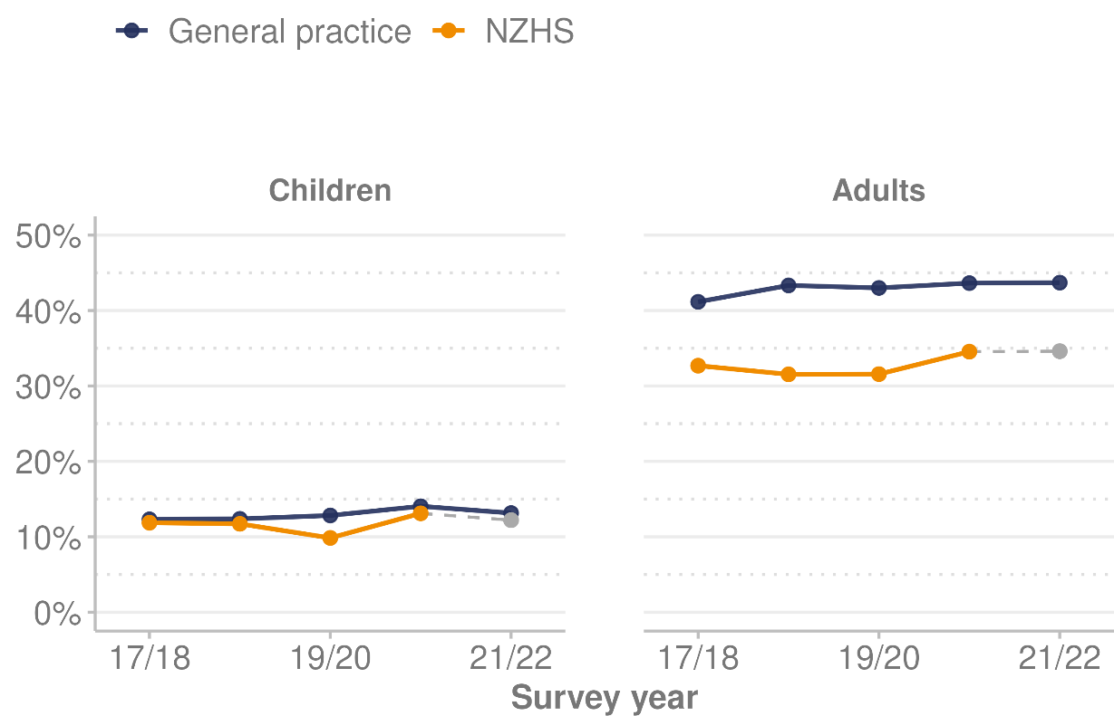

Appendix

Process to obtain data from general practices
The Ministry contracted Reach Aotearoa to access, extract and summarise data on body size measurements (height and weight) from the HealthStat panel. Reach Aotearoa had access to individual-level data via the patient management systems, and strict protocols were in place to ensure the confidentiality and security of data. All data provided to the Ministry was aggregated into summary statistics.

Reach Aotearoa obtained permission for the use of data from practices on the HealthStat panel by writing a letter to each practice. An initial letter was sent on 29 June 2022 and a follow-up letter was sent on 20 July 2022. 76 out of 96 practices responded by 24 August 2022; 74 practices agreed to provide access to data for this project and 2 declined. The other 20 practices did not respond within the timeframe given.

Reach Aotearoa uses the panel of general practices used here for other research and policy purposes. Reach Aotearoa designed the panel to be representative of the population for these purposes. The practices are a systematic random sample selected from all GP practices in New Zealand, stratified by District Health Board to ensure a geographic spread across the country.

The sample sizes provided in the table below are for the number of unique measurements (ie, number of individuals with height and weight measurements).
Table 1: Yearly sample sizes for general practice data
Survey year | Unique measurements
2017/18 | 69,579
2018/19 | 60,582
2019/20 | 58,431
2020/21 | 64,468
2021/22 | 53,619

Methods to produce dataset
Reach Aotearoa extracted, cleaned and summarised data according to specifications developed by the Ministry. Briefly, these outlined the data to extract (measurements and demographic variables), time periods to match the survey (July to June), plausible limits for measurements, how to calculate body mass index (BMI) and how to define obesity (which varies by age and gender in children).

Part of Reach Aotearoa’s process was to reduce the data to one set of measurements (height and weight) per person per time period, so that data for people who were measured more frequently in general practice did not have more influence over the results. If a person had their weight or height measured more than once in a year, one measurement was randomly selected. Height is measured less often than weight, especially among adults (because it is generally stable in adulthood). Therefore, the most recent height measure was used for adults, even if it had to be borrowed from an earlier year.

Limitations of using data from general practices
There are limitations entailed in using data from general practices in estimating the prevalence of obesity in New Zealand. In particular, there are likely to be some biases in who is represented in the data and variation in the equipment and methods used to take measurements.

The composition of the sample from general practice differs to the New Zealand population (see Figures 5 to 7) due to differences in who has access to and uses primary health care services and who has their height and weight measured.

Health needs drive patterns of primary health care use. People with long-term conditions are more likely to visit their general practice. Given that obesity is a risk factor for many long-term conditions, people with larger body size are more likely to use primary health care services. Data from the 2020/21 NZHS shows that 78% of obese adults had visited their GP in the past 12 months, compared with 75% of adults who were overweight and 69% of adults who were in the healthy weight category.

Not everyone who goes to their general practice gets measured, and this also is influenced by body size. Data from the 2020/21 NZHS shows that around 44% of obese adults who had been to their GP in the past 12 months reported having their height or weight measured, compared with 34% of adults who were overweight and 30% of adults who were in the healthy weight category. On the other hand, children are more likely to be measured regularly, to monitor their growth, regardless of their body size.

Although data from general practices is collected by trained health professionals, it is likely that there is variation in the type and accuracy of the equipment used and the protocols for taking measurements.

The NZHS continues to be the preferred data source for body size trends, because it produces annual samples that are representative of the New Zealand population (including people who do not use health services). In addition, NZHS interviewers are trained to collect health measurements in a consistent and precise manner, using standard equipment that is re-calibrated annually. The NZHS takes multiple measurements (to 0.1 kg or 0.1 cm) to increase precision.

A further difference between the 2 data sources is the way in which they define ethnic group variables. The NZHS uses the concept of total response ethnicity, where each person is allocated to all ethnic groups that they have identified with. The general practice data uses the concept of prioritised ethnicity, where each person is allocated to a single ethnic group in an order of priority (Māori, Pacific, Asian then European/Other), even if they identify with more than one ethnicity. In this appendix, we present NZHS results as total response ethnicity in order to match previously published NZHS results, and general practice figures are shown as prioritised.

Analysis
The analysis in this section explores how well data summaries generated from measurements recorded in general practice compare with data from the NZHS, for the years in which we have both sources of information. The goal is to assess how useful the trends observed in the general practice data between 2020/21 and 2021/22 might be at filling the gap in our knowledge created by the lack of data from the NZHS this year, with the limitations described in mind.

The analysis is a relatively simple exploration of how the levels and trends in obesity for key subgroups of the population compare between the 2 data sources, and how well the composition of the set of people measured in the HealthStat practices matches the New Zealand population. Further work could be done on weighting or modelling the general practice data to produce estimates that might more closely match the NZHS statistics.

Comparison of trends for population groups
Figures in this section compare obesity rates from general practice data with previously published NZHS statistics for the survey years from 2017/18 to 2020/21.

Levels of obesity for children are very similar between the 2 data sources, while for adults a higher proportion of people measured in general practice are obese compared to NZHS statistics for the same years. This difference for adults is likely to be because of the reasons discussed in the section ‘Limitations of using data from general practices’ above.

While the levels do not match exactly, the broad patterns across subgroups of the population are very similar between the 2 data sources, and show:
- higher rates of obesity for increasing age groups up to the 45–54-year and 55–64-year age groups, and then decreasing rates for older age groups
- higher rates of obesity for Pacific peoples and Māori, compared with people of European/Other and Asian ethnicity
- higher rates of obesity associated with higher neighbourhood deprivation, as measured by the New Zealand Deprivation Index (NZDep).

Comparing trends over time, the year-on-year changes in the general practice data are similar to the year-on-year changes in the NZHS statistics. The NZHS statistics show obesity rates were mostly stable from 2017/18 to 2019/20, with an increase for most groups in 2020/21, whereas the general practice data over the same period tends to show small but steady increases.

The general practice data is not a substitute for the NZHS statistics, particularly in terms of accurately representing the level of obesity in New Zealand. However, the patterns and trends in the general practice data are similar enough to NZHS statistics in previous years to suggest the changes in the general practice data between 2020/21 and 2021/22 provide useful information about how NZHS obesity statistics might have changed if height and weight measurements had been able to be collected this year.

For age, ethnicity and neighbourhood deprivation groups, the NZHS and general practice data reveal similar patterns (Figures 2, 3 and 4). Of note is the fact that children (those aged 2–14 years) exhibit very similar obesity prevalence in the 2 datasets.

Figure 2: Prevalence of obesity in the New Zealand Health Survey data and general practice data, by age group, 2017/18–2021/22
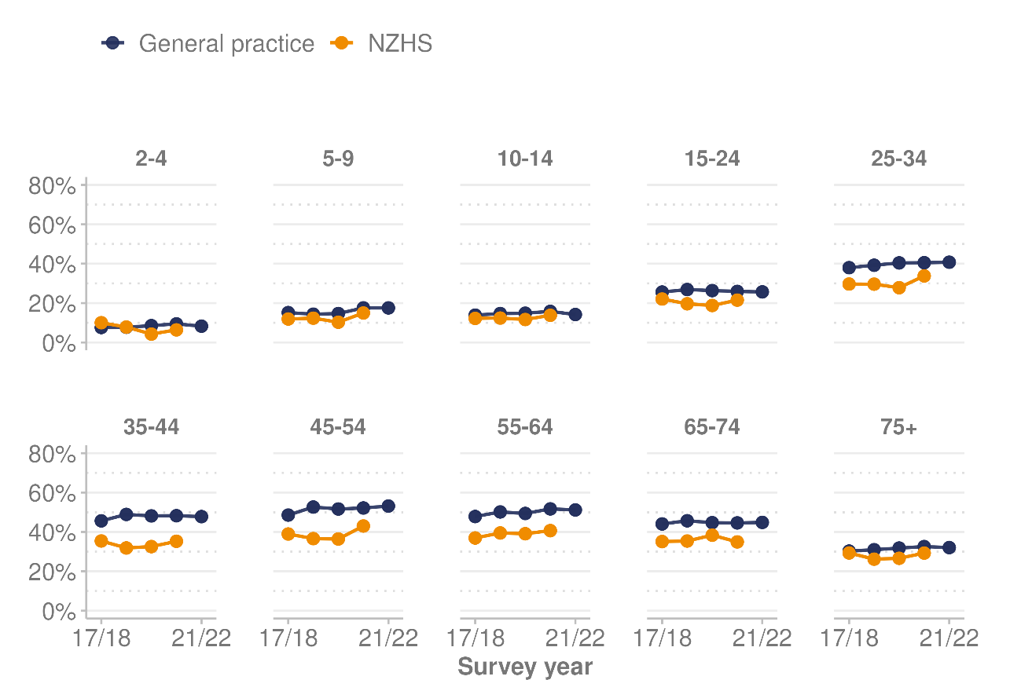

Figure 3: Prevalence of obesity in the New Zealand Health Survey data by total response ethnicity and general practice data, by prioritised ethnicity, 2017/18–2021/22
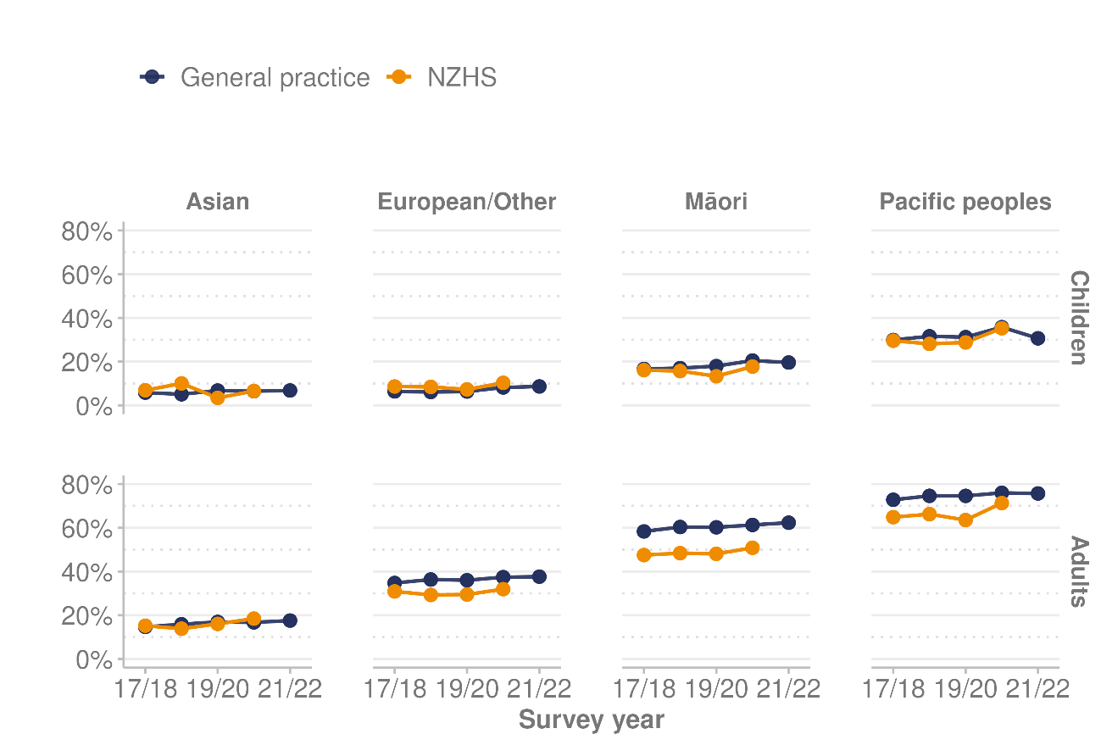

Figure 4: Prevalence of obesity in the New Zealand Health Survey data and general practice data, by NZDep2018 quintile, 2017/18–2021/22
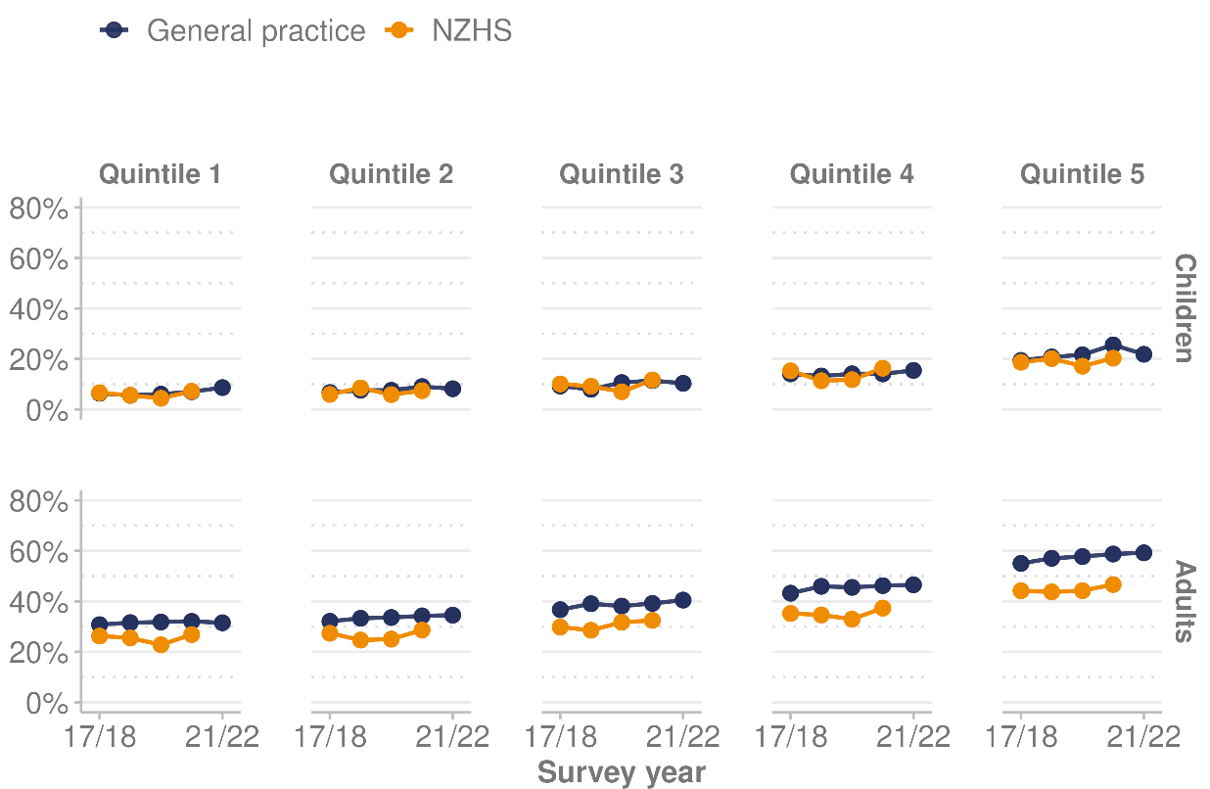

Demographic characteristics of people measured in general practice
Figures in this section compare the composition of the sample of people contributing to the general practice data with the composition of the NZHS samples, by age, ethnicity and deprivation. The NZHS sample design deliberately over-samples some parts of the New Zealand population, to produce more precise survey statistics for those subgroups, and the NZHS statistics account for this over-sampling through weighting. Therefore, the comparisons here are to the weighted composition of the NZHS sample.

Overall, the general practice data and the NZHS data sets are broadly similar in terms of the demographic characteristics of the people contributing to the obesity statistics presented in the previous section, with some notable exceptions.

Comparing the two data sources by age (Figure 5), the data from general practices tends to under-represent young adults and over-represent older adults, compared to the age structure of the New Zealand population.

Figure 5: Age group distribution in New Zealand Health Survey data and general practice data populations, 2017/18–2021/22
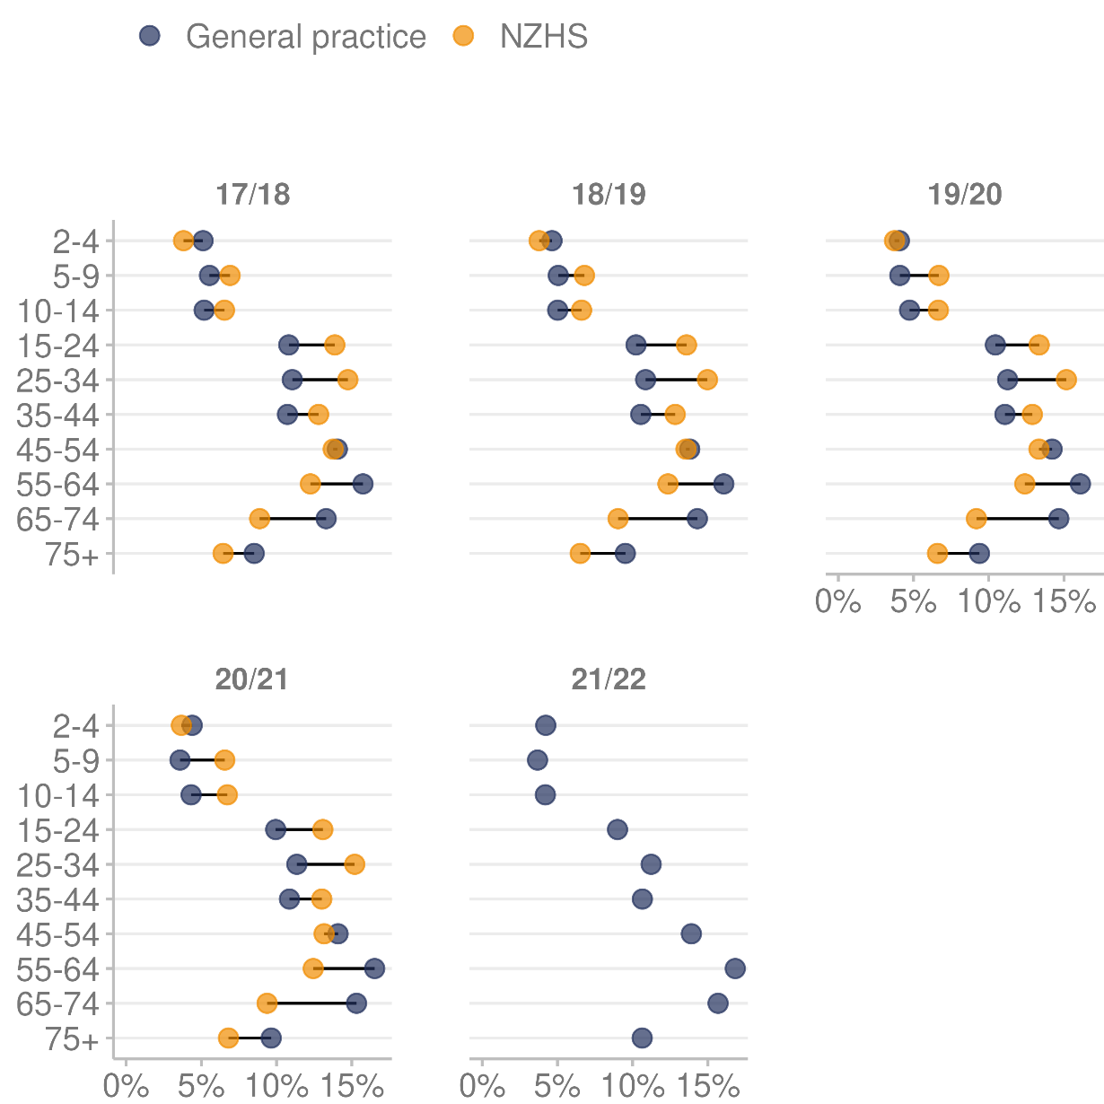

Comparing by ethnicity (Figure 6), the data from general practices tends to under-represent people of European/Other ethnicity and over-represent Māori, compared to the ethnic composition of the New Zealand population. These differences are slightly more pronounced in adults.

Figure 6 presents the ethnic composition of the NZHS sample using prioritised ethnicity, to be more comparable with the data from general practices.

Figure 6: Prioritised ethnic group distribution in New Zealand Health Survey data and general practice data populations, 2017/18–2021/22
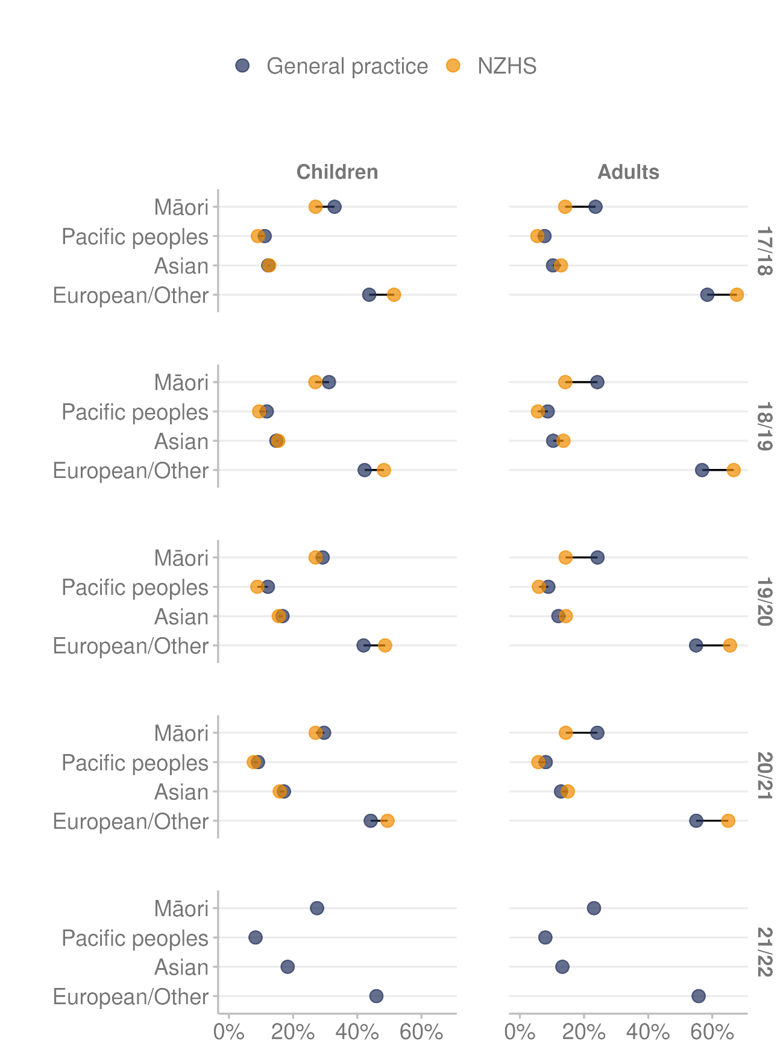

For both children and adults, the general practice data contains proportionally more people who live in areas with high socioeconomic deprivation (NZDep2018 quintile 5) than the NZHS data, and fewer people who live in the least deprived areas (NZDep2018 quintile 1). The sample of children contributing to the general practice data is more aligned with the NZHS in later years (Figure 7).
Figure 7: NZDep2018 quintile distribution in New Zealand Health Survey data and general practice data populations, 2017/18–2021/22
