Recalculation of New Zealand Health Survey results | October 2021

Key points
Updated population data has been used to recalculate results from the New Zealand Health Survey between 2011/12 and 2019/20. This means that some results in the 2017–20 Regional Data Explorer will be different to those that have been previously published. The impact on prevalences is negligible, but the estimated numbers of people are slightly larger, particularly for Māori.

The Ministry of Health has also taken this opportunity to implement an improved calculation method, and a small amount of the change in the results can be attributed to improvements in the method.

Background to population data changes
The survey uses the calibrated weighting method to construct survey weights that rate up the responding sample to represent the target population. This method takes into account the probability of selection of each respondent, and uses external population benchmarks to correct for any discrepancies between the sample and population benchmarks (by age, gender, ethnicity and deprivation).

After the 2018 Census, the scheduled updates to the population estimates were more substantial than in other years, particularly with regard to estimates number of Māori. The changes also covered a longer time period: 12 years rather than the usual 5. For more information please see: https://www.stats.govt.nz/methods/maori-ethnic-group-population-estimates-200618-methods-and-results.

The new population data had follow-on impacts on the Household Labour Force Survey estimates of population, which supply population counts for the NZHS weights, and these have also been incorporated into the revised weights. For more information please see: https://www.stats.govt.nz/reports/household-labour-force-survey-population-rebase-from-2018-estimated-resident-population.

Background to calculation method changes
The New Zealand Health Survey has historically used SAS software to calculate the results. The calculations are being shifted into R software. The prevalences for the Regional Data Explorer were calculated in R, though the weights have still been done in SAS. For a small number of indicators with complex rules there are small differences in results.

Impact on previously published results
In the 2017–20 Regional Data Explorer, the new population data has been used to recalculate the prevalences, means, and adjusted rate ratios from the New Zealand Health Survey. This means that some results will be different to those that have been previously published. The impact on the New Zealand Health Survey prevalences is small because population data is not used directly as a denominator. The impact on the estimates of numbers of people are slightly larger, particularly in Māori.

Comparison of original and recalculated time series for “good, very good, or excellent health”, for adults and children
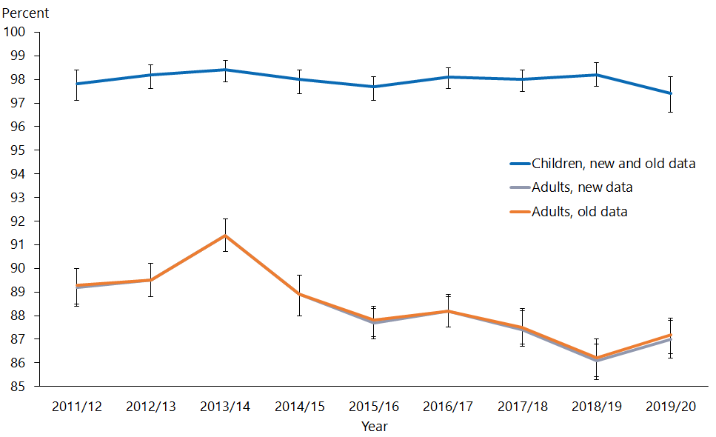

Comparison of original and recalculated time series for unmet need for primary care, for adults and children
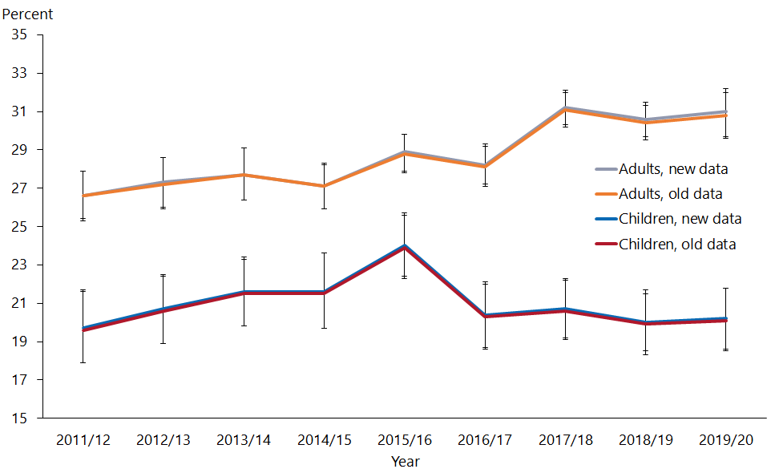

Comparison of original and recalculated time series for rate of current smoking and number of current smokers, for adults
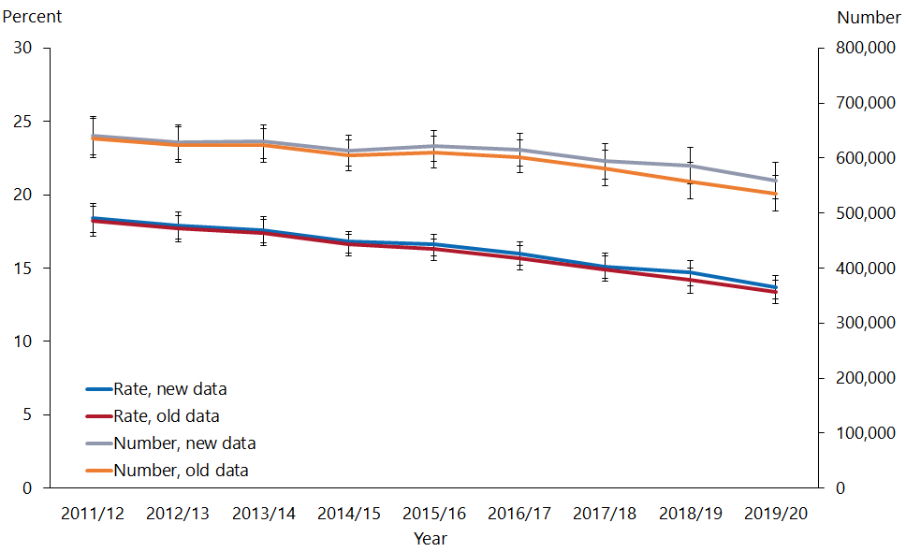

Comparison of original and recalculated time series for rate of smoking among Māori and number of Māori who are current smokers, for adults
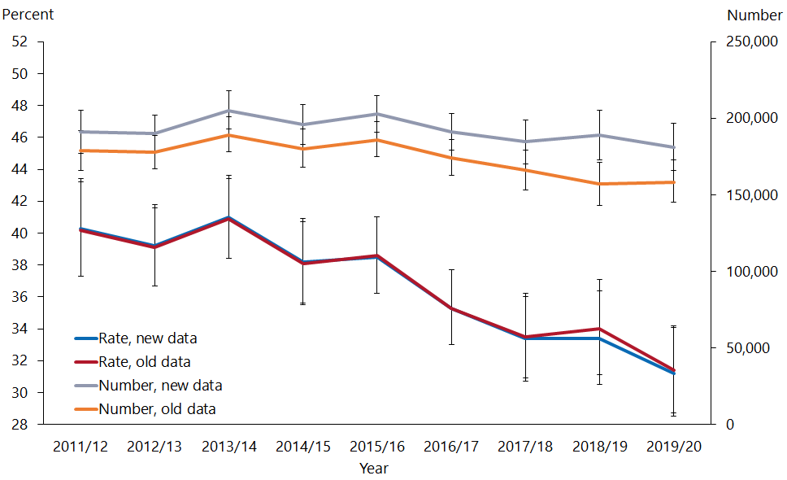

The 2017–20 The Regional Data Explorer contains results for all of New Zealand. When the Annual Data Explorer is updated to include 2020/21 results on 18 November 2021, results will be recalculated using with the updated population data. As with the Regional Data Explorer, this will result in slightly revised results. At this point the Regional Explorer and the Annual explorer will be internally consistent and appropriate to use together.

Previously released CURFs and data in the IDI will also need to be updated in order to be fully consistent with the new data. This is scheduled for late 2021.

October 2021
HP 7879

