Wai 2575
Māori Health Trends Report

Citation: Ministry of Health. 2019. Wai 2575 Māori Health Trends Report. Wellington: Ministry of Health.
Published in September 2019 by the Ministry of Health
PO Box 5013, Wellington 6140, New Zealand
ISBN 978-1-98-859716-4 (online)
HP 7243
This document is available at health.govt.nz
This work is licensed under the Creative Commons Attribution 4.0 International licence. In essence, you are free to: share ie, copy and redistribute the material in any medium or format; adapt ie, remix, transform and build upon the material. You must give appropriate credit, provide a link to the licence and indicate if changes were made.

Contents
Acknowledgements xvii
Executive summary xix
Introduction 1
Data sources and methods 2
Numerator 2
Denominator 2
Ethnicity classification 3
Age-standardised and crude rates 3
Confidence intervals 4
Rate ratios 4
Demographics 5
Population by age structure 5
Population projections 7
Population by DHB 8
Socioeconomic determinants of health 15
Neighbourhood deprivation 15
Socioeconomic indicators 17
Racial discrimination 20
Risk and protective factors 23
Tobacco smoking 23
Alcohol and drug use 28
Nutrition (vegetable and fruit servings) 32
Body size 36
Physical activity 41
Gambling 42
Health status indicators 45
Major causes of death 45
Cardiovascular disease 51
Cancer 72
BreastScreen Aotearoa and National Cervical Screening Programmes 104
Respiratory disease 109
Diabetes 119
Chronic conditions: arthritis, osteoporosis, and chronic pain 126
Dementia mortality 132
Infectious disease 136
Suicide and intentional self-harm 147
Interpersonal violence 154
Oral health 158
Self-rated health 176
Mental health 179
Infant health 183
Infant and child mortality 188
Unintentional injury 203
Leading unintentional injury mortality categories 219
Health service use 226
Primary health care access 226
Health system indicators 233
Amenable mortality and ambulatory sensitive hospitalisation (ASH) 233
Publicly-funded hospital discharges 237
Emergency department attendances 241
Health workforce 244
Nursing Council of New Zealand – nurses 245
Midwifery Council of New Zealand – midwifery 246
Medical Council of New Zealand – medical employed FTE 247
Dental Council of New Zealand – oral health 248
New Zealand Physiotherapists Board – physiotherapists 249
New Zealand Psychologists Board – psychologists 250
New Zealand Medical Radiation Technologists Board – medical radiologists 251
New Zealand Dietitians Board – dietitians 252
Medical Sciences Council of New Zealand – medical laboratory scientist 253
Medical Sciences Council of New Zealand – medical laboratory technician 254
Pharmacy Council of New Zealand – pharmacists 255
New Zealand Optometrists and Dispensing Opticians Board – optometrists 256
New Zealand Optometrists and Dispensing Opticians Board – dispensing optician 257
New Zealand Podiatrists Board – podiatrist 258
Osteopathic Council of New Zealand – osteopaths 259
New Zealand Chiropractic Board – chiropractors 260
Māori and non-Māori non-Pacific analysis 261
Body size 262
Cardiovascular disease 266
Cancer 275
Respiratory disease 298
Diabetes complications 306
Infectious diseases 311
Oral health 316
Mental health 323
Emergency department attendances 326
References 328
Appendices 332
Appendix 1: What Māori and non-Māori non-Pacific analysis can be prepared for the Wai 2575 Health Services and Outcomes Inquiry 332
Appendix 2: ICD codes 336
Appendix 3: 2001 Census total Māori population 349
Appendix 4: Overview of Breast and Cervical Cancer Screening Programmes 350
Appendix 5: Diabetes coding changes 361
Appendix 6: Health workforce supplementary tables 364

List of figures
Figure 1: Proportion of DHB population that is Māori, 2001 10
Figure 2: Proportion of DHB population that is Māori, 2006 12
Figure 3: Proportion of DHB population that is Māori, 2013 14
Figure 4: Neighbourhood deprivation distribution (NZDep 2013), Māori and non-Māori, 2013 16
Figure 5: Daily smoking in people aged 14–15 years, by gender, Māori and non-Māori, 1999–2015 24
Figure 6: Current smoking in people aged 15 and over, by gender, Māori and non-Māori, 2006/07–2016/17 25
Figure 7: Daily smoking in people aged 15 and over, by gender, Māori and non-Māori, 2006/07–2016/17 26
Figure 8: Ex-smokers in people aged 15 and over, by gender, Māori and non-Māori, 2006/07–2016/17 27
Figure 9: Drank alcohol four or more times a week in the past 12 months (among past year drinkers), 15+ years, by gender, Māori and non-Māori, 2006/07–2016/17 29
Figure 10: Hazardous drinkers (among past year drinkers), 15+ years, by gender, Māori and non-Māori, 2006/07–2016/17 30
Figure 11: Using cannabis in the past 12 months, 15+ years, by gender, Māori and non-Māori, 2006/07–2016/17 31
Figure 12: Three or more servings of vegetables and two or more servings of fruit per day, 15+ years, by gender, Māori and non-Māori, 2006/07–2016/17 33
Figure 13: Three or more servings of vegetables per day, 15+ years, by gender, Māori and non-Māori, 2006/07–2016/17 34
Figure 14: Two or more servings of fruit per day, 15+ years, Māori and non-Māori, 2006/07–2016/17 35
Figure 15: Overweight, 15+ years, by gender, Māori and non-Māori, 2006/07–2016/17 38
Figure 16: Obese, 15+ years, by gender, Māori and non-Māori, 2006/07–2016/17 39
Figure 17: Obese, 2–14 years, by gender, Māori and non-Māori, 2006/07–2016/17 40
Figure 18: Regular physical activity, 15+ years, by gender, Māori and non-Māori, 2006/07–2016/17 41
Figure 19: Total cardiovascular disease mortality rates, 35+ years, by gender, Māori and non-Māori, 1996–98 to 2012–14 53
Figure 20: Total cardiovascular disease hospitalisation rates, 35+ years, by gender, Māori and non-Māori, 1996–98 to 2014–16 54
Figure 21: Cerebrovascular disease (stroke) mortality rates, 35+ years, by gender, Māori and non-Māori, 1996–98 to 2012–14 56
Figure 22: Cerebrovascular disease (stroke) hospitalisation rates, 35+ years, by gender, Māori and non-Māori, 1996–98 to 2014–16 57
Figure 23: Heart failure mortality rates, 35+ years, by gender, Māori and non-Māori, 1996–98 to 2012–14 59
Figure 24: Heart failure hospitalisation rates, 35+ years, by gender, Māori and non-Māori, 1996–98 to 2014–16 60
Figure 25: Chronic rheumatic heart disease mortality rates, 15+ years, by gender, Māori and non-Māori, 1996–98 to 2012–14 62
Figure 26: Chronic rheumatic heart disease hospitalisation rates, 15+ years, by gender, Māori and non-Māori, 1996–98 to 2014–16 63
Figure 27: Ischaemic heart disease mortality rates, 35+ years, by gender, Māori and non-Māori, 1996–98 to 2012–14 65
Figure 28: Ischaemic heart disease hospitalisation rates, 35+ years, by gender, Māori and non-Māori, 1996–98 to 2014–16 66
Figure 29: All revascularisation (coronary artery bypass graft (CARB) and angioplasty) heart disease procedure rates, 35+ years, by gender, Māori and non-Māori, 1996–98 to 2014–16 68
Figure 30: All coronary angioplasty procedure (percutaneous) rates, 35+ years, by gender, Māori and non-Māori, 1996–98 to 2014–16 70
Figure 31: Total cancer registration rates, 25+ years, Māori and non-Māori males, 1996–98 to 2013–15 73
Figure 32: Total cancer registration rates, 25+ years, Māori and non-Māori females, 1996–98 to 2013–15 74
Figure 33: Total cancer mortality rates, 25+ years, Māori and non-Māori males, 1996–98 to 2012–14 76
Figure 34: Total cancer mortality rates, 25+ years, Māori and non-Māori females, 1996–98 to 2012–14 77
Figure 35: Cancer registration rates, by site, 25+ years, Māori males, 1996–98 to 2013–15 79
Figure 36: Cancer mortality rates, by site, 25+ years, Māori males, 1996–98 to 2012–14 80
Figure 37: Cancer registration rates, by site, 25+ years, Māori females, 1996–98 to 2013–15 81
Figure 38: Cancer mortality rates, by site, 25+ years, Māori females, 1996–98 to 2012–14 82
Figure 39: Lung cancer registration rates, 25+ years, Māori and non-Māori males, 1996–98 to 2013–15 83
Figure 40: Lung cancer registration rates, 25+ years, Māori and non-Māori females, 1996–98 to 2013–15 84
Figure 41: Lung cancer mortality rates, 25+ years, Māori and non-Māori males, 1996–98 to 2012–14 86
Figure 42: Lung cancer mortality rates, 25+ years, Māori and non-Māori females, 1996–98 to 2012–14 87
Figure 43: Colorectal cancer registration rates, 25+ years, Māori and non-Māori males, 1996–98 to 2013–15 89
Figure 44: Colorectal cancer registration rates, 25+ years, Māori and non-Māori females, 1996–98 to 2013–15 90
Figure 45: Colorectal cancer mortality rates, 25+ years, Māori and non-Māori males, 1996–98 to 2012–14 92
Figure 46: Colorectal cancer mortality rates, 25+ years, Māori and non-Māori females, 1996–98 to 2012–14 93
Figure 47: Cervical cancer registration rates, 25+ years, Māori and non-Māori females, 1996–98 to 2013–15 95
Figure 48: Cervical cancer mortality rates, 25+ years, Māori and non-Māori females, 1996–98 to 2012–14 96
Figure 49: Prostate cancer registration rates, 25+ years, Māori and non-Māori males, 1996–98 to 2013–15 98
Figure 50: Prostate cancer mortality rates, 25+ years, Māori and non-Māori males, 1996–98 to 2012–14 99
Figure 51: Breast cancer registration rates, 25+ years, Māori and non-Māori females, 1996–98 to 2013–15 101
Figure 52: Breast cancer mortality rates, 25+ years, Māori and non-Māori females, 1996–98 to 2012–14 102
Figure 53: Māori and non-Māori women screened in a two year screening period, aged 45–69 years, 2007–2017 105
Figure 54: Māori and non-Māori women screened in a two year screening period, aged 50–69 years, 2003–2017 106
Figure 55: Two-year cervical screening coverage of Māori and non-Māori women aged 20–69 years, 2002–2017 107
Figure 56: Two year cervical screening coverage of Māori and non-Māori women aged 25–69 years, 2002–2017 108
Figure 57: Asthma hospitalisation rates, 5–34 years, by gender, Māori and non-Māori, 1996–98 to 2014–16 111
Figure 58: Bronchiectasis (excludes congenital) hospitalisation rates, all age, by gender, Māori and non-Māori, 1996–98 to 2014–16 112
Figure 59: Bronchiectasis (excludes congenital) hospitalisation rates, 0–14 years, Māori and non-Māori, 1996–98 to 2014–16 113
Figure 60: Bronchiolitis (acute, excludes chronic) hospitalisation rates, 0–4 years, by gender, Māori and non-Māori, 1996–98 to 2014–16 114
Figure 61: Chronic obstructive pulmonary disease (COPD) hospitalisation rates, 45+ years, by gender, Māori and non-Māori, 1996–98 to 2014–16 115
Figure 62: Chronic obstructive pulmonary disease (COPD) mortality rates, 45+ years, Māori and non-Māori, 1996–98 to 2012–14 116
Figure 63: Pneumonia hospitalisation rates, all age, Māori and non-Māori, 1996–98 to 2014–16 117
Figure 64: Pneumonia mortality rates, all age, Māori and non-Māori, 1996–98 to 2012–14 118
Figure 65: Diabetes diagnosed by doctors, 15+ years, by gender, Māori and non-Māori, 2006/07–2016/17 120
Figure 66: Type 2 diabetes (diagnosed after 25 years of age), 15+ years, by gender, Māori and non-Māori, 2006/07–2016/17 121
Figure 67: Rates of renal failure with concurrent diabetes, 15+ years, by gender, Māori and non-Māori, 1996–98 to 2014–16 122
Figure 68: Rate ratios of renal failure with concurrent diabetes, 15+ years, by gender, Māori and non-Māori, 1996–98 to 2014–16 123
Figure 69: Rates of lower limb amputation with concurrent diabetes, 15+ years, by gender, Māori and non-Māori, 1996–98 to 2014–16 124
Figure 70: Rate ratios of lower limb amputation with concurrent diabetes, 15+ years, by gender, Māori and non-Māori, 1996–98 to 2014–16 125
Figure 71: Diagnosed arthritis, 15+ years, Māori and non-Māori, 2006/07–2016/17 127
Figure 72: Diagnosed arthritis, 15+ years, by gender, Māori and non-Māori, 2006/07–2016/17 128
Figure 73: Diagnosed osteoporosis, 15+ years, by gender, Māori and non-Māori, 2006/07–2016/17 129
Figure 74: Experienced chronic pain, 15+ years, Māori and non-Māori, 2006/07–2016/17 130
Figure 75: Experienced chronic pain, 15+ years, by gender, Māori and non-Māori, 2006/07–2016/17 131
Figure 76: Dementia (including Alzheimer’s Disease) mortality rates, 65+ years, Māori and non-Māori, 1996–98 to 2012–14 134
Figure 77: Dementia (including Alzheimer’s Disease) mortality rates, 65+ years, by gender, Māori and non-Māori, 1996–98 to 2012–14 135
Figure 78: Tuberculosis (TB) notification rates, Māori and non-Māori, 1997–99 to 2015–17 137
Figure 79: First episode rheumatic fever hospitalisation rates, Māori and non-Māori, 1996–98 and 2014–16 139
Figure 80: Meningococcal notification rates, Māori and non-Māori, 1997–99 and 2015–17 141
Figure 81: Suicide mortality rates, all age groups, by gender, Māori and non-Māori, 1996–98 to 2012–14 148
Figure 82: Suicide mortality, 15–24 years, by gender, Māori and non-Māori, 1996–98 to 2012–14 149
Figure 83: Intentional self-harm hospitalisation rates, all age groups, by gender, Māori and non-Māori, 1996–98 to 2014–16 150
Figure 84: Intentional self-harm hospitalisation, 15–24 years, by gender, Māori and non-Māori, 1996–98 to 2014–16 151
Figure 85: Intentional self-harm hospitalisation, 25–44 years, by gender, Māori and non-Māori, 1996–98 to 2014–16 152
Figure 86: Intentional self-harm hospitalisation, 45–64 years, by gender, Māori and non-Māori, 1996–98 to 2014–16 153
Figure 87: Assault and homicide mortality rates, 15+ years, by gender, Māori and non-Māori, 1996–98 to 2012–14 155
Figure 88: Assault and attempted homicide hospitalisation rates, 15+ years, by gender, Māori and non-Māori, 1996–98 to 2014–16 156
Figure 89: Mean number of decayed, missing and filled teeth (dmft), 5 years, Māori and non-Māori, 2002–2016 159
Figure 90: Mean number of decayed, missing and filled teeth (DMFT), Year 8, Māori and non-Māori, 2002–2016 161
Figure 91: Percentage of caries-free children, 5 years, Māori and non-Māori, 2002–2016 163
Figure 92: Percentage of caries-free children, Year 8, Māori and non-Māori, 2002–2016 165
Figure 93: Visiting dental health care worker in previous year, 1–14 years, Māori and non-Māori, 2006/07–2016/17 167
Figure 94: Visiting dental health care worker in previous year, 15+ years, Māori and non-Māori with natural teeth, 2006/07–2016/17 168
Figure 95: Had teeth extracted due to decay, abscess or infection in previous year, 1–14 years, Māori and non-Māori, 2011/12–2016/17 170
Figure 96: Had teeth extracted due to decay, abscess, infection or gum disease in previous year, 15+ years, Māori and non-Māori, 2011/12–2016/17 172
Figure 97: Only visit a dental health care worker for dental problems, or never visits, 15+ years, Māori and non-Māori with natural teeth, 2006/07–2016/17 174
Figure 98: Excellent, very good or good self-rated health, 15+ years, Māori and non-Māori, 2006/07–2016/17 177
Figure 99: Excellent, very good or good self-rated health, 15+ years, by gender, Māori and non-Māori, 2006/07–2016/17 178
Figure 100: Psychological distress (high or very high probability of anxiety or depressive disorder), 15+ years, Māori and non-Māori, 2006/07–2016/17 180
Figure 101: Psychological distress (high or very high probability of anxiety or depressive disorder), 15+ years, by gender, Māori and non-Māori 2006/07–2016/17 181
Figure 102: Diagnosed common mental disorder (depression, bipolar disorder and/or anxiety disorder), 15+ years, by gender, Māori and non-Māori, 2006/07–2016/17 182
Figure 103: Exclusively breastfed at 13 weeks (among children aged 13 weeks–4 years), Māori and non-Māori, 2006/07–2016/17 184
Figure 104: Exclusively breastfed at 26 weeks (among children aged 26 weeks–4 years), Māori and non-Māori, 2006/07–2016/17 185
Figure 105: Low birthweight, Māori and non-Māori, 1996–2016 186
Figure 106: Low birthweight, by gender, Māori and non-Māori, 1996–2016 187
Figure 107: Time periods for fetal and infant deaths 188
Figure 108: Infant mortality rates, Māori and non-Māori, 1996–98 to 2012–14 190
Figure 109: Early neonatal mortality rates, Māori and non-Māori, 1996–98 to 2012–14 192
Figure 110: Late neonatal mortality rates, Māori and non-Māori, 1996–98 to 2012–14 194
Figure 111: Post neonatal mortality rates, Māori and non-Māori, 1996–98 to 2012–14 195
Figure 112: Sudden unexpected death in infancy (SUDI) mortality rates, Māori and non-Māori, 1996–98 to 2012–14 197
Figure 113: Sudden infant death syndrome (SIDS) mortality rate, Māori and non-Māori, 1996–98 and 2012–14 199
Figure 114: Child mortality rates, Māori and non-Māori, 1996–98 and 2012–2014 201
Figure 115: Unintentional injury hospitalisation rates, all ages, by gender, Māori and non-Māori, 1996–98 to 2014–16 204
Figure 116: Unintentional injury hospitalisation rates, 0–14 years, by gender, Māori and non-Māori, 1996–98 to 2014–16 206
Figure 117: Unintentional injury hospitalisation rates, 15–64 years, by gender, Māori and non-Māori, 1996–98 to 2014–16 208
Figure 118: Unintentional injury hospitalisation rates, 65+ years, by gender, Māori and non-Māori, 1996–98 to 2014–16 210
Figure 119: Unintentional injury mortality rates, all ages, by gender, Māori and non-Māori, 1996–98 to 2012–14 212
Figure 120: Unintentional injury mortality rates, 0–14 years, by gender, Māori and non-Māori, 1996–98 to 2012–14 214
Figure 121: Unintentional injury mortality rates, 15–64 years, by gender, Māori and non-Māori, 1996–98 to 2012–14 216
Figure 122: Unintentional injury mortality rates, 65+ years, by gender, Māori and non-Māori, 1996–98 to 2012–14 218
Figure 123: Has GP clinic or medical centre that usually goes to when unwell or injured, 15+ years, Māori and non-Māori, 2006/07–2016/17 227
Figure 124: Visited after-hours medical centre in past 12 months, 0–14 years, Māori and non-Māori, 2011/12–2016/17 228
Figure 125: Unfilled prescription due to cost in past 12 months, 15+ years, Māori and non-Māori, 2011/12–2016/17 231
Figure 126: Unfilled prescription due to cost in past 12 months, 0–14 years, by gender, Māori and non-Māori, 2011/12–2016/17 232
Figure 127: Amenable mortality rates, 0–74 years, by gender, Māori and non-Māori, 2000–2015 233
Figure 128: Age-standardised rate ratios for amenable mortality, 0–74 years, by gender, Māori vs non-Māori, 2000–2015 234
Figure 129: Ambulatory sensitive hospitalisation (ASH) rates, 0–4 years, by gender, Māori and non-Māori, 2002–2017 235
Figure 130: Age-standardised rate ratios for ambulatory sensitive hospitalisation (ASH), 45–64 years, by gender, Māori vs non-Māori, 2002–2017 236
Figure 131: Publicly-funded hospital discharge rates, by gender, Māori and non-Māori, 1996–97 to 2016–17 238
Figure 132: Emergency department attendance rates, by gender, Māori and non-Māori, 2007–08 to 2016–17 242
Figure 133: Overweight, 15+ years, by gender, Māori and non-Māori non-Pacific, 2006/07–2016/17 263
Figure 134: Obese, 15+ years, by gender, Māori and non-Māori non-Pacific, 2006/07–2016/17 264
Figure 135: Obese, 2–14 years, by gender, Māori and non-Māori non-Pacific, 2006/07–2016/17 265
Figure 136: Chronic rheumatic heart disease mortality rates, 15+ years, by gender, Māori and non-Māori non-Pacific, 2001–03 to 2011–13 267
Figure 137: Chronic rheumatic heart disease hospitalisation rates, 15+ years, by gender, Māori and non-Māori non-Pacific, 2001–03 to 2011–13 269
Figure 138: All revascularisation (coronary artery bypass graft (CARB) and angioplasty) heart disease procedure rates, 35+ years, by gender, Māori and non-Māori non-Pacific, 2001–03 to 2011–13 271
Figure 139: All coronary angioplasty procedure (percutaneous) rates, 35+ years, by gender, Māori and non-Māori non-Pacific, 2001–03 to 2011–13 273
Figure 140: Total cancer registration rates, 25+ years, Māori and non-Māori non-Pacific males, 2001–03 to 2011–13 276
Figure 141: Total cancer registration rates, 25+ years, Māori and non-Māori non-Pacific females, 2001–03 to 2011–13 277
Figure 142: Total cancer mortality rates, 25+ years, Māori and non-Māori non-Pacific males, 2001–03 to 2011–13 279
Figure 143: Total cancer mortality rates, 25+ years, Māori and non-Māori non-Pacific females, 2001–03 to 2011–13 280
Figure 144: Lung cancer registration rates, 25+ years, Māori and non-Māori non-Pacific males, 2001–03 to 2011–13 282
Figure 145: Lung cancer registration rates, 25+ years, Māori and non-Māori non-Pacific females, 2001–03 to 2011–13 283
Figure 146: Lung cancer mortality rates, 25+ years, Māori and non-Māori non-Pacific males, 2001–03 to 2011–13 284
Figure 147: Lung cancer mortality rates, 25+ years, Māori and non-Māori non-Pacific females, 2001–03 to 2011–13 285
Figure 148: Colorectal cancer registration rates, 25+ years, Māori and non-Māori non-Pacific males, 2001–03 to 2011–13 287
Figure 149: Colorectal cancer registration rates, 25+ years, Māori and non-Māori non-Pacific females, 2001–03 to 2011–13 288
Figure 150: Colorectal cancer mortality rates, 25+ years, Māori and non-Māori non-Pacific males, 2001–03 to 2011–13 289
Figure 151: Colorectal cancer mortality rates, 25+ years, Māori and non-Māori non-Pacific females, 2001–03 to 2011–13 290
Figure 152: Cervical cancer registration rates, 25+ years, Māori and non-Māori non-Pacific females, 2001–03 to 2011–13 292
Figure 153: Cervical cancer mortality rates, 25+ years, Māori and non-Māori non-Pacific females, 2001–03 to 2011–13 293
Figure 154: Breast cancer registration rates, 25+ years, Māori and non-Māori non-Pacific females, 2001–03 to 2011–13 295
Figure 155: Breast cancer mortality rate, Māori and non-Māori non-Pacific females aged 25 years and over, from 2001–03 to 2011–13 296
Figure 156: Asthma hospitalisation rates, 5–34 years, by gender, Māori and non-Māori non-Pacific, 2001–03 to 2011–13 299
Figure 157: Bronchiectasis (excludes congenital) hospitalisation rates, all age, by gender, Māori and non-Māori non-Pacific, 2001–03 to 2011–13 301
Figure 158: Bronchiectasis (excludes congenital) hospitalisation rates, 0–14 years, by gender, Māori and non-Māori non-Pacific, 2001–03 to 2011–13 302
Figure 159: Bronchiolitis (acute, excludes chronic) hospitalisation rates, 0–4 years, by gender, Māori and non-Māori non-Pacific, 2001–03 to 2011–13 303
Figure 160: Chronic obstructive pulmonary disease (COPD) hospitalisation rates, 45+ years, by gender, Māori and non-Māori non-Pacific, 2001–03 to 2011–13 304
Figure 161: Chronic obstructive pulmonary disease (COPD) mortality rates, 45+ years, by gender, Māori and non-Māori non-Pacific, 2001–03 to 2011–13 305
Figure 162: Rates of renal failure with concurrent diabetes, 15+ years, by gender, Māori and non-Māori non-Pacific, 2001–03 to 2011–13 307
Figure 163: Rate ratios of renal failure with concurrent diabetes, 15+ years, by gender, Māori and non-Māori non-Pacific, 2001–03 to 2011–13 308
Figure 164: Rates of lower limb amputation with concurrent diabetes, 15+ years, by gender, Māori and non-Māori non-Pacific, 2001–03 to 2011–13 309
Figure 165: Rate ratios of lower limb amputation with concurrent diabetes, 15+ years, by gender, Māori and non-Māori non-Pacific, 2001–03 to 2011–13 310
Figure 166: Tuberculosis (TB) notification rates, Māori and non-Māori non-Pacific, 2001–03 to 2011–13 312
Figure 167: Meningococcal notification rates, Māori and non-Māori non-Pacific, 2001–03 and 2011–13 314
Figure 168: First episode rheumatic fever hospitalisation rates, Māori and non-Māori non-Pacific, 2001–03 and 2011–13 315
Figure 169: Mean number of decayed, missing and filled teeth (dmft), 5 years, Māori and non-Māori non-Pacific, 2002–2016 317
Figure 170: Mean number of decayed, missing and filled teeth (DMFT), Year 8, Māori and non-Māori non-Pacific, 2002–2016 318
Figure 171: Percentage of caries-free children, 5 years, Māori and non-Māori non-Pacific, 2002–2016 320
Figure 172: Percentage of caries-free children, Year 8, Māori and non-Māori non-Pacific, 2002–2016 321
Figure 173: Psychological distress (high or very high probability of anxiety or depressive disorder), 15+ years, Māori and non-Māori non-Pacific, 2006/07–2016/17 324
Figure 174: Diagnosed common mental disorder (depression, bipolar disorder and/or anxiety disorder), 15+ years, by gender, Māori and non-Māori non-Pacific, 2006/07–2016/17 325
Figure 175: Emergency department attendance rates, by gender, Māori and non-Māori non-Pacific, 2007–08 to 2016–17 326

List of tables
Table 1: Population by age group and gender, Māori and non-Māori, 2001 5
Table 2: Population by age group and gender, Māori and non-Māori, 2006 6
Table 3: Population by age group and gender, Māori and non-Māori, 2013 6
Table 4: Projected populations by gender, Māori and non-Māori, 2015–2030 7
Table 5: District Health Board age distributions, Māori and non-Māori, 2001 9
Table 6: District Health Board age distributions, Māori and non-Māori, 2006 11
Table 7: District Health Board age distributions, Māori and non-Māori, 2013 13
Table 8: Populations by neighbourhood deprivation decile (NZDep) and by gender, Māori and non-Māori, 2001, 2006 and 2013 15
Table 9: Socioeconomic indicators, by gender, Māori and non-Māori, 2001 17
Table 10: Socioeconomic indicators, by gender, Māori and non-Māori, 2006 18
Table 11: Socioeconomic indicators, by gender, Māori and non-Māori, 2013 19
Table12: Self-reported experience of any racial discrimination, by gender, Māori and non-Māori, 2006/07 and 2011/12 20
Table 13: Self-reported experience of ethnically motivated personal attack, by gender, Māori and non-Māori, 2006/07 to 2016/17 21
Table 14: Self-reported experience of unfair treatment on the basis of ethnicity, by gender, Māori and non-Māori, 2006/07 and 2011/12 22
Table 15: International BMI cut-off points for adults aged 18 years and over 37
Table 16: PGSI scores and categorisation 43
Table 17: Gambling indicators for Māori and non-Māori in 2006/07 and 2011/12 43
Table 18: Key for major causes of death 45
Table 19: Major causes of death, ranked by age-standardised mortality rates, Māori and non-Māori males, 1996–2014 46
Table 20: Major causes of death, ranked by years of life lost (YLL), Māori and non-Māori males, 1996–2014 47
Table 21: Major causes of death, ranked by age-standardised mortality rates, Māori and non-Māori females, 1996–2014 48
Table 22: Major causes of death, ranked by years of life lost (YLL), Māori and non-Māori females, 1996–2014 49
Table 23: Count (percentage %) of HIV diagnoses, by gender, Māori and non-Māori, 1996 to 2017 143
Table 24: Count (percentage %) of AIDS diagnoses, by gender, Māori and Non-Māori, 1996 to 2017 145
Table 25: Key for leading unintentional injury mortality categories 219
Table 26: Three leading injury mortalities, ranked by age-standardised rates, 0–14 years, Māori and non-Māori males 220
Table 27: Three leading injury mortalities, ranked by age-standardised rates, 15–64 years, Māori and non-Māori males 221
Table 28: Three leading injury mortalities, ranked by age-standardised rates, 65+ years, Māori and non-Māori males 222
Table 29: Three leading injury mortalities, ranked by age-standardised rates, 0–14 years, Māori and non-Māori females 223
Table 30: Three leading injury mortalities, ranked by age-standardised rates, 15–64 years, Māori and non-Māori females 224
Table 31: Three leading injury mortalities, ranked by age-standardised rates, 65+ years, Māori and non-Māori females 225
Table 32: Any unmet need in the past 12 months, 15+ years, by gender, Māori and non-Māori, 2011/12–2016/17 229
Table 33: Any unmet need in the past 12 months, 0–14 years, Māori and non-Māori, 2011/12–2016/17 230
Table 34: Publicly-funded hospital discharge rates, by gender, Māori and non-Māori, 1996–97 to 2016–17 240
Table 35: Emergency department attendance rates, by gender, Māori and non-Māori, 2007–08 to 2016–17 243
Table 36: Estimated number (percentage in workforce) of Māori and non-Māori in nursing, 2005–2018 245
Table 37: Estimated number (percentage in workforce) of Māori and non-Māori in midwifery, 2005–2016 246
Table 38: Estimated number (percentage in workforce) of Māori and non-Māori in the medical employed FTE, 2004–2016 247
Table 39: Estimated number (percentage in workforce) of Māori and non-Māori in the oral health workforce, 2006–2008 and 2015–2017 248
Table 40: Estimated number (percentage in workforce) of Māori and non-Māori in the physiotherapy workforce, 2005, 2007–2010 and 2014–2018 249
Table 41: Estimated number (percentage in workforce) of Māori and non-Māori in the psychology workforce, 2005–2010 and 2018 250
Table 42: Estimated number (percentage in workforce) of Māori and non-Māori in the medical radiology workforce, 2005–2010 251
Table 43: Estimated number (percentage in workforce) of Māori and non-Māori in the dietitian workforce, 2005–2010 252
Table 44: Estimated number (percentage in workforce) of Māori and non-Māori in the medical laboratory scientist workforce, 2005–2010 253
Table 45: Estimated number (percentage in workforce) of Māori and non-Māori in the medical laboratory technician workforce, 2005 to 2010 254
Table 46: Estimated number (percentage in workforce) of Māori and non-Māori in the pharmacy workforce, 2005–2018 255
Table 47: Estimated number (percentage in workforce) of Māori and non-Māori in the optometry workforce, 2005–2010 256
Table 48: Estimated number (percentage in workforce) of Māori and non-Māori in the dispensing optician workforce, 2005–2010 257
Table 49: Estimated number (percentage in workforce) of Māori and non-Māori in the podiatry workforce, 2005–2010 258
Table 50: Estimated number (percentage in workforce) of Māori and non-Māori in the osteopath workforce, 2005–2010 259
Table 51: Estimated number (percentage in workforce) of Māori and non-Māori in the chiropractor workforce, 2005–2010 260
Table 52: Emergency department attendance rates, by gender, Māori and non-Māori non-Pacific, 2007–08 to 2016–17 327
Table A1.1: Estimates of the Māori population using National Māori Population Estimates and DHB Māori Population Estimates 334
Table A2.1: Amenable mortality codes – 2012 version, codes as defined in Saving Lives: Amenable mortality in New Zealand, 1996–2006 336
Table A2.2: Amenable mortality codes – 2016 revised version, to be used with data from 2010 338
Table A2.3: Ambulatory-sensitive hospitalisation (ASH) codes 340
Table A2.4: ICD codes used in this report 347
Table A3.1: 2001 Census total Māori population 349
Table A5.1: Number of discharges that contain any diagnosis of E10–E14, 1 July 2004 to 30 June 2014 361
Table A6.1: Estimated number (percentage in workforce) of Māori and non-Māori, enrolled nurses, 2011–2018 364
Table A6.2: Estimated number (percentage in workforce) of Māori and non-Māori, nurse practitioners, 2011–2018 364
Table A6.3: Estimated number (percentage in workforce) of Māori and non-Māori, registered nurses, 2011–2018 365
Table A6.4: Estimated number (percentage in workforce) of Māori and non-Māori, senior medical officers, 2009–2016 365
Table A6.5: Estimated number (percentage in workforce) of Māori and non-Māori, medical officers, 2009–2016 366
Table A6.6: Estimated number (percentage in workforce) of Māori and non-Māori general practitioners, 2009–2016 366
Table A6.7: Estimated number (percentage in workforce) of Māori and non-Māori, registrars, 2009–2016 366
Table A6.8: Estimated number (percentage in workforce) of Māori and non-Māori, house officers, 2009–2016 367
Table A6.9: Estimated number (percentage in workforce) of Māori and non-Māori, probationers and interns, 2009–2016 367

Acknowledgements
The authors of this report are from the Māori Health Insights team (Li-Chia Yeh, Peter Himona, Natalie Talamaivao and Kirk Paterson) of the Māori Health Directorate and from the Priority Projects team (Gemma Wong) of the System Strategy and Policy Directorate within the Ministry of Health.

The authors would like to acknowledge the Wai 2575 claimants for their input into the scope of the report.

The authors would also like to acknowledge the numerous people who provided data and advice throughout the report’s development. These include people from the Ministry of Health and the external peer reviewers: Bridget Robson, Director of Te Rōpū Rangahau Hauora a Eru Pōmare at the University of Otago, Wellington, and Andrew Sporle, Deputy Director of Healthier Lives National Science Challenge.

Executive summary
This report presents statistical trends in Māori health over the years 1990–2015, specifically for the Wai 2575 Health Services and Outcomes Inquiry (Wai 2575), and provides high-quality evidence to be used as an agreed baseline for Wai 2575.

All indicators presented in this report compare Māori with non-Māori. Some indicators compare Māori with non-Māori non-Pacific as requested by the claimants.

There have been improvements in Māori health over time, and the inequity between Māori and non-Māori in some areas has narrowed. These areas include:
- lung cancer registration and mortality rates
- low birthweight rates
- infant and child mortality rates, including both Sudden Unexpected Death in Infancy (SUDI) and Sudden Infant Death Syndrome (SIDS) mortality rates
- tuberculosis disease (TB) notification rates, with Māori having a lower rate of TB infection than non-Māori from 2013.

There have also been areas where improvements have been more marked for non-Māori than Māori. This means that even though improvements for Māori may have occurred, there is now increased disparity between Māori and non-Māori outcomes. These areas include rates for:
- smoking
- hospitalisation and mortality for adults aged 35 years and over in all types of cardiovascular disease
- assault and homicide mortality for females aged 15 years and over
- asthma hospitalisation for those aged 5–34 years.

Introduction
The purpose of this report is to show statistical trends in Māori health over the years 1990–2015, specifically for the Wai 2575 Health Services and Outcomes Inquiry (Wai 2575). More information about the Wai 2575 Inquiry can be found on the Ministry of Health’s website (www.health.govt.nz/our-work/populations/maori-health/wai-2575-health-services-and-outcomes-kaupapa-inquiry). This report aims to provide high-quality evidence to be used as an agreed baseline for Wai 2575.

The reporting time period (1990–2015) was chosen because reliable data exists for this period. Reliable data is required to be able to report trends with confidence and to be able to analyse results and insights. Before this period, the ethnicity data quality was not reliable and Māori tended to be under counted due to different definitions of ethnicity on death registration, birth registration and census forms. Therefore, most of the data collection allowing analysis of trends for Māori and non-Māori starts from 1996.

Other changes, such as International Statistical Classification of Diseases and Related Health Problems (ICD) version changes, changes in the definitions of conditions, methodological changes and significant changes in socioeconomic circumstances of Māori from 1984 to 1989 as a result of the neo-liberal reforms that took place in New Zealand over this time also make comparisons and/or trends difficult to assess before the 1990s. Other research for the inquiry will analyse the historical experience of Māori with the health system.

All indicators presented in this report compare Māori with non-Māori. Some indicators compare Māori with non-Māori non-Pacific (see Appendix 1 for more detail), which were requested by claimants.

Data sources and methods

Numerator
Data was sourced from the Ministry of Health (including the New Zealand Health Survey (NZHS)), Statistics New Zealand (Stats NZ), the Institute of Environmental Science and Research Ltd (ESR), the Action for Smokefree 2025 (ASH) Year 10 Snapshot Survey and the Community Oral Health Service.

Where administrative data (ie, national collections and notifications) was used, three years of data were aggregated to provide stable rate estimates.

Only publicly-funded hospital data was used (private hospital data was not included). National Minimum Data Set (NMDS) data does not include emergency department (ED) events under three hours in duration and therefore will not include events that are treated and discharged within this time period. ED events from the National Non-Admitted Patient Collection (NNPAC) do not have diagnosis data and cannot be included.

Where the NZHS was used, the numerator was the sum of the weights for the respondents in the relevant subgroup (eg, Māori who had diabetes). Further information about survey weights for the NZHS can be found in Methodology Report 2016/17: New Zealand Health Survey (Ministry of Health 2017b).

Appendix 2 gives full details of the ICD codes used for data from national collections.

Denominator
Stats NZ’s mid-year (at 30 June) estimated resident population was used as the denominator data in calculating population rates for deaths, hospitalisations and cancer registrations. Live births, again sourced from Stats NZ, were used as denominators for rates of infant death and low birthweight.

For NZHS data, the denominator was the sum of the weights for the respondents in the relevant population group (eg, Māori).

Ethnicity classification
All indicators compare Māori with non-Māori. Prioritised ethnicity classification was used when people identified with more than one ethnic group. A person was classified as Māori if one of their recorded ethnicities was Māori (for example, a person recorded as both Māori and New Zealand European was counted as Māori). All other people were recorded as non-Māori and represent a comparative or reference group. Unknown or missing ethnicity was counted as non-Māori. Unless otherwise stated, all indicators used ethnicity as recorded on the relevant collection or survey.

Some indicators compare Māori with non-Māori non-Pacific (see Appendix 1 for more detail). All ethnicities other than Māori and Pacific were classified as non-Māori non-Pacific and represent a comparative or reference group.

Age-standardised and crude rates
Age-standardised rates account for differences in population structure and can be used to compare groups with different age structures, such as Māori and non-Māori. Direct age-standardisation was used, and rates were standardised to the 2001 Census total Māori population (see Appendix 3). Most of the indicators are expressed as an age-standardised rate per 100 (ie, a percentage) or per 100,000.

Standardising to the 2001 Census total Māori population provides rates that more closely approximate the crude Māori rates (ie, the actual rates among the Māori population) than could be provided by other standard populations (eg, the World Health Organization (WHO) world standard population), while also allowing comparisons with the non-Māori population. Caution should be taken when comparing data in this report with data in reports that use a different population standard. Further information about age-standardisation can be found in Position Paper on Māori Health Analytics – Age Standardisation (Ministry of Health 2018g).

Where census data or data for a specific age was presented, crude rates were calculated. Crude rates are the number of events (eg, infant deaths) divided by the population of that age. In this case, caution should be taken when comparing Māori with non-Māori (or with non-Māori non-Pacific) results. Crude rates accurately portray a situation in each population but make comparisons difficult because they do not take into account different age distributions in each of the populations (eg, the Māori population is much younger than the non-Māori population).

Rates were not calculated for counts fewer than five in data from national collections or where the population group being analysed (denominator) comprised fewer than 30 in data from surveys.

Confidence intervals
A confidence interval (CI) gives an indication of uncertainty around a single value (such as an age-standardised rate). CIs are calculated with a stated probability, for example 95 percent, which refers to 95 percent probability of enclosing the true value.

The CI is influenced by the sample size of the group. As the sample size becomes smaller, the CI becomes wider, and there is less certainty about the rate.

Rate ratios
Age-standardised rate ratios are used to compare age-standardised rates between Māori and non-Māori or between Māori and non-Māori non-Pacific. The rate ratio (RR) is equal to the age-standardised Māori rate divided by the age-standardised non-Māori (or non-Māori non-Pacific) rate. Thus the non-Māori population (or non-Māori non-Pacific population) is used as the reference population. For example, an age-standardised RR of 1.5 means that the rate is 50 percent higher (or 1.5 times as high) in Māori than in non-Māori, after taking into account the different age structures of these two populations.

Demographics
This section presents the trends of the demographics for Māori and non-Māori in 2001, 2006 and 2013 as described in Tatau Kahukura – Māori Health Chart Books (Ministry of Health 2006, 2010c and 2015b).

Population by age structure
Table 1: Population by age group and gender, Māori and non-Māori, 2001
Age group (years) | Māori |  |  | Non-Māori
 | Males | Females | Total | Males | Females | Total
0–14 | 100,656  (23%) | 95,772  (23%) | 196,428  (23%) | 333,852  (77%) | 317,097  (77%) | 650,949  (77%)
15–24 | 44,901  (18%) | 46,839  (19%) | 91,740  (18%) | 208,950  (82%) | 204,486  (81%) | 413,436  (82%)
25–44 | 70,287  (13%) | 80,406  (14%) | 150,693  (14%) | 460,659  (87%) | 497,511  (86%) | 958,170  (86%)
45–64 | 33,633  (8%) | 35,967  (9%) | 69,600  (8%) | 372,501  (92%) | 382,125  (91%) | 754,626  (92%)
65+ | 8,058  (4%) | 9,717  (4%) | 17,775  (4%) | 188,694  (96%) | 244,158  (96%) | 432,852  (96%)
Total | 257,535  (14%) | 268,701  (14%) | 526,236  (14%) | 1,564,656  (86%) | 1,645,377  (86%) | 3,210,033  (86%)
Note: Due to rounding, individual figures in this table do not add to give the stated totals.
Source: Stats NZ

In 2001 (Table 1), Māori comprised 14 percent of the New Zealand population. Females made up 51 percent of the Māori population, and males 49 percent. In comparison with non-Māori, Māori constituted a very youthful population: 37 percent of Māori were aged less than 15 years, compared with only 20 percent of non-Māori. The median age for Māori in 2001 was 21.9 years, in comparison the median age of the total population was 34.8 years.

Table 2: Population by age group and gender, Māori and non-Māori, 2006
Age group (years) | Māori |  |  | Non-Māori
 | Males | Females | Total | Males | Females | Total
0–14 | 102,645  (23%) | 97,278  (23%) | 199,923  (23%) | 341,379  (77%) | 326,268  (77%) | 667,653  (77%)
15–24 | 49,371  (17%) | 51,933  (18%) | 101,304  (18%) | 238,152  (83%) | 231,720  (82%) | 469,872  (82%)
25–44 | 70,824  (13%) | 82,608  (14%) | 153,435  (14%) | 471,177  (87%) | 509,643  (86%) | 980,817  (86%)
45–64 | 41,547  (9%) | 46,002  (9%) | 87,537  (9%) | 429,375  (91%) | 442,416  (91%) | 871,797  (91%)
65+ | 10,479  (5%) | 12,645  (5%) | 23,124  (5%) | 210,663  (95%) | 261,819  (95%) | 472,479  (95%)
Total | 274,860  (14%) | 290,469  (14%) | 565,326  (14%) | 1,690,758  (86%) | 1,771,860  (86%) | 3,462,621  (86%)
Note: Due to rounding, individual figures in this table do not add to give the stated totals.
Source: Stats NZ

In 2006 (Table 2), Māori comprised 14 percent of the New Zealand population. Females made up 51 percent of the Māori population and males 49 percent. In comparison with non-Māori, Māori constituted a very youthful population: 35 percent of Māori were aged less than 15 years, compared with only 19 percent of non-Māori. The median age for Māori in 2006 was 22.7 years, in comparison the median age for the total population was 35.9 years.

Table 3: Population by age group and gender, Māori and non-Māori, 2013
Age group (years) | Māori |  |  | Non-Māori
 | Males | Females | Total | Males | Females | Total
0–14 | 119,790  (26%) | 113,200  (26%) | 232,980  (26%) | 346,110  (74%) | 329,640  (74%) | 675,790  (74%)
15–24 | 63,550  (20%) | 64,210  (21%) | 127,760  (20%) | 255,780  (80%) | 243,860  (79%) | 499,640  (80%)
25–44 | 77,180  (14%) | 90,420  (15%) | 167,600  (15%) | 469,330  (86%) | 504,590  (85%) | 973,910  (85%)
45–64 | 59,870  (11%) | 67,590  (12%) | 127,460  (11%) | 491,980  (89%) | 518,990  (88%) | 1,010,970  (89%)
65+ | 16,560  (6%) | 19,900  (6%) | 36,460  (6%) | 272,000  (94%) | 317,530  (94%) | 589,520  (94%)
Total | 337,000  (16%) | 355,300  (16%) | 692,300  (16%) | 1,835,200  (84%) | 1,914,600  (84%) | 3,749,800  (84%)
Note: Due to rounding, individual figures in this table do not add to give the stated totals.
Source: Stats NZ

In 2013 (Table 3), Māori comprised 16 percent of the New Zealand population. Females made up 51 percent of the Māori population, and males 49 percent. In comparison with non-Māori, Māori constituted a very youthful population: 34 percent of Māori were aged less than 15 years, compared with only 18 percent of non-Māori. The median age for Māori in 2013 was 23.9 years, in comparison the median age for the total population was 38.0 years.

Population projections
Table 4: Projected populations by gender, Māori and non-Māori, 2015–2030
Year | Māori |  |  | Non-Māori
 | Male | Female | Total | Male | Female | Total
2015 | 346,850 | 365,110 | 711,960 | 1,895,375 | 1,972,195 | 3,867,570
2020 | 366,360 | 383,720 | 750,080 | 1,993,685 | 2,065,760 | 4,059,445
2025 | 386,210 | 402,780 | 788,990 | 2,079,415 | 2,149,520 | 4,228,935
2030 | 405,900 | 421,330 | 827,230 | 2,160,355 | 2,229,015 | 4,389,370
Notes:
Due to rounding, individual figures in this table do not add to give the stated totals.
Māori figures are series 6 projections based on 2013 Census, and assume medium fertility, medium mortality, medium annual net migration and medium inter-ethnic mobility. Non-Māori figures are derived from national series 5 projections based on the 2013 Census and assume medium fertility, medium mortality and long-term annual net migration of 10,000. The two series are designed to be directly comparable.

Table 4 shows that between 2015 and 2030, the Māori population is projected to grow by 16 percent, whereas the non-Māori population is projected to grow by 14 percent. The Māori projected population has a slightly higher growth rate (an average annual increase of 1 percent) compared with the non-Māori projected population (an average annual increase of 0.8 percent).

There are a number of drivers of this higher population growth rate for Māori, including a higher fertility rate for Māori females. In 2014 the Māori total fertility rate was 2.34 in 2014, compared with 1.92 for New Zealand (Stats NZ 2015).

Another factor is that the Māori population has a younger age structure, with a relatively large proportion in the main reproductive ages (15–44 years; see Tables 1–3). This provides built-in momentum for future population growth (Stats NZ 2005).

Population by DHB
Table 5 presents the Māori and non-Māori populations of each DHB, by life cycle age group for the 2001 census. A map showing the proportion of each DHB’s population that is Māori follows as Figure 1.

Table 6 presents the Māori and non-Māori populations of each DHB, by life cycle age group for the 2006 census. A map showing the proportion of each DHB’s population that is Māori follows as Figure 2.

Table 7 presents the Māori and non-Māori populations of each DHB, by life cycle age group for the 2013 census. A map showing the proportion of each DHB’s population that is Māori follows as Figure 3. Note the Southland and Otago DHB’s merged in 2010 to form the Southern DHB.

Table 5: District Health Board age distributions, Māori and non-Māori, 2001
DHB | 0–14 years |  | 15–24 years |  | 25–44 years |  | 45–64 years |  | 65+ years |  | Total
 | Māori | Non-Māori | Māori | Non-Māori | Māori | Non-Māori | Māori | Non-Māori | Māori | Non-Māori | Māori | Non-Māori
Northland | 15,588 | 19,464 | 5,979 | 9,489 | 10,932 | 25,923 | 6,132 | 27,657 | 2,112 | 16,674 | 40,743 | 99,207
Waitemata | 14,784 | 82,635 | 7,206 | 50,277 | 12,246 | 121,215 | 4,593 | 90,786 | 933 | 45,393 | 39,762 | 390,306
Auckland | 9,012 | 63,297 | 5,568 | 50,766 | 9,642 | 117,042 | 4,011 | 70,578 | 915 | 36,909 | 29,148 | 338,592
Counties Manukau | 23,922 | 75,972 | 10,803 | 42,858 | 17,679 | 94,359 | 7,590 | 69,519 | 1,392 | 31,311 | 61,386 | 314,019
Waikato | 24,306 | 52,668 | 11,586 | 32,751 | 17,793 | 72,147 | 8,337 | 60,405 | 2,247 | 35,451 | 64,269 | 253,422
Lakes | 11,211 | 13,038 | 5,223 | 7,074 | 8,649 | 19,404 | 4,098 | 16,623 | 1,164 | 9,462 | 30,345 | 65,631
Bay of Plenty | 16,242 | 26,469 | 6,633 | 13,242 | 11,772 | 36,054 | 6,186 | 34,689 | 1,764 | 24,900 | 42,594 | 135,354
Tairāwhiti | 6,987 | 5,097 | 2,967 | 2,550 | 5,346 | 6,702 | 3,051 | 6,201 | 1,047 | 4,086 | 19,398 | 24,636
Taranaki | 5,655 | 18,587 | 2,481 | 9,972 | 3,948 | 24,438 | 1,944 | 21,270 | 597 | 14,052 | 14,625 | 88,419
Hawkes Bay | 12,288 | 22,677 | 5,529 | 11,811 | 8,919 | 30,381 | 4,506 | 28,428 | 1,248 | 17,898 | 32,490 | 111,195
Whanganui | 5,412 | 10,005 | 2,289 | 5,529 | 3,948 | 13,128 | 1,914 | 12,153 | 531 | 8,637 | 14,094 | 49,452
MidCentral | 9,087 | 26,025 | 4,332 | 18,207 | 6,504 | 36,201 | 2,841 | 30,720 | 789 | 20,079 | 23,553 | 131,232
Hutt Valley | 7,275 | 24,117 | 3,609 | 13,695 | 5,871 | 34,542 | 2,400 | 25,881 | 432 | 13,986 | 19,587 | 112,221
Capital and Coast | 8,442 | 42,372 | 4,533 | 31,830 | 7,758 | 74,373 | 3,048 | 48,327 | 549 | 24,684 | 24,330 | 221,586
Wairarapa | 2,205 | 6,612 | 876 | 3,291 | 1,371 | 8,556 | 717 | 8,844 | 216 | 5,577 | 5,385 | 32,880
Nelson/Marlborough | 3,840 | 22,554 | 1,605 | 11,994 | 2,877 | 31,977 | 1,278 | 28,749 | 276 | 17,184 | 9,876 | 112,458
West Coast | 1,065 | 5,712 | 360 | 2,739 | 696 | 8,040 | 351 | 7,191 | 84 | 3,978 | 2,556 | 27,660
Canterbury | 10,521 | 75,564 | 5,418 | 53,691 | 8,508 | 119,073 | 3,477 | 93,585 | 768 | 56,505 | 28,692 | 398,418
South Canterbury | 1,098 | 9,948 | 504 | 4,986 | 717 | 13,128 | 426 | 12,795 | 111 | 9,048 | 2,856 | 49,905
Otago | 3,444 | 29,295 | 2,292 | 25,695 | 2,595 | 43,467 | 1,206 | 38,073 | 255 | 24,414 | 9,792 | 160,944
Southland | 4,044 | 18,741 | 1,947 | 10,989 | 2,922 | 28,020 | 1,494 | 22,152 | 348 | 12,594 | 10,755 | 92,496
Source: Stats NZ

Figure 1: Proportion of DHB population that is Māori, 2001
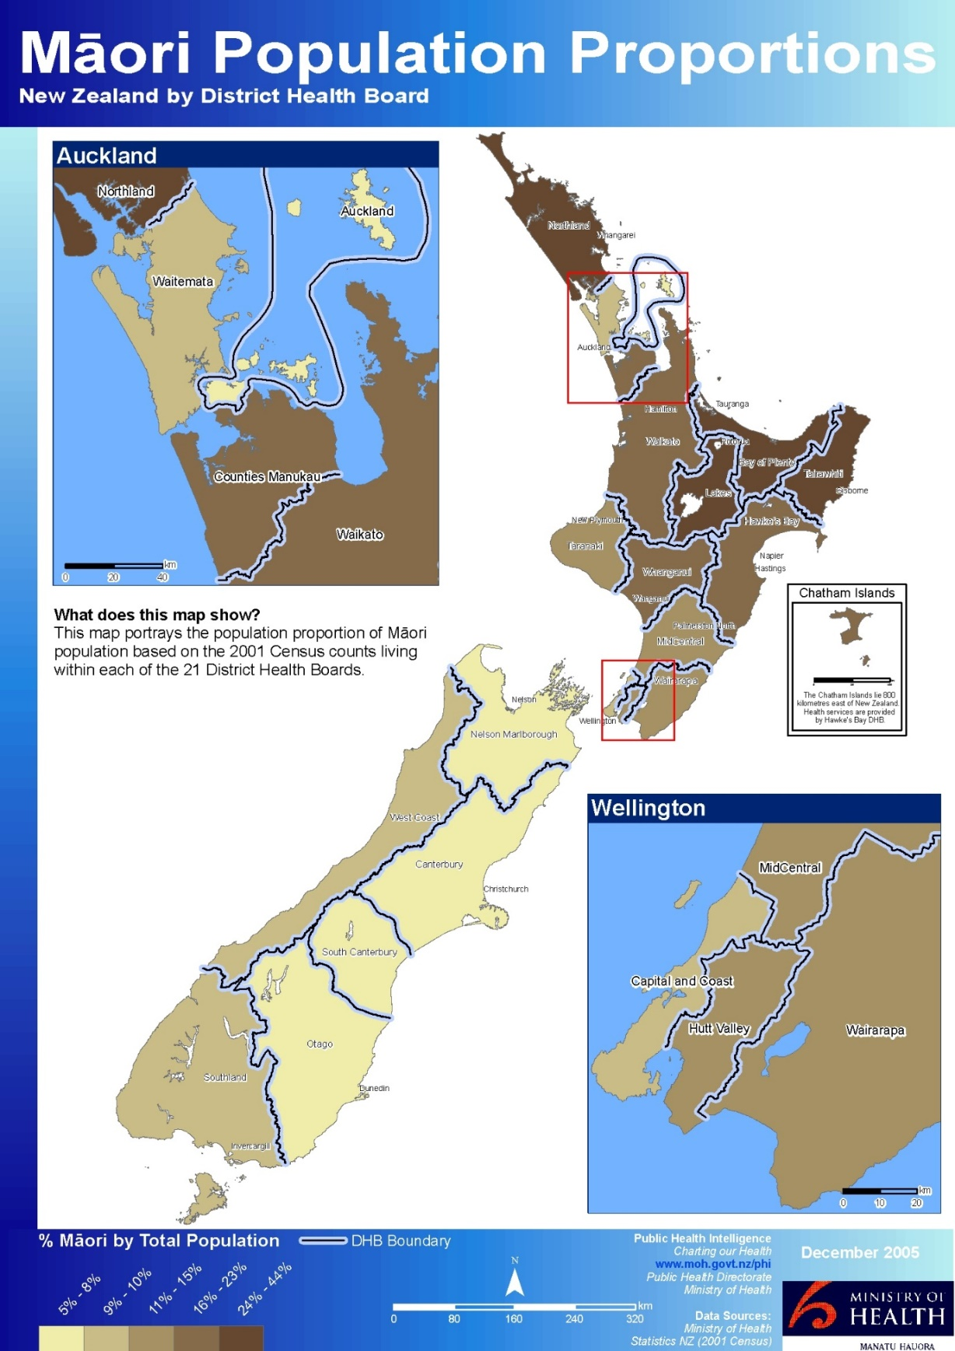

Table 6: District Health Board age distributions, Māori and non-Māori, 2006
DHB | 0–14 years |  | 15–24 years |  | 25–44 years |  | 45–64 years |  | 65+ years |  | Total
 | Māori | Non-Māori | Māori | Non-Māori | Māori | Non-Māori | Māori | Non-Māori | Māori | Non-Māori | Māori | Non-Māori
Northland | 15,579 | 19,197 | 6,873 | 10,287 | 10,827 | 24,864 | 7,575 | 31,785 | 2,670 | 18,789 | 43,527 | 104,913
Waitemata | 15,312 | 89,244 | 7,875 | 59,835 | 12,300 | 130,815 | 6,138 | 107,154 | 1,251 | 51,690 | 42,876 | 438,735
Auckland | 8,736 | 67,359 | 5,736 | 61,515 | 9,423 | 126,759 | 4,785 | 81,537 | 1,167 | 37,602 | 29,847 | 374,772
Counties Manukau | 25,365 | 86,745 | 12,096 | 53,019 | 18,288 | 105,777 | 9,558 | 84,090 | 1,944 | 36,204 | 67,248 | 365,838
Waikato | 24,027 | 53,337 | 12,426 | 36,498 | 17,871 | 72,279 | 10,332 | 69,711 | 2,820 | 39,900 | 67,476 | 271,716
Lakes | 11,028 | 12,837 | 5,304 | 7,155 | 8,457 | 18,228 | 5,133 | 18,468 | 1,458 | 10,251 | 31,377 | 66,942
Bay of Plenty | 16,305 | 27,306 | 7,329 | 15,282 | 11,913 | 36,927 | 7,758 | 41,211 | 2,346 | 28,554 | 45,642 | 149,289
Tairāwhiti | 6,807 | 4,842 | 3,138 | 2,616 | 5,103 | 6,096 | 3,540 | 6,981 | 1,176 | 4,158 | 19,758 | 24,705
Taranaki | 5,679 | 17,037 | 2,817 | 10,266 | 4,158 | 23,013 | 2,421 | 23,460 | 738 | 14,697 | 15,819 | 88,458
Hawkes Bay | 12,174 | 21,921 | 5,742 | 12,471 | 8,913 | 29,145 | 5,544 | 31,800 | 1,533 | 19,005 | 33,903 | 114,345
Whanganui | 5,112 | 8,685 | 2,514 | 5,337 | 3,732 | 11,487 | 2,343 | 13,212 | 720 | 9,069 | 14,424 | 47,787
MidCentral | 9,858 | 24,072 | 5,091 | 18,999 | 7,059 | 33,840 | 3,690 | 33,888 | 1,008 | 21,336 | 26,712 | 132,129
Hutt | 7,701 | 23,136 | 3,900 | 14,580 | 6,126 | 32.964 | 3,162 | 29,079 | 597 | 14,853 | 21,480 | 114,621
Capital and Coast | 8,583 | 43,332 | 5,226 | 37,134 | 8,079 | 77,208 | 3,804 | 55,179 | 810 | 27,294 | 26,496 | 240,162
Wairarapa | 2,055 | 6,096 | 912 | 3,309 | 1,356 | 7,734 | 894 | 9,933 | 276 | 6,048 | 5,493 | 33,120
Nelson/Marlborough | 3,813 | 21,960 | 1,947 | 12,744 | 2,982 | 31,104 | 1,785 | 34,548 | 426 | 18,756 | 10,953 | 119,109
West Coast | 1,092 | 5,304 | 471 | 2,919 | 756 | 7,629 | 471 | 8,349 | 120 | 4,215 | 2,916 | 28,410
Canterbury | 11,817 | 79,872 | 6,411 | 60,099 | 9,291 | 122,382 | 4,818 | 109,032 | 1,071 | 61,617 | 33,417 | 432,990
South Canterbury | 1,164 | 9,336 | 594 | 5,208 | 786 | 12,204 | 483 | 14,382 | 135 | 9,582 | 3,159 | 50,718
Otago | 3,783 | 28,128 | 2,742 | 28,983 | 2,973 | 42,177 | 1,593 | 43,149 | 375 | 25,491 | 11,466 | 167,931
Southland | 3,939 | 17,874 | 2,151 | 11,589 | 3,021 | 28,107 | 1,707 | 24,642 | 504 | 13,296 | 11,319 | 95,508
Source: Stats NZ

Figure 2: Proportion of DHB population that is Māori, 2006
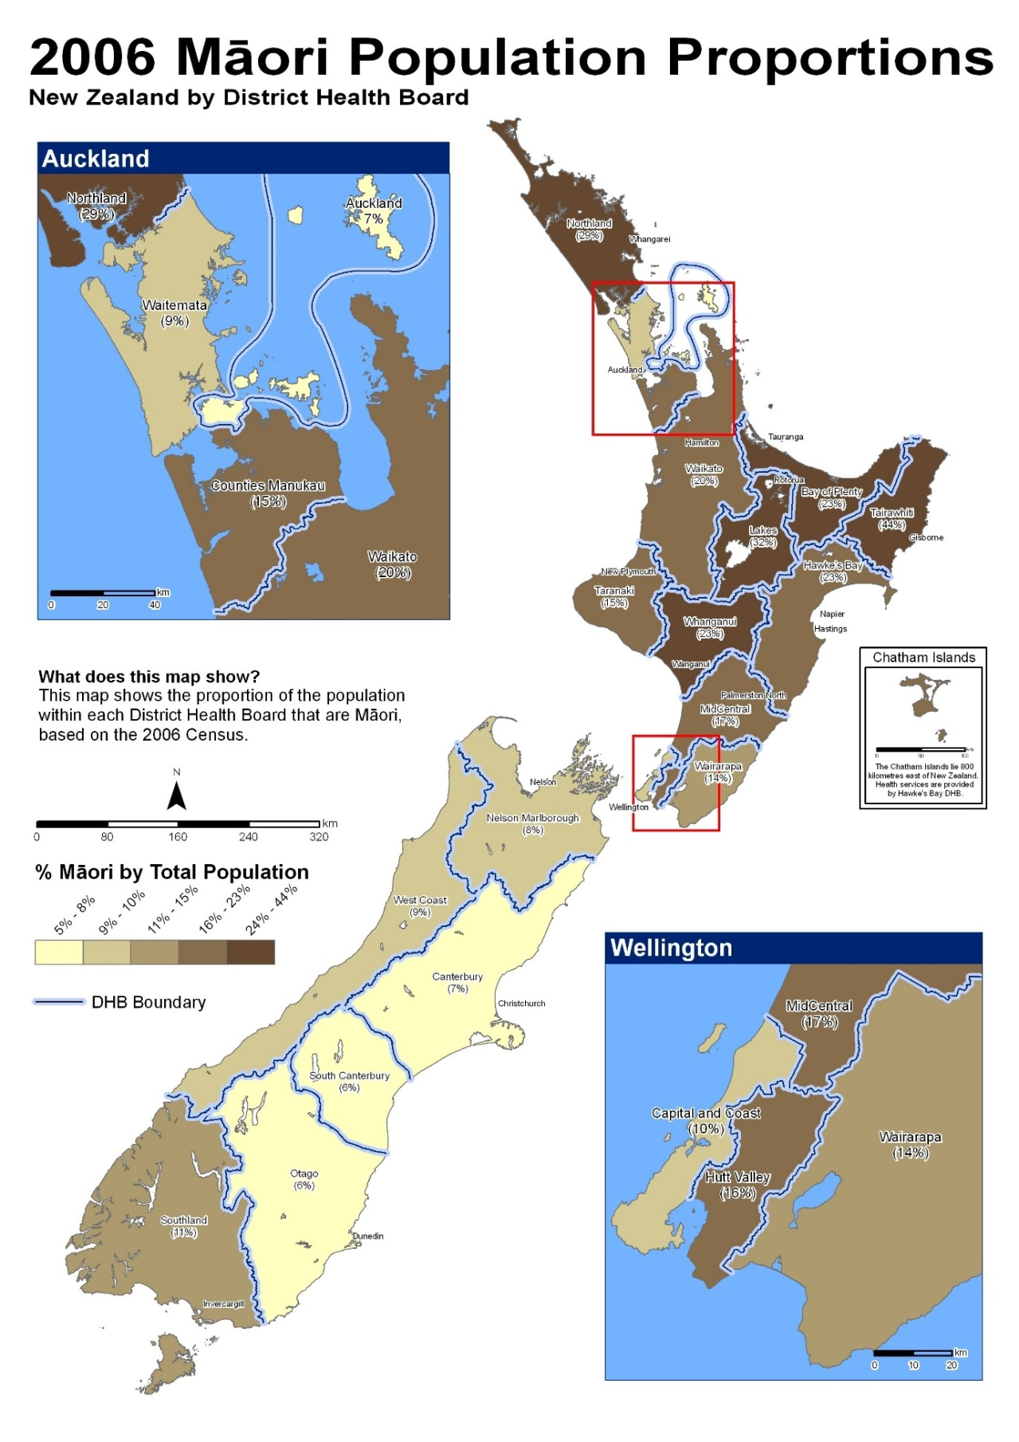

Table 7: District Health Board age distributions, Māori and non-Māori, 2013
DHB | 0–14 years |  | 15–24 years |  | 25–44 years |  | 45–64 years |  | 65+ years |  | Total
 | Māori | Non-Māori | Māori | Non-Māori | Māori | Non-Māori | Māori | Non-Māori | Māori | Non-Māori | Māori | Non-Māori
Northland | 15,138 | 17,610 | 6,888 | 9,795 | 9,723 | 21,258 | 9,738 | 33,774 | 3,441 | 24,324 | 44,928 | 106,764
Waitemata | 15,942 | 92,049 | 8,634 | 63,111 | 11,613 | 130,923 | 8,238 | 126,564 | 1,875 | 66,609 | 46,302 | 479,256
Auckland | 8,820 | 70,182 | 6,255 | 64,059 | 8,751 | 129,363 | 6,159 | 96,465 | 1,554 | 44,736 | 31,542 | 404,802
Counties Manukau | 24,408 | 88,698 | 12,399 | 58,455 | 16,317 | 107,019 | 11,799 | 99,945 | 3,009 | 47,235 | 67,944 | 401,349
Waikato | 25,374 | 52,212 | 13,530 | 36,879 | 17,850 | 69,822 | 13,446 | 77,178 | 3,855 | 49,167 | 74,049 | 285,261
Lakes | 10,455 | 11,727 | 5,298 | 6,942 | 7,488 | 16,035 | 6,270 | 19,422 | 1,932 | 12,624 | 31,440 | 66,747
Bay of Plenty | 16,011 | 27,513 | 7,584 | 15,870 | 11,100 | 34,908 | 9,456 | 45,414 | 3,126 | 35,025 | 47,277 | 158,718
Tairāwhiti | 6,429 | 4,302 | 3,114 | 2,439 | 4,545 | 5,442 | 4,146 | 7,113 | 1,446 | 4,680 | 19,683 | 23,970
Taranaki | 6,447 | 16,722 | 3,015 | 9,918 | 4,416 | 22,212 | 3,282 | 25,929 | 1,005 | 16,812 | 18,165 | 91,590
Hawkes Bay | 12,144 | 20,862 | 5,808 | 12,255 | 8,154 | 25,764 | 6,765 | 34,410 | 2,106 | 23,421 | 34,977 | 116,718
Whanganui | 4,641 | 7,782 | 2,436 | 4,863 | 3,291 | 9,597 | 2,889 | 13,680 | 900 | 10,038 | 14,151 | 45,969
MidCentral | 9,876 | 22,956 | 5,379 | 18,330 | 6,678 | 30,849 | 4,977 | 36,630 | 1,425 | 25,464 | 28,347 | 134,217
Hutt Valley | 7,140 | 22,011 | 3,717 | 14,331 | 5,532 | 31,161 | 3,960 | 32,103 | 861 | 17,562 | 21,213 | 117,165
Capital and Coast | 8,943 | 44,193 | 5,910 | 39,069 | 7,671 | 74,793 | 5,013 | 64,062 | 1,215 | 32,838 | 28,749 | 254,955
Wairarapa | 2,223 | 5,928 | 1,155 | 3,387 | 1,416 | 7,224 | 1,197 | 10,719 | 375 | 7,485 | 6,360 | 34,752
Nelson/Marlborough | 4,263 | 21,663 | 2,085 | 11,943 | 2,919 | 27,993 | 2,430 | 38,226 | 687 | 24,789 | 12,384 | 124,611
West Coast | 1,053 | 5,097 | 531 | 2,976 | 729 | 6,714 | 672 | 9,195 | 189 | 4,992 | 3,171 | 28,977
Canterbury | 12,705 | 77,562 | 7,377 | 59,268 | 9,660 | 114,753 | 6,597 | 122,061 | 1,635 | 70,557 | 37,971 | 444,207
South Canterbury | 1,416 | 8,718 | 648 | 5,415 | 894 | 10,977 | 672 | 15,531 | 213 | 11,130 | 3,843 | 51,783
Southern | 8,889 | 45,510 | 5,244 | 40,113 | 6,192 | 66,177 | 4,440 | 74,241 | 1,323 | 45,300 | 26,085 | 271,338
Note: Otago DHB and Southland DHB merged to form Southern DHB in 2010.
Source: Stats NZ.

Figure 3: Proportion of DHB population that is Māori, 2013
T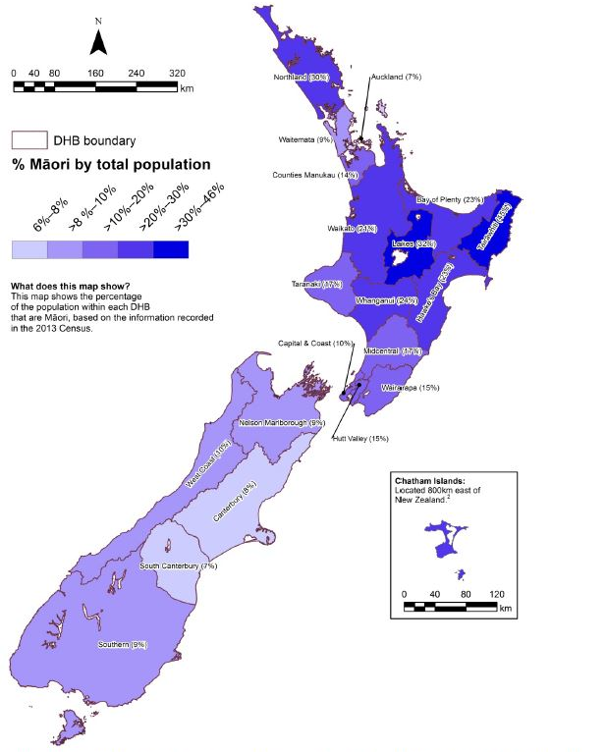
Note: Prioritised ethnicity has been used.
Source: Ministry of Health.

Socioeconomic determinants of health
This section presents the trends of the socioeconomic determinants of health for Māori and non-Māori in 2001, 2006 and 2013 as described in the Tatau Kahukura Māori Health Chart Books (Ministry of Health 2006, 2010c and 2015b).

Neighbourhood deprivation
Table 8: Populations by neighbourhood deprivation decile (NZDep) and by gender, Māori and non-Māori, 2001, 2006 and 2013
NZDep decile | 2001 |  | 2006 |  | 2013
 | Māori | Non-Māori | Māori | Non-Māori | Māori | Non-Māori
1 (least deprived) | 16,629  (3%) | 338,700  (11%) | 19,215  (3%) | 386,277  (12%) | 22,845  (4%) | 396,504  (12%)
2 | 21,027  (4%) | 329,952  (10%) | 24,603  (4%) | 374,643  (11%) | 28,773  (5%) | 395,583  (12%)
3 | 26,508  (5%) | 347,385  (11%) | 29,361  (5%) | 367,875  (11%) | 32,004  (5%) | 381,726  (11%)
4 | 30,552  (6%) | 324,507  (10%) | 33,678  (6%) | 355,188  (11%) | 37,173  (6%) | 365,547  (11%)
5 | 41,478  (8%) | 326,130  (10%) | 40,191  (7%) | 343,464  (10%) | 44,706  (7%) | 355,488  (10%)
6 | 48,591  (9%) | 317,841  (10%) | 50,184  (9%) | 333,948  (10%) | 52,848  (9%) | 342,387  (10%)
7 | 53,148  (10%) | 306,519  (10%) | 58,908  (10%) | 319,884  (10%) | 61,827  (10%) | 329,565  (10%)
8 | 66,216  (13%) | 294,441  (9%) | 73,692  (13%) | 300,948  (9%) | 76,434  (13%) | 312,522  (9%)
9 | 85,191  (16%) | 268,932  (8%) | 98,838  (17%) | 278,652  (8%) | 100,728  (17%) | 287,640  (8%)
10 (most deprived) | 121,227  (23%) | 225,408  (7%) | 136,452  (24%) | 229,626  (7%) | 140,886  (24%) | 232,779  (7%)
Unknown | 15,669  (3%) | 130,218  (4%) | 213  (0%) | 4,329  (0%) | 381  (0%) | 13,068  (0%)
Total | 526,236  (100%) | 3,210,033  (100%) | 565,326  (100%) | 3,294,834  (100%) | 598,604  (100%) | 3,412,809  (100%)
Notes:
Due to rounding, individual figures in this table do not add to give the stated totals.
‘Unknown’ refers to the population for whom an NZDep score was not ascertained for that year.
Source: 2001 – Stats NZ, 2006 – Salmond et al 2007, 2013 – Atkinson et al 2014.
NZDep is a small-area-based index providing a measure of neighbourhood deprivation, by looking at the comparative socioeconomic positions of small areas and assigning them decile numbers from 1 (least deprived) to 10 (most deprived). The index is based on nine socioeconomic variables from that year’s Census. The prevalence of those variables in an area is used to create a measure of relative socioeconomic deprivation for that area called a decile score. This measure is representative of the area and does not mean all individuals living in that area as a whole experience the same level of deprivation.

Higher proportions of Māori live in areas that have the most deprived NZDep scores; that is, the Māori population is highly skewed towards the most deprived deciles. In 2001, 23 percent of Māori lived in decile 10 areas (compared with 7 percent of non-Māori), while only 3 percent of Māori lived in decile 1 areas (compared with 11 percent of non-Māori).

This did not change much over time, in 2006 and 2013, 24 percent of Māori lived in decile 10 areas (compared with 7 percent of non-Māori), while 3 percent of Māori lived in decile 1 areas in 2006 and 4 percent in 2013 (compared with 12 percent of non-Māori for both 2006 and 2013).

Figure 4 shows the percentage of Māori in each decile in the neighbourhood deprivation distribution (NZDep 2013). This figure reflects the results mentioned above.

Figure 4: Neighbourhood deprivation distribution (NZDep 2013), Māori and non-Māori, 2013
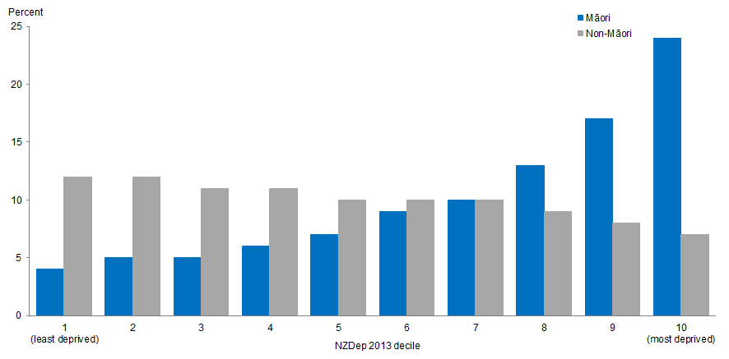

Socioeconomic indicators
Tables 9, 10, and 11 present crude rates rather than age-standardised rates.

Caution should be taken when comparing Māori and non-Māori results. Crude rates accurately portray the situation in each population but make comparisons difficult because they do not take into account different age distributions in each of the populations (the Māori population is much younger than the non-Māori population).

Table 9: Socioeconomic indicators, by gender, Māori and non-Māori, 2001
Indicator | Māori |  |  | Non-Māori
 | Males | Females | Total | Males | Females | Total
School completion (6th form certificate or higher), 15+ years | 30.4 | 34.5 | 32.5 | 51.7 | 49.9 | 50.8
Unemployed, 15+ years | 11.3 | 11.4 | 11.4 | 4.2 | 3.8 | 4.0
Total personal income less than $10,000, 15+ years | 27.8 | 32.1 | 30.1 | 19.2 | 28.6 | 24.1
Receiving means-tested benefit,¹ 15+ years | 24.8 | 36.1 | 30.7 | 10.2 | 12.8 | 11.5
Living in household without telephone access,² 15+ years | 12.2 | 12.8 | 12.5 | 6.5 | 5.7 | 6.1
Living in household without motor vehicle access, 15+ years | 10.1 | 13.5 | 11.9 | 4.2 | 6.9 | 5.6
Not living in own home, 15+ years | 64.4 | 65.2 | 64.8 | 40.3 | 38.1 | 39.1
Household crowding,³ all age groups | 20.3 | 21.6 | 21.0 | 6.9 | 6.9 | 6.9
Notes:
1 Includes community Wage (Job Seeker and Sickness Benefit), Domestic Purposes benefit, Invalid’s Benefit, and Student Allowance.
2 Household with no Telephone access includes households stating no telephone access and households for which it was not stated.
3 Based on the Canadian National Crowding Index. A required number of bedrooms is calculated for each household (based on the age, sex and number of people living in the dwelling), which is compared with the actual number of bedrooms. A household is considered crowded when there are fewer bedrooms than required.
Source: Stats NZ

Table 10: Socioeconomic indicators, by gender, Māori and non-Māori, 2006
Indicator | Māori |  |  | Non-Māori
 | Males | Females | Total | Males | Females | Total
School completion (Level 2 Certificate or higher), 15+ years | 40.7 | 45.7 | 43.4 | 65.0 | 62.5 | 63.7
Unemployed, 15+ years | 7.1 | 8.2 | 7.6 | 2.8 | 3.0 | 2.9
Total personal income less than $10,000, 15+ years | 22.8 | 27.9 | 25.5 | 16.1 | 25.6 | 21.0
Receiving means-tested benefit, 15+ years | 19.9 | 32.6 | 26.7 | 8.8 | 12.1 | 10.5
Living in household without telephone access, 15+ years | 5.6 | 5.3 | 5.5 | 1.5 | 1.0 | 1.2
Living in household without motor vehicle access, 15+ years | 7.8 | 10.2 | 9.1 | 3.8 | 6.2 | 5.0
Not living in own home, 15+ years | 69.6 | 70.1 | 69.9 | 44.9 | 42.6 | 43.7
Household crowding,¹ all age groups | 22.2 | 23.3 | 22.8 | 7.9 | 7.9 | 7.9
Notes:
1 Based on the Canadian National Crowding Index. A required number of bedrooms is calculated for each household (based on the age, sex and number of people living in the dwelling), which is compared with the actual number of bedrooms. A household is considered crowded when there are fewer bedrooms than required.
Source: Stats NZ

Table 11: Socioeconomic indicators, by gender, Māori and non-Māori, 2013
Indicator | Māori |  |  | Non-Māori
 | Males | Females | Total | Males | Females | Total
School completion (Level 2 Certificate or higher), 15+ years | 42.1 | 47.8 | 45.1 | 65.2 | 63.4 | 64.3
Unemployed, 15+ years | 9.8 | 10.9 | 10.4 | 3.9 | 4.1 | 4.0
Total personal income less than $10,000, 15+ years | 23.0 | 25.0 | 24.1 | 14.8 | 21.7 | 18.4
Receiving income support, 15+ years | 23.1 | 36.7 | 30.4 | 10.9 | 16.4 | 13.8
Living in household without any telecommunications,¹ all age groups | 3.1 | 2.9 | 3.0 | 1.0 | 0.8 | 0.9
Living in household with internet access, all age groups | 69.4 | 68.6 | 69.0 | 84.3 | 83.2 | 83.8
Living in household without motor vehicle access, all age groups | 8.1 | 9.3 | 8.7 | 3.7 | 5.0 | 4.4
Living in rented accommodation, all age groups | 48.3 | 50.5 | 49.5 | 27.7 | 27.3 | 27.5
Household crowding,² all age groups | 18.3 | 18.8 | 18.6 | 7.8 | 7.6 | 7.7
Notes:
1 Telecommunications include telephone, cell/mobile phone, facsimile and internet.
2 Based on the Canadian National Crowding Index. A required number of bedrooms is calculated for each household (based on the age, sex and number of people living in the dwelling), which is compared with the actual number of bedrooms. A household is considered crowded when there are fewer bedrooms than required.
Source: Stats NZ

The results from Tables 9, 10 and 11 show that Māori are less advantaged than non-Māori across all socioeconomic indicators presented.

The indicators included in the socioeconomic variables have changed over time:
- A new indicator was added between 2006 and 2013:
- The percentage of people living in household with internet access.
- The conditions for four of the indicators were altered:
- School completion from 6th form certificate or higher to Level 2 Certificate or higher
- Means-tested benefit became receiving living income support.
- Living without telephone access became living without telecommunications access.
- Not living in own home became living in rented accommodation.
- The age range for three of the indicators were altered from 15+ years to all ages between 2006 and 2013:
- Living without telephone access/living without telecommunications access.
- Living without motor vehicle access.
- Not living in own home/living in rented accommodation.

Racial discrimination
This section presents the prevalence of self-reported experience of racial discrimination ‘ever’ in a person’s lifetime in 2006/07, 2011/12 and 2016/17. ‘Racial discrimination’ refers to experience of ethnically motivated personal attack (physical or verbal) and experience of unfair treatment on the basis of ethnicity in any of three situations: healthcare, housing or work.

It is important to note the data on racial discrimination sourced from the NZHS is self-reported prevalence (from the victim’s perspective), which may incorrectly estimate the true prevalence resulting in lower or higher percentages. Therefore, caution should be taken when comparing results from this brief with reports that use a different data source.

Experience of any racial discrimination
Table12: Self-reported experience of any racial discrimination, by gender, Māori and non-Māori, 2006/07 and 2011/12
Indicator | Year | Māori |  |  | Non-Māori
 |  | Male | Female | Total | Male | Female | Total
Self-reported experience of any ethnically motivated personal attack or any unfair treatment on the basis of ethnicity (ever), 15+ years, percentage | 2006/07 | 28.1  (24.7–31.9) | 30.5  (27.9–33.3) | 29.3  (27.0–31.8) | 20.6  (18.7–22.5) | 16.0  (14.6–17.5) | 18.2  (17.1–19.4)
 | 2011/12 | 29.2  (25.2–33.6) | 24.3  (21.4–27.5) | 26.3  (24.1–28.7) | 15.4  (13.7–17.4) | 13.2  (11.7–14.9) | 14.3  (13.2–15.5)
Notes:
Figures are age-standardised to the 2001 Census total Māori population.
Prioritised ethnicity has been used.
Source: New Zealand Health Survey (NZHS), Ministry of Health, 2006/07 and 2011/12.

Table 12 shows, overall, Māori adults were more than 1½ times as likely as non-Māori to report ever experiencing racial discrimination (age-standardised rate ratio (RR) 1.65 in 2006/07 and 1.84 in 2011/12). Between 2006/07 and 2011/12, the percentage of Māori adults who have experienced racial discrimination remained constant and the percentage of non-Māori adults who experienced racial discrimination decreased (18.2 percent to 14.3 percent).

Ethnically motivated personal attack
Table 13: Self-reported experience of ethnically motivated personal attack, by gender, Māori and non-Māori, 2006/07 to 2016/17
Indicator | Year | Māori |  |  | Non-Māori
 |  | Male | Female | Total | Male | Female | Total
Self-reported experience of any ethnically motivated personal (physical or verbal) attack (ever), 15+ years, percentage | 2006/07 | 24.1  (20.9–27.6) | 24.1  (21.7–26.6) | 24.0  (22.0–26.3) | 17.9  (16.1–19.7) | 13.3  (12.0–14.7) | 15.5  (14.5–16.6)
 | 2011/12 | 26.3  (22.3–30.7) | 18.6  (15.9–21.6) | 21.9  (19.7–24.4) | 13.7  (12.1–15.6) | 11.3  (9.9–12.9) | 12.5  (11.4–13.7)
 | 2016/17 | 24.9  (21.0–29.2) | 22.4  (19.7–25.2) | 23.6  (21.4–25.9) | 16.7  (15.1–18.6) | 11.3  (10.1–12.5) | 14.0  (12.9–15.1)
Self-reported experience of any ethnically motivated personal physical attack (ever), 15+ years, percentage | 2006/07 | 7.3  (5.4–9.7) | 3.9  (3.0–5.0) | 5.5  (4.4–6.7) | 5.1  (4.2–6.2) | 1.9  (1.4–2.4) | 3.5  (3.0–4.0)
 | 2011/12 | 12.1  (9.2–15.7) | 3.8  (2.6–5.3) | 7.5  (6.1–9.4) | 4.4  (3.6–5.3) | 2.1  (1.7–2.7) | 3.2  (2.8–3.7)
 | 2016/17 | 9.8  (7.4–13.0) | 5.1  (3.9–6.7) | 7.3  (6.0–8.9) | 5.1  (4.3–6.0) | 1.5  (1.1–1.9) | 3.2  (2.8–3.7)
Self-reported experience of any ethnically motivated personal verbal attack (ever), 15+ years, percentage | 2006/07 | 22.2  (19.2–25.4) | 22.5  (20.2–25.1) | 22.3  (20.3–24.5) | 16.0  (14.3–17.8) | 12.3  (11.0–13.7) | 14.1  (13.1–15.2)
 | 2011/12 | 23.9  (20.1–28.2) | 18.1  (15.4–21.1) | 20.6  (18.4–23.0) | 12.6  (10.9–14.5) | 10.6  (9.3–12.0) | 11.6  (10.5–12.7)
 | 2016/17 | 23.5  (19.8–27.6) | 21.8  (19.3–24.5) | 22.6  (20.5–24.8) | 15.6  (14.0–17.4) | 11.0  (9.9–12.2) | 13.3  (12.3–14.4)
Notes:
Figures are age-standardised to the 2001 Census total Māori population.
Prioritised ethnicity has been used.
Due to the nature of the survey, the individual figures for physical and verbal do not equal the figures for physical or verbal.
Source: New Zealand Health Survey (NZHS), Ministry of Health, 2006/07, 2011/12 and 2016/17.

Table 13 shows, overall, Māori adults were more than 1½ times as likely as non-Māori to have experienced any ethnically motivated personal (physical or verbal) attack (RR 1.57 in 2006/07, 1.76 in 2011/12 and 1.73 in 2016/17). The disparity was greater for rates of experience of a physical attack and the gap is widening: Māori adults were more than twice as likely as non-Māori to have experienced a physical attack in 2016/17 (RR 1.63 in 2006/07, 1.76 in 2011/12 and 2.41 in 2016/17).

Unfair treatment based on ethnicity
Table 14: Self-reported experience of unfair treatment on the basis of ethnicity, by gender, Māori and non-Māori, 2006/07 and 2011/12
Indicator | Year | Māori |  |  | Non-Māori
 |  | Male | Female | Total | Male | Female | Total
Self-reported experience of unfair treatment by a health professional on the basis of ethnicity (ever), 15+ years, percentage | 2006/07 | 3.3  (2.3–4.6) | 6.4  (5.2–7.8) | 4.9  (4.1–5.8) | 1.7  (1.3–2.3) | 1.8  (1.4–2.3) | 1.8  (1.4–2.1)
 | 2011/12 | 3.7  (2.0–6.0) | 4.9  (3.7–6.2) | 4.3  (3.3–5.4) | 0.9  (0.6–1.2) | 1.6  (1.2–2.1) | 1.3  (1.0–1.5)
Self-reported experience of unfair treatment at work or being refused a job unfairly because of ethnicity (ever), 15+ years, percentage | 2006/07 | 4.7  (3.5–6.1) | 5.9  (4.7–7.3) | 5.3  (4.4–6.3) | 3.8  (3.1–4.5) | 3.6  (3.1–4.1) | 3.7  (3.3–4.1)
 | 2011/12 | 8.0  (6.0–10.5) | 5.0  (3.8–6.6) | 6.4  (5.2–7.8) | 2.8  (2.2–3.4) | 3.2  (2.5–4.0) | 3.0  (2.5–3.5)
Self-reported experience of unfair treatment when renting or buying a house on the basis of ethnicity (ever), 15+ years, percentage | 2006/07 | 4.0  (2.8–5.5) | 8.4  (7.1–9.8) | 6.3  (5.4–7.3) | 1.5  (1.1–1.9) | 1.1  (0.9–1.4) | 1.3  (1.0–1.6)
 | 2011/12 | 3.9  (2.4–5.9) | 6.3  (5.0–8.0) | 5.2  (4.1–6.5) | 0.8  (0.6–1.2) | 0.9  (0.6–1.1) | 0.9  (0.7–1.0)
Self-reported experience of any unfair treatment on the basis of ethnicity (ever), 15+ years, percentage | 2006/07 | 9.8  (8.1–11.9) | 15.1  (13.1–17.4) | 12.6  (11.2–14.1) | 5.9  (5.0–6.9) | 5.5  (4.8–6.2) | 5.7  (5.1–6.3)
 | 2011/12 | 12.4  (9.6–15.8) | 12.5  (10.3–15.0) | 12.3  (10.6–14.3) | 3.9  (3.3–4.6) | 4.7  (3.9–5.6) | 4.3  (3.8–4.8)
Notes:
Figures are age-standardised to the 2001 Census total Māori population.
Prioritised ethnicity has been used.
Due to the nature of the survey, the individual figures for health, job or house do not equal the figures for any unfair treatment.
Source: New Zealand Health Survey (NZHS), Ministry of Health, 2006/07 and 2011/12.

Table 14 shows, overall, Māori adults were more than twice as likely as non-Māori to have experienced any unfair treatment on the basis of ethnicity (RR 2.29 in 2006/07). This rose to nearly three times as likely in 2011/12 (RR 2.90 in 2011/12). The disparity was greater for rates of experience of unfair treatment in housing among females: Māori females were more than seven times as likely as non-Māori females to have experienced unfair treatment in renting or buying houses because of ethnicity (RR 7.03 in 2006/07 and 7.27 in 2011/12).

Risk and protective factors

Tobacco smoking
This section presents results over time for tobacco smoking, data sources are self-reported but they do give a good indication of change over time as the methods have not changed.

What is the data telling us?
Overall the data shows that:
- Māori youth aged 14–15 years (Year 10) have a higher prevalence of daily smoking than non-Māori youth from 1999 to 2015.
- Youth smoking rates have declined substantially over time, however, smoking rates for Māori girls remain disproportionately high – four times as high as those of non-Māori girls.
- Daily and current smoking rates for Māori adults aged 15 and over have decreased slightly over time.
- Persistent disparities remain over time for Māori compared with non-Māori for both current and daily smoking. Disparities are particularly pronounced for Māori females.
- Māori females were more likely to be an ex-smoker than non-Māori females.

Youth smoking (aged 14–15 years)
Youth smoking is sourced from the Action for Smokefree 2025 (ASH) Year 10 Snapshot Survey. The ASH Year 10 Snapshot Survey samples 20,000–30,000 students aged 14–15 years (in Year 10 at school) every year on their smoking behaviours and attitudes.

The ASH Survey shows that Māori students in Year 10 at school (aged 14–15 years) had a higher prevalence of daily smoking than non-Māori in the same age group. Daily smoking is defined as smoking at least once a day.

Figure 5: Daily smoking in people aged 14–15 years, by gender, Māori and non-Māori, 1999–2015
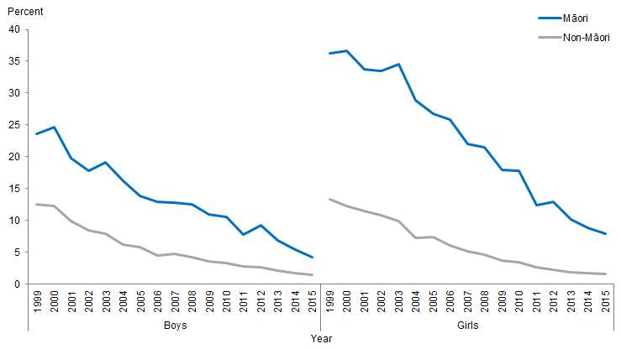
Note: Daily smoking consists of participants who report smoking at least once a day.
Source: ASH Year 10 Snapshot Surveys, 1999–2015.

Figure 5 shows that daily smoking rates for both Māori and non-Māori youth steadily declined from 1999 to 2015, however, rates for Māori girls remain twice as high as rates for Māori boys, and four times as high as those of non-Māori girls.

Between 1999 and 2015, Māori boys’ daily smoking rates decreased by 82 percent, while non-Māori boys’ rates decreased by 89 percent. During the same time, Māori girls’ daily smoking rates reduced by 78 percent while non-Māori girls’ rates decreased by 88 percent.

Between 1999 and 2015, the difference between Māori and non-Māori boys’ daily smoking rates decreased by 75 percent, decreasing from 11 percentage points (the difference in 1999) to 3 percentage points (the difference in 2015). For girls, the difference between Māori and non-Māori rates decreased by 73 percent (from 23 to 6 percentage points).

Further information regarding never smoked and daily smoking rates for Māori compared with non-Māori non-Pacific over time (2000–2016) can be found in the factsheet 2016 ASH Year 10 Snapshot: Smoking Among Māori Youth (ASH n.d.).

Current smoking (aged 15 and over)
The New Zealand Health Survey (NZHS) collects self-reported data on tobacco smoking for adults aged 15 and over and examines current smoking, daily smoking and ex-smoker status in 2006/07 and then in a continuous survey cycle from 2011/12 to 2016/17.

The NZHS results show that the prevalence of current smoking has decreased slowly over time for both Māori and non-Māori. From 2006/07 to 2016/17, rates of current smoking for Māori decreased by 17 percent compared with 25 percent for non-Māori. A persisting disparity is evident for Māori when compared with non-Māori – with Māori being at least 2½ times as likely as non-Māori to be a current smoker over the time period.

Figure 6: Current smoking in people aged 15 and over, by gender, Māori and non-Māori, 2006/07–2016/17
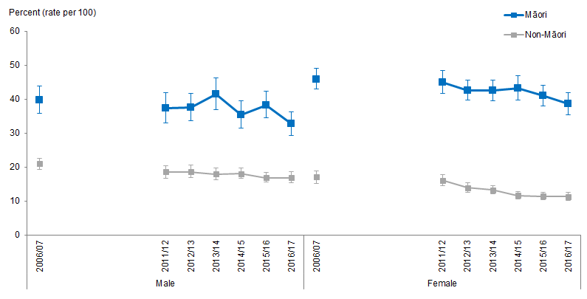
Notes:
Figures are age-standardised to the 2001 Census total Māori population.
Prioritised ethnicity has been used.
If the confidence intervals of two rates do not overlap, the difference in rates is said to be statistically significant.
Current smoking is defined as having smoked more than 100 cigarettes in lifetime and currently smoking at least once a month.
Source: New Zealand Health Survey (NZHS), Ministry of Health, 2006/07–2016/17.

Figure 6 shows that rates of current smoking have declined over time and Māori females have the highest rates of current smoking. In 2016/17, 39 percent of Māori females were current smokers compared with 11 percent of non-Māori females.

The disparity between Māori and non-Māori is particularly pronounced for females. In 2016/17, Māori females were nearly 3½ times as likely as non-Māori females to be a current smoker compared with just over 2½ times in 2006/07. This is due to a faster decline in current smoking rates for non-Māori females over the time period (33 percent decline for non-Māori females compared with 16 percent for Māori females). Māori males are around twice as likely as non-Māori males to be current smokers and this has remained stable over the time period.

Daily smoking (aged 15 and over)
Figure 7: Daily smoking in people aged 15 and over, by gender, Māori and non-Māori, 2006/07–2016/17
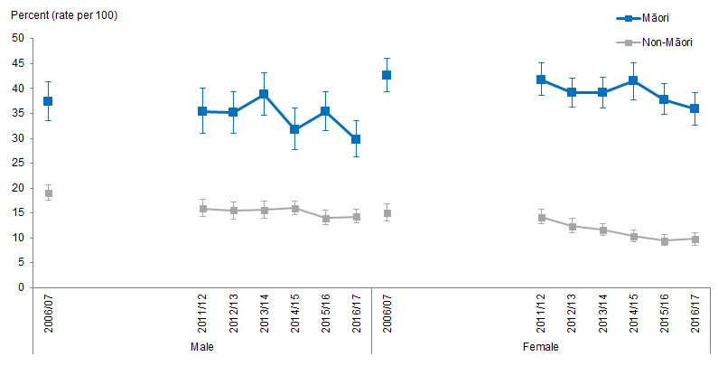
Notes:
Figures are age-standardised to the 2001 Census total Māori population.
Prioritised ethnicity has been used.
If the confidence intervals of two rates do not overlap, the difference in rates is said to be statistically significant.
Daily smoking is defined as having smoked more than 100 cigarettes in a respondent’s lifetime and currently smoking at least once a day.
Source: New Zealand Health Survey (NZHS), Ministry of Health, 2006/07–2016/17.

Trends for daily smoking are similar to that of current smoking, with Māori more likely to smoke daily than non-Māori with decreases in daily smoking evident over time for both Māori and non-Māori. Māori females have the highest rates of daily smoking with some decrease since 2014/15 (Figure 7). In 2016/17, Māori females were over 3½ times as likely to be daily smokers as non-Māori females and Māori males were twice as likely to be daily smokers as non-Māori males.

Ex-smokers (aged 15 and over)
Figure 8: Ex-smokers in people aged 15 and over, by gender, Māori and non-Māori,
2006/07–2016/17
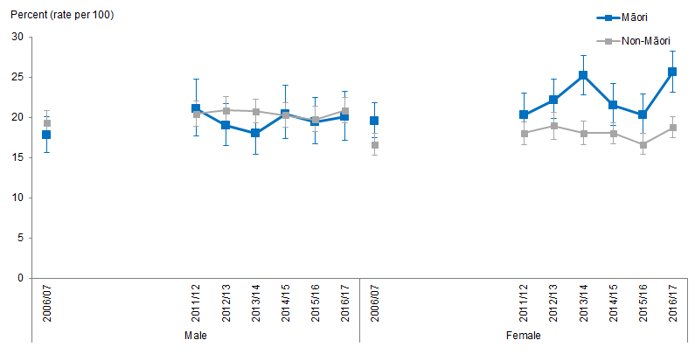
Notes:
Figures are age-standardised to the 2001 Census total Māori population.
Prioritised ethnicity has been used.
If the confidence intervals of two rates do not overlap, the difference in rates is said to be statistically significant.
An ex-smoker is defined as having smoked more than 100 cigarettes in a lifetime and has now stopped for more than one month.
Source: New Zealand Health Survey (NZHS), Ministry of Health, 2006/07–2016/17.

Māori are more likely than non-Māori to be ex-smokers. In 2016/17, 23 percent of Māori were ex-smokers compared with 20 percent of non-Māori.

Figure 8 shows that the proportion of Māori females and males becoming ex-smokers increased over time between 2006/07 and 2016/17 (by 31 percent for Māori females and 12 percent for Māori males). Māori females were more likely to be an ex-smoker than non-Māori females.

Alcohol and drug use
This section presents results for alcohol and drug use for Māori and non-Māori aged 15 and over. This is self-reported behaviour, which may be an underestimate but it is the best data we have. This is useful for exploring changes over time because the survey method hasn’t changed.

What is the data telling us?
Alcohol use
- Māori and non-Māori adults aged 15 and over were equally likely to have consumed alcohol in the past year and this was consistent over time from 2006/07 to 2016/17.
- Māori drinkers were less likely than non-Māori drinkers to have drunk alcohol four or more times a week in the past year and this hasn’t changed over time.
- Of those who had consumed alcohol in the past year, Māori were more likely to score 8 points or more on AUDIT test (hazardous drinking indicator) than non-Māori at each time period presented.
Drug use
- Māori were about twice as likely as non-Māori to use cannabis and this was consistent over time.
- Māori males had the highest prevalence of cannabis use.

Alcohol use
Figure 9: Drank alcohol four or more times a week in the past 12 months (among past year drinkers), 15+ years, by gender, Māori and non-Māori, 2006/07–2016/17
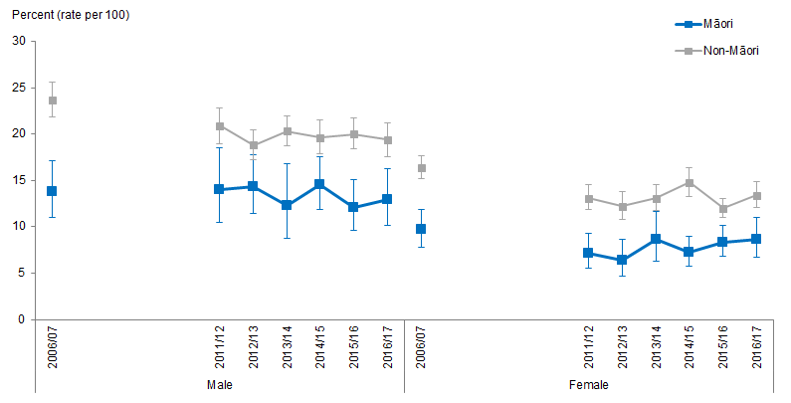
Notes:
Figures are age-standardised to the 2001 Census total Māori population.
Prioritised ethnicity has been used.
If the confidence intervals of two rates do not overlap, the difference in rates is said to be statistically significant.
Source: New Zealand Health Survey (NZHS), Ministry of Health, 2006/07–2016/17.

Māori and non-Māori adults aged 15 and over were equally likely to have consumed alcohol in the past year and this was consistent over time. The prevalence of consuming alcohol is slightly declining over time for both Māori and non-Māori.

Among those who consumed alcohol in the past year (at the time of survey), Māori were less likely to drink four or more times a week than non-Māori (Figure 9). Males were more likely to drink four or more times a week than females.

Hazardous drinking
Figure 10: Hazardous drinkers (among past year drinkers), 15+ years, by gender, Māori and non-Māori, 2006/07–2016/17
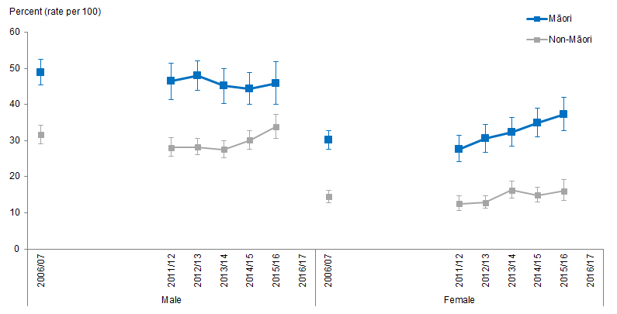
Notes:
Figures are age-standardised to the 2001 Census total Māori population.
Prioritised ethnicity has been used.
If the confidence intervals of two rates do not overlap, the difference in rates is said to be statistically significant.
Hazardous drinking is measured using the 10-question Alcohol Use Disorders Identification Test (AUDIT) developed by the World Health Organization. The AUDIT is a 10-item questionnaire that covers three aspects of alcohol use: alcohol consumption, dependence and adverse consequences. An AUDIT score is the total of the scores obtained for each of the 10 items (Babor et al 2001).
Source: New Zealand Health Survey (NZHS), Ministry of Health, 2006/07–2016/17.

Hazardous drinkers (past-year drinkers as measured at time of survey) are adults who obtained an AUDIT score of 8 or more, among the respondents who had a drink containing alcohol in the last year – representing an established pattern of drinking that carries a high risk of future damage to physical or mental health. Māori were more likely to drink at a hazardous drinking level than non-Māori and this was consistent over time. Among hazardous drinkers, Māori males were more likely to drink large amounts of alcohol at least weekly than Māori females.

Figure 10 shows that from 2006/07 to 2015/16 there has been a slight decrease in hazardous drinking for Māori males whereas there has been an increasing trend in hazardous drinking for Māori females. In 2006/07, 30 percent of Māori females were classified as hazardous drinkers increasing to 37 percent in 2015/16.

The disparity was greater between Māori and non-Māori females. From 2006/07 to 2015/16, Māori females were around 2–2½ times as likely to be hazardous drinkers as non-Māori. The disparity for Māori males and non-Māori males appears to be narrowing slightly over time.

Drug use (cannabis and amphetamine)
Figure 11: Using cannabis in the past 12 months, 15+ years, by gender, Māori and non-Māori, 2006/07–2016/17
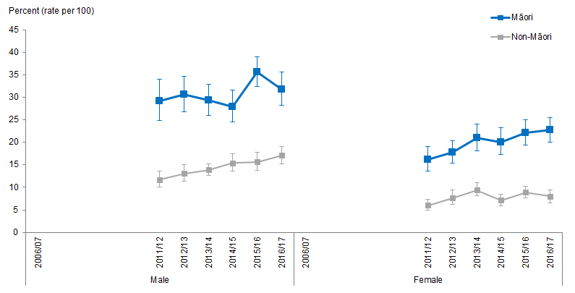
Notes:
Figures are age-standardised to the 2001 Census total Māori population.
Prioritised ethnicity has been used.
If the confidence intervals of two rates do not overlap, the difference in rates is said to be statistically significant.
Source: New Zealand Health Survey (NZHS), Ministry of Health, 2006/07–2016/17.

Figure 11 shows that cannabis use increased slightly over time from 2011/12 to 2016/17. Māori males had the highest level of cannabis use over time from 2011/12 to 2016/17. Māori were nearly twice as likely as non-Māori to use cannabis. In 2016/17, Māori males were nearly twice as likely as non-Māori males to use cannabis whilst Māori females were three times as likely as non-Māori females.

The prevalence of amphetamine use was low for both Māori and non-Māori with Māori reporting higher rates of use than non-Māori. In 2016/17, 2 percent of Māori reported using amphetamine compared with 1 percent of non-Māori. Results should be treated with caution however due to the low numbers reporting amphetamine use.

Nutrition (vegetable and fruit servings)
This section presents results from the New Zealand Health Survey (NZHS) for Māori and non-Māori aged 15 and over for nutrition (vegetable and fruit servings). This is self-reported behaviour, which may be an underestimate but it is the best data we have. This is useful for exploring changes over time because the survey method hasn’t changed.

What is the data telling us?
Overall the data shows that:
- Well over half of both Māori and non-Māori adults aged 15 and over did not meet the recommended intake for vegetables and fruit and that this has not changed much over time from 2006/07 to 2016/17.
- Māori females were less likely to meet the recommended fruit and vegetable intakes than non-Māori females and this was consistent over time.

The Ministry of Health recommends that New Zealanders eat at least three servings of vegetables and at least two servings of fruit per day (Ministry of Health 2015a). Well over half of Māori and non-Māori did not meet this recommended intake for vegetables and fruit and there has been a decline in the proportion meeting the recommendation since 2006/07. From 2006/07 to 2016/17 there has been a decline of 12 percent of Māori adults meeting the fruit and vegetable guideline compared with 9 percent of non-Māori adults.

Figure 12: Three or more servings of vegetables and two or more servings of fruit per day, 15+ years, by gender, Māori and non-Māori, 2006/07–2016/17
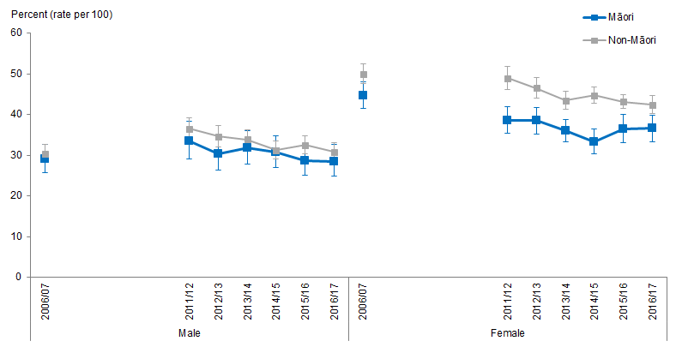
Notes:
Figures are age-standardised to the 2001 Census total Māori population.
Prioritised ethnicity has been used.
If the confidence intervals of two rates do not overlap, the difference in rates is said to be statistically significant.
Source: New Zealand Health Survey (NZHS), Ministry of Health, 2006/07–2016/17.

Figure 12 shows that Māori females were less likely to meet the recommended intakes than non-Māori females. In 2016/17, 37 percent of Māori females met the recommended intake of fruit and vegetables compared with 42 percent of non-Māori females. Māori males had a similar proportion as non-Māori males meeting the recommended daily intake.

Figure 13: Three or more servings of vegetables per day, 15+ years, by gender, Māori and non-Māori, 2006/07–2016/17
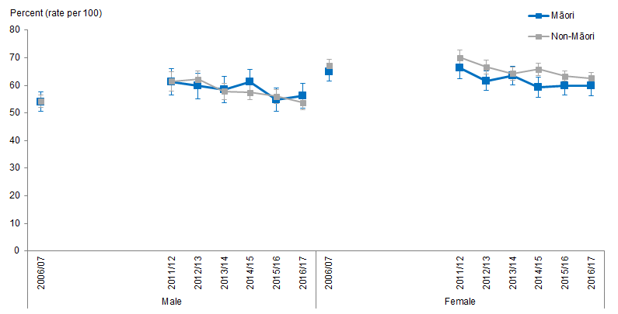
Notes:
Figures are age-standardised to the 2001 Census total Māori population.
Prioritised ethnicity has been used.
If the confidence intervals of two rates do not overlap, the difference in rates is said to be statistically significant.
Source: New Zealand Health Survey (NZHS), Ministry of Health, 2006/07–2016/17.

There was little change between 2006/07 and 2016/17 for Māori and non-Māori adults in meeting the recommended number of vegetable servings. Figure 13 shows that Māori males had similar proportions meeting the three or more servings of vegetables guideline over time when compared with non-Māori males. In 2016/17, 56 percent of Māori males met the vegetable servings guideline compared with 54 percent of non-Māori males. Māori females were slightly less likely to meet the guideline than non-Māori females and this was consistent over the time period.

Figure 14: Two or more servings of fruit per day, 15+ years, Māori and non-Māori, 2006/07–2016/17
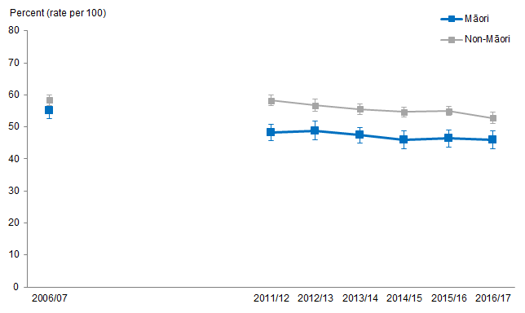
Notes:
Figures are age-standardised to the 2001 Census total Māori population.
Prioritised ethnicity has been used.
If the confidence intervals of two rates do not overlap, the difference in rates is said to be statistically significant.
Source: New Zealand Health Survey (NZHS), Ministry of Health, 2006/07–2016/17.

Figure 14 shows that Māori were less likely to meet the fruit intake recommendation of two or more servings a day than non-Māori. Over time there has been a decline in the proportion of Māori meeting the recommendation – from 55 percent in 2006/07 to 46 percent in 2016/17 (a decrease of 17 percent compared with a 10 percent decrease for non-Māori adults).

Body size
This section presents results for body size for Māori and non-Māori children aged 2–14 years and adults aged 15 and over.

What is the data telling us?
Overall the data shows that:
- The prevalence of being overweight declined slightly overtime for Māori aged 15 and over. Māori males were less likely than non-Māori males to be overweight.
- The prevalence of being obese has increased over time. Māori adults were more than 1½ times as likely to be obese as non-Māori adults.
- Māori children aged 2–14 years were more likely to be overweight than non-Māori children with little change overtime.
- The prevalence of being obese has fluctuated over time for Māori boys and girls with rates remaining higher than that of non-Māori boys and girls.

Background
A healthy body size is recognised as important for good health and wellbeing. Evidence shows that obese children and adults are at greater risk of short- and long-term health consequences. Body mass index (BMI) provides a useful population-level indicator of excess body weight. It is a measure of weight adjusted for height, and is calculated by dividing weight in kilograms by the square of height in metres (kg/m²). This measure is used internationally to classify underweight, overweight and obesity. BMI is used as it is easy to measure and calculate. It should be noted that BMI is a crude measure, and does not distinguish between weight associated with muscle and weight associated with fat. However, it is considered to be a good estimate of increased risk of health conditions associated with obesity (WHO 2007).

From July 2012, the NZHS measured height using a laser meter, replacing the stadiometers used in the 2006/07 and 2011/12 NZHS. Refer to the Indicator Interpretation Guide 2013/14: New Zealand Health Survey for more details (Ministry of Health 2014).

Table 15: International BMI cut-off points for adults aged 18 years and over
Classification | BMI score (kg/m²) | Risk of health conditions
Underweight | <18.50 | Low risk
Normal range | 18.50–24.99 | Average risk
Overweight | 25.00–29.99 | Increased risk
Obese | ≥30.00 | Substantially increased risk
Note: Risk only includes health conditions associated with increasing BMI.
Source: WHO 2007

Details on the classification of overweight and obesity in children under 18 years can be found in Cole et al (2000, 2007).

There is an association between BMI and health risk (Asia Pacific Cohort Studies Collaboration 2004), and therefore data on BMI distribution, as well as BMI cut-offs, is useful. For this reason, this brief presents data on mean BMI score and mean waist measurement (centimetres, cm) as well as the prevalence of overweight and obesity.

Body size for adults aged 15 and over
Figure 15: Overweight, 15+ years, by gender, Māori and non-Māori, 2006/07–2016/17
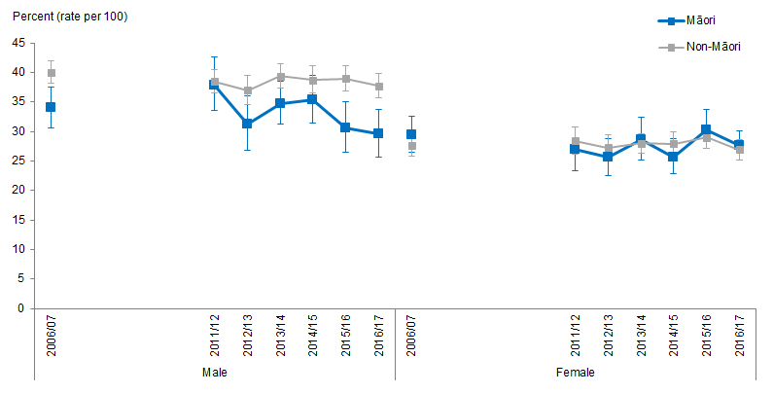
Notes:
Figures are age-standardised to the 2001 Census total Māori population.
Prioritised ethnicity has been used.
If the confidence intervals of two rates do not overlap, the difference in rates is said to be statistically significant.
Source: New Zealand Health Survey (NZHS), Ministry of Health, 2006/07–2016/17.

The prevalence of being overweight declined slightly overtime for Māori adults aged 15 and over, particularly for Māori males (a decrease of 13 percent from 2006/07 to 2016/17 for Māori males). Figure 15 shows that Māori males were less likely than non-Māori males to be overweight over time. Māori and non-Māori females had similar prevalence of being overweight.

Figure 16: Obese, 15+ years, by gender, Māori and non-Māori, 2006/07–2016/17
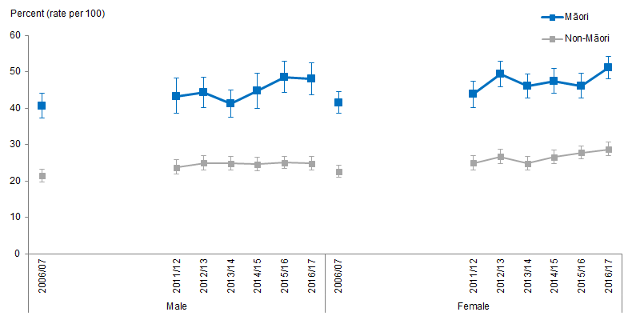
Notes:
Figures are age-standardised to the 2001 Census total Māori population.
Prioritised ethnicity has been used.
If the confidence intervals of two rates do not overlap, the difference in rates is said to be statistically significant.
Source: New Zealand Health Survey (NZHS), Ministry of Health, 2006/07–2016/17.

Figure 16 shows that the prevalence of being obese has increased slightly over time. In 2016/17, 50 percent of Māori adults were obese compared with 27 percent of non-Māori adults. In 2006/07, 41 percent of Māori were obese compared with 22 percent of non-Māori. Māori adults were over 1½ times as likely to be obese as non-Māori adults, this difference remaining consistent between 2006/07 and 2016/17.

Mean BMI scores show little change overtime for both Māori and non-Māori adults aged 15 and over. Māori adults had a mean BMI score of around 30 kg/m² over the time period compared with around 27 kg/m² for non-Māori adults. There was little difference by gender.

There is similarly little substantial change over time when looking at waist measurement, Māori waist measurement increased slightly from 93.6 cm in 2006/07 to 96.6 cm in 2016/17 (compared with 87.8 cm and 89.5 cm for non-Māori).

Body size for children aged 2–14 years
Figure 17: Obese, 2–14 years, by gender, Māori and non-Māori, 2006/07–2016/17
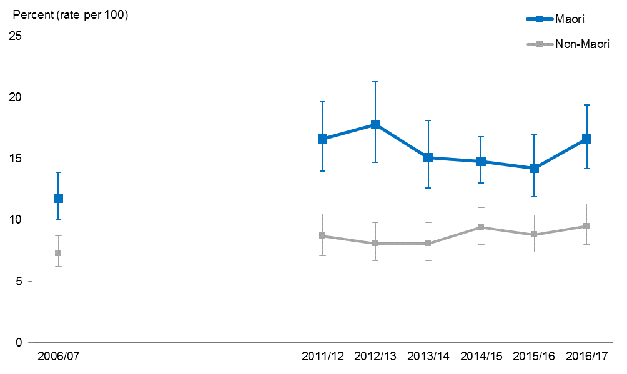
Notes:
Figures are age-standardised to the 2001 Census total Māori population.
Prioritised ethnicity has been used.
If the confidence intervals of two rates do not overlap, the difference in rates is said to be statistically significant.
Source: New Zealand Health Survey (NZHS), Ministry of Health, 2006/07–2016/17.

Māori children aged 2–14 years were more likely to be overweight than non-Māori children over the time period 2006/07 to 2016/17. In 2016/17 Māori children were over 1½ times as likely to be overweight as non-Māori children, these differences were consistent over time.

The prevalence of being obese has fluctuated over time for Māori children but overall showed an increase over time from 12 percent recorded as obese in 2006/07 to 17 percent in 2016/17 (compared with 7 percent and 10 percent for non-Māori children). In 2016/17, Māori children were 1.7 times as likely to be obese as non-Māori children.

Māori children had slightly higher mean BMI scores than non-Māori children with little change over time. Over time, Māori children had a mean BMI score of around 19 kg/m² compared with around 18 kg/m² for non-Māori children.

There has been little change in mean waist measurements over time for both Māori and non-Māori children. Māori children had slightly higher mean waist measurements when comparing with non-Māori children, in 2016/17, Māori children had a measurement of 65.7 cm compared with 62.2 cm for non-Māori children.

Physical activity
This section presents results from the New Zealand Health Survey (NZHS) for Māori and non-Māori aged 15 and over for physical activity. This is self-reported behaviour, which may be an underestimate but it is the best data we have. This is useful for exploring changes over time because the survey method hasn’t changed.

What is the data telling us?
Overall the data shows that Māori and non-Māori adults reported similar levels of physical activity over time.

The Ministry of Health recommends that adults aged 18+ years do at least 30 minutes of moderate-intensity physical activity on most if not all days of the week (Ministry of Health 2015a). Regular physical activity is defined in the NZHS as at least 30 minutes of physical activity per day on five or more days of the week.

Māori and non-Māori adults reported similar levels of physical activity over time (Figure 18). Māori males were more likely to be physically active than Māori females.

Figure 18: Regular physical activity, 15+ years, by gender, Māori and non-Māori, 2006/07–2016/17
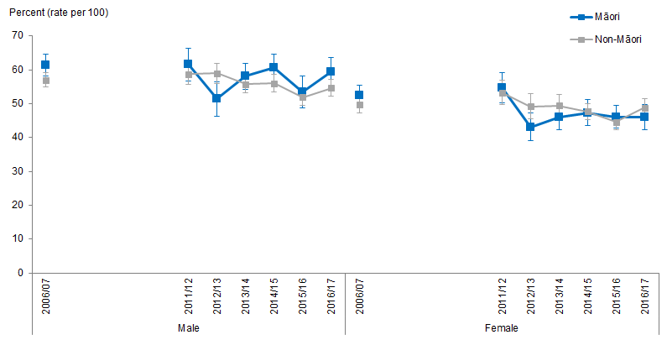
Notes:
Figures are age-standardised to the 2001 Census total Māori population.
Prioritised ethnicity has been used.
If the confidence intervals of two rates do not overlap, the difference in rates is said to be statistically significant.
Source: New Zealand Health Survey (NZHS), Ministry of Health, 2006/07–2016/17.

Gambling
This section presents results for Māori and non-Māori adults aged 15 and over for gambling. Results are shown for the two time periods (2006/07 and 2011/12) that the New Zealand Healthy Survey (NZHS) collected gambling data. This is self-reported behaviour, which may be an underestimate but it is the best data we have.

What is the data telling us?
Overall the data shows that:
- In 2006/07, just over a quarter (28 percent) of Māori adults identified as ‘non-gamblers’ compared with nearly half of all Māori adults in 2011/12 (48 percent).
- Māori and non-Māori adults equally likely to be non-gamblers by 2011/12.
- Of those who had gambled (in the last 12 months at time of survey), Māori adults had higher rates of gambling at low risk, moderate risk and problem level gambling when compared with non-Māori adults.
- There was little difference between Māori and non-Māori in relation to non-problem/recreational gambling in both 2006/07 and 2011/12.
- Māori females are affected more by someone else’s gambling. In 2011/12, Māori females were 2½ times as likely as non-Māori females to report experiencing problems because of someone else’s gambling.

How is problem gambling measured in the NZHS?
Questions on problem gambling have been included in the core 2006/07 NZHS and then in 2011/12 as part of a module on ‘behaviours and risk factors’ when the NZHS moved to operate as a continuous survey comprising of a set of core questions and revolving modules. Questions on problem gambling have not been repeated since 2011/12.

The Problem Gambling Severity Index (PGSI) is a standardised measure of problem gambling (Ferris and Wynne 2001) that was included in both the 2006/07 and 2011/12 NZHS. The PGSI is a nine-item questionnaire that enquires about the following aspects of gambling behaviour over the last 12 months: loss of control; feelings of guilt; chasing losses; problem recognition; criticism; negative effects on health; motivation; financial problems; and borrowing. A final score is calculated and can range from zero through to a maximum of 27, with higher scores being indicative of a greater risk of problematic gambling.

Table 16 outlines the four categories of gambling that people can be grouped under according to PGSI scores.

Table 16: PGSI scores and categorisation
PGSI score | PGSI categorisation | Defining characteristics
0 | Non-problematic / recreational gambling | Gambling with no associated problems or negative impacts
1 or 2 | Low-risk gambling | Low level of problems with few or no identified negative consequences
3 to 7 | Moderate-risk gambling | Moderate level of problems leading to some negative consequences
8 or more | Problem gambling | Problem gambling with negative consequences and a possible loss of control
Source: Rossen 2015.

Gambling indicators
Table 17: Gambling indicators for Māori and non-Māori in 2006/07 and 2011/12
NZHS indicator (percent) | 2006/07 |  | 2011/12
 | Māori | Non-Māori | Māori | Non-Māori
Non-gambler | 28.1  (CI 26.2–30.1) | 37.6  (CI 36.2–39.1) | 48.3  (CI 45.0–51.7) | 51.1  (49.1–53.1)
Non-problematic/  recreational gambling | 60.0  (CI 58.0–61.9) | 57.7  (CI 56.2–59.1) | 44.8  (CI 41.7–48.0) | 46.0  (CI 44.1–48.0)
Low-risk gambling | 6.6  (CI 5.6–7.9) | 3.3  (CI 2.9–3.8) | 3.6  (CI 2.8–4.7) | 1.9  (CI 1.5–2.3)
Moderate-risk gambling | 3.5  (CI 2.8–4.4) | 1.1  (CI 0.9–1.4) | 2.7  (CI 1.9–3.6) | 0.7  (CI 0.5–1.0)
Problem gambling* | 1.7  (CI 1.2–0.3) | 0.3  (CI 0.2–0.5) | 0.5  (CI 0.3–0.9) | 0.2  (CI 0.1–0.4)
Notes:
Figures are age-standardised to the 2001 Census total Māori population.
Prioritised ethnicity has been used.
If the confidence intervals of two rates do not overlap, the difference in rates is said to be statistically significant.
* Findings should be treated with caution due to the small numbers in the problem gambling category.
Source: New Zealand Health Survey (NZHS), Ministry of Health, 2006/07 and 2011/12.

Increased proportions of Māori adults aged 15 and over were classified as ‘non-gamblers’ in 2011/12 than in 2006/07 (48 percent in 2011/12 compared with 28 percent in 2006/07).

In 2011/12, Māori and non-Māori were equally as likely to be non-gamblers – whereas in 2006/07 Māori were less likely to be non-gamblers than non-Māori (Table 17).

Of those who had gambled (in the last 12 months at time of survey), Māori adults had higher rates of gambling at low risk, moderate risk and problem level gambling when compared with non-Māori adults. Māori were over three times as likely as non-Māori to report moderate-risk gambling and around twice as likely to report low-risk gambling in both 2006/07 and 2011/12.

There was little difference between Māori and non-Māori in relation to non-problem/recreational gambling in both 2006/07 and 2011/12.

Experiencing problems because of someone else’s gambling
Greater proportions of Māori adults experience negative impacts from someone else’s gambling than non-Māori adults. There is little change evident between 2006/07 and 2011/12. In 2011/12, 6 percent of Māori adults reported experiencing problems because of someone else’s gambling compared with 2 percent of non-Māori adults (7 percent and 3 percent respectively in 2006/07).

Māori females are disproportionately affected by someone else’s gambling: Māori females were over three times as likely as non-Māori females to report experiencing problems because of someone else’s gambling in 2006/07 and around 2½ times in 2011/12.

The publication Gambling and Problem Gambling: Results of the 2011/12 New Zealand Health Survey (Rossen 2015) also provides an analysis of the 2011/12 NZHS gambling indicators and can be accessed from: www.health.govt.nz/system/files/documents/publications/gambling-results-of-the-201112-nzhs.pdf

Health status indicators

Major causes of death
This section presents the trends of the major causes of death for Māori and non-Māori males and females.

The major causes of death are ranked using two methods, first by age-standardised mortality rates and then by years of life lost (YLL).

Age-standardised rates account for the differences in the population structure between Māori and non-Māori.

Years of life lost (YLL) measures health loss from early death, taking into account the age that a death occurred. A death that occurs at a young age has a higher weighting than a death that occurs at an older age. YLLs are calculated with reference to a standard life expectancy at each age.

The data describing trends in time for major causes of death is presented in comparative tables. These tables use abbreviations to refer to different causes of death and therefore a key is provided below to aid in interpretation (Table 18).

Table 18: Key for major causes of death
Abbreviation | Cause of death
BC | Breast Cancer
CC | Colorectal Cancer
CD | Cerebrovascular Disease (Stroke)
CPD | Chronic Obstructive Pulmonary Disease
DI | Diabetes
HD | Other Heart Diseases (excluding Ischaemic)
IHD | Ischaemic Heart Disease
LC | Lung Cancer
LRD | Chronic Lower Respiratory Disease
MV | Motor Vehicle Accidents
SU | Suicide

Major causes of death, Māori and non-Māori males, 1996–2014
Table 19: Major causes of death, ranked by age-standardised mortality rates, Māori and non-Māori males, 1996–2014
 | Ranking | Year
 |  | 1996–98 | 1997–99 | 1998-00 | 1999–01 | 2000-02 | 2001–03 | 2002-04 | 2003-05 | 2004-06 | 2005–07 | 2006–08 | 2007–09 | 2008–10 | 2009–11 | 2010–12 | 2011–13 | 2012–14
Māori | 1 | IHD | IHD | IHD | IHD | IHD | IHD | IHD | IHD | IHD | IHD | IHD | IHD | IHD | IHD | IHD | IHD | IHD
 | 2 | LC | LC | LC | LC | LC | LC | LC | LC | LC | LC | LC | LC | LC | LC | LC | LC | LC
 | 3 | HD | DI | DI | DI | DI | DI | DI | DI | DI | DI | DI | DI | DI | DI | SU | SU | HD
 | 4 | MV | HD | HD | HD | HD | HD | MV | MV | MV | MV | MV | MV | MV | SU | DI | DI | SU
 | 5 | DI | MV | MV | MV | MV | MV | SU | SU | SU | SU | SU | CPD | CPD | MV | MV | HD | DI
Non-Māori | 1 | IHD | IHD | IHD | IHD | IHD | IHD | IHD | IHD | IHD | IHD | IHD | IHD | IHD | IHD | IHD | IHD | IHD
 | 2 | SU | SU | SU | SU | SU | SU | SU | SU | SU | SU | SU | SU | SU | SU | SU | SU | SU
 | 3 | LC | LC | CD | CD | CD | LC | LC | LC | LC | LC | LC | LC | LC | LC | LC | LC | LC
 | 4 | CD | CD | LC | LC | MV | CD | CD | CD | CD | CD | CD | MV | MV | CD | CD | CD | CD
 | 5 | MV | MV | MV | MV | LC | MV | MV | MV | MV | MV | MV | CD | CD | MV | MV | CC | CC
Notes:
Figures are age-standardised to the 2001 Census total Māori population.
Prioritised ethnicity has been used.
Source: Mortality Collection Data Set (MORT), Ministry of Health, 1996–2014.

Table 19 shows the leading causes of death for Māori and non-Māori males between 1996–98 and 2012–14, ranked by age-standardised mortality rates.

The leading cause of death, ranked by age-standardised mortality rates, for Māori and non-Māori males between 1996–98 and 2012–14 was ischaemic heart disease (IHD).

The second leading cause of death, ranked by age-standardised mortality rates, for Māori males between 1996–98 and 2012–14 was lung cancer (LC).

Suicide (SU) was the second leading cause for non-Māori males from 1996–98 to
2012–14.

Diabetes (DI) and other heart diseases (HD) frequently occurred in the five major causes for Māori males between 1996–98 and 2012–14 but neither featured in the five major causes for non-Māori males.

Cerebrovascular disease (stroke (CD)) was a common feature in the five leading causes of death for non-Māori males but did not feature in the five leading causes of death for Māori males between 1996–98 and 2012–14.

Table 20: Major causes of death, ranked by years of life lost (YLL), Māori and non-Māori males, 1996–2014
 | Ranking | Year
 |  | 1996–98 | 1997–99 | 1998-00 | 1999–01 | 2000-02 | 2001–03 | 2002-04 | 2003-05 | 2004-06 | 2005–07 | 2006–08 | 2007–09 | 2008–10 | 2009–11 | 2010–12 | 2011–13 | 2012–14
Māori | 1 | IHD | IHD | IHD | IHD | IHD | IHD | IHD | IHD | IHD | IHD | IHD | IHD | IHD | IHD | IHD | IHD | IHD
 | 2 | MV | MV | MV | MV | MV | MV | MV | MV | MV | MV | MV | MV | MV | LC | SU | SU | LC
 | 3 | SU | SU | SU | SU | SU | SU | SU | SU | SU | SU | SU | LC | LC | SU | LC | LC | SU
 | 4 | LC | LC | LC | LC | LC | LC | LC | LC | LC | LC | DI | SU | SU | MV | MV | DI | HD
 | 5 | HD | DI | DI | DI | DI | DI | DI | DI | DI | DI | HD | DI | DI | DI | DI | HD | DI
Non-Māori | 1 | IHD | IHD | IHD | IHD | IHD | IHD | IHD | IHD | IHD | IHD | IHD | IHD | IHD | IHD | IHD | IHD | IHD
 | 2 | LC | LC | LC | LC | CD | LC | LC | LC | LC | LC | LC | LC | LC | LC | LC | LC | LC
 | 3 | CD | CD | CD | CD | LC | CD | CD | CD | CD | CD | CD | CD | CD | CD | CD | CD | CD
 | 4 | SU | SU | SU | SU | SU | SU | SU | SU | SU | SU | SU | SU | SU | SU | SU | SU | SU
 | 5 | CC | CC | CC | CC | CC | CPD | CPD | CC | CC | CC | CC | CC | CC | CC | CC | CC | CC
Note: Prioritised ethnicity has been used.
Source: Mortality Collection Data Set (MORT), Ministry of Health, 1996–2014.

Table 20 shows the ranking of the major causes of premature death, ranked by years of life lost, for Māori and non-Māori males between 1996–98 and 2012–14.

The leading cause of premature death, ranked by years of life lost, for Māori and non-Māori males was ischaemic heart disease between 1996–98 and 2012–14.

Motor vehicle accidents were the second leading cause of premature death, ranked by years of life lost, for Māori males between 1996–98 and 2008–10.

Lung cancer was the second leading cause of premature death, ranked by years of life lost, for non-Māori males between 1996–98 and 2012–14.

Motor vehicle accidents and diabetes frequently occurred in the five leading causes of premature death, ranked by years of life lost, for Māori males but did not feature in the five leading causes of premature death, ranked by years of life lost, for non-Māori males.

Cerebrovascular disease (stroke) and colorectal cancer (CC) frequently occurred in the five leading causes of premature death, ranked by years of life lost, for non-Māori males between 1996–98 and 2012–14. However, these did not feature in the leading causes of premature death, ranked by years of life lost, for Māori males.

Major causes of death, Māori and non-Māori females, 1996–2014
Table 21: Major causes of death, ranked by age-standardised mortality rates, Māori and non-Māori females, 1996–2014
 | Ranking | Year
 |  | 1996–98 | 1997–99 | 1998-00 | 1999–01 | 2000-02 | 2001–03 | 2002-04 | 2003-05 | 2004-06 | 2005–07 | 2006–08 | 2007–09 | 2008–10 | 2009–11 | 2010–12 | 2011–13 | 2012–14
Māori | 1 | IHD | IHD | IHD | IHD | IHD | IHD | IHD | IHD | IHD | IHD | IHD | IHD | IHD | IHD | LC | LC | LC
 | 2 | LC | LC | LC | LC | LC | LC | LC | LC | LC | LC | LC | LC | LC | LC | IHD | IHD | IHD
 | 3 | DI | DI | DI | CD | CD | DI | DI | DI | CPD | CPD | CPD | CPD | CPD | CPD | CPD | CPD | CPD
 | 4 | CD | CD | CD | DI | DI | CD | CPD | CPD | CD | DI | BC | CD | CD | CD | CD | BC | BC
 | 5 | BC | BC | BC | BC | CPD | CPD | CD | CD | DI | CD | DI | DI | BC | BC | DI | CD | CD
Non-Māori | 1 | IHD | IHD | IHD | IHD | IHD | IHD | IHD | IHD | IHD | IHD | IHD | IHD | IHD | IHD | IHD | IHD | IHD
 | 2 | BC | BC | BC | CD | CD | CD | CD | BC | BC | BC | BC | BC | BC | BC | BC | BC | BC
 | 3 | CD | CD | CD | BC | BC | BC | BC | CD | CD | CD | CD | CD | CD | CD | CD | CD | CD
 | 4 | CC | CC | CC | LRD | CC | LC | LC | LC | LC | LC | LC | LC | LC | LC | LC | LC | LC
 | 5 | LC | LRD | LRD | CC | LRD | LRD | LRD | CC | CC | CC | CC | CC | LRD | CC | CC | CC | CC
Notes:
Figures are age-standardised to the 2001 Census total Māori population.
Prioritised ethnicity has been used.
Source: Mortality Collection Data Set (MORT), Ministry of Health, 1996–2014.

Table 21 shows the ranking of major causes of death by age-standardised mortality rate for Māori and non-Māori females between 1996–98 and 2012–14 as recorded in the Mortality Collection Dataset.

The leading cause of death, ranked by age-standardised mortality rates, for Māori females was ischaemic heart disease between 1996–98 and 2009–11. Lung cancer was the leading cause of death for Māori females between 2010–12 and 2012–14.

The second leading cause of death for Māori females was lung cancer between
1996–98 and 2009–11. Ischaemic heart disease was the second leading cause of death for Māori females between 2010–12 and 2012–14.

Ischaemic heart disease was the leading cause of death for non-Māori females between 1996–98 and 2012–14.

Breast cancer (BC) was the second leading cause of death for non-Māori females between 1996–98 and 1998-00 and again between 2003-05 and 2012–14. Cerebrovascular disease (stroke) was the second leading cause for non-Māori females between 1999–01 and 2002-04.

Diabetes and chronic obstructive pulmonary disease (CPD) occurred frequently in the five major causes of death for Māori females, but neither featured in the five major causes of death for non-Māori females between 1996–98 and 2012–14.

Chronic lower respiratory disease (LRD) and colorectal cancer occurred frequently in the five major causes of death for non-Māori females but did not feature in the five major causes of death for Māori females between 1996–98 and 2012–14.

Every featured major cause of death, when ranked by age-standardised mortality rates, for Māori and non-Māori females were chronic diseases.

Table 22: Major causes of death, ranked by years of life lost (YLL), Māori and non-Māori females, 1996–2014
 | Ranking | Year
 |  | 1996–98 | 1997–99 | 1998-00 | 1999–01 | 2000-02 | 2001–03 | 2002-04 | 2003-05 | 2004-06 | 2005–07 | 2006–08 | 2007–09 | 2008–10 | 2009–11 | 2010–12 | 2011–13 | 2012–14
Māori | 1 | IHD | IHD | IHD | IHD | IHD | IHD | IHD | IHD | IHD | IHD | IHD | LC | LC | LC | LC | LC | LC
 | 2 | LC | LC | LC | LC | LC | LC | LC | LC | LC | LC | LC | IHD | IHD | IHD | IHD | IHD | IHD
 | 3 | BC | BC | BC | BC | BC | BC | BC | BC | BC | BC | BC | BC | BC | BC | BC | BC | BC
 | 4 | MV | MV | DI | DI | CD | DI | DI | DI | DI | DI | CPD | CPD | CPD | CD | CPD | CPD | CPD
 | 5 | DI | DI | MV | CD | DI | CD | CD | CPD | CPD | CPD | DI | DI | CD | CPD | DI | CD | CD
Non-Māori | 1 | IHD | IHD | IHD | IHD | IHD | IHD | IHD | IHD | IHD | IHD | IHD | IHD | IHD | IHD | IHD | IHD | IHD
 | 2 | CD | CD | CD | CD | CD | CD | CD | CD | CD | CD | CD | CD | CD | CD | CD | CD | CD
 | 3 | BC | BC | BC | BC | BC | BC | BC | BC | BC | BC | BC | BC | BC | BC | BC | BC | BC
 | 4 | CC | CC | CC | CC | CC | LC | LC | CC | CC | CC | LC | LC | LC | LC | LC | LC | LC
 | 5 | LC | LC | LC | LC | LC | CC | CC | LC | LC | LC | CC | CC | CC | CC | CC | CC | CC
Note: Prioritised ethnicity has been used.
Source: Mortality Collection Data Set (MORT), Ministry of Health, 1996–2014.

Table 22 shows the ranking of major causes of premature death, based on years of life lost, for Māori and non-Māori females between 1996–98 and 2012–14.

The leading cause of premature death, based on years of life lost, for Māori females was ischaemic heart disease between 1996–98 and 2006–08 and lung cancer from 2007–09 to 2012–14.

The second leading cause of premature death, based on years of life lost, for Māori females was lung cancer between 1996–98 and 2006–08 and ischaemic heart disease from 2007–09 to 2012–14.

The leading cause of premature death, based on years of life lost, for non-Māori females was ischaemic heart disease between 1996–98 and 2012–14.

The second leading cause of premature death, based on years of life lost, for non-Māori females was cerebrovascular disease (stroke) between 1996–98 and
2012–14.

Diabetes and chronic obstructive pulmonary disease frequently occurred in the five leading causes of premature death for Māori females between 1996–98 and 2012–14 but did not occur in the leading causes of premature death for non-Māori.

Colorectal cancer occurred frequently in the five leading causes of premature death for non-Māori females between 1996–98 and 2012–14 but did not occur in the leading causes of premature death for Māori.

Cardiovascular disease
Cardiovascular disease is the leading cause of death both globally, and within New Zealand for both the Māori and non-Māori populations, contributing to many hospitalisations. This section presents the trends related to cardiovascular disease mortality and hospitalisation rates over time for Māori and non-Māori adults aged 35+ years.

Hospitalisation and proceedure rates are an important indicator of both access to health care and the burden of a disease on a population. The rates help to describe the use of health care resources, and inform on areas of improvement, particularly on preventable disease such as some cardioascular diseases.

In 1996, hospitalisation data began collecting multiple responses for ethnicity data, hence this is the start date of our analysis to ensure a valid time series analysis.

What is the data telling us?
Mortality
Overall the data shows that between 1996–98 and 2012–14, for adults aged 35+ years:
- Mortality rates for both Māori and non-Māori in all cardiovascular disease indicators have been decreasing over time, often by more than 50 percent.
- Mortality rates in all cardiovascular disease indicators were higher for Māori compared with non-Māori, often more than twice as high.
- The difference between Māori and non-Māori age-standardised heart failure mortality rates reduced by over 50 percent between 1996–98 and 2012–14. However, rates for Māori remain more than four times as high as those for non-Māori.
- Between 1996–98 and 2012–14, heart failure and ischaemic heart disease mortality rates reduced by over 50 percent for both Māori and non-Māori.
- Between 1996–98 and 2012–14, total cardiovascular mortality rates reduced by 50 percent for Māori males and females, while rates reduced by 52 percent for non-Māori males and by 47 percent for non-Māori females.
Overall the data shows that between 1996–98 and 2012–14, for adults aged 15+ years:
- The largest differences between Māori and non-Māori rates were for chronic rheumatic heart disease, where rates for both Māori males and females were more than four times as high as those for non-Māori males and females.
Hospitalisation
Overall the data shows that between 1996–98 and 2014–16, for adults aged 35+ years:
- Māori males had higher rates of hospitalisation due to total cardiovascular disease compared with non-Māori males, as did Māori females compared with non-Māori females.
- Both Māori males and females, compared with non-Māori males and females, had higher rates of hospitalisation due to cerebrovascular disease (stroke), heart failure, chronic rheumatic heart disease, and ischaemic heart disease.
- Māori females also had higher rates of hospitalisation due all revascularisation heart disease procedures and coronary angioplasty procedures than non-Māori females.
- Perhaps the largest differences between Māori and non-Māori rates were for heart failure hospitalisations, where rates for both Māori males and females were more than four times as high as those for non-Māori males and females.
- Cerebrovascular disease (stroke) rates of hospitalisation rates for Māori females were twice as high as those for non-Māori females.
Overall the data shows that between 1996–98 and 2014–16, for adults aged 15+ years:
- Māori females had higher rates of chronic rheumatic heart disease than both Māori males and non-Māori males and females, with Māori female rates four to five times as high as those of non-Māori females. Māori male rates were three to four times as high as those of non-Māori males.

Total cardiovascular disease
Total cardiovascular disease is also referred to as diseases of the circulatory system (ICD 10 chapter IX, I00–I99) which includes but is not limited to: acute rheumatic fever, chronic rheumatic heart disease, ischaemic heart disease, heart failure, and cerebrovascular disease (stroke).

Figure 19: Total cardiovascular disease mortality rates, 35+ years, by gender, Māori and non-Māori, 1996–98 to 2012–14
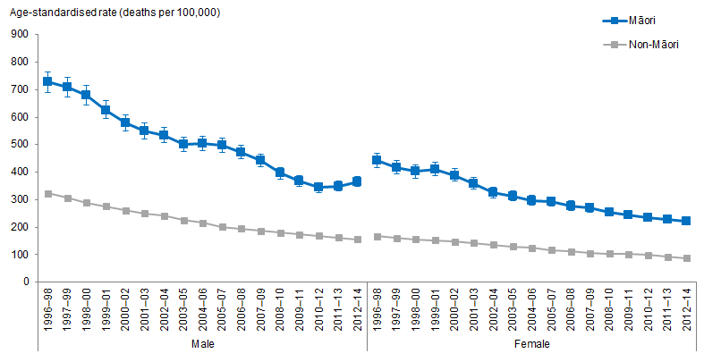
Notes:
Figures are age-standardised to the 2001 Census total Māori population.
Prioritised ethnicity has been used.
If the confidence intervals of two rates do not overlap, the difference in rates is said to be statistically significant.
Source: Mortality Collection Data Set (MORT), Ministry of Health, 1996–98 to 2012–14.

Figure 19 shows that Māori males and females aged 35+ years have higher age-standardised total cardiovascular disease mortality rates compared with non-Māori males and females.

Total cardiovascular disease mortality rates have decreased
Between 1996–98 and 2012–14 age-standardised total cardiovascular disease mortality rates decreased for Māori and non-Māori males and females.

Age-standardised rates for Māori males decreased by 50 percent (from 728 to 365 deaths per 100,000), while rates for non-Māori males decreased by 52 percent (from 323 to 156 deaths per 100,000). For females, the decrease was higher for Māori females than for non-Māori females. Between 1996–98 and 2012–14, the rate for Māori females decreased 50 percent (from 442 to 221 deaths per 100,000), whereas the decrease for non-Māori women was 47 percent (from 167 to 88 deaths per 100,000).

The difference between Māori and non-Māori total cardiovascular disease mortality rates has decreased
Between 1996–98 and 2012–14, the difference between Māori and non-Māori male total cardiovascular disease mortality rates decreased by 48 percent, reducing from 404 per 100,000 (the difference in 1996–98) to 210 per 100,000 (the difference in
2012–14). Similarly, for females the difference between Māori and non-Māori mortality rates decreased by 52 percent (from 275 per 100,000 in 1996–98 to 133 per 100,000 in 2012–14).

The difference between Māori and non-Māori age-standardised total cardiovascular disease mortality rates halved between 1996–98 and 2012–14, however, rates for Māori remain more than twice as high as those for non-Māori.

Figure 20: Total cardiovascular disease hospitalisation rates, 35+ years, by gender, Māori and non-Māori, 1996–98 to 2014–16
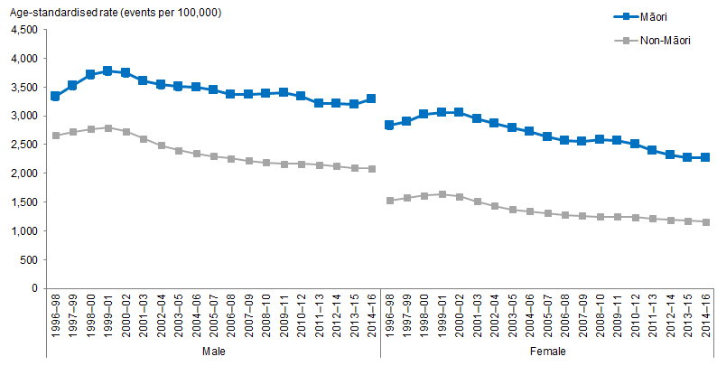
Notes:
Figures are age-standardised to the 2001 Census total Māori population.
Prioritised ethnicity has been used.
If the confidence intervals of two rates do not overlap, the difference in rates is said to be statistically significant.
Source: National Minimum Data Set (NMDS), Ministry of Health, 1996–98 to 2014–16.

Figure 20 shows that Māori males and females aged 35+ years have higher age-standardised rates of hospitalisations due to all cardiovascular diseases compared with non-Māori males and females.

Hospitalisation rates due to total cardiovascular diseases have decreased
Overall, between 1996–98 and 2014–16, age-standardised rates of hospitalisations due to total cardiovascular diseases decreased for males and females. Hospitalisation rates due to total cardiovascular disease increased from 1996–98 to 1999–01 then decreased to 2014–16.

Between 1996–98 and 2014–16, age-standardised rates for non-Māori males decreased by 22 percent (from 2,659 to 2,082 hospitalisations per 100,000), more than for Māori males which decreased by 2 percent (from 3,341 to 3,285 hospitalisations per 100,000). For females, the rate of hospitalisations per 100,000 for Māori females decreased by 20 percent (from 2,831 to 2,272 hospitalisations per 100,000), whereas the decrease for non-Māori women was 24 percent (from 1,525 to 1,161 hospitalisations per 100,000).

The difference between Māori and non-Māori total cardiovascular disease hospitalisation rates increased for males, and decreased for females
Between 1996–98 and 2014–16, the difference between Māori and non-Māori age-standardised rates of hospitalisations due to all cardiovascular diseases rates increased for males and decreased for females. Rates for Māori males increased to be 1.5 times as high as those of non-Māori males. For females, Māori female rates remain twice as high as non-Māori female rates.

Between 1996–98 and 2014–16, the difference between Māori and non-Māori male total cardiovascular disease hospitalisation rates increased by 77 percent, increasing from 682 hospitalisations per 100,000 (the difference in 1996–98) to 1,203 hospitalisations per 100,000 (the difference in 2014–16). For females, the difference between Māori and non-Māori hospitalisation rates decreased by 15 percent (from 1,306 per 100,000 in 1996–98 to 1,111 per 100,000 in 2014–16).

Cerebrovascular disease (stroke)
Figure 21: Cerebrovascular disease (stroke) mortality rates, 35+ years, by gender, Māori and non-Māori, 1996–98 to 2012–14
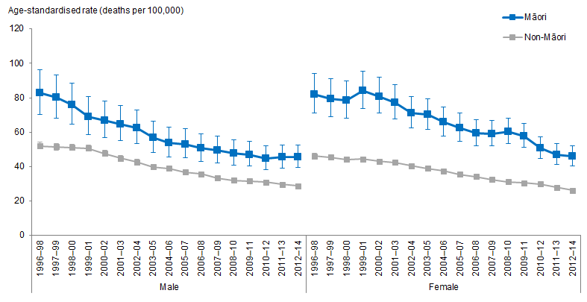
Notes:
Figures are age-standardised to the 2001 Census total Māori population.
Prioritised ethnicity has been used.
If the confidence intervals of two rates do not overlap, the difference in rates is said to be statistically significant.
Source: Mortality Collection Data Set (MORT), Ministry of Health, 1996–98 to 2012–14.

Figure 21 shows that Māori males and females aged 35+ years have higher age-standardised stroke mortality rates compared with non-Māori males and females.

Stroke mortality rates have decreased
Overall, between 1996–98 and 2012–14 age-standardised stroke mortality rates for Māori and non-Māori males and females decreased by around 45 percent.

Between 1996–98 and 2012–14, the decrease in age-standardised rates for stroke was greater for Māori males than for non-Māori males. For Māori males, the decrease was 37 (from 83 to 46) deaths per 100,000, compared with 23 (from 52 to 29) deaths per 100,000 for non-Māori males. For females, the decrease in rates was also higher for Māori females than non-Māori females. The decrease for Māori females was 36 (from 82 to 46) deaths per 100,000, whereas the decrease for non-Māori females was 20 (from 46 to 26) deaths per 100,000.

The difference between Māori and non-Māori stroke mortality rates has decreased
The difference between Māori and non-Māori age-standardised stroke mortality rates decreased by 44 percent between 1996–98 and 2012–14. However, rates for Māori males remain 1.5 times as high as those for non-Māori males, and rates for Māori females remain 1.8 times as high as for Māori females as those for non-Māori females.

Between 1996–98 and 2012–14, the difference between Māori and non-Māori male stroke mortality rates decreased by 44 percent, reducing from 31 per 100,000 (the difference in 1996–98) to 17 per 100,000 (the difference in 2012–14). For females, the difference between Māori and non-Māori mortality rates also decreased by 44 percent (from 36 per 100,000 in 1996–98 to 20 per 100,000 in 2012–14).

Figure 22: Cerebrovascular disease (stroke) hospitalisation rates, 35+ years, by gender, Māori and non-Māori, 1996–98 to 2014–16
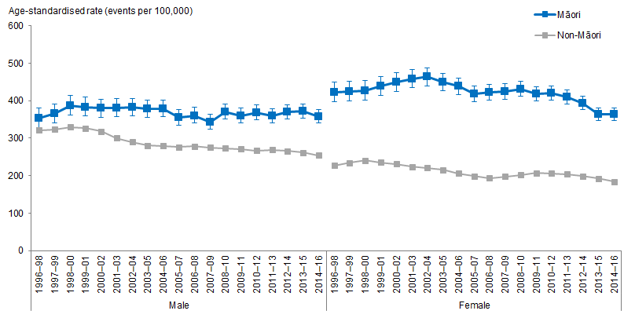
Notes:
Figures are age-standardised to the 2001 Census total Māori population.
Prioritised ethnicity has been used.
If the confidence intervals of two rates do not overlap, the difference in rates is said to be statistically significant.
Source: National Minimum Data Set (NMDS), Ministry of Health, 1996–98 to 2014–16.

Figure 22 shows that Māori males and females aged 35+ years have higher age-standardised rates of hospitalisations due to stroke compared with their non-Māori counterparts.

Hospitalisation rates due to stroke have decreased
Overall, between 1996–98 and 2014–16 age-standardised rates of hospitalisations due to stroke for Māori males did not change much, and rates for Māori females and non-Māori males and females decreased.

Between 1996–98 and 2014–16, age-standardised rates for Māori males increased by 1 percent (from 353 to 358 hospitalisations per 100,000) and rates for non-Māori males decreased by 21 percent (from 321 to 254 hospitalisations per 100,000). For females, the rate of hospitalisations per 100,000 for Māori females decreased by 14 percent (from 422 to 363 hospitalisations per 100,000), whereas the decrease for non-Māori women was 19 percent (from 226 to 184 hospitalisations per 100,000).

The difference between Māori and non-Māori stroke hospitalisation rates increased for males, and decreased for females
Between 1996–98 and 2014–16, the difference between Māori and non-Māori age-standardised rates of hospitalisations due to stroke more than doubled for males and decreased for females. Rates for Māori males increased to be nearly 1.5 times as high as those of non-Māori males. For females, Māori rates remain twice as high as non-Māori rates.

Between 1996–98 and 2014–16, the difference between Māori and non-Māori male stroke hospitalisation rates increased by 225 percent, increasing from 32 hospitalisations per 100,000 (the difference in 1996–98) to 104 hospitalisations per 100,000 (the difference in 2014–16). For females, the difference between Māori and non-Māori hospitalisation rates decreased by 9 percent (from 196 per 100,000 in
1996–98 to 179 per 100,000 in 2014–16).

Heart failure
Figure 23: Heart failure mortality rates, 35+ years, by gender, Māori and non-Māori, 1996–98 to 2012–14
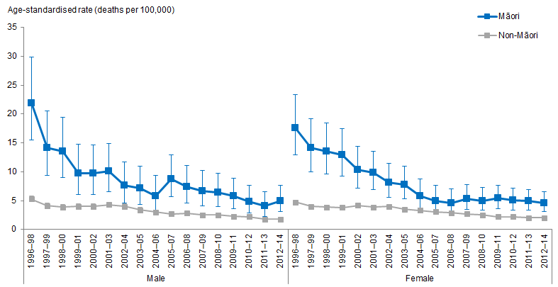
Notes:
Figures are age-standardised to the 2001 Census total Māori population.
Prioritised ethnicity has been used.
If the confidence intervals of two rates do not overlap, the difference in rates is said to be statistically significant.
Source: Mortality Collection Data Set (MORT), Ministry of Health, 1996–98 to 2012–14.

Figure 23 shows that Māori males and females aged 35+ years have higher age-standardised heart failure mortality rates compared with non-Māori males and females.

Heart failure mortality rates have decreased
Between 1996–98 and 2012–14, age-standardised heart failure mortality rates decreased more for Māori males than for non-Māori males, likewise for Māori females than for non-Māori females.

For Māori males, the rate of deaths per 100,000 due to heart failure decreased by 77 percent (from 22 to 5 deaths per 100,000), whereas the decrease for non-Māori males was by 66 percent (from 5 to 2 deaths per 100,000). For Māori females, the rate of deaths per 100,000 due to heart failure decreased by 74 percent (from 18 to 5 deaths per 100,000), whereas the decrease for non-Māori females was by 57 percent (from 5 to 2 deaths per 100,000).

The difference between Māori and non-Māori heart failure mortality rates has decreased
The difference between Māori and non-Māori age-standardised heart failure mortality rates decreased by around 80 percent between 1996–98 and 2012–14. However, rates for Māori remain more than twice as high as those for non-Māori.

Between 1996–98 and 2012–14, the difference between Māori and non-Māori male age-standardised heart failure mortality rates decreased by 81 percent, reducing from 17 per 100,000 (the difference in 1996–98) to 3 per 100,000 (the difference in 2012–14). Similarly, for females the difference between Māori and non-Māori mortality rates decreased by 80 percent (from 13 per 100,000 in 1996–98 to 3 per 100,000 in 2012–14).

Figure 24: Heart failure hospitalisation rates, 35+ years, by gender, Māori and non-Māori, 1996–98 to 2014–16
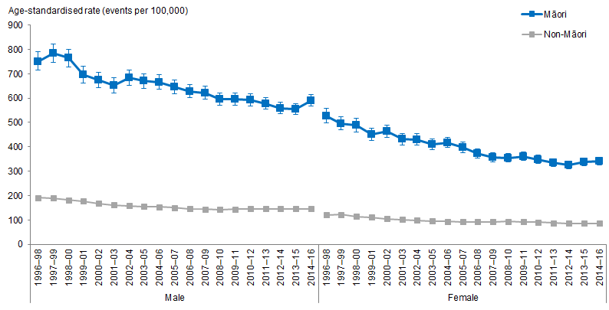
Notes:
Figures are age-standardised to the 2001 Census total Māori population.
Prioritised ethnicity has been used.
If the confidence intervals of two rates do not overlap, the difference in rates is said to be statistically significant.
Source: National Minimum Data Set (NMDS), Ministry of Health, 1996–98 to 2014–16.

Figure 24 shows that Māori males and females aged 35+ years have higher age-standardised rates of hospitalisations due to heart failure compared with non-Māori males and females.

Hospitalisation rates due to heart failure have decreased
Overall, between 1996–98 and 2014–16 age-standardised rates of hospitalisations due to heart failure for Māori and non-Māori decreased.

For Māori males, rates decreased by 21 percent (from 751 to 591 hospitalisations per 100,000), and rates for non-Māori males decreased by 24 percent (from 192 to 145 hospitalisations per 100,000). For females, the decrease was much higher for Māori females than non-Māori females. Between 1996–98 and 2014–16, the rates for Māori females decreased by 35 percent (from 527 to 342 hospitalisations per 100,000), whereas the decrease for non-Māori females was by 29 percent (from 120 to 85 hospitalisations per 100,000).

The difference between Māori and non-Māori heart failure hospitalisation rates decreased for males and females
Between 1996–98 and 2014–16, the difference between Māori and non-Māori age-standardised rates of hospitalisations due to heart failure decreased for males and females. However, rates for Māori males and females remain around four times as high as those of non-Māori males and females.

Between 1996–98 and 2014–16, the difference between Māori and non-Māori male heart failure hospitalisation rates decreased by 20 percent, from 559 hospitalisations per 100,000 (the difference in 1996–98) to 446 hospitalisations per 100,000 (the difference in 2014–16). For females, the difference between Māori and non-Māori hospitalisation rates decreased by 37 percent (from 407 per 100,000 in 1996–98 to 257 per 100,000 in 2014–16).

Chronic rheumatic heart disease
Figure 25: Chronic rheumatic heart disease mortality rates, 15+ years, by gender, Māori and non-Māori, 1996–98 to 2012–14
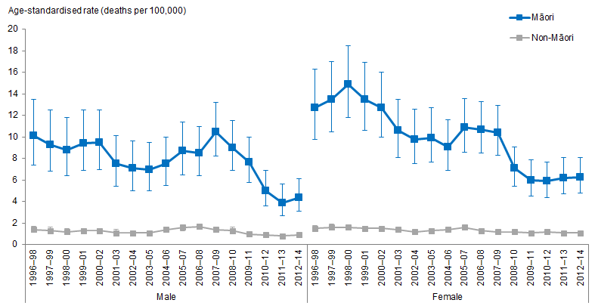
Notes:
Figures are age-standardised to the 2001 Census total Māori population.
Prioritised ethnicity has been used.
If the confidence intervals of two rates do not overlap, the difference in rates is said to be statistically significant.
Source: Mortality Collection Data Set (MORT), Ministry of Health, 1996–98 to 2012–14.

Figure 25 shows that Māori males and females aged 15+ years have higher age-standardised chronic rheumatic heart disease mortality rates to compared with non-Māori males and females.

Chronic rheumatic heart disease mortality rates have decreased
Between 1996–98 and 2012–14, age-standardised chronic rheumatic heart disease mortality rates decreased more for Māori males and females than for non-Māori males and females.

For Māori males, the rate of deaths per 100,000 due to chronic rheumatic heart disease decreased by 50 percent (from 10 to 4 deaths per 100,000). For Māori females, the rate of deaths per 100,000 due to chronic rheumatic heart disease decreased by 56 percent (from 13 to 6 deaths per 100,000). It is important to note that measuring decreases for non-Māori males and females could be misleading as the number of deaths per 100,000 is low for these groups, at around 1 death per 100,000. At these low rates an increase or decrease of just 1 death per 100,000 will correspond to percentage change of 100 percent, which is misleading considering the small change.

The difference between Māori and non-Māori chronic rheumatic heart disease mortality rates has decreased
The difference between Māori and non-Māori age-standardised heart failure mortality rates decreased by over 50 percent between 1996–98 and 2012–14. However, rates for Māori remain more than four times as high as those for non-Māori.

Between 1996–98 and 2012–14, the difference between Māori and non-Māori male age-standardised chronic rheumatic heart disease mortality rates decreased by 60 percent, reducing from 9 per 100,000 (the difference in 1996–98) to 4 per 100,000 (the difference in 2012–14). Similarly, for females the difference between Māori and non-Māori mortality rates decreased by 54 percent (from 11 per 100,000 in 1996–98 to 5 per 100,000 in 2012–14).

Figure 26: Chronic rheumatic heart disease hospitalisation rates, 15+ years, by gender, Māori and non-Māori, 1996–98 to 2014–16
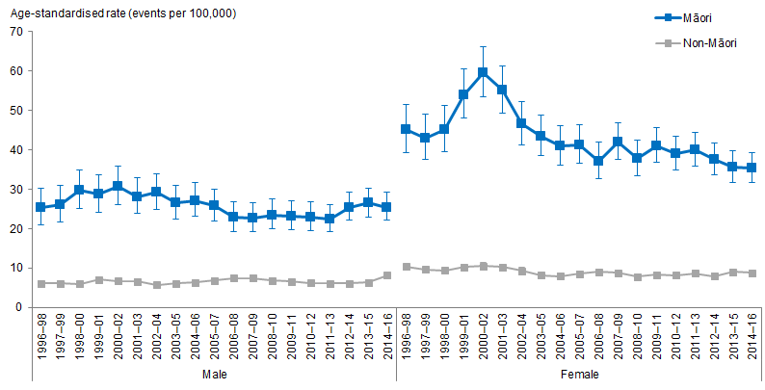
Notes:
Figures are age-standardised to the 2001 Census total Māori population.
Prioritised ethnicity has been used.
If the confidence intervals of two rates do not overlap, the difference in rates is said to be statistically significant.
Source: National Minimum Data Set (NMDS), Ministry of Health, 1996–98 to 2014–16.

Figure 26 shows that Māori males and females aged 15+ years have higher age-standardised rates of hospitalisations due to chronic rheumatic heart disease compared with their non-Māori counterparts.

Hospitalisation rates due to chronic rheumatic heart disease have decreased for Māori females
Overall, between 1996–98 and 2014–16, hospitalisations per 100,000 for Māori females decreased, and rates for Māori males and non-Māori males and females did not change much.

For Māori females, the rate of hospitalisations due to chronic rheumatic heart disease decreased by 22 percent (from 45 to 35 hospitalisations per 100,000). For non-Māori females, and males, the change was by 2 or less hospitalisations per 100,000.

The difference between Māori and non-Māori chronic rheumatic heart disease hospitalisation rates did not change much for males, and decreased for females
Between 1996–98 and 2014–16, the difference between Māori and non-Māori age-standardised rates of hospitalisations due to heart failure did not change much for males, and decreased for females. Rates for Māori males and females and remain more than three times as high as those of non-Māori males and females.

Between 1996–98 and 2014–16, the difference between Māori and non-Māori male chronic rheumatic heart disease hospitalisation rates did not change much, decreasing from 19 hospitalisations per 100,000 (the difference in 1996–98) to 17 hospitalisations per 100,000 (the difference in 2014–16). For females, the difference between Māori and non-Māori hospitalisation rates decreased by 24 percent (from 35 per 100,000 in
1996–98 to 27 per 100,000 in 2014–16).

Ischaemic heart disease
Figure 27: Ischaemic heart disease mortality rates, 35+ years, by gender, Māori and non-Māori, 1996–98 to 2012–14
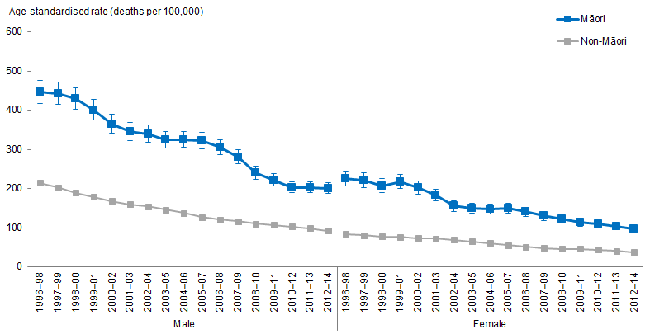
Notes:
Figures are age-standardised to the 2001 Census total Māori population.
Prioritised ethnicity has been used.
If the confidence intervals of two rates do not overlap, the difference in rates is said to be statistically significant.
Source: Mortality Collection Data Set (MORT), Ministry of Health, 1996–98 to 2012–14.

Figure 27 shows that Māori males and females aged 35+ years have higher age-standardised ischaemic heart disease mortality rates compared with non-Māori males and females.

Ischaemic heart disease mortality rates have decreased
Between 1996–98 and 2012–14, ischaemic heart disease mortality rates decreased for Māori and non-Māori males and females by over 50 percent. For Māori males, mortality rates decreased by 55 percent (from 447 to 201 deaths per 100,000). For non-Māori males, rates decreased 57 percent (from 215 to 92 deaths per 100,000). For Māori females, mortality rates decreased by 57 percent (from 226 to 97 deaths per 100,000), and for non-Māori females, rates decreased by 55 percent (from 85 to 38 deaths per 100,000).

The difference between Māori and non-Māori ischaemic heart disease mortality rates has decreased
Between 1996–98 and 2012–14, the difference between Māori and non-Māori male ischaemic heart disease mortality rates halved, reducing from 232 per 100,000 (the difference in 1996–98) to 109 per 100,000 (the difference in 2012–14). Similarly, for females the difference between Māori and non-Māori mortality rates decreased by nearly 60 percent (from 141 per 100,000 in 1996–98 to 59 per 100,000 in 2012–14).

The difference between Māori and non-Māori age-standardised ischaemic heart disease mortality rates have halved between 1996–98 and 2012–14, however, rates for Māori remain twice as high as those for non-Māori.

Figure 28: Ischaemic heart disease hospitalisation rates, 35+ years, by gender, Māori and non-Māori, 1996–98 to 2014–16
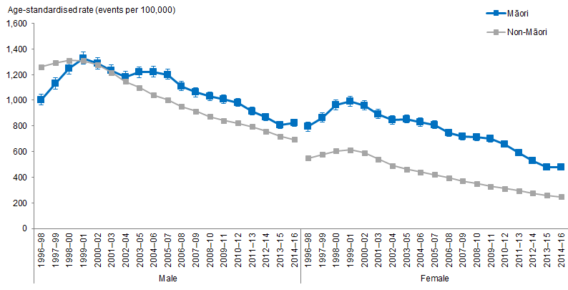
Notes:
Figures are age-standardised to the 2001 Census total Māori population.
Prioritised ethnicity has been used.
If the confidence intervals of two rates do not overlap, the difference in rates is said to be statistically significant.
Source: National Minimum Data Set (NMDS), Ministry of Health, 1996–98 to 2014–16.

Figure 28 shows that Māori males and females aged 35+ years have higher age-standardised rates of hospitalisations due to ischaemic heart disease compared with their non-Māori counterparts.

Hospitalisation rates due to ischaemic heart disease have decreased
Overall, between 1996–98 and 2014–16, ischaemic heart disease hospitalisation rates decreased for Māori and non-Māori. For Māori males, hospitalisation rates decreased by 18 percent (from 1,005 to 825 hospitalisations per 100,000), and for non-Māori males, hospitalisation rates decreased by 45 percent (from 1,261 to 694 hospitalisations per 100,000). For Māori females, hospitalisation rates decreased by 40 percent (from 795 to 476 hospitalisations per 100,000), whereas the decrease for non-Māori women was by 55 percent (from 550 to 248 hospitalisations per 100,000).

The difference between Māori and non-Māori ischaemic heart disease hospitalisation rates decreased for females and increased for males
Between 1996–98 and 2014–16, the difference between Māori and non-Māori male ischaemic heart disease hospitalisation rates increased by 151 percent, from 256 less hospitalisations per 100,000 (the difference in 1996–98) to 131 more hospitalisations per 100,000 (the difference in 2014–16). For females, the difference between Māori and non-Māori hospitalisation rates decreased by 7 percent (from 245 per 100,000 in
1996–98 to 228 per 100,000 in 2014–16).

Between 1996–98 and 2014–16, the difference between Māori and non-Māori age-standardised rates of hospitalisations due to ischaemic heart disease increased for males and decreased for females. Rates for Māori males remain around 1.2 times as high as those of non-Māori males, and rates for Māori females remain around twice those of non-Māori females.

All revascularisation (coronary artery bypass graft (CARB) and angioplasty) heart disease procedures
Figure 29: All revascularisation (coronary artery bypass graft (CARB) and angioplasty) heart disease procedure rates, 35+ years, by gender, Māori and non-Māori, 1996–98 to 2014–16
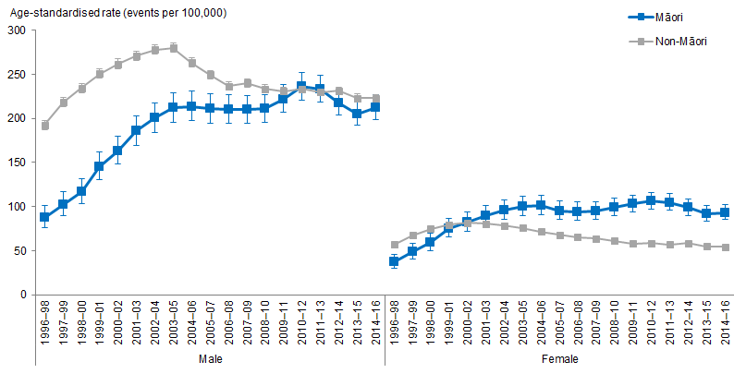
Notes:
Figures are age-standardised to the 2001 Census total Māori population.
Prioritised ethnicity has been used.
If the confidence intervals of two rates do not overlap, the difference in rates is said to be statistically significant.
Source: National Minimum Data Set (NMDS), Ministry of Health, 1996–98 to 2014–16.

Figure 29 shows that between 1996–98 and 2014–16 rates of all revascularisation heart disease procedures increased more for Māori males and females than for non-Māori males and females.

All revascularisation heart disease procedures for Māori have increased
Between 1996–98 and 2014–16, all revascularisation heart disease procedure rates increased for Māori males and females and for non-Māori males. For Māori males, procedure rates increased by 143 percent (from 88 to 212 procedures per 100,000), and for non-Māori males procedures increased by 16 percent (from 192 to 223 procedures 100,000). For females, the rate of procedures for Māori females increased by 150 percent (from 37 to 93 procedures per 100,000) whereas there was a decrease in procedures for non-Māori women by 5 percent (from 57 to 54 procedures per 100,000).

The difference between Māori and non-Māori all revascularisation heart disease procedure rates have decreased for males and increased for females
Between 1996–98 and 2014–16, the difference between Māori and non-Māori male all revascularisation heart disease procedure rates decreased by 90 percent, from 105 less procedures per 100,000 (the difference in 1996–98) to 11 less procedures per 100,000 (the difference in 2014–16). For females, the difference between Māori and non-Māori hospitalisation rates increased by 300 percent (from 20 less procedures per 100,000 in 1996–98 to 39 more procedures per 100,000 in 2014–16).

Over time, the difference between Māori and non-Māori age-standardised rates of all revascularisation heart disease procedure rates decreased for males and increased for females. Rates of procedures are now similar for Māori and non-Māori males. Rates for Māori females are around 1.7 times as high as that for non-Māori females.

All coronary angioplasty procedures (percutaneous)
Figure 30: All coronary angioplasty procedure (percutaneous) rates, 35+ years, by gender, Māori and non-Māori, 1996–98 to 2014–16
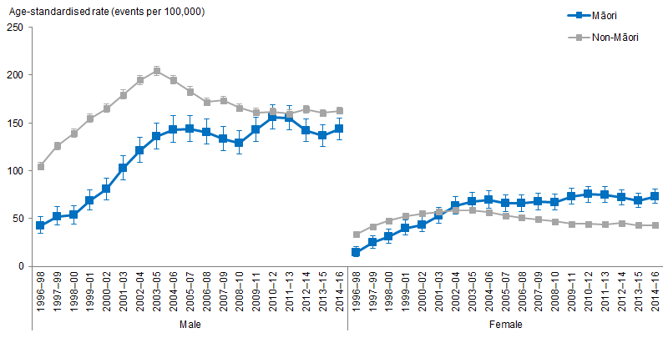
Notes:
Figures are age-standardised to the 2001 Census total Māori population.
Prioritised ethnicity has been used.
If the confidence intervals of two rates do not overlap, the difference in rates is said to be statistically significant.
Source: National Minimum Data Set (NMDS), Ministry of Health, 1996–98 to 2014–16.

Figure 30 shows that between 1996–98 and 2014–16 rates of all coronary angioplasty procedures increased more for Māori males and females than for non-Māori males and females.

All coronary angioplasty procedure rates have increased
Between 1996–98 and 2014–16, all coronary angioplasty procedure rates increased for Māori and non-Māori males and females. For Māori males procedure rates increased by 238 percent (from 42 to 144 procedures per 100,000), and for non-Māori males procedures increased by 56 percent (from 105 to 163 procedures 100,000). For females, the rate of procedures for Māori females increased by 400 percent (from 15 to 73 procedures per 100,000), and the rate of procedures increased by 28 percent (from 32 to 41 procedures per 100,000) for non-Māori females.

The difference between Māori and non-Māori all coronary angioplasty procedure rates have decreased for males and increased for females
Between 1996–98 and 2014–16, the difference between Māori and non-Māori male all revascularisation heart disease procedure rates decreased by 69 percent, from 62 less procedures per 100,000 (the difference in 1996–98) to 19 less procedures per 100,000 (the difference in 2014–16). For females, the difference between Māori and non-Māori hospitalisation rates increased by 259 percent (from 19 less procedures per 100,000 in 1996–98 to 49 more procedures per 100,000 in 2014–16).

Over time, the difference between Māori and non-Māori male age-standardised rates of all coronary angioplasty procedure deceased, and for females, the difference increased. Rates of procedures for Māori males is now close to that of non-Māori males, and rates for Māori females are around 1.7 times as high as for non-Māori females.

Cancer
Cancer is New Zealand’s single biggest cause of death. Many cancers can be cured if they are found and treated in time (Ministry of Health 2019c).

This section presents the trends related to cancer registration and mortality over time for Māori and non-Māori adults aged 25 years and over.

What is the data telling us?
Overall the data shows that:
- Māori adults aged 25 years and over have higher total-cancer registration and total-cancer mortality rates than non-Māori adults in the same age group over time.
- The total-cancer registration and mortality rate differences between Māori females and non-Māori females were greater than the differences between Māori males and non-Māori males.
- Total-cancer registrations have declined for Māori males and remained similar for Māori females between 1996–98 and 2013–15. During this period, the difference between Māori and non-Māori in cancer registrations showed little change.
- Total-cancer mortality has declined steadily for Māori and non-Māori between 1996–98 and 2012–14. The difference between Māori and non-Māori cancer mortality has remained similar during this period.
- The most common cancers registered by Māori males aged 25 years and over was prostate cancer, lung cancer and colorectal cancer, and this has not changed over time.
- The leading cause of cancer death for Māori males aged 25 years and over was lung cancer in 1996–98 and this remained the same in 2012–14.
- The most common cancers registered for Māori females aged 25 years and over in 2013–15 were breast cancer and lung cancer, and this has not changed over time.
- The leading causes of cancer death for Māori females aged 25 years and over in 2012–14 was lung cancer and breast cancer, the top two leading cancer deaths remained the same over time.

Total cancer
Figure 31: Total cancer registration rates, 25+ years, Māori and non-Māori males, 1996–98 to 2013–15
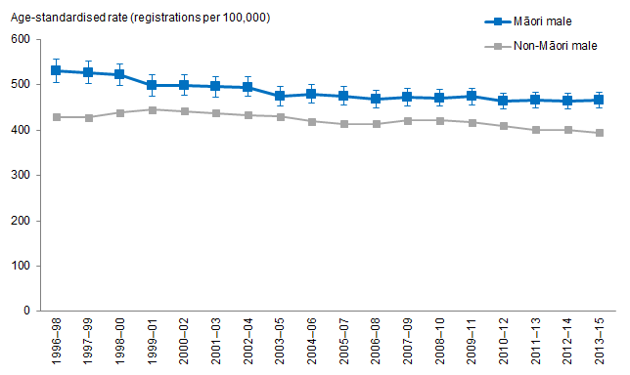
Notes:
Figures are age-standardised to the 2001 Census total Māori population.
Prioritised ethnicity has been used.
If the confidence intervals of two rates do not overlap, the difference in rates is said to be statistically significant.
Source: New Zealand Cancer Registry (NZCR), Ministry of Health, 1996–98 to 2013–15.

Figure 31 shows that, after adjusting for age, Māori males aged 25 years and over have higher total-cancer registration rates than non-Māori males over time.

The total-cancer registration rate decreased over time for Māori males
After adjusting for age, the total-cancer registration rates decreased over time for both Māori and non-Māori males aged 25 years and over.

The age-standardised total-cancer registration rates for Māori males aged 25 years and over decreased by 12 percent, from 530.2 registrations per 100,000 in 1996–98 to 466.0 registrations per 100,000 in 2013–15.

The age-standardised total-cancer registration rates for non-Māori males decreased by 8 percent, from 428.8 registrations per 100,000 in 1996–98 to 394.5 registrations per 100,000 in 2013–15.

The difference in total-cancer registration rates between Māori and non-Māori males decreased over time
The difference in age-standardised total-cancer registration rates between Māori and non-Māori males aged 25 years and over decreased by 29 percent over time. Māori males aged 25 years and over had 101.4 more registrations per 100,000 than non-Māori males in 1996–98, and 71.5 more registrations per 100,000 in 2013–15.

The difference in total-cancer registration rate between Māori and non-Māori males decreased over time. However, the age-standardised total-cancer registration rate among Māori males aged 25 years and over was 24 percent higher than that for non-Māori males in the same age group in 1996–98, and 18 percent higher in 2013–15.

Figure 32: Total cancer registration rates, 25+ years, Māori and non-Māori females, 1996–98 to 2013–15
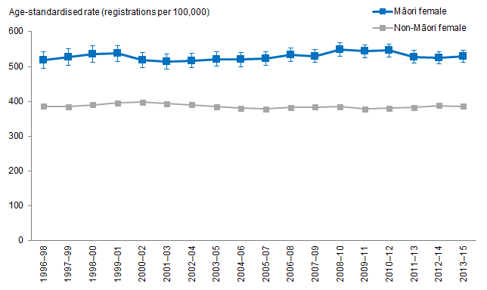
Notes:
Figures are age-standardised to the 2001 Census total Māori population.
Prioritised ethnicity has been used.
If the confidence intervals of two rates do not overlap, the difference in rates is said to be statistically significant.
Source: New Zealand Cancer Registry (NZCR), Ministry of Health, 1996–98 to 2013–15.

Figure 32 shows that, after adjusting for age, Māori females aged 25 years and over have higher total-cancer registration rates than non-Māori females in the same age group over time.

The total-cancer registration rate remained the same over time for Māori females
After adjusting for age, the total-cancer registration rates remained similar over time for Māori females aged 25 years and over and remained constant for non-Māori.

The age-standardised total-cancer registration rates for Māori females aged 25 years and over remained similar over time, with 518.3 registrations per 100,000 in 1996–98 and 529.3 registrations per 100,000 in 2013–15.

The age-standardised total-cancer registration rates for non-Māori females in the same age group remained constant, with 386.1 registrations per 100,000 in 1996–98 and in 2013–15.

The difference in total-cancer registration rates between Māori and non-Māori females remained similar over time
The difference in the age-standardised total-cancer registration rates between Māori and non-Māori females aged 25 years and over remained similar over time. Māori females aged 25 years and over had 130.2 more registrations per 100,000 than non-Māori females in 1996–98, and 143.2 more registrations per 100,000 in 2013–15.

The difference in the age-standardised total-cancer registration rates between Māori and non-Māori females aged 25 years and over were greater than that between Māori and non-Māori males in the same age group.

The difference between Māori and non-Māori females showed little change: the total-cancer registration rates among Māori females aged 25 years and over was 34 percent higher than that among non-Māori females in the same age group in 1996–98, and 37 percent higher in 2013–15.

Figure 33: Total cancer mortality rates, 25+ years, Māori and non-Māori males,
1996–98 to 2012–14
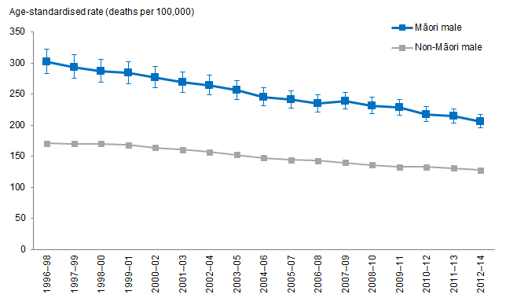
Notes:
Figures are age-standardised to the 2001 Census total Māori population.
Prioritised ethnicity has been used.
If the confidence intervals of two rates do not overlap, the difference in rates is said to be statistically significant.
Source: Mortality Collection Data Set (MORT), Ministry of Health, 1996–98 to 2012–14.

Figure 33 shows that, after adjusting for age, Māori males aged 25 years and over have higher total-cancer mortality rates than non-Māori males in the same age group over time.

The total-cancer mortality rate decreased over time for Māori males
After adjusting for age, total-cancer mortality rates decreased over time for both Māori and non-Māori males aged 25 years and over.

The age-standardised total-cancer mortality rates for Māori males aged 25 years and over decreased by 32 percent, from 301.7 deaths per 100,000 in 1996–98 to 206.4 deaths per 100,000 in 2012–14.

The age-standardised total-cancer mortality rates for non-Māori males in the same age group decreased by 25 percent over time, from 171.0 deaths per 100,000 in 1996–98 to 128.0 deaths per 100,000 in 2012–14.

The difference in total-cancer mortality rates between Māori and non-Māori males decreased over time
The difference in age-standardised total-cancer mortality rates between Māori and non-Māori males aged 25 years and over decreased by 40 percent over time. Māori males aged 25 years and over had 130.7 more deaths per 100,000 than non-Māori males in 1996–98, and 78.4 more deaths per 100,000 in 2012–14.

The difference between Māori and non-Māori males aged 25 years and over is decreasing: the total-cancer mortality rate among Māori males aged 25 years and over was 76 percent higher than non-Māori males in 1998–98, and 61 percent higher in 2012–14.

Figure 34: Total cancer mortality rates, 25+ years, Māori and non-Māori females, 1996–98 to 2012–14
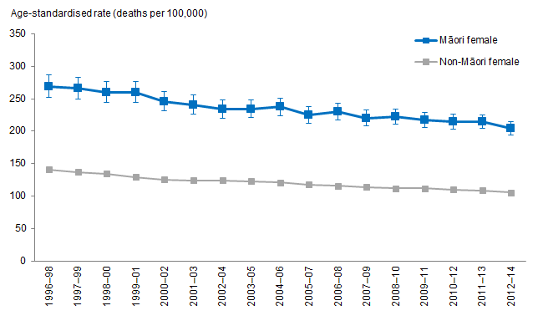
Notes:
Figures are age-standardised to the 2001 Census total Māori population.
Prioritised ethnicity has been used.
If the confidence intervals of two rates do not overlap, the difference in rates is said to be statistically significant.
Source: Mortality Collection Data Set (MORT), Ministry of Health, 1996–98 to 2012–14.

Figure 34 shows that, after adjusting for age, Māori females aged 25 years and over have higher total-cancer mortality rates than non-Māori females in the same age group over time.

The total-cancer mortality rate decreased over time for Māori females
After adjusting for age, total-cancer mortality rates decreased over time for both Māori and non-Māori females aged 25 years and over.

The age-standardised total-cancer mortality rates for Māori females aged 25 years and over decreased by 24 percent, from 268.8 deaths per 100,000 in 1996–98 to 203.9 deaths per 100,000 in 2012–14.

The age-standardised total-cancer mortality rates for non-Māori females in the same age group decreased by 25 percent over time, from 141.2 deaths per 100,000 in
1996–98 to 105.3 deaths per 100,000 in 2012–14.

The difference in total-cancer mortality rates between Māori and non-Māori females decreased over time
The difference in age-standardised total-cancer mortality rates between Māori and non-Māori females aged 25 years and over decreased by 23 percent over time. Māori females aged 25 years and over had 127.6 more deaths per 100,000 than non-Māori females in 1996–98, and 98.6 more deaths per 100,000 in 2012–14.

Māori females aged 25 years and over had total-cancer mortality rate almost twice that of non-Māori females in the same age group in 2012–14. This has not changed much over time.

Common cancer registration and mortality for Māori males and females
Figure 35: Cancer registration rates, by site, 25+ years, Māori males, 1996–98 to 2013–15
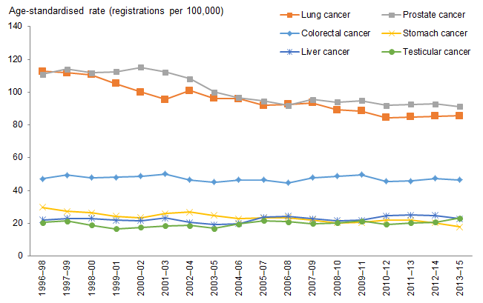
Notes:
Figures are age-standardised to the 2001 Census total Māori population.
Prioritised ethnicity has been used.
Source: New Zealand Cancer Registry (NZCR), Ministry of Health, 1996–98 to 2013–15.

Figure 35 shows the common cancer sites registered by Māori males aged 25 years and over from 1996–98 to 2013–15. The most common cancer registered by Māori males aged 25 years and over in 2013–15 was prostate cancer, followed by lung cancer and colorectal cancer. The top three cancer sites remained the same over time.

Figure 36: Cancer mortality rates, by site, 25+ years, Māori males, 1996–98 to
2012–14
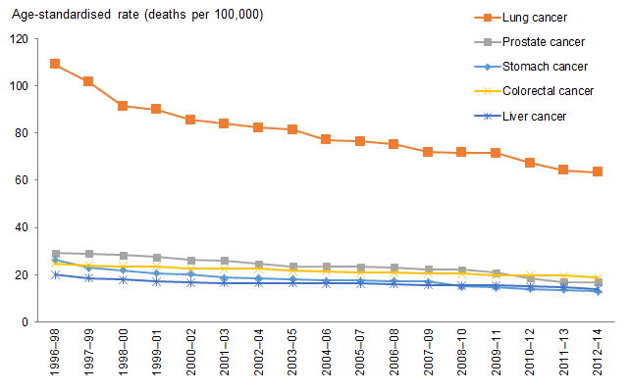
Notes:
Figures are age-standardised to the 2001 Census total Māori population.
Prioritised ethnicity has been used.
Source: Mortality Collection Data Set (MORT), Ministry of Health, 1996–98 to 2012–14.

Figure 36 shows the leading causes of cancer death for Māori males aged 25 years and over from 1996–98 to 2012–14. The leading cause of cancer death for Māori males aged 25 years and over in 1996–98 was lung cancer and this has not changed over time.

Figure 37: Cancer registration rates, by site, 25+ years, Māori females, 1996–98 to 2013–15
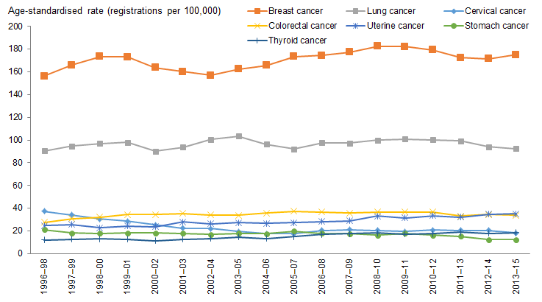
Notes:
Figures are age-standardised to the 2001 Census total Māori population.
Prioritised ethnicity has been used.
Source: New Zealand Cancer Registry (NZCR), Ministry of Health, 1996–98 to 2013–15.

Figure 37 shows the common cancer sites registered by Māori females aged 25 years and over from 1996–98 to 2013–15. The most common cancers registered by Māori females aged 25 years and over in 2013–15 were breast cancer and lung cancer, and this has not changed over time.

Figure 38: Cancer mortality rates, by site, 25+ years, Māori females, 1996–98 to
2012–14
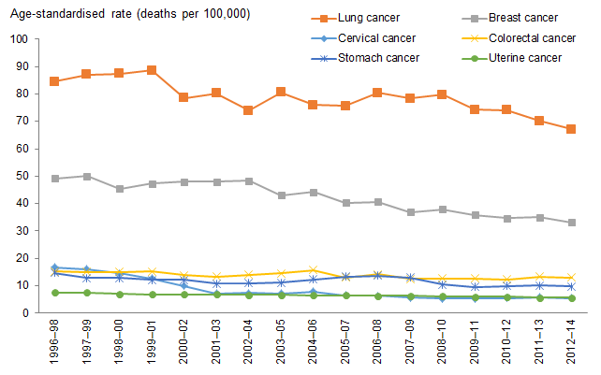
Notes:
Figures are age-standardised to the 2001 Census total Māori population.
Prioritised ethnicity has been used.
Source: Mortality Collection Data Set (MORT), Ministry of Health, 1996–98 to 2012–14.

Figure 38 shows the leading causes of cancer death for Māori females aged 25 years and over from 1996–98 to 2012–14. The top two leading causes of cancer death for Māori females aged 25 years and over in 2012–14 were lung cancer and breast cancer, and this has not changed over time.

Lung cancer
Figure 39: Lung cancer registration rates, 25+ years, Māori and non-Māori males, 1996–98 to 2013–15
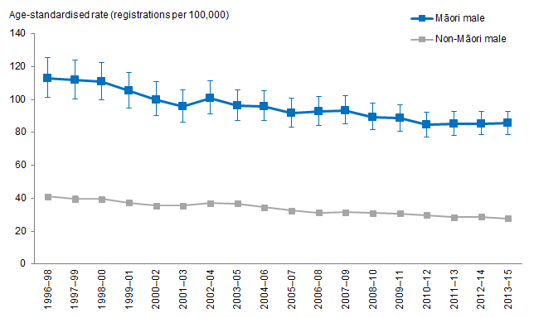
Notes:
Figures are age-standardised to the 2001 Census total Māori population.
Prioritised ethnicity has been used.
If the confidence intervals of two rates do not overlap, the difference in rates is said to be statistically significant.
Source: New Zealand Cancer Registry (NZCR), Ministry of Health, 1996–98 to 2013–15.

Figure 39 shows that, after adjusting for age, Māori males aged 25 years and over have higher lung cancer registration rates than non-Māori males in the same age group over time.

Lung cancer registration rate decreased over time for Māori males
After adjusting for age, lung cancer registration rates decreased over time for both Māori and non-Māori males aged 25 years and over.

The age-standardised lung cancer registration rates for Māori males aged 25 years and over decreased by 24 percent, from 112.8 registrations per 100,000 in 1996–98 to 85.5 registrations per 100,000 in 2013–15.

The age-standardised lung cancer registration rates for non-Māori males in the same age group decreased by 32 percent over time, from 41.0 registrations per 100,000 in 1996–98 to 27.8 registrations per 100,000 in 2013–15.

The difference in lung cancer registration rates between Māori and non-Māori males decreased over time
The difference in age-standardised lung cancer registration rates between Māori and non-Māori males aged 25 years and over decreased by 20 percent over time. Māori males aged 25 years and over had 71.8 more registrations per 100,000 than non-Māori males in 1996–98, and 57.7 more registrations per 100,000 in 2013–15.

Māori males aged 25 years and over had a lung cancer registration rate three times that of non-Māori males in the same age group in 2013–15. The age-standardised rate ratio increased from 2.75 in 1996–98 to 3.08 in 2013–15.

Figure 40: Lung cancer registration rates, 25+ years, Māori and non-Māori females, 1996–98 to 2013–15
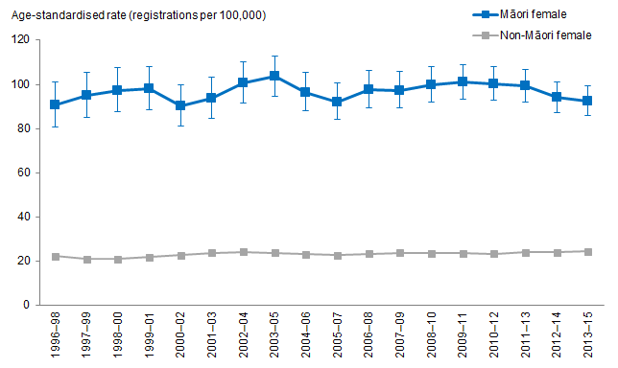
Notes:
Figures are age-standardised to the 2001 Census total Māori population.
Prioritised ethnicity has been used.
If the confidence intervals of two rates do not overlap, the difference in rates is said to be statistically significant.
Source: New Zealand Cancer Registry (NZCR), Ministry of Health, 1996–98 to 2013–15.

Figure 40 shows that, after adjusting for age, Māori females aged 25 years and over have higher lung cancer registration rates than non-Māori females in the same age group over time.

Lung cancer registration rate remained similar over time for Māori females
After adjusting for age, lung cancer registrations remained similar over time for both Māori and non-Māori females aged 25 years and over.

The age-standardised lung cancer registration rates for Māori females aged 25 years and over remained similar over time, with 90.5 registrations per 100,000 in 1996–98 and 92.5 registrations per 100,000 in 2013–15.

For non-Māori females in the same age group, the age-standardised lung cancer registration rates also remained similar, with 22.4 registrations per 100,000 in 1996–98 and 24.4 registrations per 100,000 in 2013–15.

The difference in lung cancer registration rates between Māori and non-Māori females remained the same over time
The difference in age-standardised lung cancer registration rates between Māori and non-Māori females aged 25 years and over has not changed over time. Māori females aged 25 years and over had 68.1 more registrations per 100,000 than non-Māori females in 1996–98, and in 2013–15.

Māori females aged 25 years and over had a lung cancer registration rate more than 3½ times that of non-Māori females in the same age group in 2013–15.
Figure 41: Lung cancer mortality rates, 25+ years, Māori and non-Māori males,
1996–98 to 2012–14
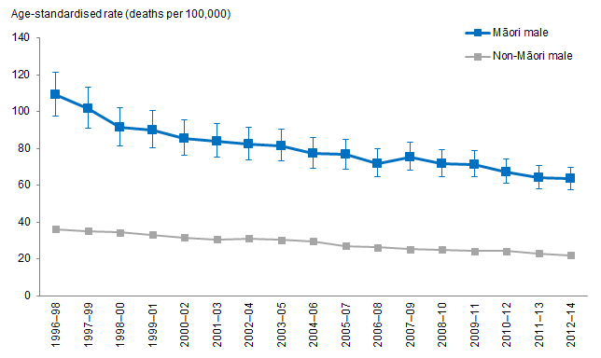
Notes:
Figures are age-standardised to the 2001 Census total Māori population.
Prioritised ethnicity has been used.
If the confidence intervals of two rates do not overlap, the difference in rates is said to be statistically significant.
Source: Mortality Collection Data Set (MORT), Ministry of Health, 1996–98 to 2012–14.

Figure 41 shows that, after adjusting for age, Māori males aged 25 years and over have higher lung cancer mortality rates than non-Māori males in the same age group over time.

Lung cancer mortality rate decreased over time for Māori males
After adjusting for age, lung cancer mortality rates decreased over time for both Māori and non-Māori males aged 25 years and over.

The age-standardised lung cancer mortality rates for Māori males aged 25 years and over decreased by 42 percent, from 109.1 deaths per 100,000 in 1996–98 to 63.5 deaths per 100,000 in 2012–14.

The age-standardised lung cancer mortality rates for non-Māori males in the same age group decreased by 39 percent over time, from 36.3 deaths per 100,000 in 1996–98 to 22.1 deaths per 100,000 in 2012–14.

The difference in lung cancer mortality rates between Māori and non-Māori males decreased over time
The difference in age-standardised lung cancer mortality rate between Māori and non-Māori males aged 25 years and over decreased by 43 percent over time. Māori males aged 25 years and over had 72.8 more deaths per 100,000 than non-Māori males in 1996–98, and 41.4 more deaths per 100,000 in 2012–14.

In 2012–14, Māori males aged 25 years and over were almost three times as likely to die from lung cancer as non-Māori males in the same age group, after adjusting for age. There was a 4.7 percent decrease in the age-standardised rate ratios, from 3.01 in 1996–98 to 2.87 in 2012–14.

Figure 42: Lung cancer mortality rates, 25+ years, Māori and non-Māori females, 1996–98 to 2012–14
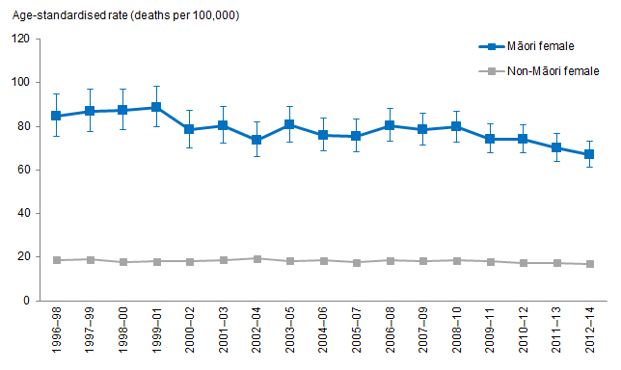
Notes:
Figures are age-standardised to the 2001 Census total Māori population.
Prioritised ethnicity has been used.
If the confidence intervals of two rates do not overlap, the difference in rates is said to be statistically significant.
Source: Mortality Collection Data Set (MORT), Ministry of Health, 1996–98 to 2012–14.

Figure 42 shows that, after adjusting for age, Māori females aged 25 years and over have higher lung cancer mortality rates than non-Māori females in the same age group over time.

Lung cancer mortality rate decreased over time for Māori females
Lung cancer mortality rates decreased over time for Māori females aged 25 years and over, after adjusting for age.

The age-standardised lung cancer mortality rates for Māori females aged 25 years and over decreased by 21 percent over time, from 84.6 deaths per 100,000 in 1996–98 to 67.1 deaths per 100,000 in 2012–14.

For non-Māori females in the same age group, the age-standardised lung cancer mortality rates remained similar over time, from 18.8 deaths per 100,000 in 1996–98 to 16.9 deaths per 100,000 in 2012–14.

The difference in lung cancer mortality rates between Māori and non-Māori females decreased over time
The difference in age-standardised lung cancer mortality rates between Māori and non-Māori females aged 25 years and over decreased by 24 percent over time. Māori females aged 25 years and over had 65.8 more deaths per 100,000 than non-Māori females in 1996–98, and 50.2 more deaths per 100,000 in 2012–14.

The difference between Māori and non-Māori females decreased over time. In
2012–14, Māori females aged 25 years and over were almost four times as likely to die from lung cancer as non-Māori females in the same age group, after adjusting for age. The age-standardised rate ratios decreased from 4.50 in 1996–98 to 3.98 in 2012–14.

Colorectal cancer
Figure 43: Colorectal cancer registration rates, 25+ years, Māori and non-Māori males, 1996–98 to 2013–15
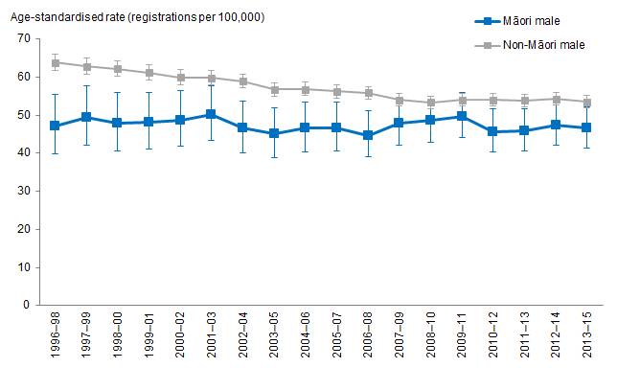
Notes:
Figures are age-standardised to the 2001 Census total Māori population.
Prioritised ethnicity has been used.
If the confidence intervals of two rates do not overlap, the difference in rates is said to be statistically significant.
Source: New Zealand Cancer Registry (NZCR), Ministry of Health, 1996–98 to 2013–15.

Figure 43 shows that Māori males aged 25 years and over have a lower colorectal cancer registration rate than non-Māori males in the same age group over time, after adjusting for age.

Colorectal cancer registration rate remained the same over time for Māori males
After adjusting for age, the colorectal cancer registration rate has not changed much over time for Māori males aged 25 years and over but decreased for non-Māori males in the same age group.

The age-standardised colorectal cancer registration rates for Māori males aged 25 years and over have not changed much over time. Māori males had 47.2 colorectal cancer registrations per 100,000 in 1996–98, and 46.5 registrations per 100,000 in 2013–15.

This age-standardised colorectal cancer registration rates for non-Māori males in the same age group decreased by 16 percent over time, from 63.8 registrations per 100,000 in 1996–98 to 53.5 registrations per 100,000 in 2013–15.

The difference in colorectal cancer registration rates between Māori and non-Māori males decreased over time
The difference in age-standardised colorectal cancer registration rates between Māori and non-Māori males aged 25 years and over decreased over time. Māori males aged 25 years and over had 16.6 fewer registrations per 100,000 than non-Māori males in 1996–98, and 7.0 fewer registrations per 100,000 in 2013–15.

Māori males aged 25 years and over had a significantly lower colorectal cancer registration rate than non-Māori males in the same age group in 2013–15. The difference between Māori and non-Māori males is narrowing, however, the age-standardised rate ratio increased from 0.74 in 1996–98 to 0.87 in 2013–15.

Figure 44: Colorectal cancer registration rates, 25+ years, Māori and non-Māori females, 1996–98 to 2013–15
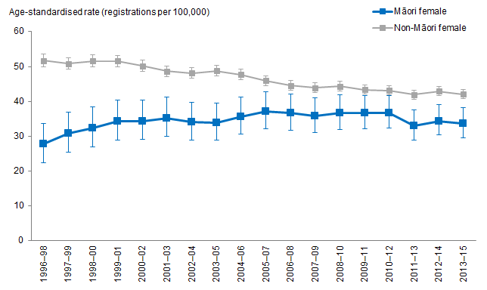
Notes:
Figures are age-standardised to the 2001 Census total Māori population.
Prioritised ethnicity has been used.
If the confidence intervals of two rates do not overlap, the difference in rates is said to be statistically significant.
Source: New Zealand Cancer Registry (NZCR), Ministry of Health, 1996–98 to 2013–15.

Figure 44 shows that Māori females aged 25 years and over have a lower colorectal cancer registration rate than non-Māori females in the same age group over time, after adjusting for age.

Colorectal cancer registration rate increased over time for Māori females
After adjusting for age, colorectal cancer registration rates increased over time for Māori females aged 25 years and over but decreased for non-Māori females in the same age group.

The age-standardised colorectal cancer registration rates for Māori females aged 25 years and over increased by 21 percent, from 27.7 registrations per 100,000 in 1996–98 to 33.6 registrations per 100,000 in 2013–15.

For non-Māori females in the same age group, the age-standardised colorectal cancer registration decreased by 19 percent over time, from 51.7 registrations per 100,000 in 1996–98 to 42.0 registrations per 100,000 in 2013–15.

The difference in colorectal cancer registration rates between Māori and non-Māori females decreased over time
The difference in age-standardised colorectal cancer registration rates between Māori and non-Māori females aged 25 years and over decreased by 65 percent over time. Māori females aged 25 years and over had 24.0 fewer registrations per 100,000 than non-Māori females in 1996–98, and 8.4 fewer registrations per 100,000 in 2013–15.

Māori females aged 25 years and over had a lower colorectal cancer registration rate than non-Māori females in the same age group in 2013–15, however, the difference between Māori and non-Māori females is narrowing. The age-standardised rate ratio increased by 51 percent, from 0.53 in 1996–98 to 0.80 in 2013–15.

Figure 45: Colorectal cancer mortality rates, 25+ years, Māori and non-Māori males, 1996–98 to 2012–14
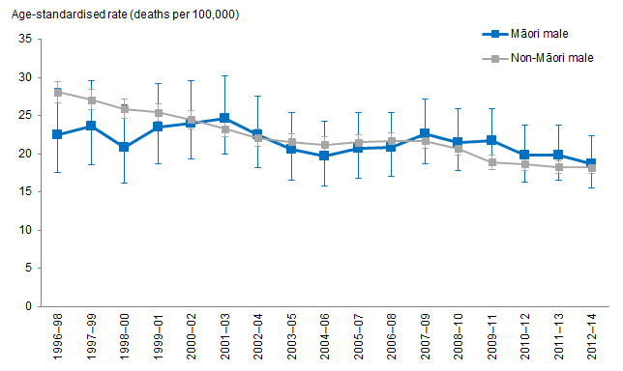
Notes:
Figures are age-standardised to the 2001 Census total Māori population.
Prioritised ethnicity has been used.
If the confidence intervals of two rates do not overlap, the difference in rates is said to be statistically significant.
Source: Mortality Collection Data Set (MORT), Ministry of Health, 1996–98 to 2012–14.

Although Māori males aged 25 years and over had a lower colorectal cancer registration rate than non-Māori males in the same age group, Māori males aged 25 years and over had a similar colorectal cancer mortality rate as non-Māori males in the same age group, after adjusting for age (Figure 45).

Colorectal cancer mortality rate decreased over time for Māori males
After adjusting for age, the colorectal cancer mortality rates decreased over time for both Māori and non-Māori males aged 25 years and over.

The age-standardised colorectal cancer mortality rates for Māori males aged 25 years and over decreased by 17 percent over time, from 22.5 deaths per 100,000 in 1996–98 to 18.7 deaths per 100,000 in 2012–14.

The age-standardised colorectal cancer mortality rates for non-Māori males in the same age group decreased by 35 percent over time, from 28.1 deaths per 100,000 in 1996–98 to 18.2 deaths per 100,000 in 2012–14.

The difference in colorectal cancer mortality rates between Māori and non-Māori males increased over time
The difference in age-standardised colorectal cancer mortality rate between Māori and non-Māori males aged 25 years and over increased over time. Māori males aged 25 years and over had 5.6 fewer deaths per 100,000 than non-Māori males in 1996–98, and 0.5 more deaths per 100,000 in 2012–14.

There was no significant difference in colorectal mortality rates over time between Māori males and non-Māori males aged 25 years and over in the same age group.

Figure 46: Colorectal cancer mortality rates, 25+ years, Māori and non-Māori females, 1996–98 to 2012–14
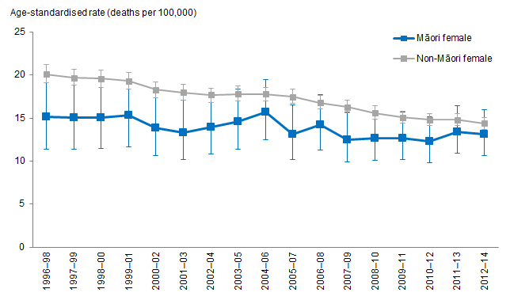
Notes:
Figures are age-standardised to the 2001 Census total Māori population.
Prioritised ethnicity has been used.
If the confidence intervals of two rates do not overlap, the difference in rates is said to be statistically significant.
Source: Mortality Collection Data Set (MORT), Ministry of Health, 1996–98 to 2012–14.

Figure 46 shows that Māori females aged 25 years and over have a lower colorectal cancer mortality rate than non-Māori females in the same age group, after adjusting for age.

Colorectal cancer mortality rate decreased over time for Māori females
After adjusting for age, colorectal cancer mortality rates decreased over time for both Māori and non-Māori females aged 25 years and over.

The age-standardised colorectal cancer mortality rates for Māori females aged 25 years and over decreased over time, from 15.2 deaths per 100,000 in 1996–98 to 13.1 deaths per 100,000 in 2012–14.

The age-standardised colorectal cancer mortality rates for non-Māori females in the same age group decreased by 28 percent over time, from 20.1 deaths per 100,000 in 1996–98 to 14.4 deaths per 100,000 in 2012–14.

The difference in colorectal cancer mortality rates between Māori and non-Māori females decreased over time
The difference in age-standardised colorectal cancer mortality rates between Māori and non-Māori females aged 25 years and over decreased over time. Māori females aged 25 years and over had 4.9 fewer deaths per 100,000 than non-Māori females in 1996–98, and 1.3 fewer deaths per 100,000 in 2012–14.

The difference between Māori and non-Māori females decreased over time: the age-standardised rate ratios increased from 0.75 (Māori females had a significantly lower colorectal cancer mortality rate than non-Māori females) in 1996–98 to 0.91 (there was no significant difference between Māori and non-Māori females) in 2012–14.

Cervical cancer
Figure 47: Cervical cancer registration rates, 25+ years, Māori and non-Māori females, 1996–98 to 2013–15
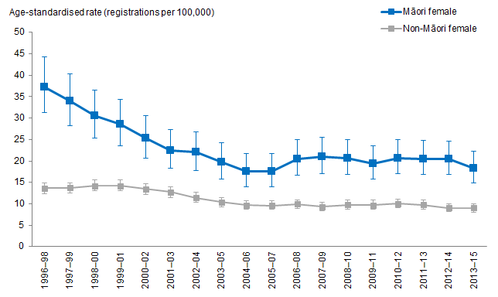
Notes:
Figures are age-standardised to the 2001 Census total Māori population.
Prioritised ethnicity has been used.
If the confidence intervals of two rates do not overlap, the difference in rates is said to be statistically significant.
Source: New Zealand Cancer Registry (NZCR), Ministry of Health, 1996–98 to 2013–15.

Figure 47 shows that Māori females aged 25 years and over have a higher cervical cancer registration rates than non-Māori females in the same age group over time, after adjusting for age.

Cervical cancer registration rates decreased over time for Māori and non-Māori females
The age-standardised cervical cancer registration rates for Māori females aged 25 years and over decreased by 51 percent, from 37.3 registrations per 100,000 in 1996–98 to 18.3 registrations per 100,000 in 2013–15. Most of these decreases occurred between 1996–98 and 2005–07.

For non-Māori females in the same age group, the age-standardised cervical cancer registration decreased by 34 percent over time, from 13.6 registrations per 100,000 in 1996–98 to 9.0 registrations per 100,000 in 2013–15.

The difference in cervical cancer registration rates between Māori and non-Māori females decreased over time
The difference in age-standardised cervical cancer registration rate between Māori and non-Māori females aged 25 years and over decreased by 61 percent over time. Māori females aged 25 years and over had 23.7 more registrations per 100,000 than non-Māori females in 1996–98, and 9.3 more registrations per 100,000 in 2013–15.

After adjusting for age, cervical cancer registration rates decreased over time for both Māori and non-Māori females aged 25 years and over with larger decreases for Māori females (51 percent) compared with non-Māori females (34 percent). Most of these decreases occurred between 1996–98 and 2005–07. Despite these larger decreases for Māori females, rates for Māori females remain twice as high as those of non-Māori females.

Figure 48: Cervical cancer mortality rates, 25+ years, Māori and non-Māori females, 1996–98 to 2012–14
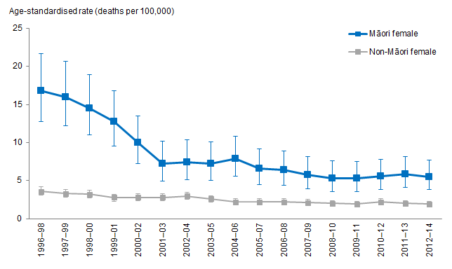
Notes:
Figures are age-standardised to the 2001 Census total Māori population.
Prioritised ethnicity has been used.
If the confidence intervals of two rates do not overlap, the difference in rates is said to be statistically significant.
Source: Mortality Collection Data Set (MORT), Ministry of Health, 1996–98 to 2012–14.

Figure 48 shows that Māori females aged 25 years and over have higher cervical cancer mortality rates than non-Māori females in the same age group, after adjusting for age.

Cervical cancer mortality rate decreased over time for Māori and non-Māori females
After adjusting for age, cervical cancer mortality rates decreased over time for both Māori and non-Māori females aged 25 years and over with larger decreases for Māori females (67 percent) compared with non-Māori females (47 percent).

The age-standardised cervical cancer mortality rates for Māori females aged 25 years and over decreased by 67 percent, from 16.8 deaths per 100,000 in 1996–98 to 5.5 deaths per 100,000 in 2012–14. Most of these decreases occurred between 1996–98 and 2001–03.

The age-standardised cervical cancer mortality rates for non-Māori females in the same age group decreased by 47 percent over time, from 3.6 deaths per 100,000 in 1996–98 to 1.9 deaths per 100,000 in 2012–14.

The difference in cervical cancer mortality rates between Māori and non-Māori females decreased over time
The difference in age-standardised cervical cancer mortality rate between Māori and non-Māori females aged 25 years and over decreased by 73 percent over time. Māori females aged 25 years and over had 13.2 more registrations per 100,000 than non-Māori females in 1996–98, and 3.6 more registrations per 100,000 in 2012–14.

The age-standardised rate ratios decreased from 4.62 in 1996–98 to 2.82 in 2012–14.

Prostate cancer
Figure 49: Prostate cancer registration rates, 25+ years, Māori and non-Māori males, 1996–98 to 2013–15
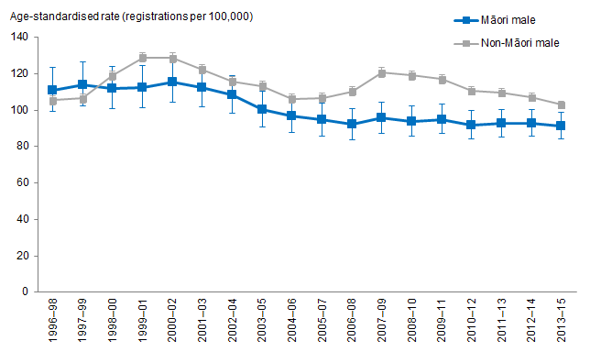
Notes:
Figures are age-standardised to the 2001 Census total Māori population.
Prioritised ethnicity has been used.
If the confidence intervals of two rates do not overlap, the difference in rates is said to be statistically significant.
Source: New Zealand Cancer Registry (NZCR), Ministry of Health, 1996–98 to 2013–15.

Figure 49 shows that Māori males aged 25 years and over had a lower prostate cancer registration rate than non-Māori males in the same age group since 1999–2001, after adjusting for age. Before that, Māori males aged 25 years and over had similar age-standardised prostate cancer registration rates as non-Māori males in the same age group.

Prostate cancer registration rate decreased over time for Māori males
After adjusting for age, prostate cancer registration rates decreased over time for Māori males aged 25 years and over, but remained similar for non-Māori males.

The age-standardised prostate cancer registration rates for Māori males aged 25 years and over decreased by 18 percent, from 110.8 registrations per 100,000 in 1996–98 to 91.2 registrations per 100,000 in 2013–15.

The age-standardised prostate cancer registration rates for non-Māori males in the same age group have not changed much, from 105.4 registrations per 100,000 in 1996–98 to 102.8 registrations per 100,000 in 2013–15.

The difference in prostate cancer registration rates between Māori and non-Māori males decreased over time
The difference in age-standardised prostate cancer registration rate between Māori and non-Māori males aged 25 years and over decreased over time. Māori males aged 25 years and over had 5.4 more registrations per 100,000 than non-Māori males in 1996–98, and 11.6 fewer registrations per 100,000 in 2013–15.

Māori males aged 25 years and over had a significantly lower prostate cancer registration rate than non-Māori males in the same age group in 2013–15, and there was no significant difference in 1996–98.

Figure 50: Prostate cancer mortality rates, 25+ years, Māori and non-Māori males, 1996–98 to 2012–14
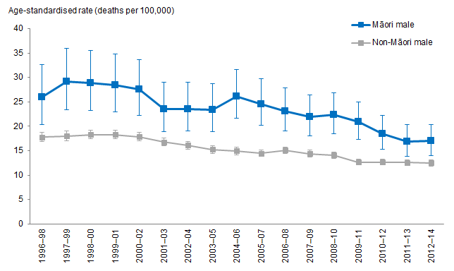
Notes:
Figures are age-standardised to the 2001 Census total Māori population.
Prioritised ethnicity has been used.
If the confidence intervals of two rates do not overlap, the difference in rates is said to be statistically significant.
Source: Mortality Collection Data Set (MORT), Ministry of Health, 1996–98 to 2012–14.

Figure 50 shows that Māori males aged 25 years and over have a higher prostate cancer mortality rate than non-Māori males in the same age group over time, after adjusting for age.

Prostate cancer mortality rate decreased over time for Māori males
After adjusting for age, prostate cancer mortality rates decreased over time for both Māori and non-Māori males aged 25 years and over.

The age-standardised prostate cancer mortality rates for Māori males aged 25 years and over decreased by 35 percent, from 26.0 deaths per 100,000 in 1996–98 to 17.0 deaths per 100,000 in 2012–14.

For non-Māori males in the same age group, the age-standardised prostate cancer mortality rates decreased by 30 percent over time, from 17.8 deaths per 100,000 in 1996–98 to 12.5 deaths per 100,000 in 2012–14.

The difference in prostate cancer mortality rates between Māori and non-Māori males decreased over time
The difference in age-standardised prostate cancer mortality rates between Māori and non-Māori males aged 25 years and over decreased by 45 percent over time. Māori males aged 25 years and over had 8.2 more deaths per 100,000 than non-Māori males in 1996–98, and 4.5 more deaths per 100,000 in 2012–14.

The difference between Māori and non-Māori males aged 25 years and over is narrowing: the age-standardised rate ratios decreased from 1.46 in 1996–98 to 1.36 in 2012–14.

Breast cancer
Figure 51: Breast cancer registration rates, 25+ years, Māori and non-Māori females, 1996–98 to 2013–15
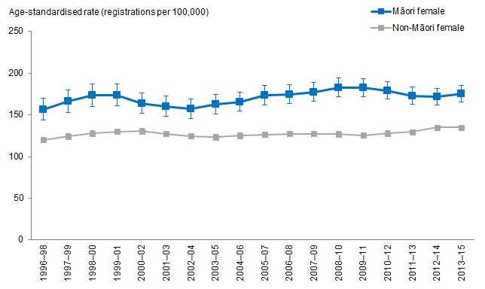
Notes:
Figures are age-standardised to the 2001 Census total Māori population.
Prioritised ethnicity has been used.
If the confidence intervals of two rates do not overlap, the difference in rates is said to be statistically significant.
Source: New Zealand Cancer Registry (NZCR), Ministry of Health, 1996–98 to 2013–15.

Figure 51 shows that Māori females aged 25 years and over had a higher breast cancer registration rate than non-Māori females in the same age group, after adjusting for age. This has remained the same over time.

Breast cancer registration rate increased over time for Māori females
After adjusting for age, breast cancer registration rates increased over time for both Māori and non-Māori females aged 25 years and over.

The age-standardised breast cancer registration rates for Māori females aged 25 years and over increased by 12 percent, from 156.5 registrations per 100,000 in 1996–98 to 175.1 registrations per 100,000 in 2013–15.

For non-Māori females in the same age group, the age-standardised breast cancer registration rates increased by 12 percent over time, from 120.0 registrations per 100,000 in 1996–98 to 134.8 registrations per 100,000 in 2013–15.

The difference in breast cancer registration rates between Māori and non-Māori females remained similar over time
The difference in age-standardised breast cancer registration rates between Māori and non-Māori females aged 25 years and over remained similar over time. Māori females aged 25 years and over had 36.5 more registrations per 100,000 than non-Māori females in 1996–98, and 40.3 more registrations per 100,000 in 2013–15.

Māori females aged 25 years and over had a breast cancer registration rate 1.3 times that of non-Māori females in the same age group in 2013–15. This has not changed much over time.

Figure 52: Breast cancer mortality rates, 25+ years, Māori and non-Māori females, 1996–98 to 2012–14
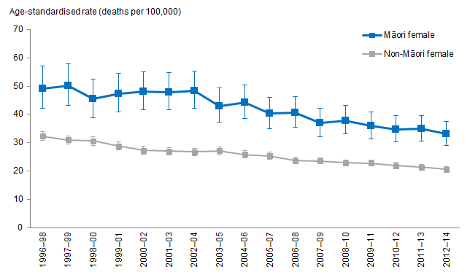
Notes:
Figures are age-standardised to the 2001 Census total Māori population.
Prioritised ethnicity has been used.
If the confidence intervals of two rates do not overlap, the difference in rates is said to be statistically significant.
Source: Mortality Collection Data Set (MORT), Ministry of Health, 1996–98 to 2012–14.

Figure 52 shows that Māori females aged 25 years and over have higher breast cancer mortality rates than non-Māori females in the same age group over time, after adjusting for age.

Breast cancer mortality rate decreased over time for Māori females
After adjusting for age, breast cancer mortality rates decreased over time for both Māori and non-Māori females aged 25 years and over.

The age-standardised breast cancer mortality rates for Māori females aged 25 years and over decreased by 33 percent, from 49.1 deaths per 100,000 in 1996–98 to 33.1 registrations per 100,000 in 2012–14.

The age-standardised breast cancer mortality rates for non-Māori females in the same age group decreased by 36 percent over time, from 32.3 deaths per 100,000 in
1996–98 to 20.6 deaths per 100,000 in 2012–14.

The difference in breast cancer mortality rates between Māori and non-Māori females remained similar over time
The difference in age-standardised breast cancer mortality rates between Māori and non-Māori females aged 25 years and over remained similar over time. Māori females aged 25 years and over had 16.8 more deaths per 100,000 than non-Māori females in 1996–98, and 12.5 more deaths per 100,000 in 2012–14.

Māori females aged 25 years and over had a breast cancer mortality rate 1.6 times that of non-Māori females in the same age group in 2012–14. This has not changed much over time.

BreastScreen Aotearoa and National Cervical Screening Programmes
This section presents data from BreastScreen Aotearoa (BSA) and the National Cervical Screening Programme (NCSP), programmes of the National Screening Unit at the Ministry of Health. Trends over time from 2002 and 2017 are shown for Māori and non-Māori women.

The aim of screening is to identify cancers at an early stage, allowing treatment to be commenced sooner than might otherwise be expected. Please refer to the Appendix 4: Overview of Breast and Cervical Cancer Screening Programmes for an explanation of the key points relating to these screening programmes.

What is the data telling us?
Breast screening data shows that:
- Between 2003 and 2017, Māori women had lower rates of breast screening than non-Māori women.
- Between 2007 and 2017, breast screening rates of Māori and non-Māori women aged 45 to 69 increased, with bigger increases for Māori women.
- Between 2007 and 2017, breast screening rates of Māori women aged 45 to 69 increased from 42 percent to 65 percent, an increase of 23 percentage points or 55 percent. The corresponding increase for non-Māori women was from 57 percent to 73 percent, an increase of 16 percentage points or 28 percent.
- Between 2003 and 2017, breast screening rates of Māori women aged 50 to 69 increased from 45 percent to 65 percent, an increase of 20 percentage points or 46 percent. The corresponding increase for non-Māori women was from 57 percent to 73 percent, an increase of 20 percentage points or 38 percent.
Cervical screening data shows that:
- Between 2002 and 2017, Māori women have had lower cervical screening rates than non-Māori women (on average about 10 percentage points lower).
- Cervical screening rates for both Māori and non-Māori women have not changed much between 2002 and 2017.
- Between 2002 and 2017, cervical screening rates of Māori women aged 20 to 69 fluctuated around 64 percent, while the corresponding rate for non-Māori women fluctuated around 74 percent.
- Between 2002 and 2017, cervical screening rates of Māori women aged 25 to 69 fluctuated around 66 percent, while the corresponding rate for non-Māori women fluctuated around 76 percent.

BreastScreen Aotearoa

Women aged 45 to 69 years
Figure 53: Māori and non-Māori women screened in a two year screening period, aged 45–69 years, 2007–2017
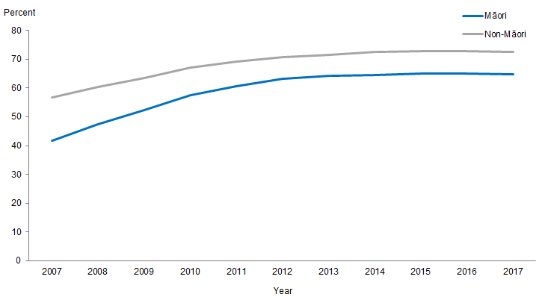
Notes:
Percentages (%) are presented here to measure screening participation.
Both the breast screening and cervical screen programmes had changes to the way the eligible population is measured resulting in the current reporting not being comparable to earlier reporting.
The population denominators used for calculating cervical screening coverage is Stats NZ’s 2017 update of DHB population projections (2013 Census base) at the end of the monitoring period adjusted for the prevalence of hysterectomy (as most women who have had a hysterectomy are not eligible for screening).
Data showing results by five-year age groups for 2003 to 2017 are provided in Excel workbooks.
Source: BreastScreen Aotearoa, Ministry of Health, extracted 3 July 2018.

Between 2007 and 2017, Māori women aged 45 to 69 had lower rates of breast screening than non-Māori women in the same age group – see Figure 53.

Between 2007 and 2017, breast screening rates of Māori and non-Māori women aged 45 to 69 increased. The percentage of Māori women screened increased from 42 percent to 65 percent during this time, an increase of 23 percentage points or 55 percent. The increase for non-Māori women screened during the same time increased from 57 percent to 73 percent, an increase of 16 percentage points or 28 percent. Most of these increases occurred between 2007 and 2012, with little or no increases since 2012. The little or no increases since 2012 can be associated with the flattening of Māori and non-Māori results in the above graph since 2012.

Between 2012 and 2017, on average breast screening rates were around 10 percentage points lower for Māori women compared with Māori women. This rate did not vary much between the five-year age groups between the ages 45 to 69 (see Excel workbook for five-year age group data).

Women aged 50 to 69 years
Figure 54: Māori and non-Māori women screened in a two year screening period, aged 50–69 years, 2003–2017
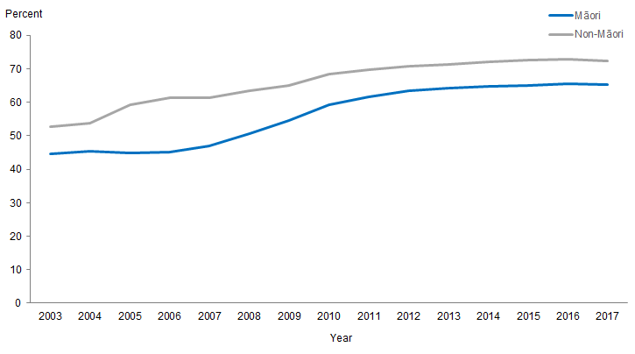
Notes:
Percentages (%) are presented here to measure screening participation.
Both the breast screening and cervical screen programmes had changes to the way the eligible population is measured resulting in the current reporting not being comparable to earlier reporting.
The population denominators used for calculating cervical screening coverage is Stats NZ’s 2017 update of DHB population projections (2013 Census base) at the end of the monitoring period adjusted for the prevalence of hysterectomy (as most women who have had a hysterectomy are not eligible for screening).
Data showing results by five-year age groups for 2003 to 2017 are provided in Excel workbooks.
Source: BreastScreen Aotearoa, Ministry of Health, extracted 3 July 2018.

Between 2003 and 2017, Māori women aged 50 to 69 had lower rates of breast screening than non-Māori women in the same in age group – see Figure 54.

Between 2003 and 2017, breast screening rates of Māori and non-Māori women aged 50 to 69 both increased by around 20 percentage points. Likewise with the results of women aged 45 to 69, most of these increases occurred between 2003 and 2012, with little or no increases since 2012. The little or no increases since 2012 can be associated with the flattening of Māori and non-Māori results in the above graph during since 2012.

Between 2012 and 2017, on average breast screening rates were around 10 percentage points lower for Māori women compared with Māori women. This rate did not vary much between all the five-year age groups between the ages 45 to 69 (see Excel workbook for five-year age group data).

National Cervical Screening Programme

Women aged 20 to 69 years
Figure 55: Two-year cervical screening coverage of Māori and non-Māori women aged 20–69 years, 2002–2017
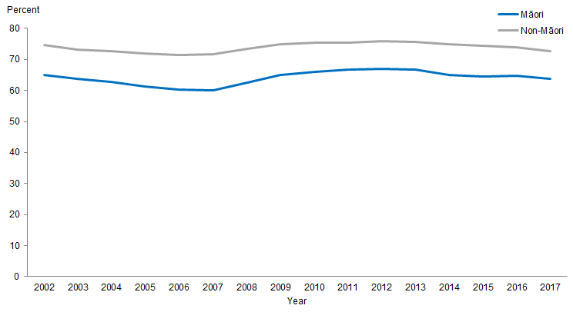
Notes:
Percentages (%) are presented here to measure screening participation.
Both the breast screening and cervical screen programmes had changes to the way the eligible population is measured resulting in the current reporting not being comparable to earlier reporting.
The population denominators used for calculating cervical screening coverage is Stats NZ’s 2017 update of DHB population projections (2013 Census base) at the end of the monitoring period adjusted for the prevalence of hysterectomy (as most women who have had a hysterectomy are not eligible for screening).
Data showing results by five-year age groups for 2003 to 2017 are provided in Excel workbooks.
Source: National Cervical Screening Programme, Ministry of Health, extracted 3 July 2018.

Between 2002 and 2017, Māori women aged 20 to 69 had lower rates of cervical screening than non-Māori women – see Figure 55.

Cervical screening rates for Māori and non-Māori women aged 20 to 69 did not change much between 2002 and 2017. Cervical screening rates for Māori women fluctuated around 64 percent while the rates for non-Māori women fluctuated around 74 percent.

Between 2002 and 2017, on average, cervical screening rates were 10 percentage points lower during this time for Māori women compared with non-Māori women. This applied to most five-year age groups (30 to 69 years) except the rate for Māori women aged 20 to 24 was around 1 percentage point less than those of non-Māori women the same age, and the rate for Māori women aged 25 to 29 was around 5 percentage point less than those of non-Māori women the same age (see Excel workbook for five-year age group data).

Women aged 25 to 69 years
Figure 56: Two year cervical screening coverage of Māori and non-Māori women aged 25–69 years, 2002–2017
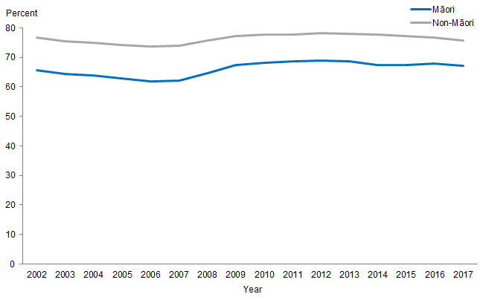
Notes:
Percentages (%) are presented here to measure screening participation.
Both the breast screening and cervical screen programmes had changes to the way the eligible population is measured resulting in the current reporting not being comparable to earlier reporting.
The population denominators used for calculating cervical screening coverage is Stats NZ’s 2017 update of DHB population projections (2013 Census base) at the end of the monitoring period adjusted for the prevalence of hysterectomy (as most women who have had a hysterectomy are not eligible for screening).
Data showing results by five-year age groups for 2003 to 2017 are provided in Excel workbooks.
Source: National Cervical Screening Programme, Ministry of Health, extracted 3 July 2018.

Between 2002 and 2017, Māori women aged 25 to 69 had lower rates of cervical screening than non-Māori women – see Figure 56. Non-Māori women had consistently higher rates of cervical screening across all five-year age groups between ages 25 to 69.

Cervical screening rates of Māori and non-Māori women aged 25 to 69 did not change much between 2002 and 2017. Cervical screening rates of Māori women fluctuated around 66 percent while the rates for non-Māori women fluctuated around 76 percent.

Between 2002 and 2017, on average, cervical screening rates were 10 percentage points lower during this time for Māori women compared with non-Māori women. This applied to most five-year age groups (30 to 69 years) except the rate for Māori women aged 25 to 29 was around 5 percentage point less than those of non-Māori women the same age (see Excel workbook for five-year age group data).

Respiratory disease
This section presents the trends in respiratory disease for Māori compared with non-Māori. Respiratory diseases presented include: asthma hospitalisations, diagnosed asthma, bronchiectasis hospitalisations, bronchiolitis hospitalisations, chronic obstructive pulmonary disease mortality and hospitalisations, and pneumonia mortality and hospitalisations.

What is the data telling us?
Asthma
- Māori adults aged 15–44 years were more likely than non-Māori adults aged 15–44 years to report being diagnosed with asthma in the NZHS with little change over time.
- Over time, asthma hospitalisation rates have decreased for both Māori and non-Māori, however the decrease has been more marked for non-Māori resulting in an increased disparity between Māori and non-Māori.
Bronchiectasis and bronchiolitis
- Over time, hospitalisation rates for bronchiectasis for Māori males have increased whilst for Māori females some decline was apparent until 2012–14 when rates appear to be rising again.
- The disparity between Māori and non-Māori children aged 0–14 years has increased over time, and markedly in the early 2000s. In 2014–16, Māori children aged 0–14 years were three times as likely as non-Māori children to be hospitalised for bronchiectasis.
- Over time, rates of hospitalisation for bronchiolitis for Māori children aged
0–4 years of age have increased.
- Māori boys have the highest rates of bronchiolitis hospitalisations and this rate has increased over time.
Chronic obstructive pulmonary disease (COPD)
- From 1996–98 to 2014–16, rates of hospitalisation for COPD have increased for Māori, whilst decreasing for non-Māori.
- Māori females had the highest rates of COPD hospitalisations, this did not change over time.
- The rate of COPD hospitalisations increased over time for both male and female Māori.
- Over time there has been a decrease in COPD mortality rates for Māori aged 45 and over.
Pneumonia
- Māori have remained around 2½ times as likely as non-Māori to be hospitalised for pneumonia over time.
- There has been a decrease over time in deaths from pneumonia for Māori, however Māori are more likely than non-Māori to die from pneumonia and this disparity changed little over time.

Asthma

Diagnosed asthma
Māori adults aged 15–44 years were more likely than non-Māori adults aged 15–44 years to report being diagnosed with asthma in the New Zealand Health Survey (NZHS). In 2016/17, 15 percent of Māori adults reported diagnosed asthma compared with 11 percent of non-Māori adults. There was little change over time from 2006/07 to 2016/17.

Asthma hospitalisations (aged 5–34 years)
Figure 57: Asthma hospitalisation rates, 5–34 years, by gender, Māori and non-Māori, 1996–98 to 2014–16
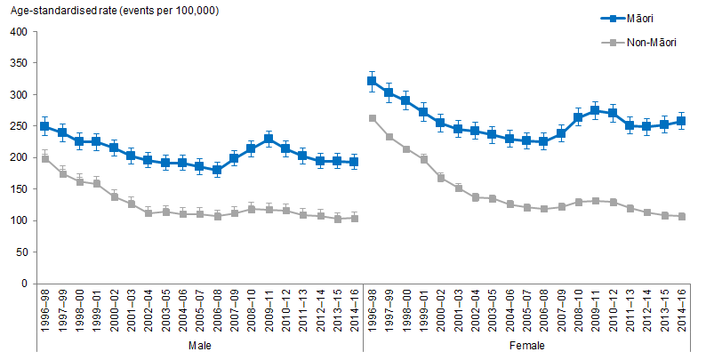
Notes:
Figures are age-standardised to the 2001 Census total Māori population.
Prioritised ethnicity has been used.
If the confidence intervals of two rates do not overlap, the difference in rates is said to be statistically significant.
Source: National Minimum Data Set (NMDS), Ministry of Health, 1996–98 to 2014–16.
Figure 57 shows that over time Māori females had the highest rates of asthma hospitalisations and an increasing disparity between Māori and non-Māori females. By 2014–16, Māori females were nearly 2½ times as likely as non-Māori females to be hospitalised for asthma.
Māori aged 5–34 years were more likely than non-Māori aged 5–34 years to be hospitalised for asthma. In 2014–16, Māori were over twice as likely as non-Māori to be hospitalised for asthma.
Over time, hospitalisation rates have decreased for both Māori and non-Māori adults, however the decrease has been more marked for non-Māori resulting in an increased disparity between Māori and non-Māori. From 1996–98 to 2014–16, hospitalisations for asthma (events per 100,000 people) decreased by 21 percent for Māori compared with 54 percent for non-Māori.

Bronchiectasis (excludes congenital) hospitalisation
Figure 58: Bronchiectasis (excludes congenital) hospitalisation rates, all age, by gender, Māori and non-Māori, 1996–98 to 2014–16
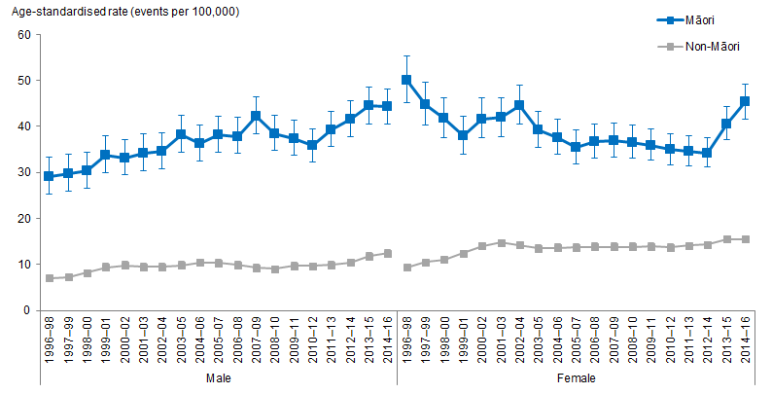
Notes:
Figures are age-standardised to the 2001 Census total Māori population.
Prioritised ethnicity has been used.
If the confidence intervals of two rates do not overlap, the difference in rates is said to be statistically significant.
Source: National Minimum Data Set (NMDS), Ministry of Health, 1996–98 to 2014–16.

Bronchiectasis hospitalisations for all ages show little change over time for Māori, however when looking at trends by gender some different patterns are evident. Figure 58 shows that from 1996–98, the rate of bronchiectasis for Māori males increased over time by 52 percent (from 29.1 events per 100,000 people in 1996–98 to 44.2 per 100,000 people in 2014–16). Over time, there appeared to be a decline in bronchiectasis hospitalisation rates for Māori females, however since 2012–14 rates appear to be rising again.

Figure 59: Bronchiectasis (excludes congenital) hospitalisation rates, 0–14 years, Māori and non-Māori, 1996–98 to 2014–16
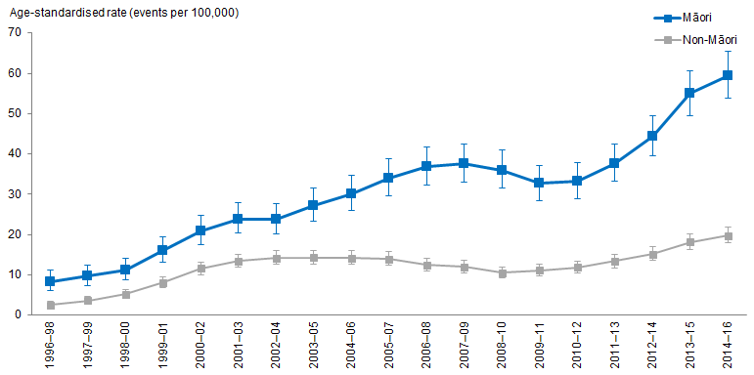
Notes:
Figures are age-standardised to the 2001 Census total Māori population.
Prioritised ethnicity has been used.
If the confidence intervals of two rates do not overlap, the difference in rates is said to be statistically significant.
Source: National Minimum Data Set (NMDS), Ministry of Health, 1996–98 to 2014–16.

Figure 59 shows that Māori children aged 0–14 years were more likely than non-Māori children aged 0–14 years to be hospitalised for bronchiectasis over time. Rates of bronchiectasis for Māori children increased over time from 1996–98 to 2014–16. The same upward trend was not evident for non-Māori children over time and therefore the disparity between Māori and non-Māori children aged 0–14 years has increased over time, and markedly in the early 2000s. In 2014–16, Māori children aged 0–14 years were three times as likely as non-Māori children to be hospitalised for bronchiectasis.

Excel tools attached provide further data for the following age groups (including by gender): 25–44 years of age, 45–64 years of age and 65 and over.

Bronchiolitis (acute, excludes chronic) hospitalisation
Figure 60: Bronchiolitis (acute, excludes chronic) hospitalisation rates, 0–4 years, by gender, Māori and non-Māori, 1996–98 to 2014–16
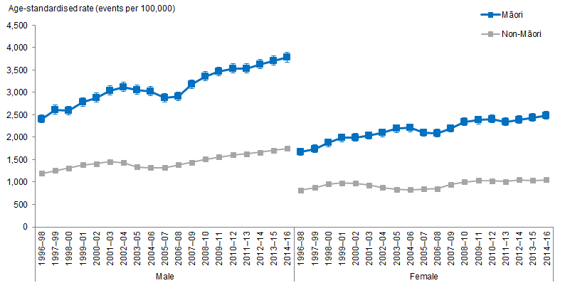
Notes:
Figures are age-standardised to the 2001 Census total Māori population.
Prioritised ethnicity has been used.
If the confidence intervals of two rates do not overlap, the difference in rates is said to be statistically significant.
Source: National Minimum Data Set (NMDS), Ministry of Health, 1996–98 to 2014–16.

Over time, rates of hospitalisation for bronchiolitis for Māori children aged 0–4 years of age have increased. In 2014–16, Māori children were over twice as likely as non-Māori children to be hospitalised for bronchiolitis and this difference has not changed over time.

Figure 60 shows that Māori boys have the highest rates of bronchiolitis hospitalisations and that this rate has increased over time by 57 percent (from 2,407.2 events per 100,000 people in 1996–98 to 3,782.9 in 2014–16). For Māori girls aged 0–4 years the hospitalisation rate increased by 49 percent (from 1,667.1 events per 100,000 people in 1996–98 to 2,485.1 in 2014–16). Hospitalisation rates for non-Māori children aged
0–4 years also increased over time meaning the disparity between Māori and non-Māori children remained at around or just over twice.

Chronic obstructive pulmonary disease (COPD)

COPD hospitalisation
Figure 61: Chronic obstructive pulmonary disease (COPD) hospitalisation rates, 45+ years, by gender, Māori and non-Māori, 1996–98 to 2014–16
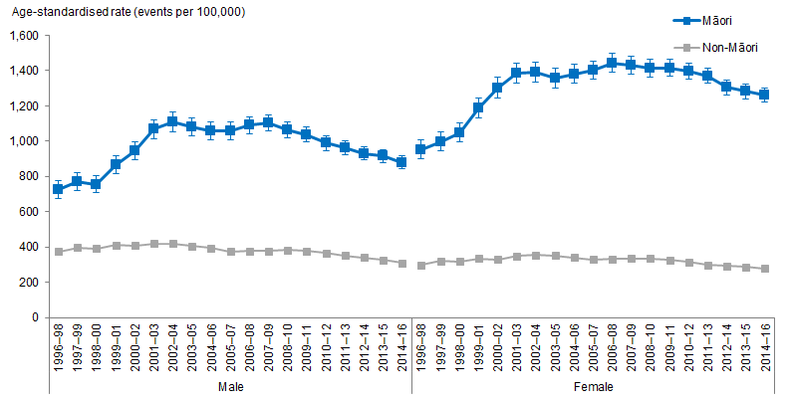
Notes:
Figures are age-standardised to the 2001 Census total Māori population.
Prioritised ethnicity has been used.
If the confidence intervals of two rates do not overlap, the difference in rates is said to be statistically significant.
Source: National Minimum Data Set (NMDS), Ministry of Health, 1996–98 to 2014–16.

From 1996–98 to 2014–16, rates of hospitalisation for COPD have increased for Māori, while decreasing for non-Māori. This translates to an increase in the difference between Māori and non-Māori, from Māori being around 2½ times as likely to be hospitalised for COPD in the mid-1990s to being over 3½ times as likely in the mid-2000s.

Figure 61 shows that Māori females have the highest rates of COPD hospitalisations, this did not change over time, and the rates of hospitalisations for Māori, both male and female, have increased over time. From 1996–98 to 2014–16, COPD hospitalisations for Māori females increased by 33 percent (from 952.9 events per 100,000 people to 1,262.2 per 100,000 people). For Māori males the increase over time in COPD hospitalisations was 21 percent. There are signs of a decrease in hospitalisations for COPD since the mid to late 2000s for both Māori males and females.

The disparity between Māori and non-Māori males and females has increased over the time period. In 2014–16, Māori males were over 2½ times as likely as non-Māori males to have been hospitalised for COPD.

COPD mortality
Figure 62: Chronic obstructive pulmonary disease (COPD) mortality rates, 45+ years, Māori and non-Māori, 1996–98 to 2012–14
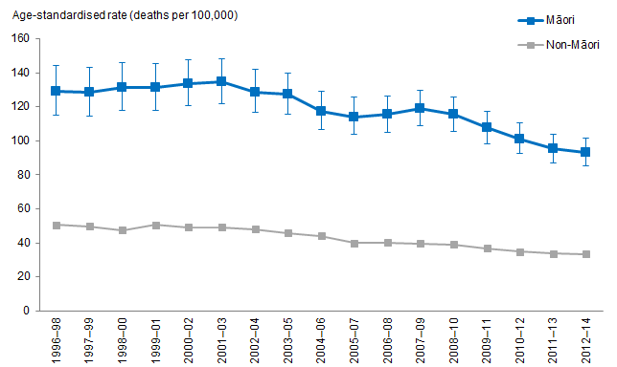
Notes:
Figures are age-standardised to the 2001 Census total Māori population.
Prioritised ethnicity has been used.
If the confidence intervals of two rates do not overlap, the difference in rates is said to be statistically significant.
Source: Mortality Collection Data Set (MORT), Ministry of Health, 1996–98 to 2012–14.

Figure 62 shows that overtime there has been a decrease in COPD mortality rates for Māori aged 45 and over. From 1996–98 to 2012–14 there was a decrease of 28 percent (from 129.1 deaths per 100,000 people to 93.4 deaths per 100,000 people). Over the same time period there has also been a decrease in mortality rates for non-Māori, therefore resulting in little change in the disparity between Māori and non-Māori. In 2012–14, Māori aged 45 and over were over 2½ times as likely as non-Māori aged 45 and over to die from COPD.

The disparity between Māori and non-Māori females is higher than that of Māori and non-Māori males. From 1996–98 to 2012–14, Māori males were generally around 2½ times as likely as non-Māori males to die of COPD while Māori females were consistently over three times as likely as non-Māori females to die of COPD.

Pneumonia

Pneumonia hospitalisation
Figure 63: Pneumonia hospitalisation rates, all age, Māori and non-Māori, 1996–98 to 2014–16
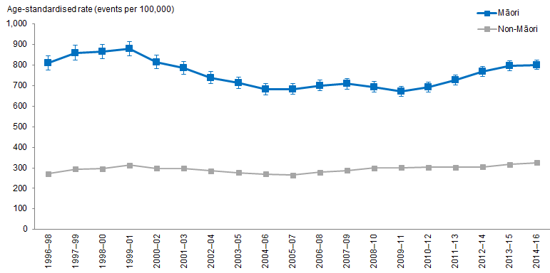
Notes:
Figures are age-standardised to the 2001 Census total Māori population.
Prioritised ethnicity has been used.
If the confidence intervals of two rates do not overlap, the difference in rates is said to be statistically significant.
Source: National Minimum Data Set (NMDS), Ministry of Health, 1996–98 to 2014–16.

Figure 63 shows that overtime there has been little change in the rates of pneumonia hospitalisations for Māori. Rates of pneumonia hospitalisations for non-Māori has increased slightly over time resulting in a slight decrease in the disparity between Māori and non-Māori hospitalisations. In the mid to late 1990s, Māori were nearly three times as likely to be hospitalised for pneumonia, by the mid-2000s this difference decreased slightly to around 2½ times.

Pneumonia mortality
Figure 64: Pneumonia mortality rates, all age, Māori and non-Māori, 1996–98 to 2012–14
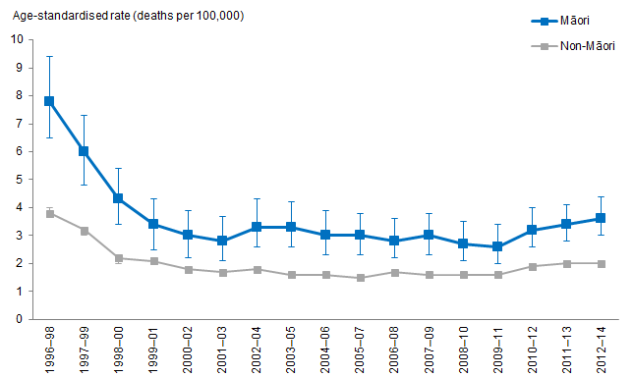
Notes:
Figures are age-standardised to the 2001 Census total Māori population.
Prioritised ethnicity has been used.
If the confidence intervals of two rates do not overlap, the difference in rates is said to be statistically significant.
Source: Mortality Collection Data Set (MORT), Ministry of Health, 1996–98 to 2012–14.

Figure 64 shows that there has been a decrease over time in deaths from pneumonia for Māori. From 1996–98 to 2012–14 there was a decrease of 54 percent (from 7.8 deaths per 100,000 people to 3.6 deaths per 100,000 people). Māori are more likely than non-Māori to die from pneumonia and this disparity changed little over time. In 2012–14, Māori were over 1½ times as likely as non-Māori to die from pneumonia.

Diabetes
This section presents diabetes prevalence and age-standardised rates of diabetes complications over time, for Māori and non-Māori adults aged 15 years and over.

What is the data telling us?
Diabetes prevalence
- Māori adults aged 15 years and over have higher prevalence of reporting they have been diagnosed with diabetes than non-Māori adults.
- Males have a higher prevalence of diabetes than females among both Māori and non-Māori.
- Self-reported diabetes prevalence has not changed significantly for both Māori and non-Māori adults between 2006/07 and 2016/17.
- The self-reported diabetes prevalence among Māori adults was about twice that of non-Māori adults during this period.
Diabetes complications
- Māori adults aged 15 years and over had higher rates of diabetes complications than non-Māori adults over time.
- Males have higher rates of diabetes complications than females among both Māori and non-Māori.

Prevalence of diagnosed diabetes
Figure 65: Diabetes diagnosed by doctors, 15+ years, by gender, Māori and non-Māori, 2006/07–2016/17
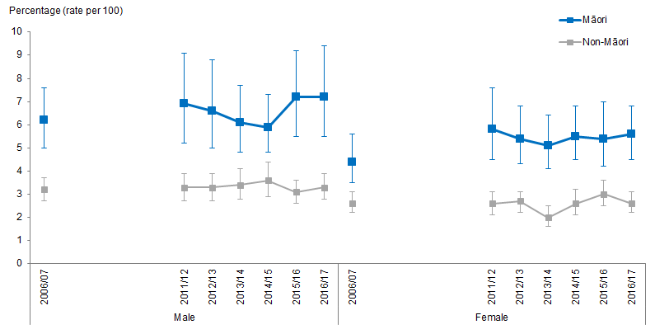
Notes:
Figures are age-standardised to the 2001 Census total Māori population.
Prioritised ethnicity has been used.
If the confidence intervals of two rates do not overlap, the difference in rates is said to be statistically significant.
Source: New Zealand Health Survey (NZHS), Ministry of Health, 2006/07–2016/17.

Māori adults are more likely than non-Māori adults to report being diagnosed with diabetes by a doctor, after adjusting for age.

Males have a higher prevalence of diabetes than females among both Māori and non-Māori (Figure 65), although the difference is not statistically significant.

There has been no significant change in the prevalence of diabetes over time among Māori and non-Māori males and females. The self-reported prevalence of diabetes among Māori remained about twice that of non-Māori between 2006/07 and 2016/17.

Type 2 diabetes (diagnosed after 25 years of age)
Figure 66: Type 2 diabetes (diagnosed after 25 years of age), 15+ years, by gender, Māori and non-Māori, 2006/07–2016/17
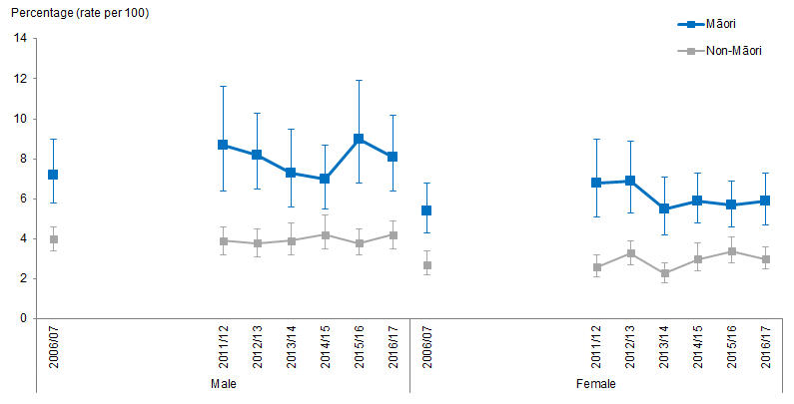
Notes:
Figures are age-standardised to the 2001 Census total Māori population.
Prioritised ethnicity has been used.
If the confidence intervals of two rates do not overlap, the difference in rates is said to be statistically significant.
Source: New Zealand Health Survey (NZHS), Ministry of Health, 2006/07–2016/17.

Type 2 diabetes is defined as diabetes diagnosed after 25 years of age. Māori adults have a higher self-reported prevalence of type 2 diabetes than non-Māori after adjusting for age. Using self-reported diabetes as a measure underestimates the true prevalence, because some people living with type 2 diabetes have not yet been diagnosed.

Males have a higher prevalence of type 2 diabetes than females among both Māori and non-Māori (Figure 66).

The prevalence of type 2 diabetes has not changed significantly over time for both Māori and non-Māori adults, and the difference between Māori and non-Māori has also remained steady. The prevalence for Māori is about 3 percentage points higher, around twice the prevalence of non-Māori.

Diabetes complications – renal failure with concurrent diabetes
Figure 67: Rates of renal failure with concurrent diabetes, 15+ years, by gender, Māori and non-Māori, 1996–98 to 2014–16
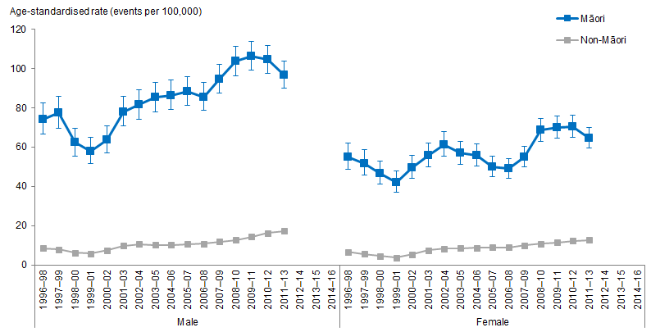
Notes:
Figures are age-standardised to the 2001 Census total Māori population.
Prioritised ethnicity has been used.
If the confidence intervals of two rates do not overlap, the difference in rates is said to be statistically significant.
Source: National Minimum Data Set (NMDS), Ministry of Health, 1996–98 to 2014–16.

Renal failure is one of the complications of diabetes. Figure 67 shows that Māori adults aged 15 years and over have higher age-standardised hospitalisation rates for renal failure with concurrent diabetes than non-Māori over time. Generally, males have higher rates than females, for both Māori and non-Māori.

Rates after 2012–14 are not presented as they are not comparable due to coding changes. As of 1 July 2014 diabetes mellitus and impaired glucose regulation do not need to be recorded as the primary diagnosis. This was previously required in some cases before 1 July 2014. Please refer to Appendix 5 for more details.

The difference between Māori and non-Māori decreased over time: age-standardised rate of renal failure with concurrent diabetes for Māori aged 15 years and over was more than 8½ (8.65) times in 1996–98, and about 5½ (5.33) times that of non-Māori in 2011–13. This was due to a higher percentage increase in renal failure rate for non-Māori than for Māori.

Some of this difference can be attributed to the higher prevalence of diabetes among Māori, to take this into account, the relative risk of renal failure among people with diabetes can be estimated by dividing the relative risk of renal failure by the relative risk of prevalence. This suggests that among people with diabetes, Māori were 4.8 times as likely as non-Māori to have renal failure in 1996–98 (ie, 8.65 ÷ 1.80, which is the rate ratio (RR) of diabetes prevalence in 2006/07), and 2.6 times in 2011–13 (ie, 5.33 ÷ 2.05, average RR of diabetes prevalence in 2011/12 and 2012/13).

The difference between Māori and non-Māori males was higher in the time periods 2003–05 and 2009–11 (Figure 68).

Figure 68: Rate ratios of renal failure with concurrent diabetes, 15+ years, by gender, Māori and non-Māori, 1996–98 to 2014–16
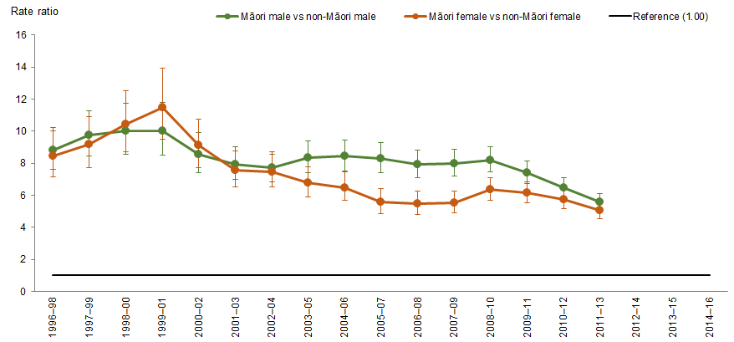
Notes:
Figures are age-standardised to the 2001 Census total Māori population.
Prioritised ethnicity has been used.
If the confidence interval of the rate ratio does not include the number 1, the ratio is said to be statistically significant.
Source: National Minimum Data Set (NMDS), Ministry of Health, 1996–98 to 2014–16.

Diabetes complications – lower limb amputation with concurrent diabetes
Figure 69: Rates of lower limb amputation with concurrent diabetes, 15+ years, by gender, Māori and non-Māori, 1996–98 to 2014–16
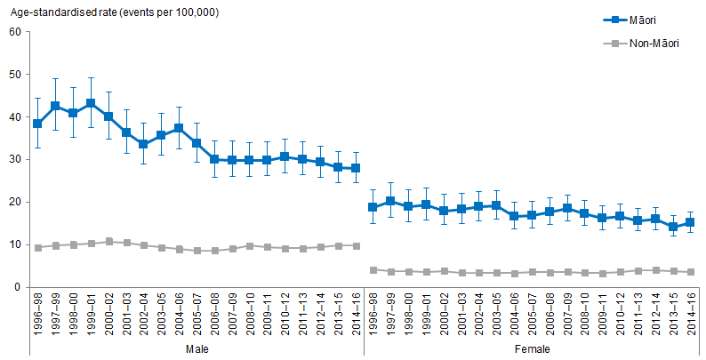
Notes:
Figures are age-standardised to the 2001 Census total Māori population.
Prioritised ethnicity has been used.
If the confidence intervals of two rates do not overlap, the difference in rates is said to be statistically significant.
Source: National Minimum Data Set (NMDS), Ministry of Health, 1996–98 to 2014–16.

Lower limb amputation is another complication of diabetes. Figure 69 shows that Māori adults aged 15 years and over have a higher age-standardised hospitalisation rates of lower limb amputation with concurrent diabetes than non-Māori at the same age group over time. Generally, males have higher rates than females, for both Māori and non-Māori.

For Māori adults, the rates decreased over time by 26 percent, from 28.2 hospitalisations per 100,000 population in 1996–98 to 20.9 hospitalisations in 2014–16. The rates for non-Māori have not changed much over time.

The difference between Māori and non-Māori adults decreased over time: Māori had 21.6 more hospitalisations per 100,000 than non-Māori in 1996–98 and 14.3 more hospitalisations in 2014–16.

The age-standardised rate ratios shows a similar story: the rate of lower limb amputation with concurrent diabetes for Māori aged 15 years and over was more than four times (4.27) that of non-Māori at the same age group in in 1996–98, decreasing to just over three times (3.18) in 2014–16.

Similarly, some of this difference can be attributed to the higher prevalence of diabetes among Māori. To take this into account, the relative risk of lower limb amputation among people with diabetes can be estimated by dividing the relative risk of lower limb amputation by the relative risk of prevalence. Therefore, among people with diabetes, lower limb amputations among Māori can be estimated as 2.4 times that of non-Māori in 1996–98 (ie, 4.27 ÷ 1.80, RR of diabetes prevalence in 2006/07), and 1.7 times in 2014–16 (ie, 3.18 ÷ 1.89, average RR of diabetes prevalence in 2014/15 and 2015/16).

The difference between Māori and non-Māori females was greater than the difference between Māori and non-Māori males over time, even though females had lower rates of lower limb amputation with concurrent diabetes than males (Figure 70).

Figure 70: Rate ratios of lower limb amputation with concurrent diabetes, 15+ years, by gender, Māori and non-Māori, 1996–98 to 2014–16
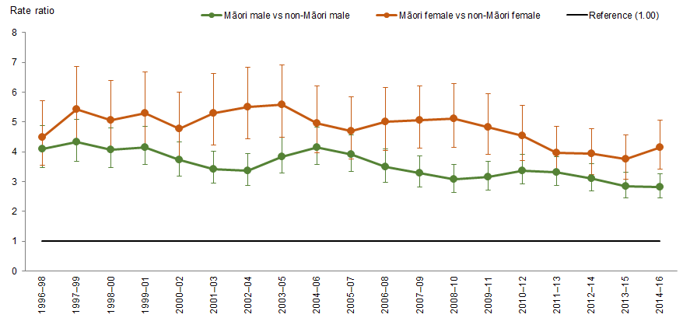
Notes:
Figures are age-standardised to the 2001 Census total Māori population.
Prioritised ethnicity has been used.
If the confidence interval of the rate ratio does not include the number 1, the ratio is said to be statistically significant.
Source: National Minimum Data Set (NMDS), Ministry of Health, 1996–98 to 2014–16.

Chronic conditions: arthritis, osteoporosis, and chronic pain
Chronic conditions can be defined as any ongoing, long term or recurring conditions that can have a significant impact on people’s lives. They are also sometimes referred to as long-term conditions and non-communicable diseases (Ministry of Health 2018d). This section presents results over time focusing on three chronic conditions: arthritis, osteoporosis, and chronic pain.

The chronic conditions data was sourced from the New Zealand Health Survey (NZHS), covering the period from 2006/07 to 2016/17. It is important to note the data was self-reported, which may not be an accurate representation of the true prevalence of these conditions. Therefore, caution should be taken when comparing results from this report with reports that use a different data source.

What is the data telling us?
Arthritis
- Māori have been more likely to report an arthritis diagnosis than non-Māori, and the difference between diagnosis rates by ethnicity has been consistent over time.
- Māori males are more likely than non-Māori males to report an arthritis diagnosis, but there was no significant difference for diagnosis rates between Māori females and non-Māori females.
Osteoporosis
- There were no significant differences over time in the rates of reported osteoporosis diagnosis by ethnicity or sex.
Chronic pain
- In general, Māori were more likely to report having experienced chronic pain than non-Māori, and the difference has increased over time.
- The difference in the rate of Māori males reporting having experienced chronic pain compared with non-Māori males has been fairly consistent over time, but the difference between Māori and non-Māori females has increased.

Arthritis
Arthritis is a condition which affects the joints, making them stiff, painful and swollen. There are many different kinds of arthritis and they can affect people of any age (Ministry of Health 2018a). The most common types of arthritis in New Zealand are osteoarthritis, gout arthritis, and rheumatoid arthritis (Arthritis New Zealand n.d.).

Māori were more likely to self-report an arthritis diagnosis than non-Māori, and the difference between reported rates of diagnosis by ethnicity has been fairly consistent over time. Māori males were more likely than non-Māori males to report an arthritis diagnosis, but there was no significant difference in reported diagnosis rates between Māori and non-Māori females.

Figure 71: Diagnosed arthritis, 15+ years, Māori and non-Māori,
2006/07–2016/17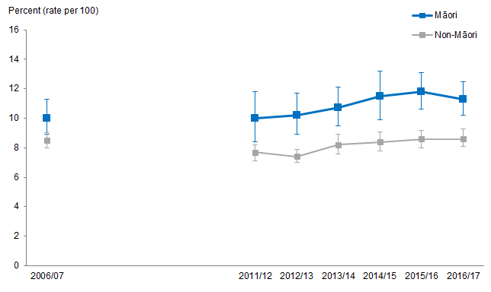
Notes:
Figures are age-standardised to the 2001 Census total Māori population.
Prioritised ethnicity has been used.
If the confidence intervals of two rates do not overlap, the difference in rates is said to be statistically significant.
Source: New Zealand Health Survey (NZHS), Ministry of Health, 2006/07–2016/17.

Figure 71 shows that since 2011/12, the percentage of Māori who reported an arthritis diagnosis was higher than the percentage of non-Māori who reported an arthritis diagnosis. There were no significant differences in 2006/07. The prevalence of reported arthritis diagnosis has not changed much over time for Māori or non-Māori, meaning the rate ratio of reported diagnosis by ethnicity has stayed fairly similar. Māori are about 1.2 times as likely to report an arthritis diagnosis as non-Māori.

Figure 72: Diagnosed arthritis, 15+ years, by gender, Māori and non-Māori,
2006/07–2016/17
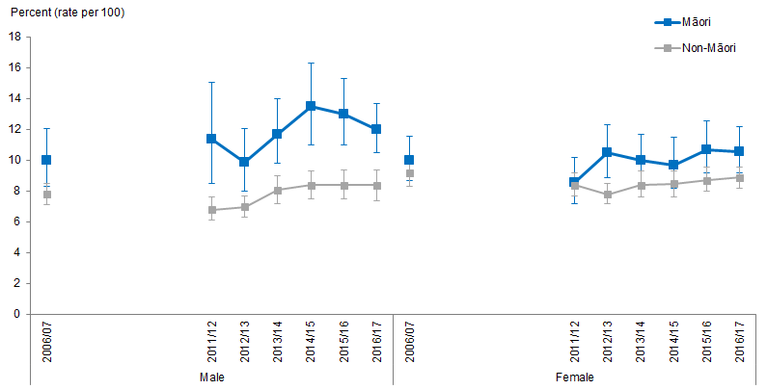
Notes:
Figures are age-standardised to the 2001 Census total Māori population.
Prioritised ethnicity has been used.
If the confidence intervals of two rates do not overlap, the difference in rates is said to be statistically significant.
Source: New Zealand Health Survey (NZHS), Ministry of Health, 2006/07–2016/17.

Figure 72 shows that Māori males have been more likely to report an arthritis diagnosis than non-Māori males from 2011/12 onwards. The prevalance of reported arthritis diagnosis has not changed much over time for either Māori or non-Māori males, so the difference in rates of reported diagnosis between Māori and non-Māori males has stayed fairly similar. Māori males are about 1.5 times as likely to report an arthritis diagnosis as non-Māori males.

In general, there were no significant differences between the percentage of Māori females who reported an arthritis diagnosis compared with non-Māori females.

Osteoporosis
Osteoporosis is when a person’s bones become thin and brittle. It means a person is more at risk of breaks and fractures. It’s most common in older people, although young people can suffer from it as well (Ministry of Health 2018f).

Figure 73: Diagnosed osteoporosis, 15+ years, by gender, Māori and non-Māori, 2006/07–2016/17
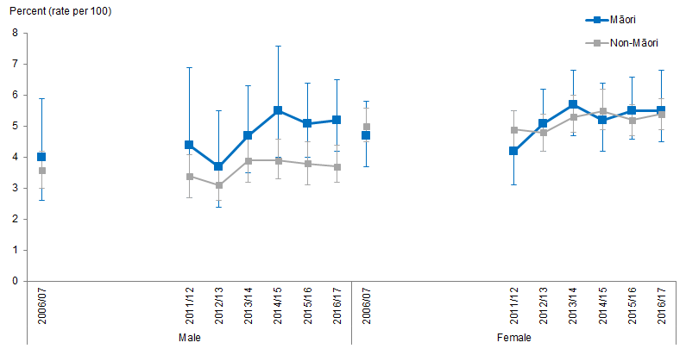
Notes:
Figures are age-standardised to the 2001 Census total Māori population.
Prioritised ethnicity has been used.
If the confidence intervals of two rates do not overlap, the difference in rates is said to be statistically significant.
Source: New Zealand Health Survey (NZHS), Ministry of Health, 2006/07–2016/17.

Figure 73 shows that there were no significant differences by ethnicity or sex in the rate of reported osteoporosis diagnosis over time.

Chronic pain
Chronic pain is pain that lasts longer than three months, also referred to as persistent pain or long-term pain. It is often described as pain that does not go away as expected after an injury or illness and is thought to occur when nerves become over-sensitive even when there is no injury, or the original injury causing pain has healed (Health Navigator New Zealand 2019b).

Māori are more likely to report having experienced chronic pain than non-Māori, and the difference has increased over time. The difference in the rate of Māori males who reported having experienced chronic pain compared with non-Māori males has stayed fairly consistent over time, but the difference between Māori and non-Māori females has increased.

Figure 74: Experienced chronic pain, 15+ years, Māori and non-Māori,
2006/07–2016/17
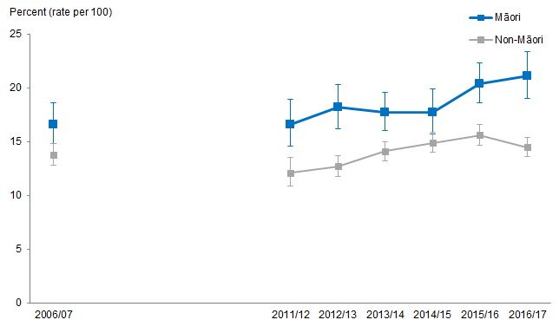
Notes:
Figures are age-standardised to the 2001 Census total Māori population.
Prioritised ethnicity has been used.
If the confidence intervals of two rates do not overlap, the difference in rates is said to be statistically significant.
Source: New Zealand Health Survey (NZHS), Ministry of Health, 2006/07–2016/17.

Figure 74 shows that Māori have, in general, been more likely to report having experienced chronic pain than non-Māori since 2011/12. There were no significant differences in 2006/07.

The percentage of both Māori and non-Māori who reported having experienced chronic pain has increased over time. The percentage of Māori who reported having experienced chronic pain increased more rapidly, from 16.6 percent in 2011/12 to 21.1 percent in 2016/17, an increase of 4.5 percentage points or 27.1 percent. The percentage of non-Māori who reported having experienced chronic pain in this time period increased from 12.1 percent to 14.5 percent, an increase of 2.4 percentage points or 19.8 percent. This means the overall difference between Māori and non-Māori has increased.

Figure 75: Experienced chronic pain, 15+ years, by gender, Māori and non-Māori, 2006/07–2016/17
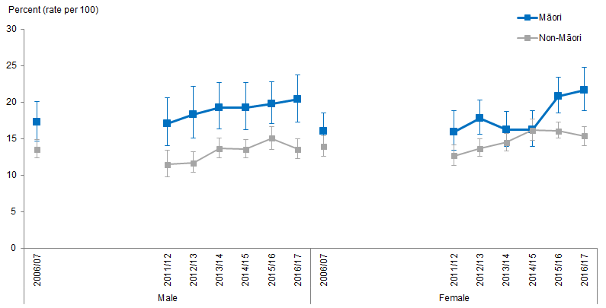
Notes:
Figures are age-standardised to the 2001 Census total Māori population.
Prioritised ethnicity has been used.
If the confidence intervals of two rates do not overlap, the difference in rates is said to be statistically significant.
Source: New Zealand Health Survey (NZHS), Ministry of Health, 2006/07–2016/17.

Figure 75 shows that there have been differences in the reported experience of chronic pain between ethnicities for both males and females.

Māori males have been more likely to report experiencing chronic pain than non-Māori males from 2011/12 onwards. The percentage of males reporting having experienced chronic pain has increased over time for both Māori and non-Māori at a similar rate, meaning the ratio of Māori males reporting having experienced chronic pain compared with non-Māori males has stayed fairly similar. Māori males have been about 1.4 times as likely to report having experienced chronic pain as non-Māori males.

The percentage of females reporting having experienced chronic pain has also increased over time, regardless of ethnicity. Figure 75 shows that Māori females were more likely to report having experienced chronic pain than non-Māori females in 2012/13, 2015/16, and 2016/17. The difference between the percentage of Māori females experiencing chronic pain compared with non-Māori females has increased, particularly since 2015/16.

Dementia mortality
This section presents results over time for the rate of deaths due to dementia (including Alzheimer’s disease) for Māori versus non-Māori.

Dementia is a gradual loss of brain function due to physical changes in the structure of a person’s brain. There are many causes of dementia, but the most common is Alzheimer’s disease. A person can have a combination of different causes of dementia, and each cause tends to affect particular areas of the brain and will cause different changes in a person’s behaviour (Ministry of Health 2018b).

Dementia is not a normal part of the ageing process. However, it is much more common for people over the age of 65 (Ministry of Health 2018b), so the data presented here focuses on dementia mortality for people over 65 years of age.

What is the data telling us?
- Dementia mortality for people over 65 years of age has increased over time for both Māori and non-Māori.
- The rate of increase has been more rapid for Māori.
- In general, the data does not show any statistically significant differences in the dementia mortality rates between Māori and non-Māori.
- In general, females have higher rates of dementia mortality than males.

Issues with the data
Reliability issues arise from using dementia mortality as an indicator of the prevalence of dementia, as dementia is unlikely to be recorded as a primary cause of death. For example, if a person with dementia dies from an injury such as a hip fracture, the cause of the accident or incident leading to that injury (such as a fall) will be recorded as the cause of death. This means the numbers of dementia mortality regardless of ethnicity is small, and is potentially only capturing a small proportion of people dying as a result of dementia.

There are also a variety of possible issues with dementia diagnosis, and it is not yet known how this might affect ethnic populations differently. The diagnosis of dementia is complex. In most high income countries, it is estimated that 50 to 60 percent of cases of dementia are undiagnosed (Prince et al 2016). There are a variety of reasons for this, including issues with stigma, lack of community education, and reluctance to give a diagnosis where limited support is available to people who have dementia (Dyall 2014). Additionally, researchers have suggested the diagnostic tools for dementia are not always appropriate for Māori, potentially resulting in further misdiagnosis (Brain Research New Zealand n.d.). As noted above, there is also a relationship between older age and the development of dementia (Ministry of Health 2018b). Although it has been suggested that the higher exposure to socioeconomic and co-morbidity risk factors in similar indigenous populations may lead to a higher risk of dementia (Jacklin et al 2013), Māori may be less likely to develop/be diagnosed with dementia due to the lower life expectancy of Māori compared with non-Māori.

This may contribute to the very small numbers of dementia mortality for Māori compared with the numbers for non-Māori. It is worth noting that a small number means the confidence interval for dementia mortality rates for Māori is very large. This means it is difficult to paint a clear picture of statistically significant differences between ethnicities, but does not necessarily mean that these differences do not exist. The incidence of dementia in Māori may increase more rapidly than in non-Māori in years to come, due to a higher prevalence of risk factors for the development of dementia, such as heart and lung disease and socioeconomic inequality, coupled with a more rapidly ageing population (Kerse et al 2017).

Dementia mortality
Figure 76: Dementia (including Alzheimer’s Disease) mortality rates, 65+ years, Māori and non-Māori, 1996–98 to 2012–14
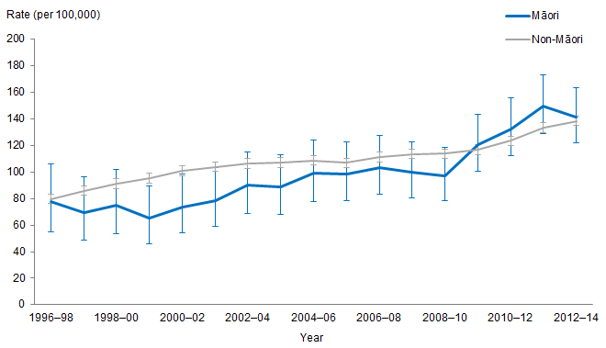
Notes:
Figures are age-standardised to the 2001 Census total Māori population.
Prioritised ethnicity has been used.
If the confidence intervals of two rates do not overlap, the difference in rates is said to be statistically significant.
Source: Mortality Collection Data Set (MORT), Ministry of Health, 1996–98 to 2012–14.

Dementia mortality has increased over time for both Māori and non-Māori, but the rate of increase has been slightly more rapid for Māori. In general, the data does not show statistically different rates of dementia mortality for Māori compared with non-Māori.

Figure 76 shows that the rate of dementia mortality has increased steadily over time for both Māori and non-Māori aged 65 years and over. For older Māori, dementia mortality increased substantially from 77.4 deaths per 100,000 in 1996–98 to 141.5 deaths per 100,000 in 2012–14, an increase of 64.1 deaths or 82.8 percent. The rate for non-Māori also saw a large increase, from 79.7 deaths per 100,000 in 1996–98 to 138.4 deaths per 100,000 in 2012–14, an increase of 58.7 deaths or 73.6 percent.

There were generally no significant differences between Māori and non-Māori dementia mortality rates over time.

Figure 77: Dementia (including Alzheimer’s Disease) mortality rates, 65+ years, by gender, Māori and non-Māori, 1996–98 to 2012–14
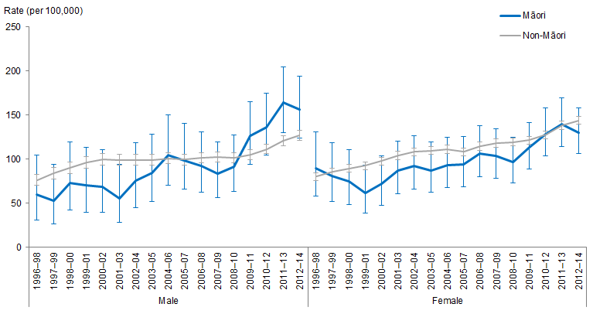
Notes:
Figures are age-standardised to the 2001 Census total Māori population.
Prioritised ethnicity has been used.
If the confidence intervals of two rates do not overlap, the difference in rates is said to be statistically significant.
Source: Mortality Collection Data Set (MORT), Ministry of Health, 1996–98 to 2012–14.

Figure 77 shows that, in general, there were no significant differences in the rate of dementia mortality between Māori and non-Māori males, or Māori and non-Māori females. The difference in the rate of dementia mortality was not statistically significant between Māori males and females across the time period shown. The rates for non-Māori males were lower than for non-Māori females from 2006–08 onwards, and it is possible this difference would be reflected in the Māori population if the numbers were larger. There are a variety of possible reasons dementia mortality might be more common in females, including a gene variant that affects females differently than males (Altmann et al 2014), the relationship between heart disease and dementia and dementia and older age, and the longer life expectancy of females (Hughes et al 2013).

Infectious disease
This section presents the trends related to selected infectious diseases for Māori and non-Māori, including tuberculosis and meningococcal disease notifications, first episode rheumatic fever hospitalisations and HIV/AIDS.

What is the data telling us?
- Between 1997–99 and 2007–09 the Māori rate of tuberculosis notifications was greater than that of non-Māori.
- Between 2013–15 and 2015–17 the Māori rate of tuberculosis notifications was lower than the non-Māori rate.
- The age-standardised rate of tuberculosis notifications for Māori decreased at a faster rate than that of non-Māori between 1997–99 and 2015–17.
- The Māori rate of first episode rheumatic fever hospitalisations was greater than that of non-Māori, this did not change over time.
- The rate of first episode rheumatic fever hospitalisations for Māori nearly halved between 2010–12 and 2014–16 after nearly doubling between
1996–98 and 2010–12.
- The rate of meningococcal disease notifications for Māori was nearly twice that of non-Māori, this did not change over time.
- The rate of meningococcal disease notifications decreased by nearly 90 percent for both Māori and non-Māori between 1997–99 and 2015–17.

Tuberculosis
Tuberculosis (TB) is a bacterial infection that most commonly affects the lungs, but can also affect the lymph nodes, bones, joints and kidneys, it can also cause meningitis (an infection of the membranes that cover the brain) (Ministry of Health 2018h).

Figure 78: Tuberculosis (TB) notification rates, Māori and non-Māori, 1997–99 to 2015–17
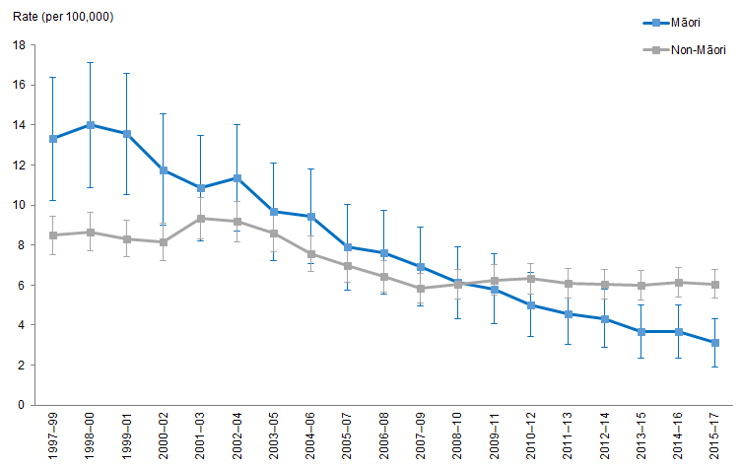
Notes:
Figures are age-standardised to the 2001 Census total Māori population.
Prioritised ethnicity has been used.
If the confidence intervals of two rates do not overlap, the difference in rates is said to be statistically significant.
Source: Institute of Environmental Science and Research Limited (ESR), 1997–2017.

Figure 78 shows the age-standardised rate of TB notifications for Māori and non-Māori between 1997 and 2017.

Māori rate of TB notifications decreased faster than that of non-Māori
The age-standardised rate of TB notifications for Māori decreased by 77 percent between 1997–99 and 2015–17 (from 13 to 3 notifications per 100,000).

In comparison, the rate of TB notifications for non-Māori decreased by 29 percent over this period (from 8 to 6 notifications per 100,000).

Change in difference for rate of TB notifications for Māori and non-Māori
The difference between Māori and non-Māori rates of TB notifications decreased as the rate of TB notifications for Māori decreased. In 1997–99 Māori had a higher rate of TB notifications than non-Māori (rate ratio was 1.6), by 2008–10 there was no significant difference between Māori and non-Māori rates of TB notifications (rate ratio was 1.01 in 2008–10).

The continued decrease of the Māori rate of TB notifications resulted in Māori having a lower rate of TB notifications than that of non-Māori from 2013–15 onwards (rate ratio of 0.6 in 2013–15 and 0.5 in 2015–17). In 2015–17, Māori had a lower rate of TB notifications than non-Māori.

First episode rheumatic fever hospitalisations
Rheumatic fever is an autoimmune disease where the immune system attacks parts of the body. It can develop after a ‘strep throat’ (a throat infection caused by a group A Streptococcus (GAS) bacteria) (Ministry of 2019e).

The Ministry of Health has a focus on reducing the incidence of rheumatic fever, thus reports concentrate on first episode rheumatic fever hospitalisations.

Figure 79: First episode rheumatic fever hospitalisation rates, Māori and non-Māori, 1996–98 and 2014–16
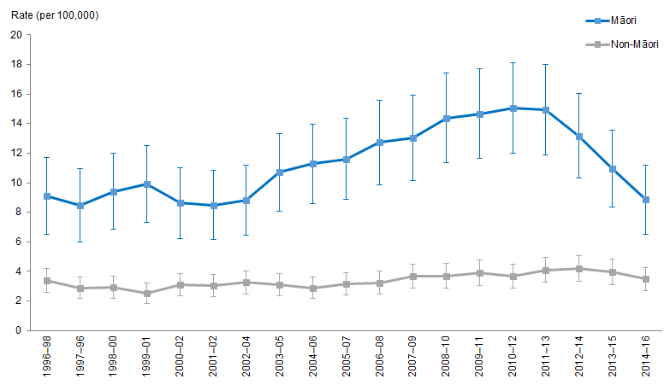
Notes:
Figures are age-standardised to the 2001 Census total Māori population.
Prioritised ethnicity has been used.
If the confidence intervals of two rates do not overlap, the difference in rates is said to be statistically significant.
Source: National Minimum Data Set (NMDS), Ministry of Health, 1996–98 to 2014–16.

Figure 79 shows the age-standardised rates of first episode rheumatic fever (RF) hospitalisations for Māori and non-Māori between 1996–98 and 2014–16.

Change in rate of first episode RF hospitalisations for Māori
The rate of first episode RF hospitalisations for Māori increased by 65 percent between 1996–98 and 2010–12 (from 9 in 1996–98 to 15 hospitalisations per 100,000 in
2010–12). Between 2010–12 and 2014–16, the Māori rate of first episode RF hospitalisations nearly halved (to 9 hospitalisations per 100,000 in 2014–16).

In comparison, the rate of first episode RF hospitalisations for non-Māori remained reasonably constant over the period (average of 3 hospitalisations per 100,000).

Difference between Māori and non-Māori rate of first episode RF hospitalisations
Māori had a higher rate of first episode RF hospitalisations than non-Māori, this did not change over time. However, the size of the difference between Māori and non-Māori did – the difference between Māori and non-Māori followed a similar trend to the Māori rate of first episode RF hospitalisations – increasing between 1996–98 and 2010–12 and decreasing between 2010–12 and 2014–16.

In 1996–98, the rate of first episode RF hospitalisations for Māori was over 2½ times that of non-Māori, this gap increased until 2010–12 where the rate of first episode RF hospitalisations for Māori was over four times that of non-Māori. The gap then decreased between 2010–12 and 2014–16, where the rate of first episode RF hospitalisations for Māori was over 2½ times the rate for non-Māori.

Meningococcal disease
Meningococcal disease is a bacterial infection that causes meningitis and septicaemia (blood poisoning), meningococcal can also cause permanent disability, such as deafness (Ministry of Health 2018e).

Figure 80: Meningococcal notification rates, Māori and non-Māori, 1997–99 and 2015–17
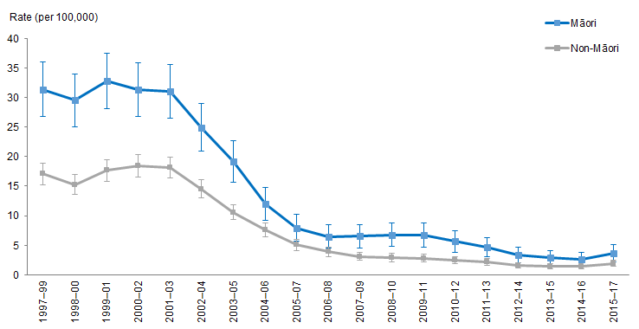
Notes:
Figures are age-standardised to the 2001 Census total Māori population.
Prioritised ethnicity has been used.
If the confidence intervals of two rates do not overlap, the difference in rates is said to be statistically significant.
Source: Institute of Environmental Science and Research Limited (ESR) 1997–2017.

Figure 80 shows the age-standardised rate of meningococcal disease notifications for Māori and non-Māori between 1997 and 2017.

Decrease in rate of meningococcal disease notifications for Māori and non-Māori
The rate of meningococcal disease notifications decreased for both Māori and non-Māori between 1997–99 and 2015–17 at a similar rate (both decreasing by nearly 90 percent). In 2015–17, the rate of meningococcal notifications was 4 notifications per 100,000 compared with a rate of 2 per 100,000 non-Māori.

During this time the rate of meningococcal disease notifications for Māori decreased by 88 percent (from 31 to 4 notifications per 100,000) and the rate for non-Māori also decreased by almost 89 percent over the same period (from 17 to 2 notifications per 100,000).

Difference between Māori and non-Māori rates of meningococcal disease notifications
Māori rate of meningococcal disease notifications was nearly twice that of non-Māori, this did not change over time due to the rates of meningococcal disease notifications for Māori and non-Māori decreasing at similar rates. Although the rate ratio did not change over time the absolute difference did, decreasing by 88 percent between
1997–99 and 2015–17 (Māori had 14 more notifications per 100,000 than non-Māori in 1997–99 and 2 more notifications per 100,000 in 2015–17).

HIV/AIDS
HIV (human immunodeficiency virus) damages the immune system. When a person has HIV and one or more serious illnesses (such as pneumonia) or cancers, they are said to have AIDS (acquired immunodeficiency syndrome) (Ministry of Health 2018c).

Table 23: Count (percentage %) of HIV diagnoses, by gender, Māori and non-Māori, 1996 to 2017
Year | Māori |  | Non-Māori |  | Total
 | Male | Female | Male | Female
1996 | 5 (5.3) | 1 (1.1) | 73 (76.8) | 16 (16.8) | 95 (100.0)
1997 | 5 (6.8) | 1 (1.4) | 52 (71.2) | 15 (20.5) | 73 (100.0)
1998 | 4 (3.5) | 0 (0.0) | 88 (77.9) | 21 (18.6) | 113 (100.0)
1999 | 12 (6.0) | 2 (1.0) | 158 (79.4) | 27 (13.6) | 199 (100.0)
2000 | 4 (3.8) | 1 (1.0) | 74 (70.5) | 26 (24.8) | 105 (100.0)
2001 | 5 (4.2) | 2 (1.7) | 76 (63.9) | 36 (30.3) | 119 (100.0)
2002 | 8 (5.9) | 0 (0.0) | 104 (76.5) | 24 (17.6) | 136 (100.0)
2003 | 12 (6.5) | 0 (0.0) | 139 (74.7) | 35 (18.8) | 186 (100.0)
2004 | 8 (4.4) | 1 (0.5) | 135 (74.2) | 38 (20.9) | 182 (100.0)
2005 | 12 (5.5) | 1 (0.5) | 158 (72.8) | 46 (21.2) | 217 (100.0)
2006 | 9 (4.5) | 3 (1.5) | 137 (67.8) | 53 (26.2) | 202 (100.0)
2007 | 19 (9.7) | 0 (0.0) | 132 (67.7) | 44 (22.6) | 195 (100.0)
2008 | 18 (8.1) | 1 (2.1) | 166 (75.1) | 36 (16.3) | 221 (100.0)
2009 | 10 (5.2) | 4 (2.1) | 141 (73.1) | 38 (19.7) | 193 (100.0)
2010 | 16 (8.9) | 0 (0.0) | 140 (77.8) | 24 (13.3) | 180 (100.0)
2011 | 10 (7.2) | 1 (0.7) | 110 (79.1) | 18 (12.9) | 139 (100.0)
2012 | 5 (3.0) | 3 (1.8) | 134 (80.7) | 24 (14.5) | 166 (100.0)
2013 | 7 (3.9) | 2 (1.1) | 147 (82.6) | 22 (12.4) | 178 (100.0)
2014 | 22 (10.0) | 2 (0.9) | 171 (77.7) | 25 (11.4) | 220 (100.0)
2015 | 16 (7.3) | 2 (0.9) | 186 (84.9) | 15 (6.8) | 219 (100.0)
2016 | 13 (5.2) | 1 (0.4) | 205 (82.7) | 29 (11.7) | 248 (100.0)
2017 | 8 (4.1) | 2 (1.0) | 162 (83.9) | 21 (10.9) | 193 (100.0)
Notes:
Interpretation: X (Y) where X is the number of people (count) and (Y) is the percentage (%) of people diagnosed with HIV.
Prioritised ethnicity was used.
Crude counts and percentages have been used.
Includes people who have developed AIDS.
Source: AIDS Epidemiology Group, Dunedin School of Medicine, 1996–2017.

Table 23 shows the counts and percentages of HIV diagnoses for Māori and non-Māori, by gender, between 1996 and 2017.

There is a large amount of annual variation in the number of people diagnosed with HIV. This is, in part, due to the small number of people diagnosed with HIV between 1996 and 2017.

The majority of those diagnosed with HIV were non-Māori, this did not change over time – on average over 93 percent of those diagnosed with HIV were non-Māori (almost 7 percent were Māori).

Males had higher counts of HIV than females, regardless of ethnicity.

The count of non-Māori males diagnosed with HIV has increased from 73 diagnoses in 1996 to 162 diagnoses in 2017. Non-Māori females, and both Māori males and females did not show much change in the number of HIV diagnoses over this period.

Table 24: Count (percentage %) of AIDS diagnoses, by gender, Māori and Non-Māori, 1996 to 2017
Year | Māori |  | Non-Māori |  | Total
 | Male | Female | Male | Female
1996 | 7 (11.1) | 0 (0.0) | 51 (81.0) | 5 (7.9) | 63 (100.0)
1997 | 4 (10.8) | 0 (0.0) | 32 (86.5) | 1 (2.7) | 37 (100.0)
1998 | 2 (6.9) | 1 (3.4) | 21 (72.4) | 5 (17.2) | 29 (100.0)
1999 | 2 (5.3) | 1 (2.6) | 27 (71.1) | 8 (21.1) | 38 (100.0)
2000 | 0 (0.0) | 0 (0.0) | 21 (84.0) | 4 (16.0) | 25 (100.0)
2001 | 0 (0.0) | 1 (3.3) | 21 (70.0) | 8 (26.7) | 30 (100.0)
2002 | 4 (20.0) | 1 (5.0) | 11 (55.0) | 4 (16.0) | 20 (100.0)
2003 | 3 (8.3) | 1 (2.8) | 27 (75.0) | 5 (13.9) | 36 (100.0)
2004 | 2 (4.5) | 1 (2.3) | 30 (68.2) | 11 (25.0) | 44 (100.0)
2005 | 4 (10.5) | 0 (0.0) | 27 (71.1) | 7 (18.4) | 38 (100.0)
2006 | 3 (8.3) | 0 (0.0) | 17 (60.7) | 8 (28.6) | 28 (100.0)
2007 | 6 (21.4) | 0 (0.0) | 17 (60.7) | 5 (17.9) | 28 (100.0)
2008 | 7 (18.4) | 0 (0.0) | 26 (68.4) | 5 (13.2) | 38 (100.0)
2009 | 2 (8.7) | 1 (4.3) | 15 (65.2) | 5 (21.7) | 23 (100.0)
2010 | 8 (24.2) | 0 (0.0) | 21 (63.6) | 4 (12.1) | 33 (100.0)
2011 | 3 (13.6) | 1 (4.5) | 16 (72.7) | 2 (9.1) | 22 (100.0)
2012 | 2 (25.0) | 2 (9.5) | 12 (57.1) | 5 (23.8) | 21 (100.0)
2013 | 4 (20.0) | 0 (0.0) | 13 (65.0) | 3 (15.0) | 20 (100.0)
2014 | 3 (25.0) | 1 (8.3) | 6 (50.0) | 2 (16.7) | 12 (100.0)
2015 | 2 (18.2) | 0 (0.0) | 9 (81.8) | 0 (0.0) | 11 (100.0)
2016 | 3 (14.3) | 1 (4.8) | 14 (66.7) | 3 (14.3) | 21 (100.0)
2017 | 1 (9.1) | 0 (0.0) | 9 (81.8) | 1 (9.1) | 11 (100.0)
Notes:
Interpretation: X (Y) where X is the number of people (count) and (Y) is the percentage (%) of people diagnosed with AIDS.
Prioritised ethnicity was used.
Crude counts and percentages have been used.
Source: AIDS Epidemiology Group, Dunedin School of Medicine, 1996–2017.

Table 24 shows the counts and percentages for Māori and non-Māori diagnosed with AIDS, by gender, between 1996 and 2017.

There is a large amount of annual variation in the number of people diagnosed with AIDS. This is, in part, due to the small number of people diagnosed with AIDS between 1996 and 2017.

The majority of those diagnosed with AIDS were non-Māori, this did not change over time – on average, over 85 percent of those diagnosed with AIDS were non-Māori (nearly 15 percent were Māori).

Males had higher rates of AIDS diagnoses than females, regardless of ethnicity, this was consistent with HIV diagnoses over this period.

The total number of AIDS diagnoses decreased over time, from 63 diagnoses in 1996 to 11 diagnoses in 2017.

Suicide and intentional self-harm
This section presents the trends for suicide and intentional self-harm for Māori and non-Māori by age groups.

What is the data telling us?
Suicide mortality
- Māori have higher incidence of suicide mortality than non-Māori over time, except for older Māori (aged 45–64 years). In 2012–14, Māori were over 1½ times as likely as non-Māori to die by suicide.
- Māori males have the highest suicide mortality rates overall.
- The difference between Māori females and non-Māori females has increased over time (over twice as likely).
- Young people aged 15–24 years had the highest suicide mortality rates out of all age groups, with Māori males in particular having the highest rates of mortality.
- Suicide mortality rates have increased over time for young Māori females aged 15–24 years. The difference between Māori females and non-Māori females has increased over time.
Intentional self-harm hospitalisations
- Māori were more likely than non-Māori to be hospitalised for intentional self-harm, particularly since the early 2000s.
- There has been a steep increase in intentional self-harm hospitalisation rates for females, particularly since the late 2000s.
- Over time, intentional self-harm hospitalisation rates have increased for both males and females with a widening disparity particularly evident between Māori males and non-Māori males.

Suicide mortality
Figure 81: Suicide mortality rates, all age groups, by gender, Māori and non-Māori, 1996–98 to 2012–14
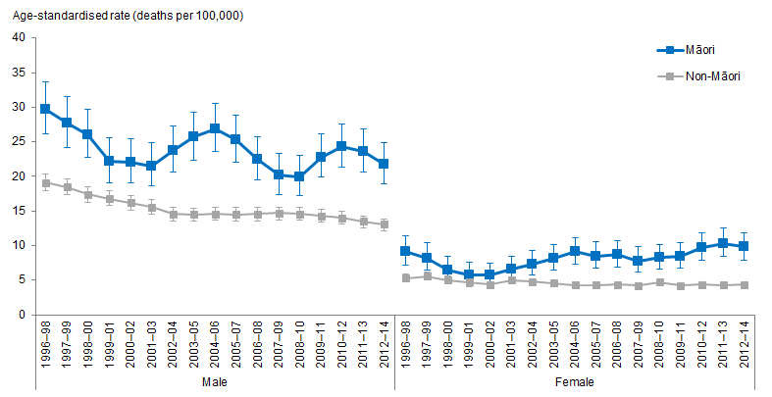
Notes:
Figures are age-standardised to the 2001 Census total Māori population.
Prioritised ethnicity has been used.
If the confidence intervals of two rates do not overlap, the difference in rates is said to be statistically significant.
Source: Mortality Collection Data Set (MORT), Ministry of Health, 1996–98 to 2012–14.

Māori have higher incidence of suicide mortality than non-Māori over time, in 2012–14, Māori were over 1½ times as likely as non-Māori to die by suicide.

Suicide mortality has fluctuated for Māori over time, decreasing from the mid-1990s then increasing in the mid-2000s before dipping and increasing again in 2009–11. In contrast, suicide mortality rates have steadily declined for non-Māori over time.

Figure 81 shows that there are clear differences by gender, with males more likely to die by suicide than females, with Māori males having the highest suicide mortality rates overall. The trends for Māori males mirror the fluctuating pattern, however, overall from 1996–98 to 2012–14 the suicide mortality rate for Māori males decreased by 27 percent (from 29.7 deaths per 100,000 to 21.8 deaths per 100,000).

Suicide mortality rates for Māori females decreased between 1996 and 2000, then steadily increased to around double the rate in 2000. The difference between Māori females and non-Māori females has increased over time. There is a widening of the gap apparent from 2009–11, with Māori females over twice as likely as non-Māori females to die by suicide.

Suicide mortality trends by age group
Figure 82: Suicide mortality, 15–24 years, by gender, Māori and non-Māori, 1996–98 to 2012–14
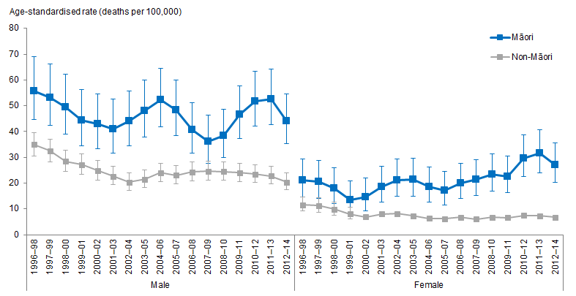
Notes:
Figures are age-standardised to the 2001 Census total Māori population.
Prioritised ethnicity has been used.
If the confidence intervals of two rates do not overlap, the difference in rates is said to be statistically significant.
Source: Mortality Collection Data Set (MORT), Ministry of Health, 1996–98 to 2012–14.

Young people aged 15–24 years had the highest suicide mortality rates out of all age groups with Māori males in particular having the highest rates of mortality, showing a similar fluctuating trend as all age groups pattern. In 2012–14, young Māori males were over twice as likely as young non-Māori males to die by suicide.

Figure 82 shows that suicide mortality rates have increased over time for young Māori females aged 15–24 years, an increase of 29 percent from 1996–98 to 2012–14 (from 21.0 deaths per 100,000 to 27.1 deaths per 100,000). The difference between Māori and non-Māori females aged 15–24 years has also widened over time. In 1999–01, young Māori females were over 1½ times as likely to die by suicide as non-Māori young females, in 2012–14 this difference had widened to four times as likely.

For Māori aged 25–44 years, there is a similar pattern over time, showing that Māori continue to have higher suicide mortality rates than non-Māori, with males experiencing higher rates than females. There has been little change over time for Māori females aged 25–44, whereas suicide mortality rates for Māori males aged 25–44 have decreased over time (with some fluctuation) by 23 percent (from 52.8 deaths per 100,000 in 1996–98 to 40.7 deaths per 100,000 in 2012–14).

Intentional self-harm hospitalisation
Figure 83: Intentional self-harm hospitalisation rates, all age groups, by gender, Māori and non-Māori, 1996–98 to 2014–16
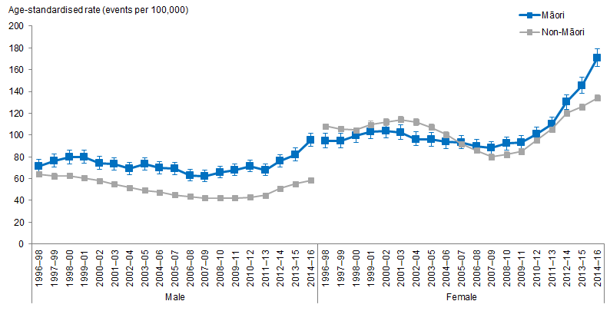
Notes:
Figures are age-standardised to the 2001 Census total Māori population.
Prioritised ethnicity has been used.
If the confidence intervals of two rates do not overlap, the difference in rates is said to be statistically significant.
Source: National Minimum Data Set (NMDS), Ministry of Health, 1996–98 to 2014–16.

Māori were more likely than non-Māori to be hospitalised for intentional self-harm, particularly since the early 2000s. Over time, self-harm hospitalisation rates increased for Māori by around 60 percent (from 83.3 events per 100,000 in 1996–98 to 132.7 in 2014–16).

The difference between Māori and non-Māori also increased over time. From 1996–98 to the mid-2000s there was little difference between Māori females and non-Māori females with similar rates of hospitalisation for self-harm. However since the mid-2000s, Māori females have been increasingly more likely than non-Māori females to be hospitalised for self-harm.

Figure 83 shows that females are more likely to be hospitalised for intentional self-harm than males. For Māori females, rates of hospitalisation for self-harm have increased over time by around 80 percent (from 94.6 events per 100,000 in 1996–98 to 170.8 events per 100,000 in 2014–16). For Māori males, there is a more fluctuating pattern over time, with an indication of increasing rates of self-harm hospitalisation from 2012–14.

Māori males are more likely than non-Māori males to be hospitalised for intentional self-harm, and from 1996–98 the difference appears to be increasing. In 2014–16 Māori males were over 1½ times as likely as non-Māori males to be hospitalised. Unlike males, there was little difference between Māori females and non-Māori females over time. However, since 2013–15, Māori females are slightly more likely than non-Māori females to be hospitalised for intentional self-harm.

Intentional self-harm hospitalisation trends by age group
Figure 84: Intentional self-harm hospitalisation, 15–24 years, by gender, Māori and non-Māori, 1996–98 to 2014–16
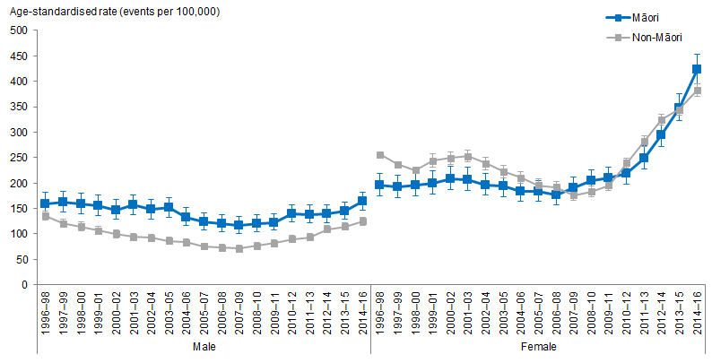
Notes:
Figures are age-standardised to the 2001 Census total Māori population.
Prioritised ethnicity has been used.
If the confidence intervals of two rates do not overlap, the difference in rates is said to be statistically significant.
Source: National Minimum Data Set (NMDS), Ministry of Health, 1996–98 to 2014–16.

Young people aged 15–24 years had the highest rates of self-harm hospitalisations out of all age groups, with little difference between Māori and non-Māori until around 2013–15, when rates become slightly higher for Māori. Self-harm hospitalisations have increased over time for Māori by 64 percent (from 177.8 events per 100,000 in 1996–98 to 291.2 events per 100,000 in 2014–16).

Figure 84 shows that females have higher rates of self-harm hospitalisations than males. There has not been much change over time for males, however, for females there has been a steep increase in self-harm hospitalisations particularly since the late 2000s. Over time, hospitalisations for self-harm for Māori females aged 15–24 years have increased by over 100 percent from 2007–09 to 2014–16 (from 189.9 events per 100,000 to 423.8 events per 100,000).

Figure 85: Intentional self-harm hospitalisation, 25–44 years, by gender, Māori and non-Māori, 1996–98 to 2014–16
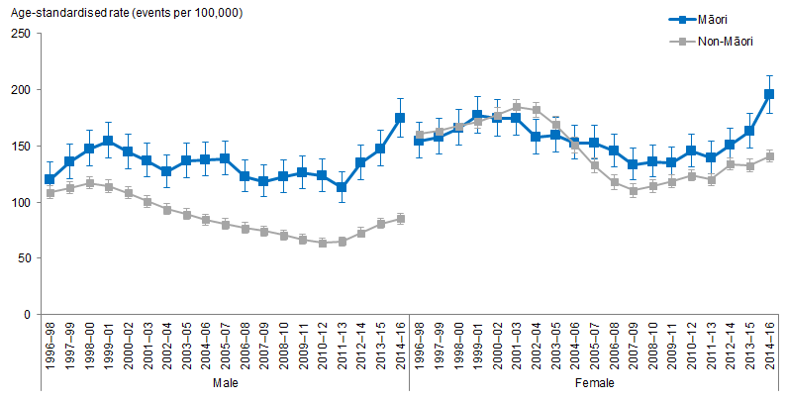
Notes:
Figures are age-standardised to the 2001 Census total Māori population.
Prioritised ethnicity has been used.
If the confidence intervals of two rates do not overlap, the difference in rates is said to be statistically significant.
Source: National Minimum Data Set (NMDS), Ministry of Health, 1996–98 to 2014–16.

Over time, self-harm hospitalisations have increased for Māori aged 25–44 years with a widening disparity particularly evident between Māori males and non-Māori males (Figure 85). In 2014–16, Māori males aged 25–44 years were twice as likely as non-Māori males to be hospitalised for self-harm.

For females aged 25–44 years, there was little difference between Māori and non-Māori females until 2005–07 when Māori females were slightly more likely to be hospitalised for intentional self-harm. The hospitalisation rates for self-harm for Māori females aged 25–44 years have increased by 30 percent from 2005–07 to 2014–16 (from 152.8 events per 100,000 to 195.4 events per 100,000).

Figure 86: Intentional self-harm hospitalisation, 45–64 years, by gender, Māori and non-Māori, 1996–98 to 2014–16
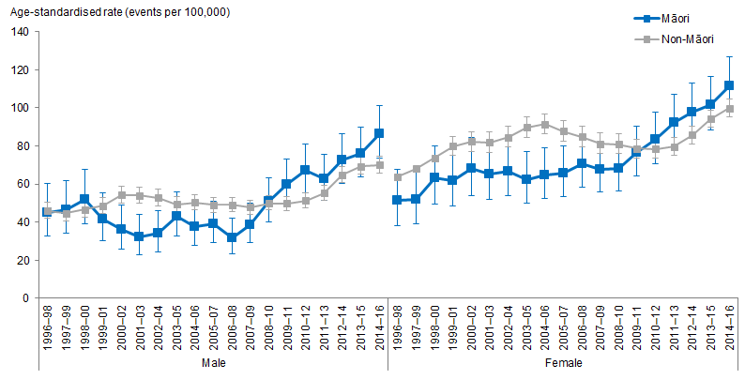
Notes:
Figures are age-standardised to the 2001 Census total Māori population.
Prioritised ethnicity has been used.
If the confidence intervals of two rates do not overlap, the difference in rates is said to be statistically significant.
Source: National Minimum Data Set (NMDS), Ministry of Health, 1996–98 to 2014–16.

Figure 86 shows that self-harm hospitalisation rates have increased over time for Māori aged 45–64 years. Before 2010–12, Māori aged 45–64 years were less likely than non-Māori of the same age group to be hospitalised for self-harm, however, since this time period, both Māori males and females were more likely than non-Māori to be hospitalised for self-harm, with an increasing upward trend. The hospitalisation rates for self-harm for Māori aged 45–64 years have increased by around 30 percent from 2010–12 to 2014–16 (from 67.3 events per 100,000 to 86.5 events per 100,000 for males, from 83.4 events per 100,000 to 111.5 events per 100,000 for females).

Interpersonal violence
This section presents the trends in assault and homicide mortality and assault and attempted homicide hospitalisation for Māori and non-Māori adults aged 15 years and over.

What is the data telling us?
Assault and homicide mortality
- Māori have a higher incidence of assault and homicide mortality than non-Māori and this has not changed over time.
- Māori males have disproportionally higher incidence of assault and homicide mortality. In 2012–14, Māori males were nearly six times as likely to have died from assault and homicide as non-Māori males.
- Between 1996–98 and 2012–14, age-standardised rates of assault and homicide mortality for Māori females has decreased but still remain almost twice as high as those of non-Māori females.
Assault and attempted homicide hospitalisations
- Māori age-standardised rates of hospitalisation as the result of assault or attempted homicide remain higher than those of non-Māori over time.
- The difference between Māori and non-Māori has steadily increased over time. In the mid to late 1990s, Māori were around 2½ times as likely to be hospitalised for assault or attempted homicide in the mid to late 1990s with the difference increasing to over 3½ times in 2014–16.
- Māori males continue to experience the highest rates of interpersonal violence when looking at hospitalisations.
- Māori females also experience much higher rates of hospitalisations from assault and attempted homicide than non-Māori females with little change apparent over time.

Assault and homicide mortality
Figure 87: Assault and homicide mortality rates, 15+ years, by gender, Māori and non-Māori, 1996–98 to 2012–14
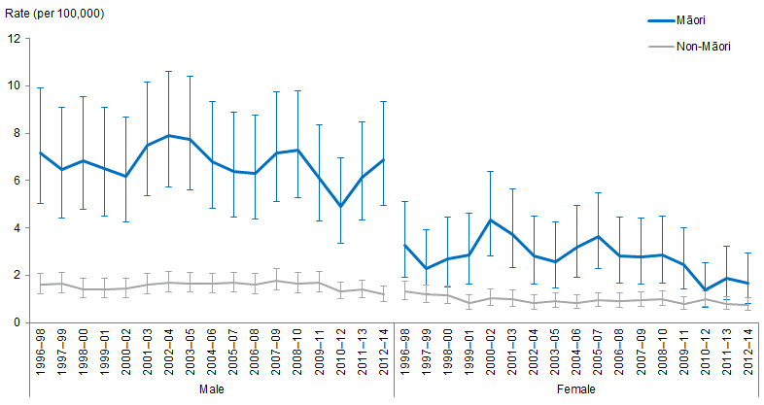
Notes:
Figures are age-standardised to the 2001 Census total Māori population.
Prioritised ethnicity has been used.
If the confidence intervals of two rates do not overlap, the difference in rates is said to be statistically significant.
Source: Mortality Collection Data Set (MORT), Ministry of Health, 1996–98 to 2012–14.

Māori aged 15 years and over have higher incidence of assault and homicide mortality than non-Māori and this has not changed over time since the mid-1990s. In 2012–14, Māori were over four times as likely as non-Māori to die from assault and homicide.

Figure 87 shows that Māori males are disproportionally affected by assault and homicide, with Māori males having far higher age-standardised rates than Māori females and non-Māori males and females. Age-standardised rates fluctuated over time for Māori males but remained at least over 3½ times as high as that of non-Māori males. In 2012–14, Māori males were nearly six times as likely to have died from assault and homicide as non-Māori males, the highest rate difference over the time series.

Between 1996–98 and 2012–14, age-standardised rates of assault and homicide mortality for Māori females have not changed much. Similarly, there was little change over time in the difference between Māori and non-Māori women, with rates for Māori women remaining twice as high as that of non-Māori women for most years in the time series.

Assault and attempted homicide hospitalisation
Figure 88: Assault and attempted homicide hospitalisation rates, 15+ years, by gender, Māori and non-Māori, 1996–98 to 2014–16
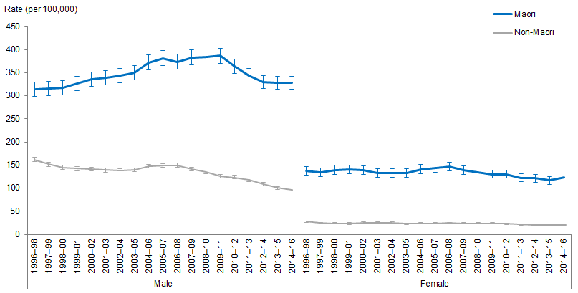
Notes:
Figures are age-standardised to the 2001 Census total Māori population.
Prioritised ethnicity has been used.
If the confidence intervals of two rates do not overlap, the difference in rates is said to be statistically significant.
Source: National Minimum Data Set (NMDS), Ministry of Health, 1996–98 to 2014–16.

Māori age-standardised rates of hospitalisation as the result of assault or attempted homicide remain higher than that of non-Māori over time.

The disparity between Māori and non-Māori has steadily increased over time. In the mid to late 1990s, Māori were around 2½ times as likely as non-Māori to be hospitalised for assault or attempted homicide with the difference increasing to over 3½ times in 2014–16.

Figure 88 shows that Māori males continue to experience the highest rates of interpersonal violence when looking at hospitalisations for assault and attempted homicide. Māori male age-standardised rates of hospitalisations for assault and attempted homicide increased until 2009–11 and then appear to have started to slowly decrease again – however by 2014–16 rates still remain higher than they were in the mid to late 1990s. In contrast, hospitalisations for assault and attempted homicide for non-Māori decreased over time (a decrease of 40 percent from 162.1 admissions per 100,000 people in 1996–98 to 97.1 admissions in 2014–16). This has resulted in the difference between Māori and non-Māori males increasing over time. In 1996–98 Māori males were nearly twice as likely to be hospitalised as non-Māori males and by
2014–16 this difference increased to be over three times as likely.

Figure 88 shows that Māori females have experienced a slight decline in hospitalisations for assault and attempted homicide (a decrease of 27 percent from 137.3 assault and homicide admissions per 100,000 people in 1996–98 to 123.6 admissions in 2014–16). This compares to a similar decrease of 26 percent over the same time period for non-Māori females. Over time it is apparent that Māori females continue to experience much higher rates of hospitalisations from assault and attempted homicide than non-Māori females, with Māori females consistently around five to six times as likely as non-Māori females to be hospitalised from interpersonal violence.

Oral health
Oral health refers to the health of our teeth and mouth. It is critical to the good health and wellbeing of children and adults. Oral diseases are among the most prevalent chronic diseases in New Zealand and represent a considerable burden on the health of the public (Ministry of Health 2010a).

This section presents the trends related to oral health for Māori and non-Māori children and adults. For the purpose of this report whether a child lives within a fluoridated area or not is determined by their school’s fluoridation status not the location of their residence. Also, in some DHB areas without community water fluoridation, the Community Oral Health Service provides regular fluoride varnish application for children at higher risk of poor oral health outcomes, this is not accounted for in this report and therefore the data may not accurately represent the fluoride exposure. The figures for fluoridated and non-fluoridated areas are included in the accompanying Excel tool and are commented on but not shown here.

Decayed, missing and filled teeth is, by convention, abbreviated to ‘dmft’ for primary/deciduous teeth and ‘DMFT’ for permanent teeth.

What is the data telling us?
- On average, the mean dmft of Māori children aged five was nearly 1½ times the mean dmft of non-Māori children of the same age between 2002 and 2016.
- The mean DMFT of Māori children in Year 8 was, on average, 1.3 times the mean DMFT of non-Māori children in Year 8 regardless of whether they were living in a fluoridated area or not between 2002 and 2016.
- Māori children aged five were less likely to be caries free than non-Māori within the same age group between 2002 and 2016.
- Māori children in Year 8 were less likely to be caries free than non-Māori within the same age group between 2002 and 2016.
- In 2006/07 non-Māori were under 1.3 times as likely to visit a dental health care worker as Māori, this decreased to under 1¼ in 2016/17.
- In 2006/07 Māori children aged 14 or below were over 1.6 times as likely as non-Māori children of the same age to have had teeth extracted in the previous year.
- In 2016/17 Māori children aged 14 or below were under 1.3 times as likely as non-Māori in the same age group to have teeth extracted.
- Between 2006/07 and 2016/17 Māori adults were, on average, more than 1½ times as likely as non-Māori adults to have had teeth extracted.
- Between 2006/07 and 2016/17 Māori adults were, on average, under 1½ times as likely as non-Māori adults to only visit a dental health care worker for dental problems, or never visit.

Mean number of decayed, missing and filled teeth (dmft) at five years of age
Figure 89: Mean number of decayed, missing and filled teeth (dmft), 5 years, Māori and non-Māori, 2002–2016
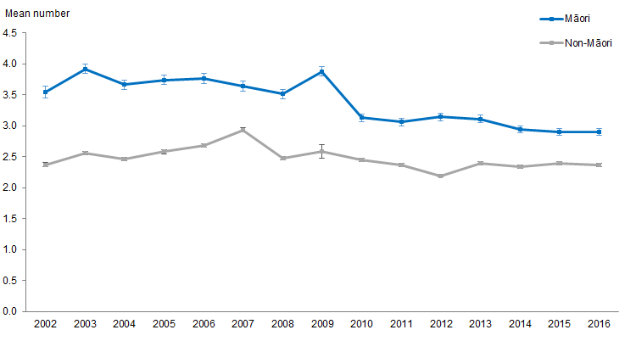
Note: If the confidence intervals of two means do not overlap, the difference in means is said to be statistically significant.
Source: Community Oral Health Services, 2002–2016.

Figure 89 shows the difference in the mean number of decayed, missing and filled teeth (dmft) between 2002 and 2016 for Māori and non-Māori children at five years of age. See the attached Excel tool for figures showing the rate ratio, fluoridated and non-fluoridated data.

Decrease in mean dmft for Māori children aged five between 2002 and 2016
The mean dmft for Māori aged five in 2002 decreased by 18.2 percent from 3.6 teeth in 2002 to 2.9 teeth in 2016. Māori five-year-olds living in fluoridated areas had a decrease in the mean dmft by 7.7 percent between 2002 and 2016, whereas those living in non-fluoridated areas had a decrease of 24.8 percent over this period.

The mean dmft for non-Māori remained constant between 2002 and 2016, with an average of 2.5 teeth. In 2016, the mean dmft for non-Māori aged five was 2.4 teeth.

Non-Māori five-year-olds living in non- fluoridated areas showed a decrease in mean dmft, dropping by 16.6 percent, whereas non-Māori five-year-olds living in fluoridated areas showed an increase of 26.9 percent in mean dmft between 2002 and 2016.

Difference in mean dmft between Māori and non-Māori aged five remained significant over time
The difference in mean dmft between Māori and non-Māori for children aged five remained significant between 2002 and 2016. On average, the mean dmft of Māori five-year-olds was nearly 1½ times that of non-Māori, regardless of whether they lived in a fluoridated area or not, between 2002 and 2016 (the average rate ratio over time was 1.4 while the rate ratio in 2016 was 1.2).

Mean number of decayed, missing and filled teeth (DMFT) at school Year 8
Figure 90: Mean number of decayed, missing and filled teeth (DMFT), Year 8, Māori and non-Māori, 2002–2016
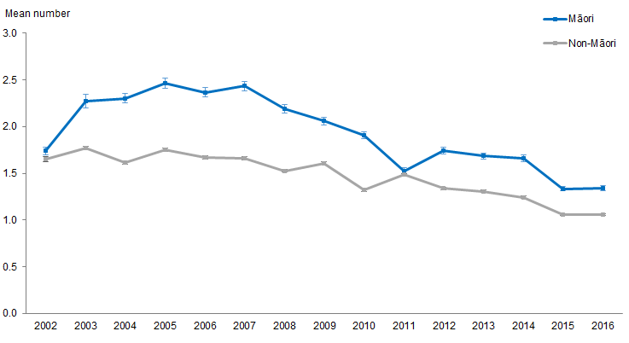
Note: If the confidence intervals of two means do not overlap, the difference in means is said to be statistically significant.
Source: Community Oral Health Services, 2002–2016.

Figure 90 shows the mean DMFT for Māori and non-Māori children in Year 8, between 2002 and 2016. See the attached Excel tool for figures showing the rate ratio, fluoridated and non-fluoridated data.

Mean DMFT in Māori children in Year 8 in a fluoridated area increased
Overall, the mean DMFT for Māori children in Year 8 increased from 2002 to 2007 by 40.9 percent (1.7 to 2.4 teeth) and decreased from 2007 to 2016 by 44.8 percent (2.4 to 1.4 teeth). In 2016, the mean DMFT for Māori was 1.4 teeth. In comparison, the mean DMFT for non-Māori was 1.1 teeth.

The mean DMFT of non-Māori children in Year 8 followed a similar trend increasing from 2.4 teeth in 2002 to 3.0 teeth in 2007, an increase of 23.7 percent. The mean DMFT of non-Māori also decreased from 3.0 teeth in 2007 to 1.1 in 2016, a decrease of 36.4 percent.

Year 8s living in non-fluoridated areas had higher mean DMFT numbers than those living in fluoridated areas, regardless of ethnicity.

Difference in mean DMFT between Māori and non-Māori decreased from 2003
The difference in mean DMFT for children in Year 8 between Māori and non-Māori decreased from 0.5 teeth in 2003 to 0.3 teeth in 2016, a decrease of 43.3 percent.

The difference between Māori and non-Māori Year 8s remained constant. Between 2002 and 2016 the mean DMFT of Māori children in Year 8 was, on average, 1.3 times the mean DMFT of non-Māori children in Year 8 of the same age group regardless of whether their living area was fluoridated or not.

Caries free at five years of age
Figure 91: Percentage of caries-free children, 5 years, Māori and non-Māori,
2002–2016
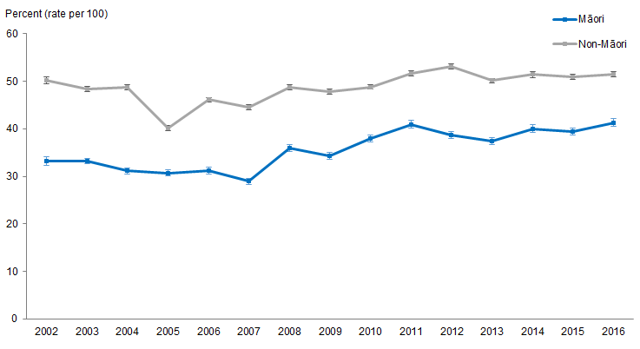
Note: If the confidence intervals of two rates do not overlap, the difference in rates is said to be statistically significant.
Source: Community Oral Health Services, 2002–2016.

Figure 91 shows the percentage of Māori and non-Māori children who are caries free at five years of age between 2002 and 2016. See the attached Excel tool for figures showing the rate ratio, fluoridated and non-fluoridated data.

Percentage of Māori children aged five who are caries free and not fluoridated decreased
The percentage of Māori children aged five who are caries free increased by 24.5 percent between 2002 and 2016. In 2016, 41.4 percent of Māori aged five were caries free. In comparison, 51.5 percent of non-Māori were caries free.

Children aged five living in non-fluoridated areas showed the largest changes. Māori who were caries free in this group increased by 71.3 percent between 2002 and 2016 (22.5 to 38.6 percent) and non-Māori children in this group increased by 23.6 percent between 2002 and 2016 (40.8 to 50.4 percent).

The caries-free rate was greater in fluoridated areas than non-fluoridated areas for five-year-olds, regardless of ethnicity.

Difference in caries-free percentages between Māori and non-Māori decreased between 2002 and 2016
The difference between the percentage of Māori and non-Māori children aged five who are caries free decreased. However, Māori children aged five were less likely to be caries free than non-Māori of the same age group between 2002 and 2016, regardless of whether the area they were living in was fluoridated or not.

Caries free at school Year 8
Figure 92: Percentage of caries-free children, Year 8, Māori and non-Māori,
2002–2016
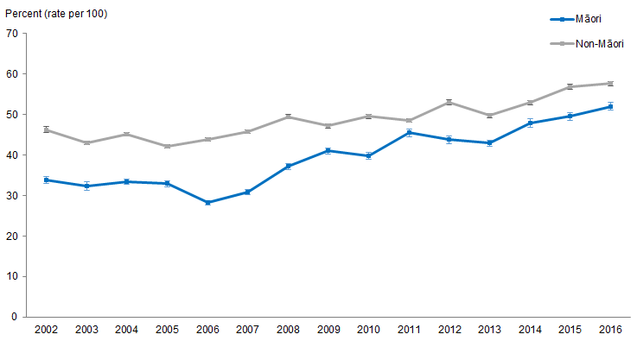
Note: If the confidence intervals of two rates do not overlap, the difference in rates is said to be statistically significant.
Source: Community Oral Health Services, 2002–2016.

Figure 92 shows the percentage of Māori and non-Māori children who are caries free at Year 8, recorded between 2002 and 2016. See the attached Excel tool for figures showing the rate ratio, fluoridated and non-fluoridated data.

Percentage of caries free Māori children in Year 8 increased between 2002 and 2016
The percentage of Māori children in Year 8 who were caries free increased by 53.9 percent between 2002 and 2016. In 2016, 52.1 percent of Māori in Year 8 were caries free. In comparison, 57.6 percent of non-Māori were caries free.

The percentage of Māori children living in non-fluoridated areas who were caries free at Year 8 increased by 70.0 percent between 2002 and 2016 (28.6 to 48.7 percent). The percentage of non-Māori children in Year 8 living in non-fluoridated area who were caries free also increased by 39.4 percent over the same period (39.5 to 55.1 percent).

The percentage of children in Year 8 living in fluoridated areas who were caries free also increased, although at a slower rate. The percentage of Māori children who are caries free increased by 42.0 percent between 2002 and 2016 (39.1 to 55.5 percent). The percentage of non-Māori children in Year 8 living in fluoridated areas increased by 13.5 percent over this period (from 53.0 to 60.2 percent). Despite the slower rate of increase those in fluoridated areas had a higher percentage caries free between 2002 and 2016 for both Māori and non-Māori.

Difference in caries-free percentages between Māori and non-Māori children in Year 8 decreased between 2002 and 2016
The difference in the percentage of caries-free children in Year 8 between Māori and non-Māori decreased between 2002 and 2016 by 55.2 percent (12.43 to 5.6 percentage points). Despite this decrease Māori children in Year 8 were less likely to be caries free than non-Māori within the same age group.

Visited a dental health care worker in previous year
Figure 93: Visiting dental health care worker in previous year, 1–14 years, Māori and non-Māori, 2006/07–2016/17
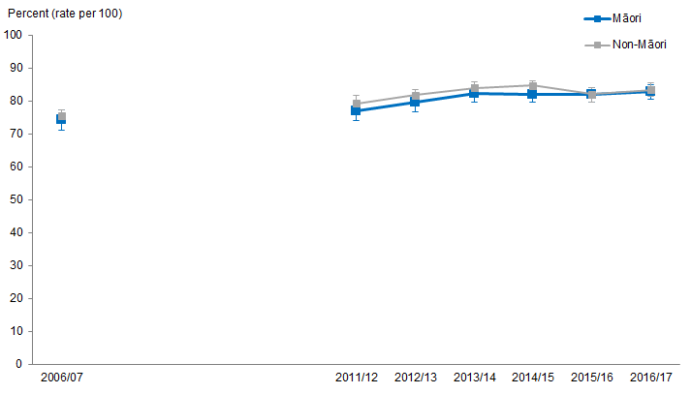
Notes:
Figures are age-standardised to the 2001 Census total Māori population.
Prioritised ethnicity has been used.
If the confidence intervals of two rates do not overlap, the difference in rates is said to be statistically significant.
The term ‘dental health care worker’ refers to dentists and other dental health care professionals, such as dental therapists and dental hygienists, as well as dental specialists, such as orthodontists.
Source: New Zealand Health Survey (NZHS), Ministry of Health, 2006/07–2016/17.

Figure 93 shows, after adjusting for age, the percentage of Māori and non-Māori children that have visited a dental health care worker in the previous year between 2006/07 and 2016/17. In 2016/17, the percentage of Māori children who had visited a dental health care worker in the previous year was 82.9 percent. In comparison, 83.5 percent of non-Māori children had visited a dental health care worker in the previous year.

Percentage of Māori children who visited dental health care worker has increased
The age-standardised percentage of Māori children who had visited a dental health care worker in the previous year increased from 74.4 percent in 2006/07 to 82.9 percent in 2016/17, an increase of 11.4 percent.

The age-standardised percentage of non-Māori children who had visited a dental health care worker in the previous year increased from 75.6 percent in 2006/07 to 83.5 percent in 2016/17, an increase of 10.5 percent.

After adjusting for age, the percentage of Māori children who had visited a dental health care worker in the previous year increased faster than non-Māori children. The difference between Māori and non-Māori children showed little change between 2006/07 and 2016/17.

Figure 94: Visiting dental health care worker in previous year, 15+ years, Māori and non-Māori with natural teeth, 2006/07–2016/17
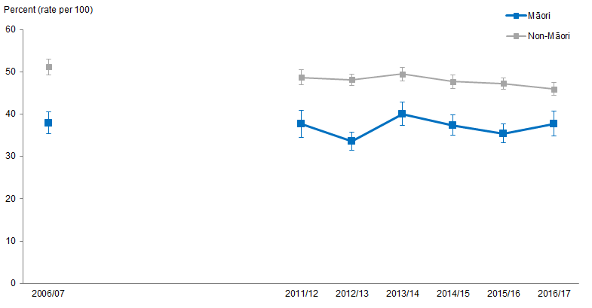
Notes:
Figures are age-standardised to the 2001 Census total Māori population.
Prioritised ethnicity has been used.
If the confidence intervals of two rates do not overlap, the difference in rates is said to be statistically significant.
The term ‘dental health care worker’ refers to dentists and other dental health care professionals, such as dental therapists and dental hygienists, as well as dental specialists, such as orthodontists.
Source: New Zealand Health Survey (NZHS), Ministry of Health, 2006/07–2016/17.

Figure 94 shows, after adjusting for age, the percentage of Māori and non-Māori adults aged 15 years and above who have visited a dental health care worker in the previous year between 2006/07 and 2016/17. In 2016/17, 37.7 percent of Māori adults had visited a dental health care worker in the previous year. In comparison, 46.0 percent of non-Māori adults had visited a dental health care worker in the previous year.

Percentage of Māori adults that visited dental health care worker has remained constant
After adjusting for age, the percentage of Māori adults who visited a dental health care worker in the previous year has remained stationary between 2006/07 and 2016/17 at an average of 37.1 percent.

In contrast the age-adjusted percentage of non-Māori adults who visited a dental health care worker in the previous year has decreased from 51.3 percent in 2006/07 to 46.0 percent in 2016/17 a decrease of 10.3 percent.

The difference in percentage between Māori and non-Māori adults who have visited a dental health care worker has decreased over time
The difference in age-standardised percentage between Māori and non-Māori adults who visited a dental health care worker in the previous year has decreased from 13.3 percent in 2006/07 to 8.3 percent in 2016/17, a decrease of 37.6 percent. The change in the difference came from a decrease in the percentage (10.3 percent) of non-Māori adults who had visited a dental health care worker in the previous year.

Between 2006/07 and 2016/17 Māori were less likely to visit a dental health care worker than non-Māori.

Had any teeth extracted due to decay, abscess or infection in previous year for children aged
1–14 years
Figure 95: Had teeth extracted due to decay, abscess or infection in previous year,
1–14 years, Māori and non-Māori, 2011/12–2016/17
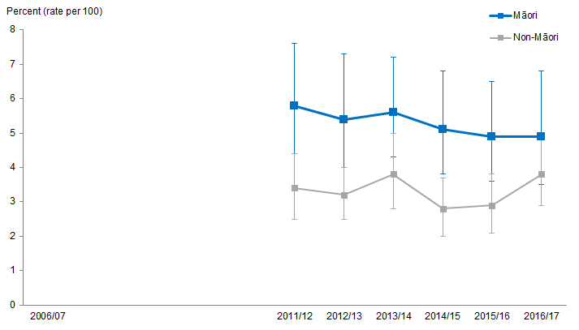
Notes:
Figures are age-standardised to the 2001 Census total Māori population.
Prioritised ethnicity has been used.
If the confidence intervals of two rates do not overlap, the difference in rates is said to be statistically significant.
Source: New Zealand Health Survey (NZHS), Ministry of Health, 2011/12–2016/17.

Figure 95 shows, after adjusting for age, the percentage of Māori and non-Māori children, aged 1–14 years, who had teeth extracted due to decay, abscess or infection in the previous year between 2011/12 and 2016/17.

In 2016/17, the percentage of Māori children who had teeth extracted was 4.9 percent. In comparison, 3.8 percent of non-Māori children had teeth extracted in the previous year.

Percentage of Māori children with teeth extracted remained constant
There was no significant change in the age-standardised percentage of Māori children who had teeth extracted between 2011/12 and 2016/17. The age-standardised percentage of Māori children who had teeth extracted in the previous year remained constant with an average of 5.3 percent between 2011/12 and 2016/17.

In contrast the age-standardised percentage of non-Māori children who had teeth extracted remained constant between 2011/12 and 2016/17, with an average of 3.3 percent. The percentage for 2016/17 was 3.8 percent.

Difference in teeth extracted between Māori and non-Māori decreased from 2011/12 to 2016/17
There was a decrease in the difference between Māori and non-Māori children who had teeth extracted. In 2011/12 Māori children were over 1.6 times as likely as non-Māori children to have had teeth extracted in the previous year. This difference declined to under 1.3 times by 2016/17.

Had any teeth extracted due to decay, abscess, infection or gum disease in previous year for adults 15+ years
Figure 96: Had teeth extracted due to decay, abscess, infection or gum disease in previous year, 15+ years, Māori and non-Māori, 2011/12–2016/17
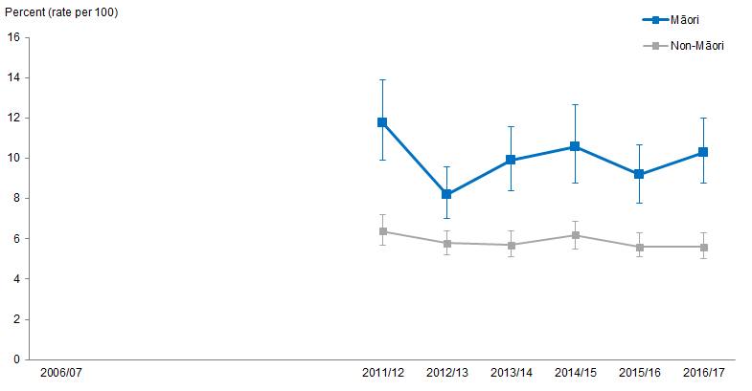
Notes:
Figures are age-standardised to the 2001 Census total Māori population.
Prioritised ethnicity has been used.
If the confidence intervals of two rates do not overlap, the difference in rates is said to be statistically significant.
Teeth lost for other reasons, such as injury, a crowded mouth or orthodontics, were excluded.
Source: New Zealand Health Survey (NZHS), Ministry of Health, 2011/12–2016/17.

Figure 96 shows, after adjusting for age, the percentage of Māori and non-Māori adults, aged 15 and above, who had teeth extracted due to decay, abscess, infection or gum disease in the previous year between 2011/12 and 2016/17.

In 2016/17, the percentage of Māori adults who had teeth extracted was 10.3 percent. In comparison, 5.6 percent of non-Māori adults had teeth extracted in the previous year.

Percentage of Māori adults who had teeth extracted remained constant
The percentage, once age-adjusted, of Māori adults who had teeth extracted remained constant between 2011/12 and 2016/17, with an average of 10.0 percent.

The lowest percentage of Māori adults with teeth extracted was recorded in 2012/13 at 8.2 percent.

The percentage, once age-adjusted, of non-Māori adults who had teeth extracted remained constant between 2011/12 and 2016/17, with an average of 5.8 percent.

The difference between Māori and non-Māori adults is statistically significant
The difference in percentage between Māori and non-Māori adults who had teeth extracted between 2011/12 and 2016/17 remained significant. Between 2011/12 and 2016/17 Māori adults were, on average, more than 1½ times as likely as non-Māori to have had teeth extracted than non-Māori adults.

The smallest difference occurred in 2012/13 where Māori were less than 1.3 times as likely as non-Māori to have had teeth extracted in the previous year.

Only visits a dental health care worker for dental problems or never visits, among adults 15 and above with natural teeth
Figure 97: Only visit a dental health care worker for dental problems, or never visits, 15+ years, Māori and non-Māori with natural teeth, 2006/07–2016/17
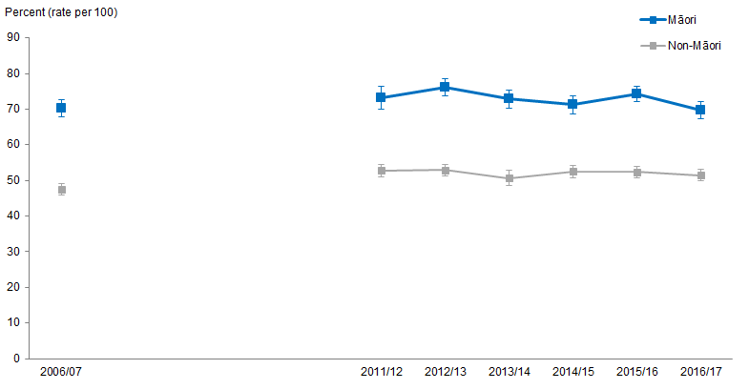
Notes:
Figures are age-standardised to the 2001 Census total Māori population.
Prioritised ethnicity has been used.
If the confidence intervals of two rates do not overlap, the difference in rates is said to be statistically significant.
Source: New Zealand Health Survey (NZHS), Ministry of Health, 2006/07–2016/17.

Figure 97 shows, after adjusting for age, the percentage of Māori and non-Māori adults with natural teeth who only visit dental health care workers for dental health problems or never visit between 2006/07 and 2016/17.

In 2016/17, the percentage of Māori adults that only visited for dental health problems, or never visited, was 69.7 percent. In comparison, 51.5 percent of non-Māori adults only visited for dental health problems, or never visited.

Percentage of Māori adults who only visit for dental health problems remained constant
The age-standardised percentage of Māori adults who only visited for dental health problems or never visited remained constant between 2006/07 and 2016/17 at an average of 72.6 percent. The highest percentage that was recorded for Māori adults was in 2012/13 at 76.2 percent.

The age-standardised percentage of non-Māori adults who only visited for dental health problems or never visited remained constant between 2006/07 and 2016/17, with an average of 51.4 percent.

Difference between Māori and non-Māori remains significant
The difference in percentage, when age-adjusted, between Māori and non-Māori adults who only visited a dental health worker for dental health problems remained significant in the 2006/07 and 2016/17 period. On average Māori adults were under 1½ times as likely as non-Māori adults to only visit for dental health problems or never visit between 2006/07 and 2016/17.

Self-rated health
This section presents results over time for self-rated health for Māori and non-Māori adults aged 15 years and over.

Self-rated health (also known as self-assessed health or self-perceived health) is a health measure that is based on a person’s own perception of their health. Individuals rate the current status of their own health on a scale from excellent to poor (Bombak 2013). This provides an alternative source of data from objective measures of health such as hospital rates and disease prevalence, which is useful for placing more emphasis on quality of life and wellbeing (Ministry of Health 2010d).

What is the data telling us?
- Māori adults aged 15 years and over were less likely to self-rate their health as good, very good or excellent than non-Māori adults, regardless of sex.
- Self-rated health scores have decreased slightly for both Māori and non-Māori, but the rate ratio has had no significant change.

Figure 98: Excellent, very good or good self-rated health, 15+ years, Māori and non-Māori, 2006/07–2016/17
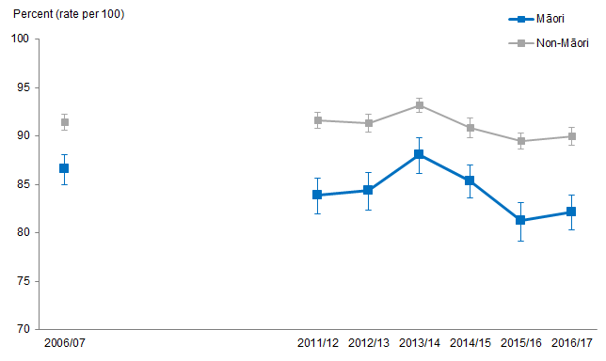
Notes:
Figures are age-standardised to the 2001 Census total Māori population.
Prioritised ethnicity has been used.
If the confidence intervals of two rates do not overlap, the difference in rates is said to be statistically significant.
Source: New Zealand Health Survey (NZHS), Ministry of Health, 2006/07–2016/17.

Figure 98 shows that Māori adults have been less likely to self-rate their health as good, very good or excellent than non-Māori adults across time, from 2006/07 to 2016/17. The percentages of people rating their health as good or above have decreased slightly for both Māori and non-Māori over time, but the rate ratio has had no significant change.

This trend is reflected in the age-standardised percentages by sex. In general, Māori males were less likely to rate their health as good or above than non-Māori males, and Māori females were less likely to rate their health as good or above compared with non-Māori females (Figure 99).

Figure 99: Excellent, very good or good self-rated health, 15+ years, by gender, Māori and non-Māori, 2006/07–2016/17
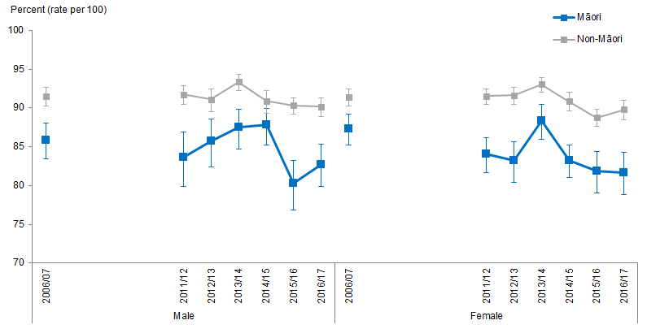
Notes:
Figures are age-standardised to the 2001 Census total Māori population.
Prioritised ethnicity has been used.
If the confidence intervals of two rates do not overlap, the difference in rates is said to be statistically significant.
Source: New Zealand Health Survey (NZHS), Ministry of Health, 2006/07–2016/17.

Mental health
This section presents results over time for mental health for Māori and non-Māori, including scores of psychological distress and self-reported diagnosis of common mental disorders.

What is the data telling us?
Psychological distress
- Māori had higher levels of psychological distress than non-Māori.
- The percentage of people with a high psychological distress score has increased for both Māori and non-Māori over time, but the difference between Māori and non-Māori has narrowed.
- Māori males and females were more likely to have a high psychological distress score than non-Māori males and females.
Diagnosis of common mental disorder
- There were no significant differences between Māori and non-Māori in the percentage of people diagnosed with a common mental disorder, regardless of sex.
- Females were more likely to be diagnosed with a common mental disorder than males, for both Māori and non-Māori.

Psychological distress
Psychological distress is a risk factor for mental illness. It is measured in the New Zealand Health Survey (NZHS) using a set of questions called the Kessler Psychological Distress Scale (K10) (Stats NZ 2017). It is very likely that a person has an anxiety or depressive disorder if they have a high score on this scale (K10 score of 12 or more) (Andrew and Slade 2001).

It is important to note the data was self-reported, which may not be an accurate representation of the true prevalence of these conditions. Therefore, caution should be taken when comparing results from this report with reports that use a different data source.

Figure 100: Psychological distress (high or very high probability of anxiety or depressive disorder), 15+ years, Māori and non-Māori, 2006/07–2016/17
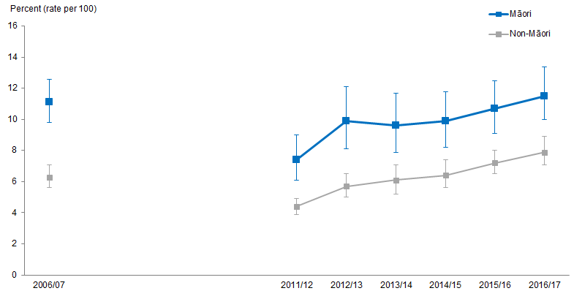
Notes:
Figures are age-standardised to the 2001 Census total Māori population.
Prioritised ethnicity has been used.
If the confidence intervals of two rates do not overlap, the difference in rates is said to be statistically significant.
Source: New Zealand Health Survey (NZHS), Ministry of Health, 2006/07–2016/17.

Figure 100 shows the percentage of people who had a high score for psychological distress (self-reported), for Māori and non-Māori.

Māori had higher levels of psychological distress than non-Māori across the time period shown, and the percentage of people with a high psychological distress score has increased for both Māori and non-Māori over time. In particular, the percentage of Māori with a high psychological distress score increased between 2011/12 and 2016/17, from 7.4 percent to 11.5 percent. This is an increase of 4.1 percentage points. Over the same time period the percentage of non-Māori with a high psychological distress score increased more rapidly, from 4.4 percent to 7.9 percent, an increase of 3.5 percentage points.

This means that although Māori were still more likely to have a high psychological distress score than non-Māori, the difference between ethnicities has narrowed slightly. In 2006/07 Māori were 1.7 times as likely as non-Māori to have a high psychological distress score, and this decreased to 1.5 times as likely in 2016/17.

Figure 101: Psychological distress (high or very high probability of anxiety or depressive disorder), 15+ years, by gender, Māori and non-Māori 2006/07–2016/17
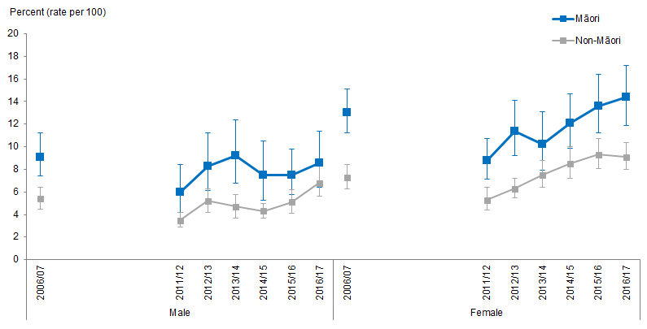
Notes:
Figures are age-standardised to the 2001 Census total Māori population.
Prioritised ethnicity has been used.
If the confidence intervals of two rates do not overlap, the difference in rates is said to be statistically significant.
Source: New Zealand Health Survey (NZHS), Ministry of Health, 2006/07–2016/17.

Figure 101 shows that, in general, Māori males and females were more likely to have a higher psychological distress score than non-Māori males and females across the time period shown, from 2006/07 to 2016/17.

Diagnosed common mental disorder
Common mental disorders include depression, bipolar disorder, and anxiety disorders. Depression causes a person to feel sad or miserable most of the time, with a persistently very low mood (Ministry of Health 2019d). Bipolar disorder may be diagnosed when a person experiences both periods of elevated mood (known as mania) and low mood (depression). Bipolar disorder was previously known as manic depression (Ministry of Health 2019b). Anxiety disorders include generalised anxiety disorder, panic disorder, phobias, post-traumatic stress disorder, and obsessive-compulsive disorder. They are characterised by a level of worry or fear that is so extreme it interferes with a person’s day to day life and wellbeing (Health Navigator New Zealand 2019a, Ministry of Health 2019a).

It is important to note the data on diagnosed common mental disorders sourced from the NZHS is self-reported prevalence, which may not be an accurate representation of the true prevalence of these conditions. Therefore, caution should be taken when comparing results from this report with reports that use a different data source.

Figure 102: Diagnosed common mental disorder (depression, bipolar disorder and/or anxiety disorder), 15+ years, by gender, Māori and non-Māori, 2006/07–2016/17
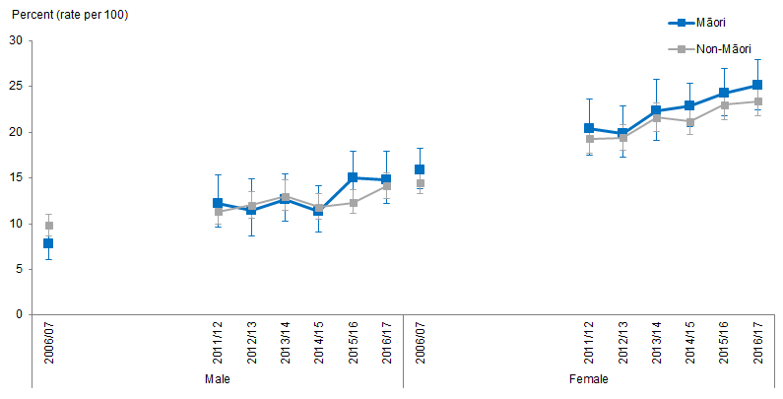
Notes:
Figures are age-standardised to the 2001 Census total Māori population.
Prioritised ethnicity has been used.
If the confidence intervals of two rates do not overlap, the difference in rates is said to be statistically significant.
Source: New Zealand Health Survey (NZHS), Ministry of Health, 2006/07–2016/17.

Figure 102 shows there were no significant differences between Māori and non-Māori in the percentage of people diagnosed with a common mental disorder, regardless of sex. Females were more likely to be diagnosed with a common mental disorder than males, for both Māori and non-Māori.

Infant health
This section presents results over time for two key indicators of infant health status: breastfeeding and low birth weight, for Māori and non-Māori.

What is the data telling us?
Breastfeeding
- In 2006/07 there were no significant differences in the exclusive breastfeeding rate of Māori and non-Māori babies at three months and six months of age.
- Māori babies have been less likely than non-Māori babies to have been exclusively breastfed at three months (13 weeks) and six months (26 weeks) of age since 2011/12.
- Exclusive breastfeeding of Māori babies at three months of age decreased between 2006/07 and 2016/17, while exclusive breastfeeding of non-Māori babies at three months of age increased. Overall, the difference between rates of exclusive breastfeeding among Māori and non-Māori babies at three months of age has increased since 2006/07, regardless of sex.
- Exclusive breastfeeding of Māori babies at six months of age increased slightly between 2006/07 and 2016/17. Exclusive breastfeeding among non-Māori babies also increased during the same period. Overall the difference in exclusive breastfeeding at six months of age between Māori and non-Māori babies has increased since 2006/07, regardless of sex.
Low birth weight
- From 1996 to 2016 Māori babies were more likely than non-Māori babies to be born weighting less than 2,500 grams.
- The low birthweight rate has declined over time for both Māori and non-Māori. The decline has happened more rapidly for Māori, meaning the ethnic difference has decreased.
- Baby girls were more likely to be born weighting less than 2,500 grams than baby boys, for both Māori and non-Māori.

Breastfeeding
The Ministry of Health recommends that babies are exclusively breastfed until they are around six months of age, with continued breastfeeding until they are at least one year old (Ministry of Health 2016a). Exclusive breastfeeding means that, since birth, a baby has only had breast milk (from the breast or expressed) and prescribed medicines. Breastfeeding contributes positively to both infant and maternal health. Breastfed babies have lower rates of common childhood infections such as diarrhoea, respiratory and middle ear infections, and Sudden Infant Death Syndrome (US Department of Health and Human Services 2011). Mothers who breastfeed have lower rates of post-partum haemorrhage, breast cancer, and ovarian cancer (National Breastfeeding Advisory Committee of New Zealand 2009).

Figure 103: Exclusively breastfed at 13 weeks (among children aged 13 weeks–4 years), Māori and non-Māori, 2006/07–2016/17
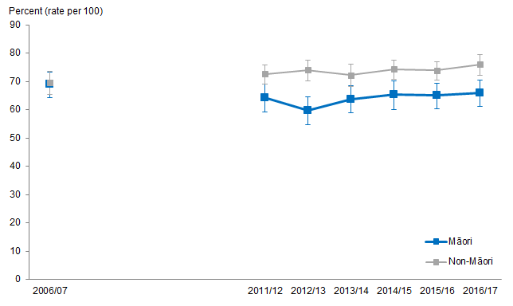
Notes:
Figures are age-standardised to the 2001 Census total Māori population.
Prioritised ethnicity has been used.
If the confidence intervals of two rates do not overlap, the difference in rates is said to be statistically significant.
Source: New Zealand Health Survey (NZHS), Ministry of Health, 2006/07–2016/17.

Māori babies have been less likely than non-Māori babies to be exclusively breastfed at three months (13 weeks) and six months (26 weeks) of age, since 2011/12 (Figures 103 and 104). In 2006/07 there were no significant differences in exclusive breastfeeding rates between Māori and non-Māori babies.

Figure 103 shows that there were no significant differences between the percentages of Māori and non-Māori babies being exclusively breastfed in 2006/07. However, Māori babies were less likely than non-Māori babies to be exclusively breastfed at three months of age in 2016/17. The percentage of Māori babies that were exclusively breastfed has stayed fairly similar across time, while the percentage of non-Māori babies that were exclusively breastfed increased by 7 percentage points (from 69 percent in 2006/07 to 76 percent in 2016/17). For every 10 non-Māori babies that were exclusively breastfed, just under 9 Māori babies were exclusively breastfed at three months of age.

Figure 104: Exclusively breastfed at 26 weeks (among children aged 26 weeks–4 years), Māori and non-Māori, 2006/07–2016/17
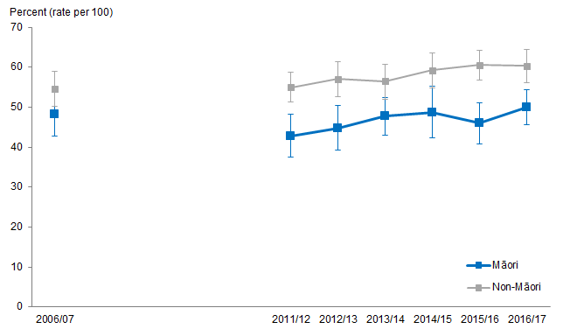
Notes:
Figures are age-standardised to the 2001 Census total Māori population.
Prioritised ethnicity has been used.
If the confidence intervals of two rates do not overlap, the difference in rates is said to be statistically significant.
Source: New Zealand Health Survey (NZHS), Ministry of Health, 2006/07–2016/17.

Although there were no significant differences between the percentages of Māori and non-Māori babies being exclusively breastfed in 2006/07, Māori babies were less likely than non-Māori babies to be exclusively breastfed at six months of age in 2016/17 (Figure 104). The percentage of Māori babies that were exclusively breastfed has stayed fairly similar across time, while the percentage of non-Māori babies that were exclusively breastfed increased from 55 percent in 2006/07 to 60 percent in 2016/17 (an increase of 6 percentage points or 11 percent). Around 8 Māori babies were exclusively breastfed for every 10 non-Māori babies that are exclusively breastfed at six months of age in 2016/17.

Low birthweight
Low birthweight is a major determinant of infant mortality and morbidity. Low birthweight infants are at increased risk of a variety of health problems, such as neurodevelopmental problems and respiratory tract infections. Low birthweight is defined as a birthweight of less than 2,500 grams.

Babies are born with low birthweight either because they are born prematurely (<37 weeks) or because they have not grown adequately during the pregnancy. Risk factors for inadequate growth during pregnancy include poor nutritional status and maternal smoking (Kramer 1987).

Figure 105: Low birthweight, Māori and non-Māori, 1996–2016
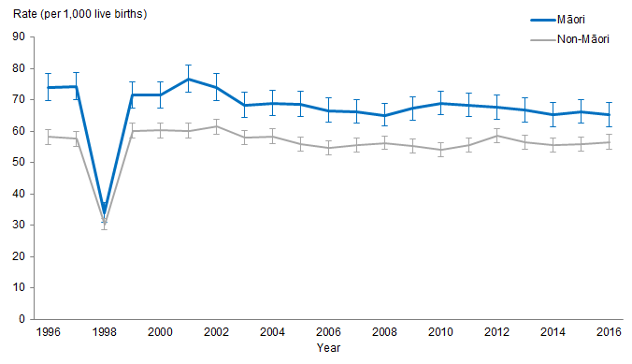
Notes:
Prioritised ethnicity has been used.
If the confidence intervals of two rates do not overlap, the difference in rates is said to be statistically significant.
A lot of birthweight records were missing in Year 1998, this was the reason of the sudden drop in the rate.
Source: Ministry of Health.

The data shows that more Māori babies were born with low birthweight from 1996 to 2016 (Figure 105). The low birthweight rate declined over time for both Māori and non-Māori. Baby girls are more likely to be born weighing less than 2,500 grams than baby boys, for both Māori and non-Māori.

Between 1996 and 2016, the low birthweight rate for Māori babies decreased from 74 babies per 1,000 live births to 65 babies, a reduction of 12 percent (or 9 percentage points). For non-Māori babies, the rate decreased more slowly from 58 babies to 57 babies per 1,000 live births, a reduction of 3 percent (or 1 percentage point).

The difference between the rate of Māori babies born with low birth weight compared with non-Māori babies born with low birthweight has decreased by 45 percent (or 7 percentage points). In 1996, Māori had 16 more babies with low birthweight per 1,000 live births than non-Māori, and this reduced to 9 per 1,000 live births in 2016, a reduction of 45 percent (or 7 percentage points).

Māori babies were 1.3 times as likely to be born with a low birthweight rate as non-Māori babies in 1996. This difference has reduced so that Māori babies born in 2016 were 1.2 times as likely to be born with a low birthweight as non-Māori babies. This is, around 12 Māori babies were born with low birthweight for every 10 non-Māori babies that were born with low birthweight.

Figure 106: Low birthweight, by gender, Māori and non-Māori, 1996–2016
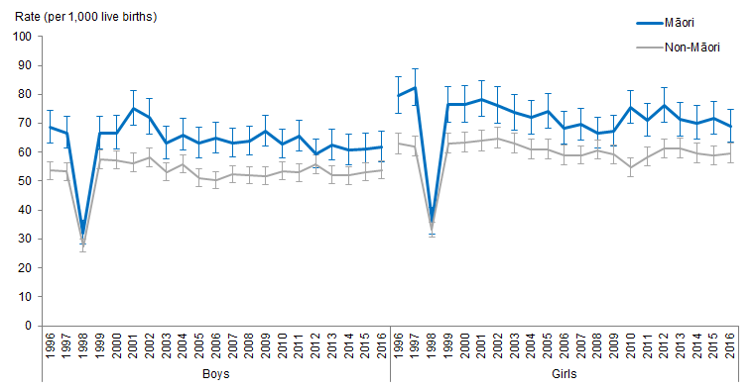
Notes:
Prioritised ethnicity has been used.
If the confidence intervals of two rates do not overlap, the difference in rates is said to be statistically significant.
A lot of birthweight records were missing in Year 1998, this was the reason of the sudden drop in the rate.
Source: Ministry of Health.

Girls were more likely to be born weighing less than 2,500 grams than boys across the time period shown, for both Māori and non-Māori (Figure 106).

Low birthweight disparities between Māori and non-Māori babies have not changed much over time regardless of sex. That is, Māori girls are more likely to be born with low birthweight compared with non-Māori girls, and Māori boys are more likely to be born with low birthweight compared with non-Māori boys.

Infant and child mortality
This section presents the trends related to neonatal, infant and child mortality for Māori and non-Māori. Figure 107 specifies time periods for fetal and infant deaths used in this brief (Ministry of Health 2012).
Figure 107: Time periods for fetal and infant deaths

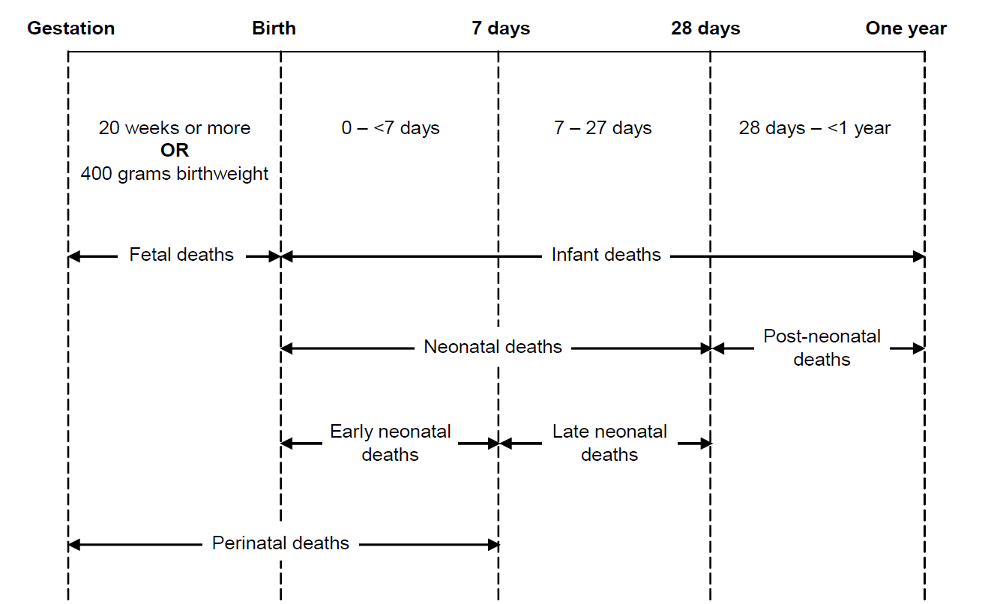

What is the data telling us?
- The age-specific infant mortality rate for Māori decreased by 43 percent between 1996–98 and 2012–14.
- In 2012–14 the Māori early neonatal mortality rate was equal with the non-Māori rate.
- The age-specific late neonatal mortality rate for Māori halved between
1996–98 and 2012–14.
- Despite a decrease of 68 percent, the difference between Māori and non-Māori post neonatal mortality rates remained significant.
- The Māori Sudden Unexpected Death in Infancy (SUDI) mortality rate was almost five times as high as the rate for non-Māori infants in 1996–98. By
2012–14 the Māori SUDI mortality rate was over three times as high as the non-Māori rate.
- The Māori Sudden Infant Death Syndrome (SIDS) mortality rate was over 4½ times as high as the rate for non-Māori infants in 1996–98. By 2012–14 the Māori SIDS mortality rate was twice as high as the non-Māori rate.
- The age-specific child mortality rate for Māori nearly halved between 1996–98 and 2012–14.
- In 2012–14 Māori had a child mortality rate under 1½ times the non-Māori rate.

Infant mortality
Infants were categorised as children aged one or below. The infant mortality rates are a summation of the early, late and post neonatal mortality rates discussed later in this report.

Figure 108: Infant mortality rates, Māori and non-Māori, 1996–98 to 2012–14
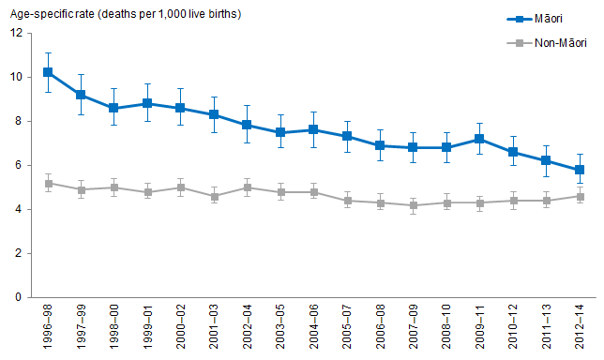
Notes:
Prioritised ethnicity has been used.
If the confidence intervals of two rates do not overlap, the difference in rates is said to be statistically significant.
Source: Mortality Collection Data Set (MORT), Ministry of Health, 1996–98 to 2012–14.

Significant decrease in infant mortality for Māori between
1996–98 and 2012–2014
Figure 108 shows the age-specific rate of infant deaths per 1,000 live births for Māori and non-Māori between 1996–98 and 2012–14.

The age-specific infant mortality rate for Māori nearly halved from 10.2 deaths per 1,000 live births in 1996–98 to 5.8 deaths per 1,000 live births in 2012–14, a decrease of 43 percent.

The age-specific infant mortality rate for non-Māori remained constant between
1996–98 and 2012–14 with an average of 4.6 deaths per 1,000 live births.

Decrease in difference of infant mortality rate between Māori and non-Māori
The difference in age-specific infant mortality rates between Māori and non-Māori decreased from 5.0 deaths per 1,000 live births in 1996–98 to 1.2 deaths per 1,000 live births in 2012–14, a decrease of 76 percent.

The rate ratio also indicates there was a decrease in the difference in the relative size of the Māori and non-Māori infant mortality rates. In 1996–98 the rate of infant deaths per 1,000 live births for Māori was nearly twice as large as the rate for non-Māori. This has fallen over time so that in 2012–14 the rate of infant deaths per 1,000 live births for Māori was under 1⅓ times that of non-Māori in 2012–14.

Early neonatal mortality
For the purpose of this report early neonatal encompasses the age group 0–7 days of age.

Figure 109: Early neonatal mortality rates, Māori and non-Māori, 1996–98 to 2012–14
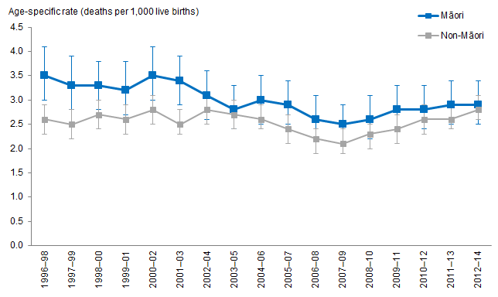
Notes:
Prioritised ethnicity has been used.
If the confidence intervals of two rates do not overlap, the difference in rates is said to be statistically significant.
Source: Mortality Collection Data Set (MORT), Ministry of Health, 1996–98 to 2012–14.

Decrease in early neonatal mortality rates for Māori between 1996–98 and 2012–14
Figure 109 shows the age-specific rates of early neonatal deaths per 1,000 live births for Māori and non-Māori between 1996–98 and 2012–14.

The age-specific early neonatal mortality rate for Māori decreased from 3.5 deaths per 1,000 live births in 1996–98 to 2.9 deaths per 1,000 live births in 2012–14, a decrease of 17 percent.

The age-specific early neonatal mortality rate for non-Māori was constant between 1996–98 and 2012–14 with an average of 2.5 deaths per 1,000 live births.

Decrease in the difference between Māori and non-Māori early neonatal mortality rates between 1996–98 and 2012–14
The difference in early neonatal mortality rate between Māori and non-Māori decreased from a significant difference of 0.9 deaths per 1,000 live births in 1996–98 to a non-significant difference of 0.1 deaths per 1,000 live births in 2012–14.

The relative size in early neonatal mortality rate between Māori and non-Māori decreased, going from significant in 1996–98 to non-significant in 2012–14. The rate ratio followed this trend, in 1996–98 Māori early neonatal mortality rates were 1⅓ times as high as non-Māori and in 2012–14 Māori and non-Māori early neonatal mortality rates were nearly equal.

Late neonatal mortality
For the purpose of this report, late neonatal is defined as the age group 8–28 days of age.

Figure 110: Late neonatal mortality rates, Māori and non-Māori, 1996–98 to 2012–14
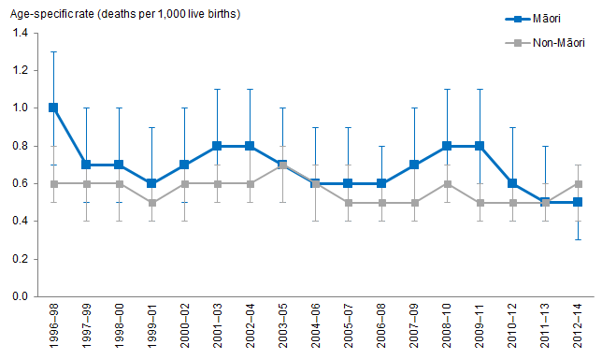
Notes:
Prioritised ethnicity has been used.
If the confidence intervals of two rates do not overlap, the difference in rates is said to be statistically significant.
Source: Mortality Collection Data Set (MORT), Ministry of Health, 1996–98 to 2012–14.

Decrease in late neonatal mortality rates for Māori between 1996–98 and 2012–14
Figure 110 shows the age-specific rates for late neonatal deaths per 1,000 live births for Māori and non-Māori between 1996–98 and 2012–14.

The age-specific late neonatal mortality rate for Māori halved between 1996–98 and 2012–14. The rate was 1.0 deaths per 1,000 live births in 1996–98, and the rate was 0.5 deaths per 1,000 live births in 2012–14.

The age-specific late neonatal mortality rate for non-Māori remained constant between 1996–98 and 2012–14 with an average of 0.6 deaths per live births.

Differences between Māori and non-Māori in late neonatal mortality rates between 1996–98 and 2012–14
In 1996–98 and 2009–11 the age-specific late neonatal mortality rate ratio showed that Māori had rates over 50 percent greater than non-Māori. The rate ratios between 1997–98 and 2012–14 showed that there were no significant differences in the late neonatal mortality rates between Māori and non-Māori.

Post neonatal mortality
For the purpose of this report, post neonatal is defined as the age group 29 days to 1 year of age.

Figure 111: Post neonatal mortality rates, Māori and non-Māori, 1996–98 to 2012–14
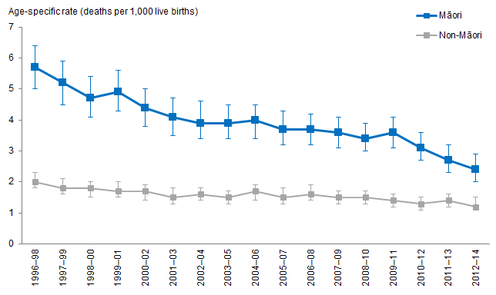
Notes:
Prioritised ethnicity has been used.
If the confidence intervals of two rates do not overlap, the difference in rates is said to be statistically significant.
Source: Mortality Collection Data Set (MORT), Ministry of Health, 1996–98 to 2012–14.

Significant decrease in post neonatal mortality rate for Māori between 1996–98 and 2012–14
Figure 111 shows the age-specific post neonatal mortality rate per 1,000 live births for Māori and non-Māori between 1996–98 and 2012–14.

The post neonatal mortality rate for Māori more than halved between 1996–98 and 2012–14, from 5.7 deaths per 1,000 live births in 1996–98 to 2.4 deaths per 1,000 live births in 2012–14, a decrease of 58 percent.

The greatest decrease, a drop of 33 percent, occurred between 2009–11 and 2012–14. The rate was 3.6 deaths per 1,000 live births in 2009–11, and the rate was 2.4 deaths per 1,000 live births in 2012–14.

The age-specific post neonatal mortality rate for non-Māori decreased from 2.0 deaths per 1,000 live births in 1996–98 to 1.2 deaths per 1,000 live births in 2012–14, a decrease of 40 percent.

Decrease in difference in post neonatal mortality rates for Māori and non-Māori between 1996–98 and 2012–14
The difference between Māori and non-Māori post neonatal mortality rates decreased from 3.7 deaths per 1,000 live births in 1996–98 to 1.2 deaths per 1,000 live births in 2012–14, a decrease of 68 percent. Despite this decrease the difference between Māori and non-Māori remained significant.

The rate ratio for post neonatal mortality also indicated a decrease in the difference between Māori and non-Māori post neonatal mortality rates. In 1996–98 Māori had a post neonatal mortality rate over 2½ times as high as the rate of non-Māori, in comparison Māori had a post neonatal mortality rate nearly twice as high as non-Māori in 2012–14.

Sudden unexpected death in infancy (SUDI) mortality
Sudden unexpected death in infancy (SUDI) includes sudden infant death syndrome (SIDS), unintentional suffocation and other unspecified sudden deaths or unattended deaths from unknown causes.

Figure 112: Sudden unexpected death in infancy (SUDI) mortality rates, Māori and non-Māori, 1996–98 to 2012–14
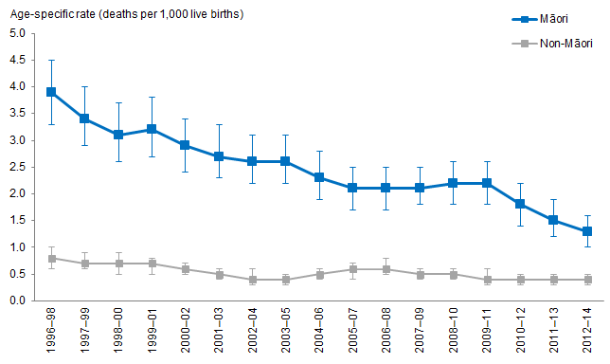
Notes:
Prioritised ethnicity has been used.
If the confidence intervals of two rates do not overlap, the difference in rates is said to be statistically significant.
Source: Mortality Collection Data Set (MORT), Ministry of Health, 1996–98 to 2012–14.

Significant decrease in SUDI mortality rate for Māori between 1996–98 and 2012–14
Figure 112 shows the age-specific SUDI mortality rate per 1,000 live births for Māori and non-Māori between 1996–98 and 2012–14.

The age-specific SUDI mortality rate for Māori decreased by two-thirds from 3.9 deaths per 1,000 live births in 1996–98 to 1.3 deaths per 1,000 live births in 2012–14, a decrease of 67 percent. The steepest decrease occurred between 2009–11, where the rate was 2.2 deaths per 1,000 live births and 2012–14, where the rate was 1.3 deaths per 1,000 live births, a decrease of 41 percent.

The age-specific SUDI mortality rate for non-Māori halved from 0.8 deaths per 1,000 live births in 1996–98 to 0.4 deaths in 2012–14, a decrease of 50 percent.

Decrease in the difference between Māori and non-Māori SUDI mortality rates between 1996–98 and 2012–14
The difference in SUDI mortality rates for Māori and non-Māori decreased by over two-thirds from 3.1 deaths per 1,000 live births in 1996–98 to 0.9 deaths per 1,000 live births in 2012–14, a decrease of 71 percent. Despite this decrease the difference between Māori and non-Māori SUDI mortality rates remained significant.

The rate ratio for SUDI mortality shows a consistent decrease as the rates. In 1996–98, Māori had a SUDI mortality rate nearly five times as high as the non-Māori rate, and in 2012–14, Māori had a SUDI mortality rate over three times as high as the non-Māori rate.

Sudden infant death syndrome (SIDS) mortality
Sudden infant death syndrome (SIDS) mortality refers to deaths for which no identifiable cause can be found following autopsy, clinical history and scene examination. Babies who die from SIDS usually die in their sleep.

Figure 113: Sudden infant death syndrome (SIDS) mortality rate, Māori and non-Māori, 1996–98 and 2012–14
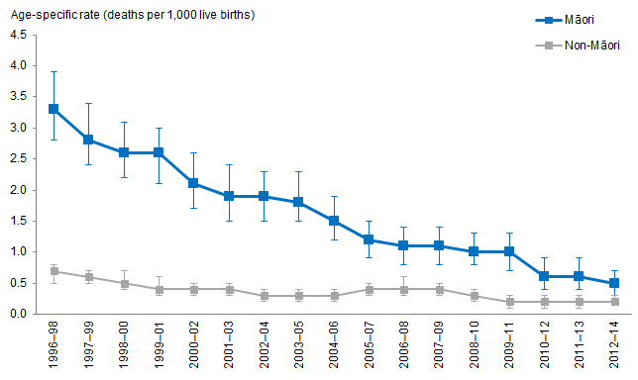
Notes:
Prioritised ethnicity has been used.
If the confidence intervals of two rates do not overlap, the difference in rates is said to be statistically significant.
Source: Mortality Collection Data Set (MORT), Ministry of Health, 1996–98 to 2012–14.

Significant decrease in SIDS mortality rate for Māori between 1996–98 and 2012–14
Figure 113 shows the age-specific SIDS mortality rate per 1,000 live births for Māori and non-Māori between 1996–98 and 2012–14.

The age-specific SIDS mortality rate for Māori decreased from 3.3 deaths per 1,000 live births in 1996–98 to 0.5 deaths per 1,000 live births in 2012–14, a decrease of 85 percent.

The age-specific SIDS mortality rate for non-Māori decreased from 0.7 deaths per 1,000 live births in 1996–98 to 0.2 deaths per 1,000 live births in 2012–14, a decrease of 71 percent.

Decrease in the difference in SIDS mortality rate between Māori and non-Māori between 1996–98 and 2012–14
The difference in SIDS mortality rates for Māori and non-Māori decreased from 2.6 deaths per 1,000 live births in 1996–98 to 0.3 deaths per 1,000 live births in
2012–14, a decrease of 89 percent. The difference between Māori and non-Māori was significant between 1996–98 and 2011–13 and was not significant in 2012–14 due to the decrease described above.

The rate ratio for SIDS mortality showed an overall decline, however it rose from
1996–98, where the SIDS mortality rate for Māori was over 4½ times as high as the non-Māori rate, to 2003–05, where the SIDS mortality rate for Māori was over 6½ times as high as the non-Māori rate. The rate ratio decreased from 2003–05 to 2012–14, where the SIDS mortality rate for Māori was twice as large as the non-Māori rate.

Child mortality
For the purpose of this report a child includes those aged from 0–5 years old. All causes of death are included in the child mortality rates.

Figure 114: Child mortality rates, Māori and non-Māori, 1996–98 and 2012–2014
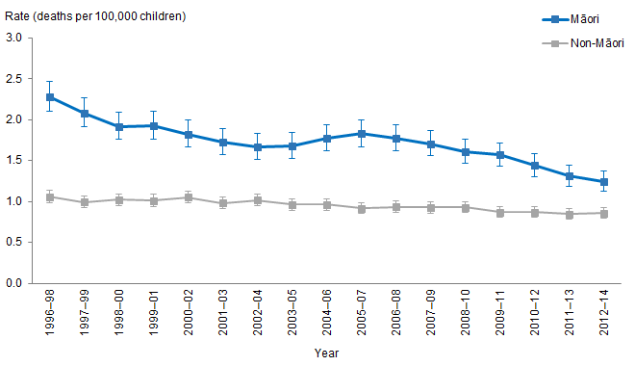
Notes:
Prioritised ethnicity has been used.
If the confidence intervals of two rates do not overlap, the difference in rates is said to be statistically significant.
Source: Mortality Collection Data Set (MORT), Ministry of Health, 1996–98 to 2012–14.

Significant decrease in child mortality for Māori between
1996–98 and 2012–14
Figure 114 shows the age-specific child mortality rates for Māori and non-Māori between 1996–98 and 2012–14.

The age-specific child mortality rate nearly halved from 2.3 deaths per 100,000 children in 1996–98 to 1.2 deaths per 100,000 children in 2012–14, a decrease of 45 percent.

The age-specific child mortality rate for non-Māori remained constant between
1996–98 and 2012–14, with an average of 0.95 (or 1.0 deaths so the format of 1dp is consistent) deaths per 100,000.

Decrease in the difference in child mortality rates between Māori and non-Māori
The difference in child mortality rates between Māori and non-Māori decreased by two-thirds from 1.2 deaths per 100,000 children in 1996–98 to 0.4 deaths per 100,000 children in 2012–14, a decrease of 68 percent. Despite this decrease, the difference between Māori and non-Māori remained significant between 1996–98 and 2012–14.

The rate ratio shows a similar declining trend, in 1996–98 the child mortality rate for Māori was over twice as large as the rate for non-Māori, whereas in 2012–14 the child mortality rate for Māori was under 1½ times the rate for non-Māori.

Unintentional injury
This section presents the trends related to unintentional injury hospitalisation and mortality rates for Māori and non-Māori by age groups.

Unintentional injuries include falls, poisonings, thermal injury, drowning and submersions, suffocation and motor vehicle accidents.

What is the data telling us?
- The rate of hospitalisations due to unintentional injuries increased for Māori of all ages – the rate for Māori females increased more than for Māori males.
- There was an increase in the difference between Māori and non-Māori children’s rates of hospitalisations due to unintentional injuries between 1996–98 and 2014–16.
- The difference in rates of hospitalisation due to unintentional injuries between Māori and non-Māori adults increased between 1996–98 and 2014–16. The difference between Māori and non-Māori adults increased more for males than for females.
- Māori females aged 65+ years had lower rates of hospitalisations due to unintentional injuries than non-Māori females of the same age group, this was consistent over time.
- Māori and non-Māori males aged 65+ had similar rates of hospitalisation due to unintentional injuries, this did not change over time.
- The difference between Māori and non-Māori, of all ages, did not change – Māori mortality rates were twice as high as the non-Māori rates, this did not change over time.
- Māori boys had a mortality rate 2½ times as high as that of non-Māori boys, this did not change over time.
- On average, the unintentional injury mortality rate for Māori girls was three times as high as that of non-Māori girls, this did not change over time.
- The mortality rate for Māori aged 15–64 years was larger than the non-Māori rate, this did not change over time.
- The unintentional mortality rates for Māori and non-Māori of both sexes aged 65 years and above remained similar between 1996–98 and 2012–14.

Unintentional injury hospitalisations, all ages
Figure 115: Unintentional injury hospitalisation rates, all ages, by gender, Māori and non-Māori, 1996–98 to 2014–16
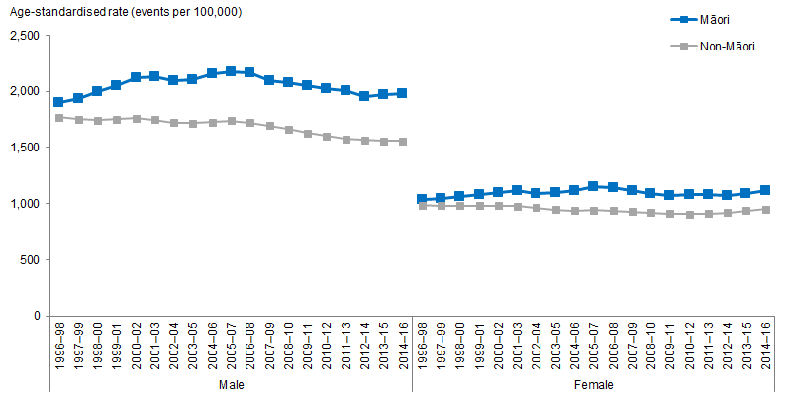
Notes:
Figures are age-standardised to the 2001 Census total Māori population.
Prioritised ethnicity has been used.
If the confidence intervals of two rates do not overlap, the difference in rates is said to be statistically significant.
Source: National Minimum Data Set (NMDS), Ministry of Health, 1996–98 to 2014–16.

Figure 115 shows the age-standardised unintentional injury hospitalisations for Māori and non-Māori of all age groups, by gender, between 1996–98 and 2014–16.

The rate of unintentional injury hospitalisations for Māori increased between 1996–98 and 2014–16
The rate of hospitalisations due to unintentional injuries increased for Māori – the rate for Māori females increased more than for Māori males. The age-standardised rate of unintentional injuries for Māori males increased by 5 percent between 1996–98 and 2014–16 (from 1,894 to 1,980 hospitalisations per 100,000), the rate for Māori females increased by 8 percent over this period (from 1,032 to 1,117 hospitalisations per 100,000).

The rate of hospitalisations due to unintentional injuries decreased for non-Māori – the rate for non-Māori males decreased more than for non-Māori females. The age-standardised rate of unintentional injuries for non-Māori decreased between 1996–98 and 2014–16 with males decreasing by 12 percent (from 1,769 to 1,557 hospitalisations per 100,000) and females decreasing by 4 percent (from 986 to 951 hospitalisations per 100,000).

On average, both Māori and non-Māori male rates of hospitalisation due to unintentional injuries were nearly double the respective rates of females.

Difference between Māori and non-Māori unintentional injury hospitalisation rates increased between 1996–98 and 2014–16
Between 1996–98 and 2014–16, there was an increase in the difference between Māori and non-Māori male and female rates of hospitalisations due to unintentional injuries.

The difference between Māori and non-Māori increased more for females than for males. The Māori and non-Māori difference for males, increased by almost 240 percent (from 125 hospitalisations per 100,000 in 1996–98 to 423 in 2014–16). For females, the difference between Māori and non-Māori increased by almost 260 percent (from 46 hospitalisations per 100,000 in 1996–98 to 166 in 2014–16).

By 2014–16 Māori had a rate of hospitalisations around 1.2 times as high as those of non-Māori, regardless of sex.

Unintentional injury hospitalisations, 0–14 years
Figure 116: Unintentional injury hospitalisation rates, 0–14 years, by gender, Māori and non-Māori, 1996–98 to 2014–16
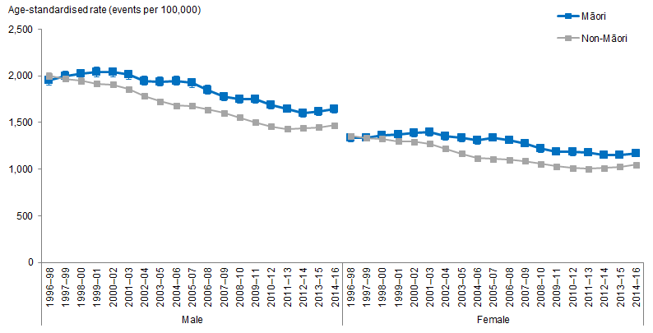
Notes:
Figures are age-standardised to the 2001 Census total Māori population.
Prioritised ethnicity has been used.
If the confidence intervals of two rates do not overlap, the difference in rates is said to be statistically significant.
Source: National Minimum Data Set (NMDS), Ministry of Health, 1996–98 to 2014–16.

Figure 116 shows the age-standardised rate of hospitalisations due to unintentional injuries for Māori and non-Māori children aged 0–14 years, by gender, between
1996–98 and 2014–16.

Unintentional injury hospitalisation rates decrease for Māori children between 1996–98 and 2014–16
The age-standardised rate of hospitalisations due to unintentional injuries decreased for Māori children aged 0–14 years between 1996–98 and 2014–16.

Māori boys decreased by 16 percent over this period (from 1,950 to 1,642 hospitalisations per 100,000) and Māori girls decreased by 12 percent (from 1,336 to 1,169 hospitalisations per 100,000).

Difference between Māori and non-Māori children unintentional injury hospitalisation rates increased between 1996–98 and 2014–16
There was an increase in the difference between Māori and non-Māori children’s rates of hospitalisations due to unintentional injuries. In 1996–98, Māori children had lower rates than non-Māori children. By 2014–16 Māori children had higher rates than non-Māori children.

The difference in rate of hospitalisations due to unintentional injuries between Māori and non-Māori children increased by 442 percent for boys (Māori boys had 50 fewer unintentional injury hospitalisations per 100,000 than non-Māori boys in 1996–98 but 173 more hospitalisations in 2014–16) and by 738 percent for girls (Māori girls had 19 fewer unintentional injury hospitalisations per 100,000 than non-Māori in 1996–98 but 124 more hospitalisations in 2014–16).

In 1996–98 and 1997–99 Māori and non-Māori children aged 0–14 years had similar rates of hospitalisations due to unintentional injuries regardless of sex. By 2014–16 Māori had a rate of hospitalisations caused by unintentional injuries over 1.1 times as high as those of non-Māori.

Unintentional injury hospitalisations, 15–64 years
Figure 117: Unintentional injury hospitalisation rates, 15–64 years, by gender, Māori and non-Māori, 1996–98 to 2014–16
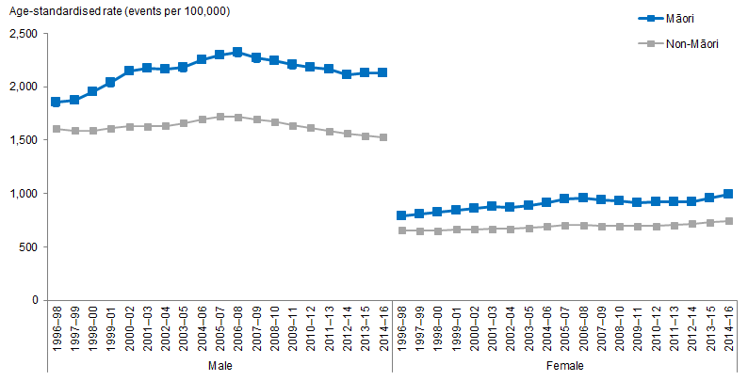
Notes:
Figures are age-standardised to the 2001 Census total Māori population.
Prioritised ethnicity has been used.
If the confidence intervals of two rates do not overlap, the difference in rates is said to be statistically significant.
Source: National Minimum Data Set (NMDS), Ministry of Health, 1996–98 to 2014–16.

Figure 117 shows the age-standardised rate of hospitalisations due to unintentional injuries for Māori and non-Māori adults aged 15–64 years, by gender, between
1996–98 and 2014–16.

Rate of unintentional injury hospitalisations increased for Māori adults aged 15–64 years between 1996–98 and 2014–16
The age-standardised rate of unintentional injuries for Māori males increased by 15 percent between 1996–98 and 2014–16 (from 1,852 to 2,125 hospitalisations per 100,000), and the rate increased by 25 percent over this period (from 791 to 991 hospitalisations per 100,000) for Māori females.

In contrast, between 1996–98 and 2014–16, the age-standardised rate of unintentional injuries for non-Māori males decreased by 5 percent (from 1,607 to 1,524 hospitalisations per 100,000) and increased by 14 percent (from 652 to 742 hospitalisations per 100,000) for non-Māori females.

On average both Māori and non-Māori male rates of hospitalisation due to unintentional injuries were more than double the respective rates of females.

Difference in unintentional injury hospitalisation rates between Māori and non-Māori adults aged 15–64 years increased between 1996–98 and 2014–16
The difference in rate of hospitalisation due to unintentional injuries between Māori and non-Māori aged 15–64 years increased between 1996–98 and 2014–16.

The difference between Māori and non-Māori increased at a higher rate for males than those of females. The difference for males increased by 145 percent over this period (from 246 to 601 more hospitalisations per 100,000 than non-Māori males) and by 80 percent for females over this period (from 138 to 249 more hospitalisations per 100,000).

In 1996–98 Māori rates of hospitalisation due to unintentional injuries were 1.2 times as high as those of non-Māori. By 2014–16 Māori had a rate of hospitalisations caused by unintentional injuries 1.4 times as high as those of non-Māori.

Unintentional injury hospitalisations, 65+ years
Figure 118: Unintentional injury hospitalisation rates, 65+ years, by gender, Māori and non-Māori, 1996–98 to 2014–16
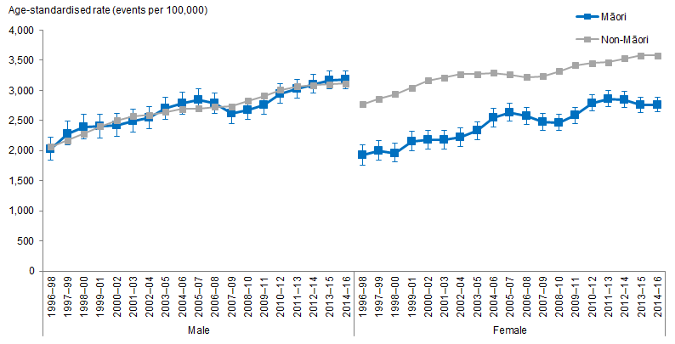
Notes:
Figures are age-standardised to the 2001 Census total Māori population.
Prioritised ethnicity has been used.
If the confidence intervals of two rates do not overlap, the difference in rates is said to be statistically significant.
Source: National Minimum Data Set (NMDS), Ministry of Health, 1996–98 to 2014–16.

Figure 118 shows the age-standardised rate of hospitalisation due to unintentional injury for Māori and non-Māori aged 65 years and above, by gender, between 1996–98 and 2014–16.

Rate of unintentional injury hospitalisations for Māori aged 65+ years increased between 1996–98 and 2014–16
The age-standardised rate of hospitalisation due to unintentional injury increased for adults aged 65+ years between 1996–98 and 2014–16.

Males showed the largest increases between 1996–98 and 2014–16 with Māori males increasing by 57 percent (from 2,022 to 3,173 hospitalisations per 100,000) and non-Māori males increasing by 51 percent (from 2,064 to 3,112 hospitalisations per 100,000).

Māori females had higher increases than non-Māori females, whereas Māori females increased by 44 percent (from 1,921 to 2,757 hospitalisations per 100,000) during the same time and non-Māori females increased by 29 percent (from 2,764 to 3,577 hospitalisations per 100,000).

Difference in unintentional injury hospitalisation rates between Māori and non-Māori females aged 65+ years decreased
Māori females aged 65+ years had lower rates of hospitalisations due to unintentional injuries than non-Māori females of the same age group. Between 1996–98 and
2014–16 the difference for Māori and non-Māori females decreased by 3 percent (from 843 to 820 hospitalisations per 100,000).

During the same time, Māori and non-Māori males aged 65+ had similar rates of hospitalisation due to unintentional injuries, this did not change over time.

Unintentional injury mortality, all ages
Figure 119: Unintentional injury mortality rates, all ages, by gender, Māori and non-Māori, 1996–98 to 2012–14
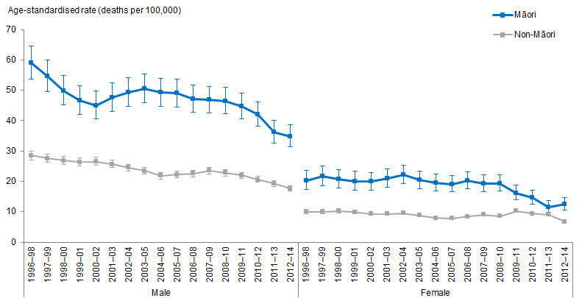
Notes:
Figures are age-standardised to the 2001 Census total Māori population.
Prioritised ethnicity has been used.
If the confidence intervals of two rates do not overlap, the difference in rates is said to be statistically significant.
Source: Mortality Collection Data Set (MORT), Ministry of Health, 1996–98 to 2012–14.

Figure 119 shows the age-standardised unintentional injury mortality rates for Māori and non-Māori for all ages, by gender, between 1996–98 and 2012–14.

Decrease in unintentional injury mortality rates for Māori males and females
Unintentional injury mortality rates for Māori and non-Māori of both sexes decreased by more than 30 percent between 1996–98 and 2012–14. The unintentional injury mortality rate of Māori males decreased by 41 percent between 1996–98 and 2012–14 (from 59 to 35 deaths per 100,000) and Māori females decreased by 39 percent over this period (from 20 to 12 deaths per 100,000).

The unintentional injury mortality rate for non-Māori showed similar trends over the same period, males decreased by 38 percent (from 29 to 18 deaths per 100,000) and females decreased by 33 percent (from 10 to 7 deaths per 100,000).

Males had a higher unintentional injury mortality rate than females for both Māori and non-Māori between 1996–98 and 2012–14.

Māori unintentional injury mortality rates were twice as high as non-Māori between 1996–98 and 2012–14
The difference between Māori and non-Māori unintentional injury mortality rates did not change between 1996–98 and 2012–14. On average, Māori mortality rates were twice as high as non-Māori rates, regardless of sex.

Unintentional injury mortality, 0–14 years
Figure 120: Unintentional injury mortality rates, 0–14 years, by gender, Māori and non-Māori, 1996–98 to 2012–14
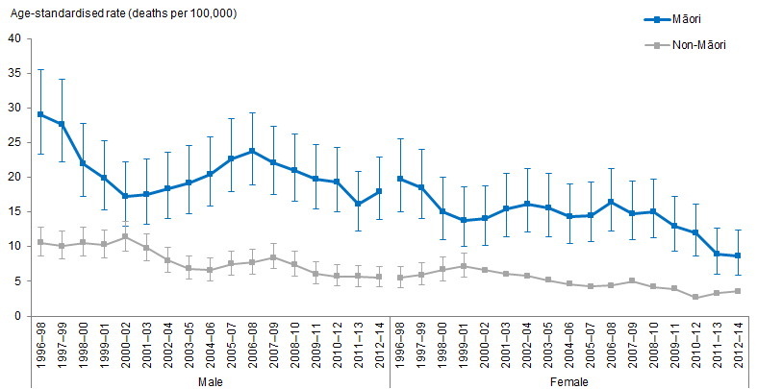
Notes:
Figures are age-standardised to the 2001 Census total Māori population.
Prioritised ethnicity has been used.
If the confidence intervals of two rates do not overlap, the difference in rates is said to be statistically significant.
Source: Mortality Collection Data Set (MORT), Ministry of Health, 1996–98 to 2012–14.

Figure 120 shows the age-standardised unintentional injury mortality rate for Māori and non-Māori children aged 0–14 years, by gender, between 1996–98 and 2012–14.

Māori children’s unintentional injury mortality rates decreased between 1996–98 and 2012–14
The unintentional injury mortality rates decreased for both Māori and non-Māori children between 1996–98 and 2012–14.

The unintentional injury mortality rates for Māori children decreased, girls decreased by 56 percent between 1996–98 and 2012–14 (from 20 to 9 deaths per 100,000) and boys decreased by 38 percent over the same period (from 29 to 18 deaths per 100,000).

Non-Māori children’s unintentional injury mortality rates also decreased, boys decreased by 47 percent between 1996–98 and 2012–14 (from 11 to 6 deaths per 100,000) and girls decreased by 35 percent over the same period (from 6 to 4 deaths per 100,000).

The unintentional injury mortality rates for boys aged 0–14 were greater than girls aged 0–14 years, regardless of ethnicity.

Māori children’s unintentional injury mortality rates were greater than non-Māori children’s rates
Māori boys’ unintentional injury mortality rates were, on average, more than 2½ times as high as that of non-Māori boys. The difference was greater for girls, where Māori girls’ unintentional injury mortality rates were, on average, three times as high as that of non-Māori girls.

These differences did not change over time.

Unintentional injury mortality, 15–64 years
Figure 121: Unintentional injury mortality rates, 15–64 years, by gender, Māori and non-Māori, 1996–98 to 2012–14
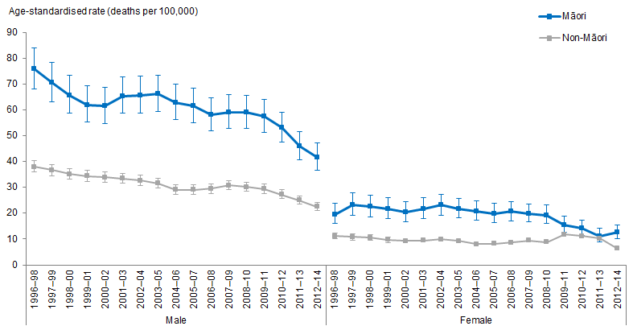
Notes:
Figures are age-standardised to the 2001 Census total Māori population.
Prioritised ethnicity has been used.
If the confidence intervals of two rates do not overlap, the difference in rates is said to be statistically significant.
Source: Mortality Collection Data Set (MORT), Ministry of Health, 1996–98 to 2012–14.

Figure 121 shows the age-standardised unintentional injury mortality rates for Māori and non-Māori aged 15–64 years, by gender, between 1996–98 and 2012–14.

Decrease in unintentional injury mortality rate for Māori males and females aged 15–64 years
The unintentional injury mortality rate for Māori males aged 15–64 years decreased by 45 percent between 1996–98 and 2012–14 (from 76 to 42 deaths per 100,000). Māori females within the same age group showed a decrease of 36 percent over the same period (from 20 to 13 deaths per 100,000).

The unintentional injury mortality rate for non-Māori aged 15–64 years showed similar trends – males decreased by 41 percent between 1996–98 and 2012–14 (from 38 to 23 deaths per 100,000) and females decreased by 43 percent over this period (from 11 to 6 deaths per 100,000).

Males aged 15–64 years had higher unintentional injury mortality rates than females within the same age group between 1996–98 and 2012–14, regardless of ethnicity.

Māori adults aged 15–64 years had unintentional injury mortality rates twice as high as the rates of non-Māori
The mortality rate for Māori aged 15–64 years was larger than the non-Māori rate, this did not change over time.

The unintentional injury mortality rate for Māori aged 15–64 years was, on average, twice the rate of non-Māori within the same age group between 1996–98 and 2012–14, regardless of sex.

Unintentional injury mortality, 65+ years
Figure 122: Unintentional injury mortality rates, 65+ years, by gender, Māori and non-Māori, 1996–98 to 2012–14
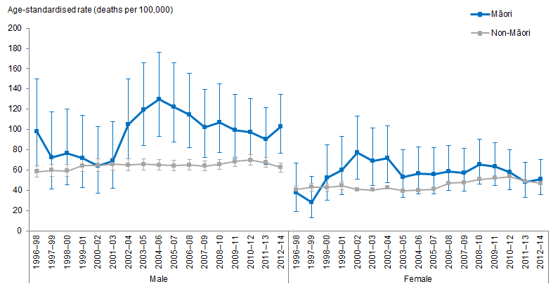
Notes:
Figures are age-standardised to the 2001 Census total Māori population.
Prioritised ethnicity has been used.
If the confidence intervals of two rates do not overlap, the difference in rates is said to be statistically significant.
Source: Mortality Collection Data Set (MORT), Ministry of Health, 1996–98 to 2012–14.

Figure 122 shows the age-standardised unintentional injury mortality rate for Māori and non-Māori aged 65+ years, by gender, between 1996–98 and 2012–14.

Little change in unintentional injury mortality rates for Māori aged 65+ years
Generally, the unintentional mortality rate for Māori and non-Māori aged 65 years and over were similar in 1996–98 and 2012–14, but fluctuated between these dates. The average for Māori males was 97 deaths per 100,000 and Māori females averaged 57 deaths per 100,000 over this period. For non-Māori, males averaged 64 deaths per 100,000 and females averaged 45 deaths per 100,000 over this period. Males had greater mortality rates than females over this period.

Māori males aged 65+ years had a higher rate of mortality due to unintentional injury than non-Māori males
The difference in mortality rates due to unintentional injuries for Māori and non-Māori fluctuated between 1996–98 and 2012–14, this was consistent for both sexes.

Excluding 1997–98 to 2001–03 and 2011–13, Māori males aged 65 years and above had a higher rate of mortality due to unintentional injury than non-Māori males of the same age group. On average Māori males mortality rates were 1½ times as high as the non-Māori males’ rates.

Leading unintentional injury mortality categories
This section presents the three leading unintentional injury mortality categories for Māori and non-Māori by gender and age group over time.

The three leading unintentional injury mortality categories were ranked by age-standardised rates, this accounts for the differences in the population structure between Māori and non-Māori.

The data describing trends in time for the three leading unintentional injury mortality categories is presented in comparative tables. These tables use abbreviations to refer to different injuries and therefore a key is provided below to aid in interpretation. This key should be referred to when interpreting the tables in this report and the graphics in the accompanying Excel tools.

Table 25: Key for leading unintentional injury mortality categories
Abbreviation | Unintentional injury category
DS | Drowning and Submersions
FA | Falls
MV | Motor Vehicle Accidents
PO | Poisoning
SF | Suffocation
TI | Thermal Injury

Unintentional injury mortality rankings for males aged 0–14 years
Table 26: Three leading injury mortalities, ranked by age-standardised rates, 0–14 years, Māori and non-Māori males
 | Ranking | Year
 |  | 1996–98 | 1997–99 | 1998-00 | 1999–01 | 2000-02 | 2001–03 | 2002-04 | 2003-05 | 2004-06 | 2005–07 | 2006–08 | 2007–09 | 2008–10 | 2009–11 | 2010–12 | 2011–13 | 2012–14
Māori | 1 | MV | MV | MV | MV | MV | SF | MV | MV | MV | SF | SF | SF | SF | SF | SF | SF | SF
 | 2 | SF | SF | DS | SF | SF | MV | SF | SF | SF | MV | MV | MV | MV | MV | MV | MV | MV
 | 3 | DS | TI | SF | TI | TI | DS | DS | DS | DS | DS | DS | DS | DS | DS | DS | DS | DS
Non-Māori | 1 | MV | MV | MV | MV | MV | MV | MV | MV | MV | MV | MV | MV | SF | SF | MV | MV | MV
 | 2 | SF | SF | DS | DS | DS | DS | SF | SF | SF | SF | SF | SF | MV | MV | SF | SF | SF
 | 3 | DS | DS | SF | SF | SF | SF | DS | DS | DS | DS | DS | DS | DS | DS | DS | DS | DS
Notes:
Figures are age-standardised to the 2001 Census total Māori population.
Prioritised ethnicity has been used.
Source: Mortality Collection Data Set (MORT), Ministry of Health, 1996–98 to 2012–14.

Table 26 shows the three leading unintentional injury mortality categories for Māori and non-Māori males aged 0–14 years ranked by age-standardised rates.

Motor vehicle accidents (MV) was the leading category for Māori males aged 0–14 years between 1996–98 and 2000–02 and again in 2002–04 to 2004–06. Suffocation (SF) was the leading category in 2001–03 and between 2005–07 and 2012–14. Drowning and submersions (DS) and thermal injury (TI) were the other categories that made up the three leading causes of unintentional injury for Māori males aged 0–14 years.

Motor vehicle accidents was the leading category for non-Māori males aged 0–14 years between 1996–98 and 2007–09 and again in 2010–12 to 2012–14. Suffocation was the leading category in 2008–10 and 2009–11. Drowning and submersions was the other leading category for non-Māori males aged 0–14 years.

Thermal Injury (third in 1997–98, 1999–01 and 2000–02) was one of the leading categories for Māori males aged 0–14 years but did not occur in the three leading categories for non-Māori males in the same age group.

Unintentional injury mortality rankings for males aged 15–64 years
Table 27: Three leading injury mortalities, ranked by age-standardised rates, 15–64 years, Māori and non-Māori males
 | Ranking | Year
 |  | 1996–98 | 1997–99 | 1998-00 | 1999–01 | 2000-02 | 2001–03 | 2002-04 | 2003-05 | 2004-06 | 2005–07 | 2006–08 | 2007–09 | 2008–10 | 2009–11 | 2010–12 | 2011–13 | 2012–14
Māori | 1 | MV | MV | MV | MV | MV | MV | MV | MV | MV | MV | MV | MV | MV | MV | MV | MV | MV
 | 2 | DS | DS | DS | DS | DS | PO | PO | PO | PO | PO | PO | PO | PO | PO | PO | PO | PO
 | 3 | FA | FA | FA | FA | FA | PO | DS | DS | DS | DS | DS | DS | DS | DS | FA | DS | DS
Non-Māori | 1 | MV | MV | MV | MV | MV | MV | MV | MV | MV | MV | MV | MV | MV | MV | MV | MV | MV
 | 2 | DS | DS | DS | DS | DS | FA | FA | FA | FA | PO | PO | PO | PO | PO | PO | PO | PO
 | 3 | FA | FA | FA | FA | FA | DS | DS | DS | PO | DS | DS | FA | FA | DS | DS | DS | DS
Notes:
Figures are age-standardised to the 2001 Census total Māori population.
Prioritised ethnicity has been used.
Source: Mortality Collection Data Set (MORT), Ministry of Health, 1996–98 to 2012–14.

Table 27 shows the three leading unintentional injury mortality categories for Māori and non-Māori males aged 15–64 years ranked by age-standardised rates.

Motor vehicle accidents was the leading category for both Māori and non-Māori males aged 15–64 years between 1996–98 and 2012–14.

Drowning and submersions was the second leading category of unintentional injury for Māori males aged 15–64 years between 1996–98 and 2000–02. Poisonings (PO) was the second leading category from 2001–03 to 2012–14. Falls (FA) was the other leading category for Māori males aged 15–64 between 1996–98 and 2012–14.

Drowning and submersions, falls, and poisonings were the remaining categories that appeared in the second and third leading mortalities for non-Māori males aged 15–64 years.

Unintentional injury mortality rankings for males aged 65+ years
Table 28: Three leading injury mortalities, ranked by age-standardised rates, 65+ years, Māori and non-Māori males
 | Ranking | Year
 |  | 1996–98 | 1997–99 | 1998-00 | 1999–01 | 2000-02 | 2001–03 | 2002-04 | 2003-05 | 2004-06 | 2005–07 | 2006–08 | 2007–09 | 2008–10 | 2009–11 | 2010–12 | 2011–13 | 2012–14
Māori | 1 | MV | MV | MV | MV | MV | MV | FA | FA | FA | MV | FA | FA | FA | FA | FA | FA | FA
 | 2 | FA | FA | FA | FA | FA | FA | MV | MV | MV | FA | MV | MV | MV | MV | MV | MV | MV
 | 3 | TI | DS | DS | DS | TI | TI | SF | DS | SF | SF | DS | DS | DS | PO | PO | PO | TI
Non-Māori | 1 | FA | FA | FA | FA | FA | FA | FA | FA | FA | FA | FA | FA | FA | FA | FA | FA | FA
 | 2 | MV | MV | MV | MV | MV | MV | MV | MV | MV | MV | MV | MV | MV | MV | MV | MV | MV
 | 3 | SF | SF | TI | SF | SF | DS | DS | DS | DS | DS | DS | PO | SF | SF | SF | SF | SF
Notes:
Figures are age-standardised to the 2001 Census total Māori population.
Prioritised ethnicity has been used.
Source: Mortality Collection Data Set (MORT), Ministry of Health, 1996–98 to 2012–14.

Table 28 shows the three leading unintentional injury mortality categories for Māori and non-Māori males aged 65 years and above ranked by age-standardised rates.

Between 1996–98 and 2000–02 and again in 2005–07 motor vehicle accidents was the leading category and falls was the second leading category of unintentional injury mortalities for Māori males aged 65 years and above. From 2002–04 to 2004–06 and 2006–08 to 2012–14, falls was the leading category and motor vehicle accidents was the second leading category for Māori males aged 65 years and above.

Falls was the leading category and motor vehicle accidents were the second leading category for non-Māori males aged 65 years and above between 1996–98 and
2012–14.

Suffocation, thermal injury, drowning and submersions and poisonings were the third leading category at various times between 1996–98 and 2012–14 for both Māori and non-Māori males aged 65 years and above.

Unintentional injury mortality rankings for females aged 0–14 years
Table 29: Three leading injury mortalities, ranked by age-standardised rates,
0–14 years, Māori and non-Māori females
 | Ranking | Year
 |  | 1996–98 | 1997–99 | 1998-00 | 1999–01 | 2000-02 | 2001–03 | 2002-04 | 2003-05 | 2004-06 | 2005–07 | 2006–08 | 2007–09 | 2008–10 | 2009–11 | 2010–12 | 2011–13 | 2012–14
Māori | 1 | MV | MV | MV | MV | MV | MV | MV | MV | MV | MV | SF | SF | SF | SF | SF | SF | SF
 | 2 | SF | SF | SF | SF | SF | SF | SF | SF | SF | SF | MV | MV | MV | MV | MV | MV | MV
 | 3 | DS | TI | DS | DS | DS | DS | DS | DS | DS | DS | DS | PO | PO | PO | PO | PO | TI
Non-Māori | 1 | MV | MV | MV | MV | MV | MV | MV | MV | MV | MV | MV | MV | MV | MV | MV | DS | MV
 | 2 | DS | DS | SF | SF | SF | DS | SF | SF | SF | SF | SF | SF | SF | DS | SF | SF | SF
 | 3 | SF | DS | DS | DS | TI | TI | DS | DS | DS | DS | DS | DS | DS | SF | DS | MV | DS
Notes:
Figures are age-standardised to the 2001 Census total Māori population.
Prioritised ethnicity has been used.
Source: Mortality Collection Data Set (MORT), Ministry of Health, 1996–98 to 2012–14.

Table 29 shows the three leading unintentional injury mortality categories for Māori and non-Māori females aged 0–14 years ranked by age-standardised rates.

The leading category for Māori females aged 0–14 years was motor vehicle accidents between 1996–98 and 2005–07 and suffocation from 2006–08 to 2012–14. Drowning and submersions, thermal injury and poisonings were the remaining categories that appeared in the third leading unintentional injury mortality between 1996–98 and 2012–14.

The leading category for non-Māori females aged 0–14 years was motor vehicle accidents between 1996–98 and 2010–12 and again in 2012–14. In 2011–13, drowning and submersions was the leading category for non-Māori females.

Poisonings was a frequently occurring category for Māori females aged 0–14 years that did not feature for non-Māori females of the same age group between 1996–98 and 2012–14.

Unintentional injury mortality rankings for females aged 15–64 years
Table 30: Three leading injury mortalities, ranked by age-standardised rates,
15–64 years, Māori and non-Māori females
 | Ranking | Year
 |  | 1996–98 | 1997–99 | 1998-00 | 1999–01 | 2000-02 | 2001–03 | 2002-04 | 2003-05 | 2004-06 | 2005–07 | 2006–08 | 2007–09 | 2008–10 | 2009–11 | 2010–12 | 2011–13 | 2012–14
Māori | 1 | MV | MV | MV | MV | MV | MV | MV | MV | MV | MV | MV | MV | MV | MV | MV | MV | MV
 | 2 | PO | TI | DS | FA | PO | PO | PO | PO | PO | PO | PO | PO | PO | PO | PO | PO | PO
 | 3 | SF | PO | TI | PO | TI | FA | FA | FA | FA | FA | FA | FA | FA | FA | FA | FA | TI
Non-Māori | 1 | MV | MV | MV | MV | MV | MV | MV | MV | MV | MV | MV | MV | MV | MV | MV | MV | MV
 | 2 | DS | FA | FA | FA | PO | PO | PO | PO | PO | PO | PO | PO | PO | PO | PO | PO | PO
 | 3 | FA | PO | PO | PO | FA | FA | DS | FA | FA | FA | FA | FA | FA | FA | FA | FA | FA
Notes:
Figures are age-standardised to the 2001 Census total Māori population.
Prioritised ethnicity has been used.
Source: Mortality Collection Data Set (MORT), Ministry of Health, 1996–98 to 2012–14.

Table 30 shows the three leading unintentional injury mortality categories for Māori and non-Māori females aged 15–64 years and above ranked by age-standardised rates.

Motor vehicle accidents was the leading category for both Māori and non-Māori females aged 15–64 years.

Poisonings was the second leading category for both Māori and non-Māori females aged 15–64 years between 2000–02 and 2012–14.

Falls occurred frequently in the third leading categories for both Māori and non-Māori females aged 15–64 years.

Unintentional injury mortality rankings for females aged 65+ years
Table 31: Three leading injury mortalities, ranked by age-standardised rates, 65+ years, Māori and non-Māori females
 | Ranking | Year
 |  | 1996–98 | 1997–99 | 1998-00 | 1999–01 | 2000-02 | 2001–03 | 2002-04 | 2003-05 | 2004-06 | 2005–07 | 2006–08 | 2007–09 | 2008–10 | 2009–11 | 2010–12 | 2011–13 | 2012–14
Māori | 1 | FA | FA | FA | FA | FA | FA | FA | FA | FA | FA | FA | FA | FA | FA | FA | FA | FA
 | 2 | MV | MV | MV | MV | MV | MV | MV | MV | MV | MV | MV | MV | MV | MV | MV | MV | MV
 | 3 | TI | TI | TI | - | DS | TI | TI | TI | TI | TI | – | – | – | PO | SF | SF | SF
Non-Māori | 1 | FA | FA | FA | FA | FA | FA | FA | FA | FA | FA | FA | FA | FA | FA | FA | FA | FA
 | 2 | MV | MV | MV | MV | MV | MV | MV | MV | MV | MV | MV | MV | MV | MV | MV | MV | MV
 | 3 | SF | SF | SF | TI | TI | TI | SF | SF | SF | TI | TI | SF | SF | SF | SF | SF | SF
Notes:
Figures are age-standardised to the 2001 Census total Māori population.
Prioritised ethnicity has been used.
Source: Mortality Collection Data Set (MORT), Ministry of Health, 1996–98 to 2012–14.

Table 31 shows the three leading unintentional injury mortality categories for Māori and non-Māori females aged 65+ years and above ranked by age-standardised rates.

The missing values in 1999–01 and from 2006–08 to 2008–10 are due to low age-standardised rates (deaths per 100,000) for Māori females aged 65 years and above.

Falls was the leading category for Māori and non-Māori females aged 65 and above between 1996–98 and 2012–14. Motor vehicle accidents was the second leading category for Māori and non-Māori females aged 65 years and above over this period.

Health service use

Primary health care access
Primary health care providers are most people’s first point of contact with the health system: they include general practice teams, after-hours clinics and some community health services. This section presents a few findings on access to primary health care for Māori and non-Māori adults aged 15+ years and for children aged 0–14 years.

What is the data telling us?
Overall the data shows that Māori adults were:
- more likely than non-Māori to have a usual medical centre
- less likely than non-Māori to see a GP or to visit after-hours
- more likely than non-Māori to see a practice nurse without seeing a GP
- more likely than non-Māori to have unmet needs and unfilled prescriptions
- Māori males were less likely than Māori females to visit primary health care services and less likely to report unmet need or unfilled prescriptions.
These patterns have not changed much over the last 10 years.
Māori children were:
- as likely as non-Māori children to have a usual medical centre
- as likely as non-Māori children to see a GP
- less likely than non-Māori children to have visited after hours
- more likely than non-Māori children to have unmet needs and unfilled prescriptions.
Patterns have fluctuated over time.

Accessing primary health care
Figure 123: Has GP clinic or medical centre that usually goes to when unwell or injured, 15+ years, Māori and non-Māori, 2006/07–2016/17
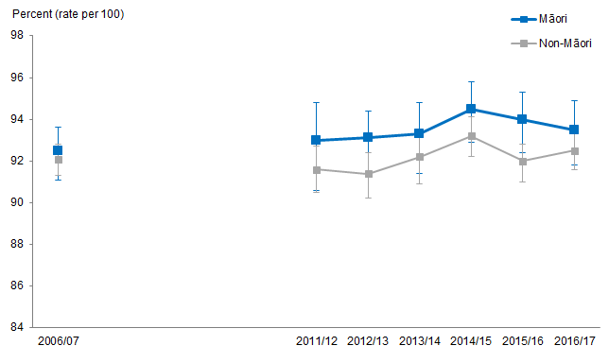
Notes:
Figures are age-standardised to the 2001 Census total Māori population.
Prioritised ethnicity has been used.
If the confidence intervals of two rates do not overlap, the difference in rates is said to be statistically significant.
Source: New Zealand Health Survey (NZHS), Ministry of Health, 2006/07–2016/17.

Figure 123 shows that most Māori adults (just over 90 percent) have a usual GP clinic / medical centre. Around three-quarters had visited a GP in the past 12 months, and one in four had seen a practice nurse without seeing a GP. One in 10 had visited an after-hours medical centre.

Compared with Māori females, Māori males were less likely to have a usual GP clinic / medical centre and less likely to have visited a GP, practice nurse or an after-hours medical centre in the past 12 months.

Figure 124: Visited after-hours medical centre in past 12 months, 0–14 years, Māori and non-Māori, 2011/12–2016/17
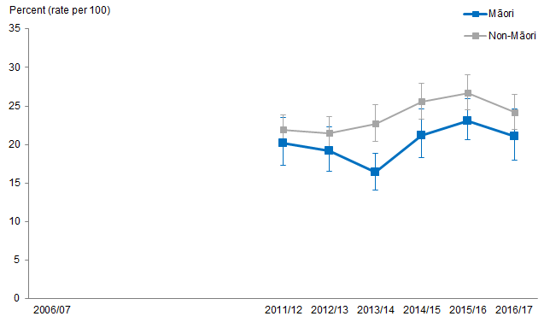
Notes:
Figures are age-standardised to the 2001 Census total Māori population.
Prioritised ethnicity has been used.
If the confidence intervals of two rates do not overlap, the difference in rates is said to be statistically significant.
Source: New Zealand Health Survey (NZHS), 2011/12–2016/17, Ministry of Health.

Nearly all Māori children had a usual GP or medical centre (97.6 percent in 2016/17), and similar proportions of Māori and non-Māori children had visited their GP in the last 12 months (71.5 percent for Māori children and 73.1 percent for non-Māori children in 2016/17). Māori children were less likely to have visited an after-hours medical centre in the past 12 months than non-Māori children (Figure 124).

Māori reported a greater experience of unmet need when accessing services compared with non-Māori
Table 32: Any unmet need in the past 12 months, 15+ years, by gender, Māori and non-Māori, 2011/12–2016/17
Survey year | Māori male  % | Non-Māori male  % | Māori female  % | Non-Māori female  %
2011/12 | 31.6 | 19.8 | 48.0 | 32.9
2012/13 | 30.1 | 21.0 | 48.6 | 33.0
2013/14 | 30.0 | 21.8 | 45.2 | 32.9
2014/15 | 28.0 | 20.9 | 39.5 | 33.1
2015/16 | 28.6 | 21.8 | 49.7 | 36.1
2016/17 | 31.2 | 21.5 | 44.3 | 33.6
Notes:
Figures are age-standardised to the 2001 Census total Māori population.
Prioritised ethnicity has been used.
Source: New Zealand Health Survey (NZHS), Ministry of Health, 2011/12–2016/17.

Table 32 shows that Māori report a higher unmet need than non-Māori over time (2011/12–2016/17). The prevalence of unmet need experience has decreased slightly over time: in 2011/12, 40.1 percent of Māori adults reported one or more types of unmet need compared with 38.0 percent in 2016/17.

Māori females report the highest percent of experiencing unmet need accessing primary health care and this was consistent over time.

Table 33: Any unmet need in the past 12 months, 0–14 years, Māori and non-Māori, 2011/12–2016/17
Survey year | Māori children  % | Non-Māori children  %
2011/12 | 27.0 | 17.2
2012/13 | 27.8 | 18.2
2013/14 | 27.4 | 19.4
2014/15 | 27.3 | 19.6
2015/16 | 28.1 | 22.4
2016/17 | 24.8 | 18.7
Notes:
Figures are age-standardised to the 2001 Census total Māori population.
Prioritised ethnicity has been used.
Source: New Zealand Health Survey (NZHS), Ministry of Health, 2011/12–2016/17.

Māori children experienced higher unmet need than non-Māori children over time (2011/12–2016/17).

Māori females reported the highest percentage of unfilled prescriptions due to cost
Figure 125: Unfilled prescription due to cost in past 12 months, 15+ years, Māori and non-Māori, 2011/12–2016/17
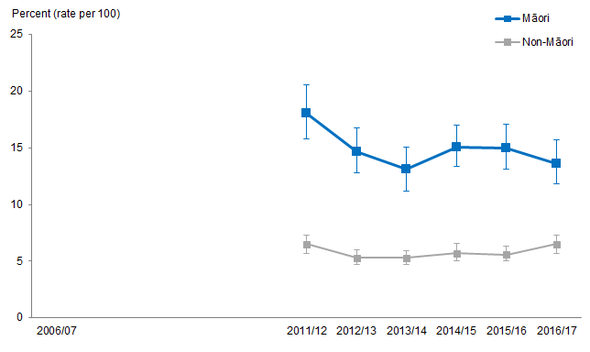
Notes:
Figures are age-standardised to the 2001 Census total Māori population.
Prioritised ethnicity has been used.
If the confidence intervals of two rates do not overlap, the difference in rates is said to be statistically significant.
Source: New Zealand Health Survey (NZHS), Ministry of Health, 2011/12–2016/17.

Figure 125 shows that Māori adults were more likely than non-Māori adults to have reported not collecting prescriptions due to cost at any time in the last 12 months. Whilst the percentage of unfilled prescriptions due to cost has decreased slightly over time for Māori, in 2016/17, Māori adults were still more than twice as likely to have unfilled prescriptions due to cost as non-Māori adults.

Māori females aged 15+ reported the highest percentage of unfilled prescriptions due to cost from 2011/12 (21.3 percent) to 2016/17 (17.7 percent) compared with non-Māori females (8.0 percent in 2011/12 and 8.7 percent in 2016/17).

Figure 126: Unfilled prescription due to cost in past 12 months, 0–14 years, by gender, Māori and non-Māori, 2011/12–2016/17
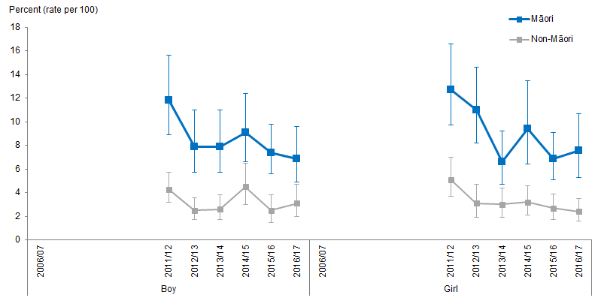
Notes:
Figures are age-standardised to the 2001 Census total Māori population.
Prioritised ethnicity has been used.
If the confidence intervals of two rates do not overlap, the difference in rates is said to be statistically significant.
Source: New Zealand Health Survey (NZHS), Ministry of Health, 2011/12–2016/17.

Figure 126 shows that Māori children were more likely than non-Māori children to have unfilled prescriptions due to cost at any time in the last 12 months. Whilst the percentage of unfilled prescriptions due to cost has decreased over time for Māori children, Māori children were still over 2½ times as likely as non-Māori children to have unfilled prescriptions due to cost in 2016/17 and this has changed little over time.

Health system indicators

Amenable mortality and ambulatory sensitive hospitalisation (ASH)
The indicators included in this section are used to measure the performance of the health system and include amenable mortality and ambulatory-sensitive hospitalisation (ASH).

Amenable mortality
Amenable mortality is defined as premature deaths (deaths under the age of 75 years) that could potentially be avoided, given effective and timely health care. That is, early deaths from diseases or injuries for which effective health interventions exist and are accessible to New Zealanders in need (Ministry of Health 2016b).

Figure 127: Amenable mortality rates, 0–74 years, by gender, Māori and non-Māori, 2000–2015
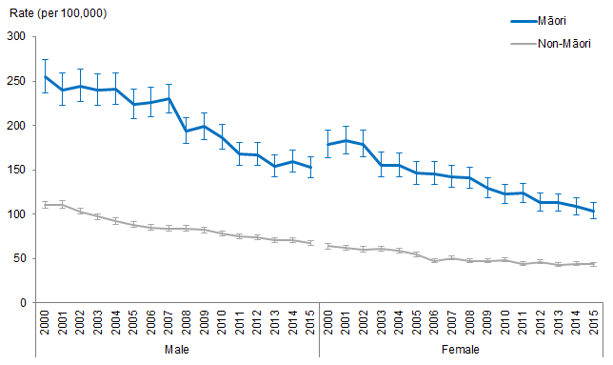
Notes:
Figures are age-standardised to the 2001 Census total Māori population.
Prioritised ethnicity has been used.
If the confidence intervals of two rates do not overlap, the difference in rates is said to be statistically significant.
Source: Mortality Collection Data Set (MORT), Ministry of Health, 2000 to 2015.
Figure 127 shows that Māori have a higher amenable mortality rate than non-Māori after adjusting for age. This disparity is higher for females: the age-standardised amenable mortality rate among Māori females is 2.39 times as high as that among non-Māori females in 2015. The Māori male amenable mortality rate remains higher than that of Māori females, despite the rate ratios being mostly higher for females.

Figure 128: Age-standardised rate ratios for amenable mortality, 0–74 years, by gender, Māori vs non-Māori, 2000–2015
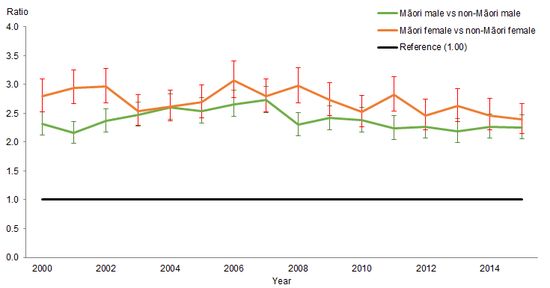
Notes:
Figures are age-standardised to the 2001 Census total Māori population.
Prioritised ethnicity has been used.
If the confidence interval of the rate ratio does not include the number 1, the ratio is said to be statistically significant.
Source: Mortality Collection Data Set (MORT), Ministry of Health, 2000 to 2015.

The equity gap is narrowing over time, especially for females: the age-standardised amenable mortality rate was nearly three times as likely in Māori females as it was in non-Māori females in 2000 and dropped to 2.39 times in 2015 (Figure 128).

Saving Lives: Amenable mortality in New Zealand, 1996–2006 (Ministry of Health 2010b) contains further analyses comparing Māori with non-Māori: www.health.govt.nz/publication/saving-lives-amenable-mortality-new-zealand-1996–2006

Ambulatory sensitive hospitalisation (ASH)
ASH refers to mostly acute hospital admissions of people less than 75 years old for conditions that are preventable, or that could have been treated earlier in the primary health care setting (Ministry of Health 2017a).

Figure 129: Ambulatory sensitive hospitalisation (ASH) rates, 0–4 years, by gender, Māori and non-Māori, 2002–2017
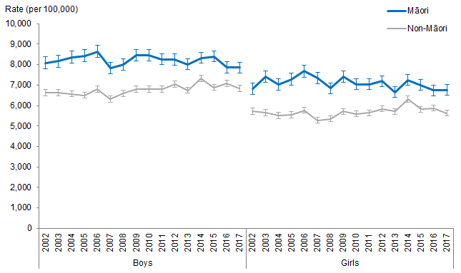
Notes:
Prioritised ethnicity has been used.
If the confidence intervals of two rates do not overlap, the difference in rates is said to be statistically significant.
Source: National Minimum Data Set (NMDS), Ministry of Health, 2002 to 2017.

Figure 129 shows that boys had a higher rate of ASH than girls among both Māori and non-Māori children. Māori children aged 0–4 years have an approximate 20 percent higher ASH rate than non-Māori children at the same age group. There was a widening gap between Māori children and non-Māori children in the early 2000s, followed by some narrowing of the gap. Some of the narrowing, however, is due to an increase in non-Māori children’s ASH rates from around 2009, rather than a decrease in Māori children’s ASH rates.

Figure 130: Age-standardised rate ratios for ambulatory sensitive hospitalisation (ASH), 45–64 years, by gender, Māori vs non-Māori, 2002–2017
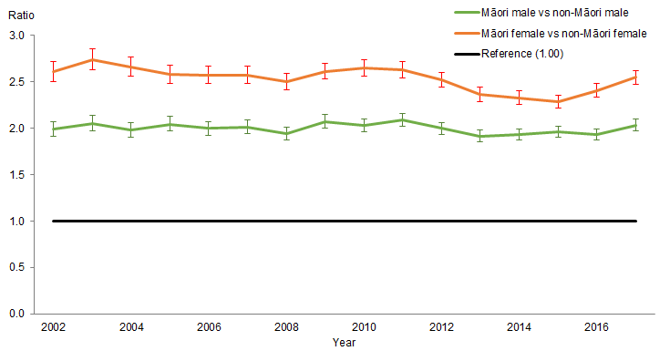
Notes:
Figures are age-standardised to the 2001 Census total Māori population.
Prioritised ethnicity has been used.
If the confidence interval of the rate ratio does not include the number 1, the ratio is said to be statistically significant.
Source: National Minimum Data Set (NMDS), Ministry of Health, 2002 to 2017.

Māori adults aged 45–64 years had higher age-standardised ASH rates than non-Māori adults in the same age group, and the equity gap has not changed much over time.

Among Māori, males and females have similar ASH rates, while among non-Māori, females have lower ASH rates than males. This is shown in the greater disparity between Māori and non-Māori females: age-standardised ASH rates among Māori females aged 45–64 years were more than 2.5 times as high as those of non-Māori females in the same age group in 2017 (Figure 130).

Publicly-funded hospital discharges
This section presents information on publicly-funded hospital discharges for Māori and non-Māori males and females.

Discharge is when a patient leaves hospital to return home, transfers to another hospital or residential institution, or dies in hospital after being formally admitted.

This section covers the period 1996 to 2017 and reports age-standardised discharge rates per 100 population. Reporting per 100 population is the standard way the Ministry of Health reports on discharges.

What is the data telling us?
Overall the data shows that between 1996–97 and 2016–17:
- Both Māori males and females had higher age-standardised rates of publicly-funded hospital discharges compared with non-Māori males and females.
- Age-standardised rates of publicly-funded hospital discharges increased for Māori and non-Māori males and females during this time, however, the increases were greater for Māori males and females compared with non-Māori males and females.
- In 2016/17, the age-standardised rates of publicly-funded hospital discharges per 100 population was higher for Māori males (21 discharges per 100 population) compared with non-Māori males (18), and higher for Māori females (28) compared with non-Māori females (23).

Age-standardised rates of publicly-funded hospital discharges have increased
Figure 131: Publicly-funded hospital discharge rates, by gender, Māori and non-Māori, 1996–97 to 2016–17
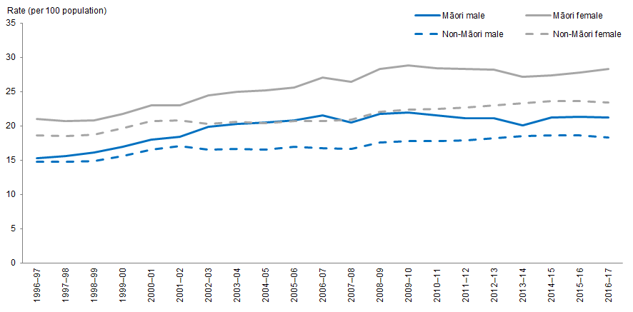
Notes:
Figures are age-standardised to the 2001 Census total Māori population.
Prioritised ethnicity has been used.
Source: National Minimum Dataset (NMDS, 10 January 2019), Ministry of Health, 1996–97 to 2016–17.

Figure 131 shows both Māori males and females had higher age-standardised rates of publicly-funded hospital discharges compared with non-Māori males and females.

Between 1996–97 and 2016–17, age-standardised rates of publicly-funded hospital discharges for Māori males increased by 38 percent (from 15 to 21 hospitalisations per 100), more than for non-Māori males which increased by 25 percent (from 15 to 18 hospitalisations per 100). For females, the rate of publicly-funded discharges per 100 for Māori females increased by 35 percent (from 21 to 28 publicly-funded discharges per 100), whereas the increase for non-Māori females was 26 percent (from 19 to 23 publicly-funded discharges per 100).

The difference between Māori and non-Māori rates increased for males and for females
Between 1996–97 and 2016–17, there was an increase in the difference between the rates of Māori and non-Māori male and female publicly-funded hospital discharges. The Māori and non-Māori rate difference for males, increasing from less than 1 per 100 in 1996–97 to just under 3 per 100 in 2016–17. For females, the difference between Māori and non-Māori discharge increased from just over 2 per 100 in 1996–97 to just under 5 per 100 in 2016–17.

Between 1996–97 and 2016–17, the difference between Māori and non-Māori age-standardised rates of publicly-funded hospital discharges increased for males and females. Rates for both Māori males and females increased to be 1.2 times as high as those of non-Māori males and females.

Table 34: Publicly-funded hospital discharge rates, by gender, Māori and non-Māori, 1996–97 to 2016–17
Year | Māori |  | Non-Māori
 | Males | Females | Males | Females
1996–97 | 15.3 | 21.0 | 14.7 | 18.6
1997–98 | 15.6 | 20.7 | 14.7 | 18.5
1998–99 | 16.1 | 20.8 | 14.9 | 18.7
1999–00 | 16.9 | 21.7 | 15.6 | 19.6
2000-01 | 18.0 | 23.0 | 16.5 | 20.7
2001–02 | 18.4 | 23.0 | 17.0 | 20.8
2002-03 | 19.9 | 24.4 | 16.5 | 20.3
2003-04 | 20.3 | 25.0 | 16.6 | 20.6
2004-05 | 20.5 | 25.2 | 16.5 | 20.4
2005–06 | 20.8 | 25.6 | 16.9 | 20.7
2006–07 | 21.5 | 27.0 | 16.7 | 20.7
2007–08 | 20.5 | 26.4 | 16.6 | 20.9
2008-09 | 21.7 | 28.3 | 17.6 | 22.0
2009–10 | 21.9 | 28.8 | 17.8 | 22.4
2010–11 | 21.5 | 28.4 | 17.8 | 22.5
2011–12 | 21.1 | 28.3 | 17.9 | 22.7
2012–13 | 21.1 | 28.2 | 18.2 | 23.0
2013–14 | 20.1 | 27.1 | 18.5 | 23.3
2014–15 | 21.2 | 27.3 | 18.6 | 23.6
2015–16 | 21.3 | 27.8 | 18.6 | 23.6
2016–17 | 21.2 | 28.3 | 18.3 | 23.4
Notes:
Figures are age-standardised to the 2001 Census total Māori population.
Prioritised ethnicity has been used.
Source: National Minimum Dataset (NMDS, 10 January 2019), Ministry of Health, 1996–97 to 2016–17.

Emergency department attendances
This section presents information on emergency department attendances for Māori and non-Māori males and females.

An attendance is where the health care user is assessed by a registered medical practitioner or nurse practitioner. The health care user received treatment, therapy, advice, diagnostic or investigatory procedures.

This section covers the period 2007 to 2017 and reports age-standardised attendance rates per 100 population. Reporting per 100 population is the standard way the Ministry reports on attendances. Reporting on emergency department attendances first started in 2006–07; however reporting for that year was incomplete hence this reporting starts in 2007–08.

What is the data telling us?
Overall the data shows that between 2007–08 and 2016–17:
- Both Māori males and females had higher age-standardised rates of emergency department attendances compared with non-Māori males and females.
- Age-standardised rates of emergency department attendances increased for Māori and non-Māori males and females during this time, however, the increases were greater for Māori males and females compared with non-Māori males and females.
- In 2016–17, the age-standardised rate of emergency department attendances per 100 population was eight attendances higher for Māori males (30 attendances per 100 population) compared with non-Māori males (22), and 10 attendances higher for Māori females (31) compared with non-Māori females (21).

Age-standardised rates of emergency department attendances have increased
Figure 132: Emergency department attendance rates, by gender, Māori and non-Māori, 2007–08 to 2016–17
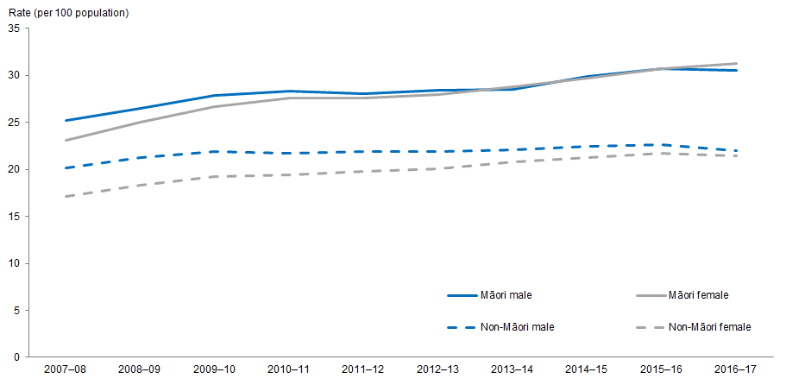
Notes:
Figures are age-standardised to the 2001 Census total Māori population.
Prioritised ethnicity has been used.
Source: National Minimum Dataset (NMDS, 10 January 2019), Ministry of Health, 2007–08 to 2016–17.

Figure 132 shows both Māori males and females had higher age-standardised rates of emergency department attendances compared with non-Māori males and females, with greater differences between females than males.

Between 2007–08 and 2016–17, age-standardised rates of emergency department attendances for Māori males increased by 21 percent (from 25 to 30 attendances per 100), more than for non-Māori males which increased by 9 percent (from 20 to 22 attendances per 100). For females, the rate of emergency department attendances per 100 for Māori females increased by 35 percent (from 23 to 31 emergency department attendances per 100), lower than the increase for non-Māori females, which was 25 percent (from 17 to 21 emergency department attendances per 100).

The difference in emergency department attendances between Māori and non-Māori rates increased for males and females
Between 2007–08 and 2016–17, there was an increase in the difference between the rates of Māori and non-Māori male and female emergency department attendance rates. The Māori and non-Māori rate difference for males, increasing from 5 attendances per 100 in 2007–08 to 8 per 100 in 2016–17. For females, the difference between Māori and non-Māori attendances increased from 6 per 100 in 2007–08 to 10 per 100 in 2016–17.

Table 35: Emergency department attendance rates, by gender, Māori and non-Māori, 2007–08 to 2016–17
Year | Māori |  | Non-Māori
 | Males | Females | Males | Females
2007–08 | 25.2 | 23.1 | 20.2 | 17.1
2008–09 | 26.5 | 25.0 | 21.3 | 18.3
2009–10 | 27.9 | 26.7 | 21.9 | 19.2
2010–11 | 28.3 | 27.6 | 21.7 | 19.4
2011–12 | 28.1 | 27.6 | 21.9 | 19.8
2012–13 | 28.4 | 28.0 | 21.9 | 20.1
2013–14 | 28.5 | 28.8 | 22.1 | 20.8
2014–15 | 29.9 | 29.7 | 22.5 | 21.3
2015–16 | 30.7 | 30.7 | 22.6 | 21.7
2016–17 | 30.5 | 31.3 | 22.0 | 21.4
Notes:
Figures are age-standardised to the 2001 Census total Māori population.
Prioritised ethnicity has been used.
Source: National Minimum Dataset (NMDS, 10 January 2019), Ministry of Health, 2007–08 to 2016–17.

Health workforce
This section presents the trends related to the health workforce data between 2004 and 2018. Data is sourced from workforce surveys by the relevant regulatory authorities. Fourteen of the 16 regulatory bodies that operate under the Health Practitioners Competence Assurance Act (2003) are included in this brief.

The regulatory bodies, and the covered professions, included within this brief are:
- Nursing Council of New Zealand – Nursing
- Midwifery Council of New Zealand – Midwives
- Medical Council of New Zealand – Medical Employed FTE
- Dental Council of New Zealand – Oral Health
- New Zealand Physiotherapists Board – Physiotherapists
- New Zealand Psychologists Board – Psychologists
- Medical Radiation Technologists Board – Medical Radiologists
- New Zealand Dietitians Board – Dietitians
- Medical Sciences Council of New Zealand – Medical Laboratory Scientists and Technicians
- Pharmacy Council of New Zealand – Pharmacists
- New Zealand Optometrists and Dispensing Opticians Board – Optometrists and Dispensing Opticians
- New Zealand Podiatrists Board – Podiatrists
- New Zealand Psychologists Board – Osteopaths
- New Zealand Chiropractic Board – Chiropractors.

The availability of health workforce data is subject to the make-up of the workforce surveys for each regulative authority. Because of this no information is available for the occupational therapy and psychotherapy workforces and various other professions covered in this report have gaps in the reported timeframe.

This section does not include professions that are either: unregulated (eg, kaiāwhina/care and support workers) or regulated but not covered under the Health Practitioners Competence Assurance Act (2003) (eg, social workers) as no data is available for these professions.

It is evident from the below indicators that in general, the number of Māori in the health workforce increased at a similar rate to the total number of workers in that profession. Because of this the percentage of Māori in each workforce did not improve over time – every profession did not reflect the ethnic population distribution (14.9 percent Māori, 85.1 percent non-Māori).

Nursing Council of New Zealand – nurses
The nursing workforce includes enrolled, practising and registered nurses.

Table 36: Estimated number (percentage in workforce) of Māori and non-Māori in nursing, 2005–2018
Nursing (2005–2018)
Year | Māori | Non-Māori
2005 | 3,003 (7.5%) | 37,127 (92.5%)
2006 | 2,941 (7.4%) | 36,913 (92.6%)
2007 | 3,053 (7.3%) | 38,860 (92.7%)
2008 | 3,237 (7.2%) | 41,525 (92.8%)
2009 | 2,803 (6.3%) | 41,757 (93.7%)
2010 | – | –
2011 | 3,484 (7.2%) | 45,079 (92.8%)
2012 | 3,501 (7.1%) | 45,875 (92.9%)
2013 | 3,428 (6.8%) | 46,646 (93.2%)
2014 | 3,547 (6.9%) | 47,859 (93.1%)
2015 | 3,632 (6.9%) | 49,097 (93.1%)
2016 | 3,783 (7.0%) | 50,139 (93.0%)
2017 | 3,977 (7.2%) | 51,312 (92.8%)
2018 | 4,163 (7.4%) | 52,193 (92.6%)
Source: Nursing Council of New Zealand, 2005–2009 and 2011–2018.

Table 36 shows the estimated number and percentage of Māori and non-Māori in the nursing workforce between 2009 and 2018, excluding 2010.

Despite the number of Māori in the nursing workforce increasing over time, the percentage of Māori in the workforce did not change much – the average percentage of Māori in the nursing workforce between 2005 and 2018 was 7.1 percent (average of 3,427 Māori nurses, compared with an average of 44,952 non-Māori nurses). The nursing workforce does not reflect the ethnic population distribution in New Zealand (14.9 percent Māori, 85.1 percent non-Māori).

The workforce population data for enrolled, practising and registered nurses can be found in Appendix 6 in Tables A6.1, A6.2 and A6.3 respectively.

Midwifery Council of New Zealand – midwifery
Table 37: Estimated number (percentage in workforce) of Māori and non-Māori in midwifery, 2005–2016
Midwifery (2005–2016)
Year | Māori | Non-Māori
2005 | 171 (6.5%) | 2,440 (93.5%)
2006 | 153 (6.6%) | 2,150 (93.4%)
2007 | 146 (5.9%) | 2,323 (94.1%)
2008 | 166 (6.7%) | 2,302 (93.3%)
2009 | 182 (7.1%) | 2,365 (92.9%)
2010 | 198 (7.5%) | 2,441 (92.5%)
2011 | – | –
2012 | 236 (8.1%) | 2,674 (91.9%)
2013 | 255 (8.7%) | 2,683 (91.3%)
2014 | 266 (9.0%) | 2,705 (91.0%)
2015 | 278 (9.2%) | 2,755 (90.8%)
2016 | 285 (9.4%) | 2,738 (90.6%)
Source: Midwifery Council of New Zealand, 2005–2010 and 2011–2016.

Table 37 shows the estimated number and percentage of Māori and non-Māori in the midwifery workforce between 2005 and 2016, excluding 2011.

The number and percentage of Māori in the midwifery workforce increased over time – from 6.5 percent in 2005 to 9.4 percent in 2016 (171 to 285 Māori midwives). The number of non-Māori in the midwifery workforce also increased (from 2,440 to 2,738 non-Māori midwives), the percentage of non-Māori in the workforce decreased (from 93.5 percent in 2005 to 90.6 percent in 2016). The midwifery workforce does not reflect the ethnic population distribution in New Zealand (14.9 percent Māori, 85.1 percent non-Māori).

Medical Council of New Zealand – medical employed FTE
The medical employed full-time employees (FTE) workforce incorporates senior medical officers, medical officers, general practitioners, registrars, house officers, and probationers and interns.

Table 38: Estimated number (percentage in workforce) of Māori and non-Māori in the medical employed FTE, 2004–2016
Medical employed FTE (2004–2016)
Year | Māori | Non-Māori
2004 | 234 (2.6%) | 8,757 (97.4%)
2005 | 230 (2.6%) | 8,516 (97.4%)
2006 | 240 (2.5%) | 9,307 (97.5%)
2007 | 261 (2.7%) | 9,496 (97.3%)
2008 | 328 (3.1%) | 10,224 (96.9%)
2009 | 324 (2.9%) | 10,665 (97.1%)
2010 | 341 (3.0%) | 10,890 (97.0 %)
2011 | 324 (2.8%) | 11,194 (97.2%)
2012 | 348 (2.9%) | 11,456 (97.1%)
2013 | 341 (2.8%) | 11,936 (97.2%)
2014 | 409 (3.2%) | 12,322 (96.8%)
2015 | 452 (3.3%) | 13,447 (96.7%)
2016 | 465 (3.3%) | 13,695 (96.7%)
Source: Medical Council of New Zealand, 2004–2016.

Table 38 shows the estimated number and percentage of Māori and non-Māori covered in the medical employed FTE workforce between 2004 and 2016.

Despite the number of Māori in the medical employed FTE workforce increasing over time, the percentage of Māori in the workforce did not change much – the average percentage of Māori in the medical employed FTE workforce between 2004 and 2016 was 2.9 percent. The medical employed FTE workforce does not reflect the ethnic population distribution in New Zealand (14.9 percent Māori, 85.1 percent non-Māori).

The workforce population data for senior medical officers, medical officers, general practitioners, registrars, house officers, and probationers and Interns can be found in Appendix 6 in Tables A6.4, A6.5, A6.6, A6.7, A6.8 and A6.9 respectively.

Dental Council of New Zealand – oral health
Table 39: Estimated number (percentage in workforce) of Māori and non-Māori in the oral health workforce, 2006–2008 and 2015–2017
Oral health (2006–2008 and 2015–2017)
Year | Māori | Non-Māori
2006 | 134 (4.4%) | 2,942 (95.6%)
2007 | 153 (4.7%) | 3,124 (95.3%)
2008 | 156 (4.6%) | 3,263 (95.4%)
2009 | – | –
2010 | – | –
2011 | – | –
2012 | – | –
2013 | – | –
2014 | – | –
2015 | 164 (4.3%) | 3,658 (95.7%)
2016 | 183 (4.6%) | 3,764 (95.4%)
2017 | 171 (4.2%) | 3,853 (95.8%)
Source: Dental Council of New Zealand, 2006–2008 and 2015–2017.

Table 39 shows the estimated number and percentage of Māori and non-Māori in the oral health workforce – a summation of dentists, hygienists, technologists and therapists, from 2006 to 2008 and 2015 to 2017.

Despite the number of Māori in the oral health workforce increasing over time, the percentage of Māori in the workforce did not change much – the average percentage of Māori in the oral health workforce from 2006 to 2008 and 2015 to 2017 was 4.1 percent (average of 106 Māori oral health workers, compared with an average of 3,434 non-Māori). The oral health workforce does not reflect the ethnic population distribution in New Zealand (14.9 percent Māori, 85.1 percent non-Māori).

New Zealand Physiotherapists Board – physiotherapists
Table 40: Estimated number (percentage in workforce) of Māori and non-Māori in the physiotherapy workforce, 2005, 2007–2010 and 2014–2018
Physiotherapy (2005–2010 and 2014–2018)
Year | Māori | Non-Māori
2005 | 65 (3.3%) | 1,920 (96.7%)
2006 | – | –
2007 | 65 (4.0%) | 1,561 (96.0%)
2008 | 106 (4.5%) | 2,275 (95.5%)
2009 | 97 (3.9%) | 2,359 (96.1%)
2010 | 107 (4.3%) | 2,378 (95.7%)
2011 | – | –
2012 | – | –
2013 | – | –
2014 | – (5.0%) | – (95.0%)
2015 | – (5.0%) | – (95.0%)
2016 | – (4.4%) | – (95.6%)
2017 | – (4.5%) | – (95.5%)
2018 | – (4.9%) | – (95.1%)
Source: Physiotherapy Board of New Zealand, 2005, 2007–2010 and 2014–2018.

Table 40 shows the estimated number and percentage of Māori and non-Māori in the physiotherapy workforce from 2005 to 2010 (excluding 2006) and 2014 to 2018.

Despite the number of Māori in the physiotherapy workforce increasing over time, the percentage of Māori in the workforce did not change much – the average percentage of Māori in the physiotherapy workforce from 2005 to 2010 (excluding 2006) and 2014 to 2018 was 4.4 percent. The physiotherapy workforce does not reflect the ethnic population distribution in New Zealand (14.9 percent Māori, 85.1 percent non-Māori).

New Zealand Psychologists Board – psychologists
Table 41: Estimated number (percentage in workforce) of Māori and non-Māori in the psychology workforce, 2005–2010 and 2018
Psychology (2005–2010, 2018)
Year | Māori | Non–Māori
2005 | 38 (3.8%) | 962 (96.2%)
2006 | 33 (3.0%) | 1,080 (97.0%)
2007 | 42 (3.8%) | 1,067 (96.2%)
2008 | 47 (3.9%) | 1,166 (96.1%)
2009 | 65 (5.3%) | 1,160 (94.7%)
2010 | 60 (4.5%) | 1,286 (95.5%)
2011 | – | –
2012 | – | –
2013 | – | –
2014 | – | –
2015 | – | –
2016 | – | –
2017 | – | –
2018 | 144 (5.3%) | 2,579 (94.7%)
Source: New Zealand Psychologists Board, 2005–2010 and 2018.

Table 41 shows the estimated number and percentage of Māori and non-Māori in the psychology workforce from 2005 to 2010 and 2018.

Despite the number of Māori in the psychology workforce increasing over time, the percentage of Māori in the workforce did not change much – the average percentage of Māori in the psychology workforce from 2005 to 2010 and 2018 was 4.2 percent. The psychology workforce does not reflect the ethnic population distribution in New Zealand (14.9 percent Māori, 85.1 percent non-Māori).

New Zealand Medical Radiation Technologists Board – medical radiologists
Table 42: Estimated number (percentage in workforce) of Māori and non-Māori in the medical radiology workforce, 2005–2010
Medical radiology (2005–2010)
Year | Māori | Non-Māori
2005 | 34 (2.7%) | 1,214 (97.3%)
2006 | 39 (2.9%) | 1,303 (97.1%)
2007 | 36 (3.2%) | 1,092 (96.8%)
2008 | 48 (3.0%) | 1,528 (97.0%)
2009 | 59 (3.5%) | 1,604 (96.5%)
2010 | 54 (3.1%) | 1,667 (96.9%)
Source: New Zealand Medical Radiation Technologists Board, 2005–2010.

Table 42 shows the estimated number and percentage of Māori and non-Māori in the medical radiology workforce from 2005 to 2010.

Despite the number of Māori in the medical radiology workforce increasing over time, the percentage of Māori in the workforce did not change much – the average percentage of Māori in the medical radiology workforce between 2005 and 2010 was 3.1 percent (average of 45 Māori medical radiologists, compared with an average of 1,401 non-Māori). The medical radiology workforce does not reflect the ethnic population distribution in New Zealand (14.9 percent Māori, 85.1 percent non-Māori).

New Zealand Dietitians Board – dietitians
Table 43: Estimated number (percentage in workforce) of Māori and non-Māori in the dietitian workforce, 2005–2010
Dietitian (2005–2010)
Year | Māori | Non-Māori
2005 | 11 (3.1%) | 342 (96.9%)
2006 | 10 (2.8%) | 342 (97.2%)
2007 | 9 (2.4%) | 360 (97.6%)
2008 | 10 (2.4%) | 404 (97.6%)
2009 | 15 (3.4%) | 425 (96.6%)
2010 | 16 (3.6%) | 432 (96.4%)
Source: Dietitians Board of New Zealand, 2005–2010.

Table 43 shows the estimated number and percentage of Māori and non-Māori in the dietitian workforce from 2005 to 2010.

Despite the number of Māori in the dietitian workforce increasing, the percentage of Māori in the workforce did not change much – the average percentage of Māori in the dietitian workforce between 2005 and 2010 was 3.0 percent (average of 12 Māori dietitians, compared with an average of 384 non-Māori). The dietitian workforce does not reflect the ethnic population distribution in New Zealand (14.9 percent Māori, 85.1 percent non-Māori).

Medical Sciences Council of New Zealand – medical laboratory scientist
Table 44: Estimated number (percentage in workforce) of Māori and non-Māori in the medical laboratory scientist workforce, 2005–2010
Medical laboratory scientist (2005–2010)
Year | Māori | Non-Māori
2005 | 13 (1.3%) | 1,020 (98.7%)
2006 | 14 (1.3%) | 1,099 (98.7%)
2007 | 18 (1.5%) | 1,186 (98.5%)
2008 | 37 (3.3%) | 1,068 (96.7%)
2009 | 21 (1.8%) | 1,158 (98.2%)
2010 | 22 (1.7%) | 1,290 (98.3%)
Source: Medical Sciences Council of New Zealand, 2005–2010.

Table 44 shows the estimated number and percentage of Māori and non-Māori in the medical laboratory scientist workforce from 2005 to 2010.

Despite the number of Māori in the medical laboratory scientist workforce increasing over time, the percentage of Māori in the workforce did not change much – the average percentage of Māori in the medical laboratory scientist workforce between 2005 and 2010 was 1.8 percent (average of 21 Māori medical laboratory scientists, compared with an average of 1,137 non-Māori). The medical laboratory scientist workforce does not reflect the ethnic population distribution in New Zealand (14.9 percent Māori, 85.1 percent non-Māori).

Medical Sciences Council of New Zealand – medical laboratory technician
Table 45: Estimated number (percentage in workforce) of Māori and non-Māori in the medical laboratory technician workforce, 2005 to 2010
Medical laboratory technician (2005–2010)
Year | Māori | Non-Māori
2005 | 12 (2.4%) | 482 (97.6%)
2006 | 43 (4.7%) | 866 (95.3%)
2007 | 50 (4.9%) | 974 (95.1%)
2008 | 23 (2.0%) | 1,144 (98.0%)
2009 | 49 (4.5%) | 1,039 (95.5%)
2010 | 53 (4.7%) | 1,070 (95.3%)
Source: Medical Sciences Council of New Zealand, 2005–2010.

Table 45 shows the estimated number and percentage of Māori and non-Māori in the medical laboratory technician workforce from 2005 to 2010.

Despite the number of Māori in the medical laboratory technician workforce increasing over time, the percentage of Māori in the workforce did not change much – the average percentage of Māori in the medical laboratory technician workforce between 2005 and 2010 was 3.9 percent (average of 38 Māori medical laboratory technicians, compared with an average of 929 non-Māori). The medical laboratory technician workforce does not reflect the ethnic population distribution in New Zealand (14.9 percent Māori, 85.1 percent non-Māori).

Pharmacy Council of New Zealand – pharmacists
Table 46: Estimated number (percentage in workforce) of Māori and non-Māori in the pharmacy workforce, 2005–2018
Pharmacists (2005–2018)
Year | Māori | Non-Māori
2005 | 41 (1.5%) | 2,704 (98.5%)
2006 | 45 (1.6%) | 2,756 (98.4%)
2007 | 48 (1.7%) | 2,841 (98.3%)
2008 | 49 (1.6%) | 2,929 (98.4%)
2009 | 46 (1.5%) | 3,030 (98.5%)
2010 | 45 (1.4%) | 3,135 (98.6%)
2011 | 79 (2.4%) | 3,146 (97.6%)
2012 | 80 (2.4%) | 3,224 (97.6%)
2013 | 79 (2.4%) | 3,274 (97.6%)
2014 | 82 (2.4%) | 3,324 (97.6%)
2015 | 80 (2.3%) | 3,426 (97.7%)
2016 | 83 (2.3%) | 3,494 (97.7%)
2017 | 87 (2.4%) | 3,533 (97.6%)
2018 | 91 (2.5%) | 3,575 (97.5%)
Note: These values may differ from data in Annual Reports as the data was extracted on different dates and some pharmacists did not specify their ethnicity.
Source: Pharmacy Council of New Zealand, 2005–2018.

Table 46 shows the estimated number and percentage of Māori and non-Māori in the pharmacy workforce from 2005 to 2018.

Despite the number of Māori in the pharmacy workforce increasing over time, the percentage of Māori in the workforce did not change much – the average percentage of Māori in the pharmacy workforce between 2005 and 2018 was 2.0 percent (average of 67 Māori pharmacists, compared with an average of 3,171 non-Māori). The pharmacy workforce does not reflect the ethnic population distribution in New Zealand (14.9 percent Māori, 85.1 percent non-Māori).

New Zealand Optometrists and Dispensing Opticians Board – optometrists
Table 47: Estimated number (percentage in workforce) of Māori and non-Māori in the optometry workforce, 2005–2010
Optometrists (2005–2010)
Year | Māori | Non-Māori
2005 | 5 (1.1%) | 457 (98.9%)
2006 | 8 (1.8%) | 444 (98.2%)
2007 | 9 (1.8%) | 498 (98.2%)
2008 | 9 (1.7%) | 510 (98.3%)
2009 | 12 (2.2%) | 529 (97.8%)
2010 | 10 (1.8%) | 532 (98.2%)
Source: New Zealand Optometrists and Dispensing Opticians Board, 2005–2010.

Table 47 shows the estimated number and percentage of Māori and non-Māori in the optometry workforce from 2005 to 2010.

Despite the number of Māori in the optometry workforce increasing over time, the percentage of Māori in the workforce did not change much – the average percentage of Māori in the optometry workforce between 2005 and 2010 was 1.7 percent (average of 9 Māori optometrists, compared with an average of 495 non-Māori). The optometry workforce does not reflect the ethnic population distribution in New Zealand (14.9 percent Māori, 85.1 percent non-Māori).

New Zealand Optometrists and Dispensing Opticians Board – dispensing optician
Table 48: Estimated number (percentage in workforce) of Māori and non-Māori in the dispensing optician workforce, 2005–2010
Dispensing optician (2005–2010)
Year | Māori | Non-Māori
2005 | 1 (1.1%) | 86 (98.9%)
2006 | 1 (1.0%) | 104 (99.0%)
2007 | 1 (0.9%) | 107 (99.1%)
2008 | 1 (0.8%) | 121 (99.2%)
2009 | 2 (1.4%) | 145 (98.6%)
2010 | 3 (1.9%) | 154 (98.1%)
Source: New Zealand Optometrists and Dispensing Opticians Board, 2005–2010.

Table 48 shows the estimated number and percentage of Māori and non-Māori in the dispensing optician workforce from 2005 to 2010.

The number of Māori in the dispensing optician workforce remained constant over time and the percentage of Māori in the workforce did not change much – the average percentage of Māori in the dispensing optician workforce between 2005 and 2010 was 1.2 percent (average of 2 Māori dispensing opticians, compared with an average of 120 non-Māori). The dispensing optician workforce does not reflect the ethnic population distribution in New Zealand (14.9 percent Māori, 85.1 percent non-Māori).

New Zealand Podiatrists Board – podiatrist
Table 49: Estimated number (percentage in workforce) of Māori and non-Māori in the podiatry workforce, 2005–2010
Podiatry (2005–2010)
Year | Māori | Non-Māori
2005 | 8 (4.7%) | 163 (95.3%)
2006 | 6 (4.0%) | 144 (96.0%)
2007 | 7 (4.5%) | 150 (95.5%)
2008 | 4 (2.3%) | 170 (97.7%)
2009 | 5 (2.8%) | 175 (97.2%)
2010 | 12 (6.9%) | 161 (93.1%)
Source: New Zealand Podiatrists Board, 2005–2010.

Table 49 shows the estimated number and percentage of Māori and non-Māori in the podiatry workforce from 2005 to 2010.

The number and percentage of Māori in the podiatry workforce increased slightly over time – from 4.7 percent in 2005 to 6.9 percent in 2010 (8 to 12 Māori podiatrists). In comparison, the number of non-Māori podiatrists did not change much over time – an average of 161 non-Māori podiatrists between 2005 and 2010. The percentage of non-Māori in the podiatry workforce decreased from 95.3 percent in 2005 to 93.1 percent in 2010.

Despite the increase in percentage, the podiatry workforce remained a poor reflection of the ethnic population distribution in New Zealand (14.9 percent Māori, 85.1 percent non-Māori).

Osteopathic Council of New Zealand – osteopaths
Table 50: Estimated number (percentage in workforce) of Māori and non-Māori in the osteopath workforce, 2005–2010
Osteopaths (2005–2010)
Year | Māori | Non-Māori
2005 | 7 (2.3%) | 295 (97.7%)
2006 | 5 (2.0%) | 247 (98.0%)
2007 | 5 (1.9%) | 264 (98.1%)
2008 | 5 (1.8%) | 266 (98.2%)
2009 | 10 (3.4%) | 283 (96.6%)
2010 | 7 (2.5%) | 274 (97.5%)
Source: Osteopathic Council of New Zealand, 2005–2010.

Table 50 shows the estimated number and percentage of Māori and non-Māori in the osteopath workforce from 2005 to 2010.

The number and percentage of Māori in the osteopath workforce did not change much over time – the average percentage of Māori in the osteopath workforce between 2005 and 2010 was 2.3 percent (average of 7 Māori osteopaths, compared with an average of 272 non-Māori). The osteopath workforce does not reflect the ethnic population distribution in New Zealand (14.9 percent Māori, 85.1 percent non-Māori).

New Zealand Chiropractic Board – chiropractors
Table 51: Estimated number (percentage in workforce) of Māori and non-Māori in the chiropractor workforce, 2005–2010
Chiropractors (2005–2010)
Year | Māori | Non-Māori
2005 | 8 (3.6%) | 215 (96.4%)
2006 | 4 (1.7%) | 236 (98.3%)
2007 | 9 (3.6%) | 239 (96.4%)
2008 | 12 (4.1%) | 279 (95.9%)
2009 | 8 (2.5%) | 311 (97.5%)
2010 | 12 (3.7%) | 309 (96.3%)
Source: New Zealand Chiropractic Board, 2005–2010.

Table 51 shows the estimated number and percentage of Māori and non-Māori in the chiropractor workforce from 2005 to 2010.

Despite the number of Māori in the chiropractor workforce increasing over time the percentage of Māori in the workforce did not change much – the average percentage of Māori in the chiropractor workforce between 2005 and 2010 was 3.2 percent (average of 9 Māori chiropractors, compared with an average of 265 non-Māori). The chiropractor workforce does not reflect the ethnic population distribution in New Zealand (14.9 percent Māori, 85.1 percent non-Māori).

Māori and non-Māori non-Pacific analysis
This section presents indicators compare Māori with non-Māori non-Pacific, which were requested by claimants.

The reporting time period is different from the Māori and non-Māori analysis presented in the report due to data limitations. Population estimates for non-Māori non-Pacific is only available for the period 2001–2013 (see Appendix 1 for more detail).

Body size
This section presents results for Māori and non-Māori non-Pacific children aged
2–14 years and adults aged 15 and over for body size.

What is the data telling us?
Overall the data shows that:
- The prevalence of being overweight declined slightly over time for Māori adults aged 15 and over. Māori males were less likely than non-Māori non-Pacific males to be overweight over time.
- Māori adults were around twice as likely to be obese as non-Māori non-Pacific adults, this difference remaining consistent over time.
- Māori children aged 2–14 years were more likely to be overweight than non-Māori non-Pacific children with little change over time.
- In 2016/17 Māori children were 2.8 times as likely to be obese as non-Māori non-Pacific children.

Body size for adults aged 15 and over
Figure 133: Overweight, 15+ years, by gender, Māori and non-Māori non-Pacific, 2006/07–2016/17
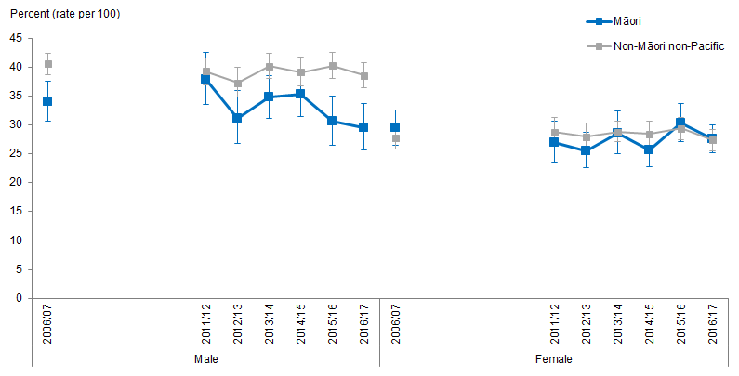
Notes:
Figures are age-standardised to the 2001 Census total Māori population.
Prioritised ethnicity has been used.
If the confidence intervals of two rates do not overlap, the difference in rates is said to be statistically significant.
Source: New Zealand Health Survey (NZHS), Ministry of Health, 2006/07–2016/17.

The prevalence of being overweight declined slightly overtime for Māori adults aged 15 and over, particularly for Māori males (a decrease of 13 percent from 2006/07 to 2016/17 for Māori males). Figure 133 shows that Māori males were less likely than non-Māori non-Pacific males to be overweight over time. Māori and non-Māori non-Pacific females had similar prevalence of being overweight.

Figure 134: Obese, 15+ years, by gender, Māori and non-Māori non-Pacific,
2006/07–2016/17
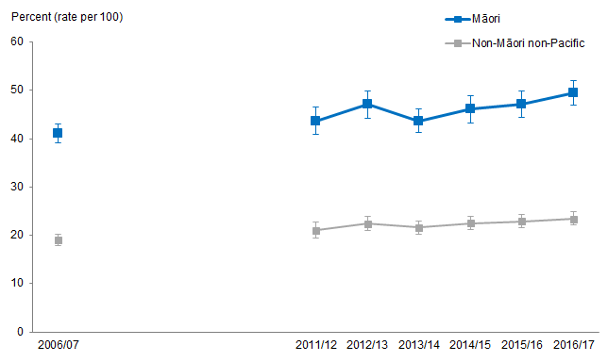
Notes:
Figures are age-standardised to the 2001 Census total Māori population.
Prioritised ethnicity has been used.
If the confidence intervals of two rates do not overlap, the difference in rates is said to be statistically significant.
Source: New Zealand Health Survey (NZHS), Ministry of Health, 2006/07–2016/17.

Figure 134 shows that the prevalence of being obese has increased slightly over time. In 2016/17, nearly 50 percent of Māori adults were obese compared with 23 percent of non-Māori non-Pacific adults. In 2006/07, 41 percent of Māori were obese compared with 19 percent of non-Māori non-Pacific. Māori adults were around twice as likely to be obese as non-Māori non-Pacific adults, this difference remaining consistent over time.

Mean BMI scores show little change overtime for both Māori and non-Māori non-Pacific adults aged 15 and over. Māori adults had a mean BMI score of around 30 kg/m² over the time period compared with around 26 kg/m² for non-Māori non-Pacific adults. There was no difference by gender.

There is similarly little substantial change over time when looking at waist measurement, Māori mean waist measurement (cm) increased slightly from 93.6 cm in 2006/07 to 96.6 cm in 2016/17 (compared with 86.9 cm and 88.4 cm for non-Māori non-Pacific).

Body size for children aged 2–14 years
Figure 135: Obese, 2–14 years, by gender, Māori and non-Māori non-Pacific,
2006/07–2016/17
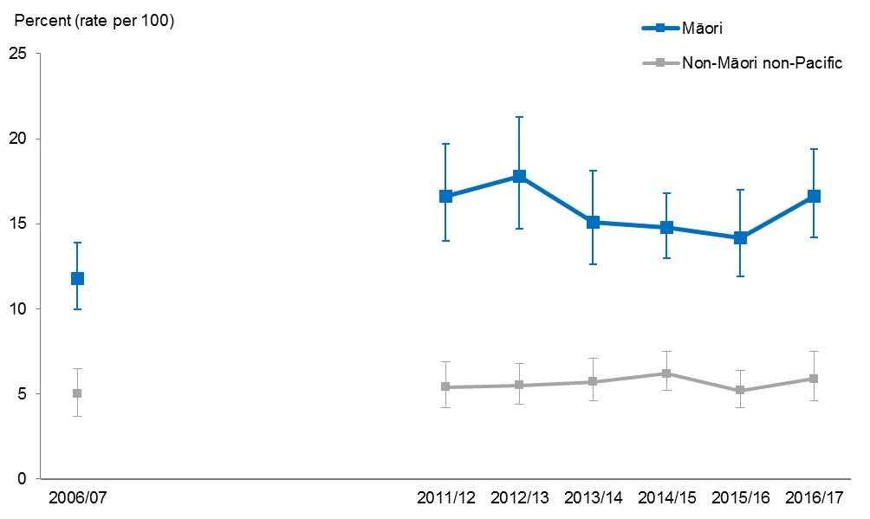
Notes:
Figures are age-standardised to the 2001 Census total Māori population.
Prioritised ethnicity has been used.
If the confidence intervals of two rates do not overlap, the difference in rates is said to be statistically significant.
Source: New Zealand Health Survey (NZHS), Ministry of Health, 2006/07–2016/17.

Māori children aged 2–14 years were more likely to be overweight than non-Māori non-Pacific children over the time period 2006/07 to 2016/17. In 2016/17 Māori children were more than 1½ times as likely to be overweight as non-Māori non-Pacific children, these differences were consistent over time.

The prevalence of being obese has fluctuated over time for Māori children but overall showed an increase over time from 12 percent recorded as obese in 2006/07 to 17 percent in 2016/17 (compared with 5 percent and 6 percent for non-Māori non-Pacific children). In 2016/17, Māori children were 2.8 times as likely to be obese as non-Māori non-Pacific children.

Māori children had slightly higher mean BMI scores than non-Māori non-Pacific children with little change over time. Over time, Māori children had a mean BMI score of around 19 kg/m² compared with around 18 kg/m² for non-Māori non-Pacific children.

There has been little change in mean waist measurements over time for both Māori and non-Māori non-Pacific children. Māori children had slightly higher mean waist measurements when comparing to non-Māori non-Pacific children, in 2016/17, Māori children had a mean waist measurement of 65.7 cm compared with 61.5 cm for non-Māori non-Pacific children.

Cardiovascular disease
This section presents the trends related to chronic rheumatic heart disease mortality and hospitalisation, all revascularisation (coronary artery bypass graft (CABG) and angioplasty) heart disease procedures and coronary angioplasty procedures (percutaneous) for Māori and non-Māori non-Pacific adults.

What is the data telling us?
Overall the data shows that between 2001–03 and 2011–13:
- For adults aged 15+ years, age-standardised chronic rheumatic heart disease:
– mortality rates for Māori males and females have reduced by over 40 percent, but remain more than eight times as high as those for non-Māori non-Pacific males and females
– hospitalisation rates have been reduced by more than 20 percent
– the difference between Māori and non-Māori non-Pacific age-standardised chronic rheumatic heart disease hospitalisation rates decreased by 17 percent for males, and 27 percent for females
– hospitalisation rates for Māori males remain around six times as high as those for non-Māori non-Pacific males, and rates for Māori females remain around eight times as high as those of non-Māori non-Pacific females.
- For adults aged 35+ years:
– the difference between Māori and non-Māori non-Pacific age-standardised rates of all revascularisation heart disease procedures decreased by 112 percent for males, and increased by 394 percent for females
– age-standardised rates of all revascularisation heart disease procedures are now similar for Māori and non-Māori non-Pacific males, and rates for Māori females are around twice as high as those for non-Māori non-Pacific females
– the difference between Māori and non-Māori non-Pacific male age-standardised rates of all coronary angioplasty procedures decreased by 97 percent, and for Māori females, increased by 814 percent
– age-standardised rates of all coronary angioplasty procedures for Māori males are now close to those of non-Māori non-Pacific males, and rates for Māori females are around 1.7 times as high as those for non-Māori non-Pacific females.

Chronic rheumatic heart disease mortality
Figure 136: Chronic rheumatic heart disease mortality rates, 15+ years, by gender, Māori and non-Māori non-Pacific, 2001–03 to 2011–13
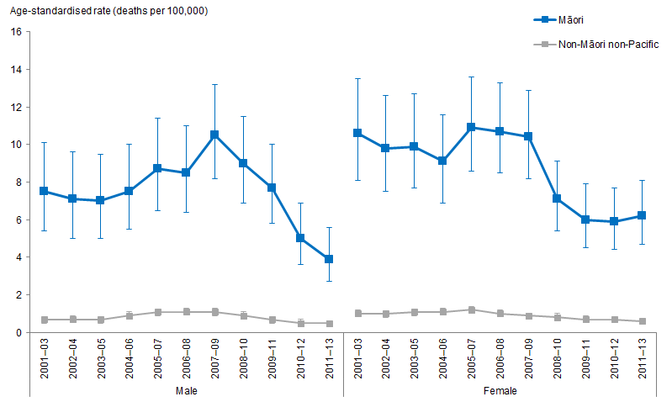
Notes:
Figures are age-standardised to the 2001 Census total Māori population.
Prioritised ethnicity has been used.
If the confidence intervals of two rates do not overlap, the difference in rates is said to be statistically significant.
Source: Mortality Collection Data Set (MORT), Ministry of Health, 2001–03 to 2011–13.

Figure 136 shows that Māori adults aged 15+ years have higher age-standardised chronic rheumatic heart disease mortality rates compared with non-Māori non-Pacific adults at the same age group.

Chronic rheumatic heart disease mortality rates have decreased for Māori
Between 2001–03 and 2011–13, age-standardised chronic rheumatic heart disease mortality rates decreased for Māori adults, and did not change much for non-Māori non-Pacific adults.

Between 2001–03 and 2011–13, for Māori males, the rate of deaths per 100,000 due to chronic rheumatic heart disease decreased by 48 percent (from 8 to 4 deaths per 100,000). For Māori females, the rate of deaths per 100,000 due to chronic rheumatic heart disease decreased by 42 percent (from 11 to 6 deaths per 100,000). Rates for non-Māori non-Pacific males and females remained at or below 1 death per 100,000.

The difference in chronic rheumatic heart disease mortality rates between Māori and non-Māori non-Pacific rates has decreased
Between 2001–03 and 2011–13, the difference between Māori and non-Māori non-Pacific male age-standardised chronic rheumatic heart disease mortality rates decreased by 50 percent, reducing from 7 per 100,000 (the difference in 2001–03) to 3 per 100,000 (the difference in 2011–13). Similarly, for females the difference between Māori and non-Māori non-Pacific mortality rates decreased by 42 percent (from 10 per 100,000 in 2001–03 to 6 per 100,000 in 2011–13).

The difference between Māori and non-Māori non-Pacific age-standardised chronic rheumatic heart disease mortality rates decreased by over 40 percent between
2001–03 and 2011–13. However, rates for Māori remain more than eight times as high as those for non-Māori non-Pacific.

Chronic rheumatic heart disease hospitalisation
Figure 137: Chronic rheumatic heart disease hospitalisation rates, 15+ years, by gender, Māori and non-Māori non-Pacific, 2001–03 to 2011–13
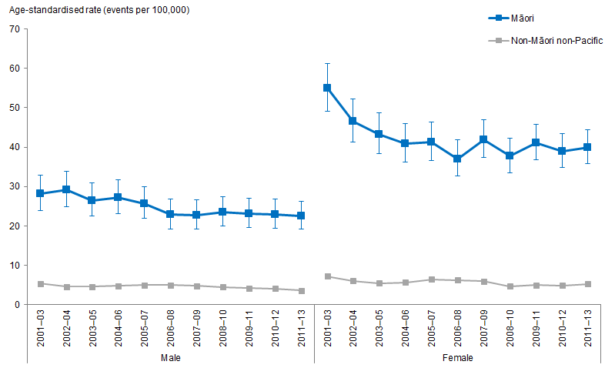
Notes:
Figures are age-standardised to the 2001 Census total Māori population.
Prioritised ethnicity has been used.
If the confidence intervals of two rates do not overlap, the difference in rates is said to be statistically significant.
Source: National Minimum Data Set (NMDS), Ministry of Health, 2001–03 to 2011–13.

Figure 137 shows that Māori males and females aged 15+ years have higher age-standardised rates of hospitalisations due to chronic rheumatic heart disease compared with non-Māori non-Pacific males and females.

Chronic rheumatic heart disease hospitalisation rates have decreased
Between 2001–03 and 2011–13, the rate of hospitalisations due to chronic rheumatic heart disease for Māori males decreased by 20 percent (from 28 to 22 hospitalisations per 100,000). For non-Māori non-Pacific males, the decrease was by 34 percent (from 5 to 4 hospitalisations per 100,000). For Māori females, rates decreased by 27 percent (from 55 to 40 hospitalisations per 100,000). For non-Māori non-Pacific females, decrease was by 28 percent (from 7 to 5 hospitalisations per 100,000).

The difference in chronic rheumatic heart disease hospitalisation rates between Māori and non-Māori non-Pacific rates decreased
Between 2001–03 and 2011–13, the difference between Māori and non-Māori non-Pacific male chronic rheumatic heart disease hospitalisation rates decreased by 17 percent, decreasing from 23 hospitalisations per 100,000 (the difference in 2001–03) to 19 hospitalisations per 100,000 (the difference in 2011–13). For females, the difference between Māori and non-Māori non-Pacific hospitalisation rates decreased by 27 percent (from 48 per 100,000 in 2001–03 to 35 per 100,000 in 2011–13).

Rates for Māori males remain around six times as high as those for non-Māori non-Pacific males, and rates for Māori females remain around eight times as high as those of non-Māori non-Pacific females.

All revascularisation (coronary artery bypass graft (CARB) and angioplasty) heart disease procedures
Figure 138: All revascularisation (coronary artery bypass graft (CARB) and angioplasty) heart disease procedure rates, 35+ years, by gender, Māori and non-Māori non-Pacific, 2001–03 to 2011–13
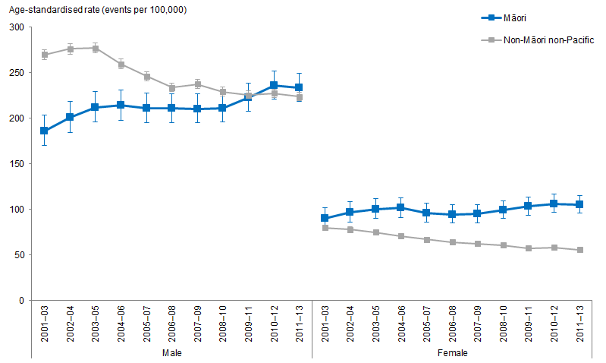
Notes:
Figures are age-standardised to the 2001 Census total Māori population.
Prioritised ethnicity has been used.
If the confidence intervals of two rates do not overlap, the difference in rates is said to be statistically significant.
Source: National Minimum Data Set (NMDS), Ministry of Health, 2001–03 to 2011–13.

Figure 138 shows that between 2001–03 and 2011–13 rates of all revascularisation heart disease procedures increased for Māori males and females and decreased for non-Māori non-Pacific males and females.

All revascularisation heart disease procedure rates for Māori have increased
Between 2001–03 and 2011–13, Māori males procedure rates increased by 26 percent (from 186 to 233 procedures per 100,000), and for non-Māori non-Pacific males procedure rates decreased by 17 percent (from 269 to 223 procedures 100,000). For females, the rate of procedures for Māori females increased by 17 percent (from 90 to 105 procedures per 100,000) whereas there was a decrease in procedures for non-Māori non-Pacific females by 31 percent (from 80 to 55 procedures per 100,000).

The difference in all revascularisation heart disease procedure rates between Māori and non-Māori non-Pacific rates have decreased for males and increased for females
Between 2001–03 and 2011–13, the difference between Māori and non-Māori non-Pacific male all revascularisation heart disease procedure rates decreased by 112 percent, from 84 less procedures per 100,000 (the difference in 2001–03) to 10 more procedures per 100,000 (the difference in 2011–13). For females, the difference between Māori and non-Māori non-Pacific procedure rates increased by 394 percent (from 10 more procedures per 100,000 in 2001–03 to 49 more procedures per 100,000 in 2011–13).

Rates of procedures are now similar for Māori and non-Māori non-Pacific males, and rates for Māori females are around twice as high as for Māori females compared with non-Māori non-Pacific females.

All coronary angioplasty procedures (percutaneous)
Figure 139: All coronary angioplasty procedure (percutaneous) rates, 35+ years, by gender, Māori and non-Māori non-Pacific, 2001–03 to 2011–13
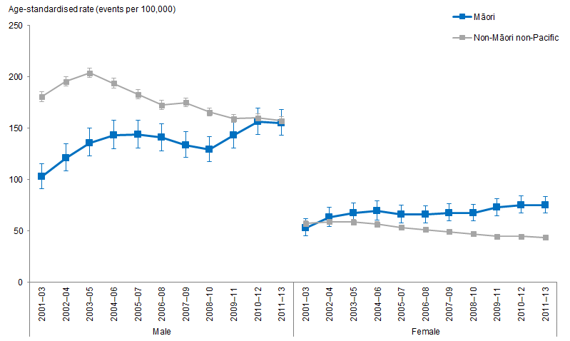
Notes:
Figures are age-standardised to the 2001 Census total Māori population.
Prioritised ethnicity has been used.
If the confidence intervals of two rates do not overlap, the difference in rates is said to be statistically significant.
Source: National Minimum Data Set (NMDS), Ministry of Health, 2001–03 to 2011–13.

Figure 139 shows that between 2001–03 and 2011–13 rates of all coronary angioplasty procedures increased for Māori males and females and decreased for non-Māori non-Pacific males and females.

All coronary angioplasty procedure rates have increased for Māori
Between 2001–03 and 2011–13, all coronary angioplasty procedure rates increased for Māori males and females. For Māori males, rates increased by 51 percent (from 103 to 155 procedures per 100,000), and for non-Māori non-Pacific males procedures decreased by 13 percent (from 181 to 157 procedures 100,000). For Māori females, the rate of procedures increased by 42 percent (from 53 to 75 procedures per 100,000). For non-Māori non-Pacific females the rate of procedures decreased by 24 percent (from 57 to 43 procedures per 100,000).

The difference in all coronary angioplasty procedure rates between Māori and non-Māori non-Pacific rates have decreased for males and increased for females
Between 2001–03 and 2011–13, the difference between Māori and non-Māori non-Pacific males all coronary angioplasty procedure rates decrease by 97 percent, from 78 less procedures per 100,000 (the difference in 2001–03) to 2 less procedures per 100,000 (the difference in 2011–13). For females, the difference between Māori and non-Māori non-Pacific hospitalisation rates increased by 814 percent (from 4 less procedures per 100,000 in 2001–03 to 31 more procedures per 100,000 in 2011–13).

Rates of procedures for Māori males are now close to those of non-Māori non-Pacific males, and rates for Māori females are around 1.7 times as high as those of non-Māori non-Pacific females.

Cancer
This section presents the trends relating to cancer registration and mortality from
2001–03 to 2011–13 for Māori and non-Māori non-Pacific adults aged 25 years and over.

What is the data telling us?
Overall the data shows that:
- Māori adults aged 25 years and over have higher cancer registration and mortality rates for total cancers than non-Māori non-Pacific adults over time.
- The difference in cancer registration and mortality rates for total cancers between Māori and non-Māori non-Pacific adults aged 25 years and over was greater for females over time.
- Māori adults aged 25 years and over were more likely to develop lung cancer and to die from lung cancer than non-Māori non-Pacific adults at the same age group over time. This difference was higher among females.
- Colorectal cancer registration rates were lower for Māori adults aged 25 years and over than for non-Māori non-Pacific adults at the same age group over time.
- Māori females aged 25 years and over had lower colorectal cancer mortality rates than non-Māori non-Pacific females at the same age group over time. However, there was no significant difference in rates of colorectal cancer mortality over time between Māori and non-Māori non-Pacific males aged 25 years and over.
- Māori females aged 25 years and over were more likely to develop cervical cancer and to die from cervical cancer than non-Māori non-Pacific females at the same age group over time.
- Māori females aged 25 years and over were more likely to develop breast cancer than non-Māori non-Pacific females at the same age group, and the difference between Māori and non-Māori non-Pacific females aged 25 years and over is getting bigger over time.
- Māori females aged 25 years and over were more likely to die from breast cancer than non-Māori non-Pacific females at the same age group, and the difference between Māori and non-Māori non-Pacific females aged 25 years and over is getting smaller over time.

Total cancer
Figure 140: Total cancer registration rates, 25+ years, Māori and non-Māori non-Pacific males, 2001–03 to 2011–13
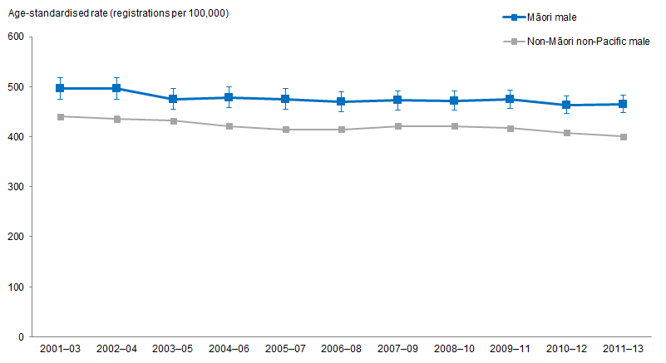
Notes:
Figures are age-standardised to the 2001 Census total Māori population.
Prioritised ethnicity has been used.
If the confidence intervals of two rates do not overlap, the difference in rates is said to be statistically significant.
Source: New Zealand Cancer Registry (NZCR), Ministry of Health, 2001–03 to 2011–13.

Figure 140 shows that, after adjusting for age, Māori males aged 25 years and over have higher total-cancer registration rates than non-Māori non-Pacific males at the same age group over time.

The total-cancer registration rate decreased over time for Māori males
The age-standardised total-cancer registration rates for Māori males aged 25 years and over decreased by 6 percent over time, from 495.9 registrations per 100,000 in
2001–03 to 465.2 registrations per 100,000 in 2011–13.

The age-standardised total-cancer registration rates for non-Māori non-Pacific males at the same age group decreased by 8 percent over time, from 440.2 registrations per 100,000 in 2001–03 to 400.5 registrations per 100,000 in 2011–13.

The difference in total-cancer registration rate between Māori and non-Māori non-Pacific males remained similar over time
The age-standardised total-cancer registration rate difference between Māori and non-Māori non-Pacific males aged 25 years and over remained similar over time. After adjusting for age, Māori males aged 25 years and over had 55.7 more registrations per 100,000 than non-Māori non-Pacific in 2001–03 and 64.7 more registrations per 100,000 in 2011–13.

The total-cancer registration rate was on average 13 percent higher in Māori males aged 25 years and over than in non-Māori non-Pacific males at the same age group over time.

Figure 141: Total cancer registration rates, 25+ years, Māori and non-Māori non-Pacific females, 2001–03 to 2011–13
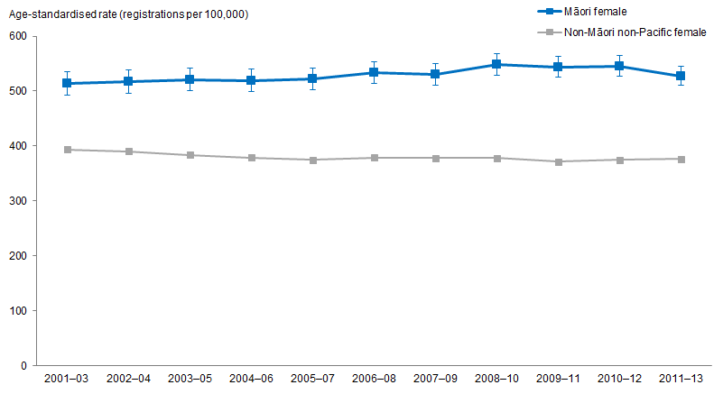
Notes:
Figures are age-standardised to the 2001 Census total Māori population.
Prioritised ethnicity has been used.
If the confidence intervals of two rates do not overlap, the difference in rates is said to be statistically significant.
Source: New Zealand Cancer Registry (NZCR), Ministry of Health, 2001–03 to 2011–13.

Figure 141 shows that, after adjusting for age, Māori females aged 25 years and over have higher total-cancer registration rates than non-Māori non-Pacific females at the same age group over time.

The total-cancer registration rate has increased for Māori females over time
The age-standardised total-cancer registration rates for Māori females aged 25 years and over increased by 3 percent over time, from 513.6 registrations per 100,000 in 2001–03 to 527.8 registrations per 100,000 in 2011–13.

The age-standardised total-cancer registration rates for non-Māori non-Pacific females at the same age group decreased by 4 percent over time, from 393.7 registrations per 100,000 in 2001–03 to 376.4 registrations per 100,000 in 2011–13.

The difference in total-cancer registration rates between Māori and non-Māori non-Pacific females increased over time
The age-standardised total-cancer registration rate difference between Māori and non-Māori non-Pacific females aged 25 years and over increased by 26 percent over time. After adjusting for age, Māori females aged 25 years and over had 119.9 more registrations per 100,000 in 2001–03, and 151.4 more registrations per 100,000 in 2011–13.

The age-standardised total-cancer registration rate difference between Māori and non-Māori non-Pacific females aged 25 years and over was greater than that between Māori and non-Māori non-Pacific males at the same age groups.

After adjusting for age, the total-cancer registration rates for Māori females aged 25 years and over slightly increased, and the rate for non-Māori non-Pacific females slightly decreased over time. This has widened the gap between Māori and non-Māori non-Pacific: the total-cancer registration rate was 40 percent higher for Māori females aged 25 years and over in 2011–13 than non-Māori non-Pacific females at the same age group, and 30 percent higher in 2001–03.

Figure 142: Total cancer mortality rates, 25+ years, Māori and non-Māori non-Pacific males, 2001–03 to 2011–13
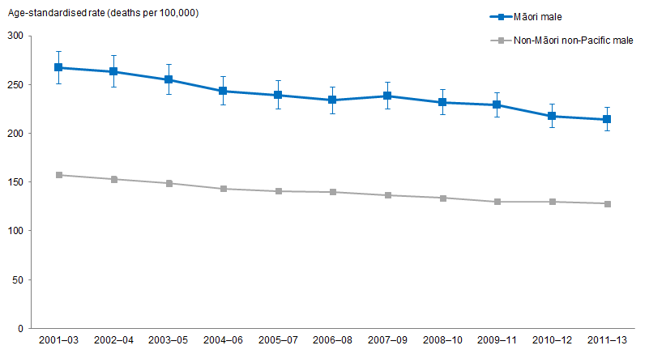
Notes:
Figures are age-standardised to the 2001 Census total Māori population.
Prioritised ethnicity has been used.
If the confidence intervals of two rates do not overlap, the difference in rates is said to be statistically significant.
Source: Mortality Collection Data Set (MORT), Ministry of Health, 2001–03 to 2011–13.

Figure 142 shows that, after adjusting for age, Māori males aged 25 years and over have higher total-cancer mortality rates than non-Māori non-Pacific males at the same age group over time.

The total-cancer mortality rate decreased over time for Māori males
The age-standardised total-cancer mortality rates for Māori males aged 25 years and over decreased by 20 percent, from 267.0 deaths per 100,000 in 2001–03 to 214.3 deaths per 100,000 in 2011–13.

The age-standardised total-cancer mortality rates for non-Māori non-Pacific males at the same age group decreased by 19 percent, from 157.3 deaths per 100,000 in
2001–03 to 127.9 deaths per 100,000 in 2011–13.

The difference in total-cancer mortality rate between Māori and non-Māori non-Pacific males decreased over time
The age-standardised total-cancer mortality rate difference between Māori and non-Māori non-Pacific males aged 25 years and over decreased by 21 percent over time. After adjusting for age, Māori males aged 25 years and over had 109.7 more deaths per 100,000 in 2001–03 and 86.4 more deaths per 100,000 in 2011–13.

The total-cancer mortality rate for Māori males aged 25 years and over was on average more than 1½ times as high as that for non-Māori non-Pacific males over time.

Figure 143: Total cancer mortality rates, 25+ years, Māori and non-Māori non-Pacific females, 2001–03 to 2011–13
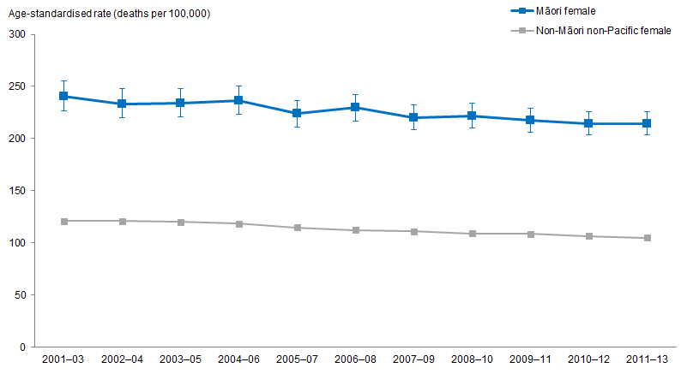
Notes:
Figures are age-standardised to the 2001 Census total Māori population.
Prioritised ethnicity has been used.
If the confidence intervals of two rates do not overlap, the difference in rates is said to be statistically significant.
Source: Mortality Collection Data Set (MORT), Ministry of Health, 2001–03 to 2011–13.

Figure 143 shows that, after adjusting for age, Māori females aged 25 years and over have higher total-cancer mortality rates than non-Māori non-Pacific females at the same age group over time.

The total-cancer mortality rate decreased over time for Māori females
The age-standardised total-cancer mortality rates for Māori females aged 25 years and over decreased by 11 percent, from 240.4 deaths per 100,000 in 2001–03 to 214.5 deaths per 100,000 in 2011–13.

The age-standardised total-cancer mortality rates for non-Māori non-Pacific females at the same age group decreased by 13 percent, from 120.8 deaths per 100,000 in
2001–03 to 104.8 deaths per 100,000 in 2011–13.

The difference in total-cancer mortality rate between Māori and non-Māori non-Pacific females decreased slightly over time
The age-standardised total-cancer mortality rate difference between Māori and non-Māori non-Pacific females aged 25 years and over decreased by 8 percent over time. After adjusting for age, Māori females aged 25 years and over had 119.6 more deaths per 100,000 in 2001–03 and 109.7 more deaths per 100,000 in 2011–13.

Māori females aged 25 years and over had on average a total-cancer mortality rate twice that of non-Māori non-Pacific females at the same age group over time.

Lung cancer
Figure 144: Lung cancer registration rates, 25+ years, Māori and non-Māori non-Pacific males, 2001–03 to 2011–13
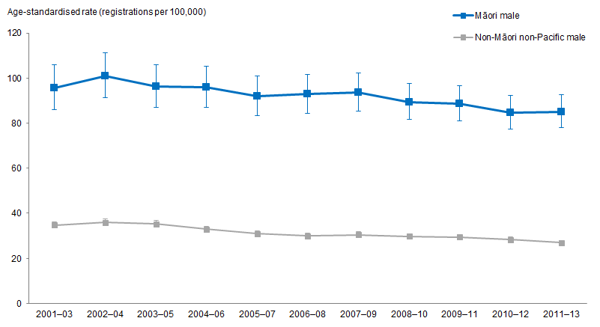
Notes:
Figures are age-standardised to the 2001 Census total Māori population.
Prioritised ethnicity has been used.
If the confidence intervals of two rates do not overlap, the difference in rates is said to be statistically significant.
Source: New Zealand Cancer Registry (NZCR), Ministry of Health, 2001–03 to 2011–13.

Figure 144 shows that, after adjusting for age, Māori males aged 25 years and over have higher lung cancer registration rates than non-Māori non-Pacific males at the same age group over time.

Lung cancer registration rate decreased over time for Māori males
The age-standardised lung cancer registration rates for Māori males aged 25 years and over decreased by 11 percent, from 95.6 registrations per 100,000 in 2001–03 to 85.0 registrations per 100,000 in 2011–13.

The age-standardised lung cancer registration rates for non-Māori non-Pacific males at the same age group also decreased, from 34.8 registrations per 100,000 in 2001–03 to 26.9 registrations per 100,000 in 2011–13.

The difference in lung cancer registration rates between Māori and non-Māori non-Pacific males has not changed much over time
The age-standardised lung cancer registration rate difference between Māori and non-Māori non-Pacific males aged 25 years and over has not changed much over time. Māori males aged 25 years and over had 60.8 more registrations per 100,000 in
2001–03 and 58.1 more registrations per 100,000 in 2011–13.

Māori males aged 25 years and over had a lung cancer registration rate more than three times that of non-Māori non-Pacific males at the same age group in 2011–13. The difference has not changed much over time.

Figure 145: Lung cancer registration rates, 25+ years, Māori and non-Māori non-Pacific females, 2001–03 to 2011–13
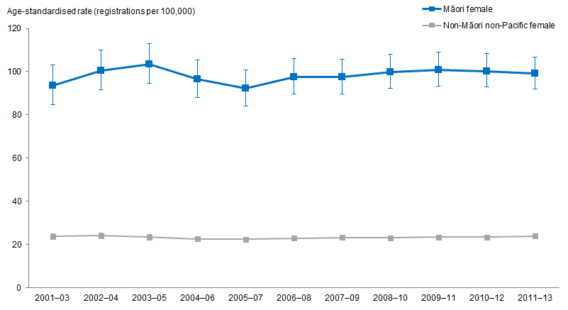
Notes:
Figures are age-standardised to the 2001 Census total Māori population.
Prioritised ethnicity has been used.
If the confidence intervals of two rates do not overlap, the difference in rates is said to be statistically significant.
Source: New Zealand Cancer Registry (NZCR), Ministry of Health, 2001–03 to 2011–13.

Figure 145 shows that Māori females aged 25 years and over have higher lung cancer registration rates than non-Māori non-Pacific females at the same age group over time.

Lung cancer registration rate remained similar over time for Māori females
The age-standardised lung cancer registration rates for Māori females aged 25 years and over remained similar, with 93.6 registrations per 100,000 in 2001–03 and 99.3 registrations per 100,000 in 2011–13.

The age-standardised lung cancer registration rates for non-Māori non-Pacific females at the same age group has also not changed much over time, with 23.7 registrations per 100,000 in 2001–03 to 23.8 registrations in 2011–13.

The difference in lung cancer registration rates between Māori and non-Māori non-Pacific females remained similar over time
The age-standardised lung cancer registration rate difference between Māori and non-Māori non-Pacific females aged 25 years and over remained similar over time. Māori females aged 25 years and over had 69.9 more registrations per 100,000 in 2001–03 and 75.5 more registrations per 100,000 in 2011–13.

Māori females aged 25 years and over had a lung cancer registration rate more than four times that of non-Māori non-Pacific females at the same age group over time.

Figure 146: Lung cancer mortality rates, 25+ years, Māori and non-Māori non-Pacific males, 2001–03 to 2011–13
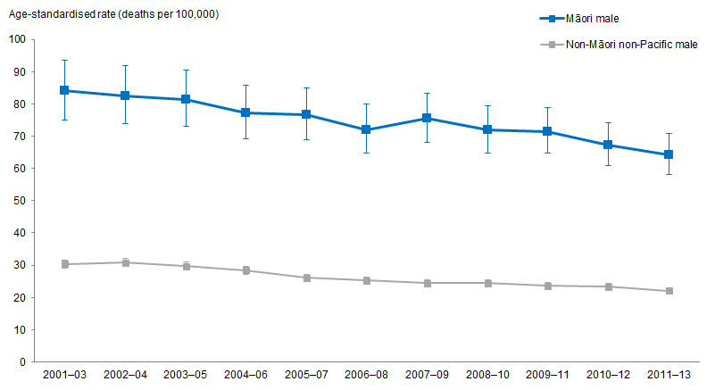
Notes:
Figures are age-standardised to the 2001 Census total Māori population.
Prioritised ethnicity has been used.
If the confidence intervals of two rates do not overlap, the difference in rates is said to be statistically significant.
Source: Mortality Collection Data Set (MORT), Ministry of Health, 2001–03 to 2011–13.

Figure 146 shows that, after adjusting for age, Māori males aged 25 years and over have a higher lung cancer mortality rate than non-Māori non-Pacific males at the same age group over time.

Lung cancer mortality rate decreased over time for Māori males
The age-standardised lung cancer mortality rates for Māori males aged 25 years and over decreased by 24 percent, from 84.0 deaths per 100,000 in 2001–03 to 64.2 deaths per 100,000 in 2011–13.

The age-standardised lung cancer mortality rates for non-Māori non-Pacific males at the same age group decreased by 27 percent, from 30.3 deaths per 100,000 in 2001–03 to 22.0 deaths per 100,000 in 2011–13.

The difference in lung cancer mortality rate between Māori and non-Māori non-Pacific males decreased over time
The age-standardised lung cancer mortality rate difference between Māori and non-Māori non-Pacific males aged 25 years and over decreased by 21 percent over time. Māori males aged 25 years and over had 53.7 more deaths per 100,000 in
2001–03 and 42.2 more deaths per 100,000 in 2011–13.

Māori males aged 25 years and over were almost three times as likely to die from lung cancer as non-Māori non-Pacific males at the same age group over time.

Figure 147: Lung cancer mortality rates, 25+ years, Māori and non-Māori non-Pacific females, 2001–03 to 2011–13
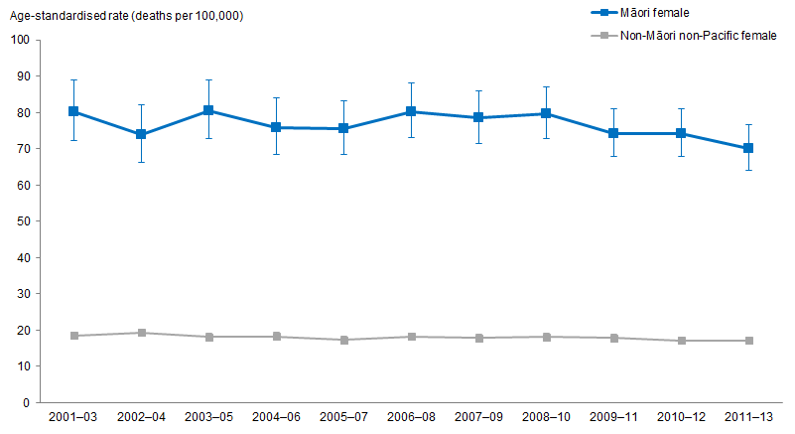
Notes:
Figures are age-standardised to the 2001 Census total Māori population.
Prioritised ethnicity has been used.
If the confidence intervals of two rates do not overlap, the difference in rates is said to be statistically significant.
Source: Mortality Collection Data Set (MORT), Ministry of Health, 2001–03 to 2011–13.
Figure 147 shows that Māori females aged 25 years and over have a higher lung cancer mortality rate than non-Māori non-Pacific females at the same age group over time.

Lung cancer mortality rate decreased over time for Māori females
The age-standardised lung cancer mortality rates for Māori females aged 25 years and over decreased by 13 percent, from 80.2 deaths per 100,000 in 2001–03 to 70.1 deaths per 100,000 in 2011–13.

The age-standardised lung cancer mortality rates for non-Māori non-Pacific females at the same age group did not change much, with 18.5 deaths per 100,000 in 2001–03 and 17.1 deaths per 100,000 in 2011–13.

The difference in lung cancer mortality rate between Māori and non-Māori non-Pacific females decreased over time
The age-standardised lung cancer mortality rate difference between Māori and non-Māori non-Pacific females aged 25 years and over decreased by 14 percent over time. Māori females aged 25 years and over had 61.7 more deaths per 100,000 in 2001–03 and 53.0 more deaths per 100,000 in 2011–13.

Māori females aged 25 years and over were about four times as likely to die from lung cancer as non-Māori non-Pacific females at the same age group over time.

Colorectal cancer
Figure 148: Colorectal cancer registration rates, 25+ years, Māori and non-Māori non-Pacific males, 2001–03 to 2011–13
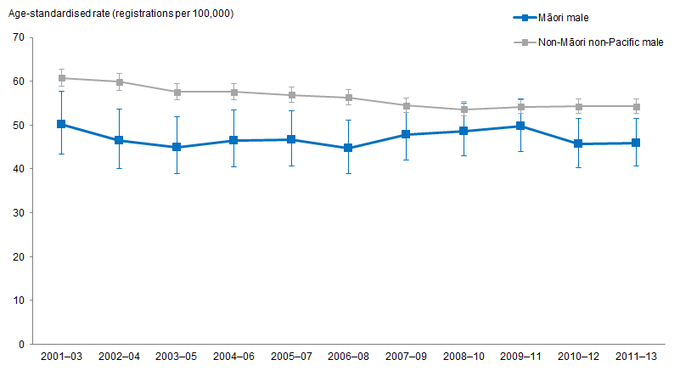
Notes:
Figures are age-standardised to the 2001 Census total Māori population.
Prioritised ethnicity has been used.
If the confidence intervals of two rates do not overlap, the difference in rates is said to be statistically significant.
Source: New Zealand Cancer Registry (NZCR), Ministry of Health, 2001–03 to 2011–13.

Figure 148 shows that Māori males aged 25 years and over had a lower colorectal cancer registration rate than non-Māori non-Pacific males at the same age group, after adjusting for age, and this remains the same over time.

Colorectal cancer registration rate decreased over time for Māori males
The age-standardised colorectal cancer registration rates for Māori males aged 25 years and over decreased by 9 percent, from 50.1 registrations per 100,000 in
2001–03 to 45.8 registrations per 100,000 in 2011–13.

The age-standardised colorectal cancer registration rates for non-Māori non-Pacific males at the same age group decreased by 11 percent, from 60.8 registrations per 100,000 in 2001–03 to 54.3 registrations per 100,000 in 2011–13.

The difference in colorectal cancer registration rate between Māori and non-Māori non-Pacific males has not changed much over time
The age-standardised colorectal cancer registration rate difference between Māori and non-Māori non-Pacific males aged 25 years has remained relatively constant over time. Māori males aged 25 years and over had 10.7 fewer registrations per 100,000 in
2001–03 and 8.5 fewer registrations per 100,000 in 2011–13.

Māori males aged 25 years over had a lower colorectal cancer registration rate than non-Māori non-Pacific males at the same age group over time.

Figure 149: Colorectal cancer registration rates, 25+ years, Māori and non-Māori non-Pacific females, 2001–03 to 2011–13
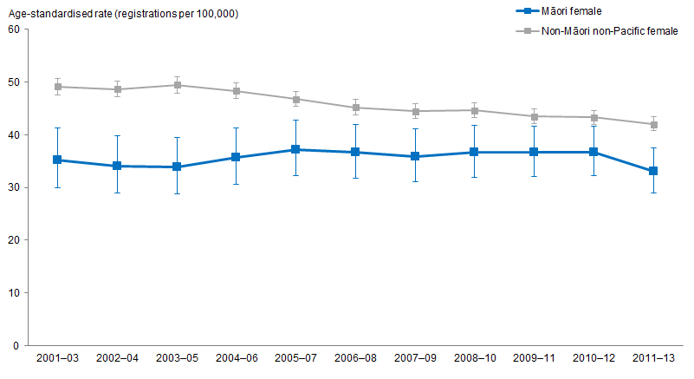
Notes:
Figures are age-standardised to the 2001 Census total Māori population.
Prioritised ethnicity has been used.
If the confidence intervals of two rates do not overlap, the difference in rates is said to be statistically significant.
Source: New Zealand Cancer Registry (NZCR), Ministry of Health, 2001–03 to 2011–13.

Figure 149 shows that Māori females aged 25 years and over had a lower colorectal cancer registration rate than non-Māori non-Pacific females at the same age group over time.

Colorectal cancer registration rate decreased over time for Māori females
The age-standardised colorectal cancer registration rates for Māori females aged 25 years and over decreased by 6 percent, from 35.2 registrations per 100,000 in
2001–03 to 33.0 registrations per 100,000 in 2011–13.

The age-standardised colorectal cancer registration rates for non-Māori non-Pacific females at the same age group decreased by 14 percent, from 49.1 registrations per 100,000 in 2001–03 to 42.0 registrations per 100,000 in 2011–13.

The difference in colorectal cancer registration rate between Māori and non-Māori non-Pacific females decreased over time
The age-standardised colorectal cancer registration rate difference between Māori and non-Māori non-Pacific females aged 25 years and over decreased by 35 percent over time. Māori females aged 25 years and over had 13.9 fewer registrations per 100,000 in 2001–03 and 9.0 fewer registrations per 100,000 in 2011–13.

Māori females aged 25 years over had a significantly lower colorectal cancer registration rate than non-Māori non-Pacific females at the same age group over time.

Figure 150: Colorectal cancer mortality rates, 25+ years, Māori and non-Māori non-Pacific males, 2001–03 to 2011–13
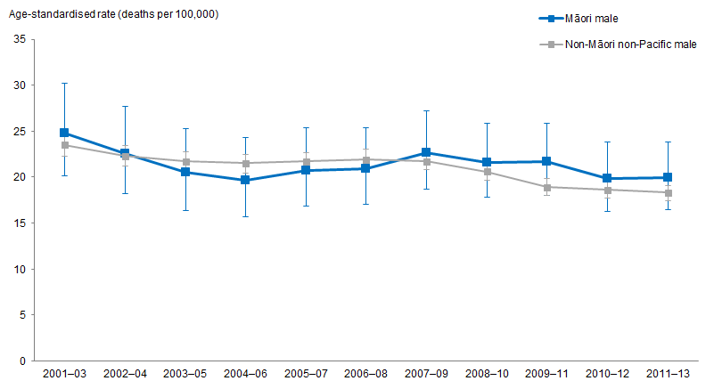
Notes:
Figures are age-standardised to the 2001 Census total Māori population.
Prioritised ethnicity has been used.
If the confidence intervals of two rates do not overlap, the difference in rates is said to be statistically significant.
Source: Mortality Collection Data Set (MORT), Ministry of Health, 2001–03 to 2011–13.

Māori males aged 25 years and over had a lower colorectal cancer registration rate than non-Māori non-Pacific males at the same age group (Figure 148), but Māori males aged 25 years and over had a similar colorectal cancer mortality rate to non-Māori non-Pacific males at the same age group over time (Figure 150).

Colorectal cancer mortality rate decreased over time for Māori males
The age-standardised colorectal cancer mortality rates for Māori males aged 25 years and over decreased by 20 percent, from 24.8 deaths per 100,000 in 2001–03 to 19.9 deaths per 100,000 in 2011–13.

The age-standardised colorectal cancer mortality rates for non-Māori non-Pacific males at the same age group decreased by 22 percent, from 23.5 deaths per 100,000 in
2001–03 to 18.3 deaths per 100,000 in 2011–13.

The difference in colorectal cancer mortality rate between Māori and non-Māori non-Pacific males remained similar over time
The age-standardised colorectal cancer mortality rate difference between Māori and non-Māori non-Pacific males aged 25 years remained similar over time. Māori males aged 25 years and over had 1.3 more deaths per 100,000 in 2001–03 and 1.6 more deaths per 100,000 in 2011–13.

The absolute difference was around five fewer deaths in each ethnic group per 100,000. There was no significant difference in colorectal mortality rates between Māori males aged 25 years and over and non-Māori non-Pacific males at the same age group over time.

Figure 151: Colorectal cancer mortality rates, 25+ years, Māori and non-Māori non-Pacific females, 2001–03 to 2011–13
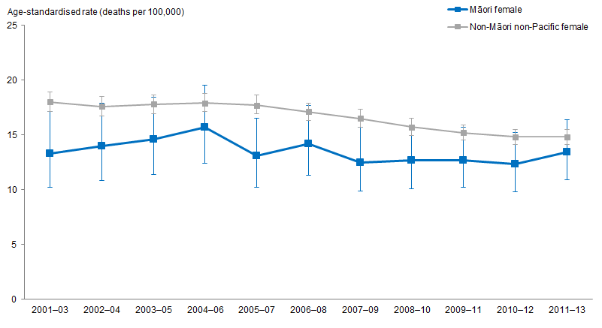
Notes:
Figures are age-standardised to the 2001 Census total Māori population.
Prioritised ethnicity has been used.
If the confidence intervals of two rates do not overlap, the difference in rates is said to be statistically significant.
Source: Mortality Collection Data Set (MORT), Ministry of Health, 2001–03 to 2011–13.

Figure 151 shows that Māori females aged 25 years and over had a lower colorectal cancer mortality rate than non-Māori non-Pacific females at the same age group over time.

Colorectal cancer mortality rates have not changed over time for Māori females
The age-standardised colorectal cancer mortality rates for Māori females aged 25 years and over have not changed much over time, with 13.3 deaths per 100,000 in 2001–03 and 13.4 deaths per 100,000 in 2011–13.

The age-standardised colorectal cancer mortality rates for non-Māori non-Pacific females at the same age group decreased slightly, with 18.0 deaths per 100,000 in 2001–03 and 14.8 deaths per 100,000 in 2011–13.

The difference in colorectal cancer mortality rate between Māori and non-Māori non-Pacific females decreased over time
The age-standardised colorectal cancer mortality rate difference between Māori and non-Māori non-Pacific is decreasing over time. Māori females aged 25 years and over had 4.7 fewer deaths per 100,000 in 2001–03 and 1.4 fewer deaths per 100,000 in 2011–13.

There was no significant difference in colorectal mortality rates between Māori females aged 25 years and over and non-Māori non-Pacific females at the same age group in 2011–13, after adjusting for age. The age-standardised rate ratio increased by 22 percent over time, from 0.74 (significantly lower) in 2001–03 to 0.90 (no significant difference) in 2011–13.

Cervical cancer
Figure 152: Cervical cancer registration rates, 25+ years, Māori and non-Māori non-Pacific females, 2001–03 to 2011–13
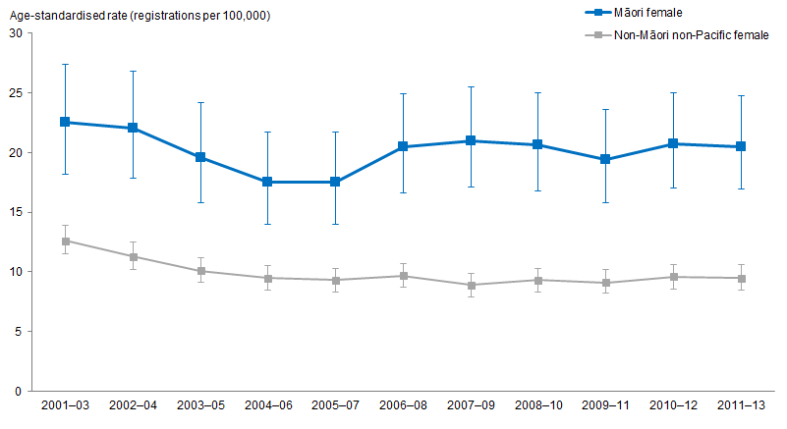
Notes:
Figures are age-standardised to the 2001 Census total Māori population.
Prioritised ethnicity has been used.
If the confidence intervals of two rates do not overlap, the difference in rates is said to be statistically significant.
Source: New Zealand Cancer Registry (NZCR), Ministry of Health, 2001–03 to 2011–13.

Figure 152 shows that Māori females aged 25 years and over had a higher cervical cancer registration rate than non-Māori non-Pacific females at the same age group, after adjusting for age. This remains the same over time.

Cervical cancer registration rate decreased over time for Māori females
The age-standardised cervical cancer registration rates for Māori females aged 25 years and over decreased, from 22.5 registrations per 100,000 in 2001–03 to 20.5 registrations per 100,000 in 2011–13.

The age-standardised cervical cancer registration rates for non-Māori non-Pacific females at the same age group also decreased, from 12.6 registrations per 100,000 in 2001–03 to 9.5 registrations per 100,000 in 2011–13.

The difference in cervical cancer registration rate between Māori and non-Māori non-Pacific females has not changed much over time
The age-standardised cervical cancer registration rate difference between Māori and non-Māori non-Pacific females aged 25 years and over did not change much over time. Māori females aged 25 years and over had 9.9 more registrations per 100,000 than non-Māori non-Pacific in 2001–03, and 11.0 more registrations per 100,000 in 2011–13.

Māori females aged 25 years and over had a cervical cancer registration rate 2.2 times that of non-Māori non-Pacific females at the same age group in 2011–13.

Figure 153: Cervical cancer mortality rates, 25+ years, Māori and non-Māori non-Pacific females, 2001–03 to 2011–13
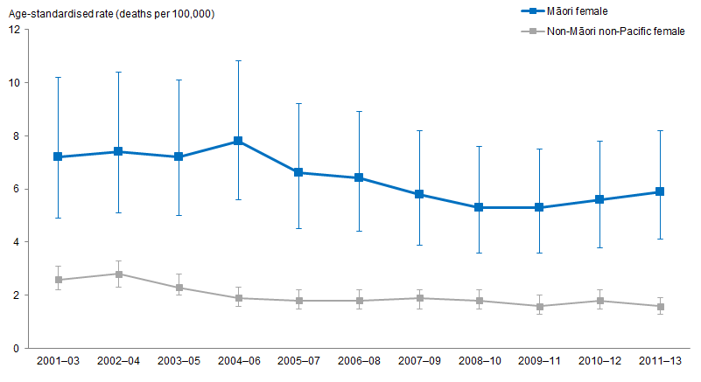
Notes:
Figures are age-standardised to the 2001 Census total Māori population.
Prioritised ethnicity has been used.
If the confidence intervals of two rates do not overlap, the difference in rates is said to be statistically significant.
Source: Mortality Collection Data Set (MORT), Ministry of Health, 2001–03 to 2011–13.

Figure 153 shows that Māori females aged 25 years and over had a higher cervical cancer mortality rate than non-Māori non-Pacific females at the same age group over time, after adjusting for age.

Cervical cancer mortality rate decreased over time for Māori females
The age-standardised cervical cancer mortality rates for Māori females aged 25 years and over decreased slightly, from 7.2 deaths per 100,000 in 2001–03 to 5.9 deaths per 100,000 in 2011–13.

The age-standardised cervical cancer mortality rates for non-Māori non-Pacific females at the same age group also showed a small decrease, from 2.6 deaths per 100,000 in 2001–03 to 1.6 deaths per 100,000 in 2011–13.

The difference in cervical cancer mortality rate between Māori and non-Māori non-Pacific females has not changed much over time
The age-standardised cervical cancer mortality rate difference between Māori and non-Māori non-Pacific females aged 25 years and over remained similar over time. Māori females aged 25 years and over had 4.6 more deaths per 100,000 in 2001–03 and 4.3 more deaths per 100,000 in 2011–13.

Māori females aged 25 years and over had a cervical cancer mortality rate almost four times that of non-Māori non-Pacific females at the same age group in 2011–13.

Breast cancer
Figure 154: Breast cancer registration rates, 25+ years, Māori and non-Māori non-Pacific females, 2001–03 to 2011–13
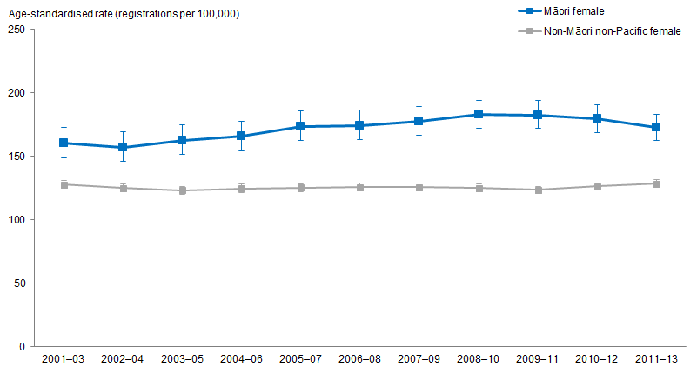
Notes:
Figures are age-standardised to the 2001 Census total Māori population.
Prioritised ethnicity has been used.
If the confidence intervals of two rates do not overlap, the difference in rates is said to be statistically significant.
Source: New Zealand Cancer Registry (NZCR), Ministry of Health, 2001–03 to 2011–13.

Figure 154 shows that Māori females aged 25 years and over had higher breast cancer registration rates than non-Māori non-Pacific females at the same age group over time.

Breast cancer registration rate increased over time for Māori females
The age-standardised breast cancer registration rates for Māori females aged 25 years and over increased by 8 percent, from 160.1 registrations per 100,000 in 2001–03 to 172.6 registrations per 100,000 in 2011–13.

The age-standardised breast cancer registration rates for non-Māori non-Pacific females at the same age group remained similar over time, with 127.7 registrations per 100,000 in 2001–03 and 128.4 registrations per 100,000 in 2011–13.

The difference in breast cancer registration rate between Māori and non-Māori non-Pacific females increased slightly over time
The age-standardised breast cancer registration rate difference between Māori and non-Māori non-Pacific females aged 25 years and over showed a slight increase over time. Māori females aged 25 years and over had 32.4 more registrations than non-Māori non-Pacific per 100,000 in 2001–03, and 44.2 more registrations per 100,000 in 2011–13.

The breast cancer registration rate was 34 percent higher in Māori females aged 25 years and over than in non-Māori non-Pacific females at the same age group in 2011–13. This gap has increased over time: the age-standardised rate ratio increased from 1.25 in 2001–03 to 1.34 in 2011–13.

Figure 155: Breast cancer mortality rate, Māori and non-Māori non-Pacific females aged 25 years and over, from 2001–03 to 2011–13
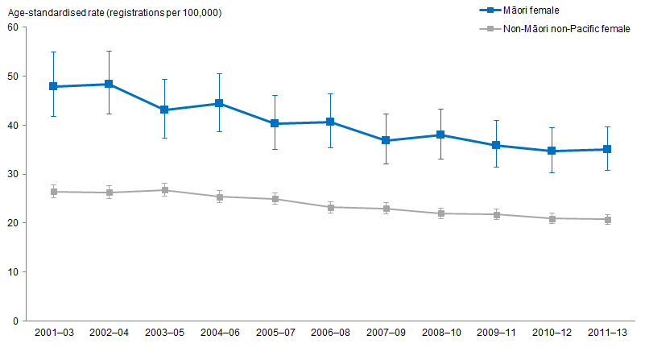
Notes:
Figures are age-standardised to the 2001 Census total Māori population.
Prioritised ethnicity has been used.
If the confidence intervals of two rates do not overlap, the difference in rates is said to be statistically significant.
Source: Mortality Collection Data Set (MORT), Ministry of Health, 2001–03 to 2011–13.

Figure 155 shows that Māori females aged 25 years and over had a higher breast cancer mortality rate than non-Māori non-Pacific females at the same age group over time.

Breast cancer mortality rate decreased over time for Māori females
The age-standardised breast cancer mortality rates for Māori females aged 25 years and over decreased by 27 percent, from 47.9 deaths per 100,000 in 2001–03 to 35.0 deaths per 100,000 in 2011–13.

The age-standardised breast cancer mortality rates for non-Māori non-Pacific females at the same age group decreased by 21 percent, from 26.4 deaths per 100,000 in
2001–03 to 20.8 deaths per 100,000 in 2011–13.

The difference in breast cancer mortality rate between Māori and non-Māori non-Pacific females decreased over time
The age-standardised breast cancer mortality rate difference between Māori and non-Māori non-Pacific females aged 25 years and over decreased by 34 percent over time. Māori females aged 25 years and over had 21.5 more deaths per 100,000 in 2001–03, and 14.2 more deaths per 100,000 in 2011–13.

The age-standardised rate ratio decreased from 1.81 in 2001–03 to 1.68 in 2011–13.

Respiratory disease
This section presents the trends in respiratory disease for Māori compared with non-Māori non-Pacific. Respiratory diseases presented include: asthma hospitalisations, diagnosed asthma, bronchiectasis hospitalisations, bronchiolitis hospitalisations, chronic obstructive pulmonary disease mortality and hospitalisations.

What is the data telling us?
Asthma
- Māori adults aged 15–44 years were more likely than non-Māori non-Pacific adults aged 15–44 years to report being diagnosed with asthma. There was little change over time from 2006/07 to 2016/17.
- Over time, hospitalisation rates have remained constant for Māori and decreased for non-Māori non-Pacific resulting in an increased disparity between Māori and non-Māori non-Pacific.
Bronchiectasis and bronchiolitis
- Over time, hospitalisation rates for bronchiectasis for Māori males have increased whilst for Māori females some decline was apparent.
- The disparity between Māori and non-Māori non-Pacific children aged 0–14 years has increased over time. In 2011–13, Māori children aged 0–14 years were nearly six times as likely as non-Māori non-Pacific children to be hospitalised for bronchiectasis.
- Over time, rates of hospitalisation for bronchiolitis for Māori children aged
0–4 years of age have increased.
- Māori boys have the highest rates of bronchiolitis hospitalisations and this rate has increased over time.
Chronic obstructive pulmonary disease (COPD)
- From 2001–03 to 2011–13, rates of hospitalisation for COPD have increased for Māori, whilst remaining constant for non-Māori non-Pacific.
- Māori females have the highest rates of COPD hospitalisations over time.
- Overtime there has been a decrease in COPD mortality rates for Māori and non-Māori non-Pacific aged 45 and over.

Asthma

Diagnosed asthma
Māori adults aged 15–44 years were more likely than non-Māori non-Pacific adults aged 15–44 years to report being diagnosed with asthma in the NZHS. In 2016/17, 15 percent of Māori adults reported diagnosed asthma compared with 11 percent of non-Māori non-Pacific adults. There was little change over time from 2006/07 to 2016/17.

Asthma hospitalisations (aged 5–34 years)
Figure 156: Asthma hospitalisation rates, 5–34 years, by gender, Māori and non-Māori non-Pacific, 2001–03 to 2011–13
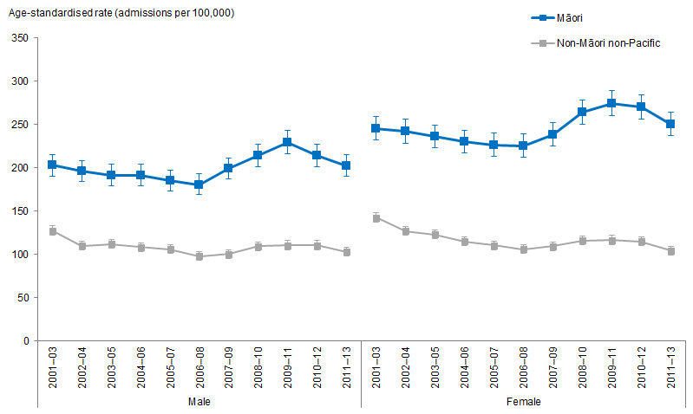
Notes:
Figures are age-standardised to the 2001 Census total Māori population.
Prioritised ethnicity has been used.
If the confidence intervals of two rates do not overlap, the difference in rates is said to be statistically significant.
Source: National Minimum Data Set (NMDS), Ministry of Health, 2001–03 to 2011–13.

Māori aged 5–34 years were more likely than non-Māori non-Pacific aged 5–34 years to be hospitalised for asthma. In 2011–13, Māori were over twice as likely as non-Māori non-Pacific to be hospitalised for asthma. Over time, hospitalisation rates have decreased for non-Māori non-Pacific, whereas the rate for Māori remained constant with an average of 224.3 admissions per 100,000 people, resulting in an increased disparity between Māori and non-Māori non-Pacific. From 2001–03 to 2011–13, the hospitalisation rate for asthma decreased by 23 percent for non-Māori non-Pacific.
Figure 156 shows that over time Māori females had the highest rates of asthma hospitalisations and an increasing disparity between Māori and non-Māori non-Pacific females. By 2011–13, Māori females were nearly 2½ times as likely as non-Māori non-Pacific females to be hospitalised for asthma.

Bronchiectasis (excludes congenital) hospitalisation
Figure 157: Bronchiectasis (excludes congenital) hospitalisation rates, all age, by gender, Māori and non-Māori non-Pacific, 2001–03 to 2011–13
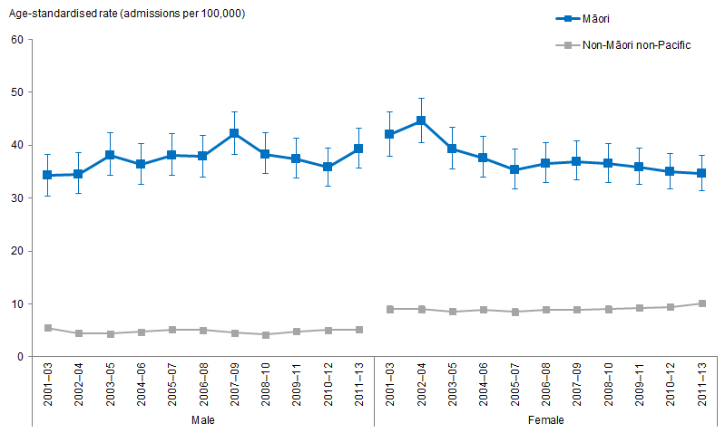
Notes:
Figures are age-standardised to the 2001 Census total Māori population.
Prioritised ethnicity has been used.
If the confidence intervals of two rates do not overlap, the difference in rates is said to be statistically significant.
Source: National Minimum Data Set (NMDS), Ministry of Health, 2001–03 to 2011–13.

Bronchiectasis hospitalisations for all ages show little change over time for Māori, however when looking at trends by gender some different patterns are evident. Figure 157 shows that from 2001–03, the rate of bronchiectasis for Māori males increased over time by 15 percent (from 34.2 events per 100,000 people in 2001–03 to 39.3 per 100,000 people in 2011–13). Over time, there was a decline of 17 percent in bronchiectasis hospitalisation rates for Māori females (41.9 events per 100,000 people in 2001–03 to 34.6 per 100,000 people in 2011–13).

Figure 158: Bronchiectasis (excludes congenital) hospitalisation rates, 0–14 years, by gender, Māori and non-Māori non-Pacific, 2001–03 to 2011–13
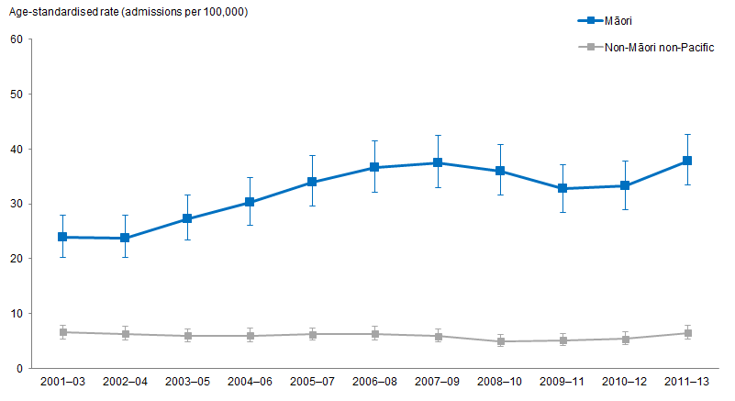
Notes:
Figures are age-standardised to the 2001 Census total Māori population.
Prioritised ethnicity has been used.
If the confidence intervals of two rates do not overlap, the difference in rates is said to be statistically significant.
Source: National Minimum Data Set (NMDS), Ministry of Health, 2001–03 to 2011–13.

Figure 158 shows that Māori children aged 0–14 years were more likely than non-Māori non-Pacific children aged 0–14 years to be hospitalised for bronchiectasis over time. Rates of bronchiectasis for Māori children increased by 58 percent over time from 2001–03 to 2011–13. The same upward trend was not evident for non-Māori non-Pacific children and therefore the disparity between Māori and non-Māori non-Pacific children aged 0–14 years has increased over time. In 2011–13, Māori children aged 0–14 years were nearly six times as likely as non-Māori non-Pacific children to be hospitalised for bronchiectasis.

Excel tools attached provide further data for the following age groups (including by gender): 15–24 years, 25–44 years of age, 45–64 years of age and 65 and over.

Bronchiolitis (acute, excludes chronic) hospitalisation
Figure 159: Bronchiolitis (acute, excludes chronic) hospitalisation rates, 0–4 years, by gender, Māori and non-Māori non-Pacific, 2001–03 to 2011–13
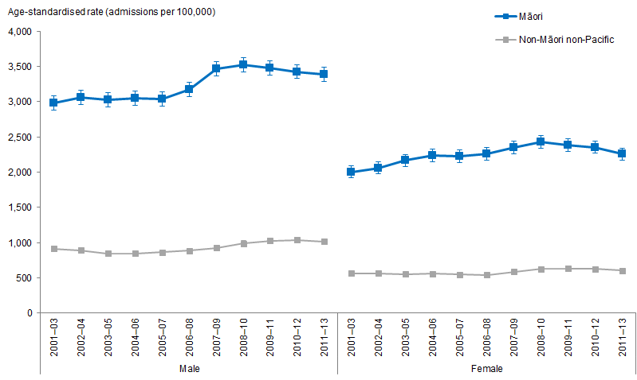
Notes:
Figures are age-standardised to the 2001 Census total Māori population.
Prioritised ethnicity has been used.
If the confidence intervals of two rates do not overlap, the difference in rates is said to be statistically significant.
Source: National Minimum Data Set (NMDS), Ministry of Health, 2001–03 to 2011–13.

Over time, rates of hospitalisation for bronchiolitis for Māori children aged 0–4 years of age have increased. In 2011–13, Māori children were nearly 3½ times as likely as non-Māori non-Pacific children to be hospitalised for bronchiolitis and this difference has not changed over time.

Figure 159 shows that Māori boys have the highest rates of bronchiolitis hospitalisations and that this rate has increased over time by 14 percent (from 2,981.5 events per 100,000 people in 2001–03 to 3,382.6 in 2011–13). For Māori girls aged 0–4 years the hospitalisation rate increased by 13 percent (from 2,004.4 events per 100,000 people in 2001–03 to 2,257.7 in 2011–13). Hospitalisation rates for non-Māori non-Pacific children aged 0–4 years also increased over time meaning the disparity between Māori and non-Māori non-Pacific children remained at around or just over 3½ times.

Chronic obstructive pulmonary disease (COPD)

COPD hospitalisation
Figure 160: Chronic obstructive pulmonary disease (COPD) hospitalisation rates, 45+ years, by gender, Māori and non-Māori non-Pacific, 2001–03 to 2011–13
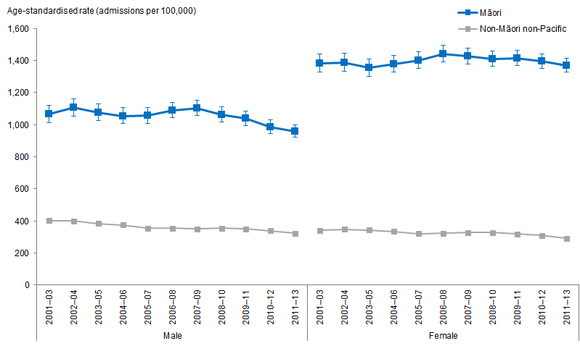
Notes:
Figures are age-standardised to the 2001 Census total Māori population.
Prioritised ethnicity has been used.
If the confidence intervals of two rates do not overlap, the difference in rates is said to be statistically significant.
Source: National Minimum Data Set (NMDS), Ministry of Health, 2001–03 to 2011–13.

From 2001–03 to 2011–13, rates of hospitalisation for COPD have remained constant for Māori, while decreasing for non-Māori non-Pacific. This translates to an increase in the difference between Māori and non-Māori non-Pacific, from Māori being around 3½ times as likely to be hospitalised for COPD in 2001–03 to being nearly four times as likely in the mid-2011–13.

Figure 160 shows that Māori females have the highest rates of COPD hospitalisations over time, and the rates remained constant. There was a decrease of 11 percent for Māori males (1,066.4 events per 100,000 people to 959.6 events per 100,000 people) over time in COPD hospitalisations. Non-Māori non-Pacific males and females both decreased over time (20 and 14 percent respectively).

The disparity between Māori and non-Māori non-Pacific males and females has increased over time. In 2011–13, Māori males were nearly three times as likely as non-Māori non-Pacific males to have been hospitalised for COPD. Whereas Māori females were over 4½ times as likely as non-Māori non-Pacific females to have been hospitalised for COPD.

COPD mortality
Figure 161: Chronic obstructive pulmonary disease (COPD) mortality rates, 45+ years, by gender, Māori and non-Māori non-Pacific, 2001–03 to 2011–13
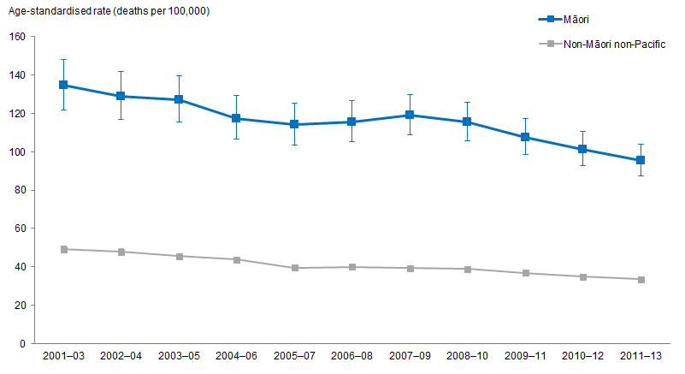
Notes:
Figures are age-standardised to the 2001 Census total Māori population.
Prioritised ethnicity has been used.
If the confidence intervals of two rates do not overlap, the difference in rates is said to be statistically significant.
Source: Mortality Collection Data Set (MORT), Ministry of Health, 2001–03 to 2011–13.

Figure 161 shows that overtime there has been a decrease in COPD mortality rates for Māori aged 45 and over. From 2001–03 to 2011–13 there was a decrease of 29 percent (from 134.5 deaths per 100,000 people to 95.4 deaths per 100,000 people). Over the same time period there has also been a decrease in mortality rates for non-Māori non-Pacific, therefore resulting in little change in the disparity between Māori and non-Māori non-Pacific. In 2011–13, Māori aged 45 and over were nearly three times as likely as non-Māori non-Pacific aged 45 and over to die from COPD.

The disparity between Māori and non-Māori non-Pacific females is higher than that of Māori and non-Māori non-Pacific males. From 2001–03 to 2011–13, Māori males were generally nearly 2½ times as likely as non-Māori non-Pacific males to die of COPD whilst Māori females were on average just below 3½ times as likely as non-Māori non-Pacific females to die of COPD.

Diabetes complications
This section presents age-standardised rates of two diabetes complications over time, renal failure and lower limb amputation, for Māori and non-Māori non-Pacific adults aged 15 years and over.

What is the data telling us?
Diabetes complication – renal failure with concurrent diabetes
- Māori adults aged 15 years and over have higher age-standardised hospitalisation rates of renal failure with concurrent diabetes than non-Māori non-Pacific over time.
- Generally, males have higher rates of renal failure than females, for both Māori and non-Māori non-Pacific.
- The rates of renal failure with concurrent diabetes increased over time for both Māori and non-Māori non-Pacific adults. The difference between these groups decreased over time, from 10 times as high to 7 times as high. This was because the increase in renal failure rates was greater for non-Māori non-Pacific adults.
Diabetes complication – lower limb amputation with concurrent diabetes
- Since 2001–03, Māori adults aged 15 years and over have had higher age-standardised hospitalisation rates of lower limb amputation with concurrent diabetes than non-Māori non-Pacific.
- Generally, males have higher rates than females, for both Māori and non-Māori non-Pacific.
- The rates of lower limb amputation with concurrent diabetes have remained similar over time for both Māori and non-Māori non-Pacific adults. Consequently, the difference between Māori and non-Māori non-Pacific has not changed much over time.

Diabetes complications – renal failure with concurrent diabetes
Figure 162: Rates of renal failure with concurrent diabetes, 15+ years, by gender, Māori and non-Māori non-Pacific, 2001–03 to 2011–13
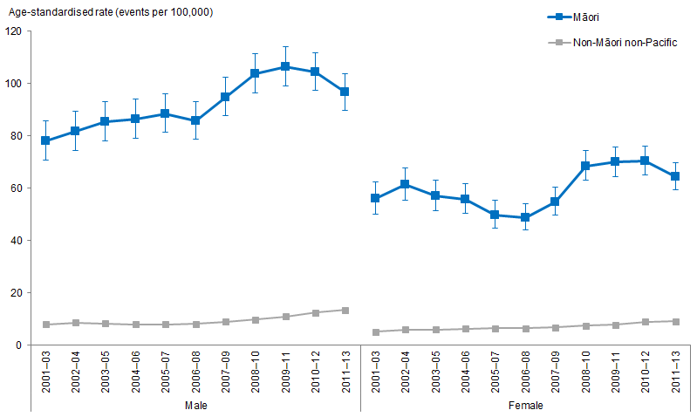
Notes:
Figures are age-standardised to the 2001 Census total Māori population.
Prioritised ethnicity has been used.
If the confidence intervals of two rates do not overlap, the difference in rates is said to be statistically significant.
Source: National Minimum Data Set (NMDS), Ministry of Health, 2001–03 to 2011–13.

Figure 162 shows that Māori adults aged 15 years and over have higher age-standardised hospitalisation rates of renal failure with concurrent diabetes than non-Māori non-Pacific at the same age group over time. Generally, males have higher rates than females, for both Māori and non-Māori non-Pacific.

Figure 163: Rate ratios of renal failure with concurrent diabetes, 15+ years, by gender, Māori and non-Māori non-Pacific, 2001–03 to 2011–13
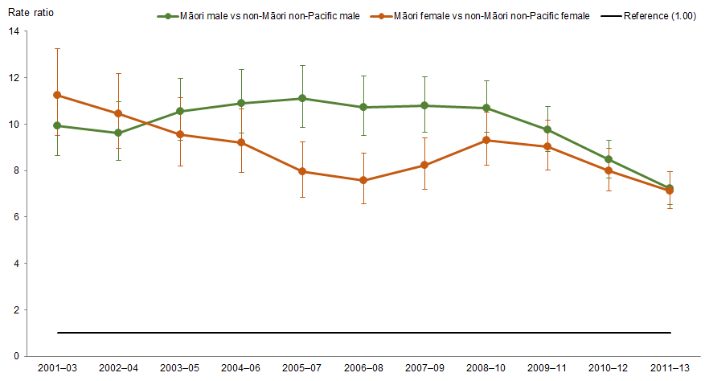
Notes:
Figures are age-standardised to the 2001 Census total Māori population.
Prioritised ethnicity has been used.
If the confidence interval of the rate ratio does not include the number 1, the ratio is said to be statistically significant.
Source: National Minimum Data Set (NMDS), Ministry of Health, 2001–03 to 2011–13.

Both Māori and non-Māori non-Pacific adults had increasing rates of renal failure with concurrent diabetes over time, but the difference between Māori and non-Māori non-Pacific decreased over time. The age-standardised rate of renal failure with concurrent diabetes for Māori aged 15 years and over was more than ten times that of non-Māori non-Pacific at the same age group in 2001–03, and more than seven times in 2011–13.

The difference between Māori and non-Māori non-Pacific males was higher than the difference between Māori and non-Māori non-Pacific females until 2008–10, after which it was similar (Figure 163).

Diabetes complications – lower limb amputation with concurrent diabetes
Figure 164: Rates of lower limb amputation with concurrent diabetes, 15+ years, by gender, Māori and non-Māori non-Pacific, 2001–03 to 2011–13
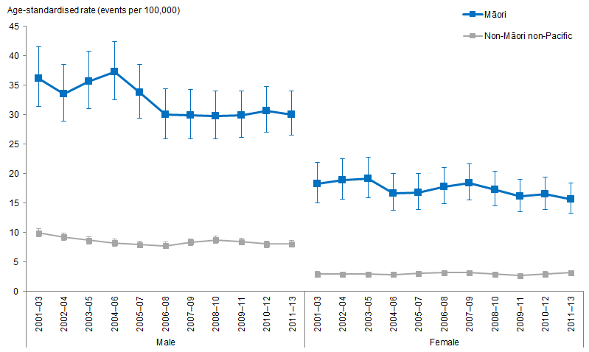
Notes:
Figures are age-standardised to the 2001 Census total Māori population.
Prioritised ethnicity has been used.
If the confidence intervals of two rates do not overlap, the difference in rates is said to be statistically significant.
Source: National Minimum Data Set (NMDS), Ministry of Health, 2001–03 to 2011–13.

Figure 164 shows that Māori adults aged 15 years and over have higher age-standardised hospitalisation rates of lower limb amputation with concurrent diabetes than non-Māori non-Pacific at the same age group over time. Generally, males have higher rates than females, for both Māori and non-Māori non-Pacific.

For both Māori and non-Māori non-Pacific adults, the rates of lower limb amputation with concurrent diabetes did not change much over time, after adjusting for age.

Figure 165: Rate ratios of lower limb amputation with concurrent diabetes, 15+ years, by gender, Māori and non-Māori non-Pacific, 2001–03 to 2011–13
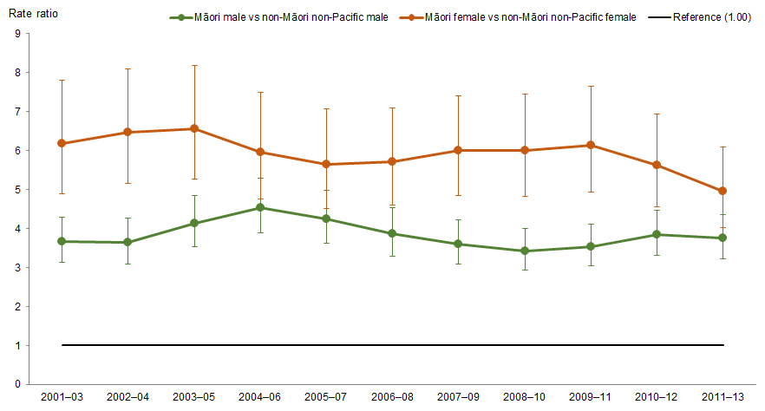
Notes:
Figures are age-standardised to the 2001 Census total Māori population.
Prioritised ethnicity has been used.
If the confidence interval of the rate ratio does not include the number 1, the ratio is said to be statistically significant.
Source: National Minimum Data Set (NMDS), Ministry of Health, 2001–03 to 2011–13.

The difference between Māori and non-Māori did not change much over time: the age-standardised rate of lower limb amputation with concurrent diabetes for Māori aged 15 years and over was about four times that of non-Māori non-Pacific from 2001 to 2013.

The difference between Māori and non-Māori non-Pacific females was greater than the difference between Māori and non-Māori non-Pacific males over time, even though females had a lower rate of lower limb amputation with concurrent diabetes than males (Figure 165).

Infectious diseases
This section presents the trends related to selected infectious diseases for Māori and non-Māori non-Pacific, including tuberculosis and meningococcal disease notifications, and the first episode rheumatic fever hospitalisations.

What is the data telling us?
- The rate of tuberculosis notifications for Māori decreased by 58 percent between 2001–03 and 2011–13.
- Between 2001–03 and 2007–09 Māori had a higher rate of TB notifications than non-Māori non-Pacific.
- In 2011–13 Māori had a lower rate of TB notifications than non-Māori non-Pacific.
- The rate of meningococcal notifications for Māori was over twice the rate for non-Māori non-Pacific, this did not change much over time.
- The rate of meningococcal notifications decreased for both Māori and non-Māori non-Pacific.
- In 2011–13, the rate of meningococcal notifications for Māori was over 2½ times that of non-Māori non-Pacific.
- The Māori rate of first episode rheumatic fever hospitalisations increased significantly between 2001–03 and 2011–13.
- The difference between Māori and non-Māori non-Pacific rates of first episode rheumatic fever hospitalisation increased over time.
- In 2011–13, Māori rate of first episode rheumatic fever hospitalisation was almost 30 times as high as the non-Māori non-Pacific rate.

Tuberculosis
Figure 166: Tuberculosis (TB) notification rates, Māori and non-Māori non-Pacific, 2001–03 to 2011–13
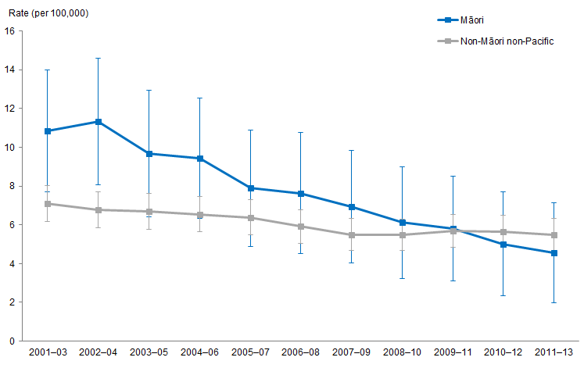
Notes:
Figures are age-standardised to the 2001 Census total Māori population.
Prioritised ethnicity has been used.
If the confidence intervals of two rates do not overlap, the difference in rates is said to be statistically significant.
Source: Institute of Environmental Science and Research Limited (ESR), 2001–2013.

Figure 166 shows, after adjusting for age, the rate of TB notifications for Māori and non-Māori non-Pacific people between 2001 and 2013.

Decrease in TB notification rates for Māori
The rate of TB notifications for Māori showed a larger decrease than the rate of TB notifications for non-Māori non-Pacific between 2001–03 and 2011–13.

The age-standardised rate of TB notifications for Māori decreased by 58 percent between 2001–03 and 2011–13 (from 11 to 5 notifications per 100,000).

In comparison, the rate of TB notifications for non-Māori non-Pacific decreased by 22 percent over the same period (from 7 to 6 notifications per 100,000).

Difference in TB notification rates between Māori and non-Māori non-Pacific
Between 2001–03 and 2007–09 Māori had a higher rate of TB notifications than non-Māori non-Pacific (rate ratio of 1.5 in 2001–03 and 1.3 in 2007–09). Between
2008–10 and 2010–12 there was no difference in rates of TB notifications between Māori and non-Māori non-Pacific (rate ratio of 1.1 in 2008–10 and 0.9 in 2010–12). By 2011–13, the rate of TB notifications for Māori was lower than that of non-Māori non-Pacific (rate ratio of 0.8 in 2011–13).

Meningococcal disease
Figure 167: Meningococcal notification rates, Māori and non-Māori non-Pacific, 2001–03 and 2011–13
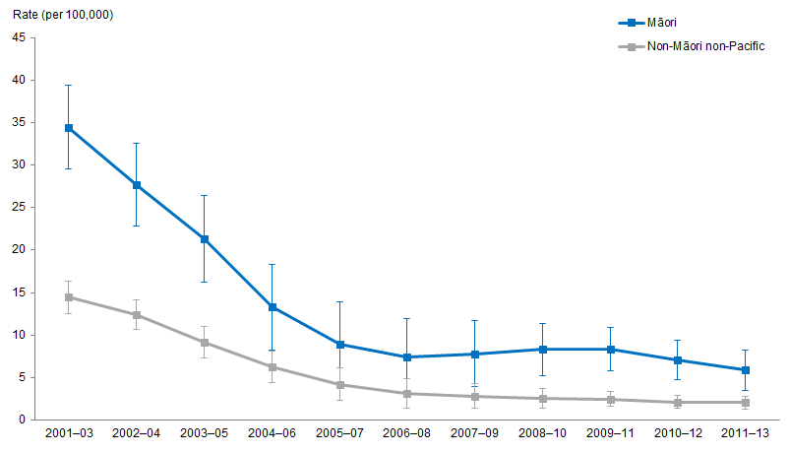
Notes:
Figures are age-standardised to the 2001 Census total Māori population.
Prioritised ethnicity has been used.
If the confidence intervals of two rates do not overlap, the difference in rates is said to be statistically significant.
Source: Institute of Environmental Science and Research Limited (ESR), 2001–2013.

Figure 167 shows, after adjusting for age, the rate of meningococcal disease notifications for Māori and non-Māori non-Pacific between 2001 and 2013.

Decrease in rate of meningococcal disease notifications for Māori and non-Māori non-Pacific
The Māori rate of meningococcal disease notifications decreased by 83 percent between 2001–03 and 2011–13 (from 35 to 6 notifications per 100,000).

In comparison, the rate of meningococcal disease notifications for non-Māori non-Pacific decreased by 86 percent between 2001–03 and 2011–13 (from 14 to 2 notifications per 100,000).

Difference between rate of meningococcal disease notifications for Māori and non-Māori non-Pacific
The rate of meningococcal disease notifications for Māori was over twice that of non-Māori non-Pacific, this did not change much over time. In 2011–13 the rate of meningococcal disease notifications for Māori was over 2½ times that of non-Māori non-Pacific (rate ratio of 2.8).

First episode rheumatic fever hospitalisations
Figure 168: First episode rheumatic fever hospitalisation rates, Māori and non-Māori non-Pacific, 2001–03 and 2011–13
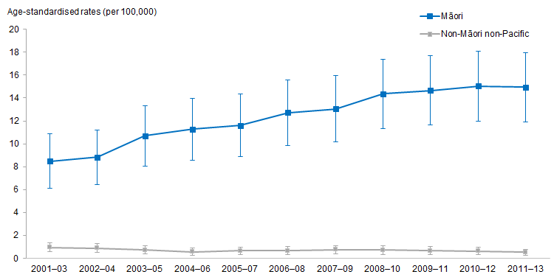
Notes:
Figures are age-standardised to the 2001 Census total Māori population.
Prioritised ethnicity has been used.
If the confidence intervals of two rates do not overlap, the difference in rates is said to be statistically significant.
Source: National Minimum Data Set (NMDS), Ministry of Health, 2001–03 to 2011–13.

Figure 168 shows the age-standardised rate of first episode rheumatic fever (RF) hospitalisations for Māori and non-Māori non-Pacific between 2001–03 and 2011–13.

The rate of first episode rheumatic fever hospitalisations for Māori increased over time
The Māori rate of first episode RF hospitalisations increased by almost 76 percent between 2001–03 and 2011–13 (from just over 8 in 2001–03 to almost 15 hospitalisations per 100,000 population in 2011–13). In comparison, the non-Māori non-Pacific rate of first episode RF hospitalisations did not change significantly over this period, remaining less than one hospitalisation per 100,000 population. The hospitalisation rate appears to have declined over this period of time, but the low numbers mean that this change is not statistically significant.

The relative difference in the first episode rheumatic fever hospitalisation rates between Māori and non-Māori non-Pacific increased over time
Between 2001–03 and 2011–13, the relative difference in rates of first episode RF hospitalisations for Māori and non-Māori non-Pacific more than trebled. In
2001–03, the rate of first episode RF hospitalisations for Māori was nearly 9 times the rate for non-Māori non-Pacific. By 2011–13, the rate was almost 30 times the rate for non-Māori non-Pacific.

Oral health
This section presents the trends related to oral health from 2002 to 2016 for Māori and non-Māori non-Pacific children aged five years or in Year 8. Data was collected from Community Oral Health Services.

What is the data telling us?
- The mean dmft of Māori children aged five was, on average, twice that of non-Māori non-Pacific children in the same age group.
- The mean DMFT of Māori children in Year 8 was less than 1.3 times that of non-Māori non-Pacific children in the same age group.
- Māori children aged five were less likely to be caries free than non-Māori non-Pacific children in the same age group between 2002 and 2016.
- Māori children in Year 8 were less likely to be caries free than non-Māori non-Pacific children in the same age group between 2002 and 2016.

Mean number of decayed, missing and filled teeth (dmft) at five years of age
Figure 169: Mean number of decayed, missing and filled teeth (dmft), 5 years, Māori and non-Māori non-Pacific, 2002–2016
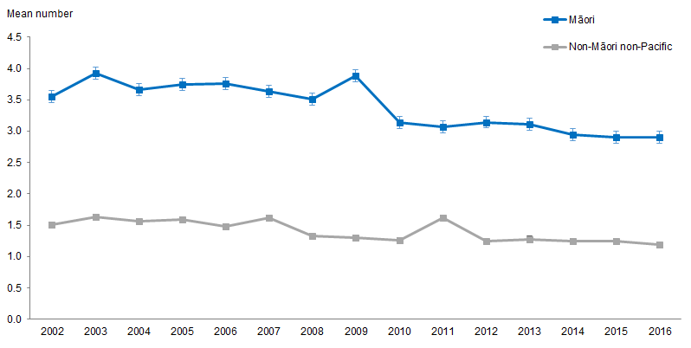
Note: If the confidence intervals of two means do not overlap, the difference in means is said to be statistically significant.
Source: Community Oral Health Services, 2002–2016.
Figure 169 shows the difference in the mean number of decayed, missing and filled teeth (dmft) between 2002 and 2016 for Māori and non-Māori non-Pacific children at five years of age. See the attached Excel tool for figures showing the rate ratio, fluoridated and non-fluoridated data.

Decrease in mean dmft for Māori children aged five between 2002 and 2016
The mean dmft for Māori aged five in 2002 decreased by 18.2 percent from 3.6 teeth in 2002 to 2.9 in 2016. Māori five-year-olds living in fluoridated areas had a decrease in the mean dmft by 7.7 percent between 2002 and 2016, whereas those living in non-fluoridated areas had a decrease of 24.8 percent over this period.
The mean dmft for non-Māori non-Pacific aged five in 2002 was 1.5 teeth, this decreased to 1.2 in 2016, a decrease of 21.3 percent. Non-Māori non-Pacific five-year-olds living in non-fluoridated areas showed the largest decrease in mean dmft, dropping by 37.8 percent, whereas non-Māori non-Pacific five-year-olds living in fluoridated areas had an increase of 9.5 percent in mean dmft (an increase from 1.05 in 2002 to 1.15 teeth in 2016).

Difference in mean dmft between Māori and non-Māori non-Pacific aged five remained significant over time
The difference in mean dmft between Māori and non-Māori non-Pacific children aged five remained significant between 2002 and 2016. On average, the mean dmft for Māori five-year-olds was nearly 2½ times that of non-Māori non-Pacific children, regardless of whether they lived in a fluoridated area or not, between 2002 and 2016.

Mean number of decayed, missing and filled teeth (DMFT) at school Year 8
Figure 170: Mean number of decayed, missing and filled teeth (DMFT), Year 8, Māori and non-Māori non-Pacific, 2002–2016
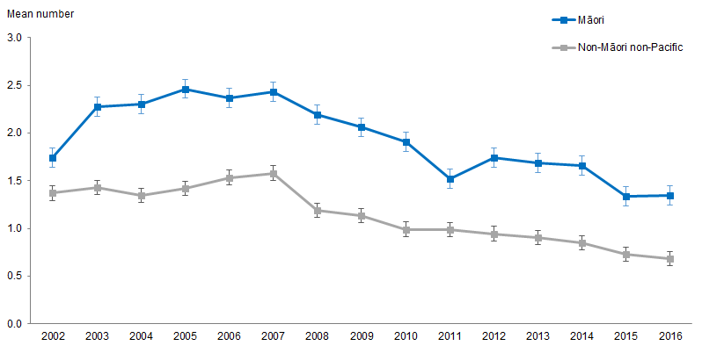
Note: If the confidence intervals of two means do not overlap, the difference in means is said to be statistically significant.
Source: Community Oral Health Services, 2002–2016.

Figure 170 shows the mean DMFT for Māori and non-Māori non-Pacific children in Year 8, between 2002 and 2016. See the attached Excel tool for figures showing the rate ratio, fluoridated and non-fluoridated data.

Mean DMFT in Māori children in Year 8 fluctuated between 2002 and 2016
In 2016 the mean DMFT for Māori children in Year 8 was 1.4. In comparison, the mean DMFT for non-Māori non-Pacific children of the same age was 0.7.

Overall, the mean DMFT for Māori children in Year 8 increased from 2002 to 2007 by 39.9 percent (1.7 to 2.4 teeth) and decreased from 2007 to 2016 by 44.3 percent (2.4 to 1.4 teeth).

The mean DMFT for non-Māori non-Pacific children in Year 8 followed a similar trend increasing from 1.4 teeth in 2002 to 1.6 teeth in 2007, an increase of 15.3 percent. The mean DMFT for non-Māori non-Pacific also decreased from 1.6 teeth in 2007 to 0.7 teeth in 2016, a decrease of 56.6 percent.

Difference in mean DMFT between Māori and non-Māori non-Pacific decreased from 2004
The difference in mean DMFT for children in Year 8 between Māori and non-Māori non-Pacific decreased from 1.0 in 2004 to 0.7 in 2016, a decrease of 31.3 percent.

In 2002, the mean DMFT of Māori children in Year 8 was less than 1.3 times the mean DMFT of non-Māori non-Pacific children of the same age. This increased to 2016, where the mean DMFT of Māori children in Year 8 was nearly twice the mean DMFT of non-Māori non-Pacific children in the same age group.

Caries free at five years of age
Figure 171: Percentage of caries-free children, 5 years, Māori and non-Māori non-Pacific, 2002–2016
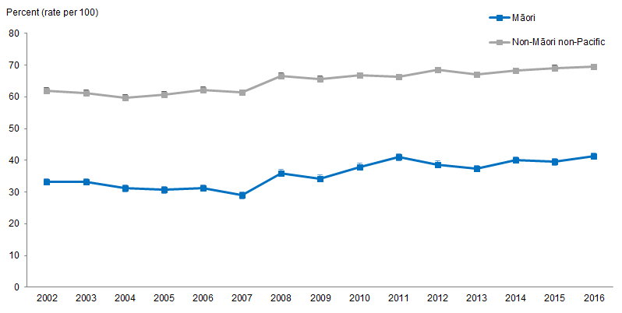
Note: If the confidence intervals of two rates do not overlap, the difference in rates is said to be statistically significant.
Source: Community Oral Health Services, 2002–2016.

Figure 171 shows the percentage of Māori and non-Māori non-Pacific children who are caries free at five years of age between 2002 and 2016. See the attached Excel tool for figures showing the rate ratio, fluoridated and non-fluoridated data.

Percentage of Māori children aged five who are caries free and not living in a fluoridated area increased
In 2016, 41.4 percent of Māori aged five were caries free. In comparison, 69.5 non-Māori non-Pacific aged five were caries free.

Children aged five living in non-fluoridated areas showed the largest changes. Māori who were caries free in this group increased by 71.3 percent between 2002 and 2016 (22.5 to 38.6 percent) and the percentage of caries-free children in the non-Māori non-Pacific group increased by 28.8 percent between 2002 and 2016 (53.0 to 68.3 percent). The percentage of caries-free children in Year 8 was found to be higher in fluoridated areas (than non-fluoridated areas) although there was no change over time.

Difference in caries-free percentages between Māori and non-Māori non-Pacific remained constant between 2002 and 2016
The difference between the percentage of Māori and non-Māori non-Pacific children aged five who are caries free remained significant between 2002 and 2016. Māori children aged five were less likely to be caries free than non-Māori non-Pacific children of the same age. On average, the percentage of Māori children aged five who were caries free was only just over half the percentage of non-Māori non-Pacific in the same age group, regardless of whether they were living in a fluoridated area or not.

Caries free at school Year 8
Figure 172: Percentage of caries-free children, Year 8, Māori and non-Māori non-Pacific, 2002–2016
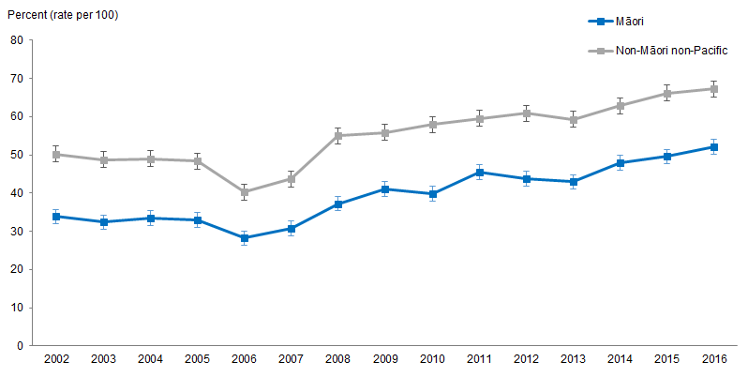
Note: If the confidence intervals of two rates do not overlap, the difference in rates is said to be statistically significant.
Source: Community Oral Health Services, 2002–2016.

Figure 172 shows the percentage of Māori and non-Māori non-Pacific children who are caries free at Year 8, recorded between 2002 and 2016. See the attached Excel tool for figures showing the rate ratio, fluoridated and non-fluoridated data.

Percentage of caries free Māori children in Year 8 increased between 2002 and 2016
The percentage of Māori children who were caries free increased by 53.9 percent between 2002 and 2016. In 2016, 52.1 percent of Māori in Year 8 were caries free. In comparison, 67.2 percent of non-Māori non-Pacific were caries free.

Children in Year 8 who live in non-fluoridated areas showed the largest improvement in the percentage who were caries free. The percentage of caries-free Māori children increased by 70.0 percent between 2002 and 2016 (28.6 to 48.7 percent) and the percentage of caries-free non-Māori non-Pacific children increased by 53.2 percent over this period (from 42.4 to 64.9 percent).

The percentage of children in Year 8 living in fluoridated areas who were caries free also increased, although at a slower rate. The percentage of Māori children who are caries free increased by 42.0 percent between 2002 and 2016 (39.1 to 55.5 percent). The percentage of caries-free non-Māori non-Pacific children in Year 8 living in fluoridated areas increased by 19.6 percent over this period (from 58.1 to 69.5 percent). Despite the slower rate of increase those in fluoridated areas had a higher percentage caries free between 2002 and 2016.

Difference in caries-free percentages between Māori and non-Māori non-Pacific children in Year 8 remained significant
The difference in the percentage of caries-free children in Year 8 between Māori and non-Māori non-Pacific remained significant between 2002 and 2016. Māori children in Year 8 were less likely to be caries free than non-Māori non-Pacific children in Year 8, regardless of whether they lived in fluoridated areas or not.

Mental health
This section presents results over time for mental health for Māori and non-Māori non-Pacific, including scores of psychological distress and self reported diagnosis of common mental disorders.

What is the data telling us?
Psychological distress
- Māori had higher levels of psychological distress than non-Māori non-Pacific.
- The percentage of people with a high psychological distress score has increased for both Māori and non-Māori non-Pacific over time, but the difference between Māori and non-Māori non-Pacific has narrowed.
Diagnosis of common mental disorder
- There were no significant differences between Māori and non-Māori non-Pacific in the percentage of people diagnosed with a common mental disorder, regardless of sex.
- Females were more likely to be diagnosed with a common mental disorder than males, for both Māori and non-Māori non-Pacific.

Psychological distress
Figure 173: Psychological distress (high or very high probability of anxiety or depressive disorder), 15+ years, Māori and non-Māori non-Pacific, 2006/07–2016/17
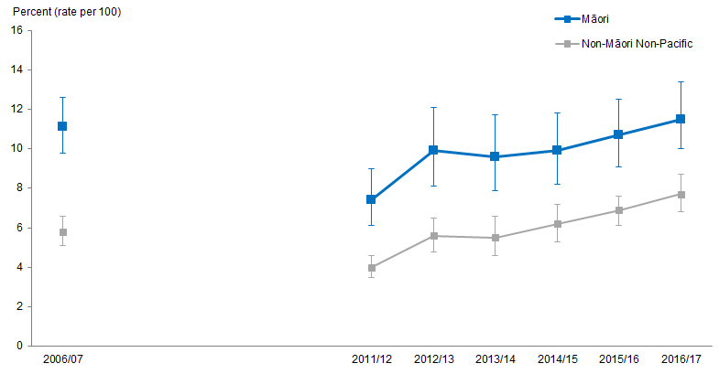
Notes:
Figures are age-standardised to the 2001 Census total Māori population.
Prioritised ethnicity has been used.
If the confidence intervals of two rates do not overlap, the difference in rates is said to be statistically significant.
Source: New Zealand Health Survey (NZHS), Ministry of Health, 2006/07–2016/17.

Figure 173 shows the percentage of people who had a high score for psychological distress (self-reported), for Māori and non-Māori non-Pacific.

Māori had higher levels of psychological distress than non-Māori non-Pacific across the time period shown, and the percentage of people with a high psychological distress score has increased for both Māori and non-Māori non-Pacific over time. In particular, the percentage of Māori with a high psychological distress score increased between 2011/12 and 2016/17, from 7.4 percent to 11.5 percent. This is an increase of 4.1 percentage points. Over the same time period the percentage of non-Māori non-Pacific with a high psychological distress score increased more rapidly, from 4.0 percent to 7.7 percent, an increase of 3.7 percentage points.

This means that although Māori were still more likely to have a high psychological distress score than non-Māori non-Pacific, the difference between ethnicities has narrowed slightly. In 2006/07 Māori were 1.9 times as likely to have a high psychological distress score as non-Māori non-Pacific, and this decreased to 1.6 times as likely in 2016/17.

In general, females had higher prevalence than males for both Māori and non-Māori non-Pacific between 2006/07 and 2016/17.

Diagnosed common mental disorder
Figure 174: Diagnosed common mental disorder (depression, bipolar disorder and/or anxiety disorder), 15+ years, by gender, Māori and non-Māori non-Pacific,
2006/07–2016/17
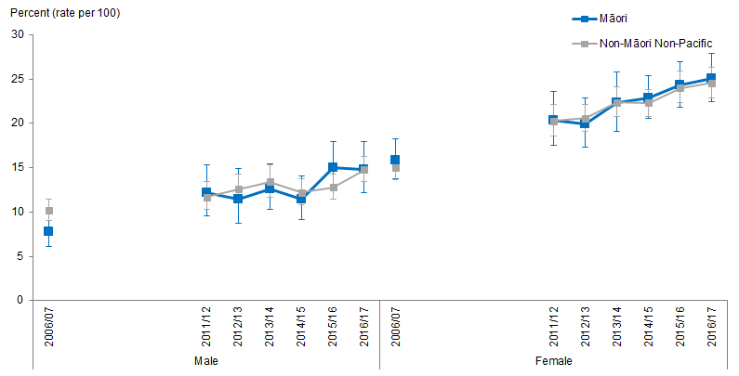
Notes:
Figures are age-standardised to the 2001 Census total Māori population.
Prioritised ethnicity has been used.
If the confidence intervals of two rates do not overlap, the difference in rates is said to be statistically significant.
Source: New Zealand Health Survey (NZHS), Ministry of Health, 2006/07–2016/17.

Figure 174 shows there were no significant differences between Māori and non-Māori non-Pacific in the percentage of people diagnosed with a common mental disorder, regardless of sex. Females have been more likely to be diagnosed with a common mental disorder than males, for both Māori and non-Māori non-Pacific.

Emergency department attendances
This brief provides information on emergency department attendances for Māori and non-Māori non-Pacific males and females.

What is the data telling us?
Overall the data shows that between 2007–08 and 2012–13:
- Differences between Māori and non-Māori non-Pacific males and females age-standardised rates of emergency department attendances closely followed the differences between Māori and non-Māori males and females, being less than one emergency department attendance greater per year than the difference between Māori and non-Māori males and females.

Figure 175: Emergency department attendance rates, by gender, Māori and non-Māori non-Pacific, 2007–08 to 2016–17
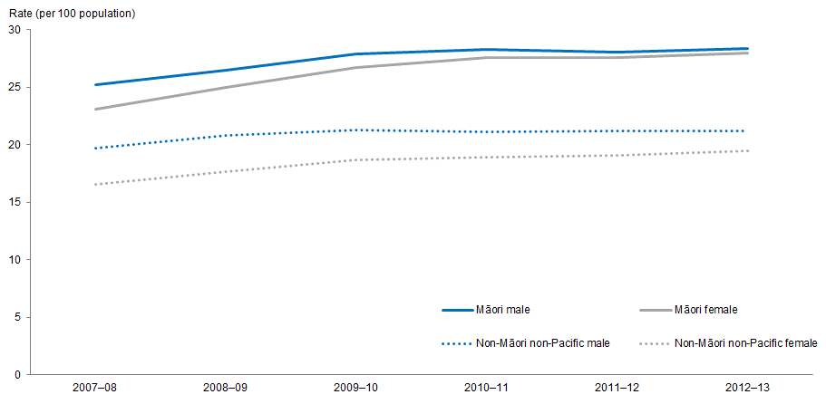
Notes:
Figures are age-standardised to the 2001 Census total Māori population.
Prioritised ethnicity has been used.
Source: National Minimum Dataset (NMDS, 10 January 2019), Ministry of Health, 2007–08 to 2016–17.

Figure 175 shows both Māori males and females had higher age-standardised rates of emergency department attendances compared with non-Māori non-Pacific males and females. The difference was larger for females than for males.

Age-standardised rates of emergency department attendances have increased
Between 2007–08 and 2012–13, age-standardised rates of emergency department attendances for Māori males increased by 13 percent (from 25 to 28 attendances per 100), more than for non-Māori non-Pacific males which increased by 8 percent (from 20 to 21 attendances per 100). For females, the rate of emergency department attendances per 100 for Māori females increased by 21 percent (from 23 to 28 emergency department attendances per 100), higher than the increase for non-Māori non-Pacific females which was 18 percent (from 17 to 20 emergency department attendances per 100).

Table 52: Emergency department attendance rates, by gender, Māori and non-Māori non-Pacific, 2007–08 to 2016–17
Year | Māori |  | Non-Māori non-Pacific
 | Males | Females | Males | Females
2007–08 | 25.2 | 23.1 | 19.7 | 16.6
2008–09 | 26.5 | 25.0 | 20.8 | 17.7
2009–10 | 27.9 | 26.7 | 21.3 | 18.7
2010–11 | 28.3 | 27.6 | 21.1 | 18.9
2011–12 | 28.1 | 27.6 | 21.2 | 19.1
2012–13 | 28.4 | 28.0 | 21.2 | 19.5
2013–14 | 28.5 | 28.8
2014–15 | 29.9 | 29.7
2015–16 | 30.7 | 30.7
2016–17 | 30.5 | 31.3
Notes:
Figures are age-standardised to the 2001 Census total Māori population.
Prioritised ethnicity has been used.
Source: National Minimum Dataset (NMDS, 10 January 2019), Ministry of Health, 2007–08 to 2016–17.

References
Altmann A, Tian L, Henderson VW, et al. 2014. Sex modifies the APOE‐related risk of developing Alzheimer disease. Annals of Neurology 75(4): 563–73.
Andrews G, Slade T. 2001. Interpreting scores on the Kessler Psychological Distress Scale (K10). Australian and New Zealand Journal of Public Health 25: 494–7.
Arthritis New Zealand. n.d. Forms of Arthritis. URL: www.arthritis.org.nz/information/forms-of-arthritis/ (accessed 26 August 2019).
ASH. n.d. 2016 ASH Year 10 Snapshot: Smoking among Māori youth. Wellington: Health Promotion Agency. URL: https://d3n8a8pro7vhmx.cloudfront.net/ashnz/pages/70/attachments/original/1518396379/2016_ASH_Y10_Snapshot_Maori_FINAL.pdf?1518396379 (accessed 26 August 2019).
Asia Pacific Cohort Studies Collaboration. 2004. Body mass index and cardiovascular disease in the Asia-Pacific Region; an overview of 33 cohorts involving 310,000 participants. International Journal of Epidemiology 33: 751–8.
Atkinson J, Salmond C, Crampton P. 2014. NZDep2013 Index of Deprivation. Wellington: Department of the Public Health, University of Otago.
Babor T, Higgins-Biddle J, Saunders J, et al. 2001. AUDIT: The Alcohol Use Disorders Identification Test: Guidelines for use in primary care. Second edition. Geneva: World Health Organization.
Bombak AE. 2013. Self-rated health and public health: a critical perspective. Frontiers in Public Health 1: 15.
Brain Research New Zealand. n.d. New Dementia Research on Māori Led by Māori. URL: www.brnz.ac.nz/news-events/new-dementia-research-on-maori-led-by-maori (accessed 26 August 2019).
Cole TJ, Bellizzi MC, Flegal KM, et al. 2000. Establishing a standard definition for child overweight and obesity worldwide: international survey. British Medical Journal 320: 1−6.
Cole TJ, Flegal KM, Nicholls D, et al. 2007. Body mass index cut offs to define thinness in children and adolescents: international survey. British Medical Journal 335(7612): 194.
Dyall L. 2014. Dementia: continuation of health and ethnic inequalities in New Zealand. New Zealand Medical Journal 127(1389): 68–80.
Ferris J, Wynne H. 2001. The Canadian Problem Gambling Index: Final Report. Ottawa: Canadian Centre on Substance Abuse.
Health Navigator New Zealand. 2019a. Anxiety. URL: www.healthnavigator.org.nz/health-a-z/a/anxiety/ (accessed 26 August 2019).
Health Navigator New Zealand. 2019b. Chronic Pain. URL: www.healthnavigator.org.nz/health-a-z/c/chronic-pain/ (accessed 26 August 2019).
Hughes TM, Kuller LH, Barinas-Mitchell EJ, et al. 2013. Pulse wave velocity is associated with β-amyloid deposition in the brains of very elderly adults. Neurology 81(19):
1711–18.
Jacklin KM, Walker JD, Shawande M. 2013. The emergence of dementia as a health concern among First Nations populations in Alberta, Canada. Canadian Journal of Public Health 104(1).
Kerse N, Lapsley H, Moyes S, et al. 2017. Dementia: Supplementary Findings from LiLACS NZ for Section Five, ‘Service Use and Common Health Conditions’ in the report ‘Health, Independence and Caregiving in Advanced Age’. Auckland: School of Population Health, The University of Auckland. URL: www.health.govt.nz/publication/dementia-supplementary-findings-lilacs-nz-section-five-service-use-and-common-health-conditions (accessed 26 August 2019).
Kramer MS. 1987. Determinants of low birthweight: methodological assessment and meta-analysis. Bulletin of the World Health Organization 65(5): 663–737.
Ministry of Health. 2006. Tatau Kahukura: Māori Health Chart Book, Public Health Intelligence Monitoring Report No. 5. Wellington: Ministry of Health.
Ministry of Health. 2010a. Our Oral Health: Key findings of the 2009 New Zealand Oral Health Survey. Wellington: Ministry of Health.
Ministry of Health. 2010b. Saving Lives: Amenable Mortality in New Zealand,
1996–2006. Wellington: Ministry of Health.
Ministry of Health. 2010c. Tatau Kahukura: Māori Health Chart Book 2010 (2nd edition). Wellington: Ministry of Health.
Ministry of Health. 2010d. The New Zealand Health Survey: Objectives and topic areas. August. Wellington: Ministry of Health.
Ministry of Health. 2012. Fetal and Infant Deaths 2008 and 2009. Wellington: Ministry of Health.
Ministry of Health. 2014. Indicator Interpretation Guide 2013/14: New Zealand Health Survey. Wellington: Ministry of Health.
Ministry of Health. 2015a. Eating and Activity Guidelines for New Zealand Adults. Wellington: Ministry of Health.
Ministry of Health. 2015b. Tatau Kahukura: Māori Health Chart Book 2015 (3rd edition). Wellington: Ministry of Health.
Ministry of Health. 2016a. Breastfeeding Is Perfect for You and Your Baby. URL: https://www.health.govt.nz/your-health/pregnancy-and-kids/first-year/helpful-advice-during-first-year/breastfeeding-perfect-you-and-your-baby (accessed 26 August 2019).
Ministry of Health. 2016b. Defining Amenable Mortality. Wellington: Ministry of Health.
Ministry of Health. 2017a. Health and Independence Report 2016. Wellington: Ministry of Health.
Ministry of Health. 2017b. Methodology Report 2016/17: New Zealand Health Survey. Wellington: Ministry of Health. URL: www.health.govt.nz/publication/methodology-report-2016-17-new-zealand-health-survey (accessed 26 August 2019).
Ministry of Health. 2018a. Arthritis. URL: www.health.govt.nz/your-health/conditions-and-treatments/diseases-and-illnesses/arthritis (accessed 26 August 2019).
Ministry of Health. 2018b. Dementia. URL: https://www.health.govt.nz/your-health/conditions-and-treatments/diseases-and-illnesses/dementia (accessed 26 August 2019).
Ministry of Health. 2018c. HIV/AIDS. URL: www.health.govt.nz/your-health/conditions-and-treatments/diseases-and-illnesses/hiv-aids (accessed 26 August 2019).
Ministry of Health. 2018d. Long-Term Conditions. URL: www.health.govt.nz/our-work/diseases-and-conditions/long-term-conditions (accessed 26 August 2019).
Ministry of Health. 2018e. Meningococcal Disease (including meningitis). URL: www.health.govt.nz/your-health/conditions-and-treatments/diseases-and-illnesses/meningococcal-disease-including-meningitis (accessed 26 August 2019).
Ministry of Health. 2018f. Osteoporosis. URL: www.health.govt.nz/your-health/conditions-and-treatments/diseases-and-illnesses/osteoporosis (accessed 26 August 2019).
Ministry of Health. 2018g. Position Paper on Māori Health Analytics – Age standardisation. Wellington: Ministry of Health. URL: www.health.govt.nz/publication/position-paper-maori-health-analytics-age-standardisation (accessed 26 August 2019).
Ministry of Health. 2018h. Tuberculosis Disease. URL: www.health.govt.nz/your-health/conditions-and-treatments/diseases-and-illnesses/tuberculosis-disease (accessed 26 August 2019).
Ministry of Health. 2019a. Anxiety. URL: www.health.govt.nz/your-health/conditions-and-treatments/mental-health/anxiety (accessed 26 August 2019).
Ministry of Health. 2019b. Bipolar Disorder. URL: www.health.govt.nz/your-health/conditions-and-treatments/mental-health/bipolar-disorder (accessed 26 August 2019).
Ministry of Health. 2019c. Cancer. URL: www.health.govt.nz/your-health/conditions-and-treatments/diseases-and-illnesses/cancer (accessed 26 August 2019).
Ministry of Health. 2019d. Depression. URL: www.health.govt.nz/your-health/conditions-and-treatments/mental-health/depression (accessed 26 August 2019).
Ministry of Health. 2019e. Rheumatic Fever. URL: www.health.govt.nz/our-work/diseases-and-conditions/rheumatic-fever (accessed 26 August 2019).
National Breastfeeding Advisory Committee of New Zealand. 2009. National Strategic Plan of Action for Breastfeeding 2008–2012: National Breastfeeding Advisory Committee of New Zealand’s advice to the Director-General of Health. Wellington. Ministry of Health.
Prince M, Comas-Herrera A, Knapp M, et al. 2016. World Alzheimer Report 2016: Improving healthcare for people living with dementia: coverage, quality and costs now and in the future. London: Alzheimer’s Disease International. URL: www.alz.co.uk/research/WorldAlzheimerReport2016.pdf (accessed 26 August 2019).
Rossen F. 2015. Gambling and Problem Gambling: Results of the 2011/12 New Zealand Health Survey. Centre for Addiction Research, Prepared for the Ministry of Health. Auckland, New Zealand: Auckland UniServices Limited, The University of Auckland.
Salmond C, Crampton P, Atkinson J. 2007. NZDep2006 Index of Deprivation. Wellington: Department of Public Health, University of Otago.
Stats NZ. 2005. Māori Population: Looking out to 2021. Hui Taumata 2005. Wellington: Statistics New Zealand.
Stats NZ. 2015. Births and Deaths: Year ended December 2014. Wellington: Statistics New Zealand.
Stats NZ. 2017. Prevalence of Psychological Distress. URL: http://archive.stats.govt.nz/browse_for_stats/snapshots-of-nz/nz-social-indicators/Home/Health/prevalence-psych-distress.aspx (accessed 26 August 2019).
US Department of Health and Human Services. 2011. The Surgeon General’s Call to Action to Support Breastfeeding. Washington, DC: US Department of Health and Human Services, Office of the Surgeon General.
WHO. 2007. Global Database on Body Mass Index. Geneva: World Health Organization.

Appendices

Appendix 1: What Māori and non-Māori non-Pacific analysis can be prepared for the Wai 2575 Health Services and Outcomes Inquiry

Issue
Claimants in Wai 2575 have requested the Ministry of Health (the Ministry) to compare statistics on Māori health with a non-Māori non-Pacific comparator group for a selected group of health conditions and risk factors. Comparisons between two groups are often made by comparing age-standardised rates of each group. Age standardisation requires population estimates which are prepared by Stats NZ.

This paper sets out how Māori and non-Māori non-Pacific analysis could be undertaken in Wai 2575.

Māori compared with the non-Māori comparator group
The Ministry will use the 1991 to 2017 National Māori Population Estimates produced by Stats NZ for the Māori population when preparing analysis for Wai 2575. These population estimates are based on the 1991, 2001, 2006 and 2013 Censuses and ignore results from the 1996 Census. The 1996 Census is believed to over-estimate the Māori population due to different wording being used in the ethnicity question of that Census.

The Ministry can derive the non-Māori population by subtracting National Māori Population Estimates from National Population Estimates. This is the Ministry’s standard practice for providing National Non-Māori Population Estimates.

Māori compared with the non-Māori non-Pacific comparator group
To compare Māori with a non-Māori non-Pacific population, the Ministry will require estimates of the Māori and non-Māori non-Pacific populations. It will also be useful to include non-Māori analysis at the same time as most readers will also be interested in non-Māori analysis, and the Ministry and claimants will have a complete Māori non-Māori analysis for all health conditions and risk factors analysed in Wai 2575.

DHB Population Estimates tables have been produced for the period 1996 to 2013 by Stats NZ. Māori, Pacific and Other ethnicities are provided in these estimates where Other are all ethnicities excluding Māori and Pacific – effectively a non-Māori non-Pacific population. DHB Population Estimates provide ethnicity data in this way to comply with the 2017 Ethnicity Data Protocols which describe the standard procedures for collecting, recording and using data on the ethnicity of people treated by the New Zealand health and disability sector.

DHB Population Estimates for a particular year are derived from the Censuses either side of that year, and for years when a Census is held, from that year’s Census. For example, estimates for 1999 are derived from the 1996 and 2001 Censuses, and estimates for 2006 are derived from the 2006 Census. Estimates for 2014 to 2018 will not be derived until the results of the 2018 Census are available.

When comparing Māori to a non-Māori non-Pacific group it is important that the same data set is used for both population groups because different datasets use different methods to collect data. The National Māori Population Estimates and the DHB Population Estimate tables use different Census to estimate the period from 1996 to 2000: the National Māori Population estimates ignore results from the 1996 Census whereas the DHB Population Estimates include results from the 1996 Census.

The differences in the estimates of the Māori population can be seen in the following table.

Table A1.1: Estimates of the Māori population using National Māori Population Estimates and DHB Māori Population Estimates
Year | National Māori Population Estimates  (excludes results from  the 1996 Census) | DHB Māori Population Estimates  (includes results from  the 1996 Census) | Difference  (+ a believed over estimate)
1991 | 468,400
1992 | 481,000
1993 | 493,310
1994 | 505,100
1995 | 517,360
1996 | 528,910 | 573,150 | +44,240
1997 | 540,530 | 577,390 | +36,860
1998 | 552,020 | 580,310 | +28,290
1999 | 562,810 | 582,030 | +19,220
2000 | 573,780 | 583,990 | +10,210
2001 | 585,970 | 585,940 | 30
2002 | 594,890 | 594,900 | 10
2003 | 602,960 | 602,940 | 20
2004 | 610,600 | 610,670 | 70
2005 | 617,590 | 617,560 | 30
2006 | 624,290 | 624,330 | 40
2007 | 634,300 | 634,330 | 30
2008 | 644,980 | 644,960 | 20
2009 | 654,890 | 654,920 | 30
2010 | 665,890 | 665,890 | 0
2011 | 675,490 | 675,520 | 30
2012 | 684,160 | 684,180 | 20
2013 | 692,300 | 692,270 | 30
2014 | 701,640
2015 | 712,210
2016 | 723,410
2017 | 734,270
Source: Stats NZ, Wellington.

Table A1.1 shows that estimates for the Māori population differ in the two population estimates, particularly in the years 1996 to 2000. This is because of National Māori Population Estimates ignore results from the 1996 Census whereas DHB Population Estimates do not. From 2001 to 2013 there is very little difference between the estimates. Analysis using either population estimates between 2001 and 2013 will produce very similar results. The differences between 2001 and 2013 are due to rounding which is a procedure designed to protect the confidentiality of individuals.

Recommendation
The Ministry of Health recommends that Māori compared with non-Māori non-Pacific analysis is only prepared for the period 2001 to 2013.

Because:
- it is good practice to use the same dataset when analysing different populations
- National Māori Population Estimates are the preferred estimates to measure the Māori population
- the 1996 Census is believed to overestimate the Māori population
- DHB Population Estimates between 1996 and 2000 are derived from the 1996 Census, and
- DHB Population Estimates have only been prepared for the period 1996 to 2013.

Appendix 2: ICD codes
Table A2.1: Amenable mortality codes – 2012 version, codes as defined in Saving Lives: Amenable mortality in New Zealand, 1996–2006
Group | Condition | ICD-9-CMA-II | ICD-10-AM-II | Notes
Infections | Pulmonary tuberculosis | 011 | A15–A16
 | Meningococcal disease | 036 | A39
 | Pneumococcal disease | 038.2, 320.1, 481 | A40.3, G00.1, J13
 | HIV/AIDS | 042 | B20–B24
Cancers | Stomach cancer | 151 | C16
 | Rectal cancer | 154 | C19–C21
 | Bone and cartilage cancer | 170 | C40–C41
 | Melanoma of skin | 172 | C43
 | Female breast cancer | 174 | C50 | Females only
 | Cervical cancer | 180 | C53
 | Prostate cancer | 185 | C61
 | Testis cancer | 186 | C62
 | Thyroid cancer | 193 | C73
 | Hodgkin lymphoma | 201 | C81
 | Acute lymphoblastic leukaemia | 204.0 | C91.0 | Ages 0–44 only
Maternal and infant | Complications of pregnancy | 630–676 | O00–O96, O98–O99
 | Complications of perinatal period | 761–762, 763.0–763.4, 763.6–763.9, 764–767, 768.2–768.9, 769–778, 779.0–779.4 | P01–P03, P05–P94
 | Cardiac septal defect | 745.2, 745.4–745.6, 745.8–745.9 | Q21 | Includes some bulbous cord anomalies in ICD-9
Chronic disorders | Diabetes | 250 | E10–E14
 | Valvular heart disease | 391, 394–398, 421.0, 424 | I01, I05–I09, I33–I37
 | Hypertensive diseases | 401–404 | I10–I13
 | Coronary disease | 410–414 | I20–I25
 | Pulmonary embolism | 415 | I26
 | Heart failure | 428 | I50
 | Cerebrovascular diseases | 430–438 | I60–I69
 | COPD | 490–492, 496 | J40–J44 | Some 9–10 differences in coding rules
 | Asthma | 493 | J45–J46 | Some 9–10 differences in coding rules
 | Peptic ulcer disease | 531–533 | K25–K27
 | Cholelithiasis | 574 | K80
 | Renal failure | 584–586 | N17–N19
Injuries | Land transport accidents excluding trains | E811–E829, E846–E848 | V01–V04, V06–V14, V16–V24, V26–V34, V36–V44, V46–V54, V56–V64, V66–V74, V76–V79, V80.0–V80.5, V80.7–V80.9, V82–V86, V87.0–V87.5,  V87.7–V87.9,  V88.0–V88.5,  V88.7–V88.9, V89,  V98–V99 | Include V00 if using ICD-10-AM-VI
 | Accidental falls on same level | E884.2, E884.4, E884.6, E884.7, E885–E886 | W00–W08, W18
 | Fire | E890–E899 | X00–X09
 | Suicide | E950–E958 | X60–X84
 | Treatment injury | E870–E876 | Y60–Y82

Table A2.2: Amenable mortality codes – 2016 revised version, to be used with data from 2010
Group | Condition | ICD-9-CMA-II | ICD-10-AM-II | Notes
Infections | Pulmonary tuberculosis | 011 | A15–A16
 | Meningococcal disease | 036 | A39
 | Pneumococcal disease | 038.2, 320.1, 481 | A40.3, G00.1, J13
 | Hepatitis C virus | 070.41, 070.44, 070.51, 070.54 | B17.1, B18.2 | New in this version
 | HIV/AIDS | 042 | B20–B24
Cancers | Stomach cancer | 151 | C16
 | Rectal cancer | 154 | C19–C21
 | Bone and cartilage cancer | 170 | C40–C41
 | Melanoma of skin | 172 | C43
 | Female breast cancer | 174 | C50 | Females only
 | Cervical cancer | 180 | C53
 | Uterine cancer | 179, 182 | C54–C55 | New in this version
 | Prostate cancer | 185 | C61
 | Testis cancer | 186 | C62
 | Thyroid cancer | 193 | C73
 | Hodgkin lymphoma | 201 | C81
 | Acute lymphoblastic leukaemia | 204.0 | C91.0 | Ages 0–44 only
Maternal and infant disorders | Complications of pregnancy | 630–676 | O00–O96, O98–O99
 | Complications of perinatal period | 761–762, 763.0–763.4, 763.6–763.9, 764–767, 768.2–768.9, 769–778, 779.0–779.4 | P01–P03, P05–P94
 | Cardiac septal defect | 745.2, 745.4–745.6, 745.8–745.9 | Q21 | Includes some bulbous cord anomalies in ICD-9
Cardio-vascular disorders and diabetes | Diabetes | 250 | E10–E14
 | Valvular heart disease | 391, 394–398, 421.0, 424 | I01, I05–I09, I33–I37
 | Hypertensive diseases | 401–404 | I10–I13
 | Coronary disease | 410–414 | I20–I25
 | Pulmonary embolism | 415 | I26
 | Atrial fibrillation and flutter | 427.3 | I48 | New in this version
 | Heart failure | 428 | I50
 | Cerebrovascular diseases | 430–438 | I60–I69
Other chronic disorders | COPD | 490–492, 496 | J40–J44 | Some 9–10 differences in coding rules
 | Asthma | 493 | J45–J46 | Some 9–10 differences in coding rules
 | Peptic ulcer disease | 531–533 | K25–K27
 | Cholelithiasis | 574 | K80
 | Renal failure | 584–586 | N17–N19
Injuries | Land transport accidents excluding trains | E811–E829,  E846–E848 | V01–V04, V06–V14, V16–V24, V26–V34, V36–V44, V46–V54, V56–V64, V66–V74, V76–V79, V80.0–V80.5, V80.7–V80.9, V82–V86, V87.0–V87.5,  V87.7–V87.9,  V88.0–V88.5,  V88.7–V88.9, V89,  V98–V99 | Include V00 if using ICD-10-AM-VI
 | Accidental falls on same level | E884.2, E884.4, E884.6, E884.7, E885–E886 | W00–W08, W18
 | Fire | E890–E899 | X00–X09
 | Suicide | E950–E958 | X60–X84

Table A2.3: Ambulatory-sensitive hospitalisation (ASH) codes
ASH condition | Diagnosis code | Diagnosis description | Applicable ages | Includes elective events
Cardiovascular
Angina and chest pain | R07.2 | Precordial pain | 15+ | No
 | R07.3 | Other chest pain | 15+ | No
 | R07.4 | Chest pain, unspecified | 15+ | No
 | I20 | Angina pectoris | 15+ | No
Congestive heart failure | I50 | Heart failure | 15+ | No
 | J81 | Pulmonary oedema | 15+ | No
Hypertensive disease | I10 | Essential (primary) hypertension | 15+ | No
 | I11 | Hypertensive heart disease | 15+ | No
 | I12 | Hypertensive kidney disease | 15+ | No
 | I13 | Hypertensive heart and kidney disease | 15+ | No
 | I15 | Secondary hypertension | 15+ | No
 | I67.4 | Hypertensive encephalopathy | 15+ | No
Myocardial infarction | I21 | Acute myocardial infarction | 15+ | No
 | I22 | Subsequent myocardial infarction | 15+ | No
 | I23 | Certain current complications following acute myocardial infarction | 15+ | No
 | I24.1 | Dressler’s syndrome | 15+ | No
Other isochaemic heart disease | I24.0 | Coronary thrombosis not resulting in myocardial infarction | 15+ | No
 | I24.8 | Other forms of acute ischaemic heart disease | 15+ | No
 | I24.9 | Acute ischaemic heart disease, unspecified | 15+ | No
 | I25 | Chronic ischaemic heart disease | 15+ | No
Rheumatic fever/ heart disease | I00 | Rheumatic fever without mention of heart involvement | All | No
 | I01 | Rheumatic fever with heart involvement | All | No
 | I02 | Rheumatic chorea | All | No
 | I05 | Rheumatic mitral valve diseases | All | No
 | I06 | Rheumatic aortic valve diseases | All | No
 | I07 | Rheumatic tricuspid valve diseases | All | No
 | I08 | Multiple valve diseases | All | No
 | I09 | Other rheumatic heart diseases | All | No
Dental
Dental conditions | K02 | Dental caries | All | Yes
 | K04 | Diseases of pulp and periapical tissues | All | Yes
 | K05 | Gingivitis and periodontal diseases | All | Yes
Dermatological
Cellulitis | L01 | Impetigo | All | No
 | L02 | Cutaneous abscess, furuncle and carbuncle | All | No
 | L03 | Cellulitis | All | No
 | L04 | Acute lymphadenitis | All | No
 | L08 | Other local infections of skin and subcutaneous tissue | All | No
 | H00.0 | Hordeolum and other deep inflammation of eyelid | All | No
 | H01.0 | Blepharitis | All | No
 | J34.0 | Abscess, furuncle and carbuncle of nose | All | No
 | L98.0 | Pyogenic granuloma | All | No
Dermatitis and eczema | L20 | Atopic dermatitis | All | No
 | L21 | Seborrhoeic dermatitis | All | No
 | L22 | Diaper [napkin] dermatitis | All | No
 | L23 | Allergic contact dermatitis | All | No
 | L24 | Irritant contact dermatitis | All | No
 | L25 | Unspecified contact dermatitis | All | No
 | L26 | Exfoliative dermatitis | All | No
 | L27 | Dermatitis due to substances taken internally | All | No
 | L28 | Lichen simplex chronicus and prurigo | All | No
 | L29 | Pruritus | All | No
 | L30 | Other dermatitis | All | No
Gastrointestinal
Constipation | K59.0 | Constipation | All | No
Gastroenteritis/ dehydration | A02 | Other salmonella infections | All | No
 | A03 | Shigellosis | All | No
 | A04 | Other bacterial intestinal infections | All | No
 | A05 | Other bacterial food-borne intoxications, not elsewhere classified | All | No
 | A06 | Amoebiasis | All | No
 | A07 | Other protozoal intestinal diseases | All | No
 | A08 | Viral and other specified intestinal infections | All | No
 | A09 | Other gastroenteritis and colitis of infectious and unspecified origin | All | No
 | R11 | Nausea and vomiting | All | No
 | K52.9 | Noninfective gastroenteritis and colitis, unspecified | All | No
GORD (gastro-oesphageal reflux disease) | K21 | Gastro-oesophageal reflux disease | All | No
Nutrition deficiency and anaemia | D50 | Iron deficiency anaemia | All | No
 | D51 | Vitamin B12 deficiency anaemia | All | No
 | D52 | Folate deficiency anaemia | All | No
 | D53 | Other nutritional anaemias | All | No
 | E40 | Kwashiorkor | All | No
 | E41 | Nutritional marasmus | All | No
 | E42 | Marasmic kwashiorkor | All | No
 | E43 | Unspecified severe protein-energy malnutrition | All | No
 | E44 | Protein-energy malnutrition of moderate and mild degree | All | No
 | E45 | Retarded development following protein-energy malnutrition | All | No
 | E46 | Unspecified protein-energy malnutrition | All | No
 | E50 | Vitamin A deficiency | All | No
 | E51 | Thiamine deficiency | All | No
 | E52 | Niacin deficiency [pellagra] | All | No
Nutrition deficiency and anaemia (continued) | E53 | Deficiency of other B group vitamins | All | No
 | E54 | Ascorbic acid deficiency | All | No
 | E55 | Vitamin D deficiency | All | No
 | E56 | Other vitamin deficiencies | All | No
 | E58 | Dietary calcium deficiency | All | No
 | E59 | Dietary selenium deficiency | All | No
 | E60 | Dietary zinc deficiency | All | No
 | E61 | Deficiency of other nutrient elements | All | No
 | E63 | Other nutritional deficiencies | All | No
 | M83.3 | Adult osteomalacia due to malnutrition | 15+ | No
Peptic ulcer | K25 | Gastric ulcer | 15+ | No
 | K26 | Duodenal ulcer | 15+ | No
 | K27 | Peptic ulcer, site unspecified | 15+ | No
 | K28 | Gastrojejunal ulcer | 15+ | No
Respiratory
Asthma | J45 | Asthma | All | No
 | J46 | Status asthmaticus | All | No
 | R06.2 | Wheeze | 0 to 4 years | No
Bronchiectasis | J47 | Bronchiectasis | 15+ | No
COPD | J44 | Chronic obstructive pulmonary disease | 15+ | No
Lower respiratory infections | J22 | Unspecified acute lower respiratory infection | 0 to 4 years | No
Pneumonia | J13 | Pneumonia due to Streptococcus pneumoniae | All | No
 | J14 | Pneumonia due to Haemophilus influenzae | All | No
 | J15 | Bacterial pneumonia, not elsewhere classified | All | No
 | J16 | Pneumonia due to other infectious organisms, not elsewhere classified | All | No
 | J18 | Pneumonia, organism unspecified | All | No
Upper and ENT respiratory infections | J00 | Acute nasopharyngitis [common cold] | All | No
 | J01 | Acute sinusitis | All | No
 | J02 | Acute pharyngitis | All | No
 | J03 | Acute tonsillitis | All | No
 | J04 | Acute laryngitis and tracheitis | All | No
 | J06 | Acute upper respiratory infections of multiple and unspecified sites | All | No
 | H65 | Nonsuppurative otitis media | All | No
 | H66 | Suppurative and unspecified otitis media | All | No
 | H67 | Otitis media in diseases classified elsewhere | All | No
Vaccine-preventable disease
Vaccine-preventable MMR | B05 | Measles | 15 months to 14 years | No
 | B06 | Rubella [German measles] | 15 months to 14 years | No
 | B26 | Mumps | 15 months to 14 years | No
 | P350 | Congenital rubella syndrome | 15 months to 14 years | No
Other vaccine preventable disease | A33 | Tetanus neonatorum | 6 months to 14 years | No
 | A34 | Obstetrical tetanus | 6 months to 14 years | No
 | A35 | Other tetanus | 6 months to 14 years | No
 | A36 | Diphtheria | 6 months to 14 years | No
 | A37 | Whooping cough | 6 months to 14 years | No
 | A80 | Acute poliomyelitis | 6 months to 14 years | No
 | B16 | Acute hepatitis B | 6 months to 14 years | No
 | B18 | Chronic viral hepatitis | 6 months to 14 years | No
 | A40.3 | Sepsis due to Streptococcus pneumoniae | 6 months to 14 years | No
Other
Cervical cancer | C53 | Malignant neoplasm of cervix uteri | 15+ | No
Diabetes | E10 | Type 1 diabetes mellitus | 15+ | No
 | E11 | Type 2 diabetes mellitus | 15+ | No
 | E13 | Other specified diabetes mellitus | 15+ | No
 | E14 | Unspecified diabetes mellitus | 15+ | No
 | E16.2 | Hypoglycaemia, unspecified | 15+ | No
Epilepsy | G40 | Epilepsy | 15+ | No
 | G41 | Status epilepticus | 15+ | No
 | O15 | Eclampsia | 15+ | No
 | R56.0 | Febrile convulsions | 15+ | No
 | R56.8 | Other and unspecified convulsions | 15+ | No
Kidney/urinary infection | N10 | Acute tubulo-interstitial nephritis | 5+ | No
 | N12 | Tubulo-interstitial nephritis, not specified as acute or chronic | 5+ | No
 | N13.6 | Pyonephrosis | 5+ | No
 | N30.9 | Cystitis, unspecified | 5+ | No
 | N39.0 | Urinary tract infection, site not specified | 5+ | No
Sexually transmitted infections | A50 | Congenital syphilis | 15+ | No
 | A51 | Early syphilis | 15+ | No
 | A52 | Late syphilis | 15+ | No
 | A53 | Other and unspecified syphilis | 15+ | No
 | A54 | Gonococcal infection | 15+ | No
 | A55 | Chlamydial lymphogranuloma (venereum) | 15+ | No
 | A56 | Other sexually transmitted chlamydial diseases | 15+ | No
 | A57 | Chancroid | 15+ | No
 | A58 | Granuloma inguinale | 15+ | No
 | A59 | Trichomoniasis | 15+ | No
 | A60 | Anogenital herpesviral [herpes simplex] infection | 15+ | No
 | A63 | Other predominantly sexually transmitted diseases, not elsewhere classified | 15+ | No
 | A64 | Unspecified sexually transmitted disease | 15+ | No
Sexually transmitted infections (continued) | M02.3 | Reiter’s disease | 15+ | No
 | N34.1 | Nonspecific urethritis | 15+ | No
Stroke | I61 | Intracerebral haemorrhage | 15+ | No
 | I63 | Cerebral infarction | 15+ | No
 | I64 | Stroke, not specified as haemorrhage or infarction | 15+ | No
 | I65 | Occlusion and stenosis of precerebral arteries, not resulting in cerebral infarction | 15+ | No
 | I66 | Occlusion and stenosis of cerebral arteries, not resulting in cerebral infarction | 15+ | No
Exclusions: Non-casemix events, neonates (ie, patients less than 29 days old at admission), events with an overseas or unknown DHB domicile.
Notes: Acute is defined as having one of the following admission type codes: AA, AC, ZA, WU, RL, or ZC. Elective is defined as having one of the following admission type codes: AP, WN, WP, or ZW. Age is calculated at admission.

Table A2.4: ICD codes used in this report
Condition | ICD-9-CMA | ICD-10-AM
Total cancer | 140–208 | C00–C96, D45–D47
Stomach cancer | 151 | C16
Colorectal cancer | 153–154 | C18–C21
Liver cancer | 155 | C22
Lung cancer | 162 | C33–C34
Melanoma | 172, 184.1, 184.2, 184.4, 187.1, 187.4, 187.7, 187.9 | C43, C51.0, C51.1, C51.9, C60.0, C60.9, C63.2, C63.9
Breast cancer | 174 | C50
Uterine cancer | 179, 182 | C54–C55
Cervical cancer | 180 | C53
Prostate cancer | 185 | C61
Testicular cancer | 186 | C62
Thyroid cancer | 193 | C73
Diabetes | 250 | E10–E14
Diabetes complications – renal failure with concurrent diabetes | 250.4 | E10.2, E11.2, E12.2, E13.2, E14.2
Diabetes complications – lower limb amputation with concurrent diabetes | 250 together with 841 | E10–E14 together with 4433800, 4435800, 9055700, 4436100, 4436400, 4436401, 4436101, 4436700, 4437000, 4437300, 5023600, 5203300, 5023602, 4436701, 4436702
Dementia including Alzheimer’s Disease | 290–294, 331.0 | F00–F07, F20–F28, G30
Total cardiovascular disease | 390–459 | I00–I99
Chronic rheumatic heart disease | 393–398 | I05–I09
Ischaemic heart disease | 410–414 | I20–I25
Other forms of heart disease | 420–429 | I30–I52
Heart failure | 428 | I50
Cerebrovascular diseases (stroke) | 430–438 | I60–I69
All revascularisation (coronary artery bypass graft (CABG) and angioplasty) heart disease procedures | procedure code 3601, 3602, 3605, 3606, 3607, 3609, 3610, 3611, 3612, 3613, 3614, 3615, 3616, 3619 | procedure code blocks 669, 670, 671, 672, 673, 674, 675, 676, 678, 679, 3530400, 3530500, 3531000, 3531001, 3531002, 3849700, 3849701, 3849702, 3849703, 3849704, 3849705, 3849706, 3849707, 3850000, 3850300, 3850001, 3850301, 3850002, 3850302, 3850003, 3850303, 3850004, 3850304, 9020100, 9020101, 9020102, 9020103
Coronary angioplasty procedures (percutaneous) [Open angioplasties and open coronary endarterectomy not included] | procedure code 3601, 3602, 3605, 3606, 3607, 3609 | procedure code blocks 669, 670, 671, 3530400, 3530500, 3531000, 3531001, 3531002
Pneumonia | 480–486 | J12–J18
Bronchiolitis (acute, excludes chronic) | 466.1 | J21
Chronic obstructive pulmonary disease (COPD) | 491.2, 496, 493.2 | J44
Asthma | 493 | J45–J46
Bronchiectasis (excludes congenital) | 494 | J47
Congenital anomalies: CVS | 745–747 | Q20–Q28
Congenital anomalies: Other | 743–744, 748–757, 759 | Q08–Q19, Q29–Q89
Extreme prematurity | 765 | P07.2
Other perinatal conditions | 764, 766–767,  770–779 | P05–P19, P23–P96
Sudden unexpected death in infancy (SUDI) | 798, 798.1, 798.2, 798.9, E911, E913.0 | R95–R96, R98–R99, W75, W78–W79
Sudden infant death syndrome (SIDS) | 798 | R95
All unintentional injury | E800–E848,  E850–E869,  E880–E888,  E890–E928 | V00–X59
Motor vehicle accidents | E810–E819,  E820–E825, E826 | V02–V04, V09.0–V09.3, V12–V14, V19.0–V19.6,  V20–V79, V80.3–V80.5, V81.0–V81.1, V82.0–V82.1, V83.0–V83.3, V84.0–V84.3, V85.0–V85.3,  V86.0–V87.8, V88.0–V88.8, V89.0, V89.2, V89.9
Suicide / Intentional self-harm | E950–E958 | X60–X84
Assault and homicide | E960–E968 | X85–Y09

Appendix 3: 2001 Census total Māori population
Table A3.1: 2001 Census total Māori population
Age group  (years) | 2001 Census total  Māori population | Weighting
0–4 | 67,404 | 12.81
5–9 | 66,186 | 12.58
10–14 | 62,838 | 11.94
15–19 | 49,587 | 9.42
20–24 | 42,153 | 8.01
25–29 | 40,218 | 7.64
30–34 | 39,231 | 7.46
35–39 | 38,412 | 7.30
40–44 | 32,832 | 6.24
45–49 | 25,101 | 4.77
50–54 | 19,335 | 3.67
55–59 | 13,740 | 2.61
60–64 | 11,424 | 2.17
65–69 | 8,043 | 1.53
70–74 | 5,046 | 0.96
75–79 | 2,736 | 0.52
80–84 | 1,251 | 0.24
85+ | 699 | 0.13

Appendix 4: Overview of Breast and Cervical Cancer Screening Programmes

Key points

BreastScreen Aotearoa
- Breast cancer is a significant health concern in New Zealand. It is the most common cancer diagnosed in women in New Zealand and the second most common cause of cancer deaths for women. Approximately 3,000 women are diagnosed, and 635 die from breast cancer each year.
- Screening mammography does not prevent breast cancer but can identify breast cancer before symptoms present thereby improving the probability of a positive outcome.
- By providing free mammograms to women aged 45 to 69 every two years, BreastScreen Aotearoa (BSA) have reduced mortality from breast cancer by a third for women who have been screened by BSA, compared with women who have never been screened.
- Around 270,000 women aged between 45 and 69 are screened each year in New Zealand through BSA. The breast screening programme is a high-quality programme that maximises the benefits and minimises the potential harms of breast screening.
- BSA’s target is to achieve 70 percent coverage (the proportion of eligible women screened within the two-year screening interval). BSA has achieved the coverage target of 70 percent nationally for women overall and for Pacific women. However, coverage for Māori women remains below target at 65.8 percent and in many regions around New Zealand Pacific coverage has not reached the target.
- Improving access to screening service for Māori women and Pacific women is a priority focus for BSA. The effect of the equity gap is especially significant because rates of breast cancer are higher for Māori women than for non-Māori and more Māori women and Pacific women die from breast cancer than non-Māori and non-Pacific women.

National Cervical Screening Programme
- In New Zealand around 140 women are diagnosed with cervical cancer and about 55 women die from the disease each year. Cervical cancer is one of the most preventable forms of cancer and screening programmes have been shown to be effective at significantly reducing cervical cancer rates.
- The National Cervical Screening Programme (NCSP) aims to identify precancerous cell changes through screening so women can have treatment before they develop cervical cancer.
- Each year around 400,000 women aged 20 to 69 are screened. By providing screening every three years the incidence of cervical cancer in New Zealand has reduced by 60 percent and deaths by 70 percent since the programme began in 1990.
- Smear taking is performed by a range of health professionals. Women pay for the screening appointment with their health care provider, the cost is the same as a normal appointment. The NCSP funds some free smear tests for priority group women.
- International evidence shows that Human Papillomavirus (HPV) causes 99 percent of cervical cancers. The HPV immunisation programme was introduced in 2008 and over time 90 percent of cervical cancers will be prevented by HPV immunisation alone. Cervical cancer prevention in New Zealand is now primary prevention through HPV immunisation and secondary prevention through cervical screening.
- While the screening programme is performing well, the decline in cervical cancer incidence and mortality rates have flattened. There is also an equity gap with screening coverage for Māori women, Pacific and Asian women lower than other women. The rates of cervical cancer among Māori women and Pacific women remains higher.

Screening programmes

What is population screening?
The National Screening Unit (NSU) uses the New Zealand National Health Committee’s deﬁnition of ‘screening’:
Screening is a health service in which members of a defined population, who either do not necessarily perceive they are at risk of, or are already affected by a disease or its complications, are asked a question or offered a test, to identify those individuals who are more likely to be helped than harmed by further tests or treatment to reduce the risk of a disease or its complications.

People who are invited to be screened do not display symptoms of the condition being screened for (asymptomatic). The screening test identifies those who have an increased chance of having the condition (positive screening result) and those who do not have an increased chance of having the condition (negative screening result). People with a positive screening result will be offered further investigation, which will give more information about whether they have the condition for which they were screened. Where the condition is confirmed, people are offered treatment.

Screening programmes can offer regular testing for the condition or may be a once-off test. For example, women are screened regularly for the symptoms of breast or cervical cancer, while newborn babies are screened only once for potential metabolic conditions at birth.

The majority of participants in any screening programme are healthy individuals, and potentially exposing this population to unnecessary harm is always a major consideration. Considerable infrastructure and resource are put in place to ensure the quality of a screening programme is monitored and kept as high as possible. Safety of participants is of paramount importance. Psychological as well as physical harm must be minimised whilst targeting those most at risk.

How screening programmes are managed and operated within the Ministry of Health
The National Screening Unit (NSU) is a business unit in the Service Commissioning Directorate within the Ministry of Health. The NSU does not run the screening programmes directly, rather it is responsible for the development, monitoring and oversight of all national population-based screening programmes. The NSU also contracts and funds some screening services.

There are currently three national population-based screening programmes for cancer in New Zealand:
- BreastScreen Aotearoa
- the National Cervical Screening Programme
- the National Bowel Screening Programme (currently being rolled out nationally).

New Zealand also offers pregnant women antenatal screening for Down syndrome and other conditions. After babies are born they are screened for metabolic conditions (heel prick test) and for hearing loss.

Providers are contracted by the NSU to provide screening services. Service providers include district health boards (DHBs), private radiology providers, public and private laboratories, general practice and community-based providers.

A reduction in mortality at a population level depends on high levels of coverage of the population, along with high-quality screening and follow-up services. For these reasons, an organised approach to screening on a national basis has been shown to be more successful than ad hoc screening at reducing the mortality from breast cancer, or incidence and mortality from cervical cancer.

The NSU promotes continuous improvement in the quality of the screening services provided. A high-quality service is evidence-based, regularly monitored and evaluated, people-centred, safe and effective. National services provide the opportunity for the same care and health outcomes to all eligible New Zealanders, regardless of their gender, ethnicity, socioeconomic status, or where they live.

Equity is a key priority for all screening programmes and recognises that while screening programmes contribute to keeping New Zealanders well, the health gains are currently not equitably distributed. Evidence of this is frequently seen in programme monitoring reports for Māori, Pacific and Asian populations. Equity is a priority focus and the NSU is undertaking several national activities to improve breast and cervical screening rates.
- Contracting a range of providers (Iwi, Pacific, DHBs, primary health organisations (PHOs) and a commissioning agency) to provide screening support services. These services provide individualised support to screening appointments (for example transport or support to attend appointments) to women as well as supporting breast screening providers to offer a culturally appropriate service and promoting the benefits of screening in the community.
- A social media project has been implemented to improve breast and cervical screening rates for priority women. This includes the launch of a consumer-facing website, a dedicated Facebook page to promote national and local initiatives and rebranding of some resources. This approach has been tested with Māori focus groups, discussed with Māori providers and will be evaluated to measure effectiveness.

The NSU is supported by a range of advisory groups, including the BSA Advisory Group, the NCSP Advisory Group, the HPV Technical Reference Group, the Māori Monitoring and Equity Group and the National Screening Advisory Committee. These groups draw on clinical, technical and cultural expertise to review progress and advise the NSU on future direction for screening programmes.

BreastScreen Aotearoa
BSA was established nationally in December 1998 to provide biennial screening mammograms for asymptomatic women aged 50 to 64 years. In July 2004, the eligible age range was extended to include women aged 45 to 69 years, effectively doubling the number of women eligible for the programme.

Each year approximately 3,000 women are diagnosed with breast cancer in New Zealand. Breast cancer is the second most common cause of cancer deaths for women in New Zealand, after lung cancer. Around 635 women die from breast cancer each year.

Māori women have a significantly higher breast cancer incidence and mortality compared with non-Māori and are almost twice as likely to die from breast cancer as non-Māori. Pacific women also have higher breast cancer incidence and mortality. For this reason, Māori and Pacific women are considered priority groups for the programme. Asian women have lower incidence and mortality rates of breast cancer so are not considered a priority group for breast screening.

Screening mammography cannot prevent breast cancer but international evidence has shown that mammography, when delivered through an organised screening programme, can reduce mortality from breast cancer. In New Zealand, coverage of 70 percent or higher has been shown to result in a reduction in breast cancer mortality of 30 percent or more for all women screened compared with women who were not screened. This is in line with what was found through international randomised controlled trials.

Mammographic screening can identify breast cancer at an early stage, thereby improving the probability of a positive outcome. This is because survival after diagnosis and treatment is directly related to the stage at which the cancer is diagnosed. In addition, early stage small tumours are more amenable to treatment with breast conserving surgery (that is, complete local excision), which is known to have some important psychological and practical advantages over mastectomy.

Currently, BSA offers free mammography every two years to women who are aged 45 to 69 years and meet other eligibility criteria. The BSA age range was determined using international evidence to identify the group of women who would benefit the most from breast screening.

The coalition agreement between the New Zealand Labour Party and New Zealand First includes progressively increasing the age for free breast screening to 74 years. Extending the eligible age range for the programme is a significant change and planning is under way to ensure that the benefits of extending the age range can be realised.

BreastScreen Aotearoa enrolment
Eligible women can self-enrol through the BSA 0800 number, NSU website, Time to Screen website, or if they have given consent, they can be enrolled by their general practitioner. BSA providers work with general practice teams to identify women who are eligible for screening services, but not enrolled, so that the practice can contact the women to invite them to enrol for breast screening. Once enrolled, women are sent an invitation to have a screening appointment every two years. Breast screening and assessment services are free for women and publicly-funded treatment services are provided through DHBs.

Symptomatic women follow a different clinical pathway to those without symptoms and are not eligible for the breast screening programme. Women with symptoms need to have these symptoms investigated without delay. DHBs are funded to provide services for symptomatic women after GP referral to outpatient clinics or radiology departments. These services are separate to BSA.

Women who are considered at high risk of breast cancer can also access free extra breast imaging services if they are referred by their doctor to the DHB.

BreastScreen Aotearoa service delivery
BSA is delivered through eight lead providers (five are based in DHBs and three are private radiology providers). Each lead provider is responsible for providing, either directly or by subcontracting another provider, all services (except those provided by screening support service providers) throughout their region. Services include; health promotion, recruiting women, screening mammograms, sending screening results to women and their primary healthcare provider, investigation if an abnormality is seen on the screening mammogram, support and counselling for women, referral to treatment services and quality assurance throughout the screening pathway. BSA services are provided from about 35 fixed sites and 10 mobile units.

Lead providers must offer timely access to women recalled for further assessment. Assessment can include further mammogram pictures, clinical examination, ultrasound, biopsy and pathology services. Assessment clinics are usually provided at central locations as they require a multidisciplinary team including on-site radiologists and specialised equipment. Because of this, there are far fewer assessment clinics than screening sites, but assessment clinics still need to be accessible to women.

In addition to the eight lead providers, screening support service providers are contracted by the NSU to provide support services directly to priority women who might otherwise not be able to access services.

Programme performance
BSA’s target is to achieve 70 percent coverage (the proportion of eligible women screened within the two-year screening interval). BSA has achieved the coverage target of 70 percent nationally for women overall (71.7 percent) and for Pacific women (72.9 percent). However, coverage for Māori women remains below target at 65.8 percent and in many regions around New Zealand Pacific coverage has not reached the target. The rate of women who return for further screening within recommended timeframes (rescreening rate) is showing a declining trend and is being investigated by the NSU.

Screening coverage is monitored closely and the data is used by the NSU, DHBs, PHOs and providers to monitor coverage by ethnicity, assess what impact activities to increase breast screening coverage have had, and to inform future planning. There is ongoing work by the NSU with providers to support implementation of initiatives to close the equity gap and to share successful initiatives nationally.

There has been a gradual increase in the number of breast cancers registered each year. Despite this there has been a decline in mortality from breast cancer for women in New Zealand. This is due to a number of factors, including improvements in breast cancer treatment and national breast screening. Unlike cervical and bowel screening, breast screening cannot prevent the development of breast cancer, only detect it at an earlier stage. This is why there has not been a decrease in registrations since the start of the screening programme.

As a national population health screening programme, BSA must maintain high-quality standards to maximise benefits, minimise harms and maintain public confidence in the programme. The programme has National Policy and Quality Standards (NPQS) and all providers are contractually obliged to meet these standards (lead providers, their subcontractors and independent service providers).

The NPQS provides the basis for the NSU’s ongoing programme monitoring and monitoring reports are produced annually. The latest monitoring report shows that the programme is performing well across most indicators, but a number of timeliness indicators are not being met. These timeliness indicators do not signal a clinical risk, but meeting timeliness targets is a way of reducing potential anxiety while women wait for results or their next appointment. The NSU is working with breast screening providers to address and improve equity and timeliness issues.

BSA also reviews interval cancer rates. Consistently low interval cancer rates correlate with significant reductions in breast cancer mortality in screened populations.

While treatment services are outside the BSA pathway, outcomes from treatment are monitored by the programme and the Royal Australasian College of Surgeons collate an annual review of breast cancer treatment outcomes in New Zealand. Women diagnosed with breast cancer through BSA tend to be diagnosed at an earlier stage compared with those diagnosed outside the programme. As a result, these women are more likely to have breast-conserving surgery, are less likely to require extensive axillary surgery, and are less likely to require chemotherapy.

National Cervical Screening Programme
NCSP was introduced in 1990 to reduce the number of women who develop and die from cervical cancer. The 2015 Parliamentary Review Committee noted that the NCSP is one of the most successful screening programmes in the world.

Cervical cancer is one of the most preventable forms of cancer and screening can reduce the risk of developing it by up to 90 percent. Cervical cancer is the fifth most common cancer registered for women in New Zealand. Approximately 140 women are diagnosed with cervical cancer and about 55 women die from the disease each year.

The programme was established following recommendations from the Cartwright Enquiry 1987-1988 that investigated alleged malpractice by a gynaecologist at National Women’s Hospital in Auckland. It was the first organised screening programme to be set up in New Zealand and is governed by Part 4A of the Health Act 1956.

Women aged 20 to 69 years are invited by their primary health care provider to be screened on a three-yearly basis. The aim of the programme is to reduce the incidence and mortality of cervical cancer by detecting cell changes which could progress to cervical cancer.

The NCSP-Register holds cervical screening clinical information. The register provides the critical safety net that monitors women’s recall for cervical screening and referrals to colposcopy. The register is managed by a national provider and supported by local DHB register staff in 16 DHBs who handle enquiries from practices and manage data quality.

There are significant equity issues in incidence and mortality of cervical cancer. Māori women have a higher burden of cervical cancer. While this has narrowed over time, Māori women are still twice as likely to get cervical cancer and to die from it. Pacific women also have higher incidence of cervical cancer than ‘Other’ women.

In 2008 the free HPV Immunisation Programme was introduced for young girls in New Zealand and in 2017 the programme was extended to include boys. Up to 90 percent of cervical cancers can be prevented with HPV immunisation alone. However, the vaccine does not provide protection against all strains of HPV that can cause cervical cancer. Screening continues to be a vital part of cervical cancer prevention. Over time HPV vaccination will reduce the incidence and mortality of cervical cancer.

In New Zealand HPV immunisation is the primary prevention and cervical screening is the secondary prevention against cervical cancer.

The cervical screening pathway
The cervical screening pathway includes:
- screening by primary health care providers
- analysis of the sample by laboratories
- referral to colposcopy for assessment and treatment of abnormal cells as required.

Primary health care providers deliver routine cervical screening (cervical smear test) to women aged 20 to 69 years on a three-yearly basis. Smear taking is performed by a range of health professionals, including general practitioners (GPs), nurses, gynaecologists and midwives. Settings include GP practices, sexual health centres, outreach clinics (for example in marae, industrial or community settings) and colposcopy clinics. Women pay for the appointment with their health care provider, the cost is the same as a normal appointment. The NCSP funds some free smear tests for priority group women.

Cytology screening is the primary test currently used in the screening pathway. Cytology is a manual test where cells from the cervix are examined under a microscope by scientists who specialise in analysing these samples. HPV testing can also be undertaken in certain clinical situations. If abnormal cells are detected through cytology women may be referred to colposcopy services.

Colposcopy services are provided by DHBs, as an outpatient procedure, or through a private provider. A colposcopy is an examination of the cervix under a microscope to identify abnormal cells on the cervix and subsequent treatment if required.

Services associated with the NCSP cost approximately $37.5 million per year. This includes funding for the NCSP Register, laboratory services, DHB colposcopy services, regional NCSP Register and NCSP coordination services, free smears for priority group women, screening support services, independent programme monitoring and laboratory training services.

Programme performance, monitoring and evaluation
Following the introduction of the NCSP in 1990 there has been a steady decline in registrations and mortality from cervical cancer. In recent years cervical cancer incidence and mortality has plateaued for all women with no further narrowing of the gap between Māori women and non-Māori women.

The NCSP target is to reach 80 percent coverage of women being screened. Overall 74.8 percent of eligible women in New Zealand have had a cervical smear within the last three years.

Achieving equitable coverage for all populations is essential to reduce the incidence and mortality of cervical cancer. Māori women and Asian women in particular are less likely to be screened, and are therefore more at risk of cervical cancer.

Evaluation of the effectiveness of the programme involves a number of processes such as:
- independent monitoring
- laboratory and colposcopy service audits
- monitoring against NCSP policies and quality standards
- monitoring outcomes such as incidence and mortality.

The NSU contracts the Cancer Council of New South Wales to undertake independent monitoring of the programme every six months and to provide an Annual Report. The University of Otago are contracted to undertake Cancer Case Reviews. These reviews identify information about women diagnosed with cervical cancer in New Zealand and their screening histories and are used to inform quality improvement initiatives.

Each DHB is provided with monthly and quarterly cervical screening coverage data for its district by NCSP. This information is also published on the NSU website (www.nsu.govt.nz).

The NCSP provides PHOs with an electronic report on the screening status of all women enrolled in the PHO. This is passed on to practices and can be used to identify women to invite for a screening appointment, or for data quality to compare information held in their Patient Management System with data on the NCSP Register.

National Kaitiaki Group
Early on, concerns were raised by Māori women about the use and publishing of Māori data on cervical screening. Legislation was passed in 1995 to establish the National Kaitiaki Group (NKG). The NKG is appointed by, and is accountable to the Minister of Health.

The NKG protects Māori women cervical screening data by ensuring that the data is not used or published inappropriately or in a way that reflects negatively on Māori. It also provides a way of assuring Māori women that their data is protected so that they continue to participate in the screening programme.

Transitioning from cytology to HPV primary screening
The NSU is planning to transition from cytology to HPV primary screening. International clinical evidence convincingly demonstrates that using an HPV test as the first test in the screening pathway (HPV primary screening) is the most effective way to prevent cervical cancer. HPV causes 99 percent of cervical cancers and persistent HPV infection is the most important risk factor for developing cervical cancer.

International Agency for Research on Cancer (IARC) and the World Health Organisation have both endorsed HPV testing as the primary method for cervical screening. Several countries including Australia, the United Kingdom, Italy, Finland and the Netherlands have implemented HPV primary screening.

Changing from the current cytology-based programme to HPV primary screening will reduce the incidence of cervical cancer by a further 15 percent in unvaccinated women and 12 percent in vaccinated women. It will also reduce cervical cancer mortality by a further 16 percent in unvaccinated women and 12 percent in vaccinated women. This change aligns with the HPV immunisation programme.

Clinically, cytology screening is not a suitable primary screening test for vaccinated women and in an HPV immunised environment, high frequency cytology testing is insufficient and will become too costly in the long term.

The change in test will mean the screening interval can be extended from three to five years as the HPV test detects risk earlier than cytology. This will mean fewer screening tests are needed and will save costs in the long term as well as meaning women will need less tests over their lifetime.

HPV self-sampling
HPV primary screening also provides the opportunity to include HPV self-sampling as a screening option for some women. HPV self-sampling will support improved equity in access to cervical screening, particularly among Māori women.

Recent research in New Zealand supports HPV self-sampling as a more amenable test for Māori women. Issues such as the desire for bodily autonomy (whakamā, shyness and embarrassment) are leading contributors to screening barriers for never-screened and under-screened Māori women. HPV self-sampling addresses some of these barriers and the research supports implementation of HPV self-sampling for never-screened and under-screened Māori women.

Raising the starting age for screening to 25 years
The NSU is planning to increase the starting age for screening from 20 to 25 years. IARC recommends starting screening at age 25 and a number of international programmes start at 25 or older, including Australia and England.

Analysis of New Zealand data demonstrates that screening women aged 20 to 24 years has had little or no impact on the number of cases of cervical cancer or deaths in this age group or up to age 30.

This is consistent with international findings in countries such as Australia, England and the Canada.

Appendix 5: Diabetes coding changes
This version updated by Kendra Telfer on 6 December 2016.

Coding of DM when mentioned in patient’s clinical notes
Looking for any evidence of diabetes mellitus (DM) within the patient’s notes and then coding DM as an additional diagnosis was common practice up into July 2008. DM was coded even when DM did not met the criterion for an additional diagnosis. However in July 2008 the coding rules were changed so that DM had to the meet the criterion and then changed back to the original rule in Jul 2012.

As shown in the table below these changes had notable impact on the number of discharges that contained a ‘diabetes diagnosis’.

Table A5.1: Number of discharges that contain any diagnosis of E10–E14, 1 July 2004 to 30 June 2014
Financial year | Diabetes coded as additional diagnoses (Y/N) | Number of discharges
2004/05 | Y | 61,724
2005/06 | Y | 64,636
2006/07 | Y | 69,156
2007/08 | Y | 64,953
2008/09 | N | 41,605
2009/10 | N | 41,848
2010/11 | N | 42,733
2011/12 | N | 47,631
2012/13 | Y | 100,364
2013/14 | Y | 106,618
Note: Auckland DHB did not implement the coding change and continued to code diabetes throughout the whole period.
Source: NMDS

For more information, please see: www.health.govt.nz/system/files/documents/pages/cn-2012-nmds-diabetes-v1–0.pdf

This coding change has less impact on the VDR as the VDR identifies people with diabetes within multiple years of hospitalisation data (from 1999 onwards) and multiple data sources (ie, not solely hospitalisation data). However it will have an impact on both analyses with diabetes hospitalisation data or analyses on the subset of people on the VDR identified solely through hospitalisation data.

Sequencing of Diabetes Mellitus or Impaired Glucose Regulation
As of 1 July 2014 diabetes mellitus and impaired glucose regulation do not need to be sequenced as the primary diagnosis anymore (it was previously required in some cases pre-1 July 2014). This means that researchers should be careful when running queries with DM or IGR as a primary diagnosis.

Furthermore additional conditions outside of E09–E14 need to meet the condition of a principal or additional diagnosis (to fully describe the clinical diagnosis; rule 4b). In previous versions of the coding standard this was not required.

The following section of the coding has more detail for your information.
IMPACT OF REVISED STANDARD
Change in coding practice and DRG allocation.
In ICD-10-AM 6th edition the diabetes mellitus (DM) code had to be always sequenced before the complication/condition associated with DM. In ICD-10-AM 8th Edition this rule has been revised with the assignment of DM being determined by following the criteria in ACS 0001 Principal diagnosis and ACS 0002 Additional diagnoses. This change means the complication/condition associated with DM can be sequenced before the diabetes mellitus code, see example 5 below. In some circumstances where the change impacts on the principal diagnosis assignment there may be a change in DRG allocation, see examples 6 and 7.

EXAMPLE 5 6th edition | 8th edition
Patient with Type 2 diabetes mellitus was admitted for treatment of a cataract.  Principal diagnosis  E11.39 Type 2 diabetes mellitus with other specified ophthalmic complication  Additional diagnoses  H26.9 Cataract, unspecified | Patient with Type 2 diabetes mellitus was admitted for treatment of a cataract.  Principal diagnosis  H26.9 Cataract, unspecified  Additional diagnoses  E11.39 Type 2 diabetes mellitus with other specified ophthalmic complication
DRG allocation  C63Z Other disorders of the eye | DRG allocation  C63Z Other disorders of the eye
EXAMPLE 7 6th edition | 8th edition
Patient admitted for treatment of foot cellulitis with IV antibiotics. Patient’s history includes Type 2 diabetes mellitus and peripheral vascular disease.  Principal diagnosis  E11.73 Type 2 diabetes mellitus with foot ulcer due to multiple causes  Additional diagnoses  L03.11 Cellulitis of lower limb  I70.20 Atherosclerosis of arteries of extremities, unspecified | Patient admitted for treatment of foot cellulitis with IV antibiotics. Patient’s history includes Type 2 diabetes mellitus and peripheral vascular disease.  Principal diagnosis  L03.11 Cellulitis of lower limb  Additional diagnoses  E11.51 Type 2 diabetes mellitus with peripheral angiopathy, without gangrene  E11.73 Type 2 diabetes mellitus with foot ulcer due to multiple causes
Sequencing the complication/condition associated with DM as the principal diagnosis reflects the condition that was chiefly responsible for occasioning the episode of care. However there will be changes in DRG allocation as per examples 6 and 7.

Appendix 6: Health workforce supplementary tables

Nursing occupations
Table A6.1: Estimated number (percentage in workforce) of Māori and non-Māori, enrolled nurses, 2011–2018
Enrolled nurse (2011–2018)
Year | Māori | Non-Māori
2011 | 253 (8.0%) | 2,907 (92.0%)
2012 | 314 (10.5%) | 2,670 (89.5%)
2013 | 296 (10.0%) | 2,669 (90.0%)
2014 | 272 (9.2%) | 2,599 (90.5%)
2015 | 259 (9.2%) | 2,556 (90.8%)
2016 | 254 (9.3%) | 2,483 (90.7%)
2017 | 244 (9.2%) | 2,404 (90.8%)
2018 | 244 (9.6%) | 2,305 (90.4%)
Source: Nursing Council of New Zealand, 2011–2018.

Table A6.2: Estimated number (percentage in workforce) of Māori and non-Māori, nurse practitioners, 2011–2018
Nurse practitioner (2011–2018)
Year | Māori | Non-Māori
2011 | 4 (5.9%) | 64 (94.1%)
2012 | 3 (3.9%) | 73 (96.1%)
2013 | 7 (7.7%) | 84 (92.3%)
2014 | 13 (10.1%) | 116 (89.9%)
2015 | 15 (10.3%) | 130 (89.7%)
2016 | 19 (11.6%) | 145 (88.4%)
2017 | 24 (9.9%) | 218 (90.1%)
2018 | 29 (9.7%) | 271 (90.3%)
Source: Nursing Council of New Zealand, 2011–2018.

Table A6.3: Estimated number (percentage in workforce) of Māori and non-Māori, registered nurses, 2011–2018
Registered nurse (2011–2018)
Year | Māori | Non-Māori
2011 | 3,227 (7.1%) | 42,108 (92.9%)
2012 | 3,184 (6.9%) | 43,132 (93.1%)
2013 | 3,125 (6.6%) | 43,893 (93.4%)
2014 | 3,262 (6.7%) | 45,144 (93.3%)
2015 | 3,358 (6.7%) | 46,411 (93.3%)
2016 | 3,510 (6.9%) | 47,511 (93.1%)
2017 | 3,709 (7.1%) | 48,690 (92.9%)
2018 | 3,890 (7.3%) | 49,617 (92.7%)
Source: Nursing Council of New Zealand, 2011–2018.

Medical employed FTE occupations
Table A6.4: Estimated number (percentage in workforce) of Māori and non-Māori, senior medical officers, 2009–2016
Senior medical officer (2009–2016)
Year | Māori | Non-Māori
2009 | 75 (1.9%) | 3,804 (98.1%)
2010 | 81 (2.0%) | 3,912 (98.0%)
2011 | 80 (1.9%) | 4,107 (98.1%)
2012 | 84 (2.0%) | 4,191 (98.0%)
2013 | 82 (1.8%) | 4,403 (98.2%)
2014 | 92 (2.0%) | 4,608 (98.0%)
2015 | 100 (2.0%) | 4,939 (98.0%)
2016 | 103 (2.0%) | 5,149 (98.0%)
Source: Medical Council of New Zealand, 2009–2016.

Table A6.5: Estimated number (percentage in workforce) of Māori and non-Māori, medical officers, 2009–2016
Medical officer (2009–2016)
Year | Māori | Non-Māori
2009 | 13 (2.6%) | 484 (97.4%)
2010 | 12 (2.3%) | 514 (97.7%)
2011 | 14 (2.7%) | 507 (97.3%)
2012 | 14 (2.5%) | 540 (97.5%)
2013 | 15 (2.9%) | 496 (97.1%)
2014 | 18 (3.3%) | 528 (96.7%)
2015 | 23 (4.4%) | 500 (95.6%)
2016 | 25 (4.2%) | 577 (95.8%)
Source: Medical Council of New Zealand, 2009–2016.

Table A6.6: Estimated number (percentage in workforce) of Māori and non-Māori general practitioners, 2009–2016
General practitioner (2009–2016)
Year | Māori | Non-Māori
2009 | 99 (2.8%) | 3,442 (97.2%)
2010 | 110 (3.1%) | 3,422 (96.9%)
2011 | 101 (2.8%) | 3,513 (97.2%)
2012 | 106 (2.9%) | 3,488 (97.1%)
2013 | 94 (2.6%) | 3,585 (97.4%)
2014 | 121 (3.2%) | 3,649 (96.8%)
2015 | 117 (3.0%) | 3,727 (97.0%)
2016 | 120 (3.0%) | 3,830 (97.0%)
Source: Medical Council of New Zealand, 2009–2016.

Table A6.7: Estimated number (percentage in workforce) of Māori and non-Māori, registrars, 2009–2016
Registrar (2009–2016)
Year | Māori | Non-Māori
2009 | 58 (3.4%) | 1,631 (96.6%)
2010 | 60 (3.4%) | 1,714 (96.6%)
2011 | 58 (3.2%) | 1,729 (96.8%)
2012 | 69 (3.6%) | 1,828 (96.4%)
2013 | 68 (3.4%) | 1,945 (96.6%)
2014 | 85 (4.0%) | 2,019 (96.0%)
2015 | 97 (4.0%) | 2,336 (96.0%)
2016 | 106 (4.2%) | 2,447 (95.8%)
Source: Medical Council of New Zealand, 2009–2016.

Table A6.8: Estimated number (percentage in workforce) of Māori and non-Māori, house officers, 2009–2016
House officer (first year doctor) (2009–2016)
Year | Māori | Non-Māori
2009 | 62 (6.4%) | 908 (93.6%)
2010 | 56 (5.8%) | 905 (94.2%)
2011 | 52 (5.0%) | 982 (95.0%)
2012 | 52 (4.9%) | 1,019 (95.1%)
2013 | 54 (4.8%) | 1,081 (95.1%)
2014 | 63 (5.4%) | 1,108 (94.6%)
2015 | 93 (6.1%) | 1,423 (93.9%)
2016 | 90 (6.8%) | 1,243 (93.2%)
Source: Medical Council of New Zealand, 2009–2016.

Table A6.9: Estimated number (percentage in workforce) of Māori and non-Māori, probationers and interns, 2009–2016
Probationers and interns (2009–2016)
Year | Māori | Non-Māori
2009 | 17 (4.1%) | 396 (95.9%)
2010 | 22 (4.9%) | 423 (95.1%)
2011 | 19 (5.1%) | 356 (94.9%)
2012 | 23 (5.6%) | 390 (94.4%)
2013 | 28 (6.2%) | 426 (93.8%)
2014 | 30 (6.8%) | 410 (93.2%)
2015 | 22 (4.0%) | 522 (96.0%)
2016 | 21 (4.5%) | 449 (95.5%)
Source: Medical Council of New Zealand, 2009–2016.

The total fertility rate is the average number of live births that a women would have during her life if she experienced the age-specific fertility rates of a given period (usually a year). It excludes the effect of mortality.
Since 1 July 2015, Canterbury DHB has been responsible for providing health care services to the Chatham Islands. Before this the Chatham Islands were part of the Hawke’s Bay DHB. The proportions presented in this map are based on DHB populations from the 2013 Census therefore, while services are currently provided by Canterbury DHB, the percentage of Māori in the Chatham Islands presented here reflects the percentage of Māori in the Hawke’s Bay DHB (23 percent) rather than Canterbury DHB (8 percent).
Based upon the New Zealand Ministry of Health Mortality 2015 data tables, grouping all diseases of the circulatory system together.
Note that hospitalisations for asthma likely represent serious cases of asthma and may reflect access issues to primary health care.
Pneumonia (J17) had a coding change in July 2014 which meant that pneumonia could now be assigned as a primary diagnosis (prior to July 2014 this was not the case).
Adult respondents (aged 15+ years) in the NZHS are defined as having arthritis if they had ever been told by a doctor that they have arthritis, including gout, lupus or psoriatic arthritis. Note that this definition is likely to underestimate the true number of people with arthritis, as some people may not be aware that they have arthritis.
The NZHS has only collected information on unmet need since 2011/12. Unmet need for primary health indicator investigates whether people had experienced any of the following barriers to accessing primary health care in the last 12 months: unmet need for a GP due to cost, unmet need for after-hours services due to cost, unmet need for a GP due to lack of transport, unmet need for after-hours services due to lack of transport, inability to get an appointment at their usual medical centre within 24 hours and lack of child care.
The NZHS has only collected information on unfilled prescriptions due to cost since 2011/12.
Age standardisation allows comparison between ethnic groups with different age distributions. This can be seen in the graphs showing Māori to non-Māori rate ratios in the accompanying Excel workbook – all rate ratios and confidence intervals are greater than one. Although age standardisation is often not necessary when comparing age groups, due to the significantly different distribution of ages between Māori and non-Māori in these older age groups, it was necessary to age standardise to preserve comparability.
2013 Census data, Stats NZ, Wellington.
2013 Census data, Stats NZ, Wellington.
2013 Census data, Stats NZ, Wellington.
2013 Census data, Stats NZ, Wellington.
2013 Census data, Stats NZ, Wellington.
2013 Census data, Stats NZ, Wellington.
2013 Census data, Stats NZ, Wellington.
2013 Census data, Stats NZ, Wellington.
2013 Census data, Stats NZ, Wellington.
2013 Census data, Stats NZ, Wellington.
2013 Census data, Stats NZ, Wellington.
2013 Census data, Stats NZ, Wellington.
2013 Census data, Stats NZ, Wellington.
2013 Census data, Stats NZ, Wellington.
2013 Census data, Stats NZ Wellington.
2013 Census data, Stats NZ, Wellington.
2013 Census data, Stats NZ, Wellington.
Note that hospitalisations for asthma likely represent serious cases of asthma and may reflect access issues to primary health care.
1991 to 2017 Māori Population Estimates, Stats NZ. See http://archive.stats.govt.nz/browse_for_stats/population/estimates_and_projections/MaoriPopulationEstimates_HOTPAt30Jun17.aspx
Māori Population Estimates, Stats NZ. See http://datainfoplus.stats.govt.nz/Item/nz.govt.stats/5b6313fc-3ce3-434e-8ee7-6bac79305e53?_ga=2.92342621.1181817368.1531345437–953833498.1529353831
Ministry of Health. 2017. HISO 1001:2017 Ethnicity Data Protocols Wellington: Ministry of Health. URL: www.health.govt.nz/publication/hiso-100012017-ethnicity-data-protocols (accessed 26 August 2019).
2003.
Morrell S, Taylor R, Rhoder D, et al. 2015. Cohort and Case Control Analyses of Breast Cancer Morality: BreastScreen Aotearoa 1999–2011. Wellington: National Screening Unit.
Royal Australasian College of Surgeons. 2014. BREASTSURGANZ Quality Audit: Report on early and locally advanced breast cancers diagnosed in New Zealand patients in 2012. North Adelaide: Royal Australasian College of Surgeons.
Tan JHJ, Ward G, Thompson LH. 2015. Report of the Parliamentary Review Committee regarding the New Zealand Cervical Screening Programme. Wellington: Ministry of Health.
Māori, Pacific and Asian women and any other women aged 30 to 69 years who are unscreened or under-screened.
Coverage is defined as the number of women aged 25 to 69 years of age who have been screening within the previous three years. The screening coverage runs on a ‘within three year’ cycle therefore the reporting cycle begins at 25 years of age.
The Health (Cervical Screening (Kaitiaki)) Regulations 1995.
Report of the Parliamentary Review Committee regarding the NZ Cervical Screening Programme, NZ Government, June 2015.
WHO. 2014. Comprehensive Cervical Cancer Control: A guide to essential practice, Second edition. Geneva: World Health Organization. URL: http://apps.who.int/iris/bitstream/10665/144785/1/9789241548953_eng.pdf (accessed 9 September 2015).
Lew J-B, Simms K, Smith M, et al. 2016. Effectiveness modelling and economic evaluation of primary HPV screening for cervical cancer prevention in New Zealand. PLoS ONE 11(5): e0151619. doi:10.1371/journal.pone.0151619, May.
Franco E, Cuzick J, Hildesheim A, et al. 2006. Chapter 20: Issues in planning cervical cancer screening in the era of HPV vaccination. Vaccine 24S3: 171–7.
He Tapu te Whare Tangata. 2018. Research to Inform Cervical Screening Strategies for Māori Women. Wellington: Women’s Health Research Centre, University of Otago.
Sasieni P, Castanon A, Cuzick J. 2009. Screening and adenocarcinoma of the cervix. Int J Cancer 125(3): 525–9.

