Newborn Pre-Enrolment Toolkit
2012

Citation: Ministry of Health. 2012. Newborn Pre-Enrolment Toolkit.
Wellington: Ministry of Health.
Published in September 2012 by the
Ministry of Health
PO Box 5013, Wellington 6145, New Zealand
ISBN 978-0-478-39390-3 (online)
HP 5567
This document is available at www.health.govt.nz


 This work is licensed under the Creative Commons Attribution 4.0 International licence. In essence, you are free to: share ie, copy and redistribute the material in any medium or format; adapt ie, remix, transform and build upon the material. You must give appropriate credit, provide a link to the licence and indicate if changes were made.
Contents
Introduction 1
Step-by-step guide 2
Algorithm for newborn enrolment 4
Pre-enrolment code business rules for capitation-based funding 5
Frequently asked questions 7
Appendices
Appendix 1: Sample letters 10
Appendix 2: Sample enrolment form 12
Appendix 3: Instructions for adding the newborn pre-enrolment code to Medtech 32, Houston VIP and Profile for Windows 20

Introduction
Currently, a primary health provider nominated as provider for a particular newborn cannot apply for or receive capitation funding for that newborn until they have completed the full enrolment process. This often does not occur until the baby’s first visit to the general practice, and can result in a newborn starting their immunisations late.

The new preliminary newborn enrolment process comes into effect from 1 October 2012. The intention of this toolkit is to provide primary health organisations (PHOs) with a training resource with which they can assist their providers to ensure they can confidently implement the new process.

The process aims to ensure that:
- newborns are enrolled with a general practice and PHO as early as possible
- newborns receive their immunisations on time
- the risk of children falling through the gaps in our health system is minimised.

Under the new system, providers can pre-enrol newborns and can claim funding for a newborn before the full enrolment process is completed.

Step-by-step guide
The pre-enrolment process is as follows.
1 At birth, a newborn’s parent/guardian submits National Immunisation Register (NIR) information for the baby and nominates a provider to be responsible for their vaccinations.
2 The NIR forwards this information to the provider in the form of an electronic nomination message.
3 The provider accepts the NIR’s notification (ideally within two weeks of birth).
4 The provider immediately enters the newborn into their patient management system (PMS), along with:
a the appropriate pre-enrolment code (see Appendices; note that the code supplied by most PMS vendors is ‘Newborn Preliminary Enrolment (B) Code’ or a variation of this), which signifies that the full enrolment process is yet to be completed
b the date of pre-enrolment, which should be the date of entry into the PMS (the date of last consultation will be blank until the first consultation).
5 The pre-enrolled newborn may then be included in the next patient register to be submitted for capitation funding, regardless of whether the provider has completed the eligibility and enrolment process.
6 According to best practice, within a week of accepting the NIR notification the provider should send a letter to the family welcoming the newborn to the practice and enclosing an enrolment form, if the provider already knows the newborn is eligible (for example, if the mother or father is a New Zealand citizen).
7 If the provider receives a completed enrolment form in response to the welcome letter, the provider can change the newborn’s enrolment status in the PMS from ‘pre-enrolled’ to ‘enrolled’ and update the date of enrolment with the date the parent/guardian signed the form.
8 According to best practice, the provider should pre-call the newborn at four or five weeks of age for a six-week immunisation appointment and a general health and physical assessment, and again if the newborn does not attend either of these appointments.
9 If a provider has still not received a completed enrolment form by the time the newborn first presents for services, they should go through the eligibility and enrolment process at that first visit (which includes, according to the usual procedure, a check that the newborn is eligible for the full range of publicly funded services). Then:
a if the newborn is eligible, the provider should change the newborn’s enrolment status in the PMS to ‘enrolled’ and update the date of enrolment with the date the parent/guardian signed the enrolment form (the date of last consultation will automatically populate in the PMS when the service has been completed)
b if the newborn is not eligible, the provider and/or the PHO should remove them from subsequent patient enrolment registers and change their status in the PMS as appropriate (for example, to ‘registered’ or ‘casual’).

Note that providers must complete this enrolment process before a pre-enrolled newborn is submitted for funding a second time. The Ministry of Health’s system will reject a second submission.

Algorithm for newborn enrolment
The process outlined above is summarised in the following flowchart.

Pre-enrolment code business rules for capitation-based funding
A new code and related business rules have been incorporated into the Ministry of Health’s capitation-based funding system. The ‘pre-enrolment code B’ denotes a newborn that has been accepted for funding before the enrolment process has been completed.

After each quarterly patient enrolment register submission from providers, the Ministry of Health system will check whether a baby coded as pre-enrolled has a date of birth recorded between the date 14 days prior to the previous register’s submission date and the current register’s submission date minus one day.

The system will only accept a baby coded ‘pre-enrolled’ with a date of birth falling within this range. If the date of birth is outside the range, it will send the relevant PHO an error message.

The following rules apply in the case of duplication. Matching will be performed firstly on the primary National Health Index identifier, and then on individual name (first given and surname) and date of birth.
a Where a duplicate involves two PHOs, where one organisation has recorded the person as enrolled or pre-enrolled and the other organisation has recorded the person as registered, the person’s record is assigned to the PHO where the person is enrolled.
b Where a duplicate involves two PHOs, where both PHOs have recorded a person as enrolled, the person’s record is assigned to the PHO with the most recent date of enrolment. If the dates of enrolment are the same, the person is assigned to the organisation with the most recent date of last consultation. If the date of the last consultation on one PHO register is blank, the person’s record will be assigned to the PHO with the date of last consultation.
c Where a duplicate involves two PHOs, if both PHOs have recorded a newborn as pre-enrolled, the newborn’s record is assigned to the PHO with the most recent date of pre-enrolment. If the dates of pre-enrolment are the same, the person is assigned to the organisation with the most recent date of last consultation. If the date of the last consultation on one PHO register is blank, the person’s record will be assigned to the PHO with the date of last consultation.
d Where a duplicate involves two PHOs, where both PHOs have recorded a person as registered, the person’s record is assigned to the PHO with the most recent date of last consultation. If the date of last consultation on one PHO enrolment register is blank, the PHO with the date of last consultation completed will be assigned the person. If the dates of last consultation are the same (or both are blank), the person is assigned to the organisation with the most recent date of registration.
e Where a duplicate involves two PHOs, where one organisation has recorded a newborn as pre-enrolled and the other organisation has recorded the newborn as registered, the newborn’s record is assigned to the PHO with the most recent date of last consultation. If the date of last consultation on one PHO enrolment register is blank, the PHO with a date of last consultation completed will be assigned the newborn. If the dates of last consultation are the same (or both are blank), the newborn is assigned to the organisation with the most recent date of pre-enrolment or registration.

In the extremely few cases where the above rules do not resolve duplicates, the person’s record will be assigned to the first register processed.

Frequently asked questions

Why have a preliminary newborn enrolment policy?
There are a number of reasons to introduce this policy, as follows.

It will implement government policy to ensure that all children are enrolled with a GP/ practice at birth.

It also supports the new Health Target for immunisation, which states that 85 percent of eight-month-olds will be fully immunised by July 2013, 90 percent by July 2014 and 95 percent by December 2014. The immunisation schedule for infants covers three primary series of immunisations (due at six weeks, three months and five months).

Recent New Zealand research has found that an established relationship with a primary health care provider is a critical factor in the timely delivery of immunisations, and that there is a need to better facilitate early engagement with primary health care providers. Current data shows that virtually no newborn babies are enrolled with a GP/practice and PHO by the first immunisation event at six weeks, and just under half are enrolled at 12 weeks of age.

Why do we need a new registration code for pre-enrolled newborns?
The pre-enrolment code provides the Ministry of Health with a simple way to identify this newborn group, and manage the risk of ineligible newborns being funded for more than one quarter. The code also enables the Ministry to monitor and report on this new policy.

Since 2006, on average about 2 percent of babies born in New Zealand have not been eligible for PHO enrolment. Under the new system, it is inevitable that some pre-enrolled newborns for whom a funding application has been submitted in the first quarterly download will be identified as ineligible during the full enrolment process. Since this is outside the control of GPs/practices, DHBs have agreed to fund these ineligible newborns for the first quarter following notification to the NIR of their birth. To ensure that ineligible newborns are not re-submitted for funding in the second quarter, it is essential that full enrolment generally takes place within three months of birth.

Another reason for the new code is the risk that GPs/practices could overlook the need to complete the enrolment process if there is not a clear flag in their systems to alert them that a particular newborn needs to be enrolled. Where a GP/practice uses a system that includes embedded registration codes, the pre-enrolment code will alert them to the need to complete the enrolment process.

Will there be fee-for-service offsets (claw-backs)?
No. For the first quarter that a newborn is funded under a pre-enrolment code the Ministry of Health and DHBs have agreed not to offset (or claw back) general medical subsidy claims for newborns who may make a casual visit elsewhere.

What about audits and recovery for ineligible newborns?
Newborns coded pre-enrolled will not be included in audits.

There will be no recovery for ineligible newborns for the first quarter that they are submitted for funding.

Can I enrol a newborn fully without using the pre-enrolment process?
Yes. If a parent/guardian has fully completed an enrolment form and the practice has confirmed eligibility, the newborn can be fully enrolled without going through any pre-enrolment process.

How do these new arrangements align with existing local initiatives covering ‘triple enrolment’ or ‘quadruple enrolment’?
The intention of these local initiatives is exactly the same – that is, to enable the valid enrolment of newborns as early as possible. In any situation, a validated enrolled status will take precedence over a pre-enrolment status. Therefore, localities with successful triple/quadruple enrolment processes are likely to be supplying fully completed enrolment forms to providers at the same time as (or even earlier than) the NIR sends a proposed pre-enrolment notification under this policy. Receipt of a completed enrolment form under a local scheme will eliminate the need for the pre-enrolment process outlined in this toolkit.

Can I enrol a newborn who was born before 1 October 2012?
After each quarterly patient enrolment register submission from providers, the Ministry of Health system will check whether a baby coded as pre-enrolled has a date of birth recorded between the date 14 days prior to the previous register’s submission date and the current register’s submission date minus one day.

So for the 1 October 2012 quarter pre-enrolled babies born up to 14 days prior to the 30/08/12 date will be accepted.

Where can I find resources to help us implement the policy within our PMS?
The following resources are available:
1 instructions (including screenshots) applicable to various PMSs: in the Appendices within this toolkit. Screen shots have not been provided for MyPractice because there are no changes in MyPractice’s provider systems. MyPractice assigns the pre-enrolled code after extracting the providers’ enrolment register.
2 a step-by-step instructional video applicable to the Medtech 32, Houston VIP and Profile PMSs, available at: http://www.health.govt.nz/our-work/primary-health-care/primary-health-care-services-and-projects/newborns-will-be-enrolled-gps-sooner

Appendix 1:
Sample letters
The following is a sample letter a practice might send to the parents/guardians of a newborn, welcoming them to the practice.

XXXX [Parent name and address pulled from PMS account holder]

Dear XXXX

We have recently received notification from the National Immunisation Register regarding the birth of xxxx [baby name]. We would like to take this opportunity to congratulate you and invite you to enrol xxx [baby name] with our practice. Please find enclosed an enrolment form for completion and return. While we await the return of this form we have arranged a temporary enrolment for xxx [baby name] to ensure that you are able to access our services in the meantime.

It is essential that we receive the completed enrolment form as soon as possible, as temporary enrolment is only valid for a maximum of three months.

We look forward to providing general practice services to you both, and look forward to meeting xxx at his/her six-week immunisation check.

Yours sincerely

xxxxxxx

The following is a sample letter a PHO might send to a practice, accompanying this toolkit.

[Practice manager]
[Practice address]

Dear [Practice manager]

Newborn pre-enrolment process

The Ministry of Health and primary health organisations have been working together over the past few months to develop systems and processes for the preliminary enrolment of newborn children with a GP. In addition, the various practice management system providers have been working to ensure that the IT systems you work with are able to undergo the appropriate system changes to enable newborn pre-enrolment.

To support the implementation of the newborn pre-enrolment process, the Ministry of Health has commissioned a provider training resource, in the form of a toolkit.

I am pleased to enclose a copy of this toolkit, which outlines the step-by-step process by which you can implement newborn pre-enrolment within your practice. This includes instructions for updating various PMSs, frequently asked questions and a template letter for your practice to send to parents/guardians about pre-enrolment. If you would like further support or information with regard to this process, please do not hesitate to contact me.

Yours sincerely

XXXXXX
PHO manager

Appendix 2:
Sample enrolment form
PHO logo |  | Practice name*  Address  Phone number |  | Practice logo
Title | Dr Mr Mrs Ms Miss |  |  | NHI*
First* name(s) |  |  |  | Family name*
Preferred name |  |  |  | Other names known by (eg, maiden name)
Gender* |  Male  Female |  |  | Place and country of birth*
Physical address* | Street or rapid (rural) number
Physical address* | Name of street |  |  | Date of birth* | / /  Day Month Year
Physical address* | Suburb
Physical address* | City/town postcode
Postal address |  |  |  | Community Services Card | Yes / No
Contact details | Day phone |  |  | Card number
Contact details | Night phone |  |  | Expiry date
Contact details | Cell phone
Contact details | Email
Emergency contact | Name of person to contact |  |  | High User Health Card* | Yes / No
Emergency contact | Relationship |  |  | Card number
Emergency contact | Phone number |  |  | Expiry date
Emergency contact | Other contact details

Which ethnic group do you belong to?*  Mark the space or spaces which apply to you |  | Blank for practice to add to
New Zealand European
Māori
Samoan |  | Transfer of records
Cook Islands Māori |  | In order to get the best care possible, I agree to the practice obtaining my records from my previous doctor. I also understand that I will be removed from their practice register   Yes  No  Not applicable
Tongan
Niuean
Chinese
Indian |  | Doctor’s name:
Other (such as Dutch, Japanese, Tokelauan). Please state: |  | Address / location:

See page 2 for eligibility, consent and signature.

Enrolment in the practice/primary health organisation
I intend to use [practice or doctor name] as my regular and ongoing provider of general practice/first-level primary health care services.

I am entitled to enrol because I am residing permanently in New Zealand and meet one of the following criteria:
a I am a New Zealand citizen OR | Yes / No
b I hold a resident visa or a permanent resident visa (or a residence permit if issued before December 2010) | Yes / No
c I am an Australian citizen or Australian permanent resident AND able to show I have been in New Zealand or intend to stay in New Zealand for at least two consecutive years | Yes / No
d I have a work visa/permit and can show that I am able to be in New Zealand for at least two years (previous permits included) | Yes / No
e I am an interim visa holder who was eligible immediately before my interim visa started | Yes / No
f I am a refugee or protected person OR in the process of applying for, or appealing refugee or protection status, OR a victim or suspected victim of people trafficking | Yes / No
g I am under 18 years and in the care and control of a parent/legal guardian/adopting parent who meets one criterion in clauses a–f above | Yes / No
h I am 18 or 19 years old and can demonstrate that, on 15 April 2011, I was the dependant of an eligible work permit holder | Yes / No
i I am a New Zealand Aid Programme student studying in New Zealand and receiving Official Development Assistance funding (or their partner or child under 18 years old) | Yes / No
j I am participating in the Ministry of Education Foreign Language Teaching Assistantship scheme | Yes / No
k I am a Commonwealth Scholarship holder studying in New Zealand and receiving funding from a New Zealand university under the Commonwealth Scholarship and Fellowship Fund | Yes / No

I confirm that, if requested, I can provide proof of my eligibility.

My agreement to the enrolment process
NB: Parent or caregiver to sign if you are under 16 years.

I choose to enrol with this practice as my regular and ongoing provider of general practice/first-level primary health care services.

I understand that by enrolling with this practice I will be enrolled with the primary health organisation (PHO) this practice belongs to, and that my name, address and other identification details will be included on both the practice and the PHO Enrolment Register.

I understand that if I visit another provider where I am not enrolled I may be charged a higher fee.

I have been given information about the benefits and implications of enrolment with the PHO, and their contact details.

I have read and I agree with the Health Information Privacy Statement (overleaf).

I agree to inform the practice of any changes in my eligibility.

/ /
Day Month Year
Signature* | Date*
or signed of ‘by authority’
Full name of authority
Contact phone number
Relationship
Address
Signature of authority |  | / /  Day Month Year
Detail the basis of authority (eg, parent of a child under 16):

Health Information Privacy Statement
I understand the following.

Access to my health information
I have the right to access (and have corrected) my health information under Rules 6 and 7 of the Health Information Privacy Code 1994.

Visiting another GP
If I visit another GP who is not my regular doctor I will be asked for permission to share information from the visit with my regular doctor or practice.

If I am under six years old or have a High User Health Card, or a Community Services Card, and I visit another GP who is not my regular doctor, he/she can make a claim for a subsidy, and the practice I am enrolled in will be informed of the date of that visit. The name of the practice I visited and the reason(s) for the visit will not be disclosed unless I give my consent.

Patient enrolment information
The information I have provided on the practice enrolment form will be:
- held by the practice
- used by the Ministry of Health to give me a National Health Index (NHI) number, or update any changes
- sent to the PHO and Ministry of Health to obtain subsidised funding on my behalf
- used to determine my eligibility to receive publicly funded services. Information may be compared with other government agencies, but only when permitted under the Privacy Act.

Health information
Members of my health team may:
- add to my health record during any services provided to me and use that information to provide appropriate care
- share relevant health information with other health professionals who are directly involved in my care.

Audit
In the case of financial audits, my health information may be reviewed by an auditor for checking a financial claim made by the practice, but only according to the terms and conditions of section 22G of the Health Act 1956 (or any subsequent applicable Act). I may be contacted by the auditor to check that services have been received. If the audit involves checking on health matters, an appropriately qualified health care practitioner will view the health records.

Health programmes
Health data relevant to a programme in which I am enrolled (eg, breast screening, immunisation, diabetes) may be sent to the PHO or the external health agency managing the programme.

Other uses of health information
Health information which will not include my name but may include my National Health Index Identifier (NHI) may be used by health agencies such as the District Health Board, Ministry of Health or PHO for the following purposes, as long as it is not used or published in a way that can identify me:
- health service planning and reporting
- monitoring service quality
- payment.

Research
My health information may be used for health research, but only if this has been approved by an ethics committee and the information will not be used or published in a way that can identify me.

Except as listed above, I understand that details about my health status or the services I have received will remain confidential within the medical practice unless I give specific consent for this information to be communicated.

Enrolling with a general practice
General practices provide comprehensive primary, community-based and continuing patient-centred health care to patients enrolled with them and others who consult. General practice services include the diagnosis, management and treatment of health conditions, continuity of health care throughout the lifespan, health promotion, prevention, screening and referral to hospital and specialists.

Most general practice providers are affiliated to a PHO. The fund-holding role of PHOs allows an extended range of services to be provided across the collective of providers within a PHO.

Enrolling with a PHO

What is a PHO?
Primary health organisations are the local structures for delivering and coordinating primary health care services. They bring together doctors, nurses and other health professionals (such as Māori health workers, health promoters, dieticians, pharmacists, physiotherapists, mental health workers and midwives) in the community to serve the needs of their enrolled populations.

Primary health organisations receive a set amount of funding from the government to ensure the provision of a range of health services, including visits to the doctor. Funding is based on the people enrolled with the PHO and their characteristics (eg, age and gender). Funding also covers services that help people stay healthy and services that reach out to groups of people in the community who are missing out on health services or who have poor health.

Benefits of enrolling
Enrolling is free and voluntary. If you choose not to enrol you can still receive health services from a chosen GP /provider of first-level primary health care services. Advantages of enrolling include the fact that your visits to the doctor will be cheaper and that you will have direct access to a range of services linked to the PHO.

How do I enrol?
To enrol, you need to complete an enrolment form at the general practice of your choice. Parents can enrol children under 16 years of age, but children over 16 years need to sign their own form.

Q & A

What happens if I go to another general practice?
You can go to another general practice or change to a new general practice at any time. If you are enrolled in a PHO through one general practice and visit another practice as a casual patient, you will pay a higher fee for that visit. So if you have more than one general practice you should consider enrolling with the practice you visit most often.

What happens if the general practice changes to a new PHO?
If the general practice changes to a new PHO, the practice will make this information available to you.

What happens if I am enrolled in a general practice but don’t see them very often?
If you have not received services from your general practice in a three-year period, it is likely that the practice will contact you and ask if you wish to remain with the practice. If you are not able to be contacted or do not respond, your name will be taken off the practice and PHO Enrolment Registers. You can re-enrol with the same general practice or another general practice and the affiliated PHO at a later time.

How do I know if I’m eligible for publicly funded health and disability services?
Talk to your practice staff, call 0800 855 151 or visit www.health.govt.nz/new-zealand-health-system/eligibility-publicly-funded-health-services and work through the ‘Guide to eligibility’ criteria.

Appendix 3:
Instructions for adding the newborn pre-enrolment code to Medtech 32, Houston VIP and Profile for Windows

Medtech 32

1 NIR new patient nomination
When a new patient is added via a NIR ‘New patient nomination’ message, set their enrolment status to ‘Newborn Preliminary Enrolment (B)’.

When a new patient is added to MT32 via a NIR ‘New patient nomination’ message, their enrolment status will be set to ‘Newborn Preliminary Enrolment (B)’. The ‘Date Confirmed’ field will be set to the date the patient was added to the system.

The Patient Register > Enrolment – Funding tab will be modified to include the ‘Newborn Preliminary Enrolment (B)’ enrolment status. If a patient was added via a NIR ‘New patient nomination’ message, the ‘Enrolment Status’ drop-down field will be set to ‘Newborn Preliminary Enrolment (B)’. The date confirmed will be set to the date the newborn was entered into the system with a ‘B’ enrolment status code.

2 Patient palette
The Patient Palette will be modified to display the Newborn Preliminary Enrolment status code, B, and its funding status. The palette will also display any patient alerts for pre-enrolled newborns.

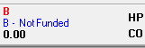

If a patient has a ‘B’ enrolment status code, an alert will be created and displayed when the patient is placed on the palette. At the relevant time, the alert will notify you to complete the eligibility and enrolment process for the newborn patient.

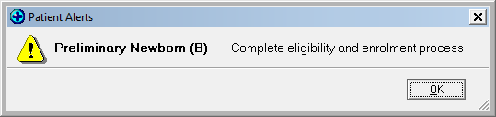

3 Appointment book
The Appointment Book will be modified to highlight patients with a ‘B’ enrolment status code. The ‘Stat’ grid cell will have a pink background if the patient has a ‘B’ enrolment status code.

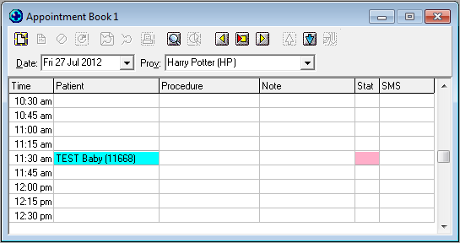

Houston VIP

1 Inbox > NIR – Message type: Patient Nomination
When processing the ‘Patient Nomination’ message, you will have the option to reject or accept the nomination. If you click ‘Reject Nomination’, this warning message will pop up:
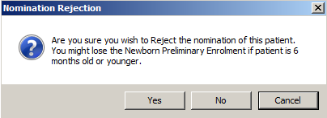

If you accept the nomination, the F3 warning will be updated as below.

2 Enrolment screen and registration
At this stage, the Enrolment screen is still empty. The patient is just stored in the record as a new patient.

Patient status is ‘Registered’; the registration date is recorded as the date when the provider accepts the NIR nomination message.

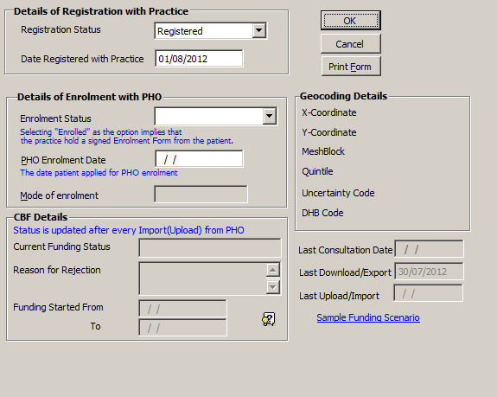

Once the eligibility and enrolment process is completed, fill in the details of enrolment with PHO fields. The warning message as above will be removed automatically, as it is no longer required.

3 Patient list in the ASR report
If the enrolment form has not yet been filled in (‘Enrol Status’ and date fields are still empty), the ‘Enrol Status’ in the ASR report is ‘Baby Coded B’.

If the patient is enrolled, the ‘Enrol Status’ is ‘Enrolled’, as for other patients generally.

4 In the CBF/ASR report
PID||^^^^|AHhkQDsNmv||Little^Stuart^^^Mast^^||20120601|M||||||||||||||99||||||
ZRD|^^^^^^|||Y|^^^^^^^||20120705|||B|||||||^||N||

The ‘Registration Status’ is ‘B’; the registration date is recorded as the date when the patient record is stored in VIP data.

Profile for Windows

1 Use Case – NIR Nomination Notification
Messages from the NIR that the provider has been chosen as a newborn’s GP appear in the Work Centre > NIR > NIR Messages screen.

If you accept the nomination, the newborn can be added as follows:
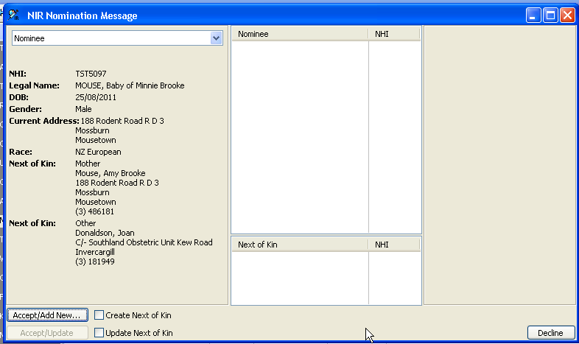

In the nomination message, click on ‘Accept/Add New’. This will cause the following:
i. The newborn’s details are used to add a new patient.
ii. The ‘Patient status’ is set to ‘Registered’.
iii. A new care plan is created for the new patient. A pre-call letter will be automatically sent out when today’s date = (newborn date of birth + 28 days).
iv. A new patient card is created for the patient that will appear in Alter Patient > Financial – named ‘Newborn Pre-enrol Card’. It will have an expiry date of newborn date of birth +92 days.

This completes the nomination workflow.

2 Use Case – CBF Events
In the Control > Centre > CBF Messages screen:

1 ‘CBF Register Export’ is launched.
If patient being exported has a ‘Newborn Pre-Enrol Card’, do the following:
i. If the expiry date > = today’s date, set the ‘Patient Status Code’ to ‘B’ (not expired).
ii. If the expiry date < today’s date and the ‘Patient Status’ is ‘Registered, set the ‘Patient Status Code’ to ‘R’.
iii. If the expiry date < today’s date and the ‘Patient Status’ is ‘Enrolled’, set the ‘Patient Status Code’ to ‘E’.
2 ‘CBF Register Import’ is launched.
i. The CBF register import returns patients processed under the CBF business rules. The records will be returned with the new ‘B’ code in the ZRD record, for example:
ZRD|^^^^^^|-36.864519|174.900956|Y|^^^^^^^||20110402||20110413|B|0||0||675900|2|D^4|SAK|N|| <---- Patient Record Part2

Note: If the acknowledgement messages are either ‘Accepted’ or ‘Rejected’, there is no need to make any changes to the profile; if it is accepted, the newborn’s status will be changed to ‘Enrolled’ (the same as all the others).

In order to ensure the new ‘B’ code does not cause problems for the ‘CBF Register Import’ workflow, the following points must be confirmed.
- Profile does not issue an error when ‘B’ records are processed.
- Profile does not update ‘Profile Patient’ with ‘B’ status (the status should remain unchanged after import).
- Profile updates funding status for ‘B’ patients as expected.

3 Use case – audit and alerts
In order to review the status of newborn enrolments, is necessary to develop a query (‘Find Objects Query – Find Newborns not Enrolled’) to list all patients with Status = ‘Registered’ and Newborn Pre-Enrol Card Expiry Date < today’s date (expired).

Create an alert macro to be checked when newborn arrives for an appointment.

Alert conditions:
Patient Status = ‘Registered’ and Newborn Pre-Enrol Card Expiry Date > = today’s date (not expired)

Display a warning:
‘This newborn is pre-enrolled. Please complete enrolment documentation and change patient status to Enrolled’

Grant CC, Petousis-Harris H, Turner N, et al. 2011. Primary care practice and health professional determinants of immunisation coverage. Journal of Paediatrics and Child Health 47: 541–9.
The definition of ‘residing in New Zealand’ is that you intend to be resident in New Zealand for at least 183 days in the next 12 months.
An authority is the legal right to sign for another person if for some reason they are unable to consent on their own behalf.

