Requirements for conformity assessment bodies that conduct certification audits of providers holding contracts with Te Whatu Ora - Health New Zealand, Whaikaha – Ministry of Disabled People and/or the Accident Compensation Corporation to provide home and community support services.
Auditing Requirements
Ngā Paerewa Health and Disability Services Standard: NZS 8134:2021
Acknowledgments
This is the first edition of the Auditing Requirements: Ngā Paerewa Health and Disability Services Standard NZS8134. It is adapted from the previous handbook for Home and community support sector Standard (2nd edn). NZS 8158:2012 which was first published in October 2012 and revised in May 2017.
Manatū Hauora | the Ministry of Health partnered with Te Whatu Ora – Health New Zealand, Te Aka Whai Ora – Māori Health Authority, Whaikaha – Ministry of Disabled People and Accident Compensation Corporation (ACC) to write and review this handbook.
Citation: Ministry of Health. 2023. Auditing Requirements: Ngā Paerewa Health and Disability Services Standard NZS8134: Wellington: Ministry of Health.
Published in July 2023 by the
Ministry of Health
PO Box 5013, Wellington 6140, New Zealand
ISBN 978-1-991075-41-3 (online)
HP 8805
This document is available at
health.govt.nz

Preface
Home and community support services (HCSS) providers that hold a contract with Te Whatu Ora - Health New Zealand, Whaikaha – Ministry of Disabled People and/or the Accident Compensation Corporation must be certified against Ngā Paerewa Health and Disability Services Standard. This document, Auditing Requirements: Ngā Paerewa Health and Disability Services Standard NZS 8134, guides this certification scheme.

In 2015 an HCSS Oversight Committee ((the Oversight Committee) was formed to support the ongoing development of this certification scheme. It is made up of funder representatives and representatives from HealthCERT. One of the key changes the Oversight Committee made in 2016 was to make it easier to process HCSS audit reports through an electronic database – the Provider Regulation and Monitoring System (PRMS). Using PRMS will eventually make it possible to identify national trends in audit outcomes across HCSS providers with a view to developing quality improvement initiatives with the sector.

This is a revised document of the 2012 document Auditing Requirements: Home and community support sector Standard NZS 8158. A previous revision in 2017 included significant feedback from stakeholder groups. This document is being updated due to NZS 8158 Standards being replaced by the Ngā Paerewa Health and Disability Services Standard :8134(Ngā Paerewa)

During the 2017 revision, stakeholder groups asked the Oversight Committee to consider the following areas of change, some of which remain outstanding in 2023:
- a risk-based approach when deciding on periods of certification
- unannounced midpoint/surveillance audits
- an integrated audit programme (as with the aged residential care sector)
- a standardised tool for ‘clip-on’ events (that include additional contractual elements)
- a sampling methodology that covers:
- the number of sites when auditing large, multi-site providers
- auditors’ time on site
- minimum file review and interviews
- tracer methodology
- the role and function of the Independent Assessment Committee
- audit requirements when a provider sells a certified organisation.

The Oversight Committee considers that it needs to consult further with stakeholders over these areas of change.

In 2021, the Ministry reviewed the potential to regulate HCSS under the Health and Disability Service (Safety) Act 2001. Following consultation with HCSS stakeholders and extensive review, the decision was made not to regulate but instead to strengthen the mechanisms for quality assurance within the existing certification scheme. The Ministry intends to review regulation in 2023.
Contents
Preface iii
1 Introduction 1
1.1 Oversight Committee 1
1.2 Independent Assessment Committee 1
1.3 HealthCERT 2
2. Conformity assessment bodies 3
2.1 An approved CAB 3
2.2 Responsibilities of a CAB 4
2.3 Audit teams 5
2.4 Auditor days on site 6
2.5 Sampling methods 7
2.6 Reporting requirements 8
2.7 Audit costs 9
2.8 Provider regulation and monitoring system 10
3. Audit 11
3.1 Attainment level 13
3.2 Evaluation methods 14
3.3 Risk management 14
4. Certification 16
4.1 Certification period 16
4.2 Certification conditions 16
4.3 Certification document 17
4.4 Monitoring 17
4.5 Additional sites 17
4.6 Sale of a certified organisation 18
4.7 Audits of lead suppliers and subcontractors 18
5. Transition to Ngā Paerewa 19
References 20
Appendix 1: Process of certification for the home and community support sector 21
Appendix 2: Square root table 22
Appendix 3. Capturing information in the audit report under the grace period 23

1 Introduction
This document sets out what conformity assessment bodies (CABs) that audit and certify providers of home and community support services (HCSS) must do to audit and certify these providers against the Ngā Paerewa Health and Disability Services Standard NZS 8134- (Ngā Paerewa). It also outlines the roles of other stakeholders operating within the certification scheme, including the Oversight Committee, the Independent Assessment Committee and HealthCERT.

1.1 Oversight Committee
The Oversight Committee was established in 2015. It is primarily made up of representatives from Manatū Hauora - The Ministry of Health, Te Whatu Ora – Health New Zealand and Te Aka Whai Ora – The Māori Health Authority, HCSS funders, Whaikaha – The Ministry of Disabled People and Accident Compensation Corporation (ACC).

The purpose of this committee is to provide oversight and direction to the HCSS certification scheme, and ultimately to improve sector outcomes. national trends based on audit reports will be identified with audit reports being processed through an electronic database, the Provider Regulation and Monitoring System (PRMS). Over time, PRMS data will build a national picture of the main areas of non-conformity. This information will create the opportunity to work with the sector on key areas for improvement.

From an operational perspective, the Oversight Committee will:
- provide advice to the Independent Assessment Committee (IAC) where required.
- complete an annual review of the terms of reference of the IAC. The role of the IAC is outlined below.
- seek expertise from the relevant groups such as Conformity Assessment Bodies or providers as issues arise.
- hold contact lists for HCSS funders and make it available to CABs
- receive HCSS auditing schedules from CABs and share them with HCSS funders. It is up to funders to identify with CABs if they wish to request specific sites or providers be included in their auditing sampling.

Please note the Oversight Committee is not responsible for the operational activities of the conformity assessment bodies (CABs).

See Appendix 1 for a flowchart of the process involved in certifying HCSS providers.

1.2 Independent Assessment Committee
The role of the Independent Assessment Committee is to conduct an independent review of the audit report and decide whether to endorse the decision to award certification, noting the CAB is responsible for the final certification decision (in line with ISO 17021-1:2015, clause 5.1.3 (ISO 2011)).

The IAC is made up of funder representatives. Each funder nominates at least one representative to participate as a member. To be a member of the IAC, the nominated representative must understand Ngā Paerewa and the certification process relevant to this scheme. The IAC follows Terms of Reference that the Oversight Committee reviews each year.

If the IAC has a complaint that it cannot resolve directly with the CAB, the IAC can escalate the issue to the CAB’s independent appeals committee. HealthCERT will facilitate the process as part of its administrative function as the Oversight Committee has set out (see below).

1.3 HealthCERT
The Oversight Committee has agreed that HealthCERT – Manatū Hauora, the Ministry of Health – will coordinate and administer the HCSS framework on behalf of funders. HealthCERT’s role is to:
- maintain a central repository and collation point for audit reports, audit summaries and progress reports for corrective actions
- manage audit reports using the PRMS
- manage and maintain the web page for publishing audit summaries. Audit summaries will only be published if they meet the Ministry’s publication standards
- channel communications between each CAB and the IAC as they review certification audit reports
- undertake other administrative functions as agreed by the Oversight Committee, including the receipt and dissemination of auditing schedules from CABs to funders, and the maintenance of HCSS funder list to be made available to CABs.

2. Conformity assessment bodies
The requirements in this document apply to audits of HCSS providers that hold contracts with Te Whatu Ora – Health New Zealand and/or the Accident Compensation Corporation (ACC). The contract requires HCSS providers to demonstrate through certification that it is complying with Ngā Paerewa.

In addition to the contractual requirement for HCSS providers to hold certification, a funder may choose to undertake or commission other audit and monitoring activities within the terms and conditions of its contract with a provider.

If a CAB meets the requirements in this document, funders can be assured that it follows a robust and consistent process when undertaking audits and providing audit reports that lead to the certification of HCSS providers.

Once an approved CAB audits and certifies a HCSS provider, that provider meets the certification requirements in its funder contract. Providers may become certified against standards by non-approved CABs, but those providers will not meet certification requirements in funder contracts.

The requirements in this document supplement:
- ISO/IEC 17021-1: Conformity assessment– requirements for bodies providing audit and certification of management systems.
- guidelines for auditing management systems (ISO 19011)
Except where otherwise stated, all elements of ISO/IEC 17021-1: (ISO 2011) apply.

Additional references that apply to these requirements are:
- Ngā Paerewa Health and Disability Services Standard (Ngā Paerewa)
- Conformity Assessment: Vocabulary and general principles (ISO/IEC 17000) (ISO 2004)
- Conformity Assessment: Requirements for bodies providing audit and certification of management systems (ISO/IEC 17021-1) (ISO 2011).

2.1 An approved CAB
A CAB may audit against Ngā Paerewa: NZS 8134:2021 (or later versions) if it:
- meets the requirements in this document
- complies with the following International Accreditation Forum (IAF) documents:
- AS/NZS ISO 19011:– Guidelines for auditing management systems.
- IAF MD1: IAF Mandatory Document for the Audit and Certification of a Management System Operated by a Multi-Site Organization.
- IAF MD2:– International Accreditation Forum Mandatory Document for the Transfer of Accredited Certification of Management Systems.
- IAF MD5:– International Accreditation Forum Mandatory Document for Duration of Quality Management Systems and Environmental Management Systems Audits.
- is a designated auditing agency as authorised under the Health and Disability Services (Safety) Act 2001
- holds third party accreditation with either the Joint Accreditation System of Australia and New Zealand (JAS-ANZ) or the International Society for Quality in Health Care (ISQua) for the Health and Disability Services Standards, and meets all costs associated with this accreditation. If a CAB is ISQua accredited, the CAB must also demonstrate that, as a minimum:
- it reports progress annually to ISQua
- ISQua conducts a two-yearly on-site surveillance audit of the CAB.

A CAB that meets the criteria listed above is an ‘approved CAB’.

If a funder asks for a copy of a CAB’s third-party accreditation certificate, the CAB must provide it. CABs must work to the auditing principles and code of ethics outlined in the Designated Auditing Agency Handbook (Ministry of Health.

2.2 Responsibilities of a CAB
As a CAB, you are responsible for:
- meeting requirements outlined in ISO/IEC 17021-1
- coordinating audit activities with the provider such as:
- ensuring the provider’s certification can continue where the provider achieves compliance
- planning the audit
- conducting the audit
- writing the audit report
- establishing that the provider’s certification status is consistent with this document, ISO 19011 (ISO 2003) and ISO/IEC 17021-1
- contacting the funders before an on-site audit (as part of audit planning) and, seven days before the audit, giving the provider a copy of any funder feedback for follow-up
- submitting the audit report to HealthCERT, who will engage no fewer than two IAC members to review the audit report
- providing a draft of the audit report that covers any specific additional contractual requirements that the funder has paid you to audit
- submitting an electronic audit report using a specified template into PRMS
- notifying funders in writing as soon as practicable (ideally at the time of audit, but within 24 hours of completion of the audit), where the audit identifies critical or high risks; and/or notifying funders where a cumulative number of corrective actions delay the awarding of certification. For national providers, all funders must be informed of critical or high risks irrespective of whether the audited site was in their region.
- monitoring the provider throughout the certification period in line with surveillance requirements and any progress reporting that is required as a result of the audit
- notifying funders if the provider’s progress against corrective actions is inadequate and submitting a record of progress monitoring into PRMS.
- provide the Oversight Committee with an annual audit schedule, commencing 29 January each year and provide an update of this schedule on a quarterly basis.

2.3 Audit teams
The audit team must follow the principles of auditing:
- ISO/IEC 17021-1: Conformity Assessment: Requirements for bodies providing audit and certification of management systems (ISO 2011).
- the principles outlined in the Designated Auditing Agency Handbook (Ministry of Health 2016).

The members of the audit team must be competent in areas appropriate to the service they are auditing. The team must have enough auditors to complete the audit against all relevant criteria in the standards.

The audit team must include a:
- team leader (or lead auditor) who is familiar with person-centred HCSS models of care
- clinical/technical expert in the delivery of HCSS who has:
- a qualification in nursing or allied health services and current annual practising certificate; or a rehabilitation qualification and/or home care auditing experience
- experience in medication management (within an HCSS setting)
- consumer auditor when this is a contractual requirement

Auditors have developed sufficient knowledge and skills in quality management if they have achieved as a minimum:
- a qualification of unit standard NZQA 8086 (demonstrate knowledge required for quality auditing)
- two years’ work experience in the Health and Disability sector unless a consumer auditor.

Clinical/technical experts must have at least two years’ work experience in HCSS or related fields; or have experience in auditing home care services.

The team leader and clinical/technical expert may be the same person and fulfil both roles and responsibilities of the audit if the person meets the criteria for both roles above.

A consumer auditor may be a qualified auditor or a person who has been trained in auditing principles (but is not necessarily qualified as an auditor) and is a person with a disability and a lived experience of receiving residential services or HCSS; or is a family member of that person. Where the consumer auditor is qualified as an auditor, they may take on audit functions in addition to the consumer role as outlined in the Designated Auditing Agency Handbook (Ministry of Health 2022).

If a team of two or more is performing an audit, each team member does not have to meet all the competency criteria for the area of activity involved. However, the team as a whole must meet all the competency criteria.

The requirements for audit team competency apply to all types of audits.

For a surveillance audit, a:
- team leader can conduct it if they are experienced in auditing home care services and, as a minimum, have access to the CAB’s clinical/technical advisor
- consumer auditor need not be involved.

As a CAB, you must have procedures for establishing the ongoing competence of your auditors, including auditors in the roles of team leader, clinical/technical expert, and consumer auditors. You must also have a process for reviewing the performance of each auditor at least once a year through, for example, periodically observing each auditor’s performance on site. Base the frequency of such observations on the need you identify from all monitoring information available.

2.4 Auditor days on site
The length of the certification audit depends on the size, nature, and complexity of the organisation you are auditing. You should work out the time required on site to satisfactorily complete the audit. This time will involve at least:
- 50 percent of the estimated time spent preparing for the audit (stage 1) and completing the audit report (all audits)
- for a certification audit, two auditors on site for:
- 1.5 days (or equivalent) for a single-site provider or 1 day for smaller providers.
- 0.5 days for each additional site audited for a multi-site provider
- for a surveillance audit, one auditor on site for:
- 1 day (or equivalent) for a single-site provider
- 0.5 days for each additional site audited for a multi-site provider.

2.5 Sampling methods
The following sampling requirements apply to consumer record reviews and interviews, and sampling multiple sites.

Minimum sample size – consumer record reviews
Consumer records are reviewed as part of the on-site audit. Ideally, the records you review will be those of the consumers you interview.

Decide on the minimum sample of consumer record reviews using this square root rule:
- certification audit consumer record sample = 0.6 times the square root of the number of current consumers receiving HCSS (rounded to a whole number). Exception: If a service has fewer than 10 consumers, review a minimum of three records, maximum of 20
- surveillance audit consumer record sample = 0.3 times the square root of the number of current consumers receiving HCSS (rounded to a whole number). Exception: If a service has fewer than 50 consumers, review a minimum of three records, maximum of 20.

Stratify sampling so it is representative of:
- the current consumers receiving HCSS (that is, stratified to complex, non-complex, short term, long term and so on)
- service agreements between the provider and its funders.

Increase the sample size if you identify non-conformity with the standard.

Minimum sample size – consumer interviews
The number of consumers interviewed as part of the audit process depends on the size, nature, complexity, internal quality monitoring of consumer satisfaction and funding arrangements of the provider you are auditing. Decide on the minimum sample using the same 0.6 x square root rule for certification and surveillance audits as set out for consumer records above, with a maximum of 20. Whānau shall be included in the minimum sampling requirements for consumer interviews as outlined in the Designated Auditing Agency Handbook (Ministry of Health).

Conduct face-to-face interviews with consumers as part of the sample for certification audits. In addition, you may also conduct telephone interviews or surveys.
Increase the sample size for face-to-face consumer interviews if you identify non-conformity.

Minimum sample size – multiple sites
Decide on the minimum sample for multi-site reviews using this square root rule:
- certification audit site sample = the square root of the number of sites
- surveillance audit site sample = and 0.6 times the square root of the number of sites.

It is expected that you will rotate the sites you audit within a three-year period (initial certification audit, surveillance audit and next certification audit) so that you audit the maximum possible number of individual sites of the multi-site provider.

- Funders may ask you to include or exclude their region or a particular regional site in your sample plan for any audit. These requests must be provided within five days by the funder to enable audit planning.

2.6 Reporting requirements

Evidence
You may use your own audit tools and workbooks to audit against Ngā Paerewa As part of the process of collecting audit evidence, consider using standardised assessment and outcome tools consistent with the service delivery aspects of Ngā Paerewa, as required under a provider’s contract with its funder.

Audit reports
For all audit reports:
- use the prescribed template to complete it
- the writer must be the team leader or audit team for all audits, including verification visits
- include:
- the reporting requirements outlined in ISO/IEC 17021-1: (ISO 2011)
- the level of compliance against each criterion for each outcome in the standard as set out in the auditing requirements for each type of audit
- an executive summary for each standard, stating whether the provider achieved attained, partially attained, or unattained for each criterion, and identifying criteria that were not met
- details of non-conformities with supporting evidence
- where criteria have not been achieved, corrective actions that are specific, measurable, and relevant and contain a timeframe
- the areas covered by the audit (for example, areas of the services provided and locations, satellite services, departments, processes, number, and types of interviews), and observations made, both positive (for example, noteworthy features) and negative (for example, opportunities for improvement)
- opportunities for improvement where criteria have been fully attained and the auditors have noted further actions that the provider could take to move towards continuous improvement
- make sure the report reflects the findings of the audit
- present the report in word-processed format
- follow Manatū Hauora – The Ministry of Health’s Audit Report Writing Guide (Ministry of Health 2014).

Allow funders to review and comment on the draft audit report where it relates to any specific additional contractual elements, before you finalise the audit report. The funders have seven working days to come back to you with comments.

Submit final audit reports electronically into PRMS and copy them to funders. Submit a final report no later than eight weeks following the on-site audit, unless you identified further actions the provider needs to take before you can award certification.
Manatū Hauora – The Ministry of Health intends to publish audit summaries on its website. Your audit summaries must meet the Ministry of Health publication standards and the provider must agree with the final audit summary before you submit the report into PRMS. You must have a process for dealing with situations where you and a provider cannot agree on the audit summary.

2.7 Audit costs
Funders are not liable for the cost of certification audit services.

If a funder requests you to include additional criteria in an audit, specific to a service agreement that it holds with a provider, the funder will negotiate any payment to you before the audit starts. This payment is likely to be a set price based on a time requirement the funders and you have already worked out and agreed on.

If a funder requests you to include a site within the sample for the audit, you must include this without the funder gaining additional costs, unless you cannot accommodate this additional site within the sampling equation (see ‘Minimum sample size – multiple sites’ in Section 2.5).

2.8 Provider regulation and monitoring system
You must:
- access the PRMS via a connection to the New Zealand Health Network (Connected Health)
- securely manage user-specific log-in and passwords to the PRMS
- use the PRMS to download provider-specific audit reporting templates, which you then use to complete audits
- use the PRMS to upload completed audit reports
- complete the prescribed form in the PRMS that maintains an up-to-date register of auditors who undertake audits on your behalf. An auditor must not undertake an audit on your behalf if you have not entered them onto the auditor register
- ensure the lead auditor/team leader and a peer reviewer have reviewed all audit reports before you submit them to the PRMS. The peer review process must include but is not limited to:
- proofreading the report
- ensuring the report is factual and accurate
- ensuring the audit activities conducted were technically adequate and properly documented
- ensure the report follows the guidelines set out in the Ministry of Health’s Audit Report Writing Guide (Ministry of Health 2014).

3. Audit
The three types of audits of HCSS providers are:
- certification audit
- verification audit
- surveillance audit.

In all audits, you must include the subsections and related criteria listed in Table 1.

Table 1: Audit activity required by audit type
Type of audit | Description of organisations that are audited | Audit activity required | Result
Certification audit | Organisations providing home and community support services that are seeking certification against Ngā Paerewa | Conduct a first stage audit, considering any revised or new policies and procedures against Ngā Paerewa  Conduct a second stage on-site audit against Ngā Paerewa | Conformity assessment body issues three-year certificate
Verification audit | - adding an additional premise into an existing certificate  - adding an additional scope of practice  - Changing premises or making significant changes to premises | The provider shall notify the CAB prior to the establishment of the new site.  A risk-based approach should be taken.  If a surveillance or certification audit is scheduled within the next six months, the following process applies:  - The provider warrants that governance, systems, processes, policies, and procedures are substantially the same as the current service and provides the following information:  - Management changes/adaptations for the move  - Management of the logistics of the move to a new building  - Adjustments to policies and procedures  - Planned process flow for the service delivery  - At the next surveillance or certification audit (conducted within the next six months) the new site/s will be included in the sample and the information provided at number 1 above will be verified.  If a surveillance or certification audit is not planned within the next six months, a verification audit should be conducted. The verification audit should include all in scope HCSS Ngā Paerewa Subsections/criteria. | New site added to existing certificate. Dates do not change
Surveillance audit | Services near the midpoint date of their certification period – the surveillance audit occurs in the window two months either side of this date | Conduct an on-site audit of:  - non-conformities identified at the certification audit  - changes that have occurred since the certification audit  - 1.3 My Rights during service delivery (five criteria)  - 1.5 I am protected from abuse 1.5.1, 1.5.2, 1.5.3, 1.5.4)  - 1.8 I have the right to complain (five criteria)  - 2.1 Governance (2.1.1, 2.1.2, 2.1.3, 2.1.4)  - 2.2 Quality and Risk (2.2.2, 2.2.4, 2.2.6)  - 2.3 Service management (2.3.1, 2.3.2, 2.3.3, 2.3.4)  - 2.4 Healthcare and support workers and their availability (2.4.2, 2.4.3, 2.4.4)  - 3.1 Entry and declining service (3.1.2, 3.1.3)  - 3.2 My pathway to wellbeing (3.2.1, 3.2.2, 3.2.6, 3.2.7,)  - 4.2 Security of people and workforce (4.2.3, 4.2.6)  - 5.2 The infection prevention programme and implementation (5.2.3, 5.2.6) | Contribution to monitoring that occurs within the period of certification
Provisional Audit | For new ‘start up’ providers (prior to services being provided to clients) | Conduct a full certification audit of as much of the standard as is possible. Given that a substantial amount will be rated as ‘not audited’ or ‘not applicable’, particularly in Pathways to Wellbeing,  Certification should be awarded for one year, and a condition of certification shall be that a full certification audit is conducted within 12 months of services being provided. If the full certification audit confirms that the standards are substantially complied with, certification can then be confirmed – the original certification dates and requirements for surveillance and corrective action reporting will remain in place. | Full certification that is provisional upon a full certification audit within 12 months of commencing service delivery.

3.1 Attainment level
As part of the audit process, you must decide on the level of attainment the provider achieves for each relevant criterion. The levels of attainment are based on a continuous quality improvement model, so are incremental (see Table 2).

Table 2: Meaning of the attainment levels
Attainment level |  | What it means
CI | Continuous improvement | The service has attained the criterion and demonstrates a review process, including:  - analysing and reporting findings  - having evidence that it has acted based on those findings  - improving service provision and consumers’ safety or satisfaction as a result of the review process
FA | Fully attained | The service demonstrates implementation (for example, practice evidence, training, records, or visual evidence) of the process, systems, or structures to meet the required outcome of the criterion.
PA | Partially attained | There is evidence that the service has implemented an appropriate process (for example, a policy, procedure, or guideline), system or structure without having the required supporting documentation.  Or  A documented process (for example, a policy, procedure, or guideline), system or structure is evident, but the organisation or service cannot demonstrate that it has implemented it where this is required.
UA | Unattained | The organisation or service cannot demonstrate appropriate processes, systems, or structures to meet the required outcome of the criterion.
NA | Not applicable | The criterion does not apply to the service that is being audited.

In your audit report, record the lowest attainment level finding for each of the criteria and outcomes you are reporting on.

3.2 Evaluation methods
Auditors record evaluation methods used in their field notes. They triangulate audit evidence where possible.

3.3 Risk management
Identify the degree of risk to consumers’ safety that is associated with the level of attainment the provider achieves for each criterion. Audit the ‘risk’ in relation to its possible impact on the consumer, based on the consequence and likelihood of harm occurring if the provider does not fully attain the criterion. Use the risk management matrix when the audit result for any criterion is partially attained or unattained.

To use the risk management matrix, you need to:
- consider what consequences for consumer safety might follow from the provider achieving partially attained or unattained for a criterion, within a range from extreme/actual harm to negligible risk of harm occurring
- consider how likely it is that this adverse event will occur due to the provider achieving partially attained or unattained for a criterion, within a range from being almost certain to occur to rare
- plot the findings on the risk assessment matrix to identify the level of risk, which may range from critical to negligible, and prioritise risks in relation to severity (for example, critical to negligible)
- approve the appropriate action the provider must take to eliminate or minimise risk within the timeframe in the ‘action required’ section (Figure 1). Note that timeframes are set based on full resolution of the requirement, which may include a systems change or staff training programme. State anything requiring urgent attention in your report, along with any longer timeframe the provider needs to make sustainable change.

Figure 1: Risk management matrix
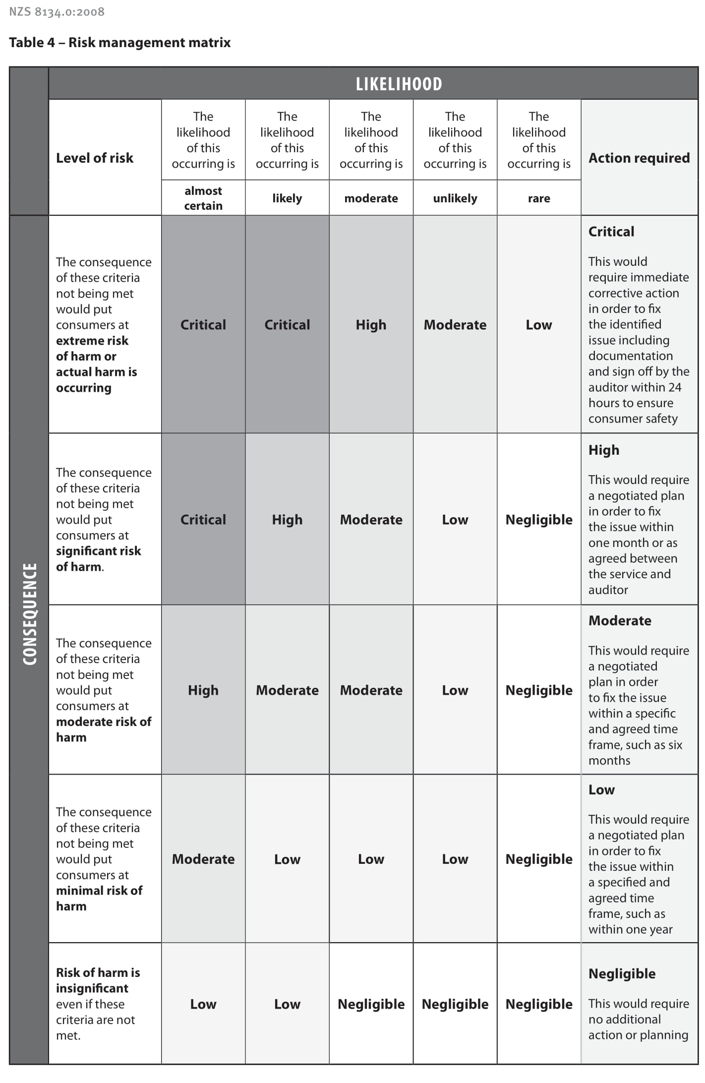

4. Certification
Follow a two-stage certification decision process.
- A team leader experienced in auditing home care services conducts a systematic peer review of the audit report. The peer review includes associated audit evidence (that is, field notes, workbooks, or tools) where a report is ambiguous. The peer reviewer must be independent of the original audit. After the peer reviewer has completed the peer review, the CAB recommends either certification or delaying certification pending completion of corrective action requirements.
- An Independent Assessment Committee, made up of two funder representatives, conducts an independent review of the audit report and decides whether to endorse the decision to award certification. The Independent Assessment Committee has seven working days to respond to and provide feedback on the audit report.

A provider with a ‘critical’ or residual high level of risk may not be certified.

You must decide on certification and notify the provider of your decision within eight weeks of completing the audit. You must also have an appeal process consistent with ISO/IEC 17021-1:2015

4.1 Certification period
The certification period is three years from the date of the certification decision. A provider must have at least one on-site surveillance audit near the midpoint date of its certification period to maintain its certification. Findings are actioned in line with the risk management matrix (see Figure 1 in Section 3.3). You can schedule this surveillance audit two months either side of the midpoint.

If a provider has a ‘critical’ or residual high level of risk and certification proceeds, you may, in liaison with the IAC, require additional surveillance activities. This may include on-site visits or yearly surveillance audits.

4.2 Certification conditions
With each certificate you issue, include conditions of certification based on risks that the audit has identified. These conditions may include requirements for the provider to make written progress reports of corrective actions or for you to verify corrective actions on site and to conduct an annual surveillance audit or other progress monitoring.

4.3 Certification document
Notify the provider of your audit report and give it a copy of the report and a certification document that includes the information outlined in ISO/IEC 17021-1: (ISO 2011).

Keep an up-to-date record of all the provider’s sites that have met the certification requirements. You must date certification documents from the date of your formal decision to award certification.

4.4 Monitoring
Monitor the HCSS provider during the period of certification to ensure it:
- has addressed any non-conformity that you identified at the time of the certification or surveillance audit
- is maintaining its systems and processes.

Have procedures in place to ensure that the provider takes corrective action in line with the risk management matrix (see Figure 1 in Section 3.3). These procedures may include getting a written progress report from the provider or making an on-site verification visit.

If the provider does not correct a non-conformity in the timeframe agreed at the audit and to be consistent with the risk management matrix, you:
- may suspend certification
- must notify the funders before any such suspension.
- notify the Oversight Committee of any suspensions of certification.

Make available to the funders your monitoring reports on a provider. Funders may work with you in monitoring requirements that result from audits.

4.5 Additional sites
When the provider plans to add another satellite (for example, a regional site) to an existing service that holds certification, it must apply to you to complete a verification audit within six months of establishing the additional site. You must issue certification to match the expiry of the current certificate that the provider holds.

The provider must notify you before adding the new site and confirm in writing that its governance, systems, processes, policies, and procedures are substantially the same as those in the current service.

4.6 Sale of a certified organisation
The current provider owns the certification. If a new organisation buys a certified organisation, it may keep that certification for a maximum of six months (unless the certification period expires before this date). The organisation shall have a CAB complete a certification audit within six months of taking possession, to issue a new certificate.

You may withdraw or suspend certification, where it has been transferred with the sale of an organisation if the systems and processes for operational management or quality and risk management differ substantially from those in the certified organisation. Before doing so, however, you must liaise with the relevant funders of the new organisation.

4.7 Audits of lead suppliers and subcontractors
In an audit of a lead supplier of HCSS, consider how that supplier manages quality and risk management systems, its organisational management, and how consistently it delivers services across its subcontractors.

In auditing a lead supplier against Ngā Paerewa: establish whether the lead supplier:
- has a process for subcontractor organisations to implement policies and procedures that are consistent with the lead supplier’s policies and procedures
- collects high-quality monitoring information from its contractors and subcontractors and has a mechanism for regularly communicating issues with its contractors and subcontractors.

Subcontractor organisations must be certified against Ngā Paerewa: and demonstrate how they share information with a lead supplier. If a lead supplier is a supply chain management organisation providing services in the capacity of a lead supplier, it needs to be certified against Ngā Paerewa:

5. Transition to Ngā Paerewa
A non-punitive approach will be used to HCSS providers transition to Ngā Paerewa. The approach includes the following guidelines:
- Mapped criteria will continue to be audited as usual and attainment aligned with existing audit practices.
- Partially mapped criteria will have a grace period for all audits undertaken from 1 July 2023 until 31 July 2023.
- Unmapped/new criteria will have a grace period for all audits undertaken from 1 July 2023 until 31 January 2024
- The grace period only applies to the HCSS providers first audit against Ngā Paerewa. At the next subsequent audit, the standard process will apply (attainment will be awarded).
- A partially attained rating will be applied if a provider cannot demonstrate any progress toward implementation of a new (‘not mapped’) or partially mapped criterion.
- If there is a clinical risk found at audit associated with the partially mapped or new (’not mapped’) criterion, the auditor can either make it a finding or impose a recommendation with a timeframe and risk rating (in the narrative). It will be up to the auditor’s discretion to decide whether a finding or recommendation is warranted.
- During the grace period, where a HCSS provider has not fully achieved a partially mapped or new (‘not mapped’) criterion but is making progress towards implementation: It will be marked as fully attained (FA) at criterion level and narrative about the evidence will be made at the criterion level and at subsection level under the recommendation field.

It is important to note: any standard BAU recommendations made will be mixed with the grace period narrative, hence the narrative in the recommendation field needs to be clear to define the difference.

See Appendix 3 for capturing grace period data in the audit report.

References
IAF. 2007a. IAF Mandatory Document for the Certification of Multiple Sites Based on Sampling. Issue 1, Version 2. IAF MD1:2007. Quebec: International Accreditation Forum.
IAF. 2007b. IAF Mandatory Document for the Transfer of Accredited Certification of Management Systems. Issue 1. IAF MD2:2007. Quebec: International Accreditation Forum.
IAF. 2015. IAF Mandatory Document for Duration of QMS and EMS Audits. Issue 3. IAF MD5:2015. Quebec: International Accreditation Forum.
ISO. 2003. Guidelines for Auditing Management Systems. ISO 19011:2011. Geneva: International Organization for Standardization.
ISO. 2004. Conformity Assessment: Vocabulary and general principles. ISO/IEC 17000:2004. Geneva: International Organization for Standardization.
ISO. 2011. Conformity Assessment: Requirements for bodies providing audit and certification of management systems. ISO/IEC 17021-1:2015. Geneva: International Organization for Standardization.
Ministry of Health. 2014. Audit Report Writing Guide: A guide for writing audit reports to the Ministry of Health (revised November 2014). Wellington: Ministry of Health.
Ministry of Health. 2022. Designated Auditing Agency Handbook: Ministry of Health auditor handbook (revised 2022). Wellington: Ministry of Health. URL: www.health.govt.nz/publication/designated-auditing-agency-handbook (accessed5 May 2022).
SNZ. 2012. Home and Community Support Sector Standard. NZS 8158:2012. Wellington: Standards New Zealand.
SNZ. 2021. Ngā Paerewa Health and Disability Services Standard. NZS 8134:2021. Wellington: Standards New Zealand.

Appendix 1: Process of certification for the home and community support sector
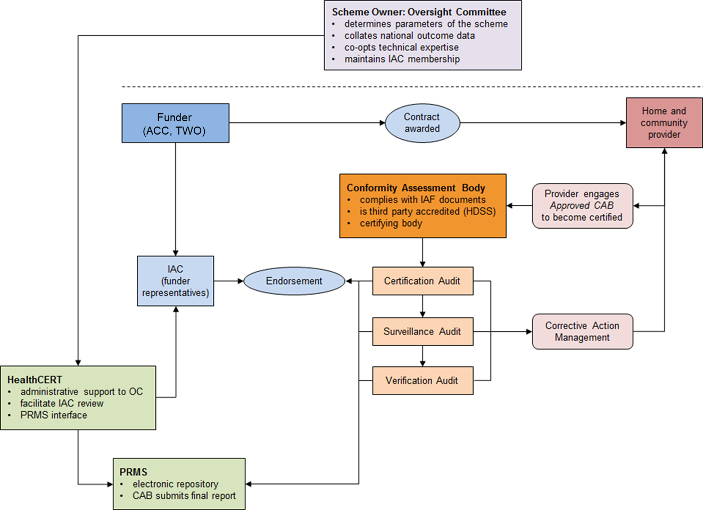

Key:
ACC Accident Compensation Corporation
CAB Conformity assessment body
HDSS Health and Disability Services Standards
IAC Independent Assessment Committee
IAF International Accreditation Forum
TWO Te Whatu Ora – Health NZ
OC Oversight Committee
PRMS Provider Regulation and Monitoring System

Appendix 2: Square root table
Use this guide to check you have followed the square root rule correctly. Note that you round up numbers with decimal points to the next whole number.
Note: a maximum of 20

Number of home and community support service clients currently receiving support | Square root calculation of sample size
 | 0.6 times the square root | 0.3 times the square root
10 | 3  (minimum requirement;  square root rule does not apply) | 3  (minimum requirement;  square root rule does not apply)
20 | 3 | 3  (minimum requirement;  square root rule does not apply)
30 | 4 | 3  (minimum requirement;  square root rule does not apply)
40 | 4 | 3  (minimum requirement;  square root rule does not apply)
50 | 5 | 3
100 | 6 | 3
150 | 8 | 4
200 | 9 | 5
250 | 10 | 5
300 | 11 | 6
350 | 12 | 6
400 | 12 | 6
450 | 13 | 7
500 | 14 | 7
750 | 17 | 9
1,000 | 19 | 10
1,250 | 20 | 11
1,500 | 20 | 12
1,750 | 20 | 13
2,000 | 20 | 14

Appendix 3. Capturing information in the audit report under the grace period
There are three possible scenarios that apply:
- Where the partially mapped or new (‘not mapped’) criterion is truly rated as FA or continuous improvement (CI): follow the standard practice.
- Where a HCSS provider has not fully achieved a partially mapped or new (‘not mapped’) criterion but is making progress towards implementation: It will be marked as fully attained (FA) at criterion level and narrative about the evidence will be made at the criterion level and at subsection level under the recommendation field.
Enter as per the following:
- at criterion level choose the rating: FA
- enter narrative at criterion level into the evidence field. See example:
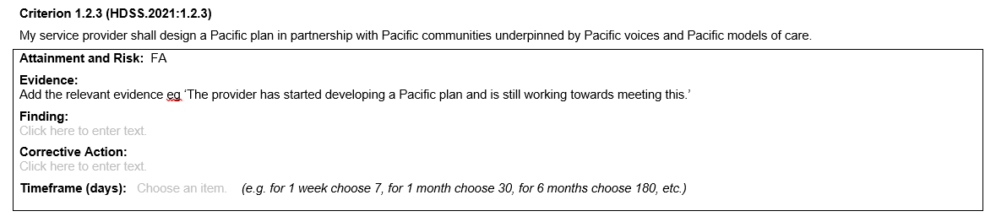
- the findings, corrective action and timeframe fields will not be used.
- at subsection level under the recommendation field add narrative. Use the following style:

‘This is the providers first audit against Ngā paerewa and has occurred within the grace period. The provider is still working towards meeting the following criterion/criteria:
Criterion/criteria for ‘XXX: evidence: XXXXXX’ See example:
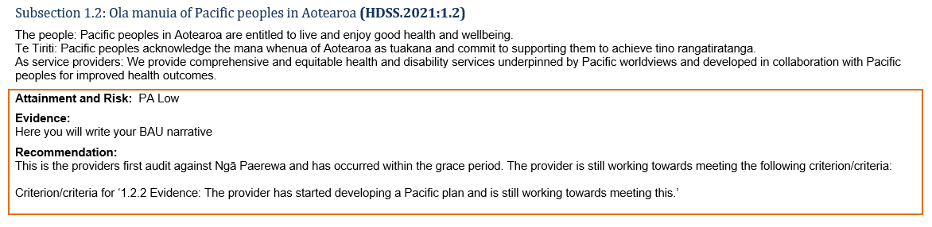
- It is important to note: any standard BAU recommendations made will be mixed with the grace period narrative, hence the narrative in the recommendation field needs to be clear to define the difference.
- Enter in the attainment and risk and evidence field for the overall subsection as per the usual process.

- Identification of potential clinical risks or other concerns:
If there is a clinical risk found at audit associated with the partially mapped or new (’not mapped’) criterion, the auditor can either make it a finding or impose a recommendation with a timeframe and risk rating (in the narrative). It will be up to the auditor’s discretion to decide whether a finding or recommendation is warranted.
- If a finding is required: use the standard process. There will be no need to add this narrative under the recommendation field.
- If a recommendation is required and you are not imposing a finding:
- at criterion level choose the rating: FA
- add narrative at criterion level into the evidence field. See example:
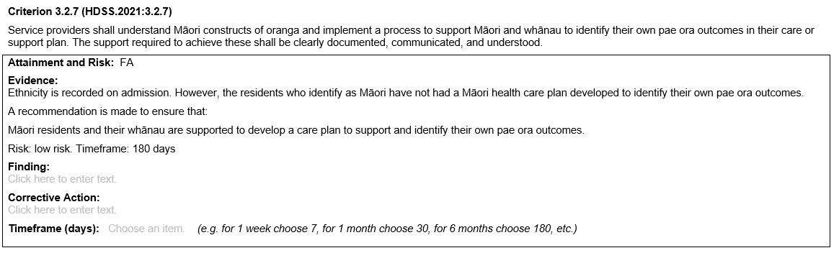
- At the subsection level in the recommendation field add the narrative. Use the following style:
‘The provider is still working towards meeting the following criterion/criteria, however clinical risk has been associated and the following recommendation has been made:
Criterion/criteria for ‘XXX: Audit evidence: XXXXXX
Risk: XX
Timeframe: XX’ See example:
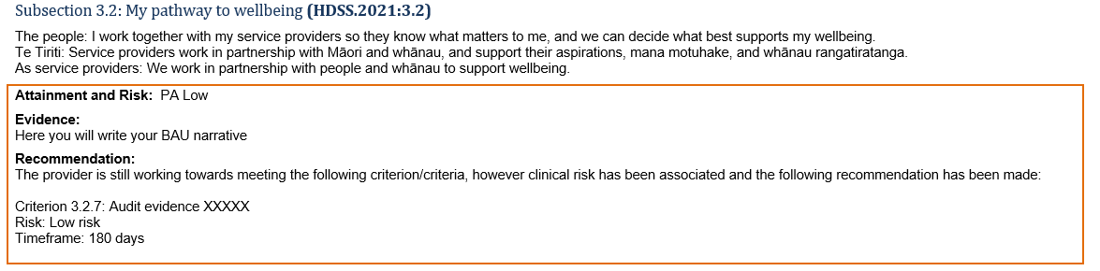
It is important to note: any standard BAU recommendations made will be mixed with the grace period narrative, hence the narrative in the recommendation field needs to be clear to define the difference.

A certification scheme defines the process and criteria for deciding whether a service meets specific criteria.
HealthCERT regulates overnight health services in line with the Health and Disability Services (Safety) Act 2001.
The IAC reviews certification reports of contracted providers only.
If you are an approved CAB, you will receive a link to PRMS.
See Appendix 2 for an example of sampling based on the square root rule.
Notification to the Oversight committee can be made to HealthCERT via the Certification email inbox certification@health.govt.nz
A lead supplier holds a service agreement with a funder. The lead supplier may, if its service agreement allows subcontract services to an independent party where it has a contractual arrangement with the lead supplier (and not with the funder directly).

