National Health Emergency Plan
A framework for the health and disability sector

Citation: Ministry of Health. 2015. National Health Emergency Plan:
A framework for the health and disability sector. Wellington: Ministry of Health.
Published in October 2015
by the Ministry of Health
PO Box 5013, Wellington 6145, New Zealand
ISBN 978-0-478-44853-5 (online)
HP 6236
This document is available at www.health.govt.nz


 This work is licensed under the Creative Commons Attribution 4.0 International licence. In essence, you are free to: share, ie, copy and redistribute the material in any medium or format; adapt, ie, remix, transform and build upon the material. You must give appropriate credit, provide a link to the licence and indicate if changes were made.

Foreword
Since the release of the first National Health Emergency Plan in 2004, New Zealand has experienced a number of significant disasters and emergencies. These include major national events, such as the Canterbury earthquakes, and the impact of global events such as the H1N1 influenza pandemic in 2009.

Our planning and preparedness have continued to be tested over this time, with more complex issues arising. These have required us to reflect on how we manage emerging situations and have necessitated greater collaboration, both within the health and disability sector and across other agencies, to effectively respond as a nation to these types of events.

The sector has clear responsibilities under the Health Act 1956, the Civil Defence Emergency Management Act 2002, and the National Civil Defence Emergency Management Plan Order (2015) to be able continue functioning to the fullest possible extent in an emergency and plan to manage surge capacity in a coordinated way.

We must be adaptive and evolve to ensure the health and disability sector has both the capability to respond effectively to emergency events and the flexibility to adjust our plans to new situations.

The National Health Emergency Plan 2015 reflects this current thinking. It is written across the 4R’s of reduction, readiness, response and recovery and describes a framework for all within the health sector to plan and prepare for any of the numerous risks we face.

Chai Chuah
Director-General of Health

Plan development and review
This edition of the National Health Emergency Plan has been revised and updated to reflect current thinking on the health aspects of emergency management in New Zealand and internationally. It reflects the sophistication of a second-generation, risk-based plan developed by emergency management specialists under the leadership of the Joint Centre for Disaster Research in partnership with the Ministry of Health.

The plan was developed in consultation with local and international specialists in the field of emergency management, emergency managers and planners in the health and disability sector, and other key stakeholders. A collaborative, consultative approach has been taken throughout the development of the plan, including holding workshops with health emergency management stakeholders across the nation. Constant contact has been maintained with the concurrent review of the National Civil Defence Emergency Management Plan Order 2015 (National CDEM Plan) to ensure consistency between the two plans.

In acknowledgement of the importance of evidence-based policy and practice, an extensive international literature review formed the basis for much of the plan’s content.

To maintain its alignment with the National CDEM Plan, the National Health Emergency Plan will be reviewed by the Ministry of Health within five years of its adoption. The plan will also be reviewed and updated as required following any new developments or substantial changes to the operations or organisation of New Zealand health and disability services, as a result of lessons from a significant emergency affecting the health of communities or the health and disability sector itself, if new hazards and risks are identified, or by direction of the Minister of Health or Director-General of Health.

Annexes at the back of the plan are intended to provide a short document format that can be rapidly updated with new or revised guidance on specific issues as they are identified. The Ministry of Health welcomes submissions of good practice that can be incorporated into future editions.

Contents
Foreword iii
Plan development and review iv
Executive summary viii
Introduction 1
Purpose 1
Audience 2
Context 2
Objectives 3
Guiding principles 4
Emergency management approach 5
Emergency management enablers 6
Hazards and risks to be managed 14
Types of hazards 14
Hazards, risks and consequences 15
Reduction 17
Introduction 17
Risk reduction activities 17
Readiness 20
Introduction 20
Planning for readiness 20
Public education 29
Capability development 30
Response 34
Introduction 34
Warnings and advisories 37
Key response functions 48
Review of emergency responses 50
Recovery 52
References 55
Appendices 57
Appendix 1: Self-assessment checklist for a health emergency plan 57
Appendix 2: Suggested content for health emergency plan 59
Appendix 3: Risk analysis – hazards and their consequences for the health and disability sector 61
Appendix 4: International Health Regulations 2005 64
Appendix 5: Border health protection 65
Appendix 6: Ethical values underpinning decision-making 68
Appendix 7: Whole-of-community health services 70
Appendix 8: Human resources and staffing 72
Appendix 9: Organisational debriefings 75
Appendix 10: Managing volunteers in an emergency 78
Appendix 11: Position statement on infant feeding in an emergency 80
Appendix 12: Evacuation, relocation or shelter in place of health care facilities 82
Appendix 13: Management of the deceased 85
Appendix 14: The coordinated incident management system 88
Appendix 15: Roles by Ministry of Health alert codes 91
Appendix 16: Framework for funding during planning and response cycles 93
Glossary and abbreviations 95

List of tables
Table 1: Health and disability sector roles and responsibilities in readiness and reduction 10
Table 2: Health and disability sector roles and responsibilities in response and recovery 11
Table 3: Health and disability sector alert codes 39
Table 4: Response, including health response, at five levels of incident or emergency 41
Table A1: Ethical values to inform how decisions are made 66
Table A2: Ethical values to inform what decisions are made 67
Table A3: Considerations for community-based assessment centres 69
Table A4: Considerations for staffing issues 72
Table A5: Debriefing considerations 75
Table A6: Volunteer management considerations 77
Table A7: Health care facility evacuation considerations 81

List of figures
Figure 1: Framework for health emergency management documents 3
Figure 2: Risk-based comprehensive emergency management 5
Figure 3: Generic health response coordination structure 35
Figure 4: National crisis management – Ministry of Health as national lead agency 36
Figure 5: Health EMIS logic diagram 44
Figure 6: Generic multi-level response coordination 47
Figure 7: Formal liaison structure for DHBs and other local response agencies 47
Figure 8: Integrated + holistic recovery 52
Figure A1: CIMS in the health context 87

Executive summary
The National Health Emergency Plan marks an important step forward in the continual development of the capability and capacity of health emergency management in New Zealand. The plan builds on the experiences of preparing for, building resilience to, responding to and recovering from a range of hazards in New Zealand and elsewhere, including human disease pandemics, tsunami, terrorist incidents, earthquakes and technological incidents over the past decade.

The plan uses a comprehensive, risk-based approach to emergency management, intended to support all health stakeholders to better understand the risk context they are required to manage and to deliver services in. It strengthens the focus on risk reduction to ensure that all parts of New Zealand’s health and disability sector understand they have roles in managing risks to their services and the communities they serve. The plan focuses on those risks described in the National Hazardscape Report (ODESC 2007) and outlined in the National CDEM Plan.

The plan describes the context in which health emergency management occurs within New Zealand. It provides guidance on the enablers of effective health emergency management and describes the roles and responsibilities at all levels across the areas of reduction, readiness, response and recovery. The mechanisms, systems and tools used in the health and disability sector to respond to an emergency event are also described in detail.

To support planning activities, the appendices provide additional information and practical guidance for the health and disability sector on specific aspects covered in the National Health Emergency Plan.

Introduction
An emergency is a situation that poses an immediate risk to life, health, property, or the environment that requires a coordinated response.

By their very nature, emergencies have consequences that are difficult to predict. They can happen anywhere, at any time, with little or no warning. An emergency can vary in scope, intensity and impact. However, we can ensure that we have an adequate understanding of the nature of hazards our communities, health services and partner organisations face and that we are all as prepared for them as possible. We all have a role to play in building resilience to hazards and reducing vulnerabilities before, during and after emergencies.

An emergency can affect access to health services and the health and disability sector’s ability to respond to the public’s health needs. The greater the complexity, impact and geographic scope of an emergency, the more multi-agency coordination will be required. To prevent, prepare for, respond to and recover from such emergencies, a whole-of-sector approach is needed which combines expertise and capabilities at all levels across all agencies.

Aspects of this plan are directive, requiring entities and organisations within the health and disability sector to enter into arrangements and partnerships, develop plans, manage risks, build capabilities, and contribute responses to and recovery from emergencies.

Purpose
The intent of this plan, and its supporting sub-plans and associated documents, is to ensure that New Zealand health and disability services are positioned to effectively meet the health needs of the community during an emergency in an appropriate and sustainable manner. The plan will provide a resource to assist in the response to an emergency, minimise the impacts of the emergency on the health of individuals and the community, facilitate the recovery process and help to build a resilient community and health and disability sector. This plan is about understanding the nature of risks and hazards, building resilience and reducing vulnerabilities. The plan provides a framework that services can use to inform their planning to meet their expected capacity in these circumstances.

Specifically the National Health Emergency Plan:
- creates the strategic framework to guide the health and disability sector in its approach to planning for, responding to and recovering from health-related risks and consequences of significant hazards in New Zealand
- clarifies how the health and disability sector fits within the context of New Zealand emergency management
- specifies roles and responsibilities required to be provided for and carried out by health and disability agencies and providers in emergency planning, risk reduction, readiness, response and recovery
- supports government agencies and other organisations with contextual information on the health and disability sector’s emergency management strategic framework and response structure.

Audience
The National Health Emergency Plan and supporting materials provide strategic national guidance for all agencies’ planning, decisions and actions involving the health and disability sector, in relation to risk reduction, readiness for, response to and recovery from an emergency. Relevant agencies include:
- all district health boards (DHBs) in their capacities as governance bodies, lead entities and service providers
- all health providers throughout New Zealand, including providers of primary care, aged care and disability support, and other non-government providers
- agencies who interact with these providers, such as ambulance, fire and police services
- Ministry of Civil Defence & Emergency Management (MCDEM), Civil Defence Emergency Management (CDEM) Groups and other government agencies.

Context
The Civil Defence Emergency Management Act 2002 (and amendments) and National CDEM Plan outlines the roles and responsibilities of key government agencies, including the Ministry of Health, in an emergency. A range of supporting and enabling legislation provides the legislative framework for health emergency management planning. This legislation includes but is not limited to the:
- Health (Burial) Regulations 1946
- Health Act 1956
- Health (Infectious and Notifiable Diseases) Regulations 1966
- Medicines Act 1981
- Health (Quarantine) Regulations 1983
- Hazardous Substances and New Organisms Act 1996
- New Zealand Public Health and Disability Act 2000
- Civil Defence Emergency Management Act 2002
- Health Practitioners Competence Assurance Act 2003
- International Health Regulations 2005
- Epidemic Preparedness Act 2006.

In 2004, in response to the threat of the severe acute respiratory syndrome (SARS) virus, the Ministry of Health produced the original National Health Emergency Plan: Infectious Diseases (Ministry of Health 2004). Since then the Ministry has published a series of documents related to emergency management to guide the health and disability sector.

The National Health Emergency Plan provides the overall strategic framework and is underpinned by specific sub-plans. The latest electronic versions of all National Health Emergency Plan subsidiary and related documents are available from the Ministry of Health website (www.health.govt.nz/our-work/emergency-management). Figure 1 presents the framework for the health emergency management planning documents.

Figure 1: Framework for health emergency management documents

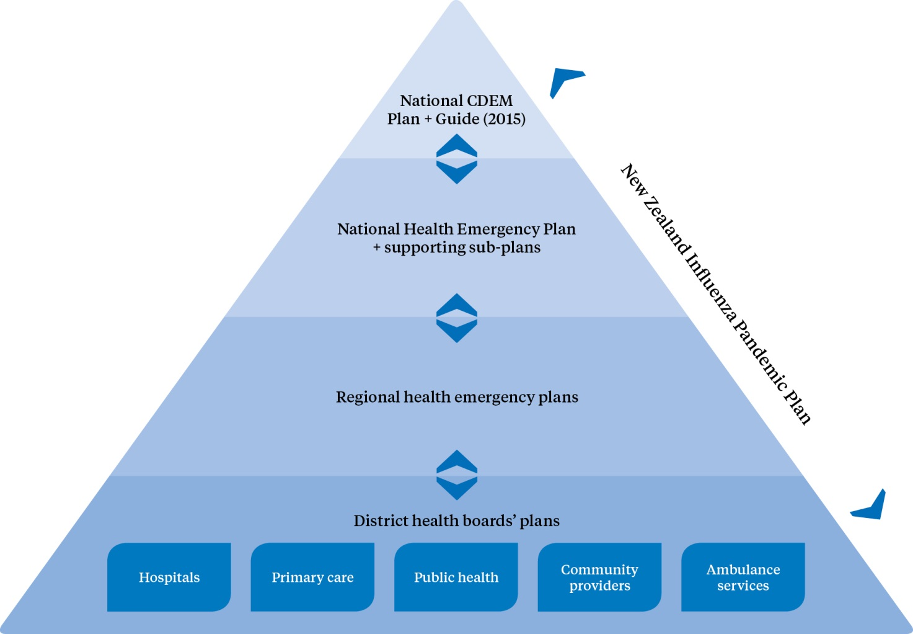

Objectives
The objectives of the National Health Emergency Plan are to:
- describe the larger emergency management context within which the Ministry of Health and all New Zealand health and disability services have roles
- clarify the emergency management roles and responsibilities of the Ministry, DHBs, public health units (PHUs), public and private health providers and other key organisations
- generate guidance and advice that support the health and disability sector to:
- understand the risks it faces
- work to reduce risks and build resilience within communities and the health and disability sector
- undertake planning and readiness activities for both business continuity and operational roles in an emergency
- explain how the health and disability sector will function during any emergency, including New Zealand’s responsibilities under international agreements and regulations
- explain the Ministry of Health’s emergency management system, the expectations for it and capabilities of DHBs and the wider health and disability sector
- define the roles and responsibilities of the health and disability sector in recovery.

Guiding principles
The guiding principles for health and disability services to effectively manage the health-related risks and consequences of significant hazards are listed below.
1. Comprehensive approach: Encompass all hazards and associated risks, and inform and enable a range of risk treatments concerned with reduction, readiness, response and recovery.
2. Integrated all agencies approach: Develop and maintain effective relationships among individuals and organisations, both in the health and disability sector and with partners, to enhance collaborative planning and operational management activities at all levels (local, regional and national).
3. Community and stakeholder engagement: Facilitate community input to and understanding of the full spectrum of risk identification, reduction, readiness, response and recovery activities and arrangements.
4. Hazard risk management: Take a contemporary all-hazards approach based on sound risk management principles (hazard identification, risk analysis and impact analysis).
5. Health wellness and safety: Maintain an emergency management structure that supports, to the greatest extent possible, the protection of all health workers, health and disability service consumers and the population at large.
6. Health equity: Establish, maintain, develop and support services that are best able to meet the needs of patients/clients and their communities during and after an emergency, even when resources are limited, and ensure that special provisions are made for vulnerable people and hard-to-reach communities so that emergency responses do not create or exacerbate inequalities.
7. Continuous improvement: All agencies undertake continuous improvement, through ongoing monitoring and review, in which they update capabilities, plans and arrangements using an evidence-based approach. Continuous improvement incorporates education, professional development, exercising, post-operational debrief, review, evaluation and ethical practice.

Emergency management approach
The comprehensive approach to emergency management used in this plan is illustrated in Figure 2. The approach comprises six related components: risks, risk understanding, readiness, reduction, response and recovery. It articulates an all-hazards, all-risks, multi-agency, integrated and community-focused approach, in accordance with the National Civil Defence Emergency Management Strategy (MCDEM 2008) and World Health Organization (WHO) strategies for risk reduction and emergency preparedness.

Figure 2: Risk-based comprehensive emergency management
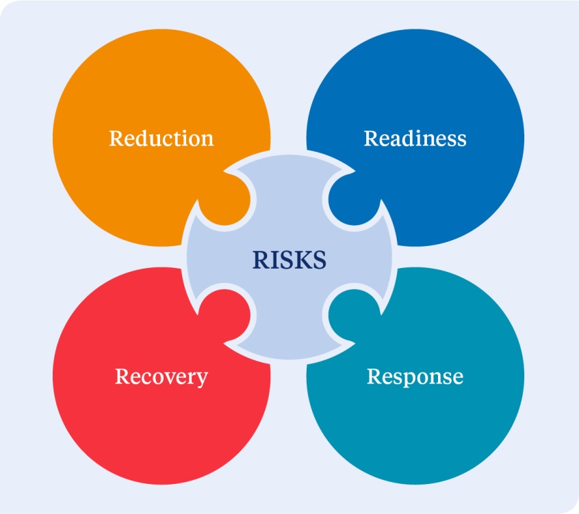

The generic all-hazards approach reflects a somewhat simplistic notion of being prepared for any and all emergencies in a generic fashion. That approach focuses on the perceived commonalities of hazards, risks and consequences to create plans that would be adaptable across a range of emergencies without reference to any particular hazards or their relative risks.

A contemporary all-hazards approach recognises that, because different risks have diverse characteristics, they may require different analyses, preparations and responses. It combines a generic, all-hazards approach with a set of contingency plans for well-selected priority hazards.

Central to this approach is identifying and assessing hazards and associated risk. By identifying the hazards to which a community is most vulnerable, specific hazard scenarios and contingency plans can be developed. This approach ensures that emergency plans are adaptable to a variety of emergencies and that, by addressing the hazards that pose the greatest risk, the community will be better prepared for other risks.

Through the risk identification and understanding process, not all risks will need to be treated, (or logically able to be treated); subjective decisions will be required by those undertaking the planning processes about what is an acceptable risk.

Emergency management is a programme of inter-related activities, for which the goals are to strengthen the overall capacity and capability of a country or a community to effectively reduce the likelihood of hazards, and to prepare for, respond to and recover from incidents and emergencies. The approach taken in this plan is firmly based on and extends the ‘4 Rs’ of reduction, readiness, response and recovery (see glossary for a definition of each of these terms).

Effective emergency management requires: careful planning; personnel at all levels and in all sectors to be trained and to work together based on clear roles and responsibilities; engaged, informed and resilient communities; and regular monitoring and evaluation of all these measures. These elements, the enablers of integrated emergency management, are addressed in the following section.

Emergency management enablers

Planning
If the health aspects of emergencies are to be managed effectively, all health providers must undertake planning and preparedness activities that are sufficient for them to continue their usual business functions and to fulfil their operational roles in emergencies.

Health and disability service providers are required under the Civil Defence Emergency Management Act 2002 (CDEM Act) and National CDEM Plan to have major incident and emergency plans. Sound business practice dictates that providers at least have a robust business continuity plan to respond to any emergency.

DHBs are required to develop, maintain, exercise and operate a DHB health emergency plan and to ensure health care providers and supporting agencies (through contractual arrangements) have a corresponding ability to plan, maintain, exercise and continue the delivery of health services in an emergency.

Likewise PHUs are required to develop, maintain, exercise and operate emergency plans to meet their obligations under the Health Act, CDEM Act and International Health Regulations as well as under any other relevant instruments.

All health providers must develop emergency plans that address all components of emergency management. Planning is an integral part of the readiness process, is key to reducing the health impacts of emergencies and is essential to ensuring an effective response and optimal recovery.

Effective planning is cyclical. It does not solely focus on outputs (plans to meet legal obligations) but instead is a deliberate process of building a programme of carefully aligned activities, including continuous:
- communication and consultation
- assessment and monitoring of risk
- monitoring, exercising and review of arrangements
- education and training of staff
- development and maintenance of relationships and communication with relevant partners, stakeholders and communities.

A checklist (Appendix 1) and plan outline (Appendix 2) have been developed as a guide to assist those responsible for the development and maintenance of health service emergency plans, programmes and capabilities.

Business continuity management
Business continuity management is a holistic management process that identifies potential threats to an organisation and their impacts on business operations if they were realised. It provides a framework for building organisational resilience with the capability of an effective response that safeguards the interests of its key stakeholders, reputation and value-creating activities.

All health services are deemed emergency services under the CDEM Act. Each service is required to have a plan to ensure that it is able to function to the fullest possible extent, even though this may be at a reduced level, during and after an emergency. This responsibility extends to services provided through partnerships or other forms of contractual arrangement.

Business continuity is a key component in organisational resilience and should be addressed by all health providers. Effective business continuity planning should be integrated into each health provider’s normal business process; it should align with other inter-related processes (such as risk management) and be developed in collaboration with personnel, suppliers, stakeholders and partner organisations.

The international standard for business continuity is ISO 22301 Societal Security – Business Continuity Management Systems – Requirements. This standard specifies requirements to plan, establish, implement, operate, monitor, review, maintain and continually improve a documented management system to protect against disruptive incidents, reduce the likelihood of their occurrence, prepare for and respond to them, and recover from such incidents when they occur.

Community engagement
Supporting individuals, families, whānau and communities in preparing for, responding to and recovering from emergencies requires effective planning based on an understanding of community vulnerabilities, risks and strengths.

All health providers must recognise that it is not only their existing clients or patients that they need to consider in emergency planning. During and following an emergency, the client/patient profile of services is likely to broaden to include individuals, families and whānau previously unknown to them.

Consideration must also be given to what provisions can be made for vulnerable people and hard-to-reach communities so that emergency responses do not exacerbate existing inequalities or create new inequalities or vulnerabilities. Although everyone is at risk of harm during an emergency, due to their circumstances some groups or communities are less able to take advantage of risk reduction opportunities, or have more limited access to preparedness planning, response and recovery resources and activities, and are therefore at greater risk of harm both during and after an emergency.

Barriers and challenges that may inhibit the resilience of communities and individuals can include: age; physical, mental, emotional or cognitive status; culture; ethnicity; religion; language; geography; and socioeconomic status.

Communities should be actively involved in all aspects of resilience-building and preparedness planning, implementation and review. It is important to:
- understand that communities are made up of dynamic and networked groups of people
- engage with communities proactively and meaningfully
- support and build on networks and activities that already exist both within and between communities
- ensure that emergency health and welfare services address the specific needs of individuals, families, whānau and communities where practicable
- enhance self-reliance for all individuals, families, whānau and groups in communities.

The importance of consulting appropriately and developing policy and plans for liaison and communication with local people, including Māori and local iwi, is highlighted in the reviews of the responses to the Canterbury earthquakes and the MV Rena grounding.

Resilience
Resilience is dynamic and can be developed and strengthened over time. A resilient organisation or community is one in which people work together to understand and manage the risks that it confronts. Building resilience is a shared responsibility, not just of the civil defence sector but of individuals, communities, health services, businesses and governments. To increase resilience, all sectors must work together with a shared sense of responsibility and focus.

Community resilience and community-based risk reduction can only be achieved through meaningful engagement and empowerment of the community. Growing and sustaining key relationships and networks is crucial, and is best achieved by building on, rather than replacing, existing strengths, relationships and arrangements. It involves understanding the risks to services and the community, developing economic resources, reducing resource inequities and attending to areas of greatest social vulnerability.

Health and disability services have a significant part to play in building their own resilience and the resilience of the communities that they serve. Health services need to be continually looking at ways to nurture and consolidate this resilience.

Monitoring and review
Smart practice in emergency management is continuously monitored, updated and adjusted in the light of experiences from exercises and operations as well as experiences in other emergencies at home and abroad – within all components of emergency management, from understanding risk to reduction, readiness, response and recovery.

All agencies with responsibilities under the CDEM Act, including health providers, are expected to:
- monitor and evaluate their capacity and capability to respond to and assist with recovery from emergencies by:
- measuring performance against standards, benchmarks or performance indicators
- exercising and testing capacity and capability
- analysing effectiveness
- tracking progress towards goals and objectives
- monitor their compliance with the CDEM Act.

See Appendix 1 for a checklist and Appendix 2 for a plan outline developed as a guide to assist those responsible for the development and maintenance of health emergency plans, programmes and capabilities.

Roles and responsibilities
All health providers have roles and responsibilities across all components of emergency management, including to:
- plan for functioning during and after an emergency
- be capable of continuing to function to the fullest extent possible (albeit at a reduced level) during and after an emergency
- develop, review and improve their emergency plans
- respond to the emergency as required.

Health and disability services in New Zealand are delivered by a network of organisations and people. This network includes:
- the Minister of Health, who has overall responsibility for New Zealand’s health and disability system
- healthAlliance (FPSC) Limited, a DHB-owned company that manages national procurement for all DHBs and supply chain services
- the Ministry of Health, which acts as principal advisor to the Minister of Health and Government on health and disability policy, and leads and supports the sector to achieve better health for New Zealanders
- district health boards, each of which plans, manages, provides and purchases services for the population of its district, including funding of tertiary, secondary and primary care, public health, aged care, assessment, treatment and rehabilitation services and services provided by other non-government providers
- primary health care, which provides health care in the community, usually from general practitioners or practice nurses
- public health services, which provide epidemiological surveillance, environmental health, communicable disease control, preventative interventions and health promotion programmes
- ambulance services, which provide clinical control centres (formally Emergency Ambulance Control Centres), pre-hospital care and transport for patients in the community, inter-hospital transport where patients require referral for specific cares and specialist services such as support to police tactical response, urban search and rescue and to hazardous material incidents
- other private and non-governmental providers, including community pharmacies, laboratories, radiology clinics, independent midwife and nursing practices, Māori and Pacific providers, residential care facilities, disability support services, mental health services, voluntary providers, community trusts and private hospitals
- other infrastructure and logistic providers supporting health care services.

Under the CDEM Act and National CDEM Plan, the Director-General of Health, on behalf of the Minister of Health, has overall responsibility for health matters related to emergency management. Other specified roles are summarised in Tables 1 and 2.

Table 1: Health and disability sector roles and responsibilities in readiness and reduction
Ministry of Health | a. Develop, maintain and review policy.  b. Maintain the International Health Regulations National Focal Point.  c. Undertake national planning for health-related aspects of emergencies.  d. Develop, maintain and exercise the National Health Emergency Plan and supporting documents.  e. Maintain primary and alternative capabilities of the National Health Coordination Centre.  f. Maintain the Health Emergency Management Information System (Health EMIS) and related capability development, to support the health and disability sector in risk reduction, readiness, response and recovery.  g. Maintain and exercise a Ministry of Health business continuity management plan and capabilities.  h. Provide leadership and guidance to the health and disability sector for education, planning and national guidelines.
healthAlliance (FPSC) Ltd | a. Ensure processes are in place for national supply chain services for the health and disability sector to meet estimated surges in demand, through plans, contracts and capability development, professional development and exercises.  b. Ensure that entities involved in procurement and supply chains for DHBs have effective and exercised business continuity management plans and capabilities and that suppliers contracted by shared services or Pharmaceutical Management Agency Ltd (PHARMAC) have appropriate requirements for business continuity management within their contracts.
DHBs | a. Lead and coordinate local readiness planning and capability development activities across health service providers within their district.  b. Develop, maintain and exercise health emergency plans and more detailed response management procedures for emergencies affecting their district and in support of other districts.  c. Cooperate with neighbouring DHBs in developing and exercising inter-DHB, sub-regional, regional and national emergency management plans and capabilities:  i. as appropriate to identify how services will be delivered in an emergency  ii. acknowledging DHBs’ role as both funders and providers of health services.  These arrangements should include the provision of support directly or indirectly to other affected parts of the country.  d. Ensure that all their plans adequately provide for public, primary, secondary, tertiary, mental and disability health services, and vulnerable people.  e. Monitor health provider plans and resources to ensure that they can respond to emergencies in an integrated and effective manner.  f. Ensure that hospitals and health services are ready to function to the fullest possible extent during and after an emergency by preparing and exercising mutually supportive plans and capabilities that:  i. provide for continuity of care for existing patients, the management of increased demand for services, including the provision of surge capacity, and assistance with the recovery of services, including business continuity management  ii. are integrated across the sector and are aligned with the plans of the other emergency services and respective CDEM Group plans and other response agencies and with public health planning and responses.  g. Be represented on committees of CDEM Groups as required.
Public health units | a. Develop and maintain plans specific to public health emergencies.  b. Integrate public health planning and responses with comprehensive DHB emergency management planning, exercises and responses.  c. Cooperate with other PHUs in developing and exercising local, inter-unit, regional and national emergency management plans and capabilities:  i. as appropriate to identify how services will be delivered in an emergency.  d. Advise local agencies and lifeline utilities about public health aspects of their business continuity management processes and activities.  e. Maintain liaison and coordination with DHB regional groups, CDEM Groups and other response agencies as required.  f. Contribute to emergency planning capability-building and exercises in conjunction with DHBs and the Ministry of Health, as required.  g. Maintain up-to-date epidemiological surveillance data.
Land and air ambulance providers | a. Ensure the provision of continuity of care for existing patients, the management of increased demand for services, including the provision of surge capacity, and assistance with the recovery of services, including business continuity management.  b. Prepare and maintain incident and emergency management plans that are integrated across the ambulance sector and are aligned with the plans of the DHB, other emergency services and the regional group plans and with public health planning and responses.  c. Be represented on committees of DHB regional groups and CDEM Groups as required.  d. Contribute to emergency planning capability-building and exercises in conjunction with DHBs and the Ministry of Health, as required.
Community and private providers | a. Ensure the provision of continuity of care for existing patients, the management of increased demand for services, including the provision of surge capacity, and assistance with the recovery of services, including business continuity management.  b. Prepare and maintain incident and emergency management plans that are integrated across the community-care sector and are aligned with the plans of the DHB, other emergency services and the regional group plan and with public health planning and responses.  c. Be represented on committees of DHB regional groups and CDEM Groups as required.  d. Contribute to emergency planning capability-building and exercises in conjunction with DHBs and the Ministry of Health, as required.

Table 2: Health and disability sector roles and responsibilities in response and recovery
Ministry of Health | a. Monitor any developing emergencies.  b. Activate the national health emergency response capabilities and process and the National Health Coordination Centre as appropriate.  c. Coordinate and manage the health and disability sector response during and recovery from emergencies that have significant regional or national impacts.  d. Coordinate health responses with those led by other national-level agencies, including the designated lead agency and relevant support agencies. (See more on the Ministry’s role as a support agency under ‘Lead and support agencies’.)  e. Act as lead agency in an all-of-government response to a health emergency such as an epidemic or pandemic. (See more on the Ministry’s role in this capacity under ‘Lead and support agencies’.)  f. Provide managed release of resources and support to New Zealand Medical Assistance Team deployments.
healthAlliance (FPSC) Ltd | a. Ensure that the shared services continue their delivery and manage any increased demand.  b. Coordinate with the National Health Coordination Centre, DHBs and suppliers as required.
DHBs | a. Coordinate the local health and disability sector response to and recovery from emergencies. Ensure appropriate coordination of all health and disability service providers and close liaison with civil defence and recovery management at regional and local levels.  b. Coordinate the provision of psychosocial support, specialist public health, mental health and addiction services and advise government and non-governmental organisations and primary health organisations on the type and nature of services needed for ongoing psychosocial support.  c. Ensure that hospitals and health services are able to function to the fullest possible extent during and after an emergency.  d. Continue their services and manage any increased demand.  e. Reshape services and funding to meet changes in demand.
Public health units | a. Maintain their services and manage any increased demand.  b. Respond to emergencies involving risk to public health.  c. Contribute to epidemiological surveillance and communicate information to the relevant emergency operations centre (EOC) and to the Ministry.  d. Coordinate with local DHB EOCs if operating.  e. Liaise with the CDEM Group or local EOC during an emergency.  f. Coordinate public health initiatives during the recovery phase.
Land and air ambulance providers | a. Continue their services and manage any increased demand.  b. Coordinate via local DHB EOCs, the National Ambulance Crisis Coordination Centre, the National Health Coordination Centre and other ambulance providers.
Community and private providers | a. Continue their services and manage any increased demand.  b. Coordinate via local DHB EOCs.

Assistance to Cook Islands, Niue and Tokelau
The New Zealand Government also has obligations to provide assistance to the Cook Islands, Niue and Tokelau in respect of administrative matters, international relations and emergencies. These obligations stem from New Zealand’s special relationships with those countries. The Cook Islands and Niue are self-governing states in free association with New Zealand. Tokelau is a dependent territory of New Zealand, moving towards adopting self-government in free association. The inhabitants of all three countries are New Zealand citizens. While all three are autonomous (to a greater or lesser degree), they are linked to New Zealand in ways that set them apart from other countries of the Pacific.

Lead and support agencies
Emergency management in New Zealand relies on the concept of ‘lead and support agencies’ for specified hazards and functions. These terms are defined in both The New Zealand Coordinated Incident Management System manual (ODESC 2014) and the National CDEM Plan:
- Lead agency is the agency with a mandate to manage the response to an incident through legislation, under protocols, by agreement or because it has the expertise and experience.
- Support agency is an agency that provides support to the lead agency in a response.

Although ‘lead’ and ‘support’ agencies are generally described in response-focused terms, in reality these relative roles follow through all aspects of emergency management. The National Health Emergency Plan is written from the perspective of the Ministry of Health as:
- the lead agency for all components of emergency management for health hazards, such as emerging infectious diseases, and pandemics
- a support agency for all-of-government emergency management, across all components of emergency management, ensuring that health functions are coordinated with and within wider responses and pre- and post-incident emergency management
- a coordinating agency for the entire health and disability sector in all aspects of emergency management.

Inter-agency collaboration and communication
Organisations and communities that have strong day-to-day relationships are generally more likely to function well during emergency response, as well as in recovery decision-making processes and operations.

Emergency management, even just within the health and disability sector, involves multiple disciplines and agencies. To achieve a united effort and to realise effective health outcomes in emergencies, it is critical to share information and coordinate activities within and across organisational boundaries.

It is important that all who may be involved are not only kept informed, but also encouraged to contribute to the process, in order to establish a common understanding of how decisions are made and to develop trust.

Both formal and informal collaboration within and from the health and disability sector can be a mechanism to foster a culture of trust and the experience of working together. This teamwork can be achieved through interactions such as training, workshops, joint exercises and information sharing in planning and readiness aspects of comprehensive health emergency management.

Hazards and risks to be managed

Types of hazards
Every health provider has an obligation to understand both the hazards and the risks it faces. In understanding these risks, a service can make informed decisions about how to manage risk and develop needed capabilities; if it knows the origins of risk, it is better able to identify ways of reducing that risk; and if it can calculate a value for risk, the service can more easily set priorities for reducing risk.

A hazard is a potential or existing condition that may harm people or may damage property or the social, economic, cultural or natural environment. Hazards may have many potential consequences including death, injury, illness, and damage to property or the previously mentioned environments. Even where a hazard does not directly affect health or infrastructure, disruption to critical services can have serious consequences which can in turn endanger community health and safety and disrupt the continuity of health services.

Risk is a function of the hazards to which a community is exposed and the vulnerabilities of that community, modified by the level of resilience of the community at risk. Vulnerability refers to the degree to which an individual, organisation, community or system is unable to anticipate, cope with, resist or recover from the impact of hazards. Resilience refers to their capacity to prevent, reduce, prepare for, respond to and recover from the impacts of hazards.

At the national level, the National Hazardscape Report, published by the Officials’ Committee for Domestic and External Security Coordination (ODESC 2007), identifies and considers the range of natural and artificial hazards that have relevance to New Zealand from national and regional perspectives. The report identifies the following 17 types of hazards, all of which have the potential to cause emergencies that require coordination or management at the national level:
- earthquakes
- volcanic hazards
- landslides
- tsunami
- coastal hazards (for example, storm surge and coastal erosion)
- floods
- severe winds
- snow
- droughts
- wildfires
- animal and plant pests and disease
- infectious human disease pandemics (including water-borne illnesses)
- infrastructure failure
- hazardous substance incidents (including chemical, biological and radiological)
- major transport accidents (air, land and water)
- terrorism
- food safety (for example, accidental or deliberate contamination of food).

Appendix 3 sets out an outline analysis of the consequences of these hazards.

This plan can be used to address the factors contributing to and the consequences of emergencies arising from any other hazard source not identified by the National Hazardscape Report (ODESC 2007), such as extreme temperature incidents.

Consistent with the risk-based approach, where a hazard poses sufficient risk a hazard-specific comprehensive, contingency or functional plan will be developed. Examples of these plans in the health context include the New Zealand Influenza Pandemic Plan (Ministry of Health 2010) and the New Zealand Ambulance Major Incident and Emergency Plan (AMPLANZ) (Ambulance New Zealand 2011). Health emergency management, within all health services and providers, begins with and is informed by an adequately thorough analysis of the hazards and risks relevant to that context, in collaboration with partner organisations at the respective level of operation.

Hazards, risks and consequences
Health emergency plans should include assessment and prioritisation of hazards based on the impact they will have on provision of services and on the health of the communities to which the service has a responsibility. Risk analysis is more effective when carried out in collaboration with partner organisations.

To assess risk, it is necessary to consider all hazards that may occur in an area. For each of those hazards, the probability of occurrence and its consequences need to be estimated. Then the risks should be prioritised and ranked.

Risk assessment provides valuable information which should be used in the planning process across all components of emergency management. The Australian and New Zealand Risk Management Standard (AS/NZS 31000:2009) is recommended for undertaking a risk assessment. Some services may have an alternative prescribed manner for conducting risk assessments.

The risk analysis in Appendix 3 identifies a range of risks and consequences for the health and disability sector to consider when undertaking more detailed assessment and subsequent planning.

Implications for health
DHBs should develop the risk section of their health emergency plan in conjunction with their respective CDEM Group(s). Local health providers should carry out their risk analysis in conjunction with their local authority and informed by their DHB’s analysis.

The impact of some risks may be solely on health. Such risks may be entirely managed within the health and disability sector.

Health providers need to be able to contribute to the management of risks to their communities and the health and disability sector. To achieve this, health providers must:
- understand that health services are part of a continuum of care and need to be considered in all aspects of emergency management
- address standards of service provision
- take a whole-of-sector and community-based approach.

Reduction
The objective of risk reduction is to avoid or mitigate adverse consequences before they occur and to realise the sustainable benefits for society of managing risks at acceptable levels.

Introduction
Reduction strategies start with the identification and analysis of significant hazards. By analysing these hazards using a matrix based on their likelihood and consequences, it is possible to calculate a value representing the level of risk involved and the areas within which risk reduction efforts should be focused. The risks can then be prioritised. Thereafter, in response to this analysis, a risk reduction strategy can be developed to eliminate risks where practicable and, where elimination is not practicable, to reduce the likelihood and magnitude of their impact.

Risk reduction activities
The key challenge for risk reduction is to ensure that reduction strategies encompass all components of emergency management. Reducing risk requires either reducing the likelihood of hazards or reducing potential consequences, or both.

Health services have only limited influence on the probability of a hazard occurring, other than for specifically health-related hazards such as contagious diseases and exposure of health services and personnel to physical risks. However, the health and disability sector does have the ability and opportunity to lessen the vulnerability of the community and health services to hazards more generally and to mitigate the consequences for them. Health services can achieve these outcomes through a range of actions within the broad strategies of:
- reducing community exposure and vulnerability to hazards – surveillance and intervention
- reducing organisational susceptibility to hazards – business continuity management
- building organisational resilience within the health and disability sector to the impact of hazards
- employing response interventions that constrain incidents from escalating to emergencies.

Planning to reduce risk
All health providers have a responsibility to engage in risk reduction planning and delivery, and to monitor and review the effectiveness of their risk reduction over time. Including risk reduction objectives within business continuity management plans and programmes is a primary contributor to effective risk reduction and resilience building.

Also crucial to health-related risk reduction is that DHBs and public health agencies plan and are adequately resourced to enable stakeholders to engage with regional policy and district planning.

By leading, developing, engaging in or delivering community health development projects and whole-of-community health services, the health and disability sector contributes to a growing resilience among communities to a wide range of hazards of the scale countenanced in this plan. The Ministry of Health, DHBs, PHUs and health service providers all have a part to play in more holistic resilience-building and risk reduction.

Through health promotion, risk communication and advice functions delivered in business-as-usual health service delivery, DHBs and PHUs have critical roles in risk reduction, readiness, response and recovery processes. It is essential that any such communication activities are developed and delivered in a collaborative manner with partner agencies, in particular the lead agency for the hazard or emergency in any particular case.

Hazards for which health services have particular responsibility (although they may not necessarily lead an associated response) include communicable diseases, extreme weather (heat or cold), hazardous substances, ionising sources, drinking-water, exotic organisms of public health significance, and primary and secondary health consequences of all other hazards.

The Ministry of Health works with other government agencies to develop and refine legislation and regulations that contribute to risk reduction.

DHBs have a responsibility to work with their respective CDEM Group(s) and their member local authorities in the development of comprehensive risk reduction strategies.

A role for health service providers is to work with partner organisations and the communities they serve to reduce risks and enhance resilience.

Surveillance and intelligence
Gathering data and information is important in planning for and reducing the impact of disasters. All health providers should maintain effective processes for data/information recording and reporting. They should use these processes across all components of emergency management as baseline data and subsequently to identify and quantify changes in demand and service use.

In keeping with the principles of hazard management and reducing risk, the Ministry of Health, in consultation with MCDEM and other government agencies, conducts a ‘watching brief’ on emerging hazards and changing risks, both national and international. The Ministry gathers intelligence from various sources.
- MCDEM provides information on national and international hazards, for example, earthquakes and potential tsunamis.
- The Institute of Environmental Science and Research Ltd (ESR) provides national epidemiological surveillance of infectious agents, collects and collates disease burden data and, if required, provides cultures or isolates to WHO reference laboratories. The National Centre for Biosecurity and Infectious Disease (NCBID), part of ESR, operates early detection of potential outbreaks and provides communicable disease alerts to the Ministry and public health units.
- Other agencies providing information include Massey University Centre for Public Health Research (hazardous substances injury surveillance, environmental health indicators and birth defect monitoring), Hopkirk Institute (protozoa surveillance), Southern Monitoring Services (mosquito surveillance) and public health units (localised surveillance and incident reports).

As hazards and risks become known, information is collected and shared between the Ministry of Health and the health and disability sector.

The international experience of the 2009 influenza A (H1N1) pandemic response and numerous mass gathering events has highlighted the importance of maintaining robust routine epidemiological surveillance and detection systems prior to any emergency.

The Ministry of Health, ESR and PHUs carry out epidemiological surveillance systems that need to be supplemented with event-specific systems to provide earlier and/or more sensitive warning for specific risks identified through the risk assessment process. In the event of an emergency, the extent of additional resources and enhancements required will vary according to the existing level of surveillance infrastructure.

International Health Regulations
In New Zealand the primary responsibility for international surveillance and reporting rests with the Ministry of Health, although other agencies may monitor the international data for anticipatory purposes.

Under the International Health Regulations 2005 (IHR), New Zealand is part of a global commitment to plan and prepare for a prompt response to public health threats to both New Zealand and the wider international community. The IHR provides a framework for coordinating the management of incidents that may constitute a public health emergency of international concern. The goal is to improve the capacity of all countries to detect, assess, notify and respond to public health threats.

The IHR takes an all-hazards approach, while avoiding unnecessary interference with international travel and trade. The IHR covers risks from biological agents (eg, disease, vectors, venomous organisms), chemical agents (hazardous substances) and radioactive sources. The IHR requires countries to have certain core capacities in place in order to detect, notify and communicate information about public health emergencies. It provides for an adapted response focus, rather than a ‘one size fits all’ approach – the appropriate response will depend on the nature and seriousness of the threat. See Appendix 4 for further information.

Readiness
The objective of emergency readiness is to build the capacity and capability of the health and disability sector to respond to emergencies and to assist the recovery of the community and health services from the consequences of those emergencies.

Introduction
Readiness involves developing operational systems and capabilities before an emergency occurs, based on sound risk management principles. Another aspect of readiness is to use public education and community engagement programmes to promote resilient communities.

New Zealand’s health and disability sector and its communities have finite capacity and capability to respond to and recover from impacts on community health and the health services themselves. Building and maintaining capacity and capability for emergency health response and recovery requires ongoing processes to identify and address significant gaps and shortfalls.

If they are to function to the fullest possible extent, even at a reduced level, during and after an emergency, and to contribute to response and recovery, all health providers must take steps to identify and address issues specifically related to their capability and capacity. Ongoing readiness activities include:
- planning, training, exercising and testing of arrangements
- monitoring and evaluating capacity and capability to perform across different emergency situations
- establishing and maintaining necessary equipment and operational systems, including addressing any need for interoperability and coordination with interdependent agencies.

Planning for readiness

Development of health emergency plans
All health providers should develop and maintain current health emergency plans, in conjunction with stakeholder organisations, at their respective level of responsibility.

The most effective and comprehensive plans are prepared by a multi-agency team in a collaborative environment. They describe how the health service will carry out its emergency-related roles and responsibilities, including:
- how it will deliver and coordinate services when dealing with the high-priority hazards and risks for the organisation and its level of operation
- how it will coordinate with other agencies in an emergency
- each aspect of its risk analysis, reduction, readiness, response and recovery activities at its respective level of responsibility
- what services and support will be provided in an emergency
- how to activate, transition to and deliver recovery roles, responsibilities and capabilities.

The emergency plan must also consider the post-emergency environment. Recovery planning will be more timely, efficient and effective where health services and communities have plans in place before emergencies occur.

However, the new environment that evolves after an emergency will inevitably pose new challenges. It will therefore be necessary to follow a recovery planning process to ensure that health services and communities have the capabilities, capacity and resources to identify needs and develop recovery strategies.

Emergency plans and procedures at national level
The Ministry of Health develops and maintains a number of emergency-related plans, functions and associated professional development documents. These documents can be accessed through the Ministry of Health website (www.health.govt.nz).

These plans, guidelines and related documents are subject to regular reviews. The current versions are posted to the Ministry of Health website or within Health Emergency Management Information System (Health EMIS) resource libraries.

Surge capacity planning
Surge capacity refers to the ability to manage a sudden, usually unexpected increase in demand that would otherwise severely challenge or exceed the capacity of the facility or service. It is the ability of health services to deliver appropriate care/services to all people affected by an emergency.

Emergency surge capacity requires a different approach to the normal capacity and capability of day-to-day emergency health services dealing with daily, weekly or seasonal fluctuations. An extraordinary increase in demand for patient care challenges systems, space, staff and supplies. When planning surge capacity, health providers, particularly DHBs, should consider the following aspects.
- Can a surge be accommodated using early transfer or discharge of current patients to other areas?
- Alternative areas to manage patients requiring admission may need to be arranged.
- Outpatient clinics and elective services may need to be deferred.
- What is the most effective way of decanting patients or clients from facilities in which services have been lost or severely reduced?
- Historically, during emergencies a large proportion of those injured go directly to the nearest hospital. The mass casualty arrangements in the Mass Casualty Action Plan (Ministry of Health 2011) allow for the rapid transport of patients to alternative destinations, depending on the severity of their conditions. This procedure can significantly increase the surge capacity of a health service.
- How can staff from one area be redeployed to another to assist with the response?
- What is the most effective way to support caregivers and health care providers responding during an emergency?
- How will a supply shortage be addressed? Options include:
- prepare: routinely maintain stockpiles of necessary items or their equivalents
- substitute or adapt: use a clinically equivalent or alternative item or technology
- conserve: use less of a resource by reviewing dosage and utilisation practices
- reuse: use again after appropriate disinfection or sterilisation
- reallocate: move therapy or technology from one patient to another with a higher chance of benefit.
- It is necessary to consult and collaborate with all sectors, including public, private and non-governmental health providers, and providers of other key services, such as funeral directors, transport operators and utility suppliers.

Planning considerations
In addition to the factors addressed above, a range of other factors must be considered to enable effective planning, capacity building and resource development in readiness for an emergency response. These factors are described briefly in this section. For selected issues, more detailed information is provided in appendices.

Ethical values underpinning decision-making
Many critical ethical issues arise in emergency planning, preparedness and response. These include: priority setting and equitable access to resources; restriction of individuals’ movements as a result of isolation, quarantine and social-distancing measures; and the respective obligations of health care workers, and the obligations of agencies and countries regarding each other. If these issues are not properly addressed in planning, emergency response efforts could be seriously hampered. See Appendix 6 for further information.

Inter-DHB coordination and support
Most health and disability services, including administration, support and procurement services, are planned, funded and delivered at a district level. However, DHBs are experiencing an increasing need and expectation to work together in a more intentional and collaborative manner, which may be at a national, regional or sub-regional level. National and regional service planning outlines how DHBs intend to work together to improve the quality of care and reduce service vulnerability and cost.

The collaborative approach is particularly valuable in emergency management planning. DHBs must work with the Ministry of Health and with local authorities and other relevant agencies within the respective regional/local CDEM framework to ensure emergency management plans are integrated at local and regional levels. Each DHB is required to work with the other DHBs in its regional grouping to develop a regional health emergency plan. The regional plan provides a generic process for managing regional incidents, along with a consistent approach to coordination, cooperation and communication across the region.

Public health units are also required to ensure that their emergency planning complements the local and regional DHB plans.

Whole-of-community services
DHBs’ planning must include provision for community-based models of care that allow for the best care possible in different types of emergencies when existing services are unable to meet the demand. A range of community-based systems can be adapted or developed to assess the health needs of the population, determine the appropriate level of medical care to be delivered, and issue relevant health information that will inform the public’s decisions regarding health care needs. These systems can include community-based assessment centres, triage centres and ‘virtual’ systems such as telephone and internet-based programmes. See Appendix 7 for further information.

Human resources and staffing
Human resources are an essential part of an effectively managed response to and recovery from a health emergency. Emergency planning must take into account different types of emergencies and their likely impact on staff numbers and capabilities, as well as staff safety and health during and following both short- and long-term emergencies.

Health and disability sector plans must also take account of regional and national staffing arrangements. In situations where additional personnel are needed from outside the affected area a national staffing request will be required.

The Ministry of Health also requires that the emergency planning of public health units complements plans developed by DHBs and regional groupings of DHBs. See Appendix 8 for further information.

Organisational debriefings
Before an emergency occurs, it is important to establish a process for organisational debriefing, reviewing plans and post-event arrangements, and a method to communicate these expectations with all stakeholders. The aim of the organisational debriefing is for staff to convey their experiences across all phases of an emergency so that lessons can be identified and arrangements modified to improve the organisation’s ability to respond in future emergencies. See Appendix 9 for further information.

Professional development
Professional development is most effective when it is based on the operational needs at respective levels of response and recovery, on the one hand, and current capability and capacity on the other. It is crucial to have a meaningful and sustainable professional development strategy at national level and professional development plans within each health organisation so that emergency management roles are performed effectively in reduction and readiness, and, critically, when the pressure comes on during response and recovery.

Professional development strategies and plans should include the ability to provide just-in-time training during major responses when existing trained human resources are insufficient and other personnel are about to step into roles for which they have not been adequately prepared.

Managing emergency volunteers
Volunteers can be a valuable asset in an emergency response. However, advanced planning is required to harness their full potential. Ideally this will include provision for trained, credentialed health volunteers to support local surge capacity. See Appendix 10 for further information.

Infant feeding
During an emergency, the use of breast milk substitutes (infant formula) to feed infants
(0–12 months) can become a critical issue. Breastfeeding in an emergency remains safe and the best option for infant feeding, and should be continued where possible.

The role of providing infant formula in an emergency, if it is required in the community, will be performed by local civil defence responders. This role includes sourcing and distributing infant formula, water (for powdered formula) and the associated feeding equipment.

While DHBs will provide infant formula for those in their care who require it, it is not the role of DHBs to provide infant formula or feeding equipment for the community in an emergency or otherwise.

However DHBs do need to be prepared to offer advice and guidance to other agencies about appropriate measures for all infant feeding at the time of an emergency, and to act as the single designated health agency to manage any unsolicited donations.

The Ministry of Health has developed a position statement on infant feeding in an emergency (Appendix 11). Other resources for consumers and emergency responders are available on the Ministry of Health website (www.health.govt.nz).

Visitors and dependants
In emergencies, DHBs can expect to have to cope with large numbers of people who do not need care but want to be with sick relatives or friends or to locate missing relatives. This will present additional management challenges. Plans will need to take different type of emergencies into account in this context.

Another result of an emergency may be that some dependants – young, elderly or disabled – are effectively orphaned and/or isolated because of the hospitalisation or death of their principal caregiver. Planning will need to take these situations into consideration; liaison with welfare agencies may be required.

Mass casualty
Dealing with a mass casualty incident (MCI) requires a coordinated plan and response from emergency services and the health and disability sector.

An incident of this nature will significantly increase demand for the services of all agencies involved in the response. Wherever possible, the process for responding should be consistent with business-as-usual processes to minimise disruption and promote consistency.

Mass casualty incidents require an effective response by ambulance services and DHBs. The effectiveness of any response is heavily influenced by the state of readiness, as established through effective planning and exercising of those plans. All DHBs and ambulance services are expected to include actions within their health emergency plan to direct them in their response to MCIs. These actions may include:
- stopping all elective surgical and outpatient activity
- identifying inpatients for rapid discharge or transfer to a sub-acute setting
- supplementing available equipment
- making alternative use of bed resources, including taking measures to supplement the maximum bed capacity available in acute hospitals
- using non-acute facilities and any independent sector capacity and/or pre-identifying suitable accommodation that could be used, if required, in conjunction with local authorities
- developing arrangements to set up and provide facilities to assist in the triage, diagnosis, treatment and support of those patients who are not obviously seriously ill or injured
- making contingencies to maintain patients in the community and to limit or avoid referrals to acute hospitals as far as possible
- ensuring that the primary health care sector include MCI actions within their plans so that they can respond to MCI.

National mass casualty transport
The role of the ambulance sector in response to a major incident is to deliver and maintain appropriate pre-hospital clinical care and, in most cases, to make inter-hospital transfers. In a mass casualty incident, ambulance will lead the operational health response to the incident at the scene/s by managing the triage, treatment and transport of patients.

The overall aim of ambulance management at the incident scene is to provide operational and tactical leadership. This leadership will cover the set-up of appropriate command and communications structures, safety of all health responders and the appropriate triage, treatment and transport of patients from the scene to the appropriate health care facilities. Fulfilling this role will require coordination and communications with receiving health care facilities, DHBs and emergency service partners to manage demands on the health care system.

If regional ambulance resources are overwhelmed, ambulance services will open the National Crisis Coordination Centre (NCCC). The NCCC will coordinate with the National Health Coordination Centre and other national emergency management structures (National Crisis Management Centre) as required. The NCCC will also coordinate the ambulance response. Ambulance will provide triage, initial treatment and transportation as outlined in the Ambulance Major Incident and Emergency Plan (Ambulance New Zealand 2011).

The computer aided dispatch (CAD) systems of the three ambulance Clinical Control Centres will maintain current information on the majority of ambulance resources available for deployment. This information will be in a form that is immediately accessible to the National Health Coordination Centre (NHCC), such as via the Health EMIS. It will include the location and detail of major incident caches in urban centres and rural station kits in strategic rural stations.

In a major incident the NCCC manages and coordinates all land-based, rotor and fixed-wing assets for roadside to bedside transport, including inter-hospital transfers.

Mass evacuation
The mass evacuation of a particular area or a wider community is necessary when a hazard threatens and puts at risk the safety of those within the area, or after a hazard has rendered the area uninhabitable. Evacuation becomes necessary when the benefits of leaving significantly outweigh the risk of ‘sheltering in place’.

An understanding of the nature of health care services and facilities in the community is vital so that plans can reflect the health care support required for evacuees. This support includes oversight of specialised transportation for evacuees with medical and functional needs; medical care for evacuees; public health considerations; and support for individuals at transfer points.

Mass evacuation can have significant impacts on the health services and facilities in both the evacuated and host locations. Such impacts include, but are not limited to:
- increased demand on hospitals from mass casualties (see above)
- evacuation of health care facilities (see below)
- increased demand on ambulance services
- increased demand on primary care and other community-based providers (eg, pharmacies, laboratories, mental health and addiction services)
- public health risks arising from evacuations and relocation to temporary housing and welfare centres.

Evacuation of health care facilities
Health services, hospitals and facilities providing residential care for the elderly and people with disabilities have a moral, legal and professional responsibility to plan and prepare for emergency operations, including relocation, evacuation or sheltering in place.

The evacuation of a hospital in New Zealand will require a regional or national response to support the evacuation process. See Appendix 12 for further information.

Management of the deceased
In a major emergency there may be an increased number of deaths which is referred to as a mass fatality incident. A mass fatality incident can be the consequence of a wide range of event types including natural disasters, pandemics, large accidents and deliberate attacks. While health agencies do not have a lead role in managing mass fatality incidents caused by event types other than pandemics, they do have responsibilities in support of the disaster victim identification process led by the New Zealand Police.

A National Mass Fatality Plan is being prepared for any mass fatality incident that might occur in future. As the agency with the lead responsibility for its development, the New Zealand Police is actively engaging with other agencies such as health to prepare the plan.

See Appendix 13 for further information.

Quarantine and border health plans
The International Health Regulations 2005 require competent authorities and designated points of entry to establish and maintain public health emergency contingency plans. The World Health Organization has published International Health Regulations (2005): A guide for public health emergency contingency planning at designated points of entry (WHO 2012).

Border health planning in New Zealand is aligned with the World Health Organization’s advice and with this plan. Any point-of-entry public health emergency contingency plan should be flexible and adaptable to match a wide variety of public health contingencies, especially emerging diseases. It will also:
- consider national, local and community plans including public and private sectors, laws, regulations and policies
- include plans to develop surge capacity on an ‘as required’ basis that can be engaged when needed
- fully respect the dignity, human rights and fundamental freedoms of people
- place equal focus on readiness and recovery rather than only on the response phase of an emergency plan
- ensure that regular exercising, refreshing and maintenance of plans are both factored in and budgeted for.

There is a suite of plans and standard operating procedures for border health responses that reflect local and regional arrangements. They cover:
- quarantine facilities – public health unit arrangements with local accommodation and catering facilities for the care of people placed in quarantine
- ill travellers – public health unit procedures for responding to reports of ill travellers
- border health protection responses – public health unit plans for any public health emergency at the border, including biological (pests and diseases of public health significance), chemical and radiological hazards
- port emergency responses – sea or airport emergency and incident response plans that include responding to public health risks arising from biological (pests and diseases of public health significance), chemical and radiological hazards.

Mass prophylaxis
Mass prophylaxis is the capability to protect the health of the population by administering critical interventions in response to a public health emergency, in order to prevent the development of disease among those who are exposed or are potentially exposed to public health threats. This capability includes appropriately following up and monitoring adverse events, as well as providing risk communication messages to address the concerns of the public.

DHB and PHU emergency planning should consider:
- coordination of potential point-of-dispensing sites or methods
- recruitment, accreditation and training of staff for clinics
- collaboration with other agencies and community groups
- creation of appropriate medical screening tools and models
- appropriate risk communication with other stakeholder agencies and public.

National reserve supplies
In readiness for the increased demand for specialist emergency equipment and supplies during an emergency and in the recovery period, the Ministry of Health manages a number of national emergency supply reserves and stockpiles.

The national reserve supply stocks have been developed to ensure that, as far as possible, DHBs and the wider health and disability sector will continue to have access to essential supplies during large or prolonged emergencies that generate unusual demands on normal health service stocks or supply chains.

DHBs should manage their ‘business-as-usual’ supplies and supply chain capacity at a level that can support all reasonably predictable local events without requiring additional resources from national reserves. This is an important element of business continuity management for all health services, as is planning to enable the expansion of services to meet increased demand and the provision of alternative sites for continuity of operations.

Reserve supplies include:
- personal protective equipment (for example, P2 respirators and general-purpose face masks, aprons, gloves, eye protection)
- clinical equipment and vaccination supplies (for example, syringes)
- medicines and vaccines (for example, antivirals and antibiotics)
- other supplies (for example, body bags).

National Health Emergency Plan: National Reserve Supplies Management and Usage Policies (Ministry of Health 2013) details the principal responsibilities of the Ministry of Health and DHBs in managing and using these significant national resources.

The Ministry is required to:
- maintain national reserve stockpiles in no less than three locations spread throughout New Zealand
- set and communicate policies for the management, prioritisation, allocation and use of national reserve supplies
- develop clinical guidelines where appropriate and necessary
- release national reserve supplies for use when necessary and appropriate
- prioritise and allocate national reserve supplies between DHBs and/or regions
- transport and distribute bulk national reserve supplies to DHBs
- monitor and forecast national supplies use
- fund national reserve supplies use
- replenish national reserve bulk supplies.

DHBs are required to:
- maintain and turn over national reserve supplies held in DHB stores
- prioritise and allocate internal DHB supplies in emergencies
- support neighbouring or regional DHBs
- report and forecast local and regional supplies usage
- apply to the National Coordinator (or designated person) for Ministry release of national reserve supplies if or when appropriate
- arrange all aspects of transport, distribution and security of supplies within DHB districts
- observe all relevant clinical guidelines, usage policies or national priorities developed by the Ministry
- ensure appropriate and economical use of national reserve supplies in all clinical settings in their districts (including at airports)
- account to the Ministry for all national reserve supply received and used.

DHBs should proactively discuss their supply situation and any potential requests for the release of national reserve supplies with the National Coordinator who is responsible for the prioritisation and release of national reserve supplies. In the event that the National Health Coordination Centre is not formally activated, the Director Emergency Management holds responsibility for release of national reserve supplies.

healthAlliance (FPSC) Ltd has specific responsibilities to ensure that processes are in place for national supply chain services to meet the demand surge. It is also responsible for ensuring that associated and contracted entities involved in the procurement and supply chain for DHBs have business continuity management in place to support this.

Public education
Public education on health-related emergency management aims to build public awareness of the health aspects of New Zealand’s hazards and the consequences of those hazards for health. The goal is to enable individuals and communities to take the necessary steps to reduce risks and prepare for emergencies.

National public education programme
A national public education programme for civil defence emergency management provides overall direction for developing and delivering public education programmes. It will:
- effectively build individual and community awareness and acknowledgement of all hazards, and improve their preparedness to cope in an emergency
- increase levels of community awareness and understanding of and participation in civil defence emergency management
- define those programmes that are best coordinated and delivered at a national level by MCDEM
- identify supporting strategies for programmes delivered by CDEM Groups and local authorities at regional and local levels
- ensure consistency and effectiveness of messaging at every consumer touch point.

Public education activities
The Ministry of Health, DHBs, PHUs, primary health organisations and health providers will support Civil Defence in the development and delivery of public education strategies and programmes related to the hazards and risks they manage.

All health agencies developing public messages about hazards and risks are encouraged to develop collaborative public messages about health aspects of hazards and risks relevant to the communities they serve. All these messages should be consistent with nationally agreed and supported messages for emergency management.

Capability development
Effective delivery of emergency management across all agencies depends on building and maintaining effective human resource and technology capabilities. A common framework of competencies, supported by education, training and exercise standards and accredited programmes, underpins professional development for emergency response and recovery roles.

Capability development activities
The National CDEM Plan refers to capability development as the process of developing people, organisations and systems to perform together with confidence, under potentially high levels of stress. In accordance with the National CDEM Plan, health providers should use needs analysis processes to determine and refine activities to develop emergency management capability. Mechanisms to develop capability of people in emergency roles can include:
- emergency management-related professional development delivered by government departments, CDEM Groups, DHBs, local authorities, and education providers such as polytechnics, universities and private training establishments
- on-the-job learning and assessment, such as supervision, mentoring, and employer-sponsored visits or study nationally and internationally
- opportunities that support emergency management knowledge and performance, including:
- emergency management delivery based on national or international standards
- collaborative planning
- effective internal and external communications
- organisational training
- scenario-based exercises
- professional development programmes
- emergency management themed forums, such as workshops, seminars or conferences
- performance evaluations to assess and improve development programmes, including:
- debriefings
- assessments
- internal or external audits
- monitoring and review
- improvement planning and implementation
- remote delivery and assessment through distance learning
- multi-agency collaboration and network building, including:
- joint risk analysis
- joint planning for readiness
- response or recovery capability
- cluster meetings
- national, regional or local projects.

Professional development
All those involved in emergency management should undergo education and training to keep their knowledge up to date and to maintain their skills at an appropriate level.

As the profession of emergency management evolves, there is a growing recognition of the need for more formalised training and education for emergency managers and others involved in emergency management. This view is evidenced by the increasing number of undergraduate and graduate degree programmes for emergency management internationally.

Training in the fundamentals of emergency management is necessary. Further, to be truly effective, emergency managers require a thorough knowledge and understanding of the background of hazards, the human reactions to threat, and the analytical tools to plan, develop and implement comprehensive strategies and activities across all components of emergency management.

Key emergency management personnel should be encouraged and supported to undertake formal tertiary education. This education may cover:
- organisational or community resilience-building
- health emergency management
- response coordination
- disaster recovery management
- comprehensive emergency management
- leading and changing organisations.

Formal emergency-related education (such as CIMS in Health) should also be made available to other professionals, including clinicians, public health officers and managers, health administrators and planners, logistics managers and all those working in emergency medicine.

Formal vocationally focused training should ensure that the minimum standards for practice are met across all aspects of emergency management, including:
- response coordination (see ‘Appointment to key roles’)
- community engagement
- resilience-building
- business continuity management
- critical infrastructure management
- emergency management governance.

Exercising
Exercising is a key component of capability building which should be undertaken as part of a wider programme of training, education and development. Exercising and testing response and recovery arrangements and capabilities assists in:
- assessing suitability of arrangements, roles and responsibilities
- evaluating effectiveness of capabilities
- identifying gaps, issues and improvement planning
- providing opportunities for practising established roles and responsibilities
- implementing debrief recommendations and revising and updating plans.

Lessons identified should be integrated into work programmes. They should be used to update plans and procedures to further improve an agency’s ability to prepare and respond to an emergency and assist with recovery.

Exercises can vary from simple to very complex. They can take the form of:
- orientation or a ‘walk through’
- drill
- tabletop
- functional
- full scale.

Refer to CDEM Exercises: Director’s Guideline for Civil Defence Emergency Management Groups (MCDEM 2009) for a detailed discussion of these five types of exercise.

National emergency exercise programme
The national emergency exercise programme, administered by the Department of the Prime Minister and Cabinet, provides the means to test the operational capability of central government agencies, including the Ministry of Health and MCDEM. It can likewise exercise CDEM Groups and their local partners, including DHBs and health services, lifeline utilities and other partners.

The national emergency exercise programme seeks to exercise the operational arrangements and capabilities provided for within the all-of-government, agency, regional and local emergency management and associated operational plans so as to:
- improve response and recovery at local, regional and national levels
- assess the capability of participants.

As one part of the all-of-government exercise schedule, it is supplemented by regular agency and local exercises.

Exercising and testing activities
All health providers will regularly exercise and test their emergency response and recovery arrangements and capabilities. A health provider may conduct exercises:
- by itself
- in partnership with health services at the same level of operation
- within the exercise programme of its DHB
- in partnership with its CDEM Group(s)
- within the national exercise programme, or
- within the all-of-government exercise schedule.

Each health provider is to develop and conduct an exercise programme that supports the systematic and progressive testing of:
- its internal arrangements and capabilities
- arrangements and relationships with partner organisations
- coordination with organisations at levels of operation above and below its own.

Health providers are to share learnings and improvements resulting from exercises and tests with other relevant health services and partner organisations.

Response
The objective of the health and disability sector is to provide health services during emergencies to minimise the impacts of the emergency on the health of individuals and the community.

Introduction
Response involves those actions taken immediately before, during or directly after an emergency to save lives and property and to help communities recover.

In emergencies, the Ministry of Health, DHBs and other health service providers are expected to activate their response with the aim of minimising the impacts of the emergency on their populations and of maintaining services to the greatest practical extent. In general, the health and disability sector is expected to:
- coordinate a national, regional and local health service response to emergencies
- develop and disseminate health messages
- support welfare activity
- support CDEM Groups (including local territorial authorities).

Health services have roles that contribute to achieving many of the response objectives within New Zealand’s emergency management model including:
- preserving life
- preventing escalation of the emergency
- providing safety and security measures for people and property
- caring for sick, injured and dependent people
- providing essential services
- preserving governance
- enabling the continuation or restoration of community activity.

Effective, unified multi-sector and multi-agency responses require:
- readiness to act underpinned by an understanding of risk, deliberate planning and engaged partnerships
- organisational structures and capabilities that are scalable, flexible and adaptable
- coordinated control and a clear understanding of roles and responsibilities (see Figure 3)
- clear, focused communication and information management and the processes to support it.

Figure 3: Generic health response coordination structure
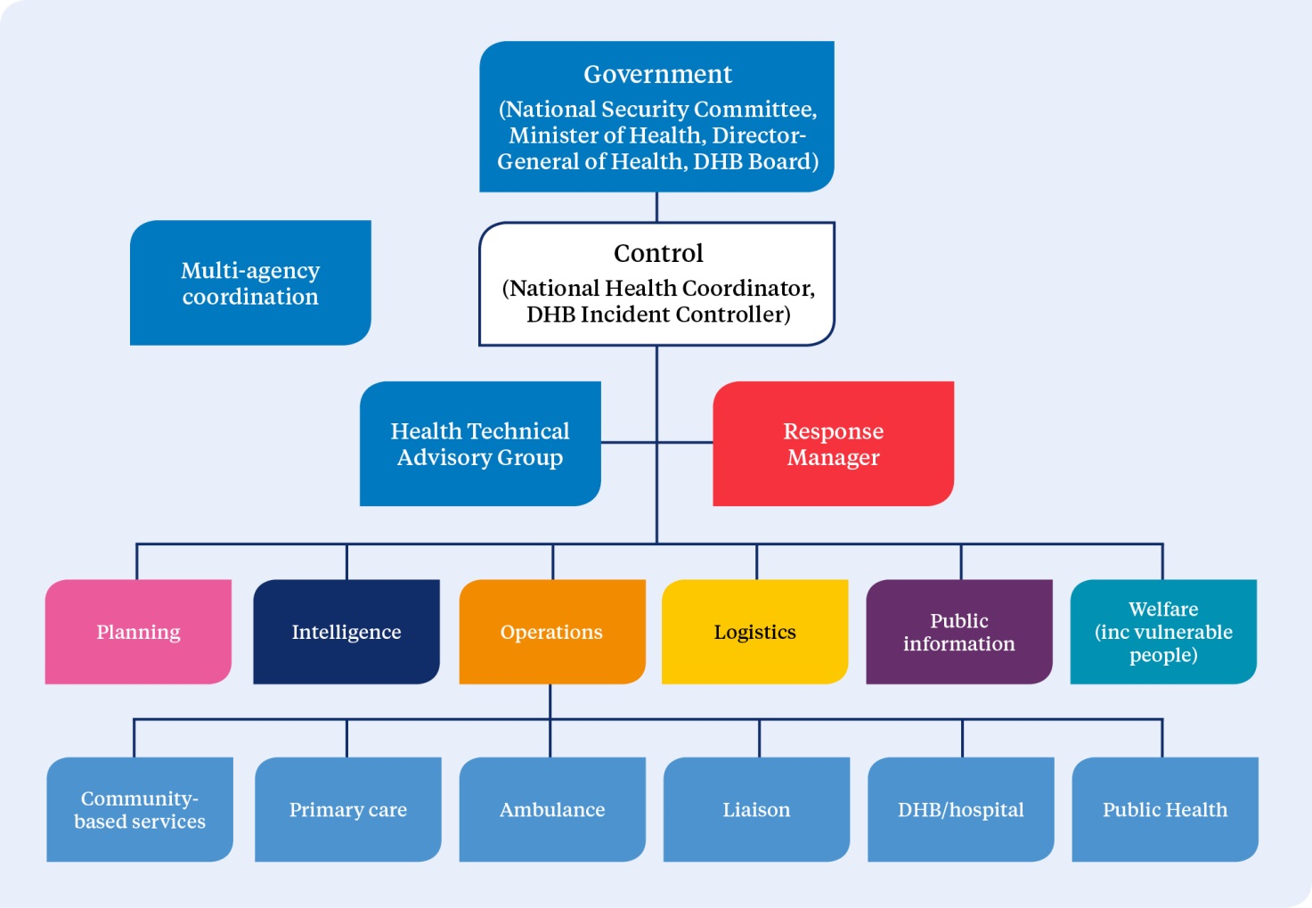
Source: Based on The New Zealand Coordinated Incident Management System, ODESC (2014)

Ministry of Health as national lead agency in response
The Ministry of Health has the role of lead agency in an all-of-government response to a health emergency such as an epidemic or pandemic.

As lead agency for an emergency at the national level, the Ministry:
- must coordinate the management of the emergency in accordance with its own emergency plans and statutory functions and powers
- may use the provisions of the National CDEM Plan in support of its management of the impacts of the emergency if they cannot be dealt with by the emergency services, or otherwise require a significant and coordinated response at the national level.

In a national emergency where the Ministry is the lead government agency, it has the two roles of coordinating the:
- health and disability sector response
- all-of-government response.

The structure used in an emergency in which the Ministry is the national lead agency at the operational level is outlined in Figure 4.

Figure 4: National crisis management – Ministry of Health as national lead agency
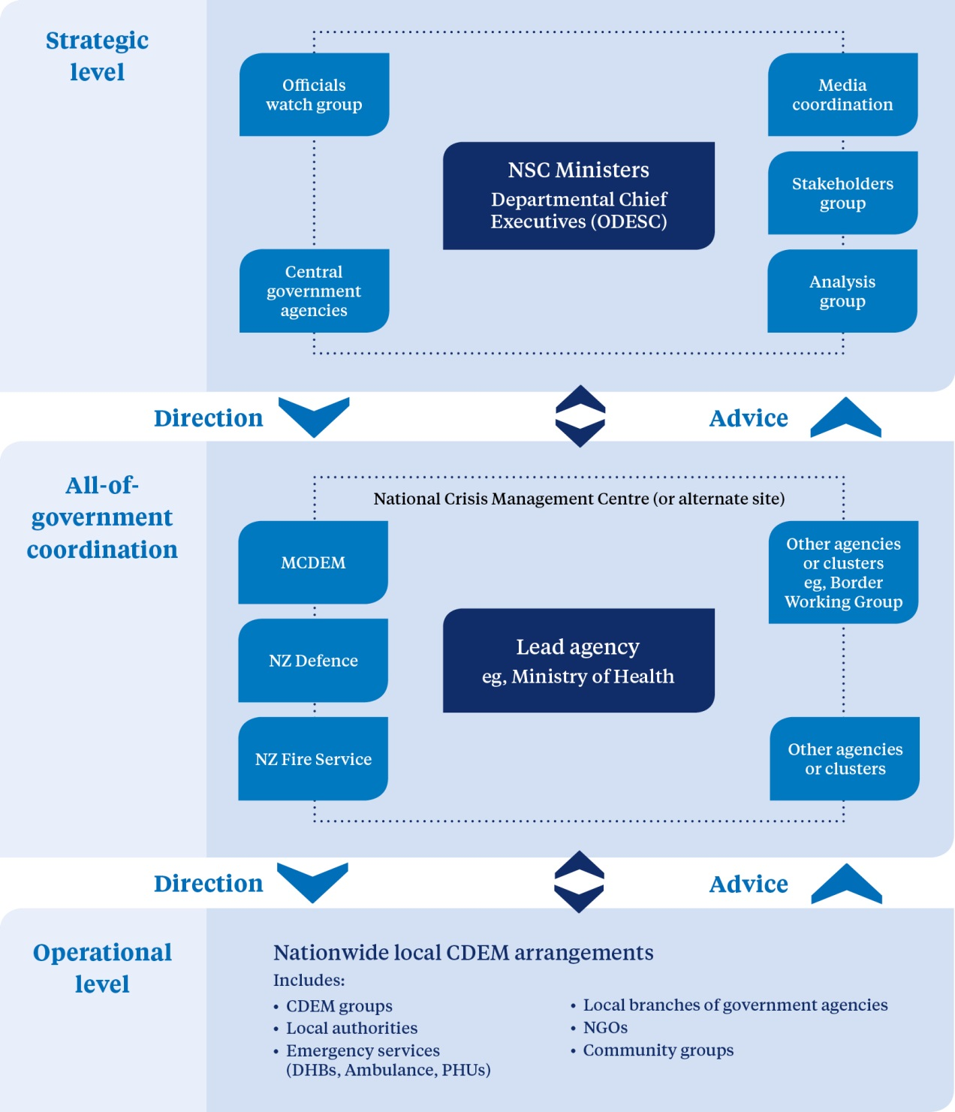
Source: Adapted from Guide to the National Civil Defence Emergency Management Plan, ODESC (2015)

In this scenario, the Ministry of Civil Defence and Emergency Management, in conjunction with the Department of the Prime Minister and Cabinet (DPMC) and support agencies, will assess what level of all-of-government coordination is required.
- Limited interagency coordination with Health as the lead agency: NHCC will coordinate both the health and disability sector response and the all-of government response (for example, during border management operations).
- Significant interagency coordination: the National Crisis Management Centre (NCMC) may be activated with a Ministry of Health lead to support the domestic and external security coordination system, while NHCC focuses on the health and disability response.

The NCMC is activated by ODESC in consultation with the DPMC. It facilitates an all-of-government response in support of government crisis management arrangements by providing a secure, centralised facility for information gathering and information management, strategic-level oversight, decision-making and coordination of national responses.

In this situation, coordination of the health and disability sector will continue to be based at the NHCC, and the all-of-government coordination will occur at the NCMC. Both centres will be led by the Ministry of Health. The NHCC is staffed by health officials, but the NCMC may be staffed by a range of officials from across government.

Ministry of Health as national support agency in response
In an emergency where the Ministry of Health is providing support, depending on the nature of the emergency it may provide a health liaison officer to the lead government agency. The liaison officer’s role is to act as a conduit between the health and disability sector and the lead agency in terms of requests, information transfers and so on.

Health liaison officers may also be provided to key all-of-government groups or other government agencies to facilitate emergency coordination and response across agencies. For example, health liaison officers may be provided to the National Welfare Coordination Group (NWCG).

Warnings and advisories
Emergency warnings and advisories provide information about imminent or sudden onset incidents that can potentially have significant impacts on people, property, areas, or social or economic activities. The objective is to issue warnings and advisories in a timely manner so that local authorities, agencies and people can take action to reduce loss of life, illness, injury and damage.

For a warning or advisory to be effective, the appropriate people must receive it and understand the hazard and what they should do under the particular circumstances. There must also be effective readiness and response at all levels.

Warnings and advisories about predictable events (for example, severe weather, volcanic eruption, distance-source tsunami) are to be given as quickly as practicable. For unpredictable events (for example, earthquakes, local-source tsunami) where a prior warning may not be possible, the objective is to inform emergency response by indicating the likely magnitude of the event and extent of the affected areas.

The responsibility for issuing a warning rests with the agency that, through its normal function, is responsible for monitoring, identifying and analysing the particular hazard.

Relevant government agencies, CDEM Groups, local authorities and lifeline utilities must maintain arrangements to receive and respond to warnings.

National warning system
The national warning system is a 24-hours-a-day, 7-days-a-week process for communicating information in order to alert recipients to the need for readiness and possible response to an imminent or sudden onset of a hazard incident that may result in an emergency.

MCDEM is responsible for overseeing the maintenance and function of the national warning system. It provides national warnings to CDEM Groups, local authorities, emergency services, government departments, lifeline utilities, certain broadcasters and other agencies. CDEM Groups are responsible for disseminating national warnings to local communities and maintaining local warning systems.

If arrangements are made with MCDEM, the national warning system can be used to issue national warnings on hazards for which other lead agencies are responsible for deciding and maintaining warning arrangements.

Single point of contact system
The Ministry of Health and each DHB and public health unit maintain a single point of contact (SPOC) system that is available on a 24-hour, 7-days-a-week basis. The SPOC system is an integral part of health and disability sector coordination for emergency management, especially for those with a role focused on response. The purpose of the system is to enable effective and rapid communications between senior Ministry of Health officials, DHBs and public health units at any time, via a dedicated SPOC phone number or through a dedicated SPOC email, to notify each other of a potential or actual emergency with health appreciable implications. The SPOC system does not reach out beyond DHBs and public health units.

Although the primary intention for the SPOC system is to initiate coordination in readiness for and during emergency responses, it remains in place at all times. It supplements but does not replace normal day-to-day communication channels and processes.

The Ministry maintains the SPOC contact lists and regularly tests and reviews the integrity of the system. Each organisation on the SPOC system is also expected to regularly test and review internal systems to receive and process communications via the SPOC system. Each contact in the system is intended to function as an access point within each organisation to receive and transmit all emergency-related communication within and between organisations.

Once a code red alert (see Table 3) has been sent and the relevant DHBs have activated their incident management team, the SPOC will continue to operate through the emergency operations centre (EOC). Incident management team arrangements should take this into account.

Alert codes
The Ministry of Health has developed alert codes to provide an easily understood system of high-priority communication leading up to and during emergency response activations. These alert codes are issued from the Ministry via the SPOC system. The alert codes outlined in Table 3 are intended for use in relation to nationally led communication.

It is not necessary for all DHBs to be at equally corresponding levels of alert. The appropriate level will be determined by the impact and the ability for DHB(s) to respond or provide support for the response. (See ‘Activating a response’). For example, a single or group of DHBs may be in code red, while the remaining DHBs are in code yellow.

Table 3: Health and disability sector alert codes
Phase | Measures | Code
Information | Notification of a potential emergency that may impact in and/or on New Zealand or specific information important to the health and disability sector.  Example: emergence of a new infectious disease with pandemic potential, or early warning of volcanic activity. | White
Standby | Warning of imminent code red alert that will require immediate activation of health emergency plans.  Example: imported case of a new and highly infectious disease in New Zealand without local transmission, or initial reports of a major mass casualty incident within one area of New Zealand which may require assistance from unaffected DHBs. | Yellow
Activation | Major emergency in New Zealand exists that requires immediate activation of health emergency plans.  Example: large-scale epidemic or pandemic or major mass casualty incident requiring assistance from unaffected DHBs. | Red
Stand-down | Deactivation of emergency response.  Example: end of outbreak or epidemic. Recovery activities will continue. | Green

Roles and responsibilities by alert codes
The role of the Ministry of Health in an emergency is primarily to coordinate health and disability services nationally. The Ministry will also coordinate all international arrangements for the health and disability sector, in partnership with the Ministry of Foreign Affairs and Trade and MCDEM.

The initial response for the management of an emergency is made by the affected local provider, which may be the local DHB, or the inter-DHB regional group if support between DHBs is required. At each phase of an emergency there are specific actions that need to be taken at local, regional and national levels. Appendix 15 summarises key roles and responsibilities at each of these levels during each alert code.

The Ministry of Health’s alert codes should be read in conjunction with the five levels of response described in Table 4.

Activating a response
As with most emergency responses, health service responses are predominantly activated near the sites of impact, as communities and services marshal their resource to meet immediate needs, reduce impacts and attempt to coordinate responses. Deliberate activation of emergency health response capabilities and coordination is a critical aspect of an effective emergency response.

Due to the potential interruption to normal service delivery, the decision to activate significant aspects of emergency health response and coordination capabilities should be made by executive managers or other senior personnel with delegated authority to do so.

A key aspect of all responses is to communicate any changes in the level of activation and share information on the hazard, impact and response within health services and with partner response and recovery organisations.

Although emergency health responses may be activated autonomously at each level by the health and related agencies that have service delivery or coordination responsibilities at that level, lower-level responses may also be activated by higher levels of management. Health response capabilities may also be requested or activated by lead agencies with authority to do so, including the Ministry of Health and CDEM controllers at local, regional or national level. Table 4 outlines the response procedures and roles involved at five levels of incident or emergency.

DHBs are required to notify the Ministry of Health of any activations where their EOC is established to manage an event. Notification can be made through normal reporting mechanisms, or if the event is out of hours through the Ministry’s emergency 0800 number. This will enable the appropriate levels of support to be provided to the affected DHB(s) if required.

Table 4: Response, including health response, at five levels of incident or emergency
Level of incident/ emergency | Status and procedures | Health ECC/EOC roles | Health Controllers’ roles | NCMC operating mode
1 Community  Site incident: Can be dealt with by community/emergency services and/or local authority resources alone. Specialists may be required for specific circumstances. | Communities, organisations and businesses self-respond to emergencies, either as part of official pre-existing arrangements or on their own in a spontaneous or emergent manner. Response agencies need to accommodate, link with, support and coordinate with community participation in response. | Hospital or health service EOCs Incident Management Teams may be alerted or be partially operative in support of the lead agency and to coordinate health resources and activities. | DHB Incident controller and Incident Management Team are notified if EOC is likely to be involved.
2 Incident  Local/site multi-agency incident: Can be dealt with by emergency services and/or local authority resources though remote support (Incident Control Point) is likely to be required. Specialists may be required for specific circumstances. | Incident level response is the first official level of multi-agency response and is carried out by first responders and the communities involved. A Civil Defence Declaration is made only if emergency powers are required, ie, response agencies cannot manage using their normal arrangements, or significant coordinated response is required. | Hospital or health services EOC is a key support agency. Lead agency EOC is partially or fully activated and coordinates agreed functions. CDEM Group and DHB EOC or emergency coordination centre (ECC) may be partially activated in a monitoring role. | DHB Incident Controller coordinates the agreed functions.  Group and DHB EOCs/controllers are notified. | Monitor  Monitor and assess threats and incidents that may lead to a local emergency.  Lead agency: on standby. Minimal staffing to monitor impending or actual emergency.  Support agencies: on standby.
3 Local  Coordination or support necessary.  Imminent or state of local emergency involves a single local territorial authority. The event may not or cannot be managed without the adoption of emergency powers. | The coordination centre for a local level response is an EOC. EOCs are usually activated for the purpose of multi-agency or multi-incident coordination. EOCs are staffed and managed by the lead agency, and supplemented by personnel representing, or provided by, other agencies.  Declaration of state of local emergency in a single local territorial authority may be considered or has been deemed necessary. Declaration can be for an entire district or one or more wards. | Hospital or health service EOC Incident Management Team is fully activated and coordinates responses to the emergency. CDEM Group, DHB EOC and adjacent EOCs are alerted or partially activated to monitor situation and respond if it deteriorates. | Local CDEM controller may exercise statutory powers.  DHB controller supports the CDEM Group Controller and considers further escalation.  Adjacent DHBs and CDEM Groups and National Controller are notified.  Consideration is given to use of medical officer of health powers pursuant to ss 70–71 of the Health Act 1956. | Engage  In addition to monitoring activities: collect, analyse, and disseminate information on emergencies; report to or advise Government; provide public information service.  Lead agency: increased staffing.  Support agencies: kept informed, some activated.
4 Regional  Inter-DHB or regional coordination or support is required. Local emergency is regionally significant: The event impacts on one local authority but requires response and resources from outside that local authority, or the event impacts on two or more local authorities within a CDEM Group/DHB area, or coordinated assistance is required to support an adjoining (or distant) DHB or CDEM Group(s). | A regional level response may be activated:  - to direct, coordinate, and support incidents with regional or national implications  - when a local response requires wider coordination, and  - when the Regional Health Coordinator or their governance deems it necessary.  The Regional Health Coordinator coordinates the regional level response for the incident, and directs, supports and coordinates local responses. The coordination centre for a regional level response is an ECC (RHCC).  Declaration of state of local emergency for a region may be considered or has been deemed necessary. | ECCs and EOCs are fully activated. NHCC and adjacent DHB EOCs may be alerted or partially activated to monitor the situation and be ready to respond if the situation deteriorates. | Group controller may exercises statutory powers.  National Controller considers further escalation.  DHB controllers respond to priorities set by the Local/Group CDEM controller.  Consideration is given to use of medical officer of health powers pursuant to ss 70–71 of the Health Act 1956. | Assist  In addition to engagement activities: process or coordinate requests for support from regional and local organisations, including assistance from overseas, and international liaison; report to or advise Government.  Lead agency: partial to full staffing.  Support agencies: most activated.  NCMC: fully operational.
5 National  Coordination or support is required.  State of national emergency is possible, imminent or declared. | National response, information and resources are coordinated.  Coordination of national response is applied. The response is consistent with CIMS.  Declaration of state of national emergency is being considered, or has been deemed necessary. | NHCC, ECCs and EOCs are fully activated. | National Controller exercises statutory powers.  DHB controller responds to priorities set by the National Controller and National Health Coordinator.  DHB controller responds to priorities set by the local CDEM controller.  Consideration is given to use of medical officer of health powers pursuant to ss 70–71 of the Health Act 1956. | Direct  In addition to assisting activities: control and direct the overall response.  Lead agency: full staffing.  Support agencies: all activated.  NCMC: fully operational.
Source: Adapted from the National CDEM Plan 2015 and CIMS 2nd edition (2014)

Response information sharing and coordination
During an emergency response, health services need to be able to coordinate with other agencies and to communicate effectively within their own agency, as well as with partner health service providers and the public. It is imperative that organisations circulate clear and consistent messages for both internal and external communications.

Various media may be used for these communications, such as social media, websites, TV, radio and print media. They include both formal structured systems and informal networks.

Structures and tools for response management

National Health Coordination Centre
The Ministry of Health established the National Health Coordination Centre (NHCC) as a structure through which the Ministry can nationally coordinate and manage the health responses to and recovery from emergencies. The centre is kept in a constant state of readiness for activation for a response to any emergency, and this will take precedence over exercising and testing.

When the Ministry is the lead agency in a response, it may also use the National Crisis Management Centre (NCMC), maintained by MCDEM, depending on the extent of the response required.

The Ministry of Health maintains alternative NHCC capabilities so that the NHCC can be established in any location, depending on the needs of any particular emergency.

Health Emergency Management Information System (Health EMIS)
Health EMIS, the health and disability sector’s web-based ‘emergency management information system’, is the primary tool for managing significant incidents and emergencies at local, DHB, inter-DHB and national levels.

Figure 5: Health EMIS logic diagram
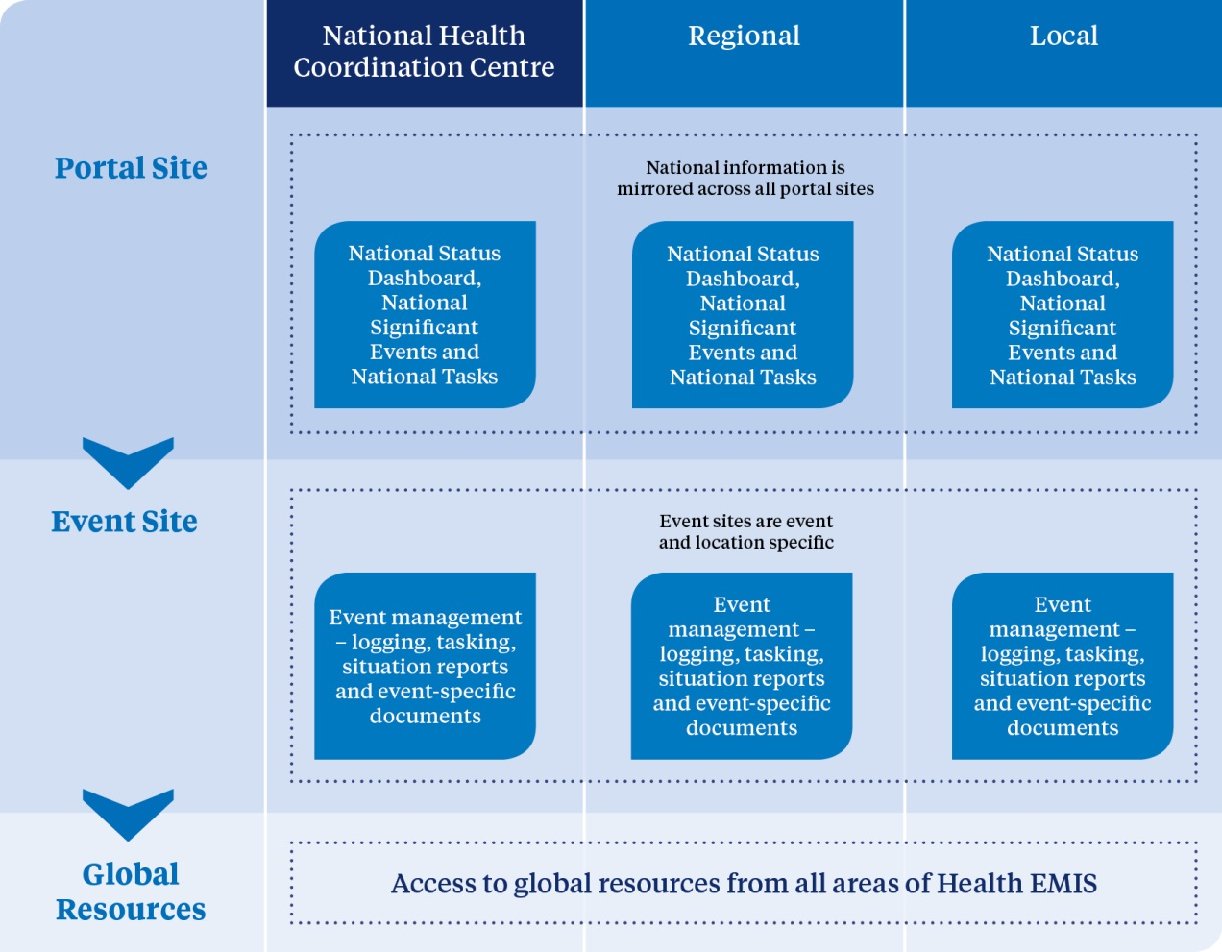

Health EMIS provides an electronic system to manage information produced during an incident or emergency. It does not replace verbal communications between agencies and service providers. It provides DHBs, public health units and other key health responders, such as ambulance services, with a logging and task-tracking system which they can use to manage their local response to an incident. The system complements other business-as-usual information systems.

Health EMIS is an adaptable system, regulated by a formal set of standards and processes that are aligned to best practice and include a formal change management process.

Information in Health EMIS is visible to all organisations with access rights who are involved in the response. In the event of an emergency, other government agencies may be given access rights so that the health and disability sector response in an emergency is more visible.

The Ministry of Health manages and hosts the system. It has ensured that appropriate disaster recovery systems are in place to minimise the risk that Health EMIS will be unavailable due to an information technology outage.

Further information, online training and other materials are available to all, irrespective of access rights, at www.health.govt.nz/our-work/emergency-management

Alternative telecommunications
There may be periods of time in which the Health EMIS is inaccessible. During these times, an alternative system replicating the main Health EMIS functions will be achieved using paper-based templates. Alternative communication links, such as satellite phones and/or radio links, may be used to convey necessary information.

Templates, both electronic and paper-based, have been developed for situation reports, action and task plans, intelligence reports and requests for information and action. The completed templates will be disseminated via the SPOC system using email, fax, satellite or radiotelephone. DHBs and PHUs are responsible for developing their own alternative mechanisms for logging information and tracking tasks locally. Use of the templates will ensure that necessary verbal communication is quick and succinct, and that it is supported by an existing record of pertinent information.

Public information management
Effective public information management involves identifying the need for information or advice, appropriate presentation and dissemination, media liaison and monitoring. It should promote effective leadership and decision-making, create strong public confidence, and enable people to understand what is happening and take the appropriate actions to protect themselves.

Achieving these outcomes requires the provision of rapid, honest, frequent and open communication to target audiences. Other considerations are both the nature of the message (taking into account, for example, language and literacy levels) and the best mechanisms for disseminating it, in terms of what will be most effective for its intended audiences.

If public information management is to be effective, all agencies must work collaboratively at all levels, based on pre-established plans, working relationships and understandings of role expectations during an emergency.

The Ministry of Health will manage national media communication in a health emergency, in consultation with other government agencies and DHBs. DHBs, in developing their public information management plans, will take the Ministry’s role into consideration. DHB plans will address methods of disseminating and reinforcing local messages for their local populations. The Ministry and DHBs will work within their own and partner agency CIMS-based response coordination roles and structure to coordinate the development and dissemination of public information, in conjunction with the lead agency.

In an emergency the Ministry will place information specific to the health and disability sector on its website. In this way, health providers, other agencies and the general public have direct access to the information. Health providers should make use of and monitor the information on this website during an emergency.

In a health-related emergency the Ministry’s emergency website is to be used for information of general relevance to other agencies. However, other agencies remain responsible for generating customised information relevant to their sector and disseminating it through appropriate channels for those sectors after consultation with the lead agency.

All of government communications group
The all-of-government communications group is convened by the lead agency involved in the response to the emergency. The group’s role is to coordinate government agencies in developing national and international key messages that will guide all communications and to advise the DPMC on public information management matters. During the initial response of a health emergency, the group will include communications managers from the Ministry of Health plus communications managers from the Department of Internal Affairs, Ministry of Foreign Affairs and Trade, Ministry of Social Development and Ministry of Transport, and a representative from DPMC.

Social media
Driven by increasing access to and use of social media, web-based journalism and constant news coverage, the public increasingly expect immediate and continuous access to information. Social media, in particular, has changed how the world responds to emergencies by allowing for rapid, wide-scale interaction between members of the public. Accordingly, it is a tool that can be used to improve crisis management through enhancing both information gathering and information sharing.

While the power of social media should be harnessed in all components of emergency management, consideration must be given to several important issues, such as content accuracy, security issues and privacy. Useful information is provided in the good practice guide Social media for Emergency Management, developed by the Wellington CDEM Group (Wellington Region Emergency Management Office 2014).

Communicating with local, national and international emergency agencies

Local and regional coordination
DHBs are responsible for communicating directly with other local emergency agencies that may be involved in the response, including CDEM Groups, through their ECCs and local EOCs, and ambulance, police and fire services. The lead agency ECC will provide the basis for multi-agency response coordination, which simplifies liaison, information sharing and coordination (see Figure 6).

Figure 6: Generic multi-level response coordination
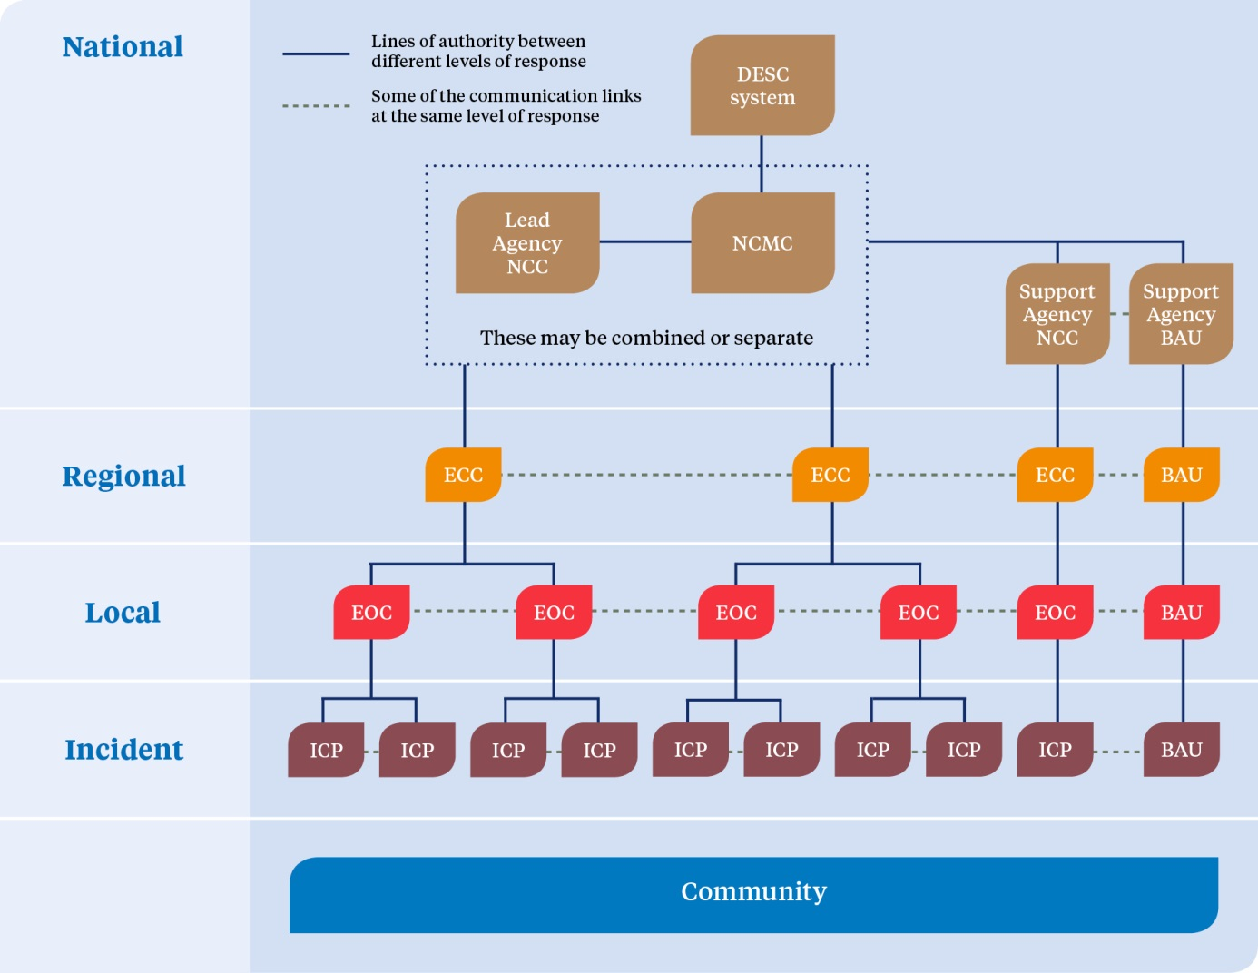
Source: The New Zealand Coordinated Incident Management System, ODESC (2014)
For term definitions see Glossary and Abbreviations section (page 95)

During the activation of a local or inter-DHB health emergency response, DHBs will establish formal liaison with other local response agencies (see Figure 7). To achieve this, DHBs will plan for the provision of a liaison officer to their local or regional CDEM Group’s ECC. DHBs will also provide for liaison officers from other agencies within their own EOC. The liaison officer will communicate and disseminate inter-agency information when a DHB, inter-DHB or national health emergency response is activated. All formal inter-agency communications must go through established liaison channels.

Figure 7: Formal liaison structure for DHBs and other local response agencies
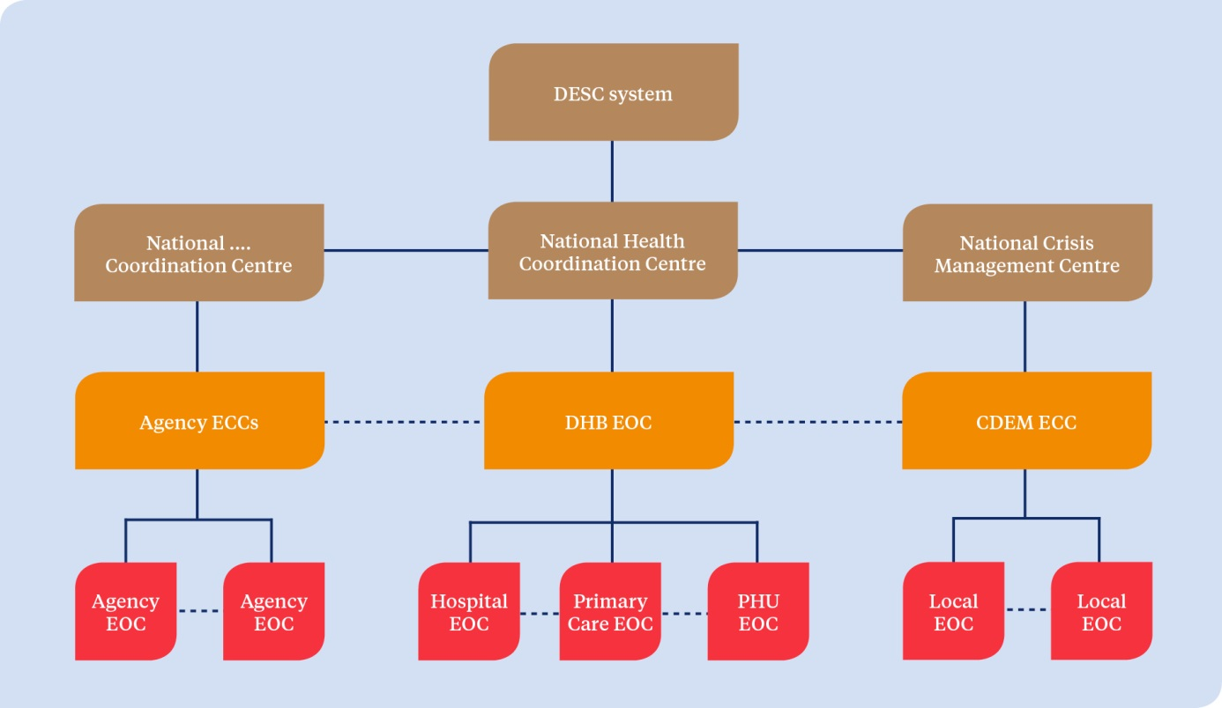

The Ministry of Health will coordinate all communications at a national level with MCDEM, national representatives of ambulance, police and fire services, ODESC and all of government, including the all-of-government communications group. When a health-based response is activated, liaison officers from other agencies, operating at a national level, will be involved in order to facilitate national decision-making and liaison.

International assistance
The Ministry of Health, along with the NCMC international assistance cell, will coordinate requests for and offers of international assistance. The international desk, which is run by MCDEM with input from the Ministry of Foreign Affairs and Trade, may be staffed by a range of agencies. When the Ministry of Health receives bilateral requests for or offers of assistance, it will ensure that the international desk, if activated, is aware of the request or offer or, if the international desk is not activated, that the Ministry of Foreign Affairs and Trade is aware of this information.

Key response functions
In addition to the functions and factors already addressed in this plan, there are a number of other key response functions that must be considered. These are described briefly in this section. For selected issues, more detailed information is provided in the appendices and supporting information.

Regional coordination
DHBs are expected to progress opportunities for regional system integration and regional service development and to focus on effective regional governance, accountability and decision-making. This same expectation applies to emergency response. DHBs and other health and disability agencies must liaise with each other to ensure they can provide an integrated emergency response at a local level. Any incident requiring a response from more than one DHB, or a request for assistance from one region to another, is to be dealt with regionally.

Medical officers of health
Medical officers of health are designated to a region of New Zealand by the Director-General of Health. They have a number of statutory responsibilities under a number of different statutes, including the Health Act 1956.

The medical officer of health, and any designated officers or other person authorised in that behalf by the medical officer of health have wide-ranging powers as described in sections 70 and 71 of the Health Act 1956. They may use these powers by authorisation of the Minister of Health, or if a state of emergency has been declared under the Civil Defence Emergency Management Act 2002, or if an epidemic notice is issued by the Prime Minister under the Epidemic Preparedness Act 2006.

These powers can only be used to prevent the spread of an infectious disease. They include the ability to:
- prohibit the use of any land, building or thing and/or have anything destroyed
- require people, places, buildings, ships, vehicles, aircraft, animals and things to be isolated, quarantined or disinfected
- forbid people, ships, animals or things to be brought to any (air or sea) port or place in the health district from any port or place that is, or is supposed to be, infected
- forbid people to leave a place or area until they have been medically examined and found to be free from infectious disease
- require (by order in a newspaper or broadcast media) any or all of premises within a district to be closed and/or forbid the congregation of people at any place of recreation or amusement
- requisition any land, building, vehicle or craft necessary for the treatment and care of patients, including transport or accommodation of equipment and staff, or transport of clothing, bedding and temporary accommodation.

Medical officers of health have other powers and responsibilities beyond the Health Act, and also have key roles as health leaders and spokespeople. Because of these existing responsibilities, many of which they will be required to exercise during an emergency, it is recommended that medical officers of health do not act as CIMS incident controllers or regional controllers outside their own health agencies.

It is important that a medical officer of health or a deputy liaises directly with the incident controller in order to provide expert advice to prevent mixed messages or conflicting actions. It is also important that communication teams from the Ministry of Health, MCDEM, district health boards, CDEM Group and local civil defence work closely with each other and with both their incident controller and the medical officer of health. When powers are invoked, other agencies may be required to be involved, particularly the Police.

Appointment to key roles
For any component of emergency management to be effective, it is essential that the right people or organisations are appointed or assigned to appropriate roles. Achieving the appropriate match is particularly important for response and recovery to ensure that those with key roles are developed so that they can deliver their functions competently and confidently during emergencies.

Key response roles should be clearly documented and incorporated within plans, operating procedures and professional development programmes. They include response coordination roles based on the coordinated incident management system (CIMS; see Appendix 14) within each organisation and at each level of coordination. Specific roles are:
- Response/Incident Controller/Coordinator (for Ministry of Health, DHBs, all health services)
- Operations Managers
- Coordinators for Operations functions
- Intelligence Managers
- Planning Managers
- Logistics Managers
- Public Information Manager
- Recovery Manager/Coordinator
- Liaison Officers
- Welfare Managers
- Technical Advisory Group.

New Zealand Medical Assistance Team
New Zealand Medical Assistance Team (NZMAT) is a civilian-based medical team comprising of clinical and allied staff that can be deployed to support local health services in the event of a major emergency in New Zealand, the south-west Pacific or other areas as directed by the Ministry of Foreign Affairs and Trade.

NZMAT uses a modular team structure to provide a range of functions from public health and primary care to surgical and nursing care. The size and composition of a deployed team depend on the disaster epidemiology and the support required by the affected agency. A national NZMAT registration database allows staff to pre-register at any time as well as to register their availability when a sudden onset disaster occurs. Eligible staff are provided with specialist deployment training; however, in some circumstances untrained staff may also be deployed.

The NZMAT capability does not replace or lessen the requirement for health providers to plan for resilient services, or for DHBs to have mechanisms for inter-DHB support.

Volunteer management
Volunteer management involves effectively coordinating the use of volunteers during an emergency, including through recruiting, identifying, resourcing and providing just-in-time training for volunteers. See Appendix 10 for further information.

Review of emergency responses
A formal review may be initiated after an emergency response. The purpose of the review is to analyse the plans and arrangements in place at the time of the emergency. The review will evaluate the actions of all participants and their responses, and should identify areas for improvement. The review and subsequent actions may require inter-agency collaboration.

The post-emergency debrief provides a mechanism for those involved in the response to communicate their experiences. For a discussion of the types of organisational debriefing that can be used to facilitate post-emergency learning, see Appendix 9.

Plans should be revised, taking account of the review or debrief findings. The new plans will then require testing and validation by exercising to ensure that the lessons learnt have been effectively applied. The findings of reviews must be recorded and these reports may become public documents. Reports should be reviewed by all recipient participants and agencies.

Recovery
Emergency recovery objectives include:
- minimising the escalation of the consequences of the emergency
- regenerating the emotional, social and physical wellbeing of individuals and communities
- taking opportunities to adapt to meet the future needs of the community
- reducing future exposure to hazards and their associated risks.

Recovery involves the coordinated efforts and processes used to bring about the short-, medium- and long-term holistic regeneration of a community following an emergency. The recovery period may last for any amount of time, from weeks to decades.

Planning for recovery is integral to preparing for emergencies and is not simply a post-emergency consideration. Recovery is not about returning to normality. It is more about regeneration; building back smarter, better, more sustainably and with more resilience. The post-emergency environment poses new challenges and opportunities to re-plan and perhaps even relocate. Health services need to transition from the immediate response to longer-term recovery with partner organisations and affected communities.

Considerations for immediate and long-term community recovery can include:
- providing immediate health services to affected individuals and families
- assessing community health and psychosocial recovery needs and prioritising the actions required
- developing, implementing and monitoring the provision of community health recovery activities
- enabling communication with the vulnerable community and participation in decision-making
- adapting existing organisations and procedures in order to minimise the time needed to get post-disaster institutions functioning
- contributing to future mitigation needs or improvements to planning.

In many ways, the activities involved in recovering from an emergency are similar to normal daily life: people seeking accommodation and building homes, businesses meeting commercial challenges, and utilities and public services improving infrastructure and facilities. What is unique in the recovery period is that these activities occur simultaneously and in a compressed period of time. This phenomenon has been used to explain many of the key elements of recovery processes, including the:
- conflict between the pressure to restore a sense of normalcy and the use of speed and quality as measures of recovery success
- mismatch between the flow of financial resources and the pace of recovery
- exacerbation of pre-disaster inequities after disasters due to the simultaneous and competing demands for limited resources
- opportunities to change, upgrade and improve land uses, facilities and infrastructure
- conflict between the need for fast decision-making and the lack of support for it from the flow of information, knowledge and planning
- differential rates of recovery across the community with uneven and contrived processes of physical construction, supply resources, and restoration of community networks.

Recovery extends beyond restoring physical assets and providing welfare services. Successful recovery recognises that both communities and individuals have a wide range of recovery needs, which must be addressed in a coordinated way. A holistic framework is needed to consider the multi-faceted aspects of recovery that support the foundations of community sustainability. The framework used by MCDEM encompasses the community and its four environments (social, economic, natural and built), as illustrated in Figure 8.

Health agencies and service providers contribute to all four environments of recovery. As well as ensuring that services are accessible and sustainable, the health and disability sector must adjust to emerging requirements and changes in demand by reshaping services and models of care delivery.
Figure 8: Integrated + holistic recovery

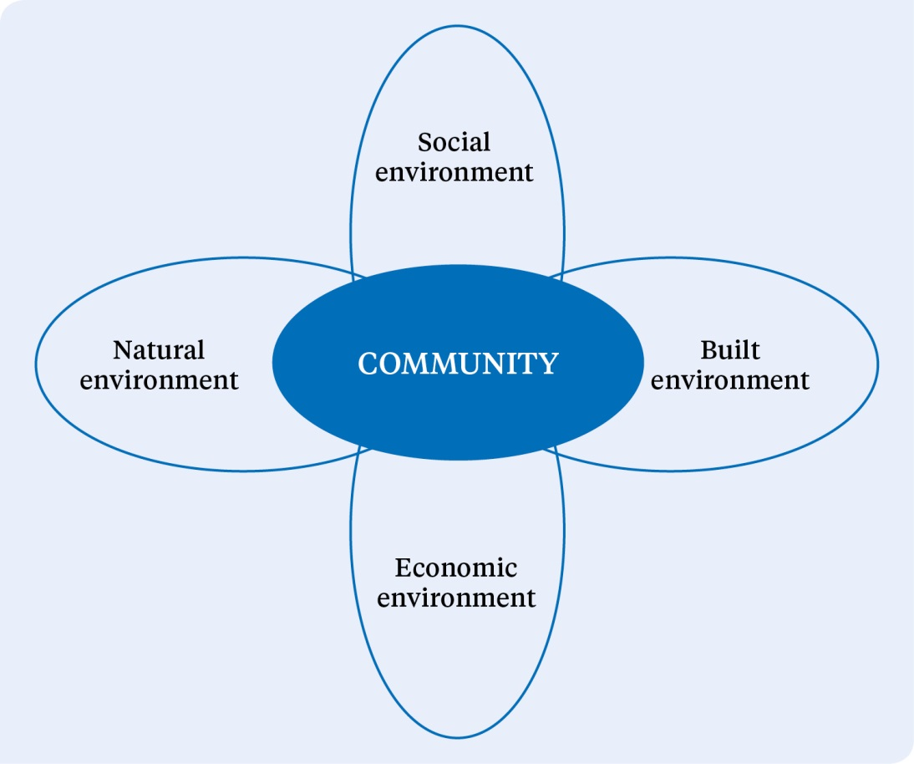

Source: Focus on Recovery: A holistic framework for recovery in New Zealand, MCDEM (2005)

While the delivery of medical, mental and community health services is a key component of social recovery, it is also critical to manage health aspects of environmental impacts and subsequent recovery. A healthy community is essential to economic recovery, and the resources used by public and private health services and the financial contributions they make to local and regional economies are crucial to economic recovery and sustainability.

Health services (and in particular public health units), therefore, need to be appropriately represented in the relevant aspects of recovery management for their own communities, local areas or regions. DHBs should be actively involved in the recovery management committee(s) or similar organisations established by their respective CDEM Group(s). In addition, they will be active members of recovery management organisations activated by their local authority or CDEM Group or by central government during or following the responses to significant emergencies.

Monitoring and review during recovery contribute to the continuance of health care delivery and to improvements in planning and future mitigation activities. This activity entails actively monitoring and reviewing:
- health service recovery needs
- risks and vulnerabilities that may impede the ability of health services to deliver essential services to the community and prioritise health care recovery needs
- continuity of operations (business continuity in health care delivery)
- health recovery activities.

Psychosocial recovery
With the rewriting of the National CDEM Plan and subsequent guidelines, the responsibility for community psychosocial recovery is now vested with the Ministry of Health and the health and disability sector.

The Ministry will provide strategic advice and guidance to the Government, CDEM agencies and health and disability sector through the Office of the Director of Mental Health. The Ministry will represent the health and disability sector on the National Welfare Coordination Group.

It is expected that DHBs will lead the wider local groups responsible for delivery of services that meet the psychosocial needs of a community after an emergency. It is expected DHBs will be represented on welfare coordination groups to provide advice, guidance and lead agency responsibilities for psychosocial recovery.

References
Ambulance New Zealand. 2011. New Zealand Ambulance Major Incident and Emergency Plan. Wellington: Ambulance New Zealand.
Australian Red Cross. 2010. Spontaneous Volunteer Management Resource Kit: Helping to manage spontaneous volunteers in emergencies. Canberra: Commonwealth of Australia.
Carswell S. 2011. What We Have Learnt: Aged care provider learnings on responding to the February earthquake in Canterbury. Christchurch: Eldernet and Canterbury DHB.
MCDEM. 2005. Focus on Recovery: A holistic framework for recovery in New Zealand. Wellington: Ministry of Civil Defence and Emergency Management.
MCDEM. 2006. Organisational Debriefing: Information for the CDEM sector. Wellington: Ministry of Civil Defence and Emergency Management.
MCDEM 2008. National Civil Defence Emergency Management Strategy. Wellington: Ministry of Civil Defence and Emergency Management.
MCDEM. 2009. CDEM Exercises: Director’s Guideline for Civil Defence Emergency Management Groups. Wellington: Ministry of Civil Defence and Emergency Management.
MCDEM. 2013. Volunteer Coordination in CDEM: Director’s Guideline for Civil Defence Emergency Management Groups. Wellington: Ministry of Civil Defence and Emergency Management.
Ministry of Health. 2004. National Health Emergency Plan: Infectious Diseases. Wellington: Ministry of Health.
Ministry of Health. 2008. Guidance on Community-based Assessment Centres and Other Support Services. Wellington: Ministry of Health.
Ministry of Health. 2010. New Zealand Influenza Pandemic Plan: A framework for action. Wellington: Ministry of Health.
Ministry of Health. 2011. National Health Emergency Plan: Mass Casualty Action Plan. Wellington: Ministry of Health.
Ministry of Health. 2013. National Health Emergency Plan: National Reserve Supplies Management and Usage Policies. Wellington: Ministry of Health.
National Ethics Advisory Committee. 2007. Getting Through Together: Ethical values for a pandemic. Wellington: National Ethics Advisory Committee.
ODESC. 2007. National Hazardscape Report. Wellington: Officials’ Committee for Domestic and External Security Coordination.
ODESC. 2014. The New Zealand Coordinated Incident Management System: Safer communities through integrated emergency management. 2nd edition. Wellington: Officials’ Committee for Domestic and External Security Coordination.
ODESC. 2015. Guide to the National Civil Defence Emergency Plan. Wellington: Officials’ Committee for Domestic and External Security Coordination.
State of Victoria, Department of Health. 2013. Relocation, Shelter in Place and Evacuation. Melbourne: Department of Health.
Wellington Region Emergency Management Office. 2014. Social Media for Emergency Management: A good practice guide. Wellington: Wellington Region Emergency Management Office.
WHO. 2012. International Health Regulations (2005): A guide for public health emergency contingency planning at designated points of entry. Geneva: World Health Organization.

Appendix 1: Self-assessment checklist for a health emergency plan
This checklist has been developed to assist those responsible for developing and maintaining health service emergency plans, programmes and capabilities. The checklist draws on requirements from the National Health Emergency Plan and National CDEM Plan and Guide.

Name of health service (cluster or grouping):
Date of assessment:
Date of current emergency management plan: Date for review:
Chief Executive: Executive lead for assessment:
Overall comments and feedback:

Assessment criteria
Rating:
0 = None apparent
1 = Not compliant – ineffective
2 = Marginally compliant – marginally effective
3 = Acceptably compliant and effective in relation to minor risks
4 = Largely compliant – likely to be effective in medium-scale incidents
5 = Fully compliant – likely to be effective in relation to significant risks
Question | Rating 0–5 | Comments
1. Evidence of governance/senior executive ownership of emergency management
2. Responsibilities of executive in delivering comprehensive emergency management
3. Risk analysis supporting emergency management planning
Reduction
4. Risk reduction and resilience-building opportunities, role, processes articulated
5. Business continuity management plan and processes
Response
6. Response and response coordination roles, processes and capabilities:
a. In-house health functions
b. Partner services (including, for DHBs, neighbouring DHBs)
c. Mass casualty response management
d. Hazardous substance decontamination
e. CIMS functions (at respective and subsidiary levels)
Readiness
7. Readiness processes, and activities documented:
a. Capability analysis (including training needs)
b. Response functions professional development
c. Response coordination professional development
d. Response coordination information management
e. Resilient response coordination centre locations
8. Alerting procedures (including SPOC)
9. Response activation process and roles
10. Community engagement processes (including Māori and Pacific peoples)
11. Vulnerable people support management
12. Surge management capabilities (in-house and receiving)
13. Critical resource management (including national stockpiles)
14. Emergency patient management, internal and external transfer processes
15. Community psychosocial support and recovery management
16. Management of health-related spontaneous volunteers
17. Management of deceased
18. Recovery management (within local/regional recovery management)
19. Asset management strategy – major risk inclusion
20. Monitoring and evaluation processes (all functions)
21. Communication and collaboration:
a. Emergency and risk management on governance/executive agendas/key performance indicators
b. Executive collaboration with emergency management peers
c. Management collaboration on emergency management (in-house)
d. Management collaboration on emergency management (with external peers)
e. Functional emergency management engagement with communities/clients

Appendix 2: Suggested content for a health emergency plan
Executive summary
Table of contents
Context
- Purpose and objectives of DHB/organisation emergency management
- Health district/service context
- Local/regional community profile
- Relationships with other (DHB) emergency planning and arrangements
- Links to National Health Emergency Plan, CDEM Group plan(s), previous and future plans
Hazard risk analysis
- Outline hazardscape (for the DHB/organisation and its communities)
- Risk analysis (linked to risk analysis of CDEM Group(s))
- Assessment and prioritisation of hazards (understanding)
Risk reduction
- Risk reduction strategies
- Business continuity arrangements
- Links to CDEM Group(s) and partner agency risk reduction strategies
- Contribution to community resilience
Readiness
- Planning, training, exercising and testing
- Capacity and capability monitoring
- Equipment and operational systems
- Interoperability, surge capacities
- Relationship-building with partner organisations
Response
- Response management arrangements
- Response roles, responsibilities and relationships (DHB, health services, partner agencies)
Activation and management processes
- Communications
- Public information management
Recovery
- Recovery management arrangements
- Recovery roles, responsibilities and relationships (DHB, health services, partner agencies)
Monitoring and evaluation
- Description of what success will look like
- How achievement of objectives will be measured
- Links to the national monitoring and evaluation programme within CDEM Plan
Glossary
- Definitions/interpretations of terminology, acronyms and abbreviations
Supporting documents (which will include the following)
- DHB health emergency management plan
- Risk analysis
- Standard operating procedures
- Business continuity plan.

Appendix 3: Risk analysis – hazards and their consequences for the health and disability sector
Hazard | Impact on health facilities and services | Community impacts – response and recovery
Earthquakes | Damage to facilities and/or critical infrastructure  Transportation disruption to supply chain  Impact on staff and families (physical, social, homes, transport, etc)  Scale: Widespread, local to regional | Death and injury (crush, fractures, lacerations, burns, abrasions, particulate inhalation)  Psychosocial impacts  Low risk for infectious disease from endemic pathogens  Economic impacts
Volcanic hazards | Damage to facilities and/or critical infrastructure (within eruption and associated quake zones)  Ash impacts on water supplies, air quality, air-conditioning and facilities  Loss of staff (self-evacuating)  Transportation disruption to supply chain  Scale: Local to regional | Illness (respiratory symptoms, exacerbations of pre-existing lung and heart disease)  Potential chronic conditions due to environmental contamination  Psychosocial impacts  Economic impacts
Landslides | Damage to facilities and/or critical infrastructure (in slip zone)  Transportation disruption to supply chain  Scale: Site to area | Injury  Psychosocial impacts  Economic impacts
Tsunami | Damage to facilities and/or critical infrastructure (in low-lying areas)  Impact on staff and families (physical, social, homes, transport, etc)  Transportation disruption to supply chain  Scale: Local to regional | Death and injury (drowning, serious crush, fractures, lacerations, wound infection)  Psychosocial impacts  Economic impacts  Contamination of environment, water supplies, infrastructure, etc
Coastal hazards (eg, storm surge and erosion) | Inundation of health services, staff homes, etc, in low-lying areas  Access to premises/site compromised or denied  Scale: Site to local | Death and injury due mainly to storm surge (drowning, serious crush, fractures, lacerations, wound infection)  Contamination of environment, water supplies, infrastructure, etc  Psychosocial impacts  Economic impacts
Floods | Damage to facilities and/or critical infrastructure (in low-lying areas)  Loss/contamination of essential drugs and supplies  Isolation of services, staff, patients and/or communities  Loss of staff/health workers  Water supplies contaminated and/or reduced  Transportation disruption to supply chain  Scale: Area to regional | Death and injury (from drowning, electrocutions or physical trauma)  Illness (due to drinking-water contamination, wound infection, respiratory and dermatological symptoms due to mould growth)  Low risk of communicable disease outbreak usually associated with heavy population displacement  Psychosocial impacts  Economic impacts  Evacuation-related health risks
Severe winds | Damage to facilities and/or critical infrastructure  Transportation disruption to supply chain  Scale: Generally local | Death and injury (debris, vehicle accidents, electrocutions)
Snow | Damage to facilities and/or critical infrastructure (due to snow-loading)  Isolation of services, staff, patients and/or communities  Scale: Local to regional | Injury (vehicle accidents, slips and falls)  Hypothermia
Drought | Water supplies reduced  Scale: Regional | Illness (airborne and dust-related respiratory symptoms)  Infectious disease (related to population displacement, vulnerable populations, drought-related behaviours such as reduction in hand hygiene practices)  Psychosocial impacts (especially those whose livelihoods depend on rainfall)
Wildfire | Damage to facilities and/or critical infrastructure (in at-risk areas)  Transportation disruption to supply chain  Scale: Local | Death and injury (burns, smoke inhalation, eye injuries)  Psychosocial impacts  Economic impacts  Evacuation-related health risks
Animal and plant pests and disease | Isolation of services, staff, patients and/or communities  Scale: Local to regional | Illness  Injuries (culling/disposal)  Communities isolated
Human disease pandemic (including water-borne illnesses) | Health impacts to staff  Impact on staff and families (physical, social, homes, transport, etc)  Critical services compromised  Border control and quarantine  Scale: Regional, national or international | Death  Illness  Psychosocial impacts  Communities isolated
Infrastructure failure | Critical services compromised  Information security compromised  Communication impacted  Transportation disruption to supply chain  Scale: Site to local | Economic impacts  Loss of public confidence  Loss of confidential information  Illness/injury (due to disruption to access to water, heating, power)
Hazardous substance incidents | Health impacts/injuries to responders and/or health workers  Scale: Site to local | Injury and illness (respiratory, eye and skin symptoms; genotoxic effects; endocrine abnormalities; headache; nausea; dizziness; and tiredness or fatigue)  Chronic respiratory disorders  Psychosocial impacts  Economic impacts  Environmental contamination
Major transport accidents | Damage to or contamination of facilities and/or critical infrastructure  Access to site compromised  Patient transport compromised  Impact of managing mass casualties on clinical staff and services  Scale: Site to area | Death and injury (impact, trauma, burns, hazardous substances)
Terrorism | Damage to or contamination of facilities and/or critical infrastructure  Critical services compromised  Health impacts/injuries to health responders  Impact of managing mass casualties on clinical staff and services  Scale: Site to area | Death and injury (blast, lacerations, crushing, contamination – chemical, biological, radiological and nuclear)  Illness (respiratory symptoms, including loss of pulmonary function)  Psychosocial impacts
Food safety  (eg, accidental or deliberate contamination) | Health service catering contamination  Loss of staff/health workers  Food Act 2014 officer investigations  Scale: Multi-site with regional/national implications | Illness (due to contamination)
Extreme weather incidents (heat or cold) | Critical infrastructure compromised  Scale: Local to regional | Death and illness (respiratory symptoms, exacerbation of pre-existing lung and heart disease)  Heat exhaustion  Hypothermia

Appendix 4: International Health Regulations 2005
The International Health Regulations 2005 (IHR) were developed by member states of the World Health Organization and came into force in June 2007. Under the IHR, New Zealand has joined the global commitment to plan and prepare for a prompt response to public health threats to both New Zealand and the wider international community. The purpose of the IHR is to protect against the international spread of disease by providing measures to prevent and control such events. Any public health response must be appropriate to the public health risk and avoid unnecessary interference with international traffic and trade.

The IHR has a wide scope to cover existing and new diseases, as well as emergencies caused by non-infectious disease agents (eg, radiation or chemical spills). The IHR requires countries to have certain core capacities in place in order to detect, notify and communicate information about public health emergencies. It provides for an adapted response focus – the right response will depend on the nature and seriousness of the threat.

The IHR takes a proactive approach, with defined procedures and responsibilities between WHO and member states. Countries are required to notify WHO of all events that could be a ‘public health emergency of international concern’. The IHR provides a global reporting and notification framework for this purpose and there are administrative and coordination requirements.

A key focus of the IHR is on capacity building. Each country needs to work to ensure it has certain core surveillance and response capacities for public health threats. Countries also need to have certain core capacities at their international points of entry (airports, seaports and land border crossings). These core capacities are regarded as critical for preventing the international spread of disease and other public health risks. They cover capacities like having access to appropriate medical facilities, trained staff and the right equipment, providing a safe environment for travellers and responding to a potential public health emergency of international concern (such as a pandemic).

The IHR also includes a range of public health actions, measures and documentation requirements for international travellers, goods, cargo and conveyances, and the seaports and airports that they use. This area covers the provision of facilities, services, inspections, quarantine, treatment and a range of control activities that enable health authorities to protect against public health threats.

Following a notification to WHO, or in circumstances where WHO has declared (or is considering whether to declare) a public health emergency of international concern, the IHR National Focal Point is required to maintain communications with WHO, including by collating information and disseminating it throughout the health and disability sector and to and from other government agencies as appropriate. The Office of the Director of Public Health is New Zealand’s designated National Focal Point and is also responsible for activating and overseeing New Zealand’s use of the IHR Decision Instrument under the IHR. Formal recommendations from WHO as to emergency health measures must be considered rapidly and implemented as appropriate. New Zealand is party to various other international obligations, as noted in relevant Acts.

Appendix 5: Border health protection
Effective border health protection aims to improve, promote and protect public health and to mitigate biological (pests and diseases of public health significance), chemical and radiological risks that may arise at the border.

Border health protection measures are focused on the health and wellbeing of international travellers and aircraft and ship crew. However, given that these people will enter and exit New Zealand, such measures also seek to protect the wider New Zealand public from being exposed to public health threats. In addition, with international travel becoming a standard part of many people’s lives (especially by air) over recent decades, New Zealand as part of the global community is committed to contributing to a collaborative and effective international border health effort.

New Zealand has joined a global commitment under the International Health Regulations 2005 to plan and prepare for, and be able to promptly respond to, public health threats to both New Zealand and the wider international community.

The purpose of the International Health Regulations 2005 is to prevent, protect against and control the international spread of disease, and to provide a public health response that is appropriate to the public health risk and that avoids unnecessary interference with international traffic and trade.

Risks to public health include the international spread of established infectious diseases, emerging infections such as severe acute respiratory syndrome (SARS) and risks from other sources (eg, chemicals or radiation).

The International Health Regulations 2005 specify a range of surveillance, response and reporting requirements for the management of risks to public health – at community, national and international levels. The International Health Regulations 2005 have a dual focus of seeking to rapidly respond to and contain public health threats at their source, along with controlling disease spread at borders.

A set of criteria is available to assist people involved in border health protection to determine priorities and to assess whether any potential public health issue or emergency:
- is of such (potential) significance that further action is warranted at the border; or
- whether post-border action may be a more appropriate and effective response; or
- if existing actions (at and post-border) provide a sufficient response and no further measures are needed.

The main groups of health measures are: travel measures at international points of entry; management of symptomatic and/or exposed travellers; and exit measures. A combination of these measures is likely to be applied, with the particular combination depending on the specific public health threat.

Travel measures at international points of entry include:
- health advice and alerts for travellers
- international travel advisories
- entry screening of travellers including inspection on board conveyances, health declaration forms, visual screening, temperature screening, rapid laboratory investigations, and screening of goods, cargo and conveyances that present a risk
- travel restrictions, potential border closures and diversion of aircraft.

Management of symptomatic and exposed people who are arriving or departing travellers include managing:
- symptomatic travellers through passenger locator information, medical assessment, rapid laboratory investigations, isolation, treatment and/or contact tracing
- exposed travellers through passenger locator information, self-health monitoring and illness reporting, and/or home or institutional quarantine.

In regard to exit measures, many of the measures listed above in relation to international points of entry and symptomatic or exposed travellers can also be applied to conveyances and travellers wanting to depart from New Zealand. However, to be effective, exit measures need to be applied from the time when potential travellers are considering decisions about whether and where to travel rather than solely at the point of departure. They are likely to be applied only at the recommendation of WHO and/or at the request of the country of destination. Implications for business, trade and tourism in the countries of destination may be significant so the public health risk would need to be greater than the impacts of the measures (eg, effects on income or food security).

When potential border health measures are being considered, the following principles inform decision-making.
- Public health measures related to international border and travel should be implemented under the framework of the International Health Regulations 2005.
- Public health measures at the border are commensurate with the threat that the outbreak poses to New Zealand, advice from the World Health Organization and actions of countries in the region.
- Public health measures should be adapted to suit national and local epidemiological and sociocultural context. The response has to be tailored to the threat and be flexible. The previous response cannot be assumed to be appropriate in the next public health threat.
- Public health measures should be evidence-based. Where limited or no evidence of effectiveness exists, mechanisms should be established to assess the effectiveness or review new evidence when it becomes available.
- Consider expected public health benefits, cost and resources required, feasibility of measures and ethical issues.

Proposed border health measures need to be discussed before they are adopted with public health border response teams and other key stakeholders (Border Working Group, airlines, Board of Airline Representatives New Zealand, Aviation Security Service, airport authorities, ground handlers, etc).

The health measures considered most viable for implementation at New Zealand points of entry to respond to public health threats include:
- proactive public health advisories and alerts for travellers
- enabling passenger self-reporting
- passenger locator information to manage symptomatic and exposed travellers
- visible public health presence at points of entry
- using a range of communication platforms to get information to people (electronic message boards, forms and handouts, targeting ‘meeters and greeters’, etc)
- landside monitoring and support to travellers (not airside)
- isolation of symptomatic travellers
- offering treatment for symptomatic travellers
- contact tracing
- regular point-of-entry workforce briefs (eg, personal protective equipment training).

Other measures may be appropriate in specific situations. Further recommendations and advice from the Ministry of Health will be provided on a case-by-case basis.

Public health units work with their border stakeholders to develop and maintain three key documents to manage public health risks of international concern at the border. These documents are the:
- ill traveller protocol – the public health unit plan for responding to reports of ill travellers who are not suspected of having a quarantinable disease
- border public health response plan – part of the emergency response plan of the airport or seaport
- public health unit border emergency response plan – how the public health unit responds to an emergency at the border.

Developing, maintaining, exercising and implementing these plans are activities that contribute to achieving and maintaining the core capacities required for designation of points of entry under the International Health Regulations 2005.

Appendix 6: Ethical values underpinning decision-making

Overview
The response by health and disability service providers in a health emergency will require a balancing of individual rights and collective interests. The appropriate balance will depend on the particular emergency. For example, in an infection-related emergency, the community’s health and safety may be given a higher priority than individual rights.

Resource
National Ethics Advisory Committee. 2007. Getting Through Together: Ethical values for a pandemic.
www.neac.health.govt.nz
Provides guidance on the shared ethical values that inform the methods and outcomes of decision-making.
In response to a WHO recommendation that ethical values be considered as part of pandemic planning, the Ministry of Health asked the National Ethics Advisory Committee to provide guidance on ethical values applicable to a pandemic. The document produced by the Committee (see right) is relevant to decision-making in all emergencies, for all levels of decision-making and across all sectors.

The values and characteristics of good decision-making processes are summarised in Table A1 below. Table A2 outlines the values on which good decisions are based.

Table A1: Ethical values to inform how decisions are made
Ethical value | Actions associated with the value
Inclusiveness | Include those who will be affected by the decision.  Include people from all cultures and communities.  Take everyone’s contribution seriously.  Strive for acceptance of an agreed decision-making process, even by those who might not agree with the particular decision made.
Openness | Let others know what decisions need to be made, how they will be made and on what basis they will be made.  Let others know what decisions have been made and why.  Let others know what will come next.  Be seen to be fair.
Reasonableness | Work with alternative options and ways of thinking.  Work with and reflect cultural diversity.  Use a fair process to make decisions.  Base decisions on shared values and best evidence.
Responsiveness | Be willing to make changes and be innovative.  Make changes when relevant information or the context changes.  Enable contributions whenever possible from decision-makers and others.  Enable others to challenge our decisions and actions.
Responsibleness | Act on our responsibility to others for our decisions and actions.  Help others to take responsibility for their decisions and actions.
Table A2: Ethical values to inform what decisions are made
Ethical value | Actions associated with the value
Minimising harm | Do not harm others.  Protect one another from harm.  Accept restrictions on our freedom when needed to protect others.
Respect/ manaakitanga | Recognise that every person matters and treat people accordingly.  Support others to make decisions on behalf of people who cannot make their own decisions.  Restrict freedom as little as possible, but as fairly as possible, if freedom must be restricted for the public good.
Fairness | Give everyone a fair go.  Prioritise fairly when there are not enough resources for all to get the services they need.  Support others to get what they are entitled to.  Minimise inequalities.
Neighbourliness/ whanaungatanga | Help and care for neighbours and friends.  Help and care for family, whānau and relations.  Work together when there is a need to be met.
Reciprocity | Help one another.  Act on any social standing or special responsibilities we may have, such as those associated with professionalism.  Agree to extra support for those who have extra responsibilities to care for others.
Unity/kotahitanga | Be committed to getting through the situation together.  Show commitment to strengthening individuals and communities.

Appendix 7: Whole-of-community health services

Overview

Core principles of CBACs
- Community-based assessment centres require clear clinical leadership, with strong management and administrative support.
- They will provide clinical assessment, advice, triage and referrals as necessary.
- They will not provide inpatient or observation services.
- The final decisions on the nature, location and activation of CBACs are to be made locally by the DHB.
- Once CBACs are established, their purpose and location will be widely publicised.
In a national or regional health-related emergency, DHBs, in consultation with primary and community providers and ambulance services, must plan the most effective way of responding to large volumes of demand while maintaining other services to the greatest degree possible.

A sudden increase in demand for primary care services may arise from the need to provide separate facilities for people with infectious disease symptoms during a significant outbreak such as an influenza pandemic, or when there has been a mass casualty incident or evacuation from a DHB or region.

Community-based assessment centres
The purpose of a community-based assessment centre (CBAC) is to provide additional primary health care capacity. Its primary functions include:
- undertaking triage and clinical assessment

Resource
Ministry of Health. 2008. National Health Emergency Plan: Guidance on community-based assessment centres and 0ther support services.
www.health.govt.nz/emergencymanagement
This document provides guidance to DHBs and primary health organisations on the role and function of CBACs, home-based services and teletriage in an emergency.
- giving advice
- making referrals to other primary health or secondary health care services
- gathering information to inform the Government, civil defence and emergency management groups and other agencies on the state of the public health
- during a pandemic, providing a secure centre for dispensing antivirals and antibiotics.

Essential features of CBACs
CBACs can be established in any facility where the resources for the required clinical services can be provided and where they can best meet the needs of the local community (eg, within a medical centre, a hospital outpatient facility, a community hall or a marae). CBACs will probably be stand-alone facilities and may also be mobile units. When a DHB is choosing a facility, priority features will be:
- location – the site should be familiar to the community and have acceptable proximity to hospital and pharmacy services
- capacity of the facility to accommodate patients and staff appropriately
- layout that supports safe practice (ie, provides appropriate infection prevention and control)
- storage – the facility must have the ability to safely store medicines, equipment and supplies
- other requirements (eg, for governance, insurance, compliance, fire protection) are met.

Table A3: Considerations for community-based assessment centres
Risk reduction and readiness activities | DHBs, in consultation with primary and community providers and ambulance services, will plan, make agreements and exercise arrangements for implementing CBACs, teletriage and other community-based arrangements when required.  Plan with the needs of the community in mind; one size does not fit all in emergencies.  Acknowledge social factors in planning a CBAC location and use existing relationships.  Educate and train staff who are likely to be involved in a CBAC.
Response activities | The decision to activate a CBAC will be made locally by a DHB in consultation with the Ministry of Health.  CBACs established must meet as many of the essential features of CBACs as possible.  The location and the purpose of the CBAC will be widely publicised in accordance with the CBAC communication plan.  CBACs can be used to disseminate public information and to feed information back through Health EMIS.  CBACs are likely to be disestablished as soon as possible once operating conditions no longer warrant this type of facility.  The date and time of the official deactivation of the CBAC will be determined by the DHB in consultation with the Ministry.

Teletriage
A 24-hours-a-day, 7-days-a-week teletriage system enables the public to access health information and advice over the telephone via a call centre. It is a key public information management tool that optimises the efficiency and effectiveness of the health and disability sector. Teletriage can: cope with large volumes of callers simultaneously; re-route people to their local calling area for local advice; or redirect people to additional services such as CBACs or to direct home-based services if they are unable to travel. Teletriage reduces the immediate need for callers and/or their families to travel, thereby reducing road traffic. Reducing the need for personal contact in turn reduces the risk of cross-infection, providing one of the safest methods of communicating health advice to a large number of people in a pandemic.

Home-based services
The ability to care for oneself or one’s family in the home is a significant component of any emergency, particularly when access to the health care system may be compromised. During an emergency, the demand for home-based services is likely to increase and staffing levels may be severely reduced. These conditions may result in significant demands on existing services and reduced levels of care.

DHBs, in consultation with home-based service providers and Needs Assessment and Service Coordination agencies, should consider how home-based services will be supported and/or extended. Using volunteers under the supervision of clinical staff is likely to be necessary to increase home-based services.

In a pandemic, the ‘stay at home and phone’ message will be widely communicated. Many people may want to distance themselves from CBACs and other medical facilities, where their risk of contracting infection will be higher. This behaviour will also place extra demands on community-based services.

Appendix 8: Human resources and staffing

Overview

Core principles
- The resilience of the workforce during an emergency and its ability to recover well after the event are directly related to planning and preparedness.
- The health and safety of employees (including health care volunteers) is pivotal to a successful emergency response.
Emergency management must take into account different types of emergencies and their likely impact on staff numbers and capabilities, as well as on staff safety and health, during and following emergencies.

Incident management team
All providers, including the Ministry of Health, will plan to have a sufficient level of staff capable of maintaining a 24-hours-a-day, 7-days-a-week response using the structure of the coordinated incident management system over an extended period until a stand-down is issued. Staffing levels in an emergency operations centre are likely to fluctuate over the period of the emergency. Depending on the nature of the emergency, multiple teams of staff may be required to work in an EOC using the CIMS structure.

Agencies should also plan to be in a position to deploy liaison staff to support CDEM/Lead Agency EOCs or ECCs.

Staff will be educated and trained in CIMS. They will know how the health emergency plan for their area will work in an emergency, what their likely role within the CIMS structure will be and how the services they normally provide will be affected in an emergency.

Wider workforce
Plans need to consider how best to redeploy the workforce. They will acknowledge that redeployed staff may face the stress of unfamiliar environments and procedures, lack of confidence and high-pressure working conditions. Plans should take into account:
- a reduction in normal capacity due to the inability or unwillingness of staff to work
- the need for staff to rest in the early stages of an emergency so that they remain fresh for upcoming shifts
- the potential for redeployment of staff to involve professional regulation and scope of practice issues
- regional and national staffing arrangements.

Health care volunteers
The effectiveness of health care volunteers can be enhanced through preparation and planning. Volunteer management of health professionals ideally involves a system to identify trained, credentialed staff to assist with patient care or other duties during emergency and surge operations. While New Zealand does not operate a medical volunteer register, volunteers could register with existing volunteer organisations, such as St John and Red Cross, which provide advance verification of credentials to facilitate rapid deployment. Medical personnel could also consider advance registration of their interest for deployment in a New Zealand Medical Assistance Team (NZMAT).

NZMAT is a multidisciplinary team providing health specialists who have the necessary skills, qualifications and training to support a health emergency response in an affected area. It may include experts from a wide range of health disciplines such as emergency ambulance services, emergency medicine, surgery, paediatrics, obstetrics, primary care, public health, mental health, emergency management, allied health, and logistics and communications support.

During a domestic incident, an NZMAT may deploy concurrently with national staffing support to the DHB. The principal difference will be that NZMAT personnel may be deployed into an austere environment and working out of temporary facilities whereas national staffing support will be working and living in a less austere environment on a locum model.

Formal training in disaster medicine is a valuable way of enhancing a health care professional’s usefulness in an emergency. Disaster medicine involves the delivery of care under austere conditions, often with limited resources. It recognises the acute care and public health consequences of disasters, including occupational health, environmental health and mental health.

Health and safety of employees
One aspect of health and safety is to consider physical, mental and social wellbeing during the emergency, including the provision of a safe environment in which this wellbeing can be maintained. Providers are required under the Health and Safety in Employment Act 1992 to take all practical steps to mitigate risk and protect employees, especially those at higher risk, such as health care staff, support staff and first responders. The term ‘all practical steps’ also applies to the general duties that staff and volunteers perform in an emergency. Hazards as far as possible should be eliminated where it is practicable to do so or, when elimination is not practicable, should be isolated. If isolation is not practicable, then the employer must minimise the likelihood that the hazard will harm employees and other people on site.

Health workers and other response workers in emergencies are at risk of experiencing significant psychosocial impact, especially if they are highly exposed to traumatic stimuli. Many staff will experience some psychosocial reaction, usually within manageable range. Some may exhibit more extreme reactions in the short, medium or long term. Most staff will be affected in some way by the experience, either directly or indirectly. In addition, life circumstances of staff after the emergency are likely to have changed. Research indicates that most people who experience an emergency tend to recover with time and support. With proper debriefing and support, the prevalence of conditions such as post-traumatic stress disorder drops relatively quickly in the aftermath of an emergency.

Section 28A of the Health and Safety in Employment Act 1992 states that employees have the right to refuse to perform work if they believe it is likely to lead to their suffering serious harm. However, their belief must be on reasonable grounds and they must have attempted to resolve the matter with their employer before they ultimately refuse. The right to refuse unsafe work does not apply unless the understood risks of the work have increased materially.

Table A4: Considerations for staffing issues
Risk reduction and  readiness activities | DHBs and PHUs will ensure the ongoing competency of staff in order to meet the demand for skilled staff to manage the response during an emergency.  Staff will receive ongoing training and education in:  - the CIMS structure used in the emergency operation centre, including their likely role within that structure  - how the health emergency plan will work in their area in an emergency and how the services they normally provide will be affected in an emergency.  Encourage staff to undertake personal emergency planning. Workers are generally not able to focus on delivering care to others when they have concerns for their own personal and family wellbeing.  Develop a system of communicating with off-duty staff during an emergency.  Encourage staff to consider how they will get to work in an emergency.
Response activities | Maintain a 24-hours-a-day, 7-days-a-week response using the CIMS structure.  Providers as far as practicable will ensure that their employees and other people, where appropriate, have access to:  - information on relevant policies and procedures  - the required personal protective equipment and decontamination facilities  - supplies, for example antibiotics and antivirals, to treat anyone who may be exposed to infectious diseases  - relief staff  - facilities to maintain their physical and mental wellbeing throughout the response phase  - any other protective measure that is practical to provide.  Administrative controls designed to reduce the impact on staff welfare are essential. Ideally health worker shifts should be limited to no more than 12 hours and staff should be rotated between high-, medium- and low-stress areas; and a sufficient number of relief teams should be provided.
Recovery activities | Support services should be made available for those who wish to use them on a confidential basis.  Consideration should be given to the individual in the context of the family and household as well as the workplace.  Support mechanisms that may be offered include:  - support from managers and/or fellow staff members (peer support)  - access to support via helplines, counselling or psychological services  - encouragement of a no-blame culture  - access to occupational health services.

Appendix 9: Organisational debriefings

Overview

Core principles
Debriefing should:
- be conducted openly and honestly
- pursue personal, group or organisational understanding and learning
- be consistent with professional responsibilities
- recognise positive outcomes
- be published and distributed appropriately
- respect the rights of individuals
- value equally all those concerned.
Debriefing is subject to the Official Information Act 1982, and privacy principles apply.
The aim of a debriefing is for staff to communicate their experiences of a particular exercise or activity (including an emergency) so that lessons can be identified and plans can be modified to reflect those lessons and best practice. All personnel who contributed to the activity that is being debriefed should be able to contribute to the debriefing process.

Debriefings are a quality improvement activity to help improve an organisation’s ability to respond to future emergencies. They also provide an opportunity for the organisation to thank its staff and to provide positive feedback.

Consideration should be given to the community’s need for debriefing, which will depend on the type and scale of the emergency. DHBs, public health units and primary health organisations may be actively involved.

Types of organisational debriefing
The following three types of organisational debriefing can be used to facilitate post-event learning.

The ‘hot’ or immediate post-event debrief
A ‘hot’ debrief is held immediately after the incident response or after the shift is completed. Hot debriefs allow a rapid ‘offload’ of a variety of issues. They provide a forum in which to address key health and safety issues. Hot debriefs may be facilitated by a range of people within the organisation, and a number of hot debriefs may be held within an organisation simultaneously following an incident.

The person who communicates the stand-down within the organisation will ensure that an initial debrief is held immediately. This debrief should be attended by all key staff involved in the management of the incident and those who will be assuming responsibility for the ongoing management of any affected services.

At a minimum, the hot debrief should include discussion on the:
- identification and management of matters that need to be addressed urgently
- management of any extraordinary measures that may need to remain in place
- restoration of a response capability
- process for the ‘cold’ debrief and/or the multi-agency debrief
- process of reporting the hot debrief.

The ‘cold’ or internal organisational debrief
A ‘cold’ debrief should be held within four weeks of the incident. If the incident continues to be managed over the medium to long term, it may be necessary to hold regular internal organisational debriefs at key milestones. Cold debriefs are attended by those within the organisation that were involved in the response to the incident. They address organisational issues, rather than personal or psychological issues. They focus on strengths and weaknesses, as well as ideas for future learning. Cold debriefs may be facilitated by a range of people within the organisation.

The multi-agency debrief
A multi-agency debrief is held within six weeks of the incident. Whenever an emergency involves more than one agency, it will be necessary to hold a multi-agency debrief. If the incident continues to be managed over the medium to long term, it may be necessary to hold regular multi-agency debriefs at key milestones.

Resource
MCDEM. 2006. Organisational Debriefing: Information for the CDEM sector [IS6/06].
www.civildefence.govt.nz
This guideline provides CDEM stakeholders with a practical framework for organisational debriefing that can be applied in a variety of settings by either a single agency or groups of agencies.
Multi-agency debriefs focus on the effectiveness of inter-agency coordination. They address multi-agency organisational issues, rather than personal or psychological issues. They look for strengths and weaknesses, as well as ideas for future learning. Multi-agency debriefs may be facilitated by a range of emergency organisations, for example, MCDEM, the Ministry of Health, Police or fire services. They may also form part of a tiered debriefing process, for example, at local, regional and national levels.

Debriefing reports
Following debriefing, reports should be compiled. They should be supported by action plans and recommendations in order to update any relevant plans and outline any training and further exercising required. These must be reinforced by achievable timeframes. The report should then be disseminated to all participants, along with other providers or agencies that may benefit from the information gathered and lessons learnt from the debriefing.

Table A5: Debriefing considerations
Risk reduction  and readiness activities | Establish a process for organisational debriefing and for reviewing plans and arrangements after an emergency.  Communicate expectations about debriefs with all stakeholders before an emergency.  Review plans and arrangements to promote organisational learning.
Response  activities | Hold appropriate and timely organisational debriefs during an emergency.  Conduct debriefs at different times during the response, eg, at the end of each shift, at the end of the response, before the transition to recovery.  Review plans and arrangements and develop reports and action plans as necessary to address identified lessons and/or gaps.  Identify suitable training and exercising following the debriefing process to validate new arrangements.
Recovery  activities | Provide organisational debriefing opportunities for all agencies involved.  Hold debriefs at different times, eg, after the transition from response to recovery, throughout the recovery activity and following the exit strategy.  Review plans and arrangements and develop reports and action plans.  Identify suitable training and exercising to validate new arrangements.  Consider the community’s need for debriefing.  Include community feedback in organisational debriefs to highlight underlying recovery issues.

Appendix 10: Managing volunteers in an emergency

/Overview

Core principles
People affected by any emergency are the first priority.
Volunteering is valuable and aids community recovery.
Everybody has a right to offer assistance and to feel that their offer has been valued.
Effective volunteer management includes processes to:
- ensure that agencies are not overwhelmed with offers of support
- harness the capabilities of volunteers while minimising the challenges they pose
- integrate volunteers into the emergency management structure
- reduce the duplication of efforts
- ensure the safety of volunteers and emergency personnel.
Many people may offer their assistance in times of emergency, including pre-existing volunteers who are affiliated to an established organisation and trained for specific disaster response activities.

Health professionals who volunteer their services to other DHBs represent a special category, as they are still DHB staff. Appendix 8 covers issues relating to planning for and using health care volunteers.

The nature of volunteering within emergency management is changing and the phenomenon of spontaneous volunteering is an increasing part of the emergency landscape.

/Spontaneous volunteers come with a variety of skills and experience but seldom have formal training in emergency response. While offers of assistance can be helpful, they can also overwhelm agencies that are attempting to assist those affected by emergencies. In addition, the time when volunteers are needed may not coincide with the time when offers are made. Spontaneous volunteers are not always required and in some circumstances may not be encouraged.

Resources
MCDEM. 2006. Volunteer Coordination in CDEM: Director’s Guideline for Civil Defence Emergency Management Groups [DGL 15/13].
www.civildefence.govt.nz
This best practice guide assists CDEM groups to plan for the management of volunteers.
Australian Red Cross. 2010. Spontaneous Volunteer Management Resource Kit: Helping to manage spontaneous volunteers in emergencies.
www.dss.gov.au
This resource kit was developed by the Australian Red Cross and funded by the Australian Department of Families, Housing, Community Services and Indigenous Affairs.

Planning for volunteer involvement
Planning for volunteer involvement must occur before an emergency rather than in an ad-hoc way at the time. A volunteer management plan should cover all phases of emergency management and consider:
- roles and responsibilities of volunteer coordinators
- means of accountability and demobilisation
- protocols for establishing volunteer registration and coordination centres for spontaneous volunteers
- protocols for managing spontaneous volunteers when they are not always required
- use of technology and social media to relay information on volunteering
- volunteer credentialing and identification.

Table A6: Volunteer management considerations
Risk reduction and readiness activities | Develop and exercise a volunteer management plan with the involvement of established emergency response organisations and other community organisations.  Develop an organisational policy statement on the use of volunteers in emergencies and a communication strategy that reflects this statement.  Identify potential capacity and/or skills gaps for emergency-related work and develop job descriptions for potential volunteer roles (including skills required and tasks to be undertaken).
Response activities | Activate decision-making processes on the use of volunteers.  Scan response information for indicators of spontaneous volunteer activity that could contribute to your response.  Coordinate with and support spontaneous volunteer groups where appropriate.  Activate and manage registration and accreditation of volunteers if necessary.  Activate resource infrastructure as appropriate, including:  - telecommunications: websites, social media, phone, sms, etc  - face-to-face screening sessions  - pre-deployment training  - personal protective equipment  - response resources  - transport  - shelter, water and food – if required.  Activate the communication strategy.  Manage risks to:  - responders  - patients and community  - infrastructure and resources  - natural environment  - reputation.  Include volunteers and community response in situational awareness and action plans.  Actively coordinate volunteers within your control or working with your response.  Ensure briefings and debriefings occur, and issues are escalated.
Recovery activities | Acknowledge and recognise volunteers and promote ongoing volunteering opportunities.  Review the volunteer management plan and the use of volunteers.  Follow up on volunteers and community organisations to encourage affiliation and future preparedness.

Appendix 11: Position statement on infant feeding in an emergency for babies aged 0–12 months
This position statement aligns New Zealand’s emergency preparedness and response with international obligations and best practice for feeding babies in an emergency.

Summary
- Breastfeeding provides the best possible nutrition for babies and is the safest way to feed babies in an emergency, especially if clean water and electricity are not available.
- Where babies are not fed breast milk, a properly prepared, commercial infant formula is the only safe alternative.
- Cows’ milk should not be given as a drink to babies less than 12 months of age.
- Parents and caregivers are encouraged to have emergency supplies to last at least three days.

Breastfeeding in an emergency
Health practitioners and emergency responders will:
- encourage women who are breastfeeding to continue breastfeeding as normal
- recognise that relactation is an option for women who have recently stopped breastfeeding, providing the women can access a health professional to help
- not distribute infant formula products to breastfeeding mothers
- be aware that, if possible:
- babies should be fed only breast milk until around six months of age
- breastfeeding should continue once complementary foods have been introduced until at least one year of age, or beyond.

Formula feeding in an emergency
Health practitioners and emergency responders will:
- where possible, support families to purchase, safely prepare and use their own supplies of infant formula
- only distribute infant formula, feeding equipment and other essential feeding supplies:
- to people who need it
- that have been provided on behalf of the relevant Civil Defence Controller and in accordance with the Controller’s assessment of the emergency situation
- ensure that follow-on formula and toddler milks are not given to babies under the age of six months.

Supply of infant formula in an emergency
Agencies, health practitioners and emergency responders will:
- decline, and not seek out, donations of infant formula, follow-on formula and toddler milks but use only infant formula that has been sourced and distributed on behalf of the relevant Civil Defence Controller and in accordance with the Controller’s assessment of the emergency situation
- follow Civil Defence donated goods management procedures and suggest that donations of money be made to the emergency relief effort instead of goods
- not distribute unsolicited donations of infant formula, follow-on formula and toddler milks but return or remove it, in conjunction with the designated district health board emergency response point-of-contact.

Contacts
Parents and caregivers needing advice on breastfeeding and formula feeding in an emergency can contact:
- their lead maternity carer, Well Child/Tamariki Ora provider, lactation consultant or registered dietitian
- Plunketline on 0800 933 922 or Healthline on 0800 611 116
- the Civil Defence staff / Civil Defence centre to find out which health services are available.

Parents and caregivers needing infant formula, feeding equipment and clean water and who cannot purchase these items in the usual way can contact Civil Defence staff operating in their area or go to their local Civil Defence Centre.

If a baby has special dietary/nutritional needs for medical reasons, contact the nearest hospital or health service.

Civil Defence Emergency Management staff seeking advice on infant feeding in an emergency should contact their local district health board emergency response point-of-contact in the first instance.

Appendix 12: Evacuation, relocation or shelter in place of health care facilities

/Overview

Core principles and definitions
Health services, hospitals and facilities providing residential care for the elderly and people with disabilities have a moral, legal and professional responsibility to plan and prepare for emergency operations, including relocation or evacuation of the facility or sheltering in place.
Evacuation is the urgent movement of residents to a safer location in response to the impact of an emergency or imminent threat. It is scalable and may be partial or full.
Relocation is the planned movement of residents and an appropriate number of staff from a facility to comparable accommodation in response to a warning of a potential or actual emergency.
To shelter in place is to remain on site within an existing facility during an emergency.
Evacuation of a health facility is time consuming and complex. It involves inherent risk to the patients/residents who may be frail, bed-ridden, cognitively impaired, comatose and/or dependent on medical equipment.

In addition to the movement of vulnerable people, evacuation of a facility may involve the transfer of staff, medical records, medications, medical equipment and clinical products.

It is also recognised that public health risks arise from evacuations and relocation to temporary accommodation sites. PHUs will assist in assessing the situation and provide appropriate advice.

For effective evacuation planning and execution, facilities should have an emergency management plan that:
- is developed and updated regularly with the involvement of local emergency services
- /is based on a risk assessment and reflects risks relevant to the facility’s location, physical environment and structure, profile of patients/residents and staff, and other internal factors

Resource
State of Victoria, Department of Health. 2013. Relocation, Shelter in Place and Evacuation.
www.health.vic.gov.au
This guidance for health services, hospitals and residential aged-care services includes considerations to inform planning, decision-making and response to an emergency that might entail evacuation.
- has clear indicators associated with the decision to relocate, evacuate or shelter in place and identifies the individual responsible for implementing evacuation procedures
- contains authority for decision-making, communication and transport arrangements, and patient/resident needs.

The decision to evacuate, relocate or shelter in place
When faced with an emergency that threatens the safety of patients/residents, a facility may need to use evacuation, sheltering in place or a combination of both as a means of protection. There is no simple formula that can be applied and there are many factors that influence a decision, including the nature of the emergency risk environment, nature of the facility, alternative accommodation options and availability of staff and transportation. The decision should be made on the basis of a hazard assessment that determines the immediacy and likely scope of the threat to patients/residents and staff and weighs these risks against any potential harm that evacuation may cause patients/residents.

Receiving relocated patients/residents
In addition to many of the considerations outlined above, the following apply to an agency that is preparing to host patients/residents relocated or evacuated from other facilities:
- availability of suitable space and/or accommodation
- staffing availability and capacity
- equipment, services and supplies
- delivery of services to meet individual care needs of patients/residents
- communication and coordination with staff, patients/residents and their families from both facilities
- potential psychological impacts on patients/residents and staff
- other support requirement, for example, accommodation for staff accompanying incoming patients/residents
- accurate record keeping.

Table A7: Health care facility evacuation considerations
Pre-emergency planning  (risk reduction and readiness activities) | Understand the hazards that the facility and potential alternative facilities are exposed to.  Routinely review patient/resident status to determine potential needs during evacuation or relocation and maintain a high needs client register.  Determine what essential medical and other information should accompany patients/residents and develop a process to support this.  Determine what items and how much each patient/resident should take.  Determine how patients/residents and accompanying staff will be transported. Relying on ambulance transport is not a viable option.  Identify primary and alternative evacuation routes.  Estimate the amount of time required for a full evacuation, allowing for lengthy and unpredictable travel times.  Specify procedures for staff to accompany evacuating patients/residents and for staff to care for them after evacuation.  Specify patient/resident identification procedures.  Specify procedures for responding to family inquiries about evacuated patients/residents.  Maintain up-to-date emergency management contact details.  Identify the support that may be needed from external agencies and consult with them – establish formal agreements.  Maintain additional stocks of critical stores.  Determine the facility’s essential operating requirements to shelter in place.
Response activities | Maintain situational assessment through continually revised risk assessments.  Actively engage with the relevant incident controller/emergency services contact.  Make a decision to evacuate and/or shelter in place. The decision must be made on behalf of the facility by the person with stipulated or delegated authority, in discussion with the relevant response coordination facility.  Communicate the decision, along with information about the facility’s current situation, to the relevant response coordination facility and the respective DHB.  Designate a person to liaise with the relevant response coordination facility and/or DHB response management.  Initiate the facility’s emergency response procedures after consulting with the response coordination facility, other emergency services and DHB response management.  Activate any pre-established reciprocal accommodation arrangements.  Determine the number of ambulatory and non-ambulatory patients/residents and identify patients/residents requiring more than minimal assistance to evacuate.  Determine mobility and transport needs of patients/residents.  Determine organisational, staffing and other critical needs.  Identify other facilities or providers of appropriate accommodation.
Recovery activities | In considering the return or longer-term relocation of evacuated patients/residents:  - determine who makes the decision for a patient/resident to return or relocate elsewhere for a longer term  - determine how patients/residents and accompanying staff will be transported  - ensure recovery plans are in place and coordinated with DHB recovery management  - estimate how long the process will take and resource accordingly.

The Christchurch experience
As a result/ of the Canterbury earthquake on 22 February 2011, seven aged-care residential facilities were fully evacuated and two were partially evacuated. Over 600 aged-care residential beds were lost and approximately 300 residents were urgently relocated to other parts of New Zealand. The following useful advice has emerged from that experience.
- A streamlined process for transferring resident information is vital. Use a robust system such as wristbands or pin-on tags.
- Resident medication information is essential; use pre-packed/labelled medications.
- In advance, determine and communicate what resident possessions can be taken.
- Implement a single point of entry coordination system as soon as possible.
- Wherever possible, match transport type with resident need; inform facilities as soon as possible where residents are being evacuated to; minimise wait time for transport for high-needs residents and begin the journey in daylight; accompany all evacuees.
- A receiving facility could retrieve evacuees from the sending facility.
- Agree sector guidelines for communicating with families, including informing relatives at admission about emergency procedures and maintaining current contact details.
Source: Carswell (2011)

Appendix 13: Management of the deceased
A mass fatalities incident (MFI) can be the consequence of a wide range of event types including natural disasters, pandemics, large accidents and deliberate attacks. The National Mass Fatalities Framework (2014) (NMFF) defines a mass fatalities incident as any incident where the number and nature of fatalities is greater than the local resources can manage. While health agencies do not have a lead role in managing mass fatalities incidents caused by event types other than pandemics, they do have responsibilities in support of the disaster victim identification process led by the New Zealand Police.

The Ministry of Health is the lead agency for pandemic/infectious disease outbreaks. As outlined in the New Zealand Influenza Pandemic Plan (Ministry of Health 2010), the Ministry of Health is responsible for public health issues, burial and cremation legislation and the receipt of certification of deaths.

District health boards are required to conduct surge capacity planning to cover all hazard types and impacts of incidents. This role includes planning for limited temporary storage during a pandemic for deaths that occur within the hospital (not in the community), and surge capacity planning to support a mass casualty incident. Some DHBs do not use on-site mortuary facilities for deaths that occur within the hospital; therefore, for disaster victim identification, these DHBs will work with police to support the establishment of appropriate mortuary facilities.

Under the Health (Burial) Regulations 1946 and sections 70 and 71 of the Health Act 1956, medical officers of health and health protection officers can perform activities such as: collecting ante- and post-mortem information; directing embalming processes; certifying temporary mortuary facilities; and setting conditions for the hygienic storage (including long-term storage for identification purposes). Furthermore, public health officers may be asked to advise the police on appropriate, safe and hygienic storage and burial of human remains during an MFI.

National Mass Fatalities Framework (NMFF)
The NMFF outlines the agreed arrangements for any situation that involves a large number of deaths regardless of the cause. The NMFF identifies planning and operational issues, resolves ambiguities, defines responsibilities and provides an inter-agency national plan to set in place processes to address requirements for dealing with mass fatalities. It is intended to serve two distinct purposes: providing overarching guidance on arrangements for a wide audience (eg, ministers, senior officials, ancillary service providers) who might want a quick briefing on the arrangements at the time of a major incident); and setting out agreed understandings on principles, responsibilities and operations to help coordination among the emergency services and specialists in dealing with an incident.

Overall, the intended outcome of the NMFF is to:
- provide an integrated response to MFIs in New Zealand that meets or exceeds statutory responsibilities and best practice
- provide options for dealing with incidents involving large numbers of human fatalities and assisting all associated victims of the MFI
- provide an integrated response to MFIs overseas that requires the identification and repatriation of New Zealand nationals
- act as a signposting document for other agencies in order to ensure that there are agreed functional-based arrangements which are integrated across all lead agency plans and can be applied to any emergency that results in a MFI.

Pandemic
The standard planning model for a severe pandemic assumes about 33,000 deaths over an eight-week pandemic wave, with a maximum of around 10,000 in the peak week. For context, New Zealand averages about 550 deaths from any cause per week in normal times (Ministry of Health 2010). The increase in deaths during a pandemic will have an impact on normal services for dealing with the deceased, and there may be delays in transferring a patient who has died in hospital to the family-employed funeral director’s premises. It is the DHB’s responsibility to appropriately store the deceased of those who have died within hospital until the funeral director is able to take receipt of the body.

The Ministry of Health (NZIPAP 2010, p 145) outlines coronial considerations in this way:
During a pandemic some deaths will require coronial assessment. The Office of the Chief Coroner will maintain a database of suspect and confirmed cases of pandemic influenza. The Ministry of Health and the Office of the Chief Coroner, under a specific memorandum of understanding, will work together to share information on each case when a new pandemic strain threatening human health in New Zealand emerges, and to ensure public information is released as consistently as possible. It is acknowledged that coronial findings may take a long time to process before being released to the Ministry of Health.

A medical officer of health may exercise powers under sections 70 and 71 of the Health Act 1956 only when a national or regional civil defence emergency has been declared or where the Director-General of Health has given written authorisation to the medical officer of health upon application. Medical officers of health have powers to order burial or cremation or, pending burial, removal of a body to the nearest mortuary or other place within a stated timeframe. They may also enquire into embalming treatments and require further treatment as necessary, and may direct funeral directors to place bodies in hermetically sealed coffins.

Furthermore, the Cremation Regulations 1953 have a specific emergency provision in Regulation 12 to allow cremations in certain circumstances:
(a) if the Medical Referee is satisfied that any deceased person was at the time of his death suffering from anthrax, plague, cholera, small-pox, or yellow fever, he may, with the approval of the medical officer of health, permit the cremation of the body without an application under regulation 5 and without complying with regulation 7
(b) the Minister may, in the event of an epidemic or for other sufficient reason, permit cremations to be carried out, or authorise Medical Referees to permit cremations to be carried out, in any place, without an application under regulation 5 and without complying with regulation 7, either generally within the district of a local authority or in relation to particular cases or classes of cases or particular places subject to such exceptions or conditions as he may see fit to specify or impose, and any such permission or authorisation shall have effect according to its tenor.

For further guidance relating to the care of the deceased during a pandemic or infectious disease outbreak; the role of agencies; coronial issues; infection hazards from bodies of people who have died from influenza; gatherings, tangihanga and funerals; refrigeration and storage; burial; cremation; and transport of bodies to or from overseas; please refer to the New Zealand Influenza Pandemic Plan (Ministry of Health 2010, pp 144–147).

Relevant documents
- Burial and Cremation Act 1964 (under review in 2015)
- Civil Defence Emergency Management Act 2002
- Coroners Act 2006
- Cremation Regulations 1973 (Reprinted January 2009)
- Health Act 1956
- Health (Burial) Regulations 1946 Ministry of Health. 2010. New Zealand Influenza Pandemic Plan: A framework for action. Wellington: Ministry of Health

Appendix 14: The coordinated incident management system
The coordinated incident management system (CIMS) is New Zealand’s model for the systematic management of all emergency responses. It is designed primarily to improve the management of the response to emergency incidents through effective coordination between major emergency services. All emergency services in New Zealand use a CIMS organisational structure to staff their emergency operations centres.

The CIMS organisational structure is built around the following major elements:
- control – coordinates and controls the response
- intelligence – collection, analysis and dissemination of incident information and intelligence related to the context
- planning – multi-function and multi-agency planning of response activities
- operations – multi-function and/or multi agency direction, coordination and supervision of response elements
- logistics – acquisition and management of facilities, services and materials to support response activities
- public information management – develops and delivers messages to the public, directly and through the media, and liaises with the community if required
- welfare – coordinates the delivery of emergency welfare services and resources to affected individuals, families, whanau and communities.

Further information on CIMS can be found in The New Zealand Co-ordinated Incident Management System: Safer communities through integrated emergency management (ODESC 2014).

CIMS in the health and disability sector
The organisational structures, roles and processes used by the health and disability sector in its response to a national health-related emergency or to manage health aspects of any emergency are based on CIMS, tailored for use within the health context. CIMS provides a structure to allow and support the multiple agencies or units involved in an emergency to work together effectively and efficiently.

The application of CIMS does not detract from or replace the normal day-to-day vertical management and service delivery, and horizontal dependencies and collaboration, within DHBs and other health agencies. Rather, it incorporates management, dependencies and collaboration into a coordination model that goes beyond normal processes. Normal clinical, managerial and other relationships are maintained within units and agencies involved in a response. CIMS, as such, has no impact on the identity of individual services or the way they carry out their statutory responsibilities, although emergency management requirements may have implications for priorities and reporting lines.

Figure A1 sets out the CIMS structure for a national health emergency response, assuming all regions are activated.

Figure A1: CIMS in the health context
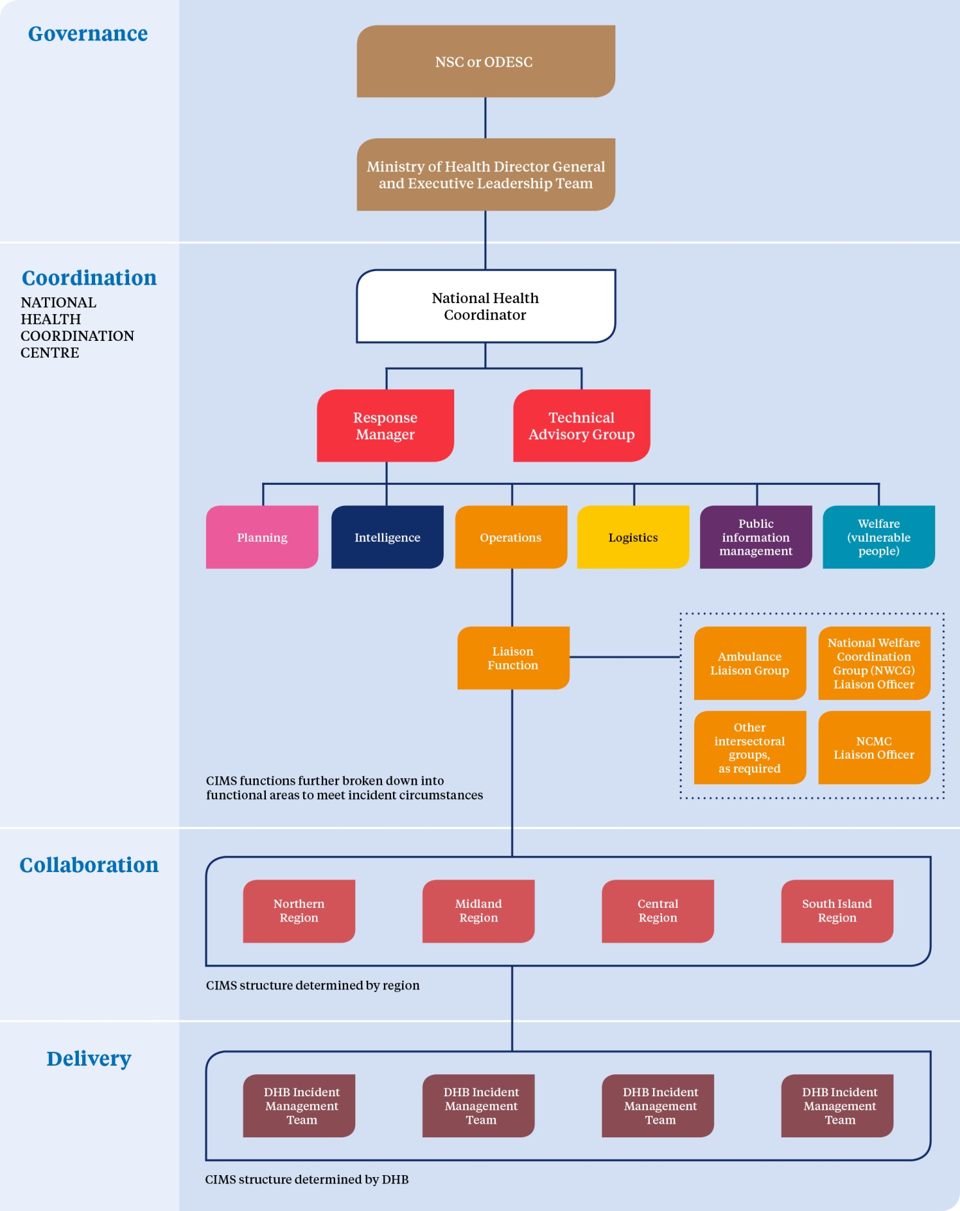

The CIMS-based structures, roles, terms and processes for emergency response coordination are consistent at all operational levels within the health and disability sector, in acknowledgment that consistency is necessary for effective communication both within the health and disability sector and across the whole of government. This structure is to be used whenever a health emergency response is activated.

Local, regional and national plans and capabilities will provide for the staffing that the CIMS-based structure requires to manage emergency responses of various scales. The staffing provided will be appropriate to the risks that the respective organisations contribute to the management of and the roles the health organisations play in response.

Responses may extend over a protracted period, 24 hours a day, 7 days a week. In such situations, a number of teams of staff will be needed to cover all shifts. Providers will plan the appropriate number of staff and shift structure required to support their CIMS-based response structure.

Appendix 15: Roles by Ministry of Health alert codes
All alert phases
National (Ministry) | Local (DHB)
Coordinates the health and disability sector operational response at the national level  Provides information and advice to the Minister  Provides strategic direction on the health and disability sector’s response  Liaises with other agencies at the national level  Liaises with international agencies  Identifies and activates national technical advisory group(s) as required  Provides clinical and public health advice on control and management, where possible  Approves/directs distribution of national reserve supplies  Ensures technical advisory groups analyse critical data  Provides information to assist with response  Plans for recovery | Coordinates and manages the health and disability sector’s response in its particular area  Liaises with other agencies at the local level and within the region  Provides the region and the Ministry with required information  Activates inter-DHB response support and coordination as required  Coordinates input and use of Health EMIS within health services
Information (code white) (includes advisories)
National (Ministry) | Local (DHB)
Issues code white alert through SPOC system  Monitors situation and continues surveillance  May activate a national incident on Health EMIS  Advises DHB chief executives, DHB single points of contact and all public health unit managers of the emerging situation and potential developments  Provides media with public information and advice, as necessary  Liaises with other government agencies at the national level as necessary  Liaises with international agencies as necessary | Monitors situation and obtains intelligence reports and advice from the Ministry  Advises all relevant staff, services and service providers of the event and developing intelligence  Liaises with the Ministry regarding media statements  Reviews local and regional health emergency plans  Prepares to activate emergency plans  Liaises with other emergency management agencies within the region
Standby (code yellow)
National (Ministry) | Local (DHB)
Issues code yellow alert  Identifies and appoints national incident management team  May activate a national incident on Health EMIS  Assesses whether activation of the National Health Coordination Centre is required, and activates if necessary  Determines and communicates strategic actions for response to the incident  Identifies and activates national technical advisory group(s) as required  Advises the health and disability sector of the situation via the SPOC system  Manages liaison and communications with other government agencies  Manages liaison with international agencies | Prepares to activate DHB emergency operations centre  Identifies need for and appoints DHB incident management team  Prepares to activate regional coordination  Advises and prepares all staff, services and service providers  Manages liaison with local agencies  Monitors local situation and liaises with the Ministry  Prepares to activate CBACs and teletriage as necessary  Note: In certain types of emergencies (such as a pandemic), public health units may fully deploy while clinical services remain on standby to provide assistance to public health units if required and to mount a clinical response.

Activation (code red)
National (Ministry) |  | Local (DHB)
Issues code red alert; thereafter communicates via Health EMIS and the four regional emergency management advisors  Activates a national incident on Health EMIS  Coordinates the health response at the national level, as required  Activates the National Health Coordination Centre, as required  Monitors the situation, revises and communicates strategic actions for response, as required  Approves/directs distribution of national reserve supplies when required  Considers strategic recovery issues  Provides clinical and public health advice on control and management, where possible  Carries out national public information management activities  Manages liaison with other government agencies  Manages liaison with international agencies  Implements recovery planning |  | Activates DHB emergency operations centre  Activates DHB incident management team  Manages DHB primary, secondary and public health service response  Liaises with other agencies at a district level  Activates CBACs and teletriage as necessary  Provides inter-DHB coordination with DHB/ community health intelligence  Activates inter-DHB response support and coordination as required  Notifies health providers of change of alert level  Appoints a recovery manager
Stand-down (code green)
National (Ministry) | Local (DHB)
Issues code green alert  Advises other government and international agencies of stand-down  Advises media and public  Stands down Ministry incident management team  Stands down the National Health Coordination Centre  Focuses activities on national recovery issues for the health and disability sector  Implements recovery plan in conjunction with other agencies  Supplies national public information on recovery  Manages national debrief and evaluation of events  Reviews plans | Stands down DHB emergency operations centre  Stands down DHB incident management team  Focuses activities on health recovery issues in the DHB region  Stands down inter-DHB coordination if appropriate  Facilitates debriefs  Provides Ministry with information following debriefs  Updates plans

Appendix 16: Framework for funding during planning and response cycles
The Ministry of Health provides funding to all DHBs to support and enhance emergency management preparedness and response. This funding acknowledges each DHB’s population mix, tertiary loading and hazard complexity. Funding for an emergency is to be used to:
- provide for the development and maintenance of emergency plans
- ensure planning reaches beyond the hospital environment to encompass a response across the whole health and disability sector
- ensure the response links robustly with local services
- provide sustained and effective education and training on emergency management
- ensure the capacity of DHBs and the primary health sector can be fully used in an emergency response
- develop and maintain effective means of emergency communication with identified stakeholders.

The Ministry will be closely involved in Crown decisions on whether to provide DHBs with additional funding to cover the cost of additional services required during a health emergency response. In almost all cases, such services will be funded through existing pathways. All existing contracts contain provisions for variation of funding arrangements or additional funding, should this become necessary in exceptional circumstances, such as a major mass casualty incident or a pandemic.

DHB funding – Operational Policy Framework
The Operational Policy Framework (OPF) states that the DHB emergency management function is to be funded by sustainable funding provided for the purpose through the Crown Funding Agreement and other Ministry contracts, plus any additional DHB funds required to meet legislative and Ministry requirements relating to emergency planning and management.

Funding required to be met through the need to respond to an emergency will be covered by the DHB as per the OPF. If the funding exceeds 0.1 per cent of the DHB’s total population based funding, the Crown will determine on a case-by-case basis, and in consultation with the DHB, whether:
- the DHB is able to fund additional services purchased
- to provide the DHB with additional funding
- there will be any negative effects on the DHB’s baseline services.

An emergency response related to an epidemic, pandemic or accidental or deliberate mass casualty incident will be regarded as a ‘major incident’. All DHB planning should be undertaken with the above section of the OPF in mind.

Clearly, identifying what the 0.1 percent figure represents and tracking the emergency response-related expenses directly related to it will require comprehensive financial involvement within DHBs and the Ministry from the start of any emergency.

Detailed, realistic and fully completed accounts will be necessary to support any funding discussions between DHBs and the Crown. Normal practice during an emergency response will be for a finance representative to be included in CIMS structures at national and local levels, who will track extraordinary costs incurred. It is strongly recommended that this involvement commence at the beginning of any emergency response.

All DHB-funded services are covered by the OPF. These include provider-arm services (personal and mental health), primary care services, laboratories, pharmacies and other referred services, public health units, and much of disability support services.

As part of primary or provider-arm services, an emergency response might require DHBs to establish special facilities or services, such as community-based assessment centres or staff vaccination programmes. These services are covered by this section.

The potential range and scope of DHB activities during an emergency response will require close financial monitoring. Section 25 of the Public Finance Act 1989 provides authority for the Minister of Finance to approve the incurring of expenses or capital expenditure necessary in the event of a defined emergency. Early notification by the Ministry of Health to the Treasury will help obtain rapid approval from the Minister of Finance in the event of such an emergency. The Ministry’s corporate finance staff should be contacted urgently if such emergency funding is required.

Inter-district flows
Clinically driven referrals and transfers between hospitals in different DHBs are part of normal day-to-day business, enabled by the inter-district flow (IDF) business rules for funding contained in the OPF. The standard IDF business rules provide for financial adjustments between DHBs if there are abnormal numbers of IDF referrals or transfers for any reason, for example, as a result of a mass casualty incident, disease epidemic or pandemic.

Eligibility for publicly funded health and disability services
The Health and Disability Services Eligibility Direction 2011 sets out the groups of people eligible for publicly funded health and disability services in New Zealand (available on the Ministry website at www.health.govt.nz/new-zealand-health-system/eligibility-publicly-funded-health-services). Later eligibility directions may supersede this document. Individual DHBs should apply their normal cost-recovery rules where treatment has been provided to people not eligible for publicly funded health and disability services in New Zealand, according to the current eligibility direction.

Glossary and abbreviations
For the purposes of this plan, the following interpretations shall apply.
4Rs | (a) Reduction: identifying risks to human life and property from hazards and taking steps to eliminate these risks if practicable or, if elimination is not practicable, reducing the magnitude of their impact and the likelihood of their occurring.  (b) Readiness: developing operational systems and capabilities before an emergency happens, including self-help and response programmes for the general public and specific programmes for emergency services, lifeline utilities and other agencies.  (c) Response: actions taken immediately before, during or directly after an emergency to save lives and property, and to help communities recover.  (d) Recovery: the coordinated efforts and processes used to bring about the immediate, medium-term and long-term holistic regeneration of a community following an emergency.
Agencies | Government agencies (including public service departments, non-public service departments, Crown entities and Offices of Parliament), non-governmental agencies, lifeline utilities and private businesses providing critical infrastructure and logistic services supporting health care services.
AMPLANZ | Ambulance National Major Incident and Emergency Plan. 2005. AMPLANZ is a detailed operational framework for the New Zealand ambulance sector to provide clear guidance for all Ambulance Services in all parts of the emergency management cycle.
CAD | Computer aided dispatch.
Capability | The effectiveness of cooperation and coordination arrangements across agencies for the delivery of resources in the event of an emergency.
Capacity | The adequacy of resources in terms of quantity and suitability of personnel, equipment, facilities and finances.
CBAC | Community-based assessment centre. CBACs are set up by DHBs during an emergency. They are commonly used in instances of mass evacuations or in an infectious disease outbreak affecting a large number of people.
CDEM | Civil defence and emergency management.
CDEM Act | Civil Defence Emergency Management Act 2002.
CIMS | Coordinated incident management system. A structure to systematically manage emergency incidents, which allows multiple agencies or units involved in an emergency to work together in emergencies.
Cluster | A group of agencies that interact to achieve common civil defence emergency management outcomes.
DHB | District health board. Provides hospital and community-based health services (including public health units). DHBs are funders and providers of publicly funded services for the populations of specific geographical areas in New Zealand.
DPMC | The Department of the Prime Minister and Cabinet.
ECC | Emergency Coordination Centre. A facility to support a Controller in coordinating a response, or part of it and provides support to national, regional and local level responses.
Emergency | For the purposes of this plan, an emergency is a situation that poses an immediate risk to life, health, property, or the environment that requires a coordinated response (ODESC 2014). Also see definition of emergency in the CDEM Act 2002.
Emergency managers | (Also known as emergency coordinators, or emergency service leaders). Generally they are embedded within the health service providers such as DHBs, PHUs, primary health organisation ambulance providers or primary care. They are usually tasked with their organisation’s responsibilities under the CDEM Act, this National Health Emergency Plan or the Ministry’s Operational Policy Framework.
EOC | Emergency operations centre. A local level emergency coordination centre that coordinates the local response and provides support to incident level response activities.
Epidemic | A disease affecting or tending to affect an atypically large number of individuals within a population, community or region at the same time.
ESR | Institute of Environmental Science and Research Limited.
Health EMIS | Health Emergency Management Information System. Health EMIS is an electronic system used by the health sector to manage and share information and coordinate across the 4 Rs, It is the primary tool for managing significant incidents and emergencies at local, DHB, inter-DHB and national levels.
Hospital and health service | As defined by the Health and Disability Services Act 1993.
IDF | Inter-district flow.
IHR | International Health Regulations 2005.
IMT | Incident management team. A team set up following the CIMS doctrine and tasked with leading the organisational response to the emergency requiring management. Can be drawn from within the organisation or from external sources.
Liaison officers | Those who act as single points of contact between agencies to improve the flow of information.
Lifeline utilities | Services or networks that provide the necessities of life, for example, power and gas, water, sewerage, petrol, roading, transporters of essential supplies, fast-moving consumer goods, radio, television, air transport and shipping.
Likelihood | Used in risk management as a general description of probability or frequency.
Local population or provider group | A designated population or a provider group working in a specific geographical area. The DHB of a local area has overall responsibility for providing health and disability services in an emergency to a local population; however, local provider groups also have obligations to provide for services in an emergency.
Logistics | A logistics team is responsible for the provision of facilities, services and materials in an emergency.
MCDEM | Ministry of Civil Defence and Emergency Management.
MCI | Mass casualty incident.
MFI | Mass Fatalities Incident. Can be the consequence of a wide range of event types including natural disasters, pandemics, large accidents and deliberate attacks.
National coordinator | This single position leads the Ministry of Health’s national coordination team, with overall responsibility for coordinating emergency response at the national level.
NCMC | National Crisis Management Centre. A permanent, generic national coordination facility for use by any national lead agency, It is intended to coordinate all-of-government responses.
NHCC | National Health Coordination Centre. The centre whose function is to coordinate at the national level the health sector response in an emergency. In an emergency where the Ministry of Health is lead agency, all of government coordination may also be managed within the NHCC.
NMFI | National Mass Fatalities Incident. Any incident where the number and nature of fatalities is greater than the local resources can manage.
NSC | The National Security Committee. The committee is chaired by the Prime Minister, and includes those ministers responsible for departments that may play essential roles in emergencies. The NSC is the key decision-making body of executive government for coordinating and directing national responses to major crises or circumstances affecting national security (either domestic or international).
NWCG | National Welfare Coordination Group. A national-level, strategic welfare group that plans, supports and helps coordinate welfare activity during the emergency response and recovery.
NZMAT | New Zealand Medical Assistance Team. A New Zealand Medical Assistance Team (NZMAT) is a multidisciplinary team providing health specialists with necessary skills, qualifications and training to support a health emergency response in an affected area.
ODESC | Officials’ Committee for Domestic and External Security Coordination. A committee of government chief executives charged with providing strategic policy advice to ministers. It provides support to DESC and oversees emergency readiness, intelligence and security, terrorism and maritime security. Activation of ODESC is at ministerial request; for example, where a growing risk of a particular threat has been identified.
OPF | Operational Policy Framework. One of a group of documents collectively known as the ‘Policy Component of the District Health Board Planning Package’ that sets out the operational-level accountabilities for DHBs for each fiscal year. The OPF is executed through Crown funding agreements between the Minister of Health and each DHB. The OPF covers emergency obligations based on the 4 Rs.
Pandemic | An epidemic that spreads to the point that it affects a whole region, a continent or the world.
PHU | Public Health Unit. An agency that provides health services to populations rather than individuals. There are 12 Public Health Units providing environmental health, communicable disease control and health promotion programmes. PHUs are led by a manager and staffed by medical officers of health, public health nurses, communicable disease nurses, health protection officers, health promoters and others.
Primary care | Care/services provided by general practitioners, nurses, pharmacists, dentists, ambulance services, midwives and others in the community.
Provider | For the purposes of clarity within this document only, any health and disability provider; for example, a DHB, primary health organisation, health-related non-government service or ambulance service.
Regional Coordination | New Zealand’s 20 DHBs are divided into four regions, Northern, Midland, Central and South Island.  Under the National Civil Defence Emergency Management Plan Order 2015 (National CDEM Plan), this National Health Emergency Plan, the Operational Policy Framework (OPF) for DHBs (ongoing), all DHBs and their PHUs are tasked with developing and maintaining regional health emergency plans (RHEP). These plans apply the structures and processes identified in the National Health Emergency Plan (NHEP) by district and region.  RHEPs are required to address the situation where a provider is overwhelmed and cannot deal with the situation without regional (or national) assistance. The RHEP is also designed to assist where another region requests assistance outside of its boundaries.
REMA | Regional emergency management advisor. REMAs cover the four health regions and are responsible to the DHBs and health and disability sector stakeholders in those regions. They give advice on emergency management planning, exercising, policy and compliance.
Risk | The combination of the likelihood and the consequences of a hazard.
SARS | Severe acute respiratory syndrome.
Secondary/ tertiary health care | The levels of care provided in a hospital. Secondary care is treatment by a specialist to whom a patient has been referred by a primary care provider. Tertiary care is treatment given in a health care centre that includes highly trained specialists and often advanced technology.
SPOC | Single point of contact system. The Ministry of Health and each DHB and public health unit maintain a single point of contact within their organisation that is available on a 24-hour, 7-days-a-week basis. The system is used to facilitate effective and rapid communications in the health sector in readiness for and during emergency responses.
Situation report | A standardised brief of an incident, usually given at regular intervals. It provides a snapshot of the situation and response. It does not provide up-to-date situational awareness. There is a specific template for a situation report in Health EMIS.
Triage | The sorting or classification of casualties according to the nature or degree of illness or injury.
WHO | World Health Organization.

When considering deployment, note that medical officers of health and health protection officers are designated to a specific region of New Zealand by the Director-General of Health. However, under section 7A(1) of the Health Act 1956, the Director-General of Health may designate medical officers of health to operate within other specified regions if required.
More comprehensive information on preparing for an emergency and feeding your baby in an emergency is available in Consumer Resource: Feeding Your Baby during an Emergency (for babies aged 0–12 months) available on the Ministry of Health website (http://www.health.govt.nz/your-health/healthy-living/emergency-management/feeding-your-baby-during-emergency).
As a general guide, ‘recently’ means women who have stopped breastfeeding within the last three weeks or so.
Means the person who is the National Controller, in accordance with section 10 of the Civil Defence Emergency Management Act 2002, or a Group Controller appointed under section 26 of that Act.
The Ministry of Health does not recommend follow-on formula and toddler milks. After 12 months of age, babies can be fed whole (dark blue) cows’ milk as a drink.

