Update of the New Zealand Health Strategy

All New Zealanders live well, stay well, get well

Consultation draft

The Ministry of Health thanks the following organisations for the use of photographs in this document:

Auckland Hospital Design for Health and Wellbeing Lab, p 12

Health Promotion Agency, p 15

Whanganui DHB, p 21

Auckland Regional Public Health Service, p 23

Canterbury DHB, p 25

Nelson Marlborough DHB, p 26

Citation: Ministry of Health. 2015. *Update of the New Zealand Health Strategy: All New Zealanders live well, stay well, get well: Consultation draft*. Wellington: Ministry of Health.

Published in October 2015  
by the Ministry of Health  
PO Box 5013, Wellington 6145, New Zealand

ISBN: 978-0-947491-22-2 (print)  
ISBN: 978-0-947491-23-9 (online)  
HP 6288

This document is available at health.govt.nz



 This work is licensed under the Creative Commons Attribution 4.0 International licence. In essence, you are free to: share ie, copy and redistribute the material in any medium or format; adapt ie, remix, transform and build upon the material. You must give appropriate credit, provide a link to the licence and indicate if changes were made.

# Minister of Health’s foreword

**We enjoy good health and health services in New Zealand. But looking to the future, we will need to work differently to meet changing health needs.**

The increased pressures on our health care system continue to result in significant demands on the health budget. Population changes, for example, mean a greater proportion of Kiwis will be older and require increased care and support. Some families find our current services hard to reach, and there are greater demands to address the social needs for the most vulnerable. Further, there is an emerging consensus that working intersectorally will help address those drivers of ill health that sit outside the health system. Specific action plans to tackle long-term conditions are under way but need to focus on the same end goal overall to ensure our health investment achieves the best equity, health and social outcomes.

It is timely to refresh the 2000 Health Strategy to best meet our changing health priorities and fiscal targets, while encouraging innovation and creating opportunities, including the exciting medical and information technology areas. Engagement with the sector to develop a picture of what the future might look like resulted in a greater emphasis on health education and prevention to reduce future demands.

Overwhelmingly, we heard the need for a greater focus on people, how to engage better in co-designing services, and how to better understand their needs.

I also heard from many in the sector that they are ready and willing to continue to work better together to embrace the changes we need to make to breathe life into the Health Strategy — that they are committed to leading their different parts of the system toward a common future. In a complex and devolved system, commitment to changing how we work is critical to achieving success.

This updated Strategy shares the common view of where we want to go in New Zealand health. This is a ‘draft’ Strategy and Roadmap to the future. Consultation on the draft allows us to continue the conversation together, to keep shaping the detail on what to do next, how to leverage our existing strengths and how to identify solutions to current barriers.

I look forward to hearing more about your discussions on the draft actions and how your ideas can position us to better meet future needs and a more integrated and cohesive system.

Working together, we will take our good health system and make it a great system, where all New Zealanders live well, stay well and get well.

**Hon Dr Jonathan Coleman**

**Minister of Health**

# Director-General of Health’s foreword

In discussions over the past months, I have heard many people describe the direction that New Zealand’s health and disability system needs to take into the future.

There is general agreement that the challenges we face are complex. But there is also a confidence that we can work together to address these, using the very real strengths of our system and the experience and skills that we bring to our roles.

This draft Strategy emphasises the need for integration of our framework, methodology and approach, as well as coherence so that we are all clear on the role we each have to play in making our desired future a reality.

Your comments have allowed us to develop a clear picture of the future that reflects who we are as New Zealanders, and has been important to help set the direction of where we want to go in health. The future picture is underpinned by guiding principles for how we wish to work together. These give colour to the kinds of values, behaviour and culture that will be important to achieving a change in the health system.

Your engagement helped us to identify five strategic themes for the Strategy. A draft Roadmap of Actions brings these strategic themes to life, proposing an evolution of change to realign our operating model, encourage innovation and ensure sustainability.

I recognise the way forward will require us all to think and act differently. For the Ministry of Health, that means we need to clarify our leadership role in the system, how we interact with others and how we focus our efforts to make improvements in the system. There are leadership roles throughout the system but the Ministry’s role includes being a system steward. This involves keeping an overview of the whole system and ensuring that the capabilities and connections across organisations add up to a strong system that is more than the sum of its parts. I recently commenced our Ministry’s change initiative to help guide our staff to a new way of working and to build our capability so we can do our part in enabling the journey.

I am confident that, together with other leaders in the system, we can bring about the necessary changes to make the future envisaged in this Strategy into a reality and achieve even better health outcomes for all New Zealanders.

**Chai Chuah**

**Director-General of Health**

Contents

Minister of Health’s foreword iii

Director-General of Health’s foreword iv

I. Future Direction 1

Why a Health Strategy? 1

Health in its wider context 3

Challenges and opportunities 5

The future we want 8

Five strategic themes 10

1 People-powered 11

2 Closer to home 14

3 Value and high performance 18

4 One team 21

5 Smart system 24

Turning Strategy into action 27

II. Roadmap of Actions 30

Introduction 30

Section A: Action areas 32

1 People-powered 33

2 Closer to home 35

3 Value and high performance 39

4 One team 42

5 Smart system 45

Section B: Implementation 47

Co-creation of the Roadmap 47

Annual planning 47

Role of the Ministry 47

Appendix 1: Summary of actions 48

Your feedback 51

Consultation questions 53

# I. Future Direction

# Why a Health Strategy?

Every New Zealander is supported by our health and disability system at times in their life.

The things we need for our health and independence can vary widely, from support for wellness and prevention through primary care and community services, to ongoing management of long-term conditions, to the urgent help we may need for accidents or acute illness.

New Zealand’s health and disability system (the system)[1] has many skilled and dedicated health workers and organisations. But unfortunately our system is not always geared up to give people easy interactions with services.

It can struggle to ensure equitable access to limited resources, and health disparities persist. We sometimes fail to connect people to the health and social services they need. And we have to rise to the challenge of achieving more within the resources we have. This means finding new ways of working to deliver the services we need.

A high-performing system involves more than just a skilled health workforce and resources. It requires a shared view of the overall purpose and direction of our travel, as well as effective ways of working.

The legislation that governs New Zealand’s health and disability system requires a Health Strategy.[2] The current Health Strategy was developed in 2000.

While we have made significant progress since then in areas such as the affordability of primary care and elective surgery waiting times, the challenges now facing the system mean there is a need for a renewed clarity of direction.

This update of the Health Strategy will provide this focus and enable us to work together to create a better system.

**A strategy is a guide** for achieving the sort of **future** that you want. It can help people, organisations or whole systems to **work together** more effectively on the most **important things**. Without a strategy, things that are small problems today can become big problems over time.

The Strategy has two parts.

**I. Future Direction** (this document) outlines a new high-level direction for New Zealand’s health and disability system over the next 10 years. It lays out some of the **challenges and opportunities** the system currently faces; describes **the future we want**, including the culture and values that will underpin this; and identifies **five strategic themes** for the changes that will take us toward this future.

**II. Roadmap of Actions** (companion document) identifies 20 work areas for the next five years to put the Strategy in place.

Figure 1.1 illustrates the components of the Strategy and their location in this and the companion Roadmap of Actions documents.

Figure 1.1:  
Components of the Strategy

The New Zealand Health Strategy has two parts.

Part 1 is The Future Direction, which includes challenges and opportunities on page 5, the future we want on page 8, five strategic themes on page 10.

Part 2 is the Roadmap of Actions, which includes five-year signposts and an annual focus.

The vision is All New Zealanders live well, stay well, get well.


**New Zealand’s health system performs well**

**90 percent** of New Zealanders report they are in **good, very good or excellent** health, the **highest percentage reported across the OECD**; for those aged over 75 the figure is over 80 percent

**80 percent** of adults report they are **satisfied with the care** they receive from their usual medical centre and 83 percent of people rate their care in emergency department services as good or very good

**95 percent** of New Zealanders are enrolled with a primary health organisation

New Zealanders are more likely to report being able to get a **doctor’s appointment** on the **same or next day** than people in the United Kingdom or Australia

Waits for **emergency department care** are the best of 11 countries surveyed by the Commonwealth Fund

**Life expectancy for New Zealanders** is 79.7 years for boys and 83.2 years for girls, both **above the OECD average**

Our health system **supports**: 12.7 **million** **daytime visits to general practitioners** (GPs) per year (and 2.9 million visits to GP nurses); the dispensing of 64.5 millionpharmaceutical items; **24 million** **laboratory tests**; and 1 million emergency department attendances per year

Source: Ministry of Health. 2014. *Health and Independence Report*. Also unpublished Ministry data.

# Health in its wider context

Health is something that affects everyone, every day and our system contributes in important ways to the overall wellbeing of New Zealanders and their families.

People working in the system carry out a wide range of activities: they provide immunisations, diagnose illness, treat injuries, deliver specialist hospital and community care, ensure safe drinking-water, and provide advice through community services such as pharmacies.

Having good health also benefits other aspects of people’s lives (Figure 1.2). For example, the health and mental wellbeing of parents supports the social development, educational outcomes and lifelong experiences of their children, and of their wider families and whānau. In a similar way, wider factors such as home and workplace environments also contribute to people’s health.

This Strategy is focused on health but is set within this wider context of the interconnections between health and other aspects of people’s lives.

### Partnering across government

The Government is focused on improving the lives and wellbeing of New Zealanders. Its priorities include work, across agencies, to tackle the complex and long-term problems that some New Zealand families face.

Its ‘better public services’[3] priority sets challenging targets for government agencies. These include the specific targets for the health system for immunisation and rheumatic fever prevention. The nine other result areas include reducing welfare dependency, reducing assaults on children, and improving people’s interactions with government, for example, through online services. Health has a part to play in all these result areas.

**Figure 1.2:**  
Health links with the wider environment

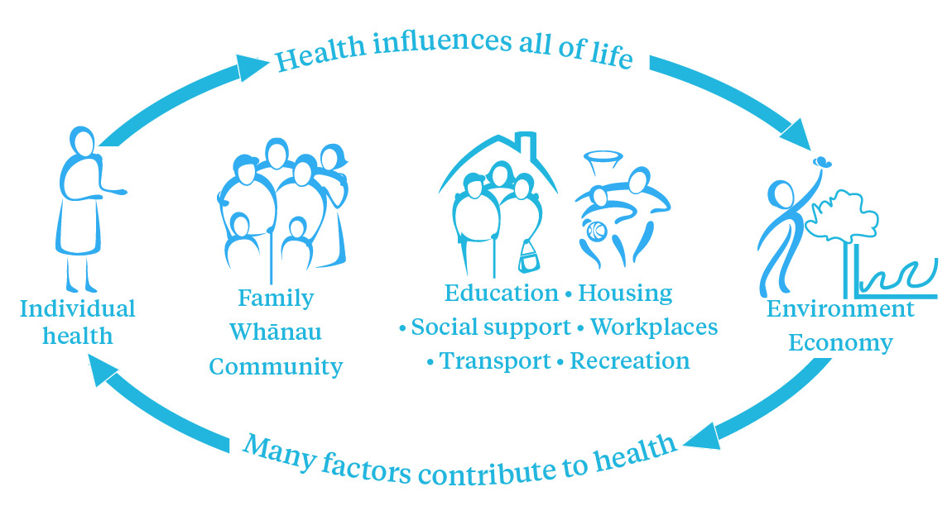

Increasingly, government agencies are working in coordinated and effective ways to respond to priority issues. Data is being used and shared in more effective ways to find out who needs services the most, and agencies are taking more coordinated responses with service users that deal with more than one of them. Agencies are also using investment approaches (described in the box on page 4) that identify the mix of services that will result in the best return for New Zealand in the long term.

The New Zealand Productivity Commission’s 2015 report on More Effective Social Services highlights the imperative to work differently to better meet the needs of New Zealand’s most disadvantaged and provides guidance to agencies to meet this goal, recognising that it will be a process of learning.

An **investment approach** takes into account the **long-term** impact of current spending on people’s lives. Investment in the **health** sector, which results in people having a greater ability to **participate** in **education** and **employment** and be free of, for instance, alcohol and drug dependency, family violence or mental health conditions, has a positive long-term financial impact for the **social sector.** It also has non-financial benefits as people experience **longer lives**, lived in **better health** and **independence**, and with **dignity**. As a specific funding mechanism, ‘investment funding’ gives providers an incentive to focus on these long-term impacts and **value them** alongside immediate, short-term gains.

The health system is working on a range of initiatives with other government agencies including:

* providing healthier homes and addressing factors such as overcrowding to reduce the risk of illnesses like rheumatic fever and respiratory conditions
* putting families and whānau at the centre of service delivery through Whānau Ora
* reducing assaults on children, by working closely with the Police, courts and justice sector partners, and providing mental health and addiction treatment.

Figure 1.3 shows how the Strategy fits with other existing government strategies and priorities. It has been informed by the Government’s four high-level priorities and will support the health system’s contribution to a range of cross-government strategies.

The Ministry of Health has a range of other population and other health strategies that provide more specific directions particular to populations or health conditions. Updates to these in 2015 and beyond will reflect the direction of this Strategy.

Figure 1.3:  
The Strategy in its government context

Government priorities: 
delivering better public services
responsibly managing the Government's finances
rebuilding Christchurch
building a more competitive and productive economy.

These feed into cross-government strategies, eg, Social Sector trials, Whānau Ora, Children's Action Plan, Action Plan on Household Crowding to Reduce Rheumatic Fever, Prime Minister's Youth Mental Health Project, New Zealand Disability Strategy.

At the centre of these is the New Zealand Health Strategy. It is the founding strategy for all other population and health strategies, such as He Korowai Oranga - the Māori Health Strategy; 'Ala Mo'ui - Pathways to Pacific Health and Wellbeing; Health of Older People Strategy; Primary Health Care Strategy; Rising to the Challenge: Mental Health and Addiction Service Development Plan




# Challenges and opportunities

A new Health Strategy will use our many strengths to address challenges and embrace opportunities.

### New Zealand’s health system is strong

Measuring our performance against international benchmarks shows us that New Zealanders can usually get the care they need when they need it and that most New Zealanders are generally happy with services they receive.[4]

Among our strengths are:

* a publicly funded, universal health system with a committed and highly trained workforce
* a strong primary care focus with a widely supported focus on wellness
* a unique public health and no-fault accident compensation system, which serves the whole population throughout their lives
* a strong desire to better integrate health and social services
* local decision-makers in district health boards (DHBs) who are well positioned to respond to community needs and integrate services
* a growing best-practice evidence base developed through research
* Māori and Pacific health providers, connected to their communities that model integrated approaches to health.

### … and connected to a changing world

New Zealand will always be geographically distant from the rest the world. But we are now more connected with it than ever, through the movement of people, through technology markets, and through the spread of knowledge and cultural practices on the internet.

This context will continue to shape New Zealanders’ experience of health. It means our system needs to be aware of developments and effectively draw on and absorb global ideas and evidence.

**Global challenges**

Providing health and social services to increasing numbers of **older people** who are living longer

A growing burden of long-term conditions, such as **heart disease,** **diabetes, depression and dementia**

How to afford **new technologies** and drugs and meet rising expectations

A highly **mobile** global workforce

The emergence of **new infections** and antibiotic resistance

The health and social consequences of **climate change**

### There are challenges

New Zealanders are living longer and every year there are more people aged over 65. This is a good thing for individuals and families. But it does present an affordability challenge to the health system.

Keeping an older person healthy and independent usually takes more health and social services than are needed for younger people. Older people are also more vulnerable to disability and to having more than one health condition.

Long-term conditions are a particular challenge with an ageing population. Dementia is one example and we expect the number of New Zealanders with dementia to rise from about 48,000 in 2011 to about 78,000 in 2026.

Obesity is another condition that is becoming more common and has long term health impacts. Among New Zealand children as a whole, 10 percent are obese, but the rate is 25 percent in Pacific children.[5]

Some of New Zealand’s population groups receive unequal benefits from the health and disability system. This can be seen in life expectancy statistics; while New Zealanders overall are living longer, Māori and Pacific peoples still have a lower life expectancy (Figure 1.4). Children are another population that, being dependent on others for care, may not access the health services they need.

New Zealand’s total health and disability spending in the public, private and non-governmental organisation (NGO) sectors is about $18 billion, or about 9.5 percent of gross domestic product (GDP).[6] This is slightly over the OECD average, but consistent with most OECD countries. New Zealand is unusual in that most health expenditure is funded by taxpayers – about 7 percent of GDP.[7] Health makes up about 22 percent of government spending.

The Treasury considers that New Zealand cannot afford to keep providing services as we do now. It projects that, without significant change, government health spending would have to rise from about 7 percent of GDP now, to about 11 percent of GDP in 2060 (Figure 1.5).

Figure 1.4:  
Life expectancy at birth by ethnicity, 1950–2014

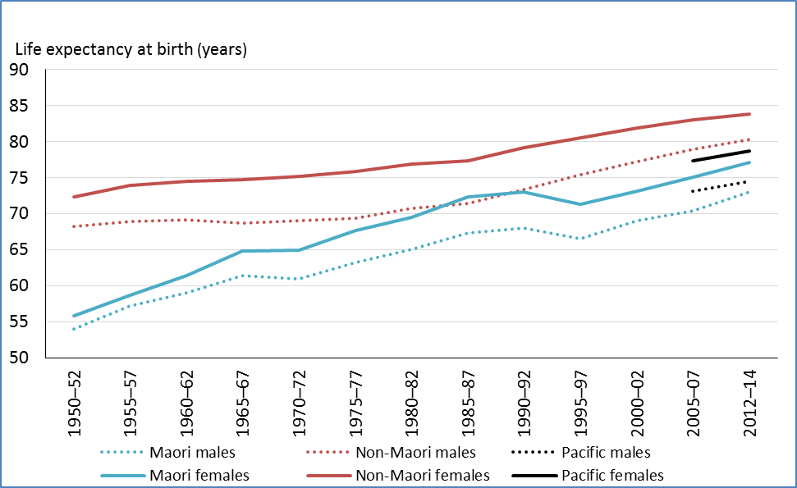

Source: Statistics New Zealand. 2014. *Complete New Zealand Period Life Tables – time series summaries: Life expectancy by age and sex, 1950–52 to 2012–14.*

Figure 1.5:  
Projected government health spending as % GDP

Source: New Zealand Treasury. 2012. *Health Projections and Policy Options for the 2013 Long-term Fiscal Statement*, p 18.

An independent review of New Zealand’s health funding system[8] noted three ways in which it sometimes acts as a barrier.

* There is a lack of visibility of results that makes it hard to prioritise funding or take into account long term, cross-sectoral benefits from investment.
* Service mix and design changes are too slow to address changes in demand. Often our funding and contracting arrangements embed the status quo, instead of allowing us to work differently.
* Some funding arrangements contribute to stubborn disparities in access to services, and sometimes they widen the gap in unmet need.

New Zealand’s health workforce also faces challenges. It is ageing– 39 percent of doctors and 46 percent of nurses are aged over 50.[9] It also has a large number (about 63,000) of care and support workers, or kaiāwhina, who often have limited access to training. Many of our workforce have trained overseas – 43 percent of our doctors, 34 percent of our midwives and 26 percent of our nurses – and are not permanent residents.[10] This means we need to continually invest in training to ensure that the skills of our health workforce can meet the health needs and expectations of care of New Zealanders.

These needs and expectations are themselves changing, not only with population ageing, but also with the growing ethnic diversity in New Zealand. In Auckland, for instance , around 39 percent of residents were born overseas; Asian populations are growing the fastest and now represent almost one in four people living in Auckland.[11]

### ... but we have many opportunities

A focus on prevention and making healthy choices easy, through approaches at both population and individual levels, can help stop or slow the occurrence of some health conditions.

In New Zealand, we have a strong and growing knowledge base, developed from research, about what contributes to good health, from birth into adulthood.[12] This will be an ongoing resource to guide policies that help ensure children start out on healthy pathways for growth and development. Early intervention can help prevent some health conditions that occur later in life.

We can keep expanding our thinking about who contributes to health by tapping into the skills of individuals, families, communities and businesses through stronger and earlier partnerships.

Like other sectors, the health sector can also take advantage of advances in technology and related infrastructure such as broadband. Automation of routine tasks can free up skilled staff to focus on what they do best. Sharing information across organisations can let us know who is missing out and what isn’t working so we can change it.

In summary, our system may be functioning well enough today, but we can’t guarantee that it will be tomorrow. This Strategy provides us with an opportunity to improve our health system and wider social services, so that going forward we are better able to support the health and wellness of New Zealanders. A key factor in this evolution will be our ability to work together.

# 

# The future we want

A wide range of people contributed to this Strategy, sharing their ideas and experiences about the challenges facing today’s system, and what a better future system could look like.

The discussions we had in developing this Strategy revealed a range of things we need to do differently or better. In many cases, the very process of identifying the problem presented us with potential solutions. (Some of the comments made by participants in meetings are displayed in the ‘speech bubbles’ at the bottom of this page and throughout the Strategy.)

We found many examples of great practice or progress that we could extend across the system.

From the range of information and perspectives there emerged a relatively consistent view of what a better, more ‘fit for the future’ system could look like. We captured this as follows:

So that **all** New Zealanders **live well**, **stay well**, **get well**, we will be **people-powered**, providing services **closer to home**, designed for **value and high performance**, and working as **one team** in a **smart system**.

The statement ‘All New Zealanders live well, stay well, get well’ is central to this Strategy. We intend it to reflect New Zealand’s distinctive health context and population needs.

The word ‘all’ was chosen to reflect the important need for this Strategy to reduce disparities in health outcomes, and make sure the health system is fair and responsive to the needs of all people — young and old, from all ethnic groups, and wherever they may live.

The statement also highlights wellness as a goal. This acknowledges that people want not just long life, but also quality of life, which maximises years of wellness.

### Culture and values

There is an **exciting vision**. How can we be the **best system in the world** around improving?

Feedback during Health Strategy engagement, May–June 2015

The previous Health Strategy, developed in 2000, was built on seven principles. Our discussions indicate that these principles still reflect our values, and the expectations New Zealanders have of their health and disability system.

We propose to retain these principles and to add one more, to reflect what people told us about the importance of working beyond the boundaries of health services.

Our refreshed principles underpin this Strategy, and will apply in work across the system, and in any new strategies or developments.

Aligning behaviours

To give effect to this Strategy, and apply these guiding principles, there need to be some shifts in behaviours across the system. We can use these as markers for success. As we keep moving ahead, we will think and act differently. The behaviour shifts we hope to see at a system level are:

* from treatment to prevention and support for independence
* from service-centred delivery to people-centred services
* from competition to trust, cohesion and collaboration
* from fragmented health sector silos to integrated social responses.

Don’t underestimate that the **core value** for health professionals is to **do good in people’s lives**.

Feedback during Health Strategy engagement, May–June 2015

Refreshed guiding principles for the system

1. The best **health and wellbeing** possible for all New Zealanders **throughout their lives**
2. An **improvement in health status** of those currently disadvantaged
3. Collaborative **health promotion** and disease and **injury prevention** by all sectors
4. Acknowledging the **special relationship** between Māori and the Crown under the **Treaty of Waitangi**
5. **Timely and equitable access** for all New Zealanders to a comprehensive range of health and disability services, regardless of ability to pay
6. A **high-performing system** in which people have **confidence**
7. Active **partnership** with **people and communities** at all levels
8. Thinking beyond narrow definitions of health and **collaborating with others** to achieve wellbeing

# Five strategic themes

Building on our guiding principles, this Strategy has five themes to guide us forward. These provide a focus for change.

The themes are shown in Figure 1.6 below and discussed further in the sections that follow.

These themes are shown as interconnected. This reflects the balance that everyone working in the system has to strike between what is best for people’s health and wellbeing, at individual and population levels, and what is affordable and possible. This involves choices. Sometimes there are trade-offs; for example, when someone can’t get an appointment as soon as they want because more urgent requests are being met.

A great system will find a balance that matches the most important needs with the best use of skills and resources. The aim is a more integrated and cohesive system that works in the best interests of New Zealanders.

Figure1. 6:  
Five strategic themes of the Strategy

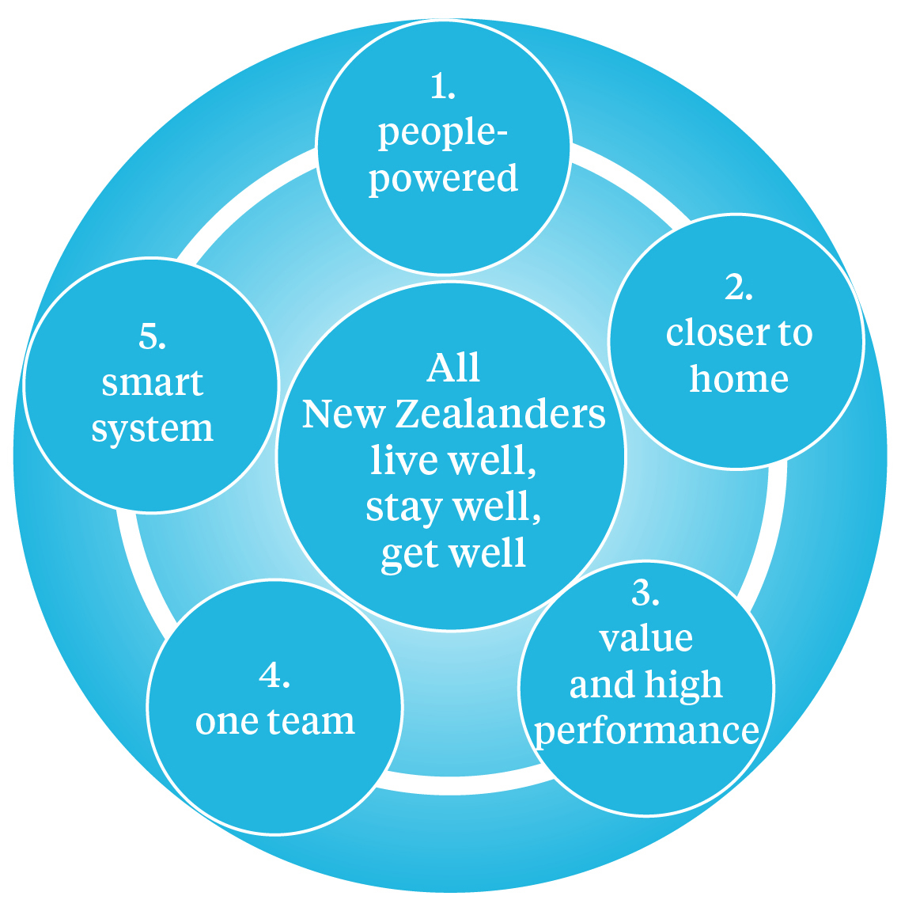

# 1 People-powered

### This theme is about:

* understanding people’s needs and wants and partnering with them to design services to meet these
* encouraging and empowering people to be more involved in their health, by engaging with them about their wellbeing and helping to make healthy choices easy
* communicating well and supporting people’s navigation of the system, by building health literacy, as well as using technology such as mobile phones and the internet.

### Why is it important?

The health and disability system plays an important role in providing people with the necessary information and skills to engage with health services and manage their own health. Different people or groups can require different approaches – older people, for instance, can require more support to obtain and use the information they need for their health.

This theme is focused on people, but goes hand in hand with digital technologies, like telehealth systems and mobile health apps, that enable health services to engage with people wherever they are located.

Moving to a stronger customer-focused approach is important to the Government, and is part of its ‘better public services’ priority area. This Strategy takes this approach though it uses the term ‘people’, rather than ‘customer’.

New Zealand’s Māori Health Strategy, He Korowai Oranga,[13] uses the concept of mauri ora to reflect its focus on individual people. It says that people using health services need pathways to care that meet their immediate needs as well as their future needs, across all stages of their life. This Strategy similarly acknowledges that need.

A people-powered approach seeks to understand how health fits into people’s lives, and how it relates to their common needs, interests and priorities. With this knowledge, there is the opportunity to partner with people to provide the care they need and want. This can involve the development of tailored services that better cater for population segments; for example, providing access to health services in community settings such as schools or churches rather than in a clinic.

Some people choose to receive their **disability support** funding as a **personal budget;** this is called ‘Individualised Funding’. This funding model gives people **choice and control** about how, from who and when they get support. It means they can get the services that best suit their needs. Around **2330 New Zealanders** now have an Individualised Funding allocation.

People-powered health requires direct engagement between the system, and people and their wider families and support networks. It requires us to use data to better understand people and populations, know what works for people and why, and continuously adapt service and funding approaches.

Across the health, disability and wider social sector there are examples of new initiatives that are taking more people-centred approaches. These provide models for what should become more widespread across the system.

Putting control back to people requires **big bold steps**.

Feedback during Health Strategy engagement, May–June 2015

The **Design for Health and Wellbeing** lab, located in Auckland City Hospital, is a collaborative venture between Auckland DHB and AUT University that is using a **people-focused, design-led** approach to improve hospital and health services. The image below is from a project to improve the **emergency department (ED)** experience by reducing people’s **uncertainty and stress**. On the wall is a **patient journey map** that explains the ED process in simple terms.

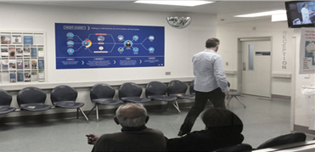

The **Prime Minister’s Youth Mental Health Project** is a health-led programme to improve **mental health and wellbeing of 12- to 19-year-olds**. The programme includes 26 initiatives being implemented in schools, health settings and communities, and online. **SPARX** is one of these and is an **interactive** fantasy-based **computer program** to help young people learn skills to deal with feeling down, depressed or stressed. It is an **evidence-based tool** developed by the University of Auckland that has won several international awards and was a finalist in the 2015 New Zealand Innovators Awards.

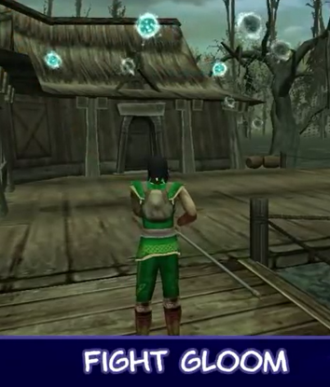

**Patient portals** are secure online sites provided by GPs where people can access **their health information** and interact with their general practice. This enables people to better **self-manage** **their health**. One example is Medplus in the North Shore. Through Medplus, people can now **request repeat prescriptions** and **book appointments online**. As well as being convenient, portals are **efficient for practices** too; they **reduce administration time** and allow practice teams to deal with more acute, critical care needs. More than 75,000 people enrolled at 181 general practices across the country can now use a patient portal.

### What great might look like in 10 years

This is our vision for **people-powered** health in 10 years’ time.

* People are able to take greater control of their own health, by making informed choices and accessing relevant information when they need it; for example, through electronic patient portals.
* Everyone who delivers and supports services in the health and disability system understands the needs and goals of the individual they are supporting, their family, whānau and community, and focuses on the person receiving care in everything that they do.
* People access practical evidence-based health advice that makes it easier for them to make healthy choices and stay well. Technology tools such as mobile devices, smartphones and wearable devices are options for everyone.
* New Zealand has a reputation for innovative and effective health services designed with people’s input.
* People receive high-quality, timely and appropriate services in the most convenient way.
* Health and injury services provide a more consistent experience for people.

How do we **encourage** more self-management – we need to **shift power** back to **people**.

Feedback during Health Strategy engagement, May–June 2015

# 2 Closer to home

### This theme is about:

* more integrated health services, including better connections with wider public services
* investment early in life and a focus on children, young people and families and whānau
* care closer to where people live, learn, work and play, especially for management of long-term conditions
* focus on wellness and prevention of long-term conditions through both population-based and targeted initiatives.

### Why is it important?

Good health begins at home and in communities so it makes sense to support people’s health through services located close to these places where possible.

We will always need specialist services provided in hospitals for complex treatments or surgery. But new skills and technologies are allowing us to shift some services closer to home. These changes are already happening with, for example, minor surgery and intravenous antibiotics for serious skin infections being available in primary and community care settings as an alternative to hospitals. Encouraging these sort of shifts will be important where they provide convenient, good-quality and affordable options.

For those that live in remote locations or who are unable to reach health services, we can use other approaches. These include the use of telehealth, mobile vans and out-reach clinics.

Providing services closer to home can require us to work broadly, with other agencies in health and across the wider government and community sectors. By working collaboratively, and with an investment approach, we can more effectively understand and respond to the needs of populations that may be under-served or have high needs. Some people in these groups will have interactions across multiple health and other services. For these people, we know that coordination of services is very important; for example, effective work between health services and the Accident Compensation Corporation (ACC) helps older people to live well and stay safe in their own homes after a fall.

There are good examples of health services providing integrated services closer to home. Māori and Pacific models and approaches are among these, and there are opportunities for these to be adopted more widely to make primary care more accessible and affordable.

Māori organisations are uniquely placed to contribute to the goal of closer-to-home health care. They are geared to be responsive to their Māori owners, often the very community they serve, and are inherently people-centred. This is important as Māori (and also Pacific) adults are more likely than the adult population as a whole to say that they are unable to access primary health care services due to cost (Table 1.1).

Table 1.1:  
Percentage of adults reporting unmet need for primary health care, 2013/14

|  |  |  |  |
| --- | --- | --- | --- |
|  | **All** | **Māori** | **Pacific** |
| Any unmet need | 28% | 37% | 33% |
| Unable to visit GP due to cost | 14% | 22% | 21% |
| Unable to visit after-hours clinic due to cost | 7% | 13% | 11% |
| Unable to collect prescription due to cost | 6% | 13% | 16% |

Source: Ministry of Health. 2014. *Annual Update of Key Results 2013/14: New Zealand Health Survey*.

The **Ngati Hine Health Trust** is establishing an **Integrated Family Health Centre** on site at the Bay of Islands Hospital. It will combine four GPs with Ngati Hine’s tapuhi (community nursing), Well Child / Tamariki Ora, podiatry, adolescent, oral health, mental health, alcohol and drug, physiotherapy, cafeteria and social services **all under the one umbrella**. It especially aims to meet the needs of rangatahi, kuia and kaumātua. The Centre will provide **streamlined services** between the hospital and primary care, making use of a single reception area and a common IT system and common support services.

Invest in **child health** – investing in the **future** is the way to **make a** **change.**

Feedback during Health Strategy engagement, May–June 2015

**‘Key tips for a warmer, drier home’** is an information toolkit to support **conversations** with families and whānau about steps to take for **healthy housing**, including keeping space between sleeping children. It has been developed by the Ministry of Health with the Energy Efficiency Conservation Authority (EECA) and the Health Promotion Agency and with input from **Māori, Tongan and Samoan** communities. The Ministry of Education is using the resource in its work with community groups associated with **early childhood education** centres.

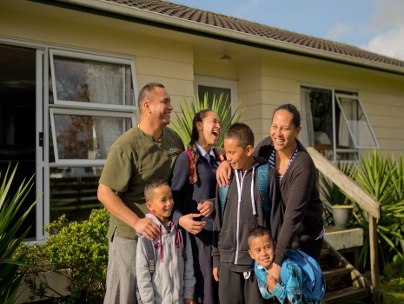

### Children, families and whānau

Early investment in the health and wellbeing of our children, parents, families and whānau sets the foundation for lifelong health.

New Zealand has a strong base of universal, community-based services that are generally available to all children and families. These include maternity, general practice, immunisation, Well Child / Tamariki Ora, B4 School Check, and community oral health services. We need to sustain these services, but also improve their uptake, and make better use of the opportunities they provide health professionals to work with families to promote healthy development and provide additional support where needed.

For children and young people that are struggling with health or social problems, there is an important need to ensure that they have access to services that will help them thrive and contribute positively to their communities. This will require a social investment approach and coordination across agencies.

**Children’s teams** work locally to respond to the needs of individual children at risk by bringing together the **best mix of practitioners**, including teachers, doctors, social workers and iwi. This work is guided by the Government’s **Children’s Action Plan** and the Vulnerable Children Act 2014. Hamilton’s Children’s Team aims to help children **thrive, achieve and belong.** It was launched in September 2015, and will support approximately **650 vulnerable children** when it reaches scale.

### Long-term conditions, including obesity

Like other countries, New Zealand faces a rising burden from long term health and injury conditions such as heart disease, respiratory conditions, cancer, mental health conditions, diabetes and musculoskeletal conditions, and also from obesity. Many of these affect populations in different ways. For example, as Figure 1.7 shows, diabetes increases with age, but is more common among Pacific, Indian and Māori people.

Figure 1.7:  
Prevalence of diabetes, by ethnic group and age, 2013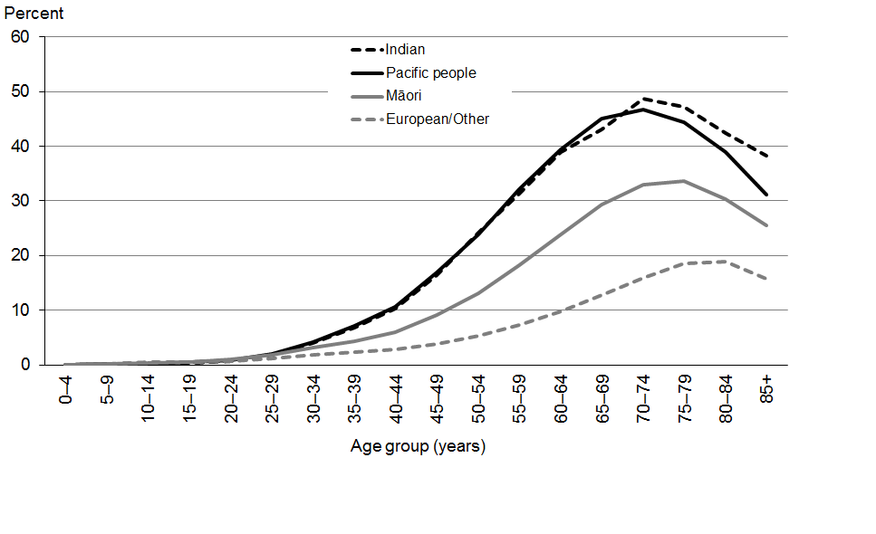

Source: Ministry of Health. 2014. *Health and Independence Report*.

**Obesity rates** have increased. By 2016, obesity is expected to overtake **tobacco as the leading risk to health**. Children living in **deprived** neighbourhoods are more likely to be obese. Obesity is a preventable risk factor for diabetes, cardiovascular problems, dementia, some cancers, mental illness and chronic pain. Children with obesity may have **attention problems** that affect their ability to learn.

Primary care and community services can work together to prevent and manage many aspects of long-term conditions. We need to take advantage of this opportunity, by providing more or better access to community services.

We can also shift services from hospital to community settings in some cases.

Population-based strategies can also make healthier choices easier for all New Zealanders and help prevent and manage long-term conditions. They include things such as smokefree areas, safe sport programmes, public education initiatives, and initiatives with industry to support workplace safety or health-appropriate food product information.

A trial to improve the health and wider socialoutcomes in **Porirua** started in 2013 and set about **slowing the rate of admissions** to emergency departments and hospitals. Its approach has been to strengthen the **coordination of local social and health agencies** to address the cause of health problems in the community. Important health problems among **children** living in Porirua have improved since the trial started: there has been an increase in the number of children enrolled for **dental care** and a reduction in admissions for **skin infections**, which for 5- to 14-year-olds have dropped from 34 per year in 2012 to 11 in 2015. In this trial, **local leadership** is being empowered to address long-standing causes of health issues in the community.

### What great might look like in 10 years

This is our vision for services that are **closer to home** in 10 years’ time.

* People are safe, well and healthy in their own homes and communities.
* We have well-designed and integrated pathways for the common journeys people take through our health and disability system (eg, cancer, maternity, diabetes), starting and finishing in homes.
* We have workforce capability and capacity in primary and community services that provide high-quality care as close to home as possible.
* We have adapted our service configuration (at all levels) so that we can leverage scale where we need to and take advantage of cross-government partnerships, as well as public and private partnerships.
* Māori and Pacific health models, such as Whānau Ora and the Pacific Fonofale model, are used to provide effective and accessible care responsive to their communities.
* Our health system contributes to lifelong health through its support for parents, children, families and whānau.
* We are good at identifying key health problems, preventing them or slowing their deterioration, and keeping people well. We provide well-coordinated care and rehabilitation for people with complex conditions, injuries or disabilities, as well as for frail older people, and for children and families with unmet needs.
* The health system works effectively with other agencies, to improve outcomes for all children and young people, and particularly those at risk, through strong community links with early childhood centres, schools, marae, churches, local authorities, and other social service agencies; for example, in the areas of housing, social development and corrections.

# 3 Value and high performance

### This theme is about:

* a focus on outcomes: people’s experience of care, health and equity of health outcomes, and best-value use of resources
* transparent use of information to drive learning and decision-making for better performance
* strong performance measurement and a culture of improvement, in which we are open and honest about where we can improve
* striving for equity of health outcomes for all New Zealand populations
* an integrated operating model that makes people’s responsibilities clear
* the use of investment approaches to address complex health and social issues.

### Why is it important?

New Zealand’s health system performs well, but it can and should do better.

We need to focus on the results that matter most. Our approach needs to take account of the full range of factors that affect health outcomes, including financial factors, human and technological resources, service users’ experience, quality, health behaviours, the physical environment and social factors.

We can make information work much harder for us. Better information about real-time health results, which is more visible, can help us improve at the front line and at a national level.

The Triple Aim framework (Figure 1.8) provides us with a system approach to making improvements in services. It can help us balance our goals in terms of outcomes. One of its aims is improved health and equity for all populations.

New Zealand’s health system needs to do better for the populations that do not enjoy the same health as the country as a whole. These include Māori and Pacific populations and people with disabilities. To achieve this, our focus must be on removing the infrastructural, financial, physical and other barriers to delivering high-quality health services that exist within the health sector and between our sector and other sectors.

Figure 1.8:  
The New Zealand Triple Aim framework

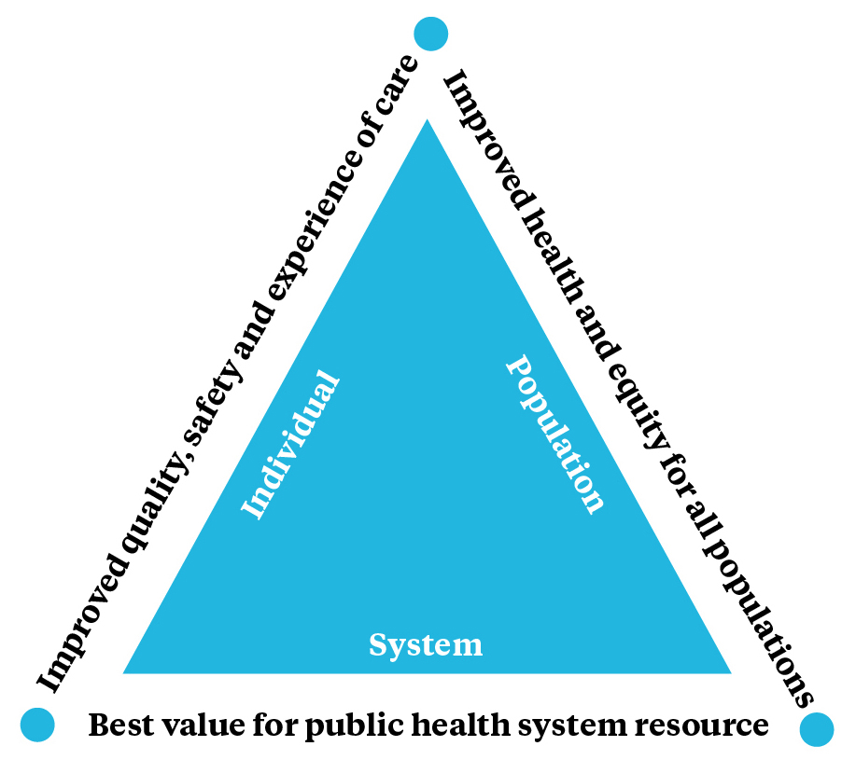

If the purpose is to reduce inequalities we need to urgently **start doing things** we are not currently doing.

Feedback during Health Strategy engagement, May–June 2015

We need to be clear about who is accountable and responsible for what. This is particularly important if we want to provide integrated care. Our operating model must describe the role and purpose of all players in the system and, equally importantly, our way of working. We need to define the processes and culture that allow us to work as a team, and the skills, resources and information that build them.

Failures in the quality and safety of health services are costly to the system and to individual people and their families and whānau. We need to promote a culture of quality improvement across our health services so that patient harm is minimised and health and injury treatment outcomes are optimised.

New Zealand has outstanding and internationally recognised research teams, working in and with the health system, contributing to innovations that can improve performance and safety. Our achievements include the knowledge and improved practice we have developed in relation to asthma, cot death, the links between housing and health, the use of cooling caps for premature infants, and heart disease decision support tools.

But in general we need to get better and faster at sharing the best new ideas and evidence and putting them to work throughout the system. This will help us avoid unwarranted variations in the quality, safety and sustainability of services, and will also mean that effort is not wasted when regions or organisations independently develop solutions to common problems. This can be achieved if we take the learnings from successful implementations and apply them systematically to areas in need of improvement.

Value for money is an imperative in the face of changing and increasing health needs. Working with others across government is one way to achieve this.

Another way is to realise the potential for the health system to make more use of investment approaches. By adopting a more holistic perspective on social value and costs – an investment approach – we can make better decisions and more informed trade-offs.

**PHARMAC**’s approach to managing pharmaceutical spend is **world leading**, and New Zealand has one of the highest proportions of generic **medicines** by volume, fifth out of 26 OECD countries. In 2013 spending on medicines managed by PHARMAC was $784 million, but PHARMAC estimates that without the **savings** it has achieved on the cost of medicines since 2002, these medicines would instead cost over $2 billion.

Source: PHARMAC Annual Report 2012/13.

### What great might look like in 10 years

This is our vision for **value and high performance** in 10 years’ time.

* The health system provides high-quality, accessible, health services that best help people live well, stay well, get well, at the lowest cost it can and within the income it has.
* The system deploys its resources skilfully to ensure services effectively reach people who need them. As a result, the system is more socially, financially and clinically sustainable.
* Clinical and support systems are clearly understood. All involved in delivering and supporting services strive for excellence and improvement, and engage in analysis and modelling.
* All New Zealanders enjoy good health, and there has been a clear lift in health outcomes experienced by population groups previously disadvantaged, such as Māori, Pacific peoples and people with disabilities.
* The health system minimises harm to people, by ensuring that it honestly and openly tracks harm when it occurs, and learns from mistakes, so that the system as a whole can improve.
* The health system has an operating model that clarifies relevant policies, legislation, regulations, guidelines, standards, roles and responsibilities, funding arrangements, systems and processes, and strategic direction. The model allows all parts of the system to play their roles effectively and efficiently.
* Funding approaches consider multiple ‘bottom lines’ as part of a commitment to a social investment approach.
* The health system constantly monitors its performance and scans the environment to ensure it is functioning well, maintaining its strategic direction and detecting changes. It learns and shares knowledge and innovation rapidly throughout.

Figure 1.9 displays some of the words people working in the health system use when describing what a high-performing system could look like.

Figure 9:  
A word map developed from Strategy workshops held during May–June 2015.

# 4 One team

### This theme is about:

* operating as a team in a high-trust system with better cohesion
* making the best, most flexible use of our health and disability workforce
* leadership, talent and workforce development throughout the system
* strengthening the roles of people, families, whānau and communities as carers
* the system leadership role of the Ministry of Health
* collaborating with researchers.

### Why is it important?

We will need a more cohesive team approach across our health and disability system to reach the goal of a high-performing system. We need to work towards shared goals, and be able to work beyond organisational boundaries, proactively assisting people and populations in need.

We need to reduce the fragmentation of care in our health system, and foster increased trust and collaboration. Getting rid of the fragmentation will provide us with opportunities to improve the quality of services, improve timeliness of access and reduce doubling up on resources.

It is important that we have a workforce whose size and skills match New Zealand’s needs. Going forward, this will mean the development of new or stronger skills for some, especially those supporting integrated care that work in teams with a range of health specialties. There is also a need to enable flexible and full use of skills, and this will mean continuing to reduce the barriers that currently prevent this, including legislative barriers.

It will also include strengthening the capability of NGO providers — not only the capability of their people but also their access to technology infrastructure to allow them to work to their full potential.

Whanganui DHB is using a team approach, working with whānau and community providers, to improve Māori health. A Haumoana (navigator) service helps whānau find their way through DHB services. It has an open door approach, catering for any family, whatever the need. The service includes provision of a whare for families who experience the sudden death of a whānau member. The service is delivered by non-clinical Māori staff working alongside clinicians and health professionals. It is available 24 hours, 7 days a week.

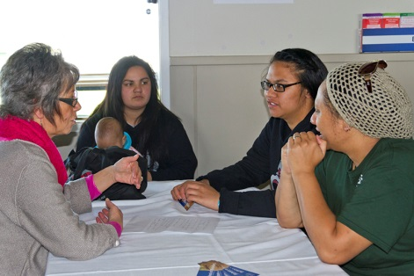

Beyond the formal workforce, there will be an important need to support families, whānau and individuals in communities in their roles as carers of people close to them. This could involve specially tailored information and training for volunteers, as well as the opportunity for them to contribute to design choices for our health system.

We will need great leaders and managers to enable change. These people will make the most of the diverse skills in our system, optimise our use of resources and continuously improve our management processes. There are many great leaders already in the system, but we need to remember that leadership and management skills need to honed. It is also important that we foster the next generation of leaders.

The Ministry of Health has the role of system leadership. This means keeping an overview of the system as a whole, with a view to supporting its long term capability and performance, and working with DHBs and other Crown entities, such as ACC and the Healthy Quality and Safety Commission (HQSC), to support their own leadership roles within the system. It includes attention to the linkages between different parts of the system, and strengthening these where needed to support a high-functioning system. Achieving the future envisaged in this Strategy will require strong system leadership. Steps to support the Ministry’s capability for this are among the early actions for implementation of the Strategy.

A one-team approach also encompasses links with scientists and researchers, including those working in the health system also as clinicians, and those in the wider tertiary system or in industry. Their expertise can help us determine opportunities for improvement, measure the impacts of our interventions, and introduce new ideas into the system.

The **Health Research Council** (HRC) in 2013/14 supported $42 million of research in **collaboration** with clinicians and other users. This research includes developing **new** **technologies**, carrying out evaluations and cost–benefit analyses, and designing **effective** **interventions**. This applied research is supported by the HRC’s broader investments in basic research that support **breakthroughs** in knowledge.

Source: Health Research Council. 2015. *Research to Action: Improving the lives of New Zealand through health research*.

This Strategy places particular emphasis on **integration**, which is critically dependent on a team approach. Particular examples of integration in the health system include:

* integrated care for a **disease condition** or population that improves an individual person’s journey; for example, a diabetes pathway
* integrated **health services** that combine different services under one roof; for example, provision of Well Child / Tamariki Ora checks at the same location as ultrasound scans
* coordination with **initiatives in other sectors;** for example, the Healthy Homes Initiatives, Healthy Auckland Together and Healthy Christchurch
* **vertical integration and service planning** that make the right facilities available in the right coverage areas; for example, access to specialists from remote locations, or sharing equipment across hospitals.

### What great might look like in 10 years

This is our vision for the **one-team** approach in 10 years’ time.

* The health system is more than the sum of its parts, with each part clear on its role and working to achieve the aims of the system as a whole.
* The system has competent leaders who have an unwavering focus on the system’s goals, and a culture of listening carefully and working together in the interests of people’s ongoing wellbeing.
* New Zealand offers coherent pathways for leadership and talent development that inspire and motivate people already working in the health system, and those considering health work as a career.
* We invest in the capability and capacity of our workforce, including that in NGOs and the volunteer sector, and make sure that it fosters leadership, flexibility and sustainability.
* The Ministry of Health is a competent system leader, playing its role effectively as part of the wider health and disability system, and partnering with other sectors.

What works is **leadership** that is **clear** about what it is trying to achieve but **flexible** about how it is delivered.

Feedback during Health Strategy engagement, May–June 2015

We have **motivated** and highly **skilled** people and **committed** communities.

Feedback during Health Strategy engagement, May–June 2015

* There is a culture of enquiry and improvement throughout the health system, and seamless links to the New Zealand and international science communities.
* New Zealand and international research, best practice and local innovations are shared freely and used to roll out improvements nationally.

**Healthy Auckland Together** is a coalition working to make it easier for Aucklanders to **eat better, exercise more and maintain a healthy weight**. The focus is on five areas: streets, **parks and places**; food environments and marketing; schools and early childhood education services; workplaces; and **community settings**. The 21 agencies involved include health entities, local government, iwi-based organisations and NGOs. Together, they have developed a regional action plan with 65 actions towards achieving their goals.



# 5 Smart system

### This theme is about:

* information being reliable, accurate and available at the point of care
* individual online health records that people are able to access and contribute to
* data and smart information systems that improve evidence-based decisions, management reporting and clinical audit
* standardised technology that allows us to easily make efficient changes
* being able to take advantage of opportunities of new and emerging technologies.

### Why is it important?

The world of technology is advancing very fast. Every aspect of our lives is affected. New technologies have already had a profound impact in industries like banking, air travel and retail. In the coming years they will play a significant role in the health system in terms of what, how, where and when services are provided, and who provides them.

New technologies have the potential to generate large amounts of data that can unlock insights about the health system and the health of New Zealanders. Data and smart information systems can support evidence-based decisions on treatments, options and interventions. Technology can perform some tasks for us, help us communicate with each other and ultimately improve our productivity.

Well-organised data can help us to target different population groups and track their progress in terms of our shared goals. This is important not only in the health system, but also in the delivery of services that span other government agencies and sectors.

Our system needs to become a learning system, continuously monitoring and evaluating what we are doing, and standardising approaches where possible. Fragmentation makes technology overly complex and expensive. To share new ideas or innovations, we must have sufficient scale and similarity to roll them out across our system.

**eReferrals** make the **patient journey** smoother by making the transfer of information between health care providers smoother. They support **faster clinical decision-making** and increase **safety** by making it less likely for referrals to be lost or hard to read. eReferrals allow specialists to **communicate** with referrers on the **best treatment options**. This may mean that people can be **treated in the community**, without needing specialist appointments. Auckland, Waitemata and Counties Manukau DHBs have been using eReferrals between GPs and hospitals since 2012. From April to June 2015, eReferrals made up 64,415 out of 86,077 or **75 percent of total referrals in the Auckland metro DHBs**.

Technology involves more than just digital technologies. Other technologies are revolutionising health systems: robots and other automated systems are carrying out repeatable and predictable processes, advanced analytics are providing new insights into complex health problems, and research breakthroughs in human and life sciences are making ‘personalised medicine’ a reality for more and more people.

Electronic health records can let people access their own health information and gain more control of their own health. They also allow health providers to share information with others to ensure timely and consistent care and to make better decisions.

**Shared care plans** give people with complex long-term conditions **ownership of their health care**, supported by a multidisciplinary team. The plans enable them to **set their own health goals** with **measurable outcomes**. In Canterbury and Auckland DHBs, significant numbers of people are enrolled in shared care programmes – over 16,000 in total have active care plans. The DHBs are creating plans not only for people with long-term conditions, but also for people receiving **palliative care**, **older people** needing acute care and others needing advanced care. Shared care plans involve a **health navigator** who takes responsibility for care coordination in each individual case.

Health information and services can be provided to people via voice or video through the devices they already use, such as phones and computers. These telehealth approaches can help give people in rural locations, in particular, access to specialist care. They can improve management of long-term conditions, decrease hospital admissions and reduce travel costs.

**Telehealth** enables health professionals to **deliver health services** without being in the same room as the person receiving care. It can also deliver health care-related **education, research and evaluation remotely**. In Central Otago, doctors can support children with type 1 diabetes through a **safe and secure video link** to specialists in Dunedin. This eliminates the need for the children and their families to make a six- to eight-hour round trip for a routine half-hour appointment. It means people living in **rural or remote areas** in Central Otago have access to the same **specialist care** as those living in the city. Currently, 17 out of 20 DHBs are actively making use of telehealth.

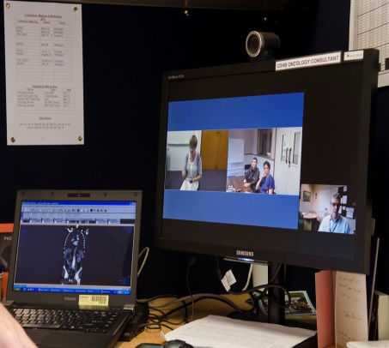

### What great might look like in 10 years

This is our vision for a **smart system** in 10 years’ time.

* New Zealanders make regular and effective use of a patient portal to access their health information and improve their interactions with their doctor and other health care providers.

The process of **designing** the technology can be the **game-changer** – means you get together and have a conversation.

Feedback during Health Strategy engagement, May–June 2015

* When people first attend a health service, the provider already knows their details. Their journey and scheduling are integrated.
* People at risk of various conditions have easier access to follow-up tests and services and benefit from more individually tailored treatment and management plans.
* The quality of health care is high as health workers spend quality time with people, errors are reduced and better decisions are made.
* The data we collect is more specific, so that management can be more proactive.
* Data is used consistently and reliably, with appropriate safeguards, to continuously improve services.

**Nelson Marlborough DHB** has developed an ED system that demonstrates how **clinicians can lead the design** and development of innovations. **ED at a Glance** displays all of a service user’s **relevant information** on a large electronic whiteboard for ED staff. It allows clinicians access to a person’s existing care management plan each time they come in. Since the project was introduced in 2013, visits to the ED by the most frequent attenders have reduced significantly. This **frees up the ED for those who need really urgent care**. In 2014, ED at a Glance won Dr Tom Morton and his team the Clinician’s Challenge – an award from the National Health IT Board and Health Informatics New Zealand for **innovative uses of technology** to improve care.

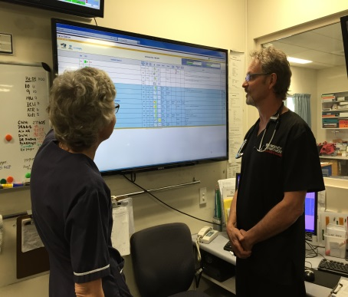

# 

# Turning Strategy into action

Implementation of the Strategy will require effort from everyone who works in the system and contributes to health in New Zealand.

Figure 1.10 (p 28) shows the wide range of inter-linked players in New Zealand’s health and disability system. They include many government and Crown agencies, including DHBs, as well as NGOs and private providers such as Māori and Pacific providers and independent general practices. As this Strategy makes clear, at the heart of the system are New Zealanders themselves, and their families and networks of informal carers and supporters.

The performance of the system depends not only on the capability of each individual part but also on the strength of linkages throughout the system. The Ministry of Health supports this through its system leadership role.

### Roadmap of Actions

In a system with this many players, we need to be clear about what needs to happen and when, and who is responsible. This Strategy has a 10-year outlook. But setting out to achieve this requires some more immediate signposts. These are developed in II. Roadmap of Actions, which is part two of the Strategy.

The first thing is to get **systems thinking** in place. It’s not about one, it’s about a system of **integrated** parts.

Feedback during Health Strategy engagement, May–June 2015

The Roadmap takes the five strategic themes introduced in I. Future Direction and lays out 20 concrete action areas to focus implementation over a five-year time horizon. Figure 1.11 (p 29) indicates some of the results expected from delivering the actions.

The Roadmap will be updated annually, serving as a practical guide for DHBs and other agencies to support the planning and prioritisation of work to deliver the Strategy. In all the work that they do, DHBs are expected to reflect the directions of the Health Strategy. The Roadmap updates will involve continued collaboration across the health system with a new annual forum.

### Tracking progress

The Ministry of Health will monitor work undertaken on the actions in the Roadmap as part of the Strategy implementation process.

A set of measures will be used to track progress – these will be relevant to the outcomes sought through the Strategy and shared widely to demonstrate and motivate ongoing learning and change. They will also support the Minister’s annual report on the implementation of the Strategy as required by legislation.

Figure 10:  
Overview of the New Zealand health and disability system

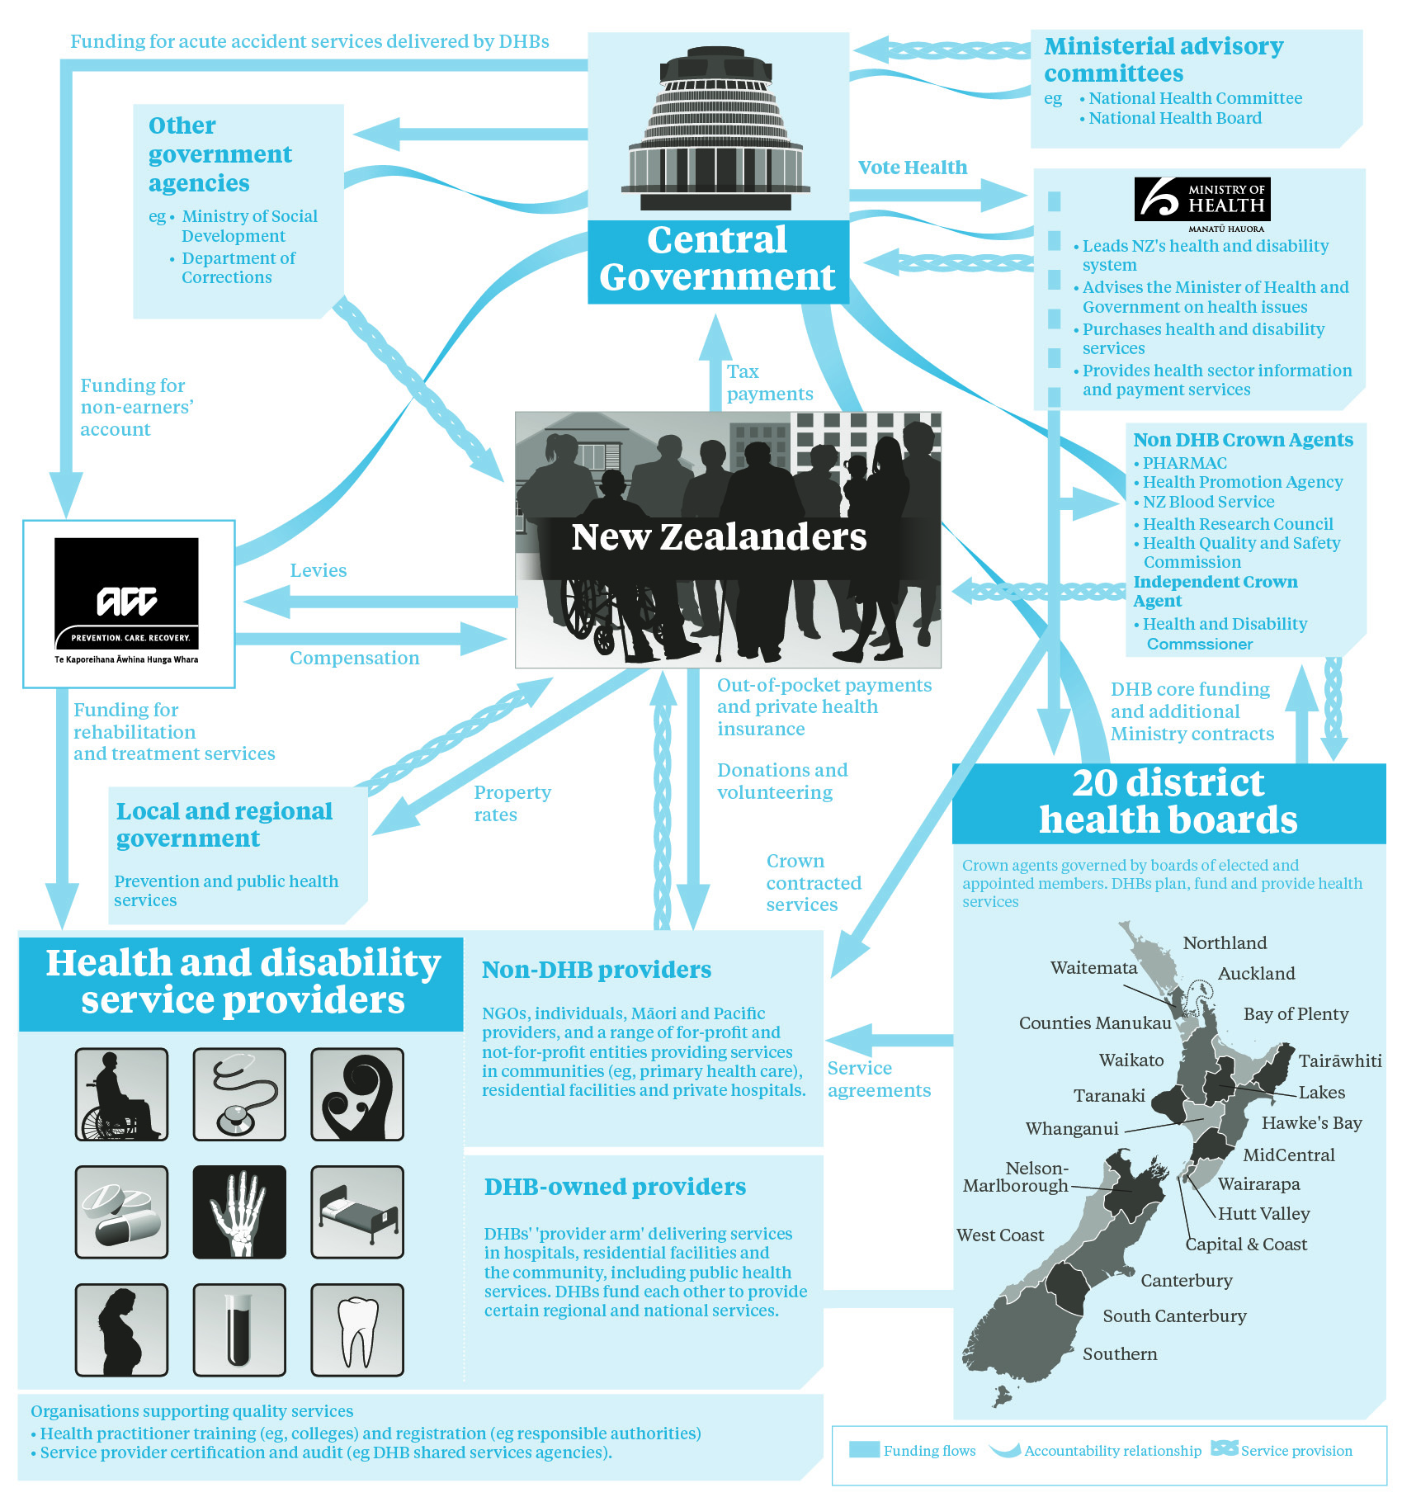

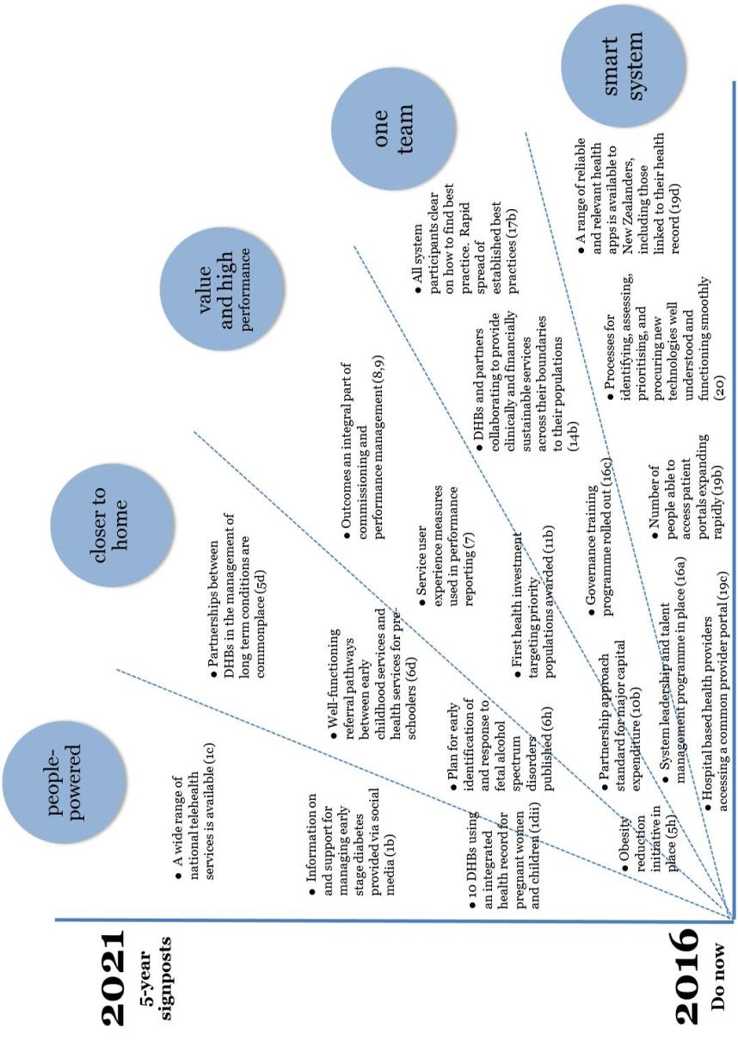

Figure 11: Possible results from implementing the Roadmap of Actions over time (illustrative with selection only; see Strategy: II. Roadmap of Actions for full list of actions)

# II. Roadmap of Actions

# Introduction

New Zealand’s health system is good by international standards but we need to continue to adapt and find new ways of working, to ensure we are doing our best for the health and wellbeing of New Zealanders into the future.

Like many other health systems around the world, our system faces the challenges of an ageing population and a growing burden of long-term conditions, such as heart disease, diabetes and mental health conditions. Issues such as obesity can also lead to longer-term health problems.

The Government expects the public health system to continue to focus on delivering high-quality health services, improving performance where it matters most.

It also wants to tackle priority issues with wider impact, such as housing quality and the wellbeing of children. The health system already makes important contributions to these issues. Stronger partnerships and changing approaches will allow us to do even more.

The **New Zealand Health Strategy: All New Zealanders live well, stay well, get well** (the Strategy) has been developed to guide change in the system. Over the longer term, the Strategy’s implementation will lead to a health system with a new way of working to support the health and wellbeing of New Zealanders.

The Strategy has two parts.

**I. Future Direction** (companion document) outlines a high-level direction for New Zealand’s health and disability system over the next 10 years. It lays out some of the challenges and opportunities the system currently faces; describes the future we want, including the culture and values that will underpin this; and identifies five strategic themes for the changes that will take us toward this future.

**II. Roadmap of Actions** (this document) identifies 20 work areas for the next five years to put the Strategy in place.

The areas of work set out in this Roadmap will have a critical role in driving change. In some cases, this is because they have a system-wide impact; in others, it’s because they play a catalytic role in modelling or unlocking the particular change required. Some areas address issues that are a priority for the Government. In this case, this Roadmap underlines what we need to do to reach government goals.

The work areas in this Roadmap are not all new. Most are, to varying degrees, the subject of programmes of work at the Ministry of Health and in district health boards (DHBs), in other Crown entities and across the system.

Their presence in this Roadmap signals their importance for the future of New Zealand’s health system, and reflects our expectation that going forward we will focus on them collectively to achieve positive change.

The Strategy includes eight principles that reflect the values of New Zealanders and their expectations of the system (see the box below). These principles apply also to this Roadmap and have relevance across all the themes and to many of the actions. The Strategy principles can be used to guide decisions; for example, about how services could be redesigned, who should be involved and what outcomes to expect.

As a specific example, the principle that acknowledges the Treaty of Waitangi should guide the design of training for health workers and board members to ensure they have appropriate knowledge about the Treaty, its implications for the participation of Māori in the health system, partnership approaches to services, and the need to improve the health status of Māori.

**Section A** of this Roadmap describes action areas under each of the five themes of the Strategy (Figure 2.1).

**Section B** of this Roadmap outlines how the Strategy will be implemented, including the ongoing work to develop this Roadmap on an annual basis.

Figure 2.1:  
Five strategic themes of the Strategy





Refreshed guiding principles for the system

1. The best **health and wellbeing** possible for all New Zealanders **throughout their lives**

2. An **improvement in health status** of those currently **disadvantaged**

3. Collaborative **health promotion** and disease and **injury prevention** by all sectors

4. Acknowledging the special relationship between Māori and the Crown under the **Treaty of Waitangi**

5. **Timely and equitable access** for all New Zealanders to a comprehensive range of health and disability services, regardless of ability to pay

6. A **high-performing system** in which people have **confidence**

7. Active **partnership** with **people and communities** at all levels

8. Thinking beyond narrow definitions of health and **collaborating with others** to achieve wellbeing

# Section A: Action areas

This section of the Roadmap sets out actions within 20 work areas under each of the five themes of the Strategy. We have laid out the actions in a way that recognises that progress will be step-wise.

We recognise that organisations will be at different stages in their own development. However, in setting out these actions, we have aimed to provide a general approach. The actions typically start with an assessment of current progress. They then comprise guidelines for sharing good practice, and build on further improvement from that base.

The actions are intended to be carried out within a five-year timeframe, with first steps starting in 2016/17 and indicated with an asterisk (*). The workplan will be updated annually as set out in Part B.

Appendix 1 on page 49 contains a summary of the 20 areas for action.

## 1 People-powered

This theme reflects the Government’s priority of delivering ‘better public services’ and the opportunity to achieve this through more people-centred approaches to health services. A people-powered system will involve people not only as users of health services but also as partners in health care. It will support and equip all New Zealanders to be **informed** about and **involved** in their own health.

New Zealand is home to a diverse range of cultures and ethnicities, and our health system has to cater for all of our people, at all points in their lifespan. The better we **know** people’s preferences and lifestyles, their health needs, their experiences of care and the outcomes they are seeking, the better we can **design** services that deliver best value for our resources. For example, many Pacific peoples have strong connections with churches, so it can make sense to use these as convenient access points for health care advice or services, designed in partnership with these communities.

### What do we want in 5 years?

* People have access to reliable and easily understood information, including online, to find out about the choices they can make and how they can take greater responsibility for their own health.
* People can easily provide feedback on their experiences of using services.
* The design of the health and disability system reflects ‘person, need, outcome’ principles. The system measures what matters to people, and people’s involvement improves quality, safety, experience and health and equity of health outcomes.
* Providers listen to service users to understand the segments, needs and desired health outcomes for populations in their area. Planners continuously improve services to better meet needs and improve quality, safety, experience and equity of health outcomes.

|  |  |
| --- | --- |
| **Inform and involve people** | |
| Action 1 | Improve coordination and oversight and expand delivery of information to support **self-management of health** through a range of **digital technologies**.  a. * Start with a stocktake of current provision and consider different innovation and information channels relevant to people’s needs when growing the available information network.  b. Use social media to provide information on early stage diabetes.  c. * Continue to strengthen the National Telehealth Service by providing more support for self-management of people’s health and conditions.  d. Create partnerships for better health services by giving everyone on the health team, including the person, access to the same information.  i. * Promote to service users and clinicians the benefit of having access to health information accessible via a patient portal.  ii. * Expand the number of early adopter DHBs using an integrated health record for pregnant women and children (as part of the Maternity Information System) from five to ten. |

|  |  |
| --- | --- |
| **Know and design** | |
| Action 2 | **Promote people-led service design** by collecting and sharing good examples of it from design laboratories and practices; focus especially on those examples that effectively reach and understand high-need priority populations.  a. * Identify and showcase three high-quality, people-led service designs at the annual forum (links to action 17).  b. Support clinician-led collaborations to engage with high-need priority populations on key health issues. |

## 2 Closer to home

Good health begins at home and in communities and these are the places most people would choose to receive care and support they need for their health. There will always be a need for hospitals. But opportunities are increasing for **shifting services** out of such specialist centres, so that we can prevent and manage health conditions safely and effectively in people’s local communities. One way we can do this is to help people in the health workforce undertake tasks they are skilled (or can be trained) to do that have traditionally been outside their roles.

This theme is the intersection point between health services, other social services, and the broader community and business environment. It has a focus on prevention, early intervention, rehabilitation and wellbeing for **long-term conditions**, through evidence-based initiatives aimed broadly at all New Zealanders as well as those designed for people at higher risk. It also recognises the pressing need for us to work together more effectively to support **children, families and whānau**, particularly those at risk of poor health or social outcomes.

### What do we want in 5 years?

* People have access to services, information and support as close as possible to home, services are available when they want them, and access to services is as easy as possible.
* Strategic planning will be done regionally, and there will be stronger advisory support for determining and managing the implementation of regional services.
* The balance of services for long-term conditions will have shifted closer to the service user (by growing preventative, self-management, home, community services and primary care).
* Investment approaches will be the norm for agencies across government to improve overall outcomes and to support provision of services for at-risk children and families and other priority populations.

|  |  |
| --- | --- |
| **Shift services** | |
| Action 3 | To maximise value for people and achieve the **best health outcomes**, the Ministry of Health, with input from the system, will ensure the **right services are delivered at the right location** in an equitable and clinically and financially sustainable way.  a. * Engage with DHBs in establishing service configuration design principles (recognising that some services, such as primary care, need to be available locally, while other specialist services, such as heart transplants, need only be in one location).  b. * Agree design principles for the approach.  c. Collaborate on the approach to implementation and timing. |
| Action 4 | Enable all **people working in the health system** to add the greatest value by making sure they are providing the right care at the earliest time while **fully utilising their health skills and training**.  a. * Remove legislative barriers to allow health practitioners, such as pharmacists and nurses, to prescribe under limited circumstances.  b. * Increase the use of telehealth approaches, including telemedicine and telemonitoring, to provide services to people closer to their home. |

|  |  |
| --- | --- |
| **Tackle long-term conditions and obesity** | |
| Action 5 | The Ministry of Health and DHBs will increase the effort on **prevention, early intervention, rehabilitation and wellbeing** for long-term conditions such as diabetes, cancers, cardiovascular disease, chronic respiratory conditions, mental health conditions, musculoskeletal disorders, and for obesity, addressing common contributors or risk factors of these conditions and focusing efforts on points in the lifecourse with the greatest opportunity for success.  a. * Agree the outcomes framework for setting expectations and judging success.  b. * Reorient planning guidance and performance management to outcomes for long-term conditions, starting with a focus on one of these; for example, diabetes or mental health conditions or cardiovascular disease.  c. * Make greater use of new and existing clinical networks to strengthen collaborative approaches to long-term conditions that span DHB boundaries.  d. Support the spread of best practice over time, by requiring partnerships between those producing the best and most equitable health outcomes and others.  e. Over time, progressively target other aspects of long term condition prevention and management – perhaps population segments, or weaker segments of the end-to-end journey; perhaps emerging conditions.  f. Capture the service user’s care plan in an electronic form for access by all health providers who make up the care team.  g. * Collaborate with other government agencies to implement an evidence-based programme of vocational rehabilitation to maintain employment for people with long-term conditions.  h. * Implement a package of initiatives to prevent and manage obesity in children and young people up to 18 years of age that combines targeted interventions for those who are obese, increased support for those at risk of becoming obese, and a broad base of population-based strategies to make healthier choices easier for all New Zealanders. |

|  |  |
| --- | --- |
| **A great start for children, families and whānau** | |
| Action 6 | The Ministry of Health will continue to **collaborate across government agencies, using social investment and lifecourse approaches**, to improve and make more equitable the health and social outcomes for all children, families and whānau, particularly those at risk.  a. * Increase support to pregnant and postnatal women experiencing mental health and alcohol and other drug conditions.  b. * Promote healthy nutrition and activity for pregnant women and children to reduce the prevalence of childhood and adult obesity.  c. * Support families, especially those with newborn babies, to have healthy housing (warm, dry and smokefree) and address crowding issues, to reduce transmission of infectious diseases and family stress.  d. * Improve collaboration between early childhood services and health services for preschoolers to improve early childhood education attendance and better address unmet health and development needs.  e. * Be a strong participant in the Government’s programme of work to improve social outcomes for children and young people, with initial focus on:  i. * leading the Government’s programme of work to ensure all children, at the age of six, turn up to school regularly, are ready to learn, are well fed and healthy, and live in a safe and nurturing environment  ii. * supporting Ministry of Education’s lead on the Government’s strategy for at-risk 15- to 24-year-olds, which includes working towards improved health outcomes for these young people.  f. * Connect children and families of offenders to health services.  g. * Work with the Accident Compensation Corporation (ACC) and other partners to build on a range of programmes that support young people to make healthy relationship choices with the aim of reducing the incidence of sexual and family violence in the future.  h. * Lead the development of a plan to improve the health system’s response to children and families who are living with fetal alcohol spectrum disorders. |

## 3 Value and high performance

Possibly one of the most important and achievable gains we can make in the performance of the system will come from making smarter and more transparent use of information. As an integral part of a health and equity of health **outcomes-based performance** framework, this will bring immediate benefits at the point of care and also in the longer term. At a system level, it will also help with more purposefully targeting high-need priority populations.

This theme recognises that we need to make better use of our **funding, better directing it** towhere needs are greatest, and that this could be done using a **health investment** mindset in a long-term approach. We are already doing well in terms of **quality and safety**. Strengthening the relationships with key agencies, such as the Health Quality and Safety Commission (HQSC) and ACC, will allow us to do even better.

The New Zealand Productivity Commission’s recommendations on More Effective Social Services recognise that improving social outcomes depends critically on the involvement and capability of not only government agencies but also non-governmental organisations (NGOs) and the wider community sector.

### What do we want in 5 years?

* Population health management is improved through: looking at the population carefully and then focusing on high-risk individuals or other groups; developing multi-sector partnerships, using key stakeholder resources and aligning our policies to provide community-based support for all who wish to make health-related behaviour change; and striving for a fair system.
* Services are configured in a way that is more clinically and financially sustainable and equitable. Services are delivered in community settings where possible.
* Primary care services use teams to deliver core services; develop shared plans of care; better coordinate care with specialists and hospitals; improve people’s access through better scheduling; and work with their communities.
* Secondary hospitals improve their core services and strengthen their partnerships within regions to address workforce and quality pressures.
* Specialist/tertiary services tend to be consolidated into a smaller number of services delivering specialised care for a defined population base (regional or national) in collaboration with local referring clinicians and interacting electronically.
* Funding and information systems support providers to improve their service:
* changes to funding processes improve access to universal services for high-need priority populations
* providers use a health investment approach
* funding, incentives and payment streams for primary care support its role in the system
* commissioning of services and payment approaches focus on equity of health outcomes
* purchasing from NGOs and commissioning at the local level improve, with standardisation of contracts, are linked to performance and are sustainable.

|  |  |
| --- | --- |
| **Improve performance and outcomes** | |
| Action 7 | * The Ministry, working with the HQSC, will develop and implement **service user experience measures**. This could build on the HQSC’s existing work with online patient experience surveys. |
| Action 8 | * Develop and implement a **health outcome-focused framework**, with involvement from the health and disability system, service users and the wider social sector. The framework will reflect the links between people, their needs, and outcomes of services and will shift the focus from inputs to outcomes. This work will build on the Integrated Performance and Incentive Framework work to date, and aims to increase equity of health outcomes, quality and value. |
| Action 9 | * Work with the system to develop a **performance management** approach that makes use of streamlined reporting at all levels, to make the whole system publicly transparent. This will draw on service user experience results (developed through action 7), operate within the outcomes framework (developed through action 8) and involve approaching planning, monitoring and continuous improvement in a tight–loose–tight way (ie, setting specific target outcomes, making service delivery options flexible, and being tight on achieving health and equity outcomes) and supporting innovation. |

|  |  |
| --- | --- |
| **Align funding** | |
| Action 10 | Align funding better **across the system** with a rolling programme focused on getting the best value from health investment (including incentives where relevant to support Strategy direction).  a. * Ministry of Health will provide advice on the best way to ensure access to **health services for those most in need through financial support** (eg, very low-cost access).  b. * **Embed the partnership approach between Ministry of Health, Treasury and DHBs for major capital expenditure**, providing additional support from people with expertise in major capital expenditure to strengthen governance, planning and delivery.  c. * **Improve commissioning** by using a wider range of service delivery models, expanding the use of contracting for health and equity of health outcomes, and build capability to lift the quality of commissioning (as suggested in the New Zealand Productivity Commission’s More Effective Social Services’ review recommendations).  d. Agree on **information technology (IT) project funding** priorities with input from across the system. |

|  |  |
| --- | --- |
| **Target investments** | |
| Action 11 | Develop and use a **health investment approach** with DHBs. This could be used to target high-need priority populations to improve overall health outcomes, while developing and spreading better practices. This will increase knowledge about population segmentation, drive collaboration, build skills in developing investment cases in the system, improve visibility of value for money, and build on the New Zealand Productivity Commission’s recommendations around a learning system.  a. * Develop the techniques, standards and guidance for health investment cases.  b. Trial the approach by targeting services for population segments offering the highest potential health and fiscal returns. Funding will be awarded on the basis of the strongest investment cases for a three- to five-year period to enable longer-term contracting of NGO providers where relevant*.*  c. Review results and learnings and consider extending the scope to cover the country for the selected population outcome and segment, and/or other outcomes and segments. |

|  |  |
| --- | --- |
| **Improve quality and safety** | |
| Action 12 | **Continuously improve system quality and safety**. The Ministry of Health will achieve this by:  a. * partnering with other organisations on quality and safety initiatives in primary and rest home care  b. * working with ACC and the HQSC to strengthen initiatives to reduce patient harm, in particular where services have high volumes or high costs  c. * working with ACC and HQSC to analyse data on treatment injury, making continuous improvements to solutions to the problems identified  d. * reviewing and streamlining annual reporting to incorporate relevant quality performance reporting. |

## 4 One team

The Strategy demands a more integrated and cohesive system, but this will only be possible when people have a clear view of their own **roles, responsibilities and accountabilities,** whether these are in **governance**, clinical, managerial or other areas**.** The Ministry of Health’s system leadership role involves keeping a **whole-of-system** view, and this will be supported by an annual forum for the system that can feed into **annual planning**. Another important initiative could be to simplify the structure of national committees, to enable the **integrated health advice** the Ministryneeds for its leadership role. This will have governance and legal implications.

Great **system leadership,** including alignment across clinical, managerial and governance domains, leads to great health outcomes. Health system staff are demanding better support for leadership and **talent development**; we need to meet that demand. There is an ongoing need to ensure the sustainability of our health and disability **workforce** to meet changing population needs and new models of care. This needs to include building the capability and diversity of the workforce to meet the demands for more integrated health care, prevention, self-care and care closer to home, and could include developing and drawing on skills in the wider NGO and volunteer communities.

### What do we want in 5 years?

* All actors within the system are committed to collaboration and the future direction of the system. They freely and rapidly share innovation and good practices, and support one another. Survey results show rising levels of engagement across the system.
* Roles throughout the system are clearer and better understood; so are the parameters within which those roles are exercised.
* An established, integrated, central advisory framework supports the shared future direction.
* The leadership, alignment, flexibility, diversity and sustainability of the health and disability workforce improve significantly.
* A performance and planning system supports the strategic direction.

|  |  |
| --- | --- |
| **Clarify roles, responsibilities and accountabilities** | |
| Action 13 | Improve **governance** and **decision-making processes** across the system, through a focus on **capability, innovation and best practice**, in order to improve overall outcomes.  a. * Review governance arrangements across the system, including those of the Ministry of Health and ministerial advisory committees.  b. Develop and implement a regular review of DHB governance performance. |
| Action 14 | The Ministry of Health will work with leaders in the system to improve the cohesion of the health system, including by **clarifying roles and responsibilities/accountabilities** across the system as part of the planning and implementation of the Strategy.  a. * The Ministry will review its structures, processes and culture to ensure it is well positioned for its stewardship role in the system and its leadership role in implementing the Strategy, including ensuring good-quality policy and legislative/regulatory advice, and monitoring of performance.  b. DHBs will carry out their roles and responsibilities at national, regional and local levels, including any changes to these as a result of implementation of the Strategy. |

|  |  |
| --- | --- |
| **Integrate health advice** | |
| Action 15 | * The Ministry of Health, with input from the system, will establish a simplified and **integrated health advisory structure** that oversees health system changes and incorporates or takes into account relevant existing national committees (eg, the National Health IT Board, the Capital Investment Committee, Health Workforce New Zealand, the National Health Board, and the National Health Committee). |

|  |  |
| --- | --- |
| **Build system leadership, talent and workforce** | |
| Action 16 | Put in place a **system leadership and talent management programme** and **workforce development** initiatives to enhance capacity, capability, diversity and succession planning and build workforce flexibility.  a. * Develop a system-wide leadership and talent management programme aligned with the State Services Commission framework.  b. Use the same principles to strengthen skills and capability and expand support for the NGO/primary and volunteer sector.  c. * Develop and roll out governance training programme bespoke for the system.  d. * Work with the HQSC to equip clinical networks to lead quality improvement, emphasising clinical leadership.  e. Working with other social sector agencies, the Ministry of Health will identify areas of workforce capacity planning that it can lead on behalf of the social sector and accelerate workforce development actions for the carer and support workforce.  f. The Ministry of Health will identify and use workforce data to inform workforce planning and development where a workforce is not sustainable and initiate a remedial work programme to address this. |

|  |  |
| --- | --- |
| **Lead whole-of-system forums** | |
| Action 17 | To create a **‘one-team’ approach for health in New Zealand**, the Ministry of Health will **facilitate whole-of-system forums annually** (in advance of DHB planning), to discuss government priorities, share international and New Zealand best practices and build leadership. Forums will inform advice to the Minister of Health on system priorities on an annual basis and contribute to a culture of trust and partnership.  * Communicate yearly to share progress on the implementation of the Strategy.  * Share best practices and identify, publicise and spread examples of innovation that demonstrate improved equity of health outcomes, efficiency, quality and safety, and reduction of harm. |

## 5 Smart system

In order to fully unlock the benefits of information and other technologies, we need to develop our **analytical capability and the quality of our data** at a national level. Having and sharing good-quality information will drive better performance in the health system and support effective work with other government agencies.

We need to ensure all New Zealanders, regardless of where they interact with the health system, have online access to their health and social services information. We can do this by extending the current range of online services, health information and decision support tools, and by developing **electronic health records and patient portals.** It is challenging to keep up with the development of **health technologies,** but important. We need to actively scan, evaluate and develop **knowledge** and **innovative** technologies in a New Zealand context, and apply the best of these nationally.

### What do we want in 5 years?

* Data is consistent and accurate. It is accessible across the country, and not needlessly duplicated. Privacy is assured.
* People are increasingly able to interact with the health system online.
* There will be strong analytical capability working to national standards, able to transform individual data into the knowledge required to accurately and effectively target services to meet people’s needs, including where health services have high potential to deliver on priority outcomes in social service areas, such as employment outcomes.
* Government agencies will design and collect information consistently and share information to segment the population, to improve targeting of health services including where services assist delivery of priority social outcomes.
* Innovative health technologies and best practices are rapidly identified, evaluated and introduced across the system.
* Improved processes and clarified roles and responsibilities result in faster uptake of digital solutions and processes designed to national standards.

|  |  |
| --- | --- |
| **Strengthen national analytical capability** | |
| Action 18 | Increase New Zealand’s **national data quality and analytical capability** to improve transparency across the health system.  a. The Ministry of Health will work with other government agencies to ensure better information and analytics for effective cross-sectoral action at all levels of the system.  i. * Progress analytical and research networks to inform decision-making, working with Superu.  ii. * Work with Statistics New Zealand’s integrated data infrastructure to inform prioritisation of health and social investment programmes.  iii. * Increase Ministry of Health capability (links to actions 14 and 15). |

|  |  |
| --- | --- |
| **Use electronic records and patient portals** | |
| Action 19 | The Ministry of Health will establish a **national electronic health record** that is accessed through certified systems including: **patient portals**, health provider portals, and mobile applications.  a. * Design and implement a national electronic health record, with appropriate standardisation to ensure high-quality data is accessible by certified health applications.  b. * Continue to drive uptake of patient portals so that over time all New Zealanders will be able to access their health information electronically.  c. * Public hospital-based health providers will use a common provider portal to access medical records, standardised to enable effective sharing of medical records, and with appropriate privacy safeguards.  d. Establish a list of certified mobile ‘health apps’ that service users and health providers can use with confidence (to be known as the ‘Health App Formulary’). |

|  |  |
| --- | --- |
| **Strengthen the impact of health research and technology** | |
| Action 20 | Develop capability for **effective identification, development, prioritisation, regulation and uptake of knowledge and technologies**. This action area seeks to improve the health system’s service effectiveness, reduce cost, improve engagement with people who access health services, promote healthy behaviours and self-management, and aid people-led design. It includes use of new technologies (medicines, medical devices from dressings to robotics, cell and tissue therapies), service design/models of care, and information technology.  a. * The Ministry of Health will work with the Ministry of Business, Innovation and Employment and the Health Research Council to better align and strengthen the impact of health research for New Zealand.  b. * Continue to develop and implement the regulatory scheme to support the assessment and uptake of medical devices and therapeutic products.  c. Continue to improve and simplify processes and systems for prioritisation and procurement of technologies (links to action 15). |

# Section B: Implementation

Implementation of a strategy means doing new things, doing things differently and also stopping things.

At the level of the health system, there will undoubtedly be challenges in putting this Roadmap into action. It is ambitious and will involve change. In order to achieve the future we want, each of us will need to do things differently.

The actions in this Roadmap are expected to contribute to the direction of the Strategy and its five themes. They also reflect New Zealand and international experience and research about what enables change in health systems and how these can be embedded into implementation. These enablers include the use of existing good practice as springboards, leadership that is supportive of change, and the effective use of data about the impact of actions as part of feedback loops.

Implementation will nonetheless need to recognise the time and effort it can take to build trust and work in new ways. It will need to be treated as a learning process – there will be things that work well, and things that don’t. We need to work together as a team, and freely share what we learn.

## Co-creation of the Roadmap

This Roadmap of Actions is intended to be a living document, updated annually as new developments and results emerge, but remaining within the context of the overall Strategy. The Ministry of Health will lead an annual forum that will provide a place to share practice, develop a system overview and inform the Roadmap and the annual actions.

## Annual planning

The Strategy, including this Roadmap, provides guidance for the annual planning cycle of DHBs and other agencies working in the health system, including the Ministry of Health.

The New Zealand Public Health and Disability Act 2000 requires DHBs’ annual plans to reflect the direction set out in the Health Strategy. In addition, the Crown Entities Act 2004 allows the Minister of Health to direct statutory Crown agents for whom the Minister of Health is responsible to give effect to government policy that relates to the entity’s functions and objectives.[14]

## Role of the Ministry

The Ministry of Health will maintain an overview of the changes put in motion through the Strategy and this Roadmap, advise the Minister of Health on the policy or regulatory changes required to deliver, and monitor the agencies involved in implementing the Strategy. The Ministry also has responsibility for implementing or supporting others to implement many of the actions in the Strategy.

**Tracking progress**

For information on the Roadmap, see the Health Strategy page on the Ministry of Health’s website: [www.health.govt.nz](http://www.health.govt.nz).

# Appendix 1: Summary of actions

|  |  |
| --- | --- |
| **People- powered** | 1. Improve coordination and expand delivery of information to support self-management in health through digital solutions. |
| 2. Promote people-led service design including for high-need priority populations. |
| **Closer to home** | 3. Ensure the right services are delivered at the right location in an equitable and clinically and financially sustainable way. |
| 4. Enable all people working in the health system to add the greatest value by providing the right care at the earliest time, fully utilising their skills and training. |
| 5. Increase the effort on prevention, early intervention, rehabilitation and wellbeing for long-term conditions and for obesity. |
| 6. Collaborate across government agencies, using social investment approaches, to improve the health outcomes and the equity of health and social outcomes for children, families and whānau, particularly those at risk. |
| **Value and high performance** | 7. Implement service user experience measures. |
| 8. Implement a health outcome-focused framework to better reflect links between people, their needs, and outcomes of services. |
| 9. Work with the system to develop a performance management approach with reporting that enhances public transparency. |
| 10. Align funding across the system to get the best value from health investment, starting with better access to those most in need, improved delivery of major capital expenditure, and more effective commissioning by contracting for outcomes. |
| 11. Develop and use a health investment approach with DHBs and consider using this to target high-need priority populations to improve overall outcomes while developing and spreading better practices. |
| 12. Continuously improve system quality and safety. |
| **One team** | 13. Improve governance and decision-making processes across the system, through a focus on capability, innovation and best practice, in order to improve overall outcomes. |
| 14. Clarify roles and responsibilities and accountabilities across the system as part of the implementation of the Strategy. |
| 15. Establish a simplified and integrated health advisory structure. |
| 16. Implement a system leadership and talent management programme and workforce development initiatives to enhance capacity, capability, diversity and succession planning and build workforce flexibility. |
| 17. Create a ‘one team’ approach for health through an annual whole of system forum, sharing best practice and contributing to a culture of trust and partnership. |
| **Smart system** | 18. Increase New Zealand’s national data quality and analytical capability to improve transparency across the health system. |
| 19. Establish a national electronic health record that is accessed via certified systems including patient portals, health provider portals, and mobile applications. |
| 20. Develop capability for effective identification, development, prioritisation, regulation, and uptake of knowledge and technologies. |

# 

# Your feedback

Your feedback will help us to finalise the updated New Zealand Health Strategy for release in 2016.

Consultation on the Strategy includes feedback on I. Future Direction and II. Roadmap of Actions. Consultation is open to any person or organisation interested in contributing to the future of New Zealand’s health and disability system. You can provide feedback by making a written submission during the consultation period. The closing date for submissions is **5 pm on Friday 4 December 2015**.

The Ministry of Health must have your submission by this date and time. Any submissions received after this time will not be included in the analysis of submissions.

In making your submission, please include or cite relevant supporting evidence if you are able to do so.

### How to provide feedback

We will publish all submissions on the Ministry’s website, unless you are submitting as an individual (not in your professional capacity or on behalf of an organisation) and tell us you would rather your submission not be made public or request your submission be published anonymously.

To assist with providing feedback you are encouraged to fill out the submission form available online at: [www.health.govt.nz/consultations](http://www.health.govt.nz/consultations)

You do not need to answer all the questions or you may choose to provide more general feedback.

To provide your feedback, you can either:

* email your submission to [nzhs_strategy@moh.govt.nz](mailto:nzhs_strategy@moh.govt.nz)
* mail your submission to:

New Zealand Health Strategy Consultation

Ministry of Health

PO Box 5013, Wellington

* complete an online submission here: [www.health.govt.nz/publication/new-zealand-health-strategy-consultation](http://www.health.govt.nz/publication/new-zealand-health-strategy-consultation)

The following questions are intended to help you to focus your submission. It will help us analyse the feedback we receive on the Strategy if you can use this format. You are welcome to answer some or all questions.

**You can find out more about the submission process on the Ministry’s website:** [**www.health.govt.nz/consultations**](http://www.health.govt.nz/consultations%20)

You do not have to answer all the questions or provide personal information if you do not want to.

|  |  |
| --- | --- |
| This submission was completed by: *(name)* |  |
| Address: *(street/box number)* |  |
| *(town/city)* |  |
| Email: |  |
| Organisation (if applicable): |  |
| Position (if applicable): |  |

Are you submitting this *(tick one box only in this section)*:

as an individual or individuals (not on behalf of an organisation nor in a professional capacity)

on behalf of a group or organisation(s)

If you are an individual or individuals, the Ministry of Health will remove your personal details from your submission, and your name(s) will not be listed in the published summary of submissions, if you check the following box:

I do not give permission for my personal details to be released.

(The above information will be taken into consideration if your submission is requested under the Official Information Act 1982.)

Please indicate which sector(s) your submission represents  
*(you may tick more than one box in this section)*:

Māori  Regulatory authority

Pacific  Consumer

Asian  District health board

Education/training  Local government

Service provider  Government

Non-governmental organisation  Pharmacy professional association

Primary health organisation  Other professional association

Professional association

Academic/research  Other *(please specify)*:

## Consultation questions

These questions might help you to focus your submission and provide an option to guide your written feedback. They relate to both parts of the Strategy: I. Future Direction and II. Roadmap of Actions.

### Challenges and opportunities

The Strategy reflects a range of challenges and opportunities that are relevant to New Zealand’s health system. Some of these are outlined in I. Future Direction on pages 5–7.

1. Are there any additional or different challenges or opportunities that should be part of the background for the Strategy?

|  |
| --- |
|  |

### The future we want

The statement on page 8 of I. Future Direction seeks to capture the future we want for our health system:

So that **all** New Zealanders **live well, stay well, get well**, we will be **people-powered**, providing services **closer to home**, designed for **value and high performance**, and working as **one team** in a **smart system**.

2. Does the statement capture what you want from New Zealand’s health system? What would you change or suggest instead?

|  |
| --- |
|  |

A set of eight principles is proposed to guide the New Zealand health system. These principles are listed on page 9 of I. Future Direction and page 31 of II. Roadmap of Actions.

3 Do you think that these are the right principles for the New Zealand health system? Will these be helpful to guide us to implement the Strategy?

|  |
| --- |
|  |

### Five strategic themes

The Strategy proposes five strategic themes to focus action – people-powered, closer to home, value and high performance, one team and smart system (I. Future Direction, from page 10).

4 Do these five themes provide the right focus for action? Do the sections ‘What great might look like in 10 years’ provide enough clarity and stretch to guide us?

|  |
| --- |
|  |

### Roadmap of Actions

II. Roadmap of Actions has 20 areas for action over the next five years.

5 Are these the most important action areas to guide change in each strategic theme? Are there other actions that would be better at helping us reach our desired future?

|  |
| --- |
|  |

### Turning strategy into action

6 What sort of approaches do you think will best support the ongoing development of the Roadmap of Actions? Do you have ideas for tracking and reporting of progress?

|  |
| --- |
|  |

### Any other matters

7 Are there any other comments you want to make as part of your submission?

|  |
| --- |
|  |

Thank you for taking the time to provide feedback.

1. By health and disability system we mean the range of organisations contributing to the health of New Zealanders, including but not restricted to the organisations, such as district health boards and other Crown entities, established through the Public Health and Disability Act 2000. Figure 1.10 on page 28 of this document contains an overview of the system. With respect to disability, this Strategy is directly relevant to the provision of health services for people with disabilities and informs wider disability support services, including a signalled update to the Disability Strategy in 2016.
2. The New Zealand Public Health and Disability Act 2000 requires the Minister of Health to determine a strategy for health services to provide the framework for the Government’s overall direction of the health sector.
3. www.ssc.govt.nz/better-public-services
4. Ministry of Health. 2014. *Health and Independence Report.*
5. Ministry of Health. 2014. *Annual Update of Key results 2013/14: New Zealand Health Survey*, p 45.
6. Statistics New Zealand. <http://stats.oecd.org/index.aspx?Dataset>. Code=SHA (accessed 14 September 2015).
7. New Zealand Treasury. 2013. *Affording Our Future,* p 4.
8. See [www.health.govt.nz](http://www.health.govt.nz)/healthstrategyupdate
9. Ministry of Health. 2014. *Health of the Health Workforce 2013 to 2014*.
10. Ibid.
11. Statistics New Zealand. 2013. *Census Quickstats about a Place: Auckland region.*
12. For example, Growing Up in New Zealand ([www.growingup.co.nz](http://www.growingup.co.nz)) or the Dunedin study (http://dunedinstudy.otago.ac.nz).
13. See [www.health.govt.nz/our-work/populations/maori-health/he-korowai-oranga](http://www.health.govt.nz/our-work/populations/maori-health/he-korowai-oranga)
14. Crown agents under the responsibility of the Minister of Health are DHBs, the Health Promotion Agency, the HQSC, the Health Research Council, the New Zealand Blood Service and PHARMAC.