AN EVALUATION OF THE REORIENTATION OF CHILD
AND ADOLESCENT ORAL HEALTH SERVICES

Prepared as part of a Ministry of Health
contract for scientific services

by

Jeff Foote, Maria Hepi and Graeme Nicholas

July 2014

Client Report
FW 14036

AN EVALUATION OF THE REORIENTATION OF CHILD
AND ADOLESCENT ORAL HEALTH SERVICES

Science Programme Manager

Chris Litten



Project Leader Peer Reviewer
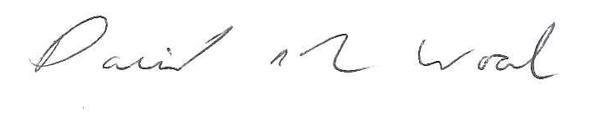
Jeff Foote David Wood
DISCLAIMER

This report or document ("the Report") is given by the Institute of Environmental Science and Research Limited ("ESR") solely for the benefit of the Ministry of Health, Public Health Services Providers and other Third Party Beneficiaries as defined in the Contract between ESR and the Ministry of Health, and is strictly subject to the conditions laid out in that Contract.

Neither ESR nor any of its employees makes any warranty, express or implied, or assumes any legal liability or responsibility for use of the Report or its contents by any other person or organisation.

ACKNOWLEDGMENTS

The evaluation team would thank:

All those who took the time to complete the online surveys.

Bay of Plenty District Health Board and Plunket NZ for piloting the online surveys.

The research guidance group members, QUIG members, key informants, case study participants and sector stakeholders who generously gave their time and insights into reorientation of child and adolescent oral health services.

Hone Taimona and Nichol Gully for translating the parent/caregiver survey and invitation card into te reo Māori, Dr David Wood for statistical advice, and Gaynor Wall for survey data entry.

Contents
Executive Summary 3
1. Introduction 9
1.1 Evaluation purposes 9
1.2 Situational analysis 10
2. Evaluation design 13
2.1 Business case process and implementation 14
2.2 Impacts 15
2.2.1 Administering the surveys 17
2.2.2 Response rates 18
2.2.3 Limitations 19
2.3 Evaluation focus 20
2.4 A self-evaluation tool 20
3. Evaluation findings 22
3.1 Business case development and implementation 22
3.1.1 Canterbury District Health Board 22
3.1.2 Northland District Health Board 27
3.2 Māori oral health providers 33
3.3 Impacts associated with the COHS implementation 34
3.3.1 Improved and equitable access and uptake of service 35
3.3.2 Family/Whānau involvement 40
3.3.3 Effective utilisation of people and plant 43
3.3.4 Improved prevention and early detection 45
3.3.5 Standardisation of clinical practice 47
4. Enablers and barriers 50
4.1 Leadership and management of change 50
4.2 Improving the involvement of family and whānau 51
4.3 Service availability, equitable access and family/whānau involvement 52
4.4 Enhancing relationship with other health services 52
4.5 What is best done regionally, and what is best done nationally? 52
4.6 Developing clinical practice 53
6. Evaluation insights and recommendations 54
7. References 58
Appendix 1: Terms of Reference for the Research Guidance Group 60
Appendix 2: An intervention logic 62
Appendix 3: Survey for parents and care-givers 63
Appendix 4: Survey invitation card 67
Appendix 5: Self-evaluation tool 68

Figures
Figure 1: Parent and care-giver participants by ethnicity 19
Figure 2: For those in the community who have the greatest need, locations have improved access to care 36
Figure 3: Service locations have generally improved access to care 36
Figure 4: For those in the community who have the greatest need, hours of operation have improved access to care 39
Figure 5: The new model of care provides equitable access to care for those in greatest need 40
Figure 6: Parents/care-givers information received 42
Figure 7: The right skill mix and staffing level to deliver quality dental care 44
Figure 8: In a typical week our team is ... 46

Tables
Table 1: Evaluation design – Business case development process and implementation 14
Table 2: Evaluation design – Impacts 16
Table 3: A comparison of the 'old' and 'new' model of care (Ministry of Health, 2006a) 20

Executive Summary
The government’s vision for oral health, Good Oral Health for All, for Life, sets out a vision for a seamless child and adolescent oral health service. Realising this vision has required a reinvestment in community-based oral health facilities and the development of a model of care that focuses on prevention and early detection of oral health disease as fundamental to improving oral health and reducing oral health inequalities.

The Ministry of Health asked the Institute of Environmental Science and Research to undertake an evaluation of its reinvestment programme. The evaluation had three aims:

- To determine the effectiveness of the Ministry of Health reinvestment programme including the business case development and implementation process;
- To develop recommendations to support the ongoing implementation; and
- To identify barriers and enablers underpinning the reorientation of child and adolescent oral health services.

This report details the evaluation of changes to the child and adolescent oral health services involved in the creation of Community Oral Health Services (COHS). The evaluation, which started on 1 June 2013 and concluded on 30 June 2014, involved a number of activities overseen by a Research Guidance Group (RGG). This group included representatives from the Ministry of Health, District Health Boards (DHBs), Māori Oral Health Providers Quality Improvement Group (QIG), The New Zealand Māori Dental Association Te Aō Marama, New Zealand Dental and Oral Health Therapist Association and New Zealand Plunket.

The evaluation process involved:
- Documenting an intervention logic which sets out the changes to the child and adolescent oral health services are intended to reduce inequalities and improve oral health outcomes.
- Undertaking case studies of the business case development process and implementation.
- Engaging with QIG to gain a Māori oral health provider perspective on business case implementation and impacts for Māori.
- Drawing on (1) to develop, pilot and administer surveys to all COHS clinical teams and service managers/clinical directors, a purposeful sample of parents/caregivers, and all Well Child/Tamariki Ora providers to assess the extent that the reorientation has achieved a number of impacts.
- Drawing on (1) and (2) to develop in dialogue with RGG and sector stakeholders an understanding of what has enabled or hindered the reorientation of child and adolescent oral health services.
- Making recommendations to support the ongoing implementation of the new model of care associated with COHS.
- Developing a self-evaluation tool to support COHS decision makers to continuously improve the way in which services are delivered.

Key findings
Business case development process and implementation
Two case studies were undertaken to understand the strengths and weaknesses of the business case development process and implementation. These were Northland and Canterbury COHS because they had contrasting demographic profiles, levels of clinical need and models of service delivery, but like other COHS had concerns including dental therapist recruitment and retention, access issues, and facilities that did not meet legal/professional standards.

Strengths
Common perceived strengths related to the business case development and implementation were clear vision, strong clinical leadership, ability to build on and leverage existing relationships, supporting resources including facility guidelines, and the pragmatic way in which the Ministry of Health worked with COHS to address any issues.

Weaknesses
Common perceived weaknesses related to the business case development and implementation were separation of business case development from the operational ‘realities’, the lack of community and Māori engagement, difficulties in translating training into practice, underestimation of the scale of change for staff, and lack of clarity surrounding the relocation of staff to new facilities and the new model of care.

Innovations and on-going challenges
A number of local innovations were also noted including setting up call centres and 0800 numbers to enhance access, focus on preschool enrolments including creating better links with maternity services, active case management of high-need children referred for general anaesthetic, piloting dental assistants to apply fluoride varnishes, and approaches to change management including mechanisms to ensure two way flow of information between clinical staff and management. On-going challenges centred on strengthening the focus on reducing oral health inequalities, increasing preschool engagements, enhancing access for ‘hard to reach’ populations, action to address the levels of not attended appointments (Did Not Attend), sustainability of facilities, staff recruitment and retention and increasing staff understanding of the new model of care and ability to engage with parent/caregivers.

Impacts associated with the COHS implementation
Improved and equitable access
The findings from parent/caregiver survey indicate that those parents and caregivers who responded to the survey did not find the location and timing of the appointments a barrier to access. However, of those few who responded to the survey but had not attended an appointment with their child, work and other commitments were cited as a reason. Whereas the majority of the clinical team respondents disagreed, and did not think that the location of the facilities or hours of operation had improved access to care for those with the greatest need, given a number of access barriers. In contrast to the clinical teams, most clinical directors/service managers held the view that the COHS provided greater access to care for those with greatest need. Well Child/Tamariki Ora providers mostly found it easy to refer a child to a COHS although a number found the quality of feedback from the COHS to be non-existent and/or inadequate.
However, a review by the Ministry of Health of clinic locations noted that the population-weighted median distance to a clinic site is roughly half a kilometre in the most deprived quintile, compared to over a kilometre for the least deprived quintile. Also, 90% of children in the most deprived quintile live in mesh blocks that are less than 1.8 km from a clinic site, while the corresponding distance for the three least deprived quintiles is over 5 km. This confirms that the siting of clinics has achieved its goal of improving accessibility for children in lower socioeconomic areas.

Family/whānau involvement
Nearly all clinical team respondents felt they could confidently work with family/whānau to achieve good oral health practices in the home, although less than half of clinical team respondents felt that parents/caregivers understood what was expected of them. Most of the clinical director/service manager respondents saw family/whānau as central to the new model of care and most of the Well Child/Tamariki Ora provider respondents said they could confidently communicate messages about the importance of family/whānau involvement to parents and caregivers. The main reasons cited by parents and caregiver respondents for attending appointments were to ‘support my child’, ‘be involved in my child’s care’ or ‘support how we care for teeth at home’ which showed parents were engaged in their child’s oral health care. Some parents/caregivers reported that they did not receive information on tooth brushing, food and drink choices, dental care and how to access oral health care. However, feedback from the RRG and sector stakeholders indicated that this finding might be due to the fact that clinical teams would only expect to give information out on one or two of these at an appointment but not all of them. Nearly all parent/caregiver respondents held the view that attending the appointment was a good use of the time and their expectations were meet.

Effective utilisation of people and plant
The clinical team respondents were mostly satisfied with the layout and standard of the new facilities. The majority of clinical director/service manager respondents thought the staffing level and skill mix was right and that there was enhanced team work (as did the clinical team respondents), although clinical director and service manager respondents differed on the extent, they agreed that the new model provides greater clarity of dental team roles.

The reinvestment programme has been a considerable change for most of the COHS staff, who for some, have worked by themselves and in charge of their individual clinics for over 40 years to working in teams and in multi-chair fixed clinics and mobiles. This has included loss of some autonomy and learning new clinical skills and also other new skills such as driving mobile vans and for some a change in work hours. Parent/caregiver participation in appointments has been another challenge for some staff as they have had to develop new skills engaging parents as well as the children.

Improved prevention and early detection
The majority of the clinical team respondents reported an increase in the delivery of preventative care stating they were seeing more preschoolers than before the reorientation (nearly all clinical directors/service mangers believed this was the case). The Ministry of Health data does show that preschool enrolment numbers have increased from 43% of the eligible population prior to implementation to 73% enrolled at December 2013. The clinical team respondents did not all agree that they were placing a greater focus on care for ‘at risk’ children. In terms of clinical practice, clinical team respondents considered they were using radiographs and fluoride varnishes more than they were two years ago, but were less convinced they were using fissure sealants and motivational interviewing more. The vast majority of clinical director/service manager respondents held the view that the new model of care provides improved detection of dental caries and increased delivery of preventative care. Almost all Well Child/Tamariki Ora providers could confidently undertake a ‘Lift the Lip’ assessment and confidently communicate key oral health messages.

Standardisation of clinical practice
Most of the clinical team respondents considered that their team was motivated to practice evidence-based dentistry, the new model of care provided greater consistency of clinical practice as well as a culture that values learning and quality improvement, and the facilities supported professional codes of practice. There was a perception of some clinical team respondents that resourcing issues impacted on the availability of dental assistants was limiting the practice of hour handed dentistry.

Enablers and barriers
A variety of barriers and enablers shaped the development of the business case and implementation of the model of care. These include: an evidence base supporting a ‘compelling need’ to reconfigure the School Dental Service; leadership and management of change; the way in which clinical attitudes and skills coupled with organisational practices impact on involvement of family/whānau; the negotiation of service levels and how these impact on access; the role of feedback in enhancing the relationship with other health services such as Well Child/Tamariki Ora providers; clarity around what aspects of the reinvestment should be managed nationally or regionally; and issues of workforce recruitment and development still remaining central to how the reorientation will unfold in future years.

We acknowledge the scale of change associated with the reinvestment programme and the demands this has made on the workforce and the existing management systems. The evaluation has produced promising evidence of an engaged workforce committed to a reoriented service, considerable changes in clinical practice and an increasing understanding of how to translate the model of care underpinning the reinvestment programme into day-to-day delivery of oral health services. In our view, this reflects positively on a resilient and adaptable workforce that is critical to realising the promises of the reoriented service.

Recommendations
Improved and equitable access to and uptake of care
- Annually review mobile unit schedules to ensure services are timely and accessible, especially for rural and high risk populations.
- Review hours and flexibility of the COHS to enhance accessibility for working parents/whānau.

Focus on family/whānau involvement
- COHSs to maintain communication with their communities about the essential elements of the improved model of care. This will include what is expected of parents/caregivers and what parents/caregivers can expect in return from the COHS.
- Develop tools to achieve greater involvement of parents and whānau in co-creating good oral health outcomes, including COHS establishing a role for dental therapists who have particular expertise and interest in parental engagement.
- Consider developing a national brand for COHS.

Effective utilisation of people and plant
- Develop a work programme with Health Workforce New Zealand to address issues relating to Dental Therapist supply and demand, to provide advice on the numbers of dental therapists and dental assistants required to practice evidence based dentistry and to meet service demands.
- Develop a strategy to ensure that COHSs take a consistent approach to addressing issues relating to Dental Therapist recruitment and retention.
- Develop and implement asset management plans to maintain fixed and mobile community clinics and clinical equipment.
- Actively involve clinical staff in operationalising the improved model of care, and utilise data about clinical practices, patient satisfaction and oral health outcomes to improve service delivery.

Improved prevention and early detection
- Reinforce to DHBs, COHS staff and stakeholders that the purpose of the reinvestment is to transform the way in which oral health services are delivered; that is, to promote oral health and focus on prevention and early detection.
- Evaluate the effectiveness of the Healthy Smile, Healthy Child oral health guide as the training curriculum for health providers who have specific training in child health.

Increased standardisation of clinical care
- Develop and disseminate best practice guidelines, for example engaging with families/whānau and the 0 – 2 year old patient pathway to further enable clinical consistency within and between COHS.

System
- Consider further work to strengthen stakeholder engagement at the regional level with the aim of enhancing the connection with primary health care (including non-government organisations), increasing preschool enrolments and parental/caregiver engagement with oral health services, and enabling deliberation about strategic issues and directions (e.g. improving access for ‘hard to reach’ populations).
- Refine the online survey used in this project and use it every two or three years to monitor reorientation impacts over time, including clinical staff understanding of the new model of care (the next survey would be in 2017).
- Trial the self-evaluation tool developed in this project with selected COHS to refine its applicability. We suggest applying the self-evaluation tool to the resolution of a problematic issue such as Did Not Attend rates or increasing Māori preschool enrolments.
- Consider establishing a stakeholder guidance group including Māori providers, professional bodies, regulatory agencies, and consumers to examine how best to progress the next stage of the reorientation.
- Ministry of Health’s Oral Health Programme and COHS leadership teams determine how to implement recommendations in this report including which are best actioned nationally or regionally.

1. Introduction
The government’s vision for oral health, Good Oral Health for All, for Life, sets out a vision for a seamless child and adolescent oral health service (Ministry of Health, 2006a). Good Oral Health for All, for Life identifies the need to reinvest in community-based oral health facilities so that these services focus on prevention and early detection of oral health disease as fundamental to improving oral health and reducing oral health inequalities.

The Ministry of Health reinvestment programme has replaced existing school dental clinics with a mixture of 177 stand-alone community-based clinics and 143 mobile units in outreach locations including schools with health promotion services. In addition, there have been changes in the model of care offered by the child and adolescent oral health service. These changes include the use of dental assistants and support staff to enhance productivity and quality of care, stronger linkages with primary health care to increase preschool enrolments and referrals through the ‘Lift the Lip’ initiative, and engagement with family/whānau to support good oral health practice at home. The result of the reinvestment programme and service reorientation is known as the Community Oral Health Service (COHS). COHS is the largest outpatient health service in New Zealand, providing 1.1 million appointments per year (Litmus, 2013).

1.1 Evaluation purposes

A formal evaluation was signalled in Good Oral Health for All, for Life. This report details the findings of an evaluation of changes to the child and adolescent oral health services involved in the creation of COHS.

The evaluation aims were to:
- Determine the effectiveness of the Ministry of Health’s reinvestment programme, including the business case development process.
- Develop recommendations to support the ongoing implementation.
- Identify enablers and barriers underpinning the reorientation of child and adolescent oral health services.

1.2 Situational analysis
Oral diseases, including dental carries, are prevalent chronic diseases that impact on the health and wellbeing of New Zealanders (Ministry of Health, 2010). Oral health is a population/Māori health priority (Ministry of Health, 2000 and 2002). Good Oral Health for All, for Life paints a picture of New Zealand’s oral health status prior to the reorientation noting:

Dramatic declines in the prevalence and severity of child dental decay began to plateau in the mid-1990s, and have now begun to reverse. New Zealand’s oral health statistics now compare unfavourably with similar countries, such as Australia and the United Kingdom (p. 2)

And that:

Even more concerning is the pattern of inequalities that underlies child oral health statistics…. Unfortunately, it appears that these inequalities – particularly between Māori and non-Māori – are worsening (p. 3)

Good Oral Health for All, for Life goes on to note the uncertainty about the oral health status of adolescents and adults given but refers to research that “suggests that inequalities in child oral health re-merge following exit from school dental services” (p. 4). As oral health status at age 5 is closely associated with oral health status at age 26 (Ministry of Health, 2006a), access to child and adolescent oral health services is a key determinant of oral health status. The School Dental Service (SDS) [created in 1921] provided school-based dental services for children, with adolescents receiving care from private dentists under the Adolescent and Special Dental Services Agreement (Dow, 1995; Ministry of Health, 2006a).

Growing concern about New Zealand’s oral health outcomes led the Public Health Advisory Committee (2003) to report on significant oral health inequalities and to question the effectiveness of the SDS. A National School Dental Service Review followed and documented the ‘strategic crisis’ facing the SDS. It concluded, “that to improve the oral health of those most disadvantaged children in New Zealand the service requires strategic direction, rebranding and major reconfiguration at the operational level” (DHBNZ, 2004, p.10).

The DHBNZ’s (2004) review of the SDS highlighted a number of strategic issues including service structure issues between the Ministries of Education and Health; inequalities in oral health; access issues; dental therapist workforce recruitment and retention problems; low preschool enrolment rates; inadequate and unsafe facilities; lack of education and health promotion; and fluoridation variances. Prior to the reinvestment there were 922 school dental clinics open on average 60 day per annum. Only 45% of schools had an onsite clinic.

The Māori Child Oral Health Review concluded “unacceptable inequalities exist in the oral health of New Zealand children, especially among Māori, Pacific and those children low socioeconomic status families” (Mauri Ora Associates, 2004, p. 5).

Addressing the challenges would require “a fundamental shift in the way oral health care is delivered” (Ministry of Health, 2006a, p. 11). The Government’s vision called for child and adolescent oral health services to be part of a strong primary healthcare-led system providing community-based and seamless care. A major reinvestment in the configuration and delivery of oral health services would:

- Treat the health problems at an early stage of development
- Emphasise illness prevention and promotion
- Empower communities to participate in decisions about their oral health
- Involve intersectoral collaboration, where possible
- Have particular consideration for the needs of groups with inequitable oral health outcomes or access to services
- Have a strong focus on maintaining good oral health in early childhood
(Ministry of Health, 2006a, p. 9)

Good Oral Health for All, for Life sets out actions to reorient child and adolescent oral health services, including supporting DHBs to develop the business cases for reinvestment in child and adolescent oral health services. The Government allocated $116 million capital funding and an additional $31.3 million operational funding per annum ongoing for operating expenses. The Ministry of Health provided DHBs with guidelines to “guide DHBs in their preparation of business cases for capital and operational investment in oral health services” (Ministry of Health, 2006b, p. 1). The three stages of business case development included strategic analysis, option analysis, and completion of the final business case. In detailing these stages the business case guidelines summarised the key issues, causes and consequences that the reinvestment programme aimed to address. These included:

- Many school dental clinics are in a state of poor repair, and the majority are not suitable to the needs of modern dentistry
- Clinic configurations do not meet the needs of local communities
- There are significant recruitment and retention issues in the dental therapist workforce
- Enrolment rates of preschoolers are poor, and the continuity of care for adolescents is problematic
- The current Memorandum of Understanding with the Ministry of Education is not the most effective tool for ensuring school dental clinics are maintained at a standard suitable for the practice of modern dentistry.
(Ministry of Health, 2006b, p. 2)

The business case guidelines then describe how the reinvestment programme will address the above issues:

A community-based and population-focused oral health service will require a mixture of oral health facilities appropriate to the needs of each community and the needs of the population. The 2004 New Zealand School Dental Service Review reported proposed reconfigured or oral health facilities based on the ‘hub and spoke’ model. It is anticipated this configuration will usually consist of strategically sited ‘hub’ clinics with appropriate outreach services and facilities. Outreach services may include examination and preventive care only, or full treatment services. The focus of outreach services should be on retaining and improving access to oral health care in a new oral health facility configuration…. The vision for re-establishing and re-equipping child and adolescent oral health services offers the opportunity for future expansion, flexibility, and for allowing services to be extended beyond those traditionally offered from oral health facilities
(Ministry of Health, 2006b, p. 2).

2. Evaluation design
The focus of the evaluation is the COHS. That is, the newly configured ‘hub and spoke’ model of fixed and mobile clinics that together with a model of care focused on prevention and early detection and aims to improve oral health outcomes and reduce oral health inequalities.

Specifically, the evaluation focuses on two aspects of the reorientation.
- Business case development process and implementation
- Impacts associated with the COHS implementation

The evaluation process involved:
- Developing an intervention logic which sets out how the changes to the child and adolescent oral health services are intended to reduce inequalities and improve oral health outcomes.
- Developing, piloting and administrating surveys to all COHS providers, a purposeful sample of parents/caregivers, and all Well Child/Tamariki Ora providers to assess the extent the reorientation has enabled a greater focus on prevention and early detection.
- Developing, in dialogue with sector stakeholders and drawing on (1) and (2), an understanding of what has enabled or hindered the reorientation of community oral health services.
- Making recommendations to support the ongoing implementation of the new model of care associated with COHS.
- Developing a self-evaluation tool to support COHS decision makers to continuously improve the way in which services are delivered.

In order to gain ‘buy-in’ to the evaluation process and socialise the findings, the evaluation team introduced the evaluation purposes and approach to the Clinical Directors Leadership Group, provided updates to the quarterly DHB service manager teleconferences, presented initial findings at the 2014 Community Oral Health Sector Forum. The team considered implications of their findings with sector stakeholders, as well as engaging with QIG to gain their perspective of the reorientation and the preliminary findings.

The evaluation started on 1 June 2013 and concluded on 30 June 2014. A Research Guidance Group (RGG) including representatives from the Ministry of Health, District Health Boards (DHBs), Māori oral health providers (QIG), The New Zealand Māori Dental Association Te Aō Marama, New Zealand Dental and Oral Health Therapist Association and New Zealand Plunket was established. Three RGG meetings were held to review evaluation design and outputs including the provisional findings (see Appendix 1 for Terms of Reference).

2.1 Business case process and implementation
A case study approach was undertaken to develop an in-depth understanding of the strengths and weaknesses associated with the business case development process, local innovations arising out of business case process and/or implementation, and future opportunities and threats facing the COHS. In consultation with the Ministry of Health two case study sites were selected. These were the:
- Canterbury COHS: earlier adopter, relatively low need, and high performing DHB; and
- Northland COHS: late adopter, relatively high need and deprivation, high Māori population and most improved DHB in terms of addressing arrears.

A series of in-depth interviews with staff and stakeholders who had been involved in the business case development process and implementation was undertaken. Interviewees were identified in consultation with the Clinical Director and Service Manager and included dental therapists, dental assistants, community dentists, planning and funding representatives, facility managers, service managers, clinical directors, Māori provider representatives and school principals. In-depth interviews between 60 – 90 minutes were held and covered (a) which aspects of the reorientation processes and support services have worked well; (b) past and current challenges to the implementation of the new model of care; and (c) perspectives on the most significant changes associated with changes to the child/adolescent oral health service. With consent the interviews were audio recorded and then transcribed for thematic analysis.

Table 1 sets out the evaluation design which details the evaluation questions, methods and data sources.

Table 1: Evaluation design – Business case development process and implementation
Evaluation questions | Method | Data Source
What were the strengths and weaknesses of the business case process? | Key informant interviews  In-depth interviews with  Document analysis | Key personnel involved in business case development process and/or implementation  Key informants involved in development of the reinvestment programme  COHS documents including strategies and policies
What were the local innovations arising out of business case process and/or implementation? | Document analysis  In-depth interviews with | Key personnel involved in business case development process and/or implementation  COHS documents including strategies and policies
What factors enabled or hindered the implementation of the business cases? | Documentary analysis  In-depth interviews with | Key personnel involved in business case development process and/or implementation  COHS documents including strategies and policies

2.2 Impacts
An intervention logic provides the basis for the impact evaluation. In this case, the intervention logic sets out how the changes to the child and adolescent oral health services are intended to achieve short, medium and long-term outcomes (Funnell and Rogers, 2011).

The intervention logic was developed from a review of policy documentation, key informant interviews, observations and interviews from four regional COHS visits and two case studies of business case implementation (Northland and Canterbury), and a sector stakeholder workshop. The theory of change underpinning the reoriented COHS is set out in Appendix 2.

To further understand the inter-relationships, boundaries and perspectives associated with the reinvestment programme, COHS purposes were expressed as transformations, which “change some defined input into some defined output” (Checkland, 2000, p. 74) including those which can reflect ‘primary tasks’ (e.g., reducing oral health inequalities) and ‘issues’ (e.g., enhancing the change management capacity).

Expressing purposes as transformations and then modelling these in terms of beneficiaries, actors, worldviews and constraints allowed sector stakeholders to agree on five areas of enquiry informing the evaluation (we refer to these as ‘Impact Areas’):
- Improved and equitable access to and uptake of care.
- Focus on family/whānau involvement.
- Effective utilisation of people and plant.
- Improved prevention and early detection.
- Increased standardisation of clinical care.

Drawing on Funnell and Rogers (2011), evaluation questions and criteria were derived from the intervention logic and were grouped according to five ‘impact areas’ noted above. A mixed methods approach was adopted which involved “the planned use of two or more different kinds of empirical design or data gathering and analysis tools” (Greene, 2005, p. 255). Table 2 sets out the evaluation design that details the evaluation questions, methods and data sources by ‘impact areas’.

Table 2: Evaluation design – Impacts
Impact area | Evaluation questions | Method | Data Source
Improved and equitable access to and uptake of care | What evidence is there that the location and hours of operation have improved access?  What evidence is there that the COHS is seeing more ‘at risk’ pre-schoolers, primary school children and adolescents?  What are the Māori oral health provider views of the reorientation?  What do clinical teams and parents/caregivers see as enablers and barriers to access? | Online survey | Parents/caregivers  Clinical teams  Clinical directors/service managers  Well Child/Tamariki Ora providers
Focus on family/whānau involvement | What evidence is there that parents/caregivers are engaged?  What value do parents/caregivers receive from attending the appointments? | Online survey  Ethnographic observation | Parents/caregivers  Clinical teams  Clinical directors/service managers  Well Child/Tamariki Ora providers
Effective utilization of people and plant | To what extent do clinical teams and clinical directors/service managers believe that the new model of care makes the most of people and plant? | Online survey  Documentary analysis | Clinical teams  Clinical directors/service managers  Ministry of Health statistics
Improved prevention and early detection | What evidence is that there is more preventative activities including the use of radiographs, fluoride varnishes, fissure sealants and motivational interviewing? | Online survey | Parents/caregivers  Clinical teams  Clinical directors/service managers  Well Child/Tamariki Ora providers
Increased standardisation of clinical care | To what extent do the clinical teams and clinical directors/service managers believe that there is increased standardisation of clinical care? | Online survey | Clinical teams  Clinical directors/service managers

The principal method to collect data about the impact associated with reoriented COHS was the use of surveys specific to clinical teams, service managers and clinical directors, parents and care-givers, and Well Child/Tamariki Ora providers. The principal method for collecting survey responses was an internet-based platform for online participation. This method was chosen as an efficient way to collect data without interviewer bias and with relative anonymity for participants. Respondents in such surveys are likely to be honest about challenges or issues (see Browne, 2005).

The surveys were developed and offered to all participants using SurveyMonkey. The survey for parents and care-givers was also made available through clinics as a printable version to be mailed to the evaluation team by the clinic. This was an effort to remove a barrier to participation. Paper responses were then entered into SurveyMonkey manually.

Parents or caregivers of children or adolescents who attended an appointment at either a mobile or fixed clinic on a specified day were invited to participate in the survey (Appendix 3). An invitation card with the link to the online survey, an information sheet, and the paper option of the survey were provided to clinics to give to each person seen on the day, the card was given to the child or adolescent if the parent or caregiver was not present and they were asked to give the invitation to their parent or care-giver (Appendix 4). The layout of the parent/care-giver survey was optimized so it correctly displayed on a smart phone. Parents/caregivers were also given the option to complete the survey in te reo Māori. To increase the parent/caregiver response rate a chance to win one of five Colgate electric toothbrushes was offered.

It is possible that those with internet access may not be representative of the parents/caregivers with children and/or adolescents attending the COHS. However, access to the internet is relatively common in New Zealand especially given widespread adoption of pre-paid smart phones. Completing the survey did require a commitment of time by participants and so is likely to have selected for the more motivated parents/care-givers. The survey did not cover those children or adolescents who, for whatever reason, did not attend their appointment on the day.

The Bay of Plenty DHB piloted the information sheets, and online surveys for the clinical team, clinical director/service manager and parent/caregiver. The Well Child/Tamariki Ora information sheet and online survey were piloted by New Zealand Plunket.

2.2.1 Administering the surveys
For the clinical directors/service managers and clinical team survey, an information sheet and link to respective online survey were provided to the service manager of the COHS who had agreed to administer the survey to all clinical staff: dental therapists, dental assistants, service managers, clinical directors, community dentists employed by the DHB, and Māori oral health providers.

The Well Child/Tamariki Ora provider survey was emailed to all clinical leaders who then were asked to forward the information sheet and link to all Well Child/Tamariki Ora nurses. A printable version of the online survey was provided for members of the clinical teams who did not have access to the internet. Again, paper based responses were manually entered into SurveyMonkey and then checked for accuracy by the evaluation team.

A non-probability sample of parents/caregivers was obtained by inviting all parents/caregivers who had children and/or adolescents attend an appointment on a typical ‘day’ selected on 25 February 2014. To ensure that the sample included parents/caregivers with preschool, primary and/or secondary school children, DHB service managers were asked ensure that scheduled appointments included a mix of different age groups.

Survey data was analysed using simple exploratory data analysis techniques such as summary statistics, frequency and contingency tables (Erickson and Nosanchuk, 1979).

2.2.2 Response rates
We had 248 responses from parents and caregivers which was a 6.7% response rate of the appointments booked on the day and is to be expected in a randomised survey of this type. 71% of the parents and caregivers who responded had a child attend between 5-12 years old and 26% between 0-5 years old, and 3% between 13 -18 years. 80% of the parents and caregivers who responded had a child that attended a fixed clinic compared to 20% whose child had attended a mobile clinic.

Even though the overall response rate was small from parents and caregivers the ethnicity spread of those who responded generally reflected the overall population mix of New Zealand compared to the 2013 census ethnicity data, apart from those of Asian or Pasifika descent (Figure 1). There was a larger Pasifika response (12%) compared to the census data (7%) and a smaller Asian response (5%) compared to the census data (12%).

For the clinical teams survey there were 391 responses (40%) with 242 dental therapists, 143 dental assistants, 5 community dentists and 1 administrator.

DTs had worked in their role an average of 22 years (standard deviation = 13.2) and DAs had worked in their role an average of 7.4 years (standard deviation = 6.5), and nearly all of the clinical team respondents were female (98%).

There were 23 responses (72%) from the clinical directors and service managers with 13 service managers and 8 clinical directors responding.

There were only 27 responses (4.5%) from the Well Child/Tamariki Ora providers which was disappointing but of those that responded there was a wide response rate from over the country.

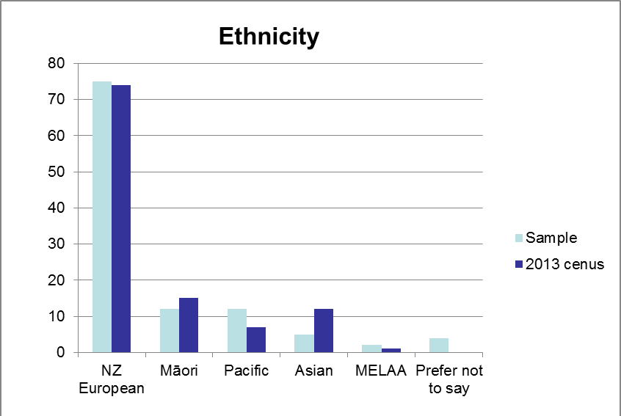
Figure 1: Parent and care-giver participants by ethnicity

2.2.3 Limitations
COHS responses to online survey were variable so we cannot compare and contrast DHBs as was initially planned. The evaluation did not examine oral health inequalities or the gauge the extent that preventive/early detection activities are following best practice

Additionally, the research team was dependent on the service managers in administering the survey. This contributed a number of limitations. It had been assumed that the clinical team and parent/caregiver survey would be sent out to Māori providers in each DHB. However, it was not until the research team was analysing the survey data that it was noticed there were no responses from clinical teams in Māori providers. There had been an oversight and the service managers had not sent the survey to any of their Māori providers. To overcome this oversight the survey was re-opened and sent to the Māori providers, but for unknown reasons no one from the Māori providers filled in the survey. A key limitation, therefore, of the survey results is that there is no perspective from clinical teams from Māori providers, or that of parents and caregivers who access oral services from Māori providers.

Another limitation in administration of the survey is that we are unsure of selection bias in the parents and caregivers survey, in that the research team does not know who the dental team gave the survey out to. Although the teams were requested to give the invitation to participate to all patients on the day, we do not know how comprehensively this was done.

2.3 Evaluation focus
The development of the Community-based Oral Health Services (COHS) involves of a network of oral health providers based on a ‘hub and spoke’ configuration, and the greater involvement of parents and whānau in co-creating oral health outcomes. COHS represents a major reinvestment by central government. The Ministry of Health obtained and allocated additional funding for child and adolescent oral health services and supported the DHBs to develop business cases for models of care that will “best meet the needs of their individual communities” (Ministry of Health, 2006a, p. 9). DHBs, that are tasked by central government to provide and/or fund health services in their regions, were required to plan, fund and implement a model of care that would reorient child and adolescent oral health services towards early intervention, promoting good oral health, building links with primary health care and reduce inequalities in access to oral health services and oral health outcomes (Ministry of Health, 2006a). The logic of COHS in contrast to the old School Dental Service is set out in Table 3.

Table 3: A comparison of the 'old' and 'new' model of care (Ministry of Health, 2006a)
Now | Future
An emphasis on treatment | An emphasis on prevention and early intervention
A division between oral health and general health | Oral health is integrated into general health frameworks
DHBs provide services | There is a mix of service providers, including DHBs, PHOs [Primary Health Organisations], Māori and Pacific providers and non-government organisations (NGOs)
School-based dental services for children | Community-based dental services for children, with the potential to expand to adolescents and low-income adults
Separate funding for child and adolescent oral health services | Funding that allows flexibility of service programme design
An emphasis on primary school years | An emphasis on preschool and early primary school years
Clinicians work in isolation | A team-based approach to oral health – dentists, dental therapists and dental assistants work together
A small Māori and Pacific oral health workforce | A workforce more representative of ethnic diversity of New Zealand
Pressure on secondary services | Greater capability at the primary care level, with secondary services focused on patients who cannot be managed by primary care

2.4 A self-evaluation tool

To help strengthen the ongoing implementation of the model of care underpinning the reinvestment programme, a self-evaluation tool was developed to improve the way COHSs deliver services to children, adolescents and their parents/caregivers. The self-evaluation tool is intended to be used by COHSs to actively involve clinical staff in operationalising the model of care and drawing on quantitative and qualitative data about clinical practices, patient satisfaction and oral health outcomes. This self-evaluation tool was reviewed by RGG and is described in Appendix 5.

3. Evaluation findings

3.1 Business case development and implementation
The business case development process had a number of aims including encouraging DHBs to adopt models of care based on prevention and early detection of oral health disease, ensure clinical activities were efficiently delivered with purpose-built facilities and up-to-date equipment, encourage joint procurement, minimise risks and promote regional collaboration. As well as supporting robust oral health service planning, business case development would provide the Ministry of Health with confidence that the DHB requests for capital and operational funding were sound and would lead to improved quality of service delivery. The business case development process consisted of three stages: strategic analysis, option analysis and completion of the final business case. See Ministry of Health (2006b) for a description of the business development process including key dates and the funding allocation process.

A case study approach was used to develop an in-depth understanding of the strengths and weaknesses associated with the business case development process, local innovations arising out of business case process and/or implementation, and future opportunities and threats facing the COHS.

In consultation with the Ministry of Health two case study sites were selected:
- Canterbury COHS (earlier adopter, relatively low need, high performing DHB)
- Northland COHS (late adopter, relatively high need and deprivation, high Māori population, most improved DHB)

3.1.1 Canterbury District Health Board
Canterbury DHB (CDHB) was chosen as a case study because it was seen as an earlier adopter, relatively low need and high performing DHB.

A total of nine individuals involved in the business case development and implementation process for CDHB were interviewed during August/September 2013. These individuals included the service manager, the clinical director, the business case development project manager, two dental therapists, a school principal as well as representatives from the DHB’s Facilities Management Group and the COHS call centre.

What were the perceived strengths of the Canterbury business case implementation?
The CDHB business case (Canterbury DHB, 2007) drew on the Good Oral Health for All, for Life (Ministry of Health, 2006a), Business Case Guidelines for Investment in Child and Adolescent Oral Health Services (Ministry of Health, 2006b), and Community Oral Health Service Facility Guideline (Ministry of Health, 2006c). In reviewing the CDHB’s service delivery model, the business case identified a number of strategic issues, including a decline in oral health status of child and adolescents, dental therapist recruitment and retention issues, professional isolation of dental therapists, facilities which do not meet legal/professional standards, poor utilisation of 128 school dental clinics, access issues from closed clinics, and no service offered outside the school term.

The Canterbury DHB employed a project manager to implement the business case developed by the clinical director and a previously employed service manager. The latter two individuals had been heavily involved in shaping the parameters of the reinvestment programme, and were familiar with the business case development guidelines, and so had a ‘head start’ in articulating a reconfigured model of service delivery. Involvement by the DHB planning and funding department was described as “minimal,” with the oral health service given autonomy to develop and implement a business case that worked best for Canterbury (accountable to Governance group).

The clinical manager had a strong vision for a transformed system of service delivery. While the project manager did not have expertise in oral health, there were a number of mechanisms set up to ensure he had a close working relationship with the service manager and the clinical director, including having a desk “next to [them] so we’d regularly have conversations about things”.

Good communication characterised the CDHB business case with “weekly meetings for the implementation and governance meetings once a month”. In addition, there were regular meetings at the clinical level where issues could be feed back to the business case implementation team via the team leaders and then “dealt with at an administration level”.

The Ministry of Health facilitated monthly teleconference meetings with DHBs which were seen as a “good opportunity to share,” with “each DHB [having an] opportunity carte blache to talk about anything that came up”. For the Canterbury DHB, these teleconferences enabled shared learning: “afterwards, we might call up one of these particular staff, maybe in Northland or something, and say ‘oh, do you think what they said was right?’. “There were … a few very reliable, engaged people around the DHBs that you could turn to for advice or just talk things over.”
The Ministry of Health also identified common issues across DHBs and at times encouraged those involved in the business case implementation to share information with each other.
I remember at one stage with Nelson Marlborough, they appointed a project manager and she came down and spent the day with me. And that was facilitated by the … Ministry. So that was good to be able to share those ideas on a one on one basis.

As well as encouraging shared learning across the DHBs about what worked, what did not and why, the Ministry of Health also acknowledged the significant learning of individual DHBs and were willing to be flexible in relation to the implementation of the business case.
“If something wasn’t working and we didn’t quite agree with the business case, [we could ask] what are our options, can we look at something else…. There was some leniency … [because] the focus throughout the project really remained on the oral health for children and adolescents. The Ministry was quite focused on that”.

One of the Canterbury DHB facilities managers had been instrumental in writing the Ministry’s facility guidelines, and it was noted that they were “received quite well… [making] life easy with the builders and the construction workers. And also with the mobile builders… and I think also that by and large the users themselves, the dental assistants and therapists, knew what to expect”.

While “the Ministry of Health had lots of guidelines around what was required”, it was acknowledged that ongoing support from the Ministry’s advisors was key to keeping “the momentum up” and “if there was a blockage … [they] would put [their] hand up and try to deal with that”.

Although the quarterly reporting to the Ministry of Health (a requirement of the Crown Funding Agreement) was seen as “convoluted”, the project manager used the information in the report to structure discussions with the governance group set up to oversee the business case development.
So we’d just go through how much funding we were seeking back from the Ministry … what are the key issues, how we’re going against our targets.

Interviewees acknowledged that for staff the reconfigured COHS “turned everything inside and out” and involved significant changes not only to where they might work, but also to how they undertake their day-to-day work. In addition to “early information sessions … [which described] what was going to happen”, training was a priority and covered various areas such as driving and setting up the mobile vans, using new equipment and new practices such as motivational interviewing.
So the mobiles, the staff had to foremost get around driving the things. And there was a bit of resistance from some of the staff by that account: ‘I’ve never had to do this in my job, I’m not confident driving a big van’. So that had to be tackled, so we went through driving training. Also the dental equipment itself took a little bit of getting used to. And [the Clinical Director] in particular spent a lot of time training [staff], getting them familiar with the digital radiography, the sterilizers and the new practices. So it was a change of the physical environment… but also changing what they’ve got to do, their procedures on a daily basis

The process of change was complicated by the fact that the new model of care was first implemented in South Canterbury, but this had the unexpected benefit of “dental therapists and assistants … sharing ideas and grumbles, trading ideas on what worked and what didn’t”.

What were the perceived weaknesses of the Canterbury business case development process and implementation?
As noted above the business case was developed by individuals who had been involved in shaping the Ministry’s reinvestment programme but did not closely involve the service manager and clinical staff who focused on ‘business as usual’ and structuring the leadership of the service in a way to “support the change management that was coming as part of the business case”.

While the separation between business case development and operations was efficient, it was thought to have had the unintended consequence of limiting the opportunities for clinical staff to “know and understand what was going on and think about it a bit more”.

Operationalising the ‘vision’ created change management issues:

I don’t think the service staff understand the [new model of care] particularly well. We understand the buildings, because our old ones were [substandard]. We had [poor] equipment and it didn’t work half the time and it was really expensive. So we understand why we’ve got new facilities, but the model of care and the focus on prevention I don’t think is well understood.

Prioritising preschoolers and engaging with parents/caregivers was seen as particular challenges. While training was provided to staff to implement the new model of care, one interviewee questioned the effectiveness of workshop based training where “people come along and are told … theory and information, and then they go away and they’re expected to assimilate it”. In hindsight, a ‘ground up’ approach that engaged staff was preferred with an implementation group working alongside the business case development:

I think we’ve made it really hard for ourselves because we haven’t thought and we haven’t invested enough in that change process [to] (a) get the staff buy-in and (b) find solutions to problems from the ground up.

Interviewees were mindful that engaging with Māori was more than a ‘tick box’ exercise. A business case advisory group provided some Māori input and the team was supported by the DHB’s Director of Māori Health. Māori engagement was variable and principally centred on the location of fixed clinics including those planned for Ngā Hau e Whā and Aranui High School.

Although, under the new model of care, high risk children are to be identified earlier, a targeted approach to reducing oral health inequalities was seen as insufficient. One interviewee noted that “my perception of the service ... we’ve developed is that it’s a standard one size fits all”.

Feedback from Māori groups highlighted the importance of facilities and oral health delivery that meet the needs of Māori.

We rolled out, as throughout the whole country, our standard clinic. And within reason, standard colours and a standard look. But [we were told] … make [the clinic] look inviting to [Māori], because they just see this as another one of these horrible, enclosed, sterile places.

A related weakness was the difficulty in engaging with the wider community despite producing school newsletters and organising some community meetings (“there were some community meetings [but few] turned up”). Given the scale of change for parents and caregivers, engagement with service users was ad hoc and after the fact with a call centre (set up to manage appointment bookings) managing complaints/requests for information.

So for the community the change came when we rocked into the school in a screening van and sent home a card saying: ‘your child needs a filling, you must make an appointment and come with them’. And that’s when the community consultation, if you like, community information started happen. Because up till then school aged children would come home with a card saying: ‘I need a filling’ – the parent would sign it, it would go back to the school, and the kid would come home the next day with a filling, no parental involvement whatsoever. So suddenly, we start asking [parents], and we’d sort of talked about it, but suddenly [parents] had to take time off work to bring their children in for an appointment if they needed treatment…. The call centre took flak for 18 months. They managed that change process.

The business case development process did not address the way in which existing employment arrangements limited the availability of the service and potentially created access barriers for parents/caregivers. This was a source of ongoing tension between management and staff.
Our current staff employment agreement … says that the staff work seven hours and fifteen minutes a day, so they finish work at 4:15pm, and they only work the days that primary schools are open. It’s a very old, historic agreement. The Ministry’s expectation is that our service is available normal hours that the health service is available, normal hours that businesses are open. We can’t provide that level of service at the moment because our employment agreement says something different. So not only were the call centre saying ‘you need to bring your child in for an appointment’, they were saying ‘our last appointment is at 3:30pm’.

Another outstanding challenge was that business case did not address clinical recruitment issues.

Innovations
A number of innovations were identified by interviewees including:
- Setting up a call centre and 0800 number to book appointments for treatment; given an inability to secure sufficient funding for clinic receptionists. A direct link with parents/caregivers has led to positive and unintended outcomes including opportunities for oral health promotion and managing the change associated with parental involvement.
- Focus on preschool enrolments ‘pushing back’ enrolment date from 2 ½ years to 18 months and doubling enrolments.
- Active case management of high-need children referred for a general anaesthetic and clarification of clinical pathways.
- Fixed clinics being leased by private dentists to provide affordable dental care for populations such as university students.
- Consideration of creating an ‘innovation hub’ where new graduates are supported to trial new working arrangements and equipment “with a mandate to do something different”.

Future issues
Interviewees were invited to reflect on what they saw as future opportunities or threats to the newly created COHS. These included:
- Strengthening the focus on reducing oral health inequalities and engaging with Māori as well as those considered ‘hard to reach’ (those unlikely to access fixed clinics).
- Continued focus on increasing preschool enrolments and engaging with parents.
- Ensuring the sustainability of the mobile units.

3.1.2 Northland District Health Board
Northland DHB (NDHB) was chosen as a case study because it was seen as a late adopter, with relatively high needs and deprivation levels, high Māori population, and as the most improved DHB.

In contrast to CDHB, the NDHB business case development occured in a context of high clinical need, past performance issues and the need to develop a collective response to addressing oral health outcomes and inequalities. A total of nine individual and focus group interviews were undertaken in October 2013 with those involved in the business case development and implementation process. Participants included dental therapists, dental assistants, a school principal as well as representatives from the Oral Health Leadership Team, the Change Management Group, Hauora Hokianga and Ngāti Hine Health Trust.

It is difficult to tease out the two phases of reorientation because of the delay between the business case development and implementation. The infrastructure has been implemented, but the new model of care is still being embedded. However, interviewees recognised gains such as “greater levels of professionalism” and “clinical excellence.”

The SDS in Northland had already operated mobile ‘caravan’ units and utilised dental assistants. Since 2008, NDHB has used a mixed service model, with service delivery by the DHB provider arm, Hauora Hokianga, Ngāti Hine Health Trust and private dental practices. A recent clinical governance review concluded that “all the providers exhibited a high level of commitment to the delivery of quality oral health services for their respective population groups … [and] demonstrated a commitment to working together to deliver the Oral Health Service for Northland” (Northland DHB, 2011, p. 2).

Led by their planning and funding department, NDHB’s business case development was undertaken by external consultants and, given an acknowledged lack of local and sector knowledge, with input from the clinical director and service manager. The original business case was rejected by the Ministry of Health but then approved with significantly less capital funding:

[Planning and Funding] developed a business case, it went down to the Ministry, we asked for a lot more [funding] than what we were actually given.
I think they went for a gold star, you know, hoping that they would get all of these things…. But I think they could have been guided a bit better had they had the providers that were actually delivering the services working alongside them. And more around where the best points to put in the hubs, where were the best places to have mobiles going in.

Implementing the business case proved difficult. The resignation of a third project manager lead to the service manager and clinical director assuming responsibility for the business case implementation. The decision allowed the provider arm of the DHB to take a leadership role and work in partnership with the other oral health providers:

At the end of the day the DHB is responsible for providing oral health services in Northland, so you do that in partnership model with these other providers out there. And so I think that was one of the key things to the success of the [reinvestment] programme.

A number of weaknesses were identified in the business case and, given the Ministry’s expectations about facility utilisation, a decision was made to review the model of service delivery and the fixed community clinics earmarked for Ngāti Hine Health Trust and Hauora Hokianga.

While there had been little in the way of meaningful engagement with Māori oral health providers, revising the business case required discussions with Hauora Hokianga and Ngāti Hine Health Trust about how oral health services could be provided in Northland.

And then we had to have conversations with [Hauora] Hokianga and Ngāti Hine [Health Trust] to say ‘look, it’s not going to turn out, we can’t guarantee you’re going to get 80% [utilisation] on the seats’.

In terms of the school based services at that time, we ran all the school based services, but then we gave some school children to Ngāti Hine and we gave some to Hokianga.

What were the perceived strengths of the Northland business case implementation?
Leadership, relationships and sharing of information between providers were seen as critical success factors. Interviewees made particular mention of the skills of the service manager in “driving and getting [the business case] implemented in Northland,” given they “knew the area, knew the best kind of model to deliver, and had the relationships with providers out there.” In contrast to the development of the original business case where the involvement of the oral health providers was minimized, an inclusive approach was taken, with the service manager facilitating “joint meetings with [the other providers] [where] we [would] sit down and we talk about [issues]”. This collective approach to issues was dubbed by some interviewees as the ‘Northland way,’ where issues get “discussed before they get too big.”

Although the quarterly reporting was seen as burdensome, the COHS leadership team described the Ministry’s business case development process as “very clear,” and particular mention was made of the support that the Ministry representatives provided to the DHB in trouble shooting issues. Views on the Ministry’s facility guidelines were varied, with one interviewee noting the “direction from the Ministry around fixed facilities and mobiles… were positive;” but another regarding them “as top down solutions”.

Interviewees identified a number of outcomes from the reorientation. These included:
- Better access to oral health services with the provision of a 0800 MYTEETH number, a call centre, and a network of fixed and mobile clinics. Interviewees noted that with greater access to clinical and preventive care and advice “kids are getting a far superior service,” and that clinical teams are beginning to notice “changes in child’s mouths”. Unlike previous years, media coverage is favourable.
- Greater sense of professionalism and collegiality where dental therapists working alongside each other in an environment “where clinical excellence can flourish.”
- The mutual learning that occurs between community dentists, and dental therapists, and the flow-on effect this has on the quality of clinical care: “dental therapists are learning heaps from the dentists and are able to explain to children what will happen next [for treatment outside dental therapist scope of practice];” and “dentists are learning from dental therapists about how to interact with children.”
- Oral health workforce development; including employing community dentists, oral health promoters, a receptionist and additional dental assistants.
- Closer relationship between the DHB provider arm, and Hauora Hokianga and Ngāti Hine Health Trust, which for some interviewees was an important step in enhancing sustainability (e.g., access to public health dentists, involvement in regional strategic planning and overcoming problems of professional isolation).
- Greater coordination between maternity services and oral health services with enrolment at birth.
- Systems, processes and tools to support clinical governance, and clinical and service delivery outcomes.

Reflecting the outcomes associated with the reorientation, interviewees noted the way in which the business development process had facilitated discussions about a model of care that emphasised team work and clinical excellence.

While the business case development and implementation suffered from a number of false starts and setbacks, there is good evidence that reinvestment in child and adolescent oral health services has gone beyond the introduction of new facilities and equipment. A model of care that is population and outcomes focused is emerging which is structuring discussion about how to improve service delivery and clinical outcomes (e.g., what might be done to improve the health literacy of young parents).

What were the perceived weaknesses of the Northland business case development process and implementation?
Nearly all of the reported weaknesses related to development and/or implementation of the business case, rather than the Ministry’s process per se. Interviewees acknowledged the support the Ministry of Health had provided in terms of guidelines for the business case development and community oral health service facility, joint procurement, and training in areas such as motivational interviewing. Some interviewees held the perception that there was a “one size fits all approach” that specified how many visits per full-time equivalent therapist per year were expected, regardless of the level of clinical need.

However in discussion with the Ministry the decision to invest in a public dental facility and the size of the facility was influenced by many factors, for example demand for dental services, the level of oral health need in the population, productivity and the proportion of the overall service that will be delivered from a facility.

To assist DHBs to develop their facility configuration to achieve an optimum staffing mix and maximum efficiencies the Ministry included in the Community Oral Health Service Facility Guideline a section on calculating the number of dental chairs required. This set out an estimated number of appointments per year a chair could support. Further modelling on service demand based on risk according to the oral health status in the population provided an estimate of the number of appointments required to deliver care. As an example a dental chair in Northland is estimated to support dental care for around 1,000 children, in comparison a dental chair in Wellington may support up to 1,500 children.

Some interviewees were critical of the length of time the DHB took to develop the business case (“this DHB was one of the last to get accepted”) and the way in which it was developed without meaningful engagement with the oral health providers (beyond providing basic information). Involvement at the business case implementation (while necessary) was seen as “very late in the process.”

It was acknowledged that a weakness of the business case development process was the lack of meaningful community engagement. Where community meetings were held, they were poorly attended and often only attended by interested DHB staff.

As part of implementing the business case, schools were consulted over the planned changes. The service manager and the clinical director who had the necessary credibility and expertise to explain the revised model of service delivery visited every school principal:

[The service manager] knows oral health, she’s done it. And you can talk with a lot of confidence in it, but you don’t know oral health and you can’t answer a question that’s being asked of you from a principal or whatever, well, how does that look in terms of credibility? So they did, and that was one of the key things.

Visits were described as nearly all “positive,” and an opportunity to learn about the way in which the School Dental Service clinicians had been working with the school in practice. Lack of communication between the School Dental Service and the schools was identified as an issue. School principals were seen as a conduit between the business case and the wider community and interviewees noted a “verbal agreement with [each] principal that they would let their board of trustees and community know”. However, it is unclear to what extent school principals shared information with the community. The need for further engagement with the schools was noted.

We visited every principal in Northland and went over the criteria [for locating ‘hubs and ‘spokes’] and what services were going to be, what services were going to be provided at their school And that was really over a seven month period, it was pretty time consuming, but we’ve actually started going back to some of the schools now just to keep the momentum. Because we actually learnt quite a bit by actually meeting with these principals face to face. Not only about their school and their community, but also about our own dental teams that were going there. They were really positive visits.

A related weaknesses associated with the original business case was the lack of Māori engagement, with one interviewee noting that “there was no meaningful consultation with Ngāti Hine.”

Although clinical staff noted “huge improvements with facilities and the huge difference that this makes with people’s perception of the care they are getting”, the ‘hub and spoke’ model creates uncertainty for clinical staff who “didn’t have a say on where they would [work],” and, consequently, “did not know where [they] were going to go.”
One interviewee voiced dissatisfaction with the design of the mobile units and held the opinion that they were “over engineered and spec’d,” and therefore “not good value for money”. A question was raised about the necessity of concrete ‘pads’ given that pre-reinvestment these structures were not required at schools.

Although provision was made in the business case for change management, this aspect of the reorientation proved difficult with “some staff struggling to let go.” Some interviewees held the view that the business case development prioritised plant and equipment, with “not a lot [of investment put] into people.”

A series of change management workshops began in 2008, but interviewees noted “some of the change didn’t happen until 2011 so there was a bit of a gap”. These change management workshops “worked with the therapists and assistants” with the intention of “slowly guid[ing] the staff … [and] getting them to understand,” given the scale of the change that included concerns about working alongside other clinical teams, and perceptions of losing control over booking appointments.

In addition, specific changes were negotiated with the dental therapists:
I spent a lot of time on change management talking through that whole process of how their [dental therapist] appointment books were going to be managed. And in the end it consumed a lot of time. We went to every individual dental therapist and spoke to them about the appointment book and how they would to have new appointment book set up. Like we wanted some consistency around certain times in the day, that’s what had to happen, and we expected that there was a patient in the chair by 8:30am and there was one in the chair at 3:30pm. But, within that day, what sort of treatments would they like to see – would they like to be doing treatment in the morning, and examinations in the afternoon. And it was just giving them … a feeling that they hadn’t lost control.

The ‘shake-down’ associated staff training, the introduction of new facilities, equipment and approaches (such as motivational interviewing), and the Ministry of Health’s expectations about productivity levels proved challenging:
The expectation of having all these bums on seats, but you can’t have all these bums on seats if the staff haven’t actually been adequately trained to use all the equipment. And then what we’re finding with the new mobiles and new sites you’re going into, the first time that you go into that site, quite often there is a problem. You know, the broadband wasn’t connected properly or the site wasn’t as flat as what we thought it was going to be, or something. So, you know, there is that little bit of downtime. And you sometimes wonder if perhaps the Ministry didn’t quite understand how frustrating it was for us. You know, we knew that we needed to get our attendances up, and it’s in the back of our mind, but there’s all this other stuff that’s going on around staff training and stuff not working which actually ends up everybody being frustrated.

The transition between the old SDS and the ‘hub and spoke’ model was considered ‘lumpy’. Interviewees reflected on the tension created between decommissioning school dental clinics and the “mobiles coming on board,” with “shortages of places for dental therapists to go”. Clinical team understandings of the new model of care were described as a “work in progress;” but interviewees noted the work currently being undertaken by the Oral Health Leadership team in strengthening clinical governance, making explicit the new model of care.

Parental involvement was identified as an ongoing challenge, with rurality posing particular difficulties, along with inconsistent use of motivational interviewing techniques (despite the Ministry’s facilitated training and support materials), a need to remind mobile teams to invite parents to appointments, and dental therapists’ perceptions that “parents just add another stress.”

Other outstanding challenges were that the business case did not address clinical recruitment issues, provide sufficient funding to extend opening hours beyond school hours or reflect the aspirations of some oral health providers to “treat the whole whānau” and “grow their own [workforce].”

Innovations
A number of innovations were identified by interviewees including:
- The formation of a “change management group” with the union; set up to ensure two-way flow of information between clinical staff and management.
- Piloting the use of dental assistants to apply fluoride varnishes.
- Running ‘preschool weeks’ during the school holidays, where “parents are less shy because there are lots of other parents”.
- An integrated service where new graduates can work in secondary care to maintain hygiene scope.
- Engaging with maternity services and ‘capturing’ pregnant mums (especially those at risk) as part of developing a seamless service from 0 to 18 years old. Structurally, both services are part of “Child, Youth, Maternal, Oral & Public Health,” and a shared population health focus provided “the connectors and connectivity that needs to happen.”
- Future planning to give practical effect to oral health as part of general health and wellbeing by examining the feasibility of non-oral health professionals with access to children applying fluoride varnishes, and enhancing oral health delivery by linking with (rheumatic fever) school-based throat swabbing services.

Future issues
Interviewees were invited to reflect on some ongoing challenges facing the newly created COHS. Issues identified included:
- Making sure the fixed clinics and mobile units are properly maintained and funding is ring fenced to replace assets, given they are off-site and potentially “out of sight, out of mind”.
- Increasing staff understanding of the new model of care.
- Greater focus on inequalities, including engaging with ‘hard to reach’ children (who might be transient), increasing the number of times high risk children are seen per year, and treating the whole whānau.

3.2 Māori oral health providers
The research team engaged three times during the research with the Quality Improvement Group (QIG) set up by the Ministry of Health for Māori oral health providers. The first engagement was a discussion held over the phone which led to an invitation for the team to meet with QUIG at its next two meetings. At these meetings the research team enquired into oral health Māori providers’ perspectives on the reorientation, as well as reporting preliminary findings and gaining a critique of these findings from the QIG members.

The following is a summary of the key perspectives of the QIG members.

It was felt that the Māori providers got sold on the idea of the reorientation early on as they saw it as a shift towards community and whānau ora. They said input into the business plan was variable, depending on which DHB they belonged to. Some Māori providers had a lot of input, whereas others did not. However, no matter what the input, when it came to the implementation of the business plan, the DHB addressed its own needs. Therefore the model did not change, it was more focused on ageing workforce, equipment and facilities and they thought by doing this it would not address the inequalities in oral health for Māori children. Also it was felt that the DHBs gave them the things that the DHB did not want for example, rural, isolated, poor and Māori who are hard to access. For QIG members it is just a retrofit of the old school dental system and was a huge missed opportunity to do something really different. They would have liked to seen a whānau ora model put in place where the whole whānau could be seen and treated from 0-100.

Additionally the change for Māori providers has not been as great as it has for the mainstream workforce based in the old school dental system. Whereas mainstream therapists have had to go from working by themselves to working in a mobile or a hub with a dental team, some of the areas where Māori oral health providers reside already had mobiles and/or a hub and spoke model. Therefore for Māori providers the change in the reorientation has had much less of an impact and they have not really seen it as a reorientation at all, hence the feeling of a lost opportunity to do something quite different.

Some of their concerns were about the widening inequalities between Māori children and others, as Māori in some regions, were more likely to live rurally and/or be at a socioeconomic disadvantage so less likely to be able to travel to hubs. Also, with mobile clinics moving once they have seen the children, Māori children are more likely to need further treatment and may have to access the mobile at another school and again there could be transport issues. Additionally, some of the Māori providers are only funded to treat kōhanga reo and kura kaupapa schools, however lots of children who attend kōhanga reo go on to mainstream stream schools and the parents/caregivers do not understand why they cannot stay with their Māori provider. However in other areas parents/caregivers get a choice at enrolment if they want to attend the Māori provider or the mainstream provider.

It was stated that they would like to have seen Māori as the driver for change in the reorientation; however they were shipped in and out as required and were not the driving force. The DHBs were told they had to consult, which they did; but then it was felt they discarded their input. However, it was also perceived by QIG that it was the Ministry’s responsibility to come back to them, which did not happen. If there were any further changes they felt a group like QIG should be involved to be able to give that Māori input and perspective.

3.3 Impacts associated with the COHS implementation
The following section contains findings sourced from data from the national survey along with interviews and focus groups in the DHB visits and the two case studies of Northland and Canterbury. Some data from the Ministry of Health has also been included for clarification on some points raised.

3.3.1 Improved and equitable access and uptake of service
Survey feedback from parents and care-givers suggests that location of facilities and times of appointment are rarely a barrier to accessing the community oral health service. 90% of respondents agreed or strongly agreed that the appointment time and date was convenient, 94% agreed or strongly agreed that the clinic was easy to find, and only 4% of respondents thought it was costly or difficult to travel to an appointment. NZ European/Pākehā respondents were more likely (5%) than others to agree or strongly agree that they found it costly or difficult to travel to an appointment. Only 2% of Māori respondents held this position.

We note, however, that survey participation depended on a certain level of motivation by parents or care-givers, and that the survey did not reach those who did not have a child attend that day (for whatever reason). Therefore, it is only possible to say that those who did use the service on the day found, generally, that the location and hours were not a barrier to access.

There is some indication in the survey responses that the hours of service may be an issue for some parents and care-givers. Of those who responded to the survey but had not attended an appointment with their child, work and other commitments were cited as a reason by some, and, as one respondent commented, “it is definitely not convenient to have to be out of work for two hours or more in the middle of a work day to take my son to a dental appointment.” That respondent asked, “Where are the weekend appointments?”

On the other hand, feedback from those in the clinical teams, clinical directors, service managers and Well Child/Tamariki Ora providers was less clear about the impact of the service reorientation on equitable access and uptake of service.

Well over half of respondents to the clinical team survey did not think that the location of facilities had improved access to care for those with the greatest need (Figure 2). There was somewhat greater agreement that location may have improved access generally (Figure 3). Those with greater years of service were less likely to consider that location had improved access than those with fewer years of service.

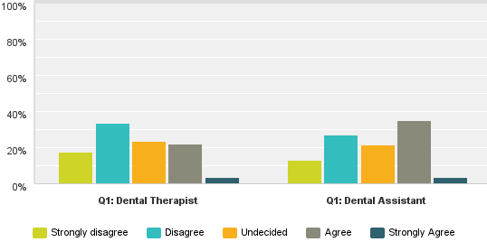
Figure 2: For those in the community who have the greatest need,
locations have improved access to care

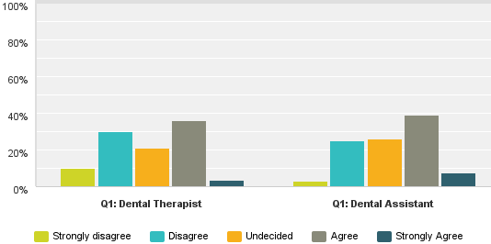
Figure 3: Service locations have generally improved access to care
Some dental therapists and dental assistants expressed specific concerns about access. Clinical team respondents who disagreed or strongly disagreed that the new locations provide improved access for people with the greatest need were given the opportunity to comment. Several comments pointed out that those with most need are likely to be from families who may have difficulty accessing a clinic because they have no transport, or are in low paid jobs with little flexibility to take time off work, and may not give teeth a priority. Other concerns were that treatment hubs may not be located well, either because they were far away from low-decile schools, or that they are not on public transport routes; and that mobile clinics or transport dental units (TDUs) may move-on from schools even though all the children had not had their care completed, meaning children were expected to access the mobiles or TDUs at the next location that could be a great distance away. Another concern was that, in rural areas, when the mobile units are not on-site there may be the perception that there is no access to oral health care.

As mentioned in the previous section on Māori provider perspective of the reorientation, QIG representatives shared some of these concerns and felt the reorientation would widen inequalities between Māori children and others. This because Māori children were more likely to live rurally in some regions and/or be at a socioeconomic disadvantage (so less likely to be able to travel), and are more likely to need multiple treatments and have to access the mobile clinic at another school, requiring travel. While the mobile clinics are enabling access for children, they can make engagement with families/whānau challenging due to not offering pre-specified appointment times, and not having appointments outside school hours.

One survey respondent made the observation that the new facilities have been very helpful for their disabled patients who use the facilities with more ease, which did improve equitable access and uptake of service.
The Ministry of Health said that as part of Government's re-investment programme, pre-existing school dental clinics were replaced with many new or refurbished fixed-site ‘hub’ clinics supported by ‘spoke’ mobile dental units. The intention was to locate ‘hub’ clinics where they would increase access to services for children in lower socio-economic and rural communities.
Data was available on the locations of 1530 COHS dental clinics as of December 2012, comprising 150 fixed sites, 27 transportable dental unit sites operating from 97 sites and 143 mobile dental clinics operating from 1283 mobile sites. Clinic locations were combined with mesh block population data from the 2006 Census, and distances between clinic sites and mesh block centroids were analysed by Statistics New Zealand's Urban Rural Profile 2006.
Overall, 90% of children aged under 18 lived in mesh blocks that were less than 4.4 km from a clinic site. In contrast, 90% of urban children lived in mesh blocks that were less than 2.2 km from a clinic site, while 90% of rural children lived in mesh blocks less than 13.5 km from a clinic site.
Deprivation is also related to distance from clinic sites, with more deprived areas being closer to sites on average. The population-weighted median distance to a clinic site is roughly half a kilometre in the most deprived quintile, compared to over a kilometre for the least deprived quintile. Also, 90% of children in the most deprived quintile live in mesh blocks that are less than 1.8 km from a clinic site, while the corresponding distance for the three least deprived quintiles is over 5 km.
The above provides evidence that the siting of clinics has achieved its goal of improving accessibility for children in lower socioeconomic areas.

One respondent thought that the reorientation was not working as well as it could be, due to a lack of advertising about the changes. As an example, in the Northland case study the clinical director and service manager had asked the schools to let their board and school community know about the changes, and assumed they would; but a lot of the schools did not. This was a weakness of the implementation, and, in hindsight, they said they would have worked in partnership with schools to ensure schools communicated better with their communities.

Another respondent thought that access had only improved in that the fixed facilities are somewhere a parent can go and know someone will be there. This was observed by the researchers while undertaking clinic observations. One of the parents said that since they now knew where to go they had just walked in off the street to make an appointment that day.

Both case study sites (Canterbury and Northland DHBs) had call centres. Parents appreciated the call centres for the ease of obtaining an appointment. As one dental therapist from the Northland case study said, “... the call centre is actually a pain in everybody’s life, except for the patient and the parents. Parents love it. They love it to bits.” Dental therapists also found that, since parents can ring up for an appointment at any time of the year, the parents were being more proactive in getting their children seen; whereas with the old school dental system they relied on the system to pick them up. This was reflected in one of the parents’ comments from the survey, they said, “His annual check was overdue so I followed up myself and made an appointment as had not heard from the dental service.”

It is noted by the Ministry, that the proportion of preschool and primary school children overdue for their scheduled oral health examination has been reduced substantially in recent years from around 28% in 2008 to 10% at December 2013.

It is acknowledged that there will continue to be a ‘hard to reach’ group. One therapist said that while the theory behind having more parental contact is a good one, in reality it is some of the most needy that do not get brought in for their appointments. As one clinical director pointed out, “…we’ll still have trouble accessing those children they’re talking about, even if we’re on site. We might be able to get them, but we might never get parent engagement to actually get consent to treat, without some extra help from somebody. So you’re still going to get those pockets, even when you go into a school that are difficult to reach.” But, another clinical director stated, “…you shouldn’t design service around the 1% that might not bring in their children and you can do other things to target that 1%.”

DHBs were taking different approaches in trying to address accessing those who are ‘hard to reach’. For instance in Canterbury they were undertaking a small pilot to actively case manage children that require a general anaesthetic (GA), to see if this could improve access for those that are ‘hard to reach’.
We have a sub group of patients with really high needs who are referred to Christchurch Hospital for GA and I’m working with one of the therapists on a wee project there developing a case management model for those children while they’re on the waiting list… we write the referral and then we don’t see them again…it’s 500 odd kids a year…It’s maybe two kids, three kids per therapist. We could actually do some active case management on those kids and improve their oral health before they get there [to hospital], improve the chances of them actually getting there and getting the GA. Because a lot of times they don’t turn up because they don’t fill in the right paperwork for hospital dental so they take them off the waiting list.

In relation to how the hours of operation might have improved access for those in greatest need, or generally; again, over half of clinical team respondents did not consider that hours had that effect (e.g., Figure 4). It was noted by many respondents that the hours of operation had not changed with the reorientation, however the majority of DHBs have made some changes to the hours of service to include opening during school holidays. One barrier to changing the hours of service for a number of DHBs is the current staff employment agreements. For example in Canterbury the employment agreement links clinic opening hours to primary school hours so they do not provide appointments outside of this or on weekends or during school holidays. Each DHB has had to negotiate and some are still negotiating changing the staff employment agreements to better cater for the new model of care.
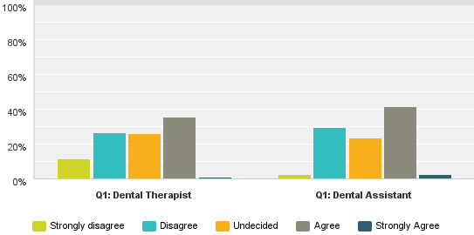
Figure 4: For those in the community who have the greatest need,
hours of operation have improved access to care
Clinical team respondents commented that even if the hours were extended it would make no difference because the most difficult thing for parents was physically getting to the clinic due to lack of transport or money for petrol, or no public transport; or that they did not prioritise their children’s teeth. However, some agreed that having the clinics open for longer hours or open in the weekends or school holidays would help with access as this is what parents wanted. One person pointed to a lack of flexibility of management to allow for glide time of therapists to enable cover during school holidays.

Although most clinical team respondents thought that the new model of care provides a better quality of care for children and adolescents, fewer than half of them considered that it provides equitable access to care for those in greatest need (Figure 5). One respondent noted that since they have been able to roster DHB salaried community dentists into the new community oral health facilities they had improved access to care in more remote areas for children and adolescents requiring treatment beyond the scope of practice and experience of dental therapists.

Therapists with greater years of service are less likely than those early in their career to agree that the new model of care provides equitable access to care for those in greatest need (43% for those with up to five years’ service, compared with 31% for those with over 30 years). Clinical directors and service managers, however, were much more likely than DTs and DAs to think that the new model provides equitable access to care for those in greatest need (83%).

This result that the clinical directors and service managers were more positive that the front line staff is not surprising as it supports previous findings in the literature in organization change (Jones et al. 2008).

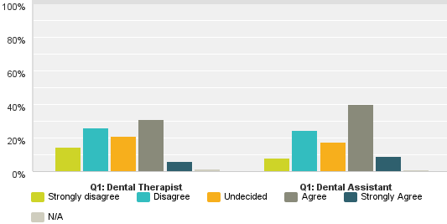
Figure 5: The new model of care provides equitable
access to care for those in greatest need
It is found that the leaders within organisations going through organisational change have more access to information and also the impact of change is less dramatic for them than for the frontline staff. Front line staff are more focused on how the change would affect them in day-to-day work routine and their immediate job. This is reflected throughout the five outcomes, with clinical directors and service managers consistently more positive than the dental therapists and the dental assistants.

Meanwhile, Well Child/Tamariki Ora providers generally agreed or strongly agreed that it is easy to refer a child to COHS, although 18 (66%) of the 27 providers that responded found the quality of feedback from COHS after referring a child to be non-existent or inadequate.

3.3.2 Family/Whānau involvement
Clinical team respondents to the survey (94%) reported that they can confidently work with family/whānau to achieve good oral health practices in the home. One dental therapist interviewed articulated how they were engaging better with parents with the new model of care. She said, “because we were so much at the stage of talking and rather than engaging. And I think that’s changed. You know, the new model of care has made us think that ...we have to engage them to make a difference, don’t we? We won’t make a difference unless we will engage those families really.”

However, fewer (84%) agreed that parents/caregivers make an important contribution to dental care, and a much smaller percentage (45%) agreed that parents/caregivers understand what is expected of them. Clinical directors and service managers also reported at 94% that the new model of care is based on a family/whānau approach.

Two thirds of the Well Child/Tamariki Ora providers strongly agreed that they felt confident in communicating messages including the importance of family/whānau involvement.

Where the clinical teams seemed to need improvement was on using motivational interviewing to provide oral health education to parents and caregivers. 20% of respondents said they did not think it applicable to them or they were using it less often than two years ago. As one dental therapist said:
I would really like to see us have a first appointment a bit longer... Because it’s amazing how when you do the motivational interviewing what comes out in discussion...because you don't want to just talk about teeth, you’ve actually got to talk about feeding, you’ve got to talk about what are they like as a new baby, what are they like as sleeping, where are they fitting in the family, how do they feel about tooth brushing themselves? Do you feel ok about coming into the clinic today? ... the difference is ... when we were in our clinics we could allow that. Whereas here our appointment books are set up for us, and preschool appointments are 15 minutes.

Parents and caregivers nearly all agreed or strongly agreed that they attended the appointment expecting to ‘support my child’, ‘be involved in my child’s care’, or ‘support how we care for teeth at home’. As one respondent said, ‘I believe a parent should be involved in their own child’s health and well-being’. However, those accompanying school-age children were less likely to strongly agree that they expected to ‘increase my knowledge on how to care for my child’s teeth’. Nearly two thirds agreed or strongly agreed that they felt obliged to attend the appointment as ‘it was expected of me’. As one respondent stated, “I came to the appointment because I had to drive my son there, and then back to school afterwards. For no other reason than I had to do that was I there.” This respondent reported that they strongly agreed that the appointment was a good use of their time and that the information they received was useful or very useful and they would return with their child. This may demonstrate that once a parent is there, they may find it a good use of their time. Of the ethnic groups Asian and Pasifika parents were more likely than others to agree or strongly agree they came because it was expected of them.

Of concern was that 20% of parents and caregivers reported that they did not receive information on tooth brushing, food and drink choices and how to access oral health care, and 12% did not receive information on dental care. However, feedback from the RRG and sector stakeholders indicated that this finding might be due to the fact that clinical teams would only expect to give information out on one or two of these at an appointment but not all of them. In this way, a parent or caregiver may have received information on tooth brushing but not food and drink choices. Nevertheless, some clinical staff felt that they did not have adequate time to deliver dental health education messages.
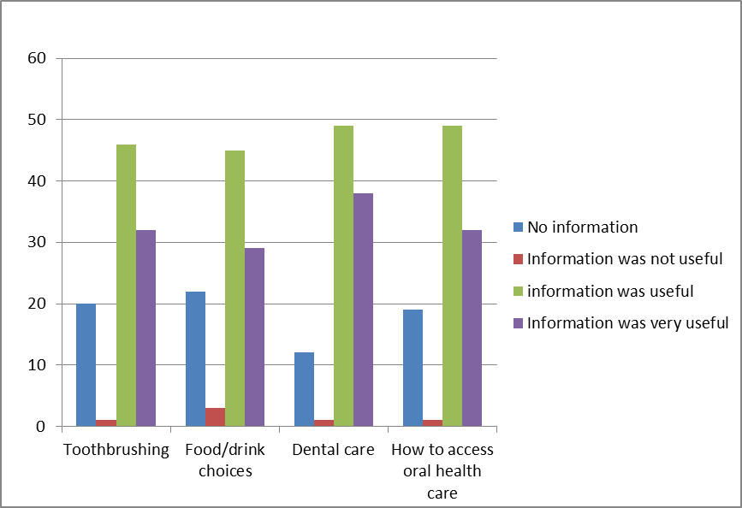
Figure 6: Parents/care-givers information received

It is worth noting that the information that was received by parents and caregivers, they overwhelmingly found it useful or very useful. Informal comment reinforced this. As one respondent said “Information is always given is applicable. Very informative and caring,” and another stated, “The dental nurse gave me the opportunity to look at what she was doing as she worked on my child’s teeth, pointing out where decay had started, and she was happy to answer all my questions.”

An encouraging finding was that fewer than 5% of parent or care-giver respondents did not think attending the appointment was a good use of their time, which demonstrates that once parents were at the appointment they did value it. On the whole their expectations were meet with nearly all strongly agreeing or agreeing that attending the appointment was useful to, increase their knowledge on how to care for their child’s teeth, support their child, be involved with their child’s care, and support how they care for teeth at home.

Even more encouraging was that only two respondents said that they would not return with their child. Parents of primary school aged children comments ranged from ‘compassionate, professional and genuine’, they received ‘lots of information’ and the therapists were very accommodating ‘towards meeting the needs of the children’. Parents also mentioned that the ‘appointment times were flexible if they didn’t suit’, and that you ‘could schedule the appointments together for more than one child’ and parents also wanted ‘to be there to support their child’. Others said they would return because they had to, but they preferred the old dental school system.

Of the preschool parents the overwhelming majority of comments were on how great the service was, especially as a lot of the preschool children were nervous, “Awesome! My daughter cried but I was able to sit with her so the lovely ladies could look at her pearly whites,” “my child felt comfortable in their care, they built up to the exam slowly,” “great friendly staff very good with my daughter as she was a little unsure. A+++,” “thank you very much for making the dentist fun as for me I hated going when I was a child and still as an adult, but really loved this time with my son, he liked it so I thank you guys for this ☺,” and “the nurses were so gentle and compassionate and fabulous with my child.”

However as one DT respondent noted access could improve with getting the message out to family and whānau, they said “with community ‘buy-in’ and cooperation they could see this working but that we needed to work on this New Zealand wide.”

3.3.3 Effective utilisation of people and plant
Satisfaction with the layout and standard of the new facilities is substantial, but not universal. Just over one in five DTs that participated in the survey found the facilities unsatisfactory or very unsatisfactory. The biggest complaints from the qualitative data were with the mobile clinics, with a few respondents saying there was a lack of space and storage. There was also an issue when a parent or caregiver brought siblings with them and/or a pushchair, and the unit did not have enough room. Complaints about the fixed facilities were around the lack of doors between the hall way and each surgery, so it could be noisy and at times seen to compromise privacy despite the facilities and position of the chair being designed to manage privacy and minimise transfer of noise. However, during informal discussion with parents attending clinics, parents commented that they liked the no door approach as a closed door created a ‘trapped atmosphere’. All service managers and clinical directors that participated in the survey were satisfied or very satisfied with the facilities.

Clinical teams and clinical directors were divided on whether the new model of care provides the right skill mix and staffing level to deliver quality dental care (Figure 7). However, two thirds of respondents thought the new model provided a workplace culture that values learning and quality improvement, almost 60% considered that there are increased opportunities to improve their clinical knowledge and skills, and over 80% of clinical team respondents thought the facilities support professional codes of practice.

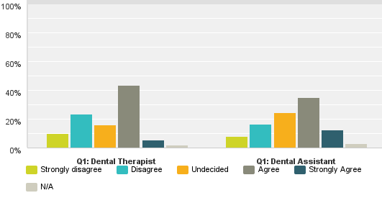
Figure 7: The right skill mix and staffing level to deliver quality dental care
Most service managers thought the staffing and skill mix was right. On the other hand, clinical teams did largely agree that the new model provides enhanced team work (70%) and greater clarity of roles (59%) for the dental team, and that a greater range of treatment was available ‘in-house’ (60%). Service managers were more likely than clinical directors to agree that the new model provides greater clarity of roles for the dental team, whereas both groups affirmed that the model provided enhanced team work. Clinical directors were more likely than service managers to think the new model provided a greater range of treatment in-house.

Survey participants were asked to assess the extent to which various roles contribute to the quality of care. While service managers and clinical directors were ambivalent about the role of call centre or reception roles, they generally affirmed the contribution of the team work of the clinical team, community dentists, health promoters, and primary health care providers, as did clinical team respondents.

DTs and DAs were asked to select any of eleven statements to describe their experience of working with the new model of care. The three most commonly selected statements were:
- I am making a difference to the oral health of the community.
- It is fantastic working in the new facilities, it is a positive environment.
- The collegial and peer support is really good as it creates more opportunities for learning across practice.

It may be worth noting that DTs were much more likely (56%) than DAs (32%) to select the statement on collegial and peer support. That statement was also strongly affirmed by clinical directors and service managers.

Comments from clinical team members suggest that some feel reduced job satisfaction because they have less opportunity to complete treatment, less sense of continuity of care, the experience of being understaffed, and an emphasis on patient throughput. In some areas the opportunity to practice ‘four-handed’ dentistry was constrained by lack of staff.
Additionally it was felt by some that their time and skills were not being utilised as they should, due to the overwhelming time spent in administration and infection control.

The reinvestment programme has been a considerable change for most of the COHS staff, who for some, have worked by themselves and in charge of their individual clinics for over 40 years to working in teams and in multi-chair fixed clinics and mobiles. This has included a perceived loss of autonomy (for some), learning new clinical skills as well as other skills such as driving mobile vans, and (for some) a change in work hours. Parent/caregiver participation in appointments has been another challenge for some staff as they have had to develop new skills engaging parents as well as the children. Reflecting on the scale of change and the adaptability of the clinical workforce, respondents noted:
You know, it took a while, change always takes a while, but it’s better now. And I’d say that the majority are really happy with the changes. Because they can see something different. But things are changing, even in the mouths of the kids, they’re seeing the light at the end of the tunnel.

When you’re looking at whole system change, you need to look at the elements of change and where people are in that change. And huge challenges for staff moving from self-practitioner to a team environment. You know, really scary about getting eight people working in a facility… you know, and to a self-managing team…. It’s really heartening to see the value that staff are now placing on working in a team. Their apprehension around moving into the team has gone, and in many cases where they thought parents wouldn’t be bringing their children, especially primary school children, they are actually attending…And therapists reported that parents and whānau are supporting their children to attend their appointments much more than they would attend the school, the school dental clinic.

3.3.4 Improved prevention and early detection
Almost three quarters of the clinical team survey participants thought there has been an increase in delivery of preventative care.

Most clinical team members who responded to the online survey (66%) thought they were seeing more preschoolers than before the reorientation, although those with longer service were less likely to have this view. Almost all the clinical director or service manager respondents thought their teams were seeing more pre-schoolers. Ministry of Health data confirms this with the number of preschool children enrolled in the service has increased from 125,923, 43% of the eligible population prior to implementation to 225,502 or 73% of the eligible population at December 2013. Particularly lower for Māori (59%) and Pacific (68% preschool children).

Clinical team respondents were divided on whether they were seeing more primary school children, and only 60% of respondents were able to agree or strongly agree that they were placing a greater focus on care for ‘at risk’ children. Those with more than twenty years’ service were less likely to hold this view than those in their first ten years.

Data from the Ministry of Health shows for primary school children there is evidence of high enrolment at around 96% of the relevant age group and has been maintained for some time. However disparities continue with lower enrolment, higher not attended appointments amongst Māori and Pacific children.

In terms of clinical practice, 80% of respondents considered they were using radiographs more than two years earlier, most (69%) considered they were using fluoride varnish more, fewer than half the respondents reported using fissure sealant or motivational interviewing more (47% and 44%), and some (6%) thought they were using motivational interviewing less (Figure 8).

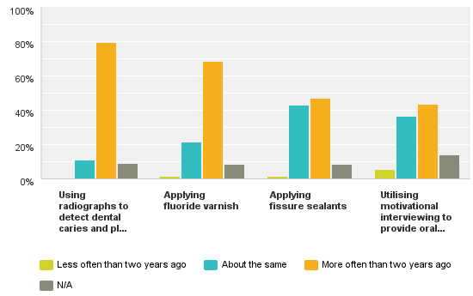
Figure 8: In a typical week our team is ...
Almost all the dental therapist respondents reported they were confident using radiography and fissure sealant, and almost 80% of them reported they were confident working with family or whānau to achieve good oral health practices in the home.

Over a third of clinical team respondents (37%) and just under half of the clinical director and service manager respondents (47%) chose as one description of working with the new model of care, “I am seeing evidence that the preventative aspect of the new model of care is really working.”

Clinical directors and service managers who responded to the survey overwhelmingly considered that the new model of care provides improved early detection of dental caries (83%), and three quarters of them thought the model provides increased delivery of preventative care.

Almost all Well Child or Tamariki Ora providers stated that they were confident to communicate key messages on oral health such as how to access care, the importance of family/whānau involvement, importance of tooth brushing, importance of prevention and early detection, and the importance of food and drink choices. Most (81%) said they were confident to do the ‘Lift the Lip’ assessment in their practice. Four of the twenty seven providers that participated in the survey said that they were not confident to promote oral health in their practice or did not see it as a priority. Nine respondents saw oral health as central to their practice.

Some DTs agreed that having more involvement with the parents will contribute to prevention. Meanwhile, almost 90% of parents and caregivers that participated in the survey reported that attending the appointment with their child was useful because it increased their knowledge on how to care for their child’s teeth.

The Ministry of Health said that in discussions with DHBs, they acknowledged that even following enrolment there are significant challenges in ensuring children, particularly preschool children are brought to the clinic. Key challenges noted include:
- Lack of parental/caregivers knowledge about the importance of oral health.
- For some families/whānau oral health care for children is a low priority due to other social, environmental and economic challenges.

The Ministry said to overcome these attendance challenges, COHS are implementing a range of strategies including:
- Strategic relationships with Māori and Pacific providers to facilitate the connection with families/whānau. However, feedback suggests that in some cases further work is needed by COHS to identify ways to work effectively with iwi health and early education providers.
- Health promotion teams engaging with preschool providers and delivering train the trainer to preschool, kōhanga reo and other early childhood services.
- Arranging examination for preschool children as soon as possible after enrolment to leverage from the enrolment/referral process.

3.3.5 Standardisation of clinical practice
Two thirds of the clinical team respondents to the survey considered that their team was motivated to practice evidence-based dentistry; however, among just the dental therapist respondents the agreement on this was higher (74%).

When asked if the new model of care provides greater consistency of clinical practice, 63% of the clinical team respondents agreed or strongly agreed, as did a substantial proportion (88%) of the clinical directors and service managers. Most of the clinical team respondents (81%) and service managers and clinical directors (88%) thought that the facilities support professional codes of practice.

There is a perspective in the qualitative data from both DTs and DAs that a shortage of DAs was limiting the practice of ‘four handed dentistry’. Many said that if only they had more DAs then they could do better work and productivity would be much better. As one dental therapist said:
Oh, it’s fantastic, quick fast appointments. Our four handed dentistry means that a child is in the chair quicker, faster, and their treatment is just far more pleasant. …It’s so inconvenient if I don't have one which sometimes we don’t.

However, the December 2013 actual workforce data from the Ministry of Health showed, there are only eight DHBs out of 19 who have less than one DA to one DT, and all of these DHBs had planned for additional DAs in their workforce plan at full implementation. The number of dental assistants has increased from 222 to 419 full time equivalents.

For some DT respondents reported what they saw as a push to examine more children within their recall time frame without a focus on completion. But if a child’s treatment is not completed before the team moves on to another school, a plan is put in place to ensure the treatment is completed at the mobile’s next location or a fixed clinic.

In discussion with the Ministry of Health, they said that there are a number of issues which impact on the COHS completing care including:
- Consenting for treatment – for a child to receive treatment parental/caregiver consent is required. If the parent/caregiver is not present seeking consent will delay treatment.
- Absenteeism can affect the ability of the COHS to assess and complete care for all children accessing mobile services. 10% of New Zealand European and 15% of Māori are absent from secondary school or 9% are absent from primary school on any given day.
- Families/whānau mobility creates challenges for ensuring children receive treatment.

Mobile clinics, however, are seen by the Ministry of Health as a key contributor to increasing the proportion of children receiving care particularly for those living in rural communities.

Another negative mentioned by clinical team respondents were the sense that ownership or responsibility for clinical practice was compromised because DTs work on rotation and do not always complete the treatment of the children they have examined. However, some respondents noted that the model of care has uncovered inconsistency in clinical practice between DTs, which has allowed development and learning to occur. This was also noted in the Northland case study, a member of the leadership team stated, “There was a lot of chit-chat going on about: ‘I can’t believe that she’s put that down on the treatment plan. Why would you do that?’ But now they’re extremely professional about it. They will actually go and ask the therapist, you know, or ring the therapist …So they’re actually engaging in those professional conversations.”

Another member of the leadership team in Northland felt that because the clinicians were now working together in the new model of care the service provided a better service for the children:
I just think the kids now in Northland are getting a far superior service, and a far better quality service. And I think a big part of it is around the clinicians working together. We’ve got access to one oral health record so that we can chase the patient round. Yeah. And I think with different clinicians seeing, you know, one child might see three or four different clinicians, but to me that’s really healthy. And I think we’re starting to see a lot more consistency between what the clinicians are doing. Because they’re seeing each other’s work and they’re able to discuss what might be done and what might not be done.

4. Enablers and barriers
The Ministry of Health reinvestment programme for child and adolescent oral health, and the associated changes to the model of care set out to achieve six outcomes:
- Treat the health problems at an early stage of development
- Emphasise illness prevention and promotion
- Empower communities to participate in decisions about their oral health
- Involve intersectoral collaboration, where possible
- Have particular consideration for the needs of groups with inequitable oral health outcomes or access to services
- Have a strong focus on maintaining good oral health in early childhood
(Ministry of Health, 2006a, p. 9)

To bring these changes about, the Ministry supported DHBs to produce business cases for reinvestment in child and adolescent oral health in their areas, and then funded the implementation of these business cases to establish the Community Oral Health Service. An analysis of the aims of the reinvestment and the key features required in the business cases reveals five impact areas that can be evaluated:
- Improved and equitable access to and uptake of care.
- Focus on family/whānau involvement.
- Effective utilisation of people and plant.
- Improved prevention and early detection.
- Increased standardisation of clinical care.

These impact areas have shaped our evaluation enquiry. We have carried out case studies in two contrasting DHBs, and engaged with sector representatives including the QIG, to understand how the business cases were developed and implemented. We have surveyed clinical teams, service managers, clinical directors, parents and care-givers, and Well Child/Tamariki Ora providers to discover possible reorientation impacts. The initial evaluation findings with sector stakeholders to develop an understanding of what has enabled or hindered the reinvestment programme and consider what recommendations would enhance the reorientation of child and adolescent oral health services.

4.1 Leadership and management of change
It is clear that the case for change from a Ministry perspective was compelling, and that DHBs were able to present convincing business cases to support investment in a new model of community oral health. However, the ways in which business cases were developed in each DHB, and the ways in which change was introduced and managed are important in shaping how various stakeholders contribute to positive outcomes.

Several examples can be found in the current evaluation. In each of the two DHBs studied, the knowledge, reputation and skill of those leading the development and implementation, was said to be important in how the implementation unfolded.

Also, key stakeholders could have been engaged more productively. For example, Māori providers have expressed the view that their involvement was intermittent, and that an opportunity for a more radical improvement in oral health care has been missed. In particular more Māori input into the reorientation of the service may have prompted a more ‘whānau-centric’ approach that could address the oral health needs of whole communities.

Schools and communities were part of local engagement, but it is not clear that school communities and the public at large have been sufficiently equipped to play their part in improved oral health outcomes in tandem with the new service. An example of an issue here is that parents and care-givers need to know what service is available and how to access it.

The potential of the new service is also constrained by some key human and labour issues. Clinical teams and their unions still need to be engaged in problem solving before all the promises of the reorientation can be realised.

The reinvestment programme has required COHS staff to embrace and adapt to considerable change in day-to-day practices. Change management that has been important and may need further attention includes involving the workforce in aspects of service and facility design, providing timely information and updates on what is happening, training staff for new ways of working, and facilitating transfer of learning and good practice between and across DHBs and clinical teams. Nevertheless, the evaluation has produced promising evidence of an engaged workforce committed to a reoriented service, considerable changes in clinical practice and an increasing understanding of how to translate the model of care underpinning the reinvestment programme into day-to-day delivery of oral health services. In our view, this reflects positively on a resilient and adaptable workforce that is critical to realising the promises of the reoriented service.

4.2 Improving the involvement of family and whānau
There is evidence that parents and care-givers that are engaging with COHS regard the service positively, have their expectations met or exceeded and gain useful information to support the oral health of their children. There is also evidence that clinical staff have a generally positive experience of engaging with family and whānau as part of care, and that they mostly embrace the value of this.

However, feedback from clinical staff suggests that the way in which appointments are scheduled, and productivity expectations are limiting the quality of engagement with family/whānau. Time constraints, for example appointment scheduling may limit the use of motivational interviewing and may compromise how well the model of care is provided.

4.3 Service availability, equitable access and family/whānau involvement
The current study was not able to determine the extent to which operating hours and location of COHS facilities may present barriers for some people in accessing care. That is because we have not heard from those for whom such barriers may have been too great to overcome.

However, feedback from clinical staff, and qualitative comment from some parents and care-givers suggests that more flexibility of operating hours and days may mean that parents in employment are more able to be involved with COHS in the care of their children. And, feedback from some clinical staff also raises the question of how distances and transport costs may make it harder or impossible for some people to access the service. Of particular concern is that such factors would unduly affect low income and rural families. Māori providers suggested that this might particularly affect Māori. Further work will be required to test if changing hours of operation and the location of services would improve family/whānau involvement and/or equitable access to service.

4.4 Enhancing relationship with other health services
We found evidence of innovative initiatives to involve other services in improving oral health outcomes (e.g., working with maternity services to provide information and to enroll preschoolers). We also heard of positive commitment by some Well Child/Tamariki Ora providers.

However, some feedback suggests that these relationships could be improved with further training and with better feedback from COHS. For example, a number of Well Child/Tamariki Ora providers found the feedback after a referral as either non-existent or unsatisfactory. And Māori providers expressed frustration at how, in some situations, their role had been limited (e.g., to working with those at kōhanga reo and kura kaupapa).

It is reasonable to suggest that such providers would put a higher value on their role in oral health care if they experienced higher levels of integration, collegiality and professional feedback.

There may need to be specific strategies (nationally and regionally) to better engage health services in systemic or integrated approach to ‘co-produce’ desired health outcomes.

4.5 What is best done regionally, and what is best done nationally?
The role of the Ministry has been vital in initiating, facilitating and supporting the development of COHS. DHBs have been responsible for key aspects of how the service has been configured and implemented; and some local problem-solving has led to significant innovation.

Feedback from DHBs suggests they have found the role the Ministry has played to be supportive, if sometimes frustrating. In addition, DHBs reported that they valued some sharing of information and ideas between DHBs.

To support the future sustainability and development of COHS around the country as a mechanism for delivering the new model of care, it will be important to achieve the right balance between local configuration and innovation decisions, national requirements, national infrastructure and support, and effective sharing of learning between DHBs. Further work will be required to inform this balance or responsibilities.

4.6 Developing clinical practice
While the development of COHS has been styled as a re-investment ( to re-orientate), and it is easy to focus on change that involves tangible assets (e.g., mobile vans, hubs, equipment), at the heart of the reorientation is a change in the model of care, and that involves change in clinical practice. Discussions highlighted that the new model of care is in early implementation phase. The building of new facilities was nearing completion at the time of this evaluation and service configurations and processes are still embedding. In this context the service providers are exploring what works and does not work, and how to enhance their service delivery. There is a strong perception that as the model and processes become more embedded further gains will be made. Issues of workforce recruitment and development will be central to how the reorientation unfolds in future years, and how sustainable the model is.

There is evidence that the clinical teams feel confident in the technologies of prevention and early detection, and that the new context of practice has supported clinical learning and improved practice. However, some aspects seem less well embedded than others. For example, some areas may not have the balance between DTs and DAs appropriate to support ‘four handed’ dentistry. Some clinical staff are reporting high stress levels, unsustainable workloads, and lowering of job satisfaction. And there are questions about the recruitment and retention of DTs and DAs.

The sustainability of a high performing service will require an integrated approach (nationally and regionally) to workforce training, recruitment and utilization.

Evaluation insights and recommendations

The DHB case studies and engagement with QIG revealed the following important insights:
- The project management and leadership to develop and then implement the business case for reinvestment were critical to how it unfolded and how it is perceived by key stakeholders.
- Stakeholder engagement needs to be well done; including sufficient engagement with Māori, the communities, schools, and those staff whose working conditions and practices will be affected.
- Change management is necessary to support change by key stakeholders.
- The relationship between what DHBs took responsibility for and what the Ministry took responsibility for is important.
- Networking between DHBs was important.
- Workforce recruitment and professional development are critical to the sustainability of the model.
- Local problem solving has led to positive innovation (e.g., the use of 0800 call centres).
- There remain some challenges, particularly around care for ‘hard to reach’ families, and the sustainability of the model (in regard to both workforce and facilities).
- The new model of care and context for clinical practice has enabled clinical learning and improved practice.
- There is opportunity for enhanced relationships between services (e.g., with maternity services, Māori providers, Well Child/Tamariki Ora providers).
- The service is still focused on child and adolescent patients, albeit with the expectation of family/whānau involvement; but some have noted a missed opportunity for a more whānau-centric approach where treatment is not restricted by age.
- Continuity of care is important to some clinicians.

Insights from the surveys revealed additional important insights:
- Parents and care-givers respondents who are accessing the service appear over-whelmingly positive about the experience and experienced few barriers.
- Parents and care-givers respondents who are accessing the service appear committed to an important role in the oral health of their children, and appreciated the information they received.
- The limited times of the day, week and year that the service is available is a potential barrier for some families.
- While parents and caregivers respondents did not seem concerned about distance and travel being a barrier, some staff are concerned that this may be an issue, especially in rural and low-decile areas.
- Parents need to know how and where to access oral health care.
- Those respondents in leadership (service managers and clinical directors) are more likely to be positive about the impact that reorientation is having than those respondents working in the clinics.
- Generally, clinical staff respondents have a positive experience of engaging with family/whānau as part of care, although there is evidence that more focus on motivational interviewing may be needed, and that some therapists respondents find the scheduled time for appointments is a constraint on parental engagement and motivational interviewing.
- While most respondents were positive about the new facilities, there are some issues with space.
- By far most clinical staff respondents consider that the facilities support professional codes of practice.
- Some clinical staff respondents report reduced job satisfaction. They cite less opportunity to complete treatment, less sense of continuity of care, understaffing, and an emphasis on patient throughput.
- Managing the workload and staffing levels do seem to be a problem in some situations, with some DHB experiencing difficulty in filling dental therapists vacancies.
- Clinical staff respondents with greater years of service seem more cautious about attributing positive outcomes to the reorientation.
- Clinical staff respondents are generally confident in using the technologies of prevention and early detection.

Recommendations

Improved and equitable access to and uptake of care
- Annually review mobile unit schedules to ensure services are timely and accessible, especially for rural and high risk populations.
- Review hours and flexibility of the COHS to enhance accessibility for working parents/whānau.

Focus on family/whānau involvement
- COHSs to maintain communication with their communities about the essential elements of the improved model of care. This will include what is expected of parents/caregivers and what parents/caregivers can expect in return from the COHS.
- Develop tools to achieve greater involvement of parents and whānau in co-creating good oral health outcomes, including COHS establishing a role for dental therapists who have particular expertise and interest in parental engagement.
- Consider developing a national brand for COHS.

Effective utilisation of people and plant
- Develop a work programme with Health Workforce New Zealand to address issues relating to Dental Therapist supply and demand, to provide advice on the numbers of dental therapists and dental assistants required to practice evidence based dentistry and to meet service demands.
- Develop a strategy to ensure that COHSs take a consistent approach to addressing issues relating to Dental Therapist recruitment and retention.
- Develop and implement asset management plans to maintain fixed and mobile community clinics and clinical equipment.
- Actively involve clinical staff in operationalising the improved model of care, and utilise data about clinical practices, patient satisfaction and oral health outcomes to improve service delivery.

Improved prevention and early detection
- Reinforce to DHBs, COHS staff and stakeholders that the purpose of the reinvestment is to transform the way in which oral health services are delivered; that is, to promote oral health and focus on prevention and early detection.
- Evaluate the effectiveness of the Healthy Smile, Healthy Child oral health guide as the training curriculum for health providers who have specific training in child health.

Increased standardisation of clinical care
- Develop and disseminate best practice guidelines, for example engaging with families /whānau and the 0 – 2 year old patient pathway to further enable clinical consistency within and between COHS.

System
- Consider further work to strengthen stakeholder engagement at the regional level with the aim of enhancing the connection with primary health care (including non-government organisations), increasing preschool enrolments and parental/caregiver engagement with oral health services, and enabling deliberation about strategic issues and directions (e.g. improving access for ‘hard to reach’ populations).
- Refine the online survey used in this project and use it every two or three years to monitor reorientation impacts over time, including clinical staff understanding of the new model of care (the next survey would be in 2017).
- Trial the self-evaluation tool developed in this project with selected COHS to refine its applicability. We suggest applying the self-evaluation tool to the resolution of a problematic issue such as Did Not Attend rates or increasing Māori preschool enrolments.
- Consider establishing a stakeholder guidance group including Māori providers, professional bodies, regulatory agencies, and consumers to examine how best to progress the next stage of the reorientation.
- Ministry of Health’s Oral Health Programme and COHS leadership teams determine how to implement recommendations in this report including which are best actioned nationally or regionally.

7. References
Browne, J “Survey design”. In: J. Green and J. Browne (eds) Principles of social research, Open University Press, Milton Keynes 2005.

Canterbury District Health Board Business case – investment in child and adolescent oral health services, Canterbury District Health Board, Christchurch, 2007.

District Health Board NZ [DHBNZ] National School Dental Service Review: Final Report, December 2004, Ministry of Health, Wellington, 2006.

Dow, D Safeguarding the public health: a history of the New Zealand Department of Health, Victoria University Press, Wellington, 1995.

Erickson, B., and Nosanchuk, T Understanding data: an introduction to exploratory and confirmatory data analysis for students in the social sciences, Open University Press, Milton Keynes, 1979.

Foote, J., Hepi, M., Nicholas, G., and Dasler, S “Towards a systemic understanding of health service transformation”, Australian and New Zealand Health Services Research Association, Wellington, December 2013.

Foote, J., and Nicholas, G Towards a systemic theory of change in complex service systems, Institute of Environmental Science and Research, Christchurch, 2013.

Frechtling, J Logic modelling methods in program evaluation, John Wiley and Sons, New York, 2007.

Funnell, S., and Rogers, S Purposeful program theory: effective use of theories of change and logic models, John Wiley and Sons, New York, 2011.

Greene, J “Mixed methods”. In: S. Mathison (ed). Encyclopedia of evaluation, Sage, Thousand Oaks, 2005.

Jones, L., Watson, B., Hobman, E., Bordia, P., Gallois, C., and Callab, V “Employee perceptions of organizational change: impact of hierarchical levels”, Leadership & Organization Development Journal, 29:4(2008), 294 – 316.

Litmus Review of access to and service coverage of community oral health services, Client Report for the Ministry of Health, Wellington, 2013.

Mauri Ora Associates Review of Māori child oral health services, Client Report for the Ministry of Health, Mauri Ora Associates, 2004.

Ministry of Health New Zealand Health Strategy, Ministry of Health, Wellington, 2000.

Ministry of Health He Korowai Oranga: Māori Health Strategy, Ministry of Health, Wellington, 2002.

Ministry of Health Good oral health for all, for life, Ministry of Health, Wellington, 2006a.

Ministry of Health Business case guidelines for investment in child and adolescent oral health services, Ministry of Health, Wellington, 2006b.

Ministry of Health Early childhood oral health: a toolkit for District Health Boards, primary health care and public health providers and for oral health services relating to infant and preschool oral health, Ministry of Health, Wellington, 2008.

Ministry of Health Our oral health: key findings of the 2009 New Zealand Oral Health Survey, Ministry of Health, Wellington, 2010.

Northland District Health Board Clinical governance review of community oral health providers in the Northland DHB region, Northland District Health Board, Whangarei, 2011.

Public Health Advisory Committee Improving Child Oral Health and Reducing Child Oral Health Inequalities, National Health Committee, Wellington, 2003.

Wehipeihana, N., Oakden, J., Spee, K., Cram, F., Pip, K., and Porima, L Evaluation of Māori Oral Health Providers, Ministry of Health, Wellington, 2011.

Appendix 1: Terms of Reference for the Research Guidance Group

Aim
The Research Guidance Group (RGG) has been established to support the Oral Health Reorientation Evaluation and Research project by providing advice and feedback to the team and help ensure the outcomes of the project are useful and durable for the sector. The Terms of Reference covers the period from 1 June 2013 to 31st of May 2014.

Nature of the Relationship
- The RGG provides a sounding-board for the project team, noting that other people may provide operational guidance for process and comparative impact evaluations.
- The intention is for the composition of the RGG to be stable for the duration of the project. If a member needs to leave the RGG, as much warning as possible will be given to the research team so that a replacement can be found and briefed.
- The RGG provides an opportunity for two-way learning between the research team and the RGG.
- The RGG provides a confidential space to discuss challenging issues relating to the evaluation and research.
- RGG members provide expertise in child health and oral health services, workforce development and health programme and policy development.

Responsibilities
The RGG will:
- Be expected to attend three face-to-face meetings once every four months, and may need to provide feedback electronically in-between meetings.
- Ensure they are familiar with the material being discussed at meetings so they can fully participate.
- Draw on their institutional knowledge and experience to:
  - Provide constructive criticism and advice about the relevance and usefulness of the evaluation and research in their wider networks;
  - Offer views of how the evaluation and research fits into the bigger strategic picture of oral and child health.
  - Identify gaps in the evaluation and research that could be closed in the project or give direction for future evaluation and/or research;
- Articulate what they need to know to be able to contribute to the aim.
- Provide points of contact into wider community, organisation and research networks.

The research team will:
- Provide four-monthly updates of the findings and progress of the research in summary form.
- Organise and pay for travel for RGG members so that they can attend four monthly face-to-face reference group meetings.

Decision Making
- The intention is that decisions will be made by the research team, helped by a reflective process between the RGG and the team.

Communication and Confidentiality
- Jeff Foote and Sue Dasler are the contacts for the research team (jeff.foote@esr.cri.nz and sue_dasler@moh.govt.nz).
- The RGG and research team respect the confidentiality of some issues discussed in meetings.
  - During a meeting, anyone can request a discussion or material to remain confidential.
  - Evaluation and research data is confidential, but evaluation and research findings once reported can be shared.
- The RGG will be asked to suggest appropriate ways to disseminate the evaluation and research findings to its wider community and organisation networks.

Appendix 2: An intervention logic

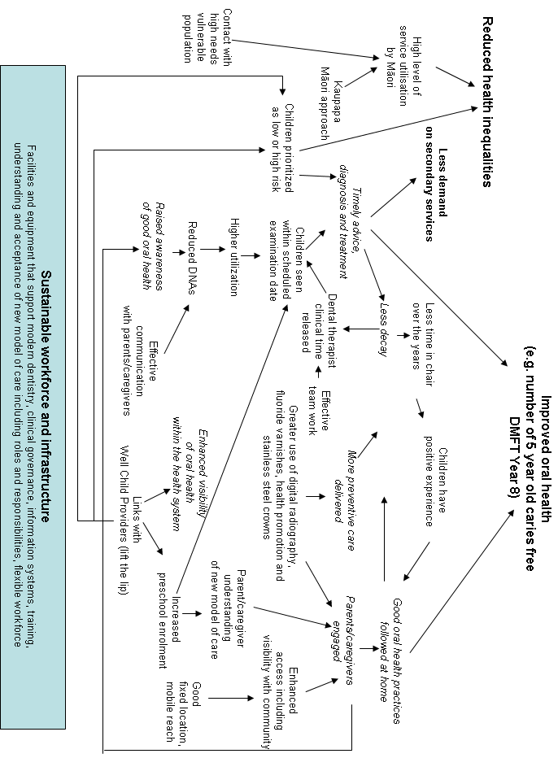

Appendix 3: Survey for parents and care-givers

The Ministry of Health in partnership with the Institute of Environmental Science and Research (ESR) are undertaking an evaluation of the changes to child and adolescent oral health services. Under these changes parents and caregivers are encouraged to attend their child’s dental appointment. As part of this evaluation we are conducting a number of surveys to gather information on the effectiveness of the changes.

Please complete this survey by 11 March.

1. Please choose which language you wish to use for this survey:

Tēnā koa, tohua mai ka reo Māori, ka reo Pākehā rānei tōu hiahia mō tēnei uiui
rangahau:
- Te reo Māori [Tēnā koa, me pātai koe mō te uiui Māori]
- English

Welcome.

This survey is part of a project to find out how well recent changes in community oral health are working, and to learn from the feedback.

Be in to win!
By participating in the survey you have a chance of winning one of six Colgate Sonic Power battery toothbrushes.
If you would like to be in to win a prize you will need to include your contact details (mobile number or email address) at the end of the survey.
This is optional and will be only be used for that purpose.

This survey is for parents or caregivers of children that have recently attended an appointment with the oral health service.

Your participation in the survey is entirely voluntary and anonymous. You can withdraw from the survey at any time.

For those of you who wish to participate, thank you for your time, it is much appreciated.
Please make sure you at least answer the questions with * beside them

2. My child has recently attended an oral health appointment at:
- A mobile (van) clinic
- A fixed (building) clinic

3. My child is:
- Aged 0-4
- Aged 5-12
- Aged 13-17

4. Did you attend an appointment at the oral health service with your child?
- Yes: Please go to Question 5
- No, I was not invited to: Please go to Question 12.
- No, I was unable to get to the appointment: Please go to Question 11.
- No, I did not want to attend the appointment: Please go to Question 11.

5. I came to the appointment expecting to:
[Strongly disagree; Disagree; Undecided; Agree; Strongly agree]
- Increase my knowledge on how to care for my child's teeth
- Support my child
- Be involved with my child’s care
- Support how we care for teeth at home
- It was expected of me
- Other (please specify)

6. Attending the appointment with my child was useful because:
[Strongly disagree; Disagree; Undecided; Agree; Strongly agree]

- Increase my knowledge on how to care for my child's teeth
- Support my child
- Be involved with my child’s care
- Support how we care for teeth at home
- It was expected of me
- Other

7. Please tell us about your child's appointment:
[Strongly disagree; Disagree; Undecided; Agree; Strongly agree; N/A]

- The appointment time and date was convenient
- The clinic was easy to find
- The clinic environment was welcoming
- I found it costly or difficult to travel to the appointment
- Other

8. By attending the appointment I received information on the following:
- [No information; Information was not useful; Information was useful; Information was very useful]
- Tooth brushing \
- Food/drink choices
- Dental care How to get dental care for my child
- Other useful information I received:

9. Attending the appointment was a good use of my time
[Strongly disagree; Disagree; Undecided; Agree; Strongly agree]

10. Would you return with your child?
- Yes
- No
- Comment

11. What was the main reason that stopped you attending?

- The time was not convenient
- The clinic was too far away
- I could not afford the time
- It did not seem very important
- I do not like places like that
- I had other important commitments
- Other (please specify)

12. I received information from the service on the following:
[No information; Information was not useful; Information was useful; Information was very useful]

- Tooth brushing
- Food and drink choices
- Dental care
- How to get dental
- care for my child
- Other useful information I received:

13. Do you wish to offer further comments?
- Yes
- No
- Please add your comments:

14. How would you describe your ethnicity?
- NZ European/Pākehā
- Māori
- Pacific
- Asian
- MELAA (Middle Eastern/Latin American/ African)
- I prefer not to answer
- Other (please specify)

15. The oral health service that my child attended was a Māori provider
- Yes
- No
- I am not sure

16. My District Health Board region is:
- Auckland DHB
- Bay of Plenty DHB
- Canterbury DHB
- Capital & Coast DHB
- Counties Manukau DHB
- Hawke’s Bay DHB
- Hutt Valley DHB
- Lakes DHB
- MidCentral DHB
- Nelson Marlborough DHB
- Northland DHB
- South Canterbury DHB
- Southern DHB
- Tairawhiti DHB
- Taranaki DHB
- Waikato DHB
- Wairarapa DHB
- Waitemata DHB
- West Coast DHB
- Whanganui DHB
- I do not know

Thank you for your time participating in this survey.

17. If you would like to go in the draw to win one of six Colgate Sonic Power battery toothbrushes, please give us your contact details (one of the following).
This is completely optional, and will not be used for any other
purpose.
- Mobile phone number:
- Contact email address:

Appendix 4: Survey invitation card
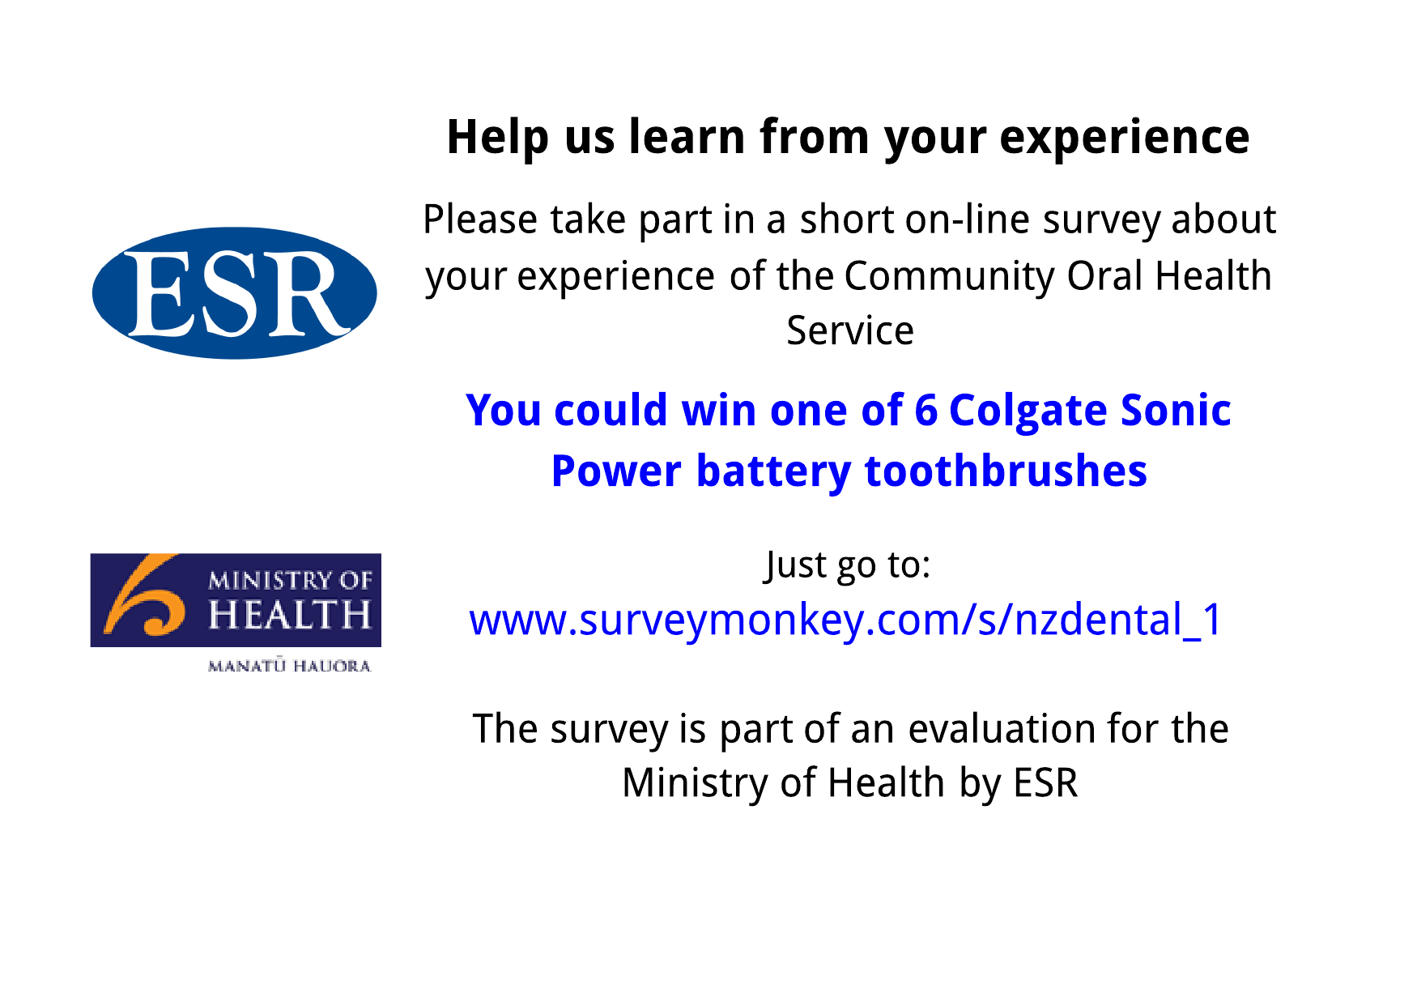

Appendix 5: Self-evaluation tool

The self-evaluation tool aims to assist with the on-going implementation of the reoriented model of care by:
- Developing a shared understanding about reorientation purposes.
- Taking stock of where the reorientation stands vis á vis intended outcomes as well as strengths, weaknesses, opportunities and threats.
- Planning improvements to the way in which oral health services are delivered either locally (for specific mobiles or clinics) or regionally (as a COHS).
- Enhancing the evaluation capacity of the COHSs.

The intended users of the self evaluation tool are the clinical governance teams in partnership with clinical staff and service users and the tool could be used as part of a regular clinical governance meeting, a special meeting with key people invited, as a response to an opportunity, threat or crisis or as some combination of the above.

The self-evaluation tool is set out in Figure A5.1, and centres around two inter-related phases: ‘diagnosis’ and ‘planning for improvement’. Figure 1 gives the impression of a linear approach to self-evaluation, but in practice there is considerable overlap and iteration between phases, as is usual with quality improvement approaches.

Figure A5.1: The self-evaluation tool

Diagnosis Phase

The reoriented model of care is characterised by five ‘impact areas’:
- Improved and equitable access to and uptake of care.
- Focus on family/whanau.
- Effective utilisation of people and plant.
- Improved prevention and early detection.
- Increased standardisation of clinical care.

The diagnosis phase uses a structured method to assess ‘what is working, what isn’t and why’ in relation to at least one of the five ‘impact areas’. For each selected ‘impact area’, key questions are asked at the level of service delivery, shared information, resourcing, monitoring context and policy understandings (Table A5.1). Shared sense-making drawing data about clinical practices, patient satisfaction and oral health outcomes as well as clinical staff reflections/experiences enables identification of what aspects of the service are working well and what are the key areas for improvement.

Table A5.1: Diagnosis
Level [for selected impact area] | Key question
Service delivery | How well is local practice contributing to towards [selected impact area]?  What is working well? What can be improved?
Shared information | How is information and insights shared between mobiles/fixed clinics, oral health service providers and with related health services?
Resourcing | How are critical decisions about resourcing the service made, and by whom?  What is working well? What can be improved?
Monitoring context | How are we monitoring and adapting to changes in our operating environment that could impact on [selected impact area?]  What is working well? What can be improved?
Policy understanding | How are the desired outcomes and overall model of care refined, articulated and understood?  What is working well? What can be improved?

Planning for Improvement Phase

The outputs of the Diagnosis Phase are reviewed especially the accumulated list of improvements. Taking at least one area for improvement, a modified ‘Action Planning’ cycle provides an approach to develop, prioritise and evaluate specific actions that enhance outcomes. The approach is set out in Figure A5.2.
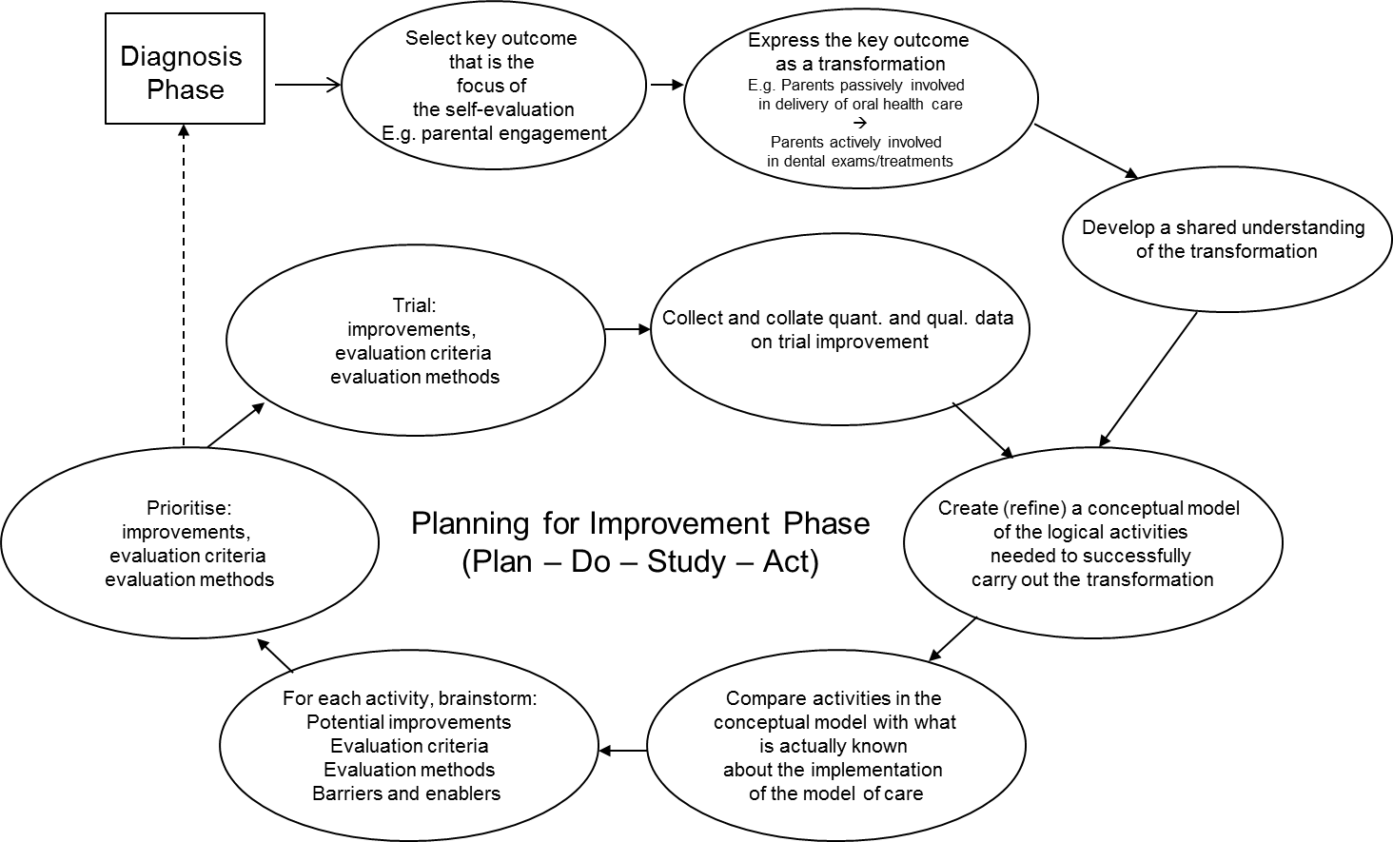

Figure A5.2: Planning for Improvement Phase

Following the logic of Figure A5.2, the area for improvement (outcome) is expressed as a transformation, which “change some defined input into some defined output” (Checkland, 2000, p. 74). For example, debate and dialogue resulting from the diagnosis phase identifies parental engagement as a key improvement area. This might be expressed as the following transformation:

From: Parents passively involved in the delivery of oral health care

To: Parents actively involved in dental examinations/treatments

To help build a shared understanding about what the transformation might mean, the following questions might be asked:
- Who is needed to make the transformation happen?
- What are the givens in our operating environment that could affect the change?
- What do we need to believe or depend on for this transformation to make sense?

Taking the example from above, possible answers in turn to these questions include:
- Child, parents/caregivers, dental therapists and dental assistants.
- Parental time, attitudes and priorities.
- “It’s what happens in the home that really counts”.

A conceptual model is created of the activities that are logically required to produce the transformation. These are brainstormed, expressed with verbs up-front, and placed in relation to one another so the systemic relationships between activities and the outcomes sort can be understood. Heavily borrowing from Rollnick et al. (1999) the following conceptual model of the activities involved in parental engagement was developed and presented in Figure A5.3.

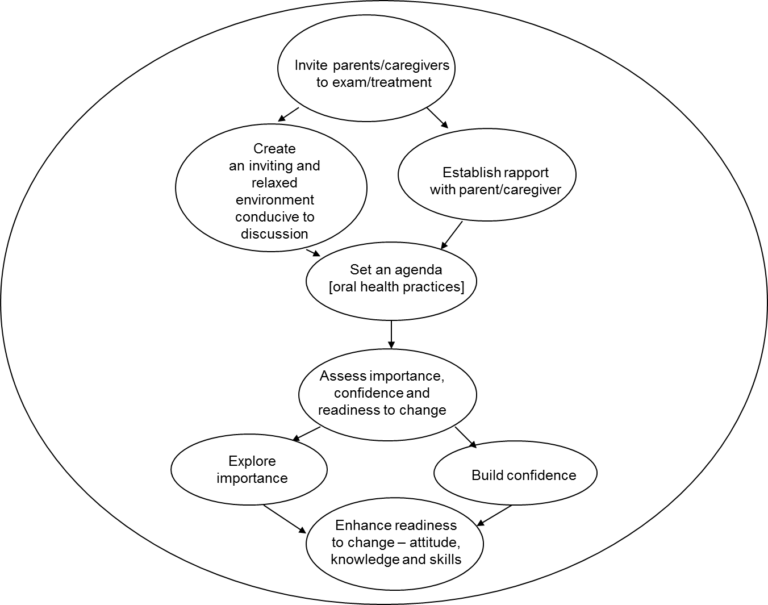

Figure A5.3: Conceptual model of parental engagement

For each activity in the conceptual model the following questions were asked in order to consider what specific improvements might be undertaken (these are potential improvements until they have been prioritised) and how these would be evaluated to establish whether the change was in fact an improvement:
- Is the activity being done?
- If not, should the activity be done?
- If yes, how well is the activity been done? By who?
- How do we know if the activity is being done well?
- What are the possible improvements to the activity?

Potential improvements along with associated evaluation criteria and methods are prioritised and trialled according to “Plan-Do-Study-Act” logic. A number of iterations including refining the conceptual model and reconsidering potential improvements, evaluation criteria and methods might be required before outcomes are achieved. Alternatively, the understanding gained from the Planning for Improvement Phase might be feedback into the Diagnosis Phase to triage another area for improvement.

The Government allocated $116 million capital funding and an additional $31.3 million per annum ongoing for operating expenses.
This figure excludes transportable dental units which are similar to stand alone community clinics and are in operation in regions including Auckland. A level 1 mobile unit provides diagnostic services only while a Level 2 mobile unit provides both diagnostic and treatment services as per a stand-alone community clinic.
The ‘Lift the Lip’ assessment is a technique used by primary care clinicians such as Well Child /Tamariki Ora providers to assess whether infants and/or toddlers have dental caries. At risk preschoolers can then be referred to Community Oral Health Services for treatment and health promotion (Ministry of Health, 2008).
Chronic conditions are the leading cause of ill-health and early death in New Zealand (Ministry of Health, 2008), disproportionately affect Māori (Ministry of Health, 2002), account for over 70% of health system costs (Ministry of Health, 2009) and are population health priorities (Ministry of Health, 2000).
The evaluation has been complemented by research examining the determinants of complex change in service systems including the institutional, organizational, professional and individual factors underpinning health service transformation (e.g., Foote and Nicholas, 2013; Foote et al., 2013). The research findings identifying success factors underpinning the reorientation and whether these can be applied to other health service improvement projects will be reported in early 2015.
These included the various reviews undertaken that have informed the development of the reinvestment programme including the Improving Child Oral Health and Reducing Child Oral Health Inequalities (Public Health Advisory Committee, 2003), Māori Child Oral Health Review (Mauri Ora Associates, 2004), National School Dental Service Review (DHBNZ, 2006), and Evaluation of Māori Oral Health Providers (Wehipeihana et al., 2011).
A total of five key individuals with in-depth knowledge and experience of the reinvestment programme including the business case process were interviewed. The interviews lasted between 60 to 90 minutes, were audio recorded and transcribed for thematic analysis.
These included Southland, Nelson-Marlborough, Waikato and Counties-Manukau DHBs.
The clinical teams included dental therapists, dental assistants and community dentists.
http://surveymonkey.com
The ‘hub and spoke’ model involves oral health services being delivered from a mixture of stand alone community-based clinics and mobile units in outreach locations including schools with health promotion services.
Rollnick, S., Mason, P., and Butler, C Health behaviour change: a guide for practitioners, Churchhill Livingstone, Edinburgh, 1999.

