Demographic Report on Clients Allocated the Ministry of Health’s Disability Support Services
as at September 2016
Citation: Ministry of Health. 2017. Demographic Report on Clients Allocated the
Ministry of Health’s Disability Support Services: As at September 2016.
Wellington: Ministry of Health.
Published in July 2017
by the Ministry of Health
PO Box 5013, Wellington 6140, New Zealand
ISBN 978-1-98-850246-5 (online)
HP 6590
This document is available at health.govt.nz


 This work is licensed under the Creative Commons Attribution 4.0 International licence. In essence, you are free to: share ie, copy and redistribute the material in any medium or format; adapt ie, remix, transform and build upon the material. You must give appropriate credit, provide a link to the licence and indicate if changes were made.
Contents
Executive summary xii
Introduction xii
Overall Client demographics xii
Disability support services xiii
Disability types xvi
Trends xvi
Introduction 1
Purpose 1
Audience 1
Scope 1
Exclusions 2
Terminology 2
Methodology 3
Demographic data 3
Statistics New Zealand census data 3
DSS Clients compared with the New Zealand population 4
Age and sex 4
Observations 5
Ethnicity 5
Disability services 7
Types of disability support services 7
Overall Client demographics 8
Age and sex 8
Ethnicity 10
Ethnicity−age profiles 11
Marital status 13
Accommodation 14
Location 15
Principal disabilities 16
Support package allocation 18
Needs assessment service coordination organisations (NASCs) 20
Client demographics, by service 22
Home and community support 22
Carer support 29
Community residential services 36
YPD – younger people in aged care 43
Supported living 49
Respite 57
Behaviour support 63
Day services 69
High and Complex (H&C) Framework 75
Choices in Community Living 79
Enabling Good Lives 84
Individualised Funding 88
Enhanced individualised funding 95
Funded family care 100
Equipment and modification services 106
Client demographics, by disability 109
Intellectual disability 109
Physical disability 111
Autism spectrum disorder 112
Sensory disability 113
Neurological disability 114
Service usage, by ethnicity 115
Service usage, by region 118
Northland 118
Auckland 121
Waikato 124
Bay of Plenty 127
Hawke’s Bay 130
Gisborne 133
Taranaki 136
Manawatu–Wanganui 139
Wellington 142
Tasman 145
Nelson 148
Marlborough 151
West Coast 154
Canterbury 156
Otago 159
Southland 162
Appendices 165

Tables
Table 1: Ethnicity of DSS Clients compared with the New Zealand population aged 0−79 years 5
Table 2: Client numbers per service type* 7
Table 3: DSS Clients, by age and sex, September 2016 8
Table 4: DSS Clients, by age and ethnicity 10
Table 5: DSS Clients, by marital status and sex 13
Table 6: DSS Clients, by accommodation type and sex 14
Table 7: DSS Clients, by ethnicity and regional council 15
Table 8: DSS Clients, by sex and class of principal disability* 16
Table 9: DSS Clients, by SPA level and age 18
Table 10: DSS Clients, by NASC 20
Table 11: HCSS Clients, by age and sex 22
Table 12: HCSS Clients, by age and ethnicity 24
Table 13: HCSS Clients, by marital status and sex 25
Table 14: HCSS Clients, by sex and accommodation type 25
Table 15: HCSS Clients, by region and ethnicity 26
Table 16: HCSS Clients, by principal disability type and sex* 27
Table 17: HCSS Clients, by SPA level and sex 28
Table 18: Carer support Clients, by age and sex 29
Table 19: Carer support Clients, by age and ethnicity 31
Table 20: Carer support Clients, by sex and accommodation type 32
Table 21: Carer support Clients, by region and ethnicity 33
Table 22: Carer support Clients, by sex and principal disability* 34
Table 23: Carer support Clients, by SPA level and sex 35
Table 24: Community residential services Clients, by age and sex 36
Table 25: Community residential services Clients, by ethnicity and age 38
Table 26: Community residential services Clients, by region and ethnicity 39
Table 27: Community residential services Clients, by principal disability and sex* 40
Table 28: Community residential services Clients, by SPA level and sex 41
Table 29: YPD Clients, by age and sex 43
Table 30: YPD Clients, by age and ethnicity 44
Table 31: YPD Clients, by sex and marital status 45
Table 32: YPD Clients, by ethnicity and region 46
Table 33: YPD Clients, by sex and disability type* 47
Table 34: YPD Clients, by SPA level and sex 47
Table 35: Clients using supported living services, by age and sex 49
Table 36: Clients using supported living services, by ethnicity and age 51
Table 37: Clients using supported living services, by marital status and sex 52
Table 38: Clients using supported living services, by accommodation type and sex 53
Table 39: Clients using supported living services, by ethnicity and region 54
Table 40: Clients using supported living services, by principal disability and sex* 55
Table 41: Clients using supported living services, by SPA level and sex 56
Table 42: Respite Clients, by age and sex 57
Table 43: Respite Clients, by age and ethnicity 58
Table 44: Respite Clients, by sex and accommodation type 59
Table 45: Respite Clients, by ethnicity and region 60
Table 46: Respite Clients, by sex and disability type* 61
Table 47: Respite Clients, by SPA level and sex 62
Table 48: Behaviour support services Clients, by age and sex 63
Table 49: Behaviour support services Clients, by age and ethnicity 64
Table 50: Behaviour support services Clients, by sex and accommodation type 65
Table 51: Behaviour support services Clients, by ethnicity and region 66
Table 52: Behaviour support services Clients, by sex and disability type* 67
Table 53: Behaviour support services Clients, by SPA level and sex 68
Table 54: Day services Clients, by age and sex 69
Table 55: Day services Clients, by age and ethnicity 70
Table 56: Day services Clients, by region 71
Table 57: Day services Clients, by principal disability 72
Table 58: Day services Clients, by SPA level 73
Table 59: H&C Clients using supported living services, by age and sex 75
Table 60: H&C Clients, by ethnicity and age 76
Table 61: H&C Clients, by ethnicity and region* 77
Table 62: Choices in Community Living Clients, by age and sex 79
Table 63: Choices in Community Living Clients, by ethnicity and age 80
Table 64: Choices in Community Living Clients, by ethnicity and region 81
Table 65: Choices in Community Living Clients, by principal disability 82
Table 66: Choices in Community Living Clients, by SPA level 82
Table 67: EGL Clients, by age and sex 84
Table 68: EGL Clients, by ethnicity and age 85
Table 69: EGL Clients, by principal disability 86
Table 70: EGL Clients, by SPA level and sex 87
Table 71: Individualised funding Clients, by age and sex 88
Table 72: Individualised funding Clients, by age and ethnicity 89
Table 73: Individualised funding Clients, by marital status 90
Table 74: Individualised funding Clients, by sex and accommodation type 91
Table 75: Individualised funding Clients, by ethnicity and region 92
Table 76: Individualised funding Clients, by sex and disability type* 93
Table 77: Individualised funding Clients, by SPA level and sex 94
Table 78: EIF Clients, by age and sex 95
Table 79: EIF Clients, by age and ethnicity 96
Table 80: EIF Clients, by sex and accommodation type 97
Table 81: EIF Clients, by sex and disability type* 97
Table 70: EIF Clients, by SPA level and sex 98
Table 83: Funded family care Clients, by age and sex 100
Table 84: Funded family care Clients, by age and ethnicity 101
Table 85: Funded family care Clients, by sex and accommodation type 102
Table 86: Funded family care Clients, by ethnicity and region 103
Table 87: Funded family care Clients, by sex and disability type* 104
Table 88: Funded family care Clients, by SPA level and sex 104
Table 89: EMS Clients, by age and provider 106
Table 90: EMS Clients, by ethnicity and provider 107
Table 91: EMS Clients, by age and application type 108
Table 92: DSS Clients with intellectual disability, by age and sex 109
Table 93: DSS Clients with physical disability, by age and sex 111
Table 94: DSS Clients with ASD, by age and sex 112
Table 95: Sensory disability Clients, by age and sex 113
Table 96: Clients with neurological disability, by age and sex 114
Table 97: Northland DSS Clients, by age and service allocated 118
Table 98: Auckland DSS Clients, by age and service allocated 121
Table 99: Waikato DSS Clients, by age and service allocated 124
Table 100: Bay of Plenty DSS Clients, by age and service allocated 127
Table 101: Hawke’s Bay DSS Clients, by age and service allocated 130
Table 102: Gisborne DSS Clients, by age and service allocated 133
Table 103: Taranaki DSS Clients, by age and service allocated 136
Table 104: Manawatu–Wanganui DSS Clients, by age and service allocated 139
Table 105: Wellington DSS Clients, by age and service allocated 142
Table 106: Tasman DSS Clients, by age and service allocated 145
Table 107: Nelson DSS Clients, by age and service allocated 148
Table 108: Marlborough DSS Clients, by age and service allocated 151
Table 109: West Coast DSS Clients, by age and service allocated 154
Table 110: Canterbury DSS Clients, by age and service allocated 156
Table 111: Otago DSS Clients, by age and service allocated 159
Table 112: Southland DSS Clients, by age and service allocated 162
Table A1: Principal disability types, by number of DSS Clients 168
Figures
Figure 1A: DSS Clients, by age and sex, 2016 4
Figure 1B: New Zealand population, by age and sex, 2013 census 4
Figure 2: Ethnicity of DSS Clients compared with the New Zealand population aged 0−79 years 5
Figure 3: DSS Clients, by age and sex, September 2016 9
Figure 4: DSS Clients, by main ethnic group 11
Figure 5: DSS Clients, by ethnicity and regional council 15
Figure 6: DSS Clients, by sex and type of principal disability 17
Figure 7: DSS Clients, by SPA level and age 18
Figure 8: DSS Clients, by NASC 21
Figure 9: HCSS Clients, by age and sex 23
Figure 10: HCSS Clients, by age and ethnicity 24
Figure 11: HCSS Clients, by region and ethnicity 26
Figure 12: HCSS Clients, by principal disability type and sex 27
Figure 13: HCSS Clients, by SPA level and sex 28
Figure 14: Carer support Clients, by age and sex 30
Figure 15: Carer support Clients, by age and ethnicity 31
Figure 16: Carer support Clients, by region and ethnicity 33
Figure 17: Carer support Clients, by sex and principal disability 34
Figure 18: Carer support Clients, by SPA level and sex 35
Figure 19: Community residential services Clients, by age and sex 37
Figure 20: Community residential services Clients, by ethnicity and age 38
Figure 21: Community residential services Clients, by region and ethnicity 40
Figure 22: Community residential services Clients, by principal disability and sex 41
Figure 23: Community residential services Clients, by SPA level and sex 42
Figure 24: YPD Clients, by age and sex 43
Figure 25: YPD Clients, by age and ethnicity 44
Figure 26: YPD Clients, by ethnicity and region 46
Figure 27: YPD Clients, by sex and disability type 47
Figure 28: YPD Clients, by SPA level and sex 48
Figure 29: Clients using supported living services, by age and sex 50
Figure 30: Clients using supported living services, by ethnicity and age group 51
Figure 31: Clients using supported living services, by ethnicity and region 54
Figure 32: Clients using supported living services, by principal disability and sex 55
Figure 33: Clients using supported living services, by SPA level and sex 56
Figure 34: Respite Clients, by age and sex 57
Figure 35: Respite Clients, by age and ethnicity 59
Figure 36: Respite Clients, by ethnicity and region 60
Figure 37: Respite Clients, by sex and disability type 61
Figure 38: Respite Clients, by SPA level and sex 62
Figure 39: Behaviour support services Clients, by age and sex 63
Figure 40: Behaviour support services Clients, by age and ethnicity 64
Figure 41: Behaviour support services Clients, by ethnicity and region 66
Figure 42: Behaviour support services Clients, by sex and disability type 67
Figure 43: Behaviour support services Clients, by SPA level and sex 68
Figure 44: Day services Clients, by age and sex 70
Figure 45: Day services Clients, by age and ethnicity 71
Figure 46: Day services Clients, by region 72
Figure 47: Day services Clients, by principal disability 73
Figure 48: Day services Clients, by SPA level 74
Figure 49: H&C Clients using supported living services, by age and sex 75
Figure 50: Average number of H&C Clients per annum, 2013–2016 76
Figure 51: H&C Clients, by ethnicity and age group 77
Figure 52: H&C Clients, by ethnicity and region 78
Figure 53: Choices in Community Living Clients, by age and sex 79
Figure 54: Choices in Community Living Clients, by ethnicity and age group 80
Figure 55: Choices in Community Living Clients, by ethnicity and region 81
Figure 56: Choices in Community Living Clients, by principal disability 82
Figure 57: Choices in Community Living Clients, by SPA level 83
Figure 58: EGL Clients, by age and sex 84
Figure 59: EGL Clients, by ethnicity and age group 85
Figure 60: EGL Clients, by principal disability 86
Figure 61: EGL Clients, by SPA level and sex 87
Figure 62: Individualised funding Clients, by age and sex 88
Figure 63: Individualised funding Clients, by age and ethnicity 90
Figure 64: Individualised funding Clients, by ethnicity and region 92
Figure 65: Individualised funding Clients, by sex and disability type 93
Figure 66: Individualised funding Clients, by SPA level and sex 94
Figure 67: EIF Clients, by age and sex 95
Figure 68: EIF Clients, by age and ethnicity 96
Figure 69: EIF Clients, by sex and disability type 98
Figure 70: EIF Clients, by SPA level and sex 98
Figure 71: Funded family care Clients, by age and sex 100
Figure 72: Funded family care Clients, by age and ethnicity 101
Figure 73: Funded family care Clients, by ethnicity and region 103
Figure 74: Funded family care Clients, by sex and disability type 104
Figure 75: Funded family care Clients, by SPA level and sex 105
Figure 76: EMS Clients, by age and provider 106
Figure 77: EMS Clients, by ethnicity and provider 107
Figure 78: EMS Clients, by age and application type 108
Figure 79: DSS Clients with intellectual disability, by age and sex 110
Figure 80: DSS Clients with physical disability, by age and sex 111
Figure 81: DSS Clients with ASD, by age and sex 112
Figure 82: Sensory disability Clients, by age and sex 113
Figure 83: Clients with neurological disability, by age and sex 114
Figure 84: Overall service usage, by ethnicity 115
Figure 85: Service usage by Clients of European/Other ethnicity 115
Figure 86: Service usage by Clients of Māori ethnicity 116
Figure 87: Service usage by Clients of Pacific ethnicity 116
Figure 88: Service usage by Clients of Asian ethnicity 117
Figure 89: Northland DSS Clients, by age and service allocated 119
Figure 90: Northland DSS Clients, by ethnicity and service allocated 119
Figure 91: Northland DSS Clients, by age and disability type 120
Figure 92: Auckland DSS Clients, by age and service allocated 122
Figure 93: Auckland DSS Clients, by ethnicity and service allocated 122
Figure 94: Auckland DSS Clients, by age and disability type 123
Figure 95: Waikato DSS Clients, by age and service allocated 125
Figure 96: Waikato DSS Clients, by ethnicity and service allocated 125
Figure 97: Waikato DSS Clients, by age and disability type 126
Figure 98: Bay of Plenty DSS Clients, by age and service allocated 128
Figure 99: Bay of Plenty DSS Clients, by ethnicity and service allocated 128
Figure 100: Bay of Plenty DSS Clients, by age and disability type 129
Figure 101: Hawke’s Bay DSS Clients, by age and service allocated 131
Figure 102: Hawke’s Bay DSS Clients, by ethnicity and service allocated 131
Figure 103: Hawke’s Bay DSS Clients, by age and disability type 132
Figure 104: Gisborne DSS Clients, by age and service allocated 134
Figure 105: Gisborne DSS Clients, by ethnicity and service allocated 134
Figure 106: Gisborne DSS Clients, by age and disability type 135
Figure 107: Taranaki DSS Clients, by age and service allocated 137
Figure 108: Taranaki DSS Clients, by ethnicity and service allocated 137
Figure 109: Taranaki DSS Clients, by age and disability type 138
Figure 110: Manawatu–Wanganui DSS Clients, by age and service allocated 140
Figure 111: Manawatu–Wanganui DSS Clients, by ethnicity and service allocated 140
Figure 112: Manawatu–Wanganui DSS Clients, by age and disability type 141
Figure 113: Wellington DSS Clients, by age and service allocated 143
Figure 114: Wellington DSS Clients, by ethnicity and service allocated 143
Figure 115: Wellington DSS Clients, by age and disability type 144
Figure 116: Tasman DSS Clients, by age and service allocated 146
Figure 117: Tasman DSS Clients, by ethnicity and service allocated 146
Figure 118: Tasman DSS Clients, by age and disability type 147
Figure 119: Nelson DSS Clients, by age and service allocated 149
Figure 120: Nelson DSS Clients, by ethnicity and service allocated 149
Figure 121: Nelson DSS Clients, by age and disability type 150
Figure 122: Marlborough DSS Clients, by age and service allocated 152
Figure 123: Marlborough DSS Clients, by ethnicity and service allocated 152
Figure 124: Marlborough DSS Clients, by age and disability type 153
Figure 125: West Coast DSS Clients, by age and service allocated 154
Figure 126: West Coast DSS Clients, by ethnicity and service allocated 155
Figure 127: West Coast DSS Clients, by age and disability type 155
Figure 128: Canterbury DSS Clients, by age and service allocated 157
Figure 129: Canterbury DSS Clients, by ethnicity and service allocated 157
Figure 130: Canterbury DSS Clients, by age and disability type 158
Figure 131: Otago DSS Clients, by age and service allocated 160
Figure 132: Otago DSS Clients, by ethnicity and service allocated 160
Figure 133: Otago DSS Clients, by age and disability type 161
Figure 134: Southland DSS Clients, by age and service allocated 163
Figure 135: Southland DSS Clients, by ethnicity and service allocated 163
Figure 136: Southland DSS Clients, by age and disability type 164

Executive summary

Introduction
The purpose of this report is to provide demographic information about the disabled people allocated the majority of disability support services funded by the Ministry of Health’s Disability Support Services (DSS). The report excludes information about disabled people allocated the following services: child development, and hospital-based assessment, treatment and rehabilitation.

It is important to note that the report is based on information about services allocated to people by the needs assessment and service coordination (NASC) organisations. It does not report on services used.

Overall Client demographics
- In September 2016 there were 33,804 disabled people allocated one or more Ministry-funded disability support services.
- (In addition there were 63,856 disabled people allocated equipment and modification services [EMS]. It is important to note that Client data for EMS are obtained from the two providers of these services and do not include the level of detail available from the Ministry’s Socrates information system. For this reason, overall Client demographics referred to in this report exclude EMS Clients.)
- More males (58%) than females (42%) are allocated disability support services. Males dominate the age groups from 5 to 29 years.
- The median age of DSS Clients is 28 years.
- The ethnicity of Clients allocated disability support services is: 67% European/Other, 17.5% Māori, 6% Pacific and 6% Asian, with 4% of unknown ethnicity. European/Other and Pacific people are slightly under-represented when compared with the total New Zealand population; Māori are slightly over-represented, while Asian people are significantly under-represented.
- Among Asian Clients, 65% are male.
- Males make up 57% of Clients with intellectual disabilities, while females make up 58% of Clients with physical disabilities. Males (81%) dominate the Clients with autism spectrum disorder (ASD).
- Almost half (48%) of DSS Clients live in their own home or their family home.
- Over half (53%) of DSS Clients reside in the three most populated regions, which include the major cities of Auckland, Christchurch and Hamilton.
- Half of all DSS Clients have an intellectual disability as their principal disability. Many of these Clients may also have a physical disability.
- One-quarter of DSS Clients have a physical disability as their principal disability.
- One-fifth of DSS Clients have ASD as their principal disability.
- Only 5% of DSS Clients have a sensory (hearing or sight) or neurological disability.

Disability support services

Home and community support
- The median age of Clients is 44 years.
- People with physical disabilities make up almost half (48%) of the Clients allocated home and community support.
- Just over half (52%) of Clients are male.
- While Pacific and Asian ethnicities are well represented among Clients of home and community support, European/Other people are slightly over-represented and Māori are slightly under-represented.

Carer support
- The median age of Clients is 15 years.
- People with intellectual disabilities make up 45% of the Clients whose carers receive carer support.
- Carer support is used predominantly for male Clients (64%) and for Clients under 20 years (66%).
- Clients of Māori, Pacific and Asian ethnicities are over-represented among those allocated carer support, while European/Other Clients are under-represented.

Community residential services
- The median age of Clients is 48 years.
- There are more males (57%) than females allocated residential services.
- Clients of residential services are predominantly European/Other (77%) and Māori (15%). People of Pacific and Asian ethnicities are under-represented.
- People with intellectual disabilities account for 83% of the Clients allocated residential services.

YPD – younger people (i.e. aged under 65 years) in aged care
- The median age of Clients is 61 years, with only 12% of this group aged under 50 years.
- People with physical disabilities make up 67% of YPD Clients.
- Disabled people living in aged care services are predominantly European/Other (75%) and Māori (13%). Pacific (5%) and Asian (3%) ethnicities are under-represented.

Supported living
- The median age of Clients is 42 years, and 55% are male.
- People with intellectual disabilities make up 68% of the Clients using supported living.
- People using supported living services are predominantly European/Other (77%) and Māori (15%). People of Pacific and Asian ethnicities are under-represented.

Respite
- The median age of Clients is 18 years.
- Almost two-thirds (62%) of Clients allocated respite services are male.
- Māori represent 18%, Pacific people 7% and Asian people 10% of the Clients allocated respite.
- Almost half (44%) of respite Clients are on Very High support packages.

Behaviour support services
- The median age of Clients is 12 years.
- Almost three-quarters (72%) of Clients allocated behaviour support services are male.
- European/Other ethnicities (63%) are under-represented, while Māori (19%), Pacific (7%) and Asian (7%) ethnicities are marginally over-represented.
- Over half (54%) of behaviour support services Clients have an intellectual disability, while 40% have ASD.

Clients under the High and Complex (H&C) Framework
- The median age of Clients is 31 years.
- The majority (86%) of H&C Clients are male.
- European/Other ethnicities (43%) are under-represented, while disabled people of Māori ethnicity (43%) are significantly over-represented. Pacific people (8%) in H&C services are marginally over-represented, while Asian people (1%) are significantly under-represented.

Choices in Community Living
- The median age of Clients is 37 years, and 52% are male.
- European/Other ethnicities (73%) are over-represented, while Māori (14%), Pacific people (3%) and Asian people (5%) are under-represented.
- Almost three-quarters (71%) of Choices in Community Living Clients have an intellectual disability, 22% have a physical disability, and 4% have ASD.

Day services
- The median age of Clients is 50 years.
- DSS only funds day services for Clients who:
- were once living in institutions such as Tokanui and Kimberley, and/or
- are currently using H&C services allocated by the National Intellectual Disability Care Agency.
- There are more male day services Clients (58%) than female (42%).
- The majority of day services Clients are aged between 40 and 65 years.
- European/Other people (72%) are over-represented among day services Clients.
- The majority (89%) of Clients using day services have intellectual disabilities.

Enabling Good Lives (Christchurch demonstration only)
- The median age of Clients is 22 years.
- Over half (55%) of Clients using Enabling Good Lives services are male.
- European/Other (79%) and Asian (8%) ethnicities are over-represented, while Māori (11%) and Pacific (1%) ethnicities are under-represented.
- Over half (59%) of Enabling Good Lives Clients have an intellectual disability, 18% have a physical disability, 13% have a sensory disability and 9% have ASD.

Individualised Funding
- The median age of Clients is 21 years.
- Over half (55%) of Clients allocated Individualised Funding are male.
- European/Other (67%) and Pacific (7%) ethnicities are well represented, while Māori (16%) are under-represented and Asian (7%) disabled people are over-represented.
- Of Individualised Funding Clients, 39% have an intellectual disability, 37% have a physical disability and 17% have ASD.

Enhanced Individualised Funding (Bay of Plenty only)
- The median age of Clients is 19 years.
- Over half (52%) of Clients allocated Enhanced Individualised Funding are male.
- European/Other (70%) and Māori (28%) ethnicities are over-represented, while Pacific (0%) and Asian (2%) disabled people are under-represented.
- Less than half (46%) of Enhanced Individualised Funding Clients have an intellectual disability, while 26% have a physical disability and 20% have ASD.

Funded Family Care
- The median age of Clients is 26 years.
- Over half (59%) of Clients allocated Funded Family Care are male.
- European/Other people (61%) are under-represented, Māori (17%) and Asian people (6%) are well represented, while Pacific (15%) Clients are significantly over-represented.
- Half (50%) of Funded Family Care Clients have an intellectual disability, while 39% have a physical disability and 9% have ASD.

Equipment and modification services
- Almost three-quarters (74%) of EMS Clients are aged 65 years and over.
- European/Other (83%) are over-represented (compared with the New Zealand total population), while Māori (9%), Pacific (5%) and Asian (3) ethnicities are significantly under-represented.
- Over half of approved EMS applications are for equipment for daily living, while 37% are for mobility and positioning.

Disability types

Intellectual disabilities
- The median age is 28 years.
- Clients whose primary disability is an intellectual disability make up almost half of all DSS Clients. Many of them also have a physical disability.
- There are significantly more males (57%) with an intellectual disability allocated disability support services than females.
- There are two peaks in the age group profiles for both sexes: 5−25 years and 45−59 years.

Physical disabilities
- The median age is 54 years.
- Clients whose primary disability is a physical disability make up a quarter of all DSS Clients.
- Females make up 58% of Clients with a physical disability.

Autism spectrum disorder
- The median age is 12 years.
- Clients with ASD are predominantly male (81%).

Sensory disabilities
- The median age is 42 years.
- Males (49%) and females (51%) are evenly represented in this group.

Neurological disabilities
- The median age is 55 years.
- Almost two-thirds (62%) of Clients are aged over 50 years.
- Males (51%) and females (49%) are evenly represented in this group.

Trends
- The number of Clients allocated disability support services increased by 8.7% between September 2013 and September 2016.
- Over the September 2013 to September 2016 period the following changes occurred in the ethnicities of Clients allocated disability support services:
- European/Other: 6% increase to 22,579 clients
- Māori: 18% increase to 5920 clients
- Pacific people: 13% increase to 2084 clients
- Asian Clients: 34% increase to 1913 clients.
- Over the September 2013 to September 2016 period the following changes occurred in the numbers of Clients allocated the following services:
- supported living: 23% increase to 3438 Clients
- community residential services: 1% increase to 6557 Clients
- carer support: 15% increase to 18,331 Clients
- respite: 82% increase to 2977 Clients.
- Over the September 2013 to September 2016 period the following changes occurred in the numbers of Clients with the following principal disability types:
- intellectual disability: 17% increase to 16,839 Clients
- physical disability: 3% increase to 8519 Clients
- ASD: 35% increase to 6620 clients
- sensory disability: 3% decrease to 1066 Clients
- neurological disability: 39% decrease to 581 Clients.
- There was little change in the location of DSS Clients from 2013 to 2016.
- Over the September 2013 to September 2016 period the following changes occurred in the numbers of Clients with the following Support Package Allocations:
- Very High: 18% increase
- High: 15% increase
- Medium: 0.3% decrease
- Low: 18% decrease.

Introduction

Purpose
The purpose of this report is to inform decision-making on the planning and procurement of disability support services in both the New Zealand Ministry of Health (the Ministry) and the wider disability sector. This is the third demographic report, and it provides demographic information about the disabled people and their families/whānau who were allocated services funded by Disability Support Services (DSS) of the Ministry of Health in September 2016. It also provides a comparison with the previous reports describing client demographics in 2013 and 2014 to identify the extent of any changes.

Audience
The principal intended audience of this report is the staff and managers of DSS who are involved in developing and implementing strategic and annual plans for the procurement of services.

It will also be of use to providers of disability support services as they plan future service delivery options, and to disabled people’s organisations, disabled people using funded disability support services, and their families, whānau, aiga or carers.

Scope
The report provides demographic information obtained from the Ministry’s Socrates database collected by needs assessment service coordination (NASC) organisations from the disabled people who have been allocated Ministry-funded disability support services. This report includes demographic information on clients allocated to 16 different service types, compared with only six service types in the 2014 report.

The information relates to people who were allocated the following disability support services in September 2016:
- home and community support
- carer support
- community residential services
- Choices in Community Living
- younger people in aged care services
- supported living
- respite
- behaviour support services
- day services
- community therapy services
- Enabling Good Lives
- individualised funding
- enhanced individualised funding
- regional intellectual disability supported accommodation services
- funded family care
- equipment and modification services.

The demographic information presented relates to:
- age
- sex
- ethnicity
- marital status
- type of accommodation
- regional location within New Zealand
- type of disability
- support package allocation (SPA).

Exclusions
This report excludes people allocated the following Ministry-funded services:
- child development
- assessment, treatment and rehabilitation.

It is important to note that the report is based on information about services allocated to people by the NASC organisations. It is not based on services used.

Terminology
Throughout this report we have used the capitalised noun ‘Client’ to refer to a person with a disability who is allocated a service funded by DSS.

Methodology
This report analyses data on people who were allocated Ministry-funded disability support services in September 2016.

Demographic data
The data presented in this report were derived from the Ministry’s Socrates database in an extract provided by the Contract and Information Support team within the Service Excellence Directorate of the Ministry.

The Socrates database is a Ministry of Health information system consisting of a database and computer application for managing the delivery of services to DSS Clients. The extract used for this report contained one record for each Client for each service allocated to that Client. This means that the demographic data for any client accessing multiple services appears more than once; that is, in each service-related table.

Socrates includes records of all Clients who have ever been assessed by NASC for eligibility to access Ministry-funded disability support services. There are 15 NASCs across New Zealand.

With regard to a Client’s ethnicity, each Client is allocated to a single ethnic group using the Ministry’s priority system. The aim of prioritisation is to ensure that where some need exists to assign people to a single ethnic group, ethnic groups of policy importance, or of small size, are not swamped by the NZ European ethnic group.

Note: many tables do not total 100% due to rounding.

Statistics New Zealand census data
The majority of comparisons with the New Zealand population made in the report use the 2013 New Zealand census data.

DSS Clients compared with the New Zealand population
There are notable differences between the age and sex demographics of DSS Clients compared with the overall New Zealand population, using the 2013 census data.

Age and sex
Figure 1A: DSS Clients, by age and sex, 2016
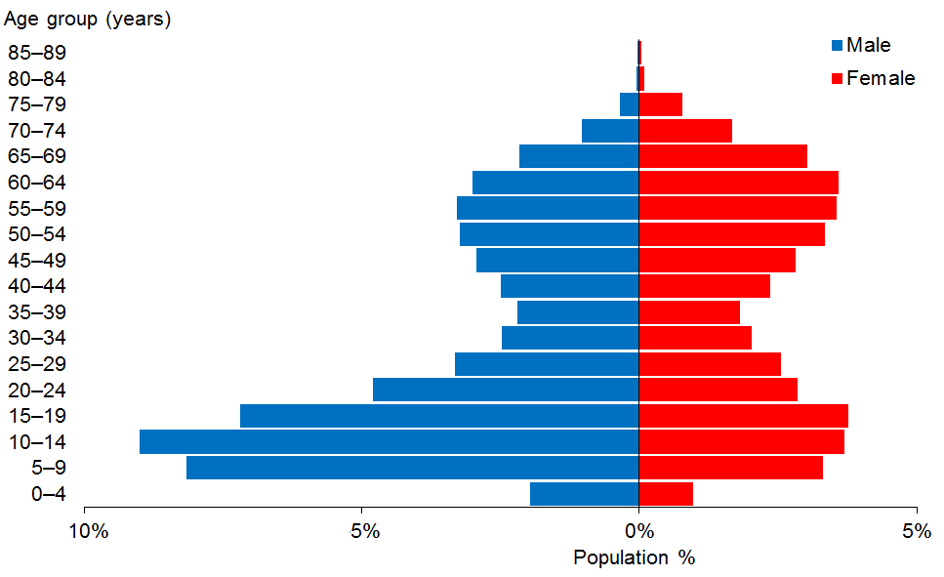

Figure 1B: New Zealand population, by age and sex, 2013 census
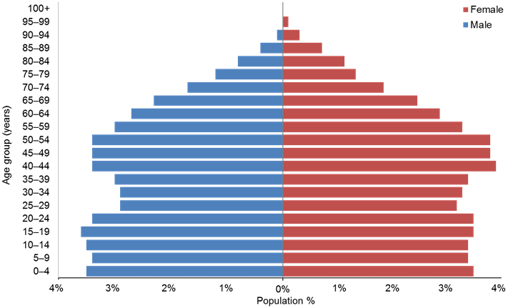

Observations
- DSS Clients are markedly more concentrated in the 5–19 and 45–65 years age groups, with males predominant in the younger age groups and females slightly more predominant in the older age groups.
- Generally, eligibility for DSS services is for people aged under 65, hence the lower numbers of people in the over-65 age groups compared with the general population. As at September 2016 there were 3121 (9.2%) DSS Clients aged 65+ years (compared with 14% aged 65+ years in the total New Zealand population).

Ethnicity
A comparison between DSS Clients’ ethnicities in 2016 and the 2013 census ethnicity statistics for people aged 0−79 years is set out below.

Table 1: Ethnicity of DSS Clients compared with the New Zealand population aged
0−79 years
Ethnicity | DSS 2016 | Census 2013 | DSS 2016 | Census 2013
European/Other | 22,579 | 2,945,220 | 66.8% | 72.1%
Māori | 5920 | 594,135 | 17.5% | 14.5%
Pacific | 2084 | 293,814 | 6.2% | 7.2%
Asian | 1913 | 467,769 | 5.7% | 11.4%
Not stated | 1308 | 212,253 | 3.8% | 5.2%
Total | 33,804 | 4,087,707* | 100.0% | 110.4%**
* This total is less than the sum of the figures because some people identify as having more than one ethnicity.
** Some people identify as having more than one ethnicity.

Figure 2: Ethnicity of DSS Clients compared with the New Zealand population aged
0−79 years
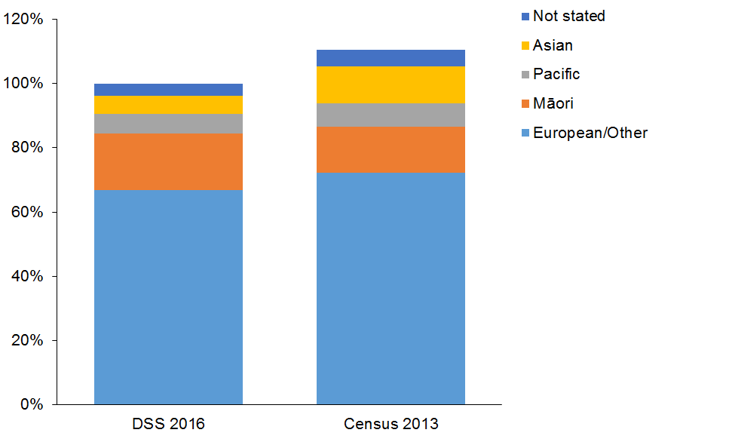

Observations
- The European/Other and Pacific ethnicities are slightly under-represented in the DSS Client group.
- The Asian ethnicity is significantly under-represented in DSS services.
- Māori are somewhat over-represented in the DSS Client group. This may be because the age-adjusted disability rate among Māori is higher than for the total population (32% for Māori compared with 24% for the total population).
- Since 2013 there has been an 18% increase (905) in the number of Māori being allocated disability support services, a 13% increase (239) in the number of Pacific clients, and a 34% increase (484) in Asian clients.

Caveat: care is needed when making inferences from comparisons between DSS and New Zealand-wide numbers because DSS ethnicities are ‘prioritised’, and this will tend to exaggerate the proportion of Māori and Pacific people over Asian, European and Other people.

Disability services

Types of disability support services
The numbers of Clients using different services are set out in Table 2.
Table 2: Client numbers per service type*
Service group description | Clients | Group total
Equipment and modifications | 81,957** | 81,957**
Carer support | 18,331 | 18,331
Home and community support, including people using individualised funding for this | 12,177 | 12,177
Community residential | 6557 | 7296
Residential: aged care facilities, rest homes and hospitals | 739 | 7296
Supported living | 3438 | 3438
Respite, including in-home support, facility-based respite (including people using individualised funding for this) | 2977 | 2977
Behaviour support | 2460 | 2460
Day services | 1765 | 1765
Enhanced individualised funding | 406 | 406
High and Complex (NIDSS/RIDSS/RIDSAS) | 244 | 244
Enabling Good Lives | 166 | 166
Choices in Community Living | 161 | 161
Community rehabilitation | 89 | 89
* Clients are counted more than once if they are allocated to more than one service type.
** Data source: six-monthly reports from Accessable and Enable NZ for the period 1 July 2015 to 30 June 2016.

Observations
- The numbers of Clients using carer support has increased by 15% since 2013.
- Residential client numbers have remained steady over the past three years.
- An additional 641 people are using supported living services, an increase of 23% since 2013.
- A significant increase (1340) in the number of respite clients has occurred since 2013, representing a growth of 82%.
- There are 535 fewer day services clients than there were in 2013, representing a 23% decrease.

Overall Client demographics
This section shows the demographic details of all the Clients allocated services from DSS service providers. The total number of Clients as at September 2016 was 33,804.

Age and sex
Table 3: DSS Clients, by age and sex, September 2016
Age group | Female | Male | Total
0−4 | 330 | 665 | 995
5−9 | 1,117 | 2,762 | 3,879
10−14 | 1,250 | 3,045 | 4,295
15−19 | 1,275 | 2,432 | 3,707
20−24 | 963 | 1,623 | 2,586
25−29 | 861 | 1,126 | 1,987
30−34 | 687 | 836 | 1,523
35−39 | 610 | 745 | 1,355
40−44 | 800 | 844 | 1,644
45−49 | 952 | 991 | 1,943
50−54 | 1,128 | 1,097 | 2,225
55−59 | 1,202 | 1,113 | 2,315
60−64 | 1,214 | 1,015 | 2,229
65−69 | 1,021 | 729 | 1,750
70−74 | 568 | 349 | 917
75−79 | 259 | 120 | 379
80−84 | 29 | 19 | 48
85−89 | 15 | 12 | 27
Total | 14,281 | 19,523 | 33,804
 | 42% | 58% | 100%

Observations
- The total number of individuals allocated disability support services has increased by 8% (from 31,101) since 2013 and by 5% since 2014.
- The median age was 28 years in 2016. This represents a significant drop from the median age of 31 years in 2014. This drop is due to the increasing numbers of Māori, Pacific and Asian clients, who are predominantly young.
- The number and percentage of people aged over 65 has almost doubled since 2013, when 7.6% (2377) of clients were aged over 65. In 2016, 15.8% (5350) of clients were aged over 65.

Figure 3: DSS Clients, by age and sex, September 2016

Observations
- There are significantly more males (58%) than females (42%) using DSS services. The preponderance of males has increased since 2013, when the proportions of males and females were 56% and 44%, respectively.
- There are two high points in the age profiles of DSS Clients: one in the child and teenage years and the second in the 50–69 years age groups. This is predominantly due to the large number of carers needing carer support during these years.
- Males dominate the age groups from 0 to 25 years, and females are significantly more numerous than males in the 65+ years age groups.

Ethnicity
Table 4: DSS Clients, by age and ethnicity
Age | European / Other | Māori | Pacific | Asian | Not stated | Total
0−4 | 474 | 191 | 81 | 132 | 117 | 995
5−9 | 2,012 | 840 | 309 | 370 | 348 | 3,879
10−14 | 2,662 | 839 | 274 | 322 | 198 | 4,295
15−19 | 2,318 | 735 | 258 | 303 | 93 | 3,707
20−24 | 1,675 | 501 | 200 | 186 | 24 | 2,586
25−29 | 1,304 | 349 | 153 | 138 | 43 | 1,987
30−34 | 1,021 | 266 | 121 | 83 | 32 | 1,523
35−39 | 963 | 245 | 72 | 54 | 21 | 1,355
40−44 | 1,182 | 267 | 99 | 39 | 57 | 1,644
45−49 | 1,420 | 320 | 90 | 49 | 64 | 1,943
50−54 | 1,641 | 359 | 103 | 61 | 61 | 2,225
55−59 | 1,716 | 377 | 98 | 57 | 67 | 2,315
60−64 | 1,679 | 322 | 99 | 54 | 75 | 2,229
65−69 | 1,398 | 192 | 71 | 34 | 55 | 1,750
70−74 | 728 | 86 | 40 | 21 | 42 | 917
75−79 | 319 | 26 | 16 | 10 | 8 | 379
80−84 | 43 | 4 |  |  | 1 | 48
85−89 | 24 | 1 |  |  | 2 | 27
Total | 22,579 | 5,920 | 2,084 | 1,913 | 1,308 | 33,804
 | 66.8% | 17.5% | 6.2% | 5.7% | 3.9% | 100%

Observations
- There have been some changes in the ethnicity profile of DSS clients since 2013, including:
- a reduction in the proportion of European/Other Clients, from 69% to 67% (despite a 5% increase in Client numbers)
- an increase in Māori Clients, from 16.2% to 17.5% (an 18% increase)
- an increase in Pasifika Clients, from 5.9% to 6.2% (a 13% increase)
- an increase in Asian Clients, from 4.6% to 5.7% (a 34% increase).

Ethnicity−age profiles
There are distinct differences in the age profiles of the four main ethnic groups.

Figure 4: DSS Clients, by main ethnic group
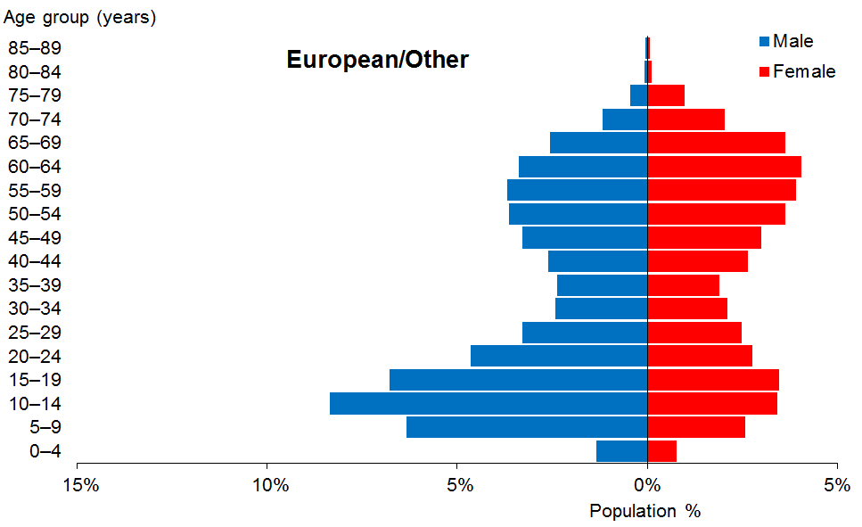

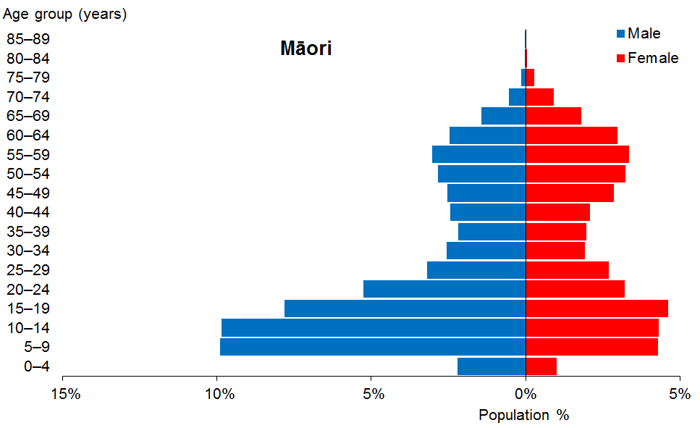

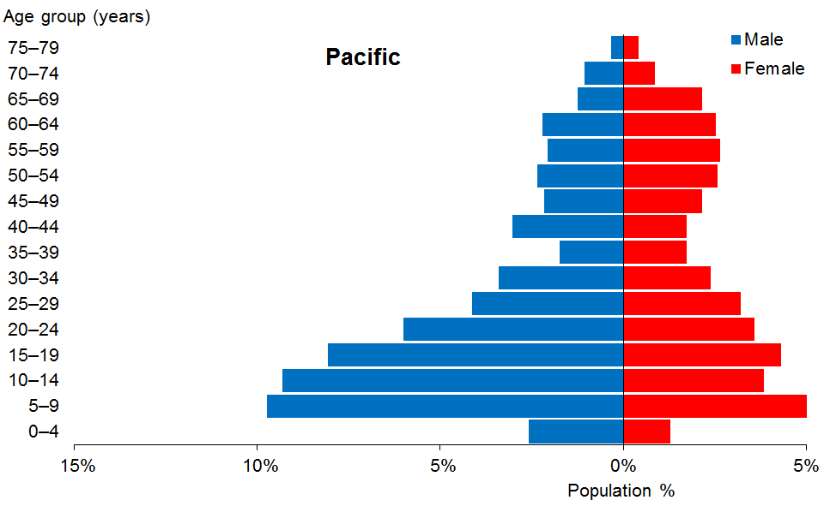

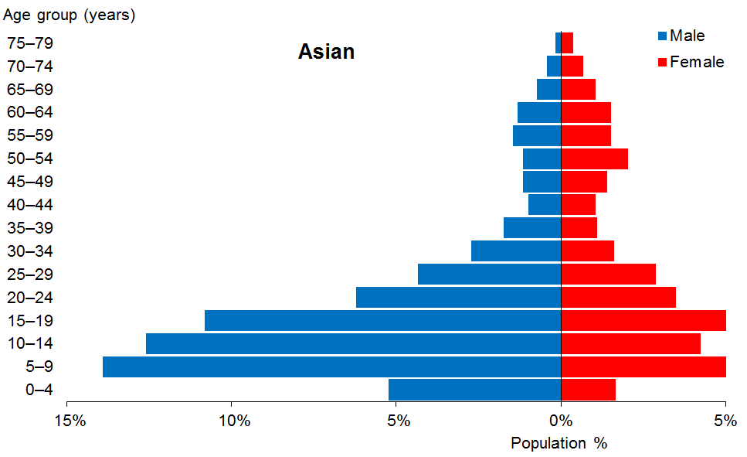

Observations
- Young people of both sexes are over-represented among the Māori, the Pacific and especially the Asian Clients, particularly young males. The median age of each ethnicity group is:
- European/Other: 34 years
- Māori: 23 years
- Pacific: 22 years
- Asian: 17 years.
- Asian people are particularly under-represented in the older age groups.

Marital status
Table 5: DSS Clients, by marital status and sex
Marital status | Male | Female | Total
Non-partnered, not further defined | 3,424 | 2,516 | 5,940
Non-partnered, never married | 1,706 | 1,035 | 2,741
Married (not separated), not further defined | 447 | 785 | 1,232
Not stated | 337 | 256 | 593
Non-partnered, divorced | 103 | 196 | 299
Partnered, not further defined | 122 | 158 | 280
Non-partnered, separated | 100 | 153 | 253
Non-partnered, widowed | 36 | 175 | 211
First marriage (not separated) | 17 | 24 | 41
Don’t know | 19 | 20 | 39
Response outside scope | 18 | 10 | 28
Opposite-sex partnership | 6 | 8 | 14
Remarried (not separated) | 4 | 9 | 13
Same-sex partnership | 1 | 3 | 4
Blank | 13,183 | 8,933 | 22,116
Total | 19,523 | 14,281 | 33,804

Observations
- Marital status is not recorded for 65% of DSS Clients.
- Of DSS Clients for whom data are recorded, 80% do not have partners. This pattern has not changed since 2013.

Accommodation
Table 6: DSS Clients, by accommodation type and sex
Accommodation | Male | Female | Total
Own / family home | 9,504 | 6,645 | 16,149
Community residential home | 3,488 | 2,444 | 5,932
Rental accommodation | 2,900 | 2,208 | 5,108
Unknown | 1,627 | 1,163 | 2,790
Housing New Zealand accommodation | 942 | 842 | 1,784
Other | 489 | 414 | 903
Rest home / continuing care hospital | 263 | 312 | 575
Boarder | 175 | 138 | 313
Council accommodation | 107 | 78 | 185
Unit in a retirement village | 11 | 26 | 37
No fixed abode | 15 | 2 | 17
Unit in a retirement village − licence to occupy | 2 | 9 | 11
Total | 19,523 | 14,281 | 33,804

Observations
- Almost half of DSS Clients (47.7%) live in their own or their family home, and over half (59%) of these are male.
- A small proportion (5%) of DSS Clients live in Housing NZ accommodation.
- The accommodation profiles for male and female DSS Clients are generally similar.

Location
Table 7: DSS Clients, by ethnicity and regional council
Regional council | European/Other | Māori | Pacific | Asian | Not stated | Total | %
Auckland | 5,295 | 1,439 | 1,553 | 1,287 | 701 | 10,275 | 30
Canterbury | 3,695 | 424 | 74 | 156 | 183 | 4,532 | 13
Waikato | 2,119 | 812 | 68 | 108 | 126 | 3,233 | 10
Wellington | 2,215 | 452 | 221 | 154 | 109 | 3,151 | 9
Bay of Plenty | 1,505 | 719 | 25 | 44 | 14 | 2,307 | 7
Manawatu–Wanganui | 1,596 | 391 | 38 | 48 | 36 | 2,109 | 6
Otago | 1,585 | 129 | 25 | 27 | 65 | 1,831 | 5
Northland | 754 | 633 | 20 | 24 | 2 | 1,433 | 4
Hawke’s Bay | 819 | 292 | 29 | 25 | 24 | 1,189 | 4
Taranaki | 800 | 195 | 7 | 14 | 19 | 1,035 | 3
Southland | 728 | 73 | 8 | 6 | 14 | 829 | 2
Nelson | 494 | 59 | 6 | 12 | 1 | 572 | 2
Marlborough | 310 | 54 | 1 | 4 | 1 | 370 | 1
Tasman | 328 | 31 | 2 | 3 |  | 364 | 1
Gisborne | 137 | 198 | 6 | 1 |  | 342 | 1
West Coast | 199 | 19 | 1 |  | 13 | 232 | 1
Total | 22,579 | 5,920 | 2,084 | 1913 | 1,308 | 33,804

Figure 5: DSS Clients, by ethnicity and regional council
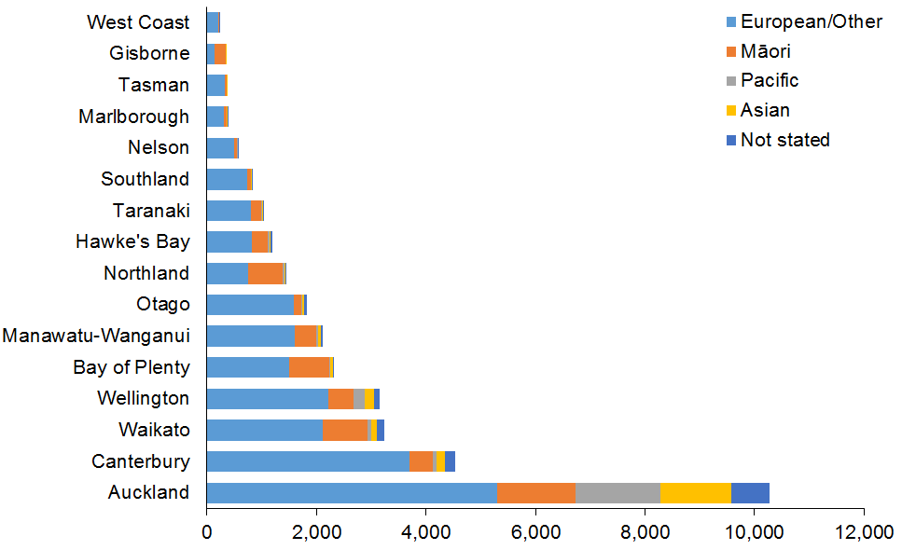

Observations
- Half of DSS Clients reside in the three most populated regions, which include the major cities of Auckland, Christchurch and Hamilton.
- Almost three-quarters (74%) of Pacific Clients reside in the Auckland region.
- Two-thirds (67%) of Asian Clients reside in the Auckland region.
- The Auckland region has the greatest variation of ethnicities:
- 15% Pacific
- 14% Māori
- 13% Asian.
- The regions with the largest proportions of Māori clients are:
- Gisborne (58%)
- Northland (44%)
- Bay of Plenty (31%)
- Waikato (25%).

Principal disabilities
Each DSS Client is recorded in Socrates with a principal disability. Appendix 1 lists the disabilities included within each disability type. Some Clients have multiple disability types, one of which will be designated as the primary disability. Occasionally a Client will have two principal disabilities. Only the first principal disability is counted in the data presented in this report.

There are six disability classes: intellectual, physical, autism spectrum disorder (ASD), sensory, neurological and ‘Not DSS’ (eg, mental health, cancer, medical). Only the first five are reported on in this report.

Table 8: DSS Clients, by sex and class of principal disability*
Principal disability prioritised | Male | Female | Total | %
Intellectual | 9,680 | 7,159 | 16,839 | 49.8
Physical | 3,598 | 4,921 | 8,519 | 25.2
Autism spectrum disorder | 5,361 | 1,259 | 6,620 | 19.6
Sensory | 525 | 541 | 1,066 | 3.2
Neurological | 299 | 282 | 581 | 1.7
Other | 60 | 119 | 179 | 0.5
Total | 19,523 | 14,281 | 33,804 | 100
* Where a Client was recorded as having two principal disabilities, only the first one was used in this analysis.

Figure 6: DSS Clients, by sex and type of principal disability
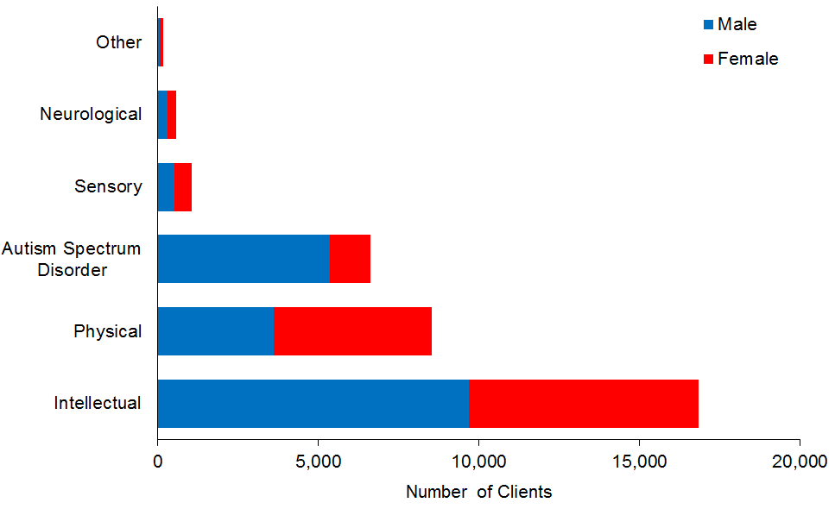

Observations
- Almost half (49.8%) of all DSS Clients have an intellectual disability as their primary disability. This proportion has increased from 46% in 2013. Many of these Clients also have a physical disability.
- The proportion of Clients with a physical disability has dropped to a quarter, from 31% in 2014.
- The proportion of Clients with ASD has increased from 16% in 2013 to almost one-fifth (19.6%) of the total Client group.
- Males are predominant in the groups of Clients with ASD (81%) and intellectual disabilities (57%). These proportions have remained the same over the past three years.
- Females (58%) are predominant in the group of Clients with physical disabilities.

Support package allocation
Each DSS Client has a support package allocation (SPA) determined by their NASC on the basis of a detailed needs assessment.

Table 9: DSS Clients, by SPA level and age
Age group | Very high | High | Medium | Low | Very low | Blank | Total
0−4 | 134 | 324 | 438 | 98 |  | 1 | 995
5−9 | 457 | 1,404 | 1,776 | 239 | 3 |  | 3,879
10−14 | 644 | 1,535 | 1,944 | 167 | 5 |  | 4,295
15−19 | 759 | 1,352 | 1,482 | 82 | 5 | 27 | 3,707
20−24 | 755 | 1,000 | 738 | 47 | 1 | 45 | 2,586
25−29 | 636 | 749 | 536 | 30 |  | 36 | 1,987
30−34 | 569 | 540 | 369 | 14 | 1 | 30 | 1,523
35−39 | 506 | 460 | 348 | 13 | 1 | 27 | 1,355
40−44 | 637 | 587 | 383 | 18 | 0 | 19 | 1,644
45−49 | 761 | 689 | 441 | 27 | 1 | 24 | 1,943
50−54 | 853 | 789 | 527 | 43 | 0 | 13 | 2,225
55−59 | 823 | 864 | 573 | 38 | 1 | 16 | 2,315
60−64 | 725 | 792 | 640 | 68 |  | 4 | 2,229
65−69 | 510 | 595 | 554 | 90 |  | 1 | 1,750
70−74 | 244 | 300 | 311 | 61 | 0 | 1 | 917
75−79 | 107 | 117 | 138 | 17 |  |  | 379
80−84 | 17 | 17 | 12 | 2 |  |  | 48
85−89 | 15 | 12 | 0 |  |  |  | 27
Total | 9,152 | 12,126 | 11,210 | 1,054 | 18 | 244 | 33,804
 | 27% | 36% | 33% | 3% | 0% | 1% | 100%

Figure 7: DSS Clients, by SPA level and age
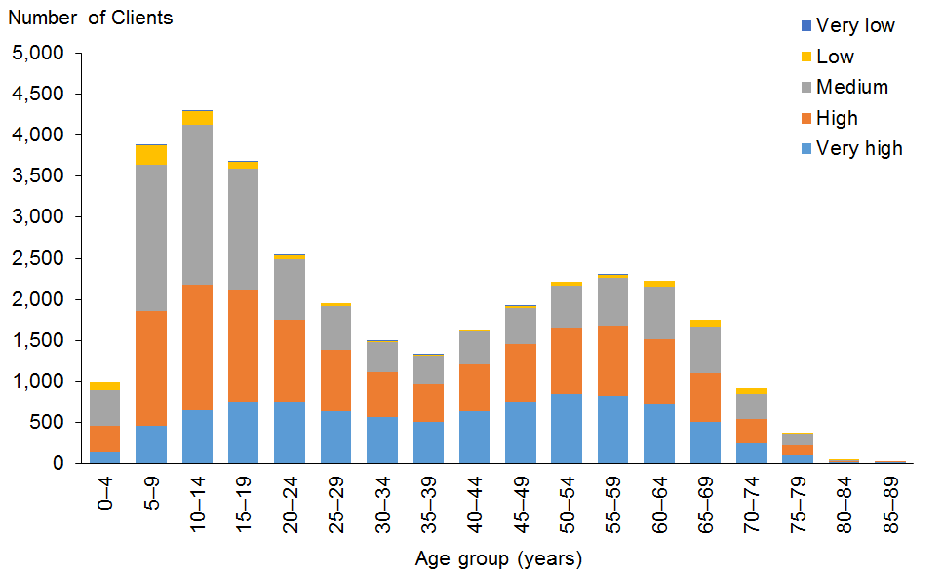

Observations
- The proportion of Clients on Very High SPA bands has increased since 2013, from 25% to 27%.
- The proportion of Clients on High SPA bands has increased since 2013, from 34% to 36%.
- The proportion of Clients on Medium SPA bands has decreased since 2013, from 36% to 33%.
- The proportion of Clients on Low SPA bands has decreased since 2013, from 4% to 3%.
- Older Clients tend to have higher SPAs.
- While 37% of Clients in their 50s have Very High SPAs, only 17% of Clients aged 10 to 19 have Very High SPAs.
- Over one-third (36%) of both of these age groups have High SPAs.
- Another 43% of Clients aged 10 to 19 have Medium SPAs, while only 24% of Clients in their 50s have Medium SPAs.

Needs assessment service coordination organisations (NASCs)
Table 10: DSS Clients, by NASC
NASC | Male | Female | Total | %
Taikura Trust − Auckland | 6,385 | 3,949 | 10,334 | 31
Life Links − Christchurch | 2,651 | 2,072 | 4,723 | 14
Disability Support Link − Waikato | 1,697 | 1,229 | 2,926 | 9
Access Ability − Otago | 1,442 | 1,202 | 2,644 | 8
Support Net Kupenga Hao Ite Ora Tauranga − Tauranga | 1,384 | 1,141 | 2,525 | 7
Enable New Zealand − Palmerston North | 848 | 725 | 1,573 | 5
Capital Support − Wellington | 905 | 637 | 1,542 | 5
NorthAble − Whangarei | 774 | 643 | 1,417 | 4
Support Works − Nelson | 690 | 612 | 1,302 | 4
Options – Hawke’s Bay | 677 | 511 | 1,188 | 4
L.I.F.E. Unlimited − Hutt Valley | 656 | 507 | 1,163 | 3
Access Ability Taranaki − New Plymouth | 564 | 470 | 1,034 | 3
Access Ability − Wanganui | 262 | 238 | 500 | 1
Focus − Masterton | 187 | 160 | 347 | 1
L.I.F.E. Unlimited Charitable Trust − Gisborne | 191 | 151 | 342 | 1
NASC Subtotal | 19,313 | 14,247 | 33,560
NIDCA Auckland | 71 | 10 | 81
NIDCA Central | 58 | 11 | 69
NIDCA South Island | 52 | 10 | 62
NIDCA Midland | 29 | 3 | 32
NIDCA Subtotal | 210 | 34 | 244
Grand total | 19,523 | 14,281 | 33,804
Note: National Intellectual Disability Care Agencies (NIDCAs) provide needs assessment and service coordination for Clients under the High and Complex (H&C) framework, including those under the Intellectual Disability Compulsory Care and Rehabilitation Act.

Figure 8: DSS Clients, by NASC
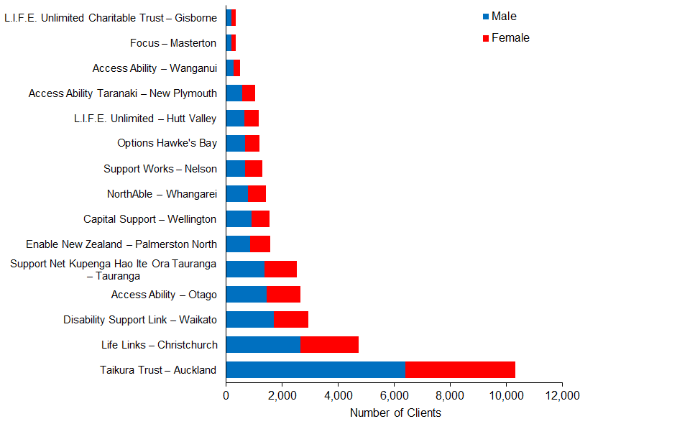

Observations
- Taikura Trust in Auckland has more than twice as many Clients as the second-largest NASC and works with 31% of DSS Clients.
- The proportions of Clients involved with each NASC have not substantially changed over the past three years.

Client demographics, by service

Home and community support
This subsection provides demographic profiles for the 12,177 DSS Clients who are receiving home and community support services (HCSS). These services include personal care and/or household management carried out in the Client’s home.

Age and sex
Table 11: HCSS Clients, by age and sex
Age group | Male | Female | Total
0−4 | 107 | 62 | 169
5−9 | 418 | 220 | 638
10−14 | 672 | 378 | 1,050
15−19 | 735 | 447 | 1,182
20−24 | 582 | 399 | 981
25−29 | 356 | 308 | 664
30−34 | 241 | 258 | 499
35−39 | 210 | 216 | 426
40−44 | 250 | 336 | 586
45−49 | 307 | 426 | 733
50−54 | 379 | 537 | 916
55−59 | 458 | 649 | 1,107
60−64 | 494 | 766 | 1,260
65−69 | 393 | 716 | 1,109
70−74 | 179 | 409 | 588
75−79 | 58 | 191 | 249
80−84 | 4 | 10 | 14
85−89 | 2 | 4 | 6
Total | 5,845 | 6,332 | 12,177
 | 48% | 52%

Figure 9: HCSS Clients, by age and sex
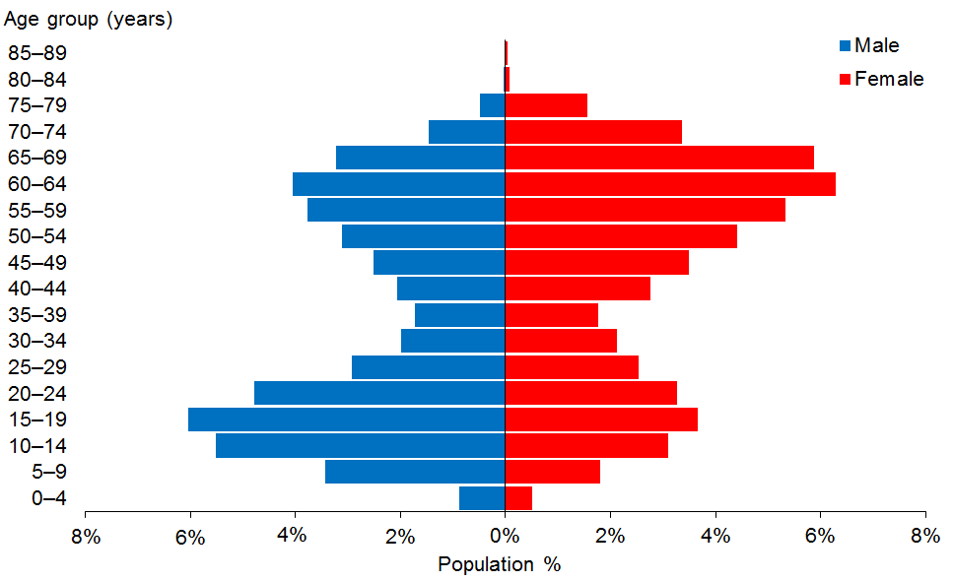

Observations
- The median age is 44 years. This is two years younger than in 2014.
- There are more female than male HCSS Clients in the older age groups, while the younger age groups are predominantly male. This may be an age at which young males are less willing to have their parents provide their personal care.

Ethnicity
Table 12: HCSS Clients, by age and ethnicity
Age group | European/  Other | Māori | Pacific | Asian | Not stated | Total
0−4 | 81 | 30 | 14 | 15 | 29 | 169
5−9 | 361 | 123 | 53 | 65 | 36 | 638
10−14 | 666 | 180 | 72 | 93 | 39 | 1,050
15−19 | 725 | 216 | 92 | 122 | 27 | 1,182
20−24 | 633 | 182 | 69 | 85 | 12 | 981
25−29 | 433 | 107 | 53 | 58 | 13 | 664
30−34 | 318 | 82 | 50 | 38 | 11 | 499
35−39 | 305 | 74 | 23 | 17 | 7 | 426
40−44 | 407 | 89 | 42 | 25 | 23 | 586
45−49 | 521 | 125 | 39 | 30 | 18 | 733
50−54 | 641 | 163 | 56 | 34 | 22 | 916
55−59 | 782 | 198 | 61 | 41 | 25 | 1,107
60−64 | 937 | 177 | 63 | 39 | 44 | 1,260
65−69 | 893 | 117 | 42 | 24 | 33 | 1,109
70−74 | 457 | 63 | 28 | 16 | 24 | 588
75−79 | 203 | 17 | 13 | 9 | 7 | 249
80−84 | 14 |  |  |  |  | 14
85−89 | 6 |  |  |  |  | 6
Total | 8,383 | 1,943 | 770 | 711 | 370 | 12,177
 | 69% | 16% | 6% | 6% | 3%

Figure 10: HCSS Clients, by age and ethnicity
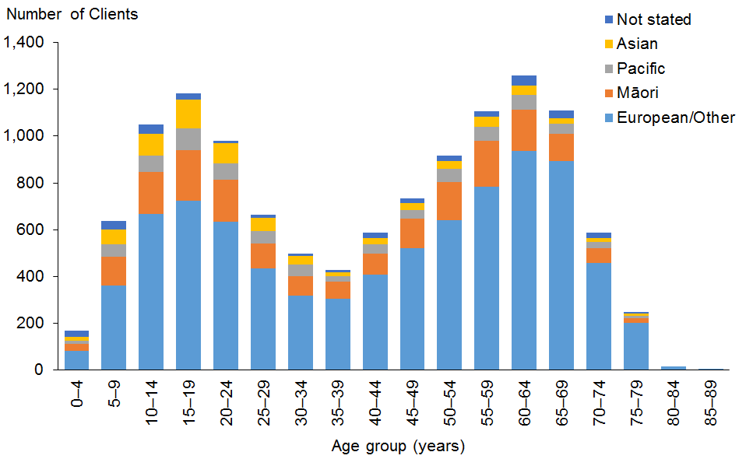

Observations
- The ethnicity of HCSS Clients has remained similar over the past three years.

Marital status
Table 13: HCSS Clients, by marital status and sex
Marital status | Male | Female | Total
Non-partnered, not further defined | 1,155 | 1,079 | 2,234
Non-partnered, never married | 542 | 379 | 921
Married (not separated), not further defined | 303 | 611 | 914
Not stated | 126 | 145 | 271
Non-partnered, divorced | 78 | 159 | 237
Non-partnered, separated | 83 | 112 | 195
Non-partnered, widowed | 27 | 152 | 179
Partnered, not further defined | 70 | 104 | 174
First marriage (not separated) | 13 | 16 | 29
Don’t know | 12 | 13 | 25
Remarried (not separated) | 3 | 9 | 12
Response outside scope | 5 | 4 | 9
Opposite-sex partnership | 3 | 4 | 7
Blank | 3,425 | 3,545 | 6,970
Total | 5,845 | 6,332 | 12,177

Observations
- Of the Clients with marital status recorded, 72% were not in any form of partnership or marriage. There has been no change since the 2014 report.

Accommodation
Table 14: HCSS Clients, by sex and accommodation type
Accommodation | Male | Female | Total
Own / family home | 3,206 | 3,509 | 6,715
Rental accommodation | 1,006 | 1,603 | 2,069
Unknown | 520 | 629 | 1,149
Housing New Zealand accommodation | 481 | 562 | 1,043
Community residential home | 321 | 227 | 548
Other | 158 | 194 | 352
Council accommodation | 72 | 56 | 128
Boarder | 43 | 40 | 83
Rest home / continuing care hospital | 25 | 24 | 49
Unit in a retirement village | 9 | 23 | 32
Unit in a retirement village − licence to occupy | 1 | 5 | 6
No fixed abode | 3 |  | 3
Total | 5,845 | 6,332 | 12,177

Observation
- Of the HCSS Clients whose accommodation type was recorded, the majority (55%) lived in their own home or their family home (a drop from 65% in 2013).

Location
Table 15: HCSS Clients, by region and ethnicity
Region | European /Other | Māori | Pacific | Asian | Not stated | Total | %
Auckland | 1,924 | 463 | 578 | 497 | 162 | 3,624 | 30
Canterbury | 1,330 | 145 | 23 | 48 | 65 | 1,611 | 13
Wellington | 822 | 146 | 75 | 64 | 43 | 1,150 | 9
Waikato | 608 | 198 | 24 | 26 | 28 | 884 | 7
Manawatu−Wanganui | 687 | 143 | 20 | 17 | 15 | 882 | 7
Otago | 661 | 34 | 13 | 8 | 18 | 734 | 6
Bay of Plenty | 444 | 226 | 8 | 17 | 7 | 702 | 6
Northland | 393 | 276 | 6 | 14 | 1 | 690 | 6
Taranaki | 357 | 86 | 6 | 5 | 9 | 463 | 4
Hawke’s Bay | 271 | 88 | 8 | 5 | 3 | 375 | 3
Southland | 325 | 27 | 3 | 2 | 8 | 365 | 3
Marlborough | 173 | 24 |  |  | 1 | 198 | 2
Nelson | 153 | 15 | 2 | 7 |  | 177 | 1
Tasman | 119 | 7 |  | 1 |  | 127 | 1
Gisborne | 50 | 61 | 3 |  |  | 114 | 1
West Coast | 66 | 4 | 1 |  | 10 | 81 | 1
Total | 8,383 | 1,943 | 770 | 711 | 370 | 12,177 | 100

Figure 11: HCSS Clients, by region and ethnicity
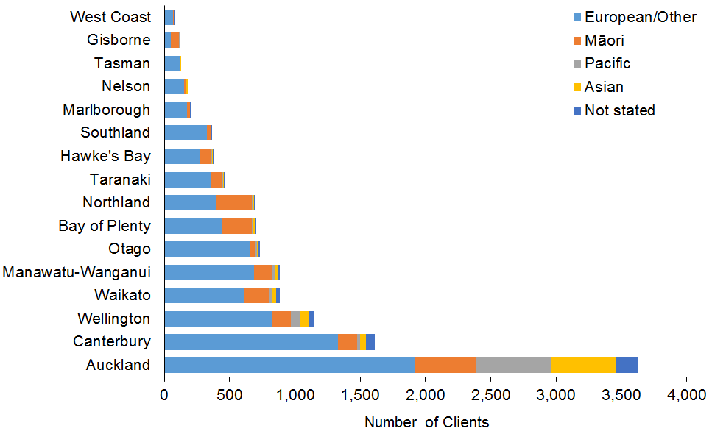

Observations
- Almost one-third (31%) of HCSS Clients live in the Auckland region.
- The Auckland region has the largest ethnic diversity of HCSS Clients: 53% European/Other, 16% Pacific, 14% Asian and 13% Māori.

Principal disability
Table 16: HCSS Clients, by principal disability type and sex*
Principal disability | Male | Female | Total | %
Physical | 2,237 | 3,616 | 5,853 | 48
Intellectual | 2,306 | 1,877 | 4,183 | 34
Autism spectrum disorder | 869 | 248 | 1,117 | 9
Sensory | 263 | 314 | 577 | 5
Neurological | 147 | 179 | 326 | 3
Other | 23 | 98 | 121 | 1
Total | 5,845 | 6,332 | 12,177 | 100
* Where Clients recorded two principal disabilities, only the first one has been used in this report.

Figure 12: HCSS Clients, by principal disability type and sex
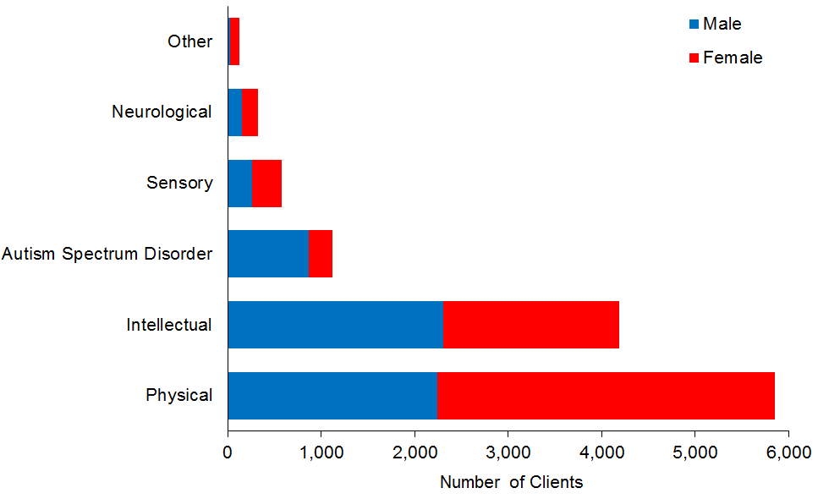

Observations
- Over the past two years the proportion of HCSS Clients with a physical disability as their primary disability has decreased (56% in 2014, 48% in 2016).
- Over the past two years the proportion of HCSS Clients with an intellectual disability as their primary disability has increased (30% in 2013, 34% in 2016).

Support package allocation
Table 17: HCSS Clients, by SPA level and sex
SPA level | Male | Female | Total | %
Low | 81 | 239 | 320 | 3
Medium | 1,298 | 2,105 | 3,403 | 28
High | 2,492 | 2,516 | 5,008 | 41
Very high | 1,974 | 1,472 | 3,446 | 28
Total | 5,845 | 6,332 | 12,177 | 100

Figure 13: HCSS Clients, by SPA level and sex
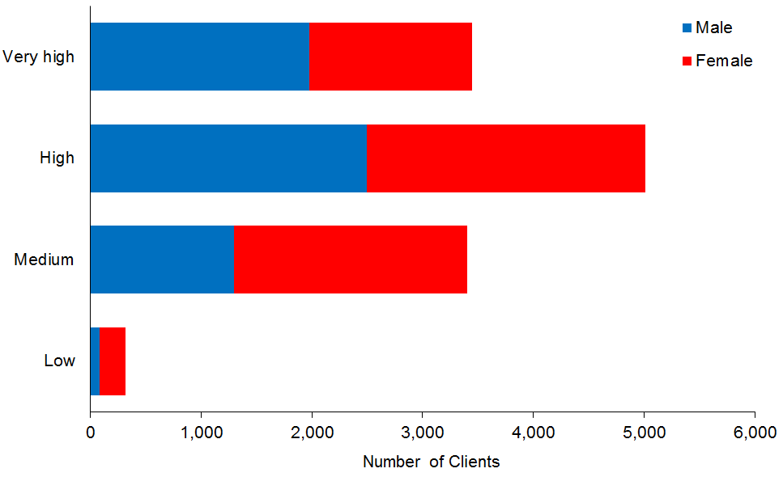

Observations
- Over the past three years there has been a slight increase in HCSS Clients with Very High SPAs (28%, up from 25% in 2013) and a slight decrease in HCSS Clients with High SPAs (41%, down from 43% in 2013).

Carer support
This subsection provides demographic profiles for the 18,331 DSS Clients whose carers were allocated the carer support subsidy of $76 per day in order to access a break from caring. The NASC allocates a number of days per year to each carer on the basis of need. Some of these Clients also appear in demographics for other services.

Age and sex
Table 18: Carer support Clients, by age and sex
Age group | Male | Female | Total
0−4 | 631 | 316 | 947
5−9 | 2,670 | 1,078 | 3,748
10−14 | 2,909 | 1,203 | 4,112
15−19 | 2,181 | 1,141 | 3,322
20−24 | 1,112 | 657 | 1,769
25−29 | 554 | 426 | 980
30−34 | 293 | 264 | 557
35−39 | 194 | 161 | 355
40−44 | 189 | 181 | 370
45−49 | 174 | 185 | 359
50−54 | 182 | 213 | 395
55−59 | 200 | 236 | 436
60−64 | 177 | 232 | 409
65−69 | 143 | 198 | 341
70−74 | 85 | 96 | 181
75−79 | 18 | 29 | 47
80−84 | 2 |  | 2
85−89 | 1 |  | 1
Total | 11,715 | 6,616 | 18,331
 | 64% | 36%

Figure 14: Carer support Clients, by age and sex
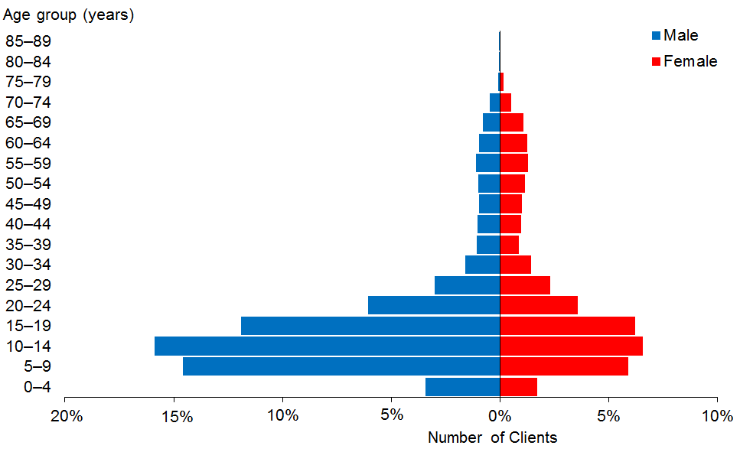

Observations
- The median age of carer support Clients is 15 years. There is no change from the 2014 report.
- Two-thirds (66%) of Clients whose carers are receiving carer support are aged under 20.

Ethnicity
Table 19: Carer support Clients, by age and ethnicity
Age group | European/Other | Māori | Pacific | Asian | Not stated | Total
0−4 | 452 | 182 | 75 | 127 | 111 | 947
5−9 | 1937 | 819 | 299 | 358 | 335 | 3,748
10−14 | 2548 | 799 | 266 | 310 | 189 | 4,112
15−19 | 2084 | 642 | 236 | 277 | 83 | 3,322
20−24 | 1124 | 340 | 151 | 140 | 14 | 1,769
25−29 | 579 | 186 | 105 | 97 | 13 | 980
30−34 | 342 | 102 | 68 | 35 | 10 | 557
35−39 | 226 | 74 | 30 | 22 | 3 | 355
40−44 | 235 | 67 | 44 | 15 | 9 | 370
45−49 | 229 | 68 | 36 | 18 | 8 | 359
50−54 | 249 | 76 | 37 | 23 | 10 | 395
55−59 | 269 | 91 | 40 | 23 | 13 | 436
60−64 | 264 | 65 | 49 | 17 | 14 | 409
65−69 | 223 | 51 | 38 | 18 | 11 | 341
70−74 | 108 | 29 | 28 | 8 | 8 | 181
75−79 | 26 | 7 | 11 | 3 |  | 47
80−84 | 2 |  |  |  |  | 2
85−89 | 1 |  |  |  |  | 1
Total | 10,898 | 3,598 | 1,513 | 1,491 | 831 | 18,331
 | 59% | 20% | 8% | 8% | 5%

Figure 15: Carer support Clients, by age and ethnicity
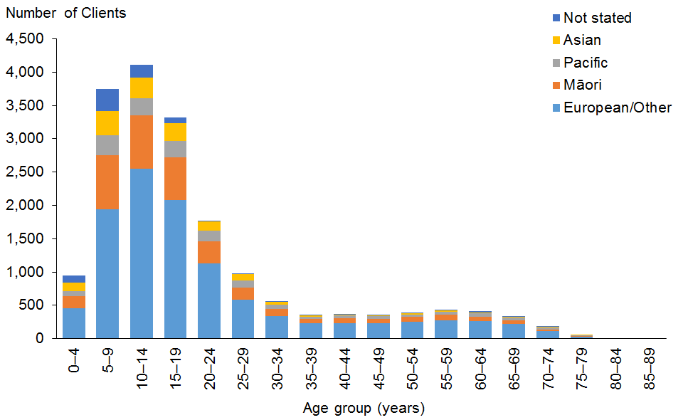

Observations
- Māori, Pacific and Asian Clients are over-represented among the DSS Clients using carer support.
- European/Other people (59%) are under-represented in carer support, compared with 69% in the DSS Client population.

Accommodation
Table 20: Carer support Clients, by sex and accommodation type
Accommodation type | Male | Female | Total
Own/family home | 7,705 | 4,401 | 12,106
Rental accommodation | 1892 | 1,009 | 2,901
Unknown | 1159 | 583 | 1,742
Housing New Zealand accommodation | 604 | 399 | 1,003
Other | 215 | 125 | 340
Community residential home | 71 | 47 | 118
Boarder | 42 | 40 | 82
Rest home / continuing care hospital | 12 | 7 | 19
No fixed abode | 8 | 1 | 9
Council accommodation | 4 | 2 | 6
Unit in a retirement village | 3 | 2 | 5
Total | 11,715 | 6,616 | 18,331

Observation
- Two-thirds (66%) of carer support Clients are living in their own homes and another 16% live in rental accommodation.

Marital status

Observations
- Only 13.5% of Clients for whom marital status was recorded were married or in a relationship.
- The remaining 86.5% were single, which reflects the general youthfulness of carer support clients.

Location
Table 21: Carer support Clients, by region and ethnicity
Region | European /Other | Māori | Pacific | Asian | Not stated | Total | %
Auckland | 2,970 | 900 | 1,178 | 1,046 | 598 | 6,692 | 37
Canterbury | 1,846 | 293 | 52 | 122 | 58 | 2,371 | 13
Waikato | 1,084 | 500 | 51 | 80 | 45 | 1,760 | 10
Wellington | 1,011 | 250 | 140 | 115 | 52 | 1,568 | 9
Bay of Plenty | 786 | 455 | 18 | 27 | 6 | 1,292 | 7
Manawatu−Wanganui | 613 | 210 | 18 | 37 | 10 | 888 | 5
Northland | 366 | 406 | 10 | 16 | 2 | 800 | 4
Otago | 651 | 66 | 14 | 14 | 30 | 775 | 4
Hawke’s Bay | 289 | 167 | 16 | 15 | 7 | 494 | 3
Taranaki | 347 | 108 | 4 | 9 | 10 | 478 | 3
Southland | 323 | 47 | 4 | 5 | 8 | 387 | 2
Tasman | 172 | 22 |  |  |  | 194 | 1
Marlborough | 144 | 30 |  | 2 |  | 176 | 1
Nelson | 134 | 27 | 4 | 2 |  | 167 | 1
Gisborne | 53 | 105 | 4 | 1 |  | 163 | 1
West Coast | 109 | 12 |  |  | 5 | 126 | 1
Total | 10,898 | 3,598 | 1,513 | 1,491 | 831 | 18,331 | 100

Figure 16: Carer support Clients, by region and ethnicity
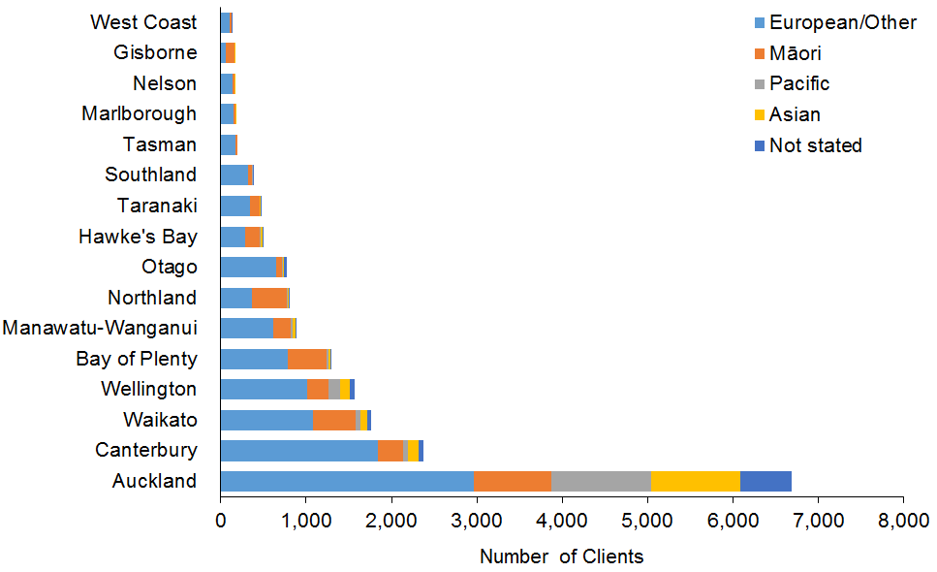

Observations
- Over one-third (37%) of carer support Clients live in the Auckland region.
- Since 2013 in the Auckland region, the proportion of European/Other carer support Clients has dropped from 47% to 44%, while the proportion of Asian Clients has increased from 13% to 16%. During the same period the proportion of Māori and Pacific Clients remained the same (13% and 17.5%, respectively).

Principal disability
Table 22: Carer support Clients, by sex and principal disability*
Principal disability | Male | Female | Total | %
Intellectual | 4,967 | 3,485 | 8,452 | 46
Autism spectrum disorder | 4,710 | 1,074 | 5,784 | 32
Physical | 1,642 | 1,709 | 3,351 | 18
Sensory | 263 | 235 | 498 | 3
Neurological | 104 | 89 | 193 | 1
Other | 29 | 24 | 53 | 0
Total | 11,715 | 6,616 | 18,331 | 100
* Where Clients recorded two principal disabilities, this research has used only the first one.

Figure 17: Carer support Clients, by sex and principal disability
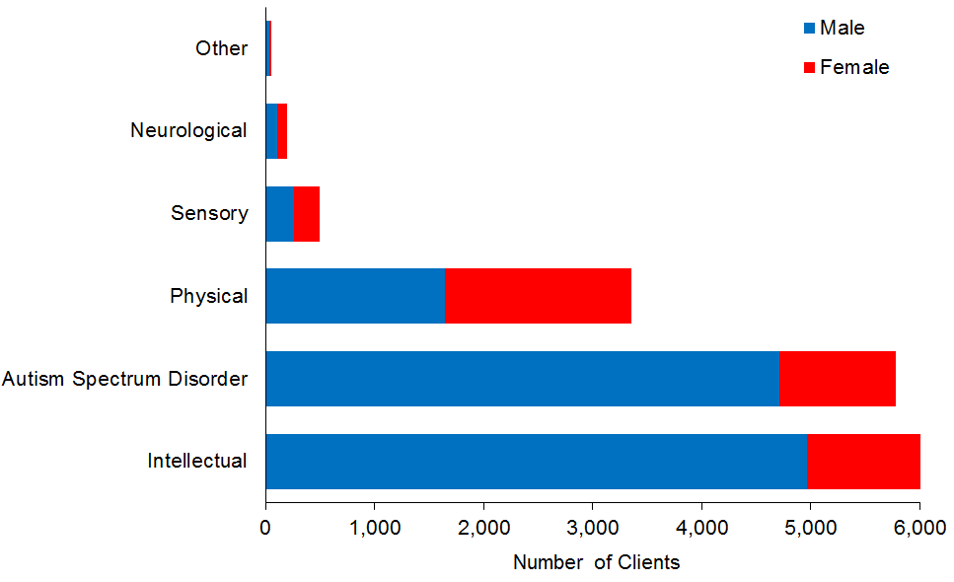

Observations
- An increasing proportion of carer support Clients have an intellectual disability: from 43% in 2013 to 46% in 2016.
- Over the same three-year period the proportion of carer support Clients with ASD increased from 26% in to 32%.
- Clients with physical disabilities have increased slightly from 2013, while those with other disabilities have decreased.
- Over 80% of carer support Clients with ASD are male.

Support package allocation
Table 23: Carer support Clients, by SPA level and sex
SPA level | Male | Female | Total | %
Very low | 12 | 4 | 16 | 0
Low | 508 | 209 | 717 | 4
Medium | 5,014 | 2,613 | 7,627 | 42
High | 4,414 | 2,722 | 7,136 | 39
Very high | 1,767 | 1,068 | 2,835 | 15
Total | 11,715 | 6,616 | 18,331 | 100

Figure 18: Carer support Clients, by SPA level and sex
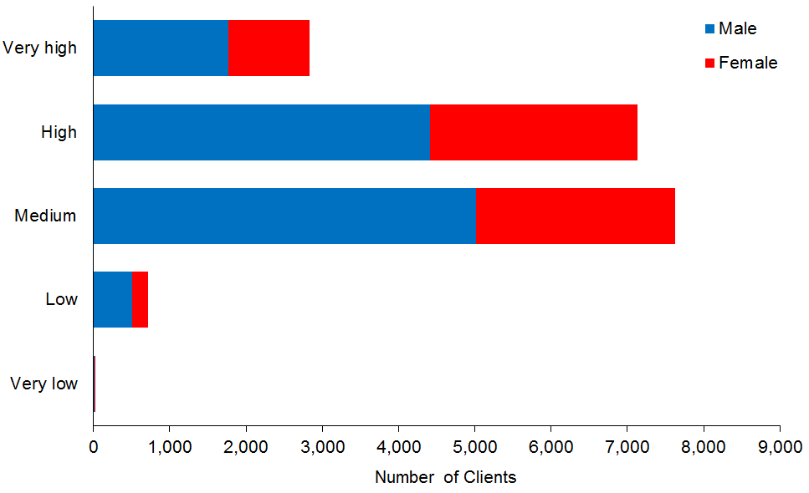

Observations
- Most (81%) carer support Clients have Medium to High SPA levels.
- Over half (54%) have High or Very High SPA levels.

Community residential services
This subsection provides demographic profiles of the 6600 DSS Clients receiving community residential services. It includes children living in children’s residential services, but does not analyse residential Clients living in hospitals or rest home services.

Age and sex
Table 24: Community residential services Clients, by age and sex
Age group | Male | Female | Total
5−9 | 3 | 1 | 4
10−14 | 26 | 5 | 31
15−19 | 109 | 57 | 166
20−24 | 271 | 132 | 403
25−29 | 301 | 205 | 506
30−34 | 291 | 212 | 503
35−39 | 312 | 195 | 507
40−44 | 374 | 299 | 673
45−49 | 467 | 343 | 810
50−54 | 478 | 401 | 879
55−59 | 450 | 351 | 801
60−64 | 322 | 257 | 579
65−69 | 194 | 173 | 367
70−74 | 90 | 85 | 175
75−79 | 49 | 53 | 102
80−84 | 10 | 19 | 29
85−89 | 10 | 12 | 22
Total | 3,757 | 2,800 | 6,557
 | 57% | 43%

Figure 19: Community residential services Clients, by age and sex
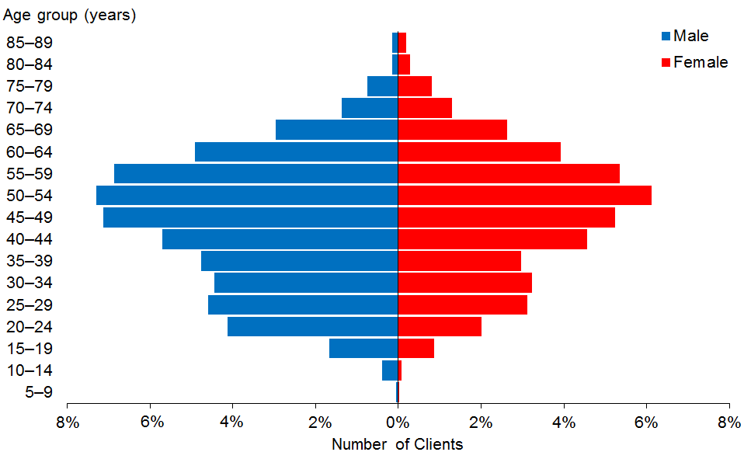

Observations
- The median age of community residential Clients is 48 years, one year older than the median age in 2014.
- There are significantly more males than females using community residential services, although this preponderance has reduced from 59% male in 2013 to 57% in 2016.
- The 45–54 years age groups are the largest for both males and females.
- There are 35 children aged under 15 living in children’s residential services.
- The proportion of people aged under 30 years living in community residential services reduced from 20% in 2013 to 14% in 2016.

Ethnicity
Table 25: Community residential services Clients, by ethnicity and age
Age group | European  /Other | Māori | Pacific | Asian | Not stated | Total
5−9 | 2 | 2 |  |  |  | 4
10−14 | 21 | 7 | 1 | 2 |  | 31
15−19 | 113 | 36 | 10 | 4 | 3 | 166
20−24 | 280 | 84 | 21 | 18 |  | 403
25−29 | 385 | 76 | 18 | 17 | 10 | 506
30−34 | 360 | 83 | 24 | 26 | 10 | 503
35−39 | 361 | 98 | 27 | 12 | 9 | 507
40−44 | 510 | 102 | 30 | 7 | 24 | 673
45−49 | 625 | 116 | 29 | 11 | 29 | 810
50−54 | 686 | 123 | 25 | 16 | 29 | 879
55−59 | 649 | 102 | 19 | 4 | 27 | 801
60−64 | 471 | 73 | 12 | 4 | 19 | 579
65−69 | 308 | 39 | 8 | 1 | 11 | 367
70−74 | 155 | 8 | 1 | 1 | 10 | 175
75−79 | 98 | 3 |  |  | 1 | 102
80−84 | 24 | 4 |  |  | 1 | 29
85−89 | 19 | 1 |  |  | 2 | 22
Total | 5,067 | 957 | 225 | 123 | 185 | 6,557
 | 77% | 15% | 3% | 2% | 3%

Figure 20: Community residential services Clients, by ethnicity and age
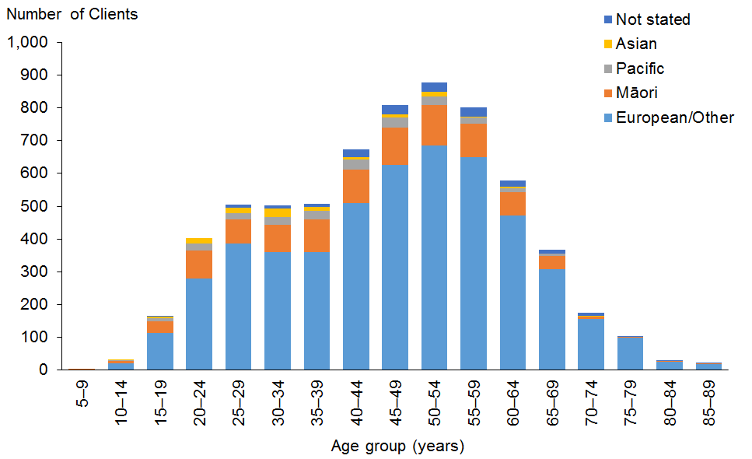

Observations
- Pacific and Asian Clients are significantly under-represented users of residential services.
- Māori are slightly under-represented.
- European/Other Clients are over-represented: they constitute 87% of all community residential clients aged 65 and over.

Marital status

Observations
- Marital status is not recorded for 62% of community residential services Clients.
- Of those for whom marital status was recorded, only 3% were in some kind of partnership.

Accommodation

Observations
- The majority (82%) of Clients are living in community residential homes.
- The remaining Clients have recorded other living arrangements, such as rest home, hospital-level care or rental accommodation.

Location
Table 26: Community residential services Clients, by region and ethnicity
Region | European/  Other | Māori | Pacific | Asian | Not stated | Total | %
Auckland | 1,082 | 232 | 150 | 74 | 14 | 1,552 | 24
Canterbury | 879 | 55 | 10 | 8 | 62 | 1,014 | 15
Waikato | 539 | 170 | 12 | 5 | 53 | 779 | 12
Wellington | 491 | 69 | 26 | 13 | 20 | 619 | 9
Manawatu−Wanganui | 428 | 84 | 3 | 2 | 10 | 527 | 8
Otago | 327 | 21 | 3 | 5 | 9 | 365 | 6
Hawke’s Bay | 280 | 55 | 6 | 10 | 12 | 363 | 6
Bay of Plenty | 256 | 97 | 5 | 1 | 2 | 361 | 6
Northland | 139 | 70 | 4 | 1 |  | 214 | 3
Nelson | 193 | 17 | 2 | 1 |  | 213 | 3
Taranaki | 132 | 20 |  | 1 | 1 | 154 | 2
Southland | 137 | 6 | 1 |  | 1 | 145 | 2
Marlborough | 62 | 12 | 1 | 1 |  | 76 | 1
Gisborne | 34 | 41 |  |  |  | 75 | 1
Tasman | 51 | 6 | 1 | 1 |  | 59 | 1
West Coast | 37 | 2 | 1 |  | 1 | 41 | 1
Total | 5,067 | 957 | 225 | 123 | 185 | 6,557 | 100

Figure 21: Community residential services Clients, by region and ethnicity
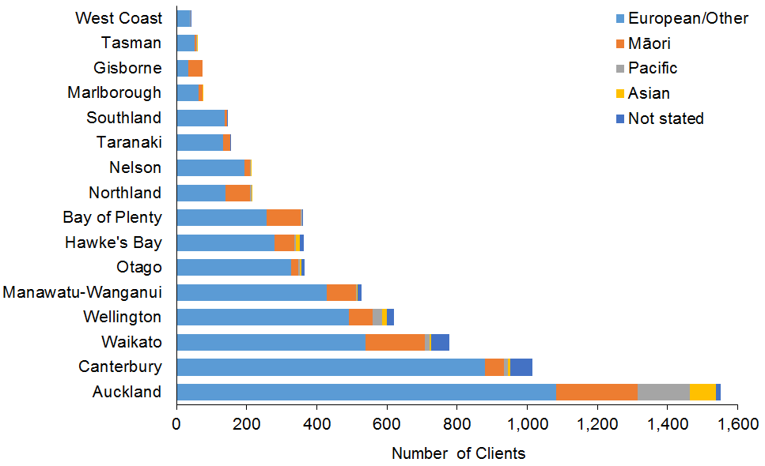

Observations
- The Auckland, Waikato and Bay of Plenty regions have the largest numbers of Māori community residential Clients.
- The Auckland and Wellington regions have the largest numbers of Pacific community residential Clients.

Principal disability
Table 27: Community residential services Clients, by principal disability and sex*
Principal disability | Male | Female | Total | %
Intellectual | 3,068 | 2,348 | 5,416 | 83
Physical | 326 | 319 | 645 | 10
Autism spectrum disorder | 278 | 70 | 348 | 5
Neurological | 39 | 33 | 72 | 1
Sensory | 39 | 27 | 66 | 1
Other | 7 | 3 | 10 | 0
Total | 3,757 | 2,800 | 6,557 | 100
* Where a Client recorded two principal disabilities, this report has used only the first one.

Figure 22: Community residential services Clients, by principal disability and sex
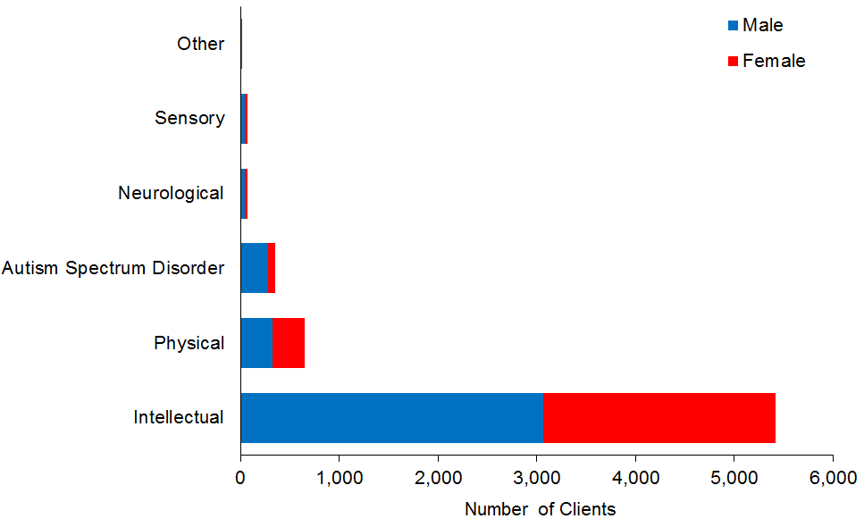

Observation
- A large majority (83%) of Clients in community residential services have an intellectual disability as their primary disability. Many of these Clients also have a physical disability.

Support package allocation
Table 28: Community residential services Clients, by SPA level and sex
SPA level | Male | Female | Total | %
Low | 4 | 1 | 5 | 0
Medium | 65 | 60 | 125 | 2
High | 924 | 775 | 1,699 | 26
Very high | 2,764 | 1,964 | 4,728 | 72
Total | 3,757 | 2,800 | 6,557 | 100

Figure 23: Community residential services Clients, by SPA level and sex
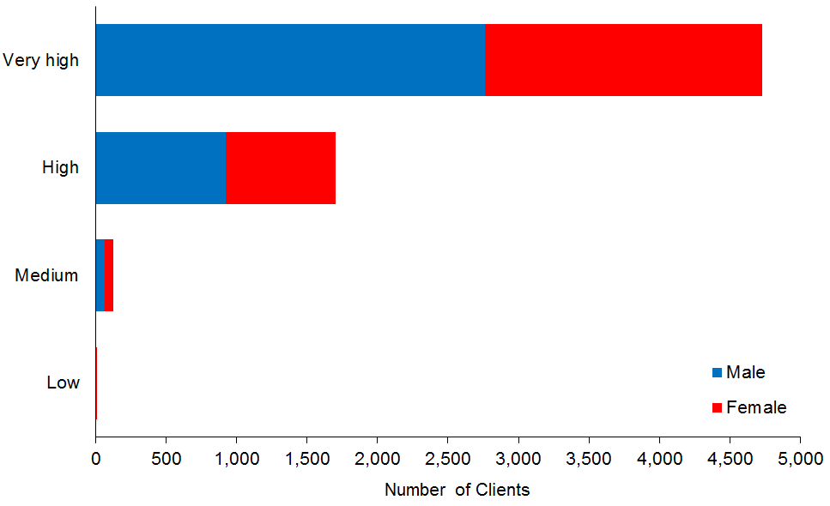

Observation
- The proportion of community residential services Clients who have High or Very High SPAs increased from 92% to 98% over the past three years.

YPD – younger people in aged care
This subsection provides demographic profiles of the 739 DSS Clients using YPD services. Some of these Clients will also appear in demographics for other services.

Age and sex
Table 29: YPD Clients, by age and sex
Age group | Male | Female | Total
20−24 | 1 |  | 1
25−29 |  | 4 | 4
30−34 | 2 | 4 | 6
35−39 | 7 | 2 | 9
40−44 | 5 | 12 | 17
45−49 | 21 | 28 | 49
50−54 | 35 | 55 | 90
55−59 | 52 | 67 | 119
60−64 | 99 | 88 | 187
65−69 | 66 | 77 | 143
70−74 | 36 | 54 | 90
75−79 | 8 | 12 | 20
80−84 | 4 |  | 4
Total | 336 | 403 | 739
 | 45% | 55%

Figure 24: YPD Clients, by age and sex
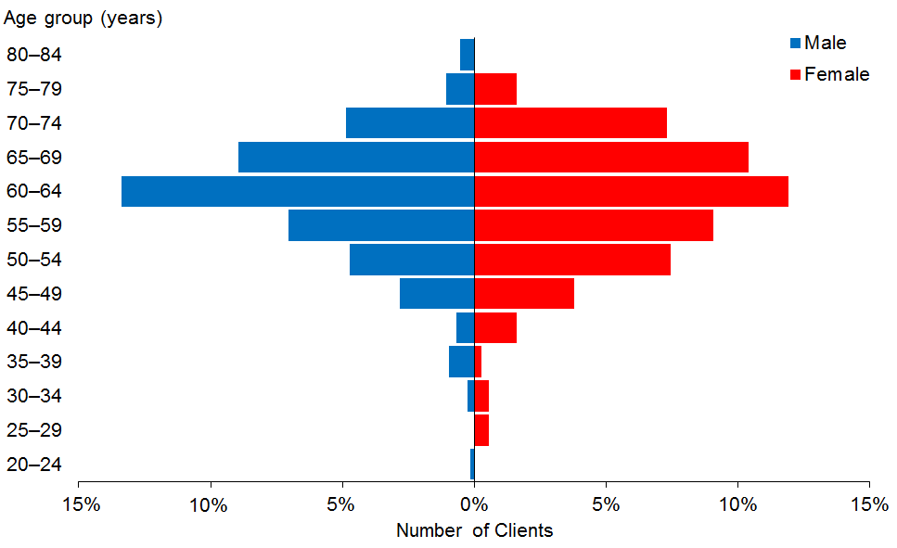

Observations
- The median age of YPD Clients is 61 years.
- Only 12% of YPD clients are aged under 50 years.
- The gender pattern for DSS Clients as a whole (58% male) is reversed for YPD Clients, where there are more females (55%) than males using YPD services.

Ethnicity
Table 30: YPD Clients, by age and ethnicity
Age group | European/Other | Māori | Pacific | Asian | Not stated | Total
20−24 | 1 |  |  |  |  | 1
25−29 | 1 | 2 | 1 |  |  | 4
30−34 | 6 |  |  |  |  | 6
35−39 | 3 | 1 | 4 | 1 |  | 9
40−44 | 11 | 4 |  | 1 | 1 | 17
45−49 | 35 | 8 | 2 | 1 | 3 | 49
50−54 | 60 | 15 | 7 | 4 | 4 | 90
55−59 | 89 | 17 | 4 | 7 | 2 | 119
60−64 | 139 | 27 | 9 | 5 | 7 | 187
65−69 | 114 | 13 | 9 | 3 | 4 | 143
70−74 | 76 | 5 | 4 | 2 | 3 | 90
75−79 | 14 | 5 |  | 1 |  | 20
80−84 | 4 |  |  |  |  | 4
Total | 553 | 97 | 40 | 25 | 24 | 739
 | 75% | 13% | 5% | 3% | 3%

Figure 25: YPD Clients, by age and ethnicity
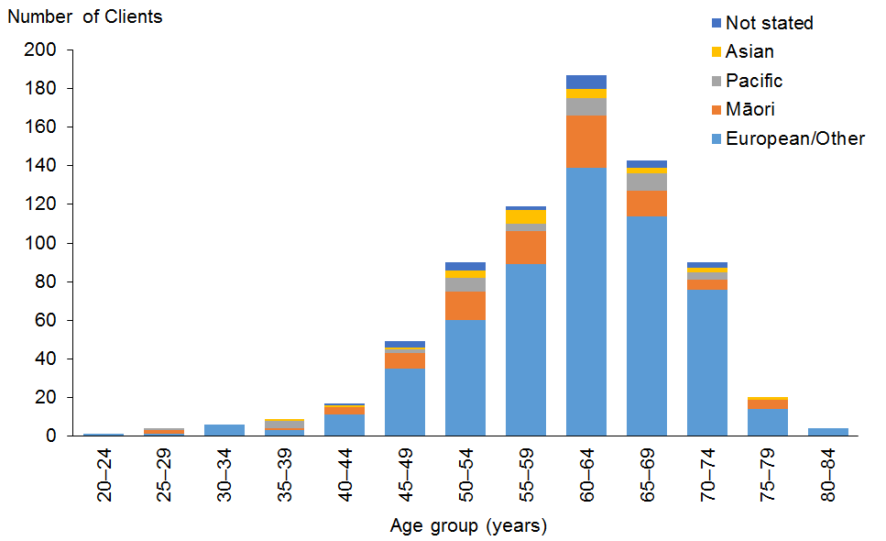

Observations
- European/Other people are over-represented among YPD Clients.
- All other ethnicities are under-represented.

Marital status
Table 31: YPD Clients, by sex and marital status
Marital status | Male | Female | Total
Non-partnered, not further defined | 80 | 58 | 138
Married (not separated), not further defined | 22 | 41 | 63
Non-partnered, never married | 16 | 22 | 38
Non-partnered, divorced | 15 | 19 | 34
Non-partnered, separated | 4 | 18 | 22
Not stated | 6 | 11 | 17
Non-partnered, widowed | 3 | 11 | 14
Partnered, not further defined | 2 | 9 | 11
First marriage (not separated) | 1 | 1 | 2
Don’t know |  | 2 | 2
Opposite-sex partnership | 1 |  | 1
Blank | 186 | 211 | 397
Total | 336 | 403 | 739

Observations
- Almost three-quarters (72%) of YPD Clients for whom marital status is recorded are single.
- Over three-quarters (79%) of male YPD Clients are single, while 67% of female Clients are single.

Location
Table 32: YPD Clients, by ethnicity and region
Region | European /Other | Māori | Pacific | Asian | Not stated | Total | %
Auckland | 185 | 30 | 29 | 22 | 4 | 270 | 37
Canterbury | 96 | 4 | 2 | 1 | 11 | 114 | 15
Bay of Plenty | 39 | 18 |  |  | 2 | 59 | 8
Wellington | 31 | 5 | 5 | 1 | 2 | 44 | 6
Manawatu−Wanganui | 38 | 4 | 2 |  |  | 44 | 6
Waikato | 31 | 8 | 1 |  | 2 | 42 | 6
Northland | 18 | 13 |  |  |  | 31 | 4
Southland | 25 | 3 |  |  | 1 | 29 | 4
Taranaki | 24 | 3 |  | 1 |  | 28 | 4
Otago | 21 | 1 |  |  |  | 22 | 3
Hawke’s Bay | 13 | 6 | 1 |  | 2 | 22 | 3
Marlborough | 14 |  |  |  |  | 14 | 2
West Coast | 6 | 1 |  |  |  | 7 | 1
Tasman | 5 |  |  |  |  | 5 | 1
Nelson | 5 |  |  |  |  | 5 | 1
Gisborne | 2 | 1 |  |  |  | 3 | 0
Total | 553 | 97 | 40 | 25 | 24 | 739 | 100

Figure 26: YPD Clients, by ethnicity and region
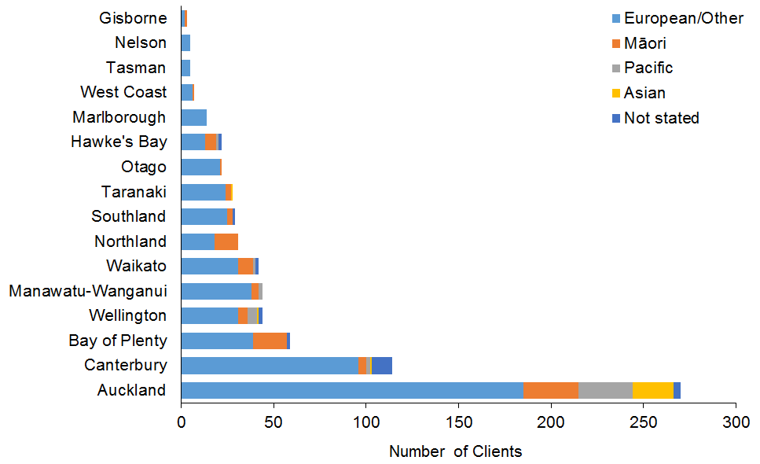

Observations
- There are regional disparities in the allocation of YPD Clients.
- The Auckland region is over-represented, with 37% of DSS YPD Clients but only 30% of all DSS Clients.
- The Canterbury region is slightly over-represented.

Principal disability
Table 33: YPD Clients, by sex and disability type*
Principal disability | Male | Female | Total | %
Physical | 221 | 272 | 493 | 67
Intellectual | 67 | 91 | 158 | 21
Neurological | 35 | 29 | 64 | 9
Sensory | 6 | 8 | 14 | 2
Other | 7 | 2 | 9 | 1
Autism spectrum disorder |  | 1 | 1 | 0
Total | 336 | 403 | 739 | 100
* Where a Client recorded two principal disabilities, this report has used only the first one.

Figure 27: YPD Clients, by sex and disability type
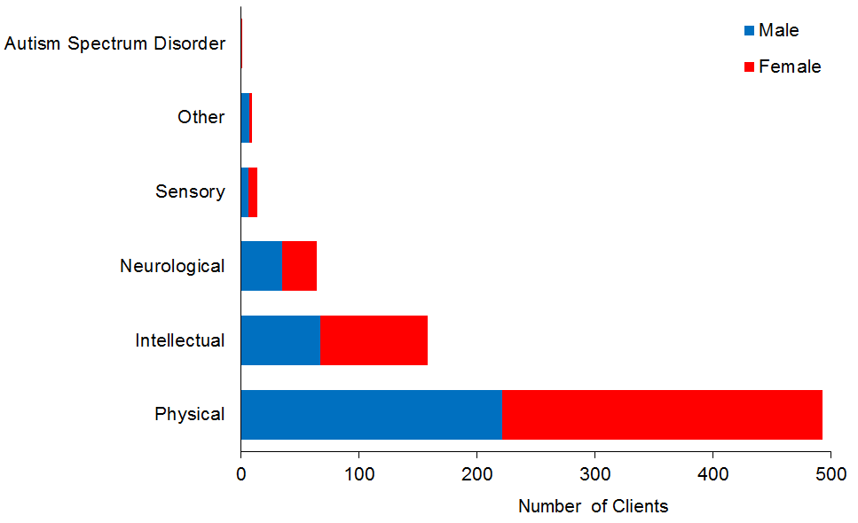

Observation
- Over two-thirds (67%) of YPD Clients have physical disabilities.

Support package allocation
Table 34: YPD Clients, by SPA level and sex
SPA level | Male | Female | Total | %
Medium |  | 1 | 1 | 0
High | 93 | 83 | 176 | 24
Very high | 243 | 319 | 562 | 76
Total | 336 | 403 | 739 | 100

Figure 28: YPD Clients, by SPA level and sex
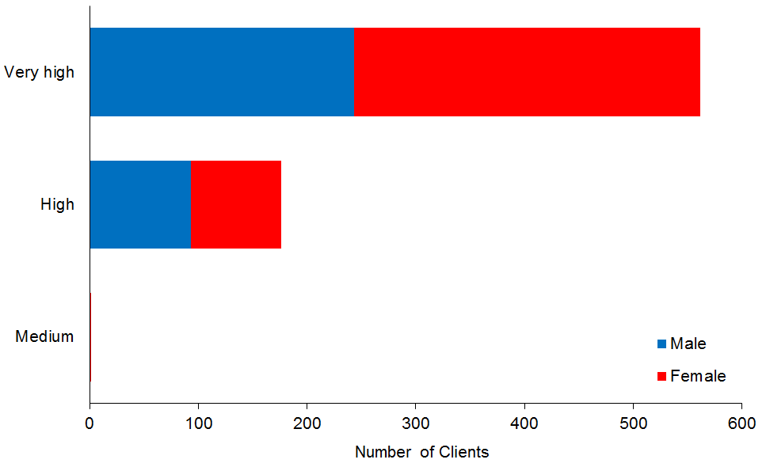

Observation
- Over three-quarters (76%) of YPD Clients have Very High SPAs.

Supported living
This subsection provides demographic profiles of the 3438 DSS Clients using supported living services. Some of these Clients will also appear in demographics for other services.

Age and sex
Table 35: Clients using supported living services, by age and sex
Age group | Male | Female | Total
0−4 | 4 | 1 | 5
5−9 | 17 | 1 | 18
10−14 | 8 | 4 | 12
15−19 | 66 | 47 | 113
20−24 | 236 | 139 | 375
25−29 | 229 | 197 | 426
30−34 | 176 | 149 | 325
35−39 | 154 | 146 | 300
40−44 | 172 | 158 | 330
45−49 | 189 | 174 | 363
50−54 | 206 | 156 | 362
55−59 | 175 | 158 | 333
60−64 | 137 | 127 | 264
65−69 | 79 | 62 | 141
70−74 | 34 | 16 | 50
75−79 | 9 | 7 | 16
80−84 |  | 2 | 2
85−89 | 1 | 2 | 3
Total | 1,892 | 1,546 | 3,438
 | 55% | 45%

Figure 29: Clients using supported living services, by age and sex
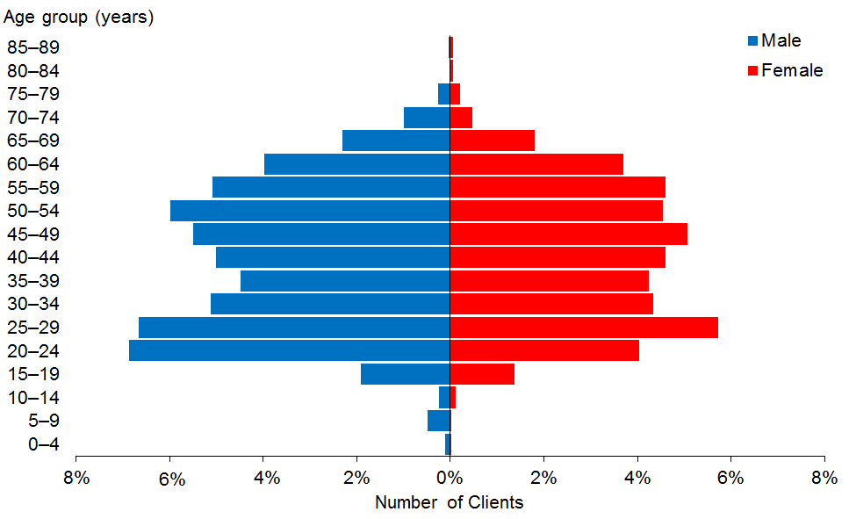

Observations
- The median age of supported living Clients is 42 years, one year older than in 2014.
- There are slightly more males than females receiving supported living services.
- The number of Clients using supported living services has increased by 641 (23%) since 2013.

Ethnicity
Table 36: Clients using supported living services, by ethnicity and age
Age group | European/  Other | Māori | Pacific | Asian | Not stated | Total
0−4 | 3 |  | 1 | 1 |  | 5
5−9 | 6 | 4 |  | 4 | 4 | 18
10−14 | 6 | 2 | 2 | 2 |  | 12
15−19 | 73 | 22 | 6 | 7 | 5 | 113
20−24 | 275 | 64 | 18 | 11 | 7 | 375
25−29 | 304 | 69 | 22 | 22 | 9 | 426
30−34 | 244 | 58 | 9 | 9 | 5 | 325
35−39 | 231 | 43 | 8 | 10 | 8 | 300
40−44 | 252 | 53 | 11 | 3 | 11 | 330
45−49 | 287 | 54 | 7 | 4 | 11 | 363
50−54 | 305 | 43 | 4 | 1 | 9 | 362
55−59 | 264 | 51 | 3 | 2 | 13 | 333
60−64 | 215 | 33 | 3 | 5 | 8 | 264
65−69 | 117 | 14 |  | 1 | 9 | 141
70−74 | 44 | 2 |  |  | 4 | 50
75−79 | 15 |  | 1 |  |  | 16
80−84 | 2 |  |  |  |  | 2
85−89 | 3 |  |  |  |  | 3
Total | 2,646 | 512 | 95 | 82 | 103 | 3,438
 | 77% | 15% | 3% | 2% | 3%

Figure 30: Clients using supported living services, by ethnicity and age group
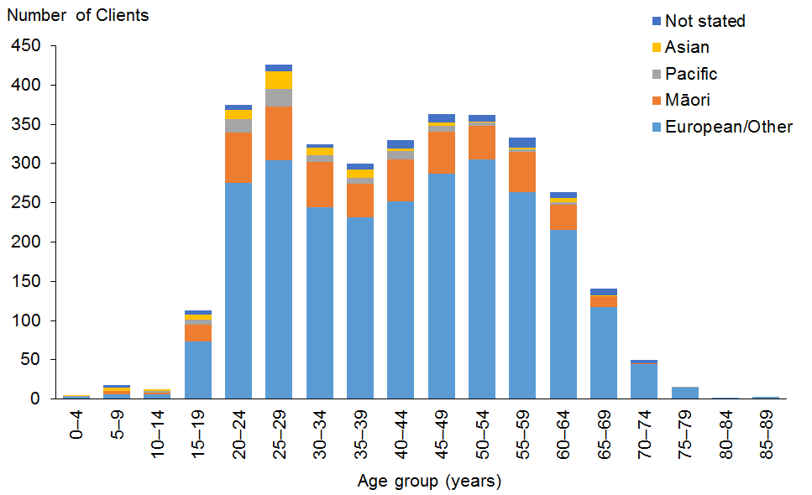

Observations
- European/Other people are significantly over-represented among users of supported living services, Māori are slightly under-represented, while Pacific and Asian people are significantly under-represented.
- This pattern has changed only slightly over the past three years, with Māori representation increasing from 13% to 15%, and European/Other representation dropping from 79% to 77%.

Marital status
Table 37: Clients using supported living services, by marital status and sex
Marital status | Male | Female | Total
Non-partnered, not further defined | 394 | 300 | 694
Non-partnered, never married | 160 | 129 | 289
Married (not separated), not further defined | 45 | 62 | 107
Partnered, not further defined | 31 | 34 | 65
Not stated | 39 | 26 | 65
Non-partnered, separated | 8 | 21 | 29
Non-partnered, divorced | 8 | 15 | 23
Non-partnered, widowed | 3 | 9 | 12
First marriage (not separated) | 1 | 6 | 7
Don’t know | 1 | 3 | 4
Opposite-sex partnership | 1 | 3 | 4
Remarried (not separated) | 1 |  | 1
Blank | 1,200 | 938 | 2,138
Total | 1,892 | 1,546 | 3,438

Observations
- Marital status was not recorded for almost two-thirds (62%) of Clients.
- Of the remaining Clients, 80% do not have a partner.

Accommodation
Table 38: Clients using supported living services, by accommodation type and sex
Accommodation type | Male | Female | Total
Own/family home | 692 | 537 | 1,229
Rental accommodation | 596 | 562 | 1,158
Unknown | 200 | 137 | 337
Housing New Zealand accommodation | 101 | 107 | 208
Community residential home | 123 | 79 | 202
Other | 61 | 39 | 100
Council accommodation | 56 | 36 | 92
Boarder | 50 | 37 | 87
Rest home / continuing care hospital | 6 | 7 | 13
No fixed abode | 4 | 1 | 5
Unit in a retirement village − licence to occupy | 1 | 3 | 4
Unit in a retirement village | 2 | 1 | 3
Total | 1,892 | 1,546 | 3,438

Observations
- Over 0ne-third (36%) of Clients receiving supported living services are living in their own or the family home.
- Another third live in rental accommodation.

Location
Table 39: Clients using supported living services, by ethnicity and region
Region | European /Other | Māori | Pacific | Asian | Not stated | Total | %
Auckland | 369 | 103 | 61 | 47 | 28 | 608 | 18
Canterbury | 395 | 23 | 3 | 4 | 25 | 450 | 13
Otago | 347 | 28 | 3 | 6 | 11 | 395 | 11
Bay of Plenty | 285 | 82 | 2 | 8 | 2 | 379 | 11
Wellington | 246 | 42 | 12 | 3 | 9 | 312 | 9
Manawatu−Wanganui | 193 | 33 | 4 | 5 | 7 | 242 | 7
Waikato | 171 | 46 | 1 | 3 | 14 | 235 | 7
Taranaki | 143 | 32 |  | 1 | 2 | 178 | 5
Hawke’s Bay | 101 | 34 | 3 | 1 | 2 | 141 | 4
Southland | 116 | 11 | 2 |  |  | 129 | 4
Northland | 55 | 35 | 3 |  |  | 93 | 3
Nelson | 72 | 11 |  | 2 |  | 85 | 2
Marlborough | 59 | 11 |  | 1 |  | 71 | 2
Tasman | 46 | 2 | 1 | 1 |  | 50 | 1
Gisborne | 20 | 18 |  |  |  | 38 | 1
West Coast | 28 | 1 |  |  | 3 | 32 | 1
Total | 2,646 | 512 | 95 | 82 | 103 | 3,438 | 100

Figure 31: Clients using supported living services, by ethnicity and region
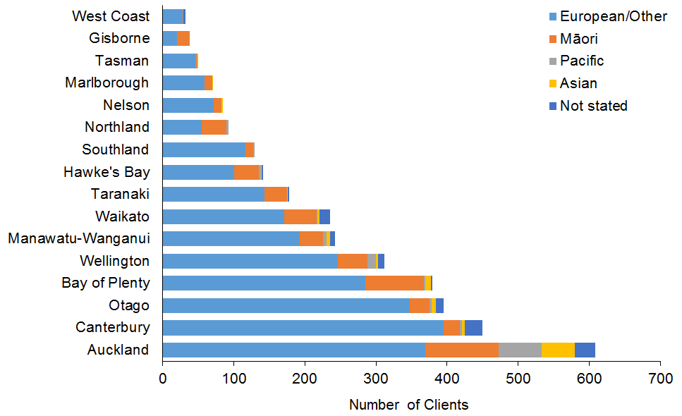

Observations
- More than a third of Auckland Clients using supported living services are of non-European/Other ethnicity.
- The Bay of Plenty and Otago regions are significantly over-represented in terms of the number of people using supported living services.

Principal disability
Table 40: Clients using supported living services, by principal disability and sex*
Principal disability | Male | Female | Total | %
Intellectual | 1,222 | 1,099 | 2,321 | 68
Physical | 294 | 275 | 569 | 17
Autism spectrum disorder | 270 | 73 | 343 | 10
Sensory | 61 | 68 | 129 | 4
Neurological | 42 | 27 | 69 | 2
Other | 3 | 4 | 7 | 0
Total | 1,892 | 1,546 | 3,438 | 100
* Where a Client recorded two principal disabilities, this research has used only the first one.

Figure 32: Clients using supported living services, by principal disability and sex
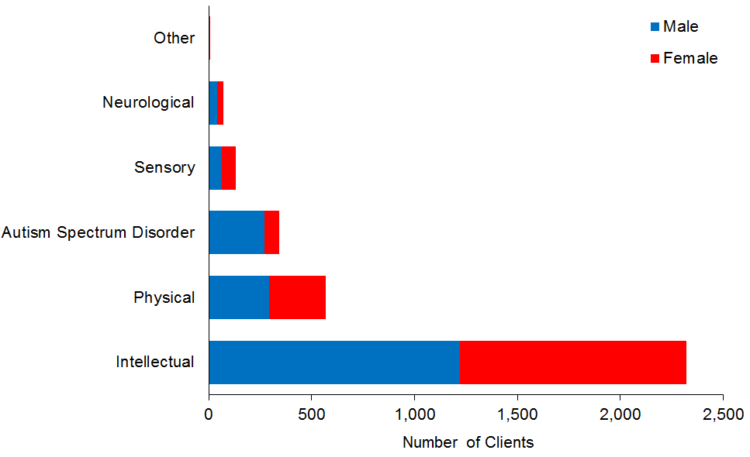

Observations
- Over two-thirds (68%) of Clients using supported living services have an intellectual disability as their primary disability.
- The proportion of Clients with ASD increased from 8% in 2013 to 10% in 2016.
- The proportion of Clients with a physical disability increased from 15% to 17% in the same three-year period.

Support package allocation
Table 41: Clients using supported living services, by SPA level and sex
SPA level | Male | Female | Total | %
Low | 9 | 9 | 18 | 1
Medium | 645 | 522 | 1,167 | 34
High | 1,008 | 809 | 1,817 | 53
Very high | 230 | 206 | 436 | 13
Total | 1,892 | 1,546 | 3,438 | 100

Figure 33: Clients using supported living services, by SPA level and sex
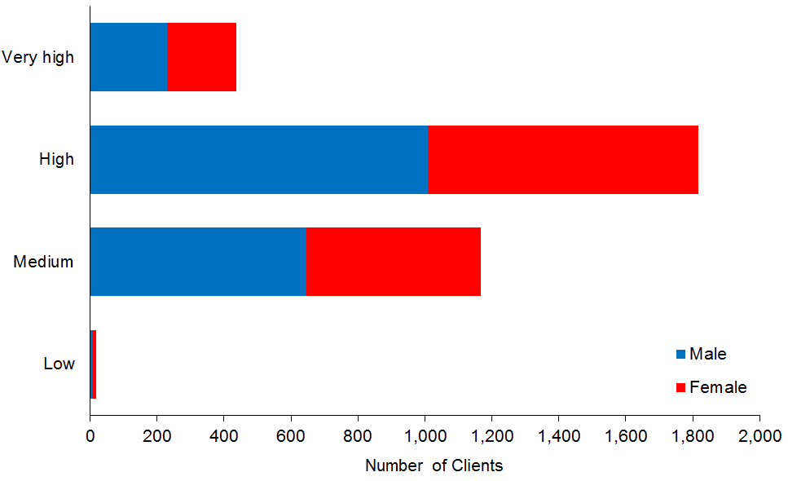

Observation
- Most (87%) supported living Clients have a Medium (34%) or High (53%) SPA level.

Respite
This subsection provides demographic profiles of the 2977 DSS Clients using respite services. Some of these Clients will also appear in demographics for other services.

Age and sex
Table 42: Respite Clients, by age and sex
Age group | Male | Female | Total
0−4 | 33 | 19 | 52
5−9 | 228 | 96 | 324
10−14 | 432 | 171 | 603
15−19 | 451 | 235 | 686
20−24 | 247 | 153 | 400
25−29 | 90 | 74 | 164
30−34 | 43 | 49 | 92
35−39 | 34 | 23 | 57
40−44 | 41 | 43 | 84
45−49 | 35 | 31 | 66
50−54 | 38 | 47 | 85
55−59 | 58 | 54 | 112
60−64 | 49 | 58 | 107
65−69 | 43 | 48 | 91
70−74 | 18 | 22 | 40
75−79 | 6 | 5 | 11
80−84 | 1 | 2 | 3
Total | 1,847 | 1,130 | 2,977
 | 62% | 38%

Figure 34: Respite Clients, by age and sex
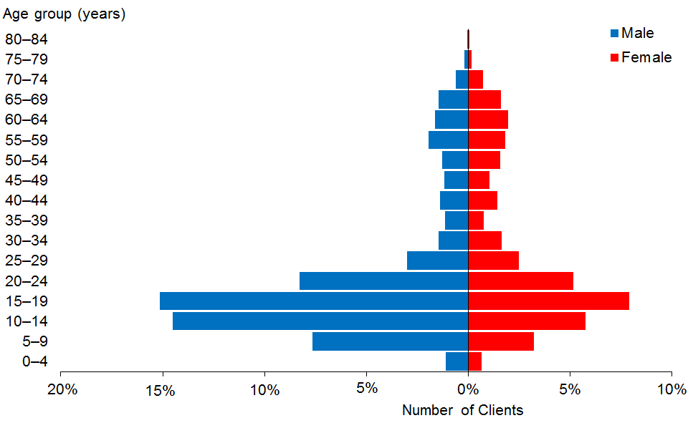

Observations
- The median age of respite Clients is 18 years. There has been no change in the median age since the 2014 report.
- There are significantly more males (62%) than females using respite.

Ethnicity
Table 43: Respite Clients, by age and ethnicity
Age group | European/  Other | Māori | Pacific | Asian | Not stated | Total
0−4 | 22 | 7 | 7 | 6 | 10 | 52
5−9 | 164 | 66 | 26 | 38 | 30 | 324
10−14 | 387 | 118 | 30 | 48 | 20 | 603
15−19 | 413 | 123 | 49 | 86 | 15 | 686
20−24 | 248 | 71 | 26 | 52 | 3 | 400
25−29 | 99 | 30 | 11 | 23 | 1 | 164
30−34 | 59 | 16 | 9 | 6 | 2 | 92
35−39 | 39 | 9 | 5 | 4 |  | 57
40−44 | 51 | 20 | 7 | 4 | 2 | 84
45−49 | 42 | 14 | 6 | 2 | 2 | 66
50−54 | 51 | 20 | 7 | 4 | 3 | 85
55−59 | 80 | 22 | 4 | 4 | 2 | 112
60−64 | 82 | 15 | 3 | 3 | 4 | 107
65−69 | 71 | 9 | 6 | 2 | 3 | 91
70−74 | 34 | 1 | 2 | 2 | 1 | 40
75−79 | 8 | 2 |  | 1 |  | 11
80−84 | 3 |  |  |  |  | 3
Total | 1,853 | 543 | 198 | 285 | 98 | 2,977
 | 62% | 18% | 7% | 10% | 3%

Figure 35: Respite Clients, by age and ethnicity
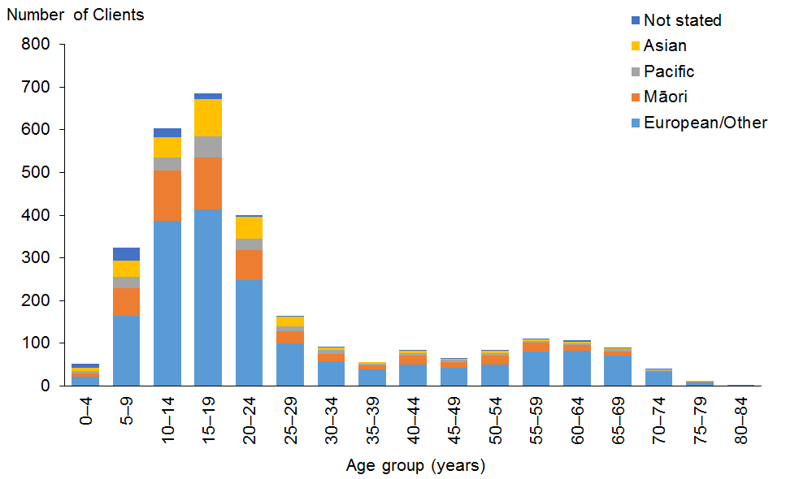

Observations
- European/Other people are under-represented among users of respite.
- Māori and Pacific people are slightly over-represented among users of respite.
- Asian people are over-represented.

Marital status

Observation
- Over three-quarters (79%) of Clients for whom marital status is recorded are single. This aligns with the large numbers of respite Clients who are aged under 20 years.

Accommodation
Table 44: Respite Clients, by sex and accommodation type
Accommodation type | Male | Female | Total
Own/family home | 1,206 | 705 | 1,911
Rental accommodation | 261 | 182 | 443
Unknown | 159 | 84 | 243
Housing New Zealand accommodation | 117 | 59 | 176
Other | 44 | 41 | 85
Community residential home | 35 | 33 | 68
Rest home / continuing care hospital | 17 | 13 | 30
Boarder | 6 | 6 | 12
Council accommodation |  | 4 | 4
Unit in a retirement village | 1 | 2 | 3
No fixed abode | 1 |  | 1
Unit in a retirement village − licence to occupy |  | 1 | 1
Total | 1,847 | 1,130 | 2,977

Observation
- Over two-thirds (64%) of respite Clients live in their own home or the family home.

Location
Table 45: Respite Clients, by ethnicity and region
Region | European/ Other | Māori | Pacific | Asian | Not  stated | Total | %
Auckland | 643 | 177 | 140 | 220 | 65 | 1,245 | 42
Wellington | 251 | 73 | 24 | 23 | 9 | 380 | 13
Canterbury | 264 | 35 | 8 | 11 | 7 | 325 | 11
Waikato | 143 | 45 | 11 | 8 | 2 | 209 | 7
Bay of Plenty | 87 | 57 | 3 | 5 | 4 | 156 | 5
Manawatu−Wanganui | 111 | 29 | 5 | 3 | 4 | 152 | 5
Northland | 52 | 46 | 2 | 6 |  | 106 | 4
Taranaki | 58 | 19 |  | 3 | 2 | 82 | 3
Hawke’s Bay | 43 | 27 | 3 | 4 | 2 | 79 | 3
Otago | 66 | 5 |  |  | 1 | 72 | 2
Marlborough | 38 | 6 |  |  |  | 44 | 1
Tasman | 34 | 8 |  |  |  | 42 | 1
Southland | 30 | 2 | 1 |  |  | 33 | 1
Nelson | 24 | 5 | 1 | 2 |  | 32 | 1
Gisborne | 4 | 8 |  |  |  | 12 | 0
West Coast | 5 | 1 |  |  | 2 | 8 | 0
Total | 1,853 | 543 | 198 | 285 | 98 | 2,977 | 100

Figure 36: Respite Clients, by ethnicity and region
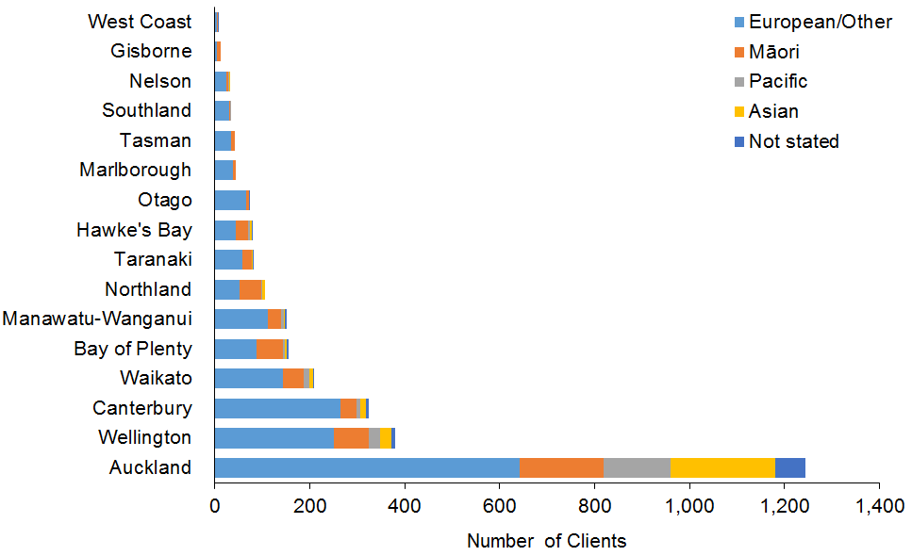

Observations
- There are regional disparities in the allocation of respite.
- The Auckland region is significantly over-represented, with 42% of DSS respite Clients but only 30% of all DSS Clients. This is a marked change from 2013, when the Auckland region had 29% of respite Clients.
- The Auckland region also has the majority of Pacific and Asian respite Clients.

Principal disability
Table 46: Respite Clients, by sex and disability type*
Principal disability | Male | Female | Total | %
Intellectual | 860 | 592 | 1,452 | 49
Autism spectrum disorder | 574 | 138 | 712 | 24
Physical | 349 | 350 | 699 | 23
Sensory | 31 | 25 | 56 | 2
Neurological | 31 | 22 | 53 | 2
Other | 2 | 3 | 5 | 0
Total | 1,847 | 1,130 | 2,977 | 100
* Where a Client recorded two principal disabilities, this report has used only the first one.

Figure 37: Respite Clients, by sex and disability type
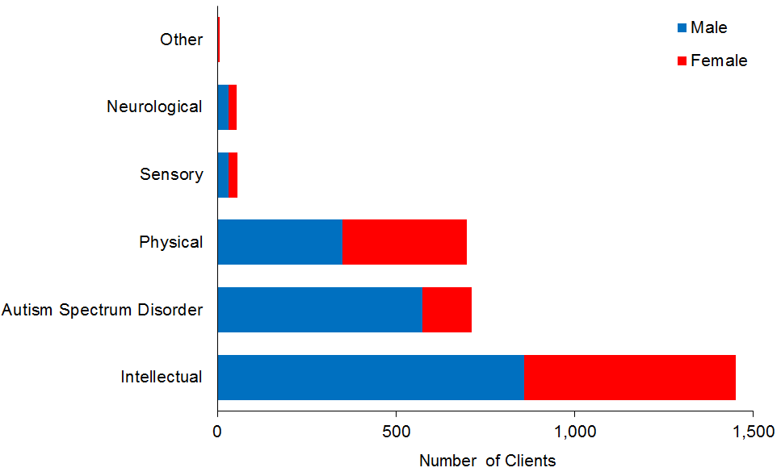

Observations
- Clients with intellectual disabilities make up 49% of respite care users.
- Clients with ASD make up almost a quarter (24%) of respite users, 81% of whom are male.

Support package allocation
Table 47: Respite Clients, by SPA level and sex
SPA level | Male | Female | Total | %
Low | 2 |  | 2 | 0
Medium | 188 | 126 | 314 | 11
High | 856 | 487 | 1,343 | 45
Very high | 801 | 517 | 1,318 | 44
Total | 1,847 | 1,130 | 2,977 | 100

Figure 38: Respite Clients, by SPA level and sex
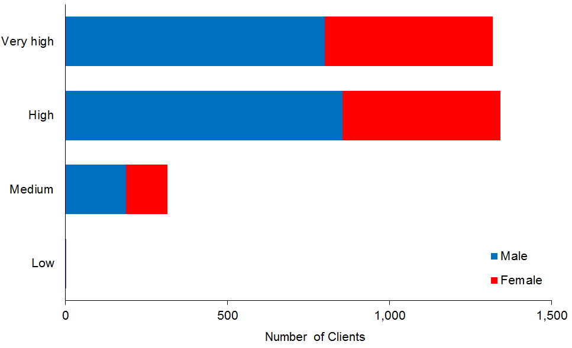

Observation
- Most (89%) respite Clients have Very High or High SPAs.

Behaviour support
This subsection provides demographic profiles of the 2460 DSS Clients using behaviour support services. Some of these Clients may also appear in demographics for other services.

Age and sex
Table 48: Behaviour support services Clients, by age and sex
Age group | Male | Female | Total
0–4 | 102 | 30 | 132
5–9 | 540 | 168 | 708
10–14 | 503 | 177 | 680
15–19 | 263 | 128 | 391
20–24 | 114 | 47 | 161
25–29 | 53 | 31 | 84
30–34 | 47 | 20 | 67
35–39 | 24 | 15 | 39
40–44 | 29 | 18 | 47
45–49 | 26 | 18 | 44
50–54 | 27 | 14 | 41
55–59 | 19 | 10 | 29
60–64 | 16 | 11 | 27
65–69 | 5 | 3 | 8
75–79 | 1 | 1 | 2
Total | 1,769 | 691 | 2,460
 | 72% | 28%

Figure 39: Behaviour support services Clients, by age and sex
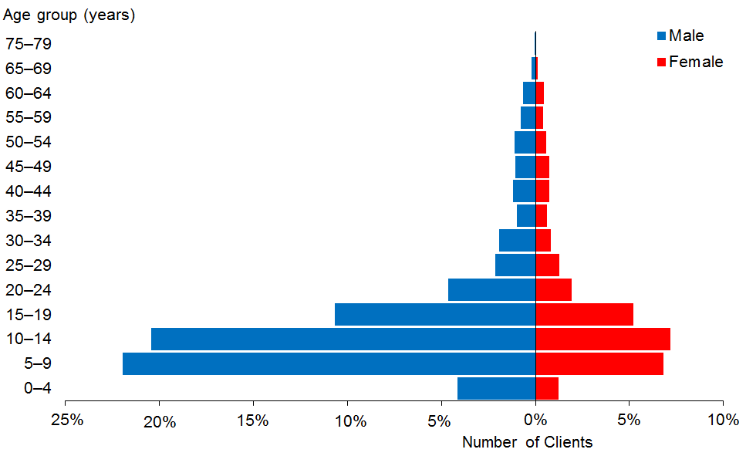

Observations
- The median age of behaviour support services Clients is 12 years.
- There are significantly more males (72%) than females using behaviour support services.

Ethnicity
Table 49: Behaviour support services Clients, by age and ethnicity
Age group | European/  Other | Māori | Pacific | Asian | Not stated | Total
0–4 | 64 | 25 | 13 | 13 | 17 | 132
5–9 | 405 | 140 | 62 | 47 | 54 | 708
10–14 | 441 | 130 | 37 | 44 | 28 | 680
15–19 | 229 | 94 | 26 | 27 | 15 | 391
20–24 | 113 | 26 | 8 | 12 | 2 | 161
25–29 | 64 | 10 | 4 | 4 | 2 | 84
30–34 | 44 | 10 | 4 | 7 | 2 | 67
35–39 | 26 | 7 | 4 | 2 |  | 39
40–44 | 39 | 2 | 2 | 2 | 2 | 47
45–49 | 37 | 5 |  | 1 | 1 | 44
50–54 | 30 | 7 | 1 | 1 | 2 | 41
55–59 | 25 | 2 |  |  | 2 | 29
60–64 | 23 | 3 |  |  | 1 | 27
65–69 | 6 | 1 |  |  | 1 | 8
75–79 | 2 |  |  |  |  | 2
Total | 1,548 | 462 | 161 | 160 | 129 | 2,460
 | 63% | 19% | 7% | 7% | 5%

Figure 40: Behaviour support services Clients, by age and ethnicity
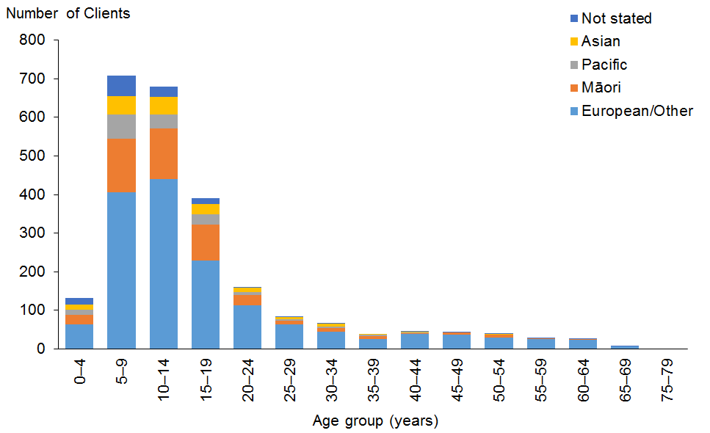

Observations
- European/Other people are slightly under-represented among users of behaviour support services (63%, compared with 67% of the total DSS Client population).
- Overall, Māori, Pacific and Asian people are each marginally over-represented among users of behaviour support services, with particular over-representation among the younger age groups.

Marital status

Observation
- Due to the high proportion of young people using behaviour support services, less than 1% of people for whom marital status is recorded are married.

Accommodation
Table 50: Behaviour support services Clients, by sex and accommodation type
Accommodation type | Male | Female | Total
Own/family home | 928 | 357 | 1,285
Rental accommodation | 305 | 109 | 414
Unknown | 202 | 71 | 273
Community residential home | 185 | 86 | 271
Housing New Zealand accommodation | 95 | 30 | 125
Other | 37 | 25 | 62
Boarder | 7 | 6 | 13
Rest home / continuing care hospital | 5 | 6 | 11
Council accommodation | 2 | 1 | 3
No fixed abode | 2 |  | 2
Unit in a retirement village | 1 |  | 1
Total | 1,769 | 691 | 2,460

Observations
- Over half (52%) of behaviour support services Clients live in their own home or the family home.
- A further 11% live in community residential support services.

Location
Table 51: Behaviour support services Clients, by ethnicity and region
Region | European/  Other | Māori | Pacific | Asian | Not  stated | Total | %
Auckland | 335 | 97 | 110 | 92 | 77 | 711 | 29
Canterbury | 310 | 41 | 13 | 18 | 7 | 389 | 16
Wellington | 196 | 61 | 17 | 23 | 12 | 309 | 13
Manawatu–Wanganui | 147 | 43 | 5 | 8 | 5 | 208 | 8
Waikato | 122 | 51 | 4 | 5 | 9 | 191 | 8
Otago | 98 | 16 | 3 |  | 13 | 130 | 5
Northland | 37 | 46 | 1 | 4 |  | 88 | 4
Bay of Plenty | 47 | 31 | 3 |  |  | 81 | 3
Hawke’s Bay | 49 | 20 | 3 | 5 | 1 | 78 | 3
Southland | 57 | 13 |  | 1 | 4 | 75 | 3
Taranaki | 40 | 13 |  |  | 1 | 54 | 2
Tasman | 44 | 6 | 1 | 1 |  | 52 | 2
Nelson | 32 | 5 | 1 | 2 |  | 40 | 2
Gisborne | 5 | 15 |  |  |  | 20 | 1
Marlborough | 13 | 4 |  | 1 |  | 18 | 1
West Coast | 16 |  |  |  |  | 16 | 1
Total | 1,548 | 462 | 161 | 160 | 129 | 2,460 | 100

Figure 41: Behaviour support services Clients, by ethnicity and region
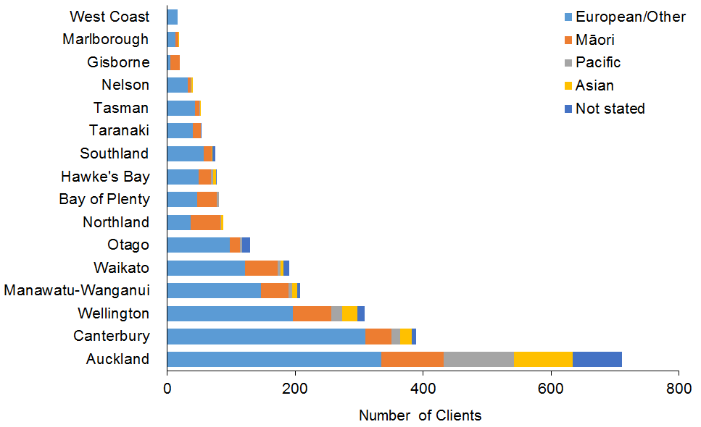

Observations
- People of Asian and Pacific ethnicities in the Auckland region are slightly over-represented among Clients of behaviour support services.
- Waikato is slightly under-represented.

Principal disability
Table 52: Behaviour support services Clients, by sex and disability type*
Principal disability | Male | Female | Total | %
Intellectual | 862 | 466 | 1,328 | 54
Autism spectrum disorder | 817 | 172 | 989 | 40
Physical | 66 | 39 | 105 | 4
Sensory | 16 | 11 | 27 | 1
Neurological | 5 | 2 | 7 | 0
Other | 3 | 1 | 4 | 0
Total | 1,769 | 691 | 2,460 | 100
* Where a Client recorded two principal disabilities, this report has used only the first one.

Figure 42: Behaviour support services Clients, by sex and disability type
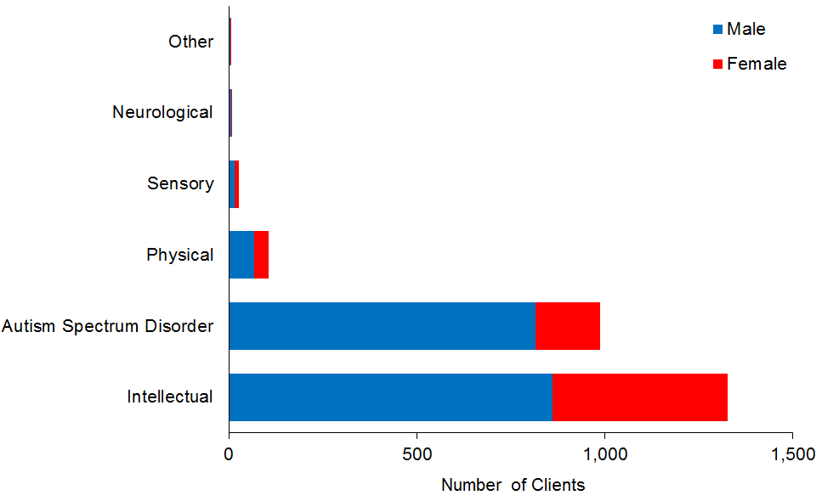

Observations
- Clients with intellectual disabilities make up the majority (54%) of behaviour support services Clients.
- Clients with ASD are significantly over-represented (40%) when compared with the overall DSS Client population, which includes 20% of Clients with ASD.

Support package allocation
Table 53: Behaviour support services Clients, by SPA level and sex
SPA level | Male | Female | Total | %
Blank | 5 | 1 | 6 | 0
Very low | 2 |  | 2 | 0
Low | 24 | 6 | 30 | 1
Medium | 421 | 146 | 567 | 23
High | 823 | 302 | 1,125 | 46
Very high | 494 | 236 | 730 | 30
Total | 1,769 | 691 | 2,460 | 100

Figure 43: Behaviour support services Clients, by SPA level and sex
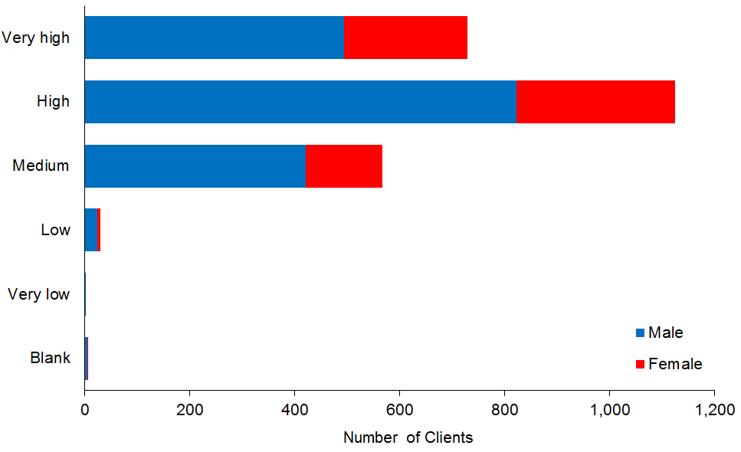

Observation
- Over three-quarters (76%) of behaviour support services Clients have Very High or High SPAs.

Day services
DSS fund day services for Clients who:
- were once living in institutions such as Tokanui and Kimberley, and/or
- are using High and Complex services allocated by the National Intellectual Disability Care Agency (NIDCA), or
- are in neither of the above two categories but who have retained their prior access to a DSS-funded day services under a specific agreement.

This subsection provides demographic profiling of the 1765 Clients allocated Ministry-funded day services. Many of these Clients may also appear in the demographics for other services.

Age and sex
Table 54: Day services Clients, by age and sex
Age group | Male | Female | Total
15–19 | 15 | 4 | 19
20–24 | 48 | 19 | 67
25–29 | 71 | 57 | 128
30–34 | 85 | 48 | 133
35–39 | 80 | 55 | 135
40–44 | 112 | 70 | 182
45–49 | 130 | 88 | 218
50–54 | 133 | 91 | 224
55–59 | 129 | 95 | 224
60–64 | 101 | 87 | 188
65–69 | 57 | 54 | 111
70–74 | 28 | 25 | 53
75–79 | 28 | 30 | 58
80–84 | 4 | 7 | 11
85–89 | 7 | 7 | 14
Total | 1,028 | 737 | 1,765
 | 58% | 42%

Figure 44: Day services Clients, by age and sex
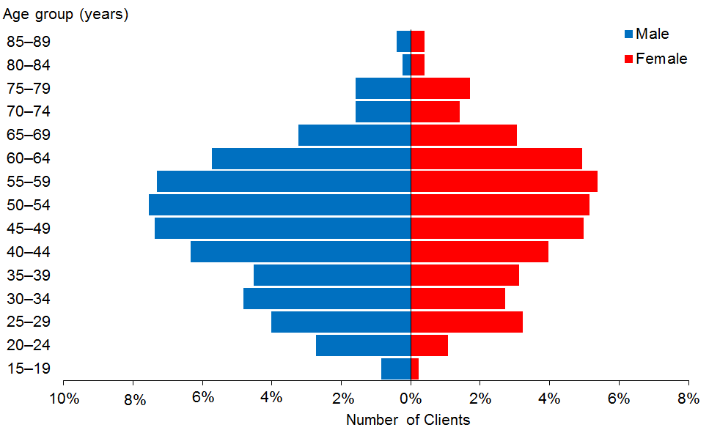

Observations
- The median age of day services Clients is 50 years. This is five years older than in 2014.
- There are more male day services Clients (58%) than female (42%).
- The majority of day services Clients are aged between 40 and 65 years.

Ethnicity
Table 55: Day services Clients, by age and ethnicity
Age group | European/ Other | Māori | Pacific | Asian | Not stated | Total
15–19 | 7 | 8 | 3 | 1 |  | 19
20–24 | 38 | 25 | 4 |  |  | 67
25–29 | 83 | 27 | 7 | 5 | 6 | 128
30–34 | 83 | 38 | 5 | 3 | 4 | 133
35–39 | 91 | 30 | 4 | 9 | 1 | 135
40–44 | 124 | 47 | 6 | 2 | 3 | 182
45–49 | 151 | 54 | 3 | 2 | 8 | 218
50–54 | 171 | 40 | 4 | 4 | 5 | 224
55–59 | 175 | 37 | 2 | 1 | 9 | 224
60–64 | 146 | 29 | 3 |  | 10 | 188
65–69 | 85 | 18 | 2 | 1 | 5 | 111
70–74 | 46 | 6 |  |  | 1 | 53
75–79 | 53 | 4 |  |  | 1 | 58
80–84 | 10 |  |  |  | 1 | 11
85–89 | 12 |  |  |  | 2 | 14
Total | 1,275 | 363 | 43 | 28 | 56 | 1,765
 | 72% | 21% | 2% | 2% | 3%

Figure 45: Day services Clients, by age and ethnicity
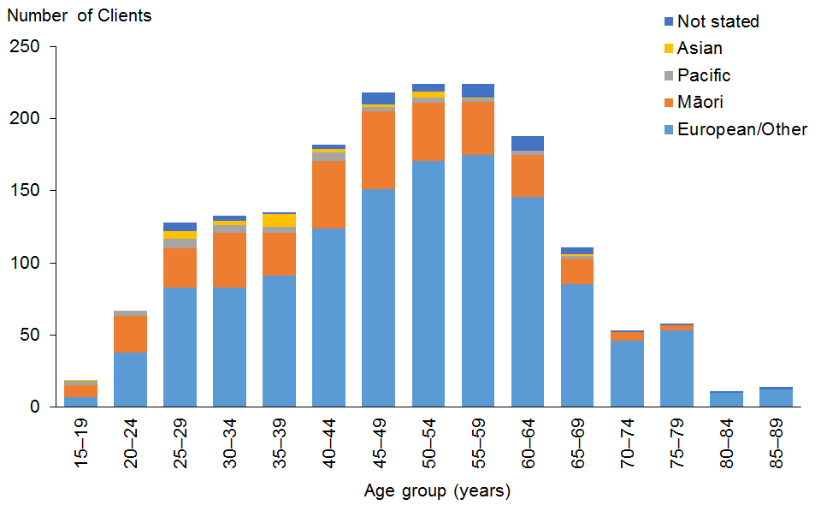

Observations
- European/Other people (72%) and Māori (21%) are significantly over-represented in day services Clients.
- Pacific (2%) and Asian (2%) people are significantly under-represented.

Location
Table 56: Day services Clients, by region
Region | European/ Other | Māori | Pacific | Asian | Not  stated | Total | %
Waikato | 306 | 110 | 9 | 11 | 23 | 459 | 26
Canterbury | 218 | 14 |  | 1 | 15 | 248 | 14
Manawatu–Wanganui | 177 | 25 | 2 | 4 | 7 | 215 | 12
Auckland | 101 | 49 | 20 | 11 | 3 | 184 | 10
Bay of Plenty | 105 | 56 | 1 |  | 2 | 164 | 9
Northland | 77 | 39 | 1 |  |  | 117 | 7
Wellington | 73 | 18 | 6 | 1 | 3 | 101 | 6
Nelson | 60 | 11 |  |  |  | 71 | 4
Hawke’s Bay | 44 | 11 | 1 |  | 1 | 57 | 3
Taranaki | 41 | 7 |  |  |  | 48 | 3
Gisborne | 12 | 18 | 1 |  |  | 31 | 2
Otago | 21 | 4 | 1 |  | 2 | 28 | 2
Tasman | 20 | 1 | 1 |  |  | 22 | 1
Marlborough | 11 |  |  |  |  | 11 | 1
West Coast | 6 |  |  |  |  | 6 | 0
Southland | 3 |  |  |  |  | 3 | 0
Total | 1,275 | 363 | 43 | 28 | 56 | 1,765 | 100

Figure 46: Day services Clients, by region
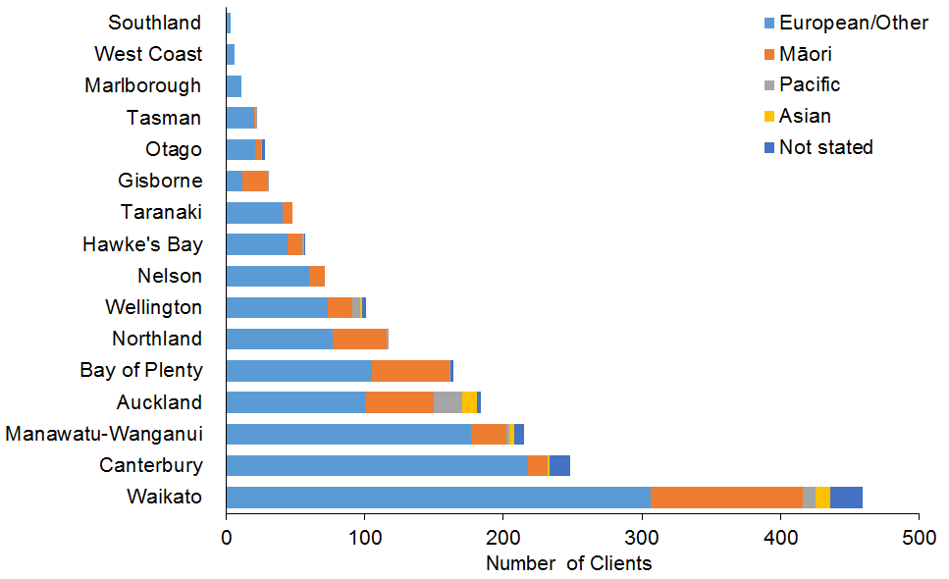

Observations
- The Waikato region is significantly over-represented in day services Clients, with 10% of all DSS Clients but 26% of day services Clients.
- Waikato, Canterbury and Manawatu−Wanganui have the largest numbers of day services Clients due to the closures of Tokanui, Sunnyside and Kimberley, respectively, in these areas, and the agreement of the Ministry to fund day services for these Clients.

Principal disability
Table 57: Day services Clients, by principal disability
Principal disability | Male | Female | Total | %
Intellectual | 902 | 661 | 1,563 | 89
Physical | 79 | 62 | 141 | 8
Autism spectrum disorder | 34 | 4 | 38 | 2
Neurological | 12 | 5 | 17 | 1
Sensory |  | 5 | 5 | 0
Other | 1 |  | 1 | 0
Total | 1,028 | 737 | 1,765 | 100

Figure 47: Day services Clients, by principal disability
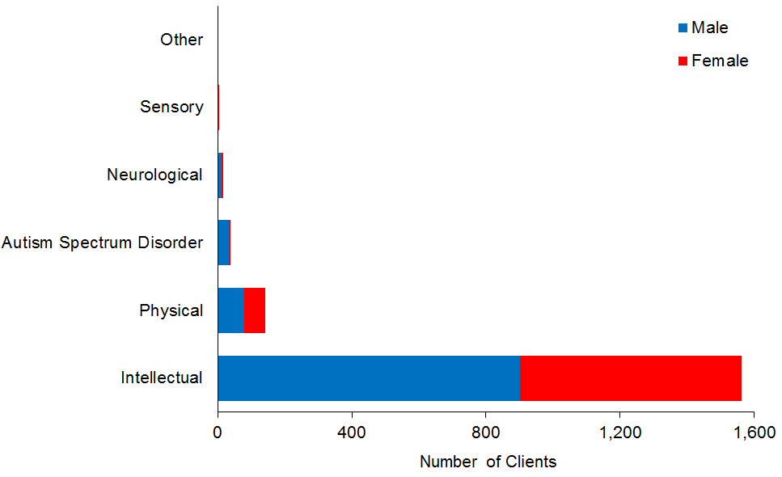

Observation
- The majority (89%) of Clients using day services have intellectual disabilities.

Support package allocation
Table 58: Day services Clients, by SPA level
SPA level | Male | Female | Total | %
Blank | 135 | 24 | 159 | 9
Low | 1 | 3 | 4 | 0
Medium | 39 | 33 | 72 | 4
High | 217 | 174 | 391 | 22
Very high | 636 | 503 | 1,139 | 65
Total | 1,028 | 737 | 1,765 | 100

Figure 48: Day services Clients, by SPA level
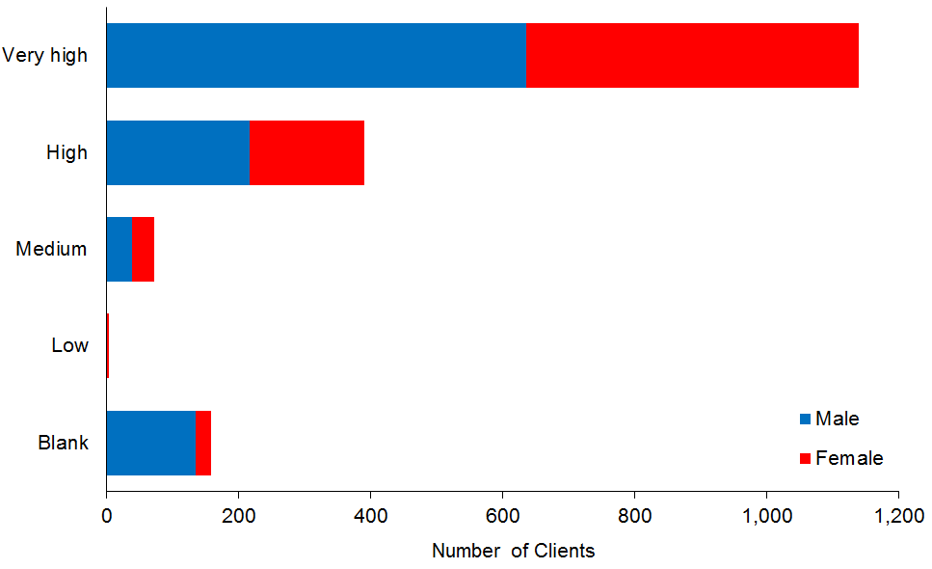

Observation
- Over two-thirds (65%) of day services Clients have a Very High SPA level, and a further 22% have a High level.

High and Complex (H&C) Framework
This subsection provides demographic profiles of the 244 DSS Clients under the High and Complex Framework; ie, clients using National Intellectual Disability Secure Services (NIDSS), Regional Intellectual Disability Secure Services (RIDSS) or Regional Intellectual Disability Supported Accommodation Services (RIDSAS). Some of these Clients may also appear in demographics for other services, such as equipment and modifications, and behaviour support.

Age and sex
Table 59: H&C Clients using supported living services, by age and sex
Age group | Male | Female | Total
0–4 | 1 |  | 1
15–19 | 22 | 5 | 27
20–24 | 40 | 5 | 45
25–29 | 32 | 4 | 36
30–34 | 30 |  | 30
35–39 | 26 | 1 | 27
40–44 | 15 | 4 | 19
45–49 | 15 | 9 | 24
50–54 | 11 | 2 | 13
55–59 | 13 | 3 | 16
60–64 | 3 | 1 | 4
65–69 | 1 |  | 1
70–74 | 1 |  | 1
Total | 210 | 34 | 244
 | 86% | 14%

Figure 49: H&C Clients using supported living services, by age and sex
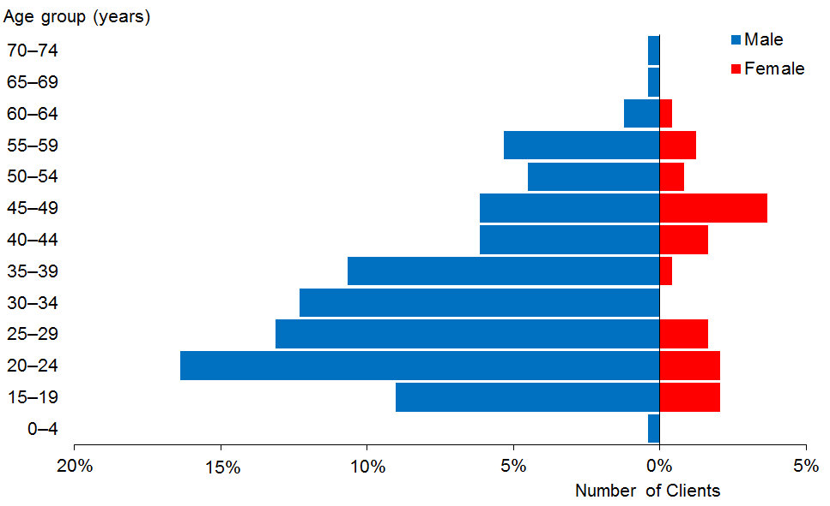

Figure 50: Average number of H&C Clients per annum, 2013–2016
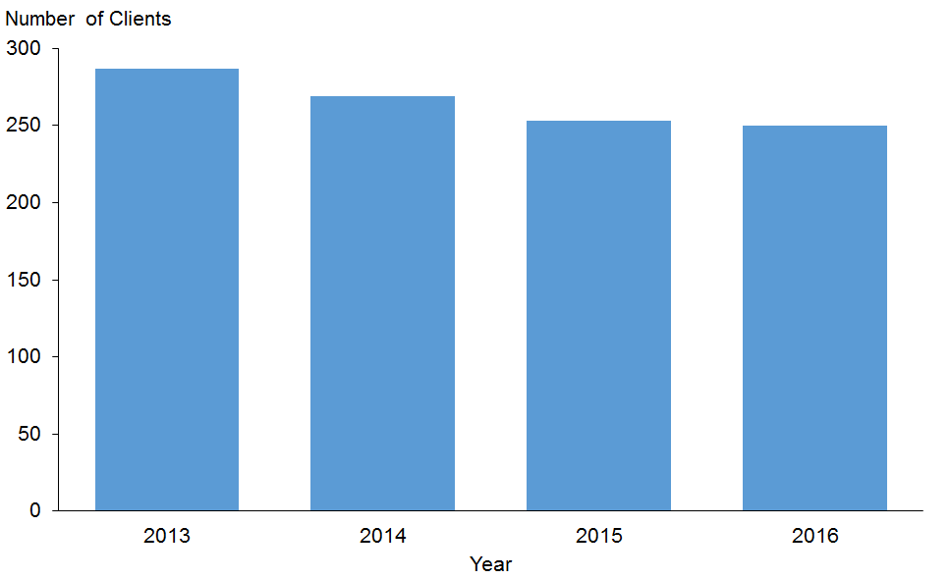

Observations
- The median age of H&C Clients is 31 years.
- There is a marked majority (86%) of males among the H&C Client group.
- The average number of H&C Clients over the past three years has declined overall by 13%. This is due to the numbers of the civil population (ie, clients not under the IDCCR Act) declining over time, which has been in line with the Ministry’s intention to ensure that eligibility is determined appropriately. The population receiving care (who are under the IDCCR Act) has remained relatively stable over time.

Ethnicity
Table 60: H&C Clients, by ethnicity and age
Age group | European/  Other | Māori | Pacific | Asian | Not  stated | Total
0–4 | 1 |  |  |  |  | 1
15–19 | 10 | 14 | 3 |  |  | 27
20–24 | 12 | 28 | 4 | 1 |  | 45
25–29 | 12 | 12 | 6 | 1 | 5 | 36
30–34 | 14 | 11 | 2 |  | 3 | 30
35–39 | 18 | 6 | 1 | 1 | 1 | 27
40–44 | 9 | 9 | 1 |  |  | 19
45–49 | 13 | 9 |  |  | 2 | 24
50–54 | 6 | 6 | 1 |  |  | 13
55–59 | 6 | 6 | 1 |  | 3 | 16
60–64 | 3 |  |  |  | 1 | 4
65–69 |  | 1 |  |  |  | 1
70–74 | 1 |  |  |  |  | 1
Total | 105 | 102 | 19 | 3 | 15 | 244
 | 43% | 42% | 8% | 1% | 6%
Figure 51: H&C Clients, by ethnicity and age group
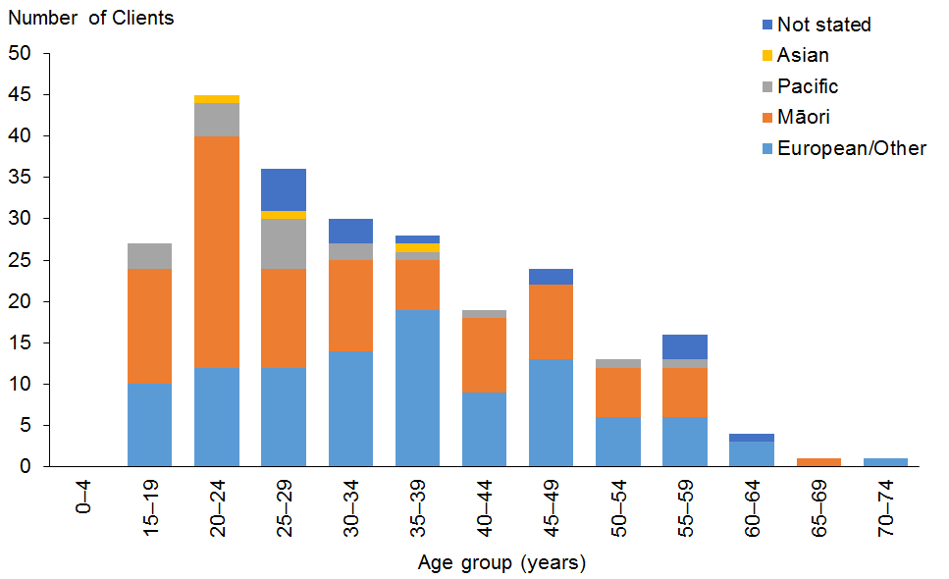

Observations
- Māori are significantly over-represented (42%) among H&C Clients. The proportion of Māori H&C Clients aged 20–24 years is 62%.
- Asian people are significantly under-represented.

Marital status

Observations
- Marital status was not recorded for almost two-thirds (64%) of H&C Clients.
- Of the remaining Clients, only two were recorded as being married. The remaining 98% of H&C Clients were single.

Location
Table 61: H&C Clients, by ethnicity and region*
Region | European /Other | Māori | Pacific | Asian | Not  stated | Total | %
Auckland | 21 | 33 | 17 | 2 | 1 | 74 | 30
Wellington | 27 | 25 | 1 |  | 2 | 55 | 23
Canterbury | 25 | 5 |  |  | 4 | 34 | 14
Waikato | 9 | 22 |  | 1 |  | 32 | 13
Otago | 12 | 5 |  |  | 6 | 23 | 9
Manawatu–Wanganui | 7 | 6 |  |  | 1 | 14 | 6
Northland | 1 | 5 | 1 |  |  | 7 | 3
Nelson | 2 | 1 |  |  | 1 | 4 | 2
Southland | 1 |  |  |  |  | 1 | 0
Total | 105 | 102 | 19 | 3 | 15 | 244 | 100
* The locations of H&C Clients are determined by the locations of secure facilities, which only exist in some regions.
Figure 52: H&C Clients, by ethnicity and region
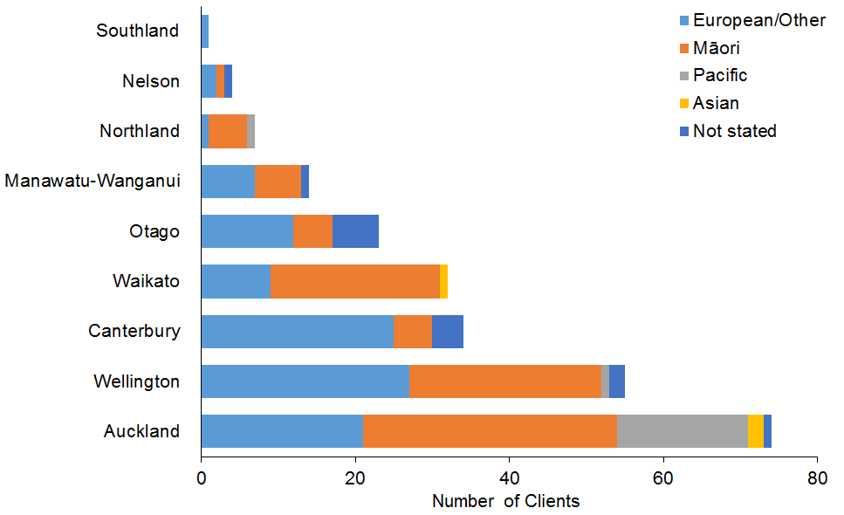

Observations
- Locations of H&C Clients are determined by the locations of secure facilities which only exist in some regions.
- Waikato and Northland H&C services have predominantly Māori clients.
- Auckland has the majority of Pacific H&C clients.

Principal disability
The only disability type recorded for H&C Clients is intellectual disability, as the High and Complex framework was established to provide services to people with this disability type.

Choices in Community Living
This subsection provides demographic profiles of the 161 DSS Clients engaged in the Choices in Community Living (CiCL) demonstration in Auckland and Waikato. Some of these Clients may also appear in demographics for other services.

Age and sex
Table 62: Choices in Community Living Clients, by age and sex
Age group | Male | Female | Total
15–19 | 3 | 3 | 6
20–24 | 14 | 13 | 27
25–29 | 9 | 12 | 21
30–34 | 12 | 8 | 20
35–39 | 6 | 9 | 15
40–44 | 3 | 9 | 12
45–49 | 5 | 7 | 12
50–54 | 8 | 8 | 16
55–59 | 8 | 3 | 11
60–64 | 10 | 5 | 15
65–69 | 4 | 1 | 5
70–74 | 1 |  | 1
Total | 83 | 78 | 161
 | 52% | 48%

Figure 53: Choices in Community Living Clients, by age and sex
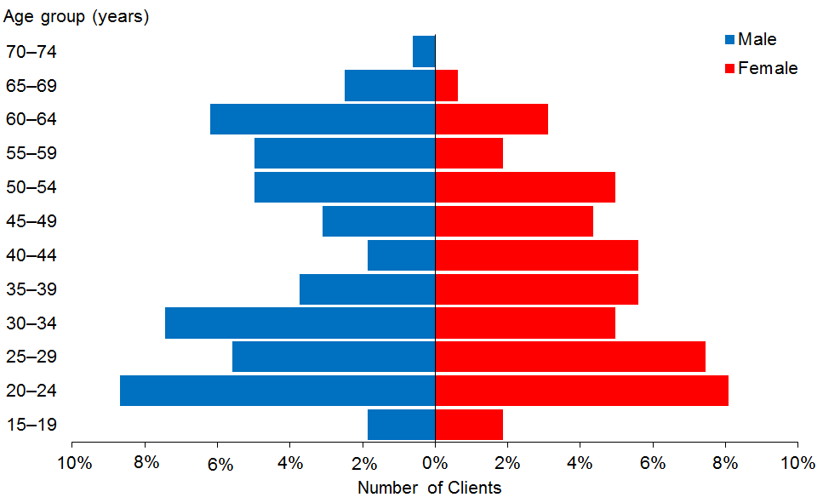

Observations
- The median age of CiCL Clients is 37 years.
- Males and females are more evenly balanced than in other DSS Client groups.
- There is a wide age range of people using CiCL services.

Ethnicity
Table 63: Choices in Community Living Clients, by ethnicity and age
Age group | European/ Other | Māori | Pacific | Asian | Not  stated | Total
15–19 | 6 |  |  |  |  | 6
20–24 | 22 | 2 | 2 | 1 |  | 27
25–29 | 16 | 3 |  | 2 |  | 21
30–34 | 14 | 3 |  | 2 | 1 | 20
35–39 | 10 | 3 |  | 2 |  | 15
40–44 | 9 | 2 | 1 |  |  | 12
45–49 | 10 | 1 |  |  | 1 | 12
50–54 | 8 | 4 | 2 |  | 2 | 16
55–59 | 8 | 2 |  |  | 1 | 11
60–64 | 10 | 3 |  | 1 | 1 | 15
65–69 | 4 |  |  |  | 1 | 5
70–74 | 1 |  |  |  |  | 1
Total | 118 | 23 | 5 | 8 | 7 | 161
 | 73% | 14% | 3% | 5% | 4%

Figure 54: Choices in Community Living Clients, by ethnicity and age group
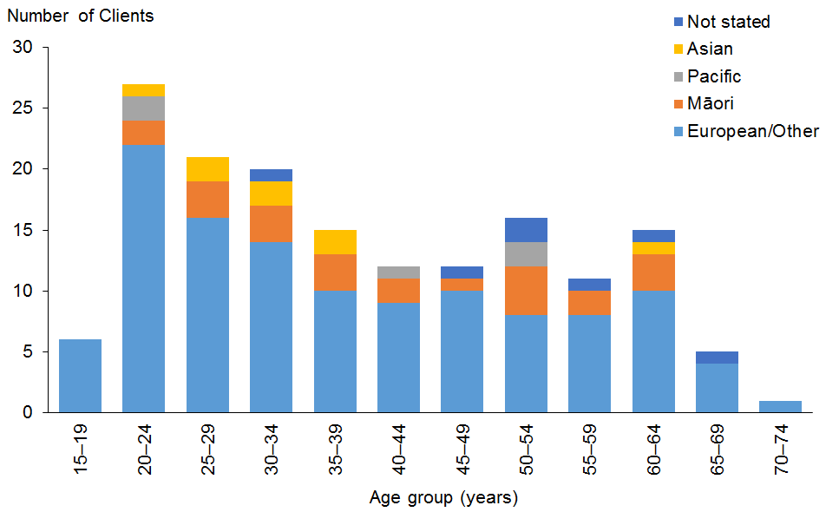

Observations
- European/Other people are over-represented (73%) among CiCL Clients compared with all DSS Clients (67%).
- Māori are slightly under-represented (14%) among CiCL Clients compared with all DSS Clients (17.5%).
- Asian ethnicity among CiCL Clients (5%) is similar to the proportion in the total DSS Client group (5.7%).

Marital status

Observations
- Marital status was not recorded for 76% of CiCL Clients.
- Of the remaining Clients, 98% were recorded as being single.

Location
Table 64: Choices in Community Living Clients, by ethnicity and region
Region | European/ Other | Māori | Pacific | Asian | Not  stated | Total | %
Auckland | 61 | 13 | 5 | 5 | 1 | 85 | 53
Waikato | 57 | 10 |  | 3 | 6 | 76 | 47
Total | 118 | 23 | 5 | 8 | 7 | 161 | 100

Figure 55: Choices in Community Living Clients, by ethnicity and region
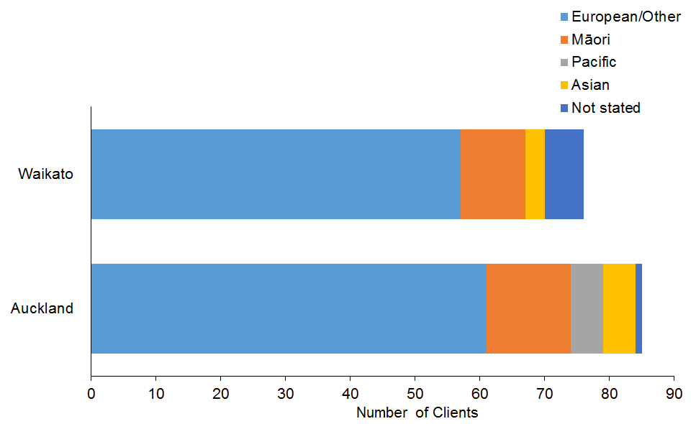

Observations
- Auckland and Waikato were the only locations involved in the CiCL demonstration.
- In the Auckland region it is notable that European/Other ethnicities are predominant, despite the overall Auckland DSS Client group being more ethnically diverse, with only 52% European/Other ethnicities.

Principal disability
Table 65: Choices in Community Living Clients, by principal disability
Principal disability | Male | Female | Total | %
Intellectual | 59 | 56 | 115 | 71
Physical | 18 | 17 | 35 | 22
Autism spectrum disorder | 5 | 2 | 7 | 4
Sensory |  | 2 | 2 | 1
Neurological | 1 |  | 1 | 1
Other |  | 1 | 1 | 1
Total | 83 | 78 | 161 | 100

Figure 56: Choices in Community Living Clients, by principal disability
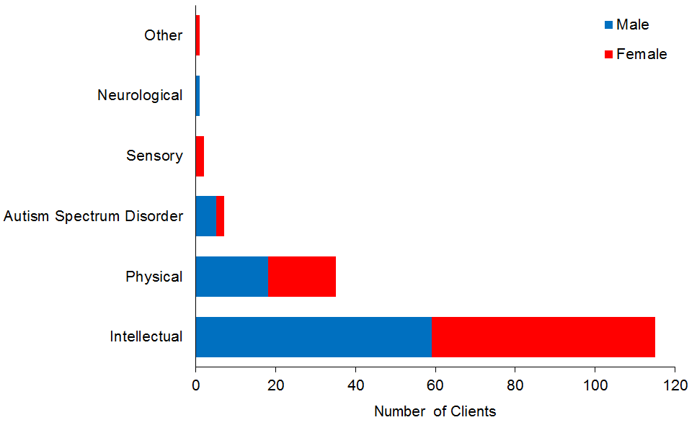

Observations
- Almost three-quarters (71%) of CiCL Clients have an intellectual disability.

Support package allocation
Table 66: Choices in Community Living Clients, by SPA level
SPA level | Male | Female | Total | %
Medium | 1 |  | 1 | 1
High | 14 | 21 | 35 | 22
Very high | 68 | 57 | 125 | 78
Total | 83 | 78 | 161 | 100

Figure 57: Choices in Community Living Clients, by SPA level
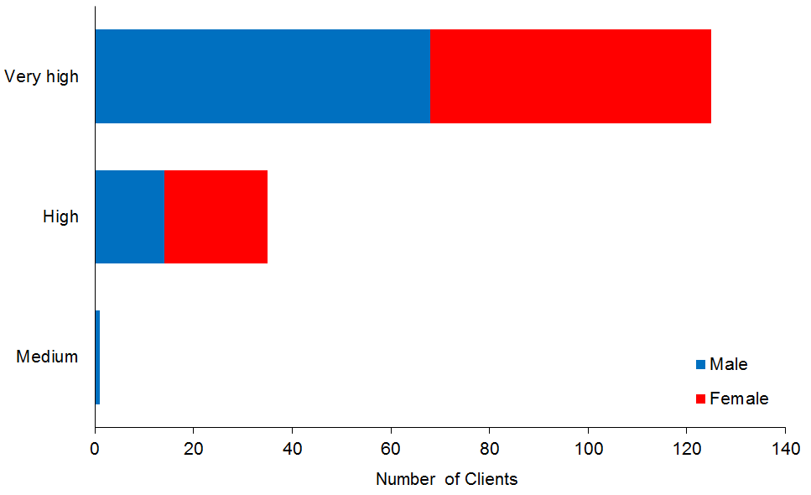

Observations
- Over three-quarters (78%) of CiCL Clients have a Very High SPA level, and a further 22% have a High level.

Enabling Good Lives
This subsection provides demographic profiles of the 166 DSS Clients engaged in the Enabling Good Lives (EGL) demonstration in Christchurch. Some of these Clients may also appear in demographics for other services.

Age and sex
Table 67: EGL Clients, by age and sex
Age group | Male | Female | Total
15–19 | 16 | 13 | 29
20–24 | 70 | 59 | 129
25–29 | 4 | 2 | 6
30–34 | 1 |  | 1
35–39 |  |  | 0
40–44 |  |  | 0
45–49 | 1 |  | 1
Total | 92 | 74 | 166
 | 55% | 45%

Figure 58: EGL Clients, by age and sex
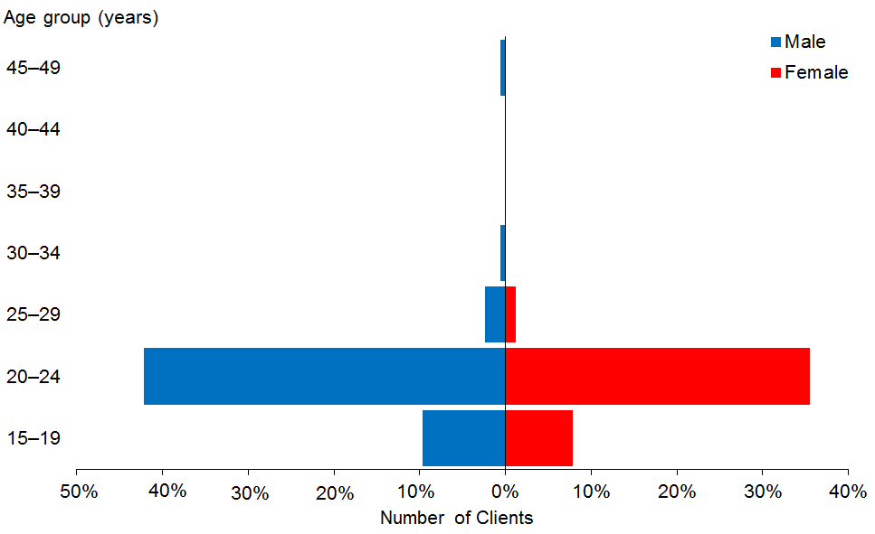

Observations
- The median age of EGL Clients is 22 years. This is due to the original scope of the EGL demonstration, which was to focus on school leavers when it started in 2012.
- There are more males than females in the EGL Client group.

Ethnicity
Table 68: EGL Clients, by ethnicity and age
Age group | European/ Other | Māori | Pacific | Asian | Not  stated | Total
15–19 | 21 | 5 |  | 2 | 1 | 29
20–24 | 105 | 13 | 2 | 9 |  | 129
25–29 | 3 |  |  | 3 |  | 6
30–34 | 1 |  |  |  |  | 1
35–39 |  |  |  |  |  | 0
40–44 |  |  |  |  |  | 0
45–49 | 1 |  |  |  |  | 1
Total | 131 | 18 | 2 | 14 | 1 | 166
 | 79% | 11% | 1% | 8% | 1%

Figure 59: EGL Clients, by ethnicity and age group
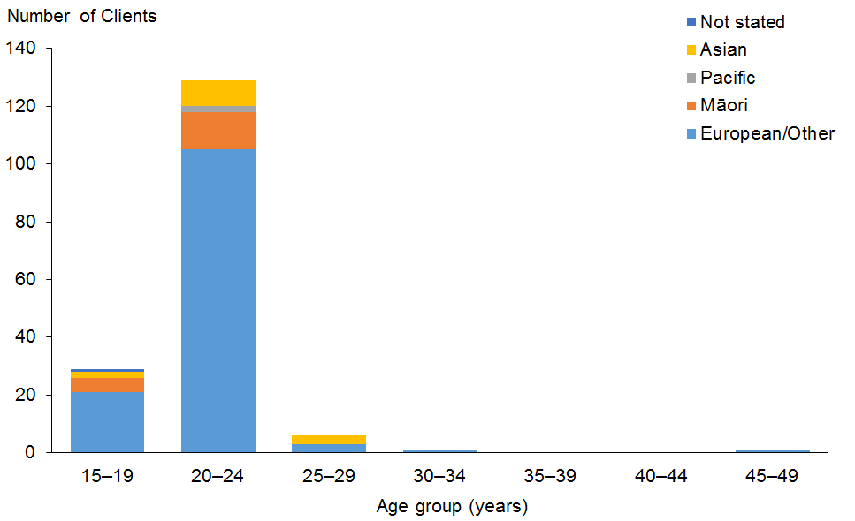

Observations
- European/Other people (79%) are under-represented when compared with the Christchurch total population, where they comprise 85% of the population.
- Māori (11%) are over-represented among EGL Clients when compared with the Christchurch total population, where Māori comprise 8% of the population.
- Pacific people comprise 3% of the Christchurch total population, but only 1% of the EGL Client group, and are therefore under-represented. If EGL Clients with Pacific ethnicity as a second ethnicity are also counted, their representation increases to 5%.
- People of Asian ethnicity comprise 8% of the Christchurch total population, and they are 8% of the EGL Client group.

Marital status

Observations
- No EGL Clients were recorded as having partners.

Location

Observation
- Most (98%) of EGL Clients live in the Canterbury region.

Principal disability
Table 69: EGL Clients, by principal disability
Principal disability | Male | Female | Total | %
Intellectual | 50 | 48 | 98 | 59
Physical | 17 | 13 | 30 | 18
Sensory | 11 | 10 | 21 | 13
Autism spectrum disorder | 13 | 2 | 15 | 9
Neurological | 1 | 1 | 2 | 1
Total | 92 | 74 | 166 | 100

Figure 60: EGL Clients, by principal disability
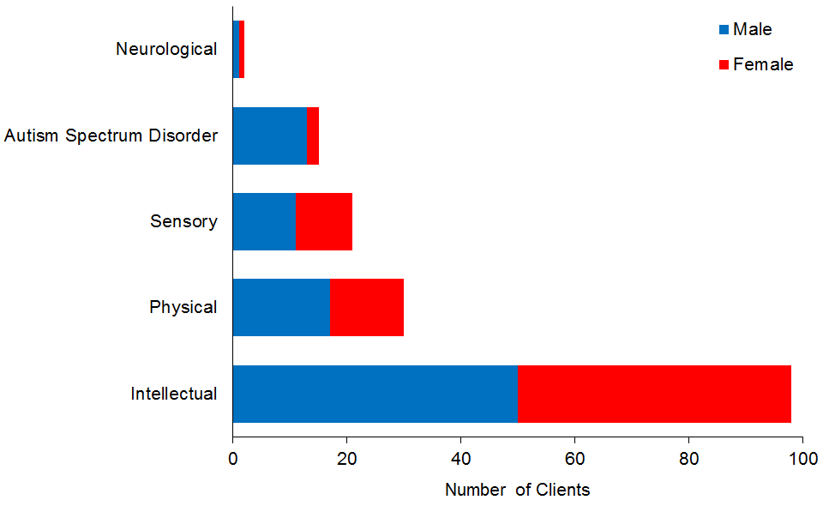

Observations
- Almost 60% of EGL Clients have an intellectual disability.
- People with sensory disability comprise only a small proportion (3%) of people using disability support services overall, but constitute 13% of the EGL Client group.
- EGL Clients with ASD are predominantly male.

Support package allocation
Table 70: EGL Clients, by SPA level and sex
SPA level | Male | Female | Total | %
Low | 1 | 1 | 2 | 1
Medium | 13 | 14 | 27 | 16
High | 46 | 35 | 81 | 49
Very high | 32 | 24 | 56 | 34
Total | 92 | 74 | 166 | 100

Figure 61: EGL Clients, by SPA level and sex
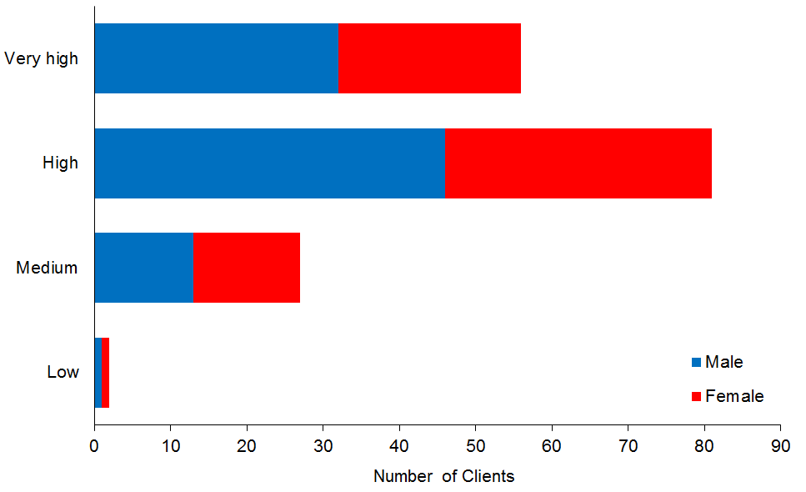

Observations
- SPA levels for EGL Clients are higher overall than for all DSS Clients:
- 27% of DSS Clients have Very High SPAs, compared with 34% of EGL Clients
- 35% of DSS Clients have High SPAs compared with 49% of EGL Clients.

Individualised Funding
This subsection provides demographic profiles of the 3323 DSS Clients using individualised funding (IF). Some of these Clients may also appear in demographics for other services.

Age and sex
Table 71: Individualised funding Clients, by age and sex
Age group | Male | Female | Total
0–4 | 72 | 40 | 112
5–9 | 260 | 124 | 384
10–14 | 349 | 190 | 539
15–19 | 288 | 178 | 466
20–24 | 248 | 150 | 398
25–29 | 126 | 112 | 238
30–34 | 61 | 80 | 141
35–39 | 54 | 62 | 116
40–44 | 60 | 74 | 134
45–49 | 54 | 84 | 138
50–54 | 66 | 92 | 158
55–59 | 78 | 90 | 168
60–64 | 60 | 97 | 157
65–69 | 39 | 71 | 110
70–74 | 21 | 24 | 45
75–79 | 5 | 14 | 19
Total | 1,841 | 1,482 | 3,323
 | 55% | 45%

Figure 62: Individualised funding Clients, by age and sex
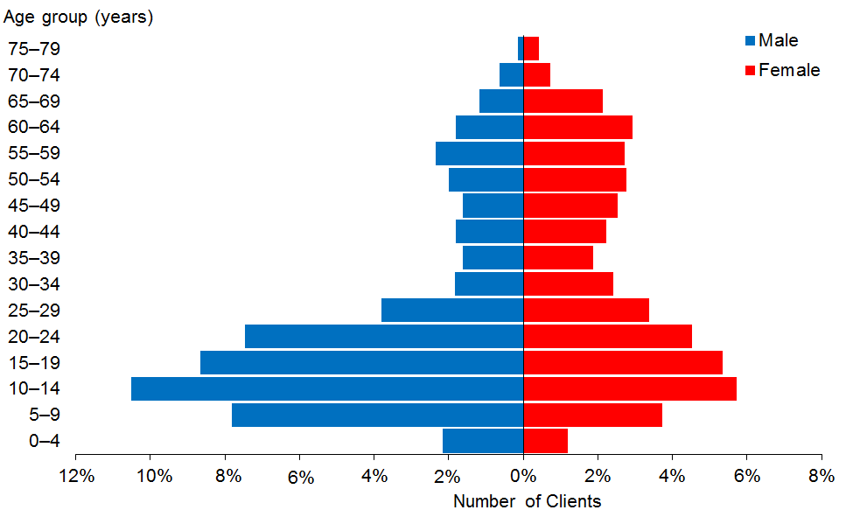

Observations
- IF Clients are generally younger than the overall DSS Client group, with a median age of 21 years.
- The proportion of males to females mirrors the gender proportions of the DSS Client group overall.

Ethnicity
Table 72: Individualised funding Clients, by age and ethnicity
Age group | European/ Other | Māori | Pacific | Asian | Not  stated | Total
0–4 | 56 | 16 | 8 | 7 | 25 | 112
5–9 | 220 | 61 | 27 | 43 | 33 | 384
10–14 | 372 | 85 | 27 | 37 | 18 | 539
15–19 | 309 | 66 | 33 | 46 | 12 | 466
20–24 | 273 | 64 | 21 | 37 | 3 | 398
25–29 | 169 | 37 | 14 | 15 | 3 | 238
30–34 | 95 | 19 | 16 | 6 | 5 | 141
35–39 | 89 | 17 | 5 | 5 |  | 116
40–44 | 88 | 23 | 13 | 4 | 6 | 134
45–49 | 87 | 31 | 12 | 4 | 4 | 138
50–54 | 106 | 25 | 16 | 6 | 5 | 158
55–59 | 111 | 39 | 12 | 5 | 1 | 168
60–64 | 110 | 29 | 10 | 6 | 2 | 157
65–69 | 84 | 17 | 3 |  | 6 | 110
70–74 | 35 | 5 | 3 |  | 2 | 45
75–79 | 12 | 1 | 5 | 1 |  | 19
Total | 2,216 | 535 | 225 | 222 | 125 | 3,323
 | 67% | 16% | 7% | 7% | 4%

Figure 63: Individualised funding Clients, by age and ethnicity
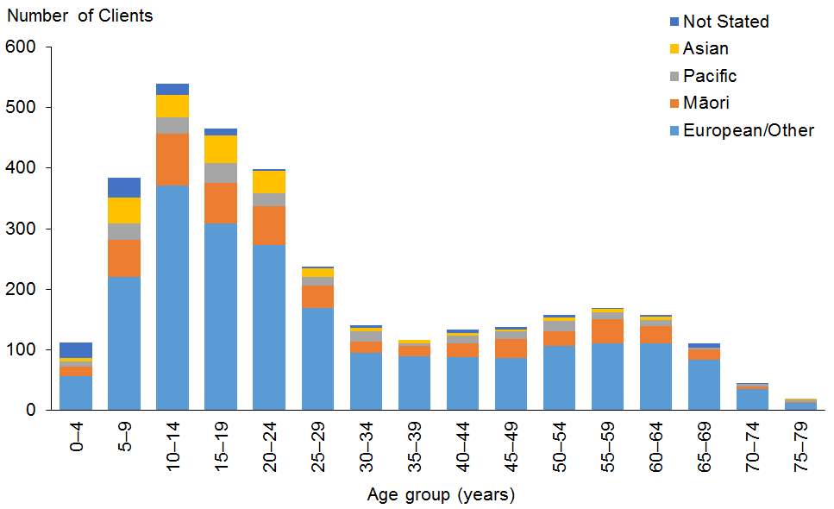

Observations
- Māori are slightly under-represented among IF Clients (16% compared with 17.5% of the total DSS Client population).
- Pacific and Asian Clients are each marginally over-represented among IF Clients, especially among the younger age groups.

Marital status
Table 73: Individualised funding Clients, by marital status
Marital status | Male | Female | Total
Non-partnered, not further defined | 385 | 300 | 685
Non-partnered, never married | 176 | 124 | 300
Married (not separated), not further defined | 80 | 111 | 191
Not stated | 43 | 34 | 77
Partnered, not further defined | 20 | 17 | 37
Non-partnered, divorced | 13 | 17 | 30
Non-partnered, separated | 8 | 21 | 29
Non-partnered, widowed | 3 | 12 | 15
Don’t know | 4 | 3 | 7
First marriage (not separated) | 3 | 2 | 5
Response outside scope | 1 | 2 | 3
Opposite-sex partnership | 2 | 1 | 3
Remarried (not separated) |  | 1 | 1
Blank | 1,103 | 837 | 1,940
Total | 1,841 | 1,482 | 3,323

Observation
- The high proportion of single people among IF Clients mirrors the marital status of DSS Clients overall.

Accommodation
Table 74: Individualised funding Clients, by sex and accommodation type
Accommodation type | Male | Female | Total
Own/family home | 1,189 | 938 | 2,127
Rental accommodation | 311 | 244 | 555
Unknown | 148 | 131 | 279
Housing New Zealand accommodation | 110 | 94 | 204
Other | 35 | 31 | 66
Community residential home | 23 | 16 | 39
Boarder | 12 | 15 | 27
Rest home / continuing care hospital | 7 | 4 | 11
Council accommodation | 4 | 4 | 8
Unit in a retirement village | 1 | 4 | 5
No fixed abode | 1 |  | 1
Unit in a retirement village – licence to occupy |  | 1 | 1
Total | 1,841 | 1,482 | 3,323

Observation
- Almost two-thirds (64%) of IF Clients live in their own or family home, which reflects the generally youthful nature of this client group.

Location
Table 75: Individualised funding Clients, by ethnicity and region
Region | European /Other | Māori | Pacific | Asian | Not stated | Total | %
Auckland | 817 | 163 | 179 | 177 | 87 | 1423 | 43
Canterbury | 347 | 49 | 6 | 13 | 11 | 426 | 13
Wellington | 167 | 39 | 18 | 7 | 9 | 240 | 7
Waikato | 155 | 49 | 8 | 5 | 7 | 224 | 7
Manawatu–Wanganui | 140 | 45 | 5 | 8 | 2 | 200 | 6
Otago | 129 | 9 | 1 | 2 | 3 | 144 | 4
Northland | 68 | 67 |  | 6 |  | 141 | 4
Taranaki | 90 | 22 | 2 | 1 | 1 | 116 | 3
Bay of Plenty | 47 | 46 | 3 | 3 |  | 99 | 3
Marlborough | 77 | 10 |  |  |  | 87 | 3
Hawke’s Bay | 57 | 20 | 1 |  | 2 | 80 | 2
Southland | 50 | 6 | 1 |  | 1 | 58 | 2
Tasman | 34 | 1 |  |  |  | 35 | 1
Nelson | 28 | 2 |  |  |  | 30 | 1
Gisborne | 4 | 6 | 1 |  |  | 11 | 0
West Coast | 6 | 1 |  |  | 2 | 9 | 0
Total | 2,216 | 535 | 225 | 222 | 125 | 3,323 | 100

Figure 64: Individualised funding Clients, by ethnicity and region
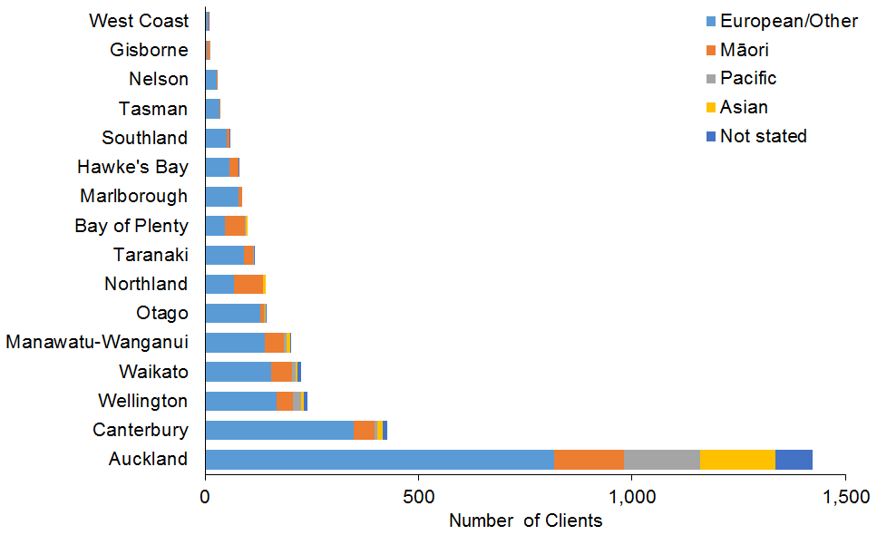

Observations
- The Auckland region is significantly over-represented. It has 30% of all DSS Clients but 43% of IF Clients.
- Canterbury representation is the same as its proportion of the DSS Clients overall.
- All other areas are under-represented for IF Clients.

Principal disability
Table 76: Individualised funding Clients, by sex and disability type*
Principal disability | Male | Female | Total | %
Intellectual | 738 | 569 | 1,307 | 39
Physical | 548 | 672 | 1,220 | 37
Autism spectrum disorder | 453 | 121 | 574 | 17
Sensory | 58 | 75 | 133 | 4
Neurological | 40 | 39 | 79 | 2
Other | 4 | 6 | 10 | 0
Total | 1,841 | 1,482 | 3,323 | 100
* Where a Client recorded two principal disabilities, this report has used only the first one.

Figure 65: Individualised funding Clients, by sex and disability type
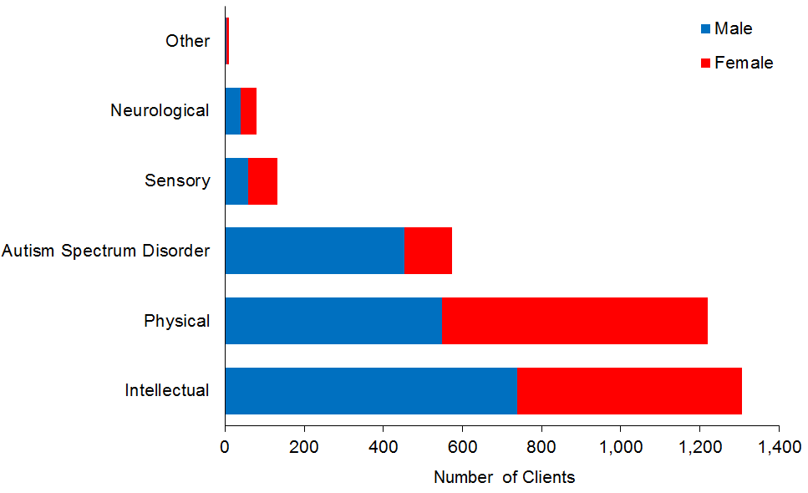

Observations
- Clients with intellectual disabilities are significantly under-represented among IF Clients (39% compared with 50% of the total DSS Client group).
- Clients with ASD are slightly under-represented (17% compared with 20% of the total DSS Client group).
- Clients with all other disability types are over-represented among IF Clients.

Support package allocation
Table 77: Individualised funding Clients, by SPA level and sex
SPA level | Male | Female | Total | %
Low | 2 | 1 | 3 | 0
Medium | 157 | 211 | 368 | 11
High | 766 | 662 | 1,428 | 43
Very high | 916 | 608 | 1,524 | 46
Total | 1,841 | 1,482 | 3,323 | 100

Figure 66: Individualised funding Clients, by SPA level and sex
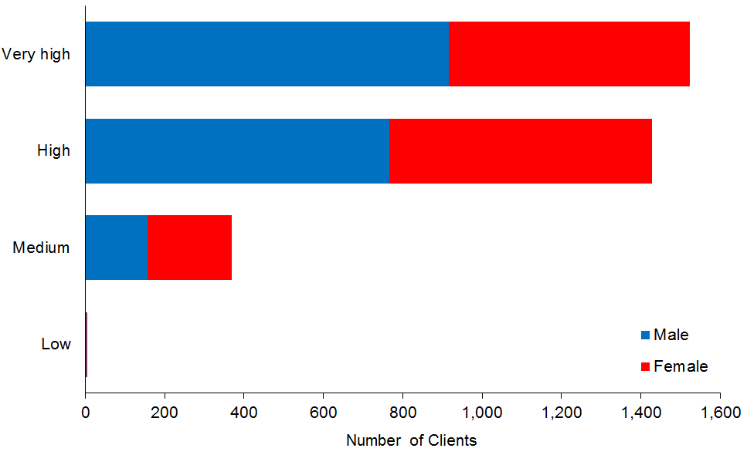

Observations
- Very High and High SPA levels are significantly over-represented among IF Clients.
- Over one-quarter (27%) of the total DSS Client population has Very High SPAs, compared with 46% of IF Clients.
- Over one-third (36%) of the total DSS Client population has High SPAs, compared with 43% of IF Clients.
- Another third (33%) of the total DSS Client population has Medium SPAs, compared with 11% of IF Clients.

Enhanced individualised funding
This subsection provides demographic profiles of the 406 DSS Clients using enhanced individualised funding (EIF). Some of these Clients may also appear in demographics for other services.

Age and sex
Table 78: EIF Clients, by age and sex
Age group | Male | Female | Total
0–4 | 7 | 10 | 17
5–9 | 43 | 24 | 67
10–14 | 42 | 27 | 69
15–19 | 36 | 21 | 57
20–24 | 22 | 15 | 37
25–29 | 14 | 17 | 31
30–34 | 8 | 14 | 22
35–39 | 4 | 8 | 12
40–44 | 12 | 6 | 18
45–49 | 3 | 10 | 13
50–54 | 3 | 8 | 11
55–59 | 9 | 14 | 23
60–64 | 6 | 13 | 19
65–69 | 3 | 5 | 8
70–74 | 1 | 1 | 2
Total | 213 | 193 | 406
 | 52% | 48%

Figure 67: EIF Clients, by age and sex
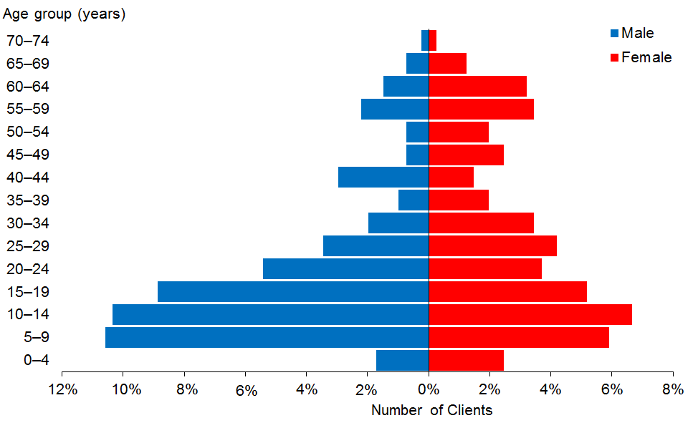

Observations
- The median age of EIF Clients is 19 years.
- There are more males (52%) than females using EIF.

Ethnicity
Table 79: EIF Clients, by age and ethnicity
Age group | European/ Other | Māori | Pacific | Asian | Not  stated | Total
0–4 | 12 | 5 |  |  |  | 17
5–9 | 45 | 18 |  | 3 | 1 | 67
10–14 | 47 | 19 |  | 2 | 1 | 69
15–19 | 42 | 14 |  | 1 |  | 57
20–24 | 27 | 9 | 1 |  |  | 37
25–29 | 21 | 10 |  |  |  | 31
30–34 | 15 | 7 |  |  |  | 22
35–39 | 8 | 4 |  |  |  | 12
40–44 | 14 | 4 |  |  |  | 18
45–49 | 8 | 4 |  | 1 |  | 13
50–54 | 7 | 4 |  |  |  | 11
55–59 | 18 | 5 |  |  |  | 23
60–64 | 10 | 9 |  |  |  | 19
65–69 | 7 | 1 |  |  |  | 8
70–74 | 2 |  |  |  |  | 2
Total | 283 | 113 | 1 | 7 | 2 | 406
 | 70% | 28% | 0% | 2% | 0%

Figure 68: EIF Clients, by age and ethnicity
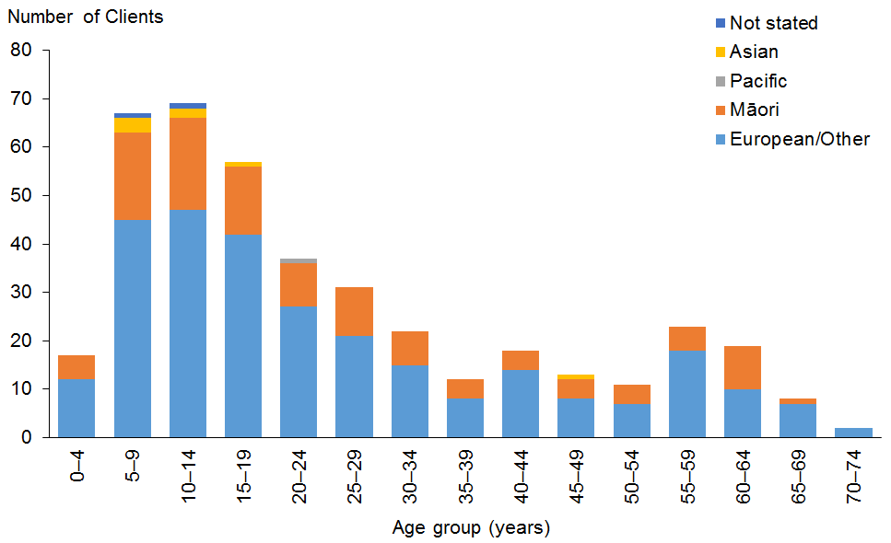

Observations
- European/Other people are slightly over-represented among EIF users (70% compared with 67% of the total DSS Client population).
- Māori are significantly over-represented (28% compared with 17.5% of the total DSS Client population). This is likely to be partly due to the location of the EIF demonstration in the Bay of Plenty, where 27.5% of the total population are Māori, compared with 14.5% of the New Zealand population being Māori.
- Pacific and Asian people are significantly under-represented because they form a very small proportion of the Bay of Plenty population.

Accommodation
Table 80: EIF Clients, by sex and accommodation type
Accommodation type | Male | Female | Total
Own/family home | 196 | 172 | 368
Rental accommodation | 12 | 21 | 33
Unknown | 2 |  | 2
Community residential home | 2 |  | 2
Housing New Zealand accommodation | 1 |  | 1
Total | 213 | 193 | 406

Observation
- The majority (91%) of EIF Clients live in their own home or the family home.

Location

Observation
- EIF is only being demonstrated in the Bay of Plenty region, so all EIF Clients live in this area.

Principal disability
Table 81: EIF Clients, by sex and disability type*
Principal disability | Male | Female | Total | %
Intellectual | 93 | 92 | 185 | 46
Physical | 46 | 61 | 107 | 26
Autism spectrum disorder | 60 | 22 | 82 | 20
Sensory | 10 | 11 | 21 | 5
Neurological | 3 | 7 | 10 | 2
Other | 1 |  | 1 | 0
Total | 213 | 193 | 406 | 100
* Where a Client recorded two principal disabilities, this report has used only the first one.

Figure 69: EIF Clients, by sex and disability type
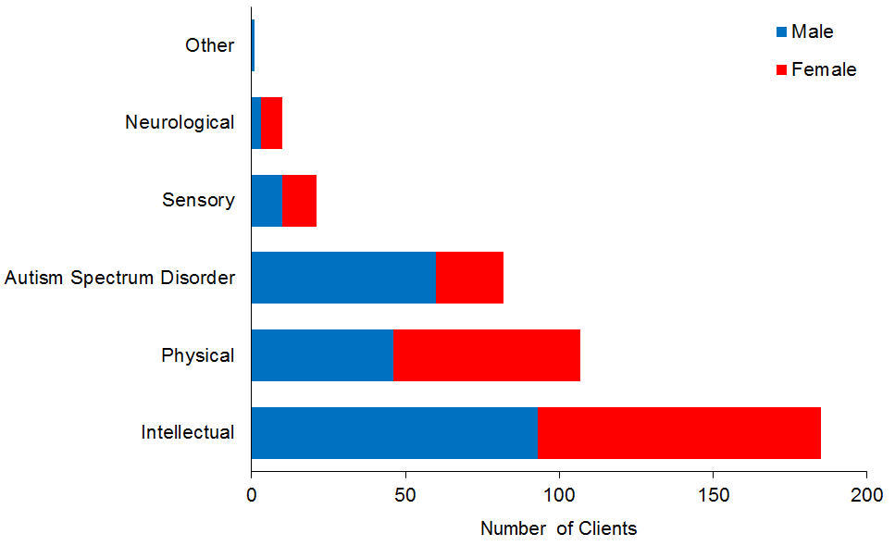

Observation
- EIF Clients have similar proportions of disability types to the overall DSS Client group.

Support package allocation
Table 70: EIF Clients, by SPA level and sex
SPA level | Male | Female | Total | %
Medium | 26 | 33 | 59 | 15
High | 111 | 106 | 217 | 53
Very high | 76 | 54 | 130 | 32
Total | 213 | 193 | 406 | 100

Figure 70: EIF Clients, by SPA level and sex
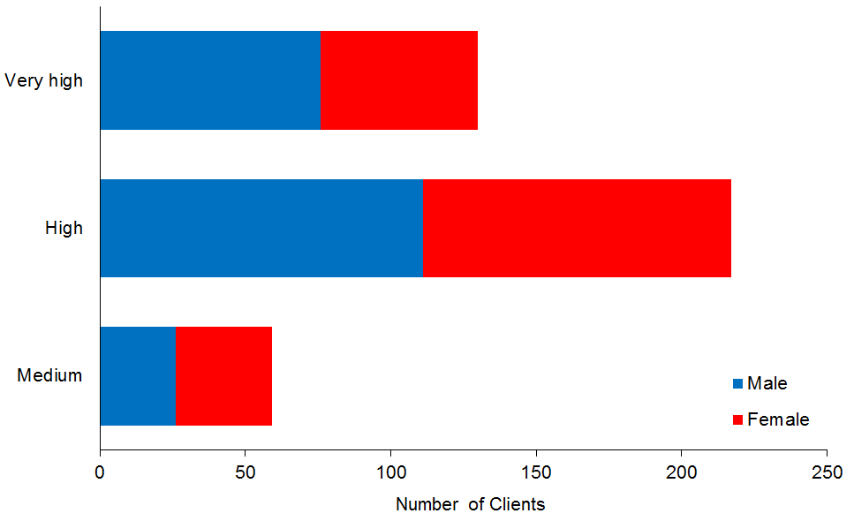

Observation
- EIF Clients have higher SPA levels than the overall DSS Client Group:
- 27% of DSS Clients have Very High SPA levels (compared with 32% of EIF Clients)
- 36% of DSS Clients have High SPA levels (compared with 53% of EIF Clients)
- 33% of DSS Clients have Medium SPA levels (compared with 15% of EIF Clients).

Funded family care
This subsection provides demographic profiles of the 310 DSS Clients using funded family care (FFC). Some of these Clients may also appear in demographics for other services.

Age and sex
Table 83: Funded family care Clients, by age and sex
Age group | Male | Female | Total
15–19 | 10 | 4 | 14
20–24 | 68 | 45 | 113
25–29 | 38 | 23 | 61
30–34 | 14 | 10 | 24
35–39 | 13 | 7 | 20
40–44 | 18 | 10 | 28
45–49 | 8 | 6 | 14
50–54 | 2 | 6 | 8
55–59 | 5 | 9 | 14
60–64 | 2 | 1 | 3
65–69 | 4 | 2 | 6
70–74 | 2 | 2 | 4
75–79 |  | 1 | 1
Total | 184 | 126 | 310
 | 59% | 41%

Figure 71: Funded family care Clients, by age and sex
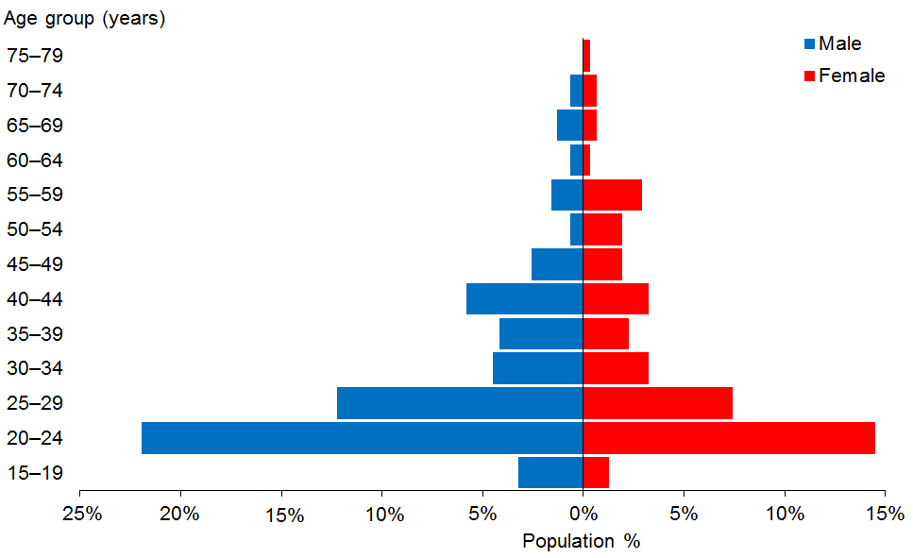

Observations
- The median age of funded family care Clients is 26 years.
- There are significantly more males (59%) than females using funded family care.

Ethnicity
Table 84: Funded family care Clients, by age and ethnicity
Age group | European/ Other | Māori | Pacific | Asian | Not  stated | Total
15–19 | 10 | 1 | 2 | 1 |  | 14
20–24 | 81 | 13 | 11 | 8 |  | 113
25–29 | 34 | 13 | 10 | 4 |  | 61
30–34 | 13 | 2 | 5 | 3 | 1 | 24
35–39 | 12 | 6 | 2 |  |  | 20
40–44 | 17 | 5 | 5 | 1 |  | 28
45–49 | 6 | 4 | 3 | 1 |  | 14
50–54 | 5 | 1 | 1 | 1 |  | 8
55–59 | 6 | 4 | 2 | 1 | 1 | 14
60–64 | 2 |  | 1 |  |  | 3
65–69 | 3 | 3 |  |  |  | 6
70–74 |  |  | 4 |  |  | 4
75–79 | 1 |  |  |  |  | 1
Total | 190 | 52 | 46 | 20 | 2 | 310
 | 61% | 17% | 15% | 6% | 1%

Figure 72: Funded family care Clients, by age and ethnicity
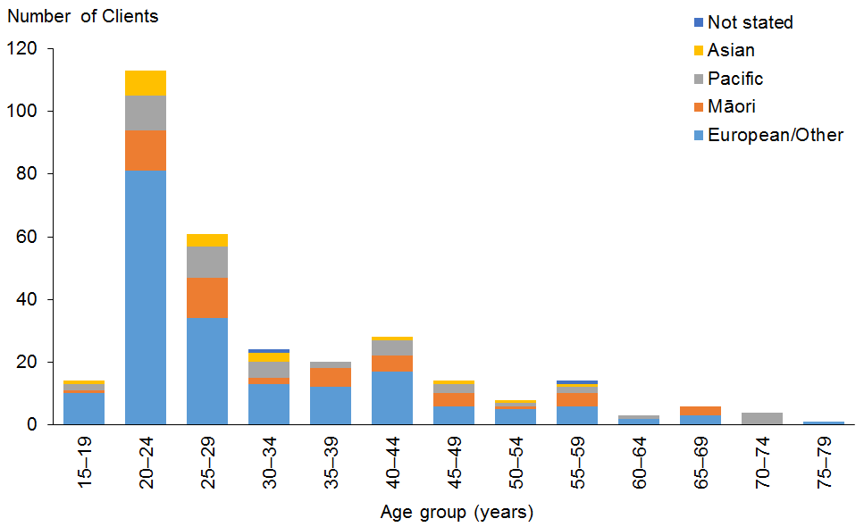

Observations
- European/Other people are under-represented among funded family care Clients (61% compared with 67% of the total DSS Client population).
- Overall, Māori and Asian people are well represented among funded family care Clients.
- Pacific people are significantly over-represented among funded family care Clients (15% compared with 6% of the total DSS Client population).

Marital status

Observation
- Only 6% of the funded family care Clients whose marital status was recorded were married or partnered.

Accommodation
Table 85: Funded family care Clients, by sex and accommodation type
Accommodation type | Male | Female | Total
Own/family home | 135 | 98 | 233
Rental accommodation | 16 | 10 | 26
Unknown | 11 | 6 | 17
Housing New Zealand Accommodation | 9 | 8 | 17
Other | 7 | 2 | 9
Community residential home | 2 | 1 | 3
Rest home / continuing care Hospital | 2 |  | 2
Boarder | 1 | 1 | 2
Unit in a retirement village | 1 |  | 1
Total | 184 | 126 | 310

Observation
- Three-quarters (75%) of funded family care Clients live in their own home or the family home.

Location
Table 86: Funded family care Clients, by ethnicity and region
Region | European/ Other | Māori | Pacific | Asian | Not  stated | Total | %
Auckland | 36 | 4 | 32 | 9 | 1 | 82 | 26
Bay of Plenty | 23 | 19 | 1 |  |  | 43 | 14
Canterbury | 31 | 5 | 1 | 3 |  | 40 | 13
Wellington | 19 | 5 | 11 | 2 | 1 | 38 | 12
Manawatu–Wanganui | 17 | 6 | 1 | 1 |  | 25 | 8
Waikato | 14 | 4 |  | 2 |  | 20 | 6
Northland | 9 | 6 |  | 3 |  | 18 | 6
Hawke’s Bay | 14 |  |  |  |  | 14 | 5
Southland | 9 |  |  |  |  | 9 | 3
Otago | 6 | 1 |  |  |  | 7 | 2
Taranaki | 4 | 1 |  |  |  | 5 | 2
Marlborough | 3 | 1 |  |  |  | 4 | 1
Nelson | 3 |  |  |  |  | 3 | 1
Tasman | 2 |  |  |  |  | 2 | 1
Total | 190 | 52 | 46 | 20 | 2 | 310 | 100

Figure 73: Funded family care Clients, by ethnicity and region
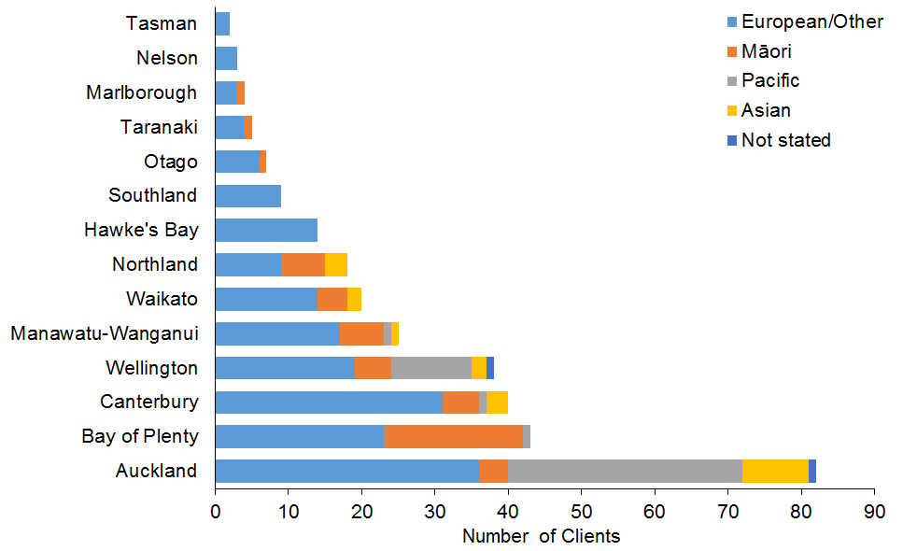

Observations
- Auckland, Wellington and Waikato are slightly under-represented among funded family care Clients.
- Bay of Plenty and Manawatu–Wanganui are over-represented.

Principal disability
Table 87: Funded family care Clients, by sex and disability type*
Principal disability | Male | Female | Total | %
Intellectual | 90 | 64 | 154 | 50
Physical | 70 | 50 | 120 | 39
Autism spectrum disorder | 22 | 5 | 27 | 9
Neurological | 1 | 4 | 5 | 2
Sensory | 1 | 3 | 4 | 1
Total | 184 | 126 | 310 | 100
* Where a Client recorded two principal disabilities, this report has used only the first one.

Figure 74: Funded family care Clients, by sex and disability type
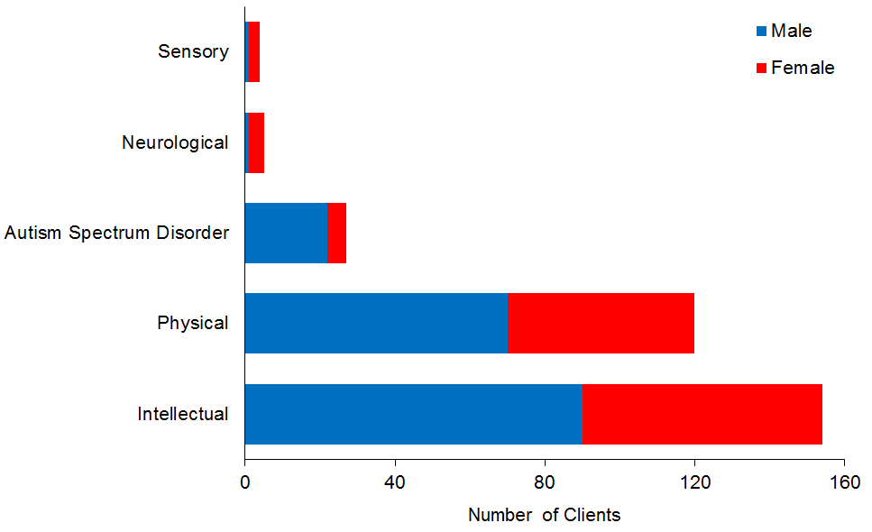

Observations
- While funded family care Clients have the same proportion (50%) of people with intellectual disability as the total DSS Client group, people with physical disability are over-represented (39% compared with 25% of all DSS Clients).
- Clients with ASD are significantly under-represented (9% compared with 20% of all DSS Clients).

Support package allocation
Table 88: Funded family care Clients, by SPA level and sex
SPA level | Male | Female | Total | %
Medium | 1 | 0 | 1 | 0
High | 79 | 72 | 151 | 49
Very high | 104 | 54 | 158 | 51
Total | 184 | 126 | 310 | 100

Figure 75: Funded family care Clients, by SPA level and sex
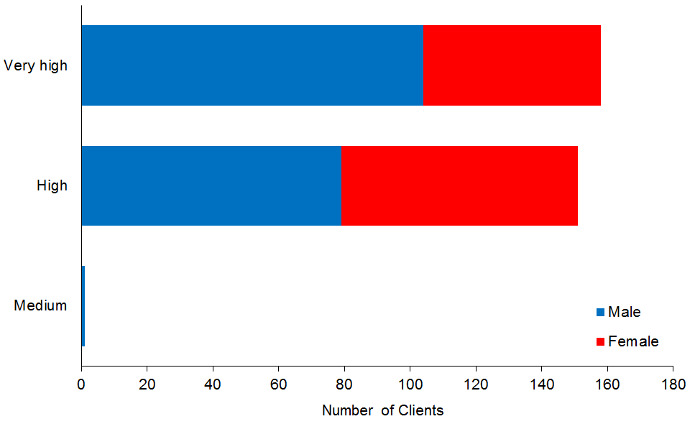

Observations
- Funded family care Clients have much higher SPA levels than the total DSS Client group:
- 51% have a Very High SPA level, compared with 27% of the total DSS Client group
- 49% have a High SPA level, compared with 36% of the total DSS Client group.

Equipment and modification services
This section provides demographic profiles of the 81,957 Clients using equipment and modification services (EMS). Some of these Clients may also appear in demographics for other services. EMS are funded by the Ministry and delivered by two providers: Accessable (from North of Meremere near the Bombay Hills) and Enable NZ for the remainder of New Zealand.

Table 89: EMS Clients, by age and provider
Age group | Accessable | Enable NZ | Total | %
0–15 | 2,199 | 2,967 | 5,166 | 6%
16–64 | 5,229 | 11,213 | 16,442 | 20%
65+ | 20,833 | 39,516 | 60,349 | 74%
Total | 28,261 | 53,696 | 81,957 | 100
 | 34% | 66%

Figure 76: EMS Clients, by age and provider
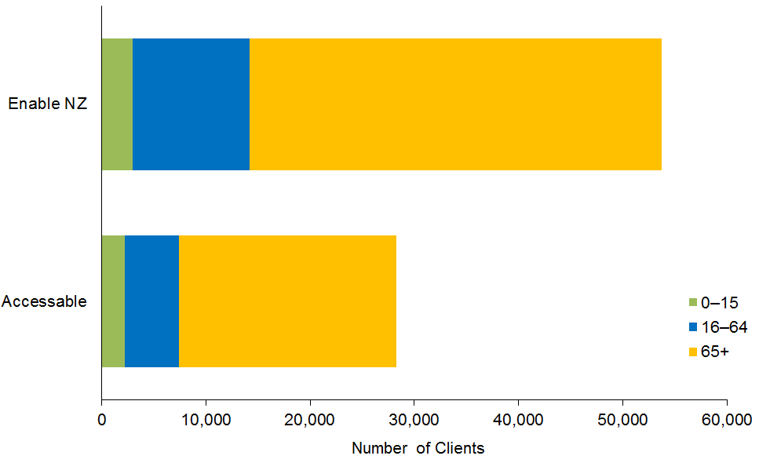

Observation
- Almost three-quarters (74%) of Clients using EMS are aged over 65 years.

Table 90: EMS Clients, by ethnicity and provider
Ethnicity | Accessable | Enable NZ | Total | %
NZ European | 13,313 | 31,201 | 44,514 | 69.7
Other | 2,913 | 5,347 | 8,260 | 12.9
NZ Māori | 1,500 | 4,512 | 6,012 | 9.4
Pacific Island | 2,494 | 743 | 3,237 | 5.1
Asian | 1,392 | 441 | 1,833 | 2.9
Total | 21,612 | 42,244 | 63,856 | 100

Figure 77: EMS Clients, by ethnicity and provider
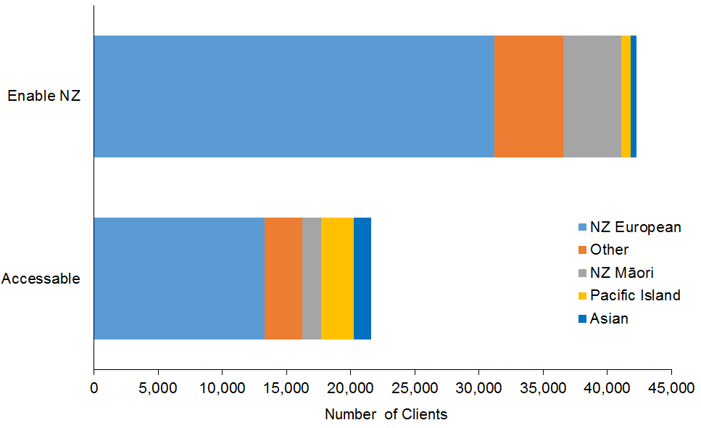

Observations
- People of European/Other ethnicities (82.6%) are significantly over-represented compared with the NZ population (72%).
- Māori make up 9.4% of EMS Clients, Pacific people 5.1%, and Asian people 2.9%. These ethnicities are all significantly under-represented compared with the NZ population.

Table 91: EMS Clients, by age and application type
 | Age in years
Application type | 0–15 | 16–64 | 65+ | Total | %
Equipment for daily living | 1,985 | 8,688 | 35,775 | 46,448 | 57
Mobility and positioning | 2,181 | 5,923 | 21,955 | 30,059 | 37
Housing modification | 359 | 924 | 2,177 | 3,460 | 4
Communication | 313 | 274 | 124 | 711 | 1
Hearing assistive technology (HAT) | 6 | 284 | 232 | 522 | 1
Vehicles 1: driving assessment | 205 | 139 | 17 | 361 | 0.4
Unknown | 18 | 101 | 57 | 176 | 0.2
Vehicles 2: vehicle modification | 85 | 64 | 0 | 149 | 0.2
Vehicles 3: vehicle purchase | 6 | 37 | 1 | 44 | 0.1
Vision | 8 | 8 | 11 | 27 | 0.03
Total | 5,166 | 16,442 | 60,349 | 81,957 | 100

Figure 78: EMS Clients, by age and application type
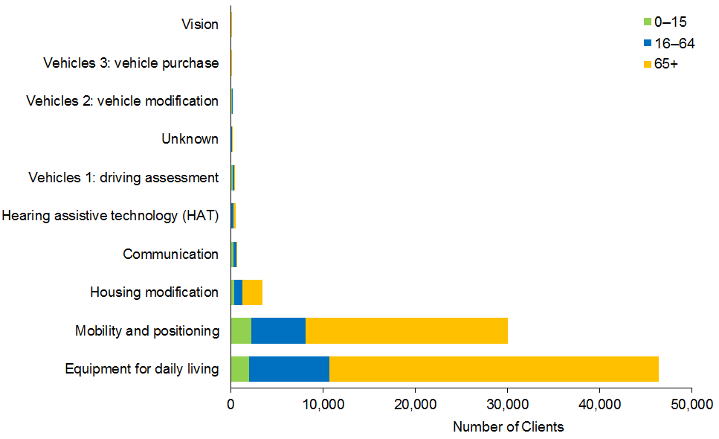

Observations
- Over half (57%) of all EMS applications are for equipment for daily living (eg, shower stools).
- Over a third (37%) of EMS applications are for mobility and positioning (eg, wheelchairs, adjustable beds).

Client demographics, by disability
This section focuses on the five broad disability types and provides the demographic profiles of the DSS Clients with each of these disabilities. While all Clients are recorded as having one principal disability, some Clients are listed with two principal disabilities. This report focuses on only the first principal disability recorded.

Intellectual disability

Age and sex
Table 92: DSS Clients with intellectual disability, by age and sex
Age group | Male | Female | Total
0–4 | 265 | 171 | 436
5–9 | 999 | 601 | 1,600
10–14 | 1,216 | 700 | 1,916
15–19 | 1,120 | 793 | 1,913
20–24 | 927 | 651 | 1,578
25–29 | 725 | 608 | 1,333
30–34 | 559 | 476 | 1,035
35–39 | 519 | 394 | 913
40–44 | 576 | 469 | 1,045
45–49 | 669 | 503 | 1,172
50–54 | 643 | 511 | 1,154
55–59 | 588 | 490 | 1,078
60–64 | 415 | 360 | 775
65–69 | 247 | 226 | 473
70–74 | 133 | 110 | 243
75–79 | 56 | 64 | 120
80–84 | 12 | 20 | 32
85–89 | 11 | 12 | 23
Total | 9,680 | 7,159 | 16,839
 | 57% | 43%

Figure 79: DSS Clients with intellectual disability, by age and sex
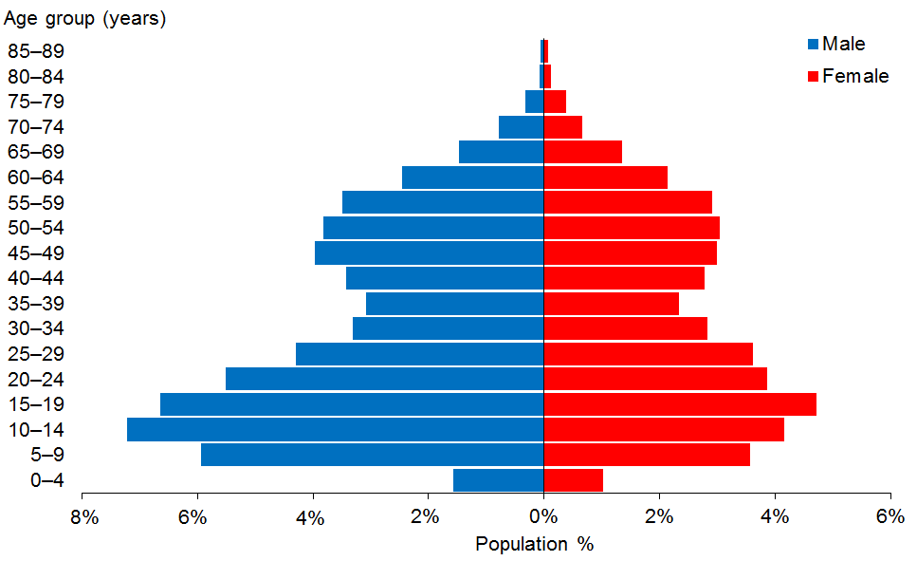

Observations
- The median age of Clients with an intellectual disability is 28 years (no change from the 2014 report).
- There are significantly more males (57%) than females (43%) with an intellectual disability in the DSS Client group. This proportion has not changed over the past three years.
- There are two peaks in the age group profiles for both sexes: 5–25 years and 45–59 years.

Physical disability

Age and sex
Table 93: DSS Clients with physical disability, by age and sex
Age group | Male | Female | Total
0–4 | 68 | 65 | 133
5–9 | 195 | 152 | 347
10–14 | 219 | 170 | 389
15–19 | 216 | 183 | 399
20–24 | 215 | 150 | 365
25–29 | 157 | 154 | 311
30–34 | 136 | 149 | 285
35–39 | 129 | 162 | 291
40–44 | 169 | 261 | 430
45–49 | 228 | 379 | 607
50–54 | 320 | 494 | 814
55–59 | 408 | 612 | 1,020
60–64 | 492 | 716 | 1,208
65–69 | 400 | 694 | 1,094
70–74 | 184 | 403 | 587
75–79 | 55 | 165 | 220
80–84 | 6 | 9 | 15
85–89 | 1 | 3 | 4
Total | 3,598 | 4,921 | 8,519
 | 42% | 58%

Figure 80: DSS Clients with physical disability, by age and sex
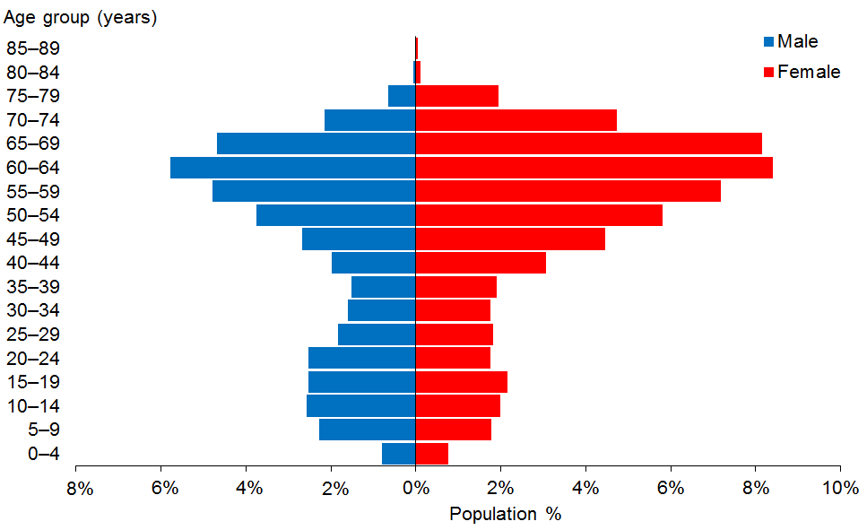

Observations
- Clients with a physical disability are a markedly older group, with a median age of 54 years (two years older than in 2014).
- Females make up 58% of Clients with a physical disability.
- This age–sex structure has remained the same for the past three years.

Autism spectrum disorder
This subsection describes Clients who have one of the following disabilities: Asperger’s syndrome; autism spectrum disorder (ASD); other ASD.

Age and sex
Table 94: DSS Clients with ASD, by age and sex
Age group | Male | Female | Total
0–4 | 309 | 78 | 387
5–9 | 1,515 | 321 | 1,836
10–14 | 1,528 | 331 | 1,859
15–19 | 1,027 | 247 | 1,274
20–24 | 443 | 116 | 559
25–29 | 215 | 63 | 278
30–34 | 115 | 29 | 144
35–39 | 60 | 21 | 81
40–44 | 45 | 18 | 63
45–49 | 29 | 8 | 37
50–54 | 40 | 11 | 51
55–59 | 20 | 5 | 25
60–64 | 7 | 6 | 13
65–69 | 6 | 4 | 10
70–74 | 2 | 1 | 3
Total | 5,361 | 1,259 | 6,620
 | 81% | 19%

Figure 81: DSS Clients with ASD, by age and sex
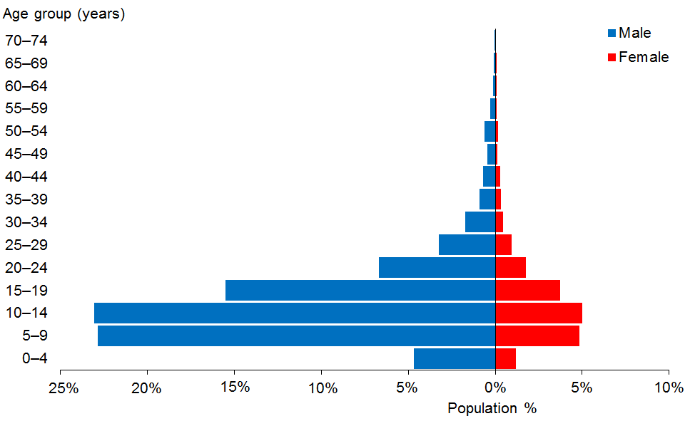

Observations
- ASD Clients are predominantly young, with a median age of 12 years (no change since 2014).
- ASD Clients are predominantly male (81%).
- This age–sex structure has remained essentially the same for the past three years.

Sensory disability

Age and sex
Table 95: Sensory disability Clients, by age and sex
Age group | Male | Female | Total
0–4 | 16 | 11 | 27
5–9 | 37 | 37 | 74
10–14 | 62 | 36 | 98
15–19 | 51 | 43 | 94
20–24 | 33 | 36 | 69
25–29 | 25 | 30 | 55
30–34 | 15 | 27 | 42
35–39 | 24 | 16 | 40
40–44 | 27 | 35 | 62
45–49 | 37 | 31 | 68
50–54 | 55 | 60 | 115
55–59 | 44 | 51 | 95
60–64 | 51 | 54 | 105
65–69 | 26 | 39 | 65
70–74 | 17 | 20 | 37
75–79 | 4 | 15 | 19
80–84 | 1 |  | 1
Total | 525 | 541 | 1,066
 | 49% | 51%

Figure 82: Sensory disability Clients, by age and sex
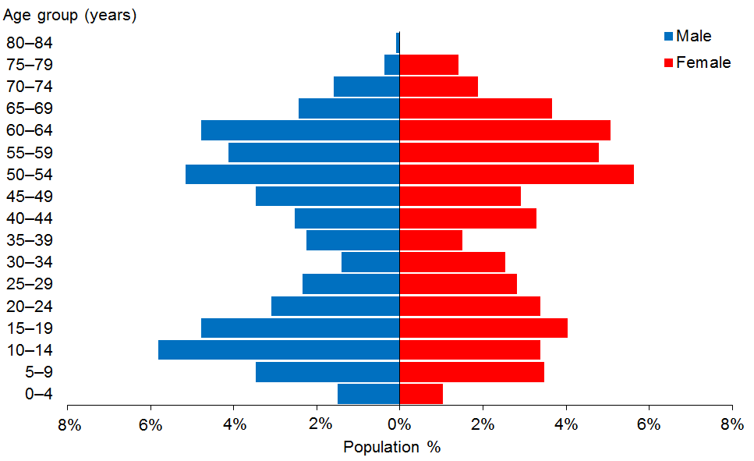

Observations
- The median age of clients with sensory disabilities is 42 years (two years older than in 2014).
- Males and females are more evenly represented in this disability group.

Neurological disability

Age and sex
Table 96: Clients with neurological disability, by age and sex
Age group | Male | Female | Total
0–4 | 5 | 4 | 9
5–9 | 14 | 6 | 20
10–14 | 14 | 9 | 23
15–19 | 9 | 8 | 17
20–24 | 1 | 8 | 9
25–29 | 3 | 5 | 8
30–34 | 9 | 6 | 15
35–39 | 12 | 14 | 26
40–44 | 24 | 12 | 36
45–49 | 26 | 25 | 51
50–54 | 34 | 35 | 69
55–59 | 47 | 35 | 82
60–64 | 46 | 59 | 105
65–69 | 44 | 37 | 81
70–74 | 8 | 15 | 23
75–79 | 3 | 4 | 7
Total | 299 | 282 | 581
 | 51% | 49%

Figure 83: Clients with neurological disability, by age and sex
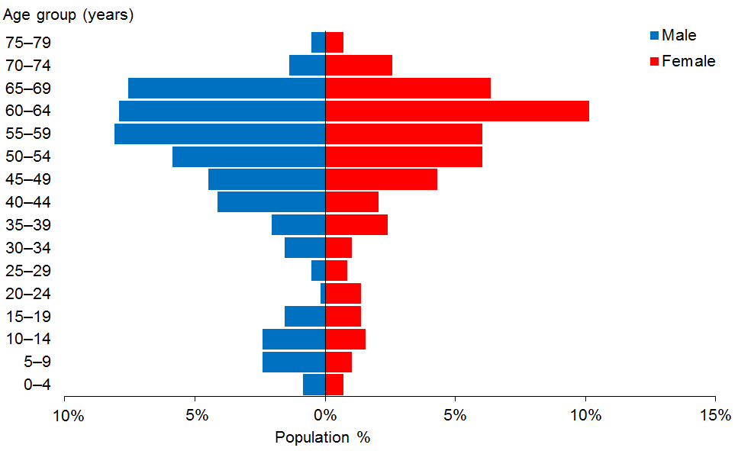

Observations
- The median age of Clients with neurological disabilities (eg, brain injury, multiple sclerosis) is 55 years (two years older than in 2014).
- Almost two-thirds (62%) of Clients with neurological disabilities using disability support services are aged over 50 years.

Service usage, by ethnicity
This section illustrates service usage by each of the four main ethnic groups: European/Other, Māori, Pacific and Asian.

Figure 84: Overall service usage, by ethnicity
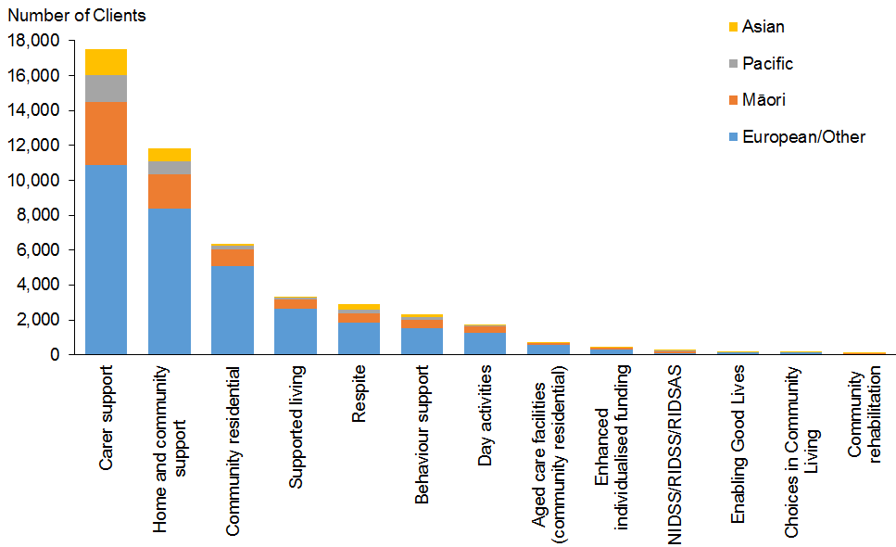

Figure 85: Service usage by Clients of European/Other ethnicity
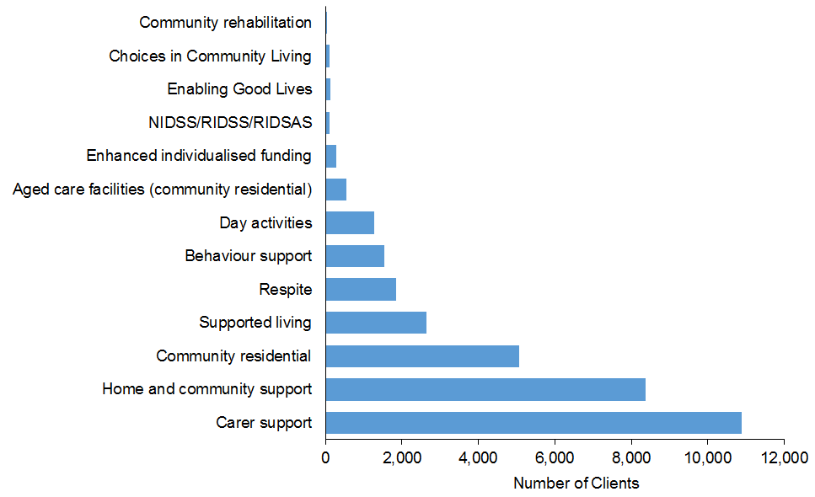

Figure 86: Service usage by Clients of Māori ethnicity
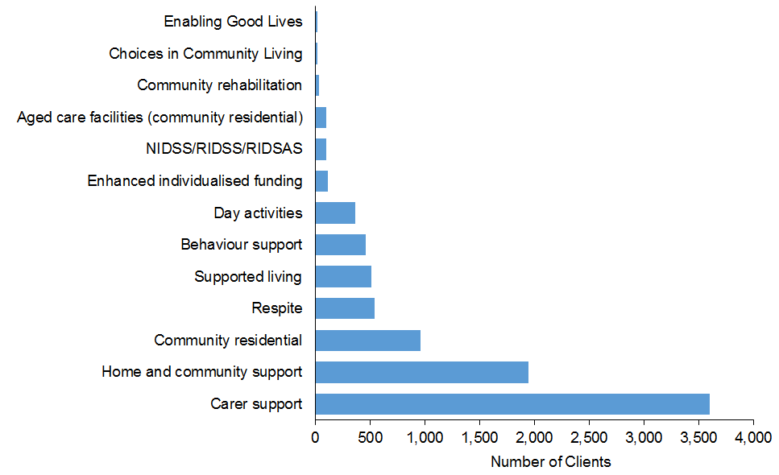

Figure 87: Service usage by Clients of Pacific ethnicity
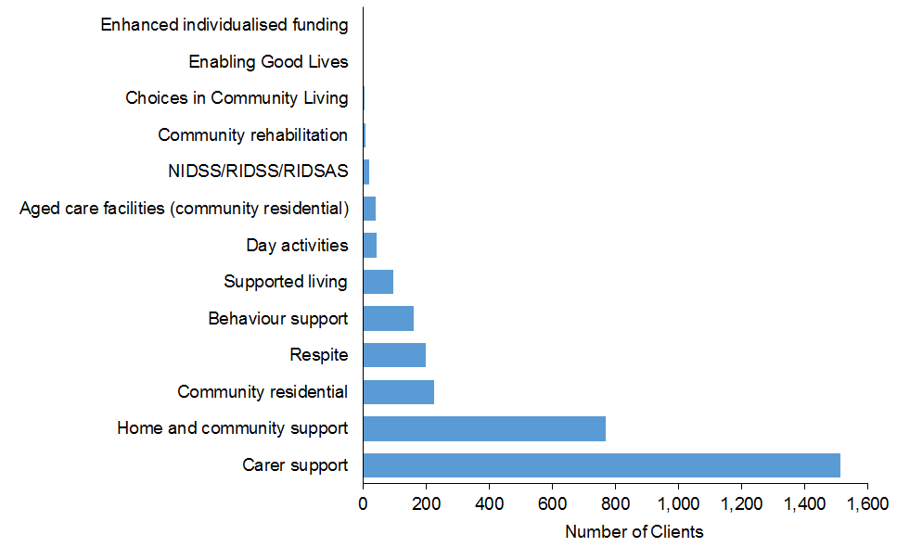

Figure 88: Service usage by Clients of Asian ethnicity
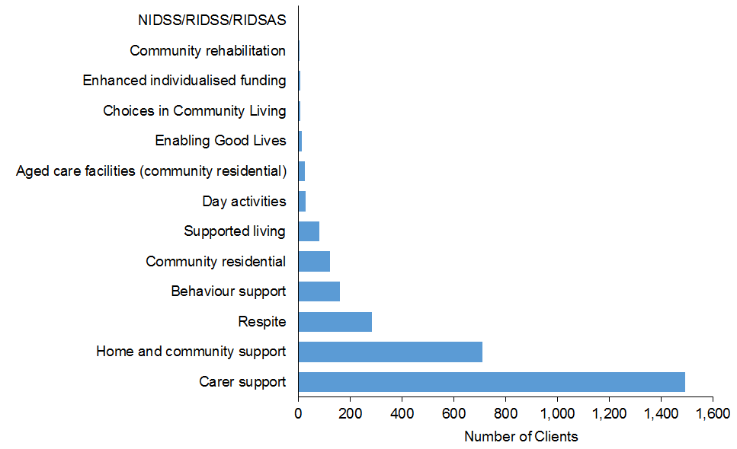

Observations
- For all ethnicities, carer support is the most widely used Ministry-funded disability support service, and home and community supports are the second most commonly used.
- There are ethnic differences in the use of community residential and supported living services.

Service usage, by region
This section illustrates the number, age, ethnicity and disability types of DSS Clients allocated the different service types provided in each region.

Northland
Table 97: Northland DSS Clients, by age and service allocated
Age group | Carer support | HCSS | Community residential | Day services | Respite | Supported living | Behaviour support | YPD | H&C | Community rehabilitation | Total
0–4 | 44 | 5 |  |  |  |  | 6 |  |  |  | 55
5–9 | 155 | 31 |  |  | 10 |  | 20 |  |  |  | 216
10–14 | 171 | 52 |  |  | 18 |  | 30 |  |  |  | 271
15–19 | 127 | 55 | 1 |  | 19 | 2 | 13 |  |  |  | 217
20–24 | 71 | 58 | 17 |  | 17 | 12 | 11 |  |  |  | 186
25–29 | 35 | 46 | 21 |  | 8 | 11 | 1 |  |  |  | 122
30–34 | 25 | 37 | 14 | 6 | 3 | 5 | 3 |  | 4 |  | 97
35–39 | 15 | 28 | 22 | 10 | 1 | 6 | 1 |  | 1 | 1 | 85
40–44 | 17 | 39 | 21 | 14 | 6 | 14 |  |  |  | 1 | 112
45–49 | 18 | 32 | 30 | 19 | 3 | 10 |  | 1 |  |  | 113
50–54 | 25 | 49 | 19 | 12 | 3 | 12 |  | 7 | 1 | 2 | 130
55–59 | 28 | 67 | 27 | 21 | 6 | 10 | 2 | 6 | 1 |  | 168
60–64 | 22 | 64 | 23 | 18 | 7 | 8 | 1 | 7 |  | 1 | 151
65–69 | 28 | 65 | 10 | 9 | 4 | 2 |  | 5 |  |  | 123
70–74 | 18 | 39 | 7 | 5 | 1 | 1 |  | 4 |  |  | 75
75–79 | 1 | 23 | 2 | 3 |  |  |  | 1 |  |  | 30
Total | 800 | 690 | 214 | 117 | 106 | 93 | 88 | 31 | 7 | 5 | 2,151

Figure 89: Northland DSS Clients, by age and service allocated
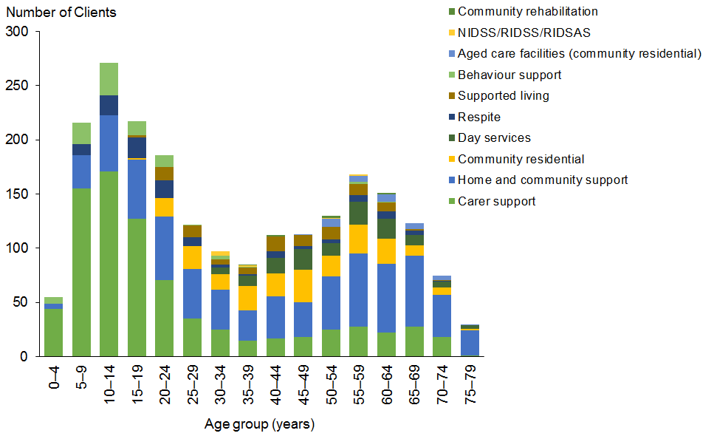

Figure 90: Northland DSS Clients, by ethnicity and service allocated
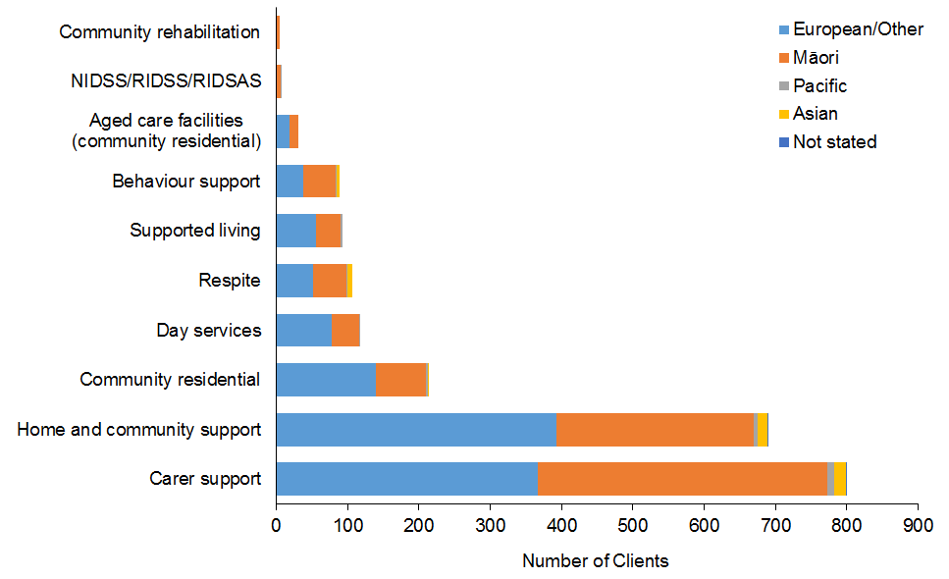

Figure 91: Northland DSS Clients, by age and disability type
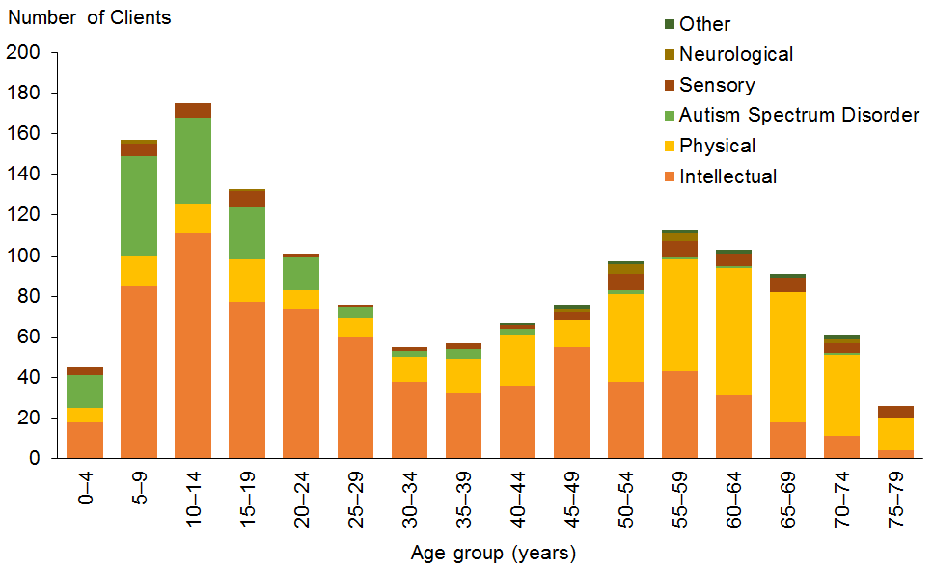

Auckland
Table 98: Auckland DSS Clients, by age and service allocated
Age group | Carer support | HCSS | Community residential | Respite | Behaviour support | Supported living | YPD | Day services | Choices in Community Living | H&C | Community rehabilitation | Enhanced individualised funding | Total
0–4 | 415 | 80 |  | 41 | 67 | 3 |  |  |  |  |  |  | 606
5–9 | 1,389 | 258 |  | 166 | 243 | 15 |  |  |  |  |  |  | 2071
10–14 | 1,542 | 443 |  | 275 | 177 | 9 |  |  |  |  |  |  | 2446
15–19 | 1,220 | 484 | 36 | 325 | 127 | 45 |  | 6 | 5 | 7 |  |  | 2255
20–24 | 666 | 350 | 96 | 181 | 35 | 116 |  | 14 | 16 | 14 | 1 |  | 1489
25–29 | 369 | 226 | 124 | 69 | 14 | 102 |  | 16 | 9 | 15 | 1 |  | 945
30–34 | 190 | 147 | 143 | 32 | 15 | 63 |  | 19 | 11 | 8 | 2 | 1 | 631
35–39 | 109 | 114 | 139 | 13 | 10 | 47 | 1 | 29 | 7 | 10 | 2 |  | 481
40–44 | 123 | 154 | 164 | 20 | 3 | 40 | 6 | 24 | 7 | 5 | 3 |  | 549
45–49 | 113 | 175 | 191 | 20 | 3 | 57 | 15 | 14 | 6 | 6 | 2 |  | 602
50–54 | 121 | 230 | 214 | 26 | 7 | 44 | 35 | 5 | 8 | 3 | 5 |  | 698
55–59 | 122 | 255 | 198 | 24 | 5 | 31 | 41 | 15 | 7 | 4 | 2 |  | 704
60–64 | 116 | 256 | 116 | 20 | 3 | 21 | 70 | 14 | 7 | 2 | 4 |  | 629
65–69 | 94 | 211 | 67 | 14 | 2 | 7 | 51 | 5 | 2 |  | 1 |  | 454
70–74 | 71 | 155 | 40 | 14 |  | 5 | 41 | 9 |  |  |  |  | 335
75–79 | 32 | 86 | 18 | 5 |  | 3 | 9 | 12 |  |  |  |  | 165
80–84 |  |  | 3 |  |  |  | 1 | 1 |  |  |  |  | 5
85–89 |  |  | 3 |  |  |  |  | 1 |  |  |  |  | 4
Total | 6,692 | 3,624 | 1,552 | 1,245 | 711 | 608 | 270 | 184 | 85 | 74 | 23 | 1 | 15,069

Figure 92: Auckland DSS Clients, by age and service allocated
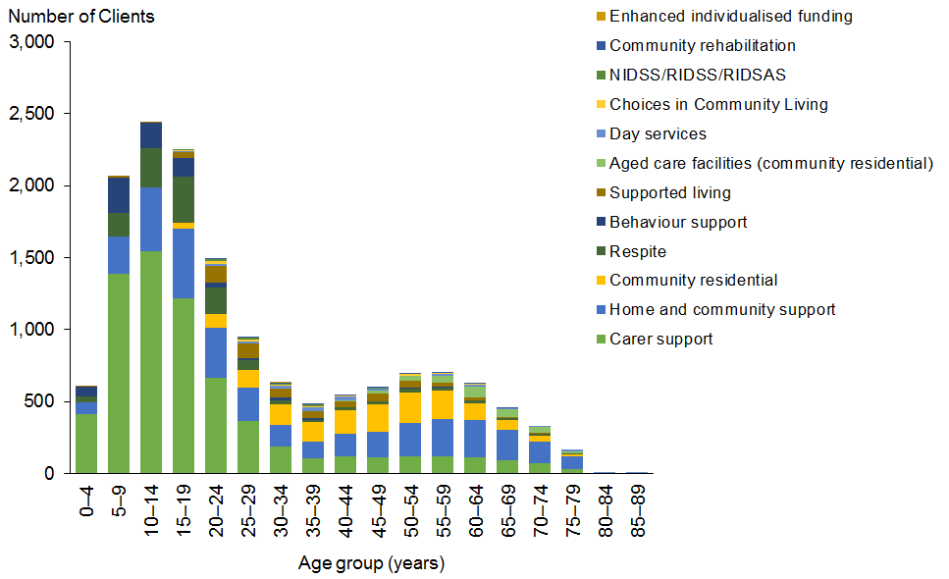

Figure 93: Auckland DSS Clients, by ethnicity and service allocated
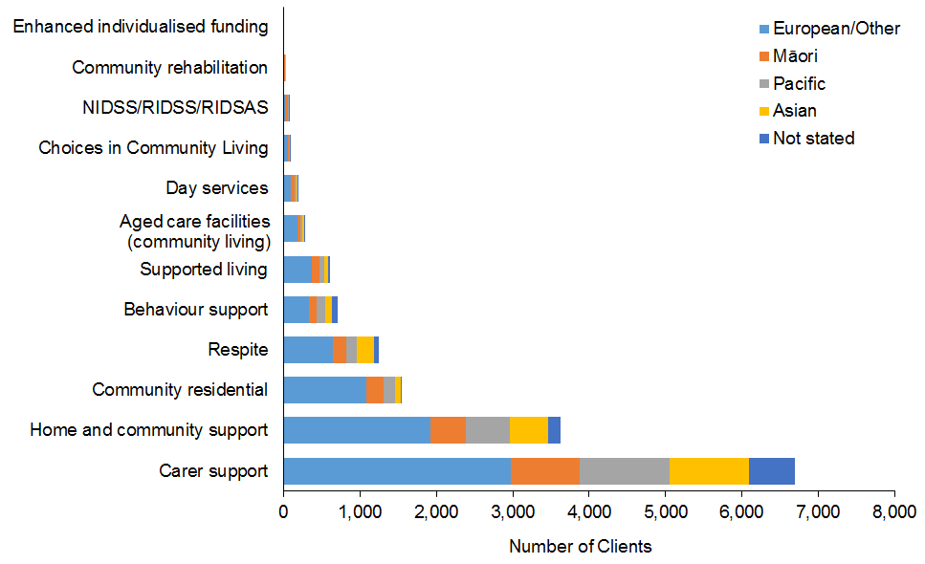

Figure 94: Auckland DSS Clients, by age and disability type
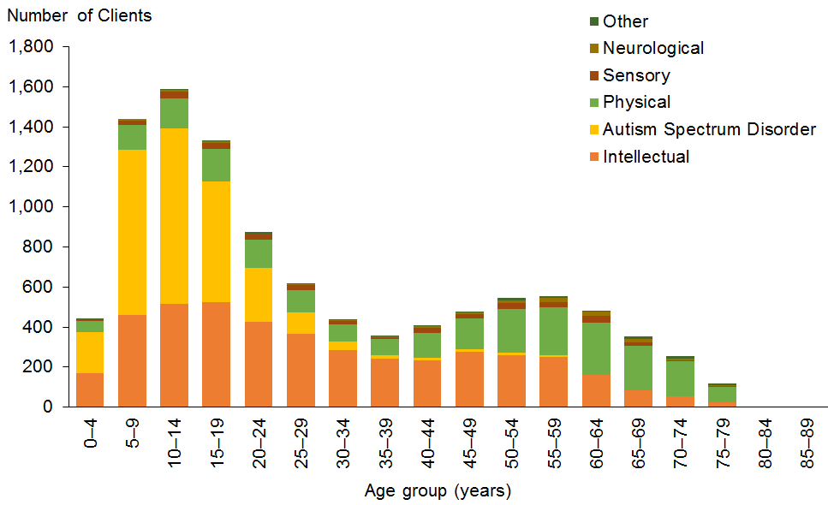

Waikato
Table 99: Waikato DSS Clients, by age and service allocated
Age group | Carer support | HCSS | Community residential | Day services | Supported living | Respite | Behaviour support | Choices in Community Living | YPD | H&C | Community rehabilitation | Total
0–4 | 90 | 5 |  |  |  | 2 | 4 |  |  |  |  | 101
5–9 | 398 | 37 | 1 |  |  | 20 | 47 |  |  |  |  | 503
10–14 | 412 | 70 | 2 |  |  | 45 | 52 |  |  |  |  | 581
15–19 | 317 | 70 | 21 | 2 | 3 | 46 | 36 | 1 |  | 5 |  | 501
20–24 | 144 | 47 | 73 | 35 | 24 | 29 | 14 | 11 |  | 12 | 1 | 390
25–29 | 82 | 42 | 88 | 78 | 18 | 17 | 11 | 12 |  | 2 | 1 | 351
30–34 | 62 | 30 | 58 | 50 | 20 | 11 | 10 | 9 |  | 4 |  | 254
35–39 | 32 | 28 | 50 | 38 | 20 | 6 | 1 | 8 | 1 | 2 |  | 186
40–44 | 24 | 38 | 83 | 42 | 14 | 6 | 6 | 5 |  | 2 | 2 | 222
45–49 | 36 | 75 | 110 | 60 | 39 | 6 | 5 | 6 | 6 | 2 | 1 | 346
50–54 | 37 | 69 | 91 | 46 | 25 | 3 | 1 | 8 | 2 | 2 | 2 | 286
55–59 | 35 | 93 | 77 | 33 | 18 | 7 |  | 4 | 10 | 1 | 6 | 284
60–64 | 40 | 129 | 66 | 42 | 30 | 9 | 4 | 8 | 16 |  | 8 | 352
65–69 | 41 | 104 | 30 | 17 | 18 | 2 |  | 3 | 4 |  | 2 | 221
70–74 | 6 | 36 | 14 | 5 | 4 |  |  | 1 | 3 |  |  | 69
75–79 | 3 | 10 | 11 | 8 | 2 |  |  |  |  |  |  | 34
80–84 |  | 1 | 3 | 2 |  |  |  |  |  |  |  | 6
85–89 |  |  | 1 | 1 |  |  |  |  |  |  |  | 2
Total | 1,759 | 884 | 779 | 459 | 235 | 209 | 191 | 76 | 42 | 32 | 23 | 4,689

Figure 95: Waikato DSS Clients, by age and service allocated
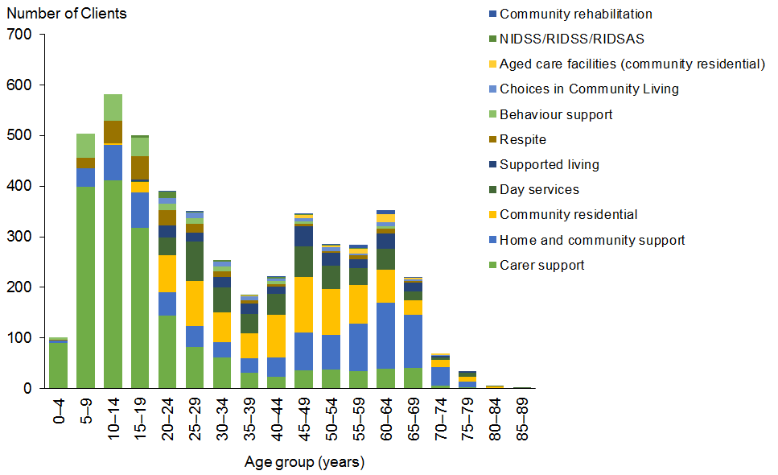

Figure 96: Waikato DSS Clients, by ethnicity and service allocated
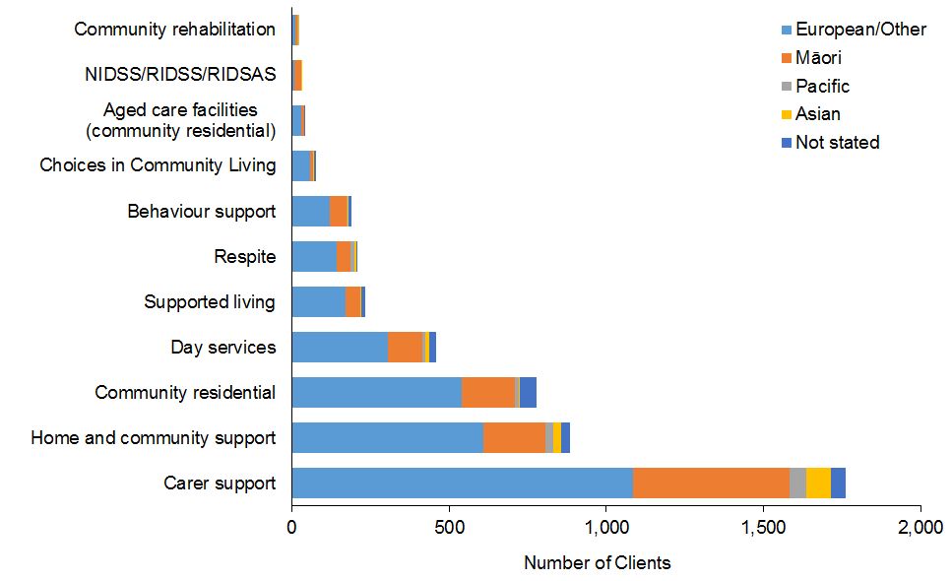

Figure 97: Waikato DSS Clients, by age and disability type
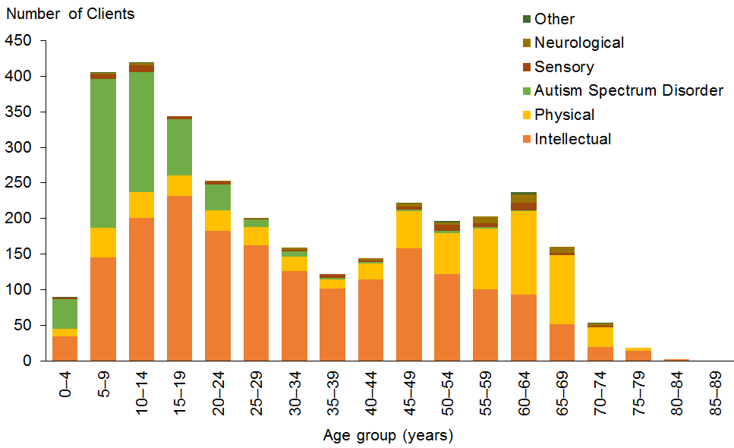

Bay of Plenty
Table 100: Bay of Plenty DSS Clients, by age and service allocated
Age group | Carer support | HCSS | Enhanced individualised funding | Supported living | Community residential | Day services | Respite | Behaviour support | YPD | Community rehabilitation | Total
0–4 | 71 | 15 | 17 |  |  |  | 1 |  |  |  | 104
5–9 | 275 | 36 | 67 |  |  |  | 14 | 22 |  |  | 414
10–14 | 271 | 33 | 69 |  | 2 |  | 20 | 24 |  |  | 419
15–19 | 208 | 46 | 57 | 5 | 9 |  | 25 | 15 |  |  | 365
20–24 | 122 | 68 | 37 | 33 | 17 | 1 | 40 | 8 |  |  | 326
25–29 | 67 | 38 | 31 | 41 | 27 | 6 | 16 | 2 | 1 |  | 229
30–34 | 46 | 28 | 21 | 38 | 30 | 19 | 6 | 2 | 1 |  | 191
35–39 | 22 | 24 | 12 | 38 | 29 | 19 | 7 |  | 1 |  | 152
40–44 | 29 | 39 | 18 | 41 | 36 | 19 | 8 | 4 | 1 |  | 195
45–49 | 25 | 59 | 13 | 50 | 52 | 22 | 2 | 2 | 7 |  | 232
50–54 | 32 | 53 | 11 | 32 | 47 | 26 | 4 |  | 7 |  | 212
55–59 | 46 | 81 | 23 | 43 | 47 | 20 | 7 |  | 7 |  | 274
60–64 | 41 | 75 | 19 | 28 | 31 | 11 | 2 | 2 | 10 | 1 | 220
65–69 | 29 | 71 | 8 | 20 | 20 | 11 | 3 |  | 19 |  | 181
70–74 | 9 | 34 | 2 | 7 | 5 | 4 | 1 |  | 5 |  | 67
75–79 |  | 2 |  | 3 | 3 | 2 |  |  |  |  | 10
80–84 |  |  |  |  | 3 | 1 |  |  |  |  | 4
85–89 |  |  |  |  | 3 | 3 |  |  |  |  | 6
Total | 1,293 | 702 | 405 | 379 | 361 | 164 | 156 | 81 | 59 | 1 | 3,601

Figure 98: Bay of Plenty DSS Clients, by age and service allocated
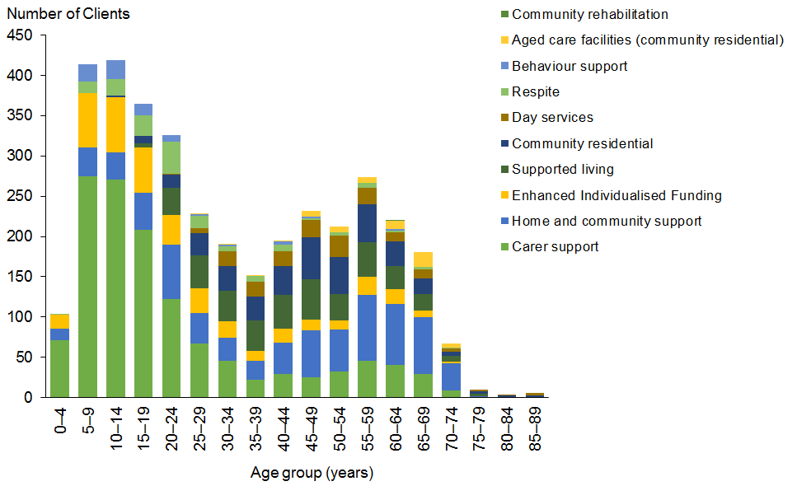

Figure 99: Bay of Plenty DSS Clients, by ethnicity and service allocated
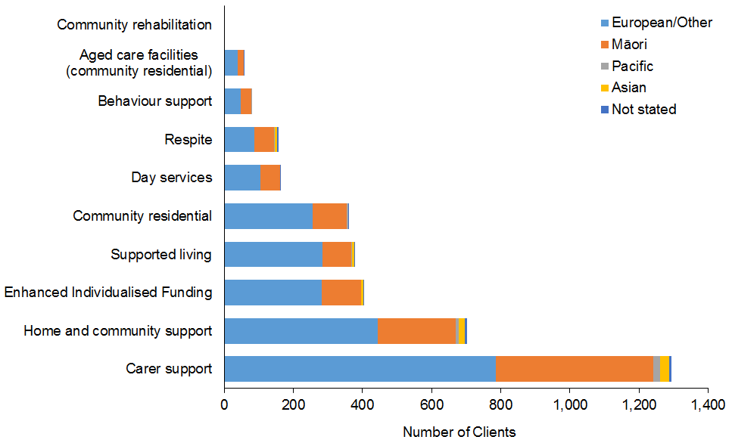

Figure 100: Bay of Plenty DSS Clients, by age and disability type
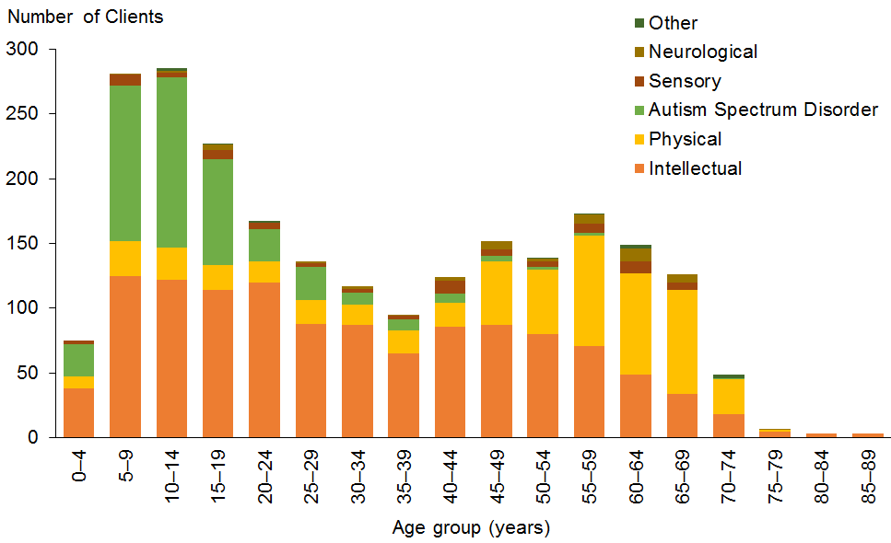

Hawke’s Bay
Table 101: Hawke’s Bay DSS Clients, by age and service allocated
Age group | Carer support | HCSS | Community residential | Supported living | Respite | Behaviour support | Day services | YPD | Community rehabilitation | Enabling Good Lives | Total
0–4 | 26 | 6 |  |  |  | 1 |  |  |  |  | 33
5–9 | 105 | 21 | 1 | 1 | 12 | 14 |  |  |  |  | 154
10–14 | 120 | 15 | 14 |  | 35 | 21 |  |  |  |  | 205
15–19 | 87 | 26 | 26 | 3 | 17 | 10 |  |  |  | 1 | 170
20–24 | 53 | 24 | 26 | 13 | 5 | 8 |  |  |  |  | 129
25–29 | 28 | 17 | 34 | 18 | 2 | 9 |  |  |  |  | 108
30–34 | 11 | 18 | 28 | 17 |  | 3 | 2 | 1 |  |  | 80
35–39 | 11 | 28 | 45 | 10 | 1 | 2 | 2 | 3 |  |  | 102
40–44 | 10 | 31 | 41 | 11 |  | 4 | 13 | 1 |  |  | 111
45–49 | 8 | 32 | 38 | 17 | 3 | 4 | 7 | 3 | 2 |  | 114
50–54 | 8 | 40 | 41 | 13 |  |  | 8 |  |  |  | 110
55–59 | 11 | 36 | 19 | 14 | 2 | 1 | 8 | 5 | 2 |  | 98
60–64 | 9 | 40 | 27 | 13 | 1 | 1 | 9 | 2 |  |  | 102
65–69 | 3 | 27 | 10 | 6 | 1 |  | 7 | 4 |  |  | 58
70–74 | 4 | 9 | 9 | 3 |  |  | 1 | 3 |  |  | 29
75–79 |  | 4 | 3 | 1 |  |  |  |  |  |  | 8
80–84 |  |  | 1 |  |  |  |  |  |  |  | 1
85–89 |  | 1 |  | 1 |  |  |  |  |  |  | 2
Total | 494 | 375 | 363 | 141 | 79 | 78 | 57 | 22 | 4 | 1 | 1,614

Figure 101: Hawke’s Bay DSS Clients, by age and service allocated
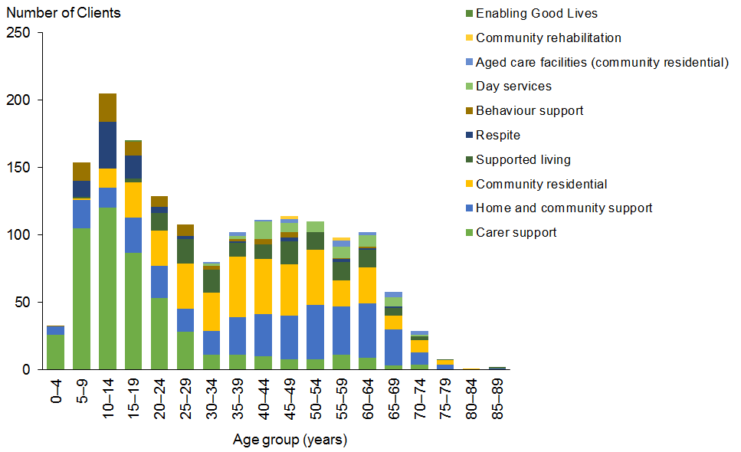

Figure 102: Hawke’s Bay DSS Clients, by ethnicity and service allocated
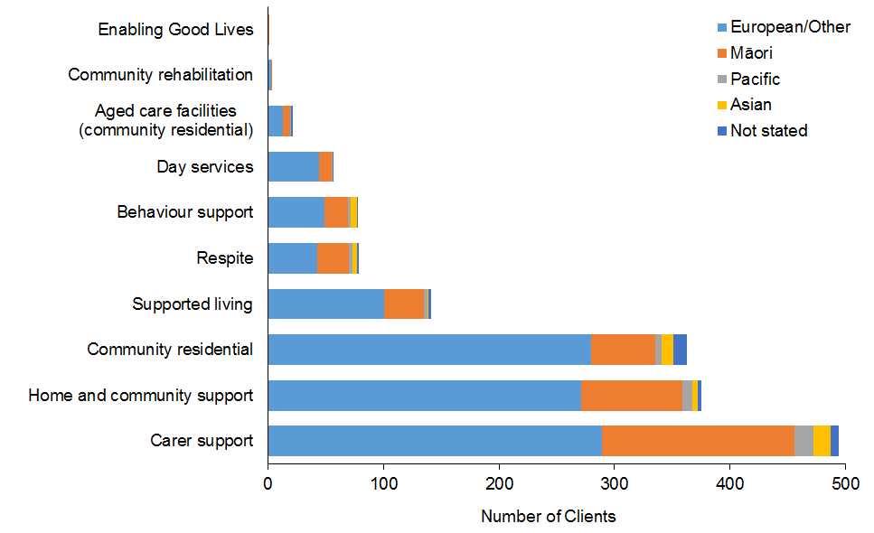

Figure 103: Hawke’s Bay DSS Clients, by age and disability type
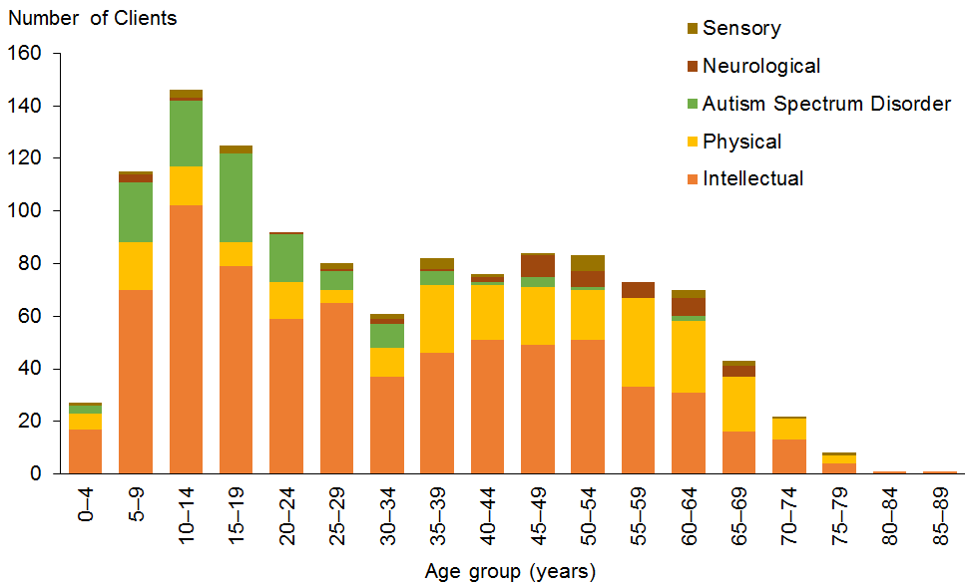

Gisborne
Table 102: Gisborne DSS Clients, by age and service allocated
Age group | Carer support | HCSS | Community residential | Supported living | Day services | Behaviour support | Respite | Community rehabilitation | YPD | Total
0–4 | 7 |  |  |  |  | 1 |  |  |  | 8
5–9 | 38 | 3 |  |  |  | 5 |  |  |  | 46
10–14 | 39 | 7 |  |  |  | 8 | 2 |  |  | 56
15–19 | 29 | 12 | 4 |  |  | 3 | 5 |  |  | 53
20–24 | 8 | 2 | 3 | 2 | 1 |  | 1 |  |  | 17
25–29 | 7 | 8 | 5 | 2 | 4 | 1 | 1 |  |  | 28
30–34 | 4 | 7 | 10 | 2 | 7 |  |  | 1 |  | 31
35–39 | 6 | 3 | 4 | 3 | 1 |  |  |  |  | 17
40–44 | 2 | 6 | 7 | 3 | 3 | 1 | 1 | 1 |  | 24
45–49 | 2 | 6 | 7 | 7 | 1 |  |  |  |  | 23
50–54 | 4 | 11 | 7 | 3 | 6 |  |  | 1 |  | 32
55–59 | 3 | 10 | 10 | 7 | 2 |  |  | 2 | 2 | 36
60–64 | 6 | 12 | 8 | 5 | 2 |  | 2 | 1 | 1 | 37
65–69 | 6 | 15 | 5 | 1 | 2 | 1 |  |  |  | 30
70–74 | 2 | 7 | 4 | 2 | 1 |  |  |  |  | 16
75–79 |  | 5 | 1 | 1 | 1 |  |  |  |  | 8
Total | 163 | 114 | 75 | 38 | 31 | 20 | 12 | 6 | 3 | 462

Figure 104: Gisborne DSS Clients, by age and service allocated
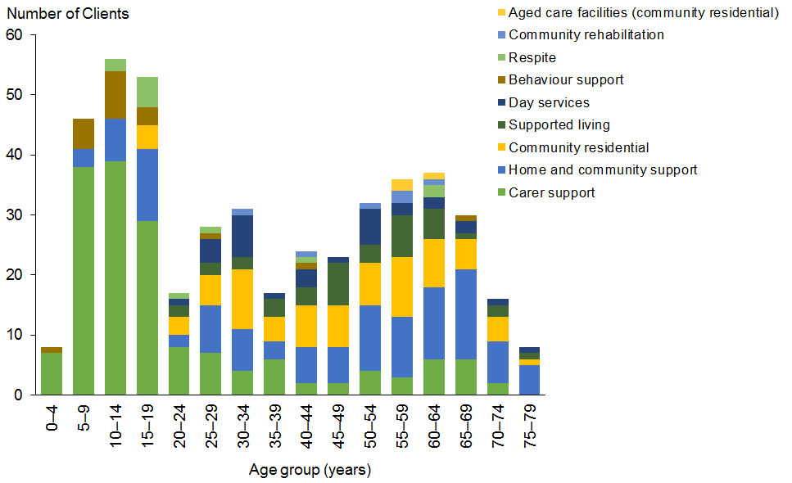

Figure 105: Gisborne DSS Clients, by ethnicity and service allocated
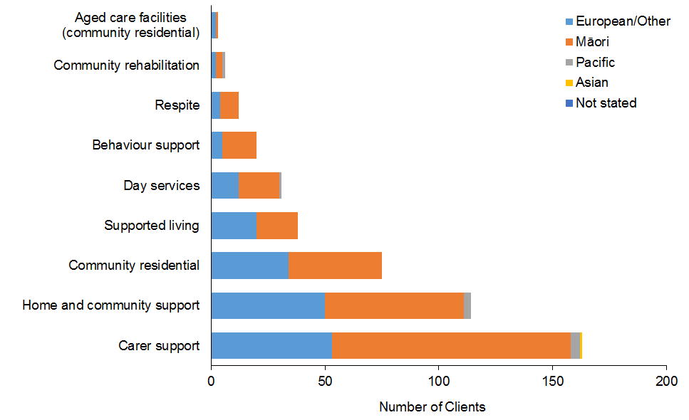

Figure 106: Gisborne DSS Clients, by age and disability type
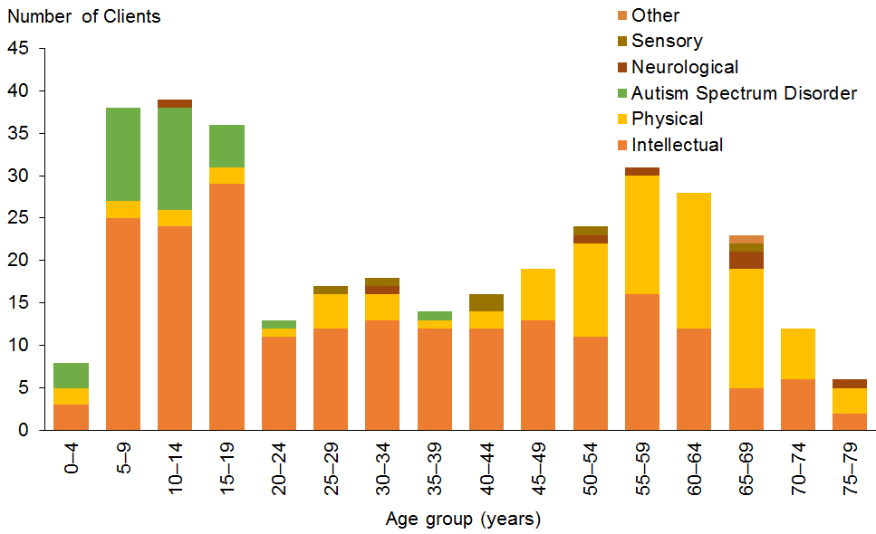

Taranaki
Table 103: Taranaki DSS Clients, by age and service allocated
Age group | Carer support | HCSS | Supported living | Community residential | Respite | Behaviour support | Day services | H&C | Community rehabilitation | Total
0–4 | 23 | 5 |  |  |  |  |  |  |  | 28
5–9 | 90 | 20 |  |  | 8 | 7 |  |  |  | 125
10–14 | 113 | 40 |  |  | 25 | 17 |  |  |  | 195
15–19 | 119 | 47 | 7 | 4 | 28 | 14 |  |  |  | 219
20–24 | 30 | 28 | 15 | 11 | 7 | 5 |  |  |  | 96
25–29 | 13 | 20 | 18 | 14 | 2 |  | 4 | 1 |  | 72
30–34 | 15 | 30 | 18 | 16 |  | 2 | 10 |  |  | 91
35–39 | 10 | 22 | 21 | 12 | 3 | 1 | 8 | 1 |  | 78
40–44 | 12 | 25 | 26 | 9 |  | 1 | 4 | 1 |  | 78
45–49 | 11 | 27 | 13 | 20 |  | 2 | 4 | 2 |  | 79
50–54 | 10 | 37 | 13 | 20 | 1 | 3 | 2 | 8 | 1 | 95
55–59 | 13 | 48 | 21 | 11 | 3 | 1 | 2 | 5 |  | 104
60–64 | 10 | 53 | 15 | 21 | 4 | 1 | 6 | 7 |  | 117
65–69 | 7 | 38 | 9 | 8 |  |  | 2 | 2 |  | 66
70–74 | 2 | 20 | 2 | 3 | 1 |  | 1 | 1 |  | 30
75–79 |  | 3 |  | 4 |  |  | 4 |  |  | 11
80–84 |  |  |  | 1 |  |  | 1 |  |  | 2
Total | 478 | 463 | 178 | 154 | 82 | 54 | 48 | 28 | 1 | 1,486

Figure 107: Taranaki DSS Clients, by age and service allocated
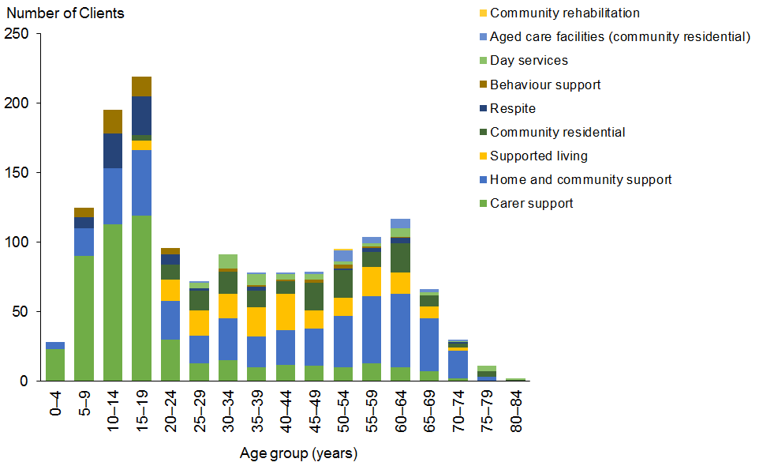

Figure 108: Taranaki DSS Clients, by ethnicity and service allocated
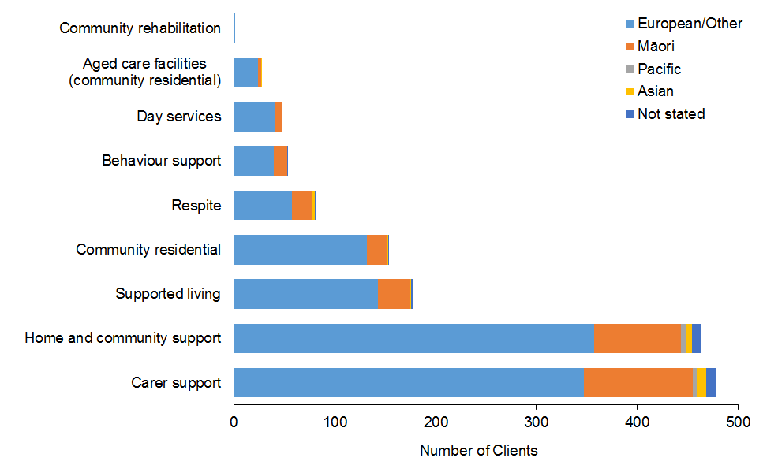

Figure 109: Taranaki DSS Clients, by age and disability type
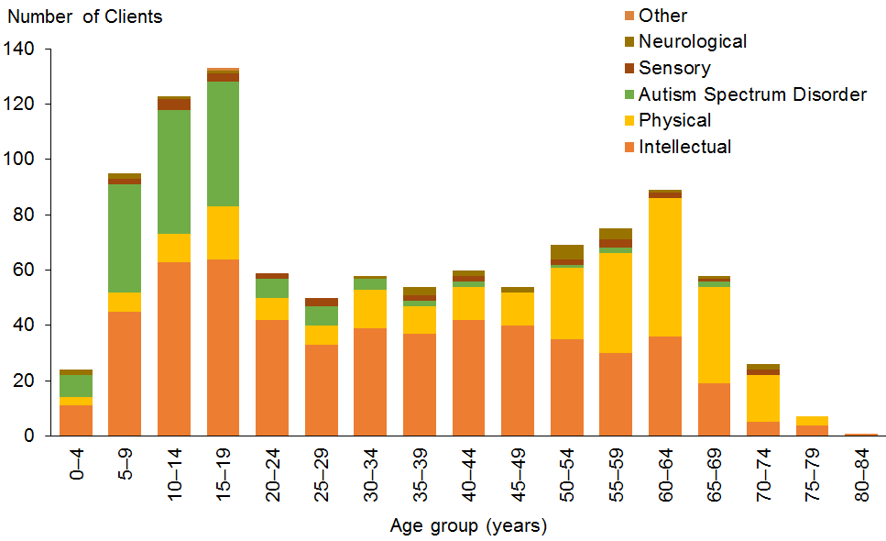

Manawatu–Wanganui
Table 104: Manawatu–Wanganui DSS Clients, by age and service allocated
Age group | Carer support | HCSS | Community residential | Supported living | Day services | Behaviour support | Respite | H&C | H&C | Community rehabilitation | Enabling Good Lives | Total
0–4 | 20 | 3 |  |  |  | 10 |  |  |  |  |  | 33
5–9 | 159 | 20 |  |  |  | 61 | 11 |  |  |  |  | 251
10–14 | 181 | 67 | 2 |  |  | 56 | 30 |  |  |  |  | 336
15–19 | 174 | 74 | 8 | 8 | 2 | 34 | 43 |  | 1 |  | 1 | 345
20–24 | 92 | 62 | 29 | 24 | 4 | 9 | 12 |  | 2 |  |  | 234
25–29 | 59 | 46 | 34 | 30 | 6 | 8 | 3 |  | 2 |  |  | 188
30–34 | 28 | 32 | 28 | 20 | 7 | 5 | 2 |  |  |  |  | 122
35–39 | 20 | 35 | 29 | 18 | 7 | 1 | 5 | 2 | 1 | 2 |  | 120
40–44 | 24 | 47 | 56 | 24 | 22 | 5 | 6 | 1 | 1 |  |  | 186
45–49 | 29 | 59 | 54 | 28 | 32 | 6 | 4 | 1 | 2 |  |  | 215
50–54 | 36 | 82 | 72 | 37 | 27 | 4 | 5 | 4 | 1 |  |  | 268
55–59 | 22 | 80 | 85 | 24 | 41 | 7 | 7 | 4 | 4 | 1 |  | 275
60–64 | 19 | 112 | 69 | 16 | 37 | 2 | 8 | 11 |  |  |  | 274
65–69 | 16 | 112 | 36 | 7 | 19 |  | 10 | 16 |  |  |  | 216
70–74 | 6 | 43 | 14 | 5 | 4 |  | 5 | 4 |  | 1 |  | 82
75–79 | 3 | 7 | 10 | 1 | 6 |  | 1 | 1 |  |  |  | 29
80–84 |  | 1 | 1 |  | 1 |  |  |  |  |  |  | 3
Total | 888 | 882 | 527 | 242 | 215 | 208 | 152 | 44 | 14 | 4 | 1 | 3,177

Figure 110: Manawatu–Wanganui DSS Clients, by age and service allocated
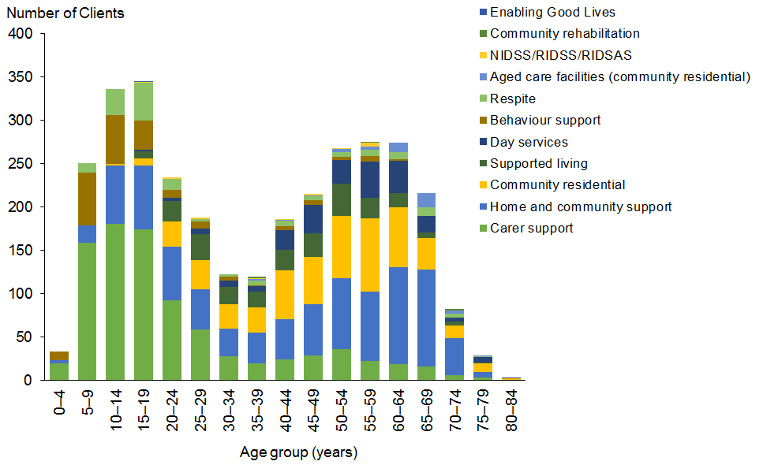

Figure 111: Manawatu–Wanganui DSS Clients, by ethnicity and service allocated
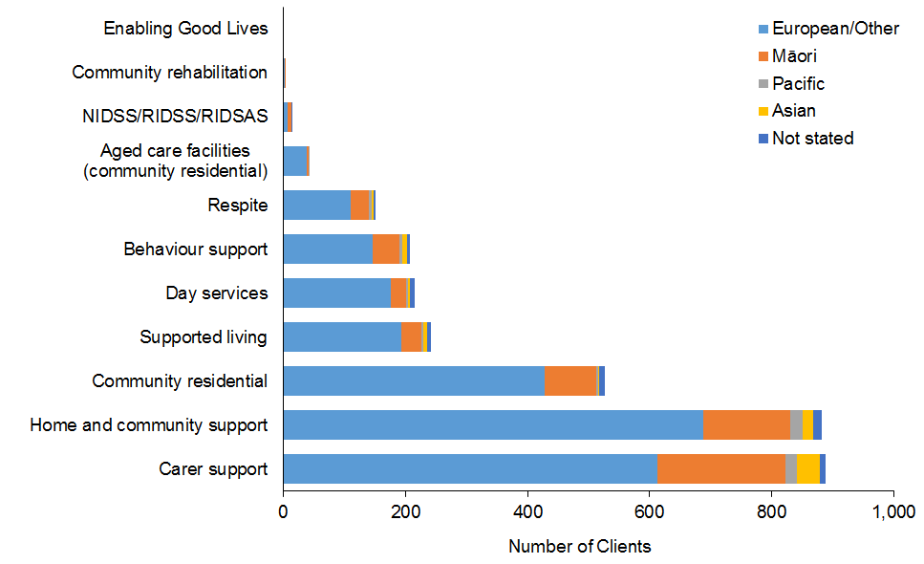

Figure 112: Manawatu–Wanganui DSS Clients, by age and disability type
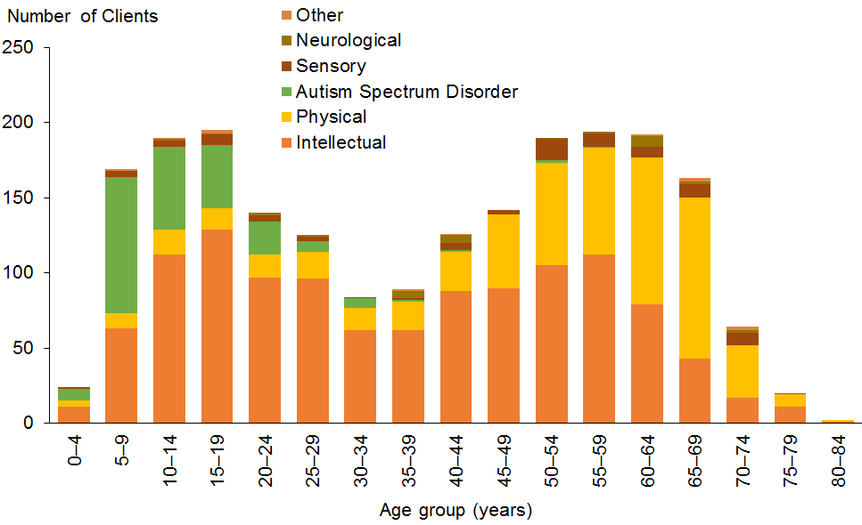

Wellington
Table 105: Wellington DSS Clients, by age and service allocated
Age group | Carer support | HCSS | Community residential | Respite | Supported living | Behaviour support | Day services | H&C | YPD | Community rehabilitation | Total
0–4 | 79 | 13 |  | 5 |  | 13 |  |  |  |  | 110
5–9 | 353 | 69 |  | 50 |  | 115 |  |  |  |  | 587
10–14 | 331 | 90 | 1 | 70 |  | 73 |  |  |  |  | 565
15–19 | 276 | 114 | 7 | 77 | 3 | 46 | 6 | 9 |  |  | 538
20–24 | 160 | 111 | 37 | 48 | 18 | 16 | 7 | 7 | 1 |  | 405
25–29 | 94 | 74 | 35 | 14 | 44 | 7 | 4 | 6 |  |  | 278
30–34 | 58 | 56 | 49 | 13 | 37 | 8 | 3 | 7 |  |  | 231
35–39 | 31 | 39 | 51 | 10 | 34 | 8 | 5 | 5 |  | 1 | 184
40–44 | 34 | 51 | 69 | 11 | 35 | 5 | 13 | 6 | 1 | 2 | 227
45–49 | 17 | 58 | 89 | 10 | 33 | 5 | 10 | 7 | 2 | 1 | 232
50–54 | 28 | 90 | 91 | 20 | 33 | 7 | 16 | 5 | 1 | 2 | 293
55–59 | 35 | 97 | 68 | 15 | 38 | 2 | 9 | 2 | 6 | 4 | 276
60–64 | 28 | 105 | 48 | 13 | 25 | 2 | 6 |  | 10 |  | 237
65–69 | 31 | 109 | 51 | 17 | 8 | 1 | 10 | 1 | 14 |  | 242
70–74 | 13 | 54 | 10 | 6 | 4 |  | 4 |  | 6 |  | 97
75–79 |  | 19 | 6 | 1 |  | 1 | 2 |  | 3 |  | 32
80–84 |  |  | 2 |  |  |  | 2 |  |  |  | 4
85–89 |  | 1 | 5 |  |  |  | 4 |  |  |  | 10
Total | 1,568 | 1,150 | 619 | 380 | 312 | 309 | 101 | 55 | 44 | 10 | 4,548

Figure 113: Wellington DSS Clients, by age and service allocated
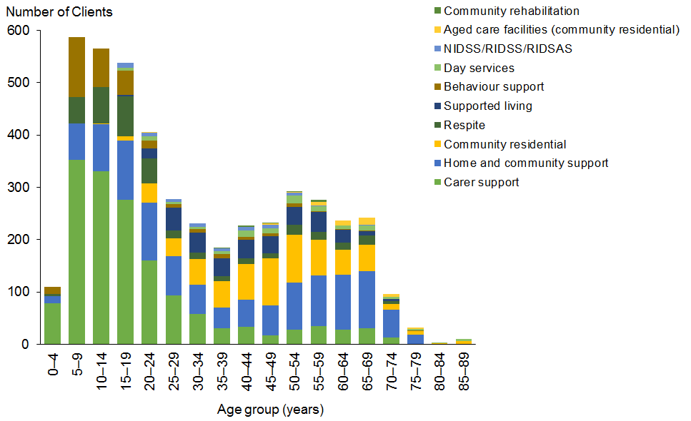

Figure 114: Wellington DSS Clients, by ethnicity and service allocated
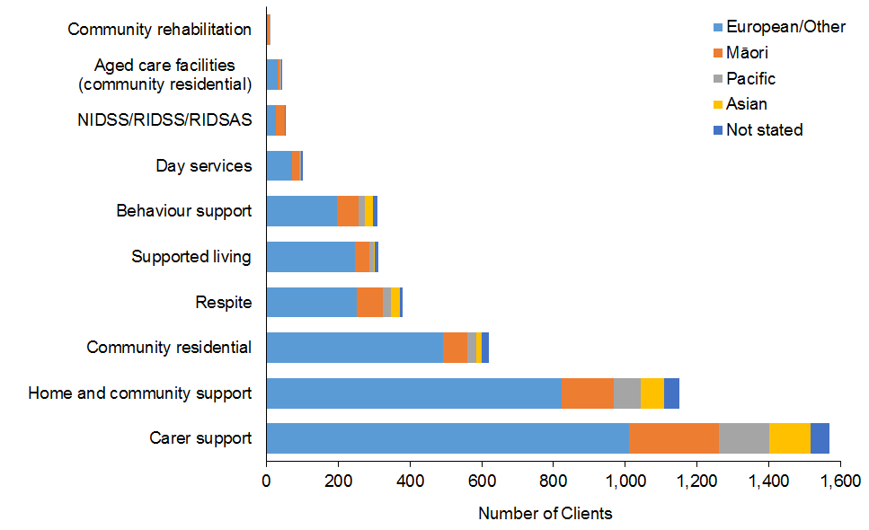

Figure 115: Wellington DSS Clients, by age and disability type
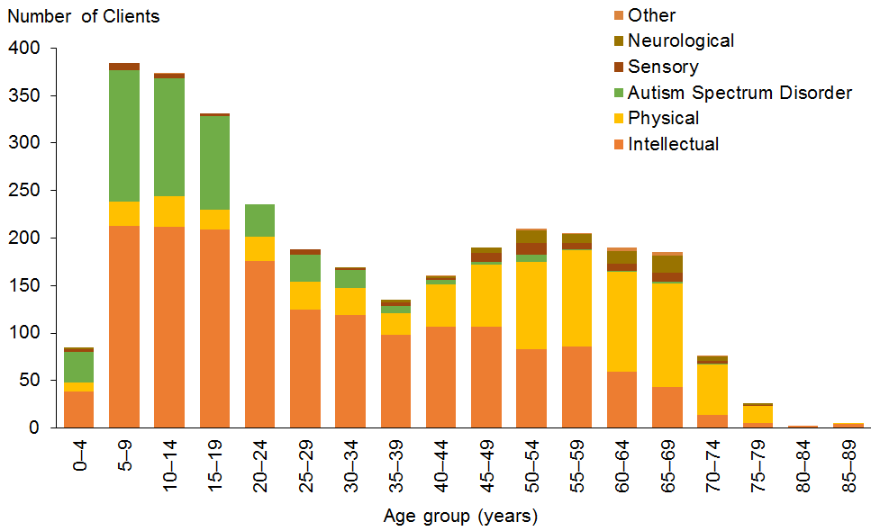

Tasman
Table 106: Tasman DSS Clients, by age and service allocated
Age group | Carer support | HCSS | Community residential | Behaviour support | Supported living | Respite | Day services | YPD | Total
0–4 | 5 | 2 |  | 2 |  | 2 |  |  | 11
5–9 | 30 |  |  | 7 |  |  |  |  | 37
10–14 | 57 | 8 |  | 16 |  | 6 |  |  | 87
15–19 | 44 | 10 | 2 | 11 | 1 | 11 |  |  | 79
20–24 | 17 | 13 | 2 | 3 | 6 | 4 |  |  | 45
25–29 | 9 | 10 | 4 | 4 | 12 | 6 |  |  | 45
30–34 | 5 | 4 | 2 | 2 | 7 |  |  |  | 20
35–39 | 2 | 2 | 4 | 1 | 7 |  |  |  | 16
40–44 | 3 | 4 | 4 |  | 1 |  | 2 |  | 14
45–49 | 1 | 9 | 13 | 1 | 2 | 2 | 4 |  | 32
50–54 | 2 | 5 | 10 | 3 | 2 | 1 | 6 | 1 | 30
55–59 | 8 | 13 | 4 | 1 | 5 | 2 | 4 | 1 | 38
60–64 | 3 | 13 | 5 |  | 3 | 2 | 2 |  | 28
65–69 | 6 | 23 | 4 | 1 | 3 | 6 |  | 1 | 44
70–74 | 2 | 8 | 4 |  | 1 |  | 3 | 2 | 20
75–79 |  | 3 | 1 |  |  |  | 1 |  | 5
Total | 194 | 127 | 59 | 52 | 50 | 42 | 22 | 5 | 551

Figure 116: Tasman DSS Clients, by age and service allocated
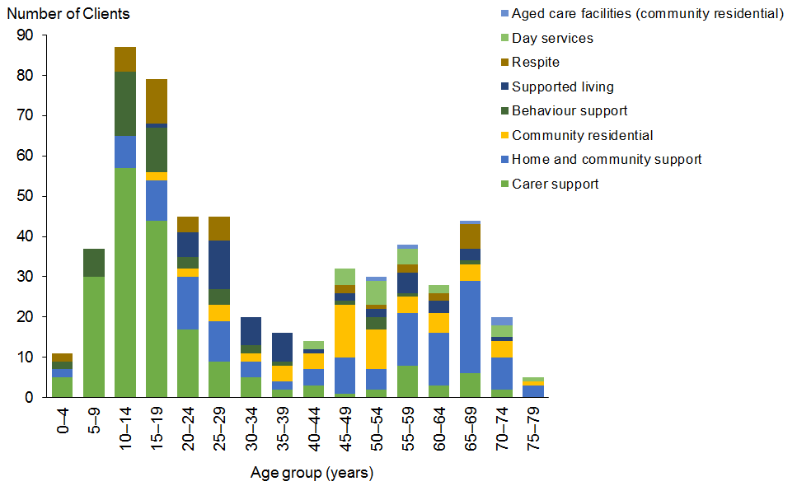

Figure 117: Tasman DSS Clients, by ethnicity and service allocated
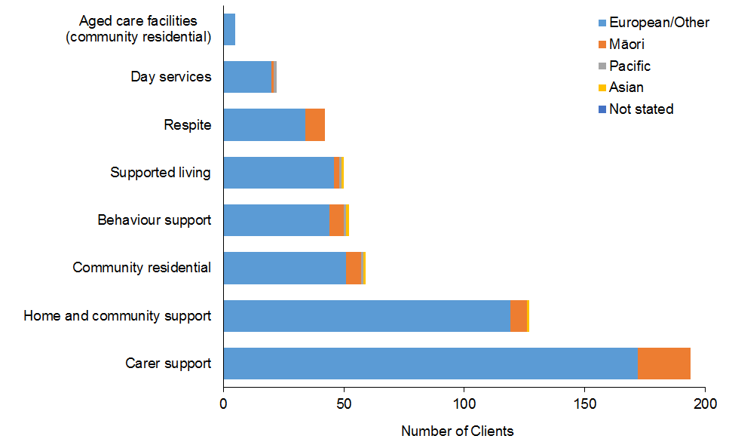

Figure 118: Tasman DSS Clients, by age and disability type
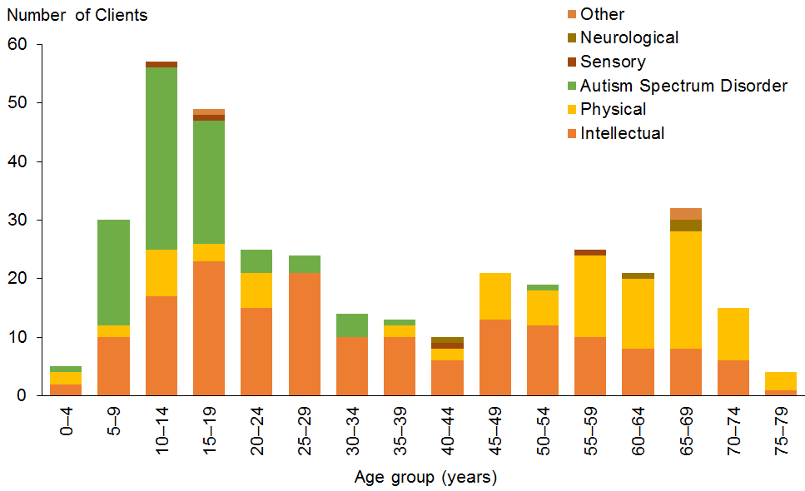

Nelson
Table 107: Nelson DSS Clients, by age and service allocated
Age group | Community residential | HCSS | Carer support | Supported living | Day services | Behaviour support | Respite | H&C | YPD | Total
0–4 |  | 2 | 6 |  |  | 1 |  |  | 1 | 10
5–9 |  | 1 | 37 |  |  | 5 | 1 |  |  | 44
10–14 |  | 7 | 44 |  |  | 7 | 4 |  |  | 62
15–19 | 3 | 9 | 24 |  |  | 8 | 8 |  |  | 52
20–24 | 9 | 20 | 26 | 9 |  | 5 | 11 |  |  | 80
25–29 | 15 | 6 | 6 | 12 | 1 | 2 |  |  |  | 42
30–34 | 9 | 11 | 4 | 8 |  | 3 | 1 |  |  | 36
35–39 | 11 | 4 | 1 | 8 | 2 | 1 | 1 |  |  | 28
40–44 | 11 |  | 1 | 6 | 5 | 1 | 1 |  | 2 | 27
45–49 | 17 | 14 | 2 | 7 | 5 | 2 | 1 | 1 |  | 49
50–54 | 34 | 10 | 1 | 12 | 12 | 4 | 1 | 1 |  | 75
55–59 | 33 | 21 | 3 | 9 | 16 |  |  |  |  | 82
60–64 | 24 | 15 | 4 | 2 | 6 | 1 | 2 |  | 1 | 55
65–69 | 15 | 35 | 7 | 7 | 7 |  | 1 | 1 |  | 73
70–74 | 12 | 12 | 1 | 3 | 7 |  |  | 1 |  | 36
75–79 | 14 | 9 |  | 2 | 10 |  |  | 1 |  | 36
80–84 | 5 | 1 |  |  |  |  |  |  |  | 6
85–89 | 1 |  |  |  |  |  |  |  |  | 1
Total | 213 | 177 | 167 | 85 | 71 | 40 | 32 | 5 | 4 | 794

Figure 119: Nelson DSS Clients, by age and service allocated
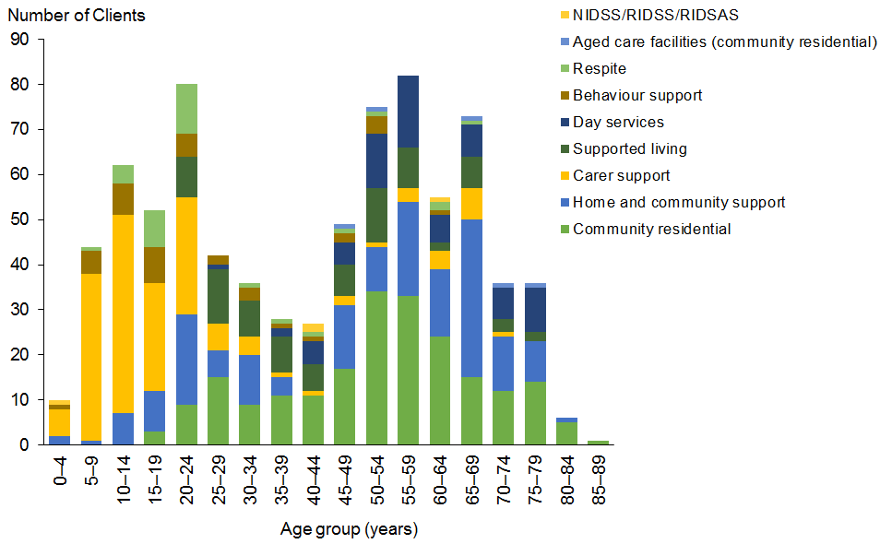

Figure 120: Nelson DSS Clients, by ethnicity and service allocated
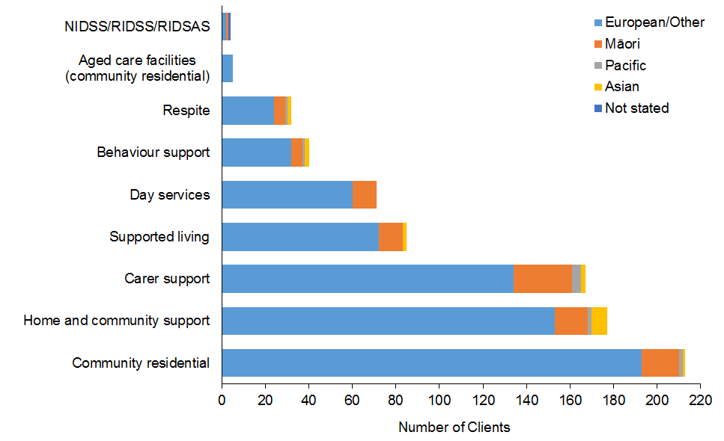

Figure 121: Nelson DSS Clients, by age and disability type
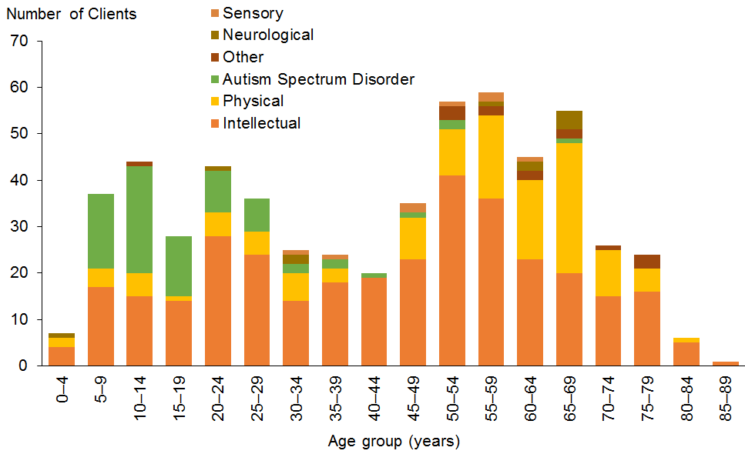

Marlborough
Table 108: Marlborough DSS Clients, by age and service allocated
Age group | HCSS | Carer support | Community residential | Supported living | Respite | Behaviour support | YPD | Day services | Community rehabilitation | Total
0–4 | 2 | 9 |  |  |  | 1 |  |  |  | 12
5–9 | 9 | 26 |  |  | 1 | 2 |  |  |  | 38
10–14 | 20 | 32 |  |  | 3 | 6 |  |  |  | 61
15–19 | 12 | 22 |  | 2 | 5 |  |  |  |  | 41
20–24 | 21 | 24 | 5 | 12 |  | 3 |  | 1 | 1 | 67
25–29 | 12 | 11 | 4 | 8 |  | 1 |  |  |  | 36
30–34 | 7 | 7 | 5 | 8 | 2 | 1 | 1 |  |  | 31
35–39 | 6 | 4 | 7 | 4 |  |  |  |  |  | 21
40–44 | 10 | 3 | 7 | 10 | 1 | 1 |  |  |  | 32
45–49 | 7 | 4 | 13 | 7 | 3 | 2 |  | 1 |  | 37
50–54 | 16 | 9 | 11 | 9 | 7 |  |  | 3 |  | 55
55–59 | 16 | 6 | 9 | 7 | 6 |  | 3 | 1 |  | 48
60–64 | 18 | 9 | 3 | 3 | 4 | 1 | 3 | 2 |  | 43
65–69 | 17 | 6 | 8 | 1 | 6 |  | 1 | 2 |  | 41
70–74 | 16 | 3 | 2 |  | 2 |  | 5 |  |  | 28
75–79 | 8 | 1 | 2 |  | 3 |  |  | 1 |  | 15
80–84 | 1 |  |  |  | 1 |  | 1 |  |  | 3
Total | 198 | 176 | 76 | 71 | 44 | 18 | 14 | 11 | 1 | 609

Figure 122: Marlborough DSS Clients, by age and service allocated
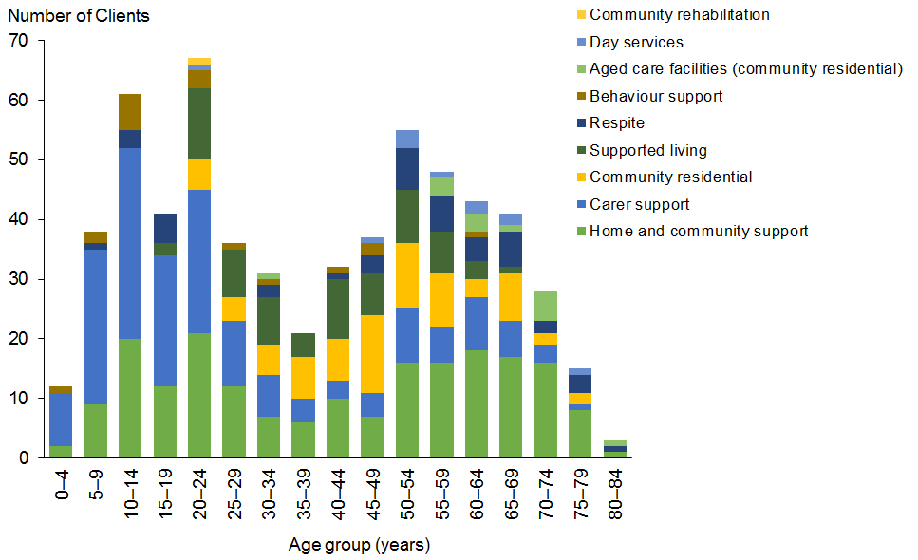

Figure 123: Marlborough DSS Clients, by ethnicity and service allocated
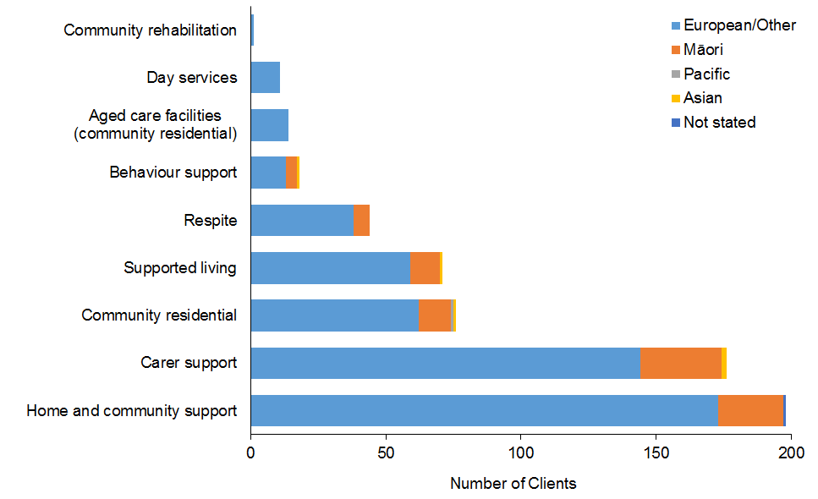

Figure 124: Marlborough DSS Clients, by age and disability type
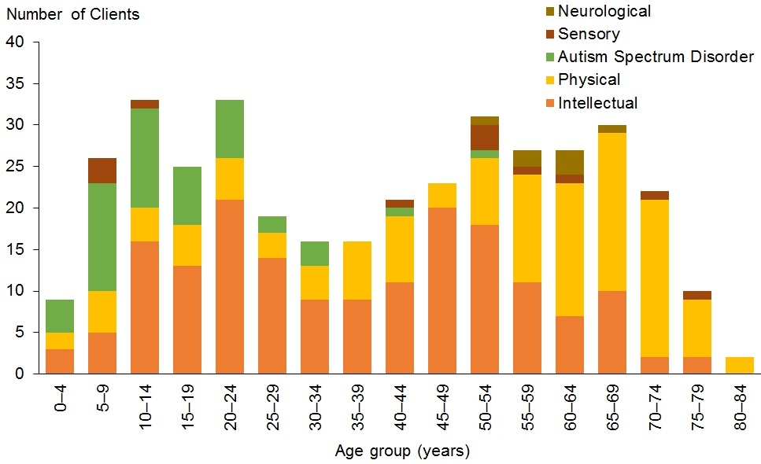

West Coast
Table 109: West Coast DSS Clients, by age and service allocated
Age group | Carer support | HCSS | Community residential | Supported living | Behaviour support | Respite | YPD | Day services | Enabling Good Lives | Total
0–4 | 6 |  |  |  | 2 |  |  |  |  | 8
5–9 | 17 |  |  |  | 2 | 1 |  |  |  | 20
10–14 | 37 | 1 |  |  | 9 | 1 |  |  |  | 48
15–19 | 30 | 4 |  |  | 1 | 2 |  |  | 1 | 38
20–24 | 6 | 2 | 1 |  | 1 |  |  |  |  | 10
25–29 | 5 | 5 | 2 | 3 | 1 |  |  |  |  | 16
30–34 |  | 1 | 3 | 1 |  |  |  |  |  | 5
35–39 | 4 | 6 | 3 | 4 |  | 1 |  |  |  | 18
40–44 | 5 | 5 | 4 | 3 |  | 1 | 1 |  |  | 19
45–49 | 3 | 12 | 6 | 8 |  |  | 1 |  |  | 30
50–54 | 9 | 9 | 6 | 3 |  |  | 1 |  |  | 28
55–59 | 2 | 10 | 5 | 4 |  | 1 |  | 2 |  | 24
60–64 | 2 | 10 | 6 | 5 |  | 1 | 2 | 2 |  | 28
65–69 |  | 9 | 3 |  |  |  | 1 | 2 |  | 15
70–74 |  | 5 | 2 | 1 |  |  | 1 |  |  | 9
75–79 |  | 2 |  |  |  |  |  |  |  | 2
Total | 126 | 81 | 41 | 32 | 16 | 8 | 7 | 6 | 1 | 318

Figure 125: West Coast DSS Clients, by age and service allocated
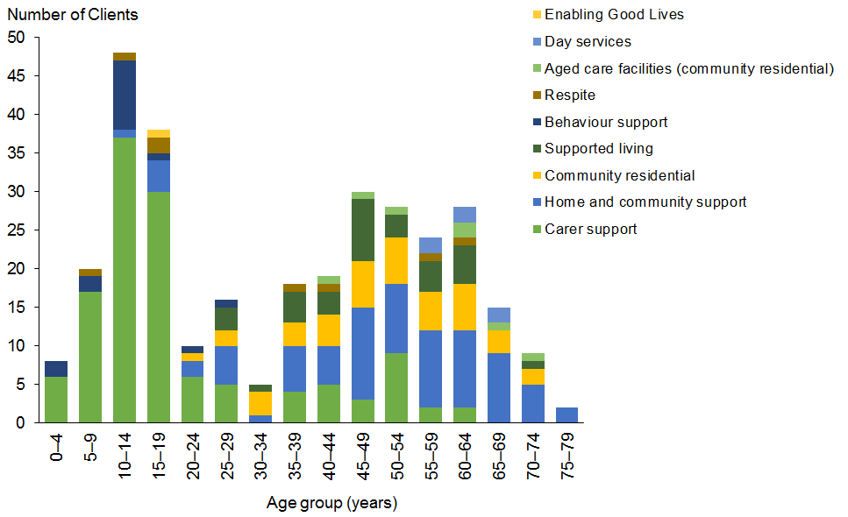
Figure 126: West Coast DSS Clients, by ethnicity and service allocated
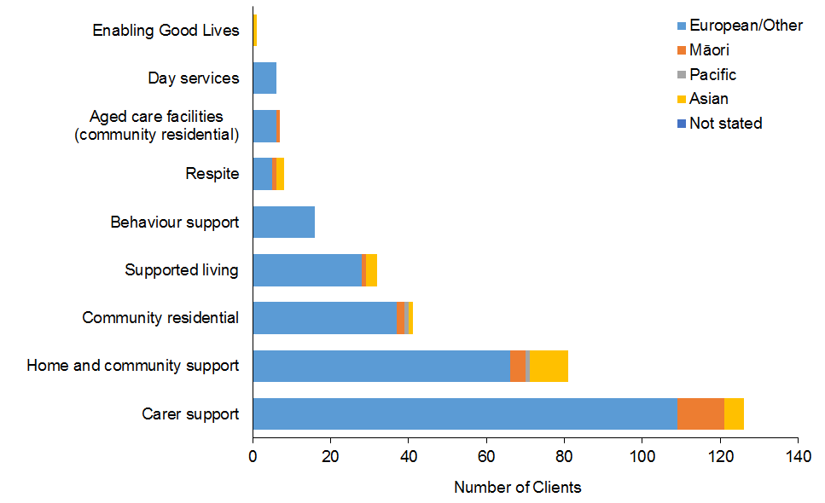

Figure 127: West Coast DSS Clients, by age and disability type
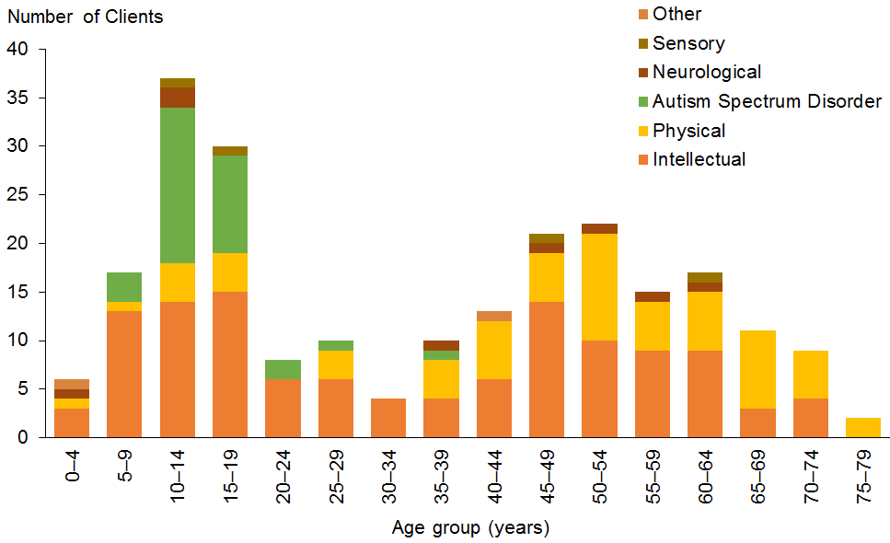

Canterbury
Table 110: Canterbury DSS Clients, by age and service allocated
Age group | Carer support | HCSS | Community residential | Supported living | Behaviour support | Respite | Day services | Enabling Good Lives | YPD | H&C | Community rehabilitation | Total
0–4 | 101 | 19 |  |  | 8 | 1 |  |  |  |  |  | 129
5–9 | 479 | 95 | 2 |  | 112 | 28 |  |  |  |  |  | 716
10–14 | 500 | 136 | 6 |  | 126 | 64 |  |  |  |  |  | 832
15–19 | 423 | 129 | 24 | 9 | 41 | 64 | 3 | 26 |  | 5 | 1 | 725
20–24 | 242 | 97 | 45 | 32 | 30 | 36 | 4 | 128 |  | 7 |  | 621
25–29 | 145 | 72 | 59 | 42 | 15 | 18 | 5 | 6 | 1 | 6 |  | 369
30–34 | 68 | 54 | 70 | 34 | 8 | 15 | 7 | 1 | 3 | 3 | 2 | 265
35–39 | 54 | 57 | 74 | 33 | 11 | 5 | 12 |  |  | 5 |  | 251
40–44 | 54 | 79 | 114 | 46 | 10 | 16 | 18 |  | 5 | 1 |  | 343
45–49 | 57 | 103 | 111 | 49 | 8 | 8 | 36 | 1 | 6 | 5 | 2 | 386
50–54 | 50 | 131 | 142 | 56 | 5 | 5 | 51 |  | 16 |  | 3 | 459
55–59 | 64 | 165 | 144 | 56 | 6 | 16 | 49 |  | 21 | 1 | 2 | 524
60–64 | 62 | 220 | 90 | 50 | 6 | 20 | 28 |  | 30 |  | 1 | 507
65–69 | 39 | 141 | 64 | 28 | 2 | 18 | 17 |  | 18 |  |  | 327
70–74 | 29 | 80 | 40 | 8 |  | 9 | 9 |  | 9 | 1 |  | 185
75–79 | 3 | 26 | 16 | 3 | 1 |  | 5 |  | 4 |  |  | 58
80–84 | 1 | 4 | 9 | 2 |  | 2 | 2 |  | 1 |  |  | 21
85–89 |  | 3 | 4 | 2 |  |  | 2 |  |  |  |  | 11
Total | 2,371 | 1,611 | 1,014 | 450 | 389 | 325 | 248 | 162 | 114 | 34 | 11 | 6,729

Figure 128: Canterbury DSS Clients, by age and service allocated
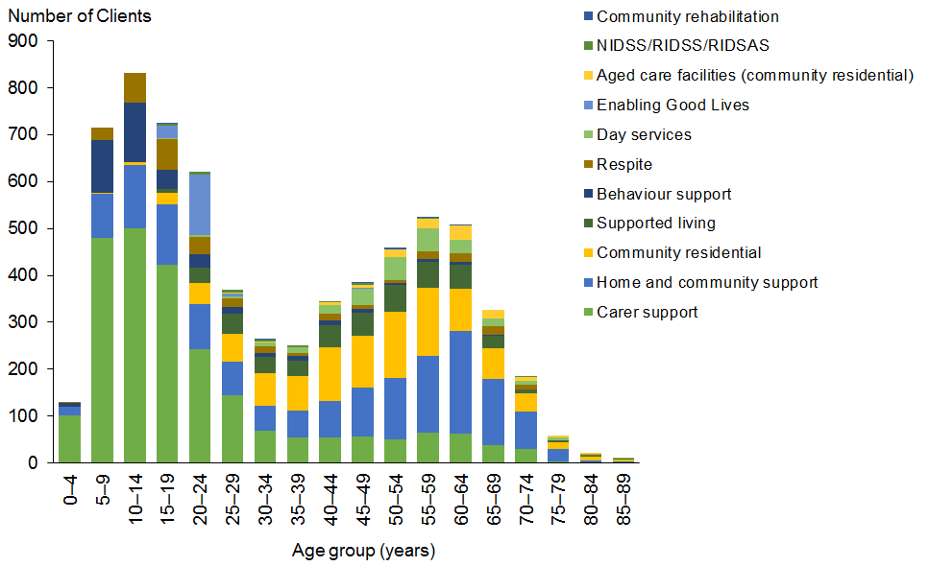

Figure 129: Canterbury DSS Clients, by ethnicity and service allocated
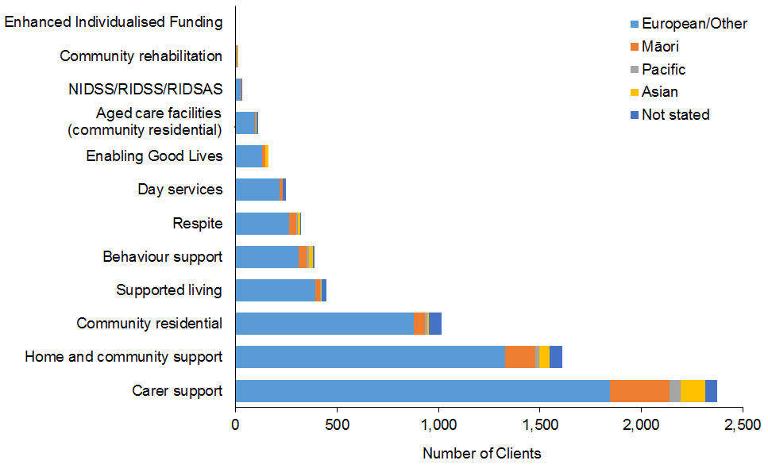

Figure 130: Canterbury DSS Clients, by age and disability type
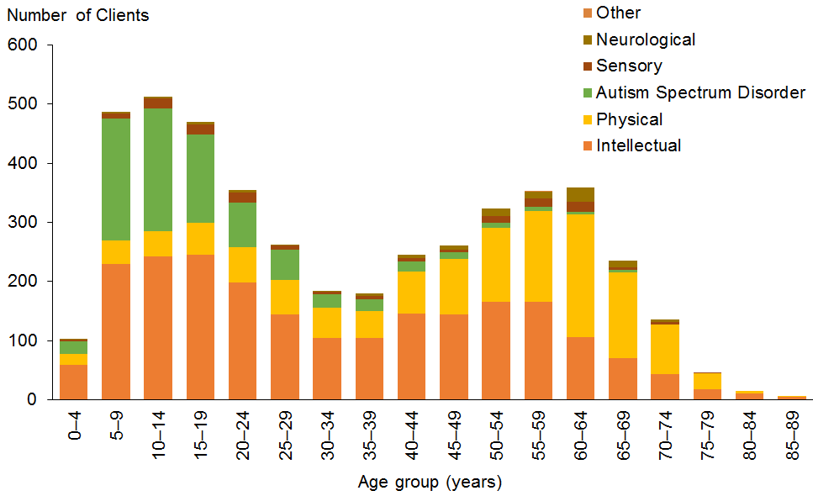

Otago
Table 111: Otago DSS Clients, by age and service allocated
Age group | Carer support | HCSS | Supported living | Community residential | Behaviour support | Respite | Day services | H&C | YPD | Enabling Good Lives | Total
0–4 | 33 | 9 | 2 |  | 11 |  |  |  |  |  | 55
5–9 | 129 | 24 | 1 |  | 25 | 1 |  |  |  |  | 180
10–14 | 180 | 42 | 2 | 3 | 33 | 5 |  |  |  |  | 265
15–19 | 148 | 57 | 18 | 14 | 21 | 4 |  |  |  |  | 262
20–24 | 61 | 54 | 38 | 26 | 11 | 7 |  | 3 |  | 1 | 201
25–29 | 35 | 28 | 47 | 30 | 7 | 7 | 4 | 5 |  |  | 163
30–34 | 22 | 25 | 37 | 25 | 3 | 5 | 3 | 4 |  |  | 124
35–39 | 23 | 17 | 41 | 19 |  | 4 | 2 | 3 |  |  | 109
40–44 | 21 | 39 | 42 | 30 | 6 | 5 | 3 | 2 |  |  | 148
45–49 | 24 | 45 | 27 | 44 | 3 | 4 | 3 | 1 | 1 |  | 152
50–54 | 15 | 54 | 54 | 55 | 5 | 7 | 4 | 1 | 2 |  | 197
55–59 | 26 | 67 | 32 | 42 | 2 | 10 | 1 | 3 | 4 |  | 187
60–64 | 28 | 96 | 33 | 33 | 2 | 4 | 2 | 1 | 8 |  | 207
65–69 | 16 | 90 | 18 | 24 | 1 | 8 | 1 |  | 1 |  | 159
70–74 | 10 | 51 | 3 | 6 |  | 1 |  |  | 4 |  | 75
75–79 | 3 | 31 |  | 8 |  |  | 1 |  | 1 |  | 44
80–84 |  | 4 |  | 1 |  |  | 1 |  | 1 |  | 7
85–89 | 1 | 1 |  | 5 |  |  | 3 |  |  |  | 10
Total | 775 | 734 | 395 | 365 | 130 | 72 | 28 | 23 | 22 | 1 | 2,545

Figure 131: Otago DSS Clients, by age and service allocated
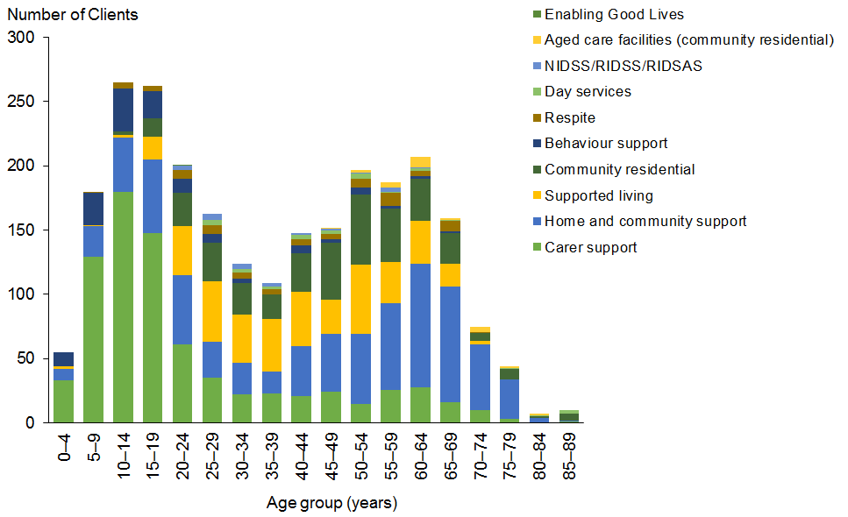

Figure 132: Otago DSS Clients, by ethnicity and service allocated
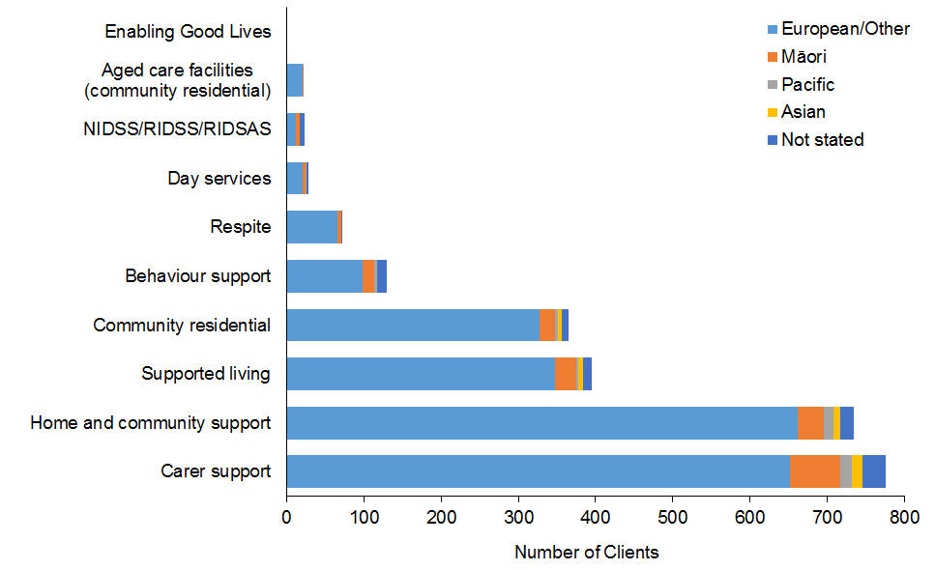

Figure 133: Otago DSS Clients, by age and disability type
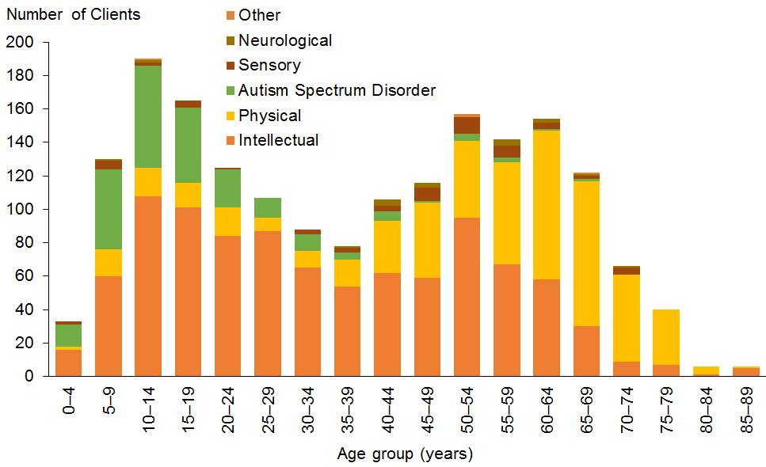

Southland
Table 112: Southland DSS Clients, by age and service allocated
Age group | Carer support | HCSS | Community residential | Supported living | Behaviour support | Respite | YPD | Day services | H&C | Total
0–4 | 12 | 3 |  |  | 5 |  |  |  |  | 20
5–9 | 68 | 14 |  | 1 | 21 | 1 |  |  |  | 105
10–14 | 82 | 19 | 1 | 1 | 25 |  |  |  |  | 128
15–19 | 74 | 33 | 7 | 7 | 11 | 7 |  |  |  | 139
20–24 | 47 | 24 | 6 | 21 | 2 | 2 |  |  |  | 102
25–29 | 15 | 14 | 10 | 18 | 1 | 1 | 1 |  |  | 60
30–34 | 12 | 12 | 13 | 10 | 2 | 2 |  |  |  | 51
35–39 | 11 | 13 | 8 | 6 | 2 |  |  |  |  | 40
40–44 | 8 | 19 | 17 | 14 |  | 2 |  |  |  | 60
45–49 | 9 | 20 | 15 | 9 | 1 |  | 3 |  | 1 | 58
50–54 | 8 | 30 | 19 | 14 | 2 | 2 | 5 |  |  | 80
55–59 | 12 | 48 | 22 | 14 | 2 | 6 | 4 |  |  | 108
60–64 | 10 | 42 | 9 | 7 | 1 | 8 | 10 | 1 |  | 88
65–69 | 12 | 42 | 12 | 6 |  | 1 | 5 |  |  | 78
70–74 | 5 | 19 | 3 | 1 |  |  | 1 |  |  | 29
75–79 | 1 | 11 | 3 |  |  | 1 |  | 2 |  | 18
80–84 | 1 | 2 |  |  |  |  |  |  |  | 3
Total | 387 | 365 | 145 | 129 | 75 | 33 | 29 | 3 | 1 | 1,167

Figure 134: Southland DSS Clients, by age and service allocated
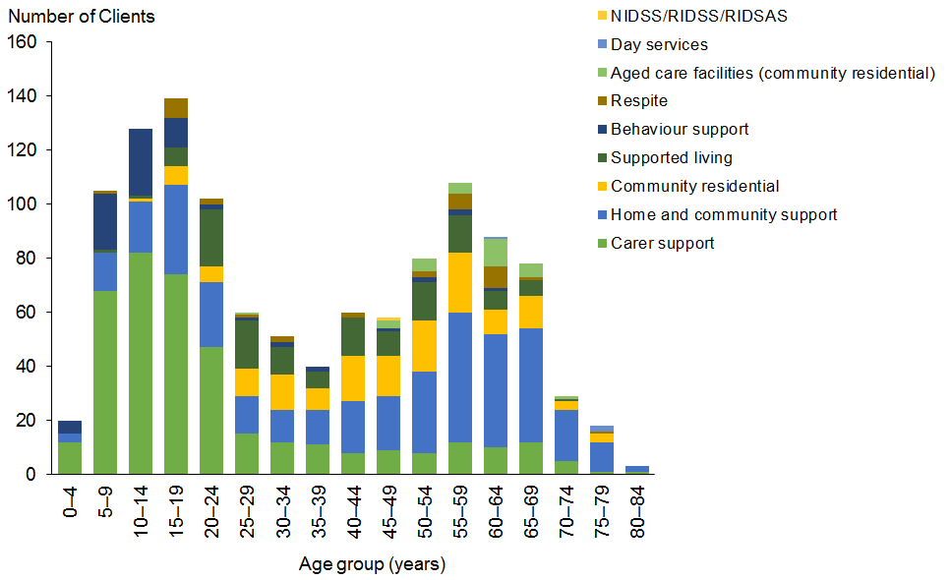

Figure 135: Southland DSS Clients, by ethnicity and service allocated
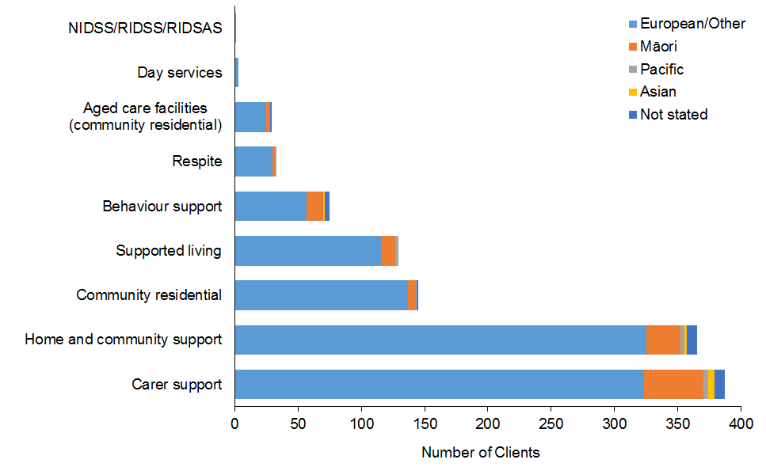

Figure 136: Southland DSS Clients, by age and disability type
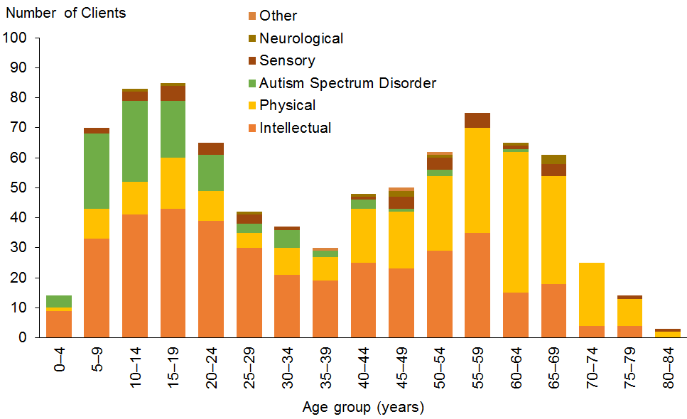

Appendix 1: Descriptions of disability support services
Disability support service type | Description
Behaviour support services (BSS) | BSS aim to improve the quality of life for people who have challenging behaviour, making it easier for them to be independent and involved in the community.  BSS work with the disabled person and their support network to develop and implement a plan to reduce the impact of the person’s challenging behaviour.
Carer support | Carer support is available to the full-time, unpaid carer for a disabled person to take time out for themselves and support them to continue in their caring role.  Carer support provides reimbursement of some of the costs of using a support person to care and support a disabled person.
Choice in Community Living (CiCL) | CiCL is an alternative to residential services and aims to open up opportunities for disabled people to have more choice in and control of their living circumstances – where they live, who they live with and how they are supported.  CiCL is being demonstrated in the Auckland and Waikato regions only.  CiCL has enabled participants to develop skills and capabilities to support independent living with more opportunities for relationships, community access and participation.
Community residential support services | Community residential support services provide support for up to 24 hours a day in a home-like setting in the community. This might include help with things like:  - shopping  - preparing and cooking meals  - household chores (eg, clothes washing, cleaning)  - personal cares (eg, eating and drinking, getting dressed and undressed, and taking a shower)  - getting out and doing things in the neighbourhood (eg, going to see a movie).  Services are provided in a range of community settings, such as small or large homes, or groups of small homes or flats where the disabled person can have their own personal belongings.
Day services | Day services help disabled adults who can’t find work to take part in their community and improve their personal skills by providing access to regular meaningful social contact and stimulating activities.  The services include a range of activities depending on the provider and the disabled person’s interests and abilities. Activities may include daily living skills, education and learning activities, social activities, and recreation and leisure activities.
Enabling Good Lives (EGL) | EGL is a way of supporting disabled people that offers them greater choice and control over the supports they receive and the lives they lead.  It is being demonstrated in Christchurch and Waikato only, and involves pooling of funding from the Ministries of Health, Education and Social Development to allocate funding directly to disabled people to purchase the supports that best meet their disability needs.
Enhanced individualised funding (EIF) | EIF involves disabled people directly purchasing the full range of disability supports they need. It is not restricted to HCSS and respite services only.  EIF can be spent on support that is:  - a disability support  - part of the disabled person’s plan and helps progress towards their goals  - support that is the responsibility of the Ministry of Health and not provided by other government agencies (such as education).  EIF is being demonstrated in the Bay of Plenty only.
Equipment and modification services (EMS) | EMS include the following services, all of which must be approved by an EMS assessor:  - equipment such as:  - wheelchairs  - shower stools  - raised toilet seats  - adjustable beds  - walking frames  - hoists  - communication devices (eg, communication boards, equipment that speaks for you, computer software for work or tertiary study)  - visual or vibrating alert systems (eg, smoke alarms)  - magnifiers  - housing modifications such as:  - handrail  - ramp or lift  - level access shower  - doorway widening  - vehicle modifications.
Funded family care (FFC) | FFC is Ministry of Health funding for eligible disabled people to employ their parents or family members over 18 who they live with to provide them with their personal care and/or household management disability supports.  FFC cannot be used to pay a disabled person’s spouse or partner or to pay for non-disability supports.
High and complex (H&C) services | H&C services provide secure residential facilities for people with an intellectual disability under the Intellectual Disability (Compulsory Care and Rehabilitation) Act 2003.  H&C include the following services:  - National Intellectual Disability Secure Services (NIDSS)  - Regional Intellectual Disability Secure Services (RIDSS) and  - Regional Intellectual Disability Supported Accommodation Services (RIDSAS).
Home and community support services (HCSS) | HCSS help disabled people to live at home. They can include:  - household management, which may include help with:  - meal preparation  - washing, drying or folding clothes  - house-cleaning  - personal care, which may include help with:  - eating and drinking  - getting dressed and undressed  - getting up in the morning and getting ready for bed  - showering and going to the toilet  - getting around the home.
Individualised funding (IF) | IF involves disabled people directly purchasing their own HCSS and respite services. IF gives disabled people more choice, control and flexibility in how they are supported.
Respite | Respite services provide short-term breaks for the carers of a disabled person, while also providing a positive, stimulating and worthwhile experience for the disabled person.
Supported living (SL) | SL helps disabled people to live independently by providing support in those areas of their life where help is needed. This could include:  - using community facilities such as libraries, swimming pools  - shopping, budgeting or cooking  - help when dealing with agencies (eg, WINZ, the bank).  A support worker works with the disabled person, usually at their home, but also at times and places that are agreed.
Younger persons, ie, aged under 65 years) with physical disabilities living in aged care services (YPD) | YPD services provide 24-hour residential support in aged care services for people with physical disabilities who require clinical supports not available in community residential support services.

Appendix 2: Disability types
Table A1: Principal disability types, by number of DSS Clients
Note: If a Client has two principal disabilities, then both disabilities are counted.
Disability class | Principal disability | Number
Autistic spectrum disorder | Asperger’s syndrome | 1,118
Autistic spectrum disorder | Autistic spectrum disorder (ASD) | 6,166
Autistic spectrum disorder | Other autistic spectrum disorder (ASD) | 1
Autistic spectrum disorder total |  | 7,285
Intellectual | Birth asphyxia or intrauterine hypoxia | 16
 | Developmental delay, type not specified | 2,010
 | Down syndrome (Trisomy 21) | 2,028
 | Edwards’ syndrome (Trisomy 18) | 9
 | Fragile X syndrome | 106
 | Intellectual disability (ID), type not specified | 10,773
 | Klinefelter’s syndrome | 30
 | Learning disability/difficulty/delay, type not specified | 998
 | Microcephalus/microcephaly | 81
 | Other intellectual, learning or developmental disorder (specify) | 478
 | Prader-Willi syndrome | 27
Intellectual total |  | 16,556
Neurological | Brain injury / head injury caused by accident (external cause) | 108
 | Brain injury, cause not specified | 146
 | Encephalitis | 35
 | Neurological disorder/disability, type not specified | 89
Neurological total |  | 378
Other | Alcohol/drug-related disorder (excluding Korsakov’s syndrome) | 9
 | Alzheimer’s (including early onset) | 1
 | Angina | 3
 | Anxiety disorder | 36
 | Asthma | 20
 | Attention deficit / hyperactivity (eg, ADD, ADHD) | 117
 | Behavioural problem/issue, type not specified | 125
 | Bipolar disorder (manic depression) | 20
 | Cancer (malignant, CA) (eg, leukaemia, lymphoma, melanoma, breast, lung, prostate, colon, neuroblastoma) | 9
 | Chronic back pain, type not specified | 20
 | Chronic fatigue syndrome / ME (myalgic encephalomyelitis) | 30
 | Chronic obstructive pulmonary or respiratory disease (COPD/CORD) (eg, chronic bronchitis, emphysema) | 13
 | Chronic pain / chronic pain syndrome, cause not specified (excludes chronic back pain) | 3
 | Cleft lip / palate | 2
 | Congenital heart disease/defects/problems | 18
 | Cystic fibrosis | 6
 | Depression | 15
 | Diabetes (NIDDM or IDDM) | 71
 | Eczema and dermatitis | 3
 | Epidermolysis bullosa | 1
 | Epilepsy, seizures | 288
 | Faecal incontinence, encopresis | 2
 | Fibromyalgia | 41
 | Foetal alcohol syndrome (FAS) | 33
 | Gout | 1
 | Haemophilia | 1
 | Heart attack (myocardial infarction) | 7
 | Heart failure | 4
 | Hypertension / high blood pressure | 17
 | Inflammatory bowel disease (eg, Crohn’s disease, ulcerative colitis, other non-infective bowel disease) | 5
 | Ischaemic heart disease (IHD), type not specified | 9
 | Korsakov’s syndrome / alcohol-related dementia | 6
 | Language delay | 6
 | Liver disease (eg, hepatitis, cirrhosis) | 3
 | Lymphoedema | 3
 | Motor delay, developmental dyspraxia | 23
 | Mute | 3
 | Neurofibromatosis | 11
 | Obesity | 1
 | Osteoporosis | 32
 | Other (specify) | 17
 | Other cancer/tumour (specify) | 13
 | Other connective tissue disorder (specify) | 9
 | Other dementia (specify) | 4
 | Other digestive disorder (specify) | 6
 | Other genitourinary disorder (specify) | 5
 | Other heart or blood vessel disorder (specify) | 36
 | Other nutritional, hormonal or metabolic disorder (specify) | 19
 | Other psychiatric disorder (specify) | 26
 | Other respiratory disorder (specify) | 13
 | Other skin and subcutaneous tissue disorder (specify) | 5
 | Other speech disorder (specify) | 12
 | Peripheral vascular disease | 1
 | Personality disorder | 9
 | Recurrent or chronic otitis media or ear infections (glue ear) | 1
 | Renal (kidney) failure, renal dialysis, haemodialysis | 10
 | Schizophrenia | 44
 | Sleep disorder (eg, narcolepsy, sleep apnoea) | 4
 | Speech delay | 11
 | Systemic sclerosis/scleroderma | 4
 | TIA (transient ischaemic attack) | 2
 | Tracheostomy | 1
Other total |  | 1,270
Physical | Amputation / partial amputation of arm/hand | 30
 | Amputation / partial amputation of leg/foot | 149
 | Ankylosing spondylitis | 31
 | Arthrogryposis | 36
 | Ataxia (cerebellar, spinocerebellar, Friedreich’s) | 169
 | Back injury due to accident (external cause) | 22
 | Cerebral palsy | 1,884
 | Club foot or feet (talipes) | 16
 | Congenital absence / partial absence of arm/hand (upper limb reduction) | 12
 | Congenital absence / partial absence of leg/foot (lower limb reduction) | 18
 | Guillain Barré syndrome | 21
 | Kyphosis, lordosis or scoliosis | 76
 | Low birthweight / prematurity / short gestation | 36
 | Multiple sclerosis | 951
 | Muscular dystrophy | 272
 | Non-malignant growth / tumour | 10
 | Osteoarthritis | 667
 | Other bone, joint or cartilage disorder (specify) | 194
 | Other conditions originating around time of birth (specify) | 53
 | Other muscle and tendon disorder (specify) | 86
 | Other musculoskeletal disorder (specify) | 131
 | Other spine or back disorder (specify) | 172
 | Paralysis, paresis (hemiplegia, paraplegia, tetraplegia, quadraplegia, diplegia) | 548
 | Patau’s syndrome (Trisomy 13) | 2
 | Polio and post-polio | 87
 | Polymyalgia rheumatica | 8
 | Prolapsed disc, disc degeneration, sciatica | 38
 | Rheumatoid arthritis | 443
 | Short stature / dwarfism (eg, achondroplasia) | 43
 | Spina bifida | 323
 | Spinal muscular atrophy | 32
 | Spinal stenosis | 63
 | Spondylosis | 25
 | Stroke, brain/subarachnoid haemorrhage, cerebrovascular accident (CVA), parietal / cerebral / cerebellar / middle cerebral artery (MCA) / thalamic / frontal lobe infarct | 1,730
 | Systemic lupus erythematosus (lupus, SLE) | 23
Physical total |  | 8,401
Physical/intellectual | Other congenital or chromosomal defects affecting multiple systems (specify) | 814
Physical/intellectual total |  | 814
Physical/intellectual/  neurological | Hydrocephalus/hydrocephaly | 86
 | Other brain or nervous system disorder (specify) | 641
Physical/intellectual/  neurological total |  | 727
Physical/neurological | Huntington’s | 145
 | Meningitis | 22
 | Motor neuron disease | 85
 | Parkinson’s disease | 188
Physical/neurological total |  | 440
Sensory | Blind or vision impaired, type not specified | 635
 | Congenital cataract (present at birth) | 18
 | Deaf or hearing impaired, type not specified | 415
 | Glaucoma | 15
 | Optic neuritis, optic atrophy | 9
 | Other cataract | 5
 | Other ear or hearing disorder (specify) | 47
 | Other eye or vision disorder (specify) | 135
 | Retinopathy, retinal dystrophy, retinitis pigmentosa, detached retina | 58
Sensory total |  | 1,337
Grand total |  | 37,208

Appendix 3: Abbreviations
ASD | autism spectrum disorder
Beh Supp | behaviour support
Carer Supp | carer support
CiCL | Choice in Community Living
Com Res | community residential services
Day Serv | day services
DSS | Disability Support Services, ie, the Ministry of Health department that purchases disability support services
EGL | Enabling Good Lives
EIF | enhanced individualised funding (to include services in addition to HCSS − being trialled in Eastern Bay of Plenty only)
EMS | equipment modification services
FFC | funded family care
H&C | high and complex services, including NIDSS, RIDSS and RIDSAS
HCSS | home and community support services
IF | individualised funding (includes only home and community support services and respite)
NASC | needs assessment service coordination: these services are funded by the Ministry of Health. Their role is to assess a person’s disability-related support needs, and then to allocate and/or coordinate funding or services to meet these needs.
NIDSS | National Intellectual Disability Secure Services
RIDCA | Regional Intellectual Disability Care Agency
RIDSAS | Regional Intellectual Disability Supported Accommodation Service
RIDSS | Regional Intellectual Disability Secure Services
Supp living | supported living (same as SIL – supported independent living)
SPA | Support package allocation: the funding or range of disability support services allocated to a disabled Client to address their disability support needs, as identified by the needs assessment and service coordination organisation.
YPD | younger people with physical disability (generally living in residential care).

See Appendix 1 for a description of each disability support service included in this report.
The NZ Census statistics add up to more than 100% as people were able to specify more than one ethnicity.
In 2013 and 2014 the number of HCSS Clients was 16,289 and 16,461, respectively. This is because people were double counted when they were using both personal care and household management.
Not everyone who is allocated carer support takes advantage of the subsidy.
EMS clients may be counted more than once in this table if they applied for more than one type of EMS service.
EMS clients may be counted more than once in this table if they applied for more than one type of EMS service.
Refer to Appendix 3 Abbreviations.
Refer to Appendix 3 Abbreviations.
Refer to Appendix 3 Abbreviations.
Refer to Appendix 3 Abbreviations.
Refer to Appendix 3 Abbreviations.
Refer to Appendix 3 Abbreviations.
Refer to Appendix 3 Abbreviations.
Refer to Appendix 3 Abbreviations.
Refer to Appendix 3 Abbreviations.
Refer to Appendix 3 Abbreviations.
Refer to Appendix 3 Abbreviations.
Refer to Appendix 3 Abbreviations.
Refer to Appendix 3 Abbreviations.
Refer to Appendix 3 Abbreviations.
Refer to Appendix 3 Abbreviations.
Refer to Appendix 3 Abbreviations.

