Increasing Deceased Organ Donation and Transplantation

Towards a national strategy

Acknowledgements
We would like to acknowledge and thank the members of the expert advisory group and the sector working group. We are particularly grateful to the members of the expert advisory group and the sector working group for their willingness to share their knowledge and for committing their time and energy to ensure that this important strategy development work was completed.

Citation: Ministry of Health. 2017. Increased Deceased Organ Donation and Transplantation: Towards a national strategy. Wellington: Ministry of Health.
Published in August 2017
by the Ministry of Health
PO Box 5013, Wellington 6140, New Zealand
ISBN 978-1-98-850286-1 (online)
HP 6679
This document is available at health.govt.nz
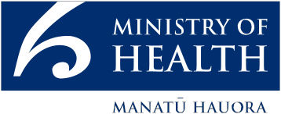
 This work is licensed under the Creative Commons Attribution 4.0 International licence. In essence, you are free to: share ie, copy and redistribute the material in any medium or format; adapt ie, remix, transform and build upon the material. You must give appropriate credit, provide a link to the licence and indicate if changes were made.
Contents

Introduction 1
Strategic connection to the New Zealand Health Strategy 2
Organ donation and transplantation 2
Overview of the deceased organ donation and transplant process 3
Enabling the organ donation decision 4
The need for a strategy 6
Features of the strategy 7
The strategic framework 8
Foundations 11
Measurement, monitoring and evaluation 13
Strategic priorities and priority actions – supplementary discussion 14
Strategic priority one: Improving public awareness and media engagement about organ donation and transplantation 14
Strategic priority two: Improving New Zealand’s system of registering and sharing donor intent for individuals, families/ whānau and clinicians 18
Strategic priority three: Enhancing capability and consistency through improved training 24
Strategic priority four: Increasing hospital-based capacity for deceased organ donation 27
Strategic priority five: Establishing a national agency to lead the implementation of the strategy 31
Strategic priority six: Measuring progress 36
Glossary 39
References 41
Appendix 1 45

List of Tables
Table 1: Key features of a comprehensive deceased organ donation (and transplantation system) 8

List of Figures
Figure 1: Steps in the deceased donation and transplant process 4
Figure 2: Deceased organ donation rates per million population, 2011–2015 7
Figure 3: Strategic framework for organ donation and transplantation 9
Figure 4: Family consent to organ donation when an individual is registered/not registered as a donor (United Kingdom and Australia) 20
Figure 5: Functions of a national agency 33

Introduction
This document provides detail and context for the national strategy for increasing deceased organ donation and transplantation.
Deceased organ donation means organ donation from the deceased person who has been clinically determined as having brain death or circulatory death. Conveniently it is referred as deceased organ donation in this document.

Increasing Deceased Organ Donation and Transplantation: A national strategy (the strategy) is focused on increasing deceased organ donation – but not at any cost. Organs are not simple commodities. Organ donation occurs in the context of human tragedy, involving grieving families/whānau in an intensive care unit (ICU) at a time of great stress. There are important and sensitive personal and cultural issues to be respected during the organ donation process.

Organ donation is a very special gift. We want to support it, but the decision to donate must be voluntary and must always be respected. It is not something the government can fix with more money or changes to the law. It depends on public support and trust in the system of donation and transplantation. Ultimately, it relies on a decision made by family/whānau to donate a loved one’s organs for the benefit of a person or people they are unlikely to ever meet.

At the centre of the strategy is the core objective of enabling donation conversations. The strategy aims to encourage and make it easier for New Zealanders to make their donation wishes known to their families/whānau. It also aims to help families/whānau to make the most appropriate decision with the best possible support and confidence. This will be achieved by enabling conversations both within families/whānau and between families/whānau and ICU staff.

The strategy was developed through a comprehensive process. It involved reviewing international experiences of successful efforts to increase donation rates, reviewing the current system in New Zealand and drawing on the advice of an expert advisory group and a sector working group, as well as public consultation. The Ministry of Health’s (the Ministry’s) detailed review and other supporting material, including public submissions on the strategy, are available on the Ministry’s website (www.health.govt.nz).

The strategy acknowledges the broader context of live organ donation and the entire donation and transplantation process. It also recognises that improving organ donation is everyone’s responsibility – the public, clinicians and the government all have their roles. We need to develop a culture that recognises organ donation as a ‘core business’ of the health system; an important component of the health care system that is mandated by the Minister and the Ministry. Every district health board (DHB) needs to be encouraged and supported to improve their donation services to efficiently and promptly recognise potential donors and offer appropriate support for the people involved in all aspects of the donation process.

Strategic connection to the New Zealand Health Strategy
The strategy to increase deceased organ donation fits with the strategic themes of the government’s overall New Zealand Health Strategy.

People-powered: Organ donation depends on public confidence and willingness to donate. The strategy focuses on ensuring that the needs of the individual and their families/whānau are met so that their confidence is maintained and enhanced.

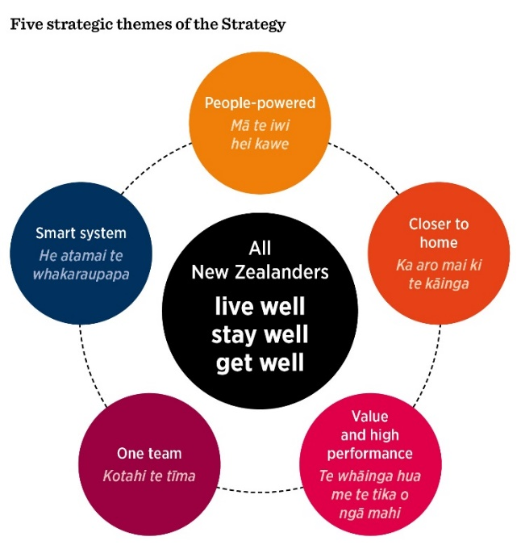 | Closer to home: Organ transplants can help people to lead active lives at home rather than receiving ongoing invasive treatment in hospitals.  Value and high performance: Organ transplantation, particularly kidney transplants (which make up the bulk of transplants), is an extremely cost-effective intervention compared with ongoing dialysis. It is also able to significantly improve life quality and expectancy of those patients.  One team: A national agency will coordinate all donation and transplantation activities and ensure that information about best practice is communicated freely throughout the health sector.

Smart system: Reliable, accurate information will be available at ICUs. This will be supported by relevant online health records that the individuals and their health care specialists can access and update when it is necessary. Donor preferences will be easily recorded and readily available when needed to inform decision-making.

Organ donation and transplantation
Organ transplantation is a life-saving treatment that is often the best, or only, option for people suffering from organ failure. A transplant can transform a person’s constrained quality of life and limited life expectancy.

Demand for transplants, particularly for kidney transplants, continues to rise worldwide. The key factor limiting the number of transplants is the number of organs available for transplant. Donated organs can come from both deceased and living donors (in the case of kidneys and livers). One deceased donor could provide up to seven organs (these include a heart, two lungs, two kidneys, liver and pancreas, but not include tissues such as heart valves, corneas and skin) for transplantation.

It should be acknowledged that New Zealand’s rate of live organ donation – including altruistic donation to strangers – is relatively high by international standards. In 2015, New Zealand ranked tenth of 40 countries reporting living kidney donor transplantation rates per million population. While the generosity of live donors is life-saving, they take on significant risks to their own personal health through the donation process. The need for live organ donations could be reduced if deceased organ donation rates were improved.

By comparison, while our rate of deceased organ donation is increasing, in 2015, we ranked 34th out of 44 countries reporting transplantation rates from deceased kidney donors (IRODaT 2016). Some countries’ organ donation rates have improved significantly as a result of introducing comprehensive and effective donation strategies.

Overview of the deceased organ donation and transplant process
Only a small number of people (less than 1 percent) will die in circumstances that make it possible for their organs to be donated for transplantation.

The majority of potential deceased donors are people who have suffered a fatal illness or injury that has led to severe and irreversible brain damage and have subsequently experienced brain death while receiving mechanical ventilation in an ICU. Donation in this circumstance is referred to as Donation after Brain Death (DBD).

The other category of deceased organ donors is those who have a fatal, irreversible condition that does not result in brain death. They die after treatment is withdrawn following discussion with their family/whānau, again while they are receiving mechanical ventilation in an ICU. Organ donation in these circumstances is referred to as Donation after Circulatory Death (DCD). There is significant potential to increase DCD organ donation in New Zealand.

The broad process of organ donation and transplantation is outlined in Figure 1. This strategy focuses on the first two steps in the process, but all the steps are important.

Figure 1: Steps in the deceased donation and transplant process
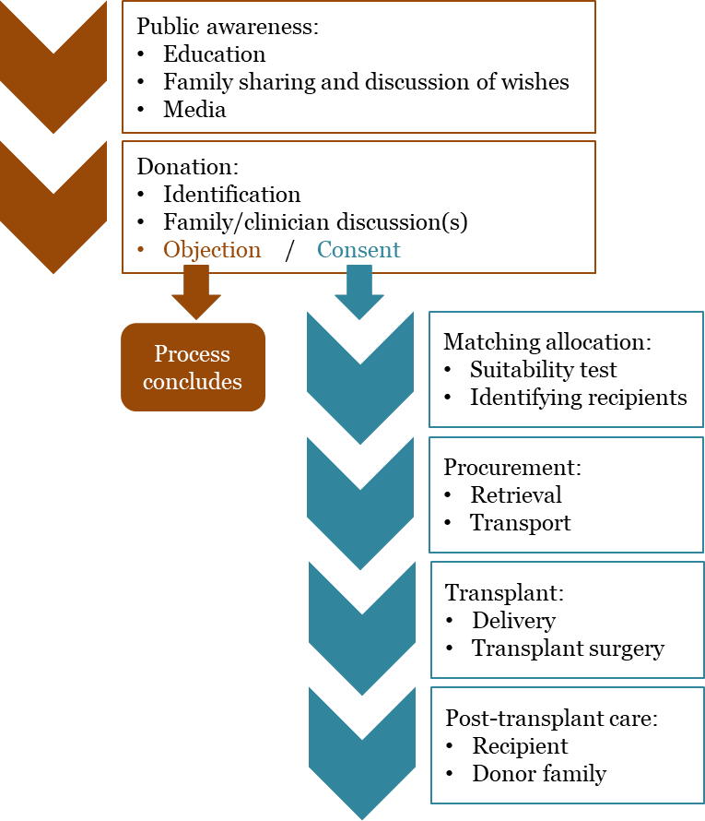

Enabling the organ donation decision
To increase deceased organ donation rates we need to consider how best to encourage individuals’ and families/whānau to consider the options and opportunities for donating.

This strategy addresses several points along the organ donation and transplantation path where improvements to the organ donation process could have the most impact.

The strategy recognises that, in the first instance, individuals who wish to be donors after their death need to be able to communicate their wishes effectively to other family/whānau members. Moreover, family/ whānau are more likely to be receptive to ideas of organ donation if they understand the process beforehand. Thus the strategy seeks to improve public knowledge of organ donation and transplantation options and processes.

However, even if an individual makes it clear before their death that they wish to donate their organs, in New Zealand that person’s family/whānau have the absolute right to decline donation of their deceased loved one’s organs, and their decision must be respected. Consequently, the conversation with the family/whānau is placed at the centre of the deceased organ donation process. Without the consent of the family/whānau, organ donation cannot occur.

The family/whānau make the decision about whether or not to consent to donation at a time of grief and stress. Thus all interactions with the family/whānau need to be respectful, empathetic, reassuring and as comforting as possible. The strategy identifies best practices to guide clinical staff in undertaking these discussions sensitively and effectively to ensure that family/whānau members make a decision they will be comfortable with at the time and in the future. In following the strategy’s recommended practices, clinicians can also feel reassured that they have done their best for the deceased person, for that person’s family/whānau and for potential organ recipients.

Even before the family/whānau is asked to consider donation a clinical assessment must be conducted to identify the potential viability of any donor. The strategy also contains recommendations for improving the clinical governance process. Features include more quickly identifying both potential DCD donors and their families/whānau, who can then be approached in a timely manner to consider the options.

The need for a strategy
Many countries have transformed their organ donation and transplantation systems.
The Australian Organ and Tissue Authority identifies three key themes that should underpin a strategy to increase deceased organ donation (Organ and Tissue Authority 2013b). An effective organ donation strategy includes:
- an infrastructure that underpins the national model: for example, an established network of donation specialists and transplant coordinators
- a methodical and sustained approach to clinical practice: increasing consistency in approaches to end-of-life care at the hospital level is critical, along with a central role for a national agency to drive change
- progressive and cumulative growth: successful changes in systems, practices and institutional arrangements are implemented progressively over time; actions are phased and prioritised and lessons learned and applied continuously – this is not a ‘quick fix’ process.

In addition, the 2016 Ministry review of deceased organ donation and transplantation identified three further key elements (Ministry of Health 2016d). These are:
- a mandate and stewardship from central government: to give visible priority to this work and to commission the necessary changes within the health sector
- clinical credibility: appropriate clinical practices are critical for instigating change, so clinicians must have confidence in the proposed change
- actions that recognise the core elements to be reformed but fit the local environment, including health system arrangements and social and cultural contexts.

Australia and the United Kingdom have implemented successful reforms that contextualise elements of other successful reform programmes to suit their health care systems and social, ethnic, economic and ethical environments. These reforms provide good guidance for New Zealand, as Australia and the United Kingdom were in similar positions to New Zealand before their reforms. The Australian experience is particularly relevant given its many similarities with New Zealand and commonality of practice.

Figure 2 shows the donation rates per million people (dpmp) between 2011 and 2015 in New Zealand, Australia, Ireland and the United Kingdom.

Figure 2: Deceased organ donation rates per million population, 2011–2015
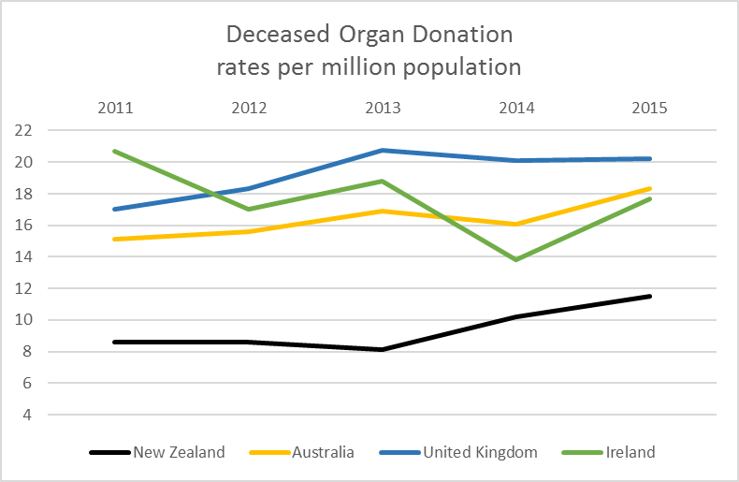
Source: IRODaT 2012, 2013, 2014, 2015, 2016

The increase in overall rates of deceased organ donation in Australia and the United Kingdom are due in no small part to increasing DCD rates in these countries. The strategy recognises there are still potential gains to be made in improving DBD rates. In 2016, New Zealand had 55 DBD donors (11.7 dpmp) and Australia had 15.5 dpmp, a gap of approximately 25 percent (Organ Donation New Zealand 2017). Further, DCD is far more resource intensive than DBD, so it is important to consider capacity when looking at increases in DCD.

Features of the strategy
New Zealand is already well positioned to successfully develop and implement a national strategy to increase rates of deceased organ donation, with many of the key elements already in place. We already have an audit of all deaths in ICU and facilitate training in organ donation. The coordination between donor hospitals and transplant services is also very well regarded. This suggests that major reform is not required. Rather, some existing elements need to be strengthened, while a few new elements need to be added to ensure that we have a comprehensive strategic approach. Table 1 lists the key elements of a comprehensive national strategy, indicating which are suitable as they are, which need strengthening and which are completely new.

Table 1: Key features of a comprehensive deceased organ donation (and transplantation system)
Comprehensive strategic approach | Existing | Strengthened | New
National strategy |  |  | ✓
National agency with a clear mandate to increase deceased organ donation |  |  | ✓
ICU access to 24/7 specialist advice and national donor coordination/logistics | ✓
Public awareness and media engagement plan |  |  | ✓
ICU clinical organ donation specialists (ICU physicians and nurses) portfolios within each ICU that focus on organ donation (Link teams) |  | ✓
Funding provided to ICUs on a trial basis to support the deceased organ donation process (extended Link team nurses) |  | ✓
Clinical governance framework: Death (donation) audit data reported and monitored from each ICU |  | ✓
Specialist training (to support clinicians in organ donation processes, including family/whānau conversations) |  | ✓
Register (a mechanism for registering organ donor intent through the driver licence record) |  | ✓
International cooperation to share best practices  (especially with Australia) | ✓
Robust legal and ethical framework | ✓
Note: Bold indicates a strategic priority action area detailed in the strategy.

The strategic framework
Figure 3 shows how the parts of the strategic framework fit together. At the centre is the core objective of enabling donation conversations to support individuals’ and family/whānau decision-making. Alongside this are the objectives of improving clinical practices and broadening the scope of deceased organ donation to include more DCD donations.

Figure 3: Strategic framework for organ donation and transplantation
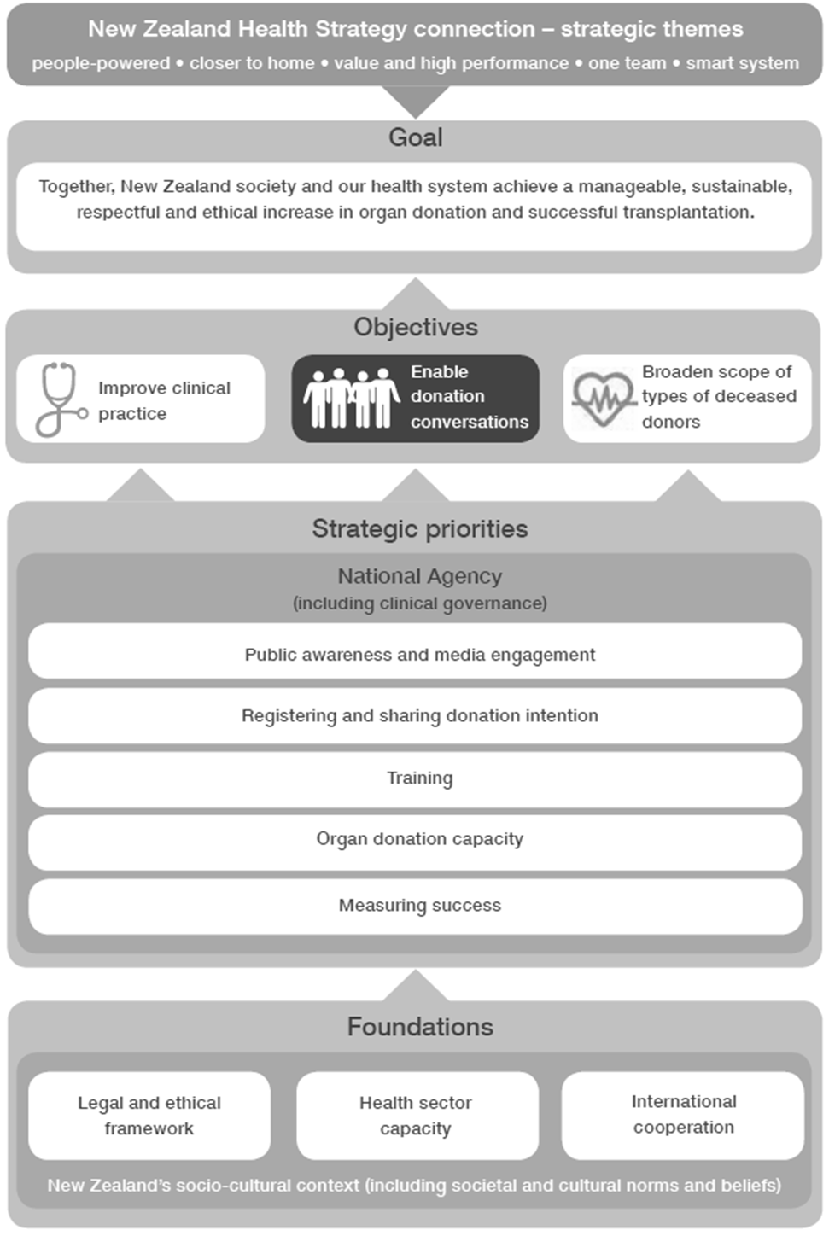

Strategic goals
- The overarching aim of the strategy is to increase the number of successful donations, and therefore transplants to improve health outcomes for New Zealanders who need lifesaving and life-enhancing organ treatment. This aim meets the vision of the New Zealand Health Strategy.
- Together New Zealand society and the health care system demonstrate that organ donation is relevant to everyone.
- The organ donation and transplantation processes move towards the overarching aim in a manageable and sustainable manner. This includes ensuring that planning and funding of supporting health-care infrastructure (including capacity and training) is mandated, supported and prioritised.
- Being respectful of potential donors’ wishes and of the decisions made by their families/whānau is fundamental to the strategy. All organ donation and transplantation processes respect the fact that organ donation is voluntary. No family/whānau should ever feel coerced to donate the organs of their loved ones.
- All organ donation and transplantation processes are carried out with the highest standards of ethical, legal and clinical practice.
- The overarching aim is achieved by enabling donation conversations, improving clinical practices and broadening the scope of donors.

Strategic priorities
There are six priorities that directly support the strategic goals.
1. Improving public awareness and media engagement about organ donation and transplantation
2. Improving New Zealand’s system for registering and sharing donation intent for individuals, families/whānau and clinicians
3. Enhancing capability and consistency through improved training
4. Increasing hospital-based capacity for deceased organ donation
5. Establishing a national agency to lead, oversee and support the implementation of the strategy
6. Measuring progress.

The six strategic priorities are in turn supported by 18 priority actions. These actions will help families/whānau prepare for the donation conversation and learn what their loved ones wanted. The actions will also help clinicians conduct the donation conversation in the best possible way, taking account of the appropriate sociocultural context within New Zealand.

Foundations
The strategy is supported by a robust legal and ethical framework, international cooperation to share best practice and a suitable structure that develops the capacity to respond to potential donation opportunities as they arise and carry out increased transplants effectively.

Sound legal framework for organ donation
In New Zealand, organ donation is governed by the Human Tissue Act 2008. There will be no changes to the Act, which is considered sufficiently sound and reflects the broader sociocultural context and norms that support organ donation.

The Act sets the basis for informed consent. Fundamentally, it is considered appropriate in the New Zealand context for families/whānau to be asked to provide informed consent or objection to the donation of their deceased loved ones’ organs.

The role and use of the New Zealand driver licence record as a register of donor intent (not informed consent) of each driver’s wishes regarding organ donation is explained under strategic priority two: Improving New Zealand’s system of registering and sharing donor intent for individuals, families/whānau and clinicians below. Further information about the relationship between legal frameworks and donor registers is also provided in Appendix 1.

Appropriate ethical framework to support organ donation
Organ donation involves complex ethical, social and cultural issues. The Ministry’s review of deceased organ donation and transplantation found that some clinicians were uncertain about the ethical implications of some new practices, such as DCD (Ministry of Health 2016d). Clinicians want robust and readily available ethical guidance if they are to implement significant new practices.

Where ethical guidance is required, the National Ethics Advisory Committee (NEAC) was regarded as the appropriate source of advice. The NEAC agrees its work programme annually with the Minister of Health. The ethical issues of organ donation can be added to that programme if required.

Health sector capacity

Donation capacity
Deceased organ donation is a resource-intensive process. It requires an available staffed ICU bed and clinicians to manage the care of the potential donor and address the needs of their family/whānau. The workload for dealing with a potential donor is often shared amongst a small number of ICU clinicians trained in deceased organ donation. This can put a lot of pressure on staff capacity, and there are occasions when staff voluntarily provide their services beyond their rostered hours to enable a donation to occur.

Donation capacity is discussed further under strategic priority four: Increasing hospital-based capacity for deceased organ donation below.

Transplantation capacity
There is also an ongoing need to ensure sufficient capacity in transplantation services – in terms of surgical teams both retrieving the organs and transplanting the donor organs, as well as extra capacity for supporting services, such as physiotherapy, pharmacy and dietetics services.

Kidney transplants are carried out at Auckland, Wellington and Christchurch hospitals. The transplants directly benefit the local DHB of the transplant recipient by reducing demand for dialysis. Kidney transplants for patients from another DHB are funded by the patients’ local DHBs via an inter-district flow (payment between DHBs). This allows the DHBs that are conducting the transplants to meet increased volume without additional direct government funding and ensures that costs are allocated to the DHBs that benefit.

Auckland DHB is the main transplanting centre for other organs (eg, it is the only centre that performs cardiothoracic and liver transplants).

International cooperation
The strategy has been informed by overseas experience. The organ donation and transplantation system will continue to learn from and adopt international best practices. New Zealand already works closely with Australia in the following ways.
- The two countries share common specialist medical colleges and societies – including the College of Intensive Care Medicine of Australia and New Zealand (CICM), the Australasian College for Emergency Medicine (ACEM), the Australian and New Zealand College of Anaesthetists (ANZCA) and the Australia and New Zealand Intensive Care Society (ANZICS).
- There is a trans-Tasman organ sharing agreement for the Transplant Society of Australia and New Zealand (TSANZ). Organs for transplantation can be shared between the two countries if a suitable recipient is not identified in the country of the organ’s origin (travel times limit the sharing of organs further afield).
- Discussions are underway to form a trans-Tasman kidney exchange scheme as this would increase the likelihood of compatible matches.

This cooperation and mutual learning works well, and should continue. The national agency and other stakeholders in the deceased organ donation and transplantation system will continue to look for opportunities to work with, and learn from, colleagues in other countries.

Organ donation in a diverse social and cultural context
While overall societal norms in New Zealand appear to reflect strong support for the benefits of organ donation (Ministry of Health 2016a), there are important cultural, ethnic and religious considerations to be taken into account throughout the deceased organ donation process (eg, different world views about life and death and what it means for the organs of a family/whānau member to be donated to someone beyond the family group). It is further recognised that potential deceased organ donors and their families/whānau hold their own personal values and beliefs regarding organ donation, quite distinct from those of their cultures, ethnicities or religious backgrounds, and that beliefs can vary between generations and over time.

Coupled with broader cultural diversity are the aspirations expressed through He Korowai Oranga (the Māori Health Strategy) (Ministry of Health 2014b) and ’Ala Mo’ui: Pathways to Pacific health and wellbeing 2014–2018 (Ministry of Health 2014a) and the obligations of the Government arising through the Treaty of Waitangi and the Ottawa Charter for Health Promotion (Ministry of Health 2002).

The strategy aims to address the increasingly culturally diverse context in which New Zealanders live and within which deceased organ donation occurs. Cultural diversity implications are reflected especially in the strategy’s priority one (improving public awareness (health literacy) and media engagement about organ donation and transplantation) and three (enhancing capability and consistency through improved training – ie, cultural competence) to facilitate discussions with family/whānau about organ donation.

Measurement, monitoring and evaluation
The strategy includes a measurement, monitoring and evaluation framework to help assess whether the strategy is moving towards its overall goal. The Ministry will have a significant role in monitoring the strategy and the work of the national agency and DHBs. DHBs will be expected to have in place their own accountability arrangements for formally monitoring progress against the strategy, including in their annual plans. Further details on the monitoring framework can be found under Strategic priority six: Measuring progress.

Strategic priorities and priority actions – supplementary discussion
Strategic priority one: Improving public awareness and media engagement about organ donation and transplantation | The national agency will be responsible for developing a national public awareness and media engagement plan that will be based on sound research and will be monitored and evaluated regularly.
- New Zealand and international research has found that while the majority of people are in favour of organ donation, they have not always shared their intention to donate (Li et al 2015; Ministry of Health 2016a).
- Awareness campaigns can play an important role in educating the public about organ donation and busting common myths (Li et al 2015).
- A systematic review and meta-analysis found that, overall, campaigns improved awareness and registration (Feeley and Moon 2009).
- Media advocacy has been utilised successfully in many countries (Misterska et al 2010).

The current state
There is currently no organisation with a mandate for improving public awareness or media engagement around deceased organ donation in New Zealand. Organ Donation New Zealand (ODNZ) has not been formally contracted to carry out public awareness campaigns, although it has engaged in some activity, operating a website and 0800 telephone number and producing resources for schools.

There is also currently no national plan for engaging with the media on the topics of organ donation and transplantation. ODNZ has indicated that it attempts to correct media releases that contain misleading information. However, there is no proactive, coordinated and consistent messaging or contact with media outlets and journalists to ensure that the information they provide is accurately and positively portrayed.

The current level of population awareness and understanding of organ donation in New Zealand is unknown. Research has suggested that most New Zealanders are in favour of organ donation. A small survey of New Zealand university students in Dunedin found that most of the people surveyed supported organ and tissue donation as ‘being a benefit to society’ and answered positively when asked whether they would donate their organs/tissue (Cornwall et al 2015). Despite this positive attitude, which is also found in many other countries, New Zealand still has a low donation rate.

Changes to be made
Public awareness campaigns are used to improve understanding of the issues around organ donation and transplantation and can have a positive effect on attitudes and intentions. International organ donation reform programmes universally include a focus on improving public awareness.

Such campaigns can play an important role (along with media engagement) in educating the public about organ donation, and busting common myths (Li et al 2015). For example, there is still a common misperception in New Zealand that selecting ‘yes’ to being a potential organ donor on a driver licence counts as informed consent. In fact, it only indicates intent – the individual’s family/whānau must provide informed consent after the individual’s death (Ministry of Health 2016a). Recent Australian research (Neate et al 2015) found that barriers to consent included a lack of knowledge of an individual’s wishes before their death, which could be partly addressed by improving public awareness of the importance of families/whānau sharing their wishes and discussing organ donation. See also Strategic prioritytwo: Improving New Zealand’s system of registering and sharing donor intent for individuals, families/whānau and clinicians below.

Public awareness campaigns take various forms. Examples include mass media or focused campaigns that target high schools, workplaces or communities, etc. A systematic review and meta-analysis has found that, overall, campaigns improved public awareness and registration (Feeley and Moon 2009).

Combined interventions (generally mass media and community-based interpersonal campaigns, including social media) appear to be most successful (Salim et al 2010; Feeley and Moon 2009). Specific studies of social media have also indicated positive results in raising awareness. A Facebook campaign in Poland became the most popular organ donation page in the world in 2014 (Klikowicz 2015). Based on these findings, we recommend that any public awareness strategy include social media elements in addition to traditional mass media options.

Media coverage of organ donation is very important. Mainstream media are some of the public’s main sources of organ donation information (Morgan et al 2007). Negative messaging about organ donation, whether in the press or in entertainment media, can have a direct and negative effect on transplant rates (Misterska et al 2010). In a small country like New Zealand, it is important to work with and guide the media to ensure that the media do not provide misinformation or breach the privacy of individuals and their families/whānau. Media advocacy has been used successfully in other countries, particularly Spain, which has the highest rates of organ donation (Misterska et al 2010).

A key focus of public awareness strategies will be to promote conversations about organ donation and transplantation within families/whānau and communities. Better public knowledge about organ donation and transplantation will make it easier to discuss donations in the ICU – especially if the family/whānau has already discussed organ donation and is aware of their loved one’s wishes.

Public and clinical support for a public awareness and media engagement plan
The consultation process yielded a very positive response to the idea of a national agency that is mandated to develop a public awareness plan, including strategies to engage with the media.

Clinicians said that better public awareness would make the discussions with family/whānau easier for everyone involved. However, some submitters pointed out that public awareness campaigns do not necessarily increase donation rates. Submitters also noted the need to provide balanced and accurate information.

Māori and Pacific peoples were identified as a key audience, and any public awareness plan should include specific strategies for engaging with those communities. Some submitters emphasised that such efforts should focus on providing accurate information that is appropriate to the audience rather than primarily addressing perceived cultural barriers to donation. Submitters commented that any existing cultural barriers to organ donation need to be considered from the perspective of the cultures concerned.

The national agency’s communication leadership role
The national agency will be responsible for developing and implementing a public awareness and media engagement plan. This is a broad-based role that includes commissioning public awareness campaigns, managing media engagement and supporting the wider health sector to communicate, manage and plan for public engagement with the organ donation and transplantation programme. The two key elements of the role will cover:
- raising public awareness and understanding of organ donation and transplantation
Public awareness initiatives will be based on sound research, and they will meet the needs of different audiences, through direct engagement with diverse communities. They will include a specific communication strategy for Māori and Pacific peoples. Initiatives would also use the existing driver licence register as a means of raising awareness and prompting family/whānau discussion. (See also Strategic prioritytwo: Improving New Zealand’s system of registering and sharing donor intent for individuals, families/whānau and clinicians below.)
- proactively engaging with a wide range of media
The national agency will develop a specific plan to proactively engage a wide range of media to help present accurate information through their reports, dispel inaccurate ‘myths’ and reduce the negative impacts from inaccurate reporting.

This leadership role will include providing a single point of contact for media liaison through to DHBs and clinicians. There is a need for ongoing and proactive media liaison. Specific activities could include providing: consistent messaging, guidance and support to the media; working with schools; collaborating with government agencies; managing third-party organisations who want to collaborate (eg, on public awareness campaigns); facilitating positive association stories for donation and managing confidential donor and recipient information.

Public awareness campaigns will be monitored and evaluated regularly to measure changes in awareness and understanding of organ donation and transplantation in New Zealand, to identify gaps in public awareness and understanding, and consequently to develop focus areas for future campaigns.

Priority actions
- Raise public awareness and understanding of organ donation and transplantation.
- Proactively engage a wide range of media. This will include support for the sector around communication planning.

Measuring success:  improving public awareness and media engagement |  | Strategic objectives
 |  | Improve clinical practice | Enabling donation conversations |  | Broaden scope of donors
Indicator | Conduct a baseline survey of public awareness of organ donation and transplantation knowledge in the population (including awareness of organ donation wishes of family/whānau members – see registering donor intent) |  |  | ✓
Data source | National survey (TBC)
Indicator | Observe an increase in awareness and understanding of the organ donation wishes of family/whānau members over time (including across specific audiences, such as Māori and Pasifika) [level of increase to be established post-baseline] | ✓ |  | ✓
Data source | National survey (TBC)
Indicator | Increase in affirmative donor registrations over time |  |  |   ✓
Data source | Driver licence register (TBC)
Indicator | Monitor the extent of positive and accurate reporting on organ donation and transplantation by the media over time | ✓ |  | ✓
Data source | Media monitoring (TBC)

Strategic priority two: Improving New Zealand’s system of registering and sharing donor intent for individuals, families/ whānau and clinicians | New Zealand has a sound legal consent framework for organ donation that will be retained. It is expected that the electronic health record will become the primary record of donor intent over time to better communicate an individual’s wishes to families/whānau and clinicians.
- New Zealand (with mandatory choice) has the highest rate of affirmative registrations in the world (Rosenblum et al 2012b).
- Evidence indicates that family/whānau consent rates are much higher when families/whānau know that their loved ones were registered as a donor (Hopkinson 2015; Stephens 2013).
- Collectively, international experience suggests that the real value of a register is to:
- provide a tangible focal point for raising awareness
- enable people to record their donation wishes and discuss and communicate those wishes with their family/whānau
- indicate someone’s donation wishes when they can no longer do so themselves (to families/whānau and clinicians)
– provide accessible and reliable information about donor wishes to clinicians.

The current state

New Zealand’s legal consent framework
The Human Tissue Act 2008 (the Act) regulates the collection and use of tissue, primarily from deceased human bodies, and sets up a framework that requires informed consent for human tissue collection and use. Organs cannot be retrieved for transplantation without first obtaining proper informed consent. Informed consent is defined as consent to a particular use of an organ or tissue (rather than a general agreement) ‘given freely in light of all the information a reasonable person, in that person’s circumstances, needs to make an informed decision’ (Human Tissue Act 2008, section 9(1)(c)).

This framework is similar to the Health and Disability Consumers’ Code of Rights, which also sets out requirements for voluntary and informed consent (particularly right 7(10) (Health and Disability Commissioner 1996). It is not possible for potential donors to give legally binding consent: they can only indicate their willingness to donate their organs in the event of their death, which does not constitute informed or binding consent as set out in the Act.

International evidence has found that regardless of the types of legal consent frameworks or type of donor register that operates within a country, families are almost always asked to make the decision whether or not to donate a deceased family/whānau member’s organs. This applies in both presumed and explicit consent systems and even where there are legally binding registers (Rosenblum et al 2012a). This practice is also reflected in the New Zealand strategy. A key reason for this is that the family/whānau are usually in the situation of having to suddenly and unexpectedly confront the devastating loss of their loved one. It is unimaginable to doctors and nurses working in such an environment not to consult the family/whānau and incorporate their views.

Driver licence is a record of intent, not consent
The driver licence organ donation information does not meet the requirements of informed consent under the Act. The decision to donate therefore falls to the donor’s immediate family/whānau or ‘close available relative’ (Human Tissue Act 2008, section 10). If the deceased person’s family/whānau does not consent (ie, has an informed objection to the donation will not proceed.

The driver licence record effectively operates as documentation of a licence holder’s intention to be a potential (prospective) donor. New Zealand’s current driver licence record is a mandatory choice combined opt-in/opt-out, non-binding record of intent (see Appendix 1 for a background on consent models and types of registers/records and where the New Zealand model fits) where individuals must answer the question ‘Would you be willing to donate organs in the event of your death?’ Applicants tick either ‘yes’ or ‘no’ when applying for a driver licence. This information is recorded on the driver licence and New Zealand Transport Association (NZTA) driver licence record. Where a person dies in circumstances that enable them to potentially become a deceased organ donor (maybe many years after applying for their driver licence), this provides some indication of their intention (what they planned to do at the time they answered the question). Licence holders can request that the database/record be updated if they change their minds and can change their donor status each time they renew their licence (every 10 years).

Because of the mandatory choice model, New Zealand has a very high affirmative (‘yes’) rate of donor intent preferences at 54 percent (the highest rate globally) (Rosenblum et al 2012b). However, clinicians do not routinely refer to donor intent records due to concerns about the accuracy and relevance of the information contained them as well as restricted access to them. Furthermore, it is not clear if the public fully understands the current informed consent and driver licence record system or if, and to what extent, individuals share their wishes with their family/whānau.

While the driver licence record has the advantage of reaching the majority of the adult population, there is still a significant proportion of the population who do not have a driver licence and therefore are not reached via this approach to recording donation wishes.

Keeping the role of registers in perspective
Research suggests that, internationally, donation rates are the outcome of complex, multifactorial processes (Ministry of Health 2016b). Some authors suggest that countries that maintain a donor register exhibit higher organ donation and transplantation rates on average when compared with countries that do not maintain a register (Bilgel and Galle 2014). However, many researchers have concluded that registers make only a small contribution to increasing the total number of organs and tissues available for transplantation.

Evidence from the United Kingdom and Australia, where such registers are in place, shows that family/whānau consent rates are much higher when a person is registered as a donor (Hopkinson 2015; Stephens et al 2013) (see Figure 4 below). However, the total number of registrations is still relatively low (30 percent), indicating that other strategies are required to encourage people to discuss their wishes before their death (promoted by public awareness campaigns).

Figure 4: Family consent to organ donation when an individual is registered/not registered as a donor (United Kingdom and Australia)
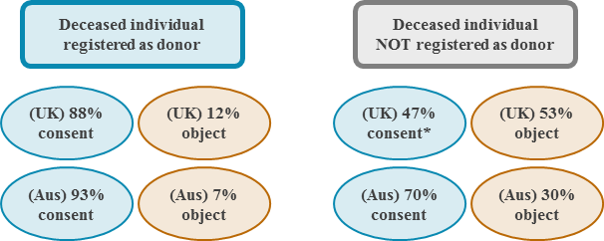

Collectively, international experience suggests that the real value of a donation register (or record of intent) lies in its ability to act as a mechanism to:
- provide a tangible focal point for raising awareness
- enable people to record their donation wishes and to discuss and communicate those wishes with their family/whānau
- indicate donation wishes to a family/whānau when an individual can no longer do so themselves
- potentially provide accessible and reliable information about donor wishes to clinicians.

While registers have a place in most comprehensive organ donation and transplantation systems, evidence suggests that the most important components relate to the quality of clinical training and the quality of discussions between family/whānau and clinicians as part of end-of-life care.

Changes to be made

The public value some form of donation register
Public consultation revealed a very clear desire for some form of donation register. There is a public expectation that the donor’s record of intent will be made known to their family/whānau, and to clinicians to inform organ donation discussions with the family/whānau. Many submitters favoured continuing to use the driver licence record, citing its very high registration rate by international standards. Others raised concern that it was difficult for individuals to record when they had changed their minds. Some submitters preferred establishing a stand-alone register (with some specifying a binding register). There was general agreement that it would be valuable to provide more explanatory information at the point of recording donor intent.

Clinicians do not routinely refer to donor records of intent in organ donation conversations with families/whānau
While the public reasonably expect that the driver licence record of their intentions will be taken into consideration, the record is not routinely accessed by clinicians in ICUs when discussing organ donation with a deceased person’s family/whānau.

This is because clinicians have concerns about the usefulness and accuracy of such records. They consider that driver licence information does not necessarily represent someone’s fully informed view or acknowledge any change of mind. For example, someone who has indicated ‘No’ may have subsequently changed their mind or may have ticked ‘No’ because they did not understand the question.

Also, it is difficult to obtain information about licence records out of working hours. The family/whānau must authorise ODNZ to request the information through the police. Consequently, the record is largely ineffective in providing clinicians and the family/whānau with the deceased person’s intention.

A simple ‘yes’ or ‘no’ response does not provide the full range of choice
The compulsory nature of the donor intent question in driver licencing records and its wide population reach (91 percent of the adult population in 2014) (Ministry of Transport 2015) helps address donor apathy (a common problem with donation registers). However, some driver licence applicants feel unprepared to make a decision at the time of driver licence registration and can make an uninformed, inaccurate or uncertain choice (Ministry of Health 2016a).

Also, some submitters felt that a simple ‘yes’ and ‘no’ answer does not allow the driver licence applicants the full range of choices. Submitters also generally agreed that it would be useful to provide more general information on organ donation and transplantation with the driver licence application.

The effectiveness of registering donor intent in encouraging family/whānau conversations is not clear
There is no clear evidence of the effectiveness of registered donor intent in helping to encourage conversations within the family/whānau about potential organ donation. Registration is not currently supported by any national or community-level public awareness campaigns (unlike in many other countries), and currently only limited (if any) information on organ donation is available at driver licensing facilities.

The New Zealand approach

Our overarching legal consent framework
Organ donation registers are influenced by the overall legal framework, cultural norms and practices in a country. However, organ donation and retrieval systems are complex, and legislation and practices often differ. Research has found that even countries that have presumed consent legislation (and binding registers) follow much softer practices, meaning binding registers do not lead to compulsory organ acquisition.

On balance, a binding register is not considered suitable for the New Zealand context as it is inappropriate to override the wishes of family/whānau in ICU conversations. Consequently, the current New Zealand legal consent framework (requiring informed consent to a particular use of an organ or tissue before any organ can be retrieved for transplantation) is considered to be sufficiently sound.

The existing mandatory driver licence donor record of intent system remains a convenient community-based opportunity to reach most of the adult population for in-person registration and will be retained and remain non-binding in the short-term.

Other effective systems, including the electronic health record
The Ministry, and the national agency upon its establishment, will explore other effective systems for registering donor intent. Once it is developed, it is expected that the individualised electronic health record (EHR) will provide a means of registering donor intent. The system will create an online centralised record of people’s health information, attached to their National Health Index (NHI) number, which will be accessible and updateable by the individual concerned and available routinely in clinical settings.

This system has the advantage of including people who don’t have a driver licence. It will allow more detailed information to be held, such as confirming whether individuals have considered organ donation (eg, by nominating family/whānau members with whom they have discussed their preferences in detail), and identifying what organs and tissue they are willing (or not willing) to donate. Australia has already successfully implemented such an electronic record system (My Health Record), which is supported by a mobile app.

An effective register of donor intent would:
- provide reliable information on donor wishes
- be easy to access for clinicians and families/whānau
- be easy for the individuals to change
- be cost effective.

Improving the existing driver licence record
The national agency, the Ministry of Transport, and NZTA will investigate options to improve the existing system. Any such investigations will involve a robust policy analysis of the proposals, an assessment of the likely costs and a clear commitment to funding appropriate proposals. Improvements that may prove feasible include:
- Simplifying the process to update the donor record. Existing driver licence holders may be able to change their donor status on the database more easily in future, possibly online.
- Increasing the availability of information on organ donation. The Ministry of Transport and NZTA websites already link to online resources about organ donation, and can link to updated online resources as they are developed Updated physical resources can be provided at licensing agents.
Public awareness campaigns could explain the purpose of organ donation, and may be evaluated to understand whether public awareness, understanding, attitudes, motivations, and intentions are changing in relation to organ donation in New Zealand.
- Facilitating and encouraging the use of the driver licence record. Organ donation specialists could incorporate consulting the driver licence record and registering the donation intention from the driver licence record on the person’s EHR into standard organ donation practices. Over time, it is expected that donor intent information will inform donation discussions more often, particularly if there are simple cost-effective steps that would make the record easier to use. The Australian Organ and Tissue Authority (OTA) best practice guideline requires intensive care physicians in Australia to access information on an individual’s intention to inform their donation conversations. It may also become part of the standard approach in New Zealand.
- Exploring options for expanding the menu of choices about donor intent. This could allow intended organ donors (and existing driver licence holders) to select from further options clarifying their wishes: expanding from the basic ‘yes’ and ‘no’ responses to include other options, such as ‘family/whānau to decide’, ‘undecided’ and to specifying particular organs for donation.

Priority actions
- Explore other effective systems, including the EHR (under development), to allow people to record and manage their wishes to be an organ donor more efficiently.
- Provide families/whānau and clinicians in ICUs with improved access to accurate donor intent records and encourage them to consult this information.
- Enable New Zealanders to record, change and access their donor status more easily.
- Promote communication of organ donation wishes to families/whānau and friends through public awareness campaign and social media.
- Explore options to expand the list of donor choices from ‘Yes’, and ‘No’, to include further options.

Measuring success:  improving the register of intent |  | Strategic objectives
 |  | Improve clinical practice | Enabling donation conversations |  | Broaden scope of donors
Indicator | The Ministry (to be replaced by the national agency upon establishment) and NZTA work together to improve the driver licence record. | ✓ |  | ✓
Data source | TBC
Indicator | Establish a baseline of general family/whānau awareness of organ donation wishes.  Observe an increase in family/whānau awareness of organ donation wishes over time. | ✓ |  | ✓
Data source | Deceased organ donation measurement tool (TBC)
Indicator | Establish a baseline of clinicians including donor intent information in organ donation discussions with family/whānau in ICUs.  Observe an increase in clinicians including donor intent information in discussions with family/ whānau over time. | ✓ |  | ✓
Data source | Donation audit data

Strategic priority three: Enhancing capability and consistency through improved training | The importance of organ donation training is well recognised in New Zealand: ODNZ currently provides a range of education and training, including workshops for clinicians, organ donation study days, Link team nurse induction days and Link team workshops.
- It is estimated that only 30–50 percent of ICU clinicians have completed any organ donation training (EY 2016a).
- Organ donation is more likely to occur if the family/whānau is approached by someone trained in organ donation (National Health Service Blood and Transplant 2015).
- One-off attendance at an appropriate workshop is unlikely by itself to optimise clinicians’ donation requesting skills (Opdam 2015).

The current state
The CICM is responsible for training ICU doctors in New Zealand. The CICM training programme teaches and assesses multiple facets of organ donation, including a Family Donation Conversation (FDC) workshop (College of Intensive Care Medicine of Australia and New Zealand 2011). The workshop has only been mandatory for those training after the 2014 curriculum review, but many ICU doctors have completed it voluntarily. Moreover, the Australian OTA sees the workshop as a minimum requirement for all those conducting organ donation conversations with families (Organ and Tissue Authority 2013a).

Some doctors who are involved in deceased organ donation (particularly those staffing the smaller, regional ICUs) have trained as anaesthetists or emergency physicians. The training programmes for those specialties do not require training in organ donation conversations (Australian and New Zealand College of Anaesthetists 2017). Nonetheless, they must complete appropriate continuing professional development activities consistent with their scope of practice (Medical Council of New Zealand 2016). During consultation around developing this strategy, submitters agreed that emergency department (ED) physicians had an important role in organ donation but suggested that their training should be better tailored to address organ donation conversations. Some submitters also thought that anaesthetists working in ICUs should be appropriately trained in organ donation.

Published research suggests that consent to organ donation is more likely to be given if the family/whānau is approached by someone trained in organ donation (National Health Service Blood and Transplant 2015). A mixture of didactic and skills-based training in a workshop setting is also associated with an increase in consent rates (Siminoff et al 2009). In Australia, having an FDC-trained clinician to first raise the issue of organ donation with families significantly increased consent rates compared with clinicians who had not received specific training. The conversation is even more influential if the trained clinician is separate from the treating clinical team (Lewis et al 2015). In the United Kingdom those who are leading organ donation discussions with families must have received appropriate training (National Institute for Health and Care Excellence 2011).

It should be noted that this published research on the effectiveness of training is largely observational and is mostly conducted with health care systems that have existing training programmes and legislation that is very different from that in New Zealand.

Overall, it is estimated that only 30–50 percent of ICU doctors in New Zealand have completed any organ donation training (EY 2016a). There is scope to improve the coverage of organ donation conversation training around the country. It is logical that this training be prioritised to those who are conducting such conversations: ICU doctors and Link team nurses. Link team nurses could be deployed to lead conversations in smaller centres in preference to the conversation being led by a doctor who has not completed organ donation conversation training.

One-off attendance at an appropriate workshop is unlikely to result in a clinician having optimal organ donation conversation skills (Opdam 2015). In Australia, an important policy change has resulted in organ donation specialists (usually ICU doctors) being employed in selected hospitals to undertake further simulation-based training and are tasked with optimising donation processes, including education and communication.

Training specific to cultural competence
Many submitters emphasised that any training must be tailored to reflect the cultural and clinical settings of New Zealand.

The Medical Council of New Zealand consider cultural competence to be a cornerstone of continuing professional development (Medical Council of New Zealand 2006). Māori and Pacific families/whānau are currently less likely to be approached about organ donation than other New Zealand ethnicities. The reasons for this are unclear, but the situation may reflect a misperception among clinicians that Māori and Pacific families/whānau are unlikely to donate, or perhaps clinicians feel less confident in initiating a conversation about deceased organ donation with Māori and Pacific peoples. ODNZ include some cultural components in its nursing education, but these are not specifically aimed at discussing organ donation with families/whānau. We need more evidence-based educational material that specifically addresses the cultural aspects of organ donation in relation to New Zealand patients.

Changes to be made
The national agency will oversee and promote training in the organ donation conversation. It will work with DHBs and medical colleges to promote and support an increased uptake of training. Over time, the range of training offered will be expanded to ensure it continues to meet the differing and ongoing needs of the clinicians involved in organ donation.

The agency will ensure that training resources are allocated to have the greatest impact and ensure the greatest improvements. Training for ICU doctors and Link team nurses will be a priority, as emphasis needs to be placed on training the people ‘on the ground’ who are regularly involved in organ donation conversations with family/whānau. They will receive formal training to a standard approved by the national agency in consultation with the CICM core Family Donor Conversation (cFDC) or equivalent. There may be flow-on benefits, as knowledge and skills from lead intensivists will be transferred to other clinicians and non-clinical staff. In addition, improved training may be provided to ED doctors, anaesthetists, and non-clinical staff who are also involved in the organ donation process.

The national agency will work with training providers and professional bodies to improve cultural competency training specific to the New Zealand environment. This training should address any potential misperceptions around organ donation and cultural values and will provide the skills and information to enable culturally appropriate conversations with family/whānau.

Further opportunities for training will be identified through a clinical governance framework that will use performance reporting to highlight gaps and areas for improvement for different DHBs, the wider health sector workforce and the community.

Priority actions
- Coordinate training in organ donation conversations for clinicians and work with DHBs and professional organisations to promote and improve the uptake of training opportunities.
- Provide training to intensive care doctors, Link nurses, emergency department staff, anaesthetists, and other staff involved in the organ donation process.
- Develop educational material on cultural awareness as applied to organ donation conversations with Māori and Pasifika.
- Collect data on the uptake of organ donation conversation training and its impact on service providers and consumers.

Measuring success:  improving and increasing training |  | Strategic objectives
 |  | Improve clinical practice | Enabling donation conversations |  | Broaden scope of donors
Indicator | All clinicians who are conducting organ donation conversations with family/whānau receive appropriate training in this area. | ✓ |  | ✓
Data source | National agency data on whether clinician is cFDC trained
Indicator | All families/whānau of individuals who are eligible to be considered for organ donation have access to full and consistent information to enable them to make the best choices about organ donation. | ✓ |  | ✓ |  | ✓
Data source | Donation Audit data: Confirmed brain death, donation discussed

Strategic priority four:  Increasing hospital-based capacity for deceased organ donation | Our health system needs to be able to support increasing numbers of deceased organ donations.
- Funding of dedicated specialist medical and nursing roles to manage the donation process is the single most effective initiative to increase the rates of deceased organ donation (submission from public consultation).
- Deceased organ donation is resource intensive and some work is currently conducted on a “goodwill” basis (EY 2016a, p70).
- Most countries with substantially higher deceased donation rates have dedicated and partially funded intensivist positions in major hospitals to act as a donation champion (EY 2016a, p45).

The current state
Deceased organ donation is an uncommon event in New Zealand but when it does occur it involves a huge number of resources – both equipment and personnel. The process of deceased organ donation requires an available, staffed, ICU bed and clinicians need to be available to manage the care of the potential donor and address the needs of the donor’s family/whānau.

A high workload is shared amongst a relatively small number of clinicians trained in deceased organ donation
The public consultation and review around developing the strategy found that there are times when staff voluntarily provide their services beyond their rostered hours to enable deceased organ donation to take place. A comprehensive approach is needed to ensure that a funded workforce is available for deceased organ donation when required. The deceased organ donation workload is intensive, sporadic and spread around the country.

In 2016, approximately three potential organ donation events occurred each week (158 in total), and these were spread across smaller as well as larger ICUs in DHBs throughout New Zealand. The number of potential organ donor patients per ICU is small compared with total ICU admissions, but each potential donor requires considerable clinical care regardless of whether donation occurs. Of the 61 patients who eventually became organ donors, 33 donors came from three hospitals (Christchurch, Dunedin, Wellington), 13 donors came from two hospitals (Auckland City DCCM and Waikato), and the remaining 15 donors came from six DHBs (Hawke’s Bay, Nelson, Tauranga, Southland, Whanganui and Whangarei) (Organ Donation New Zealand 2017). It should be noted that DHBs with neurosurgical services have a higher incidence of donor patients. However, there were a further 97 potential donors from across the country who did not eventuate as organ donors. All of these potential donors were provided with end-of-life care in an ICU, and steps were taken to explore the possibilities of having them become organ donors.

Staffed ICU bed numbers
One of the most significant capacity constraints is the relative shortage of available beds in ICU.
ANZICS defines an ‘available bed’ as having ‘advanced life support capability that is fully staffed and funded’ (ANZICS 2016). A shortage of available beds can mean that possibly suitable organ donors are not always considered. This is likely to occur more frequently with ‘marginal’ patients (eg, patients whose age means that there is a small likelihood of retrieving multiple organs).
There were 5.37 physical ICU beds per 100,000 New Zealanders in 2015. This is roughly one-third lower than the rate in Australia in the same year (8.74 per 100,000 people)(ANZICS 2016). In addition, the number of available beds is likely to be lower than the number of physical beds due to ICU nursing capacity.

ODNZ have helped establish Link teams in each ICU. Each team includes an intensive care nurse, an operating theatre nurse, and an intensive care physician, and members are mostly involved in deceased organ donation quality assurance and education work. Typically, Link team roles do not have protected time or specific funding, so members are not always available when a patient is identified as a potential deceased organ donor, and so the considerable work of exploring that possibility often falls to the duty team. A successful expanded Link team initiative has been trialled since 2014

Donation after circulatory death can be increased
The opportunity to increase DCD needs to be prioritised and better resourced. DCD presently accounts for a very small proportion of deceased organ donation in New Zealand, with 1.1 dpmp (donation per million people) (IRODaT 2016). There are likely to be many reasons for the differences in the rates of DCD in New Zealand compared with some other countries, including the differences in end-of-life practices and more liberal donor acceptability criteria. New Zealand’s geography (with a spread-out population and numerous smaller centres) may also impact on the rate of DCD. Countries where DCD has become established have experienced a considerable increase in the overall number of deceased organ donations. This highlights the issue that many ICUs in New Zealand have not yet been accredited to carry out this complicated process (currently seven hospitals are accredited).

Strategic change

Continue to support the expanded Link team initiative and explore supporting clinical ‘champions’
The national agency will work with DHBs and ICUs to increase the number of extended Link team nurses with dedicated work hours allocated to organ donation work. There should be adequate flexibility to reflect the different situations and needs of individual DHBs and ICUs. Further, the national agency will work with DHBs and ICUs to identify and explore opportunities to support and resource ICU specialists to act as advocates and champions for deceased organ donation.

Most countries with substantially higher deceased donation rates than New Zealand have specialist and nursing roles that act as champions and provide explicit leadership for organ donation at the local level. These have some, or all, of their work hours protected for this organ donation role. The evidence shows that this is a necessary condition for raising the deceased donation rate.

An expanded Link team initiative has been on trial in New Zealand since 2014. Some DHBs have been allocated an expanded Link team nurse role that is responsible for ensuring that all potential donors are identified. These roles have 0.2–0.4 full-time equivalent (FTE) hours of protected time (sometimes shared amongst multiple staff) for deceased organ donation activities. Between the four DHBs, the number of deceased organ donors increased from 19 donors in 2013 to 31 donors in 2015. Capital & Coast DHB has experienced the most significant increase in deceased donors during the trial, with donation rates tripling. To maximise its investment in the trial, the DHB added in some protected time for an ICU specialist champion.

The outcomes of the trial highlight that changes in capacity supported by DHB leadership, such as providing protected time to ICU clinical champions and ensuring all potential donors are identified, contributes toward increases in deceased organ donation. Given its success, the trial will be made permanent and the approach implemented more widely, with further expanded Link team nurse roles and protected time being provided where appropriate. It is important to recognise that different DHBs and ICUs have slightly different needs, and therefore the extension of the Link team initiative needs to be sufficiently flexible so that it is responsive to local requirements.

Circulatory death as an important deceased organ donation pathway
Developing the capacity for DCD is one way to increase the rate of deceased organ donation. However, the United Kingdom experience, reported through personal correspondence, suggests that the rate of potential donors from this pathway who eventuate as organ donors has been comparatively low: 1:9 DCD compared with 1:3 DBD. Nevertheless, internationally DCD has become increasingly necessary in order to meet transplantation need (Matesanz et al 2017).

If New Zealand is to continue accrediting more hospitals for DCD, we can expect a corresponding significant increase in potential deceased organ donors. The issue of overall capacity will be compounded as the rate of deceased organ donation increases, and changes to the health system are needed to support the aimed-for increased donor rate.

Improving knowledge sharing through Morbidity and Mortality meetings
Improving capacity to identify, manage and support deceased organ donations needs to be facilitated by greater knowledge sharing between clinical staff. The regular Morbidity and Mortality meetings held in all ICUs are an important avenue for this, with peer review supporting and promoting developments in clinical culture. Link team members should attend every Morbidity and Mortality meeting, and deceased organ donation should be a standing agenda item (as already established in many ICUs around the country).

Deceased organ donation as part of a larger process
Deceased organ donation is one aspect of a larger ‘donation and transplantation’ process (EY 2016b, 2016c). It is essential that efforts to increase the rate of donation are matched by efforts to increase the capacity of downstream transplantation services and the long-term follow-up care required by organ recipients. DHB governance and leadership needs to ensure that all organ donation services are considered within the local and regional funding and planning arrangements, ensuring that organs retrieved in New Zealand are able to be transplanted in New Zealand and the recipients are able to receive high-quality care afterwards.

Priority actions
- Continue to support the expanded Link nurse roles across the deceased organ donation environment, as appropriate to regions.
- Resource specialist medical and nursing organ donation roles within ICU’s as appropriate to enable them to champion and advocate for deceased organ donation within the DHB.
- Expand the clinical practice framework specific to organ donation following circulatory death.
- Increase knowledge-sharing around the opportunity for deceased organ donation and the organ donation system through the more effective use of Morbidity and Mortality meetings, and wider alignment with Donation Audit data.
- Develop sustainable capacity for increased organ donation, retrieval, transplantation, and follow-up care, within national DHB planning and funding processes.

Measuring success:  increasing capacity for deceased organ donation |  | Strategic objectives
 |  | Improve clinical practice | Enabling donation conversations |  | Broaden scope of donors
Indicator | Identify and explore all donation opportunities. |  |  | ✓ |  | ✓
Data source | Donation Audit data
Indicator | No deceased donor organs leave New Zealand if there is an appropriate recipient in New Zealand. | ✓ |  | ✓
Data source | Donation Audit data
Indicator | The clinical framework includes a specific component on DCD. |  |  | ✓ |  | ✓
Data source | TBC

Strategic priority five: Establishing a national agency to lead the implementation of the strategy | A national agency with overall responsibility for deceased organ (and tissue) donation will implement key elements of the strategy and will have a clear mandate to increase rates of deceased donation.
- A national agency with overall responsibility for organ donation is a key element of successful organ donation systems overseas.
- The review identified a key gap in having an agency with oversight across the entire spectrum of organ and tissue donation and transplantation and a clear mandate to increase donation and transplantation rates.
- Public consultation identified that the governance of ODNZ as a business unit of a DHB, rather than a stand-alone entity, could be a potential impediment to reform.

The current state
Organ Donation New Zealand (ODNZ) is the body currently responsible for organ donation in this country. It coordinates donor and transplantation hospitals, offers technical advice and educational programmes to clinicians, and provides information and follow-up to families/ whānau of deceased donors. Over the past decade ODNZ and a growing group of ICU Link team nurses and doctors have achieved considerable progress in increasing donation rates and developing significant expertise in the area.

ODNZ is a business unit of the Auckland DHB rather than a stand-alone entity. The governance of ODNZ as a business unit of a DHB has been identified as a potential impediment to reform due to competing priorities, perceived or actual conflicts of interest and insufficient transparency.

The Ministry’s initial review and public consultation found that ODNZ has done a good job of carrying out its contracted functions, and clinicians gave positive feedback particularly on its coordination and advisory functions. However, a key gap identified was the need for an agency with a comprehensive view across the entire spectrum of organ and tissue donation and transplantation and a clear mandate to increase donations and transplantations.

During the review, concern was expressed regarding ODNZ’s ability to fulfil this mandate in its current form. ODNZ does not have a specific goal to increase donation numbers, and there is currently no national agency with this role. Public awareness campaigns are specifically excluded from ODNZ’s responsibilities.

A report completed by Ernst & Young (EY) (EY 2016c) recommended reconsidering ODNZ’s location within the Auckland DHB, strengthening governance arrangements, making an increase in the rate of deceased organ donation a clear and explicit objective and providing the national agency with the mandate to lead and implement change in the organ donation and transplantation system.

A national agency with overall responsibility for organ donation is a key element of successful donation systems overseas, including those in Australia, Croatia and Portugal (Ministry of Health 2016c). The Australian OTA was established in 2009 as a national agency with the purpose of implementing a national organ donation reform agenda. The OTA has implemented a suite of programmes and services and has set visions and priorities through a strategic plan (Organ and Tissue Authority 2014). The reform has proved successful, with the number of deceased organ donors in Australia increasing by 104 percent between 2009 and 2016 (Organ and Tissue Authority 2016).

Quality improvement and governance structures
A lack of a clear focus at national, regional and district levels on improving donation rates means that the responsibility for leading improvements in organ donation practices is largely left to the discretion and motivation of individual ICUs. In some ICUs, there is a strong focus on organ donation due to strong clinical leadership, but the focus varies across ICUs.

To support increases in organ donation and transplantation, successful countries have worked to ensure that clinicians are supported by a structured clinical governance framework that articulates the objectives, actions, results and measures required for an effective organ donation system. One component of these frameworks is an audit of deaths to identify any missed donation opportunities and to provide quality assurance feedback to the system (this is already occurring in New Zealand - see Changes to be made, below).

Changes to be made
A national-level agency will be created that has a clear focus on increasing deceased organ donation and transplantation. The agency will retain the existing responsibilities, expertise, relationships and networks of ODNZ but will have the additional functions of raising public awareness, engaging with media, improving training and developing a comprehensive clinical governance framework.

A national agency with an explicit objective of increasing deceased organ donation will give a strong national profile to organ donation and will clearly signal the importance of this issue. It will also enable elements of the strategy to be rolled out nationally, such as raising public awareness and increasing training.

The agency will be required to follow government policy – in this case the strategy – but will have some flexibility in how the goals of the strategy are achieved. It will work with the other organisations in the health sector to implement the strategy and will seek to refine elements of the strategy over time as necessary.

The agency will aim to optimise the availability of donated organs for transplantation and govern the systems and policies connected with the entire organ donation process. Important focuses will be the experience of all families/whānau faced with the decision of donating and on the capability and capacity of clinical staff to provide appropriate support to families/whānau in this situation, irrespective of their final decision.

The agency should also concern itself with the logistics of the retrieval process, ensuring the best outcome from each donation. These functions are currently performed by ODNZ, and the new national agency will need to retain the expertise and experience of ODNZ staff to maintain high performance in this area.

Figure 5: Functions of a national agency
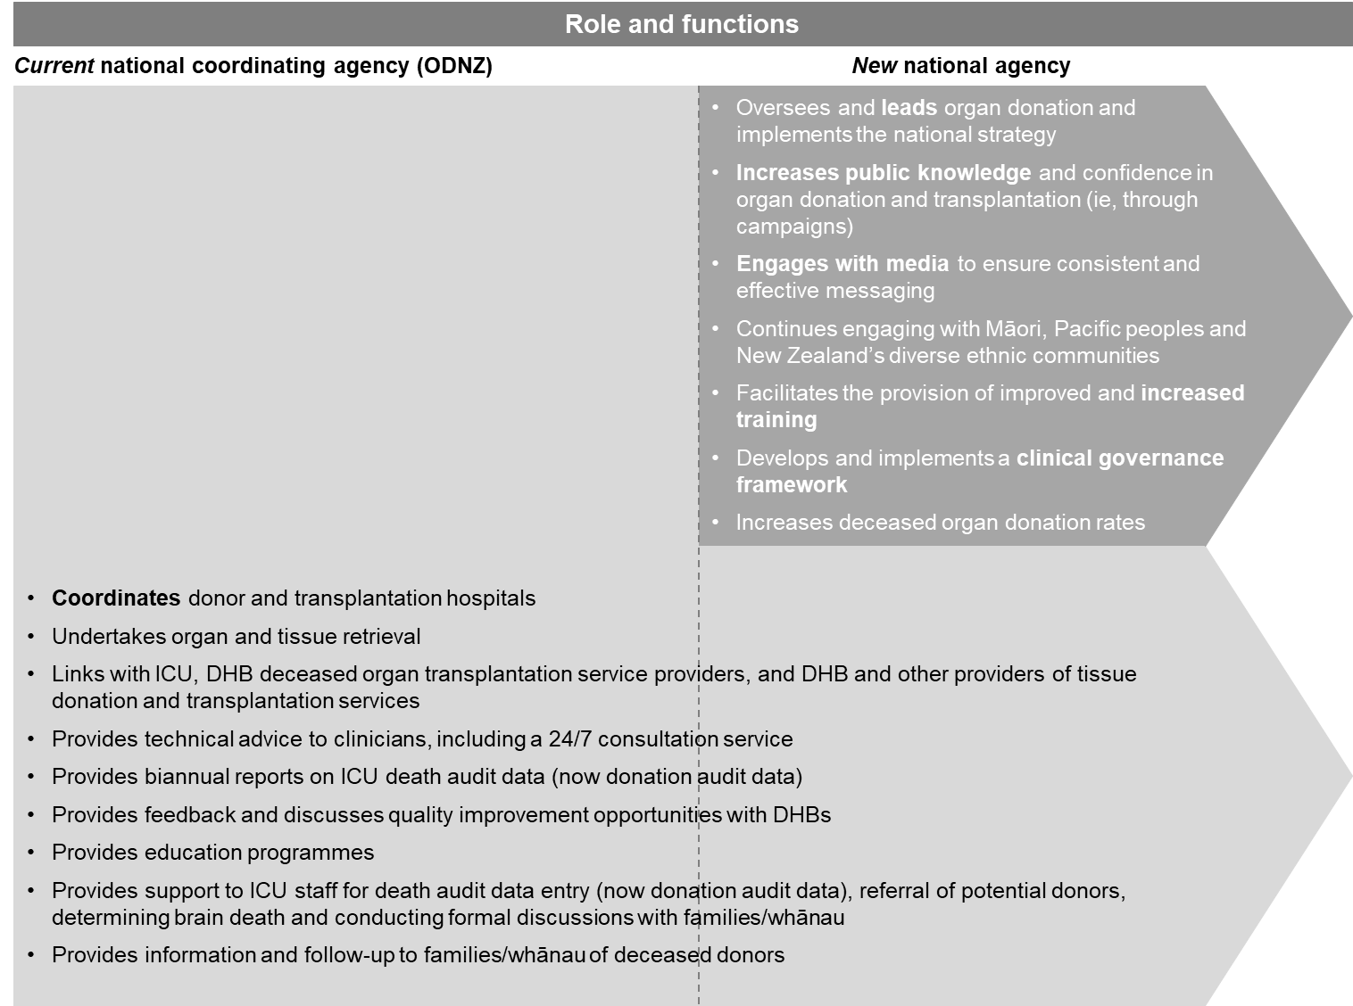

/The national agency will continue ODNZ’s role of providing technical advice on organ and tissue donation and transplantation to the health sector. Technical advice will be case specific and will also be provided where gaps in knowledge are identified or when new information on best practice becomes available.

A key new function will be to increase public knowledge and confidence in organ donation and transplantation. This will include ongoing engagement with Māori, Pacific peoples and New Zealand’s diverse ethnic communities in appropriate community settings.

The new national agency will provide a national profile for organ donation with a strategic focus. It will be operationally independent of the Ministry and any DHB but will work with all DHBs to implement the strategy, including collecting and distributing performance information.

It will be accountable to the Minister of Health and will have an annual agreement, which will be monitored by the Ministry on behalf of the Minister of Health. The national agency will be required to report annually on performance against its goals.

The overarching objective of the agency will be to increase deceased organ and tissue donation and transplantation. Other objectives will include:
- improving public knowledge about, and confidence in, organ and tissue donation and transplantation services
- improving support services for organ and tissue donors and their partners and families/whānau
- reducing health disparities by improving health outcomes for Māori and other population groups using transplant services
- promoting a nationally coordinated and consistent approach to organ or tissue donation and transplantation
- improving access to organ or tissue donation and transplantation services
- improve the skills and knowledge of people involved in providing organ or tissue donation and transplantation services
- providing a ‘hub’ for national networking and collaboration to improve strategies
- improving the identification of potential organ or tissue donors
- encouraging the optimum arrangement for the most effective and efficient delivery of donation and transplantation services to achieve the best possible outcomes
- upholding ethical and clinical standards.
To monitor progress against these objectives, the national agency will collect, analyse and disseminate data. Measures are identified throughout the strategy and are discussed in more detail under strategic priority six: Measuring progress.

Establishing a clinical governance framework
The national agency will be responsible for establishing a clinical governance framework to support best practice across the entire health sector. A clinical governance framework will provide a systematic approach to improving the quality of service, systems and performance with an aim to increasing rates of deceased organ donation and transplantation in New Zealand. This will require strong clinical input.

The framework will establish clear expectations and accountabilities for the clinical governance of organ donation that will flow through to DHBs’ existing wider governance frameworks. This will improve the level of focus and accountability and will enable the national agency to provide targeted support and technical advice to promote best practices.

The clinical practice improvement programme should include specific and measurable actions, but the precise details should be agreed between the national agency and DHBs. This will require the national agency to work closely with DHBs in developing the framework to ensure that it is fit for purpose.

Priority actions
- Establish a national agency to lead the implementation of the strategy with a role to:
- raise the profile of deceased organ donation in the health sector and in the community
- support effective clinical governance
- work with the sector to coordinate donation and transplantation processes
- provide expert advice and information on deceased organ and tissue donation to the sector, government, media, and public.

Measuring success:  establishing a national agency |  | Strategic objectives
 |  | Improve clinical practice | Enabling donation conversations |  | Broaden scope of donors
Indicator | Establish a national agency with overall responsibility for deceased organ donation. | ✓ |  | ✓ |  | ✓
Data source | Service agreement with the Ministry of Health
Indicator | Establish and implement a clinical governance framework. | ✓ |  | ✓ |  | ✓
Data source | National agency annual report
Indicator | The Ministry of Health and national agency develop and measure performance expectations and goals for the agency. | ✓ |  | ✓ |  | ✓
Data source | National agency annual report

Strategic priority six: Measuring progress | An overarching high-level monitoring and evaluation framework will support delivery of the strategy by gathering information on the strategy’s priorities for action, measuring core process improvements and improving performance reporting.
- Most countries that have comprehensive organ donation reform programmes also have a clear national goal, supported by measurement and evaluation frameworks (Organ and Tissue Authority 2014; National Health Service 2013).
- A measurement framework will focus on process measures, including measuring family/whānau satisfaction, clinician perceptions and missed opportunities for identifying potential deceased organ donors.
- International comparisons suggest that significant gains in the rate of deceased organ donation have been achieved in countries where organ donation is occurring more frequently following circulatory death (Matesanz et al 2017).

The current state
ODNZ commenced quality assurance activities around organ donation in 2008, with the setting up of the New Zealand death audit database (to be renamed as the Donation Audit Database). The database was refined in 2012 and then further modified in 2015 to provide each ICU across the country with an online report of donation activity.

There are opportunities to build on existing performance reporting to develop a more robust measurement framework that monitors progress and identifies gaps in the organ donation and transplantation process.

Performance reporting

Data collected through audits
Data received from each ICU is currently collated, monitored and reported by ODNZ through an audit of deaths. The audit focuses on potential DBD. It collects information on:
- the number of potential donors (possible brain dead)
- confirmation of brain death
- informal and formal discussions with families
- consultation with ODNZ
- consent by families/whānau to donate
- the number of actual donors.

There have been recent improvements in audit data reporting, and the quality of information has also improved with the establishment of additional Link team roles. National information drawn from the audit was made publicly available through ODNZ’s 2015 annual report for the first time since their 2009 annual report (Organ Donation New Zealand 2016). In addition, ODNZ developed a database that now allows ICUs to generate their own donation activity reports.

International comparisons suggest that countries where organ donation is occurring more frequently following DCD have significantly improved rates of deceased organ donation (Matesanz et al 2017). Data on missed opportunities for DCD is currently excluded from audit data, however ODNZ is working to include potential DCD donors in the audit process.

An important measure is the rate of potential donors who have been overlooked for organ donation. This rate decreased from 45 percent to 20 percent since 2008, but could be significantly lower.

Emergency department data not collected
The number of potential donors in EDs is currently not being captured in the audit data, meaning that opportunities for donation are being missed and lessons are not being learned. ODNZ have an ongoing project assessing the potential for organ donation in patients presented to EDs. However, it is not clear whether the information in the audit is consistent. Reporting is irregular, and ICUs only receive feedback months (or even years) after donation opportunities have been missed (EY 2016a).

Patient experience and clinical perceptions data
An important area of knowledge to inform performance of clinical practices across the organ donation system and related processes is the area of family/whānau experience and their satisfaction with the organ donation process (ie, their experiences of communication and processes).

It will also important to gather information from clinicians on their perceptions of, and their satisfaction with, the new national agency once it has been established (eg, quality of support, communication).

Changes to be made

Measuring success under the strategy
Each section of this document includes measures for tracking progress against the strategy. The strategy’s priorities for action will be embedded within an overarching high-level monitoring and evaluation framework. Tracking and monitoring progress towards achieving the strategy’s priority actions will enable the national agency to identify trends, areas of strength and opportunities for improvement, forming an essential part of a national quality system.

An evaluation programme can run in parallel with the strategy’s implementation, defining ‘what success looks like’ and developing measurable goals that positively drive and incentivise appropriate actions. Regular reporting will enable real-time feedback, facilitating continuous quality improvement. The qualitative measures included in such an evaluation programme will complement and supplement the national goal, taking into account the diverse clinical contexts of deceased organ donation and the diverse cultural contexts of the New Zealand population.

Measuring process improvements
The national agency will collect and analyse data on process improvements through a mix of performance reporting (see below), satisfaction measures and identifying patients who have been overlooked for deceased organ donation.

One measure will involve seeking qualitative feedback from the family/whānau on their experiences throughout the organ donation process. This is already taking place in several DHBs but not in a uniform way. Another qualitative measure will involve collecting data on clinicians’ perceptions of, and overall satisfaction with, the national agency.

The national agency will continue to report on rates of potential donors who have been overlooked. The aim will be to reduce the rate of overlooked potential donors to 10 percent or lower.

Improving performance reporting
The national agency will continue to improve the accuracy and frequency of donation audit (previously death audit) reporting. This will include encouraging the sharing of regional data between DHBs. The agency will work with the health sector to expand the range of data collected through the donation audit, including DCD, and to identify potential donors in EDs (both DBD and DCD).

Responsibilities
The Ministry will monitor the overall strategy. The national agency will report regularly on progress against the strategy, supported by data from the DHBs.

/In addition to the measures identified in the strategy, the national agency will continue to collect and report on data that is currently being used (such as the number of donated organs and transplantations) and other data that has been identified as being useful for measuring success and identifying opportunities for improvement.

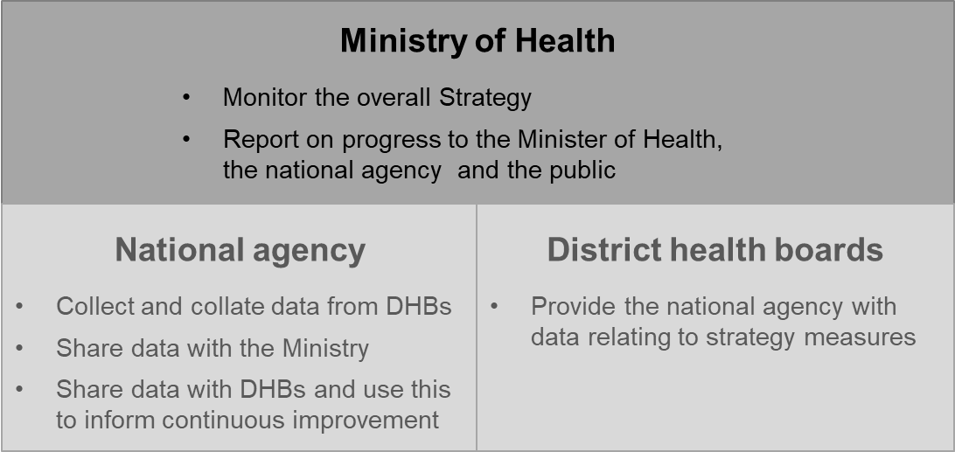

Priority action
- Develop and implement a measurement and reporting framework.

Glossary
ACEM | Australasian College for Emergency Medicine
ANZCA | Australian and New Zealand College of Anaesthetists
ANZICS | Australia and New Zealand Intensive Care Society
Available bed | An ICU bed that has advanced life-support capability that is fully staffed and funded.
Binding register | Primary consent is given to the individual and family/whānau members cannot oppose the individual’s wishes.
cFDC | Core Family Donation Conversation
CICM | College of Intensive Care Medicine of Australia and New Zealand
Combined register | A combination of opt-in and opt-out (see below)  People can signal their willingness/unwillingness to donate.
DBD | Donation after brain death  Brain death is the irreversible loss of function of the brain and brain stem.
DCD | Donation after circulatory death  Circulatory death is the irreversible loss of function of the heart and lungs.
DHB | District health board
Donation audit | Formally ‘death audit’, ICU data collected for Organ Donation New Zealand (ODNZ)
dpmp | Donation per million people  This is a standard international measure of deceased organ donation rates.
ED | Emergency department
EHR | Electronic health record
Explicit consent | An individual or their proxy must give expressed consent for donation.
FDC | Family Donation Conversation
FTE | Full-time equivalent
ICU | Intensive care unit
ICU clinician | All of the clinically trained staff in an ICU
ICU specialist | A medical specialist trained and assessed to be proficient in the comprehensive clinical management of critically ill patients as the leader of a multidisciplinary team
Informed consent | Consent (rather than general agreement) given freely in light of all the information a reasonable person, in that person’s circumstances, needs in order to make an informed decision
IRODaT | International Registry in Organ Donation and Transplantation
Link team | An ICU nurse, a theatre nurse and an ICU doctor with a focus on organ donation
Morbidity and Mortality meeting | A meeting of doctors for a protected discussion of cases, which enables clinical peer review
NEAC | National Ethics Advisory Committee
NHI | National Health Index
Non-binding register | Regardless of whether an individual has expressed consent or objection to donation before their death, the individual’s family/whānau views will be taken into account.
NZTA | New Zealand Transport Authority
ODNZ | Organ Donation New Zealand
Opt-in register | A register where only people willing to donate are listed
Opt-out register | A register where only people unwilling to donate (non-donors) are listed
OTA | Organ and Tissue Authority (Australia)
Presumed consent | Everyone in a population is assumed to have consented to being a deceased donor, unless there is a recorded objection.
The strategy | Increasing Deceased Organ Donation and Transplantation: A national strategy
TSANZ | Transplant Society of Australia and New Zealand

References
ANZICS. 2016. ANZICS Centre for Outcome and Resource Evaluation Annual Report 2014/15. Australia: Australia and New Zealand Intensive Care Society (ANZICS).
Australian and New Zealand College of Anaesthetists. 2017. Anaesthesia training program: Curriculum. Melbourne: ANZCA. URL: www.anzca.edu.au/documents/anaesthesia-training-program-curriculum.pdf (accessed 7 July 2017).
Bilgel F, Galle BD. 2014. Paying for altruism: The case for organ donation revisited. Boston College Law School Faculty Papers. URL: http://lawdigitalcommons.bc.edu/lsfp/933/ (accessed 7 July 2017).
College of Intensive Care Medicine of Australia and New Zealand. 2011. Competencies, Learning Opportunities, Teaching and Assessments for Training in General Intensive Care Medicine. Prahran Victoria: College of Intensive Care Medicine of Australia and New Zealand. URL: https://www.cicm.org.au/CICM_Media/CICMSite/CICM-Website/Trainees/Training%20Program/Competencies,-Learning,-Teaching-and-Assessments-for-training-in-general-intensive-care.pdf (accessed 7 July 2017).
Cornwall J, Schafer C, Lal N, et al. 2015. New Zealand university students’ knowledge and attitudes to organ and tissue donation. New Zealand Medical Journal 128(1418).
EY. 2016a. Deceased Organ Donation and Transplantation in New Zealand: Recommendations for improving practice in clinical settings and commentary on institutional arrangements (p80). Wellington: Ministry of Health.
EY. 2016b. Review of Deceased Organ Donation and Transplantation: Appendum to ‘Report on potential high level system capacity impacts from an increase in the deceased organ donation rate’. Wellington: Ministry of Health.
EY. 2016c. Review of Deceased Organ Donation and Transplantation: Report on potential high level system capacity impacts from an increase in the deceased organ donation rate (p77).
Feeley TH, Moon S-I. 2009. A meta-analytic review of communication campaigns to promote organ donation. Communication Reports 22(2): 63–73. URL: https://doi.org/10.1080/08934210903258852 (accessed 7 July 2017).
Health and Disability Commissioner. 1996. Code of Health and Disability Services Consumers’ Rights: Regulation 1996. Auckland: Health and Disability Commissioner. URL: www.hdc.org.nz/the-act--code/the-code-of-rights (accessed 7 July 2017).
IRODaT. 2012. Second Report Data 2011. Barcelona: International Registry in Organ Donation and Transplantation (IRODaT). URL: www.irodat.org/img/database/pdf/IRODaT%20Newsletter%202011.pdf (accessed 7 July 2017).
IRODaT. 2013. Final Numbers 2012. Barcelona: International Registry in Organ Donation and Transplantation (IRODaT). URL: www.irodat.org/img/database/pdf/IRODaT%20Newsletter%202012.pdf (accessed 7 July 2017).
IRODaT. 2014. Final Numbers 2013. Barcelona: International Registry in Organ Donation and Transplantation (IRODaT). URL: www.irodat.org/img/database/pdf/IRODaT%20Newsletter%202013%20.pdf (accessed 7 July 2017).
IRODaT. 2015. Final Numbers 2014. Barcelona: International Registry in Organ Donation and Transplantation (IRODaT). URL: www.irodat.org/img/database/pdf/NEWSLETTER2015_December2.pdf (accessed 7 July 2017).
IRODaT. 2016. Preliminary Numbers 2015. Barcelona: International Registry in Organ Donation and Transplantation (IRODaT). URL: www.irodat.org/img/database/pdf/NEWSLETTER2016_SecondEdition.pdf (accessed 7 July 2017).
Klikowicz P. 2015. Facebook as a medium for promoting statement of intent for organ donation: 5 years of experience. Annals of Transplantation 20: 141–146. URL: https://doi.org/10.12659/AOT.892494 (accessed 7 July 2017).
Lewis VJ, White VM, Bell A, et al. 2015. Towards a national model for organ donation requests in Australia: Evaluation of a pilot model. Critical Care and Resuscitation: Journal of the Australasian Academy of Critical Care Medicine 17(4): 233–8.
Li AT, Wong G, Irving M, et al. 2015. Community-based interventions and individualsʼ willingness to be a deceased organ donor: Systematic review and meta-analysis. Transplantation 99(12): 2634–43. https://doi.org/10.1097/TP.0000000000000897 (accessed 7 July 2017).
Matesanz R, Domínguez-Gil B, Coll E, et al. 2017. How Spain reached 40 deceased organ donors per million population. American Journal of Transplantation. https://doi.org/10.1111/ajt.14104 (accessed 7 July 2017).
Medical Council of New Zealand. 2006. Statement on cultural competence. URL: https://www.mcnz.org.nz/assets/News-and-Publications/Statements/Statement-on-cultural-competence.pdf (accessed 7 July 2017).
Medical Council of New Zealand. 2016. Recertification and Continuing Professional Development Booklet. Wellington: Medical Council of New Zealand.
Ministry of Health. 2002. Te Pai Me Te Oranga O Nga Iwi: Health for all people: An overview of public health. Wellington: Ministry of Health.
Ministry of Health. 2014a. ’Ala Mo’ui: Pathways to Pacific Health and Wellbeing 2014–2018. Wellington: Ministry of Health. URL: www.health.govt.nz/publication/ala-moui-pathways-pacific-health-and-wellbeing-2014-2018 (accessed 7 July 2017).
Ministry of Health. 2014b. He Korowai Oranga. URL: www.health.govt.nz/our-work/populations/maori-health/he-korowai-oranga (accessed 29 March 2017).
Ministry of Health. 2016a. Public and media awareness and promotion of organ donation. Discussion paper. Wellington: Ministry of Health.
Ministry of Health. 2016b. Registers for deceased organ donation. Discussion paper. Wellington: Ministry of Health.
Ministry of Health. 2016c. Summary of international examples of organ donation reform programmes. Discussion paper. Wellington: Ministry of Health.
Ministry of Health. 2016d. Review of Deceased Organ Donation and Transplantation Rates: Initial report to the Minister of Health. Wellington: Ministry of Health.
Ministry of Transport. 2015. 25 Years of New Zealand Travel: New Zealand household travel 1989–2014. Wellington: Ministry of Transport. URL: www.transport.govt.nz/assets/Uploads/Research/Documents/25yrs-of-how-NZers-Travel.pdf (accessed 7 July 2017).
Misterska E, Glowacki M, Wlodarczyk Z. 2010. Mass-media and the transplantation crisis: The example of Poland. Medical Science Monitor 16(8).
Morgan SE, Harrison TR, Chewning L, et al. 2007. Entertainment (Mis)education: The framing of organ donation in entertainment television. Health Communication 22(2).
National Health Service. 2013. Taking Organ Donation Transplantation to 2020: A detailed strategy. URL: www.nhsbt.nhs.uk/to2020/ (accessed 7 July 2017).
National Health Service Blood and Transplant. 2015. Approaching the Families of Potential Organ Donors: Best practice guideline. National Health Service Blood and Transplant. URL: www.odt.nhs.uk/pdf/family_approach_best_practice_guide.pdf (accessed 7 July 2017).
National Health Service Blood and Transplant 2015. Potential Donor Audit Summary Report for the 12-month Period 1 April 2014 to 31 March 2015. URL: https://nhsbtdbe.blob.core.windows.net/umbraco-assets-corp/.../pda_report_1415. (accessed 7 July 2017).
National Institute for Health and Care Excellence. 2011. Organ Donation for Transplantation: Improving donor identification and consent rates for deceased organ donation. London: NICE.
Neate SL, Marck CH, Skinner M, et al. 2015. Understanding Australian families’ organ donation decisions. Anaesthesia and Intensive Care 43(1): 42–50.
Opdam H. 2015. The family donation conversation: Time to move to evidence-based practice. Critical Care and Resuscitation: Journal of the Australasian Academy of Critical Care Medicine 17(4): 231–2.
Organ and Tissue Authority. 2013a. Donate Life Clinical Governance Framework. Canberra: Organ and Tissue Authority, Australian Government. URL: www.donatelife.gov.au/sites/default/files/DonateLife%20Clinical%20Governance%20Framework_0.pdf (accessed 7 July 2017).
Organ and Tissue Authority. 2013b. International Approaches to Organ Donation Reform. Canberra: Organ and Tissue Authority, Australian Government. URL: www.donatelife.gov.au/fact-sheets (accessed 7 July 2017).
Organ and Tissue Authority. 2014. Organ and Tissue Donation for Transplantation in Australia, 2014–2015. Strategic plan. Canberra: Organ and Tissue Authority, Australian Government.
Organ and Tissue Authority. 2016. Australian Donation and Transplantation Activity Report 2016. Canberra: Organ and Tissue Authority, Australian Government.
Organ Donation New Zealand. 2016. Annual Report 2015. Auckland: Organ Donation New Zealand. URL: www.donor.co.nz/media-centre/annual-report-2015/ (accessed 7 July 2017).
Organ Donation New Zealand. 2017. Annual Report 2016. Auckland: Organ Donation New Zealand. URL: www.donor.co.nz/media-centre/annual-report-2016/ (accessed 7 July 2017).
Rosenblum AM, Horvat LD, Siminoff LA, et al. 2012a. The authority of next-of-kin in explicit and presumed consent systems for deceased organ donation: An analysis of 54 nations. Nephrology Dialysis Transplantation 27(6): 2533–46. URL: https://doi.org/10.1093/ndt/gfr619 (accessed 7 July 2017).
Rosenblum AM, Li AH-T, Roels L, et al. 2012b. Worldwide variability in deceased organ donation registries: Variability in deceased organ donation registries. Transplant International 25(8): 801–11. URL: https://doi.org/10.1111/j.1432-2277.2012.01472.x (accessed 7 July 2017).
Salim A, Malinoski D, Schulman D, et al. 2010. The combination of an online organ and tissue registry with a public education campaign can increase the number of organs available for transplantation. The Journal of Trauma: Injury, Infection, and Critical Care 69(2): 451–4. URL: https://doi.org/10.1097/TA.0b013e3181e7847a (accessed 7 July 2017).
Siminoff LA, Marshall HM, Dumenci L, et al. 2009. Communicating effectively about donation: An educational intervention to increase consent to donation. Progress in Transplantation (Aliso Viejo, Calif.) 19(1): 35–43.
Stephens HO, Pilcher DV, Opdam HI. 2013. The impact of checking the Australian Organ Donor Register on family consent rates. The Medical Journal of Australia 199(8): 536–8. URL: https://doi.org/10.5694/mja13.10146 (accessed 7 July 2017).

Appendix 1

Informed consent and donor registers
Consent models and organ donation registers are complex issues. Within legal consent frameworks worldwide, registers are often used as a tool to record information about the wishes, preferences or intentions of potential donors. These registers can take many different forms, ranging from legally binding registers of informed consent to an indicative record of an individual’s donor intent (the New Zealand approach). This section outlines legal consent frameworks, types of registers, current practices and New Zealand’s system.

Legal frameworks
Globally there is a wide variety of legislation governing legal consent to organ donation. However, the main legal frameworks tend to fall into either presumed or explicit consent.
- Presumed consent means everyone in a population is assumed to have consented to being a deceased donor, unless there is a recorded objection.
- Explicit consent means that an individual or their proxy must give expressed consent for donation. This is the system that New Zealand follows.

Organ donation registers
Organ donation registers are computerised databases that record people’s donation wishes. Donation registers provide people with an opportunity to record their wishes with regard to organ donation and ensure that a person’s wishes will be taken into account when they die. However, there are many reasons why these wishes might not be able to be followed through (eg, where a person dies due to a condition that makes organ donation impossible). Although such registers provide hospitals with an indication of a deceased person’s wishes when considering whether or not they could be a potential organ donor, the family/whānau usually has the final say nonetheless. Currently only around 40 countries have active donor registries (20 percent of all countries). New Zealand is classed as one of the countries with a form of register.

Donor registers can be:
- opt-out: only people unwilling to donate (non-donors) are listed
- opt-in: only people willing to donate are listed
- combined opt-in /opt-out: people signal either their willingness or their unwillingness to donate. This is New Zealand’s system.

Under the principle of presumed consent, a deceased individual is classified as a potential donor by default unless they explicitly object to donation before death. Therefore, an opt-out register mechanism is normally required to record an objection to consent donation. An opt-out register is a legal tool for individuals to express their objection.

Conversely, opt-in registers generally operate in countries where an individual’s intent or consent to be a donor must be actively expressed (explicit) rather than presumed. Combined registers provide people with the opportunity to record either 1) intent or consent to be a donor (opt-in) or 2) objection to be a donor (opt-out). Combined registers are used in some presumed consent countries as well as some countries where intent or consent must be actively expressed, which is currently the case in New Zealand (see below).

Binding versus non-binding registers
A binding register gives primary consent to the individual and does not allow the family/ whānau to oppose the individual’s wishes. Registrations that fulfil legal requirements for donation authorisation and/or objection are valid legal documents providing authorisation for donation to proceed.

In countries with a non-binding register, it is normal practice to let the family/whānau know if the individual is on the register, and doctors can decide not to proceed if faced with opposition from relatives. The individual’s family are informed and their views taken into consideration regardless of whether it is known that the individual agreed or objected to organ donation before their death.

There are a small number of countries with binding consent registers, where there is no active consultation with family members and organ donation proceeds even if the relatives object to donation. International evidence suggests that in most countries, even those with binding registers, immediate family are still ultimately consulted, and organ donation will not proceed if the family objects (Rosenblum et al. 2012a).

Mandatory choice
Mandatory choice means everyone is asked and has to decide ‘yes’ or ‘no’ to the question of organ donation. In 2012, New Zealand was the only country where indicating one’s donation decision was compulsory in order to obtain a driver licence.

New Zealand’s system
New Zealand has a mandatory choice, combined opt-in/opt out, non-binding record of intent.

A binding register gives primary consent to the individual and does not allow families/whānau to oppose the individual’s wishes if the individual has expressed consent or objection to donation. Registrations that fulfil legal requirements for donation authorisation and/or objection are valid legal documents providing authorisation for a donation to proceed. This type of consent is not feasible under the New Zealand’s legislative framework (see also Appendix 1).

