Community Residential Services

The strategy
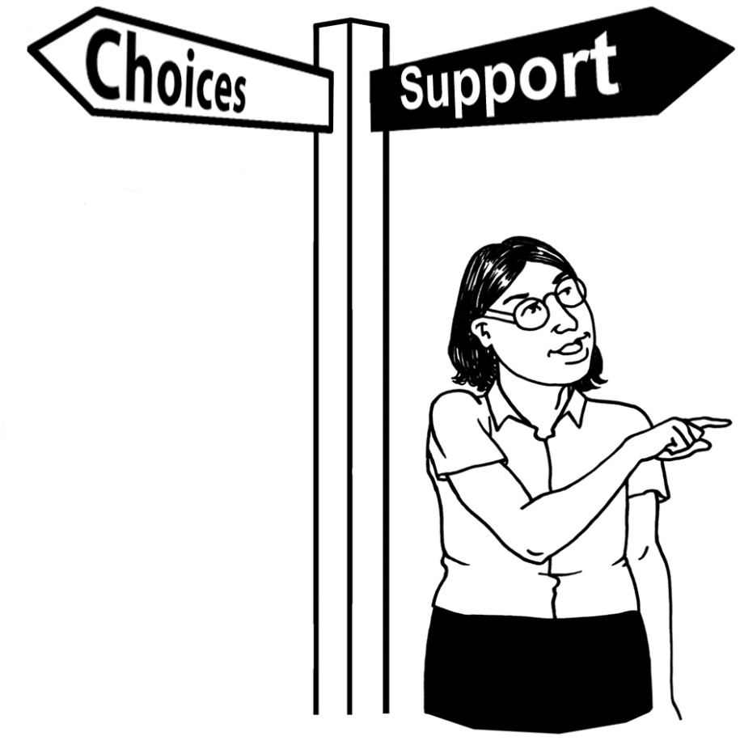

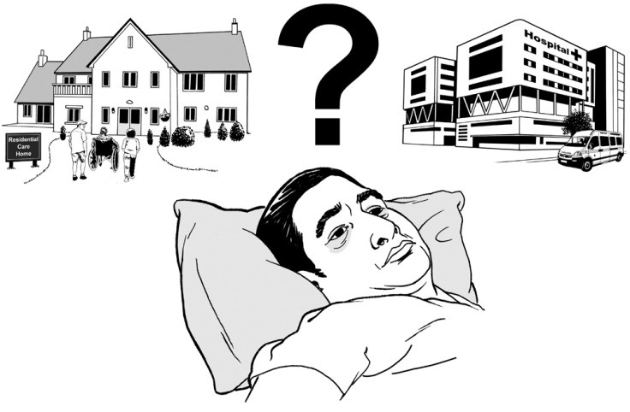

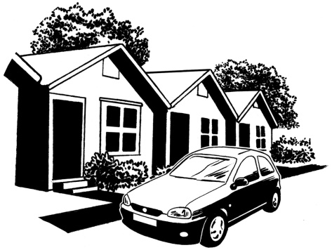

Easy Read 2018
Before you start


This is a long document.

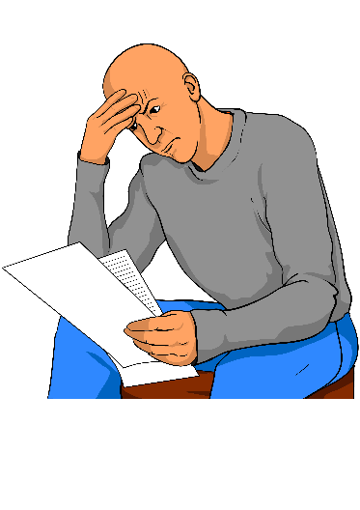
While it is written in Easy Read it can be hard for some people to read a document this long.

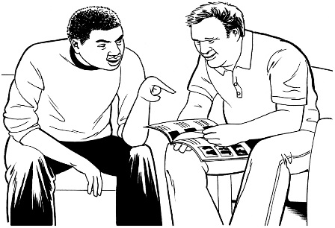
Some things you can do to make it easier are:

- read it a few pages at a time
- have someone to assist you to understand it.
What is in this document?

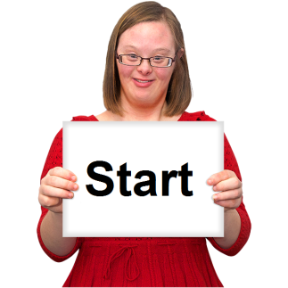

Before you start ………………………....1

What is in this document? ……………. 2
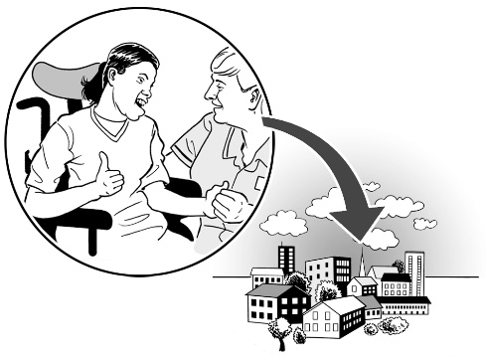

What are Community
Residential Services? …………………..3

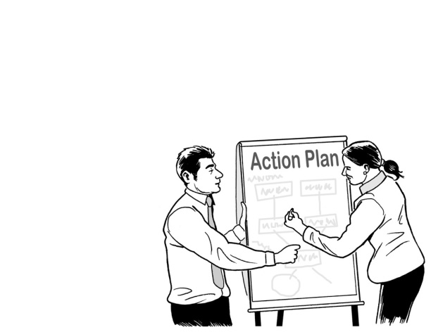
The strategy …………………................6

What is the strategy about?.…..............8

The Roadmap …………………….……22

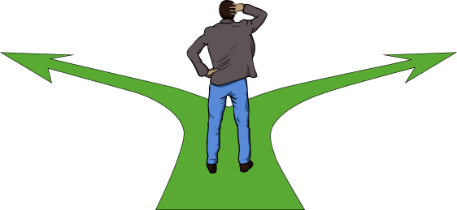
Where did the ideas in the
strategy come from? …………………..40
What are Community Residential Services?

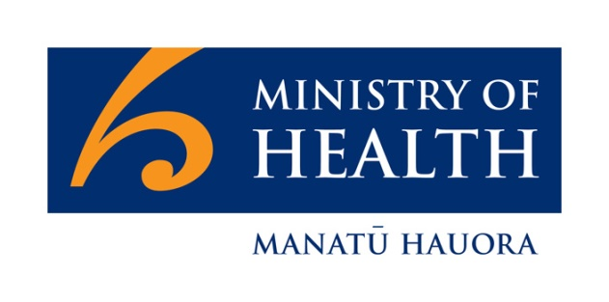
Community Residential Services are paid for by the Ministry of Health.

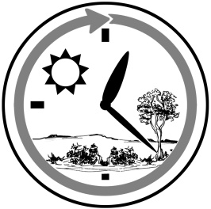
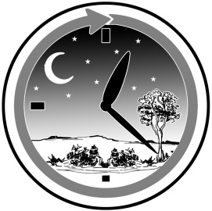
Community Residential Services means houses for disabled people that have support workers there day and night.

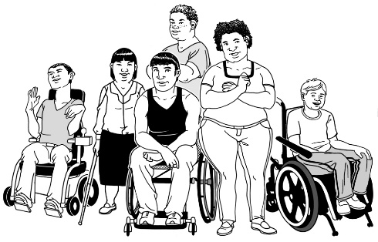
The disabled people who can get this kind of support:

- are under 65 years old

- have a disability that they need support for.

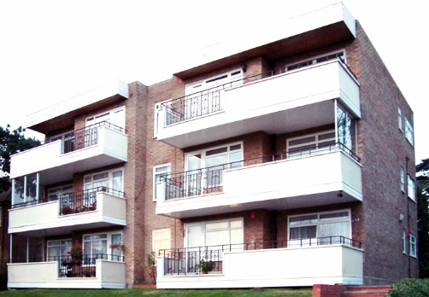
Community residential services offer support services in a number of different places.

These places can be:
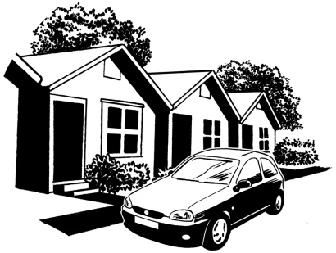
- small and large homes

- groups of small homes

- groups of flats.

People with needs that can be hard to support sometimes get the support they need at bigger places.

These places are called specialist services.

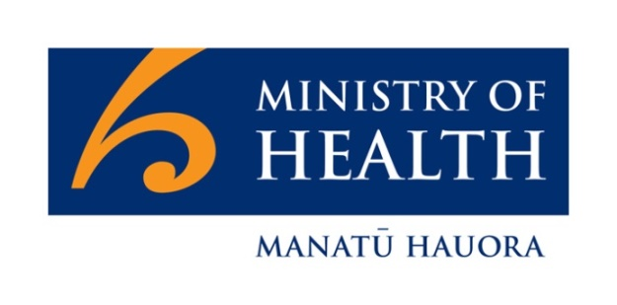

The Ministry of Health spends over 5 hundred and 20 million dollars every year on Community Residential Services.

This money supports:
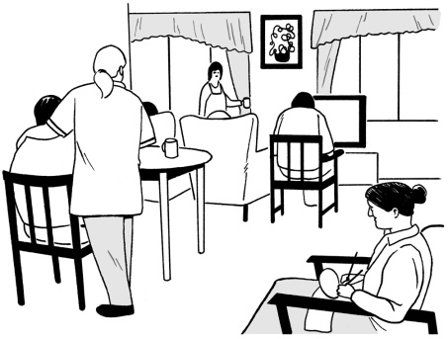
- 6 thousand 6 hundred disabled people

- 1 thousand disabled people that live in hospitals or rest homes.

People with learning disability make up nearly all of the people in residential care.

The strategy

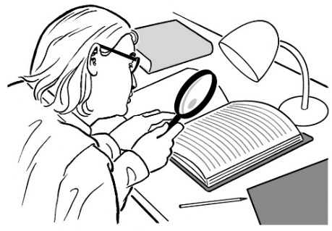
The Ministry of Health has a Community Residential Services strategy.

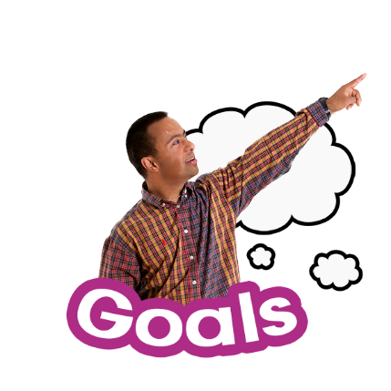
A strategy is a plan.

Strategies have goals that people try to make come true.

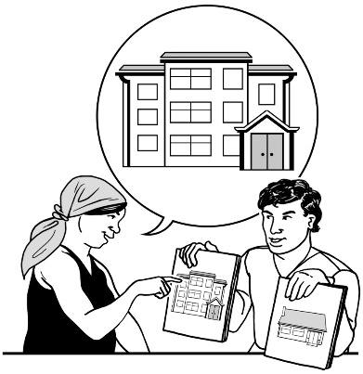
The goal of this strategy is for disabled people to have choices and control over where they live.

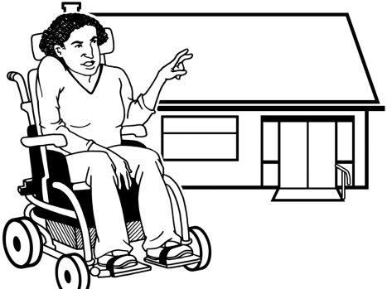
Another goal of this strategy is for there to be better choices for people with needs that can be hard to support.
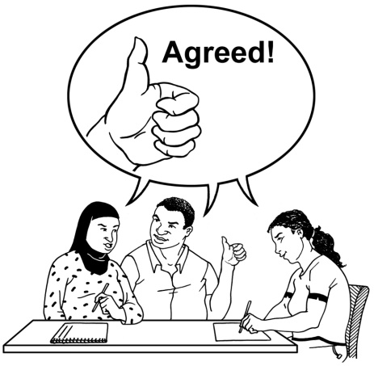
The Ministry wants the Community Residential Services strategy to:

- meet the support needs that disabled people have

- support disabled people to have good lives.

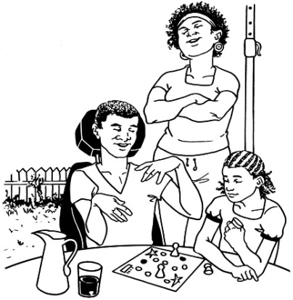
This strategy has been made to help:

- disabled people

- their families / whānau / aiga.

The Ministry of Health will use the strategy for 2 years.
What is the strategy about?

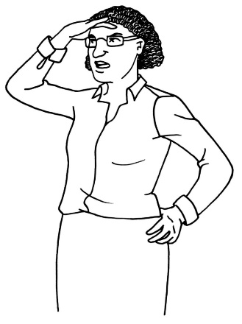
The Ministry of Health can see that things are changing in Community Residential Services.

These are some of the changes we have seen in Community Residential Services:

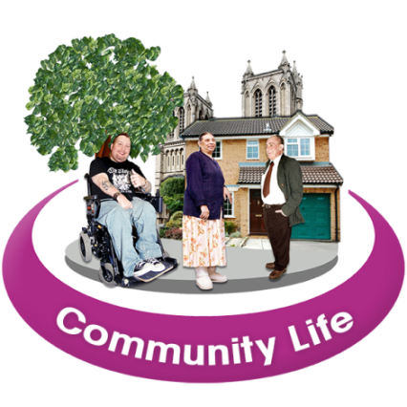
- people feel it is more important for disabled people to:

            - be part of the community

            - take part in community life
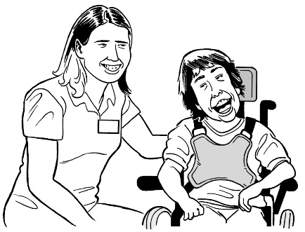
- disabled people with needs that can be hard to support sometimes need more support than they did before
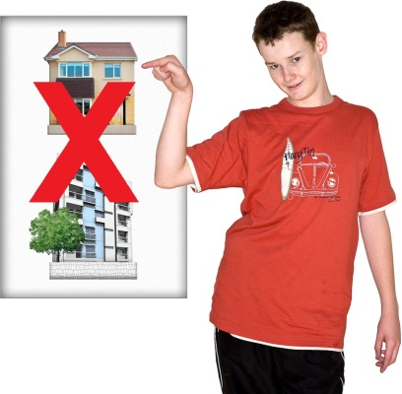
- young people are moving to residential services because they have no other choice

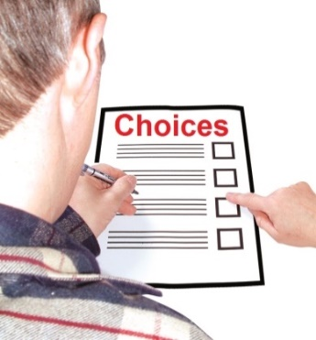
- disabled people and their families want more choice and control over where they live

- many disabled people now have better lives than before.

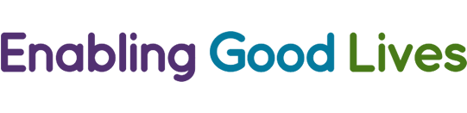
The strategy will support the Enabling Good Lives approach.

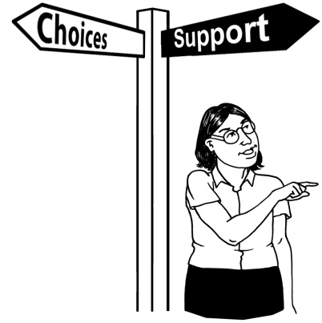
Enabling Good Lives is about helping disabled people to make their own decisions about the supports they get to live everyday lives.
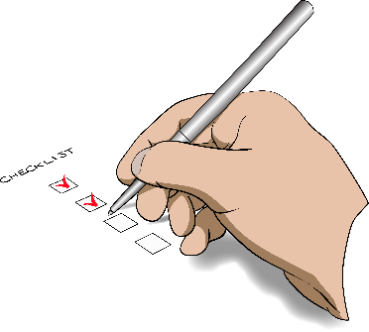
Here is a list of which parts of Community Residential Services are covered by this strategy:

- Community Residential Services that already get money from the Ministry of Health.

This includes residential support for adults who have needs that can be hard to support.

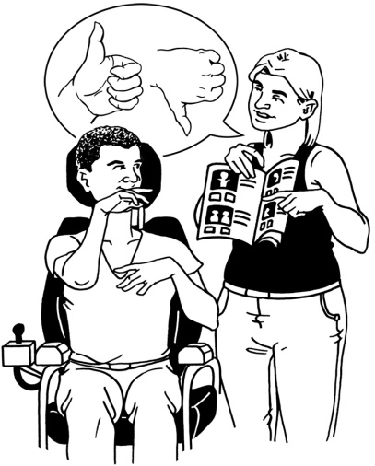
- Making sure that:

- there are the right amount of staff to support disabled people

- people who work with disabled people are trained and do their job well.

Here is a list of which parts of Community Residential Services are not covered by this strategy:

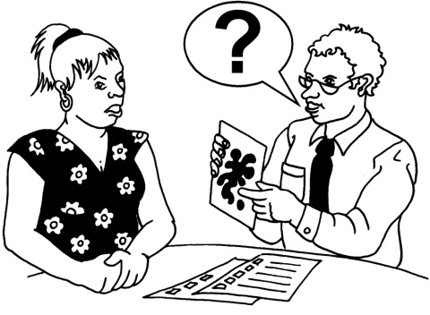
- Services for people who mainly use mental health services

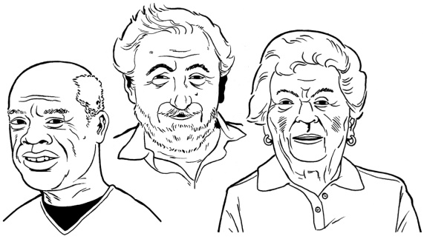
- Health services for older people

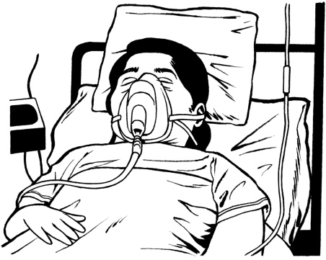
- Palliative care

Palliative care is a service for people with very serious health problems.

Here are some more parts of Community Residential Services that are not covered by this strategy:
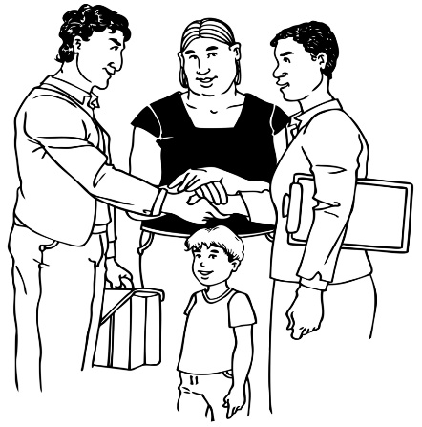

- People under 18 years old in residential care


- Looking at who can get funding for disability services

- Looking at how much money people get to pay for disability services
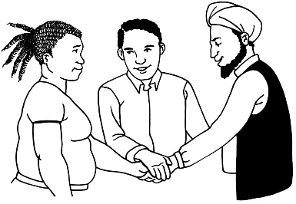

- Disability services that support people with how they act.

Here is another part of Community Residential Services that is not covered by this strategy:

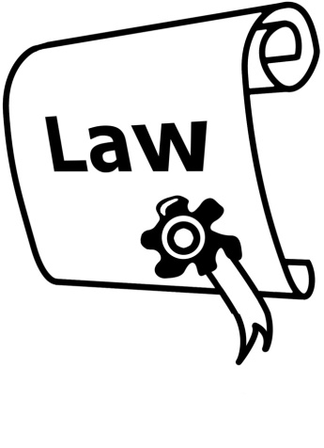
- Services that happen because of the Intellectual Disability
( Compulsory Care and Rehabilitation ) Act 2003.

The Act is a law.
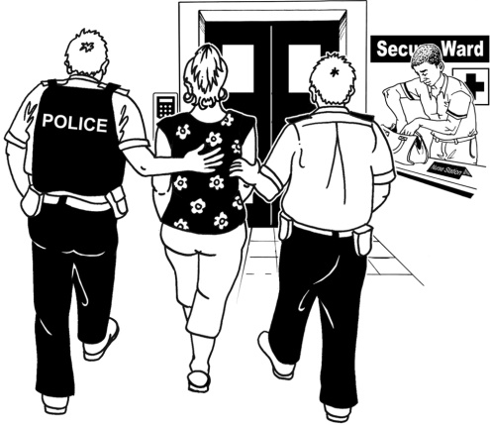

It is for people with learning disability who have done a crime.

The Act deals with the support services these people get.

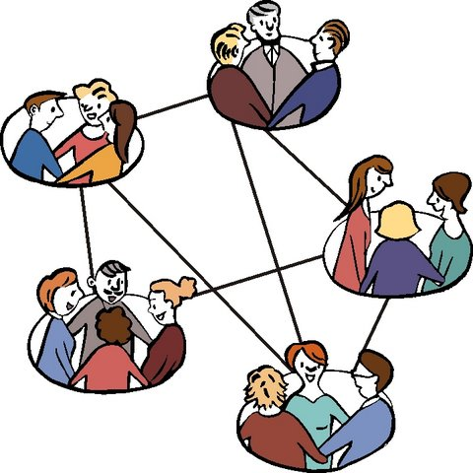
This strategy has been made with the help of:

- disabled people

- Disabled Person’s Organisations

- disability service providers.
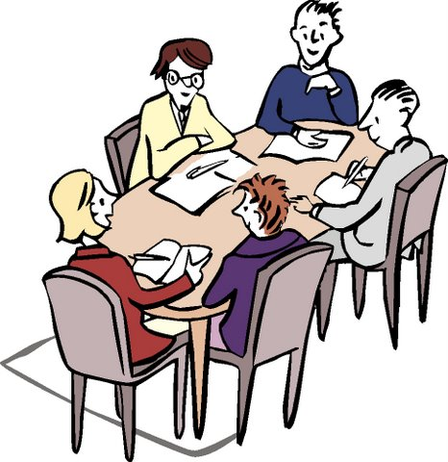

The Ministry of Health held 2 workshops in December 2016.

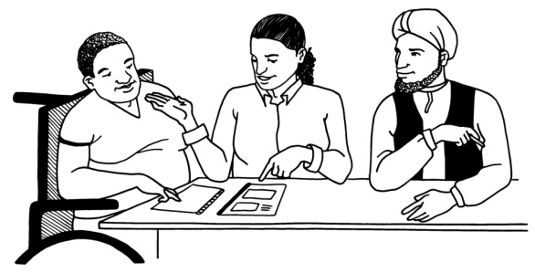
Ministry of Health also had a smaller group of people from the Disability community tell us what they thought of a draft of the strategy.

The draft was a strategy that we had not finished making.

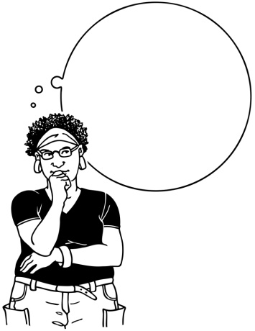
We have thought about what people told us as we were writing the strategy.

Here are some of the things people told us.

Disabled people said

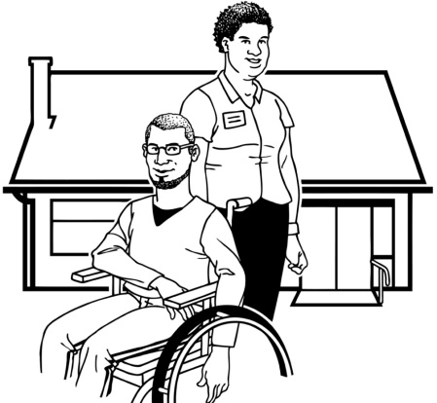
The Ministry of Health should keep supporting disabled people to live everyday lives.

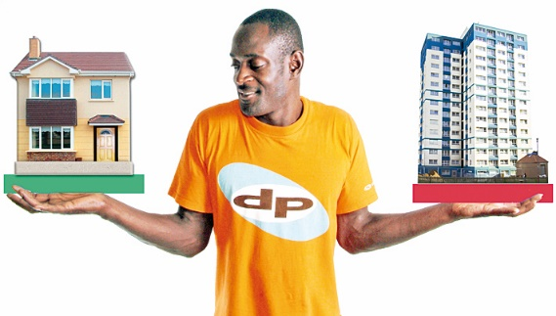
When disabled people do not use residential services they should have better choices around their support.

Disabled people also said
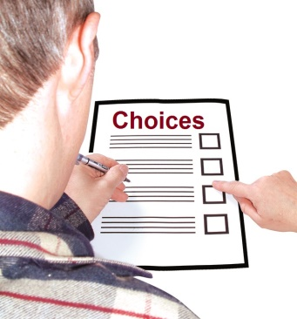

Disabled people should have more choice and control when they are using residential services.

Sometimes the places where disabled people live do not feel like homes.

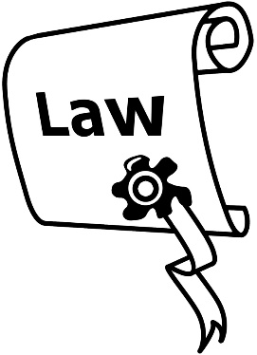
This is because of the rules in the Health and Disability Services
( Safety ) Act 2001.

This Act is a law.
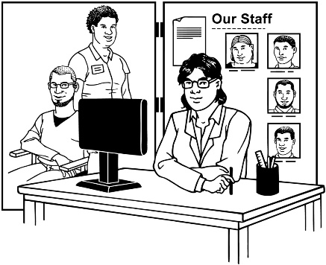
This law tells disability service providers what rules they need to follow if they want to make a service for disabled people.

Disabled people also said

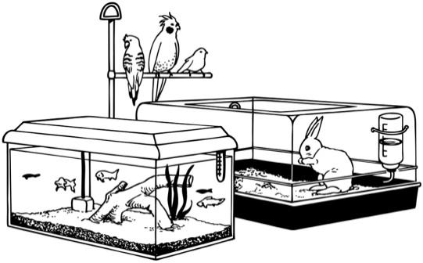
Disabled people want to live like everyone else, with:

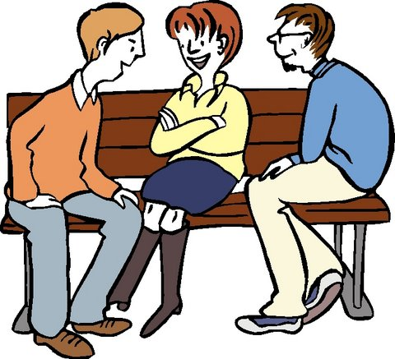
- pets

- friends and parties

- choices about:

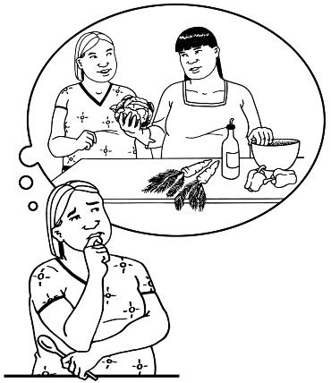
- staff

- when they want or need support.

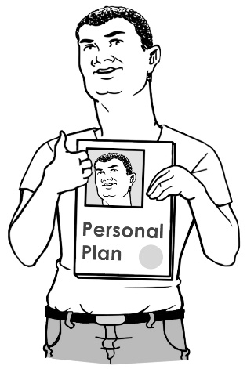
- plans for when making big changes, like leaving school

- specialist help when it is needed

- the right information.
Disability service providers said

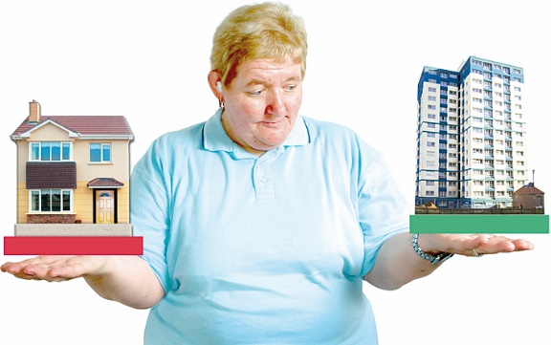
Disabled people should be able to try out living in different kinds of places like:

- flatting

or

- living alone.

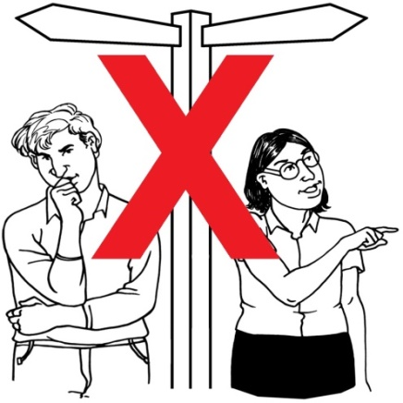
The way the Ministry of Health pays for support services can stop people being able to make choices for their lives.

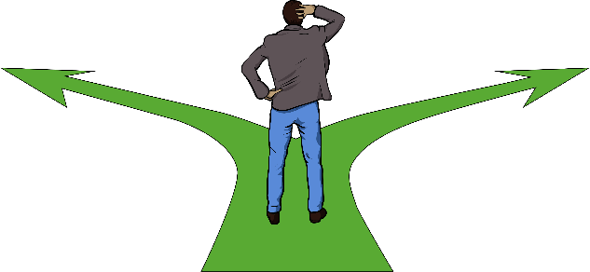
For example:
As a disabled person learns to do more things for themselves they might need support from more than 1 service.
Disability service providers also said

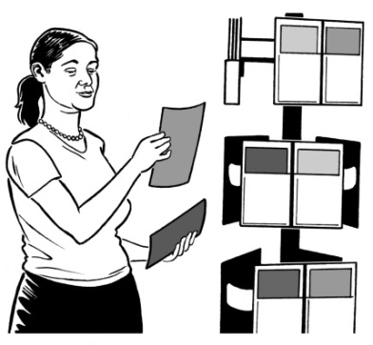

There needs to be a better way to let disabled people and families know about all the services they can choose from.
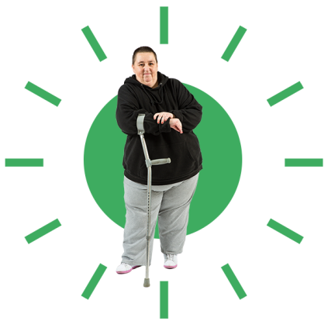

The Ministry of Health needs to think about all the things that make disabled people who they are.

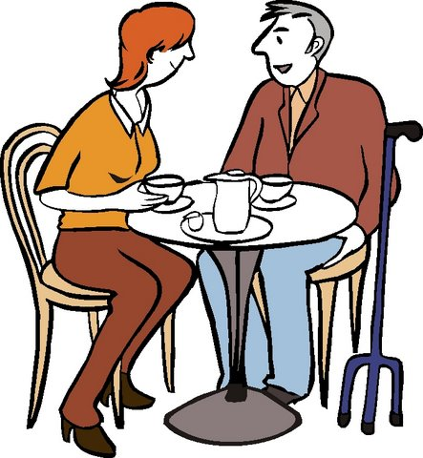
For example: people should be able to get support to:

- make friendships
- have relationships.
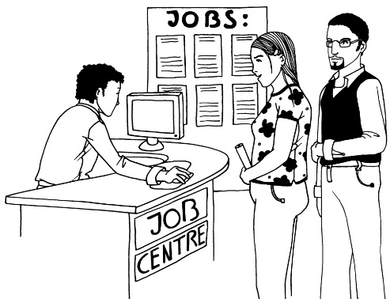
Disability service providers must be able to give the right support at the right time to the people who need it.
The smaller group said

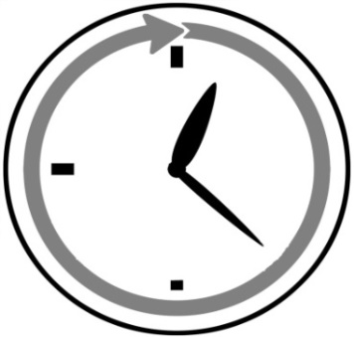
Not everyone needs support all of the time.

Services should only be there when people need them.

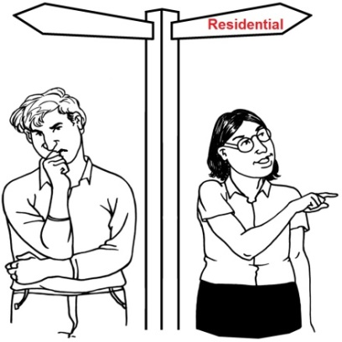
Disabled people are not choosing residential services.

The choice to use these services is mostly made for people by others, because of:

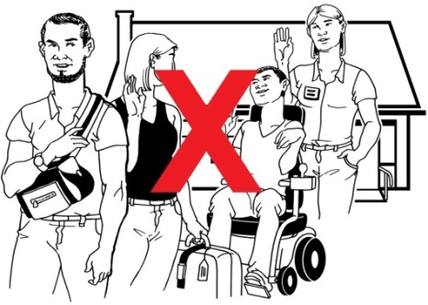
- family problems

- not being able to get the support people need to stay in the family home.

The smaller group also said

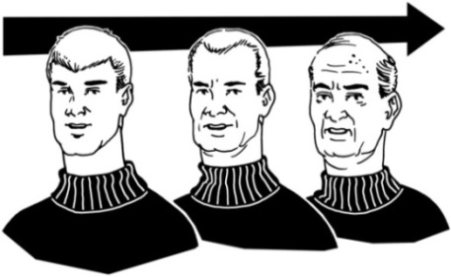

Residential services should not always be a long term choice.

The Roadmap

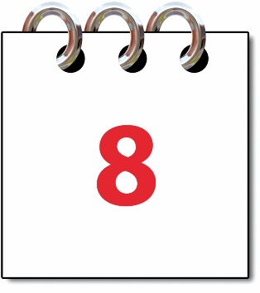
If the Community Residential Services strategy works well 8 things will happen.

We have called this a Roadmap.
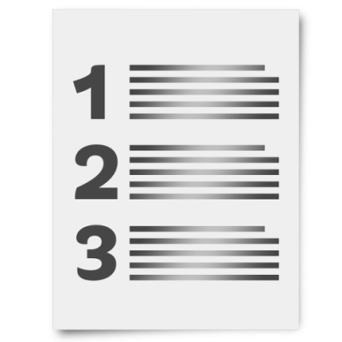

The roadmap is made up of 3 parts.

The 3 parts of the Roadmap are:

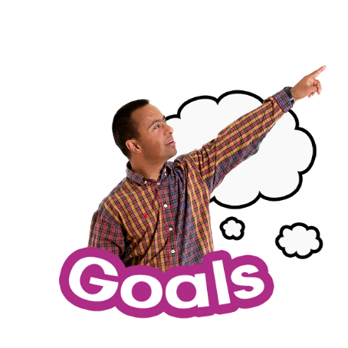
- Outcomes

Outcomes are the things we hope will happen.

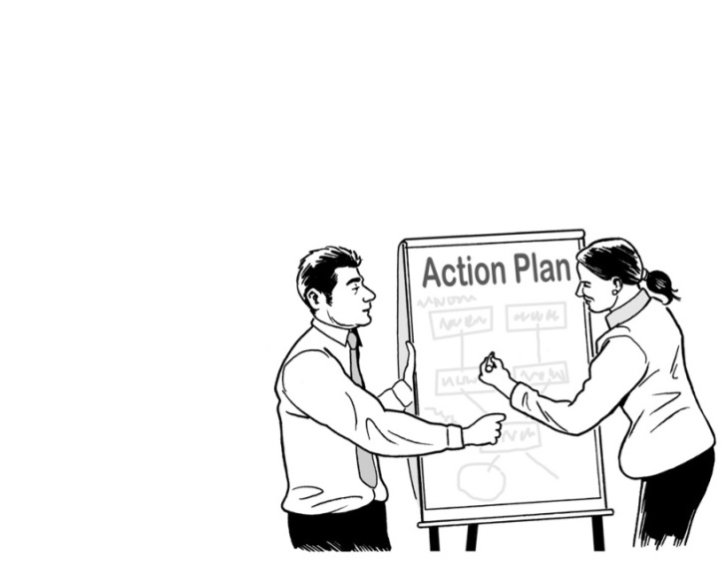
- Actions

Action means what work needs to be done to make an outcome happen.

- What needs to happen in the next 2 years.

Here is the Roadmap:

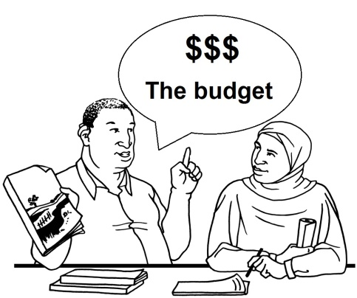
Outcome 1
Disabled people and their families / whānau have the choice to manage a budget.

Outcome 2

Disabled people and their families / whānau have the choice to use the money they get for services in the way that works for them.

Please note:
Outcomes 1 and 2 have the same:
- Action

- plan for what will need to happen in the next 2 years.

The action that will need to be done to make outcomes 1 and 2 happen:
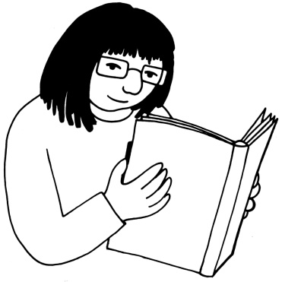
Look into ways that help disabled people and their family / whānau to use the money they get for services in a way that works for them.

What will need to happen in the next 2 years:

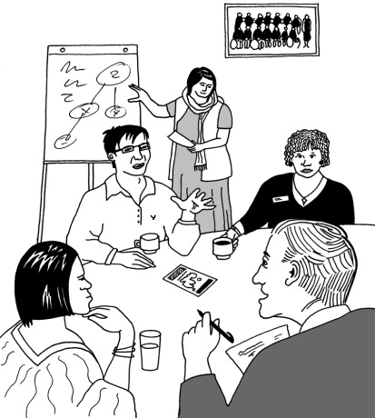
People in charge of planning the new disability support system for New Zealand will work together with the disability community on how to give disabled people more choice and control over their funding.

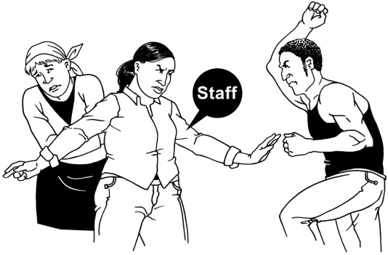
Outcome 3:

Disabled people are safe from abuse.


The action that will need to be done to make outcome 3 happen:

The Ministry of Health must make sure the rules on dealing with and stopping abuse are used in the right way.

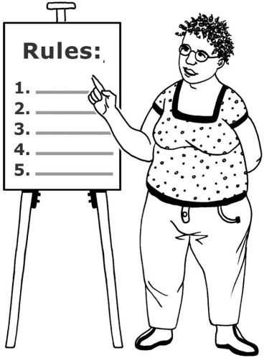
What will need to happen in the next 2 years:

Service providers will need to have easy to follow steps that will stop abuse from happening.

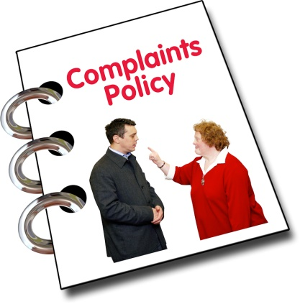
What will need to happen in the next 2 years:

Service providers will need to show they have a good way of handling any complaints they get from disabled people.

Outcome 4:
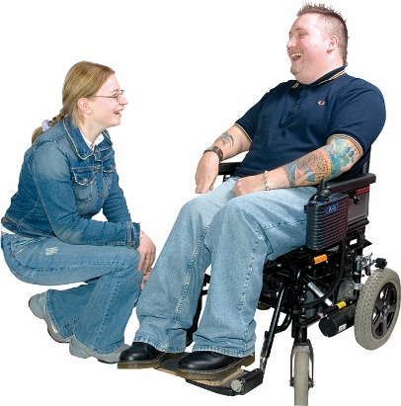
Community residential services give staff a good place that they like to work.

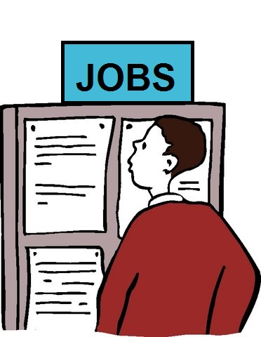
The action that will need to be done to make outcome 4 happen:

The Ministry of Health will work with service providers to help them get better at finding and keeping good support workers.

What will need to happen in the next 2 years:
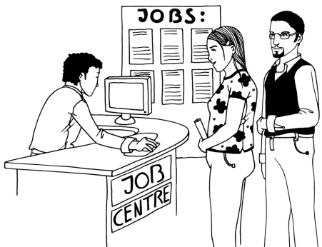
Disabled people and their families / whānau can easily find support workers.

What will need to happen in the next 2 years:

Staff should enjoy their work.

Staff can see that being a good support worker can make the lives of the people they support better.
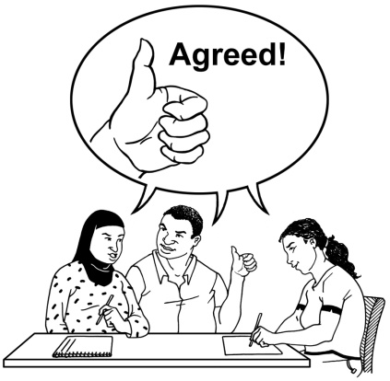
The Ministry of Health can determine a plan that will make the Pay Equity Settlement real for people.

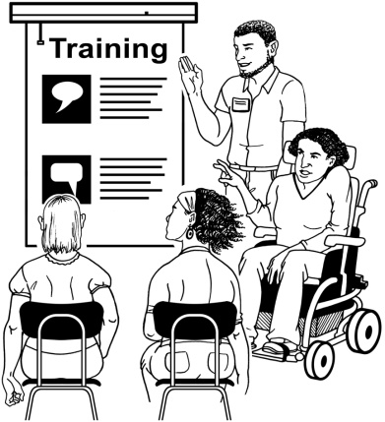
The Ministry of Health supports training support workers so that they have all the training they need to do their job well.

An example is having health and safety training for staff who work for people with higher support needs.

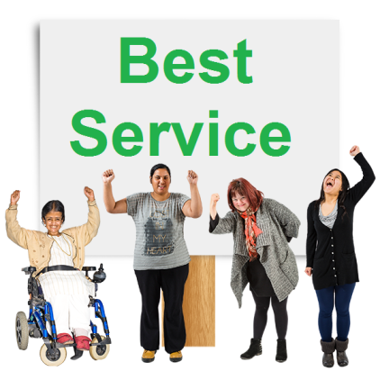
Outcome 5:

Disabled people and their families / whānau can get the best out of the residential supports they use.

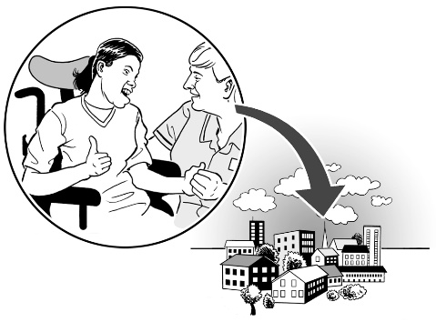
Disabled people and their families / whānau can also find and use choices other than residential supports if that is what they want.

The actions that will need to be done to make outcome 5 happen:

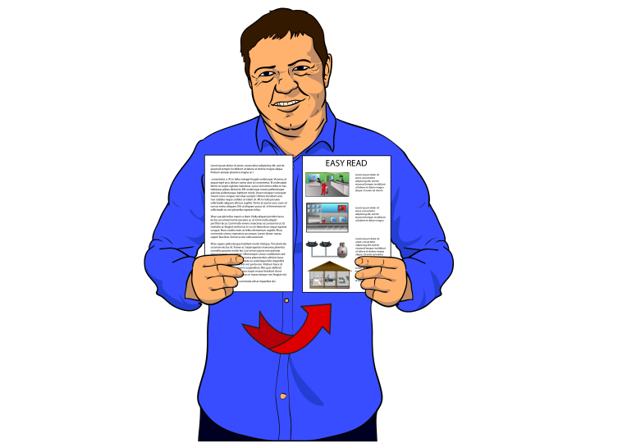
The Ministry of Health will make a guide that easily shows families / whānau how they can:

- use the money they get for services

- get supports.

The actions that will need to be done to make outcome 5 happen:
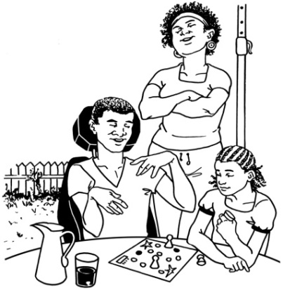

The Ministry of Health will have new choices that better support children and young people to live at home.
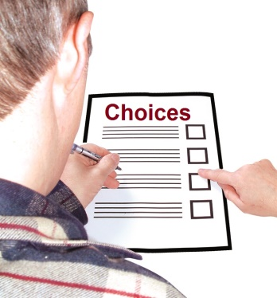

This will grow their choices in the future.

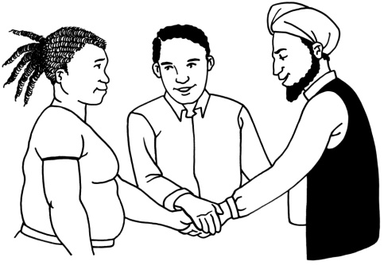
All groups and Government departments will work together to make sure disabled people can get the supports they need like health and education services.

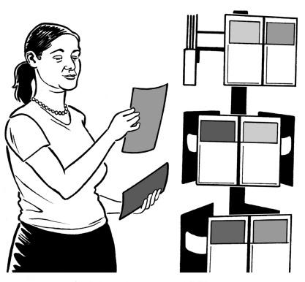
What will need to happen in the next 2 years:

There will be guides on how to use the money a person gets for services and how to get supports.


You will be able to find lots of good information online about the choices in every area.


The Ministry of Health will support disabled people to have choices wherever they live.


The Ministry of Health will have service contracts with providers that give disabled people lots of choices that work with their support needs.

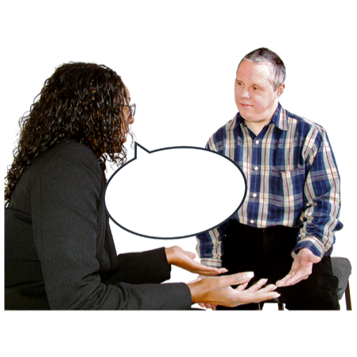
Outcome 6:

NASCs are supported to work better with disabled people so that they have more independence.

The actions that will need to be done to make outcome 6 happen:

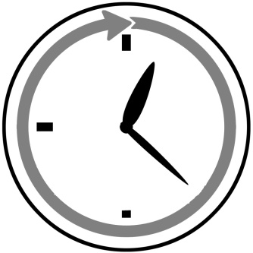
NASC services must be supported to:

- invest early in disabled people

Investing means to give support to people early so things will be better in the future.

The actions that will need to be done to make outcome 6 happen:

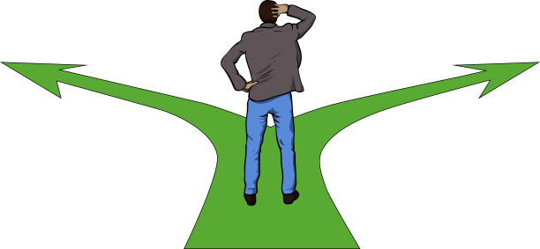
- let people know they can use the money they get for support services in whatever way they like

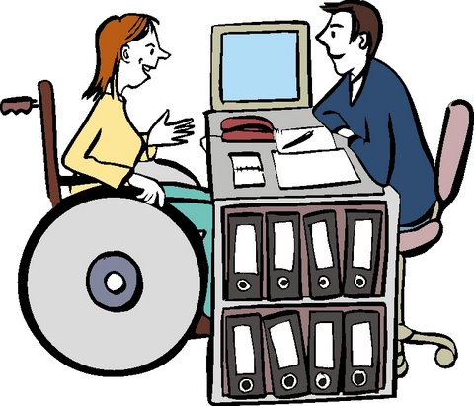
- let people know they can get early support services like behaviour support services.

What will need to happen in the next 2 years:
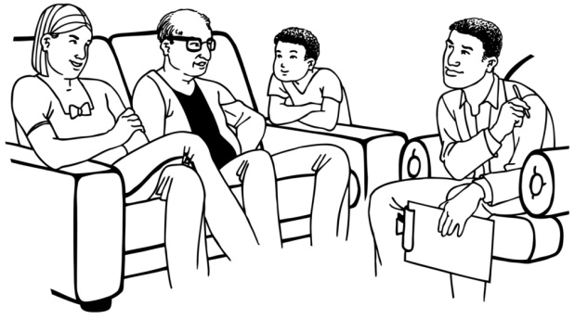
Disabled people and their families / whānau need to feel they are better supported by NASC services because they have more options.

What will need to happen in the next 2 years:
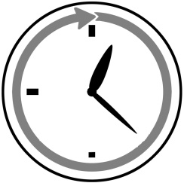
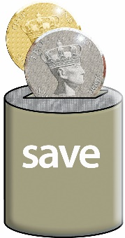
NASC staff will know what it means to invest early in people and how to use supports to make it work.
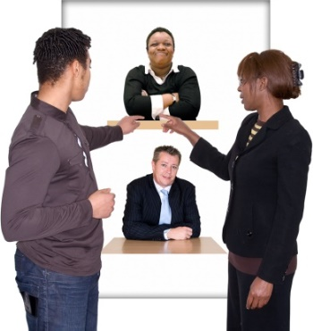
Disabled people and their families will be able to get an independent person or group to help them to find and use services.
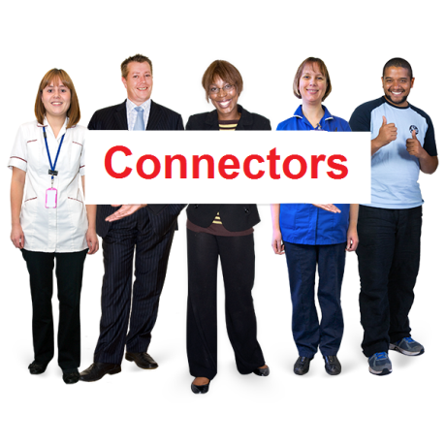
There needs to be more Connectors so families can plan better for the future.

Outcome 7:

People are supported to live well no matter how much support they need.

The actions that will need to be done to make outcome 7 happen:

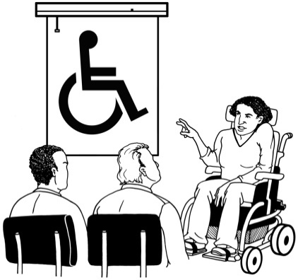
The Ministry of Health must support providers to be better at assisting people with needs that can be hard to support.

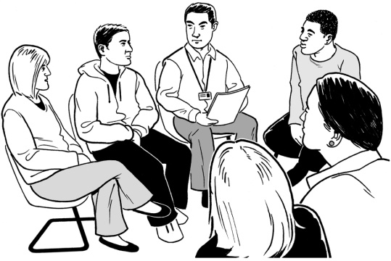
People must be able to meet with specialist support services earlier.

What will need to happen in the next 2 years:

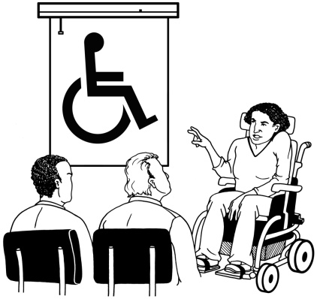
Services must be better at understanding and working with people with needs that can be hard to support.

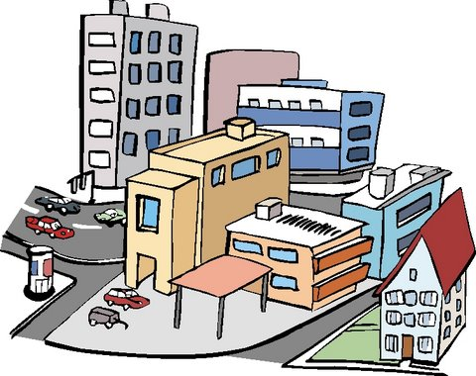
There must be local specialist services that work the same as services for everyone else but can easily help people who have needs that can be hard to support.

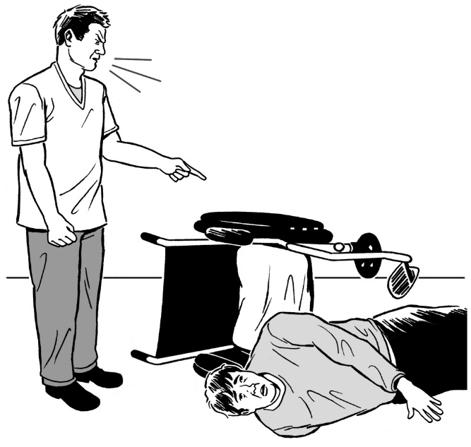
Crisis support choices must be there when needed.

Crisis support is specialist support for when something goes wrong.

Outcome 8:
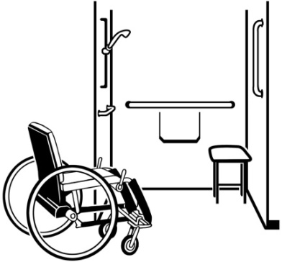
Disabled people will find it easier to get assistive technology that supports them to have a good life.

The action that will need to be done to make outcome 8 happen:
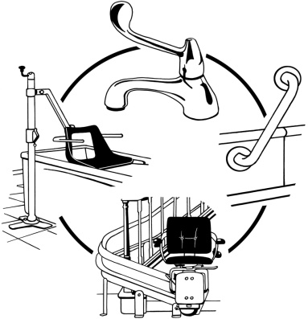

The Ministry of Health will support work that helps to make it easier for people to get and use assistive technology in Community Residential Services.
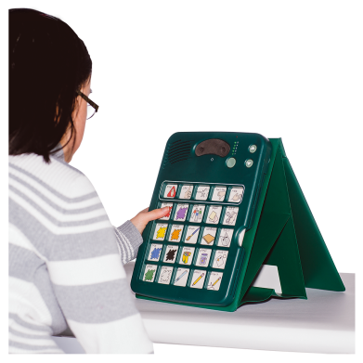

For example using tablets and picture boards.

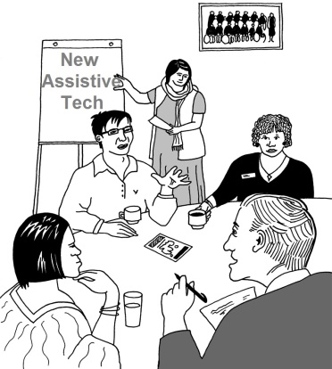
What will need to happen in the next 2 years:

The Ministry of Health will look at ways to better use assistive technology for disabled people and providers.

Where did the ideas in the strategy come from?

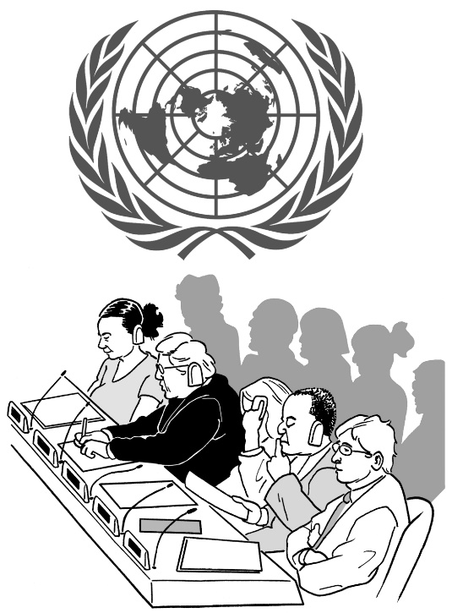
This strategy follows the ideas and rules in the documents below:

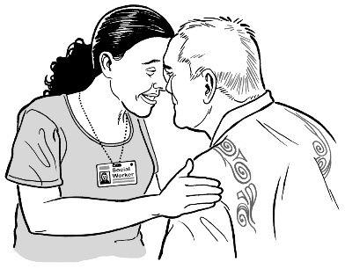
- United Nations Convention for the Rights of Persons with Disabilities (UNCRPD)

- The Treaty of Waitangi
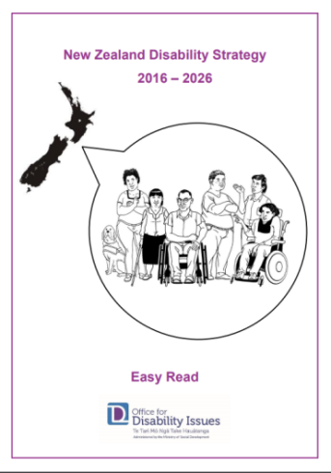
- New Zealand Health and Disability Strategies

- Enabling Good Lives

- Disability Support System Transformation.

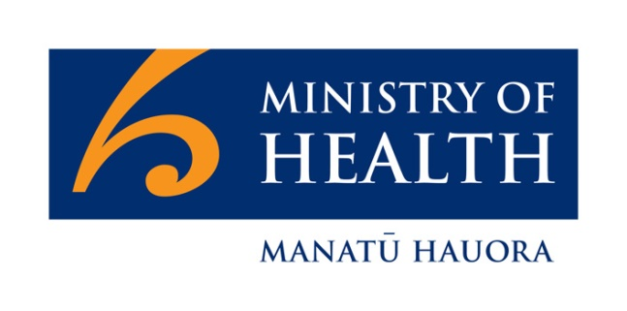
Disability Support System Transformation is the name for the change between the old system and the new system.

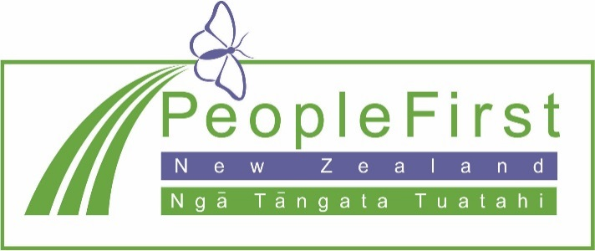


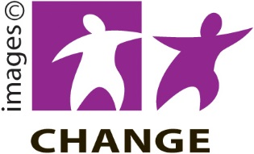
This information has been translated into Easy Read
by People First New Zealand Inc. Ngā Tāngata Tuatahi

