Social, Emotional and Behavioural Difficulties in New Zealand Children
Summary of Findings
Citation: Ministry of Health. 2018. Social, Emotional and Behavioural Difficulties in New Zealand Children: Summary of findings. Wellington: Ministry of Health.
Published in June 2018
by the Ministry of Health
PO Box 5013, Wellington 6140, New Zealand
ISBN 978-1-98-853939-3 (online)
HP 6760
This document is available at health.govt.nz

 This work is licensed under the Creative Commons Attribution 4.0 International licence. In essence, you are free to: share ie, copy and redistribute the material in any medium or format; adapt ie, remix, transform and build upon the material. You must give appropriate credit, provide a link to the licence and indicate if changes were made.
Contents
Introduction 1
Key findings 1
The Strengths and Difficulties Questionnaire 1
New Zealand Health Survey sample 2
Findings 3
Implications 7
References 8

Introduction
This brief presents the prevalence of New Zealand children aged 3–14 years who are at high risk of experiencing social, emotional or behavioural difficulties based on the Strengths and Difficulties Questionnaire (SDQ, Goodman 1997).

Key findings
The majority of New Zealand children aged 3–14 years are developing well, without major social, emotional and/or behavioural problems. However, based on the SDQ about 8 percent of children experience significant difficulties (an estimated 57,000 children). The prevalence and nature of difficulties differs across subgroups.

The Strengths and Difficulties Questionnaire
The SDQ is one of the most widely used screening measures for social, emotional and behavioural problems in children internationally. It is extensively used in New Zealand, for example as part of the B4 School Check, which assesses all four-year-old children.

The SDQ is completed by parents. It asks parents to rate their child on 25 statements, covering five aspects of children’s development: emotions, peer relationships, hyperactivity, conduct and prosocial behaviour. The information from parents is used to predict how likely a child is to have a social, emotional and/or behavioural problem on a scale of low, medium (referred to as a ‘borderline’ score) or high (referred to as a ‘concerning’ score).

SDQ scores are classified as:
- unlikely to have difficulties
- borderline: medium likelihood of difficulties
- concerning: high likelihood of difficulties.

Children’s scores can be evaluated for each of the aspect of development separately, or based on the questionnaire as a whole (the ‘total difficulties’ score, which includes all areas assessed except prosocial behaviour). Children with a ‘concerning’ total difficulties score are likely to benefit from a more thorough clinical assessment, and potentially some kind of service intervention. Based on previous work internationally, it is expected that around 10% of children will be in the ‘borderline’ category and 10% in the ‘concerning’ category (Youth in Mind 2014).

Based on the SDQ, the risk of the child experiencing difficulties is assessed for four aspects of development:
- emotions
- peer relationships
- hyperactivity
- conduct.
Together they form a total difficulties score.

New Zealand Health Survey sample
The findings in this brief are based on data collected through the New Zealand Health Survey in 2012/13, 2014/15 and 2015/16. The total sample included 10,457 children between the ages of three and 14 years. Weights were used to adjust the estimates calculated from the data, to ensure that the findings are representative of the New Zealand child population.

Findings
An estimated 57,000 New Zealand children between the ages of three and 14 years had a total difficulties score indicating concern, which is about 8%. A further estimated 50,000 children (7.0%) had a ‘borderline’ total difficulties score.

The percentage of children with a ‘concerning’ total difficulties score was higher for boys (9.5%) compared with girls (6.6%). In terms of age groups, children aged 5–9 years had the lowest rate (6.9%), with higher rates for those aged 3–4 years (10.2%) and 10–14 years (8.4%).

The table below presents adjusted rate ratios for different subgroups. This reveals how much more or less likely the group of interest is to experience difficulties on the SDQ compared with the reference group. For example, boys were 1.5 times more likely than girls to have a total difficulties score indicating concern.

Adjusted rate ratio for a ‘concerning’ total difficulties score
Boys vs girls | 1.5*
10–14 years vs 5–9 years | 1.3*
Māori vs non-Māori | 1.8*
Pacific vs non-Pacific | 1.3
Asian vs non-Asian | 0.6*
Most vs least deprived | 3.0*
Note: * The difference between the two groups is statistically significant.
For adjustments made, see the technical report Social, Emotional and Behavioural Functioning of New Zealand Children: New Zealand Health Survey (Ministry of Health 2018).

After adjusting for differences in age and sex, a total difficulties score indicating concern was more likely in Māori children compared with non-Māori children and less likely in Asian children compared with non-Asian children. Rates of ‘concerning’ total difficulties scores were comparable for Pacific and non-Pacific children.

Adjusting for differences in age, sex and ethnicity, children living in areas of high socioeconomic deprivation were more likely to have a total difficulties score indicating concern than children living in areas of low deprivation.

The SDQ total difficulties score combines the child’s scores for the four aspects of development assessed: emotions, peer relationships, hyperactivity and conduct. For the majority of children with a ‘concerning’ total difficulties score, parents reported that their child experienced some level of difficulty across more than one of these areas. On the other hand, some children experienced difficulties in one specific area of development, but did not have a total difficulties score indicating concern. In the following sections we explore the prevalence of difficulties for each area across different subgroups of children.

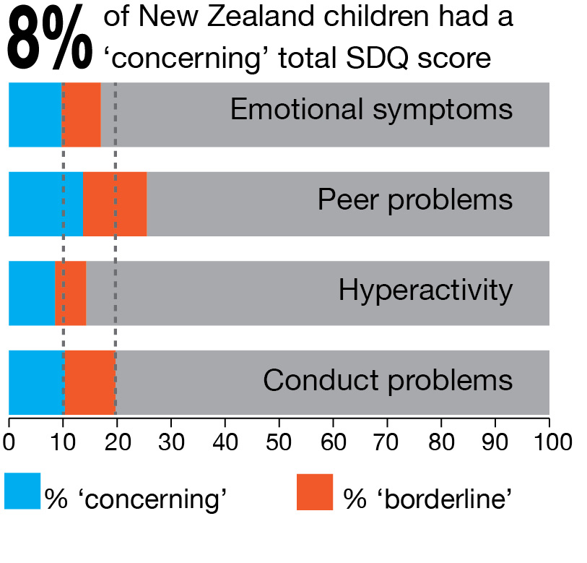 | Total child population 3–14 years
 |  | % 'concerning' | % 'borderline'
 | Total difficulties | 8.0 | 7.0
 | Emotional symptoms | 9.7 | 7.3
 | Peer problems | 13.7 | 11.8
 | Hyperactivity | 8.5 | 5.8
 | Conduct problems | 10.3 | 9.4
 | Note: Percentages are unadjusted.
Note: In this and later figures blue highlights the percentage of children in New Zealand with a ‘concerning’ score and orange the percentage with a ‘borderline’ score. The 10% and 20% markers are indicated as these are the percentages of children the SDQ thresholds were designed to identify in the original work by the questionnaire’s author (10% ‘concerning’ and 10% ‘borderline’).

According to parents’ reports, peer problems were the most common of all four areas, followed by conduct problems. While hyperactivity and emotional symptoms were more prevalent in older age groups compared to younger groups, the rate of conduct and peer problems was comparable across the age groups. Boys were more likely than girls to experience difficulties in the areas of conduct, peers and hyperactivity. Girls were more likely than boys to experience emotional symptoms.

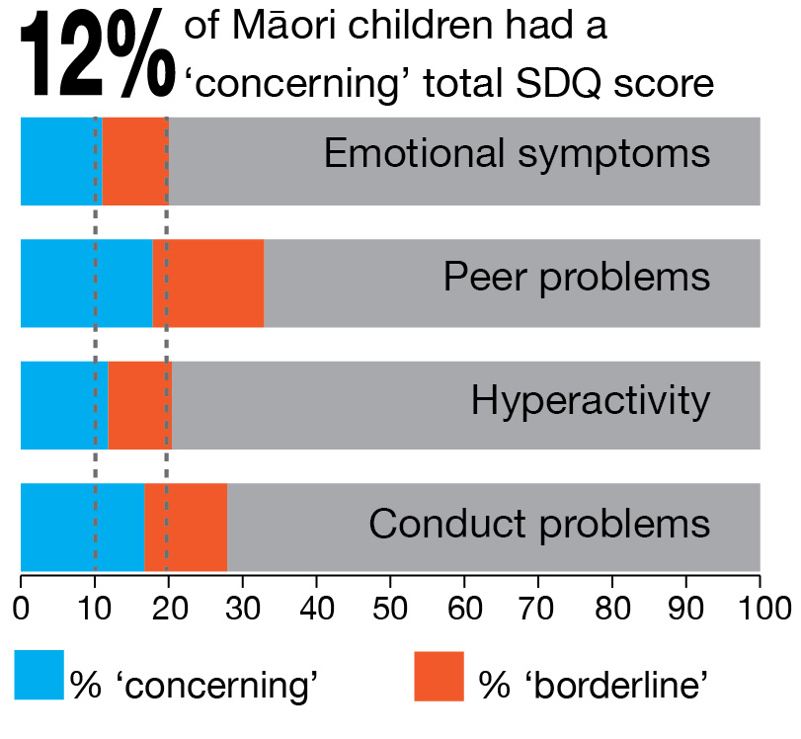 | Māori children
 |  | % 'concerning' | % 'borderline'
 | Total difficulties | 12.0 | 10.0
 | Emotional symptoms | 11.0 | 9.0
 | Peer problems | 17.8 | 15.1
 | Hyperactivity | 11.8 | 8.6
 | Conduct problems | 16.7 | 11.2
 | Note: Percentages are unadjusted.

After adjusting for differences in age and sex, Māori children were more likely to experience peer problems, hyperactivity and conduct problems than non-Māori children. The biggest difference was for conduct problems. Rates of emotional symptoms were comparable.*

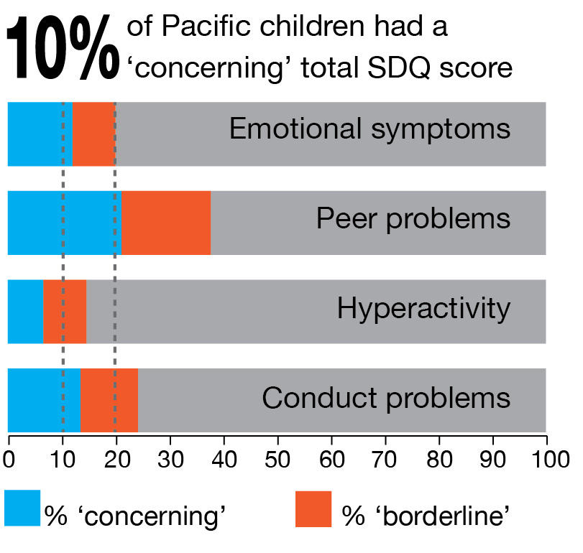 | Pacific children
 |  | % 'concerning' | % 'borderline'
 | Total difficulties | 10.0 | 9.0
 | Emotional symptoms | 12.0 | 8.0
 | Peer problems | 21.1 | 16.6
 | Hyperactivity | 6.6 | 8.0
 | Conduct problems | 13.5 | 10.7
 | Note: Percentages are unadjusted.

After adjusting for differences in age and sex, Pacific children were more likely to experience emotional symptoms and peer and conduct problems than non-Pacific children. Rates of hyperactivity were lower for Pacific children.*

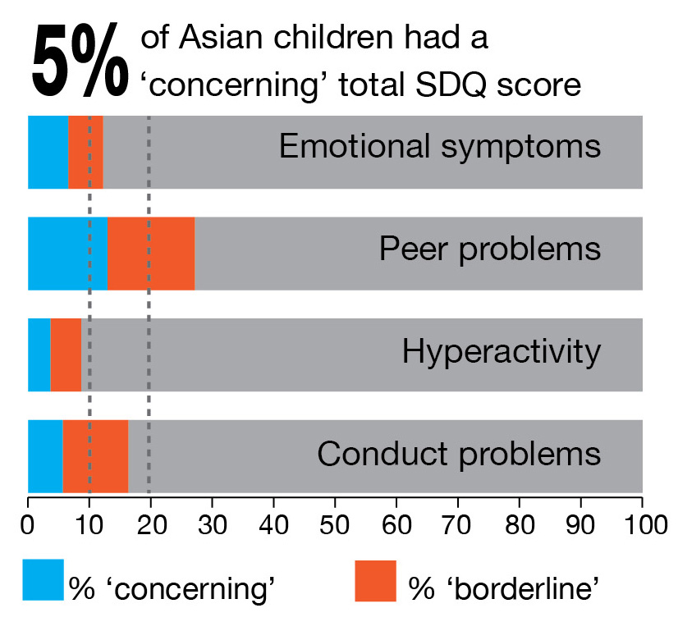 | Asian children
 |  | % 'concerning' | % 'borderline'
 | Total difficulties | 4.9 | 5.2
 | Emotional symptoms | 6.5 | 5.7
 | Peer problems | 12.9 | 14.2
 | Hyperactivity | 3.6 | 5.0
 | Conduct problems | 5.6 | 10.7
 | Note: Percentages are unadjusted.

After adjusting for differences in age and sex, Asian children were less likely to experience emotional symptoms, hyperactivity and conduct problems than non-Asian children. Rates of peer problems were comparable.*

* Note: Group differences discussed are based on the threshold for ‘concerning’. See the technical report Social, Emotional and Behavioural Functioning of New Zealand Children: New Zealand Health Survey (Ministry of Health 2018) for adjusted rate ratios.

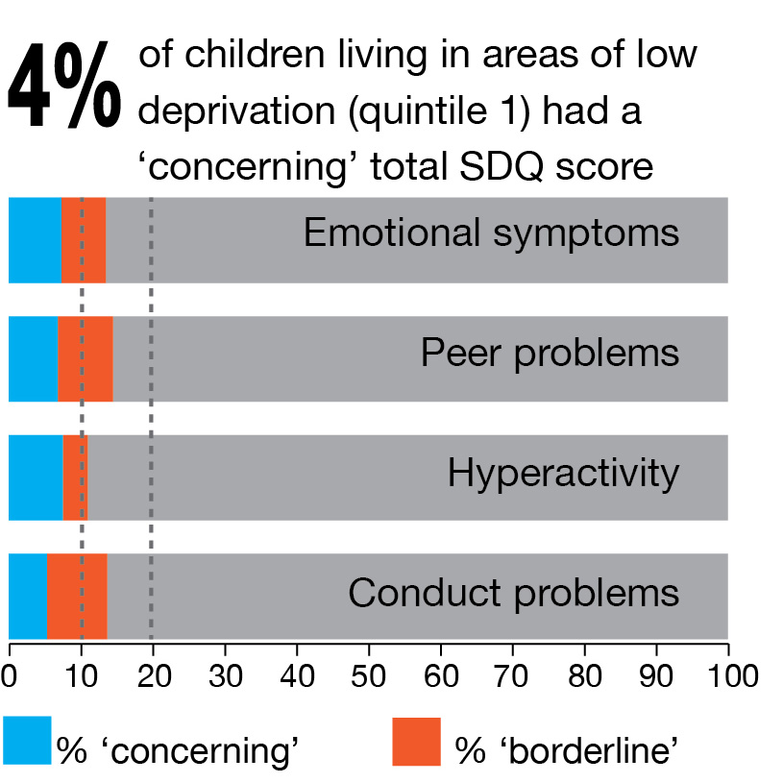 | Low neighbourhood deprivation
 |  | % 'concerning' | % 'borderline'
 | Total difficulties | 3.7 | 4.2
 | Emotional symptoms | 7.3 | 6.2
 | Peer problems | 6.8 | 7.7
 | Hyperactivity | 7.5 | 3.5
 | Conduct problems | 5.3 | 8.4
 | Note: Percentages are unadjusted.

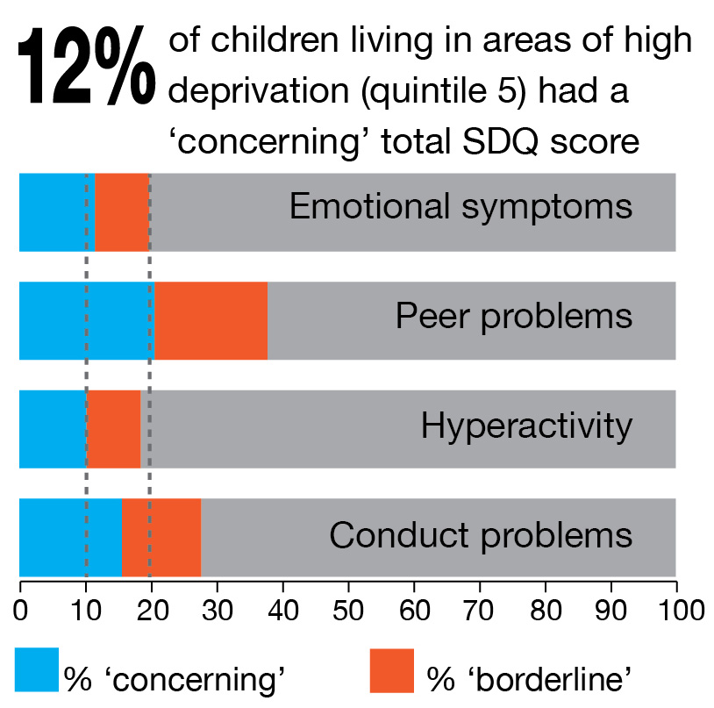 | High neighbourhood deprivation
 |  | % 'concerning' | % 'borderline'
 | Total difficulties | 12.4 | 9.6
 | Emotional symptoms | 11.5 | 8.3
 | Peer problems | 20.6 | 17.2
 | Hyperactivity | 10.2 | 8.3
 | Conduct problems | 15.6 | 12.1
 | Note: Percentages are unadjusted.

After adjusting for differences in age, sex and ethnicity, children living in areas of high socioeconomic deprivation were more likely to experience emotional symptoms, conduct problems and peer problems than children living in areas of low deprivation. Rates of ‘concerning’ scores for hyperactivity were comparable across the two groups, however, children living in areas of high deprivation were more likely to have a ‘borderline’ score for hyperactivity.

For a more detailed discussion of the prevalence of social, emotional and behavioural difficulties in New Zealand children based on the Health Survey data, see the technical report Social, Emotional and Behavioural Functioning of New Zealand Children: New Zealand Health Survey (Ministry of Health 2018).

Implications
Mental disorders, such as anxiety disorder or attention deficit hyperactivity disorder (ADHD), are the largest contributor to disability in young people aged 10–24 years (Whiteford et al 2015). In 2013 they accounted for 35% of all health loss in those aged 15–24 years (Ministry of Health 2016). The findings based on the Health Survey highlight that by using the SDQ it is possible to detect social, emotional and behavioural difficulties at an early age, which may be indicative of an underlying mental health problem. Being able to do so is important as it provides opportunities for intervention. Early intervention in response to difficulties can reduce the risk or severity of certain types of mental disorders later in childhood, adolescence or adulthood. This can also and improve children’s developmental, emotional, academic and social outcomes. The earlier the intervention occurs, the greater those improvements are (Manning 2017).

Using the SDQ has minimal demands on time and resources. It can be used to screen children on a population level, ensuring no one misses out. However, it can only be used for an initial screen and not to make a formal diagnosis. Screening questionnaires like the SDQ are designed to identify more children as at risk than those who actually experience substantial difficulties requiring attention, to make sure no children are missed. Children identified as at risk of difficulties should be referred for further clinical assessment.

For the SDQ to contribute to better outcomes in mental health and wellbeing, it is essential that adequate referral processes for further assessment are in place, as well as effective, culturally appropriate interventions. The Health Survey results provide estimates of the number of children who could benefit from further clinical assessment. They show that the rates of difficulties as parents report them differed across subgroups of children in the New Zealand population. Also, the nature of the difficulties experienced differed according to age group, sex, ethnicity and neighbourhood deprivation. For example, while peer problems were an important contributor to difficulties for all groups, difficulties with hyperactivity were less prevalent in Pacific and Asian children. Interventions should take such differences into account.

Overall, this report show that while a share of New Zealand children may require some additional support, the majority of children in New Zealand are developing without any significant social, emotional or behavioural problems.

References
Goodman R. 1997. The Strengths and Difficulties Questionnaire: a research note. Journal of Child Psychology and Psychiatry 38(5): 581–6.
Manning. 2017. Addressing developmental challenges to improve the wellbeing of children. In S Garvis, D Pendergast, Health and Wellbeing in Childhood (2nd ed, pp 39–56). Cambridge: Cambridge University Press.
Ministry of Health. 2016. Health Loss in New Zealand 1990–2013: A report from the New Zealand Burden of Diseases, Injuries and Risk Factors Study. Wellington: Ministry of Health.
Ministry of Health. 2018. Social, Emotional and Behavioural Functioning of New Zealand Children: New Zealand Health Survey. Wellington: Ministry of Health.
Whiteford HA, Ferrari AJ, Degenhardt L, et al. 2015. The global burden of mental, neurological and substance use disorders: an analysis from the Global Burden of Disease Study 2010. PloS one 10(2): e0116820.
Youth in Mind. 2014. SDQ: information for researchers and professionals about the Strengths and Difficulties Questionnaires. URL: www.sdqinfo.com.

For scoring instructions and thresholds for ‘borderline’ and ‘concerning’ scores, see the SDQ website www.sdqinfo.com/a0.html
For more information on the New Zealand Health Survey and its methodology, see www.health.govt.nz/nz-health-statistics/national-collections-and-surveys/surveys/current-recent-surveys/new-zealand-health-survey
A rate ratio above 1 means the indicator is more likely in the group of interest than in the reference group; a rate ratio below 1 means the indicator is less likely.

