Annual Report for the year ended 30 June 2019
Ministry of Health
Presented to the House of Representatives pursuant to section 44 of the Public Finance Act 1989

Citation: Ministry of Health. 2019. Annual Report for the Year Ended 30 June 2019: Ministry of Health. Wellington: Ministry of Health.
Published in October 2019 by the Ministry of Health
PO Box 5013, Wellington 6140, New Zealand
ISBN 978-1-98-859720-1 (print)
ISBN 978-1-98-859719-5 (online)
HP 7247

This document is available at health.govt.nz
 | This work is licensed under the Creative Commons Attribution 4.0 International licence. In essence, you are free to: share ie, copy and redistribute the material in any medium or format; adapt ie, remix, transform and build upon the material. You must give appropriate credit, provide a link to the licence and indicate if changes were made.

Director-General’s overview

Kia ora koutou katoa
I am pleased to present the Ministry of Health’s 2018/19 Annual Report.
It has been a busy and eventful year. It has also been my privilege to work alongside a team of passionate people both within the Ministry and across our health and disability system, who are collectively committed to delivering the best possible health outcomes for all New Zealanders.
I believe the Ministry, as kaitiaki of the health and disability system in Aotearoa New Zealand, is in an improved position to provide active stewardship and leadership across the system. It is also better placed to prioritise equity in health outcomes so people receive the highest levels of care, regardless of who they are or where they live.
This year, the Wellbeing Budget presented a significant shift in the Government’s approach to how we measure our success as a country – one that incorporates the health of our people and communities. With more funding for mental wellbeing, equity for Māori and Pacific peoples, workforce and infrastructure, and support for cost pressures in the health and disability system, this approach is a positive step towards improving the intergenerational wellbeing of New Zealanders.
The year 2018/19 has contained many highlights. Starting the Ministry’s Achieving Equity Programme was an important step toward tackling equity in health outcomes in Aotearoa New Zealand. Working with our partners, we agreed on a common definition and understanding of equity, which will inform us on how to embed equity into the design of our services and programmes.
We have improved access to primary care by working with the sector to expand zero fees to children aged under 14 years and lowering the cost of primary care visits for Community Services Card holders. As a result, access to primary care has become more affordable for our most vulnerable people.
Opening the new outpatients’ facility at Christchurch Hospital was another achievement for both the Ministry and our partners. We are confident the new facilities will meet the current and future needs of the Canterbury region. We also extended our mental health support services to schools throughout Christchurch, Hurunui and Kaikōura.
I’m very proud of the way we came together to respond to Christchurch mosque attacks, working closely alongside Canterbury District Health Board and many other government and non-governmental organisations. The team on the ground, as well as those providing support and services through the national mental health helpline 1737, did an outstanding job to care for those who were hurt during the attacks and those who needed support afterwards.
Since I joined the Ministry in June 2018, we have made significant changes to align the structure of the Ministry with the wider health and disability system so that it better reflects how the sector plans, organises and delivers health and disability services.
A second phase of organisational change will structure the Ministry in a way that supports the sector to deliver better health outcomes with a focus on equity and meeting our Te Tiriti o Waitangi responsibilities. In addition, it will equip us to successfully deliver our work programme and the Government’s priorities, and ultimately to fulfil our role in achieving pae ora – healthy futures for all New Zealanders.
As well as putting the right people in the right places to deliver on our substantial work programme, we have developed a new organisational strategy for the Ministry. The strategy articulates our purpose as ‘kaitiaki of the health and disability system in Aotearoa New Zealand’ and we have established a mission of having ‘a fair, effective and sustainable system that people trust’.
We have identified strategic objectives that we will focus on for the next five years to achieve our mission, as well as internal capability objectives that will position us for success and make the Ministry of Health a great place to work.
Looking ahead, achieving the Government’s aspirations will, in large part, rest on our ability as kaitiaki and stewards to inspire, drive and oversee change in the health and disability system. I am confident that the work the Ministry has under way positions us to create a positive impact now and long into the future.
Naku te rourou nau te rourou ka ora ai te iwi.
With my basket and your basket, the people will live.

Ngā mihi,

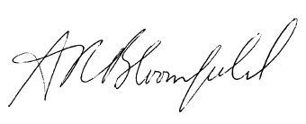
Dr Ashley Bloomfield, Director-General of Health

Contents
Director-General’s overview iii
Welcome 1
Our year in review 2
Part 1: About us 4
Our organisation 5
Our core business 7
Our commitment to New Zealand 8
Improving health and disability outcomes 9
Refreshing our strategic direction 10
Meeting our obligations under Te Tiriti o Waitangi 11
Embedding our wellbeing approach 11
Working with others 12
Our people 13
Part 2: Our performance 18
Our strategic priorities 19
Strategic priority 1: Improve health outcomes for population groups – with a focus on Māori and Pacific peoples, older people and children 20
Strategic priority 2: Improve access to, and the efficacy of, health services for New Zealanders – with a focus on mental health and addictions, primary care, disability support services, and bowel cancer 29
Strategic priority 3: Improve outcomes for New Zealanders with long-term conditions 37
Strategic priority 4: Improve our understanding of system performance 47
Strategic priority 5: Implement our investment approach 51
Our outputs 57
Part 3: Audit report and financial statements 70
Statement of responsibility 71
Financial statements 77
Non-departmental statements and schedules for the year ended 30 June 2019 104
Appendices 121
Appendix 1: Outcome and impact measures 122
Appendix 2: System Performance Measures 130
Appendix 3: Legal and regulatory framework 137
Appendix 4: Committees 140
Appendix 5: Information about our people 144
Appendix 6: Asset performance indicators 148

List of figures
Figure 1: Overview of the health and disability system 6
Figure 2: About our core business 7
Figure 3: Strategic priorities of the Ministry of Health 9
Figure 4 Influenza vaccinations 36
Figure 5: Health loss due to tobacco use 38
Figure 6: Health loss due to not eating enough vegetables 41
Figure 7: Health loss due to alcohol use 41
Figure 8: Health loss due to low physical activity 42
Figure 9: Think FAST stroke campaign 44
Figure 10: Permanent staff FTE and headcount, by business unit 144
Figure 11: Length of service 145
Figure 12: Ethnicity 145
Figure 13: Gender and age group 146
Figure 14: Gender and remuneration band 146

List of tables
Table 1: Outcome measures 122
Table 2: Impact measures 124
Table 3: System Level Measures national dashboard 131
Table 4: National health target results for 2018/19 136
Table 5: National health target results for 2017/18 136
Table 6: Permanent staff location and headcount 147
Table 7: Asset performance indicators 148

Welcome
Welcome to the Ministry of Health’s Annual Report for the year ending 30 June 2019. As required by the Public Finance Act 1989, our Annual Report outlines our achievements against our Statement of Strategic Intentions 2017/18–2020/21. Here you’ll find information about us and our financial and non-financial performance during 2018/19. The report assesses our performance across the short and medium term – the activities we carried out in 2018/19 to make a positive difference, and how we performed against the measures set.
The Annual Report consists of the following three parts.
Part 1: About us
Provides an overview of our organisation – our purpose, our strategic direction and core business, our people and our way of working with others.

Part 2: Our performance
Provides information about how we performed during 2018/19. It shows achievements against our five strategic objectives, our outputs and how our key metrics are tracking.

Part 3: Audit report and financial reports
Reports on the financial resources we have used to deliver our services. This section also includes an independent audit report on our financial and non-financial performance.


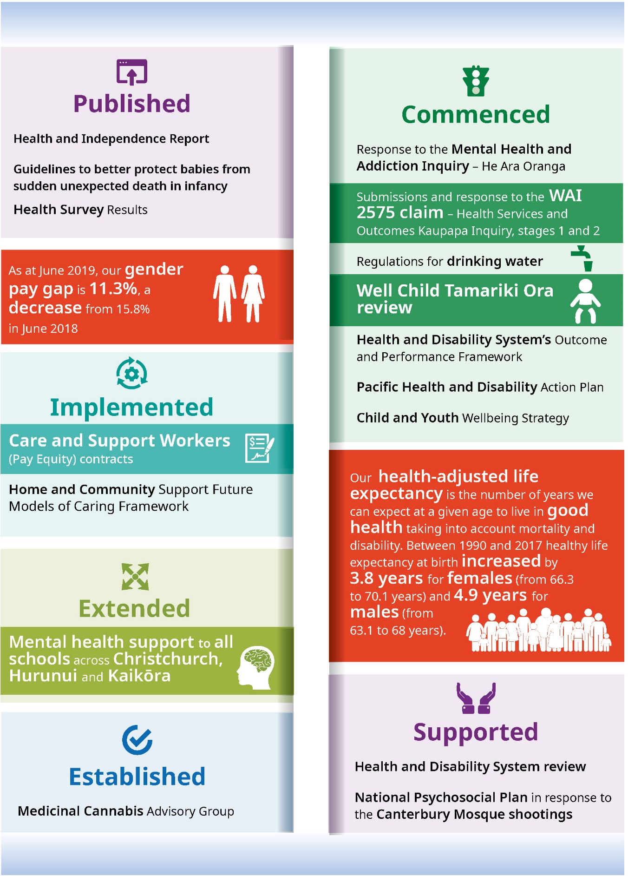
Our year in review
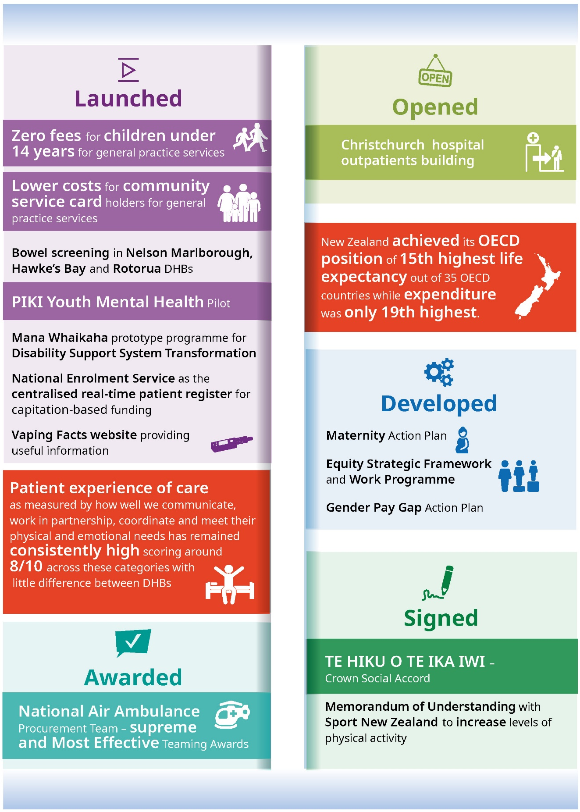

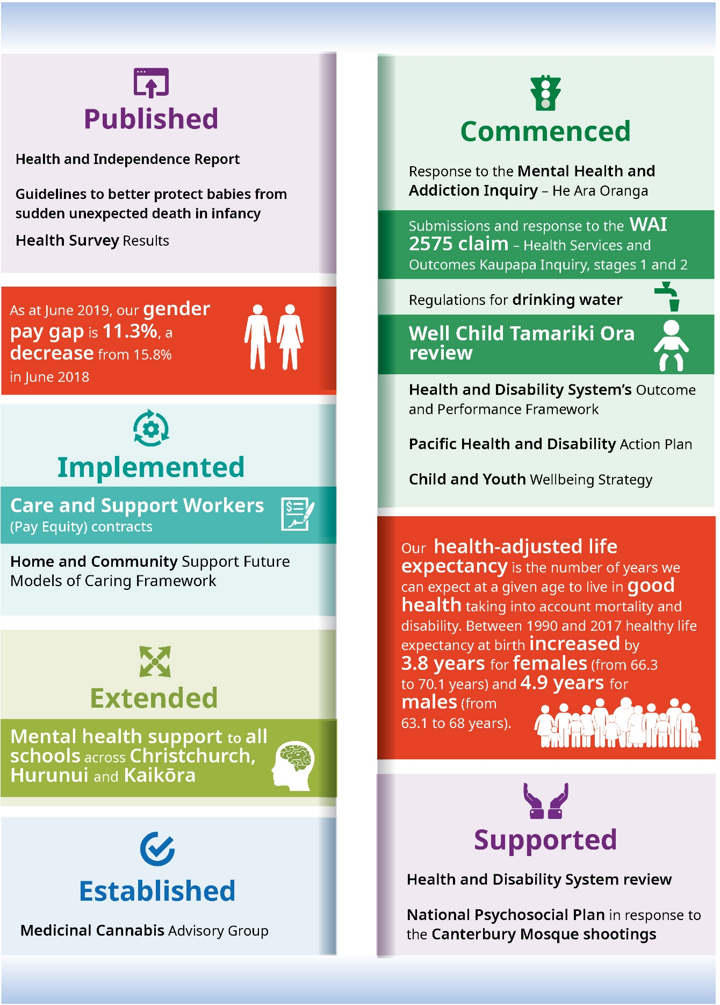


Part 1:
About us

Our organisation
As kaitiaki of the health and disability system in Aotearoa New Zealand, the Ministry of Health plays a leadership role as steward of the system and is responsible for its overall performance. We want to provide a fair, effective and sustainable public health system that people trust.
The Ministry of Health is the lead advisor to the Government on health and disability matters. We provide support and advice to the Minister of Health and Associate Ministers of Health to advance the system for current and future generations.
We work collaboratively with our partners in the health and disability system, which includes district health boards (DHBs), Crown entities and other government and non-governmental organisations (Figure 1). Collectively, we strive to improve health outcomes and address health inequities for the people of Aotearoa New Zealand, providing evidence-informed advice on health and disability matters to the Government, the Minister of Health, Associate Ministers of Health, and other stakeholders.
Figure 1: Overview of the health and disability system
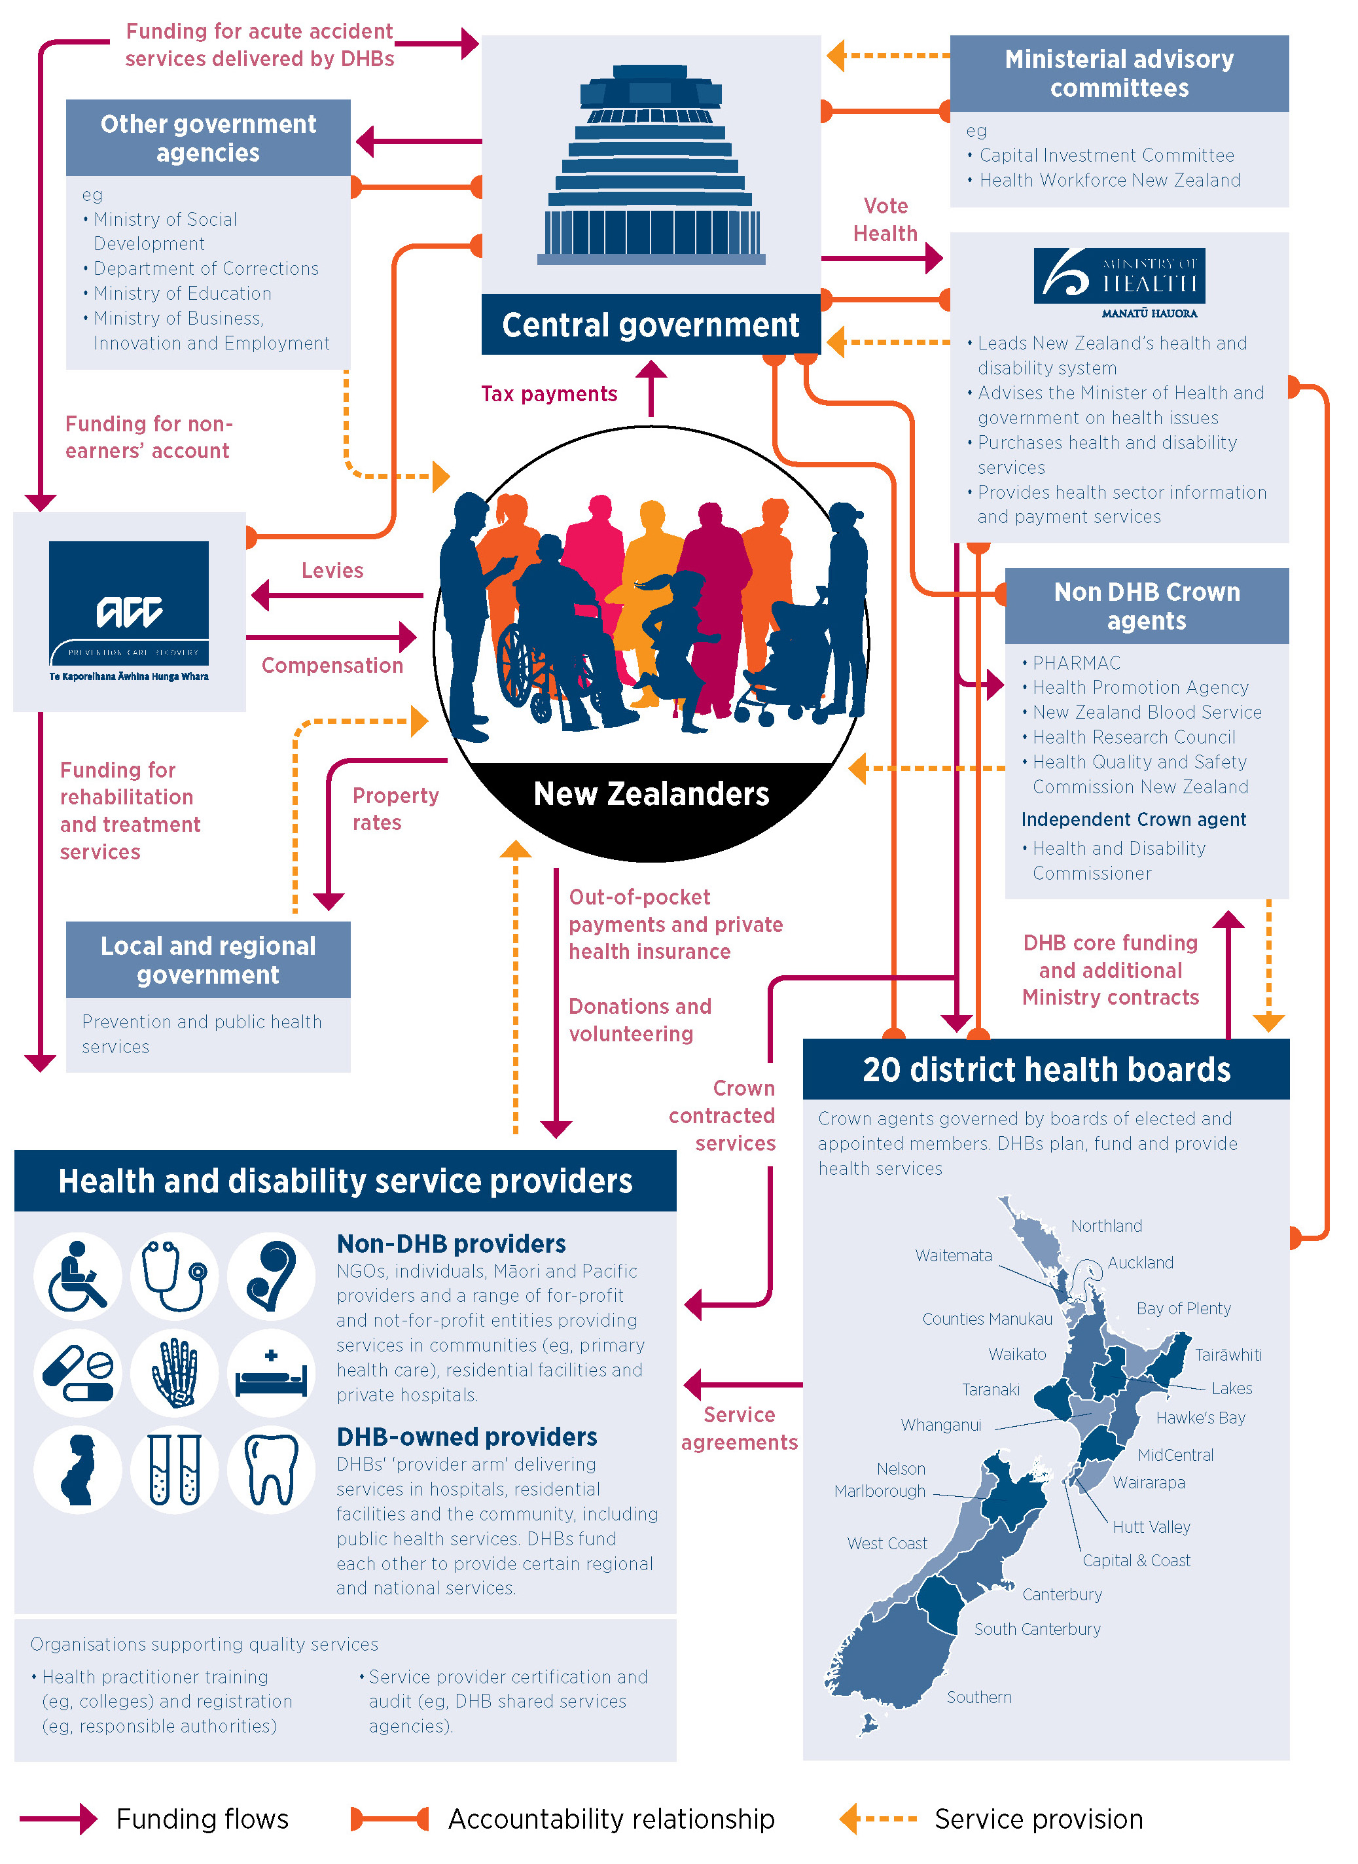

Our core business
Our core business is all about promoting, protecting and improving the health and wellbeing of New Zealanders in the following ways (Figure 2).
- Advising Government: We provide clear and practical advice to the Minister of Health and Associate Ministers of Health and other stakeholders based on strong, evidence-based analysis.
- Buying health and disability services: We ensure system funding, resources and assets are effectively and responsibly managed to meet current and future needs.
- Providing information and payments: We manage key systems and infrastructure, especially our national information systems and sector payments service, to support the health and disability system.
- Sector planning and performance: We support and monitor DHBs, Crown entities, other government organisations and non-governmental organisations in our health and disability system to plan, implement and measure the system’s performance. We also ensure the system and sector providers are delivering the Government’s priorities, are well governed and are financially sustainable.
- Regulatory and enforcement services: We ensure our legislation and regulations are appropriately administered and remain fit for purpose to meet New Zealanders’ needs in a changing world.
Figure 2: About our core business
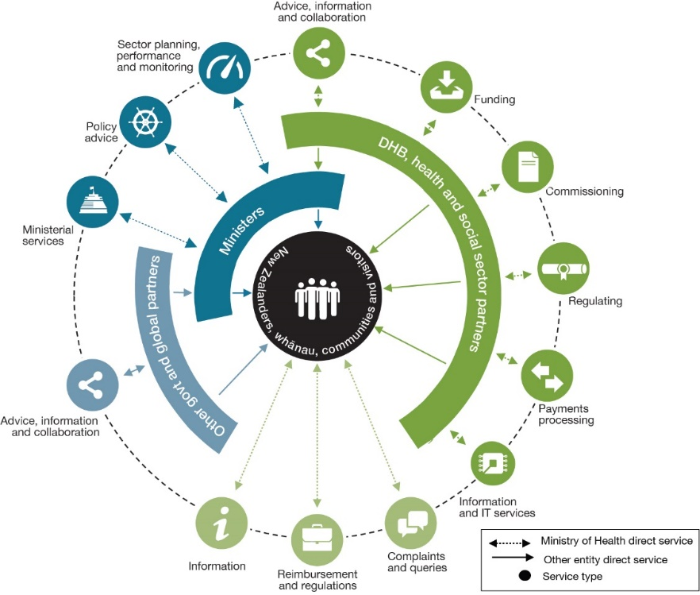
In delivering our core business, we seek to continuously improve how we work. For this reason, we established the Capability Uplift Programme to focus on key activities that will strengthen our systems and processes. In 2018/19, we refreshed our governance arrangements to strengthen oversight of our delivery and performance on strategic initiatives, policy and legislative changes, service commissioning and corporate functions. We also put in place a Leadership Framework to articulate our vision for leadership at the Ministry of Health and our approach to strengthening leadership capability through recruiting, developing, recognising and managing talent. This three-year plan starts with ensuring we have strong foundations in place, and then moves towards more mature leadership practice that is aligned with the sector leadership framework and global best practice.
The Health and Independence Report 2018
The Health and Independence Report 2018 takes the pulse of New Zealanders’ health. It highlights several positives while also underlining the challenges we need to address.
Most New Zealanders feel they are in good, very good or excellent health. New Zealanders are living longer, and their health life expectancy (how long people live in good health) is increasing too.
However, the report also identified people are spending a longer period of their lives in poor health – often due to avoidable illness. Inequities in physical and mental health outcomes persist, particularly among Māori, Pacific peoples and those living in lower socioeconomic communities.
As kaitiaki of the health and disability system, the Ministry of Health is learning from these trends and looking at ways we can work with our partners to improve health and wellbeing outcomes for New Zealanders.

Our commitment to
New Zealand
New Zealand’s health and disability system serves over 4.9 million people and touches the lives of hundreds of thousands of New Zealanders every day. Predictions are that the New Zealand population will grow by about 85,000 people each year and a bigger proportion of people will be 65 years or older and from increasingly diverse backgrounds as more people choose to make New Zealand their home. With increased urbanisation, technological advancements and globalisation, the needs and expectations of the people the system serves are changing as well. These factors are expected to increase demand and change the way health services are delivered.
As kaitiaki, the Ministry of Health is committed to providing a fair, effective and sustainable system that improves health outcomes for different groups of people, closing the equity gap. Commenting on the report’s findings, the Hon Dr David Clark, Minister of Health, observed:
Clearly we have more work to do. I’m confident the review of the New Zealand health and disability system we’ve begun will provide a solid foundation on which to make the changes we need to deliver a healthier and fairer future.

Improving health and disability outcomes
New Zealand continues to have one of the best public health and disability systems in the world. As sector leader and kaitiaki, the Ministry of Health’s role is to ensure the health and disability system continues to meet New Zealanders’ health and disability needs today, as well as in the future. We are focused on creating a fair, effective and sustainable system that continues to improve health and disability outcomes for the people of New Zealand.
Over the last year, working with our health and disability system partners, other government agencies, people and their communities, we have made progress against the five strategic priorities we identified in our Statement of Strategic Intentions 2017/18-2020/21 (Figure 3). Part 2 discusses our achievements in delivering initiatives to improve these strategic priorities.
Figure 3: Strategic priorities of the Ministry of Health
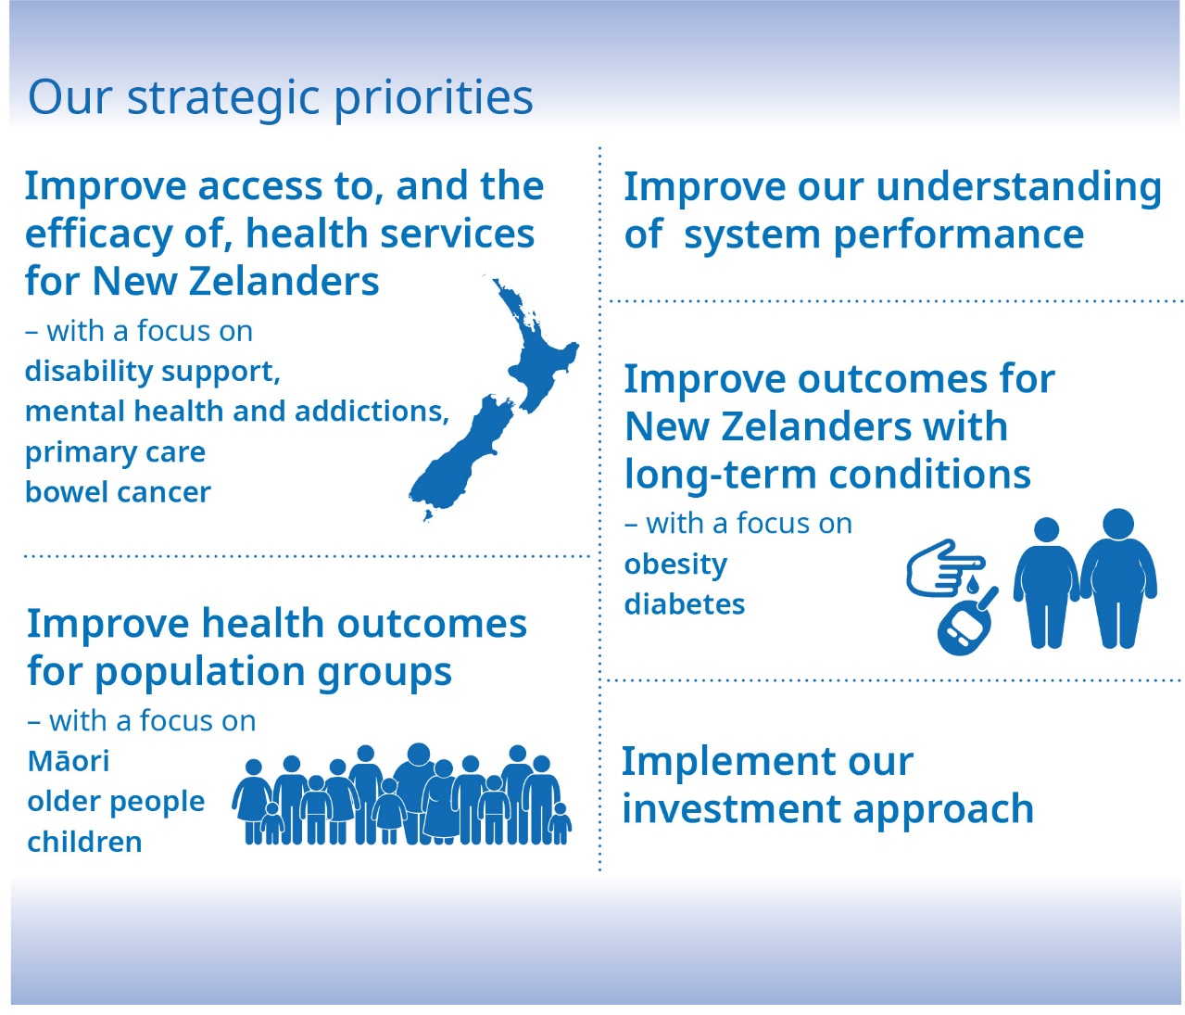

Refreshing our strategic direction
The needs of New Zealanders are changing, as is the health and disability system’s operating environment. As kaitiaki, the Ministry of Health will need to provide strong, future-focused advice to Ministers and guide our system partners to anticipate and prepare for the challenges and opportunities ahead. We will need to respond to changes in demand for health services, maintain regulatory environments to keep them fit for purpose, and identify appropriate future-focused health investments, while ensuring the health and disability system is financially sustainable.
We have reflected on what it means to be ‘kaitiaki’ and steward of the health and disability system. A central question is how we can use our unique role in the system to help improve health and disability outcomes.
During 2018/19, we developed a new organisational strategy to set our direction from 2019/20. Our new strategy specifies what we will focus on to improve health outcomes and ensure we have a fair, effective and sustainable health and disability system that people trust.
Our new strategic objectives are to:
- improve equity in health outcomes and independence for Māori and all other people
- provide sustainable and safe health and disability services
- have an integrated, collaborative and innovative health and disability system
- provide people-centred services, support and advice that meet the needs of everyone.
We have also identified objectives for our internal capability, which we need to sustain and develop to achieve our strategic objectives. These objectives are to:
- build capability to engage meaningfully with Māori
- work with our stakeholders to achieve shared goals
- support our people to succeed
- use data insights and evidence to drive our decisions
- invest in robust and functional technology
- make the Ministry a great place to work.
Our next Statement of Intentions will reflect these changes to strategic direction, priorities and measures.

Meeting our obligations under Te Tiriti o Waitangi
The Ministry of Health supports the Crown to fulfil our collective obligations under Te Tiriti o Waitangi (Treaty of Waitangi). We are committed to improving health outcomes for Māori through partnership, active protection, and providing options for tino rangatiratanga (Māori self-determination).
During 2018/19, the Waitangi Tribunal’s Wai 2575 Health Services and Outcomes Kaupapa Inquiry heard claims over grievances relating to health services and outcomes for Māori. As kaitiaki of the health and disability system, we are responsible for providing advice to the Minister of Health, and as needed to Cabinet, about the Government’s response to the inquiry. We recognise more needs to be done and we are committed to building a health and disability system that works in practical and effective partnerships with Māori to achieve their aspirations for health and lasting equity. Our commitment is reflected in our new organisational strategy, Te Hiku o Te Ika Iwi (Crown Social Accord), as well as He Korowai Oranga (Māori Health Strategy).

Embedding our wellbeing approach
The Ministry is embedding a wellbeing approach and taking a holistic view of our work so that we can make the most difference in improving the lives of New Zealanders and enabling them to lead the lives they aspire to. This means the focus of our work goes beyond economic and fiscal impacts to include determinants of wellbeing, such as the investment in human, social and environmental ‘capitals’ that the Treasury recognises in its Living Standards Framework. In the health and disability system, we play an important role in nurturing and improving both physical and mental wellbeing of individual people, their families and whānau, and communities. We know that improving wellbeing requires collective action, working across our sector, across other government agencies and across New Zealand communities, to achieve intergenerational change.
We took a wellbeing approach to Budget 2019 to integrate our holistic interconnected and intergenerational thinking into our future programmes. Part 2 explains the results from Budget 2019 further.
‘[The Wellbeing Budget] positions our country to begin tackling our long-term challenges and puts in place what we need to make a difference now and for generations to come.’
- Rt Hon Jacinda Ardern, Prime Minister of New Zealand

Working with others
The health and disability system is a large and multifaceted network of people and organisations, where each one plays an important and valuable role. We work in partnership to provide services and improve health and disability outcomes for New Zealanders. Our partners are important to us and we are dedicated to building and maintaining our relationships and ways of working.
Some of the key achievements we worked with our partners to deliver this year are:
- successfully rolling out lower costs for community services card holders
- continuing to engage on the DHB capital programme
- addressing pressures through the Nursing Accord
- consulting on medicinal cannabis.
Part 2 gives more detail about these achievements in the context of our strategic priorities.

Our people
The Ministry’s team of over 1,200 people is diverse and innovative. They bring a wide range of valuable skills and experience to their work and are passionate about supporting the people of New Zealand to have healthy futures.
Our people are vital to achieving our ambition, so we need to attract, develop and retain exceptional people who demonstrate a ‘spirit of service’ and enthusiasm to achieve a fair, effective and sustainable health and disability system that people trust.
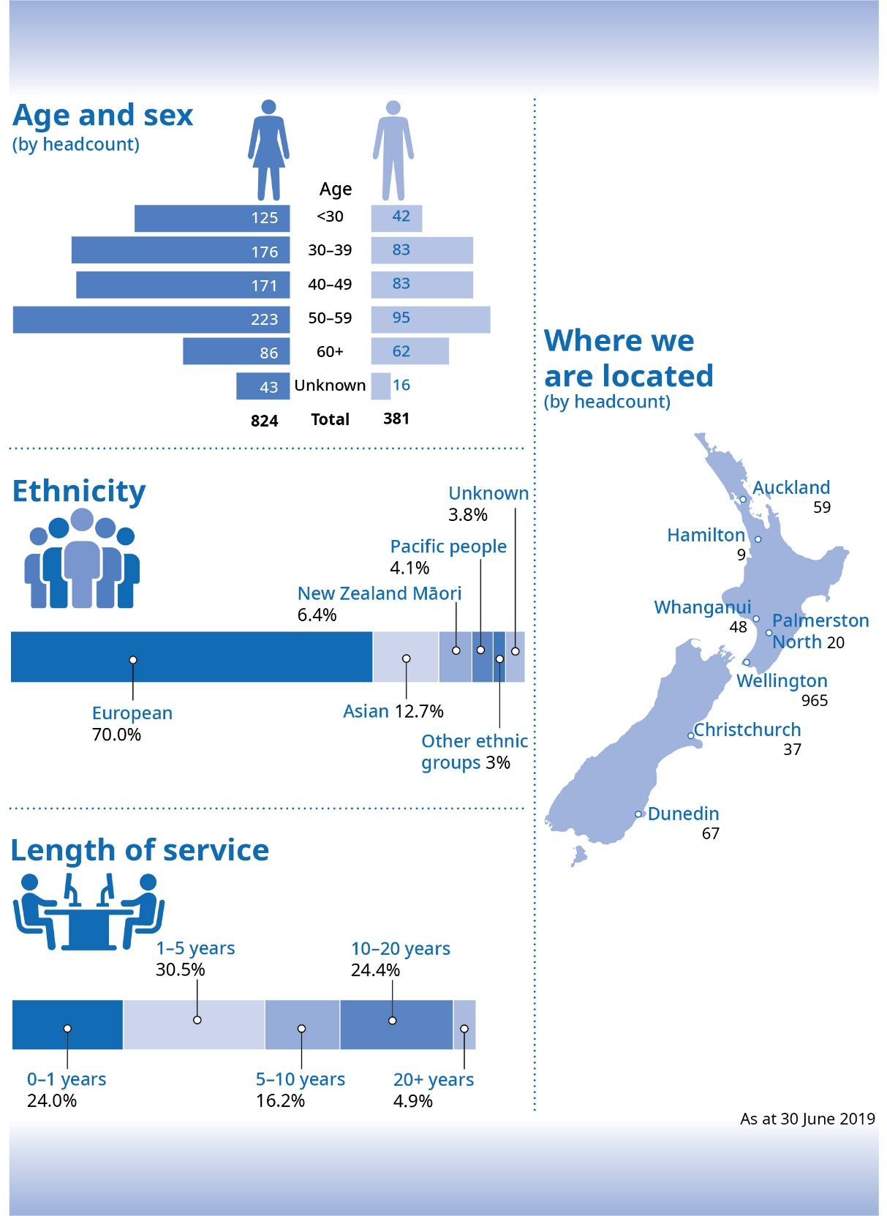

Changes to our leadership
During the year, we began a review of our organisational structure. Phase 1 of the change programme reviewed how the Ministry of Health should be organised to achieve the Government’s priorities and to be an effective leader and kaitiaki of the health and disability system. We changed our directorate structure, which led to changes to the second tier of our Executive Leadership Team.
Phase 2 of the change programme was announced in June 2019. It looks at how each directorate is organised and what capabilities are needed to deliver the Government’s priorities and our new organisational strategy. This phase will be implemented on 1 October 2019.

Making the Ministry a great place to work
We want the Ministry to be a great place to work. We are committed to providing a work environment that has a strong and positive culture, where people are valued and can succeed.
The Ministry’s People Plan sets out a programme for building an engaging culture, developing staff capability in the areas where we need it and building great leadership. It also outlines a continuous improvement programme for our people processes.
Many of the initiatives within the People Plan support the delivery of the Capability Uplift Programme. The Capability Uplift Programme was developed to respond to the recommendations of the Ministry’s 2017 Performance Improvement Framework review. The initiatives also enable us to align our people practices with the state sector workforce priorities, including the Public Sector Leadership Success Profile, and commitments to gender diversity and eliminating the gender pay gap.
During 2018/19, we developed and launched initiatives to enhance the experience of Ministry staff. We are putting the right support, teams, processes and systems in place for our people to grow and develop and to make the Ministry an even better place to work.

Building our leadership capability
We have developed a Leadership Framework that outlines how we will build leadership and management capability over the next three years. This work aligns with the public service leadership and talent programme led by the State Services Commission.
The framework reflects our commitment to building leadership capability at all levels, from emerging leaders to executive level. It sets out how we will strengthen our leadership by:
- enhancing the recruitment and selection process for leaders
- developing leadership and management capability at all levels within our organisation
- recognising and managing leadership talent
- undertaking succession planning
- rewarding and recognising great leadership capability.
This year, our focus has been on implementing the ‘year one’ deliverables in the framework and setting the foundations for great leadership. We have:
- introduced a new coaching and situational leadership programme for managers
- redesigned and implemented a new emerging leaders’ programme
- established a new leadership award
- enhanced the recruitment and selection process for managers as part of our change programme.
- begun to develop a new manager induction programme and toolkit.

Supporting the wellbeing of our people
To help our people to feel supported and empowered to achieve their optimum health and wellbeing, the Ministry developed a Wellbeing Roadmap this year. It sets out a three-year plan for supporting and championing staff wellbeing.
The Māori health model, Te Whare Tapa Whā, has underpinned our wellbeing approach. It includes providing the support, tools and programmes for staff to achieve their best possible:
- taha whānau – family and community health
- taha wairua – spiritual health
- taha tinana – physical health
- taha hinengaro – mental health.
A Wellbeing Calendar accompanies the Wellbeing Roadmap. It includes key wellbeing events that the Ministry will support and promote during the year, such as Mental Health Awareness Week, Matariki and Pink Shirt Day.

Supporting our people to succeed
We want everyone who joins the Ministry of Health to know how they can be successful in their new role. This year we implemented a new induction programme, as well as introducing an induction journal to support our new people through their first three months with the Ministry.
We also upgraded the health sector learning management system, LearnOnline. The website, which the Ministry maintains, provides free professional education and training for health professionals in New Zealand, including our people.

Building capability to engage meaningfully with Māori
Over the past year, we have implemented initiatives to build the cultural competency and capability of Ministry staff to engage with Māori, in line with our Tikanga Framework. These initiatives include:
- piloting and then implementing a permanent te reo Māori programme, which has been popular with staff across the Ministry
- making Māori cultural awareness a key component of the Ministry’s Orientation Day and induction programme
- running events that promote Matariki and Te Wiki o te Reo Māori (Māori Language Week).
While these initiatives have started to establish baseline cultural competency, we recognise the need to build that competency to more advanced levels. The Ministry’s new organisational strategy makes clear our ambition to build capability to engage meaningfully with Māori over the next five years. We will align our activity to the Te Ao Māori capability framework and the Takapau Wharanui Māori as Leadership in Practice Profile, which are both currently being developed for the public sector.

Diversity and inclusion
This year, the Ministry finalised and implemented its Diversity and Inclusion Strategy. We are committed to promoting a culture in which all people, whatever their gender, ethnic or social background, sexual orientation or role, are valued and treated equitably and with respect. We want our people to feel comfortable to be themselves at work.
An inclusive culture is fundamental to ensuring our diverse workforce can develop and thrive. As part of our commitment to being a good employer, we promote equal employment opportunities through our practices for recruiting, developing, managing and retaining our people.
February saw the launch of the Ministry of Health’s Gender Pay Action Plan. This plan reflects the Gender Pay Principles for the state sector and responds to the Eliminating the Public Service Gender Pay Gap 2018–2020 Action Plan.
The following month, on International Women’s Day, the Ministry launched an employee-led Women’s Network. The network is part of the Government Women’s Network and is a platform to encourage women in the Ministry to achieve their potential.
We have also made progress on eliminating the gender pay gap. As at June 2019, our gender pay gap is 11.3%, a decrease from 15.8% in June 2018. This is pleasing progress and we remain committed to eliminating the gap altogether. The Ministry’s gender pay gap is restricted to just a few roles, which we intend to address through our 2019 remuneration review process and careful choices of new appointments. We have also piloted Unconscious Bias training workshops, which we will roll out to all hiring managers by the end of 2019.
This year, the Ministry signed a membership agreement with Access Advisors to become a member of The Accessibility Tick Programme. Access Advisors is an initiative of the Royal New Zealand Foundation of the Blind who partner with other organisations across the disability sector to provide pan-disability expertise. Making a workplace accessible benefits everyone. We know that a diverse and inclusive workplace brings out the best in our people and helps us to provide better products and services. An organisation we are committed to providing secure, accessible products and services that are relevant to how people live and work in both the physical and digital worlds.
We are also working towards the Government’s goal that by 2020, all agencies will be flexible-by-default. This means we are enabling more flexible working options (such as working from home, activity-based working and reduced or compressed working hours) to become standard practice across the Ministry.

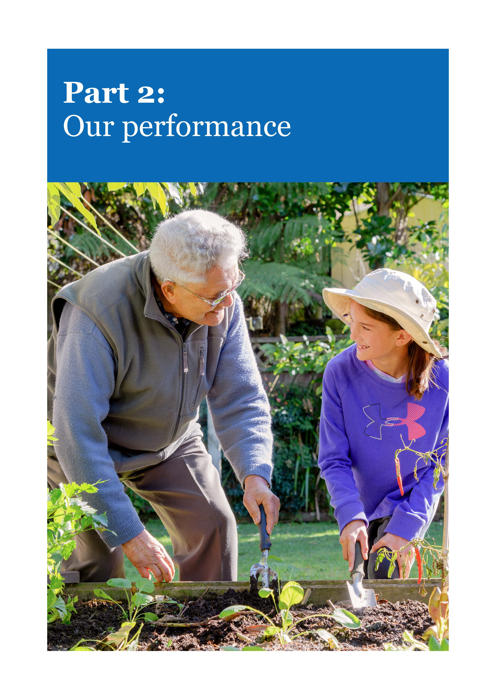
Part 2:
Our performance

Our strategic priorities
The Ministry identified five strategic priorities in our Statement of Strategic Intentions 2017/18–2020/21. This part tells the story of how we delivered initiatives to advance these priorities in 2018/19. Many of these initiatives have had input from across the Ministry and across the system and take an intergenerational approach to improving equity and health and disability outcomes for people in New Zealand.



Strategic priority 1: Improve health outcomes for population groups – with a focus on Māori and Pacific peoples, older people and children
The health and disability system is serving most New Zealanders well. However, some population groups experience poorer health outcomes than others. A major priority of the Government is achieving equitable health outcomes for all New Zealanders, particularly for Māori and Pacific peoples, and those living in low socioeconomic communities. Our goal is to enable the health and disability system to deliver the same health outcomes for everyone, so that they can reach their full health potential, no matter what their personal circumstances are.
This year we continued to collaborate with our partners in the health and disability system as well as the wider public sector to improve the equity of health outcomes for New Zealanders. This work focused particularly on Māori and Pacific peoples, older people and children.

Achieving Equity Programme
The Ministry’s Achieving Equity Programme aims to improve equity by making a cultural shift in how the health and disability system works together with communities and organisations around Aotearoa New Zealand.
A central goal of this programme is to prompt discussion about what equity means and how it can be measured. Having a common understanding of equity provides an essential foundation for a coordinated response across the health and disability system as well as with other government agencies whose work influences the broader social and economic determinants of health. In February 2019, we agreed on the following definition of equity:
The ‘No credit, no worries’ pilot ran from 1 May to 31 July 2019 this year to improve equity by enabling people to access online health resources without using mobile data. It recognised that, while over 85 per cent of Kiwis have access to a smartphone, not everyone has credit on their phone. It was a joint initiative with the Health Promotion Agency and WellSouth Primary Health Network.
The pilot’s goal was to make health more equitable by reducing the costs that prevent some people from accessing the health information they need through the internet. During the pilot, a selection of New Zealand’s most popular health and wellbeing websites had a ‘zero rating’ for data. This included important websites about mental health such as depression.org.nz and choicenotchance.org.nz. This pilot complements other initiatives to improve access to health care by reducing financial barriers that prevent some people from visiting health services.
We will analyse the data and information from the pilot to better understand the benefits of providing zero-rating access to online health resources and how a permanent zero-rating programme could be made available throughout New Zealand.

In Aotearoa New Zealand, people have differences in health that are not only avoidable but unfair and unjust. Equity recognises different people with different levels of advantage require different approaches and resources to get equitable health outcomes.
Engaging with our stakeholders, we developed a strategic framework and guidance to support DHBs with annual planning and started to build an understanding of equity through smart data, analytics and rich insight. We also published Achieving Equity in Health Outcomes: Highlights of selected papers to provoke thought, and prompt discussion, about equity in New Zealand by tracing the beginnings of health equity and the philosophical and ethical foundations that underpin it.
During 2018/19, we completed the discovery phase of our programme. We delivered a report exploring the common challenges, as well as the opportunities for the system to improve health equity across Aotearoa New Zealand.

Improving health outcomes for Māori and Pacific peoples
Health and wellbeing statistics show Māori and Pacific population groups generally experience poorer outcomes than other ethnicities. Being able to access high-quality health services can be a challenge for some Māori and Pacific peoples and people in low socioeconomic communities.
The Ministry has taken a number of approaches to improve health outcomes for Māori and Pacific peoples.

Building the Māori and Pacific health workforce through investment and innovation – a multi-pronged approach
To improve health outcomes for Māori and Pacific peoples, we want to build a stronger Māori and Pacific workforce within the health and disability system.
By investing in scholarships the Ministry has helped 788 students with whakapapa and/or cultural links with te ao Māori or Pacific descent who have a commitment to and/or competence in health and wellbeing studies to undertake an accredited course or health care worker training.
Another way the Ministry supports the Māori and Pacific workforce is through the Māori and Pacific provider and innovation funds.
Our Te Ao Auahatanga Māori (Māori Innovation Fund) supports Māori health providers to design, develop, deliver, evaluate and share innovative ways to improve service delivery and achieve key objectives. This investment supports providers to grow and develop their initiatives over several years. We manage an investment portfolio of up to $20 million over a four-year cycle and this year obtained an additional $4 million to invest over 2019–2022. In 2018/19, we supported six Te Ruinga (spreading) programmes and agreed a further 18 new Te Kakano (seedling) contracts.
An overarching initiative we are working on with the Institute for Health Metrics and Evaluation is to include Māori and non-Māori estimates in the upcoming Global Burden of Disease study. This will be the first time that ethnicity has been included in this study for subnational estimates. The results will inform our future planning for improving outcomes for Māori and other population groups.
We also support Māori health providers through the Māori Provider Development Scheme, which is a contestable fund aimed at building providers’ capacity and capability. During 2018/19, we received 98 applications. Following discussion with the relevant district health boards, we expect contracts for approved projects to be in place by the end of September.
Our Pacific Innovation Fund invests in Pacific health and Pacific community providers to trial new initiatives that demonstrate innovation through new strategies, models and methods of service delivery. The fund has a budget of $4.5 million for 2018/19 through to 2020/21. It currently supports 11 different innovative services.
Through our Pacific Provider Fund, the Ministry helps to strengthen the capability of Pacific health providers to deliver high quality health services with a distinctive Pacific focus and achieve the best health outcomes for Pacific peoples. Administered through regional Collectives, this year the fund went to 28 Pacific health providers to improve their services.

New Pacific Health and Disability Action Plan
In 2018/19, we started work on a new Pacific Health and Disability Action Plan to replace ‘Ala Mo’ui: Pathways to Pacific Health and Wellbeing 2014–2018. Taking a prevention approach, the plan will focus on important determinants of health for Pacific peoples, including education, housing, income and employment, and culture. Initial public engagement on this cross-agency plan was undertaken during the year, and we will be finalising the plan through Cabinet later in 2019.

Pacific Investment Plan
The Ministry is developing a Pacific Investment Plan which will outline and guide the current and future investment in Pacific health initiatives. This plan will ensure that
investment and resources in the form of workforce (their skills and expertise), leadership and intellectual capital forms part of the wider investment strategy.

Resetting Crown–Māori relationships in health
The Ministry is committed to improving Crown–Māori relationships. In 2018/19, we became a party to and signed Te Hiku o te Ika Iwi – Crown Social Accord. As a result, we have become part of a renewed cross-government partnership to improve the social development and wellbeing of whānau, hapū and iwi in the Far North. Signing the Accord is an opportunity to develop the ways we work as a Crown agency with iwi, in a way that is consistent with Treaty of Waitangi principles. We have a work programme under way that will provide a model for future engagement with iwi.
We also worked with the Office for Māori Crown Relations – Te Arawhiti to develop health-related relationship agreements with various iwi post-settlement governance entities and the relevant DHBs.

WAI 2575 Health Services and Outcomes Kaupapa Inquiry
The Waitangi Tribunal (the Tribunal) is undertaking a Health Services and Outcomes Kaupapa Inquiry, known as Wai 2575, to investigate issues of national significance relating to health services and outcomes for Māori. The intention is to conduct the inquiry in three stages.
- Stage One is a targeted inquiry into the legislative and policy framework of the primary health care system.
- Stage Two will investigate themes of national significance relating to mental health (including suicide and self-harm), Māori with disabilities, and alcohol and substance abuse (including tobacco).
- Stage Three will investigate the remaining nationally significant health issues and eligible historical claims.
We are leading the submission to the Tribunal, providing information and support and addressing findings as appropriate. For a discussion of our achievements in Stage One, see Strategic priority 2.

Improving health outcomes for older people
Most older New Zealanders want to live independently in their own homes and communities, with access to high-quality health care services. Taking a wellbeing approach, we want to enable them to lead the lives they aspire to; we also want to reduce the proportion of New Zealanders requiring residential care and the rate of acute hospital admissions. We are working on several initiatives, in partnership with others, to deliver better outcomes for older people.

Healthy Ageing Strategy – Implementation plan
As part of the Healthy Ageing Strategy, released in 2016, we developed an implementation plan that identifies how we can improve the health and wellbeing of older people over a period of 10 years. Working with our partners in the health and disability system, this year we reviewed our progress against the strategy’s first implementation plan and carried out workshops, fono and hui to help develop the next phase of the implementation plan.

Home and community support – future models of caring
Partnering with DHBs and engaging with stakeholders in the health and social sectors, we developed a national framework to guide how home and support services for older New Zealanders are commissioned and developed in the future. The framework, which is a priority within the Healthy Ageing Strategy, will make service and resource allocation for home and community support more consistent and transparent. Our DHB partners will be implementing the framework from July 2019.

Aged residential care – funding model review
The aged care residential sector cares for around 32,000 older people. During 2018/19, we commissioned a review, working with DHBs and aged residential care providers, to look at the residential care funding model. The review will improve our understanding of how to make best use of the funding to provide resident-centred care, make these facilities fiscally sustainable and improve equity of access to them.

Improving child and youth wellbeing, including health outcomes for children
New Zealand’s universal health services – including maternity services, the Well Child / Tamariki Ora programme, community health and immunisation programmes and the B4 School Checks – provide care for all children from birth to five years old. However, some New Zealand children are still missing out. The Ministry working alongside our partners in the health and disability system and other government and non-governmental organisations to remove barriers to access and find solutions so that all children have equitable health and wellbeing.

Contributing to the development of New Zealand’s first Child and Youth Wellbeing Strategy
The time of life between pre-conception and when a child turns five years old, especially the first three years, is crucial for healthy brain development and lifelong physical and mental health.

As part of the development of the Government’s Child and Youth Wellbeing Strategy, the Ministry was asked to lead the following two priority areas:
- children experience optimal development in their ‘first 1,000 days’, which involves safe and positive pregnancy, birth and parenting (from conception to around two years of age).
Children and young people with a high level of wellbeing have:
- good physical and mental health
- intact and well-functioning language and cognition
- an age-appropriate set of social and emotional skills
- friendships and social connections
- a robust cultural and self-identity (which differs between individuals).
Important features of the context in which a child with a high level of wellbeing lives are that it is a:
- supportive, loving family environment
- safe and healthy community.
- FN Chief Science Advisors report to the Prime Minister regarding Child and Youth Wellbeing

- the mental wellbeing of children and young people is supported.
- During 2018/19, we worked closely with the Department of Prime Minister and Cabinet (DPMC) on these priority areas and established the Health Leaders Advisory Group on Child Wellbeing. The Advisory Group, made up of DHB chief executives, Ministry of Health executives and clinical leaders, provided the DPMC with clinical expertise on what children, young people and their families and whānau need to gain the best possible start in life.
- Through strengthened partnerships with DHBs, we collectively contributed to the development of the Child and Youth Wellbeing Strategy and its supporting framework. First, we held a series of 10 national hui to discuss and share thoughts on the most significant barriers to and ways of advancing child and youth wellbeing. These hui also generated ideas and feedback on possible outcomes and focus areas to support DPMC in drafting the Child and Youth Wellbeing Strategy, as well as strengthening understanding of the key role that the health and disability system plays in improving wellbeing.
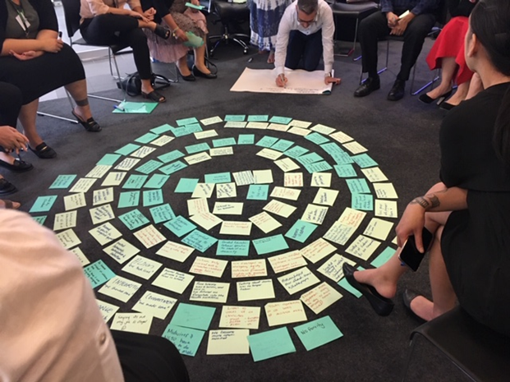
Second, we worked with other agencies (including the Ministries of Education and Social Development, Oranga Tamariki and the Social Investment Agency) on what the first 1,000 days of life look like now and in the future and what good mental wellbeing is for children and youth. This ongoing work is creating a common understanding across government about what is needed to improve wellbeing in the early years, with a lifelong benefit to children and their families and whānau.

Well Child / Tamariki Ora review
The Well Child / Tamariki Ora programme is responsible for protecting and improving the health and wellbeing of children from birth to five years old. To achieve this aim, it is essential to ensure at-risk children and their families and whānau are accessing and using the programme. The service carries out health and development screening and surveillance, family and whānau care and support, and health education. Well Child / Tamariki Ora also provides children with access to hearing and vision screening and surveillance, and referral for further assessment and treatment or intervention services where they are required.
In 2018/19, we started our cross-agency review of the service and generated interim advice on how it might be changed, as part of a broader work programme on child and youth wellbeing. To better understand how to improve the service in the future, we are seeking the views of the health sector and the public. We are also linking up our work with other current related projects, such as the development of the Child and Youth Wellbeing Strategy, the Wai 2575 inquiry and the review of the health and disability system.
While the overall number of SUDI deaths in New Zealand is small, the rates do tend to fluctuate annually. Overall infant mortality rates declined from 2009–2015. Trend data indicates that rates have decreased for Māori and the ‘other’ ethnic group, but increased for Pacific peoples and Asians.

National sudden unexpected death in infancy programme

Over the year, we published two new guidelines to help families, whānau, people working in health and social services, and health professionals to better protect babies from sudden unexpected death in infancy (SUDI). The National Safe Sleep Device Quality Specification Guidelines offers advice on what to look for in a safe sleep device, such as a wahakura or a Pēpi-Pod. It also provides information on how to use each device safely. Our National SUDI Prevention Programme: Needs assessment and care planning guide offers recommended strategies and advice for protecting babies from SUDI. These guidelines are part of a range of measures we use to help combat SUDI.

Fetal Alcohol Spectrum Disorder Action Plan
Drinking during pregnancy can lead to fetal alcohol spectrum disorder (FASD), which includes a range of physical, cognitive, behavioural and neurodevelopmental disabilities. International studies suggest FASD may affect around 3% of births.
Working with other agencies (Ministry of Education, Oranga Tamariki and the Health Promotion Agency), the Ministry led the development of the FASD Action Plan, which focuses on preventing FASD and identifying and supporting people affected – families, whānau, parents and caregivers. The goals of the plan are both to prevent FASD and to enable people with FASD and their families and whānau to lead the best possible lives. The plan will be implemented over three years, during which we will work with Ministry for Primary Industries, Ministry of Justice, Department of Corrections and New Zealand Police. To support alcohol-free pregnancies as well as women who continue to drink while pregnant, two specific initiatives in the plan are the Health Promotion Agency’s ‘Don’t know? Don’t drink’ campaign, and the pregnancy and parenting pilot programmes of the Waitematā, Northland, Tairāwhiti and Hawke’s Bay DHBs.
To mark FASD Awareness Day 2018, we launched the FASD page on our website. This webpage updates families, whānau and caregivers on the progress we are making in implementing the FASD Action Plan. We also hosted a cross-agency seminar with parents and caregivers to highlight challenges and best practice in working with families that include young people.

Whole-of-maternity system action plan
Working with the maternity sector, we developed a whole-of-maternity system action plan to provide more equitable access to services and help make a more sustainable system by addressing workforce pressures. The action plan is intended to transform our national maternity services over the next five years. Some key aspects of the plan are already progressing. The Ministry is engaging further with other agencies and the public to continue to improve future maternity services.
During 2018/19, we signed the Midwifery Accord, alongside the Midwifery Employee Representation and Advisory Service, the New Zealand Nurses Organisation and DHBs, to ensure midwives, mothers, and babies are safe. This accord affirms how we will work together to implement the Care Capacity Demand Management programme, which includes a tool to help our hospitals to plan and roster the appropriate number and skill mix of nurses and midwives to meet demand. The Midwifery Accord provides a strong foundation for us to continue to work closely together and ensure services are sustainable.



Strategic priority 2: Improve access to, and the efficacy of, health services for New Zealanders – with a focus on mental health and addictions, primary care, disability support services, and bowel cancer
New Zealanders receive a range of health services throughout their lives. While most people today are able to access more services than in the past and the quality of services has improved, certain groups experience greater barriers to access, particularly those living in lower socioeconomic communities.
Through our work with our health and disability system partners, we have made progress in improving access and helping to achieve more equitable health outcomes. We are focused on building a stronger health and disability system that improves outcomes for all New Zealanders through targeted early intervention and support.

Mental health and addictions

He Ara Oranga – the Government’s Inquiry into Mental Health and Addiction and implementing the Government’s response
The report of the Inquiry into Mental Health and Addiction, He Ara Oranga, released in December 2018, recommends a system-wide transformation of New Zealand’s approach to mental health and addiction to achieve ‘mental wellbeing for all’. It sets out a vision of a flourishing New Zealand where everyone can achieve mental wellbeing, and outcomes are equitable across the whole of society. The report recommends taking a people-centric approach to mental wellbeing and includes 40 recommendations for change.
The Ministry is leading work across government agencies to implement the Government’s response to He Ara Oranga. We work in partnership with Māori, people with lived experience, non-governmental organisations, primary and community health care organisations, and other stakeholders to build a whole-of-system, integrated approach to mental health, addiction and wellbeing that provides for New Zealanders across the full continuum of need. We established the Māori mental health and addiction group (Mātanga Mauri Ora) to support our response and incorporate the views and aspirations of Māori tāngata whaiora, their whānau and organisations that provide Māori mental health and addiction services.
Our initial focus this year has been on three priorities: completing a suicide prevention strategy and action plan; reforming the Mental Health (Compulsory Assessment and Treatment) Act 1992; and re-establishing a Mental Health and Wellbeing Commission. We have phased the work to implement these initiatives, as well as to address the 40 recommendations, over the next few years.
Piki Mental Health Pilot
Many young New Zealanders experience mental distress. Research has shown three-quarters of all lifelong mental illness is developed by the time someone reaches 24 years of age. By intervening early to support good mental health and wellbeing, we can help prevent small problems from becoming major issues.
In 2018/19, the Ministry supported the Piki Mental Health pilot to deliver integrated therapies for young people aged 18 to 25 years. Piki’s vision is to enhance young people’s quality of life by equipping them with tools to overcome adversity and strengthen their wellbeing.
Where young people in this age group are experiencing mental distress, Piki offers: free and easy access to talking therapy at a convenient place and time; an emotional wellness app that helps young people access support and track their progress; and links to 24/7 support through phone and web services and trained peer support coaches. Piki was co-designed with young people who have lived experience of mental distress and is delivered in partnership with several organisations.
The Piki programme, led by Tū Ora Compass Health, will run for three years with a phased service expansion. Starting in Porirua City, it will expand to cover Capital & Coast DHB in May 2019 and then Hutt Valley and Wairarapa DHBs in the 2019/20 year.

‘We know life can sometimes be tough for our young people and many face mental distress. Piki delivers free access to counselling services and other mental health support that can make a real difference.’ - Hon Dr David Clark, Minister of Health

Our Psychosocial Recovery Plan in response to the Christchurch mosque attacks
We are working on the Mana Ake – Stronger for tomorrow programme with Canterbury DHB and the Ministry of Education and through the Canterbury Clinical Network.
From its beginnings in April 2018, this three-year, $28 million programme has focused on supporting the wellbeing and positive mental health of children who have been impacted by earthquakes.
Over this year, the programme rolled out support to all primary and intermediate school-aged children across greater Christchurch, Hurunui and Kaikōura.
The Ministry is responsible for coordinating the provision of psychosocial support for New Zealand for events like the Christchurch mosque attacks. New Zealand communities are exposed to a broad range of hazards that may harm people and damage social, economic, cultural and natural environments. Our primary objectives for psychosocial recovery are to minimise the physical, psychological and social consequences of an emergency and to enhance the emotional, social and physical wellbeing of individuals, families, whānau and communities.
In response to the Christchurch mosque attacks, our people worked closely with the team at Canterbury DHB, as well as with other government and non-governmental organisations, to look after the victims’ immediate and longer-term needs. The ‘1737’ service from within our National Telehealth Services played a big part in the response, providing people with access to free support from a trained counsellor 24/7. We are also developing a Psychosocial Recovery Plan to guide the longer-term response and recovery actions through to 2020. The recovery plan is a living document that we will continue to review and develop as the longer-term impacts of the attacks become clearer.

Primary health care services
Primary health care is the first point of contact for most people seeking health services and is the main way that they gain access to wider community and secondary services. Good-quality, affordable primary health care is an integral part of our health system. International research has found systems that prioritise primary health care have better health outcomes, lower per-capita costs and lower rates of premature mortality. A strong primary health care sector can reduce overall demand on health services by treating health problems before they escalate, as well as improving coordination and access to our wider health and disability system.

Reducing cost barriers to primary care
Increasing equity of access to primary health care services is a Ministry priority. We are implementing new initiatives to reduce cost barriers and promote the importance and benefits of enrolment in a general practice.
A notable success in 2018/19 came through working with our DHBs, primary care sector (primary health organisations, general practice and DHBs) and other government agency partners (Accident Compensation Corporation and Ministry of Social Development) to implement the lower cost general practice visits introduced in Budget 2018. This initiative to improve access to primary care involved two groups: Community Services Card (CSC) holders and 13-year-olds.
This collaboration with our partners produced a system change. From 1 December 2018, the cost of a general practice visit was reduced by an average of $20–$30 for about 540,000 more people with a CSC. This means that about 96% of people who have a CSC and are enrolled with a general practice now pay less than $20 for a standard visit to see a doctor or nurse – as do their dependants aged 14 to 17 years.
As at 1 June 2019:
- 90% of non-Very Low Cost Access (VLCA) practices had joined the CSC scheme for lower cost general practice visits and now offer low-cost standard consultations to CSC holders and their dependants
- about 96% of people with a CSC (and their dependants) who are enrolled at a general practice now benefit from paying a low consultation fee with a doctor or nurse
- about 98% of Māori and Pacific peoples who are CSC holders are enrolled with a practice that offers lower cost fees.
The lower cost general practice visits for CSC holders has been very successful. The combined result of these changes is that, as at June 2019, almost 2.5 million people have access to zero fees or low cost services, through either the Very Low Cost Access (VLCA), Community Services Card (CSC) or zero fees schemes. This represents around 54% of the total enrolled population.
Also from 1 December 2018, an estimated 56,000 more 13-year-olds became eligible for zero fees visits with their doctor or nurse. More than 99% of general practices across Aotearoa New Zealand took up this scheme.

Wai 2575 –the Health Services and Outcomes Kaupapa Inquiry – Stage One primary care
Over the past year, we led the Crown response to Stage One of Wai 2575 – the Health Services and Outcomes Kaupapa Inquiry. Stage One is a targeted inquiry into the legislative and policy framework of the primary health care system. It investigates two claims: one from a group of Māori primary health organisations and providers; and the other from the National Hauora Coalition.
The Stage One hearings concluded in 2018 and the Crown provided its closing submissions in early 2019. Following the Tribunal’s recent release of its report on Stage One, we will be carefully reviewing the findings and recommendations to inform future policy development. The Tribunal has acknowledged the cooperative approach that the Crown and Ministry have taken in this inquiry to date.
Mana Whaikaha Case Study:
George phoned Mana Whaikaha asking for a Connector as he felt he no longer required Supported Living in his life. After an initial meeting with a Connector he was able to ask his provider to reduce all his formal supports, except for a couple of hours monthly as a safeguard.
George is now being supported informally by an uncle to oversee his finances. This has led to him gaining greater confidence and competence around finances. He is now able to manage a small budget confidently on his own.
He lives independently in a rented flat and takes care of all his home management, shopping and activities he enjoys. George is extremely proud of his recent strive towards independence.

Transformation of the disability support system – Mana Whaikaha

We are transforming the disability support system to improve the wellbeing of disabled people and their families and whānau by providing them with more options and decision-making authority about how they want to live, what support they receive and how to improve their outcomes. We are also aiming to create a more cost-effective and sustainable disability support system.
In October 2018, we launched the prototype to transform the disability support system, the Mana Whaikaha (Enabling Good Lives) programme, in the MidCentral DHB region. Mana Whaikaha was co-designed with the disability community.
More than 900 people have engaged with the prototype, which represents approximately one-third of the people currently supported by disability support services in this region. Around 740 of these people are working with a Connector, who supports them to build relationships, self-determination and ordinary life outcomes.
Mana Whaikaha is reaching people who may not have engaged with disability supports before, including 198 disabled people who have not been known previously to any Needs Assessment and Service Coordination provider. Of these people, 136 were children and young people aged 21 years and under.
Through Mana Whaikaha, around 540 funding decisions have been made and about 320 disabled people and their families and whānau have been allocated a personal and flexible budget that they can use.
The following are the key features of this prototype:
- Disabled people and their families and whānau are involved in designing, implementing, evaluating and contributing to the governance of the prototype.
- They have access to a Connector, who can walk alongside them to help them identify what they want in their life, how to build that life, and the range of supports available (universal, community based, paid and unpaid) to lead that life.
- The funding system is easy to use with flexibility around purchases and an easy way of reporting on how funding has been used. A capability fund supports groups of disabled people, family and whānau to build their skills and capacity to make the most of opportunities of the transformed disability support system.
- Support is integrated across government agencies. Government liaisons work in the background to support access to other government services (eg, benefit applications) and to build positive relationships with other parts of government (eg, learning support in school).
- Providers have greater flexibility through having flexible disability support contracts.
Our evaluation of the prototype compares the experience of disabled people and their families and whānau in the previous system with their experience in Mana Whaikaha. It is a try, learn and adjust approach. The governance group for the pilot will provide recommendations on process adjustments or improvements needed in the current system. Over the 2018/19, work has continued on the policy work programme agreed by Cabinet to support any nationwide transformation of the disability support system.

Bowel cancer rates
New Zealand has one of the highest rates of bowel cancer in the world, and evidence shows that early detection improves outcomes significantly. The primary objective of bowel screening is to reduce the mortality rate from bowel cancer by diagnosing and treating bowel cancer at an early, curable stage. Screening can also identify precancerous advanced adenomas, which can be removed before they become cancerous. Other advantages of diagnosing cancer at an earlier stage is that treatment is easier and costs less than the treatment of more advanced cancer. Over time, screening and early diagnosis reduces bowel cancer incidence and contributes to a more sustainable health system.
The National Bowel Screening Programme is being implemented in phases across New Zealand and will be fully rolled out by 30 June 2021. During 2018/19, we began screening in Nelson Marlborough, Hawke’s Bay and Lakes DHB districts. The programme will be rolled out in Whanganui and MidCentral DHBs in late 2019 and then in Auckland, Canterbury, Capital & Coast, South Canterbury and Tairāwhiti DHBs in the first half of 2020. Once fully implemented, it will have an eligible population of around 700,000 men and women aged 60–74 years, who will be invited for free bowel cancer screening every two-years.
Working with the National Bowel Cancer Working Group, we also released the Bowel Cancer Quality Improvement Report in 2018/19. The goal of this report is to support more equitable outcomes in the treatment of bowel cancer for all New Zealanders, and particularly for those known to have poorer health outcomes. The report will help drive improvement in cancer care and treatment and improve outcomes for people with bowel cancer in New Zealand, no matter where they live.

Other initiatives in 2018/19 to improve access to and the efficacy of health services
Responding to stakeholder feedback, we launched a new approach to Planned Care Services (previously called Elective Services). Working with our partners in the health and disability system, we started work to look at changes to the strategic direction, how we set expectations for providers, the funding model, and how we will measure performance.

Organ donation agency
It is positive to see increased rates of organ donation (deceased) in New Zealand since 2013. However, while the number of New Zealanders benefiting from a transplant has increased, the number of people with chronic organ failure also continues to increase, which adds pressure to the demand for transplants. New Zealand rates of organ donation remain comparatively low by international standards and we need to encourage more New Zealanders to donate organs.
Organ transplantation is an effective treatment that extends the length of life and improves its quality for people who live with the disability of life-threatening organ failure. The number of transplants undertaken in New Zealand is limited by the number of donated organs available.
In response to our published strategy Increasing Deceased Organ Donation and Transplantation: A National Strategy 2017, the New Zealand Blood Service will add to its functions the role of being the national agency for organ donation. We are working to enable it to do so through the Organ Donation and Related Matters Bill, which was introduced into Parliament in March 2019. Under this legislation, the national agency will be able to start this role in July 2020. We are working with the New Zealand Blood Service and Auckland DHB to prepare for and implement the proposed changes
Flu tracking
Each year, 10–20% of the population will become infected with influenza (more commonly known as flu). To help us plan to manage the spread and severity of this illness, we launched a joint initiative for flu tracking with Hunter New England Health, New South Wales, Australia.
Figure 4 Influenza vaccinations
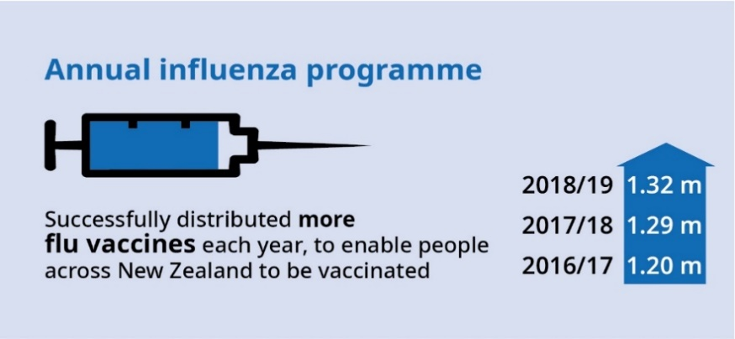
Volunteers register to answer a short survey on flu-related questions, which takes less than 10 seconds each week during flu season.
This information is used to map out the onset of flu by region and the severity of the flu season. We will be able to use this information to help prepare for our vaccination programme each year.


Strategic priority 3: Improve outcomes for New Zealanders with long-term conditions
Long-term conditions, including cancers and mental health conditions, cause an estimated 88% of health loss in New Zealand. They are major contributors to inequitable health outcomes, particularly for Māori, Pacific peoples and those living in low socioeconomic communities. The Ministry has been working on several programmes to address these conditions with our partners in the health and disability system. An indicator of the effectiveness of this work is that health loss from premature mortality and illness from long-term conditions has been steadily decreasing.
Long-term conditions can begin at any stage of life; their progress and prognosis then vary with each condition and person. An estimated 37-42% of health loss from long-term conditions in New Zealand is potentially preventable through reduction in risk factors; either by preventing the condition altogether (primary prevention) or by slowing its deterioration and impact on health (secondary prevention, which primary care services often provide). Primary prevention is the better option but, once diagnosed, people have better outcomes if their conditions are identified early and they manage them effectively. The Ministry and our partners play an important role in helping people to access the appropriate health services to identify and manage their condition, within the context of their family, whānau and community.

Prevention
We are strengthening our focus on the wider social factors that influence health and wellbeing through partnering with government and non-governmental organisations. In 2017, the Global Burden of Disease study has identified the six leading risk factors contributing to health loss for all people were tobacco use, dietary risks, overweight, high systolic blood pressure, high fasting blood glucose, and harmful alcohol use. Here we discuss the work we undertook over the last year to address these risk factors.

Tobacco
Smoking is a leading cause of health loss in New Zealand and contributes substantially to reversible health inequity, particularly for Māori. New Zealand has well-established tobacco control programmes. The priority audience is young Māori women, who have the highest rates of smoking.
In 2018/19, we began to consult on an action plan towards achieving New Zealand’s goal to be Smokefree in 2025.
Figure 5: Health loss due to tobacco use
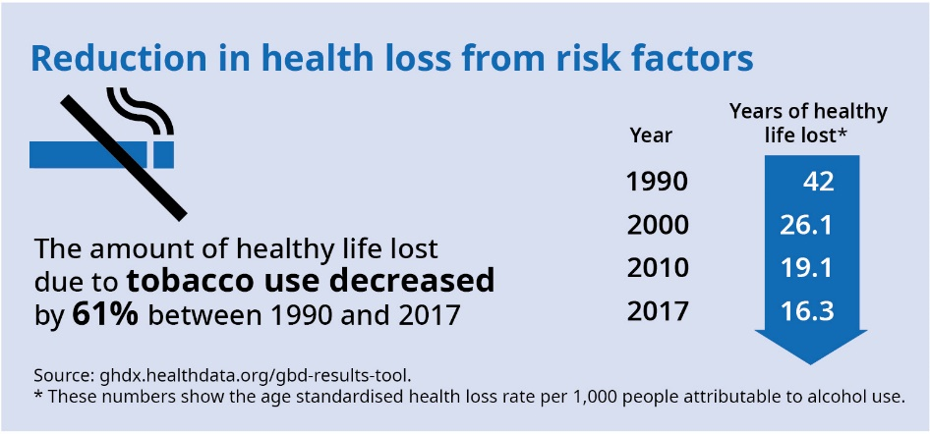
We also supported the Government’s decision to amend the Smoke-free Environments Act 1990. The amendment prohibits smoking in vehicles that are carrying children under the age of 18 years. This measure will reduce children’s exposure to second-hand smoke in motor vehicles. It is also expected to protect children from the risk of serious medical conditions associated with exposure to tobacco smoke.
Working alongside the Health Promotion Agency, we launched the Vaping Facts website. This website is for adults who smoke and their families and whānau, as well as for people with questions about what vaping is and how it is different from smoking. The site includes essential tips for quitting smoking, information on vaping safety, and links to local stop smoking services.
Supporting young Māori women to stop smoking
In 2017, we started to gather insights that will improve our understanding of why young Māori women aged 18–24 years start, continue and stop smoking. We shared the resulting insights with four Māori community providers, who delivered and tested four delivery models to help people stop smoking. New programmes were co-designed with young Māori woman to help meet their needs.
Our evaluation of these new programmes:
- showed how different holistic approaches enabled young Māori women to reduce smoking harm and improve their overall wellbeing – of the 54 women who participated in the services, 41 stopped or reduced smoking.
- gave us a better insight into common challenges providers face in reaching and engaging with young Māori women who smoke, as well as into the role of smoking in the lives of these women.
- showed that the success of the services has flow-on benefits in terms of reducing health costs and increasing wellbeing as the participants have greater confidence, more social connections, lower anxiety and depression, reduced alcohol and drug use, improved parenting skills, lower risks of domestic violence, less homelessness, and more engagement in education, training and employment.
Many of the women profiled in the evaluation say that being approached to take part in the programme was one of the best things that has happened to them.
Before the programme, I was always tired, I drank a lot, smoked a lot, I was broke, had no self-confidence or motivation and I was just unhealthy. Now that’s all changed. A while back, I was dead on the inside … now I see a future where I will stay alive and be happy.
Using these findings, and working with our partners in the health and disability system, we developed a set of guidelines to support stop smoking services for young Māori women. These guidelines will be trialled for three months by the providers who helped develop them, and then shared more widely based on feedback on what is working well.
New Zealand has the third- highest adult obesity rate in the Organisation for Economic Co-operation and Development, and its obesity rates are rising. The New Zealand Health Survey 2017/18 found that 32% (1.26 million adults) were obese, up from 28.6% in 2011/12. Children living in the most socioeconomically deprived neighbourhoods were 2.1 times more likely to be obese than children living in the least deprived neighbourhoods, after adjusting for age, sex and ethnic differences.

Improving healthy weight

Poor diet and being overweight are two of the top causes of health loss in New Zealand. The Global Burden of Disease 2016 study showed that having a high body mass index (being overweight or obese) accounted for about 8.9% of health loss in New Zealand. It also showed poor diet accounted for 8.6% of health loss. Poor diet and being overweight are major risk factors for developing many long-term conditions, including cardiovascular disease, type 2 diabetes and musculoskeletal conditions.
We take a whole-of-population approach to addressing obesity and healthy weight with a broad aim ‘to ensure that all New Zealanders are supported to eat well and be active for health and wellbeing’. The approach recognises the important role that prevention plays in wellbeing, and that children and young people are a priority population group in this work.
Our focus in the past year has been on creating supportive food and activity environments across a range of settings. We are continuing to disseminate recommendations from our publications, Clinical Guidelines for Weight Management in New Zealand Adults and Clinical Guidelines for Weight Management in Children and Young People. This includes recognising the role that sleep plays in weight management and monitoring weight regularly across the life course.

Healthy food environments
A key focus of our work this year has been to create supportive food environments across a range of settings so that healthy eating is the easy option. Our National Healthy Food and Drink Policy is all about DHBs and the Ministry leading by example to create healthier food environments within hospitals, our organisation and health care settings. We continued to implement our own healthy food policy within the Ministry and are encouraging other government agencies to also adopt a healthy food and drink policy.
We worked with the Ministry of Education and Sport New Zealand to promote and improve healthy eating and physical activity in schools, kura, early learning services and ngā kohanga reo. This collaboration resulted in the joint agency initiative, Budget 19 Healthy Active Learning. We will take this initiative forward through our work on policies for only healthy food, water and plain milk in educational settings so that children can learn good eating and drinking habits and bring those home to their families and whānau.
Figure 6: Health loss due to not eating enough vegetables
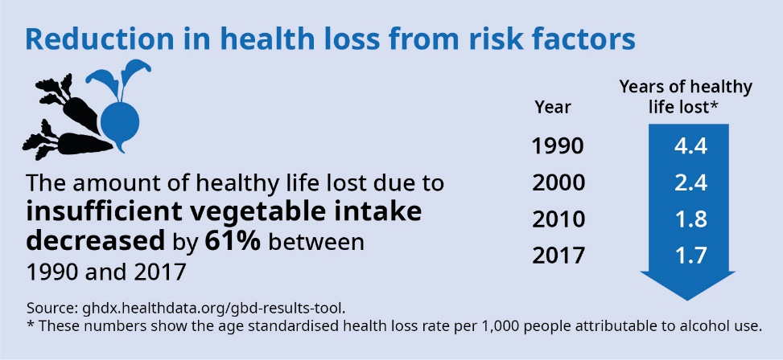
To further improve the food environment, we worked collaboratively with others – for example, the Ministry for Primary Industries – on labelling food, reviewing the Health Star Rating and fortifying folic acid.
A review of our Eating and Activity Guidelines for pregnancy and from birth to two years is also under way.

Avoiding harmful use of alcohol
New Zealand has a high level of acute alcohol-related harm, such as injuries, road trauma, crime and alcohol poisoning.
Alcohol consumption also contributes to more than 200 disease and injury conditions, including mental health conditions. For almost all conditions, heavier alcohol use increases the risk of disease. In preventing some conditions, such as fetal alcohol spectrum disorder and cancer, no ‘safe’ level of alcohol consumption has been identified.
Figure 7: Health loss due to alcohol use
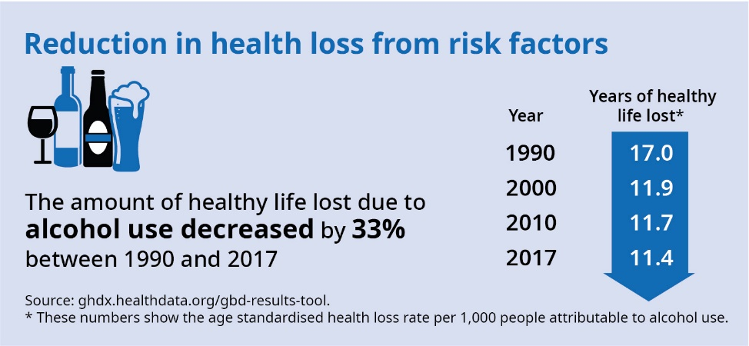

The National Drug Policy 2015 to 2020 sets out the approach to alcohol and other drug issues. The overarching goal is to minimise alcohol and other drug harm and promote and protect health and wellbeing. Over the year, we continued to work with the Health Promotion Agency, Ministries of Justice, Social Development and Education, the New Zealand Police, the Department of Corrections and the New Zealand Customs Service to raise awareness of the harm caused by alcohol.
About one in five New Zealand adults drinks alcohol in a way that could cause harm to themselves or others. Hazardous drinking rates are higher in men, young people aged 18–24 years, Māori adults and adults living in the most deprived areas.

Physical activity
Low physical activity has a negative impact on our overall health and wellbeing. In 2018/19, we worked with Sport New Zealand to initiate a cross-agency approach to increasing levels of physical activity as outlined in the World Health Organization Global Action Plan on Physical Activity.
Figure 8: Health loss due to low physical activity
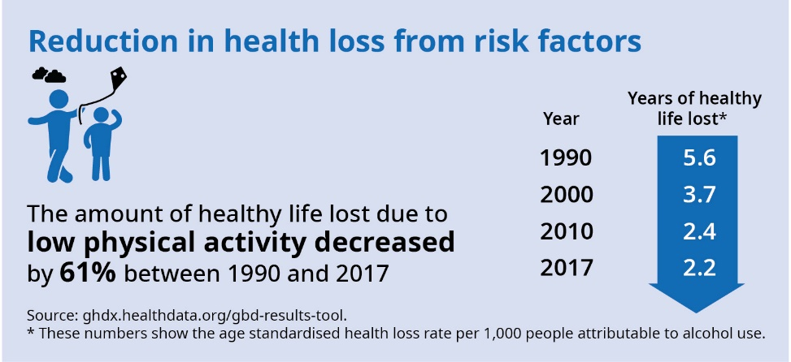

Healthy Families New Zealand
Healthy Families NZ is a large-scale initiative to prevent chronic disease that brings community leaders together in a united effort to improve health. It is a move away from disconnected, small-scale and time-limited projects and interventions, towards a whole-of-community approach that makes sustainable and long-term changes to the ‘systems’ that influence the health and wellbeing of individuals, families, whānau and communities. It is an example of how the Ministry works in creative partnership with communities.
In 2018/19, the Healthy Families NZ locations have continued to expand their work in settings where people live, learn, work and play.
- All locations have chosen to prioritise active transport as a key focus area throughout 2018/19 and beyond.
- The Healthy Families NZ Summative Evaluation Report (released in December 2018) highlights how the approach of Healthy Families NZ prioritises equity and achieving equitable health outcomes, particularly for Māori. Equity has been a guiding value in designing and implementing the initiative.
- Healthy Families NZ is working with Māori leaders at all levels to explore how the revitalisation of traditional Māori concepts can inspire new thinking and action. These leaders are working alongside their communities to influence action around kai (food) sovereignty and food insecurity, promoting the value of drinking wai (water) and integrating physical activity, digital technology and mātauranga Māori (Māori knowledge) to encourage whānau to move and play more often.
- The initiative is strengthening its focus on workplace wellbeing as an opportunity to make sustainable change in communities.

Preventing and managing cancer
Cancer is the leading cause of death in New Zealand, accounting for nearly one-third of all deaths. The impact of cancer in New Zealand, measured in terms of disability adjusted life years (DALYs) lost, is similar to comparable countries. In these countries, age-adjusted DALYs lost per 100,000 people is declining over time, largely because age-specific cancer mortality rates are falling. An estimated 40% of this health loss can be prevented.
Cancer cases will continue to increase, however, due to our growing and ageing populations. Outcomes for cancer vary within New Zealand. They are worse for Māori and most marginalised groups, such as Pacific peoples, people in rural and deprived areas, people with a mental illness and people with disabilities.
We are consulting on an Interim Cancer Action Plan 2019–2024 (Cancer Action Plan) that will provide a clear set of priorities and proposed actions to deliver better services to prevent and care for cancer in New Zealand. These actions will guide the health and disability system to follow the most effective ways of reducing the impact and incidence of cancer, reduce inequities in cancer outcomes and improve the quality of life for those with cancer. The Cancer Action Plan will focus on four outcome areas: fewer cancers; better survival; equitable cancer outcomes; and a sustainable system of care. We will provide a final version of the plan to Cabinet in 2020.
While the main focus of the cancer programme has been on developing the Cancer Action Plan, other achievements this year include:
- implementing the Cancer Health Information Strategy – a project to improve cancer information in New Zealand, which has included developing the Radiation Oncology Collection and the Systemic Anti-Cancer Therapy Collection
- developing quality performance indicators for bowel and lung cancer to provide information for quality improvement activities
- publishing the Prostate Decision Support Tool
- collaborating with clinical advisory groups to the cancer programme, including the Radiation, Medical Oncology, Haematology, and National Bowel Cancer working groups
- supporting the Adolescent and Young Adult and Child Cancer Network.

Preventing and managing cardiovascular disease
Preventing and managing cardiovascular risk is a key primary care programme. Clinicians and academics have collaboratively developed New Zealand-specific risk equations, using data from 400,000 New Zealanders. They have also agreed on updated guidance on risk factor management for cardiovascular disease assessment and risk management (CVDRAM).
We are working with the sector towards adopting a standards-based approach to CVDRAM and have published a data dictionary as a Health Information Standards Organisation (HISO) standard. Working with stakeholders, we are also developing a CVDRAM calculator that makes available an assessment tool based on the new equations to all health practitioners in New Zealand. As the New Zealand Cardiac Network has recommended, we made two new cardiac indicators part of DHB reporting.

Think FAST stroke campaign
Evidence shows that the earlier a stroke is identified and treated, the greater the chances are for improved recovery and reduced disability. In 2017, working with the Stroke Foundation, we contracted the Health Promotion Agency to come up with a national campaign to increase awareness of the signs and symptoms of stroke, and to encourage people to act fast if they suspect they or someone else has had a stroke.
The Think FAST stroke awareness campaign urges people to call 111 if they experience or see someone else showing any signs of stroke. The memorable ‘FAST’ acronym sums up these signs (Figure 9).
Figure 9: Think FAST stroke campaign
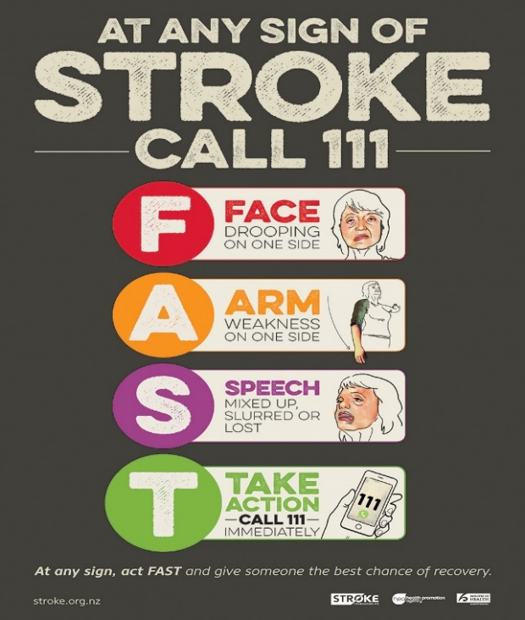
Over the year we evaluated the last two annual campaigns. Results showed significant increases in awareness among the general population, but more specifically among Māori and Pacific populations. Based on these findings, the campaign will continue for the next three years (2019–2021), with a focus on reaching Māori and other at-risk populations.
We collaborated with our partners across the system to establish thrombectomy as a National Service Improvement Programme.

National Hepatitis C Action Plan
An estimated 45,000 people in New Zealand have chronic hepatitis C infection
(a bloodborne disease that causes inflammation of the liver), with approximately 1,000 new cases each year. If it is left untreated, 20–25% of people infected will develop serious liver complications. Of the infected population, 40–50% remain undiagnosed and are unaware of the risks associated with the disease.

New Zealand has a unique opportunity to eliminate hepatitis C as a major public health threat within the next 10 years. Some significant developments have come together in recent times to make this possible. First, unrestricted access is now available to PHARMAC-funded direct-acting antiviral (DAA) treatment, which is highly effective and well tolerated. Second, a groundswell of energy and activity has occurred among parts of the health sector and affected communities, who are calling for the development of a national hepatitis C action plan for New Zealand.
New Zealand adopted the World Health Organization’s (WHO’s) Global Health Sector Strategy on Viral Hepatitis in 2016. The WHO’s vision for this global strategy is ‘a world where viral hepatitis transmission is halted and everyone living with viral hepatitis has access to safe, affordable and effective prevention, care and treatment services’. The Ministry worked with a cross-sector group on a Hepatitis C Action Plan, with the aim of working towards eliminating viral hepatitis as a public health threat by 2030 – consistent with a goal in the WHO strategy. The plan went out for consultation in July 2019.
The Hepatitis Foundation, with our support, developed, designed and implemented a national campaign. The campaign was to focus on raising awareness among those who may be at risk of having hepatitis C, identifying the populations at greatest risk and encouraging them to seek testing and, if needed, treatment.

Improving palliative care
We supported research into the trajectories of death and settings for palliative care in New Zealand.
Over the year, the Ministry has worked with the Palliative Care Advisory Panel on a range of activities that reflect the priorities of the Palliative Care Action Plan, published in 2017. These priorities are to:
- respond to the voices of people with palliative care needs and their families and whānau
- ensure strong strategic connections
- improve quality across all settings
- increase emphasis on primary palliative care
- grow the capability of communities and informal carers.

The system’s multi-layered approach to managing long-term conditions
The Ministry has taken a multi-layered approach, in collaboration with our partners in the health and disability system, to improve health and wellbeing of New Zealanders to prevent and manage long-term conditions. We work through our national and regional networks to drive service improvement. Over the year, we successfully convened the Shifting Care Closer to Home Conference, established the Primary Health Organisation Clinical Leaders Group for long-term conditions and established a SNOMED CT virtual working group to improve coding of conditions in emergency departments.
During 2018/19, we published the Management of multimorbidity guidelines online. These guidelines include recommendations around optimising care for adults with multiple long-term conditions. Specifically, this care involves working with them to improve their quality of life by reducing the treatment burden, polypharmacy, multiple appointments and unplanned care and by improving coordination of care across services.
Our guidelines Top Tips for Improving your Acute Demand Management, also published this year, are designed to identify gaps in local acute service delivery. The tips cover implementing strategies for teams, departments and organisations wanting to see improved practice and improved health outcomes for their patients.

Medicinal cannabis to improve outcomes for New Zealanders with long-term conditions
The Government passed the Misuse of Drugs (Medicinal Cannabis) Amendment Act 2018 on 18 December 2018. Under the Amendment Act:
- individuals requiring palliation have an exception and statutory defence to the charge of possession or use of illicit cannabis
- quality standards can be set for medicinal cannabis products and for all stages of their production
- cannabidiol and any substances related to tetrahydrocannabinols that are not psychoactive are not controlled drugs.
Over the last six months, we established the Medicinal Cannabis Advisory Group – the agency that will administer the scheme. The Advisory Group has already met and provided advice on the scheme’s proposals. We also starting developing the regulations setting quality standards for medicinal cannabis, which are required by 18 December 2019.



Strategic priority 4: Improve our understanding of system performance
The work of the health and disability system helps to create healthier, safer, more connected communities and to make New Zealand the best place in the world to be a child. In the Ministry’s role as kaitiaki and steward of the health and disability system, we need to understand what is working well, where there are pressures, and what is changing in terms of the needs and service expectations of people in the system.
We are building robust frameworks for performance management, system-wide analytics and trusted partnerships to share information safely. By getting a better understanding of our system performance, we can use the insights we gather to build a stronger, more equitable and sustainable public health system now and for generations to come.

Better understanding the health and disability system

Supporting the health and disability system review
The wide-ranging health and disability system review is designed to look at ways we can future-proof our health and disability system and improve equity of outcomes for New Zealand. It is examining where the current system is working well, where barriers to access seem insurmountable and where the system is not easy to navigate and not meeting people’s needs. The independent panel undertaking this review is engaging with DHBs, primary care, other health professionals and the public in developing its recommendations.
The Ministry is supporting the review by providing information about our current system’s coverage, models of care, funding and performance frameworks and facilitating the panel to undertake its review activities. We are looking forward to the review recommendations and implementing changes to provide a more equitable and sustainable health and disability system.

Outcomes and Performance Framework to achieve healthy futures
The Ministry has begun to develop the health and disability system’s Outcomes and Performance Framework. This framework will align the efforts of everyone in the system to deliver improved health outcomes for all New Zealanders, and will also support the delivery of the Government’s wellbeing goals.
The vision of the Outcomes and Performance Framework is to achieve pae ora – healthy futures for New Zealanders. This holistic concept includes three interconnected elements: mauri ora – healthy individuals; whānau ora – healthy families; and wai ora – healthy environments.
The framework acknowledges that achieving equity for Māori is a priority for the health and disability system. He Korowai Oranga, the Māori Health Strategy, guided its development and shares the overarching aim of pae ora.
Supporting the framework’s vision are three high-level outcomes and nine sub-outcomes that represent a complete view of population health at a high level and respond to New Zealand’s important challenges for population health. The high-level outcomes are: New Zealanders live longer in good health; New Zealanders have improved quality of life; and health equity is achieved for Māori and other groups. The framework encourages everyone in the health and disability system to work collaboratively, think beyond narrow definitions of health and provide high-quality and effective services.

System Level Measures – the System Improvement Programme
The System Level Measures Programme supports DHBs to work together, as a system, with their local health partners to improve the quality, safety and experience of care; improve the health and equity for all populations; and provide best value for public health system resource. We co-designed the programme with the health sector as a way of measuring the success of the system’s performance as a whole and providing a scaffold for continuous quality improvement. Appendix 2 details the results for these measures.
Results to date indicate the health and disability system’s performance is improving. Longer-term system change is expected over the following years.

Improving the performance of district health boards

District Health Board Performance Programme
DHBs are the main agents in New Zealand for planning and delivering health care so they are critical to the success of the health and disability system. This year, in collaboration with DHBs and the Treasury, we developed a work programme to support DHBs in enhancing their capability and performance.
The focus of the District Health Board Performance Programme is to align the DHB outcome framework with the Government’s priorities and with the wider system’s Outcomes and Performance Framework. It also strengthens governance and support, enhances performance reporting and accountability, and improves financial monitoring based on more detailed analysis of deficit drivers. The programme’s long-term objective is to improve DHBs’ financial and non-financial performance. We are also looking to improve how we measure health outcomes of local populations, as well as gaining a better understanding of the drivers of DHB deficits.
The work programme will be implemented over 15 months. It has already resolved some immediate issues around DHBs’ performance related to implementing pay equity and deficit support. The Ministry obtained funding through Budget 2019 that will further advance our programme to promote long-term sustainability and create changes in system behaviour and performance.

District health board annual planning and accountability
We provided DHBs with a 2019/20 planning package to support them to develop strategic plans to align with the Minister of Health’s updated priorities and expectations. This package also included meaningful updates to the DHB accountability measures and the main schedules in the Crown Funding Agreement to support them to improve their performance.
Over the year, we reviewed DHBs’ quarterly progress reports against their accountability measures and activities agreed in their annual plans and regional service plans. We then provided feedback to support them to improve performance against key expectations.

Other initiatives that improve our understanding of the system’s performance

National health information platform
We started to develop a business case for investing in a National Health Information Platform. The proposed platform will bring together health information from the health and disability system so it can be accessed by New Zealanders, health care providers, planners and those who initiate models of care in the future.

Every year, we publish the New Zealand Health Survey’s results for that year. The survey comprises more than 150 indicators, which we make available for everyone through our website.
This survey provides us with many insights into New Zealanders’ health and wellbeing. For example, in 2017/18 most children aged 1–14 years (83%) visited a dental health care worker in the past year, up from 76% in 2006/07. In contrast, although 80% of adults rated their oral health to be ‘good, very good or excellent’, about 1.6 million adults with natural teeth (44%) avoided going to a dental health care worker in the past 12 months because of cost.
This annual survey is a fundamental building block to inform our work on improving health and wellbeing.

Drinking Water Regulation

In November 2018 Cabinet agreed to develop proposals to strengthen the regulation of drinking water, wastewater and stormwater, and to new institutional arrangements for a centralised water regulator. The regulatory proposals for drinking water were developed in collaboration with the Department of Internal Affairs and Ministry for the Environment as part of the Government's Three Waters review. Targeted engagements with our public health and the broader drinking water sector was held around the country to discuss improvements to drinking water regulations.
The Ministry released the New Zealand Water Safety Plan Framework in December 2018 and accompanying handbook in May 2019. These help to improve our drinking water safety through incorporating lessons learned about water safety planning following the Havelock North incident and ensuring consistency with the World Health Organisation (WHO) guidelines and international best practice. Training and support to apply the new framework is being rolled out across New Zealand.
The Ministry supported the implementation of urgent minor changes to the Drinking Water Standards which came into force in March 2019. One of the main changes was to require drinking-water suppliers to monitor for total coliforms as well as E. coli. Total coliforms are a useful indicator of drinking-water quality and may detect abnormalities and changes in quality over time. These changes help water suppliers to identify when that their water quality is changing so they can undertake further testing and assessment as appropriate.
In July 2019, Cabinet agreed a new Regulatory Regime for drinking water and the establishment of a dedicated (drinking) water regulator. The Ministry is working to develop a business case for the establishment of the proposed water regulator and will present the service delivery arrangements and funding options to support the new regulatory regime for drinking water.



Strategic priority 5: Implement our investment approach
To invest in the health and disability system, the Ministry takes a holistic and whole-of-system approach with the aim of improving the health and wellbeing of New Zealanders in ways that will make the most difference. In making investment decisions, we look beyond the economic costs to take into consideration the impacts on both physical and mental health and wellbeing of individual people, their families and whānau, and communities – now and in the future. Key areas where we applied our investment approach include our work on Budget 2019, capital asset management, workforce and system infrastructure initiatives.

Budget 2019 – a wellbeing approach
The Ministry, working with our partners from other government agencies, took a cross-government approach to look at where, and how, we needed to invest to meet the needs of present generations, as well as for future generations. In our business cases for Budget 2019, we analysed not just the financial implications, but the broader determinants of success for people and communities, such as the impact on New Zealand’s social, human and environmental resources. Our investment approach puts people at the centre all that we do and sets equity as our overarching aspiration.
As a result, we received over $3.9 billion of additional operational funding and over $1.7 billion of capital investment for the health and disability system over the next four years. Areas that received additional funding include:
- $672.9 million for mental health and addiction initiatives, including programmes that will: increase suicide prevention services and support for people bereaved by suicide; improve support for people experiencing a mental health crisis; expand access to and choice of primary mental health and addiction support; and enhance school-based health services. Funding was also provided to re-establish the Mental Health and Wellbeing Commission, as well as to focus on improving the mental wellbeing of children, Māori and the capability and capacity of the system’s workforce to meet the demand for services. These programmes will support the Ministry’s response to He Ara Oranga (the Government Inquiry into Mental Health and Addiction).
- $38.1 million of additional funding will be used to focus on lifting health outcomes of Māori and Pacific peoples through programmes to pilot innovations in how we deliver services, as well as workforce and provider development initiatives.
- $94.9 million to support existing and new programmes to improve child wellbeing by increasing access and modernising our child development services, maternity services and the Well Child / Tamariki Ora programme.
- $42.8 million to fund additional workforce initiatives to support workforce development and training, and the nursing workforce accord activities to improve safety of our services across New Zealand.
- $1.7 billion to continue our work to strengthen the health and disability system’s infrastructure through sector capital projects across New Zealand so the system is better prepared to service New Zealanders now and in the future.
- Over $3.1 billion to fund our response to pressures across our system, including by providing support for DHBs, disability services, ambulance services, planned care, primary care, Well Child / Tamariki Ora and maternity services.
The Ministry has begun work with our health and disability system partners to implement the Budget 2019 initiatives. We are heartened by the improvements this work will bring to the health and wellbeing outcomes for people across New Zealand.

Improving the system’s capital assets
To deliver high-quality services to New Zealanders, the health and disability system needs appropriate facilities and equipment that are fit for purpose. Given the state of its current assets is mixed, the main focus for investment in the health and disability system is on undertaking timely work to remediate those assets that have deteriorated, as well as on preparing the system for significant population growth, health needs and demographic changes.

Highlights from our investment in the health and disability system
Canterbury: A programme of hospital redevelopment activities to the value of around
$1 billion is under way. This includes building: the new Burwood Hospital, which opened in 2016; a new outpatients facility, which opened in 2018; and the Acute Services Building on the Christchurch Hospital campus, due to open in 2019. We are also overseeing the Canterbury DHB business case for refurbishing and/or building new facilities at Hillmorton Hospital for specialist mental health services, which are currently housed at Princess Margaret Hospital. Ministry staff are working closely with the team at Canterbury DHB to ensure all new facilities are fit for purpose so that they will meet the current and future health needs of the Canterbury region.
West Coast: We continued working on a $77.8 million new hospital in Greymouth, where construction started in 2016. The new facility will include 56 in-patient beds, three operating theatres and an integrated family health centre. It will also house and support the delivery of other clinical services, including a 24/7 emergency department, critical care unit, acute and planned medical and surgical services, maternity services and outpatient care. The facility is progressing well and expected to open later in 2019.
Dunedin: In November 2018, we purchased the former Cadbury chocolate factory site as the site for the new Dunedin hospital. Replacing the existing hospital will be the single biggest hospital build ever in New Zealand – costing up to $1.4 billion. The new hospital will make a big difference to Southern DHB’s communities because the current facilities are deteriorating and inflexible, impacting on the quality of care provided. The Southern DHB region faces challenges due to its size, location and demographics, including a population that has a low growth rate and is ageing. This new hospital will deliver benefits that will allow Southern DHB to provide for the people of the region now and in generations to come.

National Asset Management Plan and National Asset Management Register
A key focus in 2018/19 was on making improvements to our capital investment processes, and our capacity and capability to meet the growing investment challenges. With the Treasury, we have been working on a National Asset Management Plan so we can better understand the state of the system’s assets now and for the next 10–20 years. We are also working on a proposal to establish our own health infrastructure entity to help us better prepare for and manage health capital assets in the future.
At the request of the Minister of Health, we provided him and the Minister of Finance with a report on the feasibility of producing a national asset management register. We started populating the register by carrying out an assessment of our buildings and infrastructure that are most critical (in terms of their condition and fitness for purpose). DHBs will place the remaining buildings and infrastructure on the register.
Information in the register, though improving our understanding of the current state of hospital buildings and infrastructure, will guide investment decisions over the next 10–20 years.
We will deliver an initial report with an overview of the current state of infrastructure for joint Ministers in September 2019. The full National Asset Management Plan will be delivered in December 2019.

A new prioritisation process for allocating funding to capital assets
Health capital spending, above a certain threshold, requires business case approval from the Capital Investment Committee.
We improved the business case approval process this year by adopting new prioritisation criteria to allocate investment. The criteria are: capacity in high-growth areas; remediation of critical assets (facilities, infrastructure and information and communications technology); and required mental health facilities (not fit for purpose and/or capacity). With these criteria, we can take a more planned approach to our capital investment.

Workforce initiatives

National Health and Disability Workforce strategic priorities
The Ministry has been focused on investing in the health and disability system’s workforce by working with the sector to develop a framework for thinking about workforce issues and agree on strategic focus areas. Over 2018/19, we worked with our partners in the system to determine seven key strategic focus areas for the health and disability workforce. We are working with representatives from across the sector to map the workforce work underway across the system and understand if, and where, there are gaps, and how best to address these.

Implementing the Care and Support Workers (Pay Equity) Settlement Act 2017
Since the care and support workers pay equity settlement was introduced in April 2017, the Ministry has been supporting the sector to substantially increase wages to achieve pay equity for care and support workers.
In 2018/19, working together with DHBs, we developed and agreed the best approach to devolve pay equity funding so that DHBs can collectively manage how they use and allocate this funding among themselves from 1 July 2019. Our focus over the next two years is on incorporating the pay equity funding into the overall Population Based Funding Formula so that it becomes a seamless part of our overall funding framework.

Implementing pay equity settlement for aged residential care, home and community care and disability support sectors
In 2018/19, we continued our work to implement the pay equity settlement and provided additional financial support (support workers’ wages) for providers financially disadvantaged by that settlement. We also provided people with information and help to implement the changes, including through regular newsletters, roadshows, an 0800 phone line and a helpdesk.

Nurses Safe Staffing Accord
We are working with our sector partners to increase recruitment and retention of nurses in the health and disability system. To show our commitment to safer nursing, we, alongside the New Zealand Nurses Organisation and DHBs, signed the Safe Staffing Accord in July 2018. This puts into place actions to ensure safe staffing levels and explores options for employing new registered and enrolled nurse graduates, and for recruiting and retaining the nursing workforce.
We also worked with our accord partners and Central Region Technical Advisory Service to progress a programme of work that included:
- developing a nursing workforce retention strategy using a 'bundles of intervention' approach, which acknowledges that many factors influence nurses’ decisions to stay in or leave their job, or to return to nursing after time away, and that many actions are required across the health system to retain nurses.
- continuing to roll out care capacity demand management across all DHBs to support planning and management of safe staffing levels.
- extending transition to practice programmes for all new graduate registered and enrolled nurses, which will support safe staffing, recruitment and retention, and employment of nurses across the health system.

Other initiatives to improve our investment approach
Our National Air Ambulance procurement team took out the Supreme and Most Effective Teaming awards at the 2018 Procurement Excellence Awards. The Supreme Award celebrates teams who are pooling their expertise and knowledge to achieve exceptional results, while the Most Effective Teaming Award showcases multidisciplinary teams that are successfully collaborating on procurement, either internally or with external organisations.
These two awards recognised the significant work under way to invest in and transform New Zealand's air ambulance helicopter service, so it is nationally integrated and coordinated. We are proud of our achievements that, in partnership with Accident Compensation Corporation, improve services and outcomes for all New Zealanders.

Transforming sector operations – improving operations payments
This year the Ministry established a multi-year programme to improve customer experience by processing faster, more timely and accurate payments through the Ministry’s sector operations. This function supports the health and disability system to run by processing around 112 million claims transactions and handles over 260 payment types representing over $9.5 billion each year. This programme addresses current challenges and issues by replacing legacy information technology systems and processes.
An important milestone we are working towards is to complete the client claim payment system in 2019/20, which will improve our supply risk management capability. The upgrade of the integrated remedy system platform has also begun. It will improve the way we log and track calls channelled through our contact centre.

National Enrolment Service
Through the Ministry’s investment in our health information system infrastructure, the health and disability system transitioned from the periodically updated primary health patient enrolment database to the National Enrolment Service. This live register shows patient enrolment in real time, so people can register and access primary care services faster. By the end of 2018/19, the National Enrolment Service had enabled 4.65 million New Zealanders to be enrolled with their chosen general practice team.
The live register also improves the processes for managing the capitation-based funding for general practices across New Zealand. The success of this service would not be possible without the hard work and collaboration of general practice teams, primary health organisations and alliances, and DHBs that have worked alongside the Ministry over the last four years.

Our outputs
This section outlines our performance against the outputs that are specified in the Vote Health Main Estimates of Appropriation 2018/19 and, where updated, Vote Health – Supplementary Estimates of Appropriation.
Performance information for selected non-departmental appropriations for the year ended 30 June 2019 is available in a separate Vote Health Report.

Health sector information systems
This appropriation is limited to providing information technology services and publishing data and information derived from these services to the health and disability system. The intention is to provide information technology services and infrastructure to support the operation of New Zealand’s health services.

What we do
The Ministry is responsible for the technology and digital services that underpin the national data collections and systems used within the Ministry and across the health and disability system. These services enable the health and disability system to undertake local, regional and national planning of resources for current and future service demand.
Major data collections and systems include:
- the Ministry’s website
- the National Health Index (NHI)
- the National Immunisation Register (NIR)
- Pharmacy Electronic Claiming (PEC).

Performance assessment
Actual  2017/18 | Performance measure |  | Actual  2018/19 | Budget standard  2018/19
 | Client insight and analytics
100% | Percentage of published Tier 1 statistics meet Statistics New Zealand standards within agreed timetable |  | 100% | 100%
98% | Respondent satisfaction with how the Health Survey is conducted is greater than |  | 98% | 90%
 | National infrastructure and Ministry information systems
99.9% | Percentage of time for which key sector and public-facing systems are available (see note 1) |  | 99.9% | 99%
0 | Number of security breach incidents |  | 0 | 0
Note 1: Key sector and public-facing systems are the National Health Index (NHI), National Immunisation Register (NIR), Online Pharmacy, Special Authorities, Oracle Financials, and Web Access.

Financial performance
Actual  2017/18  $000 | Health sector information systems | Actual  2018/19  $000 | Main estimates  2018/19  $000 | Voted appropriation  2018/19  $000
52,845 | Crown revenue | 51,118 | 55,618 | 51,118
- | Third party revenue | - | - | -
52,845 | Total revenue | 51,118 | 55,618 | 51,118
52,840 | Total expenses | 51,050 | 55,618 | 51,118
5 | Net surplus (deficit) | 68 | - | -

Managing the purchase of services
This appropriation is limited to purchasing services for the public and the health and disability system on behalf of the Crown, for those services where the Ministry has responsibility for the purchasing function (ie, funding is not devolved to another entity). The intention is to achieve the administration of health and disability services, purchased on behalf of the Crown in line with Government priorities and the Ministry of Health’s strategic intentions (as outlined in the Statement of Strategic Intentions).

What we do
We are responsible for procuring health and disability services for New Zealanders on behalf of the Crown.
In 2018/19, the Ministry provided a total of $13.338 billion of funding to DHBs. It also spent $3.575 billion on direct purchasing of non-departmental services and non-DHB Crown entities. In addition, the Ministry holds contracts on behalf of the Crown to procure services from third-party service providers such as NGOs to provide health, disability and social services to people in New Zealand. These contracts include:
- any new, or renewed, contracts supporting national service procurement, including services such as the National Screening Unit, disability support services, ambulance services, maternity services and public health services
- any new, or renewed, contracts entered into by the Ministry for providing services to external parties using non-departmental expenditure funding.
To ensure we continue to comply with current government standards and expectations, we periodically review our internal procurement policies and standards.

Performance assessment
Actual  2017/18 | Performance measure |  | Actual  2018/19 | Budget standard  2018/19
Achieved | Ministry procurement process is in line with government standards |  | Achieved | Achieved
1:75 | Ratio of departmental expenditure for the output class against relevant non-departmental expenditure |  | 1:73 | 1:107
100% | The percentage of Ministry feedback to Crown funding agreement variation (CFAV) monitoring reports that are supplied to DHBs within agreed timeframes (see note 1) |  | 95% | 95%
100% | The percentage of complaints in regards to disability support services (DSS) that receive either a resolution notification or progress update within 20 days of DSS receiving the complaint (see note 2) |  | 92.7% | 95%
Note 1: When the Ministry receives a monitoring report, it is logged into an electronic system. This generates an automated letter stating the Ministry has received the report. The ‘formal response’ is the next contact the Ministry has with the provider, when necessary. The formal response could take the form of a phone call, email, formal letter or site visit.
Note 2: In 2018/19, 52 of 56 (92.7%) complaints DSS received were within this target. The reasons why the four complaints did not meet the 20-day timeframe include delays in the complainant responding to communication and in the handover of complaint information. The Ministry is monitoring this measure and will continue to work so that outputs are within the 20-day timeframe.

Financial performance
Actual  2017/18  $000 | Managing the purchase of services | Actual  2018/19  $000 | Main estimates  2018/19  $000 | Voted appropriation  2018/19  $000
43,368 | Crown revenue | 49,374 | 41,974 | 49,374
28 | Third party revenue | - | - | -
43,396 | Total revenue | 49,374 | 41,974 | 49,374
43,368 | Total expenses | 49,313 | 41,974 | 49,374
28 | Net surplus (deficit) | 61 | - | -

Payment services
This appropriation is limited to administering and auditing contracts and payments on behalf of the Crown and Crown agencies. The intention is to provide for timely and accurate payments to be made to eligible parties (including eligible health service providers and consumers) and contracts to be audited and processed efficiently and effectively.

What we do
The Ministry is responsible for administering over $9.5 billion core health payment processes for the health and disability system. This includes administering agreements held between health funding organisations and service providers, managing over 240 payment types, capturing and tracking health care users’ entitlements to and use of health care. The agreements we manage include contracts between funders (Ministry or DHBs) and the service provider, but exclude Crown funding agreements, and their variations, as these are administered outside of the payment services systems.
The Ministry operates a contact centre that manages around 450,000 contacts annually. This includes queries and service requests from funders, providers and health care consumers in support of the payment services function. The contact centre also supports the health and disability system and the wider public by responding to health-related enquiries in approximately 60 service areas. These include queries relating to special authority, the NHI and eligibility for publicly funded health services. The performance measures below do not cover Ministry-funded, but outsourced, contact-centre services such as Plunketline, Healthline and 1737.
The Ministry also performs audit and investigation activities on the payments made across the health and disability system to ensure the funding is appropriately used for the purpose for which it was provided.

Performance assessment
Actual  2017/18 | Performance measure |  | Actual  2018/19 | Budget standard  2018/19
99.8% | Percentage of claims paid on time |  | 99.8% | 98%
98.9% | Percentage of claims processed accurately |  | 98.6% | 95%
85.1% | Percentage of draft agreements prepared for funders within target timeframes (see note 1) |  | 90.3% | 95%
100% | Percentage of agreements prepared accurately (see note 2) |  | 100% | 95%
81.2% | Percentage of calls to contact centres answered within service specifications for timeliness (20 seconds) |  | 81.9% | 80%
3.8% | Percentage of calls abandoned by callers prior to being answered by the contact centre is less than |  | 2.6% | 5%
96.1% | Percentage of enquiries resolved in under 10 working days |  | 95.1% | 95%
0 | Court written decisions and findings relating to concluded Ministry of Health Audit & Compliance initiated prosecutions contain no adverse judicial comment in regard to the evidential basis of the prosecutions |  | 0 | 0
97% | Percentage of Health Integrity Line complaints that are evaluated within 10 working days of complaint being received is greater than or equal to (see note 3) |  | 100% | 95%
Note 1: The overall performance for the year was lower than budget standard, due to the flow on impact from the concentrated high-demand period of agreement requests received in July and August every year. Despite this, the Ministry’s performance for 2018/19 improved significantly by 5% from 2017/18 as a result of upskilling of team members, active re-allocation and close monitoring of workflow.
Note 2: All information is deemed to be processed accurately if agreements are legally binding and purchase order information is correctly entered.
Note 3: The Health Integrity Line received 219 complaints in 2018/19 (134 complaints in 2017/18) and the Ministry made a scrupulous effort to evaluate all of these within 10 working days.

Financial performance
Actual  2017/18  $000 | Payment services | Actual  2018/19  $000 | Main estimates  2018/19  $000 | Voted appropriation  2018/19  $000
15,840 | Crown revenue | 15,340 | 17,340 | 15,340
28 | Third party revenue | 0 | 0 | 0
15,868 | Total revenue | 15,340 | 17,340 | 15,340
15,838 | Total expenses | 15,331 | 17,340 | 15,340
30 | Net Surplus (Deficit) | 9 | 0 | 0

Regulatory and enforcement services
This appropriation is limited to implementing, enforcing and administering health- and disability-related legislation and regulations, providing regulatory advice to the sector and to Ministers, and providing support services for committees established under statute or appointed by the Minister in line with legislation. The intention is to ensure that health and disability services are regulated so that appropriate standards are followed.

What we do
We have multiple regulatory, leadership, protection and purchasing roles. We protect New Zealanders from public health risks (such as environmental and disease risk factors that lead to ill health). We also regulate to ensure products, services and premises in health products and services are safe and provide advice and leadership to ensure we meet international and legal obligations.
The Ministry assists the Minister with making appointments of members to statutory committees and regulatory authorities. The Director-General of Health appoints statutory officers under several Acts of Parliament, including the Health Act 1956, Hazardous Substances and New Organisms Act 1996, Biosecurity Act 1993 and Smoke-free Environments Act 1990.
The Ministry coordinates public health protection and related regulatory functions between the DHBs. This work includes administering the environmental health-related aspects of legislation and providing advice, manuals, guidelines and training.
The Ministry administers the Burial and Cremation Act 1964, including through processing disinterment licences, applications for burials in special places, burial ground/cemetery applications, medical referee appointments and cremator applications.
The Ministry is responsible for delivering regulatory functions, and supporting committees established under statute. Its main regulatory functions include:
- the Director of Public Health and Director of Mental Health, who have leadership and decision-making responsibilities, including the interpretation and administration of health- and disability-related legislation
- the New Zealand Medicines and Medical Devices Safety Authority (Medsafe), which is responsible for regulating therapeutic products
- HealthCERT, which is responsible for ensuring hospitals, aged residential care providers (including rest homes), residential disability care providers and fertility service providers provide safe and reasonable levels of service. The Ministry receives and responds to complaints made under the Health and Disability Services (Safety) Act 2001 against certified providers
- the Office of Radiation Safety, which is responsible for regulating ionising radiation
- Medicines Control, which is responsible for regulating the distribution chain of medicines and controlled drugs
- the Psychoactive Substances Regulatory Authority, which is responsible for the operation of psychoactive substances legislation
- the Public Health Group, which administers legislation protecting people from communicable disease and environmental health risks.
Appendix 4 provides a full list of the committees established under statute that the Ministry supports.
The Ministry’s licensing and certification roles include:
- licensing pharmacies and other parties involved in the pharmaceutical supply chain, such as wholesalers and researchers (under the Medicines Act 1981 and the Misuse of Drugs Act 1975)
- licensing service providers who use and possess radioactive substances (under the Radiation Safety Act 2016)
- certifying hospitals, rest homes, residential disability care providers and fertility providers (under the Health and Disability Services (Safety) Act 2001).
Our audit functions support our licensing and certification roles, and also seek to improve the quality of services beyond formal licensing and certification requirements.
The Ministry purchases and monitors health-related border control and environmental health services on behalf of the Crown and exercises regulatory powers in this area to minimise public risk.
The Ministry’s role includes oversight of interventions to reduce the risks from environmental hazards and communicable diseases, and to manage outbreaks.

Performance assessment
Actual  2017/18 | Performance measure |  | Actual  2018/19 | Budget standard  2018/19
99% | Percentage of medium- and high-priority quality incident notifications relating to medicines and medical devices that undergo an initial review within 5 working days |  | 98% | 90%
90% | Percentage of certificates issued to providers under the Health and Disability Services (Safety) Act 2001 within target timeframes |  | 91% | 90%
84% | Percentage of licences and authorities issued to providers under the Medicines Act 1981 and Misuse of Drugs Act 1975 within target timeframes  (see note 1) |  | 88% | 90%
90% | Percentage of licences and consents issued to radiation users under the Radiation Safety Act 2016 within 10 working days of the receipt of all information and payment of the required fee |  | 90% | 90%
85% | Percentage of new medicines applications (for ministerial consent to market) that receive an initial assessment within 200 days (see note 2) |  | 77% | 80%
100% | Percentage of changed medicines notifications (for ministerial consent to market) responded to within 45 days |  | 100% | 100%
4 | Average rating for statutory committee satisfaction with secretariat services provided by the Ministry |  | 4 | 4 out of 5  or greater
Note 1: The overall performance for the year was slightly lower than budget standard, due to a backlog of applications to license pharmacies in July 2018. The backlog resulted from a large increase in the number of industrial hemp licences that required processing, following a change to the Food Act 2014.
Note 2: The final result is slightly below budget standard for the 2018/19 year. This is due to low percentages in the three months from November 2018 to January 2019. A considered decision was made to focus limited capacity on other evaluation streams (such as changed medicines applications, which have a statutory timeline) and to assess responses from applicants relating to early review questions. From February to June 2019, the budget standard was achieved or exceeded and it is expected that this trend will continue.

Financial performance
Actual  2017/18  $000 | Regulatory and enforcement services | Actual  2018/19  $000 | Main estimates  2018/19  $000 | Voted appropriation  2018/19  $000
11,363 | Crown revenue | 12,735 | 10,653 | 12,735
10,336 | Third party revenue | 11,882 | 13,458 | 10,708
21,699 | Total revenue | 24,617 | 24,111 | 23,443
24,820 | Total expenses | 23,345 | 24,111 | 23,443
(3,121) | Net Surplus (Deficit) | 1,272 | - | -

Sector planning and performance
This appropriation is limited to advising on and coordinating health sector planning and performance improvement; and funding, monitoring and supporting the governance of health sector Crown entities, and sector coordination.
This appropriation is intended to ensure health sector services are appropriately planned, funded and monitored; health sector Crown entities, agencies and companies are appropriately governed; and sector coordination is encouraged and assisted.

What we do
The Minister, in consultation with Cabinet and Caucus, appoints suitable candidates to DHBs and other health Crown entity boards. The Ministry assists the Minister with the appointments process.
The Ministry is responsible for the funding, monitoring and planning of DHBs and other health Crown entities. We work with these agencies to create accountability documents outlining their deliverables and what can be done to improve their performance (eg, statements of intent and output agreements). We also monitor their service and financial performance over the year against their targets, and work with them to address any issues that may affect their ability to meet performance expectations. We use several performance indicators to set expectations and monitor performance to ensure DHBs appropriately work towards agreed priorities for performance improvement and health outcomes. The timeliness target for planning and reporting between DHBs or non-DHB Crown entities and the Ministry serves as a proxy measure of the quality of the activities that the Ministry undertakes.
We hold the capability and capacity to lead and coordinate a national health response to an emergency. This includes maintaining plans to continue functioning during and after an emergency, in accordance with the Civil Defence Emergency Management Act 2002. Our responsibilities include:
- ensuring we are capable of continuing to function to the fullest extent possible in an emergency that affects our operations
- having the capability and capacity to respond in an emergency that has health implications
- providing leadership and coordination for the health sector in planning and preparing for, and responding to, a health emergency
- leading an all-of-government response to a national health emergency such as a pandemic.
We maintain the capability to activate an emergency response within two hours of notification of an emergency event requiring national coordination, including activation of the National Health Coordination Centre (NHCC). We have identified primary and alternative sites for the NHCC, and our system also allows for the NHCC to be set up at an alternative location, if required.

Performance assessment
Actual  2017/18 | Performance measure |  | Actual  2018/19 | Budget standard  2018/19
Advice delayed at the request of Ministers | Planning and funding advice for the financial year is provided to Crown entities by 31 December |  | Achieved | Achieved
Advice delayed as a result of late planning and funding advice | The Ministry provides the Minister with advice of all DHB annual plans by 30 June |  | Achieved | Achieved
100% | Percentage of monitoring feedback reports about performance supplied to DHBs within agreed timeframes |  | 100% | 100%
40% | Percentage of quarterly and monthly monitoring reports about DHBs provided to the Minister within agreed timeframes (see note 1) |  | 5% | 100%
100% | Percentage of quarterly and monthly monitoring reports about Crown entities (excluding DHBs) provided to the Minister within agreed timeframes (see note 2) |  | 50% | 100%
Achieved | Maintain the capability and capacity to respond to national emergencies and emerging health threats (see note 3) |  | Achieved | Achieved
78% | The percentage of appointments to DHBs and other health Crown entity boards where advice is presented to the Minister prior to the current appointee’s term expiring |  | 100% | 95%
Note 1: As the financial performance of the DHB sector became more complex, longer time was needed to collect, analyse and review the financial information. This had an impact on the time required to produce reports to a satisfactory standard and the Ministry is working to improve performance in this area.
Note 2: The first and second quarterly results were consolidated into the quarter three report for the Minister. The Ministry has put in place an action plan to ensure that the future reporting is completed on time.
Note 3: Having the capability and capacity to respond means the Ministry has the necessary systems, procedures, facilities and staffing in place to initiate and manage the health response to a national emergency or emerging health threat at the national level.

Financial performance
Actual  2017/18  $000 | Sector planning and performance | Actual  2018/19  $000 | Main estimates  2018/19  $000 | Voted appropriation  2018/19  $000
48,315 | Crown revenue | 54,277 | 47,277 | 54,277
1 | Third party revenue | 2 | 149 | 149
48,316 | Total revenue | 54,279 | 47,426 | 54,426
48,464 | Total expenses | 54,230 | 47,426 | 54,426
(148) | Net surplus (deficit) | 49 | - | -

Policy advice and ministerial servicing
The purpose of this multi-category expense appropriation is to provide policy advice and other support to Ministers in discharging their policy decision-making and other portfolio responsibilities.

What we do
The Ministry provides a wide range of advice and policy services to Ministers, including preparing draft correspondence, briefings, and responses to parliamentary questions and Official Information Act 1982 (OIA) requests. We provide policy advice, often in collaboration with other government agencies or the broader sector, on a range of issues impacting the health and disability system. We also provide support to the Expert Panel advising Ministers on the review of the New Zealand health and disability system.

Performance assessment
Actual  2017/18 | Performance measure |  | Actual  2018/19 | Budget standard  2018/19
 | Ministerial servicing
88.8% | Percentage of responses provided to the Minister within agreed timeframes; for written parliamentary questions and ministerial letters (see note 1) |  | 79.9% | 95%
87.8% | Percentage of responses provided to the Minister within agreed timeframes, for requested briefings (see note 1) |  | 77.7% | 95%
NA | Percentage of ministerial letters that required no substantive amendments (see note 2) |  | NA | 95%
83.8% | Percentage of responses to Official Information Act requests provided to the Minister within the agreed timeframe (for requests made to the Minister) or to the requestor within the statutory timeframe, including where extended in line with the Act (for requests made to the Ministry) (see note 3) |  | 96.6% | 95%
 | Policy advice
7.23 | Average score attained by written policy advice as assessed by an external reviewer (see note 4) |  | 3.12 out of 5 | greater than  7 out of 10
 | Supporting the Review of the New Zealand Health and disability system
See note 5 | The Health and disability system Review's key milestones are achieved |  | Achieved | Achieved
See note 5 | The health and disability system review members are satisfied with the support services provided |  | Satisfied | Satisfied or better
Note 1: The result for written parliamentary questions and ministerial letters combines written Parliamentary questions (94.4%) and ministerials (62.4%). There were backlogs for ministerials and requested briefings were cleared by the end of the reporting year and a steady state has been reached.
Note 2: The results for this measure are not available due to limitations within the current Quill system for tracking data on ministerial letters. During 2018/19, the Ministry developed a manual way of extracting the amendment rate but results are not available for the full year.
Note 3: The Ministry put in place a centralised processing team and implemented new processes to improve our response to OIA requests. These changes delivered a significant improvement in timeliness in 2018/19 and increased the level of the Ministry’s transparency and accountability to New Zealanders.
Note 4: At the time this performance measure was set, the Ministry intended to use scoring system from 1 to 10 for the external assessment of our policy advice. In July 2019, a refreshed Policy Quality Framework (developed through a cross-agency policy project lead by Department of Prime Minister and Cabinet) was released. All agencies are required to use this new framework from 2019/20 and the Ministry has opted to early adopt this new framework in 2018/19. Under the new framework, the Ministry assessed the quality of policy advice through a review panel comprising of internal and external members with relevant skills and expertise.
This refreshed Policy Quality Framework has a different scoring system to that previously used by the external reviewer (NZIER). The new scoring scale ranges from 1 to 5 (where as the scale used by NZIER was from 5 to 10) and therefore a comparable score with previous years would mean scores need to be transposed and not doubled (i.e. 7.12 out of 10 would be the equivalent to 3.12 out of 5).
Note 5: New performance measure for 2018/19; comparable information has not previously been reported. The key milestones for the Review relate to the interim and final reports which were both on-track to be met at 30 June 2019.

Financial performance
Actual  2017/18  $000 | Policy advice and ministerial servicing | Actual  2018/19  $000 | Main estimates  2018/19  $000 | Voted appropriation  2018/19  $000
 | Ministerial servicing
5,202 | Crown revenue | 4,702 | 4,702 | 4,702
0 | Third party revenue | 0 | - | -
5,202 | Total revenue | 4,702 | 4,702 | 4,702
5,201 | Total expenses | 4,684 | 4,702 | 4,702
1 | Net surplus (deficit) | 18 | - | -
 | Policy advice
15,389 | Crown revenue | 16,439 | 16,289 | 16,439
0 | Third party revenue | 1 | - | -
15,389 | Total revenue | 16,440 | 16,289 | 16,439
15,385 | Total expenses | 16,404 | 16,289 | 16,439
4 | Net surplus (deficit) | 36 | - | -
 | Supporting the review of the New Zealand health and disability system
- | Crown revenue | 5,260 | - | 5,260
- | Third party revenue | - | - | -
- | Total revenue | 5,260 | - | 5,260
- | Total expenses | 2,667 | - | 5,260
- | Net surplus (deficit) | 2,593 | - | -

Ministry of Health – capital expenditure
This appropriation is limited to purchasing or developing assets by and for the use of the Ministry of Health, as authorised by section 24(1) of the Public Finance Act 1989.
The Ministry has an approved Five Year Capital Expenditure Plan and all capital spending is included in this plan.
This appropriation is intended to achieve the renewal, upgrade or redesign of assets to support the delivery of the Ministry of Health’s core functions and responsibilities.

What we do
The Ministry manages the renewal, upgrade or redesign of assets used in the delivery of the Ministry of Health’s core functions and responsibilities. Key projects include updates to our information technology for the sector payments system, Microsoft Office 365 and finance management system.

Performance assessment
Actual  2017/18 | Performance measure | Actual  2018/19 | Budget standard  2018/19
Achieved | Expenditure is in accordance with the Ministry of Health’s capital asset management plan | Achieved | Achieved

Financial performance
Actual  2017/18  $000 | Ministry of Health – capital expenditure | Actual  2018/19  $000 | Main estimates  2018/19  $000 | Voted appropriation  2018/19  $000
7,163 | Total appropriation | 12,781 | 8,837 | 20,887


Part 3:
Audit report and financial statements

Statement of responsibility
I am responsible, as Director-General of Health and Chief Executive of the Ministry of Health (Ministry), for:
- the preparation of the Ministry’s financial statements, and statements of expenses and capital expenditure, and for the judgements expressed in them.
- having in place a system of internal control designed to provide reasonable assurance as to the integrity and reliability of financial reporting.
- ensuring that end-of-year performance information on each appropriation administered by the Ministry is provided in accordance with sections 19A to 19C of the Public Finance Act 1989, whether or not that information is included in this annual report.
- the accuracy of any end-of-year performance information prepared by the Ministry, whether or not that information is included in the annual report.
In my opinion:
- the financial statements reflect the financial statements of the Ministry as at 30 June 2019 and its operations for the year ended on that date.
- the forecast financial statements fairly reflect the forecast financial position of the Ministry as at 30 June 2020 and its operations for the year ending on that date.

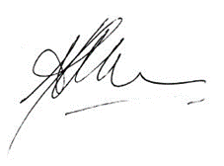
Ashley Bloomfield Fergus Welsh
Director-General of Health Chief Financial Officer
30 September 2019 30 September 2019

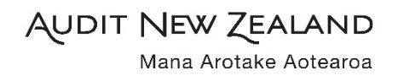
Independent Auditor’s Report
To the readers of the Ministry of Health’s annual report
for the year ended 30 June 2019

The Auditor-General is the auditor of the Ministry of Health (the Ministry). The Auditor-General has appointed me, Stephen Lucy, using the staff and resources of Audit New Zealand, to carry out, on his behalf, the audit of:
- the financial statements of the Ministry on pages 77 to 103, that comprise the statement of financial position, statement of commitments, statement of contingent liabilities and contingent assets as at 30 June 2019, the statement of comprehensive revenue and expense, statement of changes in equity, and statement of cash flows for the year ended on that date and the notes to the financial statements that include accounting policies and other explanatory information;
- the performance information prepared by the Ministry for the year ended 30 June 2019 on pages 57 to 69 and 122 to 136;
- the statements of expenses and capital expenditure of the Ministry for the year ended 30 June 2019 on pages 113 to 116 and 119 to 120 and
- the schedules of non-departmental activities which are managed by the Ministry on behalf of the Crown on pages 105 to 112 and 117 to 118 that comprise:
  - the schedules of assets; liabilities; commitments; and contingent liabilities and assets as at 30 June 2019;
  - the schedules of expenses; and revenue for the year ended 30 June 2019; and
  - the notes to the schedules that include accounting policies and other explanatory information.
Opinion
In our opinion:
- the financial statements of the Ministry on pages 77 to 103:
  - present fairly, in all material respects:
    - its financial position as at 30 June 2019; and
    - its financial performance and cash flows for the year ended on that date; and
  - comply with generally accepted accounting practice in New Zealand in accordance with Public Benefit Entity Standards.
- the performance information of the Ministry on pages 57 to 69 and 122 to 136:
  - presents fairly, in all material respects, for the year ended 30 June 2019:
    - what has been achieved with the appropriation; and
    - the actual expenses or capital expenditure incurred compared with the appropriated or forecast expenses or capital expenditure; and
  - complies with generally accepted accounting practice in New Zealand.
- the statements of expenses and capital expenditure of the Ministry on pages 113 to 116 and 119 to 120 are presented fairly, in all material respects, in accordance with the requirements of section 45A of the Public Finance Act 1989.
- the schedules of non-departmental activities which are managed by the Ministry on behalf of the Crown on pages 105 to 112 and 117 to 118 present fairly, in all material respects, in accordance with the Treasury Instructions:
  - the assets; liabilities; commitments; and contingent liabilities and assets as at 30 June 2019; and
  - expenses; and revenue for the year ended 30 June 2019.

Our audit was completed on 30 September 2019. This is the date at which our opinion is expressed.
The basis for our opinion is explained below. In addition, we outline the responsibilities of the Director-General of Health and our responsibilities relating to the information to be audited, we comment on other information, and we explain our independence.
Basis for our opinion
We carried out our audit in accordance with the Auditor-General’s Auditing Standards, which incorporate the Professional and Ethical Standards and the International Standards on Auditing (New Zealand) issued by the New Zealand Auditing and Assurance Standards Board. Our responsibilities under those standards are further described in the Responsibilities of the auditor section of our report.
We have fulfilled our responsibilities in accordance with the Auditor-General’s Auditing Standards.
We believe that the audit evidence we have obtained is sufficient and appropriate to provide a basis for our audit opinion.
Responsibilities of the Director-General of Health for the information to be audited
The Director-General of Health is responsible on behalf of the Ministry for preparing:
- financial statements that present fairly the Ministry’s financial position, financial performance, and its cash flows, and that comply with generally accepted accounting practice in New Zealand.
- performance information that presents fairly what has been achieved with each appropriation, the expenditure incurred as compared with expenditure expected to be incurred, and that complies with generally accepted accounting practice in New Zealand.
- statements of expenses and capital expenditure of the Ministry, that are presented fairly, in accordance with the requirements of the Public Finance Act 1989.
- schedules of non-departmental activities, in accordance with the Treasury Instructions, that present fairly those activities managed by the Ministry on behalf of the Crown.
The Director-General of Health is responsible for such internal control as is determined is necessary to enable the preparation of the information to be audited that is free from material misstatement, whether due to fraud or error.
In preparing the information to be audited, the Director-General of Health is responsible on behalf of the Ministry for assessing the Ministry’s ability to continue as a going concern. The Director-General of Health is also responsible for disclosing, as applicable, matters related to going concern and using the going concern basis of accounting, unless there is an intention to merge or to terminate the activities of the Ministry, or there is no realistic alternative but to do so.
The Director-General of Health’s responsibilities arise from the Public Finance Act 1989.
Responsibilities of the auditor for the information to be audited
Our objectives are to obtain reasonable assurance about whether the information we audited, as a whole, is free from material misstatement, whether due to fraud or error, and to issue an auditor’s report that includes our opinion.
Reasonable assurance is a high level of assurance, but is not a guarantee that an audit carried out in accordance with the Auditor-General’s Auditing Standards will always detect a material misstatement when it exists. Misstatements are differences or omissions of amounts or disclosures, and can arise from fraud or error. Misstatements are considered material if, individually or in the aggregate, they could reasonably be expected to influence the decisions of readers, taken on the basis of the information we audited.
For the budget information reported in the information we audited, our procedures were limited to checking that the information agreed to the Ministry’s Statement of Strategic Intentions 2017 to 2021, Estimates and Supplementary Estimates of Appropriations 2018/19 for Vote Health, and the 2018/19 forecast financial figures in the Ministry’s 2017/18 Annual Report.
We did not evaluate the security and controls over the electronic publication of the information we audited.
As part of an audit in accordance with the Auditor-General’s Auditing Standards, we exercise professional judgement and maintain professional scepticism throughout the audit. Also:
- We identify and assess the risks of material misstatement of the information we audited, whether due to fraud or error, design and perform audit procedures responsive to those risks, and obtain audit evidence that is sufficient and appropriate to provide a basis for our opinion. The risk of not detecting a material misstatement resulting from fraud is higher than for one resulting from error, as fraud may involve collusion, forgery, intentional omissions, misrepresentations, or the override of internal control.
- We obtain an understanding of internal control relevant to the audit in order to design audit procedures that are appropriate in the circumstances, but not for the purpose of expressing an opinion on the effectiveness of the Ministry’s internal control.
- We evaluate the appropriateness of accounting policies used and the reasonableness of accounting estimates and related disclosures made by the Director-General of Health.
- We evaluate the appropriateness of the reported performance information within the Ministry’s framework for reporting its performance.
- We conclude on the appropriateness of the use of the going concern basis of accounting by the Director-General of Health and, based on the audit evidence obtained, whether a material uncertainty exists related to events or conditions that may cast significant doubt on the Ministry’s ability to continue as a going concern. If we conclude that a material uncertainty exists, we are required to draw attention in our auditor’s report to the related disclosures in the information we audited or, if such disclosures are inadequate, to modify our opinion. Our conclusions are based on the audit evidence obtained up to the date of our auditor’s report. However, future events or conditions may cause the Ministry to cease to continue as a going concern.
- We evaluate the overall presentation, structure and content of the information we audited, including the disclosures, and whether the information we audited represents the underlying transactions and events in a manner that achieves fair presentation.
We communicate with the Director-General of Health regarding, among other matters, the planned scope and timing of the audit and significant audit findings, including any significant deficiencies in internal control that we identify during our audit.
Our responsibilities arise from the Public Audit Act 2001.
Other information
The Director-General of Health is responsible for the other information. The other information comprises the information included on pages iii to vii, 1 to 56, 71, and 137 to 149 but does not include the information we audited, and our auditor’s report thereon.
Our opinion on the information we audited does not cover the other information and we do not express any form of audit opinion or assurance conclusion thereon.
Our responsibility is to read the other information. In doing so, we consider whether the other information is materially inconsistent with the information we audited or our knowledge obtained in the audit, or otherwise appears to be materially misstated. If, based on our work, we conclude that there is a material misstatement of this other information, we are required to report that fact. We have nothing to report in this regard.
Independence
We are independent of the Ministry in accordance with the independence requirements of the Auditor-General’s Auditing Standards, which incorporate the independence requirements of Professional and Ethical Standard 1 (Revised): Code of Ethics for Assurance Practitioners issued by the New Zealand Auditing and Assurance Standards Board.
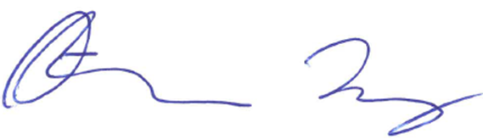
Other than in our capacity as auditor, we have no relationship with, or interests, in the Ministry.

S B Lucy
Audit New Zealand
On behalf of the Auditor-General
Wellington, New Zealand

Financial statements

Statement of comprehensive revenue and expense for the year ended 30 June 2019
Actual |  |  | Note | Actual | Unaudited | Unaudited
 |  |  |  |  | budget | forecast
2018 |  |  |  | 2019 | 2019 | 2020
$000 |  |  |  | $000 | $000 | $000
 |  | Revenue
192,322 |  | Revenue Crown |  | 209,245 | 193,853 | 207,359
10,392 |  | Other revenue | 2 | 11,885 | 13,607 | 13,607
202,714 |  | Total revenue |  | 221,130 | 207,460 | 220,966
 |  | Expenses
115,728 |  | Personnel costs | 3 | 124,965 | 114,580 | 123,976
8,219 |  | Depreciation and amortisation expense | 6,7 | 7,418 | 8,216 | 12,118
1,875 |  | Capital charge | 4 | 2,130 | 2,108 | 2,344
80,095 |  | Other expenses | 5 | 82,511 | 80,667 | 82,528
(1) |  | Net (gain)/loss on sale/disposal of property, plant and equipment |  | - | - | -
205,916 |  | Total expenses |  | 217,024 | 205,571 | 220,966
(3,202) |  | Surplus/(deficit) |  | 4,106 | 1,889 | -
 |  | Other comprehensive revenue and expense
- |  | Item that will not be reclassified to net surplus/(deficit) |  | - | - | -
- |  | Total other comprehensive revenue and expense |  | - | - | -
(3,202) |  | Total comprehensive revenue and expense |  | 4,106 | 1,889 | -
Explanations of major variances against budget are detailed in note 16.
The accompanying notes form part of these financial statements.

Statement of financial position as at 30 June 2019
Actual |  |  | Note | Actual | Unaudited | Unaudited
 |  |  |  |  | budget | forecast
2018 |  |  |  | 2019 | 2019 | 2020
$000 |  |  |  | $000 | $000 | $000
 |  | Equity
30,385 |  | Taxpayers' funds |  | 40,477 | 33,583 | 44,954
2,590 |  | Property revaluation reserve |  | 2,590 | 2,590 | 2,590
(1,521) |  | Memorandum accounts |  | (2,857) | (1,521) | (2,857)
31,454 |  | Total equity | 12 | 40,210 | 34,652 | 44,687
 |  | Represented by:
 |  | Assets
 |  | Current assets
6,203 |  | Cash and cash equivalents |  | 8,904 | 7,000 | 7,000
1,213 |  | Receivables |  | 2,067 | 1,146 | 1,146
7,418 |  | Crown debtors |  | 17,283 | 5,218 | 4,085
- |  | Inventory |  | 32 | - | -
1,889 |  | Prepayments |  | 3,618 | 2,894 | 2,894
16,723 |  | Total current assets |  | 31,904 | 16,258 | 15,125
 |  | Non-current assets
10,048 |  | Property, plant and equipment | 6 | 9,335 | 9,241 | 11,267
30,255 |  | Intangible assets | 7 | 36,005 | 33,850 | 41,981
40,303 |  | Total non-current assets |  | 45,340 | 43,091 | 53,248
57,026 |  | Total assets |  | 77,244 | 59,349 | 68,373
 |  | Liabilities
 |  | Current liabilities
16,337 |  | Payables | 8 | 19,972 | 10,895 | 11,773
- |  | Return of operating surplus | 9 | 5,442 | 1,889 | -
- |  | Provisions | 10 | 1,511 | 2,372 | 2,372
7,810 |  | Employee entitlements | 11 | 8,442 | 8,168 | 8,168
24,147 |  | Total current liabilities |  | 35,367 | 23,324 | 22,313
 |  | Non-current liabilities
1,425 |  | Employee entitlements | 11 | 1,667 | 1,373 | 1,373
1,425 |  | Total non-current liabilities |  | 1,667 | 1,373 | 1,373
25,572 |  | Total liabilities |  | 37,034 | 24,697 | 23,686
31,454 |  | Net assets |  | 40,210 | 34,652 | 44,687
Explanations of major variances against budget are detailed in note 16.
The accompanying notes form part of these financial statements.

Statement of changes in equity for the year ended 30 June 2019
Actual |  |  | Note | Actual | Unaudited | Unaudited
 |  |  |  |  | budget | forecast
2018 |  |  |  | 2019 | 2019 | 2020
$000 |  |  |  | $000 | $000 | $000
32,656 |  | Balance at 1 July |  | 31,454 | 34,652 | 41,543
(3,202) |  | Total comprehensive revenue and expense |  | 4,106 | 1,889 | -
 |  | Owner transactions
- |  | Return of operating surplus to the Crown | 9 | (5,442) | (1,889) | -
2,000 |  | Capital contribution - cash |  | 10,092 | - | 3,144
31,454 |  | Balance at 30 June |  | 40,210 | 34,652 | 44,687

Explanations of major variances against budget are detailed in note 16.
The accompanying notes form part of these financial statements.

Statement of cash flows for the year ended 30 June 2019
Actual |  |  |  | Actual | Unaudited | Unaudited
 |  |  |  |  | budget | forecast
2018 |  |  |  | 2019 | 2019 | 2020
$000 |  |  |  | $000 | $000 | $000
 |  | Cash flows from operating activities
191,668 |  | Receipts from revenue Crown |  | 199,380 | 194,448 | 215,462
10,752 |  | Receipts from other revenue |  | 10,962 | 13,607 | 13,607
(79,897) |  | Payments to suppliers |  | (79,827) | (86,230) | (87,949)
(115,629) |  | Payments to employees |  | (123,696) | (108,991) | (118,220)
(1,874) |  | Payments for capital charge |  | (2,130) | (2,108) | (2,344)
(184) |  | Goods and services tax (net) |  | 557 | - | -
4,836 |  | Net cash flow from operating activities |  | 5,246 | 10,726 | 20,556
 |  | Cash flows from investing activities
1 |  | Receipts from sale of property, plant and equipment |  | 144 | - | -
(577) |  | Purchase of property, plant and equipment |  | (195) | (50) | (1,163)
(6,586) |  | Purchase of intangible assets |  | (12,586) | (8,787) | (14,837)
(7,162) |  | Net cash flow from investing activities |  | (12,637) | (8,837) | (16,000)
 |  | Cash flows from financing activities
2,000 |  | Capital injection |  | 10,092 | - | 3,144
(1,229) |  | Return of operating surplus |  | - | (1,889) | (7,700)
771 |  | Net cash flow from financing activities |  | 10,092 | (1,889) | (4,556)
(1,555) |  | Net increase in cash held |  | 2,701 | - | -
7,758 |  | Cash at the beginning of the year |  | 6,203 | 7,000 | 7,000
6,203 |  | Cash at the end of the year |  | 8,904 | 7,000 | 7,000

Explanations of major variances against budget are detailed in note 16.
The accompanying notes form part of these financial statements.

Statement of cash flows for the year ended 30 June 2019 (continued)

Reconciliation of net surplus/(deficit) to net cash flow from operating activities
Actual |  |  |  | Actual
2018 |  |  |  | 2019
$000 |  |  |  | $000
(3,202) |  | Net surplus/(deficit) |  | 4,106
 |  | Add/(less) non-cash items:
8,219 |  | Depreciation and amortisation expense |  | 7,418
116 |  | Asset write off/down |  | -
8,335 |  | Total non-cash items |  | 7,418
 |  | Add/(less) items classified as investing or financing activities:
(1) |  | (Gains) on disposal of property, plant and equipment |  | -
160 |  | Non-cash transaction - adjustment to depreciation |  | -
159 |  | Total items classified as investing or financing activities |  | -
 |  | Add/(less) movements in working capital items:
(29) |  | (Increase)/decrease in receivables |  | (854)
(654) |  | (Increase)/decrease in Crown debtor |  | (9,865)
- |  | (Increase)/decrease in inventory |  | (32)
2,667 |  | (Increase)/decrease in prepayments |  | (1,729)
(634) |  | Increase/(decrease) in payables |  | 3,817
(982) |  | Increase/(decrease) in provisions |  | 1,511
(824) |  | Increase/(decrease) in employee entitlements |  | 874
(456) |  | Total movements in working capital items |  | (6,278)
4,836 |  | Net cash flow from operating activities |  | 5,246

Explanations of major variances against budget are detailed in note 16.
The accompanying notes form part of these financial statements.
Statement of commitments as at 30 June 2019

Capital commitments
Capital commitments are the aggregate amount of capital contracted for the acquisition of property, plant and equipment and intangible assets that have not been paid for or are not recognised as a liability at the balance date.
Cancellable capital commitments that have penalty or exit costs explicit in the agreement on exercising that option to cancel are reported below at the lower of the remaining contractual commitment and the value of those penalty or exit costs.

Non-cancellable operating lease commitments
The Ministry leases property, plant and equipment in the normal course of its business. The majority of these leases are for premises and photocopiers, which have a non-cancellable leasing period ranging from three to ten years.
The Ministry’s non-cancellable operating leases have varying terms, escalation clauses and renewal rights.
Actual |  |  |  |  | Actual
2018 |  |  |  |  | 2019
$000 |  |  |  |  | $000
 |  | Capital commitments
680 |  | Intangible assets |  |  | 3,026
680 |  | Total capital commitments |  |  | 3,026
 |  | Operating leases as lessee
 |  | Future aggregate lease payments to be paid under non-cancellable operating leases are as follows:
9,319 |  | Not later than one year |  |  | 7,265
37,580 |  | Later than one year and not later than five years |  |  | 37,729
73,233 |  | Later than five years |  |  | 65,898
120,132 |  | Total non-cancellable operating lease commitments |  |  | 110,892
120,812 |  | Total commitments |  |  | 113,918

The Ministry has medium to long-term leases on its premises in Auckland, Christchurch, Dunedin, Hamilton, Whanganui and Wellington. The annual lease payments are subject to regular reviews ranging from one to four years. Amounts disclosed are based on current rental rates.

Statement of contingent liabilities and contingent assets as at 30 June 2019
The Ministry is defending legal disputes involving past employees for which a potential liability has not yet been quantified as at 30 June 2019. The Ministry had no other contingencies liabilities as at the balance date (2018: $nil).
The Ministry had no contingent assets as at the balance date (2018: $nil).

Notes to the financial statements for the year ended 30 June 2019

Notes index
1. Statement of accounting policies
2. Revenue
3. Personnel costs
4. Capital charge
5. Other expenses
6. Plant, property and equipment
7. Intangible assets
8. Payables
9. Return of operating surplus
10. Provisions
11. Employee entitlements
12. Equity
13. Memorandum accounts
14. Related party transactions
15. Events after the balance date
16. Explanations of major variances against budget

1 Statement of accounting policies

Reporting entity

The Ministry of Health (the Ministry) is a government department as defined by section 2 of the Public Finance Act 1989 (PFA) and is domiciled and operates in New Zealand. The relevant legislation governing the Ministry’s operations includes the PFA and the New Zealand Public Health and Disability Act 2000. The Ministry’s ultimate parent is the New Zealand Crown.
The Ministry’s primary objective is to provide services to the New Zealand public. The Ministry funds, administers and monitors the delivery of health services. The Ministry does not operate to make a financial return. In addition, the Ministry has reported on Crown activities and trust monies that it administers in the non-departmental statements and schedules on pages 104 to 120.
The financial statements are for the year ended 30 June 2019 and were approved for issue by the Director-General of Health on 30 September 2019.

Basis of preparation
The financial statements have been prepared on a going-concern basis and the accounting policies have been applied consistently throughout the year.

Statement of compliance
The financial statements of the Ministry have been prepared in accordance with the requirements of the PFA, which include the requirement to comply with New Zealand generally accepted accounting practice and Treasury Instructions.
The Ministry has designated itself as a public benefit entity (PBE) for the purposes of complying with generally accepted accounting practice. The financial statements have been prepared in accordance with and comply with PBE accounting standards.

Presentation currency and rounding
The financial statements are presented in New Zealand dollars and all values are rounded to the nearest thousand dollars ($000).

Changes in accounting policies
There have been no changes in the Ministry’s accounting policies since the date of the last audited financial statements.

Comparative figures
When presentation or classification of items in the financial statements is amended or accounting policies are changed, comparative figures are restated to ensure consistency with the current period unless it is impracticable to do so.

Standards issued, not yet effective and not early adopted
Standards and amendments, issued but not yet effective that have not been early adopted, and which are relevant to the Ministry are:

Impairment of revalued assets
In April 2017, the XRB issued Impairment of Revalued Assets, which now clearly scopes revalued property, plant, and equipment into the impairment accounting standards. Previously, only property, plant, and equipment measured at cost were scoped into the impairment accounting standards. Under the amendment, a revalued asset can be impaired without having to revalue the entire class-of asset to which the asset belongs. This amendment is effective for the 30 June 2020 financial statements, with early adoption permitted. The timing of the Ministry adopting this amendment will be guided by the Treasury’s decision on when the Financial Statements of the Government will adopt the amendment.

Standards issued, not yet effective and early adopted

Financial instruments
In January 2017, the XRB issued PBE IFRS 9 Financial Instruments. This replaces PBE IPSAS 29 Financial Instruments: Recognition and Measurement. PBE IFRS 9 is effective for financial years beginning on or after 1 January 2021, with earlier application permitted. The main changes under the standard relevant to the Ministry are:
- new financial asset classification requirements for determining whether an asset is measured at fair value or amortised cost
- a new impairment model for financial assets based on expected losses, which might result in the earlier recognition of impairment losses.
The Treasury has decided that the Financial Statements of the Government will early adopt PBE IFRS 9 for the 30 June 2019 financial year. The Ministry has also early adopted PBE IFRS 9 for the 30 June 2019 financial year to be consistent with Crown’s accounting policy for financial instruments.
The Ministry has assessed its departmental financial instruments as per the requirements of PBE IFRS 9 Financial Instruments and determined that no adjustments are required as a result of the adoption.

Summary of significant accounting policies
Significant accounting policies are included in the notes to which they relate. Significant accounting policies that do not relate to a specific note are outlined below.

Foreign currency transactions
Foreign currency transactions are translated into New Zealand dollars using the spot exchange rates at the dates of the transactions. Foreign exchange gains and losses resulting from the settlement of such transactions are recognised in the surplus or deficit.

Cash and cash equivalents
Cash and cash equivalents comprise funds in current accounts with Westpac New Zealand Limited, a registered bank.
The Ministry is only permitted to expend its cash and cash equivalents within the scope and limits of its appropriations.
Cash and cash equivalents are subject to the expected loss requirements of PBE IFRS 9. However, no loss allowance has been recognised because the estimated loss allowance for credit losses is considered to be nil or trivial.

Receivables
Short-term receivables are measured at amortised cost and recorded at the amount less any provision for uncollectability and an allowance for credit losses as per the requirements of PBE IFRS 9. No adjustment for credit losses has been made as the estimated loss allowance is considered to be nil or trivial.
A receivable is considered to be uncollectable when there is evidence that the amount will not be fully collectable. The amount that is uncollectable is the difference between the carrying amount due and the present value of the amount expected to be collected.

Goods and services tax (GST)
Items in the financial statements are stated exclusive of GST, except for receivables and payables, which are stated on a GST-inclusive basis. Where GST is not recoverable as input tax, it is recognised as part of the related asset or expense.
The net amount of GST recoverable from, or payable to, the Inland Revenue Department (IRD) is included as part of receivables or payables in the statement of financial position. The net GST paid to or received from the IRD, including the GST relating to investing and financing activities, is classified as an operating cash flow in the statement of cash flows.

Income tax
The Ministry is a public authority and consequently is exempt from income tax. Accordingly, no provision has been made for income tax.

Budget and forecast figures

Basis of the budget figures
The 2018/19 budget figures are for the year ended 30 June 2019 and were published in the 2017/18 Annual Report. They are consistent with the Ministry’s best estimate financial forecast information submitted to the Treasury for the Budget Economic and Fiscal Update (BEFU) for the year ending 2018/19.

Basis of the forecast figures
The 2019/20 forecast figures are for the year ending 30 June 2020, which are consistent with the best estimate financial forecast information submitted to the Treasury for the BEFU for the year ending 2019/20.
The forecast financial statements have been prepared as required by the PFA to communicate forecast financial information for accountability purposes. The 30 June 2020 forecast figures have been prepared in accordance with and comply with PBE FRS 42 Prospective Financial Statements.
The budget and forecast figures are unaudited and have been prepared using the accounting policies adopted in preparing these financial statements.
The Chief Executive is responsible for the forecast financial statements including the appropriateness of the assumptions underlying them and all other required disclosures. The forecast financial statements were approved by the Chief Executive on 24 April 2019.
While the Ministry regularly updates its forecasts, updated forecast financial statements for the year ending 30 June 2020 will not be published.

Significant assumptions used in preparing the forecast financial information
The forecast figures contained in these financial statements reflect the Ministry’s purpose and activities, and are based on a number of assumptions on what may occur during the 2019/2020 year. The forecast figures have been compiled on the basis of existing government policies and ministerial expectations at the time the Main Estimates were finalised.
The main assumptions, which were adopted as at 24 April 2019, were as follows:
- the Ministry’s activities and output expectations will remain substantially the same as the previous year focusing on the Government’s priorities
- personnel costs were based on current wages and salary costs adjusted for anticipated remuneration changes
- operating costs were based on historical experience and other factors that are believed to be reasonable in the circumstances and are the Ministry’s best estimate of future costs that will be incurred
- estimated year-end information for 2018/19 was used as the opening position for the 2019/20 forecasts.
The actual financial results achieved for 30 June 2020 are likely to vary from the forecast information presented. Factors that may lead to a material difference between information in these forecast financial information statements and the actual reported results include changes to the budget through initiatives approved by Cabinet, technical adjustments to including transfers between financial years and timing of expenditure relating to significant programmes and projects.

2 Revenue

Accounting policy
The specific accounting policies for significant revenue items are explained below.
The Ministry derives revenue through the provision of outputs to the Crown and for services to third parties. Such revenue is recognised at fair value of consideration received.

Revenue Crown
Revenue from the Crown is measured based on the Ministry’s funding entitlement for the reporting period. The funding entitlement is established by Parliament when it passes the Appropriation Acts for the financial year. The amount of revenue recognised takes into account any amendments to appropriations approved in the Appropriation (Supplementary Estimates) Act for the year and certain other unconditional funding adjustments formally approved prior to the balance date.
There are no conditions attached to the funding from the Crown. However, the Ministry can incur expenses only within the scope and limits of its appropriations.
The fair value of Revenue Crown has been determined to be equivalent to the funding entitlement.

Supply of services
Revenue from the supply of services is recognised by reference to the stage of completion of the transaction at balance date and only to the extent that the outcome of the transaction can be estimated reliably.

Breakdown of other revenue
Actual |  |  |  |  |  | Actual
2018 |  |  |  |  |  | 2019
$000 |  |  |  |  |  | $000
7,616 |  | Medicines registration |  |  |  | 9,080
427 |  | Service fees |  |  |  | 501
2,264 |  | Annual licence and registration fees |  |  |  | 2,288
85 |  | Other revenue |  |  |  | 16
10,392 |  | Total other revenue |  |  |  | 11,885

3 Personnel costs

Accounting policy
Salaries and wages are recognised as an expense as employees provide services.

Breakdown personnel costs
Actual |  |  |  |  |  | Actual
2018 |  |  |  |  |  | 2019
$000 |  |  |  |  |  | $000
110,358 |  | Salaries and wages |  |  |  | 115,886
3,521 |  | Employer contributions to defined contribution plans |  |  |  | 3,611
(825) |  | Increase/(decrease) in employee entitlements |  |  |  | 875
2,674 |  | Other personnel costs |  |  |  | 3,082
- |  | Cost of Restructuring |  |  |  | 1,511
115,728 |  | Total personnel costs |  |  |  | 124,965

4 Capital charge

Accounting policy
The capital charge is recognised as an expense in the financial year to which the charge relates.
The Ministry pays a capital charge to the Crown on its equity (adjusted for memorandum accounts) as at 30 June and 31 December each year. The capital charge rate for the year ended 30 June 2019 was 6.0% (2018: 6.0%).

5 Other expenses

Accounting policy

Operating leases
An operating lease is a lease that does not transfer substantially all the risks and rewards incidental to ownership of an asset. Lease payments under an operating lease are recognised as an expense on a straight-line basis over the term of the lease.

Lease incentives are recognised in the surplus or deficit as a reduction of rental expense over the lease term.

Other expenses
Other expenses are recognised as goods and services as received.

Breakdown of other expenses
 |  |  |  |  | Unaudited | Unaudited
Actual |  |  |  | Actual | Budget | Forecast
2018 |  |  |  | 2019 | 2019 | 2020
$000 |  |  |  | $000 | $000 | $000
416 |  | Fees to Audit New Zealand for audit of financial statements |  | 427 | 385 | 416
21,042 |  | Contractors and consultants |  | 18,981 | 21,408 | 19,471
22,516 |  | Computer services |  | 26,149 | 23,150 | 30,724
3,456 |  | Travel |  | 3,381 | 3,187 | 3,125
6,351 |  | Communications and couriers |  | 6,350 | 6,783 | 7,259
1,410 |  | Printing and stationery |  | 1,121 | 1,510 | 1,115
11,669 |  | Operating lease payments |  | 11,341 | 11,287 | 11,099
3,154 |  | Occupancy costs other than leases |  | 3,046 | 3,482 | 3,015
6,709 |  | Professional specialist fees |  | 7,986 | 7,003 | 4,870
116 |  | Asset write-offs |  | - | - | -
3,256 |  | Other expenses |  | 3,729 | 2,472 | 1,434
80,095 |  | Total other expenses |  | 82,511 | 80,667 | 82,528

6 Plant, property and equipment

Accounting policy
Property, plant and equipment consists of the following asset classes: land, buildings, leasehold improvements, furniture and office equipment, and motor vehicles.
Land is measured at fair value and buildings are measured at fair value less accumulated depreciation. All other classes are measured at cost less accumulated depreciation and impairment losses.
Individual assets, or groups of assets, are capitalised if their cost is greater than $4,000.

Depreciation
Depreciation is provided on a straight-line basis on all property, plant and equipment, other than land, at rates that will write off the cost (or valuation) of the assets to their estimated residual values over their useful lives. The useful lives and associated depreciation rates of major classes of property, plant and equipment have been estimated as follows:
 | Useful life |  | Depreciation rate
Buildings | 40 years |  | 2.5%
Motor vehicles | 5 years |  | 20%
Furniture and fittings | 5–10 years |  | 10–20%
Machinery | 5 years |  | 20%
Leasehold improvements | 5–10 years |  | 10–20%
IT equipment | 3–5 years |  | 20–33.3%
Leasehold improvements are capitalised over the shorter of the unexpired period of the lease or the estimated remaining useful lives of the improvements.
The residual value and useful life of an asset is reviewed, and adjusted if applicable, at each balance date.

Work in progress
Work in progress is recognised at cost less impairment and is not depreciated.

Additions
The cost of an item of property, plant and equipment is recognised as an asset only when it is probable that future economic benefits or service potential associated with the item will flow to the Ministry and the cost of the item can be measured reliably.
In most instances, an item of property, plant and equipment is initially recognised at its cost. Where an asset is acquired through a non-exchange transaction, it is recognised at its fair value as at the date of acquisition.

Disposals
Gains and losses on disposals are determined by comparing the disposal proceeds with the carrying amount of the asset and are included in the surplus or deficit. When a revalued asset is sold, the amount included in the property revaluation reserve in respect of the disposed asset is transferred to taxpayers’ funds.

Subsequent costs
Costs incurred subsequent to initial acquisition are capitalised only when it is probable that future economic benefits or service potential associated with the item will flow to the Ministry and the cost of the item can be measured reliably.
The cost of day-to-day servicing of property, plant and equipment are recognised in the surplus or deficit as they are incurred.

Revaluations
Land and buildings are revalued with sufficient regularity to ensure that the carrying amount does not differ materially from their fair value and at least every three years.
The carrying value of revalued assets are assessed annually to ensure that they do not differ materially from fair value. If there is a material difference then the off-cycle asset classes are revalued.
Land and building revaluation movements are accounted for on a class-of-asset basis.
The net revaluation results are credited or debited to other comprehensive revenue and expense and are accumulated to an asset revaluation reserve in equity for that class-of-class asset. Where this would result in a debit balance in the asset revaluation reserve, this balance is not recognised in other comprehensive revenue and expense but is recognised in the surplus or deficit. Any subsequent increase on revaluation that reverses a previous decrease in value recognised in the surplus or deficit will be recognised first in the surplus of deficit up to the amount previously expensed, and then recognised in other comprehensive revenue and expense.

Impairment
The Ministry does not hold any cash-generating assets. Assets are considered cash-generating where their primary objective is to generate a commercial return.

Non-cash-generating assets
Property, plant and equipment assets held at cost that have a finite useful life are reviewed for impairment whenever events or changes in circumstances indicate that the carrying amount may not be recoverable. An impairment loss is recognised for the amount by which the asset’s carrying amount exceeds its recoverable service amount. The recoverable service amount is the higher of an asset’s fair value less costs to sell and value in use.
Value in use is the present value of the asset’s remaining service potential. Value in use is determined using an approach based on either a depreciated replacement cost approach, restoration cost approach, or a service units approach. The most appropriate approach used to measure value in use depends on the nature of the impairment and availability of information.
If an asset’s carrying amount exceeds its recoverable service amount, the asset is considered to be impaired and the carrying amount is written down to the recoverable service amount. The total impairment loss is recognised in the surplus or deficit. Reversal of an impairment loss is recognised in the surplus of deficit.

Breakdown of property, plant and equipment
The land at 108 Victoria Street, Christchurch was valued by Bayleys Valuations Limited, an independent valuer. The effective date of the evaluation is 30 June 2018. There has been no change to the value of this land.
There are no restrictions over the title of the Ministry’s plant, property and equipment.

 | Land | Buildings/ | Furniture | Motor | Computer | Total
 |  | leasehold | plant and | vehicles | hardware
 |  | improvements | equipment
 | $000 | $000 | $000 | $000 | $000 | $000
Cost or valuation
Balance as at 1 July 2017 | 5,350 | 5,990 | 1,941 | 373 | 18,640 | 32,294
Additions | - | 48 | 27 | - | 91 | 166
Disposals | - | (240) | (307) | - | (12,096) | (12,643)
Balance as at 30 June 2018 | 5,350 | 5,798 | 1,661 | 373 | 6,635 | 19,817
Balance as at 1 July 2018 | 5,350 | 5,798 | 1,661 | 373 | 6,635 | 19,817
Additions | - | - | - | - | 231 | 231
Disposals | - | - | (20) | - | (3,806) | (3,826)
Transfers/Reclassifications | - | 11 | - | - | 14 | 25
Balance as at 30 June 2019 | 5,350 | 5,809 | 1,641 | 373 | 3,074 | 16,247
Accumulated depreciation and impairment losses
Balance as at 1 July 2017 | - | 1,387 | 1,190 | 286 | 18,472 | 21,335
Prior year adjustment |  | 160 | - | - | - | 160
Depreciation expense | - | 552 | 131 | 12 | 105 | 800
Eliminate on disposal | - | (201) | (233) | - | (12,092) | (12,526)
Balance as at 30 June 2018 | - | 1,898 | 1,088 | 298 | 6,485 | 9,769
Balance as at 1 July 2018 | - | 1,898 | 1,088 | 298 | 6,485 | 9,769
Depreciation expense | - | 545 | 129 | - | 134 | 808
Eliminate on disposal | - | - | (9) | - | (3,661) | (3,670)
Transfers/Reclassifications | - | - | 3 | - | 2 | 5
Balance as at 30 June 2019 | - | 2,443 | 1,211 | 298 | 2,960 | 6,912
Work in progress (WIP)
At 30 June 2017 | - | 3,566 | 92 | - | 24 | 3,682
At 30 June 2018 | - | - | 11 | - | 41 | 52
At 30 June 2019 | - | - | - | - | 20 | 20
Total property, plant and equipment including WIP
At 30 June 2017 | 5,350 | 4,603 | 751 | 87 | 168 | 10,959
At 30 June 2018 | 5,350 | 3,900 | 573 | 75 | 150 | 10,048
At 30 June 2019 | 5,350 | 3,366 | 430 | 75 | 114 | 9,335

7 Intangible assets

Accounting policy
Intangible assets are initially recorded at cost. The cost of an internally generated intangible asset represents expenditure incurred in the development phase of the asset only. The development phase occurs after the following can be demonstrated: technical feasibility; ability to complete the asset; intention and ability to sell or use; and where development expenditure can be reliably measured. Expenditure incurred on research related to an internally generated intangible asset is expensed when it is incurred. Where the research phase cannot be distinguished from the development phase, the expenditure is expensed when it is incurred.

Software acquisition and development
Acquired computer software licenses are capitalised on the basis of the costs incurred to acquire and bring to use the specific software.
Costs that are directly associated with the development of software for internal use are recognised as an intangible asset. Direct costs include the costs of services, software development employee costs, and an appropriate portion of relevant overheads.
Costs of software updates or upgrades are capitalised only when they increase the usefulness or value of the software.
Staff training costs, costs associated with maintaining software and costs associated with development and maintenance of the Ministry’s website are recognised as an expense when incurred.

Amortisation
The carrying value of an intangible asset with a finite life is amortised on a straight-line basis over its useful life. Amortisation begins when the asset is available for use and ceases at the date that the asset is derecognised. The amortisation charge for each financial year is recognised in the surplus or deficit. The useful lives and associated rates of major classes of intangible assets have been estimated as follows:
 | Useful life | Amortisation rate
Software – internally generated | 3–10 years | 14.3–33.3%
Software – other | 3–10 years | 14.3–33.3%

Impairment
Intangible assets subsequently measured at cost that have an indefinite useful life, or are not yet available for use, are not subject to amortisation and are tested annually for impairment. For further details, refer to the policy for impairment of property, plant and equipment in note 6 as the same approach applies to the impairment of intangible assets.

Critical accounting estimates and assumptions

Useful lives of software
The useful life of software is determined at the time the software is acquired and brought into use and is reviewed at each reporting date for appropriateness. For computer software licences, the useful life represents management’s view of the expected period over which the Ministry will receive benefits from the software but not exceeding the licence term. For internally generated software developed by the Ministry, the useful life is based on historical experience with similar systems as well as anticipation of future events that may impact the useful life such as changes in technology.

Breakdown of intangible assets
 | Acquired | Internally | Total
 | software | generated
 |  | software
 | $000 | $000 | $000
Cost
Balance as at 1 July 2017 | 20,418 | 74,848 | 95,266
Additions | 22 | 7,723 | 7,745
Disposals | (320) | (3,142) | (3,462)
Balance as at 30 June 2018 | 20,120 | 79,429 | 99,549
Balance as at 1 July 2018 | 20,120 | 79,429 | 99,549
Additions | 24 | 12,356 | 12,380
Disposals | - | - | -
Transfers | (25) | - | (25)
Balance as at 30 June 2019 | 20,119 | 91,785 | 111,904
Accumulated amortisation and impairment losses
Balance as at 1 July 2017 | 19,266 | 46,071 | 65,337
Amortisation expense | 262 | 7,157 | 7,419
Disposals | (320) | (3,142) | (3,462)
Balance as at 30 June 2018 | 19,208 | 50,086 | 69,294
Balance as at 1 July 2018 | 19,208 | 50,086 | 69,294
Amortisation expense | 213 | 6,397 | 6,610
Transfers | (5) | - | (5)
Balance as at 30 June 2019 | 19,416 | 56,483 | 75,899
Work in progress
At 30 June 2017 | 138 | 11,663 | 11,801
At 30 June 2018 | 2,488 | 6,833 | 9,321
At 30 June 2019 | 7,589 | 12,324 | 19,913
Total intangible assets including WIP
At 30 June 2017 | 1,152 | 28,777 | 29,929
At 30 June 2018 | 912 | 29,343 | 30,255
At 30 June 2019 | 703 | 35,302 | 36,005
There are no restrictions over the title of the Ministry’s intangible assets.

8 Payables

Accounting policy
Short-term payables are measured at amortised cost and recorded at the estimated obligation to pay less an allowance for credit losses per the requirements of PBE IFRS 9. As the estimated loss allowance is considered to be nil or trivial, no adjustment has been made.
Revenue in advance are fees received in advance in relation to new medicine applications.

Breakdown of payables
Actual |  |  |  | Actual
2018 |  |  |  | 2019
$000 |  |  |  | $000
3,578 |  | Creditors |  | 4,186
2,320 |  | Revenue in advance |  | 2,251
8,832 |  | Accrued expenses |  | 11,375
1,607 |  | GST payable |  | 2,160
16,337 |  | Total payables |  | 19,972

9 Return of operating surplus
Actual |  |  |  | Actual
2018 |  |  |  | 2019
$000 |  |  |  | $000
(3,202) |  | Net surplus/(deficit) |  | 4,106
 |  | Add:
1,428 |  | (Surplus)/deficit of memorandum accounts |  | 1,336
(1,774) |  | Total operating surplus/(deficit) |  | 5,442
- |  | Total return of operating surplus |  | 5,442
The return of operating surplus to the Crown is required to be paid by 31 October of each year.

10 Provisions

Accounting policy
A provision is recognised for future expenditure of an uncertain amount or timing when:
- there is a present obligation (either legal or constructive) as a result of a past event
- it is probable that an outflow of resources embodying economic benefits or service potential will be required to settle the obligation
- a reliable estimate can be made of the amount of the obligation.
Provisions are not recognised for net deficits from future operating activities.
Provisions are measured at the present value of the expenditure expected to be required to settle the obligation using a pre-tax discount rate that reflects current market assessments of the time value of money and the risks specific to the obligation. Provisions to be settled beyond 12 months are recorded at their present value.

Restructuring
A provision for restructuring is recognised when an approved detailed formal plan for the restructuring has been announced publicly to those affected or implementation has already commenced.
The restructuring provision arises from the second phase of changes to the Ministry's restructure, which was announced in June 2019, and relates to the cost of expected redundancies. Management anticipate that the restructuring will be completed within nine months of balance date and the amount of the liability is considered reasonably certain.

Breakdown of provisions
Actual |  |  |  | Actual
2018 |  |  |  | 2019
$000 |  |  |  | $000
 |  | Current portion
- |  | Restructuring |  | 1,511
- |  | Total current portion |  | 1,511
- |  | Total provisions |  | 1,511

Movement of provisions
 |  |  | Restructuring | Other | Total
 |  |  | $000 | $000 | $000
Opening balance 1 July |  |  | - | - | -
Additional provision made |  |  | 1,511 | - | 1,511
Closing balance 30 June |  |  | 1,511 | - | 1,511

11 Employee entitlements

Accounting policy

Short-term employee entitlements
Employee entitlements that are due to be settled within 12 months after the end of the year in which the employee provides the related service are measured based on accrued entitlements at current rates of pay.
These include salaries and wages accrued up to the balance date, annual leave earned but not yet taken at the balance date, long service leave and retirement gratuities expected to be settled within 12 months and sick leave.

Long-term employee entitlements
Employee entitlements that are due to be settled beyond 12 months after the end of the year in which the employee provides the related service, such as retirement and long service leave have been calculated on an actuarial basis. The calculations are based on:
- likely future entitlements accruing to employees, based on years of service, years to entitlement, the likelihood that employees will reach the point of entitlement, and contractual entitlements information
- the present value of the estimated future cash flows.

Presentation of employee entitlements
Annual leave, vested long service leave, non-vested long service leave and retirement gratuities expected to be settled within 12 months of the balance date are classified as a current liability. All other employee entitlements are classified as a non-current liability.

Critical accounting estimates and assumptions: long service leave and retirement gratuities
The measurement of the long service leave and retirement gratuities obligations depends on a number of factors that are determined on an actuarial basis using a number of assumptions. Two key assumptions used in calculating this liability include the discount rate and the salary inflation factor. Any changes in these assumptions will affect the carrying amount of the liability.
Expected future payments are discounted using discount rates derived from the yield curve of New Zealand government bonds. The discount rates used have maturities that match, as closely as possible, the estimated future cash flows. A weighted average discount rate of 1.23% (2018: 1.77%) was used. The discount rates and salary inflation factor used are those advised by the Treasury.
If the discount rates were to differ by 1% from the Ministry’s estimates, with all other factors held constant, the carrying amount of the liability and the surplus or deficit would be an estimated $110,761 higher/lower.
If the salary inflation rates were to differ by 1% from the Ministry’s estimates, with all other factors held constant, the carrying amount of the total liability and the surplus or deficit would be an estimated $146,491 higher/lower.

Breakdown of employee benefits
Actual |  |  |  | Actual
2018 |  |  |  | 2019
$000 |  |  |  | $000
 |  | Current position
6,218 |  | Annual leave |  | 6,419
759 |  | Retirement and long service leave |  | 1,099
833 |  | Accrued salaries |  | 924
7,810 |  | Total current portion |  | 8,442
 |  | Non-current position
1,425 |  | Retirement and long service leave |  | 1,667
1,425 |  | Total non-current portion |  | 1,667
9,235 |  | Total employee entitlements |  | 10,109

12 Equity

Accounting policy
Equity is the Crown’s investment in the Ministry and is measured as the difference between total assets and total liabilities. Equity is disaggregated and classified as taxpayers’ funds, memorandum accounts and property revaluation reserves.

Memorandum accounts
Memorandum accounts reflect the cumulative surplus or deficit on those departmental services provided that are intended to be fully cost recovered from third parties through fees, levies or charges. The balance of each memorandum account is expected to trend toward zero over time.

Property revaluation reserves
These reserves relate to the revaluation of land and buildings to fair value.

Breakdown of equity
Actual |  |  |  | Actual
2018 |  |  |  | 2019
$000 |  |  |  | $000
 |  | Taxpayers' funds
30,159 |  | Balance at 1 July |  | 30,385
(3,202) |  | Surplus/(deficit) |  | 4,106
1,428 |  | Transfer of memorandum account net deficit for the year |  | 1,336
- |  | Return of operating surplus to the Crown |  | (5,442)
2,000 |  | Capital injection |  | 10,092
30,385 |  | Balance at 30 June |  | 40,477
 |  | Property revaluation reserves
2,590 |  | Balance at 1 July |  | 2,590
2,590 |  | Balance at 30 June |  | 2,590
 |  | Memorandum accounts
(93) |  | Balance at 1 July |  | (1,521)
(1,428) |  | Net memorandum account deficits for the year |  | (1,336)
(1,521) |  | Balance at 30 June |  | (2,857)
31,454 |  | Total equity |  | 40,210

13 Memorandum accounts
The memorandum accounts summarise financial information relating to the accumulated surpluses and deficits incurred in the provision of statutory information and performance of accountability reviews by the Ministry to third parties in a full cost recovery basis.
The balance of each memorandum account is expected to trend toward zero over a reasonable period of time, with interim deficits being met either from cash from the Ministry’s statement of financial position or by seeking approval for a capital injection from the Crown. Capital injections will be repaid to the Crown by way of cash payments throughout the memorandum account cycle.

Action taken to address surpluses and deficits
A revised fee strategy was implemented for Medsafe to ensure the fee structure and associated revenues are in line with the forecast activities.

Capital management
The Ministry’s capital is its equity, which comprise taxpayers’ funds, memorandum accounts, and property revaluation reserves. Equity is presented by net assets.
The Ministry manages its revenues, expenses, assets, liabilities, and general financial dealings prudently. The Ministry’s equity is largely managed as a by-product of managing revenue, expenses, assets, liabilities, compliance with the government budget processes, Treasury instructions, and the PFA.
The objective of managing the Ministry’s equity is to ensure that the Ministry effectively achieves its goals and objectives, for which it has been established, while remaining a going concern.

Memorandum accounts
Actual |  |  |  | Actual
2018 |  |  |  | 2019
$000 |  |  |  | $000
 |  | Opening balance
(730) |  | Problem gambling |  | (609)
631 |  | Office of radiation safety |  | 398
6 |  | Medsafe |  | (1,310)
(93) |  |  |  | (1,521)
 |  | Revenue and appropriation
990 |  | Problem gambling appropriation |  | 990
1,126 |  | Office of radiation safety revenue |  | 1,034
7,309 |  | Medsafe revenue |  | 8,746
9,425 |  |  |  | 10,770
 |  | Expenditure
(869) |  | Problem gambling expenditure |  | (1,088)
(1,359) |  | Office of radiation safety expenditure |  | (1,536)
(8,625) |  | Medsafe expenditure |  | (9,482)
(10,853) |  |  |  | (12,106)
(1,428) |  | Total deficit for year |  | (1,336)
 |  | Closing balance
(609) |  | Problem gambling |  | (707)
398 |  | Office of radiation safety |  | (104)
(1,310) |  | Medsafe |  | (2,046)
(1,521) |  |  |  | (2,857)

14 Related party transactions
The Ministry is a wholly owned entity of the Crown.
Related party disclosures have not been made for transactions with related parties that are within a normal supplier or client/recipient relationship on terms and condition no more or less favourable than those that it is reasonable to expect the Ministry would have adopted in dealing with the party at arm’s length in the same circumstances. Further, transactions with other government agencies are not disclosed as related party transactions when they are consistent with the normal operating arrangements between government agencies and undertaken on the normal terms and conditions for such transactions.

Key management personnel compensation
Actual |  |  |  | Actual
2018 |  |  |  | 2019
$000 |  |  |  | $000
 |  | Leadership Team including the Chief Executive:
5,165 |  | Remuneration |  | 5,457
12 |  | Full-time equivalent staff |  | 14
The above key management personnel disclosure excludes the Minister of Health. The Minister’s remuneration and other benefits are not received only for his role as a member of key personnel of the Ministry. The Minister’s remuneration and other benefits are set by the Remuneration Authority under the Members of Parliament (Remuneration and Services) Act 2013 and are paid under Permanent Legislative authority, not by the Ministry of Health.

15 Events after the balance date
There are no significant events after the balance date.

16 Explanation of major variances against budget
Explanations for major variances from the Ministry’s estimated figures are outlined below.

Statement of Comprehensive Revenue and Expense

Revenue Crown
Revenue Crown was $15.4 million higher than the unaudited budget. The main changes since the budget were the establishment of the health & disability system review
($5.3 million), pay equity settlements ($4.4 million), national asset management plan
($5 million), medicinal cannabis scheme ($0.6 million), and medicinal cannabis referendum ($0.1 million). These changes have been included in the Supplementary budget.

Revenue Other
Revenue other was $1.7 million lower than the unaudited budget. This was mainly due to a decrease in annual licences ($1.3 million) and other revenue ($0.6 million) both of which is demand driven. In 2018/19, applications for intermediate risk new medicines as well as radiation safety licensing were lower than anticipated. The reduction is partly offset by higher service fees and medicines registration ($0.2 million).

Personnel Costs
Personnel costs have increased by $10.1 million due to a wage increase of 2%, the first phase of restructure that occurred in October 2018 creating new directorates and a subsequent increase in full time equivalent positions, a redundancy provision
($1.5 million) and increased long service leave provision due to changes is the discount rate and salary inflation rate in line with Treasury guidelines ($0.6 million).

Depreciation
Depreciation and amortisation costs were $0.8 million lower than the unaudited budget due to the timing of the completion of some capital projects.

Other Expenses
Other expenses were higher than the unaudited budget by $1.8 million. This was mainly due to higher computer service costs ($3.0 million) from IT as-a-service costs and work programme initiatives, and other expenses ($1.3 million) such as public/sector consultations and purchase of statistical data. These increased expenses are partially offset by lower costs across contractors and consultants ($2.4 million) as four major projects are winding down.

Statement of financial position

Current assets

Current assets were $15.6 million higher than the unaudited budget. This was due to higher Crown debtors ($12.1 million) relating to funds held for return of operating surplus of
$5.4 million, in-principle expense transfers (IPETS) of $3.1 million and other assets
($3.6 million), receivables ($0.9 million), prepayments ($0.7 million) and cash ($1.9 million).

Property, plant and equipment, and intangible assets
Intangible assets were $2.2 million higher than the unaudited budget due to timing of the completion of some capital projects.

Payables
Payables were $9.1 million higher than the unaudited budget. This was mainly due to GST to be paid in the following month ($0.6 million), higher accrued expenses which includes IT projects in progress ($1.4 million), information and communications technology ($2.5 million), the Health and Disability System Review ($0.4 million) and other payables ($4.2 million).

Non-departmental statements and schedules for the year ended 30 June 2019
The following non-departmental statements and schedules record the revenue, expenses, assets, liabilities, commitments, contingent liabilities, contingent assets, capital receipts and trust accounts that the Ministry manages on behalf of the Crown.

Statement of non-departmental expenses for the year ended 30 June 2019
Actual |  |  |  | Actual | Budget | Revised
2018 |  |  |  |  |  | budget
 |  |  |  | 2019 | 2019 | 2019
$000 |  |  |  | $000 | $000 | $000
14,036,082 |  | Contracted services funding to DHBs |  | 14,886,847 | 14,500,678 | 14,877,398
21,988 |  | Services from PHARMAC |  | 23,488 | 23,488 | 23,488
17,620 |  | Services from Institute of Environmental Research |  | 18,029 | 17,158 | 17,158
17,596 |  | Services from Health Promotion Agency |  | 16,774 | 17,048 | 17,048
13,369 |  | Services from Health Quality Safety Commission |  | 13,552 | 13,476 | 13,476
12,870 |  | Services from the Health and Disabilities Commissioner |  | 13,370 | 12,870 | 12,870
16,618 |  | Services from Other Crown Entities |  | 14,627 | 18,210 | 14,721
14,136,143 |  | Total services from Crown Entities |  | 14,986,687 | 14,602,929 | 14,976,159
1,834,203 |  | Services from third parties |  | 1,953,171 | 2,138,471 | 1,992,823
15,970,346 |  | Total services |  | 16,939,858 | 16,741,400 | 16,968,982
- |  | Revaluation loss on property, plant and equipment |  | 2,735 | - | -
(1,200) |  | Net movement in residential care loans book value |  | (755) | - | -
- |  | Write off of Crown Investments |  | 22,588 | - | -
(1,200) |  | Total revaluation and impairment adjustments |  | 24,568 | - | -
15,969,146 |  | Total non-departmental expenses |  | 16,964,426 | 16,741,400 | 16,968,982
2,402,148 |  | GST input expense |  | 2,534,792 | 2,516,594 | 2,563,958
18,371,294 |  | Total non-departmental expenses GST inclusive |  | 19,499,218 | 19,257,994 | 19,532,940
Further details of non–departmental expenditure and appropriations by Vote are provided in the Appropriations Statements on pages 113 to 116 which cover both operating and capital expenditure.

The accompanying notes form part of these financial statements.
For a full understanding of the Crown’s financial position and the results of its operations for the year, refer to the consolidated Financial Statements of the Government for the year ended 30 June 2019.

Schedule of non-departmental revenue and capital receipts for the year ended 30 June 2019
Non-departmental revenues and capital receipts are administered by the Ministry on behalf of the Crown. As these revenues are not established by the Ministry nor earned in the production of its outputs they are not reported in the financial statements.
Actual |  |  |  | Actual | Budget | Revised
 |  |  |  |  |  | budget
2018 |  |  |  | 2019 | 2019 | 2019
$000 |  |  |  | $000 | $000 | $000
 |  | Revenue
 |  | Reimbursement from the Accident Compensation Corporation (ACC)
6,092 |  | Reimbursement of complex burns costs |  | 6,357 | 5,250 | 6,357
24,920 |  | Reimbursement of work-related public hospital costs |  | 27,788 | 31,498 | 27,788
307,260 |  | Reimbursement of non-earners' account |  | 328,563 | 299,231 | 328,563
106,849 |  | Reimbursement of earners' non-work-related public hospital costs |  | 106,434 | 94,494 | 106,434
54,100 |  | Reimbursement of motor vehicle-related public hospital costs |  | 51,541 | 78,745 | 51,541
4,368 |  | Reimbursement of medical misadventure costs |  | 3,113 | 5,250 | 3,113
4,749 |  | Reimbursement of self-employed public hospital costs |  | 6,471 | 10,499 | 6,471
508,338 |  | Total ACC reimbursements |  | 530,267 | 524,967 | 530,267
 |  | Non-departmental revenue
325,984 |  | Payment of capital charge by DHB |  | 333,511 | 262,367 | 348,381
834,322 |  | Total non-departmental revenue |  | 863,778 | 787,334 | 878,648
 |  | Non-departmental capital receipts
11,220 |  | Repayment of residential care loans |  | 12,864 | 15,000 | 15,000
- |  | Repayment of DHB debt |  | - | - | -
12,499 |  | Equity repayments by DHB |  | 12,117 | 12,499 | 12,499
23,719 |  | Total non-departmental capital receipts |  | 24,981 | 27,499 | 27,499
858,041 |  | Total non-departmental revenue and capital receipts |  | 888,759 | 814,833 | 906,147

The accompanying notes form part of these financial statements.
For a full understanding of the Crown’s financial position and the results of its operations for the year, refer to the consolidated Financial Statements of the Government for the year ended 30 June 2019.

Schedule of non-departmental assets and liabilities as at 30 June 2019
Actual |  | Note | Actual | Budget | Revised
 |  |  |  |  | budget
2018 |  |  | 2019 | 2019 | 2019
$000 |  |  | $000 | $000 | $000
 | Assets
 | Current assets
162,949 | Cash and cash equivalents |  | 356,580 | 95,000 | 95,000
8,518 | Inventory | 2.8 | 8,507 | 17,000 | 17,000
 | Receivables:
591 | District Health Boards |  | 4,935 | 1,962 | 1,822
443 | ACC |  | 41,933 | 415 | 415
465 | Government departments |  | 96 | 282 | 282
6,156 | Other receivables |  | 5,892 | - | -
48,248 | Prepayments |  | 32,719 | 33,000 | 33,000
227,370 | Total current assets |  | 450,662 | 147,659 | 147,519
 | Non-current assets
 | Advances:
38,357 | Residential care loans |  | 41,046 | 37,264 | 40,361
(116) | Other advances |  | - | - | -
 | Investments:
492,131 | Hospital rebuild projects | 2.9 | 571,144 | 95,426 | 640,523
29,008 | Other investments |  | 18,127 | - | -
559,380 | Total non-current assets |  | 630,317 | 132,690 | 680,884
786,750 | Total non-departmental assets |  | 1,080,979 | 280,349 | 828,403
 | Liabilities
 | Current liabilities
- | Bank |  | - | - | -
 | Payables:
19,048 | DHB payables |  | 12,141
31,330 | Other payables | 2.10 | 15,586 | - | -
 | Accrued liabilities and provisions:
254,854 | DHB accrued liabilities |  | 263,762 | 278,848 | 269,407
1,543 | Other Crown entities |  | 1,026 | - | -
173,126 | Other accrued liabilities |  | 196,693 | 177,524 | 210,170
479,901 | Total non-departmental current liabilities |  | 489,208 | 456,372 | 479,577
The Ministry monitors a number of Crown entities including 20 DHBs. Investment in these entities is recorded in the financial statements of the Government on a line-by-line basis. No disclosure of investments in Crown entities is made in this schedule.
The accompanying notes form part of these financial statements.
For a full understanding of the Crown’s financial position and the results of its operations for the year, refer to the consolidated Financial Statements of the Government for the year ended 30 June 2019.

Schedule of non-departmental commitments as at 30 June 2019

Breakdown of capital commitments
Actual |  |  |  | Actual
2018 |  |  |  | 2019
$000 |  |  |  | $000
110,632 |  | Property, plant and equipment |  | 110,899
110,632 |  | Total capital commitments |  | 110,899

Schedule of non-departmental contingent liabilities and contingent assets as at 30 June 2019

Breakdown of contingent liabilities
Actual |  |  |  | Actual
2018 |  |  |  | 2019
$000 |  |  |  | $000
7,610 |  | Legal proceedings and disputes |  | 46,010
7,610 |  | Total contingent liabilities |  | 46,010

Legal proceedings and disputes
Legal claims against the Crown are mainly seeking recompense in relation to perceived issues regarding treatment and care and the Crown is in the process of defending these claims. Settlements are likely to be significantly less than the claims made.

Contingent assets
The Ministry had no contingent assets as at the balance date (2019: $nil).

The accompanying notes form part of these financial statements.
For a full understanding of the Crown’s financial position and the results of its operations for the year, refer to the consolidated Financial Statements of the Government for the year ended 30 June 2019.

Problem Gambling Revenue Report for the year ended 30 June 2019
In accordance with the Gambling Act 2003, the Ministry receives an appropriation for problem gambling that over time is intended to be fully funded from the levies collected from the industry by IRD. The following report shows the revenue collected to date and actual expenditure.
Actual |  | Non-departmental | Departmental | Total
 |  | actual | actual | actual
2018 |  | 2019 | 2019 | 2019
$000 |  | $000 | $000 | $000
 | Problem Gambling non-departmental expenditure
3,840 | Balance at 1 July | 7,403 | (609) | 6,794
19,550 | Revenue | 20,294 | 990 | 21,284
(15,997) | Expenses | (15,884) | (1,088) | (16,972)
7,403 | Balance at 30 June | 11,813 | (707) | 11,106
Revenue is actual levies collected by IRD less the Departmental revenue based on the ‘Preventing and Minimising Gambling Harm: Three-year service plan 2016/17–2018/19’.
The accompanying notes form part of these financial statements.
For a full understanding of the Crown’s financial position and the results of its operations for the year, refer to the consolidated Financial Statements of the Government for the year ended 30 June 2019.

Notes to the non-departmental statements and schedules

Notes index
1. Statement of accounting policies
2. Explanation of major variances against budget

1. Statement of accounting policies

Reporting entity
These non-departmental statements and schedules present financial information on public funds managed by the Ministry on behalf of the Crown. The financial information is consolidated into the Financial Statements of the Government and, therefore, readers of these schedules should also refer to the financial statements of the Government for the year ended 30 June 2019.

Basis of preparation
The non-departmental statements and schedules have been prepared in accordance with the accounting policies of the financial statements of the Government, Treasury instructions and Treasury circulars.
Measurement and recognition rules applied in the preparation of the non-departmental statements and schedules are consistent with Crown accounting policies and Tier 1 NZ PBE accounting standards.

Statement of compliance
The financial statements of the Ministry have been prepared in accordance with the requirements of the PFA, which include the requirement to comply with New Zealand generally accepted accounting practice and Treasury instructions.
The financial statements have been prepared in accordance with and comply with PBE accounting standards.

Presentation currency and rounding
The financial statements are presented in New Zealand dollars and all values are rounded to the nearest thousand dollars ($000).

Changes in accounting policies
There have been no changes in the Ministry’s accounting policies since the date of the last audited financial statements.

Standards issued, not yet effective and not early adopted
Standards and amendments issued but not yet effective that have not been early adopted and which are relevant to the Ministry are:

Impairment of revalued assets
In April 2017, the XRB issued Impairment of Revalued Assets, which now clearly scopes revalued property, plant and equipment into the impairment accounting standards. Previously, only property, plant, and equipment measured at cost were scoped into the impairment accounting standards. Under the amendment, a revalued asset can be impaired without having to revalue the entire class-of asset to which the asset belongs. This amendment is effective for the 30 June 2020 financial statements, with early adoption permitted. The timing of the Ministry adopting this amendment will be guided by the Treasury’s decision on when the Financial Statements of the Government will adopt the amendment.

Standards issued, not yet effective and early adopted

Financial instruments
The Treasury has decided that the Financial Statements of the Government will early adopt PBE IFRS 9 for the 30 June 2019 financial year. The Ministry has also early adopted PBE IFRS 9 for the 30 June 2019 financial year to be consistent with Crown’s accounting policy for financial instruments.
The Ministry has assessed its non-departmental financial instruments as per the requirements of PBE IFRS 9 Financial Instruments and determined that no adjustments are required as a result of the adoption.

Summary of significant accounting policies
Significant accounting policies are included in the notes to which they relate. Significant accounting policies that do not relate to a specific note are outlined below.

Revenue and receipts
Revenue from ACC recoveries and capital charges from DHBs is recognised when earned and is reported in the financial period to which it relates.
Cash and cash equivalents
Cash and cash equivalents are subject to the expected loss requirements of PBE IFRS 9. However, no loss allowance has been recognised because the estimated loss allowance for credit losses is considered to be nil or trivial.

Debtors and receivables
Receivables from ACC recoveries are measured at amortised cost and recorded at the value of the contract and agreed with ACC, less an allowance for credit losses as per the requirements of PBE IFRS 9. The estimated loss allowance is considered to be nil. Receivables from capital charges are recorded at estimated realisable value.

Residential care loans
An actuarial valuation of residential care loans was carried out in May 2019.

Inventory
Inventories held for consumption in the provision for services are recorded at the lower of cost or current replacement cost. Any write-down from cost to replacement cost is recognised in the Statement of Non-Departmental Expenses and Capital Expenditure against appropriations.

Investments
Investments are recorded in the Schedule of Non-Departmental Assets at historical cost. The carrying value represents the aggregate of equity injections made by the Ministry less subsequent repayments of equity returned to the Crown.

Accrued expenses
Accrued expenses are recorded at either the value of funding entitlements owing under Crown funding agreements or the estimated value of contracts already started but not yet completed.

Goods and services tax (GST)
All items in the financial statements, including appropriation statements, are stated exclusive of GST, except for receivables and payables, which are stated on a GST-inclusive basis. In accordance with Treasury instructions, GST is returned on revenue received on behalf of Crown where applicable.
Input tax deductions are not claimed on non-departmental expenditure. Instead, the amount of GST applicable to non-departmental expenditure is recognized as a separate expense and eliminated against GST revenue on consolidation of the financial statements of the Government.

Commitments
Future expenses and liabilities to be incurred on contracts that have been entered into as at the balance date are disclosed as commitments to the extent that there are equally unperformed obligations.

Budget figures
The budget figures are consistent with the financial information in the Mains Estimates. In addition, these financial statements also present the updated budget information about the Supplementary Estimates (Revised budget).

Payables and provisions
Payables and provisions are measured at amortised cost and are recorded at the estimated obligation to pay less an allowance for credit losses per the requirements of PBE IFRS 9. As the estimated loss allowance is considered to be nil or trivial, no adjustment has been made.

Changes in accounting policies
There have been no changes in accounting policies.

Events after the balance date
There are no significant events after the balance date.

Appropriation statements
The following statements report information about the expenses and capital expenditure incurred against each appropriation administered by the Ministry for the year ended 30 June 2019. They are prepared on a GST exclusive basis.

Statement of budgeted and actual expenses and capital expenditure incurred against appropriations for the year ended 30 June 2019
Actual |  | Appropriation title |  | Actual | Budget | Revised | Location of
expenditure |  |  |  | expenditure |  | budget | end-of-year
2018 |  |  |  | 2019 | 2019 | 2019 | performance
$000 |  |  | Note | $000 | $000 | $000 | information
 |  | Departmental output expenses
43,368 |  | Managing the purchase of services |  | 49,313 | 41,974 | 49,374 | 1
24,820 |  | Regulatory and enforcement services |  | 23,346 | 24,111 | 23,443 | 1
48,464 |  | Sector planning and performance |  | 54,229 | 47,426 | 54,426 | 1
52,840 |  | Health sector information systems |  | 51,050 | 55,618 | 51,118 | 1
15,838 |  | Payment services |  | 15,331 | 17,340 | 15,340 | 1
185,330 |  | Total departmental output expenses |  | 193,269 | 186,469 | 193,701
 |  | Multi-category expenses
5,201 |  | Ministerial servicing |  | 4,684 | 4,702 | 4,702 | 1
15,385 |  | Policy advice |  | 16,404 | 16,289 | 16,439 | 1
- |  | Review of Health & Disability Support Services |  | 2,667 | - | 5,260 | 1
20,586 |  | Total multi-category expenses |  | 23,755 | 20,991 | 26,401
 |  | Departmental capital expenditure |  | 217,024 | 207,460 | 220,102
7,163 |  | Ministry of Health - permanent legislative authority |  | 12,781 | 8,837 | 20,887 | 1
7,163 |  | Total departmental capital expenditure |  | 12,781 | 8,837 | 20,887
213,079 |  | Total departmental output appropriations |  | 229,805 | 216,297 | 240,989
 |  | Non-departmental output expenses
 |  | Health/disability support services for district health boards (DHBs)
564,287 |  | Northland |  | 603,894 | 599,300 | 603,896 | 2
1,464,456 |  | Waitemata |  | 1,541,545 | 1,531,538 | 1,541,548 | 2
1,252,079 |  | Auckland |  | 1,330,186 | 1,320,417 | 1,330,189 | 2
1,375,690 |  | Counties Manukau |  | 1,447,122 | 1,439,807 | 1,447,124 | 2
1,150,494 |  | Waikato |  | 1,206,300 | 1,197,666 | 1,206,301 | 2
314,710 |  | Lakes |  | 327,560 | 326,173 | 327,563 | 2
694,747 |  | Bay of Plenty |  | 728,951 | 724,436 | 728,953 | 2
160,653 |  | Tairawhiti |  | 166,213 | 165,267 | 166,215 | 2
335,661 |  | Taranaki |  | 349,768 | 345,188 | 349,770 | 2
482,423 |  | Hawke's Bay |  | 501,129 | 497,215 | 501,131 | 2
218,554 |  | Whanganui |  | 226,848 | 225,131 | 226,852 | 2
494,251 |  | MidCentral |  | 515,380 | 511,676 | 515,382 | 2
384,878 |  | Hutt Valley |  | 401,750 | 397,128 | 401,752 | 2
735,631 |  | Capital and Coast |  | 778,511 | 765,489 | 778,514 | 2
135,248 |  | Wairarapa |  | 140,647 | 140,030 | 140,650 | 2
418,361 |  | Nelson-Marlborough |  | 442,100 | 437,795 | 442,103 | 2
128,075 |  | West Coast |  | 132,026 | 132,618 | 133,949 | 2
1,378,248 |  | Canterbury |  | 1,431,953 | 1,421,052 | 1,439,372 | 2
177,017 |  | South Canterbury |  | 182,426 | 181,432 | 182,428 | 2
846,384 |  | Southern |  | 884,024 | 876,351 | 884,027 | 2
12,711,847 |  | Total health/disability support services for DHBs | 2.1 | 13,338,333 | 13,235,709 | 13,347,719
The numbers in this column represent where the end-of-year performance information has been reported for each appropriation administered by the Ministry, as detailed below:
1 The ‘Our outputs’ section of the Ministry’s annual report.
2 The DHBs annual reports.
3 The Vote Health Report in relation to selected non-departmental appropriations for the year ended 30 June 2019.
4 Exemptions granted under section 15D of the Public Finance Act 1989
** These are the appropriations from the supplementary estimates.

Statement of budgeted and actual expenses and capital expenditure incurred against appropriations for the year ended 30 June 2019 (continued)
Actual |  | Appropriation title |  | Actual | Budget | ** Revised | Location of
expenditure |  |  |  | expenditure |  | budget | end-of-year
2018 |  |  |  | 2019 | 2019 | 2019 | performance
$000 |  | Note |  | $000 | $000 | $000 | information
 |  | National services
1,255,530 |  | National disability support services | 2.2 | 1,358,397 | 1,268,594 | 1,351,707 | 3
364,314 |  | Public health services purchasing | 2.3 | 390,239 | 423,424 | 403,266 | 3
82,170 |  | National child health services |  | 92,432 | 89,254 | 93,254 | 3
354,104 |  | National elective services |  | 356,968 | 363,517 | 362,357 | 3
108,162 |  | National emergency services |  | 120,252 | 129,597 | 124,313 | 3
2,149 |  | National Māori health services |  | 3,105 | 6,828 | 6,828 | 3
166,508 |  | National maternity services |  | 180,628 | 181,067 | 181,067 | 3
65,090 |  | National mental health services |  | 76,685 | 68,094 | 80,194 | 3
24,892 |  | National contracted services - other |  | 23,488 | 28,720 | 23,488 | 3
29,844 |  | Monitoring and protecting health and disability consumer interests |  | 29,468 | 29,546 | 29,546 | 3
15,997 |  | Problem gambling services |  | 15,884 | 20,941 | 17,765 | 3
186,609 |  | Health workforce training and development |  | 184,748 | 186,745 | 187,120 | 3
192,531 |  | Primary health care strategy |  | 262,607 | 266,396 | 264,639 | 3
79,176 |  | National personal health services |  | 70,005 | 78,151 | 70,751 | 3
4,701 |  | National health information systems |  | 4,803 | 8,042 | 8,042 | 3
5,270 |  | Health sector projects operating expenses |  | 6,923 | 3,500 | 8,558 | 3
- |  | Auckland health projects integrated investment plan |  | 30 | 1,000 | 1,370 | 4
275,806 |  | Equitable Pay for Care and Support Workers | 2.5 | 362,527 | 348,000 | 377,405 | 4
23,449 |  | Mental Health Pay Equity Settlement |  | - | - | - | 4
- |  | Supporting Safe Working Conditions for Nurses | 2.4 | 36,137 | - | 45,694 | 4
3,236,303 |  | Total national services |  | 3,575,296 | 3,501,416 | 3,637,364
15,948,150 |  | Total non-departmental output expenses |  | 16,913,629 | 16,737,125 | 16,985,083
 |  | Non-departmental other expenses
1,819 |  | International health organisations |  | 1,863 | 2,030 | 2,030 | 4
1,972 |  | Legal expenses |  | 3,038 | 1,028 | 11,028 | 4
18,405 |  | Provider development |  | 21,328 | 24,289 | 28,289 | 3
22,196 |  | Total non-departmental other expenses |  | 26,229 | 27,347 | 41,347
 |  | Non-departmental revaluation and impairment adjustments
- |  | Revaluation loss on property, plant and equipment |  | 2,735 | - | - | 4
(1,200) |  | Net movement in residential care loans book value |  | (755) | - | - | 4
- |  | Write off of Crown Investments |  | 22,588 | - | - | 4
(1,200) |  | Total non-departmental revaluation and impairment adjustments |  | 24,568 | - | -
15,969,146 |  | Total non-departmental expenses |  | 16,964,426 | 16,762,472 | 17,026,430
 |  | Non-departmental capital contributions to other persons or organisations
69,300 |  | Deficit support for DHB |  | 234,211 | 139,211 | 234,211 | 2
25,811 |  | Equity for capital projects for DHBs and Health Sector Crown Agencies | 2.6 | 91,515 | 967,383 | 264,273 | 3
233,375 |  | Health sector projects | 2.7 | 158,432 | 123,000 | 213,922 | 3
12,852 |  | Residential care loans |  | 14,910 | 15,000 | 15,000 | 3
341,338 |  | Total non-departmental capital contributions to other persons or organisations |  | 499,068 | 1,244,594 | 727,406
16,311,684 |  | Total non-departmental appropriations |  | 17,463,494 | 18,009,066 | 17,753,836
16,524,763 |  | Total Vote: Health |  | 17,693,299 | 18,225,363 | 17,994,825
The numbers in this column represent where the end-of-year performance information has been reported for each appropriation administered by the Ministry, as detailed below:

1 The ‘Our outputs’ section of the Ministry’s annual report.
2 The DHBs annual reports.
** These are the appropriations from the supplementary estimates.
3 The Vote Health Report in relation to selected non-departmental appropriations for the year ended 30 June 2019.
4 Exemptions granted under section 15D of the Public Finance Act 1989

2. Explanation of major variances against budget
Explanations for major variances from the Ministry’s non-departmental appropriations within the Main Estimates are as follows.

Schedule of non-departmental expenses and capital expenditure against appropriations

2.1 Health and disability support services for DHB
Variances differ across DHBs (net unfavourable variance of $102.6 million against the Main Estimates) reflecting a number of changes during the year. These changes include the settlement of Multi-Employer Collective Agreements during the year ($79.4m million), devolvement of the Budget 2012 Cancer Control initiative ($4.0 million), additional support for those affected by the Christchurch mosque attacks ($3.0 million) and a technical change to capital charge costs in the year ($22.7 million).

2.2 National disability support services
The unfavourable variance of $89.8 million against the Main Estimates is mainly due to an overall increase in demand for disability support services including volume driven costs such as in-between travel (IBT) of $31.3 million, community care of $22.7 million, residential care services of $24.1 million, and equipment and modification services of $14.2 million. Additional funding was received in the 2018/19 Supplementary Estimates to address these cost pressures. However continued growth in the last quarter led to a $6.7 million (0.5 percent) overspend against the final voted appropriation. This is being addressed through Section 26B of the Public Finance Act.

2.3 Public health services purchasing
The favourable variance of $33.1 million against the Main Estimates is mainly due to the timing of projects in the Bowel Cancer Screening Programme ($9.8 million) and the Fluoridisation of Water Supply Assistance Scheme ($6.7 million). Additionally, $17.3 million of funding was reprioritised for disability and mental health services.

2.4 Supporting Safe Working Conditions for Nurses
This is a new appropriation established during 2018/19 with $45.7 million of funding appropriated as part of the settlement of the New Zealand Nurses Organisation nurses multi-employer collective agreement. In 2018/19, $36.1m of costs were incurred.

2.5 Equitable Pay for Care and Support Workers
The unfavourable variance of $14.5 million against the Main Estimates is due to higher costs incurred with the settlement of the mental health and addictions support workers’ pay equity claim.

2.6 Equity for capital projects for DHBs and Health Sector Crown Agencies
The favourable variance of $875.9 million against the Main Estimates is mainly due to timing of expenditure for DHB capital projects. Budget 18 provided $750.0 million new funding which has been allocated to projects with spend profiles mostly in out years.
This appropriation holds capital funds pending DHB drawdown to meet funding requirements for capital projects approved by Cabinet or joint Ministers of Health and Finance. An Agreement in principle has been made for this funding to be carried forward for projects in out-years.

2.7 Health Sector Projects
This appropriation funds health sector capital projects that are Ministry led. Funding is appropriated to Health before the projects begin but actual expenditure depends on the timing of those projects. In 2018/19, the appropriation mainly funded the Canterbury hospital rebuild, West Coast projects and the Southern DHB’s Dunedin Hospital redevelopment.
The unfavourable variance of $35.4 million against the Main Estimates was timing related as the carry-forward of funding from the prior-year for the incomplete projects totalling $61.3 million was received post the Main Estimates.

Schedule of non-departmental assets

2.8 Inventory
The value of antiviral and other stock for pandemic management totalled $8.5 million. This was $8.5m less than the Main Estimates due to the stock nearing the end of its expiry date. The value of the inventory will increase in out years as the stock is replaced.

2.9 Hospital Rebuild Projects
The hospital projects are $475.7 million higher than the Main Estimates. This is due to the delay in the completion and hand over of the Canterbury and West Coast Hospital redevelopment to the DHBs which was forecast to occur this year. As the project is behind schedule, costs amounting to $503.6 million remain in the work in progress account.

Schedule of non-departmental liabilities

2.10 Other payables
Other payables were not provided for in the Main Estimates.

Statement of cost accounting policies
The Ministry has determined the cost of outputs using the cost allocation system outlined below.
Direct costs are those costs directly attributed to an output. Indirect costs are those costs that cannot be attributed to a specific output in an economically feasible manner.
Direct costs are charged directly to outputs. Indirect costs are charged to outputs based on cost drivers and related activity or usage information. Depreciation and capital charge are on the basis of asset utilisation. Personnel costs are charged on the basis of actual time incurred. Property and other premises costs, such as maintenance, are charged on the basis of floor area occupied for the production of each output. Other indirect costs are assigned to outputs based on the proportion of direct staff costs for each output.
There have been no changes in cost accounting policies since the date of the last audited financial statements.

Statement of budgeted and actual expenses and capital expenditure incurred against appropriations for the year ended 30 June 2019

Transfers under section 26A of the PFA for Vote Public Issues
There were no appropriation transfers or adjustments made in the Supplementary Estimates under section 26A of the PFA.

Statement of expenses and capital expenditure incurred without, or in excess of, appropriation or other authority for the year ended 30 June 2019
 |  | Expenditure after | Approved | Unappropriated
 |  | remeasurements | Appropriation | expenditure
 |  | 2019 | 2019 | 2019
 |  | $000 | $000 | $000
Non-Departmental Output Expenses
National Services
Disability Support Services |  | 1,358,397 | 1,351,707 | 6,690
Non-departmental Other Expenses
Write-off of Crown Investments |  | 22,588 | - | 22,588
The Ministry of Health has two instances where expenditure has exceeded the approved appropriation.
- Disability Support Services: This will be managed under Section 26B of the Public Finance Act 1989. The Ministry of Health has incurred costs that were higher than appropriated mainly due to additional equipment claims, additional residential care services costs and growing demand for individualised funding services. This resulted in actual costs exceeding the appropriation by
$6.7 million.
- Write-off of Crown investment: This will be validated by Parliament under Section 26C of the Public Finance Act 1989. The Ministry of Health administers a number of heath related investments on behalf of the Crown. While undertaking a review of the Ministry’s Crown Statement of Financial Position asset valuations as part of the year end processes, the Ministry identified a number of historical transactions which due to past actions should not continue to be recorded in the Crown Financial Statements as investments. These investments include past capital investments or expenditure in:
- the Therapeutic Goods Agency, a joint initiative with the Australian medicines regulator, which did not proceed after a decision made in 2014.
- payments made to Housing New Zealand for housing modifications for properties.
- miscellaneous costs incurred during 2013/14 and 2014/15 that to comply with generally accepted accounting practice, should have been treated as operating expenses, and are therefore not investments.
The reason for the unappropriated expenditure is due to corrections made to the accounting treatment for previous expenditure that is no longer considered Crown investments. This balance of $22.588 million is required to be written off in 2018/19. There was no appropriation authorising these write offs to occur resulting in unappropriated expenditure.

Statement of departmental capital injections for the year ended 30 June 2019
Actual |  |  |  | Actual | Approved
capital |  |  |  | capital | appropriation
injections |  |  |  | injections
2018 |  |  |  | 2019 | 2019
$000 |  |  |  | $000 | $000
 |  | Vote Public Issues
2,000 |  | Ministry of Health - Capital injection |  | 10,092 | 10,092

Statement of departmental capital injections without, or in excess of, authority for the year ended 30 June 2019
The Ministry has not received any capital injections during the year without, or in excess, of authority.


Appendices

Appendix 1: Outcome and impact measures

Outcome measures
Table 1: Outcome measures
Measure | Target | Results
Health-adjusted life expectancy improves over time
Health-adjusted life expectancy is the number of years a person at birth can expect to live at a given age in good health taking into account mortality and disability. | Improved results for male/female | People in New Zealand live longer in good health, but spend a higher proportion of their lives with disability.
 |  | Health-adjusted life expectancy
 |  |  | 2017 |  | 2016 |  |  |  | 2015 |  |  |  | 2010 |  |  |  | 2000 |  |  |  | 1990
 |  | Female | 70.1 |  | 70.1 |  |  |  | 69.9 |  |  |  | 69.5 |  |  |  | 68.2 |  |  |  | 66.3
 |  | Male | 68.0 |  | 68.1 |  |  |  | 68.2 |  |  |  | 67.4 |  |  |  | 65.2 |  |  |  | 63.1
Life expectancy increases over time
Life expectancy at birth as an indicator of the number of years a person can expect to live, based on population mortality rates at each age in a given year/period | Improved results for male/female and Māori/  non-Māori | Life expectancy is a summary measure of mortality and the trend shows New Zealanders are living longer than ever before.
 |  | Life expectancy at birth
 |  |  | 2016–18 |  |  | 2015–17 |  |  |  |  | 2014–16 |  |  |  | 2013–15 |  |  |  | 2012–14
 |  | Female | 83.6 |  |  | 83.4 |  |  |  |  | 83.4 |  |  |  | 83.3 |  |  |  | 83.2
 |  | Male | 80.2 |  |  | 80.4 |  |  |  |  | 79.9 |  |  |  | 79.7 |  |  |  | 79.5
 |  | Ethnicity and gender |  |  |  | 2012–14 |  |  |  |  | 2005–07 |  |  |  | 2000–02 |  |  |  | 1995–97
 |  | Māori males |  |  |  | 73.0 |  |  |  |  | 70.4 |  |  |  | 69.0 |  |  |  | 66.6
 |  | Māori females |  |  |  | 77.2 |  |  |  |  | 75.1 |  |  |  | 73.2 |  |  |  | 71.3
 |  | Non-Māori males |  |  |  | 80.3 |  |  |  |  | 79.0 |  |  |  | 77.2 |  |  |  | 75.4
 |  | Non-Māori females |  |  |  | 83.9 |  |  |  |  | 83.0 |  |  |  | 81.9 |  |  |  | 80.6
 |  | Improvements in Māori life expectancy at birth since 1995–97 have narrowed the gap between Māori and non-Māori.
Decrease age-standardised disability adjusted life years (DALYs) per 1,000 people
One DALY represents the loss of one year lived in full health. DALYs include health losses from premature mortality and years lived with a disability based on severity | Decrease | Age-standardised DALY rates per 1,000 population decreased steadily from 1990 until 2017. The rate of decrease has slowed in recent years. As the population is growing and ageing, the absolute number of DALYs has slowly increased from 1,014,438 in 1990 to 1,162,704 in 2017.
 |  | Disability adjusted life years (DALYs) per 1,000 people
 |  |  |  | 2017 |  |  | 2016 |  |  | 2013 |  |  |  | 2010 |  |  |  | 2005 |  |  |  | 2000
 |  | Male |  | 219 |  |  | 217 |  |  | 221 |  |  |  | 230 |  |  |  | 244 |  |  |  | 264
 |  | Female |  | 192 |  |  | 192 |  |  | 195 |  |  |  | 200 |  |  |  | 207 |  |  |  | 217
 |  | Total |  | 205 |  |  | 204 |  |  | 207 |  |  |  | 214 |  |  |  | 224 |  |  |  | 239
Life expectancy by health spending per capita compares well within the OECD
New Zealand maintains its position within the Organisation for Economic Co-operation and Development (OECD), balancing relatively high life expectancy outcomes with relatively modest expenditure | Maintain OECD position | New Zealand has maintained its position within the OECD as having relatively high life expectancy for relatively modest expenditure. New Zealand performs well internationally with the 15th-highest life expectancy out of 35 OECD countries while expenditure was only 19th highest in 2017.
 |  | OECD life expectancy and health expenditure – position out of OECD countries
 |  |  |  | 2017 |  |  |  | 2015 |  |  |  | 2010 |  |  |  | 2005 |  |  |  | 2000
 |  | Life expectancy |  | 15th of 35 |  |  |  | 14th of 36 |  |  |  | 13th of 35 |  |  |  | 12th of 35 |  |  |  | 13th of 35
 |  | Health expenditure |  | 19th of 25 |  |  |  | 19th of 35 |  |  |  | 20th of 35 |  |  |  | 23rd of 35 |  |  |  | 20th of 35

Impact measures
Table 2: Impact measures
Measure | Target | Results
The results of the burden of disease surveys are improved | Improved results | Results have continued to improve from 1990 for most risk factors.
 |  | Health loss attributable to selected risk factors based on age-standardised DALY rates per 1,000 people
 |  | Risk factors surveyed |  |  |  |  |  | 2017 |  |  |  |  |  |  |  |  |  |  | 2010 |  |  |  |  |  |  |  |  |  | 2000 |  |  |  |  |  |  |  |  |  |  |  | 1990
 |  | High blood pressure (systolic) |  |  |  |  |  | 11.4 |  |  |  |  |  |  |  |  |  |  | 12.5 |  |  |  |  |  |  |  |  |  | 18.8 |  |  |  |  |  |  |  |  |  |  |  | 30.1
 |  | High LDL cholesterol |  |  |  |  |  | 6.3 |  |  |  |  |  |  |  |  |  |  | 6.9 |  |  |  |  |  |  |  |  |  | 11.2 |  |  |  |  |  |  |  |  |  |  |  | 18.8
 |  | Tobacco use |  |  |  |  |  | 16.3 |  |  |  |  |  |  |  |  |  |  | 19.1 |  |  |  |  |  |  |  |  |  | 26.1 |  |  |  |  |  |  |  |  |  |  |  | 42.0
 |  | Alcohol use |  |  |  |  |  | 11.4 |  |  |  |  |  |  |  |  |  |  | 11.7 |  |  |  |  |  |  |  |  |  | 11.9 |  |  |  |  |  |  |  |  |  |  |  | 17.0
 |  | Insufficient intake of vegetables |  |  |  |  |  | 1.7 |  |  |  |  |  |  |  |  |  |  | 1.8 |  |  |  |  |  |  |  |  |  | 2.4 |  |  |  |  |  |  |  |  |  |  |  | 4.4
 |  | Insufficient intake of fruit |  |  |  |  |  | 2.6 |  |  |  |  |  |  |  |  |  |  | 2.8 |  |  |  |  |  |  |  |  |  | 3.7 |  |  |  |  |  |  |  |  |  |  |  | 5.5
 |  | Low physical activity |  |  |  |  |  | 2.2 |  |  |  |  |  |  |  |  |  |  | 2.4 |  |  |  |  |  |  |  |  |  | 3.7 |  |  |  |  |  |  |  |  |  |  |  | 5.6
 |  | Illegal drug use |  |  |  |  |  | 4.3 |  |  |  |  |  |  |  |  |  |  | 4.0 |  |  |  |  |  |  |  |  |  | 4.2 |  |  |  |  |  |  |  |  |  |  |  | 3.7
At least 85% of new babies are enrolled with Plunket in the Well Child / Tamariki Ora (WCTO) programme | Greater than 85% | The Ministry works to support DHBs to improve WCTO service enrolment to target improvement to access and use of WCTO services for at-risk children and their families and whānau.
 |  | New babies enrolled with Well Child / Tamariki Ora programme
 |  |  |  |  |  |  |  |  |  | 2018/19 |  |  |  |  |  |  |  |  |  |  | 2017/18 |  |  |  |  |  |  |  |  | 2016/17 |  |  |  |  |  |  |  |  |  | 2015/16
 |  | Percentage |  |  |  |  |  |  |  | 98.8% |  |  |  |  |  |  |  |  |  |  | 98.0% |  |  |  |  |  |  |  |  | 89.0% |  |  |  |  |  |  |  |  |  | 88.3%
Daily smoking prevalence falls to 10% by 2018 and Māori and Pacific rates halve from their 2011 levels as part of Smokefree 2025 | Prevalence less than 10%  Targeted reduction:  - Māori greater than 50%  - Pacific greater than 50% | Overall, the prevalence of daily smoking has reduced since 2011 and the Ministry continues to focus on reducing smoking through prevention and providing support to quit.
 |  | Daily smoking prevalence (15 years and over)
 |  |  | 2017/18 |  |  |  |  |  |  |  | 2016/17 |  |  |  |  |  |  |  |  | 2015/16 |  |  |  |  |  |  |  |  |  |  | 2014/15 |  |  |  |  |  |  |  |  |  |  | 2013/14
 |  | Total population | 13.1% |  |  |  |  |  |  |  | 13.8% |  |  |  |  |  |  |  |  | 14.2% |  |  |  |  |  |  |  |  |  |  | 15.0% |  |  |  |  |  |  |  |  |  |  | 15.7%
 |  | Māori | 31.2% |  |  |  |  |  |  |  | 32.5% |  |  |  |  |  |  |  |  | 35.5% |  |  |  |  |  |  |  |  |  |  | 35.5% |  |  |  |  |  |  |  |  |  |  | 37.8%
 |  | Pacific | 20.0% |  |  |  |  |  |  |  | 21.8% |  |  |  |  |  |  |  |  | 22.8% |  |  |  |  |  |  |  |  |  |  | 22.4% |  |  |  |  |  |  |  |  |  |  | 22.9%
B4 School Check (B4SC) is provided to 90% of the eligible population | 90% | The B4SC is a free health and development check for all four-year-old children. Identifying health or development problems early allows children to be connected to and access support services before they start school. The B4SC includes hearing, eyesight, height, weight and oral health assessments.
 |  | Percentage of B4 School Checks provided to eligible population
 |  |  |  |  |  |  |  | 2018/19 |  |  |  |  |  |  |  |  |  |  | 2017/18 |  |  |  |  |  |  |  |  |  | 2016/17 |  |  |  |  |  |  |  |  |  |  |  | 2015/16
 |  | Percentage of eligible population |  |  |  |  |  | 91% |  |  |  |  |  |  |  |  |  |  | 93% |  |  |  |  |  |  |  |  |  | 94% |  |  |  |  |  |  |  |  |  |  |  | 92%
Suicide rates decline for all ages | Reduce | The Ministry continues to focus on reducing suicide rates. In 2015, 525 people died by suicide in New Zealand, which equates to an age-standardised rate of 11.1 per 100,000.
 |  | Suicide rates (per 100,000 population)
 |  | Age |  |  |  |  |  | 2015 |  |  |  |  |  |  |  |  |  |  | 2014 |  |  |  |  |  |  |  |  |  | 2013 |  |  |  |  |  |  |  |  |  |  |  | 2012
 |  | 15–24 years |  |  |  |  |  | 16.9 |  |  |  |  |  |  |  |  |  |  | 14.1 |  |  |  |  |  |  |  |  |  | 17.8 |  |  |  |  |  |  |  |  |  |  |  | 23.0
 |  | 25–44 years |  |  |  |  |  | 14.4 |  |  |  |  |  |  |  |  |  |  | 16.3 |  |  |  |  |  |  |  |  |  | 14.2 |  |  |  |  |  |  |  |  |  |  |  | 15.8
 |  | 45–64 years |  |  |  |  |  | 14.4 |  |  |  |  |  |  |  |  |  |  | 14.2 |  |  |  |  |  |  |  |  |  | 16.0 |  |  |  |  |  |  |  |  |  |  |  | 13.1
 |  | 65+ years |  |  |  |  |  | 9.5 |  |  |  |  |  |  |  |  |  |  | 9.5 |  |  |  |  |  |  |  |  |  | 8.9 |  |  |  |  |  |  |  |  |  |  |  | 9.5
The annual influenza programme of 1.2 million influenza vaccines is delivered | 1.2 million | Influenza is a significant public health issue in New Zealand. Each year it has a large impact on our community, with  10–20% of New Zealanders infected. The number of vaccines delivered as of 30 June 2019 has reached a record for any influenza season in New Zealand. This year’s programme was impacted by a vaccine shortage in June 2019. In response to this, the Ministry purchased an additional 55,000 vaccines to ensure that vaccination is able to continue until the end of the flu year.
 |  | Number of vaccines delivered (million)
 |  |  |  |  |  |  | 2018/19 |  |  |  |  |  |  | 2017/18 |  |  |  |  |  |  |  |  |  |  |  | 2016/17 |  |  |  |  |  |  |  |  |  |  |  | 2015/16
 |  | Number of vaccines delivered |  |  |  |  | 1.32 |  |  |  |  |  |  | 1.29 |  |  |  |  |  |  |  |  |  |  |  | 1.20 |  |  |  |  |  |  |  |  |  |  |  | 1.20
Infant mortality rates continue to decrease from a baseline of 4.8 deaths per 1,000 live births in 2009 | Decrease | Infant mortality is an ongoing focus for the health sector. In particular, there is a sustained focus on reducing early neonatal deaths through improving maternity care, and reducing sudden unexpected death in infancy (SUDI) and sudden infant death syndrome (SIDS).
 |  | Infant mortality rates per 1,000 live births
 |  |  |  |  |  |  |  | 2015 |  |  |  |  |  |  |  |  |  |  | 2014 |  |  |  |  |  |  |  |  |  | 2013 |  |  |  |  |  |  |  |  |  |  |  | 2009
 |  | Māori |  |  |  |  |  | 4.9 |  |  |  |  |  |  |  |  |  |  | 7.2 |  |  |  |  |  |  |  |  |  | 5.3 |  |  |  |  |  |  |  |  |  |  |  | 7.4
 |  | Pacific peoples |  |  |  |  |  | 7.1 |  |  |  |  |  |  |  |  |  |  | 7.1 |  |  |  |  |  |  |  |  |  | 7.6 |  |  |  |  |  |  |  |  |  |  |  | 6.0
 |  | Asian |  |  |  |  |  | 4.3 |  |  |  |  |  |  |  |  |  |  | 5.0 |  |  |  |  |  |  |  |  |  | 4.1 |  |  |  |  |  |  |  |  |  |  |  | 3.4
 |  | Other |  |  |  |  |  | 3.2 |  |  |  |  |  |  |  |  |  |  | 4.6 |  |  |  |  |  |  |  |  |  | 4.4 |  |  |  |  |  |  |  |  |  |  |  | 4.2
 |  | Total |  |  |  |  |  | 4.3 |  |  |  |  |  |  |  |  |  |  | 5.7 |  |  |  |  |  |  |  |  |  | 5.0 |  |  |  |  |  |  |  |  |  |  |  | 5.2
Amenable mortality decreases.  The amenable mortality rate measures premature deaths (deaths of people aged under 75 years) from causes that the health system could potentially have prevented. | Reduce | Amenable mortality rates have reduced from 144.9 deaths per 100,000 in 2000 to 90.8 deaths per 100,000 in 2015. This shows that the health system has been successful in reducing amenable mortality. Although the overall rate of amenable mortality is declining, disparities between ethnicities remain.
 |  | Amenable mortality rates: deaths per 100,000 population
 |  |  |  | 2015 |  |  |  |  | 2014 |  |  |  |  |  |  | 2013 |  |  |  |  |  | 2010 |  |  |  |  |  |  |  |  |  |  | 2005 |  |  |  |  |  |  |  |  |  | 2000
 |  | Deaths per 100,000 population |  | 90.8 |  |  |  |  | 92.6 |  |  |  |  |  |  | 92.8 |  |  |  |  |  | 103.7 |  |  |  |  |  |  |  |  |  |  | 119.2 |  |  |  |  |  |  |  |  |  | 144.9
The service quality score for public services (including health services) continues to improve.  The annual service quality scores (SQS) collected in the Kiwis Count survey measure New Zealanders’ satisfaction with a range of commonly used services. This includes a public health sector score and three specific health services measures: stayed in a public hospital; used the 0800 health service phone line; and received outpatient services (including accident and emergency). | Overall SQS for public servicehealth taregs continues to improve  SQS for health services (0800 health services phone line and outpatient services) continues to improve | The Ministry and the health sector are engaged in a range of local and national initiatives to make gains in the areas identified in the Kiwis Count survey as being less satisfactory.
 |  | Public health sector level SQS score
 |  |  |  | 2018 |  |  |  |  |  |  |  | 2017 |  |  |  |  |  |  |  |  | 2016 |  |  |  |  |  |  |  |  |  |  | 2015 |  |  |  |  |  |  |  |  |  | 2012
 |  | Score |  | 73% |  |  |  |  |  |  |  | 73% |  |  |  |  |  |  |  |  | 73% |  |  |  |  |  |  |  |  |  |  | 76% |  |  |  |  |  |  |  |  |  | 72%
 |  | Stayed in a public hospital
 |  |  |  | 2018 |  |  |  |  |  |  |  | 2017 |  |  |  |  |  |  |  |  | 2016 |  |  |  |  |  |  |  |  |  |  | 2015 |  |  |  |  |  |  |  |  |  | 2012
 |  | Score |  | 72% |  |  |  |  |  |  |  | 74% |  |  |  |  |  |  |  |  | 73% |  |  |  |  |  |  |  |  |  |  | 76% |  |  |  |  |  |  |  |  |  | 73%
 |  | Used 0800 health phone line
 |  |  |  | 2018 |  |  |  |  | 2017 |  |  |  |  |  |  | 2016 |  |  |  |  |  | 2015 |  |  |  |  |  |  |  |  |  |  | 2012 |  |  |  |  |  |  |  |  |  | 2007
 |  | Score |  | 73% |  |  |  |  | 73% |  |  |  |  |  |  | 74% |  |  |  |  |  | 79% |  |  |  |  |  |  |  |  |  |  | 70% |  |  |  |  |  |  |  |  |  | 67%
 |  | Received outpatient services (including accident and emergency)
 |  |  |  | 2018 |  |  |  |  | 2017 |  |  |  |  |  |  | 2016 |  |  |  |  |  | 2015 |  |  |  |  |  |  |  |  |  |  | 2012 |  |  |  |  |  |  |  |  |  | 2007
 |  | Score |  | 72% |  |  |  |  | 72% |  |  |  |  |  |  | 72% |  |  |  |  |  | 76% |  |  |  |  |  |  |  |  |  |  | 73% |  |  |  |  |  |  |  |  |  | 69%
Reduction in the proportion of older people requiring residential care; and rate of acute hospital use | Reduced prevalence | The health sector is focusing on improving the independence of older people. The aim is to maintain, or slow the decline of, the health of older people so they do not deteriorate to the point where they are better off in residential care. The majority of older adults also prefer to stay in their own home.
 |  | Reduced prevalence shown through residential care
 |  |  |  |  |  |  |  | 2017/18 |  |  |  |  |  |  |  |  |  |  | 2016/17 |  |  |  |  |  |  |  |  |  | 2015/16 |  |  |  |  |  |  |  |  |  |  |  | 2014/15
 |  | Number of older people aged 65+ requiring residential care |  |  |  |  |  | 31,701 |  |  |  |  |  |  |  |  |  |  | 31,454 |  |  |  |  |  |  |  |  |  | 31,288 |  |  |  |  |  |  |  |  |  |  |  | 30,828
 |  | Proportion of older people aged 65+ requiring residential care |  |  |  |  |  | 4.3% |  |  |  |  |  |  |  |  |  | 4.4% |  |  |  |  |  |  |  |  |  | 4.6% |  |  |  |  |  |  |  |  |  |  | 4.6%
 |  | The rate of acute hospital use through bed days is a measure of how effectively health system resources are being used. It may be affected by the quality of primary health care, discharge planning, and ongoing communication about a person’s care between hospital and community care. The corresponding aim is to reduce the rate of acute hospital use.
 |  | Reduced prevalence shown through acute hospital use
 |  |  |  |  |  | 2017/18 |  |  |  |  |  |  | 2016/17 |  |  |  |  |  |  |  |  |  |  |  | 2015/16 |  |  |  |  |  |  |  |  |  |  |  |  | 2014/15
 |  | Acute hospital use number of bed days for older people aged 65+ |  |  |  | 1.06m |  |  |  |  |  |  | 1.04m |  |  |  |  |  |  |  |  |  |  |  | 1.04m |  |  |  |  |  |  |  |  |  |  |  |  | 1.06m
 |  | Acute hospital use number of bed days per older person aged 65+ |  |  |  | 1.42 |  |  |  |  |  |  | 1.45 |  |  |  |  |  |  |  |  |  |  |  | 1.51 |  |  |  |  |  |  |  |  |  |  |  |  | 1.61
Ethnic health disparities are reduced | Reduce | Reducing ethnic health disparities continues to be a key focus for the health sector. The following metrics indicate health disparities that have reduced as health outcomes have improved. However, challenges for future improvement remain.
 |  | Current smokers unadjusted prevalence (percentage of population) of adults aged 15 years or older
 |  | Ethnicity | 2017/18 |  |  |  |  |  |  |  | 2016/17 |  |  |  |  |  |  |  |  | 2015/16 |  |  |  |  |  |  |  |  |  |  |  | 2013/14 |  |  |  |  |  |  |  |  |  | 2011/12
 |  | Māori | 33.5% |  |  |  |  |  |  |  | 35.3% |  |  |  |  |  |  |  |  | 38.6% |  |  |  |  |  |  |  |  |  |  |  | 40.9% |  |  |  |  |  |  |  |  |  | 40.2%
 |  | Pacific peoples | 22.9% |  |  |  |  |  |  |  | 24.5% |  |  |  |  |  |  |  |  | 25.5% |  |  |  |  |  |  |  |  |  |  |  | 24.7% |  |  |  |  |  |  |  |  |  | 25.9%
 |  | Asian | 7.8% |  |  |  |  |  |  |  | 8.2% |  |  |  |  |  |  |  |  | 9.1% |  |  |  |  |  |  |  |  |  |  |  | 8.3% |  |  |  |  |  |  |  |  |  | 9.4%
 |  | European and other | 13.5% |  |  |  |  |  |  |  | 14.2% |  |  |  |  |  |  |  |  | 14.5% |  |  |  |  |  |  |  |  |  |  |  | 15.3% |  |  |  |  |  |  |  |  |  | 16.5%
 |  | Ambulatory sensitive hospitalisations (ASH) crude rate per 100,000 population for children aged 0–4 years
 |  | Ethnicity | 2018 |  |  |  |  |  |  |  | 2017 |  |  |  |  |  |  |  |  | 2016 |  |  |  |  |  |  |  |  |  |  |  | 2015 |  |  |  |  |  |  |  |  |  | 2014
 |  | Māori | 8,503 |  |  |  |  |  |  |  | 7,350 |  |  |  |  |  |  |  |  | 7,323 |  |  |  |  |  |  |  |  |  |  |  | 7,723 |  |  |  |  |  |  |  |  |  | 7,799
 |  | Pacific peoples | 12,658 |  |  |  |  |  |  |  | 11,491 |  |  |  |  |  |  |  |  | 12,393 |  |  |  |  |  |  |  |  |  |  |  | 12,896 |  |  |  |  |  |  |  |  |  | 13,268
 |  | Other | 5,519 |  |  |  |  |  |  |  | 5,567 |  |  |  |  |  |  |  |  | 5,686 |  |  |  |  |  |  |  |  |  |  |  | 5,467 |  |  |  |  |  |  |  |  |  | 5,950
 |  | National total | 6,948 |  |  |  |  |  |  |  | 6,562 |  |  |  |  |  |  |  |  | 6,712 |  |  |  |  |  |  |  |  |  |  |  | 6,729 |  |  |  |  |  |  |  |  |  | 7,096
 |  | ASH age-standardised rate per 100,000 population by ethnicity for adults aged 45–64 years
 |  | Ethnicity |  | 2018 |  |  |  |  |  |  |  | 2017 |  |  |  |  |  |  |  |  | 2016 |  |  |  |  |  |  |  |  |  |  | 2015 |  |  |  |  |  |  |  |  |  | 2014
 |  | Māori |  | 7,902 |  |  |  |  |  |  |  | 7,788 |  |  |  |  |  |  |  |  | 7,299 |  |  |  |  |  |  |  |  |  |  | 7,093 |  |  |  |  |  |  |  |  |  | 7,123
 |  | Pacific peoples |  | 9,227 |  |  |  |  |  |  |  | 8,770 |  |  |  |  |  |  |  |  | 9,034 |  |  |  |  |  |  |  |  |  |  | 8,791 |  |  |  |  |  |  |  |  |  | 9,071
 |  | Other |  | 3,055 |  |  |  |  |  |  |  | 3,134 |  |  |  |  |  |  |  |  | 3,082 |  |  |  |  |  |  |  |  |  |  | 3,074 |  |  |  |  |  |  |  |  |  | 3,078
 |  | National total |  | 3,881 |  |  |  |  |  |  |  | 3,904 |  |  |  |  |  |  |  |  | 3,805 |  |  |  |  |  |  |  |  |  |  | 3,764 |  |  |  |  |  |  |  |  |  | 3,772
The proportion of people with a K10 score greater than 12 is reduced.  K10 measures a person’s experience of symptoms such as anxiety, confused emotions, depression or rage in the past four weeks. People with a score of 12 or more have a high probability of having an anxiety or depressive disorder. | Reduce | The 2017/18 New Zealand Health Survey found that 8.6% of adults experienced psychological distress in the four weeks before taking part in the survey.
 |  | Percentage of people with a K10 score ≥12
 |  |  | 2017/18 |  |  |  |  |  |  |  | 2016/17 |  |  |  |  |  |  |  |  | 2015/16 |  |  |  |  |  |  |  |  |  |  |  | 2014/15 |  |  |  |  |  |  |  |  |  | 2013/14
 |  | Males | 7.1 |  |  |  |  |  |  |  | 6.4 |  |  |  |  |  |  |  |  | 5.0 |  |  |  |  |  |  |  |  |  |  |  | 4.6 |  |  |  |  |  |  |  |  |  | 5.1
 |  | Females | 10.0 |  |  |  |  |  |  |  | 8.7 |  |  |  |  |  |  |  |  | 8.6 |  |  |  |  |  |  |  |  |  |  |  | 7.6 |  |  |  |  |  |  |  |  |  | 7.2
 |  | Total | 8.6 |  |  |  |  |  |  |  | 7.6 |  |  |  |  |  |  |  |  | 6.8 |  |  |  |  |  |  |  |  |  |  |  | 6.2 |  |  |  |  |  |  |  |  |  | 6.2
 |  | Māori | 13.9 |  |  |  |  |  |  |  | 11.5 |  |  |  |  |  |  |  |  | 10.5 |  |  |  |  |  |  |  |  |  |  |  | 9.6 |  |  |  |  |  |  |  |  |  | 9.5
 |  | Pacific peoples | 11.0 |  |  |  |  |  |  |  | 11.8 |  |  |  |  |  |  |  |  | 11.3 |  |  |  |  |  |  |  |  |  |  |  | 10.2 |  |  |  |  |  |  |  |  |  | 13.0

Appendix 2: System Performance Measures

System Level Measures Programme
The System Level Measures (SLM) programme has created a social movement for quality improvement. It has mobilised hundreds of people in the health system, in particular frontline health care professionals, to come together to improve quality of care delivered to their people. In some places, the SLM programme prompted clinicians from primary care and hospitals to work together for this purpose.
To be successful, the SLM programme requires strong and trusting partnerships between component parts of the health system, a population health focus, clinical leadership and engagement, access to patient health records, strong analytical capability and flexible commissioning approaches to match investment with local need. To date, district alliances have varied widely in their understanding of these key elements.
Outcome measures take years to change so it is too soon to measure the success of the programme with hard evidence such as reduction of ASH or bed day rates. Results achieved so far relate to strengthening of the enablers and the ways of working. One of the most important successes of the SLM programme has involved sharing the patient identifiable data from the Ministry’s national collections with the DHBs and primary health organisations (PHOs). With this data, the DHBs and PHOs can study the patient journey through the health system, understand how their demographic profile influences the demand on the system, and identify patients and population groups that are either high users of the system or not receiving equitable care. These insights then empower them to have patient- and population-centred conversations with their clinicians and alliance leadership teams to influence the future models of care that meet the needs of the local population. Without this data, the capability of district alliances to improve was much more limited.
The following were other successes for the programme.
- Frontline health professionals engaged in and led local quality improvement.
- All over the country, PHOs and DHBs are working together to improve health of their local populations.
- The three metro-Auckland DHBs have combined with the seven PHOs in their districts to produce a single SLM improvement plan.
- The patient experience survey provides valuable insights into what is working well and what could be improved. It is now the largest health survey in New Zealand.
- Data integrity has improved through collaboration on data standards.
- The Ministry developed a new measure for youth health in collaboration with the sector and young people.
Table 3 summarises the results of the programme.
Table 3: System Level Measures national dashboard
Baseline (previous 12 months) | Expected trend | Results | Comments
Ambulatory sensitive hospitalisations (ASH) rates per 100,000 children aged 0–4 years
6,769 per 100,000 national mean March 2018 results |  | 6,907 per 100,000 national mean  March 2019 results | The 12-month rolling average to March 2019 shows an upward trend for Māori, Pacific and total populations. A prominent equity gap for the Pacific population has persisted for the past five years (12,746), when compared with the non-Māori, non-Pacific rate (5,487). The equity gap for Māori (8,401) persists when compared with the non-Māori, non-Pacific rate (5,487). The top four conditions contributing to ASH rates continue to be respiratory, dental, gastroenteritis and cellulitis.
Total acute hospital bed days per capita (standardised)
428.7 per 1,000 national mean March 2018 |  | 396.5 per 1,000 national mean March 2019 | The 12-month rolling average showed a downward trend for hospital bed day use. The rate for Māori and Pacific populations remains significantly high when compared with the non-Māori, non-Pacific rate. The Pacific population continues to have the highest hospital bed day use (699) compared with the non-Māori, non-Pacific rate (353) and Māori rate (582).
Patient experience of care (February 2019 survey results)
Communication |  |  | Adult inpatient survey  At the national level, survey scores for the four domains have remained broadly consistent. They did not vary greatly between DHBs. The national response rate was consistent with previous rounds at 24%. Although respondents are reasonably representative of all ages and genders, younger people tend to be under-represented, while those aged between 65 and 74 years are over-represented. New Zealand Europeans tend to be over-represented while other ethnicities are under-represented.  Primary care survey  The primary care survey is designed to find out what patients’ experience in primary care is like and how their overall care is managed between their general practice, diagnostic services, specialists and hospital.  In February, 827 practices participated in the survey. Of the 110,738 patients invited to complete the survey, about 21,683 did so, which is a response rate of about 20%. Similar to the inpatient survey, the response rate and the four domain scores have remained consistent with little variation between DHBs.  The primary care survey is now the largest health survey in New Zealand and the second largest of any survey after the Census. The survey gives patients a voice at general practice level, with their comments providing a rich data source.  The purpose of both surveys is to provide General Practice Teams and DHBs with patient feedback to improve the quality of health services.  Work is being undertaken to increase the response rates for Māori and Pacific populations.
National mean (patient score out of 10)  Adult inpatient survey = 8.2  Adult primary care = 8.4 |  | National mean (patient score out of 10)  Adult inpatient survey = 8.3  Adult primary care = 8.3
Partnership
National mean (patient score out of 10)  Adult inpatient survey = 8.4  Adult primary care = 7.6 |  | National mean (patient score out of 10)  Adult inpatient survey = 8.5  Adult primary care = 7.5
Coordination
National mean (patient score out of 10)  Adult inpatient survey = 8.2  Adult primary care = 8.5 |  | National mean (patient score out of 10)  Adult inpatient survey = 8.3  Adult primary care = 8.4
Physical and emotional needs
National mean (patient score out of 10)  Adult inpatient survey = 8.5  Adult primary care =8.4 |  | National mean (patient score out of 10)  Adult inpatient survey = 8.6  Adult primary care =8.3
Amenable mortality
90.8 per 100,000 national mean – 2015 data |  | 87.6 per 100,000 national mean – 2016 provisional data | The time lag in data availability occurs because it is necessary to wait for the outcome of coronial inquiries. Amenable mortality rates have been declining over the last 10 years, and we expect this trend to continue. The rates for Māori, in particular, and for Pacific populations have reduced over the last 10 years. However, the equity gap between rates for Māori, Pacific peoples and the total population has remained. Māori and Pacific rates are more than twice the non-Māori, non-Pacific rate.
Babies living in smokefree homes at six weeks postnatal
76.8% for July to December 2017 |  | 56.1% for July to December 2018 data | The significant decline in the proportion of babies living in smokefree homes between December 2017 and December 2018 is due to the change in the measure denominator. Data for January to June 2018 that followed the denominator change provides a more realistic comparator (53.8%). The new data standards implemented for this measure from January 2019 will create variations for this measure over next six months. However, in the long term this change will produce more accurate results for this measure. There is a large equity gap for Māori babies (29.7%) when compared with the non-Māori, non-Pacific rate (67.1%).
Youth access to, and use of, youth-appropriate health services
Child and adolescent mental health services real-time survey results for those aged 12–24 years
2.7%  July 2016 – June 2017 |  | 1.0%  April 2018 – March 2019 | This measure captures real-time survey results from those aged 12–24 years who are seen in child and adolescent mental health services. The measure is calculated based on the number of surveys fully or partially completed relative to the total number of unique clients using the service.  DHBs vary widely in the number of surveys completed. A number of DHBs do not use the survey at all. Although the number of clients seen increased from the first to the second 12-month period, the volume of surveys fully or partially completed declined significantly (from 1,394 to 539).  In the absence of a tool that measures young people’s experience of the health system, this measure is used temporarily until a more suitable tool becomes available.
Chlamydia testing coverage for those aged 15–24 years
2015 data  15–19 years  Male = 4.7%  Female = 21.7%  20–24 years  Male = 8.7%  Female = 35.6% |  | 2016 data  15–19 years  Male = 4.6%  Female = 21.8%  20–24 years  Male = 8.9%  Female = 34.4% | This data captures the unique number of specimens tested for chlamydia nationally. Although the latest data is two years old, it provides an important indication of young people’s access to sexual health services. Evidence shows that at least 30% testing coverage is required to reduce the rate of chlamydia infections in the population. Testing coverage for males is significantly lower than for females, showing a consistent pattern of coverage across the two age groups.
Self-harm hospitalisations and short-stay emergency department presentations for those aged 10–24 years (standardised)
49.2 per 10,000  March 2018 |  | 52.3 per 10,000  March 2019 | The age group of 15–19 years has a higher rate of self-harm hospitalisation (81.6) than the age group of 20–24 years (55). Māori have a higher rate (35.3) than non-Māori, non-Pacific (23.6). Females have a significantly higher rate (80.2) than males (25.9).
Alcohol-related emergency department presentations for those aged 10–24 years
8.6%  March 2018 |  | 3.7%  March 2019 | It became mandatory for emergency departments to collect this data from 1 July 2018. Because significant data quality issues persist with this data set, no meaningful analysis can be provided. The current focus for this measure is to improve data quality, in particular to reduce the number of ‘unknown’ responses.
Adolescent oral health use for school years 9–13
71%  2016 calendar year |  | 71%  2017 calendar year | Data for the 2018 calendar year is not available for comparison. The data from previous years is not disaggregated for Māori and Pacific youth. This is a free health service and therefore an important reflection of young people’s engagement with the health system. Enrolment coverage shows an equity gap for Māori (72%) and Pacific (82%) youth when compared with non-Māori, non-Pacific youth (95%). The current focus for this measure is to improve data availability, both with timeliness and by ethnicity.

Better Public Services
During 2018, the Government announced it would not be continuing the Better Public Services programme. Accordingly, results are not available for reporting in 2018/19.

Health targets
Table 4: National health target results for 2018/19
Target area | Target | Quarter 1 | Quarter 2 | Quarter 3 | Quarter 4
Shorter stays in emergency departments | 95% | 89.1% | 89.5%  (see note 1) | 90.0%  (see note 1) | 87.7%
Faster cancer treatment | 90% | 90.4% | 90.0% | 87.6% | 86.2%
Increased immunisation | 95% | 91.4% | 90.0% | 90.1% | 90.7%
Better help for smokers to quit | 90% | 87.7% | 87.1% | 86.3% | 86.0%
Raising healthy kids | 95% | 98.1% | 97.1% | 97.1% | 97.3%
Note 1: Results are incomplete. Canterbury DHB is unable to supply data due to new system issues.
Table 5: National health target results for 2017/18
Target area | Target | Quarter 1 | Quarter 2 | Quarter 3 | Quarter 4
Shorter stays in emergency departments | 95% | 91.2% | 93.1% | 91.3% | 91.3%
Improved access to elective surgery | 100% | 103.6% | 102.3% | 102.3% | 103.2%
Faster cancer treatment  (see note 1) | 90% | 92.3% | 93.2% | 91.4% | 91.0%
Increased immunisation | 95% | 92.3% | 92.2% | 91.7% | 91.2%
Better help for smokers to quit | 90% | 88.8% | 88.3% | 88.6% | 89.7%
Raising healthy kids | 95% | 92.2% | 97.5% | 98.5% | 98.5%
Note 1: From 1 July 2017, adjustments to the faster cancer treatment target were introduced. These included an increase of the target from 85% of patients expected to receive their first cancer treatment within 62 days to 90%, and technical adjustments to allow for breaches that are appropriate for patients.

Appendix 3: Legal and regulatory framework

Additional statutory reporting requirements
The Minister of Finance has not specified any additional reporting requirements.

Health Act 1956
The Health Act 1956 requires the Director-General of Health to report annually on the current state of public health. A Health and Independence Report is tabled each year in Parliament by the Minister of Health. The Minister is required to table the report by the 12th sitting day of the House of Representatives after the date on which the Minister received the report.
The Act also requires the Director-General to report before 1 July each year on the quality of drinking-water in New Zealand. Copies of the most recent report are made available to the public through the Ministry’s website.

New Zealand Public Health and Disability Act 2000
The New Zealand Public Health and Disability Act 2000 requires the Minister of Health to report annually on the implementation of the New Zealand Health Strategy, the New Zealand Disability Strategy and the National Strategy for Quality Improvement. The Minister must make the report public and present it to the House of Representatives as soon as practicable after the report has been made.

Public Finance Act 1989
Section 19B of the Public Finance Act 1989 requires the Minister of Health to report annually on non-departmental expenditure relating to health sector agencies other than Crown entities. The Minister of Health will table the Vote Health Report, in relation to selected non-departmental appropriations for the year ended 30 June 2019, in Parliament within four months of the end of the financial year (by the end of October) or, if Parliament is not in session, as soon as possible after the commencement of the next session of Parliament.

Legislation the Ministry administers
The Ministry of Health administers the following legislation:
Burial and Cremation Act 1964
Cancer Registry Act 1993
Care and Support Workers (Pay Equity) Settlement Act 2017
Disabled Persons Community Welfare Act 1975 (Part 2A)
Epidemic Preparedness Act 2006
Health Act 1956
Health and Disability Commissioner Act 1994
Health and Disability Services (Safety) Act 2001
Health Benefits (Reciprocity with Australia) Act 1999
Health Benefits (Reciprocity with the United Kingdom) Act 1982
Health Practitioners Competence Assurance Act 2003
Health Research Council Act 1990
Health Sector (Transfers) Act 1993
Home and Community Support (Payment for Travel Between Clients) Settlement Act 2016
Human Assisted Reproductive Technology Act 2004 (in conjunction with the Ministry of Justice)
Human Tissue Act 2008
Intellectual Disability (Compulsory Care and Rehabilitation) Act 2003
Medicines Act 1981
Mental Health (Compulsory Assessment and Treatment) Act 1992
Misuse of Drugs Act 1975
New Zealand Public Health and Disability (Southern DHB) Elections Act 2016
New Zealand Public Health and Disability Act 2000
Psychoactive Substances Act 2013
Radiation Safety Act 2016
Residential Care and Disability Support Services Act 2018
Smoke-free Environments Act 1990
Substance Addiction (Compulsory Assessment and Treatment) Act 2017.

Other regulatory roles and obligations
In addition to the Ministry’s role of administering legislation, key personnel within the Ministry (such as the Directors of Public Health and Mental Health) have specific statutory powers and functions, including under the following Acts:
Biosecurity Act 1993
Civil Defence Emergency Management Act 2002
Education Act 1989
Food Act 2014
Gambling Act 2003
Hazardous Substances and New Organisms Act 1996
Local Government Act 1974
Local Government Act 2002
Maritime Security Act 2004
Prostitution Reform Act 2003
Sale and Supply of Alcohol Act 2012
Social Security Act 2018
Victims’ Rights Act 2002
Waste Minimisation Act 2008.

International compliance
The Ministry helps the Government to comply with certain international obligations by supporting and participating in international organisations such as the World Health Organization. The Ministry also ensures New Zealand complies with particular international requirements, such as the International Health Regulations (2005) and the Framework Convention on Tobacco Control, and a range of United Nations conventions.

Web resources
For Ministry of Health publications, go to www.health.govt.nz/publications
For regulations the Ministry administers, go to www.health.govt.nz/our-work/regulation-health-and-disability-system
For full, searchable copies of the Acts and associated regulations the Ministry administers, go to www.legislation.govt.nz

Appendix 4: Committees

Section 11 committees
The Minister of Health has the authority to establish committees under section 11 of the New Zealand Public Health and Disability Act 2000 for any purpose relating to the Act, or its administration and services. Section 12(5) of the Act requires the Ministry of Health to list the name, chairperson and members of each of these committees.

Capital Investment Committee
The Capital Investment Committee provides independent advice to the Director-General of Health and the Ministers of Health and Finance on capital investment and infrastructure in the public health sector in line with government priorities. This includes working with DHBs to review their business case proposals, prioritisation of capital investment, delivery of a National Asset Management Plan, and any other matters that the Minister may refer to it.

Membership
Evan Davies (chair)
Paul Carpinter
Jan Dawson
Des Gorman
Murray Milner
Margaret Wilsher

Health and disability system review
The Minister of Health appointed the Expert Review Panel for Health on 28 May 2018. The term of office started on 28 May 2018 and will end on 31 January 2020.

Membership
Heather Simpson (chair)
Shelly Campbell
Professor Peter Crampton
Dr Lloyd McCann
Dr Margaret Southwick
Dr Winfield Bennett
Sir Brian Roche

Health Workforce New Zealand
In December 2018, the Minister of Health announced the intention to refresh Health Workforce New Zealand (HWNZ), the section 11 committee responsible for national coordination and leadership on health workforce issues. An interim advisory committee, chaired by Ray Lind, was put in place alongside the Ministry’s newly formed Health Workforce Directorate to review HWNZ’s terms of reference and membership. This process is now complete, with announcements on the final terms of reference and membership expected in the second half of 2019.

Membership (HWNZ July 2018 – January 2019)
Professor Des Gorman (chair)
Helen Pocknall (deputy chair)
Gloria Crossley
Dr David Kerr
Professor Tim Wilkinson
Charmeyne Te Nana-Williams

Health and disability ethics committees
The health and disability ethics committees are a group of four regionally based ethics committees (Northern A, Northern B, Central and Southern). Their purpose is to check that health and disability research (such as clinical trials) meets or exceeds ethical standards established by the National Ethics Advisory Committee.

Membership: Northern A Health and Disability Ethics Committee
Associate Professor Mānuka Hēnare (chair)
Dr Christine Crooks
Dr Karen Bartholomew
Dr Kate Parker
Rochelle Style
Catherine Garvey

Membership: Northern B Health and Disability Ethics Committee
Kate O’Connor (chair)
Susan Sherrard
Stephanie Pollard
Tangihaere Macfarlane
Jane Wylie
Leesa Russell
Dr Nora Lynch
John Hancock

Membership: Central Health and Disability Ethics Committee
Helen Walker (chair)
Dr Cordelia Thomas
Sandy Gill
Dr Patries Herst
Helen Davidson
Dr Peter Gallagher

Membership: Southern Health and Disability Ethics Committee
Raewyn Idoine (chair)
Dr Devonie Eglinton
Dr Paul Chin
Associate Professor Jean Hay-Smith
Dr Nicola Swain
Dr Mira Harrison-Woolrych

Other committees
The following ethics committees, established under the Human Assisted Reproductive Technology Act 2004, provide advice to the Minister of Health. The Act requires the Ministry to publish information about these committees and its membership in our Annual Report.

Advisory Committee on Assisted Reproductive Technology
The Advisory Committee on Assisted Reproductive Technology (ACART) formulates policy and provides independent advice to the Minister of Health. It also issues guidelines and provides advice to the Ethics Committee on Assisted Reproductive Technology (ECART). ACART is a ministerial committee established under section 32 of the Human Assisted Reproductive Technology Act 2004. The Minister of Health appoints members.

Membership
Dr Kathleen Logan (chair)
Associate Professor Colin Gavaghan
Jonathan Darby
Dr Analosa Veukiso-Ulugia
Sue McKenzie
Professor John McMillan
Dr Karen Reader
Calum Barrett
Dr Sarah Wakeman

Ethics Committee on Assisted Reproductive Technology
The Ethics Committee on Assisted Reproductive Technology (ECART) considers, determines and monitors applications for assisted reproductive procedures and human reproductive research. It can only consider applications for procedures that ACART has issued guidelines for. ECART is a ministerial committee established under section 27 of the Human Assisted Reproductive Technology Act 2004. The Minister of Health appoints members.

Membership
Iris Reuvecamp (chair)
Associate Professor Michael Legge
Dr Angela Ballantyne
Dr Paul Copland
Michèle Stanton
Judith Charlton
Dr Mary Birdsall
Mania Maniapoto-Ngaia
Dr Tepora Emery

Appendix 5: Information about our people

Permanent staff
As at 30 June 2019, there were a total of 1,205 permanent and fixed term staff at the Ministry by headcount (1,127 as at 30 June 2018).
The number of permanent staff at the Ministry was 1,043 full-time equivalents (FTE), or 1,080 individuals. This compares with 1,011 FTE, or 1,051 individuals in June 2018. Figure 10 provides a breakdown by business unit.
Figure 10: Permanent staff FTE and headcount, by business unit

Unplanned turnover
The 12-month rolling average turnover rate for 2018/19 was 16.5%. In 2017/18, it was 13.17%.

Length of service
The average length of service for all Ministry staff (permanent and fixed term) is 6.70 years. This is down from 7.45 years in 2017/18. Figure 11 provides a breakdown of staff numbers by length of service.
Figure 11: Length of service

Ethnicity
Across all Ministry staff, New Zealand Europeans are the most dominant ethnic group (70%). Figure 12 provides a more detailed breakdown by ethnicity.
Figure 12: Ethnicity

Gender and age
68.4% of all Ministry staff are female and 31.6% are male (compared to 69% female and 31% male last year). Figure 13 provides a breakdown by age group. Figure 14 provides a breakdown by remuneration band.
Figure 13: Gender and age group

Figure 14: Gender and remuneration band

Salary
The average Ministry salary has increased 3.0 percent since 2017/18, from approximately $97,500 to $100,389.
41.5 percent of staff are paid over $100,000, this is an increase from 39 percent in 2017/18.
The Ministry is an equal employment opportunity employer. The Ministry’s remuneration policy ensures that all roles in the Ministry are evaluated using a recognised methodology and that salary bands are set accordingly, ensuring all employees, regardless of their age, gender or ethnicity, are rewarded on an appropriate salary scale.

Staff location
Our staff (permanent and fixed term) are located throughout the country, with the highest concentration of numbers in Wellington. Table 6 provides a breakdown by location.
Table 6: Staff location and headcount
Location | Head count of staff
 | 30 June 2018 | 30 June 2019
Auckland | 57 | 59
Hamilton | 8 | 9
Whanganui | 42 | 48
Palmerston North | 0 | 20
Wellington | 921 | 965
Christchurch | 36 | 37
Dunedin | 63 | 67
Total | 1,127 | 1,205

Appendix 6: Asset performance indicators
Table 7: Asset performance indicators
Actual 2017/18 | Indicator | Indicator type | Actual 2018/19 | Target 2018/19
 | Property
83% | Percentage of buildings with a Property Council of NZ Grade of C or better | Condition | 83% | >80%
100% | Percentage of buildings with an Initial Evaluation Process – New Building Standard Seismic Grade of C or better | Condition | 100% | 100%
100% | All building warrants of fitness current | Condition | 100% | 100%
13.9 m² | Average occupancy m² per head  (see note 1) | Utilisation | 15.3 m² | <14 m²
100% | Percentage of buildings with a functionality rating of 3 or better | Functionality | 100% | 100%
73 kwh/m² | Average power used kwh/m² | Functionality | 74kwh/m² | <80 kwh/m²
 | Information and communications technology (ICT)
99% | Availability of five key ICT applications including internal Ministry and sector systems (see note 2) | Availability | 99.77% | 99%
99% | Availability of key sector- and public-facing systems (see note 2) | Availability | 99.87% | 99%
14,876 | The number of active sector user logins to national systems | Utilisation | 15,178 | 15,000
Note 1: The increase in 2018/19 is due to inclusion of data in the calculation from shared space arrangements which was not available for the previous year.
Note 2: This measures the total time that an application was able to perform its required functions as a percentage of available time over total time the system should be made available. The five key ICT applications are National Health Index (NHI), National Immunisation Register (NIR), Special Authorities, Proclaim, and the Ministry of Health website. The key sector- and public-facing systems are NHI, NIR, Online Pharmacy, Special Authorities, Oracle Financials and Web Access.

https://www.health.govt.nz/our-work/populations/maori-health/he-korowai-oranga
https://treasury.govt.nz/information-and-services/nz-economy/living-standards
https://www.health.govt.nz/publication/national-sudi-prevention-programme-national-safe-sleep-device-quality-specification-guidelines
https://www.health.govt.nz/publication/national-sudi-prevention-programme-needs-assessment-and-care-planning-guide
https://www.health.govt.nz/our-work/diseases-and-conditions/fetal-alcohol-spectrum-disorder
Find out more about Supporting Living at https://www.health.govt.nz/your-health/services-and-support/disability-services/types-disability-support/supported-living
Find out more about Mana Whaikaha at https://manawhaikaha.co.nz/
Find out more about Connectors at https://manawhaikaha.co.nz/getting-started/how-does-it-work/what-connectors-can-do/
https://www.health.govt.nz/publication/annual-update-key-results-2017-18-new-zealand-health-survey)
http://ghdx.healthdata.org/gbd-2016
These figures are not designed to be added directly to give a cumulative percentage of health loss.
https://www.health.govt.nz/publication/clinical-guidelines-weight-management-new-zealand-adults
https://www.health.govt.nz/publication/clinical-guidelines-weight-management-new-zealand-children-and-young-people
www.health.govt.nz/publication/national-healthy-food-and-drink-policy
https://www.health.govt.nz/publication/hiso-100712019-cardiovascular-disease-risk-assessment-data-standard
https://www.who.int/hepatitis/strategy2016-2021/ghss-hep/en/
https://www.health.govt.nz/our-work/diseases-and-conditions/long-term-conditions/management-multimorbidity
https://www.health.govt.nz/publication/top-tips-improving-your-acute-demand-management
https://www.health.govt.nz/nz-health-statistics/national-collections-and-surveys/surveys/new-zealand-health-survey
https://www.health.govt.nz/publication/new-zealand-drinking-water-safety-plan-framework
https://treasury.govt.nz/publications/estimates/vote-health-health-sector-estimates-2018-2019
https://treasury.govt.nz/publications/supplementary-estimates/vote-health-supplementary-estimates-2018-2019
In budget 2019 and forecast 2020, ACC levy has been moved from other expenses to personnel costs to reflect the 2019 actual classification. This reclassification is reflected in the cashflow.
In the forecast 2020, the capital charge was recast in line with anticipated expenditure and other expenses adjusted accordingly. This reclassification is reflected in the cashflow.
In budget 2019 and forecast 2020, ACC levy has been moved from other expenses to personnel costs to reflect the 2019 actual classification. In the forecast 2020, the capital charge was recast in line with anticipated expenditure and other expenses adjusted accordingly. This reclassification is reflected in the cashflow.
No payables for capital expenditure have been included when calculating the increase/decrease in the payables movement.
The unaudited budget 2019 and unaudited forecast 2020 for professional specialist fees and other expenses have been updated to ensure alignment with how expenses are classified for actual 2019 expenses.
As above.
The outcome measures for ‘independent life expectancy’ have been removed to reduce confusion with the ‘health adjusted life expectancy’ results. The difference between these are minor technical amendments in the calculation useful for detailed health research purposes. The outcome measure for decrease in the ‘rate of growth in health spending over time’ has been removed due to changes in the government priorities and strategic focus for the health sector.
Prior year results have been updated as the estimates are re-calibrated and re-estimated based on new information, data and methods each year. Available at: ghdx.healthdata.org/gbd-results-tool
Available at: https://www.stats.govt.nz/information-releases/new-zealand-abridged-period-life-table-201618-final
These are the latest results available and are the same as reported in our 2016/17 Annual Report.
Prior year results have been updated as the estimates are re-calibrated and re-estimated based on new information, data, and methods each year. Available from ghdx.healthdata.org/gbd-results-tool
2017 data: The life expectancy ranking has reduced slightly since 2007 as New Zealand has been overtaken by Ireland, Luxembourg and South Korea, which made larger gains in life expectancy than New Zealand (2.5, 2.7 and 3.4 years respectively compared with 1.6 years). Note other countries have made larger gains as well, but they started from a comparatively low life expectancy. Available from: https://stats.oecd.org/index.aspx?DataSetCode=HEALTH_STAT# (accessed 23 July 2019).
Prior year results have been updated as the estimates are re-calibrated and re-estimated based on new information, data and methods each year. Available at: ghdx.healthdata.org/gbd-results-tool Behavioural factors, including poor diet, insufficient physical activity, and use of alcohol and tobacco, as well as the consequences of these behaviours, such as high body mass index, blood glucose, and cholesterol, are the leading causes of health loss (measured by disability adjusted life years) in New Zealand. The major health conditions contributing to health loss include coronary heart disease, respiratory conditions including chronic obstructive pulmonary disease (COPD), depressive disorders and transport-related injuries. This is consistent with a global trend, known as the epidemiological transition, whereby the leading causes of death and disability are shifting away from infectious causes and towards chronic conditions. Risk factors are cumulative: in general, the more risk factors that are present in a person’s life, the poorer that person’s health outcomes are likely to be over time. Multiple risk factors in one person are associated with earlier and more rapid development of a condition, more complications and recurrence, a greater health loss and disease burden, and a greater need for management of a condition.
2016/17 and 2015/16 results only include services provided by Plunket. DHBs also provide these services. The results for 2018/19 and 2017/18 have been updated to include all providers and are estimates. 2018/19 results are for the period up to December 2018.
The Government has set a goal of making New Zealand an essentially smokefree nation by 2025. This is supported by the Ministry of Health’s 2018 goal to reduce the daily smoking rate. Available at: www.health.govt.nz/nz-health-statistics/national-collections-and-surveys/surveys/new-zealand-health-survey/improving-health-new-zealanders#1
Daily smokers (adults aged 15+ years) smoke every day, and have smoked more than 100 cigarettes in their whole life. Available at: https://minhealthnz.shinyapps.io/nz-health-survey-2017-18-annual-data-explorer/_w_0811ceee/_w_4b9470c1/#!/home
Data is based on figures for a calendar year. These are the latest final results available and are the same as reported in our 2017/18 Annual Report. This is due to 2016 data remaining provisional at the time of reporting. Available at: www.health.govt.nz/publication/mortality-2015-data-tables
The number of foetal and infant deaths in New Zealand is small, which may cause rates to fluctuate markedly from year to year. Accordingly, these rates should be interpreted with caution. These are the latest results available and are the same as reported in our 2017/18 Annual Report.
State Services Commission – Kiwis Count Survey. Available at: www.ssc.govt.nz/kiwis-count
The aged residential care (ARC) numbers are derived from the Demand Planner that DHBs and providers are able to use to plan for future demand for ARC services. Available at: http://centraltas.co.nz/health-of-older-people
Results are based on the latest results available at the time of reporting. For the 12-month period ending March for 2014/15 and 2015/16. Results for 2016/17 and 2017/18 are for the 12-month period ending June.
Current smokers are adults aged 15+ years that have smoked more than 100 cigarettes in their lifetime and currently smoke at least once a month. Available at: https://minhealthnz.shinyapps.io/nz-health-survey-2017-18-annual-data-explorer/_w_0811ceee/#!/home
The national total includes all ethnicities. Results from previous years (as reported in our 2016/17 Annual Report) have been updated. The data sets are updated regularly to take account of updates or corrections from inpatient records reported by DHBs. Source: National Minimum Dataset and Statistics New Zealand (base population). Available at: www.nsfl.health.govt.nz/accountability/performance-and-monitoring/data-quarterly-reports-and-reporting/ambulatory-sensitive
Although ASH rates for Māori remain higher than for the other ethnicities and at the national total, the decrease of 520 per 100,000 population is greater for Māori between 2012 and 2016 compared with the rate of decline for other ethnicities at the national total.
National Minimum Dataset and Statistics NZ (base population). Available at: www.nsfl.health.govt.nz/accountability/performance-and-monitoring/data-quarterly-reports-and-reporting/ambulatory-sensitive
National Minimum Dataset and Statistics NZ (base population). Available at: www.nsfl.health.govt.nz/accountability/performance-and-monitoring/data-quarterly-reports-and-reporting/ambulatory-sensitive
Although ASH rates for Māori remain higher than for the other ethnicities and the national total, the decrease of 303 per 100,000 population is greater for Māori from 2012–2016 compared with the rate of decline for other ethnicities at the national total.
Available at: https://minhealthnz.shinyapps.io/nz-health-survey-2017-18-annual-data-explorer/_w_0811ceee/#!/home Prevalence of psychological distress varied by gender, age, ethnic group and socioeconomic deprivation, as follows. - Women were more likely to have experienced psychological distress than men, after adjusting for age differences (the unadjusted rates were 10% and 7.1% respectively). - Psychological distress rates were highest among young adults. - In the past four weeks, 14% of Māori adults and 11% of Pacific adults experienced psychological distress.
Ambulatory sensitive hospitalisations are defined as hospitalisations of people younger than five years old resulting from diseases sensitive to prophylactic or therapeutic interventions that are deliverable in a primary health care setting.
There has been a minor adjustment to this result since publication in the 2017/18 Annual Report to provide the latest available results which includes any additional records and updates from hospitals across New Zealand into the live database.
There has been a minor adjustment to this result since publication in the 2017/18 Annual Report to provide the latest available results which includes any additional records and updates from hospitals across New Zealand into the live database.
The Patient Experience of Care SLM is made up of primary care and inpatient patient experience surveys. The surveys are administered quarterly and results presented for four key domains.
Amenable mortality means deaths from those conditions for which variation in mortality rates (over time and across populations) reflects variation in the coverage and quality of health care (preventative or therapeutic services) delivered to individuals.
Data for this SLM is reported at six-monthly frequency. A new data standard, including a change in the denominator, came into effect on 1 January 2019.
This SLM is made up of five domains, each with a corresponding national indicator. Districts choose a minimum of one domain as the focus for their improvement activities.
From 2017/18, the Government has directed the Ministry of Health to develop a new set of performance measures to improve health outcomes for New Zealanders. While work is under way to develop these new measures, DHBs will continue to report to the Ministry against the current set of health targets, as well as against a previously established set of wider measures. Available at: https://www.health.govt.nz/new-zealand-health-system/health-targets/how-my-dhb-performing-2017-18
Section 11 committees are not DHBs or Crown entity boards.
The 2017/18 results were updated from 88% to 83% to reflect a correction in the classification of the building grade for some of the Ministry’s buildings.
Available at: https://www.propertynz.co.nz/sites/default/files/uploaded-content/website-content/quality_grading_matrix.pdf
A building warrant of fitness is a building owner’s annual statement confirming the specified systems in the compliance schedule for their building have been maintained and checked for the previous 12 months, in accordance with the compliance schedule. For more information, go to https://www.building.govt.nz/building-officials/guides-for-building-officials/building-warrants-of-fitness/
Building functionality assesses the fitness for purpose or suitability of the building to meet the service needs of the users. The rating scale for this measure is defined as: 1 actively hinders operation, 2 not fit for purpose/significant issues, 3 fit for purpose/generally fine, and 4 ideal.

