Longer, Healthier Lives: New Zealand’s Health 1990–2017
A report on the health loss estimates of the 2017 Global Burden of Disease Study

Acknowledgements
The development of this report has been a significant undertaking, with many people providing valuable input along the way. Dr Inbal Salz led the project and co-authored the report with Mathew Powell, in partnership with two of the Ministry’s business units: Health System Improvement and Innovation and System Strategy and Policy.

A cross-Ministry Advisory Group and topic expert advisory groups from the health and disability sector have provided advice and support. Dr Inbal Salz and Dr Martin Wall analysed GBD findings for the report, supported by the Analytical Projects team and Jenny McCaughey provided design and layout support for the publication.

The report is based on data from the Global Burden of Disease 2017 cycle from the Institute for Health Metrics and Evaluation at the University of Washington. The Ministry is grateful for IHME’s advice and expertise. In particular, we thank Professor Mohsen Naghavi, Professor Theo Vos, Professor Gregory Roth, Professor Haidong Wang and Professor Ashkan Afshin.

Special thanks to Professor Christopher J L Murray, IHME Director.
Citation: Ministry of Health. 2020. Longer, Healthier Lives: New Zealand’s Health 1990–2017. Wellington: Ministry of Health.
Published in February 2020 by the Ministry of Health
PO Box 5013, Wellington 6140, New Zealand
ISBN 978-1-98-859766-9 (online)
HP 7315
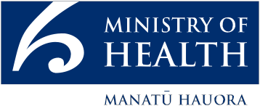
This document is available at health.govt.nz
 | This work is licensed under the Creative Commons Attribution 4.0 International licence. In essence, you are free to: share ie, copy and redistribute the material in any medium or format; adapt ie, remix, transform and build upon the material. You must give appropriate credit, provide a link to the licence and indicate if changes were made.

Director-General of Health’s Foreword
The Global Burden of Disease Study (GBD) provides important insights into the health of New Zealanders.
The GBD is a truly global study with over 190 countries included. For New Zealand, it is a significant and shared endeavour, made possible through closely working with our partners at the Institute for Health Metrics and Evaluation (IHME), University
of Washington. With each GBD cycle we develop a richer understanding, locally and globally, of population health outcomes and the factors that have the greatest influence on our health and wellbeing.

The 2017 estimates reveal that New Zealand has made important progress in areas such as increasing healthy life expectancy and decreasing our rate of health loss. Like other high-income countries, we also face significant population health challenges arising from non-communicable diseases, associated risk factors (such as dietary risks, smoking and alcohol use) and the health impacts of our changing and ageing population.

The GBD provides valuable information that we can apply to our day-to-day work and to our forward planning. It helps to inform policy makers, planners, funders and health professionals about key areas for positive change now and in the future to improve the wellbeing of New Zealanders and their families.

I encourage you to read the report, discuss it with others and where your interest is sparked, delve deeper into this fascinating work. IHME’s website healthdata.org is a great place to begin.

Ngā mihi
Dr Ashley Bloomfield
Director-General
Ministry of Health

Institute for Health Metrics and Evaluation (IHME) Director Foreword
Strong partnerships and robust evidence are key to reducing human suffering and early death.
The Ministry of Health of New Zealand and the Institute for Health Metrics and Evaluation have a shared vision of helping people live longer and healthier lives. Both the Ministry and IHME recognise that robust evidence is crucial for fostering dialogue and measuring progress in health.

From a personal perspective, this partnership is incredibly meaningful to me. I am a New Zealand citizen and my family lives in the Waikato.

The Global Burden of Disease 2017 study produces findings on 359 diseases and injuries as well as 84 risk factors. IHME serves as the coordinating centre for this annual study; such an endeavour would not be possible without the contributions and support of our dedicated global partners, such as the New Zealand Ministry of Health.

Over the past year, the Ministry and IHME have meticulously examined local and national data sources and integrated them into the study.

The results show that the lives of people in New Zealand are longer and healthier than ever before, but that the number of years they spend in poor health is also increasing. We hope that the findings from this study will help chart a path to an even healthier future for New Zealanders.

Prof Christopher J L Murray
IHME Director and Professor of Health Metrics Sciences
University of Washington

Contents
Director-General of Health’s Foreword iii
Institute for Health Metrics and Evaluation (IHME) Director Foreword iv
About the Global Burden of Disease Study 1
The GBD is an internationally recognised study 1
Each GBD cycle is unique and replaces the previous cycles 2
Health loss is measured in disability-adjusted life years 3
About this report 4
Health loss estimates for the whole population 4
Report structure 5
Summary of key findings 6
Are we living longer, healthier lives? 13
Life expectancy and healthy life expectancy 13
We are living longer and spending more years in good health 14
The time spent in poor health has also increased 16
Living longer and healthier lives: how we compare internationally 17
Which conditions affect our health the most? 22
Disability-adjusted life years 22
The main reason for the decrease in the DALY rate is a reduction in early death (YLLs) 24
Over time, early deaths decreased and years spent in poor health increased in number 28
Non-communicable diseases contribute to most of our health loss 29
Changes in health loss over time 34
A closer look at specific conditions 41
Comparing health loss of females and males 47
Health loss across the life course 49
A closer look at health loss in children 51
A closer look at selected age groups in adults 55
A closer look at health loss in young people (aged 15–24 years) 57
A closer look at health loss in older adults 60
Which risk factors contribute most to making us unwell? 64
The impact of risk factors on health outcomes 66
Understanding the changes in attributable burden due to risk factors over the last decade 70
A closer look at cancer 74
Trends across all cancers 74
Major cancers and their impact 77
Leading cancer conditions for females and males 78
Cancer across the life course 79
Reducing risk factors that contribute to cancer 83
The example of colorectal cancer 84
New Zealand Cancer Action Plan 87
Looking ahead 88
Appendix: The Global Burden of Disease methodological framework 90
Glossary 97

List of Tables
Table 1: Changes in life expectancy and healthy life expectancy, New Zealand, 1990–2017 6
Table 2: Ten leading causes of DALYs, YLLs and YLDs, total numbers, GBD Level 3, 2017 8
Table 3: Twenty leading specific conditions for health loss, ranking in 2017 and 1990 and change over time in absolute numbers of DALYs and in the age-standardised rate (ASR) 36
Table 4: Twenty leading specific conditions for health loss, ranking in 2017 and 1990 and change over time in absolute numbers and age-standardised rates of years of life lost and years lived with disability 38
Table 5: Ten leading conditions contributing to health loss among children aged under 15 years, 2017 52
Table 6: Ranked leading conditions (GBD Level 3) contributing to health loss and number of DALYs, by selected age groups, 2017 56
Table 7: Changes in ranking for 15 leading cancer conditions (total YLLs), by sex, all ages, 1990 and 2017 78
Table 8: Examples of risk factors contributing to health loss from certain cancers, by sex, 2017 83
Table A1: The first three levels of cause in the Global Burden of Disease hierarchy 90
Table A2: Disability weights for colorectal cancer 93
Table A3: Disability weights for acute ischaemic stroke 94
Table A4: Disability weights for low back pain 95
Table A5: Risk factors included in the GBD 96

List of Figures
Figure 1: Global Burden of Disease study findings are used for many purposes 2
Figure 2: GBD measures of health loss 3
Figure 3: Overview of report structure 5
Figure 4: The health loss share for three leading condition groups for people aged 45 years and over, 2017 10
Figure 5: Leading risk factors for early death from colorectal cancer, YLL numbers, 2017 12
Figure 6: Life expectancy, healthy life expectancy and time spent in poor health 13
Figure 7: Life expectancy, healthy life expectancy and years in poor health at birth, by sex, 1990 and 2017 14
Figure 8: Life expectancy, healthy life expectancy and years in poor health at 65 years, by sex, 1990 and 2017 15
Figure 9: Changes in life expectancy and healthy life expectancy, by sex, 1990 and 2017 16
Figure 10: Years someone at birth could expect to spend in poor health, comparing females and males, 1990 and 2017 16
Figure 11: Female life expectancy at birth in 2017 and percentage change from 1990 to 2017 – international comparisons 17
Figure 12: Male life expectancy at birth in 2017 and percentage change from 1990 to 2017 – international comparisons 18
Figure 13: Number of years lived in poor health, females, 2017 20
Figure 14: Proportion of life expectancy gains lived in poor health, females, 1990–2017 20
Figure 15: Number of years lived in poor health, males, 2017 20
Figure 16: Proportion of life expectancy gains lived in poor health, males, 1990–2017 20
Figure 17: Age-standardised disability-adjusted life years rate per 100,000 population 1990–2017 and total number of DALYs 2017 23
Figure 18: New Zealand’s age-standardised rate of disability-adjusted life years per 100,000 population compared with high SDI countries, 2017 23
Figure 19: New Zealand’s age-standardised rate of years of life lost per 100,000 population, compared with selected high SDI countries, 1990–2017 24
Figure 20: New Zealand’s age-standardised rate of years lived with disability per 100,000 population, compared with selected high SDI countries, 1990–2017 25
Figure 21: Number of years of life lost and years lived with disability, 1990 and 2017 28
Figure 22: Proportion of disability-adjusted life years by high-level cause (GBD Levels 1 and 2), 2017 29
Figure 23: Five leading non-communicable condition groups contributing to disability-adjusted life years, GBD Levels 2 and 3, 2017 31
Figure 24: Burden of disease from specific conditions in New Zealand and high SDI countries, 1990–2017 39
Figure 25: Disability-adjusted life years, years of life lost and years lived with disability, by sex, 2017 47
Figure 26: Comparing age-standardised rates per 100,000 by sex for GBD Level 3 conditions, 2017 48
Figure 27: Share of total DALYs (2017) compared with share of population (Census 2013), by age group 49
Figure 28: Number of disability-adjusted life years by age group and sex, GBD Level 2, 2017 50
Figure 29: Leading conditions contributing to YLLs and YLDs, among children aged under five years, 2017 54
Figure 30: Leading conditions contributing to health loss among young people aged 15–24 years, 2017 59
Figure 31: Leading conditions contributing to health loss among older adults aged 65–74 years, 2017 62
Figure 32: Leading conditions contributing to health loss among older adults aged 75 years and over, 2017 63
Figure 33: The attributable burden of risk factors 64
Figure 34: Risk factors – high-level categories 65
Figure 35: Health loss as a percentage of total disability-adjusted life years, by risk cluster and high-level cause, 2017 66
Figure 36: Proportion of health loss from leading risk factors, 2017 67
Figure 37: Percentage of health loss attributable to leading risk factors in the population, 2017, and between 1990 and 2017 69
Figure 38: Percentage change in health loss attributed to risk factors by type of risk exposure, population ageing and growth and risk-deleted DALY rate, for all causes and GBD Level 1 causes, by sex, 2007–2017 71
Figure 39: Cancer age-standardised early death rates (YLLs) per 100,000 population, high SDI countries, 2017 75
Figure 40: Age-standardised early death rates (YLLs) for cancer per 100,000 population, high SDI countries, 1990–2017 76
Figure 41: Contribution of different cancers to the total YLLs due to cancer, 2017, and trends in age-standardised YLL rates, 1990–2017 77
Figure 42: Percentage of YLL from cancers, by age group and sex, 2017 79
Figure 43: Proportion of YLLs due to specific cancers by age group, females, 2017 80
Figure 44: Proportion of YLLs due to specific cancers by age group, males, 2017 82
Figure 45: Age-standardised DALY, incidence and death rates for colorectal cancer per 100,000 population, New Zealand and high SDI countries, by sex, 2017 84
Figure 46: Colorectal cancer, age-standardised DALY rates, New Zealand and selected high SDI countries, all ages, both sexes, 1990–2017 85

About the Global Burden of Disease Study

The GBD is an internationally recognised study
The Global Burden of Disease study (GBD), led by IHME,1 is a comprehensive and internationally regarded study covering 195 countries. The GBD measures loss of healthy life from 359 major diseases and injuries and 84 risk factors, by age, sex and location.

The Socio-demographic Index: The GBD study groups countries based on the Socio-demographic Index (SDI). This summary measure of a country’s socio-demographic development is calculated from average income per person, educational achievement and fertility rate in women under age 25. With this measure, it is possible to compare countries with similar social and demographic characteristics. New Zealand is part of a group of countries with ‘high’ SDI characteristics. This report compares New Zealand’s performance against the average of all high SDI countries in the GBD as well as with a subset of 15 countries New Zealand is often compared with, such as Australia, the United Kingdom, the United States of America, Canada and Denmark. Peer group countries were selected using the following criteria: membership of the Organisation for Economic Co-operation and Development (OECD); population of more than 3 million; gross domestic product per person similar to or higher than New Zealand’s; and inclusion in the Commonwealth Fund’s Comparative Health System Performance study.

The GBD provides a rich data set of health loss estimates over the past quarter of a century (1990–2017). Researchers, policy makers and governments use its results to better understand population health and where and how to intervene, as well as to design strategy and policy to improve health outcomes (see Figure 1).

Figure 1: Global Burden of Disease study findings are used for many purposes
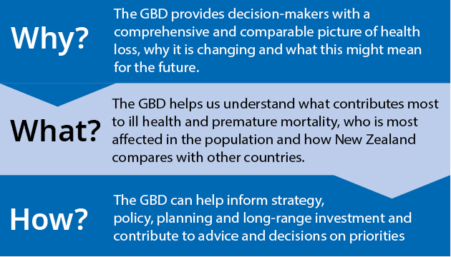

Each GBD cycle is unique and replaces the previous cycles
The GBD estimates are informed by a wide range of data, evidence and expertise. The study uses a large and diverse set of up-to-date data sources and robust standardised methods to provide a comprehensive and comparative assessment of health loss. It allows us to understand the ‘big picture’ of New Zealand’s health based on recent evidence.

Each new cycle of the GBD takes into account changes in data and evidence since the previous GBD cycle and builds these changes and new insights into the latest estimates (including modelling these changes back to 1990). This important feature of the study means each GBD cycle is unique and complete in itself and is not directly comparable with any previous cycle. For this reason, the findings from the most recent cycle replace those from all the previous cycles.

Health loss is measured in disability-adjusted life years
The GBD uses the idea of health loss to measure the impact of illness, disability and early death. Health loss is measured in disability-adjusted life years (DALYs), which is the sum of non-fatal health loss (years lived with disability (YLDs) adjusted for severity) and fatal health loss (years of life lost (YLLs) to early death) (see Figure 2). One DALY represents the loss of one year of life lived in good health.

Because a DALY includes both fatal and non-fatal components, it is an important measure for assessing overall population health. It also provides a consistent basis for comparing the impact of different types of conditions within the population, across population subgroups and between locations.

Figure 2: GBD measures of health loss
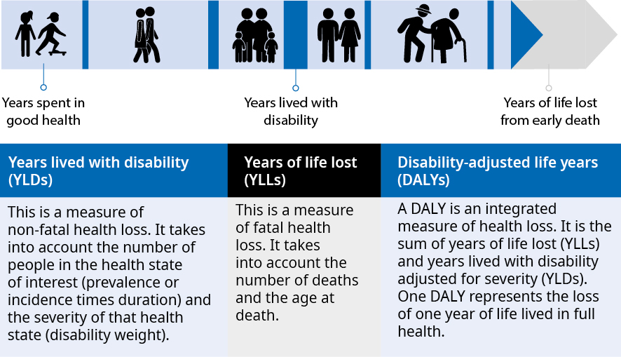

About this report

Health loss estimates for the whole population
This report focuses on estimates of health loss at a whole-of-population level using the GBD 2017 cycle. We also look at health loss by sex, for selected age groups and by time trends and sometimes compare New Zealand’s estimates with those of other GBD countries (to get a sense of what they mean in an international context).

Levels of reporting within the GBD
The GBD Study covers 359 causes of health loss, which are organised into categories. Level 1 is the broadest category with three classifications:
communicable, maternal, neonatal and nutritional diseases
injuries
non-communicable diseases.
These classifications are further broken down at Level 2 to more specific diseases or causes; for example, cancers are a sub-category of non-communicable diseases. Level 3 breaks down the sub-categories further; for example, cancers would be categorised into specific cancers. The GBD also covers 84 risk factors which are classified into 4 levels of hierarchy. For detailed information, see the appendix and the IHME website: healthdata.org/gbd/

In New Zealand, health loss estimates are not yet available at a sub-national level (such as by geographic location or ethnicity). However, the Ministry is working with GBD to prepare preliminary health loss estimates for Māori and non-Māori. These estimates are likely to be reported in future GBD cycles.

Report structure
The GBD estimates can help us to better understand the health of the population and the opportunities and challenges we face in our work to improve the wellbeing of New Zealanders. To support this understanding, we have structured this report around the following questions (Figure 3).
- Are we living longer, healthier lives?
- Which conditions affect our health the most?
- Which risk factors contribute most to making us unwell?

The answers to these questions can help policy makers, planners, funders and service providers to focus on the things that can make the biggest difference to health outcomes, now and in the future. The final section of the report uses the GBD estimates to look at cancer in more detail as the leading Level 2 category of health loss in our population.

Figure 3: Overview of report structure
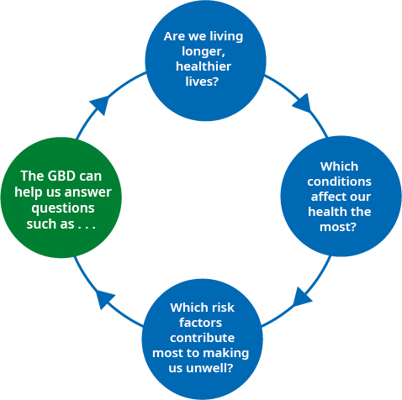

Summary of key findings

Life expectancy and the time spent in good health have increased
New Zealanders are living, on average, longer than they were two decades ago. In 2017, a female could expect to live, on average, 5.5 years longer (to 83.6 years) and a male 7.1 years longer (to 79.7 years) than their counterparts in 1990. In 2017, the life expectancy of New Zealanders was comparable with the average life expectancy of other high SDI countries in the GBD study. Life expectancy in New Zealand increased at a faster pace than in many other high SDI countries between 1990 and 2017.

New Zealanders are also spending a greater proportion of their lives in good health. Between 1990 and 2017, healthy life expectancy at birth increased by 3.8 years for females (to 70.1 years) and 4.9 years for males (to 68.0 years) (see Table 1).

Table 1: Changes in life expectancy and healthy life expectancy, New Zealand,
1990–2017
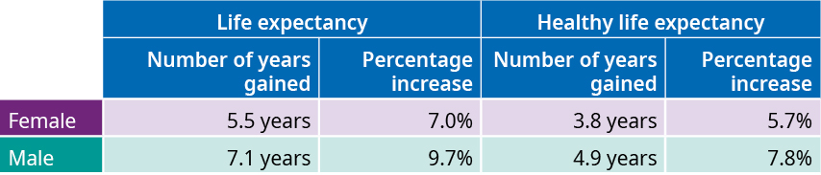

However, the time spent in poor health has also increased
New Zealand has made strong progress in reducing health loss from early death (years of life lost or YLLs): The age-standardised rates of YLLs fell by almost half (45.8 percent) between 1990 and 2017. Over the same period, the time New Zealanders spend living with illness (years lived with disability or YLDs) has remained largely stable.

New Zealand faces an important challenge: People are living more years in poor health (because life expectancy has been increasing at a faster pace than health expectancy). On average, New Zealanders are spending around a third of life-years gained in poor health, compared with around a quarter, on average, for high SDI countries. Increasing healthy life expectancy – or adding health to years – is an important focus for improving the wellbeing of the population.

The number of disability-adjusted life years is slowly increasing
The GBD shows that the number of DALYs slowly increased between 1990 and 2017 from 1.01 million to 1.16 million DALYs. This increase occurred mainly because of population growth and ageing. The high number of years lived with disability contributed most to the increase in the number of DALYs. Because the population is forecast to grow and age further, strong demand for health services and support in the community, hospitals and other care settings is likely to continue.

Non-communicable diseases are driving most of our health loss
Like other high-SDI countries, New Zealand faces the challenge of a greater number of people living with chronic illnesses, including living with and managing more than one health condition (multi-morbidity). In 2017, non-communicable diseases were the leading category of health loss, making up over four-fifths (or 82 percent) of total DALYs in New Zealand. Injuries accounted for 14 percent of total DALYs. The neonatal and communicable disease category contributed the remaining amount of health loss (4 percent). Over the past two-and-half decades, the proportion of DALYs due to ‘communicable, maternal, neonatal and nutritional diseases’ fell by around a quarter. The shift from communicable to non-communicable diseases over time reflects that New Zealand, like other high SDI countries, is well advanced along the ‘epidemiological transition’. That is, the diseases that are the main causes of poor health, disability and death have moved from being infectious diseases and neonatal and maternal disorders to diseases in the non-communicable category.

Leading causes of health loss, early mortality and ill health
Table 2 identifies the main conditions affecting the wellbeing of New Zealanders. It shows the major impact of cardiovascular diseases (such as ischaemic heart disease and stroke), cancers (such as lung, colorectal, and breast), dementia and injuries on DALYs (overall health loss), ill health (YLDs) and early death (YLLs). Musculoskeletal conditions (such as low back pain) contribute significantly to the health loss, mainly because they are highly prevalent in the population, whilst other, less prevalent conditions, such as depressive disorders and diabetes mellitus, contribute significantly to population disability due to their more severe disabling impacts. The conditions noted above were also among the leading contributors to health loss in 1990. However, health loss from conditions associated with ageing, such as dementia, has increased since 1990.

Table 2: Ten leading causes of DALYs, YLLs and YLDs, total numbers, GBD Level 3, 2017
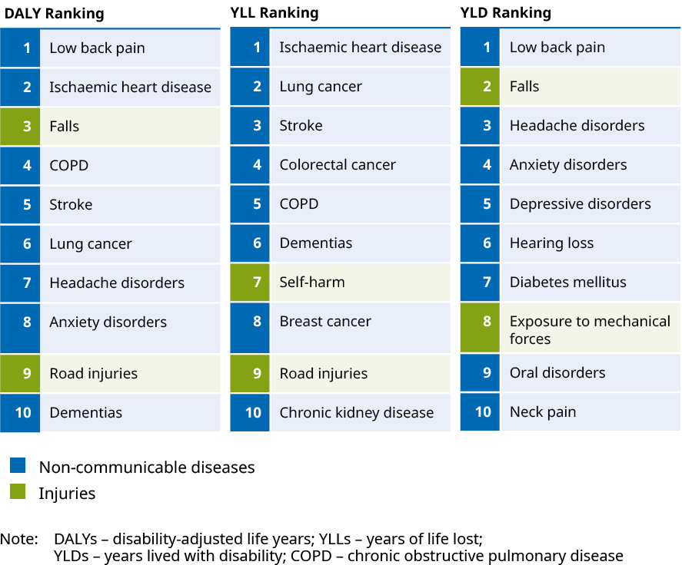
Note: DALYS – disability-adjusted life years
YLLs – years of life lost
YLDS – years lived with disability
COPD – chronic obstructive pulmonary disease

More years of life lost for males, longer lives lived in disability for females
Overall, males experienced more DALYs than females did in 2017. The main reason for the difference was males having a significantly greater estimated number of YLLs (304,452) than females (232,415) from causes such as ischaemic heart disease, transport injuries, self-harm and substance use disorders. Females experienced more DALYs from YLD-related conditions, including musculoskeletal disorders (such as low back pain) and mental disorders (such as anxiety and depression).

Sources of health loss vary across the life course
Health loss increases with age. DALYs in younger age groups, unsurprisingly, are most affected by loss of life and both death and disability associated with mental disorders and self-harm emerge as key factors for older children and young adults. Cancers introduce substantial elements of both loss of life and disability over the life course and are a dominant contributor to DALYs by middle age. Alongside cancers, cardiovascular diseases (CVD), neurological disorders and musculoskeletal disorders, contribute significantly to health loss at older ages. Adults aged 75 years and over make up approximately 6 percent of the population and accounted for around a quarter (23 percent) of health loss. It is expected that as people live longer, health system demand will increase and improving health through the life course will help to increase healthy life expectancy and overall wellbeing.

Health loss in the first year of life is mainly associated with early death across three main causes
The pattern of conditions across age groups shows that for children aged under one year, neonatal disorders (50.6 percent), congenital birth defects (23.3 percent) and sudden infant death syndrome (7.3 percent) contributed to the majority of DALYs (81.1 percent) for this age group. These conditions are strongly associated with YLL. The burden of disease in infants is therefore associated more with early death than with disability (YLD).

Around two-thirds of health loss for preschoolers is associated with YLDs from a range of conditions
For preschool children aged 1–4 years, around two-thirds (68.6 percent) of health loss is associated with YLDs. Leading conditions in this age group include dermatitis, neonatal conditions, asthma, congenital birth defects and falls. Together these five leading conditions contributed to around half (46.6 percent) of health loss for this age group.

Mental illness significantly impacts the wellbeing of young people (15–24 years)
For young people aged 15–24 years, around a quarter of health loss was associated with mental disorders (anxiety and depressive disorders were specific leading contributors in this category). Injuries also feature strongly in this age group, making up a further quarter of health loss; within this category, self-harm contributed to 8.1 percent of the total health loss. Musculoskeletal conditions, mainly from low back pain (9.3 percent of health loss), also started to contribute to burden of disease in this age group.

The share of health loss from cardiovascular diseases, cancers and neurological disorders is twice as high between the ages of 45 and 80 years
Health loss from non-communicable diseases increases significantly with age. Cancers (as a condition group) become a major contributor to DALYs in adulthood and specific cancers such as colorectal cancer, lung cancer and breast cancer appear among the 10 leading causes of health loss in adults due to early death (YLLs). The impact of cardiovascular diseases on people’s health is significant from the age of 45 years and increases with age (ischaemic heart disease was also the leading Level 3 cause of health loss for New Zealanders aged 65 years and over). Neurological disorders, such as dementia, also increase markedly for older adults aged 75 years and over (see Figure 4). Those three condition groups, cancers, cardiovascular diseases and neurological disorders contributed to about 30 percent of the total health loss for those aged 45–49 years and 60 percent for those aged over 80 years.

Figure 4: The health loss share for three leading condition groups for people aged 45 years and over, 2017
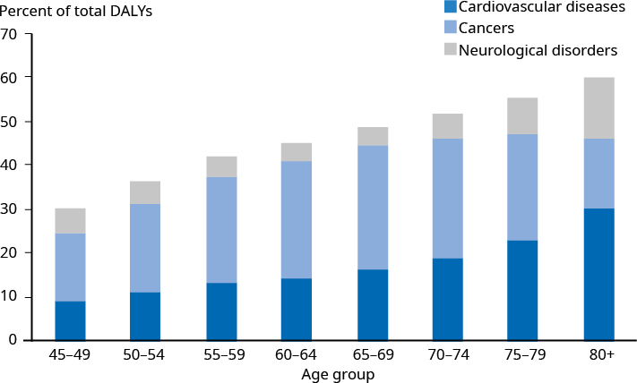

Modifiable risk factors contribute to over a third of health loss
A key opportunity to improve health and wellbeing is through prevention. Over a third (38.6 percent) of health loss is potentially avoidable by reducing modifiable risk factors.

Chief among these is tobacco use. Although tobacco use has been declining for more than half a century, it is still the leading risk factor, contributing to around a tenth (9.7 percent) of New Zealanders’ health loss.

A growing challenge is to address metabolic risk factors, such as obesity, which have been rising. Reducing these risk factors requires a society-level response as well as cross-government intervention, in which the health and disability system is one of the players. A broad and multi-faceted response is needed because risk factors are often related to other determinants of health, including poverty. Improving underlying social conditions, as envisaged in initiatives such as The Treasury’s Living Standards Framework and the Government’s focus on wellbeing, has the potential to improve population health and wellbeing.

A closer look at cancer
Cancers affect the lives of thousands of New Zealanders and are a leading cause of early death in the population. The findings on colorectal cancer are an example of the different ways the GBD can help us to understand the impact of key conditions on the population. Over time, New Zealand has reduced the incidence and death rate at a faster pace than many other high SDI countries. However, New Zealand remains among the countries with the highest health loss rates from colorectal cancer.

Prevention, early detection and prompt access to high-quality treatment are vital to reducing the burden from colorectal cancer
Reducing health loss from colorectal cancer through prevention, early detection and prompt access to high-quality treatment is an important focus. About two-thirds (65.6 percent) of health loss associated with colorectal cancers is modifiable by addressing factors such as poor diet, alcohol use, tobacco use and high body mass index (BMI) (which also impact on a range of other leading non-communicable diseases). Figure 5 illustrates the leading factors for the YLL component of the DALY.

Figure 5: Leading risk factors for early death from colorectal cancer, YLL numbers, 2017
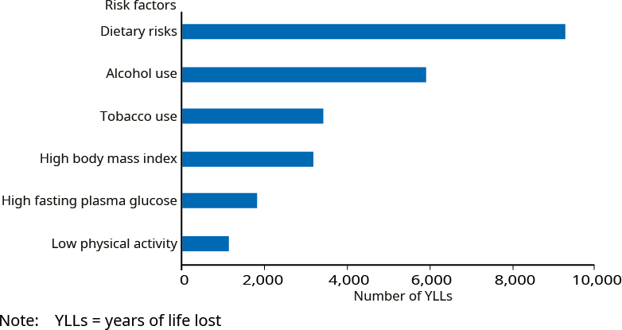
Note: YLLs = years of life lost

The National Cancer Action Plan (2019) provides a system-wide approach to improving cancer outcomes and increasing health equity across the continuum of care. The Action Plan represents an important direction of travel for the health and disability system over the coming decade to improve cancer outcomes.

Are we living longer, healthier lives?

Life expectancy and healthy life expectancy
Life expectancy is the average number of years a person can expect to live based on current age-specific mortality rates. Life expectancy is often paired with the measure of healthy life expectancy, which looks at how many years of life a person can expect to live in full health (see Figure 6). The measured difference between life expectancy and healthy life expectancy is the expected number of years spent in poor health. An important focus for the health system is to increase both life expectancy (quantity perspective) and healthy life expectancy (quality perspective) so that more people live longer in good health.

Figure 6: Life expectancy, healthy life expectancy and time spent in poor health
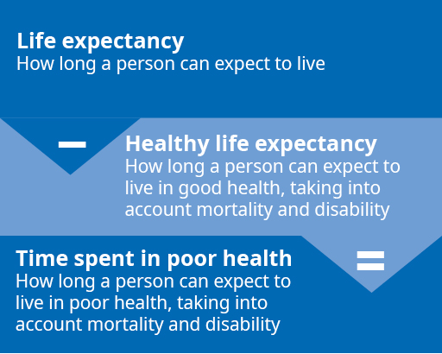

We are living longer and spending more years in good health
Both life expectancy and healthy life expectancy increased between 1990 and 2017. This was true when estimated at birth and at 65 years. Figures 7 and 8 illustrate this.

Figure 7: Life expectancy, healthy life expectancy and years in poor health at birth, by sex, 1990 and 2017
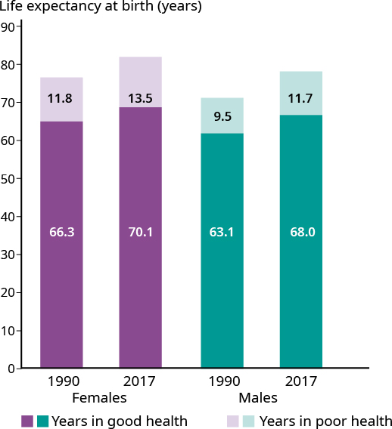

Figure 8: Life expectancy, healthy life expectancy and years in poor health at 65 years, by sex, 1990 and 2017
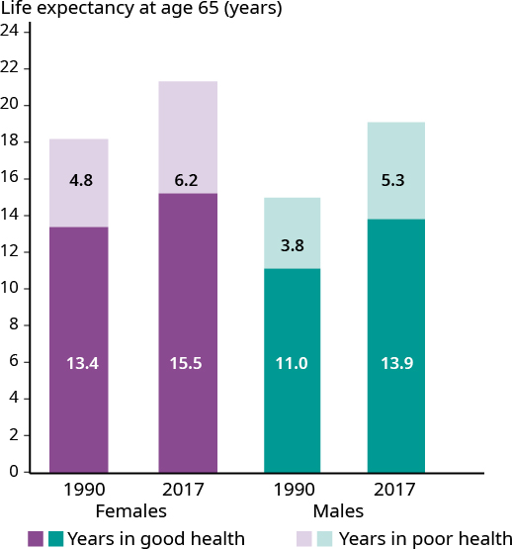

Life expectancy and healthy life expectancy increased at birth and at age 65
Life expectancy at birth increased by 5.5 years for females (from 78.1 to 83.6 years or 7.0 percent) and by 7.1 years for males (from 72.6 to 79.7 years or 9.7 percent) between 1990 and 2017. New Zealanders are also spending more time in good health. Between 1990 and 2017, healthy life expectancy at birth increased by 3.8 years for females (from 66.3 to 70.1 years or 5.7 percent) and by 4.9 years for males (from 63.1 to 68 years or 7.8 percent).

New Zealanders aged 65 years can expect to live longer than their counterparts from two decades ago. Between 1990 and 2017, life expectancy at age 65 increased by 3.5 years for females (from 18.2 to 21.7 years or 19.0 percent) and by 4.4 years for males (from 14.8 to 19.2 years or 29.7 percent). Healthy life expectancy increased over this period by 2.1 years for females (from 13.4 to 15.5 years or 15.8 percent) and 2.9 years for males (from 11.0 to 13.9 years or 26.5 percent).

Although life expectancy and healthy life expectancy have increased for both sexes over the past 27 years, they have increased more for males than for females. While a sizeable gap in life expectancy and healthy life expectancy remains between the sexes, the difference has decreased over time (see Figure 9).

Figure 9: Changes in life expectancy and healthy life expectancy, by sex, 1990 and 2017
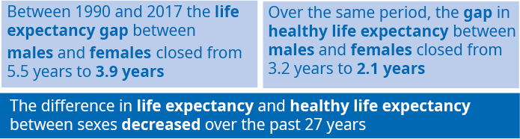

The time spent in poor health has also increased
Although New Zealanders are, on average, living longer and spending more years in good health, the time spent in poor health is also slowly increasing. This is because life expectancy has increased at a faster pace than healthy life expectancy.

Between 1990 and 2017, the time that someone at birth could expect to spend in poor health increased by 1.7 years for females and by 2.2 years for males (see Figure 10). In other words, for both males and females, almost a third of the increase in life expectancy since 1990 will be spent in poor health.

In 2017, females aged 65 years could expect to spend 1.4 more years and males 1.5 more years in poor health than their counterparts in 1990. This means that morbidity (or poor health) has expanded in absolute terms (or total number of years). Both males and females aged 65 years would spend, on average, over a third of the years they gained in life expectancy in poor health (39 percent for females and 35 percent for males).

Figure 10: Years someone at birth could expect to spend in poor health, comparing females and males, 1990 and 2017
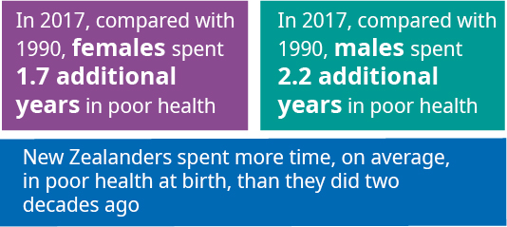

Although the number of years lived in poor health increased, the ratio of time spent in good health to life expectancy was stable (the slight decrease for females by 0.02 percent and males by 0.01 percent was not significant statistically). This finding shows that poor health and disability have not expanded over the last two decades in relative terms. As yet, we have no evidence of compression of poor health and disability (where people spend a higher proportion of their (longer) lives in good health).

Living longer and healthier lives: how we compare internationally

Life expectancy in New Zealand has increased at a faster pace than many other high SDI countries
Figure 11: Female life expectancy at birth in 2017 and percentage change from 1990 to 2017 – international comparisons
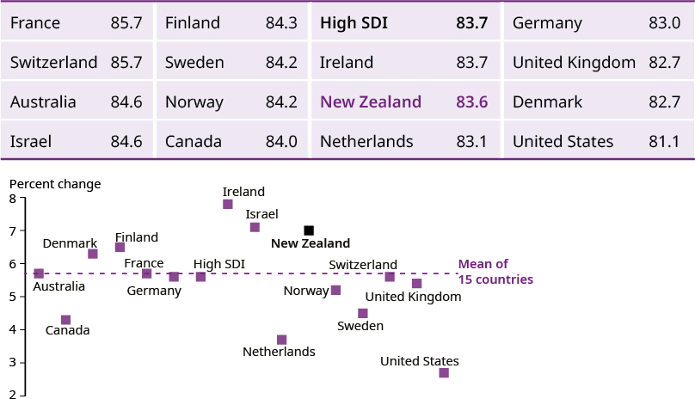

Figure 12: Male life expectancy at birth in 2017 and percentage change from 1990 to 2017 – international comparisons
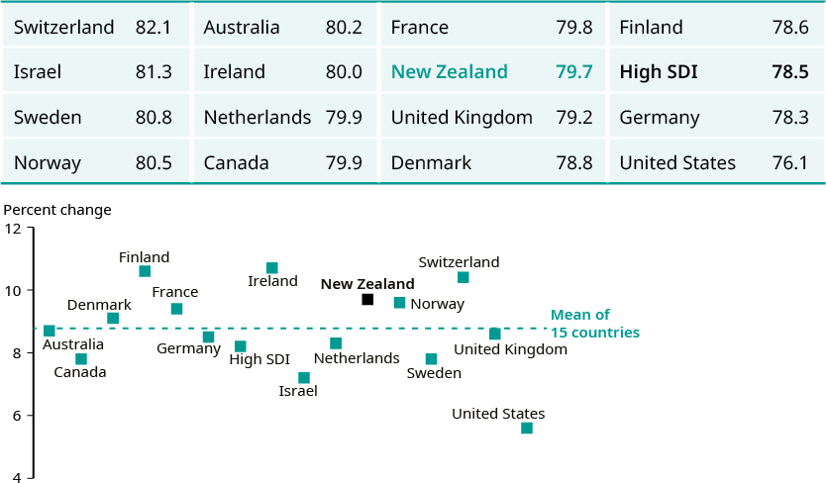

Figures 11 and 12 illustrate life expectancy at birth in 2017 by sex and country. They also show the percentage of increase in life expectancy since 1990 for 15 selected high SDI countries and for the unweighted average of the 15 selected high SDI countries and all high SDI countries.

In 2017, New Zealand females and males ranked tenth among the 15 selected high SDI countries for life expectancy at birth. Compared with the average of all high SDI countries, life expectancy for New Zealand females was roughly the same (83.6 years compared with 83.7 years), and New Zealand males lived slightly longer than the high SDI average (79.7 compared with 78.5 years).

Between 1990 and 2017, life expectancy of New Zealand females and males increased at a faster rate than the average of all high SDI countries (by 7.0 percent compared with 5.5 percent for females, and by 9.7 percent compared with 8.1 percent for males). Figures 11 and 12 show that the life expectancy increase for New Zealanders was among the highest in the selected high SDI countries (third for females and fourth for males).

New Zealanders are spending more time in poor health than people in many other high SDI countries
The amount of time spent in poor health is a significant area of challenge for New Zealand. Compared with selected high SDI countries, New Zealand females and males spent the most years in poor health in 2017 (see Figures 13 and 15).

In addition, Figures 14 and 16 illustrate that, among the selected high SDI countries, New Zealand was one of the top three in which people spent the highest proportion of years gained in life expectancy (between 1990 and 2017) in poor health (second for males and third for females). That is, New Zealanders made gains in life expectancy but spent more time in poor health, relative to other high SDI countries.

Figure 13: Number of years lived in poor health, females, 2017  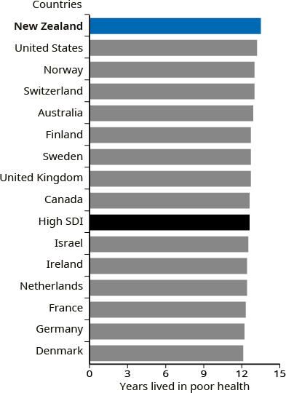 | Figure 14: Proportion of life expectancy gains lived in poor health, females, 1990–2017  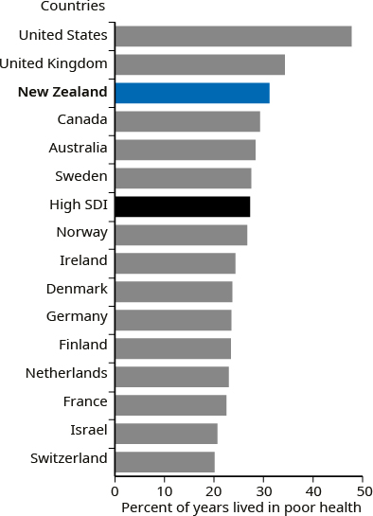
Figure 15: Number of years lived in poor health, males, 2017  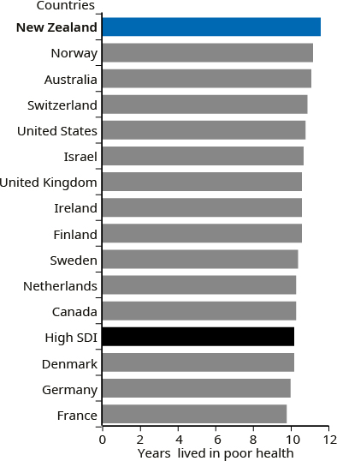 | Figure 16: Proportion of life expectancy gains lived in poor health, males, 1990–2017  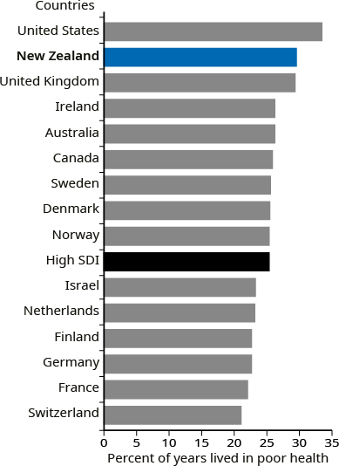

Adding health to years
This section has highlighted that New Zealanders’ life expectancy and the amount of time they spend in good health have increased. A wide range of social factors has influenced these outcomes, which span many decades. Health and disability services have played a key role too. For example, general population health improvements support longer lives and good health through measures such as health promotion, improving access to health services, improving quality of care, reducing exposure to risk factors and advancing health treatments.
However, New Zealand faces challenges, such as people spending more years in poor health. This section has highlighted that adding health to years is vital to improving population health in a sustained and equitable way for all New Zealanders. We are not on our own in this challenge. Many high-income countries are facing a similar situation as life expectancy outstrips the pace of improvement in health expectancy.
As our population grows and more New Zealanders live longer, the demand for health and disability services in the community is likely to continue increasing. This expectation underscores the importance of promoting wellness and identifying and addressing health concerns as early as possible, while supporting people living with long-term and life-limiting conditions. Many countries need to cope with this challenge of adding health to years and decreasing the time spent in poor health. No country has succeeded in achieving this goal yet.
Throughout the remainder of the report, we will elaborate on the contribution of different conditions and risk factors to adding years to life and health to years in New Zealand.

Which conditions affect our health the most?

Disability-adjusted life years
Disability-adjusted life years (DALYs) measure the total burden of health loss by summing measures of poor health, disability and early death. New Zealand has made progress in reducing the age-standardised rate of health loss since 1990.

Age-standardised rates (ASR) enable us to compare data at different points in time and locations by adjusting for differences in population size and age structures. This type of analysis is useful for understanding the relative performance of the health and disability system over time and allows us to compare rates between countries.

Figure 17 shows that from 1990 to 2017, the total number of DALYs (the solid line on the graph) increased by 15 percent, from around 1.01 million to about 1.16 million. The main reason for this upward trend is New Zealand’s growing and ageing population, which suggests that the strong demand for health services in the community, hospitals, and other care settings will continue.

It also illustrates that over the same time, the DALY rate (the dashed line on the graph), when adjusted for changes in population size and age structure, decreased by 25 percent, from approximately 27,500 DALYs per 100,000 population in 1990 to 20,500 per 100,000 population in 2017. The pace of decrease is comparable with other high SDI countries overall (22 percent), as well as with individual nations such as Australia (23 percent), Norway (25 percent) and Switzerland (27 percent).

Figure 17: Age-standardised disability-adjusted life years rate per 100,000 population 1990–2017 and total number of DALYs 2017
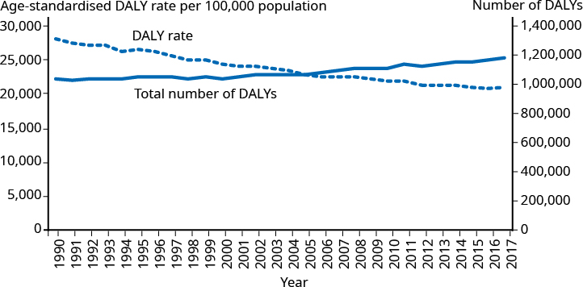

New Zealand’s DALY rate was the second highest of the selected high SDI countries in 2017, below the United States and similar to the United Kingdom. However, the differences between the countries were not statistically significant (see Figure 18).

Figure 18: New Zealand’s age-standardised rate of disability-adjusted life years per 100,000 population compared with high SDI countries, 2017
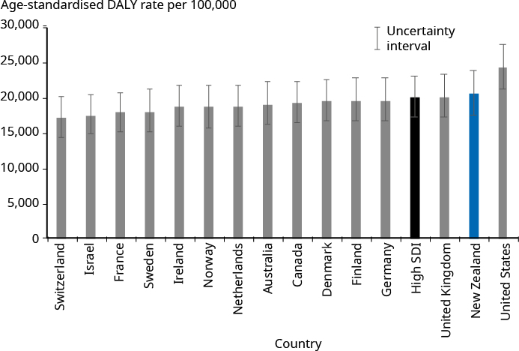

The main reason for the decrease in the DALY rate is a reduction in early death (YLLs)
Trend data shows that the age-standardised rate of years of life lost in New Zealand almost halved (45.8 percent) between 1990 and 2017 (see Figure 19). This encouraging development is consistent with a downward trend in age-standardised amenable mortality (premature deaths under age 75 that could potentially be avoided, given effective and timely health care) data in New Zealand.

Figure 19: New Zealand’s age-standardised rate of years of life lost per 100,000 population, compared with selected high SDI countries, 1990–2017
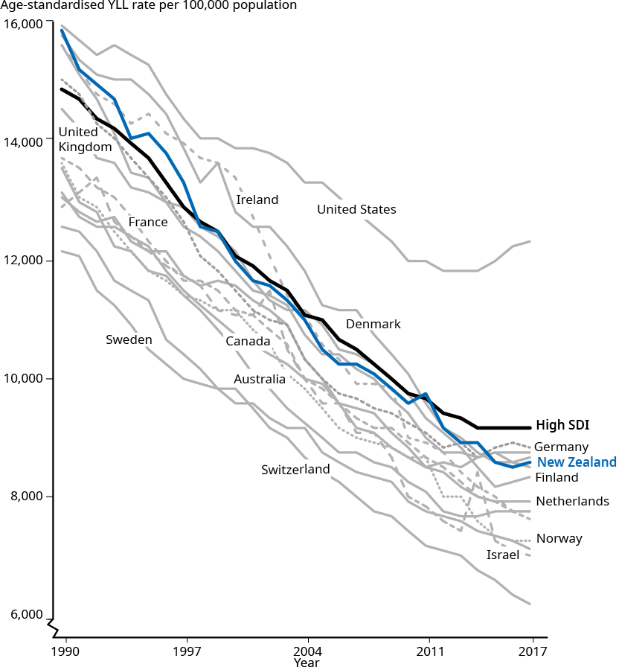

At the same time, the length of time New Zealanders spend living with illness or disability remains a challenge. In 2017 New Zealand had the second-highest (age-standardised) rate of YLDs among selected high SDI countries. (Note, however, that the difference in the YLD rates between countries was not statistically significant as all of these countries fall within the same uncertainty interval, which demonstrates the challenge of estimating non-fatal causes of health loss accurately.)

Figure 20: New Zealand’s age-standardised rate of years lived with disability per 100,000 population, compared with selected high SDI countries, 1990–2017
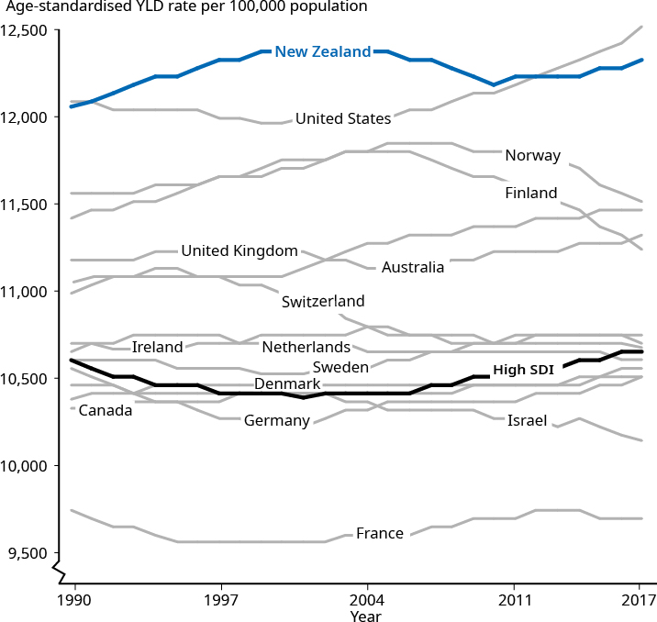

Across the high SDI countries, the trend in the number of years people are living with poor health shows little change since 1990 (see Figure 20). Looking at how well the health system is prepared for the future and addressing this issue effectively is a common challenge in efforts to improve population health and the overall quality of life.

The Ministry and the IHME are developing the first separate health loss estimates for Māori and non-Māori, which we will use in future GBD cycle reporting
In New Zealand, health inequities make a significant contribution to poor health outcomes. Māori and Pacific peoples, for example, tend to develop a range of non-communicable diseases at an earlier age, live more years with disabling health effects, and have higher mortality rates than other non-Māori and non- Pacific counterparts.
The Ministry and the IHME are developing the first separate health loss estimates for Māori and non-Māori, which we will use in future GBD cycle reporting. The results of this collaboration will deepen our understanding of health equity challenges and support the wider programme of work to improve health equity in Aotearoa New Zealand.
Achieving equity in health and wellness in Aotearoa New Zealand
Achieving health equity is an important goal for the New Zealand health and disability system. Making improvements towards this goal is expected to improve the wellbeing of the population, now and for future generations. For more information about the Ministry’s work in this area, including a recently published report, Achieving Equity in Health Outcomes: Summary of a discovery process, go to health.govt.nz/equity
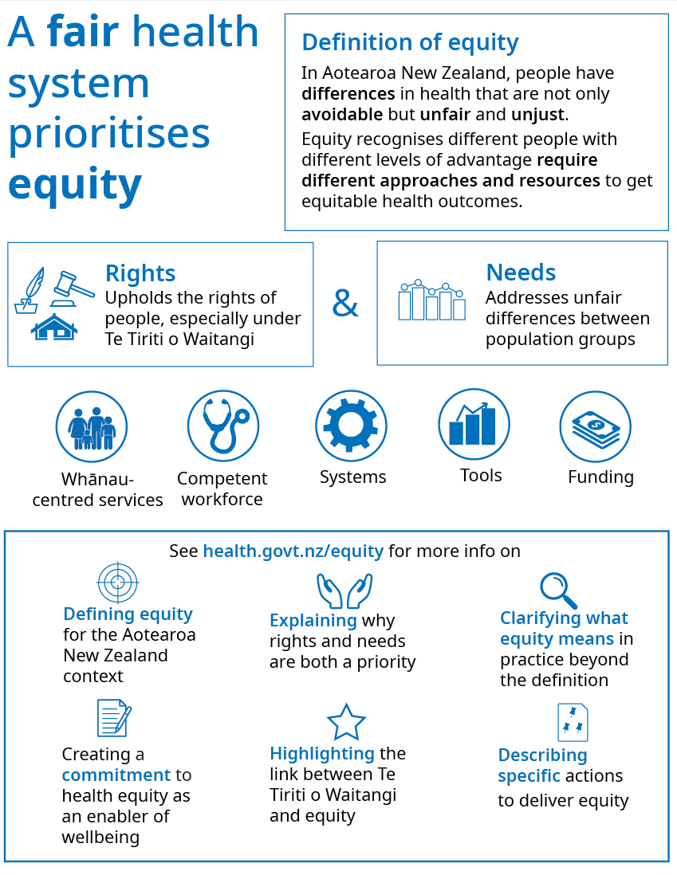

Over time, early deaths decreased and years spent in poor health increased in number
The main cause of the increasing trend in the total number of DALYs in New Zealand (as Figure 17 shows) is an increase in the proportion of years spent in poor health and disability (YLDs). Since 1990, the total number of YLDs has increased while the number of years of life lost (YLLs) has decreased. As a result, YLDs have been increasingly gaining on YLLs and now appear to have overtaken them in their contribution to the overall number of DALYs. As Figure 21 shows, in 1990, the number of YLLs was significantly higher than the number of YLDs. However, by 2017, YLDs exceeded YLLs (although not at a level of statistical significance).

These findings suggest we are getting better at saving and prolonging lives as more New Zealanders are living longer with long-term and life-limiting conditions. It is important to note that for some conditions, particularly life-threatening conditions, there is a relationship between YLLs and YLDs. By preventing early death from cancers, for example, it is possible to lower YLLs and, at the same time, increase YLD because more people are experiencing and living with the impacts of illness. Reducing both YLLs and associated YLDs is a dual aim for these kinds of conditions. On the other hand, for conditions with disabling effects that are not associated with early death, such as anxiety and low back pain, the main focus is on reducing YLDs.

Figure 21: Number of years of life lost and years lived with disability, 1990 and 2017
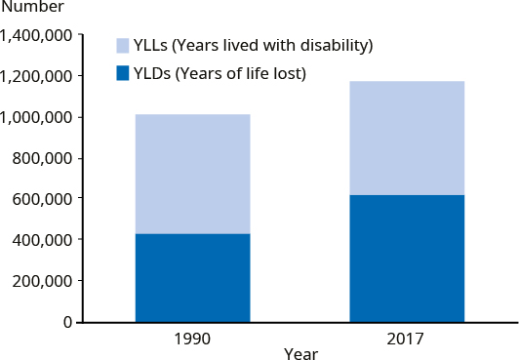

Non-communicable diseases contribute to most of our health loss
This section looks in more detail at the sorts of conditions that are contributing most to early death and time spent in ill health. This information helps us to better understand population health challenges and areas that could be improved through a more focused effort.

The GBD classifies health loss into three main categories: non-communicable diseases; injuries; and communicable, maternal, neonatal and nutritional diseases (GBD Level 1). In 2017, the majority (81.8 percent) of health loss was attributed to non-communicable diseases, 14.2 percent to injuries and 4.0 percent to communicable, maternal, neonatal and nutritional diseases (see Figure 22).

Figure 22: Proportion of disability-adjusted life years by high-level cause (GBD Levels 1 and 2), 2017
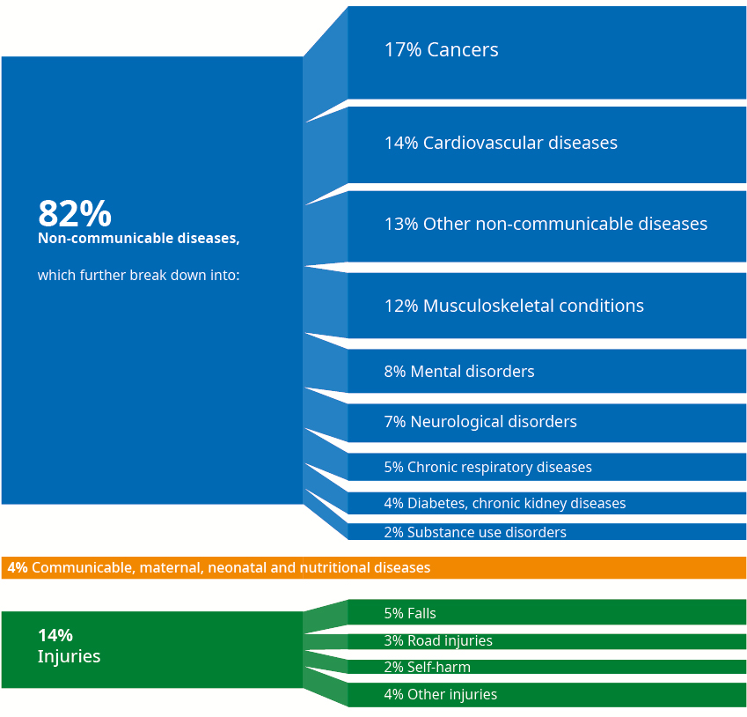

The largest burden from non-communicable diseases came from four disease groups, which together contributed half of the total health loss. Two of these groups were conditions strongly associated with years of life lost: cancers contributed 17 percent and cardiovascular diseases (mainly ischaemic heart disease) 14 percent of the total health loss. Others were non-fatal disabling conditions: musculoskeletal conditions (mainly low back pain) contributed 12 percent and mental disorders (mainly anxiety and depressive disorders) 8 percent of total health loss. (See Figure 23 for examples of specific conditions within leading non-communicable disease groupings.)

Figure 23: Five leading non-communicable condition groups contributing to disability-adjusted life years, GBD Levels 2 and 3, 2017
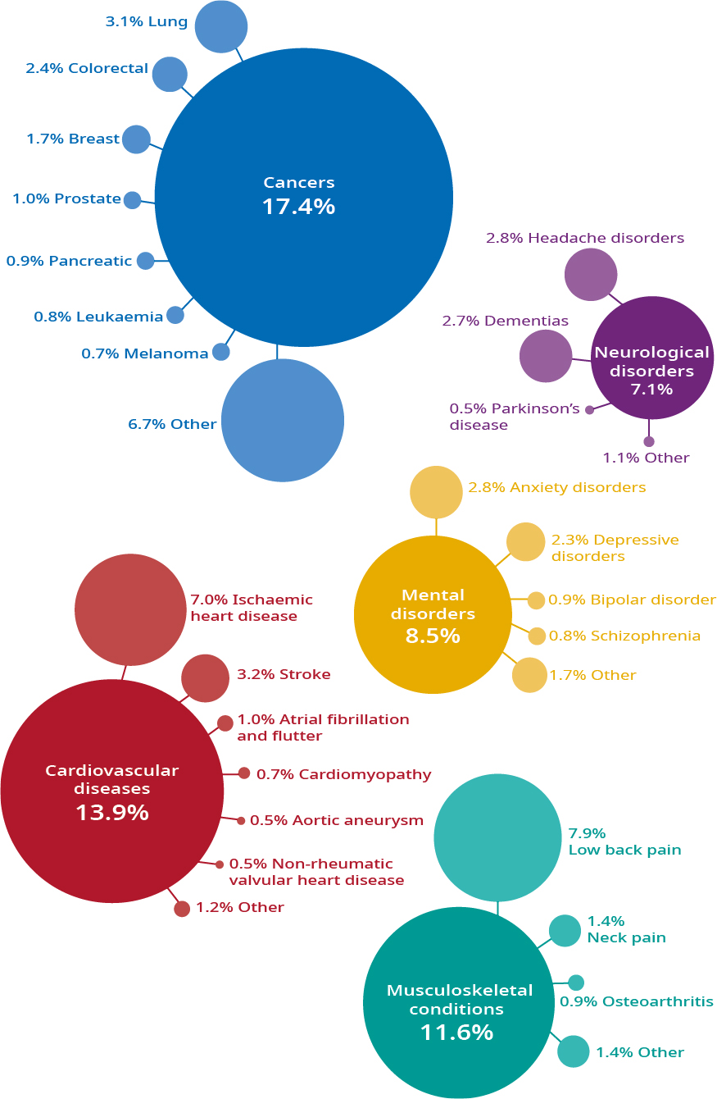

In the ‘injuries’ category, falls (4.6 percent), road injuries (2.8 percent) and self-harm (2.2 percent) were the leading contributors to DALYs in 2017. Within the communicable, maternal, neonatal and nutritional diseases category, the largest contributors were maternal and neonatal disorders (2.2 percent) and respiratory infections (1.1 percent).

Table 3 gives a detailed list of the top 20 specific conditions on level 3 in the GBD hierarchy of categories. In 2017, the leading cause of DALYs from specific conditions was musculoskeletal-related (low back pain); others among the leading five conditions were cardiovascular diseases (ischaemic heart disease (second) and stroke (fifth)). The third-largest contributor to DALYs was falls. Chronic obstructive pulmonary disease (COPD) was the fourth leading cause of DALYs in the population and is strongly linked to smoking.

Although cancers were the leading cause of DALYs at level 2, specific cancer conditions did not feature within the top five Level 3 conditions. This is because DALYs from specific cancers were shared within the overall cancer classification and their combined impact was significant. Table 3 demonstrates this effect, with three types of cancers represented within the top 20 causes of DALYs in 2017: lung (6th), colon and rectum (12th) and breast (18th), which together contributed to 7.2 percent of the total health loss.

Planned Care can help to improve access to care and reduce DALYs across a range of conditions
One way of reducing (to varying degrees) the health impacts of many of our leading conditions is to ensure New Zealanders have timely access to health services, which improves their quality of life and increases health equity.
Launched in 2019, Planned Care reflects a new direction for publicly funded health care in New Zealand, underpinned by the five principles of equity, access, quality, timeliness and experience. Planned Care is about providing services based on clinical need and service users’ priorities and preferences to achieve better health outcomes within the publicly funded resources available. Planned Care removes barriers to adopting more contemporary models of care and supports increased flexibility by enabling care to be delivered in a range of settings by a broader range of health care providers.
In addition to hospital-based care, Planned Care includes a wide range of activities such as prevention and early intervention programmes and supporting services such as diagnostic radiology and first and follow-up specialist assessments. Through the shifts in health care settings and workforce roles, along with a greater focus on prevention and early intervention, more New Zealanders will be able to access a wider range of Planned Care services.
The first early intervention programme to be included as part of Planned Care is for people with musculoskeletal conditions. These conditions are a major cause of disability and morbidity, with a substantial influence on health and quality of life. They lead to significant costs for both health and social care systems. The decision to include this programme in Planned Care builds on evidence and learning from both international and local programmes such as the Mobility Action Programme (MAP). Looking ahead, the range of preventive and early intervention programmes is expected to increase.
For more information, see health.govt.nz/our-work/hospitals-and-specialist-care

Changes in health loss over time

New Zealand is far advanced along the ‘epidemiological transition’
Between 1990 and 2017, the health loss contributed by non-communicable diseases increased by a fifth (19.1 percent, or 798,000 to 951,000 DALYs) and that due to injuries by 7.1 percent (or 154,000 to 165,000 DALYs). Over the same period, the number of DALYs that the category maternal and neonatal disorders, nutritional deficiencies and common infectious diseases contributed fell by around a quarter (24.1 percent, or from 62,000 to 47,000 DALYs). The contribution of that category to the total health loss fell from 6.1 percent to 4 percent. Along with other high SDI countries, New Zealand has experienced an epidemiological transition over the long term. That is, the main causes of poor health, disability and death have moved over time, from infectious diseases and neonatal and maternal disorders to diseases in the non-communicable category.

The number of DALYs (total burden) increased for most conditions
Table 3 provides examples of specific conditions with increasing impact between 1990 and 2017. For example, falls increased by 84.2 percent (rising from sixth to third ranking), chronic obstructive pulmonary disease (COPD) by 45.7 percent (from eighth to fourth ranking), and hearing loss by 72.1 percent (from 20th to 16th ranking). The number of DALYs contributed by diabetes mellitus increased by half (52.3 percent), and its ranking rose three places, from 14th to 11th. Dementia saw the biggest increase in DALYs of 102 percent between 1990 and 2017 and its ranking rose eight places, from 18th to 10th.
Other causes have decreased in their relative contribution to total health loss. For example, between 1990 and 2017, the number of DALYs from road injuries fell by 40.6 percent (from third to ninth) and DALYs caused by ischaemic heart disease fell by over a third (37.3 percent). DALYs caused by neonatal disorders decreased by a fifth (20.5 percent), and those caused by stroke fell by around one-tenth (12.0 percent) over this period.

After taking into account population growth and ageing, the DALY rate decreased for nearly all leading conditions
Table 3 also shows that between 1990 and 2017, the age-standardised rate of DALYs either decreased or remained stable for most of the 20 leading conditions. For example, ischaemic heart disease rates decreased by two-thirds (66.6 percent), rates of stroke (53.2 percent) and road injuries halved (56.3 percent); and rates of colorectal (36.9 percent), breast (35.6 percent) and lung (32.4 percent) cancers all fell by about a third. This is a positive direction for the health of New Zealanders across a range of major long-term conditions.

Table 3: Twenty leading specific conditions for health loss, ranking in 2017 and 1990 and change over time in absolute numbers of DALYs and in the age-standardised rate (ASR)
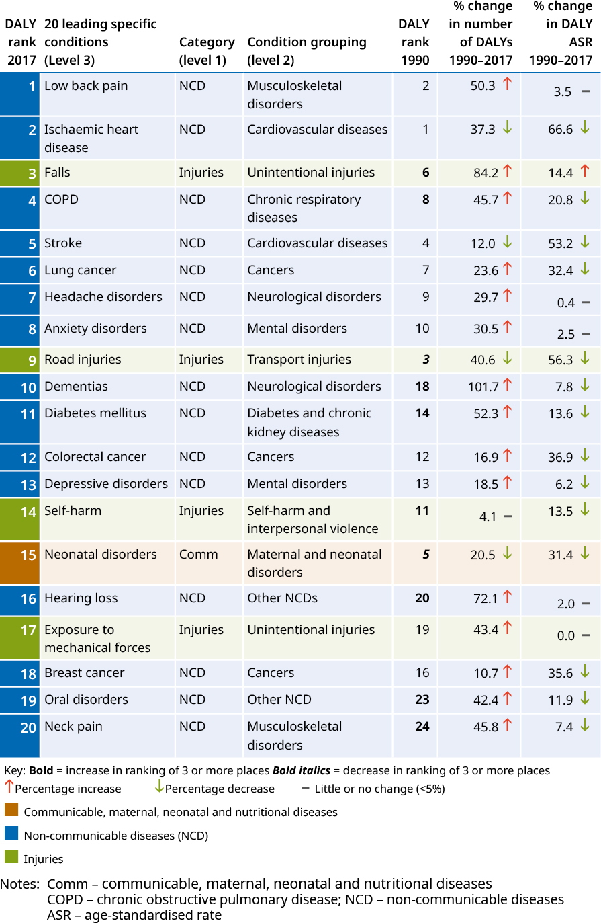
Notes: Comm – communicable, maternal, neonatal and nutritional diseases
COPD – chronic obstructive pulmonary disease
NCD – non-communicable diseases
ASR – age-standardised rate

Age-standardised YLL rates decreased for nearly all leading conditions
Table 4 provides a further breakdown by looking separately at the two components that make up DALYs (years lived with disability and years of life lost) for the 20 leading DALY conditions. Between 1990 and 2017, the number of YLDs increased for all 20 leading conditions (ranging from 18.5 percent for depressive disorders to 127.2 percent for chronic obstructive pulmonary disease). In contrast, the pattern for YLLs was mixed over this period: The largest percentage increases came from dementia and falls and the biggest decreases from road injuries and ischaemic heart disease.

A combination of factors explains much of the increase in the number of DALYs and YLDs, as well as shifts in the YLLs for specific conditions. In particular, over the past 25 years, New Zealand has experienced a growing and ageing population (increasing, conditions like dementia and falls), changes in lifestyles and health behaviours and improvements in treatments and technologies (reducing conditions like ischaemic heart disease and road injuries). The decrease in DALYs from neonatal disorders likely reflects largely stable fertility rates alongside progressive improvements in maternal and neonatal health care.

Taken together with general improvements in age-standardised rates for most conditions, the picture that emerges is of a health and disability system that has made positive progress in reducing early death. The greater challenges now, in addition to continuing to reduce the early mortality rate, are to support the growing number of people living with poor health and disability and strengthen efforts to prevent such conditions, detect conditions early and improve access to prompt treatment.

Table 4: Twenty leading specific conditions for health loss, ranking in 2017 and 1990 and change over time in absolute numbers and age-standardised rates of years of life lost and years lived with disability
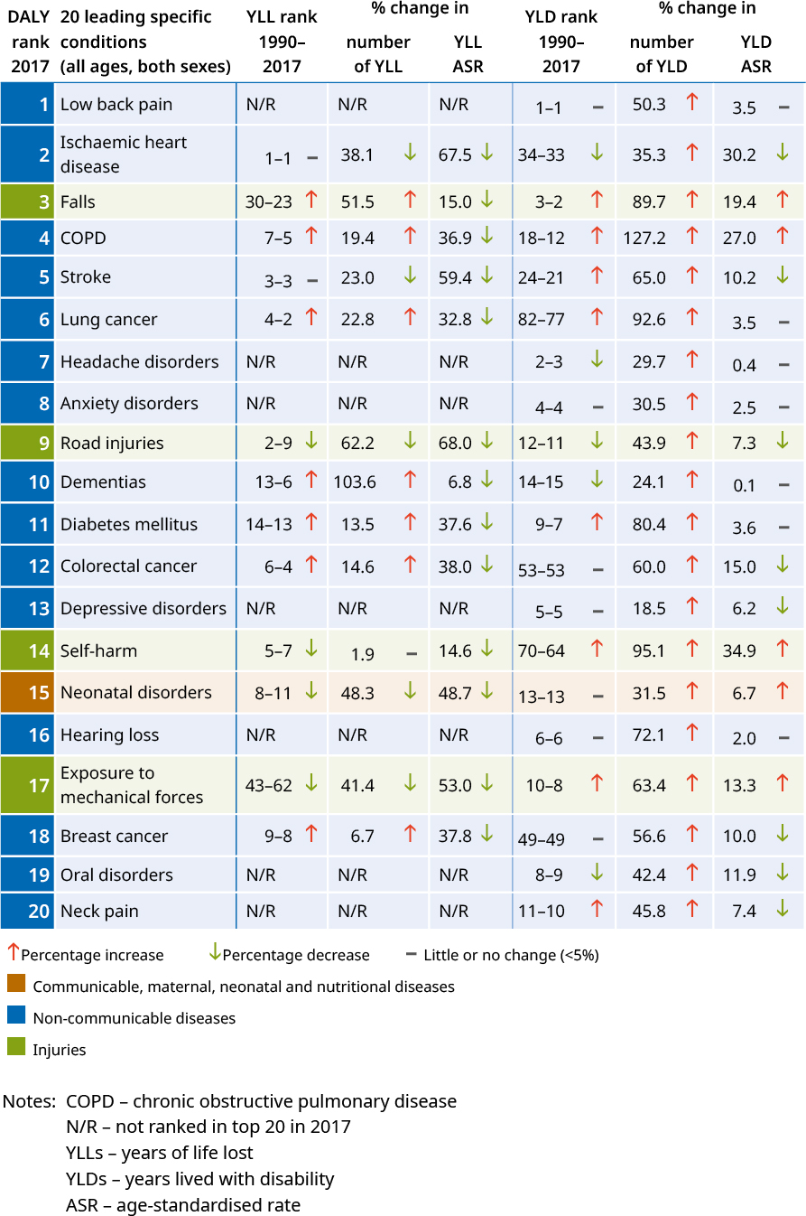
Notes: COPD – chronic obstructive pulmonary disease
N/R – not ranked in top 20 in 2017
YLLs – years of life lost
YLDs – years lived with disability
ASR – age-standardised rate

Examples of conditions where the health loss rate has not decreased
Figure 24 compares New Zealand data with the average results for all high SDI countries, looking at specific conditions in terms of both their total number of DALYs and the decrease in age-standardised DALY rate (after adjusting for changes in the size and age structure of the New Zealand population). It shows that New Zealand is not alone in the challenges it faces in addressing health loss, as described above.  For conditions such as dementia, musculoskeletal disorders and depressive disorders, the age-standardised rate has not fallen, while the total burden of disease has increased (doubling for dementia, for example, in New Zealand as in other high SDI countries). Other conditions such as substance use disorders, self-harm and unintentional injuries have followed the same trend. | Figure 24: Burden of disease from specific conditions in New Zealand and high SDI countries, 1990–2017  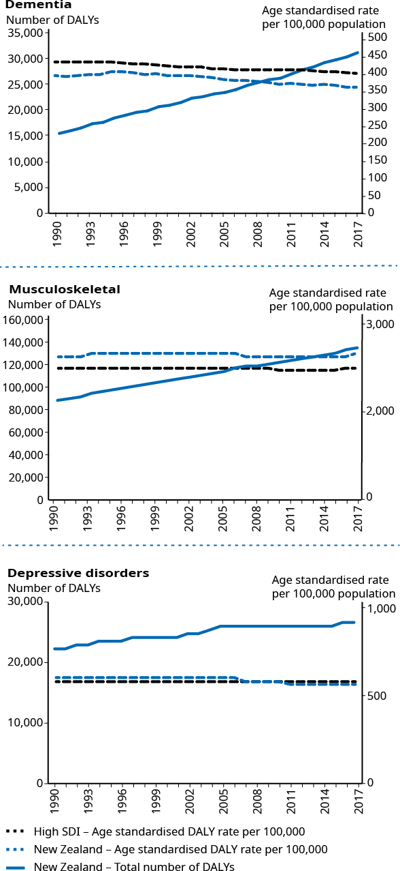

Examples of conditions where the health loss rate has improved
Figure 24: Burden of disease from specific conditions in New Zealand and high SDI countries, 1990–2017 (continued)  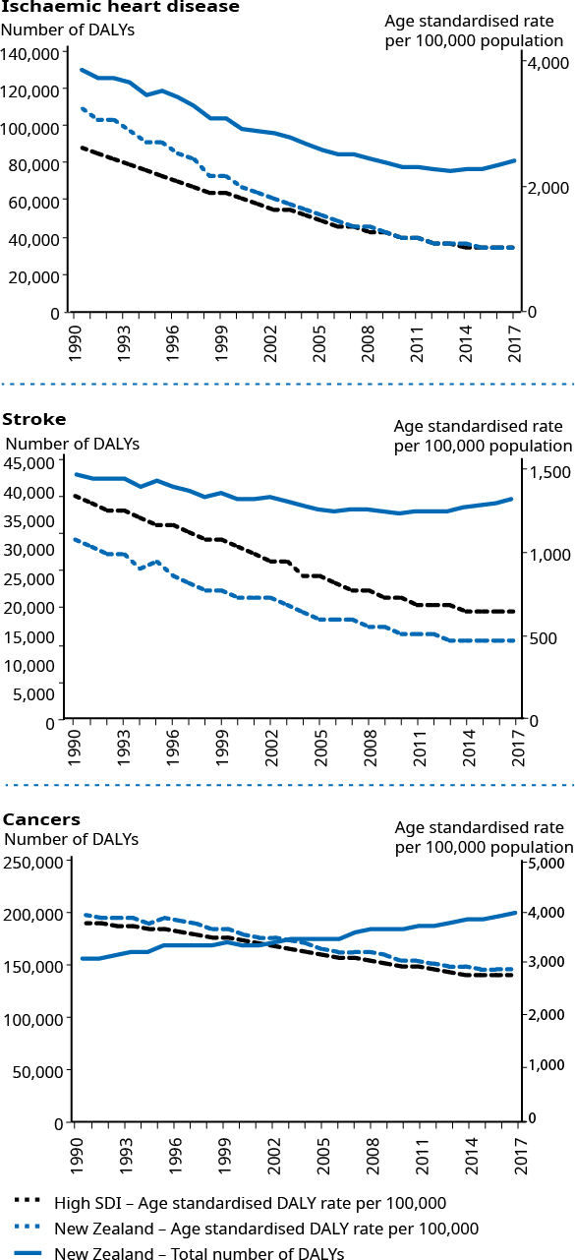 | However, for conditions such as ischaemic heart disease, New Zealand and other high SDI countries have successfully lowered both the age-standardised rate and the total burden.  For cancer, even with falling age-standardised rates of health loss in New Zealand and across high SDI countries, the total absolute burden has increased since 1990.

A closer look at specific conditions

Dementia is having an increasing impact on our health as our population ages
Within the top 20 conditions, those that have increased their contribution to the total DALYs the most between 1990 and 2017 are closely linked with population ageing. For example, dementia now ranks within the top ten leading conditions (up from 18th position in 1990). For dementias, the main increase in number of DALYs was from deaths (ranked 6th leading cause of YLL in 2017). Also, over time, the age-standardised rates decreased only slightly (6.8 percent) for YLLs and were stagnant for YLDs. Making improvements in this area is an important focus for the health system. One example of work already under way is the New Zealand Framework for Dementia Care.

Improving supports for people with dementia and their whānau
In 2013, the New Zealand Government released the New Zealand Framework for Dementia Care (the Framework) to set an agreed, overarching direction for dementia diagnosis, care and support. Central to the Framework is developing and implementing Dementia Care Pathways to deliver proactive, coordinated care and support throughout the journey with dementia for the person and their family.
Alongside the introduction of the Framework, significant investment has gone into improving dementia services and implementing Dementia Care Pathways. This has resulted in greater local, regional and national collaboration across services. For example, better collaboration between primary and secondary care is improving early diagnosis through training primary care providers and improving access to secondary care if the person needs it.
In 2019/20, the Ministry is undertaking a stocktake of dementia activities against the implementation of the Framework to understand progress to date. The information will enable DHBs to think about future priorities and to share information, learnings and best practice. At the same time, New Zealand’s dementia sector is leading the development of a draft dementia plan to identify the immediate and long-term actions it believes are required to improve dementia services and supports. The intention of this plan is to inform the Government’s future priorities for improving dementia care.

Health loss from cardiovascular diseases has decreased
Cardiovascular diseases were the leading cause of death in New Zealand in 2017, contributing to around 11,000 estimated deaths. Ischaemic heart disease contributed to an estimated 6,000 deaths and was the single leading cause of mortality. Stroke was the third-ranked condition, causing 2,500 estimated deaths. Between 1990 and 2017, the number of DALYs from ischaemic heart disease decreased by 37.3 percent and the number from stroke decreased by 12.0 percent.

Over this same period, the number of early deaths (YLLs) from these conditions decreased (by 39.1 percent for ischaemic heart disease and 23.0 percent for stroke), largely because life-saving interventions in this area have improved. However, the years spent in poor health and disability (YLDs) increased for both ischaemic heart disease (by 34.3 percent) and stroke (by 65.0 percent) due to population growth and ageing with people living with the impact of the diseases.

Age-adjusted rates for ischaemic heart disease reveal that DALYs have decreased by two-thirds (66.6 percent) over the past 25 years. The biggest decrease was in YLLs (67.5 percent), while YLDs decreased by around a third (30.2 percent). At the same time, the age-standardised DALYs rate halved (53.2 percent) for stroke. Like ischaemic heart disease, the largest decrease for stroke was in YLLs (59.4 percent), while YLDs saw a modest decrease of 10.2 percent.

These findings show New Zealand is making important progress in preventing and treating cardiovascular diseases. However, both ischaemic heart disease (ranked second for DALYs) and stroke (ranked fifth) are common in the population, share certain risk factors and contribute significantly to early death and time spent in poor health. These conditions are expected to remain important areas of work for prevention, early treatment and rehabilitation.

The New Zealand Cardiac Network
The New Zealand Cardiac Network (the Network) is a clinical network supported by four regional cardiac networks, which together cover all of New Zealand.
The diverse membership is drawn from primary, secondary and tertiary care providers and various clinical groups. The mission statement of the Network is to reduce premature mortality from heart disease and improve care for people living with heart disease. Recognising that Māori, Pacific and Southeast Asian New Zealanders have worse cardiovascular disease outcomes than other New Zealanders, the Network focuses its activities on improving timely access and equity in cardiac treatment pathways for these groups, as well as for people living outside urban areas.
Key elements for improving outcomes are understanding what services are currently provided, measuring progress over time and using data to support service change. The All New Zealand Acute Coronary Syndrome Quality Improvement Registry captures data following an acute coronary syndrome admission giving all DHBs insight into the acute interventional cardiology services they provide. The Network has supported or led work across the whole cardiac pathway, including work on:
the GoodSAM app in New Zealand, to enable community first responders
accelerated Chest Pain Pathways, to quickly diagnose patients with acute cardiac chest pain
out-of-hospital ST Elevation Myocardial Infarction (STEMI) pathways across New Zealand
recommendations for referral and access to secondary care for common cardiac conditions to identify appropriate benchmarks for care.
STEMI is a time-critical event. Once the diagnosis is confirmed, good outcomes for the patient depend on prompt intervention (reperfusion through percutaneous intervention (PCI) or fibrinolysis). Where access to primary PCI is not available within 90 minutes, processes begin for local medical personnel or ambulance services to deliver fibrinolytic therapy to dissolve any clot. The aim of developing out-of-hospital STEMI pathways in New Zealand is to clearly identify different processes and pathways based on a person’s distance from a hospital with PCI capability. These pathways also recommend promptly transferring patients who receive fibrinolytic therapy to a PCI-capable hospital for early angiography. Together with ambulance services and the regional cardiac networks, the Network successfully introduced the pathways across New Zealand in 2018 and 2019.

Cancers remain among the leading causes of early death
Cancers have a significant impact on health loss and especially on early death. Lung, colorectal (bowel) and breast cancers are among the leading conditions causing health loss in New Zealand. These three conditions ranked within the top 10 for their contribution to the number of YLLs in 2017 (lung cancer second, colorectal cancer fourth and breast cancer eighth) (see Table 2 in the ‘Summary of key findings’ section).

Between 1990 and 2017, the number of DALYs for each of these cancers increased. The number of YLDs (although much lower in absolute number) increased more than the number of YLLs, which indicates progress in reducing early death. In 1990, YLLs contributed to 95 percent of the total health loss, compared with 93 percent in 2017.

Although the number of DALYs from these conditions has increased over time, the age-standardised rates fell by around a third (32.4 percent for lung cancer, 36.9 percent for colorectal cancer, and 35.6 percent for breast cancer). The main area of improvement has been in reducing early death through improvements in prevention, screening and early detection along with advances in treatment options.

Work in this area is a continued focus of the Government’s New Zealand Cancer Action Plan (2020) and the new Cancer Control Agency.

For a more detailed discussion of cancers, see the final section, ‘A closer look at cancer’.

DALYs associated with mental illness have increased
Health loss from anxiety and depressive disorders increased between 1990 and 2017. Anxiety disorders are ranked as the eighth leading cause of DALYs, and the associated burden of disease has increased by around a third (30.5 percent) since 1990. Over the same period, the number of DALYs due to depressive disorders (ranked 13th) increased by a fifth (18.5 percent). Age-standardised rates have remained largely unchanged for anxiety disorders (2.5 percent increase), while depressive disorders decreased slightly (by 6.2 percent). Improving mental wellbeing by addressing conditions such as anxiety and depression is an important focus for the Ministry and the Government. Improvements in mental wellbeing are likely to improve physical wellbeing too, because the two areas are closely linked.

Improving mental wellbeing
Transformative work is under way to improve mental health and addiction outcomes in New Zealand. This work follows He Ara Oranga: Report of the Government Inquiry into Mental Health and Addiction, which the Inquiry Panel presented to the Government in November 2018.
Significant new investment is focused on increasing access to primary and community mental health and addiction support. Services will be designed collaboratively according to local needs and will be available in diverse settings including general practices, kaupapa Māori services, Pacific services and youth organisations. These supports will allow people to get the help they need earlier, and will complement efforts to expand school-based services, telehealth and digital support, as well as support for parents and families.
The Prime Minister and Minister of Health launched a Suicide Prevention Strategy and Action Plan (Every Life Matters) in 2019. The plan aims to promote wellbeing, respond to suicidal distress and behaviour and support individuals, families, whānau and communities after a suicide. The new Suicide Prevention Office is leading the plan by promoting collaboration and providing oversight.
In 2019, the Initial Mental Health and Wellbeing Commission (Initial Commission) was also established to provide central oversight of efforts to improve New Zealanders’ mental wellbeing. The Initial Commission’s scope extends across the many wider determinants of mental wellbeing, such as housing, education, employment and social connectedness. The Initial Commission will operate while work continues on establishing the permanent Mental Health and Wellbeing Commission as an independent Crown entity.
For more information, see:
health.govt.nz/our-work/mental-health-and-addictions/suicide-prevention-new-zealand/suicide-prevention-strategy-and-action-plan
health.govt.nz/our-work/mental-health-and-addictions/government-inquiry-mental-health-and-addiction

The impact of diabetes on years lived with disability is increasing
Between 1990 and 2017, the number of DALYs from diabetes increased by 52.3 percent. Diabetes usually begins in middle age and the effects are life-long, leading to a high number of YLDs. The most significant increase was that the number of years lived with disability increased by four-fifths (or 80.4 percent).

Addressing this illness remains an important challenge as age-standardised YLD rates have changed little between 1990 and 2017. Best practice focuses on prevention by addressing modifiable risk factors in the community, including obesity, dietary risks and insufficient physical activity.

Healthy Active Learning – an initiative to promote and improve healthy eating and physical activity in schools
Healthy Active Learning is a new Wellbeing Budget initiative that will promote and improve healthy eating and physical activity in schools, kura and early learning services across Aotearoa New Zealand.
Part of this initiative, which the Ministry of Health, Ministry of Education and Sport New Zealand are jointly leading, will involve supporting schools, kura and early learning services by providing new curriculum resources and a new health promotion workforce. Many primary and intermediate schools will also benefit from the work of physical activity providers.
Healthy Active Learning is based on evidence showing that good nutrition and an appropriate level of physical activity improve children’s academic achievement along with their physical and mental health. Research shows that only 7 percent of children and young people aged 5 to 18 years meet New Zealand guidelines for physical activity.
Healthy Active Learning has three components. The Ministry of Education will work with curriculum experts, teachers and school and kura leaders to design and publish curriculum resources for schools and kura to enhance the understanding and delivery of Health and Physical Education and physical activity initiatives.
The Ministry of Health will develop a toolkit to help all learning services and schools create a healthy food and drink environment. This will include healthy food and water only (and plain milk) policies. Public health units will employ a health promotion workforce to help schools and early learning services to develop healthy food and water-only education environments.
Sport New Zealand will partner with regional sports trusts to provide a workforce to work with primary and intermediate schools and kura. This workforce will help create active school environments by working alongside school leaders and teachers to enhance the provision of play, sport and physical education, and to improve their connections with physical activity providers in their local communities.

Low back pain is a major contributor to health loss
The total contribution that low back pain makes to non-fatal health loss is increasing. Low back pain is widespread in the community, with disabling effects that can vary from mild to severe. Because it is so widespread, the condition has become the leading contributor to health loss in New Zealand, increasing by 50.3 percent since 1990. Age-standardised rates of low back pain have remained largely unchanged since 1990 (3.5 percent increase).

Comparing health loss of females and males
Figure 25 shows that in 2017 males experienced a higher number of DALYs (592,548) than females (507,156), although the difference was not statistically significant.

Figure 25: Disability-adjusted life years, years of life lost and years lived with disability, by sex, 2017
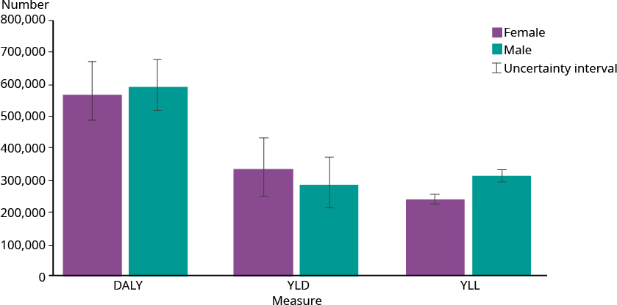

The main reason for the difference is that males experienced a greater number of YLLs (304,452) than females (232,415), which is statistically significant. Although females experienced a greater number of YLDs (337,741) than males (288,096), the difference was not statistically significant (because the uncertainty interval for non-fatal outcomes is wider than for fatal outcomes). Overall, females experienced a higher proportion of health loss from non-communicable diseases (84.5 percent compared with 79.2 percent for males), while injuries made up a greater share of health loss for males (16.8 percent compared with 11.5 percent for females).

Leading specific conditions for females and males
Among conditions grouped at GBD level 2, cancer was the leading cause for health loss in both sexes. However, females and males have some differences in the absolute burden of the other leading health conditions. Musculoskeletal disorders were ranked second in females, contributing to 76,040 DALYs and third in males, contributing to 58,925 DALYs. On the other hand, cardiovascular conditions were ranked second for males (94,466 DALYs) and third for females (66,878 DALYs). Mental disorders were ranked fourth for females (57,275) and fifth for males (41,366 DALYs). In males, the fourth-ranked cause was unintentional injuries (54,483 DALYs), whereas the same cause ranked sixth in females (42,977 DALYs).

Figure 26 shows the differences between the sexes for the main causes of health loss in 2017 at GBD Level 3. The age-standardised rates illustrate that males experienced a higher rate of DALYs from conditions such as ischaemic heart disease, road injuries, self-harm and drug and alcohol use disorders. In contrast, females experienced higher DALY rates from conditions such as low back pain, anxiety and depressive disorders.

Figure 26: Comparing age-standardised rates per 100,000 by sex for GBD Level 3 conditions, 2017
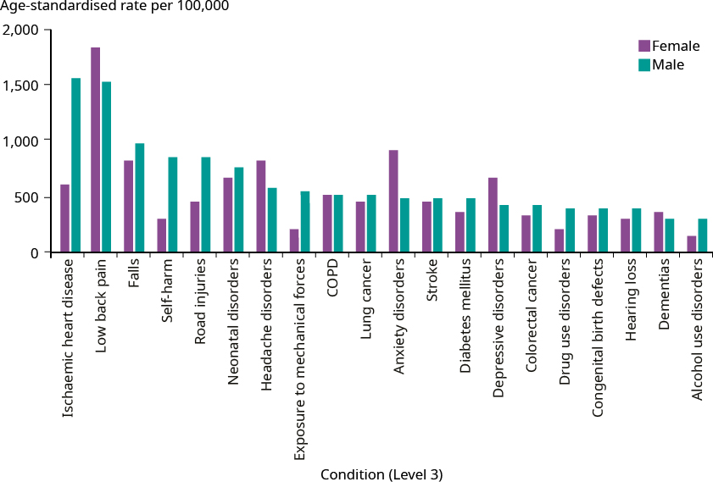

Health loss across the life course
Health loss in the population generally increases with age. Figure 27 shows the proportion of health loss by age group, alongside the proportion of the population that each of those age groups represents.

Figure 27: Share of total DALYs (2017) compared with share of population (Census 2013), by age group
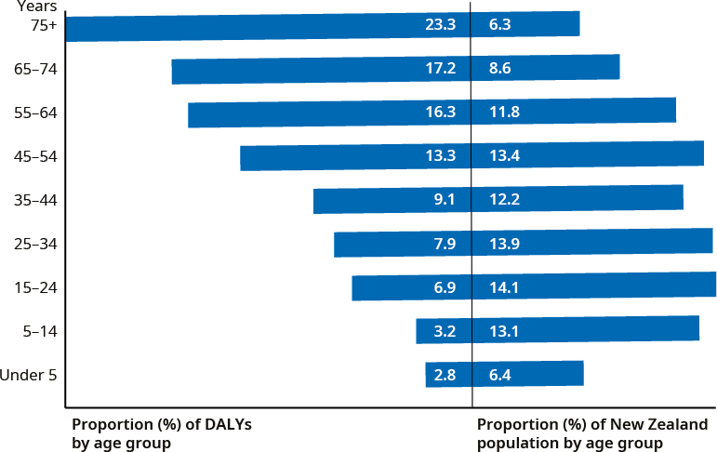

As Figure 27 shows, children under the age of 15 years make up around 20 percent of the population and accounted for 6 percent of total health loss, while people aged 75 and over make up 6 percent of the population and accounted for 23 percent of DALYs. This ‘6–20’ and ‘20–6’ pattern is a growing challenge as more New Zealanders live into their 80s and beyond. The figure above also shows that around 30 percent of total health loss occurred in middle age (45–64 years) and a further 40 percent occurred in older people (aged 65 and over). The group aged under 45 contributed to the remaining 30 percent of the health loss: 17 percent in young adults (25–44 years) and 13 percent in children and youth (under 25 years).

Leading causes of health loss across the life course
Figure 28 shows the number of DALYs across the life course by sex and condition types in 2017. It reveals that, after a spike in the early neonatal period, health loss generally increases with age (though males in their twenties do not follow this trend). Health loss increases markedly at 45–49 years and peaks at 65–69 years, before slowly tapering off as people enter their mid-seventies. The age group of 80 years and over (not shown in the graph) had the highest burden, accounting for 179,857 DALYs.

Females experienced more DALYs (98,733) than males (81,084), reflecting their longer life expectancy.

Figure 28: Number of disability-adjusted life years by age group and sex, GBD Level 2, 2017
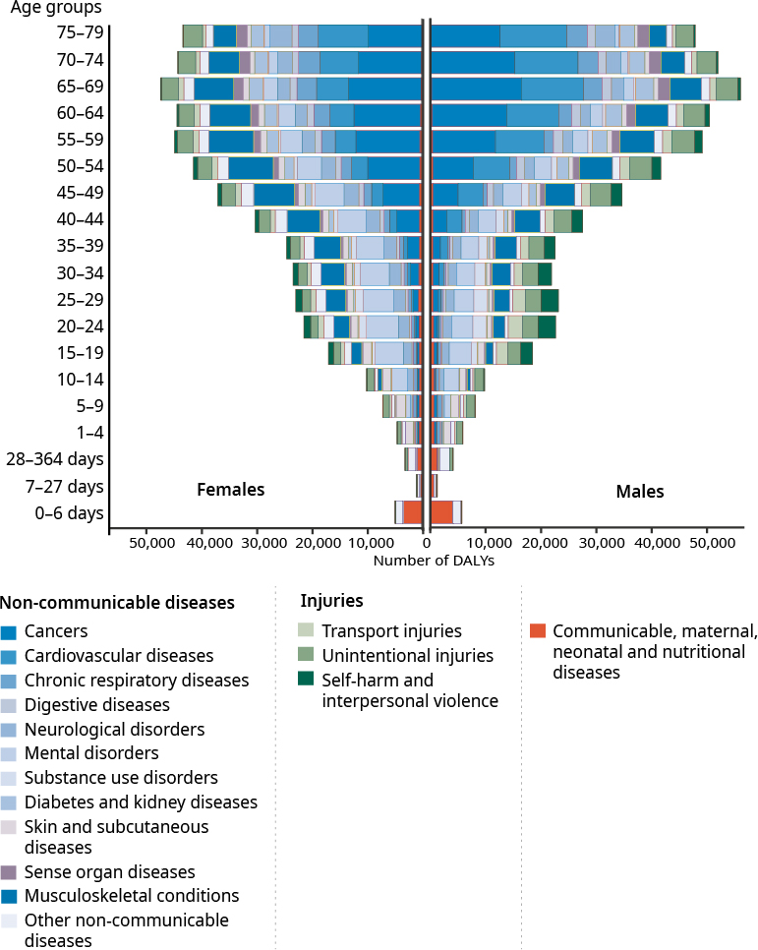

Figure 28 also reveals that maternal and neonatal disorders were the main reason for health loss for children under the age of five years for both sexes. Unintentional injuries impacted all population groups: at GBD Level 2, they were one of the five leading causes of health loss for all age groups; one of the top three causes for people in all the age groups from birth to 34 years; and the fourth highest contributor for older adults aged 75 years and over. Transport injuries were one of the five leading contributors to health loss for young people aged 15–24 years and one of the 10 leading causes of DALYs for all the age groups from birth to 54 years. Males experienced more health loss from injuries for all age groups below 80 years. Injury prevention, therefore, can contribute to significant health gains in the population.

Cancers were present in all age groups in 2017. They were the leading condition group for New Zealanders aged 45–74 years and the second leading cause of DALYs for older adults aged 75 years and over. In general, females aged 30–55 years experienced more health loss from cancers than males. (For a more detailed discussion of cancer, see the final section, ‘A closer look at cancer’.)

Cardiovascular disease is another major cause of health loss and, like cancer, its impact increases markedly with age. In 2017, cardiovascular diseases entered the group of 10 level 2 leading causes (at seventh) of DALYs for people aged 35–44 years. It was also the third leading cause of health loss for those aged 45–54 years, second for those aged 65–74 years and the leading cause in the older population (75 years and over). Males had a higher burden of cardiovascular diseases until the age of 85 years.

A closer look at health loss in children
Table 5 presents the ten leading causes of health loss in children under 15 years.

Children under five years experienced a high proportion (44.5 percent) of health loss from communicable, maternal, neonatal and nutritional diseases. Communicable diseases such as respiratory infections were among the top 10 leading conditions in this age group, especially in infants. Non-communicable diseases made up 43.7 percent of DALYs. The greatest contributions came from congenital birth defects and sudden infant death syndrome (SIDS) in infants and skin and respiratory-related conditions in those aged 1–4 years.

The leading conditions for health loss in those aged 5–14 years included a mixture of some leading conditions experienced by children under 5 years and others experienced by those aged 15 years and over. Neonatal conditions and congenital birth defects as well as asthma and dermatitis continued to feature in the 10 leading conditions of those aged 5–14 years, while this age group also started to experience anxiety and conduct disorders.

Table 5: Ten leading conditions contributing to health loss among children aged under 15 years, 2017
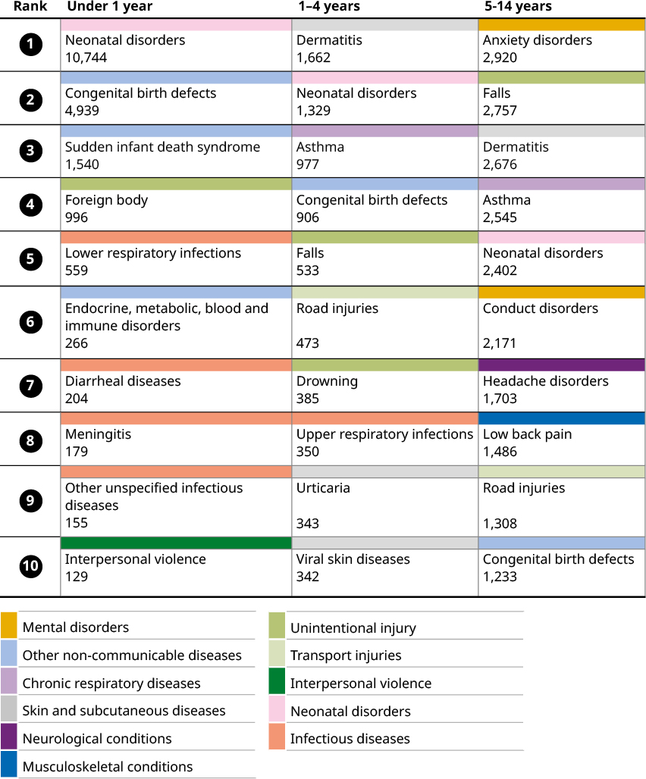

Neonatal conditions, congenital birth defects and sudden infant death syndrome are still the leading conditions in the first year of life
Health loss in infants is mainly due to YLLs. The leading contributor to health loss was neonatal conditions, which accounted for more than half of the total burden in this age group (50.6 percent). About another quarter was due to congenital birth defects (23.3 percent) and SIDS (7.3 percent).

As Figure 28 shows, those in the early neonatal group (aged under seven days) carried a considerable burden of disease – experiencing a third of all health loss among those under five years old. Of this health loss, 70 percent was due to neonatal disorders.

Most of these neonatal disorders resulted from preterm birth, while the others were due to congenital birth defects.

The late neonatal phase, from 7 to 27 days after birth, accounted for 7 percent of all health loss among under fives. Again neonatal disorders were the main cause of health loss, although they involved a greater proportion of congenital birth defects.

In the post-neonatal phase, from 28 to 364 days following birth, the share of health loss due to both congenital birth defects and neonatal disorders declined. At the same time, other causes became more important; for example, sudden infant death syndrome contributed 17.8 percent of all DALYs. Of note is that foreign body aspiration caused 10 percent of all DALYs for this post-neonatal group.

Leading causes of health loss in children aged 1–4 years
In children aged 1–4 years, neonatal conditions and congenital birth defects were still included in the top five leading causes for health loss. However, the share of the total burden decreased to 19.3 percent for the two causes combined (11.5 percent for neonatal conditions and 7.8 percent for congenital birth defects).

Other leading conditions in this age group included non-fatal conditions. For example, dermatitis contributed to 14.3 percent and asthma to 8.4 percent of health loss.

Injuries contributed to 21 percent of DALYs. In particular, falls, road injuries and drowning together contributed to 12 percent of the total burden. The other 9 percent consisted of injuries from causes that are not included in the top 10, such as exposure to mechanical forces, foreign body aspiration and interpersonal violence.

The total burden in males is higher than in females among those aged under five years
Figure 29 shows the leading YLL and YLD conditions by sex for those aged under five years. Overall in this age group, males (18,114 DALYs) experienced more health loss than females (14,710 DALYs) in 2017. Males had a higher rate of DALYs across all level 3 conditions.

The number of early deaths was consistently higher for males across all leading YLL conditions, ranging from neonatal conditions (1.2 times more than females) to SIDS (1.6 times more). Likewise, for YLD conditions such as asthma, males experienced 1.8 times more years lived in poor health than females. While the numbers differed, the proportion of DALYs due to YLLs was the same for males and females.

Figure 29: Leading conditions contributing to YLLs and YLDs, among children aged under five years, 2017
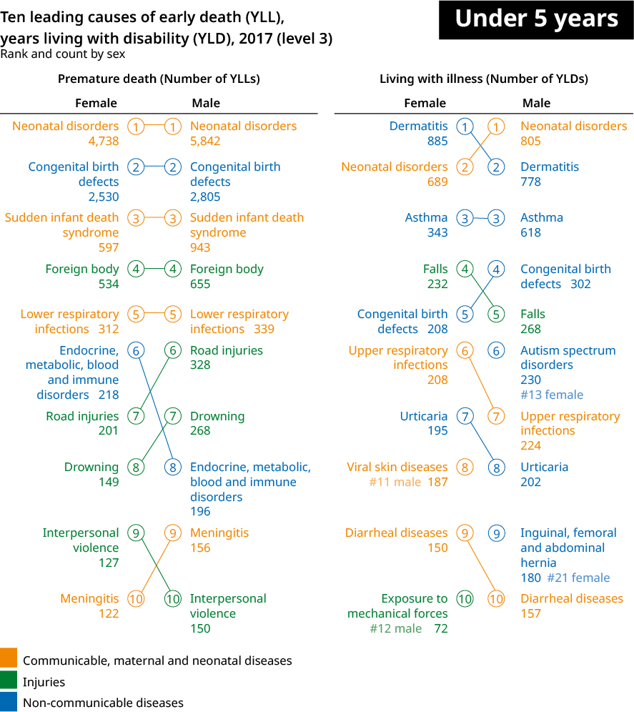

A closer look at selected age groups in adults
Table 6 provides an overview of and more detailed information on the 10 specific leading conditions affecting the health of New Zealanders aged 15 years and over in 2017. Each colour represents the level 2 condition group to which the conditions identified belong along with the number of DALYs for each condition.

Table 6: Ranked leading conditions (GBD Level 3) contributing to health loss and number of DALYs, by selected age groups, 2017
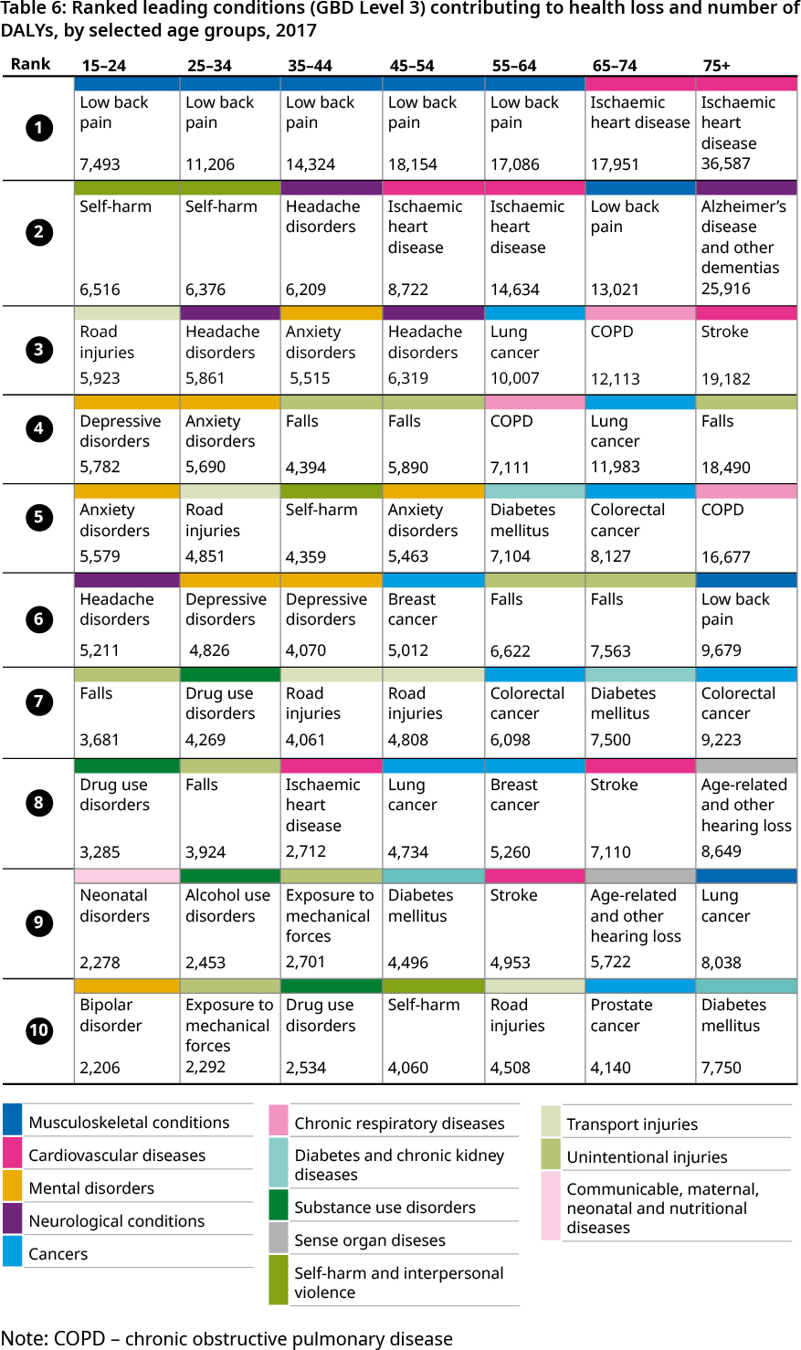
Note: COPD – chronic obstructive pulmonary disease

Looking at Table 6 and Figure 28 together helps to draw a picture for specific conditions along the life course. We describe some examples below.

The mental disorders of depression and anxiety were in the top 10 leading causes of health loss for people of working age, mainly in those aged 15–54 years. Females experienced more health loss from mental disorders in all age groups over 15 years.

Self-harm, which by itself could indicate mental distress, ranked second for people aged 15–44 years and remained in the leading 10 conditions (ranked eighth) for people aged 35–54 years. Males had a higher number of DALYs caused by self-harm than females in all age groups over 15 years.

Drug and alcohol use disorders ranked within the 10 leading causes of health loss for people aged 15–44 years. As with self-harm, males experienced more health loss from substance use than females. These findings highlight the important need to continue to focus on improving mental wellbeing and addiction outcomes in young people and across the life course.

Low back pain was a leading cause of DALYs starting at a young age. It was the most common cause of health loss for people aged 15–64 years, second for those aged
65–74 years and sixth for those aged 75 and over. Females consistently experienced more health loss through musculoskeletal disorders across all age groups.

Neurological conditions are another important cause of DALYs from the age of 15 years onwards. However, the more specific neurological condition that contributed the greatest health loss differs by age: in young people it was headache disorders, while in older adults it was dementia. Females had a higher number of DALYs from these conditions than males across all age groups.

COPD appears as a significant contributor to health loss from age 55 years onward, becoming one of the five leading causes of health loss for these age groups. Diabetes mellitus is another condition with increasing impact from 45 years, when it enters the leading ten conditions and remains there for the older age groups.

A closer look at health loss in young people (aged 15–24 years)
The health loss among those aged 15–24 years was 80,400 DALYs, which represents a 7 percent of all DALYs. Figure 30 provides a snapshot of health loss in young people by sex for conditions at different GBD levels in 2017. Non-communicable diseases become more prominent as a source for health loss in this age group, contributing to two-thirds of DALYs in 2017. The proportion of DALYs from non-communicable diseases was much higher for females (78 percent) than for males (59 percent). Overall, 75 percent of the health loss was due to YLDs, but again the figure differed markedly between males (66 percent) and females (85 percent).

Mental disorders and injuries are the leading causes of health loss in youth
An important cause of health loss among GBD Level 2 categories was mental disorders. This condition group accounted for 23 percent of all DALYs among those aged 15–24 years. It contributed almost 28 percent of total health loss for females and 19 percent for males.

Within the mental disorders category, the two main causes of health loss were depression and anxiety. Between them, these causes contributed about 14 percent of health loss in this age group overall. However, the contribution was lower for males (10 percent) than for females (19 percent).

For males aged 15–24 years, injuries accounted for a far larger burden of health loss (36 percent) than for females (17 percent). Over 30 percent of YLLs for this age group occurred because of self-harm. The contribution was almost the same for males and females aged 15–19 years. However, among those aged 20–24 years, the proportion of early mortality burden from self-harm for males was 35 percent of YLLs, much higher than that for females (26 percent). The proportion of YLLs due to self-harm in New Zealand youth was higher than the average of high SDI countries.

Improving the wellbeing of children and young people
Improving the wellbeing of children and young people is a major focus for the Government. In 2019, the Prime Minister released the first Child and Youth Wellbeing Strategy. Its vision is that New Zealand is the best place in the world for children and young people. The initial priorities are to:
reduce child poverty and mitigate the impacts of poverty and socioeconomic disadvantage
better support those children and young people of interest to Oranga Tamariki and address family and sexual violence
better support children and young people with greater needs, with an initial focus on learning support and mental wellbeing.
Being healthy and happy is one of the six domains of the strategy. The health and disability system has an important contribution to make to this domain, alongside other agencies, communities, families and whānau. This work involves ensuring the best possible physical health and mental wellbeing for children and young people.
A range of actions to bring the strategy to life is under way. For more information, see childyouthwellbeing.govt.nz/

Road injuries caused around 25 percent of YLLs among those aged 15–24 years in New Zealand. This proportion is similar to that of the average of high SDI countries.

About 10 percent of health loss was due to musculoskeletal disorders, which almost entirely involved low back pain. Low back pain was the leading cause of YLDs in both sexes, but the number in females (4,268 YLDs) was higher than in males (3,225 YLDs).

Figure 30: Leading conditions contributing to health loss among young people aged 15–24 years, 2017
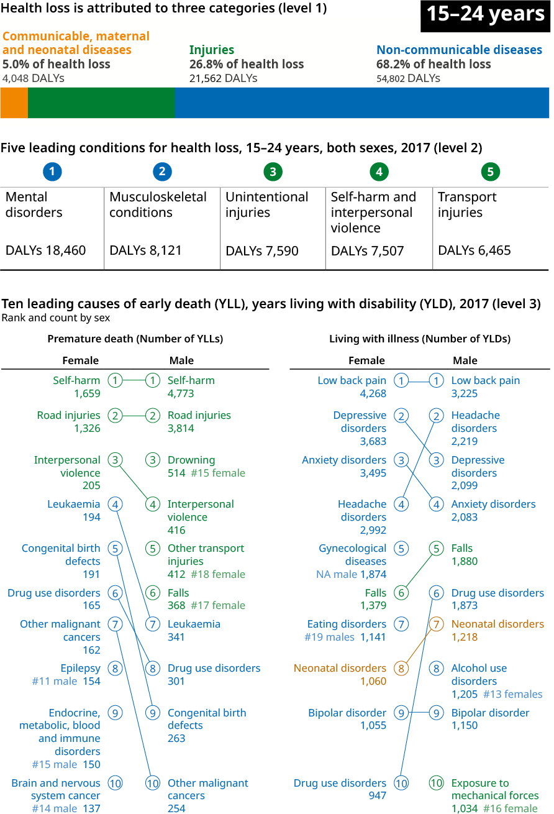

A closer look at health loss in older adults
In 2017, people aged 65 years and over experienced well over a third (40.5 percent) of total DALYs. Of those DALYs, 57.6 percent were in those aged 75 years and over, and 38.0 percent were in those aged over 80 years.

Figures 31 and 32 provide snapshots of DALYs, YLLs, and YLDs for female and male older adults. For those aged 65–74 years, the pattern of disease is very similar to the middle-aged group, but the burden itself increased. The rate of all-cause DALYs is two times higher for those aged 65–74 years than for the 45–54 years age group. The pattern shifts as people approach the average life expectancy. For those over 75 years, the main causes of death shift from cancers to cardiovascular disease. Alzheimer’s and other dementias become the second leading cause of premature mortality. The leading cause of disability is falls, followed by low back pain and hearing loss.

Improving strength and balance in New Zealand’s older people
Around one in seven New Zealanders is aged 65 years or over. By the middle of the century it is projected that one in four New Zealanders will be over 65 years and the proportion of people aged 85 years and over will have tripled.
Around 30–60 percent of people aged 65 years and over have a fall each year, with 10–20 percent ending up in hospital with a fracture. People over the age of 85 years are 15 times more likely to fracture a hip in a fall than a 65-year-old.
While it is inevitable that some falls will happen, others are preventable. The risk of falling and injury can be decreased by keeping active and increasing strength and improving balance.
The Accident Compensation Corporation (ACC), the Ministry of Health and the Health Quality & Safety Commission are working together to help reduce falls and their impact. Nationwide falls and fracture services, including fracture liaison, community class and home-based strength and balance programmes, have been established.
In addition, a National Falls and Fracture Outcomes Dashboard is tracking the impact of investment in falls and fracture programmes. Outcomes are being measured collectively.
Work is also under way in relation to frailty and falls and improving the prevention and treatment of osteoporosis. Early work has centred on improving primary care’s recognition of people at high risk. A comprehensive assessment identifies the relevant areas of need and allocates clinical support and resources to improve the person’s care and welfare. This includes reducing falls risk, managing osteoporosis, giving attention to pharmaceutical prescriptions and addressing other clinical or lifestyle matters that contribute to frailty.
In 2016, the NZ Government released the Healthy Ageing Strategy. This Strategy responded to the WHO’s direction for members to develop strategies to ensure health systems would be ready to meet the health needs of their ageing populations. It included initiatives to improve delivery of dementia care in line with the NZ Framework. It also included direction to implement the strength and balance initiatives described above.

Figure 31: Leading conditions contributing to health loss among older adults aged 65–74 years, 2017
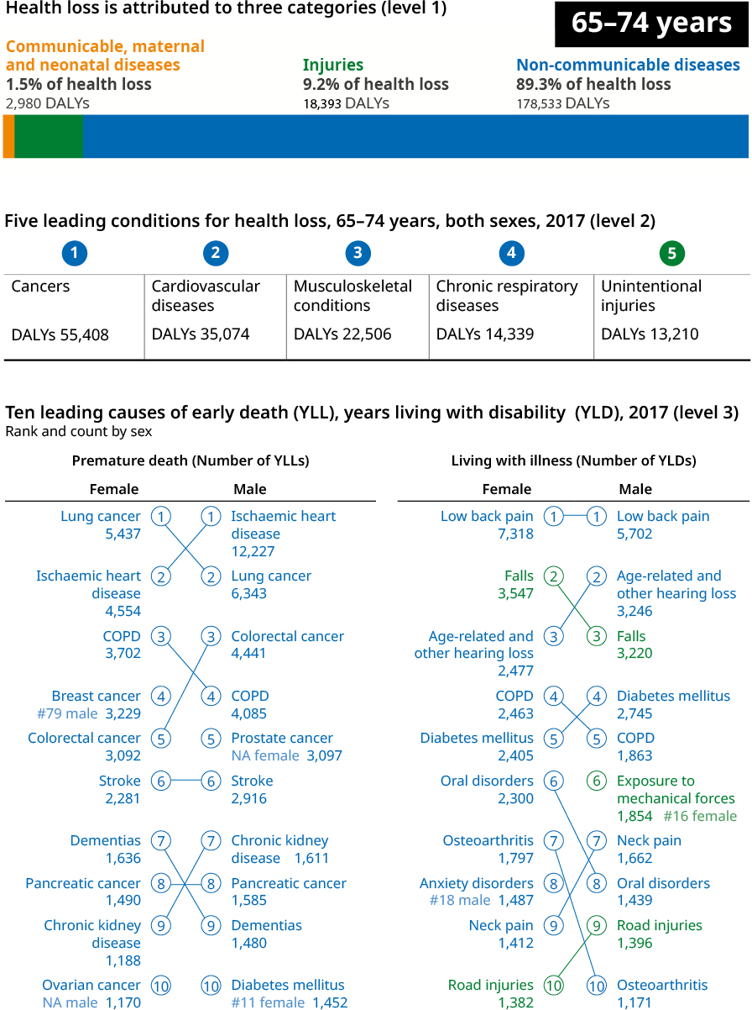

Figure 32: Leading conditions contributing to health loss among older adults aged 75 years and over, 2017
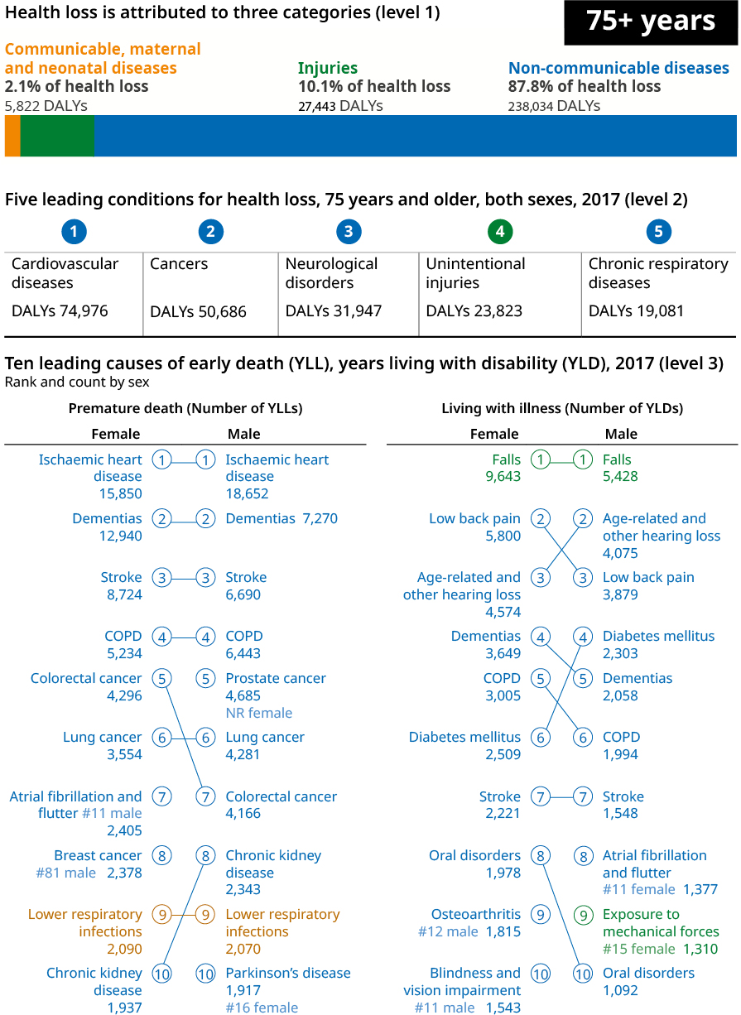

Which risk factors contribute most to making us unwell?
The GBD examines how much different risk factors contribute to health loss in the population. In 2017, risk factors contributed to close to half a million (448,485 or 39 percent) of all DALYs.
Figure 33: The attributable burden of risk factors
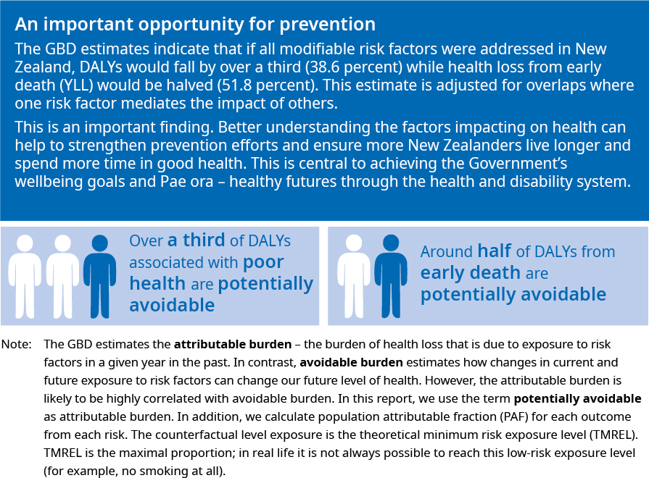

The GBD groups risk factors into three main categories: behavioural, metabolic and occupational and environmental risks. Figure 34 includes some examples of specific risks in each category. Table A1 in the appendix provides a full list of the 84 risk factors used in the 2017 estimates.

Figure 34: Risk factors – high-level categories
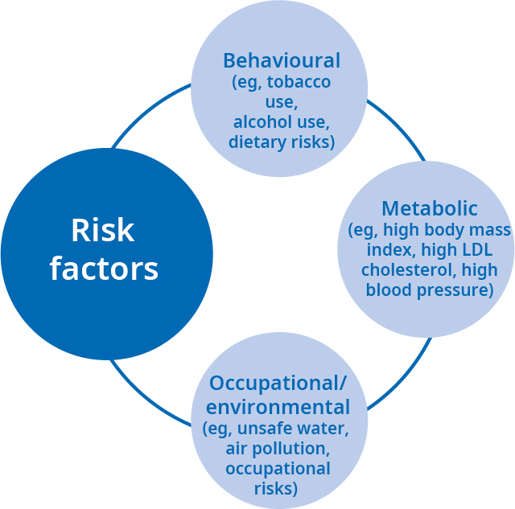

The independent contribution to health loss that each of the three main categories made in 2017 was:
- a quarter (25.6 percent) from behavioural risk factors
- a fifth (18.8 percent) from metabolic risk factors
- 5.8 percent from environmental and occupational risk factors.

It is not possible to simply add up these factors to get an overall total because they interact with each other. IHME accounts for this interaction in the GBD methodology when assessing the proportion that all risk factors together contribute to health loss. Figure 35 illustrates the contribution of different types of risks to different health conditions. The ‘all risk factors’ category combines the risk groups and accounts for risk interactions and overlaps to present an overall picture of risk factors and their contribution to health loss in New Zealand.

Figure 35: Health loss as a percentage of total disability-adjusted life years, by risk cluster and high-level cause, 2017
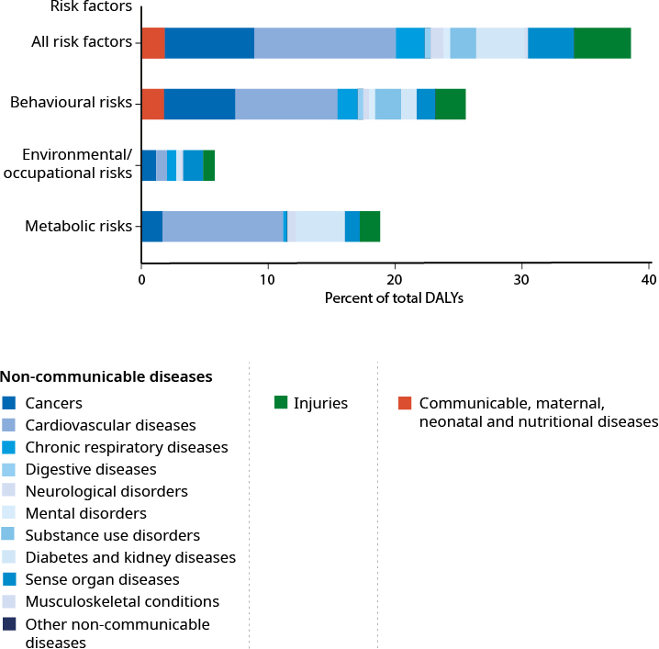

The impact of risk factors on health outcomes
Figure 36 provides a more detailed view of how key risk factors contribute to health loss through a range of conditions. We have a significant opportunity to improve the health of New Zealanders by preventing and/or lowering exposure to common risk factors in the population.

It is important to note that those risk factors occur in economic, social and political environments which may or may not promote healthy or unhealthy behaviours (ie, the context in which people live, work and play) has a substantial impact on the likelihood of behaving in a riskier way.

Figure 36: Proportion of health loss from leading risk factors, 2017
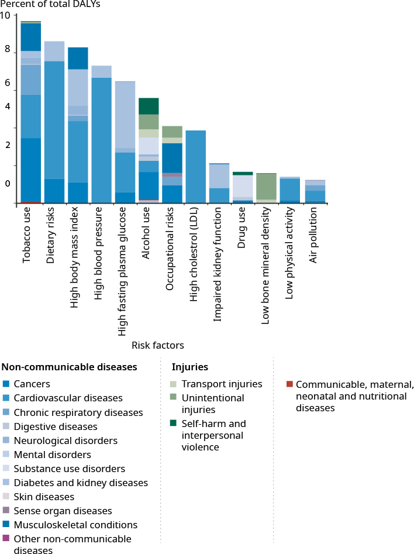

Behavioural risks (such as tobacco use, diet, low physical activity and alcohol and drug use) have a significant influence on cardiovascular diseases, cancers, other non-communicable diseases (including substance use disorders) and injuries. Behavioural risks are also the group of risks that has the greatest influence on a range of communicable, maternal, neonatal and nutritional diseases.

Metabolic risks (such as high systolic blood pressure, high body mass index, high LDL cholesterol and high fasting plasma glucose) contribute strongly to cardiovascular diseases. In addition, they influence the incidence of diabetes, kidney diseases and other conditions including cancers, injuries and musculoskeletal disorders.

Although environmental and occupational risks have a lower relative impact on health loss among the three GBD risk factors clusters, they contribute to the health loss from a range of conditions, including musculoskeletal disorders, chronic respiratory diseases and cancers.

In 2017, the six specific risk factors that made the greatest contribution to DALYs across all New Zealanders (all ages, both sexes) were:
- tobacco use
- dietary risks
- high body mass index
- high systolic blood pressure
- high fasting blood glucose
- alcohol use.

Further details are set out in Figure 37.

Overall, males experienced a greater number of DALYs from the leading six risk factors noted in Figure 37. Males also experienced higher rates of DALYs from nearly all risk factors after adjusting for age differences between the sexes.

Figure 37: Percentage of health loss attributable to leading risk factors in the population, 2017, and between 1990 and 2017
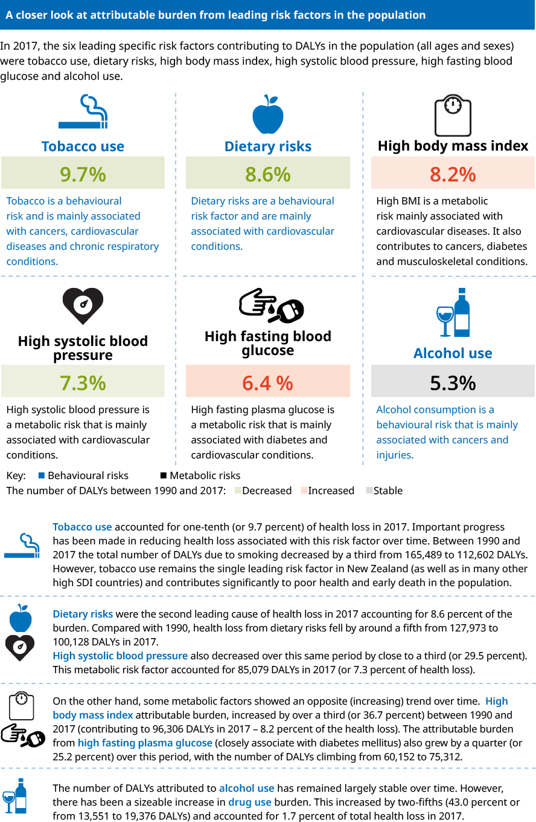

Understanding the changes in attributable burden due to risk factors over the last decade
Understanding the changes in the attributable burden due to risk factors that has occurred over the last decade is important for policy, planning and decision-making in the health system. Six factors that we know have an important influence are:
- population growth
- population age structure
- exposure to environmental and occupational risks
- exposure to behavioural risks
- exposure to metabolic risk factors
- change due to all other factors (which we measure as the risk-deleted DALY rate).

Figure 38 looks at the degree to which changes in each of these factors over the decade 2007–2017 influenced the health loss females and males experienced due to risk factors.

Figure 38: Percentage change in health loss attributed to risk factors by type of risk exposure, population ageing and growth and risk-deleted DALY rate, for all causes and GBD Level 1 causes, by sex, 2007–2017
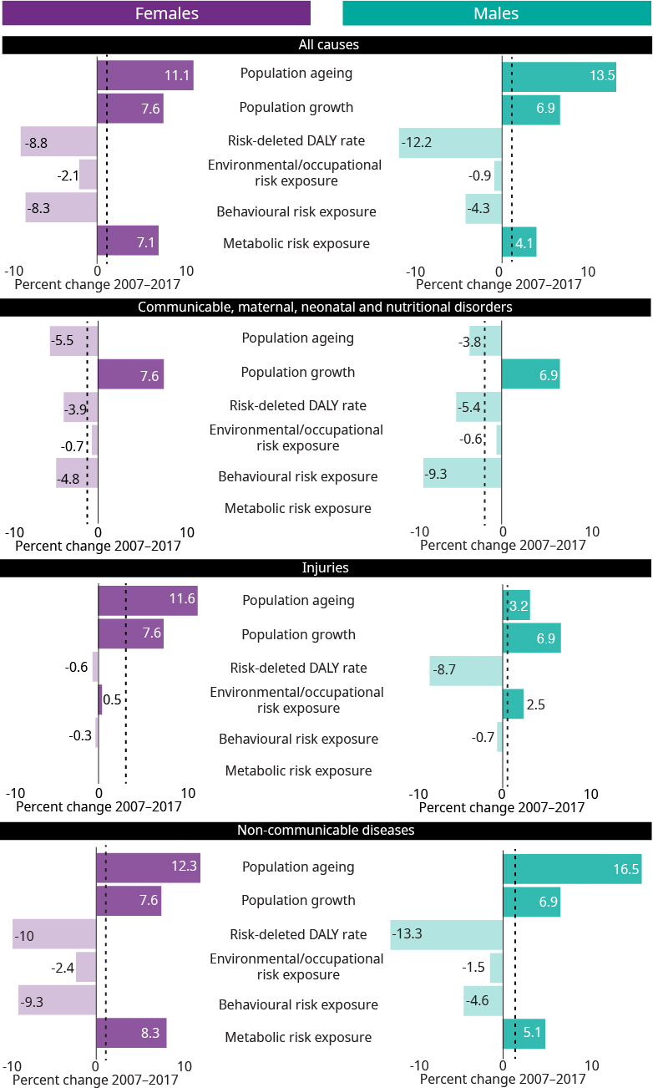
Note: Risk-deleted DALY rate is the rate of disability-adjusted life years that remains after taking account of the influence of all five other factors.

Figure 38 illustrates that over the decade 2007–2017:
- Health loss due to risk factors increased by 6.6 percent for females and 7.1 percent for males (mainly due to population ageing and population growth)
- Health loss due to behavioural risks exposure decreased (by 8.3 percent for females and 4.3 percent for males), while the burden due to metabolic risk exposure increased (by 7.1 percent for females and 4.1 percent for males)
- the ‘risk-deleted DALY rate’ (which we measure assuming all five other key factors have been addressed) decreased. The reason may be a decrease in other risk factors that are not included in the GBD and/or improvements in treatment, early detection and access to high-quality care anywhere along the continuum of care.

This section has highlighted a range of important risk factors impacting the health of New Zealanders. It is possible to modify many risks by addressing the wider determinants of health, by changing people’s day-to-day behaviours that affect their health, by creating an environment that supports healthy choices and by improving occupational and environmental health. We have made important progress over time, particularly on tobacco use. A growing challenge is to address the increase in metabolic risks, including high BMI and its impacts on the health of individuals, families, whānau and society.

The Living Standards Framework
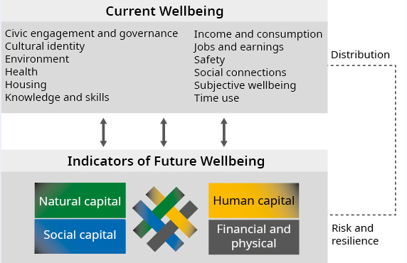
Addressing the wider determinants of health – such as poverty, education, employment and housing – is an integral part of work to increase health equity and improve wellbeing.
It is a key consideration in the Treasury’s Living Standards Framework.
People with more of these challenges in their lives are at greater risk of poor health.
The Ministry of Health is working alongside other agencies to implement a range of initiatives to improve wider outcomes related to the wellbeing of New Zealanders. This includes working with social sector partners on cross-cutting actions such as the Healthy Homes Initiatives, nurses in schools and addressing sexual violence and family violence. Reducing barriers to accessing health services is another important focus. Initiatives to this end include providing free general practitioner (GP) visits for children aged under 14 years and lowering the cost of GP visits for adults with community services cards.
For more information, go to treasury.govt.nz/information-and-services/nz-economy/living-standards/our-living-standards-framework

Addressing risk factors is an important activity for the health system. This work involves all levels of the system, including national-level activity through the New Zealand Health Promotion Agency; action taken by regional public health units; community health initiatives such as the Healthy Families New Zealand programme; and health-promoting initiatives delivered in schools and through marae.

Raising awareness about key risk factors and their impacts
The New Zealand Health Promotion Agency/Te Hiringa Hauora (HPA) is a Crown entity that leads and supports activities to promote health and wellbeing and encourage healthy lifestyles. It does this by conducting or funding research; developing tools, resources and advice for individuals, families, whānau and communities; targeted marketing, education, and communications strategies; and working through and engaging with diverse population groups. It addresses specific risk factors including tobacco smoking, gambling, mental health, skin cancer, low immunisation levels, poor nutrition and physical activity and alcohol-related harm.
HPA’s work on alcohol, for example, focuses on people at risk of, or experiencing, the greatest alcohol-related harm. These people include the following priority population groups:
teenagers under 18 years
young adults aged 18–24 years
young women, particularly Māori young woman, who are drinking moderately to hazardously and are at risk of unplanned pregnancy
adults in mid-life (45–65 years) whose drinking is putting them at risk of experiencing alcohol-related harm
people with a drinking problem who are not seeking help.
To address these priority groups, HPA works with a wide range of individuals, groups and agencies, including local communities, health professionals, non-governmental organisations, government agencies and territorial authorities.
One example of HPA’s work is that it is supporting an increased uptake of alcohol screening and brief interventions (SBI) in primary care and other settings in response to strong evidence that this approach has effective results. HPA has developed demonstration projects and provided funding for SBI projects.
HPA’s alcohol work is funded from the levy on alcohol produced or imported for sale in New Zealand. For more information on this work, see hpa.org.nz/programme/alcohol and alcohol.org.nz

A closer look at cancer
The GBD provides a rich source of information about non-communicable diseases and their impact on poor health, disability and death. This section looks at cancer as an example of how GBD metrics can help to address population health challenges and improve wellbeing.
The GBD framework allows us to look at measures such as DALYs and YLLs through a number of dimensions (such as, numbers, age-standardised rates and percentage of the total health loss among populations, countries and time periods). It also captures the factors that affect health outcomes and helps to shed light on the opportunities to prevent different conditions. These evidence-based insights are relevant to many areas, such as in developing strategy and policy, planning interventions and conducting research and for anyone with an interest in population health.

Trends across all cancers

Cancer is the leading high-level cause of health loss in New Zealand
Cancer touches the lives of thousands of New Zealanders every year. It is a leading contributor to health loss, accounting for 17 percent of all DALYs. In 2017, there were over 25,000 estimated new cases of cancer (excluding non-melanoma skin cancer) causing around 10,000 deaths.

It is important to look closely at the contribution of YLL and YLD (alongside DALYs) , particularly for life-threatening conditions such as cancers. For example, interventions like screening and treating cancer early can avert premature mortality and reduce YLLs. At the same time, YLDs are likely to be impacted because people being treated may be spending more time in poor health.

In 2017, most DALYs from cancer were attributed to early death (YLL), which accounted for 93 percent of DALYs from cancers in New Zealand in 2017. Figure 39 presents an international comparison of the YLL age-standardised rates (adjusted for population ageing and growth). It shows that in 2017, the age-standardised YLL rate for New Zealand (2,729 per 100,000) was comparable with the average across all high SDI countries (2,654 per 100,000).

Figure 39: Cancer age-standardised early death rates (YLLs) per 100,000 population, high SDI countries, 2017
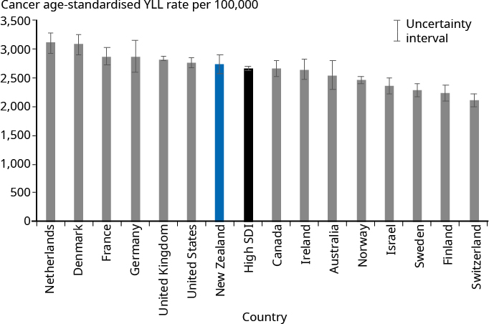

The rates of early death (YLLs) from cancer have decreased over time
Figure 40 shows the impact of cancer on early death between 1990 and 2017. Over this period, the age-standardised YLL rate for cancers fell by 28 percent, close to the rate for high SDI countries. The age-standardised rates of cancer incidence, prevalence and mortality all decreased over this period. Together they show an improvement in cancer outcomes and have contributed to the fall in the YLL rate.

Figure 40: Age-standardised early death rates (YLLs) for cancer per 100,000 population, high SDI countries, 1990–2017
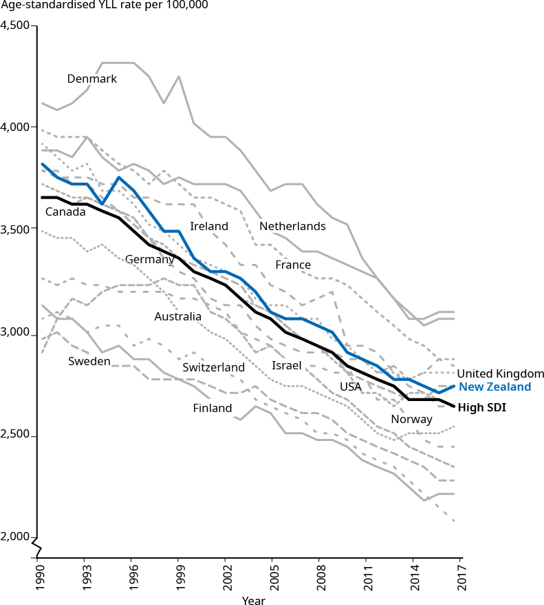

However, age is a key risk factor for cancer. As populations age and grow, the total number of YLLs due to cancer is increasing across high SDI countries, including in New Zealand. Looking at more recent trends, between 2000 and 2017, the total number of YLLs in New Zealand due to cancer increased by 18 percent to 186,435 YLLs. This increase was double the average increase (9 percent) across all high SDI countries over this period. This comparatively higher increase in YLLs presents a key challenge for New Zealand and underscores the importance of current and future work to prevent cancer, increase cancer survival and improve access to high-quality treatment and care (see ‘New Zealand Cancer Action Plan’ below for further information).

Major cancers and their impact
Because cancer is a broad category, it is useful to look at different types of cancers to gain a deeper understanding of their impact on health loss. Figure 41 shows the relative contribution specific cancers made to the total YLLs from all cancers in New Zealand in 2017 as well as the trends in the age-standardised YLL rates over time.

Figure 41: Contribution of different cancers to the total YLLs due to cancer, 2017, and trends in age-standardised YLL rates, 1990–2017
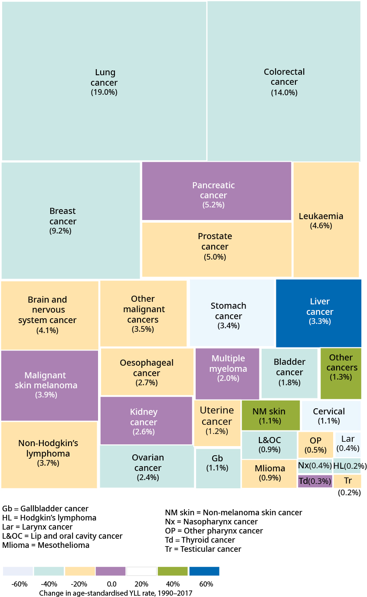

Figure 41 illustrates that lung, colorectal (bowel), breast, prostate and pancreatic cancers were among the leading contributors to early death from cancer. Together they contributed to about half (52.4 percent) of the early death from cancers in New Zealand in 2017. The figure also shows that the age-standardised YLL rate for these cancers (except for pancreatic cancer), as well as for others such as cervical cancer, stomach cancer and ovarian cancer, decreased (improved) between 1990 and 2017. However, over the same period, the age-standardised rate of YLLs increased (worsened) for liver cancer.

Leading cancer conditions for females and males
Table 7 looks at the impact of cancer conditions by sex, based on the total number of YLLs and how the impact has changed over time.

Table 7: Changes in ranking for 15 leading cancer conditions (total YLLs), by sex, all ages, 1990 and 2017
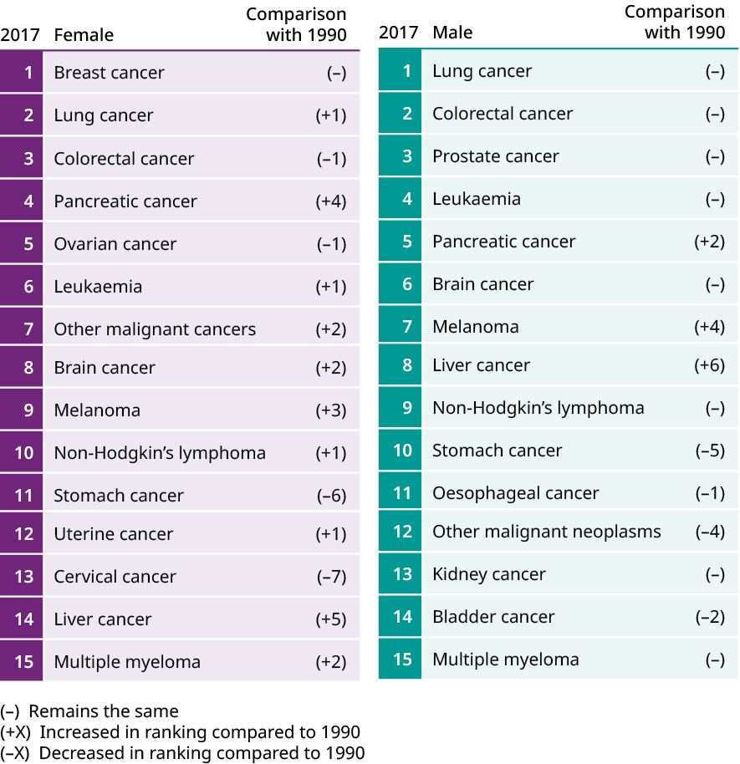

For females, the cancers contributing the most to early death were breast (7.4 percent of total YLLs), lung (7.3 percent), and colorectal (5.2 percent) cancers. For males, the leading cancers were lung (6.1 percent), colorectal (4.6 percent), and prostate (3.0 percent) cancers.

Cancer across the life course
The impact of cancer varies across age groups and by sex. For example, for females aged 40–69 years, cancer contributed to more than half of the total YLLs from all causes in the GBD framework. For females the proportion of YLLs peaked in those aged 50–59 years, when cancer accounted for 58.9 percent of the total YLLs for these age groups (see Figure 42).

Figure 42: Percentage of YLL from cancers, by age group and sex, 2017
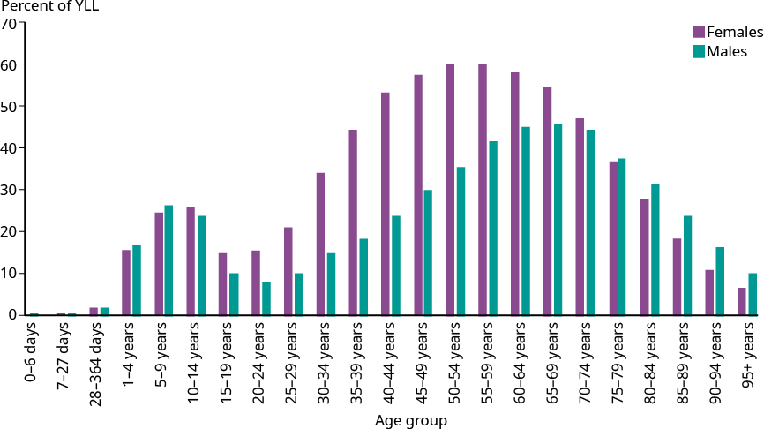

The proportion of the total YLLs was lower for males than females in all age groups from 15–74 years. For males YLL proportion peaked in an older age group (60–69 years), where it accounted for 46.6 percent of the total YLLs for these age groups.

Figure 43 breaks down the early deaths from cancers into specific cancer types for females. It shows that breast cancer contributed significantly to early deaths at younger ages, as the leading cause among the cancers for females aged 30–59 years. Its contribution was highest in the age group of 45–49 years, when it accounted for 18.6 percent of total YLLs.

Figure 43: Proportion of YLLs due to specific cancers by age group, females, 2017
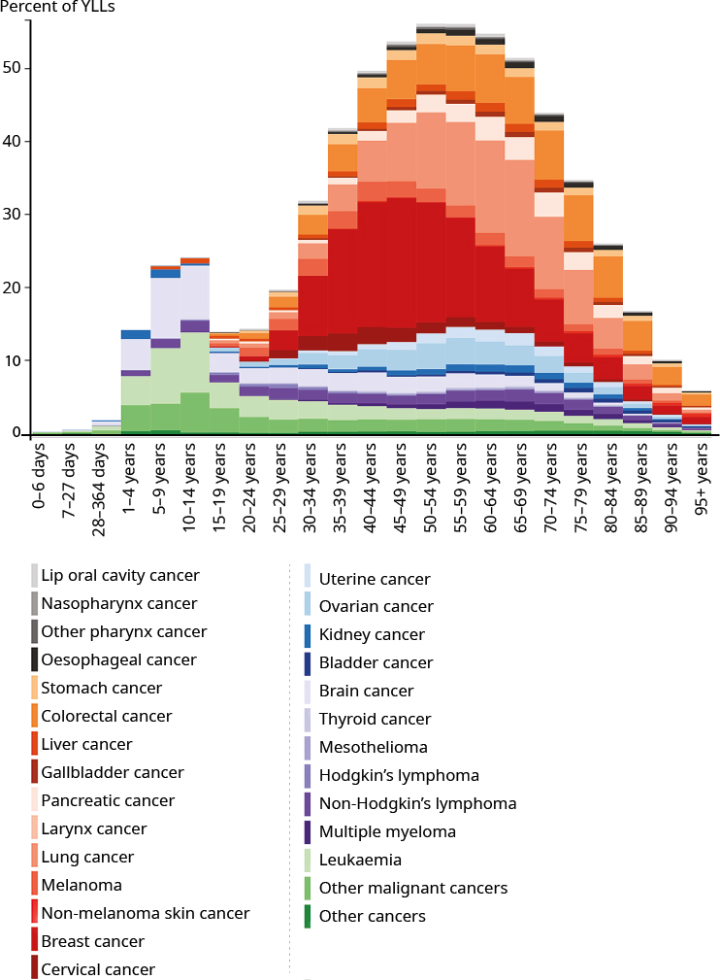

Breast cancer and breast screening
Breast cancer remains the leading cancer among females, contributing to 3.4 percent of their health loss. It was responsible for 19,305 DALYs in 2017, an increase of 11 percent from 1990. Early death (YLLs) accounted for 89.7 percent of the DALYs. The remaining 11.3 percent of DALYs was associated with living with the illness (YLDs).
The age-standardised rate of YLLs fell by 39 percent from 1990 to 2017. The age-standardised incidence rate of breast cancer decreased by 13 percent over the same period. These trends, in combination with population growth, resulted in a 63 percent increase in the number of prevalent cases of breast cancer.
Screening for breast cancer is an important health intervention. BreastScreen Aotearoa is New Zealand’s free national breast screening programme for women aged between 45 and 69 years. The service provides each woman in this age group with a mammogram every two years, which can help save lives by finding breast cancer early before it spreads. Factors that can help to lower risks of breast cancer include maintaining a healthy weight, exercising regularly and limiting alcohol and tobacco intake.
For more information on the programme, see timetoscreen.nz/breast-screening/

YLLs among males came from a range of cancers such as prostate, colorectal (bowel) and lung cancers. (see Figure 44). These cancers tend to increase in prevalence with age.

These differences in the impact of specific cancers, coupled with the tendency for breast cancer to begin earlier in females, can help to explain the age patterns of cancer for females and males outline in Figure 42.

Figure 44: Proportion of YLLs due to specific cancers by age group, males, 2017
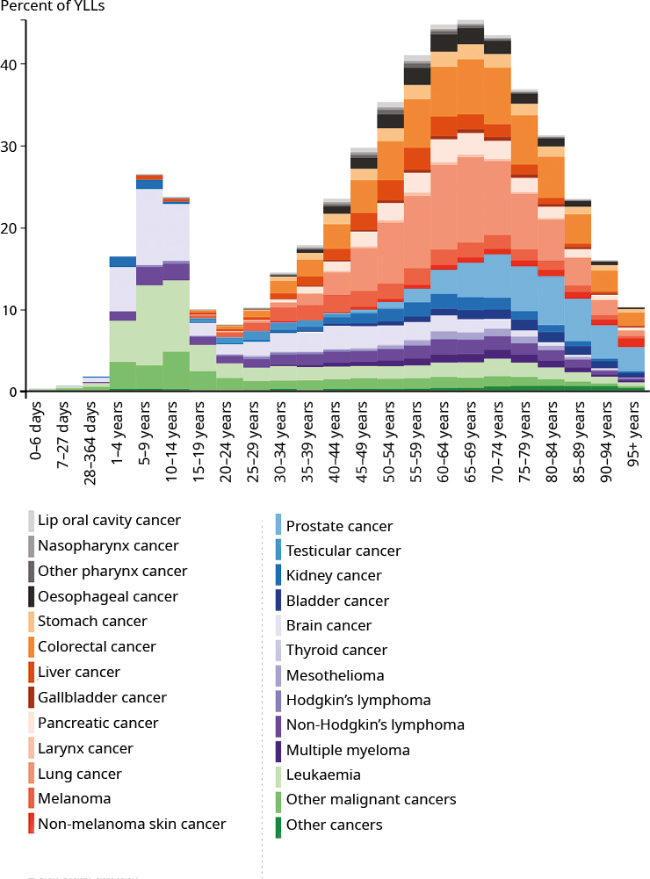

Reducing risk factors that contribute to cancer
A number of cancers that cause significant health loss in New Zealand are associated with behavioural and metabolic risk factors (see Table 8). For example, smoking and harmful alcohol use are strongly contributing to the burden associated with lung cancer, oesophageal cancer and liver cancer (especially for males).

Almost all cervical cancer is caused by human papillomavirus (HPV). The virus is spread by sexual activity. Eighty percent of people who have been sexually active will have an HPV infection at some point in their lives. However, regular cervical screening can detect any changes on the cervix, which can then be treated before they become cancers. The HPV vaccine is an important preventive measure for cervical cancer and several other cancers and is part of New Zealand’s wider immunisation programme.

Uterine cancer is strongly associated with a high BMI, as is breast cancer following menopause.

Table 8: Examples of risk factors contributing to health loss from certain cancers, by sex, 2017
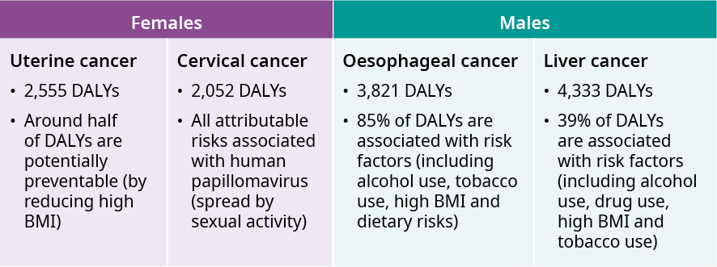

Smoking contributes to a range of poor health outcomes, including cardiovascular diseases and respiratory illnesses. Notably it is the main contributor to lung cancer (New Zealand’s leading cause of DALYs from cancer in 2017). An estimated 75 percent of DALYs from lung cancers could be avoided by addressing modifiable risks, including smoking.

New Zealand’s rates of lung cancer are comparable with those of other high SDI countries and age-standardised rates have decreased compared with 1990. However, there are significant opportunities to improve both prevention and equity (due to higher rates of smoking among Māori and Pacific peoples) by focusing on this key determinant of health. The Government’s Smokefree 2025 goal and associated work are an important focus in this area (see box below).

Smokefree Aotearoa 2025
In March 2011, the Government adopted the Smokefree 2025 goal for New Zealand. This was in response to the recommendations of the Māori Affairs select committee’s landmark parliamentary inquiry.
Progress towards this aspirational goal will be achieved by:
protecting children from exposure to tobacco marketing and promotion
reducing demand for and supply of tobacco
providing the best possible support for quitting.
A range of initiatives is in place to reduce smoking rates, including standardised packaging for tobacco products, excise tax on cigarettes, prohibiting smoking in public places and funding services to help people stop smoking. For more information, see health.govt.nz/our-work/preventative-health-wellness/tobacco- control/smokefree-aotearoa-2025

The example of colorectal cancer
This section uses colorectal cancer as an example of what the GBD framework can tell us about a specific condition.

In terms of DALYs, colorectal cancer was the second leading cause of DALYs from cancers (behind lung cancer) and the 12th leading cause of all DALYs (accounting for 2.8 percent of total health loss in 2017). It is also a major cause of early death in New Zealand. In 2017, the condition was the second leading cause of YLLs from cancers (behind lung cancer) and the fourth leading cause of all YLLs (accounting for 4.9 percent of total YLLs).

Figure 45: Age-standardised DALY, incidence and death rates for colorectal cancer per 100,000 population, New Zealand and high SDI countries, by sex, 2017
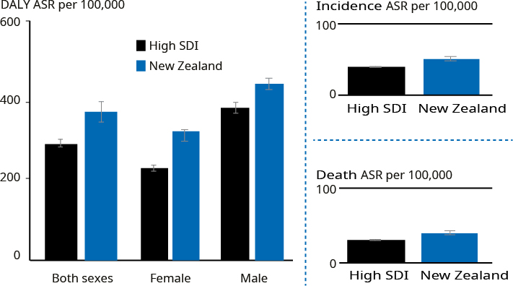

Although current rates of colorectal cancer are comparatively high internationally, New Zealand has made important progress in reducing the age-standardised rates of health loss from colorectal cancer over the past two-and-half decades (Figure 46). | In 2017, New Zealand females and males experienced higher age-standardised DALY, incidence and death rates from colorectal cancer compared with the average rate for high SDI countries.

Figure 46: Colorectal cancer, age-standardised DALY rates, New Zealand and selected high SDI countries, all ages, both sexes, 1990–2017
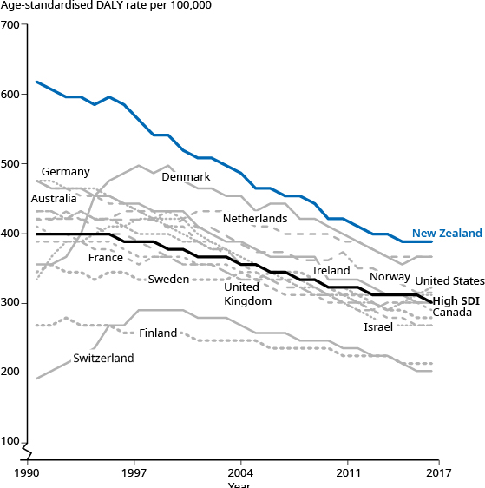 | Between 1990 and 2017 the age-standardised DALY rate of colorectal cancer fell by over a third (37 percent) in New Zealand.  The pace of this improvement was faster than the average rate for high SDI countries (24 percent).

Reducing the health loss rate of colorectal cancer
A key challenge across many countries is to reduce health loss from colorectal cancer. In 2017, New Zealand, Denmark, Norway and the Netherlands were among the high SDI countries with the highest age-standardised DALY rates for colorectal cancers, estimated at approximately 387 per 100,000 population. In contrast, Switzerland had one of the lowest DALY rates at 202 per 100,000 population.

Although New Zealand’s health loss due to cancer is comparatively high, its DALY rate fell by 37 percent between 1990 and 2017, which was a much sharper drop than the average fall of 25 percent across the high SDI countries.

Risk factors associated with colorectal cancer
As noted earlier, addressing risk factors is an important way to prevent cancers, including colorectal cancer. The GBD indicates that around two-thirds (65 percent) of DALYs from colorectal cancers are due to modifiable risk factors. The main risk factors were alcohol use, a diet low in calcium, smoking and high body mass index.

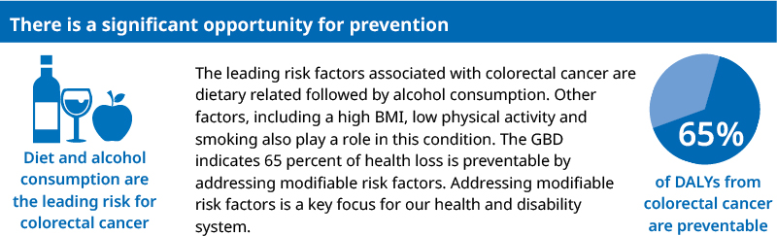

Given the significance of colorectal cancer to population health, preventing colorectal cancer, detecting the illness early and treating it promptly (when it is most responsive to treatment) are important and ongoing areas of work in the health and disability system.

Alongside prevention, screening for cancer is a major way of addressing the cancer challenge across jurisdictions and countries. Many have made strong progress in reducing health loss from bowel cancer through prevention and early detection via screening. In New Zealand, the progressive roll-out of the National Bowel Screening Programme is an important focus for the Ministry of Health and the wider sector (see box below).

National Bowel Screening Programme
Bowel cancer kills around 1,200 New Zealanders a year and is our second most common cause of cancer death, after lung cancer.
The National Bowel Screening Programme aims to reduce deaths from bowel cancer by detecting cancers early, at which stage they can often be successfully treated.
The Programme, which is being rolled out gradually across the country, is free to eligible people aged 60–74 years. It offers screening every two years using a home testing kit that detects blood in a stool sample.
People who are diagnosed with early-stage bowel cancer and receive treatment early have a 90 percent chance of long-term survival.
As well as detecting cancer in people without symptoms, bowel screening can identify polyps (growths) that can become cancerous over time but can be removed if detected at an early stage.
Once fully implemented, by mid-2021, the Programme will screen 700,000 people every two years. It is expected to find 500–700 cancers each year in the first few years of its full screening service.

New Zealand Cancer Action Plan
Bowel screening forms part of a wider work programme focused on improving cancer outcomes in New Zealand. In September 2019, the Government began to consult on the New Zealand Cancer Action Plan 2019–2029, and released the final plan in 2020.

The plan provides a roadmap to ensure we have a sustainable system that leads to fewer cancers, better survival rates and equitable outcomes. The plan is equity-led, knowledge-driven, centred on the person and their family and whānau and outcomes-focused. One feature of the plan is establishing the Cancer Control Agency in the Ministry of Health. The new agency will provide clear leadership on improving cancer outcomes in New Zealand.

The plan aims to prevent cancer by supporting Smokefree 2025, encouraging and supporting healthy living, taking actions to address cancer related to infections such as hepatitis B and C and Helicobacter pylori and reducing avoidable skin cancers and cancer attributable to occupational risk factors.

The plan also seeks to improve outcomes for those who do get cancer by increasing early detection of cancer and improving the consistency and quality of cancer treatment. Actions to achieve such improvement include providing high-quality population screening, developing fast-track diagnosis pathways for priority cancers, implementing quality improvement indicators and initiatives to support access to high-quality cancer treatment, developing options for early access to new medicines and increasing early access to palliative and end-of-life care.

The plan also aims to achieve equity by design. An express requirement is to address all forms of racism and discrimination. One of the plan’s key actions is to develop and implement a mātauranga Māori framework for delivering the cancer plan in partnership with the Crown.

Looking ahead
The Global Burden of Disease study helps to deepen our understanding of the health of New Zealanders and how it has changed over time.
The study draws attention to the challenge, shared across high SDI countries, of non-communicable diseases. It also confirms the importance and value of addressing underlying factors that contribute to chronic illness in the population as well as supporting people to live as well as they can with long-term conditions.

Important work is under way to reduce the incidence and impact of physical and mental illness in the population. The efforts of many people, over many years, have seen the age-standardised rates of health loss decrease across the population. This work continues and a range of examples outlined in the report will make a strong contribution to better outcomes over the medium term. This includes work in key areas such as child and youth wellbeing, mental wellbeing, addressing key risk factors and wider determinants of health and improving access to primary health care, screening and specialist and planned care when needed.

An important aspect of looking ahead is addressing health inequities for Māori and other groups within the population. That is why the Ministry is working closely with IHME to prepare estimates of health loss for Māori and non-Māori. This analysis at a sub-national level will be a world first and will further support the work of the Ministry and sector to improve equity for Māori. The Ministry expects to report on early findings in future GBD cycles.

Positioning the health and disability system to respond strongly to changing health needs is important. The Government has commissioned an independent and wide-ranging review of New Zealand’s health and disability system, designed to future-proof health and disability services. The New Zealand Health and Disability System Review (the Review) will consider the overall function of the health and disability system to ensure the system is better balanced towards wellness, access, equity and sustainability.

In January 2019, the Review launched the first phase of its feedback process, which involved engaging with a wide range of providers, service users and other groups to understand the issues from all perspectives. The resulting Interim Report, released in September 2019, provides a comprehensive overview of the system, highlights important areas of challenge and identifies key directions for change as a basis for further engagement to develop the final report. The Review’s final report and associated recommendations to Government are expected in March 2020. For more information, see systemreview.health.govt.nz/

This work is vital, because the GBD tells us the challenge ahead is a significant one as our population grows and ages. We want to ensure that New Zealanders live longer in good health and have improved quality of life and that we achieve health equity so that all New Zealanders achieve Pae ora – healthy futures.

Appendix:
The Global Burden of Disease methodological framework
Table A1: The first three levels of cause in the Global Burden of Disease hierarchy
Level 1
Communicable, maternal, neonatal, and nutritional diseases
Level 2
HIV/AIDS and sexually transmitted infections
HIV/AIDS
Sexually transmitted infections excluding HIV
Respiratory infections and tuberculosis
Tuberculosis Lower respiratory infections
Upper respiratory infections Otitis media
Enteric infections
Diarrheal diseases Typhoid and paratyphoid
Invasive non-typhoidal salmonella (iNTS) Other intestinal infectious diseases
Neglected tropical diseases and malaria
Malaria Chagas disease
Leishmaniasis African trypanosomiasis
Schistosomiasis Cysticercosis
Cystic echinococcosis Lymphatic filariasis
Onchocerciasis Trachoma
Dengue Yellow fever
Rabies Intestinal nematode infections
Food-borne trematodiases Leprosy
Ebola Zika virus
Guinea worm disease Other neglected tropical diseases
Other infectious diseases
Meningitis Encephalitis
Diphtheria Whooping cough
Tetanus Measles
Varicella and herpes zoster Acute hepatitis
Other unspecified infectious diseases
Maternal and neonatal disorders
Maternal disorders Neonatal disorders
Nutritional deficiencies
Protein-energy malnutrition Iodine deficiency
Vitamin A deficiency Dietary iron deficiency
Other nutritional deficiencies
Level 1
Non-communicable diseases
Level 2
Neoplasms
Lip and oral cavity cancer Nasopharynx cancer
Other pharynx cancer Oesophageal cancer
Stomach cancer Colon and rectum cancer
Liver cancer Gallbladder and biliary tract cancer
Pancreatic cancer Larynx cancer
Tracheal, bronchus and lung cancer Malignant skin melanoma
Non-melanoma skin cancer Breast cancer
Cervical cancer Uterine cancer
Ovarian cancer Prostate cancer
Testicular cancer Kidney cancer
Bladder cancer Brain and nervous system cancer
Thyroid cancer Mesothelioma
Hodgkin’s lymphoma Non-Hodgkin’s lymphoma
Multiple myeloma Leukaemia
Other malignant neoplasms Other neoplasms
Cardiovascular diseases
Rheumatic heart disease Ischaemic heart disease
Stroke Hypertensive heart disease
Non-rheumatic valvular heart disease Cardiomyopathy and myocarditis
Atrial fibrillation and flutter Aortic aneurysm
Peripheral artery disease Endocarditis
Other cardiovascular and circulatory diseases
Chronic respiratory diseases
Chronic obstructive pulmonary disease Pneumoconiosis
Asthma Interstitial lung disease and pulmonary sarcoidosis
Other chronic respiratory diseases
Digestive diseases
Cirrhosis and other chronic liver diseases Upper digestive system diseases
Appendicitis Paralytic ileus and intestinal obstruction
Inguinal, femoral and abdominal hernia Inflammatory bowel disease
Vascular intestinal disorders Gallbladder and biliary diseases
Pancreatitis Other digestive diseases
Neurological disorders
Alzheimer’s disease and other dementias Parkinson’s disease
Epilepsy Multiple sclerosis
Motor neuron disease Headache disorders
Other neurological disorders
Mental disorders
Schizophrenia Depressive disorders
Bipolar disorder Anxiety disorders
Eating disorders Autism spectrum disorders
Attention-deficit/hyperactivity disorder Conduct disorder
Idiopathic developmental intellectual disability Other mental disorders
Substance use disorders
Alcohol use disorders Drug use disorders
Diabetes and kidney diseases
Diabetes mellitus Chronic kidney disease
Acute glomerulonephritis
Skin and subcutaneous diseases
Dermatitis Psoriasis
Bacterial skin diseases Scabies
Fungal skin diseases Viral skin diseases
Acne vulgaris Alopecia areata
Pruritus Urticaria
Decubitus ulcer Other skin and subcutaneous diseases
Sense organ diseases
Blindness and vision impairment Age-related and other hearing loss
Other sense organ diseases
Musculoskeletal disorders
Rheumatoid arthritis Osteoarthritis
Low back pain Neck pain
Gout
Other musculoskeletal disorders
Other non-communicable diseases Congenital birth defects
Urinary diseases and male infertility Gynaecological diseases
Hemoglobinopathies and haemolytic anaemias Endocrine, metabolic, blood and immune disorders
Oral disorders Sudden infant death syndrome
Level 1 Injuries
Level 2
Transport injuries
Road injuries Other transport injuries
Unintentional injuries
Falls Drowning
Fire, heat and hot substances Poisonings
Exposure to mechanical forces Adverse effects of medical treatment
Animal contact Foreign body
Environmental heat and cold exposure Exposure to forces of nature
Other unintentional injuries
Self-harm and interpersonal violence
Self-harm Interpersonal violence
Conflict and terrorism Executions and police conflict

Disability weights in the Global Burden of Disease Study
Non-fatal health outcomes are quantified using disability weights. These weights take values between 0 – full health and 1 – equivalent to death. The weights are derived from survey data where participants are asked to subjectively rank health states.

The methods are described in Salomon et al (2015). The disability weights used in the GBD 2017 cover 234 health states. These health states do not map onto specific causes. For example, the disability weights in Table A2 are for colorectal cancer but the same weights are used for the four stages of all cancers.

Table A2: Disability weights for colorectal cancer
Cause | Health state | Description | DW
Colorectal cancer | Cancer, diagnosis and primary therapy | Has pain, nausea, fatigue, weight loss and high anxiety. | 0.288
 | Controlled phase | Has a chronic disease that requires medication every day and causes some worry but minimal interference with daily activities. | 0.049
 | Metastatic phase | Has severe pain, extreme fatigue, weight loss and high anxiety. | 0.451
 | Terminal phase | Has lost a lot of weight and regularly uses strong medication to avoid constant pain. The person has no appetite, feels nauseated and needs to spend most of the day in bed. | 0.54

The sequela ‘acute ischaemic stroke’ has disability weights related to its five categories of severity (see Table A3).

Table A3: Disability weights for acute ischaemic stroke
Cause | Severity level | Description | DW
Acute ischaemic stroke | 1 | Has some difficulty in moving around and some weakness in one hand, but is able to walk without help. | 0.033
 | 2 | Has some difficulty in moving around and in using the hands for lifting and holding things, dressing and grooming. | 0.07
 | 3 | Has some difficulty in moving around, in using the hands for lifting and holding things, dressing and grooming and in speaking. The person is often forgetful and confused. | 0.316
 | 4 | Is confined to bed or a wheelchair, has difficulty speaking and depends on others for feeding, toileting and dressing. | 0.552
 | 5 | Is confined to bed or a wheelchair, depends on others for feeding, toileting and dressing and has difficulty speaking, thinking clearly and remembering things. | 0.588

A large proportion of health loss is for conditions that have low disability weights but high prevalence. In New Zealand, one such condition is low back pain (see Table A4).

Table A4: Disability weights for low back pain
Condition | Stage | Description | DW
Low back pain | Mild without leg pain | Has mild back pain, which causes some difficulty with dressing, standing and lifting things. | 0.02
 | Moderate without leg pain | Has moderate back pain, which causes difficulty with dressing, sitting, standing, walking and lifting things. | 0.054
 | Severe without leg pain | Has severe back pain, which causes difficulty with dressing, sitting, standing, walking and lifting things. The person sleeps poorly and feels worried. | 0.272
 | Most severe without leg pain | Has constant back pain, which causes difficulty with dressing, sitting, standing, walking and lifting things. The person sleeps poorly, is worried and has lost some enjoyment in life. | 0.372
 | Mild with leg pain | Combined disability weights | 0.02
 | Moderate with leg pain | Combined disability weights | 0.054
 | Severe with leg pain | Has severe back and leg pain, which causes difficulty with dressing, sitting, standing, walking and lifting things. The person sleeps poorly and feels worried. | 0.325
 | Most severe with leg pain | Has constant back and leg pain, which causes difficulty with dressing, sitting, standing, walking and lifting things. The person sleeps poorly, is worried, and has lost some enjoyment in life. | 0.384

The highest disability weights are for severe mental illnesses such as acute schizophrenia (dw = 0.778) and severe major depressive disorder (dw = 0.658).

Because the degree of disability is related to the progression or state of the condition or cause rather than the specific condition, it is necessary to model disease states.

For the full list of disability weights for all conditions covered by the GBD, see ghdx.healthdata.org/record/ihme-data/gbd-2017-disability-weights

Table A5: Risk factors included in the GBD
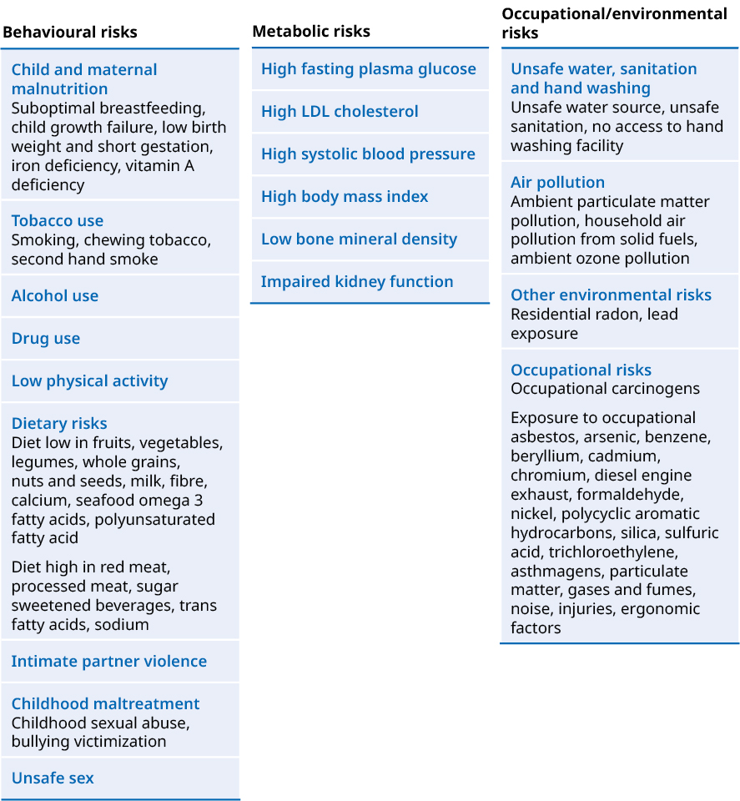

Glossary

Age-standardised rate (ASR)
A statistical technique used to compare measures for the health of populations with different age structures. It is useful because populations with different age structures will differ naturally in their burden of diseases given that certain diseases affect certain ages (for example, dementia affects older people). Age-standardisation allows comparisons between locations/countries by statistically transforming the age structure of a population to match that of a reference group. In this way, it is possible to adjust for the confounding effects of differences between the populations compared and over time. GBD uses a study-specific set of population weights that were originally derived from the World Health Organization standard and then refined over time to create the GBD population.

Amenable mortality
Premature deaths (deaths under age 75) that could potentially be avoided, given effective and timely health care. That is, early deaths from causes (diseases or injuries) for which effective health care interventions exist and are accessible to New Zealanders in need.

Attributable burden
The share of the burden of a disease that can be estimated to occur due to exposure to a particular risk factor.

Disability
Non-fatal morbidity – that is, living in ill health. Within GBD, the term disability refers to all non-fatal health loss caused by disease (such as ischaemic heart disease or depressive disorder) or injury (such as trauma from a traffic accident). It does not have the same meaning as everyday uses of disability to mean physical or mental disadvantages.

Disability-adjusted life years (DALYs)
Years of healthy life lost to premature death and disability. DALYs are the sum of years of life lost (YLLs) and years lived with disability (YLDs).

Disability weights (DW)
Numerical representations of the severity of health loss associated with a health state. Derived from a worldwide, cross-cultural study to compare the relative severity of health problems, disability weights are numbers between 0 and 1 that are multiplied by the time spent living with a health loss to determine the years lived with disability associated with the cause of that loss.

Healthy life expectancy
The number of years that a person at a given age can expect to live in full health, taking into account mortality and disability rates.

Incidence
The number of new cases of a given cause during a given period in a specified population. Incidence rate is the rate per 100,000 population.

Level of conditions (cause hierarchy)
The causes of diseases and injuries in GBD are classified into four levels. At level 1 are three large groups of risk factors: communicable, maternal, neonatal and nutritional diseases (CMNN); non-communicable diseases (NCDs); and injuries. Non-fatal conditions then have 22 level 2 causes and fatal conditions have 21 level 2 causes. The finest level of detail in causes is provided at levels 3 and 4. The cause list includes a total of 359 causes (354 non-fatal causes and 282 causes of death).

Level of risk factors (risk factors hierarchy)
The risk factors in GBD are classified into four levels (0, 1, 2, 3). At level 0, GBD 2017 reports estimates for all risk factors combined. Nested within level 0, level 1 includes three risk categories: environmental and occupational, metabolic and behavioural risk factors. This hierarchical structure continues, with each subsequent level including more detailed risk factors that are nested within the broader category above it. There are 19 risks at level 2, 39 risks at level 3 and 22 risks at level 4, for a total of 84 risks or risk groups, which includes ‘all risks’ (level 0) as a risk group.

Life expectancy
The number of years a person is expected to live at a given age assuming they will experience the age-specific mortality rates observed in a given year throughout their lifetime.

Morbidity
Poor health. In burden of disease analyses, morbidity is used interchangeably with disability.

Prevalence
The number of cases of a condition that are present in a specified population at a given time. Prevalence rate is the rate per 100,000 population.

Risk attributable burden
The share of the burden of a disease that can be estimated to occur due to exposure to a particular risk factor.

Risk factors
Potentially modifiable causes of disease and injury. A risk factor is an attribute, behaviour, exposure or other factor that is causally associated with an increased probability of a disease or injury. If the factor decreases the probability, it is a protective factor.

The GBD risk list continues to evolve to reflect the relevance of policy, public health and medical care to major risk factors based on the most recent knowledge available.

Socio-demographic Index (SDI)
A summary measure that identifies where countries or other geographic areas sit on the spectrum of development. Expressed on a scale of 0 to 1, SDI is a composite average of the rankings of the incomes per capita, average educational attainment and fertility rates under age 25 of all areas in the GBD. GBD estimates fertility for females aged 10–54 years.

Uncertainty intervals (UIs)
A range of values that reflects the certainty of an estimate. Larger uncertainty intervals can result from limited data availability, small studies and conflicting data, while smaller uncertainty intervals can result from extensive data availability, large studies and consistent data across different sources.

Years of life lost (YLLs)
Years of life lost due to premature mortality.

Years lived with disability (YLDs)
Years lived in less than ideal health. This includes health loss that may last for only a few days or for a lifetime.

The Institute for Health Metrics and Evaluation (IHME) is an independent population health research centre at UW Medicine, part of the University of Washington, which provides rigorous and comparable measurement of the world’s most important health problems and evaluates the strategies used to address them.
The GBD estimates can differ from national statistics due to differences in both data sources and methodology.
In the GBD, the term ‘disability’ refers to all non-fatal morbidity from disease and injuries. It is a wider concept than disability as defined in disability surveys or services.
One influence on New Zealand’s rates may be improvements in the quality of data used for the latest GBD cycle.
https://www.goodsamapp.org/
In addition to the 25,000 estimated cancer cases, the GBD estimates 35,000 cases of non-melanoma skin cancers in 2017. The non-melanoma skin cancer estimates are based on statistical modelling due to limited New Zealand–specific data on this cause.
Salomon J, Haagsma J, Davis A, et al. 2015. Disability weights for the Global Burden of Disease 2013 study. The Lancet Global Health 3: e712–e23.

