[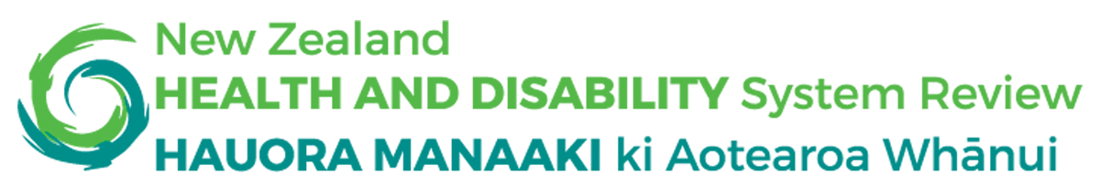](https://systemreview.health.govt.nz/)

# Health and Disability

# System Review

**Pūrongo mō tēnei wā**



# Interim Report

# 2019

# Before you start

This is a long document.

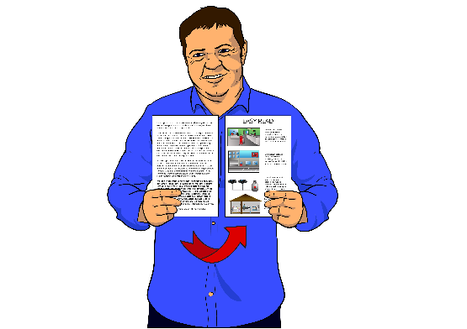

While it is written in Easy Read it can be hard for some people to read a long document.

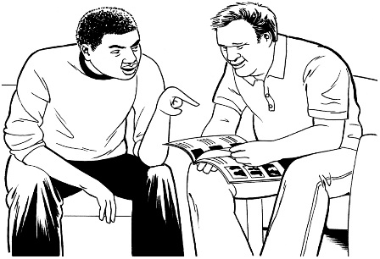Some things you can do to make it easier are:

* read it a few pages at a time
* have someone help you to understand it.

# What you will find in here

**Page number:**

[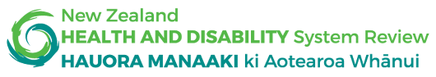](https://systemreview.health.govt.nz/)

What is the Health and Disability System Review?..................................3

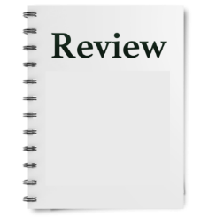

What we found out……………………11

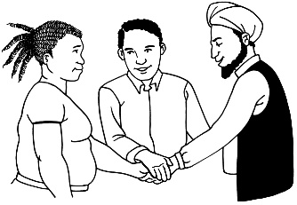

How the system needs to work……...22

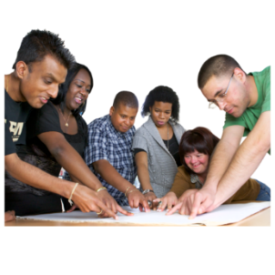

What will happen next?......................34

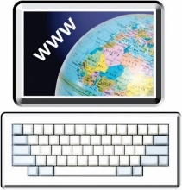

How to get more information……...…36

# What is the Health and Disability System Review?

[](https://systemreview.health.govt.nz/)This report is by the Health and Disability System Review.

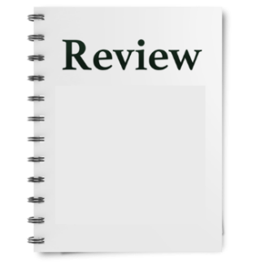

The Health and Disability System Review is sometimes just called **the Review**.

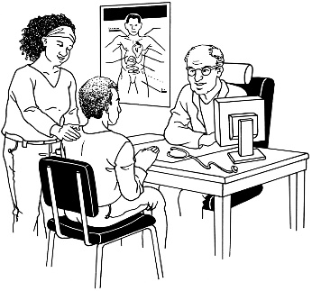The **Health and Disability system** means:

* organisations involved with:  
  + health services
  + 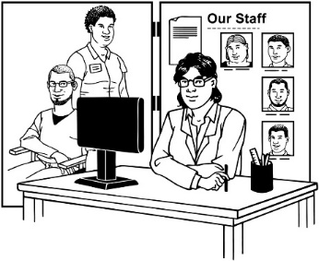disability services
* how those organisations fit together

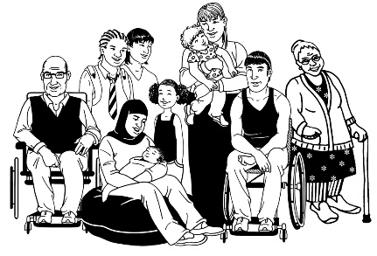The Health and Disability System also means how people decide:

* what services there are
* who can get the services.

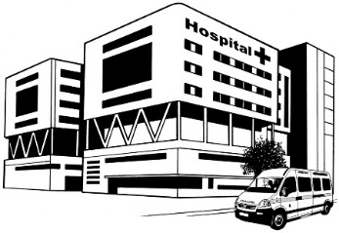The Health and Disability System is sometimes just called **the system**.

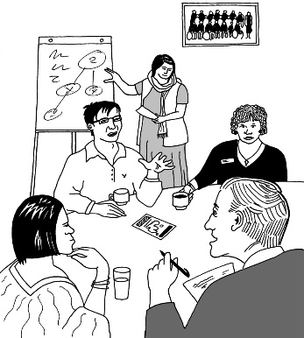The Review looks at what needs to change to make sure what the system does is:

* better
* fairer
* keeps getting better in the future.

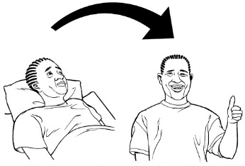

We will be looking at **outcomes**.

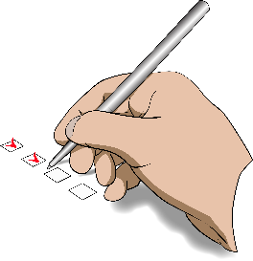**Outcomes** are how things end up because of what the system:

* does
* does not do.



New Zealand mostly has a good health system.

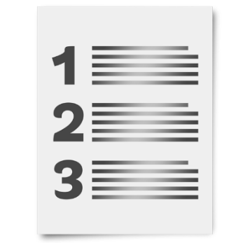

There are things that can be done better.

There are lots of things that make it hard for the system to do a good job.

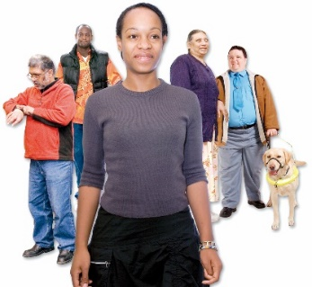

There are more people needing more things from the system.



There are also things that mean we can do things differently like new:

* 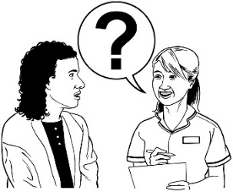technology
* ways of working.

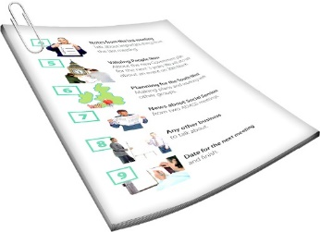**What is an interim report?**

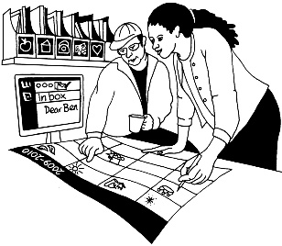An **interim report** is a report that is made before we are finished

An interim report is about how things are going so far.

We want this interim report to do 3 things:

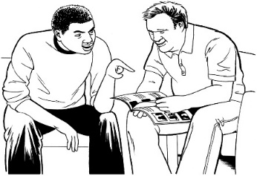

1. 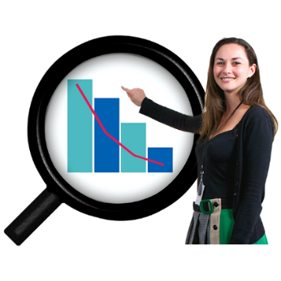talk about the things people have told us so they can read it to know we have been listening
2. check if there is information that shows the same things we have heard

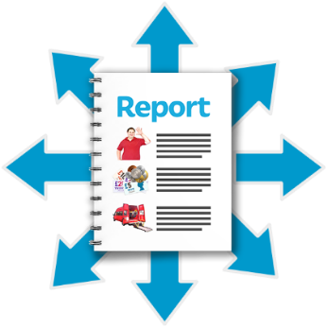

1. show what we think now about what can happen to make the system better.

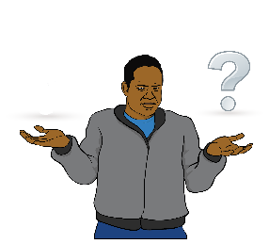The system is confusing for:

* communities
* whānau.

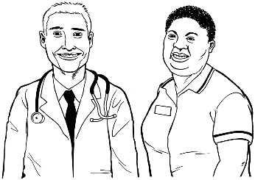

They see the system as telling people what is good for them.

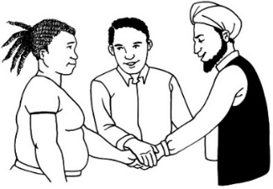

People do not see a system that works:

* together with them to make things better
* in ways built for:

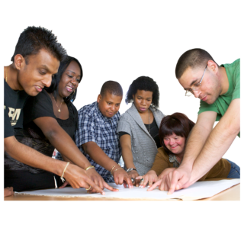

* + them
  + their needs.

There are no **recommendations** in this interim report.

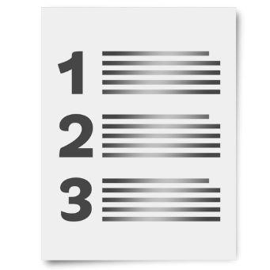

**Recommendations** are things we say should be done.

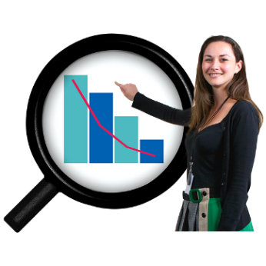Before we make recommendations we want:

* to look more at what the information we have means
* 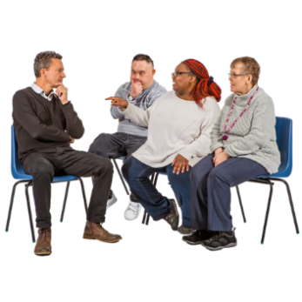a lot more talking about:  
  + what we have found
  + what can happen differently.

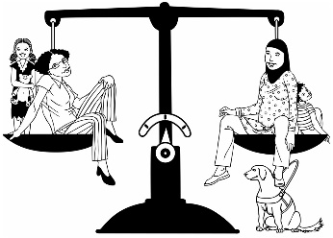From the work we have done so far we do know that lots of change needs to happen for the system to be:

* 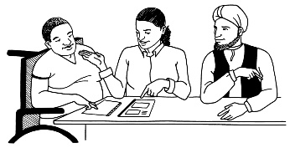fairer
* more sustainable.

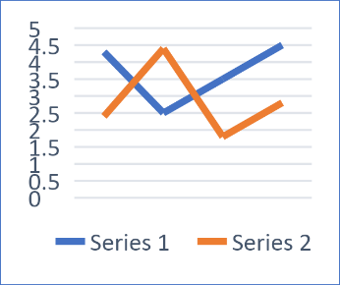When something is **sustainable** that means it will be able to keep going for a long time.

A system is not sustainable if it runs out of the things it needs.

# What we found out

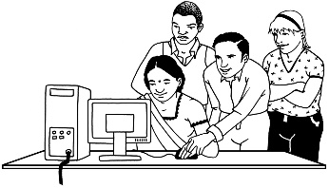This part is about the things we have found out so far.

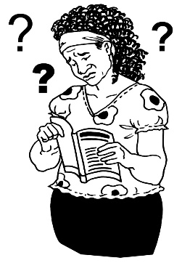For **consumers** the system:

* can be too hard to understand
* has lots of different parts which do not work well together.

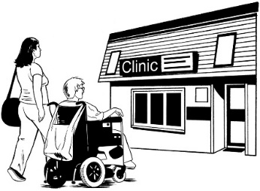**Consumers** are people who use:

* health services
* disability services.

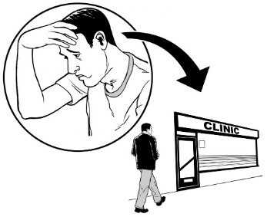This can mean consumers do not:

* trust the system
* feel sure things will go well when they use the system.

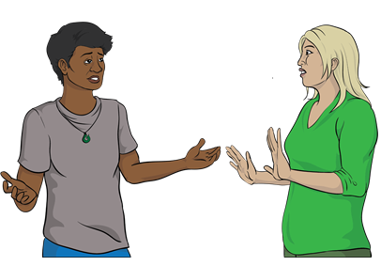

There is not enough **leadership** in the system.

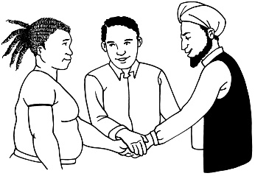When people show **leadership** they:

* decide together what is the right thing to do
* 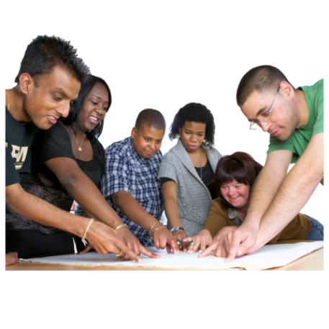make sure things happen
* organise things so that it is easy for everyone to do the right thing
* sort things out when they go wrong.

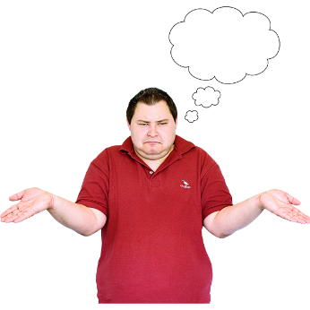When there is not enough leadership it may be:

* unclear as to how things get decided
* hard to know who the people are who will get things done
* hard to get things sorted out when they have not been done right.

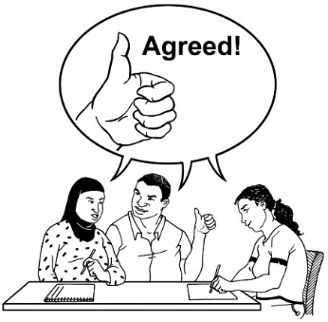

In many parts of the system lots of people agree about plans to make things better.

But doing the things in the plan can be hard.

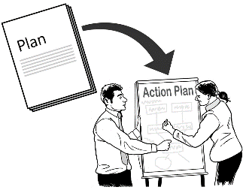

This sometimes means that things are:

* not being done

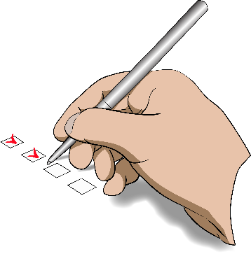

* only being done in some places
* not being done in other places.

Lots of people think that outcomes are not fair.

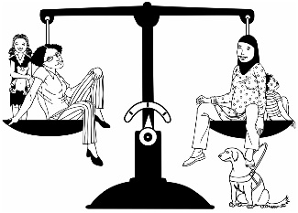

**Outcomes** are how things end up because of what the system:

* does
* does not do.

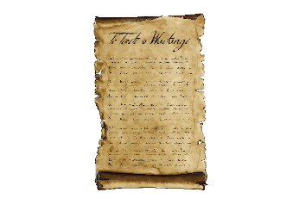The system has not been good for Māori as Tiriti / Treaty partners.

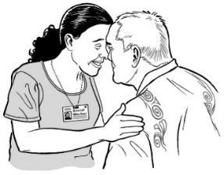The system must make sure that it fully includes:

* 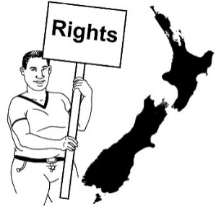mātauranga Māori
* rights under te Tiriti o Waitangi / the Treaty of Waitangi.

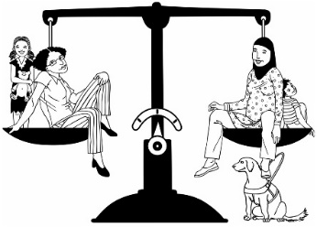The system:

* can make things fairer
* cannot make it so outcomes are the same for everyone.

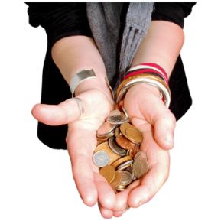This is because most of the differences in outcomes are because of things like:

* 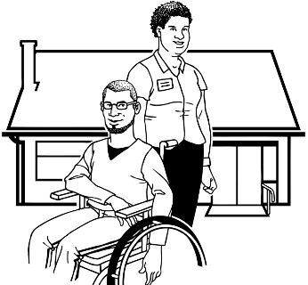how much money people have
* where people live
* what jobs they have.

Consumers want the system to work better for them.

Consumers need the system to respond to what they:

* need
* find important.

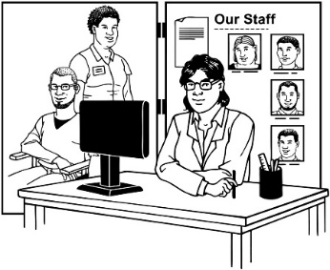The way the system is planned should not be mostly because of what people who provide services want.

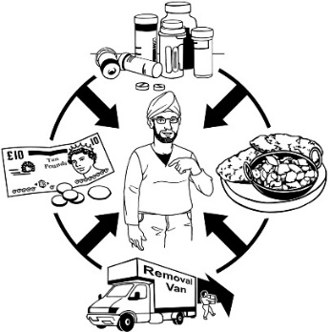Disabled people want:

* more control over their own lives
* the system to be:  
  + 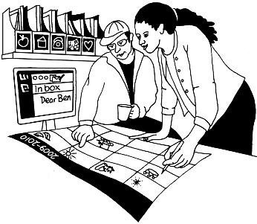able to change more to meet their needs
  + more inclusive.

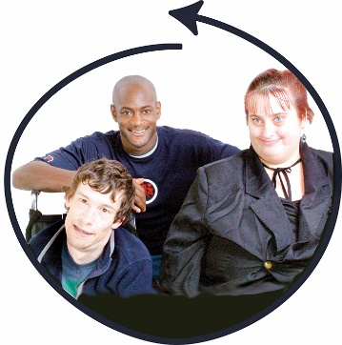An **inclusive** system means:

* everyone feels welcome
* the system works well for everyone.

The way people work in the system is not leading to the best outcomes.

Some of the ways people do not work very well are:

* healthcare services do not work together well
* many people who work in the system do not want change  
  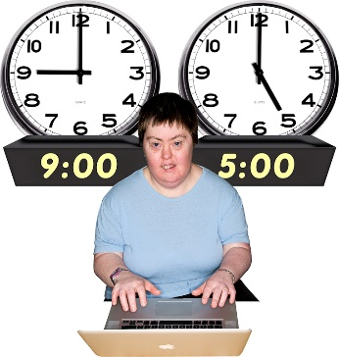
* there is not enough **flexibility** in how people work.

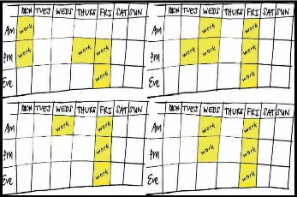**Flexibility** in how people work can mean things like being able to work:

* at different times
* from different places.

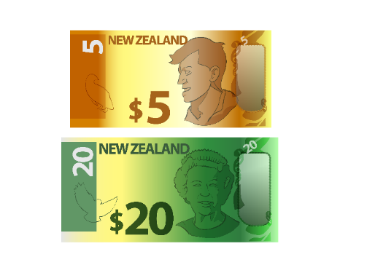Money is one thing that makes it harder for people to get what they need from the system.

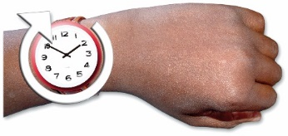But other things also make it harder like not:

* 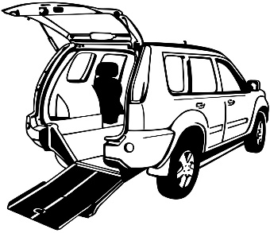having enough time
* having the transport you need
* 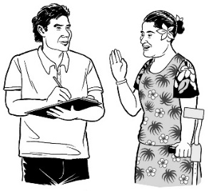not enough **culturally appropriate services**.

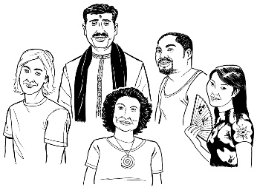**Culturally appropriate services** are ones that work well for people:

* who believe different things
* whose families are from different places.

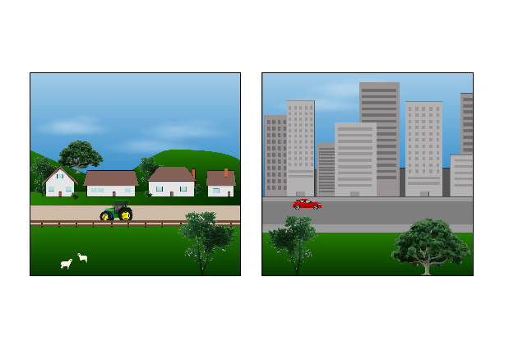Living in **rural** communities can also make it hard to get good healthcare services.

**Rural** means living in the countryside rather than in a city. 

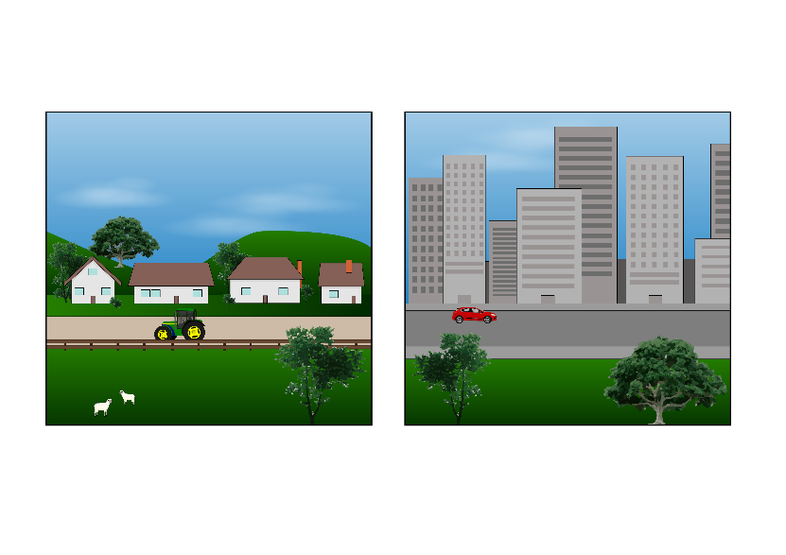

The system needs to make it easier for rural communities to get good health outcomes.

# How the system needs to work

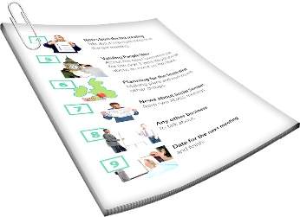

This part of the report is about how the system needs to work.



The different parts of the system need to work together better.

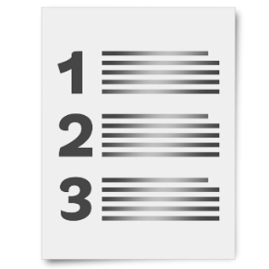There need to be **values** that services agree on.

**Values** are ideas that we:

* think are important
* use when choosing how to do things.

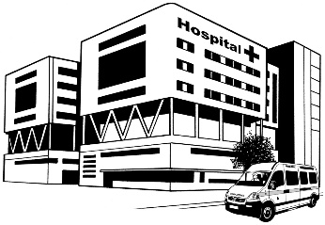These values need to be the same in all parts of the system that the government pays for.

The system needs to work in partnerships both:

* between different parts of the system
* with people who need to use the system.

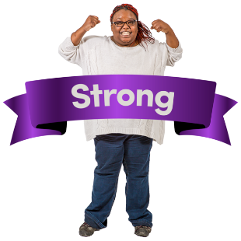

The system needs stronger **leadership**.

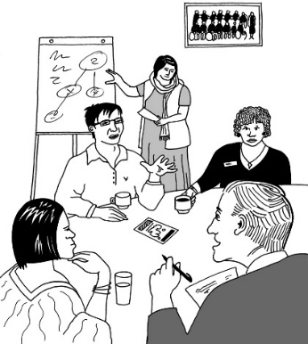It needs to be clear:

* what things need to be done
* 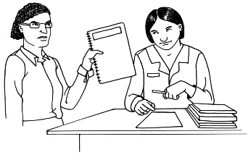who needs to make sure they get done
* what happens if they are not done.

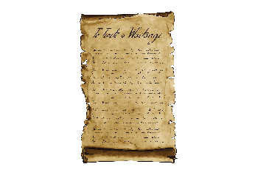Māori need to be able to:

* get their Tiriti / Treaty rights
* 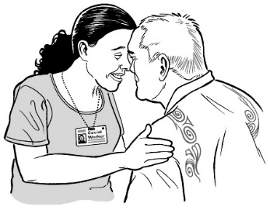have the power in the system to make services that:  
  + best fit their needs
  + 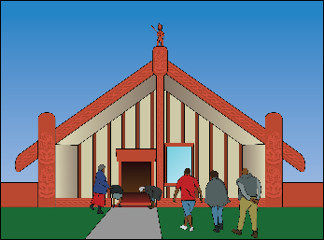let them embrace mātauranga Māori
  + let them fully show their cultural identity.

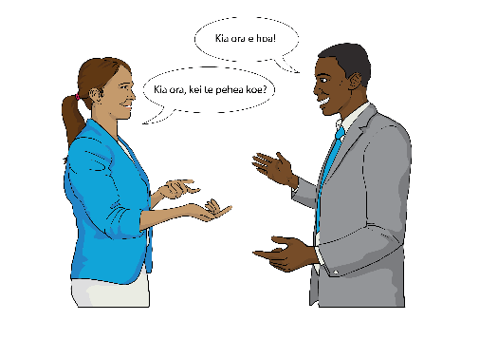

The system needs to support this.

The system needs to focus more on:

* care that stops people getting ill
* **wellness**.

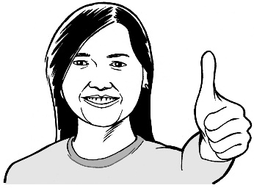**Wellness** is making sure everyone has:

* good health
* a good life.

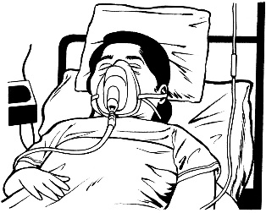

Wellness is not just about helping people who are ill.

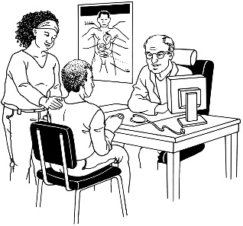To do this there needs to be more:

* 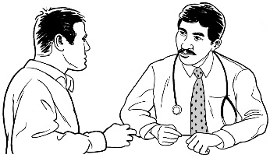services that include different kinds of healthcare
* of a focus on good services rather than seeing lots of people.

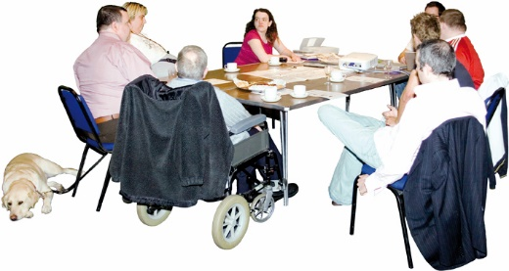Health services need to be planned:

* 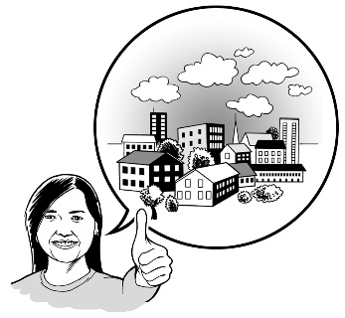in careful ways that think about the future more
* by working together with communities

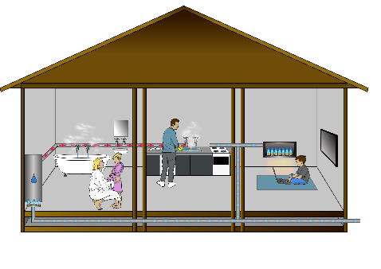Health services also need to have better links to groups who work on other things that affect health like:

* people living in homes that are warm / dry



* being able to get public transport so people can get around.

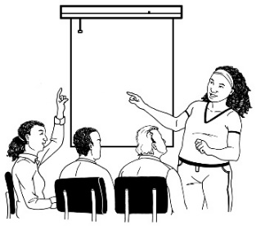

There also needs to be better planning about people who work in healthcare services.

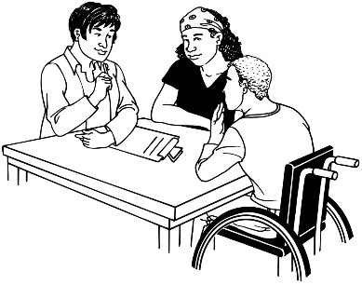

We need to have people who can relate the needs of the people they work with.

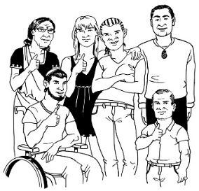

For example:

people from different cultures

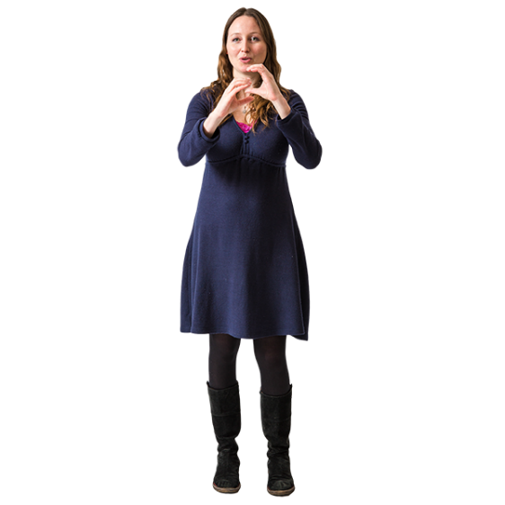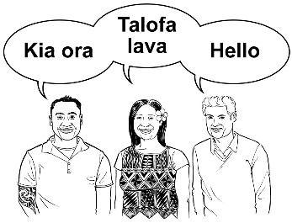

people who can speak / sign different languages.

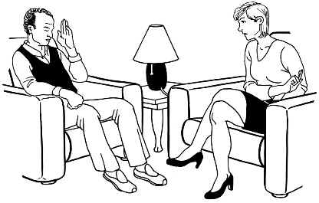

We also need people who have the skills needed for new ways of doing things.

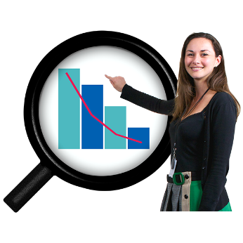

**Data** needs to be much more at the centre of how things are decided in the system.

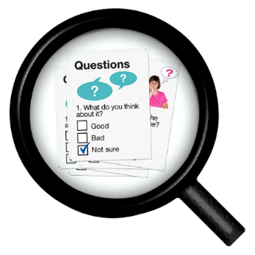**Data** is information that is collected about things like:

* what services are doing
* what kinds of people use services.

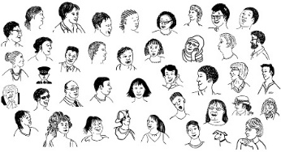Data is often about lots of people so you can see things like:

* how much something is happening
* what things are happening most.

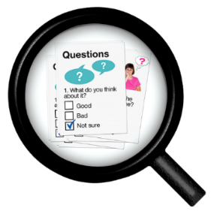

To do this we need to put more work into:

* 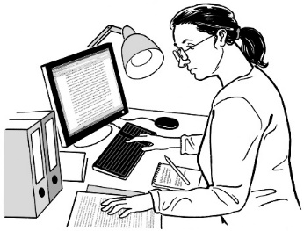what data is collected
* how good that data is.

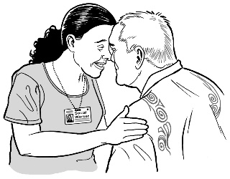It is important outcomes get better quickly for:

* 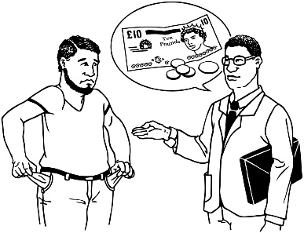Māori
* Pacific peoples
* 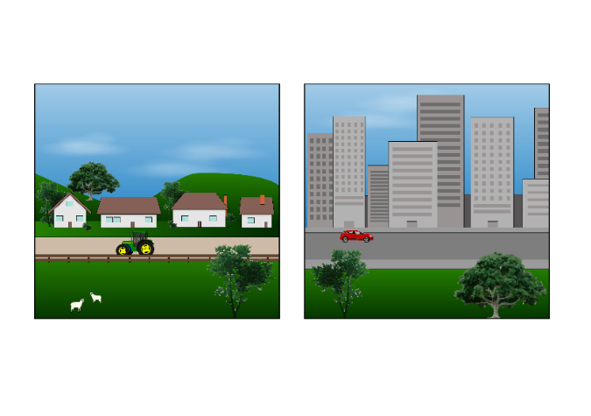people who do not have much money
* people who live in rural areas.

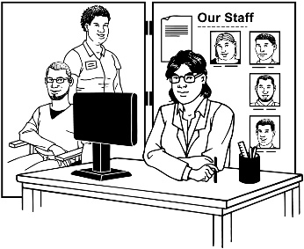This means that we need to put getting services that are a good fit for these communities first.

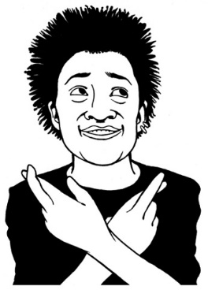We cannot just:

* make changes everywhere
* hope that they will help the people who need it most.

There are:

* 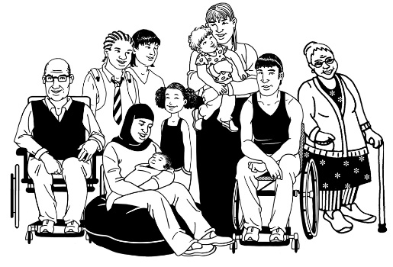more disabled people than there used to be
* going to be more disabled people in the future.

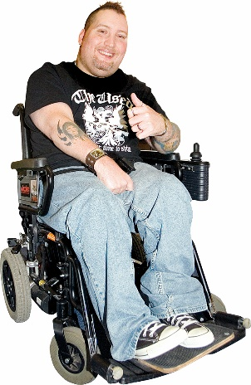That means we should make it easy for disabled people to:

* live well
* be healthy
* get the services they need.

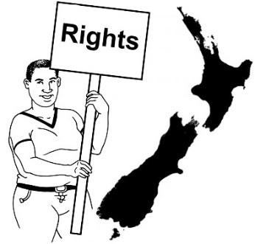

Disabled people have the right to fair outcomes from the systems.

# What will happen next

This part is about what will happen next.

We will ask people to work with us in different groups.

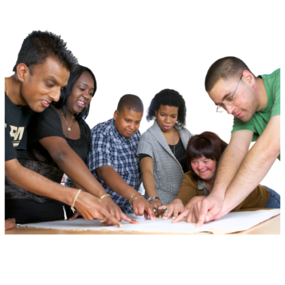

These groups will come up with more detailed plans for what can be done.

We will focus on the changes we think will do most to move the system to being more:

* fair
* responsive
* sustainable.

Many groups have already sent us their ideas for how things could be done.

We plan to use these as a start to work from.

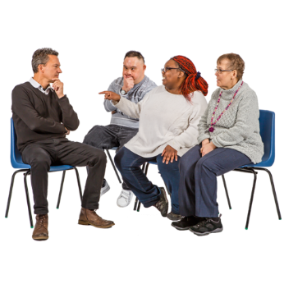

We will give people more chances to say what they think before the next report is finished.

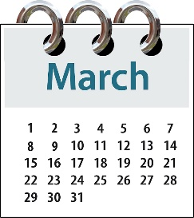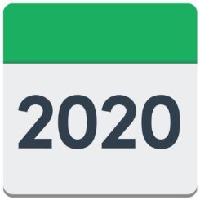

The next report will be finished in March 2020.

# How to get more information

[](https://systemreview.health.govt.nz/)The full **Health and Disability System Review – Interim Report** is on our website at:

https://systemreview.health.govt.nz/  
interim-report/download-the-report/

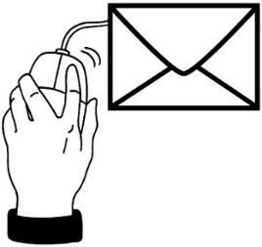You can contact the Health and Disability System Review Team:

**Email**: systemreview@health.govt.nz

**Website**:

https://systemreview.health.govt.nz/

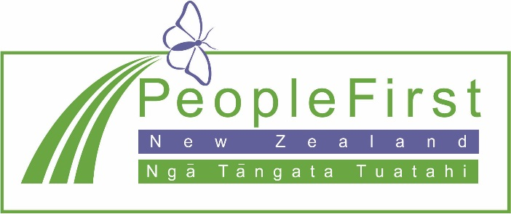

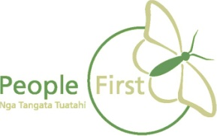**This information has been translated into Easy Read by the Make It Easy service of People First New Zealand Inc. Ngā Tāngata Tuatahi.**

**The ideas in this document are not the ideas of People First New Zealand Ngā Tāngata Tuatahi.**



