He Kaupapa Waka
Māori Expert Advisory Group Report to the Ministry of Health
2022

Citation: Māori Expert Advisory Group. 2022. He Kaupapa Waka. Māori Expert Advisory Group Report to the Ministry of Health. Wellington: Ministry of Health.
Published in November 2022 by the Ministry of Health
PO Box 5013, Wellington 6140, New Zealand
ISBN 978-1-99-110079-5 (online)
HP 8610
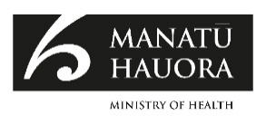
This document is available at health.govt.nz
 | This work is licensed under the Creative Commons Attribution 4.0 International licence. In essence, you are free to: share ie, copy and redistribute the material in any medium or format; adapt ie, remix, transform and build upon the material. You must give appropriate credit, provide a link to the licence and indicate if changes were made.

About He Kaupapa Waka
This report is divided into three sections. He Tirohanga outlines the
journey taken to complete this report. He Tirohanga is about the
importance of careful observation and keeping a watchful eye on our
environments:
- He Tirohanga Hauora – Current state
- He Tirohanga Whakaaro - Analysis
- He Tirohanga Anamata – Future state.

The cover image of a waka at sea emphasises the importance of He
Tirohanga. When waka are at sea, it is important for those on board to have
an expert knowledge of weather patterns, star changes, moon phases,
seasons, migrations of birds, wind patterns, wave patterns, sounds of
waves and many other observations (tirohanga). These signs enable
journeys that cover vast distances. The stylised compass on the cover
shows how our tupuna read the signs and set a true course to their
destination.

During ocean voyages if a storm hits, waka are lashed together. This action
of lashing the waka together for support and stability is called He Kaupapa
Waka. We have named the report He Kaupapa Waka as a reminder that
in the Family Violence Sexual Violence prevention area it’s the collective
actions, the actions of support and the providing of stability that are
critically important for whānau wellbeing.

Acknowledgements

Ko tā mātau he titiro hōhonu, whānui ki tēnei kaupapa ka wherawhera i ana tirohanga tātari.

Ka titiro ā Māori mēna e hāngai ana te kaupapa ki ngā uara, ki ngā mātāpono,e tau ai te wairua Māori.

Ka titiro ano ki tōna mauri, ki tōna hauora anamata.

Ko te whakatutukitanga o ēnei tirohanga ko te tāpiri mai i ngā whakatakotoranga, i ngā whakaaro o ngā iwi o ngā hāpori, o ngā mataora, i hora ki mua i ā mātau, puta noa i te motu.

The Māori Expert Advisory Group (MEAG) would like to thank the many rangatira, kaimahi, health practitioners, and whānau with lived experience from Māori and Pacific peoples’ health providers, community groups, research institutes, national training organisations and DHBs, who we met to develop this report. We are grateful for you generously giving your time, expertise and insights to our mahi. The MEAG also wishes to thank the Ministry of Health staff who have supported our work.

While our discussions with you have informed every aspect of this report, we wanted to state from the outset that we are impressed by the dedication of health and disability workers within our communities. We were struck by the innovation, the social entrepreneurship, and the commitment that we consistently found – whether we were visiting isolated rural communities or in the most densely populated urban areas of the country. The creativity exhibited in these communities and the innovation in health care to meet the needs of whānau demonstrates the growth of an agile, adaptive workforce which needs support to do what they do best for the communities they serve.

Front and back cover image credit: Te Toki Voyaging Trust
Whakatauki - He Koha Kii Hori Tait (1979)
Technical writing: Gabrielle Baker
Photographs of MEAG: Gail Imhoff
Design of report: Te Atawhai o Te Ao

Foreword
Tēnā koe,

It gives me great pleasure as kaumatua and member of the Māori Expert Advisory Group (MEAG) to introduce He Kaupapa Waka, scoping the provision of a primary health care and community provider training programme for routine enquiry for family violence, sexual violence, child abuse and neglect.

This report is the culmination of ideas, discussion, and debate amongst MEAG members and, just as importantly, added to and supported by Māori and Pacific peoples’ providers and disability groups.

MEAG was set up with a specific task: to scope the response to the serious issues of family violence, sexual violence, child abuse and neglect (FVSV) in the primary health care setting. However, we were compelled to explore the wider parameters of violence in communities, in particular our Māori and Pacific peoples’ whānau. As a result, this report has an overarching message of investment in people and their communities to build healthy environments that facilitates, supports, and meets their identified needs.

A key theme reported on was the lack of a quality FVSV training programme accessible in the primary health sector. Māori and Pacific peoples’ providers have all raised this issue as impacting on their ability to provide quality support to whānau and their communities. In addition, rural providers have an added problem in supporting whānau in isolated localities that lack access to wider support systems and resources to fully address all the risks associated with providing this service.

In response, this report and its recommendations lay out a process to build provider capability and sustainability to meet the ever-increasing burden of harm and trauma in our Māori and Pacific peoples’ communities.

We are aware of the resilience of Māori and Pacific peoples’ providers. Their ability to build on community cultural strengths, to pivot when faced with community crisis all provides exemplars of excellence. These qualities are recognised in this report and flow into our recommendations.

During our consultation with providers, MEAG developed a strong relationship with our Pacific peoples’ whānau, helped along by the three Pacific peoples’ members on MEAG. This unique relationship has added depth and breadth to the report and outcomes to be achieved. A high point to this relationship was MEAG meeting with Pacific peoples’ caucus and Māori caucus in Government.

We have listened to our Māori and Pacific peoples’ frontline workers. We felt their pain and frustration but on the other hand experienced the passion and commitment to their work and the whānau they support.

Given these points, they are as excited as I am about this report. We see it as the light at the end of a tunnel. The expectation is that this report and its recommendations will be acted upon with urgency, realising the hopes and aspiration of the voices that reside in this report.

Ngā mihi

Matt Matamua
Kaumātua

November 2021
Contents
About He Kaupapa Waka i
Acknowledgements ii
Foreword iii
Executive summary 1
He Tirohanga Hauora – Current State 1
He Tirohanga Whakaaro – Analysis 2
He Tirohanga Anamata - Future Focus 2
Me aro koe ki te hā o te tāngata 3
VIP training implemented within District Health Boards 4
Primary health care and community service provider-based training prototypes 5
Where to from here? 7
Introduction 8
The health and disability sector has roles and obligations when it comes to addressing FVSV 8
The VIP programme is currently run in all 20 DHBs 9
Budget 2019 provided funding for a response to FVSV in primary health care 9
MEAG was established to advise on the primary health care and community programme 10
The MEAG has been guided by a commitment to Te Tiriti o Waitangi 10
Our Approach 12
He Tirohanga Hauora – Current State 13
Information gathering 13
Intersectionality 18
He Tirohanga Whakaaro - Analysis 22
Listening to Māori and Pacific peoples’ providers 22
Observations from VIP training attendance 33
He Tirohanga Anamata – Future Focus 41
Ensuring an integrated approach to FVSV within the health and disability system 42
Conclusion 42
Support available 43
Glossary – technical terms 44
Kupu Māori 46
References 49
Appendix 1: MEAG Terms of Reference 53
Appendix 2: Listening to Māori and Pacific peoples’ providers 57
Appendix 3: Profiles of MEAG members 60

List of Figures
Figure 1: Synergies of Oppression 18
Figure 2: Regional visits 23

List of Diagrams
Diagram 1: Women’s voices: journey from trauma to recovery 26

Executive summary
As a Māori Expert Advisory Group (MEAG), the advice in this report for the Ministry of Health (the Ministry) has been undertaken with a clear view of accountabilities and Te Tiriti o Waitangi obligations.

The MEAG was asked to provide leadership and advice on scoping a training programme for the routine enquiry of family violence, sexual violence, child abuse and neglect (FVSV), for primary health care and community providers, to benefit our whānau. Part of the brief was to examine what elements from the Violence Intervention Programme (VIP), a training programme implemented across all district health boards (DHBs), could be used in the Primary Health Care Sector. This report outlines the work undertaken over eighteen months and includes a final set of recommendations for the Ministry to consider.

In writing this report MEAG have been conscious of the multiple audiences, from ministerial and Ministry of Health observers through to whānau and health providers, as contributors.

This audience-based focus is part of the promise of reciprocity to our Māori and Pacific peoples’ providers and other organisations who provided their insights, knowledge and experience – this report is to honour their voices.

From those commitments and the desire for an open readership, the content is created to be accessible to all readers. Context explanations in several sections may seem repetitive to some experienced ministry level analytical audiences, but this stance is deliberately taken by MEAG to provide for the whole audience.

The MEAG developed a three-part approach and framework for our work, that is based on the idea of understanding and interpreting the signs from our environment and responding appropriately. The report is laid out using these headings – but emphasises that processes are rarely linear and cycle from, responding to our environment, regularly switching from information gathering to analysis to imagining the future back to information gathering again. The intersectionality and the contextual impact of violence inform each hui we held, and the knowledge that was shared.

He Tirohanga Hauora – Current State
In taking on this task, we have also drawn on the recent work of the Waitangi Tribunal in its 2019 report Hauora. Our work is also based on an understanding of the intersecting impacts of colonisation, racism, sexism, ableism, and gendered
violence. The Ministry currently does not have a formal position statement on FVSV. Te Hirohanga Hauora involved attending the VIP training across several DHBs.

We were compelled to take a broad look at the health and disability system’s responses to violence and, in short, there appears to be a serious need for a more coordinated, whānau-centred approach.

He Tirohanga Whakaaro – Analysis
We used this stage to hear directly from Māori and Pacific peoples’ providers and representatives from the disability sector from January 2021 to August 2021, through kanohi ki te kanohi (face-to-face) hui in both rural and urban areas. We also took the opportunity to attend the VIP training during this stage.

He Tirohanga Whakaaro involved deep thinking about what we had heard so far – to shine a light on the rationale and thinking behind the VIP training and give space to ideas behind what works and what needs to change to strengthen the health and disability sector’s response to FVSV.

As part of this stage, we developed a set of key findings and observations on the current state.

He Tirohanga Anamata - Future Focus
He Tirohanga Anamata focused on the potential of the VIP training, involving an
in-depth look at its mauri, or lifeforce. Our aim in this and all stages of our approach has been to inspire widespread commitment to eliminating the harms of FVSV and identify the contributions the health and disability system can make.

MEAG endorse the potential power of FVSV training in primary health care and
community settings, and while we strongly advocate for a move from
screening to report which it currently is, towards ‘screening to support’, we
recognise that training alone will not deliver the kind of changes we know are
needed. This set of recommendations is made considering the need for a wider
health and disability system approach to FVSV.

Me aro koe ki te hā o te tāngata
These recommendations are directly related to the role of the Ministry as the current steward of the health and disability system. MEAG note the obligations of the Ministry as a Crown organisation to honour Te Tiriti o Waitangi.

Recommendation 1
The Ministry development of a position statement/paper and guidance across family violence, sexual violence, child abuse and neglect, so whānau and families benefit from a truly responsive and holistic health and disability system.

This position paper needs to be premised on the following:
    - Whānau, hapū and Iwi representatives are partners in the development of the position paper
    - Family violence, sexual violence, child abuse and neglect are wider societal issues
    - A lifespan approach is required to adequately respond to abuse
    - Responses to FVSV need to be holistic and protect the dignity of whānau
    - FVSV responses require appropriate models of care informed by Te Ao Māori and Pacific peoples’ perspectives
    - The unique position of the health sector to respond and support whānau across the FVSV prevention continuum.

Recommendation 2
The Ministry works with the Health Quality and Safety Commission on enabling the voice of consumers in the design, development and delivery of models of care.

We are aware of the funding and other strains on Kaupapa Māori and Pacific peoples’ providers. These issues have been evident for decades but have been exacerbated by prolonged periods spent responding to the immediate challenges of COVID-19. MEAG makes two recommendations aimed at supporting Māori and Pacific peoples’ providers to fully engage in the development of a holistic FVSV training
programme.

A concerted push for workforce development across the health and disability system is required, to work in line with historical trauma informed models of care, which include Te Ao Māori and Pacific peoples’ perspectives to ensure services are more accessible, holistic, culturally safe and effective.

Recommendation 3
The Ministry takes immediate steps to address the underfunding of Māori and Pacific peoples’ primary health organisations and providers and community NGOs.

Recommendation 4
Funding be accessed through the Māori Provider Development Scheme or Te Ao Auahatanga Hauora Māori fund, to enable the immediate development of FVSV training by Māori providers, towards best practice screening interventions to support whānau.

Many of the themes identified through our hui with Māori providers were similar to the messages we heard through our Pacific peoples’ fono, which we believe requires action from the Ministry as we move towards and in the new health and disability system structure.

Recommendation 5
Funding be accessed through the Pacific peoples’ Provider Development Scheme to adequately fund for Pacific peoples’ providers and other community groups working to address the trauma of FVSV. This funding needs to be targeted to the development of FVSV training towards best practice interventions to support whānau.

VIP training implemented within District Health Boards
The existing DHB-run VIP training requires urgent revision and review before it
could be considered for use in the primary health sector.

MEAG heard from our many hui, that the impact for whānau Māori, Pacific peoples and those at the margins of the margins from the burden of trauma of FVSV, is compounded by the erosion of trust and confidence from rituals of engagement with the health system. This highlights the need to have a Te Tiriti o Waitangi compliant response. This overall approach must be holistic, needs to understand intersectionality and the intergenerational nature of FVSV, focused on prevention and support.
In its present state, transferability of the VIP training content to the primary health sector would not be advised.

Recommendation 6
The structure, content and delivery of the VIP training be changed to ensure Te Tiriti o Waitangi partnership arrangements are reflected from governance through to management and implementation.

Recommendation 7
Going forward, in the new health and disability system structure, the VIP training delivered inside hospitals needs to be in direct partnership with local
Māori communities.

Recommendation 8
The content of the VIP training inside hospitals needs to be updated, to
include:
- the development of historical trauma informed models of care that include Te Ao Māori and Pacific peoples’ perspectives
- moving away from ‘screening to report’ incidences to best practice interventions to support whānau once FVSV has been identified through screening, enabling pathways to recovery for whānau and families.

Primary health care and community service provider-based training prototypes
Primary health care and community health care settings should be seen as part of a comprehensive approach by the health and disability system to address family violence, sexual violence, child abuse and neglect.

Primary health care violence intervention training must be bespoke and led by the providers and groups with proven track records of knowing to their communities, and a history of providing effective support services. These must be culturally safe and built on evidence of what works for Māori, Pacific peoples, people with lived experience of disability and other population groups living at the margins of the margins. We recommend that a series of prototypes be developed.

Recommendation 9a
Fund Primary health care and community service provider-based training prototypes for family violence, sexual violence, child abuse and neglect (FVSV), ‘screening to support’ training programmes that are designed, developed, and implemented by:
    - Māori health providers, through Kaupapa Māori training for best practice interventions to support whānau once FVSV has been identified through ‘routine inquiry’ or screening, that works for their communities.
    - Pacific peoples’ providers to ensure the protection and validation of Pacific peoples’ knowledge.
    - Providers who work with people with lived experience of disability
    - Community groups (e.g., those working with new migrant and refugee populations, LGBTQI+ groups, and those working directly with people living at the margins of the margins).

Recommendation 9b
This work should be completed within the next two years.

The prototyping will require effective oversight. Oversight is not the same as contract monitoring – it involves working with the providers to help provide guidance when needed and high-quality support across the different prototypes, in appreciation of culturally relevant approaches. This model is built on high trust and confidence already established with the providers.

Recommendation 10a
MEAG to provide oversight of the Kaupapa Māori FVSV training programme
development.

Recommendation 10b
Ensure appropriate oversight of Pacific peoples and other community-based programmes to ensure the protection and validation of Pacific peoples and other relevant knowledge. In the interim this support could be provided by the MEAG but more culturally concordant solutions will need to be provided for the longer term.

Where to from here?
Taking the time to carefully consider how best to roll out FVSV training and responses in primary and community health care settings was the right thing to do. We hope now that the Ministry of Health can move forward with our recommendations over the next two to three years, starting with making a case for budget 2022 funding for provider and community led FVSV training prototypes to move towards sustainability. This should be supported by developing a position paper to provide better guidance in relation to FVSV across health services, so that we can have a health and disability system we are proud of.

Introduction
Our whānau and communities deserve to be safe and free of violence. However, the society in which we live has created conditions for family violence, sexual violence and child abuse and neglect (sometimes referred to as FVSV) and we know that wāhine Māori, Pacific peoples’ women, children, people with lived experience of disability and those in deprived communities are disproportionately impacted.

Our mahi as a Māori Expert Advisory Group (MEAG) has been to give advice on how a training programme for routine enquiry (sometimes known as screening) for FVSV might work in primary health care and community providers to benefit our whānau.

The health and disability sector has roles and obligations when it comes to addressing FVSV
Family violence, sexual violence, child abuse and neglect are complex public health issues. Family violence has economic, social and health consequences for individuals, families, whānau, communities and society. Like most public health issues, we need a comprehensive approach that is wider than any one part of the social sector.

Under legislation, the Ministry of Health (the Ministry) has some specific obligations to collaborate with other agencies “whenever appropriate, to identify, stop, prevent, and otherwise respond to family violence” and to work in partnership with other agencies as part of the Family Violence Sexual Violence Joint Venture Agency, established in 2018. The Ministry also has a role in providing oversight of a health and disability system that meets the diverse needs of whānau and communities. Similarly, district health boards (DHBs), primary health organisations (PHOs), health and disability sector non-government organisations (NGOs) and health practitioners all have obligations to collaborate to identify, prevent and respond to family violence.

The VIP programme is currently run in all 20 DHBs
Across Aotearoa, the Ministry contracts with all 20 DHBs to implement the Violence Intervention Programme (known as the VIP). The VIP is run in six designated services in each DHB:
- Emergency department
- Mental health
- Addiction services
- Paediatrics
- Women’s health including maternity
- Sexual health.

The aim of the VIP is to reduce and prevent the health impacts of violence and abuse through early identification, assessment, and referral of women who would benefit from specialist supports or health services and is mostly offered in a hospital setting.

The programme is largely run by VIP coordinators who are DHB-based and offer a VIP training programme based on the Ministry’s 2016 guidelines Family Violence Assessment and Intervention Guidelines: Child abuse and intimate partner violence. Where possible, VIP coordinators work with local primary health care providers and can offer space on DHB training to primary health care staff where it is available – but this is not guaranteed.

Budget 2019 provided funding for a response to FVSV in primary health care
Budget 2019 provided the Ministry with $600,000 over two years to scope the provision of a training programme for primary health care and community services providers (which includes a range of health professionals such as nurses, general practitioners, and oral health therapists). As with the VIP programme the aim is to support safe, consistent, and effective responses to family violence and sexual violence throughout the country.

The Budget 2019 investment was in recognition of the role primary health care and community services play in whānau and community health and wellbeing and the regular and ongoing contact that the health professionals working in these services have with families living with FVSV.

MEAG was established to advise on the primary health care and community programme
The MEAG was established by the Ministry of Health in mid-2020. Under our terms of reference our role is to provide advice on the scoping of the response to FVSV in primary health care including:
- addressing issues affecting whānau Māori
- providing guidance and support on engaging with the primary health care sector
- setting parameters for engagement with Māori in line with Te Arawhiti’s Engaging with Māori Guidelines
- contributing to the co-design of a training programme in FVSV across primary health care that is truly responsive to Māori.

The MEAG also had a mandate to raise and discuss issues that could impact on the Ministry’s FVSV work in primary health care – such as workforce issues, Māori health inequities, geographical challenges, the capacity and capability of Māori health providers, new technologies and new FVSV models.

Our main deliverable for the year is this report, which is intended to support the Ministry and Government to make decisions on the response to violence in primary health care going forward. Our terms of reference are provided at appendix one, and a profile of each of our members is provided at appendix two.

The MEAG has been guided by a commitment to Te Tiriti o Waitangi
In carrying out our work, the MEAG has been conscious of the guidelines agreed by Cabinet for policymakers to consider the Treaty of Waitangi in policy development and implementation. This has led us to ask questions throughout our consideration of routine enquiry into FVSV in primary care to better understand the role Māori can have in design and implementation and ensuring we look at the issues surrounding routine enquiry from the perspective of tikanga values.

Throughout our work we have been guided by the Waitangi Tribunal’s 2019 Hauora report and its articulation of five principles of Te Tiriti o Waitangi that apply in primary health care. These are set out in table one, below, and have also been adopted by the Ministry of Health in its Māori health action plan, Whakamaua 2020-2025.

The guarantee of Tino Rangatiratanga | Māori self-determination in the design, delivery and monitoring of services
The principle of equity | Requires the Crown to unequivocally commit to achieving equitable health outcomes for Māori
The principle of active protection | Acting, to the fullest extent practicable, to achieve equitable health outcomes for Māori and be fully informed of Māori health outcomes and inequities
The principle of options | An obligation on the Crown to ensure that all primary health care services are provided in culturally appropriate ways that recognise and support the expression of Māori models of care. It also requires the Crown to support Māori health and disability providers to fully participate in service provision.
The principle of partnership | Requires the Crown and Māori to work in partnership in the governance, design, delivery and monitoring of primary healthcare services.
Table 1: Principles of Te Tiriti o Waitangi relevant to primary health care

We have also sought to give expression to Indigenous and other human rights, such as those set out in the United Nations Declaration on the Rights of Indigenous Peoples, the United Nations Convention on the Rights of the Child, Convention on the Elimination of All Forms of Discrimination Against Women, and the United Nations Convention on the Rights of Persons with Disabilities. Our aim is to provide advice that ensures the health and disability system can serve groups that are usually excluded or that have been pushed to the margins through the intersecting impacts of colonisation, racism, sexism, ableism, poverty, and gendered violence.

Our Approach

“Authentic and respectful engagement often requires developing habits of humility
and training in listening”

He Tirohanga Hauora – Current State
This section focuses on understanding the environment in which family violence, sexual violence, child abuse and neglect exists and the health and disability sector responses to this, specifically in terms of the VIP training. It then outlines our engagement with Māori and Pacific peoples’ providers and communities, and groups representing people with lived experience of disability as we built our understanding of what approaches to FVSV screening and routine enquiry might work best, especially for those at the margins of the margins.

Information gathering
To support all three stages of our framework, we aimed to collect a wide range of information, so we were able to understand the issues from multiple perspectives.

We collected information in the following ways:
- Over 25 kanohi ki te kanohi hui, and many more online meetings, across Aotearoa with Māori and Pacific peoples’ providers, organisation leaders, researchers, advocates and representation from the disability sector and the CARE Team at Massey University.
- A rapid literature review on best practice processes in screening for FVSV.
- A desktop analysis of reporting documentation from the VIP contract with DHBs regarding responsiveness to Māori.
- Attendance at VIP training in four different DHB locations.
- An environmental scan of institutional racism as it applies to the health and disability system response to FVSV, which included the proceedings of Wai 2575 (the Waitangi Tribunal’s kaupapa inquiry into health services and outcomes). and Wai 2700 (the Mana Wāhine Kaupapa Inquiry), the Health and Disability System Review, Māori children in care and issues around Oranga Tamariki, and the 6th Report of the Family Violence Death Review Committee.

Supporting our information gathering, we also evaluated contemporary evidence
using the Braided Rivers methodology combining western paradigms with
Indigenous frameworks.

Building trusted relationships has been core to our way of working
In developing this report, we have drawn from mātauranga Māori and tikanga and taken a Kaupapa Māori approach. This has been crucial to our work to engage with tāngata whenua and Māori providers who already have well established relationships with the communities and whānau they serve. We have also been able to spend time with Pacific peoples’ providers who similarly have strong community and family relationships. This has been invaluable to our work.

We recognised early on that there would naturally be some reservations from those who attended our hui, given both the subject matter and past experiences of engagement with the Ministry of Health and other government agencies. For this reason, it was important for us to spend time building trust and rapport so that we were able to ultimately have fruitful korero, and so that any consideration of routine enquiry into FVSV in primary care is informed by these voices. This included allowing plenty of time for each engagement and, crucially, ensuring we went back and shared our findings with these groups once we had finished our analysis.

Shifting how we talk about violence starts with rejecting the deficit, victim-blaming nature of health and disability policy of the past, which has resulted in stigmatising Māori. Racism has been shown as a significant factor in the unjust and unfair health outcomes for Māori compared to non-Māori. Changing the way we talk about violence is therefore also part of a commitment to anti-racism.

Through this stage we were reminded that violence needs to be seen in the context of all of its drivers, and many of these are socially determined.

FVSV needs to be seen in the context of all of its drivers
Structural inequities are strongly linked to FVSV, both in creating conditions for violence and abuse and as a feature of health and disability, mental health, justice, and welfare services, which in turn impact on FVSV. Evidence tells us that the unjust and disproportionate impact of violence on whānau Māori can be attributed to the complex interaction of many historical sociological, economic, and cultural factors.

It is generally accepted that existing work to eliminate FVSV does not meet the needs of large sections of our society, particularly whānau Māori and Pacific peoples’ families and tāngata whaikaha Māori (Māori with lived experience of disability). This is especially concerning given the impacts of family violence, sexual violence, and child abuse on those at the margins of the margins.

Racism and its many manifestations, including institutional racism, have a large impact on FVSV. Institutional racism includes the legislation, policies, practices and processes that maintain and provide for avoidable and unfair differences in outcomes and in access to power across ethnic/racial groups. Crucially, institutional racism also manifests as inaction in the face of demonstrated need and has been used to describe inadequate action to address the social determinants of health as part of the work of the health and disability in Aotearoa.

Other critical factors include:
- The impacts of colonisation, including the way colonisation disrupted traditional Māori social structures and systems of discipline and justice and enforcement of Pākehā institutions, resulting in dispossession of Māori land against a backdrop of Māori deprivation and newcomer privilege.
- The loss of te reo Māori and traditional beliefs, values and philosophy and the impact of this on identity, roles and relationships.
- The introduction of patriarchal society structure, which protects and promotes inequitable societal structures.
- A change in the way violence is viewed, from being a public Iwi and Hapū concern to a private whānau issue.
- Urbanisation resulting in social isolation and dislocation from support networks and hardship associated with, for example, poor educational achievement, low socio-economic status, unsatisfactory housing and low maternal age.
- Evidence also highlights the dominant societal expectations of men as parents and how current structural responses minimises their role and underestimates the ongoing impact of coercive, controlling behaviours during and after separation.

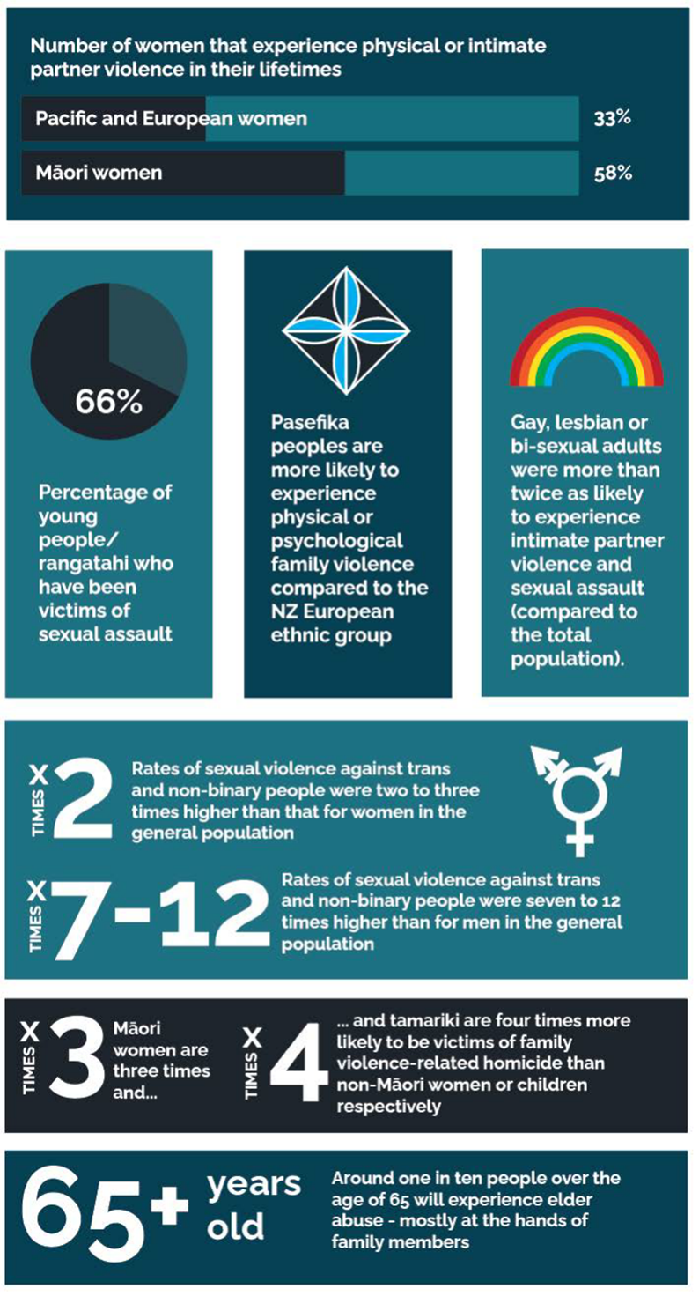

Violence within families and whānau particularly impacts wāhine Māori
FVSV data and statistics only tell us part of the picture, due to issues with data quality and under-reporting of FVSV. However, what we know from the data we have is cause for national shame, with the disproportionate impacts of violence falling on Māori and Pacific peoples’ whānau, and especially wāhine Māori. We accept that men can also be survivors of family and sexual violence, however due to the lack of limited Aotearoa based data and lack of reporting, further research is required in this space. In addition, reporting data and research continues to evidence that women continue to dominate the statistics for victim/survivors of the most serious family and sexual harm.

Key points from FVSV data for Aotearoa include:
- One in three Pacific and European women experience physical or intimate partner violence in their lifetimes. The rate is even higher for wāhine Māori, with a rate of 58% or one in two wāhine Māori experiencing physical or intimate partner violence in their lifetimes.
- Young people / rangatahi make up two thirds of those who have been victims of sexual assault.
- Pacific peoples are more likely to experience physical or psychological family violence compared to the NZ European ethnic group.
- Gay, lesbian or bi-sexual adults were more than twice as likely to experience intimate partner violence and sexual assault (compared to the total population).
- Rates of sexual violence against trans and non-binary people were two to three times higher than that for women in the general population and seven to 12 times higher than for men in the general population.
- Wāhine Māori are three times and tamariki are four times more likely to be victims of family violence-related homicide than non-Māori women or children respectively.
- People with disabilities report experiencing a significantly high lifetime prevalence of intimate partner violence compared with people without disabilities. Conservatively that magnitude is estimated as twice the overall rate for non-disabled people, increasing to between four and five times the rate for disabled children and women.
- Around one in ten people over the age of 65 will experience elder abuse - mostly at the hands of family members.

Although there is inadequate information available on disability in Aotearoa, international evidence is that people with disabilities are at greater risk of experiencing violence or abuse and there is no reason to assume there would be different levels of risk here. What we know from intersectionality theory is that the risks are likely to be even higher for tāngata whaikaha Māori.

Intersectionality
Whilst we are focusing on Te Tiriti accountabilities throughout this report, we are also considering the issues of equity for general populations and we have been influenced by theories of intersectionality, which have developed from Black feminist scholarship. These approaches show the way that individuals and communities that experience multiple layers of erasure and silencing (for example because of the intersecting impacts of racism, white supremacy, sexism and ableism) are heard.

We think the diagram provided at figure 1 (below) is a useful illustration of the
various factors we are talking about and how they create synergies of oppression
that unfairly and unjustly impact different parts of our population.
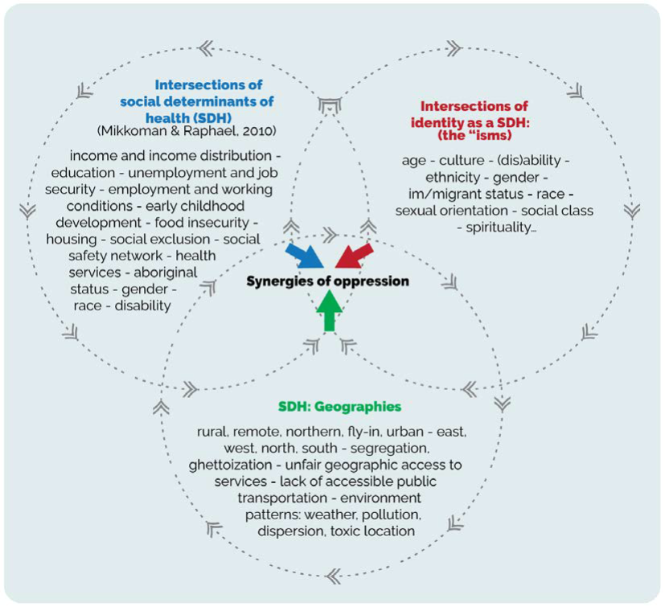
Figure 1: Synergies of Oppression

Centre for Culture-Centred approach to research and evaluation (CARE)
To add to our understanding of the current state, MEAG met with Professor Mohan Dutta and the research team at Massey University’s Centre for Culture-centred Approach to Research and Evaluation (CARE) and its recent report on Community-led Culture-centred Prevention of Family Violence Sexual Violence. We have adopted the language of the “margins of the margins” to ensure our findings and recommendations are informed by their experiences and aspirations.

In the context of Aotearoa New Zealand, we especially acknowledge the intersection of racism and ableism that has led to the marginalisation and exclusion of the voices of tāngata whaikaha Māori and Pacific peoples with disability. It was essential for us to make sure that in every stage of our process we sought voices from people with lived experience of disability and made sure we acted on what they told us.

The short comings of inadequate funding, siloed health and disability services, and lack of accessible care are widely known, and our current state assessment is not intended to repeat the depth of published evidence. Instead, we have concentrated on hearing directly from Māori and Pacific peoples’ providers and disability groups and ensuring we have built an understanding of the experiences of those working with communities.

Literature review on current primary health care responses
While the VIP training is run within DHBs, and from time to time includes primary and community health professionals, there is no holistic, unified approach to routine enquiry or screening for FVSV in primary health care providers and community health providers. Nor is there a standardised approach. This is despite those working in primary care settings being uniquely placed for detection, prevention and intervention of FVSV due to the relationship they are likely to have with patients across multiple interactions.

Better harnessing the potential of primary health and community care could lead to better identification of predisposing risk factors, noting early signs and symptoms and providing a response, including risk assessment within families, use of referral pathways and evidence-based services.

There are, however, several family violence prevention and intervention initiatives occurring across health and social settings. Key points identified through our literature review are outlined below:

- Some form of routine enquiry is common in primary health care.
- Holistic, whānau-centred responses across health services are limited.
- There are a number of tools for the primary health care sector to use in response to FVSV, including the primary health Care Family Violence Responsiveness Evaluation Tool and the Royal New Zealand College of General Practitioner’s 2003 toolkit for responding to family violence.
- VIP training can support a range of healthcare professional groups (e.g. DHBs, primary care and WellChild Tamariki Ora nurses). Primary health care professionals, who have attended DHB VIP training have said, however, that it did not apply to primary health care due to primary health care settings being different to hospital-based care provided by the DHB.
- A professional medical body called MEDSAC provides specialist training courses for medical responses to abuse and sexual assault.
- The Royal New Zealand College of General Practitioners also provides training that sits alongside its toolkit.
- The literature review did not find any published training provided by Māori or Pacific peoples’ primary health care providers in New Zealand.

Despite the disproportionate impact of violence on whānau Māori, our literature review found no Māori or Indigenous frameworks used within FVSV training resourced by the Ministry of Health. There is, however, substantial evidence that highlights the importance of culturally safe approaches to all health care and of the need for Te Tiriti o Waitangi principles to underpin efforts to achieve equitable health outcomes for Māori. We also know that Māori primary health care approaches can work for Māori, but that Kaupapa Māori providers have not been supported (or funded) to play the role they could to improve Māori health outcomes.

Our main observations from looking at the current state are that primary and community health care have the potential to be powerful sites of FVSV response and intervention, including being able to take a whole-of-whānau approach. But this will require a more coordinated approach to training that is bespoke to primary and community health care. It is also important that Māori models of wellbeing and Kaupapa Māori providers are a central part of this response.

The literature review showed us that primary health care is a potentially powerful site for FVSV screening and intervention, but this is not as simple as transferring a DHB-run programme to a community provider. This was reinforced both by our visit to providers and our own attendance at DHB-run VIP training sessions. It is also a theme of the work from the CARE team.
There were other consistencies between the CARE work and what we heard through regional hui too – including strong calls for Māori and Pacific peoples’ providers to be trusted to continue to meet the needs of their communities in culturally relevant way, and the need for more equitable and appropriate primary health care funding for Māori and Pacific peoples’ providers.

While the current state information gathering helped us to identify some key threads and themes, this stage of our mahi helped to weave these together into a set of key findings. These observations are discussed in more detail in the body of the report, but in summary:
- One size does not fit all – instead, what is needed is a flexible approach, matched with proper resourcing and support to Kaupapa Māori providers and Pacific peoples’ providers. This will allow tailored, local, solutions to be developed.
- The VIP training implemented across DHBs, is not adequately connected to a model of care. Any violence prevention training needs to be part of an overall approach that is holistic, focused on prevention, provides ongoing support, and understands the intergenerational nature of FVSV.
- There are too many barriers for Māori accessing high quality FVSV supports – and there is little evidence to support responsiveness to Māori in the existing VIP training and implementation.
- Racism, colonisation, and patriarchy play a detrimental role in FVSV, which harms everyone. Because these factors are so embedded within the complex causes of violence, addressing and calling out privilege, sexism, and colonial racism are essential elements of any solution that will work in primary health care.
- Health holds a unique place in the prevention continuum, being able to work with whānau and families in an ongoing way and also playing an integral part in care to support recovery from the trauma of violence.
- The VIP training is viewed negatively by some because it is seen as merely a step to unlock reporting to Oranga Tamariki, supporting the uplift of children. The fears shared with us, reflect an erosion of trust and confidence in the health and disability system by those at the margins of the margins. Our concern is that this prevents people, especially wāhine Māori, accessing health care when they need it. This finding has implications both for the existing VIP training and any expansion into primary health care.
- Interpretations of privacy and information sharing rules, risk running counter to human rights and ethical standards.
- Primary health care is the right setting for early intervention. The main observations from our literature review are that primary and community health care have the potential to be powerful sites of FVSV response and intervention, including because they are able to take a whole-of-whānau approach. Speaking with Māori and Pacific peoples’ providers and various communities around the motu reinforced this and it is our considered opinion that primary health care is the right setting for early intervention for FVSV.

Further literature review findings also informed our analysis and will be further
discussed below as part of He Tirohanga Whakaaro.

He Tirohanga Whakaaro - Analysis
As MEAG, we were deliberate in the decision to prioritise the voices of Māori, Pacific peoples and disability groups. This includes listening to Māori and Pacific peoples’ providers who work in ways that support our whānau, usually beyond their narrowly defined contractual obligations. These voices are not just asking for business-as-usual policy development, they want whānau to be heard, they want decision-makers to work with whānau to name the problems, and they want to be trusted to design and implement the solutions. Outside-in models are failing communities and providers are spending valuable time trying to undo, fix up or adjust what has been ill-fitting policy.

Listening to Māori and Pacific peoples’ providers

“Most people in this country would not realise the incredible contribution to health and wellbeing that is made by kaupapa Māori and kaupapa Pacific peoples’ providers in this country. It was a real honour to visit, see and hear of the mahi that they are achieving”

Throughout 2021, the MEAG met over 25 groups, with experience in Kaupapa Māori services, Pacific peoples’ providers and groups focused on lived experience of disability. Initial contact was made through face-to-face hui, but there were many follow up discussions, usually held online.

We deliberately took an inclusive approach to bring the voices from the margins of the margins. MEAG acknowledges that those attending were responsible for service provision to thousands of Māori whānau and Pacific peoples’ families both in urban and rural rohe.

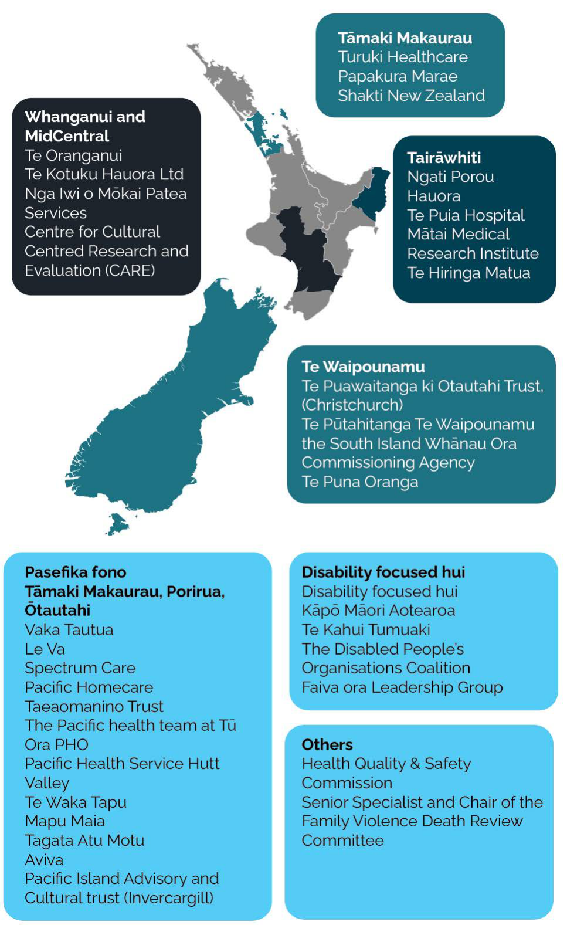

Figure 2: Regional visits
(NZ Map: https://freevectormaps.com/new-zealand/NZ-EPS-01-0002?ref=atr)

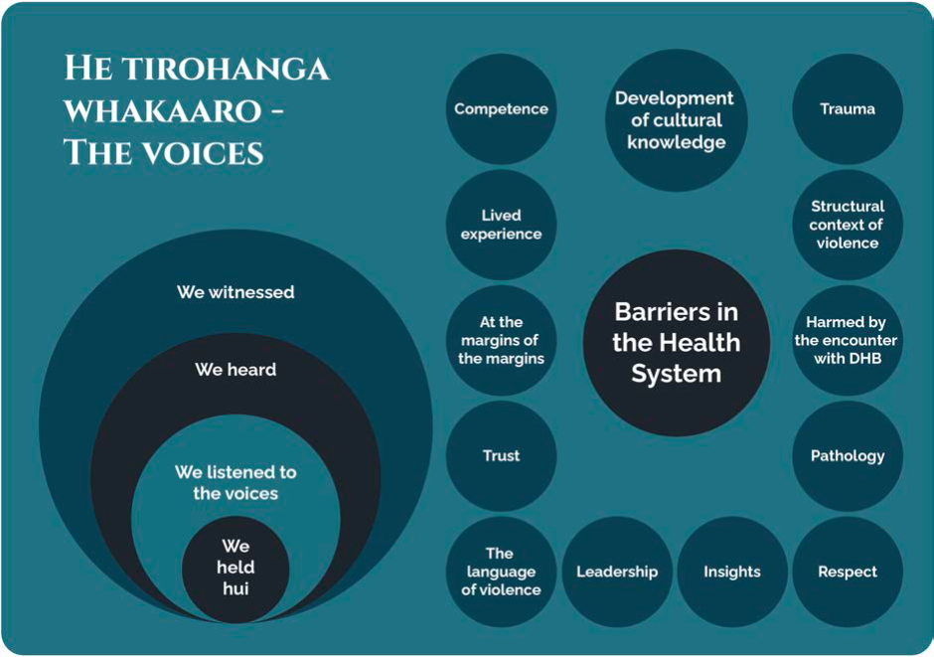
What we heard

The regional travel brought MEAG into contact with many different groups, organisations and individuals, a variety of services, relationships, and structures. It was clear that each community and region had a range of ways of working, managing tensions, diverse groups and ways to engage.

“These are smart, innovative and dedicated organisations. Their ability to adapt and respond, their ability to build on community cultural strengths, to pivot when faced with community crisis provide exemplars of excellence which are things that have not been registered in the national consciousness”

Each of the areas we visited are in different stages of pre- and post-Te Tiriti settlement, so we had a chance to speak with iwi-led services, Māori-led services, and combinations of both. It was noted that all these services were non-exclusionary and will cover other ethnic groups. Iwi-led and Māori-led services are generally appreciated and often favoured by Pacific peoples and Asian peoples because cultural needs are treated as an issue of value and priority.

Overall, we heard that successfully working in primary and community health care to improve outcomes for whānau Māori, Pacific peoples’ families and people at the margins of the margins demands that health care practitioners work in respectful ways. This means honouring patient and family perspectives and ensuring they can be partners in decision making. These factors are especially important in the context of family violence, sexual violence, and child abuse, where there is a history of institutions wielding power and causing harm in the name of ‘protection’.

We also heard that training programmes and FVSV programmes designed for a hospital or DHB setting will not work for most of the people we talked to. Instead, government agencies need to be better at trusting providers closest to the communities they serve. While these observations are expanded in our analysis section (He Tirohanga Whakairo), the following pages provide some of our overarching observations and include quotes from several of the groups we met with.

The providers we spoke to were all focused on whānau and families
We heard a strong commitment to whānau ora in its most genuine sense.

Providers were passionate about their services and working alongside whānau / families to achieve positive outcomes. They talked about the quality of service being of utmost importance and that this means spending time to build strong relationships based on trust.

We were also told of the importance of working with whānau in ways that did not rely too much on clinical language.

One group (Shakti) also talked about the conventional language and terminology around violence, highlighting that much of it is not useful in their work with African, Asian migrant and refugee communities. Their focus in on cultural competency and complexity and what that means for the people they provide for.

Many of the providers we met spoke about how they worked with whānau in ways that worked best for their circumstances. This included working across multiple settings, including in prisons, and with whole families not just women, who are the focus of the VIP programme.

“I go well beyond what I am employed to do to ensure
the whānau member who desperately needs help
and support gets it”

The diagram below, is what we know about whānau in violence. Women are incredibly resourceful at getting what they need, but it’s not always easy and straightforward. Here is what we heard works and what doesn’t.

Diagram 1: Women’s voices: journey from trauma to recovery
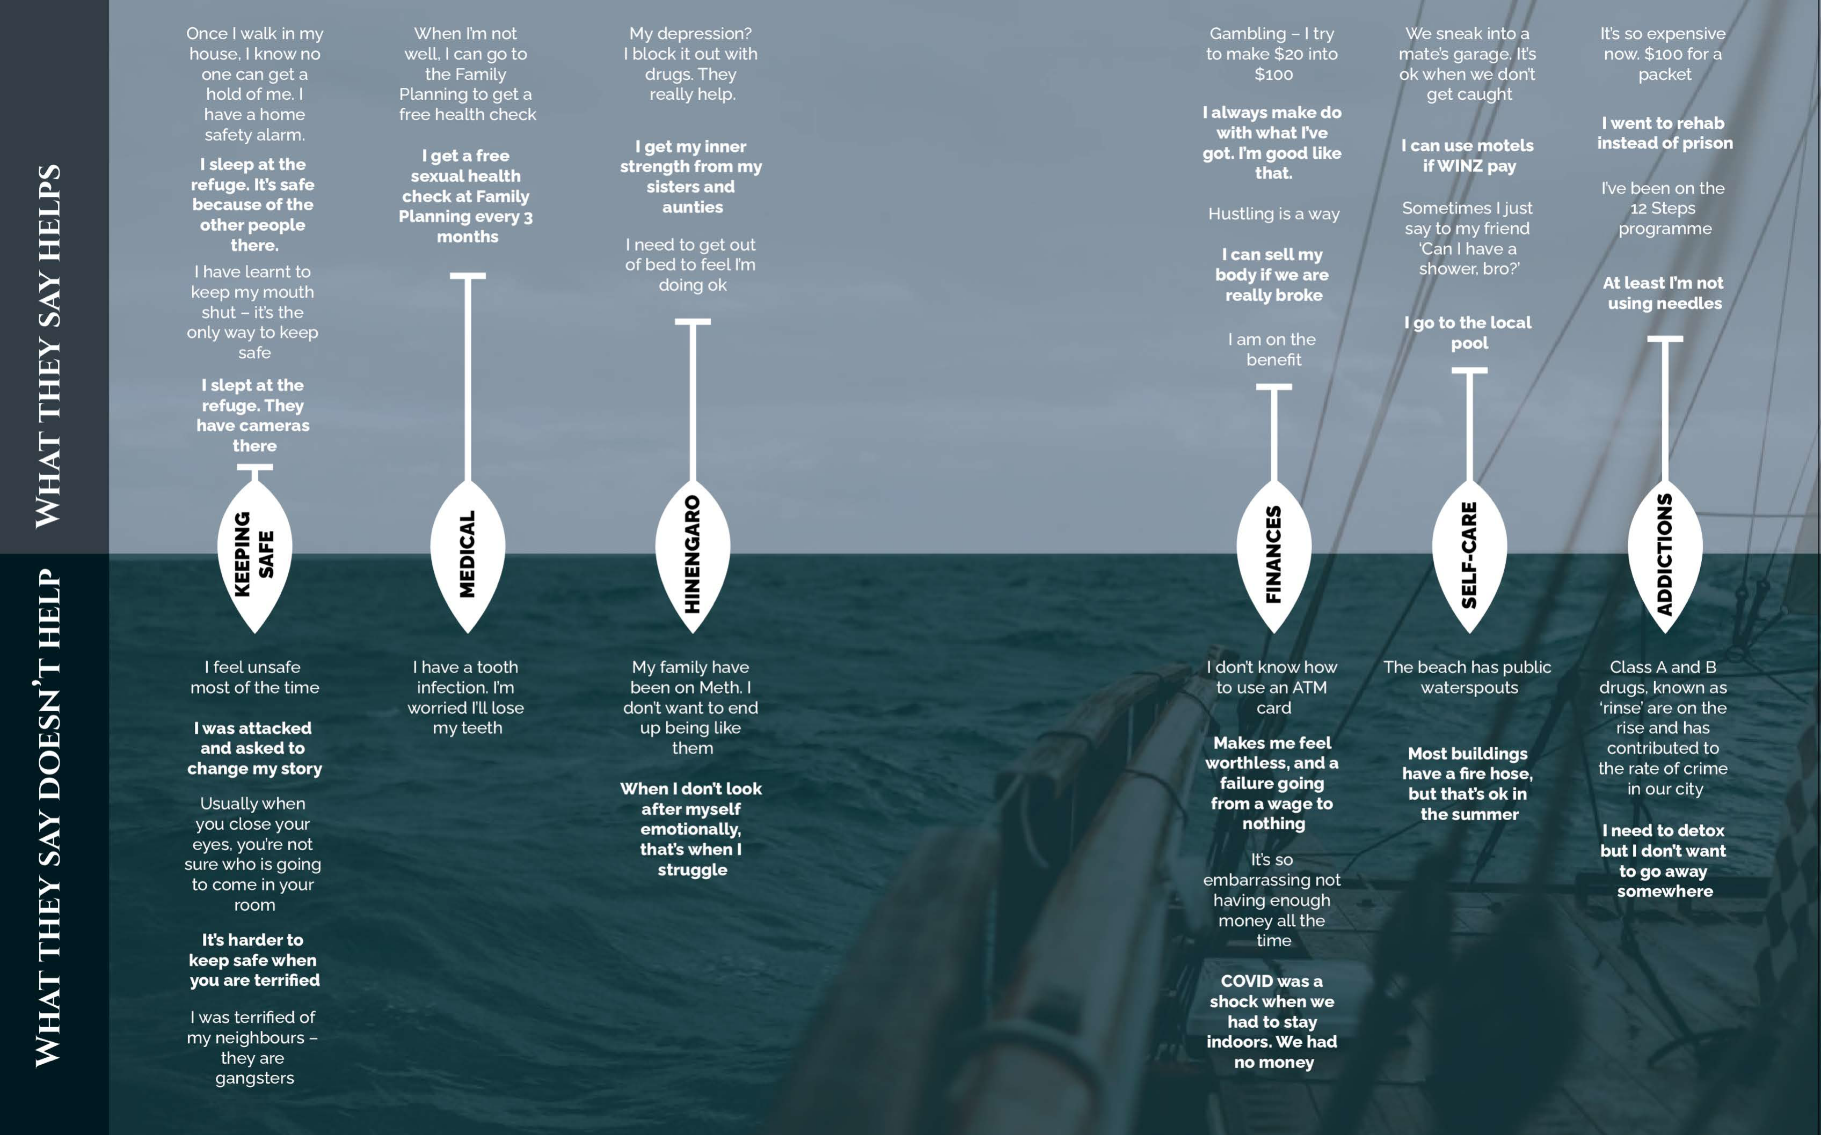
(adapted from Lifewise, et al, 2015).

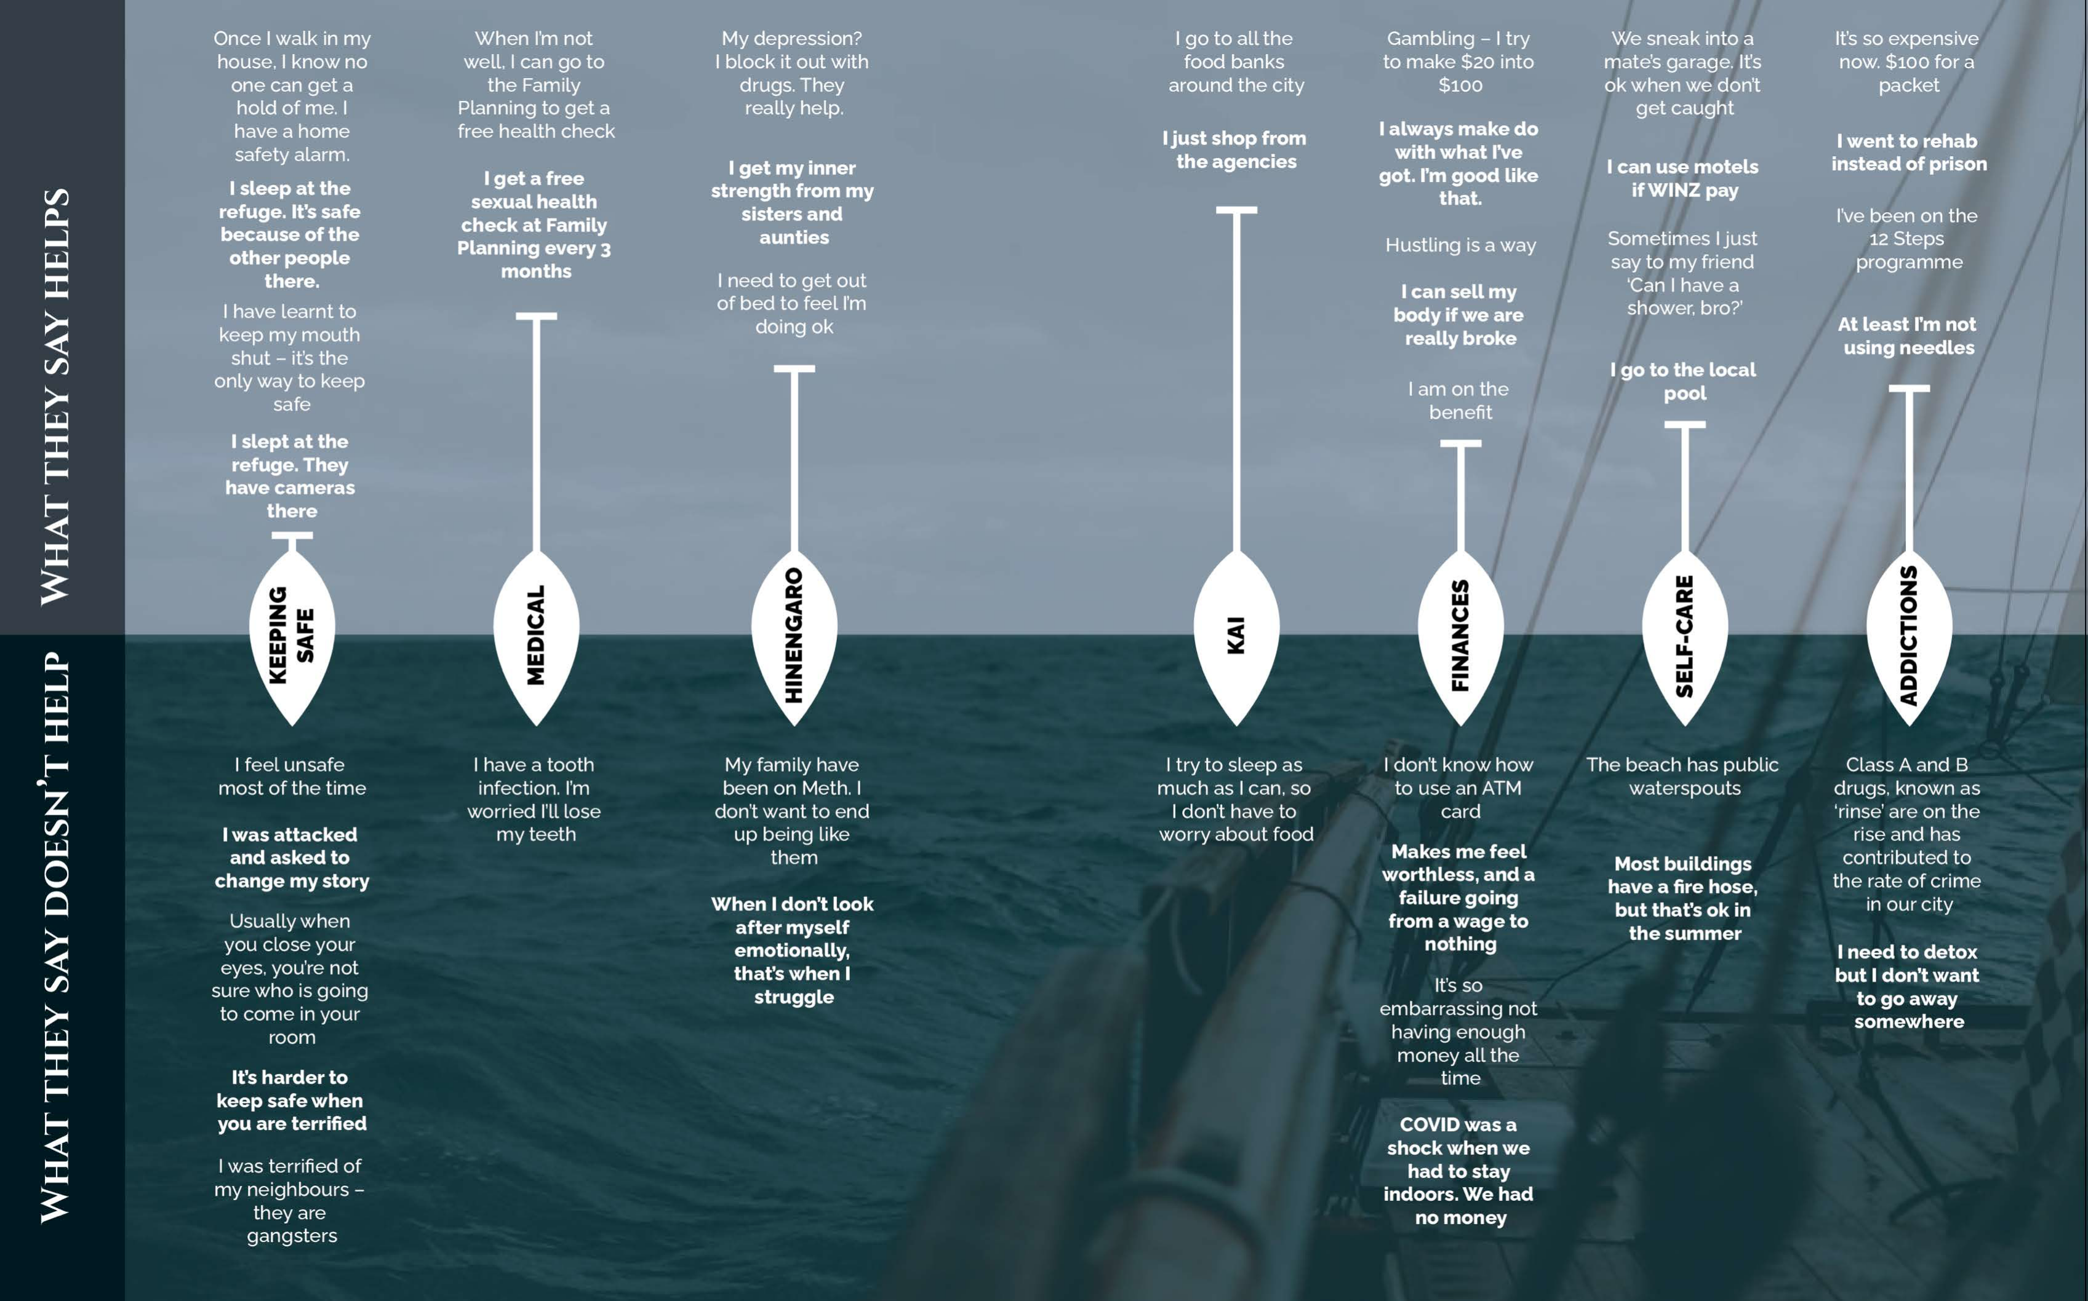

(Under)Funding
Providers are so focused on meeting the needs of the families that in many cases what they do daily extends well beyond their contractual agreements. Several of our discussions canvassed the issues of underfunding and under-resourcing of Māori and Pacific peoples’ providers, highlighting that funding to Māori health providers was only 2.48% of national health funding in 2019/20. We were told by one provider that just over 2% of the DHB budget in their region was allocated to Kaupapa Māori providers. The population of Māori in that region was over 20%.

“NGOs are quick to be used by government agencies with no thought of resources required”

The underfunding of providers who take whānau-focused approaches can lead to an unhealthy work environment for staff, and ultimately burn out – which in turn can impact the ongoing sustainability of these essential services.

Siloed systems
People we spoke with shared experiences of the current health, disability and social sector system settings getting in the way of serving whānau and families.

As one group said to us it sometimes feels “like a system within a system and never about the people”. And as we heard in Tāmaki Makāurau, the system is not good at supporting holistic, hauora focused, approaches, which adds to the frustration of many Māori and Pacific peoples’ providers.

“Kei hea taha wairua?”

On wider system issues, we heard support for reforming the health and disability
system and establishing a Māori Health Authority.

“We are an ardent supporter of the establishment of a Māori Health Authority and local commissioning, giving it a greater say in where the money goes creating a shorter pipeline from money source to provider to whānau”

Culturally relevant and culturally safe services are essential
While we were told the system does not value mental and spiritual wellbeing, it was clear that the people we spoke to do and incorporate it into their work every day where they can.

“Wairua sets the pathway for us”

The Māori and Pacific peoples’ providers we spoke to demonstrate a great deal of innovation in developing culturally safe systems and approaches to support victims of violence, however, these approaches are not valued in ways that translate to appropriate funding. Cultural knowledge is not considered as specialised and is not compensated accordingly in par with other specialist roles.

We heard regularly how important traditional cultural values are, especially when supporting people and whānau experiencing the harm of violence and abuse. Cultural connection, body language, understanding the relationships between and within whānau – these all help to build rapport and are essential in combatting the impacts of a system built on the notions of superiority, racism, and unconscious bias.

“These (mainstream) programmes very much focus on family violence/sexual violence but not looking from a pathological lens – but does not look at structural violence, systemic violence, colonisation, racism”

In our Pacific peoples’ fono, it was also clear that the fundamental Pacific peoples’ cultural values of “love, respect and kindness” underpin Pacific peoples’ provider frameworks for improving outcomes for Pacific peoples’ families. But, as with Māori providers, the need to be able to express these values fully was often at odds with underfunding and a small (and stretched) workforce.

“When we see other services (mainstream) treating our people without dignity, that affects us and puts a burden on us, because I have to pick up and do the bits that aren’t picked up (by mainstream services). Our workforces are small – we can only manage what we can manage”

Tokenism and one-size-fits-none
Our discussions also highlighted that it is too common for mainstream providers to be tokenistic in their responses. People talked about some mainstream organisations having whakataukī on the wall, but that this was rendered meaningless by the actions and values of the organisation.

The people we spoke with know that in mainstream health practice, ‘one size fits all’ approaches are being used in culturally unsafe ways. We were told, for example, the cultural needs of a Samoan person are likely different from a Tongan person but many of the available services do not acknowledge this. This is also true within cultural or ethnic groups as different generations might have different needs, as might takatāpui, as might tāngata whaikaha. What is most important is that health professionals work in partnership with people in culturally safe ways.

Current approaches to FVSV training do not work in primary and community health settings
When it comes to FVSV, we heard that merely extending current approaches, like the VIP, to primary health care will not achieve the best results.

Most people we spoke with were not aware of the VIP training delivered in DHBs. Those who were aware of the training, told us the VIP training delivered in DHBs focused on teaching medical professionals on how to identify victims of violence, reporting and referral process. This was viewed as lacking a both a holistic focus and culturally safe support for whānau/families.

The resulting VIP screening is considered very medicalised and intimidating. For example, Pacific peoples’ providers we spoke with tend not to use screening and opted to use best practice approach such as “talanoa” to first establish the relationship and build trust to provide effective support to keep victims safe and to help families recover.

People told us they would rather focus on “knowing a little bit but knowing it well”
than accessing the one-day VIP training.

“On the front line we learn by doing, through experience”

We heard that current contractual agreements limit the ability of small providers to ensure ongoing training for staff. Often this is because the workforce of many of the providers is already stretched, without extra capacity for training. The irony is that this can promote unsafe practices and compromise safety of the whānau they are working with. A solution commonly proposed was to fund providers to design their own training programmes, centred on meeting the needs of their local communities.

“Please trust us, we know how best to respond to the
needs of whānau”

Fono held with Pacific peoples’ providers highlighted a lack of standardised training which places Pacific peoples’ worldviews at the centre. The Samoan proverb “fofo e le alamea le alamea” speaks to solutions for issues and challenges affecting a community lying within that community. In the context of working with Pacific peoples’ communities around family violence and sexual violence, Pacific peoples must be both the architects and bridge between health providers and community.

Strengthening the intersectionality across Tāngata Whaikaha Māori, Pacific peoples and Disability
We acknowledge the marginalisation and exclusion of tāngata whaikaha Māori and disabled people in the current system regarding training across all points in the continuum of FVSV from prevention to crisis intervention.

In their work, the CARE team has also investigated community-led culture-centred
prevention of family violence and sexual violence. Several of the key themes from CARE reinforce what we heard directly from providers and communities. These
themes include:
- Voices from those at the margins of the margins are often unheard and unseen in relation to FVSV policies and programmes.
- There is underinvestment in FVSV prevention, despite the high level of community-demand.
- Current approaches to FVSV prevention are too individualistic and Eurocentric in nature, at the expense of approaches that look to the community capacity for change and individual and whānau agency.
- The overarching approach to FVSV prevention is driven by a ‘one-size-fits-all’ framework and prevents community-led approaches (that are able to be flexible and change according to different situations) from developing.
- While there are pockets of prevention across the motu, in some communities there is no prevention work at all, which leaves a gap in activities and services for those who are most marginalised.
- Building collaboration across sectors and communities is vital to FVSV prevention, and funding should encourage and catalyse collaborative partnerships amongst communities and local, regional and national stakeholder groups.
- Community-led prevention should be complemented by wider activity around the social determinants of health.
- There needs to be legislative change to address systemic racism and racist practices in ministries and marginalising behaviours of frontline staff. As CARE notes “the lack of workforce cultural competency in government agencies is a key barrier to community-led prevention”.

There were other consistencies between the CARE work and what we heard through regional hui too – including strong calls for Māori and Pacific peoples’ providers to be trusted to continue to meet the needs of their communities in culturally relevant way, and the need for more equitable and appropriate primary health care funding for Māori and Pacific peoples’ providers.

Tāngata whaikaha Māori and people with disabilities have the power to lead solutions that meet their needs and aspirations. To address the limitations in our mahi where there has been the absence of the voices for disability in our korero, MEAG have been holding hui with Kāpō Māori Aotearoa towards the establishment of kaupapa Māori grounded community empowerment for tāngata whaikaha Māori that addresses the intersectionality of indigeneity and disability across all age groups.

Kāpō Māori Aotearoa and CARE are also working towards the future opportunity for the CCA framework enabling participation of tāngata whaikaha Māori as community members at the margins, to draw on strengths within their cultural and local contexts to develop prevention solutions.

CARE have also been working through our Pacific peoples’ representatives towards establishing community’s empowerment addressing the intersectionality of disability, older people and the centrality of faith-based connectivity.

The wider issues of racism and ableism need to be addressed urgently

“One of the fundamental worries and threats is “if I speak up and share my information, do I lose my children and family?”

Too many examples of institutional and systemic racism were shared throughout our hui. We heard that for some whānau this was the first thing they encountered as when they went to a health appointment. This also translated to people not disclosing issues around violence and abuse for fear of what state-led institutional responses might follow, especially in relation to Oranga Tamariki intervention as a result of reports of concern.

Feedback from Pacific peoples’ disability groups suggests experiences of violence and abuse are made worse, and might even go unaddressed, because of limited support available to them. People with disability tend not to report violence, and even emotional abuse, as well as they fear losing support as a result.

Observations from VIP training attendance
Every MEAG member attended at least one VIP training session, for comparative analysis and contextual understanding. Because of timeframes we were only able to attend training sessions in four different DHBs, but we feel this gave us sufficient understanding of different approaches taken to the same nationally consistent programme.

While the dedication and passion of the VIP trainers was apparent to each of the MEAG members, overall, we noted the difficulty of conveying complex information in a limited time. We also noted that while the training is based on good intentions, it still needs a model and approach that understands local needs. This is missing at present.

The current VIP training and implementation is transactional, and about an intervention at a single point in time, in a DHB setting. This makes its application to a primary or community health care setting difficult, particularly given the life course, whānau ora, approach adopted by many of the providers we have spoken with.

Other observations from MEAG members reflect not just the training and the way it is delivered but also the content of the guidelines on which the VIP training is based.

These observations include:
- There needs to be a foundational shift within the VIP training and implementation so that the language, context, and content are mana enhancing for women and promote equal and respectful relationships between genders.
- There remain tensions between approaches that are punitive and seek to report FVSV and the parts of the sector that are focused on support and healing, and the training’s focus does not allow this tension to be remedied. MEAG member views are that there needs to be a shift from screening merely to report to screening to support.
- The training does not adequately address the fact we have multicultural workforces within hospitals, whose own cultural needs are poorly understood. This group likely have the need to build their understanding of Te Tiriti o Waitangi and the framework and guidance it provides us within health services to better serve and work with whānau Māori.
- The VIP training we attended articulated Māori principles and values as part of the training. Although they have the explanation of what each value means the values themselves are not linked or referenced in a way to support, guide, maintain best practice.
- There is little in the VIP Guidelines or in the training that really encourages DHB clinical staff to provide referral to other non-government organisations that will support addressing the wider wellbeing needs of the patient, such as housing or income support. There is no reporting of qualitative or quantitative evidence available.
- Not all comments made in training reflect the current evidence. For example, the VIP Guidelines and training link intimate partner violence to child abuse when some NZ research shows wāhine Māori are more likely to protect children.
- There is little evidence that resources on responsiveness to Māori are being implemented across any of the DHBs we visited. We also note that evaluation of the VIP implementation has not included any measure for effectiveness in this area. The VIP training continues to be based on a victim focus, without considering what’s happening for the person who is perpetrating the violence, outside Police intervention. This also contrasts with the “support” that the community providers spoke of in terms of a whole of whānau approach.
- Spending time considering the current state allowed the MEAG the opportunity to identify common threads across literature and the lived experience of providers and communities. Our next challenge was to weave these threads together in our analysis phase, to make sense of the themes and identify ways forward.

The result of this analysis we developed a set of observations, which are the focus of this section of our report.

Observation 1: One size does not fit all
We know that one-size-fits all approaches do not work when it comes to addressing inequity within the health and disability system – a fact that nationwide responses to Covid-19 have recently highlighted. Yet, what we heard across our engagement hui really brought home to us that this kind of standardisation does not work in the primary health care and community sector. And it does not work in responding to family violence, sexual violence, child abuse and neglect.

Instead, what is needed is a flexible approach, matched with resourcing and support to Kaupapa Māori providers and Pacific peoples’ providers, so that tailored, local, solutions can be developed. This would include scope for bespoke training, developed for local conditions, and run by people who know the communities best.

Bureaucratic processes, and unnecessary central government control, reinforce these one-size-fits-all approaches. Our analysis suggests that changes are needed, starting with the Ministry of Health and its role as steward of the health and disability system, to make better progress towards eliminating family violence, sexual violence and child abuse and neglect.

Observation 2: VIP training is not adequately connected to a model of care
Literature, key stakeholders and our own attendance at VIP training made it clear to us that training in FVSV needs to hold true to a set of fundamental elements to truly work for Māori and Pacific peoples’ whānau and groups at the margins of the margins. These elements include:
- being holistic
- focusing on prevention as well as ongoing support and treatment
- looking across the life-course so that support is provided across ages and stages of life
- understanding the intergenerational nature and impacts of FVSV
- including the context of the social determinants of health and wellbeing
- being whānau and family driven, and providing support to groups and collective, where it makes the most sense and is likely to have the best outcomes.

While FVSV screening should be used to provide appropriate support to families, we heard it was more often the case that reporting concern to Oranga Tamariki was the primary objective. Certainly, that is how many whānau see it. Further, our assessment is that key questions like “what other things are going on for this whānau that are relevant and are directly or indirectly contributing to this situation?” are rarely asked.

“It’s not just the tool, but who utilises the tool, how it’s delivered and does it take in cultural context and knowledge”

What we understand from the work of the Family Violence Death Review Committee is that those who come into contact with victims did not connect people to the right supports. For each review they talk to the people who were there and the providers that should have been in the picture. To us this reinforces the worrying disconnection between services, and the irreparable harms they in turn cause whānau.

The way we see it, FVSV screening should be part of an overarching model of care, not something that you add on later. For this model of care, we look to those already used by Māori and Pacific peoples’ providers and building off their knowledge and practices.

Observation 3: There are too many barriers for Māori accessing high quality FVSV supports
We have examined ‘responsiveness to Māori’ within the existing VIP training and its implementation across DHBs, and we see little evidence of this being done well. This appears to be a weakness for violence prevention work overall in Aotearoa and contravenes the health and disability sector’s commitments to Te Tiriti o Waitangi and the principles of equity, active protection and options in particular.

The literature also tells us that there are no Māori or Indigenous frameworks used within FVSV training. This is despite substantial evidence that highlights the importance of culturally safe approaches to all health care and of the need for Te Tiriti o Waitangi principles to underpin efforts to achieve equitable health outcomes for Māori. We also know that Māori primary health care approaches can work for Māori, but that Kaupapa Māori providers have not been supported (or funded) to play the role they could to improve Māori health outcomes. These sentiments were echoed in our hui across the motu.

Our analysis has highlighted a lack of whole-of-whānau or family-based approaches to FVSV. Focusing on an individual will make sense some of the time, but we believe that the default approach should be based in whānau ora and respect the mana of whānau.

Too many examples of institutional and systemic racism were shared throughout our hui. These translated to people not disclosing issues around violence for fear of what state-led institutional responses might follow, especially in relation to Oranga Tamariki intervention and reports of concern. Any developments in FVSV training and support in primary and community health care settings must be developed with a full understanding of these barriers to appropriate care for Māori.

Figure 3 over the page, (Mai I te koroirangi ki te mauri tau) illustrates a typical pathway for women or whānau accessing FVSV support through screening. It is clear to MEAG members that there is a need for health providers who are able to work with whānau, for example in primary health care, to get better outcomes.

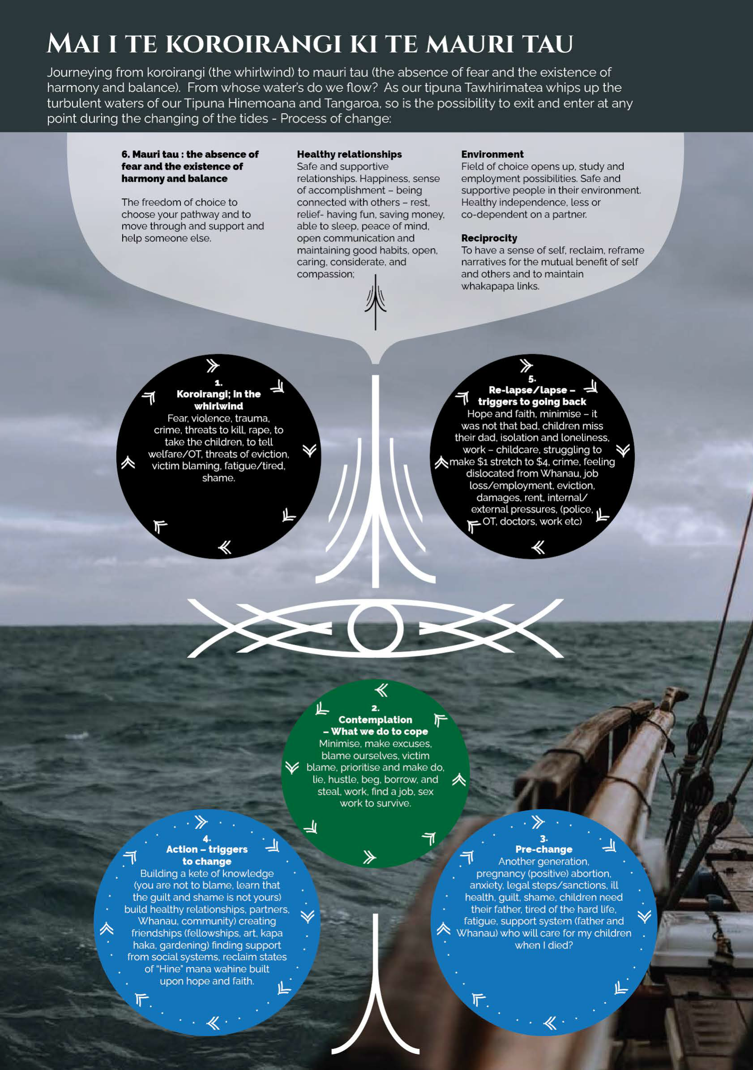

Observation 4: Racism, colonisation and patriarchy play a detrimental role for everyone
Colonisation disrupted traditional Māori social structures and systems of discipline and justice, and the enforcement of Pākehā institutions, resulted in dispossession of Māori land against a backdrop of Māori deprivation and newcomer privilege. This legacy is a driving force behind violence and abuse that disproportionately impacts wāhine Māori.

Pūao-te-ata-t was the 1988 report of the Māori Perspective Advisory Committee into the operations of the Department of Social Welfare. The report identified institutional racism within the department, which was reflected in wider society. Further, the report considered that a ‘profound misunderstanding or ignorance of the place of the child in Māori society’ was evident. The Committee advised that the over-representation of Māori in negative welfare, justice and social outcomes amounted to a crisis, requiring concerted action to redress the imbalances.

There are also impacts of patriarchal societal structures which feed violence and create cultural expectations of men as parents and can drive coercive and controlling behaviours from men, especially during and after separation.

Because these factors are so embedded within the complex causes of FVSV, addressing and calling out privilege, sexism, and colonial racism are essential elements of any solution that will work in primary health care.

Observation 5: Health holds a unique place in the prevention continuum
Our impression of the Ministry of Health’s role is that, while it is staffed by committed people working under great pressure, it is still a highly centralised bureaucracy that is not good at knowing what things to be controlling over and what things are better led by communities and providers at a local level. Our view is that design and development need to be done with whānau, with communities, so that we can see the sector health making a bigger impact on positive outcomes for whānau.

Health ū have a privileged position – often having the opportunity to identify FVSV
early so that the best supports and interventions can be put in place. Health
services are also an integral part of care to support recovery from the trauma of
violence.

Observation 6: VIP is viewed negatively as a reporting mechanism to support the uplift of children
The most revealing insight expressed by those we met with throughout our hui is the fundamental and real fear that many wāhine Māori have in accessing DHB health services. The fear is rooted in the belief they will lose their tamariki through the reporting process to Oranga Tamariki.

The fears shared with us reflect an erosion of trust and confidence in the health and disability system by those at the margins of the margins. Our concern is that this prevents people, especially wāhine Māori, accessing health care when they need it. This finding has implications both for the existing VIP training and implementation and any expansion into primary health care.

Observation 7: Interpretations of privacy and information sharing rules, risk running counter to human rights and ethical standards
Information sharing through provisions in the Oranga Tamariki Act 1989, allow DHBs to share patient information with other organisations and Agencies under the definition of child welfare and protection agencies in the Act. Information sharing includes private medical information, without the patients/individuals/whānau, knowledge or given consent.

Observation 8: Primary health care is the right setting for early intervention
The main observations from our literature review and hui are that Māori and Pacific peoples’ primary and community health care providers, have the potential to be powerful sites of FVSV response and intervention, including because they can take a whole-of-whānau approach. Speaking with Māori and Pacific peoples’ providers and various communities around the motu reinforced this and it is our considered opinion that primary health care is the right setting for early intervention for FVSV. There are practical considerations to be accounted for, however. So, while there is a pressing need to expand the health sector’s coordinated efforts beyond the walls of DHB run hospitals, our assessment is that this must be done carefully.

Observation 9: Communities and providers need to be trusted and funded to implement the right solutions
We have heard from several Māori and Pacific peoples’ providers, people working with African, Asian migrant and refugee families and people with lived experiences of disability. We have heard stories of what works. And we are concerned that the central values of culturally safe, culturally relevant primary and community services will be lost if kaimahi at these providers merely attend a training course designed by DHBs. On top of it not being relevant to the communities they serve, putting more expectation on providers to release staff for training, when the training is unlikely to seem relevant, could untended consequences such as further contributing to staff burnout and provider sustainability issues.

Our analysis is that solutions will work best when providers with a proven track record of working with communities as partners are best places to design and implement solutions, including training.

He Tirohanga Anamata – Future Focus
Our main goal is a society that is free of FVSV and safe and healthy whānau. For us, an important steppingstone to this is having a coordinated whole of government response to FVSV. The following recommendations lay out a pathway for these next steps over the next two to three years.

Our united vision as a MEAG is for Aotearoa to be free of family violence, sexual violence, child abuse and neglect. Getting there requires dismantling the power structures and oppressive systems that have created the conditions which drive up the incidence of violence. And it requires the provision of top quality, whānau centred supports for those who experience the harms and trauma of such violence.

The MEAG was set up with a very specific task – to help scope the response to FVSV in a primary health care setting. Although we have kept on task, we note that creating more silos – for example just looking at one part of the health care continuum – is not the right approach. Instead, we see a greater focus on primary health care as essential but requiring wider system level changes and supports.

Our recommendations, which are presented on page 3-6, are aimed at this type of wider system change. We hope that the recommendations, the voices of the people we held hui with, and the needs of whānau are acted on by Ministers and other health and disability system decision-makers.

In completing our mahi, we have aimed several recommendations to the Ministry of Health, as steward of the wider health and disability sector. We are, however, keenly aware of the reforms to the health and disability system, and that the roles currently played by the Ministry of Health and DHBs could be dramatically different from 1 July 2022. For this reason, where we refer to the Ministry, we encourage readers to consider that the recommendation may, in time, be best carried out by the Māori Health Authority or Health New Zealand.

Parts of the recommendations and future look of programmes that are locally inclusive of design, development and delivery elements may evolve out of the restructuring of the Ministry of Health currently underway. However, it is important that all cultures, and all people, receive the same considerations when dealing with cross-sector and complex issues such as family and sexual violence (FVSV). The recommendation in the Executive Summary (pages 1-2) would normally have been included here, a deliberate decision to include them into the Executive Summary has been made to ensure a more approachable report to the broader audience base.

Ensuring an integrated approach to FVSV within the health and disability system
Throughout our literature review, environmental scan, and regional visits we have been struck by the need for FVSV work to be embedded within a whole-of-health-system response to meeting the needs of our communities. The set of recommendations (9-12) is aimed at both the current and future health sector entities to create a joined-up approach to FVSV.

Conclusion
Taking the time to carefully consider how best to roll out training to identify and respond to family violence, sexual violence, child abuse and neglect was the right thing to do. Simply doing more of what we have always done is not only unlikely to eliminate the inequities in our current system, but it could actually lead to more trauma for those who have experienced violence.

For us, the direction from here is clear: solutions will work when they are located closest to the community and based on what whānau tell us are their needs and aspirations. Practically, this means that the responses need to be developed by the trusted providers and kaimahi who work with whānau in culturally safe ways. And that these responses are appropriately resourced by government.

We hope now that the government and Ministers can act on our recommendations over the next two to three years, starting with making a case for budget 2022 funding for provider and community led FVSV training prototypes and developing a position paper to provide better guidance in relation to FVSV across health services, so that we can have a health and disability system we are proud of.

Support available
If you are in immediate danger, please call 111

He waka tapu – support line for men who use violence: 0800 HEY BRO

Women’s Refuge National Helpline – Crisisline: 0800 REFUGE/0800 733 843

shine* Domestic Abuse Helpline: 0508 744 633

Shakti 24-hour crisis line with multilingual staff: 0800 SHAKTI/0800 742 584

Rape Crisis: National call line: 0800 88 33 00

Safe to talk – Kōrero mai, ka ora 24/7 sexual harm helpline: 0800 044 334 or text 4334

Elder Abuse Response Service National Helpline: 0800 EA NOT OK/0800 32 668 65

Family Violence Information Line: 0800 456 450 (available 9am–11pm daily)

For children and young people: tamariki and rangatahi

Kidsline: 0800 54 37 54 (speak to a Kidsline Buddy 4pm-9pm weekdays)

What's Up: 0800 WHATS UP / 0800 942 8787 (for kids and teens, daily 1pm-11pm)

Youthline: 0800 376 633 (Free TXT 234)

More information on helping services can be found on the New Zealand Family Violence Clearinghouse website: https://nzfvc.org.nz/links#help

Glossary – technical terms

Family violence
Family violence covers a broad range of controlling behaviours, commonly of a physical, sexual, and/or psychological nature which typically involve fear, intimidation, and emotional deprivation. It occurs within a variety of close interpersonal relationships, such as between current and former partners, parents and children, siblings, flatmates, carers (whether family or support workers), and in other relationships where significant others are not part of the physical household but are part of the family and/or are fulfilling the function of family.

FVSV
FVSV refers to ‘family violence, sexual violence’. In our report we include child abuse and neglect within this definition.

Gender based violence (GBV)
Gender-based violence and violence against women are often used interchangeable although the first term has a broader meaning than the later. Gender-based violence is a developing term. It is used to emphasize that violence against women is related to the gender of both victim and perpetrator. It is also increasingly being extended to connect a range of violent acts that are committed against both women and men with the purpose of maintaining social power for men.

IPV
Intimate partner violence refers to any behaviour within an intimate relationship that causes physical, psychological or sexual harm to those in the relationship.

Kaupapa Māori provider
A Kaupapa Māori provider is defined as a Māori owned and Māori governed provider serving a predominantly, but not exclusively, Māori population.

Primary health care
Primary health care relates to the professional health care provided in the community and is not hospital-based. It is generally peoples’ first point of contact with the health and disability sector.

FVSV Screening
Screening is the process of identifying if someone is experiencing family violence or sexual violence. Good screening requires good services to refer people to.

Sexual violence
Sexual violence is any forced or coerced sexual behaviour imposed on an individual, including sexual acts imposed on a person unable to give consent, and sexual activity with a child or adult with impaired ability to make decisions.

VIP
Violence Intervention Programme. The VIP is a training programme implemented in District Health Boards which provides training to the staff across women’s health, sexual health, alcohol and drug support, mental health, paediatrics and emergency. The training is for routine inquire for family violence, sexual violence for all women over the ages of 16, child abuse and neglect is incorporated into this ‘routine inquiry’.

Kupu Māori
The following is a non-exhaustive list of te reo Māori terms used in our report.

ā | particle, by which something is done
ai | particle, always, regularly
ana | possessive determiner
anamata | a vision for the future
anō | again, more, same
Aotearoa | New Zealand
awhi | To embrace, support
e | particle, address some one
ēnei | these close to me, us
hā | to breathe, taste
hāngai | relevant to, correspond to
hapori | society, group, community
hapū | sub tribe
hauora | health/ well-being
he | verb, noun, particle, interjection
hōhonu | deep, in depth
hora | display, make public
hui | gathering
i | particle indicate pass time
iwi | tribe
kaimahi | Worker, employee
kanohi | face
kaupapa | foundation for action
kei hea | where
ki | move towards
ko | transitive verb, location
koe | you
Koroirangi | is a whirlwind or whirlpool in the ocean. Also describes an emotional state.
mahi | Work, employment
mai | particle, this way, towards
mana | prestige, honour
manaakitanga | Hospitality, kindness, generosity, and care
Māori | collective of iwi
mataora | alive, invigorating
mātāpono | agreement, principle
mātau | we/us
Mātauranga | Knowledge, wisdom
mauri | life essence, life force
me | particle, which some event occurs
mēnā | if, implies the reverse of
motu | island
mua | in front of
ngā | more than two
noa | particle, only, quite, solely, merely
o | of
oranga | welfare
Pākehā | Europeans of English descent
puta | come into view, clear, exit
rangatahi | Youth, younger generation
rohe | Boundary, district
tā | particle, belonging to
taha | side
Tairawhiti | East Coast of Aotearoa
takatāpui | Historically meaning ‘intimate companion of the same sex, it has been reclaimed and used by individuals who identify as gay, lesbian, bisexual, transgender, intersex or part of the rainbow community.
Tamaki Makaurau | Auckland
tamariki | children
Tāngata whaikaha | People with lived experience of disability
tāpiri | join
tātari | agreement, principle, sieve, discern
tau | balance
te | the
Te Ao Māori | The Māori world
Te Arawhiti | Office for Māori Crown Relations Group
Te Tiriti o Waitangi | the Treaty o Waitangi
Te Waipounamu | South Island of Aotearoa
tēnei | this
tirohanga | distant view
titiro | look
tōna | particle - referring to one item,
uara | desire, value, benefit
wāhine | Women
wairua | spirit
Waitangi | geographical place name in Aotearoa
waka | canoe
whakaaro | analysis, think, thought, pay heed
whakamaua | Māori action health plan
whakatakotoranga | plan, lay down, prophecy
whakataukī | proverb, expression of thought
whakataukī | Ancestral saying, proverb
whakatutukitanga | achievement, accomplishment, closure, final, end
whānau | Family
whānui | wide
whenua | land
wherawhera | open out, spread out, investigate further

References
Cabinet Office. (2019). Circular CO (19) 5: Te Tiriti o Waitangi / Treaty of Waitangi Guidance. Department of Prime Minister and Cabinet. https://dpmc.govt.nz/sites/default/files/2019-10/CO%2019%20%285%29%20Treaty%20of%20Waitangi%20Guidance%20for%20Agencies.pdf

Crenshaw, K. (1990). Mapping the margins: Intersectionality, identity politics, and violence against women of color. Stanford Law Review, 43(6), 1241-1299.

Cronholm, P., Fogarty, C., Ambuel, B., Harrison, S. L. (2011). Intimate Partner Violence, American Family Physician ,83(10), 1165-1172.

Dutta, M. J., Jayan, P., Elers, C., Rahman, Md. M., Whittfield, F., Elers, C., Metuamate, S., Pokaia, V., Jackson, D., Kerr, B., Hashim, S., Nematollahi, N., Teikmata-Tito, C., Liu, J., Raharuhi, I., Zorn, A., Bray, S., Shah, A., Holdaway, S., Kake-O’Meara, C. (2021). Community-led culture-centered prevention of family violence and sexual violence. Center for Culture-Centered Approach to Research and Evaluation (CARE)).

Family Violence Act 2018. Oranga Tamariki Act 1989.
https://www.legislation.govt.nz/act/public/2018/0046/latest/DLM7159322.html

Family Violence Death Review Committee. (2017). Fifth Report Data: January 2009 to December 2015. Health Quality & Safety Commission.
https://www.hqsc.govt.nz/assets/FVDRC/Publications/FVDRC_2017_10_final_web.pdf

Family Violence Death Review Committee. (2020). Sixth report - Te Pūrongo tuaono: Men who use violence - Ngā tāne ka whakamahi i te whakarekereke. Health Quality & Safety Commission.
https://www.hqsc.govt.nz/assets/FVDRC/Publications/FVDRC6thReport_FINAL.pdf

Fanslow, J.L., Kelly, P., & Ministry of Health. (2016). Family Violence Assessment and Intervention Guideline: Child abuse and intimate partner violence (2nd ed). Ministry of Health.
https://www.health.govt.nz/publication/family-violence-assessment-and-intervention-guideline-child-abuse-and-intimate-partner-violence

Fanslow, J. L., Malihi, Z., Hashemi, L., Gulliver, P., & McIntosh, T. (2021). Lifetime prevalence of intimate partner violence and disability: Results from a population-based study in New Zealand. American Journal of Preventive Medicine. doi: 10.1016/j.amepre.2021.02.022

Gear, C., Koziol-McLain, J., Wilson, D., & Clark, F. (2016). Developing a response to family violence in primary health care: the New Zealand experience. BMC Family Practice 17, 115. DOI 10.1186/s12875-016-0508-x
Gear, C., Eppel, E., & Koziol-Mclain, J. (2018). Exploring the complex pathway of the primary health care response to intimate partner violence in New Zealand. Health Research Policy and Systems, 16, 99. https://doi.org/10.1186/s12961-018-0373-2

Health and Disability System Review. (2020). Health and Disability System Review – Final Report – Pūrongo Whakamutunga. Health and Disability System Review.

Health Quality and Safety Commission New Zealand. (2021, Oct 27). Atlas of health care variation - service access. https://www.hqsc.govt.nz/our-programmes/health-quality-evaluation/projects/atlas-of-healthcare-variation/health-service-access/

Higgins, D., Manhire, K., & Marshall, B. (2015). Prevalence of intimate partner violence disclosed during routine screening in a large general practice, J Prim Health Care 7(2), 102-108.

Human Rights Commission. (2020). PRISM: Human Rights issues relating to Sexual Orientation, Gender Identity and Expression, and Sex Characteristics (SOGIESC) in Aotearoa New Zealand - A report with recommendations. Human Rights Commission. https://www.hrc.co.nz/files/9215/9253/7296/HRC_PRISM_SOGIESC_Report_June_2020_FINAL.pdf

Human Rights Commission. (2021). Whakamanahia Te Tiriti, Whakahaumarutia te Tāngata, (Honour the Treaty, Protect the Person). Evidence and Recommendations
https://www.hrc.co.nz/files/6016/3822/4741/Honour_the_Treaty_Protect_the_person_Violence_and_abuse_of_tāngata_whaikaha_Maori_FINAL_English.pdf

Human Rights Commission. (2021) Whakamahia te tūkino kore ināianei, ā muri ake nei Acting now for a violence and abuse free future. Evidence and Recommendations.
https://www.hrc.co.nz/files/9316/3822/4755/Acting_now_for_a_violence_and_abuse_free_future_FINAL.pdf

King, P., Cormack, D., McLeod, M., Harris, R., Gurney, J. (2020). COVID-19 and Māori health: When equity is more than a word. Public Health Expert blog. https://blogs.otago.ac.nz/pubhealthexpert/covid-19-and-maori-health-when-equity-is-more-than-a-word/

Lifewise, Auckland Council, Auckland City Mission, & Thinkplace. (2015). An insight into the experience of rough sleeping in Central Auckland. Lifewise.
https://cdn-assets-cloud.aucklandcitymission.org.nz/acm/wp-content/uploads/2021/09/15152634/An-insight-into-the-experience-of-rough-sleeping-in-Central-Auckland.pdf

Macfarlane, S., Macfarlane, A., & Gillon, G. (2015). Sharing the food baskets of knowledge: creating space for a blending of streams. In: A. Macfarlane, S. Macfarlane & M. Webber (Eds.), Sociocultural realities: exploring new horizons (pp. 52 – 67). Canterbury University Press.

McGibbon, E. A., & McPherson C.M. (2011). Applying Intersectionality & Complexity Theory to Address the Social Determinants of Women's Health. Women's Health and Urban Life, 10(1), 59-86.

Ministry of Health. (2020). Whakamaua: Māori Health Action Plan 2020-2025. Ministry of Health. www.health.govt.nz/publication/whakamaua-maori-health-action-plan-2020-2025

Ministry of Health. (2021). Funding to Māori Health Providers 2015/16 to 2019/20. Ministry of Health. https://www.health.govt.nz/publication/funding-maori-health-providers-2015-16-2019-20

Ministry of Justice. (2016). A common approach to understanding Family Violence Risk Assessment and Management – A discussion document for consultation. Ministry of Justice.

Ministry of Justice. (2021). New Zealand Crime & Victims Survey. Key findings. Descriptive statistics. May 2021. Results drawn from Cycle 3 (2019/20) of the New Zealand Crime and Victims Survey.

Robson, B., & Harris, R. (2007). Hauora: Māori Standards of Health IV. A study of the years 2000-2005. Wellington: Te Rōpū Rangahau Hauora a Eru Pōmare.

Smith, C., Tinirau, R., Rattray-Te Mana, C., Tawaroa, Sr M., Moewaka Barnes, H., Cormack, D., & Fitzgerald, E. (2021). Whakatika: Survey of Māori Experiences of Racism. Te Atawhai o Te Ao Charitable Trust.

Taft, A.J., Small, R., Humphreys, C., Hegarty, K., Walter, R., Adams, C., & Agius, P. (2012). Enhanced maternal and child health nurse care for women experiencing intimate partner/family violence: protocol for MOVE, a cluster randomised trial of screening and referral in primary health care. BMC Public Health 2012, 12:811 http://www.biomedcentral.com/1471-2458/12/811

Te Arawhiti. (2018). Guidelines for engaging with Māori. Te Arawhiti.
https://www.tearawhiti.govt.nz/assets/Maori-Crown-Relations-Roopu/6b46d994f8/Engagement-Guidelines-1-Oct-18.pdf

The Joint Venture of the Social Wellbeing Board. (2020). Briefing to the Incoming Minister.
https://www.beehive.govt.nz/sites/default/files/2020-12/Prevention%20of%20Family%20and%20Sexual%20Violence.pdf

Waitangi Tribunal. (2019). Hauora: Report on Stage One of the Health Services and Outcomes Kaupapa Inquiry, WAI 2575. Waitangi Tribunal.

Waitangi Tribunal. (2021). He Pāharakeke, He Rito Whakakīkinga Whāruarua -Oranga Tamariki Urgent Inquiry. Waitangi Tribunal.
https://forms.justice.govt.nz/search/Documents/WT/wt_DOC_171027305/He%20Paharakeke%20W.pdf

Waldegrave, C. (2015). Measuring Elder Abuse in New Zealand : Findings from the New Zealand Longitudinal Study of Ageing (NZLSA). Ministry of Social Development.

Wilson, D., Mikahere-Hall, A., Sherwood, J., Cootes, K., & Jackson, D. (2019). E Tū Wāhine, E Tū Whānau: Wāhine Māori keeping safe in unsafe relationships. Auckland, NZ: Taupua Waiora Māori Research Centre

Wilson, D., & Webber, M. (2014). The People's Report - the People's Inquiry into Addressing Child Abuse and Domestic Violence. The Glenn Inquiry.

Appendix 1: MEAG Terms of Reference
Māori Expert Advisory group (MEAG)

Scoping the provision of a Training programme for routine enquiry for family violence, sexual violence, child abuse and neglect for primary and community health care providers.

March 2021

Terms of Reference
- Committee Name
Māori Expert Advisory Group (MEAG).
- Background
The health and disability system is committed to fulfilling the special relationship between Māori and the Crown under Te Tiriti o Waitangi (Te Tiriti). The Ministry of Health as steward of the health and disability system (under Article 1), have the responsibility to enable Māori to exercise authority over their health and wellbeing (under Article 2) and achieve equitable health outcomes for Māori (under Article 3) in ways that enable Māori to live, thrive and flourish as Māori.
- Recognising the variation across the primary health care sector in responding to Family Violence Sexual Violence and care and neglect issues (FVSV) the Ministry has received funding, to scope the provision of a training programme for routine inquiry for FVSV, for health care providers.
- It is critical that the specific needs of whānau Māori, particularly equity and active protection are integral to the primary health care sector’s response to FVSV.
- Membership of MEAG will be persons with skills, knowledge and expertise inclusive of Mātauranga Māori and Te Ao Māori who hold recognition of leadership across the continuum of responding to the impact of FVSV harm.
- Purpose
The MEAG will provide advice to inform the implementation of the Scoping Project, this will include:
- addressing issues affecting or impacting on whānau Māori within the scoping, and engagement phases
- provide guidance and advise supporting engagement with the Primary Health Care sector, inclusive of Māori providers and services
- the parameters for options based on Te Arawhiti’s engagement framework, to ensure the principles of effective engagement have been applied and the process is broad and inclusive
- contribution to the co-design collaboration and analysis towards a training programme in screening and response to FVSV across Primary Health Care, inclusive of responsiveness to whānau Māori.
- Functions
The MEAG will:
- Provide advice to the Project Team
- advise on actions addressing inequities and improving the response to FVSV from the primary health care sector
- raise and discuss issues which could impact on the scoping exercise
- discuss options to address issues.
- Issues are likely to span:
- workforce capacity, capability and training
- addressing inequalities in response to whānau Māori
- geographical challenges for provincial and rural providers
- capacity and capability of both kaupapa Māori Health providers and mainstream services
- new technologies
- new FVSV response models.
- In carrying out its functions the MEAG will:
- take account of government policy on health and disability, including the provision of publicly funded services
- be cognisant of minimising costs to industry and government.
- at the conclusion of the first phase of the project will provide a report to the Ministry’s Governance Group, with recommendations on form and function of the MEAG going forward.
- Constraints
The MEAG will not be a lobby for any one Non-Government Organisation (NGO), Disabled Persons Organisation (DPO), nor will it be a representation of provider organisations.
- Composition of the MEAG
- There will be a minimum of seven members and a maximum of ten members of the Māori Expert Advisory Group (MEAG). Collectively, members will bring the following expertise and attributes:
- mātauranga Māori and Te Ao Māori
- knowledge of current ‘best practice’ in the response to FVSV working with Māori whānau
- knowledge and experience of issues that impact on whānau Māori as they navigate a way to recovery from the impact of FVSV
- understanding of the processes associated with the delivery of publicly funded services in the primary health care setting
- sector knowledge and experience
- Amendment: The MEAG will have agency to co-op individuals who bring specific skills, experience and knowledge, including Pacific peoples’ perspectives and other world views, to assist the MEAG and participate at meetings. The Ministry will support such attendance.
- With the exclusion of Ministry staff, members will generally have a maximum of 12 months membership, ensuring the MEAG retains knowledge and consistency.
- Roles and Responsibilities of MEAG Members
- This section sets out the expectations regarding the duties and responsibilities of a member of the MEAG.
- The role of a Kaumatua will be an integral part of the MEAG.
- Meetings will be facilitated by the Ministry of Health.
- Members have a commitment to work for the public of New Zealand.
- Members attend meetings and undertake MEAG activities as both independent persons responsible to the MEAG and as representatives of their relevant professional organisations, employing organisations, interest MEAGs, or communities.
- MEAG members are expected to attend all meetings and must advise the MEAG secretariat in advance if they are unable to attend a meeting. Members are expected to prepare for meetings by reviewing any material provided. Members may be asked to prepare for and/or lead discussion on any agenda item. Members are expected to review draft meeting notes and provide comment to the MEAG secretariat.
- In keeping with tikanga of the MEAG, in the event that the Project Team are required to visit other regions across Aotearoa, on the Scoping Project business, the relevant member/s who whakapapa to that iwi, will be invited to accompany the Ministry official.
- Agendas, Minutes and Reporting Process
Meetings will be held every month on establishment of the MEAG. Consideration will be given to videoconference or tele-conference if additional meetings are required. All meetings will have an agenda prepared and disseminated prior to the meeting. Meeting notes will be circulated for approval prior to the next meeting taking place.
Secretariat and analytical support will be provided by the Ministry. The secretariat supporting the MEAG will maintain a register of interests, listing member’s interest relevant to the MEAG’s business. Declaration and discussion of conflicts of interest will be a standing item on each meeting’s agenda, and actions arising out of this will be recorded in the meeting notes.
- Secretariat and analytical support will be provided by the Ministry.
- Every endeavour will be made to provide information in accessible formats to fulfil the needs of all members.
- Meetings will be scheduled to enable the Project Team to prepare accurate and timely monitoring reports for the MEAG to consider in line with the Ministry’s business and accountability reporting timeframes.
- Minutes and recommendations from all meetings (including teleconferences) with the MEAG will be presented as meeting notes for consideration to the Public Health & Prevention Senior Management.
- Resources
- Public Health & Prevention will be responsible for meeting any secretarial, administrative, and travel arrangements including costs for the MEAG.
- Unless representing an organisation, it is envisaged that members will be paid fees (refer Cabinet Fees Framework) for attending the planned meetings. The meeting fee will be consistent with Ministry of Health rates and conditions which recognise the specific expertise within the Health and Disability Sector and Te Ao Māori.
- Travel plus any disability assistance costs will be paid for and arranged by Public Health and Prevention through the meeting organisers.
- Confidentiality
- Meetings, including agenda material and meeting notes are confidential. Members must ensure that confidentiality of MEAG business is maintained as agreed.
- Members are free to, and are expected to, express their own views within the context of meetings, or the general business of the MEAG.
- EAG members must ensure that documents are kept securely to ensure that confidentiality is maintained. Release of MEAG correspondence or papers can only be made with the agreement of the participating organisations.
- Any media queries should be referred to the Ministry Secretariat.
- Liability
Members are not liable for any act or omission done or omitted in their capacity as a member, if they acted in good faith, and with reasonable care, in pursuance of the functions of the MEAG.
- Conflict of Interest
- In making themselves available for membership of the MEAG, members should ensure that:
- there is no conflict of interest that would preclude their participation in the MEAG
- they are available, to the best of their knowledge, for the full term of the MEAG activities.
- The secretariat supporting the MEAG will maintain a register of interests, listing member’s interest relevant to the MEAG’s business. Declaration and discussion of conflicts of interest will be a standing item on each meeting’s agenda, and actions arising out of this will be recorded in the meeting notes.
- Where members believe they have a conflict of interest on a subject they will declare that conflict of interest and the MEAG will decide whether they take part in the discussion or activity.
- Review Process and End Date
The MEAG’s work will cease when it has consensus that it has fulfilled its functions, or is no longer required, an internal facing review in March 2021 will define future functions of the MEAG.

Appendix 2: Listening to Māori and Pacific peoples’ providers

Tāmaki Makaurau
- Turuki Healthcare, a Kaupapa Māori provider supporting communities with health service delivery in the Counties Manukau and Auckland DHB areas, with medical clinics in Mangere and Panmure.
- Papakura Marae, which includes a Marae health centre that offers comprehensive primary health care and social services in a safe and supportive environment.
- Shakti New Zealand, which provides a range of supports to protect the human rights of women and children and advocate for change. Their services include a national crisis call service for ethnic women in domestic violence and Shakti Asian Women’s Safehouses in Auckland.

Tairāwhiti
- Ngati Porou Hauora, including Te Puia Hospital, a Kaupapa Māori health provider and PHO.
- Mātai Medical Research Institute, a not-for-profit research centre based in Gisborne-Tairāwhiti.
- Te Hiringa Matua, a pregnancy and parenting support service based within Hauora Tairāwhiti that prioritises mātauranga Māori.

Whanganui and MidCentral
- Te Oranganui Trust, an Iwi governed Kaupapa Māori health provider serving the Whanganui Region
- Te Kotuku Hauora Ltd, a Kaupapa Māori social services provider, with kaimahi providing services across parts of the Whanganui Region
- Nga Iwi o Mōkai Patea Services, an Iwi governed Kaupapa Māori provider focused on Whānau Ora in and around Taihape.
- Centre for Cultural Centred Research and Evaluation (CARE), based at Massey University.

Te Waipounamu
- Te Puawaitanga ki Otautahi Trust, a Kaupapa Māori provider based in Christchurch offering a range of health, education and social services.
- Te Pūtahitanga Te Waipounamu the South Island Whānau Ora Commissioning Agency, Te Puna Oranga, a not-for-profit offering a whānau centred approach to wellbeing that includes counselling, social work and crisis response.

Pacific peoples’ fono
We held three Pacific peoples focused fono in Tāmaki Makaurau, Porirua, and Ōtautahi. These fono included representatives from the following groups:
- Vaka Tautua (A national “by Pacific for Pacific’ health, disability and social services provider in Aotearoa with a strong presence in Auckland, Wellington and Canterbury regions).
- Le Va, a group of Pacific health and disability experts that balances clinical and cultural expertise.
- Spectrum Care, a provider of services for New Zealanders who live with disability.
- Pacific Homecare, a group that provides home-based health care and Whānau Ora services throughout South Auckland)
- Taeaomanino Trust, a Pacific NGO providing social and mental health support to Pacific peoples’ families and people mainly in the Porirua and greater Wellington regions.
- The Pacific health team at Tū Ora PHO.
- Pacific Health Service Hutt Valley, an independent health service taking a Pacific peoples’ family-centred approach in the Hutt Valley.
- Te Waka Tapu, a Kaupapa Māori organisation in Christchurch, focusing on whānau wellbeing.
- Mapu Maia, a counselling service focused on Pacific peoples’ Families.
- Tagata Atu Motu, a long-standing Pacific peoples’ provider in Canterbury offering a range of community programmes and health services.
- Aviva, a provider providing 24-hour support to people to live free from family and sexual violence.
- Pacific Island Advisory and Cultural Trust (PIACT, an Invercargill based health and social services provider).

Disability focused hui
We also approached a small number of national groups to ensure we had input from tāngata whaikaha Māori and disabled people. This included:
- Kāpō Māori Aotearoa, a Disabled Persons Organisation (DPO) that has the mandate to speak on behalf of Kāpō Māori and their whānau in Aotearoa New Zealand. It also offers a range of whānau centred services
- Te Kahui Tumuaki, the national executive board of Kāpō Māori Aotearoa
- The Disabled People’s Organisations Coalition (DPO Coalition) a coalition of seven disability organisations in Aotearoa.
- Faiva ora Leadership Group – National disability advisory group to the Ministry of Health and its funded disability support services on issues relating to Pacific peoples with disabilities, their family members and aiga. The group also provides advice on the implementation of the Faiva Ora National Pasifika Disability plan.

We also met with the Health Quality & Safety Commission, Senior Specialist and Chair of the Family Violence Death Review Committee, who contributed to our broad understanding of the issues and helped our analysis.

In addition to face-to-face hui and fono, we kept in touch with many of these groups throughout the development of our report, including to test our recommendations. We found that iterative discussions and sense checking with this incredible group strengthened our findings and elevated our work.

Appendix 3: Profiles of MEAG members

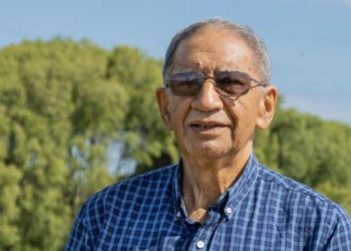
Matt Matamua

I whānau ai i Waikaremoana,
Waimako te Marae,
te Whānau Pani te hapu,
Ngai Tuhoe te iwi.
Heio ano i tupu ake ahau i runga i te Marae a te Kawiu,
Ngati Hine te hapu,
Muaupoko te iwi.

Matt is a registered Psychopaedic Nurse, specialising in intellectual disabilities since 1973. Matt’s career has included Māori Health Management and Cultural Advisor roles at Kimberley Centre, NZCare Services Intellectual Disabilities, HealthCare NZ, and Cultural advisor Careerforce ITO. In retirement, Matt continues to contribute to Māori-focused mahi, including:
- Muaupoko representative on Manawhenua Iwi collective, advisory group to the Board MidCentral Health DHB.
- Member of Te Ao Marama Disability Advisory group to the Ministry of Health.
- Kaumātua Te Kura Hinengaro Tāngata Te Kunenga Ki Purehuroa (School of Psychology) Massey.

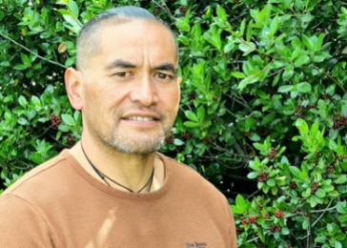
George Davis

Ko Ngati Tahinga, ko Ngati Raukawa,ko Rangitaane, ko Ngati Kahungunu oku Iwi

Ko Rarotonga,Ko Samoa, Ko Tahiti nga Moutere

George is matua of 4 tamariki and Papa of 6 mokopuna. George describes himself as “[an] excellent hole digger, one to provide kai for my people and the other to lay my people to rest.”

George has work as the Social Service Manager with Toiora Whānau/ Hikinga Manawa across Justice, Education, Corrections, Whānau ora, Social Development, and Oranga Tamariki.

George is Chairperson of his hapu Komiti and Trust and is Director of Te Taniko Toa Whakarite, providing specialised kaupapa Māori cultural resources including Suicide prevention, Intervention, Youth support, Cultural supervision, and counselling, Mahi wairua, Muri Kawenga - Generational Trauma practitioner healer, Family / Sexual Violence healer, to a broad range of clients.

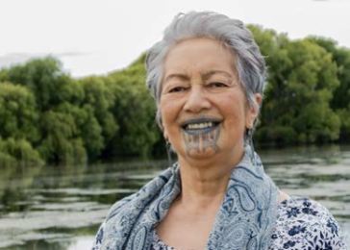
Te Awhimate Nancy Tait

Mataatua, Te Arawa, Kahungunu, Raukawa, Ngati Porou

Mother of 6, Grandmother of 19 and Great Grandmother.

Te Awhimate was the only wāhine member of a group who negotiated and effected exhumation and removal of Mokomoko’s koiwi from Mt Eden Prison, and was a trust member to the effective negotiation of pardon for the Prohet Rua Kenana.

Te Awhimate is an Iwi traditional practitioner, designing, developing and implementing Kaupapa Māori restorative programmes utilising traditional Māori models of health and wellbeing.

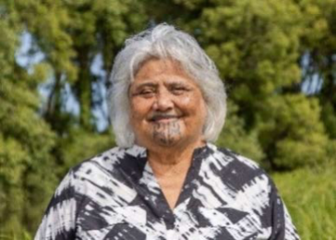
Caroline (Kararaina) Herewini
MNZM for services to women

Ngati Raukawa, Ngati Kahungungu, Ngati Pahauwera, Nga Puhi-nui-tonu, Ngai Tuhoe nga Iwi

Caroline is a human rights advocate, committed to ending all forms of violence against women and children. As the Kaiwhakahaere and the driving force of Te Whare Tiaki Waahine Refuge Charitable Trust for 25 years, underpinned by Te Tiriti o Waitangi.

Caroline is a founding member of the Everywoman Treaty Global Coalition, International Network to End Violence Against Women and Girls and Breaking Silent Codes - a movement of indigenous women trying to stop violence against women and children throughout Australia and the Pacific. Caroline is often a keynote speaker and presenter at international conferences.

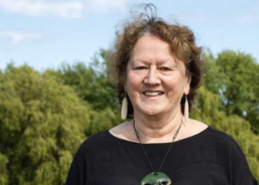
Dr Cherryl Waerea-i-te-rangi Smith

Nga Wairiki/Ngati Apa, Te Aitanga a Hauiti, Ngati Kahungunu, Ngai Tahu.

Cherryl lives in Whanganui and has has over 20 years senior kaupapa Māori research experience. Much of that research involved understanding colonial violence and its impacts on Māori. She led the 5 year research programme He Kokonga Whare: Māori Intergenerational Trauma and Healing, and co-led the Whakatika national survey on Māori experiences of everyday racism and impacts on health. She works for Te Atawhai o te Ao as a senior researcher and manages her iwi research unit, Te Roopu Rangahau in Marton.

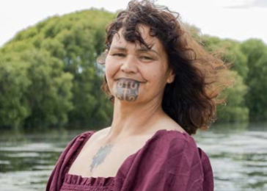
Tricia Walsh

Ngati Ruawaipu me Ngati Porou oku Iwi hoki

Tricia is the proud Nanny to fifteen beautiful mokopuna.

The legacy envisioned for Tricia’s mokopuna is for them to live in a world free of violence and sexual harm. Tricia brings a lens of lived experience to MEAG. Her vision is future focused and her motivation to dismantle the normalcy of Family and Sexual violence is the mokopuna of her 15 mokopuna.

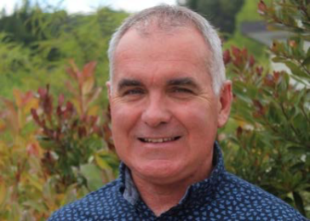
Tim Marshall (Co-opted member)

Tim has led and contributed to a number of family violence initiatives, both locally and nationally over the last 20 years. He currently co-ordinates the Tauawhi Men’s Centre in Tairawhiti, where he lives with his partner, tamariki and mokopuna.

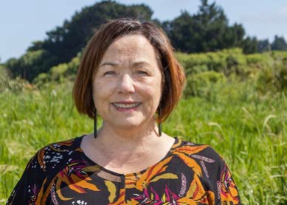
Chris Stewart
Ngati Tuwharetoa te Iwi

Chris brings over 20 years’ experience from working across central and local government, community development, the health and disability sector and education. An advocate for social justice, equity and addressing racism. Chris brings specialist knowledge from her policy work across family violence, sexual violence and child abuse. Chris brings a deep understanding of the strategic opportunities and challenges facing the sector in addressing these issues.

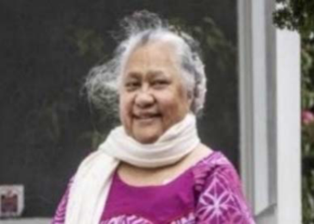
Lalopua Sanele, QSM (Co-opted member)
Lalopua was the receipient of the Absolutely Positively award in 2021 and has been E tū union’s regional executive and regional convenor of its Komiti Pacific peoples. She has represented the union at the biennial Council of Trade Union Komiti Pasefika Fono, and South Pacific and Oceania Council of Trade Unions Conference. Lalopua played a major
role in a campaign from 1999 to 2004 to gain an amendment to the Employment Relations Act to protect the jobs and working conditions of cleaners during tendering processes.

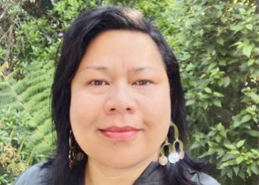
Bella Bartley
Bella has worked in the health & disability sector and not for profit organisations in strategic, operational and developmental roles. Bella has worked at Board level in the private sector and in the not-for-profit health and social sector. She also supports Pacific peoples’ communities both paid and in a voluntary capacity, through this work she is contributing positively to the lives of others in some way.

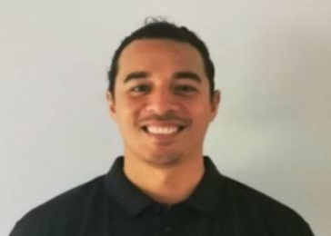
Gerhart Berking, BHSc (Co-opted member)
Gerhart is of Samoan descent, originally from Wellington and currently based in Auckland.

Gerhart currently works in public health and advocates for Pacific peoples and other vulnerable communities by working in the addictions (problem gambling) space for 7 years under Mapu Maia Services. Gerhart continues to build relationships with other fields and community groups, to support their Kaupapa and efforts to better health for Pacific peoples.

Te Ao Auahatanga Hauora Māori: Māori Health Innovation Fund (the Fund) was established in 2009 to address the service gaps and unmet needs of Māori by the health system. The Fund supports Māori Health Providers to design, develop, implement and evaluate innovative pilot programmes over a 3 to 4 year funding cycle.
A note on terminology: FVSV is widely accepted as shorthand for family violence, sexual violence, child abuse and neglect. We have concerns about FVSV as an acronym as it invisibilises child abuse and neglect, so where we felt it made sense we have used the full term. However, we have attempted to be practical, which led to us using the term FVSV where it helps the readability of our report. We do not believe in unnecessary jargon, so for simplicity sometimes refer more generically to violence.
Wilson & Webber (2014)
Family Violence Act 2018.
Fanslow et al. (2016).
Te Arawhiti (2018).
Cabinet Office (2019).
Cabinet Office (2019), p. 9
Cabinet Office (2019), p. 12.
Ministry of Health (2020).
Waitangi Tribunal (2019).
Quote from MEAG engagement with the CARE team.
More information on this inquiry is available on the Waitangi Tribunal website: https://waitangitribunal.govt.nz/inquiries/kaupapa-inquiries/health-services-and-outcomes-inquiry/
More information on this inquiry is available on the Waitangi Tribunal website: https://waitangitribunal.govt.nz/inquiries/kaupapa-inquiries/mana-wahine-kaupapa-inquiry/
Health and Disability System Review (2020).
Waitangi Tribunal (2021).
Family Violence Death Review Committee (2020).
Macfarlane et al. (2015).
Family Violence Death Review Committee (2020).
Smith et al (2021), p. 16.
Robson & Harris (2007), p. 21.
Family Violence Death Review Committee (2020).
The first four points on this list are derived from: The Joint Venture of the Social Wellbeing Board (2020), p. 9. https://www.beehive.govt.nz/sites/default/files/2020-12/Prevention%20of%20Family%20and%20Sexual%20Violence.pdf
Human Rights Commission (2020), p. 18.
Family Violence Death Review Committee (2017).
Franslow et al (2021)
Human Rights Commission (2021).
Waldegrave (2015).
The Joint Venture of the Social Wellbeing Board (2020).
See for example, Crenshaw (1990).
Synergies of oppression: a framework for addressing SDH inequities (McGibbon & McPherson, 2011).
Dutta et al (2021)
Amongst Māori and Pacific peoples’ populations. For example, 1 in 6 people (17%) surveyed report not visiting a GP or nurse in the last 12 months due to cost. This is higher for Māori and Pacific peoples’ populations who both report 1 in 4 (25%) not visiting a GP or nurse because of cost. The rates are even higher for Māori and Pacific peoples aged 15-24 (Health Quality and Safety Commission New Zealand, 2021).
Higgins et al. (2015); Taft et al. (2012).
For a discussion see Gear et al. (2016
For a discussion see Gear et al. (2018).
Fanslow et al. (2016).
Gear et al. (2016).
Gear et al. (2016).
Gear et al. (2018).
Fanslow (2016).
Waitangi Tribunal (2019).
MEAG group member.
MEAG member quote.
Quote from sector engagement hui.
Ministry of Health (2021).
Quote from sector engagement hui.
Quote from sector engagement hui.
Quote from sector engagement hui.
Quote from sector engagement hui.
Quote from sector engagement hui.
Quote from sector engagement hui.
Quote from sector engagement hui.
Three people out of all the Groups MEAG held hui with
Quote from sector engagement hui.
Quote from sector engagement hui.
Quote from sector engagement hui.
MEAG members attended VIP training through Whanganui, MidCentral, Tairāwhiti and Hutt Valley DHBs.
Wilson et al (2019).
King et al. (2020).
Quote from Stakeholder engagement hui.
For more information see: https://www.hqsc.govt.nz/our-programmes/mrc/fvdrc/about-us/
Fanslow et al. (2016).
Waitangi Tribunal (2019).
Te Puni Kokiri (2007) Arotake Tūkino Whānau: Literature Review on Family Violence
Ministry of Justice (2016).

