Health and Independence Report 2021

The Director-General of Health’s annual report on the   
state of public health

2021

**Acknowledgements**

This report was prepared by the Evidence, Research and Innovation directorate, Ministry of Health.

The authors would like to thank the content providers, peer reviewers and others who contributed to the production of this report.

Citation: Ministry of Health. 2022. *Health and Independence Report 2021: The Director-General of Health’s Annual Report on the State of Public Health.* Wellington: Ministry of Health.

Published in November 2022 by the Ministry of Health  
PO Box 5013, Wellington 6140, New Zealand

ISBN 978-1-99-110090-0 (print)  
ISBN 978-1-99-110091-7 (online)  
HP 8641



This document is available at health.govt.nz

|  |  |
| --- | --- |
| **CCBY** | This work is licensed under the Creative Commons Attribution 4.0 International licence. In essence, you are free to: share ie, copy and redistribute the material in any medium or format; adapt ie, remix, transform and build upon the material. You must give appropriate credit, provide a link to the licence and indicate if changes were made. |

# Foreword | Wāhinga kōrero

Tēnā koutou katoa

I am pleased to present the *Health and Independence Report 2021*. This report provides an overview of the state of public health in Aotearoa New Zealand for the calendar year 2021.

There are positive results to relay in this Health and Independence report; however, people and communities throughout Aotearoa New Zealand continue to experience differences in health that are unfair and unjust. For many of the health measures covered in this document, poorer outcomes are reported for Māori, Pacific peoples, disabled people and those living in high-deprivation areas.

The report provides a detailed COVID-19 section giving an overview of the pandemic response, vaccination programme, testing and COVID-19 case demographics for the 2021 calendar year.

I trust that the report will be useful for all those working to improve the health and wellbeing of people living in Aotearoa.

Ngā mihi

Dr Di Sarfati

Director-General of Health

Contents | Ngā Ihirangi

Foreword | Wāhinga kōrero iii

Executive summary | Whakarāpopototanga matua 1

People of Aotearoa | Ngā tāngata o Aotearoa 5

Population overview 5

Factors contributing to health loss 13

Impacts of COVID-19 | Ngā kawekawe o te Mate KOWHEORI-19 21

COVID-19 21

Health measures | Ngā inenga hauora 29

Maternity care 29

Enrolment with a primary health organisation 32

Barriers to accessing health care 34

Child oral health 34

Respiratory syncytial virus outbreak 35

Immunisation 36

Cancer 39

Mental wellbeing 45

Long-term conditions 48

Hospitalisations 53

Health workforce 60

Technical notes | Ngā tuhipoka hangarau 63

References | Ngā tohutoro 65

List of Figures

Figure 1: Rate of women giving birth, by age group, 2011–2020 6

Figure 2: Rate of women giving birth, by prioritised ethnic group, 2011–2020 7

Figure 3: Projected population, by age group and prioritised ethnic group, 2021 8

Figure 4: Mortality rates, by sex, 1948–2019 11

Figure 5: Mortality rates, Māori and non-Māori, 1996–2019 11

Figure 6: Prevalence of adults who reported good, very good or excellent health, by ethnic group, 2011/12–2020/21 12

Figure 7: Projected population, by NZDep2018 deprivation quintile and prioritised ethnic group (NZDep2018), 2021 14

Figure 8: Prevalence of adults who were daily smokers, by ethnic group, 2011/12–2020/21 15

Figure 9: Prevalence of obesity in adults, by ethnic group, 2011/12–2020/21 17

Figure 10: Prevalence of hazardous drinking in adults, by ethnic group, 2015/16–2020/21 19

Figure 11: Prevalence of engagement in little or no physical activity in adults, by ethnic group, 2011/12–2020/21 20

Figure 12: COVID-19 weekly community testing numbers and key events in the community, 2021 23

Figure 13: COVID-19 weekly community testing rates, by prioritised ethnic group, 2021 23

Figure 14: COVID-19 community case rates, by prioritised ethnicity, 2021 24

Figure 15: COVID-19 community case rates, by age group, 2021 24

Figure 16: COVID-19 community case rates, by NZDep2018 deprivation quintile, 2021 24

Figure 17: Vaccination status of COVID-19 cases in the community, 2021 25

Figure 18: COVID-19 vaccination uptake, by ethnic group, 2021 26

Figure 19: COVID-19 vaccination uptake, by NZDep2018 deprivation quintile, 2021 27

Figure 20: COVID-19 vaccination uptake, by eligible age groups, 2021 27

Figure 21: COVID-19 vaccination uptake, by district health board, 2021 28

Figure 22: Proportion of women registering with a lead maternity carer in the first trimester, by age, 2011–2020 30

Figure 23: Proportion of women registering with a lead maternity carer in the first trimester, by ethnicity, 2011–2020 30

Figure 24: Proportion of women registering with a lead maternity carer in the first trimester, by NZDep2018 deprivation quintile, 2011–2020 31

Figure 25: Proportion of women who received an intervention during birth, 2011–2020 31

Figure 26: Proportion of New Zealand residents enrolled with a primary health organisation, by age group, 2021 32

Figure 27: Proportion of enrolled people known to have engaged with their general practice, by age group, 2021 33

Figure 28: Proportion of 5-year-old children caries-free, by ethnic group, 2020 35

Figure 29: Percentage of children who were fully immunised at 8 months, 24 months and 5 years, by prioritised ethnic group, 2021 37

Figure 30: Incidence rates for the 10 most diagnosed cancers in Aotearoa, Māori and non-Māori, age- and sex-standardised, 2008–2017 39

Figure 31: Age- and sex-standardised cancer-related mortality, 2007–2017 40

Figure 32: Trends in select cancers’ 5-year survival rates, 1998/99–2016/17 41

Figure 33: Two-year breast screening coverage, by prioritised ethnic group, women aged 45–69 years, 2010–2021 42

Figure 34: Three-year cervical screening coverage, by prioritised ethnic group, women aged 25–69 years, 2007–2021 43

Figure 35: Prevalence of adults who experienced high psychological distress in the last 4 weeks, by ethnic group, 2011/12–2020/21 47

Figure 36: Proportion of population with one or multiple long-term conditions, by ethnic group and age, 2020 50

Figure 37: Proportion of population with diabetes, by ethnic group and age, 2020 52

Figure 38: Proportion of population with cardiovascular disease (35+ years), by ethnic group and age, 2020 53

Figure 39: Ambulatory sensitive hospital rates for 0–4-year-olds, by prioritised ethnic group, 2017–2021 54

Figure 40: Ambulatory sensitive hospital rates for 45–64-year-olds, by prioritised ethnic group, 2017–2021 55

Figure 41: Acute inpatient discharges standardised average length of stay, in days, by prioritised ethnic group, 2017–2021 56

Figure 42: Proportion of patients who waited longer than 4 months for assessment and elective treatment or surgery, January 2019–December 2021 57

Figure 43: Proportion of patients who waited longer than 4 months for elective treatment/surgery, by specialty, 2021 58

Figure 44: Proportion of patients who waited longer than 4 months for first specialist assessment by specialty, 2021 58

Figure 45: Number of planned care interventions delivered, 2017–2021 59

Figure 46: Planned inpatient discharges standardised average length of stay, in days, by prioritised ethnic group, 2017–2021 60

Figure 47: International supply of new health workers, 2016–2021 61

List of Tables

Table 1: Health-adjusted life expectancy (years), by sex, 1990–2019 10

Table 2: Time spent in poor health (years), by sex, 1990–2019 10

Table 3: New Zealand timeline of major COVID-19 events, 2021 22

Table 4: Top 10 long-term conditions and their prevalence in Aotearoa, for whole population and 65+ age group, 2020 49

Table 5: Proportion of population, by number of long-term conditions and ethnic group, 2020 51

# Executive summary | Whakarāpopototanga matua

### Introduction

This Health and Independence report covers the 2021 calendar year and provides an overview of the state of public health in New Zealand. To do this, it comprises a range of up-to-date information about the population, the COVID-19 pandemic, causes of health loss and other health measures.

### Population overview

* The total estimated resident population of New Zealand in 2021 was 5,127,200. The population is culturally diverse, and a growing proportion of older people makes up the total population.
* In 2021, New Zealand had the lowest population growth for 30 years, with just a 0.5% increase.
* Life expectancy continues to increase but varies between ethnic groups; Māori and Pacific peoples have a lower life expectancy than the Asian and European/other population groups.
* The latest availability mortality data (2019) shows the leading causes of death for Māori and non-Māori were cancer and ischaemic heart diseases.
* In the 2020/21 New Zealand Health Survey (NZHS), 88.0% of adults reported their health as being good, very good or excellent. Rates of self-rated good health were lower for Māori, Pacific peoples, disabled people and those living in the most deprived areas.
* This report includes a section covering a range of factors that contribute to population health loss, including deprivation, tobacco use, body size, alcohol use and rates of physical activity. Deprivation is strongly linked to health outcomes and features predominately in the factors contributing to health loss. Māori, Pacific peoples and disabled people are overrepresented in the most deprived areas of New Zealand.

### Impacts of COVID-19

* This 2021 report includes updated information relating to the COVID 19 pandemic and provides specific information on case numbers and demographics and the COVID-19 vaccination programme.
* In 2021, there were 10,908 confirmed community cases of COVID-19 in New Zealand and 25 deaths attributed to COVID-19. In addition, 1,115 overseas-acquired (imported) cases of COVID-19 were detected and managed at the border.
* Numbers of community cases were higher for Pacific peoples, Māori, children under 10 years of age, people aged 20-29 and people living in the highest deprivation areas.
* The prioritised vaccination programme began in February 2021, starting with border workers, frontline workers, people living in high-risk settings and priority populations. Vaccination was then offered to certain age groups, beginning with those over 60 years of age and progressively moving to younger populations.
* By 31 December 2021, 92.8% of the eligible population had been vaccinated.

### Health measures

The health sections of the report provide a wide range of information on key health topics.

#### Maternity care

* 58,659 babies were born in 2021, an increase of 1,086 from 2020.
* There is an increasing trend for women to register with a Lead Maternity Carer in the first trimester (the first 12 weeks) of pregnancy.

#### Enrolment with primary health organisations

* On 31 December 2021, 93.9% of the population were enrolled with a primary health organisation. Rates differed by population groups and were lower for people living in the most deprived areas (85.4%).

#### Barriers to accessing health care

* The NZHS reports on barriers to accessing health care. In 2021, these barriers included the accessibility of general practice, the impacts of COVID-19, and cost. The NZHS estimates that in 2021 over a quarter of a million adults had a medical problem but did not visit or talk to a general practitioner (GP) because of COVID-19. NZHS estimates that one in 10 adults had a medical problem but did not visit or talk with a GP because of cost.

#### Child oral health

* Improvements in child oral health have been recorded in recent years, however improvement differs by ethnic group: Māori and Pacific children are less likely to be caries-free at age 5 than European/other children.

#### Respiratory syncytial virus

* An outbreak of respiratory syncytial virus (RSV) occurred in 2021: children aged 12–48 months experienced a rate 5 times the rate in 2019.

#### Immunisation

* Manatū Hauora has a target that 95% of eligible children will be fully immunised at the key milestone ages. In 2021, 87.3% of eligible children were fully immunised at the key milestone age of 8 months. This reduced to 83.9% at 24 months and 83.5% at 5 years. Rates of immunisation were lower for Māori and Pacific children.
* The human papillomavirus immunisation rate in 2021 was 54.0% for the 2008 birth cohort, against the target of 75%.
* The influenza immunisation rate for over 65-year-olds was 70.4%, against the target of 75%.

#### Cancer

* Cancer is the leading cause of death in New Zealand: approximately 25,000 people are diagnosed and around 9,000 die with cancer each year.
* Cancer incidence rates show Māori are more likely than non-Māori to be diagnosed with breast, liver, lung, pancreatic, stomach and uterine cancer. Non-Māori are more likely to be diagnosed with melanoma and colorectal and prostate cancers.
* Māori experience higher mortality rates from cancer than non-Māori.
* The number of New Zealanders diagnosed with cancer is increasing, but cancer survival rates have increased substantially: more people are surviving their cancer than ever before.
* Cancer screening rates reduced in 2021 and show that:
* breast screening coverage was 63.6%, against the target of 70%
* cervical screening coverage was 68.6%, against the target of 80%
* bowel screening coverage was 60.3%, achieving the target of 60%.

#### Mental wellbeing

* In the 2020/21 NZHS almost one in 10 adults (9.6%) reported high psychological distress in the past 4 weeks.
* The New Zealand Government released Kia Manawanui Aotearoa: Long-term pathway to mental wellbeing (Ministry of Health 2021a) in 2021. It outlines actions in the following 5 areas:
* building the social, cultural, environmental, and economic foundations for mental wellbeing
* equipping communities, whānau and individuals to look after their own mental wellbeing
* fostering community-led solutions
* expanding primary mental wellbeing support in communities
* strengthening specialist services.

#### Long-term conditions

* Manatū Hauora defines long-term conditions as any ongoing, long-term or recurring conditions that can have a significant impact on people’s lives (Ministry of Health 2020c).
* 14% of New Zealanders have at least one long-term condition. Of these, 29.3% have multiple conditions.
* Long-term conditions are not distributed evenly throughout the population: they affect ethnic groups and age groups differently. The older the age of the person, the higher the likelihood they have a long-term condition. Māori and Pacific peoples develop long-term conditions at younger ages.

#### Hospitalisations

* People interact with hospitals in 2 ways: through planned care or in the emergency department (ED). Both unplanned and planned care faced challenges in reaching timeliness targets.
* In 2021, 3.3% of people who attended ED left before they received care.
* The percentage of people waiting more than 6 hours increased from 9% in 2017 to 19% in 2021.
* The average length of stay in hospital for acute conditions has been increasing since 2019.
* The COVID-19 pandemic affected wait times for planned care in 2021. During lockdown periods, and through the outbreak of the COVID-19 Delta variant, more people waited longer than 4 months for specialist assessment, and elective treatment or surgery.

#### Health workforce

* In 2021, the health workforce came under pressure due to the COVID-19 pandemic. This was due to both the reallocation of workers to respond to COVID-19 and the borders being closed, which reduced the number of migrant workers.
* An outcome of the pandemic response has been the creation of a new vaccination workforce available for other immunisation programmes.

# People of Aotearoa | Ngā tāngata o Aotearoa

## Population overview

Aotearoa New Zealand has a culturally diverse population (Stats NZ 2021d). As in many other countries, the population is ageing: there is a growing proportion of older people.

This section provides an overview of the New Zealand population. It covers:

* population numbers
* ageing structure
* health service users
* life expectancy
* health expectancy
* mortality
* self-rated health.

### Population numbers

On 31 December 2021, the estimated population of New Zealand was 5,127,200 (Stats NZ 2022b). During the 2021 year, the total population grew by 0.5%. This was the lowest population growth in New Zealand for 30 years.

The population growth was made up of:

* an estimated natural increase (births minus deaths) of 27,400
* an estimated net migration of -3,900; that is, there were more migrant departures than arrivals.

During the 5 years between 2015 and 2019, the population increase due to migration averaged 60,000 people per year. In 2020, border closures associated with the COVID-19 pandemic prevented inward migration, and by 2021 net migration was negative (Stats NZ 2021b).

### Changing demographics

In 2021, the median age of New Zealand women giving birth was 31.0 years. The median age has remained at around 30 years of age since 1999 (Stats NZ 2022a). This compares to around 25 years in the 1970s.

Over half (58%) of births in 2021 were to mothers aged 30 years or older, up from 48% in 2000.

Age-specific fertility (or birth) rates measure the number of live births that 1,000 women in a particular age group have in a given period (usually a year). Over the past 10 years (2020 compared with 2011), birth rates have dropped for every age group of women, except for those over 40 (Stats NZ 2022a, Figure 1).

Figure 1: Rate of women giving birth, by age group, 2011–2020

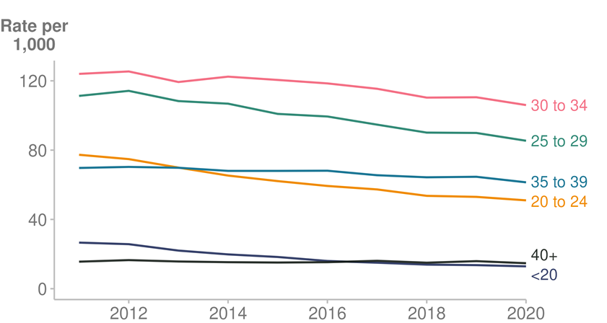

Source: [Ministry of Health (2022o)](https://minhealthnz.shinyapps.io/report-on-maternity-web-tool/)

Birth rates remain higher for Māori and Pacific peoples than the Asian and European/other ethnic groups (Ministry of Health 2022o). However, there has been a steeper decline in birth rates for Māori and Pacific peoples over the past 10 years, which means that the gap in birth rates between ethnic groups is starting to close.

Figure 2 shows the change in rates of women giving birth by ethnic group between 2011 and 2020. It sets out the following decreases over that time:

* Māori: 106.8 births per 1,000 women in 2011, compared with 82.3 births per 1,000 in 2020
* Pacific peoples: 110.3 births per 1,000 women in 2011, compared with 77.1 per 1,000 in 2020
* Asian people: 53.8 births per 1,000 women in 2011, compared with 51.7 per 1,000 in 2020
* European/other people: 56.7 births per 1,000 women in 2011, compared with 49.4 per 1,000 in 2020.

Figure 2: Rate of women giving birth, by prioritised ethnic group, 2011–2020

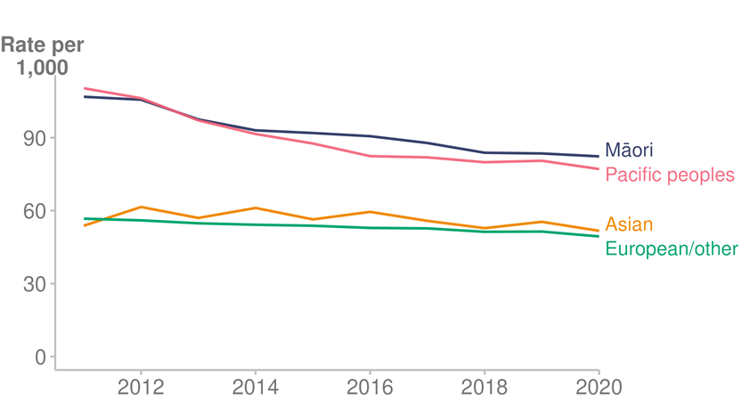

Source: [Ministry of Health (2022o)](https://minhealthnz.shinyapps.io/report-on-maternity-web-tool/)

### Age structure

The term ‘population ageing’ refers to a population in which the proportion of older people are increasing. The main causes for this are rising life expectancy (people living longer) and declining fertility (people having fewer children).

In New Zealand, the birth rate has been declining over the last 10 years, and life expectancy continues to improve (Stats NZ 2021c). An ageing population tends to put more demand on a health system, as older people commonly require more health services than younger people.

The age distribution of the population is different for ethnic groups; Māori, Pacific and Asian populations are younger than the European/other population (Ministry of Health 2022w, Figure 3).

Figure 3: Projected population, by age group and prioritised ethnic group, 2021

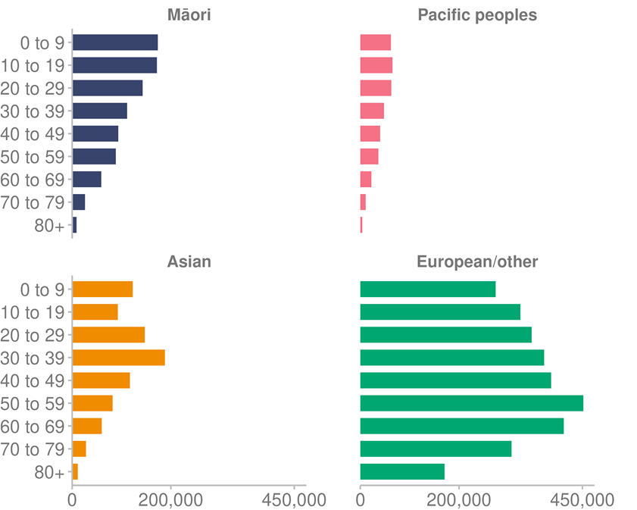

Source: [Ministry of Health (2022w)](https://minhealthnz.shinyapps.io/populations-web-tool/)

### Health service users

The Health Service User dataset (HSU) counts the number of people who receive health services in New Zealand each year. This includes people enrolled with a primary health organisation (PHO) / general practice, people admitted to hospital, people who attended emergency departments (EDs) and people filling prescriptions (Stats NZ 2022c).

The HSU can be used to calculate health statistics (Stats NZ 2022c) such as COVID-19 vaccination coverage in New Zealand. For this purpose, there were a total of 5,000,500 people who used health services in the calendar year 2020 and who were alive on 1 July 2020.

We have used the HSU 2020 as a denominator for COVID-19 reporting in this report, to be consistent with data reported by the Ministry of Health in 2021. In August 2022, Te Whatu Ora – Health New Zealand moved to using HSU 2021 to calculate COVID-19 vaccine coverage (Te Whatu Ora 2022). While this meant a technical decrease in reported vaccination rates overall, due to the larger number of eligible New Zealanders being identified in the dataset, it does not mean any fewer people have been vaccinated (Ministry of Health 2022x).

In this report, information from the HSU may be used alongside New Zealand population estimates when calculating health statistics. The technical notes section at the end of this report provides more information on the HSU.

### Life expectancy

Life expectancy varies by ethnicity (Stats NZ 2021a). Statistics detailing life expectancy by ethnic group are available after each 5-yearly census; therefore, this report relies on ethnic breakdowns for the period 2017–2019. Note, that the same life expectancy data was provided in last year’s Health and Independence Report.

Life expectancies for this period were:

* 85.1 years for Asian males and 87.9 years for Asian females
* 81.0 years for European/other males and 84.5 years for European/other females
* 75.4 years for Pacific males and 79.0 years for Pacific females
* 73.4 years for Māori males and 77.1 years for Māori females.

In 2017–19, average life expectancy was more than 7 years lower for Māori compared with non-Māori. This gap in life expectancy has narrowed over time to 7.5 years for males and 7.3 years for females, down from 8.8 years for males and 9.3 years for females in 1995–97.

### Health expectancy

Health-adjusted life expectancy (health expectancy) represents the number of years people live in good health. Although both life expectancy and health expectancy have improved for the New Zealand population, the increase in health expectancy is slightly lower than the increase in life expectancy. This means that while people are living longer, they spend more time in poor health (Ministry of Health 2020c).

Health expectancy at birth is 68.9 years for males and 70.3 years for females (Institute for Health Metrics and Evaluation 2021). Over time, health expectancy has increased for both males and females. Since 1990, males have gained 5.6 years of healthy life and females 4.2 years (Table 1).

Table 1: Health-adjusted life expectancy (years), by sex, 1990–2019

|  |  |  |  |  |  |
| --- | --- | --- | --- | --- | --- |
| **Sex** | **1990** | **2000** | **2010** | **2019** | **Change from 1990 to 2019** |
| Males | 63.3 | 65.9 | 68.4 | 68.9 | 5.6 |
| Females | 66.1 | 68.3 | 70.0 | 70.3 | 4.2 |

Source: [Institute for Health Metrics and Evaluation (2021)](http://ghdx.healthdata.org/gbd-results-tool)

Table 2: Time spent in poor health (years), by sex, 1990–2019

|  |  |  |  |  |  |
| --- | --- | --- | --- | --- | --- |
| **Sex** | **1990** | **2000** | **2010** | **2019** | **Change from 1990 to 2019** |
| Males | 9.4 | 10.0 | 10.5 | 11.0 | 1.6 |
| Females | 12.3 | 12.5 | 12.8 | 13.3 | 1.0 |

Source: [Institute for Health Metrics and Evaluation (2021)](http://ghdx.healthdata.org/gbd-results-tool)

### Mortality

There were 34,489 registered deaths in New Zealand in 2019, the latest available year for which mortality data is available (Ministry of Health 2022q).

The leading causes of death in 2019 were cancer, ischaemic heart diseases and cerebrovascular diseases. The leading causes of death for Māori were cancer, ischaemic heart diseases and chronic lower respiratory diseases (Ministry of Health 2022q).

Total mortality rate decreased over the 10 years between 2010 and 2019, from a rate of 395.6 deaths per 100,000 population to a rate of 373.6 per 100,000.

Males continue to have a higher mortality rate than females (Figure 4). In 2019 males had an age-standardised mortality rate of 438.3 per 100,000 population, compared with 315.0 per 100,000 for females.

Figure 4: Mortality rates, by sex, 1948–2019

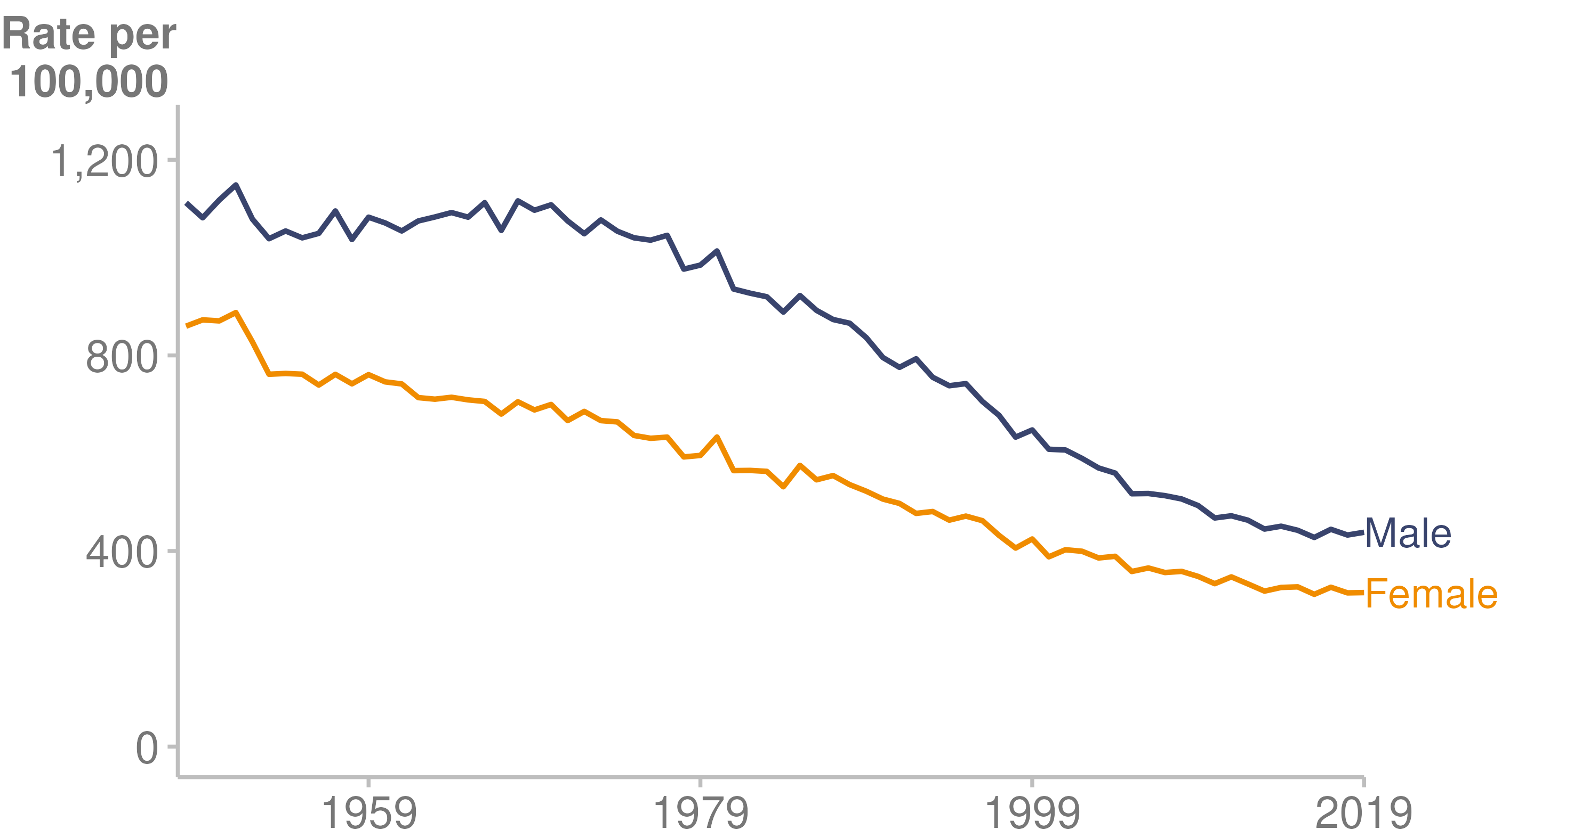

Note: Rates are per 100,000 population and age-standardised to the World Health Organization’s standard world population. 2019 mortality data is preliminary.

Source: [Ministry of Health (2022q)](https://www.health.govt.nz/publication/mortality-web-tool)

Figure 5 shows mortality rates for Māori and non-Māori. While the mortality rate for Māori decreased between 1996 and 2019 (from 1058.3 per 100,000 to 620.3 per 100,000), an equity gap remains. The mortality rate for non-Māori in 2019 was 344.5 per 100,000.

Figure 5: Mortality rates, Māori and non-Māori, 1996–2019

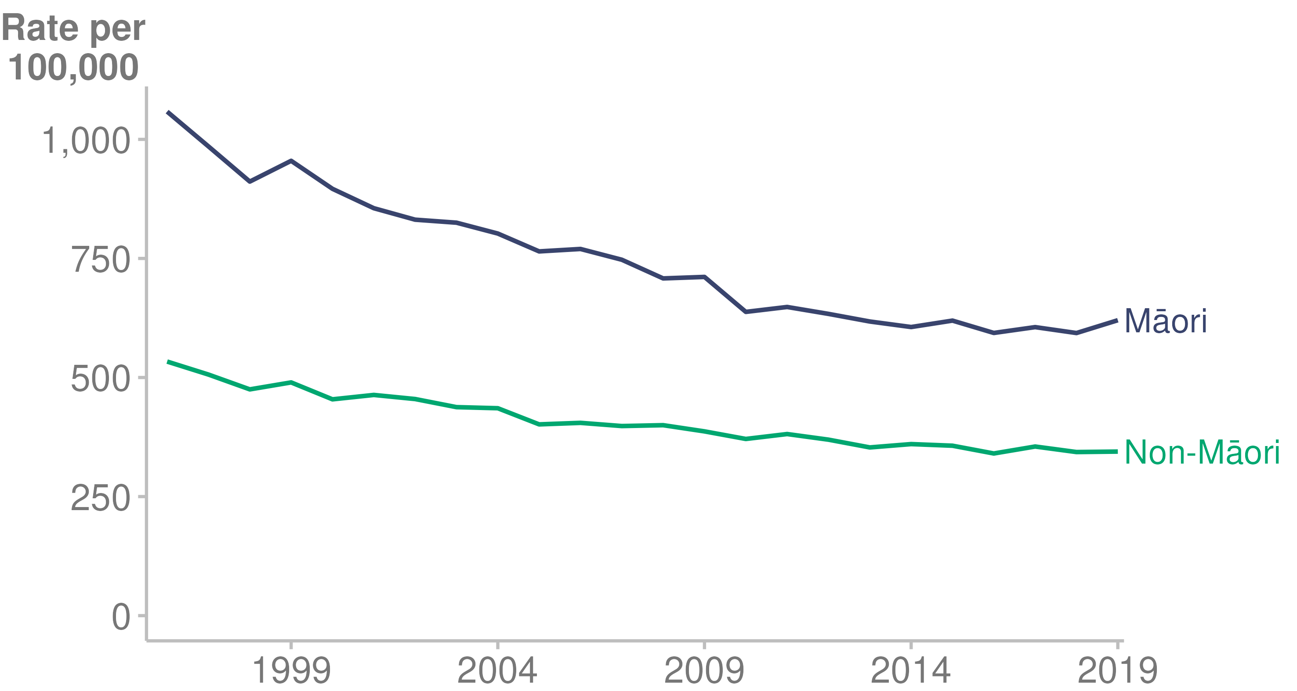

Source: [Ministry of Health (2022q)](https://www.health.govt.nz/publication/mortality-web-tool)

Notes:

* Rates are per 100,000 population and age-standardised to the World Health Organization’s standard world population.
* Ethnic breakdowns of mortality data are only shown from 1996 onwards because there was a significant change in the way ethnicity was defined and ethnicity data collected in 1995.
* 2019 mortality data is preliminary.

### Self-rated health

In the 2020/21 New Zealand Health Survey (NZHS), 88.0% of adults reported their health as being good, very good or excellent (Ministry of Health 2022b). These categories are combined as ‘self-rated good health’ in the following narrative. This has fluctuated over the 10 years to 2020/21 between a low of 86.1% and a high of 91.4%.

Inequities occur between subgroups of the population for prevalence of self-rated good health. In 2020/21:

* 82.8% of adults living in the most deprived areas rated their health as good, compared with 92.3% of adults living in the least deprived areas.
* 58.9% of disabled adults rated their health as good, compared with 90.9% of non-disabled adults.

Over the 10 years to 2020/21, Māori and Pacific peoples had lower self-rated good health in comparison to the Asian and European/other ethnic groups, as Figure 6 shows.

Figure 6: Prevalence of adults who reported good, very good or excellent health, by ethnic group, 2011/12–2020/21

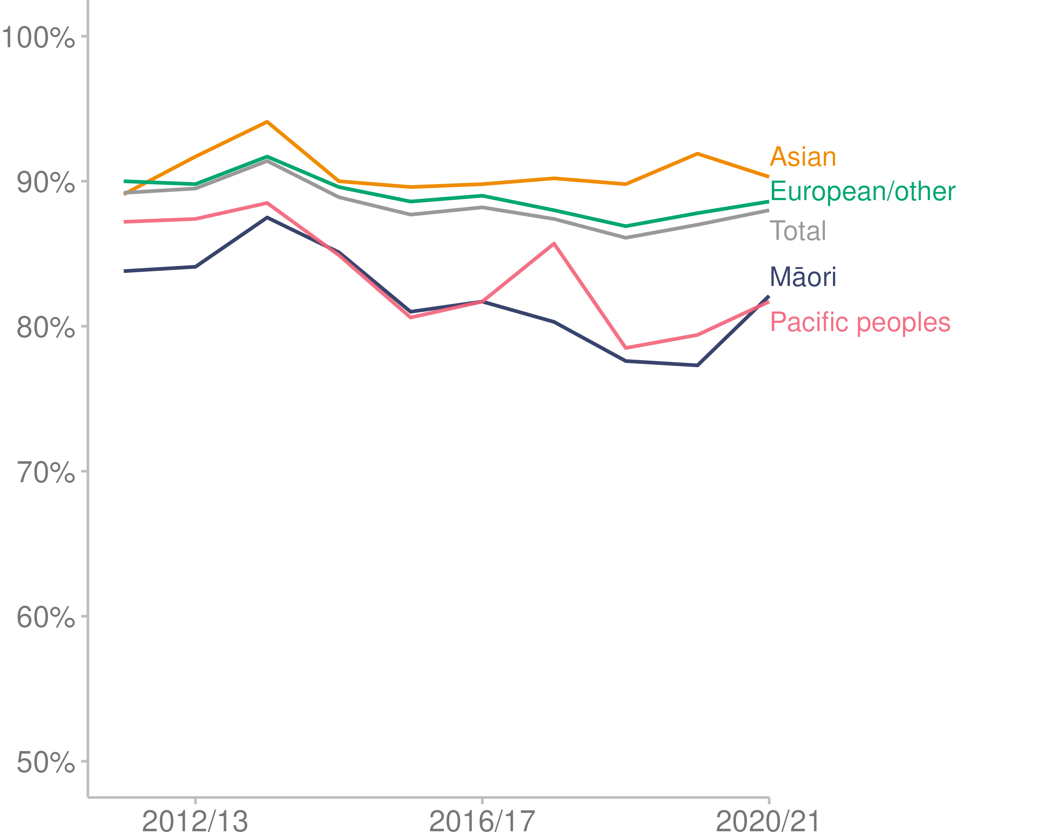

Source: [Ministry of Health (2022b)](https://minhealthnz.shinyapps.io/nz-health-survey-2020-21-annual-data-explorer/_w_871f0fb8/#!/)

## Factors contributing to health loss

Many complex factors combine to affect the health of people and communities (World Health Organization 2017). These determinants of health include:

* socioeconomic factors (income, employment status, housing and education)
* the physical environment
* individual characteristics and behaviours.

This section of the report covers

* socioeconomic deprivation
* tobacco use
* electronic cigarette (vaping) use
* body size
* obesity in children
* alcohol use
* physical activity.

### Socioeconomic deprivation

Higher income and social status are linked to better health. The greater the gap between the richest and poorest people, the greater the differences in health (World Health Organization 2017).

The New Zealand Deprivation Index (NZDep) is an area-based measure of socioeconomic deprivation in New Zealand. It measures the level of deprivation for people in each small area based on 9 census variables (Atkinson et al 2019).

Deprivation is strongly linked to health outcomes (Ministry of Health 2002). Figure 7 below shows Māori and Pacific peoples are overrepresented in the most deprived areas (Atkinson et al 2021).

Figure 7: Projected population, by NZDep2018 deprivation quintile and prioritised ethnic group (NZDep2018), 2021

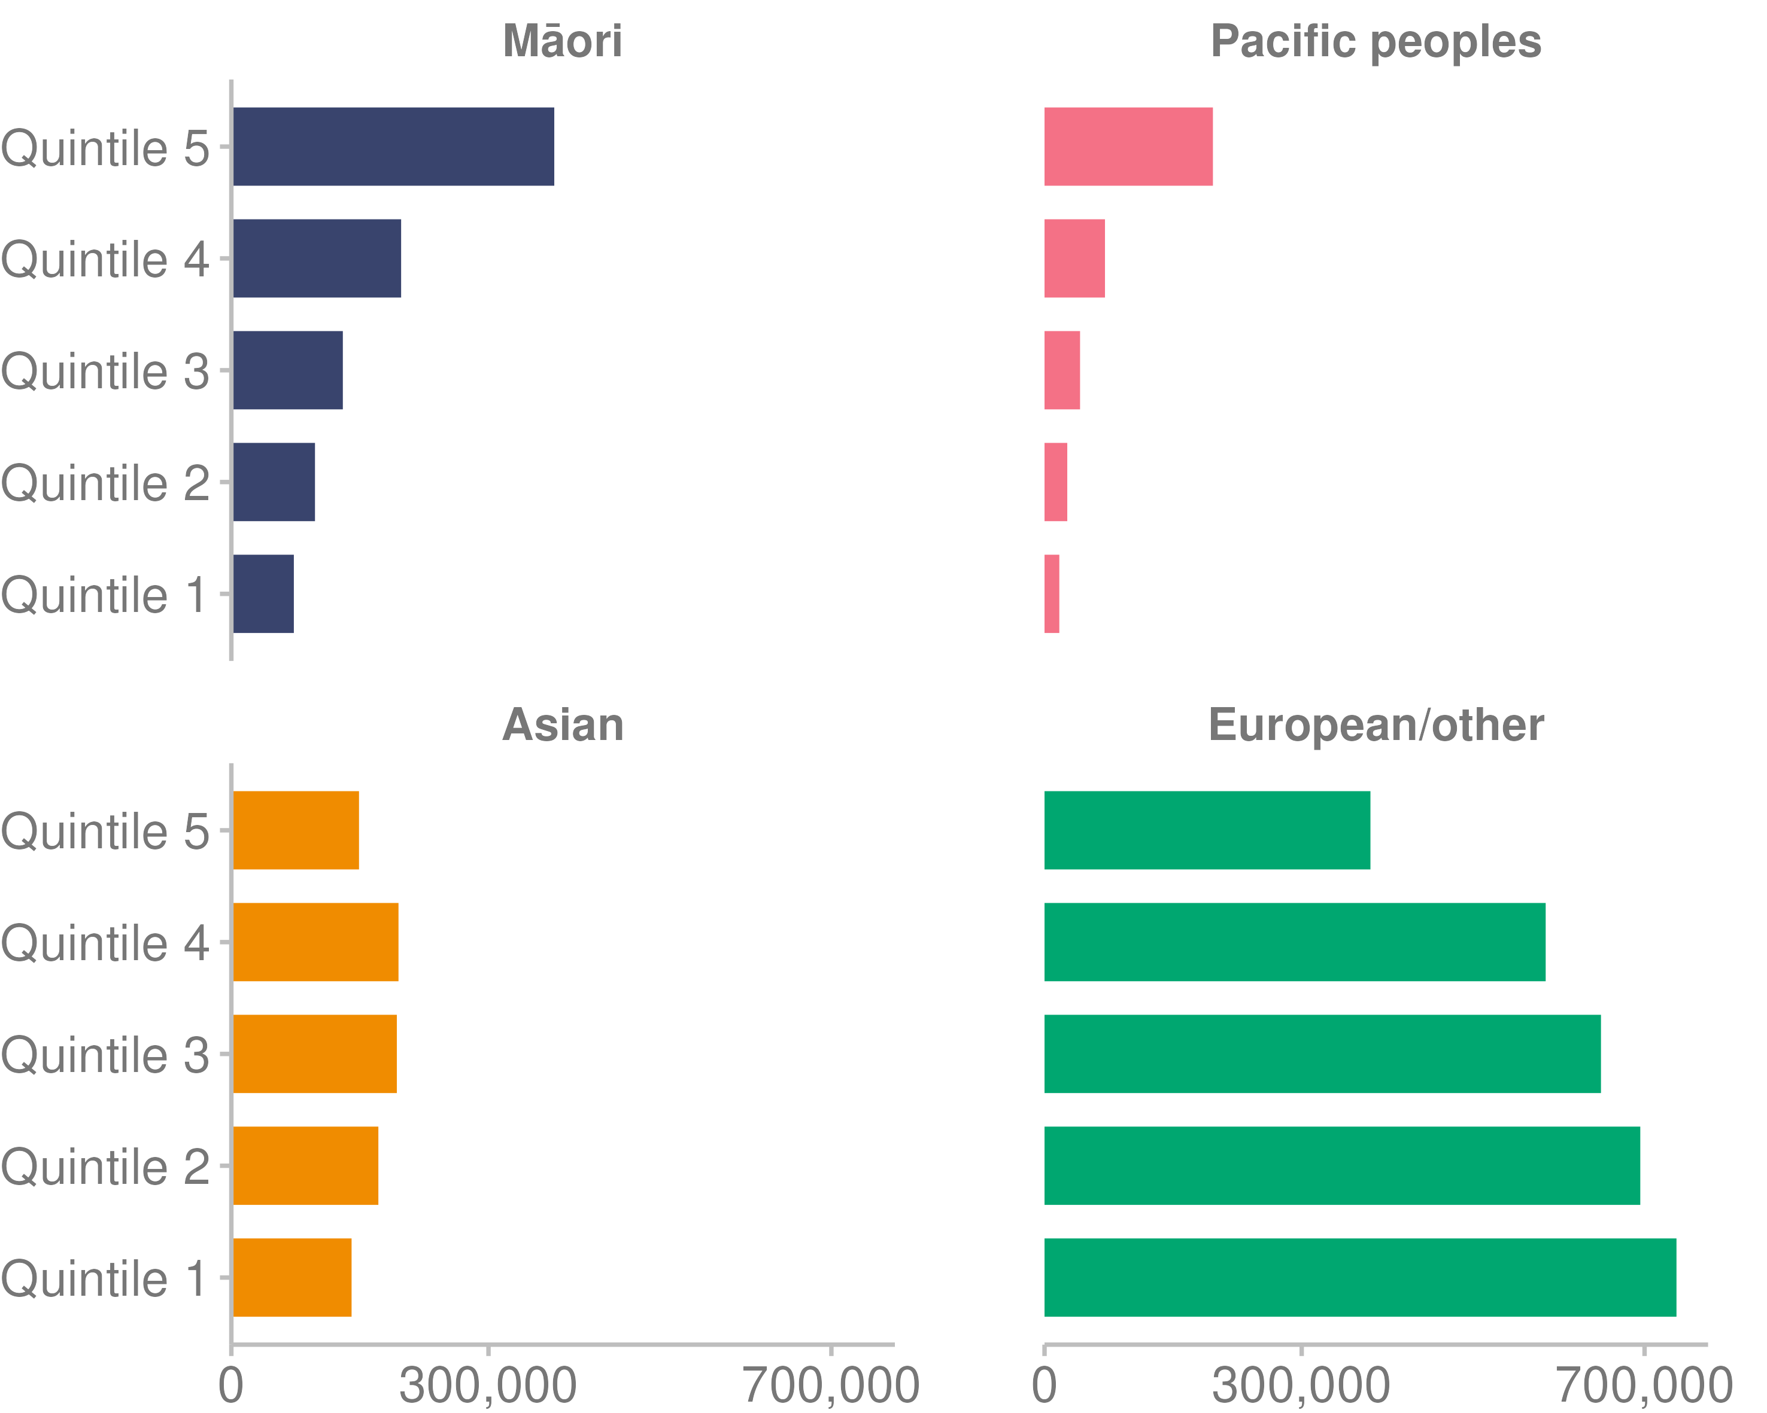

Source: [Ministry of Health (2022w)](https://minhealthnz.shinyapps.io/populations-web-tool/)

Note: Quintile 1 is the least deprived; quintile 5 the most deprived.

### Tobacco use

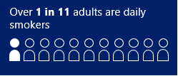Tobacco use is the leading risk factor for loss of years of healthy life, measured in disability-adjusted life years (Institute for Health Metrics and Evaluation 2019). In 2020/21, 9.4% of adults were daily smokers (Ministry of Health 2022b). Daily smokers are current smokers aged 15+ years who smoke every day and have smoked more than 100 cigarettes in their whole life. The 100-cigarette threshold limits the indicator to people with established tobacco use.

Prevalence of daily smokers has declined over time: there was a high of 16.4% in 2011/12 and a low of 9.4% in 2020/21 (Figure 8).

In this context there are inequities between subgroups of the population (Ministry of Health 2022b). In 2020/21:

* 20% of adults living in the most deprived areas smoked daily, compared with 3.4% of adults living in the least deprived areas.
* 13.5% of disabled adults smoked daily, compared with 8.9% of non-disabled adults.

Over the 10 years to 2020/21, a higher proportion of Māori and Pacific adults have reported being daily smokers than people of the Asian and European/other ethnic groups: see Figure 8 below.

Figure 8: Prevalence of adults who were daily smokers, by ethnic group, 2011/12–2020/21

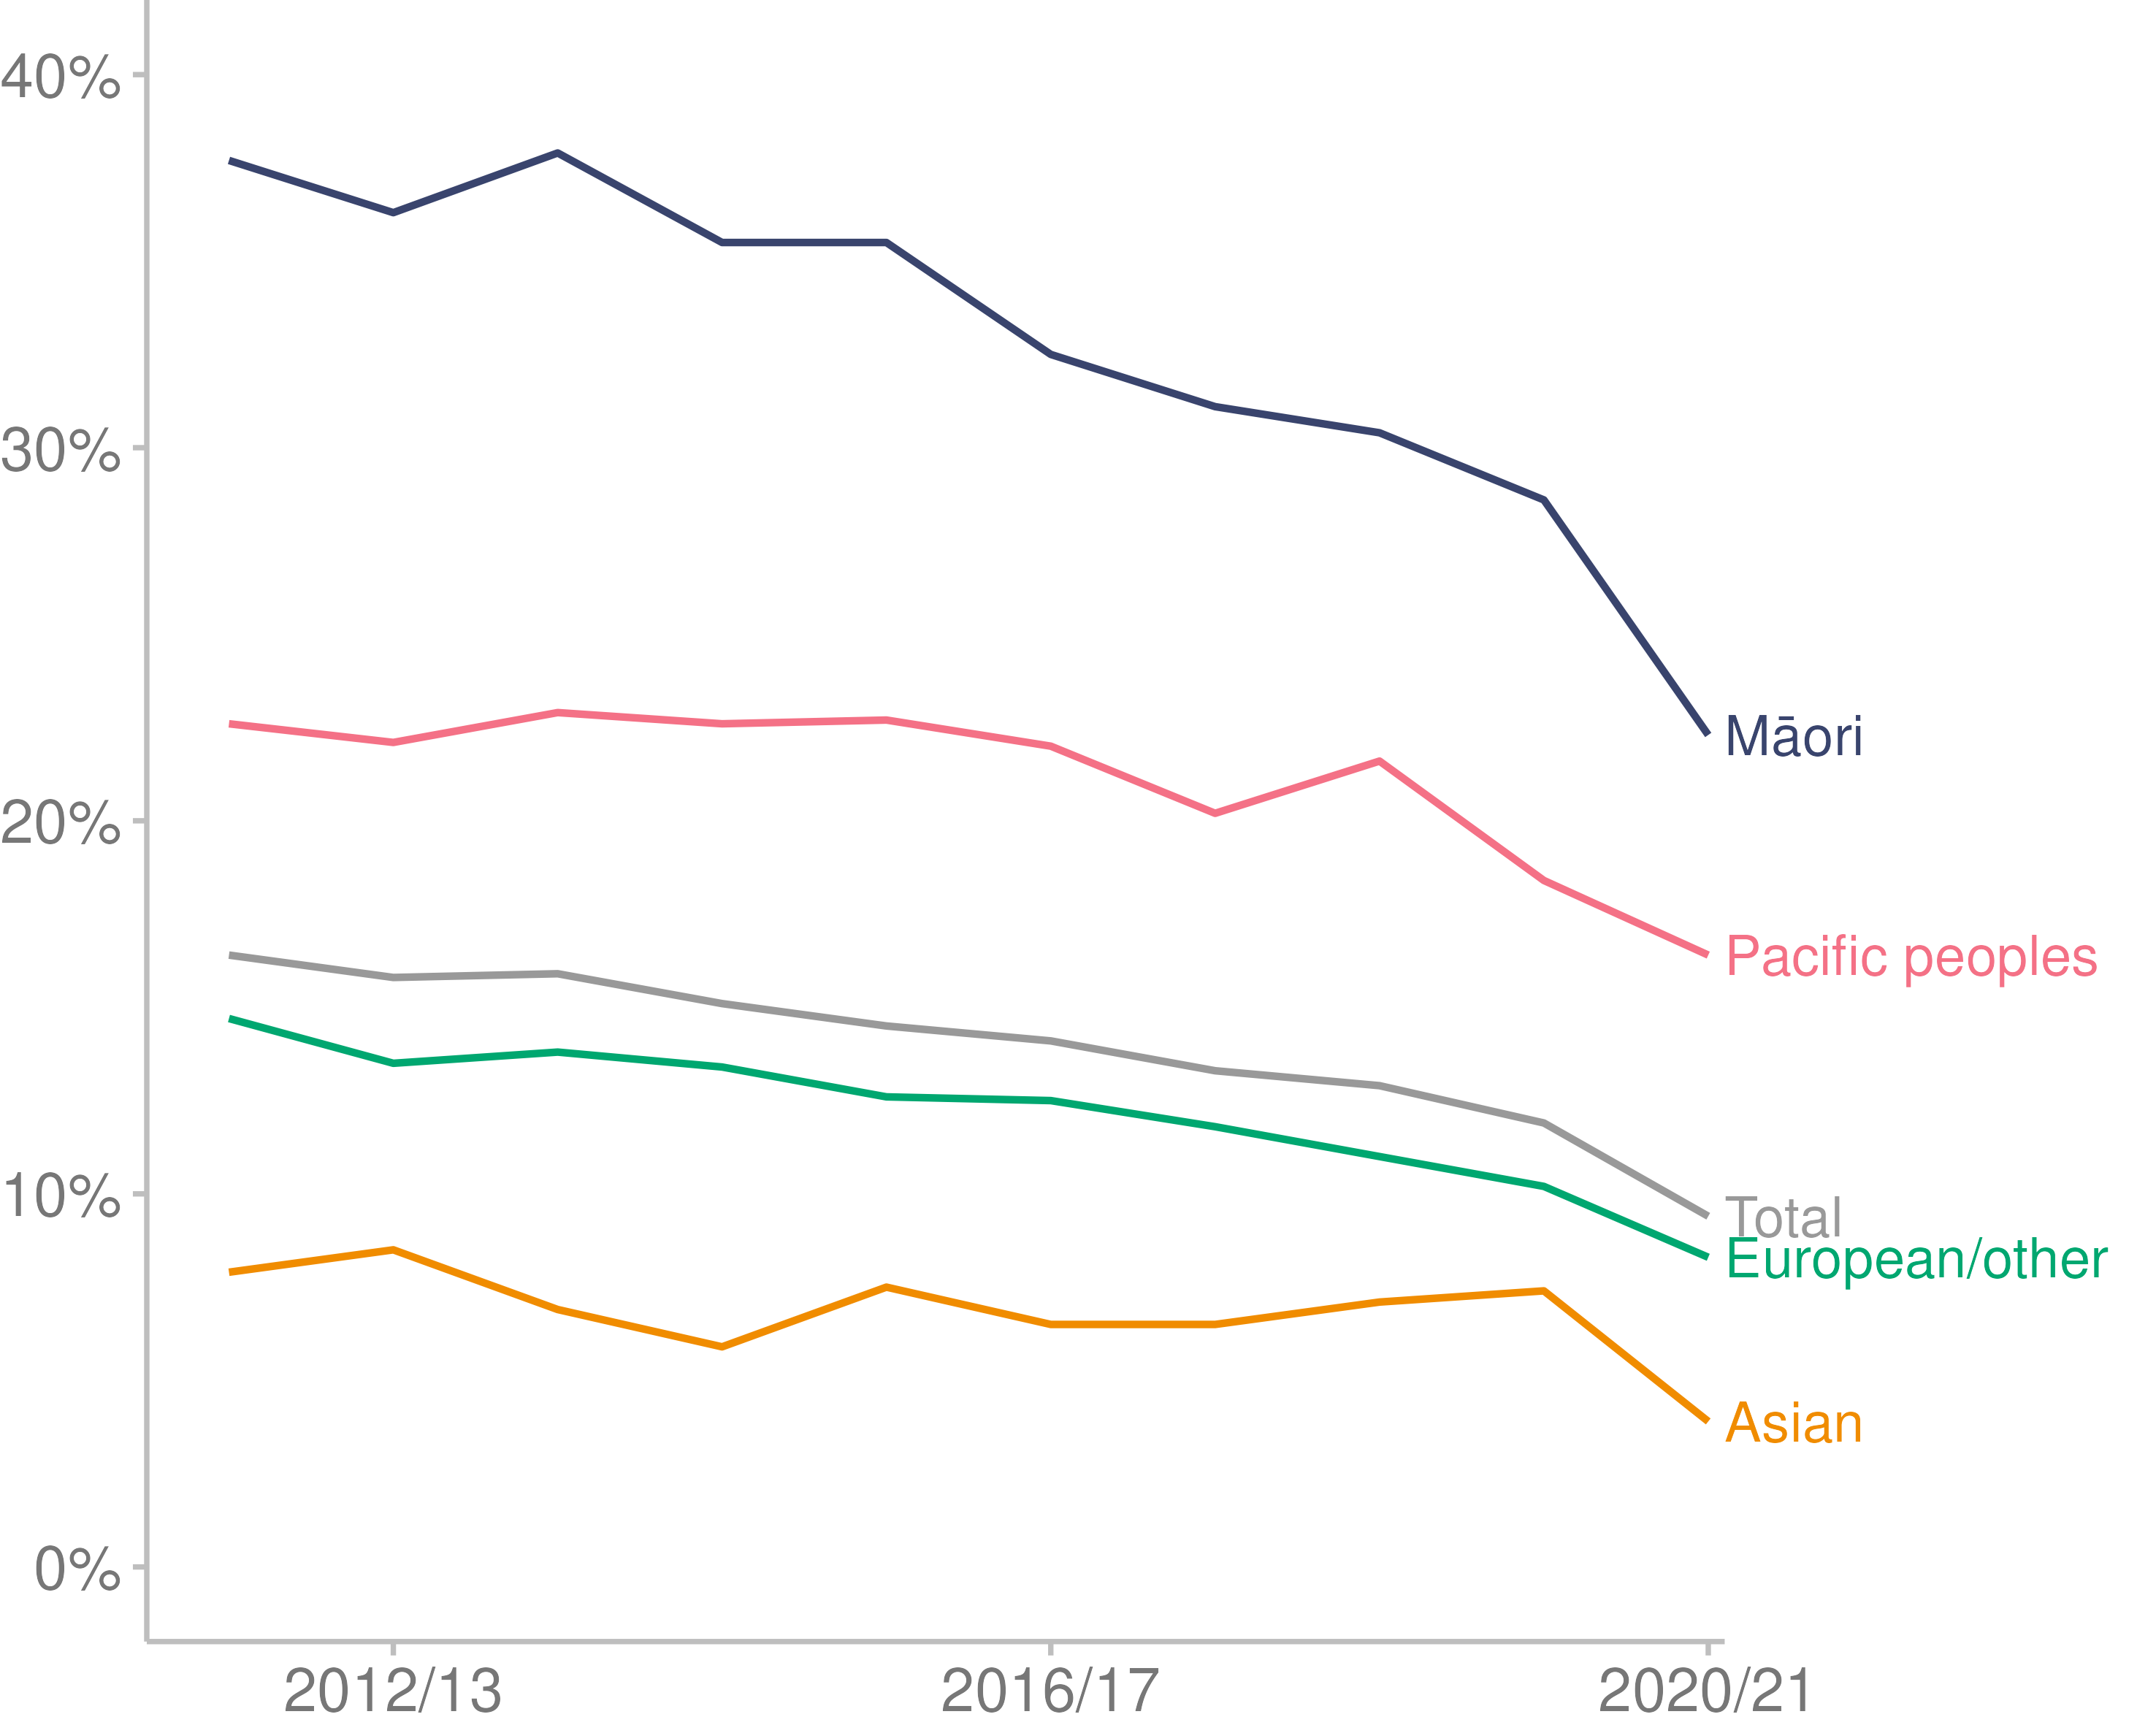

Source: [Ministry of Health (2022b)](https://minhealthnz.shinyapps.io/nz-health-survey-2020-21-annual-data-explorer/_w_871f0fb8/#!/)

The *Smokefree Aotearoa 2025 Action Plan* (Ministry of Health 2021b) sets out the actions we will take to achieve Smokefree 2025. The outcomes of the plan are focused on eliminating inequities in smoking rates, increasing the number of children and young adults who remain smokefree and increasing the number of people who successfully quit smoking.

### Electronic cigarette (vaping) use

The 2020/21 NZHS reported that daily users of electronic cigarettes (vaping) increased from 0.9% of adults in 2015/16 to 6.2% in 2020/21. Electronic cigarette (vaping) use was highest in the 18–24-year-old age group.

### Body size

A healthy weight can help people stay active and well, and reduce the risk of developing type 2 diabetes, heart disease and some cancers (Ministry of Health 2020b).

Having a high body mass index (BMI) increased from the fourth to the second leading risk factor for disability-adjusted life years from 2009 to 2019 (Institute for Health Metrics and Evaluation 2019).

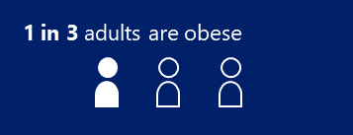In 2020/21, 34.3% of adults were obese (Ministry of Health 2022b). Obesity in adults is measured as a BMI of 30 or higher (World Health Organization 2021).

Prevalence of obesity has increased over time. It increased from 28.8% in 2011/12 to 34.3% in 2020/21 (Figure 9).

In this context, inequities occur between subgroups of the population (Ministry of Health 2022b). In 2020/21:

* 46.6% of adults living in the most deprived areas were obese, compared with 26.8% of adults living in the least deprived areas
* 48.1% of disabled adults were obese, compared with 33.0% of non-disabled adults.

Over the 10 years to 2020/21, Māori and Pacific adults had a higher prevalence of obesity in comparison to people of other ethnic groups. It should be noted that research shows that the same BMI may have different connotations of risk in different ethnic groups. BMI may be an inconsistent measure of obesity for Māori and Pacific people (Moharram et al 2020).

Figure 9: Prevalence of obesity in adults, by ethnic group, 2011/12–2020/21

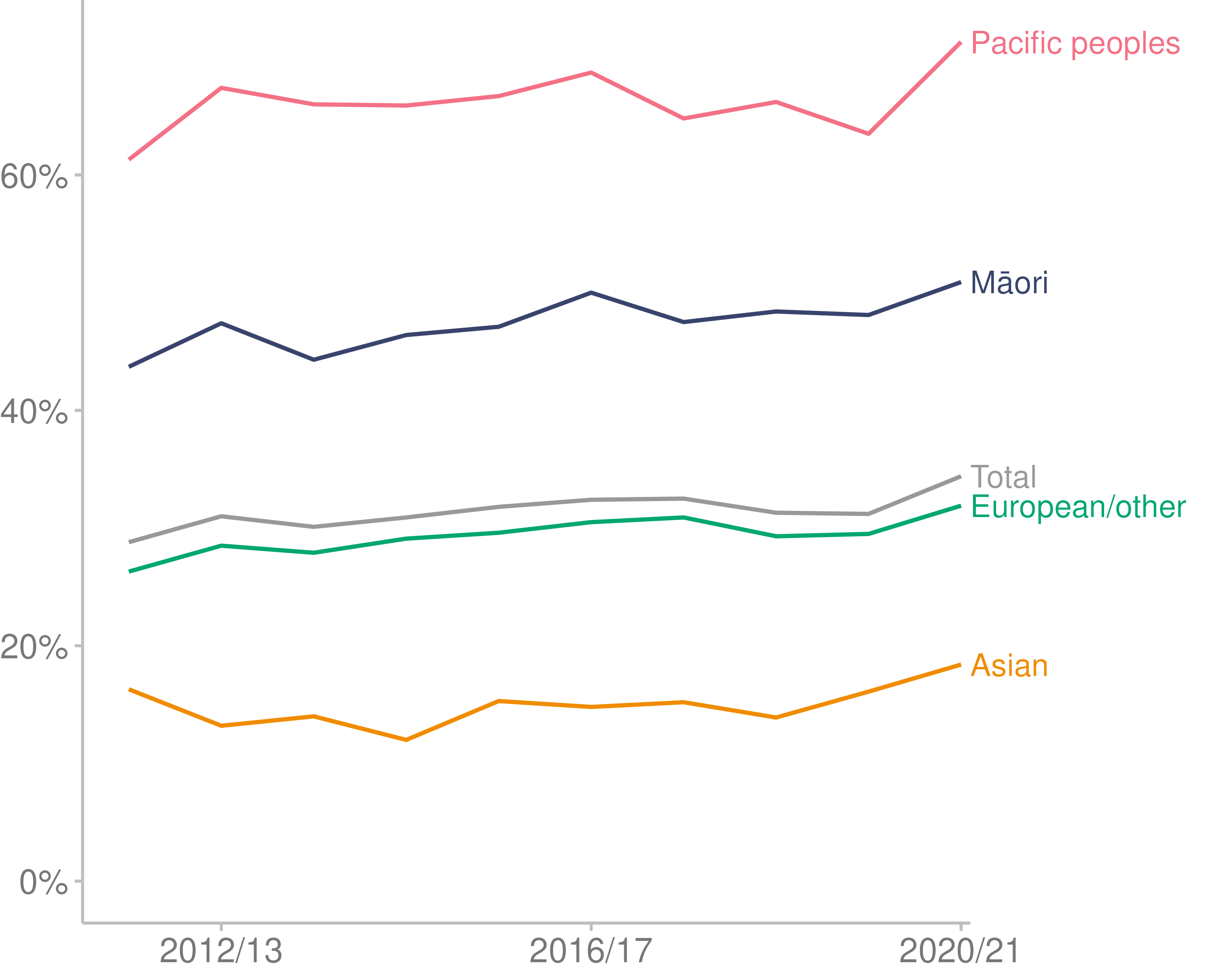

Source: [Ministry of Health (2022b)](https://minhealthnz.shinyapps.io/nz-health-survey-2020-21-annual-data-explorer/_w_871f0fb8/#!/)

#### Obesity in children

In 2020/21, 12.7% of children were obese. Obesity in children is defined as children aged 2–14 years with a BMI equivalent to an adult BMI of 30 or greater.

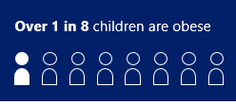Prevalence of obesity in children increased from 9.5% in 2019/20 to 12.7% in 2020/21.

In this context, inequities occur between subgroups of the population (Ministry of Health 2022b). In 2020/21:

* 20.3% of children living in the most deprived areas were obese, compared with 7.2% of children living in the least deprived areas
* 35.3% of Pacific children were obese, compared with 17.8% of Māori children, 10.3% of European/other children and 6.6% of Asian children.

### Alcohol use

Alcohol use decreased from the fifth to the sixth leading risk factor for disability-adjusted life years between 2009 and 2019 (Institute for Health Metrics and Evaluation 2019).

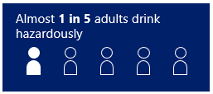

In 2020/21, 19.9% of adults were hazardous drinkers (Ministry of Health 2022b). Hazardous drinkers are defined as those with an established pattern of drinking that carries a high risk of future damage to physical or mental health (World Health Organization 2001).

The prevalence of hazardous drinking has remained stable over time. In 2019/20, the figure was 21.3%, compared to 19.8% in 2016/17 (Figure 10).

In this context, inequities occur between subgroups of the population (Ministry of Health 2022b). In 2020/21:

* 24.9% of adults living in the most deprived areas drank hazardously, compared with 17.3% of adults living in the least deprived areas
* 17.9% of disabled adults drank hazardously, compared with 20.1% of non-disabled adults.

Over the last 6 years, Māori adults had a higher prevalence of hazardous drinking in comparison to Pacific peoples and the European/other ethnic group, while the Asian ethnic group had a lower prevalence than all ethnic groups (Figure 10).

Figure 10: Prevalence of hazardous drinking in adults, by ethnic group, 2015/16–2020/21

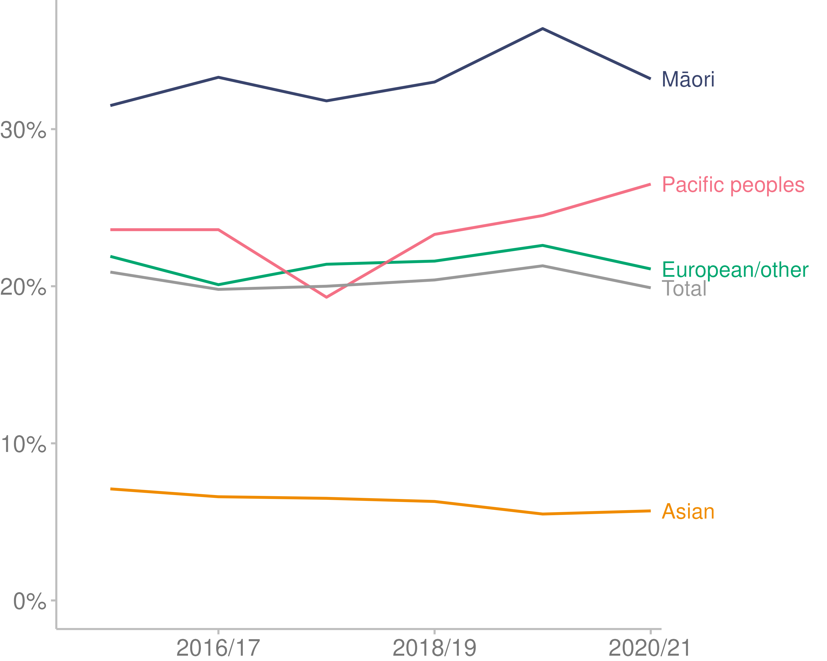

Source: [Ministry of Health (2022b)](https://minhealthnz.shinyapps.io/nz-health-survey-2020-21-annual-data-explorer/_w_871f0fb8/#!/)

### Physical activity

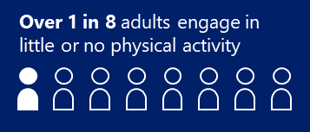In 2020/21, according to the NZHS, 12.8% of the adult population engaged in little or no physical activity (Ministry of Health 2022b). ‘Little or no physical activity’ for adults (aged 15+ years) is defined as less than 30 minutes of physical activity in the past 7 days.

The percentage of the population who engage in little or no physical activity has fluctuated over time: there was a high of 15.3% in 2015/16 and a low of 11.4% in 2017/18 (Figure 11).

The prevalence of engagement in little or no physical activity varies between population groups (Ministry of Health 2022b). In 2020/21:

* 17.7% of adults living in the most deprived areas engaged in little or no physical activity, compared with 9.8% of adults living in the least deprived areas
* 39.9% of disabled adults engaged in little or no physical activity, compared with 10.1% of non-disabled adults.

Over the 10 years to 2021/21, Māori, Asian and Pacific adults had higher prevalence of little or no physical activity in comparison to other ethnic groups (Figure 11).

Figure 11: Prevalence of engagement in little or no physical activity in adults, by ethnic group, 2011/12–2020/21

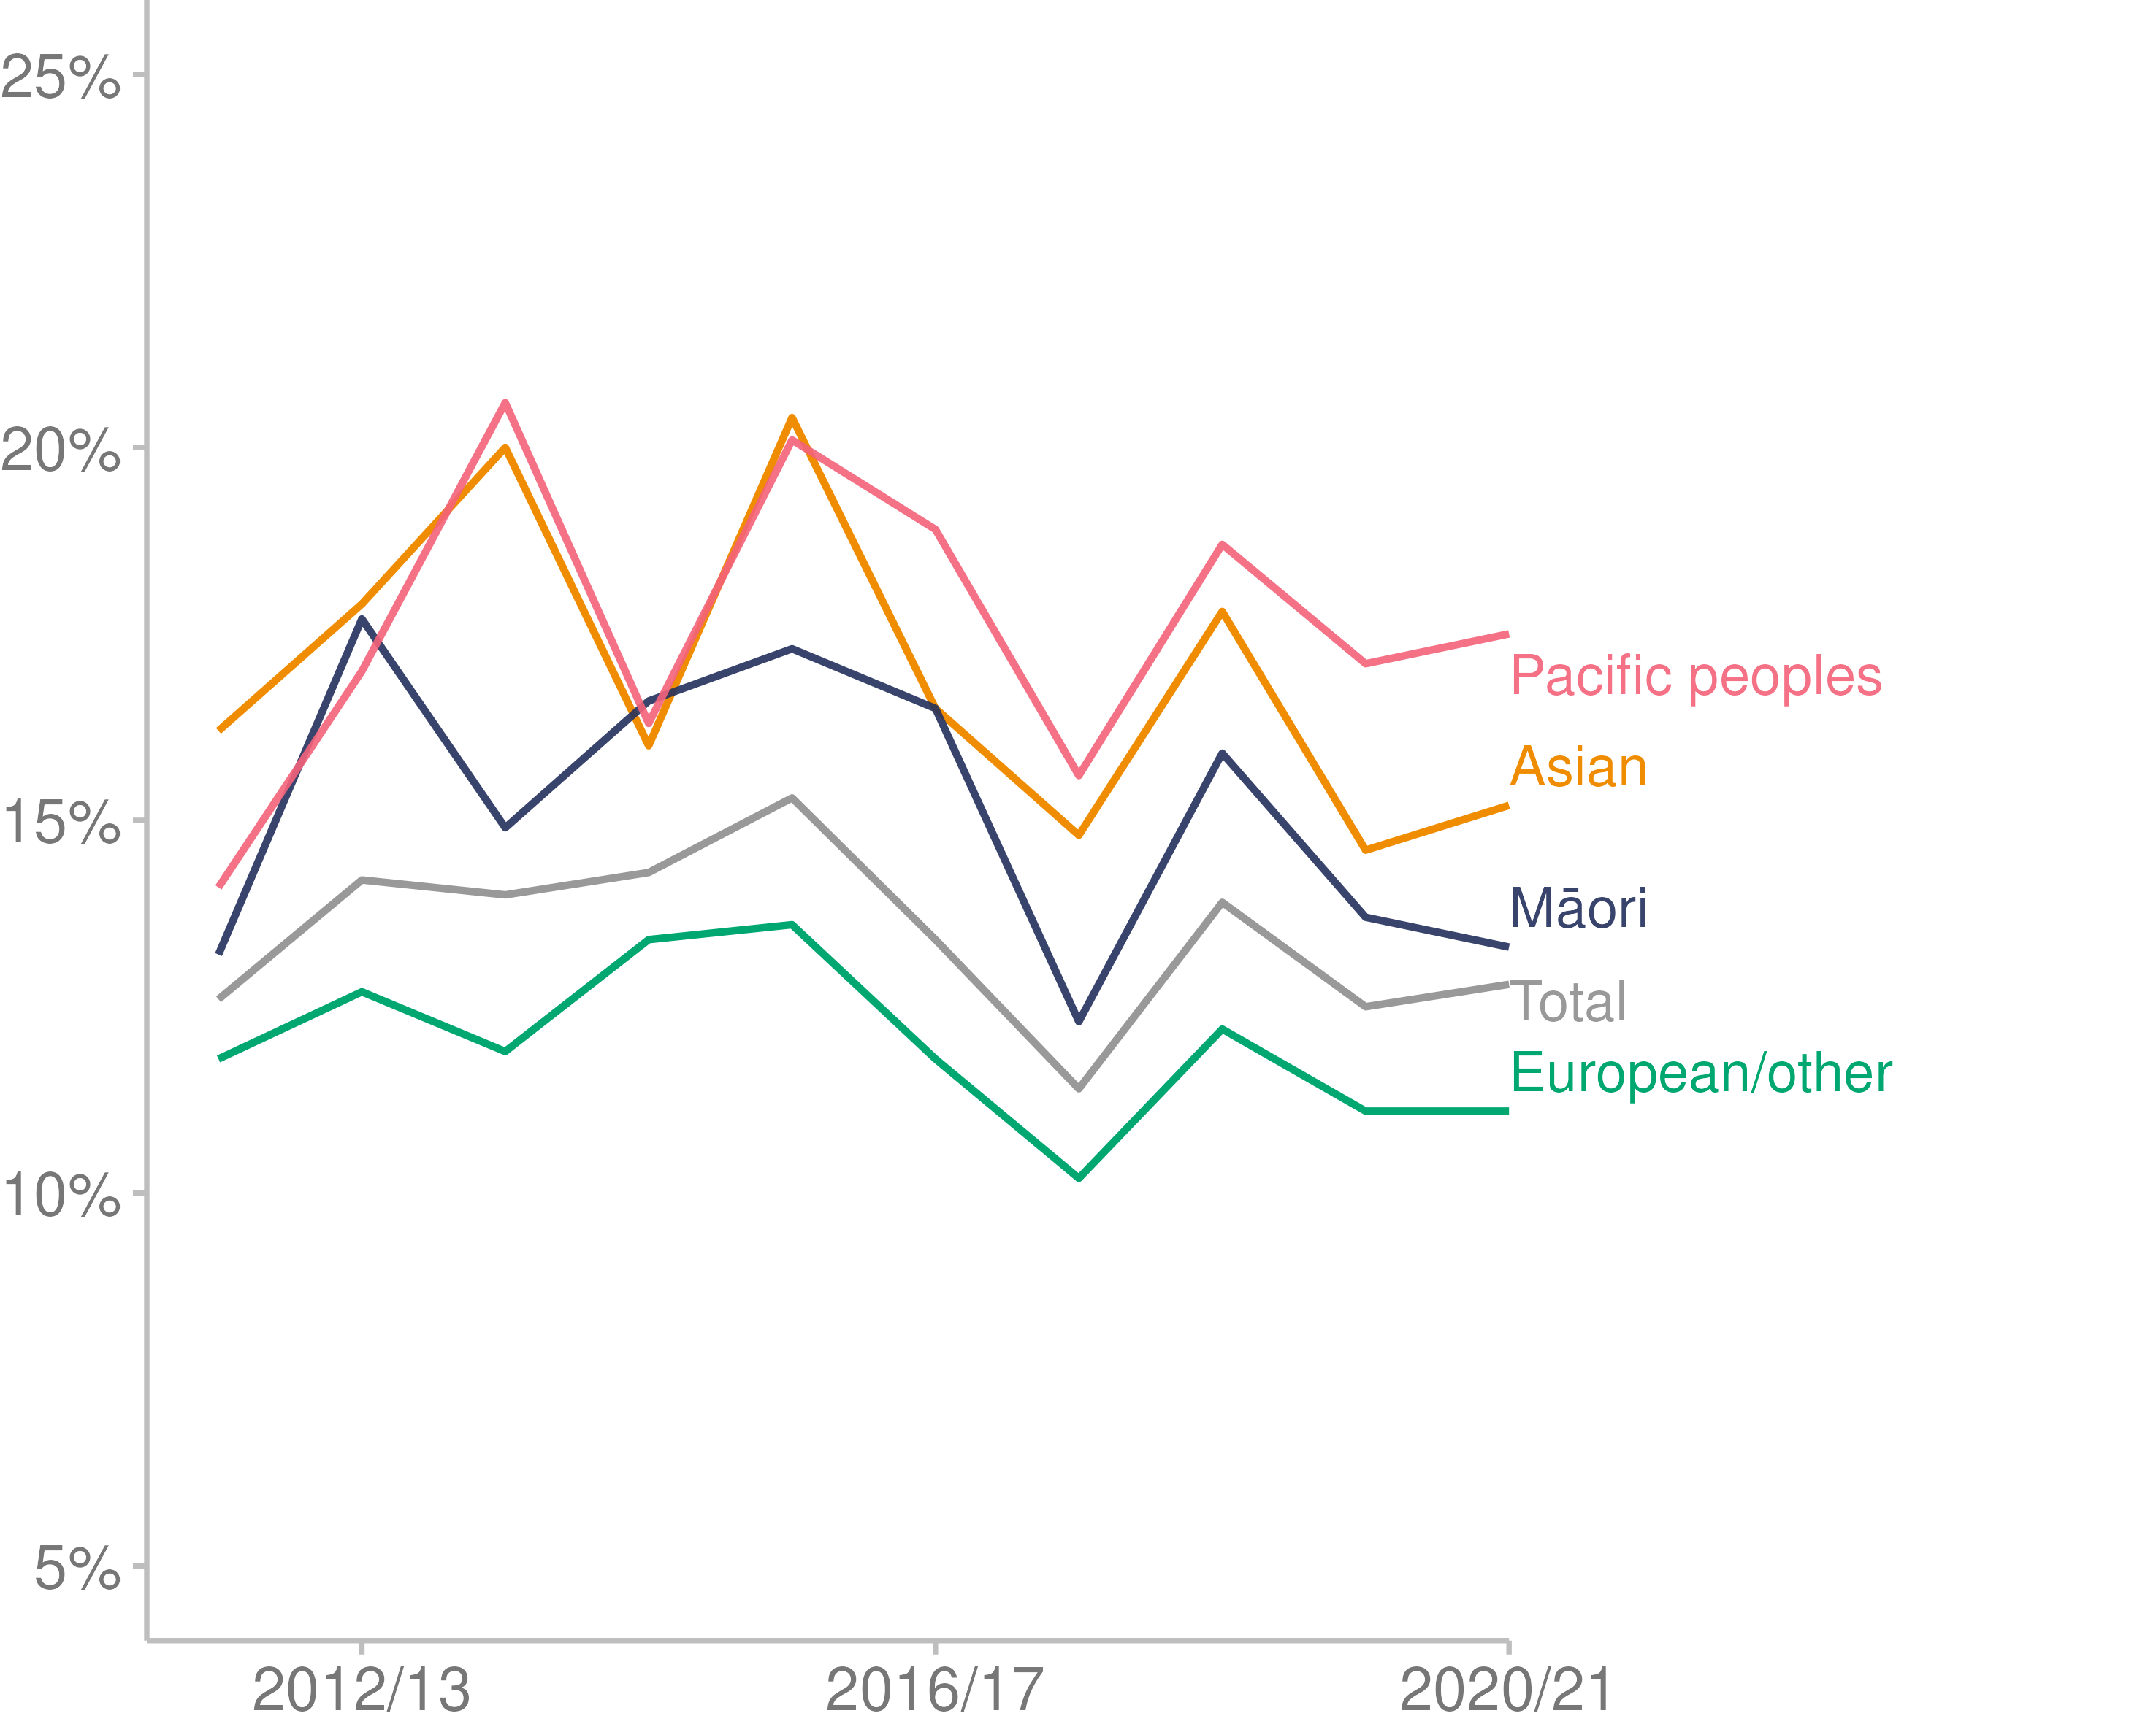

Source: [Ministry of Health (2022b)](https://minhealthnz.shinyapps.io/nz-health-survey-2020-21-annual-data-explorer/_w_871f0fb8/#!/)

# Impacts of COVID-19 | Ngā kawekawe o te Mate KOWHEORI-19

## COVID-19

The COVID-19 pandemic started in late 2019, when the World Health Organization was alerted by Chinese authorities to a mysterious viral pneumonia in Wuhan, China. The World Health Organization declared a global pandemic on 11 March 2020.

Between the start of the outbreak and December 2021, around 287 million confirmed cases and nearly 5.5 million deaths were reported globally (World Health Organization 2022b). However, estimates from the World Health Organization show that the full death toll associated directly or indirectly with the COVID-19 pandemic (described as excess mortality)[1] between 1 January 2020 and 31 December 2021 was approximately 14.9 million (World Health Organization 2022a).

In New Zealand in 2021, there were 10,908 confirmed community cases of COVID-19 and 25 deaths. These were locally acquired cases; that is, they were not associated with overseas travel. In addition, 1,115 overseas-acquired (imported) cases of COVID-19 were detected and managed at the border (Ministry of Health 2022d). It should be noted that the outbreak of the Omicron variant of COVID-19 did not start in the community in New Zealand until 2022.

### The New Zealand COVID-19 management strategy

From the beginning of 2021 through to October that year, the New Zealand Government continued to employ the elimination strategy for COVID-19 that had been in place for most of 2020. This included using a range of control measures to stop the transmission of COVID-19: controlling entry at the border, physical distancing, hygiene measures, personal protective equipment (including masks), testing, contact tracing, and isolating cases and close contacts.

In October 2021, the Government transitioned to a minimisation and protection strategy, aimed at keeping the spread of COVID-19 as low as possible, protecting people most at risk of severe disease/outcomes from COVID-19, minimising the impact of COVID-19 on livelihoods and social connections, and supporting the health system to maintain health services (Ministry of Health 2022d).

### Timeline of events

The following table shows New Zealand COVID-19-related events and responses throughout 2021.

Table 3: New Zealand timeline of major COVID-19 events, 2021

|  |  |  |  |
| --- | --- | --- | --- |
| **January** | **February** | **March** | **April** |
|  | **14:** 3 new community cases  **14:** Auckland at alert level 3; rest of New Zealand at alert level 2  **15:** First COVID-19 vaccine arrives in New Zealand | **7:** Auckland at level 2; rest of New Zealand at alert level 1  **12:** Auckland at alert level 1 | **19:** Quarantine-free travel starts from New Zealand to Australia |
| **May** | **June** | **July** | **August** |
|  | **23:** Wellington at alert level 2  **29:** Wellington joins rest of New Zealand on alert level 1 | **23:** New Zealand pauses quarantine-free travel with Australia | **17**: All New Zealand at alert level 4 following community case of presumed Delta variant  **31:** Auckland and Northland stay at alert level 4; rest of New Zealand at level 3 |
| **September** | **October** | **November** | **December** |
| **7:** All New Zealand except Auckland at alert level 2  **7:** Mandatory mask wearing and limits on indoor and outdoor gathering numbers  **22:** Auckland at alert level 3 | **3:** Part of the Waikato region at alert level 3  **8**: Northland at alert level 3  **19:** Northland at alert level 2  **27:** Parts of Waikato and Auckland at step 1, alert level 3 | **2:** Upper Northland at alert level 3  **2:** Waikato at step 2, alert level 3  **9:** Auckland at step 2, alert level 3  **11:** Upper Northland at alert level 2  **29:** Vaccine booster doses available | **2:** COVID-19 Alert Level System ends  **2:** COVID-19 Protection Framework (Traffic Light System) begins; Auckland and areas with lower vaccination start on red; rest of New Zealand on orange  **16:** First confirmed Omicron border case  **31**: Areas on the Red setting, except for Northland, move to Orange |

### COVID-19 testing

During 2021, most of the testing for COVID-19 was nasopharyngeal polymerase chain reaction (PCR) testing. As Figure 12 shows, test numbers were relatively low and stable until August 2021, when community cases of the Delta variant were detected and the country moved to alert level 4.

Figure 12: COVID-19 weekly community testing numbers and key events in the community, 2021

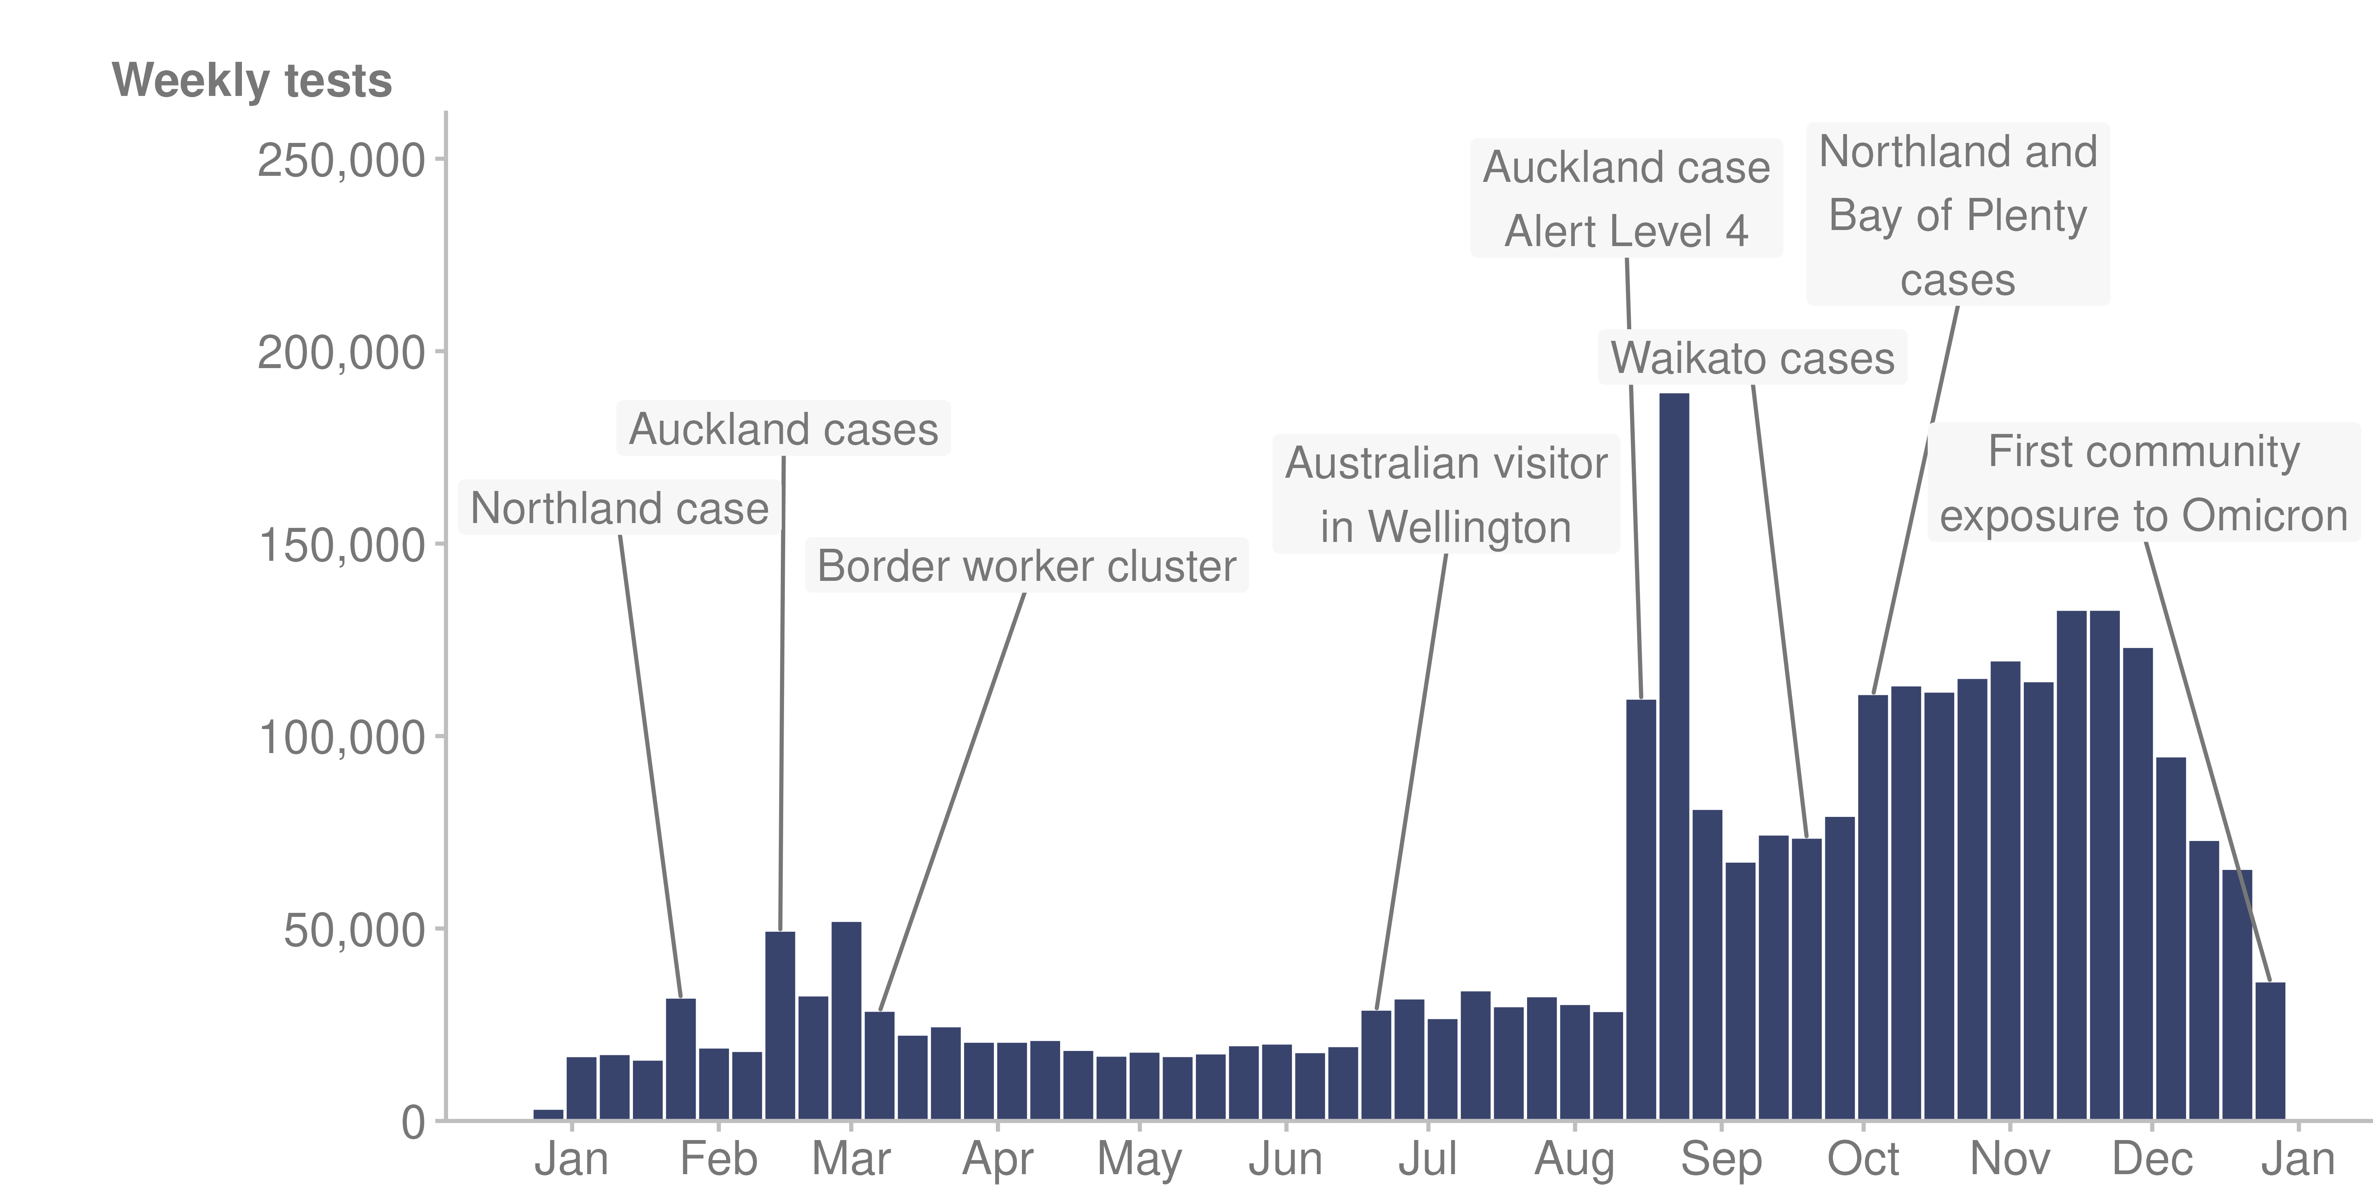

Source: Institute of Environmental Science and Research (ESR) (2022)

Testing rates differed between ethnic groups. Overall, Pacific peoples had higher rates of COVID-19 testing than other ethnic groups (Figure 13).

Figure 13: COVID-19 weekly community testing rates, by prioritised ethnic group, 2021

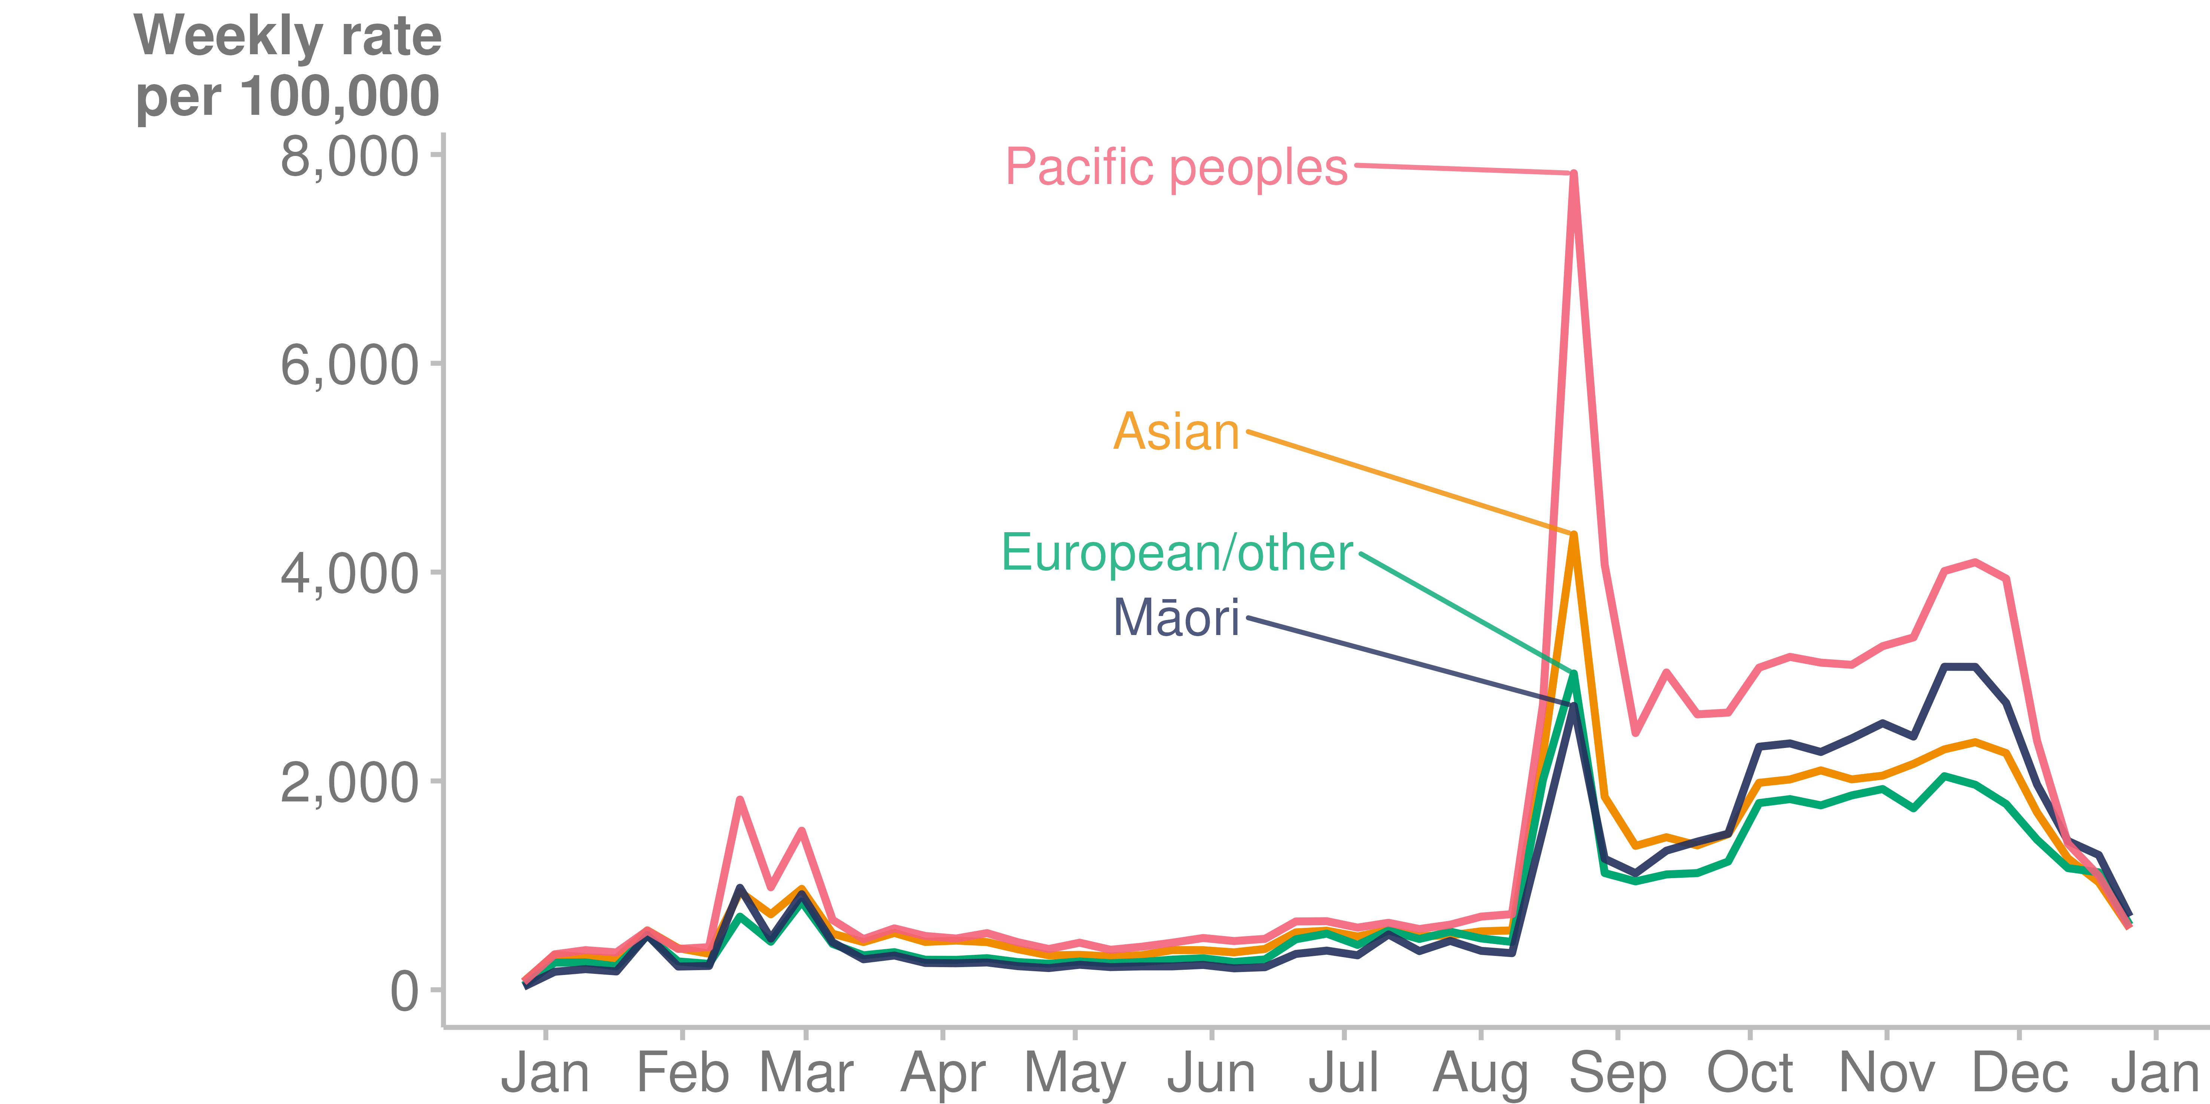

Source: Institute of Environmental Science and Research (ESR) (2022)

### Case information

Figures 14–16 show that community cases of COVID-19 were higher for

* Pacific peoples and Māori, compared to non-Māori, non-Pacific peoples (Figure 14)
* children under 10 years of age and people aged 20-29 (Figure 15)
* people living in the highest deprivation areas (Figure 16).

Figure 14: COVID-19 community case rates, by prioritised ethnicity, 2021

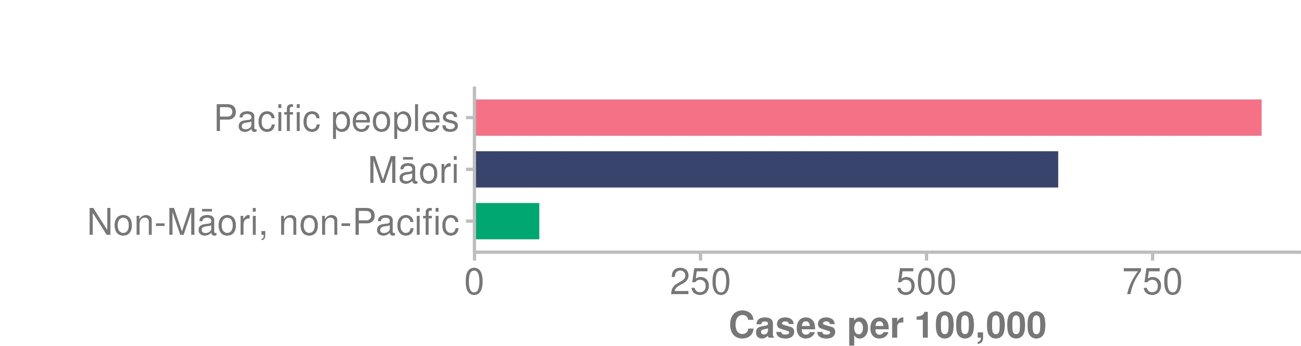

Source: Institute of Environmental Science and Research (ESR) (2022)

Figure 15: COVID-19 community case rates, by age group, 2021

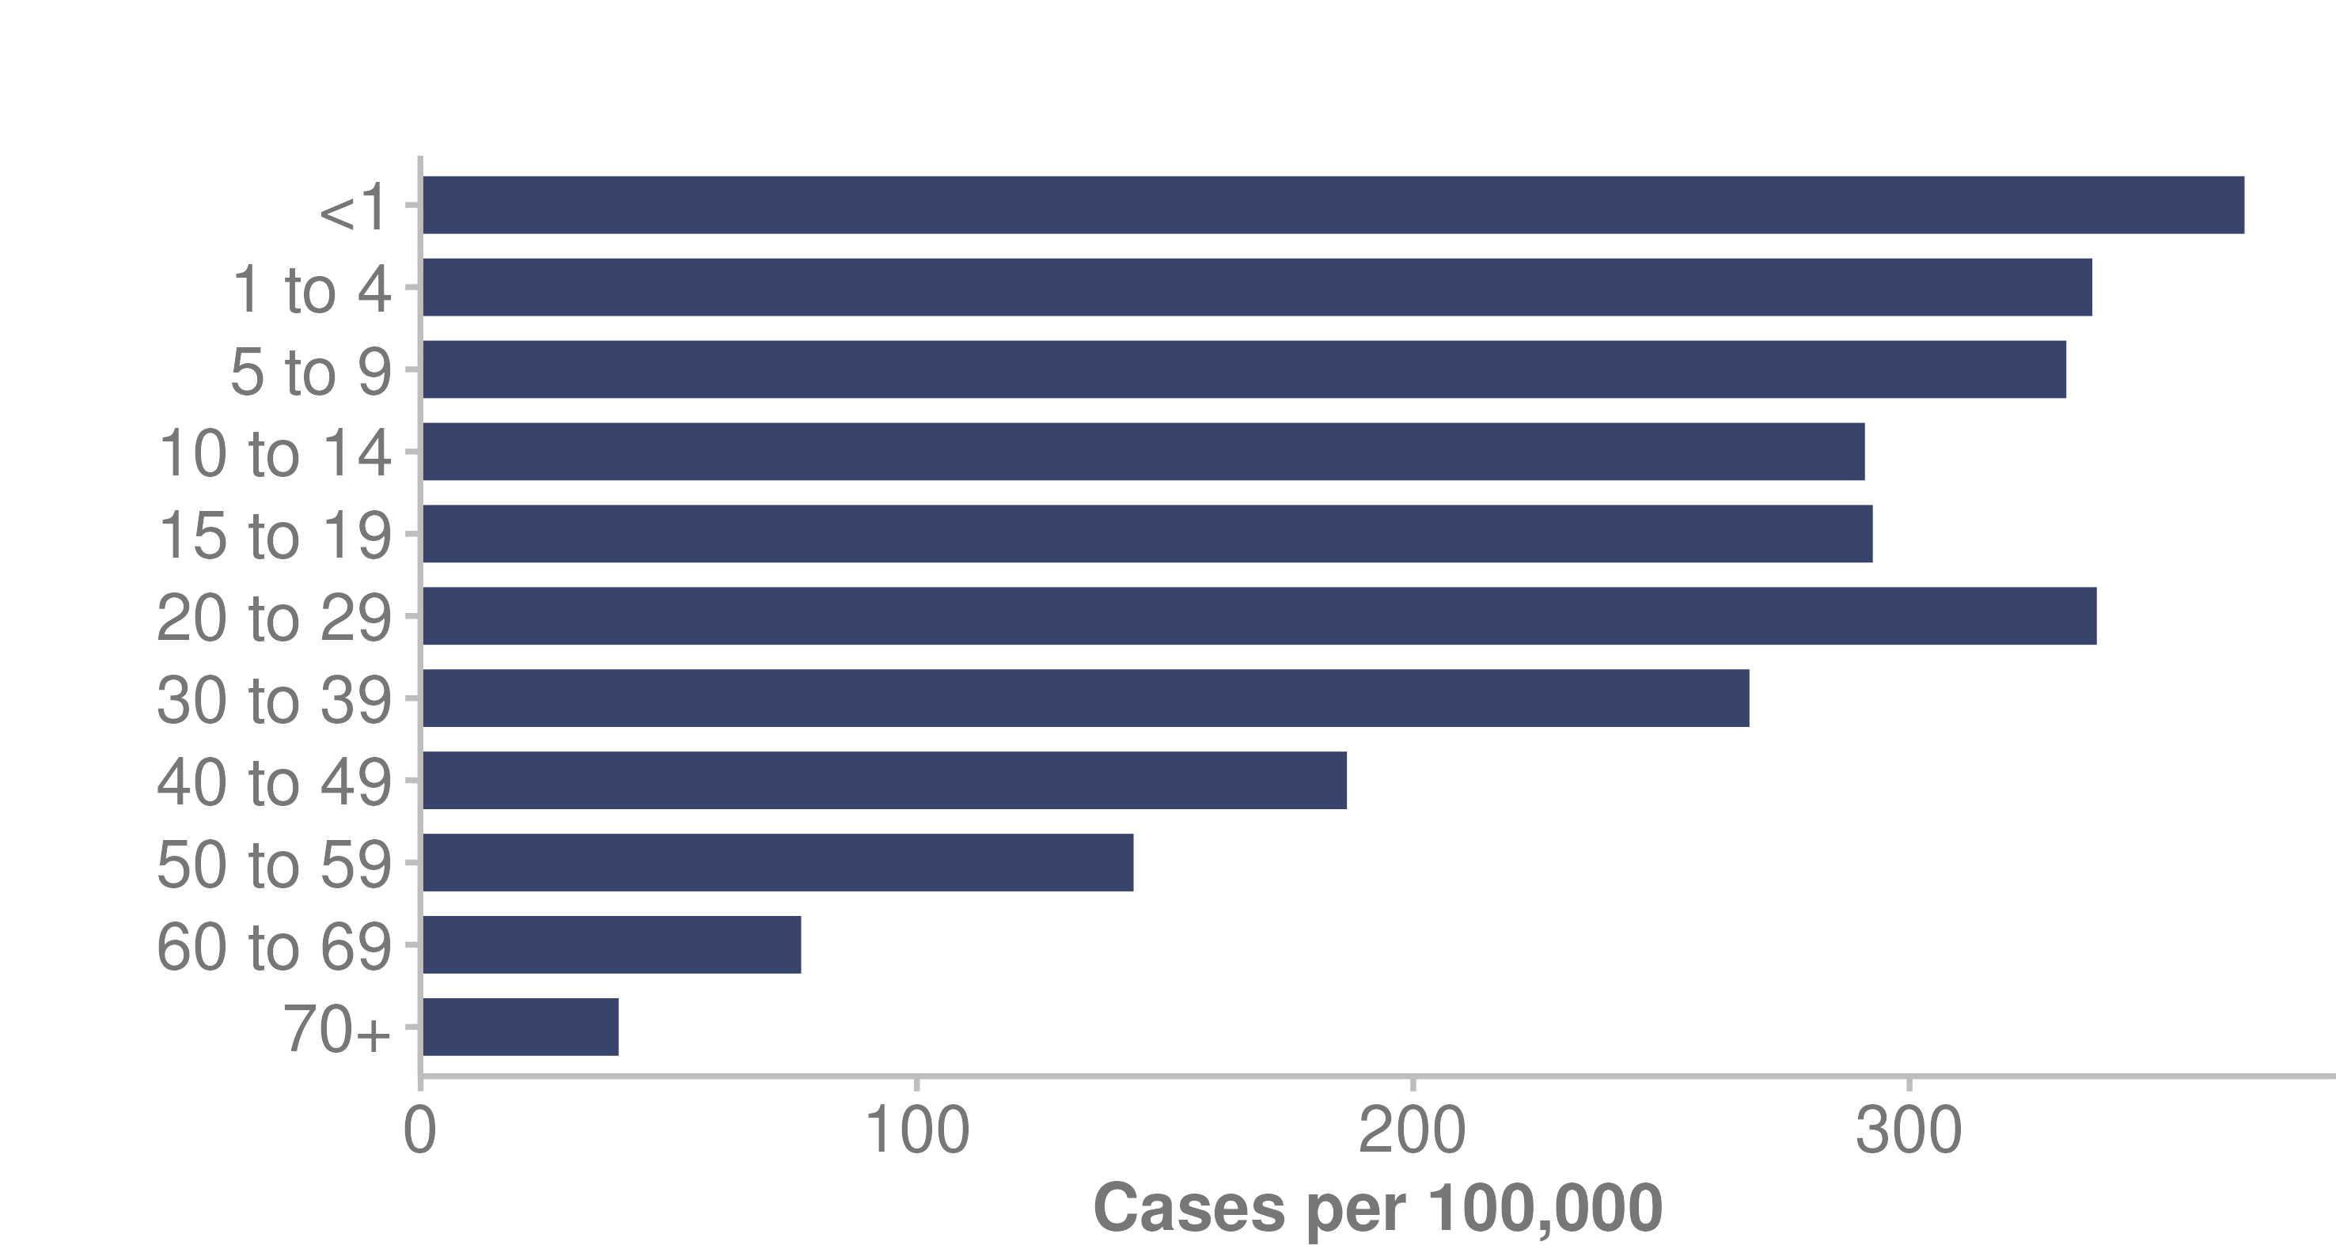

Source: Institute of Environmental Science and Research (ESR) (2022)

Figure 16: COVID-19 community case rates, by NZDep2018 deprivation quintile, 2021

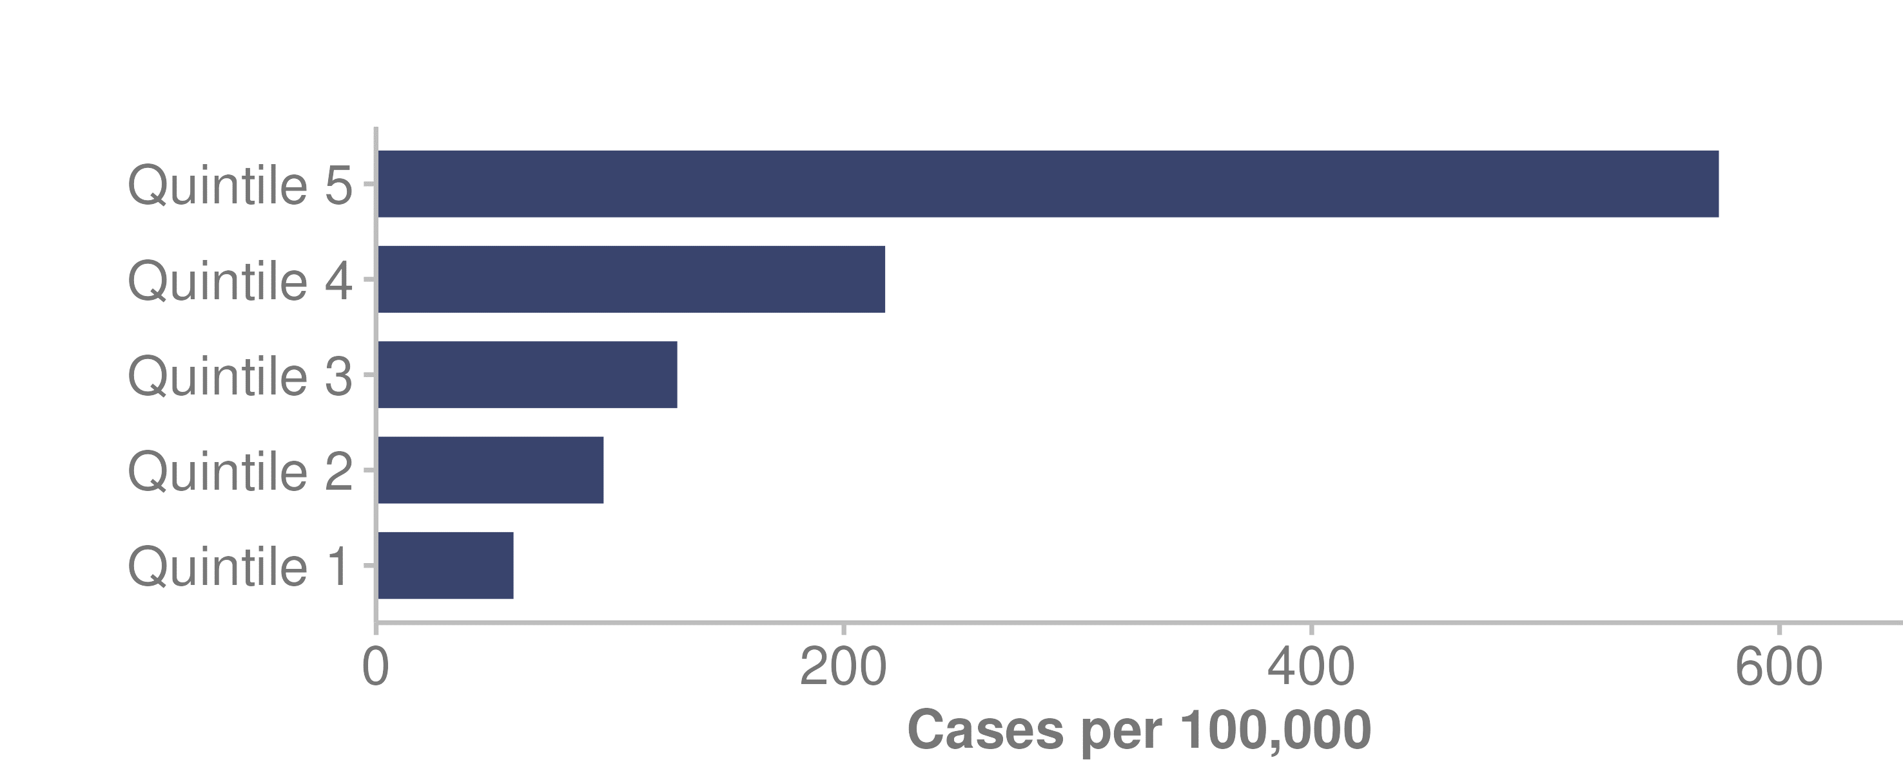

Source: Institute of Environmental Science and Research (ESR) (2022)

Note: Quintile 1 is the least deprived; quintile 5 the most deprived

### Deaths with COVID-19

In 2021, 25 people died with COVID-19 in New Zealand (ESR 2022). Those not fully vaccinated accounted for 80% of deaths. All deaths below the age of 60 were in unvaccinated people. It should be noted that the period covered in this report is prior to the Omicron outbreak in New Zealand. The first community case of Omicron in New Zealand occurred in January 2022.

### COVID-19 vaccinations

In 2021, vaccinations for COVID-19 became available in New Zealand. There was a staged approach to COVID-19 vaccinations, to:

* manage the demand for vaccination to meet the level of supply in vaccine and vaccinators available
* reach the population groups at highest risk first.

COVID-19 vaccination started for border workers, Managed Isolation and Quarantine (MIQ) workers and their household contacts in February 2021. This was followed with vaccination for front-line workers, people living in high-risk settings and priority populations (Unite against COVID-19 2021).

Next, the government offered vaccination to the remaining eligible population, progressing from older to younger age groups. By September 2021, vaccination bookings were open to everyone aged 12 and over.

The following figure shows the COVID-19 vaccination status of confirmed community cases.

Figure 17: Vaccination status of COVID-19 cases in the community, 2021

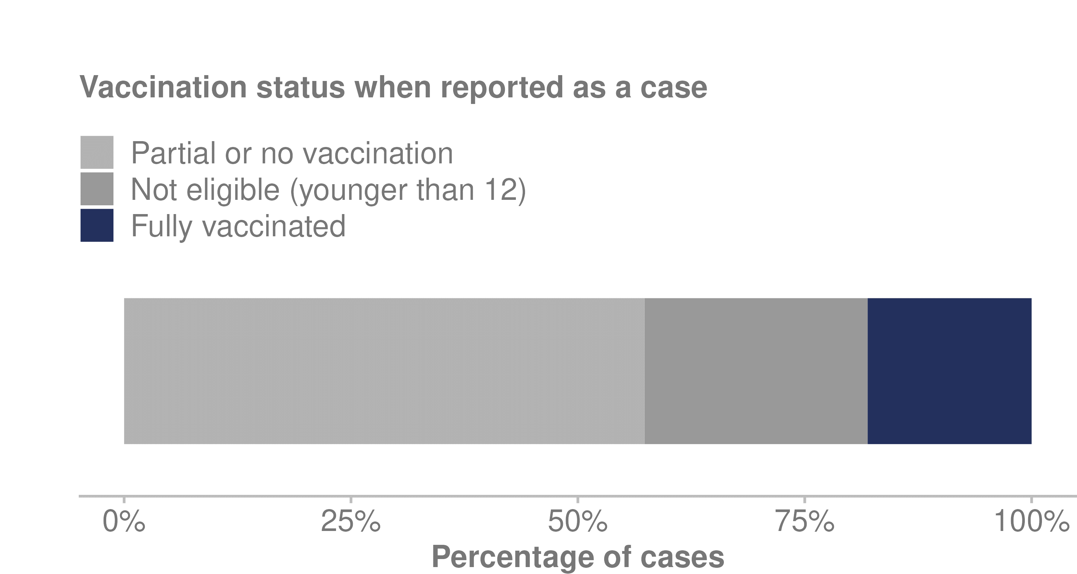

Source: Institute of Environmental Science and Research (ESR) (2022)

#### Vaccinator numbers

To help administer COVID-19 vaccines, Manatū Hauora created new roles for vaccinators. By 26 December 2021, there were 15,547 trained vaccinators and 11,184 active vaccinators, and 8,111,196 vaccinations had been administered.

#### Vaccination rates

The aim of the COVID-19 vaccination programme was to vaccinate at least 90% of the eligible population by the end of 2021. This was achieved: the overall vaccination rate for the eligible population was 92.8% at 31 December 2021 (Ministry of Health 2022d).

COVID-19 vaccination rates differed between population groups: Māori, Pacific peoples and people living in highly deprived neighbourhoods had lower vaccination rates.

Māori had the lowest COVID-19 vaccination rate: 81.3% of Māori aged 12 years and over had completed a primary course by the end of 2021. The Asian population group had the highest rate, of 104.4% (rates could exceed 100%, as sometimes more people were vaccinated in an ethnic group or a region than were identified in the 2020 HSU (Figure 18).

It should be noted that data used in this section of the report is the 2020 HSU dataset (as mentioned above, we used the HSU 2020 for COVID-19 reporting in this report for consistency with data we reported in 2021). The 2021 HSU was updated to include those vaccinated in 2021 (Stats NZ 2022c).

Disabled people had higher rates of vaccination (at least one dose) than non-disabled people at November 2021, according to analysis carried out by the Social Wellbeing Agency (Office for Disability Issues 2022). 90% of disabled people had at least one dose, compared with 83% of non-disabled people.

Figure 18: COVID-19 vaccination uptake, by ethnic group, 2021

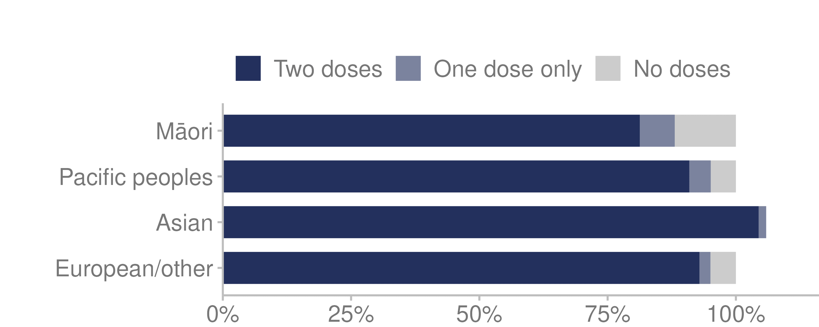

Source: Ministry of Health unpublished data (2022)

Figure 19: COVID-19 vaccination uptake, by NZDep2018 deprivation quintile, 2021

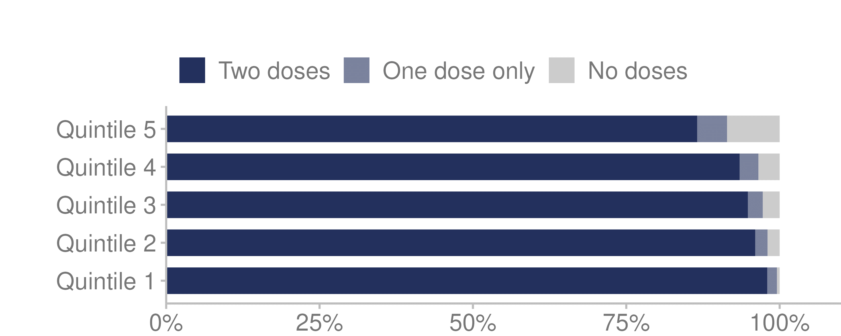

Source: Ministry of Health unpublished data (2022)

Note: Quintile 1 is the least deprived; quintile 5 the most deprived.

Those living in the most deprived areas (quintile 5) had the lowest vaccination uptake: in this quintile, 86.6% of people 12 years and over had completed their primary course at the end of 2021. People living in the least deprived areas (quintile 1) had the highest rate, at 98.0% (Figure 19).

Young people aged 12–17 years of age had the lowest vaccination uptake: 75.6% had completed their primary course at the end of 2021. Vaccination was not made available for under 12-year-olds until early 2022 (The Immunisation Advisory Centre 2021). People aged 65 years and over had the highest uptake, at 103.6% (Figure 20).

Figure 20: COVID-19 vaccination uptake, by eligible age groups, 2021

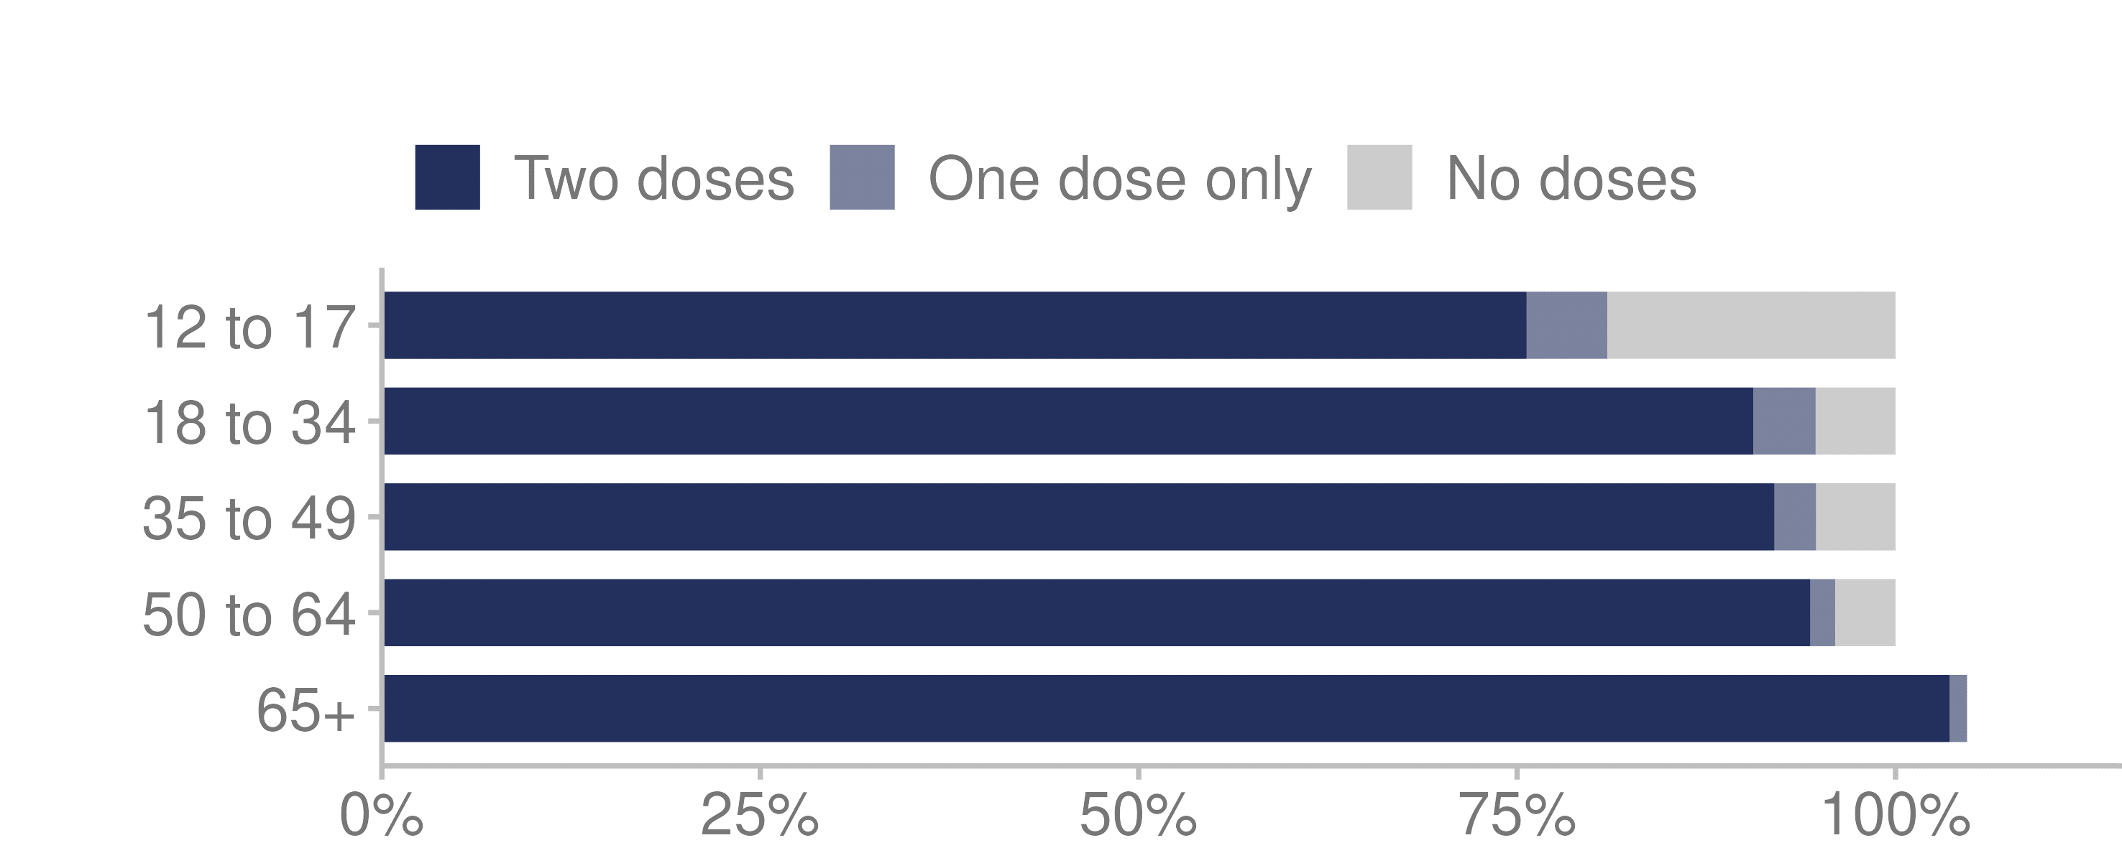

Source: Ministry of Health unpublished data (2022)

#### Vaccination by area

Northland had the lowest vaccination uptake: 84.7% of eligible people in that region had completed their primary course at the end of 2021. Canterbury had the highest uptake, at 96.9% (Figure 21).

Figure 21: COVID-19 vaccination uptake, by district health board, 2021

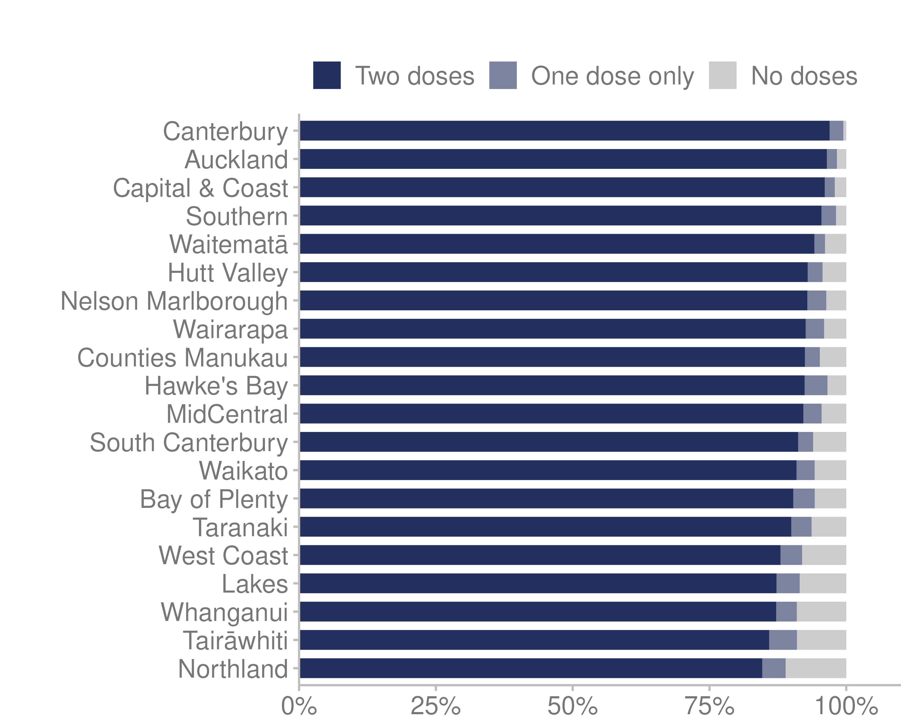

Source: Ministry of Health unpublished data (2022)

# Health measures | Ngā inenga hauora

This section of the report provides information on various health topics, including:

* maternity care
* enrolment with a PHO
* barriers to accessing health care
* oral health for children
* immunisation
* cancer
* mental wellbeing
* long-term conditions
* hospitalisations
* the health workforce.

## Maternity care

In 2021, 58,659 live births were registered in Aotearoa New Zealand. This was 1,086 more births (1.9%) than 2020 (Stats NZ 2022a).

### Primary maternity care

Maternity care is fully funded for eligible women in Aotearoa New Zealand (Ministry of Health 2018).

There is an increasing trend for women to register with a Lead Maternity Carer (LMC) (such as a midwife, general practitioner (GP) or obstetrician) in the first trimester (the first 12 weeks) of pregnancy (Ministry of Health 2022o). There is evidence that this early engagement has the potential to reduce inequities in maternal and child health outcomes (Bartholomew et al 2015). This maternity section uses 2020 data, as this is the most recently published data available (Ministry of Health 2022o).

In 2020, 96.3% of women giving birth registered for lead maternity care. Of these, 69.3% registered in the first trimester, up from 53.8% in 2011 (Ministry of Health 2022o).

There are differences in LMC registration patterns between age groups, ethnic groups, and deprivation levels. Figures 22–24 display these patterns, and cover the period 2011–2020.

Figure 22 shows that, in the 10 years to 2020, a lower percentage of younger women registered with an LMC in the first trimester.

Figure 22: Proportion of women registering with a lead maternity carer in the first trimester, by age, 2011–2020

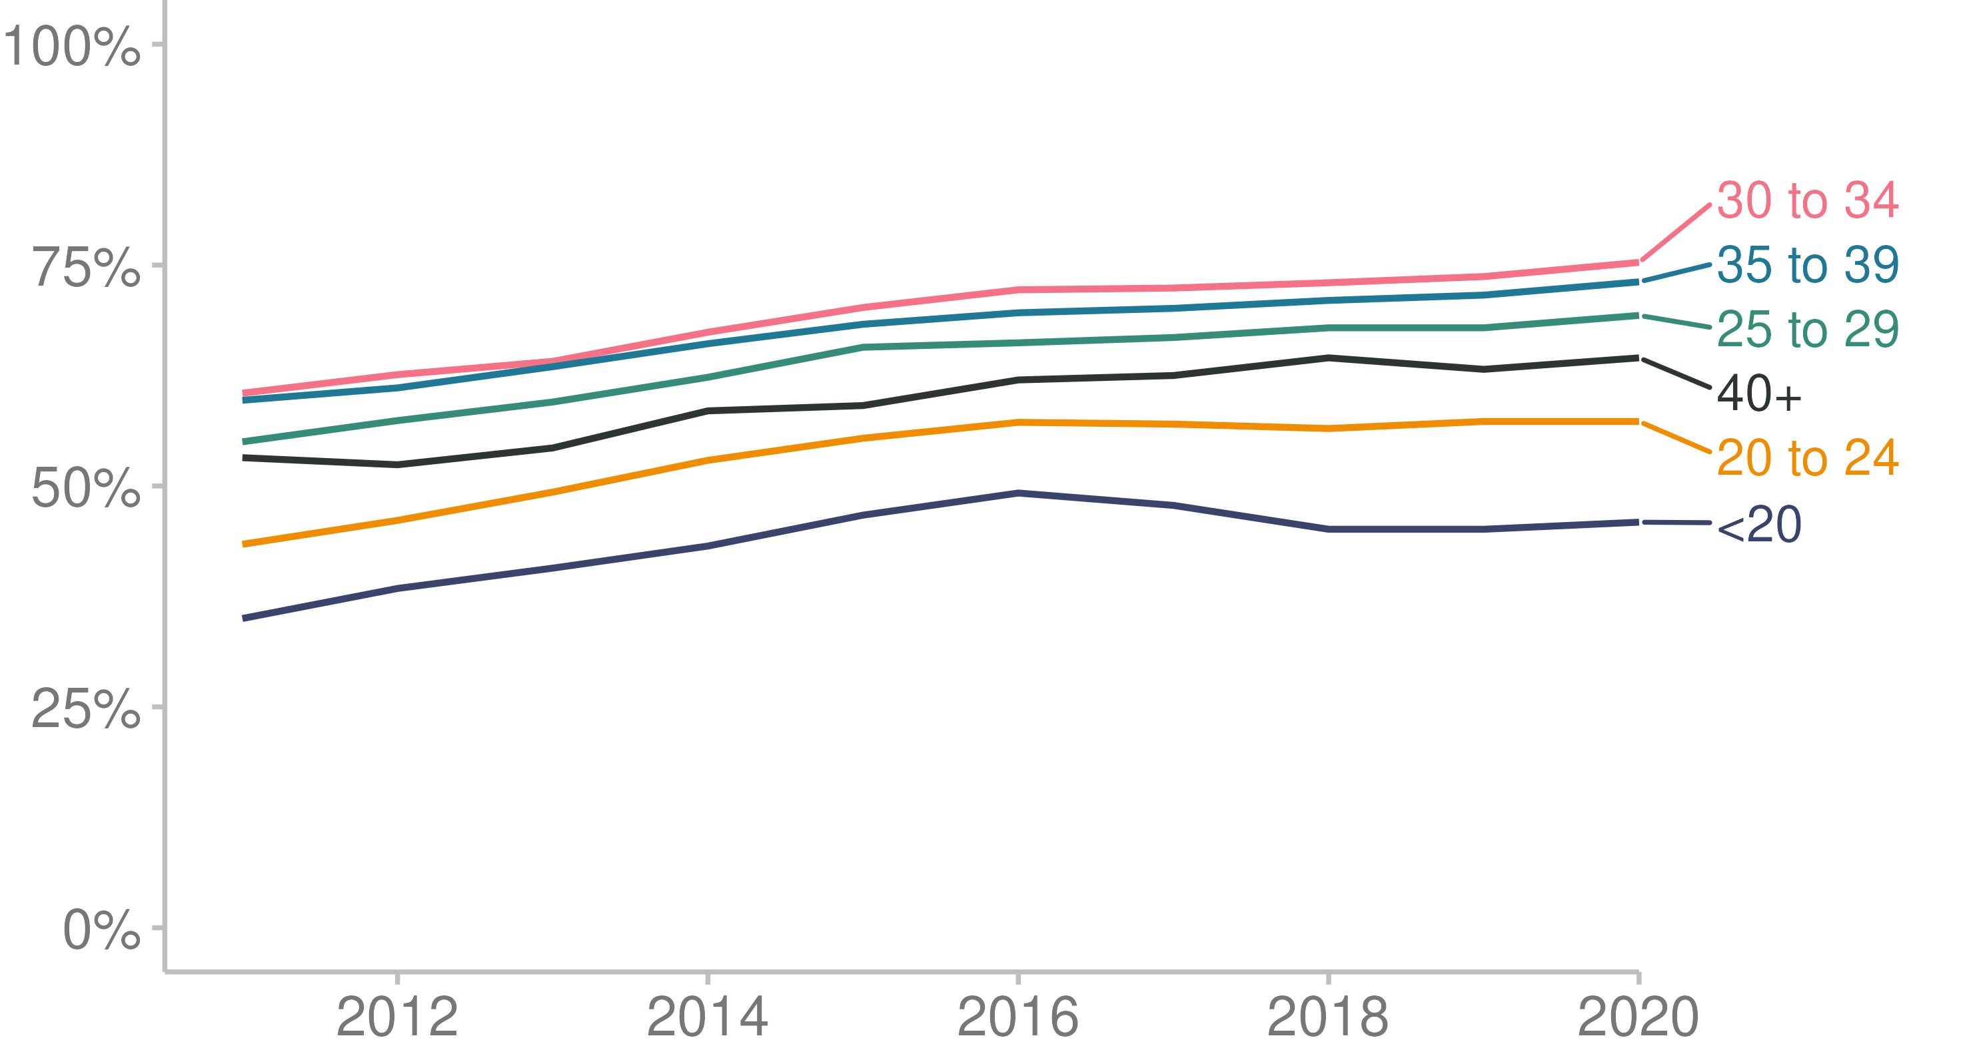

Source: [Ministry of Health (2022o)](https://minhealthnz.shinyapps.io/report-on-maternity-web-tool/)

Figure 23 displays the difference in registering with an LMC in the first trimester by ethnicity.

Figure 23: Proportion of women registering with a lead maternity carer in the first trimester, by ethnicity, 2011–2020

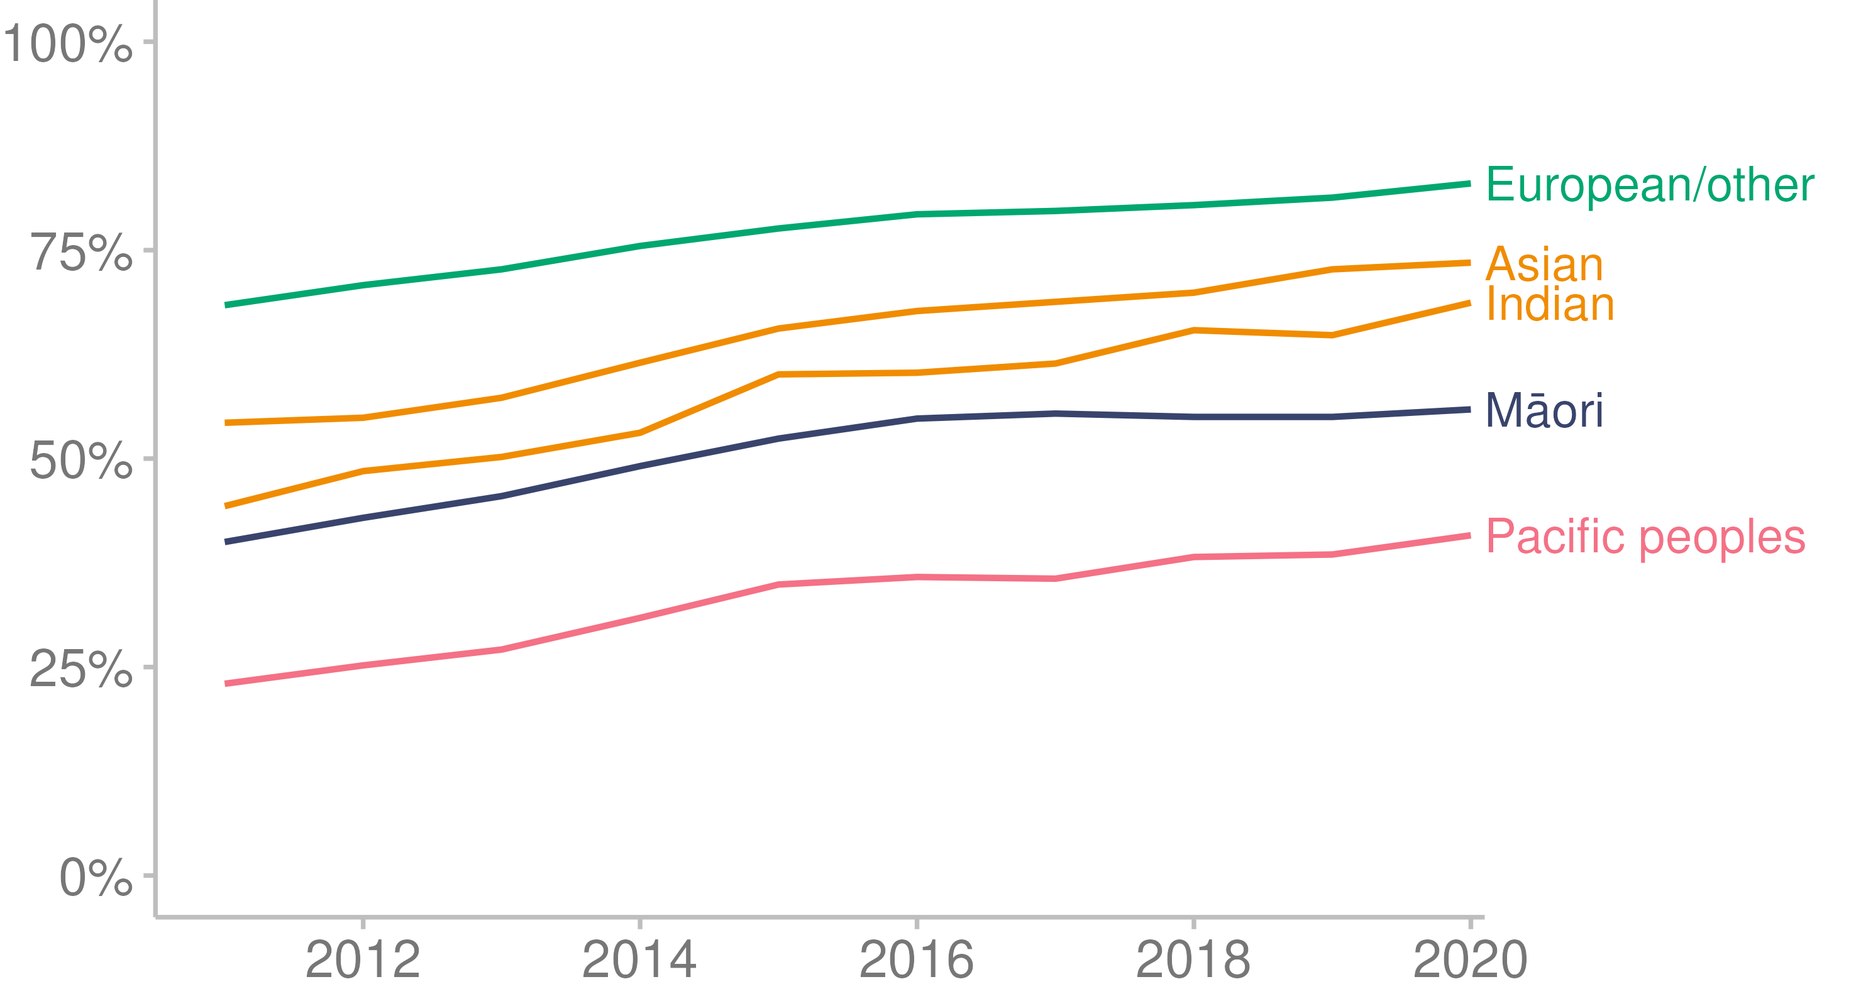

Source: [Ministry of Health (2022o)](https://minhealthnz.shinyapps.io/report-on-maternity-web-tool/)

Note: The Indian ethnic group is sometimes presented separately from the Asian ethnic  
group due to a more complex pregnancy profile. In general, women in the Indian ethnic group have a higher rate of interventions, and babies have lower birth weight than the Asian ethnic group excluding Indian (Ministry of Health 2022o).

Figure 24 shows that, in the 10 years to 2020, women living in the highest deprivation areas had lower rates of LMC registration in the first trimester of pregnancy.

Figure 24: Proportion of women registering with a lead maternity carer in the first trimester, by NZDep2018 deprivation quintile, 2011–2020

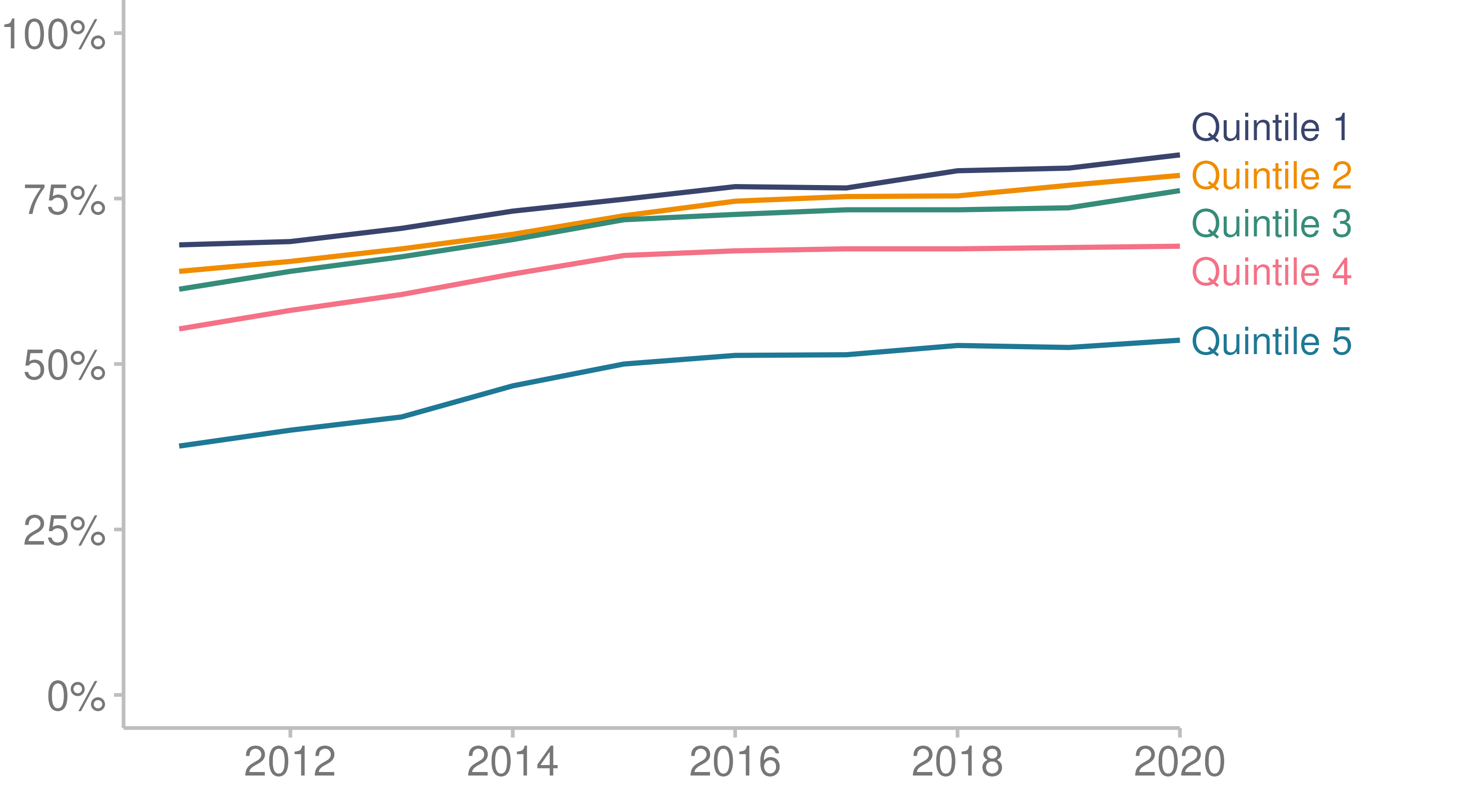

Source: [Ministry of Health (2022o)](https://minhealthnz.shinyapps.io/report-on-maternity-web-tool/)

### Interventions during birth

Figure 25 shows that, between 2011 and 2020 there were changes in the percentage and type of interventions women experienced during labour and birth (Ministry of Health 2022o). It should be noted that any one birth may have involved more than one intervention. For more detail on these interventions, see Ministry of Health 2022o.

Figure 25: Proportion of women who received an intervention during birth, 2011–2020

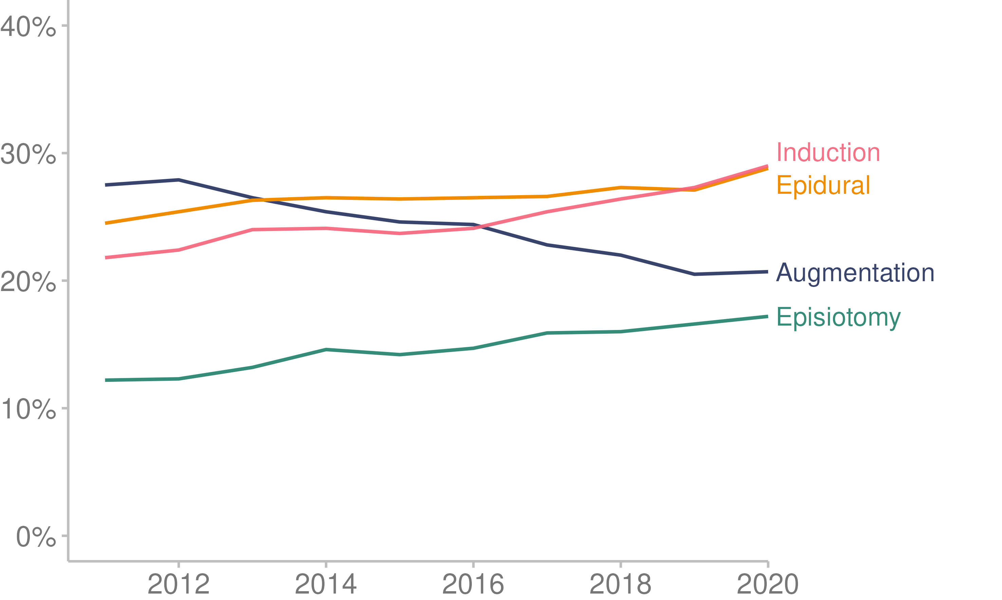

Source: [Ministry of Health (2022o)](https://minhealthnz.shinyapps.io/report-on-maternity-web-tool/)

## Enrolment with a primary health organisation

Primary health organisations and general practice have important roles in providing preventive health care to the general population and reducing the need for more costly specialised and hospital care (OECD 2022).

### Enrolled population

On 31 December 2021, 93.9%of the New Zealand population were enrolled with a PHO through a general practice (Ministry of Health 2022h).

Not being enrolled with a PHO could indicate someone is not getting the support they need to manage their health and wellbeing (Irurzun-Lopez et al 2021).

There are differences in rates of enrolment across the population, as follows.

* People living in the least deprived areas had higher rates of enrolment (close to 100%), compared to people living in the most deprived areas (85.4%).
* The European/other ethnic group (99.3%) and Pacific peoples (97.3%) had higher levels of enrolment than Māori (83.1%) and Asian (83.7%) peoples.
* Females (95.9%) had higher levels of enrolment than males (91.5%).
* Manatū Hauora does not currently have PHO enrolment figures for disabled people.
* Enrolment rates change with age, decreasing for those aged 10–24 then gradually increasing with age until 85 (Figure 26).

Figure 26: Proportion of New Zealand residents enrolled with a primary health organisation, by age group, 2021

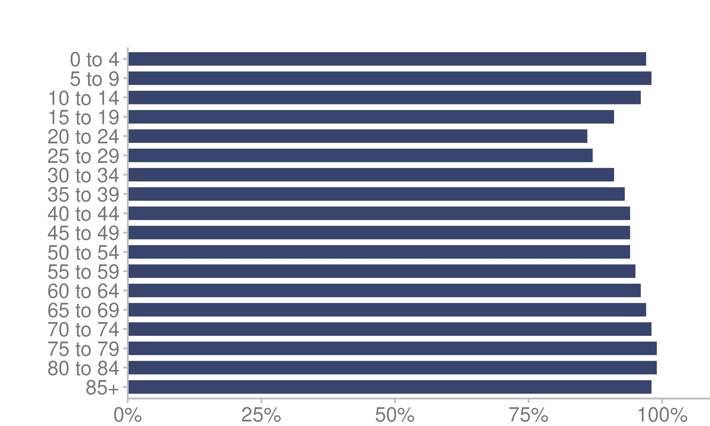

Source: Ministry of Health unpublished data (2022)

### Engagement with enrolling general practice

We define engagement with general practice as a range of interactions between a patient and the general practice they are enrolled with. These interactions include doctor and nurse consultations (face-to-face and remote), follow-up communications, prescription requests and immunisations.

Of the people who were enrolled with a PHO on 31 December 2021, 79.8% engaged with their usual general practice in person or virtually during 2021. Of the remaining people who did not interact with their general practice in 2021, 9.9% last engaged with their general practice in 2020 and 5.2% last engaged with their general practice in 2019. The remaining 5.2% did not know, or were last seen more than 3 years ago.

Subgroups of the enrolled population had different levels of engagement with their usual general practice during 2021, as follows.

* People living in the least deprived areas had higher levels of engagement (80.8%) than people living in the most deprived areas (78.0%).
* The European/other ethnic group had higher levels of engagement (82.5%) than Māori (76.1%), Pacific peoples (75.5%) and the Asian ethnic group (74.7%).
* Females had higher levels of engagement (83.2%) than males (76.2%).
* As Figure 27 shows, engagement is high during the first years of life, dropping down at 5–9 years of age and then gradually increasing with age until the 85+ age group.

Figure 27: Proportion of enrolled people known to have engaged with their general practice, by age group, 2021

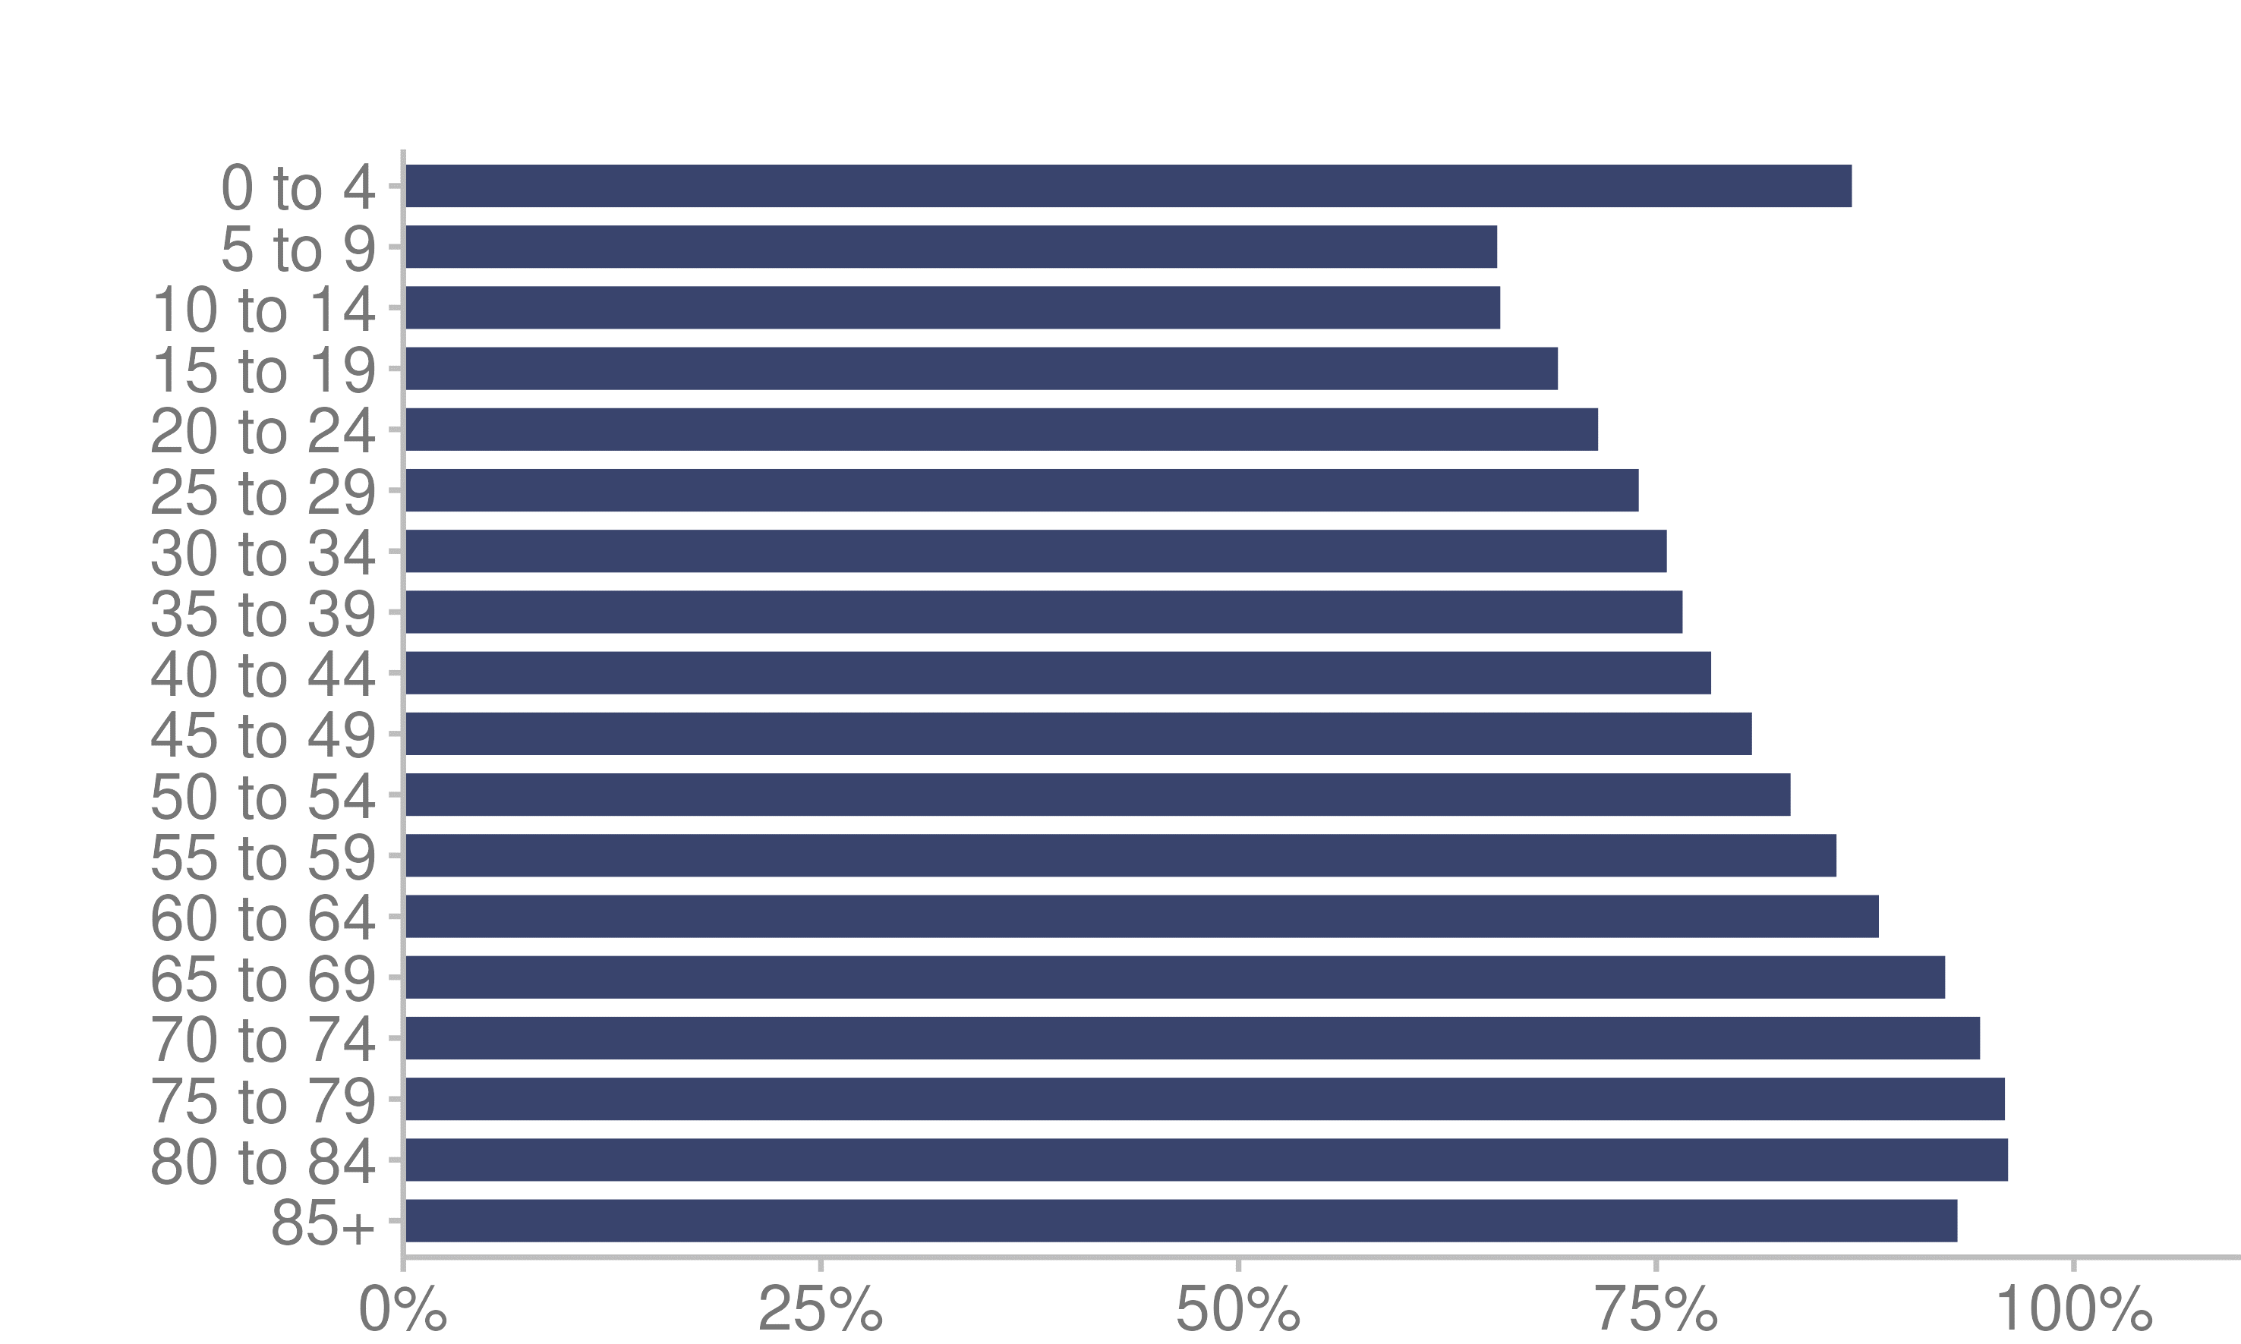

Source: Ministry of Health unpublished data (2022)

## Barriers to accessing health care

Even people enrolled with a PHO can experience barriers to accessing health care, which can affect their level of engagement with a general practice. Barriers can include accessibility, concerns about COVID-19 and cost, among other factors.

### Accessibility

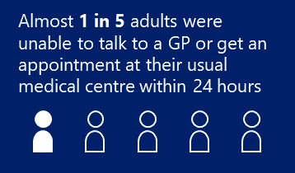The 2020/21 NZHS estimates that, in the 12 months prior, 19.4% of adults wanted to talk to or see a GP, nurse or other health care worker at their usual medical centre but were unable to get an appointment within 24 hours (Ministry of Health 2022b).

### COVID-19

In 2020/21, the NZHS added an indicator to capture reported barriers because of COVID-19. These included barriers such as fear of being infected, COVID-19 restrictions and not wanting to have a virtual consultation. The 2020/21 NZHS estimates that in 2021, over a quarter of a million adults had a medical problem but did not visit or talk to a GP because of COVID-19 (Ministry of Health 2022b).

### Cost

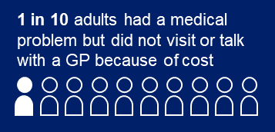The 2020/21 NZHS estimates that 10.2% of adults had an unmet need for general practice services due to cost. This is defined as having had a medical problem but not visiting or talking to a GP because of cost in the past 12 months.

## Child oral health

Dental caries, also known as tooth decay or dental cavities, is a mainly preventable disease, but remains a common disease of childhood. In 2021, dental conditions were the fourth most common reason for preventable hospital admissions for children in New Zealand (see the Hospitalisations section for more detail).

There have been certain improvements in child oral health over time. For example, between 2000 and 2019:

* the proportion of 5-year-old children who were caries-free (ie, had no past or current dental decay) increased from 52.1% to 58.8%
* the proportion of caries-free children in school year 8 rose from 42.2% to 68.5% (Environmental Health Intelligence New Zealand 2020).

The percentage of children who were caries-free at 5 years of age in 2020 (the most recent data available) differed by ethnic group. Māori and Pacific children were less likely to be caries-free at age 5 than European/other children (Figure 28) (Ministry of Health 2020a).

Figure 28: Proportion of 5-year-old children caries-free, by ethnic group, 2020

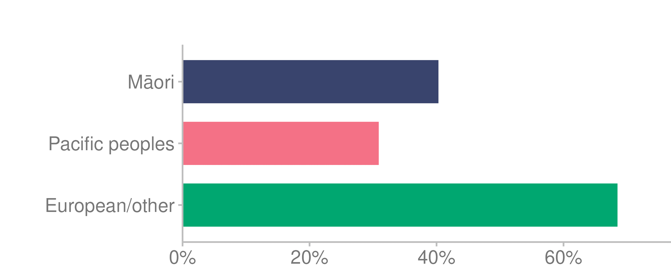

Source: [Ministry of Health (2020a)](http://www.health.govt.nz/nz-health-statistics/health-statistics-and-data-sets/oral-health-data-and-stats/age-5-and-year-8-oral-health-data-community-oral-health-service)

The 2020/21 NZHS reported that 71.0% of children up to 14 years of age had seen a dental health care worker in the last 12 months (Ministry of Health 2022b). This had reduced from 79.8% of children in 2019/20 and 82.2% in 2018/19. Restrictions relating to COVID-19 may have been a factor.

## Respiratory syncytial virus outbreak

Respiratory syncytial virus (RSV) is a highly contagious, common respiratory virus that causes lung and respiratory tract infections (Health Navigator 2022; Prasad et al 2019). It is:

* the leading cause of hospitalisation for lower respiratory tract infections in infants under 2 years old
* the most frequent cause of severe pneumonia in children younger than 5 years old
* highly seasonal: most hospitalisations occur during winter.

Anyone at any age can get RSV, but it is more common in young children and babies. The Centers for Disease Control and Prevention in the United States report that nearly all children will be infected with RSV by the time they turn 2 years old, but only a small portion of them will have severe symptoms (Centers for Disease Control and Prevention 2020).

For many adults and healthy children, RSV infection causes symptoms like those of a [cold](https://www.healthline.com/health/cold-flu/cold). But in infants, RSV can be more serious.

The measures taken in response to the COVID-19 pandemic in early 2020, such as lockdowns and closing the border, resulted in a much lower number of RSV infections in winter 2020 when compared with the 2015–2019 average (Hatter et al 2021). However, over this time, children were not exposed to the typical level of circulating viruses, limiting their chance to build immunity.

In April 2021, quarantine-free travel was in place from Australia. Shortly afterward there was a rapid increase in RSV cases. These facts may have been related, but this has not been confirmed (Hatter et al 2021).

In 2021, children aged 12–48 months, who likely would not have been exposed to RSV in 2020, experienced a rate 5 times the 2019 rate (Grant et al 2021).

## Immunisation

The COVID-19 pandemic has affected immunisation programmes, in terms of service planning and delivery, the health workforce and resources. The COVID-19 vaccination programme, New Zealand’s largest ever vaccination programme, required a redeployment of the vaccinating workforce and other resources (Ministry of Health 2022e).

### Childhood immunisation

There is a New Zealand target that 95% of eligible children be fully immunised. This is measured at key milestone ages of 8 months, 24 months and 5 years (Ministry of Health 2022r). When a child reaches these milestone ages, their immunisation status is recorded as one of the following:

* fully immunised (received all age-appropriate immunisations by the milestone age)
* declined (ie, the parent/caregiver declined to immunise their child, fully or partly)
* opted off the National Immunisation Register (NIR) (ie, the parent/caregiver chose to opt off putting any of their child’s immunisations on the NIR)
* missed (ie, immunisation has not been declined, nor has the parent/caregiver chosen to opt off the NIR, but one or more age-appropriate immunisations have not been received by the milestone age; Ministry of Health 2022v)

In 2021:

* 87.3% of eligible children across Aotearoa New Zealand were fully immunised at 8 months of age
* 83.9% were fully immunised at 24 months
* 83.5% were fully immunised at 5 years (Ministry of Health 2022r).

Māori and Pacific children have lower rates of immunisation across the milestone ages than children in the Asian and European/other ethnic groups. Figures 29–31 demonstrate this.

Figure 29: Percentage of children who were fully immunised at 8 months, 24 months and 5 years, by prioritised ethnic group, 2021

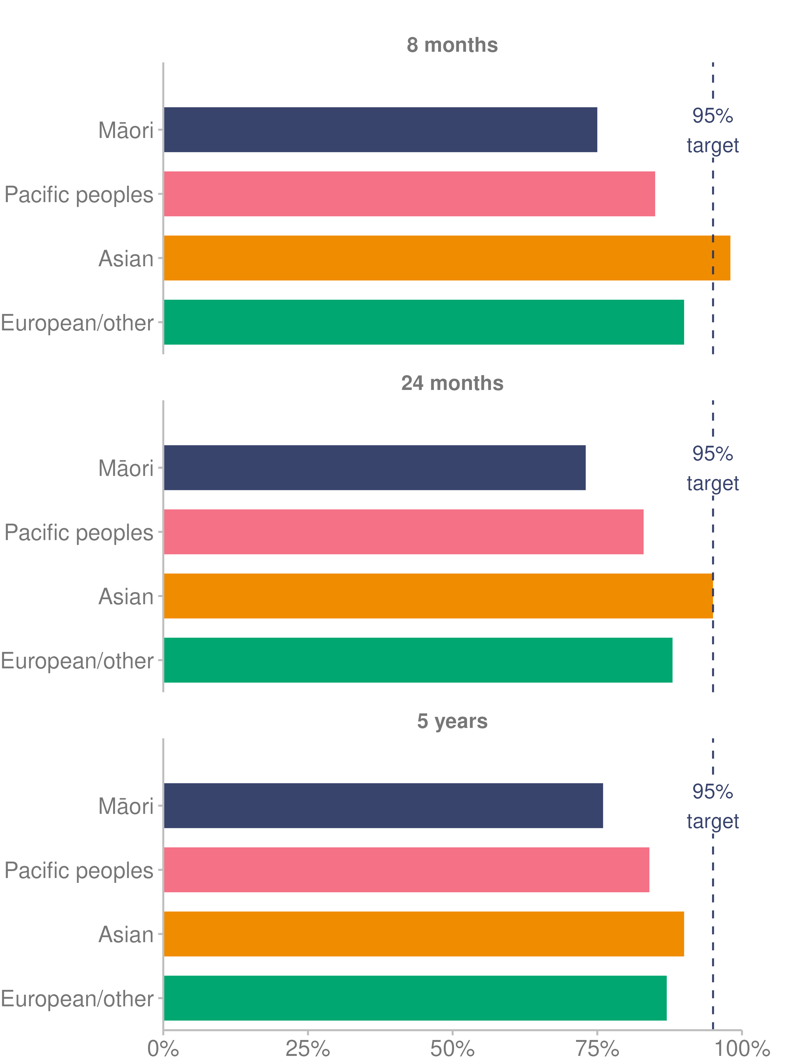

Source: [Ministry of Health (2022r)](https://www.health.govt.nz/our-work/preventative-health-wellness/immunisation/immunisation-coverage/national-and-dhb-immunisation-data)

#### Immunisation Schedule change

The New Zealand National Immunisation Schedule is the series of publicly funded vaccines that Manatū Hauora offers free to babies, children, adolescents and adults (Ministry of Health 2020e).

In October 2020, there was a change in the schedule for the measles, mumps, and rubella (MMR) vaccine. The second dose was scheduled at 15 months rather than 4 years of age (Ministry of Health 2022a).

The MMR programme aims to achieve national coverage of 95%, with 3 priority actions:

1. address the equity gap in MMR rates for Māori and Pacific children
2. increase the uptake of dose 2 at 15 months
3. deliver a catch-up campaign for those born between 1989 and 2004, for whom the immunisation rate is considered too low to prevent a measles outbreak (Ministry of Health 2022n).

#### Human papillomavirus immunisation

Human papillomavirus (HPV) immunisation is funded for people aged 9–26 years, as well as non-residents aged under 18 years (Ministry of Health 2022m).

The national HPV immunisation coverage target is 75%. At 31 December 2021, the coverage for the 2008 birth cohort was 54.0%. The rates by ethnic group were 48.5% for Māori, 46.2% for Pacific peoples, 58.2% for the Asian group and 57.2% for the European/other group.

### Influenza immunisation

The influenza immunisation programme aims to vaccinate 75% of the population aged 65 years or older[2] against influenza annually. There is a focus on achieving equitable rates for Māori and Pacific peoples (Ministry of Health 2022i).

In 2021, 70.4% of people 65 years and over were immunised against influenza. This compares to 69.2% in 2020, 57.5% in 2019 and 54.9% in 2018.

Rates of influenza immunisation in 2021 for people 65 years and older differed by ethnicity. The rate of immunisation for Māori was 57.9%, the rate for Pacific peoples was 55.8% and the rate for non-Māori / non-Pacific was 71.9%.

It should be noted that not all influenza vaccinations are reported to the NIR, as reporting adult vaccinations is not mandatory. For example, influenza vaccinations delivered in workplaces may not be reported to the NIR.

## 

## Cancer

Each year, approximately 25,000 people are diagnosed with cancer in Aotearoa New Zealand, including nearly 3,000 Māori. Cancer, when all types are combined, is the leading cause of death in New Zealand. Approximately 9,000 people die from cancer each year (Te Aho o Te Kahu Cancer Control Agency 2021).

### Cancer incidence

The most diagnosed cancers in New Zealand (excluding non-melanoma skin cancers) are breast, lung, prostate and colorectal cancers (Te Aho o Te Kahu Cancer Control Agency 2021). After adjusting for population size and age structure, Māori are more likely than non-Māori to be diagnosed with a range of cancers, including breast, liver, lung, pancreatic, stomach and uterine. However, non-Māori are more likely than Māori to be diagnosed with melanoma, colorectal and prostate cancers (Figure 30).

Figure 30: Incidence rates for the 10 most diagnosed cancers in Aotearoa, Māori and non-Māori, age- and sex-standardised, 2008–2017

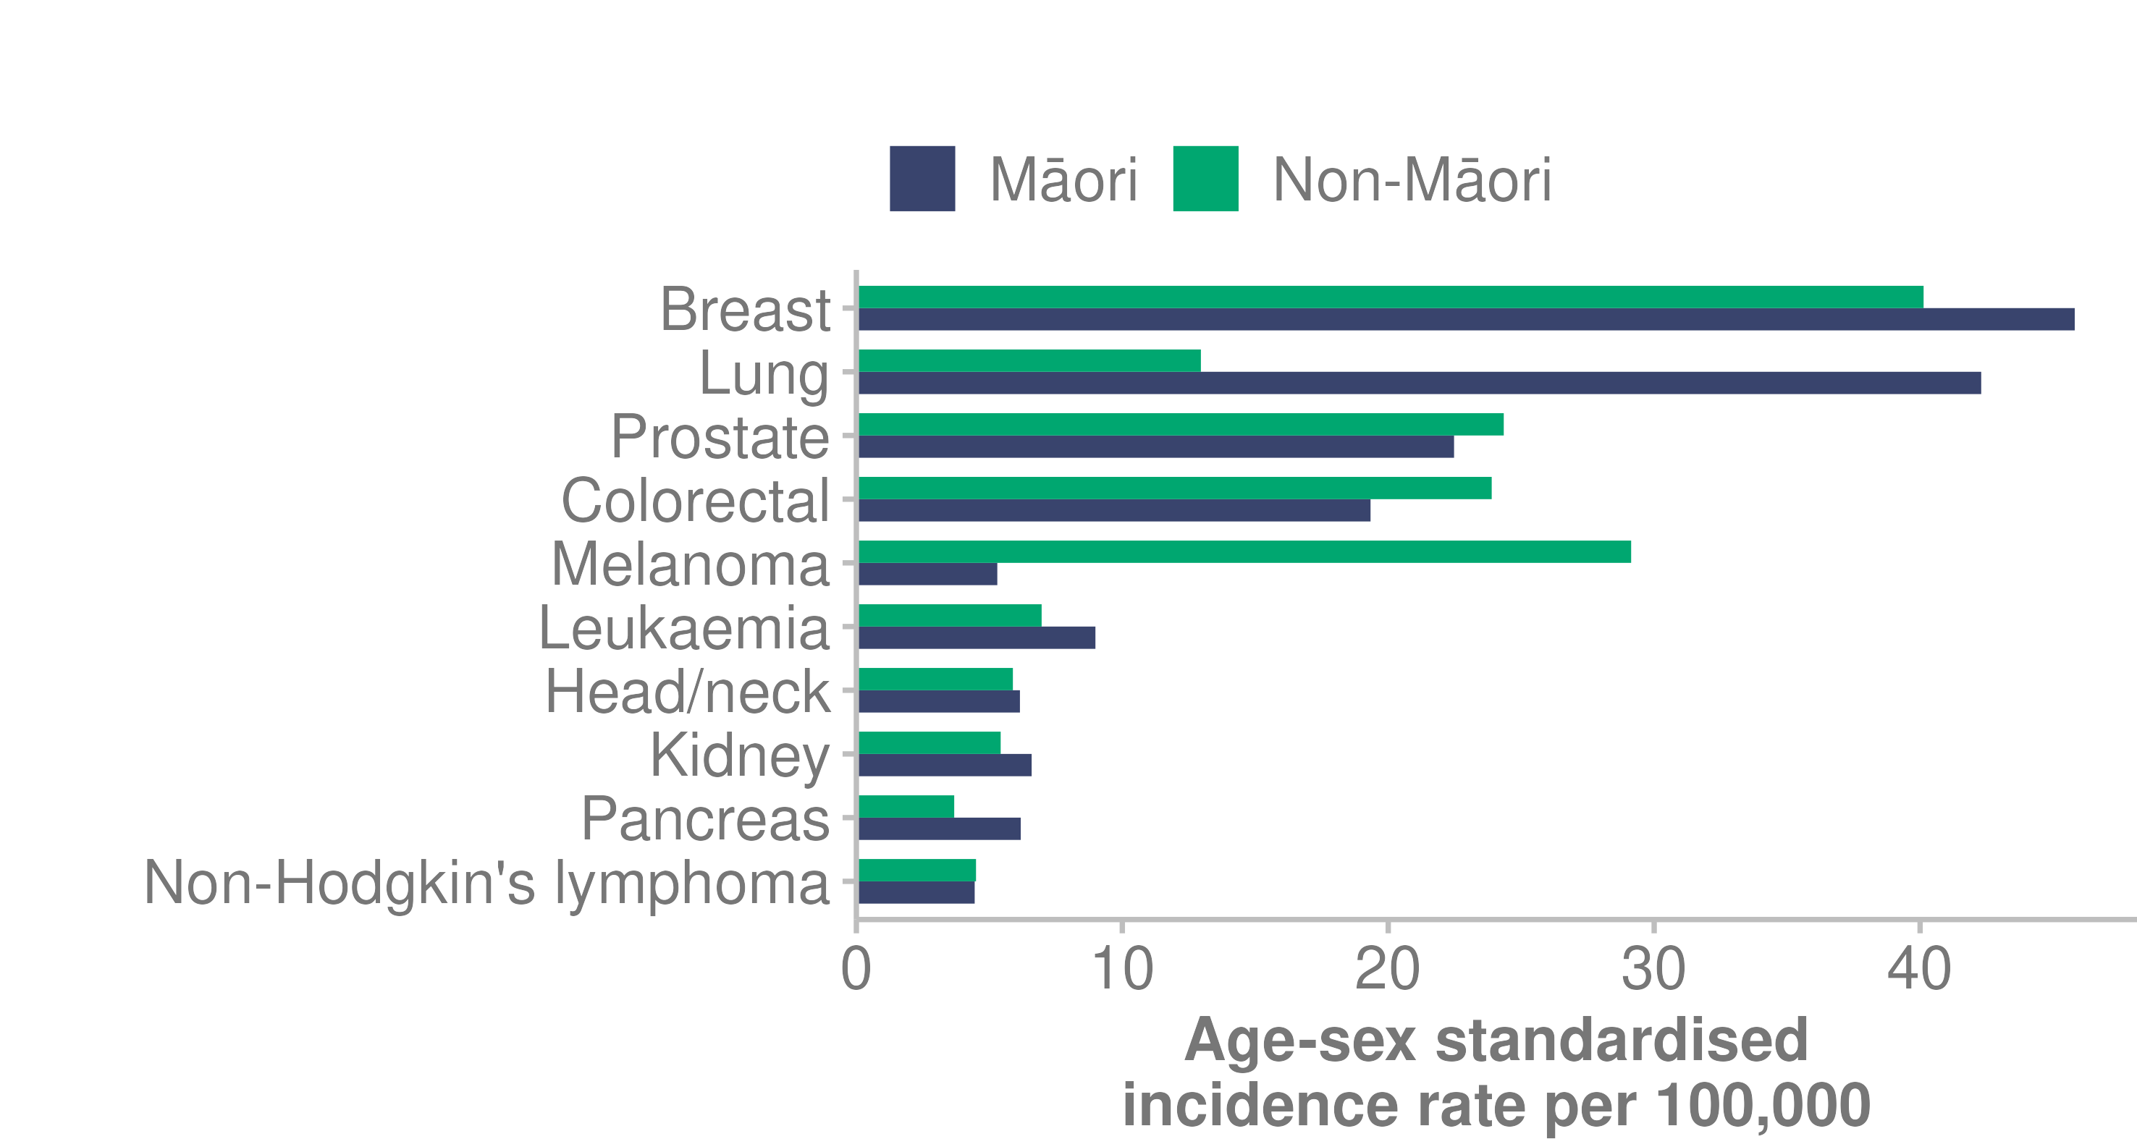

Source: [Te Aho o Te Kahu Cancer Control Agency (2021)](https://teaho.govt.nz/reports/cancer-state)

### Cancer mortality

Lung, colorectal, breast and prostate cancers are the most common causes of cancer-related death. Māori experience higher mortality rates from cancer than non-Māori (Te Aho o Te Kahu Cancer Control Agency 2021).

Figure 31: Age- and sex-standardised cancer-related mortality, 2007–2017

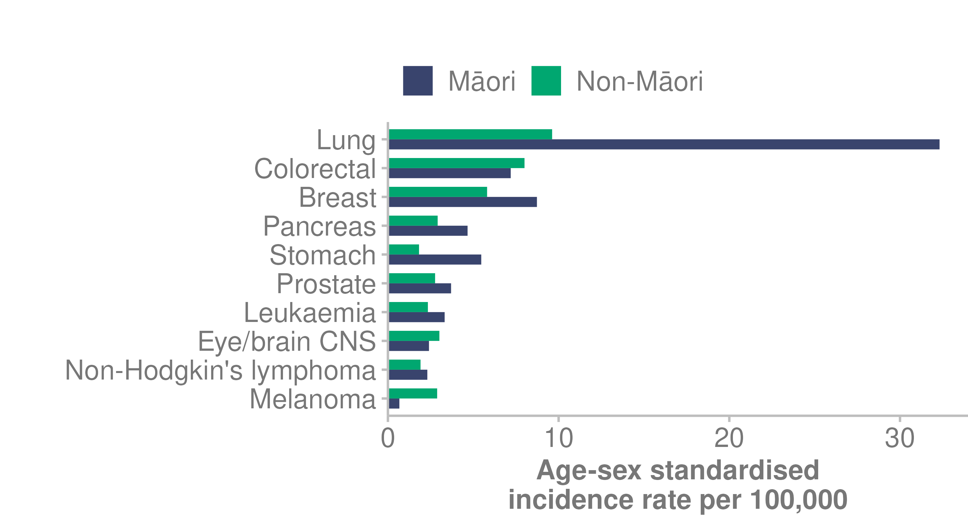

Source: [Te Aho o Te Kahu Cancer Control Agency (2021)](https://teaho.govt.nz/reports/cancer-state)

Note: CNS = central nervous system.

### Cancer trends over time

The number of New Zealanders diagnosed with cancer is increasing, likely due to the fact that our population is growing and ageing (Te Aho o Te Kahu Cancer Control Agency 2021). However, cancer incidence patterns have changed over time. Some cancers are decreasing and others are increasing.

Over the past 20 years, cancer survival rates in Aotearoa New Zealand have increased substantially: more people are surviving their cancer than ever before (Te Aho o Te Kahu Cancer Control Agency 2021).

Figure 32: Trends in select cancers’ 5-year survival rates, 1998/99–2016/17

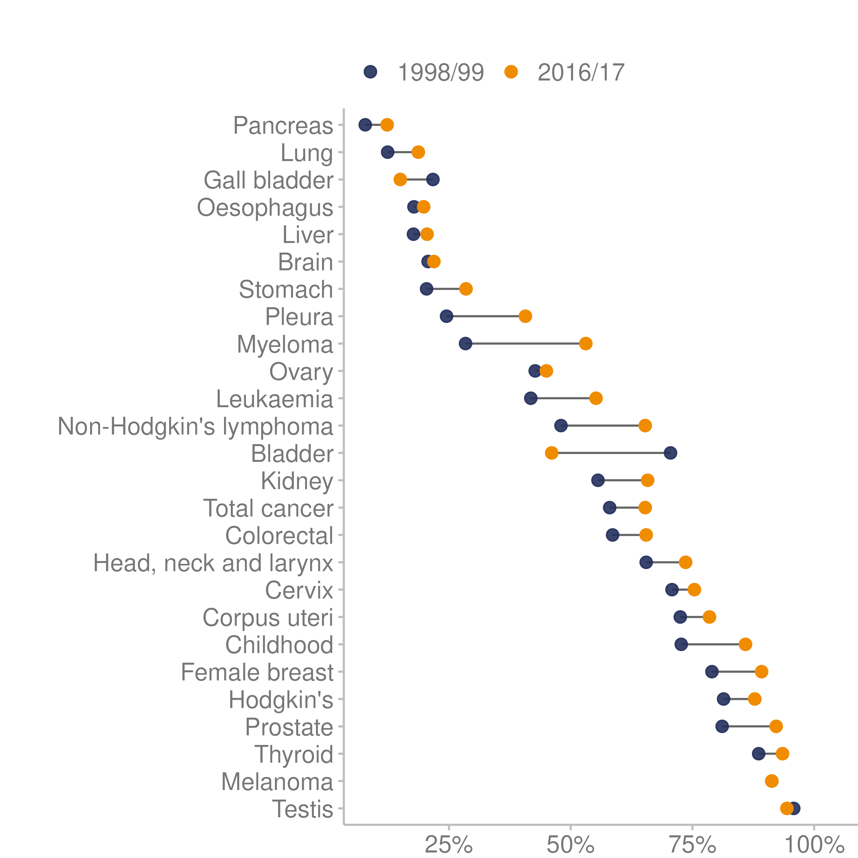

Source: [Te Aho o Te Kahu Cancer Control Agency (2021)](https://teaho.govt.nz/reports/cancer-state)

### Cancer screening services

The COVID-19 pandemic has affected screening services globally. Many countries paused screening services completely during the first wave of COVID-19 and associated lockdowns (Gurney et al 2021).

The 2021 COVID-19 Delta outbreak affected cancer screening delivery (Te Aho o Te Kahu Cancer Control Agency 2022a). The breast and cervical screening programmes were particularly vulnerable to interruption, as they require in-person attendance and contact with a clinician (National Screening Unit 2022).

It should be noted that screening programmes use different screening intervals based on the evidence of how quickly different cancers develop and progress, as well as the attributes of the screening test used to identify those at risk.

#### Breast screening

The breast screening coverage target is for 70% of eligible New Zealanders to be screened every 2 years. As at December 2021, the 2-year breast screening coverage was 63.6% (Ministry of Health 2022c).

As Figure 33 shows, screening rates remain lowest for Māori, at 58.7%. Rates for Pacific peoples reduced from above 70% in 2012 to 60.6% in 2021.

Figure 33: Two-year breast screening coverage, by prioritised ethnic group, women aged 45–69 years, 2010–2021

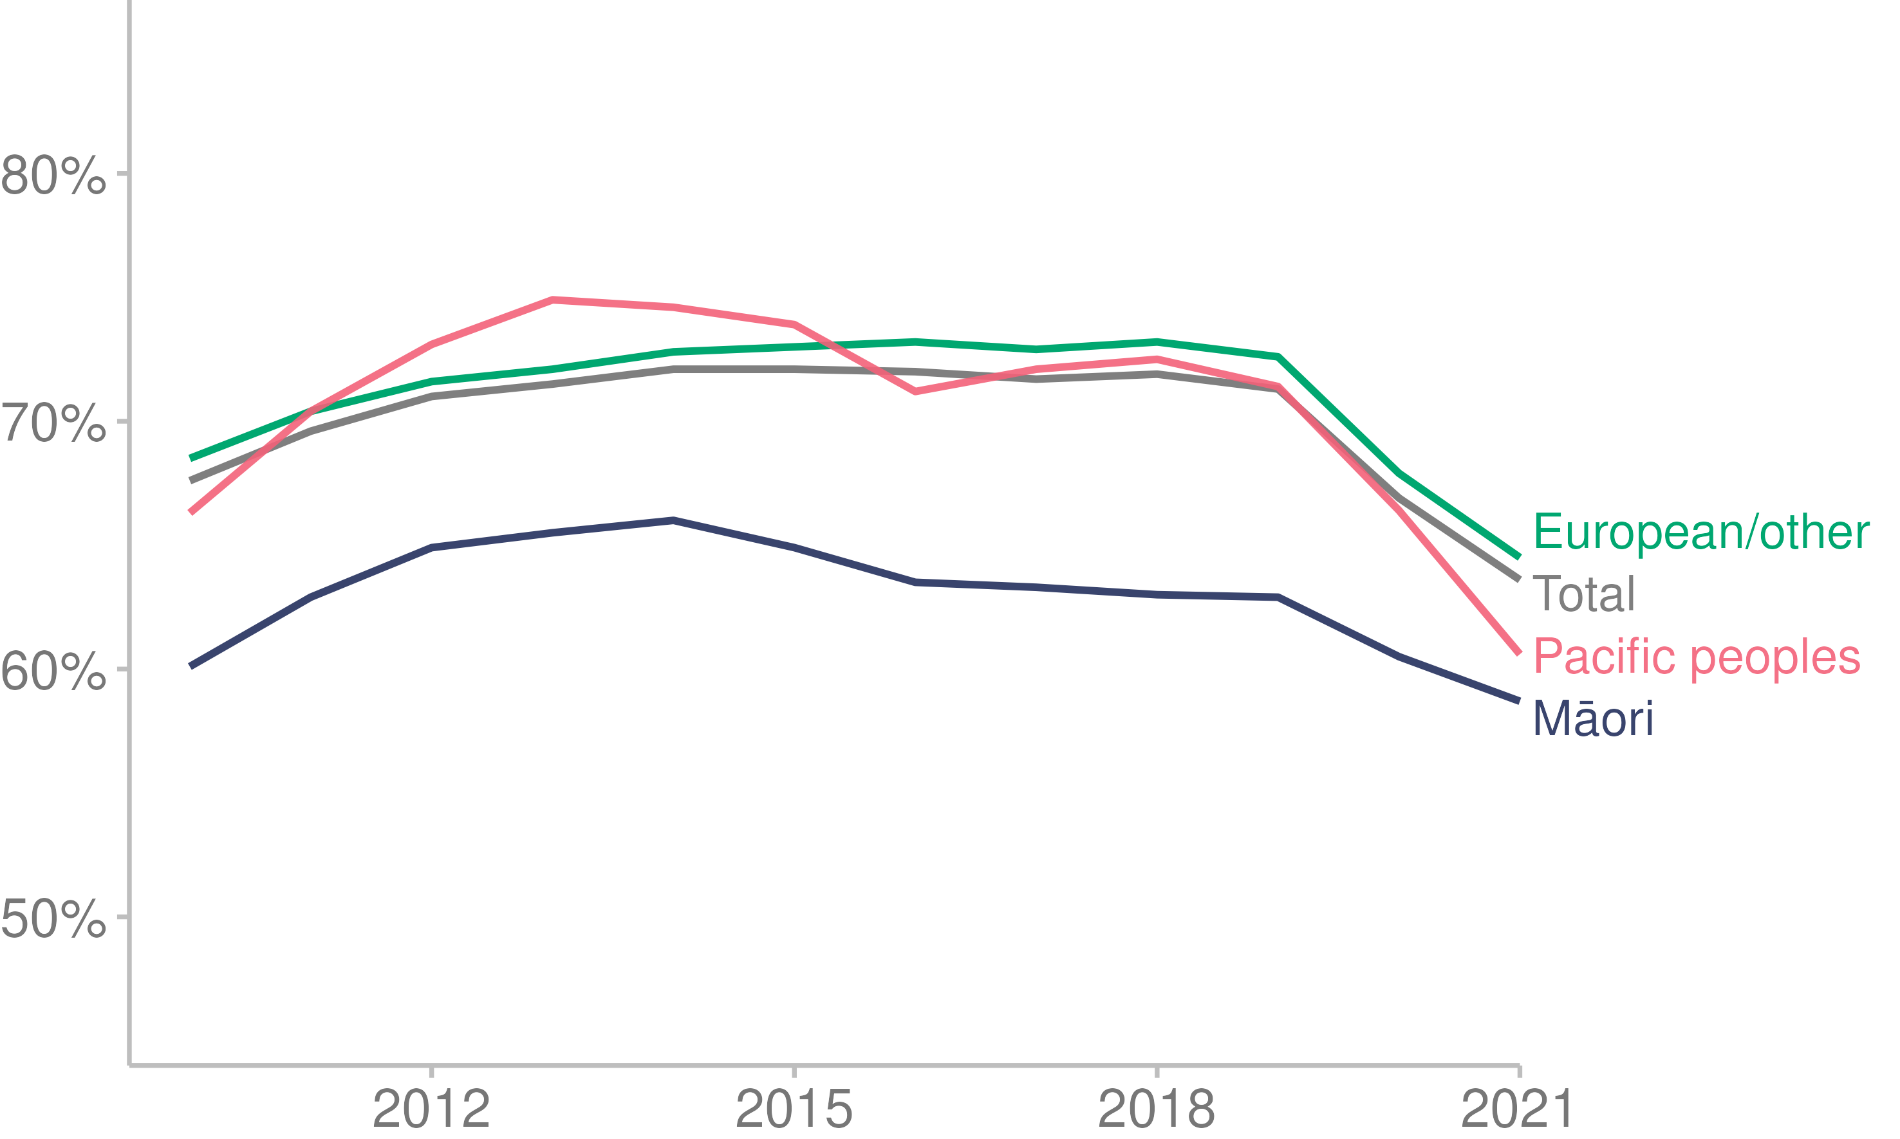

Source: [Ministry of Health (2022c)](https://minhealthnz.shinyapps.io/nsu-bsa-coverage-dhb/)

Note: Breast screening rates for the Asian ethnic group are included in the European/other group.

#### Cervical screening

The cervical screening coverage target is for 80% of eligible New Zealanders to be screened every 3 years. As at December 2021, the 3-year cervical screening coverage was 68.6% (Ministry of Health 2022u). National cervical screening rates have been decreasing for all population groups since before 2018, as Figure 34 shows. From July 2023, the primary test for cervical screening will change to a HPV test. For eligible women, this test will replace the current smear test with a simple and quick swab that women can choose to do themselves.

Figure 34: Three-year cervical screening coverage, by prioritised ethnic group, women aged 25–69 years, 2007–2021

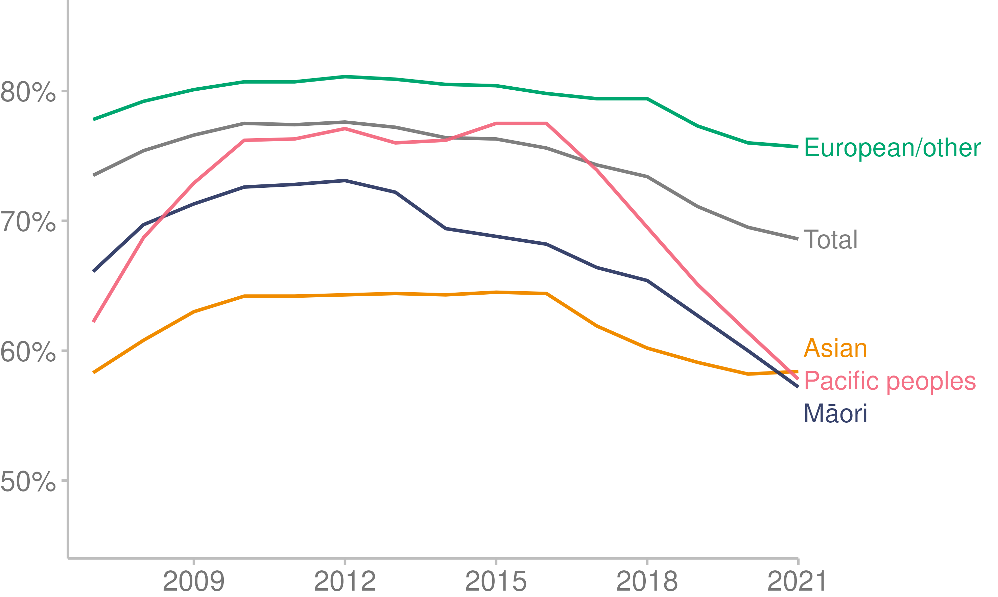

Source: [Ministry of Health (2022u)](https://minhealthnz.shinyapps.io/nsu-ncsp-coverage/)

#### National Bowel Screening Programme

The National Bowel Screening Programme is offered every 2 years, as a self-test, to eligible people aged 60–74 years. It has two targets: for 60% of eligible people to return a completed test, and to achieve equitable participation for Māori and Pacific peoples.

Participation in the Bowel Screening Programme has decreased slightly, particularly among Māori and Pacific peoples. Overall coverage fell from 62.1% of eligible people in 2020 to 60.3% in December 2021. During this time, rates for Māori reduced from 54.4% to 52.9%, and rates for Pacific people reduced from 41.9% to 41.7% (Ministry of Health 2022t).

### Cancer prevention

Prevention is the ideal in cancer control. About 30–50% of all cancers are potentially preventable (World Health Organization 2020). Preventing all such cancers would mean 7,800 to 13,000 fewer people in New Zealand would have developed cancer in 2019 (Te Aho o Te Kahu Cancer Control Agency 2022b).

In 2021, Te Aho o Te Kahu Cancer Control Agency developed a cancer prevention report. It outlines evidence-based best practice recommendations to reduce exposure to the 6 major modifiable cancer risk factors: are tobacco, alcohol, poor nutrition and excess body weight, insufficient physical activity, excessive exposure to ultraviolet radiation (the sun) and chronic infections (Te Aho o Te Kahu Cancer Control Agency 2022b). These risk factors are associated with, or known to cause, almost every cancer type.

### Inequities in cancer burden

The level of exposure to cancer risk factors differs across population groups, due to social, political and economic influences (Te Aho o Te Kahu Cancer Control Agency 2021). These influences can also drive poorer access to, and through, the health system, contributing to inequities in health outcomes (Health Quality & Safety Commission 2019; 2021a).

The burden of cancer is not the same for everyone. The cancers that are more common for Māori (including liver, lung, stomach and pancreas) tend to be highly preventable. Pacific people in Aotearoa are also more likely to develop several cancers (including liver, lung, stomach and uterus) that have a highly preventable component. The pattern of preventable cancers is similar for people living in deprived areas, to the extent that poverty has been described as a cancer-causing risk factor (Te Aho o Te Kahu Cancer Control Agency 2021).

#### Lung cancer

Lung cancer is one of the most preventable and commonly diagnosed cancers in New Zealand. It is also one of the most serious: fewer than one in 5 people survive 5 years after diagnosis with lung cancer (Te Aho o Te Kahu Cancer Control Agency 2021).

Tobacco causes at least 80% of all lung cancers globally. It also causes more than 60% of all cancers of the larynx, oral cavity and oesophagus, and is linked to at least 9 other cancers (Te Aho o Te Kahu Cancer Control Agency 2022b).

There has been a gradual reduction in the incidence of lung cancer over the past 2 decades (driven largely by reduced exposure to tobacco), but Māori rates remain substantially higher than non-Māori rates. In 2019, the rate of newly diagnosed cases of lung cancer was 3 times higher in Māori than it was in non-Māori.

Further reducing tobacco exposure could prevent at least 80% of all lung cancers (Whiteman et al 2015) and prevent approximately 2,000 cancer-related deaths in New Zealand (Institute for Health Metrics and Evaluation 2019).

Although rates of smoking have declined over time in New Zealand among all population groups, there are still marked differences by ethnic group and deprivation (Ministry of Health 2022b). Existing tobacco control strategies have been less effective for Māori, Pacific peoples and low-income communities (Edwards et al 2020). Māori are still nearly 3 times as likely to be current smokers as non-Māori (Ministry of Health 2022b).

#### Cervical cancer

Cervical cancer is the third most diagnosed gynaecological cancer in Aotearoa. Cervical cancer rates have decreased over the last 20 years; however, incidence rates remain almost 2 times higher for Māori compared to non-Māori. Māori women are also more likely to die from cervical cancer than non-Māori women (Te Aho o Te Kahu Cancer Control Agency 2021). Cervical cancer is considered highly preventable through HPV immunisation and regular cervical screening.

Over 90% of cervical cancers are caused by HPV infection (de Martel et al 2017; The Immunisation Advisory Centre 2022). HPV vaccination has been shown to significantly reduce the incidence of HPV infections (Oliveira and Niccolai 2021), precancerous HPV-related lesions (The Immunisation Advisory Centre 2022) and invasive cervical cancer (Lei et al 2020).

As noted above, from July 2023, the primary test for cervical screening will change to a HPV test, with the option of self-testing. This is considered more effective at detecting abnormal tissue that could develop into cancer (Gilham et al 2019).

#### Liver cancer

Liver cancer rates have increased steadily over the last 20 years, and survival rates from liver cancer remain low. Approximately one in 5 people survive 5 years after diagnosis with liver cancer; this has changed minimally over the past 2 decades (Te Aho o Te Kahu Cancer Control Agency 2021).

Māori have substantially higher rates of liver cancer than non-Māori and are 30% more likely to die following a diagnosis of liver cancer (Gurney et al 2020).

Hepatitis B and hepatitis C infections cause 80% of liver cancers in New Zealand and globally. In New Zealand, Māori have higher rates of hepatitis B and hepatitis C, making up 45% and 23% of cases respectively. Hepatitis C is the leading cause of liver transplantation in New Zealand and the second leading cause of liver cancer (behind hepatitis B).

The risk of developing liver cancer is much higher in people who drink high levels of alcohol (Matsushita and Takaki 2019) and/or smoke regularly (Abdel-Rahman et al 2017). Excess body weight increases the risk of developing liver cancer in people with chronic hepatitis B infection (Kim et al 2018).

Children and adolescents who are fully immunised against hepatitis B have a significantly lower risk of liver cancer. There has been a decline in hepatitis B immunisation coverage among Māori infants since 2018, from 94% in 2018 to 90% in 2020 (Te Aho o Te Kahu Cancer Control Agency 2021).

## Mental wellbeing

The Mental Health Foundation of New Zealand describes ‘mental wellbeing’ as feeling good, functioning well and feeling connected (Mental Health Foundation of New Zealand 2022). Mental wellbeing includes many other aspects, such as being able to adapt and cope with life and life’s challenges and feeling that life has meaning, as well as experiencing feelings of contentment or general happiness (Ministry of Health 2021). It is one component of broader wellbeing. Positive mental wellbeing is most likely when people feel safe, connected, valued, worthy and accepted and have a sense of belonging, identity and hope for the future.

### Psychological distress

Mental wellbeing encompasses more than psychological distress. However, at present, most reporting is about mental distress, which is further discussed in this section.

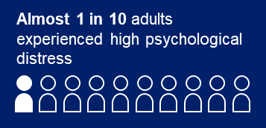In the 2020/21 NZHS, 9.6% of people reported experiencing high psychological distress in the last 4 weeks (Ministry of Health 2022b). ‘Psychological distress’ in adults (aged 15+ years) refers to a person’s experience of symptoms such as anxiety, psychological fatigue or depression.

The prevalence of high psychological distress has fluctuated over time but is generally trending upwards: there was a low of 4.6% in 2011/12 and a high of 9.6% in 2020/21 (Figure 35).

Inequities occur between subgroups of the population reporting high psychological distress (Ministry of Health 2022b). In 2020/21:

* 15.2% of adults living in the most deprived areas experienced high psychological distress, compared with 6.1% of adults living in the least deprived areas
* 27.3% of disabled adults experienced high psychological distress, compared with 7.9% of non-disabled adults.

Over the 10 years to 2020/21, Māori and Pacific adults were more likely to report experiencing high psychological distress, compared to the Asian and European/other ethnic groups (Figure 35).

Figure 35: Prevalence of adults who experienced high psychological distress in the last 4 weeks, by ethnic group, 2011/12–2020/21

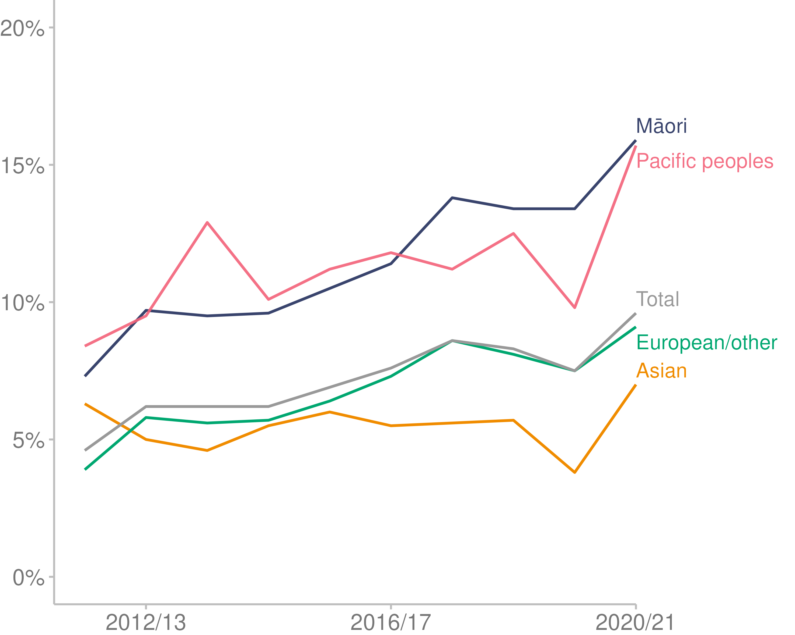

Source: [Ministry of Health (2022b)](https://minhealthnz.shinyapps.io/nz-health-survey-2020-21-annual-data-explorer/_w_871f0fb8/#!/)

### Kia Manawanui Aotearoa: Long-term pathway to mental wellbeing

In 2021, the New Zealand Government released a 10-year strategy and action plan for mental wellbeing, titled [*Kia Manawanui* *Aotearoa: Long-term pathway to mental wellbeing*](https://www.health.govt.nz/system/files/documents/publications/web3-kia-manawanui-aotearoa-v9_0.pdf) (Ministry of Health 2021a).

*Kia Manawanui* defines the next stage of the transformation of New Zealand’s approach to mental wellbeing, including the mental health and addiction system. It outlines the actions the Government will take over the short, medium and longer term.

*Kia Manawanui* identifies 5 focus areas:

* building the social, cultural, environmental and economic foundations for mental wellbeing
* equipping communities, whānau and individuals to look after their own mental wellbeing
* fostering community-led solutions
* expanding primary mental wellbeing support in communities
* strengthening specialist services.

### Access and choice

Kia Manawanui takes forward the Government’s response to He Ara Oranga: Report of the Government Inquiry into Mental Health and Addiction 2018 (Government Inquiry into Mental Health and Addiction 2018), expanding access and choice of primary mental health and addiction support. This programme (known as Access and Choice) aims to expand access to, and choice of, primary mental health and addiction services across the country (Mental Health and Wellbeing Commission 2021). It is a 5-year programme and includes 4 service delivery workstreams:

* integrated primary mental health and addiction (IPMHA) services delivered through general practice teams
* youth-specific primary mental health and addiction services for 12- to 24-year-olds
* kaupapa Māori primary mental health and addiction services for people of all ages
* primary mental health and addiction services for Pacific people of all ages.

Manatū Hauora has made progress in the delivery of the access and choice programme (Ministry of Health 2022p). As of 31 December 2021:

* over 300,000 sessions had been provided across all service delivery workstreams since the programme began in July 2019
* IPMHA services in 307 general practices had covered approximately 41% of the enrolled population
* 20 new youth primary mental health and addiction services had been created, including one national service
* 26 kaupapa Māori primary mental health and addiction services were contracted
* 9 Pacific primary mental health and addiction services were contracted.

## Long-term conditions

Manatū Hauora defines long-term conditions as any ongoing, long-term or recurring conditions that can have a significant impact on people’s lives (Ministry of Health 2020c).

It should be noted that the dataset analysed for this section of the report was compiled using definitions of long-term conditions based on hospital admission data, outpatient appointments data and pharmaceutical dispensing data. Since some conditions can be managed entirely within the community through primary care, or the pharmaceutical used for treatment is not specific to a particular condition, the prevalence of some conditions will have been underestimated. Therefore, the rates calculated will sometimes be different to rates reported in the NZHS, as often only people with more acute forms of a long-term condition were captured. We chose to use Manatū Hauora data instead of the Global Burden of Disease (GBD)[3] data, as the GBD does not provide an ethnic group breakdown for any conditions.

14% of New Zealanders have at least one long-term condition. Of these, 29.3% have multiple conditions. Several of the conditions measured are only prevalent in the older population (eg, gout and dementia; Table 4).

Table 4: Top 10 long-term conditions and their prevalence in Aotearoa, for whole population and 65+ age group, 2020

|  |  |  |
| --- | --- | --- |
| Condition | % (whole population) | % (65 years and over) |
| Diabetes | 5.5 | 16.0 |
| Cardiovascular disease[4] | 4.9 | 21.3 |
| Gout | 2.8 | 8.8 |
| Chronic obstructive pulmonary disorder | 1.5 | 6.3 |
| Cancer | 1.1 | 3.8 |
| Sleep apnoea | 0.8 | 1.0 |
| Chronic kidney disease | 0.8 | 3.6 |
| Other neurological disease | 0.7 | 1.6 |
| Dementia | 0.5 | 2.8 |
| Epilepsy | 0.4 | 0.4 |

Source: Ministry of Health unpublished data (2022)

### Differences between groups

Long-term conditions are not distributed evenly throughout the population: they affect ethnic groups and age groups differently. The likelihood of having a long-term condition increases with increasing age. Figure 36 below shows that Māori and Pacific peoples develop long-term conditions at younger ages and have a higher prevalence of multiple long-term conditions.

Figure 36: Proportion of population with one or multiple long-term conditions, by ethnic group and age, 2020

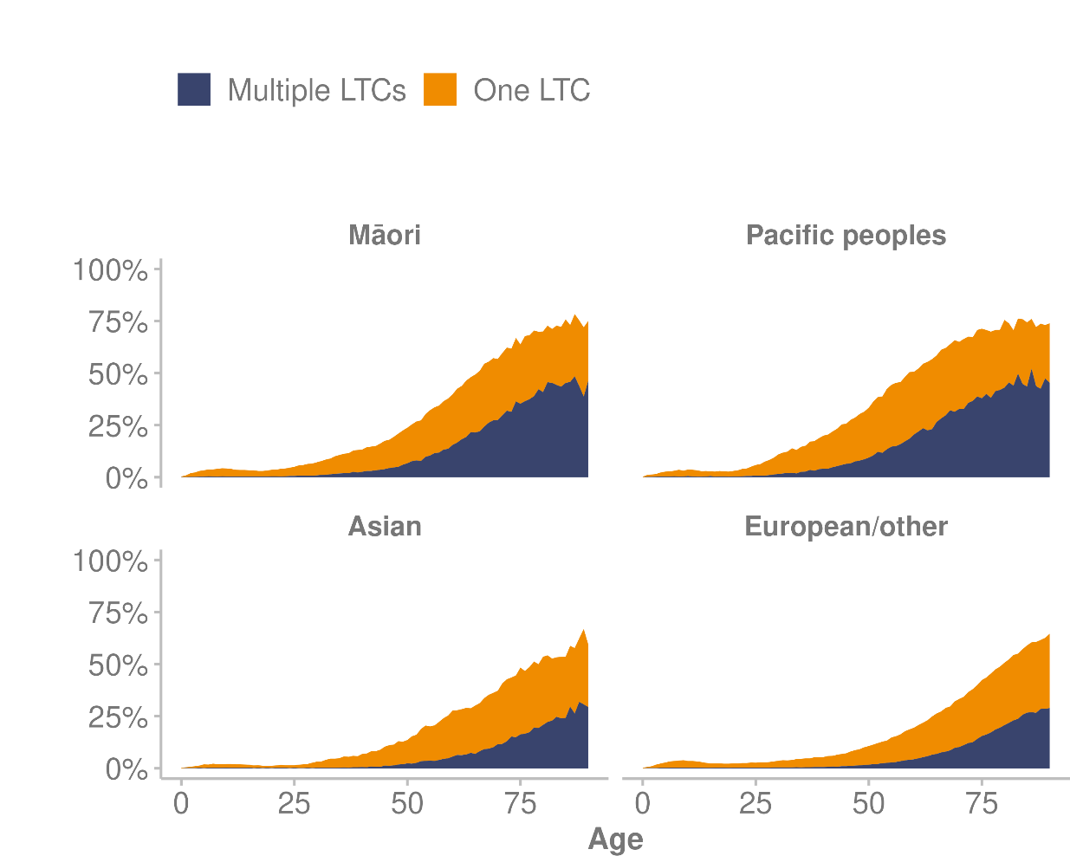

Source: Ministry of Health unpublished data (2022)

Working age Māori and Pacific peoples are disproportionately affected by long-term conditions, because they are more likely to develop a condition at a younger age (working age: 15-64 years; see Table 5). The estimated prevalence of multiple long-term conditions is 5.2% of working-age Pacific peoples, in comparison to 4.0% of Māori, 1.6% of the European/other group and 1.2% of the Asian group.

Developing long-term conditions earlier likely contributes to greater morbidity and earlier death (Ministry of Health 2020c). As discussed in the Population section of this report, the age distribution of the population is structured differently between ethnic groups. Māori, Pacific peoples and Asian populations are younger than the European/other ethnic group (Figure 3).

Pacific peoples develop long-term conditions earlier: at 59 years of age, 50% of the Pacific peoples population have at least one long-term condition (Figure 36). For Māori, the point at which at least 50% of the ethnic group have a long-term condition is 66 years, whereas people from the Asian and European/other ethnic groups are generally much older when they develop long-term conditions, reaching the same level of prevalence at 78 and 80 years respectively.

Table 5: Proportion of population, by number of long-term conditions and ethnic group, 2020

|  |  |  |  |  |
| --- | --- | --- | --- | --- |
| **Ethnic group** | **Age group (life stage)** | **No long-term condition (%)** | **Single long-term condition (%)** | **Multiple long-term conditions (%)** |
| Māori | 0–14 | 96.9 | 2.8 | 0.3 |
| 15–64 | 85.5 | 10.5 | 4.0 |
| 65+ | 39.6 | 29.5 | 31 |
| Pacific peoples | 0–14 | 97.4 | 2.3 | 0.3 |
| 15–64 | 81.0 | 13.8 | 5.2 |
| 65+ | 33 | 31.6 | 35.3 |
| Asian | 0–14 | 98.5 | 1.4 | 0.2 |
| 15–64 | 91.7 | 7.1 | 1.2 |
| 65+ | 58.6 | 27.5 | 13.9 |
| European/other | 0–14 | 97.3 | 2.5 | 0.2 |
| 15–64 | 91.3 | 7.1 | 1.6 |
| 65+ | 58.7 | 26.1 | 15.2 |

Source: Ministry of Health unpublished data (2022)

### Common combinations of long-term conditions

#### Diabetes

Diabetes is the most common long-term condition in New Zealand, with an overall prevalence of 5.5%. The distribution changes by ethnic group and age. The prevalence of diabetes in the population appears to decrease in the population aged 80 years and over. The median age of people who have diabetes is oldest for the European/other ethnic group, at 66 years, and younger for Pacific peoples (57 years), Indian people (58 years) and Māori (58 years).

The distribution of diabetes varies considerably within the Asian ethnic group; prevalence is highest in the Indian population. The following data and graphs therefore separate the Indian subgroup and combine the rest of the Asian ethnic group under European/other.

Figure 37: Proportion of population with diabetes, by ethnic group and age, 2020

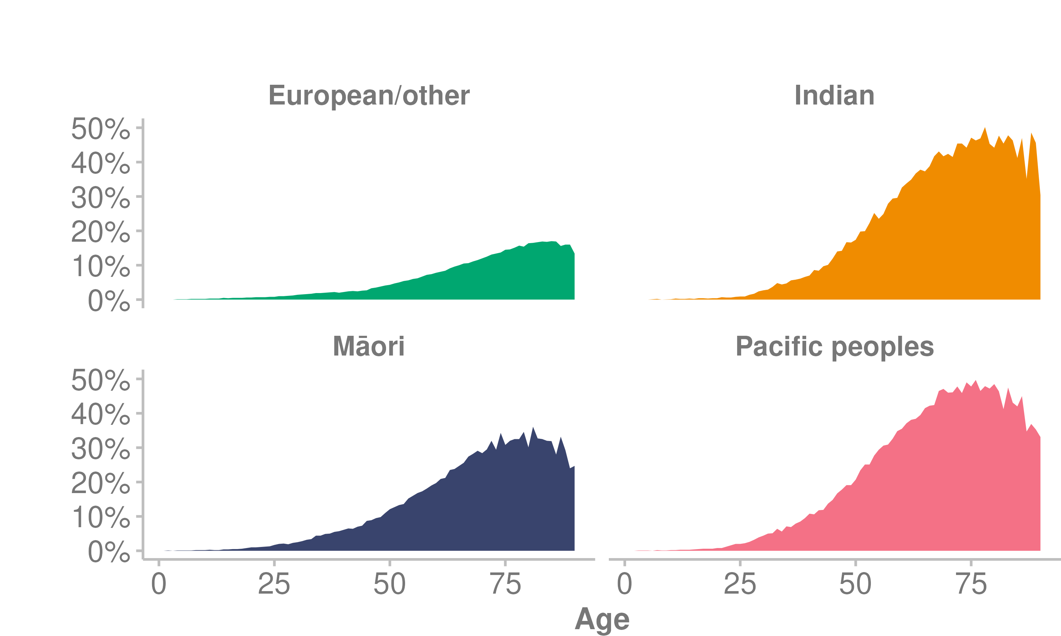

Source: Ministry of Health unpublished data (2022)

Over one in 10 working-age Pacific peoples have diabetes (11%). This is more than 3.6 times the level of prevalence in the working-age group for the European/other ethnic group (3.3%).

The most common comorbidity of all those who have diabetes is cardiovascular disease, at 22.3%, followed by gout at 13.8% and chronic kidney disease at 9.3%. The increased prevalence of these conditions is because the risk factors for developing a cardiovascular disease are similar to diabetes, and diabetes itself is a risk factor for developing a heart or kidney disease or having a stroke (Heart Research Institute NZ 2021). This is evident in the population as people with diabetes are 2 to 4 times more likely to have a heart attack or stroke than people who do not have diabetes.

#### Cardiovascular disease

Cardiovascular disease is the second most common long-term condition in the whole population, affecting 9% of those aged 35 years and over.[5] The most common comorbidity of those who have cardiovascular disease is diabetes, at 25.6%, followed by gout at 14.7% and chronic obstructive pulmonary disorder at 11.6%.

Māori, Pacific peoples and the European/other ethnic group have a similar prevalence of cardiovascular disease, at 10.0, 9.4 and 9.7% respectively, whereas the Asian ethnic group has the lowest prevalence, at 4%. However, the median age of people in the Asian ethnic group who have cardiovascular disease is 68 years, which is more similar to the equivalent age in Māori (64 years) and Pacific peoples (64 years). The median age of people in the European/other ethnic group who have cardiovascular disease is older, at 74 years.

Figure 38: Proportion of population with cardiovascular disease (35+ years), by ethnic group and age, 2020

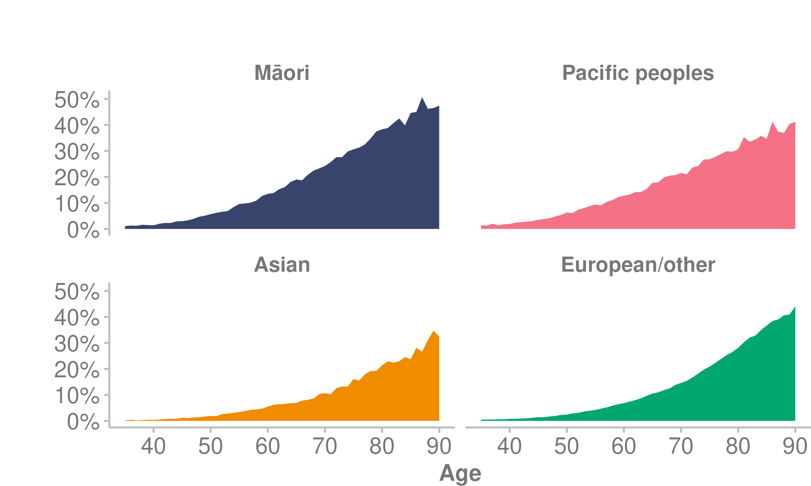

Source: Ministry of Health unpublished data (2022)

## Hospitalisations

People interact with hospitals in 2 ways: through planned care or in the ED. There are challenges in reaching timeliness targets in the context of both unplanned and planned care (Health Quality & Safety Commission 2021b).

### Unplanned/acute care

In 2021, 3.3% of people who attended an ED left before they received care. Aside from this group, there were 1,190,227 attendances to EDs around the country. As discussed in the PHO enrolment section, people reporting barriers with access to general practice may have contributed to number of people attending ED.

The percentage of people waiting more than 6 hours increased from 9% in 2017 to 19% in 2021.

#### Ambulatory sensitive hospital admissions

Ambulatory sensitive hospital (ASH) events are hospital admissions that are considered potentially avoidable through disease-preventing or therapeutic interventions delivered in a primary health care setting.

The measures taken in response to the COVID-19 epidemic in 2020, such as lockdowns and border closures, led to a drop in ASH rates for both the 0–4-year and 45–64-year age groups in 2020 (Ministry of Health 2022k). In 2021, ASH rates increased, but not to the same levels as in 2019.

##### Ambulatory sensitive hospital admissions for 0–4-year-olds

In New Zealand, upper ear, nose and throat respiratory infections and asthma are the top causes of ASH admissions for 0–4-year-olds (4,704 and 4,076 admissions in 2021 respectively), followed by gastroenteritis/dehydration (2,735) and dental conditions (2,421). Pacific children have significantly higher ASH rates than children of other ethnic groups (Nationwide Service Framework Library 2022a).

Figure 39: Ambulatory sensitive hospital rates for 0–4-year-olds, by prioritised ethnic group, 2017–2021

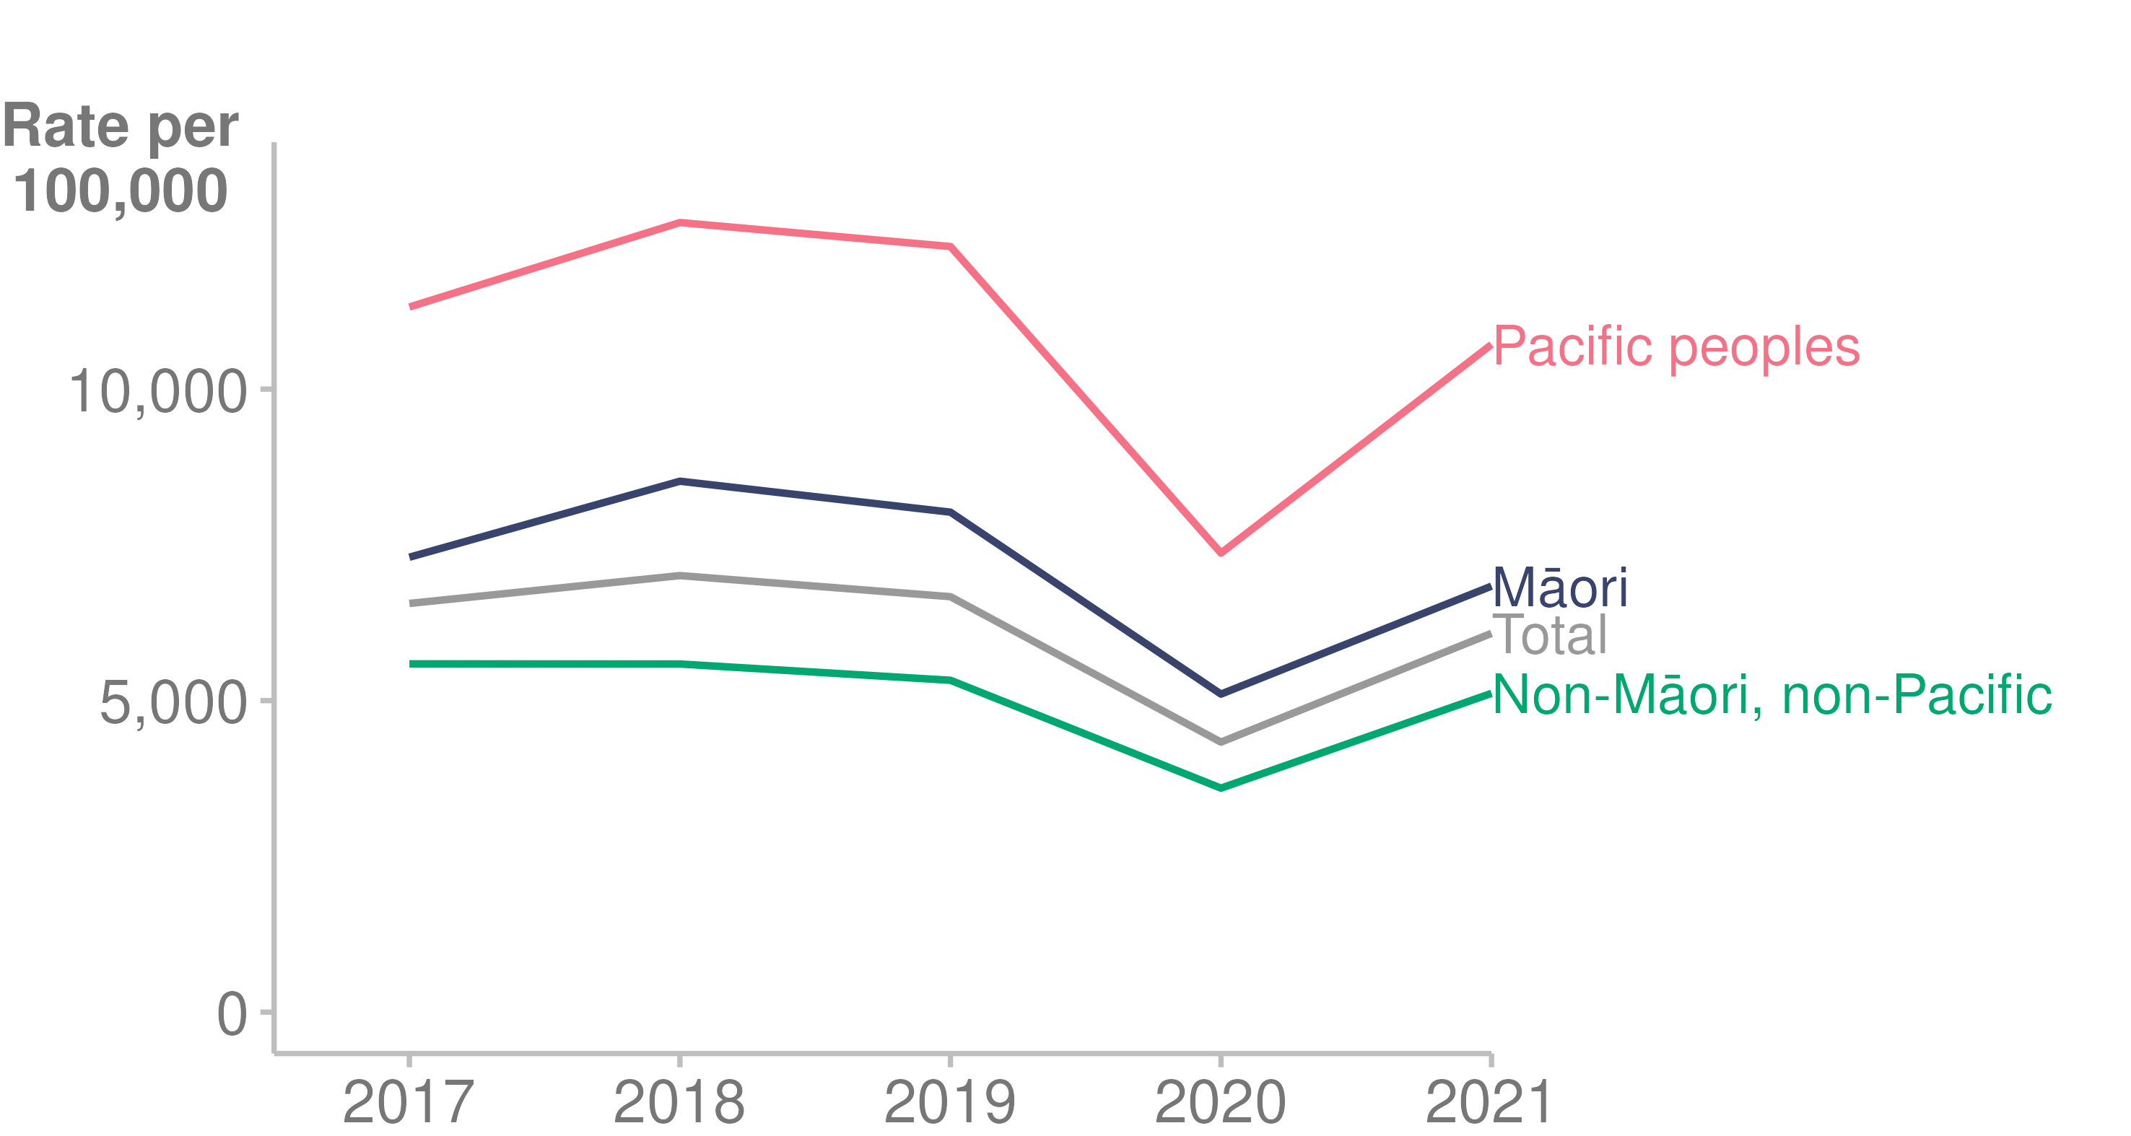

Source: [Nationwide Service Framework Library (2022a)](https://nsfl.health.govt.nz/accountability/performance-and-monitoring/data-quarterly-reports-and-reporting/ambulatory-sensitive)

##### Ambulatory sensitive hospital rates for 45–64-year-olds

In New Zealand, angina and chest pain are the leading causes of ASH admissions for 45–64-year-olds. Among the other leading causes are myocardial infarction, cellulitis and gastroenteritis (Nationwide Service Framework Library 2022a). For Māori, chronic obstructive pulmonary disease is the second highest ASH condition; the age-standardised ASH rate for Māori is more than double the rate for the other ethnic groups (the age-standardised rate of chronic obstructive pulmonary disease for Māori is 696 per 100,000, for Pacific peoples 299, and non-Māori/non-Pacific 122).

Figure 40: Ambulatory sensitive hospital rates for 45–64-year-olds, by prioritised ethnic group, 2017–2021

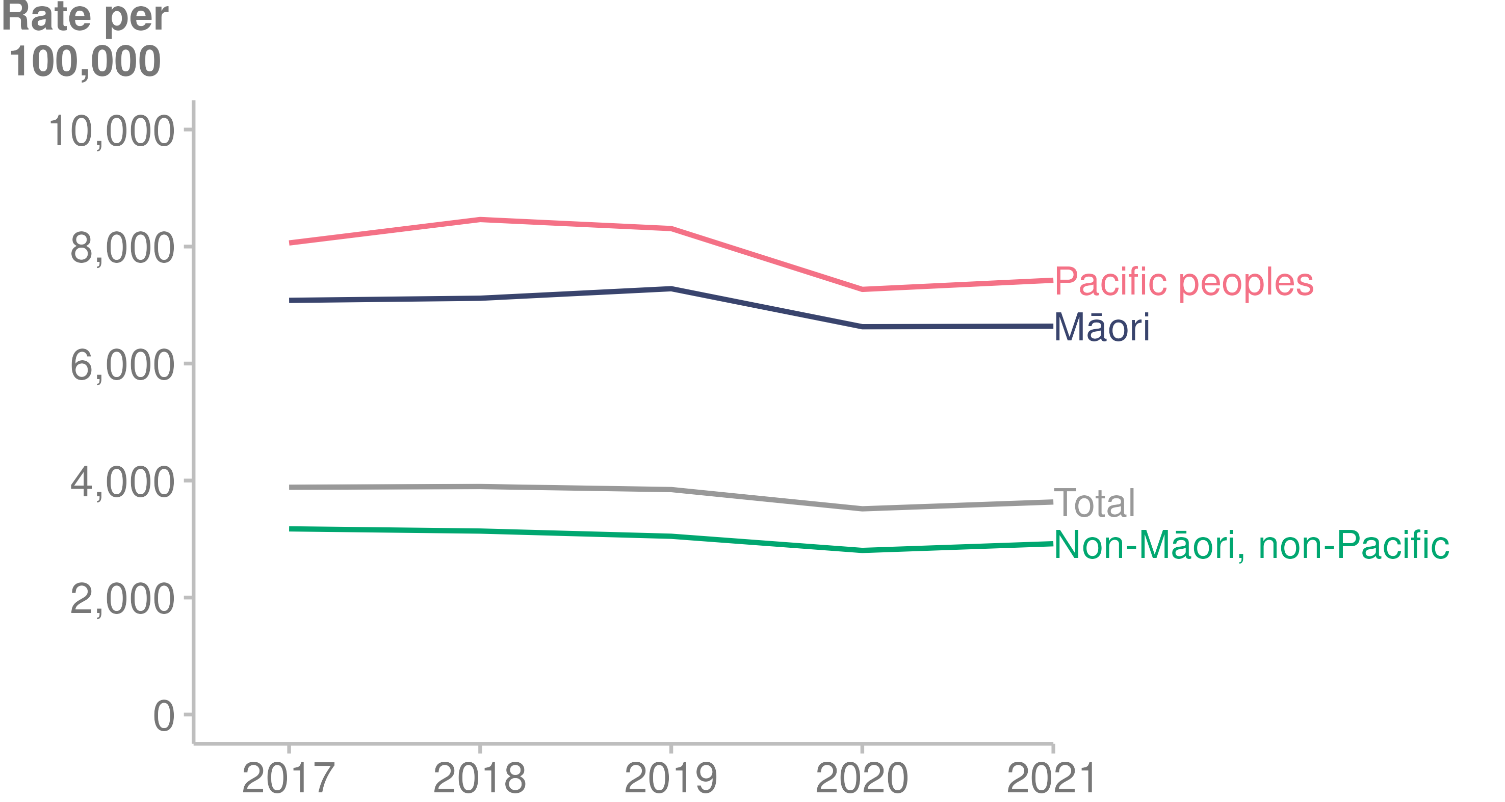

Source: [Nationwide Service Framework Library (2022a)](https://nsfl.health.govt.nz/accountability/performance-and-monitoring/data-quarterly-reports-and-reporting/ambulatory-sensitive)

##### In 2021, over 1 in 9 people were readmitted to hospital within 28 days of dischargeReadmission

An acute readmission is usually an emergency, or the unexpected return of a patient to hospital. Acute readmissions are sometimes part of an expected course of patient care; however, unplanned readmissions are associated with poor patient outcomes such as mortality, and are deemed preventable to a degree (Dsouza and Richards 2018).

Rates of acute readmissions have been stable since 2017: approximately 12% of discharges result in readmission within 28 days (12.2% in 2021).

#### Length of hospital stay for acute conditions

The average length of stay in hospital for acute conditions has been increasing since 2019 (Nationwide Service Framework Library 2022b). Over the last 5 years, Māori have had a shorter average length of stay than Pacific peoples and non-Māori/non-Pacific people.

Figure 41: Acute inpatient discharges standardised average length of stay, in days, by prioritised ethnic group, 2017–2021

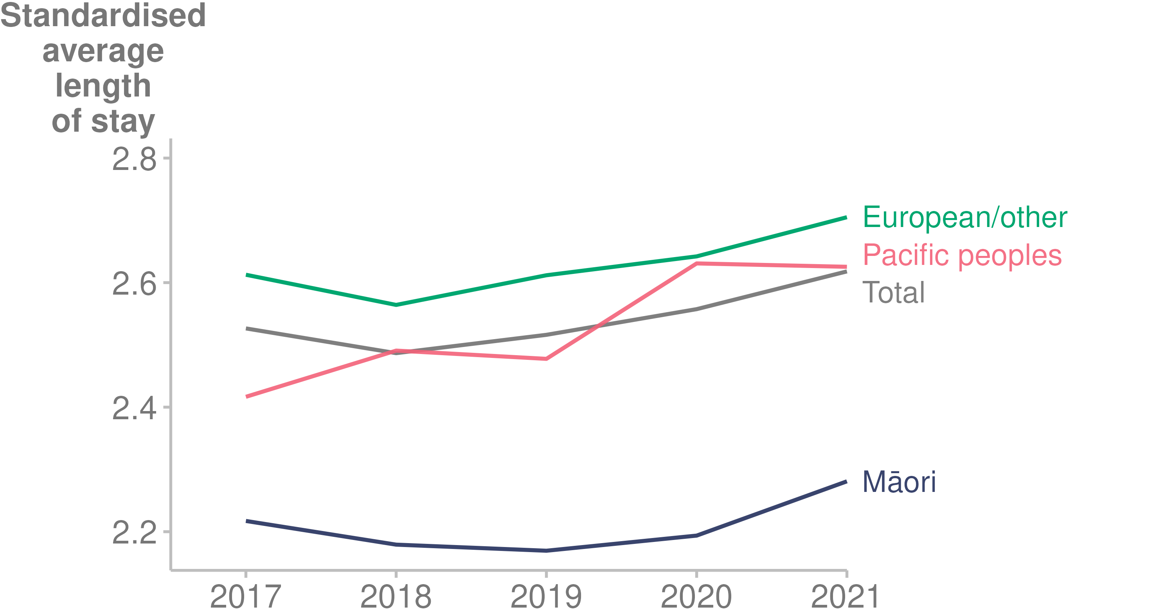

Source: [Nationwide Service Framework Library (2022b)](https://nsfl.health.govt.nz/accountability/performance-and-monitoring/data-quarterly-reports-and-reporting/inpatient-average)

### Planned care

#### Wait times

##### By the end of 2021 almost 2 in 5 people were waiting longer than 4 months for elective treatment/surgeryElective surgery/treatment

The COVID-19 pandemic affected wait times for planned care in 2021. Figure 42 shows that the peaks in wait time corresponded with lockdown periods and the Delta COVID-19 wave (Ministry of Health 2022s).

Figure 42: Proportion of patients who waited longer than 4 months for assessment and elective treatment or surgery, January 2019–December 2021

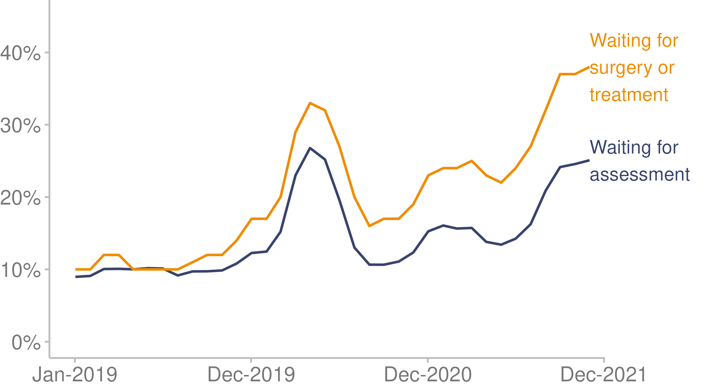

Source: Ministry of Health unpublished data (2022)

Wait times vary between specialty, as shown in Figure 43 below.

Figure 43: Proportion of patients who waited longer than 4 months for elective treatment/surgery, by specialty, 2021

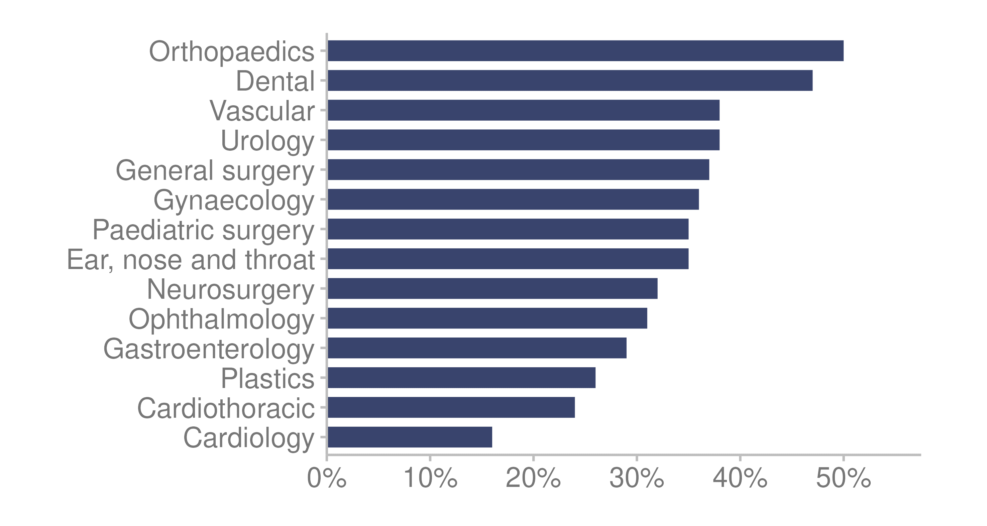

Source: Ministry of Health unpublished data (2022)

##### First specialist assessment

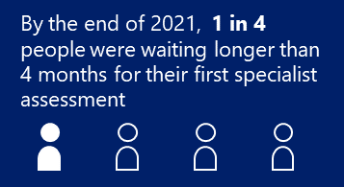The term ‘first specialist assessment’ (FSA) refers to the assessment undertaken by a hospital specialist following referral by a patient’s primary care practitioner, usually a general practitioner (GP). By the end of 2021, one in 4 people were waiting longer than 4 months for their FSA. Figure 44 shows wait times for FSA by specialty (Ministry of Health 2022g).

Figure 44: Proportion of patients who waited longer than 4 months for first specialist assessment by specialty, 2021

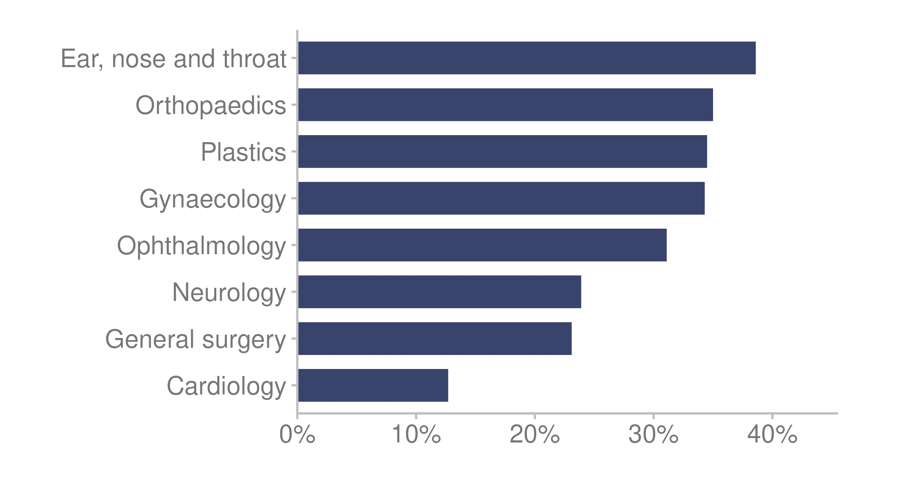

Source: [Ministry of Health (2022g)](https://minhealthnz2.shinyapps.io/ESPI-app/)

Note: There are a total of 36 speciality categories. This figure presents only the top 8 specialities by volume.

#### Planned care interventions

Over the last 5 years, the number of minor procedures (selected procedures defined as minor surgical operations completed in an inpatient, outpatient or community setting) continued to increase. The number of inpatient surgical treatments reduced slightly in 2020 but is now back to pre-COVID-19 levels. Figure 45 shows planned care delivery in 2021. In total, 142,707 minor procedures and 174,104 inpatient surgical treatments were delivered.

Figure 45: Number of planned care interventions delivered, 2017–2021

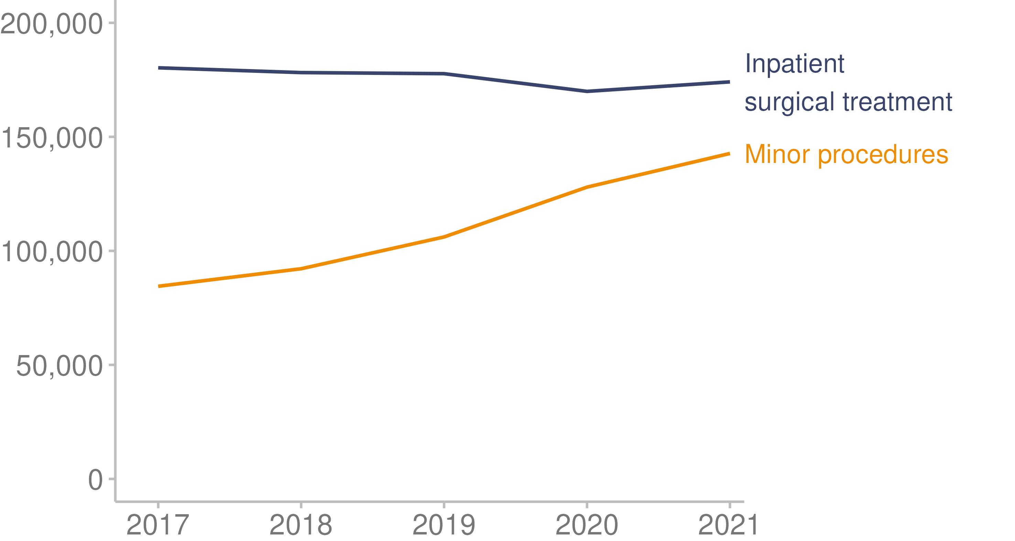

Source: Ministry of Health unpublished data (2022)

#### 

#### Length of stay in planned care

The average length of stay for planned inpatient stays differs between ethnic groups. In general, European/other patients spend longer in hospital than people in other ethnic groups.

Figure 46: Planned inpatient discharges standardised average length of stay, in days, by prioritised ethnic group, 2017–2021

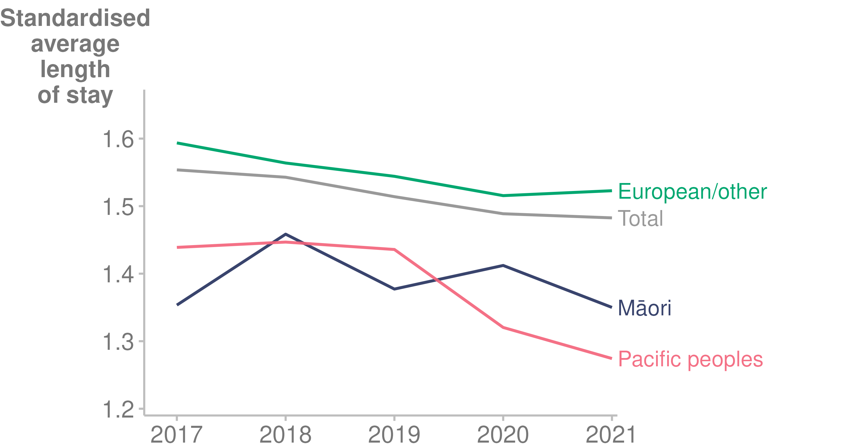

Source: [Nationwide Service Framework Library (2022b)](https://nsfl.health.govt.nz/accountability/performance-and-monitoring/data-quarterly-reports-and-reporting/inpatient-average)

## Health workforce

In 2021, the health workforce came under pressure due to the COVID-19 pandemic, in terms of both the reallocation of workers to respond to COVID-19 and the border closure, which reduced the number of migrant workers in the country. New Zealand generally relies on a significant number of internationally trained workers. For example, 42.1% of doctors in New Zealand are trained internationally (Medical Council of New Zealand 2022).

A fuller account of health workforce issues in 2021 is available in [*Health Workforce Advisory Board 2021 Annual Report to the Minister of Health*](https://www.health.govt.nz/publication/health-workforce-advisory-board-2021-annual-report-minister-health)(Ministry of Health 2022l).

### Impact of COVID-19

#### Reduced international supply

The New Zealand health workforce is made up of local and international health workers (Medical Council of New Zealand 2022). Due to COVID-19, immigration into the country was reduced, reducing the supply of health workers (Stats NZ 2022d).

Figure 47: International supply of new health workers, 2016–2021

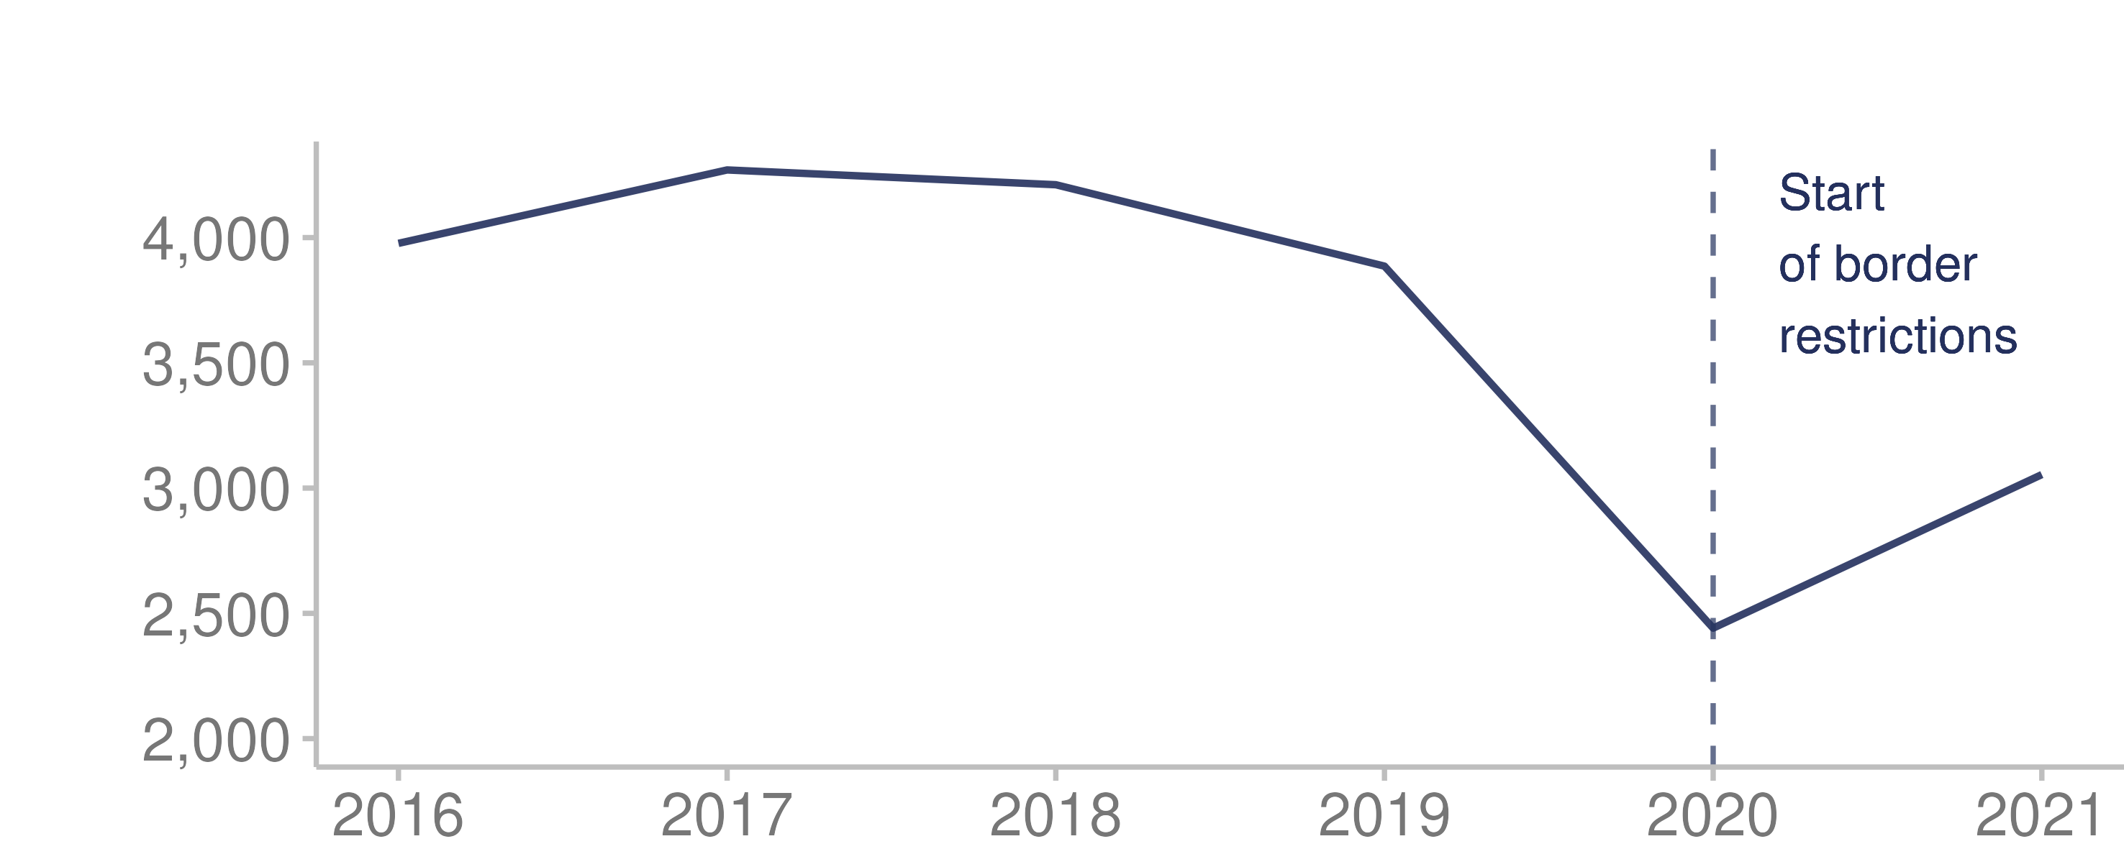

Source: [Stats NZ (2022d)](https://infoshare.stats.govt.nz/infoshare/Default.aspx)

Note: Health workers include health diagnostic and promotion professionals, health therapy professionals, medical practitioners, midwifery and nursing professionals and health and welfare support workers.

#### Expanding the workforce

In 2020 and early 2021, there was a pressing need to expand the health workforce to address the pandemic and to make up for a shortfall in the inflow of international health workers. Some of the measures in response included:

* special authorisations by the Pharmacy Council, Nursing Council and Medical Council for pharmacy, nursing and medical students to work in clinical roles under supervision
* extended scopes of practice, authorised by the Medical Council, for doctors to work in COVID-19-related roles
* temporary accommodation funded by the Ministry of Health for health workers working away from home or needing to isolate away from vulnerable family members
* the Nursing Council’s establishment of an interim practising certificate, in a limited scope, for nurses who had left practice
* the establishment of scholarships to support more Māori and Pacific peoples into health roles.

#### New roles

An outcome of the pandemic response has been the creation of new vaccination workforce available for immunisation programmes beyond COVID-19. For example, vaccinator assistants assisted registered nurses during the vaccination campaigns of 2021. This was a Manatū Hauora initiative strongly supported by the Health Workforce Advisory Board and district health boards.

More than 300 vaccinator assistants have now been trained; 50% are Māori (at September 2021). Fifty assistants are fully authorised and working in the field. There are long-term opportunities to retain this new skill set, for COVID-19 booster shots and for vaccinating younger New Zealanders in 2022 (Ministry of Health 2022l).

#### Māori and Pacific providers

During the COVID-19 response, Māori providers found that strategies for encouraging vaccination based on mātauranga Māori and kaupapa Māori were more successful in boosting numbers of vaccinations among Māori than mainstream health sector approaches. COVID-19 highlighted the agility and efficiency of Māori and Pacific providers and community-based non-government organisations working with vulnerable communities to respond to community transmission and administer the vaccination programme (Ministry of Health 2022l).

#### Impact on training and graduation

The number of students enrolled in tertiary health qualifications across all qualification levels increased by 8.6% between 2020 and 2021 (Education Counts 2022).

COVID-19 disrupted student clinical placements during 2021, resulting in delays to registration for students of physiotherapy, dentistry, occupational therapy, other allied health positions and medicine (Ministry of Health 2022l).

# Technical notes | Ngā tuhipoka hangarau

This report contains data from a range of sources, some of which are produced outside Manatū Hauora. Data is available through hyperlinks to sources, where available, or in the accompanying Excel file. We have aimed to report data only when the data collection and analytical processes are robust. Notes are included if methodological information affects the interpretation of the data. We encourage you to refer to the original data source for further details.

All data reported is the latest available from the time the report began production (30 April 2022). The time lag between the most recent data and the present can be substantial. Some data is provisional; for example, mortality data.

COVID-19 case and test figures may differ from those previously published due to methodology changes, updates to population denominators and the late addition of records.

The NZHS provides data on a variety of topics, not all of which will be covered in this report. The survey is one of the few data sources that contains data on the health of disabled people. This report includes data from the 2020/21 NZHS, which ran from September 2020 to August 2021. Due to the collection time and recall period, data will not reflect the impact of the subsequent Delta and Omicron outbreaks. For further details, please refer to the NZHS directly (Ministry of Health 2022b).

We have based ethnic comparisons on either prioritised ethnicity or total response ethnicity. With prioritised ethnicity, ethnic groups are mutually exclusive. That is, a person can appear in only one ethnic group, which is generally prioritised in the following order: Māori, Pacific peoples, Asian, other. With total response ethnicity, a person is classified in all ethnic groups they identify with. This means that a person can appear in more than one ethnic group. Prioritised ethnicity is often used for analysis based on administrative data (data collected for purposes other than statistics), such as mortality data, while total response ethnicity is shown for NZHS data.

Selected results are presented by neighbourhood deprivation, as measured by the NZDep2018 index of deprivation. This is an area-based measure of socioeconomic deprivation that uses a combination of the following 2018 Census data: household income, benefit receipt, household crowding, home ownership, employment status, qualifications, support (sole-parent families), living condition (dampness or mould) and household access to the internet. In this report, ‘quintile 5’ denotes the people living in the most socioeconomically deprived 20% of small areas in New Zealand. Conversely, ‘quintile 1’ denotes the people living in the least deprived 20% of small areas.

The report contains population data from Stats NZ population estimates and projections and the HSU population. There are some important differences between these data sources. Stats NZ population estimates are estimates of the resident population based on the Census and information on births, deaths and migration, and exclude short-term visitors to New Zealand. The HSU measures people who received health services in New Zealand in a given year, including short-term visitors. The HSU does not include people living in New Zealand if they have not interacted with the health system, and were not enrolled with a GP, during the year. Uptake of the COVID-19 vaccination programme in 2021 resulted in many people using health services in Aotearoa, including non-residents. At a population level, the HSU for 2021 is about 2% higher than the Stats NZ’s population estimate for 2021 (Ministry of Health 2022j). There are also differences in ethnicity recording between Stats NZ data and Ministry of Health data, which results in HSU totals by ethnic group differing from totals from Stats NZ population estimates and projections.

The Ministry of Health uses the HSU as the denominator for COVID-19 vaccine uptake rates (Ministry of Health 2022f). Stats NZ carried out an independent review of the HSU data and found that it is an appropriate way to measure COVID-19 vaccine coverage (Stats NZ 2022c). The Ministry response to the Stats NZ recommendations is available on the Ministry of Health [website](https://www.health.govt.nz/publication/response-stats-nz-recommendations-health-service-user-dataset) (Ministry of Health 2022x). The main rationale for using the HSU as a population denominator for health statistics, rather than data from Stats NZ, is to combat numerator-denominator bias. This happens when the demographics about a person are different in the numerator and the denominator. An example of numerator-denominator bias would be calculating vaccination coverage for Māori with COVID-19 vaccination data as the numerator and Stats NZ population estimates as the denominator. This is because the ethnic groups with which someone identifies can be different in health data – in this case in the COVID-19 Immunisation Register and Stats NZ population estimates.

When possible, we have reported on statistically significant differences between population groups and, when relevant, trends over time. In many comparisons, the results have been adjusted or standardised for factors that may influence (confound) the comparison, such as age and gender. Age standardisation is often used in this report to account for differences in age structure between population groups and over time (Ministry of Health 2020d).

# References | Ngā tohutoro

Abdel-Rahman O, Helbling D, Schöb O, et al. 2017. Cigarette smoking as a risk factor for the development of and mortality from hepatocellular carcinoma: An updated systematic review of 81 epidemiological studies. *Journal of Evidence Based Medicine* 10(4): 245-54.

Atkinson J, Crampton P, Salmond C. 2021. *NZDep2018 analysis of census 2018 variables – Overall (New Zealand)*. URL: <http://hdl.handle.net/10523/12052> (accessed 31 October 2022).

Atkinson J, Salmond C, Crampton P. 2019. *NZDep2018 Index of Deprivation*. URL: [www.otago.ac.nz/wellington/otago823833.pdf](https://mohgovtnz-my.sharepoint.com/personal/leonie_pritchard_health_govt_nz1/Documents/Documents/Health%20and%20Independence%20Report%202021/www.otago.ac.nz/wellington/otago823833.pdf) (accessed 31 October 2021).

Bartholomew K, Morton SM, Carr PE, et al. 2015. Early engagement with a Lead Maternity Carer: Results from Growing Up in New Zealand. *Australian and New Zealand Journal of Obstetrics and Gynaecology* 55(3): 227-32.

Centers for Disease Control and Prevention. 2020. *RSV in infants and young children*. URL: <https://www.cdc.gov/rsv/high-risk/infants-young-children.html> (accessed 31 October 2022).

de Martel C, Plummer M, Vignat J, et al. 2017. Worldwide burden of cancer attributable to HPV by site, country and HPV type. *International Journal of Cancer* 141(4): 664–70.

Dsouza J, Richards S. 2018. Unplanned readmissions in frail individuals. *New Zealand Medical Journal* 131: 1484.

Education Counts. 2022. *Tertiary participation (Data file)*. URL: <https://www.educationcounts.govt.nz/statistics/tertiary-participation> (accessed 31 October 2022).

Edwards R, Hoek J, Wilson N, et al. 2020. *What does the 2019/20 NZ Health Survey tell us about progress towards a Smokefree Aotearoa?* URL: <https://blogs.otago.ac.nz/pubhealthexpert/what-does-the-2019-20-nz-health-survey-tell-us-about-progress-towards-a-smokefree-aotearoa/> (accessed 31 October 2022).

Environmental Health Intelligence New Zealand. 2020. *Oral health of children*. URL: <https://www.ehinz.ac.nz/assets/Factsheets/Oral-health-of-children-FS.pdf> (accessed 31 October 2022).

ESR. 2022. *EpiSurv (Data file)*. URL: <https://surv.esr.cri.nz/episurv/index.php> (accessed 31 October 2022).

Gilham C, Sargent A, Kitchener HC, et al. 2019. HPV testing compared with routine cytology in cervical screening: long-term follow-up of ARTISTIC RCT. *Health Technology Assessment* 23(28): 1–44.

Government Inquiry into Mental Health and Addiction. 2018. *He Ara Oranga: Report of the Government inquiry into mental health and addiction*. URL: <https://mentalhealth.inquiry.govt.nz/assets/Summary-reports/He-Ara-Oranga.pdf> (accessed 31 October 2022).

Grant CC, Huang QS, Trenholme A, et al. 2021. What can we learn from our 2021 respiratory syncytial virus experience. *New Zealand Medical Journal* 134: 1540.

Gurney J, Millar E, Dunn A, et al. 2021. The impact of the COVID-19 pandemic on cancer diagnosis and service access in New Zealand–a country pursuing COVID-19 elimination. *The Lancet Regional Health - Western Pacific* 10: 100127.

Gurney J, Stanley J, McLeod M, et al. 2020. Disparities in cancer-specific survival between Māori and non-Māori New Zealanders, 2007–2016. *JCO Global Oncology* 6: 766–74.

Hatter L, Eathorne A, Hills T, et al. 2021. Respiratory syncytial virus: paying the immunity debt with interest. *The Lancet Child and Adolescent Health* 5(12): E44-E5.

Health Navigator. 2022. *Respiratory syncytial virus (RSV) infection*. URL: <https://www.healthnavigator.org.nz/health-a-z/r/respiratory-syncytial-virus-rsv-infection/> (accessed 31 October 2022).

Health Quality & Safety Commission. 2019. *A window on the quality of Aotearoa New Zealand's health care 2019: A view on Māori health equity*. URL: [www.hqsc.govt.nz/our-programmes/health-quality-evaluation/publications-and-resources/publication/3721/](https://mohgovtnz-my.sharepoint.com/personal/leonie_pritchard_health_govt_nz1/Documents/Documents/Health%20and%20Independence%20Report%202021/www.hqsc.govt.nz/our-programmes/health-quality-evaluation/publications-and-resources/publication/3721/) (accessed 31 October 2022).

Health Quality & Safety Commission. 2021a. *Bula Sautu: A window on quality 2021: Pacific health in the year of COVID-19*. URL: [www.hqsc.govt.nz/our-programmes/health-quality-evaluation/publications-and-resources/publication/4299/](https://mohgovtnz-my.sharepoint.com/personal/leonie_pritchard_health_govt_nz1/Documents/Documents/Health%20and%20Independence%20Report%202021/www.hqsc.govt.nz/our-programmes/health-quality-evaluation/publications-and-resources/publication/4299/) (accessed 31 October 2022).

Health Quality & Safety Commission. 2021b. *A window on quality 2021: COVID-19 and impacts on our broader health system*. URL: <https://www.hqsc.govt.nz/assets/Our-data/Publications-resources/COVID-Window-2021-final-web.pdf> (accessed 1 November 2022).

Heart Research Institute NZ. 2021. *Diabetes*. URL: <https://www.hri.org.nz/health/learn/cardiovascular-disease/diabetes> (accessed 31 October 2022).

Institute for Health Metrics and Evaluation. 2019. *New Zealand*. URL: <https://www.healthdata.org/new-zealand> (accessed 31 October 2022).

Institute for Health Metrics and Evaluation. 2021. *GHDx (healthdata.org): GBD results tool*. URL: <http://ghdx.healthdata.org/gbd-results-tool> (accessed 31 October 2022).

Irurzun-Lopez M, Jeffreys M, Cumming J. 2021. The enrolment gap: Who is not enrolling with primary health organizations in Aotearoa New Zealand and what are the implications? An exploration of 2015–2019 administrative data. *International Journal for Equity in Health* 20: 93.

Kim K, Choi S, Park SM. 2018. Association of high body mass index and hepatocellular carcinoma in patients with chronic Hepatitis B virus infection. *JAMA Oncology* 4(5): 737–9.

Lei J, Ploner A, Elfström M, et al. 2020. HPV vaccination and the risk of invasive cervical cancer. *New England Journal of Medicine* 383: 1340–8.

Matsushita H, Takaki A. 2019. Alcohol and hepatocellular carcinoma. *BMJ Open Gastroenterology* 6(1): e000260.

Medical Council of New Zealand. 2022. *The New Zealand medical workforce in 2021*. URL: <https://www.mcnz.org.nz/assets/Publications/Workforce-Survey/d9d2757aad/Workforce-Survey-Report-2021.pdf> (accessed 31 October 2022).

Mental Health and Wellbeing Commission. 2021. *Access and Choice Programme: Report on the first two years – Te Hōtaka mō Ngā Whai Wāhitanga me Ngā Kōwhiringa: He purongo mo ngā rua tau tuatahi*. URL: <https://www.mhwc.govt.nz/assets/Our-reports/MHWC-Access-and-Choice-report-Final.pdf> (accessed 31 October 2022).

Mental Health Foundation of New Zealand. 2022. *What is Wellbeing?* URL: <https://mentalhealth.org.nz/what-is-wellbeing> (accessed 31 October 2022).

Ministry of Health. 2002. *Reducing Inequalities in Health*. URL: <https://www.health.govt.nz/system/files/documents/publications/reducineqal.pdf> (accessed 31 October 2022).

Ministry of Health. 2018. *Pregnancy services*. URL: <https://www.health.govt.nz/new-zealand-health-system/publicly-funded-health-and-disability-services/pregnancy-services> (accessed 31 October 2022).

Ministry of Health. 2020a. *Age 5 and year 8 oral health data from the Community Oral Health Service*. URL: [www.health.govt.nz/nz-health-statistics/health-statistics-and-data-sets/oral-health-data-and-stats/age-5-and-year-8-oral-health-data-community-oral-health-service](https://mohgovtnz-my.sharepoint.com/personal/leonie_pritchard_health_govt_nz1/Documents/Documents/Health%20and%20Independence%20Report%202021/www.health.govt.nz/nz-health-statistics/health-statistics-and-data-sets/oral-health-data-and-stats/age-5-and-year-8-oral-health-data-community-oral-health-service) (accessed 31 October 2022).

Ministry of Health. 2020b. *Eating and Activity Guidelines for New Zealand Adults*. URL: [www.health.govt.nz/publication/eating-and-activity-guidelines-new-zealand-adults](https://mohgovtnz-my.sharepoint.com/personal/leonie_pritchard_health_govt_nz1/Documents/Documents/Health%20and%20Independence%20Report%202021/www.health.govt.nz/publication/eating-and-activity-guidelines-new-zealand-adults) (accessed 31 September 2022).

Ministry of Health. 2020c. *Longer, Healthier Lives: New Zealand's health 1990-2017*. URL: [www.health.govt.nz/publication/longer-healthier-lives-new-zealands-health-1990-2017](https://mohgovtnz-my.sharepoint.com/personal/leonie_pritchard_health_govt_nz1/Documents/Documents/Health%20and%20Independence%20Report%202021/www.health.govt.nz/publication/longer-healthier-lives-new-zealands-health-1990-2017) (accessed 28 October 2022).

Ministry of Health. 2020d. *Methodology Report 2019/20: New Zealand Health Survey*. URL: [www.health.govt.nz/publication/methodology-report-2019-20-new-zealand-health-survey](https://mohgovtnz-my.sharepoint.com/personal/leonie_pritchard_health_govt_nz1/Documents/Documents/Health%20and%20Independence%20Report%202021/www.health.govt.nz/publication/methodology-report-2019-20-new-zealand-health-survey) (accessed 1 November 2022).

Ministry of Health. 2020e. *New Zealand Immunisation Schedule*. URL: <https://www.health.govt.nz/our-work/preventative-health-wellness/immunisation/new-zealand-immunisation-schedule> (accessed 31 October 2022).

Ministry of Health. 2021. *Kia Manawanui Aotearoa: Long-term pathway to mental wellbeing*. URL: <https://www.health.govt.nz/system/files/documents/publications/web3-kia-manawanui-aotearoa-v9_0.pdf> (accessed 28 October 2022).

Ministry of Health. 2022a. *2020 Immunisation Schedule changes*. URL: <https://www.health.govt.nz/our-work/preventative-health-wellness/immunisation/new-zealand-immunisation-schedule/2020-immunisation-schedule-changes> (accessed 31 October 2022).

Ministry of Health. 2022b. *Annual Data Explorer 2020/21: New Zealand Health Survey (Data file)*. URL: <https://minhealthnz.shinyapps.io/nz-health-survey-2020-21-annual-data-explorer/> (accessed 31 October 2022).

Ministry of Health. 2022c. *BreastScreen Aotearoa DHB coverage report (Data file)*. URL: <https://minhealthnz.shinyapps.io/nsu-bsa-coverage-dhb/> (accessed 31 October 2022).

Ministry of Health. 2022d. *COVID-19: Minimisation and protection strategy for Aotearoa New Zealand*. URL: <https://www.health.govt.nz/covid-19-novel-coronavirus/covid-19-response-planning/covid-19-minimisation-and-protection-strategy-aotearoa-new-zealand> (accessed 31 October 2022).

Ministry of Health. 2022e. *COVID-19: Supporting the vaccine rollout*. URL: <https://www.health.govt.nz/covid-19-novel-coronavirus/covid-19-vaccines/covid-19-vaccine-information-health-professionals/covid-19-vaccine-strategy-planning-insights/covid-19-supporting-vaccine-rollout> (accessed 22 September 2022).

Ministry of Health. 2022f. *COVID-19: Vaccine data*. URL: <https://www.health.govt.nz/covid-19-novel-coronavirus/covid-19-data-and-statistics/covid-19-vaccine-data> (accessed 1 November 2022).

Ministry of Health. 2022g. *Elective Services Patient Flow Indicators Web Tool (Data file)*. URL: <https://minhealthnz2.shinyapps.io/ESPI-app/> (accessed 31 October 2022).

Ministry of Health. 2022h. *Enrolment with a general practice and primary health organisation*. URL: <https://www.health.govt.nz/our-work/primary-health-care/about-primary-health-organisations/enrolment-general-practice-and-primary-health-organisation> (accessed 31 October 2022).

Ministry of Health. 2022i. *Evaluation of the Māori Influenza and Measles Vaccination Programme: In pursuit of Māori health equity*. URL: <https://www.health.govt.nz/publication/evaluation-maori-influenza-and-measles-vaccination-programme-pursuit-maori-health-equity> (accessed 31 October 2022).

Ministry of Health. 2022j. *Further information about the HSU dataset and review*. URL: <https://www.health.govt.nz/system/files/documents/publications/further-information-about-the-hsu-dataset-and-review-4aug22.pdf> (accessed 31 October 2022).

Ministry of Health. 2022k. *Health System Indicators framework*. URL: <https://www.health.govt.nz/new-zealand-health-system/health-system-indicators-framework> (accessed 31 October 2022).

Ministry of Health. 2022l. *Health Workforce Advisory Board 2021 Annual Report to the Minister of Health*. URL: <https://www.health.govt.nz/publication/health-workforce-advisory-board-2021-annual-report-minister-health> (accessed 31 October 2022).

Ministry of Health. 2022m. *HPV immunisation*. URL: <https://www.health.govt.nz/your-health/healthy-living/immunisation/immunisation-older-children-and-teenagers/human-papillomavirus-hpv/hpv-immunisation> (accessed 31 October 2022).

Ministry of Health. 2022n. *Immunisation*. URL: <https://www.health.govt.nz/our-work/preventative-health-wellness/immunisation> (accessed 31 October 2022).

Ministry of Health. 2022o. *Maternity web tool (Data file)*. URL: <https://minhealthnz.shinyapps.io/report-on-maternity-web-tool/> (accessed 28 October 2022).

Ministry of Health. 2022p. *Mental health and addiction monitoring, reporting and data*. URL: <https://www.health.govt.nz/our-work/mental-health-and-addiction/mental-health-and-addiction-monitoring-reporting-and-data> (accessed 4 October 2022).

Ministry of Health. 2022q. *Mortality web tool (Data file)*. URL: [www.health.govt.nz/publication/mortality-web-tool](https://mohgovtnz-my.sharepoint.com/personal/leonie_pritchard_health_govt_nz1/Documents/Documents/Health%20and%20Independence%20Report%202021/www.health.govt.nz/publication/mortality-web-tool) (accessed 31 October 2022).

Ministry of Health. 2022r. *National and DHB immunisation data*. URL: <https://www.health.govt.nz/our-work/preventative-health-wellness/immunisation/immunisation-coverage/national-and-dhb-immunisation-data> (accessed 1 November 2022).

Ministry of Health. 2022s. *National Booking Reporting System data dictionary*. URL: <https://www.health.govt.nz/publication/national-booking-reporting-system-data-dictionary> (accessed 31 October 2022).

Ministry of Health. 2022t. *National Bowel Screen Programme (Data file)*. URL: <https://minhealthnz.shinyapps.io/nsu-bsp-index/> (accessed 31 October 2022).

Ministry of Health. 2022u. *National Cervical Screening Programme Coverage Report (Data file)*. URL: <https://minhealthnz.shinyapps.io/nsu-ncsp-coverage/> (accessed 31 October 2022).

Ministry of Health. 2022v. *National Immunisation Register*. URL: [www.health.govt.nz/our-work/preventative-health-wellness/immunisation/national-immunisation-register](https://mohgovtnz-my.sharepoint.com/personal/leonie_pritchard_health_govt_nz1/Documents/Documents/Health%20and%20Independence%20Report%202021/www.health.govt.nz/our-work/preventative-health-wellness/immunisation/national-immunisation-register) (accessed 31 October 2022).

Ministry of Health. 2022w. *Populations web tool (Data file)*. URL: <https://minhealthnz.shinyapps.io/populations-web-tool/> (accessed 28 October 2022).

Ministry of Health. 2022x. *Response to Stats NZ recommendations for the Health Service User dataset*. URL: <https://www.health.govt.nz/publication/response-stats-nz-recommendations-health-service-user-dataset> (accessed 28 October 2022).

Ministry of Health. nd. *Long-term conditions and common comorbidities*. URL: Ministry of Health (unpublished publication) (accessed 22 September 2022).

Moharram MA, Aitken-Buck HM, Reijers R, et al. 2020. Correlation between epicardial adipose tissue and body mass index in New Zealand ethnic populations. *New Zealand Medical Journal* 133(1516): 22–32.

National Screening Unit. 2022. *National Cervical Screening Programme Sector Update – April 2022*. URL: <https://www.nsu.govt.nz/news/national-cervical-screening-programme-sector-update-april-2022> (accessed 31 October 2022).

Nationwide Service Framework Library. 2022a. *Ambulatory sensitive (avoidable) hospital admissions*. URL: <https://nsfl.health.govt.nz/accountability/performance-and-monitoring/data-quarterly-reports-and-reporting/ambulatory-sensitive> (accessed 31 October 2022).

Nationwide Service Framework Library. 2022b. *Inpatient average length of stay (Data file)*. URL: <https://nsfl.health.govt.nz/accountability/performance-and-monitoring/data-quarterly-reports-and-reporting/inpatient-average> (accessed 31 October 2022).

OECD. 2022. *Realising the potential for primary health care*. URL: <https://www.oecd.org/health/realising-the-potential-of-primary-health-care-a92adee4-en.htm> (accessed 31 October 2022).

Office for Disability Issues. 2022. *COVID-19 data analysis*. URL: <https://www.odi.govt.nz/guidance-and-resources/covid-19-data-analysis/> (accessed 31 October 2022).

Oliveira CR, Niccolai LM. 2021. Monitoring HPV vaccine impact on cervical disease: Status and future directions for the era of cervical cancer elimination. *Preventive Medicine* 144: 106363.

Prasad N, Newbern CE, Trenholme AA, et al. 2019. Respiratory syncytial virus hospitalisations among young children: a data linkage study. *Epidemiology and Infection* 147: e246.

Stats NZ. 2021a. *National and subnational period life tables: 2017–2019*. URL: [www.stats.govt.nz/information-releases/national-and-subnational-period-life-tables-2017-2019](https://mohgovtnz-my.sharepoint.com/personal/leonie_pritchard_health_govt_nz1/Documents/Documents/Health%20and%20Independence%20Report%202021/www.stats.govt.nz/information-releases/national-and-subnational-period-life-tables-2017-2019) (accessed 28 October 2022).

Stats NZ. 2021b. *Net migration dips into the negative*. URL: <https://www.stats.govt.nz/news/net-migration-dips-into-the-negative> (accessed 28 October 2022).

Stats NZ. 2021c. *New Zealand's birth rate lowest on record, deaths drop in 2020*. URL: <https://www.stats.govt.nz/news/new-zealands-birth-rate-lowest-on-record-deaths-drop-in-2020> (accessed 28 October 2022).

Stats NZ. 2021d. *Population projected to become more ethnically diverse*. URL: [www.stats.govt.nz/news/population-projected-to-become-more-ethnically-diverse](https://mohgovtnz-my.sharepoint.com/personal/leonie_pritchard_health_govt_nz1/Documents/Documents/Health%20and%20Independence%20Report%202021/www.stats.govt.nz/news/population-projected-to-become-more-ethnically-diverse) (accessed 28 October 2022).

Stats NZ. 2022a. *Births and deaths: Year ended December 2021 (including abridged period life table)*. URL: <https://www.stats.govt.nz/information-releases/births-and-deaths-year-ended-december-2021-including-abridged-period-life-table/> (accessed 21 September 2022).

Stats NZ. 2022b. *National population estimates: At 31 October 2021 – Infoshare tables*. URL: <https://www.stats.govt.nz/information-releases/national-population-estimates-at-31-december-2021-infoshare-tables/> (accessed 28 October 2022).

Stats NZ. 2022c. *Review of Health Service User population methodology*. URL: <https://www.stats.govt.nz/reports/review-of-health-service-user-population-methodology/> (accessed 28 October 2022).

Stats NZ. 2022d. *Stats NZ: Infoshare (Data file)*. URL: <http://infoshare.stats.govt.nz/Default.aspx> (accessed 31 October 2022).

Te Aho o Te Kahu Cancer Control Agency. 2021. *The state of cancer in New Zealand 2020*. URL: <https://teaho.govt.nz/reports/cancer-state> (accessed 31 October 2022).

Te Aho o Te Kahu Cancer Control Agency. 2022a. *COVID-19 and cancer services: Working report on the impact of COVID-19 on cancer services for the period ending December 2021*. URL: <https://hcmsitesstorage.blob.core.windows.net/cca/assets/COVID_19_and_cancer_report_Nov_Dec_2021_20220216_b9ea1d00d4.pdf> (accessed 31 October 2022).

Te Aho o Te Kahu Cancer Control Agency. 2022b. *Pūrongo Ārai Mate Pukupuku Cancer Prevention Report*. URL: <https://hcmsitesstorage.blob.core.windows.net/cca/assets/Cancer_Prevention_V12_7_April22_05c46c078b.pdf> (accessed 31 October 2022).

Te Whatu Ora. 2022. *Updated health user information informs COVID-19 vaccination programme*. URL: <https://www.tewhatuora.govt.nz/about-us/news-and-updates/updated-health-user-information-informs-covid-19-vaccination-programme/> (accessed 28 October 2022).

The Immunisation Advisory Centre. 2021. *5 to 11 years old COVID resources*. URL: <https://covid.immune.org.nz/covid-19-vaccines-nz/getting-vaccinated/5-11-years-old-covid-resources> (accessed 31 October 2022).

The Immunisation Advisory Centre. 2022. *Human papillomavirus (HPV)*. URL: <https://www.immune.org.nz/diseases/human-papillomavirus-hpv> (accessed 31 October 2022).

Unite against COVID-19. 2021. *COVID-19 vaccine rollout plan*. URL: <https://covid19.govt.nz/news-and-data/latest-news/covid-19-vaccine-rollout-plan/> (accessed 31 October 2022).

Whiteman DC, Webb PM, Green AC, et al. 2015. Cancers in Australia in 2010 attributable to modifiable factors: summary and conclusions. *Australian and New Zealand journal of public health* 39(5): 477-84.

World Health Organization. 2001. *AUDIT: The alcohol use disorder identification test: guidelines for use in primary health care*. URL: <https://www.who.int/publications/i/item/WHO-MSD-MSB-01.6a> (accessed 1 November 2022).

World Health Organization. 2017. *Determinants of health*. URL: <https://www.who.int/news-room/questions-and-answers/item/determinants-of-health> (accessed 31 October 2022).

World Health Organization. 2020. *WHO report on cancer: Setting priorities, investing wisely and providing care for all*. URL: <https://www.who.int/publications/i/item/9789240001299> (accessed 1 November 2022).

World Health Organization. 2021. *Obesity and overweight*. URL: <https://www.who.int/news-room/fact-sheets/detail/obesity-and-overweight> (accessed 1 November 2022).

World Health Organization. 2022a. *14.9 million excess deaths associated with the COVID-19 pandemic in 2020 and 2021*. URL: <https://www.who.int/news/item/05-05-2022-14.9-million-excess-deaths-were-associated-with-the-covid-19-pandemic-in-2020-and-2021> (accessed 31 October 2022).

World Health Organization. 2022b. *WHO Coronavirus (COVID-19) Dashboard*. URL: <https://covid19.who.int/> (accessed 1 November 2022).

1. Excess mortality is calculated as the difference between the number of deaths that have occurred and the number that would be expected in the absence of the pandemic based on data from earlier years.
2. At the time of vaccination.
3. The Global Burden of Disease Study (GBD) is a comprehensive regional and global research program of disease burden that assesses mortality and disability from major diseases, injuries, and risk factors
4. ‘Cardiovascular disease’ is a general term for conditions affecting the heart or blood vessels. It includes coronary heart disease, ischaemic stroke, peripheral vascular disease, atrial fibrillation and flutter, congestive heart failure and mechanical heart valve.
5. Cardiovascular disease is generally only prevalent in people aged 35 and over, so statistics in this section have been limited to that age group.