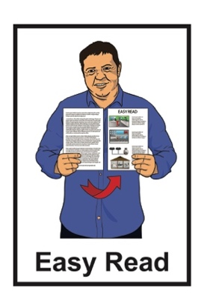
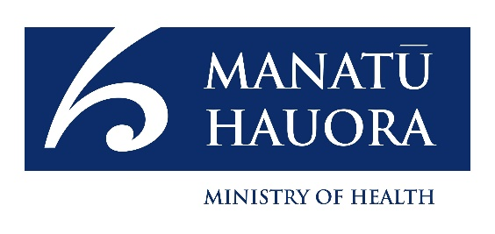



Summary of a report called:
Pharmacy Whakamahere ̶

Understanding the pharmacy needs

of our population
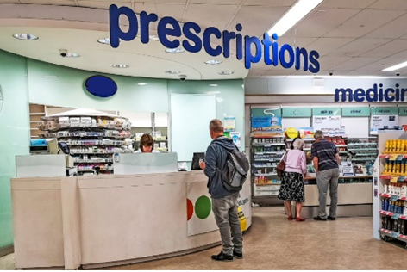

Published: August 2023
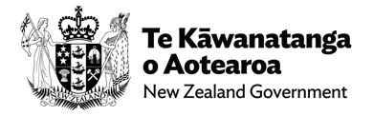

Before you start

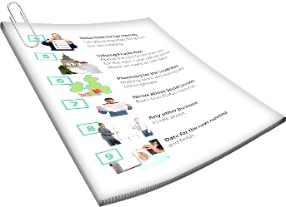
This is a long document.

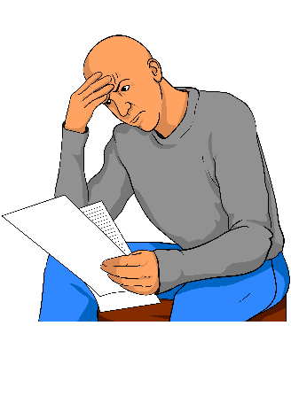
It can be hard for some people to read a document this long.

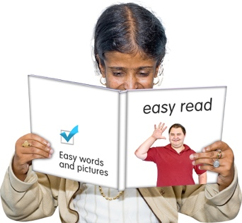
Some things you can do to make it easier are:
read it a few pages at a time
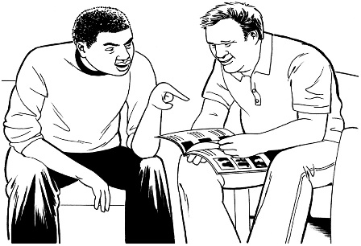
set aside some quiet time to look at it
have someone read it with you to support you to understand it.

What you will find in here

Page number:
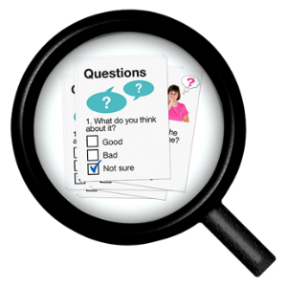

What is this document about? 4

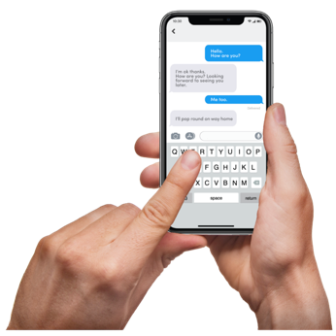
Access 11

Communication 12

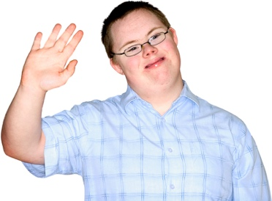
Technology 15

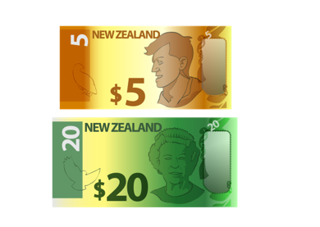
Atmosphere 19

Money 22
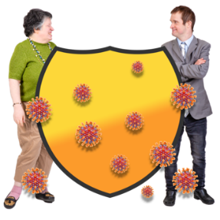

COVID-19 24

Page number:
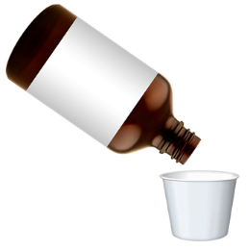

Medicine safety 27

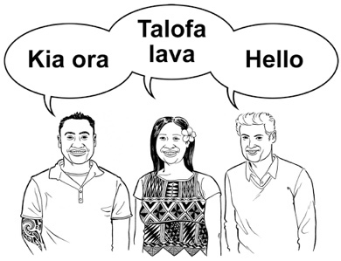
What Māori people said 29

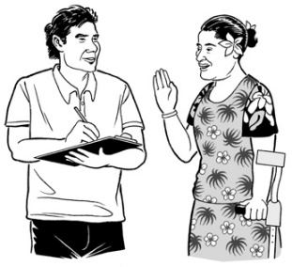
What Pacific people said 30

What disabled Pacific people
said 33
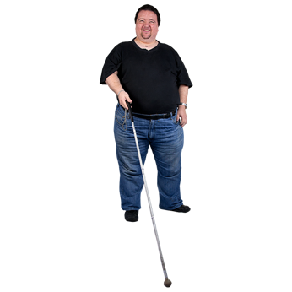

What blind / people with sight
disabilities said 35

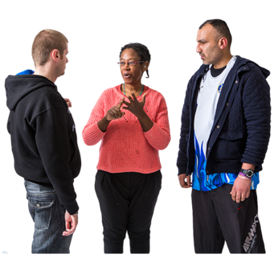
What Deaf people said 37

Whakataukī 39

What is this document about?


This Easy Read document is a summary of a consumer report called:

Pharmacy Whakamahere: Understanding the pharmacy needs of our population.
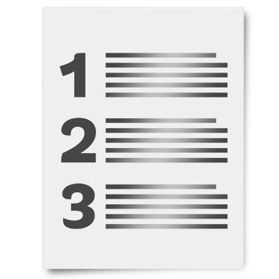

A summary tells you the most important ideas.

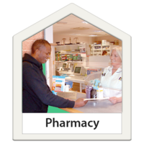
A consumer is someone who uses a service or buys something.

In this report consumers are people who go to / use pharmacy services.

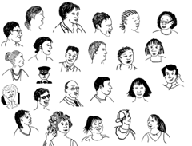
In this report population means people living in New Zealand.

The report was written by:
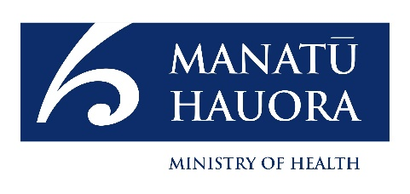
Manatū Hauora – Ministry of Health
Te Whatu Ora – Health New Zealand.

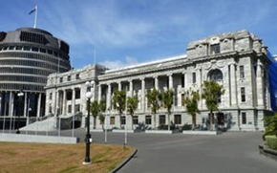
Manatū Hauora – Ministry of Health is the part of the government that makes decisions about healthcare in New Zealand.
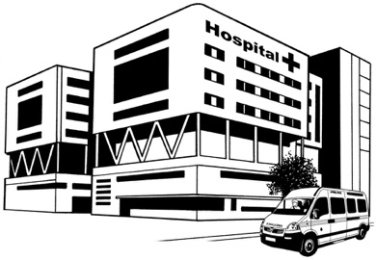

Te Whatu Ora – Health New Zealand runs the health system.
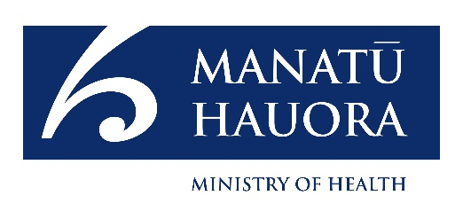
When you see the words we / us in this document it means the Ministry of Health and Te Whatu Ora.
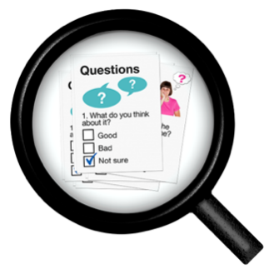
We wanted to find out how to make pharmacies better.

A pharmacy is where you go to get:
- your prescription medicines
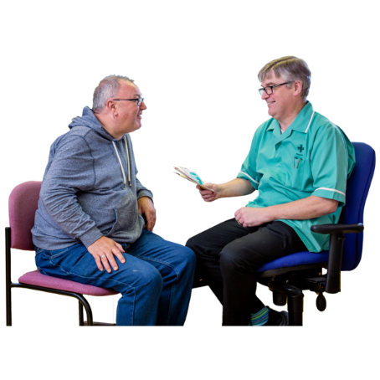
- other types of medicines
- advice about:
  - your medicine
  - your health.
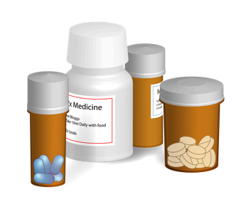

Prescription medicines might be things like:

pills / tablets
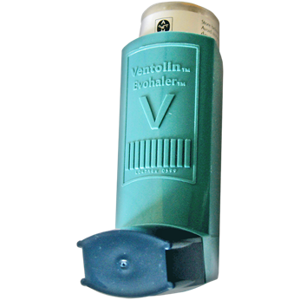
things you inject like insulin
inhalers for if you have asthma.

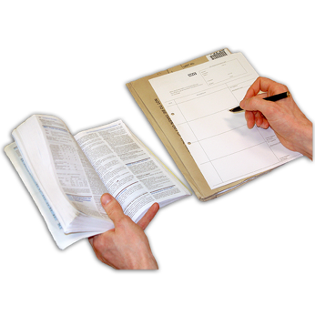
You can only get prescription medicines if you have a prescription.
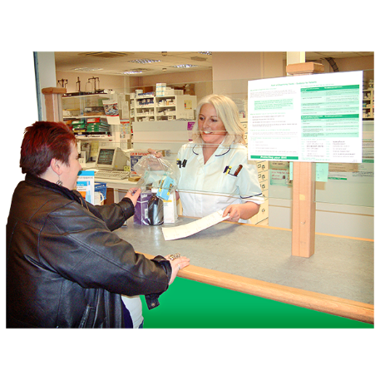

A prescription is a way for your pharmacy to know what medicine you need.

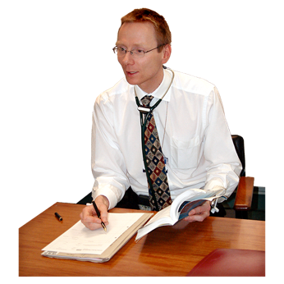
People who can write you a prescription are your:
- doctor
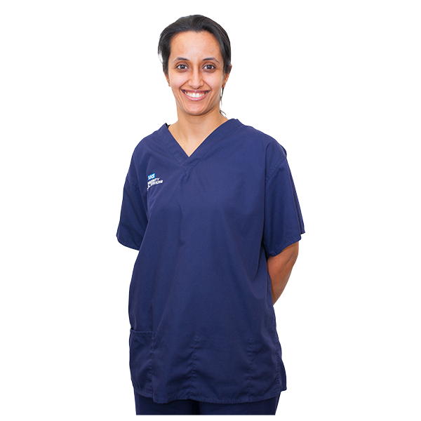
- nurse
- dentist
- midwife.

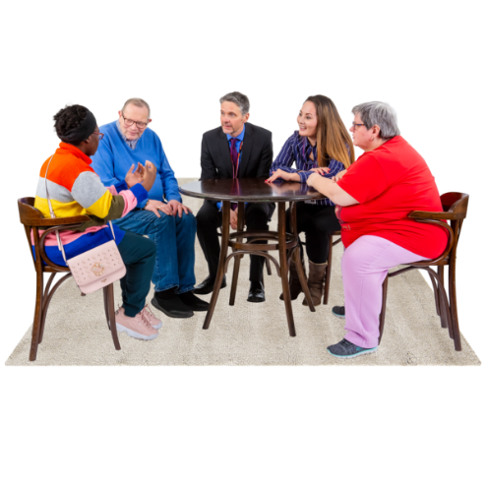
We had meetings with lots of different groups of people.

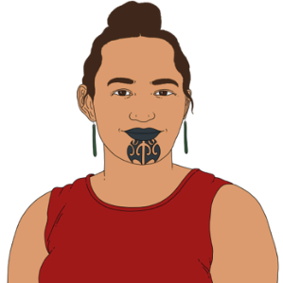
The groups of people that we asked questions to were:
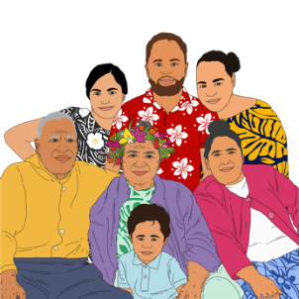
Māori
Pacific people
Disabled Pacific people
Deaf people
Blind / people with sight disabilities.
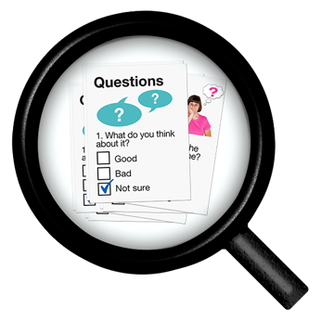
The questions we asked everyone were:
What do you like about your pharmacy?
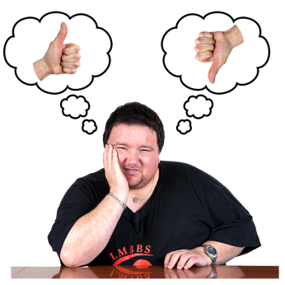
What do you not like about your pharmacy?
What would make going to the pharmacy better?
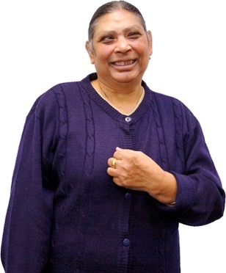
What sort of difference would having a better pharmacy make to:
- you
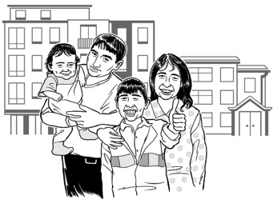
- your family / whanau
- your community?

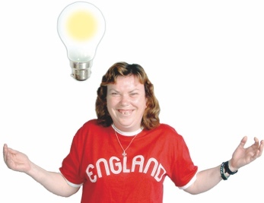
The answers to our questions showed there were 7 themes that were challenging for everyone.

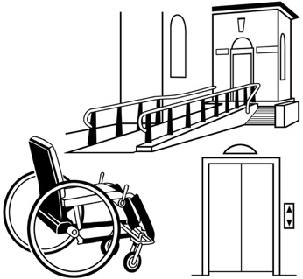
The seven themes are:
access
communication
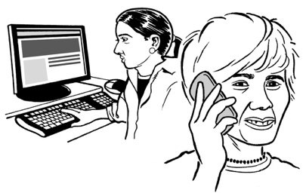
technology
atmosphere
money
COVID-19
medicine safety.
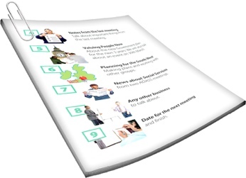

We will look at each of these 7 themes on the next few pages.

Access

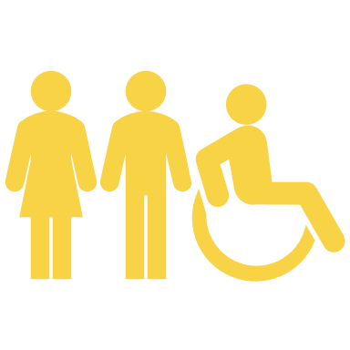
Access means how easy it is to:
get to a place
move around a place
do things in a place.

People said they need to feel safe using the pharmacy.

This means people should find it:
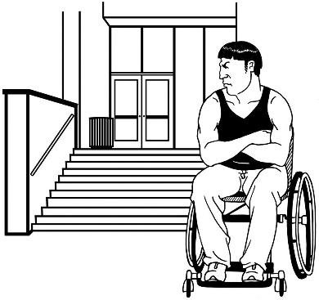
- easy to get to a pharmacy
- move around / get to the things they need inside a pharmacy.

Communication


Communication is the way we give people information.

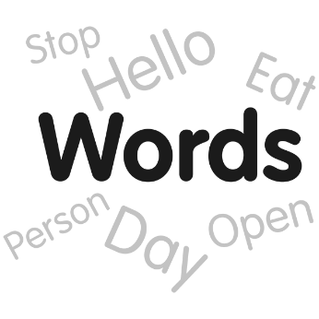
Communication can be things like:
talking
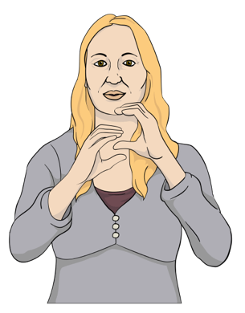
writing
New Zealand Sign Language
pictures.

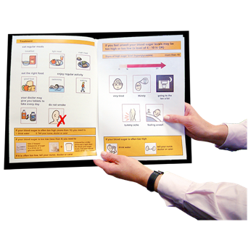
People need information about their medicine in ways that:
they understand
they can remember.
Some people said that pharmacy staff should understand what disabled people need.

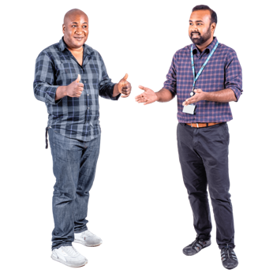
Disabled people might need pharmacy staff to:
be patient / take things slowly
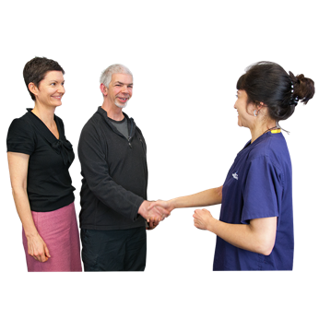
make sure the person they are talking to understands them
talk to the person not their carer.
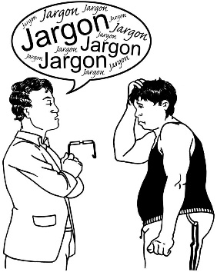

Some people get stressed when they have to talk to a lot of different people.

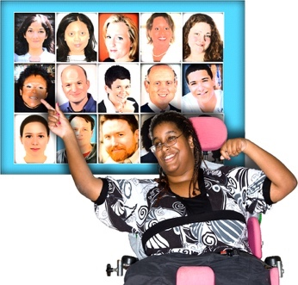
Pharmacies should make it easy to find the right person to talk to.

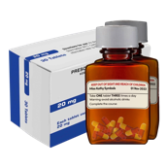
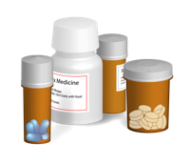

People said they feel worried when their medicine is changed.

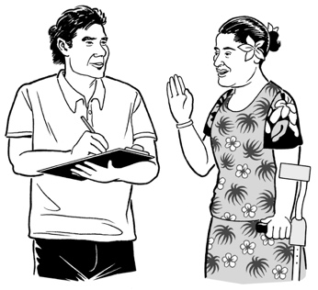
Pharmacy staff should make sure they tell people about any changes to their medicine.

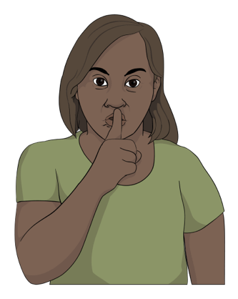
Sometimes people need to talk to pharmacy staff about things that are private.

Private means something you do not want everyone to know.

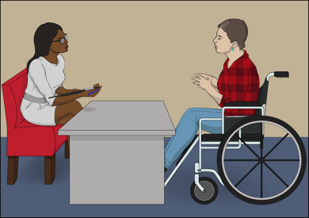
People said pharmacies should have a place to talk to pharmacy staff without other people listening.

Technology

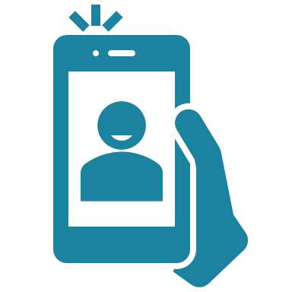
Technology means things like:
computers
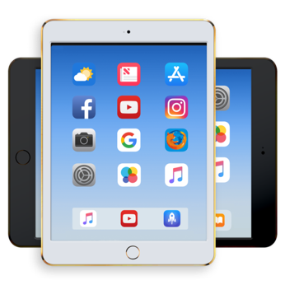
mobile phones
iPads / tablets
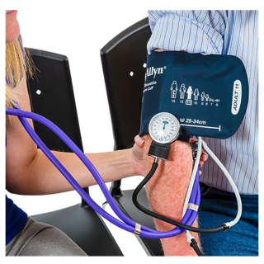
medical equipment.

Pharmacies can use technology to make things easier for people.
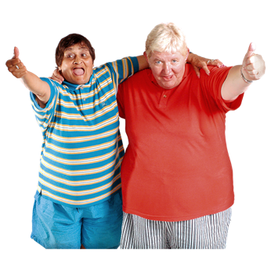

Some people said they were excited for new technology that could make using the pharmacy easier.



Other people do not use technology.
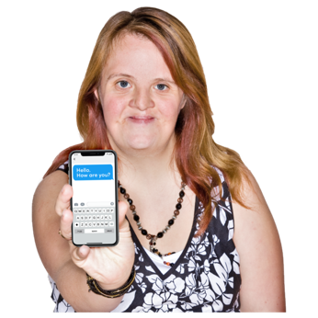
People said they wanted pharmacies to use technology to give them information in different ways like:
text messages
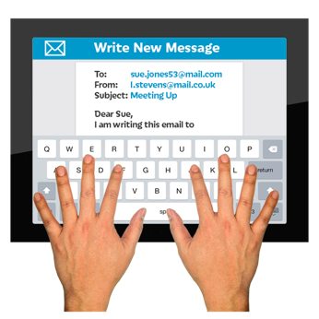
emails.

Sending information by email means that people can use a screen reader.

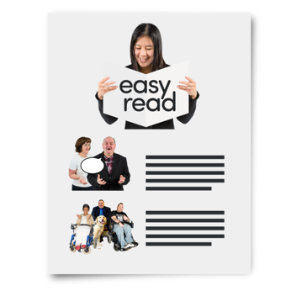
People also said they wanted information in different formats like:
Easy Read
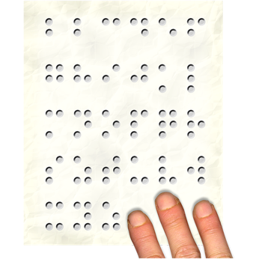
New Zealand Sign Language
Braille
pictures.

Blind people said they wanted their medicines to come in lots of different types of bottles.

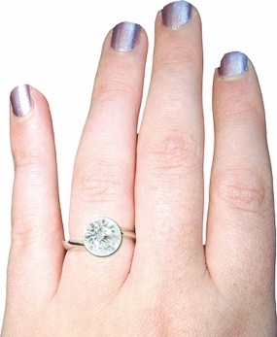
Having medicines in different bottles means you can tell them apart by how they feel.

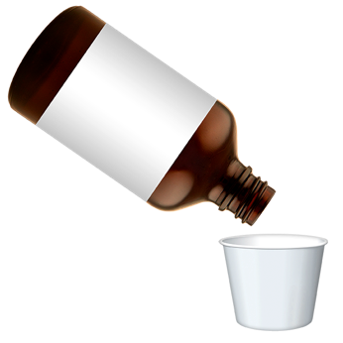
Blind people said they needed things that assist them to take the right dose of medicine.

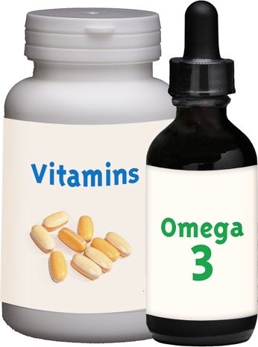
People also said they would like the labels on their medicine to:
be in Braille
use pictures
use clear language.

Deaf people said they wanted to be able to send text messages to the pharmacy.

Deaf people also said that pharmacies could support people using the New Zealand Relay Service by having:
an iPad for people to use
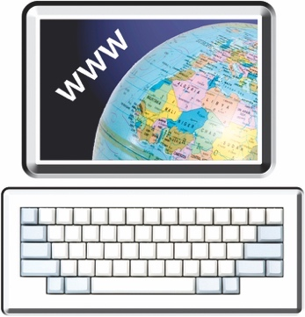
free WiFi so they can connect to the internet.

The New Zealand Relay Service is for people who:

are Deaf / hearing impaired
cannot speak.

New Zealand Relay Service translates spoken words into sign language.

Atmosphere


Atmosphere means the way a place feels.

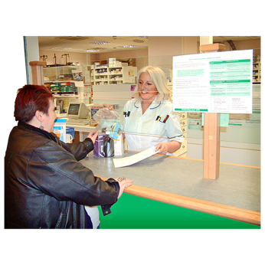
People said that pharmacies should get to know their customers so their customers can feel:
safer
more welcome.

People said going to the pharmacy would feel better if there was:
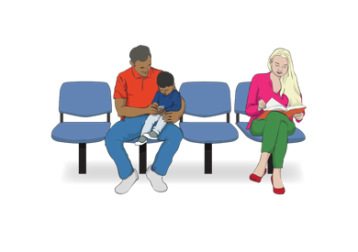
a private place to talk with staff
somewhere comfortable to sit if they have to wait a long time.

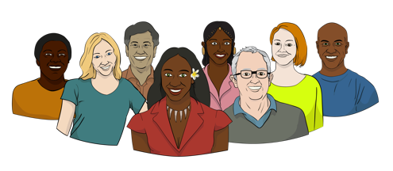
People also said that pharmacies should think about different cultures.

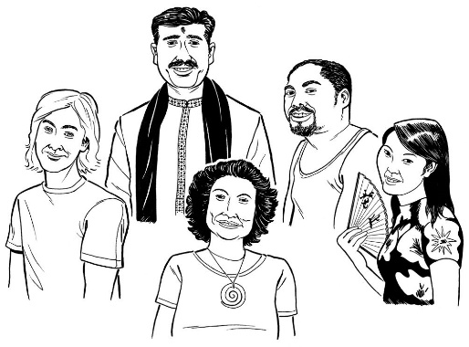
Culture is a way of:
thinking that a group shares
doing things as a group.

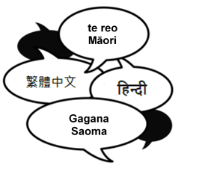
Pharmacies can think about different cultures by:
having signs / information in lots of different languages
using New Zealand Sign Language
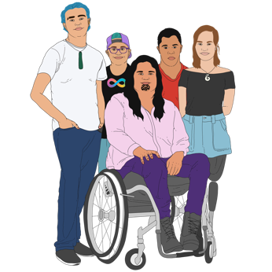
giving information in ways that work for lots of different disabled people.

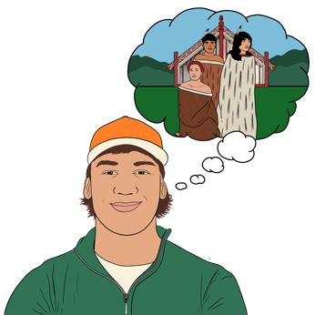
People also said it was very important for pharmacies to think about Māori culture.

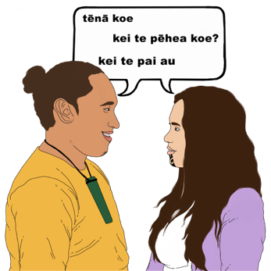
Pharmacies can think about Māori culture by:
understanding about Te Tiriti o Waitangi / The Treaty of Waitangi
using te reo Māori / Māori words.

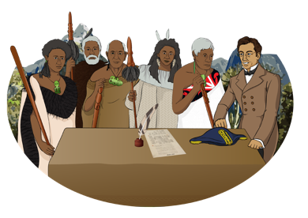
Te Tiriti o Waitangi / The Treaty of Waitangi is an important agreement between Māori and the British Crown.

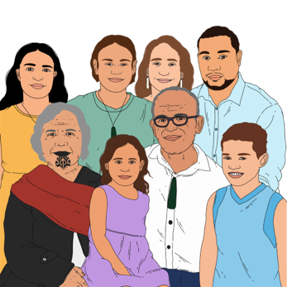
It is about Māori and the New Zealand Government:
making decisions together
protecting things that are important to Māori.

Money

From the 1 July 2023 most prescriptions are free / do not cost you money.


Some prescriptions still cost money.

People said that pharmacy staff should tell them right away if the prescription will cost money.

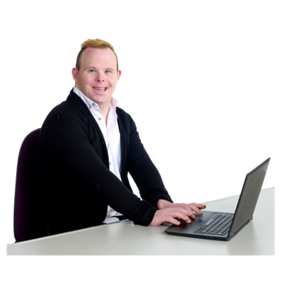
People also said they wanted to be able to pay for their prescriptions:
a little bit at a time
using online banking.

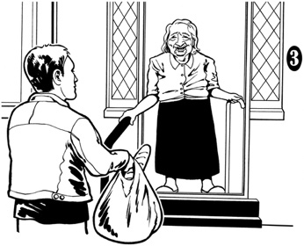
Having different ways to pay means people can get their carer to pick up their medicine for them.

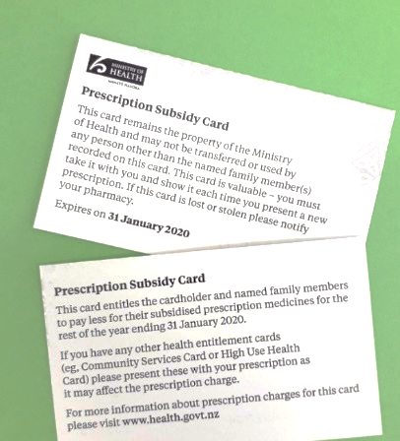
People also said pharmacies needed to tell people about the prescription subsidy card.

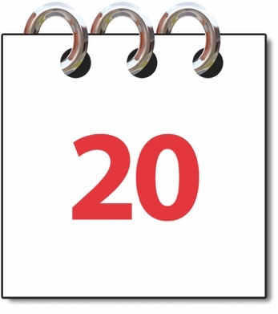
Having a prescription subsidy card means that you only have to pay for 20 prescriptions in 1 year.

COVID-19
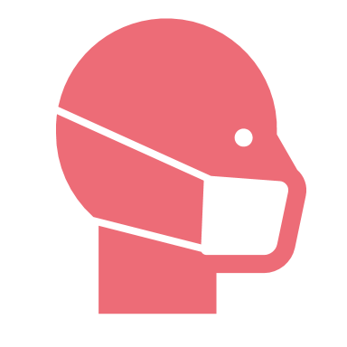

COVID-19 is a virus that can make people sick.

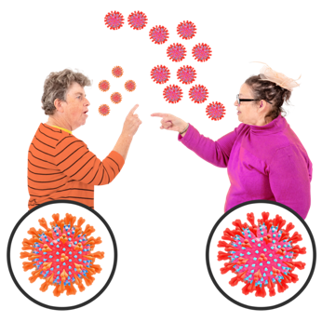
When there is a lot of COVID-19 about pharmacies change how they do things to keep everyone safe.
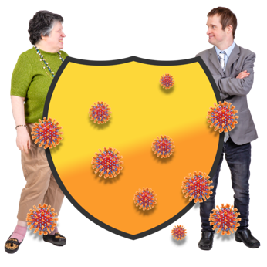

Sometimes the things pharmacies do to keep people safe from COVID-19 make the pharmacy harder to use.
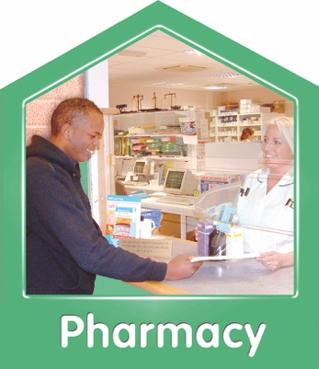

People said pharmacies need to make sure it is still easy to use the pharmacy when there is a lot of COVID-19 about.

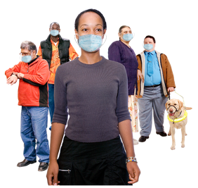
1 way to stop COVID-19 from spreading is to wear a mask.

Deaf people cannot lip-read when someone is wearing a mask.
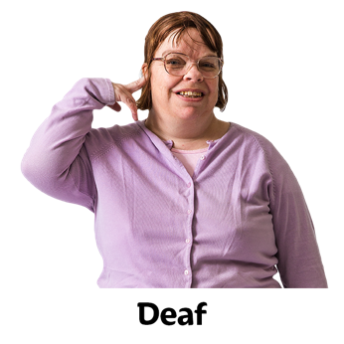

People said pharmacy staff should take off their mask if a Deaf person asks them to.

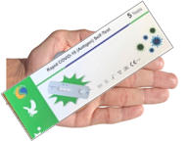
If you think you might have
COVID-19 you need to do a COVID test called a Rapid Antigen Test / RAT.

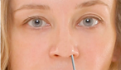
People said that pharmacies should assist people to do a RAT.

Doing a RAT test at the pharmacy may cost money.

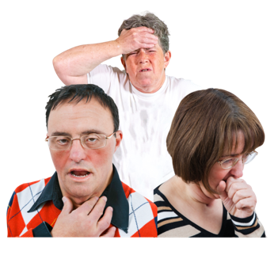
If you get sick with COVID-19 you should isolate.

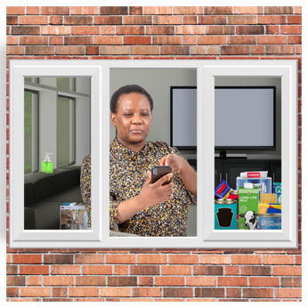
Isolate means staying at home so you do not give COVID-19 to anyone else.

People said pharmacies need to make sure that people who are isolating know they can get their medicine delivered to their home.

Medicine safety
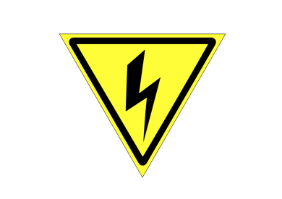

It can be dangerous to
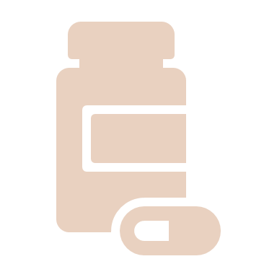
take the wrong medicine
take too much medicine
not take enough medicine.

Pharmacy staff should make sure people understand:
what their medicine is
how to take their medicine
if their medicine has changed.

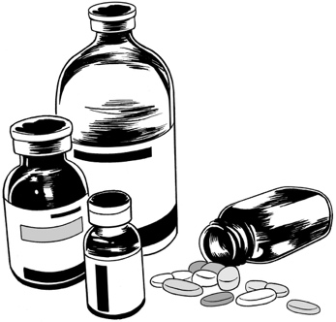
Sometimes a pharmacy does not have enough of a medicine in stock.

People said that if a pharmacy does not have enough of a medicine for a person the pharmacy staff should:
tell the person clearly
deliver the medicine when they get more.

What Māori said

Māori said that there is not just 1 answer that works for everyone.

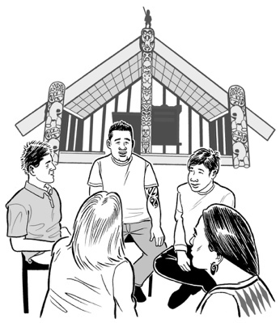
Māori people said that pharmacies should work with:
Māori health providers
marae.

If pharmacies work together with Māori services they can better support the health needs of Māori.

What Pacific people said
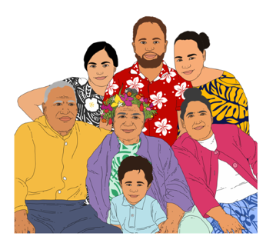

Pacific people said they need to feel welcome in pharmacies.

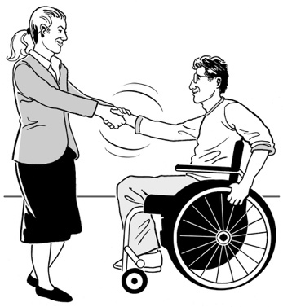
Pharmacies could make Pacific people feel welcome by:
using Pacific decorations
using Pacific languages.

Pacific people also said that it was important to have a private place to talk with staff.

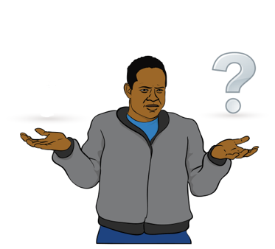
Pacific people said they did not always know all the things you can do at a pharmacy.

Pharmacies should tell people:
about all the things you can do there
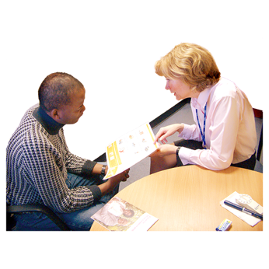
that you can ask for advice at the pharmacy
how to get the healthcare they need.

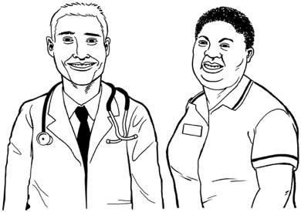
Pacific people also said that it is important for pharmacies to work with other health providers.

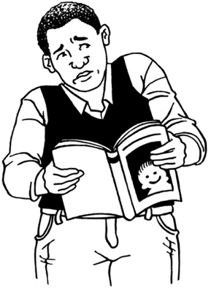
Pacific people said they were worried about misinformation.

Misinformation is information that is wrong.
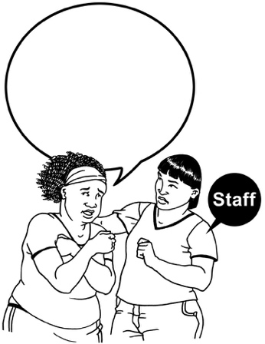

Pharmacies could make sure people have good information by:
taking time to listen when people are worried
explaining things clearly.

What disabled Pacific people said

Disabled Pacific people wanted pharmacies to understand that Pacific people often live with their extended family.

Extended family means all the people in a family like:
aunts
uncles
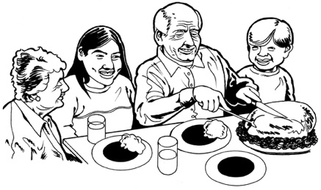
cousins
grandparents.

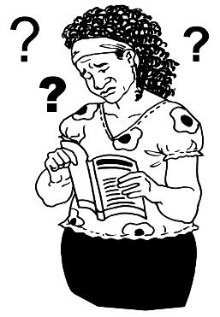
Disabled Pacific people said that when it is hard for 1 person to use the pharmacy it is a problem for the whole family.
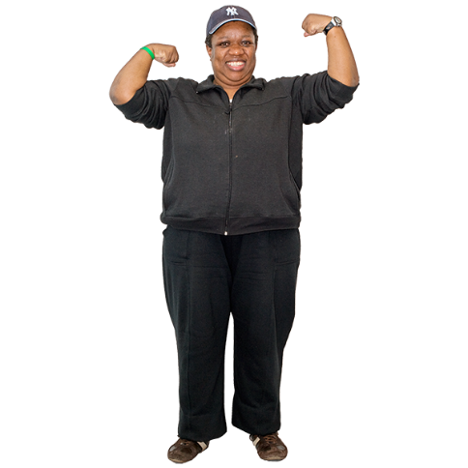
Disabled Pacific people said they needed pharmacies to support them to:
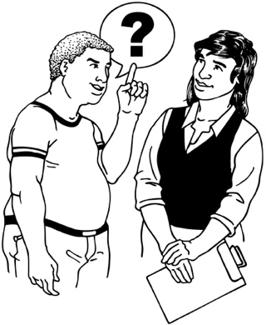
stay healthy
feel like they can ask for advice
understand their medicine
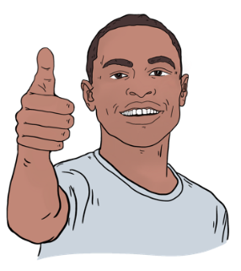
feel okay about taking their medicine.

What blind and people with

sight disabilities said

Blind people said they needed to feel safe moving around the pharmacy.

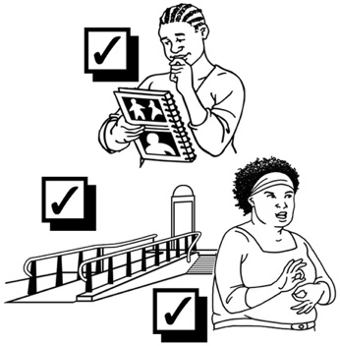
Some things that would make it safer for blind people to move around are having:
a clear path to the counter
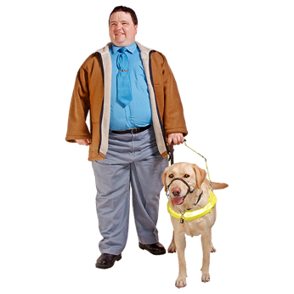
the counter near the front of the pharmacy
enough space to walk with their guide dog beside them.

Blind people also said they wanted a private place to talk to staff.

Blind people said they wanted Braille on:
medicine labels
information sheets.

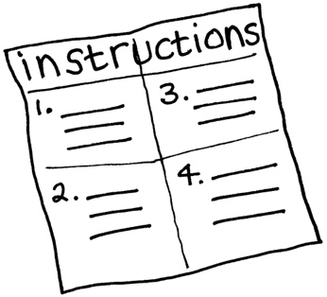

Some blind people also said pharmacies should use new technology like Script Talk.

Script Talk is technology that can read medicine labels out loud.

What Deaf people said

Deaf people said they needed:
clear information
to be able to ask questions.


Deaf people said pharmacies need to remember that Deaf people can be parents too.

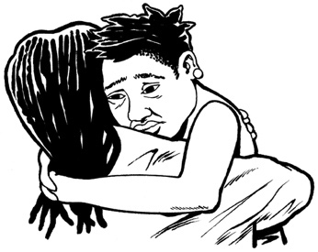
Deaf parents need good information so they can take care of sick children.

Deaf people said that if using the pharmacy was easier they would feel:
confident
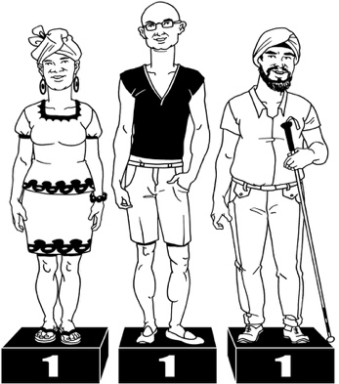
equal
independent.


Confident means someone feels sure about themselves / what they can do.

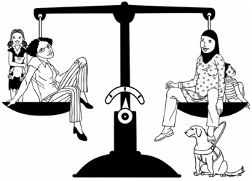
Equal means someone feels like they are being treated the same as other people.



Independent means someone is able to think for / make decisions by themselves.

Whakataukī

A whakataukī is a Māori saying.

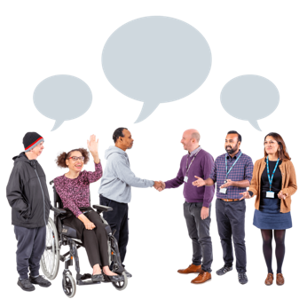
This whakataukī was said at every meeting when we talked with people.

He pūkenga wai

He nōhanga tangata
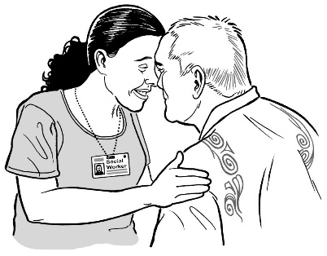
He nōhanga tangata

He pūkenga kōrero.

This whakataukī means:
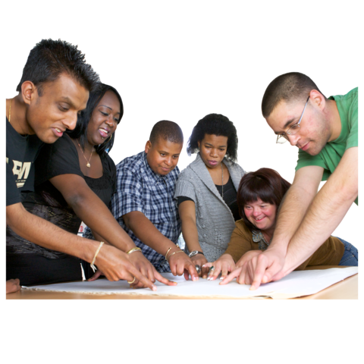
Where the rivers meet

People come together

Where people come together

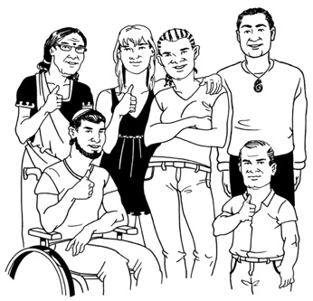
There is debate and learning.

It is about bringing different people together to learn from each other
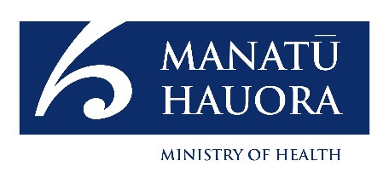
This information has been written by Manatū Hauora — Ministry of Health.

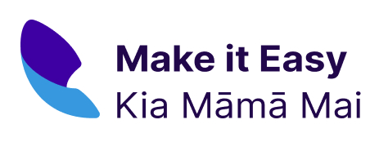
It has been translated into Easy Read by the Make it Easy Kia Māmā Mai service of People First New Zealand Ngā Tāngata Tuatahi.

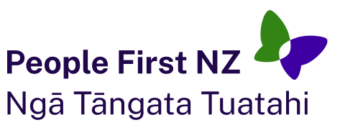
The ideas in this document are not the ideas of People First New Zealand Ngā Tāngata Tuatahi.

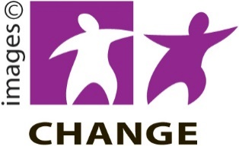
Make it Easy uses images from:

- Changepeople.org



- Photosymbols.com

- SGC Image Works

- Huriana Kopeke-Te Aho.

All images used in this Easy Read document are subject to copyright rules and cannot be used without permission.

