Consent process under the Human Tissue Act 2008 for health professionals

Purpose of this document
This document explains to health professionals the process for obtaining informed consent for the collection and use of tissue primarily from dead human bodies. The Human Tissue Act 2008 sets up the framework for informed consent.
All legislative references in this document are to the Human Tissue Act 2008 unless otherwise stated.
It is important to note that nothing in the Act limits any provision in the Code of Health and Disability Services Consumers’ Rights. The rights set out in the Code apply to living people receiving health and disability support services.

Primacy to the wishes of the individual
The consent framework gives primacy to the wishes of the individual whose tissue might be collected or used.
The framework does not allow others to legally veto an individual’s consent, but others may consent or object on the individual’s behalf, if the individual:
- was silent on the matter
- nominated them to do so.

Informed consent and informed objection have legal standing
Who may give informed consent to the collection and use of human tissue depends on whether the use of tissue is for:
- general purposes from a deceased person, such as transplantation or research (section 31)
- anatomical examination or public display, such as a body donated to a medical school (section 32)
- for use in donor analysis from a living person, such as genetic testing for Huntington’s Disease (section 33)
- a secondary purpose after the donor’s death, such as consent for the use of tissue in research where the original consent for the tissue was for diagnostic purposes (section 34).
The Act recognises decision-makers’ ability to raise an informed objection as well as to give informed consent.
These provisions reflect the principle that informed consent or informed objection should come, in the first instance, from the individual whose tissue would be collected and used.
However, the Act also provides for a hierarchy of other people who may consent or object if no one above them in the hierarchy has consented or objected. A valid consent or objection has no more or less legal weight than if it were given by the individual or another person or persons.

Consent for use of tissue for general purposes from a deceased person
A flow chart of the consent process for use of tissue for general purposes (including therapeutic use and use in research) is in Schedule 1 of the Act (reproduced in Appendix A). The four parties who may, in order, give consent or raise an objection are:
- the individual
- the individual’s nominee (or nominees)
- the individual’s immediate family
- a close available relative of the individual.

Consent by the individual
The consent process starts with the individual. The person proposing to collect or use the tissue should ask the members of the individual’s immediate family who are present whether they are aware of the deceased giving informed consent or raising an informed objection to the donation of their tissue. If the individual, while alive, gave informed consent or raised an informed objection to the collection and use of their tissue, that decision has legal standing and nobody else may legally consent or object. However, anyone with an interest (such as the individual’s immediate family) may still make their views known to the person proposing to collect and use human tissue, and that person may decide not to proceed with the collection and use of tissue (sections 16 and 17).

Consent by the individual’s nominee
Where an individual does not consent or object themselves, they may nominate one or more nominees to make such decisions for them.
In general, if:
- any single nominee objects to the collection and use of the tissue, then collection and use is not allowed
- nominees consent without any nominees objecting, that is taken as consent for the collection and use
- there is no nominee, then the decision falls to the individual’s immediate family
- there is no available nominee, then the decision falls to the individual’s immediate family
- the available nominee(s) cannot reach a decision, then the decision falls to the individual’s immediate family.

For more information about the nominees’ decision-making process, see sections 35 and 39 of the Human Tissue Act 2008.

The person proposing to collect or use the tissue, should ask whether a nominee is present or whether the immediate family is aware of the deceased’s having nominated a person or people to make the decision on his or her behalf.
The person proposing to collect or use the tissue must undertake the same level of enquiry about nominees as they currently undertake to identify whether all members of the immediate family who should be consulted have been contacted.

Consent by the individual’s immediate family
The process for the immediate family to make decisions is covered in sections 36 and 40 of the Act. Families may reach a decision about the collection and use of tissue in whatever way is appropriate to them (that is, by consensus, majority, unanimity, or by allowing a particular family member to make the decision). However, the family must collectively agree to abide by the decision and have made a reasonable effort to reflect the views of specified family members who are not present. This means, for example, that some family members may not agree with the decision, but are prepared to accept it as the will of the immediate family.
The deceased’s ‘immediate family’ is defined in section 6 of the Act.
Immediate family, in relation to a dead individual,—
- means members of the individual’s family, whānau, or other culturally recognised family group, who—
  - were in a close relationship with the individual: or
  - had, in accordance with customs or traditions of the community of which the individual was part, responsibility for the individual’s welfare and best interests; and
- to avoid doubt, includes a person whose relationship to the dead individual was, or was a relationship that is established through, 1 or more of the following relationships:
  - spouse, civil union partner, or de facto partner of the individual:
  - child, parent, guardian, grandparent, brother, or sister of the individual:
  - stepchild, step-parent, stepbrother or stepsister of the individual.
The family members listed in paragraph (b) are examples of who may comprise the individual’s family group. Paragraph (b) is not exhaustive, so an immediate family group may not include any of the people listed in paragraph (b), if, for example, the individual does not have any surviving parents, siblings, or spouse and was childless. In such a scenario a friend, cousin and/or neighbour may meet the definition of ‘immediate family’, if they were in a close relationship with the individual or were a member of a culturally recognised family group.
The definition of ‘immediate family’ was deliberately drafted to recognise different family groups and cultural norms about family in New Zealand. Sometimes the immediate family may comprise one or two people, other times it may comprise many people.
It is not possible to prescribe what constitutes an immediate family in every scenario. The intention is that people requesting the collection and use of tissue under the Act use their judgement about who meets the definition of immediate family, taking into account available information from the next of kin about the deceased individual’s relationships and family dynamics.

Immediate family required to consult (section 40)
The person requesting the collection and/or use of tissue must inform the person giving consent on the immediate family’s behalf that that person must take all reasonably practicable steps to consult the members of the family who had a close relationship with the deceased individual (section 40). It is the responsibility of the family member who consents or objects on the family’s behalf to ensure they contact the relevant family members and ascertain their views (section 40).
The person requesting collection and/or use of the tissue may assume the family member giving consent on the immediate family’s behalf has met the requirements under section 40, if the person requesting collection and/or use of the tissue is satisfied consultation has occurred based on the available information (section 29).
If the family member giving consent on the family’s behalf states that they will not discuss donation with a family member who was, or could reasonably be deemed to have been, in a close relationship with the deceased, the obligations under section 40 are unlikely to have been met. An example of this is where the deceased is a minor and the person requesting donation is refusing to discuss the matter with a parent of the deceased, and the person requesting the donation knows the parent has not been consulted.
If the family member giving consent on the family’s behalf declares they have met the requirements of section 40 and it is reasonable to assume this has occurred (eg, the person has had time to consult other family members), the person requesting collection and/or use of tissue is deemed to have met their obligations under section 29.

Consent by a close available relative
If members of the individual’s immediate family are unavailable or are unable to reach a decision, consent may be sought from a close available relative (sections 31 and 36). For example, it may be impracticable to determine whether the immediate family has made a decision (because they are in transit) (section 36), so a decision is sought from a close available relative.

The close available relative mechanism is not intended for use when an immediate family member is unwilling to consult all the family members who were in a close relationship with the deceased individual. This would be contrary to the Act’s intention that consent (or objection) by the immediate family is a family decision.

The ‘close available relative’ is defined in section 10 of the Act. This is set out as a hierarchy of relationships. If there is more than one close available relative on the same level and one relative objects, this overrides any consent from any other close available relatives.
In general, if within the same level of the hierarchy:
- any single close available relative objects to the collection and use of the tissue, then collection and use is not allowed
- a close available relative consents without any other close available relatives objecting, that is taken as consent for collection and use.

A person proposing to collect or use tissue may not act on the consent of a close available relative, unless after all reasonably practical inquiries have been made, it appears that there is no objection from anyone at the same level. Spouses, civil union partners, and de facto partners have the same ranking as specified in section 10. This means that if an individual has a spouse and a de facto partner (or a civil union partner and a de facto partner) and either objects, then the collection and use of tissue is prohibited.

What happens if no consent is given
If, after having gone through the consent process, no one gives informed consent, then the tissue must not be collected or used.

What happens after consent is given
If consent is given, the person proposing to collect and use the tissue then needs to decide whether to proceed, based on all the information available to them. There may be a number of reasons why collection should not proceed. The organs and tissue may be unsuitable for donation, the immediate family may be aware that the deceased person had changed their mind since recording their consent, or people who are not legally able to raise an informed objection but who nevertheless have an interest may be distressed by a decision to proceed with donation.

Consent for use of tissue for anatomical examination or public display
The consent process for anatomical examination or public display requires consent from two people: the individual (or their nominee) and the immediate family (or a close available relative). This reflects the particular sensitivity around uses of tissue that will prevent the person’s family from having a body to bury.
A flow chart summarising this consent process is in Schedule 2 of the Act (see Appendix B). The parties are defined in the same way as the parties who may give informed consent to the collection and use of human tissue for general purposes, but in two mini-hierarchies, rather than a single hierarchy.
If the individual or their nominee does not give consent, consent from the immediate family or close available relative is unnecessary, because collection and use cannot proceed.

Consent for use of tissue for donor analysis from a living person
The consent process described for the use of tissue for general purposes operates in a truncated form where the use is for donor analysis.
‘Donor analysis’ means analysis for the purpose of providing information (including genetic information) about an actual or potential condition.
In the case of donor analysis (section 33), the individual concerned is alive. Therefore, consent must be sought from that individual, in much the same way as an individual consents to a health care procedure under the Code of Health and Disability Services Consumers’ Rights. This means the individual is the only person allowed to make the decision to consent.

Consent for use of tissue for a secondary purpose after donor’s death
The consent process described for the use of tissue for general purposes operates in a truncated form where the use is for a secondary purpose after the donor’s death.
A secondary purpose after a donor’s death involves the use of tissue collected from a living individual for a purpose that was not contemplated while the individual was alive (section 34). Therefore, the individual has not had the opportunity to consent or object to this particular use.
The consent process starts with the immediate family, but otherwise operates in the same way as for the collection and use of tissue for general purposes (see Schedule 3 in Appendix C).

Appendix A: Consent for use of tissue for general purposes

Schedule 1
Use for general purposes of tissue that is or is from bodies
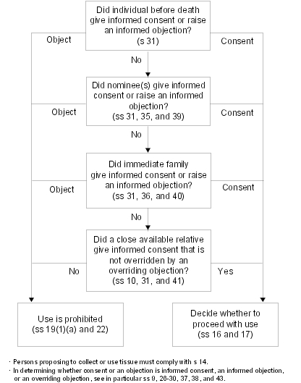

Appendix B: Consent for use of tissue for anatomical examination or public display

Schedule 2  Use for anatomical examination or public display of tissue that is or is from bodies | s 5(2)
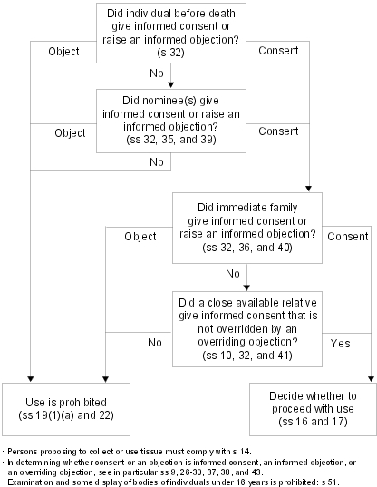

Appendix C: Consent for use of tissue for secondary purposes after donor’s death

Schedule 3  Use for secondary purposes after donor’s death of tissue from living individual | s 5(3)
