Consent process for the collection and use of human tissue under the Human Tissue Act 2008

Purpose of this document
This document explains the consent process for the collection and use of human tissue.
The Human Tissue Act 2008 sets up the consent framework and allows specified individuals to give their informed consent or objection, depending on the circumstances in different circumstances. The schedules to the Act contain flowcharts that summarise the consent process. These charts are reproduced below.
It is important to note that nothing in the Act limits any provision in the Code of Health and Disability Services Consumers’ Rights. The rights set out in the Code apply to living people receiving health and disability support services.

Wishes of individual whose tissue might be collected are most important
The consent framework gives primacy to the wishes of the individual whose tissue might be collected or used.
Other people may consent or object on the individual’s behalf if the individual was silent on the matter or nominated another person (or people) to give consent on their behalf.
If an individual has given or gives consent for their tissue to be collected and used, no other person has a legal veto over that individual’s consent.

Consent process
The Human Tissue Act 2008 sets out who may give informed consent to the collection and use of human tissue:
- from a deceased person for general purposes, such as transplantation or research (section 31 and Schedule 1)
- for anatomical examination or public display, such as a body donated to a medical school (section 32 and Schedule 2)
- from a living person for use in donor analysis, such as genetic testing for Huntington’s Disease (section 33 and Schedule 1)
- for a purpose secondary to the use for which the donor originally gave consent, such as consent for the use of tissue in research where the original consent for the tissue was for a post-mortem (section 34 and Schedule 3).
The overall principle is that informed consent (or objection) should come, in the first instance, from the individual whose tissue would be collected and/or used. If that person has not or cannot make that informed consent (or objection), sections 31 to 34 of the Act set out a hierarchy of other people may consent (or object) if no one above them in the hierarchy has consented or objected.
A valid consent (or objection) is of equal weight legally whether it is given by the individual or another person.

Consent for use of tissue from a deceased person for general purposes
The hierarchy of four parties who may give consent or raise an objection to the use of a deceased individual’s tissue for general purposes are, in order:
- the individual (consent given before death)
- the individual’s nominee (or nominees)
- the individual’s immediate family (as defined in the Act)
- a close, available relative of the individual (as defined in the Act).
The collection or use of tissue for anatomical examination or public display from the body of a person who was under the age of 16 when they died is not allowed even with consent (section 51).

Consent by the individual
The consent process starts with the individual. The person proposing to collect or use the tissue for general purposes is expected to ask the members of the individual’s immediate family who are present whether they are aware of the deceased giving informed consent or raising an informed objection to their donating tissue. If the individual while alive gave their informed consent or raised an informed objection to the collection of their tissue for general purposes, that decision has legal standing, and nobody else may legally consent or object.
Anyone with an interest in the possible collection and use of tissue (such as the immediate family) may make their views known to the person proposing to collect and use the tissue. That person may then decide not to proceed with the collection and use of tissue (sections 16 and 17 of the Human Tissue Act 2008).

Consent by the individual’s nominee

Hierarchy of consent
If the individual has not consented or objected to the collection and use of their tissue for general purposes, they may have nominated one or more nominees to make such decisions for them.
In general, if:
- any single nominee objects to the collection and use of the tissue, then collection and use is not allowed
- nominees consent without any nominees objecting, that is taken as consent for the collection and use
- there is no nominee, then the decision falls to the individual’s immediate family
- there is no available nominee, then the decision falls to the individual’s immediate family
- the available nominee(s) cannot reach a decision, then the decision falls to the individual’s immediate family.
For more information about the nominees’ decision-making process, see sections 35 and 39 of the Human Tissue Act 2008.

Expected behaviour of person proposing to collect or use the tissue
The person proposing to collect or use the tissue should ask whether:
- a nominee is present
- the immediate family is aware of the individual having nominated a person (or people) to make the decision on the individual’s behalf.
If no one is aware of a nominee, the person proposing to collect or use the tissue should undertake the same level of enquiry about nominees as they currently undertake to identify whether all members of the individual’s immediate family who should be consulted have been contacted.

Consent by the individual’s immediate family
If the individual made no informed consent or objection before they died, there is no nominee, the nominee is unavailable in the time available for the donation, or the nominee is unable or unwilling to make a decision, then the decision falls to the individual’s immediate family (see sections 36 and 40 of the Human Tissue Act 2008).
The individual’s family may reach a decision in whatever way is appropriate to them (for example, by consensus, majority or unanimity or by allowing a particular family member to make the decision). The only requirement is that the family collectively agrees how the decision will be made and a reasonable effort is taken to reflect the views of family members who are not present.

Definition of immediate family
The individual’s immediate family is defined (section 6 of the Human Tissue Act 2008) to include:
- members of the individual’s family, whānau or other culturally recognised family group, who were in a close relationship with the individual
- members of the individual’s family, whānau or other culturally recognised family group, who in accordance with the customs or traditions of the community of which the individual was part, had responsibility for the individual’s welfare and best interests
- a person whose relationship to the individual was one or more of:
- spouse
- civil union partner
- de facto partner
- child
- parent
- guardian
- grandparent
- brother or sister
- stepchild
- step-parent
- stepbrother or stepsister.
The family members listed above are only examples; the list is not exhaustive and an immediate family group may not include any of the people listed. For example, the individual may not have surviving parents, siblings or a spouse and be childless. In such a scenario, a friend, cousin or neighbour may meet the definition of immediate family, if they were in a close relationship with the individual or were a member of a culturally recognised family group.
In some situations, the immediate family may comprise only one or two people, in others it may comprise many people. It is not possible to define the members of every ‘immediate family’ in every situation.

Requirements of person proposing to collect or use the tissue
The person asking for consent to collect or use tissue should tell the family member who is acting on the immediate family’s behalf that the family member must take all reasonably practicable steps to consult the family members who had a close relationship with the individual (section 40).
It is the family member’s responsibility to make sure they contact relevant family members and find out their views about the tissue donation.

Consent by a close available relative of the individual
If members of the individual’s immediate family are unavailable or are unable to reach a decision, then it is possible for consent to be sought from a close available relative (sections 31 and 36). For example, if key family members could not be contacted in sufficient time (eg, because they were in transit), a decision on consent could be sought from a close available relative.
A close available relative cannot be sought to provide consent merely because a family member is unwilling to consult all the members who have been in a close relationship with the individual. This would contradict the underlying principle that consent or objection by the immediate family is a family decision.

Definition of a close available relative
A close available relative in relation to an individual aged 16 or older when they died is, in order:
- a person who was the individual’s spouse, civil union partner or de facto partner immediately before the individual’s death
- a son or daughter (aged at least 16), if:
- the individual, immediately before their death, had no spouse, civil union partner or de facto partner
- no person who was then the individual’s spouse, civil union partner or de facto partner is available
- a parent of the individual
- a brother or sister (aged at least 16).
In general, if within the same level of the hierarchy:
- any single close available relative objects to the collection and use of the tissue, then collection and use is not allowed
- a close available relative consents without any other close available relatives objecting, that is taken as consent for collection and use.

Acting on the consent of a close available relative
A person proposing to collect or use tissue may not act on the consent of a close available relative, unless, after all reasonably practical inquiries have been made, no one from the same level in the consent hierarchy objects.
Spouses, civil union partners and de facto partners have the same ranking as each other. This means that if an individual had a spouse and a de facto partner (or a civil union partner and a de facto partner) and one objects, then tissue must not be collected and used.

What happens if no consent given
If, after having gone through this process, no one gives informed consent, then the tissue must not be collected and used.

What happens after consent is given
If consent to collect and use the tissue is given, the person proposing to collect and use the tissue then needs to decide whether to proceed. They must make this decision on the basis of all the information available to them (which may include the views of people who are cannot legally raise an informed objection but who nevertheless have an interest).

Consent for use of tissue for anatomical examination or public display
The consent process for the collection and use of human tissue for anatomical examination or public display requires consent from two agents: the individual (or their nominee) and the individual’s immediate family (or a close available relative).
This reflects sensitivity around uses of tissue that prevent an individual’s family from burying the individual’s body.
If the individual (or their nominee) has not given consent, collection and use cannot proceed

Consent for use of tissue for donor analysis
The consent process for the collection and use of human tissue for donor analysis occurs when the individual concerned is alive. Therefore, only the individual who is alive may consent to collection and use in this circumstance.
The individual’s consent in this situation is treated in much the same way as an individual’s consent to a health care procedure under the Code of Health and Disability Services Consumers’ Rights. Further information about the Code of Health and Disability Services Consumers’ Rights can be found on the Health and Disability Commissioner’s website www.hdc.org.nz.

Consent for use of tissue for secondary purpose after donor’s death
A secondary purpose after a donor’s death involves the use of tissue collected from a living individual who gave consent to the tissue’s use but did not contemplate the use to which the tissue might be put after the individual’s death. Therefore, the individual has not had an opportunity to consent or object to this specific use.
The consent process starts with the immediate family, and then follows the same process as for consent for collection and use for general purposes.

Schedule 1  Use for general purposes of tissue that is or is from bodies | s 5(1)
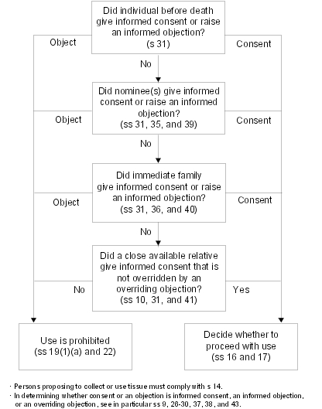

Schedule 2  Use for anatomical examination or public display of tissue that is or is from bodies | s 5(2)
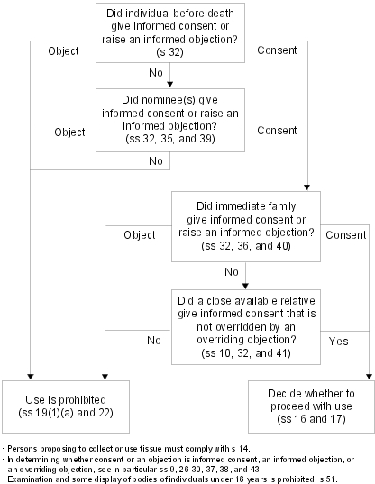

Schedule 3  Use for secondary purposes after donor’s death of tissue from living individual | s 5(3)
