
Issue 17 – November 2016
ISSN 2423-0523
 | Welcome to this edition. Our focus continues to be on Pressure Injury Prevention and Management (PIPM).  Based on the success of PIPM we will be continuing through 2017.  Providers: continue to complete S31’s for PI Stage 3 and above  DAA’s: continue prescribed reporting in the audit template | HealthCERT Work Programme 2016: Pressure Injury Prevention and Management (PIPM)  It is hard to believe we are heading into November and our focus on PIPM has continued for close to one year. Without the support of the sector, this work would not have been possible.  We continue to receive section 31 notifications – see later in this issue for a brief overview of what we have learnt from this information. Your auditing agency is also still reporting on whether PIPM is part of your quality framework during certification and surveillance audits.  We are always looking for good news stories. We would be particularly interested to receive success stories about pressure injuries, so if you and your team have had a positive outcome in this area, please contact me at donna_gordon@moh.govt.nz.  Keep 17 November in your calendar as STOP Pressure Injury Day – see the message that follows from the Office of the Chief Nursing Officer.
Inside: HealthCERT Work Programme 2016: Pressure Injury Prevention and Management (PIPM) • Office of the Chief Nursing Officer: Update on national pressure injury activities • PIPM Work Programme: s31 data • Who can I talk to? • National Survey Care Indicator Programme • Accident Compensation Corporation lead work • National Survey Care Indicators New Zealand • Research of interest: PIPM • Operating matters • Section 31 incident notification • Change of manager or clinical manager notification • Home and community support sector • Dispensation to provide hospital-level care for one named resident • Sector matters • The enrolled nurse’s role in assessment and care planning • Health Quality & Safety Commission New Zealand • Reporting notifiable event under the Health and Safety at Work Act 2015 • Websites of interest • Good news stories • Paul’s story: Residential disability service • Hohepa Hawkes Bay • Oceania Healthcare: Focus on falls • Whanganui District Health Board medical ward: Focus on falls •

Office of the Chief Nursing Officer: Update on national pressure injury activities
The Ministry of Health, the Accident Compensation Corporation (ACC) and the Health Quality & Safety Commission (the Commission) are continuing to work together on national approaches to prevent pressure injuries (PIs). Recent activities include:
- developing guidance for the sector with support from an expert group and running workshops in regions around the country (see ACC’s update later in this issue for more information)
- developing a national approach to data and measurement (for more information, see ‘Measuring and reporting pressure injuries’ on the Commission’s website, www.hqsc.govt.nz)
- providing guidance for DHBs to include pressure injury prevention in their 2016/17 annual plans
- HealthCERT’s work on profiling pressure injuries in aged residential care
- partnering with the New Zealand Wound Care Society for STOP Pressure Injury Day (see below).
Future work will include a focus on getting consumers more involved in their PI care. This work, to be led by the Commission, will include learning from case studies and stories and working with some willing providers and consumers (patients and residents) to develop consumer-oriented resources. We hope that the results of this work will be applicable to hospital care, aged residential care and community care.

STOP Pressure Injury Day 2016: 17 November
On 17 November it is this year’s STOP Pressure Injury Day. Its key messages are:
- everyone – the people at risk of a pressure injury, their family and whānau, carers, health practitioners and managers – has a role to play in preventing pressure injuries
- simple strategies are effective and achievable
- working together, we can prevent pressure injuries.
The day is an opportunity to improve understanding of pressure injuries. Last year saw a great range of promotion activities, from displays and presentations to delicious-looking cupcakes iced with prevention messages. This year the New Zealand Wound Care Society (NZWCS), the Commission, ACC and the Ministry of Health are again working together to provide resources for your use, including:
- brochures for people at risk of a pressure injury and their carers, including family and whānau
- a poster describing actions that carers, health professionals and patients can take to prevent pressure injuries
- an information sheet to help carers and health professionals to assess, stage and document pressure injuries.
You will find copies of these resources plus training aids (including a video and links to patient stories) at ‘Worldwide STOP Pressure Injury Day’ on the NZWCS website (www.nzwcs.org.nz).
We hope you will join us on 17 November to raise awareness of pressure injury prevention.

PIPM Work Programme: s31 data
As you will be aware, HealthCERT has been collecting two streams of data as part of its continuing 2016 PIPM Work Programme. These are:
- section 31 (s31) notifications received from aged residential care providers of PIs at stage 3 and above
- defined PIPM data reported during an audit.
Here we focus on s31 notifications – and thank you for your ongoing support in this area. The overview below sums up what we have found out so far from the s31 information we received between 1 December 2015 and 8 September 2016. Although the work programme began formally in January 2016, HealthCERT received a number of notifications during December 2015 so we have included this information in our analysis.

Stage of PIs reported
We received 256 notifications relating to individual residents. The majority of PIs (126) were reported as stage 3. Table 1 shows the breakdown by stage of injury. Please note that only those PIs classified as stage 3 and above were required to be reported.
Table 1: Pressure injury by stage
Stage of injury | Number
Stage 3 | 126
Stage 4 | 50
Unstagable depth unknown | 68
Suspected deep tissue | 12

Multiple PIs
Of the 256 residents reported as having a PI, 24 had more than one PI at the time of reporting. Among those 24 residents, 17 had two PIs and the remaining seven residents each had between three and six PIs. All of these injuries were reported as stage 3 and above. Figure 1 shows the breakdown.
Figure 1: Residents with multiple pressure injuries
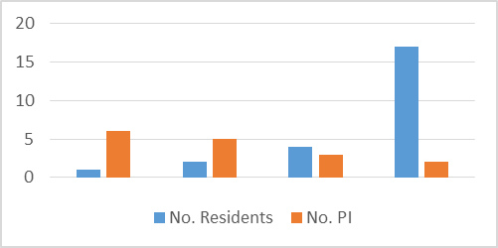

Average age
The analysis looked at the average age of the residents with reported PIs, excluding the 23 residents for whom no date of birth was provided. The average age was 83 years. Four residents were 100 years of age or older. Of the 12 residents who were under the age of 65 years, nine had injuries reported to have been acquired outside the facility.

Facility vs non-facility acquired PI
The question of where residents acquired their PIs was not initially included on the s31 notification form. Of the 256 notifications received, six did not indicate where the PI originated. Table 2 shows that 109 (43 percent) of the PIs reported were non-facility acquired – that is, acquired outside of the resident’s current aged residential care facility.
Table 2: Facility acquired vs non-facility acquired PI
 | Number | %
Facility acquired | 141 | 55
Non-facility acquired | 109 | 43
Not reported | 6 | 2
We will continue our analysis of s31 data over the coming months.

Who can I talk to?
If you have any queries or concerns about PIPM or just want to discuss this work programme, please feel free to contact Donna Gordon by phoning (04) 496 2429 or emailing donna_gordon@moh.govt.nz.

Accident Compensation Corporation lead work
ACC is leading the development of guidance, resources and tools for the sector on preventing, assessing and treating pressure injuries. In the first half of the 2016/17 year they are focusing on developing principles to inform the sector’s PI prevention activities. For the second half of the year its main focus will be on developing a Pressure Injury Prevention Toolkit (or similar), which will be a repository of resources and tools for the sector.

Regional workshops
June and July saw ACC deliver five regional pressure injuries workshops in Christchurch, Wellington, Palmerston North, Rotorua and Auckland. Around 90 people from DHBs, aged residential care and community care across the country met to understand and inform the direction of the guidance, share initiatives in their regions, and discuss the obstacles and solutions for the next steps in a national programme on reducing pressure injuries.
A fantastic range of information was gathered at these workshops and has since been pulled together to review themes and issues across the country. This will help ACC, the Commission and the Ministry of Health to understand where to focus resources to reduce pressure injuries.
We are delighted that both individuals and professional groups have been so willing to be involved and work with us in bringing a national focus on pressure injury prevention in New Zealand. Your feedback and input are important to us. If you’d like further information or want to contribute in any way, please contact Sean Bridge at ACC (Sean.Bridge@acc.co.nz).

National Survey Care Indicators New Zealand
This November the National Survey Care Indicators (NSCI-NZ) takes place for the fourth time in New Zealand. This in-depth survey investigates the prevalence of pressure injuries, incontinence, malnutrition and falls, using Donabedian's framework of:
Structure ----> Process ---> Outcome
The results of this survey provides health care facilities an insight into:
- how well they comply with having internationally recommended best practice / policies in place (structure)
- how well staff comply with best practice in their daily care activities (process)
- how to prevent residents from developing a pressure injury, becoming incontinent, having a fall or becoming malnourished (outcome).
Participating facilities enter the data they have collected online and have immediate access to their results, which are presented in graphs.
The survey was originally designed and developed by the University of Maastricht in the Netherlands. Currently it is carried out in the Netherlands, Austria, Switzerland, New Zealand, Turkey and the United Kingdom. The NSCI-NZ is led by Professor Jenny Carryer of the School of Nursing at Massey University in collaboration with Dr Jan Weststrate of Care-Metric.
The last NSCI-NZ, which was conducted in 2014, evaluated 1300 clients, of whom 50 percent came from the aged care sector. Here we highlight some of the 2014 results on the ‘hot topic’ of PIs.
The survey among the residents in aged residential care observed 48 residents who had a PI (7.6 percent), representing a total of 53 pressure injury wounds. At the time of the survey, 54 percent of those with a PI still had a high risk of developing a PI. Most PIs (64 percent) were located at the sacrum and the heel of the residents. Fifty-eight percent of the wounds had existed for longer than two weeks and 30 percent for longer than three months.
On the topic of prevention, most residents at risk of developing PIs received some sort of manual preventive interventions; only 16 percent did not. Pressure-reducing mattresses were used less than expected with those at risk: 70 percent of those at risk had a pressure-reducing cushion in place and 23 percent did not.
As to structural indicators, most facilities had appropriate policies and practices in place. The exception was the information leaflet about the prevention of PIs, which only three facilities handed out to their residents.
The results of this survey demonstrate a number of areas in which aged care facilities do well or as expected. They also highlight aspects that can be improved. For more information on the NSCI-NZ and/or to take part in this survey this November, please email info@care-metric.com.
Jan Weststrate, Care-Metric
Professor Jenny Carryer, School of Nursing at Massey University

Research of interest: PIPM
Because of HealthCERT’s 2016 PIPM Work Programme, we have chosen to focus on this topic for our research of interest. The resources below may be of interest to your service.
Baker TL, Boyce J, Gairy P, Might G. 2011. Interprofessional management of a complex continuing care patient admitted with 18 pressure ulcers: a case report. Ostomy Wound Management 57(2): 38–47. URL: www.o-wm.com/content/interprofessional-management-complex-continuing-care-patient-admitted-18-pressure-ulcers-cas (accessed 29 October 2016).

Guihan M, Hastings J, Garber S. 2009. Therapists' roles in pressure ulcer management in persons with spinal cord injury. Journal of Spinal Cord Medicine 32(5): 560–7. URL: www.ncbi.nlm.nih.gov/pmc/articles/PMC2792462/ (accessed 29 October 2016).

Health Quality Ontario. 2009. Management of chronic pressure ulcers: an evidence-based analysis. Ontario Health Technology Assessment Series 9(3): 1–203. URL: www.ncbi.nlm.nih.gov/pmc/articles/PMC3377577/ (accessed 29 October 2016).

McCulloch JM. 1998. The role of physiotherapy in managing patients with wounds. Journal of Wound Care 7(5): 241–4. URL: www.ncbi.nlm.nih.gov/pubmed/9677994 (accessed 29 October 2016).

Sibbald RG, Goodman L, Norton L, et al. 2012. Prevention and treatment of pressure ulcers. Skin Therapy Letter 17(8): 4–7. URL: www.skintherapyletter.com/2012/17.8/2.html (accessed 29 October 2016).

Smith MEB, Totten A, Hickam D, et al. 2013. Pressure ulcer treatment strategies: a systematic comparative effectiveness review. Annals of Internal Medicine 159(1): 39–50. URL: http://annals.org/article.aspx?articleid=1700644 (accessed 29 October 2016).

Operating matters

Section 31 incident notification
As you know, section 31 of the Health and Disability Services (Safety) Act 2001 requires providers to report prescribed events. Thank you all for your diligence in supplying this information.
HealthCERT has decided that falls resulting in fractures do not require a section 31 notification. For an updated guidance sheet, go to ‘Notifying of an incident or other matter required under section 31’ on the Ministry’s website (www.health.govt.nz).

Change of manager or clinical manager notification
Thank you for notifying HealthCERT of changes to clinical and/or facility managers at your service. Most services are providing this information promptly. A manager or clinical manager is generally responsible for day-to-day operating matters and will be the person HealthCERT advisors contact for information on matters such as section 31 notifications. To access forms for reporting these changes, go to ‘Notifying of a change in a premises clinical manager’ on the Ministry’s website (www.health.govt.nz).
Where the membership of the governing body, partners or trustee of a service changes, the service must report a notification on a section 31 form at ‘Notifying of an incident or other matter required under section 31’ on the Ministry’s website.
Please email Helene Smyth (helene_smyth@moh.govt.nz) if you have any queries.

Home and community support sector
The Oversight Committee – formed in 2015 – has now agreed that HealthCERT will provide administrative support to the home and community support services (HCSS) audit programme. The key initiative the Committee has agreed to since its formation is to process HCSS audit reports through an electronic database, the Provider Regulation Monitoring System (PRMS), managed by HealthCERT. PRMS holds the reports on certification and surveillance audits for overnight health services such as aged residential care facilities.
The main objective in using PRMS as the repository for HCSS audit reports is to be able to extract information from it, and, over time, to use it to provide the sector with trending information that can be used to enhance the quality of services.
To allow HCSS audit reports to interface with PRMS, the auditing agency’s have been using a new template since 1 October this year (find the audit report template on the Ministry’s website, www.health.govt.nz). The audit process and outcomes will continue to be managed in the same way. The additional benefit of using PRMS is that it will be easier to publish audit report summaries as PRMS has been set up to publish audit reports undertaken at aged residential care facilities.
If you are an HCSS provider and wish to discuss any of the changes, please contact either Donna Gordon (donna_gordon@moh.govt.nz) or Rosie De Gregorio (rosie_degregorio@moh.govt.nz).

Dispensation to provide hospital-level care for one named resident
The Health and Disability Services (Safety) Act 2001 (the Act) is the legislation that requires overnight health services to be certified. The Act allows for one hospital-level resident to be cared for by a provider certified for rest home level care. HealthCERT will consider on a case-by-case basis a dispensation for one named resident. If it decides to grant a dispensation, it will do so for three months, after which time a review is required. For further information, go to ‘Applying for a dispensation’ on the Ministry’s website (www.health.govt.nz).

Between June 2014 and September 2016 HealthCERT processed 86 dispensation requests. When this total is broken down by month (Figure 2), HealthCERT received the highest number of requests (10) in December 2015, followed by seven in August 2016.

Figure 2: Number of dispensation requests received per month, 2014–2016
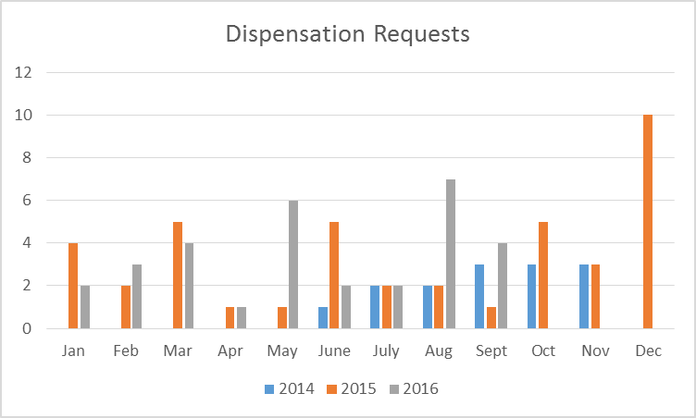

The outcome of a request may be that HealthCERT approves or declines it, or the provider may withdraw it when the named resident no longer requires the dispensation. Applications may be declined when a provider is certified for rest home (dementia care only), hospital (psychogeriatric care only) and/or residential disability (any service type) care. As Figure 3 shows, the majority of requests (67 of the 86 received) were approved. Only eight were declined and 11 requests were withdrawn.

Figure 3: Outcomes of dispensation requests, 2014–2016
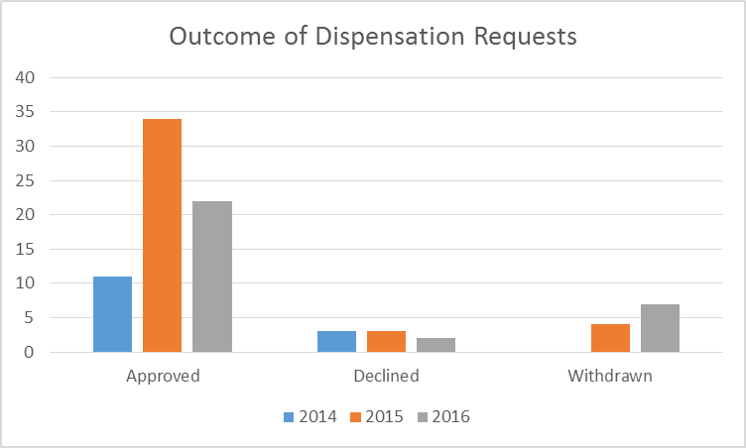

Sector matters

The enrolled nurse’s role in assessment and care planning
Here we offer some general guidance for health and disability service providers and designated auditing agency auditors about the role of enrolled nurses in assessment, care planning and documentation. For more detail, see the links at the end of this article.
Enrolled nurses are regulated health practitioners who, using the knowledge and skills gained through academic preparation, contribute to the delivery of health care services. They work in a variety of health care settings under the direction of a registered nurse. Their scope of practice permits enrolled nurses to contribute to assessment and care planning, and to lead teams of health care assistants when working under the direction of a registered nurse.
HealthCERT is part of the Ministry of Health that oversees the Health and Disability Services (Safety) Act 2001 and is responsible for the certification of health and disability providers. Health and disability providers undergo certification audits against the Health and Disability Services Standards (HDSS). The specific HDSS and criterion for assessment and care planning are:
- Standard 1.3.3: Consumers receive timely, competent and appropriate services in order to meet their assessed needs and desired outcome/goals
- Criterion 1.3.3.1: Each stage of service provision (assessment, planning, provision, evaluation, review and exit) is undertaken by suitably qualified and/or experienced service providers who are competent to perform the function.
HealthCERT found that audit reports from August 2015 to June 2016 show some variability in the way providers are managing and documenting assessment and care planning.
- In total, 19 audit reports found that an enrolled nurse and/or caregiver had completed care assessments, care plans and writing progress notes that a registered nurse had not countersigned.
- Of that total, the majority (15) were from aged care facilities, three from DHBs and one from a private surgical hospital.

Guidance for health and disability providers
Each provider of health and disability services (DHB, aged care, private hospital or hospice) is responsible for having a policy that details:
- the registered nurse’s responsibility for direction and delegation of care to enrolled nurses and health care assistants in its service
- how enrolled nurses coordinate a team of health care assistants and/or caregivers under the direction and delegation of a registered nurse
- the process for recording the registered nurse’s oversight of assessments that enrolled nurses undertake
- the process for recording the registered nurse’s oversight of care plans that enrolled nurses document.
Recognising the scope of practice and capability of enrolled nurses, HealthCERT has provided the following examples of acceptable practice to providers, employers and auditors.
- Admission assessment: The registered nurse delegates a consumer assessment to an enrolled nurse. The enrolled nurse completes the appropriate admission documentation and documents the care plan in line with policy.
- Consumer reassessment: The enrolled nurse records changes in the consumer’s care, condition or treatment in the appropriate clinical documentation (for example, admission-discharge planner). The enrolled nurse records any changes to the care plan and discusses these with the registered nurse responsible for the consumer’s care plan.
- Progress reporting: The registered nurse responsible for the care plan and who has delegated care to the enrolled nurse is named in the consumer’s health record. The enrolled nurse is responsible for documenting the consumer’s day-to day progress, care delivered and outcomes in the consumer’s health record. The registered nurse is not required to countersign these entries.
Health care assistants and/or caregivers cannot be made responsible for undertaking or documenting consumer assessments, care plans and evaluations.

Nursing Council of New Zealand links
For more information, download the following publications from the Nursing Council of New Zealand’s website (www.nursingcouncil.org.nz).
Competencies for Enrolled Nurses (April 2012) (PDF, 688 KB)
Guideline: Delegation of Care by a Registered Nurse to a Health Care Assistant (PDF, 730 KB)
Guideline: Responsibilities for Direction and Delegation of Care to Enrolled Nurses (PDF, 641 KB)

Health Quality & Safety Commission New Zealand
The Health Quality & Safety Commission’s ‘learning from adverse events’ report is scheduled for publication on 10 November.
This year the report contains information from the review of the National Reportable Event Policy 2012. It summarises options for possible changes to policy, and provides a link to the full discussion paper and ways of providing feedback up until 1 February 2017.
The Commission welcomes input from across the health and disability sector to help shape the future direction of the policy.
The Adverse Event Learning Programme shares learnings from organisational reviews of events in Open Books. These publications are widely circulated so that all providers can review their local context to work out whether a similar event might occur in their organisation. New Open Books are published regularly. To sign up to receive notifications of new publications or to discuss a case that could be shared for learning, email reportable_events@hqsc.govt.nz.

Requirement to report any notifiable event under the Health and Safety at Work Act 2015
When a notifiable event occurs as a result of the conduct of a business or undertaking, under section 56 of the Health and Safety at Work Act 2015 (HSWA) a person conducting that business or undertaking must notify WorkSafe of that event as soon as possible. The definition of ‘notifiable event’ in section 25 incorporates notifiable injuries and illnesses, which include an injury or illness that requires the person to be admitted to a hospital for immediate treatment.
However, WorkSafe recognises that there are other more appropriate reporting channels for medical misadventure incidents and accepts that reporting such incidents to both WorkSafe and health sector regulators would serve no useful purpose. In view of this, WorkSafe policy is that:
- medical treatment injuries resulting in hospitalisation are not notified to WorkSafe
- injuries arising out of non-clinical patient care are notified to WorkSafe.
Section 35 of HSWA indicates that the new Act generally accepts that other legislative regimes may also set requirements that have a health and safety element, and that set a more appropriate standard. In this way, s35 strengthens WorkSafe’s position that it will not enforce notification requirements where the notifiable event involves medical misadventure injuries to patients in a clinical context, because that event will go through comprehensive investigative processes and reporting structures under other legislation.

Continuity with the Health and Safety in Employment Act
WorkSafe’s current approach is consistent with the position taken under the previous Health and Safety in Employment Act 1992. Subsection 25(2) of this Act required employers, the self-employed and principals to report occurrences of serious harm to non-employees. Due to the nature of their work, there is a risk that health professionals may cause serious harm to persons in their place of work in the course of carrying out their professional duties. In some circumstances, subsection 25(2) required the reporting of serious harm to patients resulting from the actions of health professionals in administering medical treatment. This was not the policy intent of this subsection.
Moreover, there are comprehensive investigative processes and reporting structures for medical treatment incidents involving patients under other legislation. These processes and structures are more appropriate for dealing with such incidents. For example, the New Zealand Public Health and Disability Act 2000 requires DHBs to report any serious adverse events resulting in harm to patients to the Health Quality & Safety Commission.
On this basis, in 2003 DHBs and the then Occupational Safety and Health service negotiated a policy under which:
- medical treatment injuries resulting in serious harm would not be reported to the health and safety regulator
- injury or serious harm arising out of non-clinical patient care would be reportable.

Developing policy under the new Act
The Health and Safety at Work Act 2015 replaced the concept of serious harm with the concept of notifiable event, incident and injury or illness. Given that the HSWA’s notification requirements generally follow those under the previous Health and Safety in Employment Act, WorkSafe has carried over its policy on notifications developed under the previous Act.
WorkSafe is now developing this policy and related guidance. It will need to review the policy in relation to the new concepts in the Act and its own approach to implementing them. WorkSafe will be discussing this area with the Ministry of Health, district health boards and others.
In the meantime the existing policy, modified as the context requires to account for the new terminology, will continue to operate as it does currently.
WorkSafe New Zealand

Websites of interest

Culturally and Linguistically Diverse (CALD) Guidelines for Residents with Dementia in Aged Residential Care
Dr Kathy Peri and Dr Gary Cheung, University of Auckland, have developed a guideline for health professionals, health care assistants and caregivers working in aged residential care services, as well as for the residents with dementia and their families. The aim of the guideline is to provide best practice guidance for staff working in residential care to help them to provide culturally appropriate support and care, including at the point of transition from the new resident’s home to residential care. Note: Waitemata District Health Board eCALD and the Northern Regional Alliance supported the funding for the guideline.
For more information, go to: www.ecald.com/Portals/49/Docs/Toolkits/CALD%20Guidelines%20Dementia.pdf

interRAI
For issue 5 of the national interRAI newsletter, The interRAI Informer, go to www.interrai.co.nz. In this issue you’ll find out about:
In this issue we announce the new interRAI acute assessment tools to be launched early next year, the 2016 Software upgrade ‘What you need to know’ to understand the changes coming up in November, important information about Digital Certificates Expiring and what you need to do to ensure continued access to secure internet connections for interRAI. We also include a Central Region DHB infographic highlighting some key information obtained through interRAI assessments that can be used to start conversations by providers about the older people they care for, an update on the work to establish an integrated interRAI education and support service and finally lots of new pieces of information to keep you up to date on everything interRAI.
If you have any ideas about what you would like to see covered in the newsletter, please let us know: interrai@dhbsharedservices.health.nz

Three Steps to Better Health Literacy: A guide for health professionals
To download the Health Quality & Safety Commission’s booklet on improving health literacy, go to: www.hqsc.govt.nz/our-programmes/partners-in-care/publications-and-resources/publication/2046/.

Good news stories
In this growing section of our Bulletin, you will find stories from residential disability services, aged residential care and a district health board. Thank you all for your contributions.

Paul’s story: Residential disability service
Let me introduce myself – my name is Paul Knipping and I am a pretty special guy, who is having a great time settling in to Range View, one of the Mash Trust homes in Levin.
Now it wasn’t always like that. In fact, in the last 12 months my life has been very turbulent. Here let me explain: I lived with my mum and dad and had done so all my life and I am so lucky to have the most amazing supportive family who really care for me. In August 2015 my dad became ill and had to go into hospital and Mum was diagnosed with dementia and had to go into a home. I was quite lucky I got to go with her, but that soon turned sour. I was – you might say – not very nice to everyone and became aggressive to others. They soon moved me out to Te Whare Ra Uta, the psychogeriatric unit at Kenepuru Hospital. That didn’t go too well and at times I was physically restrained and put into seclusion.
While I was at Te Whare, my dad died. It hurt and it still does sometimes today. My family weren’t happy with what was happening to me and they managed, along with Explore, to find me a home in Paraparaumu with Mash Trust. I shared this home with four others. Now, I ruled the roost at home and I thought I could do it here too. Again, I wasn’t very nice to my other flatmates and staff. The environment just wasn’t for me. They were very noisy and I prefer it quiet. I only lasted a month before I was moved again due to some serious incidents I caused.
I moved temporarily to a place called Range View, just south of Levin. My first night, I slept well, then in the morning, the staff sat me down and explained the house rules to me. Yeah right, I tried them on and I tried to fight the staff and the flatmates. The staff kept my flatmates safe and stood back at a safe distance and watched me.
I wasn’t always in a bad mood and, when I was calm, the staff would sit with me and talk and joke with me – I liked that. I talked about my family, especially my dad and how much I missed him. They just listened and gave me a hug when I needed it. I’m allowed to watch my favourite TV channel, TV One, and the other flatmates don’t mind, and the staff are getting used to Coronation Street (well, maybe not), but they don’t change the station and I like that.
I still regress to my mischievous and challenging behaviour from time to time, but the team know how to de-escalate my behaviour quickly, which in turn has less impact on everybody.
I remember one time where I threatened one of the staff that I would smash the window. Rather than stop me, they opened the window so that I could throw things out and then they got me to help them pick them up … that was clever.
The team at Range View have shown me a lot of respect, empathy and patience, and have also given me boundaries that are realistic to my abilities. The team have been very proactive and creative when managing my behaviours. They are all on the same page, so trying to play them off against each other is just not working.
My life has been turned around from being someone with challenging behaviours, not willing to listen to anyone, to a man who is able to express his personality and be trusted within the home. In return, I am starting to trust others as well, I have made friends with my flatmates, and I have been given responsibility to complete some of the meaningful tasks in the home. I vacuum the house, empty the rubbish into the wheelie bin (instead of over the fence), I am now putting the dishes in the dishwasher (rather than on the roof), and I am responsible for putting out and bringing in the wheelie bins. It’s good to feel like an integral member of the home and that I am needed.
I like shopping for my three Pinkie bars and cheesecake every Thursday. I get to visit my mum and my family every fortnight and my family come and visit me regularly in my home as well. It’s good to know that my family are more relaxed and are happy for me to be where I am. I care for them so much and my welfare is important to all of us.
I do enjoy living at Range View and look forward to the new experiences and challenges that come my way. I have a great bunch of family members and staff (friends) supporting me and looking out for me.
There is so much more that I could share with you, but we’ll save that for another day. Or you could always come and visit me for a cup of tea and a chat.
All the best
Paul

From Paul’s family
As a family we knew that the transition to residential life was going to be a challenge for Paul. We have been very fortunate to see Paul supported to settle in Range View. The staff have shown patience, tolerance, and a whole lot of love and understanding to help Paul adjust to a new home environment, the first new home environment in Paul’s 50 plus years! It has not been easy for them and the last 12 months have been emotionally exhausting for Paul. But he has been able to grow into the calm, structured and supportive environment created by the awesome staff. We can only marvel at how far he has come. We did not think he would be where he is in himself in such a relatively short time. It is testament to the staff and to Paul’s willingness to adapt, find a new future and a new home. Thanks to all that have made this possible from all of us. We are very proud of Paul and pleased for him that he has found this new home at Range View.
SA Knipping
Family member

Hohepa Hawkes Bay
Hohepa Hawkes Bay is particularly pleased with its progress in promoting More Independent Living. For the past three years it has been advancing its project to build capacity of people who historically would have been in a lifestyle of community residential living – living in a house with five others, depending on higher levels of support.
A new housing model and a specific Independent Skills Learning Programme have enabled people to become increasingly in charge of their own lives. During our recent certification audit, the auditors took particular notice of our project, even though those homes were not subject to the audit focus. The auditors were impressed with the development and chose to specifically acknowledge it as part of our service – very satisfying for us.
However, the most satisfying outcome has been seeing two people who have come through this programme move into their own flat – something that would have been unlikely if we had not implemented the project with small unit housing and the learning programme.
Another outcome is the way many others have since aspired to be part of the project (now a programme – the project is part of service practice). Further, we can see other aspects of individuals’ aspirations to be in control of their own lives showing through. Getting a Ministry of Health Supported Living contract as part of our standard contract will legitimise what we are doing. We also acknowledge our local Needs Assessment and Service Coordination agency for its support with this initiative.
Andy White
General Manager
Hohepa Hawkes Bay

Oceania Healthcare: Focus on falls
In 2015, Oceania Healthcare developed and implemented a programme to lower the number of sentinel events (falls with fractures) in its South Island aged care facilities. It was designed to reduce the total number of falls, which would in turn reduce the number of sentinel events. In the period from 1 June 2015 to 31 May 2016, Oceania achieved a 20 percent reduction in total falls in the South Island and a 13 percent reduction in sentinel events. One facility halved its number of falls after implementing the programme.
Susan Mountier, Oceania’s Clinical and Quality Manager for the South Island and project manager for the company’s Falls Prevention Programme, began by training the clinical managers and registered nurses on how to assess each resident’s needs and create individual care plans that help prevent falls. A structured process called Intentional/Routine Rounding (IR) was also introduced.
With IR, the staff adopt specific behaviours and carry out regular checks on individual residents at set (typically hourly) intervals. During these checks, staff perform scheduled tasks or observations with the resident, which help mitigate the factors that are likely to lead to falls. The checks include monitoring pain, checking positioning, attending to toileting needs, assessing and attending to the resident’s comfort, and checking the environment for any risks to the resident’s comfort and safety. The round ends with the closing words: ‘Is there anything else I can do for you? I have time.’ It also includes a statement about when the resident can expect a staff member to return.
Another factor that was very beneficial in reducing falls was ensuring that the appropriate equipment (that is, perimeter mattresses, low beds or bed levers) was available at all sites and was being used.
Regular exercise is important in the prevention of falls, but keeping residents motivated to engage in activities can be a challenge. As part of the Falls Prevention Programme, facilities were encouraged to offer at least five group exercise sessions per week. To help keep the exercises varied and fun, an activities blog was created where activities coordinators could share their ideas. The blog was supplemented with regular email communications promoting some of the most creative and popular ideas.
Increasing the awareness of all staff (including health care assistants, cleaners, kitchen assistants, etc) had a huge impact on reducing falls. Important steps were to increase awareness of who is at risk and times of day that residents are more at risk of falling, and to plan the staff task lists around this information. One method of increasing awareness was to set up falls prevention noticeboards at nurse stations and in staffrooms. These noticeboards clearly displayed statistical information around vitamin D prescribing, sentinel events and number of falls, along with information on interventions to prevent falls.
Each month, a highly visible, colour-coded poster was put up on the noticeboard at each facility and updated every day to show the number of falls (a figure coloured in red for each fall that occurred) and the number of days without falls. This helped staff to focus on the day or shift they were working on and motivated them to better the current record of days without falls. Ongoing monitoring and support are vital, and Susan continues to compile falls statistics each month and email monthly bulletins to all clinical managers with information on falls prevention.
The response rate to a recent survey sent to all Oceania clinical mangers about the Falls Prevention Programme clearly demonstrated their enthusiasm for and commitment to continuing to reduce the number of falls. Based on this feedback and the outstanding results achieved in the South Island, Oceania has set a goal of reducing falls by a further 10 percent across all its facilities nationwide over the next year.
Susan Mountier
Business and Care Manager
Oceania Healthcare

Tara Evans
Senior Clinical and Quality Manager
Oceania Healthcare

Whanganui District Health Board medical ward: Focus on falls
The mantra of Whanganui District Health Board (WDHB) – ‘Care with dignity, Kia tū rangatira ae, kia mana ae te tangata’ – reminds us that we should always uphold the dignity of patients and their whānau and focus on what is most important to them first and foremost.

Care of the cognitively impaired
It is well recognised that, when older people are admitted to hospital, they may develop behavioural disturbances such as confusion, agitation, delirium, dementia or cognitive decline. Compared with patients without dementia, those with dementia are twice as likely to experience an adverse event such as falls, sepsis or pressure ulcers while hospitalised. They are also up to three times more likely to sustain fractures or delirium.
Ryan et al (2013) have shown that delirium occurs in about one in five general hospital inpatients and particularly in those with prior cognitive impairment. In the year to June ending 2014, 74 patients were discharged from WDHB with a diagnosis indicating identified confusion or delirium. Total discharges for the period were 1929 patients. If Ryan et al’s figure was applied to the total number discharged, then it would be expected that approximately 386 patients would show signs of confusion or delirium – rather than the 74 identified.
Recent data suggests that between 20 and 25 percent of patients aged 70 years and older admitted to an acute hospital setting have dementia (Draper et al 2011; Travers et al 2014).
Gladman et al (2012) contend that hospitalisation and being in unfamiliar surroundings disrupt the patient’s routine, which often heightens their confusion and distress. The noise level, bright lighting and lack of clear signage can be frightening and disorienting. Hospitalised patients with cognitive impairment may wander, putting themselves and others at risk. They may also display disruptive behaviours, including aggression, calling out, yelling or screaming, which creates difficulty for nursing staff to manage and deliver care, as well as causing distress to other patients. Compounding this, staff in general do not have the necessary training to manage these behaviours appropriately and the physical hospital environment is not conducive to caring for patients with cognitive impairment. Providing special observations in acute care settings is associated with significant financial costs to the service (Dick et al 2009).
Over the last three years the number of close observation (CO) hours required (as it is known at WDHB; other terms are specialling and watches) has increased significantly. From mid 2012 to 2015 WDHB has seen a 77 percent increase in the hours of CO, equating to 34 percent increase in patients requiring CO and leading to an unbudgeted staffing cost of 7 FTE.
Recognising that the most vulnerable patient was often with the least formally trained staff has been a key part of WDHB’s project. The DHB also identified that increasing staff knowledge through conversation and education would improve how they provide care.
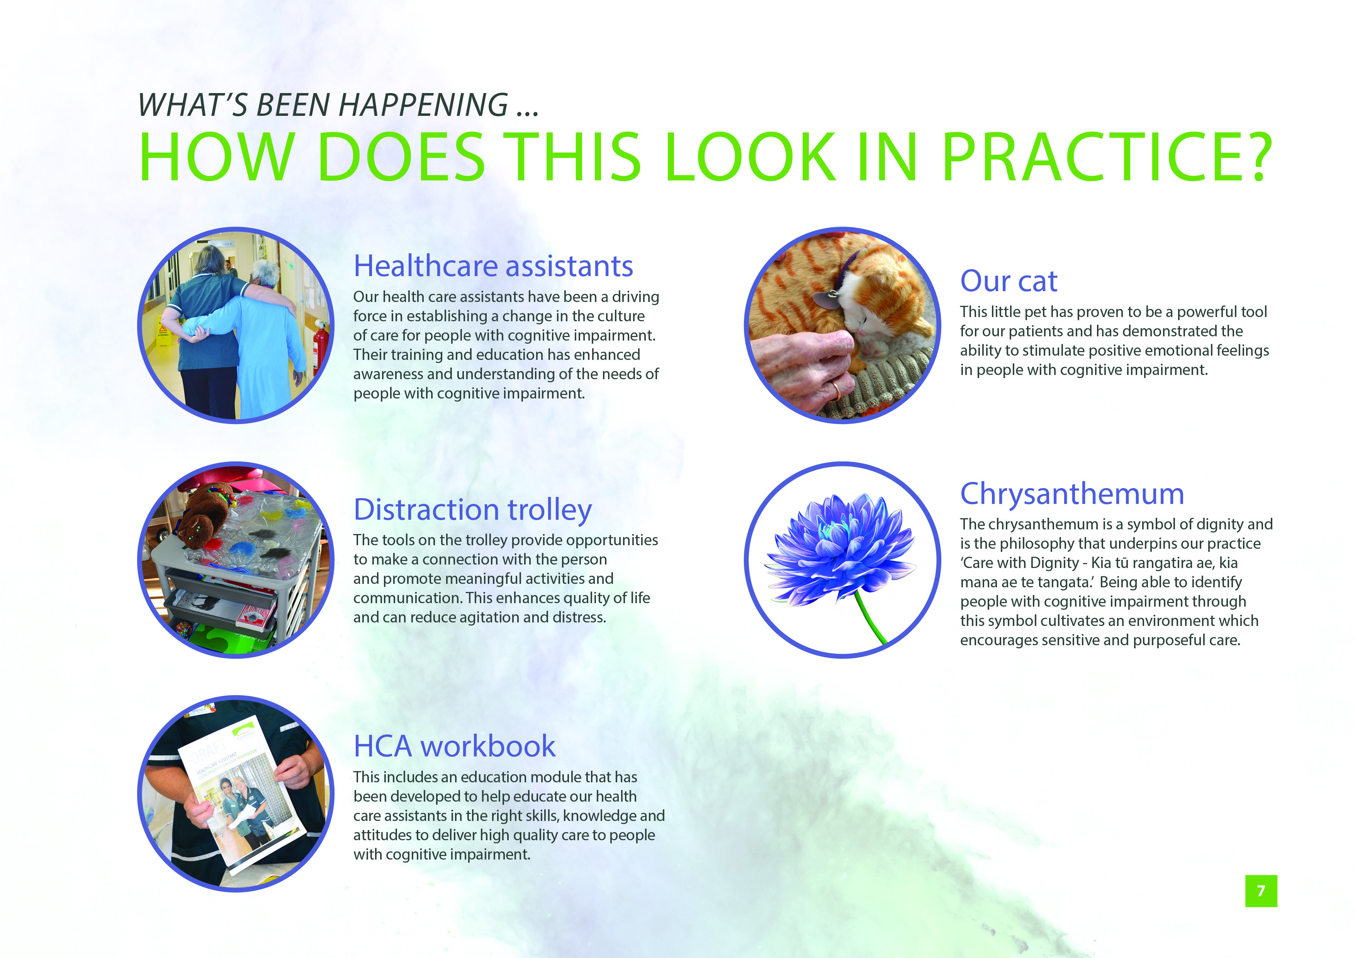
Providing focused education and increasing the health care assistants’ knowledge and awareness, while not reducing close observation time, has seen a 60 percent decrease in falls with associated harm between 2012/13 and 2014/15. The use of restraint and sedation and the amount of sick leave of staff have also fallen. Feedback from families indicates they see staff as showing more empathy and compassion, which is rewarding as this underpins the philosophy of this work.
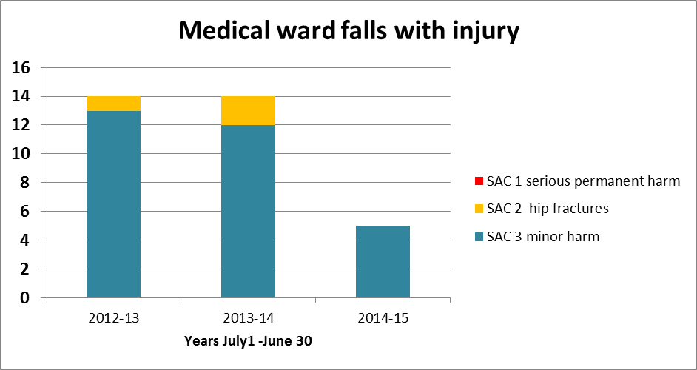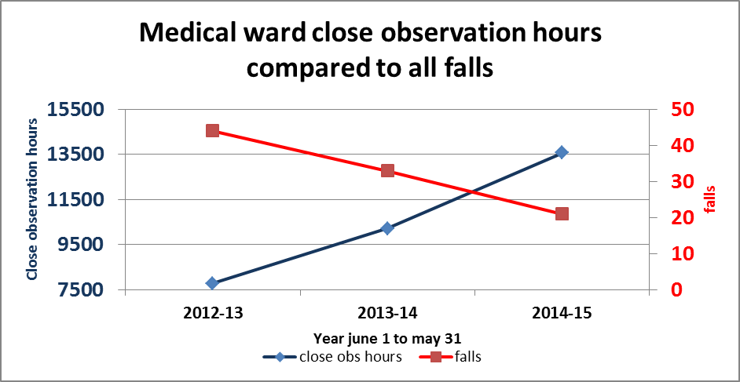

The staff voice
The following feedback reflects the success of the project from the viewpoint of staff.
Before this project
‘It was long, boring and stressful before, extremely stressful. We had no resources, nothing. Magazines was about it (if we could find them) and they were out of date.’
After the project began
‘Now it’s just wonderful, you just feel so happy because you can see that they’re more comfortable, happier and they’re thinking about something else. I tried for three days to get one patient to interact (he was not very sociable), but today I found what triggered his connection which was really cool. He was painting with water, making a steam train and said to me, “Look at that” and I said, “You’ve made a masterpiece”. So he’s been a little bit more chatty.”
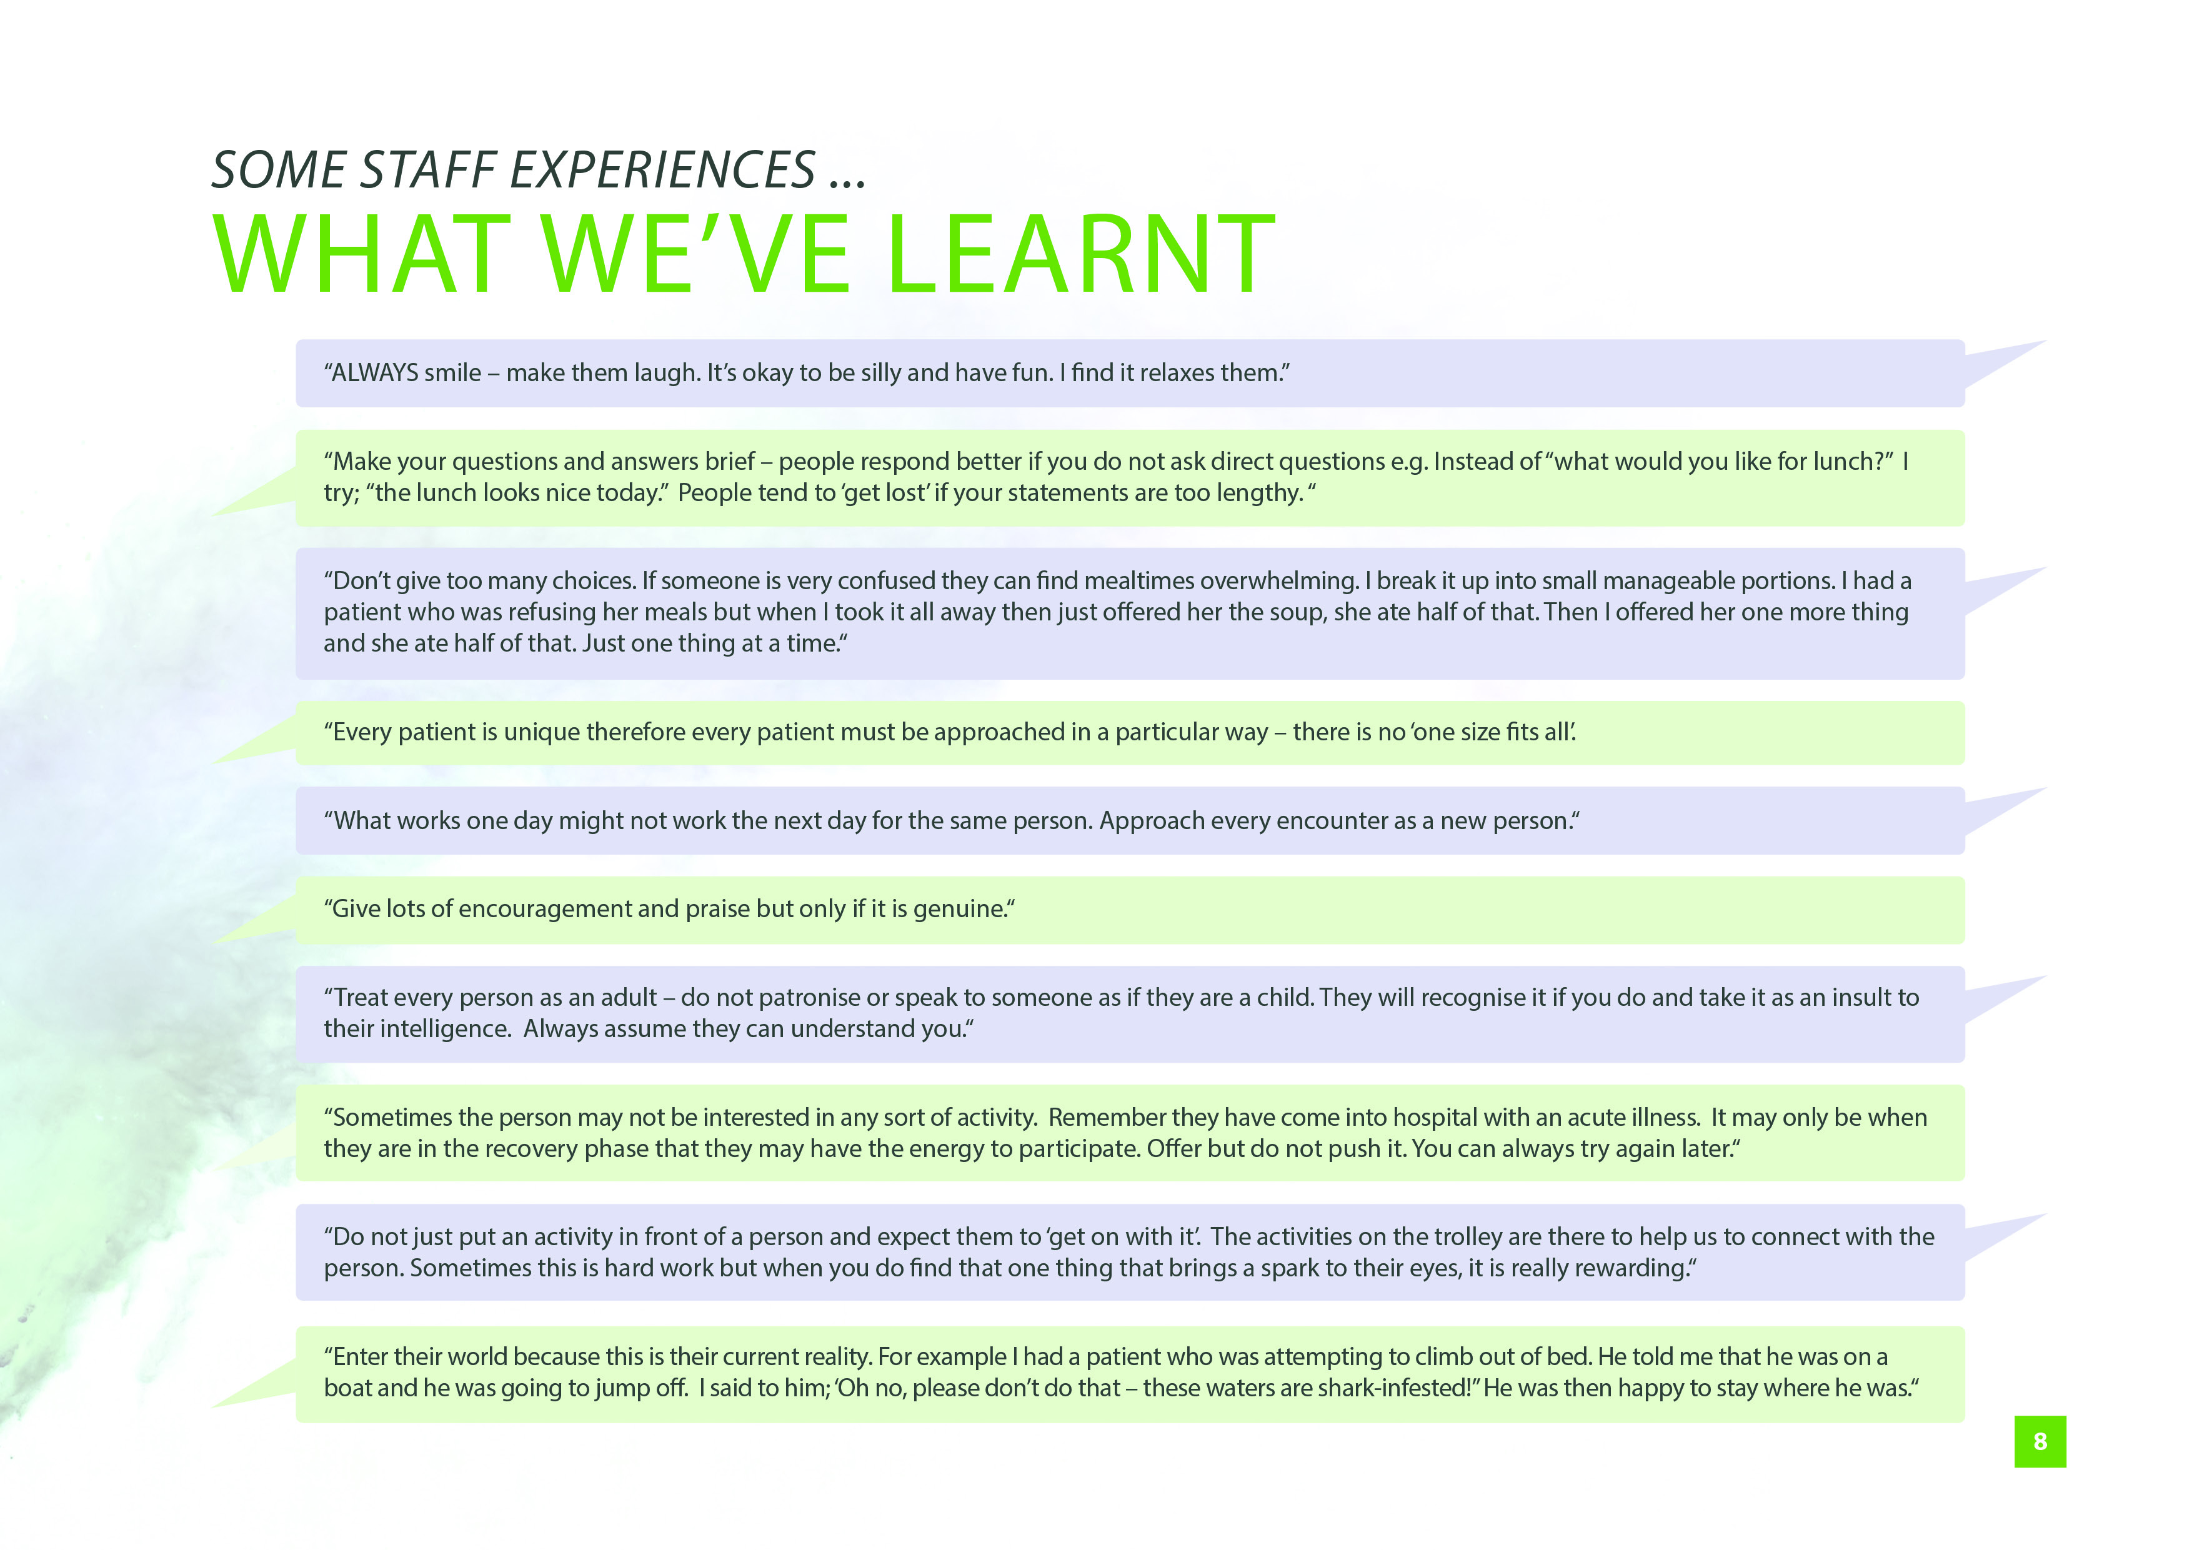
For me, the quality of my life is defined and determined by how strong I sense my own dignity, privacy and honour, and how much I feel others honour me as a total person. Richard Taylor (2007).
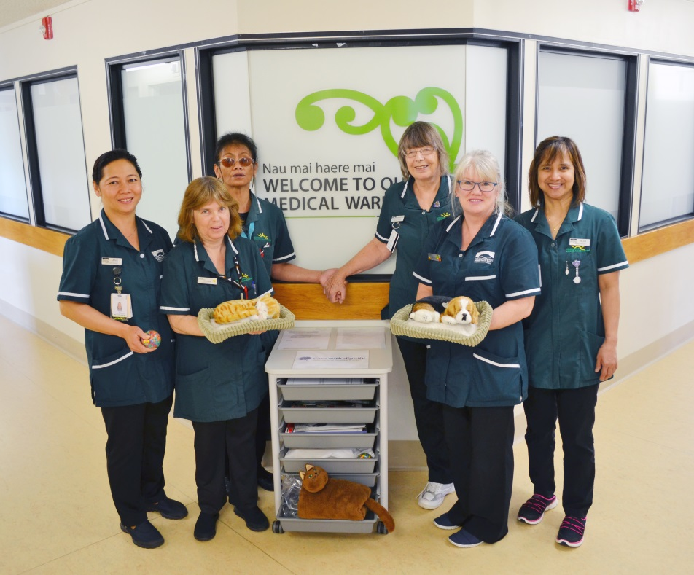
Health care assistants on the WDHB medical ward
Wendy Stanbrook-Mason
Nurse Manager
WDHB

Colleen Hill
Clinical Nurse Manager
WDHB

References and further reading
Dewing J. 2004. Concerns relating to the application of frameworks to promote person-centredness in nursing with older people. Journal of Clinical Nursing 13(3a): 39–44.
Dick A, LaGrow S, Boddy J. 2009. The effects of staff education on the practice of ‘specialling’ by care assistants in an acute care setting. Nursing Praxis in New Zealand 25(1): 17–26.
Draper B, Karmel R, Gibson D et al.2011. The Hospital Dementia Services Project: age differences in hospital stays for older people with and without dementia. International Psychogeriatrics 23(10): 1649–58.
Gladman D, Porock A, Griffiths P, et al. 2012. Better Mental Health: Care of the Older People in General Hospital. Final Report NIHR Service Delivery and Organisation Programme. Southampton: NIHR Health Services Delivery Research Programme.
Holden J, Jayathissa S, Young, G. 2008. Delirium among elderly general medical patients in a New Zealand hospital. Internal Medicine Journal 38(8): 629–34.
Laurila JV, Pitkala KH, Strandberg TE, Tilvis RS. 2004. Detection and documentation of dementia and delirium in acute geriatric wards. General Hospital Psychiatry 26(1): 31–5.
Ryan DJ, O’Regan NA, Ó Caoimh R, et al. 2013. Delirium in an adult acute hospital population: predictors, prevalence and detection. BMJ Open 3(1): 1–10.
Taylor R. 2007. Alzheimer’s from the Inside Out. Texas: Health Professionals Press.
Travers C, Byrne G, Pachana N, et al. 2013. Prospective observational study of dementia and delirium in the acute hospital setting. Internal Medicine Journal 43(3): 262–9.
Travers C, Byrne G, Pachana N, et al. 2014. Prospective observational study of dementia in older patients admitted to acute hospitals. Australasian Journal on Ageing 33(1): 55–58.
Wilkes L, Jackson D, Mohan S, Wallis M. 2010. Close observation by ‘specials’ to promote the safety of the older person with behavioural disturbances in the acute care setting. Contemporary Nurse 36(1–2): 131–142.

