
Issue 21 – March 2018
ISSN 2423-0523
 | Welcome to the first edition of 2018.  HealthCERT’s PIPM Work Programme:  Audit report data collection ends, s31 reporting continues | HealthCERT Pressure Injury Prevention and Management (PIPM): the final chapter  As you will probably recall from our last Bulletin, in the closing phases of HealthCERT’s PIPM Work Programme auditors are no longer collecting PIPM data during audits of aged residential care facilities. This data collection finished in December 2017. We are now reviewing the data with the aim of producing a report for publication on the Ministry of Health’s website.  Anecdotally we have heard this programme has been a valuable piece of work for the sector, and again HealthCERT extends thanks to both aged residential care providers and designated auditing agencies for their ongoing support for the work. We ask that aged residential care providers keep reporting pressure injuries at stage 3 and above on the prescribed section 31 notification form. Continue with this notification process whether the pressure injury is acquired in a facility or elsewhere.  If you have any queries, please do not hesitate to contact Donna Gordon (donna_gordon@moh.govt.nz) in the first instance.
Inside: HealthCERT Pressure Injury Prevention and Management (PIPM): the final chapter • A joint agency approach to reducing pressure injuries • Measuring the prevalence of pressure injuries at the Health Quality & Safety Commission • Accident Compensation Corporation • Operating matters • Health and Disability Services Standards review • Medication Guidelines for the Home and Community Support Services Sector • HealthCERT complaints 2017 • Disability Support Services complaints 2016/17 • HealthCERT forms updated • HealthCERT staff comings and goings • Sector matters • Health Quality & Safety Commission – quality improvement in aged residential care • Continuous improvement at audit • Emergency planning: recommendations for water requirements • interRAI reporting • interRAI Data Visualisation launched • Commission for Financial Capability video • Fire Safety Design Guide for Residential Community Housing • Websites of interest • Good news story • Ultimate Care Group – reducing depression

A joint agency approach to reducing pressure injuries
The Accident Compensation Corporation (ACC), the Health Quality & Safety Commission (the Commission) and the Ministry of Health (the Ministry) are working together and with the sector to reduce pressure injuries in New Zealand.
ACC has led the development of guidance for the sector, resulting in the publication of Guiding Principles for Pressure Injury Prevention and Management in New Zealand (www.acc.co.nz/assets/provider/acc7758-pressure-injury-prevention.pdf). Its task now is to look at developing resources and tools to help the sector in preventing and managing pressure injuries.
The Ministry is providing clinical oversight and support for engaging with clinical leaders. An ongoing focus is on developing a culture and infrastructure that support pressure injury prevention, promote a multidisciplinary approach and improve collaboration across the health and disability sector. For example, as readers of this Bulletin will know, in 2016 and 2017 the Ministry of Health, through HealthCERT, focused on pressure injury management in aged residential care.
The Commission has undertaken some initial work to capture patient stories that the sector can learn from and that will inform future opportunities to co-design approaches to reducing pressure injuries. For a number of stories about patients’ experiences of pressure injuries and how health care providers can respond effectively, see the Commission’s case studies web page (www.hqsc.govt.nz/our-programmes/pressure-injury-prevention/patient-stories). The Commission also continues to promote a nationally consistent approach to measuring and monitoring pressure injuries across the sector, starting with the in-hospital setting.

Measuring the prevalence of pressure injuries at the Health Quality & Safety Commission
On 13 October 2016, the Commission published the first deliverable from its ‘Measurement of pressure injury prevalence’ workstream. The report, Developing a National Approach to the Measurement and Reporting of Pressure Injuries, was informed by a multidisciplinary advisory group. To read it, go to www.hqsc.govt.nz/our-programmes/other-topics/publications-and-resources/publication/2658
The report proposes a preferred method for data measurement and reporting: skin checks via monthly random sampling with a minimum sample size of five patients per ward or unit. With this sampling method, it is possible to continue to focus on quality improvement. It also provides enough data to evaluate the effectiveness of quality improvement initiatives.
Southern, Capital & Coast, Whanganui and Waikato District Health Boards (DHBs) have been working with the Commission to test, refine and implement the proposed methodology. One deliverable from this piece of work is a ‘frequently asked questions’ resource, which you can find at www.hqsc.govt.nz/publications-and-resources/publication/3128
The major deliverable from the pilot phase of the workstream will be a ‘how to’ guide that will be a companion document to the October 2016 methodology report. The guide will detail the learnings from the four pilot sites and will be designed to ensure that other DHBs can use it to support them in implementing the measurement approach and pressure injury quality improvement projects. Watch out for the publication of the guide in April 2018.
This information is also relevant to other service providers that wish to apply this surveillance and measurement approach to inform their own pressure injury and prevention improvement work.
The outcomes of this work have helped in designing national process and outcome quality and safety markers (QSMs) for national in-hospital pressure injury surveillance. The QSMs, on which the Commission has consulted with DHBs, come into effect on 1 July 2018 and will be published from 2019 onwards.
If you would like to know more, please email Gabrielle Nicholson at gabrielle.nicholson@hqsc.govt.nz

Accident Compensation Corporation
The Guiding Principles for Pressure Injury Prevention and Management in New Zealand (the guide) was launched at the New Zealand Wound Care Society (NZWCS) Conference in May 2017. In addition, with support from relevant government agencies, the NZWCS re-launched its patient leaflet on the topic – find it on the NZWCS website (www.nzwcs.org.nz).
ACC has printed copies of both and is keen to distribute them.
To ask for a copy of either resource, please email pressureinjuryprevention@acc.co.nz

Operating matters

Health and Disability Services Standards review
The last Bulletin summarised the high-level feedback HealthCERT received on the review of the Health and Disability Services Standards. As we noted then, of the 389 responses received, the majority – 188 – indicated the standards should be amended or replaced. In addition, respondents offered significant comments, which fell into two main themes: update the standards to reflect current practice; and develop specialist standards to meet changing models of care. Other respondents cited the costs of changing the standards and compliance costs as reasons for not amending or replacing them.
This feedback was taken to the Minister of Health, who has now agreed to progress to the next stage. This will initially involve discussion with the Ministry of Business, Innovation and Employment to collaboratively agree on a programme of consultation. This discussion is progressing.
HealthCERT is also interested in understanding how other parts of the world manage health service regulation. For more on a recent review in Australia, see: the Minister for Aged Care’s release of the review (www.health.gov.au/internet/ministers/publishing.nsf/Content/health-mediarel-yr2017-wyatt107.htm?OpenDocument&yr=2017&mth=10) and the Department of Health’s report (https://agedcare.health.gov.au/quality/review-of-national-aged-care-quality-regulatory-processes).

Medication Guidelines for the Home and Community Support Services Sector
In the last edition, we mentioned plans to consult on the draft Medication Guidelines for the Home and Community Support Services Sector. Consultation is now under way and key stakeholders having been notified 21 March. If you have not yet received notification and are interested in providing feedback, please contact Donna Gordon (donna_gordon@moh.govt.nz)

HealthCERT complaints 2017
As you are probably aware, HealthCERT has a role in complaint management. Complaints come to our attention from a number of sources such as the Health and Disability Commissioner’s Office, district health boards (DHBs) and members of the public.
While the Health and Disability Services (Safety) Act 2001 enables HealthCERT to undertake unannounced inspections in response to complaints received, we generally manage complaints by working with the funder of the certified health service.
Across 2017 HealthCERT received 84 complaints. This figure excludes those received from the Health and Disability Commissioner’s Office. As the following table shows, July was the month with the highest number of complaints (12).
Number of complaints to HealthCERT, by month, 2017
Month | Number of complaints
January | 6
February | 3
March | 8
April | 5
May | 8
June | 7
July | 12
August | 10
September | 6
October | 10
November | 5
December | 4
Total | 84

After investigating the issues raised by the complainant in each case, a decision is made as to whether the complaint is substantiated, partially substantiated or not substantiated. Of the 84 complaints received in 2017, we are still investigating 28. Among those where a decision has been made, 19 were partially substantiated and 19 were not substantiated (see below).
Outcomes of complaints to HealthCERT, 2017
Complaint outcome | No of complaints
Substantiated | 18
Partially substantiated | 19
Not substantiated | 19
Still under investigation | 28
Total | 84

Disability Support Services complaints 2016/17
Anyone can make a complaint to the Ministry of Health about problems or concerns with a service funded by Disability Support Services (DSS). DSS aims to resolve all complaints within 20 working days, depending on their complexity. If a complaint is not resolved in 20 working days, complainants can expect regular updates on the status of their complaint. With the information collected from complaints, DSS gains opportunities to look at how to improve the quality and delivery of Ministry-funded services for disabled people.

Number and types of complaints
During 2016/17 DSS received 41 complaints relating to 27 providers, with an average of 3.4 complaints per month. This total represents a decrease in the number of complaints received from the previous year (66 complaints). It continues an almost decade-long trend of a decreasing number of complaints received by DSS, as the graph below shows.
DSS wants to have a culture where people can speak up about the supports they receive and use the complaints process as an opportunity to improve the quality of provider services. As only seven of the 41 complaints made last year came from disabled people, it also recognises the need to seek ways to make the complaints process more accessible. Most complainants were relatives of the people using the services (including partner, parents or other family members).
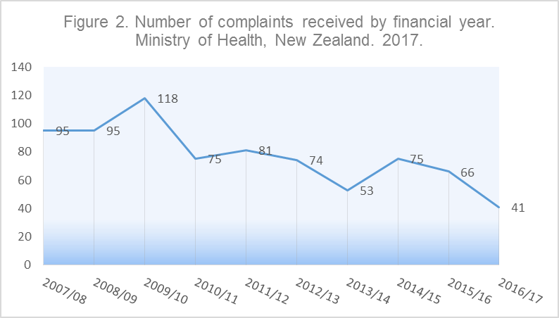

The most common reason for complaints (71%) was about service delivery (eg, inappropriate care, understaffing, vetting of staff, communication). The second most common reason (17%) involved allegations of abuse, including staff-to-client, client-to-staff and client-to-client abuse.
For more information on who to contact if you’ve got a question about Ministry-funded disability support services, or to make a complaint, go to the DSS contact web page (www.health.govt.nz/your-health/services-and-support/disability-services/more-information-disability-support/contact-disability-support-services).
DSS is always looking at how it can improve its complaints process and make it more accessible to people with disabilities. If you have any suggestions, please email dsscomplaints@moh.govt.nz

HealthCERT forms updated
The format and content of some of HealthCERT’s forms have been changed. You can access the updated forms on the Ministry of Health’s website (www.health.govt.nz/our-work/regulation-health-and-disability-system/certification-health-care-services).
The information for providers on the Ministry website is also being updated. This will make it clearer when providers need to contact HealthCERT and what form to use.

HealthCERT staff comings and goings
The HealthCERT team has seen a number of recent changes so it seems an apt time for an update.
HealthCERT’s Manager, Emma Prestidge, has moved into a new role as Group Manager, Quality Assurance and Safety. This role includes oversight of HealthCERT so she continues to support the team in strategic matters. Sandy Papp, who was the Group Administrator with HealthCERT, is now Emma’s Executive Assistant. Congratulations to them both on their new roles.
The new HealthCERT Manager has been appointed and is starting 9 April. Susan Murphy comes to us from MidCentral DHB where she has been the Manager Quality and Clinical Risk. Susan is a registered nurse with 25 years’ experience in the health sector working predominately with mental health services in NZ and the UK. Susan has been in a quality role for more than 10 years now and is passionate about ensuring patients, families and whānau get the best care possible when they are at their most vulnerable. Susan is looking forward to working with the sector to achieve the best possible outcomes for all.
The team also has a new coordinator – Molly Willerton – who joined the team in October 2017. Her background is in disability support work and administration. We now have two experienced coordinators who are well placed to respond to queries relating to certification and PRMS. Contact either Molly or Helene on 0800 113 813.

Sector matters

Health Quality & Safety Commission – quality improvement in aged residential care
Late last year the Health Quality & Safety Commission approved the establishment of a quality improvement programme for aged residential care (ARC). This reflects an evolution from the Commission’s early topic-based approach. The intent of the programme is to support the sector to further strengthen the foundations required to build a strong continuous learning and improvement culture and to improve the residents’ experience of care.
The Commission has appointed Dr Michal Boyd, Associate Professor (School of Nursing, University of Auckland) and Nurse Practitioner (Waitemata DHB), as the clinical lead for this work. Supporting Michal are a small programme team and a leadership group to progress the work.
After the current establishment phase, the programme’s implementation will begin in July 2018. The approach and areas of focus will progress at a deliberately measured pace given the complexities of this sector in terms of size, geographic spread, mix of business models and ownership structures, and the variability of infrastructures to support sustainable quality improvement. The Commission is also mindful of the excellent work already happening across aged residential care that it needs to be aware of and build on.
The Commission will be hosting a series of workshops in this half of the year, which we will publicise as dates and venues are confirmed. The aim is to partner with sector stakeholders in a way that is engaging and innovative and builds strong alliances and partnerships to support quality improvement activity across the sector, sustaining it into the future.
Engagement to date has identified the six consistent themes pictured below. These will form the basis for setting the context for the programme.
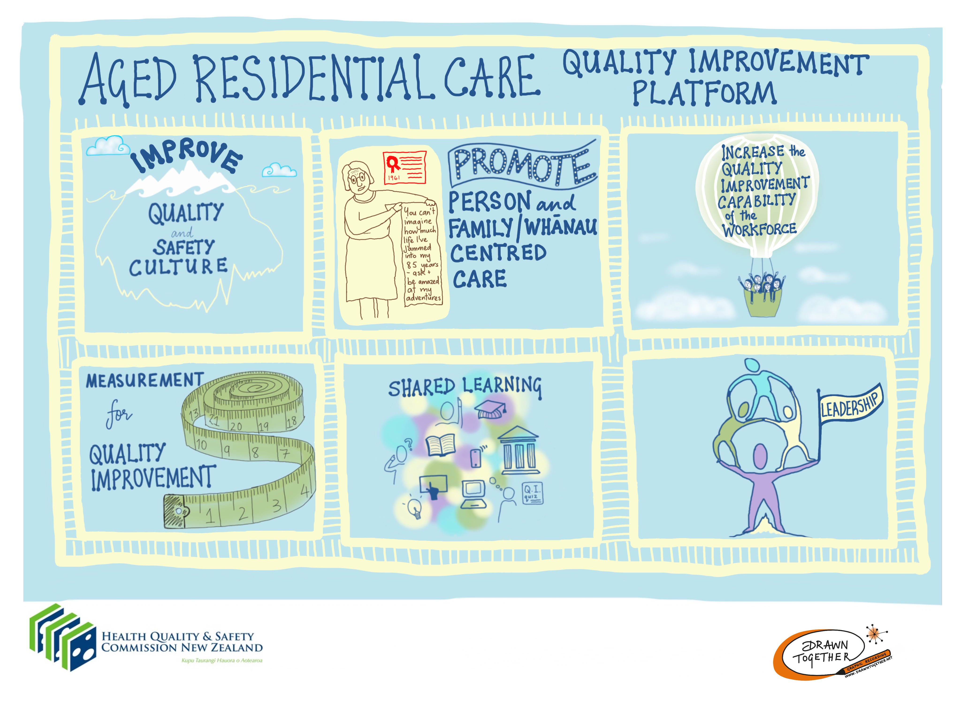
To find out more or discuss any aspects of this work, please email the Commission’s key contacts: Julene Hope (interim Project Manager) at julene.hope@hqsc.govt.nz or Carmela Petagna (Senior Portfolio Manager) at carmela.petagna@hqsc.govt.nz
Watch this space as more information comes to hand. The Commission is also developing information for its website, so keep an eye out for that too (www.hqsc.govt.nz).

Continuous improvement at audit
Providers have been asking HealthCERT how they can achieve a continuous improvement (CI) rating at audit.
The Health and Disability Services Standards define CI as follows:
Having fully attained the criterion the service can in addition clearly demonstrate a review process including analysis and reporting of findings, evidence of action taken based on those findings, and improvements to service provision and consumers’ safety or satisfaction as a result of the review process.
We ask that, if it decides a provider meets this definition, the auditing agency outlines the following when awarding and reporting a CI rating.
- Define the problem – Has an issue been raised as a result of a complaint, resident feedback and/or trending through a benchmarking programme?
- Describe the opportunity – What change/process can be implemented to improve the problem identified?
- How was success measured – Did the piece of work result in a change in practice and/or policy?
- Evaluation – Provide data that shows a change/improvement (or otherwise) has occurred as a result of the work undertaken. Develop an ongoing monitoring process to ensure change is being embedded into daily operation.
Essentially HealthCERT is interested in providers demonstrating a culture of continuous quality improvement. If you wish to discuss this further, please contact Leslie McCullough (Leslie_McCullough@moh.govt.nz).

interRAI reporting
Information from comprehensive clinical assessments can help with planning care and workflows in aged residential care facilities and for home care providers. Comprehensive clinical assessments using interRAI produce Outcome Measures and Clinical Assessment Protocols (CAPs), which provide a wealth of information.
To consider how the information from the interRAI assessment can help with determining the level of care, acuity and the staffing levels of a facility, it is important to understand the picture that the Outcome Measures and the assessor comments offer.
interRAI assessments are completed in conjunction with the client/resident, staff, family and others involved in the care and welfare of the individual. The assessor’s comments will often reflect changes or the individual’s needs outside the three-day lookback period that the assessment covers.
CAPs are triggered by research-based algorithms embedded within the assessment, Triggered CAPs identify the areas in which the resident is more likely to decline than might be expected or has a greater potential to improve or there is the possibility of resolving the problem.
The Outcome Measures are objective, based on embedded algorithms that create the scores for the scales. A decline in function or increased difficulty is expressed as an increase or higher score. For example, the Cognitive Performance Scale 0–6 describes the cognitive status of an individual; those scoring 5–6 would be considered to have a severe cognitive impairment.
Longitudinal data allows for the comparison of changes in function over time. It can be very helpful to collect and analyse before and after providers implement changes and improvements to a facility or to individual care.
For more information on national data, to book training or to contact interRAI, please visit its website (www.interrai.co.nz).

interRAI Data Visualisation launched
A new data visualisation makes information about people receiving care at home or in aged residential care available and tangible for everyone.
In 2016/17 over 100,000 comprehensive clinical assessments were completed in the community and aged residential care facilities across New Zealand. All that information is collected and aggregated to provide a picture of older people’s needs at DHB, regional and national levels.
interRAI Data Visualisation gives users access to a wealth of data, which they are already using for policy development, research, service development, quality improvement and more.
Because the tool is interactive, users are in control of the information and can select the level of detail they desire.
Complementing interRAI Data Visualisation is the interRAI Services Annual Report with a special focus on people with dementia living at home. For this special feature, experts analysed data from 35,000 home care assessments in 2016/17.
Access interRAI Data Visualisation and the Annual Report at its website (www.interRAI.co.nz/data).

Commission for Financial Capability video
Troy Churton – National Manager, Retirement Villages – recently met with the Ministry of Health to discuss a number of matters. One topic was premium care room charges – on which you may find the following short clip interesting: www.cffc.org.nz/latest-news/retirement-villages/premium-care-room-charges-may-surprise (available on the Commission for Financial Capability’s website).

Fire Safety Design Guide for Residential Community Housing
On 28 March 2018, the Ministry of Business Innovation and Employment (MBIE) published the Fire Safety Design Guide for Residential Community Housing. The document provides guidance for community housing providers, fire engineers and building consent authorities when an alternative solution is used to demonstrate Building Code compliance.
This guidance was jointly developed by MBIE, the Ministry of Health, New Zealand Fire Service, Housing New Zealand, Community Housing Aotearoa, New Zealand Disability Support Network, Disabled Person Assembly and a building control officer representative.
Public consultation on the proposed guidance document took place from 17 July to 11 September 2017.
Fire Safety Design Guide for Residential Community Housing has further information.
If you have any further questions please contact firereview@mbie.govt.nz

Websites of interest
Accident Compensation Corporation: www.acc.co.nz
Health Quality & Safety Commission: www.hqsc.govt.nz
interRAI: www.interrai.co.nz
Ministry for Primary Industries – food safety rules: www.mpi.govt.nz/news-and-resources/consultations/have-your-say-about-food-safety-rules
New Zealand Wound Care Society Inc: www.nzwcs.org.nz
Nursing Council of New Zealand: www.nursingcouncil.org.nz
Te Pou o te Whakaaro Nui: Real language, real hope: www.tepou.co.nz/resources/real-language-real-hope/790

Good news stories
In this popular section, you will find a story from an aged residential care service. Our thanks to the provider for its contribution.

Ultimate Care Group – reducing depression
Ultimate Care Group (UCG) decided to dedicate November 2017 to depression awareness. It was a perfect opportunity to address the issues that we identified in the quarterly ARC interRAI report and in view of the upcoming holiday season, which can be difficult for some of our elderly. People entering residential age care facilities are, on average, older than those living in the community. They have more complex needs due to physical and cognitive difficulties. They may also have difficulties adjusting to their loss of independence and routine. These factors all increase their risk of depression and suicidal ideation.
Depression in the elderly is becoming harder to treat due to increased clinical complexity. It is also less often recognised, for a variety of complex reasons. Barriers to diagnosis may include time constraints, other co-morbidities that complicate diagnosis and reluctance to discuss emotional problems. Moreover, low mood is tends to be considered a norm for elderly people.
Although facility-based caregivers are in a position to report on it, they often lack the training to detect symptoms of depression.

Outcome of the depression awareness campaign
- Facilities shared 13 blogs on how the depression awareness campaign has helped them in getting the most for the residents.
- 17 residents were identified as having some signs of depression.
- Caregivers reported 82% of these instances.
- Registered nurses reported 35% (some prompted by caregivers).
- 23% of the residents self-reported signs of depression to staff members.
- The internal UCG Pulse edition shared two of the stories.

Interventions provided by the facilities
In response to the signs of depression identified, UCG facilities:
- provided social interactions
- discussed the issue in staff meetings
- involved activities coordinators
- offered structured activities and walks
- involved general practitioners in multiple reviews
- reviewed care plans
- reassured residents and observed them closely
- referred some to hospice.

Plan going forward
- We will continue this project in March 2018 on the basis that the reassessments for interRAI are completed six-monthly so we can get new data to compare with the current reports.
- The last quarter UCG ARC interRAI report showed a decrease in depression within the elderly community.
- Some of the UCG facilities have made depression awareness a project for the year 2018.
We would like our plder people to integrate into the wider communities where they can use their skills and talents – for example, with young mothers’ groups and at intermediate and secondary schools.
Sherren Singh, National Quality Manager

