
Issue 22 – March 2019
ISSN 2423-0523
 | Welcome to the first edition of 2019. | HealthCERT reviews relevant standards  Review of the Health and Disability Services Standards, and the Fertility Services Standard is now beginning to take shape.  Project lead  We appointed Jade Cincotta as the project lead for this work. Jade has come to us from the Health Quality & Safety Commission. She can be contacted via email on Jade_Cincotta@moh.govt.nz, by phone on 04 816 2012 or on her mobile 021 934 315.  Governance Group  To support the project progression of the standards review, we are forming a Governance Group, which will meet for the first time in early March. The Governance Group will provide strategic advice to the project.  Scoping days  Once the Governance Group is established, we plan to host ‘scoping days’, through which we will be looking to seek the views of sector stakeholders. We are still working on the details of the scoping days. If you are interested in taking part, please contact our project lead.
Inside: HealthCERT reviews relevant standards • Project lead • Governance Group • Scoping days • Operating matters • HealthCERT new team members • Medication Guidelines for the Home and Community Support Services Sector • HealthCERT invoicing • Emergency water storage recommendations • Continuous improvement at audit • Sector matters • Heat health plans • Enhanced residential care pharmacy services (Auckland metro) • Stop the choke: standardising dysphagia diets across New Zealand by 2019 • Websites of interest • Good news story • Laura Fergusson Trust Wellington

Operating matters

HealthCERT new team members
HealthCERT has engaged three new team members since our last bulletin – two coordinators and a senior advisor.
The coordinators provide a key interface with the sector for applications for certification, and answering queries relating to our work or forwarding them to another team member. Our two new coordinators are Casey Howard, who is a registered Australian occupational therapist and has worked in mental health, and Olivia Ensor, who has a background in public health and worked in a hospital administrative role prior to coming to HealthCERT.
Jane Pryer has recently joined the team as a senior advisor. Jane has a nursing background, and was an infection prevention and control clinical nurse specialist before joining the Ministry.

Medication Guidelines for the Home and Community Support Services Sector
In the last edition of this bulletin, we mentioned that consultation was well under way on the draft Medication Guidelines for the Home and Community Support Services (the Guidelines).
Consultation concluded in 27 April 2018; 84 responses were received. The majority of survey respondents (33, or 39%) represented providers; the next highest group was employees of a home and community support services provider (21, or 25%). The majority of survey respondents (44, or 52%) thought that the Guidelines in their current form required amendment, and recommended changes to seven of the ten sections.
A working group has been formed to make amendments to the Guidelines in line with the feedback received. The finalised Guidelines will be taken to the Health of Older People Steering Group to consider the next phase.

HealthCERT invoicing
As you are probably aware, the Act prescribes our work in respect of certification requirements. Section 27 notes that the Director-General must certify a person to provide health care services of any kind if the person has:
- applied in writing and
- paid to the Director-General the fee prescribed for certification.
Recently, a small number of providers have experienced difficulty in paying the prescribed fee in a timely manner. A delay in payment may affect HealthCERT’s ability to certify a provider. We are currently exploring our internal processes to ensure the system is working effectively.

Emergency water storage recommendations
The Wellington Regional Emergency Management Office (WREMO) has increased the water storage recommendation for Wellington (including Wairarapa and Kāpiti) to 20 litres per person per day, for seven days.
If outside the WREMO please check with your local civil defence group for the recommended requirements for water storage, as they do vary.
You can find more information about water storage and upcoming ‘Plan & Prepare’ workshops online at the WREMO website (https://getprepared.nz).

Continuous improvement at audit
In the last edition of the Bulletin we outlined three key aspects HealthCERT asks auditors to report on when awarding a continuous improvement (CI) rating at audit. These were: define the problem, describe the opportunity, measure and evaluate success.
HealthCERT reviewed the number of CI ratings awarded at audit between January 2016 and May 2018.
As aged residential care providers make up the majority of certified providers; it is therefore not surprising that, of the 836 CI ratings awarded across the period considered, 682 were for aged residential care facilities.

Sector matters

Heat health plans
There is conclusive evidence that extreme heat (eg, during a heatwave) has negative impacts on health. Even modest increases above average temperatures can have negative impacts on vulnerable people – but effective planning can reduce these effects.
The Ministry has developed guidelines to raise awareness of the risks of hot weather to health, and to encourage and support the creation of heat health plans, which outline actions and systems to support those most at risk during periods of extreme heat. The Ministry recommends that individuals, health and community service providers, district health boards (DHBs), public health units and local governments consider developing their own heat health plans as part of their emergency planning.
You can find these guidelines on the Ministry’s website (www.health.govt.nz).

Enhanced residential care pharmacy services (Auckland metro)
The metro Auckland DHBs have agreements with community pharmacies for services delivered to age-related residential care and community residential care facilities. Pharmacies are funded based on the volume of medicines supplied to patients under the Integrated Community Pharmacy Services Agreement (ICPSA). The current system has a number of limitations, including variability in the quality of clinical services provided to residents.
Going forward, the metro Auckland DHBs propose to implement an enhanced residential care pharmacy services to ensure a consistent, safe and effective service provision to all residents. Furthermore, it is proposed that a limited number of community pharmacy providers will be selected with exclusive right to provide the service; and facilities will only be able to receive funded pharmacy services from one of the selected providers.
The funding model where pharmacies are reimbursed to provide the service to residential care facilities may change. DHBs are cognisant that pharmacy services should be sustainable and accessible to the population.
In late 2018, the metro Auckland DHBs undertook a period of consultation with key stakeholders across the region on a proposal to introduce an enhanced residential care pharmacy service. Over the consultation period the metro Auckland DHBs sought the views of consumers, residents of care facilities, pharmacists, prescribers, residential care facility managers, other health professionals and pharmacy sector representatives on the direction of this proposal.
The consultation resulted in around 140 responses, which included comprehensive and detailed feedback. Metro Auckland DHBs are currently reviewing this feedback. Residents and their families have shared their experiences and provided insights into what mattered to them. Health professionals, associated businesses and organisations have shared their knowledge and experience of providing healthcare services.
Once the summary report is finalised and presented to the metro Auckland DHBs’ Boards for consideration, this will be made available online. This is likely to occur in March 2019.
Thank you to everyone who contributed during the consultation.

Stop the choke: standardising dysphagia diets across New Zealand by 2019

What is dysphagia?
Dysphagia (swallowing difficulties) affects millions of people worldwide, including up to 75 percent of residents in aged care settings, due to age-related anatomical, physiological and dentition changes, associated diseases and medicine use. Common causes of dysphagia are stroke, Parkinson’s disease, dementia and head and neck cancer. Aspiration pneumonia (chest infections caused by food and drinks entering the lungs) is the most common cause of death in people with Parkinson’s disease. People with poor dentition are more likely to die of choking than people with good dentition; New Zealand has the highest rate of edentulism (toothlessness) worldwide. Deaths from choking are alarmingly high in aged care facilities; the highest culprits on autopsy are bread, meat, pastry and fruit. Malnutrition is a large problem for people with dysphagia, leading to fatigue, infections, pressure injury, falls and cognitive decline.

Texture-modified diets
Texture-modified diets are commonly used to reduce the risk of choking, and aspiration pneumonia and increase overall nutritional intake. Approximately one-third of aged care residents are on a texture-modified diet following assessment by a specialist.

The International Dysphagia Diet Standardisation Initiative
Confusion with terminology, poor understanding and a lack of referrals to speech-language therapists and dietitians; leads to increased risk for residents with dysphagia. The International Dysphagia Diet Standardisation Initiative (IDDSI) (www.iddsi.org) aims to standardise terminology and offer simple testing methods to check that the preparation of the diets are compliant. Dietitians New Zealand and the New Zealand Speech-language Therapists’ Association endorsed the IDDSI framework in 2016, and implementation began in early 2018.
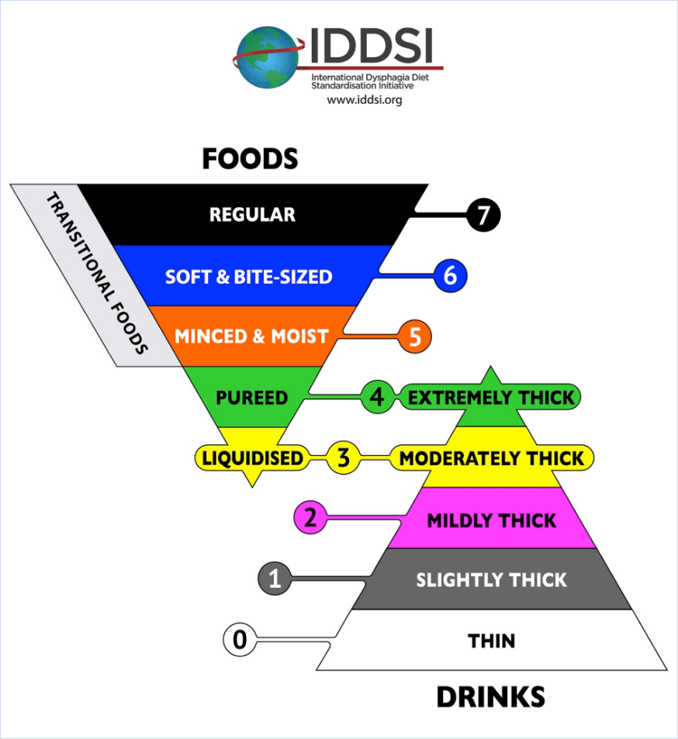
The IDDSI framework assigns standardised names, colours and numbers to assist with easily identifying texture-modified foods and fluids. All residents prescribed a texture-modified diet will be given two codes as above. It is imperative that providers follow prescribed texture modifications, to prevent risk to residents’ health.

Implementation
The IDDSI framework includes simple tests to check that texture-modified foods/fluids adhere to guidelines. Kitchen and nursing staff will be able (and should be encouraged) to easily check that their facility’s texture-modified diets and thickened fluids are prepared correctly (http://iddsi.org/framework/food-testing-methods/).

What next?
To make sure they’re adhering to the IDDSI framework, providers should:
- stop using any terms for aspects of texture-modified diets that are not on the IDDSI framework
- download the IDDSI app or look at the IDDSI website to familiarise themselves with the framework
- encourage relevant staff to access a dietitian or speech-language therapist for further support
- contact newzealand@iddsi.org to ensure they are on the mailing list for IDDSI New Zealand updates. The New Zealand team welcomes ideas to support implementation
- watch out for updates in the HealthCERT Bulletin.

Contacts
Dr Anna Miles is a researcher in dysphagia at the University of Auckland, a New Zealand Speech-language Therapists’ Association – Expert Adviser in Adult Dysphagia, and the lead for IDDSI implementation in New Zealand. Grace Combellack is a speech-language therapist at Counties Manukau District Health Board.

Websites of interest
Accident Compensation Corporation: www.acc.co.nz
Health Quality & Safety Commission: www.hqsc.govt.nz
interRAI: www.interrai.co.nz
Ministry for Primary Industries – food safety rules: www.mpi.govt.nz/news-and-resources/consultations/have-your-say-about-food-safety-rules
New Zealand Wound Care Society Inc: www.nzwcs.org.nz
Nursing Council of New Zealand: www.nursingcouncil.org.nz
Te Pou o te Whakaaro Nui: Real language, real hope: www.tepou.co.nz/resources/real-language-real-hope/790

Good news story

Laura Fergusson Trust Wellington
Two recent initiatives at Laura Fergusson Trust Wellington have had a positive impact on quality of life for residents.

Catheter management
Our service was experiencing an increased number of residents with both supra pubic catheters and indwelling catheters. We were reliant on district nurses to complete regular six-weekly changes to catheters; at times they would even provide us support to change emergency blockages during their days off.
When an emergency occurred, residents often waited up to four hours before the issue was addressed, sitting in pads until that time. If there were no district nurses available, our residents were supported through the DHB emergency department. This was an extremely uncomfortable and stressful process for them, often resulting in the resident having to wait a further four to five hours.
We established a continuous improvement plan with the following key objectives:
- Decrease the time spent waiting for a district nurse to come, or to transfer residents to hospital to have catheter unblocked
- Reduce residents’ stress/anxiety
- Promote residents’ physical comfort
- Reduce impact on residents’ day-to-day activities
- Reduce risk of infection
- Reduce risk of pressure injury
- Reduce district nurse service and DHB workload.
We determined the following measures of the success of our proposal:
      - Reduced delay in clinical intervention
      - The residents suffers less stress as staff will attend within an hour of the problem presenting
      - Residents remaining in their own environment
- Reduced catheter-related infections
- No pressure injury, as skin integrity is maintained by earlier attention
- Reduction in extra equipment required
- Reduced staff time spent facilitating district nurse visits or transfer to hospital.

How was the plan developed and implemented?
Consultation occurred with the Urology Nurse who manages our incontinence supplies. In partnership with her we noted that the number of SPC’s was gradually increasing along with blockages. We were motivated to reduce this if possible.
An action plan was determined with a number of steps outlined. Initially we decided to begin by training one of our Clinical Coordinators to see if this would work. We set aside time for one of the district nurses to mentor her, including through hands-on experience of changing catheters. Once the supervisor felt confident of the clinical coordinator’s ability, it was agreed that she would have responsibility for regular and emergency changes. If the District Nurse was available she would support this process until she felt confident that the Clinical Coordinator was fully competent.
This process was successful, and we have subsequently increased the number of staff who are competent to change catheters. This has had a direct positive influence on our clients’ quality of life.

Outcome
We can confidently demonstrate that we managed to achieve all of the identified measures identified in our plan.

Improving independence at breakfast time
We identified that the traditional breakfast service provided in a residential setting was not maximising our clients’ independence, and not promoting healthy choices. This barrier was simply caused by the way items were packaged, including jam and butter containers and the lids of spreads. Some clients were unable to open these items, which limited their choice of and access to foods otherwise enjoyed by others. Many of our clients were reliant on care staff to physically assist them, so they were only able to eat breakfast at a time convenient to the organisation.
We established a continuous improvement plan with the following key objectives:
- To increase choice and positive outcomes for residents / service users (e.g. increased independence).
- To introduce a healthy and nutritious choice of breakfast foods to residents, with food types and food portions based on the New Zealand Food and Nutrition Guidelines.
- To foster greater independence among residents.

We determined the following measures of the success of our proposal:
- Residents / service users are able to exercise choice with the introduction of a weekly breakfast menu planner that includes a healthy and nutritious selection of breakfast foods and specifies the time that residents have their breakfasts.
- A nutritious breakfast menu that meets New Zealand Food and Nutrition Guidelines.
- Development and implementation of aids to enhance residents’ independence.
- Decreased dependency on support staff to prepare residents’ breakfast.

How was the plan developed and implemented?
We conducted an initial audit to assess whether the quantities of key menu items currently available were sufficient to enable all residents to meet their recommended serving sizes and nutritional needs. We sought clinical advice on an appropriate breakfast menu, and considered a range of aids that could enable residents’ independence.
We designed a draft menu that took into account the New Zealand Food and Nutrition Guidelines. We consulted with residents and staff about the proposed changes, seeking their feedback on all aspects of the proposal. We incorporated this feedback into a final menu.
An occupational therapist assessed what equipment, aids and appliances could best facilitate our residents’ independence for the breakfast meal. To this end we designed wooden templates in the LFT workshop (with resident input) to hold small butter/margarine, jam and spread containers so that residents with limited dexterity or fine motor skills could opening these items by themselves. We devised a formalised ordering system was devised so allowing residents could choose what they wished to have for breakfast, delivered to their rooms so they were able to eat it independently.
A date was set to roll out the new menu and system. The new menu contained detail (written and visual) appropriate to the resident group.

Outcome
We have completed our evaluation of the project. The results demonstrate outcomes greater than we expected, including increased independence and choice for residents, a resident-led breakfast club initiative, cost savings and a significant reduction in food waste.

