Costs of alcohol harms in New Zealand

Updating the evidence with recent research

NZIER report to the Manatū Hauora|Ministry of Health

March 2024

About NZIER

NZIER is a specialist consulting firm that uses applied economic research and analysis to provide a wide range of strategic advice.

We undertake and make freely available economic research aimed at promoting a better understanding of New Zealand’s important economic challenges.

Our long-established Quarterly Survey of Business Opinion and Quarterly Predictions are available to members of NZIER.

We pride ourselves on our reputation for independence and delivering quality analysis in the right form and at the right time. We ensure quality through teamwork on individual projects, critical review at internal seminars, and peer review.

NZIER was established in 1958.

Authorship

This paper was prepared at NZIER by Sarah Hogan, Daniel Hamill and Tom Dunn.

It was quality approved by Todd Krieble.

The assistance of Sarah Spring is gratefully acknowledged.

NZIER would like to thank:

* Dr Tim Chambers and Dr Anja Mizdrak for agreeing to share their yet-to-be-published, New Zealand-specific alcohol-attributable fractions to support a more accurate costing of health-related alcohol harms.
* Dr Jacqueline Cumming for her helpful feedback on the draft report.

How to cite this document:

NZIER. 2024. Costs of alcohol harms in New Zealand: Updating the evidence with recent research. A report for the Ministry of Health.

Key points

Manatū Hauora|Ministry of Health commissioned this report as part of an independent review of the Alcohol Levy to assess the current evidence on the costs of alcohol harms.

The report estimates the gross costs of harms attributable to the consumption of alcohol, including harms to the drinker and others, to the extent that recent local evidence supports confidence in causal attribution and takes a conservative approach. Evidence used in calculations of cost estimates is restricted to the last ten years and the New Zealand context.

We estimate that the total societal cost of alcohol harms in 2023 is approximately $9.1 billion based on the increased risk of morbidity and mortality, with over half ($4.8 billion) due to fetal alcohol spectrum disorder (FASD), $1.2 billion due to alcohol use disorder, and $3.1 billion due to non-disordered alcohol use. Specific harms likely reflected in this estimate (and with some significant overlap between them) are estimated separately to provide evidence in key areas:

* Key areas of concern to communities estimated separately from a societal perspective: intimate partner violence (IPV) ($281 million for alcohol use disorder alone) and child maltreatment ($74 million for hazardous drinking alone), both likely underestimated due to low reporting and evidence gaps. The societal cost of road crashes is well evidenced and is estimated at over $2 billion.
* Productivity losses, which other reports find to be the largest category of alcohol harm costs, were estimated at nearly $4 billion, reflecting lost production associated with premature mortality, long-term disability, FASD and workplace absenteeism and presenteeism, the latter being the main driver at 76 percent of the total.
* Fiscal costs estimated at over $800 million, include $439 million for Vote Health and $327 million for Vote ACC. Due to major data and evidence limitations, only $42.7 million in Vote Justice costs and $1 million in Vote Social Development costs were estimated. Major evidence gaps resulted in the underestimation of Justice and Social Development costs.

Even with significant costs excluded due to data gaps and the use of conservative approaches, the costs of alcohol harms in New Zealand remain substantial and warrant prioritisation from a policy and programme perspective.

Important new research has shed light on significant concerns, but more research is needed to better understand and quantify alcohol harm in areas of concern for communities that are most affected. Statistics show that Māori experience disproportionate harms from alcohol, but many costs to whānau and communities are not captured in the available data.

Some of the worst outcomes (persistent unemployment and welfare dependency, homelessness, and family harm) are the least well described by data and evidence. Lack of access to services, such as family harm services, mental health and alcohol addiction services, and services for FASD artificially reduces measured fiscal costs and adds to the burden on New Zealand families and communities. Results should be interpreted in this context.

A cross-sectoral approach is needed to coordinate more comprehensive and regularly updated evidence from administrative data. We also recommend portions of the Alcohol Levy revenue be used to fund needed services as well as ongoing equity-focused research into alcohol harms.

Executive summary

#### This report was commissioned in the context of a review of the Alcohol Levy

Manatū Hauora|Ministry of Health commissioned this report as part of an independent review of the Alcohol Levy.

The primary objective of this report was to support Manatū Hauora in its consideration of future investment opportunities, specifically:

* to gain a better understanding of the nature and scale of harms that could be addressed through programmes and services funded by the Alcohol Levy
* to contribute (along with other evidence, including cost-effectiveness evidence) to the prioritisation of interventions, both within the health sector and by other agencies and organisations.

A secondary objective was to offer information that could be used to inform a wide range of policy decisions, including data collection and research decisions.

#### Our approach reflects the context and objectives of the report

The estimation of costs of alcohol harms for this report reflects two important study design features that were agreed with Manatū Hauora:

* A gross costs approach was taken, meaning any potential benefits are excluded from consideration,[1] consistent with the role of the Alcohol Levy as a cost recovery instrument designed to support programmes and services that address alcohol harms irrespective of any potential benefits associated with alcohol. The Levy is very small and unlikely to influence the demand for alcohol through its price; instead, it targets other mechanisms that may reduce harm, primarily influencing demand and behaviour through non-price mechanisms such as health promotion.
* Critical evidence on the role of alcohol in harms was restricted to recent New Zealand data and New Zealand studies, consistent with the approach of the Canadian Substance Use Costs and Harms (CSUCH) study which is seen as robust and world leading. This means costs of harms where insufficient recent local evidence was available were excluded from estimation, providing a clear indication of the current state of the evidence and areas of need for data and future research.

#### A societal value of increased risk of mortality and morbidity due to alcohol provides one way of estimating societal costs

The societal costs of alcohol span a wide range of impacts due to the ubiquitousness of alcohol in people’s lives and the wide range of consequences that alcohol consumption may have. This includes many significant concerns for the government and the public, such as cancers, road crashes, crime, mental illness, suicide, and family harm. Many of these impact drinkers and non-drinkers alike and have ripple effects affecting multiple sectors and even intergenerational outcomes.

Disability-adjusted life years (DALYs) are currently the only composite measure that offers a way of understanding the broader impact of a condition, illness or health risk on a population. They are commonly used in cost-of-illness studies to estimate the societal burden of disease. DALY estimates for alcohol include DALYs attributed to impacts on the drinker and DALYs attributed to fetal alcohol spectrum disorder (FASD) – estimated to be the area of most harm associated with others’ use of alcohol. Applying monetary values to DALY estimates may reflect a broad range of underlying costs to society.

Based on this measure and two alternative values suggested by the Treasury for use in public sector cost-benefit analysis using a similar composite benefit type (quality-adjusted life years (QALYs)), the total societal cost of alcohol in 2023 would be between $6.0 billion and $9.1 billion, with the latter value being based on the Value of a Statistical Life and, therefore, most comparable with previously published estimates. Just over half of this cost is associated with FASD (see Figure 1 below).

Figure  Estimated total societal value of increased risk of mortality and morbidity due to alcohol

$ millions, 2023

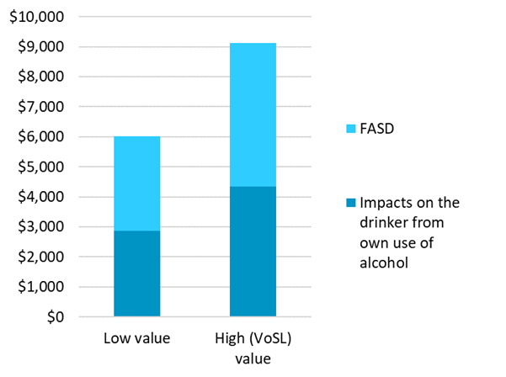

FASD: Fetal alcohol spectrum disorder

Source: NZIER

Previously published studies have indicated that, consistent with our result, the costs of harms from others’ alcohol use are likely to exceed the costs of impacts on drinkers as a result of their own alcohol use.

#### Costs representing specific concerns to communities were separately estimated from a societal perspective

While these costs are likely reflected within the societal cost of alcohol harms based on increased risk of mortality and morbidity, New Zealand communities have specific concerns regarding the impact of alcohol on road crashes, intimate partner violence (IPV), and child maltreatment, with recently published evidence supporting specific estimation of these costs from a societal perspective. Results are shown in Table 1 below. Note estimates for IPV and child maltreatment are likely underestimates due to the lack of evidence regarding the causal role of alcohol when criteria for alcohol use disorder and hazardous drinking are not met and the under-reporting of incidents.

Table Estimates of key concerns within the total societal cost of alcohol harms

$ millions, rounded to the nearest million

|  |  |  |
| --- | --- | --- |
| Key alcohol harm | Estimated value | Certainty of estimate |
| Intimate partner violence (IPV) | 281 | Low to moderate: Conservative scenario prevalence but based on old unit costs, attribution based on a single NZ study. Cost attributable to alcohol use disorder only (potential underestimation). Many costs of IPV are also reflected in other cost estimates. |
| Child maltreatment | 74 | Low to moderate: Conservative scenario prevalence but based on old unit costs, attribution based on a single NZ study. Cost attributable to hazardous drinking only (potential underestimation). |
| Road crashes | 2,095 | Moderate: Moderate certainty regarding attribution and counterfactual/ value related to loss of life/quality of life (the major component). |
| **Total societal cost of key alcohol harms** | **2,450** | Moderate certainty: Greater certainty regarding road crash costs and likely underestimate of IPV and child maltreatment due to the exclusion of cases where alcohol use disorder and hazardous drinking were not a factor. |

Source: NZIER

#### The value of productivity losses was estimated across a range of alcohol-related causes

Previous and overseas reports have found productivity losses associated with alcohol to be a major contributor to overall costs. Concerns about productivity losses, which may also be reflected within the values used to estimate the cost of alcohol-attributable DALYs, warrant separate consideration of these indirect societal costs. Productivity losses may be associated with short spells of impairment or absence from work, long term disability or death. Based on recent New Zealand data and evidence, in 2023, these costs are estimated to be up to $4 billion, as shown in the table below. However, there is significant uncertainty regarding this estimate.

Table Estimates of costs of productivity losses due to alcohol

$ millions, rounded to the nearest million

|  |  |  |
| --- | --- | --- |
| Cause of productivity loss | Cost estimate | Certainty of estimate |
| Hospitalisation for alcohol-attributable conditions and injuries | 13 | Moderate: High certainty of underlying attribution (see above) but low certainty of counterfactual productivity. |
| Premature mortality from alcohol-attributable conditions and injuries | 385 | Moderate: High certainty of underlying attribution (see above), low certainty of counterfactual productivity. |
| Long-term disability from alcohol-attributable injuries | 423 | Moderate to high: Moderate to high certainty of underlying attribution and counterfactual. |
| Incarceration for alcohol-attributable crime | 5 | Moderate: Moderate certainty of attribution (consistent with incarceration costs), conservative counterfactual. |
| Alcohol-related absenteeism and presenteeism in the workplace | 3,012 | Low: Prevalence based on a single, small NZ study, uncertainty regarding impact and counterfactual. |
| Impairment associated with fetal alcohol spectrum disorder (FASD) | 134 | Moderate: 100% certainty of attribution, uncertainty around prevalence, assumed impairment. |
| **Total productivity losses\*** | **3,972** | Low to moderate: Low to moderate certainty due to shortcomings of the human capital approach and the methods used by the study that provided the major cost. |

* Total excludes productivity losses due to hospitalisation due to potential heavy overlap with workplace absenteeism estimate.

Source: NZIER

#### Results in key areas of government expenditure are limited but show a major impact on the health sector

To understand the impact of alcohol on government expenditure, a range of costs have been estimated from a government perspective. These results show a major impact on the health system, with costs of at least $766 million in 2023 (including ACC costs). In total, $810 million in government costs were estimated; however, this is likely to be an underestimate of the true cost of alcohol to the government due to a lack of recent resource and cost data permitting full estimation of justice sector costs and a lack of evidence regarding the attribution of social sector costs, including jobseeker and other benefits, to alcohol. See Table 3 below for the results of this estimation.

Table Estimated costs to the government due to alcohol harms

$ millions, rounded to the nearest million

|  |  |  |
| --- | --- | --- |
| Vote and component | Estimated value | Certainty of estimate |
| **Health and ACC** |  |  |
| Hospitalisation for alcohol-attributable conditions and injuries | 337 | High: Local, recent, AAFs* estimated using established methods and robust data. (Estimate includes ACC funded hospitalisations) |
| Emergency services: emergency department (ED) and ambulance callouts resulting in ED visits | 102 | Low: Reliance on ED staff reporting events as “alcohol related”. True cost may be significantly higher due to the long-term role of alcohol in health conditions and the unobservable role of other people’s drinking in injuries. Higher confidence regarding the subset associated with acute inpatient events ($19m). |
| ACC compensation of workers with long-term disability attributable to alcohol | 327 | High: Good alignment of ACC data with AAFs for injuries. |
| **Total Health and ACC** | **766** | **Moderate: True cost may be significantly higher due to the exclusion of key cost areas (outpatient services and mental health services) due to data and evidence gaps.** |
| **Social Development** |  |  |
| Disability benefit and child disability allowance for disabilities attributable to alcohol | 1 | Low to moderate: Estimated attribution to alcohol based on survey data and AAFs for alcohol-attributable injuries. Likely underestimated due to a wide range of benefits unable to be attributed to alcohol attributable disability. |
| **Total Social Development** | **1** | **Low: True Social Development cost may be significantly higher due to alcohol’s potential role in broader welfare dependency and other Social Development costs unable to be estimated due to evidence gaps.** |
| **Justice** |  |  |
| Incarceration for alcohol-attributable crime | 41 | Moderate: Attribution based on a single, recent NZ study, some uncertainty regarding the application of study estimates to data. |
| Services and programmes to address family harms | 2 | Low: Estimate based on services addressing family harms only. Unclear how causal attribution applies within the programme context. |
| **Total Justice** | **43** | **Low to Moderate: True Justice cost may be significantly higher due to alcohol’s role in police and court costs, which are not estimated due to evidence gaps.** |
| **Total government costs** | **810** | Moderate: High degree of certainty on the major costs in this category. Total is likely underestimated due to a lack of data permitting estimation of up-to-date Justice and Social Development costs as well as key health sector costs. |

*AAFs=Alcohol-attributable fractions estimated for health conditions and injuries

Source: NZIER

#### The estimates in this report cannot be aggregated

Due to the approach taken to estimate costs in this report, the range of estimates cannot be aggregated due to the risk of significant double-counting. The highest risk of double-counting occurs when combining societal values: The estimated societal value of increased mortality and morbidity risk represents the most comprehensive estimate of total societal costs due to the valuation of these risks reflecting broad social and economic cost implications. The specific societal costs of key alcohol concerns separately estimated also cannot be combined with productivity losses or costs to government, since the societal costs estimated for these concerns reflect productivity losses and costs of government services and programmes. While some cost estimates where there is no clear connection to disease or health condition (e.g. incarceration costs, absenteeism and presenteeism costs) may not be well reflected in societal values associated with morbidity and mortality risk, this question represents a significant unknown.

#### Recently published research has improved the evidence base for alcohol harms

For this report, key areas of concern for communities and government were able to be costed more accurately than in previous reports due to the recent emergence of New Zealand studies providing key evidence on:

* the fractions of health conditions, diseases, injuries and mortality attributable to alcohol in the New Zealand context (alcohol-attributable fractions, or AAFs)[2]
* the prevalence of FASD and the productivity impairment associated with FASD
* the fraction of child maltreatment attributable to hazardous drinking
* the fraction of intimate partner violence attributable to alcohol abuse
* the fraction of impulsive crime attributable to alcohol.

A key point to note is that while the level of certainty is not high for many of the estimates in this report, this is not an indication of low certainty of harm but rather low certainty regarding the accuracy of cost estimates. In many cases, the true cost of alcohol harm may be considerably higher than existing evidence can show.

#### Despite areas of progress, the evidence base is not growing consistently

While recent research has improved the evidence base for some areas of alcohol harm cost estimation, in many areas, the evidence base remains thin and major sources of uncertainty remain:

* The emergence of new local studies identifying causal attribution through the use of strong controls is promising, but further research is needed to build confidence in these estimates.
* Critical information about the costs of responding to and addressing alcohol harms in New Zealand is lacking, with important reports that have informed previous estimates needing updating, particularly related to crime.
* Key areas of harm with costs to government and households lack evidence to inform understanding of harm and estimates of costs. These include the impact of alcohol on employment, welfare dependency and homelessness.

#### NZIER recommends

While estimates of the costs of harms allow for comparisons across different types of harm and a greater understanding of the social and economic impacts that may be associated with alcohol consumption, studies that investigate the extent and cost of alcohol harms are always controversial. Unresolved debates about inclusions, exclusions, methods, and data signal the inevitable high degree of uncertainty around results. The evidence base continues to evolve with major steps forward in some areas, but there remain persistent, or even growing, gaps in others.

Even where the evidence base for cost estimates is more robust, decisions about the size of the Alcohol Levy and the activities it should fund require a broader set of information, including the cost-effectiveness of interventions and the priorities and aspirations of New Zealand communities.

NZIER recommends that Manatū Hauora|Ministry of Health:

* focus decisions regarding the Alcohol Levy and the funding of services and programmes on evidence of impact, cost-effectiveness, and scale of unmet need
* consider using a portion of the Alcohol Levy revenue or other funds to fund:
  + a research programme to fill important evidence gaps regarding alcohol harms in New Zealand, potentially prioritising areas where insufficient recent evidence allows the problem to be quantified or valued, such as:
    - health-related victim impacts of alcohol-attributable crime, such as injuries and mental health impacts
    - alcohol-attributable use of outpatient services, mental health services, and aged residential care
  + activities that provide cost-effective solutions in areas with strong causal attribution to alcohol.
* collaborate with justice sector agencies, social sector agencies and the Ministry of Education to improve the evidence base regarding the non-health costs of alcohol harms
* consider using a portion of the Alcohol Levy revenue or other funds to address problems with a demonstrated strong causal attribution to alcohol, such as FASD, where investment in diagnostic and therapeutic services is much needed (to improve outcomes, reduce the private burden of FASD, and help fill significant evidence gaps such as the prevalence of FASD in New Zealand), including in the youth justice system and the prison population.

Contents

|  |
| --- |
| 1 Background 1  1.1 The Alcohol Levy has raised revenue to recover costs of addressing alcohol harms since 1978 1  1.2 The Pae Ora (Healthy Futures) Act 2022 changes the scope and context of the Levy 1  1.3 Why the interest in monetising alcohol harms? 2  1.4 The context and purpose of this report 2  1.5 What we know about alcohol harms in New Zealand 3  2 Our approach 9  2.1 Choice of approach 9  2.2 Implications of approach 9  2.3 Data 11  2.4 Causal attribution 11  3 Increased risk of mortality and morbidity 12  3.1 Estimated value increased risk of mortality and morbidity due to alcohol consumption 13  3.2 Estimated increased risk of mortality and morbidity due to alcohol use disorders 15  3.3 Increased risk of mortality and morbidity due to others’ alcohol use 16  3.4 Estimated value of increased risk of mortality and morbidity due to others’ drinking 17  3.5 Total estimated value of increased risk of mortality and morbidity due to own and others’ alcohol consumption 18  3.6 Limitations of estimates of the value of increased risk of mortality and morbidity due to alcohol consumption 18  4 Specific alcohol harms costs from a societal perspective 20  4.1 Intimate partner violence 23  4.2 Child maltreatment 26  4.3 Road crashes 30  5 Health and disability system costs 37  5.1 Inpatient hospitalisation attributable to alcohol 38  5.2 Emergency departments experience a high burden attributable to alcohol 42  5.3 Evidence suggests no additional primary care costs are attributable to hazardous drinking 48  5.4 Disability-related costs to ACC 50  5.5 Limitations of estimates of health and disability system costs 52  6 Justice sector costs of alcohol harms 55  6.1 Attribution of crime to alcohol 58  6.2 Evidence of alcohol-attributable costs of crime 59  6.3 Estimated costs to government of incarceration for alcohol-attributable crime 60  6.4 Estimated costs of programmes and services to address family harms 62  6.5 Funeral grants for victims of homicide 62  6.6 Limitations of estimated justice sector costs of alcohol harms 62  7 Victims of crime private costs 64  7.1 Estimation of victims of crime private costs attributable to alcohol 66  7.2 Limitations of the victims of crime private alcohol-attributable costs 67  8 Social development sector costs 69  8.1 Disability benefits 69  8.2 Limitations of estimates of social development sector costs 70  9 Productivity losses 72  9.1 Premature deaths attributable to alcohol 72  9.2 Costs associated with lost productivity due to alcohol-attributable premature death 73  9.3 Lost productivity associated with hospitalisation for alcohol-related conditions 74  9.4 Lost productivity associated with alcohol-attributable injuries and disability 75  9.5 Productivity losses due to incarceration 76  9.6 Lost productivity associated with alcohol-attributable absenteeism and presenteeism 78  9.7 Lost productivity associated with impairment from fetal alcohol spectrum disorder 80  9.8 Limitations of estimates of productivity losses 87  10 Summary of results 88  10.1 Aggregation and double-counting risks 90  11 Further considerations 92  11.1 Harms to others are a challenge to identify and are likely underestimated 92  11.2 Disaggregation by ethnicity is rarely possible and not always desirable, but private costs are expected to be higher for Māori 92  11.3 The strength of the evidence base for costs of alcohol harms indicates a need for ongoing research and a cross-sectoral approach 93  11.4 Making use of this report 94  12 Recommendations 97  13 References 98 |
| Appendices |
| Appendix A Our approach in more detail 104  Appendix B Comparison of relevant cost of alcohol studies 110  Appendix C Methods for estimation of productivity losses 112  Appendix D Health-adjusted life years 114  Appendix E ICD-10 codes for alcohol-attributable and partially attributable conditions 116  Appendix F Classification of crimes 117  Appendix G Evidence gaps in costs of alcohol harms 121 |
| Figures |
| Figure 1 Estimated total societal value of increased risk of mortality and morbidity due to alcohol iii  Figure 2 Alcohol affordability in New Zealand 5  Figure 3 DALYs per 100,000 people due to alcohol use disorders 7  Figure 4 Breakdown of the total estimated value of increased risk of mortality and morbidity due to own alcohol consumption in New Zealand 16  Figure 5 Breakdown of the total estimated value of increased risk of mortality and morbidity due to alcohol in New Zealand, including FASD 18  Figure 6 Trends in charges for offences against the Family Violence Act 2018 22  Figure 7 Number of children and young people with a substantiated abuse or neglect finding 27  Figure 8 Prevalence of abuse or neglect based on substantiated cases 27  Figure 9 Driver alcohol and/or drugs as contributing factors in fatal crashes 32  Figure 10 Share of alcohol-attributable bed days by age group 40  Figure 11 Share of alcohol-attributable inpatient cost by age group 42  Figure 12 Rates of Emergency Department staff-recorded “Yes or Unknown” and “Yes” for the involvement of alcohol in youth ED presentations 44  Figure 13 Average alcohol-attributable fractions of injuries by age group 51  Figure 14 Prison population by offence type* 56  Figure 15 Percentage of detainees who had consumed alcohol prior to their arrest 57  Figure 16 Mean number of standard alcoholic drinks consumed at the time of arrest by location, 2010–2016 57  Figure 17 Percent of adults reporting they have been a victim of crime by ethnicity 64  Figure 18 Percent of adults reporting they have been a victim of crime, by number of occurrences 65  Figure 19 Estimates of the prevalence of FASD in New Zealand 82 |
| Tables |
| Table 1 Estimates of key concerns within the total societal cost of alcohol harms iv  Table 2 Estimates of costs of productivity losses due to alcohol v  Table 3 Estimated costs to the government due to alcohol harms vi  Table 4 DALY rates attributable to alcohol consumption by age group 13  Table 5 DALYs attributable to alcohol consumption by age group and total 13  Table 6 Total value of increased risk of mortality and morbidity due to alcohol consumption 14  Table 7 DALY rates from alcohol use disorders 14  Table 8 DALYs from alcohol use disorders 15  Table 9 Total value of increased risk of mortality and morbidity due to alcohol use disorders 15  Table 10 DALYs attributable to others’ alcohol consumption 17  Table 11 Total value of increased risk of mortality and morbidity associated with FASD 17  Table 12 Charges for offences against the Family Violence Act 2018 22  Table 13 Estimated total societal cost of IPV 25  Table 14 Estimation of the cost of alcohol-attributable child maltreatment 29  Table 15 Driving under the influence (DUI) data 31  Table 16 Estimation of alcohol-attributable fatal vehicle crashes 32  Table 17 Estimation of alcohol-attributable serious and minor injury vehicle crashes 33  Table 18 Average social cost of a vehicle crash by severity and cost component 33  Table 19 Total estimated alcohol-attributable cost of road crashes by the severity of crash and cost component 35  Table 20 Total inpatient bed days attributable to alcohol 39  Table 21 Total bed days attributable to alcohol by ethnicity 39  Table 22 Total bed days attributable to alcohol by age group 40  Table 23 Hospital inpatient beds attributable to alcohol 41  Table 24 Cost of inpatient hospitalisations attributable to alcohol 41  Table 25 Cost of inpatient hospitalisations attributable to alcohol by ethnicity 41  Table 26 Cost of inpatient hospitalisations attributable to alcohol by age group 42  Table 27 Cost of alcohol-related ED visits (including ambulance costs) 45  Table 28 Planned and acute inpatient admissions 47  Table 29 Planned and acute inpatient admissions by ethnicity 47  Table 30 Planned and acute inpatient admissions by age group 47  Table 31 Total cost of alcohol-attributable ED visits 48  Table 32 Number of ACC active weekly claims and active weekly costs 50  Table 33 Number of ACC active weekly claims and active weekly costs 50  Table 34 Alcohol-attributable costs of active weekly claims 52  Table 35 Self-reported alcohol-attributable fractions of crime amongst Police detainees in Australia 59  Table 36 Estimated fiscal costs of incarceration for alcohol-attributable crime 61  Table 37 Number of offences reported in the NZ Crime and Victims Survey 66  Table 38 Estimated private alcohol-attributable cost of impulsive crimes 67  Table 39 Estimated cost of disability benefits attributable to alcohol 70  Table 40 Estimated productive years lost to alcohol-attributable premature mortality 72  Table 41 Estimated productive life years lost to alcohol-attributable premature mortality by ethnicity and age group 73  Table 42 Estimated total cost of lost productivity due to alcohol-attributable premature mortality 73  Table 43 Estimated total cost of lost productivity due to alcohol-attributable premature mortality by ethnicity and age group 74  Table 44 Estimated total cost of lost productivity associated with time spent in hospital 74  Table 45 Estimated cost of lost productivity in 2023 associated with time spent in hospital by ethnicity and age group 75  Table 46 Estimated cost of productivity loss associated with alcohol-attributable injuries and disability 75  Table 47 Estimated cost of productivity lost due to alcohol-attributable incarceration 77  Table 48 Productivity costs of absenteeism and presenteeism 80  Table 49 FASD population and share of FASD population 82  Table 50 Estimation of the total value of lost productivity associated with FASD 84  Table 51 Total value of lost productivity associated with FASD by ethnicity 85  Table 52 Discounted future productivity loss for the 2023 cohort of FASD babies 86  Table 53 Estimates of total societal costs of alcohol 88  Table 54 Estimates of societal costs of key alcohol harm concerns 88  Table 55 Estimates of costs of productivity losses due to alcohol 89  Table 56 Estimated costs to government due to alcohol harms 89  Table 57 Potential for double-counting when aggregating or combining cost estimates 90  Table 58 Comparison of this study with previous key studies 110  Table 59 ICD-10 Codes 116  Table 60 Classification of crimes as impulsive crimes 117  Table 61 Evidence gaps affecting estimation of costs of alcohol harms 121 |

# Background

## The Alcohol Levy has raised revenue to recover costs of addressing alcohol harms since 1978

A hypothecated levy on alcohol has been imposed since 1978. It has been raised for the purpose of recovering only the costs incurred by the health sector in addressing alcohol-related harm and other alcohol-related activities (including associated operating costs). Before the health reforms, these activities were undertaken by Te Hiringa Hauora | Health Promotion Agency, a separate entity with its own budget and specific, limited functions in relation to health promotion and prevention.

The Alcohol Levy has not materially changed in at least 10 years. The total levy fund for 2023/24 is $11.5 million. Under the previous health system, the total Levy amount was allocated to Te Hiringa Hauora | Health Promotion Agency. Under the new health system, in the 2023/24 year, $0.98 million is allocated to Manatū Hauora (Public Health Agency), $8.52m is allocated to Te Whatu Ora (Health Promotion Directorate, National Public Health Service), and $2m is allocated to Te Aka Whai Ora | Māori Health Authority.

It is important to note that the Alcohol Levy (the Levy) is very small, imposing an increase in the price of alcohol that is dwarfed by not only the excise tax on alcohol but also the Goods and Services Tax (GST). Because the Levy is very small, it is unlikely to influence the demand for alcohol through its price. The Levy revenue is, however, used to fund other mechanisms that may influence alcohol demand and behaviour, such as health promotion, as well as services and programmes that address the harmful consequences of alcohol consumption.

## The Pae Ora (Healthy Futures) Act 2022 changes the scope and context of the Levy

The Pae Ora (Healthy Futures) Act 2022 (the Pae Ora Act) came into force in 2022 and reformed the health system in New Zealand. The Pae Ora Act established new health entities, Te Whatu Ora (Health New Zealand) and Te Aka Whai Ora (Māori Health Authority). Te Hiringa Hauora | Health Promotion Agency was disestablished and became part of the National Public Health Service within Te Whatu Ora.

In addition to changing the roles of health entities in such a way as to require a different distribution of the Levy revenue, the Pae Ora Act has changed the scope and context of expenditure that could be funded by the Levy:

* Section 101 of the Pae Ora Act provides that a levy may be imposed for the purpose of enabling Manatū Hauora|Ministry of Health to recover costs it incurs in addressing alcohol-related harm and in its other alcohol-related activities. For each financial year, the Minister of Health, acting with the concurrence of the Minister of Finance, must assess the aggregate expenditure figure for that year that, in his or her opinion, would be reasonable for Manatū Hauora to spend during that year in addressing alcohol-related harm and in meeting operating costs attributable to alcohol-related activities.
* The activities that could be undertaken by Manatū Hauora (including any commissioned by Te Whatu Ora and Te Aka Whai Ora with Levy funding allocated by Manatū Hauora) to address alcohol-related harm are both more broad and more numerous than those which have previously been undertaken by Te Hiringa Hauora, the Health Promotion Agency.
* The Pae Ora Act also places significant emphasis on the Crown’s obligation to uphold Te Tiriti o Waitangi (Te Tiriti). Under section 6 of the Act, the Ministry of Health and Te Whatu Ora and Te Aka Whai Ora must do certain things to give effect to the principles of Te Tiriti. Section 7 of the Act specifies health sector principles, which the Ministry of Health, Te Whatu Ora and Te Aka Whai Ora must, so far as reasonably practicable, be guided by.

## Why the interest in monetising alcohol harms?

Alcohol harms are often best understood when described in qualitative terms that capture the full experience of harms for people, their whānau and communities, including the complex dynamics associated with alcohol harms, which point-in-time quantitative data and data collected from a service or system perspective is not able to describe. Qualitative research is essential to understanding how people are affected by alcohol harms and their aspirations for how harms might be addressed.

In addition to qualitative research on alcohol harms, much useful and insightful information can be gained by quantifying alcohol harms where data exists, for example, how many people die prematurely as a result of alcohol-attributable conditions, how many serious vehicle accidents occur when drivers are intoxicated, etc. Administrative and survey data can offer robust insights into the extent of alcohol harms in specific areas and, importantly, provide a basis for tracking harms over time.

Monetising (putting a dollar value on) alcohol harms in a cost study is generally done to:

* measure the impact or assess the potential impact of policy decisions that aim to reduce costs, particularly by repeating the cost study over time
* demonstrate the magnitude of an issue for advocacy groups, governments and other key decision-makers to motivate greater investment in prevention and measures to reduce harms
* identify the distributional impacts of the burden (the costs borne by particular groups, i.e. who bears most of the cost)
* provide information to support decision-making regarding the right sizing, prioritisation and allocation of limited resources.

While placing a dollar value on an issue facing society can be attention-grabbing, making appropriate use of such values to achieve the above objectives can be challenging.

## The context and purpose of this report

Studies on the costs of alcohol harms can be used in a variety of ways to inform policy decisions and investment prioritisation. The eventual use of this type of study should be a key consideration for study design, although in practice, many studies are designed with limited consideration for how they will be used.

Manatū Hauora|Ministry of Health, with the support of Te Whatu Ora and Te Aka Whai Ora, commissioned this report as part of an independent review of the Alcohol Levy.

The primary objective of this report was to support Manatū Hauora in its consideration of future investment opportunities, specifically:

* to gain a better understanding of the nature and scale of harms that could be addressed through programmes and services funded by the alcohol levy
* to contribute (along with other evidence, including cost-effectiveness evidence) to the prioritisation of interventions by the health agencies, the broader health sector, and other agencies and organisations.

A secondary objective was to offer information that could potentially be used to inform a wide range of policy decisions, including decisions about data collection and research.

## What we know about alcohol harms in New Zealand

As has been well-documented, including by the World Health Organization (World Health Organization 2023), excessive consumption of alcohol contributes to a range of serious individual, family and community harms, including:[3]

* criminal offences
* diseases, including alcohol-related cancers, cardiovascular disease, mental health disorders including dementia, dependence, sexually transmitted infections, etc., as well as alcohol poisoning and other health impacts such as increased risk of stroke
* fetal alcohol spectrum disorder (FASD)
* accidental injury due to intoxication, sometimes causing death (including many incidents occurring in the home and on the roads)
* domestic violence and child abuse or neglect
* harmful effects on educational outcomes, workplace productivity, friendships, social life, home life and the financial position of households
* the public nuisance of litter, glass, noise, the damage and destruction of property.

In addition, a recent New Zealand study found that:

* 26 percent of suicide deaths in New Zealand involve acute alcohol use (higher than the World Health Organization's global estimate of 19 percent)
* population groups that already have disproportionately higher suicide rates, including younger people and Māori, have a higher proportion of suicide deaths involving alcohol
* alcohol is a significant but modifiable risk factor for suicide, contributing to disinhibition, impulsivity, impaired decision-making, aggression and increased feelings of despair.

(Crossin et al. 2022)

Reducing alcohol harms is a key objective of publicly-funded health promotion and prevention activities, and just as the costs of alcohol harms span broad categories, the benefits of these activities may also have broad impacts, including benefits to national and local governments, drinkers and non-drinkers, adults, children and future generations. Just as quantifying harms and estimating their costs is made challenging due to major data and evidence limitations, estimating the value of interventions to reduce harms faces the same issues.

### Alcohol harms in New Zealand are a significant concern and a source of inequities

Alcohol is a leading cause of preventable morbidity and mortality globally, as well as in New Zealand. The harms associated with alcohol consumption, particularly from heavy and consistent drinking, are well known. A large body of research has been undertaken globally to better understand the epidemiology of alcohol-related harm and the burden that alcohol-related harm has on individuals and society.

People harm themselves through the consumption of alcohol, particularly the consistent, heavy or hazardous consumption of alcohol, and through engaging in activities where even a low level of alcohol can significantly increase risk, such as driving a vehicle. Harms to others also frequently occur as a result of heavy and hazardous drinking or situations where low levels of alcohol may significantly increase risk. Over the long term, even low levels of alcohol use can contribute to serious health problems. For some people, low levels of alcohol consumption may also cause serious short-term harm. Increasingly, public health organisations are advising that there is no safe or unharmful level of alcohol consumption.

Alcohol harms also raise important concerns related to the Crown’s Te Tiriti obligations and Manatū Hauora|Ministry of Health’s objective to improve outcomes for Māori and other populations experiencing poorer health outcomes. This is a key concern for consideration of the alcohol levy and the activities it funds.

Statistics show that Māori are disproportionately affected by alcohol harm. The New Zealand Health Survey 2022/23 found that 25.1 percent of Māori met the requirements to be described as hazardous drinkers compared with 16 percent of the general population, based on self-reported drinking (Ministry of Health 2023). As noted in Allen & Clarke’s Stage 2 report for the Independent Review of the Alcohol Levy, Māori men have a death rate from alcohol that is more than twice that of non-Māori men.[4] Māori are more likely to be apprehended by Police for an offence that involves alcohol (Alcohol Healthwatch, n.d.), which may reflect a range of contributing factors, including racism.

A New Zealand study (Casswell et al. 2023) identified published evidence indicating that:

* Māori have a 35 percent greater probability of experiencing violence due to another’s drinking
* Māori are over-represented in serious traffic crashes involving alcohol and tamariki Māori are more likely to be killed or seriously injured in alcohol crashes than non-Māori children
* Māori women have a significantly higher prevalence of drinking during pregnancy relative to other ethnic groups, leading to estimates of higher rates of FASD.

In addition, while Pacific adults generally have low levels of alcohol consumption, they have higher levels of harmful drinking (Ateara-Minster, Guiney, and Cook 2020).

With a high burden of morbidity and mortality associated with alcohol and many complex interactions between alcohol use and other causes of harm, research investments are made every year to improve understanding and reduce harms. For example, the Health Research Council (HRC) supplied a summary list of the alcohol-related research funded from 2010 to 2022, describing a total of 36 grants worth $23.1 million between 2013 and 2022, or an average of $2.3 million per year, before considering inflation.[5]

### Trends in alcohol harms are a mixed bag

As noted by the Health Promotion Agency 2020 update on alcohol affordability (Health Promotion Agency 2021), all alcohol beverage types have become more affordable since the late 1980s, including continued increases in affordability in recent years due to incomes increasing faster than alcohol prices.

Figure  Alcohol affordability in New Zealand

Alcohol affordability index (2017 base)

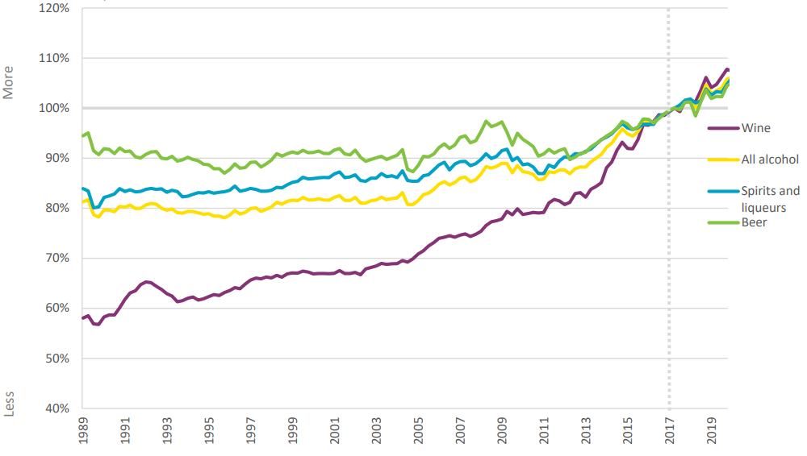

Source: Health Promotion Agency 2020

Increased incomes tend to translate into increased demand for alcohol, particularly for wine and spirits (Gallet 2007), although the Phase 1 Alcohol Levy Review Report showed no clear evidence that increased affordability has led to increased consumption at an aggregate level. While alcohol’s place in society is subject to a range of forces, including education and awareness, cultural factors, and population demographics, increased affordability of alcohol is expected to drive increased alcohol consumption in groups with lower incomes, including Māori and young people (Ministry of Health, 2020), which can be obscured in aggregate data.

Within population subgroups, limited data on alcohol consumption behaviours prevents clear conclusions from being drawn about specific populations and trends over time. Some evidence indicates a possible improvement, such as the NZHS (New Zealand Health and Lifestyles Survey), which indicates that the percentage of Māori who are heavy drinkers fell from 47.9 in 2012 to 43.2 in 2016 and 31.0 percent in 2020. However, 2020 data may not be reflective of a downward trend in heavy drinking in Māori due to the potential impact of the COVID-19 pandemic and associated restrictions. Prior to 2020, data on heavy drinking amongst Māori showed a small but steady trend upwards since 2017 (New Zealand Health Survey, 2016/17 to 2021/22).

Much of the recent evidence regarding consumption patterns within population sub-groups is derived from the NZHS and the Alcohol Use in New Zealand Survey (AUiNZ). These surveys rely on self-reported alcohol consumption, which is impacted by social desirability and recall biases.

A broad indicator of experience of harm is provided by the AUiNZ, which showed that in 2020, 25.9 percent of New Zealanders said that they had experienced harm from their own drinking, and 37.7 percent of New Zealanders had experienced harm from someone else’s drinking (AuiNZ, 2020).

Over the last 15 years, it is not clear that harms have increased:

* NZ Police data shows that alcohol-related calls to Police have remained fairly stable.
* Ministry of Justice data shows that since 2012/13:
  + Driving under the influence of alcohol and other substances (DUI) offences in court and convictions for DUI offences have decreased, with the most marked decrease observed in people aged 29 and under.
  + The number of DUI offences in court has fallen for all ethnicities where ethnicity was identified, due mainly to significant reductions in DUI offences by European and Māori (however, it should be noted that an increasing number of DUI offences in court have no identified ethnicity).
  + The number of convictions for DUI offences in court has decreased overall (by 43.7 percent).
* Ministry of Transport data shows that:
  + Since 1990, road crashes involving alcohol and/or drugs as a contributing factor have decreased.
  + Since 2008, alcohol has been a contributing factor in a decreasing fraction of road crashes involving deaths and serious injuries.
* Ministry of Health data shows that:
  + The percentage of youth emergency department (ED) visits identified as involving alcohol has been relatively stable since 2018, when the collection of national data on this measure was started, and this applies equally to all ethnicities.
* Global Burden of Disease (GBD) study data (Institute for Health Metrics and Evaluation 2019) shows that:
  + Alcohol (including the range of injuries and health conditions that are attributable to alcohol) is among a set of relatively minor mortality risk factors compared with high blood pressure, smoking, obesity, high blood sugar, and high cholesterol, all of which alcohol may contribute to but is not the only contributing factor.
  + Disability-adjusted life years (DALYs) attributable to alcohol use disorders per 100,000 population have been at a fairly stable rate since 2014; however, this follows a period in which the rate had reduced from 1995 to 1999 and remained lower until a significant increase from 2006 to 2013.

Figure  DALYs per 100,000 people due to alcohol use disorders

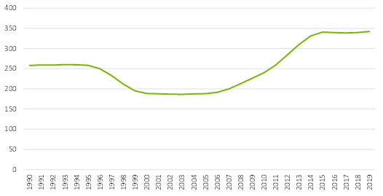

Source: NZIER, IHME, Global Burden of Disease (2019)

Despite the mixed or inconclusive evidence on trends in alcohol consumption, alcohol behaviours and alcohol-related harms, alcohol continues to be heavily involved in areas of significant harm.

Additionally, harms experienced and reported by individuals, families and communities are seen as significant and having a lasting, often intergenerational impact, with these being the least visible in available data.

The key point of these issues is that while alcohol harms may or may not be increasing, the level of alcohol-related harm continues to be a significant concern and cost to the health, justice, social, and transport sectors as well as to the general public.

### Alcohol has been identified as the most harmful drug in New Zealand

A study ranking the range of legal and illegal drugs available in New Zealand by the level of harm they cause was published in 2023 (Crossin et al. 2023). The study evaluated and ranked drug harms in New Zealand using multi-criteria decision analysis (MCDA), scoring drugs against 17 harm criteria (including gross economic costs) and then applying a weighting process to the criteria. Drugs were considered in terms of the harm they cause to the people who consume them, as well as the harm they cause to others.

Overall, for both the general population and youth, and consistent with previously published drug harm MCDA findings for the United Kingdom (UK), European Union (EU) and Australia, the study found that alcohol was the most harmful drug in New Zealand, outranking the next most harmful drugs, methamphetamine, synthetic cannabinoids, and tobacco.

The study also found that more than half of the harms caused by alcohol were harms to others.

# Our approach

Our approach, methods and considerations related to these are described in more detail in Appendix A. The key points related to these are presented here in summary form.

## Choice of approach

In the scoping phase for this project, the Alcohol Levy Working Group assembled by Manatū Hauora|Ministry of Health to support this project identified two reports as potentially relevant to consideration of study design and methodology:

* the BERL report on costs of harmful alcohol and other drug use (Slack et al. 2009)
* the Canadian Substance Use Costs and Harms (CSUCH) project developed by the Canadian Centre on Substance Use and Addiction (CCSA) and the University of Victoria’s Canadian Institute for Substance Use Research (CISUR), which has published reports from 2015 to 2020 on the costs of alcohol and substance use since 2007.

On consideration of these reports, the Working Group expressed a preference for the CSUCH approach, which focused on local data rather than aiming for a comprehensive cost estimation that would be dependent on assumptions and estimates from overseas contexts. However, the Working Group requested that this report include intangible costs reflecting the pain and suffering of people who experience morbidity and/or mortality as a result of alcohol consumption.

## Implications of approach

Consistent with the general approach of the CSUCH project, this report reflects the following considerations:

* A gross costs approach. A gross costs approach means estimating the costs of alcohol-related harms and ignoring the potential benefits associated with alcohol production or consumption. This contrasts with a net costs approach in which the latter are netted out to provide a net societal cost. In addition to being consistent (and therefore comparable) with the CSUCH approach, a gross cost approach is aligned with the Alcohol Levy’s purpose as a cost recovery mechanism designed to support programmes and services that aim to reduce alcohol harms irrespective of any benefits that may be associated with alcohol.
* In addition to conservative approaches to cost estimation, consistent with the CSUCH project, this report avoids estimating costs where there would be a heavy reliance on assumptions, outdated data, or estimates derived from overseas studies. This approach provides a clearer view of the current state of the evidence and evidence gaps.
* Because New Zealand data and evidence may allow for a broader set of costs to be estimated than the CSUCH estimated, we assessed all costs estimated in the BERL report for the feasibility of estimation against the CSUCH principles of local data and evidence and minimal use of assumptions. We also required that any data or evidence used must have been generated within the last ten years (since 2013). Appendix B presents this assessment.

Consistent with CSUCH, this report:

* Takes a prevalence approach to estimating the costs of alcohol harms. This approach is the most common in the cost-of-illness literature and involves estimating the total cost of alcohol harms incurred in a given year across the entire population. This includes long-term flows of costs associated with harms occurring in a given year (e.g. years of life lost when a person dies, all expected lost productivity when a person is incarcerated and expects to be in prison for longer than a year).
* Estimates productivity losses using the human capital approach (HCA). The HCA measures lost productivity as the amount of time by which working life is reduced. This work time lost is then valued at the market wage that is assumed to be appropriate for the relevant population group (e.g. young adults) in the counterfactual in which work time is not lost and with adjustment for labour market participation and employment. For harms that result in a flow of costs over time, costs are estimated for the cohort experiencing the harms in 2023, with future costs discounted at five percent per annum. Age 65 was used as the cut-off age applied for lost productivity calculations, consistent with the CSUCH approach and most published cost-of-illness reports. A discussion of the HCA and alternative methods is presented in Appendix C.

In consideration of the CSUCH project and its approach, and in light of the opportunities presented by New Zealand data and evidence, a range of departures from the CSUCH approach were introduced:

* There is no official or universally applied definition of alcohol harms. For this report, we used the simple logic of alcohol harms being undesirable consequences of alcohol consumption. This means that some areas of expenditure that may be included in some other reports are not included here, such as consumer expenditure on alcohol, public expenditure on alcohol education and health promotion, and health research on alcohol. We exclude these from the definition of harms as we consider that these costs may continue to be incurred as long as alcohol is available in New Zealand, even if harms are reduced or eliminated. The CSUCH project applied a wider definition of alcohol harms, more consistent with a counterfactual where alcohol would not be available at all, eliminating the need for alcohol education and research.
* We take a more conservative approach to the implicitly assumed counterfactual for productivity estimates, using the minimum wage rather than the average wage to estimate productivity losses for incarcerated individuals.
* We avoid a key method underlying the CSUCH project’s estimated health sector costs: the application of inpatient hospitalisation AAFs to other health services, including prescription drugs, specialist (outpatient) care, GP time, and long- and short-term disability, due to a lack of evidence supporting this approach. The CSUCH report (Canadian Centre on Substance Use and Addiction 2023) acknowledges that the validity of applying the AAFs to health services more broadly is unknown). In the New Zealand context, this assumption-based approach can be avoided for both short and long term disability, primary care and ED visits due to:
  + the availability of relevant administrative data that allows the AAFs for injuries to be applied to ACC weekly compensation claims to estimate short term disability costs for the employed population
  + the availability of national survey data and evidence from published studies that allows the estimation of alcohol-attributable long-term disability costs within administrative data on disability benefits
  + the availability of New Zealand evidence from a published study on excess primary care utilisation for people with alcohol use disorders
  + the availability of New Zealand data on alcohol’s involvement in ED visits.
* We avoid applying AAFs estimated in the health context to data from other sectors. CSUCH applied AAFs for inpatient hospitalisations for different types of substances (alcohol and other drugs) to estimate productivity losses associated with alcohol based on data from a survey that identified absenteeism and presenteeism from any substance. Our report avoids this potentially inappropriate transfer of proportionality by using insights from an alcohol-specific New Zealand survey on absenteeism and presenteeism published in a recent study (Sullivan, Edgar, and McAndrew 2019).
* We avoid reliance on self-reported data, particularly self-reported data on alcohol’s role in harms (e.g. surveys of criminals), due to known problems with this type of data for determining both prevalence and extent of alcohol use and alcohol harms and the causal attribution of harms to alcohol.

Other areas where our approach differs from the CSUCH approach are generally due to data differences between Canada's and New Zealand's data.

## Data

Data used in estimating costs was extracted for the most recent year available at the time that data was extracted, except inpatient hospitalisations, which were extracted for 2018 for consistency with the most recent year of mortality data available and to avoid the effects of the COVID-19 pandemic and pandemic response which impacted both on alcohol consumption and on access to health services.

Cost values were inflated to 2023, as needed, using the Consumers Price Index (CPI), which is standard practice for costs representing a wide range of underlying prices.

## Causal attribution

This report has benefited from New Zealand research that has established AAFs for health conditions and injuries in the New Zealand context.[6] For other alcohol harms, published evidence that uses some form of statistical control or alternative approach to improve confidence in causal attribution was a requirement for cost estimation. It is beyond this project’s scope to assess the methodologies of those studies regarding causal attribution, so we take the published estimates as they are.

# Increased risk of mortality and morbidity

Alcohol consumption is believed to contribute to around 200 health conditions (World Health Organization 2022), many of which involve hospital admissions broadly grouped as:

* Transport injuries
* Unintentional injuries
* Interpersonal injuries
* Self-harm
* Alcohol use disorders
* Breast cancer (female)
* Colorectal cancer
* Larynx cancer
* Lip and oral cavity cancer
* Liver cancer
* Nasopharynx cancer
* Oesophageal cancer
* Pharynx cancer
* Alcoholic cardiomyopathy
* Atrial fibrillation and cardia arrhythmia
* Stroke
* Hypertension
* Ischaemic heart disease
* Alcoholic gastritis
* Diabetes
* Epilepsy
* Liver cirrhosis
* Lower respiratory tract infections
* Pancreatitis
* Tuberculosis.

Summary measures of the burden of disease in a population, known as health-adjusted life years (HALYs), are widely used to quantify the extent of loss of life and quality of life. These measures help to simplify complex information about mortality and quality of life or disability impacts of diseases. Two common approaches to measuring HALYs are disability-adjusted life years (DALYs) and quality-adjusted life years (QALYs). Both provide a single figure representing gains or losses of both quality and length of life by equating, for example, a full year of life at 50 percent of full health to half a year in full health (see Appendix D for more detail).

Globally, 5.1 percent of the burden of disease and injury is attributable to alcohol, as measured in DALYs (World Health Organization 2022). Premature mortality is also a consequence of alcohol misuse. It represents a significant loss of life – a loss of life which is felt heavily by families and whānau and can have a significant impact on some communities.

In this section, we estimate the cost of increased risk of mortality and morbidity attributable to alcohol consumption.

## Estimated value increased risk of mortality and morbidity due to alcohol consumption

The Global Burden of Disease (GBD) study calculates the DALYs associated with a range of health risks, including alcohol. It uses local data where available from a range of sources and estimates population attributable fractions (PAFs). The GBD estimates of DALYs are based on PAFs that are estimated for New Zealand from global and regional data, to which a range of modelling approaches are applied, including expert consultation and external validation and sensitivity analyses.

According to the Institute for Health Metrics and Evaluation (IHME), alcohol consumption was responsible for DALYs in the New Zealand population in 2019 (most recent year available), as described in rates per 100,000 population in Table 4 below.

Table DALY rates attributable to alcohol consumption by age group

Per 100,000 population

|  |  |  |  |  |
| --- | --- | --- | --- | --- |
|  | 5–14 years | 15–49 years | 50–69 years | 70+ years |
| 2019 | 28.79 | 1,268.82 | 1,991.86 | 2,306.3 |

Source: IHME (2019)

Assuming the DALY rates have not changed from 2019 to 2023 and using the Stats NZ national population projection for 2023 (median, from 2022 base), these rates translate into a total of 68,548 DALYs in 2023 (see Table 5 below).

Table DALYs attributable to alcohol consumption by age group and total

|  |  |  |  |  |  |
| --- | --- | --- | --- | --- | --- |
|  | 5–14 years | 15–49 years | 50–69 years | 70+ years | Total |
| Population 2023 | 654,600 | 2,361,200 | 1,228,400 | 604,100 | 4,848,300 |
| DALYs 2023 | 188 | 29,959 | 24,468 | 13,932 | 68,548 |

Source: Stats NZ population estimates, IHME (2019), NZIER

There is no single right way of placing a monetary value on any of the measures of health outcomes. We provide some discussion in Appendix D. Given the lack of consensus on values, we estimate the value of health loss attributable to alcohol using two alternative values of QALYs that are used in public sector budget initiative cost-benefit analyses in New Zealand (The Treasury 2022):

* A value derived from the estimated cost of delivering QALYs through Pharmac investments ($41,756)
* A value derived from the Ministry of Transport’s Value of a Statistical Life (VoSL) ($63,381), which is based on the specific context of risk reduction on roads.

While neither of these is derived from a context that is clearly appropriate for alcohol harms, the higher value, based on the VoSL, is most closely related to values commonly used in health literature where the VoSL is frequently cited.

Based on these values, the DALYs estimated to be lost to alcohol consumption in 2023 are estimated to be worth at least $2.9 billion and could potentially be valued at up to $4.3 billion (see Table 6 below).

Table Total value of increased risk of mortality and morbidity due to alcohol consumption

Based on alternative values of a DALY

|  |  |  |  |
| --- | --- | --- | --- |
| Basis of DALY valuation | Total DALYs 2023 | DALY value | Total DALY value |
| QALY value (Treasury, low) | 68,548 | $41,756 | $2,862,298,795 |
| QALY value (Treasury, high – based on VoSL) | 68,548 | $63,381 | $4,344,653,700 |

Source: NZIER, based on IHME (2019); The Treasury (2022)

### Estimated value increased risk of mortality and morbidity due to alcohol use disorders alone

Alcohol use disorders are a particular alcohol-related harm which may be expected to be associated with a significant fraction of all DALYs from alcohol consumption.

According to the IHME, alcohol use disorders were responsible for the rates of DALYs in the New Zealand population in 2019 (most recent year available), as described in Table 7 below. These represent a significant proportion of the total alcohol DALY rates in these age groups (from 10 percent of all alcohol-related DALYs in the 70+ age group to 43 percent of all alcohol-related DALYs in the 15-49 age group).

Table DALY rates from alcohol use disorders

By age group, per 100,000 population

|  |  |  |  |  |
| --- | --- | --- | --- | --- |
|  | 5–14 years | 15–49 years | 50–69 years | 70+ years |
| 2019 DALY rates from alcohol use disorders | 5.23 | 544.22 | 377.36 | 229.33 |
| % of total alcohol-related DALY rate | 18% | 43% | 19% | 10% |

Source: IHME 2019

Assuming the DALY rates have not changed from 2019 to 2023 and using the Stats NZ national population projection for 2023 (median, from 2022 base), these rates translate into a total of 18,905 DALYs in 2023 (see Table 8 below). Overall, 28 percent of all alcohol-related DALYs in 2023 are estimated to be attributable to alcohol use disorders.

Table DALYs from alcohol use disorders

By age group and total

|  |  |  |  |  |  |
| --- | --- | --- | --- | --- | --- |
|  | 5–14 years | 15–49 years | 50–69 years | 70+ years | Total |
| Population 2023 | 654,600 | 2,361,200 | 1,228,400 | 604,100 | 4,848,300 |
| DALYs from alcohol use disorders in 2023 | 34 | 12,850 | 4,635 | 1,385 | 18,905 |
| % of total alcohol-related DALYs | 18% | 43% | 19% | 10% | 28% |

Source: Stats NZ population estimates, IHME (2019), NZIER

Based on the same approach to costing as presented for all DALYs attributable to alcohol, the cost of DALYs from alcohol use disorders is at least $789 million and could potentially be valued at up to $1.2 billion.

Table Total value of increased risk of mortality and morbidity due to alcohol use disorders

Based on alternative values of a DALY

|  |  |  |  |
| --- | --- | --- | --- |
| Basis of DALY valuation | Total DALYs 2023 | DALY value | Total DALY value |
| QALY value (Treasury, low) | 18,905 | $41,756 | $789,406,825 |
| QALY value (Treasury, high – based on VoSL) | 18,905 | $63,381 | $1,198,232,445 |

Source: NZIER, based on IHME (2019); The Treasury (2022)

## Estimated increased risk of mortality and morbidity due to alcohol use disorders

Based on the VoSL-based estimate of costs associated with loss of quality of life and years of life due to alcohol consumption and alcohol use disorders, alcohol use disorders account for approximately 28 percent of the total cost of alcohol harms, leaving 72 percent of the total cost due to non-disordered alcohol consumption.

Figure  Breakdown of the total estimated value of increased risk of mortality and morbidity due to own alcohol consumption in New Zealand

Millions, 2023

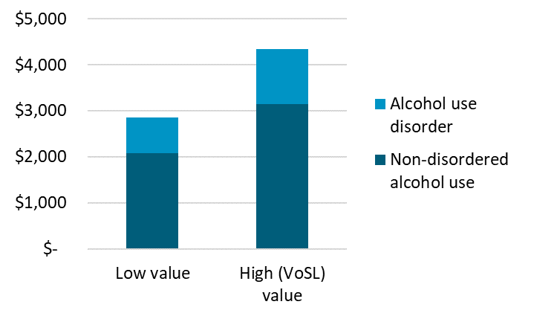

Source: NZIER, based on IHME (2019); The Treasury (2022)

## Increased risk of mortality and morbidity due to others’ alcohol use

The above estimates of DALYs and the associated societal cost to New Zealand are limited to the impacts of alcohol consumption and alcohol use disorders on the drinker (Casswell et al. 2023). However, alcohol use and alcohol use disorders can have significant impacts on others, including through three major areas of harm quantified by a New Zealand study (Casswell et al. 2023):

* FASD
* interpersonal violence
* road crashes.

Casswell et al. (2023) quantified the loss of life and quality of life experienced as a result of these harms associated with other people’s drinking, also using DALYs as the outcome measure.

The study found that:

* of the three impacts of others’ drinking that were analysed, FASD contributed the greatest share of total DALYs
* the total DALYs from these three impacts of others’ drinking exceeded the number of DALYs for drinkers, with the total DALYs in 2018 estimated to be 78,277 (14 percent higher than the 68,548 DALYs estimated in Section 3.1 even without adjusting the 2018 estimate of DALYs caused by others’ drinking to the 2023 population).

Table 10 below presents the breakdown of DALYs from others’ drinking by cause.

Table DALYs attributable to others’ alcohol consumption

By ethnicity and total

|  |  |  |  |
| --- | --- | --- | --- |
| **Cause** | **DALYs Māori** | **DALYs non-Māori** | **DALYs total** |
| FASD | 17,441 | 53,227 | 70,668 |
| Interpersonal violence | 1,110 | 1,556 | 2,666 |
| Road crashes | 1,169 | 3,774 | 4,943 |

Source: Casswell et al. 2023

## Estimated value of increased risk of mortality and morbidity due to others’ drinking

From the estimates provided by Casswell et al. (2023), we conservatively focus exclusively on the DALYs associated with FASD because Casswell et al. (2023):

* Casswell et al. (2023) estimated DALYs from road crashes based on alcohol involvement, which may overestimate the causal role of alcohol due to other factors also potentially playing an important causal role (e.g. illicit drugs, speed, etc.). This approach is inconsistent with our approach to estimating road crash costs in section 4.3.
* Casswell et al. (2023) estimated DALYs from interpersonal violence based on a 2010 Australian study, which conflicts with our approach to estimating alcohol-attributable crimes in section 6, which is based on a more recent New Zealand study.

While the exclusion of these two causes of DALYs from others’ alcohol use reduces the total DALYs for cost estimation, the impact is small due to these two causes together making up less than 10 percent of the total estimated DALYs from others’ alcohol use.

Casswell et al. (2023) provide DALY rates, but only at a total population level, which means the number of DALYs cannot be adjusted to the 2023 population in the same way that the adjustment was made for previous DALY estimates in this section. However, based on Stats NZ’s estimated resident population as of June 2018 and June 2023, we apply a growth rate of 6.85 percent to the number of DALYs to estimate a 2023 figure. This adjustment results in 75,526 DALYs in 2023 (from 70,684 in 2018).

Applying the same DALY values used throughout this section, we estimate that the value of loss of life and loss of quality of life as a result of others’ drinking causing FASD to be at least $3.2 billion and could potentially be valued at up to $4.8 billion (see Table 11 below).

Table Total value of increased risk of mortality and morbidity associated with FASD

Based on alternative values of a DALY

|  |  |  |  |
| --- | --- | --- | --- |
| **Basis of DALY valuation** | **Total DALYs 2023** | **DALY value** | **Total DALY value** |
| QALY value (Treasury, low) | 75,526 | $41,756 | $3,152,949,058 |
| QALY value (Treasury, high) | 75,526 | $63,381 | $4,785,828,725 |

Source: NZIER, based on Casswell et al. (2023), The Treasury (2022)

## Total estimated value of increased risk of mortality and morbidity due to own and others’ alcohol consumption

Aggregating the estimates described in this section provides an indication of the potential scale of cost of alcohol harms from a societal perspective. In total, 144,074 DALYs are estimated to have resulted from alcohol use in New Zealand in 2023, with over half being associated with FASD (the result of other people’s drinking).

Using the VoSL-based value of a DALY, the resulting total cost is estimated to be $9.1 billion with $4.8 billion associated with FASD and $4.3 billion attributable to drinkers’ own use of alcohol (see Figure 5 below). The alternative, lower value of a DALY reduces the total estimate to $6 billion.

Figure  Breakdown of the total estimated value of increased risk of mortality and morbidity due to alcohol in New Zealand, including FASD

$ millions, 2023

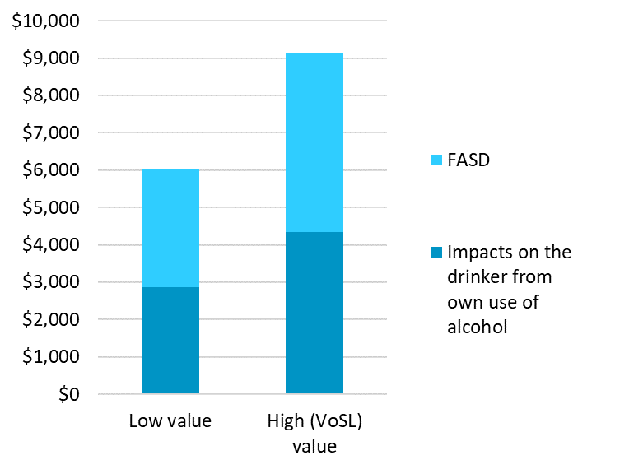

FASD: Fetal alcohol spectrum disorder

Note the exclusion of other costs associated with other’s use of alcohol that were quantified by Casswell et al. (2023) due to reasons described in section 3.4. The impact on the overall cost estimate is minor.

Source: NZIER

## Limitations of estimates of the value of increased risk of mortality and morbidity due to alcohol consumption

In addition to the uncertainty regarding the value to society of a year of life or of a year of life in perfect health, which extends to estimates of any loss of life or quality of life as measured by DALYs or any other metric, a key concern regarding these cost estimates is how they may be interpreted alongside direct and indirect cost estimates.

Because the estimated value used to calculate intangible costs may reflect society’s or individuals’ expectations of the productive value of a year of life (due to values frequently being derived from measures of economic production), intangible cost estimates should be considered as a likely area of double-counting when a broad range of costs are aggregated in cost-of-illness reports. However, because the extent to which direct and indirect costs may be implicitly reflected in intangible costs is unknown, a prudent use of intangible cost estimates is to consider them an alternative and potentially conservative approach to estimating total societal cost.

These concerns extend far beyond the costs of alcohol harms and apply to all societal and intangible cost estimates of health sector concerns and cannot be resolved within this specific project. For this reason, these estimates should be interpreted with caution. However, our use of a commonly used value based on the VoSL should provide confidence that the societal cost associated with DALYs caused by alcohol is likely to be in the range of $6 to $9 billion.

Additionally, the costs associated with loss of life and loss of quality of life due to others’ drinking are likely to be underestimated due to the decision to exclude two other dimensions of these costs (road crashes and interpersonal violence) due to methodological concerns described in section 3.4. However, the impact of these exclusions is expected to be small due to these two causes together making up less than 10 percent of the total estimated DALYs from others’ alcohol use reported by Casswell et al. (2023) – approximately $300–$500 million.

# Specific alcohol harms costs from a societal perspective

Areas of alcohol harms that represent significant concerns to New Zealanders, to communities that are disproportionately affected, and that are associated with many unmeasured impacts on families and communities are of critical importance for estimation from a societal perspective. Three key areas provided sufficient recent New Zealand evidence to be included in this report:

* intimate partner violence
* child maltreatment
* road crashes.

All three of these include harms that result from someone else’s drinking.

#### Family harms are a significant concern but one that is largely hidden and poorly understood

Family violence and other harms are an area of significant concern in New Zealand, and research underscores the wide range of flow-on effects, often with high associated costs.

For example, women’s exposure to any lifetime intimate partner violence (IPV) (including physical, sexual, psychological, controlling behaviours, and economic abuse) has been found to increase the likelihood of adverse health outcomes (Mellar et al. 2023). Nearly half of all homicides and reported violent crimes are family violence-related (Dissanayake and Bracewell 2022).

According to data from the Family Violence Clearinghouse:

* in 2016, there were ten homicides of children and young people under 20 years of age caused by a family member
* 63 children aged 16 years or under were hospitalised due to an assault perpetrated by a family member.

(New Zealand Family Violence Clearinghouse 2017)

These data do not identify the proportion that is attributed to alcohol, but alcohol is often found to be a factor in these cases.

Because family harm happens behind closed doors and people do not always report incidents, not all of the evidence is clear-cut. Estimates of the percentage of women who have been physically abused at least once by an intimate partner vary from 13 percent to 61 percent, and prevention strategies introduced by the New Zealand government have failed to reduce the level of violence (den Heyer 2022).

Despite variation in estimated prevalence, New Zealand is believed to have one of the highest rates of family violence in the developed world (Dissanayake and Bracewell 2022), although it is not known how New Zealand compares to other countries on alcohol-attributable family harms.

Following the introduction of the Family Violence Act 2018, family violence offences include any offence involving:

* assault on a family member (section 194A Crimes Act 1961)
* common assault (domestic) (section 9 Summary Offences Act 1981 or section 196 Crimes Act 1961)
* sexual offences against a spouse (section 128(4)/128B or section 129 Crimes Act 1961)
* incest (section 130 or section 131 Crimes Act 1961)
* coercion to marry (section 207A Crimes Act 1961)
* all offences included in the Domestic Violence Act 1995 (such as breach of protection order)
* other offences covered by the Family Violence Act (such as breach of protection order).

(Ministry of Justice 2023b)

#### Prevalence of family harm

Estimating the prevalence of family harm is challenging. It is widely acknowledged that many cases never come to the attention of authorities or involve accessing services. If cases are not recorded in either of these ways, there may be no data to reflect that the incident ever occurred, leading to an underestimation of prevalence. Where services are accessed, insufficient information may be collected to generate data that is useful for understanding the nature, severity, or prevalence of family harm.

A review of New Zealand data sources (Gullliver and Fanslow, 2012) from which information about family violence may be drawn concluded that none of the administrative datasets in New Zealand provide complete coverage of family violence and that the available data suffered from a range of problems. The report also agreed with an earlier review (Lievore and Mayhew 2007) that it would not be possible to count all family violence cases using the available data, but observations about trends may be possible.

One source of data from which trends may be observed is charges for offences against the Family Violence Act 2018 recorded by the Ministry of Justice. These are grouped into two categories:

* family violence: physical, sexual or psychological abuse by a person who is or has been in a family relationship (as defined in section 9 of the Act)
* other offences (any other offence against the Family Violence Act, such as breaching a protection order or failing to attend a non-violence programme).

According to the Ministry of Justice data, in 2022, there were 28,288 charges for family violence offences and 155,369 other offences against the Family Violence Act, resulting in a total of 183,657 recorded charges. This figure represents a significant decrease compared with the pre-COVID-19 figures of 29,281 recorded charges for family violence offences, 182,278 other charges for offences, which generated a total of 211,559 charges in 2019. Compared with the 2019 total, the 2022 total represents a 13 percent reduction in charges for offences against the Act (see Table 12 and Figure 6 below).

Table Charges for offences against the Family Violence Act 2018

Number of charges by type and by calendar year, 2015 to 2022

|  |  |  |  |  |  |  |  |  |
| --- | --- | --- | --- | --- | --- | --- | --- | --- |
| Offence type | 2015 | 2016 | 2017 | 2018 | 2019 | 2020 | 2021 | 2022 |
| Family violence | 26,891 | 29,421 | 29,265 | 28,848 | 29,281 | 31,637 | 26,393 | 28,288 |
| Other offences | 186,180 | 192,315 | 199,764 | 187,244 | 182,278 | 177,912 | 151,709 | 155,369 |
| Total | 213,071 | 221,736 | 229,029 | 216,092 | 211,559 | 209,549 | 178,102 | 183,657 |

Source: NZIER, Ministry of Justice data

Figure  Trends in charges for offences against the Family Violence Act 2018

Number of charges annually

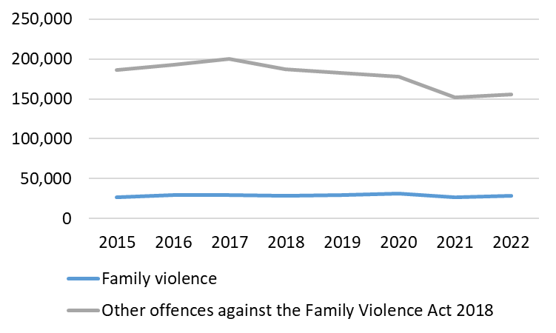

Source: NZIER, Ministry of Justice data

The trend of decreasing total charges for offences under the Act during the COVID-19 pandemic and restrictions of 2020 and 2021 is clear. What is not clear is whether 2022 continued to be affected by COVID-19-related issues that may underlie these reductions. Two years prior to the COVID-19 pandemic, there were already decreasing charges, suggesting the 2022 figure could be part of a longer-term trend.

In terms of population prevalence, the 2022 figure indicates that based on a population of 5,127,400 in 2022,[7] there was one charge for offences against the Family Violence Act in 2022 for every 28 people in New Zealand.

What cannot be known is what proportion of actual family violence and other acts actually result in charges under the Act and whether and how this proportion might change over time. Reporting rates are generally considered to be low due to victims facing difficulties in coming forward, and the private nature of family harms poses challenges for establishing a sufficient evidence base for charges to be laid. This means the prevalence of family harm is likely to always be subject to significant uncertainty.

#### Attribution of family harm to alcohol

Estimating the costs of family harm associated with alcohol adds another layer of analytical complexity to this socially complex problem. This is because there can be a long timeframe over which the full range of consequences of family violence may occur (e.g. poor educational outcomes, mental health impacts and future productivity of children affected by family harms, etc.) and the paucity of evidence on the attribution of family harms to alcohol. This paucity of evidence should not be understood as a weak or non-existent relationship between alcohol and family harm. The relationship is well acknowledged and has been for decades. Numerous studies dating back to the 1970s have consistently identified that alcohol use plays a key role in family harm (Miller 1990).

The paucity of evidence on exactly how much family harm is attributable to alcohol versus other factors is due to the relationship being multidimensional and complex, highly individual, and dynamic. Behaviours leading to family harm are influenced by a wide range of factors which may be unrelated to alcohol or maybe the short term, long term or even intergenerational consequences of alcohol consumption. The interaction between alcohol and other contributing factors may be a stronger driver than any individual factor (alcohol use combined with mental illness, for example, may increase the risk of family harm more than the individual risk increase associated with either alcohol or mental illness).

Alcohol consumption increases the risk of victimisation in IPV, as it does with some other crimes. According to Superu (2015), research indicates that the risk of being involved in IPV, either as a perpetrator or victim, increases with the amount of alcohol consumed. This dynamic adds additional complexity to this significant social problem. The World Health Organization identifies a self-reinforcing cycle in which alcohol misuse and interpersonal violence both act as catalysts for each other (World Health Organization 2006).

While family harm can involve a range of behaviours, in this section, we focus on two forms of family harm where causal attribution to alcohol has been estimated in recent New Zealand studies:

* intimate partner violence (IPV)
* child abuse and neglect.

## Intimate partner violence

According to the World Health Organization (Krug et al. 2002), IPV is any behaviour within an intimate relationship that causes physical, psychological or sexual harm to those in the relationship. This can include harms related to:

* physical aggression, including hitting, slapping, kicking or beating
* psychological abuse, such as intimidation, constant belittling and humiliation
* forced intercourse or other forms of sexual coercion
* controlling behaviours such as isolating a person from family and friends, monitoring their movements, or restricting access to information or services.

According to a 2010 New Zealand report (Fanslow et al. 2010), the lifetime prevalence of physical and/or sexual IPV among Māori women (57.6 percent) was significantly higher than that of Pacific women (32.4 percent) and European/Other women (34.3 percent). In contrast, Asian women reported a significantly lower lifetime prevalence of IPV (11.5 percent) compared with women of European/Other ethnicity.

Alcohol has been identified by many studies as a major risk factor for IPV (Devries et al. 2014). According to a Superu report (2015), the published research is generally consistent in showing:

* a small to moderate association between alcohol use and male-to-female IPV
* a larger association between alcohol use and male-to-female IPV among men who are the heaviest users (e.g. those in treatment for alcohol use disorders)
* a small association between alcohol use and female-to-male IPV.

### Attribution of IPV to alcohol

A key piece of evidence regarding the causal attribution of alcohol in IPV is provided by the Christchurch Longitudinal Study, which found that alcohol use disorder was responsible for around five to nine percent of IPV perpetration based on strong controls for a range of other potential observed and unobserved explanatory variables (Boden, Fergusson, and Horwood 2013).

### Estimated alcohol-attributable cost of IPV

Kahui and Snively (2014) estimated the economic costs of IPV in New Zealand in 2014, producing a conservative estimate of $2.508 billion for females and $207.6 million for males, based on confrontational crime among partnered people in 2008 as measured by the New Zealand Crime and Safety Survey (NZCASS) and incorporating both short-term and lifetime costs (e.g. years of life lost) resulting from those crimes. Moderate and high-end scenarios produced estimated ranges of $2.852 billion to $4.825 billion for females and $212.2 million to $586.1 million for males.

The Kahui and Snively (2014) estimates were derived by applying population prevalence estimates (based on the 2009 New Zealand Crime and Safety Survey) to the 2014 population. The estimated annual prevalence of IPV was 2.7 percent in the female population and 1.7 percent in the male population in the conservative scenario, which used rates of confrontational crime among partnered people for IPV in 2008 measured by the NZCASS. Based on the total cost of $2.716 billion and Stats NZ population estimates for males and females aged 15+ in 2014, there were 78,482 cases of IPV, with each case costing an average of $34,602 (2014 dollars).

Without new evidence from which to estimate the costs associated with IPV, we apply the Boden, Fergusson, and Horwood (2012) alcohol-attributable fraction to the Kahui and Snively (2014) cost estimate with population growth adjustment and inflation adjustment to 2023 values. This results in an estimated total cost of IPV in 2023 of $281 million (see Table 13 below).

Table Estimated total societal cost of IPV

2023

|  |  |
| --- | --- |
| Parameter | Value |
| Female prevalence of IPV | 2.70% |
| Male prevalence of IPV | 1.70% |
| Female population 2023 (aged 15-64) | 2,108,680 |
| Male population 2023 (aged 15-64) | 2,058,400 |
| Total IPV cases | 91,927 |
| IPV cases attributable to alcohol (midpoint of 5-9%) | 6,435 |
| 2014 cost per IPV case | $34,602 |
| 2023 cost per IPV case | $43,598 |
| 2023 alcohol-attributable cost of IPV | $280,549,604 |

* The Kahui and Snively cost breakdown indicates that approximately 51% of the total cost is associated with pain, suffering and premature mortality. For this report, this cost is likely to have been captured in our estimates of the costs of DALYs associated with alcohol-attributable morbidity and mortality.

Source: NZIER, based on Kahui and Snively (2014), Boden, Fergusson, and Horwood (2012) and Statistics New Zealand population estimates and projections.

It is important to note that Boden, Fergusson, and Horwood (2012) estimate of alcohol attribution in IPV is based on alcohol use disorder only. Incidents of IPV may include many where alcohol was a causal factor without alcohol use disorder being present, so cost estimates derived from this attributable fraction are likely to be an underestimate of the true cost of alcohol-attributable IPV. However, according to a review of the evidence by Superu (April 2015), the published research is generally consistent in showing that the association between alcohol use and male-to-female IPV is strongest among men who are in treatment for alcohol problems compared with those not in treatment.

|  |
| --- |
| Women’s RefugeWomen’s Refuge is New Zealand’s largest nationwide organisation supporting women and children experiencing family violence. According to the 2021/2022 annual report, the Women’s Refuge (2022):  * provided 59,000 safe nights in residential safehouses * spent $36,835,000 to deliver services and fund refuges across New Zealand.  Based on the Christchurch Longitudinal study’s estimate of 5 to 9 percent of IPV being attributable to alcohol, it means at least $1.8 million to $3.3 million in Women’s Refuge costs is potentially attributable to alcohol. |

### Limitations of estimates of alcohol-attributable costs of IPV

A single study identifying the fraction of IPV attributable to alcohol use disorder informed the estimate presented above. This represents a promising but weak evidence base.

Additionally, because that study restricted its consideration of alcohol-attributable IPV to alcohol use disorder, the fraction of IPV cases attributable to alcohol is likely to be an underestimate. It is likely that alcohol plays a causal role, alone or alongside other causal factors, in a higher fraction of IPV cases where the perpetrator and/or the victim does not meet the criteria for alcohol use disorder.

Finally, it is possible that the total cost of alcohol-attributable IPV is further underestimated by the use of survey-reported cases of IPV, which may not reveal the true prevalence of IPV in New Zealand.

## Child maltreatment

New Zealand’s rates of child abuse are among the highest in high income countries. On average, one New Zealand child dies as a result of abuse every five weeks. Most victims of child abuse are under five years old, with the largest group aged under one (Nobilo 2016).

Adults who abuse children may often have been victims of childhood abuse and neglect and experience unresolved issues associated with trauma (Howe 2005). Risks that contribute to parents and caregivers becoming abusive or neglectful include depression, substance abuse, mental health issues, poverty, poor parenting skills, difficulties in managing anger and lack of support (Nobilo 2016).

The impacts of child maltreatment are diverse and include (but are not limited to):

* lost quality of life due to pain and suffering and lost years of life due to premature mortality directly caused by abuse or associated with ill health or suicide
* increased risk of physical and mental ill health, and engagement with alcohol and addiction services later in life
* increased risk of criminality, including victims of child maltreatment becoming perpetrators of child maltreatment later in life
* poorer educational outcomes and reduced productivity, leading to lower incomes and the flow-on and intergenerational impacts of disadvantage.

The number and proportion of substantiated child abuse and neglect findings in New Zealand have fallen significantly since 2013, from 18,595 to 10,426 (see Figure 7 below).

Figure  Number of children and young people with a substantiated abuse or neglect finding

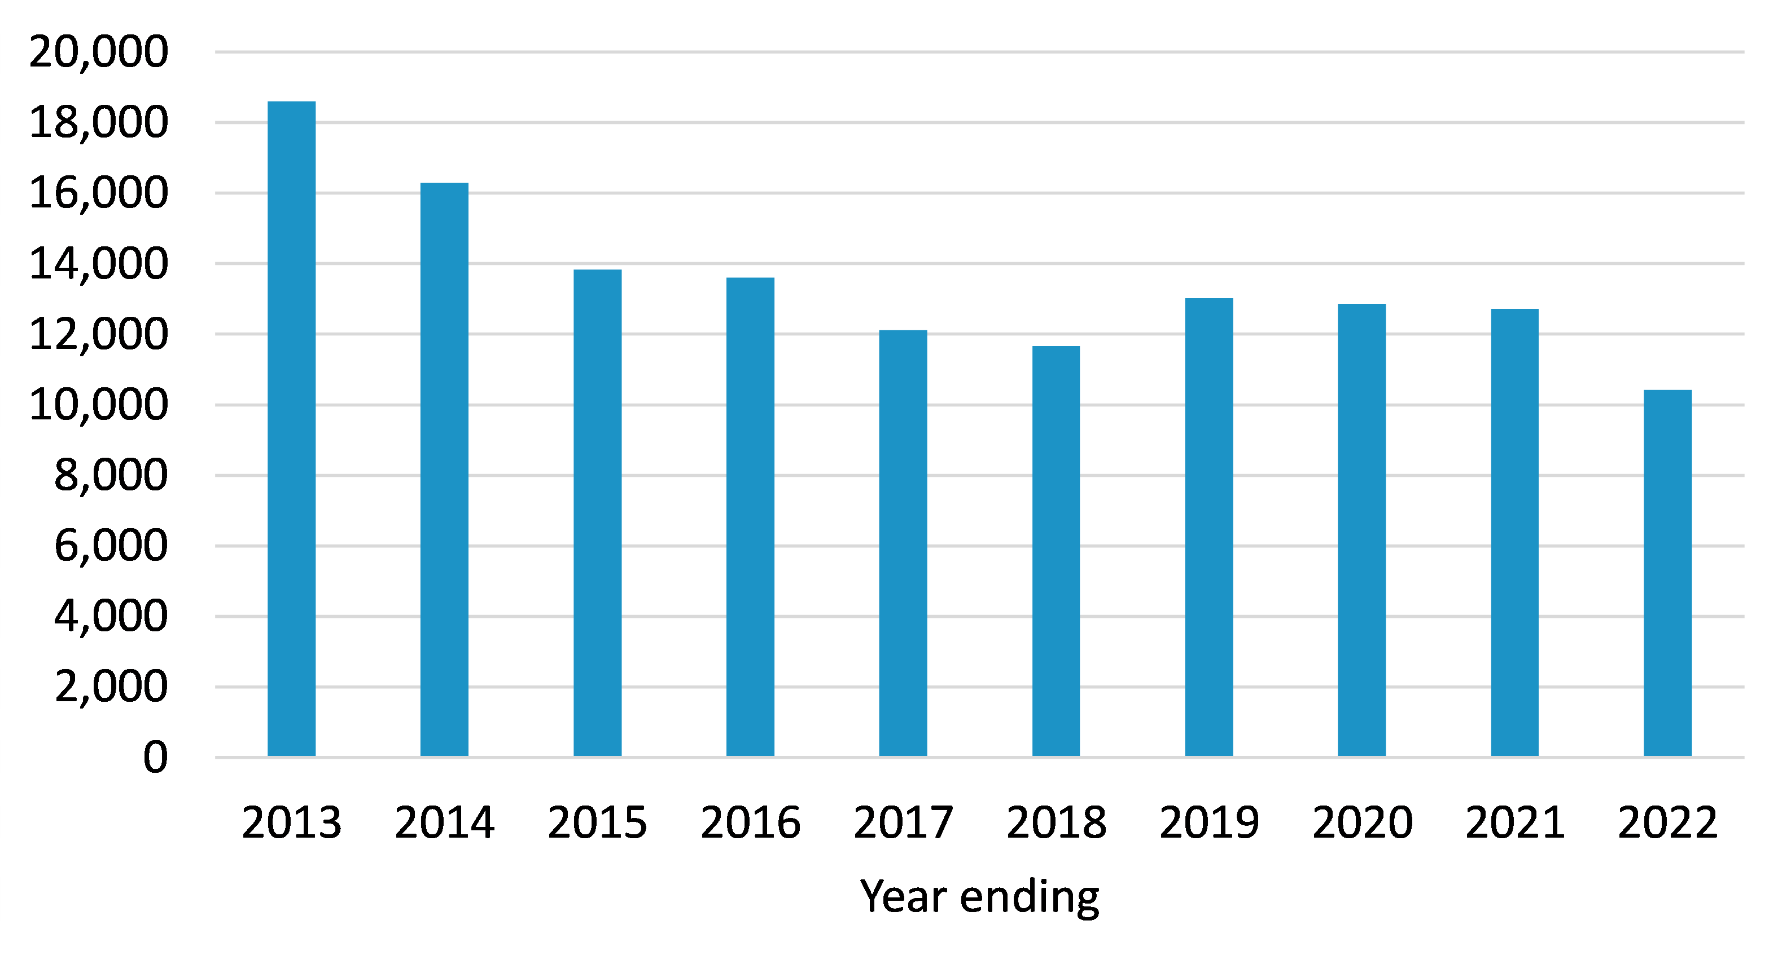

Source: NZIER, based on data from Oranga Tamariki (2023)

Based on a population aged 0 to 16 years, these results indicate that since 2013, the prevalence of abuse or neglect, based on substantiated cases, has declined from 1.8 percent to 0.95 percent (see Figure 8 below).

Figure  Prevalence of abuse or neglect based on substantiated cases

Children aged 0–16 years

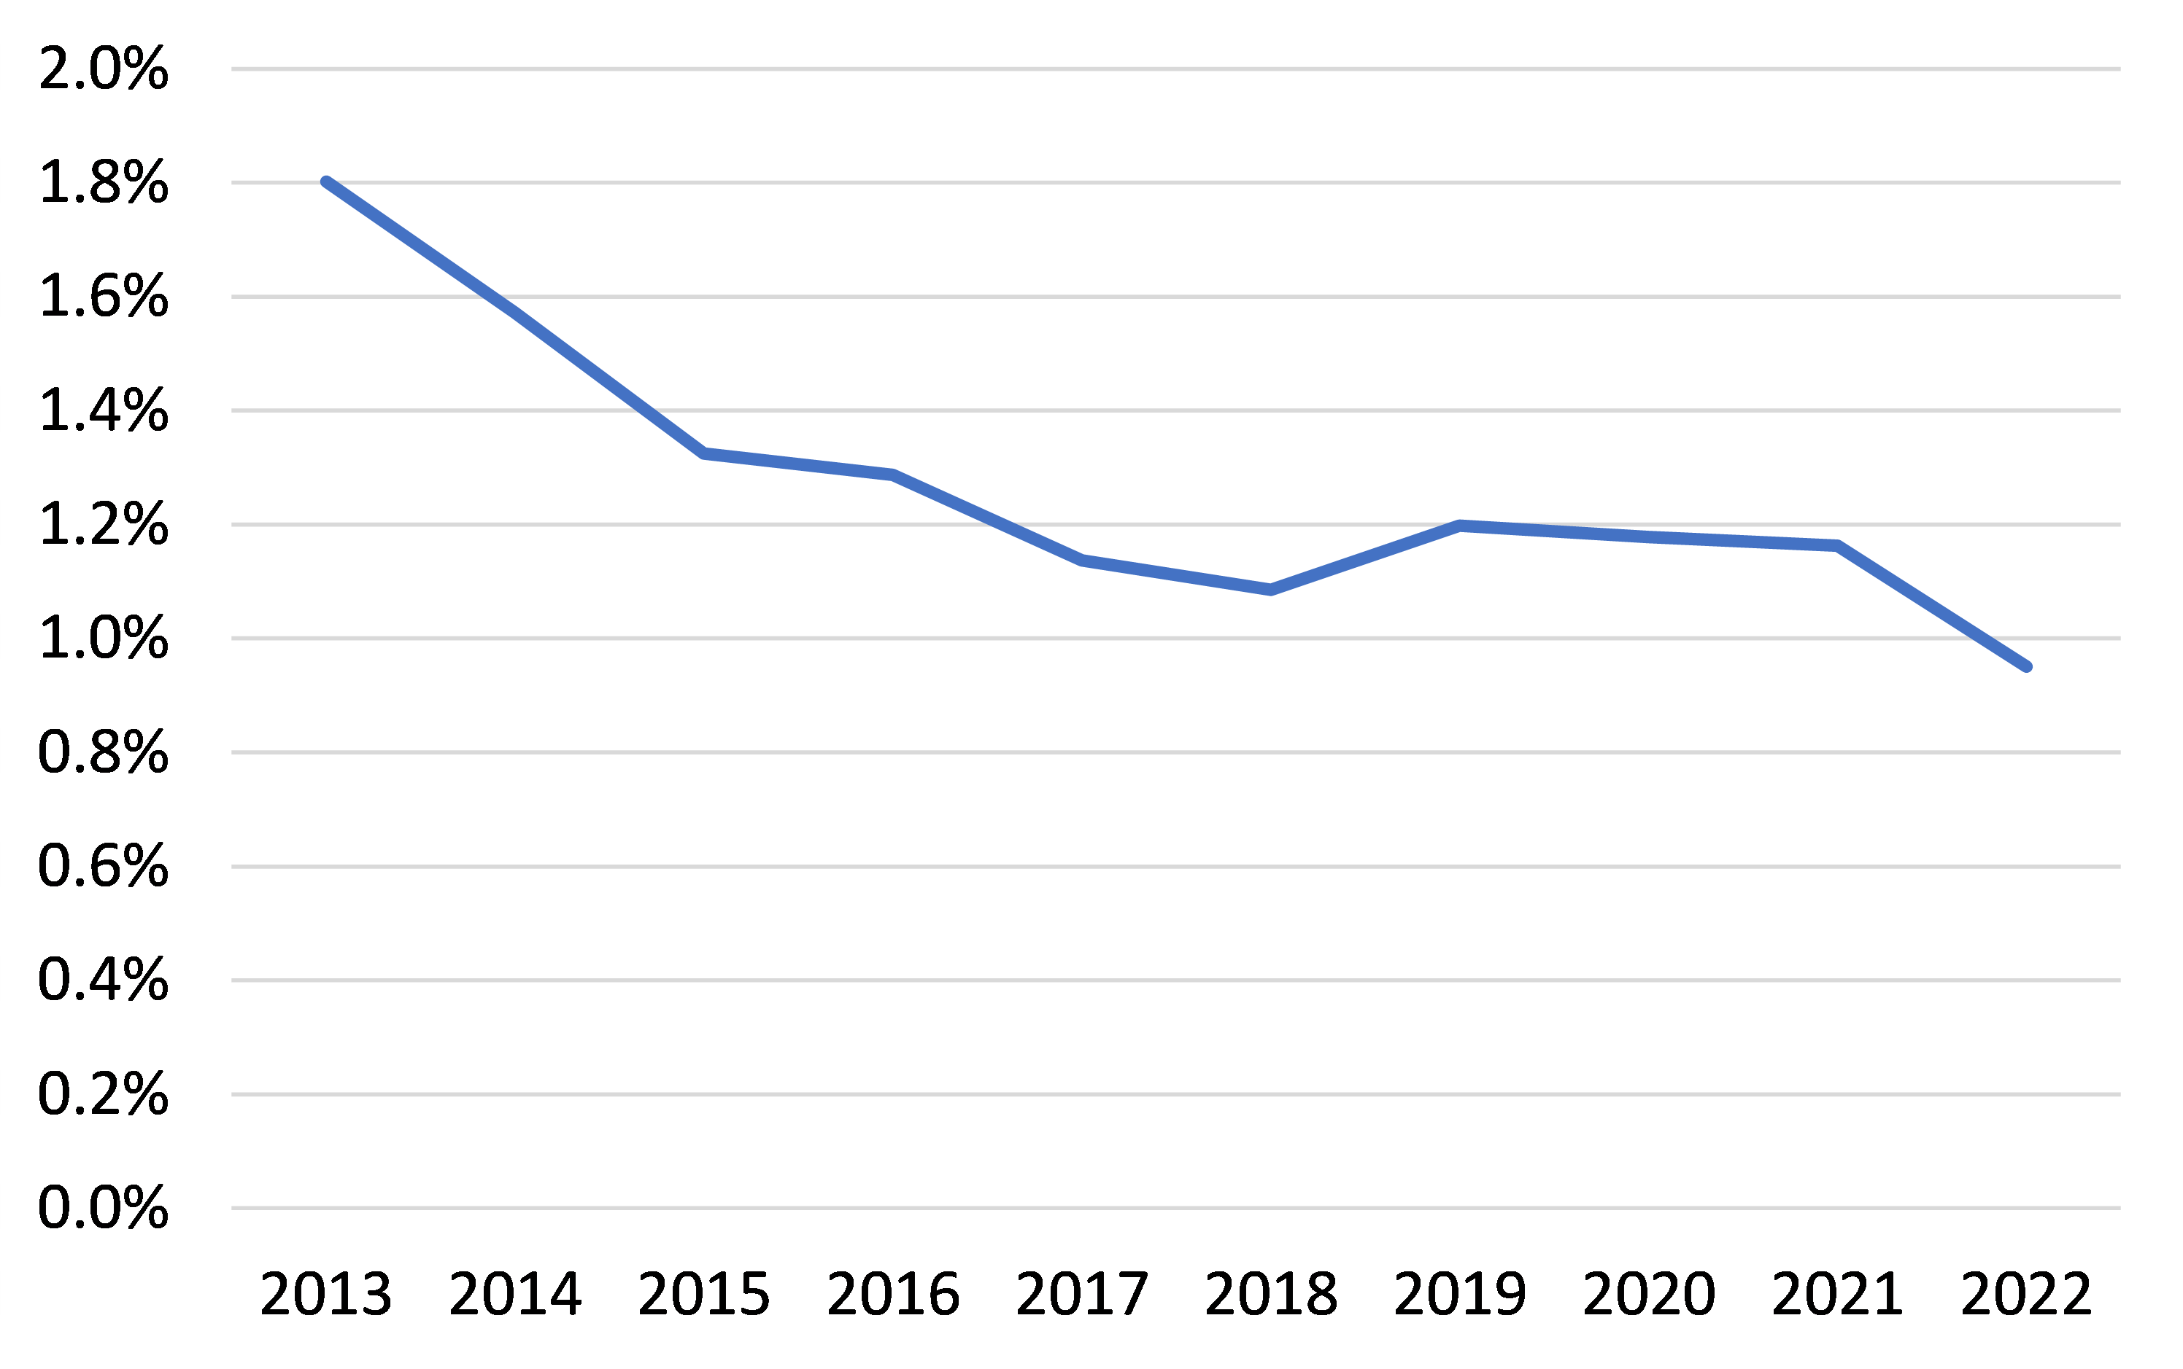

Source: NZIER, based on Oranga Tamariki (2023) and Stats NZ data

### Attribution of child maltreatment to alcohol

Like IPV, child maltreatment is a complex issue with multiple causal factors. The fact that alcohol plays a role in child abuse and neglect is not disputed, but until recently, little has been known about the extent of that role.

A recently published cohort study (Huckle and Romeo 2023) of 58,359 New Zealand children aged 0-17 years and their parents between the years 2000 and 2017, using data from the Integrated Data Infrastructure (IDI), calculated a population-attributable fraction of child maltreatment using the relative risk from the cohort and prevalence of hazardous drinking among parents. The study defined child maltreatment as physical abuse (child assault, physical abuse), neglect or abandonment, emotional/psychological abuse, sexual abuse and intimate partner violence in the household.

The study found a 65.1 percent increased risk of child maltreatment for children exposed to parents with an alcohol-attributable hospitalisation or mental health/addictions service use and that in 2017, 11.4 percent of the documented cases of child maltreatment in New Zealand could be attributable to parents with hazardous consumption of alcohol (AUDIT 8+[8]) (Huckle and Romeo 2023).

### Estimated alcohol-attributable cost of child maltreatment

We identified one major report within the last ten years that provided estimates of the costs of child maltreatment in New Zealand: the same report that informed our estimates of the alcohol-attributable cost of IPV: Kahui and Snively (2014). This report identified that a conservative scenario cost of child maltreatment, based on only substantiated cases of child abuse (n=18,595), in New Zealand was $918.6 million in 2014. Moderate and high-end scenarios are estimated at $980.6 million and $1.1349 billion, respectively. In their estimation of the costs of child maltreatment, the authors include six cost categories:

* Pain, suffering and premature mortality costs associated with the victims'/survivors’ experience of violence
* Health services costs
* Productivity-related costs, based on research carried out for the New Zealand Public Service Association (PSA) in early 2014
* Consumption-related costs, including the rise in cost of living as a result of living in a single-earner household
* Administrative and other costs, including Police, incarceration, court system costs, victim/survivor support, and violence prevention programs
* Transfer costs (the inefficiencies associated with government benefits such as victim/survivor compensation and lost taxes).

The cost estimates did not take into account potential future productivity losses for victims of child maltreatment.

Amongst the cost categories captured by the Kahui and Snively methodology, pain, suffering and premature mortality costs may already be captured in our own estimates of alcohol-attributable DALYs, although the extent of overlap is not possible to quantify without an in-depth analysis of the data informing both the Kahui and Snively study and the GBD study that estimated the DALYs attributable to alcohol. The GBD estimates are based on systematic assessments of a wide range of data on the incidence, prevalence, duration, and severity of conditions, often relying on inconsistent, fragmented or partial data available from different studies (World Health Organization 2011).

To estimate a 2023 cost of alcohol-attributable child maltreatment, we inflate the cost per case estimated by Kahui and Snively (2014) using the CPI and apply this 2023 cost to the most recent number of substantiated cases of abuse or neglect (10,426 cases in the year ending 2022 – see Figure 7).[9] We then apply the population-attributable fraction estimated by Huckle and Romeo (2023). The result is a cost of just under $74 million (see Table 14 below).

Table Estimation of the cost of alcohol-attributable child maltreatment

2023

|  |  |
| --- | --- |
| Parameter | Value |
| Previously estimated cost of child maltreatment based on 2013 cases (2014 dollars) | $918.6 m |
| Number of cases of child maltreatment in previous cost estimate | 18,595 |
| 2014 cost per case of child maltreatment | $49,400 |
| 2023 cost per case of child maltreatment | $62,244 |
| Number of cases of child maltreatment in 2023 (based on 2022) | 10,426 |
| Total cost of child maltreatment in 2023 dollars | $648,960,889 |
| Alcohol-attributable % of child maltreatment cases | 11.4% |
| Alcohol-attributable cost of child maltreatment in 2023 | $73,981,541 |

*The Kahui and Snively report indicates that approximately 55% of the total cost is associated with pain, suffering and premature mortality. For this report, this cost is likely to have been captured in our estimates of the costs of DALYs associated with alcohol-attributable morbidity and mortality, so the amount presented here represents 45% of the total alcohol-attributable cost of child maltreatment.

Source: NZIER, based on Kahui and Snively 2014, Romeo and Huckle 2023, Oranga Tamariki data

### Limitations of estimates of alcohol-attributable costs of child maltreatment

A single study identifying the fraction of child maltreatment attributable to hazardous drinking informed the estimate presented above. This represents a promising but weak evidence base.

Additionally, because that study restricted its consideration of alcohol-attributable child maltreatment to hazardous drinking, the fraction of child maltreatment attributable to alcohol is likely to be an underestimate. It is likely that alcohol plays a causal role, alone or alongside other causal factors, in a higher fraction of child maltreatment cases where the perpetrator does not meet the criteria for hazardous drinking.

Finally, it is possible that the total cost of alcohol-attributable child maltreatment is further underestimated by the use of substantiated cases of child maltreatment, with many more cases being unreported or unsubstantiated, including potentially a large share in which alcohol played a causal role.

## Road crashes

Alcohol is known to be a significant contributor to road crashes, alone or in combination with speed and/or drugs. In 2022, there were 111 deaths on New Zealand’s roads involving a driver over the prescribed limit (Knell 2023). Hazardous drinking and hazardous driving, including driving under the influence of alcohol and other drugs, are behaviours that are disproportionately concentrated in young New Zealanders, so the loss of life years in fatal crashes involving alcohol can be very high.

Because road crashes may involve catastrophic consequences, not only for a driver who may be intoxicated but for passengers, drivers of other vehicles, pedestrians and cyclists, the New Zealand Police dedicate significant resources to reducing the problem, with alcohol being a major target.

According to the NZ Police 2018 Alcohol Action Plan, 4,400 breath tests were undertaken daily to assess blood alcohol levels (New Zealand Police 2018). Since 2018, increased efforts to prevent alcohol-related road accidents have seen roadside tests increase to over 2.6 million in the 2022/23 fiscal year – an average of 7,295 tests per day (Knell 2023).

Although data presented by NZ Police, the Ministry of Justice and Stats NZ do not align perfectly due to NZ Police being the only data source that differentiates between alcohol and other substances in driving offences, the data reveal that most charges related to alcohol do not result in a prison, home or community detention sentence (see Table 15 below).

Table Driving under the influence (DUI) data

|  |  |  |
| --- | --- | --- |
| Data source | Definition | 2022/23 |
| NZ Police | Alcohol-related driver offences* (excludes drug-related driver offences) | 25,315 |
| Ministry of Justice | Convicted charges under ANZSOC group “Driving under the influence of alcohol or other substance” (includes cases where alcohol may not have been involved) | 478 |
| Ministry of Justice | Convicted charges under ANZSOC group “Exceed the prescribed content of alcohol or other substance limit” (includes cases where alcohol may not have been involved) | 15,392 |
| Ministry of Justice | People receiving a prison sentence on a conviction of ANZSOC group “Driving under the influence of alcohol or other substance” or “ANZSOC group “Exceed the prescribed content of alcohol or other substance limit” (includes cases where alcohol may not have been involved) | 248 |
| Ministry of Justice | People receiving a sentence of home or community detention on a conviction of ANZSOC group “Driving under the influence of alcohol or other substance” or “ANZSOC group “Exceed the prescribed content of alcohol or other substance limit” (includes cases where alcohol may not have been involved) | 1,665 |
| Stats NZ | Number of adults convicted for driving offences related to alcohol or drugs where this was the most serious offence (includes cases where alcohol may not have been involved) | 13,354 |

* Offences include infringement offences (common traffic offences where an infringement notice is given, e.g. a notice of a lower level breach of the breath alcohol limits), category 1 offences, and category 2 and 3 offences. Infringement offices only result in court action when the offending party chooses to challenge the notice. Infringement offences do not result in convictions. Category 1 offences may result in a criminal conviction but do not lead to prison sentences. Category 2 and 3 offences may result in a criminal conviction and a prison sentence.

Source: NZ Police, Ministry of Justice, Stats NZ

A shortcoming of the data is that it does not reveal what led to the charges and convictions. Some drivers are stopped by the preventive efforts of the Police, which in some cases may avert serious or catastrophic consequences. In other cases, charges are laid after those consequences have occurred.

According to the Ministry of Transport (2022), of all drivers involved in fatal crashes, the 20–24 year age group has the greatest number of drivers affected by alcohol and/or drugs. For older drivers, alcohol and drugs generally decrease as contributing factors in fatal crashes.

### Road crashes attribution to alcohol

The Ministry of Transport collects and analyses detailed data on road crashes, including road crashes where alcohol was involved, and has provided recent estimates of the total social cost of road crashes along with a breakdown by type of crash and cost component.

The Ministry of Transport also provides data on the share of road crashes where alcohol and/or drugs were a contributing factor, based on:

* the driver’s blood or breath alcohol level is found to be above the legal limit
* drugs proved to be in the driver’s blood
* the attending officer suspected that alcohol/drug consumption contributed to the crash.

The Ministry of Transport breaks down the factors contributing to fatal crashes from 2019 to 2021 in the figure below, identifying that 12 percent of fatal crashes involve alcohol, 12 percent involve alcohol and drugs, and 20 percent involve only drugs (see Figure 9 below).

Figure  Driver alcohol and/or drugs as contributing factors in fatal crashes

2019–2021

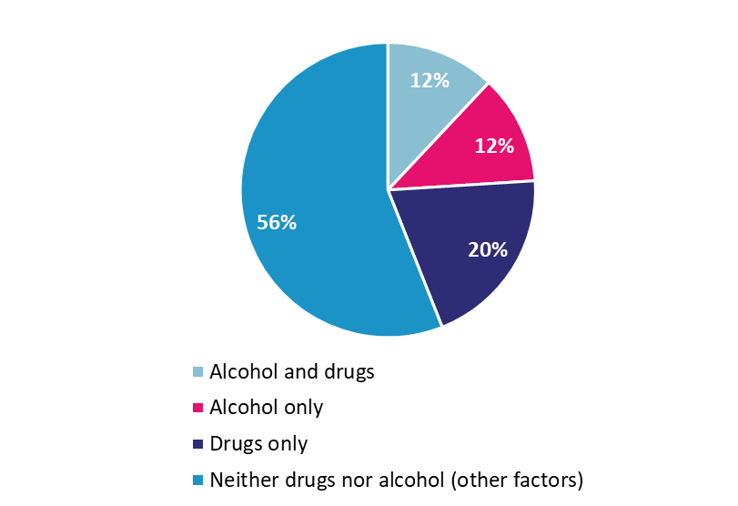

Source: NZIER, Ministry of Transport data

The Ministry of Transport also indicates that in 2021, the most recent year for which crash data is analysed by contributing factor, there were 285 fatal crashes (Ministry of Transport annual crash statement 2021). Based on these facts, alcohol alone is estimated to cause between 12 percent and 24 percent of all fatal crashes or 34 to 68 fatal vehicle crashes per year (see Table 16 below).

Table Estimation of alcohol-attributable fatal vehicle crashes

|  |  |  |
| --- | --- | --- |
|  | Low estimate (alcohol alone) | High estimate (alcohol and drugs) |
| Number of crashes | 285 | 285 |
| Percentage of crashes where alcohol was a contributing factor | 12% | 24% |
| Number of crashes potentially caused by alcohol | 34.20 | 68.40 |

Source: NZIER, Ministry of Transport data

The Ministry of Transport does not provide a breakdown of serious injury and minor injury crashes that identify those where alcohol and drugs alone were contributing factors. However, it does indicate that in 2021, there were:

* 178 serious injury crashes involving alcohol and/or drugs
* 956 minor injury crashes involving alcohol and/or drugs.

For most serious and minor injury crashes involving alcohol and/or drugs, Police would be expected to attend to the scene and offences related to driving under the influence of alcohol and/or drugs are likely to be recorded. According to data extracted from NZ Police (2023) on offences relating to driving under the influence of alcohol and/or drugs, 97 percent of offences are related to alcohol only (no other drugs). We estimate the number of serious and minor vehicle crashes attributable to alcohol based on these facts to be 173 and 936, respectively (see Table 17 below).

Table Estimation of alcohol-attributable serious and minor injury vehicle crashes

|  |  |  |
| --- | --- | --- |
|  | Serious injury crashes | Minor injury crashes |
| Number of crashes involving alcohol and/or drugs as contributing factors | 178 | 965 |
| Percentage involving alcohol alone (based on DUI data*) | 97% | 97% |
| Number of crashes potentially caused by alcohol | 173 | 936 |

*This data is not disaggregated by type of crash.

Source: NZIER, Ministry of Transport data and NZ Police data

Based on the estimation of alcohol-attributable fatal, serious and minor vehicle crashes, the total number of vehicle crashes attributable to alcohol is between 1,143 and 1,177.

### Estimated alcohol-attributable cost of road crashes

Road crashes are expected to result in total societal costs of between $38,190 to $6,660,222 per crash in 2023, based on the Ministry of Transport estimate of $33,500 and $5,842,300 in 2021 prices (Ministry of Transport 2021).

As shown in Table 18, over 90 percent of the total societal cost of fatal and serious injury crashes and over 70 percent of the total social cost of minor injury crashes is made up of loss of life and quality of life due to permanent disability.

Table Average social cost of a vehicle crash by severity and cost component

2023 dollars

|  |  |  |  |  |  |  |
| --- | --- | --- | --- | --- | --- | --- |
|  | Fatal crash | | Serious injury crash | | Minor injury crash | |
|  | Cost per crash | % of total | Cost per crash | % of total | Cost per crash | % of total |
| Loss of life/quality of life due to permanent disability | 6,582,360 | 98.8% | 635,892 | 94.3% | 27,018 | 70.7% |
| Loss of output (temporary disability) | 1,140 | 0.0% | 2,736 | 0.4% | 456 | 1.2% |
| Medical: | 18,126 | 0.3% | 21,318 | 3.2% | 1,368 | 3.6% |
| Hospital | 10,374 | 0.2% | 13,110 | 1.9% | 228 | 0.6% |
| Emergency | 5,244 | 0.1% | 1,824 | 0.3% | 1,026 | 2.7% |
| Follow-on | 2,508 | 0.0% | 6,384 | 0.9% | 114 | 0.3% |
| Legal and Court | 43,548 | 0.7% | 5,244 | 0.8% | 1,710 | 4.5% |
| Vehicle Damage | 14,934 | 0.2% | 9,462 | 1.4% | 7,524 | 19.7% |
| **Total** | **6,660,222** |  | **674,652** |  | **38,190** |  |

2023 values calculated by CPI-adjusting reported values in 2021 dollars.

Source: NZIER, based on Ministry of Transport (2021)

Based on the number of alcohol-attributable crashes of each type estimated in the previous section, we estimate the total social cost of alcohol-attributable road crashes to be over $2 billion, or approximately 42 percent of the total social cost of all road crashes, of which the largest share is loss of life or loss of quality of life due to permanent disability.

Table Total estimated alcohol-attributable cost of road crashes by the severity of crash and cost component

2023 dollars

|  |  |  |  |  |
| --- | --- | --- | --- | --- |
|  | Fatal crashes | Serious crashes | Minor crashes | All alcohol-attributable crashes |
| Loss of life or quality of life due to permanent disability | $1,636,835,461 | 265,847,368 | 111,172,045 | $2,013,854,875 |
| Loss of output or temporary disability | $283,484 | $1,143,840 | $1,876,321 | $3,303,645 |
| Medical: | $4,507,392 | $8,912,416 | $5,628,964 | $19,048,773 |
| Hospital | $2,579,703 | $5,480,898 | $938,161 | $8,998,761 |
| Emergency | $1,304,025 | $762,560 | $4,221,723 | $6,288,308 |
| Follow-on | $ 623,664 | $2,668,959 | $469,080 | $3,761,704 |
| Legal and court | $10,829,081 | $ 2,192,359 | $7,036,205 | $ 20,057,646 |
| Vehicle damage | $3,713,638 | $3,955,778 | $30,959,304 | $38,628,720 |
| **Total** | **$1,656,169,056** | **$282,051,762** | **$156,672,840** | **$2,094,893,658** |

*Total number of alcohol-attributable crashes and average costs per crash are shown in Table 17 and Table 18 above.

Source: NZIER, based on Ministry of Transport 2021 (2019 crash data), NZ Police 2023 (2019 driving offence data), IHME (alcohol-attributable fraction of fatal road crashes in New Zealand)

Many of these cost components have been estimated separately: Hospital costs for alcohol-attributable injuries resulting from vehicle crashes, ED visits associated with injuries that result in hospitalisation, DALYs attributable to alcohol, and loss of output due to short term disability.

Additional costs, not previously captured, include medical follow-on costs ($3.8 million, which may include such costs as physiotherapy), which are not fully captured elsewhere in this report. The latter are likely to be primarily ACC costs.

In addition to these costs, the total legal and court costs (not previously captured due to the focus on incarceration costs) are estimated at $20.1 million in 2023 dollars, and the total private costs of vehicle damage are estimated to be $38.6 million in 2023 dollars.

### Limitations of estimates of alcohol-attributable road crashes

This relatively detailed cost estimation is possible due to the Ministry of Transport’s detailed and recent data and costings.

A major gap in the costings, however, is the impact of alcohol-attributable road crashes on the cost of insurance which is borne by all insured drivers and the cost of registration.

A small proportion of these legal and court costs may be captured in our section on incarceration costs, where alcohol-attributable crashes resulted in a prison sentence for driving under the influence or other offence related to property damage or harm to other persons, although given the low proportion of charges that result in prison sentences (see Table 15), the double-counting here is likely to be insignificant.

There are three major uncertainties in the data and methods used in the estimation:

* the share of drug and alcohol driving offences caused by alcohol (97 percent) appears very high and may be over-estimated in NZ Police data, potentially due to the relatively limited use of roadside drug testing (random roadside alcohol testing is widespread but random roadside drug testing had not yet been introduced in New Zealand, resulting in likely under-identification of the contribution of drugs to driving offences)
* there may be a significant difference between the alcohol-attributable fraction of driver offences and the alcohol-attributable fraction of non-fatal road crashes, and if there is, with the estimated fraction applied being 97 percent, the associated cost is likely to be over-estimated
* the Ministry of Transport states that “unlike fatal crashes, many injury crashes are not reported to the New Zealand Police,” so non-fatal crashes are estimated from hospitalisation and ACC data, which will not capture road crashes where minor injuries or no injuries occurred but where there can still be significant private costs associated with vehicle and property damage.

# Health and disability system costs

According to the World Health Organization (World Health Organization 2022), the harmful use of alcohol is a causal factor in more than 200 disease and injury conditions, with over five percent of the total global burden of disease attributable to alcohol. Still, while the impact of tobacco on health is well understood, the impact of alcohol is relatively less well-evidenced (Madden and McCambridge 2021).

Alcohol consumption, particularly hazardous drinking, is expected to increase the costs of a wide range of health and disability services due to the wide range of diseases and the increased risk of injuries (including self-harm) that it contributes to. This is expected to include services addressing the short-term effects of alcohol consumption, which may consist of such concerns as acute alcohol toxicity or injuries experienced as a result of intoxication, as well as services addressing the long-term effects of alcohol consumption, such as cancers, heart disease, mental illness, and many more. Increased risk of ill health is expected to increase demand for primary care, diagnostic services, specialist visits, inpatient care, mental health and addiction services, and even aged residential care due to increased risk of stroke and dementia.

A significant research effort undertaken globally and locally has produced detailed alcohol-attributable fractions at the level of medical diagnosis (International Classification of Diseases 10th Revision (ICD-10) code), which allows for a highly accurate and detailed estimation of alcohol’s contribution to health and disability outcomes insofar as health and disability system data are described using the same information. Currently, this means the causal role of alcohol can be quantified with a high degree of confidence for inpatient hospitalisations and mortality only.

Other health services, such as outpatient services, ED, aged care, disability support, primary care and other Tier 1 services, do not record diagnoses using ICD-10 codes or at all, resulting in significant challenges in quantifying the role of alcohol.

Other more specific services, such as alcohol and drug programmes, are deliberately designed to address more than just alcohol due to the recognition that alcohol addiction commonly occurs along with other addictions, mental health conditions, and numerous other social concerns. No evidence is available on the fraction of expenditure on these programmes that is attributable to alcohol.

Health care costs associated with alcohol are potentially amenable to reduction through effective treatment of alcohol use disorders. For example, a US study investigating the impact of an outpatient chemical dependency recovery programme (Parthasarathy et al. 2015) found that patients who accessed treatment were less likely to be hospitalised, spent less time in hospital and had fewer ED visits, and had reduced total medical costs of 26 percent in the 18 months post-treatment compared with the 18 months prior to treatment.

There is also growing recognition of the negative impacts of alcohol on mental health (see, for example, Cobiac and Wilson (2018); however, to date, no estimate of causal attribution allows these impacts to be quantified.

In this section, we focus on the health and disability system impacts where recent New Zealand evidence is available to support attribution. These are in the areas of:

* inpatient hospitalisations
* emergency services (ED and ambulance)
* primary care
* income compensation for short-term disability (ACC).

## Inpatient hospitalisation attributable to alcohol

Inpatient hospitalisations attributable to alcohol were identified based on the ICD-10 codes presented in Appendix E – ICD-10 codes for which an alcohol-attributable fraction (AAF) was estimated for New Zealand (Chambers and Mizdrak, forthcoming). The AAFs supplied described the causal attribution to alcohol of wholly and partially attributable conditions and injuries by 5-year age groups (from age 15 to 99), by sex, and by Māori/non-Māori ethnicity. The data used to identify inpatient hospitalisations was the National Minimum Data Set (NMDS). The data was extracted and supplied by Te Whatu Ora for the calendar year 2018. The year 2018 was selected because the research team felt it was important to:

* avoid results being affected by any impacts of COVID-19 and the related response, on health outcomes and health system utilisation (these have had a major impact on data for the years 2020, 2021 and 2022, in particular for planned care which was often delayed)
* align the analysis with the year of data that informed the calculations of the AAFs
* align the calculation of inpatient costs with the calculation of mortality costs due to the consistent use of AAFs across both areas (the latest year available for mortality data is 2018).

Although inpatient hospitalisation data from 2019 could have been used for this analysis, the benefit of only slightly more recent data for this cost estimation was considered to be less important than the alignment with the AAFs’ base year and the mortality data.

To estimate results for 2023, we:

* applied inpatient bed day rates by population subgroup to projected population sub-groups for 2023
* calculated event costs using the Weighted Equivalent Inlier Separations methodology, applying the 2021/22 WIES multiplier for medical and surgical events inflated using the CPI to 2023 (a 7 percent increase).

Because resource use is often of greater interest to the health sector than cost estimates, we present the inpatient bed days and the resulting number of hospital beds utilised as a result of alcohol consumption as well as cost estimates.

### Alcohol-attributable inpatient bed days

In 2023, the estimated number of bed days attributable to alcohol was between 141,000 and 179,000, with a midpoint of 161,709.

Table Total inpatient bed days attributable to alcohol

2023 estimated

|  |  |  |  |
| --- | --- | --- | --- |
|  | Lower estimate | Midpoint estimate | Upper estimate |
| Total | 141,491 | 161,709 | 178,651 |

Source: NZIER, based on NMDS data from Te Whatu Ora and AAFs from Chambers and Mizdrak (forthcoming)

Breaking these bed days down by ethnicity shows that bed days for Māori are approximately 15 percent of the total number of inpatient bed days.

Table 21 Total bed days attributable to alcohol by ethnicity

2023 estimated

|  |  |  |  |  |
| --- | --- | --- | --- | --- |
|  | Lower estimate | Midpoint estimate | Upper estimate | Percent of total |
| **By ethnicity** |  |  |  |  |
| Māori | 21,058 | 23,845 | 26,059 | 15% |
| Non-Māori | 120,433 | 137,864 | 152,592 | 85% |

Source: NZIER, based on NMDS data from Te Whatu Ora and AAFs from Chambers and Mizdrak (forthcoming)

According to Stats NZ, Māori comprised 17.3 percent of the New Zealand population in 2023. Under-representation in alcohol-attributable bed days is likely due in part to the younger average age of the Māori population: the median ages for males and females identifying as Māori were 25.8 and 27.9 years, respectively (compared with national median ages of 37.0 and 39.0 years, respectively).

When broken down by age group, the estimates show that the 75-to-99-year age group experiences the greatest number of alcohol-attributable bed days (approximately 36 percent of all alcohol-attributable bed days) and that the number of bed days attributed to alcohol increases by age. This is likely to be due to the combined effects of:

* alcohol’s long-term effects on health increasing with age and shifting from increased risk of alcohol-attributable disease to disease occurrence
* age being associated with more alcohol-related and other comorbidities, which contribute to the complexity of treatment for any single condition
* longer lengths of stay for older people generally, due to increased complexity, higher risk of complications, slower recovery, and barriers to prompt discharge related to short supply of aged residential care beds or community nursing.

Table 22 Total bed days attributable to alcohol by age group

2023 estimated

|  |  |  |  |
| --- | --- | --- | --- |
|  | Lower estimate | Midpoint estimate | Upper estimate |
| **By age group** |  |  |  |
| 15-24 | 5,473 | 6,251 | 6,919 |
| 25-34 | 8,343 | 9,376 | 10,248 |
| 35-44 | 10,382 | 11,525 | 12,441 |
| 45-54 | 15,448 | 17,145 | 18,437 |
| 55-64 | 24,304 | 26,988 | 29,001 |
| 65-74 | 28,999 | 32,733 | 35,648 |
| 75-99 | 48,542 | 57,690 | 65,957 |

Source: NZIER, based on NMDS data from Te Whatu Ora and AAFs from Chambers and Mizdrak (forthcoming)

Figure  Share of alcohol-attributable bed days by age group

2023 estimated

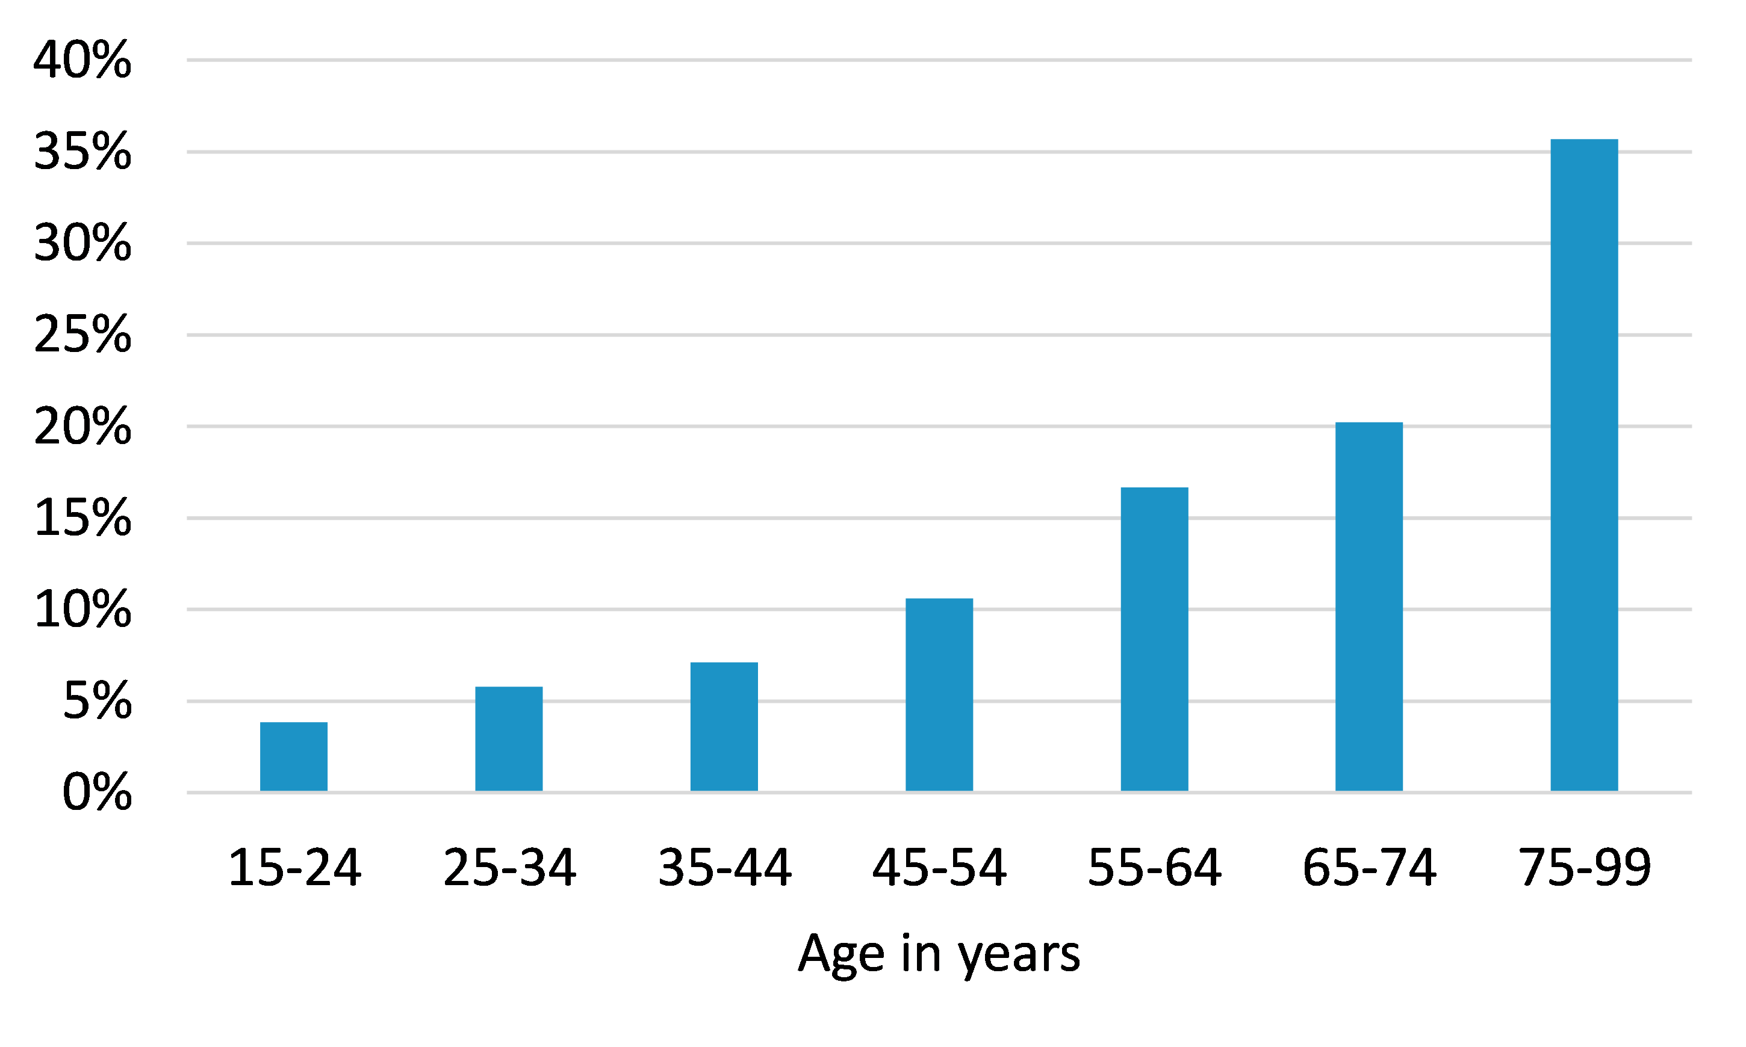

Source: NZIER, based on NMDS data from Te Whatu Ora and AAFs from Chambers and Mizdrak (forthcoming)

### Hospital beds required to accommodate alcohol-attributable inpatient needs

Reducing alcohol-attributable hospitalisations has the potential to reduce pressure on health infrastructure. Based on hospital beds being available for use 365 days per year and an 85 percent hospital bed occupancy rate (the standard safe occupancy rate used in hospital planning), in 2023, approximately 456 to 576 (midpoint 521) hospital beds are dedicated purely to caring for alcohol-attributable conditions – the equivalent of one entire major hospital bigger than Wellington Regional Hospital.

Table Hospital inpatient beds attributable to alcohol

Based on 365-day bed availability and 85% occupancy rate

|  |  |  |  |
| --- | --- | --- | --- |
|  | Lower estimate | Midpoint estimate | Upper estimate |
| Total | 456 | 521 | 576 |

Source: NZIER, based on Te Whatu Ora data and alcohol-attributable fractions from Chambers and Mizdrak (forthcoming)

### Cost of inpatient hospitalisations attributable to alcohol

The alcohol-attributable cost to the health sector of delivering inpatient care in 2023 is estimated to be between $296 million and $371 million ($337 million midpoint) (see

Table 24 below).

Table Cost of inpatient hospitalisations attributable to alcohol

2023 estimated

|  |  |  |  |
| --- | --- | --- | --- |
|  | Low estimate | Midpoint estimate | High estimate |
| Total | $296,362,523 | $337,438,659 | $371,308,836 |

Source: NZIER, based on Te Whatu Ora data and alcohol-attributable fractions from Chambers and Mizdrak (forthcoming)

Breaking costs down by ethnicity and age group reveals a similar pattern to bed days by ethnicity and age group, although the cost of inpatient care for Māori accounts for approximately 17 percent of the total cost, slightly higher than the 15 percent of total bed days calculated in the previous section, likely explained by greater complexity in presenting conditions, a recognised issue in Māori health. (See Table 25 and Table 26 below)

Table Cost of inpatient hospitalisations attributable to alcohol by ethnicity

Estimated 2023 cost

|  |  |  |  |
| --- | --- | --- | --- |
|  | Low estimate | Midpoint estimate | High estimate |
| **By ethnicity** |  |  |  |
| Māori | $49,486,749 | $55,883,078 | $60,937,771 |
| Non-Māori | $246,875,773 | $281,555,581 | $310,371,065 |

Source: NZIER, based on Te Whatu Ora data and alcohol-attributable fractions from Chambers and Mizdrak (forthcoming)

When broken down by age group, there is a similar pattern to that observed for bed days, of increasing cost with increasing age is observed, but the share of costs attributed to alcohol in the oldest age group is lower at approximately 27 percent than the share of bed days (estimated to be 36 percent in the previous section) (see Table 26 and Figure 11 below).

Table Cost of inpatient hospitalisations attributable to alcohol by age group

Estimated 2023 cost

|  |  |  |  |
| --- | --- | --- | --- |
|  | Low estimate | Midpoint estimate | High estimate |
| By age group |  |  |  |
| 15–24 | $16,653,527 | $18,874,086 | $20,762,329 |
| 25–34 | $21,244,596 | $24,006,730 | $26,324,164 |
| 35–44 | $24,465,783 | $27,373,018 | $29,697,310 |
| 45–54 | $37,404,960 | $41,716,088 | $44,989,204 |
| 55–64 | $56,757,602 | $63,107,851 | $67,851,289 |
| 65–74 | $62,610,184 | $70,552,408 | $76,721,363 |
| 75–99 | $77,225,871 | $91,808,478 | $104,963,177 |

Source: NZIER, based on Te Whatu Ora data and alcohol-attributable fractions from Chambers and Mizdrak (forthcoming)

Figure  Share of alcohol-attributable inpatient cost by age group

2023 estimated

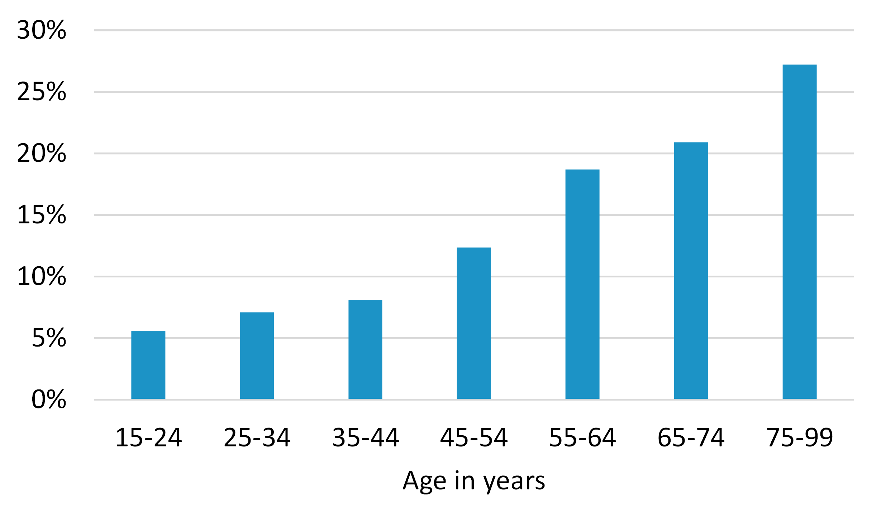

Source: NZIER, based on Te Whatu Ora data and alcohol-attributable fractions from Chambers and Mizdrak (forthcoming)

## Emergency departments experience a high burden attributable to alcohol

Alcohol is often cited as a key problem in EDs around New Zealand and internationally. According to a multi-centre study conducted in Australia and New Zealand (Egerton-Warburton et al. 2018), ED patients with alcohol-related harm:

* were more likely to be younger and male
* were highly likely (64 percent) to still be intoxicated at the time of presentation to the ED
* were more likely to be triaged for immediate care
* were more likely to arrive via ambulance or Police
* were resource-intensive
* disrupted the function of the ED
* impacted negatively on the care received by other patients.

The study estimated that approximately 10 percent of the weekly ED workload was alcohol-related.

### Youth alcohol-related Emergency Department presentations are a key concern

The Ministry of Health collects data from New Zealand EDs recording staff assessments of the involvement of alcohol in youth ED presentations, which may or may not result in inpatient hospitalisation. While the data presents an interesting view of the prevalence of alcohol involvement in ED presentations, it also illustrates the difficulty of identifying the involvement of alcohol in this context.

The data is collected in an ‘alcohol involved field’ on patients’ records, with ED clinical staff required to determine “is alcohol associated with this presentation?”. The data can be collected by any clinical staff member, including triage nurses, patients’ nurses, charge nurses or doctors. It is a mandatory field in the patient management system, and the visit cannot be completed until the question is answered. There are four available alcohol consumption response options recorded:

* Yes: associated with this presentation
* Secondary: a consequence of others’ consumption
* No: not directly associated with the presentation
* Unknown: not known or could not be determined.

In deciding on the involvement of alcohol, both acute and usual use of alcohol are considered. Staff are directed to ask about alcohol involvement if patients present with an injury or overdose. If staff do not ask about alcohol consumption, then they record the response as ‘unknown’. For all other presentations, staff use their judgement regarding alcohol’s involvement.

On average, across the four quarters from October 2021 to September 2022, the percentage of ED presentations for people aged 10 to 24 years where ED staff recorded a “yes or unknown” response as to whether alcohol was involved was 21.5 percent. But the average for the same four quarters where ED staff recorded a “yes” response as to whether alcohol was involved was 2.8 percent. These results indicate that uncertainty as to the involvement of alcohol in youth ED presentations is far greater than the rate where alcohol could be confidently identified as being involved and that this uncertainty is due to ED staff not asking the patient about alcohol consumption.

This data also does not permit causal attribution of the ED presentation to alcohol specifically.

As a time series, the data identifies that subsequent to a change in recording practice from 2017/18, rates of “yes or unknown” responses saw a decline and then have remained relatively constant since 2019, while rates of “yes” responses have seen some variability but remain at approximately the same level (see Figure 12 below).

Figure  Rates of Emergency Department staff-recorded “Yes or Unknown” and “Yes” for the involvement of alcohol in youth ED presentations

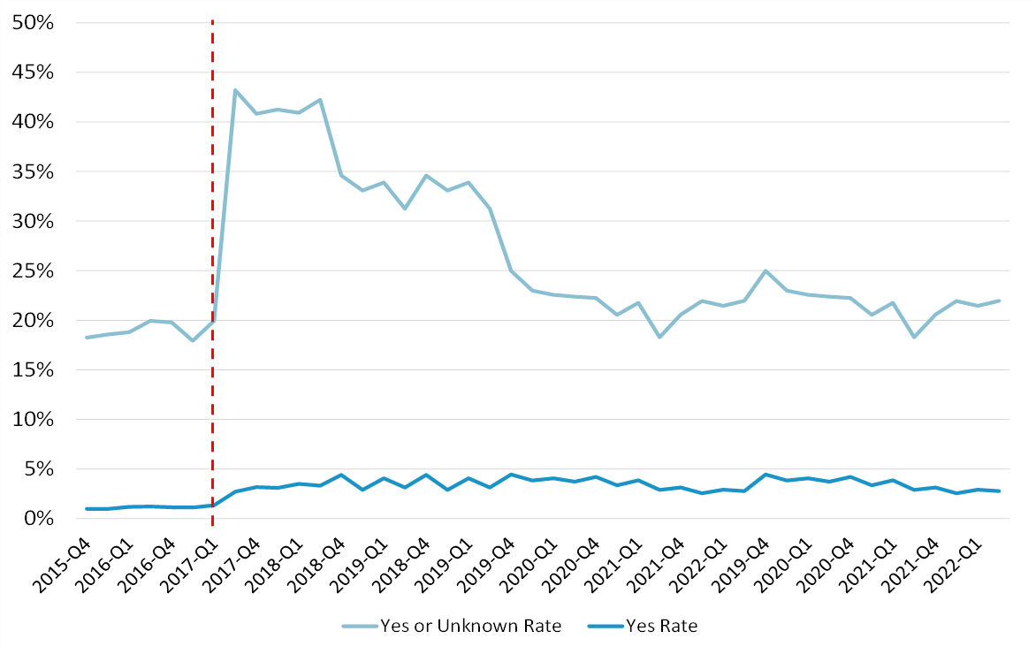

Note: A change in recording practice was implemented in 2017 (red dashed line), resulting in incomparability for results before and after this period.

Source: Ministry of Health

### All alcohol-related Emergency Department visits

A study based in Auckland Hospital (Svensen, Kool, and Buller 2019) used the same recording methodology as is used for youth ED presentations to identify all ED presentations that are alcohol-related. That study found that:

* 7 percent of ED presentations were alcohol-related
* the majority of alcohol-related presentations were male (65 percent) and aged 20-39 (52 percent)
* 16 percent of injury-related presentations were alcohol-related
* 53 percent of alcohol-related presentations arrived at the ED via emergency services, compared with only 28 percent of non-alcohol-related presentations
* 8 percent of alcohol-related presentations were classified as having life-threatening conditions (Australasian Triage Scale [ATS] 1) compared with only 3 percent of non-alcohol-related presentations
* alcohol-related presentations had a median ED length of stay of five hours compared to 2 hours and 58 minutes for non-alcohol-related presentations.

### Costs of alcohol-attributable Emergency Department visits

We estimate the total ED cost of alcohol-involved ED presentations based on the 1,250,248 ED visits nationally in 2022 (Ministry of Health,2023) and the alcohol-related presentation rate identified by Svensen, Kool, and Buller (2019). We do not factor in the relatively long length of stay in ED for alcohol-related presentations (5 hours versus just under 3 hours) or the higher rate of life-threatening conditions in these presentations (8 percent versus 3 percent) because it is not clear how these translate into costs. A longer length of stay may not always translate into higher costs because longer stays may not be related to increased complexity of care (e.g. a patient may need to sober up before assessment can confirm only a minor medical concern).

If 7 percent of all ED presentations nationally in 2022 were alcohol-related, with eight percent of these being life-threatening and 53 percent arriving by ambulance, then there were:

* 47,880 alcohol-related ED visits, including:
  + 3,830 life-threatening presentations
  + 44,050 non-life-threatening presentations
* 25,376 alcohol-related ambulance call-outs that resulted in a person being taken to the ED.

The unit costs we use to estimate the costs of alcohol-related ED visits are:

* the Treasury’s 2023 cost estimate (The Treasury 2022) of $503 per ED visit, which we use for non-life-threatening presentations
* a high-end cost for ED visits based on clinical triage suggested by Te Whatu Ora (Te Whatu Ora Health New Zealand, Counties Manukau 2020) of $1,832 in 2020 (worth approximately $2,162 in 2023), which we use for the cost of life-threatening ED presentations
* the Treasury’s 2023 cost estimate (The Treasury 2022) of $1,008 per ambulance call-out.

Based on the assumption that a similar level of ED presentations and ambulance call-outs for 2023 as there were in 2022, the health sector cost of these amounts to over $102 million.

Table Cost of alcohol-related ED visits (including ambulance costs)

2023 estimated

|  |  |
| --- | --- |
| Variable | Value |
| Total ED visits in 2022 | 1,250,247 |
| % of all ED visits related to alcohol | 7% |
| Number of alcohol-related ED visits | 87,517 |
| % of alcohol-related ED visits arriving by ambulance | 53% |
| Number of alcohol-related ambulance call-outs resulting in ED visit | 46,384 |
| % of alcohol-related ED visits that were life-threatening | 8% |
| Number of alcohol-related ED visits that were life-threatening | 7,001.38 |
| % of ED visits that were not life-threatening | 92% |
| Number of alcohol-related ED visits that were non-life-threatening | 80,516 |
| Cost of non-life-threatening ED visit | $503 |
| Cost of life-threatening ED visit | $2,162 |
| Cost of ambulance call-out | $1,008 |
| Total cost of non-life-threatening alcohol-related ED visits | $40,499,501 |
| Total cost of life-threatening alcohol-related ED visits | $15,135,310 |
| **Total cost of alcohol-related ED visits** | **$55,634,811** |
| Total cost of alcohol-related ambulance call-outs resulting in an ED visit | $46,755,237 |
| **Total cost of alcohol-related ED visits and related ambulance callouts** | **$102,390,048** |

Source: NZIER, based on data from Te Whatu Ora and Svensen, Kool, and Buller (2019)

This result is highly uncertain because it is not known to what extent data on “alcohol-involvement” in this context corresponds to attribution to alcohol. It is also difficult to determine whether this cost is likely under or overestimated. Some ED visits that are at least partially attributable to alcohol may not be recorded as alcohol-related by ED staff due to the difficulty of identifying the role of alcohol in many conditions, resulting in an underestimation of the true number of alcohol-related events.

However, it is important to note that relying on alcohol-related ED events data results in a relatively high attribution rate: The resulting attribution rate is approximately 3.5 times the rate estimated for males and eight times the rate estimated for females in a Canadian study (Myran et al. 2019). That study benefitted from diagnosis codes being recorded in ED data, so it offers a credible attribution to alcohol, albeit in the Canadian context. The New Zealand context is different from the Canadian context in important ways due to higher rates of alcohol consumption and hazardous drinking in New Zealand as well as higher barriers of access to primary care, which would be expected to result in higher rates of alcohol-attributable ED events. Nevertheless, the cost estimated here should be regarded as highly uncertain.

#### Emergency department presentations associated with alcohol-attributable inpatient hospitalisations

Within the total cost of ED presentations, there is a subset of events around which a higher level of confidence is possible: ED events associated with inpatient admissions.

Based on inpatient hospitalisation data and their AAFs, it is possible to estimate the number of associated ED presentations. Inpatient data is coded as either an acute or planned admission. Most acute admissions are admitted from the ED.

Table 28 below shows the breakdown of alcohol-attributable inpatient events to planned admissions and acute admissions. An estimated 8,772 acute admissions in 2023 will be attributable to alcohol (approximately 21 percent of all alcohol-attributable admissions).

Table Planned and acute inpatient admissions

Estimated 2023

|  |  |  |  |
| --- | --- | --- | --- |
|  | Planned admissions | Acute admissions | All admissions |
| Alcohol-attributable admissions | 32,151 | 8,772 | 40,923 |
| Share | 78.6% | 21.4% | 100% |

Source: NZIER, based on Te Whatu Ora data and alcohol-attributable fractions from Chambers and Mizdrak (forthcoming)

Table 29 below shows that for alcohol-attributable admissions, non-Māori were more likely to have acute admissions than Māori (22 percent, compared with 18 percent for Māori). Māori accounted for 15 percent of all alcohol-attributable acute inpatient admissions.

Table Planned and acute inpatient admissions by ethnicity

Estimated 2023

|  |  |  |  |  |  |
| --- | --- | --- | --- | --- | --- |
|  | Planned admissions | Acute admissions | All admissions | Planned share of all admissions | Acute share of all admissions |
| Māori | 6,074 | 1,310 | 7,384 | 82.3% | 17.7% |
| Non-Māori | 26,077 | 7,462 | 33,539 | 77.8% | 22.2% |
| % Māori | 18.9% | 14.9% | 18.0% |  |  |
| % Non-Māori | 81.1% | 85.1% | 82% |  |  |

Source: NZIER, based on Te Whatu Ora data and alcohol-attributable fractions from Chambers and Mizdrak (forthcoming)

By age group, the group with the highest share of acute admission is 65 to 74-year-olds, with 14 percent of admissions in this age group being acute. The share of acute admissions in 15–24-year-olds is very low (4 percent) when considering the observation (Egerton-Warburton et al. 2018) that alcohol-related ED visits are highly likely to involve young people. This probably indicates that people aged 15–24 who have alcohol-related presentations to the ED are highly likely to be treated and discharged from the ED and not be admitted to an inpatient ward.

Table Planned and acute inpatient admissions by age group

Estimated 2023

|  |  |  |  |  |  |
| --- | --- | --- | --- | --- | --- |
|  | Planned admissions | Acute admissions | All admissions | Planned share of all admissions | Acute share of all admissions |
| 15–24 | 3,782 | 327 | 4,108 | 96% | 4% |
| 25–34 | 3,657 | 519 | 4,177 | 94% | 6% |
| 35–44 | 3,714 | 698 | 4,413 | 92% | 8% |
| 45–54 | 4,509 | 1,214 | 5,723 | 89% | 11% |
| 55–64 | 5,165 | 1,898 | 7,063 | 87% | 13% |
| 65–74 | 5,008 | 1,980 | 6,988 | 86% | 14% |
| 75–99 | 6,316 | 2,135 | 8,451 | 87% | 13% |

Source: NZIER, based on Te Whatu Ora data and alcohol-attributable fractions from Chambers and Mizdrak (forthcoming)

Based on the total number of acute admissions (8,772) and an assumption that these admissions originate in the ED, we estimate the cost of alcohol-attributable ED visits using an ED visit cost that is at the midpoint between the average ED visit cost and the high-end ED visit cost that we used previously for life-threatening presentations. The rationale is that this set of ED visits resulted in inpatient admissions, so the average triage priority is likely to be higher than the average ED visit. The midpoint between the Treasury (CBAx Impact Database 2022) unit cost of an ED visit in 2023 ($503) and the high-end cost based on triage priority indicated by Te Whatu Ora ($2,162) is $1,333. The result of this cost estimation, just under $19 million, is presented in Table 31 below.

Table Total cost of alcohol-attributable ED visits

Estimated 2023

|  |  |
| --- | --- |
| Variable | Value |
| Number of acute alcohol-attributable inpatient admissions | 8,772 |
| Share of acute alcohol-attributable admissions originating in the ED | 100% |
| Cost per ED visit | $2,162 |
| Total ED cost | $18,965,064 |

Source: NZIER, based on Te Whatu Ora data and alcohol-attributable fractions from Chambers and Mizdrak (forthcoming)

This result is likely subject to less uncertainty than the previously estimated total costs of alcohol-related ED visits but also represents only a small subset of ED visits that may be attributable to alcohol.

## Evidence suggests no additional primary care costs are attributable to hazardous drinking

Primary care is the intended first point of contact within the health system for people experiencing health issues. However, a visit to the GP may not be the first point of contact in many instances for a range of reasons, including:

* numerous studies and population surveys identify that a significant minority do not visit the GP when they need to for health issues generally due to access barriers, including cost, time and availability
* accidents and injuries, particularly more serious ones, are most likely to be seen in urgent care contexts such as the ED
* some health conditions may be asymptomatic, or symptoms may be ignored until urgent care is needed.

A New Zealand study (Paton-Simpson et al. 2000) found that 16 percent of people who visited Auckland GPs met the criteria for hazardous drinking. However, their visits to the GP were not necessarily related to health issues that were attributable to hazardous drinking.

The question of whether people who engage in hazardous drinking visit the GP more than people who do not engage in hazardous drinking remained unanswered in the New Zealand context until a later study was published in 2020 (Jury et al. 2020). Using New Zealand Health Survey data from 2016/17, the study analysed GP visits in the past year and their association with hazardous drinking, including for various population subgroups. The study found that, overall, there was no association between hazardous drinking and greater or lesser rates of past-year GP visits: 76.54 percent of people who met the criteria for hazardous drinking had visited a GP in the past year compared with 77.60 percent of people who were not hazardous drinkers.

While the study did not control for other potential causal variables to determine the role of hazardous drinking in GP visit rates, it included sub-group analysis, which found no association between hazardous drinking and GP visits for Māori males and Māori females: That is, the rate of GP visits for Māori males and females who were hazardous drinkers was similar to the rate of GP visits for Māori males and females who did and did not meet hazardous drinking criteria. Compared with other subgroups, Māori males aged 15–24 years were least likely to have visited a GP in the past year regardless of drinking behaviour. A separate analysis by socioeconomic deprivation area (the study did not have a sufficient sample for robust analysis of subgroups determined by demographics and deprivation simultaneously) revealed a lower rate of GP visits for people who were hazardous drinkers if they lived in high-deprivation areas.

Jury et al. concluded that the results indicate that access barriers affecting general needs for GP visits are likely to affect alcohol-related GP visits as well and that the lack of differential rates of GP visits between hazardous drinkers and those who do not meet the criteria for hazardous drinking indicate it is likely contributing to poor health outcomes and higher rates of alcohol-related hospitalisations for hazardous drinkers, particularly those from more deprived groups.

Another interpretation could be that people who experience health problems associated with alcohol seek care for these and reduce their care-seeking for other issues. The Jury et al. (2020) study could not identify this behaviour due to data on the presenting problem not being available.

A European study (Probst et al. 2015) identified that lack of awareness was a key factor behind low use of services by people with lower severity of alcohol use disorder, while fear of stigma or shame and various “encounter barriers” including cost barriers, time barriers, lack of trust in the service/system and a lack of appropriate services explained low use of primary care services by people with more severe alcohol use disorders. Similar barriers may explain observed patterns of utilisation in New Zealand.

A key point to note is that if alcohol consumption is contributing to health problems and people affected by this are not seeking GP care, there are likely to be higher downstream costs as conditions worsen and affected individuals are forced to seek care at a more advanced stage. These costs may then be reflected in estimates of emergency and inpatient care. Such a conclusion is supported by overseas studies that find risky drinkers use more costly health services but not more primary care (see, for example, Miquel et al. 2018).

Another important point is that alcohol contributes to many health conditions which are screened for, identified, and at times treated in primary care, so a portion of primary care costs is likely to be attributable to alcohol. Research to identify how alcohol-attributable fractions may be used in a primary care context is needed, but in the New Zealand context, making use of such evidence will also require a detailed national primary care dataset.

Based on the current evidence, however, no cost associated with primary care is estimated.

## Disability-related costs to ACC

In addition to funding many hospital-related events related to accidents (the inpatient and ED portions of which are included in costs estimated previously), ACC covers costs associated with lost income for people who have experienced injuries that meet specific conditions.

When people experience injuries that affect their ability to work, ACC pays up to 80 percent of their usual weekly income as weekly compensation.

Table 32 below shows that in 2022, ACC had an overall total of 138,992 active weekly claims and that active weekly claims in 2022 had a cost of $1,951,774,609 (after inflating to 2023 values).

Table Number of ACC active weekly claims and active weekly costs

Total

|  |  |  |
| --- | --- | --- |
| Age group | Active weekly claims (2022) | Active weekly costs (2023 dollars) |
| Total annual | 138,992 | $1,951,774,609 |

Source: NZIER based on data supplied by ACC

Because income compensation is a function of individuals’ income level, age groups with higher income levels tend to receive higher average compensation per person. In terms of total claims, income levels interact with the number of claims, which will be highest in the age group with the most injuries eligible for income compensation.

Broken down by age group, ACC weekly claims data shows that the highest number of active weekly claims in 2022 was from 25 to 34-year-olds, but the highest cost of weekly claims was in the 45–54-year-old group (see Table 33 below).

Table Number of ACC active weekly claims and active weekly costs

By age group

|  |  |  |
| --- | --- | --- |
| Age group | Active claims (2022) | Active costs (2023 dollars) |
| 00–14 | 832 | $34,166,460 |
| 15–24 | 23,908 | $228,644,204 |
| 25–34 | 33,350 | $410,541,978 |
| 35–44 | 26,212 | $424,439,719 |
| 45–54 | 26,218 | $451,737,872 |
| 55–64 | 22,300 | $336,152,020 |
| 65-74 | 5,159 | $59,895,117 |
| 75–99 | 464 | $4,464,189 |
| Over 99 | 549 | $1,733,051 |

Source: ACC

The alcohol-attributable fractions supplied for this project (Chambers and Mizdrak, forthcoming) show that the fraction of injuries attributable to alcohol peaks in the years when income is likely to be highest, contributing to high weekly compensation claims costs.

Figure  Average alcohol-attributable fractions of injuries by age group

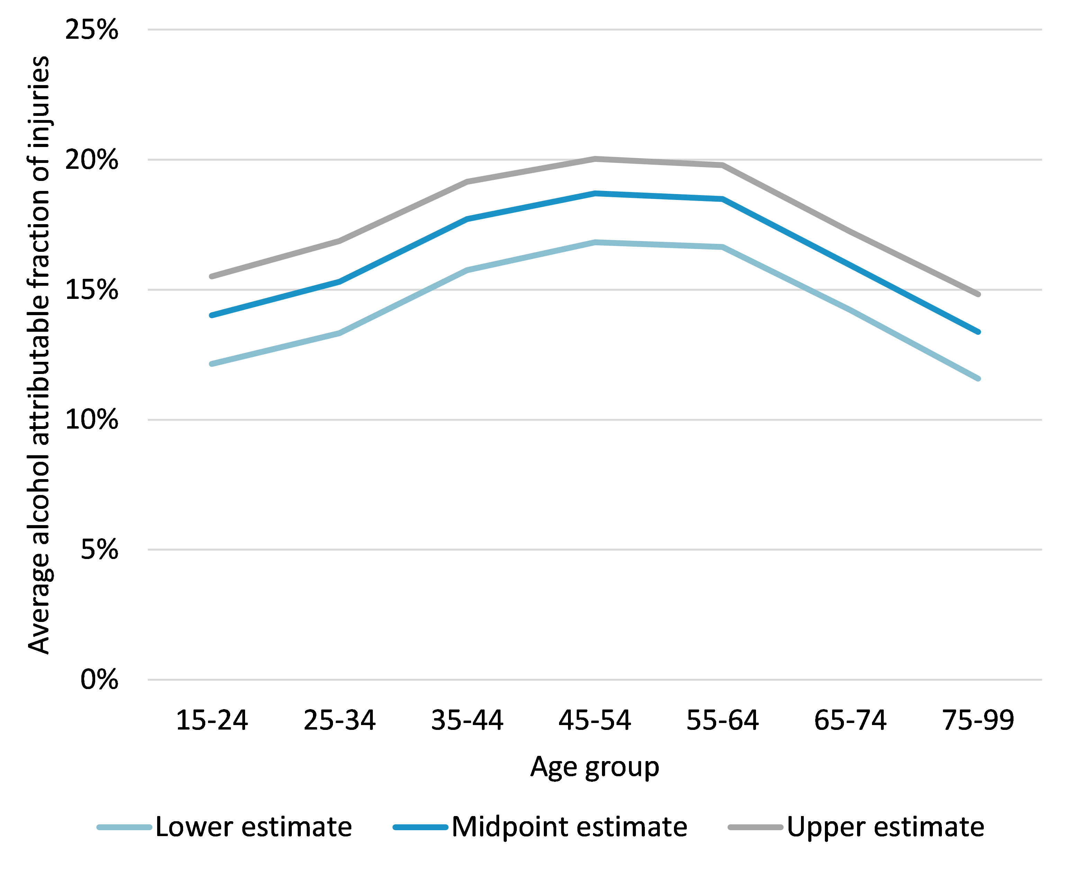

Source: NZIER based on Chambers and Midzrak (forthcoming)

When alcohol-attributable fractions are applied to weekly compensation claims by age group, the highest cost is observed in the 45–54-year age group. The total alcohol-attributable cost of weekly claims across all age groups is $326,834,329 (see Table 34 below).

These findings highlight a key difference between alcohol harms and estimated costs of alcohol harms based on incomplete data. ACC weekly compensation is paid to people who are employed at a rate that is a function of their employment income. The quality of life implications of disability, the costs associated with disability, and the loss of total production (paid and unpaid) may be similar for individuals who receive very different weekly compensation from ACC. For this reason, the results presented in this section should be seen as costs to ACC, not as monetary measures of the impact of disability.

Table Alcohol-attributable costs of active weekly claims

2023 value estimated from 2022 claims

|  |  |  |  |
| --- | --- | --- | --- |
| Age group | Active weekly claims | Active weekly costs | Alcohol-attributable costs for active weekly claims |
| 00–14 | 832 | $34,166,460 | No AAF available |
| 15–24 | 23,908 | $228,644,204 | $32,042,752 |
| 25–34 | 33,350 | $410,541,978 | $62,824,573 |
| 35–44 | 26,212 | $424,439,719 | $75,177,889 |
| 45–54 | 26,218 | $451,737,872 | $84,505,131 |
| 55–64 | 22,300 | $336,152,020 | $62,140,701 |
| 65–74 | 5,159 | $59,895,117 | $9,546,148 |
| 75–99 | 464 | $4,464,189 | $597,136 |
| Over 99 | 549 | $1,733,051 | No AAF available |
| **Total** | **138,992** | **1,951,774,609** | **$326,834,329** |

Source: NZIER, based on ACC data and AAFs from Chamers and Mizdrak (forthcoming)

## Limitations of estimates of health and disability system costs

While the health and disability sector should be well-placed to identify alcohol harms, with a growing body of research providing a high degree of confidence in the attribution of health conditions and injuries to alcohol, data collection across a range of services does not support the same degree of confidence in estimation. This issue is mainly about quantifying the problem rather than cost estimation. Two major limitations or evidence gaps are:

* the use of outpatient services attributable to alcohol
* the use of mental health services attributable to alcohol.

#### Outpatient care costs are an area of significant unknowns

Outpatient data in New Zealand is collected in the non-admitted patient collection (NNPAC) dataset held by Te Whatu Ora. Unlike inpatient data, detail on the cause and nature of outpatient visits and the medical diagnoses of people attending outpatient appointments are not available in outpatient data. This means outpatient data does not present any way of aligning service use with alcohol-attributable fractions in the same way that inpatient data allows.

We found no New Zealand studies that specifically investigated the impact of alcohol on the use of outpatient services. The limited evidence from overseas indicates no excess use of outpatients’ services by people with alcohol use disorders or moderate to high risk drinkers:

* One US study based on an older primary care population (3,954 patients aged 60 and older who completed the CAGE alcoholism screening questionnaire during routine office visits) (Callahan and Tierney 1995) found that one in 10 older patients had current evidence of alcoholism and that these patients were more likely to be hospitalised and more likely to die, but did not consume a greater amount of outpatient resources.
* Another study based on a cross-sectional survey of German adults (Baumeister et al. 2006) found that medium-risk and high-risk drinkers did not differ from low-risk drinkers in terms of outpatient service utilisation and that alcohol abstainers had a higher rate of outpatient service utilisation.

However, these studies were conducted in a different context, notably in health systems where services are differently funded from New Zealand’s – a factor that can influence service utilisation. However, studies that compare people based on alcohol consumption habits raise important questions that underscore the need for research: Results from these types of studies can be driven at least in part by the poorer health status of some alcohol abstainers who may, in fact, abstain from alcohol due to poor health. At the same time, many abstainers today abstain for health reasons and are generally health conscious, following a healthy lifestyle and potentially more inclined to seek care early or preventatively.

#### Mental health service use could be significant

The association between alcohol use and mental illness has been well documented; however, the impact of alcohol consumption on the use of mental health services in New Zealand has not been quantified.

A review of the evidence by New Zealand researchers (Cobiac and Wilson 2018) found that alcohol consumption and exposure to heavy drinking by others were both significant risk factors for reduced mental health. With almost one-third of the population reporting having a heavy drinker in their life and a high prevalence of heavy drinking, the cost implications for mental health services could be substantial. However, as the study authors indicate, while these risks are well understood, there is a lack of longitudinal studies to confidently determine causality.

#### ACC costs should not be understood as the total societal cost of disability

We estimated the costs to ACC of providing income compensation to people experiencing disability due to injuries (having applied the alcohol-attributable fractions for injuries to weekly compensation claims data). However, this only captures compensation to people who were employed at the time they became disabled by alcohol-attributable injuries. While the estimate represents the cost to ACC fairly, it does not represent the burden of alcohol-attributable injury and disability to New Zealanders fairly because:

* the burden to people who were not employed at the time of injury (in which children, women, older people, and Māori are over-represented) is not reflected in ACC claims
* the cost estimation is based on employment earnings pre-injury, not on the severity of the injury or the extent of disability beyond incapacity to work, and therefore does not reflect costs associated with non-employment impacts of disability, such as reduced ability to contribute at home or reduced social participation.

ACC also does not cover the first week following an injury, meaning there may be private costs for this period that are not otherwise captured.

# Justice sector costs of alcohol harms

The involvement of alcohol in criminal offences is well documented. According to NZ Police, a “significant proportion of Police work involves responding to alcohol-related incidents. This includes violent offending, homicides, drink-driving, family violence, ensuring the safety of intoxicated people or those around them” (New Zealand Police n.d.).

According to Horvath and Leboutillier (2014), alcohol can contribute to crime in two ways:

* by loosening inhibitions and reasoning, which leads to decreased impulse control and increased probability of offending
* by providing an economic incentive to steal to feed an alcohol abuse problem.

Heavier drinkers have been shown to have personality characteristics that are associated with perpetration (e.g. antisocial behaviour, orientation toward impersonal sex), which may be independent causal factors in both heavy drinking and criminal behaviour or may be exacerbated by alcohol consumption (Testa and Cleveland 2017).

Some studies also suggest perpetrators of crime might use alcohol as a means to justify their behaviour or diminish their level or perceived level[10] of responsibility (see, for example, Abbey 2002), adding to the complexity of the problem and raising important concerns about not only the extent of alcohol’s causal role where alcohol has been consumed prior to an offence being committed, but also about insights derived from studies that use offender survey data to identify alcohol consumption.

Whatever the mechanism for alcohol’s involvement, overseas studies (see, for example, Felson and Staff 2010) have found that the role of alcohol intoxication is strongest in homicide, sexual assault, robbery and burglary and that its role is still evident in homicide and physical assault even when offenders drank in moderation.

Department of Corrections data (2023) indicates that sexual assault, acts intended to cause injury, and unlawful entry with intent/burglary are common serious offence types in New Zealand prisons (see Figure 14 below).

Figure  Prison population by offence type*

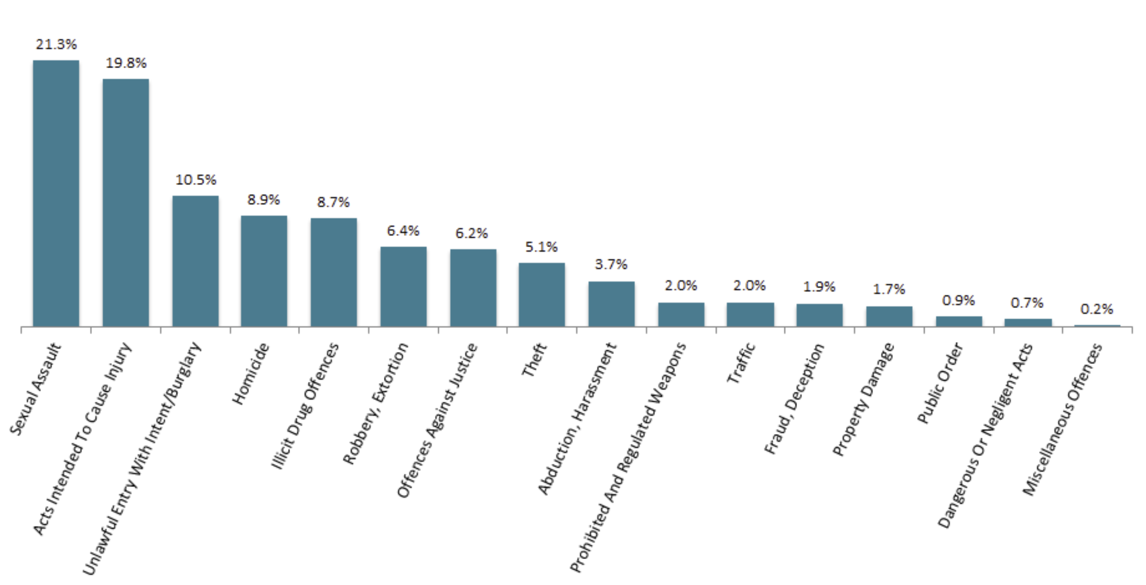

* Prisoners may be convicted of offences across multiple categories. This information is based on the most serious offence a prisoner is convicted of.

Source: Department of Corrections (2023)

According to the NZ Police 2018 Alcohol Action Plan, the average day in New Zealand sees 103 offences recorded in which the alleged offender had consumed alcohol prior to offending (time period not provided) (New Zealand Police 2018).

The New Zealand Arrestee Drug Use Monitoring (NZ-ADUM) study tracked trends in alcohol and other drug use among Police detainees in New Zealand based on interviews with detainees at four central city police watchhouses until 2016. A report presenting data from this study (Wilkins et al. 2017) identified that 28 percent of detainees had consumed alcohol prior to their arrest (relevant period of time not stated), down from 41 percent in 2010 (see Figure 15 below). The authors hypothesise that possible explanations for the reduction include greater use of Pre-Charge Warnings for minor alcohol offences and reduced opening hours for alcohol venues, which may have a greater impact on heavy drinkers.

Figure  Percentage of detainees who had consumed alcohol prior to their arrest

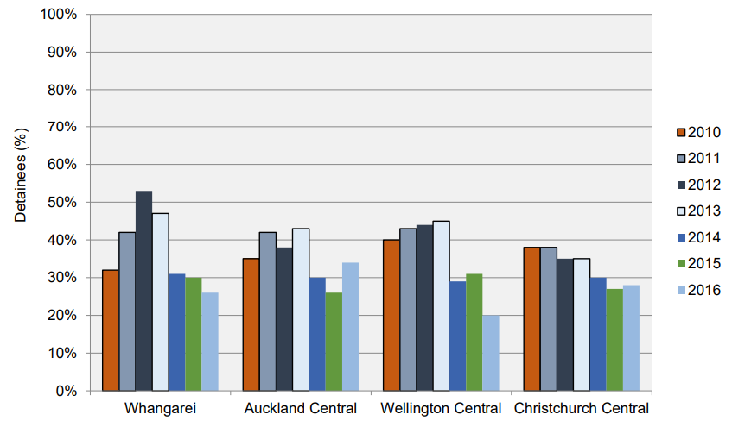

Source: Wilkins et al. (2017)

Detainees in 2016 (the most recent year of data) reported consuming an average of 14 standard drinks prior to their arrest (see Figure 16 below).

Figure  Mean number of standard alcoholic drinks consumed at the time of arrest by location, 2010–2016

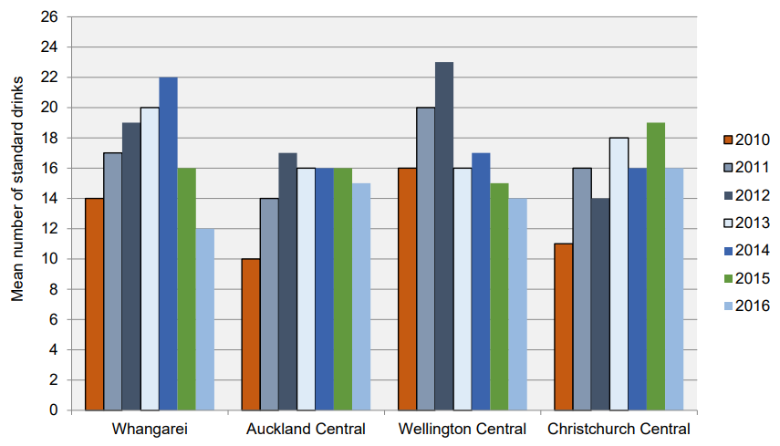

Source: Wilkins et al. (2017)

The establishment of the Alcohol and Other Drugs Treatment Courts in 2012 represented an acknowledgement by the justice sector that a traditional criminal justice approach to offences committed under the influence of alcohol and other drugs is ineffective and that a best practice approach should seek to break the cycle of offending by addressing underlying substance use disorders. Since 2021, there have been three Alcohol and Other Drugs Treatment Courts: the Auckland District Court, the Waitākere District Court, and the Hamilton District Court.

According to Vote Courts estimates, the Alcohol and Other Drug Treatment Courts were funded to a value of $1,284,000 in 2022/23 and were allocated a further $6,887,000 for the period 2023/24 to 2026/27 (Ministry of Justice 2023a). An unknown portion of this cost is attributable to alcohol, as opposed to other drugs.

## Attribution of crime to alcohol

A substantial body of research internationally has explored the question of how much crime is attributable to alcohol. This is challenging to identify at a conceptual level and even more challenging to quantify. While published research has left no doubt that alcohol consumption has often occurred around the time that a crime is committed and that many convicted criminals were under the influence of alcohol at the time they committed the crime for which they have been convicted, the three major difficulties for quantifying costs are:

* separating the effects of alcohol from the effects of illicit drugs, which may be consumed concurrently
* separating the effects of alcohol from the systemic crime inherent in the illicit drug trade with which many convicted criminals may be associated
* identifying causality in any criminal conviction where there are likely to be multiple correlated variables, as well as both measurable contributing factors and confounding factors.

To quantify the extent of alcohol’s involvement in crime, many recent reports have relied on self-reported data obtained from convicted offenders through, for example, the Computerized Assessment of Substance Abuse (CASA) data. One example of a study that used this data to determine the proportion of crimes attributable to alcohol (Young et al. 2021) calculated the number of offenders reporting that the crime of which they were convicted would not have occurred if they had not been intoxicated at the time of their offence. This was determined by a positive response to two questions:

* ‘Were you under the influence of alcohol on the day of the offence?’
* ‘Do you think you still would have committed this offence had you not been drinking?’.

Studies that employ such data face a data validity concern due to the potential inclination of convicted offenders to obfuscate responsibility for their criminal actions and the potentially unrealistic assumptions of convicted offenders regarding the counterfactual in which they would not have consumed alcohol (i.e. their ability to be realistic about whether they would have committed the crime whilst sober, or whether consumption of illicit drugs which may occur in the absence of alcohol may have led to criminal activity anyway).

The estimated attributable fractions vary widely by crime and context. For example:

* A major Canadian study (Young et al. 2021) using data from 2006 to 2016 on nearly 30,000 offenders found that just under 17 percent of all offences were attributable to alcohol, with a higher attributable fraction for violent crime (19.9 percent) than non-violent crime (7.2 percent), while other psychoactive substances were the causal factor in 26 percent of violent crime and 25 percent of non-violent crime.
* An Australian report (Whetton et al. 2021) identified self-reported alcohol-attributable fractions of crime amongst Police detainees, with attribution to alcohol ranging from 4.4 percent for drug offences to 44.8 percent for driving under the influence (DUI) offences, resulting in an average alcohol attribution of 13.7 percent, with a confidence interval of 12.4 to 15.1 percent (see Table 35 below).

Table Self-reported alcohol-attributable fractions of crime amongst Police detainees in Australia

|  |  |  |
| --- | --- | --- |
| Category of crime | Confidence interval | Central estimate |
| Violent | 15.6–20.7 | 18.0 |
| Property | 6.4 –11.0 | 8.4 |
| Drug | 2.3–8.5 | 4.4 |
| DUI | 28.4–63.0 | 44.8 |
| Traffic | 3.2–14.4 | 7.0 |
| Disorder | 20.1–34.8 | 26.8 |
| Breaches | 8.7–14.3 | 11.2 |
| Other | 8.5–7.9 | 19.2 |
| Total | 12.4–15.1 | 13.7 |

Source: Whetton et al. (2021) analysis of data from the Australian Institute of Criminology (AIC) Drug Use Monitoring in Australia (DUMA) collection (2020)

### Recent evidence from New Zealand of causal attribution to alcohol

Because causal attribution to alcohol is highly dependent on context, New Zealand estimates have been a critical missing element of previous reports on the costs of alcohol harms in New Zealand. However, local evidence is beginning to emerge, contributing to an increasingly robust and relevant evidence base.

A major 30-year longitudinal study (Boden, Fergusson, and Horwood 2013) on alcohol misuse and criminal offending in New Zealand indicates a clear causal relationship between alcohol misuse and “impulsive” crimes, such as assault and property damage/vandalism/arson. The estimated causal attribution to alcohol from this study is 9.6 to 9.9 percent of impulsive crimes. This is lower than the total 13.7 percent central estimate reported by Whetton et al. (2021); however, the method of estimation is different, with the New Zealand study using econometric techniques to control for confounding factors and avoid relying on offenders’ own assessments.

## Evidence of alcohol-attributable costs of crime

The costs of crime are substantial and include a wide range of components, each of which must be estimated based on specific unit costs and resource use. These include:

* Police costs
* court costs
* costs associated with sentences, the most significant being the cost of incarceration, but also the costs associated with home detention, parole processes and monitoring
* private costs, including costs associated with crime prevention (alarms, security, etc), insurance, and victim impacts, such as stress or pain and suffering and financial costs)
* costs of services and programmes to support victims of crime.

A major report detailing the costs of crime (all crime, irrespective of attribution to alcohol) in New Zealand was published by The Treasury in 2006, based on 2003/04 data (Roper and Thompson 2006). The total costs of crime for 2003/04 were estimated to be $9.1 billion, with $7 billion representing private sector costs and $2.1 billion representing public sector costs (2003/04 dollars).

While the Treasury report represented a significant contribution to the evidence base for many research studies that require justice sector costs, it has not been updated since. With unit costs being 20 years old, this report no longer provides estimates that can be reasonably applied to obtain comprehensive estimates of the costs of alcohol-attributable crime, with the key concerns being:

* the potential for significant misestimation of current costs due to the use of broad inflation measures to adjust costs over a long period of time
* the potential for justice sector structures, processes and resource use to have significantly changed over a long period of time, resulting in different cost implications.

Three justice sector costs, however, were able to be informed by recent estimates:

* the cost of incarceration for alcohol-attributable crime
* the cost of programmes and services to address family harms attributable to alcohol
* the costs of funeral grants to victims of alcohol-attributable homicides
* the private costs of alcohol-attributable crime (the latter are estimated in section 7).

Even as a small component of the likely costs of crime (and alcohol-attributable crime), incarceration is a significant fiscal cost, an important area of policy concern, and a particularly poor outcome for many people whose actions leading to incarceration are associated with alcohol. According to the Department of Corrections, the average annual cost of housing a prisoner was $90,977 in 2009 (equivalent to $127,105 in 2023). This is broadly consistent with a statement by the Corrections Minister in 2018 that the cost of housing a prisoner was around $100,000 (equivalent to $121,281 in 2023). However, where costs associated with small changes in prison population are being estimated, the Treasury advise that the marginal cost of keeping a person in prison should be used. This is estimated to be $16,893 per annum in 2023 dollars (Treasury 2022).

## Estimated costs to government of incarceration for alcohol-attributable crime

The fiscal costs of incarceration attributable to alcohol are a function of:

* the number of people convicted and sentenced to prison
* the fraction of prison sentences that are attributable to alcohol
* the length of prison sentences
* the fraction of prison sentences served
* the cost per person per year of incarceration.

We estimate the alcohol-attributable fraction using the estimates of Boden, Fergusson, and Horwood (2013) applied to crimes that are likely to be impulsive (9.6 to 9.9 percent). This assessment was made based on Ministry of Justice data describing categories of offences using the Australian and New Zealand Standard Offence Classification (ANZSOC). We classified each crime at the subdivision level based on definitions, inclusions and exclusions, and an assessment of whether such crimes are likely to be committed impulsively, erring on the side of inclusion due to the relatively low attributable fraction and the low number of crimes where impulsivity was less clear (see Appendix F).

Because it is unclear whether the impact of alcohol on the overall prison population would be considered small enough to warrant the use of marginal costs rather than average costs, we use two unit costs:

* a value of $125,000 per year to represent the average cost of housing a prisoner – a round number between the two values described in the previous section
* a value of $16,893 per year to represent the marginal cost of housing an additional prisoner for an additional year (the value proposed by the Treasury).

The Ministry of Justice provided a dataset of prison sentences, the number of people sentenced, and the ANZSOC categories and subdivisions for 2022, as well as an estimate of the length of prison sentences served (59 percent) based on the most recent year of prisoners released. These include incarcerations for first offences and subsequent offences that occur each year.

Consistent with other reports estimating this cost, we estimate the total discounted cost of the entire sentence expected to be served as a cost incurred in 2023.

The estimated fiscal cost of incarceration for alcohol-attributable crime is approximately $41.4 million for 2023, based on the midpoint of causal attribution estimated by Boden, Fergusson, and Horwood (2013) (see Table 36 below).

Table Estimated fiscal costs of incarceration for alcohol-attributable crime

2023

|  |  |
| --- | --- |
| Parameter | Value |
| Total discounted years served for impulsive crimes | 3,398 |
| Fiscal cost per year served in prison (average) | $125,000 |
| Fiscal cost per year serviced in prison (marginal) | $16,893 |
| High fiscal cost of years served for impulsive crimes (based on average cost) | $424,717,521 |
| Low fiscal cost of incarceration for impulsive crimes (based on marginal cost) | $57,398,022 |
| Midpoint alcohol-attributable fraction | 0.0975 |
| High value of alcohol-attributable productive years lost (based on average cost) | $41,413,125 |
| Low value of alcohol-attributable productive years lost (based on marginal cost) | $5,596,735 |

Source: NZIER, based on Boden, Fergusson, and Horwood (2013) and Ministry of Justice data

## Estimated costs of programmes and services to address family harms

The Ministry of Justice funds a range of programmes, contracted through 80 service providers of safety and non-violence programmes across the country to address family violence and its impacts. These include:

* the Non-Violence Programme
* the Adult Safety Programme
* the Child Safety Programme
* the Strengthening Safety Service.

In 2022/23, nearly 13,000 referrals have been made to these programmes (more than one referral per individual or family is possible).

The cost of these programmes in 2022/23 was $14,503,516 (cost estimate supplied by the Ministry of Justice). Based on the midpoint of IPV and child maltreatment alcohol-attributable fractions (9.2 percent – see sections 4.1 and 4.2), the cost attributable to alcohol for these programmes and services is $1,334,323.

In addition to the programmes above, the Ministry of Justice funds Whānau Protect, a service designed for people at high risk of experiencing family violence that aims to enhance safety by implementing practical measures enabling them to remain in their homes.

According to the Ministry of Justice, 998 people or families (the number of individuals is not known) have been involved with Whānau Protect in 2022/23, with service costs amounting to $3,547,880.

Based on the midpoint of IPV and child maltreatment alcohol-attributable fractions (9.2 percent), the cost attributable to alcohol for Whānau Protect is $326,405.

## Funeral grants for victims of homicide

The Ministry of Justice funds funeral grants to help families of homicide victims to cover the costs of a funeral. The grants are administered by ACC on behalf of the Ministry of Justice.

In 2022/23, the Ministry of Justice funded funeral grants for a total of $143,234.

Based on homicide being a potentially impulsive crime and the alcohol-attributable fraction of impulsive crimes being 9.6 to 9.9 percent (Boden, Fergusson, and Horwood 2013), the annual alcohol-attributable cost of funeral grants to the Ministry of Justice is between $13,750 and $14,180.

## Limitations of estimated justice sector costs of alcohol harms

Despite the recent emergence of evidence that provides some degree of confidence in the causal attribution of impulsive crimes to alcohol in New Zealand, the New Zealand evidence base still reflects the same important gaps that affect overseas evidence, including:

* a lack of granularity in the alcohol-attributable fraction of impulsive crimes that would allow alcohol’s role in different types of crime to be separately identified and costed with more confidence
* a lack of evidence regarding alcohol’s role in non-impulsive crimes, which may be less than for impulsive crimes but may also not be negligible (even low attributable fractions for high prevalence, high-cost crimes can translate into high social and economic costs overall)
* a lack of evidence regarding the role of crime victims’ and bystanders’/witnesses’ alcohol consumption, which may increase the alcohol-attributable fraction of crime (and is likely to be associated with under-reporting of crime and may impact on charges and convictions, potentially increasing perpetrators’ opportunities to re-offend by reducing the probability of incarceration).

Additionally, justice sector data does not describe the role of FASD and the associated neurological impairments that may result in non-alcohol-induced criminal activity and consequential justice sector costs. It is believed that a significant fraction of corrections clients have FASD (see, for example, Butcher 2020); however, this fraction has not been confirmed in the New Zealand context.[11]

The current evidence base is lacking in these respects, resulting in any associated costs effectively being ignored and suggesting that what cost estimates are supported by the evidence are likely to be underestimates of the true cost of alcohol-attributable crime.

# Victims of crime private costs

Crime – including alcohol-attributable crime – can have significant costs, not just to those who are arrested and convicted and to the system that bears the administrative costs: The latest New Zealand Crime and Victims Survey (NZCVS), released by the Ministry of Justice in June 2023, found that nearly a third of adults (29.93 percent) have been the victims of personal and household crime once or more within the 12 months prior to data collection (which took place between November 2021 and November 2022).

The rate of victimisation varies by ethnicity, with Māori being most likely to report being victims of crime.

Figure  Percent of adults reporting they have been a victim of crime by ethnicity

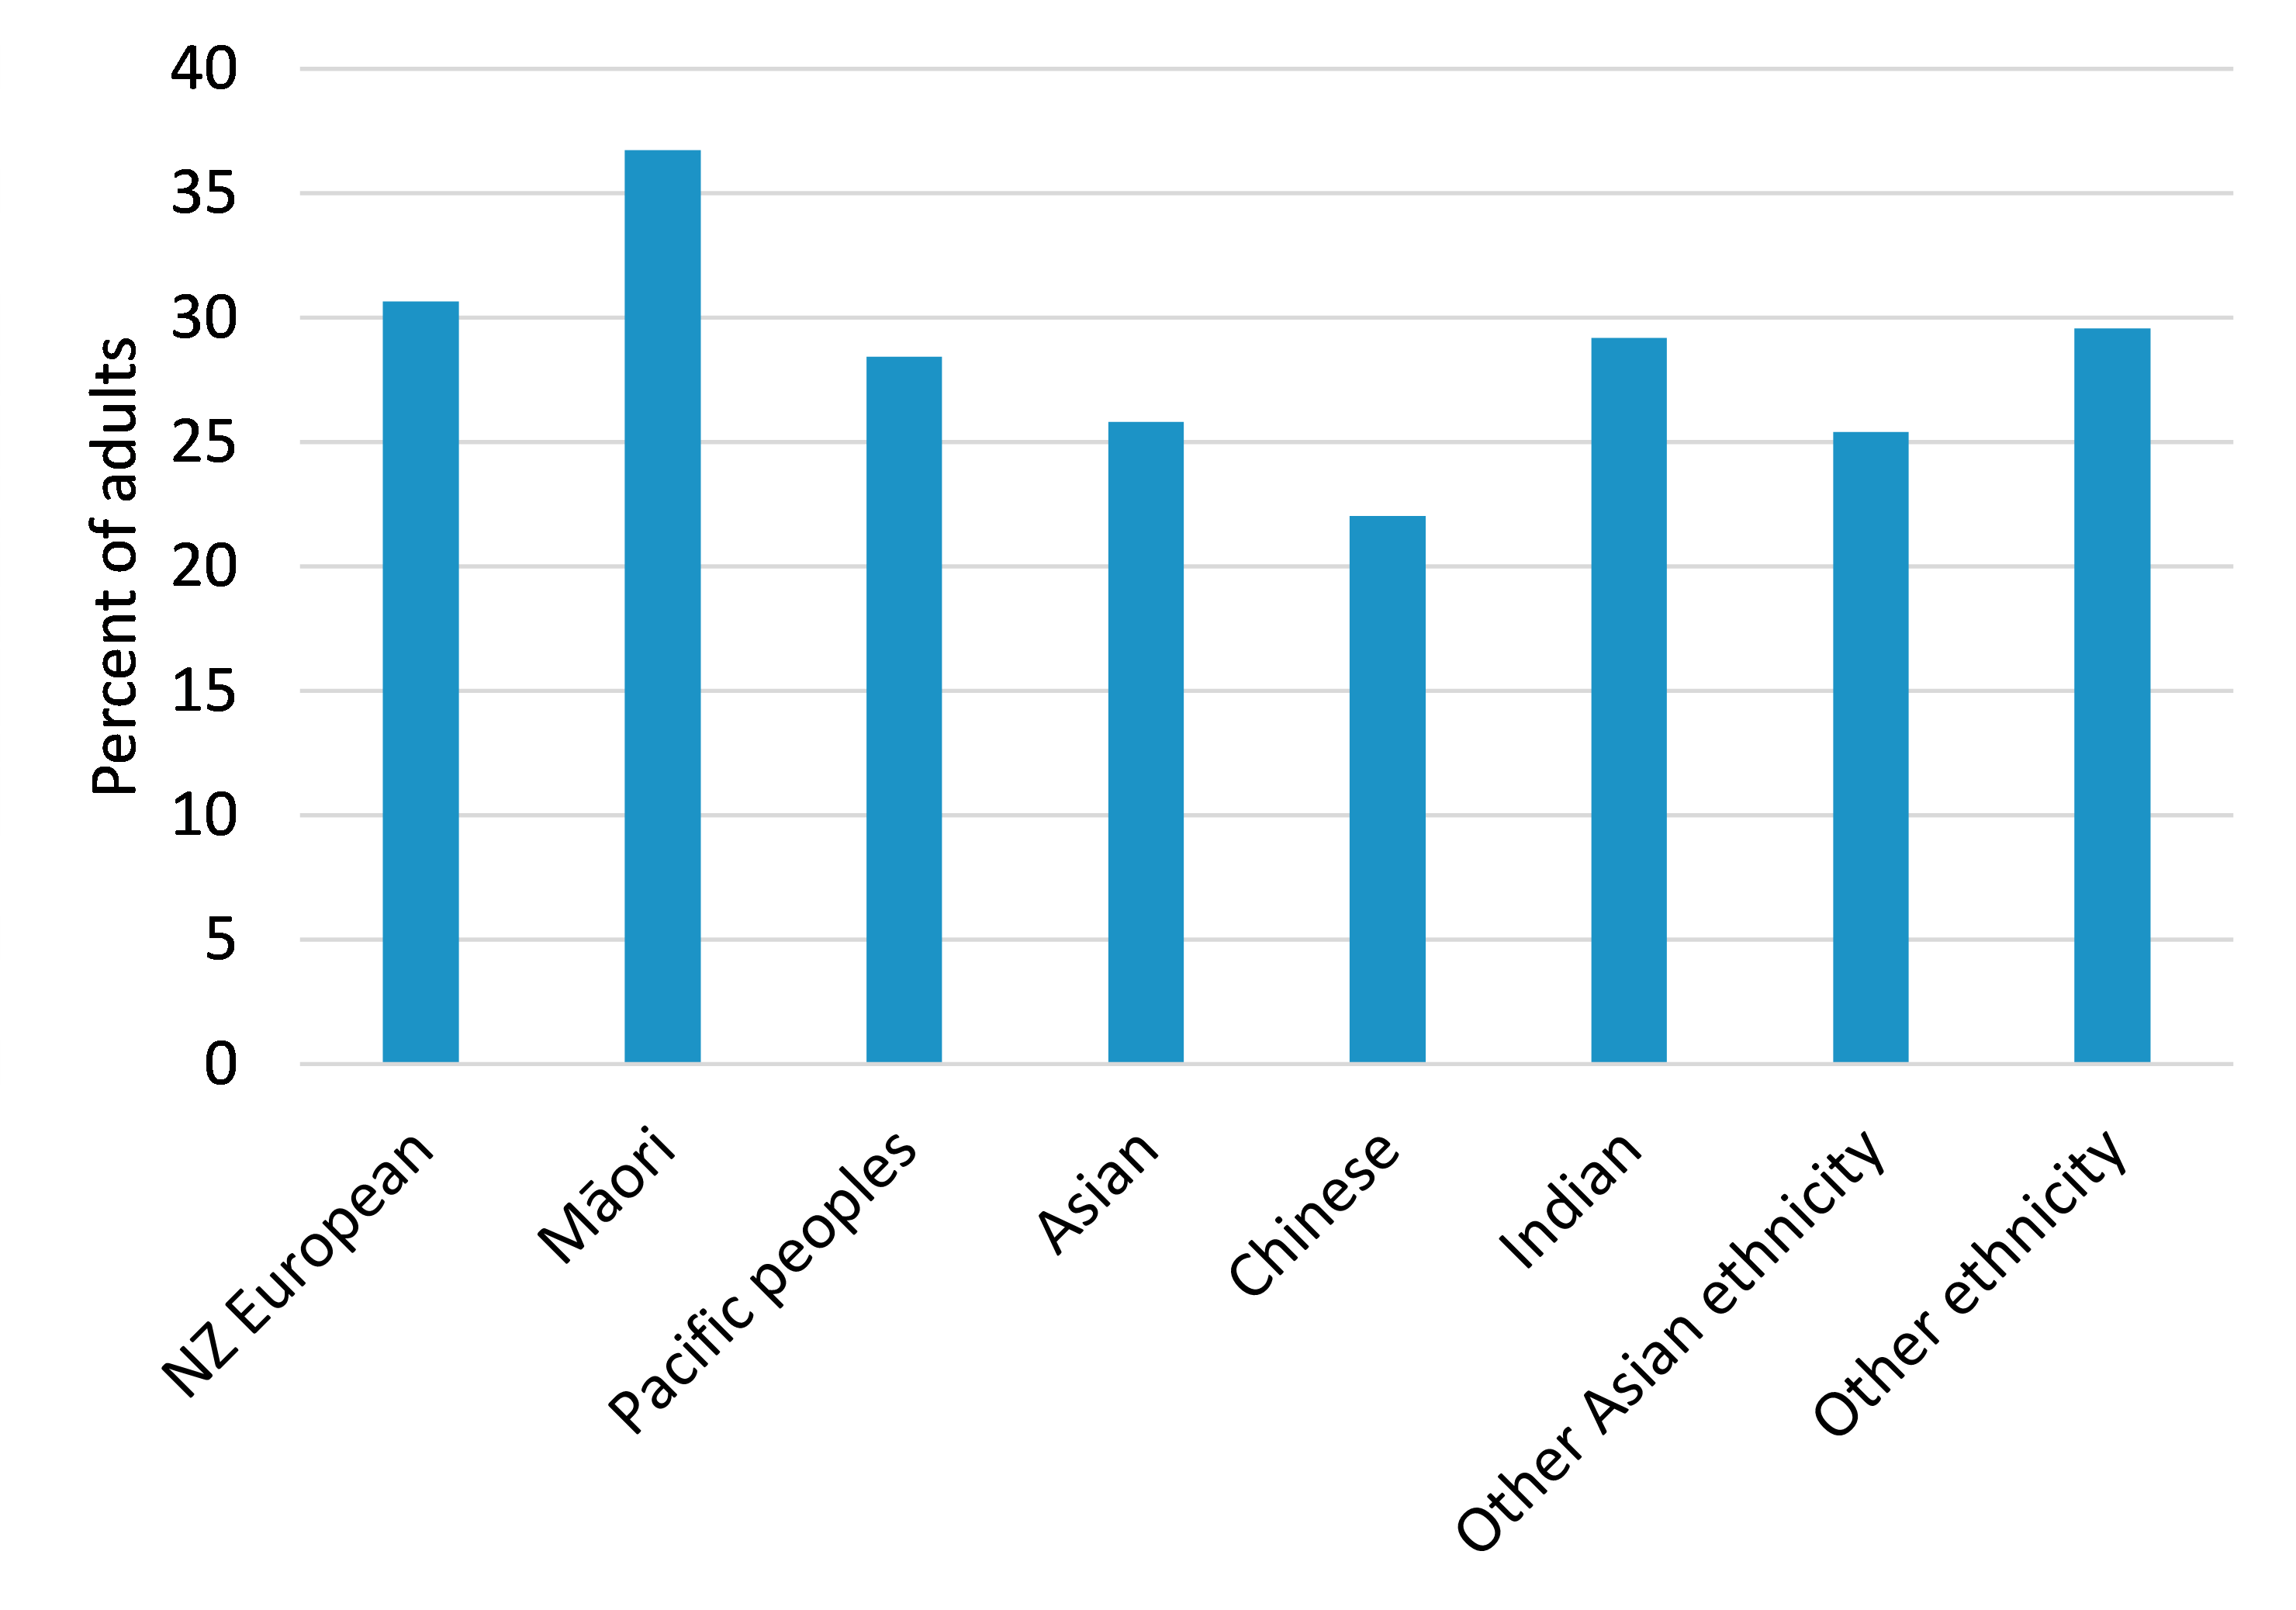

Source: NZIER, based on the New Zealand Crime and Victims Survey Cycle 5

More than one in ten adults (11 percent) reported they had been a victim of crime more than once for the 12 months prior to data collection (see Figure 18 below).

Figure  Percent of adults reporting they have been a victim of crime, by number of occurrences

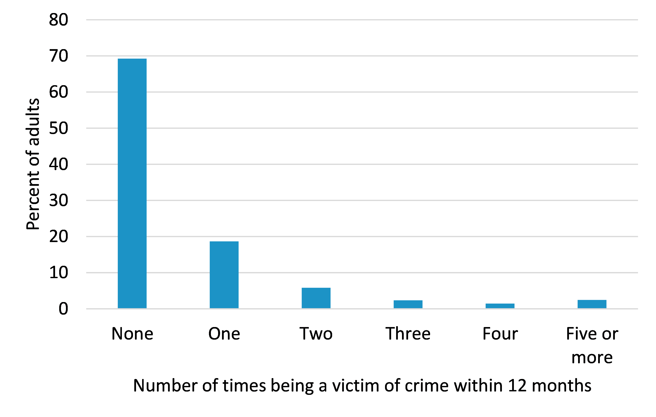

Source: NZIER, based on the New Zealand Crime and Victims Survey Cycle 5

The New Zealand Victims of Crime Survey categorises crimes as:

* Household offences, including:
  + Burglary
  + Theft of/unlawful takes/converts motor vehicle
  + Theft (from motor vehicle)
  + Unlawful interference/getting into motor vehicle
  + Damage to motor vehicles
  + Unlawful takes/converts/interferes with bicycle
  + Property damage (household)
  + Theft (except motor vehicles – household)
  + Trespass
* Personal offences, including:
  + Theft and property damage (personal)
  + Robbery and assault (except sexual assault)
  + Fraud and deception
  + Cybercrime
  + Sexual assault
  + Harassment and threatening behaviour.

Some additional descriptions are provided, but unlike Ministry of Justice data on incarceration, the ANZSOC category and subdivision is not identified, so these data do not align perfectly.

## Estimation of victims of crime private costs attributable to alcohol

To estimate an alcohol-attributable cost of crime, we assume all crimes categorised as household offences are likely to be impulsive crimes and that all crimes categorised as personal offences, except for fraud, deception and cybercrime, are likely to be impulsive crimes. We further assume the number of crimes and crime victims will remain the same in 2023. See Table 37 below.

Table Number of offences reported in the NZ Crime and Victims Survey

And estimated number of impulsive offences

|  |  |
| --- | --- |
| Crime category | Number of offences |
| **Household offences** |  |
| Burglary | 288 |
| Theft of/unlawful takes/converts motor vehicle | 43 |
| Theft (from motor vehicle) | 33 |
| Unlawful interference/getting into motor vehicle | 16 |
| Damage to motor vehicles | 58 |
| Unlawful takes/converts/interferes with bicycle | 11 |
| Property damage (household) | 64 |
| Theft (except motor vehicles – household) | 47 |
| Trespass | 57 |
| **Personal offences** |  |
| Theft and property damage (personal) | 57 |
| Robbery and assault (except sexual assault) | 253 |
| Fraud and deception | 510 |
| Cybercrime | 99 |
| Sexual assault | Data suppressed* |
| Harassment and threatening behaviour | Data suppressed* |
| Total offences | 1,536 |
| Total impulsive offences | 927 |

*Value suppressed by the Ministry of Justice due to a high level of statistical uncertainty (estimates with a relative sampling error of more than 50 percent or a margin of error higher than 20 percentage points). The implication of this is likely underestimation. Sexual assault convictions are highly prevalent within the incarcerated population, and the under-reporting of this crime is believed to be substantial.

Source: NZIER, based on the New Zealand Crime Victims Survey Cycle 5

The number of adults victimised by crime type is only reported for broad offence groups, but the grouping of fraud and cybercrime offences, which are not typically impulsive crimes, means that people victimised by this type of crime can be subtracted from the total number of crime victims. In Cycle 5 of the survey, 500 adults were victims of fraud and cybercrime, leaving 777 adult victims of impulsive crimes, experiencing an average of 1.2 crimes over 12 months.

Private costs can be estimated using a range of techniques. One technique known as subjective valuation estimates the amount of annual income required to compensate individuals for the tangible and intangible costs of crime. The Treasury provides two alternative estimates of the 2023 private cost to victims of crime derived using subjective valuation techniques: a low value of $3,706 and a high value of $8,388 (The Treasury 2022, Smith and Davies 2020). These costs do not represent all private costs of crime but rather the portion of private costs that people do not expect to receive some form of compensation for (over and above insurance and publicly funded services).

For a conservative approach, we use the Treasury’s low estimate of $3,706[12] (The Treasury 2022) and the midpoint of alcohol attribution estimated by Boden, Fergusson, and Horwood (2013). This produces an estimated private cost of alcohol-attributable crime in 2023 of $280,757.

Table Estimated private alcohol-attributable cost of impulsive crimes

(in excess of individuals’ expected compensation from insurance and publicly-funded services)

|  |  |  |  |
| --- | --- | --- | --- |
|  | Low estimate | Midpoint estimate | High estimate |
| Victims of impulsive crimes (New Zealand Crime Victims Survey Cycle 5) | 777 | 777 | 777 |
| 2023 private annual cost per victim of crime (low and high values, Treasury 2022) | $3,706 | $6,047 | $8,388 |
| Total 2023 private cost of impulsive crimes | $2,879,562 | $4,698,519 | $6,517,476 |
| Alcohol attribution (Boden, Fergusson, and Horwood 2013) | 9.60% | 9.75% | 9.90% |
| Alcohol-attributable cost of impulsive crimes | $276,438 | $458,106 | $645,230 |

Source: NZIER, based on Boden, Fergusson, and Horwood (2013), The Treasury (2022), and the New Zealand Crime Victims Survey Cycle 5

## Limitations of the victims of crime private alcohol-attributable costs

It is important to note that the estimated private alcohol-attributable cost of crime presented here represents only a small portion of the total private costs of alcohol-attributable crime: the financial compensation that individuals require over and above what they expect to receive from other sources (e.g. publicly-funded services, insurance) to cover tangible and intangible costs. Being based on private individual subjective valuation, and the non-suppressed data provided by the New Zealand Victims of Crime Survey, the estimate excludes:

* private costs of alcohol-attributable crime to businesses and institutions (including costs of crime prevention such as security systems and staff, insurance, and lost output)
* costs of alcohol-attributable crime to local councils (the Treasury cost of crimes report included these as private costs)
* costs of crime prevention and insurance to individuals and private households
* costs of alcohol-attributable sexual assault and alcohol-attributable harassment and threatening behaviour (due to suppression by the Ministry of Justice of the number of victims of these crimes).

The impact of the above exclusions is likely an underestimation of the private costs of crime, even with the definition of these restricted to exclude private costs that will be compensated for.

While the Treasury’s (2006) report on the costs of crime presented estimates of costs of crime based on a more comprehensive list of cost components, the underlying data and evidence are now over 20 years old, and some of the original cost data for that report was derived from UK sources. These considerations make adapting the published figures inappropriate and highlight the critical gap in evidence that has emerged as this key piece of research has aged.

# Social development sector costs

## Disability benefits

Some people with long-term disability attributable to alcohol may be eligible to receive a disability benefit, the two main disability benefits being:

* The Disability Allowance, a weekly payment for people of all ages who have regular, ongoing costs because of a disability. These could be visits to the doctor or hospital, medicines, extra clothing or travel (Work and Income, n.d.).
* The Child Disability Allowance, a fortnightly payment made to carers of children (aged under 18) with a serious disability in recognition of the extra care and attention needed for the child. For example, where a child is disabled due to injuries sustained in a road crash caused by an intoxicated driver, the caregivers of the child can receive this payment in recognition of the additional care the child needs.

The Disability Allowance is based on a needs assessment, so it varies according to individuals, their disabilities and their circumstances, whereas the Child Disability Allowance is a standard amount of $56.60 per fortnight for every eligible child.

To estimate the alcohol-attributable disability benefit cost, we used data from the Ministry of Social Development identifying the number of disability allowances and the average weekly disability allowance in September 2022 (Ministry of Social Development 2023), and the number of recipients of the child disability allowance along with the standard fortnightly payment in September 2022 (Ministry of Social Development 2023). The data does not indicate that the number of individuals receiving these benefits would be expected to increase year on year with population growth, but we adjust the 2022 values to 2023 to reflect inflation, except in the case of the Child Disability Allowance, which is adjusted periodically (the 2023 value remains the same as the 2022 value).

For attribution to alcohol, we focus on disability allowances paid to people who experience disability due to injury based on:

* The New Zealand 2013 Disability Survey, which identified that in New Zealand, 34 percent of adult disability and 3 percent of child disability is caused by accident or injury.
* The average alcohol-attributable fraction for injuries: 16.2 percent. We apply this fraction to the Child Disability Allowance and the Disability Allowance paid to people under 18, as well as the Disability Allowance. Although, the AAF was derived on the basis of people aged 15+ only. A high level of uncertainty regarding the use of the AAFs for this purpose is of relatively low significance given the very low fraction of disability attributable to injury, as indicated by the New Zealand Disability Survey.

Even though medical conditions may cause disability, we do not apply the non-injury AAFs to disability allowances because the proportion of adult and child disability that is not caused by injury includes not just disability caused by medical conditions but also disability associated with genetic and chromosomal conditions and neurodevelopmental disorders.

Based on this approach, we estimate that the total disability benefits cost attributable to alcohol in 2023 is approximately $1.4 million (see Table 39 below).

Table Estimated cost of disability benefits attributable to alcohol

|  |  |  |  |
| --- | --- | --- | --- |
|  | Count | 2022 value* | 2023 value |
| Disability allowance | 219,684 | $22,109,460 | $23,657,122 |
| Child disability allowance** | 44,511 | $10,077,290 | $10,077,290 |
| Disability allowance cost due to injury (34% for adults, 3% for children) |  | $7,510,469 | $8,036,202 |
| Child disability allowance cost due to injury (3%) |  | $302,319 | $302,319* |
| Disability allowance cost due to alcohol-attributable injury (16.2%) |  | $1,218,157 | $1,303,428 |
| Child disability allowance cost due to alcohol-attributable injury (16.2%) |  | $49,034 | $49,034* |
| Total disability benefits cost attributable to alcohol |  | $1,267,191 | $1,352,462 |

*We estimate the 2022 annual value of the disability allowance and child disability allowance based on the September 2022 quarter cost by multiplying by 4.

**The 2023 Child Disability Allowance payment, and therefore cost, remains at the 2022 level.

Source: NZIER, based on MSD data, New Zealand 2013 Disability Survey and AAFs from Chambers and Mizdrak (forthcoming).

Because disability benefits are intended to compensate for some of the costs associated with living with a disability (extra care and attention for disabled children and ongoing costs of services, medicines, personal items or travel for disabled adults), a portion of the underlying cost of alcohol-attributable disability is effectively double counted when this estimate and the estimate of the value of increased risk of mortality and morbidity estimated in section 3 are counted together. This is because the valuation of health-adjusted life years – the methodology used in section 3 – typically reflects such considerations. Consideration of these estimates, therefore, should note that they represent different perspectives regarding cost burden rather than separate costs amenable to aggregation.

## Limitations of estimates of social development sector costs

We estimated the costs of disability benefits specifically due to the availability of data on payments and beneficiaries, as well as the fraction of long-term disability caused by injury and the fraction of injuries attributable to alcohol.

It is important to note that disability benefits do not provide a complete cost for benefits associated with disability. Depending on the specific needs of disabled people, they may also receive a range of other benefits for:

* home modifications
* modifications at work
* transport and mobility
* communication equipment
* sole parent support
* jobseeker support
* supported living payment
* new employment transition.

It is not possible to estimate the alcohol-attributable costs of these other benefits because disabled people may receive different combinations of these depending on their circumstances, and those with alcohol-related disability may have quite different needs and circumstances than other recipients. However, the wide range of potential costs associated with alcohol-attributable disability indicates that this cost area is likely to be significantly underestimated.

Additionally, the Ministry of Social Development funds a range of programmes and services to address family harms, with approximately 10 percent of these being attributable to alcohol use disorders or hazardous drinking (see section 4) and more potentially being attributable to other alcohol consumption. Costings of these programmes and services were not available for this report.

# Productivity losses

Alcohol impacts productivity in many ways, with three major impacts being productivity losses associated with health impacts, productivity losses associated with justice sector impacts, and workplace productivity losses.

In this section, we estimate the value of lost productivity associated with these issues.

## Premature deaths attributable to alcohol

Alcohol consumption is a major risk factor for premature mortality worldwide. Premature mortality attributable to alcohol can be estimated from mortality data and the application of alcohol-attributable fractions.

When writing this report, the latest year for which complete mortality data was available from Te Whatu Ora’s Mortality Collection was 2018. We effectively assume, by using this data, that alcohol-attributable deaths in 2023 are similar in number as well as in age, sex, and ethnicity distribution.

To estimate productivity loss attributable to premature mortality, we impose an age cut-off of 65, implicitly assuming people do not work beyond age 65 – a common assumption in the estimation of productivity losses with little likelihood of significant impact due to low labour force participation rates over age 65 and the application of discounting to future years of earnings.

As shown in the tables below, between 9,015 and 11,132 productive life years were lost due to alcohol-attributable premature mortality in 2018. The greatest number of lost productive years was in the 45-to-54-year age group, where 22 percent of productive years were lost. However, all age groups from 15-24 to 45-54 lost substantial amounts of productive years, amounting to between 19 percent and 22 percent of the total.

Table Estimated productive years lost to alcohol-attributable premature mortality

Based on an assumption of productive years to age 65

|  |  |  |  |
| --- | --- | --- | --- |
|  | Low estimate | Midpoint estimate | High estimate |
| Total years | 9,015 | 10,196 | 11,132 |

Source: NZIER, based on Chambers and Mizdrak (forthcoming) and Mortality Collection data supplied by Te Whatu Ora

Table Estimated productive life years lost to alcohol-attributable premature mortality by ethnicity and age group

Based on an assumption of productive years to age 65

|  |  |  |  |
| --- | --- | --- | --- |
|  | Low estimate | Midpoint estimate | High estimate |
| **By ethnicity** |  |  |  |
| Māori | 2,999 | 3,387 | 3,693 |
| Non-Māori | 6,016 | 6,809 | 7,438 |
| **By age group** |  |  |  |
| 15–24 | 1,630 | 1,924 | 2,170 |
| 25–34 | 1,935 | 2,205 | 2,428 |
| 35–44 | 1,945 | 2,184 | 2,372 |
| 45–54 | 2,090 | 2,325 | 2,500 |
| 55–64 | 1,416 | 1,557 | 1,661 |

Source: NZIER, based on Chambers and Mizdrak (forthcoming) and Mortality Collection data supplied by Te Whatu Ora

## Costs associated with lost productivity due to alcohol-attributable premature death

On the assumption that the counterfactual for people who experience alcohol-attributable premature mortality would include average labour force participation, employment rate and employment earnings, we calculate the value of lost productivity by applying average labour force participation rates and earnings from wages, salaries and self-employment to each 5-year age-sex group across the remaining lifetime of individuals until age 65, using 2022 data (the most up-to-date labour market values available). Stats NZ publishes these for interactions between two demographic variables only. Our calculations use the age-sex interactions and apply these labour market outcomes regardless of ethnicity.

To obtain the value of lost productivity in the year that all future productivity of the individual is lost due to death, we discount the estimated expected productivity in future years at a rate of 5 percent per annum. We then inflate the 2022 values to 2023.

Table 42 below shows the discounted value of lost productivity due to alcohol-attributable mortality, which is estimated to be between $344 million and $417 million (midpoint $385 million).

Table Estimated total cost of lost productivity due to alcohol-attributable premature mortality

Based on an assumption of average productivity

|  |  |  |  |
| --- | --- | --- | --- |
|  | Low estimate | Midpoint estimate | High estimate |
| Total | $343,840,396 | $385,015,333 | $416,715,189 |

Source: NZIER, based on Chambers and Mizdrak (forthcoming) and Mortality Collection data supplied by Te Whatu Ora

Applying the value of lost productivity by sex and age group to each ethnicity, we obtain estimates of the value of lost productivity for Māori and non-Māori (see Table 43 below).

Table Estimated total cost of lost productivity due to alcohol-attributable premature mortality by ethnicity and age group

By ethnicity and age group

|  |  |  |  |
| --- | --- | --- | --- |
| Age group | Low estimate | Midpoint estimate | High estimate |
| **By ethnicity** |  |  |  |
| Māori | $107,435,165 | $119,904,334 | $129,515,386 |
| Non-Māori | $236,405,231 | $265,110,998 | $287,199,803 |
| **By age group** |  |  |  |
| 15–24 | $38,898,979 | $45,830,545 | $51,548,233 |
| 25–34 | $64,996,698 | $73,939,817 | $81,232,348 |
| 35–44 | $79,588,256 | $88,999,044 | $96,271,606 |
| 45–54 | $95,385,983 | $105,382,382 | $112,638,027 |
| 55–64 | $64,970,481 | $70,863,544 | $75,024,975 |

Source: NZIER, based on Chambers and Mizdrak (forthcoming) and Mortality Collection data supplied by Te Whatu Ora

## Lost productivity associated with hospitalisation for alcohol-related conditions

Working-age New Zealanders (aged 15 to 64) admitted to hospital lose some amount of potential working hours, which may translate into productivity loss. We estimate the potential value of productivity loss associated with time spent in hospital on the assumption that people hospitalised for alcohol-attributable conditions and injuries have average labour force participation, employment rate and employment earnings, using the same data as previously described.

We further assume that days spent in hospital are all potentially productive days. The implication of this assumption is that estimates represent some combination of paid and unpaid production due to the inclusion of days when individuals may not have engaged in paid work (e.g. Saturdays and Sundays). This assumption was preferred to one where Saturdays and Sundays are assumed not to be productive because many people work these days and/or work more than five days a week. As in previous calculations, because the labour market data we use is 2022 data, we inflate the values to 2023.

As shown in Table 44 and Table 45 below, the total value of lost productivity is estimated to be between $12 million and $14 million (midpoint $13 million) in 2023.

Table Estimated total cost of lost productivity associated with time spent in hospital

|  |  |  |  |
| --- | --- | --- | --- |
|  | Low estimate | Midpoint estimate | High estimate |
| Total | $11,940,177 | $13,097,390 | $13,917,231 |

Source: NZIER, based on Chambers and Mizdrak (forthcoming) and Mortality Collection data supplied by Te Whatu Ora

Table 45 below shows these results when productivity costs are calculated by Māori/non-Māori ethnicity and age group.

Table Estimated cost of lost productivity in 2023 associated with time spent in hospital by ethnicity and age group

|  |  |  |  |
| --- | --- | --- | --- |
|  | Low | Midpoint | High |
| **By ethnicity** |  |  |  |
| Māori | $2,775,180 | $3,051,167 | $3,243,298 |
| Non-Māori | $9,164,997 | $10,046,223 | $10,673,933 |
| **By age group** |  |  |  |
| 0–14 | n.a. | n.a. | n.a. |
| 15–24 | $492,312 | $550,515 | $596,797 |
| 25–34 | $1,623,524 | $1,800,747 | $1,938,161 |
| 35–44 | $2,185,787 | $2,394,683 | $2,547,398 |
| 45–54 | $3,661,458 | $4,005,269 | $4,242,153 |
| 55–64 | $3,977,095 | $4,346,177 | $4,592,722 |
| 65–74 | n.a. | n.a. | n.a. |
| 75–99 | n.a. | n.a. | n.a. |

Source: NZIER, based on Chambers and Mizdrak (forthcoming) and NMDS data supplied by Te Whatu Ora

## Lost productivity associated with alcohol-attributable injuries and disability

In section 5.4, we estimated the cost to ACC of paying income compensation for people who are unable to work due to alcohol-attributable injuries. As ACC pays up to 80 percent of a person’s usual income in weekly compensation, it is possible to estimate the value of productivity loss associated with these injury cases. For 2022, the most recent year of ACC claims available, we estimated the total weekly compensation costs attributable to alcohol to be $339 million. Based on this figure representing 80 percent of the income that would have been earned in the absence of alcohol-attributable injury, the estimated productivity loss is $424 million (See Table 46 below).

Table Estimated cost of productivity loss associated with alcohol-attributable injuries and disability

|  |  |  |
| --- | --- | --- |
|  | 2022 value | 2023 estimate |
| ACC weekly compensation claims | $316,567,142 | $338,726,842 |
| Compensation fraction of earnings |  | 80% |
| Value of productivity loss associated with alcohol-attributable injuries disability |  | $423,408,522 |

Source: NZIER, based on Chambers and Mizdrak (forthcoming) and data supplied by ACC

It is important to note that, like the weekly compensation claims costs to ACC, the productivity loss estimate derived from these claims only represents the value of lost production that would have been paid for by employers of people who experience short-term disability. It excludes any productivity impairment that may affect non-market activity/production and therefore under-represents lost productivity overall as well as for population groups that are less likely to be in paid employment, including children, young adults, older people, women and Māori.

For children and adults receiving the disability allowance or disability benefit, we do not estimate lost productivity as their receipt of a disability benefit does not mean the individual is not working or that their productivity is impaired. These benefits are paid to compensate for additional costs faced by disabled people and/or their carers, not to compensate for lost income. Many people receiving the disability benefit are in employment, and many disabled people do not experience productivity impairment as a result of their disability. The available data does not indicate the proportions of employed and unemployed recipients of disability benefits.

## Productivity losses due to incarceration

Productivity losses experienced by people who are incarcerated as a result of alcohol-attributable crime should be counted as alcohol-attributable. Most reports that estimate the costs of alcohol harms make a broad assumption that people who are incarcerated are unproductive due to their incarceration. However, this assumption does not hold in reality. Many prisoners are, in fact, productively employed, including in some cases in paid employment outside of prisons while serving their sentence. There are three different types of work that may be performed by prisoners:

* general prison maintenance, like cooking and cleaning (prisoners may be required to do this work, and it provides value to the corrections system by reducing the operational costs of prisons) (Community Law 2023).
* industry work experience, such as construction, farming or engineering (prisoners cannot be required to undertake this work, but is often performed on a voluntary basis) (Community Law 2023).
* work release programmes, which allow minimum security prisoners and some low and medium-security prisoners to work for employers outside of the prison (prisoners cannot be required to undertake this work, but is often performed on a voluntary basis and prisoners are paid wages from which the prison may deduct costs for housing and food, as well as any money owed for property damage, unpaid fines or reparation, child support, and costs of travel to and from work) (Department of Corrections 2022).

#### Estimating the productive prison workforce

According to the Department of Corrections, of the 8,294 on-site prison population:

* 36 percent are classified as minimum security (source)
* 20.4 percent are classified as low security
* 25.1 percent are classified as low medium security.

The Department of Corrections (2022) indicates that over 59 percent of prisoners participate in employment or industry training, translating into 4,893 people, but does not provide a breakdown that would allow employment to be separately identified from training. We make the following assumptions:

* labour force participation and employment in the 36 percent of prisoners classified as minimum security mirrors the general population’s average labour force participation and employment, resulting in 2,986 prisoners employed on work release programmes
* 1,907 other prisoners (the remaining prisoners participating in employment or industry training) are productively employed either within the prison or in voluntary work experience programmes, with an assumed average of half the productivity of the average minimum-security prisoner, reflecting the reduced but not unavailable work opportunities for this group, equivalent to 954 prisoners employed full time.

As a result of these assumptions, 52.5 percent of the time in prison is estimated to be unproductive, with prisoners engaged in training with no immediate production value (e.g. education programmes) or not engaged in any training or employment.

#### The counterfactual

The counterfactual employment scenario for incarcerated individuals is not known. It is not even known that productivity is lower in prison than out of prison. With a high level of employment through prison programmes, the productivity of this group could, in fact, be higher than in the counterfactual. For example, an Australian study (Giles and Le 2007) found that people who were incarcerated had a very low employment rate pre-incarceration (44 percent), indicating that the counterfactual is not likely to be an average labour market scenario.

We calculate productivity loss values based on two possible counterfactuals for people incarcerated for alcohol-attributable crimes:

* High productive value scenario:
  + average employment rate
  + total earnings based on full-time employment at median earnings.
* Low productive value scenario:
  + low employment rate (44 percent, based on Giles and Le 2007)
  + minimum wage earnings.

#### Cost estimation

Table 47 below compares the estimated cost of productivity lost due to alcohol-attributable incarceration based on Ministry of Justice data under the two counterfactual productivity scenarios. These result in a range of $3.4 million to $7.4 million in lost productivity for 2023, with a midpoint of $5.4 million.

Table Estimated cost of productivity lost due to alcohol-attributable incarceration

|  |  |
| --- | --- |
| Parameter | Value |
| Total discounted sentenced years of prison for impulsive crimes | 5,758.88 |
| Average % of sentence served | 59% |
| Total discounted served years of prison for impulsive crimes | 3,397.74 |
| Unproductive % of prison time | 53% |
| Total discounted non-productive years lost due to prison for impulsive crimes | 2,395.41 |
| Low productive value of year | $19,176.96 |
| High productive value of year | $42,650.59 |
| Low value of productive years lost | $34,208,121.85 |
| High value of productive years lost | $76,080,705.60 |
| Midpoint alcohol-attributable fraction (midpoint of 9.6% to 9.9% (Boden et al. 2013)) | 9.75% |
| Low value of productive years lost due to alcohol-attributable incarceration | $3,335,292 |
| High value of productive years lost due to alcohol-attributable incarceration | $7,417,869 |
| Midpoint estimate of the value of productive years lost due to alcohol-attributable incarceration | $5,376,580 |

Source: NZIER, based on Boden et al. 2013 and data supplied by the Ministry of Justice

## Lost productivity associated with alcohol-attributable absenteeism and presenteeism

Alcohol use by employees can be a major safety, productivity, and legal concern for employers and can have important impacts on workers’ ability to maintain employment and advance in their careers.

Alcohol-attributable absenteeism is missed work due to alcohol consumption. This can mean taking sick leave due to the aftereffects of alcohol consumption (e.g. intoxication or hangover), long-term health impacts of alcohol consumption, social impacts of alcohol (e.g. domestic violence), or other alcohol-related choice or behaviour that results in planned or unplanned absence from work.

Alcohol-attributable presenteeism is less easily observed than absenteeism because the individual is physically present at work but experiences reduced productivity as a result of alcohol. This could include similar causes to absenteeism (e.g. intoxication, hangover, ill health, social effects, etc.) or behaviours associated with alcohol addiction, such as consuming alcohol at work or during work hours.

Research indicates that where alcohol-attributable absenteeism and presenteeism are concerns, managers spend considerable time and effort dealing with individual cases (e.g. Buvik, Moan, and Halkjelsvik (2018)). Published reports on alcohol-related absenteeism and presenteeism estimate substantial costs to the economy.

* While alcohol-related absenteeism and presenteeism may cause a range of economic and practical problems, estimating costs is affected by the same problems as other estimates of lost productivity (discussed in section 1 and earlier in this section).

#### Absenteeism and presenteeism attribution to alcohol

Recent New Zealand research (Sullivan, Edgar, and McAndrew 2019) based on a survey of 800 New Zealand employees and 227 employers across a range of industries, measured the costs of lost productivity directly attributable to alcohol use in terms of days off work (absenteeism), lost hours of productive time while at work (presenteeism), and hours spent by employers dealing with alcohol-related issues.

The estimated annual average cost of lost productivity per employee amounted to NZ$1097.71 (NZ$209.62 due to absenteeism and NZ$888.09 due to presenteeism). At a population level, these costs equated to NZ$1.65 billion per year.

Sullivan, Edgar, and McAndrew (2019) noted that the problem of absenteeism and presenteeism was concentrated in the under-25-year age group (although the report does not identify the proportion of under-25-year-olds within the group affected by absenteeism or presenteeism), but in estimating the value of lost productivity, elected to use the average wage of the survey participants (which was very close the national average wage at the time) rather than the actual wages of people who reported experiencing alcohol-related absenteeism and presenteeism or the average wage of the most highly represented age group. This is a significant issue which is likely to have inflated the estimated costs because people aged under 25 who are employed[13] typically earn less than the average worker.

According to Stats NZ, the average hourly earnings of people in paid employment in 2016 – the year the Sullivan, Edgar, and McAndrew survey was based on – were $28.58, but the average hourly earnings of 20- to 24-year-olds in paid employment was $19.66, a difference that could result in overestimation of costs by as much as 45 percent.

An additional concern related to the use of average earnings in this context is that it implicitly assumes that people who experience absenteeism and presenteeism related to alcohol use have the same productivity as everybody else and that their employers value them just as much as workers who do not experience absenteeism and presenteeism due to alcohol use (see earlier comments regarding the choice of counterfactual for productivity losses). It is possible, even probable that workers whose drinking causes reduced productivity would experience lower occupational attainment and wages over time. However, with the problem concentrated in the youngest age group who would not have much employment history, we assume that this issue affects individuals at a later stage in their careers.

### Workplace absenteeism and presenteeism cost estimation

In the absence of more up-to-date survey data on how workers are affected by these issues, to estimate costs of absenteeism and presenteeism in 2023, we calculate the value of productivity loss that would occur in 2023 based on Sullivan et al. rates of absenteeism and presenteeism with 2023 wages and 2023 FTE workers. In addition, we introduce a correction to the estimation by substituting average earnings data for 20- to 24-year-olds instead of average earnings for all workers to reflect the concentration of absenteeism and presenteeism in this age group. This is a blunt adjustment to ensure results err on the conservative side. A more specific adjustment is not possible due to the study not reporting the specific representation of different age groups in the results.

Table 48 below presents the results of this calculation, which suggests a total absenteeism and presenteeism productivity loss worth over $3 billion.

Table Productivity costs of absenteeism and presenteeism

|  |  |  |  |  |
| --- | --- | --- | --- | --- |
| Cost category | Year of estimate | Cost per FTE | FTE workers | Total cost |
| Absenteeism | 2016 (Sullivan, Edgar, and McAndrew) | $210 | 1,505,991 | $315,685,774 |
|  | 2023 | $297 | 1,935,400 | $575,117,931 |
| Presenteeism | 2016 (Sullivan, Edgar, and McAndrew) | $888 | 1,505,999 | $1,337,462,810 |
|  | 2023 | $1,259 | 1,935,400 | $2,436,582,787 |
| **Total absenteeism and presenteeism cost in 2023** | | |  | **$3,011,700,718** |

Source: NZIER, based on Sullivan, Edgar, and McAndrew (2019) and data from Stats NZ

## Lost productivity associated with impairment from fetal alcohol spectrum disorder

Fetal alcohol spectrum disorder (FASD) is 100 percent attributable to alcohol consumption, occurring as a result of irreversible damage to the neural development of the unborn child resulting from mothers’ alcohol consumption during pregnancy. FASD is, therefore, 100 percent preventable by the avoidance of alcohol during pregnancy.

FASD includes at least four possible diagnoses:

* fetal alcohol syndrome (FAS)
* partial fetal alcohol syndrome (pFAS)
* alcohol-related neurodevelopmental disorder (ARND)
* alcohol-related birth defects (ARBD).

People born with FASD are affected by a broad range of health problems, such as birth defects, growth deficits, cognitive delays, and speech and language difficulties. The FASD population also has a high prevalence of cardiac anomalies, urogenital defects, skeletal abnormalities and visual and hearing problems. This wide range of potential health and disability issues, and the common occurrence of multiple and severe issues in many people with FASD, means:

* FASD is generally expected to be associated with impairments that reduce their ability to learn, negatively affecting their educational outcomes and their productivity as adults
* some people with FASD have special needs that require lifelong support
* raising a child with FASD, often continuing as lifelong support for an adult child with FASD, can be a heavy, lifelong burden for families, resulting in high levels of family stress and reduced economic participation by caregivers
* people with FASD, particularly if they do not receive the support they need, are at a high risk of developing secondary disabilities related to mental health problems, becoming involved in the criminal justice system, long-term welfare dependency, homelessness, and alcohol and other drug problems, and to die prematurely.

As a category of harm with significant external costs (to both the individual who will be affected by FASD for their entire lifetime and to society, which will incur significant costs meeting the needs of people with FASD and the fiscal costs associated with poor outcomes), FASD is an area of significant policy concern and relevant to any study on the costs of alcohol harms, regardless of perspective or methodological approach.

Sadly, internationally and in New Zealand, there are significant gaps in the evidence and data on FASD, although new studies offer valuable insights into the impacts of FASD.

### Prevalence of FASD in New Zealand

The prevalence of FASD in New Zealand is not known and can only be estimated. In New Zealand, access to best practice multidisciplinary FASD diagnosis is limited and costly. In some areas, it is simply not available. This means many young people living with the effects of prenatal alcohol exposure may not have a formal diagnosis of FASD (Bagley 2018). This affects the reliability of any data recording FASD diagnoses as well as the appropriateness of using service data where an FASD diagnosis is required to access the service.

According to a Ministry of Health Budget bid released by the Treasury under the OIA, a conservative estimate of the prevalence of FASD is 1 percent. This is consistent with a 2016 report (Easton et al. 2016) which estimated that fetal alcohol syndrome (FAS), the most severe form of FASD, has a prevalence of approximately 0.1 percent and that other FASDs have a prevalence of 0.9 percent. However, this report used prevalence rates from a North American source, which may underestimate the prevalence of FASD in New Zealand due to our higher rates of binge and hazardous drinking.

In early 2023, a new study (Romeo et al. 2023) on the prevalence of FASD in New Zealand was published. In this study, the prevalence of FASD was predicted by combining New Zealand data on the prevalence of alcohol use during pregnancy with international estimates of the average number of pregnant women who consumed alcohol per case of FASD (obtained through case-ascertainment studies or clinic-based methods). FASD prevalence in the general New Zealand population was estimated to be 1.7 percent in 2012/2013 year and 1.3 percent in 2018/2019, indicating a possible downward trend in the prevalence of FASD but a higher prevalence than previously estimated.

Due to a range of uncertainties in the estimation of prevalence, including a lack of recent case ascertainment studies and the use of some studies with high prevalence communities, the study included sensitivity analysis, which suggested the range of possible prevalence estimates of FASD in 2018/2019, by ethnicity (see Figure 19 below).

Figure  Estimates of the prevalence of FASD in New Zealand

By ethnicity

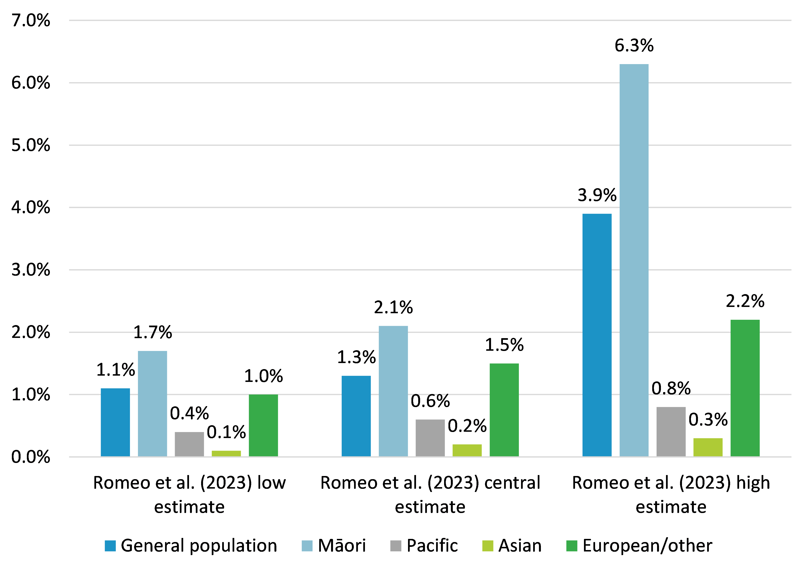

Source: NZIER based on Easton et al. (2016) and Romeo et al. (2023)

Based on 2023 projected populations, the new Romeo et al. (2023) estimates of FASD prevalence allow the burden of FASD by ethnicity to be estimated. This shows that based on the central estimates, the largest population of people living with FASD are of European/Other ethnicity (53,831 people), and a quarter of the burden of FASD is within the Māori population, with over 19,000 Māori living with FASD (see Table 52 below).

Table FASD population and share of FASD population

By ethnicity

|  |  |  |  |  |  |
| --- | --- | --- | --- | --- | --- |
|  | Māori | European/Other | Asian | Pacific | Total* |
| FASD prevalence | 2.10% | 1.50% | 0.20% | 0.50% | 1.3% |
| Population estimate | 905,800 | 3,588,700 | 861,000 | 469,500 | 5,825,000 |
| Population with FASD | 19,022 | 53,831 | 1,722 | 2,348 | 76,922 |
| Share of FASD population | 24.7% | 70.0% | 2.2% | 3.0% | 100% |

*Total represents the sum of values for the ethnic groups identified in the table. The total is higher than the total 2023 population projected by Stats NZ because subnational population projections are based on Census data, which allows individuals to identify as more than one ethnicity.

Source: NZIER, based on Romeo et al. (2023) and Stats NZ subnational ethnic population projections 2018 base

A major challenge to understanding costs associated with FASD in New Zealand is that FASD has not been recognised as a fundable disability by the Ministry of Health, precluding access to government disability and support services for around 80 percent of the FASD community (Romeo et al. 2023). Only those with a very low IQ can access disability support, but this is based on their IQ, not their FASD diagnosis.

FASD is known to be associated with a significant fiscal and private economic burden. However, currently, this burden cannot be estimated with confidence for New Zealand.

Easton et al. (2016) estimated that in 2013, approximately 0.03 percent of the New Zealand workforce experienced a loss of productivity due to FASD-attributable morbidity and premature mortality, which translated to aggregate productivity losses ranging from $49 million to $200 million, or 0.03 percent to 0.09 percent of GDP.

### Estimated value of productivity loss associated with FASD impairment

We estimate the value of productivity loss associated with FASD impairment using:

* the Romeo et al. (2023) central estimate of the prevalence of FASD in New Zealand in 2018/19 (1.3 percent)
* the Easton et al. (2016) estimated shares of FAS and other FASDs within the total FASD population in New Zealand (10 percent FAS and 90 percent other FASDs)
* the Easton et al. (2016) estimated probability of impairment and level of impairment (informed by expert clinical advice and weighted by FASD type) for people with FAS (100 percent) and other FASDs (25 percent)
* updated population and labour market data reflecting 2023 conditions.

The cost of lost productivity associated with FASD in 2023 is expected to be significantly higher than the estimates presented by Easton et al. (2016) based on 2013 prevalence, population, and labour market conditions. There are several reasons for this:

* the implication of the Romeo et al. (2023) prevalence estimate for FASD is that even without population growth, the population of people with FASD would be 30 percent higher than that estimated by Easton et al. (2016) (1.3 percent of the population versus 1 percent)
* as the population has also grown, there will be more people with FASD and related impairments in 2023
* wages, labour market participation and employment have all increased relative to 2013, resulting in a higher value of lost productivity from FASD impairment.

Easton et al. (2016) estimated a lower boundary and an upper boundary for the counterfactual earnings of people with FASD (the earnings they could be expected to have if they did not have FASD). While the upper boundary is based on a standard approach where average earnings are applied in a labour market counterfactual, the authors concede that “it could be argued that the average worker with FASD comes from a more socially deprived background, and as a result, have a lower average wage than a typical member of the labour force”. With this in mind, Easton et al. (2016) also estimate a lower boundary value based on the minimum wage.

In our assessment, Easton et al. (2016) is not a lower boundary because although it reflects the lower wages that might be expected for a person from a socially deprived background, it still assumes average labour market participation and employment rates. However, it does represent a more conservative scenario than the standard average labour market outcomes counterfactual that is often used in cost-of-illness studies. On that basis, we selected this scenario for our estimation.

Based on these key inputs from Easton et al. (2016) and Romeo et al. (2023) and population and labour market data from Stats NZ, the estimated value of productivity lost due to FASD-related impairment in 2023 is $131.4 million (see Table 50 below).

Table Estimation of the total value of lost productivity associated with FASD

2023 values

|  |  |
| --- | --- |
| Parameter | Value |
| New Zealand population | 5,149,500 |
| Share of population participating in the labour force | 58.25% |
| Population with FASD (1.3% of total population) | 66,944 |
| FAS population (10% of total FASD population) | 6,694 |
| Other FASD population (90% of total FASD population) | 60,249 |
| FAS workforce (based on 58.25% labour force participation and 3.4% unemployment) | 3,767 |
| Other FASD workforce (based on 58.25% labour force participation and 3.4% unemployment) | 33,902 |
| Total counterfactual earnings for the overall FASD population* | $1,667,408,225 |
| Impaired people with FAS in employment (100% of FAS workforce**) | 3,767 |
| Impaired people with Other FASD in employment (25% of Other FASD workforce**) | 8,475 |
| Total impaired FASD workforce | 12,242 |
| Productivity loss of impaired FASD workers (weighted impairment***) | 24.25% |
| Productivity per impaired FASD worker | $33,531 |
| Total productivity of impaired FASD workforce | $410,495,062.39 |
| Total productivity of non-impaired FASD workforce (75% of Other FASD workers) | $1,125,500,551.88 |
| Total actual productivity of the FASD population | $1,535,995,614.27 |
| **Value of lost productivity in 2023 due to FASD** | **$131,412,611** |

*Based on $22.70 per hour (MBIE https://www.mbie.govt.nz/about/news/minimum-wage-rising-from-1-april-2023/), 37.5 hours per week, 52 weeks per year

**Easton et al. (2016) estimated the percentage of the employed FAS and Other FASD populations that are affected by impairments likely to impact on productivity based on expert clinical advice.

***Easton et al. (2016) estimated a degree of impairment for each FASD diagnosis type based on expert clinical advice and then weighted this to reflect the proportion of the FASD population with each diagnosis type.

Source: NZIER, based on Romeo et al. (2023), Easton et al. (2016), population and labour market data from Stats NZ

Based on a FASD population of 66,944, the total value of lost productivity of $131,412,611 translates into a value of $1,963 of lost productivity per person with FASD per year. Applying this to the estimated number of people with FASD in each ethnicity group produces the value of FASD productivity loss for each ethnicity (see Table 51 below). This calculation reveals that the value of lost productivity attributable to FASD in the Māori population is over $37 million.

Table Total value of lost productivity associated with FASD by ethnicity

2023 values

|  |  |  |  |  |
| --- | --- | --- | --- | --- |
|  | Māori | European/  Other | Asian | Pacific |
| FASD estimated population | 19,022 | 53,831 | 1,722 | 2,348 |
| Value of lost productivity per person with FASD | $1,963 | $1,963 | $1,963 | $1,963 |
| Total value of lost productivity | $37,340,186 | $105,670,253 | $3,380,286 | $4,609,124 |

Source: NZIER

### Lifetime productivity loss associated with the 2023 cohort of babies with FASD

Because FASD is irreversible, the birth of a child with FASD represents a loss of productivity over a lifetime. Some loss of productivity is associated with impairment, as described above. Some loss of productivity is associated with premature mortality, which requires that the average life expectancy of people with FASD be known.

Only one study was identified that estimated life expectancy for people with FASD. This Canadian study (Thanh and Jonsson 2016) focused on FAS, the most severe form of FASD, accounting for approximately 10 percent of the total FASD population (Easton et al. 2016) and estimated the life expectancy of people with FAS to be 34 years. The life expectancy of people with other FASDs appears to be unconfirmed by published research, but given the lower level of impairment, we assume a life expectancy of at least 65 years for this group.

We estimate the total lifetime value lost productivity for the cohort of babies born in 2023 who are expected to have FASD based on the following evidence:

* approximately 2,400 babies are born each year with FASD – midpoint of 1,800 to 3,000 range suggested by the Ministry of Health (2022) – including 240 with FAS and 2,160 with other FASDs (based on Easton et al. 2016)
* the effect of FASD on labour market outcomes is reduced productivity only, meaning the FASD population has average labour market participation and employment in the counterfactual and in reality (as assumed previously, based on Easton et al. 2016)
* a person born with FASD would have earned $44,265 per year, on average, from age 18 until the age of 65 in the counterfactual of no FASD if they participated in the labour force and were employed
* 100 percent of people with FAS experience reduced productivity (as described by Easton et al. 2016) from age 18 until their life expectancy of 34 years (Thanh and Jonsson 2016) and total loss of productivity due to premature mortality from age 34 to 65
* 25 percent of people with other FASDs experience reduced productivity (as described by Easton et al. 2016) from age 18 until the age of 65
* the same weighted average impairment of productivity for people with FASDs as used in the previous section (24.25 percent) as described by Easton et al. 2016, based on expert clinical advice regarding the type of impairment and probability of impairment in each FASD type and the prevalence of each FASD type in the FASD population.

These values are modelled over 65 years, with all future values discounted to the present time at a rate of 5 percent per annum. The results of this calculation are presented in Table 52 below and indicate that the 2023 birth cohort of babies affected by FASDs is expected to lose $133.8 million in future productivity.

Table Discounted future productivity loss for the 2023 cohort of FASD babies

|  |  |
| --- | --- |
| Parameter | Value |
| Labour market participation | 58.25% |
| Employment | 96.60% |
| **Total FASD births** | 2400 |
| FAS | 240 |
| Other FASD | 2,160 |
| Counterfactual earnings per worker | $44,265 |
| Discount rate | 5% per annum |
| Total discounted counterfactual earnings for the FASD population born in 2023 | $471,473,005 |
| Impaired FAS workers (100% of FAS workers) | 135 |
| Impaired Other FASD workers (25% of FASD workers) | 303 |
| Weighted impairment | 24.25% |
| Working years for FAS population (based on life expectancy of 34 years) | 16 years |
| Working years for Other FASD population (based on life expectancy of 65+ years) | 47 years |
| Total discounted value of expected earnings for the FASD population born in 2023 | $337,659,002 |
| **Discounted value of lost productivity associated with FASD babies born in 2023** | **$133,814,003** |

Source: NZIER, based on Easton et al. 2016; Romeo et al. 2023; Ministry of Health 2022b; Thanh and Jonsson 2016 and population and labour market data from Stats NZ

According to another New Zealand study (Gibbs and Sherwood 2017), if ‘unseen costs’ such as those associated with the social, health and financial impacts on family members, the cost of finding alternative or extra education, the cost of legal help, and the cost of extra medical expenses and assessments or interventions were also included in a cost study of FASD, the total cost would be much greater.

## Limitations of estimates of productivity losses

Reports on costs of alcohol harms that include productivity losses typically find this area of harm to be the costliest. However, as noted in section 1, this area is also subject to a wide range of uncertainties due to:

* a lack of evidence regarding the counterfactual labour market outcomes for people who experience productivity losses as a result of alcohol consumption
* a lack of consensus as to the appropriate approach to estimating productivity losses[14]
* an implicit assumption that there is no spare capacity within the economy in the human capital approach, in other words, that lost production cannot be recovered (Pike and Grosse 2018), resulting in a potential overestimation of productivity losses
* a lack of data to support the use of the friction cost approach, which would likely provide alternative estimates[15]
* underlying studies that estimate impacts on productivity based on survey data typically:
  + lack of controls for the use of other drugs or other contributing factors, such as higher rates of mental illness, tobacco smoking, or other unhealthy lifestyle factors, which may often co-occur with alcohol consumption, especially in people whose alcohol consumption contributes to higher rates of absenteeism and presenteeism (Pidd et al. 2006)
  + do not ask survey participants who are less productive at work on some days due to alcohol use (presenteeism) or who don’t work on some days due to alcohol use (absenteeism) whether they make up for lost productivity on other days
  + often do not use individual-level earnings data to estimate costs, resorting instead to average wage data, which may not be representative of wages earned by people who experience alcohol-induced absenteeism and presenteeism.[16]

Our estimation is subject to all of these concerns.

Additionally, like most reports on the costs of alcohol harms, we provide no estimate of the value of lost unpaid production due to a lack of data on the impact of alcohol consumption on unpaid work.

For these reasons, the quantity of productivity losses and the estimated value of productivity losses should be treated with a high degree of caution.

# Summary of results

The tables below summarise the cost estimates derived in this report, including ranges where these were estimated. Reflecting on concerns about the data, the evidence base, and the methodology, we also present our assessment of the certainty level of these estimates.

Table Estimates of total societal costs of alcohol

$ millions, rounded to the nearest million

|  |  |  |
| --- | --- | --- |
| Key alcohol harm | Estimated value | Certainty of estimate |
| **Increased risk of morbidity and mortality** | **6,015 – 9,103** | **Highly uncertain due to the wide range of values proposed for a DALY. Potential underestimate due to some increased risks not reflected in estimates.** |

Source: NZIER

Table Estimates of societal costs of key alcohol harm concerns

$ millions, rounded to the nearest million

|  |  |  |
| --- | --- | --- |
| Key alcohol harm | Cost estimate | Certainty of estimate |
| Intimate partner violence (IPV) | 281 | Low to moderate: Conservative scenario prevalence but based on old unit costs, attribution based on a single NZ study. Cost attributable to alcohol use disorder only (potential underestimation). Many IPV costs are also reflected in other cost estimates. |
| Child maltreatment | 74 | Low to moderate: Conservative scenario prevalence but based on old unit costs, attribution based on a single NZ study. Cost attributable to hazardous drinking only (potential underestimation). |
| Road crashes | 2,095 | Moderate: Moderate uncertainty regarding attribution and counterfactual/ value related to loss of life/quality of life (the major component). |
| **Total societal cost of key alcohol harms** | **2,450** | Moderate certainty: Greater certainty regarding road crash costs and likely underestimate of IPV and child maltreatment due to the exclusion of cases where alcohol use disorder and hazardous drinking were not a factor. |

Source: NZIER

Table Estimates of costs of productivity losses due to alcohol

$ millions, rounded to the nearest million

|  |  |  |
| --- | --- | --- |
| Cause of productivity loss | Cost estimate | Certainty of estimate |
| Hospitalisation for alcohol-attributable conditions and injuries | 12 - 14 (midpoint 13) | Moderate: High certainty of underlying attribution (see above), uncertainty regarding counterfactual productivity. |
| Premature mortality from alcohol-attributable conditions and injuries | 344 – 417 (midpoint 385) | Moderate: High certainty of underlying attribution (see above), uncertainty regarding counterfactual productivity. |
| Long-term disability from alcohol-attributable injuries | 423 | Moderate to high: Moderate to high certainty of underlying attribution, moderate to high certainty of counterfactual. |
| Incarceration for alcohol-attributable crime | 3 - 7 (midpoint 5) | Moderate: Moderate certainty of underlying attribution (consistent with incarceration costs), conservative counterfactual. |
| Alcohol-related absenteeism and presenteeism in the workplace | 3,012 | Low: Prevalence based on a single, small NZ study, uncertainty regarding impact and counterfactual. |
| Impairment associated with fetal alcohol spectrum disorder (FASD) | 134 | Moderate: 100% certainty of attribution, uncertainty around prevalence, impairment assumptions from a single NZ study. |
| **Total productivity losses (based on midpoints)** | **3,972** | Low to moderate: Total excludes productivity losses due to hospitalisation due to potential heavy overlap with workplace absenteeism estimate. High degree of uncertainty due to shortcomings of the human capital approach and the methods used in the study that provided the major cost. |

Source: NZIER

Table Estimated costs to government due to alcohol harms

$ millions, rounded to the nearest million

|  |  |  |
| --- | --- | --- |
| Vote and component | Cost estimate | Certainty of estimate |
| **Health** |  |  |
| Hospitalisation for alcohol-attributable conditions and injuries | 296 - 371 (midpoint 337) | High: Local, recent AAFs* estimated using established methods and robust data. |
| Emergency services: ED and ambulance callouts resulting in ED visits | 102 | Low: Reliance on ED staff reporting events as “alcohol related”. True cost may be significantly higher due to the long-term role of alcohol in health conditions and the unobservable role of other people’s drinking in injuries. Higher confidence regarding the subset associated with acute inpatient events ($19m). |
| **ACC** |  |  |
| Compensation of workers with long-term disability attributable to alcohol | 327 | High: Good alignment of ACC data with AAFs for injuries. |
| **Social Development** |  |  |
| Disability benefit and child disability allowance for disabilities attributable to alcohol | 1 | Low to moderate: Estimated attribution to alcohol based on survey data and AAFs for alcohol-attributable injuries. Likely underestimated due to a wide range of benefits unable to be attributed to alcohol attributable disability. |
| **Justice** |  |  |
| Incarceration for alcohol-attributable crime | 41 | Moderate: Attribution based on a single, recent NZ study, some uncertainty regarding the application of study estimates to data. |
| Services and programmes to address family harms | 2 | Moderate: Unclear how causal attribution applies within the programme context. |
| **Total government costs (based on midpoints)** | **810** | Moderate: High degree of certainty on the major costs in this category. The total is likely an underestimate due to a lack of data permitting estimation of up-to-date Police and other justice sector costs and a broader range of Social Development costs. |

*AAFs=Alcohol-attributable fractions estimated for health conditions and injuries

Source: NZIER

## Aggregation and double-counting risks

Because we separately estimated the societal value of increased risk of mortality and morbidity, aggregation of other costs is not needed to generate a total societal value. Aggregation, or even combining specific estimates, poses a risk of double-counting. We summarise the risk in Table 57 below.

Table Potential for double-counting when aggregating or combining cost estimates

|  |  |
| --- | --- |
| Cost estimate | Potential for double-counting when aggregating or combining values |
| Increased risk of morbidity and mortality | This cost estimate potentially captures the full range of societal costs and should not be combined with any other cost estimates Although the extent to which some specific costs without a direct disease/condition relationship (e.g. absenteeism and presenteeism, incarceration) are reflected is unclear. |
| Key alcohol harm concerns (IPV, child maltreatment, road crashes) | These specific costs are likely reflected in the societal value of increased morbidity and mortality costs, health and disability system, ACC, social development and justice sector costs, so they should not be combined with any of these cost estimates. |
| Productivity losses | In general, productivity costs are highly likely to be reflected in the societal value of increased morbidity and mortality costs, so they should not be combined with these cost estimates, however the extent to which absenteeism and presenteeism are reflected in societal values of mortality and morbidity risk is unclear as there is no clear disease/condition relationship. Productivity losses associated with long-term disability are 80% reflected in ACC costs, so they should not be combined with these. Productivity losses associated with alcohol-attributable incarceration are least likely to be reflected in other costs and pose a lower risk of double-counting if combined with other estimates. |
| Health and disability system costs | Health and disability system costs are highly likely to be reflected in the societal value of increased morbidity and mortality costs, so they should not be combined with these cost estimates. |
| ACC worker compensation costs | Worker compensation costs are highly likely to be reflected in the societal value of increased morbidity and mortality costs as they are directly related to productivity losses, so they should not be combined with these cost estimates. These costs are also fully reflected in estimates of productivity loss associated with long-term disability. |
| Disability benefit and child disability allowance | Disability benefit and child disability allowance costs are highly likely to be reflected in the societal value of increased morbidity and mortality costs, so they should not be combined with these cost estimates. |
| Incarceration for alcohol-attributable crime | Justice sector costs pose a lower risk of being reflected in the societal value of increased morbidity and mortality although the risk of double-counting is likely to be greater for combining these estimates with specific societal costs where there is an identifiable criminal dimension and this relationship has been specifically estimated (IPV, child maltreatment, road crashes). |

Source: NZIER

# Further considerations

This report does not present a comprehensive estimation of the costs of alcohol harms. But it presents new estimates where important evidence has emerged on critical issues of prevalence, impact and causal attribution. This is a useful exercise because it provides estimates based on the current local evidence base. However, there are important considerations regarding how this report, or others like it, should be used.

## Harms to others are a challenge to identify and are likely underestimated

As noted, a key area of limitation in this report is alcohol harms to others – harms experienced as a result of someone else’s drinking. Apart from the DALY approach to estimating alcohol harms in which previous research has highlighted the dominance of FASD, little evidence is available to identify the nature and scale of the harms, the private and fiscal costs, and the attribution to alcohol. This evidence gap represents a significant source of underestimation, with key concerns being:

* injuries experienced as a result of someone else’s drinking, resulting from road crashes, assaults or other incidents
* the broader impacts of alcohol on IPV and child maltreatment
* caregiver costs of FASD
* private costs of crime
* private costs to families and whānau of supporting a person with alcohol use disorder, particularly where a cultural response is required
* intergenerational harms
* the impact of alcohol at the community level, which may generate ‘neighbourhood’ harms, including litter, noise, and feeling safe
* impacts on frontline staff (including Police, ambulance staff, ED staff, etc.) who experience alcohol-related verbal and physical aggression.

The overall cost to society of alcohol use could be much greater if these impacts were able to be reliably valued.

## Disaggregation by ethnicity is rarely possible and not always desirable, but private costs are expected to be higher for Māori

Understanding alcohol harms experienced by specific communities is important from a policy and programme perspective.

Some data on alcohol harms is not available, disaggregated by ethnicity. Often, this is because reporting data by ethnicity is not helpful and may only serve to reinforce existing prejudice. This is a key concern for justice sector data, which is a major impact area for alcohol harms.

While there is interest in taking an equity perspective in research on alcohol harms, presenting fiscal costs by ethnicity poses an ethical dilemma: Higher fiscal costs, either in total or on a per-person basis in some communities, might motivate greater investment in prevention in those communities, but can be interpreted to mean some people ‘cost more’ which may perversely feed arguments about spending less. But from a practical perspective, fiscal costs can rarely be differentiated by the ethnicity of the people they apply to: The unit costs made available for cost and cost-benefit analyses tend to be averages.

Where disaggregation by ethnicity would be most useful is in private costs of alcohol harms. It is well recognised that Māori experience more harms from alcohol than non-Māori across a range of dimensions. It is also well recognised that culturally appropriate services to support Māori to reduce alcohol harms within their community or whānau are in short supply, further increasing the private burden on whānau in dealing with alcohol harms, which can often require long-term care and support.

The impact of increasing alcohol harms within a whānau or community may also be greater than additive: That is, the impacts and costs of alcohol when a greater proportion of individuals are harmed may be greater than the sum of per-person cost estimates derived from broader populations. For example, a family with two members who have been harmed or killed in a car accident caused by a person intoxicated with alcohol may experience more than double the harm that is experienced in a family where one member has been harmed or killed in this way. At a community level, a higher prevalence of alcohol harms may require more than proportionate resources to address.

At this point in time, these issues remain largely qualitative due to significant gaps in the evidence regarding:

* the private costs of harms
* the impacts on whānau and communities where the prevalence of alcohol harms is greater
* the costs associated with a cultural response to alcohol harms, which are often borne by whānau.

## The strength of the evidence base for costs of alcohol harms indicates a need for ongoing research and a cross-sectoral approach

The costs of alcohol harms are challenging to estimate due to the wide range of evidence and data needed. While we have focused on key areas where recent, New Zealand evidence is available, overall, the evidence base for this type of report has significant areas of weakness. While there is hope that more robust estimation is becoming possible with the emergence of local evidence on causal attribution in particular, currently the recent New Zealand-specific evidence base often consists of a single study supporting each area of harm or cost domain. Assessment of the quality of these published studies was outside this project's scope, but even a high quality study of a complex issue does not provide a strong evidence base.

All costs estimated in this report should be considered in this context. In future, with the emergence of new studies, the evidence and robustness of estimated costs may be expected to improve.

In addition to highlighting the need for ongoing research into the harms associated with alcohol and alcohol’s specific contribution to these harms, the report’s major areas of evidence gaps point to a need for a cross-sectoral approach to ensuring the data collected by public sector agencies supports research, particularly health, social development and justice sector data. These sectors could work together to improve the evidence base for alcohol harms and their costs.

## Making use of this report

This report sought to update the evidence on the costs of alcohol harms using updated evidence on harms and costs. Notwithstanding the important limitations of the report as an assessment of costs of alcohol harms, this report should nevertheless be of interest to policymakers because it:

* describes the most up-to-date evidence and data on alcohol harms and their costs
* demonstrates the significant evidence gaps on alcohol harms and their costs
* shows how recent ground-breaking New Zealand research on some specific alcohol harms has substantially improved the evidence base for those harms and how this can be translated into an improved understanding of the costs of alcohol harms in those areas
* highlights the areas where stronger evidence is needed due to the potential magnitude of some cost dimensions and their impact on total costs
* illustrates the wide range of impacts across New Zealand society and the challenges of identifying the full range of costs
* quantifies and brings together a range of statistics on alcohol-related harms, which helps the understanding of the broad human and societal impact of these harms
* allows the opportunity presented by key areas of avoidable harms to be better understood and inform policy decisions about interventions
* highlights that relatively little is known about the private costs of alcohol harms, which has significant equity implications due to the disproportionate harm being experienced by Māori
* confirms the very high cost of alcohol harms in New Zealand from both a societal perspective and from a government perspective, especially when significant underestimation is known (e.g. the alcohol-attributable costs of government services and programmes).

Appendix G presents a summary table of the evidence gaps currently preventing a comprehensive assessment of the costs of alcohol harms in New Zealand.

#### Decision-makers should consider not only costs but also the extent to which they can be avoided

In this report, we estimated social and economic costs attributable to alcohol across a range of domains. For policy decisions, these estimates should be considered against four important questions:

* What is the full range of activities undertaken across the public sector and by NGOs to minimise or address alcohol harms?
* How cost-effective are current programmes and services in reducing harms?
* What fraction of harms is potentially avoidable through effective regulation, programmes and services?
* What is the most efficient approach to raising revenue to minimise or address alcohol harms?

A stocktake of the full range of activities across the public sector and NGOs is needed to answer the first question. The second question requires an evaluation of programmes and services.

The third question requires evidence of the impact of effective programmes, which can then be monetised and considered against the estimated costs of harms to understand the potential value of investment to reduce harms caused by alcohol. Previously published research (Chambers et al. 2023) has estimated that an effective intervention package, including a 50 percent alcohol tax increase,[17] outlet density reduction from 63 to five outlets per 100,000 people, outlet hours reduction from 112 to 50 per week and a complete ban on all forms of alcohol marketing, could reduce alcohol-related harms but would not eliminate them. Relatively little is known about the potential impacts of services and programmes funded by the Ministry of Health through the Alcohol Levy or otherwise.

Finally, the fourth question requires consideration of the overall revenue raising and funding allocation process with regards to alcohol and alcohol-related programmes and services.

#### The Alcohol Levy and the activities it funds exist within a broader context

While this report has focused on costs of harms that were identified as relevant, or potentially relevant, from the point of view of the Alcohol Levy, decisions regarding the Levy and the activities it funds should also take into account the broader context. This includes the alcohol excise tax as a demand moderating instrument, activities addressing alcohol harms undertaken by other agencies and NGOs, and secondary prevention activities funded through other revenue sources.

A key objective for government should be a cohesive and coordinated approach to optimise not just the level of investment, but the collection of revenue, the prioritisation of investments, and the optimisation of roles and responsibilities across agencies and stakeholders.

#### Direct evidence on alcohol harms remains important alongside estimates of costs

A key issue is that monetising harms, rather than just quantifying harms across a range of domains, comes with the additional uncertainty and potential for double-counting that monetisation introduces. Decision-makers should consider whether decisions may be better informed by considering the extent of the burden across each impact area (e.g. hospitalisations, premature deaths, etc.) rather than by a single monetary figure or even the monetary value of each component. Either way, considering the direct evidence of harms, their nature, scale and distribution, as well as any trends over time, remains important even after harms have been monetised.

#### The optimal level of investment and investment priorities may not reflect the costs of harms

Cost studies are of limited use when it comes to informing the level of investment that should be made or prioritising investment. The size of the appropriate investment is less a question of the size of the problem than of the extent to which the cost is avoidable through interventions, the range of investment opportunities, the effectiveness and cost-effectiveness of interventions, and the alternative investment opportunities that may address other issues facing society.

Cost estimates across the range of harms also may not align with the priorities and aspirations of New Zealand communities due to the lack of data that allows the full private, tangible and intangible impacts of harms to be converted into monetary values.

#### Costs of harms may not be able to be meaningfully tracked over time

Decision-makers are often interested in tracking a problem over time and understanding trends. While this is often possible by quantifying impacts over time using consistent definitions, cost studies tend not to be comparable over time due to the imperative to incorporate new evidence for a more comprehensive or up-to-date assessment, dominating the potential benefit of maintaining consistency of approach. This is most likely the case for complex social problems that are not well understood. Additionally, some costs are influenced by current conditions. Productivity costs will vary simply because labour market conditions change, and current data on these influence the valuation of lost productivity. Measures like lost productive life years lend themselves to more robust time trend analysis. Similarly, estimates of the average cost of keeping a person in prison may be influenced by the current prison occupancy rate, with lower occupancy resulting in higher average cost – a change that is unrelated to the problem or harm being measured.

#### Costs of harms are rarely internationally comparable

Local cost estimates are often held up against international estimates to support their validity, but international comparability of cost studies is also on shaky ground. Often, different costs have been included due to differences in data availability and definition, local economic conditions may vary, affecting lost productivity estimates, unit costs may differ substantially, different perspectives and methods may be used, and researchers may make radically different decisions regarding the relevance of internal versus external costs and assumptions about the counterfactual (which is not always explicit) against which costs are estimated (see Appendix C).

# Recommendations

In light of our review of the recent evidence on alcohol harms and their costs, and the results of our analysis, NZIER recommends that Manatū Hauora|Ministry of Health:

* focus decisions regarding the Alcohol Levy and the funding of services and programmes on evidence of impact, cost-effectiveness, and scale of unmet need
* consider using a portion of the Alcohol Levy revenue or other funds to fund:
  + a research programme to fill important evidence gaps regarding alcohol harms in New Zealand, potentially prioritising areas where insufficient recent evidence allows the problem to be quantified or valued, such as:
    - health-related victim impacts of alcohol-attributable crime, such as injuries and mental health impacts
    - alcohol-attributable use of outpatient services, mental health services, and aged residential care
  + activities that provide cost-effective solutions in areas where there is strong causal attribution to alcohol
* collaborate with justice sector agencies, social sector agencies and the Ministry of Education to improve the evidence base regarding the non-health costs of alcohol harms
* consider using a portion of the Alcohol Levy revenue or other funds to address problems with a demonstrated strong causal attribution to alcohol, such as FASD where investment in diagnostic and therapeutic services is much needed (to improve outcomes, reduce the private burden of FASD, and help fill significant evidence gaps such as the prevalence of FASD in New Zealand), including in the youth justice system and the prison population.

# References

Abbey, Antonia. 2002. “Alcohol-Related Sexual Assault: A Common Problem among College Students.” *Journal of Studies on Alcohol. Supplement*, no. 14 (March): 118–28. https://doi.org/10.15288/jsas.2002.s14.118.

Alcohol Healthwatch. n.d. “Alcohol Healthwatch > Issues & Resources > Harm to Māori.” Accessed December 8, 2023. https://www.ahw.org.nz/Issues-Resources/Harm-to-M%C4%81ori.

Anderson, Benjamin O., Nino Berdzuli, Andre Ilbawi, Dévora Kestel, Hans P. Kluge, Rüdiger Krech, Bente Mikkelsen, et al. 2023. “Health and Cancer Risks Associated with Low Levels of Alcohol Consumption.” *The Lancet Public Health* 8 (1): e6–7. https://doi.org/10.1016/S2468-2667(22)00317-6.

Ateara-Minster, J, H Guiney, and S Cook. 2020. “Taeao Malama: Alcohol Use in Pacific Peoples. Results from the New Zealand Health Survey & Attitudes and Behaviour towards Alcohol Survey.” Wellington: Te Hiringa Hauora/Health Promotion Agency. https://www.hpa.org.nz/sites/default/files/Taeao%20Malama%20-%20Alcohol%20use%20among%20Pacific%20peoples.pdf.

Bagley, Kerryn. 2018. “Responding to FASD: What Social and Community Service Professionals Do in the Absence of Diagnostic Services and Practice Standards.” *Advances in Dual Diagnosis* 12 (1/2): 14–26. https://doi.org/10.1108/ADD-05-2018-0007.

Baumeister, Sebastian E., Anja Schumann, Terry T. Nakazono, Dietrich Alte, Nele Friedrich, Ulrich John, and Henry Völzke. 2006. “Alcohol Consumption and Out-Patient Services Utilization by Abstainers and Drinkers.” *Addiction* 101 (9): 1285–91. https://doi.org/10.1111/j.1360-0443.2006.01538.x.

Boden, Joseph M., David M. Fergusson, and L. John Horwood. 2012. “Alcohol Misuse and Violent Behavior: Findings from a 30-Year Longitudinal Study.” *Drug and Alcohol Dependence* 122 (1–2): 135–41. https://doi.org/10.1016/j.drugalcdep.2011.09.023.

———. 2013. “Alcohol Misuse and Criminal Offending: Findings from a 30-Year Longitudinal Study.” *Drug and Alcohol Dependence* 128 (1): 30–36. https://doi.org/10.1016/j.drugalcdep.2012.07.014.

Butcher, Josie. 2020. “The Revolving Door: Are We Sentencing People with FASD to a Life Trapped in the Criminal Justice System?” *Auckland University Law Review* 26. http://www.nzlii.org/nz/journals/AukULawRw/2020/9.pdff.

Buvik, Kristin, Inger Synnøve Moan, and Torleif Halkjelsvik. 2018. “Alcohol-Related Absence and Presenteeism: Beyond Productivity Loss.” *The International Journal on Drug Policy* 58 (August): 71–77. https://doi.org/10.1016/j.drugpo.2018.05.005.

Callahan, Christopher M., and William M. Tierney. 1995. “Health Services Use and Mortality Among Older Primary Care Patients with Alcoholism.” *Journal of the American Geriatrics Society* 43 (12): 1378–83. https://doi.org/10.1111/j.1532-5415.1995.tb06617.x.

Canadian Centre on Substance Use and Addiction. 2023. “Canadian Substance Use Costs and Harms 2007–2020.”

Casswell, Sally, Taisia Huckle, Jose S. Romeo, Helen Moewaka Barnes, Jennie Connor, and Jurgen Rehm. 2023. “Quantifying Alcohol-Attributable Disability-Adjusted Life Years to Others than the Drinker in Aotearoa, New Zealand.” SSRN Scholarly Paper. Rochester, NY. https://doi.org/10.2139/ssrn.4425297.

Chambers, Tim, Nicki Jackson, and Janet Hoek. 2021. “New Zealand’s Proposed Ban on Alcohol Sponsorship of Sport: A Cost-Effective, pro-Equity and Feasible Move towards Reducing Alcohol-Related Harm.” *The Lancet Regional Health: Western Pacific* 13 (July): 100218. https://doi.org/10.1016/j.lanwpc.2021.100218.

Chambers, Tim, Anja Mizdrak, Sarah Herbert, Anna Davies, and Amanda Jones. 2023. “The Estimated Health Impact of Alcohol Interventions in New Zealand: A Modelling Study.” *Addiction (Abingdon, England)*, August. https://doi.org/10.1111/add.16331.

Cobiac, Linda J., and Nick Wilson. 2018. “Alcohol and Mental Health: A Review of Evidence, with a Particular Focus on New Zealand.” Report prepared to inform the Mental Health and Addiction Inquiry underway in 2018 and funded by Alcohol Healthwatch. https://www.ahw.org.nz/Portals/5/Resources/Submissions/2018/Alcohol%20Healthwatch%20Alcohol%20and%20mental%20health%202018.pdf.

Community Law. 2023. “Working While in Prison.” Community Law. 2023. https://communitylaw.org.nz/community-law-manual/test/working-studying-and-other-activities-on-the-inside/working-while-in-prison/.

Crampton, E., M. Burgess, and B. Taylor. 2012. “What’s in a Cost? Comparing Economic and Public Health Measures of Alcohol’s Social Costs.” *New Zealand Medical Journal* 125 (1360). http://ir.canterbury.ac.nz/handle/10092/7696.

Crampton, Eric, and Matt Burgess. 2009. “The Price of Everything, The Value of Nothing: A (Truly) External Review Of BERL’s Study Of Harmful Alcohol and Drug Use.” Working paper 10/2009.

Crossin, Rose, Lana Cleland, Annette Beautrais, Katrina Witt, and Joseph M. Boden. 2022. “Acute Alcohol Use and Suicide Deaths: An Analysis of New Zealand Coronial Data from 2007-2020.” *The New Zealand Medical Journal* 135 (1558): 65–78.

Crossin, Rose, Lana Cleland, Chris Wilkins, Marta Rychert, Simon Adamson, Tuari Potiki, Adam C Pomerleau, et al. 2023. “The New Zealand Drug Harms Ranking Study: A Multi-Criteria Decision Analysis.” *Journal of Psychopharmacology* 37 (9): 891–903. https://doi.org/10.1177/02698811231182012.

Daroudi, Rajabali, Ali Akbari Sari, Azin Nahvijou, and Ahmad Faramarzi. 2021. “Cost per DALY Averted in Low, Middle- and High-Income Countries: Evidence from the Global Burden of Disease Study to Estimate the Cost-Effectiveness Thresholds.” *Cost Effectiveness and Resource Allocation* 19 (1): 7. https://doi.org/10.1186/s12962-021-00260-0.

Department of Corrections. 2022. “M.04.07 Release to Work.” February 21, 2022. https://www.corrections.govt.nz/resources/policy_and_legislation/Prison-Operations-Manual/Movement/M.04-External-movement-transportation-of-prisoners/M.04.07-release-to-work-RTW.

———. 2023. “Prison Facts and Statistics - September 2023. Quarterly Prison Statistics.” https://www.corrections.govt.nz/resources/statistics/quarterly_prison_statistics/prison_stats_september_2023.

Devries, Karen M., Jennifer C. Child, Loraine J. Bacchus, Joelle Mak, Gail Falder, Kathryn Graham, Charlotte Watts, and Lori Heise. 2014. “Intimate Partner Violence Victimization and Alcohol Consumption in Women: A Systematic Review and Meta-Analysis.” *Addiction (Abingdon, England)* 109 (3): 379–91. https://doi.org/10.1111/add.12393.

Dissanayake, Harini, and Paul Bracewell. 2022. “Family Violence in the News: An Analysis of Media Reporting of Family Violence in Aotearoa New Zealand.” *Kōtuitui: New Zealand Journal of Social Sciences Online* 17 (2): 242–59. https://doi.org/10.1080/1177083X.2021.1976224.

Dunbar, R. I. M., Jacques Launay, Rafael Wlodarski, Cole Robertson, Eiluned Pearce, James Carney, and Pádraig MacCarron. 2017. “Functional Benefits of (Modest) Alcohol Consumption.” *Adaptive Human Behavior and Physiology* 3 (2): 118–33. https://doi.org/10.1007/s40750-016-0058-4.

Easton, Brian, Larry Burd, Jürgen Rehm, and Svetlana Popova. 2016. “Productivity Losses Associated with Fetal Alcohol Spectrum Disorder in New Zealand” 129 (1440).

Egerton-Warburton, Diana, Andrew Gosbell, Katie Moore, Angela Wadsworth, Drew Richardson, and Daniel M. Fatovich. 2018. “Alcohol-Related Harm in Emergency Departments: A Prospective, Multi-Centre Study.” *Addiction* 113 (4): 623–32. https://doi.org/10.1111/add.14109.

Fanslow, Janet, Elizabeth Robinson, Sue Crengle, and Lana Perese. 2010. “Juxtaposing Beliefs and Reality: Prevalence Rates of Intimate Partner Violence and Attitudes to Violence and Gender Roles Reported by New Zealand Women.” *Violence Against Women* 16 (7): 812–31. https://doi.org/10.1177/1077801210373710.

Felson, Richard B., and Jeremy Staff. 2010. “The Effects of Alcohol Intoxication on Violent Versus Other Offending.” *Criminal Justice and Behavior* 37 (12): 1343–60. https://doi.org/10.1177/0093854810382003.

Gibbs, Anita, and Kesia Sherwood. 2017. “Putting Fetal Alcohol Spectrum Disorder (FASD) on the Map in New Zealand: A Review of Health, Social, Political, Justice and Cultural Developments.” *Psychiatry, Psychology, and Law: An Interdisciplinary Journal of the Australian and New Zealand Association of Psychiatry, Psychology and Law* 24 (6): 825–42. https://doi.org/10.1080/13218719.2017.1315784.

Gullliver, Pauline, and Janet Fanslow. 2012. “Measurement of Family Violence at a Population Level: What Might Be Needed to Develop Reliable and Valid Family Violence Indicators?” Issues Paper 2. New Zealand Family Violence Clearing House. https://scholar.google.co.nz/scholar_url?url=https://www.nzfvc.org.nz/sites/nzfvc.org.nz/files/Measurement-of-family-violence-at-a-population-level-June-2012.pdf&hl=en&sa=X&ei=blLMZIq3NM6OygSauZrwBg&scisig=AFWwaeb-x-_fixWCaBCEaY1fDkFc&oi=scholarr.

Harvard T. H. Chan. 2022. “Alcohol: Balancing Risks and Benefits.” The Nutrition Source. 2022. https://www.hsph.harvard.edu/nutritionsource/healthy-drinks/drinks-to-consume-in-moderation/alcohol-full-story/.

Health Promotion Agency. 2021. “Monitoring Alcohol Affordability in Aotearoa New Zealand: 2020 Update.” https://apo.org.au/sites/default/files/resource-files/2021-10/apo-nid314661.pdf.

Heyer, Garth den. 2022. “New Zealand’s Dirty Secret: Family Violence.” In *Understanding and Preventing Community Violence: Global Criminological and Sociological Perspectives*, edited by James F. Albrecht and Garth den Heyer, 235–53. Cham: Springer International Publishing. https://doi.org/10.1007/978-3-031-05075-6_14.

Howe, David. 2005. *Child Abuse and Neglect: Attachment, Development and Intervention*. 1st edition. Basingstoke: Red Globe Press.

Huckle, Taisia, and Jose S. Romeo. 2023. “Estimating Child Maltreatment Cases That Could Be Alcohol-Attributable in New Zealand.” *Addiction* 118 (4): 669–77. https://doi.org/10.1111/add.16111.

IHME. 2019. “Global Burden of Disease.” 2019. https://www.healthdata.org/research-analysis/gbd.

Institute for Health Metrics and Evaluation. 2019. “Global Burden of Disease 2019.” 2019. https://ourworldindata.org/grapher/number-of-deaths-by-risk-factor?country=~NZL.

Jury, Angela, Ashley Koning, Jennifer Lai, Charito Tuason, Terry Huriwai, and Sarah Hetrick. 2020. “Hazardous Drinking and General Practitioner Visits in the Past Year.” *New Zealand Medical Journal* 133 (1518): 43–53.

Kahui, Sherilee, and Suzanne Snively. 2014. “Measuring the Economic Costs of Child Abuse and Intimate Partner Violence to New Zealand.” Wellington: The Glenn Inquiry. http://ndhadeliver.natlib.govt.nz/delivery/DeliveryManagerServlet?dps_pid=IE25595234&dps_custom_att_1=ilsdb.

Knell, Conor. 2023. “One Million More Drink Driving Tests than Last Year.” *The Post*, October 1, 2023. https://www.thepost.co.nz/nz-news/350081837/one-million-more-drink-driving-tests-last-year.

Krug, Etienne G., Linda L. Dahlberg, James A. Mercy, Anthony B. Zwi, and R Lozano. 2002. “World Report on Violence and Health.” World Health Organization. https://www.who.int/publications-detail-redirect/9241545615.

Kvizhinadze, Giorgi, Nick Wilson, Nisha Nair, Melissa McLeod, and Tony Blakely. 2015. “How Much Might a Society Spend on Life-Saving Interventions at Different Ages While Remaining Cost-Effective? A Case Study in a Country with Detailed Data.” *Population Health Metrics* 13 (July): 15. https://doi.org/10.1186/s12963-015-0052-2.

Law Commission, ed. 2010. *Alcohol in Our Lives: Curbing the Harm: A Report on the Review of the Regulatory Framework for the Sale and Supply of Liquor*. Report, no. 114. Wellington, N.Z: Law Commission.

Lievore, and Mayhew. 2007. “The Scale and Nature of Family Violence in New Zealand: A Review and Evaluation of Knowledge.” Ministry of Social Development. https://scholar.google.co.nz/scholar_url?url=https://www.msd.govt.nz/documents/about-msd-and-our-work/publications-resources/research/scale-nature/scale-and-nature.doc&hl=en&sa=X&ei=01TMZKz8KuyEywSA_4GIAg&scisig=AFWwaebX3ezs1FWcXc2lfIXB_nlE&oi=scholarr.

Madden, Mary, and Jim McCambridge. 2021. “Alcohol Marketing versus Public Health: David and Goliath?” *Globalization and Health* 17 (1): 45. https://doi.org/10.1186/s12992-021-00696-2.

Mayo Clinic Health System. 2021. “Balancing Risks, Benefits of Alcohol.” Mayo Clinic Health System. 2021. https://www.mayoclinichealthsystem.org/hometown-health/speaking-of-health/balancing-the-risks-benefits-of-alcohol.

Mellar, Brooklyn M., Ladan Hashemi, Vanessa Selak, Pauline J. Gulliver, Tracey K.D. McIntosh, and Janet L. Fanslow. 2023. “Association Between Women’s Exposure to Intimate Partner Violence and Self-Reported Health Outcomes in New Zealand.” *JAMA Network Open* 6 (3): e231311. https://doi.org/10.1001/jamanetworkopen.2023.1311.

Miller, Brenda A. 1990. “The Interrelationships between Alcohol and Drugs and Family Violence.” In *Drugs and Violence: Causes, Correlates, and Consequences*, edited by Mario De la Rosa, Elizabeth Y. Lambert, and Bernard A. Gropper. U.S. Department of Health and Human Services, Public Health Service, Alcohol, Drug Abuse, and Mental Health Administration, National Institute on Drug Abuse.

Ministry of Health. 2022. “Fetal Alcohol Spectrum Disorder (FASD).” Ministry of Health NZ. 2022. https://www.health.govt.nz/your-health/conditions-and-treatments/disabilities/fetal-alcohol-spectrum-disorder-fasd.

———. 2023. “Annual Update of Key Results 2022/23: New Zealand Health Survey.” Ministry of Health NZ. 2023. https://www.health.govt.nz/publication/annual-update-key-results-2022-23-new-zealand-health-survey.

Ministry of Justice. 2023a. “Courts - Estimates by Vote - Budget 2023 - 18 May 2023.” Text. NZ 2023 Budget. 2023. https://www.budget.govt.nz.

———. 2023b. “Family Violence Tables.” 2023. https://www.justice.govt.nz/justice-sector-policy/research-data/justice-statistics/data-tables.

———. 2023c. “New Zealand Crime and Victims Survey. Key Findings – Cycle 5 Report. Descriptive Statistics. June 2023. Results Drawn from Cycle 5 (2021/22) of the New Zealand Crime and Victims Survey.” Wellington: Ministry of Justice.

Ministry of Social Development. 2023. “Letter Requesting a Breakdown of Disability Allowance by Age Group,” March 22, 2023. https://www.msd.govt.nz/documents/about-msd-and-our-work/publications-resources/official-information-responses/2023/march/22032023-requesting-a-breakdown-of-the-average-and-median-rates-of-disability-allowance-for-the-period-april-2020-to-present-broken-down-by-quarter-age-group-gender-and-ethnicity.pdf.

Ministry of Transport. 2021. “Social Cost of Road Crashes and Injuries - June 2020 Update.” Wellington: Ministry of Transport. https://www.transport.govt.nz/assets/Uploads/Social-Cost-of-Road-Crashes-and-Injuries-2020_final.pdf.

———. 2022. “Alcohol and Drugs.” 2022. https://www.transport.govt.nz/statistics-and-insights/safety-annual-statistics/sheet/alcohol-and-drugs.

Miquel, Laia, Jakob Manthey, Jürgen Rehm, Emili Vela, Montserrat Bustins, Lidia Segura, Eduard Vieta, Joan Colom, Peter Anderson, and Antoni Gual. 2018. “Risky Alcohol Use: The Impact on Health Service Use.” *European Addiction Research* 24 (5): 234–44. https://doi.org/10.1159/000493884.

Myran, Daniel T., Amy T. Hsu, Glenys Smith, and Peter Tanuseputro. 2019. “Rates of Emergency Department Visits Attributable to Alcohol Use in Ontario from 2003 to 2016: A Retrospective Population-Level Study.” *CMAJ : Canadian Medical Association Journal* 191 (29): E804–10. https://doi.org/10.1503/cmaj.181575.

Nana, Ganesh. 2018. “Alcohol Costs – but, Who Pays?” Presented at the Alcohol Action NZ Conference, Wellington, New Zealand.

New Zealand Family Violence Clearinghouse. 2017. “Data Summaries 2017: Snapshot.” https://nzfvc.org.nz/sites/nzfvc.org.nz/files/Data-summaries-snapshot-2017.pdf.

New Zealand Police. 2018. “Alcohol Action Plan 2018.” New Zealand Police. 2018. https://www.police.govt.nz/about-us/publication/alcohol-action-plan-2018.

———. 2023. “Road Policing Driver Offence Data - January 2009 to June 2023.” New Zealand Police. 2023. https://www.police.govt.nz/about-us/publication/road-policing-driver-offence-data-january-2009-june-2023.

———. n.d. “Alcohol – Laws and Penalties.” New Zealand Police. Accessed December 7, 2023. https://www.police.govt.nz/advice/drugs-and-alcohol/alcohol-laws-and-penalties.

Nobilo, Hilary. 2016. “Why Should We Care? The Abuse and Neglect of Children in New Zealand.” *Brainwave Trust Aotearoa* (blog). 2016. https://brainwave.org.nz/article/why-should-we-care-the-abuse-and-neglect-of-children-in-new-zealand/.

NZIER. 2022. “Alcohol Beverages Industry: A Thriving, Durable Industry Adding Value to New Zealand’s Financial, Environmental and Social Economies.” NZIER report to NZ Alcohol Beverages Council.

Oranga Tamariki. 2023. “Prevalence of Harm to Children in Aotearoa New Zealand.” https://www.orangatamariki.govt.nz/assets/Uploads/About-us/Research/Latest-research/Prevalence-of-Harm-to-Children-and-Protective-Factors/Prevalence-of-Harm-to-Children-A3-2023.pdf.

Parthasarathy, S., C. Weisner, T. W. Hu, and C. Moore. 2015. “Association of Outpatient Alcohol and Drug Treatment with Health Care Utilization and Cost: Revisiting the Offset Hypothesis.” *Journal of Studies on Alcohol*, January. https://doi.org/10.15288/jsa.2001.62.89.

Paton-Simpson, G., I. R. McCormick, A. Powell, P. Adams, and D. Bunbury. 2000. “Problem Drinking Profiles of Patients Presenting to General Practitioners: Analysis of Alcohol Use Disorders Identification Test (AUDIT) Scores for the Auckland Area.” *The New Zealand Medical Journal* 113 (1105): 74–77.

Pidd, Kenneth J., Jesia G. Berry, Ann M. Roche, and James E. Harrison. 2006. “Estimating the Cost of Alcohol-Related Absenteeism in the Australian Workforce: The Importance of Consumption Patterns.” *Medical Journal of Australia* 185 (11). https://www.mja.com.au/journal/2006/185/11/estimating-cost-alcohol-related-absenteeism-australian-workforce-importance.

Probst, Charlotte, Jakob Manthey, Alicia Martinez, and Jürgen Rehm. 2015. “Alcohol Use Disorder Severity and Reported Reasons Not to Seek Treatment: A Cross-Sectional Study in European Primary Care Practices.” *Substance Abuse Treatment, Prevention, and Policy* 10 (1): 32. https://doi.org/10.1186/s13011-015-0028-z.

Romeo, Jose S., Taisia Huckle, Sally Casswell, Jennie Connor, Jurgen Rehm, and Valerie McGinn. 2023. “Foetal Alcohol Spectrum Disorder in Aotearoa, New Zealand: Estimates of Prevalence and Indications of Inequity.” *Drug and Alcohol Review* 42 (4): 859–67. https://doi.org/10.1111/dar.13619.

Roper, Tim, and Andrew Thompson. 2006. “Estimating the Costs of Crime in New Zealand in 2003/04.” New Zealand Treasury Working Paper 06/04. Wellington: The Treasury.

Slack, A, G Nana, M Webster, F Stokes, and J Wu. 2009. “Costs of Harmful Alcohol and Other Drug Use.” Wellington: BERL.

Sullivan, Trudy, Fiona Edgar, and Ian McAndrew. 2019. “The Hidden Costs of Employee Drinking: A Quantitative Analysis.” *Drug and Alcohol Review* 38 (5): 543–53. https://doi.org/10.1111/dar.12935.

Superu. 2015. “Reducing the Impact of Alcohol on Family Violence.” What Works. Superu Social Policy and Evaluation Research Unit. https://thehub.swa.govt.nz/assets/Uploads/What-works-Alcohol-Violence.pdf.

Svensen, Georgina, Bridget Kool, and Sarah Buller. 2019. “The Burden of Alcohol-Related Presentations to a Busy Urban New Zealand Hospital Emergency Department.” *The New Zealand Medical Journal* 132 (1504): 56–66.

Te Whatu Ora Health New Zealand, Counties Manukau. 2020. “Do You Have to Pay?” https://www.countiesmanukau.health.nz/for-patients-and-visitors/do-you-have-to-pay/.

Testa, Maria, and Michael J. Cleveland. 2017. “Does Alcohol Contribute to College Men’s Sexual Assault Perpetration? Between- and Within-Person Effects Over Five Semesters.” *Journal of Studies on Alcohol and Drugs* 78 (1): 5–13. https://doi.org/10.15288/jsad.2017.78.5.

Thanh, Nguyen Xuan, and Egon Jonsson. 2016. “LIFE EXPECTANCY OF PEOPLE WITH FETAL ALCOHOL SYNDROME.” *Journal of Population Therapeutics and Clinical Pharmacology* 23 (1). https://www.jptcp.com.

The Treasury. 2022. “CBAX Impacts Database.” 2022. https://www.treasury.govt.nz/information-and-services/state-sector-leadership/investment-management/investment-planning/treasurys-cbax-tool.

Ubel, Peter A., Richard A. Hirth, Michael E. Chernew, and A. Mark Fendrick. 2003. “What Is the Price of Life and Why Doesn’t It Increase at the Rate of Inflation?” *Archives of Internal Medicine* 163 (14): 1637–41. https://doi.org/10.1001/archinte.163.14.1637.

Whetton, Steve, Robert J. Tait, William Gilmore, Tania Dey, Seraina Agramunt, Suraya Abdul Halim, Alice McEntee, et al. 2021. “Examining the Social and Economic Costs of Alcohol Use in Australia: 2017/18.” Pert WA: National Drug Research Institute, Curtin University.

Wilkins, Chris, Jitesh Prasad, Helen Moewaka Barnes, J S Romeo, and Marta Rychert. 2017. “New Zealand Arrestee Drug Use Monitoring (NZ-ADUM): 2016 Report.” Palmerston North: SHORE & Whariki Research Centre College of Health, Massey University.

Women’s Refuge. 2022. “Annual Report 2021-22.” https://womensrefuge.org.nz/wp-content/uploads/2022/11/Annual-Report-2022-High-Res-1.pdf.

Work and Income. n.d. “Disability Allowance.” MSD. Accessed December 7, 2023. https://www.workandincome.govt.nz/products/a-z-benefits/disability-allowance.html.

World Health Organization. 2006. “Policy Briefing – Interpersonal Violence and Alcohol.”

———. 2011. “Global Burden of Disease Methodology.” In *World Report on Disability 2011*. World Health Organization. https://www.ncbi.nlm.nih.gov/books/NBK304069/.

———. 2022. “Alcohol.” 2022. https://www.who.int/news-room/fact-sheets/detail/alcohol.

World Health Organization. Europe. 2023. “No Level of Alcohol Consumption Is Safe for Our Health.” 2023. https://www.who.int/europe/news/item/04-01-2023-no-level-of-alcohol-consumption-is-safe-for-our-health.

Young, Matthew M., Chealsea De Moor, Pam Kent, Tim Stockwell, Adam Sherk, Jinhui Zhao, Justin T. Sorge, et al. 2021. “Attributable Fractions for Substance Use in Relation to Crime.” *Addiction* 116 (11): 3198–3205. https://doi.org/10.1111/add.15494.

1. Our approach in more detail

#### Different approaches are appropriate for different policy questions

Several key considerations regarding the approach that is appropriate for a cost report on alcohol harms are importantly related to the policy questions they are designed to address. These considerations include:

* The choice of a net costs or gross costs approach
* The inclusion of private costs and benefits
* The counterfactual against which costs and benefits are estimated.

#### A net costs or gross costs approach

Many previously published reports on the costs of alcohol harms have had a primary purpose of informing discussions about the appropriate scale of a corrective tax (a tax designed to reduce alcohol consumption to a socially optimal level). When adjustment to a corrective tax is the key information needed, a report on the costs of alcohol harm must comprehensively estimate all costs and benefits associated with the consumption and production of alcohol to estimate a net societal cost. The excise tax on alcohol in New Zealand, while originally implemented as a revenue tax, is currently treated as a corrective tax in policy decision-making: The level of the excise tax is influenced by the objective of encouraging consumers to shift consumption to a level that would occur if they faced the full and true costs of their choices (including both externalities and internalities[18]).

While few would disagree that the costs of alcohol harms are likely to far exceed any benefits from alcohol, what matters to the design of a corrective tax is not just whether harms exceed benefits, but the *extent* to which harms exceed benefits. This is not a matter of guessing. In addition to the well-recognised costs of negative health impacts, premature mortality, criminal activity, productivity losses, and costs representing harms that may be less well described by data, a net costs approach requires detailed analysis of the less discussed potential benefits, including:

* **Any potential health benefits of alcohol consumption.** These have often been discussed in the media and may figure strongly in many New Zealanders’ perceptions of alcohol. While these health benefits have been called into question by many health experts due to new evidence suggesting health benefits are less and apply to a smaller group of the population than previously thought, numerous health research institutions internationally still make statements supporting the existence of benefits (e.g. Harvard T.H. Chan School of Public Health (2022), the Mayo Clinic (2021)) and while the World Health Organization notes that on balance, alcohol has negative impacts on health and that no level of alcohol consumption should be considered safe overall, it acknowledges that the large negative impacts associated with some health conditions (e.g. cancer) may be partially offset by smaller protective effects in others (e.g. cardiovascular disease and diabetes) for light to moderate drinkers (Anderson et al. 2023; World Health Organization. Europe 2023). Our gross costs approach means we need not resolve or quantify this issue.
* **Potential fiscal benefits associated with early mortality.** People who die earlier than they otherwise would due to alcohol-attributable conditions and injuries cease to pay taxes but also cease to consume services, with health services and superannuation being key savings.
* **Consumer surplus associated with alcohol consumption.** Consumers purchase and consume alcohol because they expect to enjoy consuming it or derive benefits associated with its consumption (e.g. social or even professional benefits). While it is fair to say that some people consume alcohol in ways that result in negative experiences, which will more than offset any benefits, and others suffer from addiction, which compels them to purchase and consume alcohol in a way that doesn’t align with the economic concepts of utility from which consumer surplus is derived, others may drink with full knowledge and understanding of risks and may value the ability to include moderate alcohol consumption in their lives.

The Law Commission acknowledged in its 2010 report that not all alcohol consumption is excessive or harmful and that “balanced against these harms must be the pleasure many people derive from the consumption of alcohol” (Law Commission, p.7). The report quotes Otago University epidemiologist Professor Jennie Connor, who argues that: “Many [New Zealanders] drink in a low-risk manner and reap the social benefits” (Law Commission 2010).[19]

In 2023, these views may now be re-considered as the evidence base for alcohol harms has evolved, however many studies continue to confirm at least the social benefits of alcohol, such as Dunbar et al. (2017), which combined data from a national survey with data from detailed behavioural and observational studies and showed that “social drinkers have more friends on whom they can depend for emotional and other support, and feel more engaged with, and trusting of, their local community”.

* **Other economic benefits associated with the alcohol industry.** According to NZIER (2022) estimates, the alcohol industry in New Zealand contributes a total of $1.92 billion to GDP annually (value added),[20] which includes $515 million in wages to the 10,210 people employed in the industry.

Unsurprisingly, even the most comprehensive reports on the costs of alcohol harms that claim to take a net costs approach omit some costs and, even more often, some benefits, either due to a lack of data or evidence or due to varied views on what should be included.

For example, a major Canadian project to estimate the costs of alcohol (Canadian Centre on Substance Use and Addiction 2023) claims to take a net costs approach but includes only the small health benefits of alcohol consumption and ignores the relatively more substantial benefits of fiscal savings from premature mortality, consumer surplus and other economic benefits. The previous New Zealand report on costs of alcohol harms conducted by BERL in 2009 (Slack et al. 2009) with an updated estimate proposed in 2018 (Nana 2018), which also purports to be a net costs report, ignores consumer surplus as a benefit of alcohol consumption as well as the potential health benefits suggested by research on alcohol-attributable fractions.[21]

#### Inclusion or exclusion of private costs and benefits

A wide range of costs and benefits are associated with the consumption of alcohol. Costs can be classified as ‘private’ or ‘external’.

Private costs and benefits are experienced by the person who consumes alcohol and includes such considerations as the enjoyment of the beverage or the social aspects of drinking, the unpleasantness of a hangover, lost wages, unemployment or reduced career advancement, positive and negative impacts on relationships, pain and suffering associated with health outcomes, the experience of consequences of criminal activity, and many others.

External costs and benefits, sometimes called ‘spillover’ effects or externalities, refer to the impacts of a person’s alcohol consumption on others. These might include the costs to victims of alcohol-fuelled violence and other crimes, impacts on children who grow in households where resources are spent on alcohol and parenting is compromised by alcohol consumption, fiscal costs associated with addressing harms such as health system costs or justice system costs, the costs of delivering alcohol addiction programmes, and many others.

Some researchers argue that private costs should not be included in cost studies intended to inform policy decisions. Some researchers argue that private costs should be included, particularly where these are associated with alcohol addiction, on the basis that the individual is not making a rational choice, resulting in ‘internalities’. Even amongst researchers who argue for the inclusion of private costs, there is no universal approach to which ones should or shouldn’t be included.

At the very least, wherever private costs are included, if the intent is to produce an estimate of net costs, then any offsetting private benefits should also be included. This was a key concern noted about the 2009 BERL report (Eric Crampton and Burgess 2009; E. Crampton, Burgess, and Taylor 2012).

#### The counterfactual is of critical importance

The counterfactual against which costs are estimated is also relevant to the interpretation of results and the comparability of reports, as well as being a significant source of uncertainty. There are two major issues related to the assumed counterfactual in many studies of alcohol costs:

* When costs of alcohol harms are estimated, they implicitly suggest that in the absence of alcohol, those costs would not be incurred because the harm would not occur. However, if a person avoids one harmful substance and the harmful behaviour resulting from consuming it, it is still possible for that person to consume alternative harmful substances and/or engage in equally or more harmful behaviour, or to experience or contribute to other harms which alcohol and/or the harmful behaviour they engaged in under the influence of alcohol reduced opportunities for. Illegal drugs may not be seen as a substitute for alcohol by the general population, but this is an area of particular uncertainty for criminal behaviour: If there is already an inclination to engage in criminal activity, the illegal status of other drugs may not be a deterrent. Many studies estimate productivity losses and fiscal costs associated with incarceration, with the implicit counterfactual being no criminal offending other than that caused by alcohol – a potentially optimistic assumption that has the effect of overstating the costs of alcohol.
* Counterfactuals are often constructed from average population values (e.g. average productivity) and then applied to populations these values may not be realistic for. Sometimes little is known about the counterfactual productivity from which productivity costs may be estimated, but average labour market outcomes are unlikely to be relevant to large subpopulations affected by alcohol harms (e.g. convicted criminals, people with FASD, even victims of some crimes, like interpersonal violence, who are more likely to be young, Māori, and facing financial hardship (Ministry of Justice 2023c). In such cases, researchers should attempt to use specific labour market outcomes to estimate costs. The use of ethnicity-specific labour market outcomes, however, is rare in productivity loss estimation due to ethical concerns about the translation of disadvantage and discrimination unless there is reason to believe that specific labour market outcomes are a poor measure of productivity (e.g. for minority ethnicities where discrimination may be the cause of poorer labour market outcomes).

Given the high degree of uncertainty regarding the counterfactual for alcohol-related harm, estimates should always be considered against the explicit and implicit assumptions made to inform the counterfactual.

#### Attribution is a key concern in cost studies

Alcohol is known to be involved in or even contribute to a wide range of outcomes, from physical and mental health conditions to family violence, vehicle accidents, low productivity, suicide and many more.

However, the complexity of the relationships between alcohol consumption and many other factors that are associated with the same outcomes, the potential for complex multi-directional causality, and the wide range of unobserved and unobservable factors mean that quantifying causal attribution to alcohol for many potential alcohol harms is not yet possible. Where research purports to have identified the causal attribution of harms to alcohol, this is usually on the basis of statistical or econometric controls for a range of other potentially causal factors. The quality of these controls can vary across studies.

Attributing causality to alcohol is fundamentally important to achieving good policy and investment decisions. Whatever the design of studies investigating alcohol harms and their costs, the key objective is to provide the best available evidence to inform policy and investment decisions to reduce alcohol harms. Poor evidence derived from ill-informed assumptions, outdated data, or conflating correlation and causation risks, can contribute to an inappropriate balance of investment within programmes and services designed to address alcohol harms, and across the range of investment opportunities that governments have to improve the wellbeing of populations.

#### Choice of approach for this report

A wide range of published studies providing estimates of the costs of alcohol harms internationally has raised awareness that alcohol is associated with significant social and economic costs but has not provided confidence in the estimates produced due to widely differing methodologies and often extensive use of assumptions to fill evidence gaps. Reports produced for advocacy purposes, in particular, tend to pursue a more exhaustive list of cost estimates and particular methodologies to achieve a higher total cost result (Pike and Grosse 2018, Manthey et al. 2021). Of course, advocacy on either side of an issue may influence methodological choice.

In the scoping phase for this project, the Expert Advisory Group (EAG) assembled by Manatū Hauora|Ministry of Health to support this project identified two reports as potentially relevant to consideration of study design and methodology:

* the BERL report on costs of harmful alcohol and other drug use (Slack et al. 2009)
* the Canadian Substance Use Costs and Harms (CSUCH) project developed by the Canadian Centre on Substance Use and Addiction (CCSA) and the University of Victoria’s Canadian Institute for Substance Use Research (CISUR), which has published reports from 2015 to 2020 on the costs of alcohol and substance use since 2007.

These two reports have some common elements. Like most published reports of the costs of alcohol harms, both use a prevalence approach, estimating the costs associated with harms incurred in a specific year (including flows of costs over many years where relevant, such as in the case of mortality and incarceration). Both reports also use the human capital approach to estimate the value of lost productivity.

However, there are important differences in approach between the two reports:

* The BERL report aimed to be exhaustive and drew on international evidence and the use of assumptions (the authors’ own assumptions or assumptions made by authors of previously published studies) to fill in evidence gaps. This report presents cost estimates for direct, indirect and intangible costs, as well as an aggregate cost derived by summing up the cost components, ignoring potential double-counting issues that have been highlighted in other reports.
* The CSUCH project aimed to provide robust estimates supported by domestic (Canadian) administrative and survey data and other local evidence, with minimal use of assumptions and value transfers from other contexts. It also excluded intangible costs although the reasons for this are not stated in the reports. Unlike the BERL report, the CSUCH project has led to the publication of peer-reviewed studies on specific aspects of the project.

On consideration of the merits of the two approaches, the Working Group assembled by Manatū Hauora|Ministry of Health to support this project expressed an interest in taking an approach that was broadly aligned with the CSUCH project, but with the inclusion of intangible costs reflecting the pain and suffering of people who experience morbidity and/or mortality as a result of alcohol consumption.

#### Implications of approach

Consistent with the general approach of the CSUCH project, this report reflects the following considerations:

* A gross costs approach. A gross costs approach means estimating the costs of alcohol-related harms and ignoring the potential benefits associated with alcohol production or consumption. This contrasts with a net costs approach in which the latter are netted out to provide a net societal cost. In addition to being consistent (and therefore comparable) with the CSUCH approach, a gross cost approach is aligned with the alcohol levy’s purpose as a cost recovery mechanism designed to support programmes and services that address alcohol harms irrespective of any benefits associated with alcohol.
* In addition to conservative approaches to cost estimation, consistent with the CSUCH project, this report avoids estimating costs where there would be a heavy reliance on assumptions, outdated data, or estimates derived from overseas studies. This approach provides a clearer view of the current state of the evidence and evidence gaps.
* Because New Zealand data and evidence may allow for a broader set of costs to be estimated than those which CSUCH estimated, we assessed all costs estimated in the BERL report for the feasibility of estimation against the CSUCH principles of local data and evidence and minimal use of assumptions. We also imposed a requirement that any data or evidence used must have been generated within the last ten years (since 2013).

1. Comparison of relevant cost of alcohol studies

Table Comparison of this study with previous key studies

|  |  |  |  |  |
| --- | --- | --- | --- | --- |
|  | BERL 2009 | CSUCH 2020 | NZIER 2023 | Rationale for exclusion |
| **Direct costs** |  |  |  |  |
| Cost of substances/diverted inputs | P |  |  | Definition of alcohol harms |
| Road crashes | P | P | P |  |
| Police | P | P | P (Police costs of road crashes only) | Lack of recent costings/resource use data |
| Courts | P | P | P (Court costs of vehicle crashes only) | Lack of recent costings/resource use data |
| Prisons | P | P | P |  |
| Community sentences | P |  |  | Lack of recent costings |
| Pharmaceuticals | P | P |  | Lack of evidence for the application of AAFs in this context |
| Primary care | P |  | P |  |
| Ambulance services | P | P | P |  |
| Hospitalisation | P | P | P |  |
| Health care for road crash victims | P | P | P |  |
| Health care for crime victims | P | unclear | P (ED visits – dependent on assessment of alcohol involvement) | Lack of NZ evidence of alcohol-attributable utilisation by crime victims for most health services |
| Nursing home stays |  |  |  | Lack of NZ evidence of alcohol-attributable utilisation |
| Community care | P |  |  | Lack of NZ evidence of alcohol-attributable utilisation |
| Professional services (other than physicians) |  |  |  | Lack of NZ evidence of alcohol-attributable utilisation |
| Speciality institutions (including substance abuse treatment facilities) | P (alcohol and drugs combined) |  |  | Lack of NZ evidence to allow separate estimation for alcohol vs drugs |
| Intimate partner violence |  |  | P |  |
| Child abuse and neglect |  |  | P |  |
| Prevention programmes |  | P |  | Definition of alcohol harm |
| **Tangible costs – indirect** |  |  |  |  |
| Productivity costs – reduced workforce (premature mortality) | P | P | P |  |
| Productivity costs - excess unemployment | P |  |  | Lack of evidence regarding alcohol-attributable unemployment |
| Productivity costs - absenteeism | P |  | P |  |
| Productivity costs – presenteeism/reduced productivity | P |  | P |  |
| Productivity costs - FASD |  |  | P |  |
| Foregone consumption | P |  |  | Definition of alcohol harm |
| Productivity costs – long-term disability |  | P |  | Lack of NZ evidence regarding employment of people with alcohol-attributable disability |
| Productivity costs – short term disability |  | P | P |  |
| **Intangible costs** |  |  |  |  |
| Pain and suffering – road crash victims | P |  | Included in costs of road crashes and partly reflected in DALYs, but not separately identifiable |  |
| Pain and suffering - victims of crime | P |  | Included in victims of crime costs but not separately identifiable from other private costs |  |
| Pain and suffering related to users’ health | P |  | Included in total alcohol-related DALYs |  |
| Value of lost life to the deceased | P |  | P (social value of DALYs) |  |

Source: NZIER

1. Methods for estimation of productivity losses

There are two main methodological approaches to estimating productivity losses, each with its own challenges and shortcomings. The two main approaches are:

* The human capital approach (HCA)
* The friction cost approach (FCA)

These are summarised below.

#### Human capital approach

The traditional method for estimating productivity losses has been the HCA. This approach assumes that people have the potential to produce a stream of outputs (production) over their working life. The human capital approach measures lost productivity as the amount of time by which that working life is reduced (due to short term or long term causes). Work time lost is valued at the market wage, which is assumed to reflect the value of people’s work. In estimating productivity loss for a population, adjustment is made to account for labour force participation (the proportion of the population who wish to be employed) and unemployment (the proportion of the labour force that is unemployed). This approach is commonly used in contexts where a wide range of occupations and industries are involved because all that is needed is the length of time over which output is reduced, the market wage, the labour force participation rate and the unemployment rate.

In practice, the HCA often measures ‘potential’ lost productivity rather than the actual loss incurred by society due to the application of average labour market outcomes to specific groups where this assumption may not be realistic.

Other concerns related to the HCA approach are that absence from work or an event that reduces the output of a worker may not actually result in a reduction in overall output, implying no loss to society. This can occur if:

* workers do not always work at maximum productivity, resulting in an ability at the individual or firm level to compensate for periods of lower than usual productivity (e.g. workers who are absent or less productive on some days increase their productivity on other days or co-workers take on the additional work, increasing their productivity)
* there is unused available labour in the labour market, allowing employers to substitute for workers who are absent for longer periods of time or permanently, resulting in no lost production or at least significantly reduced lost production.

#### Friction cost approach

The FCA was developed in response to the shortcomings of the HCA. The FCA is a method that focuses on the short-term impact of productivity losses on the assumption that employers will seek to restore production by replacing absent workers. This approach considers that productivity loss only exists in the ‘friction period’ – the period of time until the level of production returns to normal. The FCA is based on the assumption that it is generally possible to restore production, so productivity loss is temporary.

As with the HCA, the FCA values losses using the market wage over the length of the friction period. The friction period is a function of the level of unemployment, which influences how easily employers can find replacement workers and the efficiency of the recruitment and replacement process. These factors vary by industry, occupation and over time, making the friction period a context and time-specific variable, the estimation of which is not often feasible. When the FCA is applied in economy-wide studies (as opposed to industry-specific studies), blunt rules of thumb, such as a standard 3-month friction period, are sometimes used, which is inconsistent with the intention of the FCA method to capture actual lost production.

1. Health-adjusted life years

This appendix contains some background on Health-Adjusted Life Years (HALYs), including DALYs and QALYs, and the valuation of such measures.

#### Health-adjusted life years

The following text is an excerpt from the National Collaborating Centre for Infectious Diseases (Canada):

*The ability to consistently describe the relative importance of diseases is important for public health decision-making and planning. Summary measures of the burden of disease in a population are popular and widely used, as they can simplify complex information about diseases, including risk factors, and the likelihood of resulting disability or other harm (morbidity), or death (mortality).*

*Health-adjusted life years (HALYs) are the population health summary measures typically used in estimates of the burden of disease. They measure the combined effects of mortality and morbidity in populations, allowing for comparisons across illnesses or interventions as well as between populations. Two common approaches to measuring HALYs are disability-adjusted life years (DALYs) and quality-adjusted life years (QALYs).*

*Both DALYs and QALYs are based on the latest available epidemiological data. The data must be assessed for completeness and diagnostic accuracy and can be drawn from a variety of sources, such as vital statistics, reportable disease registries, healthcare administration databases, censuses, national and local surveillance data, autopsies, hospital records, surveys (e.g. road safety, institutional, household or health surveys), police records, death certificates and mortuary records. Ideally, all the data should be valid, timely, locally derived, and disaggregated by age and sex. It is important to note that health conditions are often under-reported or underdiagnosed.*

*Regardless of whether DALYs, QALYs or some other calculations of HALYs are measured, there are three steps involved:*

1. *The health state or disease conditions associated with a pathogen or disease analysed are defined and described (morbidity)*
2. *Each health state described in step 1 is given a weighted value, often called a Health-Related Quality of Life (HRQL) value; and*
3. *The value of each health state is combined with estimates of life expectancy (mortality).*

*DALYs are currently the most common methods used for estimating burden of disease. For example, they were used in the 2012 international reports on the Global Burden of Disease (GBD 2010). DALYs measure the difference between the current state of population health and an ideal situation; i.e., where everyone reaches the age of standard life expectancy in perfect health. DALYs are based on an assumption that “time” is the most appropriate measure for the burden of disease: the greater the time lived with a disability, or with the disabling results of an illness, or lost due to premature mortality, the greater the burden of disease is considered to be.*

*DALYs measure the total length of time that a specific illness is disabling to an individual over the course of his or her life. When applied to a population, they are the measure of the total disability incurred due to a specific disease.*

*QALYs, as the name implies, measure both the quantity and the quality of life lived. They are typically used to analyse the cost-effectiveness of clinical (or public health) interventions and for social welfare improvement. For example, QALYs can compare an intervention that helps prolong life but has serious side effects (such as permanent disability caused by radiation or chemotherapy for cancer) with an intervention that improves the quality of life without prolonging it (such as palliative pain management).*

*The HRQL in QALYs is not linked to any particular disease. It is based on values assigned by individuals about their own health state (known as patient-based weights) or on the values assigned by others about a particular health state (community-based weights). Respondents are asked to assign a numerical value to what they would be willing to sacrifice in order to return from poor to perfect health, where a year of perfect health is given a value of 1 and death is considered to be 0. If the year is not spent in perfect health (e.g. living with chronic pain), the value is between 1 and 0.*

*This score takes into account five dimensions: a) mobility, b) pain or discomfort, c) self-care, d) anxiety-depression, and e) usual activities.*

*This means that QALY estimates are able to integrate psycho-social as well as biomedical aspects of the burden of a disease.*

#### Valuation of health-adjusted life years

There is no single right way of placing a monetary value on any of the measures of health outcomes measured as QALYs or DALYs. Although there is no consensus on the approach to monetising these measures, some jurisdictions use threshold values to approximate society’s willingness to pay to achieve improvements in health outcomes through health sector interventions. For example, in the UK, the National Institute of Health Care Excellence (NICE) uses a threshold range of £20,000 to £30,000 per QALY gained. In the United States, a threshold of US$50,000 to US$100,000 (approximately NZ$75,000 to NZ$150,000 in 2022) is frequently and currently referenced, despite these values having been first put forward in 1982 (Ubel et al. 2003).

Published research has produced more estimates for QALYs and DALYs, including estimates of DALY values for high and high Human Development Index (HDI) countries, such as the range of one to two times GDP per capita as estimated by Daroudi et al. (2021) using data from the GBD study.

Comparatively, less research has offered values for HALYs; some New Zealand research proposes using the WHO CHOICE approach, which indicates a threshold value equal to GDP per capita (Kvizhinadze et al. 2015), although the WHO itself now discourages this approach.

In general, there has been and continues to be significant debate regarding the value of life years (with or without any form of adjustment for quality of life), making the estimation of a monetary value for health loss an exercise that is fraught with uncertainty. In such cases, it can be helpful, if a value is required, to consider a range of possible approaches.

1. ICD-10 codes for alcohol-attributable and partially attributable conditions

Table ICD-10 Codes

|  |  |
| --- | --- |
| Alcohol-attributable conditions | ICD-10-AM codes |
| Transport injuries | V00-V99, Y85 |
| Unintentional injuries | W00-W99, X00-X44, X46-X59, Y10-Y14, Y16-Y34, Y40-Y84, Y86, Y88 |
| Interpersonal injuries | X85-X99, Y00-Y09, Y87 |
| Self-harm | X60-X64, X66-X84 |
| Alcohol use disorders | F10, X45, X65, Y15 |
| Breast cancer (female) | C50 |
| Colorectal cancer | C18-C21 |
| Larynx cancer | C32 |
| Lip and oral cavity cancer | C00-C08 |
| Liver cancer | C22 |
| Nasopharynx cancer | C11 |
| Oesophageal cancer | C15 |
| Pharynx cancer | C09-C10, C12-C14 |
| Alcoholic cardiomyopathy | I42 (ratio applied post extraction) |
| Atrial fibrillation and cardia arrhythmia | I48 |
| Stroke | G45-G46, I60-I69 (ratio applied post extraction) |
| Hypertension | I11 |
| Ischaemic heart disease | I20-I25 |
| Alcoholic gastritis | K29 (ratio applied post extraction) |
| Diabetes | E10, E11, E12, E13, E14, R73 |
| Epilepsy | G40-G41 |
| Liver cirrhosis | I85, K70-K77 |
| Lower respiratory tract infections | A70, B96-B97, J09-J22, J85-J86, P23, U04 |
| Pancreatitis | K85-K86 |
| Tuberculosis | A15-A19, B90 |

Source: Chambers and Mizdrak, forthcoming

1. Classification of crimes

Table Classification of crimes as impulsive crimes

|  |  |  |
| --- | --- | --- |
| ANZSOC Sub-divisions | ANZSOC Groups | Inclusion |
| 010: Homicide and related offences not further defined | 0100: Homicide and related offences not further defined | Included |
| 011: Murder | 0111: Murder | Included |
| 012: Attempted murder | 0121: Attempted murder | Included |
| 013: Manslaughter and driving causing death | 0131: Manslaughter | Included |
|  | 0132: Driving causing death | Included |
| 021: Assault | 0210: Assault not further defined | Included |
|  | 0213: Common assault | Included |
| 029: Other acts intended to cause injury | 0299: Other acts intended to cause injury, nec | Included |
| 031: Sexual assault | 0311: Aggravated sexual assault | Included |
|  | 0312: Non-aggravated sexual assault | Included |
| 032: Non-assaultive sexual offences | 0321: Non-assaultive sexual offences against a child | Excluded |
|  | 0322: Child pornography offences | Excluded |
|  | 0329: Non-assaultive sexual offences, nec | Excluded |
| 041: Dangerous or negligent operation of a vehicle | 0411: Driving under the influence of alcohol or other substance | Included |
|  | 0412: Dangerous or negligent operation (driving) of a vehicle | Included |
| 049: Other dangerous or negligent acts endangering persons | 0491: Neglect or ill-treatment of persons under care | Included |
|  | 0499: Other dangerous or negligent acts endangering persons, nec | Included |
| 051: Abduction and kidnapping | 0511: Abduction and kidnapping | Excluded |
| 052: Deprivation of liberty/false imprisonment | 0521: Deprivation of liberty/false imprisonment | Excluded |
| 053: Harassment and threatening behaviour | 0531: Harassment and private nuisance | Included |
|  | 0532: Threatening behaviour | Included |
| 061: Robbery | 0611: Aggravated robbery | Included |
|  | 0612: Non-aggravated robbery | Included |
| 062: Blackmail and extortion | 0621: Blackmail and extortion | Excluded |
| 071: Unlawful entry with intent/burglary, break and enter | 0711: Unlawful entry with intent/burglary, break and enter | Included |
| 081: Motor vehicle theft and related offences | 0811: Theft of a motor vehicle | Included |
|  | 0812: Illegal use of a motor vehicle | Included |
|  | 0813: Theft of motor vehicle parts or contents | Included |
| 082: Theft (except motor vehicles) | 0821: Theft from a person (excluding by force) | Excluded |
|  | 0822: Theft of intellectual property | Excluded |
|  | 0823: Theft from retail premises | Excluded |
|  | 0829: Theft (except motor vehicles), nec | Excluded |
| 083: Receive or handle proceeds of crime | 0831: Receive or handle proceeds of crime | Excluded |
| 084: Illegal use of property (except motor vehicles) | 0841: Illegal use of property (except motor vehicles) | Excluded |
| 091: Obtain benefit by deception | 0911: Obtain benefit by deception | Excluded |
| 092: Forgery and counterfeiting | 0921: Counterfeiting of currency | Excluded |
|  | 0922: Forgery of documents | Excluded |
|  | 0923: Possess equipment to make false/illegal instrument | Excluded |
| 093: Deceptive business/government practices | 0931: Fraudulent trade practices | Excluded |
|  | 0932: Misrepresentation of professional status | Excluded |
| 099: Other fraud and deception offences | 0991: Dishonest conversion | Excluded |
|  | 0999: Other fraud and deception offences, nec | Excluded |
| 101: Import or export illicit drugs | 1010: Import or export illicit drugs not further defined | Excluded |
| 102: Deal or traffic in illicit drugs | 1020: Deal or traffic in illicit drugs not further defined | Excluded |
|  | 1021: Deal or traffic in illicit drugs - commercial quantity | Excluded |
| 103: Manufacture or cultivate illicit drugs | 1031: Manufacture illicit drugs | Excluded |
|  | 1032: Cultivate illicit drugs | Excluded |
| 104: Possess and/or use illicit drugs | 1041: Possess illicit drugs | Excluded |
|  | 1042: Use illicit drugs | Excluded |
| 109: Other illicit drug offences | 1099: Other illicit drug offences, nec | Excluded |
| 111: Prohibited weapons/explosives offences | 1112: Sell, possess and/or use prohibited weapons/explosives | Excluded |
| 112: Regulated weapons/explosives offences | 1121: Unlawfully obtain or possess regulated weapons/explosives | Excluded |
|  | 1122: Misuse of regulated weapons/explosives | Included |
|  | 1123: Deal or traffic regulated weapons/explosives offences | Excluded |
|  | 1129: Regulated weapons/explosives offences, nec | Included |
| 121: Property damage | 1211: Property damage by fire or explosion | Included |
|  | 1212: Graffiti | Included |
|  | 1219: Property damage, nec | Included |
| 122: Environmental pollution | 1222: Water pollution offences | Excluded |
|  | 1229: Environmental pollution, nec | Excluded |
| 131: Disorderly conduct | 1311: Trespass | Included |
|  | 1312: Criminal intent | Included |
|  | 1313: Riot and affray | Included |
|  | 1319: Disorderly conduct, nec | Included |
| 132: Regulated public order offences | 1321: Betting and gambling offences | Excluded |
|  | 1322: Liquor and tobacco offences | Excluded |
|  | 1323: Censorship offences | Excluded |
|  | 1324: Prostitution offences | Excluded |
|  | 1325: Offences against public order sexual standards | Included |
|  | 1329: Regulated public order offences, nec | Included |
| 133: Offensive conduct | 1331: Offensive language | Included |
|  | 1332: Offensive behaviour | Included |
|  | 1334: Cruelty to animals | Included |
| 141: Driver licence offences | 1411: Drive while licence disqualified or suspended | Included |
|  | 1412: Drive without a licence | Included |
|  | 1419: Driver licence offences, nec | Included |
| 142: Vehicle registration and roadworthiness offences | 1421: Registration offences | Included |
| 143: Regulatory driving offences | 1431: Exceed the prescribed content of alcohol or other substance limit | Included |
|  | 1439: Regulatory driving offences, nec | Included |
| 150: Offences against justice procedures, government security and government operations not further defined | 1500: Offences against justice procedures, government security and government operations not further defined | Excluded |
| 151: Breach of custodial order offences | 1511: Breach of custody offences | Excluded |
|  | 1512: Breach of home detention | Included |
| 152: Breach of community-based order | 1521: Breach of community service order | Included |
|  | 1522: Breach of parole | Included |
| 152: Breach of community-based order | 1521: Breach of community service order | Included |
|  | 1522: Breach of parole | Included |
|  | 1523: Breach of bail | Included |
|  | 1524: Breach of bond - probation | Included |
|  | 1529: Breach of community-based order, nec | Included |
| 153: Breach of violence and non-violence orders | 1530: Breach of violence and non-violence orders not further defined | Included |
|  | 1531: Breach of violence order | Included |
|  | 1532: Breach of non-violence order | Included |
| 154: Offences against government operations | 1541: Resist or hinder government official (excluding Police officer, justice official or government security officer) | Excluded |
|  | 1542: Bribery involving government officials | Excluded |
|  | 1543: Immigration offences | Excluded |
|  | 1549: Offences against government operations, nec | Excluded |
| 155: Offences against government security | 1559: Offences against government security, nec | Excluded |
| 156: Offences against justice procedures | 1561: Subvert the course of justice | Excluded |
|  | 1562: Resist or hinder Police officer or justice official | Included |
|  | 1563: Prison regulation offences | Excluded |
|  | 1569: Offences against justice procedures, nec | Excluded |
| 162: Public health and safety offences | 1624: Transport regulation offences | Excluded |
|  | 1626: Licit drug offences | Excluded |
|  | 1629: Public health and safety offences, nec | Excluded |
| 163: Commercial/industry/financial regulation | 1631: Commercial/industry/financial regulation | Excluded |
| 169: Other miscellaneous offences | 1691: Environmental regulation offences | Excluded |
|  | 1694: Import/export regulations | Excluded |
|  | 1695: Procure or commit illegal abortion | Excluded |
|  | 1699: Other miscellaneous offences, nec | Excluded |

Note: nec = not elsewhere classified

Source: Ministry of Justice, NZIER

1. Evidence gaps in costs of alcohol harms

A large number of dimensions of alcohol harms were considered and explored for potential inclusion, but ultimately were not included due to either:

* a lack of recent local data on the scale of harms
* a lack of recent local data on the resources used to address harms and the costs of those resources
* a lack of evidence on the specific (quantifiable) causal attribution of harms to alcohol.

Table 61 below summarises these evidence gaps in detail.

Table Evidence gaps affecting estimation of costs of alcohol harms

|  |  |
| --- | --- |
| Area of alcohol harms | Evidence gap(s) |
| Health sector | Note: The key issue for health sector costs is the attribution of causality. AAFs for alcohol are derived from research using inpatient data. Application of these to other services has not been validated. |
| Primary care associated with alcohol consumption | Scale of primary care use, causal attribution to alcohol (context specific AAFs) |
| Ambulance call-outs associated with alcohol consumption | Scale of use associated with alcohol, especially not resulting in an ED visit, causal attribution to alcohol (context specific AAFs) |
| Outpatient visits associated with alcohol consumption | Scale of service use associated with alcohol, causal attribution to alcohol (context specific AAFs) |
| Prescription drugs associated with alcohol consumption and conditions that are partly caused by alcohol consumption | Causal attribution to alcohol (context specific AAFs) |
| Mental health and addictions service use associated with alcohol consumption | Scale of use associated with alcohol, causal attribution to alcohol (context specific AAFs) |
| Injuries from someone else’s drinking | Scale of use of ambulance, ED, inpatient, primary care, mental health services, disability support associated with injuries caused by someone else’s drinking (e.g. vehicle crash, assault, etc), ACC costs, causal attribution to alcohol |
| Mental health impacts of someone else’s drinking and associated harms | Scale of use of mental health services for adults and children experiencing short term and long term mental health impacts due to someone else’s drinking, attribution to alcohol |
| Aged residential care | Scale of use of aged residential care associated with alcohol-attributable conditions and injuries |
| Community based services | Scale of use associated with alcohol-attributable conditions and injuries |
| Alcohol rehabilitation services | Causal attribution to alcohol vs other drugs |
| Education sector |  |
| Alcohol education programmes in schools* | Fiscal costs of programmes |
| Efforts to prevent alcohol use and minimise harms (e.g. before and during school events, university orientation weeks, etc.)* | Resource use and unit costs, causal attribution to alcohol (vs other drugs) |
| Special education and other education support for children with FASD | Resource use and unit costs, causal attribution to alcohol (counterfactual education support) |
| Education sector impacts of alcohol consumption by students (e.g. dealing with behaviour/ resulting from students’ own alcohol use) | Nature and scale of harms, resource use and unit costs |
| Education sector impacts of alcohol consumption in households (e.g. dealing with effects on children and young people of caregivers’ alcohol use) | Nature and scale of harms, resource use and unit costs |
| Justice sector | Note: Some unit costs, e.g. Police time, residential care for juvenile offenders, diversionary response for youth offenders, are provided in Treasury’s CBAx Impacts Database but these are inflated from figures dating back 15 to 20 years. |
| Justice sector impacts of alcohol-attributable crime | Police and court resource use and unit costs, alcohol and drug courts fraction of costs attributable to alcohol |
| Impact of FASD on justice sector costs (Police, courts, Corrections costs) | Scale, fiscal, causal attribution to FASD. |
| Justice sector programmes addressing alcohol harms | Scale, fiscal costs, causal attribution to alcohol (e.g. versus other drugs) |
| Justice sector alcohol harms prevention (e.g. Police prevention efforts) | Scale, fiscal costs, causal attribution to alcohol (e.g. versus other drugs) |
| Social Development |  |
| Fiscal impacts of alcohol-attributable welfare dependency, including in FASD | Scale, fiscal costs, causal attribution to alcohol |
| IPV caused by alcohol consumption that does not meet the criteria for alcohol use disorder | Fiscal costs of programmes and services, causal attribution to alcohol |
| Child maltreatment caused by alcohol consumption that does not meet the criteria for hazardous drinking | Fiscal costs of programmes and services, causal attribution to alcohol |
| Local government |  |
| Costs to councils resulting from alcohol harms | Costs associated with litter (e.g. broken glass), damage to public property, responding to neighbourhood complaints/concerns, causal attribution to alcohol |
| Private costs (including harms to others borne as private costs) | |
| Costs to families and whānau | Burden on families and whānau from dealing with alcohol use disorder or other alcohol harms (e.g. IPV, child maltreatment, mental illness, suicide risk, unemployment, incarceration, FASD, etc) within the family/whānau, including cultural response, causal attribution to alcohol |
| Direct impacts on children and other household members of alcohol consumption | Scale, nature of harms and private costs, causal attribution to alcohol (e.g. financial hardship, wellbeing, mental health, educational attainment, future productivity, increased risk of substance abuse, etc.) |
| Unemployment or underemployment resulting from alcohol consumption | Scale of harms, value of lost production, causal attribution to alcohol |
| Insurance costs | Increased costs of insurance – vehicles, property (including households and businesses) as a result of alcohol-attributable property damage, causal attribution to alcohol |
| Security costs | Increased costs of security as a result of alcohol-attributable crime (households and businesses) |
| Private health care costs experienced as a result of someone else’s drinking | Scale of harms (e.g. injuries, mental health), private cost, causal attribution to alcohol |
| Non-productivity impacts of FASD on people with FASD (e.g. wellbeing) | Scale of harms, private costs, causal attribution to FASD |
| Impacts of FASD on families and caregivers of people with FASD | Scale, private costs of caring for a person with FASD, causal attribution to FASD |
| Intergenerational harms | Nature and scale of harms, private costs, causal attribution to alcohol |

*Some studies define alcohol harms to include education and prevention efforts.

Source: NZIER

1. While international expert opinion is moving towards a consensus that there are no health benefits to alcohol consumption, a net costs approach, would still require consideration of a wide range of other potential benefits associated with alcohol production, sales and consumption (e.g. consumer surplus) to inform a corrective tax or to answer the question “what is the societal cost of alcohol in New Zealand?”.
2. This research is yet to be externally peer-reviewed and published. It is the product of an international research collaboration using the International Model of Alcohol Harms and Policies (InterMAHP), an open access alcohol harms and policy scenario model developed by the University of Victoria (Canada). The New Zealand-specific AAFs were produced by New Zealand academics in collaboration with the lead model developer at the University of Victoria using InterMAHP.
3. As noted by the Law Commission (2010) and others.
4. Research on alcohol-attributable fractions of health conditions, including those that are causes of death, describes the attributable fractions for Māori and non-Māori, the latter including many non-European ethnicities, such as Pacific, Indian and other Asian ethnicities. Consequently, more granular data on alcohol-attributable mortality is not currently available.
5. Research studies involving alcohol were identified on the basis of the lay summary containing the word “alcohol” and may also include a focus on other issues, such as use of other drugs, so may not be able to be wholly attributed to alcohol.
6. This research is yet to be externally peer-reviewed and published. It is the product of an international research collaboration using the International Model of Alcohol Harms and Policies (InterMAHP), an open access alcohol harms and policy scenario model developed by the University of Victoria (Canada). The New Zealand-specific AAFs were produced by New Zealand academics in collaboration with the lead model developer at the University of Victoria using InterMAHP.
7. New Zealand's estimated resident population was provisionally 5,127,400 at 30 September 2022 according to Stats NZ. <https://www.stats.govt.nz/information-releases/national-population-estimates-at-30-september-2022/>
8. The Alcohol Use Disorders Identification Test (AUDIT) is a screening test for unhealthy alcohol use, defined as risky or hazardous consumption or any alcohol use disorder. According to the World Health Organization, a score of 8 or more (8+) is indicative of hazardous or harmful alcohol consumption and a score of 15 or more is indicative of alcohol dependence (moderate-severe alcohol use disorder).
9. There can be significant delays in publishing data on substantiated child maltreatment cases due to the time required for cases to go through legal processes.
10. While perpetrators may believe alcohol consumption will diminish their responsibility, in New Zealand law it does not.
11. According to some published studies, up to 60 percent of people with FASD will offend and become involved in either the youth or adult criminal justice system, and are believed to be 19 times more at risk of incarceration compared to people who do not have FASD (Butcher 2020).
12. As noted earlier, this cost is derived from subjective valuation studies so cannot be broken down into cost components. It is unclear, therefore, whether this cost represents tangible or intangible costs.
13. Many people in this age group are also in education or training, so while this fact does not impact on workplace productivity losses directly, the concentration of workplace absenteeism and presenteeism in this age group may also signal a high risk of sub-optimal education and training outcomes for young people, with potential long-term productivity impacts.
14. Some studies show that the human capital method, which is used in this report and is alco the most commonly used method in cost-of-illness studies tends to result in significantly higher estimates of productivity losses.
15. The friction cost approach requires data on the period of time and cost of replacing workers who cannot work. Such data is rarely available, except in industry or occupation-specific studies.
16. Additionally, our estimates of absenteeism and presenteeism are based on a very small study (Sullivan, Edgar, and McAndrew 2019), with data based on only 41 people affected by alcohol-related absenteeism and 77 people affected by alcohol-related presenteeism.
17. The study does not specify the form of the tax increase although it does reference this as a Law Commission recommendation, the latter being a 50 percent increase in the excise tax on alcohol.
18. Externalities are costs imposed on individuals who are external to the transaction (i.e. not the consumer or the producer/supplier) without their consent. Internalities are costs that an individual imposes on themselves which are not taken into account when consumption decisions are made. As a result, the individual’s level of consumption may be higher than the level they would have chosen if they had taken these costs into account.
19. Over a decade has passed since the Law Commission report was published and substantial improvements to the evidence base on alcohol harms have been achieved. It is unclear whether the Law Commission or Professor Jennie Connor would make the same statements in 2023, although the existence of harms or a better understanding of harms associated with alcohol does not preclude the existence of consumer surplus. The issue in question is whether the Law Commission today would perceive the balance of harms and benefits differently.
20. Estimated using the System of National Accounts (SNA) framework in which Gross Output Value less Intermediate Consumption equals Value Added (GDP).
21. Internationally, alcohol-attributable fractions (AAFs) include some where the estimate is negative. A negative AAF suggests alcohol may offer a protective or beneficial effect in some health conditions. The BERL (2009) report ignored these negative values, and the implied benefits, which is consistent with a gross costs approach, not the net costs approach that the report claimed to have taken.