Te Rautaki o Aotearoa e Pā ana ki ngā Mate Mokorea –   
Aotearoa New Zealand Rare Disorders Strategy

2024

Na, Kiingi Taawhio

E kore teenei whakaoranga e huri ki tua o aaku mokopuna   
My mokopuna shall inherit a better place than I inherited

Citation: Ministry of Health. 2024*. Te Rautaki o Aotearoa e Pā ana ki ngā Mate Mokorea - Aotearoa New Zealand Rare Disorders Strategy*. Wellington: Ministry of Health.

Published in July 2024 by the Ministry of Health  
PO Box 5013, Wellington 6140, New Zealand

ISBN 978-1-991075-85-7 (online)  
HP 8873

Ministry of Health logo

This document is available at health.govt.nz

|  |  |
| --- | --- |
| **CCBY** | This work is licensed under the Creative Commons Attribution 4.0 International licence. In essence, you are free to: share ie, copy and redistribute the material in any medium or format; adapt ie, remix, transform and build upon the material. You must give appropriate credit, provide a link to the licence and indicate if changes were made. |

# Kupu takamua

Tēnā koutou katoa

E tū whakahīhī ana au i te whakaputanga atu o te rautaki tuatahi e pā ana ki ngā mate mokorea ki Aotearoa. E tohu ana tēnei rautaki i tētahi takahanga matua i runga i tō mātou ara ki te whakapikinga ake o ngā mahi tautoko me te whakawhiwhinga o ngā tāngata katoa kua pāngia e ngā mate mokorea rātou ko ō rātou whānau ki ngā hua o pae ora. Hei konā kua whakatakotoria te ara me ngā aronga tōmua e arataki ana i ngā whare hauora i ngā 10 tau e heke mai ana.

Kei te mōhio mātou, rite tonu te pānga o ngā tū raruraru ki ngā tāngata rātou ko ō rātou whānau e pāngia ana e ngā mate mokorea, pērā i te whakawhiwhinga o ngā mahi taurima tautika, whai hua hoki i te wā e tika ana. Mā te rautaki ka āhei te pūnaha hauora ki te whakautu i ngā tono, ki te tautoko i te hunga e pāngia ana e ngā mate mokorea me ērā e mahi ana ki te manaaki i a rātou.

E pūmau ana tō mātou pūnaha hauora ki te whakapikinga ake o ngā putanga hauora o ngā tāngata katoa. Ka tutuki tēnei me te wawata nui o te rautaki mēnā ka whakaae mātou ki te whakarerekē i ā mātou mahi, ki te kimi i ngā ara hou, i ngā ara auaha hoki ki te tiaki i te hauora o te tangata ā ngā rā e heke mai ana.

I a mātou e whai ana kia ahu whakamua, kia aroturukina hoki te rautaki, he mea nui kia hāngai tō mātou titiro ki te pae tawhiti, kia rapu hoki mātou i ngā ara hou e puta mai ana i te ao mātai iranga me ngā ratonga hauora. Me hāpai mātou i te hangarau me ngā mōhiohio kia mārama, kia kimi whakautu hoki mātou ki ngā matea hauora o te tangata takitahi, ā, me whai wāhi, me whakahāngai hoki ngā tūmahi hauora mā te katoa.

Ehara i te mea ka ahu whakamua tēnei kaupapa i ngā whakapaunga kaha a te pūnaha hauora anake. Me tū ngātahi ki te whakatutuki i ngā tūmahi, me tūhono atu ki ngā tari kāwanatanga, ki ngā whakahaere motuhake me te hunga kua rongo i ngā pānga o te mate mokorea. Ki te kitea ngā pānga tūturu ki te tangata, ka whai māramatanga mātou ki ngā tūmahi hei whakapai ake i ngā putanga e pā ana ki ngā mate mokorea, ā, ka koke whakamua te kaupapa.

E mihi ana au ki ngā tāngata katoa i whai wāhi mai ki te āhuatanga mai o tēnei rautaki, inā rā ki Rare Disorders New Zealand me te hapori whānui o ngā mate mokorea. Kua ahu whakamua mātou i tō koutou manawanui me tō koutou ngākau hihiri, i ā koutou mahi nō nātata nei me tō koutou māia ki te hāpai i ngā mahi rerekē.

E tiro whakamua ana au i runga i te ngākau harikoa ki te whakapikinga ake o te oranga o ngā tāngata rātou ko ō rātou whānau e pāngia ana e ngā mate mokorea.

Ngā mihi maioha

**Tākuta Diana Sarfati**

Kaihautū Matua o te Hauora

# Foreword

Tēnā koutou katoa

I am proud to share our first rare disorders strategy for Aotearoa New Zealand. The strategy marks an important step in our journey to better support and share in pae ora (healthy futures) for all people and their whānau living with rare disorders. It sets the direction and long-term priorities that will guide health entities over the next 10 years.

We know people and their whānau living with rare disorders often face barriers in getting timely, effective and equitable health care. The strategy will enable the health system to become more responsive to and supportive of both the rare disorders community and service providers.

Our health system is committed to improving health outcomes for all. To achieve this and the strategy vision, we need to be willing to do things differently and look for new and creative ways to deliver health care in the future.

As we work to progress and monitor the strategy, it will be important to be future focused and seek opportunities from new developments, such as those in genetics and health services. We can use technology and information to understand and respond to individual health needs and ensure that health-promoting activities are accessible and can be tailored to everyone.

The health system cannot progress this work on its own. Success will require collective action and partnerships with government agencies, non-governmental organisations and people with lived experience of rare disorders. It is only through gaining real-life insights that we can fully understand and act on opportunities to improve rare disorders outcomes and achieve progress.

I am grateful to everyone who has played a part in shaping this strategy, especially Rare Disorders New Zealand and the wider rare disorders community. Your dedication and passion have been instrumental in moving us forward, through both your recent involvement and your commitment to advocating for change.

I am looking forward to seeing the progress we will make in improving the quality of life for people and their whānau living with rare disorders.

Ngā mihi maioha

**Dr Diana Sarfati**

Director-General of Health

# Glossary

**Disability** – Long-term physical, mental, intellectual or sensory impairments that, in interaction with various barriers, may hinder the full and effective participation of disabled people in society on an equal basis with others (United Nations Convention on the Rights of Persons with Disabilities 2006).

**Ethnic communities** – People who identify their ethnicity as African, Asian, Continental European, Latin American or Middle Eastern. Ethnic communities also include former refugees, asylum seekers, new and temporary migrants, long-term settlers and multigenerational New Zealanders.

**Karakia** – Prayer, grace or blessing.

**Manaakitanga** – Hospitality and generosity.

**Pae ora** – A holistic concept of health and wellbeing. This means it considers all the broad factors and contexts that influence people’s health and wellbeing throughout their lives. Pae ora envisages a platform on which Māori can live with good health and wellbeing in an environment that supports Māori to flourish and thrive. It includes three interconnected elements:

* **whānau ora** – a fundamental philosophy for creating strong, healthy and empowered whānau
* **mauri ora** – expressing an aspiration to shift the mauri (life force) of a person from one that is languishing to one that is flourishing
* **waiora** – acknowledging the importance of Māori connections to whenua as part of the environments where we live and belong – and the significant impact of these connections on the health and wellbeing of individuals, whānau, hapū, iwi and Māori communities.

**Rare disorder –** a rare disorder is a medical condition with a specific pattern of clinical signs, symptoms and findings that affects fewer than or equal to 1 in 2,000 people in Aotearoa New Zealand.

**Rongoā Māori and mirimiri** – A wide range of traditional Māori healing modalities, incorporating holistic aspects of mind, body and spirit.

**Ultra-rare disorder** – an ultra-rare disorder is a medical condition with a specific pattern of clinical signs, symptoms and findings that affects fewer than or equal to 1 in 50,000 people in Aotearoa New Zealand.

**Whānau** – Often translated as ‘family’, but its meaning is more complex. Whānau are part of an interconnected world of tribe and subtribe, of the living and the dead, based on whakapapa.

Ngā kōrero o roto - Contents

Kupu takamua iii

Foreword iv

Glossary v

Kupu whakataki - Introduction 3

Purpose of this strategy 3

Vision for the strategy 3

Who the strategy is for 4

What a ‘rare disorder’ is 4

Honouring Te Tiriti o Waitangi 4

Why we need a rare disorders strategy 5

What the strategy will achieve 5

Priority 1: Kia tika ngā whakaritenga, kia pai ngā mahi tautiaki - Gearing the system for quality care 6

Building leadership and coordination 6

Introducing new capabilities 7

Considering rare disorders when investing and prioritising 7

Priority 2: Te ako me te whakaūnga o ngā ahunga whakamua - Learning and sustaining progress 9

Collecting information on rare disorders 9

Using information to support provision of care 9

Using information to monitor and improve care 10

Using information to decide on priorities 10

Supporting research and evaluation 11

Priority 3: E hāpai ana i ngā kaimahi hauora ki te whakarato i ngā mahi tautiaki tōtika mō ngā mate mokorea - Equipping the health workforce to provide quality care for rare disorders 12

Rare disorders in health practitioner education 12

Rare disorders learning modules 12

Support and wellbeing learning modules 13

Clinical guidelines and pathways 13

Everyday backup tools and easy-access practitioner support 14

Priority 4: Kia rangona ngā reo o ngā tāngata rātou ko ō rātou whānau e pāngia ana e ngā mate mokorea - Giving voice to people and their whānau living with rare disorders 15

Listening to rare voices 15

Listening to whānau Māori rare voices 16

Including rare voices in communities 16

Priority 5: E tūhono atu ana ki whenua kē kia piki ake tonu ngā hua - Joining up to achieve more 17

Partnering with other countries 17

Learning, adopting and adapting 17

Joining in international clinical trials 18

Better regulation and standards 18

Whānau-led research project 19

Mai i te rautaki ki te mahi - Strategy into action 21

Principles to uphold in actioning the strategy 21

Accountability for actioning the strategy 21

Other roles in actioning the strategy 22

Ngā tuhinga tautoko me ngā taunakitanga - Supporting documents and evidence 23

List of Figures

Figure 1: Developing a Rare Disorders Strategy for Aotearoa New Zealand in 2023 1

Figure : Developing a Rare Disorders Strategy for Aotearoa New Zealand in 2023

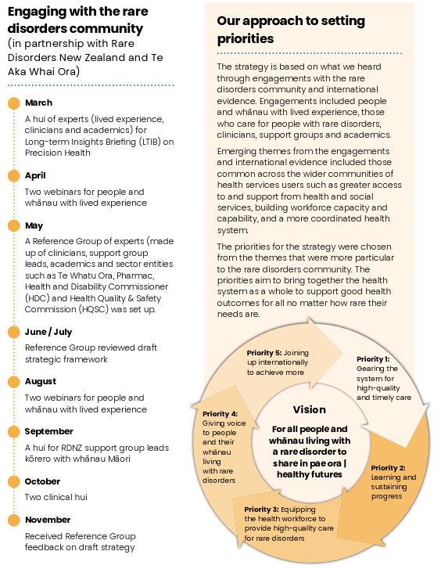

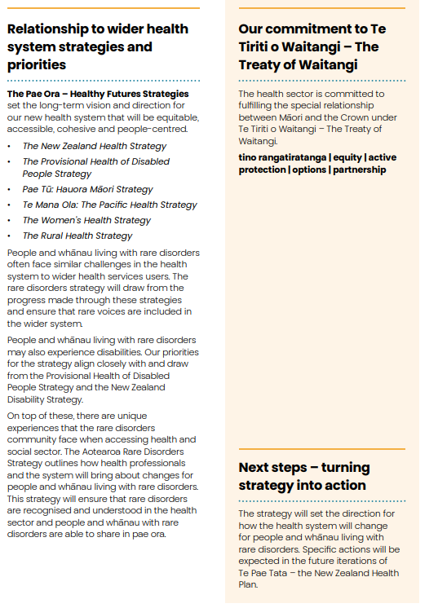

# 

# Kupu whakataki - Introduction

## Purpose of this strategy

The Aotearoa New Zealand Rare Disorders Strategy sets out the direction for the health system to better support people and their whānau living with rare disorders. It provides a framework and long-term priorities that will guide health entities in improving health and wellbeing outcomes for people and their whānau living with rare disorders over the decade 2024 to 2034.

## Vision for the strategy

All people and their whānau living with rare disorders share in pae ora (healthy futures) and live fulfilling lives.

Pae ora (healthy futures) is a holistic concept of health and wellbeing. It considers all the broad factors and contexts that influence people’s health and wellbeing throughout their lives.

Sharing in pae ora (healthy futures) means that people and their whānau living with rare disorders:

* are part of healthy and inclusive communities
* live in environments that enhance quality of life and promote health and wellbeing
* have the support of an equitable and accessible health system.

Achieving this vision requires working with people and their whānau living with rare disorders; iwi, hapū and Māori communities; Pacific communities; and other communities our health system serves. It requires collective efforts across health entities and different groups of workers, and the wider organisations and agencies that contribute to the health and wellbeing of people and their whānau living with rare disorders.

## Who the strategy is for

This strategy is for all who identify as, or provide support to, people (many of them children) and their whānau living with rare disorders in Aotearoa New Zealand. It is also for those who may not yet have a diagnosis or may not identify as someone with a rare disorder but can see their lived experiences reflected in the strategy.

Whānau and wider support networks play a vital role in supporting and making real the independence and aspirations of people living with rare disorders. We have used the term ‘people and their whānau living with rare disorders’ throughout the strategy and supporting documents to represent this collective approach to the health of people living with rare disorders. The strategy also recognises the overlap between rare disorders and disability.

## What a ‘rare disorder’ is

A **rare disorder** is a medical condition with a specific pattern of clinical signs, symptoms and findings that affects fewer than or equal to 1 in 2,000 people in Aotearoa New Zealand.

Rare disorders include, but are not limited to, rare conditions among genetic disorders, cancers, infectious disorders, poisonings, immune-related disorders, idiopathic disorders and various other rare undetermined conditions.

An **ultra-rare disorder** is a medical condition with a specific pattern of clinical signs, symptoms and findings that affects fewer than or equal to 1 in 50,000 people in Aotearoa New Zealand.

## Honouring Te Tiriti o Waitangi

The health sector is committed to fulfilling the special relationship between Māori and the Crown under Te Tiriti o Waitangi | the Treaty of Waitangi (Te Tiriti). Pae Tū: Hauora Māori Strategy 2023 and Whakamaua: Māori Health Action Plan 2020–2025 provide the guiding outcomes, principles and priorities for the health sector to uphold Te Tiriti and achieve Māori health equity, so that all Māori, whoever they are and wherever they are from, can flourish and thrive.

## Why we need a rare disorders strategy

Globally, there are over 7,000 known rare disorders, with more being identified each year. Many are ultra-rare and may affect only one or a handful of New Zealanders. Yet, in total, some 300,000 New Zealanders may live with a rare disorder.

People and their whānau living with rare disorders often face significant barriers to getting timely, effective and equitable health care. Health practitioners may find it difficult to identify rare disorders or may not know how to respond to support health and wellbeing. Aotearoa New Zealand needs a rare disorders strategy to improve system responsiveness and support for people and their whānau living with rare disorders, as well as for service providers who often face difficulties meeting patient needs.

Ultimately, the strategy will be successful if:

* people and their whānau living with a rare disorder have a better quality of life
* the health system is responsive to people whose needs or situation are uncommon, unusual or unclear
* those involved in designing, commissioning or providing new policies or services routinely consider the needs of people with rare disorders.

## What the strategy will achieve

* **Priority 1**: Gearing the system for quality and timely care
* **Priority 2**: Learning and sustaining progress
* **Priority 3**: Equipping the health workforce for quality rare disorders care
* **Priority 4**: Giving voice to people and their whānau living with rare disorders
* **Priority 5**: Joining up internationally to achieve more

# Priority 1: Kia tika ngā whakaritenga, kia pai ngā mahi tautiaki - Gearing the system for quality care

People and their whānau living with rare disorders often need help from a range of services across the health system. These services need to be connected up and easy to navigate, as well as to operate consistently throughout the country.

Practitioners have highlighted the need for more joined-up care across the health system. People working in hospital care, such as neonatal intensive care, may diagnose a rare disorder and give the news to whānau without having any way to link in to supports, counselling or other follow-up care.

## Building leadership and coordination

Building leadership and coordination to spearhead responsiveness to rare disorders will promote visibility and understanding across the system.

Responses to rare disorders are currently in different service lines and pockets across our health system. The new system will build on these responses and connect them up. Leadership and coordination across services and levels of the system will be established with the same degree of capability, recognition and support given to other system-wide leadership and improvement initiatives.

Leadership and coordination mechanisms will oversee the work of adopting elements that together make a coordinated and responsive system. These elements will include:

* diagnostic, referral, navigation and care standards, guidelines and pathways
* capability development reports and initiatives
* recommendations for service and system enhancements.

The kinds of leadership and coordination mechanisms chosen will ensure sustainability for the long term. Other countries use a range of approaches (such as networks, centres, national services and information hubs), which each have their supporters. A strong influence on the choice of mechanism in Aotearoa New Zealand will be how easily and sustainably the mechanism will integrate across the system and have the resourcing support it needs to ensure continuous improvement.

## Introducing new capabilities

Over time, new capabilities will be introduced into the system to speed up diagnosis and allow earlier preventive care.

New genomic testing for suspected rare disorders will speed up diagnosis, especially for infants and children. Rapid DNA sequencing will allow precise identification of a genetic disorder from among several thousand possibilities, rather than testing for one at a time. The capability and service infrastructure to support early testing and preventive care will be built over time.

Horizon scanning will inform early work to prepare for possible introduction of developing technologies and capabilities that can potentially benefit people with rare disorders. A workstream will clarify risks and benefits and will progress the conditions for safe adoption of technologies and capabilities, allowing for ongoing yet flexible early preparation.

Other work to occur well in advance of adopting new technologies and digital capabilities will be to develop ways to assure their safety and quality and to communicate about them. People and their whānau living with rare disorders will provide significant input to this work.

## Considering rare disorders when investing and prioritising

The approach to making decisions on and prioritising system investments will improve over time so that it values and considers benefits for people and their whānau living with rare disorders.

A programme of work across health entities will be concerned with improving the quality and timeliness of decision- making on access to diagnostic, preventive and treatment services, products and infrastructure. This work will include a particular focus on rare disorders.

An early goal of the work will be to improve and clarify how and when people with exceptional health needs or circumstances can access tests, advice, medicines, devices and other treatments that are not generally available. They may be highly expensive or require travel to other parts of the country or the world.

Over time, this programme of work will consider how to improve aspects of care such as:

* estimating and valuing all the impacts for people and their whānau of having or not having the service or product (that is, more than the direct impacts for individuals’ health)
* estimating and valuing lifetime impacts for the health system and government as well as for people
* equity, including intergenerational equity
* fairness across different types of investment (such as in medicines, new services, overseas treatments)
* fairness across different types of need (such as rare or common, prevention or treatment, ongoing or once-only, urgent or non-urgent, providing a cure or relieving symptoms).

# Priority 2: Te ako me te whakaūnga o ngā ahunga whakamua - Learning and sustaining progress

At present, we collect little information on rare disorders systematically. With limited data, we don’t know precisely how many New Zealanders live with rare disorders, what the health impacts are, and how many receive timely diagnosis and care.

## Collecting information on rare disorders

National health data sets will be able to routinely collect rare disorder information.

The level of diagnostic information that is available to readily search and report on will become more extensive and detailed over time. Increasingly, people and their whānau living with rare disorders will be able to access their information as well as more general information on rare disorders in Aotearoa New Zealand.

Clinical classifications will become increasingly detailed as national data collections adopt more advanced and specific classification systems. Classification systems will need to connect easily to supplementary data sets on rare disorders in particular.

We will need to develop ways of capturing data on suspected but unknown rare disorders. General (including ‘unknown’ or ‘unspecified’) codes may be considered for interim use where more specific categories are not yet available or do not apply.

## Using information to support provision of care

In the future, services will use rare disorder information to guide, monitor and improve care for patients.

As rare disorder information becomes more visible in the system, it will have many uses. These include to plan care, follow care provision and results, fill gaps and make improvements. These activities will build on work already done for some rare disorders, such as metabolic disorders.

Where clinical coding is not yet available, methods will be developed to connect high-quality rare disorder information with national health data.

Over time, planners and researchers will use non-identifiable information to improve care.

## Using information to monitor and improve care

Health information reports that include rare disorders will lead to improved care and choices for particular groups of patients.

Both regular reporting and reports concerned with specific issues will support quality care provision. Connecting up data for individuals and whānau will enable better and more timely care and choices. Connecting up data across groups of people who share one or more particular or related rare disorders will inform improvements in care, care pathways and future outcomes. This work will need to comply with careful standards to protect the privacy of individuals and their personal information. Examining de-identified data across the population of people living with rare disorders will help in finding ways for the system as a whole to better support and enable wellbeing.

## Using information to decide on priorities

In the future, decision-makers will consider rare disorders as they decide priorities

for evolving and changing the system. Before making changes, system planners and stewards will look at the likely impacts of those changes on outcomes for rare disorders.

People and their whānau living with rare disorders will become one of the population groups that decision-makers routinely think about when designing system improvements. Work programming to improve and invest in the system, and to evaluate these initiatives, will give priority to areas likely to produce greater benefits for people and their whānau living with rare disorders. Priorities will include, for example, intergenerational equity; improvements in services for or highly used by children; genetic and genomic infrastructure and services; and the supports and therapies (including physical and occupational) that benefit people living with rare disorders.

Though service and system improvements for the whole population or large population groups (such as children, Māori or rural communities) may lead to better outcomes for rare disorders, decision-makers will establish whether information confirms this rather than making assumptions.

## Supporting research and evaluation

The health research infrastructure will support rare disorders research and evaluation.

An expanded infrastructure will support researchers to conduct and people to participate in research on health and health services. Rare disorders research will become a key component of these activities. This will include research and evaluation of services and systems for rare disorders, along with measuring their outcomes, effectiveness and value for money.

Important activities to support growth in particular research areas over time will include:

* building support infrastructure for clinical trials, which will increasingly enable people from any part of Aotearoa New Zealand to participate in clinical trials led here or elsewhere
* developing methodology to measure and more accurately value a wider range of benefits and costs to people and their whānau living with rare disorders, and applying the methodology to support decision-making on investments and access
* evaluating service development and improvement programmes and other initiatives to improve responses for rare disorders
* including rare disorders information in the Stats NZ Integrated Data Infrastructure, where possible, to help us learn how wider social determinants link with health outcomes.

# Priority 3: E hāpai ana i ngā kaimahi hauora ki te whakarato i ngā mahi tautiaki tōtika mō ngā mate mokorea - Equipping the health workforce to provide quality care for rare disorders

Many people and whānau have expressed frustration with how long it takes to get a rare disorder diagnosis. Multiple practitioners and services may be involved, with few or none of them knowing much about rare disorders in general or about a particular rare disorder. People and their whānau feel they need to ‘fight’ for attention or to be heard.

Health practitioners throughout our engagements told us that while they want to help people and their whānau living with rare disorders, they often lack the information, resources or tools they need to provide that help.

## Rare disorders in health practitioner education

In future education programmes, health practitioners will learn more about rare disorders in general, about being responsive to unusual needs and about finding further information.

Curricula for health practitioner education at all levels will be revised over time to draw attention to rare disorders more frequently. Examples will canvass the impacts of rare disorders and the benefits of identifying and providing the right care earlier. As diagnostics, clinical guidelines and care pathways are developed, students will learn how to access the information they need to support care.

## Rare disorders learning modules

Learning modules for rare disorders will become widely accessible over time.

Health workforce learning opportunities in rare disorders will be increasingly available and become more sophisticated. Learning modules will include offerings on rare disorders specifically as well as more general offerings that include rare disorder content. Rare disorder examples will feature in an increasing portion of health workforce learning opportunities and increasingly in competency-based learning.

## Support and wellbeing learning modules

Learning modules for support and wellbeing will be widely accessible and will increasingly include rare disorders content.

Learning opportunities relevant to caring for and supporting people and their whānau living with rare disorders will become widespread. Rare disorder examples will be included in an increasing portion of learning opportunities related to tikanga practices, cultural safety and competency, care and support, counselling and social wellbeing.

## Clinical guidelines and pathways

Standard care provision will adapt, adopt and assimilate clinical guidelines and pathways for rare disorders.

A programme or process will be established to identify, adapt, authorise and publish guidelines, standards and pathways for rare disorders in Aotearoa New Zealand. The programme or process may start with rare disorders for which a national service or similar well-established approach is in place and move on to continually expand sets of tools to support care quality for increasing numbers of rare disorders.

Adaptation to the Aotearoa New Zealand context may include negotiating pathways for referrals, consultations and care transfers across different levels and different

service lines in the health system. It may include guidance on when to refer for highly specialised care or how to apply, in exceptional circumstances, for access to tests, treatments or forms of care that are not usually available.

## Everyday backup tools and easy-access practitioner support

Over time, published tools will be integrated with standard reference sources and patient management systems.

The system will also support experts in care for rare disorders to help and advise practitioners.

Expanding the help, advice and coaching functions available to practitioners will require resourcing and backup systems to make it easy for practitioners to ask for and receive help, including online.

Capacity review and redesign of specialist expert roles is likely to be required to build in time to provide this backup function as well as to cater for the care needs of an increasing number of people with identified rare disorders.

Specialist experts will need capability development that enables their ongoing learning for the role. Also important will be cross-specialty learning about how backup and advice functions best cultivate the provision of high-quality and confident care.

# Priority 4: Kia rangona ngā reo o ngā tāngata rātou ko ō rātou whānau e pāngia ana e ngā mate mokorea - Giving voice to people and their whānau living with rare disorders

People want rare voices to be heard across all parts of the health system. They want decision-makers to have at front of mind the extra issues that come with a rare disorder when they are deciding how services are provided and who can access them.

People from rare disorders communities feel that the system often prioritises health conditions that affect many people, rather than those that affect few. They say that making rare voices more prominent would lead to decisions about where to invest time and effort and make improvements that more fairly reflect the level of people’s health needs.

## Listening to rare voices

Voices of people and their whānau living with rare disorders will become evident across the health system.

Increasingly, people who can speak to rare disorders experiences will be members of forums across the health system. These forums will include consumer forums, advisory boards and committees, locality groups and partnership boards. They will include ad hoc committees and working groups set up for specific purposes such as developing guidelines or programmes or planning an event.

The voices and concerns of people and their whānau living with rare disorders will come across in major system reviews, service evaluations, business cases and investment decision-making. Existing examples of rare disorders input are evident in the 2022 independent review of Pharmac and the development of the Pae Ora Strategies.

## Listening to whānau Māori rare voices

Whānau Māori living with rare disorders will more regularly experience manaakitanga in the ways health service providers relate and respond.

Health care experts will cater to the needs of each whānau with empathy and respect, making them feel at ease. Care providers will acknowledge, welcome and listen to whānau Māori in a collaborative relationship. They will give whānau Māori the space to practise tikanga Māori. Health workers will communicate in a way that is clear and helps to build trust. Whānau Māori will experience autonomy and self- determination after consultation with their health care team.

Providers will offer choices where possible, and will accommodate the choices people make. Such choices may include, for example, rongoā Māori or mirimiri to restore wellness of mind, spirit, body and emotions.

## Including rare voices in communities

Community wellbeing efforts will become more inclusive of people and their whānau living with rare disorders.

Health promotion activities in local settings and diverse communities will increasingly focus on promoting health and wellbeing for all community members. As the number of activities, programmes and events to do with health and wellbeing increases, the focus on including all community members will become stronger. People who can speak to rare disorders experiences will be included in planning and implementing such activities and will have support to participate.

# Priority 5: E tūhono atu ana ki whenua kē kia piki ake tonu ngā hua - Joining up to achieve more

Rare disorder support groups have emphasised the importance of connecting internationally to support people and their whānau living with rare disorders. People and their carers and supporters value being able to connect with other people and whānau in similar situations or with the same disorder.

## Partnering with other countries

We will join and initiate partnerships with other countries that focus on rare disorders.

Aotearoa New Zealand health leaders will actively engage in international collaborations on rare disorders. We will partner with other countries in efforts to improve outcomes for people and their whānau living with rare disorders. Increasingly, we will make effective contributions to global efforts and seek out opportunities to collaborate with other countries in our region.

We will actively support international efforts to make it easier, faster, safer and more affordable to use new diagnostics, treatments and technologies for rare disorders. We will support the interests of smaller and less resourced countries, especially our Pacific neighbours.

## Learning, adopting and adapting

We will learn from other countries and adopt and adapt their tools, resources and advances.

Rare disorders programmes, networks, centres and other efforts have existed for some years in a range of countries. Many countries use guidelines, decision trees, referral and care pathways and similar tools based on or generating evidence of good outcomes for people with rare disorders.

A programme to adapt the most relevant tools for Aotearoa New Zealand will support easier and more widespread access to good care. Rare disorders community voices, along with Māori, Pacific, rural and other diverse voices, will be needed in testing quality and suitability for our context and service users.

Keeping up with evidence on effective approaches to rare disorders will remain important. Findings from current evaluations of the European Union’s virtual networks

of health care providers will generate new information on ways to share and concentrate knowledge and resources in order to make highly specialised care accessible.

## Joining in international clinical trials

People with rare disorders will, in time, be more able to participate in international clinical trials.

As our clinical trial infrastructure further develops, it will support New Zealanders to participate in international rare disorders clinical trials. Clinicians involved in trials will receive backup and research support where their patients are participants in suitable funded trials, even when there are very few potential participants from Aotearoa New Zealand.

## Better regulation and standards

Regulation and regulatory processes and standards will support rare disorders outcomes as much as possible.

Aotearoa New Zealand’s regulatory stewardship programme will review relevant legislation and regulatory frameworks to ensure they support rare disorders outcomes. Regulation of new technologies, digital capabilities, medicines, devices and other therapeutic products can support safe and timely access to diagnosis and effective treatments. Flexibility will be required for the appropriate level of scrutiny and safety precautions for a range of different rare disorder scenarios. Aligning Aotearoa New Zealand’s regulatory approaches with those of like-minded countries will reduce timeframes for assessment.

# Whānau-led research project

A determined whānau fight against a rare stomach cancer found a genetic cause which now saves thousands of lives

A three-decade journey to save whānau lives was awarded the 2023 Prime Minister’s Science Prize Te Puiaki Putaiao Matua a te Pirimia for a transformative scientific advance: <http://www.pmscienceprizes.org.nz>

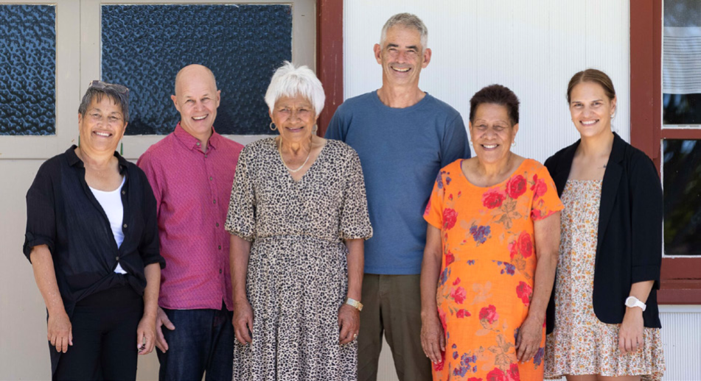

University of Otago Hereditary Diffuse Gastric Cancer Research Group members (from left) Erin Gardiner, Dr Jeremy Rossaak, Pauline Harawira, Professor Parry Guilford, Maybelle McLeod and Associate Professor Karyn Paringatai have won the 2023 Prime Minister's Science Prize.

Almost 30 years ago, the McLeod whānau teamed up with geneticists from the University of Otago and clinicians from Tauranga Hospital to uncover why many whānau members were dying young from stomach cancer They discovered a mutation in the CDH1 gene, leading to the identification of Hereditary Diffuse Gastric Cancer. This lead to the development of a genetic test to help families worldwide build knowledge of their cancer risk and take preventative measures.

This commitment and determination has saved 400 – 450 lives in Aotearoa New Zealand, with many more to be saved globally. It has also brought relief to those who learned they don’t carry the CDH1 gene – which is linked to a difficult-to-treat form of breast cancer.

The award celebrates innovation through an enduring partnership between the research team, clinicians, whānau and community. It emphasises the importance of building trust through respecting cultural and whānau values.

### Discovering the gene

In the mid-1990s, nurse and whānau member Maybelle McLeod noticed many of their younger people dying from stomach cancer. Seeking help, she contacted the University of Otago as a leading researcher into connections between genes and certain types of cancer. This led to a partnership with Professor Parry Guilford. They created an innovative agreement to maintain whānau control over genetic information. After extensive trust-building and a process of whānau members volunteering to undergo gene testing, they identified the CDH1 gene as the cause of the cancer.

### A preventative focus to treating whānau

The genetic test allows whānau members to determine their cancer risk, with preventative surgeries and regular surveillance as options after testing. The research and clinical teams know that holistic, whānau-centred care and respecting Māori values were key parts of the success and Erin Gardiner, Clinical Coordinator, and Surgeon Dr Jeremy Rossaak are committed to continuing this work.

### Supporting whānau Māori

Project member, Associate Professor Karyn Paringatai, a CDH1 carrier, has had a full gastrectomy (stomach removal) and now advocates for integrating Māori knowledge into healthcare, emphasizing the importance of understanding one’s whakapapa (genealogy).

### Whānau-led research

Professor Parry Guilford values the whānau- led approach, ensuring the research is needed and embraced by the community, fostering a sense of ownership and purpose that drives the project forward.

### Next steps

The whānau-led research project won the Prime Minister’s Science Prize for 2023 – the

$500,000 prize will fund an online hub with information about CDH1 and support further research into improved early intervention care options, potentially reducing the need for invasive surgeries.

# Mai i te rautaki ki te mahi - Strategy into action

Action across agencies, services, organisations and communities will put the strategy into effect. As activity builds over the decade, achievement will become clearly evident, with each action helping to progress others as well.

## Principles to uphold in actioning the strategy

To ensure the strategy supports pae ora for all New Zealanders, action will:

* build on and draw from the Pae Ora Strategies, the New Zealand Disability Strategy and the Child and Youth Wellbeing Strategy
* honour Te Tiriti o Waitangi and work towards achieving equity for Māori
* give voice to people and their whānau living with rare disorders
* support health practitioners and providers to deliver high-quality care
* be informed by and seek out evidence
* be collaborative and build on partnerships
* support pae ora for all while focusing on the health system challenges that come with rarity.

## Accountability for actioning the strategy

The Ministry of Health – Manatū Hauora, Health New Zealand – Te Whatu Ora, Pharmac – Te Pātaka Whaioranga and the Health Quality & Safety Commission

- Te Tāhū Hauora will be accountable for implementing and monitoring the strategy.

The Ministry of Health will support entities to make plans for actioning strategy priorities. Entities will report progress against these plans in their performance reports and annual reports.

## Other roles in actioning the strategy

Many other people, organisations and groups were pivotal in forming the strategy and will have important roles as it is put into action.

The Ministry for Disabled People – Whaikaha, the Ministry for Children – Oranga Tamariki, the Health and Disability Commissioner - Te Toihau Hauora, Hauātanga and the New Zealand Blood Service - Te Ratonga Toto O Aotearoa have a role as central government agencies serving populations to whom rare disorders are important. Non-governmental organisations like Rare Disorders New Zealand and Carers New Zealand have a role, as do iwi, universities and research institutes, professional colleges and service providers.

People with lived experience of rare disorders have a particularly important role. It is only through real-life insights that we can fully understand and act on opportunities to improve rare disorders outcomes and ultimately achieve progress.

# Ngā tuhinga tautoko me ngā taunakitanga - Supporting documents and evidence

In developing this strategy, the Ministry worked in partnership with Rare Disorders New Zealand and the Māori Health Authority – Te Aka Whai Ora to hear from those with experience and knowledge to contribute. Members of the rare disorders community and their whānau as well as researchers, clinicians and other sector experts provided their understanding of what is needed to make a difference in the lives of people and their whānau living with a rare disorder, and those who care for and support them.

Two supplementary documents provide further detail and explanation on how we developed the priorities in this strategy:

* Aotearoa New Zealand Rare Disorders Strategy: Rare voices and aspirations
* Aotearoa New Zealand Rare Disorders Strategy: Context and evidence.

We recommend reading these documents along with this strategy.