Health and Independence Report 2023 -   
Te Pūrongo mō te Hauora me te Tū Motuhake 2023

Citation: Ministry of Health. 2024. *Health and Independence Report 2023 - Te Pūrongo mō te Hauora me te Tū Motuhake 2023*. Wellington: Ministry of Health.

Published in July 2024 by the Ministry of Health  
PO Box 5013, Wellington 6140, New Zealand

ISBN 978-1-991075-82-6  (print)  
ISBN 978-1-991075-83-3  (online)  
HP 8870

Ministry of Health logo

This document is available at health.govt.nz

|  |  |
| --- | --- |
| **CCBY** | This work is licensed under the Creative Commons Attribution 4.0 International licence. In essence, you are free to: share ie, copy and redistribute the material in any medium or format; adapt ie, remix, transform and build upon the material. You must give appropriate credit, provide a link to the licence and indicate if changes were made. |

# Foreword

Tēnā koutou katoa

I am pleased to introduce the Health and Independence Report 2023, which offers a comprehensive overview of the state of public health in Aotearoa New Zealand for the 2023 calendar year. This report points to not only the progress we have made in many areas, but also the challenges we have encountered on our journey toward better health and wellbeing for all.

The 2023 year saw the health system consolidating changes that will enable health care to be nationally planned, regionally delivered and locally tailored – so people get the right care at the right time and in the right place, delivered by the right people.

Within that process, the Ministry of Health – Manatū Hauora has a key role as the chief steward of health and the health system. We lead the system by supporting the Government to set the strategic direction and policy for health. The Government Policy Statement on Health 2024-27 outlines what the Government expects the health system to deliver, and how success will be measured and reported. It captures the Government’s priorities of access, timeliness, quality, workforce and infrastructure, and ties in with the Health Targets launched in February 2024.

The Ministry also plays an essential role in monitoring the health system, using data and evidence to drive performance and inform future planning. This report provides robust data to support us to both set the direction and monitor health system performance.

The data also shows some New Zealanders are experiencing avoidable differences in health outcomes from the general population – particularly Māori, Pacific peoples, disabled people, and those living in lower-income households or areas of high socioeconomic deprivation. It is vital to acknowledge that such disparities persist within our communities. Ensuring that all New Zealanders can access high-quality health care when they need it remains a key focus for the health system.

To this end, we need robust data that we can use to design health services that support all New Zealanders to live well for longer. Our annual Health and Independence Reports contribute to this essential foundation of data underpinning our health system.

Importantly, I want to acknowledge the data in this report is much more than numbers, dots, and lines. It represents people’s real-life experiences and outcomes – something I never lose sight of. Across the health system, we are seeking to make life tangibly better for individuals, families, and communities.

Finally, I extend my sincere thanks to all those working to enhance the health and wellbeing of the people living in Aotearoa New Zealand. It is my hope this report will be a valuable resource to support your work.

Ngā mihi

Dr Diana Sarfati

Director-General of Health

# He wāhinga kōrero

Tēnā koutou katoa

E koa ana au ki te whakapuaki i te Pūrongo Hauora me te Tū Motuhake 2023, ka tuku i tētahi tirohanga whānui o te āhuatanga o te hauora tūmatanui i Aotearoa mō te tau maramataka 2023. Ka kōrero tēnei pūrongo mō tō mātou koke whakamua ki ngā wāhi maha, waihoki ka kōrero mō ngā wero i tūpono mātou i tō mātou haerenga ki te hauora me te oranga pai ake mā te katoa.

I te tau 2023 i kitea ngā panoni whakatōpū i roto i te pūnaha hauora e taea ai te whakamahere ā-motu, te whakarato ā-takiwā, me te whakahāngai ā-rohe te tiaki hauora – kia whiwhi ngā tāngata ki te tiakitanga tika i te wā tika, i te wāhi tika hoki, e whakaratoa ana e ngā tāngata tika.

I roto i taua tukanga, he tūnga matua tō te Manatū Hauora hei tuari matua o te hauora me te pūnaha hauora. E ārahi ana mātou i te pūnaha mā te tautoko i te Kāwanatanga kia whakarite i te ahunga rautaki me te kaupapahere rautaki mō te hauora. E whakahua ana te Tauākī Kaupapahere a te Kāwanatanga mō te Hauora 2024-27 he aha te tūmanako o te Kāwanatanga kia whakaratoa e te pūnaha hauora, ā, me pēhea te angitu e inea ai, e pūrongohia ai hoki. E whakatinana ana tēnei i ngā whakaarotau Kāwanatanga o te āhei, te wā tika, te kounga, te rāngai mahi, me te tūāhanga, ā, e tūhono ana hoki ki ngā Whāinga Hauora i whakarewahia i te Pēpuere o 2024.

He tūnga waiwai hoki tō te Manatū Hauora ki te aroturuki i te pūnaha hauora, e whakamahi ana i te raraunga me te taunakitanga kia kōkiri i te tutukinga, kia whai mōhio hoki te whakamahere anamata. E whakarato ana tēnei pūrongo i te raraunga pakari hei tautoko i tā mātou whakarite i te ahunga me te aroturuki i te tutukinga pūnaha hauora hoki.

E whakaatu ana hoki te raraunga i te wheako o ētahi tāngata nō Aotearoa ki ngā putanga hauora e rerekē ana i ō te taupori whānui e taea ai te karo – otirā ngāi Māori, ngā tāngata nō te Moana-nui-a-Kiwa, ngā tāngata hauā, me te hunga e noho ana ki ngā kāinga pūtea iti, ngā takiwā rānei he nui rawa te pakukore ohapori teitei rānei. He waiwai kia tūtohu i ngā manarite-kore i roto i ō mātou hapori. Ko te arotahi matua mō te pūnaha hauora kia whakatūturu e taea ai e ngā tāngata katoa o Aotearoa te āhei ki ngā tiakitanga hauora tino kounga ina hiahiatia ana.

Nā reira, e hiahia ana mātou ki te raraunga pakari e āhei ana mātou te whakamahi kia hoahoa i ngā ratonga hauora e tautoko ana i ngā tāngata o Aotearoa katoa kia noho ora ai mō te wā roa ake. E tāpae ana ā mātou Pūrongo Hauora me te Motuhaketanga ā-tau ki tēnei tūapapa waiwai o te raraunga hei pūtake o tō mātou pūnaha hauora.

Kāti rā, e hiahia ana au ki te tūtohu he mea nui ake ngā raraunga o tēnei pūrongo i te nama, te ira, me ngā rārangi noa iho. E whakakanohi ana i ngā wheako me ngā putanga tūturu o ngā tāngata – e kore tenei e wareware i a au. Puta noa i te pūnaha hauora, e kimi ana mātou kia tino piki ake te pai o te ao mō ngā tāngata takitahi, ngā whānau, me ngā hapori.

Ka mutu, ka whātoro atu taku mihi maioha ki a rātou mā e whakapau kaha ana ki te whakarākeei i te hauora me te oranga o ngā tāngata e noho ana ki Aotearoa. Ko taku tūmanako hei rauemi whai painga tēnei pūrongo hei tautoko i tō mahi.

Ngā mihi

Tākuta Diana Sarfati

Te Tumu Whakarae mō te Hauora

# Executive summary - He whakarāpopototanga

The 2023 Health and Independence Report provides a comprehensive overview of the state of public health in Aotearoa New Zealand for the 2023 calendar year. To do so, it combines the most up-to-date information available on a range of measures that illustrate key trends and other factors affecting the health and wellbeing of New Zealanders.

### People of Aotearoa New Zealand

The strategic approach to health in Aotearoa New Zealand includes the Pae Ora (Healthy Futures) Act 2022, which aims to protect, promote, and improve health, and achieve equity in health outcomes. To progress toward pae ora (healthy futures), the Ministry of Health – Manatū Hauora published six strategies in 2023: an overarching [New Zealand Health Strategy](https://www.health.govt.nz/publication/new-zealand-health-strategy), and five additional strategies addressing health and wellbeing needs for specific population groups ([Māori](https://www.health.govt.nz/new-zealand-health-system/setting-direction-our-new-health-system/pae-tu-hauora-maori-strategy), [Pacific peoples](https://www.health.govt.nz/publication/te-mana-ola-pacific-health-strategy), [disabled people](https://www.health.govt.nz/new-zealand-health-system/setting-direction-our-new-health-system/health-disabled-people-strategy), [rural health](https://www.health.govt.nz/publication/rural-health-strategy) and [women’s health](https://www.health.govt.nz/publication/womens-health-strategy)).

A snapshot of the population of Aotearoa New Zealand shows that, on 31 December 2023, the country was home to 5,305,600 people. This is a 2.8% increase from the year before, representing an estimated 145,100 additional people. This population growth was primarily driven by provisional net migration. In 2023, the net migration gain was the highest ever recorded in one year. Conversely, the natural increase was the lowest in 80 years, with no lower increase recorded since 1943.

The Aotearoa New Zealand population is becoming more ethnically diverse: the 2018 Census counted over 160 different ethnicities. The five major ethnic groups comprise: Māori (17.4% of the population), Pacific peoples (8.8%), Middle Eastern/Latin American/African (MELAA) (1.9%), Asian (17.9%) and European/other (68.9%).

In addition to becoming increasingly diverse, the population is ageing. This demographic change increases demand on health and disability services as older people typically require these services more than younger people. Currently 16.5% of the population is aged 65 years and over, and this is projected to increase to 22.1% by 2043. The proportion of people aged 65 years and over differs by ethnic group. The European/other population is markedly different: almost 20.2% of people in this group are aged 65 years and over, compared with 7.4% of Māori, 6.1% of Pacific peoples, 5.0% of MELAA and 8.8% of Asian people.

Where people live can have a profound impact on health and wellbeing, with socioeconomic and environmental factors playing significant roles. The Aotearoa New Zealand population is largely urban but includes a significant rural population. According to the 2018 Census, European/other is the largest ethnic group in rural areas (82%), followed by Māori (22%), Asian people (4%) and Pacific peoples (3%). In both urban and rural areas, rates of socioeconomic deprivation vary considerably, but higher rates of deprivation are strongly associated with worse health. Māori and Pacific peoples are much more likely to live in the most socioeconomically deprived areas (quintile 5): 43.0% of Māori and 55.8% of Pacific peoples live in quintile 5, compared with 17.5% of Asian people and 12.5% of European/other people.

Māori, Pacific peoples and the disabled population experience inequity and poorer health outcomes compared with the general population. Examples include lower life expectancy, higher rates of child poverty, lower self-rated health, higher rates of anxiety and depression, and higher rates of unmet need.

### Health measures

Key indicators of New Zealanders’ health and wellbeing include self-rated health, life expectancy, mortality rates across the population and maternity measures.

Most adults rate their health highly. However, Māori (80.5%) and Pacific (81.8%) adults were less likely to report being in good health (defined as good, very good or excellent health) than Asian (90.5%) and European/other (87.9%) adults. Only 59.4% of disabled adults reported having good health compared with 90.2% of non-disabled adults.[1]

Life expectancy continues to increase in Aotearoa New Zealand. Life expectancy at birth is estimated to be 82.2 years (80.3 years for newborn males and 83.7 years for newborn females). Between 2020 and 2021 global life expectancy fell by 1.6 years because of the COVID-19 pandemic. In contrast, Aotearoa New Zealand had one of the lowest age-adjusted excess mortality rates (the net difference between the number of deaths during the pandemic and the number of deaths that would be expected based on past trends), so maintained a small increase in life expectancy during this period.

Life expectancy in Aotearoa New Zealand is higher for females than males, but the difference is reducing over time.

Life expectancy rates in Aotearoa New Zealand differ among ethnic groups and by gender. Māori males have the lowest life expectancy at birth at 73.4 years, followed by Pacific males at 75.4 years. Asian females have the highest life expectancy at 87.9 years. Life expectancy also differs with deprivation: life expectancy for people living in the most deprived areas is about 10 years lower than the life expectancy of those living in the least deprived areas.

Trends in mortality have a major impact on changes in life expectancy. In 2021 (the most recent mortality information), the leading causes of death in Aotearoa New Zealand for both Māori and non-Māori were cancers and ischaemic heart disease. While the number of deaths has increased as the population grows and ages, the mortality rate per 100,000 people has reduced over time. Mortality rates continue to be higher for Māori than non-Māori, although this difference has also reduced over time.

Higher infant death rates occurred in the areas of highest deprivation. The infant death rate in the highest deprivation areas was close to two times the rate in the least deprived areas.

### Causes of health loss

Various factors contribute to overall health loss, which includes both mortality (deaths) and morbidity (poor health). A notable part of the Government’s current approach to reducing health loss is the 5+5 concept, which focuses on reducing five key risk factors (smoking, alcohol consumption, poor nutrition, physical inactivity, and adverse social and economic factors) to prevent five major diseases (cancer, diabetes, respiratory disease, cardiovascular disease, and poor mental health). Together, these conditions account for around 80% of deaths from non-communicable diseases in Aotearoa New Zealand and a considerable amount of the health loss that New Zealanders experience.

The Global Burden of Disease (GBD) Study measures health loss in the form of disability-adjusted life years (DALYs). One DALY represents the loss of one year of life lived in good health, taking into account both fatal and non-fatal components to assess overall population health.

According to the 2021 GBD study, non-communicable diseases cause 85% of the health loss in Aotearoa New Zealand. The five leading condition groups contributing to this health loss are cancers (neoplasms), cardiovascular diseases, musculoskeletal diseases, mental disorders, and neurological disorders. The remaining health loss occurs because of injuries (12%) and communicable, maternal, neonatal, and nutritional diseases (3%).

Health loss in the population generally increases with age. In 2021, children under the age of 15 years made up around 19% of the population but accounted for 5% of total DALYs. People aged 75 years and over were 7% of the population but accounted for 26% of DALYs.

In addition to the five leading causes of health loss identified in the GBD study, this report includes respiratory diseases, diabetes and chronic kidney disease, oral health disorders, injury and infectious diseases, including COVID-19.

### Determinants of health and wellbeing

A wide range of factors influences the overall health outcomes of individuals and populations. The broad categories of these determinants are the social and economic environment, physical environment, individual risk factors, and access to and experience of health care. Each of these factors is interconnected with the others and contributes to health disparities and overall quality of life.

In the social and economic environment, racism is increasingly acknowledged as an important determinant of health. Māori, Pacific and Asian adults are more likely to experience racial discrimination. The most common type of discrimination people experience is verbal abuse, followed by unfair treatment by a health professional.

Poverty is a major cause of poor health. In 2023, three out of the nine measures of child poverty increased. Rates of children experiencing material hardship, for example, increased to 12.5%, and rates of severe material hardship increased to 5.5% of all Aotearoa New Zealand children. Rates of material hardship were disproportionately high for Māori (21.5%) and Pacific (28.9%) children. Similarly, 22.3% disabled children experienced material hardship, compared with 11.1% of non-disabled children.

These disparate rates of material hardship among population groups were mirrored in the rates of children experiencing household food insecurity.

The physical environment is a key determinant of health: clean air, safe drinking water and adequate housing are fundamental to good health. Home ownership rates in Aotearoa New Zealand are the lowest in almost 70 years, and the proportion of people spending more than 40% of their income on housing increased in 2023. Although the cost of housing rose, some measures indicate continuing concerns with quality: 25.7% of people reported having issues with dampness or mould, and 20.5% reported issues with heating.

The determinants of health include individual risk factors. Data from the GBD study indicates that over a third (35.4%) of all health loss is due to individual risk factors. The leading risk factors include high body mass index (BMI), tobacco use, high fasting plasma glucose (high blood sugar), high blood pressure and dietary risks. Rates of physical activity, body size (obesity rates), and diet (consuming the recommended daily amount of fruit and vegetables) are provided in this report, along with information on tobacco, vaping and alcohol use.

Fewer adults drank alcohol in the past year and the rate of hazardous drinking also decreased. Smoking rates in Aotearoa New Zealand continue to decrease for all adults, all ethnic groups and both disabled and non-disabled adults.

Timely and equitable access to health care is essential for improving people’s health and reducing health disparities. This level of access includes ensuring Māori and other population groups have access to services in proportion to their health needs.

Primary and community health care services are the health services that New Zealanders most often interact with. One barrier to accessing primary health care is the time taken to get an appointment, which 21.2% of adults report. In addition, 12.9% of adults reported cost as a barrier, and this was more common among women (15.1%) than men (10.5%). Childhood immunisation coverage rates have continued to decrease.

According to the hospital inpatient experience survey, 90.6% of adults using inpatient hospital services reported their health care team definitely treated them with care and respect. On discharge, 72.5% of people reported that they had enough information to manage their condition after leaving hospital. In 2023, the number of visits to emergency departments increased, and people waiting more than four months for specialist assessment and/or treatment also continued to increase.

Contents - Ngā kōrero

Foreword iii

He wāhinga kōrero iv

Executive summary - He whakarāpopototanga vi

Introduction - He kupu whakataki 1

People of Aotearoa New Zealand - Ngā tāngata o Aotearoa 2

Health strategy 2

Population 2

Demographics 3

Disabled population 9

Equity 9

Health measures - Ngā inenga hauora 11

Self-rated health 11

Life expectancy 13

Mortality 17

Maternity 19

Causes of health loss - Ngā take mō te mate hauora 23

Overview of health loss in Aotearoa New Zealand 24

Cancers (neoplasms) 28

Cardiovascular and cerebrovascular diseases 36

Musculoskeletal conditions 37

Mental health 38

Neurological conditions 41

Respiratory diseases 41

Diabetes and chronic kidney disease 42

Oral health 42

Injury 47

Infectious (communicable) diseases 48

Determinants of health and wellbeing - Ngā tūtohu o te hauora me te oranga o te tangata 55

Social and economic environment 55

Physical environment 58

Individual risk factors 63

Health care 68

Technical notes - Ngā puna raraunga 79

References - Ngā tohutoro 82

List of Figures

Figure 1: International net migration to Aotearoa New Zealand, rolling year end, June 2013 – December 2023 3

Figure 2: Changes in age distribution of Aotearoa New Zealand population, 2003, 2023 and 2043 5

Figure 3: Age structure of the Aotearoa New Zealand population, 2023, by ethnic group (total response) 6

Figure 4: Travel time to radiation centres for patients attending radiation treatment in Aotearoa New Zealand, 2018–2021 7

Figure 5: Aotearoa New Zealand estimated resident population, by prioritised ethnic group and deprivation quintile, 2023 8

Figure 6: Self-rated good health, by ethnic group (total response), 2014/15–2022/23 12

Figure 7: Self-rated good health, by deprivation quintile, 2013/14–2022/23 12

Figure 8: Impact of COVID-19 on life expectancy at birth, comparing Aotearoa New Zealand with international data, 1990–2021 14

Figure 9: Life expectancy for males and females by region, 2017–2019 15

Figure 10: Aotearoa New Zealand life expectancy at birth, by ethnic group (total response) and gender, 2017–2019 16

Figure 11: Aotearoa New Zealand life expectancy at birth, by deprivation decile and gender, 2017–2019 16

Figure 12: Mortality rate by main causes, Māori and non-Māori, 1996–2021 18

Figure 13: Percentage of births by type and age of person giving birth, 2007–2021 20

Figure 14: Number of births, by age of person giving birth, Aotearoa New Zealand, 2007–2021 21

Figure 15: Breastfeeding status at two weeks of age, by baby’s ethnic group (prioritised ethnicity), 2021 22

Figure 16: Proportion of disability-adjusted life years (DALYs) lost by high-level cause (GBD levels 1 and 2), Aotearoa New Zealand, 2021 25

Figure 17: Top 10 leading causes of DALYs, years of life lost (YLLs) and years lived with disability (YLDs) (ranked), GBD level 3, Aotearoa New Zealand, 2021 26

Figure 18: Share of total disability-adjusted life years (DALYs) (2021) compared with share of the 2021 estimated Aotearoa New Zealand resident population (2018-base), by age group 28

Figure 19: Age-standardised rate of new cancer registrations, by ethnic group (prioritised ethnicity), 2012–2021 29

Figure 20: Changes in the net five-year survival for the eight most diagnosed cancers, 1998-99 to 2020-21 30

Figure 21: Rate of all cancer deaths by age group (years), 2021 31

Figure 22: Two-year breast screening coverage rates for women aged 45–69 years, by ethnic group (prioritised ethnicity), 2010–2023 32

Figure 23: Cervical screening coverage, up to date, by ethnic group (prioritised ethnicity), 2009–2023 34

Figure 24: Difference (%) in breast and cervical cancer screening coverage from March 2020 (beginning of COVID-19 public health restrictions), by ethnic group (prioritised ethnicity), 2012–2024 35

Figure 25: Bowel screening coverage by ethnic group (prioritised ethnicity), 2019 – 2023 36

Figure 26: Percentage of children caries-free at age five years, by ethnic group (prioritised ethnicity), 2010–2022 44

Figure 27: Mean number of decayed, missing, and filled teeth (DMFT) per child at year 8, by ethnic group (prioritised ethnicity), 2010–2022 45

Figure 28: Percentage of children who visited a dental health care worker, by ethnic group (total response ethnicity), three-year rolling average, 2013/14–2022/23 46

Figure 29: Number of reported adverse events (severity assessment code 1 or 2), before and after baseline shift to a higher number of reported events, 2018–2023 48

Figure 30: Weekly count of hospital admissions for COVID-19, 2020–2023 49

Figure 31: Weekly count of COVID-19 deaths, 2020–2023 50

Figure 32: First admissions to hospital for rheumatic fever, rate per 100,000 population, by ethnic group (prioritised ethnicity), 2006/07–2022/23 51

Figure 33: Percentage of children living in household experiencing material hardship, by ethnic group (total response), 2019–2023 57

Figure 34: Age-standardised rate of housing-related hospitalisations, by gender and ethnic group (prioritised ethnicity), 2014–2023 60

Figure 35: Proportion of report population receiving drinking-water that complied with all Drinking-water Standards for New Zealand, 2011/12–2020/21 62

Figure 36: Insurance-related costs ($ million) of severe weather events, 1993–2022 63

Figure 37: Proportion of disability-adjusted life years (DALYs) from leading risk factors, Aotearoa New Zealand, 2021 64

Figure 38: Percentage of children immunised at milestone ages, by ethnic group (prioritised ethnicity), for the three months ending December 2023 71

Figure 39: Childhood immunisation coverage at milestone ages, by ethnic group (prioritised ethnicity), 2014–2023 72

Figure 40: Rate of ambulatory sensitive hospitalisations (ASH), by age group and ethnic group (prioritised ethnicity), 2019–2023 76

Figure 41: Proportion of people who waited longer than four months for assessment, or planned treatment, January 2020 – January 2024 78

List of Tables

Table 1: Examples of inequity for Māori, Pacific peoples, and disabled people, compared with the total Aotearoa New Zealand population 10

Table 2: Top 10 leading causes of disability-adjusted life years (DALYs) (ranked) by age band, GBD level 3, Aotearoa New Zealand, 2021 27

Table 3: ACC injury, number of new claims registered, total claims paid ($ million), 2022/23 47

Table 4: Proportion of adults consuming recommended daily amount of fruit and vegetables, by population group, (total response ethnicity), 2022/23 66

Table 5: Proportion of adults reporting unmet need for primary health care (in the past 12 months) and reason for that unmet need, by population group (total response ethnicity), three-year pooled period ending 2022/23 69

Table 6: COVID-19 vaccination status, by ethnic group (prioritised ethnicity), 2023 73

Table 7: COVID-19 vaccination status, by age group, 2023 73

# Introduction - He kupu whakataki

The Health and Independence Report is an annual publication that the Ministry of Health – Manatū Hauora prepares on behalf of the Director-General of Health in line with section 3C of the Health Act 1956. This latest comprehensive report provides an overview of the health status of New Zealanders for the 2023 calendar year.

The overview covers various measures related to the health of New Zealanders, ranging from mortality rates and disease prevalence to health service use and health inequities. It also reports on the wider determinants of health, recognising the profound influence of factors such as poverty, housing, income, and employment on the health outcomes of individuals and communities.

The data presented in this report is the latest available. It includes breakdowns by ethnic group, age group, gender, disability status and socioeconomic deprivation. This report also provides information from the 2021 Global Burden of Disease study to support evidence-based decision-making. In this way, it serves as a valuable resource for policy makers, health care professionals and all stakeholders working to advance the health and wellbeing of New Zealanders.

The report has four main sections.

1. ‘People of Aotearoa New Zealand - Ngā tāngata o Aotearoa’ outlines health strategies. It describes demographic features of New Zealanders such as population estimates, ethnic and age breakdowns, population distribution, disability status, and inequity.
2. ‘Health measures - Ngā inenga hauora’ covers the burden of disease, self-rated health, life expectancy, mortality across the population and maternity health measures.
3. ‘Causes of health loss - Ngā take mo te mate hauora’ covers the major causes of health loss and introduces the 5+5 concept. This concept focuses on reducing the five major non-communicable diseases (cancer, diabetes, respiratory disease, cardiovascular disease, and poor mental health) by addressing five modifiable risk factors (smoking, alcohol consumption, poor nutrition, physical inactivity, and adverse social and economic factors). This section reports data on cancers, cardiovascular and cerebrovascular diseases, musculoskeletal conditions, mental health, neurological conditions, respiratory diseases, diabetes and chronic kidney disease, oral health, and injury. It also covers infectious diseases – namely COVID-19, rheumatic fever, measles, meningococcal disease, and sexually transmitted infections – as well as antimicrobial resistance.
4. ‘Determinants of health and wellbeing - Ngā tūtohu o te hauora me te oranga o te tangata’ describes the wider factors that combine to affect the health of individuals: the social and economic environment, the physical environment and individual risk factors. This section also reports on health care measures of access, barriers to primary and community health care, immunisation rates and use of hospital services (emergency and unplanned care, ambulatory sensitive hospitalisations. and planned care services).

# People of Aotearoa New Zealand - Ngā tāngata o Aotearoa

This section introduces health strategies that build on the 2022 health system reforms. It also describes demographic details of the Aotearoa New Zealand population such as total population, birth and migration rates, and other key metrics of the population. With more than 5.3 million people in Aotearoa New Zealand, the resident population is diverse in terms of ethnicity, age, and where people live.

Aotearoa New Zealand, like many other countries, faces inequity within its population. These include disparities in income, health care access and health outcomes, housing, wellbeing and social outcomes. This section reports how Māori, Pacific peoples and the disabled population experience disproportionately high rates of socioeconomic deprivation and poorer health outcomes compared with the general population.

## Health strategy

As part of the New Zealand health system reforms, the Pae Ora (Healthy Futures) Act was enacted in 2022. The purpose of the Act is to protect, promote and improve the health of all New Zealanders, and to achieve equity by reducing health disparities among population groups, in particular for Māori.

To deliver pae ora (healthy futures), the Ministry of Health published six strategies in 2023 to set the direction for a system that is equitable, accessible, cohesive, and people centred. The strategies include an overarching [New Zealand Health Strategy](https://www.health.govt.nz/publication/new-zealand-health-strategy) (Minister of Health 2023a), and specific strategies focusing on the health of [Māori](https://www.health.govt.nz/new-zealand-health-system/setting-direction-our-new-health-system/pae-tu-hauora-maori-strategy), [Pacific](https://www.health.govt.nz/publication/te-mana-ola-pacific-health-strategy) peoples, [disabled](https://www.health.govt.nz/new-zealand-health-system/setting-direction-our-new-health-system/health-disabled-people-strategy) people, [rural communities](https://www.health.govt.nz/publication/rural-health-strategy) and [women](https://www.health.govt.nz/publication/womens-health-strategy) (for an overview, see Ministry of Health (2023i)). Together these strategies provide a long-term vision of an Aotearoa New Zealand where all people can achieve their best possible health.

## Population

On 31 December 2023, the total projected population of Aotearoa New Zealand was 5,305,600 people. This compares with 5,160,500 the year before and represents an increase of 145,100 people (2.8%) (Stats NZ 2024e).

Two factors contributed to this increase.

First, the population increased naturally by an estimated 19,071 people; this total comes from 56,955 live births minus 37,884 deaths (Stats NZ 2024a). This was the lowest natural increase since 1943 (during World War Two) when there were 17,562 more births than deaths (Stats NZ 2024i).

* For the year ended December 2023, there were 1,932 fewer births and 690 fewer deaths compared with the year ended December 2022.
* The number of births in 2023 was the lowest in 20 years. The total fertility rate[2] was 1.56, which is the lowest rate ever recorded, down from 1.66 for the year ended December 2022 (Stats NZ 2024a).

Second, the population grew through an increase in international migration (migrant arrivals minus migrant departures) (Stats NZ 2024j). International migration statistics count and describe movements of people into and out of Aotearoa New Zealand. Provisional estimates for the 2023 year[3] (Stats NZ 2024j) are:

* migrant arrivals: 240,123, up 101.0% from the previous year
* migrant departures: 109,141, up 15.4% from the previous year
* annual net migration: gain of 130,981, compared with a net gain of 24,900 for the year ended December 2022 (following a net loss of 14,950 in 2021). The 2023 year was provisionally the highest net gain on record for one year.

Figure 1 shows international net migration between June 2013 and December 2023. This is the balance of individuals arriving in Aotearoa New Zealand minus those departing.

Figure : International net migration to Aotearoa New Zealand, rolling year end, June 2013 – December 2023

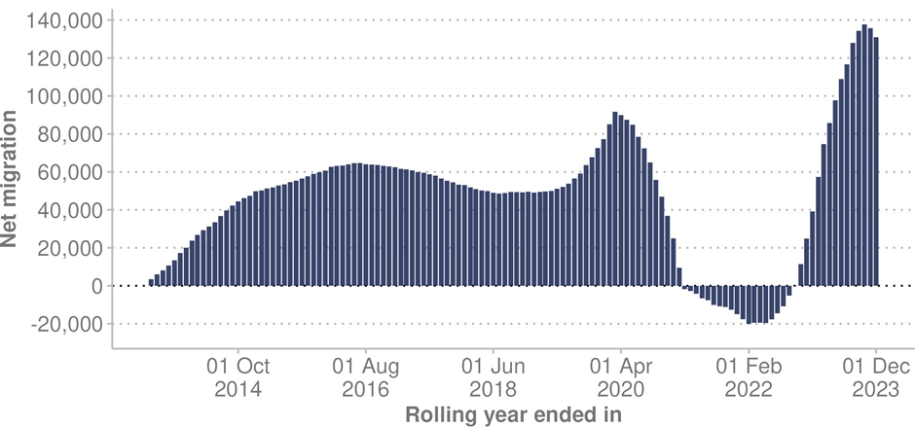

**Source:** Stats NZ (2024j)

## Demographics

To provide an understanding of the demographic landscape in 2023, this section examines various demographic characteristics of the Aotearoa New Zealand population. In particular, it looks at ethnic groups, age profile, geographic distribution and level of socioeconomic deprivation.

### Ethnic groups

Aotearoa New Zealand’s population is made up of many different ethnic groups: the 2018 Census counted over 160 ethnic groups at that time (Stats NZ 2020b). In 2023, the projected population using total response ethnicity was: Māori 17.4% of the total population, Pacific peoples 8.8%, Middle Eastern/Latin American/African (MELAA) 1.9%, Asian 17.9% and European/other 68.9% (Stats NZ 2024k).

Ethnic comparisons can be based on either prioritised ethnicity or total response ethnicity. With prioritised ethnicity, ethnic groups are mutually exclusive. That is, a person can appear in only one ethnic group. If they identify with more than one group, the group chosen for analysis is generally prioritised in the following order: Māori, Pacific peoples, Asian, other. Total response ethnicity classifies a person into all ethnic groups they identify with. This means that a person can appear in more than one ethnic group and the sum of ethnic groups will then add to more than 100%. When comparing ethnic groups and age groups, using total response ethnicity is recommended as people in younger age groups are more likely to identify with multiple ethnicities and ethnic prioritisation may misrepresent the age structure of those ethnic groups. When we report on ethnicity in this report, we state the ethnic comparison method used in each case.

### Age profile

The population of Aotearoa New Zealand and the world is ageing. This is a result of the continued decline in fertility rates and increased life expectancy. According to the World Health Organization (WHO), all countries face major challenges in preparing health and social systems for this demographic shift (WHO 2022a).

In Aotearoa New Zealand, the number of people aged 65 years or older is likely to reach 1 million by 2028 (Stats NZ 2022a). An ageing population tends to put more demand on a health system, as older people commonly require more health services than younger people. There is also a risk of higher overall rates of disability in the future as the population ages. This is because for both males and females, disability rates rise steadily with age (Minister of Health 2023a).

Figure 2 shows how the proportion of the Aotearoa New Zealand population aged 65 years and over is growing over time. In 2003, 11.8% of New Zealanders were aged 65 years and over. In 2023, the older age groups had risen to 16.5% of the population. By 2043, it is projected that 22.1% of people living in Aotearoa New Zealand will be aged 65 years and over (Health NZ 2024m).

Figure : Changes in age distribution of Aotearoa New Zealand population, 2003, 2023 and 2043

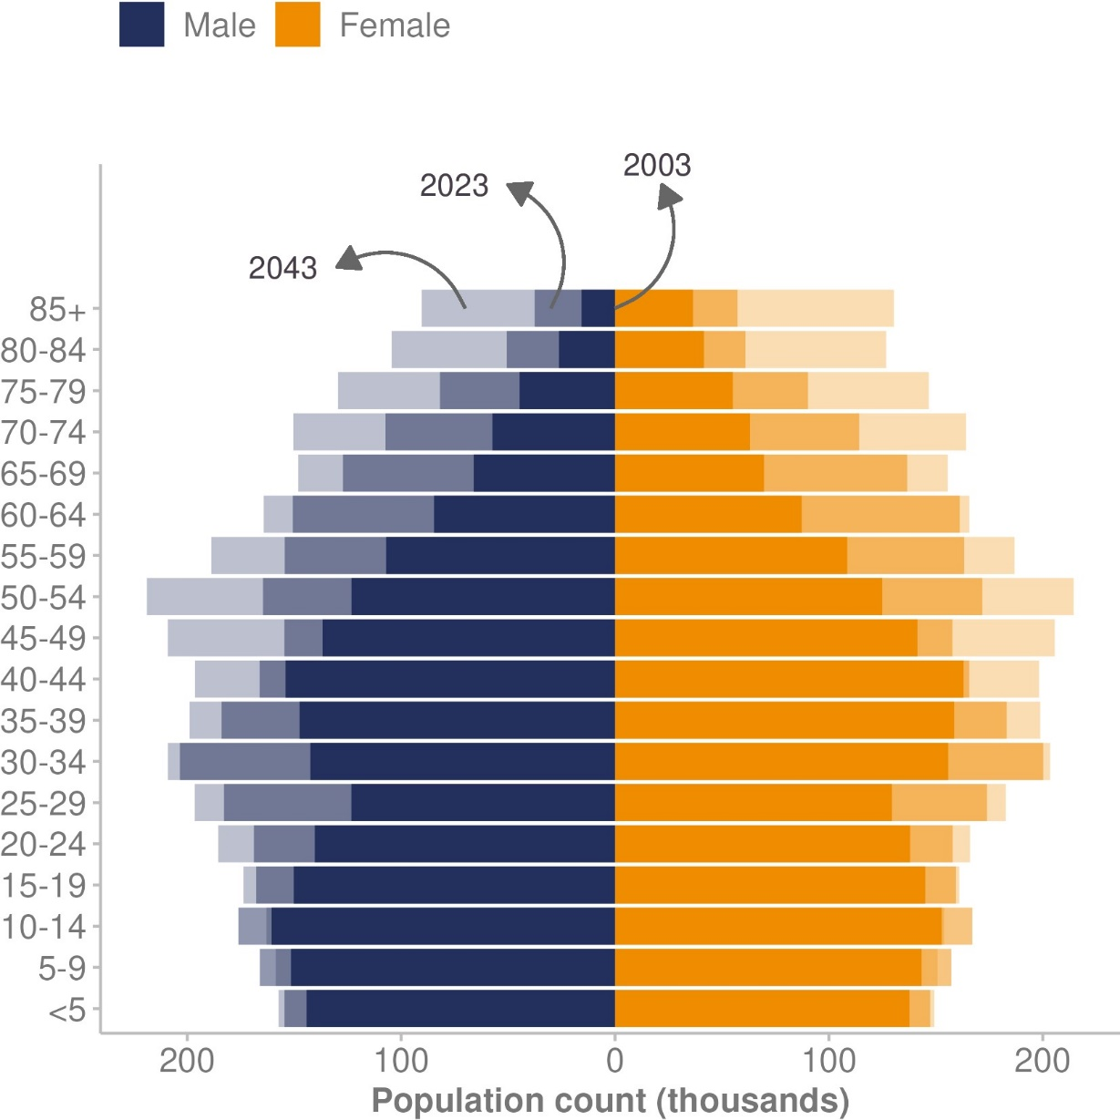

**Source:** Health NZ (2024m)

Figure 3 shows the age structure of the estimated resident population in Aotearoa New Zealand for each ethnic group (total response ethnicity). Among the European/other group, 20.2% of people (724,500 individuals) are aged 65 years and over. In contrast, the proportion of older people is lower among other ethnic groups: 7.4% (66,800) Māori, 6.1% (28,600) Pacific peoples, 5.0% (4,700) MELAA and 8.8% (75,800) Asian people are aged 65 years and over (Stats NZ 2024k).

Figure : Age structure of the Aotearoa New Zealand population, 2023, by ethnic group (total response)

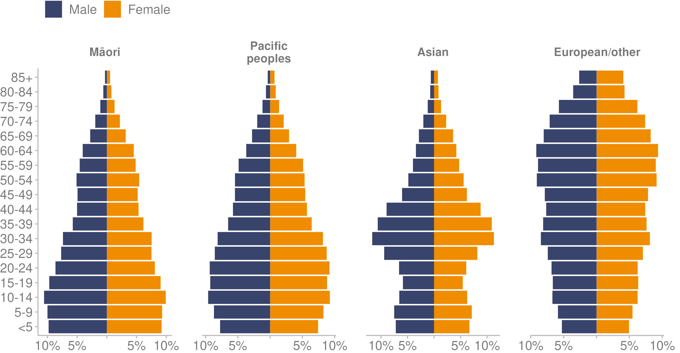

**Source:** Stats NZ (2024k)

### Geographic distribution

Throughout Aotearoa New Zealand, people live in a wide range of urban centres and rural communities. Most of the population is urban but the size of the rural population is significant. The proportion of people living in rural communities was stable at around 19% in census data between 2006 and 2018, and 19% continues to be the estimated size of the rural population (Minister of Health 2023b).

In the 2018 Census, European/other was the largest ethnic group in rural areas (82%), followed by Māori (22%).[4] Asian (4%) and Pacific peoples (3%) made up a small share of people within rural communities. The 22% of people identifying as Māori in rural communities was higher than the 15% identifying as Māori in urban areas (Minister of Health 2023b).

Older people are more likely to live in rural communities than other age groups. In 2018, around one-quarter of people aged over 65 years lived in rural communities. Between 1996 and 2018, those aged over 65 years grew from 13% to 20% of the rural population. This increase was higher than the equivalent change in urban areas (Minister of Health 2023b).

Overall, some key health outcomes for people in rural communities, particularly rural Māori, are poorer than for those in urban communities. Rural communities frequently face additional barriers to accessing health care services due to geographic distances. Other difficulties can intensify these barriers, such as weather events that disrupt key roads to services, limited mobile services and/or limited digital options, and intermittent or no internet connectivity.

Figure 4 demonstrates how travel distances can be a potential barrier to health care services. Focusing on the example of patients attending radiation treatment (Te Aho o Te Kahu 2022b), it shows that mean travel time (in hours) increases with distance from a radiation centre, adding challenges relating to travel, costs, and the possible need for overnight accommodation.

Figure : Travel time to radiation centres for patients attending radiation treatment in Aotearoa New Zealand, 2018–2021

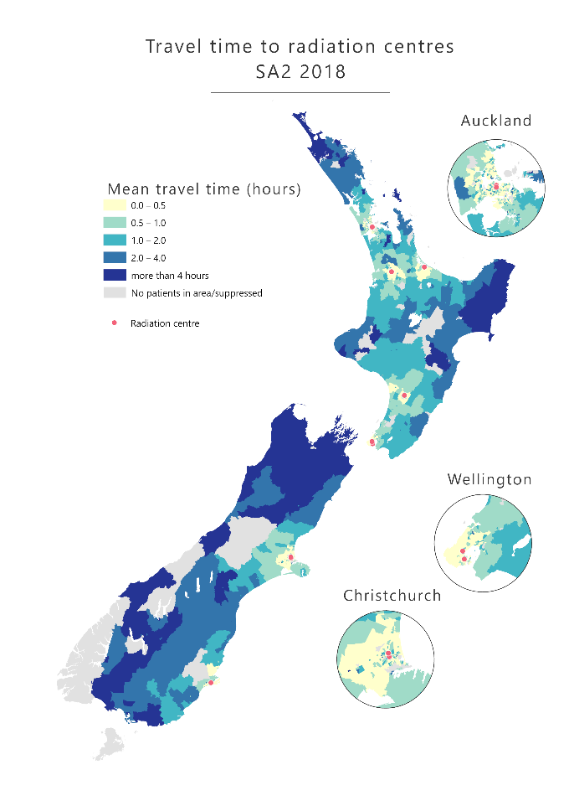

**Source:** Te Aho o Te Kahu (2022b)

### Socioeconomic deprivation

Within both urban and rural areas, the level of socioeconomic deprivation varies considerably, influencing quality of life and access to essential resources. This report uses the New Zealand Index of Deprivation (NZDep) to evaluate the level of deprivation across diverse communities. This is an area-based measure of the level of socioeconomic deprivation based on nine census variables, including income, employment, home ownership, overcrowding and housing with dampness and/or mould. It divides the population into deciles (10 groups of equal size) where:

* decile 1 represents areas with the least deprived scores
* decile 10 represents areas with the most deprived scores (Massey University (nd)).

Another common approach is to divide the NZDep measure into five groups or quintiles. Each quintile represents 20% of the population. In this approach:

* quintile 1 represents the 20% of areas with the lowest deprivation
* quintile 5 represents the 20% of areas with the highest deprivation.

It is important to note that deprivation is not distributed evenly across the population. For example, the Household Economic Survey 2020/21 estimates that the top 20% of households (quintile 1) hold approximately 62% of Aotearoa New Zealand’s total household net wealth, while the lowest 20% of households (quintile 5) hold 1% of household net wealth (Health NZ 2024a).

Higher levels of socioeconomic deprivation are associated with worse health (Massey University (nd)). Life expectancy is more than 10 years lower for people living in the most deprived areas than for those living in the least deprived areas (Stats NZ 2021a). The highest infant death rates are in most deprived areas (quintiles 4 and 5). In quintile 5, the infant death rate was close to two times the rate in the least deprived areas (Health NZ 2023b).

Deprivation distribution differs by ethnic group: Māori and Pacific peoples are much more likely to live in the most socioeconomically deprived areas. Figure 5 displays the proportion of each ethnic group living in each quintile. It shows 43.0% of Māori and 55.8% of Pacific peoples live in the most deprived quintile, compared with 17.5% of Asian and 12.5% of European/others. In contrast, nearly one in four (24.2%) of European/others live in the least deprived quintile, compared with 8.3% of Māori and 4.9% of Pacific peoples.

Figure : Aotearoa New Zealand estimated resident population, by prioritised ethnic group and deprivation quintile, 2023

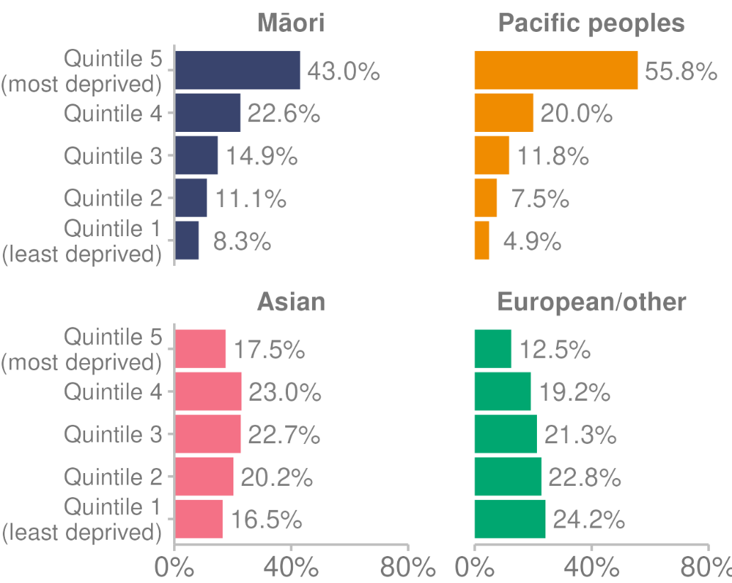

**Source:** Health NZ (2024m)

## Disabled population

The most recent data on the prevalence of disability in Aotearoa New Zealand comes from the 2013 Stats NZ New Zealand Disability Survey (Stats NZ 2014). In this survey, 1.1 million New Zealanders (24% of the population) identified as disabled.[5]

The survey showed:

* a range of impairments limited 11% of children and 27% of adults in their daily activities
* adults aged 65 years and over were much more likely to be disabled (59%) than adults aged under 65 years (21%)
* Māori and Pacific peoples had higher than average disability rates, after adjusting for differences in ethnic population age profiles.

Information from Stats NZ shows disabled people fare worse than non-disabled people across a range of outcomes relating to economic outcomes, housing and neighbourhoods, and social indicators (Stats NZ 2020a).

Stats NZ has now conducted the 2023 national disability survey and the results are expected in 2024/25. The purpose of the survey is to estimate the number of disabled people in Aotearoa New Zealand, understand more about the wellbeing of disabled people, and understand the barriers that disabled people experience in different areas of their lives (Stats NZ (nd)-a).

## Equity

The first principle of the Pae Ora (Healthy Futures) Act 2022 is that the health sector should be equitable. This includes ensuring Māori and other population groups have access to services in proportion to their health needs, receive equitable levels of service, and achieve equitable health outcomes.

The Ministry of Health (2023a) defines equity in this way:

In Aotearoa New Zealand, people have differences in health that are not only avoidable but unfair and unjust. Equity recognises different people with different levels of advantage require different approaches and resources to get equitable health outcomes.

Many of the causes of inequities are found across sectors and generations and are compounding – they build on each other. Equity is a complex, system-wide problem that requires systematic, multilevel solutions in and beyond the health sector (Health NZ 2024a).

### Health of Māori, Pacific peoples, and disabled people

Māori, Pacific peoples, and the disabled population experience inequity and poorer health outcomes compared with the general population. Table 1 presents key examples from within the report, highlighting the inequity Māori, Pacific peoples and disabled people face in health and health care.

Table : Examples of inequity for Māori, Pacific peoples, and disabled people, compared with the total Aotearoa New Zealand population

|  |  |  |  |  |
| --- | --- | --- | --- | --- |
| **Indicator** | **Total population** | **Māori** | **Pacific peoples** | **Disabled people** |
| Life expectancy | Men: 80.0 years  Women:  83.5 years | Māori men: 73.4 years  Māori women: 77.1 years | Pacific men: 75.4 years  Pacific women: 79.0 years | Not known |
| Living in most deprived areas (quintile 5) | Total: 20.0% | Māori: 43.0% | Pacific: 55.8% | Not known |
| Children living in material hardship | Total children: 12.5% | Māori children: 21.5% | Pacific children: 28.9% | Disabled children: 22.3% |
| Children living with household food insecurity | Total children: 21.3% | Māori children: 35.1% | Pacific children: 39.6% | Disabled children: 35.0% |
| Daily smokers* | Total adults: 8.2% | Māori adults:  20.2% | Pacific adults: 13.5% | Disabled adults: 12.8% |
| Self-rated good health* | Total adults: 87.4% | Māori adults:  80.5% | Pacific adults: 81.8% | Disabled adults: 59.4% |
| Breastfeeding exclusively/fully at two weeks | Total babies: 74.0% | Māori babies: 72.7% | Pacific babies: 66.6% | Not known |
| Anxiety and/or depression | Total adults: 34.8% | Māori adults: 45.2% | Pacific adults: 40.7% | Disabled adults: 61.5% |
| Emotional and/or behavioural problems** | Total children: 9.6% | Māori children: 13.5% | Pacific children: 10.1% | Disabled children: 38.9% |
| Unmet need for professional help with mental health | Total adults: 8.4% | Māori adults: 11.7% | Pacific adults: 8.8% | Disabled adults: 18.9% |

Note: * Three-year pooled period ending 2022/23. ** Two-year pooled period ending 2022/23.

**Source:** Stats NZ (2024a), Ministry of Health (2023d), Ministry of Health (2024d), Health NZ (2023e)

# Health measures - Ngā inenga hauora

This section reports on meaningful measures of the health of the Aotearoa New Zealand population. It covers self-rated health, life expectancy, mortality measures, and maternity indicators, including fetal and infant mortality.

One of the key data sources used in this section is the New Zealand Health Survey (Health Survey). This survey monitors the health and wellbeing of New Zealanders, including how people experience their own health and health services. The information covers population health, health risk and protective factors, as well as health service use (Ministry of Health 2023e). The Ministry of Health began running the Health Survey in 1992/93 and has conducted it every year since 2011/12.

## Self-rated health

Self-rated health is a measure based on a person’s perception of their own health. Individuals rate their health on a scale from excellent to poor.

In the Health Survey, for the three-year pooled period ending 2022/23, most adults (87.4%) reported that they were in good health (defined as good, very good or excellent health). However, rates differed by population group.

* Disabled adults (59.4%) were less likely to report they were in good health than non-disabled adults (90.2%), after adjusting for age and gender.
* Māori (80.5%) and Pacific (81.8%) adults were less likely to report they were in good health than Asian (90.5%) and European/other (87.9%) adults.

Figure 6 presents three-year rolling averages of self-rated good health between 2014/15 and 2022/23 by ethnic group. It shows self-reported good health for Māori and Pacific peoples has declined since 2014/15. The level of good health for Asian and European/other adults has remained stable.

Figure : Self-rated good health, by ethnic group (total response), 2014/15–2022/23

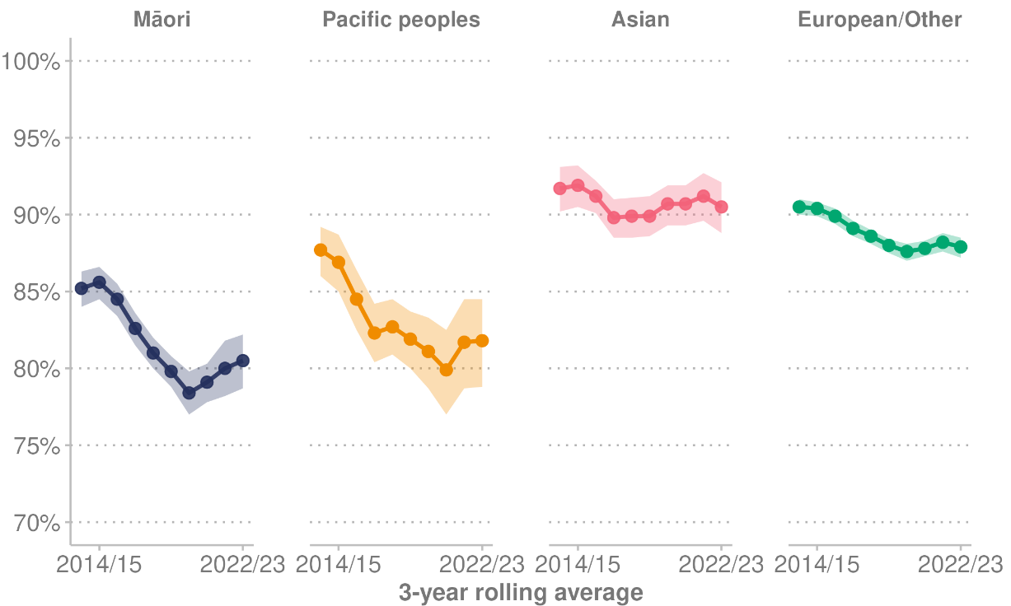

Note: Shaded area indicates 95% confidence intervals.

**Source:** Ministry of Health (2023d)

Figure 7 presents three-year rolling averages of self-reported good health (defined as good, very good or excellent health) by deprivation quintile between 2013/14 and 2022/23. It shows that fewer adults living in the most deprived quintile (81.6%) reported being in good health than those living in the least deprived quintile (90.5%).

Figure : Self-rated good health, by deprivation quintile, 2013/14–2022/23

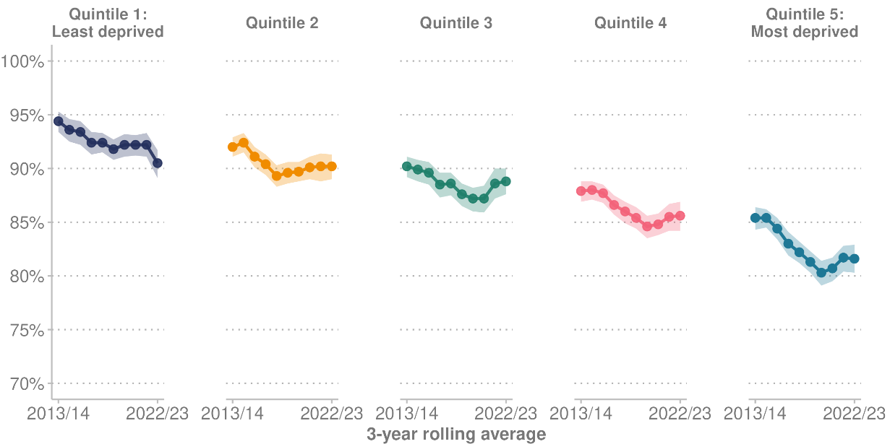

Note: Shaded area indicates 95% confidence intervals.

**Source:** Ministry of Health (2023d)

### Parent-rated child health

In the three-year pooled period ending 2022/23, according to their parents or primary caregiver, 97.0% of children were in good, very good or excellent health. This level of good health among children is down from 98.1% for the three-year pooled period ending 2018/19.

Parent-rated child health differed by population group in the three-year pooled period ending 2022/23.

* Parents of Māori children (94.7%) and Pacific children (95.2%) were less likely to rate their children’s health as very good or excellent, compared with parents of Asian children (97.8%) and European/other children (97.8%).
* Parents of children living in the most deprived neighbourhoods (quintile 5) (95.7%) were less likely to rate their children’s health as very good or excellent, compared with parents of children living in the least deprived neighbourhoods (quintile 1) (98.9%).

A question set used to identify disabled children (The Washington Group / UNICEF Child Functioning Module) was included In the Health Survey for the first time in 2022/23. Parents of disabled children were asked to rate their child’s health. For the 2022/23 year, 86.2% of parents of disabled children rated their child’s health as good, very good or excellent, compared with 97.9% of parents of non-disabled children.

## Life expectancy

Life expectancy at birth is a summary measure[6] of population survival. It is the average number of years a person born today can expect to live, if current age-specific mortality rates continue. The current estimated average life expectancy at birth for New Zealanders is 82.2 years. Compared with all countries, Aotearoa New Zealand is ranked twentieth by life expectancy at birth. Hong Kong is highest at 85.5 years, followed by Macao at 85.3 years (World Bank (nd)).

In 2023, there were 37,884 deaths in Aotearoa New Zealand. This total was 690 fewer deaths (1.8%) than the previous year. Most deaths occurred in older age groups, with almost two out of every three deaths involving people aged 75 years and over. The median age at death in 2023 was 79 years for males and 83 years for females. In 1953 (70 years ago), the median age of death was 68 years for males and 71 years for females (Stats NZ 2024a).

Although the number of deaths in 2023 was lower than in 2022, the 690 deaths in 2023 were still higher than the years before 2022, as COVID-19 contributed to increased deaths in these last two years. The number of deaths attributed to COVID-19 was 2,699 in 2022 and 1,007 in 2023.

An Institute for Health Metrics and Evaluation study described how COVID-19 had a greater impact on life expectancy than previously known. It confirmed the pandemic killed approximately 16 million people worldwide in 2020 and 2021 and caused global life expectancy to decline by 1.6 years from 2019 to 2021. According to the study, during this period Aotearoa New Zealand had one of the lowest age-adjusted excess mortality rates (the net difference between the number of deaths during the pandemic and the number of deaths that would be expected based on past trends) (Institute for Health Metrics and Evaluation 2024a).

Figure 8 shows the impact of COVID-19 on life expectancy at birth, comparing Aotearoa New Zealand, Australia, European Union countries and Organisation for Economic Co-operation and Development (OECD) countries.

Figure : Impact of COVID-19 on life expectancy at birth, comparing Aotearoa New Zealand with international data, 1990–2021

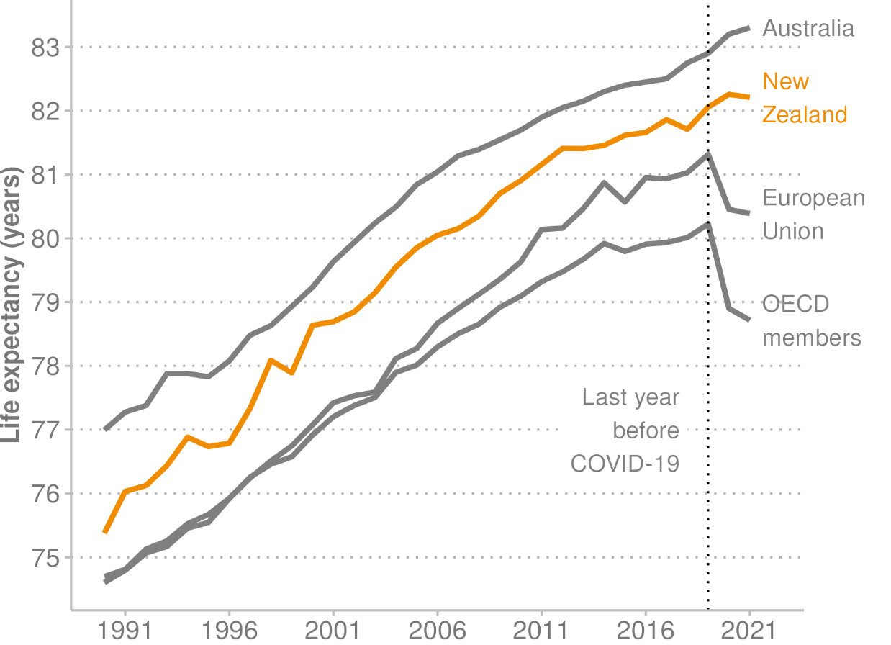

**Source:** World Bank ((nd))

### Life expectancy by gender

In Aotearoa New Zealand, females typically have a higher life expectancy than males, with statistics consistently showing a notable difference in lifespan. The gap between male and female life expectancy has reduced over time. In 2021–2023, a newborn male could expect to live 80.3 years on average and a newborn female 83.7 years, a difference of 3.4 years (Stats NZ 2024a). In 1970–1972, the gap between male and female life expectancy at birth was 6.1 years, when a newborn male was expected to live 68.5 years on average and a newborn female 74.6 years (Stats NZ (nd)-b).

At the age of 65 years, life expectancy for men is 84.6 years. That is, a 65-year-old man today can expect to live a further 19.6 years. The life expectancy for women at 65 years is 86.8 years (a further 21.8 years) (Stats NZ 2024a).

Figure 9 shows life expectancy across Aotearoa New Zealand in 2017–2019. The colour-coded areas highlight the disparities in life expectancy between males and females, and between regions. Darker blue indicates a longer lifespan. For both males and females, based on Aotearoa New Zealand period life tables 2017–2019, with uncertainty shown in brackets from low to high (Stats NZ 2021b), the Gisborne region had the lowest life expectancy with 76.8 (76.1–77.5) years for males and 80.6 (79.9–81.2) years for females. The Tasman region had the highest life expectancy with 81.2 (80.6–81.9) years for males and 84.5 (83.9–85.2) years for females (Stats NZ 2021b).

Figure : Life expectancy for males and females by region, 2017–2019

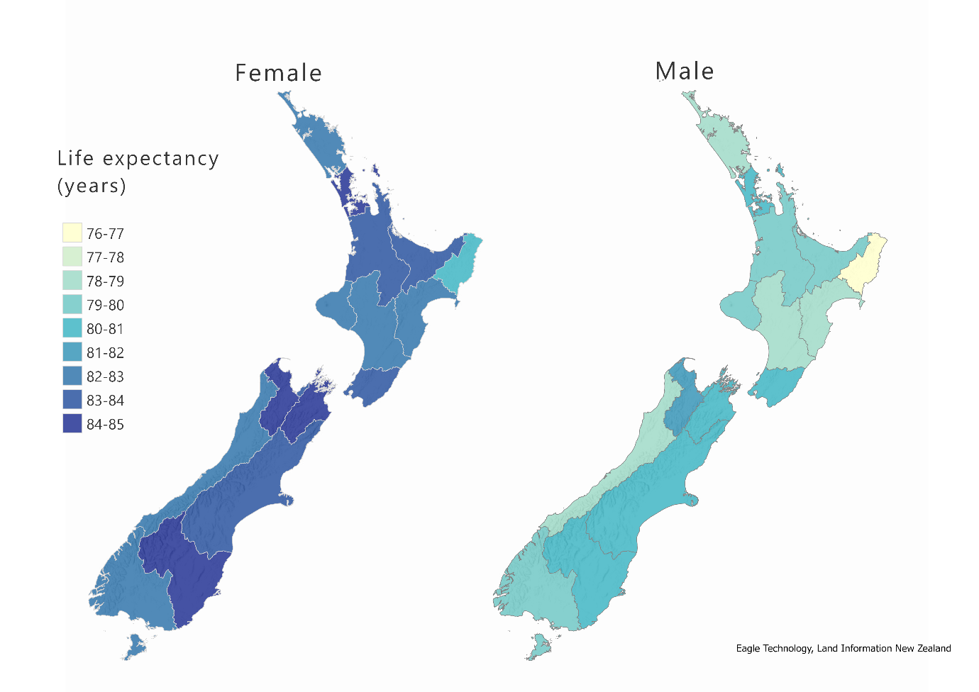

**Source:** Stats NZ (2021b)

It is important to note that life expectancy estimates for regions with small death and population numbers have greater uncertainty. In addition, calculations are based on where someone lived at the time of death, which may not necessarily be where they spent most of their life.

### Life expectancy by ethnic group and gender

In Aotearoa New Zealand, life expectancy varies by ethnic group, as Figure 10 shows. From 2017 to 2019, life expectancy at birth was 73.4 years for Māori males and 75.4 years for Pacific males. In contrast, for the total population life expectancy at birth was 80.0 years for males and 83.5 years for females. Of all ethnic groups in Aotearoa New Zealand, Asian people had the highest life expectancy at birth: Asian females were highest (87.9 years), followed by Asian males (85.1 years).

Figure : Aotearoa New Zealand life expectancy at birth, by ethnic group (total response) and gender, 2017–2019

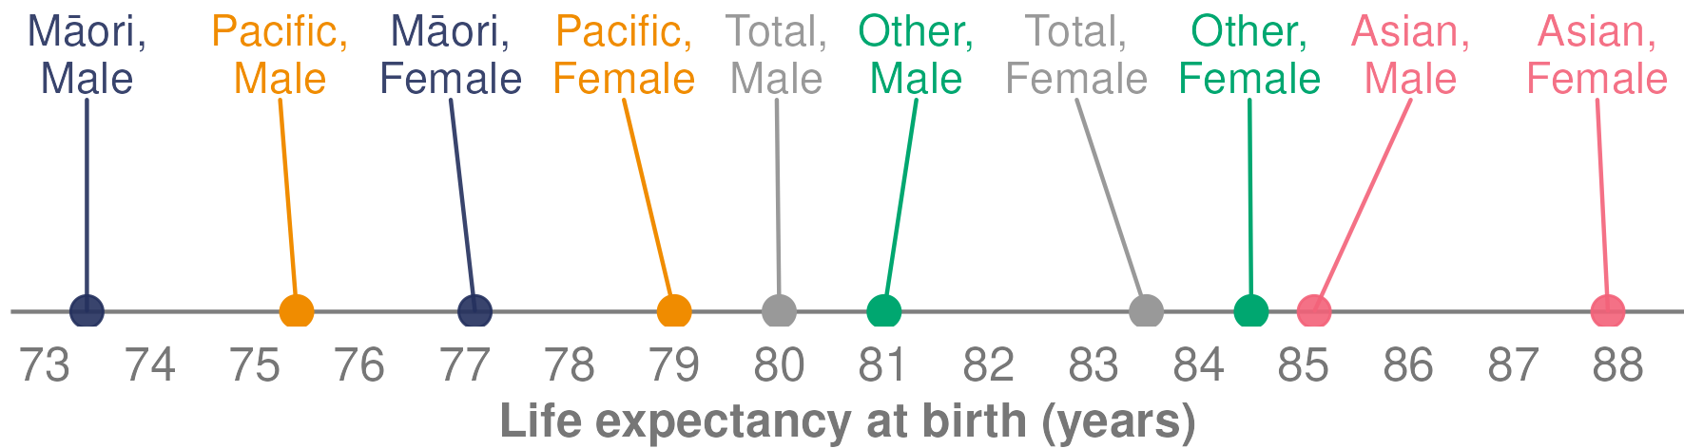

**Source:** Stats NZ (2021b)

### Life expectancy by deprivation and gender

In Aotearoa New Zealand, life expectancy at birth also varies by deprivation. In 2017–2019, males living in the most deprived areas (decile 10) had a life expectancy at birth of 74.1 years. That is almost 10 years less than males in the least deprived areas (decile 1), who have a life expectancy of 84.7 years. Similarly, females in the most deprived neighbourhoods have a life expectancy at birth of 78.5 years, which is around nine years less than females living in the least deprived neighbourhoods. Figure 11 shows life expectancy at birth by deprivation and gender.

Figure : Aotearoa New Zealand life expectancy at birth, by deprivation decile and gender, 2017–2019

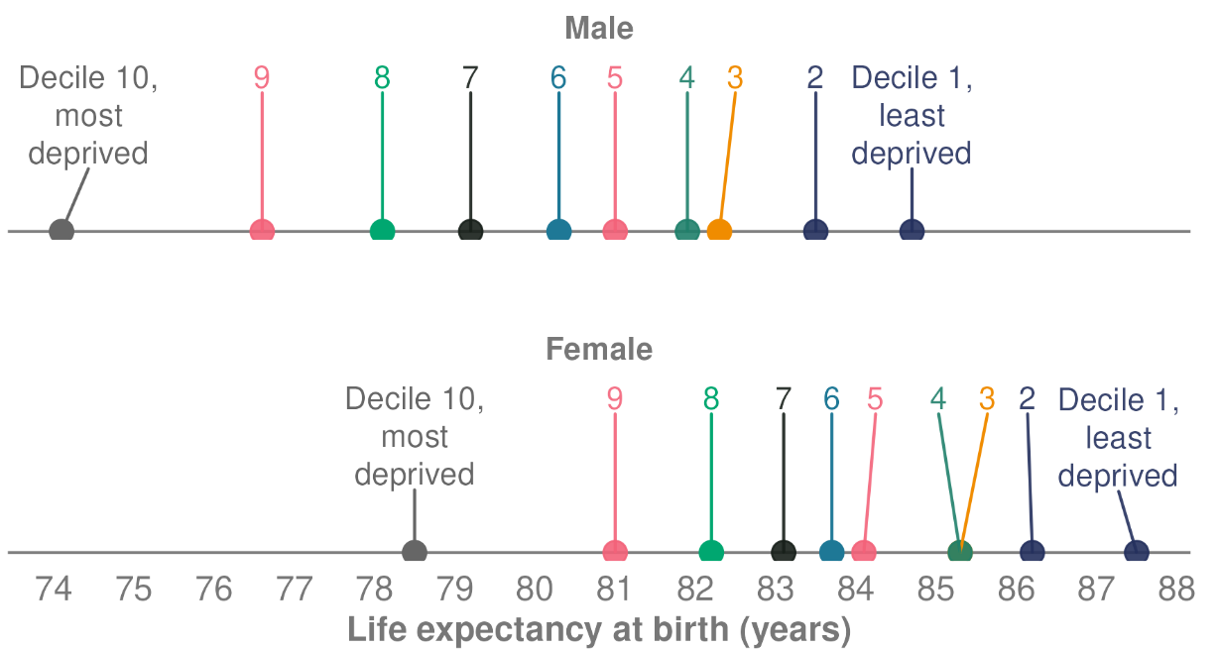

**Source:** Stats NZ (2021b)

## Mortality

Trends in mortality (deaths) are a major cause of changes in life expectancy. The mortality web tool of Health New Zealand – Te Whatu Ora (Health NZ 2023c) presents mortality data for selected causes of death registered in Aotearoa New Zealand. Data for 2020 and 2021 is preliminary, because Health New Zealand is yet to receive cause of death information for some deaths the coroner is investigating.

In 2021, 34,997 deaths were registered in Aotearoa New Zealand. The age-standardised rate was 355.8 deaths per 100,000 population. Rates are per 100,000 population, age standardised to the WHO World Standard Population.[7]

### Leading causes of death

* For the total population, the leading causes of death in 2021 were cancers (110.8 deaths per 100,000 population), ischaemic heart diseases (42.9 deaths) and cerebrovascular diseases (19.2 deaths).
* For Māori, the leading causes of death in 2021 were cancers (166.2 deaths per 100,000 Māori population), ischaemic heart diseases (72.0 deaths) and chronic lower respiratory diseases (35.5 deaths).

### Mortality trends over time

* While the total number of deaths has increased with the growing and ageing population, the age-standardised mortality rate has decreased over time, from 982.0 deaths per 100,000 population in 1948 to 355.8 deaths per 100,000 in 2021.
* Males have a higher mortality rate than females, although the gap between the two rates is decreasing.

### Mortality rates for Māori and non-Māori

Mortality rates for Māori have been generally higher than rates for non-Māori. Both Māori males and Māori females have had higher mortality rates than non-Māori males and females.

Figure 12 compares the leading causes of mortality for Māori and non-Māori from 1996 to 2021. It shows the rates of death per 100,000 population have decreased for Māori and non-Māori across the entire period for most of the leading causes of mortality. However, it also shows that inequity in mortality rates persists.

Figure : Mortality rate by main causes, Māori and non-Māori, 1996–2021

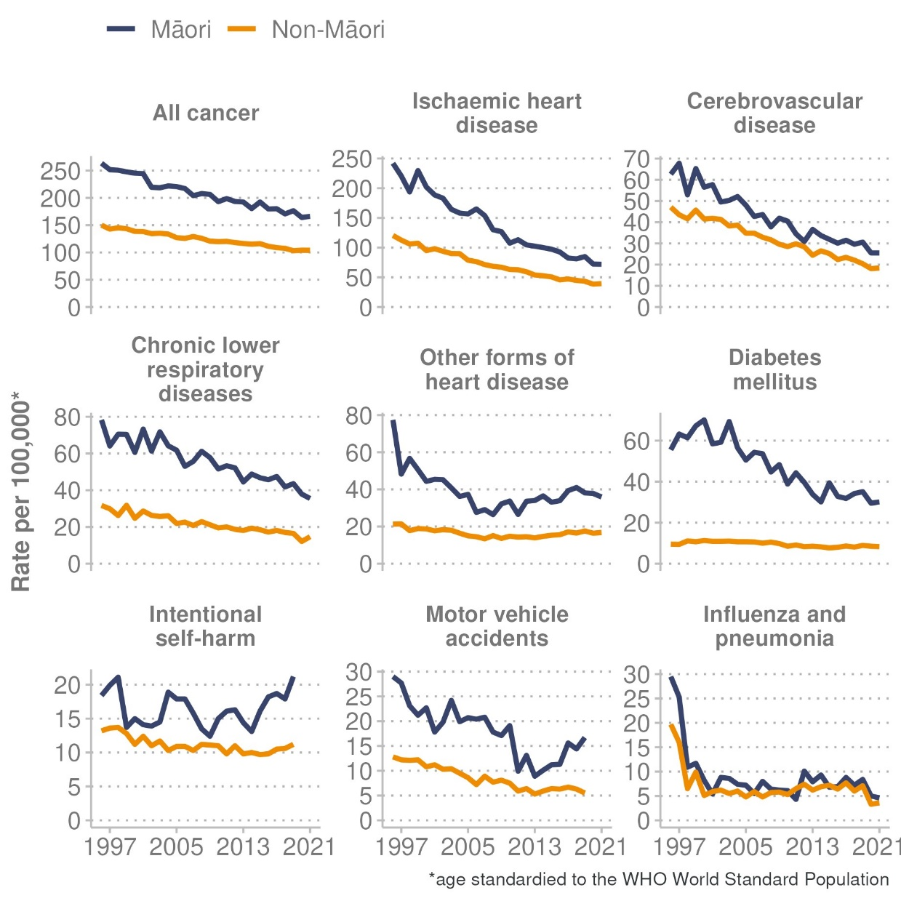

**Source:** Health NZ (2023c)

### Fetal and infant mortality

The infant mortality rate is the number of infant deaths for every 1,000 live births. An infant death is defined as the death of an infant before their first birthday, and a fetal death is defined as the death of a fetus at 20 weeks’ gestation or later or, if gestation is unknown, a fetus weighing at least 400 grams.

Health New Zealand’s Fetal and Infant Deaths web tool (Health NZ 2023b) presents a summary of fetal deaths and infant deaths in Aotearoa New Zealand, with a focus on deaths and still births registered in 2020 (the most recent year when data is available). Information presented includes demographic information, cause of death, gestation and birthweight, as well as deaths classified as sudden infant death syndrome (SIDS) and sudden unexpected death in infancy (SUDI).

In 2020, there were 434 fetal deaths and 278 infant deaths registered. This equates to a fetal death rate of 7.4 per 1,000 total births and an infant death rate of 4.8 per 1,000 live births. However, rates should be interpreted with caution because they are based on small numbers of fetal and infant deaths. As a result, rates may fluctuate markedly from year to year.

#### Key findings for 2020

* Infant death rates for Māori (6.2 per 1,000 live births) and Pacific peoples (7.1) were significantly higher than rates for Asian (3.0) and European/other (4.2) ethnic groups.
* The infant death rate was highest for infants born to people who were less than 20 years of age (9.6 per 1,000 live births).
* The highest infant death rates occurred in the most deprived areas. In quintile 5, the infant death rate was 7.3 per 1,000 live births, close to two times the rate in the least deprived areas (3.5 per 1,000 live births in quintile 1).

The infant mortality rate, after decreasing substantially in the past, has had smaller relative decreases in recent years, because the number of infant deaths is relatively low. The rate declined from 7.3 per 1,000 live births in 1996 to 5.4 in 2003, and then remained relatively stable until 2020 (when it fell to 4.8 per 1,000 live births).

## Maternity

In 2021 (the most recent year when maternity data is available), 62,433 people gave birth and 62,046 babies were live born. The birth rate in 2021 was 61.5 live births per 1,000 females of reproductive age,[8] which is an increase from 2020 (57.5 per 1,000 females of reproductive age) (Health NZ 2023e).

### Primary maternity care

In 2021, most people giving birth (93.9%) received care from a community-based lead maternity carer (LMC). Among the remainder, 3.1% of people registered with a district health board primary maternity service, and the provision of care was unknown for the other 3.0%.

In 2021, among those giving birth:

* nearly three-quarters (73.5%) of people registered with an LMC in their first trimester of pregnancy, up from just over half (56.0%) in 2012
* 15.2% of people registered with an LMC in their second trimester
* 3.6% of people registered with an LMC in their third trimester
* 1.7% registered in the postnatal period.

The rate of registration in the first trimester differed by population group. Younger age groups, Pacific peoples and people living in the most deprived areas were less likely to register with an LMC in their first trimester.

### Labour and birth

In 2021, most people gave birth at a tertiary (45.5%) or secondary (40.9%) maternity facility. A further 9.4% gave birth in a primary maternity facility. These rates have been stable over the last 10 years. In addition, 4.3% of people gave birth at home in 2021, similar to the 2020 rate.

Induction of labour, epidural analgesia and episiotomy rates have continued to increase over the last 15 years. Rates of labour augmentation have continued a downward trend over this same period.

Caesarean section rates have increased over the last 15 years to reach 30.9% of all births in 2021, the highest ever recorded. Unplanned (emergency) caesarean section rates have generally increased over the same period, whereas planned (elective) caesarean rates have remained roughly the same. There has been a corresponding decrease in spontaneous vaginal birth (57.3% in 2021) and no significant change to rates of instrumental vaginal birth (9.5% in 2021).

Figure 13 shows rates of caesarean births increased for all age groups between 2007 and 2021. Rates increased with the age of the birthing parent. In 2021, 43.7% of all people giving birth aged 40 years and over gave birth by caesarean, compared with 17.6% of people aged under 20 years.

Figure : Percentage of births by type and age of person giving birth, 2007–2021

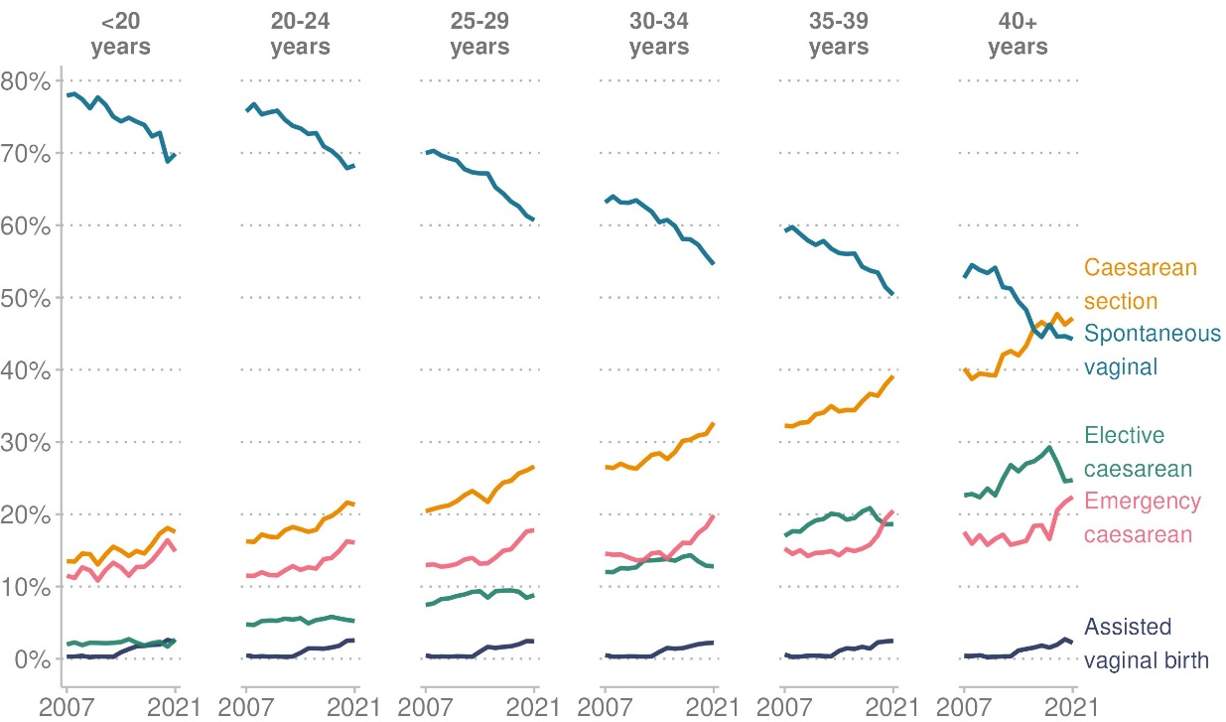

**Source:** Health NZ (2023e)

#### Age of people giving birth

Patterns in the age groups of people giving birth have changed over time. The percentage of people giving birth aged under 20 years has reduced from 7.9% of all births (5,076 births) in 2007 to 2.9% of all births (1,796) in 2021. In contrast, those aged 30–34 years made up 28.5% of all births (18,317 births) in 2007 and increased to 35.1% of births (21,906) in 2021.

Figure 14 shows the number of births by age of birthing parent between 2008 and 2021. The highest number of births was for people aged 30–34 years, while the second highest was for those aged 25–29 years.

Figure : Number of births, by age of person giving birth, Aotearoa New Zealand, 2007–2021

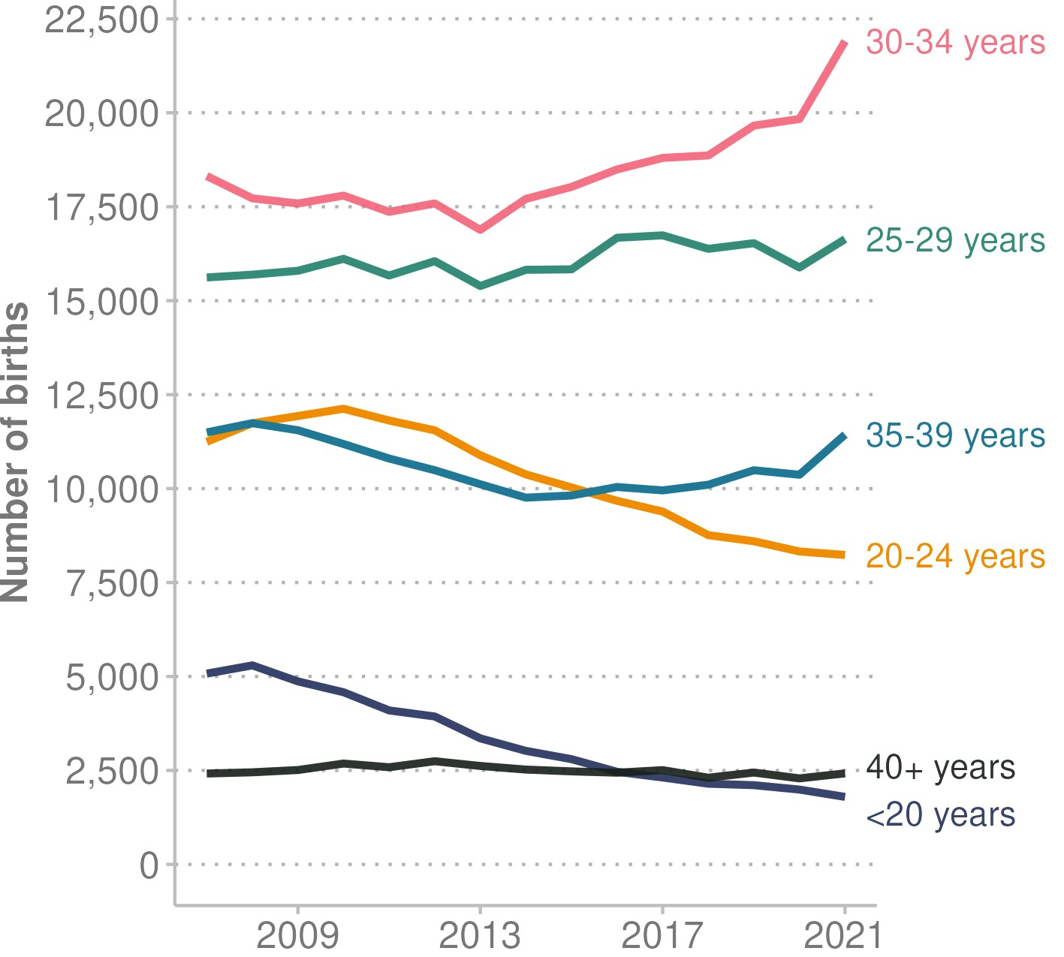

**Source:** Health NZ (2023e)

#### Babies

Trends in average birthweight and distribution of gestational age at birth have not changed over the last 15 years.

* In 2021, 7.9% of babies were born preterm (before 37 weeks’ gestation). Preterm births were more common among people under 20 years and aged 40 years and over, Māori, Pacific peoples and people living in the most deprived areas.
* Similar to previous years, in 2021, babies of low birthweight (less than 2,500 grams) were more common among people aged under 20 years, people of Indian ethnicity and people living in the most deprived areas.

### Breastfeeding status at two weeks of age

In 2021, 74.0% of babies were exclusively or fully breastfed at two weeks of age, a drop from 77.6% in 2018. The rate of partial breastfeeding (breastmilk and breastmilk substitute/infant formula) increased during this time, from 15.8% of all babies being partially breastfed in 2018 to 19.1% in 2021.

Figure 15 shows the breastfeeding status at two weeks of age in 2021, by baby’s ethnic group.

* Māori babies: 72.7% were exclusively or fully breastfed, 16.8% were partially breastfed and 10.6% were artificially fed (with a breastmilk substitute or infant formula).
* Pacific babies: 66.6% were exclusively or fully breastfed, 23.6% were partially breastfed and 9.7% were artificially fed.
* Indian babies: 68.4% were exclusively or fully breastfed, 29.5% were partially breastfed and 2.0% were artificially fed.
* Asian babies: 65.2% were exclusively or fully breastfed, 31.0% were partially breastfed and 3.7% were artificially fed.
* European/other babies: 79.7% were exclusively or fully breastfed, 14.6% were partially breastfed and 5.7% were artificially fed.

Figure : Breastfeeding status at two weeks of age, by baby’s ethnic group (prioritised ethnicity), 2021

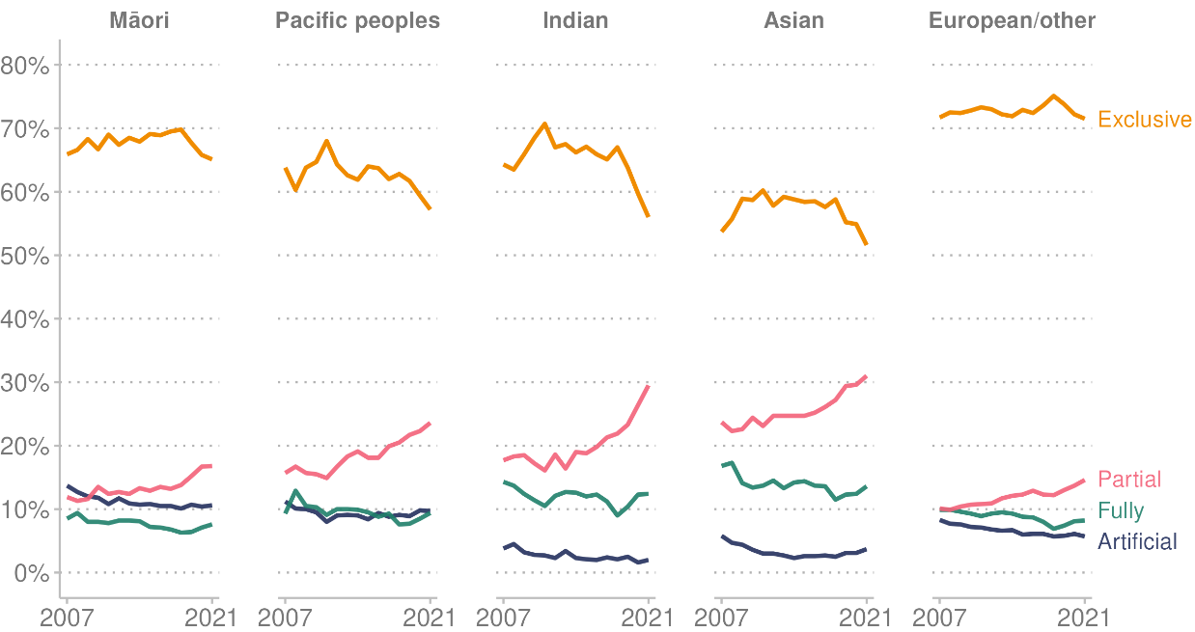

**Source:** Health NZ (2023e)

# Causes of health loss - Ngā take mō te mate hauora

This section covers major causes of health loss, which includes both mortality (deaths) and morbidity (poor health). Many factors contribute to a population’s health loss, including demographic trends, socioeconomic disparities, risk factors, environmental factors, and access to health care.

The Government’s priorities include a focus on the 5+5 concept, responding to five non-communicable diseases: cancer, diabetes, respiratory disease, cardiovascular disease, and poor mental health. Together, these conditions account for around 80% of deaths from non-communicable diseases in Aotearoa New Zealand and a considerable amount of the health loss New Zealanders experience.

Prevention of these non-communicable diseases can be improved by addressing five modifiable risk factors: smoking, alcohol consumption, poor nutrition, physical inactivity, and adverse social and environmental factors. Prioritising work to prevent and reduce the impact of these diseases aligns with Goal 3 of the United Nations Sustainable Development Goals (to reduce the premature mortality from non-communicable diseases through improved prevention and treatment) and the WHO’s Global Action Plan for the Prevention and Control of Noncommunicable Diseases 2013–2030 (Minister of Health 2024).

This report uses information from the Global Burden of Disease (GBD) study 2021 to measure health loss. This study draws on data from 152 countries, including Aotearoa New Zealand, and is the most comprehensive worldwide observational epidemiological study to date.

The GBD study provides a robust measure of health loss in the form of disability-adjusted life years (DALYs). This metric quantifies the overall burden of disease and injury on a population. DALYs represent the sum of years of life lost (YLLs) due to premature mortality (early death), and years lived with disability (YLDs) due to morbidity or illness.[9] DALYs measure the gap between the ideal health of a population and its current health status, taking into account both mortality and morbidity.

One DALY represents the loss of one year of life lived in good health. Because a DALY includes both fatal and non-fatal components, it is an important measure for assessing overall population health. It also provides a consistent basis for comparing the impact of different types of conditions within the population, across population subgroups and between locations (Ministry of Health 2020).

## Overview of health loss in Aotearoa New Zealand

Between 1990 and 2021, the total burden of disease (as measured by total number of DALYs) has increased by 26%. The main reason for this increase is that Aotearoa New Zealand’s population is growing and ageing. The age-standardised DALY rate per 100,000 people, however, has decreased by 31% during this time. The main reason for this decrease is that early deaths have reduced (ie, mortality rates have decreased), resulting in a decrease in years of life lost (the age-standardised YLL rate).

Although GBD data shows progress in reducing health loss from early death (the age-standardised rate of YLLs), the age-standardised rate of YLDs has not changed much. Because of this, an increasing proportion of health loss occurs due to morbidity or illness, indicating the need for an ongoing focus on preventing disease as the population grows and ages.

### Leading causes of health loss

Non-communicable diseases (also known as chronic or long-term conditions) cause most of the health loss in Aotearoa New Zealand. According to the GBD study, the leading condition groups causing health loss in 2021 were cancers (neoplasms), cardiovascular diseases, musculoskeletal diseases, mental disorders, and neurological disorders.

Figure 16 presents the proportion of DALYs lost according to the 2021 GBD study (showing levels 1 and 2).[10] In Aotearoa New Zealand, 85% of all health loss was due to non-communicable diseases, 12% was due to injuries and 3% was due to communicable, maternal, neonatal, and nutritional diseases.

Figure : Proportion of disability-adjusted life years (DALYs) lost by high-level cause (GBD levels 1 and 2), Aotearoa New Zealand, 2021

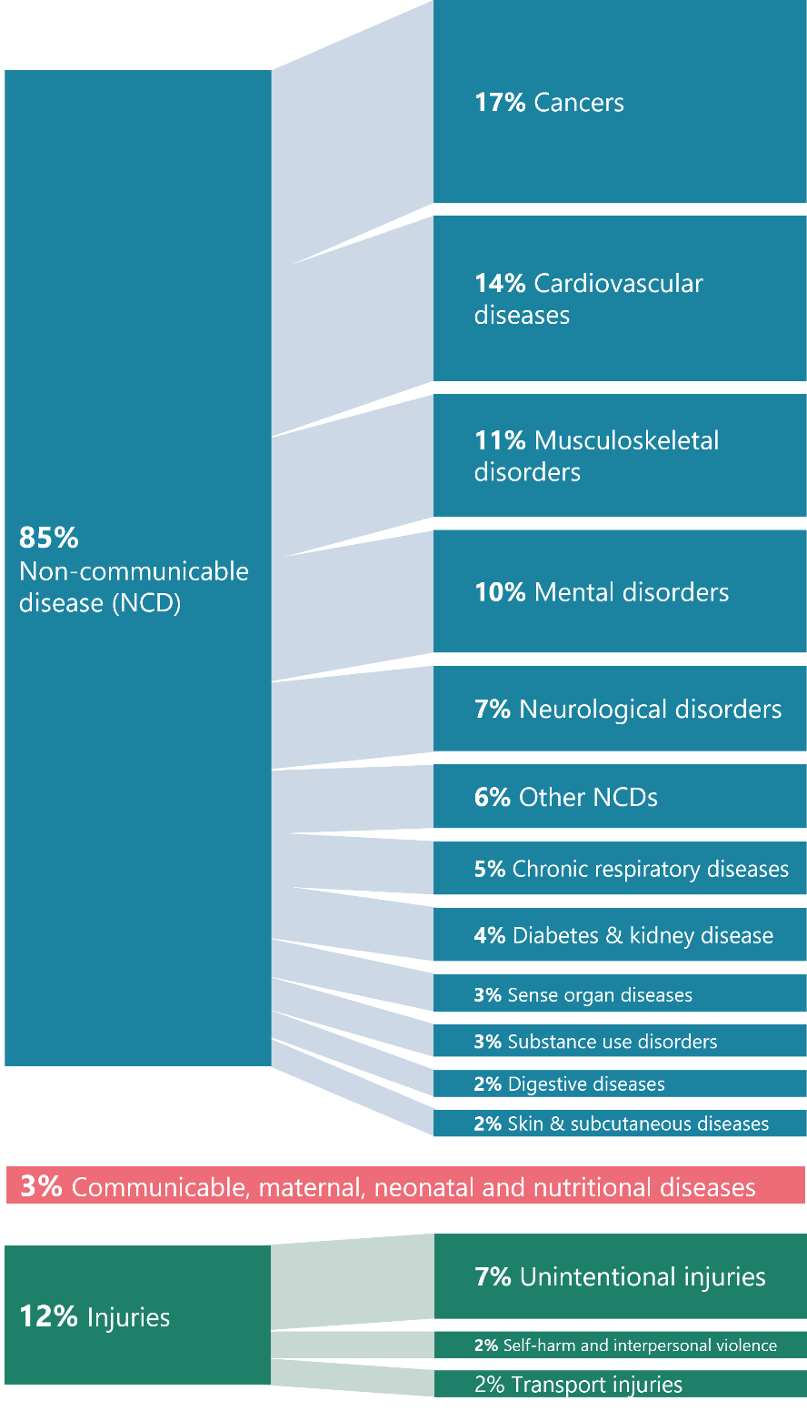

**Source:** Institute for Health Metrics and Evaluation (2024b)

### Causes of health loss, early mortality and ill health

Figure 17 presents additional detail from the GBD study on the main conditions (level 3) affecting the wellbeing of New Zealanders. It shows the major impact of cardiovascular diseases (such as ischaemic heart disease and stroke), individual cancers (such as lung, colorectal and breast cancers) and musculoskeletal disorders (such as low back pain and osteoarthritis). It also shows conditions that contribute substantially to the burden of disease include mental disorders (such as anxiety disorders and depressive disorders), neurological disorders (such as Alzheimer’s disease and headache disorders) and unintentional injuries (falls).

Figure : Top 10 leading causes of DALYs, years of life lost (YLLs) and years lived with disability (YLDs) (ranked), GBD level 3, Aotearoa New Zealand, 2021

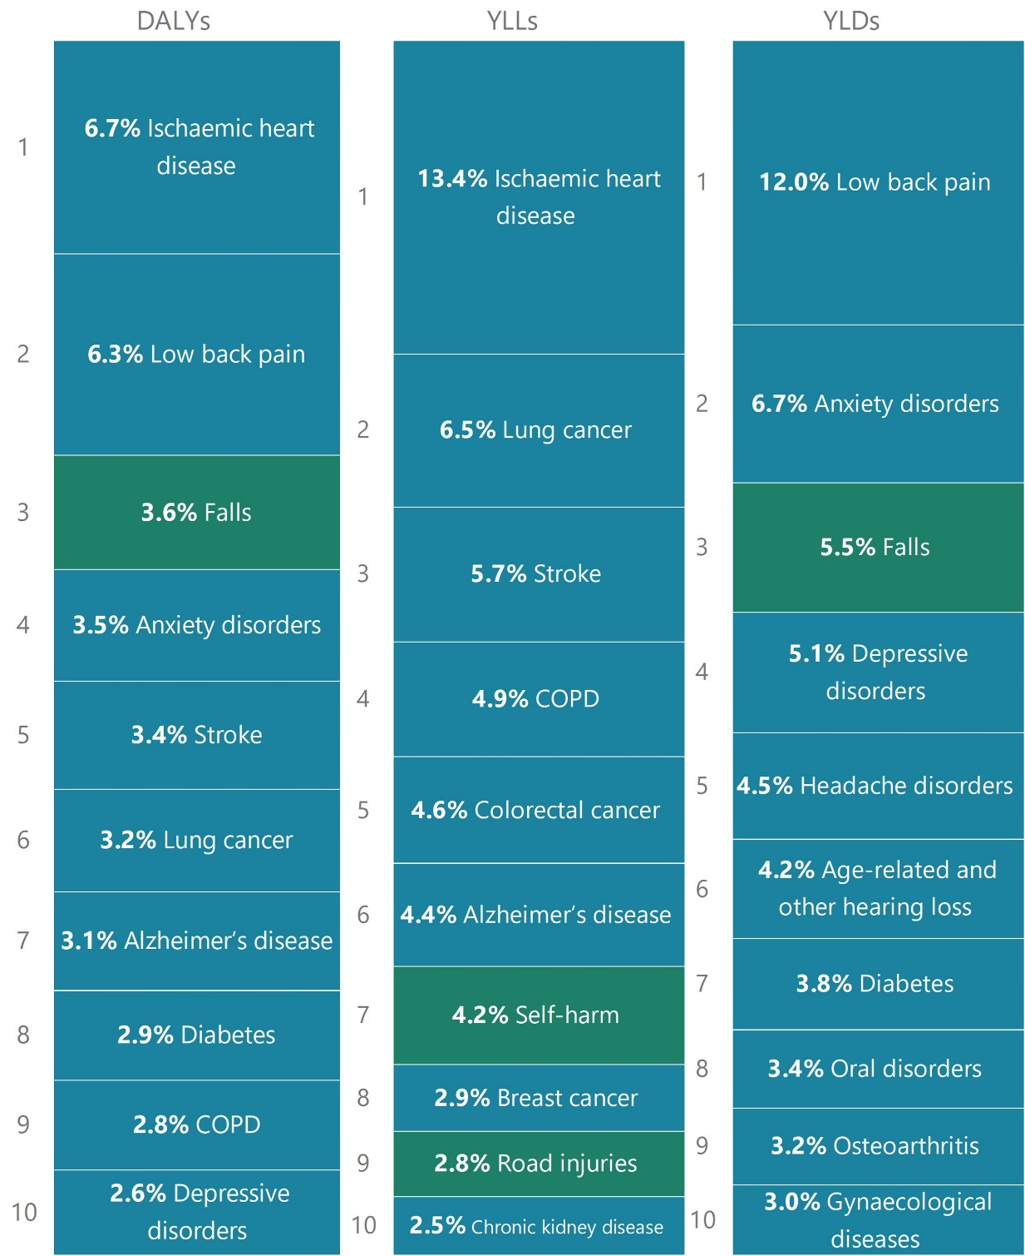

Non-communicable disease

Injuries

Note: COPD = chronic obstructive pulmonary disease.

**Source:** Institute for Health Metrics and Evaluation (2024b)

### Health loss across the life course

The main contributors to health loss differ across the life course. Table 2 shows the 10 leading conditions contributing to health loss for each age band.

Table : Top 10 leading causes of disability-adjusted life years (DALYs) (ranked) by age band, GBD level 3, Aotearoa New Zealand, 2021

|  |  |  |  |  |  |
| --- | --- | --- | --- | --- | --- |
| Rank | Age (years) | | | | |
| < 5 | 5–14 | 15–49 | 50–69 | 70+ |
| 1 | Neonatal disorders (32%) | Anxiety disorders (10%) | Low back pain (9%) | Low back pain (7%) | Ischaemic heart disease (12%) |
| 2 | Congenital birth defects (20%) | Asthma (9%) | Anxiety disorders (8%) | Ischaemic heart disease (7%) | Alzheimer's disease and other dementias (8%) |
| 3 | Sudden infant death syndrome (6%) | Dermatitis (6%) | Depressive disorders (6%) | Tracheal, bronchus and lung cancer (5%) | Stroke (7%) |
| 4 | Foreign body (5%) | Conduct disorder (6%) | Self-harm (5%) | Diabetes mellitus (4%) | Chronic obstructive pulmonary disease (5%) |
| 5 | Asthma (3%) | Falls (5%) | Headache disorders (5%) | Colon and rectum cancer (3%) | Falls (4%) |
| 6 | Dermatitis (3%) | Autism spectrum disorders (4%) | Gynaecological diseases (4%) | Falls (3%) | Tracheal, bronchus and lung cancer (4%) |
| 7 | Autism spectrum disorders (2%) | Headache disorders (4%) | Road injuries (4%) | Chronic obstructive pulmonary disease (3%) | Colon and rectum cancer (4%) |
| 8 | Drowning (2%) | Viral skin diseases (4%) | Falls (4%) | Osteoarthritis (3%) | Low back pain (3%) |
| 9 | Lower respiratory infections (2%) | Depressive disorders (4%) | Alcohol use disorders (3%) | Breast cancer (3%) | Diabetes mellitus (3%) |
| 10 | Upper respiratory infections (2%) | Low back pain (4%) | Drug use disorders (3%) | Stroke (3%) | Age-related and other hearing loss (3%) |

**Source:** Institute for Health Metrics and Evaluation (2024b)

Health loss in the population generally increases with age. Figure 18 presents the proportion of total health loss measured by DALYs across different age groups. In 2021, children under the age of 15 years made up around 19% of the population but accounted for 5% of total DALYs. People aged 75 and over were 7% of the population but accounted for 26% of DALYs.

Figure : Share of total disability-adjusted life years (DALYs) (2021) compared with share of the 2021 estimated Aotearoa New Zealand resident population (2018-base), by age group

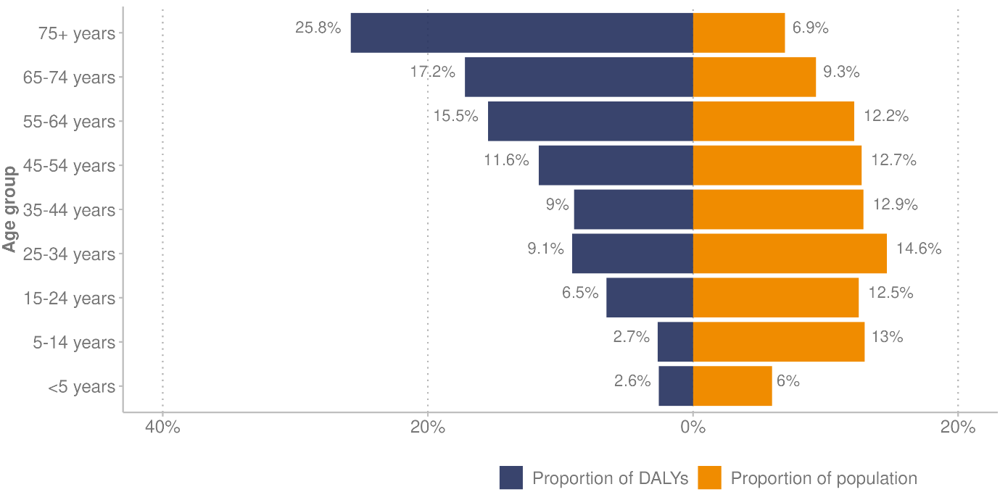

**Source:** Institute for Health Metrics and Evaluation (2024b); Stats NZ (2024e)

## Cancers (neoplasms)

Collectively, all kinds of cancers are the leading cause of health loss in Aotearoa New Zealand. They accounted for 17.4% of health loss (DALYs) in 2021 (Institute for Health Metrics and Evaluation 2024b). The most diagnosed cancers in Aotearoa New Zealand (excluding non-melanoma skin cancers) are breast, lung, prostate and colorectal (bowel) (Te Aho o Te Kahu 2021).

The *Cancer Prevention Report* (Te Aho o Te Kahu 2022a) outlines that, while cancer is incredibly complex, it is possible to prevent many cancers by reducing everyone’s exposure to cancer risk factors, such as tobacco, alcohol, poor diet, physical inactivity, excess body weight, excessive exposure to ultraviolet radiation, and chronic infection. Wider determinants of health and environmental factors play a big role in shaping health outcomes generally and cancer outcomes specifically. The *Cancer Prevention Report* focuses on how to improve environments in which people live, work, learn and play, so those environments can help to prevent cancer (and other conditions) for everyone.

### Cancer incidence

In 2021 (the most recent year when data is available), Aotearoa New Zealand had 27,869 new cancer registrations.[11] This equates to around 76 people being diagnosed with cancer every day. The total number of registrations has been steadily increasing over the last 10 years (because Aotearoa New Zealand’s population is growing and ageing, and cancer is more common among older people) (Te Aho o Te Kahu (nd)). However, the age-standardised rate has stayed roughly the same.

Cancer does not affect all ethnic groups evenly. Māori have higher rates of cancer registrations, and Asian people have lower rates, compared with European/other people. Figure 19 shows the age-standardised rate of new cancer registrations by ethnic group between 2012 and 2021.

Figure : Age-standardised rate of new cancer registrations, by ethnic group (prioritised ethnicity), 2012–2021

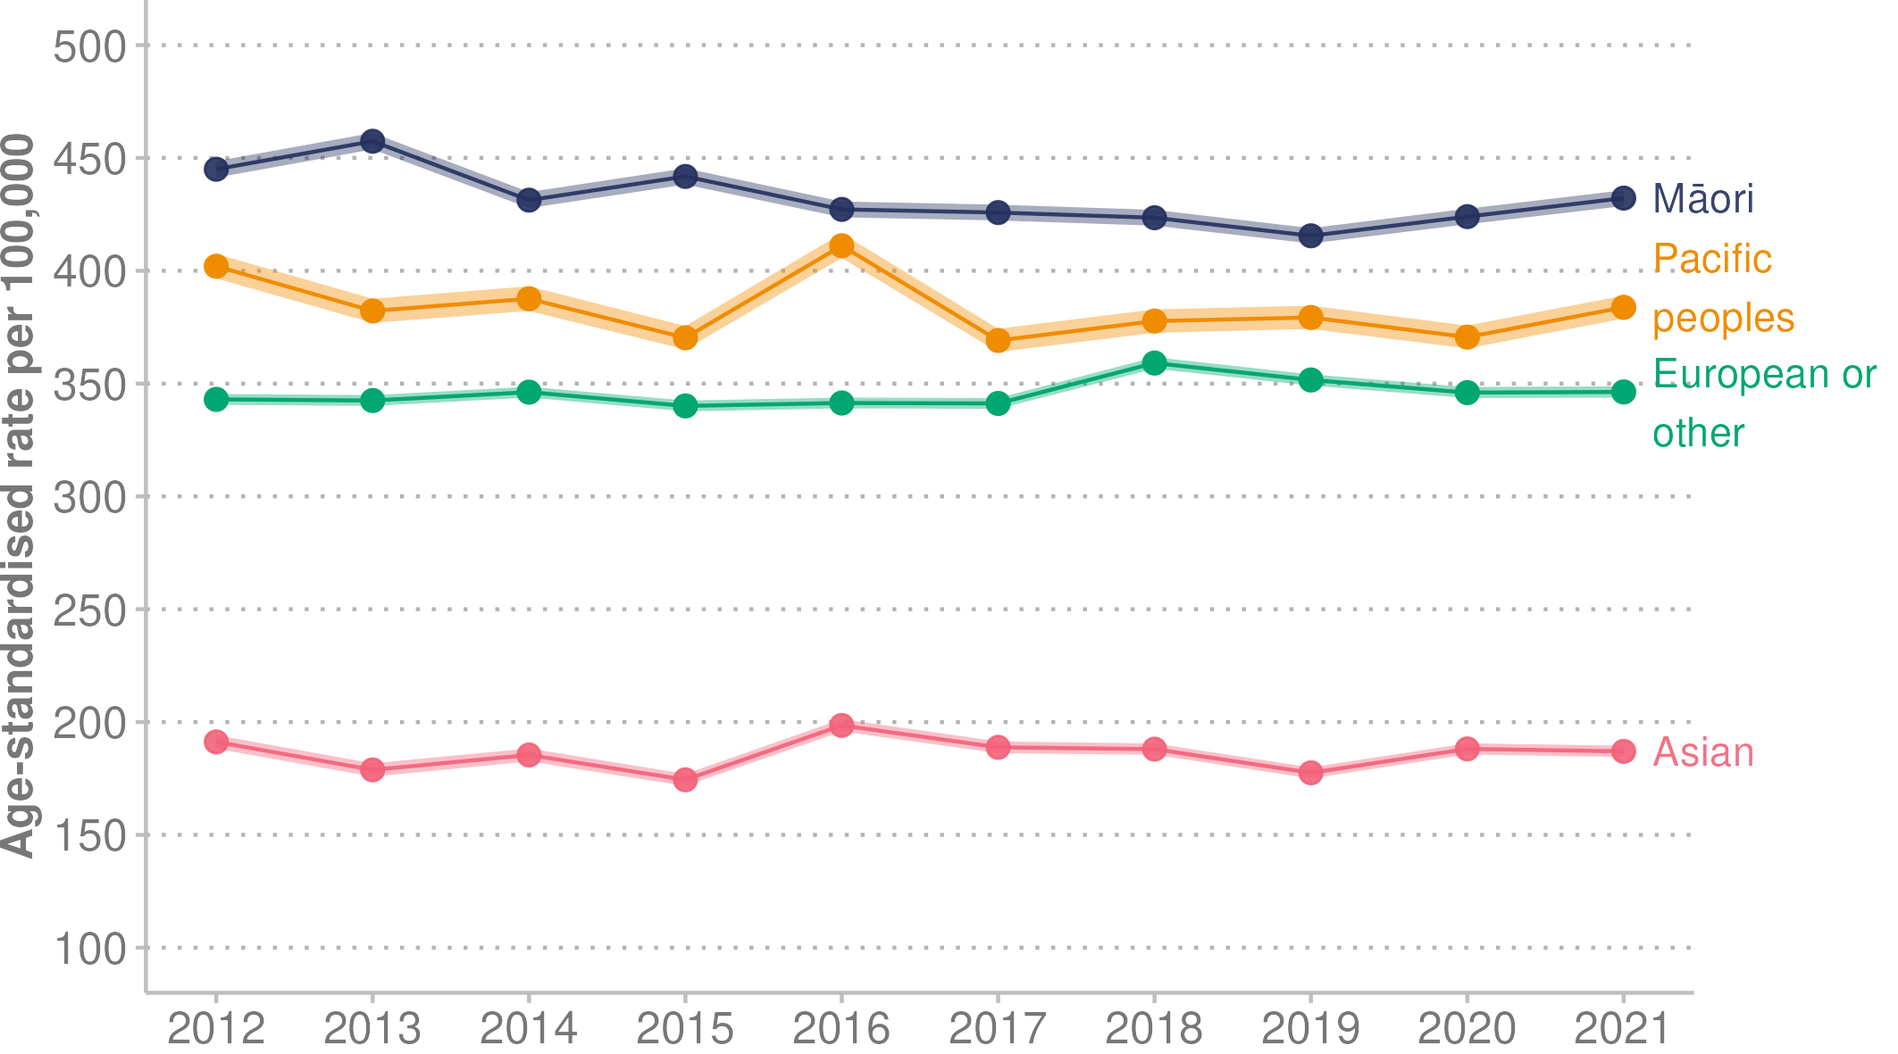

Note: Shaded area indicates 95% confidence intervals.

**Source:** Health NZ (2023a)

### Route to cancer diagnosis

Te Aho o Kahu – Cancer Control Agency, as part of its monitoring and quality improvement programme, published a report about the number of people diagnosed with cancer within 30 days of an emergency or acute (unplanned) hospital admission (Te Aho o Te Kahu 2024). The report outlines the following findings.

* Aotearoa New Zealand’s performance is poor compared with peer[12] countries.
* People diagnosed through emergency admissions can have poorer survival and other outcomes (such as poorer quality of life and worse patient experience), compared with those diagnosed through established pathways, because they can present with more advanced disease.
* Māori are more likely to be diagnosed following an emergency admission than the European/other ethnic group.
* For most cancer types, hospital districts vary in their rate of cancer diagnosis following emergency / unplanned admissions.

The report findings will be used to improve cancer detection and diagnosis processes, with the aim of reducing cancer diagnosis through emergency admissions in Aotearoa New Zealand (Te Aho o Te Kahu 2024).

### Cancer survival

The five-year net survival rate for cancer has improved for some cancers over time. Figure 20 shows the change in net five-year cancer survival for the eight most diagnosed cancers (that is, the cancers with the highest registration/incidence rate). Survival rates are shown using two years of combined data for 1998-99 and 2020-21. The graph also shows the improvement in net five-year survival for total cancer, which is up from 58.0% for the combined years of 1998-99 to 67.6% in 2020-21.

Cancer survival improved markedly for people with leukaemia, rising from 37.6% net five-year survival in 1998-99 to 57.7% in 2020-21. Likewise, survival for people with non-Hodgkin’s lymphoma increased from 47.9% net five-year survival in 1998-99 to 68.4% in 2020-21.

Figure : Changes in the net five-year survival for the eight most diagnosed cancers, 1998-99 to 2020-21

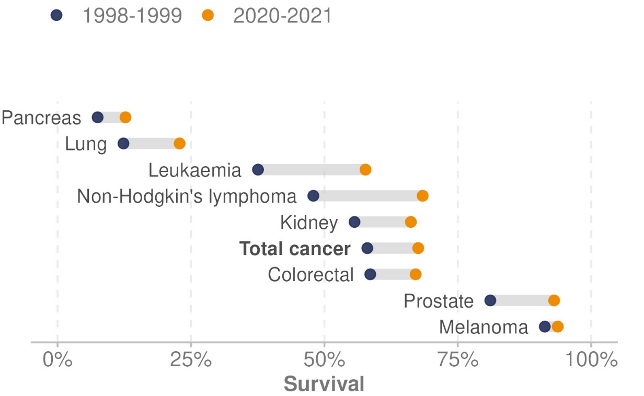

Note: Net survival (Pohar-Perme) using period method and ethnic specific life tables.

**Source:** Te Aho o Te Kahu unpublished data (2024)

### Cancer mortality

In 2021,[13] there were 10,488 cancer deaths in Aotearoa New Zealand. This equates to around 29 people dying every day from cancer. The overall age-standardised death rate was 110.8 deaths per 100,000 population.

In 2021, the age-standardised total cancer mortality rate for Māori was 167.0 deaths per 100,000 population, and the rate for Pacific peoples was 149.8 deaths per 100,000. This compares with 106.4 deaths per 100,000 for European/other and 57.5 per 100,000 for Asian people (Health NZ 2023a).

Figure 12 in the ‘Mortality’ section shows that rates of cancer deaths decreased between 1990 and 2021. It also shows the gap between the rates for Māori and non-Māori reduced during this time (Health NZ 2023c).

Older people have higher rates of cancer mortality. Figure 21 shows the rate of cancer deaths in 2021 by age group. The rate of cancer deaths for people aged 85 years and over was 2,516.9 per 100,000 population, compared with 1,515.5 for those aged 80–84 years, 1,028.0 for people aged 75–79 years, 684.4 for those aged 70–74 years and 455.7 deaths per 100,000 for people 65–69 years of age (Health NZ 2023a).

Figure : Rate of all cancer deaths by age group (years), 2021

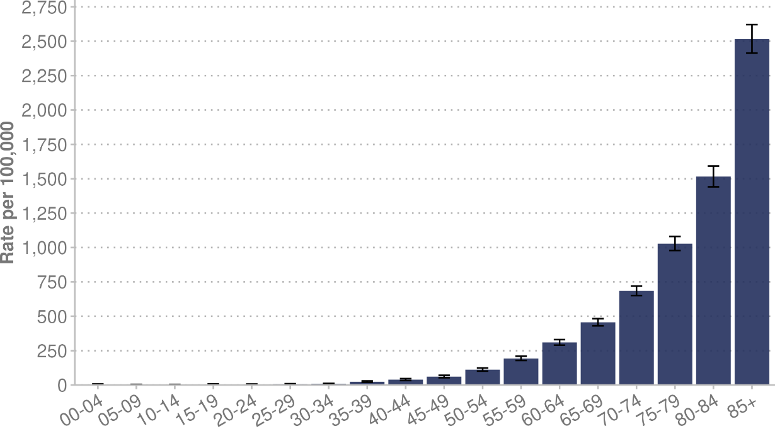

Note:Error bars indicate 95% confidence intervals.

**Source:** Health NZ (2023a)

### Cancer screening

Cancer screening (part of the National Public Health Service Prevention Directorate) aims to increase early diagnosis and treatment of cancer, which increases the options for treatment and improves the chances for cancer survival (Health NZ 2024a). Currently, Aotearoa New Zealand has population-based cancer screening programmes for breast, cervical and bowel (colorectal) cancer.

#### Breast screening

Breast cancer is the most common cancer affecting women in Aotearoa New Zealand. Breast screening is offered every two years to eligible woman aged 45 to 69 years. It aims to save lives by finding breast cancer early before it spreads. The breast screening coverage target is for at least 70% of eligible women in Aotearoa New Zealand to be screened every two years. As at December 2023, the overall two-year breast screening coverage was 67.7% (Health NZ 2024b).

As Figure 22 shows, in December 2023 breast screening coverage remains lowest for Māori at 60.7% and second lowest for Pacific peoples at 64.7%. The coverage for Asian people was 63.5% and for European/other 70.1%.

The graph shows that the COVID-19 restrictions had a significant impact on the breast screening programme, reducing its coverage rates. The disproportionate impact on Pacific and Asian ethnic groups is thought to be related to the geographic distribution of these communities in that they lived in areas most impacted by public health restrictions (National Screening Unit 2022). In 2020, coverage rates did reduce for all ethnic groups, as Figure 24 shows in more detail.

Figure : Two-year breast screening coverage rates for women aged 45–69 years, by ethnic group (prioritised ethnicity), 2010–2023

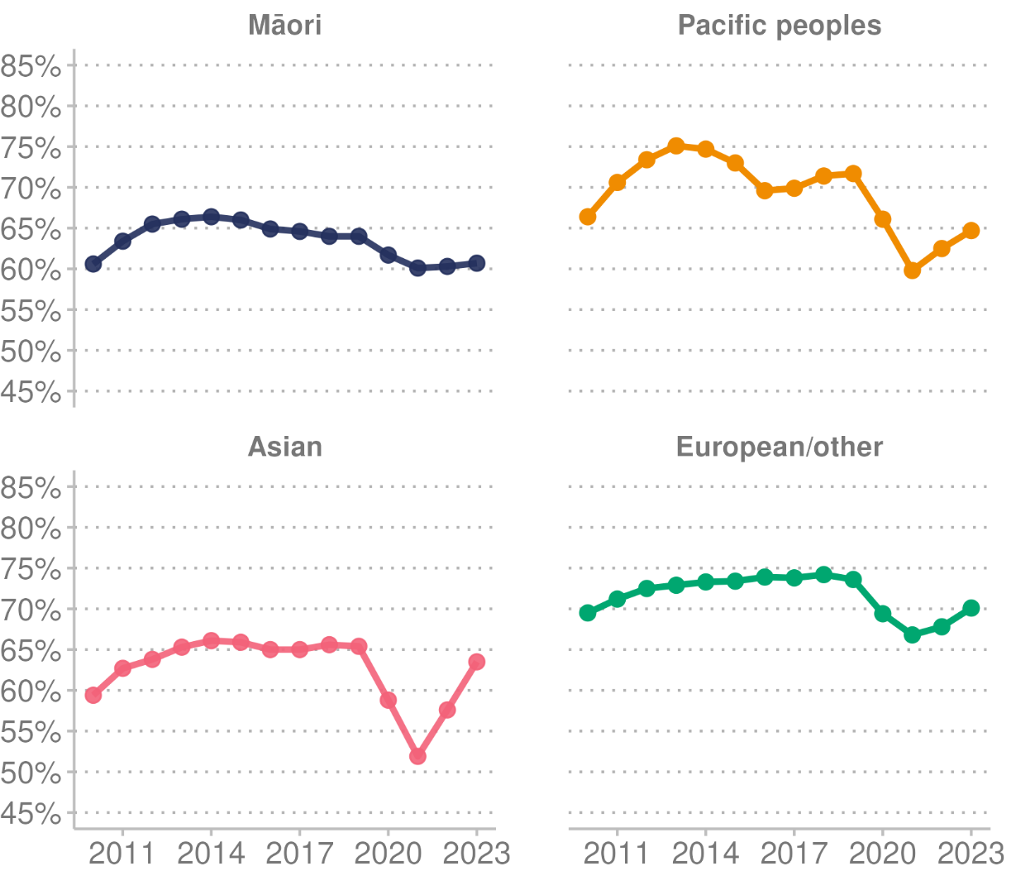

**Source:** Health NZ (2024b)

#### Cervical screening

Cervical cancer is one of the most preventable cancers if pre-cancerous changes are detected early and managed effectively. In August 2020, the World Health Assembly adopted a global strategy to eliminate cervical cancer. That strategy requires all countries to reach and maintain an incidence rate of below 4 per 100,000 women. Achieving that rate rests on three key pillars: vaccination with the human papillomavirus (HPV) vaccine; cervical cancer screening; and treatment (WHO (nd)-a).

The National Cervical Screening Programme allows for early detection, follow-up testing, and treatment. It is offered to women and people with a cervix aged 25 to 69 years. On 12 September 2023, Aotearoa New Zealand changed from cytology-based screening to HPV Primary Screening. HPV screening looks for the human papillomavirus, which causes cell changes that may lead to cervical cancer. The two options for cervical screening are:

* an HPV vaginal swab test, undertaken either as a self-test or with the help of a health professional
* a liquid-based cytology sample, which a health professional takes and which is then tested for HPV (previously referred to as a smear test).

The cervical screening coverage target is to screen at least 80% of the eligible population, including 80% within each of the ethnic groups of Māori, Pacific peoples, Asian and European/other. In the cytology-based programme, coverage was defined as the proportion eligible for screening who have been screened in the previous three years. However, this definition changed following the shift from cytology-based screening every three years to HPV primary screening every five years.[14]

As of December 2023, the overall coverage for cervical screening was 69.7%. Figure 23 shows inequities in coverage among ethnic groups. Cervical screening coverage was 57.9% for Māori and 58.4% for Pacific peoples, compared with 64.7% for Asian and 75.6% for European/other ethnic groups (Health NZ 2023d). The graph also highlights the impact of COVID-19 on cervical screening coverage: in 2020, coverage rates dropped for all ethnic groups. Figure 24 shows these changes in more detail.

Figure : Cervical screening coverage, up to date, by ethnic group (prioritised ethnicity), 2009–2023

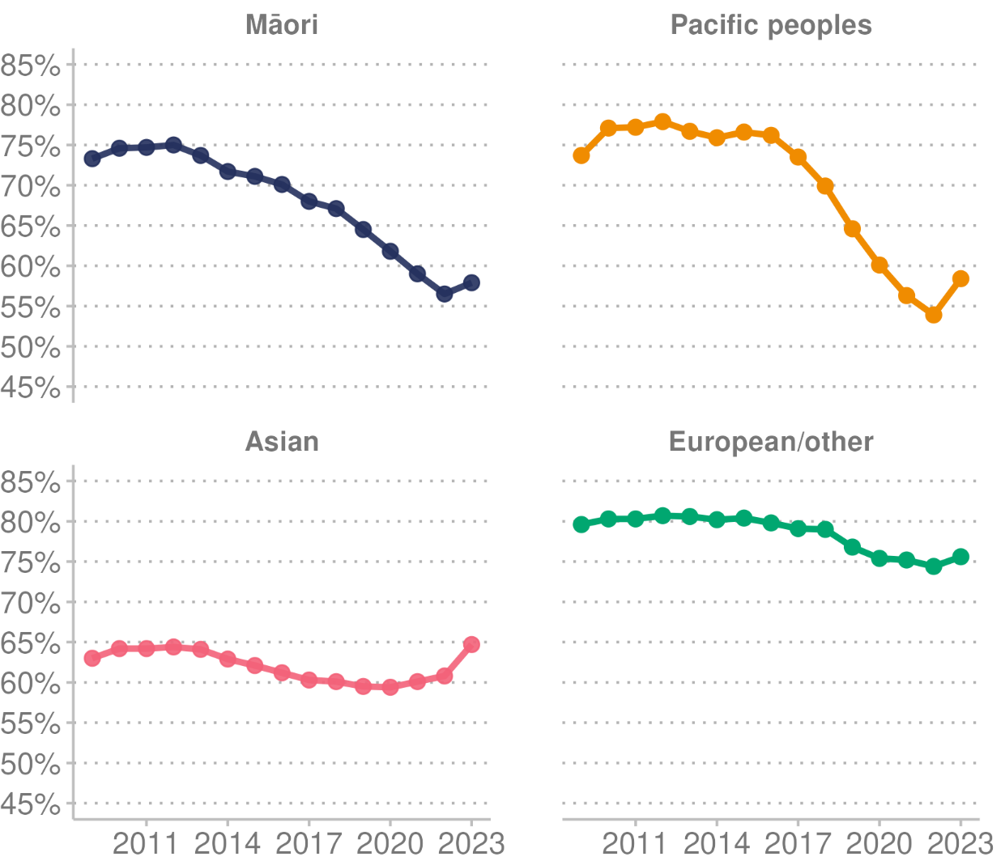

**Source:** Health NZ (2023d)

##### Impact of COVID-19 restrictions on breast and cervical screening programmes

Figure 24 shows the impact of COVID-19 restrictions on breast screening and cervical screening coverage rates. Rates dropped for most ethnic groups following the start of COVID-19 public health restrictions (March 2020) in Aotearoa New Zealand. Coverage has improved somewhat for all ethnic groups during 2023, but inequities persist.

Figure : Difference (%) in breast and cervical cancer screening coverage from March 2020 (beginning of COVID-19 public health restrictions), by ethnic group (prioritised ethnicity), 2012–2024

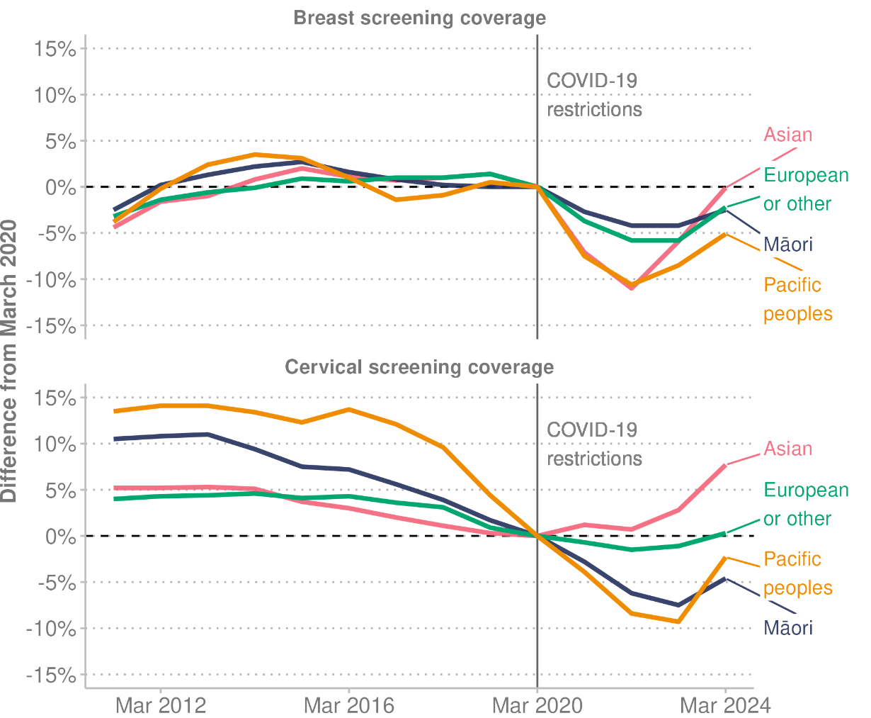

**Source:** Health NZ (2023d), Health NZ (2024b)

#### Bowel screening

The National Bowel Screening Programme (NBSP) is a free programme to help detect bowel cancer. It is offered every two years to eligible people aged 60–74 years. The programme is exploring alternative delivery options, including adjusting the eligibility age. Bowel screening every two years is designed to help save lives by finding bowel cancer at an early stage, when it can often be successfully treated (Time to screen (nd)).

The national rollout of the programme began in July 2017 within two districts and was completed in May 2022 when the final district (Hauora a Toi Bay of Plenty) went live. The NBSP has a participation target of 60% for eligible people invited to screen during each two-year period. There is a six-month lag on reporting to allow participants time to complete and return their kit.

Figure 25 shows the level of participation at the end of December 2023 was 48.7% for Māori, 37.4% for Pacific peoples and 44.1% for Asian participants, compared with 61.3% for European/other (non-Māori, non-Pacific, non-Asian) participants. It is evident that the current programme is not achieving equitable access or equitable benefit for Māori, Pacific peoples and Asian participants. Addressing this inequity is an ongoing priority.

Figure : Bowel screening coverage by ethnic group (prioritised ethnicity), 2019 – 2023

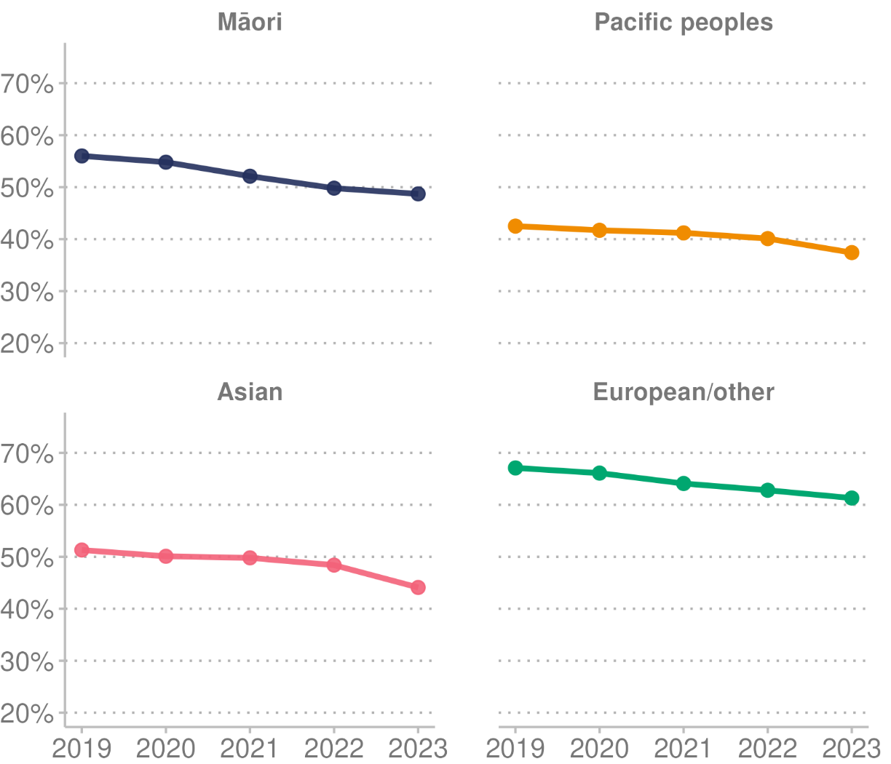

**Source:** Health NZ unpublished data (2024)

## **Cardiovascular and cerebrovascular diseases**

Cardiovascular diseases and cerebrovascular diseases are a group of disorders of the heart, blood flow and blood vessels. Collectively, these accounted for 14.0% of health loss (DALYs) in 2021 (Institute for Health Metrics and Evaluation 2024b). Within this group of diseases, ischaemic heart disease accounted for almost half of the cardiovascular and cerebrovascular disease DALYs (or 6.7% of the total health loss) and stroke accounted for 3.4% of total health loss.

Modifiable risk factors for cardiovascular and cerebrovascular diseases include an unhealthy diet, physical inactivity, tobacco use and alcohol use. The effects of these risk factors may show up in individuals as raised blood pressure, raised blood glucose, raised blood lipids, and overweight and obesity (WHO 2021). The determinants of health and wellbeing section discusses risk factors in more detail.

In mortality data from 2021 (the most recent year when information is available), ischaemic heart disease accounted for 4,594 deaths in Aotearoa New Zealand, an age-standardised rate of 42.9 deaths per 100,000 population (Health NZ 2023c). Within total deaths from this disease, the rate for Māori was 72.0 deaths per 100,000 population, compared with 39.4 deaths per 100,000 for non-Māori.

Stroke and other cerebrovascular diseases (conditions that affect blood flow and blood vessels in the brain) accounted for 2,149 deaths in 2021. This produces an age-standardised rate of 19.2 deaths per 100,000 people.

The mortality rates for ischaemic heart disease and cerebrovascular diseases have reduced over time. Figure 12 in the Mortality section shows that in 1996, 127.5 people per 100,000 population died of ischaemic heart disease and 48.2 people per 100,000 died of cerebrovascular diseases in Aotearoa New Zealand. Improvements in both prevention and treatment have contributed to the decline, including declines in cigarette smoking, improvements in hypertension treatment, use of statins to lower cholesterol and the use of thrombolysis and stents (Mensah et al 2017).

## **Musculoskeletal** **conditions**

Collectively, musculoskeletal conditions accounted for 11% of health loss (DALYs) in 2021 (Institute for Health Metrics and Evaluation 2024b). Lower back pain accounted for more than half of DALY loss within this group of conditions (or 6.2% of total health loss).

As one of the leading causes of disability and non-fatal health loss in Aotearoa New Zealand, musculoskeletal conditions place a significant health, social and economic strain on both individual quality of life and health system costs. Research indicates that one in every four adults experiences musculoskeletal conditions, including arthritis, osteoporosis, lower back pain and spinal disorders (Allen + Clarke 2021).

People with musculoskeletal conditions typically experience pain (often persistent) and face limitations to their mobility and dexterity, reducing their ability to work and participate in society. Pain in musculoskeletal structures is the most common form of non-cancer pain.

Musculoskeletal conditions are relevant across the life course – from childhood to older age. They range from those conditions that arise suddenly and are short-lived (such as fractures, sprains and strains, associated with pain and limitations in functioning) though to long-term conditions such as chronic primary lower back pain and osteoarthritis (WHO 2022c).

Arthritis is one of the musculoskeletal conditions included in the Health Survey. In 2022/23, the Ministry of Health (2023d) reported the following information about the prevalence of arthritis.

* Arthritis (all types): 17.8% of adults (approximately 746,000 people) have been diagnosed with arthritis, up from 15.1% in 2011/12. People are more likely to be diagnosed with arthritis as they age: 50.0% of people aged 75 years and over and 42.5% of people aged 65–74 years have been diagnosed with arthritis.
* Gout: 1.8% of adults have been diagnosed with gout.
* Rheumatoid arthritis: 3.2% of adults have been diagnosed with rheumatoid arthritis.
* Osteoarthritis was the most common type of arthritis, affecting 11.4% of adults in 2022/23, up from 10.7% in 2021/22.

## Mental health

Mental disorders accounted for 11% of health loss (DALYs) in Aotearoa New Zealand in 2021. Conditions contributing substantially to the burden of disease for mental health disorders included anxiety disorders (3.5% of total DALYs) and depressive disorders (2.6% of total DALYs) (Institute for Health Metrics and Evaluation 2024b).

The WHO defines mental health as a state of mental wellbeing that enables people to cope with the stresses of life, realise their abilities, learn well and work well, and contribute to their community. Mental health is more than the absence of mental disorders (WHO 2022b).

According to the 2018 Government Inquiry into Mental Health and Addiction, 50–80% of New Zealanders will experience mental distress or addiction challenges, or both, in their lifetime, and some people are at greater risk. A range of social determinants increases the risk of poor mental health: poverty, lack of affordable housing, unemployment and low-paid work, abuse and neglect, family violence and other trauma, loneliness, social isolation (especially in the elderly and rural populations) and, for Māori, deprivation and cultural alienation (Mental Health and Addiction Inquiry 2018).

The New Zealand Health Survey included a module on mental health and problematic substance use in 2016/17, 2021/22 and 2022/23. Because sample sizes were smaller in 2021/22 and 2022/23, data from these years was pooled for the purpose of analysis. See the [Mental Health and Problematic Substance Use Report 2021–23: New Zealand Health Survey](https://www.health.govt.nz/publication/mental-health-and-problematic-substance-use) (Ministry of Health 2024e) and the [Mental Health and Problematic Substance Use Data Explorer](https://minhealthnz.shinyapps.io/nz-health-survey-2022-23-mental-health-data-explorer/_w_ebc38205/) (Ministry of Health 2024d) for details.

### Anxiety and depression symptoms

The Health Survey assesses anxiety and depression for adults using the Generalized Anxiety Disorder scale and Patient Health Questionnaire. In addition to assessing each condition individually, it produces a composite measure of anxiety and/or depression symptoms based on the individual’s severity scores from both questionnaires.

In 2021–2023, in the two weeks before participating in the survey, 26.6% of adults experienced mild or greater symptoms of anxiety and 29.0% of adults experienced mild or greater symptoms of depression. The prevalence of each condition has increased since 2016/17 (when 18.5% of adults experienced anxiety and 19.9% experienced depression).

Anxiety and depression often co-occur (Kalin N H 2020). In 2021–2023, 34.8% of adults experienced mild or greater symptoms of anxiety and/ordepression in the two weeks before participating in the survey. This is an increase from 25.0% in 2016/17.

Among disabled adults, 61.5% experienced mild or greater symptoms of anxiety and/or depression in the two weeks before participating in the survey, compared with 32.2% of non-disabled adults (Ministry of Health 2024d).

### Problematic substance use

The Health Survey assessed an individual’s risk of problematic substance use with the WHO’s Alcohol, Smoking and Substance Involvement Screening Test (ASSIST).

The prevalence of moderate or high risk of problematic substance use (across all substances, including tobacco, alcohol, and illicit substances) decreased between 2016/17 and 2021–2023 (from 32.6% to 27.0%). The main changes contributing to that decrease were a decreased risk of moderate or high problematic use of both tobacco and alcohol between 2016/17 and 2021–2023 (falling from 20.7% to 14.6% for tobacco and 15.8% to 13.0% for alcohol). However, the prevalence of moderate or high risk of problematic use of illicit substances increased over the same period (from 10.1% to 11.2%).

### Emotional and/or behavioural problems (children)

In the Health Survey, child respondents (aged 2–14 years) are categorised as being ‘likely to have emotional and/or behavioural problems’ if they have a ‘total difficulties’ score of 16 or more for ages 2–4 years, or a score of 17 or more for ages 5–14 years on the Strengths and Difficulties Questionnaire (SDQ). These scores indicate a risk of experiencing substantial difficulties in the four aspects of development (subscales): emotional symptoms, conduct problems, hyperactivity and peer problems.

In 2021–2023, 10.3% of children (aged 2–14 years) have emotional and/or behavioural problems. This rate has increased since 2016/17 (when it was 9.0%). Rates of emotional and/or behavioural problems differed by population group, as the following findings for 2021–2023 indicate.

* The rate of emotional and/or behavioural problems was higher for boys (12.2%) than for girls (8.3%).
* By ethnic group, the highest rate of emotional and/or behavioural problems was recorded for Māori children (14.2%) and the second highest for Pacific children (12.0%). The rate was lower for Asian children (6.6%) and for European/other children (10.2%).
* Children living in the most deprived neighbourhoods (13.9%) had higher rates of emotional and/or behavioural problems than children living in the least deprived neighbourhoods (9.0%) (Ministry of Health 2024d).

### Service use and support

In 2021–2023, 41.1% of adults used some type of service or support for concerns about their emotions, stress, mental health, or substance use in the 12 months before they completed the Health Survey (Ministry of Health 2024d). This is an increase from 35.3% in 2016/17. In contrast, child access remained relatively unchanged (2016/17: 29.0%; 2021–2023: 28.8%).

The most common service or support both adults and children used in 2021–2023 was complementary and/or alternative therapy (which includes, but is not limited to, massage, exercise or movement therapy, herbal medicine, rongoā Māori, mirimiri or other traditional Māori healing, and traditional Pacific healing). Help from the primary sector (which includes general practitioners (GPs), nurses, and medication for emotion, stress, mental health, or substance use) was the second most common type of service and support.

### Unmet need for professional help for mental health

Having an unmet need mental health or addiction services is defined as where an individual feels like they need professional help with emotions, stress, mental health or substance use in the past 12 months but does not receive that help. Possible reasons for not accessing mental health and addiction services include wanting to handle the issue alone and/or with the support of family, whānau and friends, costs of services, and time taken to get an appointment (Ministry of Health 2024d).

Unmet need for mental health and addiction services has increased between 2016/17 and 2021–2023 for both adults (rising from 4.9% to 8.4%) and children (rising from 4.8% to 6.8%). The percentage of people reporting being unable to access mental health addiction services has also increased over that time period. For details, see the [Mental Health and Problematic Substance Use Data Explorer](https://minhealthnz.shinyapps.io/nz-health-survey-2022-23-mental-health-data-explorer/_w_ebc38205/#!/home) (Ministry of Health 2024d).

For 2021–2023, the Health Survey found the following rates of unmet need for mental health or addiction services.

* Women (10.1%) had higher rates of unmet need than men (6.4%).
* Māori adults (11.7%) and European/other adults (9.1%) had higher rates of unmet need than Pacific adults (8.8%) and Asian adults (5.8%). Children followed the same pattern, with more Māori (9.4%) and European/other (7.6%) children having unmet need than Pacific (4.5%) and Asian (3.6%) children.
* Disabled adults (18.9%) had higher rates of unmet need than non-disabled adults (7.4%).
* People living in the most deprived areas (adults: 9.6%; children: 7.2%) had higher rates of unmet need than people living in the least deprived areas (adults: 6.1%; children: 6.3%) (Ministry of Health 2024d).

### Suicide

This section reports the annual rate of suspected self-inflicted death (suspected suicide). However, it is important not to conflate mental illness with suicide or to equate these figures with some measure of the performance of the mental health system. People who die by suicide are almost always acutely distressed but do not necessarily have a mental health diagnosis. Some individuals may have a mental health diagnosis with suicidal distress and interact with the mental health system. The reasons that people take their own lives are complex and factors contributing to a death by suicide accumulate over time.

In the year ending 30 June 2023, there were 565 suspected self-inflicted deaths in Aotearoa New Zealand. The age-standardised rate of suspected self-inflicted deaths was 10.6 per 100,000 population. This rate was 9.2% lower than the average rate of suspected self-inflicted deaths over the last 14 financial years. However, the difference was not statistically significant as suicide rates are highly variable (Health NZ 2024p).

## **Neurological conditions**

Neurological conditions accounted for 7% of health loss (DALYs) in Aotearoa New Zealand in 2021. Alzheimer’s disease makes up almost half of the total DALYs for this group (3.1% of total DALYs) (Institute for Health Metrics and Evaluation 2024b).

Disorders affecting the nervous system are diverse. They include neurodevelopmental disorders, late-life neurodegeneration, and newly emergent conditions, such as cognitive impairment following COVID-19.

Globally, the number of people living with, or dying from, neurological conditions resulting from stroke, Alzheimer's disease and other dementias, and meningitis has risen substantially over the past 30 years. In part, this trend has occurred because the global population is growing and ageing. Other reasons are people’s increased exposure to environmental, metabolic and lifestyle risk factors.

Globally in 2021, the top 10 contributors to neurological health loss were stroke, neonatal encephalopathy (brain injury), migraine, Alzheimer’s disease and other dementias, diabetic neuropathy (nerve damage), meningitis, epilepsy, neurological complications from preterm birth, autism spectrum disorder and nervous system cancers (Institute for Health Metrics and Evaluation 2024c).

## Respiratory diseases

Chronic respiratory diseases affect the airways and other structures of the lungs. Some of the most common are chronic obstructive pulmonary disease (COPD), asthma, occupational lung diseases and pulmonary hypertension. COPD accounted for 2.8% of health loss (DALYs) in Aotearoa New Zealand in 2021 (Institute for Health Metrics and Evaluation 2024b).

Risk factors for respiratory diseases include tobacco smoke, air pollution, occupational chemicals and dusts, and frequent lower respiratory infections during childhood (WHO (nd)-b).

In mortality data from 2021 (the most recent year for which information is available), respiratory disease accounted for 2,656 deaths in Aotearoa New Zealand. This equates to an age-standardised rate of 24.6 deaths per 100,000 population (Health NZ 2023c). The age-standardised rate was 44.5 deaths per 100,000 population for Māori, compared with 22.4 deaths per 100,000 for non-Māori.

## Diabetes and chronic kidney disease

In 2021, diabetes accounted for 970 deaths, which equates to a rate of 10.3 deaths per 100,000 population. Within the total deaths from this disease, the age-standardised rate for Māori was 30.1 per 100,000 population, compared with 8.3 deaths per 100,000 population for non-Māori (Health NZ 2023c).

An estimated 307,400 Aotearoa New Zealanders were living with diabetes in 2022. This equates to an age-standardised rate of 43.1 people per 1,000 population) (Health NZ 2023f).

* Over the last 10 years, the estimated rate of diabetes per 1,000 population increased from 36.6 in 2013 to 43.1 in 2022.
* In 2022, Pacific peoples had the highest estimated rate of diabetes (122.7 people per 1,000 population). The next highest rates were for the Indian population (103.1 people per 1,000 population) and Māori (71.2 people per 1,000 population).
* The rate of diabetes among those living in the most deprived areas was 2.7 times higher than among those living in the least deprived areas.

Chronic kidney disease (CKD) means a person’s kidneys are not functioning properly and are unlikely to get better. CKD can lead to kidney failure, which is fatal if not treated by either dialysis or a kidney transplant. The main causes of CKD are diabetes (about one in three people with diabetes will end up with some kidney damage) and/or high blood pressure. Other risk factors include unhealthy weight, family history of kidney disease, and tobacco use (Health NZ 2024c).

## Oral health

Oral diseases, while largely preventable, are a major health burden and affect people throughout their lifetime, causing pain, discomfort, disfigurement and even death. Oral diseases disproportionately affect the most vulnerable and disadvantaged populations. Globally, people living in lower socioeconomic areas carry a higher burden of oral diseases across their life course, from early childhood to older age, and across all countries regardless of what the overall income level of the individual country is (WHO (nd)-d).

In Aotearoa New Zealand, basic oral health care is publicly funded (free) for children and adolescents aged 0 to 17 years. Once a person turns 18 years, they must fund most of their own dental care privately. A limited range of dental services is funded for some adults, such as emergency or basic care for low-income adults, and hospital dental services for people with disabilities, medical conditions or behavioural difficulties (Health NZ 2024d).

### Children’s oral health

Dental caries (tooth decay), a largely preventable disease, remains a widespread childhood disease in Aotearoa New Zealand. Among children aged 0–4 years, it is the fourth most common reason for ambulatory sensitive hospitalisations (see the Ambulatory sensitive hospitalisations section for more on this measure) (Ministry of Health 2023c).

In 2008, there was a major reorientation of community oral health services in Aotearoa New Zealand, with significant government investment into service renewal and redesign (Foote J et al 2014). In addition to improving facilities, equipment, workforce retention and models of care, the aims of the reorientation programme were to:

* increase infant and preschool contact, health promotion and preventive activities
* reduce barriers to access for Māori, Pacific peoples and low-income families
* reduce disparities
* improve access to services for adolescents.

Aotearoa New Zealand has two key measures for children’s oral health: the percentage of children caries-free at age five years; and the average level of decayed, missing and filled teeth (DMFT) in permanent teeth at year 8 (around 12 years of age). Rates are shown for Māori, Pacific peoples, European or other, and total.

Figure 26 shows the percentage of five-year-old children who were caries-free (free of dental decay) from 2010 to 2022. In 2022, among all children aged five years, 56.2% were caries-free. By ethnic group, the percentages of five-year-olds who were caries-free were:

* Māori children: 39.0%, down from 41.1% in 2021
* Pacific children: 33.5%, up from 33.1% in 2021
* European/other children: 66.4%, down from 67.6% in 2021.

Figure : Percentage of children caries-free at age five years, by ethnic group (prioritised ethnicity), 2010–2022

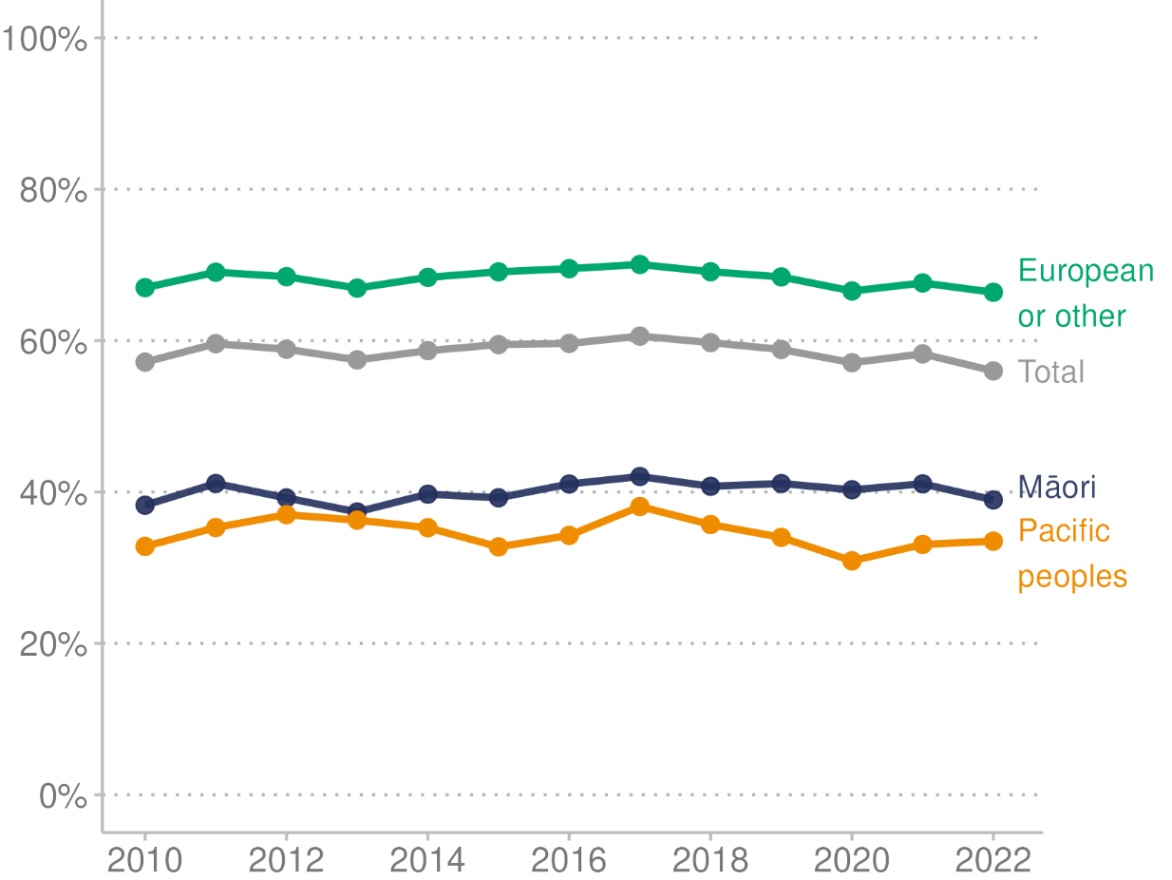

**Source:** Ministry of Health (2023b)

Figure 27 shows oral health improved for children at year 8, as measured by the average number of DMFT between 2010 and 2019 for all ethnic groups. However, improvements levelled off at that time for all but Pacific children, and inequities in DMFT numbers remain. In 2022, the average number of DMFT at year 8 for all children was 0.7. By ethnic group, the number of DMFT was 1.1 for Māori children, 0.8 for Pacific children and 0.6 for European/other children.

Figure : Mean number of decayed, missing, and filled teeth (DMFT) per child at year 8, by ethnic group (prioritised ethnicity), 2010–2022

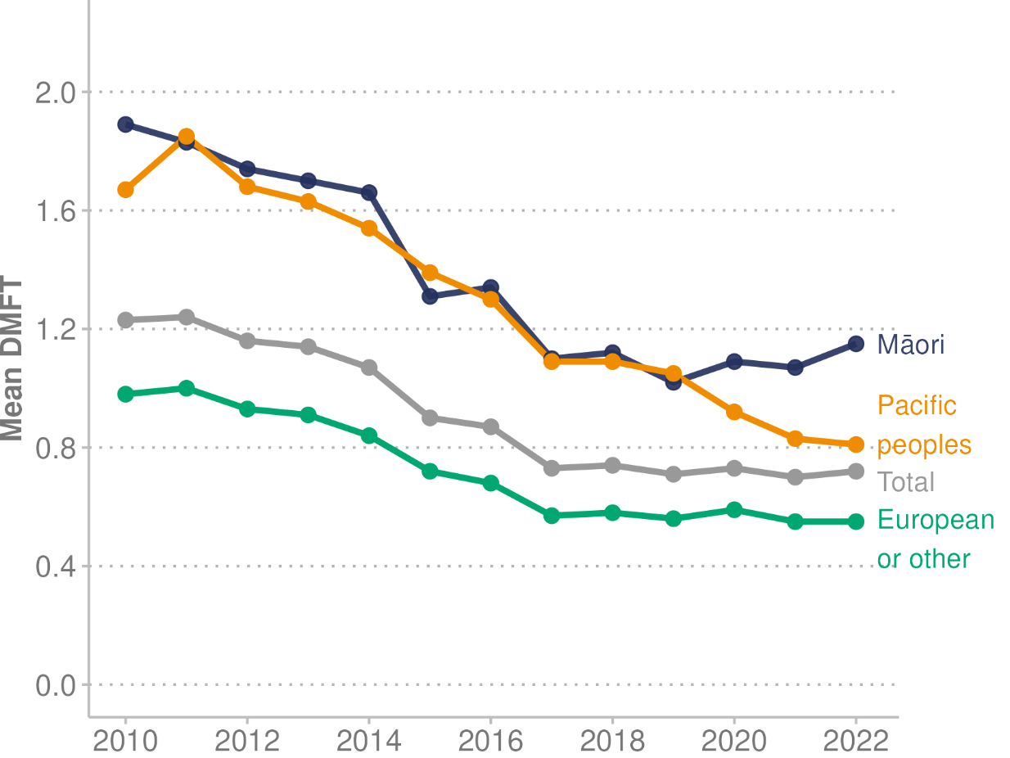

**Source:** Ministry of Health (2023b)

#### Visited a dental health care worker in the past 12 months

In the Health Survey, for the three-year pooled period ending 2022/23, 69.9% of children (1–14 years of age) had seen a dental health care worker in the past 12 months (Ministry of Health 2023d). The rate of children visiting a dental health care worker (in the previous 12 months) was stable at around 83% for the three-year pooled periods 2014/15 to 2018/19. Rates from 2020/21 decreased, likely due to the impact that the COVID-19 pandemic had on community oral health services. The decrease is evident among all age groups. For the three-year pooled period ending 2022/23, compared with the three-year pooled data ending 2013/14, the rate of children who had visited a dental health care worker in the past 12 months was:

* 46.3% among preschool children (1–4 years of age), down from 55.8%
* 78.3% among children 5–9 years of age, down from 92.2%
* 78.7% among children 10–14 years of age, down from 91.6%.

Figure 28 shows the percentage of children (1–14 years) who visited a dental health care worker in the past 12 months by ethnic group (showing three-year rolling averages). It reflects the following findings for the three-year pooled period ending 2022/23.

* Māori children: 70.8% had seen a dental health worker in the past 12 months. This was down from 78.9% for the three-year pooled period ending 2013/14, and down from a high of 83.3% for the three-year pooled period ending 2018/19.
* Pacific children: 65.1% had seen a dental health worker in the past 12 months. This was down from 74.6% for the three-year pooled period ending 2013/14, and down from a high of 78.5% for the three-year pooled periods ending 2016/17 and 2018/19.
* Asian children: 58.6% had seen a dental health worker in the past 12 months. This was down from 76.5% for the three-year pooled period ending 2013/14, and down from a high of 77.5% for the three-year pooled period ending 2014/15.
* European/other children: 73.5% had seen a dental health worker in the past 12 months. This was down from 83.1% for the three-year period ending 2013/14, and down from a high of 86.4% for the three-year pooled period ending 2016/17.

Figure : Percentage of children who visited a dental health care worker, by ethnic group (total response ethnicity), three-year rolling average, 2013/14–2022/23

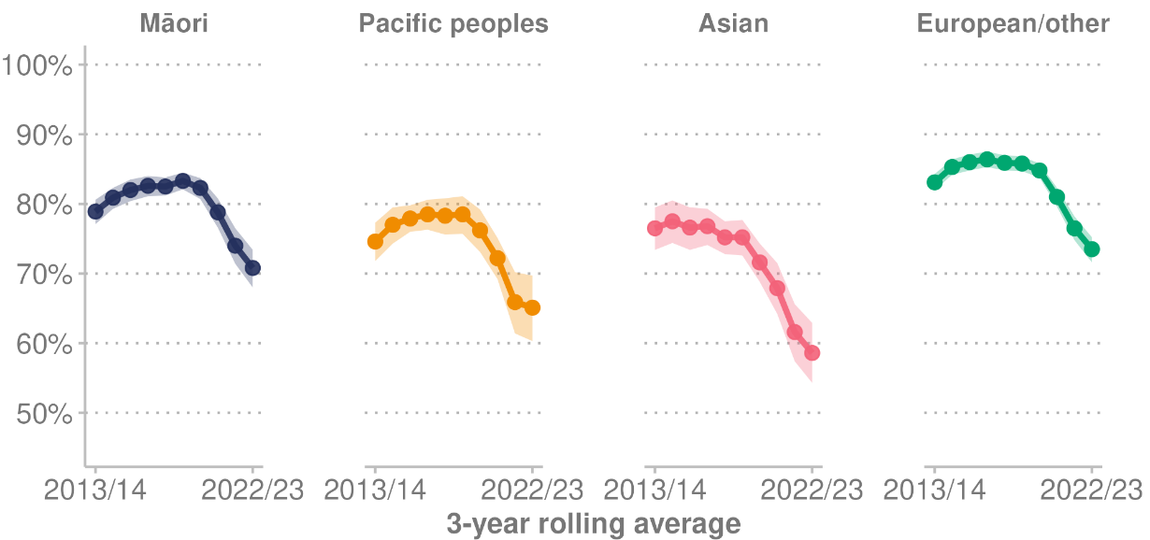

Note: Shaded area indicates 95% confidence intervals.

**Source:** Ministry of Health (2023d)

### Adult oral health care: unmet need for dental care due to cost

For adults aged 15 years and over, having unmet need for dental care due to cost is defined as avoiding going to a dental health care worker in the past 12 months because of cost. Overall, in the three-year pooled period ending 2022/23, 40.6% of adults reported unmet need for dental care due to cost. This was similar to previous three-year pooled periods. Differences are evident among population groups in the three-year pooled period ending 2022/23.

* The rate was higher for women (44.7%) than men (36.3%).
* By ethnic group, the percentage of adults with unmet need for dental care due to cost was 53.2% for Māori adults, 49.4% for Pacific adults, 42.4% for Asian adults and 38.1% for European/other adults.
* For people living in the most deprived neighbourhoods, 52.0% reported unmet need for dental care due of cost, compared with 29.3% of people living in the least deprived neighbourhoods.
* More disabled adults (49.7%) reported unmet need for dental care due to cost than non-disabled adults (39.8%) (Ministry of Health 2023d).

## Injury

In 2021, injuries accounted for 12% of all health loss (DALYs) in Aotearoa New Zealand. This health loss from injuries was made up of unintentional injuries (7%), self-harm and interpersonal violence (2%) and transport injuries (2%) (Institute for Health Metrics and Evaluation 2024b).

Anyone who is injured in an accident in Aotearoa New Zealand, including visitors to the country, is covered by the Accident Compensation Commission (ACC). The cover includes payments toward treatment, help at work and home, and income support.

In 2022/23, ACC received 1.97 million new claims. It spent $6.2 billion in the year supporting these and existing claims, at an average cost of $2,169 per claim. Falls are the most common cause of injury in Aotearoa New Zealand. They account for approximately 28% of all new ACC claims in a year (Accident Compensation Corporation 2023).

Table : ACC injury, number of new claims registered, total claims paid ($ million), 2022/23

|  |  |  |  |  |  |  |
| --- | --- | --- | --- | --- | --- | --- |
|  | **New claims registered** | | | **Total claims paid ($m)** | | |
| **Account** | **2020/21** | **2021/22** | **2022/23** | **2020/21** | **2021/22** | **2022/23** |
| Motor vehicle | 35,667 | 30,888 | 35,358 | 654 | 667 | 762 |
| Work | 209,099 | 184,919 | 198,256 | 965 | 956 | 1,076 |
| Earners’ | 801,750 | 692,216 | 738,869 | 1,930 | 2,003 | 2,342 |
| Treatment injury | 11,669 | 11,614 | 12,863 | 276 | 292 | 363 |
| Non-earners' | 1,041,199 | 884,159 | 981,628 | 1,394 | 1,454 | 1,648 |

Note: Motor vehicle account = injuries involving a moving motor vehicle. Work account = work-related injuries. Earners’ account = non-work injuries to people in employment. Treatment injury account = injuries that are caused by or happen during treatment. Non-earners’ account = injuries not covered in other accounts to people not in employment. Treatment injuries are defined as injuries caused by, or at the direction of, a registered health professional, and include injuries caused by a failure to provide appropriate treatment. Examples include healthcare associated infections, medication safety, and surgical harm.

**Source:** Accident Compensation Corporation unpublished data (2024)

### Health care harm and adverse events

Health Quality & Safety Commission – Te Tāhū Hauora (HQSC) defines health care harm (adverse events) as negative consequences for consumers and whānau directly arising from or associated with plans made, actions taken or omissions that occur while providing health care, rather than arising from an underlying disease or injury. Harm may be physical, psychological, cultural or spiritual (HQSC 2023b).

Figure 29 shows the number of reported adverse events with a severity assessment code of 1 or 2[15] between July 2018 and June 2023. The change in mid-2020 indicates a statistically significant baseline shift to a higher number of reported events from that time. This shift does not necessarily mean an increase in harm. Rather it may indicate people are more likely to report harm when it occurs, which creates more opportunities for system learning.

Figure : Number of reported adverse events (severity assessment code 1 or 2), before and after baseline shift to a higher number of reported events, 2018–2023

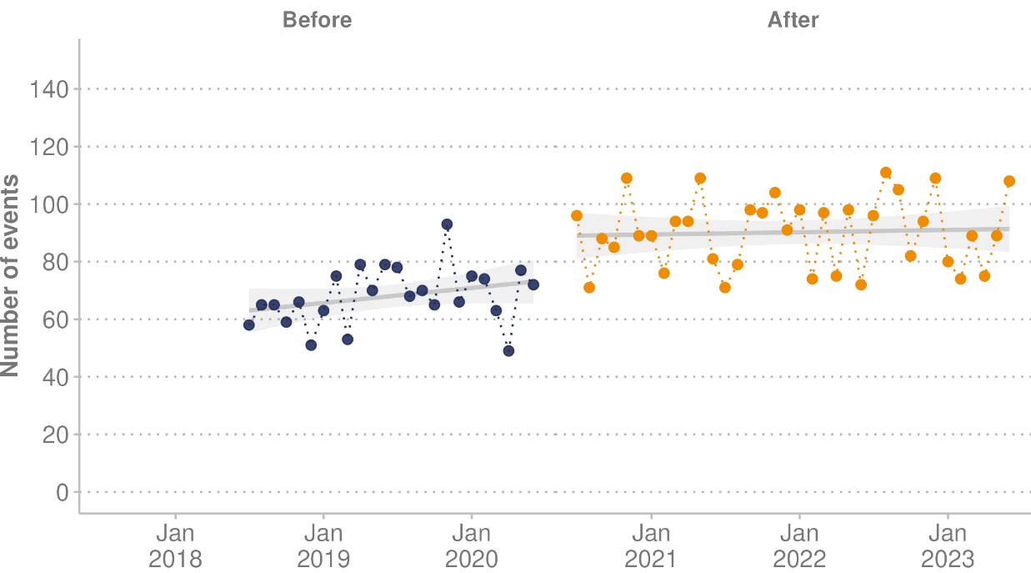

Note: Shaded area indicates 95% confidence interval of the estimated mean.

**Source:** HQSC unpublished data (2024)

HQSC released *Healing, learning and improving from harm: National adverse events policy 2023 - Te whakaora, te ako me to whakapai ake i te kino* (HQSC 2023c) on 1 July 2023. The aim of the policy is to provide a national framework for health and disability providers to continually improve the quality and safety of services following harm that occurs during the provision of health care.

## Infectious (communicable) diseases

Infectious (communicable) diseases are caused by pathogenic micro-organisms, such as bacteria, viruses, parasites, or fungi. The diseases can spread, directly or indirectly, from one person to another, between animals and humans, through food or through the environment. Many of the causes of infectious diseases lie outside the direct control of the health sector, for example, water supply, housing, and other wider determinants of health (WHO (nd)-c).

This section first provides detailed information on COVID-19. It then gives an overview of some other infectious diseases – namely rheumatic fever, measles, meningococcal disease, and sexually transmitted infections. Finally, it covers antimicrobial resistance, which makes it harder to treat infectious diseases.

### COVID-19

This section provides information on COVID-19, including counts of deaths globally and nationally and hospitalisations in Aotearoa New Zealand. For COVID-19 vaccination rates, see COVID-19 immunisation in the ‘Immunisation’ section.

In 2023, the WHO, as the global coordinating agency for the response to COVID-19, announced the end of the emergency phase of the pandemic. It determined that COVID-19 had become an established and ongoing health issue that was no longer a public health emergency of international concern (WHO 2023b).

According to the 2021 Global Burden of Disease study, the COVID-19 pandemic killed approximately 16 million people worldwide in 2020 and 2021. As a result, global life expectancy declined by 1.6 years between 2019 and 2021 (reversing historical trends). In 2020, Aotearoa New Zealand was one of 20 countries and territories with negative all-age excess mortality (fewer deaths occurred than would be expected based on past trends). In 2021, only Aotearoa New Zealand and Barbados had negative excess mortality (GBD 2021 Demographics Collaborators 2024).

Over the course of the pandemic, the Aotearoa New Zealand COVID-19 management strategy changed first from elimination to minimisation and then to protection. On 15 August 2023, all remaining COVID-19 requirements were removed. This included the mandatory seven-day isolation period for people testing positive for the virus, and the requirement for visitors to wear a mask when visiting a health care or aged care facility (beehive.govt.nz 2023).

#### COVID-19 hospital admissions

From the time the first case of COVID-19 was detected in Aotearoa New Zealand on 28 February 2020 until the end of December 2023, 35,644 people have been admitted to hospital for COVID-19. Of these, 12,242 were admitted in the calendar year of 2023 (Ministry of Health 2024f).[16] Figure 30 presents the weekly count of COVID-19 hospital admissions from 2020 to the end of 2023.

Figure : Weekly count of hospital admissions for COVID-19, 2020–2023

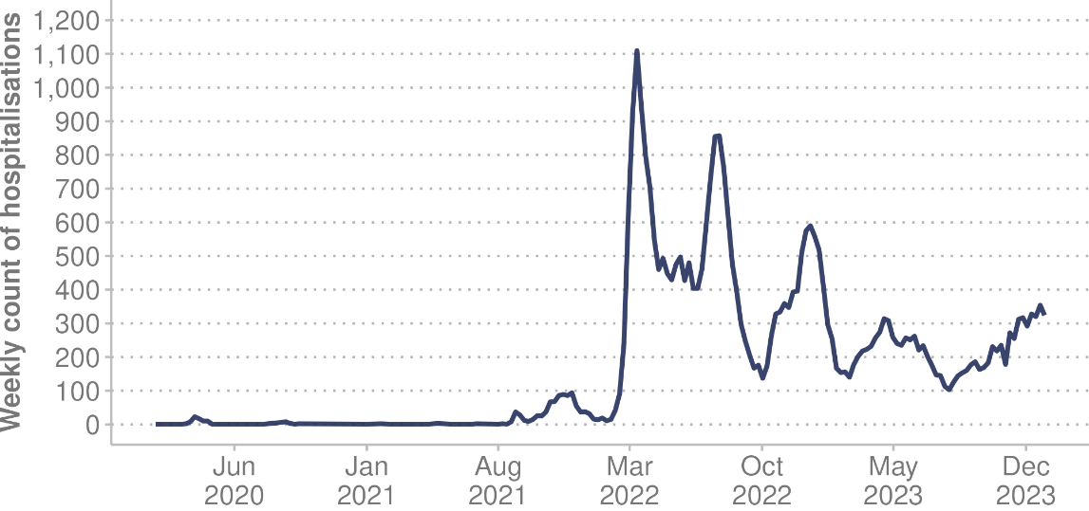

**Source:** Ministry of Health (2024f)

#### COVID-19 deaths

From the beginning of the pandemic until 31 December 2023, 5,310 people in Aotearoa New Zealand died with COVID-19 officially coded as the underlying cause.[17] Of these deaths, 1,764 were attributed to COVID-19 in the 2023 calendar year. Figure 31 presents the weekly count of COVID-19 deaths from 2020 to the end of 2023.

Figure : Weekly count of COVID-19 deaths, 2020–2023

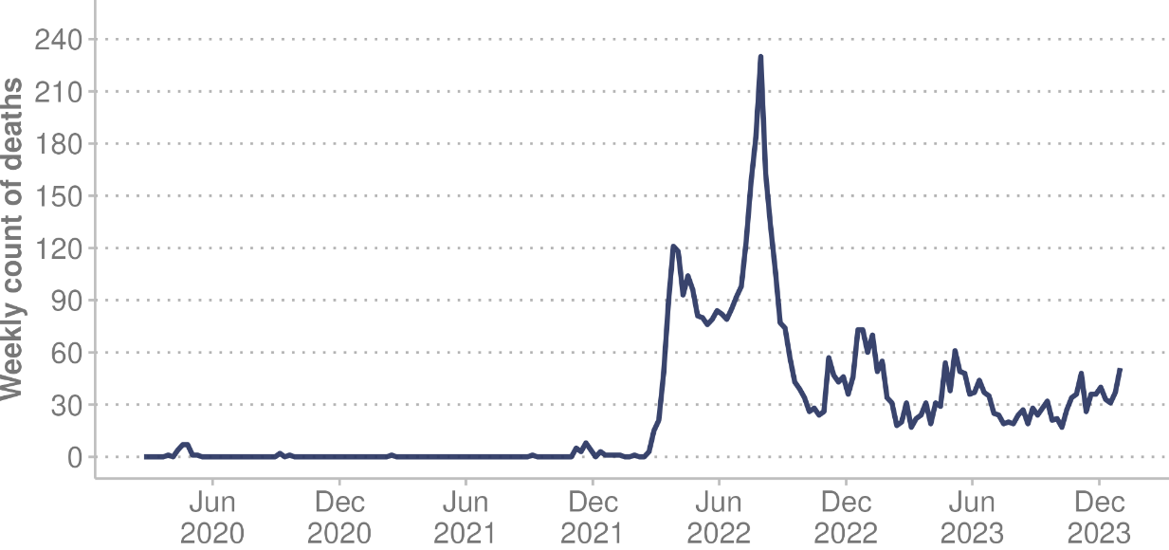

**Source:** Ministry of Health (2024f)

#### Long COVID

In Aotearoa New Zealand, the clinical definition of long COVID is ongoing symptoms that continue 12 weeks or more after infection with SARS-CoV-2, which are not explained by any other diagnosis (Ministry of Health 2024c). This is in line with the WHO definition of long COVID. Understanding the percentage of the population suffering from long COVID presents an ongoing challenge in Aotearoa New Zealand and around the world, as there are no definitive tests and diagnosis relies on symptoms alone. The WHO estimates that 10–20% of people who are infected by SARS-CoV-2 go on to develop long COVID (WHO 2022d).

While the number of people with long COVID in Aotearoa New Zealand is not presently known, it is clear that individuals do suffer significant impacts on their daily life, work and overall health following an infection with SARS-CoV-2. The Ministry of Health has funded specific research projects to provide Aotearoa New Zealand-based knowledge of long COVID. For information about these projects, see [Long COVID programme](https://www.health.govt.nz/our-work/diseases-and-conditions/covid-19-novel-coronavirus/covid-19-response-planning/long-covid-programme) on the Ministry of Health website (Ministry of Health 2024c). Long COVID research will help inform understanding of long COVID, including its prevalence, diagnosis, and treatment options.

### Other infectious diseases

#### Rheumatic fever

Strep throat (caused by group A*Streptococcus* bacteria) is a bacterial infection that causes inflammation and pain in the throat. An untreated strep throat can lead to rheumatic fever, which may cause the heart, joints, brain and skin to become inflamed and swollen. That can in turn cause rheumatic heart disease, which scars the heart valves. People with rheumatic heart disease may need heart valve replacement surgery. Rheumatic heart disease can cause premature death in adults.

In the 12 months ending 30 June 2023, 138 people were admitted to hospital with rheumatic fever for the first time (2.7 per 100,000 population) in Aotearoa New Zealand. This is an increase from 77 people in the 12 months ending 30 June 2022 (1.5 per 100,000 population). Most cases admitted to hospital with rheumatic fever for the first time were in children aged between 5 and 14 years (85 cases, a rate of 13.1 per 100,000 population) (Health NZ 2024o).

Among Māori, hospitalisations decreased from 8.7 per 100,000 (74 cases) in 2020 to 5.5 per 100,000 (49 cases) in 2022. However, they then increased to 7.0 per 100,000 (63 cases) in the year ending 30 June 2023. Hospitalisations for Pacific peoples decreased from 19.5 per 100,000 (69 cases) in 2020 to 8.2 per 100,000 (30 cases) in 2022. They then increased to 18.6 per 100,000 (69 cases) in the year ending 30 June 2023.[18] Figure 32 shows these trends by financial year.

Figure : First admissions to hospital for rheumatic fever, rate per 100,000 population, by ethnic group (prioritised ethnicity), 2006/07–2022/23

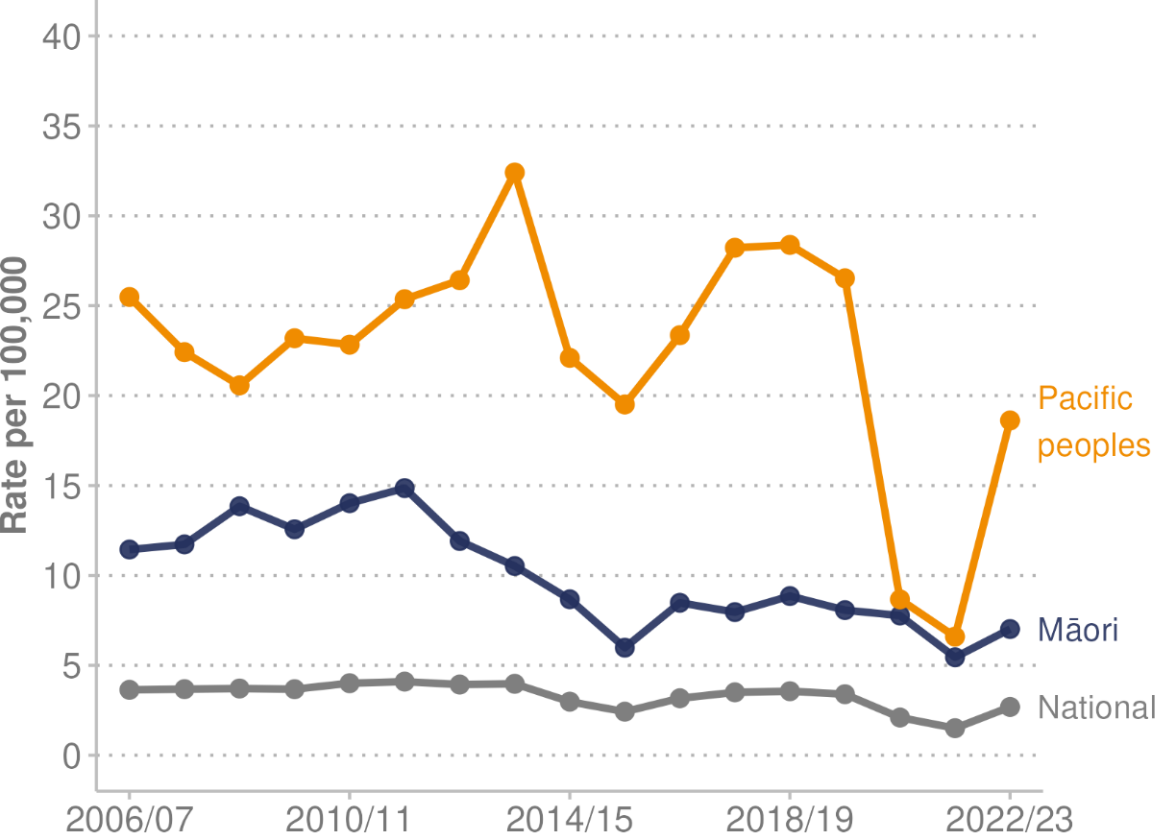

**Source:** Health NZ (2024o)

#### Measles

Measles is a serious and highly contagious disease. It can cause severe problems, including brain inflammation, chest infections and death (Health NZ 2024k). In 2023, Aotearoa New Zealand had 14 measles cases. These included one small outbreak, in addition to cases in travellers coming from overseas. Despite the low number, active measles cases are increasing around the world and vaccination rates are falling, putting Aotearoa New Zealand at very high risk of a measles outbreak (Health NZ 2024j). For childhood immunisation rates, see Childhood immunisations in the Immunisation section. (As part of the New Zealand Immunisation Schedule, Measles immunisations are offered to children at 12 months and 15 months of age).

#### Meningococcal disease

Meningococcal disease is a bacterial infection. It can cause two very serious illnesses – meningitis and blood poisoning – which can lead to permanent disability, deafness or death. Early treatment for these complications is very important (Health NZ 2024l). For the 2023 calendar year, the following information about meningococcal disease is available.

* Aotearoa New Zealand had 59 reported cases (55 confirmed and 4 probable) of invasive meningococcal disease. This total is higher than in 2020 and 2021, and lower than in 2018, 2019 and 2022.
* One person, an adult aged between 20 and 29 years, died of meningococcal disease.
* Most (87%) of the cases aged under five years were in Māori and Pacific children. In contrast, most (68%) of the cases aged 15–29 years were European/other.
* The cases were scattered widely across Aotearoa New Zealand (Institute of Environmental Science and Research 2024b).

#### Sexually transmitted infections

Sexually transmitted infections (STIs) are common in Aotearoa New Zealand. Associated complications include chronic pain, infertility, neonatal morbidity, and genital tract cancer. Māori and Pacific peoples continue to be inequitably affected by STIs, as do men who have sex with men (Institute of Environmental Science and Research 2024c).

##### Chlamydia and gonorrhoea

Chlamydia and gonorrhoea can cause pelvic inflammatory disease, which is associated with infertility, chronic pelvic pain, and poor pregnancy outcomes (Ministry of Health 2023g). In the 12 months ending September 2023, Aotearoa New Zealand had 28,164 reported cases of chlamydia and 7,794 reported cases of gonorrhoea.

Chlamydia and gonorrhoea cases and rates have remained stable over 2022/23. Gonorrhoea continues to be disproportionally reported among males and people aged 20–29 years, while chlamydia cases are most commonly reported among females and people aged 20–24 years.

##### Syphilis

Syphilis can cause serious illness if untreated. It can be transmitted from mother to child during pregnancy, leading to stillbirth or congenital syphilis (Ministry of Health 2023g). Aotearoa New Zealand had 706 syphilis cases reported in the 12 months ending September 2023. Reported cases and rates of infectious syphilis have been steadily increasing from June 2022, and sporadic cases of congenital syphilis are a persistent problem. Men who have sex with men are disproportionately affected, as are Māori (Institute of Environmental Science and Research 2024c).

##### HIV/AIDS

Human immunodeficiency virus (HIV) is a virus that depletes the body’s normal immune defence mechanism. Without treatment, it causes acquired immunodeficiency syndrome (AIDS). Most people get HIV sexually, by injecting drug use or by parent-to-child transmission during birth.

* In 2022, a total of 135 people (109 men and 26 women, including 6 transgender women) were notified with HIV in Aotearoa New Zealand. Of this total, 76 were first diagnosed in Aotearoa New Zealand and 55 had previously been diagnosed overseas. For four people, the place of first diagnosis was unknown.
* The total number notified in 2022 (135) represents a slight increase on 2021 (109), mainly due to the increase in the number who had been previously diagnosed overseas.
* While children can be infected through parent-to-child transmission during birth, since 2007 no children have been infected in this way in Aotearoa New Zealand.[19]
* In 2022, 18 people (14 men and 4 women, including 1 transgender woman) were diagnosed with AIDS (University of Otago 2023).

### Antimicrobial resistance

Antimicrobials are medicines that treat or prevent infections from bacteria, viruses, fungi or parasites. Antimicrobial resistance (AMR), also sometimes called antibiotic or drug resistance, occurs when micro-organisms evolve and become able to replicate despite antimicrobial treatment. AMR makes infections much harder to treat as the medicines to treat them become less effective.

AMR includes resistance to antibacterial, antiviral, antiparasitic and antifungal medications (Ministry of Health and Ministry for Primary Industries 2017).

AMR represents one of the most serious global public health threats today (Institute of Environmental Science and Research 2024a).

* In 2019, 4.95 million people who died had suffered from drug-resistant infections.
* AMR directly caused 1.3 million of those deaths.
* One in five of those deaths occurred among children under five years old.

Aotearoa New Zealand currently has the eighth-lowest age-standardised mortality rate per 100,000 population associated with AMR across 204 countries (Institute for Health Metrics and Evaluation (nd)). Although this rate is low compared with other countries, rates are increasing. National surveillance processes are in place to monitor AMR and identify any new AMR threats as they emerge.

# **Determinants of health and wellbeing -** Ngā tūtohu o te hauora me te oranga o te tangata

Many factors combine to affect the health of individuals and communities. The wider determinants of health are a range of factors that influence people’s mental and physical health. Social determinants are the circumstances and wider forces in the environments in which people are born, grow up, live, learn, work and age. These can affect health, wellbeing and quality of life.

The determinants of health we look at in this section are:

* the social and economic environment
* the physical environment
* the person’s individual risk factors
* access to and experience of health care.

Because the context of people’s lives determines their health, it is inappropriate to either blame individuals for having poor health or credit them for their good health. Individuals are unlikely to be able to directly control many of the determinants of health (WHO 2017).

Commercial determinants of health are commercial activities that shape the physical and social environments – both positively and negatively. For example, companies have an impact in the choices they make about products such as breast-milk substitutes, ultra-processed foods, tobacco, sugar-sweetened beverages, and alcohol. Their decisions about producing, setting prices, and targeting marketing for these products may contribute to or counteract the development of diseases such as cardiovascular disease, type 2 diabetes, and certain cancers, as well as hypertension and obesity (WHO 2023a).

## Social and economic environment

The social and economic determinants of health are non-medical factors that influence health outcomes. These have an important influence on health inequities. No matter what a country’s level of income is, health and illness follow the same social gradient: the lower someone’s socioeconomic position in the country is, the worse their health is (WHO (nd)-e). Unacceptable gaps persist in how long people can expect to be healthy and to live, according to characteristics such as where they live, how much money they have, their education level, their skin colour, their ethnic group and whether they have a disability (WHO 2024).

### Racism

Racism is an important determinant of health that contributes to health inequities (Ministry of Health 2023h). A report from the Ministry of Health in 2023 (*Racial Discrimination 2011/12, 2016/17 and 2020/21: New Zealand Health Survey)* presents key results from a racial discrimination module included in the Health Survey in 2011/12, 2016/17 and 2020/21.

* Māori, Pacific and Asian adults are more likely than non-Māori, non-Pacific, non-Asian (non-MPA) adults to experience racial discrimination.
* In the 12 months before the 2020/21 survey, 13.8% of Māori, 9.5% of Pacific, 12.3% of Asian and 4.8% of non-MPA adults experienced racial discrimination.
* Verbal abuse was the most common type of racial discrimination people experienced, followed by unfair treatment by a health professional.
* Racial discrimination was associated with higher rates of psychological distress, lower rates of good/very good/excellent self-rated health and higher rates of unmet need for primary health care (Ministry of Health 2023h).

### Poverty

Poverty is a major cause of ill health and a barrier to accessing health care. This relationship is in large part financial: people cannot afford what they need for good health, including enough good-quality food and health care. But other factors related to poverty also contribute, such as lack of information or lack of voice to access health and social services (World Bank 2014).

Poverty has been described as a carcinogen: something that causes cancer. It is identified as a barrier to accessing early diagnosis and best-practice treatment for cancers, leading to inequities in cancer survival between the poor and the rich. A person’s chance of surviving cancer reduces as their level of deprivation increases (Te Aho o Te Kahu 2021).

#### Child poverty

Stats NZ measures child poverty rates in Aotearoa New Zealand (Stats NZ 2024g). For the year ended June 2023, three of the nine measures of child poverty increased compared with the previous year.

* One in eight children (12.6%) lived in low-income households that had less than 50% of the median equivalised disposable household income before deducting housing costs (measure (a) of the Child Poverty Reduction Act 2018).
* One in six children (17.5%) lived in low-income households that had an after-housing-costs income that was less than 50% of the baseline year’s median after-housing-costs equivalised disposable household income (measure (b)).
* One in eight children (12.5%) lived in households experiencing material hardship.

#### Material hardship

Child poverty statistics include rates of children living in material hardship. A household is in material hardship if it is going without 6 or more of 17 essential consumption items due to cost. It is in severe material hardship if it is going without 9 or more of those items. The essential consumption items include fresh fruit and vegetables, doctor’s visits, good pairs of shoes, car upkeep and unexpected expenses of $500 or more.

In 2023, the rate of children living in material hardship increased by 2.0 percentage points to 12.5% of children, compared with the year ended June 2022 (10.5%). Severe material hardship increased by 1.5 percentage points, rising to 5.5% of all children (Stats NZ 2024b).

Figure 33 shows the percentage of children living in households experiencing material hardship by ethnic group. Rates were disproportionately high for Māori (21.5%) and Pacific (28.9%) children, compared with Asian (3.7%) and European/other (9.4%) children.

Child poverty statistics for 2023 show that 22.3% of disabled children were living in households that experienced material hardship, compared with 11.1% of non-disabled children (Stats NZ 2024h).

Figure : Percentage of children living in household experiencing material hardship, by ethnic group (total response), 2019–2023

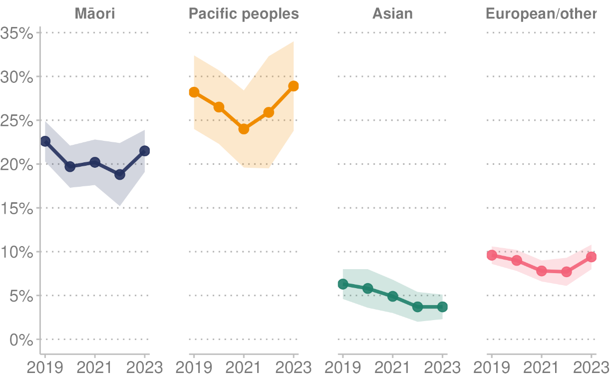

Note: Shaded area indicates 95% confidence intervals.

**Source:** Stats NZ (2024h)

#### Household food insecurity

Food insecurity is defined as a limited or uncertain availability of nutritionally adequate and safe foods, or limited ability to acquire personally acceptable foods that meet cultural needs in a socially acceptable way.

According to the Health Survey, for the single year 2022/23, 21.3% of children lived in a household where food runs out often or sometimes. This percentage was higher than the previous two annual surveys, which reported 14.4% in 2021/22 and 14.9% in 2020/21 (Ministry of Health 2023d).

The level of household food insecurity differed by population groups. For the single year 2022/23, food runs out often or sometimes for:

* 35.1% of Māori children
* 39.6% of Pacific children
* 12.3% of Asian children
* 18.0% of European children
* 35.0% of disabled children, compared with 19.5% of non-disabled children.
* 36.1% of children living in the most deprived areas, compared with 5.5% of children living in the least deprived areas.

### Employment

#### Employment rate

The employment rate reflects the number of people in Aotearoa New Zealand aged 15 years and over who are in employment. The employment rate for the quarter ending 31 December 2023 was 69.0%, down from a high of 69.8% in June 2023. By gender, the employment rate was 73.6% for men and 64.5% for women (Stats NZ 2024d).

#### Unemployment rate

The seasonally adjusted unemployment rate was 4.0% in the December 2023 quarter, compared with 3.9% in the previous quarter (ending 30 September 2023). The number of unemployed people rose to 122,000 (up 3,000).

* For men, the unemployment rate was 3.7%, compared with 3.8% in the previous quarter.
* For women, the unemployment rate was 4.3%, compared with 4.1% in the previous quarter (Stats NZ 2024l).

## Physical environment

The physical environment is a key determinant of human health and wellbeing. Included in this category are housing, air quality, drinking water, recreational water and climate change.

In general, people who live in more deprived areas are more vulnerable to environmental risks and may have less capacity to cope with the effects of those risks. They may also have fewer resources to protect themselves from environmental hazards. For example, they may be at greater risk because they:

* are unable to afford good-quality housing or a house large enough for the family
* are unable to afford to heat their house adequately or insulate it
* live closer to environmental hazards such as industrial sites or main transport routes (and be exposed to more polluted air)
* work and live with much higher levels of environmental stress (such as in environments with more noise and overcrowding, and less security), which may put them at higher risk of psychosocial health problems
* are more likely to have access to poor-quality drinking-water supplies (Environmental Health Intelligence New Zealand (nd)).

### Housing

#### Home ownership

At the time of the 2018 Census, the proportion of people living in their own home was the lowest in almost 70 years, and home ownership is becoming much less common among younger people. Census data shows that home ownership peaked in the 1990s at 73.8% and by 2018 had fallen to 64.5% of households, the lowest rate since 1951 (Stats NZ 2020c).

#### Housing affordability and quality

As housing costs approach 40% or more of a household’s income, it becomes more likely that a household will find it difficult to meet other everyday expenses, particularly if it is a low-income household. In the year ended June 2023, the proportion of households spending more than 40% of their income on housing costs was:

* 18.2% for all households (up 2.9 percentage points)
* 27.5% for households that did not own their dwelling (up 3.4 percentage points)
* 13.3% for households that owned or partly owned their dwelling (including dwellings held in a family trust) (up 2.6 percentage points) (Stats NZ 2024m).

Housing quality refers to aspects of housing that often influence costs or are made more difficult due to the cost of housing. In the year ended June 2023:

* 25.7% of households had either a major or minor issue with dampness or mould (up 1.8 percentage points from the previous year)
* 20.5% of households had either a major or a minor issue with heating and/or keeping warm enough in winter (unchanged from the previous year) (Stats NZ 2024f).

#### Housing-related hospitalisations

The quality of housing is strongly associated with tenure, as rental housing is generally older, colder, damper and mouldier than owner-occupied housing. Māori, Pacific peoples, disabled and low-income people with lower rates of home ownership are more likely to be exposed to these poorer rental housing conditions. For this reason, these groups have higher levels of potentially avoidable housing-related hospitalisations (Howden-Chapman et al 2021).

Figure 34 shows the age-standardised rate of hospitalisations per 1,000 population where housing was given as the primary cause of admission. In 2023, the age-standardised rates per 1,000 were Māori (11.9 for men and 10.2 for women); Pacific (18.6 for men and 14.6 for women); Asian (4.4 for men and 3.6 for women); and European/other (5.9 for men and 5.0 for women).

Figure : Age-standardised rate of housing-related hospitalisations, by gender and ethnic group (prioritised ethnicity), 2014–2023

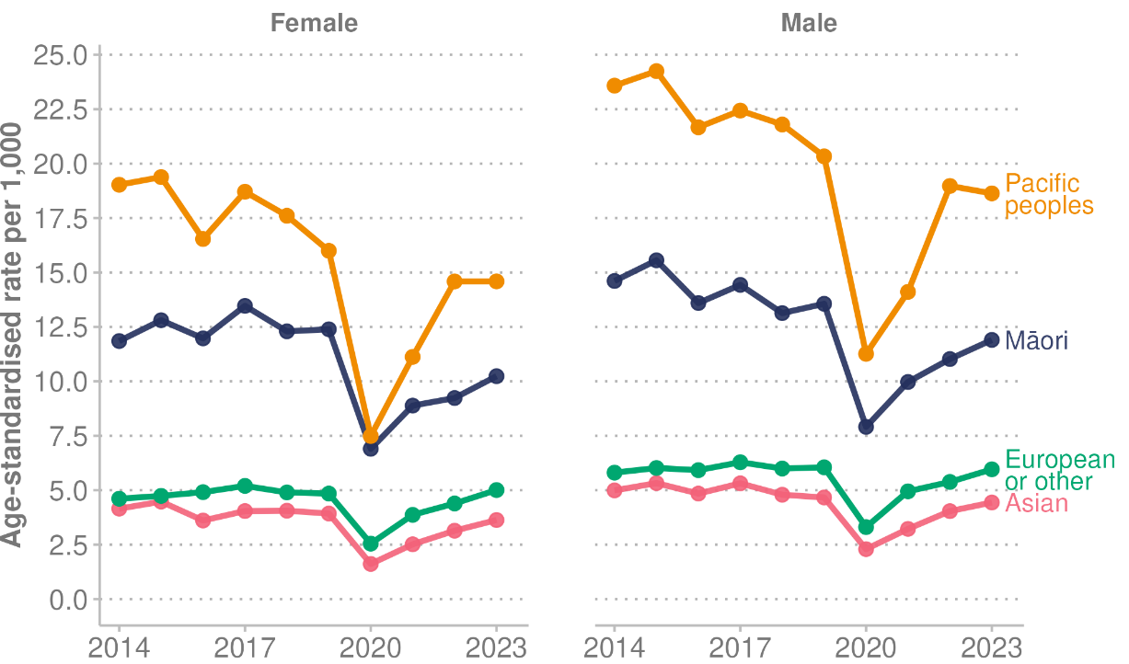

**Source:** Ministry of Health unpublished data (2024)

### Air and water quality

#### Air quality

The WHO air quality guidelines were exceeded at most Aotearoa New Zealand stations monitoring nitrogen dioxide (NO2) and fine particulate matter less than 2.5 micrometres in diameter (PM2.5) in 2020 (Environmental Health Intelligence New Zealand 2024).

Emerging evidence shows that exposure to two human-made air pollutants is associated with significant health impacts. The indicator [*Human health impacts of PM2.5 and NO2*](https://www.stats.govt.nz/indicators/human-health-impacts-of-pm2-5-and-no2/) reports on the health impacts associated with exposure to PM2.5 (mainly from combustion) and NO2 (mainly from vehicle emissions), the two human-made air pollutants now known to be of greatest concern in Aotearoa New Zealand.

In 2016, NO2 and PM2.5 were linked to an estimated 13,155 hospitalisations and an estimated 3,317 premature deaths in Aotearoa New Zealand. Of the estimated hospitalisations (all ages) attributed to exposure to human-made air pollution in 2016, it is estimated:

* 71% (9,376 cases) were associated with motor vehicle emissions (mainly NO2 with some PM2.5)
* 26% (3,375 cases) were associated with PM2.5 emissions from domestic fires.

Of the estimated premature deaths (age 30+ years) attributed to exposure to human-made air pollution in 2016, it is estimated:

* 68% (2,247 cases) were associated with motor vehicle emissions (mainly NO2 with some PM2.5)
* 29% (962 cases) were associated with PM2.5 emissions from domestic fires.

From 2006 to 2016, estimated rates of premature deaths (per 100,000 people aged 30+ years) attributed to NO2 emissions increased by 12% and hospitalisations (per 100,000 people all ages) attributed to NO2 emissions increased by 23%. In contrast, the estimated rates of premature deaths (per 100,000 people aged 30+years) and hospitalisations (per 100,000 people all ages) from PM2.5 exposure both decreased by 21%, most likely due to improvements made in domestic fire emissions (Stats NZ 2023b).

#### Water quality

This section covers water quality compliance for drinking water supplies, and water quality at recreational bathing sites (beaches, rivers, and lakes).

##### Drinking water

The Ministry of Health’s *Annual Report on Drinking-water Quality* summarises drinking-water compliance for 485 registered networked drinking-water supplies that serve populations of more than 100 people, collectively supplying water to 4,202,000 people. To fully comply with the *Drinking-water Standards for New Zealand 2005 (revised 2018)* (the Standards), a supply must comply with all the bacteriological, protozoal, and chemical requirements, including by following the prescribed sampling and monitoring schedule.

In the 2020/21 reporting period, 78% of the report population received drinking-water that complied with all the Standards. This was a decrease of 0.6 percentage points compared with the previous reporting period. People living in rural areas and small communities were less likely to have drinking-water that met safety standards (Ministry of Health 2022a).

Figure 35 shows the proportion of the report population that received drinking-water that complied with all Standards over the last 10 reporting periods. Overall, compliance with the Standards dropped in the current reporting period for the first time since the introduction of the revised Standards in 2018.

Figure : Proportion of report population receiving drinking-water that complied with all Drinking-water Standards for New Zealand, 2011/12–2020/21

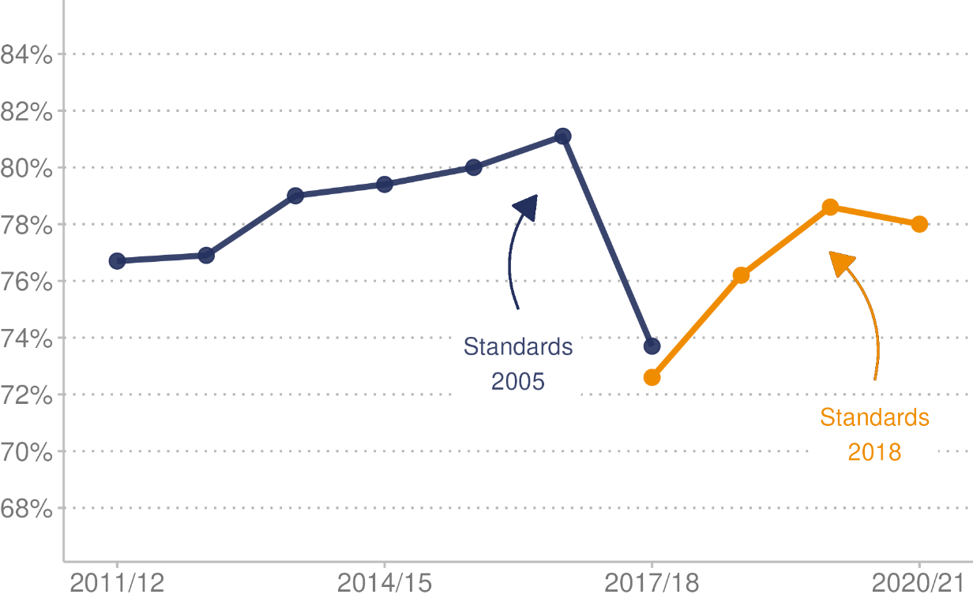

Note: Blue line = years measured against the 2006 Standards. Orange line = years measured against the 2018 Standards.

**Source:** Stats NZ (2024h)

##### Recreational bathing sites

In the 2021/22 bathing season, 63.4% of all 536 tested sites were unsafe to swim at least once. Of these, 166 beaches (57.2% of those surveyed that season) were unsafe to swim at on at least one occasion, as were 159 (84.6%) rivers and 15 (25.9%) lakes (Environmental Health Intelligence New Zealand 2023).

### Climate change

Most years since 2010 had more hot and fewer cold days compared with the baseline (Climate Normal Period 1981–2010) (Ministry for the Environment and Stats NZ 2020). Extreme rainfall affected the same regions in 2022 as Cyclone Gabrielle did in 2023 (Environmental Health Intelligence New Zealand 2024). According to the Ministry for the Environment and Stats NZ, greenhouse gas emissions from human activities are changing Aotearoa New Zealand’s climate, impacting the environment, communities and the economy (Stats NZ 2023c).

The financial costs of extreme weather events are increasing. Extreme weather is defined as a severe weather event such as a snowstorm, rain, drought, flood or storm that is rare for the place where it occurs. Figure 36 shows the cost to the insurance industry in paying claims resulting from severe weather events, which totalled $351.3 million in 2022. As this data is to year end 2022, it does not include the cost of Cyclone Hale in January 2023 or Cyclone Gabrielle in February 2023. Further, this data represents only the private insurance costs – the total costs of events will be much larger (Stats NZ 2024c).

Figure : Insurance-related costs ($ million) of severe weather events, 1993–2022

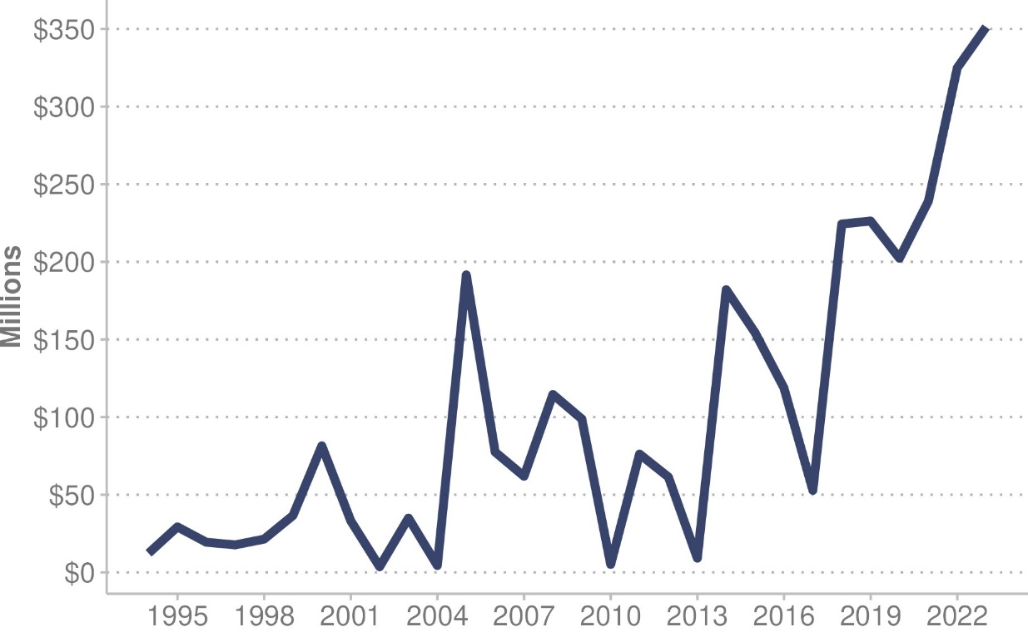

**Source:** Stats NZ (2024h)

#### Adverse weather events

In late January and mid-February 2023, tropical cyclones Hale and Gabrielle had a major impact on Aotearoa New Zealand. The adverse weather and resulting flooding caused significant damage and disruption (Stats NZ 2023a). Eleven people died as a result of Cyclone Gabrielle. The cyclone also caused significant damage to homes, infrastructure and livelihoods across northern and eastern regions of the North Island. Except for the Canterbury earthquakes, it is likely to be Aotearoa New Zealand’s costliest natural disaster: economic losses are expected to exceed those of the 2016 Kaikōura earthquake, which amounted to $2 billion to $4 billion (Ministry of Foreign Affairs and Trade 2023).

## Individual risk factors

The Global Burden of Disease study examines how risk factors contribute to health loss in a population. Data from the 2021 study indicates that over a third (35.4%) of all health loss was due to individual risk factors. The leading risk factors for health loss (DALYs) include high body mass index (BMI), tobacco use, high fasting plasma glucose (high blood sugar), high blood pressure and dietary risks (Institute for Health Metrics and Evaluation 2024b). Each of these risk factors accounted for between 5% and 8% of health loss, but it is not possible to add these measures together because risk factors interact with each other in various ways.

Figure 37 provides more detail on the leading risk factors and their contribution to health loss in Aotearoa New Zealand. It is also important to consider how the wider determinants of health contribute to these risk factors. The social, economic, and physical environments in which people are born, grow up, live, learn, work and age have a substantial impact on individual risk factors.

Figure : Proportion of disability-adjusted life years (DALYs) from leading risk factors, Aotearoa New Zealand, 2021

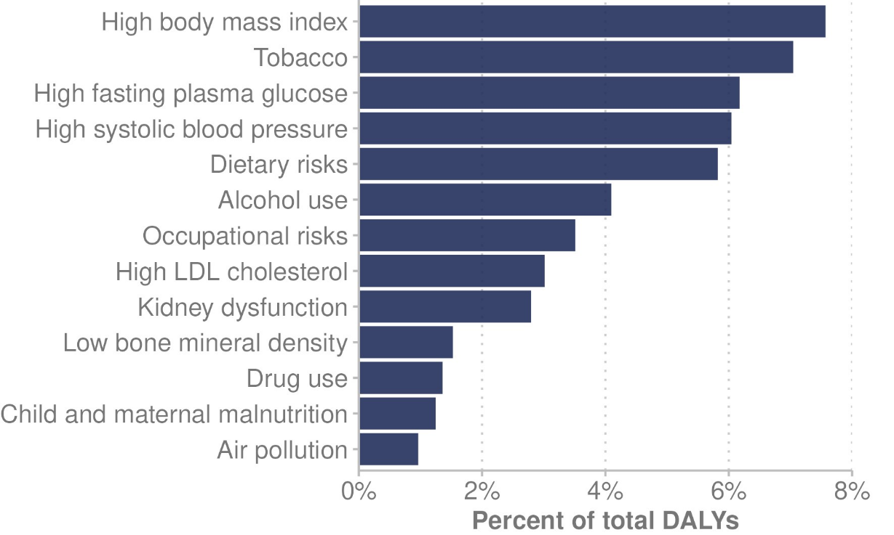

**Source:** Institute for Health Metrics and Evaluation (2024b)

### Physical activity

The Ministry of Health recommends that adults aged 18+ years do at least 30 minutes of moderate-intensity physical activity on most if not all days of the week.

For the three-year pooled period ending 2022/23, according to the Health Survey, 50.3% of adults were physically active, down from 52.0% for the previous three-year pooled period ending 2021/22 (Ministry of Health 2023d). In the Health Survey, physically active is defined as doing at least 30 minutes of brisk walking or moderate-intensity physical activity (or equivalent vigorous activity) for at least 10 minutes at a time, at least five days a week.

The prevalence of being physically active (doing at least 2.5 hours of activity in the past week, spread out over the week) varies between population groups. For the three-year pooled period ending 2022/23:

* 46.9% of women were physically active, compared with 53.8% of men
* by ethnic group, 50.9% of Māori adults, 43.9% of Pacific adults, 43.1% of Asian adults and 52.3% of European/other adults were physically active
* 45.1% of adults living in the most deprived neighbourhoods were physically active, compared with 53.5% of adults living in the least deprived neighbourhoods
* 30.8% of disabled adults were physically active, compared with 52.3% of non-disabled adults.

### Body size

In the Health Survey for the single year ending 2022/23[20], one in three adults (32.6%) was classified as obese (defined as having a BMI of 30+, or equivalent for those aged 15–18 years). This proportion is similar to five years ago (32.4%) for the year ending 30 June 2017 (Ministry of Health 2023d).

The prevalence of obesity among adults differed by population group. For the year ending 2022/23:

* Pacific (67.3%) and Māori (47.7%) adults were more likely to be classified as obese than European/other (31.6%) and Asian (13.8%) adults
* a higher proportion of disabled adults (44.2%) were classified as obese than non-disabled adults (31.6%)
* adults living in the most deprived neighbourhoods (45.2%) were more likely to be classified as obese than those living in the least deprived neighbourhoods (28.4%).

In 2022/23, 13.5% of children aged 2–14 years were classified as obese for their age, using the International Obesity Taskforce’s child BMI cut-offs.

* The prevalence of obesity among children differed by ethnic group: 21.7% of Māori, 27.8% of Pacific, 7.9% of Asian and 8.6% of European/other children were obese.
* Disabled children (23.7%) were more likely to be obese than non-disabled children (13.2%).
* Children living in the most deprived neighbourhoods (26.4%) were much more likely to be obese than children living in the least deprived neighbourhoods (6.6%), after adjusting for age, gender and ethnic group.

### Diet and nutrition

In December 2020, the Ministry of Health updated the guidelines on the recommended number of servings of fruit and vegetables per day (Health NZ 2024e). Aotearoa New Zealand has also recently updated serving size advice by adopting the evidence-based Australian serve size.

Table 4 shows the reported percentages of adults eating the recommended amount of vegetables and fruit a day: five servings of vegetables or more (depending on age and gender) and two servings of fruit. This data is from the Health Survey for the single year ending 2022/23. Results are similar to the 2021/22 year.

Table : Proportion of adults consuming recommended daily amount of fruit and vegetables, by population group, (total response ethnicity), 2022/23

|  |  |  |
| --- | --- | --- |
| **Population group** | **Proportion of adults consuming recommended daily amount** | |
| **Fruit** | **Vegetables** |
| All adults | 44.9% | 11.0% |
| Māori | 42.4% | 8.5% |
| Pacific peoples | 41.3% | 6.2% |
| Asian | 34.1% | 4.3% |
| European/other | 47.7% | 13.1% |
| Disabled adults | 39.2% | 8.4% |
| Non-disabled adults | 45.4% | 11.3% |
| Living in least deprived areas | 49.5% | 15.9% |
| Living in most deprived areas | 39.1% | 5.4% |

**Source:** Ministry of Health (2023d)

### Alcohol

In 2022/23, 76.3% of adults drank alcohol in the past year, a decrease from 2021/22 (78.4%) (Ministry of Health 2023d).

* Although the legal age for purchasing alcohol in Aotearoa New Zealand is 18 years old, 50.9% of those aged 15–17 years drank alcohol in the past year. This still represents a drop from 59.9% in this age group in 2011/12.
* Disabled adults (60.5%) were less likely to have drunk alcohol in the past year than non-disabled adults (78.0%).

#### Hazardous drinking

In the Health Survey, hazardous drinking (by those aged 15 or more years) is measured using the WHO’s Alcohol Use Disorders Identification Test (AUDIT). The AUDIT is a 10-item questionnaire that covers three aspects of alcohol use: alcohol consumption, dependence, and adverse consequences.

Hazardous drinkers are those who obtain an AUDIT score of 8 or more. These scores represent an established pattern of drinking that carries a high risk of future damage to physical or mental health.

For the three-year pooled period ending 2022/23:

* the highest prevalence of hazardous drinking was among those aged 15–24 years (23.1%) and 25–34 years (22.6%)
* the rate of hazardous drinking in adults decreased in the three-year pooled period ending 2022/23 to 18.2%, down from 20.0% for the three-year pooled period ending 2021/22
* the prevalence of hazardous drinking was 24.6% among men and 11.9% among women
* Asian adults (5.6%) had the lowest rate of hazardous drinking compared with other ethnic groups: Māori (30.5%), Pacific peoples (23.2%) and European/other (19.3%)
* people living in the most deprived neighbourhoods (20.2%) were more likely to be hazardous drinkers in the past year than those living in the least deprived neighbourhoods (16.5%) (Ministry of Health 2023d).

### Smoking and vaping

Smoking rates in Aotearoa New Zealand continue to decrease. According to the Health Survey (Ministry of Health 2023d), in the three-year pooled period ending 2022/23:

* 8.2% of adults were daily smokers (defined as current smokers who smoke every day), down from 9.9% in the previous three-year pooled period and down from 16.0% in the three-year pooled period ending 2013/14
* 12.8% of disabled adults were daily smokers (down from 15.6% in the previous three-year pooled period), compared with 7.8% of non-disabled adults (down from 9.4%).

Daily smoking declined over time for all ethnic groups (total response ethnicity) between the three-year pooled periods ending 2013/14 and 2022/23. Daily smokers in 2022/23 included:

* 20.2% of Māori, down from 37.3% in 2013/14
* 13.5% of Pacific peoples, down from 22.5%
* 3.3% of Asian people, down from 7.8%
* 7.4% of European/other people, down from 14.0%.

#### Youth smoking

The Action for Smokefree 2025 (ASH) Year 10 Snapshot surveys Year 10 students (aged 14–15 years) in Aotearoa New Zealand every year on smoking and vaping. The ASH Year 10 Survey (Action for Smokefree 2025 2024) in 2023 produced the following findings.

* Daily smoking rates remain low at 1.2%, down from 15.2% when the ASH Year 10 Survey began in 2000.
* Regular[21] smoking prevalence has decreased substantially for all ethnicities since 1999. However, differences between ethnic groups remain. Regular smoking was highest for Māori students at 6.2%, followed by Pacific (3.7%), European/Pākehā (2.0%), and Asian (1.0%) students.
* The proportion of those who have never smoked continues to increase by a statistically significant amount. It rose from 85.8% in 2022 to 87.8% in 2023, which is the highest ‘never smoking’ prevalence in the history of the survey.
* Among Māori students, the increase in ‘never smoking’ was statistically significant (rising from 73.8% to 77.7%). The increase is particularly clear for Māori girls (rising from 71.0% to 76.8%).

#### Vaping (e-cigarette use)

According to the 2022/23 Health Survey (Ministry of Health 2023d), the number of people vaping (using e-cigarettes) has increased. In the three-year pooled period ending 2022/23:

* 10.2% of adults used electronic cigarettes or a vaping device at least once a month, up from 3.9% for the three-year pooled period ending 2017/18
* 8.1% of adults used electronic cigarettes or a vaping device daily, up from 2.6% for the three-year pooled period ending 2017/18.

By age group, for the three-year pooled period ending 2022/23, adults aged 15–24 years had:

* the highest use of electronic cigarettes or a vaping device at least once per month (23.1%)
* the highest use of electronic cigarettes or a vaping device daily (17.8%).

The 2023 ASH Year 10 Snapshot survey (Action for Smokefree 2025 2024) found that regular vaping:

* among year 10 students in Aotearoa New Zealand significantly decreased for the second consecutive year (from 18.2% in 2022 to 16.4% in 2023)
* among year 10 students who have never smoked significantly decreased (from 10.3% to 9.5%).

## Health care

Following the 2022 health system reforms, Health New Zealand has been leading the day-to-day running of the health system across Aotearoa New Zealand, involving functions delivered at local, district, regional and national levels. It weaves the functions of the 20 former district health boards into its regional divisions and district offices, ensuring continuity of services in the health system. Health New Zealand manages all health services, including hospital and specialist services, and primary and community care.

### Access

Timely and equitable access to health care is critical to achieving equitable health outcomes. Achieving equity includes ensuring Māori and other population groups have access to services in proportion to their health needs, receive equitable levels of service and achieve equitable health outcomes (Pae Ora (Healthy Futures) Act 2022).

### Primary and community health care services

Primary and community health care includes a wide range of services delivered outside of a hospital setting. These include services from general practitioners, pharmacists, midwives, Māori and Pacific providers, allied health professionals, dentists and dental therapists, aged care and home care workers, disability support service providers, nurse practitioners, community and practice nurses, the non-clinical workforce, district nurses, community mental health and addiction services, public health nurses, non-governmental organisations and, in some cases, rural hospitals (Ministry of Health 2024g).

#### Barriers to accessing primary health care

The Health Survey is a source of national data on people’s perceptions of their access to and unmet need for primary health care. Unmet need for primary health care describes situations where people were unable to access primary health care for reasons such as not being able to get an appointment, cost, and lack of transport or childcare (Ministry of Health 2023d). In the year 2022/23, time taken to get an appointment and cost were the most frequent barriers to visiting a GP that adults experienced (Table 5).

* 21.2% of adults reported the time taken to get an appointment was too long. This had increased from 11.6% in the previous year.
* One in eight adults (12.9%) reported not seeing a GP due to cost in the 12 months before taking part in the 2022/23 survey. This is higher than the previous two years, but lower than other years since 2011/12.
* In 2022/23, experiencing cost as a barrier to visiting a GP was more common among women (15.1%) than men (10.5%).
* Adults living in the most deprived neighbourhoods were 1.4 times more likely than those living in the least deprived neighbourhoods to have not visited a GP due to cost in the past year, after adjusting for age, gender and ethnic group.
* One in five (21.4%) disabled adults reported not visiting a GP due to cost, compared with 12.0% of non-disabled adults.

Table : Proportion of adults reporting unmet need for primary health care (in the past 12 months) and reason for that unmet need, by population group (total response ethnicity), three-year pooled period ending 2022/23

|  |  |  |  |  |
| --- | --- | --- | --- | --- |
| **Population group (adults)** | **Unmet need for GP due to time taken to get an appointment** | **Unmet need for GP due to cost** | **Unfilled prescription due to cost** | **Unmet need for GP due to work** |
| All adults | 21.2% | 12.9% | 4.0% | 7.4% |
| Māori adults | 23.8% | 16.9% | 7.6% | 8.9% |
| Pacific adults | 22.4% | 17.6% | 8.5% | 10.1% |
| Asian adults | 19.5% | 10.4% | 2.6% | 5.6% |
| European/other | 20.9% | 12.4% | 3.3% | 7.5% |
| Disabled adults | 24.3% | 21.4% | 8.3% | 6.8% |
| Non-disabled adults | 20.9% | 12.0% | 3.5% | 7.5% |
| Least deprived areas | 20.0% | 11.1% | 1.8% | 6.7% |
| Most deprived areas | 23.0% | 17.1% | 6.0% | 7.3% |

**Source:** Ministry of Health (2023d)

#### PHO enrolment

Enrolment in a primary health organisation (PHO) is voluntary. Most New Zealanders are enrolled through their general practice and gain the benefits associated with belonging to a PHO, which can include cheaper doctors’ visits and reduced costs of prescription medicines (Health NZ 2024f).

In April 2024, an estimated 94.4% (5,003,057 people) of the Aotearoa New Zealand population were enrolled with a PHO through a general practice (Health NZ 2024f). It is estimated that those enrolled with a PHO include:

* 83.9% of Māori, 98.3% of Pacific peoples and 96.4% of European/other
* 102%[22] of people living in the least deprived neighbourhoods, compared with 86.5% of people living in the most deprived neighbourhoods.

#### Population not enrolled

To work out rates of the population enrolled with a PHO, Health New Zealand uses 2022/23 administrative data to match health service user information with general practice enrolment data. From that information, it can estimate how many health users in Aotearoa New Zealand are not enrolled with a PHO.

From this analysis, an estimated 3.0% of health service users were not enrolled with a PHO in the year 2023 (Ministry of Health unpublished data 2024). This is down from 6.2% in 2022. The 2022/23 analysis excluded 33,088 unenrolled health users who only used COVID-19 testing and vaccination services.

* By ethnic group, the proportions of people not enrolled with a PHO were: Māori 3.6%, Pacific peoples 4.9%, Asian 3.9% and European/other 2.3%.
* The age groups least likely to be enrolled with a PHO were 25–29 years (5.8%) and 20–24 years (5.1%).
* A higher proportion of people living in the most deprived neighbourhoods (3.7%) was not enrolled with a PHO, compared with people living in the least deprived neighbourhoods (2.0%).

### Immunisation

Aotearoa New Zealand immunisation programmes aim to protect individuals against disease and also prevent the onward spread of disease within the population as a whole (Health NZ 2024q). The National Immunisation Schedule lists the vaccines that are offered free to babies, children, adolescents and adults. It also lists the ages at which each vaccine should be given.

#### Childhood immunisations

Immunisation coverage for childhood immunisation is measured at milestone ages using the National Immunisation Register database and the Aotearoa Immunisation Register database. The milestone ages measured are 6 months, 8 months, 12 months (one year), 18 months, 24 months (2 years), 54 months (4.5 years) and 5 years of age. Immunisation coverage is measured to identify groups at risk of vaccine-preventable diseases and to evaluate the effectiveness of programmes designed to increase coverage (Health NZ 2024h).

The health target for childhood immunisation coverage in Aotearoa New Zealand is that 95% of children are fully immunised at 24 months of age. For the three-month reporting period ending 31 December 2023, 81.0% of children at 24 months of age were fully immunised.

Figure 38 presents the percentage of children immunised at milestone ages of 8 months, 24 months and 5 years for the three-month reporting period ending December 2023. It shows a persistent equity gap for Māori children at each milestone age.

Figure : Percentage of children immunised at milestone ages, by ethnic group (prioritised ethnicity), for the three months ending December 2023

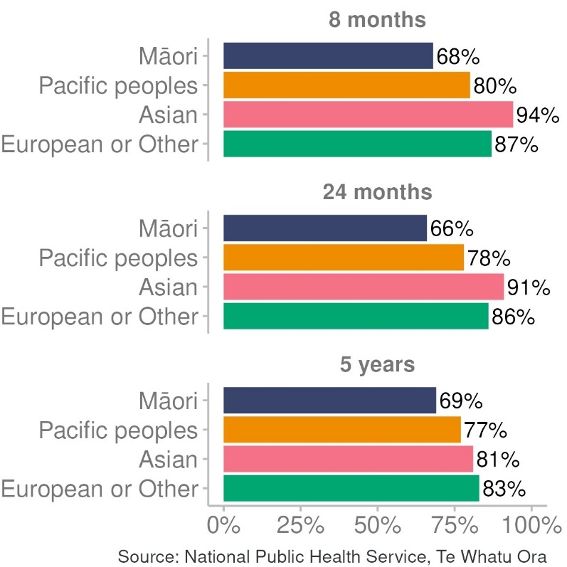

**Source:** Health NZ (2024h)

Figure 39 displays childhood immunisation coverage rates at milestone ages of 8 months, 24 months and 5 years, from 2014 to 2023. Childhood immunisation coverage rates have reduced over time for all ethnic groups at these milestone ages, particularly for Māori, Pacific and Asian children.

Figure : Childhood immunisation coverage at milestone ages, by ethnic group (prioritised ethnicity), 2014–2023

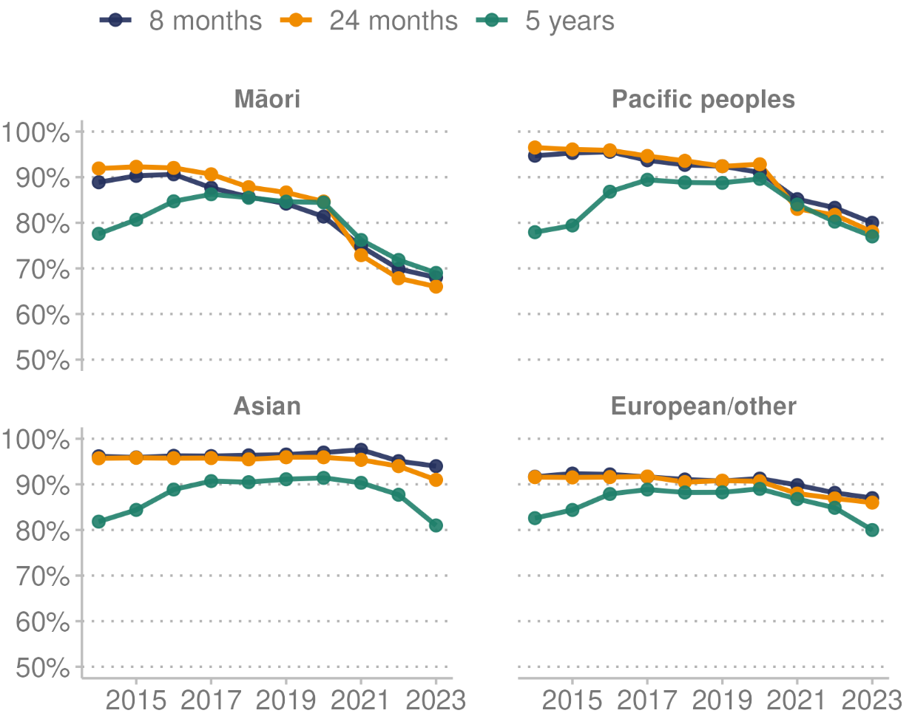

**Source:** Health NZ (2024h)

#### Influenza immunisation

The influenza immunisation programme is recommended and free for people who are pregnant, individuals aged 65 years and over, and those with eligible conditions (Health NZ 2024i). Annual influenza immunisation is recommended to provide protection from the main influenza strains that are circulating (Immunisation Advisory Centre 2024).

In 2023, among people aged 65 years and over, the influenza vaccination rates by prioritised ethnic group were: 55.0% for Māori, down from 61.0% in 2022; 54.4% for Pacific peoples, down from 59.4% in 2022; 53.4% for Asian people, down from 55.7% in 2022; and 64.7% for European/other people, down from 68.4% in 2022 (Health NZ unpublished data 2024).

In 2023, among people aged 55–64 years, 30.1% of Māori received the influenza vaccination, down from 34.8% in the year before, and 34.3% of Pacific peoples received the vaccination, down from 37.9%.

#### Human papillomavirus (HPV) immunisation

HPV immunisation began in Aotearoa New Zealand in 2008. From 1 January 2017, HPV immunisation became free for everyone aged 9 to 26 years, including non-residents under the age of 18 years. As at 31 December 2023, the coverage (final dose) for those born in 2010 by prioritised ethnic group was: 46.9% for Māori, up from 44.7% in 2022; 51.4% for Pacific peoples, up from 47.7%; 67.4% for Asian peoples, up from 66.3%; and 60.8% for European/other people, up from 57.2% (Health NZ 2024g).

#### COVID-19 immunisation

COVID-19 vaccines are free for eligible people aged five years and over. They are also available for children aged six months to four years who are at greater risk of severe illness if they were to get COVID-19. The primary course of vaccination is two doses, plus a third primary dose is available to people who meet eligibility criteria. The COVID-19 booster is additional doses given after the primary course to keep immunity levels high (Health NZ (nd)).

The tables below display the COVID-19 vaccination status of New Zealanders at 31 December 2023: Table 6 by ethnic group and Table 7 by age group. The data shows Māori (24.4%) and Pacific peoples (22.8%) are more likely to be unvaccinated for COVID-19, compared with Asian (16.8%) and European/other (11.3%) people.

European/other (61.1%) and Asian (54.4%) populations are more likely to have received at least one additional booster dose, compared with Māori (34.1%) and Pacific peoples (39.1%). The rate of COVID-19 vaccination increases with age, with 87.9% of people 65 years and over having received at least one additional booster dose.

Table : COVID-19 vaccination status, by ethnic group (prioritised ethnicity), 2023

|  |  |  |  |  |
| --- | --- | --- | --- | --- |
| **Ethnic group** | **Unvaccinated** | **Partially vaccinated** | **Fully vaccinated** | **Boosted** |
| Māori | 24.4% | 75.6% | 70.3% | 34.1% |
| Pacific peoples | 22.8% | 77.2% | 72.6% | 39.1% |
| Asian | 16.8% | 83.2% | 80.3% | 54.4% |
| European/other | 11.3% | 88.7% | 86.2% | 61.1% |

**Source:** Health NZ unpublished data (2024)

Table : COVID-19 vaccination status, by age group, 2023

|  |  |  |  |  |
| --- | --- | --- | --- | --- |
| **Age group  (years)** | **Unvaccinated** | **Partially vaccinated** | **Fully vaccinated** | **Boosted** |
| 65+ | 5.0% | 95.0% | 94.6% | 87.9% |
| 50 to 64 | 2.9% | 97.1% | 96.4% | 79.4% |
| 35 to 49 | 7.7% | 92.3% | 91.1% | 63.7% |
| 18 to 34 | 18.6% | 81.4% | 80.0% | 42.6% |
| 12 to 17 | 28.6% | 71.4% | 62.7% | 1.9% |
| 5 to 11 | 56.0% | 44.0% | 25.4% | 2.6% |

Note: Unvaccinated = individuals that have not received any doses of a COVID-19 vaccine. Partially vaccinated = individuals that have received one or more doses of a COVID-19 vaccine. Fully vaccinated = individuals that have received two or more doses of a COVID-19 vaccine. Boosted = individuals that have received three or more doses of a COVID-19 vaccine.

**Source:** Health NZ unpublished data (2024)

### Experience of care

Priority one of the New Zealand Health Strategy is to give people, whānau and communities greater control and influence over decisions about their health and the design of their health services. It aims to do this by embedding their voices in system planning, and in delivery of and reporting on health care. Achieving this priority is key to changing the system, and essential for people to have control and agency over their own health and that of their family (Minister of Health 2023a).

Patient-reported measures provide insights directly from patients about their health care experiences. The Health Quality & Safety Commission carries out a series of patient experience surveys for inpatient and primary care services. Results are used to help improve quality of care, patient safety and access to health services. Information gathered at local regional and national levels is used to benchmark patient experiences across the country and improve services locally (HQSC 2023a).

#### Findings of hospital inpatient experience survey

For the period ending November 2023, among adults aged 15 years and over:

* 90.6% reported definitely being treated with care and respect by their health care team
* 18.6% were not as involved in decisions about their treatment and care as much as they wanted to be; the percentage was higher for Māori adults (24.2%)
* 21.7% reported family and whānau were not always included in discussions about the care they received
* on discharge, 72.5% had enough information to manage their condition after they left hospital (HQSC 2024a).

#### Findings of primary care survey

For the period ending November 2023, among adults aged 15 years and over:

* 24.4% reported a time in the last 12 months when they wanted health care from a GP or nurse but couldn’t get it; this percentage was higher for Māori adults (29.3%)
* 20.1% said long wait times to get an appointment meant they were unable to get care from a GP or nurse when they wanted it
* 92.5% said the reception/administration staff treated them with respect the last time they made an appointment with their health clinic
* 10.6% were not as involved in decisions about their treatment and care as much as they wanted to be
* 92.7% said their health care provider explained things in an understandable way (HQSC 2024b).

### Hospital specialist services

In Aotearoa New Zealand, public hospitals are set up to:

* provide high-quality acute care (defined as time-sensitive care that can result in death or long-term disability if not received in a timely manner)
* ensure that as many people as possible have access to planned care (elective/non-acute) services.

Hospitals currently provide a variety of [publicly funded health and disability services](https://www.healthnz.govt.nz/corporate-information/our-health-system/eligibility-for-publicly-funded-health-services/) such as medical, surgical, maternity, diagnostic and emergency services. The way they provide these services depends on the type of care that a patient needs. Patients may be:

* inpatients, who are admitted to hospital and stay overnight in hospital
* day case patients, who are admitted to hospital and discharged later the same day
* outpatients, who attend clinics to receive specialist services without being admitted to hospital.

#### Emergency or unplanned care

Emergency departments (EDs) treat people who have a serious illness or injury that requires urgent attention. People may be referred to an ED by their doctor/general practitioner or the ambulance service, or they can self-refer. On arrival at an ED, patients are triaged to assess the illness or injury, with the aim of determining how urgent it is and how soon treatment is required. Patients are seen in order of the seriousness of their condition, with the sickest and most urgent patients seen first.

In 2023, 829,642 individuals visited EDs in Aotearoa New Zealand (Ministry of Health unpublished data 2024). They made a total of 1,315,218 visits. With the exception of 2020, which was at the start of the pandemic, the number of individuals visiting EDs has steadily increased over time. In 2014, around 700,000 individuals visited EDs.

Of the 1,315,218 visits to an ED in 2023, 5.3% (69,078 visits) ended with the person leaving before receiving care. The percentage of people leaving without receiving care has increased over time: 1.8% were in this category in 2014.

The health target for EDs is for 95% of patients to be admitted to, or discharged or transferred from an ED within six hours. Among those visiting an ED who received care:

* 873,296 (70.1%) of patients were admitted, discharged or transferred within six hours in 2023
* the percentage of people waiting more than six hours has increased over time, from 7.9% in 2014 to 29.9% in 2023.

In 2023, by prioritised ethnic group, Māori made 296,114 visits to EDs (22.5% of all ED visits), Pacific peoples made 114,447 visits (8.7% of all visits), and non-Māori, non-Pacific made 772,952 visits (68.7%). These proportions visiting EDs by ethnic group were similar in the previous year.

#### Ambulatory sensitive hospitalisations

Ambulatory sensitive hospitalisations (ASH) are a group of mostly acute admissions that could potentially have been avoided through preventative or therapeutic intervention in a primary care setting. Factors that can improve ASH rates include high-quality primary care services, high-quality population health care, and seamless interfaces between population health, primary/community care and secondary/hospital care (Ministry of Health 2023c).

ASH measurement data includes two age groups: 0–4 years and 45–64 years (broken down into five-year age groups). Figure 40 shows the rate of ASH admissions by age group and ethnic group for the period December 2019 to December 2023. For all age groups, the rate was highest for Pacific peoples. The rate of ASH admissions reduced through 2020, which may have been influenced, at least in part, by preventative measures (hand hygiene, physical distancing, mask wearing) implemented in the response to COVID-19. The rates for both age groups of 0–4 years and 45–64 years have risen through 2021 to 2023.

Figure : Rate of ambulatory sensitive hospitalisations (ASH), by age group and ethnic group (prioritised ethnicity), 2019–2023

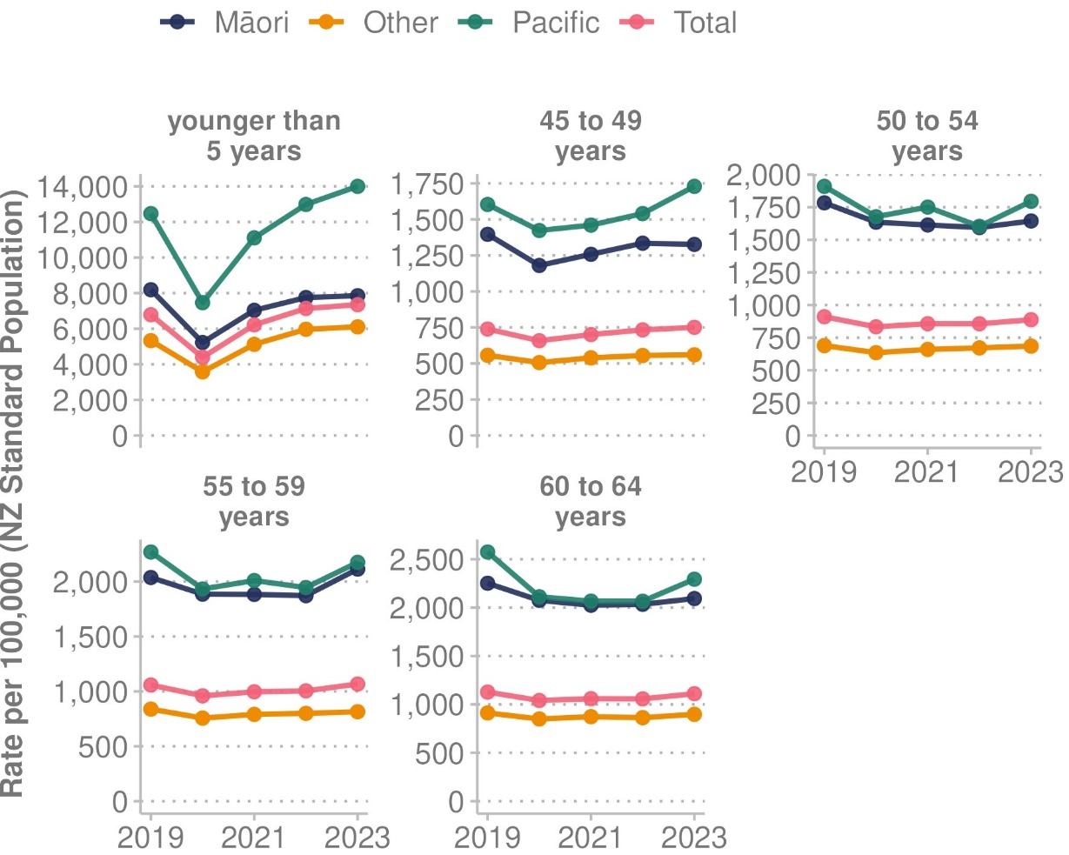

**Source:** Ministry of Health (2024a)

The top five reasons for ASH admissions in the age group 0–4 years for the 12 months ended December 2023 were:

1. asthma, with 5,404 admissions
2. upper, and ear, nose and throat (ENT) respiratory infections, with 4,790 admissions
3. gastroenteritis/dehydration, with 3,719 admissions
4. dental conditions, with 2,514 admissions
5. lower respiratory infections, with 1,463 admissions.

The top five reasons for ASH admissions in the age group 45–64 years for the 12 months ended December 2023 were:

1. angina and chest pain, with 12,928 admissions
2. cellulitis, with 4,543 admissions
3. myocardial infraction (heart attack), with 3,758 admissions
4. gastroenteritis/dehydration, with 3,710 admissions
5. pneumonia, with 3,204 admissions.

#### Planned care

Planned care involves medical and surgical care (traditionally known as elective or arranged services) that is delivered in hospitals for people who do not need to be treated right away (Health NZ 2024n).

On a person’s planned care journey, the usual steps are that:

* a general practitioner or primary care service refers them for a specialist assessment
* they receive a first specialist assessment (FSA) and diagnostic tests
* they receive treatment
* they receive specialist follow-up and/or return to the care of their general practice.

The following health targets are being implemented in 2024 for planned care.

* For **first specialist assessment:** that 95% of patients wait less than four months for an FSA.
* For **treatment:** that 95% of patients wait less than four months for elective treatment after the FSA.

At the end of December 2023:

* 36.5% of patients had waited longer than four months for their FSA.
* Of the patients who had been given a commitment to treatment, 39.7% had waited longer than four months for that treatment.

Figure 41 shows the proportion of patients who waited longer than four months for specialist assessment or treatment between January 2020 to January 2024. Wait times for specialist assessment have generally increased during this time. Wait times for treatment show a pattern of increase to January 2023 before stabilising somewhat, then increasing again at the end of 2023.

Figure : Proportion of people who waited longer than four months for assessment, or planned treatment, January 2020 – January 2024

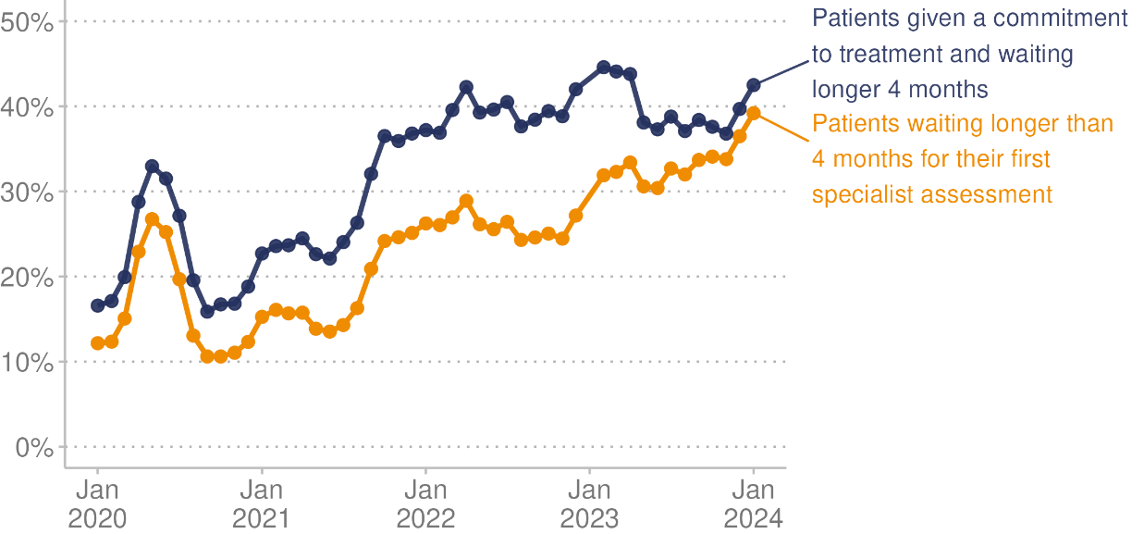

**Source:** Ministry of Health (2024b)

# Technical notes - Ngā puna raraunga

This report contains data from a range of sources, some of them outside the Ministry of Health - Manatū Hauora. This data is accessible through hyperlinks to sources, where available, or in the accompanying Excel file. The Health and Independence Report aims to include only data from sources with robust data collection and analytical processes. If the methodology of a source affects the interpretation of the data, we alert readers to this with a note. We encourage readers to refer to the original data source for further details.

Alongside this report, we have published data appendices containing otherwise unpublished health data that informed this report. All data presented here is the latest available at the time of developing this report from January to May 2024. The time lag between the most recent data and the present day can be substantial. For example, it can involve up to a three-year delay for mortality data. In such cases, the report may use provisional data.

COVID-19 data was extracted on 22 May 2024. Case, hospitalisation and death figures are subject to change due to the addition of historical cases, updated data sources, methodology changes and updates to population denominators. As a result, the figures included in this report may differ from those previously published. COVID-19 deaths are defined as people who died where the cause of death was attributable to COVID-19 (that is, COVID-19 was coded as an underlying or contributory cause). More recent trends should be interpreted with caution to account for delays in death coding.

The Ministry reports COVID-19 hospitalisations using two data sets:

1. the Inpatient Admission (IP) data set
2. the National Minimum Dataset (NMDS).

The NMDS provides more accurate and comprehensive data that covers the whole country, but this data is only available after a significant time lag, usually around 60 days. Over time, the hospitalisation data may change, as updated NMDS data becomes available.

The Health Survey provides data on a variety of topics. This report does not cover all of them.

Within the Health measures – Ngā inenga hauora section, population health measures are produced using data from the Health Survey. Most Health Survey data is presented as a three-year rolling average. This means that each statistic is averaged across three consecutive years of survey data from three Health Survey cycles. For example, data representing the three-year pooled period ending 2022/23 contains data from the survey years 2020/21, 2021/22 and 2022/23 (data collected from mid-2020 to mid-2023).

Due to this pooling methodology, Health Survey numbers in this report will be different to numbers published elsewhere. For Health Survey data that is not collected every year, data is presented by survey year rather than three-year pooled periods and marked accordingly. For a complete description of the impact of using pooled years, see the ‘Technical notes’ section of the [Health and Independence Report 2022](https://www.health.govt.nz/publication/health-and-independence-report-2022).

Ethnic group comparisons are based on either prioritised ethnicity or total response ethnicity. With prioritised ethnicity, ethnic groups are mutually exclusive. That is, a person can appear in only one ethnic group. If they identify with more than one group, the group chosen for analysis is generally prioritised in the following order: Māori, Pacific peoples, Asian, other. With total response ethnicity, a person is classified in all of the ethnic groups they identify with. This means that a person can appear in more than one ethnic group. Prioritised ethnicity is often used for analysis based on administrative data (data collected for purposes other than statistics), such as mortality data, while total response ethnicity is shown for Health Survey data.

Selected results are presented by neighbourhood deprivation, as measured by the New Zealand Index of Deprivation (NZDep2018). This area-based measure of socioeconomic deprivation combines the following 2018 Census data: household income, receiving a benefit, household crowding, home ownership, employment status, qualifications, support (sole-parent families), living condition (dampness or mould) and household access to the internet. In this report, ‘quintile 5’ means the 20% of small areas in Aotearoa New Zealand that are most socioeconomically deprived. Conversely, ‘quintile 1’ means the 20% of small areas that are least deprived.

The report contains population data from Stats NZ population estimates and projections, as well as the Health Service User (HSU) population. These data sources have some important differences. Stats NZ population estimates are estimates of the resident population based on the census and information on births, deaths and migration, and exclude short-term visitors to Aotearoa New Zealand. The HSU measures people who received health services in Aotearoa New Zealand in a given year, including short-term visitors. The HSU does not include people living in Aotearoa New Zealand if they have not interacted with the health system and were not enrolled with a GP during the year. As a result of uptake of the COVID-19 vaccination programme starting in 2021, many more people used health services in Aotearoa New Zealand in that year, including non-residents. At a population level, the HSU for 2021 is about 2% higher than Stats NZ’s population estimate for 2021 (Ministry of Health 2022b). Stats NZ data and Ministry of Health also differ in the way they record ethnicity, with the result that HSU totals by ethnic group differ from totals in Stats NZ population estimates and projections.

Health NZ and the Ministry of Health use the HSU as the denominator for COVID-19 vaccine uptake rates. In an independent review of the HSU data, Stats NZ found that it is an appropriate way to measure COVID-19 vaccine coverage (Stats NZ 2022b). The Ministry of Health response to the Stats NZ recommendations is available on its website (Ministry of Health 2022c). The main rationale for using the HSU as a population denominator for health statistics, rather than data from Stats NZ, is to combat numerator-denominator bias. This happens when the demographics about a person in the numerator are different from those in the denominator. For example, numerator-denominator bias would occur by calculating vaccination coverage for Māori with COVID-19 vaccination data as the numerator and Stats NZ population estimates as the denominator. Bias occurs because the ethnic groups with which someone identifies can differ between health data sources – in this case, between the COVID-19 Immunisation Register and Stats NZ population estimates.

There are multiple methods for calculating life expectancy, which can lead to variations in estimates. Slight differences in population estimates, such as those derived from different census data or demographic models, can influence the results. As noted above, the way of handling ethnicity also varies: some calculations may use total response ethnicity, while others use prioritised ethnicity. These methodological differences mean that the life expectancy estimates in this report may differ from those reported elsewhere.

Where possible, this Health and Independence Report includes statistically significant differences between population groups and any relevant trends over time. In many comparisons, the results have been adjusted or standardised for factors that may influence (confound) the comparison, such as age and gender. This report often uses age standardisation to account for differences in age structure between population groups and over time (Ministry of Health 2023f).

# References - Ngā tohutoro

Accident Compensation Corporation. 2023. ACC Annual Report 2023. Wellington: Accident Compensation Corporation.

Action for Smokefree 2025. 2024. *ASH Year 10 Snapshot Survey*. URL: ash.org.nz/ash_year_10 (accessed 24 May 2024).

Allen + Clarke. 2021. Evaluation of the Mobility Action Programme (MAP): Cycle 2 Final Report. Wellington: Ministry of Health.

beehive.govt.nz. 2023. *All COVID-19 requirements removed*. URL: beehive.govt.nz/release/all-covid-19-requirements-removed (accessed 24 May 2024).

Environmental Health Intelligence New Zealand. 2023. *Faecal indictor bacteria at recreational bathing sites*. Wellington: Environmental Health Intelligence NZ, Massey University.

Environmental Health Intelligence New Zealand. 2024. *Aotearoa New Zealand's environmental health: 2023*. URL: ehinz.ac.nz/indicators/overview/key-findings (accessed 24 May 2024).

Environmental Health Intelligence New Zealand. (nd). *Socioeconomic deprivation profile*. URL: ehinz.ac.nz/indicators/population-vulnerability/socioeconomic-deprivation-profile (accessed 24 May 2024).

Foote J, Hepi M, Nicholas G. 2014. An evaluation of the reorientation of child and adolescent oral health service. Institute of Environmental Science and Research Limited.

GBD 2021 Demographics Collaborators. 2024. Global age-sex-specific mortality, life expectancy, and population estimates in 204 countries and territories and 811 subnational locations, 1950-2021, and the impact of the COVID-19 pandemic: a comprehensive demographic analysis for the Global Burden of Disease Study 2021. *The Lancet 403(10440):1989–2056*: .

Health NZ. 2023a. *Cancer web tool*. URL: tewhatuora.shinyapps.io/cancer-web-tool (accessed 23 May 2024).

Health NZ. 2023b. *Fetal and infant deaths web tool*. URL: tewhatuora.shinyapps.io/fetal-and-infant-deaths-web-tool (accessed 23 May 2024).

Health NZ. 2023c. *Mortality web tool*. URL: tewhatuora.shinyapps.io/mortality-web-tool (accessed 23 May 2024).

Health NZ. 2023d. *National Cervical Screening Programme Coverage Report*. URL: tewhatuora.shinyapps.io/nsu-ncsp-coverage (accessed 23 May 2024).

Health NZ. 2023e. *Report on Maternity web tool*. URL: tewhatuora.shinyapps.io/report-on-maternity-web-tool (accessed 26 March 2024).

Health NZ. 2023f. *Virtual Diabetes Register web tool*. URL: tewhatuora.shinyapps.io/virtual-diabetes-register-web-tool (accessed 23 May 2024).

Health NZ. 2024a. Aotearoa New Zealand Health Status Report 2023 Wellington: Health New Zealand.

Health NZ. 2024b. *BreastScreen Aotearoa Coverage Report*. URL: tewhatuora.shinyapps.io/nsu-bsa-coverage (accessed 21 May 2024).

Health NZ. 2024c. *Chronic kidney disease*. URL: info.health.nz/conditions-treatments/bladder-kidney-and-urinary-system/chronic-kidney-disease (accessed 23 May 2024).

Health NZ. 2024d. *Dental care*. URL: info.health.nz/keeping-healthy/teeth-and-gums/dental-care (accessed 24 May 2024).

Health NZ. 2024e. *Eating and activity guidelines*. URL: tewhatuora.govt.nz/health-services-and-programmes/nutrition/eating-and-activity-guidelines (accessed 24 May 2024).

Health NZ. 2024f. *Enrolment with a general practice and primary health organisation*. URL: tewhatuora.govt.nz/for-health-providers/primary-care-sector/primary-health-organisations/enrolment-with-a-general-practice-and-primary-health-organisation (accessed 5 June 2024).

Health NZ. 2024g. *HPV immunisation programme*. URL: tewhatuora.govt.nz/health-services-and-programmes/vaccine-information/hpv-immunisation-programme (accessed 27 May 2024).

Health NZ. 2024h. *Immunisation coverage*. URL: tewhatuora.govt.nz/health-services-and-programmes/vaccine-information/immunisation-coverage (accessed 27 May 2024).

Health NZ. 2024i. Immunisation Handbook. Wellington: Health New Zealand.

Health NZ. 2024j. *Measles (for heath professionals)*. URL: tewhatuora.govt.nz/for-health-professionals/clinical-guidance/diseases-and-conditions/measles (accessed 27 May 2024).

Health NZ. 2024k. *Measles (health information and services)*. URL: info.health.nz/conditions-treatments/infectious-diseases/measles (accessed 24 May 2024).

Health NZ. 2024l. *Meningococcal disease*. URL: info.health.nz/conditions-treatments/infectious-diseases/meningococcal-disease (accessed 24 May 2024).

Health NZ. 2024m. *Populations web tool*. URL: tewhatuora.shinyapps.io/populations-web-tool (accessed 23 May 2024).

Health NZ. 2024n. *Questions and answers – Planned care services*. URL: tewhatuora.govt.nz/health-services-and-programmes/planned-care-services/questions-and-answers-planned-care-services (accessed 27 May 2024).

Health NZ. 2024o. *Reducing rheumatic fever*. URL: tewhatuora.govt.nz/for-health-professionals/clinical-guidance/diseases-and-conditions/rheumatic-fever-guidance/reducing-rheumatic-fever (accessed 24 May 2024).

Health NZ. 2024p. *Suicide data web tool*. URL: tewhatuora.shinyapps.io/suicide-web-tool (accessed 23 May 2024).

Health NZ. 2024q. *Why immunise?* URL: tewhatuora.govt.nz/health-services-and-programmes/vaccine-information/about-immunisation-in-new-zealand/why-immunise (accessed 27 May 2024).

Health NZ. (nd). *COVID-19 vaccines*. URL: info.health.nz/conditions-treatments/infectious-diseases/covid-19/covid-19-vaccines (accessed 27 May 2024).

Howden-Chapman P, Fyfe C, Nathan K, et al. 2021. The effects of housing on health and well-being in Aotearoa New Zealand. *New Zealand Population Review* 47: 16-32.

HQSC. 2023a. *About our patient experience surveys*. URL: hqsc.govt.nz/our-data/patient-reported-measures/patient-experience/about-our-surveys (accessed 27 May 2024).

HQSC. 2023b. *Adverse events national quarterly dashboard*. URL: reports.hqsc.govt.nz/AdverseEventsQuarterly (accessed 24 May 2024).

HQSC. 2023c. *Healing, Learning and Improving from Harm: National Adverse Events Reporting Policy 2023 | Te whakaora, te ako me to whakapai ake i te kino*. URL: hqsc.govt.nz/our-work/system-safety/healing-learning-and-improving-from-harm-policy/national-adverse-events-reporting-policy (accessed 24 May 2024).

HQSC. 2024a. *Aotearoa New Zealand patient experience survey: Adult hospital inpatient experience explorer*. URL: reports.hqsc.govt.nz/AHI-explorer/?_gl=1*1o0d9o3*_ga*MTAyMzM2NTIxMC4xNzEzMzA3ODQ3*_ga_TG4RCRSBWS*MTcxNzU1NjA4OS4xNC4xLjE3MTc1NTYyMTkuMC4wLjA.#! (accessed 5 June 2024).

HQSC. 2024b. *Aotearoa New Zealand patient experience survey: Adult primary care patient experience explorer*. URL: reports.hqsc.govt.nz/APC-explorer/?_gl=1*wny7hn*_ga*MTAyMzM2NTIxMC4xNzEzMzA3ODQ3*_ga_TG4RCRSBWS*MTcxNzU1NjA4OS4xNC4xLjE3MTc1NTYzMDMuMC4wLjA.#! (accessed 5 June 2024).

Immunisation Advisory Centre. 2024. *Influenza vaccine*. URL: immune.org.nz/vaccine/influenza-vaccine (accessed 27 May 2024).

Institute for Health Metrics and Evaluation. 2024a. *COVID-19 had greater impact on life expectancy than previously known, but child mortality rates continued to decline during the pandemic*. URL: healthdata.org/news-events/newsroom/news-releases/covid-19-had-greater-impact-life-expectancy-previously-known (accessed 23 May 2024).

Institute for Health Metrics and Evaluation. 2024b. *GBD Results*. URL: vizhub.healthdata.org/gbd-results (accessed 23 May 2024).

Institute for Health Metrics and Evaluation. 2024c. *The Lancet Neurology: Neurological conditions now leading cause of ill health and disability globally, affecting 3.4 billion people worldwide*. URL: healthdata.org/news-events/newsroom/news-releases/lancet-neurology-neurological-conditions-now-leading-cause-ill (accessed 23 May 2024).

Institute for Health Metrics and Evaluation. (nd). *The burden of antimicrobial resistance (AMR) in New Zealand*. URL: healthdata.org/sites/default/files/files/Projects/GRAM/New_Zealand_0.pdf (accessed 5 June 2024).

Institute of Environmental Science and Research. 2024a. *Antimicrobial resistance*. URL: esr.cri.nz/expertise/public-health/antimicrobial-resistance (accessed 5 June 2024).

Institute of Environmental Science and Research. 2024b. *Invasive Meningococcal Disease Monthly Report January–December 2023*: Environmental Science and Research.

Institute of Environmental Science and Research. 2024c. *New Zealand Sexually Transmitted Infection (STI) Surveillance Dashboard* URL: esr.cri.nz/digital-library/sti-quarterly-dashboard (accessed 24 May 2024).

Kalin N H. 2020. The critical relationship between anxiety and depression. pp. 365-7: American Journal of Psychiatry.

Massey University. (nd). *Socioeconomic deprivation profile*. URL: ehinz.ac.nz/indicators/population-vulnerability/socioeconomic-deprivation-profile (accessed 23 May 2024).

Mensah GA, Wei GS, Sorlie PD, et al. 2017. Decline in cardiovascular mortality: possible causes and implications. *Circulation Research* 120(2): 366–80.

Mental Health and Addiction Inquiry. 2018. *He Ara Oranga: Report of the Government Inquiry into Mental Health and Addiction*. Mental Health and Addiction Inquiry.

Minister of Health. 2023a. *New Zealand Health Strategy 2023*. Wellington: Ministry of Health.

Minister of Health. 2023b. *Rural Health Strategy 2023*. Wellington: Ministry of Health.

Minister of Health. 2024. *Government Policy Statement on Health 2024 – 2027*. Wellington: Ministry of Health.

Ministry for the Environment and Stats NZ. 2020. *New Zealand’s Environmental Reporting Series: Our atmosphere and climate 2020*. Wellington: Ministry for the Environment and Stats NZ.

Ministry of Foreign Affairs and Trade. 2023. *Cyclone Gabrielle’s impact on the New Zealand economy and exports - March 2023*. Wellington: Ministry of Foreign Affairs and Trade.

Ministry of Health. 2020. *Longer, Healthier Lives: New Zealand’s health 1990–2017*. Wellington: Ministry of Health.

Ministry of Health. 2022a. *Annual Report on Drinking-water Quality 2020–2021*. Wellington: Ministry of Health.

Ministry of Health. 2022b. *Further information about the HSU dataset and review* URL: health.govt.nz/system/files/documents/publications/further-information-about-the-hsu-dataset-and-review-4aug22.pdf (accessed 28 May 2024).

Ministry of Health. 2022c. *Response to Stats NZ recommendations for the Health Service User dataset*. URL: health.govt.nz/publication/response-stats-nz-recommendations-health-service-user-dataset (accessed 5 June 2024).

Ministry of Health. 2023a. *Achieving equity*. URL: health.govt.nz/about-ministry/what-we-do/achieving-equity (accessed 23 May 2024).

Ministry of Health. 2023b. *Age 5 and year 8 oral health data from the Community Oral Health Service*. URL: health.govt.nz/nz-health-statistics/health-statistics-and-data-sets/oral-health-data-and-stats/age-5-and-year-8-oral-health-data-community-oral-health-service (accessed 21 March 2024).

Ministry of Health. 2023c. *Ambulatory Sensitive Hospitalisation (ASH)*. URL: minhealthnz.shinyapps.io/ASH_district_dom (accessed 24 May 2024).

Ministry of Health. 2023d. *Annual Data Explorer 2022/23: New Zealand Health Survey [Data File]New Zealand Health Survey Annual Data Explorer*. URL: minhealthnz.shinyapps.io/nz-health-survey-2022-23-annual-data-explorer (accessed 13 May 2024).

Ministry of Health. 2023e. *Content Guide 2022/23: New Zealand Health Survey*. Wellington: Ministry of Health.

Ministry of Health. 2023f. *Methodology Report 2022/23: New Zealand Health Survey.* Wellington: Ministry of Health.

Ministry of Health. 2023g. *Ngā Pokenga Paipai Me Ngā Pokenga Huaketo Mā Te Toto: Te Rautaki o Aotearoa 2023–2030 | Aotearoa New Zealand Sexually Transmitted and Blood Borne Infection Strategy 2023–2030*. Wellington: Ministry of Health.

Ministry of Health. 2023h. *Racial Discrimination 2011/12, 2016/17 and 2020/21: New Zealand Health Survey*. Wellington: Ministry of Health.

Ministry of Health. 2023i. *Setting the direction for our new health system*. URL: health.govt.nz/new-zealand-health-system/setting-direction-our-new-health-system (accessed 12 May 2024).

Ministry of Health. 2024a. *Ambulatory sensitive (avoidable) hospital admissions*. URL: health.govt.nz/new-zealand-health-system/accountability-and-funding/planning-and-performance-data/ambulatory-sensitive-avoidable-hospital-admissions (accessed 5 June 2024).

Ministry of Health. 2024b. *Elective Services Patient Flow Indicators Web Tool*. URL: tewhatuora.shinyapps.io/ESPI_app (accessed 16 April 2024).

Ministry of Health. 2024c. *Long COVID Programme*. URL: health.govt.nz/our-work/diseases-and-conditions/covid-19-novel-coronavirus/covid-19-response-planning/long-covid-programme (accessed 24 May 2024).

Ministry of Health. 2024d. *Mental Health and Problematic Substance Use Data Explorer*. URL: minhealthnz.shinyapps.io/nz-health-survey-2022-23-mental-health-data-explorer (accessed 10 June 2024).

Ministry of Health. 2024e. *Mental Health and Problematic Substance Use Report 2021-23*: New Zealand Health Survey. Wellington: Ministry of Health.

Ministry of Health. 2024f. *New Zealand COVID-19 Data*. URL: github.com/minhealthnz/nz-covid-data (accessed 24 May 2024).

Ministry of Health. 2024g. *Primary and community healthcare*. URL: health.govt.nz/our-work/primary-and-community-healthcare (accessed 27 May 2024).

Ministry of Health and Ministry for Primary Industries. 2017. *New Zealand Antimicrobial Resistance Action Plan*. Wellington: Ministry of Health.

National Screening Unit. 2022. *Quality Improvement Review of Clinical Quality and Safety for Breast Screening Aotearoa*. Wellington: National Screening Unit.

Stats NZ. 2014. *Disability Survey: 2013*. URL: stats.govt.nz/information-releases/disability-survey-2013 (accessed 27 May 2024).

Stats NZ. 2020a. *Disabled people fare worse in their home, economic, and social lives*. URL: stats.govt.nz/news/disabled-people-fare-worse-in-their-home-economic-and-social-lives (accessed 28 May 2024).

Stats NZ. 2020b. *Ethnic group summaries reveal New Zealand’s multicultural make-up*. URL: stats.govt.nz/news/ethnic-group-summaries-reveal-new-zealands-multicultural-make-up (accessed 22 May 2024).

Stats NZ. 2020c. *Homeownership rate lowest in almost 70 years*. URL: stats.govt.nz/news/homeownership-rate-lowest-in-almost-70-years (accessed 24 May 2024).

Stats NZ. 2021a. *Growth in life expectancy slows*. URL: stats.govt.nz/news/growth-in-life-expectancy-slows (accessed 23 May 2024).

Stats NZ. 2021b. *National and subnational period life tables: 2017–2019*. URL: stats.govt.nz/information-releases/national-and-subnational-period-life-tables-2017-2019 (accessed 23 May 2024).

Stats NZ. 2022a. *One million people aged 65+ by 2028*. URL: stats.govt.nz/news/one-million-people-aged-65-by-2028 (accessed 22 May 2024).

Stats NZ. 2022b. *Review of Health Service User population methodology*. URL: stats.govt.nz/reports/review-of-health-service-user-population-methodology (accessed 28 October 2022).

Stats NZ. 2023a. *Adverse weather conditions in early 2023 to be reflected in economic statistics*. URL: stats.govt.nz/news/adverse-weather-conditions-in-early-2023-to-be-reflected-in-economic-statistics (accessed 24 May 2024).

Stats NZ. 2023b. *Health impacts of exposure to human-made air pollution*. URL: stats.govt.nz/news/health-impacts-of-exposure-to-human-made-air-pollution (accessed 24 May 2024).

Stats NZ. 2023c. *New report highlights pressures on Aotearoa New Zealand’s climate*. URL: stats.govt.nz/news/new-report-highlights-pressures-on-aotearoa-new-zealands-climate (accessed 24 May 2024).

Stats NZ. 2024a. *Births and deaths: Year ended December 2023 (including abridged period life table)*. URL: stats.govt.nz/information-releases/births-and-deaths-year-ended-december-2023-including-abridged-period-life-table (accessed 22 May 2024).

Stats NZ. 2024b. *Child poverty statistics show increase in material hardship for the year ended June 2023*. URL: stats.govt.nz/news/child-poverty-statistics-show-increase-in-material-hardship-for-the-year-ended-june-2023 (accessed 24 May 2024).

Stats NZ. 2024c. *Costs of extreme weather events*. URL: statisticsnz.shinyapps.io/wellbeingindicators/_w_4bee90e1/_w_d68f93ae/?page=indicators&class=Environment&type=Climate&indicator=Costs%20of%20extreme%20weather%20events (accessed 24 May 2024).

Stats NZ. 2024d. *Employment rate*. URL: stats.govt.nz/indicators/employment-rate (accessed 24 May 2024).

Stats NZ. 2024e. *Estimated Resident Population by Age and Sex (1991+) (Annual-Dec)*. URL: infoshare.stats.govt.nz/Default.aspx (accessed 9 May 2024).

Stats NZ. 2024f. *Household income and housing-cost statistics: Year ended June 2023*. URL: stats.govt.nz/information-releases/household-income-and-housing-cost-statistics-year-ended-june-2023 (accessed 24 May 2024).

Stats NZ. 2024g. *How we measure child poverty*. URL: stats.govt.nz/infographics/how-we-measure-child-poverty (accessed 24 May 2024).

Stats NZ. 2024h. *Indicators Aotearoa New Zealand*. URL: statisticsnz.shinyapps.io/wellbeingindicators (accessed 24 May 2024).

Stats NZ. 2024i. *Lowest natural increase in 80 years*. URL: stats.govt.nz/news/lowest-natural-increase-in-80-years (accessed 22 May 2024).

Stats NZ. 2024j. *Migration*. URL: stats.govt.nz/topics/migration (accessed 7 March 2024).

Stats NZ. 2024k. *National ethnic population projections, by age and sex, 2018(base)–2043*. URL: nzdotstat.stats.govt.nz/wbos/Index.aspx (accessed 5 June 2024).

Stats NZ. 2024l. *Unemployment rate*. URL: stats.govt.nz/indicators/unemployment-rate (accessed 6 June 2024).

Stats NZ. 2024m. *Weekly mortgage payments up from 2022*. URL: stats.govt.nz/news/weekly-mortgage-payments-up-from-2022 (accessed 1 July 2024).

Stats NZ. (nd)-a. *About the 2023 Disability Survey*. URL: stats.govt.nz/help-with-surveys/list-of-stats-nz-surveys/about-the-2023-disability-survey/#purpose (accessed 27 May 2024).

Stats NZ. (nd)-b. *Life expectancy*. URL: stats.govt.nz/topics/life-expectancy (accessed 23 May 2024).

Te Aho o Te Kahu. 2021. *He Pūrongo Mate Pukupuku o Aotearoa 2020: The State of Cancer in New Zealand 2020*. Wellington: Te Aho o Te Kahu – Cancer Control Agency.

Te Aho o Te Kahu. 2022a. *Pūrongo Ārai Mate Pukupuku: Cancer Prevention Report* Wellington: Te Aho o Te Kahu – Cancer Control Agency.

Te Aho o Te Kahu. 2022b. *Spotllight on radiation oncology collection*. URL: hcmsitesstorage.blob.core.windows.net/cca/assets/DRAFT_ROC_Infographic_20220921_AD_RS_cc19f9cd58.pdf (accessed 23 May 2024).

Te Aho o Te Kahu. 2024. *Quality Improvement Monitoring Report – Route to diagnosis: People diagnosed with cancer within 30 days of an emergency or acute (unplanned) hospital admission*. Wellington: Te Aho o Te Kahu – Cancer Control Agency.

Te Aho o Te Kahu. (nd). *Cancer in Numbers in Aotearoa New Zealand*. URL: teaho.govt.nz/cancer-numbers (accessed 23 May 2024).

Time to screen. (nd). *About bowel screening*. URL: timetoscreen.nz/bowel-screening/about-the-national-bowel-screening-programme (accessed 23 May 2024).

University of Otago. 2023. AIDS diagnoses. *AIDS – New Zealand* (82): 3.

WHO. 2017. *Determinants of health*. URL: who.int/news-room/questions-and-answers/item/determinants-of-health (accessed 24 May 2024).

WHO. 2021. *Cardiovascular diseases (CVDs)*. URL: who.int/news-room/fact-sheets/detail/cardiovascular-diseases-(cvds) (accessed 23 May 2024).

WHO. 2022a. *Ageing and health*. URL: who.int/news-room/fact-sheets/detail/ageing-and-health (accessed 22 May 2024).

WHO. 2022b. *Mental health*. URL: who.int/news-room/fact-sheets/detail/mental-health-strengthening-our-response (accessed 23 May 2024).

WHO. 2022c. *Musculoskeletal health*. URL: who.int/news-room/fact-sheets/detail/musculoskeletal-conditions (accessed 23 May 2024).

WHO. 2022d. *Post COVID-19 condition (Long COVID)*. URL: who.int/europe/news-room/fact-sheets/item/post-covid-19-condition (accessed 24 May 2024).

WHO. 2023a. *Commercial determinants of health*. URL: who.int/news-room/fact-sheets/detail/commercial-determinants-of-health (accessed 24 May 2024).

WHO. 2023b. *Statement on the fifteenth meeting of the IHR (2005) Emergency Committee on the COVID-19 pandemic*. URL: who.int/news/item/05-05-2023-statement-on-the-fifteenth-meeting-of-the-international-health-regulations-(2005)-emergency-committee-regarding-the-coronavirus-disease-(covid-19)-pandemic (accessed 24 May 2024).

WHO. 2024. *Operational framework for monitoring social determinants of health equity*. Geneva: World Health Organization.

WHO. (nd)-a. *Cervical Cancer Elimination Initiative*. URL: who.int/initiatives/cervical-cancer-elimination-initiative#cms (accessed 23 May 2024).

WHO. (nd)-b. *Chronic respiratory diseases*. URL: who.int/health-topics/chronic-respiratory-diseases (accessed 23 May 2024).

WHO. (nd)-c. *Infectious diseases*. URL: emro.who.int/health-topics/infectious-diseases/index.html (accessed 24 May 2024).

WHO. (nd)-d. *Oral health*. URL: who.int/health-topics/oral-health (accessed 24 May 2024).

WHO. (nd)-e. *Social determinants of health*. URL: who.int/health-topics/social-determinants-of-health (accessed 24 May 2024).

World Bank. 2014. *Poverty and Health*. URL: worldbank.org/en/topic/health/brief/poverty-health (accessed 24 May 2024).

World Bank. (nd). *Life expectancy at birth, total (years)*. URL: data.worldbank.org/indicator/SP.DYN.LE00.IN (accessed 12 March 2024).

1. Rates are for the three-year pooled period ending 2022/23.
2. Total fertility rate is the average number of live births that a woman would have during her life if she experienced the age-specific fertility rates of a given period (Stats NZ).
3. A confidence interval of 95% applies to provisional estimates.
4. This is for ‘total response’ ethnic group.
5. The general understanding of disability is that it is an impairment that may be cognitive, developmental, intellectual, mental, physical, or sensory, or some combination of these. It substantially affects a person's life activities and may be present from birth or begin later in a person's lifetime.
6. There are multiple methods for calculating life expectancy, and these can lead to variations in life expectancy measures between sources. See the ‘Technical notes’ section for further details.
7. Age-standardised rates measure the frequency of deaths in a group and are adjusted to account for any differences in age distribution of the population over time or between groups.
8. Aged between 15 and 44 years.
9. In the GBD study, the term ‘disability’ refers to all non-fatal morbidity from disease and injuries. It is a wider concept than disability as defined in disability surveys or services.
10. The GBD study organises causes of health loss into categories. Level 1 is the broadest category with three classifications: communicable, maternal, neonatal and nutritional diseases; injuries; and non-communicable diseases. Level 2 breaks these classifications down to more specific diseases, and then level 3 breaks the subcategories down to even more detail.
11. Excludes basal and squamous cancers arising in the skin, except for those of the genitalia.
12. Peer countries in this comparison are Australia, Canada, Denmark, Norway and United Kingdom.
13. Mortality data for 2021 is preliminary and may change as updated data becomes available.
14. The calculation of coverage considers when the participant’s most recent test was in relation to the implementation of HPV primary screening to account for the change to the screening interval. This approach allows monitoring of coverage to continue during the transition period. For example, a participant whose most recent test was before 12 September 2023 would be considered up to date for a period of three years following a test. A participant whose most recent test was after 12 September 2023 would be considered up to date for a period of five years following that test. Note that test intervals apply for those with no abnormalities detected.
15. SAC1 and SAC2 events are adverse events that result in death or permanent or temporary severe loss of function.
16. Data reported here may differ from numbers reported elsewhere due to differences in the definition of ‘hospitalisation for COVID-19’ and time lags before complete data sets are available.
17. This coding applies to all deaths where someone has died within 28 days of having a positive COVID-19 test result.
18. Because the numbers for each year are small, they should be interpreted with caution.
19. For children born very recently, acquired HIV cannot be definitively ruled out until they are over one year old.
20. Note: The collection of objective health measurements in the Health Survey resumed in 2022/23 after being paused in 2021/22 during the COVID-19 pandemic.
21. Regular use is defined as participants that report smoking or vaping either daily, weekly, or monthly.
22. The estimated coverage for a population is sometimes slightly more than 100% as the underlying population comes from Stats NZ population projections and the enrolment number comes from the primary care data collection.