**Final report:**

**Gambling Harm Needs Assessment 2024:** Literature review, funding review and gap analysis informed by the sector.

**April 2024**

Contents

Glossary 4

Executive summary 5

1. Background 14

1.1 Methods 15

2. Gambling in Aotearoa New Zealand 19

2.1 Gambling participation 19

2.2 Defining and measuring harmful gambling 20

2.3 Gambling regulation and legislation 21

2.4 Gambling sector roles and responsibilities 23

3. Access to gambling in Aotearoa New Zealand 24

3.1 All forms of gambling are widely accessible 24

3.2 Class 4 venues remain in areas of high deprivation 26

3.3 There is evidence of policies effectively reducing the number of Class 4 EGMs and venues 27

3.4 Online gambling has continued to increase in New Zealand 28

4. Gambling expenditure 31

4.1 Gambling expenditure across all forms of gambling has increased 31

4.2 Gaming machine profits continue to increase 31

5. Community reinvestment of gambling profits 33

5.1 Class 4 EGMs 33

5.2 Lotto NZ 35

5.3 TAB NZ 35

5.4 Casinos 36

6. The prevalence of harmful gambling 37

6.1 The prevalence of harmful gambling in Aotearoa New Zealand has remained unchanged since 2018 37

6.2 The prevalence of harmful gambling among Māori and Pacific peoples remains higher than other ethnic groups 37

6.3 Youth gambling rates have remained constant, but the prevalence of harmful gambling has reduced 38

6.4 There are increased gambling harm risks for women 39

7. Harmful gambling risks remain extensive 40

7.1 Pacific peoples continue to be at high-risk 40

7.2 There are mixed views about the association between gambling and mental and physical health 40

7.3 There is mixed evidence on the link between online gaming and harmful gambling 41

8. Harmful gambling impacts 43

8.1 Evidence infers that ‘legacy gambling harms’ are apparent for many individuals 43

8.2 Some contend that the ‘positive impacts’ of gambling are morally conflicting 43

8.3 Harmful gambling impacts wellbeing for both individuals and their whānau 44

8.4 Continuous gambling is the most harmful form of gambling 44

9. Gambling harm minimisation approaches 45

9.1 The number of clients accessing all intervention services has slightly increased in the most recent period 46

9.2 Class 4 EGMs remain the most common primary gambling mode for clients accessing intervention services 46

9.3 The implementation of a Just-In-Time Adaptive Intervention service has proven beneficial 47

10. Funding review 48

10.1 Current approach to setting the levy 48

10.2 Online gambling 49

10.3 Consultation on online gambling 50

10.4 2022/23 to 2024/25 Health Ministry Agency Disclosure Statement and current levies 50

10.5 Recommendations for review of the levy 51

10.6 Policy issues in the funding regime 52

10.7 Scenario analysis 53

11. Minimising gambling harm sector needs 59

11.1 Participants’ perceptions of sector strengths 59

11.2 Participants’ perceptions of sector gaps 60

11.3 Participants’ perceptions of sector needs 65

12. Clinical intervention service needs 71

13. Public health service needs 76

14. Research service needs 79

References 83

Figures

Figure 1: Gambling participation by activity in NZ (HLS, 2020) 19

Figure 2: Gambling participation by ethnicity (HLS, 2020) 20

Figure 3: Number of Class 4 EGMs in NZ (DIA, 2023) 24

Figure 4: Number of Class 4 venues in NZ (DIA, 2023) 25

Figure 5: Number of Class 4 venues by deprivation rating (DIA, 2023) 26

Figure 6: Gambling policies in Territorial Local Authorities (Ministry of Health, 2023) 27

Figure 7: Estimated market share of New Zealand online gambling in 2020 (Bevin, 2022) 30

Figure 8: Gaming machine profit per quarter (Department of Internal Affairs, 2023c) 32

Figure 9: Total return to communities through gaming machine profits of Non-Club Societies & Trusts and Clubs (Department of Internal Affairs, 2023b) 34

Figure 10. Approved pokie grants in 2022 by main category (Department of Internal Affairs, 2022) 35

Figure 11: Prevalence of moderate-risk and problem gambling by ethnicity (Te Whatu Ora, 2020) 38

Figure 12. Harm presentations to gambling harm intervention services per 10,000 participants in 2020 (Department of Internal Affairs, 2023a; Statistics NZ, 2024; Te Whatu Ora, 2020) 56

Figure 13. Expenditure per player by gambling type in 2020 (Bevin, 2022; Department of Internal Affairs, 2023a; Statistics NZ, 2024; Te Whatu Ora, 2020) 57

##### Glossary

|  |  |
| --- | --- |
| Abbreviation | Stands for |
| EGM | Electronic gaming machine |
| GMPs | Gaming machine profits |
| HLS | Health and Lifestyles Survey |
| JITAI | Just-In-Time Adaptive Intervention |
| NGS | National Gambling Study |
| NSOs | National Sporting Organisations |
| PGF | Problem Gambling Foundation |
| PGSI | Problem Gambling Severity Index |
| SGHS | Short Gambling Harm Screen |
| SOGS | South Oaks Gambling Screen |
| TLA | Territorial Local Authority |

##### Executive summary

###### Background

Under the Gambling Act 2003 (s318), Manatū Hauora (the Ministry of Health) is required to undertake a Needs Assessment to inform the development of the three-year Strategy to Prevent and Minimise Gambling Harm across Aotearoa New Zealand. The Ministry previously commissioned external agencies to conduct Needs Assessment reports in 2009,[1] 2012,[2] 2015,[3] 2018[4] and 2021[5] for consultation and development of the respective three-year strategies.

In November 2023, the Ministry commissioned Malatest International and Sapere to conduct a Needs Assessment to inform the Strategy to Prevent and Minimise Gambling Harm 2025/26-2027/28 (the Strategy) and assist with informing public consultation discussions in 2024.

As with previous years, the purpose of the Needs Assessment is to:

* Identify changes in the evidence since the last needs assessment completed in 2021; and
* Identify gaps in service delivery.

An additional requirement of the 2024 Needs Assessment was to undertake a strategic review to assist with informing necessary funding requirements.

It is important to note this needs assessment was conducted during a significant time of change across Aotearoa New Zealand’s government, health, minimising gambling harm agency and provider sectors. Systems and sector changes provide important context for findings highlighted in this report – and in some cases findings may be obsolete due to the constantly changing nature of the sector at the time of data collection. For example, at the time of writing this needs assessment, the government passed a bill to disestablish The Māori Health Authority - Te Aka Whai Ora which would result in their functions being distributed between Health New Zealand and the Ministry.

###### Methods

**Literature review:** This Needs Assessment provides an updated review of the literature since the last Needs Assessment in 2021. It focuses on literature published between 2022 and 2024 relevant to gambling participation, access to different gambling forms (including online gambling and changing technologies) and expenditure. It also examines recent evidence relating to harmful gambling prevalence, motivations, risks, provider services and clients and gaps in services.

**Interviews and focus groups:** A total of 15 individual and 16 group interviews were conducted with 77 representatives from various gambling stakeholder groups including Government departments and research institutions, the gambling industry (Casinos, Hospitality NZ, Lotto NZ, TAB NZ, Clubs NZ, GMANZ), gambling harm service providers (public health and/or clinical intervention) and consumer/lived experience representatives (current and historical harmful gambling experiences).

Ethics approval for the Needs Assessment was received from the Aotearoa Research Ethics Committee on 17 February 2024 for consumer engagement.

###### What does the evidence tell us?

We draw the following key conclusions from the updated literature search and funding review:

* Gambling activity has remained relatively constant in New Zealand, with data indicating that most adults engage in gambling at some stage in their lives; however, there has been a significant growth in the use of online forms of gambling in recent years, most of which sits outside of the New Zealand gambling regulatory system.
* There has been a reduction in high-risk EGMs (electronic gaming machines), though the distribution and availability of these machines remains disproportionately high in areas of high-deprivation.
* The shift towards online forms of gambling is disrupting the gambling levy setting arrangements, as it is revealing inconsistencies within the funding regime.

###### What does the funding review tell us?

Key industry and cost statistics and trends indicate that, under the status quo, there will be ongoing pressure on harm minimisation service providers which could incentivise a reduction in the scope of care they provide to those that seek help for gambling problems. There is, however, a much larger set of issues arising from the growth of online gambling and the unregulated nature of this new market.

The Gambling Commission, the Problem Gambling Foundation and a number of other stakeholders have raised the need for a review of the funding regime for the harm minimisation levy.

We analyse the organisational arrangements for the funding of the levy, then we consider two possible future scenarios for the future of the sector taking into account the trends and growth of online gambling in particular and examine the funding implications of these.

The two scenarios considered are status quo (offshore-based gambling providers continue to provide services to New Zealanders but do not pay towards the levy); and offshore-based gambling providers are regulated and pay towards the levy in New Zealand.

Under the status quo (subject to the announcement on 14 March 2024 that Cabinet had decided in-principle to regulate online gambling services), based on the findings in this report, we expect the proportion of New Zealanders who use offshore-based online gambling providers to continue to increase, however this will not be reflected by any increase in levy payments. If expenditure on offshore-based unregulated gambling providers continues to increase, we may observe a decrease in expenditure on regulated providers. Consequently, a lower proportion of overall gambling spend would be subject to the levy, and the approximately $79m investment package outlined in the Strategy may be underfunded unless the levies are raised[6].

The second scenario is that offshore-based online gambling websites that are accessed by (or available to) New Zealanders are regulated and required to contribute to the levy, consistent with the announcement on 14 March 2024.

Currently, our analysis shows that those gambling on offshore-based sites and EGMs/casinos appear more likely to receive gambling harm intervention services than those gambling on Lotto or the TAB. Similar trends emerge when looking at expenditure, as individuals gambling on offshore-based sites and EGMs/casinos lose significantly more annually than those gambling on Lotto or the TAB. The results indicate that offshore-based gambling incurs a similar amount of harm to EGMs/casinos, suggesting that a levy of similar magnitude could be appropriate, if introduced.

If offshore-based operators are included as an additional levy-paying sector, and the levy amount remained unchanged, the levies for the four existing sectors would decrease, reflecting their proportionally reduced expenditure and presentations relative to the overall sum under consideration. Levels of harm minimisation would remain the same, and the existing levy-paying sectors would pay reduced levies. A more consistent approach could involve extending the existing levy or introducing a separate levy to offshore-based gambling providers that provide gambling services to New Zealanders, recognising the fact that the harm caused by those offshore-based providers is to New Zealanders, and thus will come within the gamut of New Zealand gambling harm reduction providers.

Regulating offshore-based gambling operators would therefore acknowledge the harm associated with this growing market and would potentially justify additional funding and a levy on these providers. The magnitude of this levy would be determined by the sum of the additional investment package in the next Strategy and the projected expenditure/harm presentations of the offshore-based gambling market, should a similar approach be adopted to that of the existing Strategy.

###### What has the sector told us about minimising gambling harm sector gaps and needs?

Although a small number of participants highlighted a few systems change opportunities, almost all identified a number of perceived gaps and risks that require attention.

**Participants’ perceptions of sector strengths:** A few participants perceived that systems change has provided some new opportunities for agencies to engage in open, challenging, and shared conversations and learnings; improved partnerships between Te Whatu Ora and Te Aka Whai Ora; collective agency responsibilities and responses to provider queries; a review of historical minimising gambling harm systems and providers; and a review of outdated and inconsistent gambling regulations.

**Participants’ perceptions of sector gaps:**

* Most participants perceived that systems change has not been well executed and noted the sector was not well prepared to understand and work with such extensive changes. Separating roles and responsibilities for implementing the Strategy across three government agencies was described as further complicating an already complex system, and introducing several risks that require mitigation:
  + Risk one - Separation of specialist gambling harm and multi-disciplinary skillsets within government agencies: Splitting functions for procurement, funding and commissioning, and evaluation of services from policy and research was perceived by participants as ignorant of interdependencies and crossover between different components of the gambling sector; and reducing access to specialist skillsets and expertise within agencies.
  + Risk two - A lack of clarity and understanding about different government agency roles and responsibilities: There remains a lack of clarity about how roles and responsibilities across agencies were determined and limited agency communication has led to confusion for some in the agency and provider sector.
  + Risk three - Reduced gambling-specific public sector workforce capacity: A small number of participants highlighted that integration of gambling agencies into Te Whatu Ora and initiatives with a broader AoD focus has reduced gambling-specific workforce capacity, autonomy, and institutional knowledge within agencies.
* Most participants perceived that recent provider procurement was not well executed: executed.A small number of participants noted that moving commissioning functions to Te Whatu Ora and Te Aka Whai Ora could potentially strengthen provider procurement. However, most participants did not consider this the case and described Te Whatu Ora’s recent provider procurement process as litigious and transactional; resource and time intensive; informed by agency representatives with limited gambling sector knowledge and provider engagement; limiting service options and increasing clinical risk.

**Participants’ perceptions of sector needs:** All participants noted the gambling harm sector needs a well-functioning system. All participants were observably in a state of change and disruption at the time of interviewing – while it was noted that change can provide an opportunity to re-set, most participants emphasised that change must be supported by a well-functioning, communicative, and co-ordinated system which consists of:

* Improved co-ordination across government agencies: Most participants noted a need to include the gambling expertise within Manatū Hauora to transition systems (especially data and monitoring systems) and knowledge to Te Whatu Ora and Te Aka Whai Ora. Representation from all three agencies on future procurement panels is required and avoidance of separate agencies undertaking major commissioning processes at the same time or in such close succession.
* Strong relationships, co-ordination and connection across the sector: Some participants considered relationships across the sector had moved backwards – to the 1990’s - and emphasised an urgent need to re-establish stronger sectoral relationships. Some participants also acknowledged the gambling industry as a critical relationship partner to ensure efficient and effective systems and seamless transitions for harmful gamblers from venues to support services.
* Strong communications across the sector: Some participants expressed a lack of communication and clarity from government agencies across the sector – a critical factor given the state of flux and health and gambling sector reforms all stakeholders were experiencing at the time of interviewing.
* Efficient data and monitoring systems: Some participants highlighted a need for a data collection and monitoring system that enables shared and timely access to data across three separate agencies.
* A system that genuinely values and integrates lived experience into all aspects of gambling sector service development and delivery: Partial and/or selective inclusion of lived experience in sector initiatives and design was not perceived to reflect or value the voice of lived experience. Authentic and genuine commitments for lived experience could be reflected in actioning the government’s rhetoric and verbal commitments for inclusiveness; providing appropriate and adequate communications, notification and preparation for hui and lived experience representation as well as outcomes/actions resulting from korero and/or advice provided.
* Clear and transparent funding: Some participants noted concerns about perceived reductions in clinical workforce capacity and whether funds previously allocated to the now disestablished provider would/could be re-allocated to optimise specialist clinical workforce capacity. Transparency of levy funds and expenditure was considered a critical need.
* Review of the Strategy to ensure:
  + Funding for provider promotions/communications
  + Funding allocations for services across the gambling harm continuum (from mild/moderate to severe)
* Online gambling regulation: All participants noted an urgent need to regulate online gambling. It is important to note, however, that any development of online regulations must consider potential and unanticipated consequences, such as a precedence being set for the expansion of online gambling products and/or advertising
* Review of the Gambling levy: A small number of participants noted a need to review the gambling levy to acknowledge different types of Class 4 venues; service provider responses to online gambling; underfunding based on presentation numbers only.

###### What has the sector told us about clinical intervention service gaps and needs?

Most interviewed participants highlighted a range of clinical intervention service gaps and a need for the Strategy to support:

**Increased clinical workforce capacity:** Most participants noted clinical capacity was not adequate to meet levels of need for harmful gamblers and whanau across Aotearoa New Zealand. Workforce capacity was perceived as being further reduced with the recently disestablished provider – participants advocated a need to ensure clinical workforce funds previously allocated to this provider were reinvested in maintaining and/or growing the clinical workforce. The potential to increase peer support services was commended but not at the cost of clinical workforce capacity – particularly in light of the extensive clinical supervision and oversight required for peer support services.

**Increased access to out-of-hours clinical services, residential care and support in prisons:** Some participants emphasised the importance of reducing wait times and providing immediate clinical responses/intervention for harmful gamblers but noted that limited clinical workforce capacity compromised timely access and support. Access to clinical services can be strengthened by providing out of work hours and weekend services and support; residential services providing intensive support and reprieve for harmful gambling clients and whānau/families; adequate support in prisons and remand, and residential support on release.

**Stronger workforce recruitment and retention strategies:** Most participants advocated a need to grow gambling harm clinical capacity but also noted three main risks that require attention.

* **Workforce recruitment (pipeline, education and qualification):** The pipeline for qualified harmful gambling clinicians and specialists was considered extremely limited. A review and refinement of harmful gambling (AoD) course content was strongly recommended. Participants also highlighted the importance of ensuring that lived experience was represented and integrated into developing and delivering pipeline education and training.
* **Workforce development:** Workforce development delivered by specialists in minimising gambling harm was considered critical. Current harmful gambling providers may be best placed to strengthen and deliver workforce development pathways for clinical and peer services, especially for priority populations.
* **Workforce retention and pay equity:** Some participants noted clinical staff retention was critical and emphasised a need to review and acknowledge the importance of pay equity – particularly in light of differential salary bands offered across NGO and government settings for clinical roles in the AoD and social service sector.

**Specialist responses to harmful gambling behaviour and co-morbidities:** Participants provided mixed perspectives about perceived shifts in the rhetoric and understanding of minimising gambling harm services in relation to comorbidities and wider addiction services. Some considered it necessary to ensure clinical responses to harmful gambling were not isolated from responses to other addictions. Others noted a need to recognise harmful gambling as a specialist area/workforce with deep understandings about gambling-specific contexts and treatment pathways that cannot be addressed by generic addictions clinical responses. Integrating the Gambling Helpline into Whakarongorau Aotearoa, and reduced referrals and robust responses to harmful gamblers were highlighted as an example of minimising specialist gambling expertise in response to harmful gambling.

**Clinical responses to online gambling:** Most participants noted need for an urgent response to a fast-growing prevalence of online gambling and gaming and gambling participation. Some highlighted current and potential services and clinical models, but also noted limitations within the Gambling Act and Strategy to address/fund opportunities to minimise online gambling harms for current and prospective online harmful gamblers.

**Improved multi-venue exclusion processes:** Most participants commended and supported multi-venue exclusions but also recommended a need to provide clinical follow-up throughout and at the end of MVE contracts, reduce wait time between sign-ups and setting up/implementing orders, strict adherence to venue harm minimisation processes (e.g., storing patron photo’s out of sight), optimising the use of the CONCERN database and facial recognition equipment.

###### What has the sector told us about public health service gaps and needs?

Most participants identified a range of public health service gaps and a need for the Strategy to ensure:

* Adequate funding for provider promotion and awareness raising initiatives: Perceived underinvestment in provider promotions has limited the extent and reach of provider awareness raising and public health initiatives – providers cannot compete in a competitive online market promoting gambling activity.
* Development of health promotion and public health resources to increase awareness about gaming and online gambling.
* Evaluation of health promotion and public health resources to understand impacts on attitudes, awareness, recall of key messages and gambling behaviour.
* Development and promotion of destigmatising initiatives and key messages and, public health responses to online gambling. Some participants specifically highlighted a need to minimise stigma/shame associated with harmful gambling (for Asian and other priority groups) and reframe messaging within a trauma-informed context.
* A centralised national database of individuals excluded from gambling venues.

**Harm minimisation training for gambling venues:** Participants highlighted collaborations between the gambling industry and service providers to delivery harm minimisation training and better support venue staff to effectively engage with potential harmful gambling patrons. Participants noted that efforts made by the gambling industry can be strengthened by:

* Including lived experience and Māori, Pacific and Asian gambling harm providers/facilitators
* Revising and adding content focused on enhancing venue staff understandings about the extent of harms, their role in reducing these harms, types of support services to refer to and what these services can provide.

It is important to note that one participant also highlighted a need to ensure harm minimisation and safety measures were in place for venue staff given their frequent presence in an environment that normalises gambling behaviour and increases accessibility to gambling - Improved training content and venue rules about personal use of EGMs were recommended.

###### What has the sector told us about research gaps and needs?

Most interviewed participants highlighted a range of research and evidence gaps and noted a need for the Strategy to include:

* **A range of commissioning approaches:** Some participants noted limited research funding opportunities in recent years and potentially limiting opportunities with the recent RFP - live at the time of interviewing. Others highlighted limited opportunities for timely research that is responsive to sector needs. Commissioning research at the same time as service provider procurement was considered ill-timed and rushed during the latter part of 2023.
* **More up-to-date prevalence data and improved research dissemination:** Participants provided mixed understandings about the quality and availability of prevalence data – There is a need to ensure research findings and communications are clear and available, and dissemination methods build on what is currently in place.
* **Review and refinement of research priorities:** A small number of participants noted a need to review and reset the gambling harm research priorities and agenda. Some participants also emphasised a requirement for greater inclusion of lived experience voice.
* **Growth and retention of gambling harm research capacity:** A small number of participants noted a need to increase gambling research capacity in Aotearoa New Zealand and suggested investment in building the pipeline of potential researchers/experts in the field through MA/PhD scholarships.
* **Research that responds to regulation and policy needs:** Some participants highlighted a critical need to translate research into policy implications and optimise the use of routinely collected data in agencies to inform policy and strategic information needs and priorities. Learnings may be gained from the process MSD undertook with the Growing Up in New Zealand data where researchers and policy analysts worked together to address information gaps and analysis.
* **Provider service data:** A small number of participants also noted a need to critically review all gambling research and ensure that provider service data and levy considerations clarify:
  + Whether the number of persons presenting to services are unique individuals or multiple presentations by the same person
  + Unique versus multiple treatments.

##### Background

Under the Gambling Act 2003 (s318), Manatū Hauora (the Ministry of Health) is required to undertake a Needs Assessment to inform the development of the three-year Strategy to Prevent and Minimise Gambling Harm across Aotearoa New Zealand. The Ministry previously commissioned external agencies to conduct Needs Assessment reports in 2009,[7] 2012,[8] 2015,[9] 2018[10] and 2021[11] for consultation and development of the respective three-year strategies.

In November 2023, the Ministry commissioned Malatest International and Sapere to conduct a Needs Assessment to inform the Strategy to Prevent and Minimise Gambling Harm 2025/26-2027/28 (the Strategy) and assist with informing public consultation discussions in 2024.

As with previous years, the Needs Assessment is purposed to:

* Identify changes in the evidence since the last needs assessment completed in 2021
* Identify gaps in service delivery.

An additional requirement of the 2024 Needs Assessment was to undertake a strategic review to assist with informing necessary funding requirements. This was recommended to the Ministers of Health and Internal Affairs by the Gambling Commission in the previous Strategy consultation in 2022[12] – as noted in the report:

“Rather than accepting a historically determined budget envelope, the Ministry should re-assess the future analytical and operational requirements of an integrated problem gambling strategy and develop an updated comprehensive strategy with costings based upon those requirements.”

It is important to note this needs assessment was conducted during a significant time of change across Aotearoa New Zealand’s government, health, minimising gambling harm agency and provider sectors. Systems and sector changes provide important context for findings highlighted in this report – and in some cases findings may be obsolete due to the constantly changing nature of the sector at the time of data collection. For example, at the time of writing this needs assessment, the government passed a bill to disestablish The Māori Health Authority - Te Aka Whai Ora which would result in their functions being distributed between Health New Zealand and the Ministry.

###### Methods

* + 1. Literature review

A literature review was conducted to update the literature since the last review in 2019/2020, hence research included in this review was primarily published between 2021 and 2024. The intent is to provide an updated snapshot of the research on gambling harm, which can be read alongside the new stakeholder interviews and feedback received during this piece of work, and the review of funding arrangements for the gambling harm levy. The search methods and sources used to identify and access relevant literature include but are not limited to:

* Recent issues of the four main gambling journals: Journal of Gambling Studies, International Journal of Mental Health and Addiction, Journal of Gambling Issues, and International Gambling Studies
* Ministry funded gambling harm research and evaluations (completed between 2021-2023 – including unpublished reports)
* Key websites involved in New Zealand gambling (e.g., The Department of Internal Affairs, Te Whatu Ora - Health Promotion, TAB NZ, casinos and Lotto NZ for relevant reports) and international websites (e.g., Parliament of Australia).
  + 1. Interviews and focus groups

A total of 15 individual and 16 group interviews[13] were conducted with 77 gambling stakeholders (Table 1).

Table 1: Individual and group interviews

|  |  |
| --- | --- |
| Stakeholder group representatives | Description |
| **Government and research institutions** | Individual and group interviews with five government agencies and two research institutions.[14] |
| **Gambling industry** | Individual and group interviews with five providers (Casinos, Hospitality NZ, Lotto NZ, TAB NZ, Clubs NZ). |
| **Gambling harm service provider** | Individual and group interviews with four national service providers. |
| **Consumer/lived experience** | Individual and group interviews with current and historic consumer/lived experience representatives (incl. harmful gamblers and significant others in the recovery phase of treatment). |

* + 1. Analysis

A general inductive approach was used to guide the analysis of the interview and focus group data. We developed a coding framework to identify emergent themes. Our team frequently met throughout the Needs Assessment to discuss emergent themes and explore similarities and differences between and across the different gambling stakeholder groups.

Our culturally diverse team members of Māori, Pacific, Pākehā and Asian ethnicity and heritage, and immersion in their respective communities led the analysis, brought their interpretive frameworks, and reflective positioning to ensure that our interpretations were contextualised within different cultures where possible and that findings were framed accordingly.

The codes utilised in this report for interviewed participants*[15]* include:

* Government and research institutions: coded as Governance & research
* Gambling industry: coded as Gambling industry
* Gambling harm provider: coded as Provider
* Lived experience/consumer: coded as Lived experience

Common themes are referenced as ‘all’ (every participant interviewed), ‘most’ (more than half of participants interviewed) or ‘some’ (fewer than half of participants). Specific and/or less common themes are referenced as ‘one participant’ or ‘a small number of participants’.

* + 1. Ethics approval

An ethics application for the Needs Assessment was submitted for review by the Aotearoa Research Ethics Committee on 15 November 2023. Approval was received on 17 February 2024.

* + 1. Strengths and limitations

The strengths of this research included:

* A close working relationship with the Ministry throughout the Needs Assessment
* A partnership between Malatest and Sapere and opportunity to draw on complementary and specialist skillsets within each agency
* The research team’s experience and understanding of the harmful gambling sector and networks across the sector
* A mixed-methods approach to gather information to inform the Needs Assessment.

The limitations of this research included:

* **Limited timeframes and inclusiveness:** Data collection was primarily conducted between December 2023 and February 2024[16]. The Needs Assessment examined a broad and sensitive topic with numerous stakeholders in a tight timeframe. Almost all participants advocated a need to allow extended and adequate timeframes for future Needs Assessments to ensure:
  + Appropriate inclusiveness of lived experience and consumer voice: Participants highlighted adequate time was required to support appropriate engagement and explore in-depth cultural understandings and contexts for priority populations and lived experience/consumer representatives. Future Needs Assessments would enable opportunities to engage with priority populations using appropriate kaupapa Māori, Pacific and collective research methodologies respectively.
  + Needs Assessment findings are made publicly available prior to public consultation on the Strategy for Minimising Gambling Harm: Participants noted a risk that the Needs Assessment could become a tick box exercise and considered it critical that:
    - The Strategy reflected and addressed key findings from the Needs Assessment
    - Stakeholders had access to the Needs Assessment findings prior to Strategy public consultations for all to provide informed responses to the Strategy.

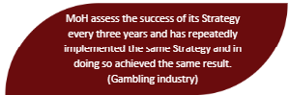

* **Live systems change throughout the duration of the Needs Assessment:** The Needs Assessment was conducted during a significant time of change across the government, and health, minimising gambling harm agency and provider sectors. Systems and sector changes provide important context for findings highlighted in this report – and in some cases findings may be obsolete due to the constantly changing nature of the sector at the time of data collection. For example, at the time of writing this Needs Assessment, the government passed a bill to disestablish The Māori Health Authority - Te Aka Whai Ora which would result in their functions being distributed between Health New Zealand and the Ministry.
* **A sample of gambling stakeholder interviews:** Although interviewed participants reflected on their vast personal experiences and expertise – the qualitative findings cannot be generalised to all gambling stakeholders.

##### Gambling in Aotearoa New Zealand

Since the 2021 Needs Assessment, gambling activity has remained at a relatively constant level in New Zealand, with data indicating that most adults engage in gambling at some stage in their lives. The frameworks and roles of the sector in preventing gambling harm have recently changed in response to the establishment of Health New Zealand - Te Whatu Ora and The Māori Health Authority - Te Aka Whai Ora, and the Department of Internal Affairs (DIA) have introduced new legislation to increase the responsibilities of Class 4 venue managers (see section 2.3).

###### Gambling participation

Although previous studies and surveys found that gambling participation rates were declining (Abbot et al., 2018; Te Whatu Ora, 2018), results from the most recent Health and Lifestyle Survey (Te Whatu Ora, 2020) show increasing rates across many forms of gambling, especially online gambling:

Figure 1: Gambling participation by activity in NZ (HLS, 2020)

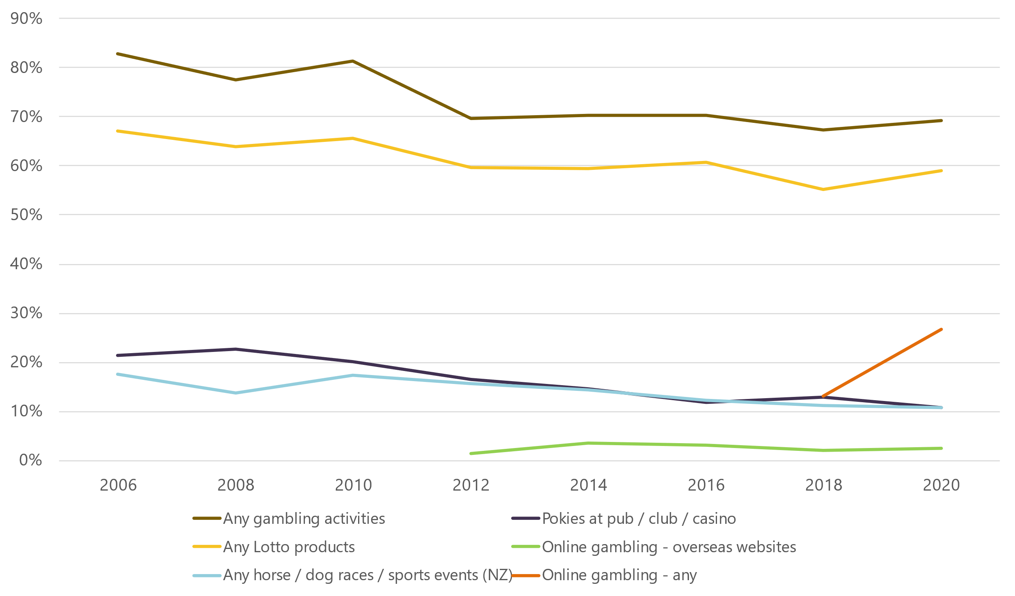

Figure 1 shows the participation rates of various gambling activities through time based on the most recent Health and Lifestyle Survey. 69.3 per cent of adults participated in some form of gambling in 2020, a statistically insignificant increase from 67.2 per cent in 2018, and 59.1 per cent of adults had purchased a Lotto product in the last year, a statistically significant increase from 55.1 per cent in 2018. Online gambling in any form[17] has increased significantly, as participation has more than doubled from 13.2 per cent in 2018 to 26.7 per cent in 2020. We observe no statistically significant changes in gambling on electronic gaming machines (commonly known as pokies) at pubs, clubs and casinos, and on horse and dog races and sports events (11.3% to 10.9%). In general, the most popular gambling activity in NZ remains use of Lotto products.

Similarly, there were no statistically significant changes in gambling participation rates by ethnicity in the 2020 HLS results (Figure 2).

Figure 2: Gambling participation by ethnicity (HLS, 2020)

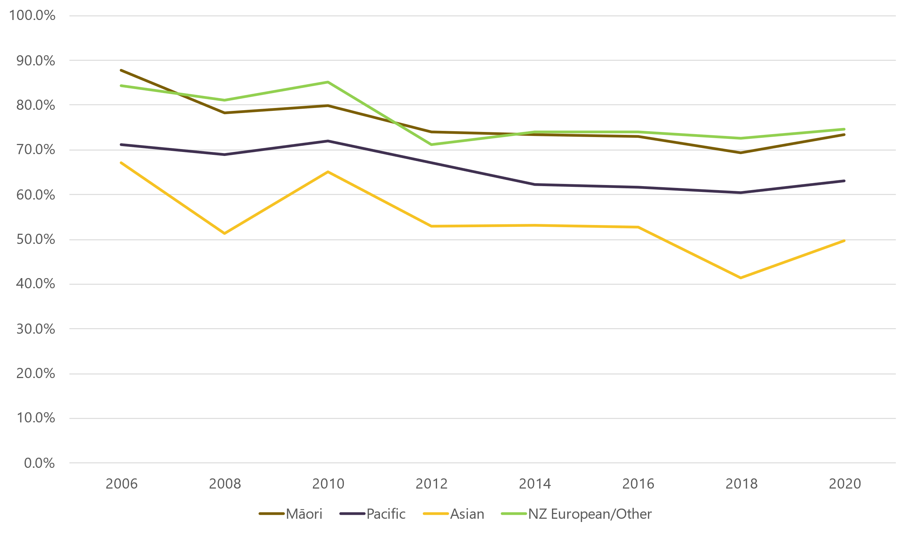

Māori had the highest participation of gambling at pokies (18.4%), as well as betting on horse and dog races and sports events (13.6%). NZ European adults had the highest gambling rates on Lotto (64.1%) and online sites (29.2%). Asian individuals had the lowest participation rates in all gambling categories (4.6% at pokies, 45% on Lotto, 3.4% on horse and dog races and sports events, and 21.5% via online sites).

###### Defining and measuring harmful gambling

The Gambling Act 2003 (the **Act**) defines gambling harm as ‘harm or distress of any kind arising from, or caused or exacerbated by, a person’s gambling’. This includes ‘personal, social, or economic harm suffered by the person, by the person’s spouse, civil union partner, de facto partner, family, whānau, or wider community, or in the workplace, or by society at large’. There are three frequently used tools to assess levels of gambling harm in New Zealand:

* The Problem Gambling Severity Index (PGSI) identifies levels of gambling risk based on individuals’ self-reporting (Ministry of Health, n.d.). It is used for screening and classifying individuals into four risk categories: no risk (non-problem gambling), low risk, moderate risk, and severe or high risk (problem gambling). The HLS (2020) measures harmful gambling using the PGSI.
* The Short Gambling Harm Screen (SGHS) measures gambling harm at both individual and population levels. The SGHS was developed and informed from research that assessed the extent of gambling harm (Browne et al., 2018).
* The South Oaks Gambling Screen (SOGS-R), was modified from the original South Oaks Gambling Screen (SOGS) (Lesieur & Blume, 1987), and provides a measure of lifetime gambling problems. Participants are classified as: non-problem, problem and probable pathological gamblers. The SOGS-R was utilised in the National Gambling Study (NGS) (Abbott, 2017).

The Practitioner’s Guide for preventing and minimising gambling harm describes all screens for use in problem gambling, and categorises them by brief intervention, full intervention and follow-up (Ministry of Health, 2019, p.196).

###### Gambling regulation and legislation

Gambling in New Zealand is legislated under the Gambling Act 2003 (the Act). The purpose of the Act is to:

* Control the growth of gambling
* Prevent and minimise the harm caused by gambling, including problem gambling
* Authorise some gambling and prohibit the rest
* Facilitate responsible gambling
* Ensure the integrity and fairness of games
* Limit opportunities for crime or dishonesty associated with gambling
* Ensure that money from gambling benefits the community
* Facilitate community involvement in decisions about the provision of gambling.

New gambling harm regulations have been introduced since the previous gambling harm needs assessment, and they are now fully in force as at 1 December 2023 (New Zealand Legislation, 2023). The Department of Internal Affairs justified the introduction of new regulations with the following statement:

“Class 4 licence holders, venue operators, and venue managers have responsibilities to identify and address gambling harm in their venues. Existing requirements had not done enough to identify, prevent and minimise harm, or to incentivise compliance. In some cases, people have suffered financial and other harms from gambling at pokies venues, yet these harms were not being consistently identified by venue managers and staff.”

The 2023 changes to the Harm Minimisation Regulations have been designed to create clear and consistent standards that apply to all venues. They introduce new monitoring procedures at venues to support venue managers and staff identify signs of harm earlier and more consistently. They also set out clear rules for how staff must respond when signs of harm are identified.” - (Department of Internal Affairs, 2023e).

The most notable amendments are the new responsibilities venue managers are required to fulfil at venues. Managers must ensure that venue staff who supervise class 4 gambling are:

* Monitoring the gambling room through regular sweeps;
* Making record of each sweep;
* Taking reasonable steps to identify a player present for nine sweeps in a row;
* Considering if a player is showing signs of gambling harm; and
* Having a conversation with players showing signs of gambling harm, and recording these conversations.

Other changes include:

* Changes in the requirements around venue design;
* Required annual problem gambling awareness training for venue personnel who supervise gambling; and
* New infringement offences to support compliance with the new requirements.

The four levy paying gambling sectors in New Zealand are racing and sports betting through the TAB, Class 4 electronic gaming machines (referred to in this paper as pokies) in clubs and pubs, lotteries products through Lotto NZ, and casinos. The Act defines four classes of gambling, and lotteries, prize competitions, games of chance and instant games fall into classes 1-3, whereas EGMs outside casinos are considered class 4 (highest risk).

We note that in November 2023, the Gaming Machine Association of New Zealand (the Association) sought a judicial review of certain aspects of the new regulations. The Association argued there was a lack of consultation during the development of the regulations and some aspects of the regulations were unreasonable. This review is ongoing at the time of writing.

###### Gambling sector roles and responsibilities

The Department of Internal Affairs, Ministry of Health, Gambling Commission and local councils have roles outlined in the Act:

**Department of Internal Affairs (DIA):**

* Regulates and enforces gambling under the Act
* Manages licensing for non-club societies and monitors fund distribution
* Conducts inspections to ensure venues comply with the Act
* Focuses on harm minimisation, fraud reduction, and maximising community returns
* Introduced a harm minimisation strategy in March 2021, emphasising community well-being and safe gambling.

**Ministry of Health:**

* Develops and implements an integrated problem gambling strategy focused on public health
* Includes measures for preventing and minimising gambling harm
* Provides services to treat problem gambling
* Conducts independent research on the social and economic impacts of gambling.

The responsibility for implementing the Strategy to Prevent and Minimise Gambling Harm is shared among Health entities: Manatū Hauora, Te Whatu Ora - Health New Zealand, and Te Aka Whai Ora - Māori Health Authority (Ministry of Health, 2023b). Manatū Hauora develops and implements the comprehensive problem gambling strategy. It oversees the strategy's progress, offers policy guidance on preventing and reducing gambling harm, and conducts research to address problem gambling. Te Whatu Ora and Te Aka Whai Ora fund, commission and evaluate problem gambling services. The Pae Ora Act was passed in 2022 and established both Health New Zealand and the Māori Health Authority. As noted above at the time of writing, the Government passed a bill that would disestablish the Māori Health Authority by 30 June 2024, and that would result in the Authority’s functions being distributed between Health New Zealand and the Ministry.

**Gambling Commission:**

* Reviews casino licensing applications and appeals on licensing and enforcement decisions
* Reports to Ministers and makes recommendations on the proposed gambling levy.

**Local councils (territorial authorities):**

* Must have TAB and Class 4 venue policies that sets out rules in their districts, with a review every three years
* Cover considerations such as allowing Class 4 gambling venues, their locations, and the social impact within the district.

##### Access to gambling in Aotearoa New Zealand

Gambling continues to be widely accessible through both regulated and unregulated providers. Local policies have attempted to reduce the more harmful gambling types by decreasing the number of electronic gaming machines (EGMs) and venues, but there are still significant inequities in their socioeconomic distribution.

###### All forms of gambling are widely accessible

**Lotteries products:** Lotto NZ recorded total sales of $1,520 million in 2022/23, a 4.3 per cent increase from the previous financial year ($1,457 million in 2021/22) (Lotto New Zealand, 2023). Lotto has decreased the number of retail outlets by about 21 per cent since 2020 following criticism for operating too many stores in low-income areas (Espiner, 2022). However, growing profits despite this reduction are a result of a shift towards online gambling services. The proportion of online sales to total revenue has increased from 31 per cent in 2019/20 (Lotto New Zealand, 2020), to 44 per cent in 2022/23 (Lotto New Zealand, 2023). Radio New Zealand reported that nearly 70 per cent of Lotto shop sales are made in the poorer half of the community(Espiner, 2022). The highest selling areas in 2021 were Henderson-Massey (decile 8) and Ōtara-Papatoetoe (decile 9), with spending totalling $26 million and $24 million respectively. A higher concentration of retail outlets in lower socioeconomic communities exploits the higher demand and susceptibility of problematic gambling, and Lotto has set targets of reducing the number of stores in high deprivation areas.

**Class 4 EGMs:** The number of Class 4 EGMs and venues in New Zealand has continued to decline as shown in Figure 3 and Figure 4 (Department of Internal Affairs, 2023c).

Figure 3: Number of Class 4 EGMs in NZ (DIA, 2023)

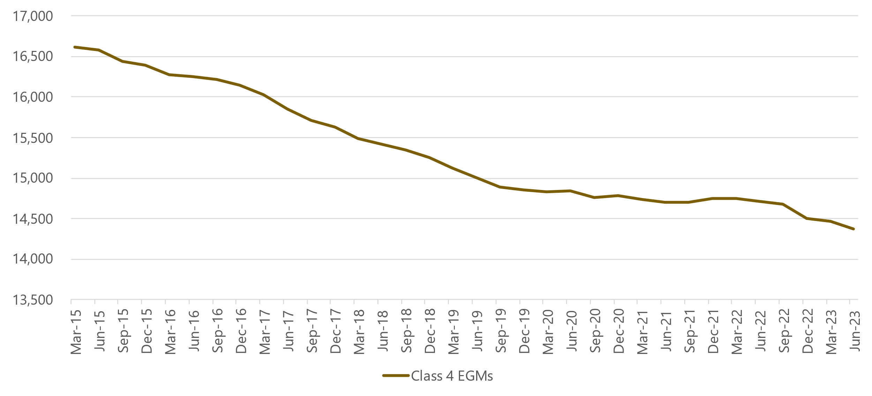

Figure 4: Number of Class 4 venues in NZ (DIA, 2023)

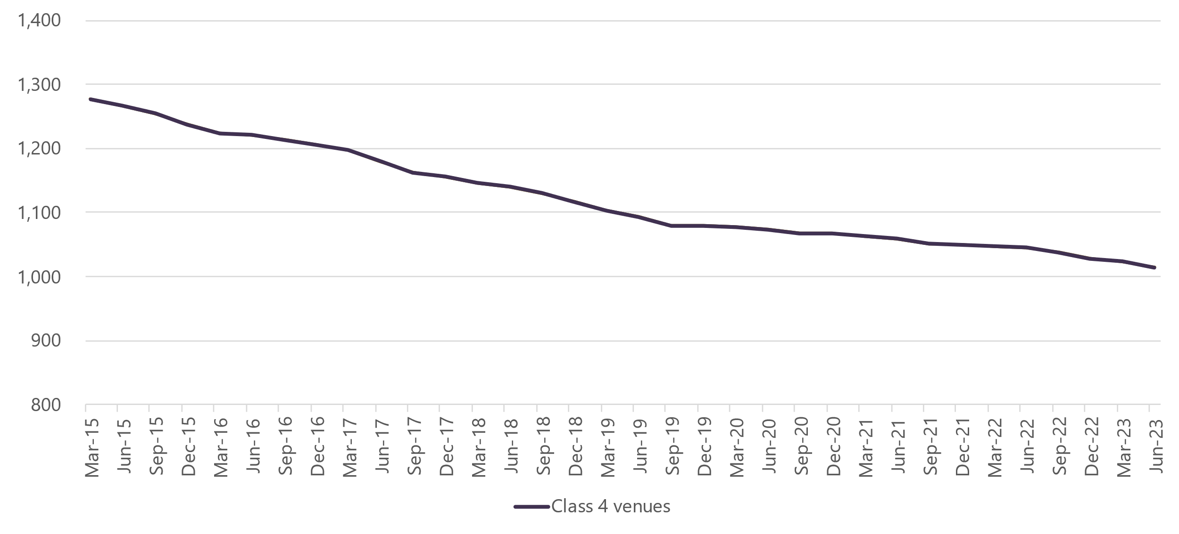

Based on the data in June 2023, there were 473 fewer EGMs than in June 2020 (14,847 to 14,374). Similarly, the number of Class 4 venues has reduced in the same three-year period by 59 (1,074 to 1,015).

**TAB New Zealand (TAB NZ):** TAB NZ is a statutory monopoly for sports betting and is regulated under the Racing Industry Act 2020. Total turnover was $2,538 million in 2021/22 (Department of Internal Affairs, 2023a)[18], a 1 per cent decrease from the previous year, primarily due to COVID-related retail site closures (TAB New Zealand, 2022). TAB NZ also attributed the reduced turnover to pressure resulting from regulatory settings that allow international betting companies to operate in NZ. TAB estimates around $150 million was lost to offshore-based operators, money that could have otherwise contributed to local sports, racing and communities (TAB New Zealand, 2022). In May 2023, former Minister for Racing Hon Kieran McAnulty announced that Cabinet had made an in-principle decision to extend TAB NZ’s monopoly for sports and racing betting to the online environment, subject to further work being done. Work was also underway considering (amongst other measures) legislatively enforcing geo-blocking to prevent international gambling (Pullar-Strecker, 2023). This was concurrent with TAB NZ’s approval to outsource operations to Entain, a British gambling entity. Part of the agreement was an upfront initial consideration of $160 million, with an additional $100 million subject to legislative geo-blocking implementation (Entain, 2023). TAB said restricting unregulated betting sites would yield both economic and social benefits, as more money could be reinvested back into communities and sporting bodies, and there would be greater oversight and implementation of harm minimisation strategies. Cabinet has more recently agreed to take steps to regulate online gambling (more on this in section 3.4 below).

**Casinos:** There are six casinos in New Zealand, and under the Gambling Act (2003) no new casino venue licences will be issued. SkyCity operates four of them: one in Auckland, one in Hamilton and two in Queenstown (Gambling Commission, 2022). SKYCITY Wharf closed temporarily in 2020 due to the impact of COVID-19 on tourist numbers and on its ability to staff the venue. The Casino is likely to remain closed for the foreseeable future. The remaining two are operated in Christchurch and Dunedin, independent of SkyCity.

**Online gambling:** New Zealand has two authorised online gambling providers – Lotto NZ and Tab NZ. Lotto provides various online gambling products such as Powerball and Instant Kiwi, and TAB offers live sports and race betting (Department of Internal Affairs, 2021c). A temporary rule change was made to Class 3 Lottery operators to allow them to operate online from October 2021 to October 2024 due to the impacts of COVID-19 (Department of Internal Affairs, 2021a). New Zealanders can also access unregulated offshore-based gambling services, and there has been a significant growth in New Zealanders’ use of these services (see Section 3.4).

###### Class 4 venues remain in areas of high deprivation

We continue to observe a higher prevalence of Class 4 venues in high deprivation areas (Figure 5) (Department of Internal Affairs, 2023c).

Figure 5: Number of Class 4 venues by deprivation rating (DIA, 2023)

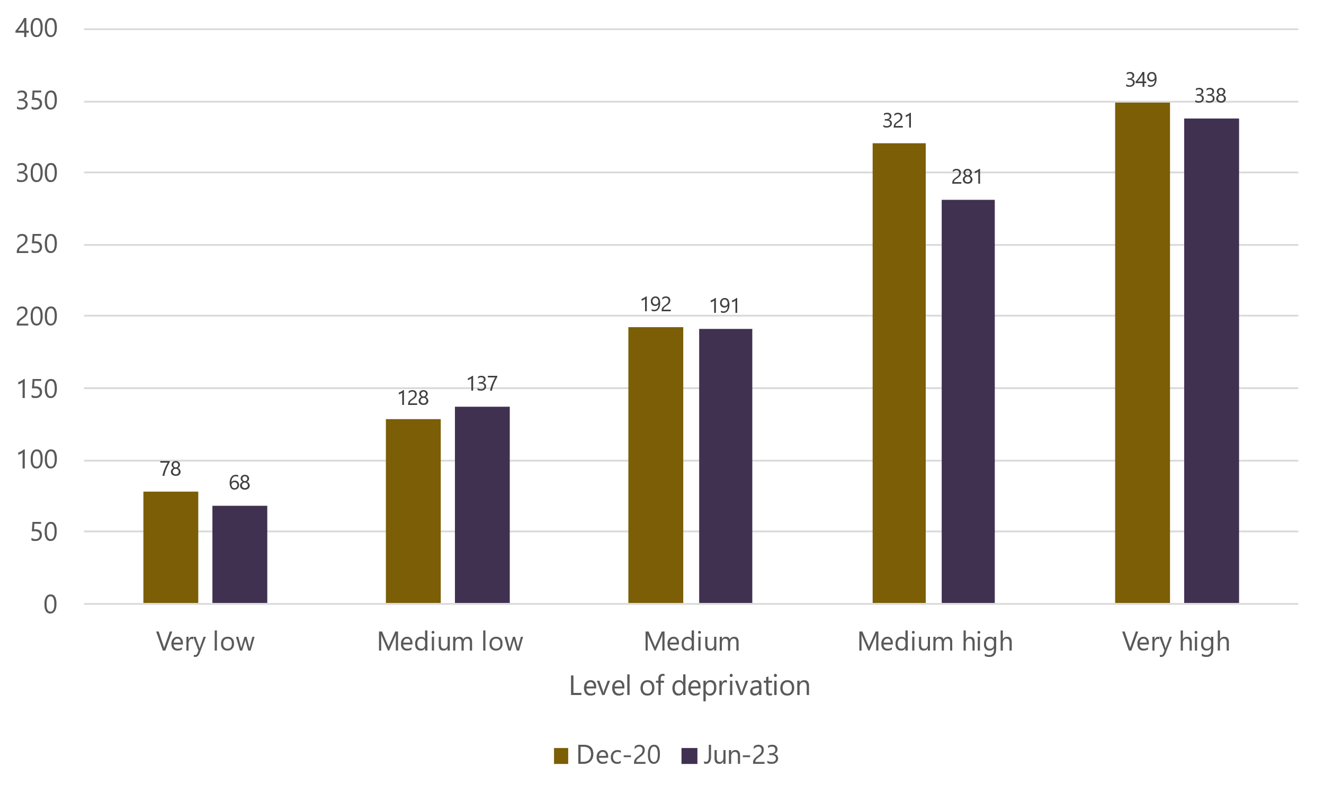

Although there continues to be inequities, the proportion of Class 4 venues in higher deprivation areas has decreased, as the reductions have primarily been in these areas. Fifty-one out of the 53 net reduction in venues in this timeframe have been in medium high and very high deprivation areas.

###### There is evidence of policies effectively reducing the number of Class 4 EGMs and venues

The New Zealand Work Research Institute and Sense Partners (Erwin et al., 2020) reported that the following policy interventions were effective in reducing the number of Class 4 EGMs and venues in New Zealand:

* Absolute caps on the number of EGMs and/or venues;
* Per capita caps on the number of EGMs and/or venues; and
* Sinking lid policies (restricting transfer of Class 4 licences to slowly reduce availability over time).

They found that sinking lids and per capita caps reduced gambling expenditure by 13 to 14 per cent relative to the reference group of territorial authorities with no restrictions other than those in the Gambling Act. Additionally, absolute caps were found to reduce expenditure by 10 per cent. Figure 6 shows the increasing implementation of gambling policies across Territorial Local Authorities (TLAs) in NZ.

Figure 6: Gambling policies in Territorial Local Authorities (Ministry of Health, 2023)

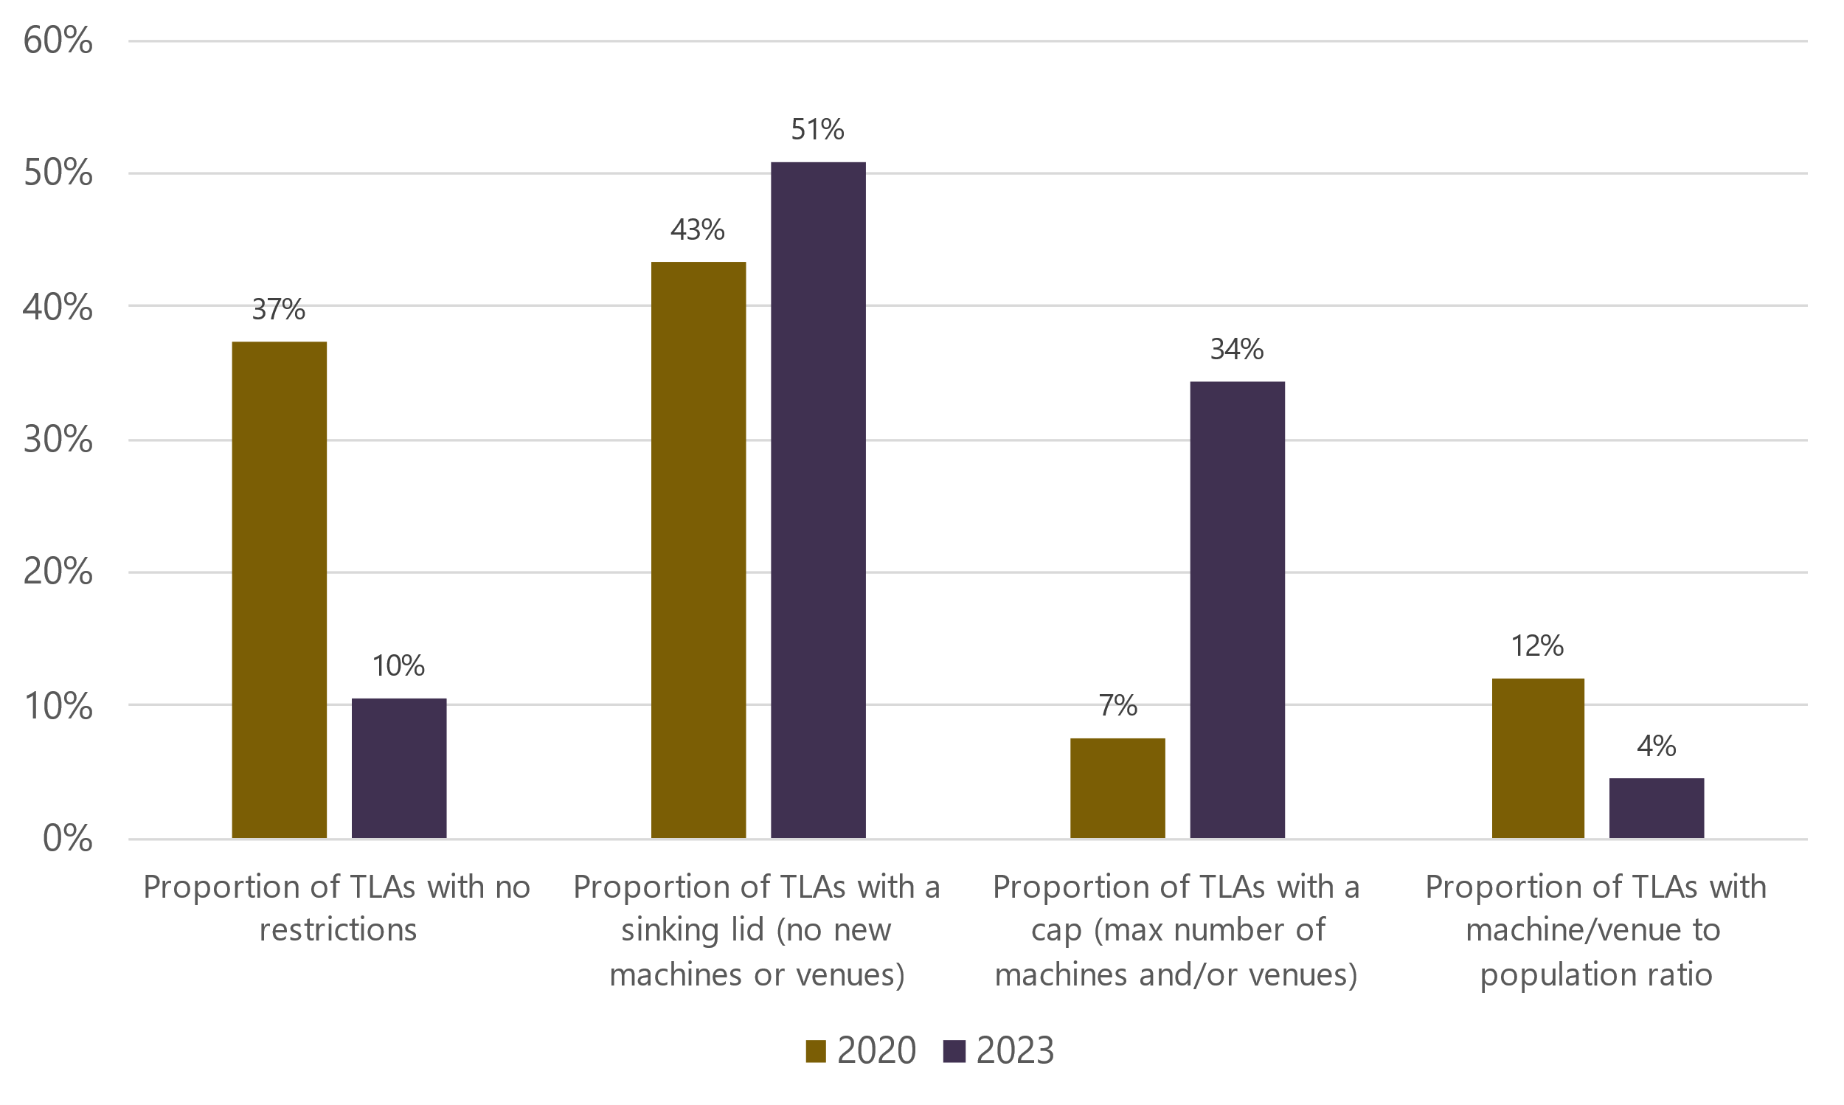

Note: Number of TLAs = 67

This data highlights the following changes from 2020 to 2023:

* The proportion of TLAs with no restrictions has decreased significantly from 37 per cent to 10 per cent (25 to 7)
* The share of TLAs restricting new machines and venues has increased from 43 per cent to 51 per cent (29 to 34)
* An additional 18 TLAs have set a cap on the number of machines and venues (5 to 23)
* Only 3 TLAs now have a machine/venue to population ratio, a reduction from 8 three years ago.

Rimal et al. (2023) conducted a qualitative study to investigate the perspectives of gambling expert stakeholders regarding EGMs in New Zealand. They interviewed policymakers, academics and health professionals on gambling harm and harm-minimisation policies. The following themes and recommendations were identified:

* To shift focus from problematic people to the problematic product
* The need for a holistic approach to gambling intervention
* To focus on creating an empowered population
* Improving protective factors and refining public health initiatives to gambling harm.

A recent study found that EGMs are responsible for more than half of gambling-related issues in Australia (Browne et al., 2023). Researchers used an aggregated dataset of national and state-based prevalence studies to estimate the prevalence and effects of various gambling forms on the total burden of gambling problems. They found that EGMs are attributable from 51 per cent to 57 per cent of gambling problems in Australia, and 90 per cent of gambling problems are linked to EGMs, casino, race and sports betting. EGMs pose high risks due to a high participation rate and high frequency of play among participants, in contrast to risky but less frequently played casino games, and prevalent but non-risky forms such as lotteries. The researchers determined that EGM regulation should be a central focus of gambling policy action in Australia, and that innovative policy ideas should be explored given the disproportionate impact of EGMs.

###### Online gambling has continued to increase in New Zealand

There has been a surge in online gambling in New Zealand, with estimated spending increasing from $139.3 million in 2014 to $332.6 million in 2022 (Bevin, 2022). In October 2023, Christchurch Casino announced its plans to introduce an online gambling platform based in Malta[19]. This marks the second instance of a New Zealand-owned, Malta-operated online casino, as SkyCity launched its product in 2019. These offshore-based operations are a result of legal loopholes, as outside of Lotto and TAB NZ, it is illegal to operate online gambling services in New Zealand but is not illegal for New Zealand consumers to gamble on offshore-based sites. This is discussed further in section 10.2.

Following the discussions in section 3.1, it could be argued that if the government doesn’t intervene against the “aggressive targeting” from offshore-based providers, the unregulated gambling sector in New Zealand is projected to reach $600 million by 2025. Figure 7 shows the estimated market share of online gambling in New Zealand in 2020, presented by Newsroom and sourced from research undertaken by consultancy firm Regulus for SkyCity (Bevin, 2022).

On 14 March 2024 it was announced that Cabinet has made an in-principle to introduce regulation of online gambling. More specifically, Cabinet decided[20]:

“[Hon] Simon Watts says Cabinet has … made an in-principle decision to regulate online casino gambling. New Zealand-based gambling operators are regulated by the Gambling Act which requires them to be licenced in New Zealand. These regulations help ensure New Zealanders can gamble safely and responsibly but they do not apply to online casinos as they are located offshore”. “New Zealand is one of only a handful of developed countries that does not regulate online casinos and that places New Zealanders at risk of being targeted by unscrupulous offshore gambling operators. There is no oversight of harm minimisation and consumer protections currently … Regulating online casino gambling will support tax collection, minimise harm and provide consumer protections to New Zealanders.”

Figure 7: Estimated market share of New Zealand online gambling in 2020 (Bevin, 2022)

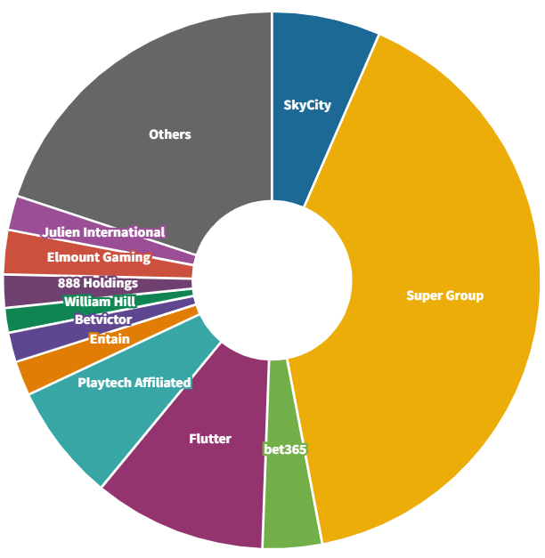

Super Group's Jackpot City holds a significant share of the estimated revenue generated by online gambling providers in New Zealand, accounting for 41 per cent or $136.2 million out of the total $332.6 million in 2020 according to Regulus. Jackpot City’s advertising of free-to-play gambling sites that resemble their own pay-to-play counterparts have raised concerns, as it exploits a loophole in New Zealand’s gambling advertising laws (Zaugg, 2023). Free-to-play gambling sites are viewed as a gateway to real money gambling, and although Section 16 of the Act prevents offshore-based gambling operators from advertising in New Zealand, free-to-play sites are not explicitly restricted in the Act.

As of 1 October 2016, the introduction of remote service rules mandated GST payments from online gambling providers operating in New Zealand. $37.8 million of GST was collected from online casino gambling providers for the year ended 31 March 2023, and $170.1 million has been collected in total since 2016 (New Zealand Parliament, 2023). Prior to the 2023 election, the National Party announced that it would close a tax loophole and ensure offshore-based operators pay tax in New Zealand. This targeted initiative was estimated to generate $179 million of annual tax revenue on average (Willis, 2023). As noted above, on 14 March 2024, the Government announced it will be regulating online gambling, requiring a gaming duty of 12% on gross betting revenue.

##### Gambling expenditure

We observe decreasing trends in total gambling expenditure and per capita spend. However, the increasing trends in gaming machine profits (GMPs) are met with uncertain conclusions on whether there are more players, higher average bets, or longer average playing times across Class 4 EGMs.

###### Gambling expenditure across all forms of gambling has increased

Total nominal gambling expenditure increased from $2,254 million in 2021/22 to $2,385 million in 2022/23, despite TAB expenditure data not being available at the time of this assessment. Expenditure on all gambling types decreased in the most recent recorded financial year:

* NZ Lotteries: $654 million to $710 million
* Gaming machines (outside casinos): $833 million to $1,070 million
* Casinos: $387 million to $604 million.

Total gambling expenditure per capita increased in 2022/23 even when adjusting for inflation and population changes. The average gambling spend per person is currently recorded as $462 in 2021/22 and $450 in 2022/23, however TAB is excluded and based on the data of previous years it is highly probable that total expenditure in 2022/23 will exceed 2021/22 once the data is released (Department of Internal Affairs, 2023a). Average per capita expenditure on the remaining gambling types either increased or remained constant in 2022/23:

* NZ Lotteries: $134 to $134
* Gaming machines (outside casinos): $171 to $202
* Casinos: $79 to $114.

###### Gaming machine profits continue to increase

Quarterly gaming machine profit (GMP) data shows a seasonal trend, with higher spend in later quarters. Overall GMP has tended to increase each year, with approximately $272 million recorded in the most recent September 2023 quarter (Figure 8) (Department of Internal Affairs, 2023c).

Figure 8: Gaming machine profit per quarter (Department of Internal Affairs, 2023c)

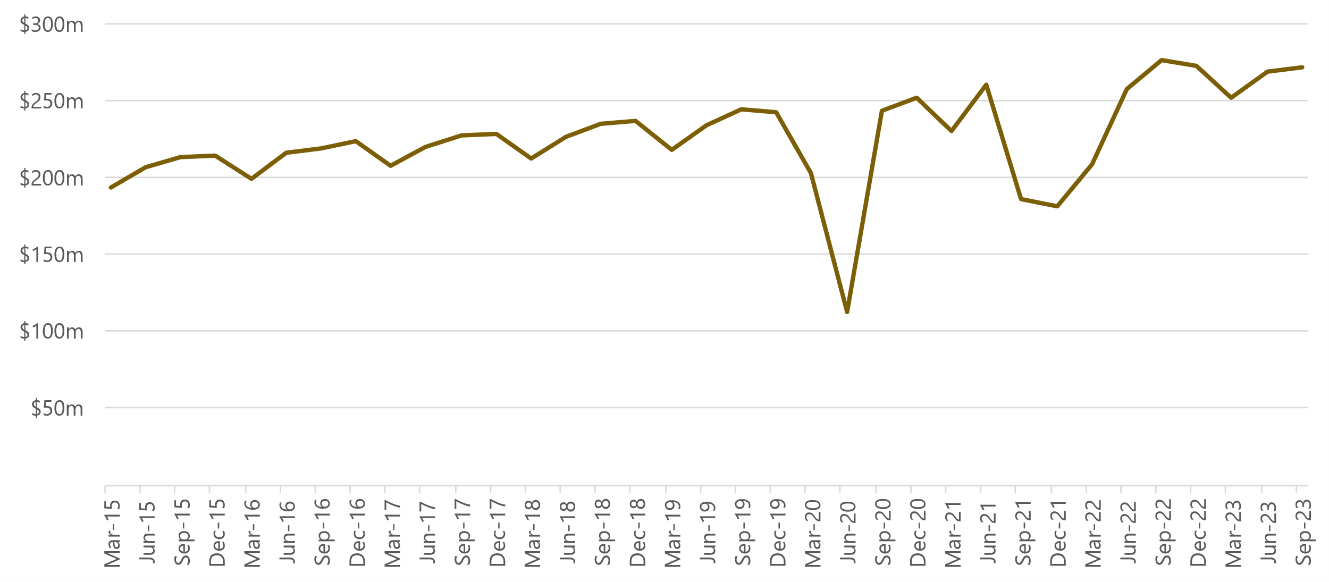

GMP per EGM has been increasing, despite the downwards trend in the number of Class 4 EGMs and venues outlined in section 3.1. The Department of Internal Affairs (2023d) states that it cannot definitively say why this is, and from the data held, it cannot determine whether:

* There are more players playing EGMs
* There are a similar number of players betting more per game; or
* There are a similar number of players betting similar amounts per game but playing for longer hours.

However, as outlined in Section 2.1, we have been observing a declining trend in gambling participation on pokies at pubs, clubs and casinos. There have been statistically significant declines in participation between 2014 and 2020 yet GMP has increased, which suggests that less people are betting more frequently and losing more money each year. It is likely that the overall harm has increased but is concentrated among a smaller number of people.

##### Community reinvestment of gambling profits

New Zealand has a community-focused gambling model, where net profits are required to be reinvested into communities rather than into the private sector. Regulated gambling bodies are required by law to return a portion of their profits to communities through grants and levies, which differs from some international models where net proceeds are purely for commercial gain.

###### Class 4 EGMs

The Act requires that a minimum of 40 per cent of gaming machine profit (GMP) generated by authorised gambling societies[21] must be reinvested into the community. Gaming machine societies and trusts exclusively conduct Class 4 gambling, and this form of gambling is permitted solely for the purpose of fundraising for a community-based cause. Although there is no legal obligation for grants to be directed back into communities that generated the profits, many societies endeavour to reinvest a significant proportion of their proceeds with the communities where the funds originated (Department of Internal Affairs, 2021d). Figure 9 shows the total returns to communities by societies, trusts and clubs through GMPs (Department of Internal Affairs, 2023b).

Figure 9: Total return to communities through gaming machine profits of Non-Club Societies & Trusts and Clubs (Department of Internal Affairs, 2023b)

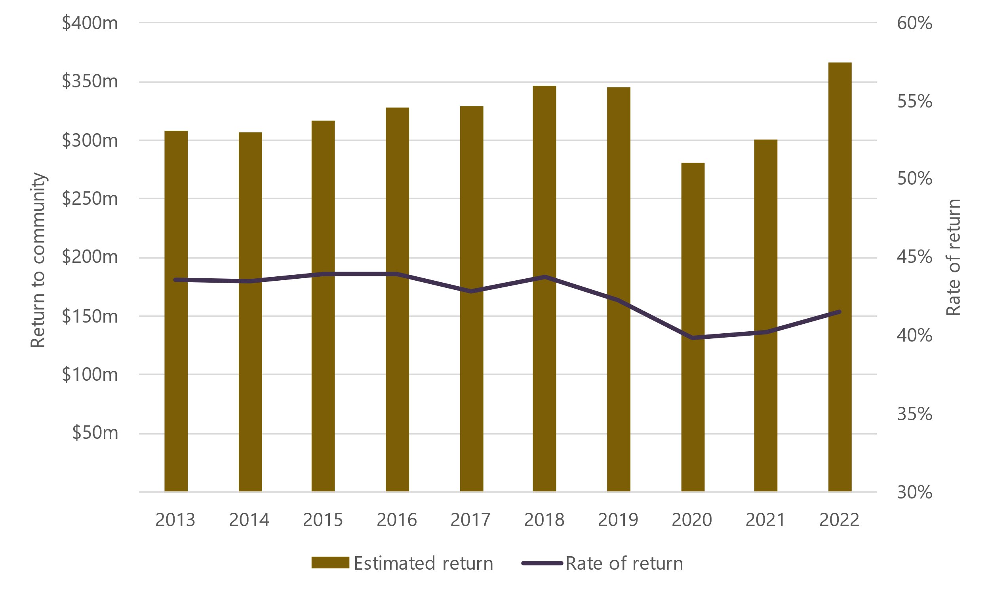

Total returns to the community have been increasing in line with an increase in total GMP (see section 4.2). The overall rate of return has remained slightly above the 40 per cent minimum threshold, with the exception for 2020 and 2021 where the grants obligation was relaxed due to COVID-19 (Department of Internal Affairs, 2023b).

In 2022, approximately $328 million of grants and applied funds were approved to 9,784 organisations (Figure 10). Total funding was allocated into sports (50.5%), community (20.2%), health/welfare/rescue services (12.5%), research and education (9.2%), arts and culture (5.9%), environment and animals (1.1%) and unspecified (0.6%) (Department of Internal Affairs, 2022).

Figure 10. Approved pokie grants in 2022 by main category (Department of Internal Affairs, 2022)

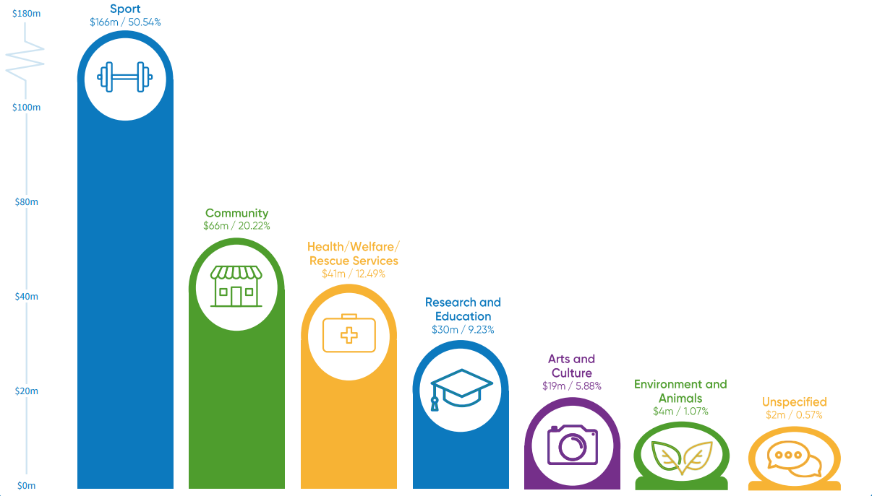

###### Lotto NZ

The Department of Internal Affairs oversees the administration of Lotto NZ grants on behalf of the Lotto NZ board. 100 per cent of profits go towards communities, which equates to about 25 per cent of total spending on Lotto products being transferred to the NZ Lottery Grants Board (Lotto New Zealand, 2024). Grants totalled $376 million in 2022/23, and almost half (42%) is allocated to three organisations: Creative New Zealand, Sport New Zealand, the New Zealand Film Commission, and the charitable trust Ngā Taonga Sound & Vision (Lotto New Zealand, 2023). The remaining portion (58%) is distributed through 20 Lottery committees and considers how well a grant request:

* Meets its own outcomes and funding priorities
* Aligns with the Lottery Grants Board’s key request criteria and funding objectives
* Responds to the community needs.

The core factors influencing grant decisions are the proposed outcomes and benefits to the community, the feasibility of the proposed project or service, and the applicant’s capacity to effectively implement their proposal (Community Matters, n.d.).

###### TAB NZ

TAB NZ is obligated by the Racing Industry Act (2020) to distribute its betting profits to the sports and racing sector. In 2021/22, $140.2 million of total betting profits were distributed to the racing community, up 13 per cent from the previous year (TAB New Zealand, 2022). Additionally, $12.6 million and $1.6 million were paid to National Sporting Organisations (NSOs) and amateur sporting organisations respectively.

###### Casinos

The six casinos that operate in New Zealand are subject to charitable trust conditions that are attached to their casino venue licences (Gambling Commission, n.d.). In 2022/23, SkyCity distributed $5.3 million in grants to 122 community organisations from revenue generated in its Auckland, Hamilton and Queenstown casinos (SkyCity, 2023). In 2023, Christchurch Casino (2023) and Dunedin Casino (2023a, 2023b) distributed approximately $450,000 and $150,000 respectively.

##### The prevalence of harmful gambling

Although the prevalence of low-risk, moderate-risk and non-problem gambling has decreased, we continue to observe inequities in harmful gambling between ethnicities. Researchers are also concerned about youth gambling (Problem Gambling Foundation, 2023b), and evidence shows that there are increased gambling harm risks for women (Palmer du Preez et al., 2021; Te Whatu Ora, 2020).

###### The prevalence of harmful gambling in Aotearoa New Zealand has remained unchanged since 2018

The most recent gambling harm data captured in the HLS shows no statistically significant changes in harmful gambling between 2018 and 2020 (Te Whatu Ora, 2020).[22] The results show that:

* The prevalence of non-problem gambling is 64.8 per cent (or 2,653,000 adults)
* The prevalence of low-risk gambling among adults is 2.9 per cent (or 119,000 adults)
* The prevalence of moderate-risk and problem gamblers is 1.6 per cent (or 65,000 adults).

It is important to recognise that the prevalence rates alone may not capture the full picture. Abbott et al. (2018) note that despite stable rates of harmful gambling since the initial 1990 study, New Zealand’s population growth and changing demographics may have increased the total number of individuals affected. For a more accurate picture, they recommend reporting both gambling harm rates and absolute numbers, which are noted above alongside the prevalence rates.

###### The prevalence of harmful gambling among Māori and Pacific peoples remains higher than other ethnic groups

In New Zealand’s national prevalence surveys, Māori and Pacific have consistently exhibited the highest prevalence of harmful gambling behaviour compared to other ethnic groups (Abbott et al., 2014; Abbott & Volberg, 1991, 2000).

Figure 11 shows the prevalence of moderate-risk and problem gambling by ethnicity between 2016 and 2020 measured by the HLS (Te Whatu Ora, 2020). Prevalence of harmful gambling among Māori and Pacific remains higher than NZ European/Other and Asian individuals. There were no statistically significant changes in harmful gambling rates by ethnicity between 2018 and 2020.

Figure 11: Prevalence of moderate-risk and problem gambling by ethnicity (Te Whatu Ora, 2020)

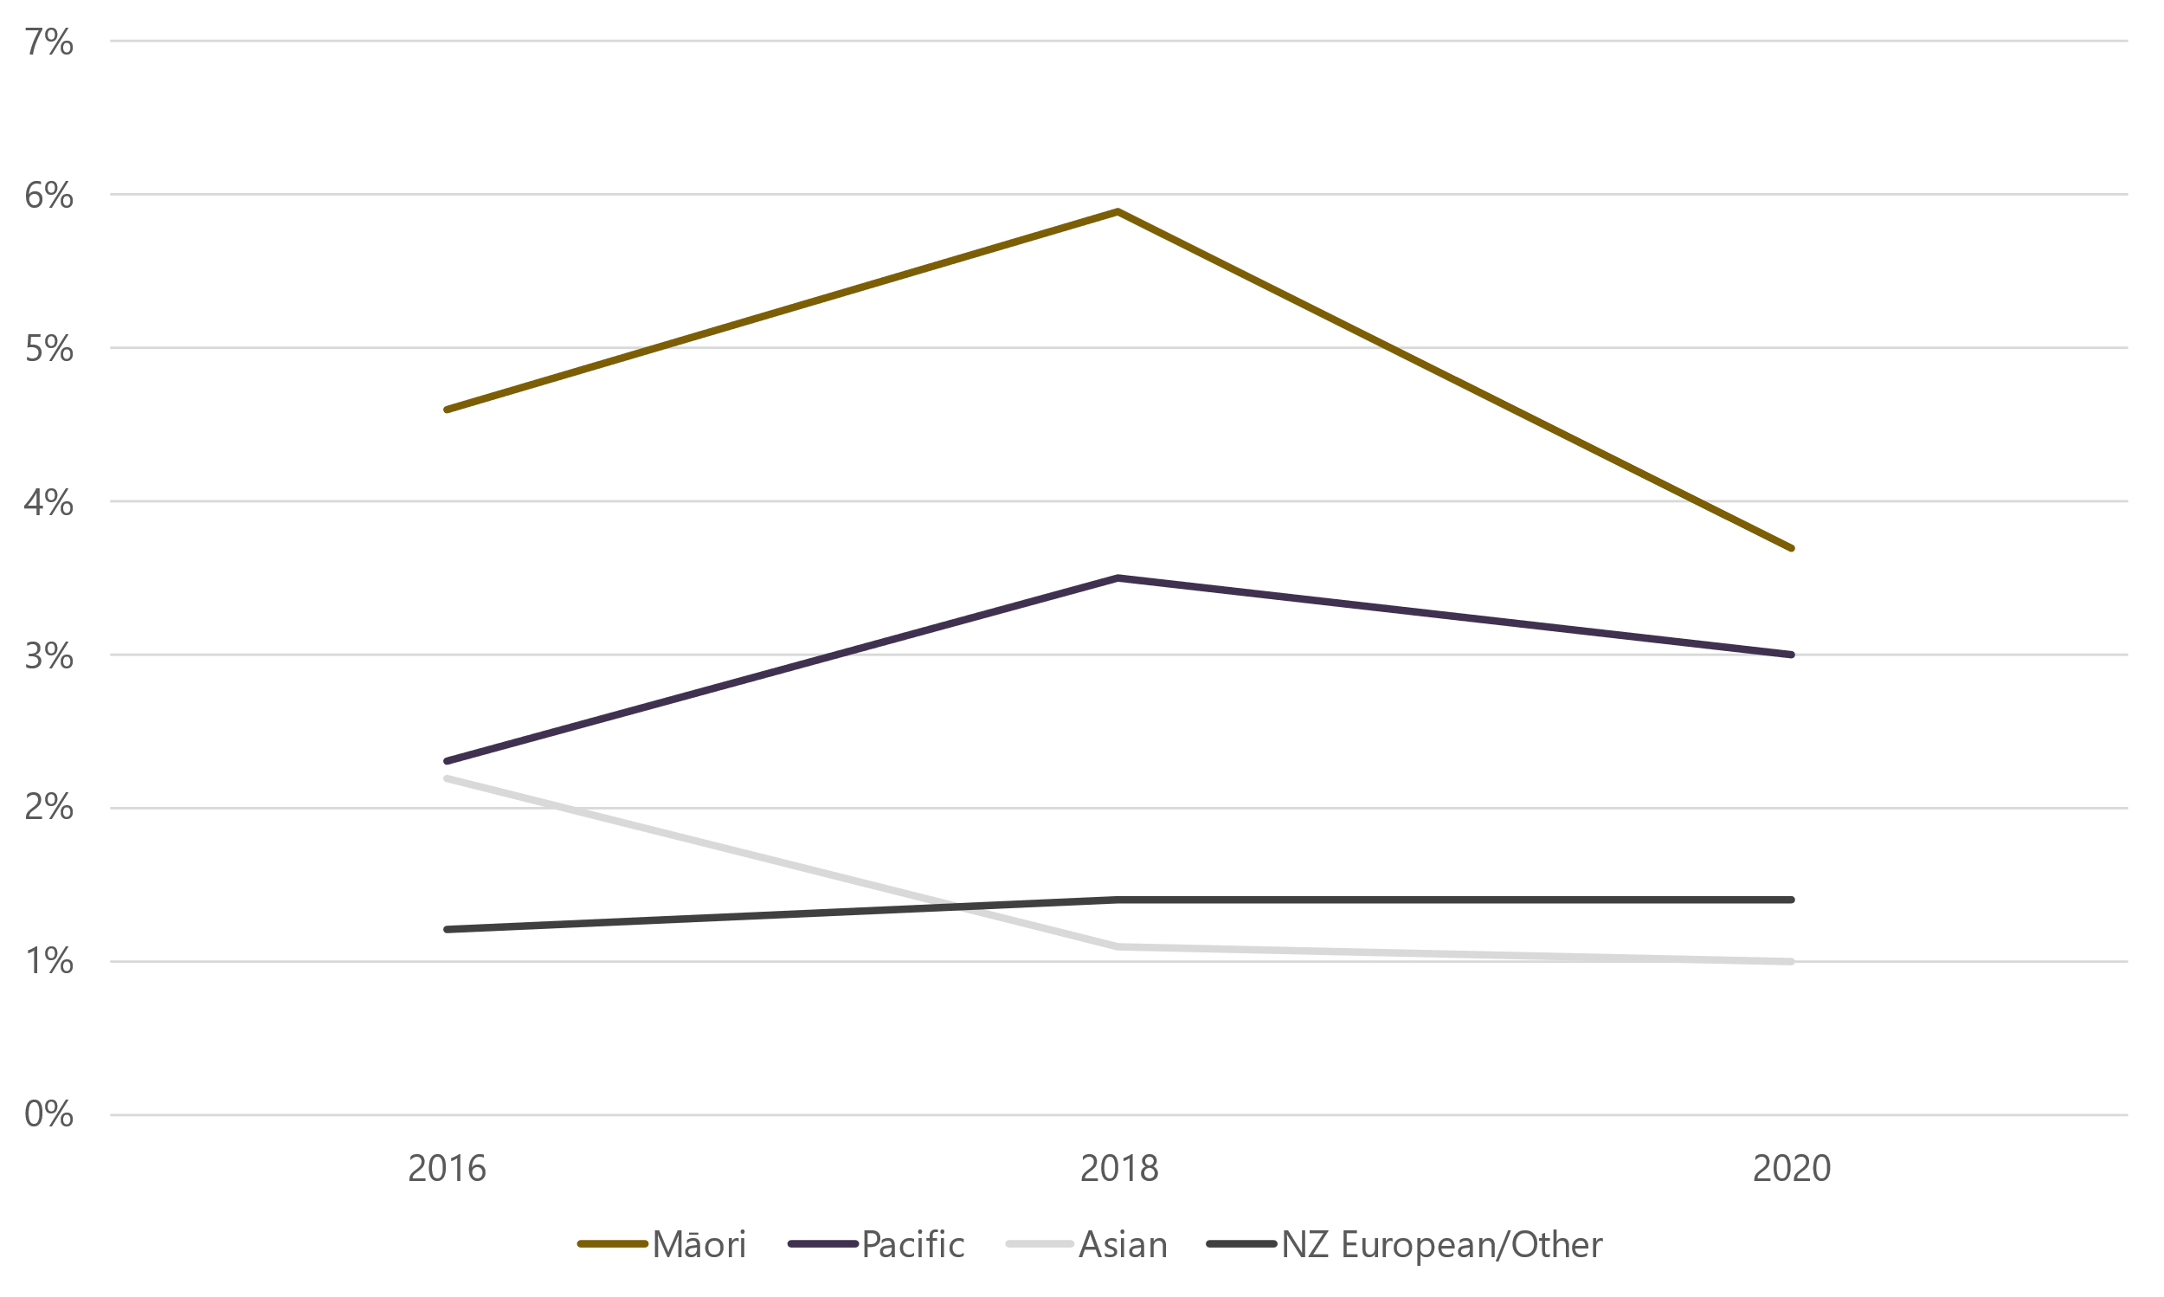

Māori and Pacific continue to be disproportionately affected by gambling harm relative to Asians and NZ European/Other. The equity-based subgroups comparison data in the HLS indicates that Māori are 3.13 times more likely to be moderate-risk or problem gamblers than non-Māori and non-Pacific, and Pacific peoples are 2.56 times more likely to be moderate-risk or problem gamblers than non-Māori and non-Pacific peoples. Moderate-risk and problem gambling are the highest levels of risk as defined by the PGSI (Ministry of Health, n.d.) (see Section 2.2).

###### Youth gambling rates have remained constant, but the prevalence of harmful gambling has reduced

Results from the 2020 HLS show that youth gambling rates have remained relatively unchanged. In 2018, 45.4 per cent of people aged 15-24 had gambled in the last year, and this figure held steady at 45.7 per cent in 2020 with no statistically significant changes (Te Whatu Ora, 2020). The prevalence of moderate risk and problem gambling for young adults aged 15-24 was 1.6 per cent in 2020.

The Problem Gambling Foundation recently launched a campaign due to concerns over youth gambling in New Zealand (Problem Gambling Foundation, 2023b). In the campaign are figures from the Youth19 study which found that one in three New Zealand secondary school students had been involved in gambling at some stage in their lives (Archer et al., 2021). Of this subgroup, only 11 per cent were worried about their own gambling behaviour.

###### There are increased gambling harm risks for women

Gambling participation for women and men in any gambling activity has remained relatively equal (69.5% vs. 69.2%) (Te Whatu Ora, 2020). In 2020, women had similar participation to men on Lotto (59.4% vs. 58.9%), but lower participation on pokies (9.4% vs. 12.5%), horse and dog races and sports events (7.3% vs. 14.5%) and online (23.8% vs. 29.7%) (Te Whatu Ora, 2020).

Palmer du Preez et al. (2021) discussed how preventions and minimisations of women’s gambling harm have been constrained by research identifying male gender as a key factor for gambling problems. They answered the following research questions by revisiting previously analysed gambling data and exploring feminist social constructionist theory:

* How do gender-related issues, notions and practices influence women’s gambling related harm?
* What are the implications for women’s gambling harm reduction?

They found that women’s societal positioning as primary caregivers affected their ability to access a range of recreational and support options and increased the likelihood of gambling for an accessible means of stress reduction. The resulting recommendation was that strategic and effective gambling harm interventions should include gender-aware and gender-responsive initiatives.

##### Harmful gambling risks remain extensive

General population gambling research, both nationally and internationally, emphasises the importance of identifying socio-demographic variables and risk factors that contribute to the incidence and development of harmful gambling behaviour.

###### Pacific peoples continue to be at high-risk

Despite the implementation of public health initiatives and treatment services, new evidence since the 2021 Needs Assessment suggests that Pacific people are more likely to experience gambling harm than the general population (Fehoko, 2020; Fehoko et al., 2022; Kolandai-Matchett et al., 2017). A recent study explored factors specific to Pacific communities on gambling harm and reduction (Fehoko et al., 2022). Tongan male elders and youth were surveyed individually and via focus groups, and the following four themes were identified:

* **Awareness of gambling harm providers:** Most participants were not aware of treatment providers and what they offered to Tongan families and communities affected by problem gambling.
* **The influence of church on gambling harm prevention and reduction:** Some participants highlighted the undervalued yet critical role of the church as a space to address the importance of preventing and minimising gambling harm.
* **Community-based strategies in addressing gambling harm behaviours:** There was a common lack of knowledge regarding gambling policies and regulation. Participants proposed that health professionals and government officials should introduce awareness around gambling and gambling harm in the educational curriculum.
* **Cultural strategies addressing gambling harm behaviours:** Critical to this study was the need for gambling treatment providers to investigate cultural and traditional practices, such as the faikava, as a means to address this social and health issue. The importance of the faikava lies in the importance of socialising, sharing, and communicating in a harmonious manner, free from the fear of judgment or misinterpretation.

###### There are mixed views about the association between gambling and mental and physical health

A recent longitudinal population study in New Zealand found that changes in some health and lifestyle behaviours are significantly associated with changes in gambling behaviours (Bellringer et al., 2024). In this study, existing data from the four waves of the longitudinal New Zealand Gambling Study were analysed to investigate the relationships between changes in substance use, mental and physical health, and quality of life, as well as deprivation, and changes in gambling risk level over time. They found that:

* Changes in substance use behaviours are significantly associated with changes in gambling behaviour
* Changes in mental health status are not significantly associated with changes in gambling behaviour
* Changing lifestyle factors and sustained negative health factors have the most significant associations with becoming a risky gambler.

They concluded that individuals should be screened for gambling behaviours when assisted with health issues or social conditions to support treatment when gambling behaviour worsens over time.

###### There is mixed evidence on the link between online gaming and harmful gambling

There has been limited new evidence on the link between online gaming and harmful gambling since the previous needs assessments, however international studies suggest:

* Video game problems may serve as a precursor to problematic gambling behaviour according to a Norwegian longitudinal study (Molde et al., 2019)
* Children who bet on gaming enhancements are deemed at-risk for potential future gambling harm (Wardle, 2019)
* The increasing prevalence of offshore-based gambling and the integration of gambling elements into sports and gaming requires attention (Christopher, 2021).

Contrarily, a recent Australian study found that young people who played general video games daily during adolescence (aged 16-17 years) did not necessarily exhibit a higher likelihood of gambling as young adults (aged 18-19 years) (Sakata & Jenkinson, 2022). However, they found that those who played simulated gambling games in adolescence had a higher probability of spending real money on gambling as young adults.

Taufa et al. (2021) analysed the experiences of Pacific youth gamers and explored the relationship between gaming and gambling in New Zealand. Participants were able to recognise their own gambling and gaming harm characteristics and could identify both distinct and shared adverse effects such as irritability, isolation, and anger. They also found that gaming often serves as a gateway to gambling activities such as solitaire and the increased desire to win. Notably, they concluded that Pacific gamers spend significantly more money on loot boxes[23] than other ethnicities. The study concluded that there is an association between prolonged regular gaming and purchasing loot boxes, as well as characteristic links between gaming and problem gambling.

##### Harmful gambling impacts

Harmful gambling has many impacts, both immediate and long-term. Research has demonstrated the long-lasting, intergenerational effects of gambling (Rockloff, Bellringer, et al., 2022; Rockloff, Browne, et al., 2022), as well as the impacts to wellbeing and quality of life (Wang & Bellringer, 2022). While gambling arguably has positive community impacts through grants and funding, researchers raise ethical concerns over the diversion of income from those participating in harmful, continuous forms of gambling (Hart, 2021; PGF Group et al., 2020).

###### Evidence infers that ‘legacy gambling harms’ are apparent for many individuals

Legacy gambling harm refers to negative consequences that persist beyond the period in which individuals are actively gambling at harmful levels (Rockloff, Browne, et al., 2022). These harms can also result in externalities to the wider community (Rockloff, Bellringer, et al., 2022).

A recent article analysed the full extent of gambling harm using methods to explicitly examine legacy, life course, and intergenerational gambling harms in New Zealand (Rockloff, Bellringer, et al., 2022). The authors found that these harms constitute a significant portion of the overall burden on individuals, estimated to be either 19.4 per cent or 23.7 per cent of total impacts on health and wellbeing depending on the method used. Acute financial harms, neglect of whānau and family responsibilities, and physical harm from family violence or personal injury were short-lived relative to other harms. However, once an individual experiences harm from gambling, there were no discernible differences among ethnicities in whether these harms persisted. Qualitative findings highlight the importance of considering how these gambling harms affect communities, cultural practices, and overall inequality. There was acknowledgement of inadequate resources for addressing legacy harms relative to crisis-level harm.

Further analysis through an online survey to past and current gamblers and concerned significant others indicated that a majority of participants continued to suffer from gambling harm even after most of their behavioural issues had been resolved 12+ months ago (Rockloff, Browne, et al., 2022).

These studies emphasise that gambling harms can persist beyond the active engagement of gambling itself, and that treatment professionals and public health experts should focus more on addressing gambling’s long-term consequences (Rockloff, Bellringer, et al., 2022; Rockloff, Browne, et al., 2022).

###### Some contend that the ‘positive impacts’ of gambling are morally conflicting

Gambling revenue is largely distributed back to the community through grants (see section 5), which is viewed as a positive impact by some. However, research found that problem gamblers contribute between 30 per cent and 60 per cent of the total amount paid out in community grants (PGF Group et al., 2020). Researchers argue that the grant system diverts income from deprived communities to national public programmes and sports interest, creating a moral dilemma where community funding relies on money generated by addiction and health issues (Hart, 2021). Some community and sporting organisations have become dependent on these grants, and researchers question the ethics of funding sourced from those who can least afford it (PGF Group et al., 2020). Furthermore, 49.2% of HLS respondents believed that raising money through gambling does more harm than good (Te Whatu Ora, 2020).

###### Harmful gambling impacts wellbeing for both individuals and their whānau

Various factors are linked to harmful gambling, with certain populations having a higher risk of developing such behaviour (Wang & Bellringer (2022). This study utilised data from a previous New Zealand national gambling survey and investigated connections between social connectedness and leisure activities with risky gambling behaviour and quality of life. The results revealed that poorer social connectedness was associated with increased gambling risk, while fewer leisure activities were linked to poorer quality of life. Social connectedness and leisure activities emerged as strong predictors of both the type of gambling activities and overall quality of life.

Additionally, Māori exhibited lower social connectedness and fewer leisure activities, coupled with a heightened gambling risk and increased psychological distress compared to the NZ European/Other population. These findings highlight that Māori have a greater risk of transitioning from recreational to risky gambling, with social connectedness and leisure activities potentially contributing to this greater risk. They concluded that it is crucial to prioritise these factors in public health and treatment initiatives aimed at reducing gambling harm for vulnerable populations.

###### Continuous gambling is the most harmful form of gambling

Continuous forms of gambling enable winnings to be immediately reinvested, and the result of the game is instant, which is in contrast to less harmful forms like lotto where players wait up to a week for the result (Problem Gambling Foundation, 2020b). Pokies are the most prominent form of continuous gambling, but other continuous forms are arguably more accessible and potentially go under the radar when public health initiatives assess harm. In 2018, Lotto introduced online games marketed as digital, animated versions of scratchie tickets. The online games manifest two characteristics of harmful gambling: continuity from their immediate outcome, and high accessibility through their online interface. Lotto’s online games have similar addictive qualities to pokie machines such as vibrant colours, sounds and illusion of skill. Researchers have expressed concern about these features and the online accessibility, and advocate for regulation to minimise harm (Marcetic, 2018). Lotto has implemented some harm-minimising measures, including $50 weekly spending limits and time restrictions (6:30am – 10:10pm) (Lotto New Zealand, n.d.), but there are recommendations to explore further harm-minimising approaches (Marcetic, 2018).

##### Gambling harm minimisation approaches

The prevention and minimisation of gambling harm are key priorities set out in the Gambling Act (2003), which includes establishing an integrated problem gambling strategy with a strong public health focus. The strategy is required to incorporate public health initiatives and intervention services which are funded by a levy on the gambling industry.

The Act also sets out the requirements for Class 4 venues to minimise gambling harm (see section 3.3), and casino licence conditions outline host responsibility programmes. These responsibilities include harm minimisation signage, harm identification policies, staff training, support for staff with potential harmful gambling, tailored cultural support, responsible marketing and advertising, liaison with providers of harmful gambling services and self-exclusion orders (Gambling Commission, n.d.). In September 2023, SkyCity faced a suspension of its casino licence for failing to comply with requirements in its host responsibility programme to detect incidences of continuous play (Edmunds, 2023). The Secretary for the Department of Internal Affairs stated that SkyCity breached its harm-minimisation obligations, and the Problem Gambling Foundation (2023a) stressed the importance of these repercussions to ensure that casinos comply with such measures.

TAB NZ’s Harm Prevention and Minimisation Policy (TAB New Zealand, 2020) outlines its requirements under the Gambling Act (2003) and the Racing Industry Act (2020). TAB NZ is required to display information on harmful gambling and provide harmful gambling awareness training for staff.

Lotto NZ established a Harm Minimisation Board Committee in 2022/23 to bring further governance to its responsible gambling programme (Lotto New Zealand, 2023). Harm minimisation approaches include:

* Responsible marketing and advertising
* Mandatory spending limits
* Self-exclusion opportunities for players
* Review and approval of new games by the Department of Internal Affairs
* Stakeholder engagement and staff training
* Information about responsible play.

###### The number of clients accessing all intervention services has slightly increased in the most recent period

The Ministry of Health intervention data for the period between July 2022 and June 2023 (Ministry of Health, 2023a) documented the counts of clients who received treatment services for harmful gambling[24]. The results showed a slight increase from the previous period:

* The total number of clients for all interventions was 10,386 (including 2,672 existing clients and 7,714 new clients – an increase of 7.3 per cent (703 clients) compared with the previous year
* The total number of clients excluding brief interventions was 4,411 (including 2,240 existing clients and 2,171 new clients) – a decrease of 2.7 per cent (-123 clients) compared with the previous year
* The proportion of clients receiving support (all interventions) for their gambling behaviour (62.7%) was higher than those identifying as family/affected others (37.3%)
* The highest proportion of clients receiving support (all interventions) were Māori (32.6%) followed by Other (32.3%), Pacific (20.7%) and Asian (14.3%)
* The highest proportion of clients receiving support excluding brief interventions identified as Other (37.2%) followed by Māori (30%), Pacific (16.7%) and Asian (16.1%)
* Of the total number of clients for all interventions, 51.1 per cent were male and 48.9 per cent were female
* Of the total number of clients (excluding brief interventions), 60.3 per cent were male and 39.7 per cent were female
* The distribution of clients across age groups for all interventions remained relatively constant, with 52.5 per cent falling within the 25-44 age range, 29.7 per cent within 45-64, 10.6 per cent within 15-24, and 7.1 per cent aged 65 and over
* The distribution of clients across age groups (excluding brief interventions) also remained relatively constant, with 58.6 per cent falling within the 25-44 age range, 27.3 per cent within 45-64, 7.7 per cent within 15-24, and 6.4 per cent aged 65 and over.

###### Class 4 EGMs remain the most common primary gambling mode for clients accessing intervention services

In 2022/23, the most common gambling mode, reported by almost half of all clients receiving intervention services, was Class 4 EGMs (45.6%), followed by Lotto NZ products (11.8%), TAB NZ (10.4%), Casino EGM (9.2%), Overseas (9.1%), Casino Table (6.1%), NZ Other (3.9%), Housie (3%) and Cards (1.0%) (Ministry of Health, 2023a). This distribution has remained relatively constant since 2020/21.

###### The implementation of a Just-In-Time Adaptive Intervention service has proven beneficial

A recent paper by Rodda et al. (2022) outlines a Just-In-Time Adaptive Intervention (JITAI) that is currently developing in New Zealand and Australia for individuals who require support to adhere to their gambling limits. It comes from the fact that problem gamblers commonly report multiple unsuccessful attempts to change their behaviour. JITAIs use algorithms to determine when and how support is provided. They adapt to dynamically changing individual needs by offering the necessary type and amount of support at the right time and only when needed. The following key components guide the design of the JITAI approach:

* Decision points – the points in time at which decisions about intervention delivery are made
* Intervention options – the type, timing, dose, and delivery modes of support that can be delivered at each decision point
* Tailoring variables – variables that collect internal state or ecological context to decide when and how interventions are delivered
* Decision rules – rules which determine which intervention options to offer, for whom, and when at different levels of each tailoring variable.

Techniques to alter gambling behaviour can be hard to implement or maintain, and the JITAI development suggests that implementing support tailored for immediate, real-time, individualised circumstances may improve behavioural change.

##### Funding review

We carried out a review of funding to establish whether the current approach to setting the levy is fit for purpose. We undertook this funding review in the context of the changes and trends identified in the literature review and considering stakeholder feedback.

In previous sections we outlined key industry and cost statistics and trends, which indicate that under the status quo there will likely be ongoing pressure on harm minimisation service providers due to the likely increase in harm. There is, moreover, a much larger set of issues arising from the growth of online gambling. Two key themes came through from interviewed stakeholders:

* There is a need to review the levy calculations and weightings given changes in the sector in recent years
* A wider policy issue regarding the scope of the requirement to pay the levy and whether this levy should apply to offshore-based online gambling websites.

Below, we set out the organisational arrangements for the funding of the levy; and then consider two possible future scenarios considering the trends and growth of online gambling. We set out the funding implications of these two scenarios.

We note that several of the features and processes of the levy are heavily prescribed in legislation and go through a several-stage process before being set in regulation. Any significant change would likely require legislative amendment.

###### Current approach to setting the levy

Problem gambling services are funded through a levy on the profits made by gambling operators. The levy is set every three years following consultation on the Ministry’s needs assessment, strategy, and service plan. The Ministry presents its recommendations to Ministers of Health and Internal Affairs. These three pieces of work are then presented, along with the proposed levy rates for industry sectors, to the Gambling Commission.

The Commission then makes its own recommendations on the problem gambling levy amount and rates to the Ministers of Health and Internal Affairs, who have the final decision on what rates to propose to Cabinet. The final levy amounts are decided by Cabinet and set in regulation and gazetted pursuant to section 319 of the Act for the relevant period.

The levy is set with the formula used for calculating the levy rates for each sector specified by the Act. The levy is calculated using rates of player expenditure (losses) and rates of people receiving problem gambling services for each gambling subsector. The levy is collected on the profits of New Zealand’s four main gambling operators: gaming machines in pubs and clubs (Class 4), casinos, TAB NZ and the New Zealand Lotteries Commission.

The current regime is exclusive; there is an absolute prohibition on any more casinos, and the status quo is that it is not legal to provide land-based gambling services within New Zealand without statutory permission (section 9 of the Act). Only operators that comply with the provisions of the Act can operate gambling services based in New Zealand.

###### Online gambling

The following is subject to the announcement on 14 March 2024 that the Government will take steps to regulate online gambling.

Online gambling is currently prohibited to be provided by a provider based in New Zealand, except for the New Zealand Lotteries Commission (TAB NZ) and Lotto NZ (section 9(1)(b) of the Act).

While it is illegal for online gambling to be provided domestically, except by authorised providers (Lotto NZ and TAB NZ), it is legal for New Zealanders to gamble on offshore-based websites (section 2, definition of “remote interactive gambling”, subsection (b)(iii) in the Act).

Offshore-based gambling websites are not regulated in New Zealand and have variable or few harm minimisation mechanisms in place to protect players. In addition, unlike domestic gambling, offshore-based online gambling provides little to no return to New Zealand communities[25]. Regulus estimated New Zealanders spent NZ$332.6 million on offshore-based gambling sites in 2022 (see section 3.4) (Bevin, 2022). For the year ended 31 March 2023, $37.8 million of GST was collected from online casino gambling providers. Since the introduction of the GST on remote services rules on 1 October 2016, the total amount of GST collected from online casino gambling providers is $170.1 million[26].

Neither do offshore-based gambling providers providing services to New Zealanders pay anything towards the gambling levy. This non-payment is despite the gambling taking place on a device in New Zealand and potentially causing harm to individuals in New Zealand.

The Act prohibits publishing or arranging to publish in New Zealand an overseas gambling advertisement (s16). Some stakeholders have, however, reported instances of advertising for overseas gambling sites, for example on international professional sports’ uniforms, and in social media. For example, on 24 March 2023, the Brumbies played the Crusaders in Christchurch. The Brumbies’ jersey included the TAB.com.au logo. DIA advised the Brumbies that this was a breach of section [16](https://www.gamblinglaw.co.nz/Gambling-Act-Sections/part-2-gambling-subpart-1-prohibitions-and-authorisations.aspx#40292), and received an assurance that the logo would be removed from the Brumbies’ jersey in future Super Rugby seasons when the games are played in New Zealand. More recently, Brendan McCullum has appeared in online advertising as brand ambassador for Cyprus-based gambling company 22Bet, however Google has removed these advertisements from YouTube citing a breach of policy[27].

###### Consultation on online gambling

The Department of Internal Affairs (DIA) carried out a consultation and review into online gambling in New Zealand in 2019;[28] This has yet to result in any changes to legislation at the time of writing (though again we note the March 2024 announcement of an in-principle decision by Cabinet to regulate online gambling). A summary of submissions was released, highlighting the following themes regarding the provision of online gambling:

* Consistent regulation between online and traditional land-based gambling was seen as important
* Operators of online gambling paying for harm was a high priority for submitters (there is a correlation between the harm suffered by individuals and the gambling products offered by online operators)
* Operators of online gambling returning benefits to the community was a high priority for submitters. Currently this does not occur outside of Lotto and TAB NZ
* Minimising online gambling-related harm was a high priority (one submitter believed individuals could suffer harm particularly because of the secretive nature of online gambling)
* Most submitters supported a regime where domestically based operators in New Zealand could offer online gambling, so long as they are licensed and implement harm minimisation techniques.

###### 2022/23 to 2024/25 Health Ministry Agency Disclosure Statement and current levies

The Problem Gambling Levy 2022/23 to 2024/25 Agency Disclosure Statement[29] (the Statement) is the current statement from the Ministry on the problem gambling levy, and specifically on the levy weighting options that affect how much each gambling sector will pay for the period 1 July 2022 to 30 June 2025. Section 318 of the Act sets the process for developing the integrated problem gambling strategy, part of which is setting the levy (section 318(1)(g)).

The Act is prescriptive regarding the levy and its calculation. It:

* Prescribes an integrated problem gambling strategy and details specific content as well as requirements for consultation on the strategy and levy (sections 317 and 318)
* Provides for a levy, set by regulation on gambling operators, to recover the cost of ‘developing, managing and delivering’ the Strategy (sections 318 and 319)
* Specifies the formula ‘to be used in estimating the proposed levy rates payable by gambling operators’ (section 320)
* Limits the weightings used to player expenditure and presentations.

The Statement contains analysis of the factors considered in accordance with the Act, which requires player expenditure forecasts amongst other things. The forecasts are developed based on a variety of sources including annual reports, payments to Inland Revenue and expenditure trends over previous years.

###### Recommendations for review of the levy

In its report to these Ministers of 10 February 2022, the Gambling Commission said that it and the Department of Internal Affairs should investigate whether more refined data can be collected in relation to online gambling expenditure and presentations. The Commission said:

“At present, ‘online gambling’ appears to be discussed generically but there may be important distinctions from a policy perspective between New Zealand gambling operators which also have an online presence (Lotto, TAB NZ and SKYCITY) and those online operators that are based entirely offshore.

Consideration should also be given to refining data in relation to the New Zealand gambling operators which provide both online and terrestrial gambling (Lotto, TAB NZ and SKYCITY). These data may show whether there are material harm differences between participation in the same form of gambling online or at a physical venue.

…

Serious consideration should be given to including online gambling as a leviable sector within the problem gambling formula set out in section 320 of the Act. Online gambling is already responsible for a growing number of presentations to problem gambling service providers, a trend that is likely to continue as life moves increasingly online.”

The Problem Gambling Foundation (PGF) also argued that there is a need for a review of the levy setting regime in the Act. The PGF said that it is seeing an increase in presentations of gambling harm caused by use of overseas-based gambling websites, many of which have few if any harm minimisation approaches in place.

Most submissions to the review of online gambling undertaken by DIA supported regulatory change to address the growth in unregulated offshore-based providers.

###### Policy issues in the funding regime

We have heard from stakeholders, and our own analysis has identified two inconsistencies in the wider policy settings for the current funding regime for gambling harm in New Zealand.

**The levy does not apply to offshore-based online gambling providers who are providing gambling services to New Zealanders**

The growth of unregulated gambling has exacerbated inconsistencies in the current funding regime. While the levy collection and allocation process in the Act applies to licensed operators (being only New Zealand-based gambling providers), it excludes any other gambling providers, including those based overseas. New Zealand-based providers are contributing but offshore-based providers are not.

This is of particular concern given the increase in player expenditure on offshore-based online gambling sites relative to player expenditure on licensed providers’ platforms/land-based gambling operations, as detailed in various parts of this document.

In effect, there appears to be a situation evolving where gambling by New Zealanders is occurring increasingly on overseas-based websites, providing revenue to those sites from New Zealanders, and inevitably involving gambling harm to New Zealanders (and with unknown or no harm minimisation measures in place). However, there is no levy being paid by those providers towards supporting New Zealand gambling harm provision, thus not contributing to minimising the harm their services generate.

This is arguably inconsistent with the purpose of the Act which is to “prevent and minimise harm from gambling, including problem gambling” (section 3(b)) and “ensure that money from gambling benefits the community” (section 3(g)).

**The levy regime is inconsistent with respect to online vs land-based gambling**

Second, there is an inconsistency in the fact that Lotto and TAB NZ are permitted by statute to provide online gambling products, while other New Zealand-based gambling providers are not permitted to do so. The nature of the gambling products offered by Lotto and TAB NZ, in addition to the fact that profits go back to the community and that Lotto and TAB NZ are owned by the Crown may explain this difference and we expect this was at least part of the original policy rationale. In addition, TAB NZ and Lotto pay tax and gambling levy on their expenditure (whether online or traditional).

However, as has come through in the submissions to the DIA’s online gambling review and as we heard from stakeholders, most people cannot see the difference between Lotto or TAB NZ offering an online gambling product, SkyCity offering an online gambling product (albeit that SkyCity’s product platform is based in Malta), or any other overseas-based entity providing online gambling to New Zealanders. It is all the same type of activity (gambling) from an end-user perspective.

###### Scenario analysis

In considering the funding review, we have posed two theoretical future scenarios for the treatment of online gambling, as well as potential policy and financial considerations for each. This discussion could have significant implications for the funding within the Strategy, including the ongoing and sustainable funding of gambling harm reduction providers in New Zealand. The scenarios considered are:

1. **Status quo** (offshore-based gambling providers continue to provide services to New Zealanders but do not pay towards the levy)[30]
2. **Offshore-based gambling providers are regulated and pay the levy** in New Zealand.
   * 1. Scenario 1 – status quo

Under the status quo, based on the findings in this report we expect the proportion of New Zealanders who use offshore-based online gambling providers to increase, however this will not be reflected by any increase in levy payments.

If expenditure on offshore-based unregulated gambling providers continues to increase, we may observe a decrease in expenditure on regulated providers. Consequently, a lower proportion of overall gambling spend would be subject to the levy, and the $79 million investment package outlined in the Strategy may be underfunded unless the levies are raised. The determination of the levies for each sector are dependent on forecasts which predict steady increases in expenditure across EGMs, Casinos, Lotto and TAB. However, as outlined in Section 4.1, DIA data shows a decrease in total gambling expenditure from 2020/21 to 2021/22 on all four types (TAB, Lotto, EGMs and casinos). There is currently no official data source for the expected or forecast increase, however Regulus estimates a significant increase in expenditure on offshore-based gambling sites (Section 3.4), which may result in lower than anticipated spend on local gambling sectors that are subject to the levy. If the forecasts outlined in the Strategy do not materialize, there may be a funding deficit of the approximately $79 million required for initiatives aimed at identifying and minimising gambling harm[31].

* + 1. Scenario 2 – offshore-based gambling providers become regulated and pay towards levy in New Zealand

In this scenario, the Government takes legislativesteps to regulate offshore-based online gambling websites that are accessed by (or available to) New Zealanders. We note again the decision in-principle to regulate online gambling of March 2024.

The solution that National proposed in pre-election policy was to:

* Establish a regulatory regime for online casino gambling to ensure offshore-based operators pay towards the levy; and
* Require online casino gambling operators to register and report their earnings for tax purposes, with IP 'geo-blocking’ of services that do not comply with the New Zealand licensing regime.

In a related point, we note that in 2021 amendments were made to the Racing Industry Act to introduce a point of consumption charge (POCC) to offshore-based betting operators (Department of Internal Affairs, 2021b). The charge applies to bets on racing and sporting events from individuals residing in New Zealand, regardless of whether the event takes place within or outside in New Zealand. The POCC rate is set at 10 per cent of gross betting revenue, which is defined as total bets received bets minus total prizes paid. Since these amendments were made to the Racing Industry Act and not the Gambling Act, the POCC does not apply to online casinos. Only 2.5 per cent of the POCC is directed to the Ministry of Health for harm minimisation funding, which results in contributions that are significantly lower compared to the four levy-paying sectors.

Amending the Gambling Act would potentially enable the universal application of charges to all gambling providers, thereby bringing offshore-based online casinos into the regulated space. Enforcing the POCC on all online gambling operators, or alternatively extending the existing levy, could result in increased available funding for gambling harm minimisation initiatives which would then likely be more right sized for the scale of harm including from online gambling.

For this scenario, to estimate the harm associated with offshore-based online gambling relative to the levy-paying, regulated sectors, we use the following data:

Table 2. Data for gambling harm estimations

|  |  |
| --- | --- |
| Data | Source |
| Offshore-based gambling expenditure estimates | Regulus’ estimates (Bevin, 2022) |
| Levy-paying sector expenditure | (Department of Internal Affairs, 2023a) |
| Gambling harm intervention services data | (Ministry of Health, 2023a) |
| Gambling participation rates | Health and Lifestyle Survey (Te Whatu Ora, 2020) |
| Population estimates | (Statistics NZ, 2024) |

In Figure 12, we combine gambling participation rates measured in the HLS[32] with population projections to estimate the total number of annual participants of each gambling type. Subsequently, we integrate gambling harm intervention services data to depict the number of presentations relative to the number of participants to measure the relative harm between each type of gambling[33].

Figure 12. Harm presentations to gambling harm intervention services per 10,000 participants in 2020 (Department of Internal Affairs, 2023a; Statistics NZ, 2024; Te Whatu Ora, 2020)

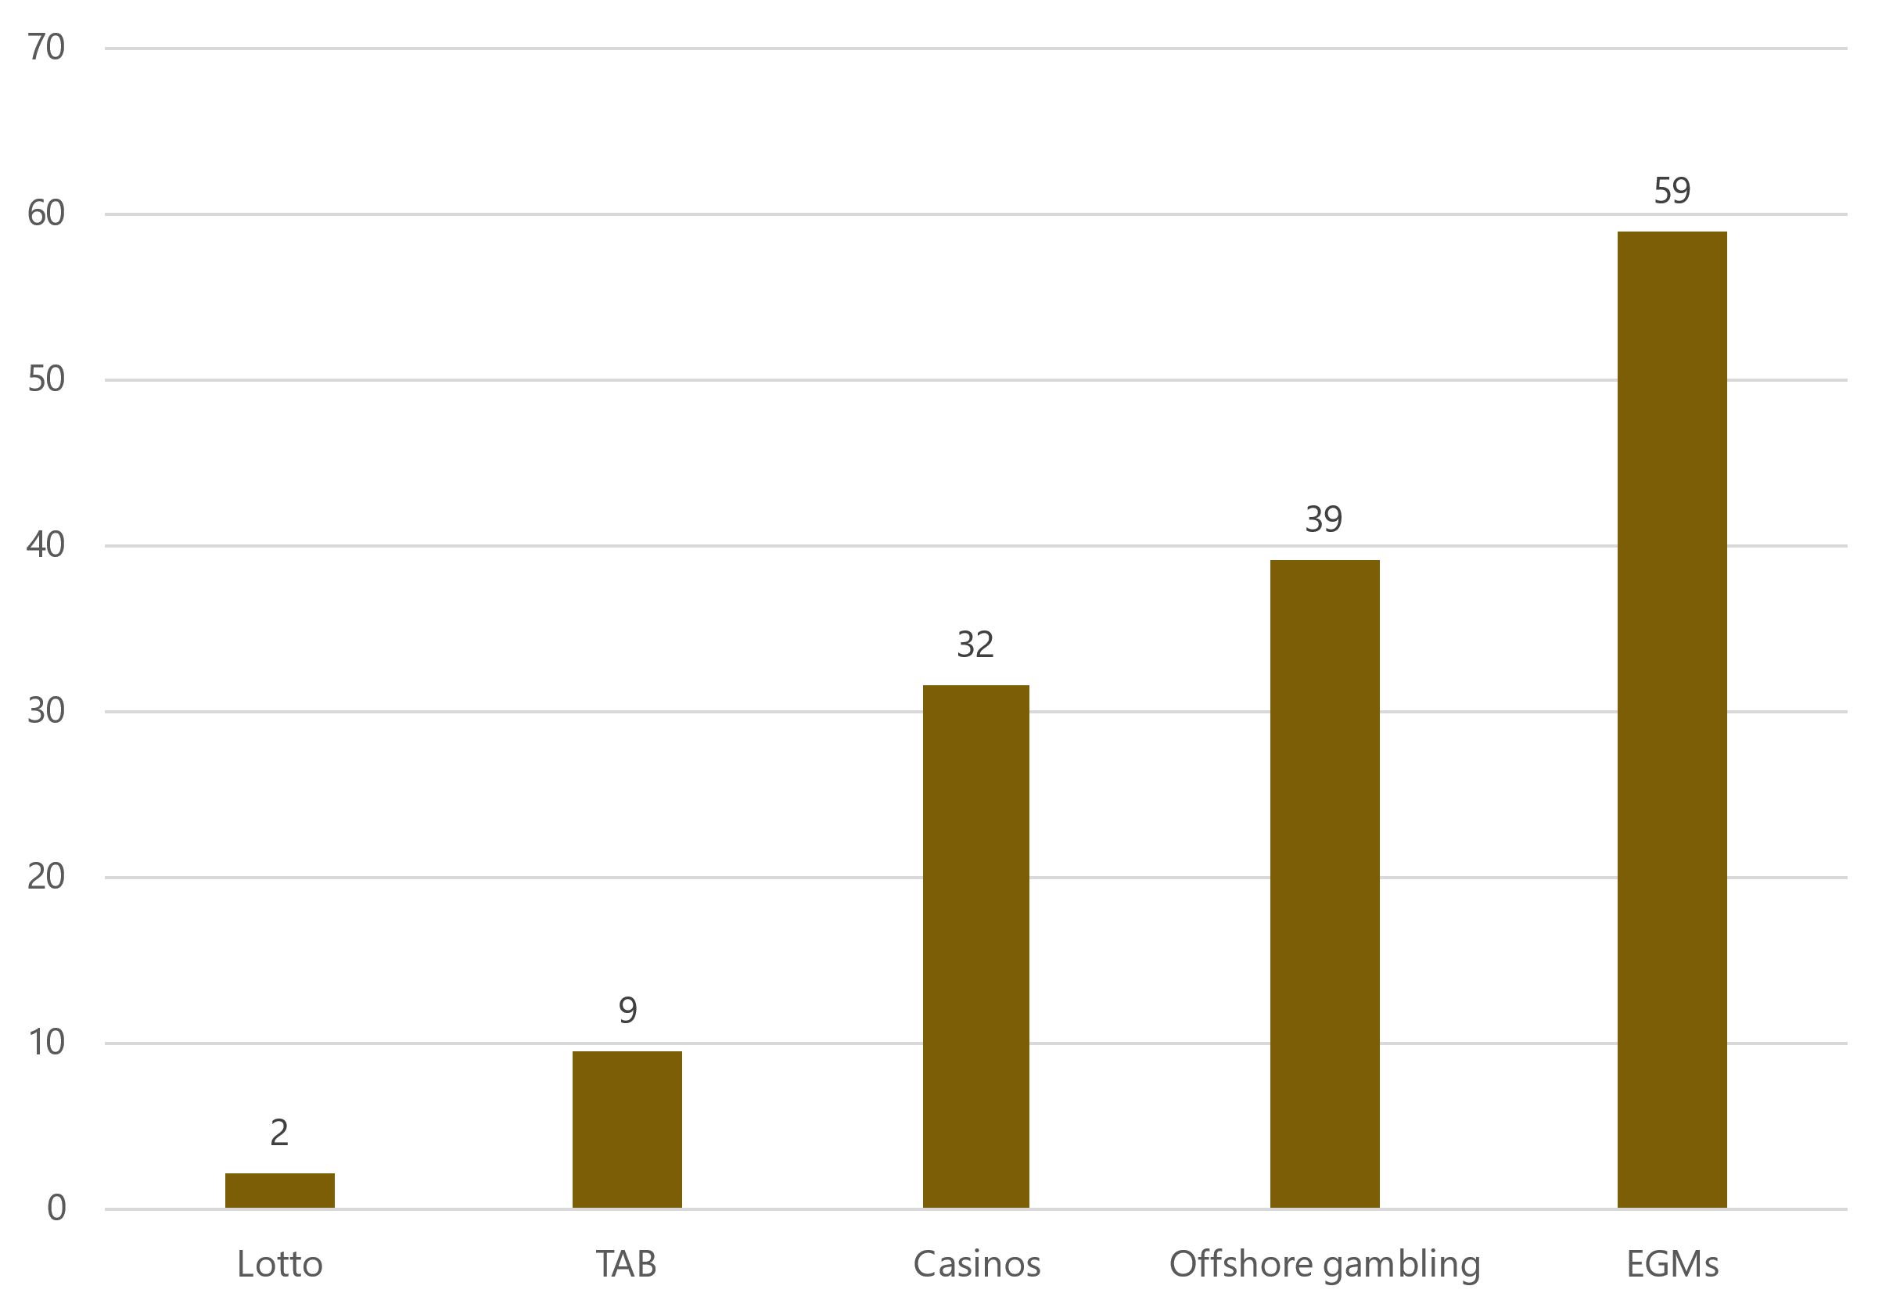

Figure 15 shows that those gambling at casinos, on offshore-based sites and on EGMs at pubs and clubs appear more likely to receive gambling harm intervention services than those gambling on Lotto or the TAB. In Figure 13, we employ the same methodology but analyse expenditure rather than presentations.

Figure 13. Expenditure per player by gambling type in 2020[34][35] (Bevin, 2022; Department of Internal Affairs, 2023a; Statistics NZ, 2024; Te Whatu Ora, 2020)

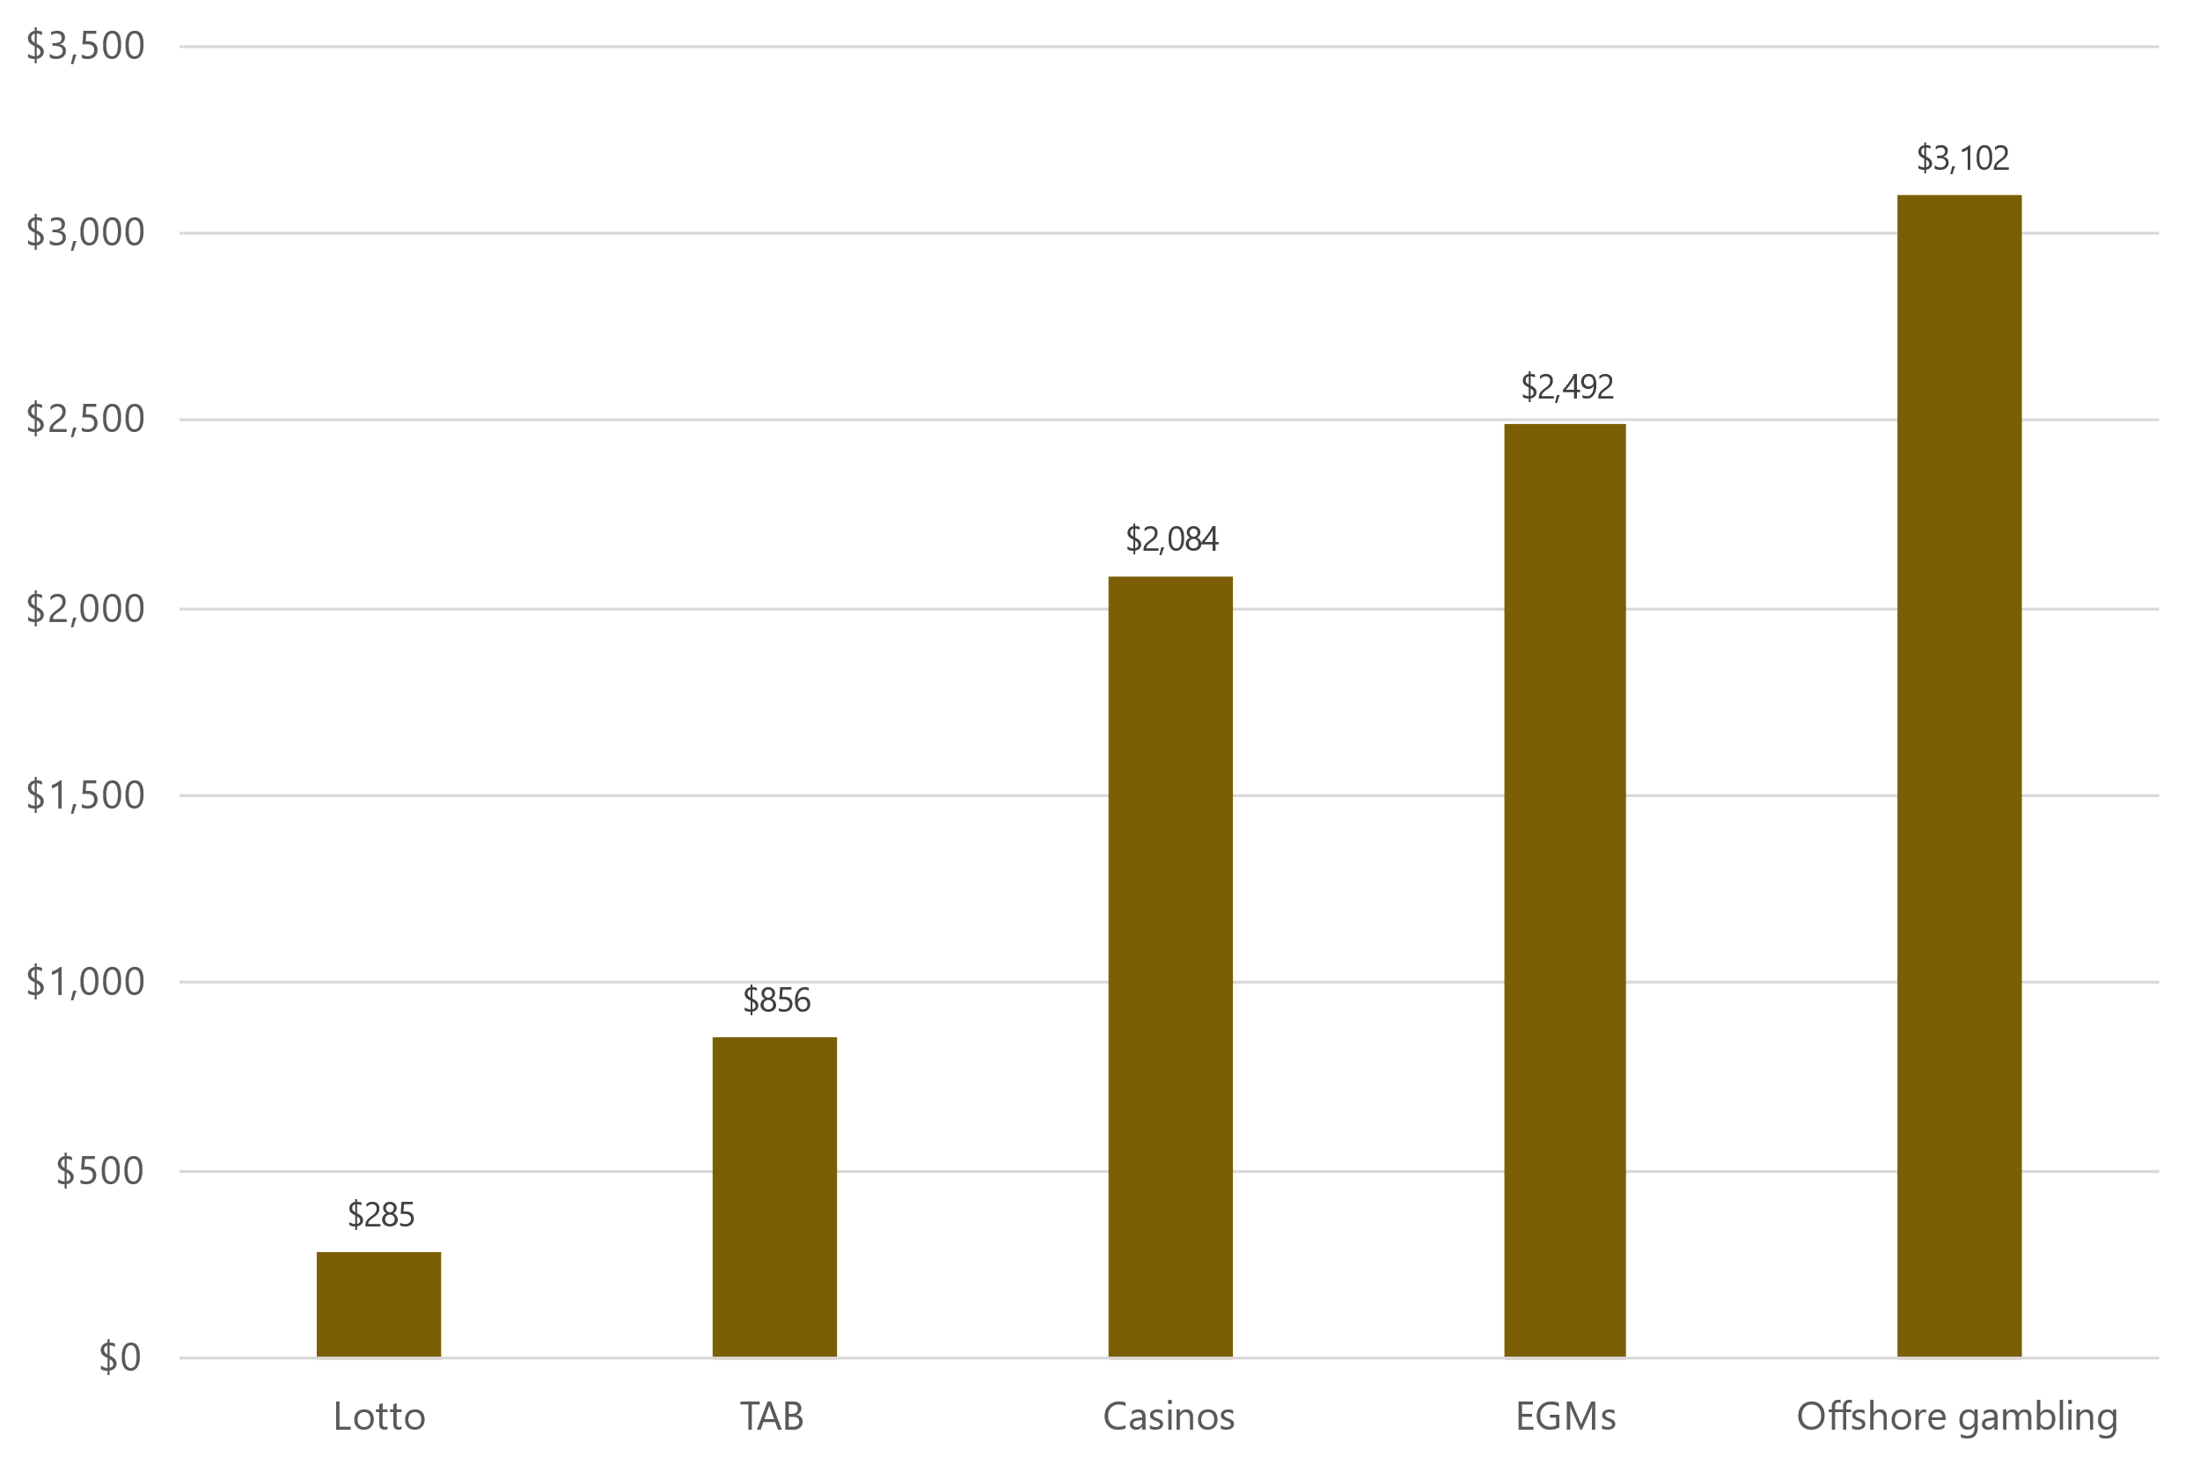

Similar trends emerge when looking at expenditure, as individuals gambling at casinos, on offshore-based sites and on EGMs at pubs and clubs appear to lose significantly more annually than those gambling on Lotto or the TAB. The levy for each sector is currently determined by expenditure and presentations, with a higher weighting for presentations (70/30) (Ministry of Health, 2022). The current levies reflect the relative harm shown in Figure 12 and Figure 13, as EGM operators incur the highest levy (1.08%), followed by casino operators (0.87%), the TAB (0.76%) and Lotteries Commission (0.44%). The results indicate that offshore-based gambling incurs a similar amount of harm to EGMs/casinos, suggesting that a levy of similar magnitude could be appropriate.

The Strategy outlines a total investment package of $76.123 million over three years to fund various services aimed at minimising gambling harm (Ministry of Health, 2022). If the Gambling Act was amended to include offshore-based operators as an additional levy-paying sector, and the levy amount remained unchanged, the levies for the four existing sectors would decrease, reflecting their proportionally reduced expenditure and presentations relative to the overall sum under consideration. In this scenario, harm minimisation would remain the same, and the benefits of regulating offshore-based providers would be directed towards the existing levy-paying sectors in the form of reduced levies. Given our comments above, a more consistent approach could involve an additional investment package directed at minimising online gambling harm specifically that is funded through extending the existing levy (or POCC) or introducing a separate levy to offshore-based gambling providers.

Regulating offshore-based gambling operators acknowledges the harm associated with this growing market, and potentially justifies additional funding and therefore an additional levy. The magnitude of this new levy would be determined by the sum of the additional investment package in the next Strategy and the projected expenditure/harm presentations of the offshore-based gambling market, should a similar approach be adopted to that of the existing Strategy. Although Figure 12 and Figure 13 suggest that offshore-based gambling incurs less harm relative to EGMs/casinos, there are three distinct elements of this market that may justify a higher levy and are worth considering from a regulatory and policy point of view:

* **Accessibility** 
  + Online casinos mostly offer a level of continuity comparable to that of EGMs and physical casinos. However, the online platform introduces a unique level of accessibility, often with minimal or no restrictions.
* **Harm minimisation**
  + Online casinos are not subject to the harm minimisation approaches that are undertaken by Class 4 venues and casinos.
* **Social investment**
  + The existing regulated sectors are either not-for-profit or return significant profits to communities through grants and other funding. While offshore-based sports and race betting sites do return a portion back to the NZ Sports and Racing sector, this amount is only a fraction of the POCC, and does not apply to online casinos.

##### Minimising gambling harm sector needs

As noted throughout this report, the 2024 Needs Assessment was conducted during a significant time of change across Aotearoa New Zealand’s government, health, minimising gambling harm agency and provider sectors. These changes provide important context for the following participants’ perspectives about gambling harm sector needs[36]. Overall, although a small number of participants highlighted a few systems change opportunities, almost all identified a number of perceived gaps and risks that require attention.

A quote in white text with a red background



###### Participants’ perceptions of sector strengths

**A few participants perceived that systems change has provided some new opportunities:** A small number of interviewed gambling agency representatives highlighted that systems change provided a range of new opportunities for the minimising gambling harm Strategy and sector, such as:

* Improved partnerships between Te Whatu Ora and Te Aka Whai Ora
* Collective government agency responsibility and response to provider queries
* Open and challenging conversations and shared learnings across government agencies particularly in relation to priority population and lived experience realities, contexts and needs
* A review of minimising gambling harm systems and providers who have had contract roll-over for several years
* A review of outdated and inconsistent gambling regulations.

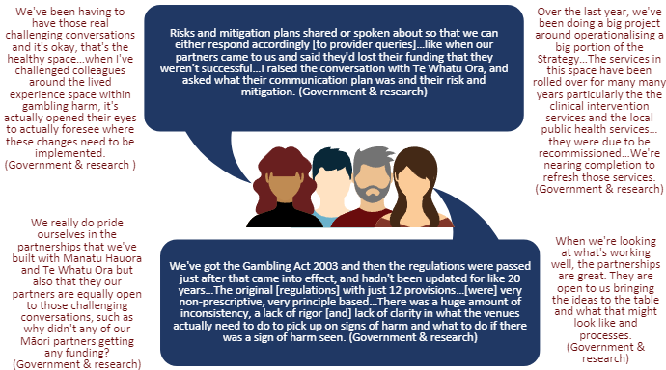

###### Participants’ perceptions of sector gaps

**Most participants perceived that systems change has not been well executed:** Most interviewed participants emphasised that systems change was extensive and gambling agencies, industry and providers were neither well prepared nor supported to understand and work with these changes. Some participants described systems change as building the plane while we’re flying it (Government & research)and perceived that the separation and sharing of roles and responsibilities for implementing the Strategy across three government agencies has further complicated an already complex system and introduced three key risks that require mitigation.

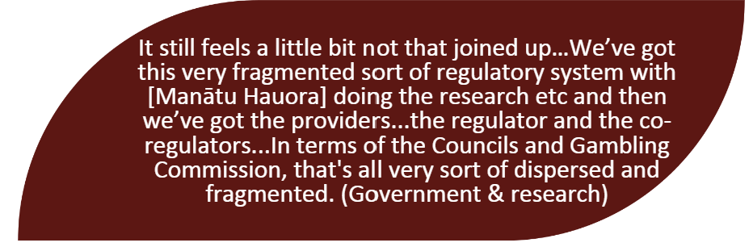

* **Risk one - Separation of specialist gambling harm and multi-disciplinary skillsets within government agencies:** Splitting functions for procurement, funding and commissioning, and evaluation of services from policy and research was perceived as:
  + Ignorant of interdependencies between different components of the gambling sector
  + Reducing access to specialist skillsets and expertise within agencies - you've just got really small groups of people across three agencies (Agency). Alongside consideration of a lead provider model between 2022-2023, this resulted in delayed provider and research contracting and commissioning. While efforts were made to establish efficient interagency engagement, some participants noted this was not yet functioning optimally, likely due to a lack of time and/or commitment within agencies.

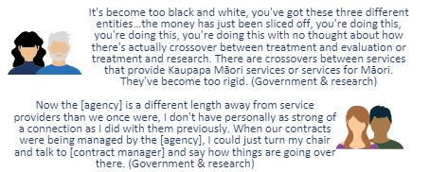

* **Risk two - A lack of clarity and understanding about different government agency roles and responsibilities:** While a systemic process appears to have been followed within agencies, some participants remained unclear and uncertain about how roles and responsibilities across agencies were determined and noted limited communication has led to confusion for some in the agency and provider sector. Some participants also highlighted potential ongoing risks relating to the Government’s indications about disestablishing Te Aka Whai Ora and the implications of this for Kaupapa Māori provider commissioning and contracts.[37]

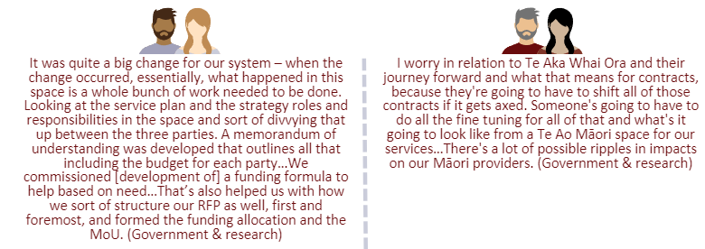

* **Risk 3 - Reduced gambling-specific public sector workforce capacity:** A small number of participants highlighted that integration of gambling agencies into Te Whatu Ora and initiatives with a broader AoD focus has reduced gambling-specific workforce capacity, autonomy and institutional knowledge within agencies.

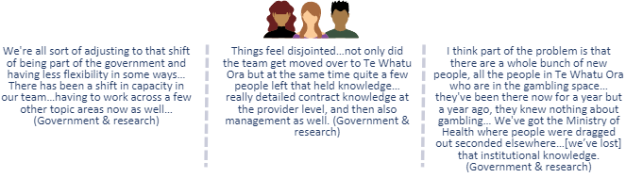

Although most stakeholders considered sector change responsive to inequities and the needs of priority populations within the gambling sector – specifically expansion and national delivery of Pacific and Asian provider services, and allocation of Kaupapa Māori provider contracting and commissioning to Te Aka Whai Ora – some participants highlighted:

* A need to acknowledge within Asian and Pacific service and funding requirements the need to service diverse ethnic-specific population groups in ways that resonate with deep cultural and contextual understandings.
* A lack of clarity about how Te Tiriti obligations would be upheld by national provider services to ensure all providers are adequately equipped to respond to Māori gambling harm needs.

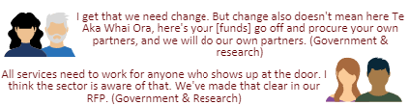

Some participants also perceived that although young people/rangatahi are a priority population, recent sector/systems changes do not adequately respond to youth gambling needs. It is important to note however that Te Whatu Ora have recently contracted the New Zealand Drug Foundation to add gambling harm components to their Tūturu education program in schools[38] - funded from the Strategy line “Public health in Schools (young people/rangatahi)”. Evidently, clear communications about this are required across the sector, particularly since some participants noted the importance of engaging with primary schools/parents and in small localities liaising with immersed and locally-known community agency representatives in schools (e.g., NZ Police) who are/can be first point of contact and referral to providers.

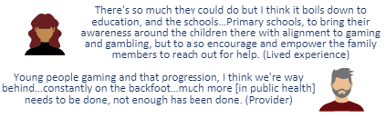

**Most participants perceived that recent provider procurement was not well executed:** A small number of participants noted that moving commissioning functions to Te Whatu Ora and Te Aka Whai Ora could potentially strengthen provider procurement.

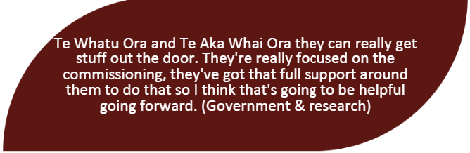

However, most participants did not consider this the case and highlighted several challenges with Te Whatu Ora’s recent provider procurement process which was described as:

* **Litigious and transactional:** Procurement processes were noted as prescriptive, rigid and government agency led. A small number of participants noted these processes limited Māori inclusion and representation. In contrast, some participants reflected on Te Aka Whai Ora’s procurement co-design process, with Māori for Māori, noting this as inclusive and respectful of provider expertise and genuine partnership.



It is important to note that an MoU signed in good faith between Manātu Hauora, Te Whatu Ora and Te Aka Whai Ora delegated Kaupapa Māori provider commissioning and funding to Te Aka Whai Ora. However, mixed understandings remained about Kaupapa Māori service providers who submitted separate bids for Te Whatu Ora funds - particularly since no Kaupapa Māori providers were selected in this space despite some being the only gambling harm provider in their region and servicing both Māori and mainstream communities. Despite no longer being funded to service non-Māori these providers are committed to remaining accessible to all.

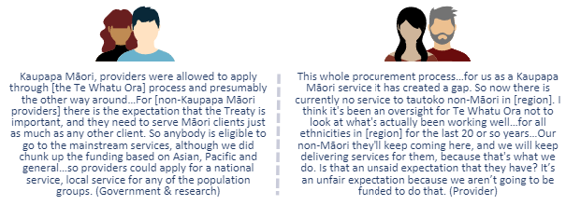

* **Resource and time intensive:** Release of the provider RFP in June 2023 and short-turn around requirements placed extensive resource and time constraints on providers. A few participants noted Te Whatu Ora provided limited clarity, communication and support around the RFP requirements.

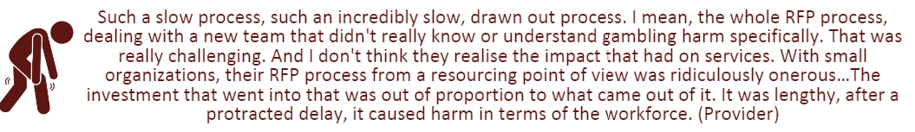

* **Informed by agency representatives with limited gambling sector knowledge/engagement and relationships with providers:** Notably, some participants highlighted that the gambling expertise, experience, institutional knowledge and provider relationships that sit within Manatū Hauora were critical but excluded from recent provider procurement processes and commissioning between late 2023-early 2024. This seemed to contradict the working relationship intended across three government agencies, especially given the important role that a small number of Manatū Hauora staff played in supporting new staff and management entering the minimising gambling harm space.

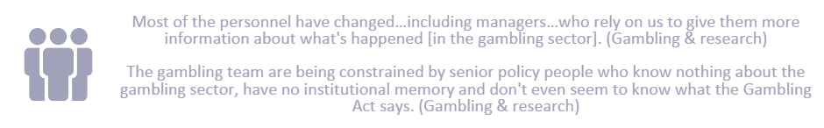

* **Limiting service options and increasing clinical risk:** Most provider and gambling industry participants noted that the disestablishment of one long-standing national harmful gambling service provider:
  + **Reduced service options, access and choice for potential harmful gamblers and whānau/families.** A few participants also noted concerns that the sole mainstream national provider service moving forward does not provide a range of in-house wrap-around social and support services like those offered by the disestablished provider, and do not have on-site premises in many regions across Aotearoa New Zealand.

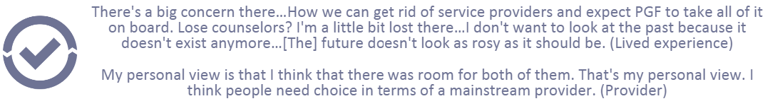

* + **Was not well managed.** As described by a small number of participants, processes were unrealistic and disrespectful of the gambling specialist expertise within this service and relationships held across the gambling sector with government agencies, providers and industry. A few participants noted that the proposed process and timing to dissolve this service by end-December 2023 and notification two-months prior:
    - Enhanced staff pressures and anxiety about future employment options just before Christmas
    - Increased potential clinical risks due to the loss of a specialist workforce within this provider setting (in addition to limited workforce capacity challenges across the health sector). Participants also perceived a lack of regard about the transition of current clients receiving support from this provider as a critical risk.

###### Participants’ perceptions of sector needs

**All participants noted that the gambling harm sector needs a well-functioning system:** All participants were observably in a state of change and disruption at the time of interviewing – while it was noted that change can provide an opportunity to re-set, most participants emphasised that change must be supported by a well-functioning, communicative and co-ordinated system.

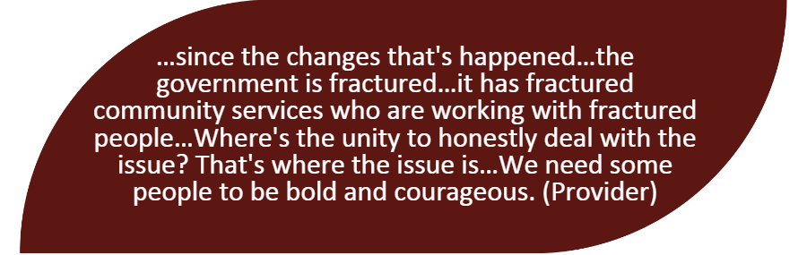

Some participants specifically noted a need for:

* **Improved co-ordination across government agencies:** Participants acknowledged the need to allow adequate time/consideration, and cross-agency collaboration lead by Manatū Hauora to transition systems (especially data and monitoring systems) and knowledge across Te Whatu Ora and Te Aka Whai Ora. Most participants also emphasised increased provider challenges and pressures resulting from all three government agencies undertaking major commissioning processes simultaneously and/or in close succession – many highlighted a need for representation from each of the three agencies on current and future Te Whatu Ora provider procurement panels (similar to how the 2023 Research RFP process was conducted and lead by Manatū Hauora).

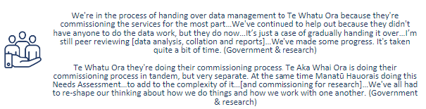

* **Strong relationships, co-ordination and connection across the sector:** Most participants (agency, providers and industry) commonly expressed a sense of loss for the gambling harm provider sector as a result of recent provider procurement. A small number of participants noted that the management of this process exemplified relationships across the sector had moved backwards – to the 1990’s - and emphasised an urgent need to re-establish stronger sectoral relationships.

Some participants also considered the gambling industry a critical relationship partner to ensure efficient and effective systems and seamless transitions for harmful gamblers from venues to support services. However, participants from both the provider and industry sectors expressed mixed views about the reality of establishing genuine relationships and some described aspirations for such as superficial lip service with little commitment or follow-through.

Others described a close working relationship between the sector [casinos] and recently disestablished provider and were unsure about the reality/feasibility of this model in future. Industry lead liaison groups and other forums inclusive of all gambling stakeholders were described as providing an opportunity to improve relationships and communications between the gambling industry and service providers. However, participants expressed mixed views about the purpose and efficiency of these groups, and commitment varied across the country.

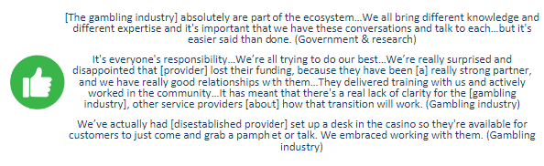

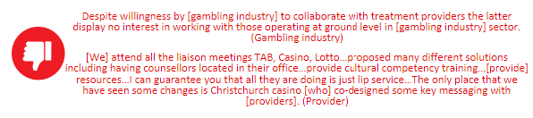

* **Strong communications across the sector:** As above, some participants expressed a lack of communication and clarity from government agencies across the sector – a critical factor given the state of flux and health and gambling sector reforms all stakeholders were experiencing at the time of interviewing. A small number of participants also noted a critical need to provide clear public communications and messaging for those who may be aware of and/or impacted by sector changes.

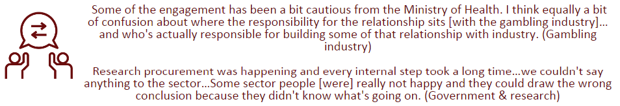

* **Efficient data and monitoring systems:** Some participants highlighted a need for a data collection and monitoring system that enables shared and timely access to data across three separate agencies with different but ideally complementary roles and responsibilities.

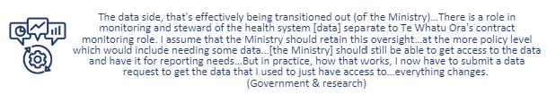

* **A system that genuinely values and integrates lived experience into all aspects of gambling sector service development and delivery:** Some participants noted involvement and inclusiveness of lived experience representation in some aspects of sector initiatives and design, and/or partial involvement in critical processes. Partial and/or selective inclusion was not perceived to reflect or value the voice of lived experience.

Almost all lived experience participants acknowledged the government’s rhetoric and verbal commitments for inclusiveness but considered this inauthentic since lived experience advice was not necessarily actioned. Lived experience advisors were also described as often receiving limited notification of hui and prior access to necessary information. Limited follow-up and/or notification of decision-making and outcomes after consultation was considered tokenistic and tick-box.

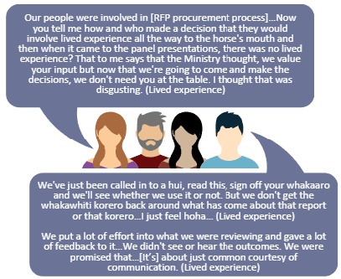

* **Clear and transparent funding:** Some participants noted concerns about a reduced clinical workforce and whether funds previously allocated to the now disestablished provider would/could be re-allocated to optimise specialist clinical workforce capacity. Transparency of levy funds and expenditure was considered a critical need.

The underutilisation of ear-marked gambling research funds since 2020 was also queried - …two years with no new research funding? (Provider 1/3). However, as data collection was underway, a gambling research RFP was released in December 2023. It is important to recognise that one FTE within the Ministry oversees the research function and budget – without accessible procurement support the capacity of this role and future required commissioning is limited. It may be important to consider adequate support for this role.

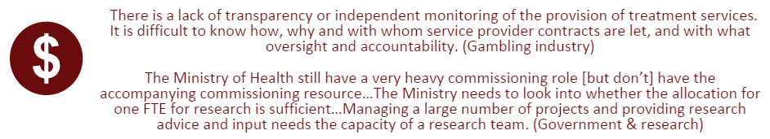

* **Review of the Strategy to ensure:**
  + Funding for provider promotions/communications: Some participants noted current funding allocations do not cover the need for providers to promote and raise awareness of their services.
  + Funding allocations for services across the gambling harm continuum: A small number of participants noted funding allocations prioritise severe harmful gamblers and inadequate investment is currently placed on addressing mild to moderate gambling.
* **Online gambling regulation:** All participants noted an urgent need to regulate online gambling and develop appropriate legislative requirements to ensure the use of harm minimisation strategies across all gambling forms, as well as appropriate contributions to the gambling levy from offshore online providers. Government agencies have previously reviewed the potential for online gambling regulation – and as noted above it appears there is potential under the current Government for progression in this area. It is important to note however, that any development of online regulations must consider potential and unanticipated consequences, such as a precedence being set for the expansion of online gambling products and/or advertising.

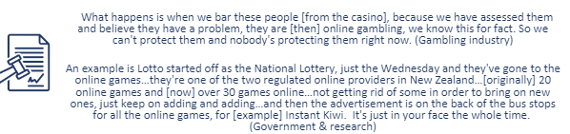

* **Review of the Gambling Levy:** A small number of participants noted a need to review the gambling levy to acknowledge:
  + Different types of Class 4 venues – Clubs were noted as having stronger controls and relationships with patrons compared to public venues and thus a more controlled environment which should be reflected in levy calculations.
  + Service provider responses to online gambling
  + Levy funds and calculations based on presentation numbers does not enable provider promotions to reach potential harmful gamblers that do not present to services.

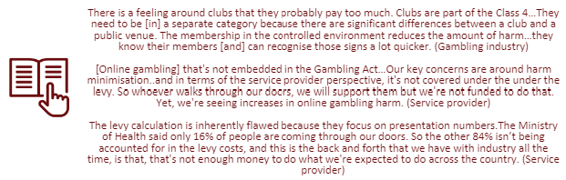

For the purpose of wider contextual insights regarding the gambling levy it is important to note stakeholders hold two distinct and contrasting views about:

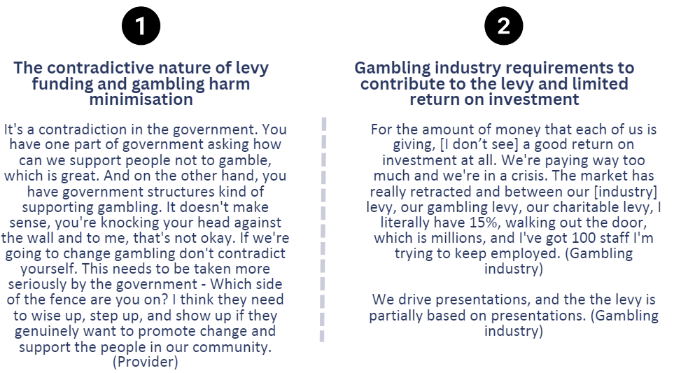

##### Clinical intervention service needs

Most interviewed participants highlighted a number of clinical intervention service gaps such as ongoing workforce capacity challenges within the harmful gambling sector (and across the health sector generally), as well as new gaps in clinical responses to potential online gambling harms within the Strategy.

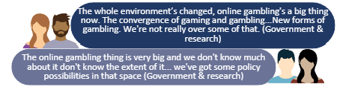

Most interviewed participants highlighted a range of clinical intervention service gaps and a need for the Strategy to support:

**Increased clinical workforce capacity:** Participants provided mixed views about whether the current clinical workforce capacity was able to address harmful gambler and whānau needs. Most participants noted reduced numbers of client presentations to harmful gambling services in recent years – some inferred this may suggest reduced need for such services while others thought this could be explained in part by notably large reductions in client referrals from Whakarongorau Aotearoa - Gambling Helpline Aotearoa compared to previous years when an independent Gambling Helpline service was provided.

A small number of participants also perceived that workforce capacity with gambling expertise was further reduced due to the recent disestablishment of a long-standing national provider (noted above), and advocated a need to ensure clinical workforce funds previously allocated to this provider were reinvested in maintaining and/or growing the clinical workforce. The potential to increase peer support services was commended but not at the cost of clinical workforce capacity – particularly in light of the extensive clinical supervision and oversight required for peer support services.

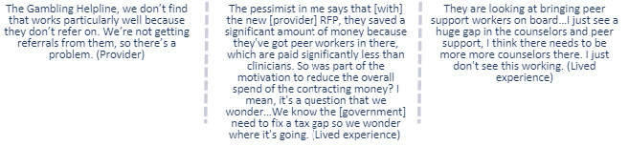

**Increased access to out-of-hours clinical services, residential care and support in prisons:** Some participants emphasised the importance of reducing wait times and providing immediate clinical responses/intervention for harmful gamblers but noted that limited clinical workforce capacity compromised timely access and support. Suggested recommendations to strengthen access to clinical services included a need to provide:

* Out of work hours and weekend services and support
* Residential services, intensive support and reprieve for harmful gambling clients and whānau/families
* Adequate support in prisons and residential support on release.

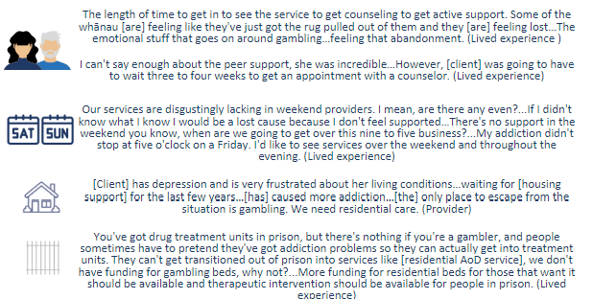

**Stronger workforce recruitment and retention strategies:** Most participants advocated a need to grow gambling harm clinical capacity but also noted three main risks that require attention.

* **Workforce recruitment (pipeline, education and qualification):** In line with workforce capacity limitations noted above, most participants highlighted that the pipeline for qualified harmful gambling clinicians and specialists was also extremely limited. Participants did not consider generic addictions training and curriculum content for prospective (AoD) clinicians adequate enough to cover the depth of understandings required for clinical specialists in gambling harm. A review and refinement of harmful gambling course content was strongly recommended. Participants also highlighted the importance of ensuring that lived experience was represented and integrated into developing and delivering pipeline education and training.
* **Workforce development:** Most participants highlighted that a long-established workforce development provider was recently disestablished and there was little communication from Te Whatu Ora about how this would be addressed. Ongoing workforce development delivered by specialists in minimising gambling harm was considered critical. Some participants suggested current harmful gambling providers may be best placed to strengthen and deliver workforce development pathways for clinical and peer services – especially for priority populations - since some had been approached by new providers with little gambling experience and cultural expertise to help inform their responses to harmful gambling.
* **Workforce retention and pay equity:** Some participants noted clinical staff retention was critical and emphasised a need to review and acknowledge the importance of pay equity – particularly in light of differential salary bands offered across NGO and government settings for clinical roles.

Two quotes in blue text
Two quotes in red text
One quote in black text

**Specialist responses to harmful gambling behaviour and co-morbidities:** Participants provided mixed perspectives about perceived shifts in the rhetoric and understanding of minimising gambling harm services in relation to comorbidities and wider addiction services:

* Some participants considered it necessary to ensure clinical responses to harmful gambling were not isolated from responses to other addictions: Many highlighted a need to equip wider addictions services and workforces to respond appropriately to harmful gamblers potential multiple/complex needs, and/or that gambling harm clinical services were positioned to respond to wider addictions and social service needs. Some participants also noted it was important that administrative data for potential gambling clients who present to AoD services is adequately captured to inform levy requirements and service planning.
* Some participants noted a need to recognise harmful gambling as a specialist area/workforce: Many indicated that deep understandings about gambling-specific contexts and treatment pathways cannot be addressed by generic addictions clinical responses. Integrating the Gambling Helpline into Whakarongorau Aotearoa and perceived subsequent reductions in the number of clients referred to gambling providers and limited accessibility to support was highlighted as an example of minimising specialist gambling expertise in response to harmful gambling. Interviewed tāngata whaiora (clients) supported the need for a specialist harmful gambling workforce and highlighted potential benefits of setting up co-located and/or a hub of addiction (harmful gambling, AoD and smoking cessation) and mental health supports to increase access and choice for whaiora and whānau.

Three quotes in white text on a blue background
One quote in red text

**Improved clinical responses to online gambling:** Most participants noted need for an urgent response to a fast-growing prevalence of online gambling and gaming and gambling participation. Some highlighted current and potential services and clinical models, but also noted limitations within the Gambling Act and Strategy to address/fund opportunities to minimise online gambling harms for current and prospective online harmful gamblers.

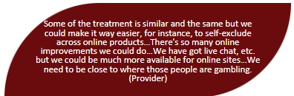

**Improved clinical responses to multi-venue exclusions:** Most participants commended and supported multi-venue exclusions but also recommended the following changes to strengthen this service:

* + Provision of clinical follow-up and/or brief intervention with harmful gamblers at the end of their MVE contract. In line with this view, a small number of participants noted a need to provide counselling, treatment and support throughout the duration of MVE contracts.
  + Reduction of timeframes between sign-ups and setting up/implementing orders
  + Ensuring venue operators adhere to harm minimisation processes and keep patron photo’s out of sight
  + Optimising the use of the CONCERN database and facial recognition equipment – noted as an expense for gambling venues with no support from Manatū Hauora. Participants provided mixed views about whether facial recognition equipment for venue operators should be funded by the levy.

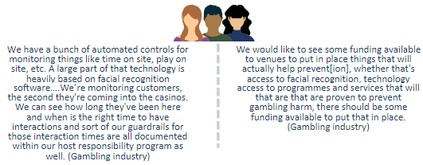

##### Public health service needs

A small number of participants noted positive changes in public health initiatives and promotions as evidenced by increased local council policies and community submissions to minimise and/or reduce Class 4 gaming outlets in some areas. However, most participants identified a range of public health service gaps and a need for the Strategy to ensure:

* **Adequate funding for provider promotion and awareness raising initiatives:** Participants noted that limited community awareness of provider services may in part contribute to reduced numbers of client presentations to harmful gambling services in recent years (as above). Some noted providers undertake promotional activities but are not funded to do so. Underinvestment in this area has limited the extent and reach of provider promotions which cannot compete in a competitive online market promoting gambling activity.

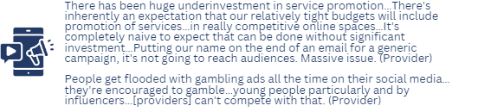

* **Development of health promotion and public health resources to increase awareness about gaming and online gambling**

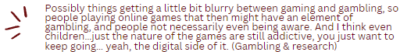

* **Evaluation of health promotion and public health resources** to understand impacts on attitudes, awareness, recall of key messages and gambling behaviour. It is also important to recognise that promotional and help seeking resources may need to be redeveloped to reflect current provider procurement outcomes.

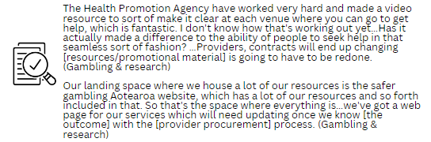

* **Development and promotion of destigmatising initiatives and key messages** and, public health responses to online gambling. A small number of participants also noted a need for research and evidence about minimising stigma/shame associated with harmful gambling (for Asian and other priority groups) – to inform the development of key public health messages. Lived experience review and reframing of harmful gambling key messages within a trauma-informed context/lens was also considered a gap in current public health messaging.

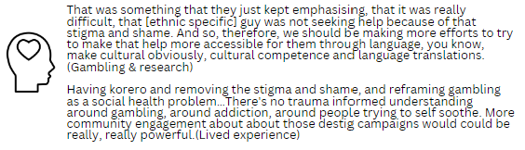

* **Use of a centralised national database of individuals excluded from gambling venues**. This could support the gambling industry to have a consistent approach and response to individuals identified with (or at risk of) harmful gambling.

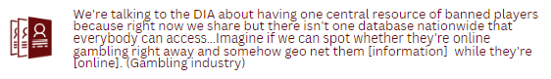

**Harm minimisation training for gambling venues:** A small number of participants highlighted collaborations between the gambling industry and service providers to deliver harm minimisation training and better support staff to effectively engage with potential harmful gambling patrons. Gambling industry participants noted this training provided ongoing upskilling for management and staff to identify and respond to signs of harmful gambling. Intervention and response policies were also developed to ensure escalation processes and immediate responses were in place, venue exclusions were encouraged and venue staff had adequate resources and tools to meet host responsibility requirements.

It is important to note that many interviewed participants highlighted a need for training content to move beyond meeting regulation requirements and increase venue staff understandings about the extent of harms experienced by individuals and whanau/families, the important impact they can have in reducing these harms, the types of support services they can refer potential patrons to and what these services can provide. Participants emphasised that the delivery of harm minimisation training would be strengthened by inclusion of lived experience and Māori, Pacific and Asian gambling harm providers/facilitators, increased role-play and site visits to gambling provider services. It is important to note that one participant also highlighted a need to ensure harm minimisation and safety measures were in place for venue staff given their frequent presence in an environment that normalises gambling behaviour and increases accessibility to gambling - Improved training content and venue rules about personal use of EGMs were recommended.

Two quotes in white text on a blue background

Four quotes in red text

##### Research service needs

Most interviewed participants highlighted a range of research and evidence gaps and noted a need for the Strategy to ensure:

* **A range of commissioning approaches:** Some participants noted limited research funding opportunities in recent years and potentially limiting opportunities with the recent RFP - live at the time of interviewing. RFP research topics, eligibility criteria and available funds were considered prescriptive, exclusive and a barrier to undertaking robust and extensive studies. In contrast, others highlighted limited opportunities for timely research that is responsive to sector needs and recommended spreading and/or staggering research funds annually rather than committing all funds to fixed term projects in the first term of a three-year strategy. Manatū Hauora remain open to this process and acknowledge that while there was no set timeline for the commissioning of previous research funds, COVID, health reform and sector changes resulted in a bulk funding approach.

Commissioning research at the same time as service provider procurement and commissioning was considered ill-timed and rushed during the latter part of 2023. Extension within the recent RFP to international gambling research providers/organisations was perceived by some to reflect a lack of commitment to developing New Zealand based research capacity, and highlighted a risk that international researchers, if commissioned, may have limited understanding of the New Zealand harmful gambling context.

Two quotes in white text on a blue background

Two quotes in red text

* **More up-to-date prevalence data and better research dissemination:** Some participants considered gambling prevalence data was outdated, and noted there was no recent measurement of online gambling participation/prevalence. A small number of participants expressed concerns that government and agency regulatory bodies were informed by outdated and international (rather than New Zealand based) research and evidence. However, it is important to note that prevalence data is available up to 2020 and a new survey is currently in the field. Also, The Health and Lifestyles survey had included questions about online gambling since 2010 – with the 2018 and 2020 surveys including more detailed questions about overseas online, Lotto online and TAB online gambling participation. These insights suggest a lack of awareness among all gambling stakeholders and a need to ensure research findings and communications are clear and available, and dissemination methods build on what is currently in place – i.e., the Manatū Hauora Website, LinkedIn and FaceBook pages, conference and workshop updates and a directory newsletter. It is also important to note some participants’ views about a need to accurately capture the reach of harmful gambling impacts – specifically the number of people affected by a harmful gambler.

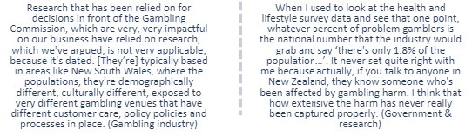

* **Review and refinement of the research priorities:** A small number of participants noted a need to review and reset the gambling harm research priorities and agenda – some perceived the priorities were informed by international experts with limited New Zealand contextual insights – others considered previous and recent research RFP topic projects were fragmented and conducted by groups for limited purpose (Gambling industry 6). Some participants also emphasised a requirement for greater inclusion of lived experience voice.

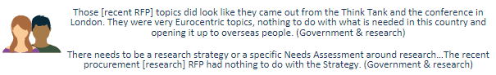

Some participants specifically highlighted a need for research on:

* + Cashless and online gambling, and gaming and gambling
  + Different forms of gambling
  + Outcomes for harmful gamblers and/or whānau/families who present to gambling harm services.

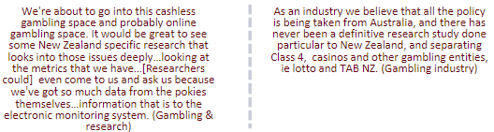

* **Growth and retention of gambling harm research capacity:** Most research representatives noted a need to increase gambling research capacity and suggested investment in building the pipeline of potential researchers/experts in the field through MA/PhD scholarships (and ensuring adequate supervision and support was in place with academic institutions.

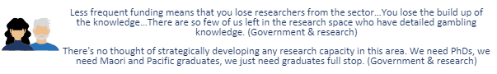

* **Better utilisation of government administrative data and translation of research findings into policy:** Some participants highlighted a critical need to translate research into policy implications and optimise the use of routinely collected data in agencies (e.g., DIA) to inform policy and strategic information needs and priorities – such as understanding why gambling expenditure has increased despite a reduction in the number of EGMs. Learnings may be gained from the process MSD undertook with the Growing Up in New Zealand data where researchers and policy analysts worked together to address information gaps and analysis.

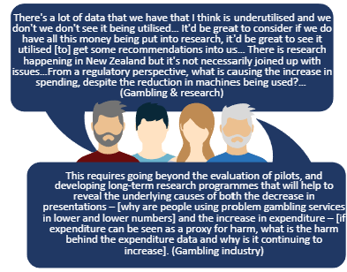

A small number of participants also reiterated that previous research recommendations highlighted by Synergia (2022) to understand the drivers for decreasing presentations to services and increasing expenditure remain outstanding:

A small number of participants also noted a need to critically review all gambling research and ensure that administrative provider data and levy considerations clarify:

* + whether the number of persons presenting to services are unique individuals or multiple presentations by the same person
  + unique versus multiple treatments.

These participants also highlighted a need for research and evidence to address the following questions:

* + What impact is the over $20 million each year having on gambling harm?
  + Which of the strategies that have been implemented over the last 10 years has had the most positive impact?

# References

Abbot, M., Bellringer, M., & Garrett, N. (2018). *New Zealand National Gambling Study: Wave 4 (2015)*. Auckland University of Technology, Gambling and Addictions Research Centre. https://www.health.govt.nz/system/files/documents/publications/national-gambling-study-report-6-aug18.pdf

Abbott, M. (2017). Gambling and Gambling Harm in New Zealand: A 28-Year Case Study. *International Journal of Mental Health and Addiction*, *15*(6), Article 6. https://doi.org/10.1007/s11469-017-9767-6

Abbott, M., Bellringer, M., Garrett, N., & Mundy-McPherson, S. (2014). *New Zealand 2012 National Gambling Study: Gambling Harm and Problem Gambling. Report Number 2*. Ministry of Health – Manatū Hauora, New Zealand Government. https://hdl.handle.net/10292/12853

Abbott, M., & Volberg, R. (1991). *Gambling and problem gambling in New Zealand* (Research Series No. 12). Department of Internal Affairs.

Abbott, M., & Volberg, R. (2000). *Taking the pulse on gambling and problem gambling in New Zealand: A report on Phase One of the 1999 National Prevalence Survey.* Department of Internal Affairs. https://www.dia.govt.nz/diawebsite.nsf/wpg_URL/Resource-material-Our-Research-and-Reports-New-Zealand-Gaming-Survey?OpenDocument#ph1

Archer, D., King-Finau, T., Kuresa, B., & Fleming, T. (2021). *Youth19 Gambling Brief*. The Youth19 Researchers and The Adolescent Health Research Group. https://www.youth19.ac.nz/publications/gambling

Bellringer, M. E., Janicot, S., & Ikeda, T. (2024). Changes in some health and lifestyle behaviours are significantly associated with changes in gambling behaviours: Findings from a longitudinal New Zealand population study. *Addictive Behaviors*, *149*, 107886. https://doi.org/10.1016/j.addbeh.2023.107886

Bevin, A. (2022, October 10). *Online gambling products ‘aggressively’ targeting NZ*. Newsroom. http://newsroom.co.nz/2022/10/10/online-gambling-aggressively-targeting-new-zealand/

Browne, M., Delfabbro, P., Thorne, H. B., Tulloch, C., Rockloff, M. J., Hing, N., Dowling, N. A., & Stevens, M. (2023). Unambiguous evidence that over half of gambling problems in Australia are caused by electronic gambling machines: Results from a large-scale composite population study. *Journal of Behavioral Addictions*, *12*(1), Article 1. https://doi.org/10.1556/2006.2022.00083

Browne, M., Goodwin, B. C., & Rockloff, M. J. (2018). Validation of the Short Gambling Harm Screen (SGHS): A Tool for Assessment of Harms from Gambling. *Journal of Gambling Studies*, *34*(2), 499–512. https://doi.org/10.1007/s10899-017-9698-y

Christchurch Casino. (2023). Community Grants. *Christchurch Casino*. https://christchurchcasino.co.nz/community-grants/

Christopher, F. (2021). Gambling: A neglected public health issue. *The Lancet Public Health*, *6*(1), e1. https://doi.org/10.1016/S2468-2667(20)30290-5

Community Matters. (n.d.). *Who makes lottery grant decisions?* Retrieved 23 January 2024, from https://www.communitymatters.govt.nz/ask-us/view/564

Department of Internal Affairs. (2021a). *Gambling class 3 lottery license rule changes*. https://www.dia.govt.nz/Gambling-class-3-lottery-license-rule-changes

Department of Internal Affairs. (2021b). *Point of Consumption Charges—Offshore Operator Guidance*. https://www.dia.govt.nz/Racing-Policy---Point-of-Consumption-Charges

Department of Internal Affairs. (2021c). *Regulatory system information: Gambling*. https://www.dia.govt.nz/Regulatory-Stewardship---Gambling

Department of Internal Affairs. (2021d). *Understanding gambling in the community*. https://www.dia.govt.nz/Gambling-territorial-authorities-policy-review-process-understanding-gambling-community

Department of Internal Affairs. (2022). *Class 4 Grants Data Analytical Review*. https://www.dia.govt.nz/gambling-statistics-class-4-grants-data-analytical-review

Department of Internal Affairs. (2023a). *Annual Gambling Expenditure Statistics* [dataset]. https://catalogue.data.govt.nz/dataset/gambling-expenditure-statistics

Department of Internal Affairs. (2023b). *Class 4 Gambing Key Performance Indicators* [dataset]. https://catalogue.data.govt.nz/dataset/class-4-gambling-key-performance-indicators

Department of Internal Affairs. (2023c). *GMP Dashboard* [dataset]. https://www.dia.govt.nz/gambling-statistics-gmp-dashboard

Department of Internal Affairs. (2023d). *GMP Dashboard—Trends*. https://www.dia.govt.nz/gambling-statistics-gmp-dashboard

Department of Internal Affairs. (2023e). *Reducing Pokies Harm*. https://www.dia.govt.nz/Gambling-Reducing-Pokies-Harm

Dunedin Casino. (2023a). *Dunedin Casino Charitable Trust Grant Recipients May 2023*. https://grandcasino.co.nz/assets/Dunedin-Casino-Charitable-Trust-Grant-Recipients-May-2023.pdf

Dunedin Casino. (2023b). *Dunedin Casino Charitable Trust Grant Recipients November 2023*. https://grandcasino.co.nz/assets/Dunedin-Casinos-Charitable-Trust_Grant-Recipients_November_2023.pdf

Edmunds, S. (2023, September 3). *SkyCity faces suspension of casino licence*. Stuff. https://www.stuff.co.nz/business/300963636/skycity-faces-suspension-of-casino-licence

Entain. (2023). *Update on TAB NZ and 365scores opportunities*. Entain. https://www.entaingroup.com/news-insights/latest-news/2023/update-on-tab-nz-partnership-and-365scores-opportunities/

Erwin, C., Lees, K., Pacheco, G., & Turcu, A. (2020). *Capping Gambling in NZ: The effectiveness of local government policy interventions*. New Zealand Work Research Institute, Sense Partners. https://www.health.govt.nz/system/files/documents/publications/capping_gambling_in_nz.pdf

Espiner, G. (2022). Lotto stores in poorest half of NZ account for 70% of sales. *Radio New Zealand*. https://www.rnz.co.nz/news/in-depth/474134/lotto-stores-in-poorest-half-of-nz-account-for-70-percent-of-sales

Fehoko, E. S. (2020). *From Games to Gambling: An Exploratory Study of Tongan-born and New Zealand-born Male Perceptions and Experiences of Gambling and Problem Gambling in New Zealand* [Auckland University of Technology]. https://hdl.handle.net/10292/13818

Fehoko, E. S., Bellringer, M. E., & Fairbairn-Dunlop, P. (2022). Culture, church, and collective: A qualitative study about gambling harm prevention and reduction in Aotearoa/New Zealand-a Tongan male perspective. *Harm Reduction Journal*, *19*(1), Article 1. https://doi.org/10.1186/s12954-022-00717-2

Gambling Commission. (n.d.). *Casino Licence Conditions*. Gambling Commission. Retrieved 23 January 2024, from https://www.gamblingcommission.govt.nz/GCwebsite.nsf/wpg_URL/Casino-Licence-Conditions-Index!OpenDocument

Gambling Commission. (2022). *Report Of The Gambling Commission*. Gambling Commission. <https://www.gamblingcommission.govt.nz/GCwebsite.nsf/wpg_URL/Reports-Publications-Problem-Gambling-Levy-2022-2025!OpenDocument>

Hart, L. (2021, July 16). *Stop relying on poor and addicted for community funding*. Stuff. https://www.stuff.co.nz/opinion/125776246/lets-stop-relying-on-our-poor-and-an-addictive-activity-for-community-funding

Kolandai-Matchett, K., Langham, E., Bellringer, M., & Siitia, P. A.-H. (2017). How gambling harms experienced by Pacific people in New Zealand amplify when they are culture-related. *Asian Journal of Gambling Issues and Public Health*, *7*(1), Article 1. https://doi.org/10.1186/s40405-017-0026-3

Lesieur, H. R., & Blume, S. B. (1987). The South Oaks Gambling Screen (SOGS): A new instrument for the identification of pathological gamblers. *The American Journal of Psychiatry*, *144*(9), 1184–1188. https://doi.org/10.1176/ajp.144.9.1184

Lotto New Zealand. (n.d.). *Instant Kiwi Online FAQs*. Retrieved 31 January 2024, from https://mylotto.co.nz/instant-kiwi/how-to-play

Lotto New Zealand. (2020). *Annual Report 2019/20*. New Zealand Lotteries Commission. https://assets.mylotto.co.nz/assets/uploads/71e5fae4-8738-11ee-a52e-005056af723d.pdf

Lotto New Zealand. (2023). *Annual Report 2022/23*. New Zealand Lotteries Commission. https://assets.mylotto.co.nz/assets/uploads/97054b86-8738-11ee-878a-005056af723d.pdf

Lotto New Zealand. (2024). *Local Grants*. https://mylotto.co.nz/community-funding

Marcetic, B. (2018, June 29). *The problem with Lotto’s move into online scratch cards*. The Spinoff. https://thespinoff.co.nz/society/29-06-2018/the-problem-with-lottos-move-into-online-scratch-cards

Ministry of Health. (n.d.). *Gambling harm*. Ministry of Health. Retrieved 16 January 2024, from https://www.health.govt.nz/our-work/mental-health-and-addiction/addiction/gambling-harm/gambling-harm-research-and-evaluation/gambling-harm

Ministry of Health. (2019). *Preventing and Minimising Gambling Harm Practitioner’s Guide*. https://www.health.govt.nz/system/files/documents/publications/preventing-and-minimising-gambling-harm-practitioners-guide-2019-aug2019.pdf

Ministry of Health. (2022). *Strategy to Prevent and Minimise Gambling Harm 2022/23 to 2024/25*. https://www.beehive.govt.nz/sites/default/files/2022-06/Strategy-to-Prevent-and-Minimise-Gambling-Harm.PDF

Ministry of Health. (2023a). *Intervention services data* [dataset]. https://www.health.govt.nz/our-work/mental-health-and-addiction/addiction/gambling-harm/service-user-data/intervention-services-data

Ministry of Health. (2023b). *The Gambling Act 2003*. Ministry of Health NZ. https://www.health.govt.nz/our-work/mental-health-and-addiction/addiction/gambling-harm/gambling-act-2003

Molde, H., Holmøy, B., Merkesdal, A. G., Torsheim, T., Mentzoni, R. A., Hanns, D., Sagoe, D., & Pallesen, S. (2019). Are Video Games a Gateway to Gambling? A Longitudinal Study Based on a Representative Norwegian Sample. *Journal of Gambling Studies*, *35*(2), 545–557. https://doi.org/10.1007/s10899-018-9781-z

New Zealand Legislation. (2023). *Gambling (Harm Prevention and Minimisation) Amendment Regulations 2023*. https://www.legislation.govt.nz/regulation/public/2023/0082/latest/LMS839227.html

Palmer du Preez, K., Paavonen, A.-M., & Bellringer, M. E. (2021). Theoretically informed gender analysis for gambling harm reduction: A New Zealand study. *Harm Reduction Journal*, *18*(1), Article 1. https://doi.org/10.1186/s12954-021-00558-5

PGF Group, Hāpai Te Hauora, & The Salvation Army. (2020). *Ending community sector dependence on pokie funding. White paper.* https://www.pgf.nz/downloads/assets/11959/1/ending_community_sector_dependence_on_pokie_funding_20200717.pdf

Problem Gambling Foundation. (2020a). *Loot Boxes*. https://www.pgf.nz/downloads/assets/11960/1/loot-boxes.pdf

Problem Gambling Foundation. (2020b). *Pokies*. https://www.pgf.nz/understand-gambling/pokies#:~:text=Pokies%20are%20a%20continuous%20form,a%20week%20for%20the%20result.

Problem Gambling Foundation. (2023a). *Possible SkyCity suspension: “I just don’t want to see anyone else put themselves in debt the way that I did”*. https://www.pgf.nz/blog/possible-skycity-suspension-i-just-dont-want-to-see-anyone-else-put-themselves-in-debt-the-way-that-i-did

Problem Gambling Foundation. (2023b). *PR: Concern over young people gambling prompts awareness campaign*. https://www.pgf.nz/blog/pr-concern-over-young-people-gambling-prompts-awareness-campaign

Pullar-Strecker, T. (2023). Here’s how blocking New Zealanders from international gambling might work. *Stuff*. https://www.stuff.co.nz/business/132166691/heres-how-blocking-new-zealanders-from-international-gambling-might-work

Rimal, R., Shepherd, R.-M., Curley, L. E., & Sundram, F. (2023). Perspectives from gambling expert stakeholders in relation to electronic gaming machines in New Zealand. *Health Policy (Amsterdam, Netherlands)*, *136*, 104897. https://doi.org/10.1016/j.healthpol.2023.104897

Rockloff, M., Bellringer, M. E., Lowe, G., Armstrong, T., Brown, M., Palmer Du Preez, K., Russel, A., Hing, N., & Greer, N. (2022). *Life Course and Legacy Gambling Harms in New Zealand*. Queensland: Central Queensland University, Experimental Gambling Research Laboratory and Auckland: Auckland University of Technology, Gambling and Addictions Research Centre. https://www.health.govt.nz/system/files/documents/publications/final-legacy-harms-report-180821.pdf

Rockloff, M., Browne, M., Russell, A. M. T., Hing, N., Armstrong, T., & Greer, N. (2022). Legacy gambling harms: What are they and how long do they last? *Journal of Behavioral Addictions*, *11*(4), Article 4. https://doi.org/10.1556/2006.2022.00073

Rodda, S. N., Bagot, K. L., Merkouris, S. S., Youssef, G., Lubman, D. I., Thomas, A. C., & Dowling, N. A. (2022). Smartphone App Delivery of a Just-In-Time Adaptive Intervention for Adult Gamblers (Gambling Habit Hacker): Protocol for a Microrandomized Trial. *JMIR Research Protocols*, *11*(7), Article 7. https://doi.org/10.2196/38919

Sakata, K., & Jenkinson, R. (2022). *What is the link between video gaming and gambling?* [Text]. https://growingupinaustralia.gov.au/sites/default/files/publication-documents/lsac-snapshot-7-teenage-gambling.pdf

SkyCity. (2023). *SkyCity Annual Report 2022/23*. https://www.skycityentertainmentgroup.com/media/3590/20230823-annual-report.pdf

Statistics NZ. (2024). *Subnational population estimates (DHB, DHB constituency), by age and sex, at 30 June 1996-2023 (2015 boundaries)* [dataset]. https://nzdotstat.stats.govt.nz/wbos/Index.aspx?_ga=2.215179479.1541391696.1707881081-1022415708.1707355376

TAB New Zealand. (2020). *Harm Prevention & Minimisation Policy*. https://fobcms.tab.co.nz/sites/default/files/2020-12/Harm_Prevention___Minimisation_Policy_2020.pdf

TAB New Zealand. (2022). *TAB NZ Annual Report 2021-22*. https://static.tab.co.nz/content/uploads/TAB%20NZ%202021-22%20annual%20report.pdf

Taufa, S., Gentles, D., Berking, G., Siataga, P., Ah-Honi, P., & Fa’alili-Fidow, J. (2021). *Pasifika Youth Online Gaming and Gambling Research: Are online video games a gateway to problem gambling among Pasifika youth?* <https://www.health.govt.nz/publication/pasifika-youth-online-gaming-and-gambling-research-are-online-video-games-gateway-problem-gambling>

Te Whatu Ora. (2018). *Health and Lifestyle Survey gambling data* [dataset]. https://kupe.healthpromotion.govt.nz/#!/gambling

Te Whatu Ora. (2020). *Health and Lifestyle Survey gambling data* [dataset]. https://kupe.healthpromotion.govt.nz/#!/gambling

Wang, G. Y., & Bellringer, M. E. (2022). Social Connectedness and Associations with Gambling Risk in New Zealand. *Journal of Clinical Medicine*, *11*(23), Article 23. https://doi.org/10.3390/jcm11237123

Wardle, H. (2019). The Same or Different? Convergence of Skin Gambling and Other Gambling Among Children. *Journal of Gambling Studies*, *35*(4), 1109–1125. https://doi.org/10.1007/s10899-019-09840-5

Willis, N. (2023). *Boosting incomes for Kiwis the responsible way*. New Zealand National Party. https://www.national.org.nz/boosting_incomes_for_kiwis_the_responsible_way

Zaugg, L. (2023, September 9). Offshore online casinos find way around NZ’s advertising laws. *1News*. https://www.1news.co.nz/2023/09/09/offshore-online-casinos-find-way-around-nzs-advertising-laws/

1. <http://www.health.govt.nz/publication/informing-2009-problem-gambling-needs-assessment-report-ministry-health-0>
2. <http://www.health.govt.nz/system/files/documents/publications/gambling-harm-report-jul2012.pdf>
3. <https://www.health.govt.nz/system/files/documents/publications/informing-2015-gambling-harm-needs-assessmnt-jul15.pdf>
4. <https://www.health.govt.nz/publication/gambling-harm-reduction-needs-assessment>
5. <https://www.health.govt.nz/system/files/documents/publications/gambling-harm-needs-assessment-2021.pdf>
6. We note the effective ‘wash up’ in section 320(2) of the Gambling Act 2003 however this itself is based on an estimate.
7. <http://www.health.govt.nz/publication/informing-2009-problem-gambling-needs-assessment-report-ministry-health-0>
8. <http://www.health.govt.nz/system/files/documents/publications/gambling-harm-report-jul2012.pdf>
9. <https://www.health.govt.nz/system/files/documents/publications/informing-2015-gambling-harm-needs-assessmnt-jul15.pdf>
10. <https://www.health.govt.nz/publication/gambling-harm-reduction-needs-assessment>
11. <https://www.health.govt.nz/system/files/documents/publications/gambling-harm-needs-assessment-2021.pdf>
12. <https://www.gamblingcommission.govt.nz/GCwebsite.nsf/wpg_URL/Reports-Publications-Problem-Gambling-Levy-2022-2025!OpenDocument>
13. Group interviews were conducted on request from participants. The synergistic nature of group discussions enabled participants to build on each other’s insights in ways that would be less possible in individual interviews. Group interviews also provoked rationalisation and explicit reasoning and helped to unpack more nuanced understandings of phenomena. Group discussions were facilitated by a senior and experienced team member to ensure inclusive, respectful and safe conversations and to minimise the potential for power dynamics in a group setting.
14. Government agencies and research institutions have been grouped in light of small numbers.
15. Individual codes and numbers have been removed to strengthen anonymity. Where multiple quotes are presented in this report, the authors have included quotes from different individuals and stakeholder groups.
16. Data collection was extended to March 2024 to accommodate availability for a small number of stakeholder interviews/focus groups.
17. “Online gambling – any” includes Lotto and TAB online
18. TAB expenditure data for 2022/23 was not available at the time of this assessment.
19. We note that Christchurch Casino did previously operate an online casino between 2005-2007 (<https://en.wikipedia.org/wiki/Christchurch_Casino>).
20. As announced on 14 March 20-14
21. There are two types of society: those that apply funds to their own purposes (e.g. clubs), and those that make grants to other bodies for community purposes.
22. It is important to note that the 2020 HLS was delayed for five months due to the COVID-19 lockdown, and it is unclear what impact this had on the data.
23. Loot boxes are digital containers holding random items for players to use in a game. Players have the ability to purchase loot boxes with real money and essentially gamble on the chance of receiving ‘rare’ items (Problem Gambling Foundation, 2020a).
24. The intervention data excludes the national gambling helpline
25. Except for some contribution via the Point of Consumption Charge, and the Betting Use Information Charge paid to TAB NZ, however these are very small amounts. This is discussed further in section 10.7 below.
26. Offshore operators are subject to paying GST under the remote service rules enacted in 2016

    <https://www.ird.govt.nz/gst/gst-for-overseas-businesses/supplying-remote-services-into-new-zealand>. See also <https://www.parliament.nz/en/pb/order-paper-questions/written-questions/document/WQ_19699_2023/19699-2023-andrew-bayly-to-the-associate-minister-of>
27. <https://www.nzherald.co.nz/nz/google-pulls-bet22-gambling-ad-featuring-brendon-mccullum-from-youtube/I6ACWB7YHFCZ5LTC5V4YUAITBE/>
28. <https://www.dia.govt.nz/onlinegamblingconsultation>
29. <https://www.treasury.govt.nz/publications/risa/cost-recovery-impact-statement-problem-gambling-levy-2022-23-2024-25>
30. Noting again the decision by Cabinet in-principle to regulate online gambling websites, however the status quo reflects the law and regulation as it stands today.
31. Acknowledging that the levy formula takes into account any historical over or under-recovery for each 3 year period, however this would be a significant under-recovery which would require a commensurate increase in the levy (if the under-recovery is to be funded purely from the levy).
32. Since the latest participation data available is from the 2020 HLS, we base our analysis on expenditure and presentations from this period to maintain consistency.
33. The HLS includes pokies at pubs, clubs and casinos as a single participation category, therefore we combine EGM and Casino expenditure and intervention services data to maintain consistency.
34. Gambling expenditure refers to the money “lost” by players, e.g. the total amount gambled minus the total prizes/winnings paid. This is equal to the operating profit of each gambling provider.
35. Note that offshore gambling expenditure is derived from Regulus’ estimates which has an element of uncertainty contrary to the actual expenditure data for the regulated sectors.
36. As noted above, a total of 77 gambling stakeholders were interviewed representing government agencies and research institutions, gambling industry, service providers, consumers and those with lived experience.
37. As above, at the time of writing this Needs Assessment, the government passed a bill to disestablish The Māori Health Authority - Te Aka Whai Ora which would result in their functions being distributed between Health New Zealand and the Ministry.
38. <https://tuturu.org.nz/>