Final report summary

COVID-19 and National Immunisation Programme research

**Submitted by**  
Auckland UniServices Ltd

**Project title**   
PROP-007 Pacific Contribution to the NZ Covid-19 Response – Strengths, Weaknesses and Missed Opportunities

# : Contact information

## Point of Contact for this report

|  |  |
| --- | --- |
| Item | Detail |
| Contact person | Jason Tautasi |
| Position | Project Manager |
| Phone number |  |
| Mobile number | 02718003377 |
| Email address | jason.tautasi@auckland.ac.nz |

# : Reporting

## Overview

Studies have shown the disproportionate burden of viral pandemics, including COVID-19, on Pasifika and Māori people in Aotearoa New Zealand throughout history. The current Covid-19 pandemic is no exception. Disaggregated ethnicity data on COVID-19 from the Ministry of Health up to March 2023 showed that Pacific people had higher incidence rates of COVID-19 out as a population group, Covid-19 cases were most likely to be hospitalised with severe illness and were most likely to die young as a result of Covid-19 compared to European/Other ethnic groups.

* Pacific people had the highest rates of COVID-19 cases at 477 per 10,000 in the population compared to 426 for the total population.
* Pacific people had the highest number of hospitalisations for COVID-19 per 1,000 cases at 17 compared with 11 for the total population and had higher rates of ICU events.
* More Pacific People died at a younger age. Of the people aged 0-59 years who died within 28 days of being reported as a case, 20% were identified as Pacific People. This is in comparison to 8% of cases identified as European/Other ethnicities in the same age group.

The over-representation of COVID-19 in Pacific people reflects socioeconomic disadvantage with poor living conditions, high prevalence of co-morbidities such as obesity and diabetes, and delayed access to health care. Co-morbidities increase the risk of infection and death from Covid-19.

Uptake of the COVID-19 vaccine in the early stages of the vaccine rollout was slow for Pacific communities partly due to reliance on conventional delivery of the vaccine, and inadequate information Uptake improved dramatically when Pacific health, church and community leaders and providers led additional vaccination drives and introduced mobile services. These observations, therefore, highlight the need for early and authentic involvement by Pasifika leaders and providers.

This study investigated the impacts of COVID-19 on Pasifika people in Aotearoa New Zealand using a co-design qualitative approach with Pasifika providers and communities. The aims were to describe the impacts of COVID-19, identify important interventions, and understand vaccine awareness and uptake. In Aotearoa, 9.1% of the population identify as Pacific peoples - a category describing a diverse youthful population of more than 16 distinct ethnic groups, languages and cultures. Taking into account the diversity of Pacific people and the different regional experiences and responses to COVID-19, a total of 16 focus groups with 147 participants were conducted across New Zealand, eight of which were conducted with Pacific ethnic-specific groups using local language. This approach enabled the capture of perspectives and insights from a broad range of Pacific people into the strengths, weaknesses and missed opportunities of the response by government and Pacific communities to COVID-19. All participants completed a demographic and health questionnaire to provide demographic information, access to medical, social and financial services during the pandemic and satisfaction ratings on hospital policies and quarantine facilities.

This research is funded by the New Zealand Ministry of Health and approved by the Auckland Health Research Ethics Committee on 02/05/2023 for three years. Reference number [AH25574].

Pacific people were disproportionately affected by Covid-19. This research project represents a focused and nuanced effort to bridge the knowledge gaps in understanding the lived experiences of Pacific communities through the COVID-19 pandemic. The comprehensive Pacific Indigenous qualitative approach, encompassing 16 focus groups with a total of 147 participants, demonstrates a commitment to capturing the perspectives of New Zealand’s diverse Pacific population.

Pacific communities understood the reason why there were extensive protective measures from sanitation, distance and lockdowns were important for the health and well-being of their families and communities. However, the practicalities of implementing the measures within large multigenerational households and within the context of financial insecurity meant that Pacific people were vulnerable to COVID-19. The measure that had a lasting impact on many Pacific families was the hospitalisation visitation policies. Future policies should be reviewed to ease anxiety and stress for Pacific families whose cultures and values are grounded in collective and communal living.

Vaccines are the greatest protection against illness and severe illness therefore vaccine hesitancy is a key health issue that is complex and difficult. Findings from the study showed that trust in the COVID-19 vaccine was established when information was received from reliable sources such as Pacific health professionals and church leaders. Utilising Pacific health, church and community leaders to convey vaccine safety messages served as an enabler for immunisation among Pacific communities. However, these messages need to be communicated as early as possible using multiple media platforms to misinformation and overall mistrust in a new vaccine. The lack of longitudinal evidence of vaccine safety for example was a key issue for the COVID-19 vaccination hesitancy and may not be relevant for other disease vaccinations. Vaccination decisions are made at both individual and family levels based on a range of factors and messages on the effectiveness, reliability and trustworthiness of the vaccine need to be communicated early by role models and community leaders to encourage vaccine uptake and dispel misinformation.

It is crucial to recognise and address the unique challenges faced by Pacific communities, especially in the context of the COVID-19 pandemic. The latter COVID-19 outbreaks repeated historical patterns where Pacific communities were the most adversely impacted. The ethnic-specific data on Pacific prevalence rates of COVID-19 for cases, hospitalisations and deaths necessitate further investigation into the strengths, weaknesses and missed opportunities from the COVID-19 response to inform future policies and strategies for Pacific communities.

The data from this study provides an empirical basis to develop targeted public health immunisation measures that specifically address the nuanced perspectives and needs of Pacific communities. Some of the key factors that contributed to the vulnerability of Pacific communities to COVID-19 outbreaks are unlikely to change. These include their over-representation in ‘essential’ work, concentration in the Auckland region and their tendency to live in large intergenerational households. These dynamics need to be taken into consideration for future pandemic responses.

Figure of New Zealand with key locations of focus groups identified: Warkworth, Auckland, Hamilton, Wellington and Christchurch.


## Results

A total of 16 focus groups from youth to health providers involving 3 different regions details of focus groups are below:

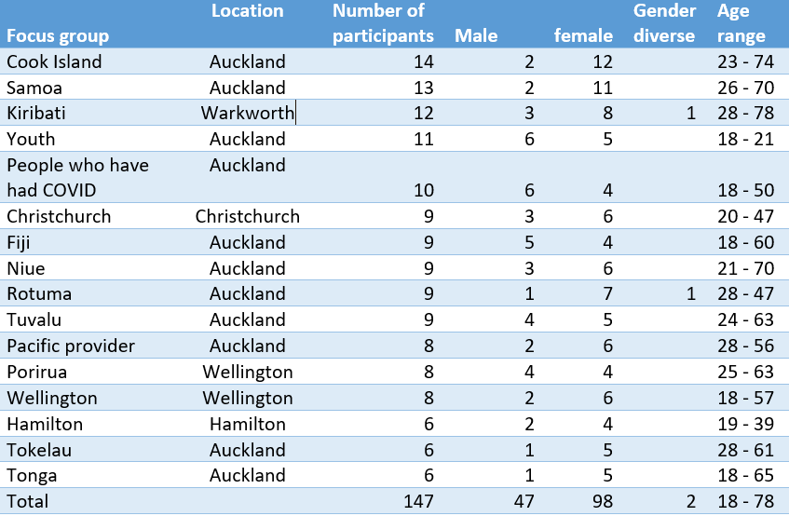

## Recommendations

Drawing on the empirical data and findings from this study a range of recommendations to support preparedness, vaccinations, communication and advocacy, contextual influences and community leadership are presented to help inform and guide policy formations that protect Pacific communities and the health and well-being of Aotearoa New Zealand more generally.

The following recommendations emphasise the need for tailored response plans, continued community involvement and engagement, and early and effective communication and support.

## Preparedness

* Ensure Pacific health service providers are given clear guidelines as soon as possible to begin outreach work with local Pacific communities and ensure patients still receive healthcare for long-term conditions.
* Plans and policies to ensure that Pacific communities services are able to establish testing and vaccination centres in local communities at the beginning of an outbreak for effectiveness and efficiencies.
* Recognise the contributions of Pacific populations as essential workers and ensure they have the necessary support to deal with their own individual health and social impacts.
* Review visitation policies at hospitals which were seen as the most challenging of all protective measures.
* Broaden and strengthen access to health and social services for regional communities.
* Mental health impacts need to be factored in early into any future pandemic protective measures.

## Vaccinations

* Pacific immunisation strategies need to take an integrated approach by focusing on family, work and social benefits of vaccinations. Awareness of vaccination availability was necessary but insufficient in improving vaccination uptake.
* The well-being benefits of vaccinations for families have a more positive influence on vaccination decision-making for young Pacific people.
* Provide as much information about the safety and effectiveness of vaccines globally to help those individuals who also prefer to do their research into vaccinations.
* Engaging church and faith-based leaders in vaccination drives is important to ensure consistent messaging with health officials and to prevent the spread of misinformation.
* Messages on the effectiveness, reliability and trustworthiness of vaccines need to be communicated early by role models and community leaders to encourage vaccine uptake and dispel misinformation.

## Communication and Advocacy

* Ensure the targeted public health campaigns that specifically address the nuanced perspectives and needs of Pacific communities. Given the importance of and immense resourcing taken to translate key health messages for COVID-19, these should serve as an important blue-print for future public health and immunisation campaigns.
* Improve the accessibility and timeliness of health information, recognising that effective communication is crucial in navigating health crises.
* Media need to understand the impacts that their reporting had on Pacific communities during the later outbreaks which fuelled racism, stigma and discrimination.
* Continue to use Pacific community leaders and health professionals to deliver key health messages.
* Forward-thinking strategies focus on mentoring and building leaders among the youth for future advocacy to ensure correct messaging and information are promoted through social media platforms.

## Contextual influences

* Pacific ethnic responses work well and should be continued and supported.
* Develop robust alternative education plans and resources considering intergenerational living arrangements and ensure digital barriers are addressed early.
* Long-term impacts of loss in learning and disengagement from school require further investigation.

## Community leadership

* Continuous engagement with churches, acknowledging their pivotal role in disseminating information and providing support.
* Ensure community leaders and volunteers are funded sufficiently – this may require some adaptability and flexibility with commissioning processes.
* Maintaining and strengthening connections and partnerships between Pacific health providers and government entities.
  + Support Pacific health providers and churches in developing robust systems to ensure equitable distribution as highlighted by reflections on some families missing out while others have more than they need.