Final report summary
COVID-19 and National Immunisation Programme research
Submitted by
University of Otago

Project title: He Aroka Urutā
PROP-065 What can we learn from factors underpinning the rollout of the COVID-19 vaccination programme and pandemic response in different rural communities? A mixed methods study.

: Contact information

Point of Contact for this report

Item | Detail
Contact person | Ali Cameron
Position | Research Advisor
Phone number | 03 470 9030
Mobile number
Email address | ali.cameron@otago.ac.nz

: Reporting

Overview
What we learnt from our quantitative research (Items 2-4 in final report):
- Vaccination rates for rural residents of NZ lagged rates for urban residents (see Figure 1).
- At the end of December 2021 there was a clear rural-to-urban gradient in vaccination uptake for both Māori and non-Māori:non-Pacific. Māori living in urban areas had higher vaccination uptake rates than Māori living in rural areas. A similar rural-urban gradient was observed for non-Māori non-Pacific. These disparities were more pronounced in younger age groups (<45 years). A clear pattern of rural:urban differential was less apparent for Pacific people (Item 4).
- Rural:urban disparity in vaccination uptake was more marked in the Northern and Te Manawa Taki regions and less so in Te Waipounamu.
- Rural areas had greater intra-variation in vaccination rates; this was apparent when comparing rates at a local level (SA2s with population 2,000-5,000). At times considerable differences were observed between neighbouring communities. The variation was more apparent for Māori than non-Māori vaccination rates.

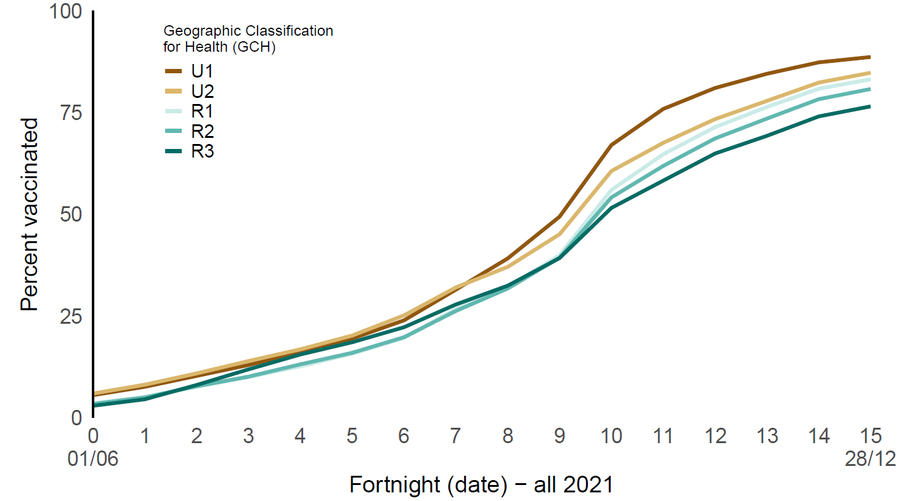
Figure 1. Rural-urban disparities: age-standardised rates of vaccination uptake by GCH (June-Dec 2021) The GCH has two urban (U1, U2) and three rural (R1, R2, R3) categories, with U1 being the “most urban” and R3 the “most rural”

What we learnt from our qualitative research (Item 5 in final report):
- The vaccine rollout was heavily reliant on established rural health and social services with strong local leadership and well-connected networks, both locally and with the wider healthcare system. Recognition that central vaccination policies and procedures were failing rural communities spurred rural health providers to tailor the vaccination rollout service to their local context considering their geography, community characteristics, cultural safety, small health provider teams, limited connectivity etc.
- In more remote communities where distances are larger and service delivery teams smaller, it was essential that the vaccine delivery was integrated as part of existing health services and connected to all other COVID-19 related activities (e.g. SIQ, swabs, clinical care etc.) within that service.
- Established networks and trusted relationships, especially for rural Māori and Pacific, are crucial for a successful vaccine rollout. Māori and Pacific clinical and non-clinical providers who are familiar with the local context, including fine-grain geography, in rural communities should take a lead role in successful vaccine delivery.
- With adequate central resourcing (as provided during COVID-19 pandemic), rural services are flexible and can pivot quickly to meet rapidly changing healthcare needs within their communities including upskilling and maximising the opportunities offered by the unregulated (but community engaged) workforce. Large, rapid, and temporary upscaling are very problematic for rural health services due to a number of factors including diseconomies of scale, greater geographical distances, small low density populations, small workforce teams, more severe workforce shortages, wide service roles and limited resources including poor connectivity and lack of physical infrastructure.
- Central IT systems designed in collaboration with rural health providers at concept to suit the rural context (e.g., where connectivity may be limited and there are low staffing configurations) along with training that does not require the need for distant travel for rural health workers would mitigate many logistical challenges faced by rural providers.

What are the practical solutions and implementation options that you recommend?
- Sustainable rural resourcing for emergency preparation. In its contracts with rural health services the commissioning arm of Te Whatu Ora and Te Aka Whai Ora should assume that events such as pandemics and extreme weather events will become increasingly common. There needs to be recognition by Te Whatu Ora and Te Aka Whai Ora that existing / established rural health services are best placed to manage the local response in such emergencies. Thus, they need to ensure rural health services have the necessary resources, leadership, relationships and resilience to undertake this role. Every effort should be made to avoid rural funding that is temporary and fragmented. When this is not appropriate or not avoidable the allocated funding should be channelled directly through local rural healthcare providers.

- User-friendly IT systems developed for robust reporting of data using Geographic Classification for Health (GCH) and ethnicity. Near real-time monitoring of pandemic and vaccination data that includes geographic information and ethnicity would allow for tailoring or adapting response based on local factors to help ensure an equitable response. Systems designed to use off-line in areas with no/poor connectivity with automatic upload when internet access is detected should be explored.

- Build and maintain long-term rural relationships. Te Whatu Ora should consolidate and formalise its points of contact with individual rural health services and rural health networks, prioritising the development of long-term relationships and ensuring a greater central understanding of the rural context.

- Rural included in emergency response. A national group of rural health and community leaders (that includes Māori and Pacific providers) should be formed in preparation of any future public health emergency. The group could then be convened at haste to design processes that actively facilitate (and avoid impeding) locally tailored responses in rural areas.

- Iwi and Pacific providers included in emergency response. Recognition of the role of rural Iwi and Pacific providers and community groups (clinical and non-clinical) in public health emergency planning and response is required. Sustained pre-existing investment (i.e. long-term contracts, arrangements and relationships that explicity acknowledge their role in future emergencies) with rural Iwi and Pacific providers will ensure rapidly available support and response.

- Clarify roles, expectations, and processes for collaboration between local rural health services and external providers. On those occasions where it becomes necessary for outside agencies to provide services within a local community (e.g., during an emergency) formal agreements/processes entered into between local and external providers around roles and expectations will ensure effective inter-organisational collaboration. Maintaining agency within the locality needs to remain an important objective.

- Focus on capacity building. Invest in a community development approach to build capacity in local rural communities: i) Ground-up community development through funding localities to identify and tailor existing generic skills within its non-regulated workforce to support healthcare providers on daily basis as well as having the capability to be mobilised during emergency responses, and ii) Strengthening rural health professional training.

What considerations need to be taken into account when implementing the solutions?
Advantages to implementing solutions identified in 1.2:
- More sustainable and resilient local rural health services that are geographically tailored, culturally appropriate, and locally driven can deliver routine care and are adequately prepared to respond to emergencies.
- More equitable outcomes will result from services that are more responsive, flexible and innovative.

Considerations to implementing solutions identified in 1.2:
- Our solutions require an alternative funding and commissioning process for rural health services to the current predominant model that is based on siloed programmes and funding: without diminishing the accountability providers have to funders, a more “high trust model” with reduced central control is necessary to achieve this

