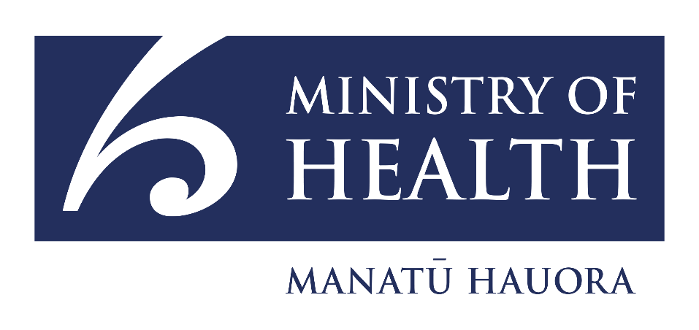

Suicide Prevention Action Plan Consultation Summary

Introduction
Suicide prevention efforts in New Zealand are guided by these two documents:
  - Every Life Matters – He Tapu te Oranga o ia Tangata: Suicide Prevention Strategy 2019–2029 (He Tapu te Oranga).
  - Suicide Prevention Action Plan 2019–2024 for Aotearoa New Zealand.

Because the Action Plan finishes in 2024, a draft action plan has been written for the next five years. The Ministry of Health is asking for feedback on the draft plan.
This plan was written to support the Government’s Mental Health priorities:
- improve access to suicide prevention support and support for family and community after a suicide;
- train more people to support those at risk of suicide or affected by suicide;
- strengthen our focus on prevention and early intervention across the range of factors that can influence suicide;
- improve the effectiveness of supports with better research and data collection.

Proposed actions for the Health sector
1. Improve access to suicide prevention and postvention supports:
- Set up a suicide prevention community fund for populations with higher needs (for example, young people and rural communities) to sit alongside Māori and Pacific funds that are already set up.
- Roll out better suicide bereavement support.
- Set up six crisis recovery cafés/hubs/services.
- Improve the cultural delivery of support after a suicide death.

2. Grow a capable and confident suicide prevention and postvention workforce:
- Increase access to suicide awareness training for communities and families.
- Develop induction materials and improve supports for suicide prevention workforces.
- Publish a framework for workforces, communities, and family members.
- Develop improved guidance for health professionals on assessing and supporting people who might be suicidal or experiencing suicidal distress.

3. Strengthen the focus on prevention and early intervention:
- Invest in acute, respite or crisis recovery services for young people in at least two regions.
- Launch a new wellbeing promotion campaign that includes resources for youth.
- Develop a national alcohol screening and brief intervention programme that includes suicide prevention topics.
- Develop updated suicide media guidelines for those reporting on suicide.
- Make inpatient mental health buildings safer.

4. Improve the effectiveness of supports with better research and data collection
- Review how effective government suicide prevention investment has been and make any changes.
- Look at options for testing a suicide data tool to provide better information on suicide.

Proposed actions for other government agencies
1. Improve access to suicide prevention and postvention supports:
- Complete development of local suicide response processes at prison sites (Ara Poutama Aotearoa | Department of Corrections).

2. Grow a capable and confident suicide prevention and postvention workforce
- Improve the suicide prevention knowledge of the Elder Abuse Response Services workforce (Ministry of Social Development).
- Update guidance for social workers and carers working with children and young people who might be suicidal or experiencing suicidal distress (Oranga Tamariki).

3. Strengthen the focus on prevention and early intervention
- Strengthen support provided by schools to students experiencing distress or self-harm and support after a suicide (Ministry of Education).
- Make prison buildings safer (Ara Poutama Aotearoa | Department of Corrections).

4. Improve the effectiveness of support with better research and data collection.
- Look at options for testing a suicide data tool to provide better information on suicide (Ministry of Justice).
- Improve online coronial findings (Ministry of Justice).

Outcomes and measures
Progress will be monitored with updates provided to the Minister for Mental Health every three months. Each year an update will be put on the Ministry of Health’s website.
The Mental Health and Wellbeing Commission | Te Hiringa Mahara will also monitor suicide prevention.

How to take part
You can read the full consultation document on the consultation page on the Ministry of Health website [https://tinyurl.com/3v537jx4]
You can provide your feedback on the draft action plan by:
- sending us an email at mhaengagement@health.govt.nz
- attending an in-person or online meeting – details will be made available on the consultation page on the Ministry of Health website [https://tinyurl.com/3v537jx4];
- answering the questions online on the Ministry of Health’s consultation hub. [https://consult.health.govt.nz].

The consultation closes on Friday 1 November at 5pm.
Consultation questions
- Do you agree with the actions for health and cross-government agencies? How could these actions be improved?
- What other actions do you think could be included for government agencies to consider?
- What do government agencies need to think about when carrying out these actions to make sure what is delivered meets the needs of communities?
- Is there anything else you want government agencies to know about what is needed to prevent suicide?

Thank you for your feedback.

Demographic questions
We encourage you to fill in this section. The information you provide will help us analyse your feedback. However, your submission will still be accepted if you do not fill in this section.
This submission was completed by:
Name: ___________________________________________
Address: (street | box number) _________________________________________________
(town | city and postcode) _________________________________________________
Email: ___________________________________________
Organisation (if applicable): _________________________
Position (if applicable): _____________________________
This submission (cross one of the two options out):
- Is made by an individual or individuals (not on behalf of an organisation nor in their professional capacity);
- Is made on behalf of a group or organisation(s)

What ethnic group/s do you belong to? (you may select more than one option | you can put a line through options that do not apply or you can highlight or circle those that do):
- Māori
- NZ European | Pakeha
- Samoan
- Tongan
- Niuean
- Cook Islands Māori
- Chinese
- Indian
- European
- Middle Eastern, African, Latin American
- Other
(please specify _____________________________________
_________________________________________________
_________________________________________________

Please indicate which perspectives your submission represents (you may select more than one option | you can put a line through options that do not apply or highlight or circle those that do):
- Māori
- Family | whanau
- Pacific
- Lived experience | Tāngata Whaiora
- Asian
- Bereaved by Suicide
- Community Provider
- Older people
- Disability
- Rainbow | LGBTQI
- Ethnic Communities
- Rural
- Service provider
- Central government
- Local government
- Researcher
- Children / Young people

Other (please specify) _______________________________
_________________________________________________

Summary of submissions
If you wish to be notified when a summary of submissions is available, please ensure your contact details are provided above and select ‘Yes’ from the statement below.
Yes: I wish to be informed when the summary of submissions is available; or
No: I do not wish to be informed when the summary of submissions is available.

End of information: Suicide Prevention Action Plan Consultation Summary
This Large Print document is adapted by Blind Citizens NZ from the standard document provided by the Ministry of Health | Mānatū Hauora

