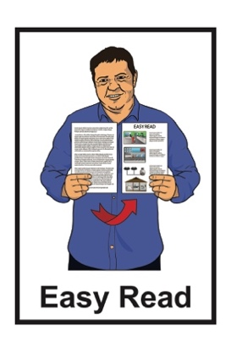



Abuse in care public apology: Ministry of Health

Photo of Dr Diana Sarfati who is the Director General - Health and Chief Executive of the Ministry of Health. 
She has curly blonde hair and is wearing a blue shirt and white necklace.

Dr Diana Sarfati

Director General – Health / Chief Executive   
  
Published: November 2024

# Before you start



This Easy Read document talks about abuse.

This information may upset some people when they are reading it.



This information is not meant to scare anyone.

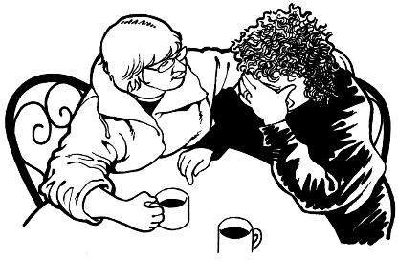

If you are upset after reading this Easy Read document you can talk to your:

* 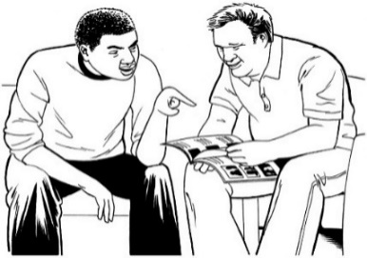whānau / family
* friends.

You can contact the Survivor Experiences Service for support.

In New Zealand you can **phone**:

**0800 456 090**



If you are calling from Australia you can **phone:**

**1 800 456 032**



You can call this number:

between **8:30 am** and **4:30 pm**



from **Monday** to **Friday.**

These times are for the New Zealand time zones.



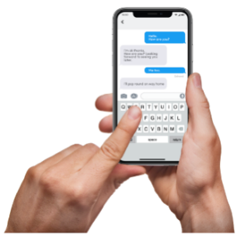You can also send a **text** to the Survivor Experiences Service.



In New Zealand you can send a **text** to:

**8328**



If you are texting from Australia you can send a **text** to:

**+61 438 384 957**



It does not cost any money to   
call / text the Survivor Experiences Service.



You can also send the Survivor Experiences Service an **email** at:

[**contact@survivorexperiences.govt.nz**](mailto:contact@survivorexperiences.govt.nz)

# About this document



On 12 November 2024 different parts of Government made a **public apology** to people who had been abused while in:

* state / government care
* faith-based care.



Sorry

A **public apology** is when someone says sorry to a group of people in a way that means everyone can be a part of what is said.



This Easy Read is a **summary** of the public apology made by the Ministry of Health – Manatū Hauora.

A **summary**:

* is shorter than the original   
  message
* tells you what you need to know.



Dr Diana Sarfati is the:

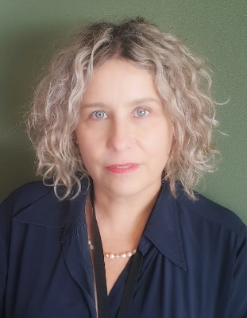Director-General of Health

**Chief Executive** of the Ministry of Health – Manatū Hauora.



A **Chief Executive** is the person in charge of an organisation.

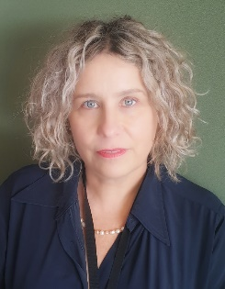This document includes some **quotes** from Dr Diana Sarfati.

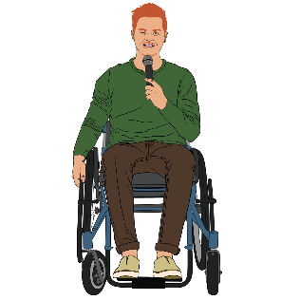

“Hello”

A **quote** is an exact copy in writing   
of what someone has said.

The quotes are in yellow boxes like this.

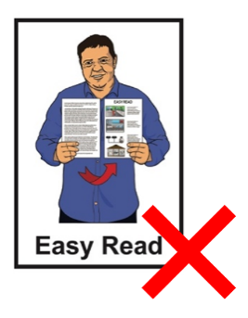

The quotes are **not** in Easy Read.

You can read the full apology on the Ministry of Health **website** at:

**www.health.govt.nz**

# Apology from the Ministry of Health



Dr Diana Sarfati says:

“Tēnā koutou katoa.

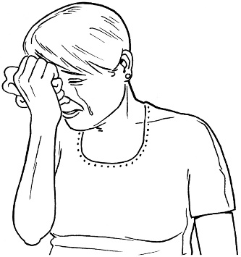

I stand before you with a **profound** sense of responsibility and sorrow.

Please let me begin with my apology to all of you who were harmed by the abuse that occurred while you were in the care of the state.”



Sorry

**Profound** means:

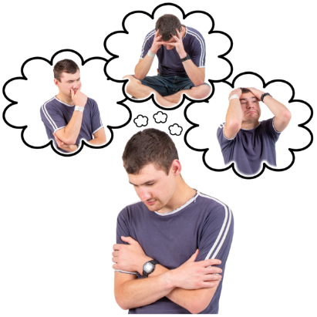very important

**and**

felt deep down inside a person.

Dr Diana Sarfati says:



“The findings of the Royal Commission of Inquiry’s report into Abuse in Care reveal the failures of the health system and those in charge of it to protect and care for you.

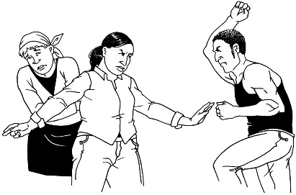

We did not have systems in place to report abuse and neglect or to keep you safe.

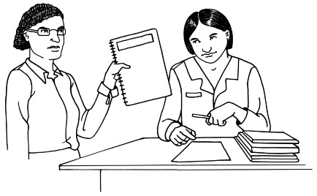

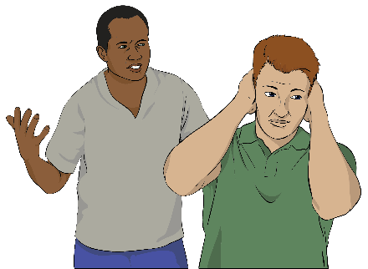We failed to listen and act when you did tell us of abuse”

Dr Diana Sarfati says:

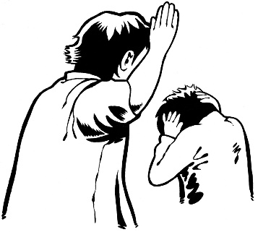

“As children, young people and adults in our care, you were harmed by unimaginable abuse and neglect.

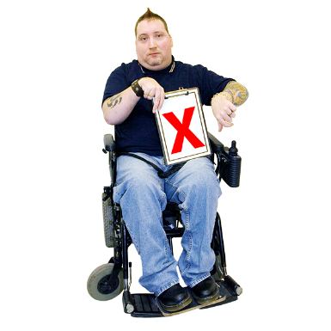

None of this could be **justified** then, and it certainly cannot be justified now.”



**Justified** means there are good reasons why something was done.

Dr Diana Sarfati says:

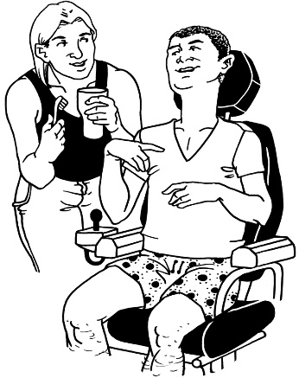“You were denied basic care, **dignity**, and **privacy**.



Sexual, physical, medical and emotional abuse occurred in health settings.”

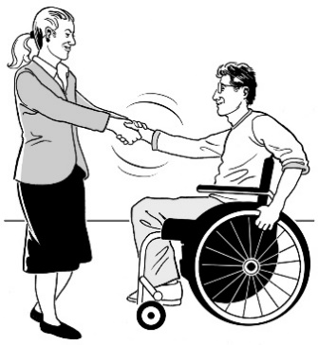Here **dignity** means treating a person with respect.

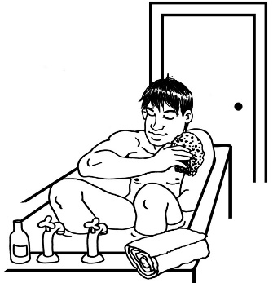

Here **privacy** means being allowed to be on your own without people watching.

Dr Diana Sarfati says:

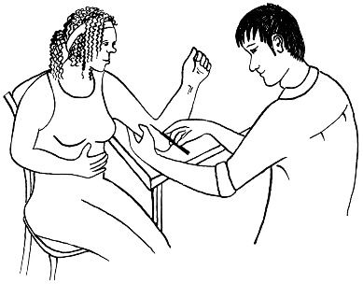

No

“In disability and mental health institutions, **abortion**, **sterilisation**, and **contraception** were provided without **consent**.”

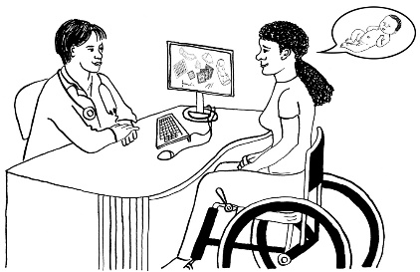

An **abortion** is a medical way a pregnant person can stop their pregnancy.

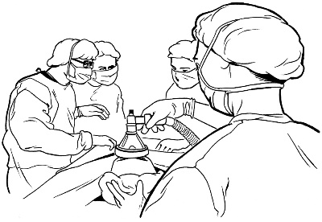**Sterilisation is** a type of surgery that can be done so people never   
get pregnant.

**Contraception** is things used by people who have sex to stop getting pregnant.

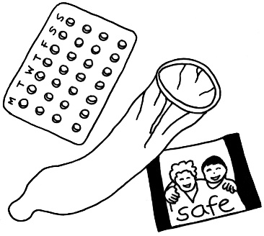This includes things like:

the pill

condoms

injections.

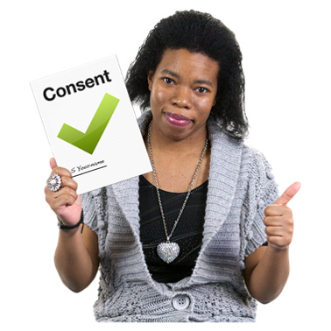**Consent** means you:

choose if you want to do something

understand what you are choosing to do.

Dr Diana Sarfati says:



**“Seclusion** and **restraint** were used inappropriately and as a means to contain, control, and punish behaviour.”

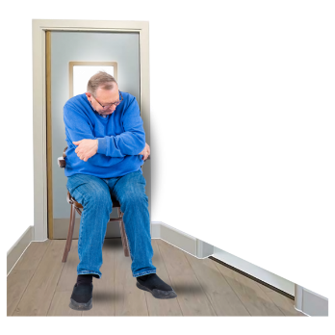

**Seclusion** is when someone is shut in a room on their own.

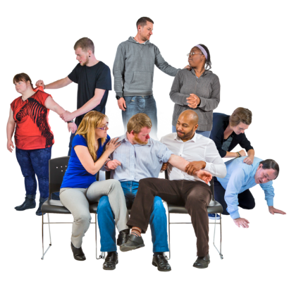**Restraint** is when someone is stopped from moving in ways like:

being tied down

being given medicine

someone using their hands.

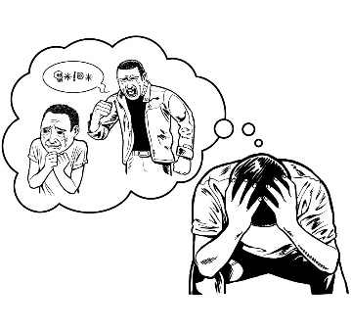Dr Diana Sarfati says:

“Many of you experienced multiple types of abuse.

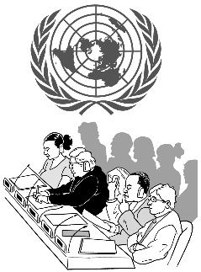

In some instances this so-called treatment was so **abhorrent** that the United Nations and the Government has recognised it as torture.”

**Abhorrent** means something is:

horrible

and

very bad to do.

Dr Diana Sarfati says:

“This abuse was **perpetrated** by people in positions of authority that survivors should have been able to trust including carers and health workers.”

**Perpetrated** means to do something in a way that is against the law.



Dr Diana Sarfati says:

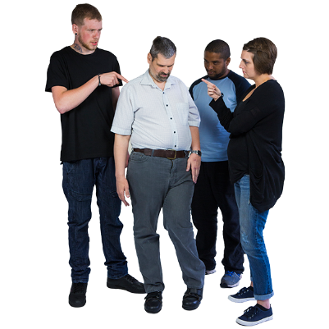**“Racism**, **ableism** and **stigma** led to practices that affected Māori, Pacific peoples, disabled people, tāngata whaikaha, Deaf people, Turi Māori and people with mental health conditions.”

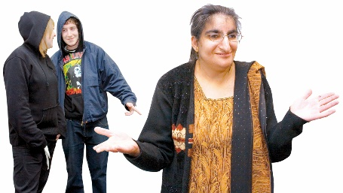**R****acism** means bad treatment of someone because of:

where they come from

their language

their skin colour

religion / their beliefs

their culture / group.

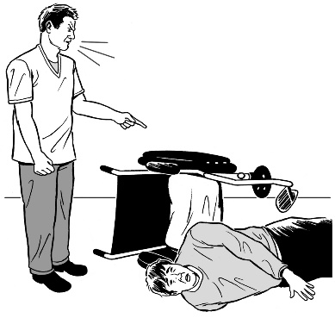

**Ableism** means bad treatment of someone because they are disabled.

Here **stigma** means something bad that people think about a person.



Dr Diana Sarfati says:

“To survivors, I offer you my deepest apology.



Sorry

I am sorry for the pain and trauma that you, your families and communities experienced.

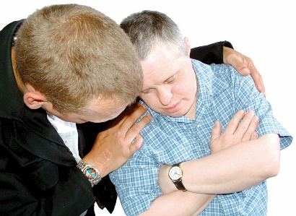

I acknowledge the lasting impact this has had on your physical, mental, spiritual, and **cultural wellbeing**.**”**

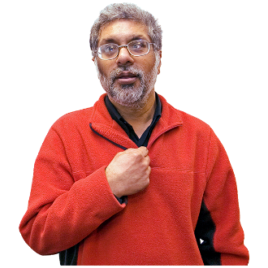

**Cultural wellbeing** means how good you feel about the way you do things:

* in your life
* 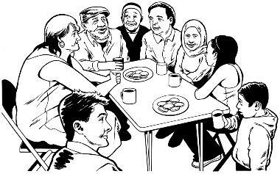with other people of your   
  culture / group.

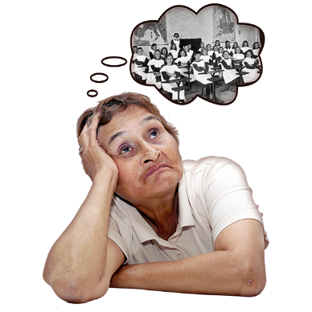Dr Diana Sarfati says:

“I also acknowledge that no apology can change the past or make up for the trauma you have suffered.



I want to make sure we have the systems in place to ensure this does not happen again.

The health system has moved away from state residential care or custody for treatment to community-based care options.

We have introduced new standards and models of care that will prevent neglect and abuse that survivors experienced in the past.”

Dr Diana Sarfati says:



“We must do more to improve the health system.



The new Mental Health Bill sets out how we provide **compulsory** mental health care.”

**Compulsory** means something that must be done.

Dr Diana Sarfati says:

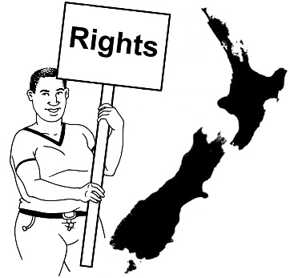“The Bill:

* recommends an approach that ensures people’s rights are put first
* 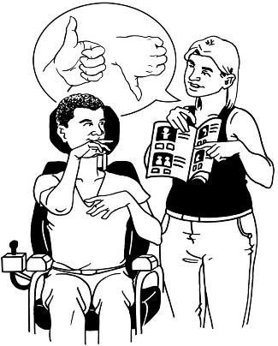empowers people to be active decision-makers in their care
* provides measures to make sure that compulsory or **coercive** treatment is **minimised**.**”**

**Coercive** means making someone do something using:

* force
* threats.



Here **minimised** means to make something happen less often.

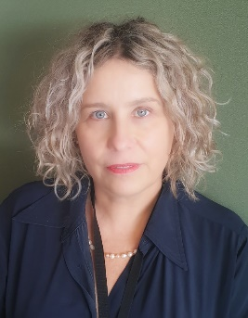Dr Diana Sarfati says:

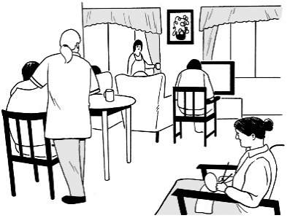“The Ministry of Health, along with Health New Zealand and other health agencies, will work together with affected communities to make sure the health system continues to improve and provide the care people need.

Finally, I would like to thank survivors for your honesty and your strength.

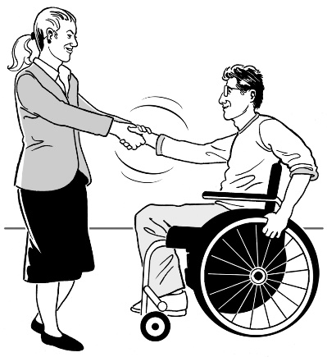

**Thank you**

We must ensure we never forget the lessons from the harm done in the past.”

**This information has been written by the Ministry of Health – Manatū Hauora.

It has been translated into Easy Read by the Make it Easy Kia Māmā Mai service of People First New Zealand Ngā Tāngata Tuatahi.



The ideas in this document are not the ideas of People First New Zealand Ngā Tāngata Tuatahi.



Make it Easy uses images from:

* Photo SymbolsChangepeople.org

Photosymbols.com

* SGC Image Works
* Huriana Kopeke-Te Aho
* T. Wood.

  
All images used in this Easy Read document are subject to copyright rules and cannot be used without permission.