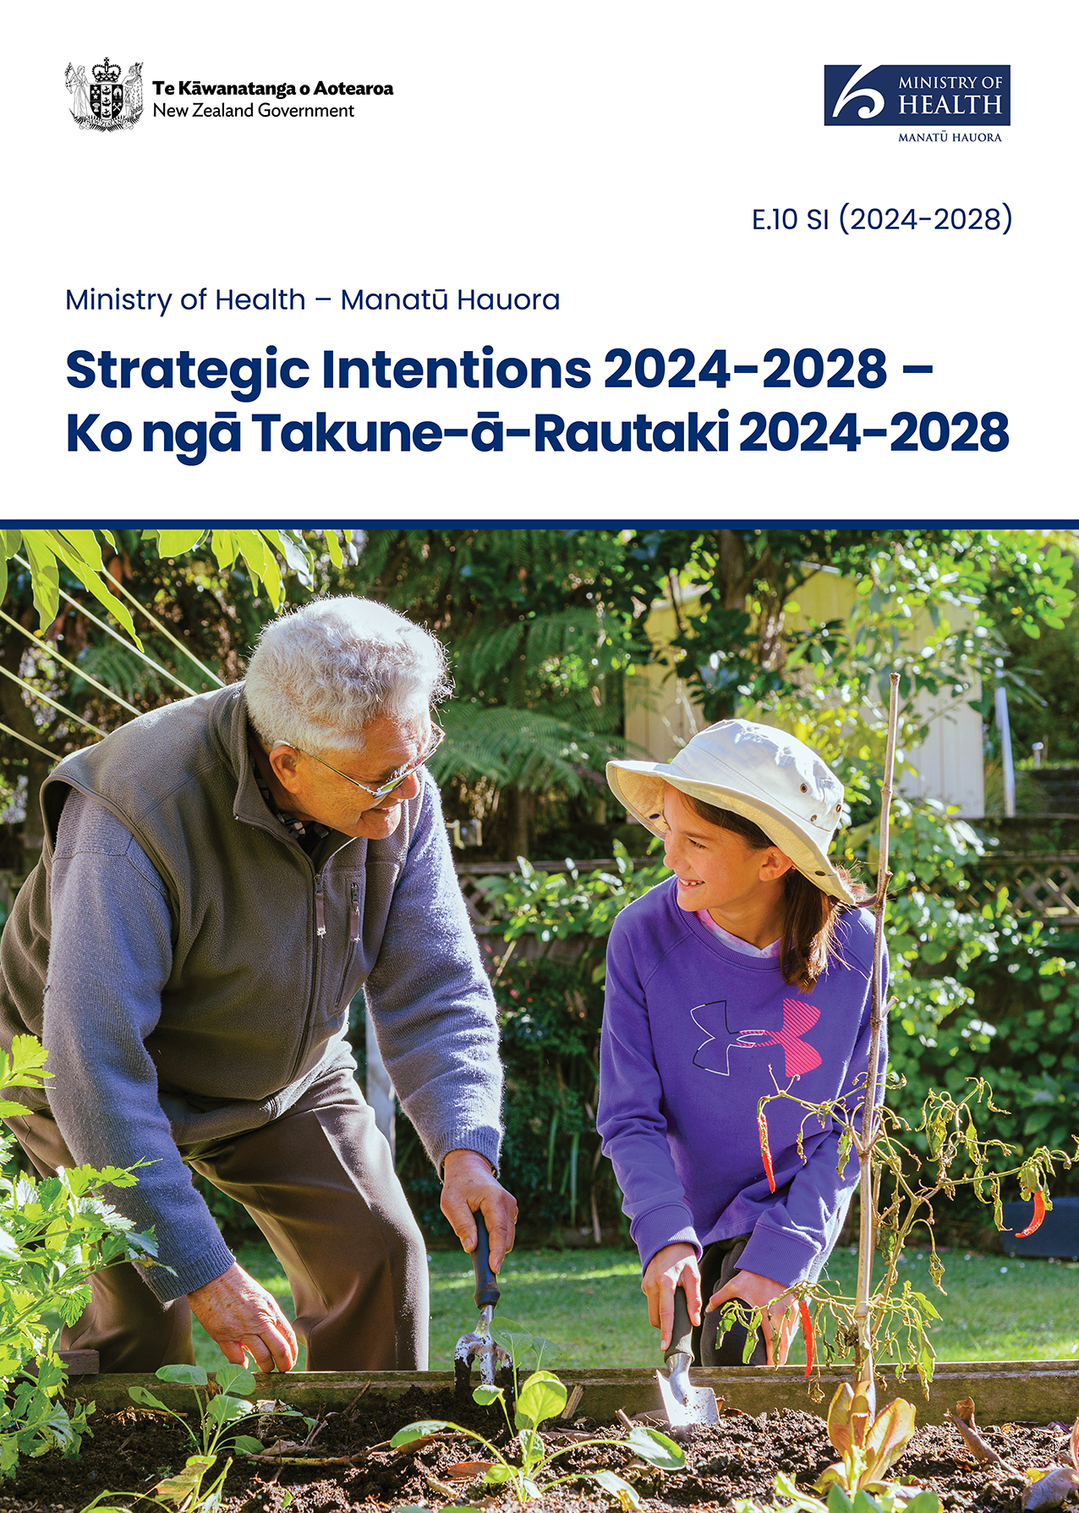

Strategic Intentions 2024-2028 –   
Ko ngā Takune-ā-Rautaki 2024-2028

Ministry of Health – Manatū Hauora

2024

Citation: Ministry of Health. 2024. *Strategic Intentions 2024–2028 – Ko ngā Takune-ā-Rautaki 2024-2028*. Wellington: Ministry of Health.

Published in October 2024 by the Ministry of Health  
PO Box 5013, Wellington 6140, New Zealand

ISBN 978-1-991324-00-9 (print)

ISBN 978-1-991324-01-6 (online)

HP 8888

Ministry of Health logo

This document is available at health.govt.nz

|  |  |
| --- | --- |
| **CCBY** | This work is licensed under the Creative Commons Attribution 4.0 International licence. In essence, you are free to: share ie, copy and redistribute the material in any medium or format; adapt ie, remix, transform and build upon the material. You must give appropriate credit, provide a link to the licence and indicate if changes were made. |

# Minister’s foreword

Like many other comparable countries, the last few years have been challenging for our health sector. The global pandemic and workforce shortages have added additional pressure to health systems that were already under strain.

It is now time to reset and look to the future. The Government’s goal is for all New Zealanders to have timely access to quality health care, to improve life expectancy and quality of life. We can only achieve this with a strong, long-term vision and clear targets – this is key to improving the performance of the health system and focusing its resources, attention and accountability.

For our health services, I have set five priority areas of focus for the health system – access, timeliness, quality, workforce, and infrastructure. These priorities are captured in the Government Policy Statement on Health 2024–2027, which ties in with the health targets and mental health and addiction targets.

Along with other countries, New Zealand faces a growing and ageing population, as well as the need to do everything we can to reduce the burden of long-term diseases such as cancer, diabetes, respiratory disease, cardiovascular disease and poor mental health.

My expectation is that the health system will also prioritise investments that have a greater focus on prevention, including modifiable risk factors such as alcohol consumption, poor nutrition, physical inactivity, adverse social and environmental factors, and smoking.

We also know that there are differences in health needs and outcomes across New Zealand’s population. We want to ensure groups with the highest need get the appropriate services at the right time to help address some of these inequities.

I am looking to the Ministry of Health – Manatū Hauora in its role as chief advisor and steward to support these goals as it continues to set the strategic direction, develop policy, and monitor the performance of our health system.

I am satisfied that the information on strategic intentions prepared by the Ministry of Health, in this *Strategic Intentions 2024–2028* document is consistent with the policies and performance expectations of the Government.

**Hon Dr Shane Reti**

Minister of Health

# Te kōrero whakataki a te Minita

Pērā i ētahi atu whenua e ōrite ana ki a tātou, he nui ngā taumahatanga ki runga i te rāngai hauora i ngā tau tata nei. Hāunga anō ngā āhuatanga kei runga kē i a rātou, kua pokea ngā pūnaha hauora e te mate urutā i pā ki te ao whānui me te korenga o ngā kaimahi.

Kua tae te wā ki te whakarite anō i a tātou, ki te anga atu ki ngā rā e haere mai ana. Ko te whāinga a te Kāwanatanga, kia tiakina paitia ngā tāngata katoa o Aotearoa e te rāngai hauora i te wā tika, kia piki ake te roa me te pai o ō rātou oranga. Ka tutuki tēnei whāinga mā tētahi whakakitenga roa, ā, me mārama hoki ki ngā whāinga whāiti – he mea nui tēnei hei whakapiki ake i ngā mahi a te pūnaha hauora, hei whakahāngai hoki i ngā rauemi me tō tātou titiro, kia tutuki ngā mahi i runga i te tika me te pono.

Hei āwhina i ngā ratonga hauora, kua whakatakoto ahau kia rima ngā kaupapa mātāmua hei whai mā te pūnaha hauora, arā, ko te whai wāhitanga, ko te wawe o te mahi hauora, ko te kounga o ngā mahi, ko te rāngai kaimahi hauora me ngā momo tūāhanga. Kua whārikihia ēnei kaupapa mātāmua ki roto i te Government Policy Statement on Health 2024–2027, waihoki, kua paiheretia ngā whāinga hauora ki ērā o te rāngai hauora ā-hinengaro me te rāngai o te mate warawara.

Pērā i ētahi atu whenua, kei te rongo a Aotearoa i te pānga o te whakapikinga ake o te nui o te taupori me te hunga kaumātua me te tino hiahia ki te whakamāmā i ngā taumahatanga o ngā mate tūroa pērā i te mate pukupuku, i te mate huka, i te mate pūkahukahu, i te mate manawa me ngā momo mate hinengaro.

Kei te hiahia au kia noho mātāmua ngā kaupapa e kaupare atu ana i ngā mate nei ki runga i te rārangi haumi o te rāngai hauora, pērā i ngā momo mahi e taea ai te whakatika; arā, ko te nui o te inu waipiro, ko te kino o te kai, ko te noho houtete, ko ngā take e pā kino ana ki te tangata, ki te taiao hoki me te kaipaipa.

Kei te mōhio hoki mātou he rerekē ngā hiahia me ngā putanga o te ao hauora ki ngā momo taupori o Aotearoa whānui. Kei te pīrangi mātou kia whakawhiwhia ngā ratonga tōtika i te wā e tika ana ki te hunga e tino pāngia ana ki ēnei taumahatanga hei kaupare atu i ētahi o ngā āhuatanga taurite-kore.

Kei te tono atu au ki te Manatū Hauora, i tana tūranga hei kaitohutohu matua, hei kaiārahi hoki, ki te tautoko i ēnei whāinga, i a rātou e whakatakoto tonu ana i te ahunga rautaki, e whakawhanake ana i ngā kaupapa here, e aroturuki ana hoki i ngā whakatutukinga o tō tātou rāngai hauora.

E whakapono ana au e hāngai ana ngā kōrero e mau ana ki ngā koronga rautaki i whakaritea e te Manatū Hauora, arā, i te tuhinga o *Strategic Intentions 2024–2028*, ki ngā kaupapa here me ngā mahi e hiahiatia ana e te Kāwanatanga.

**Hon Tākuta Shane Reti**

Minita Take Hauora

# Director-General of Health’s foreword

As chief steward of the health system, and the Government’s lead advisor on health, the core focus of the Ministry of Health – Manatū Hauora is to provide advice and take decisions that ensure the health system meets the current and future needs of all New Zealanders.

We recognise that the health sector continues to operate under immense pressure, impacted also by rising costs and the fast pace of technological change. It is our role to guide the sector through these challenges with leadership, support and advice to Government, and to our colleagues across the health system.

The Ministry sets the direction, policy and regulatory framework, for investment in health, and also monitors the outcomes for how our systems are performing. We administer legislation that supports the health and wellbeing of our communities, from mental health to epidemic preparedness and the Medicines Act 1981 – aspects of the health system that touch the lives of all New Zealanders.

Over the next four years, we will continue to focus on developing and maintaining a fair, effective, and sustainable health system, building on our achievements to date and continuing to deliver the Government’s work programme to create a system we can all be proud of.

We will continue to work closely with colleagues across the health system, the public service, and our communities to build and maintain relationships that enable us to do this.

**Chief Executive’s Statement of Responsibility**

In signing this statement, I acknowledge that I am responsible for the information on the strategic intentions for the Ministry of Health. This information has been prepared in accordance with sections 38 and 40 of the Public Finance Act 1989.

**Dr Diana Sarfati**

Director-General of Health

# Te kupu whakataki a te Tumu Whakarae mō te Hauora

I raro i tō mātou tūranga hei kaiārahi matua o te pūnaha hauora, hei kaitohutohu matua hoki o te Kāwanatanga e pā ana ki te hauora, ko te aronga nui o te Manatū Hauora, he tāpae kōrero, he whakaputa i ngā whakataunga kia tutuki i te pūnaha hauora ngā hiahia o ngā tāngata katoa o Aotearoa, ināianei, ā ngā rā e heke mai ana hoki.

Kei te mōhio mātou kua whakataumahahia ngā mahi a te rāngai hauora, kei te pāngia hoki e te whakapikinga ake o ngā utu me ngā huringa tere o te ao hangarau. Ko tā mātou mahi, he ārahi i te rāngai hauora i roto i ēnei āhuatanga, he tautoko, he tāpae kōrero ki te Kāwanatanga, ki ō mātou hoamahi hoki huri noa i te pūnaha hauora.

Ko te mahi a te Manatū, he whakatakoto i te huarahi, i ngā kaupapa here me ngā ture mō ngā mahi haumi i te ao hauora, waihoki, ka aroturuki hoki mātou i ngā hua o ngā mahi a tā tātou pūnaha. Kei te whakahaere mātou i ngā ture e hāpai ana i te hauora me te oranga o ō mātou hapori – mai i te hauora ā-hinengaro ki ngā mahi whakariterite mō te mate urutā me te Medicines Act 1981 arā, ko ngā āhuatanga o te pūnaha hauora e whai pānga ana ki te noho o ngā tāngata katoa o Aotearoa.

Hei ngā tau e whā e haere mai ana, ka arotahi tonu mātou ki te whakawhanaketanga, ki te whakapūmautanga hoki o tētahi pūnaha hauora tōtika, whaihua, tūroa anō hoki – kia piki ake anō ngā whakatutukinga o mua, ā, kia kaha tonu mātou ki te whakatutuki i te hōtaka mahi a te Kāwanatanga, kia tū whakahīhī tātou katoa i ngā mahi a tēnei pūnaha.

Ka mahitahi tonu mātou ki te taha o ō mātou hoamahi huri noa i te pūnaha hauora, i te rāngai tūmatanui me ō tātou hapori ki te whakatū, ki te whakapūmau hoki i ngā momo hononga tāngata e tutuki ai aua mahi.

Te Tauāki Haepapa a te Tumu Whakarae

Nō te hainatanga o tēnei tauāki, kei te mōhio ahau, nōku anō te haepapa ki te whakaū i ngā kōrero e pā ana ki ngā koronga rautaki a te Manatū Hauora. Kua whakaritea ēnei kōrero i raro i te wāhanga 38 me te wāhanga 40 o te Public Finance Act 1989.

**Dr Diana Sarfati**

Tumu Whakarae mō te Hauora

Contents

Minister’s foreword iii

Te kōrero whakataki a te Minita iv

Director-General of Health’s foreword v

Te kupu whakataki a te Tumu Whakarae mō te Hauora vi

Section 1: Introduction 1

Our purpose 1

Our functions and responsibilities 1

Our context 2

Section 2: Our strategic direction 8

Our strategic priorities 9

Monitoring and reporting on our performance 14

Section 3: How we operate as an organisation 15

Our partners and stakeholders 15

Transforming the Ministry of Health 17

Our values 18

Organisational health and capability 18

How the Ministry of Health is set up and structured 19

Annex 1: Te Aho o Te Kahu – Cancer Control Agency 23

List of Figures

Figure 1: Strategic monitoring framework in the GPS (June 2024) 6

Figure 2: Key components of our strategic direction 8

Figure 3: Map of entities in the health system 16

Figure 4: How we are structured to deliver on our strategic intentions 19

Figure 5: Our governance structure and external assurance 22

Figure 6: Organisational structure of the agency 24

Figure 7: How the agency aligns with Government health strategies 26

# Section 1: Introduction

## Our purpose

The Ministry of Health – Manatū Hauora (the Ministry) is the chief steward of health and the health system, and the lead advisor to Government on health. We define stewardship as:

Taking decisions or actions today that mean we are collectively better off in the future than we would otherwise have been, and building and maintaining the relationships that enable us to do this.

## Our functions and responsibilities

As steward of the health system, we are focused on improving health outcomes for all New Zealanders. Our stewardship functions are:

1. providing system-level leadership
2. driving system strategy and performance
3. being the Government’s primary advisor on health
4. future-proofing our health system
5. being the regulator of the health system
6. transforming ourselves.

The Ministry sets the direction, policy, regulatory framework and investment for health, and monitors outcomes and system and organisational performance. Our functions enable us to effectively meet Ministers’ needs, run efficiently and achieve organisational excellence.

The Ministry is responsible for overseeing the legal and regulatory framework of the health and disability system in Aotearoa New Zealand. The Ministry administers over 30 pieces of legislation, steering the national health and disability system and keeping it safe, equitable and relevant. Examples of this legislation are:

* Health Act 1956
* Pae Ora (Healthy Futures) Act 2022
* Burial and Cremation Act 1964
* Epidemic Preparedness Act 2006
* Contraception, Sterilisation, and Abortion Act 1977
* Mental Health (Compulsory Assessment and Treatment) Act 1992
* Radiation Safety Act 2016.

Some roles within the Ministry (eg, the Directors of Public Health and Mental Health) have specific statutory powers. We also have some functions provided in legislation that we do not administer, such as the Biosecurity Act 1993, Gambling Act 2003 and the Maritime Security Act 2004.

The Ministry helps the New Zealand Government to comply with international obligations by actively supporting and participating in international organisations (eg, the World Health Organization). The Ministry ensures Aotearoa New Zealand complies with international requirements, such as the International Health Regulations (2005) and the Framework Convention on Tobacco Control, as well as a range of United Nations conventions.

As steward and kaitiaki of the health system, it is our responsibility to uphold and contribute to the Crown meeting its obligations under Te Tiriti o Waitangi - the Treaty of Waitangi (Te Tiriti) as a department of the public service (as provided by section 14 of the Public Service Act 2020). We are also guided by the health sector principles as outlined in the Pae Ora (Healthy Futures) Act 2022, which recognise the Crown’s intention to give effect to the principles of Te Tiriti, and are aimed at improving the health sector for Māori and improving hauora Māori outcomes (section 6).

Te Aho o Te Kahu – the Cancer Control Agency (Te Aho o Te Kahu) is a departmental agency reporting directly to the Minister of Health and hosted by the Ministry. It was established in recognition of the impact that cancer has on New Zealanders. It provides leadership to unite work on cancer across the health system with the vision that fewer people are affected by cancer, and that people with cancer experience better survival and the same health outcomes regardless of their circumstances. The strategic intentions described in this document also apply to Te Aho o Te Kahu, as a departmental agency. For ease of understanding, information on the role, strategic direction and strategic intentions of Te Aho o Te Kahu has been provided separately in Annex 1.

## Our context

The environment we work in provides useful context for understanding our strategic objectives, intended operations and longer-term work programmes. Our operating environment is constantly changing (eg, through fiscal changes, changes in social conditions and advances in technology).

The direction from the Government of the day also affects our objectives, functions and operations. We work with the Government to ensure its priorities are delivered. However, while the Government may change, our role as steward of the health of New Zealanders and the health system does not. Our commitment to improving health outcomes for all New Zealanders and achieving equity for our diverse populations is enduring.

### Our changing operating context

Our health system, like others around the world, is under pressure for several reasons. We have an ageing and growing population with more complex needs and long-term conditions. Other challenges come from global workforce shortages, rapid technological advances and rising costs.

Moreover, while the health sector delivers good outcomes for many people, there are significant gaps in these outcomes between different groups in our population. Broader determinants of health such as education, employment, housing and the environment have a significant impact on the scale and complexity of these challenges. Considerable improvements are needed to achieve better health outcomes for all New Zealanders, including those with the highest health need.

The health workforce is an integral part of the health system and plays a significant role in improving the health of New Zealanders. Aotearoa New Zealand is experiencing major workforce challenges such as significant workforce shortages, inequitable geographical distribution of the health workforce, and inconsistent cultural and disability competency in the workforce. It will take time and considerable effort and investment to address these challenges and improve workforce outcomes.

Health technology is progressing exponentially and can help to advance scientific knowledge, reduce costs, and introduce innovative tools and approaches for diagnosing, monitoring and treating patients. Advanced technology capabilities already affecting health care include 3D printing, genomics and synthetic biology. We need to be willing to do things differently and adopt innovative ways to deliver health care into the future so that we can improve health outcomes and achieve equity for our diverse populations.

In the long term, achieving a health system that is focused on both prevention – including by addressing the determinants of health – and on financial sustainability will require fundamental changes to the way funding is used and to the approach to decision-making on investment and funding. The health system needs to get best value for money from existing resources and new investments to make the best use of resources over time.

Many other countries across the world are reforming their health care systems. In Aotearoa New Zealand, the first two years of the health system reform from 1 July 2022 to 30 June 2024 (and before the disestablishment of Te Aka Whai Ora – Māori Health Authority) focused on the structural reform of the health system. While progress across the sector is continuing to be made, there remains much work to operationalise and embed the changes and to create a sustainable health system.

Reform of this scale and complexity would usually take 10 to 15 years to implement and achieve the outcomes desired. Ongoing focus is required to put in place the culture, capability and capacity for change.

The two years since the start of the health system reform have been demanding with challenges in the delivery of services across hospital and specialist services, and primary and community care, as well as with workforce, infrastructure and technology. The Ministry will continue to work closely with Health New Zealand – Te Whatu Ora (Health New Zealand) and other health entities on the transition to an integrated health system that delivers timely access to quality health care for patients, families and communities within the overall health budget. We are determined to improve the health care system and make it a more rewarding place to work.

### Government and ministerial priorities

The Ministry supports the Government to deliver on its health priorities and, it is important for us to understand a new Government’s priorities. While the Ministry’s long-term goals remain stable, the priorities of the Government and of our Ministers influence the Ministry’s priorities and what we intend to deliver in the medium term.

The Minister of Health’s overarching focus for 2024 to 2027 is to ensure timely access to quality health care for all and to improve two critical enablers – health workforce and infrastructure. The Minister for Mental Health’s overarching focus for 2024 to 2027 is to ensure timely access to quality mental health and addiction care for all, with a focus on prevention, early intervention and community-based supports.

The Government has identified five health targets and five mental health and addiction targets to ensure a focus on action. The five health targets are:

* faster cancer treatment – 90% of patients to receive cancer management within 31 days of the decision to treat
* improved immunisation for children – 95% of children to be fully immunised at 24 months of age
* shorter stays in emergency departments – 95% of patients to be admitted, discharged, or transferred from an emergency department within six hours
* shorter wait times for first specialist assessment – 95% of patients to wait less than four months for a first specialist assessment
* shorter wait times for treatment – 95% of patients to wait less than four months for elective treatment.

Two of the health targets – shorter stays in emergency departments and shorter wait times for treatment – are included as all-of-Government targets, which were launched in April 2024.

The five mental health and addiction targets are:

* faster access to specialist mental health and addiction services – 80% of people accessing specialist mental health and addiction services are seen within three weeks
* faster access to primary mental health and addiction services – 80% of people accessing primary mental health and addiction services through the Access and Choice programme are seen within one week
* shorter mental health and addiction-related stays in emergency departments – 95% of mental health and addiction-related emergency department presentations are admitted, discharged, or transferred from an emergency department within six hours
* increased mental health and addiction workforce development – train 500 mental health and addiction professionals each year
* strengthened focus on prevention and early intervention – 25% of mental health and addiction investment is allocated towards prevention and early intervention.

The Government priorities for health are articulated in the Government Policy Statement on Health 2024–2027[1] and reinforced through the targets.

### Strategies and plans

The long-term vision for the health and wellbeing of all New Zealanders is to achieve longer life expectancy and improved quality of life. The Pae Ora (Healthy Futures) Strategies set the direction for how the system will achieve the vision and give effect to the principles of Te Tiriti.

The six strategies,[2] founded on a commitment to Te Tiriti, are:

* New Zealand Health Strategy
* Pae Tū: Hauora Māori Strategy
* Te Mana Ola: The Pacific Health Strategy
* Health of Disabled People Strategy
* Rural Health Strategy
* Women’s Health Strategy.

Achievement of the vision and outcomes in these strategies is through the [Government Policy Statement on Health 2024–2027](https://www.health.govt.nz/publication/government-policy-statement-health-2024-2027#:~:text=The%20GPS%202024%2D27%20sets,a%20prompt%20and%20efficient%20way.) (GPS). The GPS is the Minister of Health’s direction-setting instrument for signalling priorities and expectations for the health system for the three-year period. The GPS will be given effect through the New Zealand Health Plan.

The strategic monitoring framework (Figure 1) will support the Ministry’s focus as system steward on improving system performance. This provides a structure to understand system performance and to monitor short-, medium- and longer-term objectives and outcomes. The framework has a dual focus on:

* the health system, with health-led actions to protect, promote and improve health and wellbeing (the right-hand pyramid in Figure 1)
* people, population and the broader determinants of health (the left-hand pyramid).

The strategic monitoring framework brings together three layers of monitoring to provide a comprehensive picture of how the health sector is performing over time. The three layers are internal entity monitoring carried out by health entities, health entity monitoring carried out by the Ministry and system-level monitoring carried out by the Ministry. For more information see the [GPS](https://www.health.govt.nz/system/files/2024-06/government-policy-statement-on-health-2024-2027-v4.pdf) from pages 35 to 37.

Figure 1: Strategic monitoring framework in the GPS (June 2024)

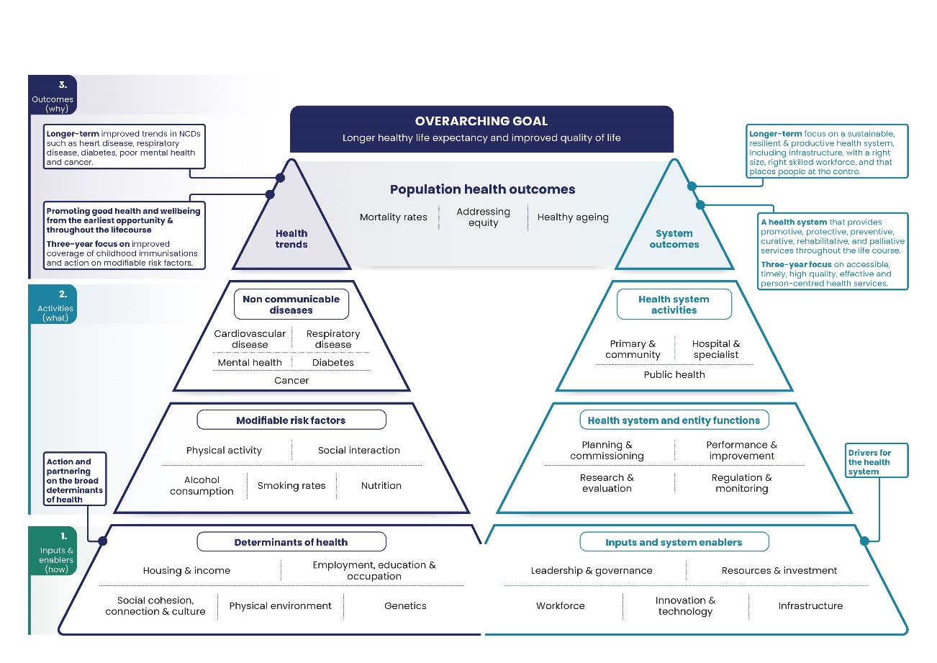

### Strategic outcomes for the health system

The strategic outcomes for the health system relate to health trends and the health system. These apply regardless of changes in Government and in Government priorities.

We interact with many actors across several systems (including the education system and social sector) to contribute to the strategic outcomes for the health system. We work closely with health entities to contribute to the shared strategic outcomes in our role as system steward.

#### Health trends

* Improved trends in non-communicable disease (eg, heart disease, respiratory disease, diabetes, poor mental health and cancer).
* Good health and wellbeing promoted from the earliest opportunity and throughout the life course.
* Improved trends in communicable disease such as improved coverage of childhood immunisations.

#### System outcomes

* A sustainable, resilient and productive health system including its infrastructure, with a right size, right skilled workforce.
* A health system that provides promotive, protective, preventative, curative, rehabilitative and palliative services throughout the life course.
* Accessible, timely, high-quality, effective and person-centred health services.

Supporting the above outcomes are the following more specific outcomes and associated measures in the GPS for the three-year period from 2024 to 2027.

* **Access**: Every person, regardless of where they live in Aotearoa New Zealand, has equitable access to the health care and services they need.
* **Timeliness**: People can access the health care and services they need, when they need it in a prompt and efficient way.
* **Quality**: Health care and services delivered in Aotearoa New Zealand are safe, easy to navigate, understandable and welcoming to users and are continuously improving.
* **Workforce**: The health workforce is available, accessible and responsive to the range and complexity of health needs.
* **Infrastructure**: The health system has the digital and physical infrastructure it needs to meet people’s needs now and into the future.
* **Financial sustainability**: The health system makes best use of resources now to ensure long-term sustainability.
* **Non-communicable diseases**: Accelerated action prevents and reduces the impact of significant non-communicable diseases.
* **Modifiable risk factors**: Addressing modifiable risk factors improves prevention of non-communicable diseases.

# Section 2: Our strategic direction

This section sets out where we will focus our efforts over the medium term to both achieve our own priorities and support the Government’s priorities. Figure 2 gives an overview of the components that make up this strategic direction.

Figure 2: Key components of our strategic direction

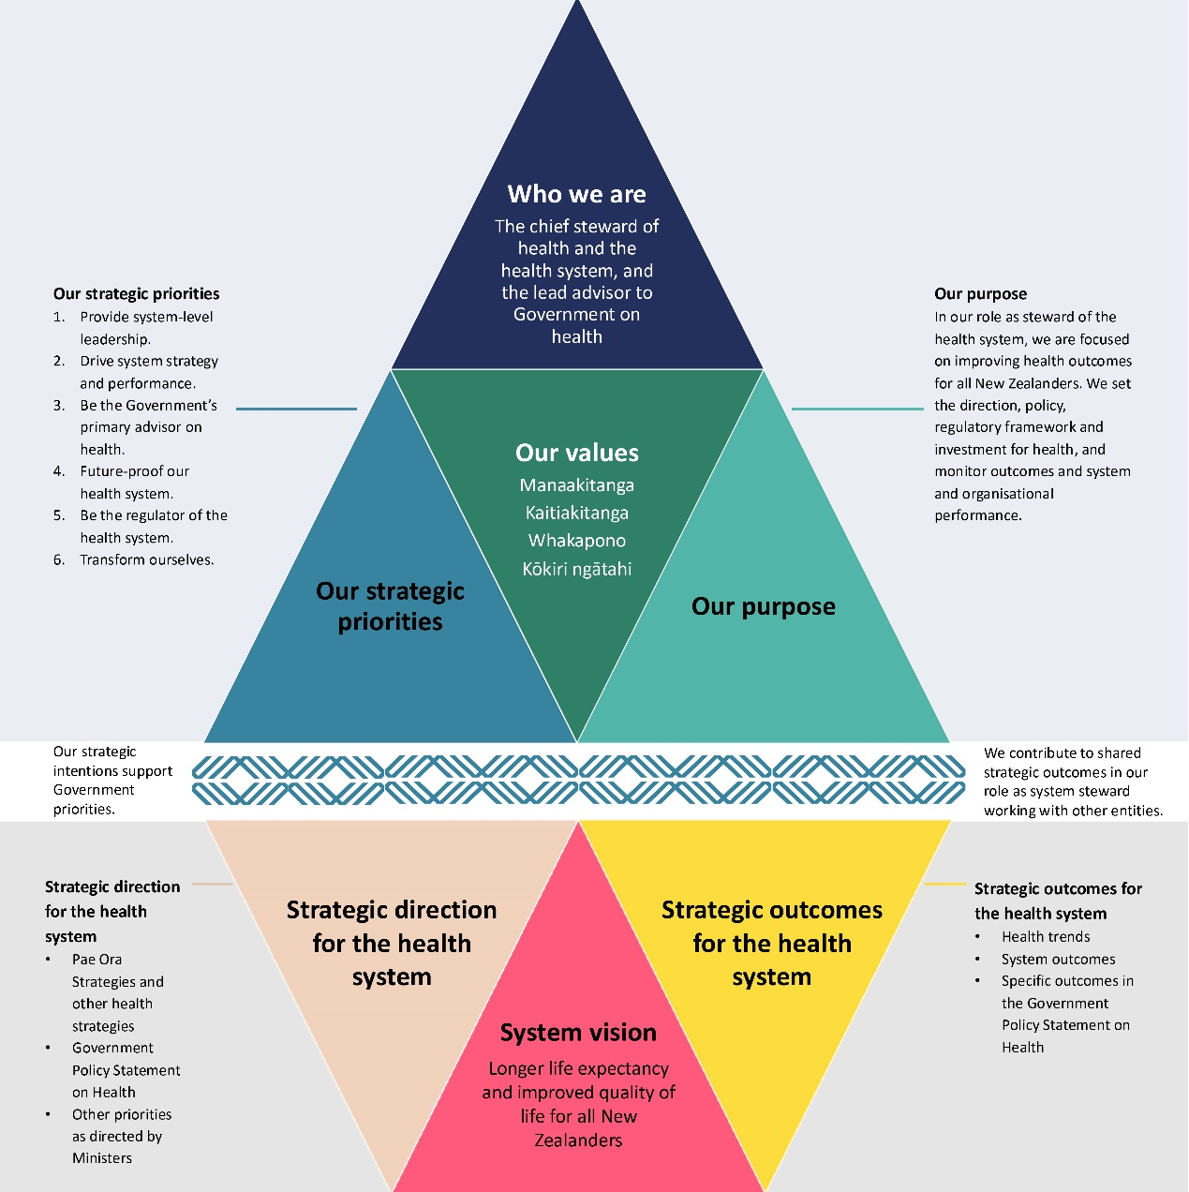

## 

## Our strategic priorities

Our stewardship functions provide an organising framework for our priority activities. The functions are enduring and keep us focused on the long-term vision while responding to opportunities and challenges in the shorter term.

Five out of six of our priorities are based on Te Kawa Mataaho Public Service Commission’s description of stewardship and ensure we are focused on our role as system steward. These are:

1. Provide system-level leadership.
2. Drive system strategy and performance.
3. Be the Government’s primary advisor on health.
4. Future-proof our health system.
5. Be the regulator of the health system

The sixth priority – transform ourselves – is about us continuing to make the shifts in the way we work to deliver on these five priorities and our stewardship role.

Set out below are our priority activities for 2024 to 2028, within the context of the operating environment and Government priorities outlined in **Our context**, Section 1.

### Provide system-level leadership

#### What good looks like

We know where the health system needs to head to deliver better health outcomes for all New Zealanders.

#### Why this matters

In our stewardship role, we set the direction for the health system. The health system is complex and includes a range of actors with various roles. Efforts can be aligned towards a common cause.

#### To do this we will

* Develop strategy, frameworks such as the Government Policy Statement on Health, and other system architecture.
* Convene others to focus on health system priorities.
* Maintain effective relationships across government and the health sector.

#### How we will get there

Develop health strategies such as:

* strategies under the Pae Ora (Healthy Futures) Act 2022
* other strategies such as Preventing and Minimising Gambling Harm.

Set and give effect to the Government Policy Statement on Health and investment strategy.

Work with our partners to achieve broader health goals such as by:

* leading Māori–Crown relationships across the health sector
* convening health system leaders.

### Drive system strategy and performance

#### What good looks like

We have a strong understanding of how we are progressing towards better health outcomes for all New Zealanders while ensuring long-term fiscal sustainability.

#### Why this matters

We want to know how we are tracking within the resources available. The performance of the health system materially affects health outcomes.

#### To do this we will

* Understand the performance of individual health entities and the health system.
* Use timely and proportionate interventions when required.

#### How we will get there

1. Set clear expectations for health entities on what we are monitoring and the information required from them.
2. Monitor activity and performance at both entity and system level and track progress. This includes:

* giving effect to the Government Policy Statement on Health
* progress towards Government targets, health targets and mental health and addiction targets
* progress against the New Zealand Health Plan.

1. Intervene and act where issues arise.

### Be the Government’s primary advisor on health

#### What good looks like

We work with the Government to ensure its priorities are delivered.

#### Why this matters

A key part of our work is delivering advice to support Government decision-making to deliver better health outcomes. The provision of high-quality advice will help to build the trust and confidence of our Ministers. As system steward, we also influence Government at the right time on longer-term trends and issues.

#### To do this we will

* Deliver high-quality advice to our Ministers.
* Be flexible and responsive to our Ministers’ priorities.
* Align our work programme with the intentions of our Ministers.
* Support and set a forward policy programme to make this work visible.

#### How we will get there

1. Deliver on key policy for the Government such as:

* primary and community care strategic direction and policy settings
* priority projects in the Mental Health portfolio
* implementing the Health Workforce Strategic Framework.

1. Support the Government in its decision-making around policy choices for annual Budgets.
2. Deliver a legislative programme as agreed, such as in relation to:

* medical products
* mental health
* addressing youth vaping
* health workforce regulatory settings.

### Future-proof our health system

#### What good looks like

We have a shared understanding of the long-term challenges, risks and opportunities for the health system so we can advise on options to address these.

#### Why this matters

We need to understand the ongoing, changing demands and emerging threats to the health system so we are well placed to advise on the choices and investments available.

#### To do this we will

* Monitor trends and undertake horizon scanning to better prepare us for emerging issues and opportunities.
* Have a strong understanding of the means to ensure that the health system is financially sustainable.
* Advise on how the government can focus on prevention and the broader determinants of health.
* Continue to build a strong evidence base including high-quality data, analytics and research and use this to inform decision-making, strategies and policies.
* Ensure our health system is prepared for and can respond to future public health threats.

#### How we will get there

1. Articulate the Government’s priorities that contribute to its long-term vision for health in New Zealand including through the Government Policy Statement on Health.
2. Work on the way health funding is used, how services are delivered, and how investment and funding decisions are made, including using evidence to decide how to get best value for money from resources over time.
3. Work on medium- and long-term issues, risks and opportunities that affect or may affect the health and wellbeing of New Zealanders (eg, population ageing and public health threats) and identify potential interventions and mitigations. This includes publishing long-term insights briefings.
4. Enhance the access, creation and use of high-quality evidence, data, insights and trends.

### Be the regulator of the health system

#### What good looks like

We have a strong regulatory environment along with a set of practices across the Ministry and the wider health system to both safeguard the public and enable innovation.

#### Why this matters

The Ministry is responsible for ensuring public safety and quality through our regulatory functions and activities. This work includes promoting the safe provision of health services to the public, monitoring the safety of medicines and enabling innovative ways of working to improve health outcomes.

#### To do this we will

* Strengthen regulatory understanding, practice and assurance across the Ministry and the wider sector so that we can be more efficient and innovative, making greater use of data and insights and sector engagement.
* Monitor and enhance the health system regulatory environment, ensuring it is fit for purpose and aligned with other systems impacting on health outcomes.
* Be future focused and apply regulatory stewardship into the future, managing risks and enabling adaptation.

#### How we will get there

1. Improve the governance and delivery of regulatory services across the Ministry.
2. Ensure regulatory design enables opportunities arising from longer-term projects such as on precision health.
3. Undertake a programme of work on regulation, such as to make changes for:

* mental health and addiction
* health workforce
* medical products.

### Transform ourselves

#### What good looks like

We are enabled to effectively deliver on the Ministry’s priorities and have a culture of internal excellence.

#### Why this matters

We have to be organised in a way that allows us to effectively and efficiently deliver our functions.

#### To do this we will

* Continuously improve our ways of working to become more connected and efficient.
* Shift the way we work to be a confident steward and a capable Ministry.
* Have empowered and trusted leadership, a shared understanding of how the Ministry operates and work aligned to strategy.

#### How we will get there

1. We will improve our organisational performance by:

* focusing on efficiency and effectiveness in our processes
* building our internal capabilities for internal excellence (eg, succession planning and leadership)

1. Enhance priority-led business planning to provide a coherent picture of our performance across the Ministry.

### Delivery of our everyday business

While this document focuses on our medium-term intentions, the delivery of our everyday business also contributes to our stewardship functions. This work is captured elsewhere, such as in the monitoring and reporting of priority-led business planning with 90-day cycles.

Examples of this work includes:

* supporting ministerial and Cabinet decision-making on appointing members to the boards of health Crown entities
* preparing for annual reviews of Parliament’s select committees
* providing advice and draft responses for written and oral parliamentary questions, and responding to requests under the Official Information Act 1982 directed to Ministers
* administering the appropriations on behalf of the appropriation Minister for Vote Health, supporting the annual development of the Estimates of Appropriations, and supporting information for Vote Health as part of the annual Budget process
* providing Ministers with advice and updates on priorities and developing issues through weekly reporting to Ministers
* assessing pharmacy licence applications
* processing notifications under section 31(5) of the Health and Disability Services (Safety) Act 2001
* processing new medicine applications to Medsafe for approval to sell the medicine in Aotearoa New Zealand
* monitoring the safety of medicines
* publishing annual updates on the health of New Zealanders in the New Zealand Health Survey.

## Monitoring and reporting on our performance

We monitor, evaluate and report on our work programme and organisational health and capability through quantitative and qualitative measures. We report against performance indicators and our priority activities for each of the Ministry’s strategic priorities in our annual report.

We measure our success across three dimensions.

1. **Contributing to outcomes for the health system.** Both long-term outcome measures and system performance measures reflect the Ministry’s role as steward of both the health of the population of Aotearoa New Zealand (ie, assessing health outcomes and trends) and the health system (ie, focusing on how the system works). This includes the targets as indicators for system performance. They are supported by other specific outcomes and associated measures in the Government Policy Statement on Health.
2. **Ministry output performance measures and Budget Standards (targets) in Vote Health.** These cover both:

* non-financial performance assessment
* financial performance assessment.

1. **Priority-led business planning with 90-day cycles.** Shorter-term reporting will provide information on the key activities that contribute to each Ministry priority, and on their progression during the year. This will inform the reporting on progress against medium-term work. In this way, the 90-day planning allows us to ensure clear milestones and delivery progress so that we will know what we want to achieve and if we are succeeding.

We will use the insights gathered from evaluating our progress to continue to learn and improve. In this way, we will enable effective performance management as we deliver on our medium-term intentions.

Measures to assess the Ministry’s performance in the reformed health system are in development. This work includes developing measures for performance reporting on system stewardship.

# Section 3: How we operate as an organisation

## Our partners and stakeholders

We work with a range of other actors on two fronts. Many of the Ministry’s own priorities (see **Our strategic priorities**, Section 2) cross agency boundaries and we will need to work with others to achieve our strategic intentions. In addition, the Ministry contributes to achieving the strategies and objectives for the health system (see **Government and ministerial priorities,** Section 1 and **Strategies and plans**, Section 1) along with other entities.

The Ministry partners, collaborates and works with many stakeholders. These stakeholders include health entities and other government agencies, the health sector, the Crown’s Māori and iwi partners, communities, the Aotearoa New Zealand public, and international counterparts and organisations. The close relationship with our stakeholders is crucial to supporting the Government and our Ministers to continuously improve system performance and to deliver better health outcomes.

Another critical element is our role as steward of the health system in improving system performance, administering public funding for health, and improving the regulatory settings for the health system. We provide advice to Government on health, priority setting, policy and system performance to maintain our Ministers’ trust and confidence in the Ministry. We provide system-level leadership and collaborate with and convene health agencies towards these purposes. Clinical leadership is fundamental to our system stewardship role as we seek to achieve longer healthy life expectancy and improved quality of life for all New Zealanders.

While the Ministry is steward of the health system, Health New Zealand is responsible for the day-to-day running of the public health system, providing health services to New Zealanders. Health New Zealand delivers many of these services directly, such as hospital services, and partners with providers by purchasing and funding other services such as primary and community care. There are other critical entities that make up the health system as shown in Figure 3. (The map of entities in Figure 3 is not intended to represent the relative size or complexity of each component.)

Figure 3: Map of entities in the health system

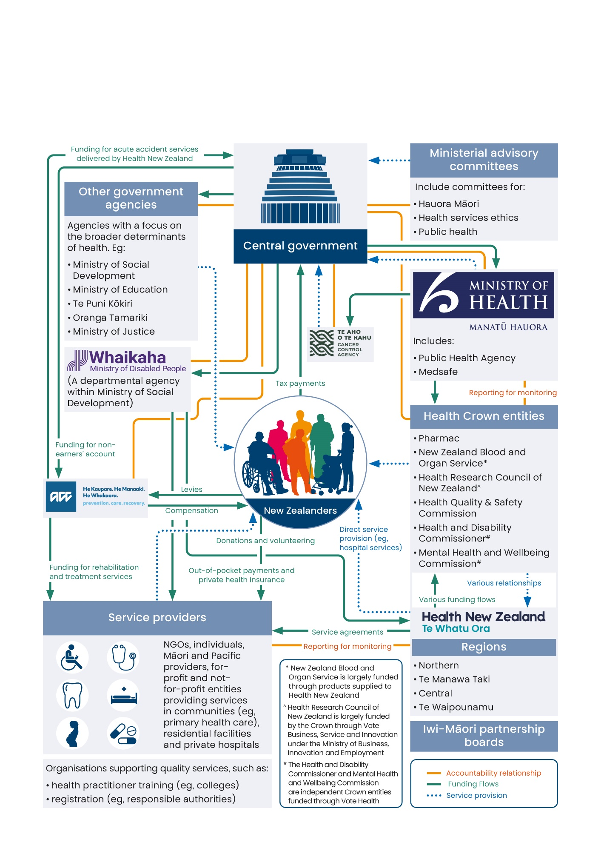

## 

## Transforming the Ministry of Health

In mid-2023, the Ministry’s transformation programme was established both in response to an independent review on how the Ministry should operate into the future, and to make the necessary shifts in our strategic direction and capability to achieve the Ministry’s desired future state. The changes resulted in a new organisational structure that came into effect from September 2024.

The changes are aimed at better enabling us to work collectively on lifting the overall performance of the health system. As we lead the health system into the future, we will be more efficient and effective at supporting Ministers to set strategic direction and policy, to shape the regulatory environment and to monitor how the system is working.

As part of the transformation programme, we defined our stewardship functions, which provide an organising framework for our priority activities. Seven transformation shifts together describe the way we intend to work.

**A confident steward.** Our stewardship role is clearly articulated and understood, with well-defined responsibilities and coordinated cross-system engagement.

**Work aligned to strategy.** A defined strategic direction directly connects to how we plan and resource work, resulting in clearly aligned work for our people.



**Shared understanding.** We have a common and shared understanding of how the Ministry cohesively operates to fulfil its roles, with supporting processes.

**Empowered leadership.** A high-trust culture focuses less on hierarchy and empowers leaders at all levels to take ownership of their work.

**A connected Ministry.** The Ministry’s systems, tools and ways of working make it easy to work across functions as ‘one organisation’.

**A capable Ministry.** The right capability, at the right time and in the right place enables us to deliver effectively on our role in the health system.

**An efficient Ministry.** Efficient and fit-for-purpose processes and tools reduce duplication, remove barriers and make the best use of the limited resources we have.

## Our values

Ngā uaratanga – our values guide our decisions, actions and behaviours.

1. Manaakitanga: We show care, inclusion respect, support, trust and kindness to each other.
2. Kaitiakitanga: We preserve and maintain an environment that enables the Ministry and our people to thrive.
3. Whakapono: We have trust and faith in each other to do the right thing.
4. Kōkiri ngātahi: We connect and work together collectively towards a common purpose.

## Organisational health and capability

The Ministry remains committed to being an equal opportunity employer. We have robust systems and processes in place to treat all candidates seeking employment and all Ministry staff fairly and equitably, regardless of individual differences such as disability, colour, race, ethnic or national origin, age, gender, sexual orientation, marital status, ethical or religious beliefs, political opinion or family and employment status.

The Ministry recognises that equality and diversity are critical for organisational success. We use impartial selection and appointment processes that have been designed to appoint the person who can best demonstrate competence for the job. The Ministry is committed to providing a workplace free from discrimination and harassment. We provide staff with appropriate disciplinary and dispute procedures and the opportunity for redress against unfair or unreasonable treatment by the Ministry.

The Ministry is committed to building and nurturing an environment that values diversity, promotes equity and creates a sense of belonging for all. Whiria te Tangata – Our Culture and Inclusion Strategy sets out the actions we will take to achieve this environment. It aligns directly with Kia Toipoto – Pay Gap Action Plan and the Public Service Commission’s Papa Pounamu – Diversity and Inclusion Programme.

Kia Toipoto is the Public Service Commission’s initiative to close the pay gaps for women, Māori, Pacific peoples and ethnic groups in the public sector. We are committed to implementing this plan and continue to undertake our ‘like for like’ job analysis as part of our annual performance and review process.

The Ministry continues to be guided by Te Māhere Reo Māori – our Māori language action plan. We are committed to implementing the activities that sit under the action plan, including our level one and two programmes in te reo Māori.

We report against our asset performance indicators for property in our annual reports. We are assessing the requirement for a set of asset performance indicators for service critical assets that meets the Cabinet Office circular CO(23)9: Investment Management and Asset Performance in Departments and Other Entities.

## How the Ministry of Health is set up and structured

Our overarching organisational structure consists of the Director-General of Health and Chief Executive, and eight directorates. In addition, our professional leads provide clinical or technical advice to Ministers, the Ministry and the sector (see Figure 4).

Figure 4: How we are structured to deliver on our strategic intentions

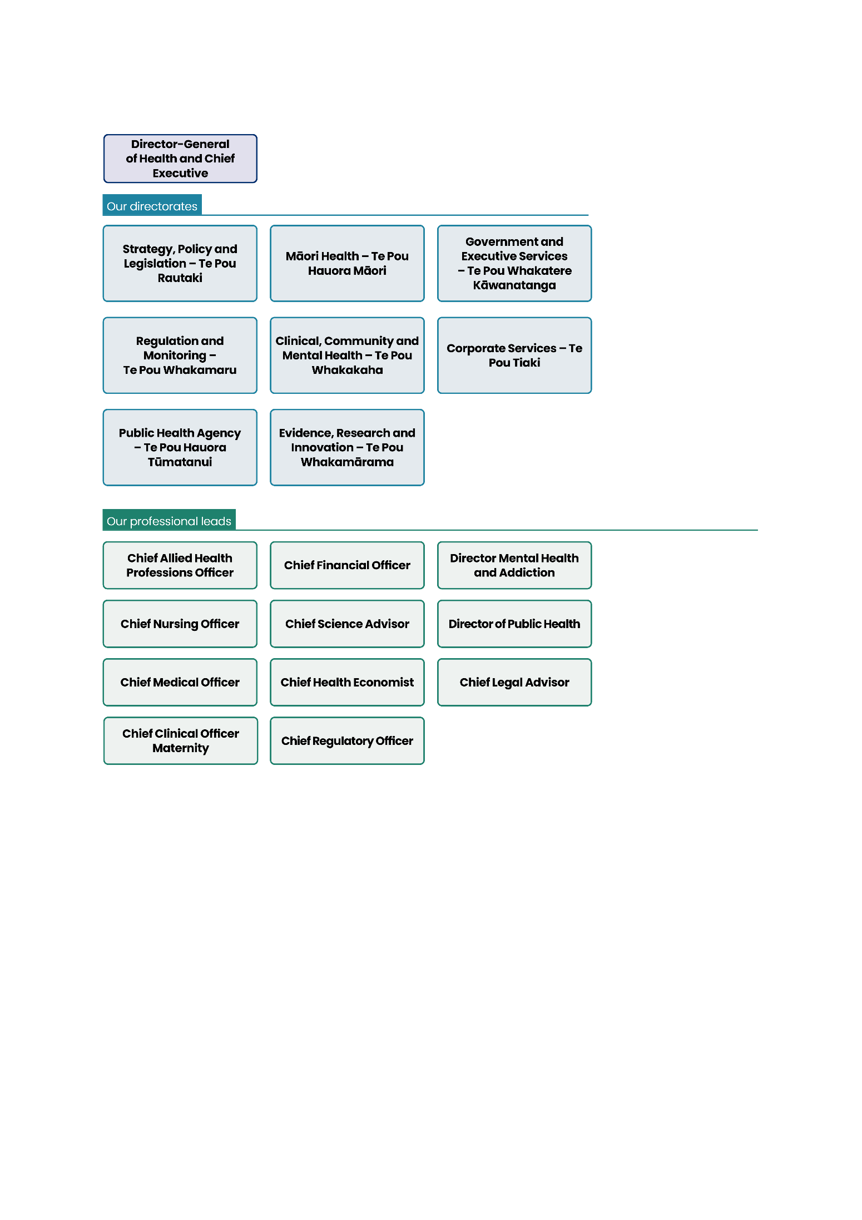

On 1 July 2024, the Ministry moved to priority-led business planning that has 90-day cycles based on medium-term and long-term priorities. The new approach to business planning aims to enhance our prioritisation, collaboration and delivery to the Government and our own priorities. It will allow us to be more agile with our resources.

Six deputy directors-general (DDG) oversee this approach in convening roles. They have responsibility for building plans that span directorates, facilitate greater cross-directorate collaboration, realise our priorities and support the new organisational structure. Two DDGs provide overall support for each Ministry priority in enabling roles. Our priority activities are set out in **Our strategic priorities**, Section 2.

#### Strategy, Policy and Legislation – Te Pou Rautaki

The Strategy, Policy and Legislation directorate provides leadership across the Ministry to achieve our priority as the Government’s primary advisor on health priority setting, strategy and policy. The directorate leads long-term strategy, setting direction and priority areas for investment.

The DDG Strategy, Policy and Legislation is the convening DDG for Priority 3: Be the Government’s primary advisor on health.

#### Regulation and Monitoring – Te Pou Whakamaru

As a regulator, the Ministry is responsible for ensuring public safety and quality. We also monitor the performance of the health system as a whole and the individual entities within it in achieving Government priorities and their responsibilities under the Pae Ora (Healthy Futures) Act 2022 and the Crown Entities Act 2024. The Regulation and Monitoring directorate includes the New Zealand Medicines and Medical Devices Safety Authority (Medsafe) to regulate therapeutic products.

The DDG Regulation and Monitoring is the convening DDG for Priority 2: Drive system strategy and performance.

#### Public Health Agency – Te Pou Hauora Tūmatanui

The Public Health Agency is a distinct branded business unit within the Ministry. It leads on public and population health strategy, policy, regulation, intelligence, evaluation and monitoring functions.

The DDG Public Health Agency is the convening DDG for Priority 5: Be the regulator of the health system.

#### Māori Health – Te Pou Hauora Māori

Te Pou Hauora Māori exercises the Ministry’s kaitiakitanga function for Māori health. As the Minister’s chief steward for Māori health, this function provides assurance that the health system is meeting its obligations under Te Tiriti, addressing Māori health aspirations and achieving equity for Māori.

The DDG Māori Health the convening DDG for Priority 6: Transform ourselves.

#### Clinical, Community and Mental Health – Te Pou Whakakaha

The Clinical, Community and Mental Health directorate provides specialist capabilities and knowledge in clinical leadership and in mental health, addiction and suicide prevention. It is the chief advisor to the Minister for Mental Health and leads a whole-of-government approach to mental wellbeing.

The DDG Clinical, Community and Mental Health is the convening DDG for Priority 1: Provide system-level leadership.

#### Evidence, Research and Innovation – Te Pou Whakamārama

The Evidence, Research and Innovation directorate provides high-quality analytics, research, science, health economics and other evidence to help make evidence-led decisions, strategies and policies and to drive innovation.

The DDG Evidence, Research and Innovation is the convening DDG for Priority 4: Future-proof our health system.

#### Government and Executive Services – Te Pou Whakatere Kāwanatanga

The Government and Executive Services directorate provides expertise and support to the organisation and to ministers to ensure we operate as a good public service agency. It supports our leaders and people to tell our strategic story, uphold our reputation and trust, maintain accountability, protect our brand and champion integrity.

The DDG Government and Executive Services is an enabling DDG.

#### Corporate Services – Te Pou Tiaki

The Corporate Services directorate ensures that the internal machinery of the Ministry works well so that it supports our people to do their jobs to the best of their ability and keeps them safe at work. It manages key organisational risks, and monitors and reports on the Ministry’s overall performance (financial and non-financial).

The DDG Corporate Services is an enabling DDG.

For more information about our directorates, go to [Ministry directorates](https://www.health.govt.nz/about-us/organisation-and-leadership/ministry-directorates) on the Ministry’s website.

### Governance and external assurance

Governance groups enable the Ministry to operate effectively and achieve its core purpose through a framework of leadership, assurance and decision-making. Our main governance forums are:

* [Executive Governance Team](https://mohgovtnz.sharepoint.com/sites/about-us/SitePages/Our-committees.aspx#executive-governance-team-%28egt%29) (EGT)
* Strategic Stewardship Team (SST)
* [Operational Leadership Team](https://mohgovtnz.sharepoint.com/sites/about-us/SitePages/Our-committees.aspx#operational-leadership-team-%28olt%29) (OLT).

Members of each of these teams work collaboratively and think strategically about the Ministry’s interests. This approach provides a whole-of-system perspective, making sure that the right things are done at the right time, we stay on track and the Ministry is kept safe from risk.

Our strategic committees and Risk and Assurance Committee also make an important contribution to governance and assurance at the Ministry.

Figure 5: Our governance structure and external assurance

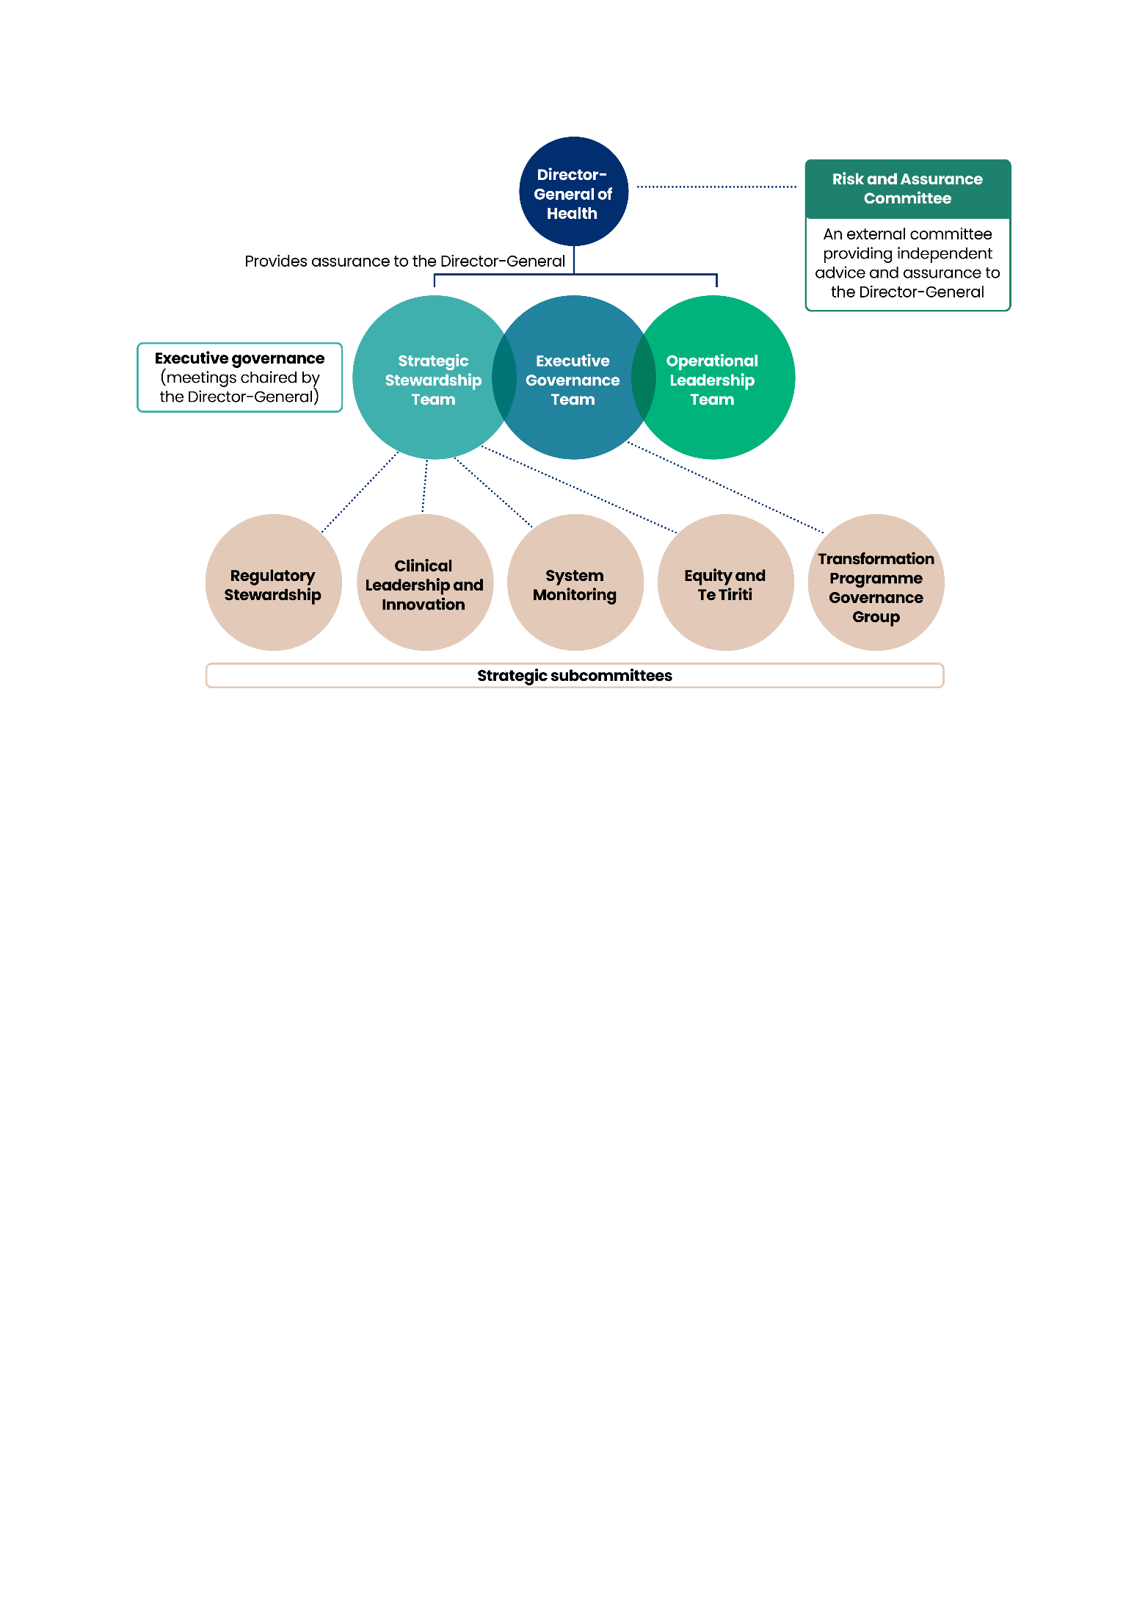

#### Executive Governance Team

The EGT is the Ministry’s strategic governance mechanism and final decision-making body with responsibilities that align with those of a board. The Director-General of Health and all deputy directors-general are members of EGT. For more information, go to [Executive Governance Team](https://www.health.govt.nz/about-us/organisation-and-leadership/executive-governance-team) on the Ministry’s website.

#### Strategic Stewardship Team

The SST is responsible for enabling an adaptive approach to strategic thinking and delivering on our stewardship role. It provides key advice to the EGT.

#### Operational Leadership Team

The OLT provides operational leadership across the Ministry. Its functions include overseeing and monitoring organisational performance, organisational policies and processes; and aligning operational activities and capability to our organisational strategies and priorities.

#### Strategic subcommittees

Each of our strategic subcommittees focuses on a different stewardship function and priority activities, wrapping governance around key work programmes and areas of importance. Strategic subcommittees provide advice and support to the EGT and the SST.

#### Risk and Assurance Committee

The Risk and Assurance Committee is an advisory body with external members. It provides independent, trusted advice and assurance to the Director-General of Health on strategic and operational risks and issues.

# Annex 1: Te Aho o Te Kahu – Cancer Control Agency

Te Aho o Te Kahu – Cancer Control Agency (the Agency) is a departmental agency reporting directly to the Minister of Health and hosted by the Ministry of Health – Manatū Hauora (the Ministry). The Agency was created in recognition of the impact cancer has on the lives of New Zealanders. The Agency provides a sharp focus on this important health issue.

### **Purpose**

Te Aho o Te Kahu provides strong central leadership and oversight of cancer control and unites efforts to deliver better cancer outcomes for Aotearoa New Zealand. Te Aho o Te Kahu is also accountable for ensuring transparency of progress towards the goals and outcomes in the 2019–2029 New Zealand Cancer Action Plan.

In practice, the Agency delivers this leadership and oversight through:

* providing advice to the Government about the current state, and future design and function of cancer services and developing options for resolving the challenges across the continuum, including transforming approaches to cancer care
* bringing stakeholders together to progress and achieve shared objectives
* undertaking national initiatives to improve the cancer system and cancer outcomes for all New Zealanders
* assembling and disseminating cancer data, insights and information to inform decision-making and service delivery
* providing support for cancer service providers when service is, or is likely to be, disrupted or is not meeting demand or expectations.

### **Vision and principles**

The Agency’s vision is to achieve fewer cancers, better survival and equity for all. Underpinning its strategic direction and work programme are the principles of being equity-led, knowledge-driven, outcomes-focused and person- and whānau-centred.

The Agency’s name in te reo Māori is a taonga that was gifted by Hei Āhuru Mōwai – Māori Cancer Leadership Network in 2020. This name is a core part of the Agency’s identity. Te Aho o Te Kahu means ‘the central thread of the cloak’. Te Aho, the central thread symbolises the Agency and its role as a leader and connector across the cancer control continuum. Te Kahu, the cloak, symbolises all the services, organisations, communities and people across the cancer system, and those people and whānau affected by it.

### **Commitment to Te Tiriti o Waitangi**

Like the Ministry, Te Aho o Te Kahu upholds and contributes to the Crown in meeting its obligations under the Te Tiriti o Waitangi - Treaty of Waitangi (Te Tiriti) as a departmental agency of the public service (as provided by section 14 of the Public Service Act 2020). We are also guided by the health sector principles as outlined in the Pae Ora (Healthy Futures) Act 2022 which recognise the Crown’s intention to give effect to the principles of Te Tiriti, and improve the health sector for Māori and improving hauora Māori outcomes (section 6).

### **Structure**

Our organisational structure is designed to deliver on our strategic priorities and turn knowledge into action, and includes the Chief Executive and National Director of Cancer Control, three Chief Advisors and three Groups.

Figure 6: Organisational structure of the agency

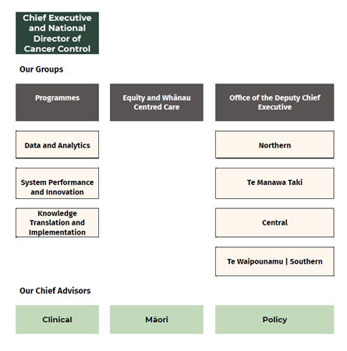

The Chief Executive of the Agency receives advice from three key leadership groups:

* Hei Āhuru Mōwai – Māori Cancer Leadership Aotearoa
* He Ara Tangata – Consumer Reference Group (Māori Chair and 50% Māori members)
* the National Clinical Assembly.

### **Our context**

The environment we work in provides useful context for understanding our strategic objectives, intended operations and longer-term work programmes. Our operating environment is constantly changing (eg, fiscal changes, social conditions and technological advancements).

The environment we are operating in is largely the same as that of the Ministry (see **Our Context**, Section 1). The cancer system is under pressure due to increasing volumes of people requiring care, global workforce shortages, rapid technological advancement and rising costs. While the cancer sector delivers good outcomes for many people and is driven by a highly committed and diligent workforce, there are significant gaps in outcomes for groups in our population.

Recent health system reforms have not changed the fundamental responsibilities and role of Te Aho o Te Kahu although the Agency has had to adapt its partner engagement approaches to align with the ongoing shifts coming out of the reform. The Agency remains the national leader for cancer control and continues to be the central thread that connects and unites both new and existing health entities, and the wider cancer sector, providing expertise and support to improve outcomes for whānau with cancer.

The establishment of Health New Zealand – Te Whatu Ora has enabled a single point of engagement nationally that was not possible under the previous district health board structure. The Agency is working closely with the Ministry and Health New Zealand on implementing key initiatives, like new cancer medicines, and the implementation of new models of care and cancer care pathways.

### **Strategic direction**

The strategic direction of Te Aho o Te Kahu is informed by the [2019–2029 New Zealand Cancer Action Plan](https://www.health.govt.nz/publications/new-zealand-cancer-action-plan-2019-2029) and the [New Zealand Cancer Control Strategy 2003](https://www.health.govt.nz/publications/the-new-zealand-cancer-control-strategy).

The Agency’s work focuses on achieving the health system’s goal of improving health outcomes for all New Zealanders and delivering the Agency’s vision of fewer cancers, better survival and equity for all. Its intentions align with the [Government Policy Statement on Health 2024–2027](https://www.health.govt.nz/publication/government-policy-statement-health-2024-2027#:~:text=The%20GPS%202024%2D27%20sets,a%20prompt%20and%20efficient%20way.).

In 2023/24, Te Aho o Te Kahu engaged staff and key stakeholders to develop a new organisational ‘knowledge to action’ strategy, organisational structure and revised work programme. The three strands of the knowledge to action strategy are:

* Data and analytics – collaborating on data collections, standards and tools needed to deliver up-to-date, shareable knowledge to inform system and patient decisions.
* System performance and innovation – knowledge ‘snapshots’, reports and research that highlight best practice, risks, or opportunities across the cancer system.
* Knowledge translation and implementation – collaborating with health sector and consumers on guidance, tools and initiatives to improve the cancer system and outcomes for all people.

### **Overview of strategic direction**

Figure 7: How the agency aligns with Government health strategies

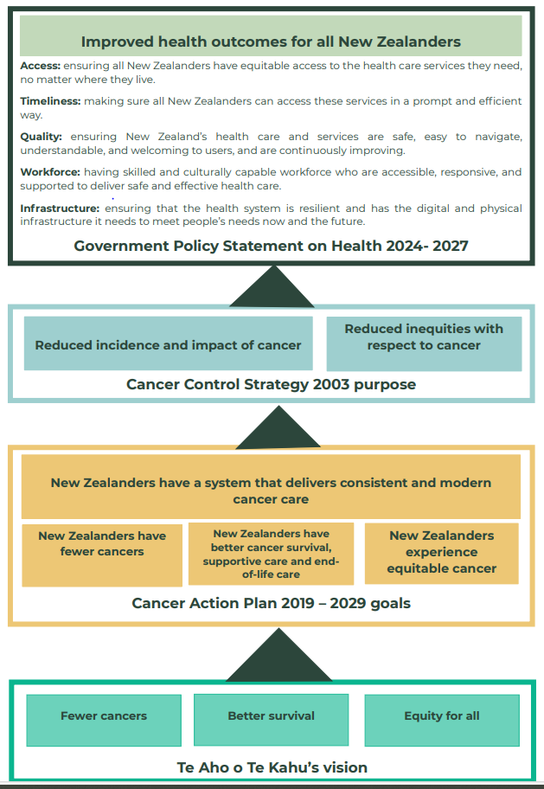

### 

### **Te Aho o Te Kahu strategic intentions**

To align with the direction and intent of our host agency, the strategic intentions of Te Aho o Te Kahu consist of a cancer-specific focus on four of the six strategic priorities of the Ministry (Provide system-level leadership for cancer, Drive cancer system strategy and performance, Be the Government’s primary advisor on cancer, and Future-proof the cancer system); plus two additional priorities (Support equity and whānau-centred system shifts and High-performing agency focused on cancer).

Our purpose, functions and principles are enduring and ensure we remain focused on the long-term vision while responding to opportunities and challenges in the shorter-term. Set out below are our priority activities for 2024–2028, which have been contextualised within the operating environment outlined above.

### Provide system-level leadership for cancer

#### What good looks like

We lead and unite efforts to create a high-performing, sustainable and equitable national cancer system for Aotearoa New Zealand.

#### Why this matters

Other health entities have to spread their attention across many priorities. Our agency has an unapologetic focus on cancer and supports the providers of cancer prevention and treatment to improve cancer care and reduce the burden of a disease that has a significant negative impact on so many people.

#### To do this we will

* Focus on progress towards achieving the outcomes of the 2019–2029 New Zealand Cancer Action Plan.
* Convene with others to focus on cancer system priorities.
* Maintain effective relationships across government, the cancer system and people with lived experience.

#### How we will get there

1. Provide advice and support to the wider health sector on cancer, including:

* models of care and optimal cancer care pathways
* informing workforce and infrastructure strategies.

1. Bring health entities together to address cancer challenges, including:

* agreeing system priorities for cancer control based on need
* identifying and supporting cancer services that are at risk of being disrupted
* finding solutions for implementing new cancer medicines.

1. Work with our partners to achieve the 2019–2029 New Zealand Cancer Action Plan outcomes:

* co-leading the National Clinical Network for Cancer and associated work programme.

### Drive cancer system strategy and performance

#### What good looks like

We have a strong understanding of how we are progressing towards improved outcomes for those who are affected by cancer and the objectives of the 2019–2029 New Zealand Cancer Action Plan.

#### Why this matters

We want to know how the cancer system is performing and where we can make improvements, address issues or implement new treatments/ways of working. How the cancer system performs has a significant effect on the performance of the wider health system.

#### To do this we will

* Understand cancer system performance.
* Develop appropriate interventions with health partners as required.

#### How we will get there

1. Develop a cancer system performance strategy.
2. Publish information and knowledge that can drive action to improve performance, including through:

* development and publication of spotlight reports, including population insights
* reports on the state of cancer in Aotearoa New Zealand
* providing subject matter expertise in relation to the Faster Cancer Treatment Health Target.

1. Monitor activity and performance against the 2019–2029 New Zealand Cancer Action Plan and other Government health targets and strategies.
2. Highlight and act when issues arise.

### Be the Government’s primary advisor on cancer

#### What good looks like

We work with the health system and the Government to ensure the outcomes of the 2019–2029 New Zealand Cancer Action Plan, and Government priorities are delivered.

#### Why this matters

A key part of our work is providing leadership, advice and coordination across the sector and Government decision-making to deliver better cancer outcomes. The provision of high-quality advice will help to build the trust and confidence of our key partners.

#### To do this we will

* Provide high-quality advice.
* Be flexible and responsive while maintaining a strategic focus in the medium to long term.
* Align our work programme with the highest priority issues.
* Ensure key partners understand our role within the cancer system.

#### How we will get there

1. Monitor progress and provide free and frank advice on outcomes under the 2019–2029 New Zealand Cancer Action Plan.
2. Deliver on key policy for the Government such as:

* implementing the new cancer medicines
* supporting services with advice to achieve the Faster Cancer Treatment targets

1. Support the Ministry of Health, Health New Zealand – Te Whatu Ora, and Government with advice on policy choices for annual Budgets relating to the cancer system.

### Future-proof the cancer system

#### What good looks like

We work across the health sector to create a shared understanding of the challenges, long-term risks and opportunities to deliver equitable cancer outcomes for all people in Aotearoa New Zealand.

#### Why this matters

The challenges being confronted by the cancer system are increasing over time and our agency is best placed to take a longer-term whole-of-system view and influence the system to effect changes that will make cancer care more sustainable. A cancer system that is not operating well will have significant impacts on the wider health system.

#### To do this we will

* Continue horizon scanning at a regional, national and international level to identify emerging issues and opportunities.
* Have access to a strong evidence base including high-quality data, analytics and research which the sector can use to inform decision-making, strategies and policies.
* Work at a ‘whole-of-system’ level, focusing specifically on cancer.

#### How we will get there

1. Work with partner health organisations to identify and address emerging and/or unexpected issues across the cancer system (eg, service level compromise, new technologies and precision medicine).
2. Enhance access to high-quality evidence, data and trends relating to cancer, including through the CanShare programme.

### Support equity and whānau centred system shifts

#### What good looks like

New Zealand’s cancer system provides accessible and equitable care in a way that meets the needs of patients and whānau.

#### Why this matters

Overall health system performance will be improved if all people are receiving care in a timely and consistent way and people’s lives will be the better for it.

#### To do this we will

* Ensure all our work considers the needs of people and whānau affected by cancer.
* Seek advice from a range of stakeholders and consumers.
* Influence partner agencies to embed equitable models of care.

#### How we will get there

1. Influence cancer service delivery partners to prioritise initiatives that transform the system in a way that improves consumer engagement and access, including through:

* improved access to travel assistance
* navigation services

1. Support initiatives that have the greatest impact on equity and address unmet need, such as:

* development of lung screening programmes.

1. Continue to prioritise relationships and working partnerships with Māori partner organisations such as Hei Āhuru Mōwai and He Ara Tangata, our consumer advisory group.
2. Support key external events such as the World Indigenous Cancer Conference 2026 (to be held in Aotearoa New Zealand).

### A high-performing agency focused on cancer

#### What good looks like

We deliver high-quality and high-value work that makes a difference for those who are affected by cancer.

#### Why this matters

It is important that we are organised to efficiently achieve our strategic work and quickly adapt to emerging issues and opportunities. Without this, the objectives desired through the establishment of our agency will not be realised and the opportunity to improve cancer outcomes lost.

#### To do this we will

* Continuously improve our processes, tools and ways of working.
* Empower staff to work in ways that are equity-led, knowledge-driven, outcomes-focused and person- and whānau-centred.
* Focus on career progression to retain and attract experts and leaders in cancer, clinical and data roles.
* Continue to build and strengthen the culture of our organisation.

#### How we will get there

1. We will improve our organisational performance by:

* continuous improvement of our processes and systems
* building our internal capabilities (eg, career progression, Whāinga Amorangi capabilities and data visualisation)
* embedding processes to improve the project management of our work.

1. Increased focus on project and programme management to deliver the biggest impact on both Agency and 2019–2029 New Zealand Cancer Action Plan outcomes.

1. Minister of Health. 2024. *Government Policy Statement on Health 2024–2027*. URL: [health.govt.nz/publications/government-policy-statement-on-health-2024-2027](https://www.health.govt.nz/publications/government-policy-statement-on-health-2024-2027) (accessed 4 September 2024).
2. The six Pae Ora Strategies are available on the Ministry’s website: [health.govt.nz/strategies-initiatives/health-strategies/pae-ora-strategies](https://www.health.govt.nz/strategies-initiatives/health-strategies/pae-ora-strategies).