Search Strategies

Contents

Epidemiology of Gender Dysphoria 1

The Medical Management of Gender Dysphoria using GnRHa 3

Puberty Blockers and impact on mental health and wellbeing outcomes for adolescents with gender dysphoria 5

Mental health and wellbeing interventions for gender dysphoria in adolescents. 8

## Epidemiology of Gender Dysphoria

|  |  |
| --- | --- |
| Item | Specification |
| Date of search | **5 September 2023** |
| Databases search | **Ovid MEDLINE adapted for Embase, Scopus, Cochrane** |
| Search terms used | **Puberty blocker** |
| **GnRH** |
| **Gonadotrophin releasing hormone** |
| **Children (6 to 12 years), adolescents (13 to 18 years) or teenagers** |
| Time frame | **Nov 2020 – 31 August 2023** |
| Inclusion criteria | **Any language** |
| **Original articles** |
| **Primary research** |
| **Clinical outcomes** |

Search Strategy

Database: Ovid MEDLINE(R) and Epub Ahead of Print, In-Process, In-Data-Review & Other Non-Indexed Citations, Daily and Versions <1946 to August 22, 2022>, adapted for Embase, Scopus, Cochrane

Search Strategy:

--------------------------------------------------------------------------------

1 puberty blocker*.mp.

2 (GnRH* and (puberty adj3 (suppress* or block*))).mp. [mp=title, book title, abstract, original title, name of substance word, subject heading word, floating sub-heading word, keyword heading word, organism supplementary concept word, protocol supplementary concept word, rare disease supplementary concept word, unique identifier, synonyms]

3 ("gonadotrophin releasing hormone*" and (puberty adj3 (suppress* or block*))).mp. [mp=title, book title, abstract, original title, name of substance word, subject heading word, floating sub-heading word, keyword heading word, organism supplementary concept word, protocol supplementary concept word, rare disease supplementary concept word, unique identifier, synonyms]

4 1 or 2 or 3

5 limit 4 to English language

6 limit 5 to ("child (6 to 12 years)" or "adolescent (13 to 18 years)"

7 5 and (teen* or adoles* or child*).mp. [mp=title, book title, abstract, original title, name of substance word, subject heading word, floating sub-heading word, keyword heading word, organism supplementary concept word, protocol supplementary concept word, rare disease supplementary concept word, unique identifier, synonyms]

8 6 or 7

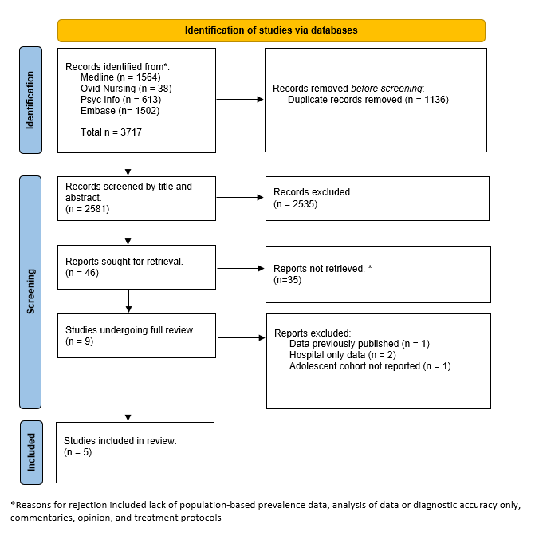

Figure 1 PRISMA Study Selection Epidemiology of Gender Dysphoria

## The Medical Management of Gender Dysphoria using GnRHa

|  |  |
| --- | --- |
| Item | Specification |
| Date of search | **5 September 2023** |
| Databases search | **Ovid MEDLINE adapted for Embase, Scopus, Cochrane** |
| Search terms used | **Puberty blocker** |
| **GnRH** |
| **Gonadotrophin releasing hormone** |
| **Children (6 to 12 years), adolescents (13 to 18 years) or teenagers** |
| Time frame | **Nov 2020 – 31 August 2023** |
| Inclusion criteria | **Any language** |
| **Original articles** |
| **Primary research** |
| **Clinical outcomes** |

Search Strategy

Database: Ovid MEDLINE(R) and Epub Ahead of Print, In-Process, In-Data-Review & Other Non-Indexed Citations, Daily and Versions <1946 to August 22, 2022>, adapted for Embase, Scopus, Cochrane

Search Strategy:

--------------------------------------------------------------------------------

1 puberty blocker*.mp.

2 (GnRH* and (puberty adj3 (suppress* or block*))).mp. [mp=title, book title, abstract, original title, name of substance word, subject heading word, floating sub-heading word, keyword heading word, organism supplementary concept word, protocol supplementary concept word, rare disease supplementary concept word, unique identifier, synonyms]

3 ("gonadotrophin releasing hormone*" and (puberty adj3 (suppress* or block*))).mp. [mp=title, book title, abstract, original title, name of substance word, subject heading word, floating sub-heading word, keyword heading word, organism supplementary concept word, protocol supplementary concept word, rare disease supplementary concept word, unique identifier, synonyms]

4 1 or 2 or 3

5 limit 4 to English language

6 limit 5 to ("child (6 to 12 years)" or "adolescent (13 to 18 years)"

7 5 and (teen* or adoles* or child*).mp. [mp=title, book title, abstract, original title, name of substance word, subject heading word, floating sub-heading word, keyword heading word, organism supplementary concept word, protocol supplementary concept word, rare disease supplementary concept word, unique identifier, synonyms]

8 6 or 7

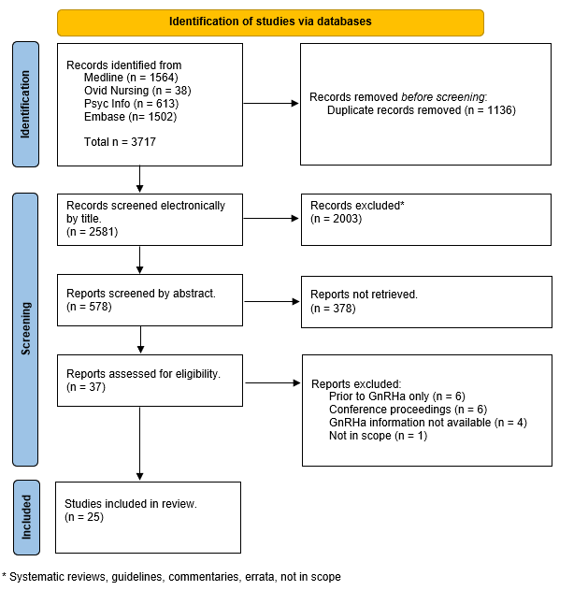

Figure 2. PRISMA Study Selection Clinical implications of Puberty Blockers as an intervention for adolescents with gender dysphoria

## Puberty Blockers and impact on mental health and wellbeing outcomes for adolescents with gender dysphoria

**Database: Ovid MEDLINE(R) and Epub Ahead of Print, In-Process, In-Data-Review & Other Non-Indexed Citations, Daily and Versions <1946 to July 19, 2023>, , adapted for Embase, Scopus, Cochrane (with targeted searching in Google Scholar, Index New Zealand, and NZ Research) or**   
 **Search Strategy:**   
**1** Gender Dysphoria/   
2 Gender Identity/   
3 Transsexualism/   
4 Transgender Persons/   
5 Health Services for Transgender Persons/   
6 exp Sex Reassignment Procedures/   
7 (gender* adj3 (dysphori* or affirm* or incongruen* or identi* or disorder* or confus* or minorit* or queer*)).tw.   
8 (transgend* or transex* or transsex* or transfem* or transwom* or transma* or transmen* or transperson* or transpeopl*).tw.   
9 (trans or crossgender* or cross-gender* or crossex* or cross-sex* or genderqueer*).tw.   
10 ((sex or gender*) adj3 (reassign* or chang* or transform* or transition*)).tw.   
11 (male-to-female or m2f or female-to-male or f2m).tw.   
12 "Sexual and Gender Disorders"/   
13 or/1-12   
14 Gonadotropin-Releasing Hormone/   
15 (pubert* adj3 block*).ti,ab.   
16 ((gonadotrophin or gonadotropin) and releasing).ti,ab.   
17 (GnRH adj2 analog*).ti,ab.   
18 GnRH*.ti,ab.   
19 "GnRH agonist*".ti,ab.   
20 14 or 15 or 16 or 17 or 18 or 19   
21 13 and 20   
22 (adolescen* or pubescen* or prepubescen* or pre-pubescen* or pubert* or prepubert* or pre-pubert* or teen* or preteen* or pre-teen* or juvenil* or youth* or under-age*).ti,ab.   
23 Adolescent/ or Adolescent Behavior/ or Adolescent Health/   
24 Puberty/   
25 (child* or minor or minors or boy* or girl* or kid or kids or young*).ti,ab.   
26 minors/   
27 exp Child/ or exp Child Behavior/ or Child Health/ or Child Welfare/   
28 22 or 23 or 24 or 25 or 26 or 27   
29 21 and 28   
30 puberty blocker*.mp.   
31 (GNrH* and (puberty adj3 (suppress* or block*))).mp.   
32 (("gonadotrophin releasing hormone*" or "gonadotrophin releasing hormone*") and (puberty adj3 (suppress* or block*))).mp  
 **33** 30 or 31 or 32   
34 29 or 33   
35 psychosocial.mp. or exp Psychosocial Functioning/   
36 mental health.mp. or exp Mental Health/   
37 self-harm.mp. or Self-Injurious Behavior/   
38 Suicidal Ideation/ or Suicide/ or suicid*.mp. or Suicide, Attempted/   
39 exp Anxiety/ or exp Stress, Psychological/ or anxi*.mp. or exp Anxiety Disorders/   
40 exp Depression/ or depression.mp.   
41 self-esteem.mp. or Self Concept/   
42 employment.mp. or Employment/   
43 Academic Success/ or exp Educational Status/ or educational outcome*.mp.   
44 (bully* or cyberbully* or cyber-bully*).mp. [mp=title, book title, abstract, original title, name of substance word, subject heading word, floating sub-heading word, keyword heading word, organism supplementary concept word, protocol supplementary concept word, rare disease supplementary concept word, unique identifier, synonyms, population supplementary concept word, anatomy supplementary concept word]   
45 "social media".mp. or exp Social Media/   
46 family violence.mp. or Domestic Violence/   
47 family reject*.mp.   
48 exp Family Relations/   
49 maori.mp. or Maori People/   
50 (pasifik* or samoa* or tonga* or fiji* or cook island* or Niue* or hawaiian* or polynesian* or micronesian* or melanesian* or Papua New Guinea or Solomon Islands or Kiribati or Tokelau* or ("pacific" and (zealand or aotearoa or maori)) or ("pacific" and austral*)).mp.   
51 35 or 36 or 37 or 38 or 39 or 40 or 41 or 42 or 43 or 44 or 45 or 46 or 47 or 48 or 49 or 50   
52 34 and 51   
53 limit 52 to (english language and yr="1990 -Current")

**Number of Results**

PsychInfo=57

Medline = 91

Scopus = 86

Embase = 231

Total = 465

Duplicates and false drops removed = 165

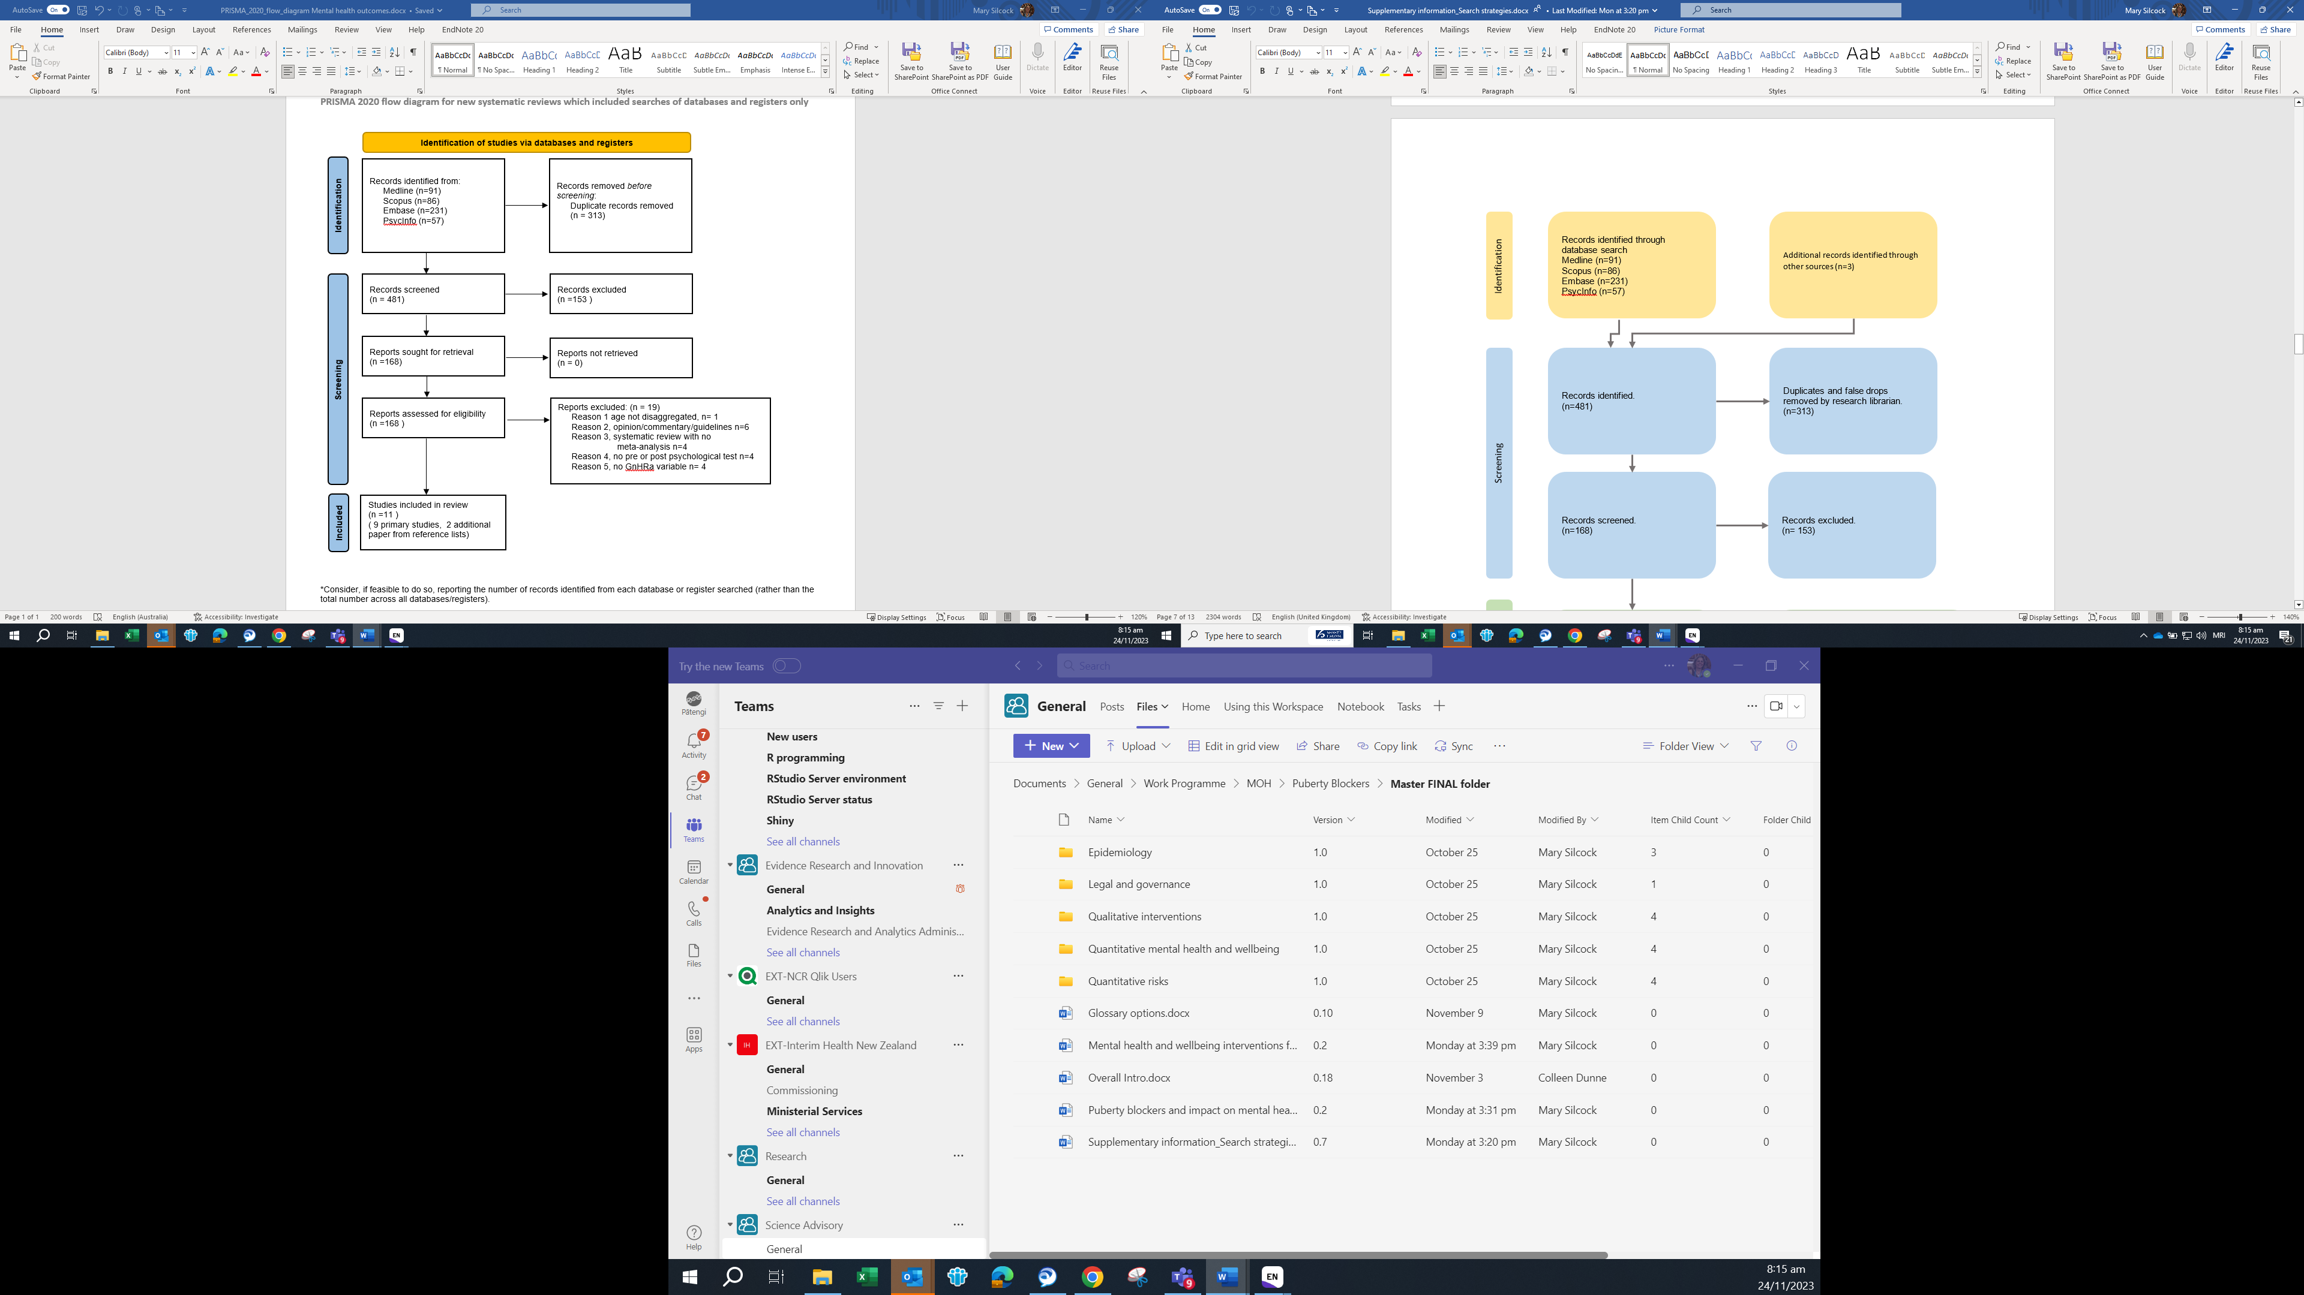

Figure 3. PRISMA Study Selection for Mental Health and Wellbeing Outcomes for adolescents with Gender Dysphoria

## Mental health and wellbeing interventions for gender dysphoria in adolescents.

First Search Strategy

**Database: Ovid MEDLINE(R) and Epub Ahead of Print, In-Process, In-Data-Review & Other Non-Indexed Citations, Daily and Versions <1946 to October 04, 2023>, adapted for PsycInfo, Scopus, Embase**   
**Search Strategy:**   
**1** Gender Dysphoria/   
2 Transsexualism/   
3 Transgender Persons/   
4 Health Services for Transgender Persons/   
5 (gender* adj3 (dysphori* or affirm* or incongruen* or disorder* or confus*)).mp.   
6 (transgend* or transex* or transsex* or transfem* or transwom* or transma* or transmen* or transperson* or transpeopl*).ab,ti.   
7 (takatapui or "Faʻafafine" or "Fa'afatama").mp. [mp=title, book title, abstract, original title, name of substance word, subject heading word, floating sub-heading word, keyword heading word, organism supplementary concept word, protocol supplementary concept word, rare disease supplementary concept word, unique identifier, synonyms, population supplementary concept word, anatomy supplementary concept word]   
8 1 or 2 or 3 or 4 or 5 or 6 or 7   
9 psychosocial.mp. or exp Psychosocial Functioning/ or psycho-social.mp.   
10 mental health.mp. or exp Mental Health/   
11 (self-harm or Self-Injurious Behavior).mp.   
12 Suicidal Ideation/ or Suicide/ or suicid*.mp. or Suicide, Attempted/

**13** exp Anxiety/ or exp Stress, Psychological/ or anxi*.mp. or exp Anxiety Disorders/ (494405)   
14 exp Depression/ or depression.mp.   
15 self-esteem.mp. or Self Concept/   
16 (belonging* or (social adj3 participat*)).mp.   
17 "quality of life".mp. or "Quality of Life"/ or wellbeing.mp. or well-being.mp.   
18 9 or 10 or 11 or 12 or 13 or 14 or 15 or 16 or 17   
19 8 and 18   
20 exp qualitative research/   
21 qualitative.ab,ti.   
22 grounded theory.mp. or Grounded Theory/   
23 action research.mp.   
24 ethnograph*.mp.   
25 Phenomenolog*.mp.   
26 interview*.mp.   
27 20 or 21 or 22 or 23 or 24 or 25 or 26   
28 19 and 27   
29 limit 28 to ("child (6 to 12 years)" or "adolescent (13 to 18 years)")   
30 youth.mp.   
31 Adolescent/ or adoles*.mp.   
32 ("young adult*" or "young people" or "young person").mp. [mp=title, book title, abstract, original title, name of substance word, subject heading word, floating sub-heading word, keyword heading word, organism supplementary concept word, protocol supplementary concept word, rare disease supplementary concept word, unique identifier, synonyms, population supplementary concept word, anatomy supplementary concept word]   
33 teen*.mp.   
34 puberty.mp. or Puberty/   
35 30 or 31 or 32 or 33 or 34   
36 28 and 35   
37 29 or 36   
38 interven*.mp.   
39 treat*.mp.   
40 38 or 39   
41 37 and 40   
42 limit 41 to (english language and yr="1990 -Current")

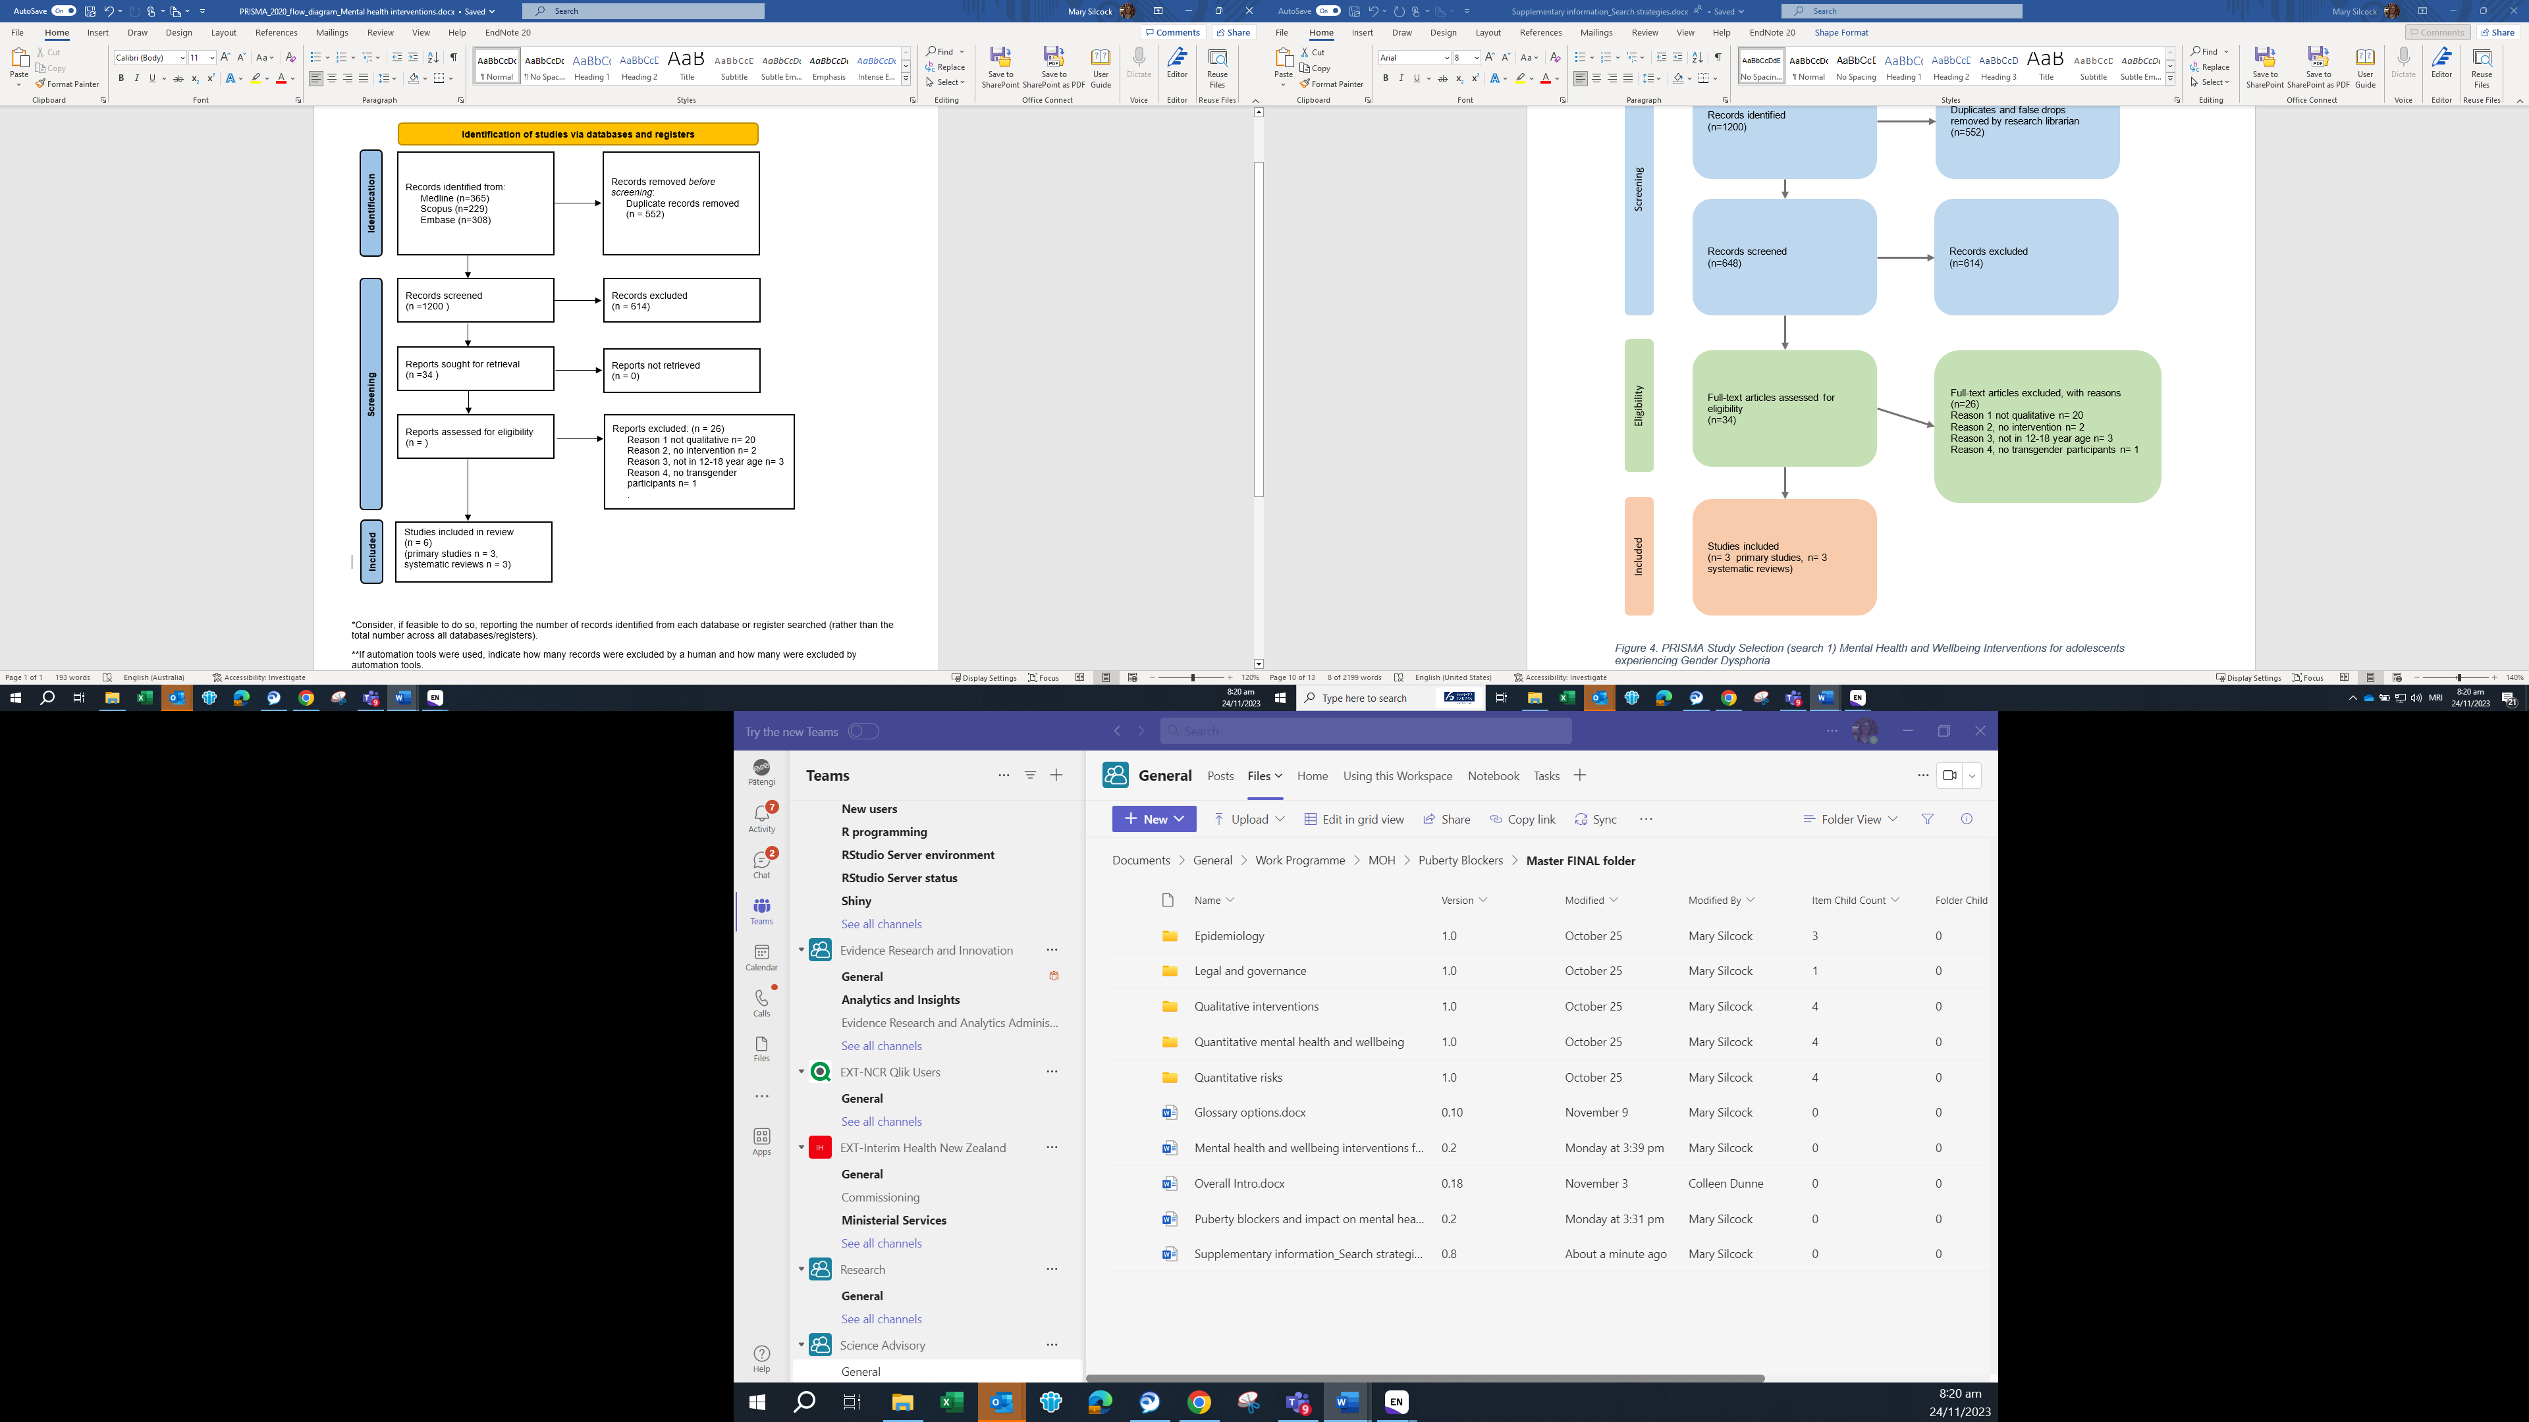

Figure 4. PRISMA Study Selection (search 1) Mental Health and Wellbeing Interventions for adolescents experiencing Gender Dysphoria

Second Search Strategy

**Database: Ovid MEDLINE(R) and Epub Ahead of Print, In-Process, In-Data-Review & Other Non-Indexed Citations, Daily and Versions <1946 to October 04, 2023>, adapted for PsycInfo, Scopus, Embase**   
**Search Strategy:**   
**1** Gender Dysphoria/   
2 Transsexualism/   
3 Transgender Persons/   
4 Health Services for Transgender Persons/   
5 (gender* adj3 (dysphori* or affirm* or incongruen* or disorder* or confus*)).mp.   
6 (transgend* or transex* or transsex* or transfem* or transwom* or transma* or transmen* or transperson* or transpeopl*).ab,ti.   
7 (takatapui or "Faʻafafine" or "Fa'afatama").mp. [mp=title, book title, abstract, original title, name of substance word, subject heading word, floating sub-heading word, keyword heading word, organism supplementary concept word, protocol supplementary concept word, rare disease supplementary concept word, unique identifier, synonyms, population supplementary concept word, anatomy supplementary concept word]   
8 1 or 2 or 3 or 4 or 5 or 6 or 7   
9 psychosocial.mp. or exp Psychosocial Functioning/ or psycho-social.mp.   
10 mental health.mp. or exp Mental Health/   
11 (self-harm or Self-Injurious Behavior).mp.   
12 Suicidal Ideation/ or Suicide/ or suicid*.mp. or Suicide, Attempted/

**13** exp Anxiety/ or exp Stress, Psychological/ or anxi*.mp. or exp Anxiety Disorders/ (494405)   
14 exp Depression/ or depression.mp.   
15 self-esteem.mp. or Self Concept/   
16 (belonging* or (social adj3 participat*)).mp.   
17 "quality of life".mp. or "Quality of Life"/ or wellbeing.mp. or well-being.mp.   
18 9 or 10 or 11 or 12 or 13 or 14 or 15 or 16 or 17   
19 8 and 18   
20 exp qualitative research/   
21 qualitative.ab,ti.   
22 grounded theory.mp. or Grounded Theory/   
23 action research.mp.   
24 ethnograph*.mp.   
25 Phenomenolog*.mp.   
26 interview*.mp.   
27 20 or 21 or 22 or 23 or 24 or 25 or 26   
28 19 and 27   
29 limit 28 to ("child (6 to 12 years)" or "adolescent (13 to 18 years)")   
30 youth.mp.   
31 Adolescent/ or adoles*.mp.   
32 ("young adult*" or "young people" or "young person").mp. [mp=title, book title, abstract, original title, name of substance word, subject heading word, floating sub-heading word, keyword heading word, organism supplementary concept word, protocol supplementary concept word, rare disease supplementary concept word, unique identifier, synonyms, population supplementary concept word, anatomy supplementary concept word]   
33 teen*.mp.   
34 puberty.mp. or Puberty/   
35 30 or 31 or 32 or 33 or 34   
36 28 and 35   
37 29 or 36   
38 interven*.mp.   
39 treat*.mp.   
40 38 or 39   
41 37 and 40   
42 limit 41 to (english language and yr="1990 -Current")

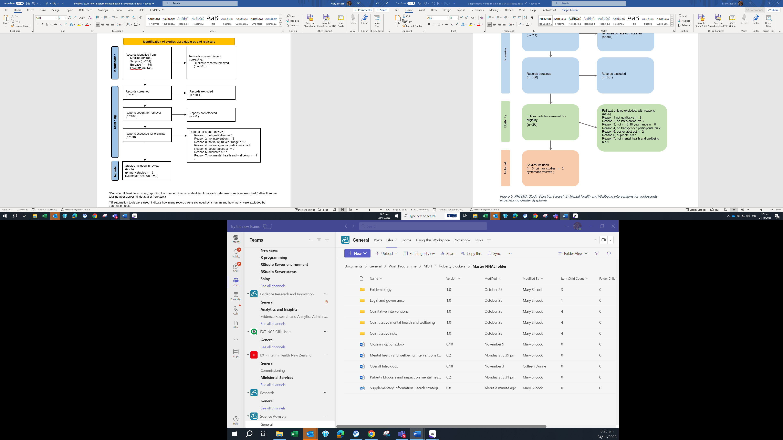

Figure 5. PRISMA Study Selection (search 2) Mental Health and Wellbeing interventions for adolescents experiencing gender dysphoria