

Adult Questionnaire Showcards

Year 13 – 2023/24

BLANK



AD.02

*No showcard for this question.*

Which of these age groups do you belong to?

|  |  |  |  |  |  |  |  |  |  |  |  |  |  |  |  |  |  |
| --- | --- | --- | --- | --- | --- | --- | --- | --- | --- | --- | --- | --- | --- | --- | --- | --- | --- |
| |  |  | | --- | --- | | **1** | 15–19 years | | **2** | 20–24 years | | **3** | 25–34 years | | **4** | 35–44 years | | **5** | 45–54 years | | **6** | 55–64 years | | **7** | 65–74 years | | **8** | 75+ years | |  |

AD.01a

At birth, what was your sex recorded as?

|  |  |
| --- | --- |
|  | Male |
|  | Female |
|  | Another term |

AD.01b

What is your gender?

|  |  |
| --- | --- |
|  | Male |
|  | Female |
|  | Another gender – please specify, if you are comfortable doing so |

|  |  |  |  |  |  |  |  |  |  |  |  |
| --- | --- | --- | --- | --- | --- | --- | --- | --- | --- | --- | --- |
| AMH2.01  This is a general question about your life as a whole these  days. This includes all areas of your life.  Where zero is completely dissatisfied, and ten is completely  satisfied, how do you feel about your life as a whole?    0 1 2 3 4 5 6 7 8 9 10   |  |  |  |  |  |  |  |  |  |  | | --- | --- | --- | --- | --- | --- | --- | --- | --- | --- | |  |  |  |  |  |  |  |  |  |  |   **10**  **0**  Completely dissatisfied Completely satisfied |  |

|  |  |  |  |  |  |  |  |  |  |  |  |  |  |  |  |
| --- | --- | --- | --- | --- | --- | --- | --- | --- | --- | --- | --- | --- | --- | --- | --- |
| AMH2.02  Now, a question about your family. Please think in general  about how your family is doing.  Where zero means extremely badly and ten means extremely  well, how would you rate how your family is doing these days?    0 1 2 3 4 5 6 7 8 9 10   |  |  |  |  |  |  |  |  |  |  | | --- | --- | --- | --- | --- | --- | --- | --- | --- | --- | |  |  |  |  |  |  |  |  |  |  |   **0**  Extremely badly Extremely well   |  |  | | --- | --- | | **11** | I don’t have any family | | **12** | I can’t define my family | | **10** |

A1.07

What treatments do you now have for your heart condition(s)?  
Select all that apply.

|  |  |
| --- | --- |
| **1** | No treatment |
| **2** | Aspirin |
| **3** | Other medicines, tablets or pills (including spray under the tongue, patches on the skin and blood thinners) |
| **4** | Diet |
| **5** | Exercise |
| **77** | Other – please specify |

A1.11

What treatments do you now have for your stroke?  
Select all that apply.

|  |  |
| --- | --- |
| **1** | No treatment |
| **2** | Aspirin |
| **3** | Other medicines, tablets or pills |
| **4** | Diet |
| **5** | Exercise or rehabilitation (include speech  therapy, occupational therapy, physiotherapy) |
| **77** | Other – please specify |

A1.14

What treatments do you now have for your diabetes?  
Select all that apply.

|  |  |
| --- | --- |
| **1** | No treatment |
| **2** | Insulin injections |
| **3** | Medicines, tablets or pills |
| **4** | Diet |
| **5** | Exercise |
| **77** | Other – please specify |

A1.17

What treatments do you **now** have for asthma?   
Select all that apply.

|  |  |
| --- | --- |
| **1** | No treatment |
| **2** | Inhalers |
| **3** | Medicines, tablets or pills |
| **77** | Other – please specify |

A1.19

What kind of arthritis was that?  
Select all that apply.

|  |  |
| --- | --- |
| **1** | Rheumatoid |
| **2** | Osteoarthritis |
| **3** | Gout |
| **4** | Psoriatic |
| **5** | Systemic lupus erythematosus (SLE) |
| **77** | Other – please specify |

A1.20

Which kind of arthritis affects you most?

|  |  |
| --- | --- |
|  | Rheumatoid |
|  | Osteoarthritis |
|  | Gout |
|  | Psoriatic |
|  | Systemic lupus erythematosus (SLE) |
| **77** | Other |

A1.21

What treatments do you now have for arthritis?  
Select all that apply.

|  |  |
| --- | --- |
| **1** | No treatment |
| **2** | Medicines, tablets or pills (including painkillers) |
| **3** | Exercise or physiotherapy |
| **4** | Injections |
| **5** | Diet |
| **77** | Other – please specify |

A1.22a

Are you now limited in any way, in your usual activities, because of arthritis symptoms?

|  |  |
| --- | --- |
| **1** | Yes, limited a lot |
| **2** | Yes, limited a little |
| **3** | No, not limited at all |

A1.31a

How would you describe the health of your teeth or mouth?

|  |  |
| --- | --- |
| **1** | Excellent |
| **2** | Very good |
| **3** | Good |
| **4** | Fair |
| **5** | Poor |

A2.040

At your **usual medical centre** have you had an appointment with any of the following health care workers about your own health, in the **past 12 months**?  
Select all that apply.

|  |  |
| --- | --- |
| **1** | GP (general practitioner or family doctor) |
| **2** | Nurse |
| **3** | Physiotherapist |
| **4** | Mental health professional (eg psychologist or counsellor) |
| **5** | Dietitian |
| **77** | Another health care worker – please specify |
| **0** | None of the above |

|  |  |  |  |  |  |  |  |  |  |  |  |  |  |  |  |  |  |  |
| --- | --- | --- | --- | --- | --- | --- | --- | --- | --- | --- | --- | --- | --- | --- | --- | --- | --- | --- |
| A2.360  In the **past 12 months**, was there a time when you had a **medical problem** but did not visit a GP for any of the following reasons?  Select all that apply.   |  |  | | --- | --- | | **1** | Time taken to get an appointment too long | | **2** | Owed money to the medical centre | | **3** | Dislike or fear of the GP | | **4** | Difficult to take time off work | | **5** | No transport or too far to travel | | **6** | Could not arrange childcare or care for a dependent adult | | **7** | Didn’t have a carer, support person or interpreter to go with you | | **77** | Another reason – please specify | | **0** | None of the above | |

|  |  |  |  |  |  |  |  |  |  |  |  |
| --- | --- | --- | --- | --- | --- | --- | --- | --- | --- | --- | --- |
| A2.720  Thinking about your last visit to an emergency department for your own health, what were **all** the reasons you went?  Select all that apply.   |  |  | | --- | --- | | **1** | Condition appeared serious / life threatening; or sent by GP | | **2** | GP or after-hours too expensive | | **3** | Time of day / day of week (outside of usual medical centre hours) | | **4** | Time taken to get an appointment was too long at usual medical centre | | **77** | Another reason – please specify | |  |

A2.730

What was the **main** reason you went to a hospital emergency department?

|  |  |
| --- | --- |
| **1** | Condition appeared serious / life threatening;  or sent by GP |
| **2** | GP or after-hours too expensive |
| **3** | Time of day / day of week (outside of usual medical centre hours) |
| **4** | Time taken to get an appointment was too long at usual medical centre |
| **77** | Another reason |

A2.91

How long has it been since you last visited a dental health care worker about your **own** dental health, for any reason?

|  |  |
| --- | --- |
| **1** | Within the past year (less than 12 months ago) |
| **2** | Within the past two years (more than 1 year but less than 2 years ago) |
| **3** | Within the past five years (more than 2 years but less than 5 years ago) |
| **4** | Five or more years ago |
| **5** | Have never seen a dental health care worker |

A2.95

Which of the following statements best describes the regularity of your consultations with a dental health care worker?

|  |  |
| --- | --- |
| **1** | I visit a dental health care worker at least every two years for a check up |
| **2** | I visit a dental health care worker for check-ups regularly, but with intervals of more than two years |
| **3** | I only visit a dental health care worker when I have a toothache or other similar trouble |
| **4** | I never visit a dental health care worker |

|  |  |
| --- | --- |
| AMH1.07a  In the **past** **12 months**, have you consulted any of the following people for concerns about your **emotions, stress, mental health, or substance use**? Select all that apply. |  |

|  |  |  |  |  |  |  |  |  |  |  |  |  |  |  |  |  |  |  |  |  |  |  |  |  |
| --- | --- | --- | --- | --- | --- | --- | --- | --- | --- | --- | --- | --- | --- | --- | --- | --- | --- | --- | --- | --- | --- | --- | --- | --- |
| |  |  | | --- | --- | | **1** | GP | | **2** | Nurse | | **3** | Psychiatrist or other medical specialist | | **4** | Social worker | | **5** | Psychologist, counsellor or psychotherapist | | **6** | Teacher | | **7** | Religious or spiritual advisor, like a minister, priest or tohunga | | **8** | Kaumātua or tohunga | | **9** | Family, whānau, partner and/or friends | | **10** | Peer support worker | | **11** | Other person | | **12** | No, none of the above | |

AMH1.08

In the **past** **12 months**, have you received help for concerns about your **emotions, stress, mental health,**

**or substance use**, from any of the following?  
Select all that apply.

|  |  |
| --- | --- |
| **1** | Hospital emergency department or an  after-hours medical centre |
| **2** | Hospital ward |
| **3** | Crisis mental health team |
| **4** | Māori health service (including Māori mental health or addictions services) |
| **5** | Community mental health or addictions service (including hospital outpatient appointments) |
| **6** | Other community support services, such as a youth ‘one-stop-shop’ |
| **7** | Programme in prison or a youth justice centre |
| **8** | Other – please specify |
| **9** | No, none of the above |

AMH1.11a

Thinking about the **most recent** time when you felt you needed professional help but didn’t receive it, why was that?  
Select all that apply.

|  |  |
| --- | --- |
| **1** | Wanted to handle it alone and/or with the support of family, whānau and friends |
| **2** | Couldn’t spare the time |
| **3** | Costs too much |
| **4** | Problems with transportation or childcare |
| **5** | Unsure where to go or who to see |
| **6** | Couldn't get an appointment at a suitable time |
| **7** | Time taken to get an appointment too long |
| **8** | Available services did not meet my cultural or language needs |
| **9** | Health professionals unhelpful or unwilling to help |
| **10** | Not satisfied with available services |
| **11** | Didn't think treatment would work |
| **12** | Concerned what others might think |
| **13** | Another reason – please specify |

DH1.19

On a scale of one to five, where one is very underweight and five is very overweight, how do **you** view your weight?

|  |  |
| --- | --- |
| **1** | Very underweight |
| **2** | Underweight |
| **3** | Neither underweight nor overweight |
| **4** | Overweight |
| **5** | Very overweight |
| **6** | Currently pregnant |

BS3.01

How tall are you without shoes?

Select unit of measure 1, 2 or 3.

____ centimetres

**1**

**2**

____ metres

____ feet and ____ inches

**3**

BS3.02

How much do you weigh?

Select unit of measure 1, 2 or 3.

____ kilograms

**1**

**2**

____ stones and ____ pounds

____ pounds

**3**

A3.08

During the last 7 days, on how many days did you do moderate physical activities?

‘Moderate’ activities make you breathe harder than normal, but only a little:

|  |  |
| --- | --- |
| Carrying light loads | Badminton (social) |
| Electrical work | Ballroom dancing |
| Farming | Bowls (indoor, outdoor / lawn) |
| Heavy gardening (digging, weeding, raking, planting, pruning, clearing section) | Cricket (outdoors – batting and bowling) |
| Heavy cleaning (sweeping, cleaning windows, moving furniture) | Cycling (recreational – less than 15km/hr – not mountain biking) |
| House renovation | Deer hunting |
| Machine tooling (operating lathe, punch press, drilling, welding) | Doubles tennis |
| Lawn mowing (manual mower) | Exercising at home (not gym) |
| Plastering | Golf |
| Plumbing | Horse Riding / Equestrian |
|  | Kayaking – slow |
| Kapa haka practice | Skate boarding |
| Waiata-a-ringa | Surfing / body boarding |
|  | Yachting / sailing / dingy sailing |

A3.10

During the last 7 days, on how many days did you do **vigorous** physical activities?

‘Vigorous’ activities make you breathe a lot harder than normal (‘huff and puff’):

|  |  |
| --- | --- |
| Carrying heavy loads | Boxing |
| Forestry | Aerobics |
| Heavy construction | Kayaking – fast |
| Digging ditches | Athletics (track and field) |
| Chopping or sawing wood | Aquarobics |
|  | Skiing |
| Taiaha | Badminton (competitive) |
| Haka | Basketball |
| Rowing | Soccer |
| Judo, karate, other martial arts | Cricket – indoors (batting and bowling) |
| Mountain biking | Rock climbing |
| Cycling (competitive) | Cycling – recreational (not mountain biking) – more than 15 km/hr |
| Rugby union | Rugby league |
| Hockey | Exercise classes – going to the gym (other than for aerobics) / weight training |
| Race walking | Netball |
| Table tennis (competitive) | Volleyball |
| Running / jogging / cross country | Softball (running and pitching only) |
| Singles tennis | Squash |
| Touch rugby | Surf life saving |
| Tramping | Swimming (competitive) |
| Triathlon | Water Polo |

A3.12b

How often do you brush your teeth?

|  |  |
| --- | --- |
| **0** | Never |
| **1** | Less than once a day |
| **2** | Once a day |
| **3** | Twice a day |
| **4** | More than twice a day |
| **5** | No natural teeth |
|  |  |

A3.12c

What type of toothpaste do you usually use?

|  |
| --- |
| 1. Standard fluoride toothpaste |
| Image result for macleans multi actionImage result for colgate total    A close up of a logo  Description automatically generated  MouthFresh Toothpaste Cool Mint 120g    IGA Thirroul - Colgate Kids Peppa Pig Toothpaste 2-5 Years Mild Mint Gel  Sugar Free Fluoride Children's Tooth Paste 90gColgate Kids Natural Fruit Baby Toothpaste 0-2 Years 50ml | SuperdrugA picture containing food  Description automatically generatedGraphical user interface  Description automatically generatedFreshChoice Leamington - Colgate Toothpaste Kids Minions 6+ Years Mild Mint  Gel 90gA picture containing food  Description automatically generated2661082 |
|  |
| 1. Non-fluoridated toothpaste |
| Description: http://www.comvita.co.nz/userfiles/image/Product/Healthcare/OralCare/225(1).jpgImage result for red seal natural |
|  |
| 1. Don’t use toothpaste / no toothpaste available in house |

A3.15

How often do you now smoke?

|  |  |
| --- | --- |
| **1** | I don’t smoke now |
| **2** | At least once a day |
| **3** | At least once a week |
| **4** | At least once a month |
| **5** | Less often than once a month |

A3.16

How long ago did you stop smoking?

|  |  |
| --- | --- |
| **1** | Within the last month |
| **2** | 1 month to 3 months ago |
| **3** | 4 months to 6 months ago |
| **4** | 7 to 12 months ago |
| **5** | 1 to 2 years ago |
| **6** | 2 to 5 years ago |
| **7** | Longer than 5 years ago |

TOB3.02a

What, if anything, did you use to help you quit smoking during your **last** quit attempt?   
Select all that apply.

|  |  |
| --- | --- |
| **1** | Vaping or e-cigarettes |
| **2** | Nicotine replacement therapies (eg patches, gum) |
| **3** | Medicines (eg Champix, Zyban and Norpress) |
| **4** | Rongoā Māori (eg plant remedies, mirimiri) |
| **5** | Quitline |
| **6** | Face-to-face stop smoking service (eg in the community, hospital) |
| **7** | Support from friends and whānau |
| **77** | Other – please specify |
| **0** | I did it on my own |

A3.21b

How often do you now use vaping devices?

|  |  |
| --- | --- |
| **1** | I don’t use them now |
| **2** | At least once a day |
| **3** | At least once a week |
| **4** | At least once a month |
| **5** | Less often than once a month |

|  |  |
| --- | --- |
| TOB4.10a  Why do you use vaping devices? Select all that apply. |  |

|  |  |  |  |  |  |  |  |  |  |  |  |  |  |  |  |  |  |  |  |  |  |  |  |  |  |  |
| --- | --- | --- | --- | --- | --- | --- | --- | --- | --- | --- | --- | --- | --- | --- | --- | --- | --- | --- | --- | --- | --- | --- | --- | --- | --- | --- |
| |  |  | | --- | --- | | **1** | Less harmful than smoking | | **2** | To reduce or quit smoking | | **3** | A stop smoking service or healthcare worker suggested it | |  | Cheaper than tobacco | | **5**  **4** | Easier to get than tobacco | | **6** | People around me do it | | **7** | More acceptable to others than smoking | | **8** | More satisfying than smoking | | **9** | I enjoy them | | **10** | I like the flavours | | **11** | I can’t go without it | | **12** | To cope with stress, anxiety, or depression | | **77** | Other – please specify | |

TOB8.02

How long ago did you stop vaping?

|  |  |
| --- | --- |
| **1** | Within the last month |
| **2** | 1 month to 12 months ago |
| **3** | More than 1 year ago |

A3.22a

On **average**, how many **servings** of fruit do you eat per day? Please include all fresh, frozen, canned and stewed fruit. Do **not**include fruit juice or dried fruit.

A ‘**serving**’ of fruit:

1 cup of canned, frozen or stewed fruit

2 small

pieces of fruit

OR

OR

1 medium piece of fruit

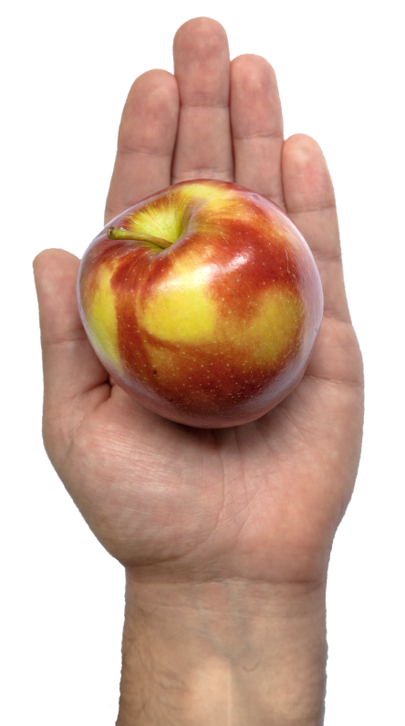

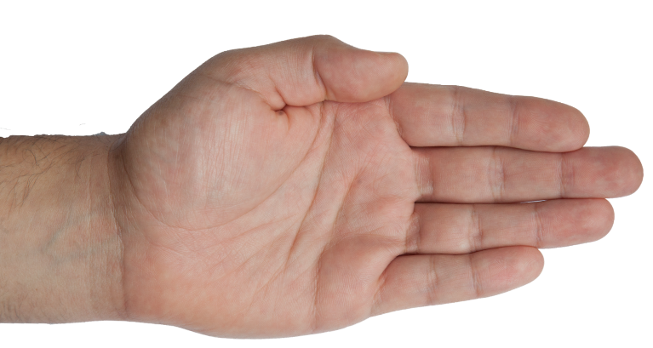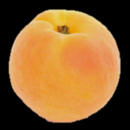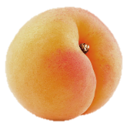

*For example: 1 apple + 2 small apricots = 2 servings.*

|  |  |
| --- | --- |
|  | I don’t eat fruit |
|  | Less than 1 serving per day |
|  | 1 serving per day |
|  | 2 servings per day |
|  | 3 servings per day |
|  | 4 servings per day |
|  | 5 servings per day |
|  | 6 or more servings per day |

A3.23a

On **average**, how many **servings** of vegetables do you eat per day? Please include all fresh, frozen and canned vegetables. Do **not** include vegetable juices.

A ‘**serving**’ of vegetables:

½ medium potato / similar sized kumara

OR

1 cup raw salad vegetables

OR

½ cup cooked vegetables

*****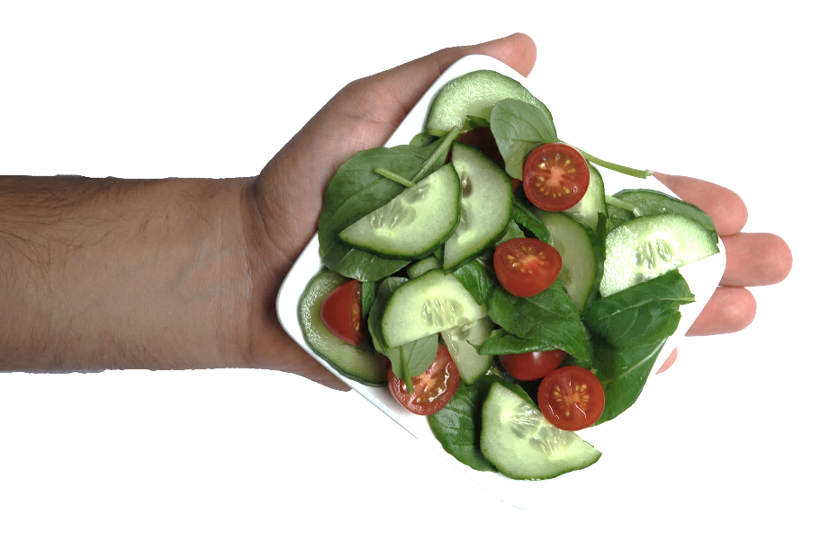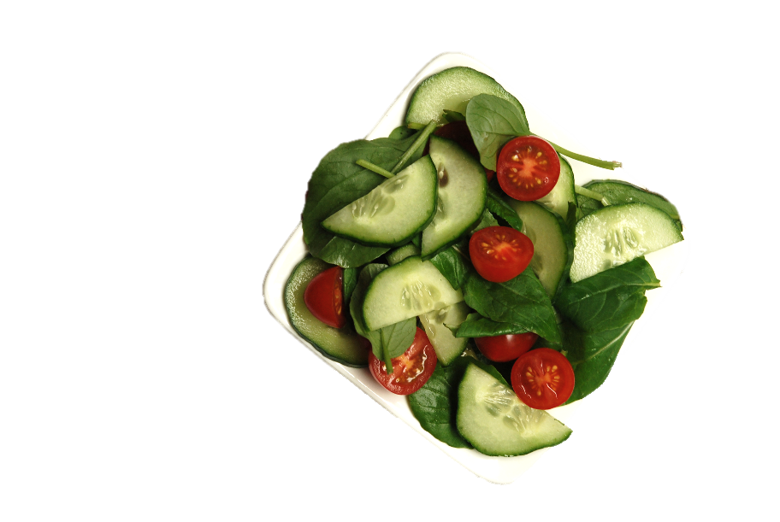*

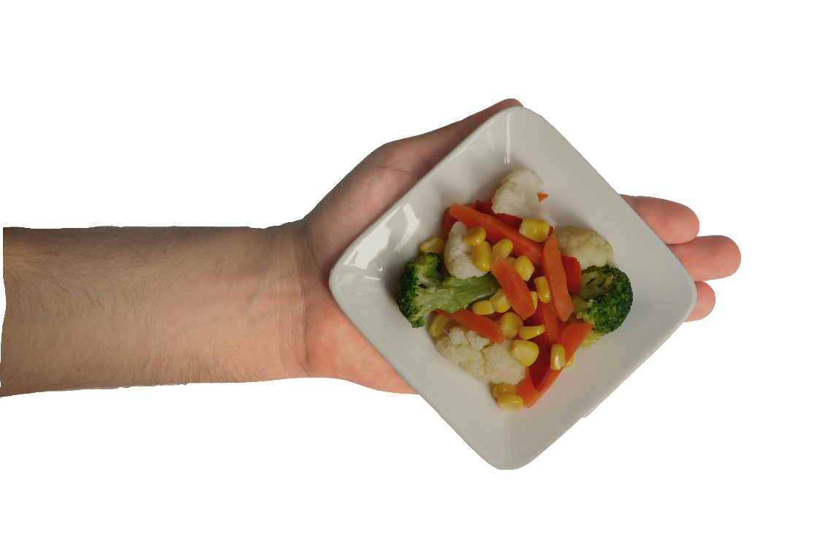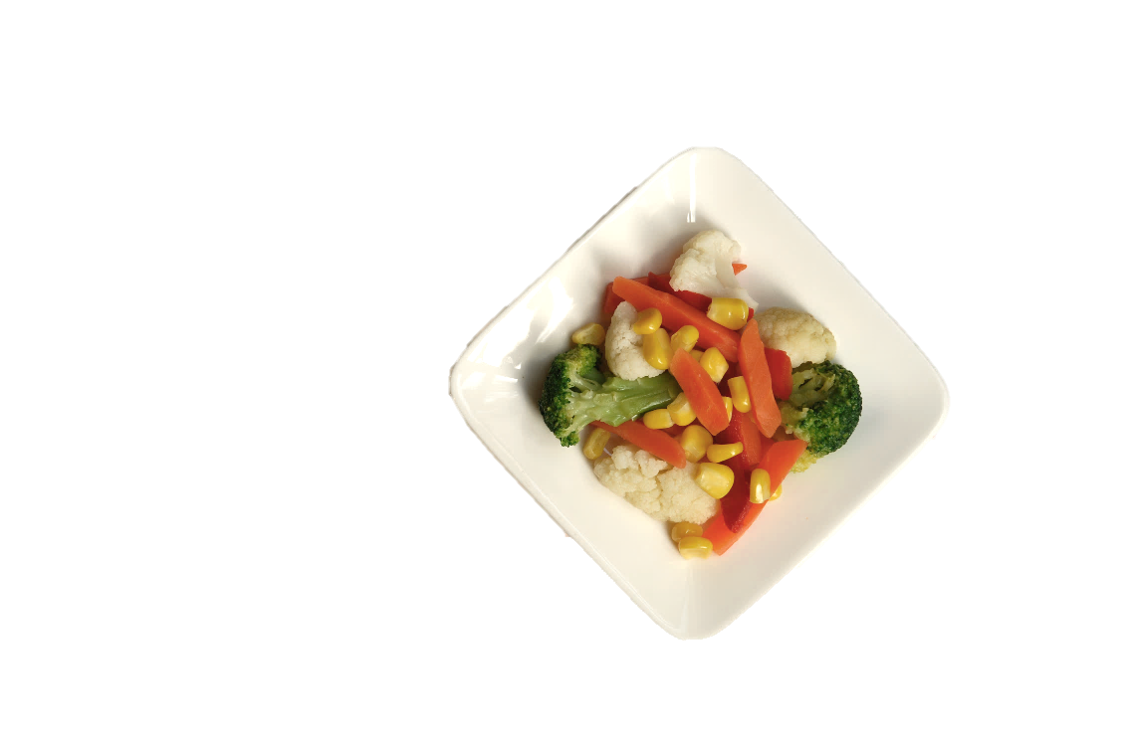

*For example: 5 servings could comprise of 1 medium potato + 1 cup of cooked vegetables + 1 cup of raw salad throughout the day.*

Remember to think about all meals and snacks.

|  |  |
| --- | --- |
|  | I don’t eat vegetables |
|  | Less than 1 serving per day |
|  | 1 serving per day |
|  | 2 servings per day |
|  | 3 servings per day |
|  | 4 servings per day |
|  | 5 servings per day |
|  | 6 or more servings per day |

A3.26a

How many drinks containing alcohol do you have on a typical day when you are drinking?

For this question: **one drink** = **one standard drink**:

* One can or stubbie of beer
* Half a large bottle of beer
* One small glass of wine
* One shot of spirits

Please see Standard Drinks Picture Showcard.

|  |  |
| --- | --- |
|  | 1 or 2 |
|  | 3 or 4 |
|  | 5 or 6 |
|  | 7 to 9 |
|  | 10 or 11 |
|  | 12 or more |

A3.27a

How often do you have six or more standard drinks on one occasion?

For this question: **one drink** = **one standard drink**:

* One can or stubbie of beer
* Half a large bottle of beer
* One small glass of wine
* One shot of spirits

Please see Standard Drinks Picture Showcard.

|  |  |
| --- | --- |
| **1** | Never |
| **2** | Less than monthly |
| **3** | Monthly |
| **4** | Weekly |
| **5** | Daily or almost daily |

A3.28

How often during the last year have you found that you were not able to stop drinking once you had started?

|  |  |
| --- | --- |
| **1** | Never |
| **2** | Less than monthly |
| **3** | Monthly |
| **4** | Weekly |
| **5** | Daily or almost daily |

A3.29

How often during the last year have you failed to do what was normally expected from you because of drinking?

|  |  |
| --- | --- |
| **1** | Never |
| **2** | Less than monthly |
| **3** | Monthly |
| **4** | Weekly |
| **5** | Daily or almost daily |

A3.30

How often during the last year have you needed a first drink in the morning to get yourself going after a heavy drinking session?

|  |  |
| --- | --- |
| **1** | Never |
| **2** | Less than monthly |
| **3** | Monthly |
| **4** | Weekly |
| **5** | Daily or almost daily |

A3.31

How often during the last year have you had a feeling of guilt or remorse after drinking?

|  |  |
| --- | --- |
| **1** | Never |
| **2** | Less than monthly |
| **3** | Monthly |
| **4** | Weekly |
| **5** | Daily or almost daily |

A3.32

How often during the last year have you been unable to remember what happened the night before because you had been drinking?

|  |  |
| --- | --- |
| **1** | Never |
| **2** | Less than monthly |
| **3** | Monthly |
| **4** | Weekly |
| **5** | Daily or almost daily |

A3.33

Have you or someone else been injured as a result of your drinking?

|  |  |
| --- | --- |
| **1** | Yes, but not in the last year |
| **2** | Yes, during the last year |
| **3** | No |

A3.34

Has a relative or friend, or a doctor or other health worker, been concerned about your drinking or suggested you cut down?

|  |  |
| --- | --- |
| **1** | Yes, but not in the last year |
| **2** | Yes, during the last year |
| **3** | No |

A3.37

In the **past 12 months**, have you used any of the following substances?

Please just read out the number next to the words.

Select all that apply.

|  |  |
| --- | --- |
| **1** | Cannabis, for example, marijuana, hash, weed |
| **2** | Cocaine |
| **3** | Ecstasy / MDMA |
| **4** | Amphetamine type stimulants, for example, ‘P’, speed, ice, Ritalin® |
| **5** | Inhalants, for example, NOS, glue, petrol, poppers |
| **6** | Sedatives or sleeping pills, for example, Valium, diazepam |
| **7** | Hallucinogens, for example, LSD, mushrooms, ketamine |
| **8** | Opioids, for example, heroin, morphine, methadone, codeine |
| **77** | Other substances – please specify (for example, synthetic cannabinoids, ‘synnies’, GHB, GBL, kava etc) |
| **0** | No, none of the above |

A3.39

In the **past three months**, how often have you used cannabis?

|  |  |
| --- | --- |
| **1** | Never |
| **2** | Once or twice |
| **3** | Monthly |
| **4** | Weekly |
| **5** | Daily or almost daily |

A3.40

During the **past three months**, how often have you had a strong desire or urge to use cannabis?

|  |  |
| --- | --- |
| **1** | Never |
| **2** | Once or twice |
| **3** | Monthly |
| **4** | Weekly |
| **5** | Daily or almost daily |

A3.41

During the **past three months**, how often has your use of cannabis led to health, social, legal or financial problems?

|  |  |
| --- | --- |
| **1** | Never |
| **2** | Once or twice |
| **3** | Monthly |
| **4** | Weekly |
| **5** | Daily or almost daily |

A3.42

During the **past three months**, how often have you failed to do what was normally expected of you because of your use of cannabis?

|  |  |
| --- | --- |
| **1** | Never |
| **2** | Once or twice |
| **3** | Monthly |
| **4** | Weekly |
| **5** | Daily or almost daily |

A3.43

Has a friend or relative or anyone else **ever** expressed concern about your use of cannabis?

|  |  |
| --- | --- |
| **1** | No, never |
| **2** | Yes, in the past 3 months |
| **3** | Yes, but not in the past 3 months |

A3.44

Have you **ever** tried and **failed** to control, cut down or stop using cannabis?

|  |  |
| --- | --- |
| **1** | No, never |
| **2** | Yes, in the past 3 months |
| **3** | Yes, but not in the past 3 months |

A4.01

In general, would you say your health is:

|  |  |
| --- | --- |
| **1** | Excellent |
| **2** | Very good |
| **3** | Good |
| **4** | Fair |
| **5** | Poor |
|  |  |

FD1.01

Do you have difficulty seeing, even if wearing glasses?

|  |  |
| --- | --- |
| **1** | No – no difficulty |
| **2** | Yes – some difficulty |
| **3** | Yes – a lot of difficulty |
| **4** | Cannot do at all |

FD1.02

Do you have difficulty hearing, even if using a hearing aid?

|  |  |
| --- | --- |
| **1** | No – no difficulty |
| **2** | Yes – some difficulty |
| **3** | Yes – a lot of difficulty |
| **4** | Cannot do at all |

FD1.03

Do you have difficulty walking or climbing steps?

|  |  |
| --- | --- |
| **1** | No – no difficulty |
| **2** | Yes – some difficulty |
| **3** | Yes – a lot of difficulty |
| **4** | Cannot do at all |

FD1.04

Do you have difficulty remembering or concentrating?

|  |  |
| --- | --- |
| **1** | No – no difficulty |
| **2** | Yes – some difficulty |
| **3** | Yes – a lot of difficulty |
| **4** | Cannot do at all |

FD1.05

Do you have difficulty washing all over or dressing?

|  |  |
| --- | --- |
| **1** | No – no difficulty |
| **2** | Yes – some difficulty |
| **3** | Yes – a lot of difficulty |
| **4** | Cannot do at all |

FD1.06

Using your usual language, do you have difficulty communicating, for example, understanding or being understood?

|  |  |
| --- | --- |
| **1** | No – no difficulty |
| **2** | Yes – some difficulty |
| **3** | Yes – a lot of difficulty |
| **4** | Cannot do at all |

FD1.07

Would you have difficulty lifting a two-litre bottle of water from waist to eye level?

|  |  |
| --- | --- |
| **1** | No – no difficulty |
| **2** | Yes – some difficulty |
| **3** | Yes – a lot of difficulty |
| **4** | Cannot do at all |

FD1.08

Do you have difficulty using your hands and fingers, such as picking up small objects, or opening containers?

|  |  |
| --- | --- |
| **1** | No – no difficulty |
| **2** | Yes – some difficulty |
| **3** | Yes – a lot of difficulty |
| **4** | Cannot do at all |

FD1.09

How often do you feel anxious, nervous or worried?

|  |  |
| --- | --- |
| **1** | Daily |
| **2** | Weekly |
| **3** | Monthly |
| **4** | A few times a year |
| **5** | Never |

FD1.10

Thinking about the last time you felt this way, how anxious, nervous or worried did you feel?

|  |  |
| --- | --- |
| **1** | A little |
| **2** | A lot |
| **3** | Somewhere in between a little and a lot |

FD1.11

How often do you feel depressed?

|  |  |
| --- | --- |
| **1** | Daily |
| **2** | Weekly |
| **3** | Monthly |
| **4** | A few times a year |
| **5** | Never |

FD1.12

Thinking about the last time you felt this way, how depressed did you feel?

|  |  |
| --- | --- |
| **1** | A little |
| **2** | A lot |
| **3** | Somewhere in between a little and a lot |

A4.13

During the past four weeks, how often did you feel tired out for no good reason – would you say all of the time, most of the time, some of the time, a little of the time, or none of the time?

|  |  |
| --- | --- |
| **1** | All of the time |
| **2** | Most of the time |
| **3** | Some of the time |
| **4** | A little of the time |
| **5** | None of the time |

A4.14

During the past four weeks, how often did you feel nervous – all of the time, most of the time, some of the time, a little of the time, or none of the time?

|  |  |
| --- | --- |
| **1** | All of the time |
| **2** | Most of the time |
| **3** | Some of the time |
| **4** | A little of the time |
| **5** | None of the time |

A4.15

During the past four weeks, how often did you feel so nervous that nothing could calm you down?

|  |  |
| --- | --- |
| **1** | All of the time |
| **2** | Most of the time |
| **3** | Some of the time |
| **4** | A little of the time |
| **5** | None of the time |

A4.16

During the past four weeks, how often did you feel hopeless?

|  |  |
| --- | --- |
| **1** | All of the time |
| **2** | Most of the time |
| **3** | Some of the time |
| **4** | A little of the time |
| **5** | None of the time |

A4.17

During the past four weeks, how often did you feel restless or fidgety?

|  |  |
| --- | --- |
| **1** | All of the time |
| **2** | Most of the time |
| **3** | Some of the time |
| **4** | A little of the time |
| **5** | None of the time |

A4.18

During the past four weeks, how often did you feel so restless you could not sit still?

|  |  |
| --- | --- |
| **1** | All of the time |
| **2** | Most of the time |
| **3** | Some of the time |
| **4** | A little of the time |
| **5** | None of the time |

A4.19

During the past four weeks, how often did you feel depressed?

|  |  |
| --- | --- |
| **1** | All of the time |
| **2** | Most of the time |
| **3** | Some of the time |
| **4** | A little of the time |
| **5** | None of the time |

A4.20

How often did you feel so depressed that nothing could cheer you up?

|  |  |
| --- | --- |
| **1** | All of the time |
| **2** | Most of the time |
| **3** | Some of the time |
| **4** | A little of the time |
| **5** | None of the time |

A4.21

During the past four weeks, how often did you feel that everything was an effort?

|  |  |
| --- | --- |
| **1** | All of the time |
| **2** | Most of the time |
| **3** | Some of the time |
| **4** | A little of the time |
| **5** | None of the time |

A4.22

During the past four weeks, how often did you feel worthless?

|  |  |
| --- | --- |
| **1** | All of the time |
| **2** | Most of the time |
| **3** | Some of the time |
| **4** | A little of the time |
| **5** | None of the time |

AMH1.01a

During the past four weeks, how often did you feel lonely?

|  |  |
| --- | --- |
| **1** | All of the time |
| **2** | Most of the time |
| **3** | Some of the time |
| **4** | A little of the time |
| **5** | None of the time |

A5.03

Which ethnic group or groups do you belong to?

Select all that apply.

|  |  |
| --- | --- |
| **1** | New Zealand European |
| **2** | Māori |
| **3** | Samoan |
| **4** | Cook Island Māori |
| **5** | Tongan |
| **6** | Niuean |
| **7** | Chinese |
| **8** | Indian |
| **77** | Other – please specify |

A5.05

Which country were you born in?

|  |  |
| --- | --- |
| **1** | New Zealand |
| **2** | Australia |
| **3** | England |
| **4** | China (People’s Republic of) |
| **5** | India |
| **6** | South Africa |
| **7** | Samoa |
| **8** | Cook Islands |
| **77** | Other – please specify |

A5.07

In which languages could you have a conversation about a lot of everyday things?

Select all that apply.

|  |  |
| --- | --- |
| **1** | English |
| **2** | Māori |
| **3** | Samoan |
| **4** | NZ sign language |
| **77** | Other language, eg Gujarati, Cantonese, Greek – please specify |

R5.08

Now I will ask you some questions about **reactions** to your ethnicity. How do **other people** usually classify you in New Zealand?

Select all that apply.

|  |  |
| --- | --- |
| **1** | New Zealand European |
| **2** | Māori |
| **3** | Samoan |
| **4** | Cook Island Māori |
| **5** | Tongan |
| **6** | Niuean |
| **7** | Chinese |
| **8** | Indian |
| **77** | Other – please specify |

R5.09

How often do you think about your ethnicity? Would you say never, once a year, once a month, once a week, once a day, once an hour, or constantly?

|  |  |
| --- | --- |
| **1** | Never |
| **2** | At least once a year |
| **3** | At least once a month |
| **4** | At least once a week |
| **5** | At least once a day |
| **6** | At least once an hour |
| **7** | Constantly |

R5.10

Have you ever been a victim of an ethnically motivated attack (verbal or physical abuse to you or your property)

**in New Zealand**?

Select all that apply.

|  |  |
| --- | --- |
| **1** | Yes, verbal – within the past 12 months |
| **2** | Yes, verbal – more than 12 months ago |
| **3** | Yes, physical – within the past 12 months |
| **4** | Yes, physical – more than 12 months ago |
| **5** | No |

R5.11

Have you ever been treated unfairly (for example, kept waiting or treated differently) by a health professional (that is, a doctor, nurse, dentist etc.) **because of your ethnicity** in New Zealand?

Select all that apply.

|  |  |
| --- | --- |
| **1** | Yes, within the past 12 months |
| **2** | Yes, more than 12 months ago |
| **3** | No |
| **4** | Not applicable – have never tried to visit a health professional in New Zealand |

R5.12

Have you ever been treated unfairly at work or been refused a job **because of your ethnicity** in New Zealand?

Select all that apply.

|  |  |
| --- | --- |
| **1** | Yes, within the past 12 months |
| **2** | Yes, more than 12 months ago |
| **3** | No |
| **4** | Not applicable – have never had a job or tried to  find a job in New Zealand |

R5.13

Have you ever been treated unfairly when renting or buying housing **because of your ethnicity** in New Zealand?

Select all that apply.

|  |  |
| --- | --- |
| **1** | Yes, within the past 12 months |
| **2** | Yes, more than 12 months ago |
| **3** | No |
| **4** | Not applicable – have never tried to rent or buy  a house in New Zealand |

A5.14

What is your highest secondary school qualification?

|  |  |
| --- | --- |
| **1** | None |
| **2** | NZ School Certificate in one or more subjects  **or** National Certificate level 1  **or** NCEA level 1 |
| **3** | NZ Sixth Form Certificate in one or more subjects  **or** National Certificate level 2  **or** NZ UE before 1986 in one or more subjects  **or** NCEA level 2 |
| **4** | NZ Higher School Certificate  **or** NZ University Bursary / Scholarship  **or** National Certificate level 3  **or** NCEA level 3  **or** NZ Scholarship level 4 |
| **5** | Other secondary school qualification  **gained in New Zealand** – please specify |
| **6** | Other secondary school qualification  **gained overseas** |

A5.15

What is your highest completed qualification?

|  |  |
| --- | --- |
| **0** | None |
| **1** | National Certificate level 1 |
| **2** | National Certificate level 2 |
| **3** | National Certificate level 3 |
| **4** | National Certificate level 4 |
| **5** | Trade Certificate |
| **6** | Diploma or Certificate level 5 |
| **7** | Advanced Trade Certificate |
| **8** | Diploma or Certificate level 6 |
| **9** | Teachers Certificate / Diploma |
| **10** | Nursing Diploma |
| **11** | Bachelor |
| **12** | Bachelor Hons |
| **13** | Postgraduate Certificate / Diploma |
| **14** | Masters Degree |
| **15** | PhD or other doctoral degree |
| **77** | Other – please specify |

A5.16

In the last 12 months, what are all the ways that you yourself got income? Please do not count loans because they are not income.

Select all that apply.

|  |  |
| --- | --- |
| **1** | Wages, salaries, commissions, bonuses etc,  paid by an employer |
| **2** | Self-employment, or business you own and work in |
| **3** | Interest, dividends, rent, other investments |
| **4** | Regular payments from ACC or a private work accident insurer |
| **5** | NZ Superannuation or Veteran’s Pension |
| **6** | Other superannuation, pensions, annuities (other than NZ Superannuation, Veteran’s Pension or war pensions) |
| **7** | Jobseeker Support |
| **8** | Sole Parent Support |
| **9** | Supported Living Payment |
| **10** | Student Allowance |
| **11** | Other government benefits, government income support payments, war pensions, paid parental leave or Disability Allowance |
| **12** | Other sources of income, including support payments from people who do not live in the household |
| **17** | No source of income during that time |

A5.23a

What is the total income that **you yourself** got from

**all sources**, before tax or anything was taken out of it, in the last 12 months? Please read out the number next to the income group.

|  |  |
| --- | --- |
| **1** | Loss |
| **2** | Zero income |
| **3** | $1 – $10,000 |
| **4** | $10,001 – $15,000 |
| **5** | $15,001 – $20,000 |
| **6** | $20,001 – $25,000 |
| **7** | $25,001 – $30,000 |
| **8** | $30,001 – $35,000 |
| **9** | $35,001 – $40,000 |
| **10** | $40,001 – $50,000 |
| **11** | $50,001 – $60,000 |
| **12** | $60,001 – $70,000 |
| **13** | $70,001 – $100,000 |
| **14** | $100,001 – $200,000 |
| **15** | $200,001 or more |

A5.24a

What is the total income that **your household** got from all sources, before tax or anything was taken out of it, in the last 12 months?

Please read out the number next to the income group.

|  |  |
| --- | --- |
| **1** | $30,000 or less |
| **2** | $30,001 – $70,000 |
| **3** | $70,001 – $100,000 |
| **4** | $100,001 – $150,000 |
| **5** | $150,001 – $200,000 |
| **6** | $200,001 or more |

A5.25

How well does your household’s total income meet the cost of basic needs such as food, clothing and housing.

Would you say it’s not enough, only just enough, enough, or more than enough?

|  |  |
| --- | --- |
| **1** | Not enough |
| **2** | Only just enough |
| **3** | Enough |
| **4** | More than enough |

A5.17

Which of these statements best describes your **current** work situation:

|  |  |
| --- | --- |
| **1** | Working in paid employment (includes self-employment) |
| **2** | Not in paid work, and looking for a job |
| **3** | Not in paid work, and not looking for a job (for any reason, such as being retired, a homemaker, caregiver, or full-time student) |
| **77** | Other – please specify |

A5.19a

In the last 4 weeks, which of these have you done, **without pay**?

Select all that apply.

|  |  |
| --- | --- |
| **1** | Household work, cooking, repairs, gardening, etc,  for **my own household** |
| **2** | Looked after a child who is a member of **my household** |
| **3** | Looked after a member of **my household** who is ill  or disabled |
| **4** | Looked after a child (who does **not** live in my household) |
| **5** | Helped someone who is ill or disabled (who does  **not** live in my household) |
| **6** | Other help or voluntary work for or through any organisation, group or marae |
| **0** | None of these |

A5.19b

Are you attending, studying or enrolled at school or any other place of education?

|  |  |
| --- | --- |
| **1** | Yes – full-time (20 hours or more a week) |
| **2** | Yes – part-time (less than 20 hours a week) |
| **3** | No – neither |

A5.21

What type of health or medical insurance is that?

|  |  |
| --- | --- |
| **1** | Comprehensive, covering day-to-day costs such as GP fees and pharmacy charges, as well as private hospital care |
| **2** | Hospital only |
| **77** | Other – please specify |

A5.22

And who pays for this health or medical insurance?

|  |  |
| --- | --- |
| **1** | Self or family members |
| **2** | Partly self or family and partly employer |
| **3** | Paid for by employer or employer of family member |
| **4** | Paid for by some other person or agency |

A5.28b

Do you, or anyone else who lives here:

|  |  |
| --- | --- |
| **1** | Hold this dwelling in a family trust |
| **2** | Own or partly own this dwelling, with or without a mortgage |
| **3** | Neither of these, for example renting |

A5.29b

Who owns this house / flat?

|  |  |
| --- | --- |
| **1** | Private person, trust or business |
| **2** | Local Authority or City Council |
| **3** | Kāinga Ora (formerly Housing New Zealand) |
| **4** | Other state-owned corporation or state-owned enterprise, or government department or ministry |
| **5** | Iwi, hapū or Māori land trust |
| **6** | Other community housing provider |

A5.29c

How many of each of the following rooms are there in this house or flat?

|  |  |
| --- | --- |
|  | Bedrooms, including any sleepouts furnished as bedrooms |
|  | Lounges, living rooms or family rooms |
|  | Dining rooms |
|  | Kitchens |
|  | Conservatories you can sit in |
|  | Studies, studios, hobby rooms |

A5.30b

Which of the following options best describes how you think of yourself?

|  |  |
| --- | --- |
| **1** | Heterosexual or straight |
| **2** | Gay or lesbian |
| **3** | Bisexual |
| **4** | Another identity – please specify, if you are  comfortable doing so |

A5.35

|  |  |
| --- | --- |
| **1** | Spouse or partner |
| **2** | Child (eg daughter) |
| **3** | Parent (eg mother) |
| **4** | Sibling (eg brother) |
| **5** | Grandchild |
| **6** | Grandparent |
| **7** | Great-grandchild |
| **8** | Great-grandparent |
| **9** | Nephew or niece |
|  | Uncle or aunt |
| **10**  **11** | Other relative |
| **12** | Unrelated |