Clearing the Air

Assessing real-world ventilation practices in New Zealand

Prepared for Ministry of Health

August 2024

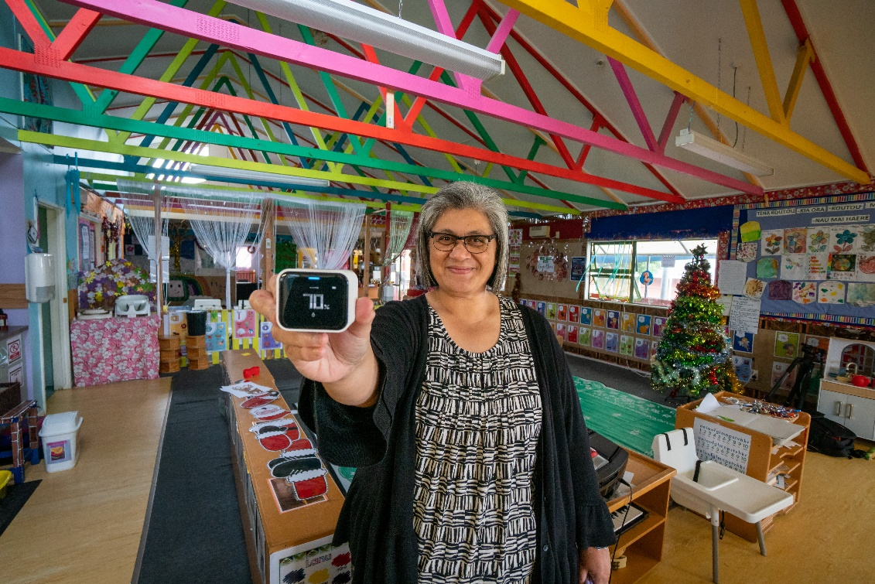

Prepared by:

Ian Longley

For any information regarding this report please contact:

Ian Longley

Programme Leader - Air Quality

+64 9 375 2096

i.longley@niwa.co.nz

National Institute of Water & Atmospheric Research Ltd  
Private Bag 99940  
Auckland 1149  
  
Phone +64 9 375 2050

NIWA CLIENT REPORT No: 2024251AK

Report date: August 2024

NIWA Project: MOH23101

|  |  |  |
| --- | --- | --- |
| Revision | Description | Date |
| Version 0.1 | Draft in preparation/in review | 5/9/2024 |
| Version 1.0 | Final version sent to client | Day Month Year |
| Version 1.1 | Amendments to sections xxx |  |

|  |  |  |
| --- | --- | --- |
| Quality Assurance Statement | | |
| A close-up of a signature | Reviewed by: | Guy Coulson  Principal Scientist - Air Quality |
|  | Formatting checked by: |  |
| A close up of a signature | Approved for release by: | Jonathan Moores  Regional Manager Auckland |

Contents

Executive summary 5

1 Introduction 7

1.1 Background 7

1.2 The need 8

1.3 The Project 9

1.4 Scope of this report 9

2 Method 11

2.1 General approach 11

2.2 Stages of the project 11

2.3 Recruitment of centres 12

2.4 Fieldwork procedure 12

2.5 Choice of study rooms 13

2.6 Monitoring variables, techniques and instrumentation 13

2.7 Intervention design and limitations 14

2.8 Outcome statistics 16

3 Results 17

3.1 Coverage 17

3.2 Carbon dioxide 17

3.3 Observed changes in door and window usage 27

4 Discussion 28

4.1 The state of ventilation in naturally ventilated buildings occupied by vulnerable persons 28

4.2 The potential for improving ventilation through changes in ventilation behaviour 28

4.3 The potential for using carbon dioxide monitoring data to promote pro-ventilation behaviour change. 30

5 Conclusions 31

5.1 What does this study say about the state of ventilation in New Zealand’s naturally ventilated non-residential buildings? 31

5.2 What does this study say about the potential of behavioural intervention? 31

6 Implications 33

6.1 Identifying spaces that require mitigation 33

6.2 Is low-cost behavioural intervention a viable mitigation approach? 33

6.3 What might be an appropriate role for sensor-based monitoring? 34

7 Acknowledgements 35

Tables

Table 2‑1: Stages of the project. 11

Table 2‑2: Number of centres monitored by type for each stage of the project. 12

Table 3‑1: Distribution of monitoring durations across all centres. 17

Figures

Figure 2‑1: Two Qingping Air Monitor Lites of the type used to monitor CO2 in this study. 13

Figure 2‑2: A magnetic opening sensor of the type used in the study. 14

Figure 2‑3: The real-time data dashboard. 15

Figure 2‑4: Example of a "calendar" style plot of CO2 data provided to all participants and discussed during the intervention meeting. 15

Figure 3‑1: Rooms ranked according to the average number of days (out of 10) during which CO2 was elevated above 800 ppm for more than an hour. 18

Figure 3‑2: Rooms ranked by the median duration that CO2 remained over 800 ppm. 18

Figure 3‑3: Rooms ranked according to the average number of days (out of 10) during which CO2 was elevated above 2000 ppm for more than quarter of an hour. 19

Figure 3‑4: The daily probability of exceeding an 800 ppm (1 hr) and 2000 ppm (15 mins) threshold for each room in the study. 20

Figure 3‑5: Box-and-whisker plot of the distribution of calculated risks of exceeding the short- and longer-term thresholds for each building type. 20

Figure 3‑6: Result of k-means cluster analysis. 21

Figure 3‑7: Time series of CO2 from the "Spin" room - the only room in the High-Risk cluster. 22

Figure 3‑8: Each days' time series of CO2 from the "Spin" room - the only room in the High-Risk cluster - overlaid. 22

Figure 3‑9: Time series of CO2 from a classroom in cluster 2. 24

Figure 3‑10: Each days' time series of CO2 from a cluster 2 classroom overlaid. 25

Figure 3‑11: Time series of CO2 from a room in cluster 3. 26

Figure 3‑12: 48-hours time series of CO2 from one Wednesday and Thursday in the consultation room example from cluster 3. 26

Figure 4‑1: Scatter plot of risk of exceeding 800 ppm for more than an hour (days per 10 days) in baseline and interventions period. 29

Executive summary

Before the COVID-19 pandemic, ventilation in most spaces was primarily driven by the goal of preventing the excessive build-up of carbon dioxide in a room. The high transmissibility and deadly impact of the SARS-CoV-2 virus meant that achieving an acceptable degree of risk prevention required a much higher ventilation demand than most buildings or ventilation systems were designed for, and the actual degree of ventilation available in most indoor settings.

The majority of New Zealand’s buildings are “naturally” ventilated, meaning they rely on the opening of windows (and/or doors) by occupants. Ventilation performance is a product of the ventilation potential – i.e. the presence, functionality and maintenance of the infrastructure available (mainly windows) - and the degree to which that potential is realised in practice, i.e. windows and doors are appropriately used. Ventilation habits are often inefficient, probably because we have a relatively poor innate sense of when a room is under-ventilated. Most members of the public under-estimate how effective windows can be in improving ventilation and air quality and reducing infection risk.

The widespread existence of windows that are rarely opened, or rarely fully opened, implies an untapped potential to increase the ventilation performance of buildings at little to no cost. However, during the height of the COVID-19 pandemic there was effectively no information on the state of ventilation in New Zealand’s naturally ventilated buildings, how many (and which) buildings required mitigation, or what behavioural (versus infrastructural) interventions could achieve.

The project reported here was designed to:

* Assess the state of ventilation (inferred from measurements of carbon dioxide) in a sample of mostly naturally ventilated buildings occupied by people more vulnerable to the acute health effects of COVID-19 infection
* Explore the potential for improving ventilation through changes in ventilation behaviour
* Explore the potential for using carbon dioxide monitoring data to promote pro-ventilation behaviour change.

This was achieved through the monitoring of carbon dioxide (CO2) in up to 4 rooms for periods varying from 14 to 78 days in 31 “centres”. Centres consisted of an aged car centre, churches, community spaces, early childhood centres, schools, gyms, clinics, libraries, offices and veterinary clinics spread over Auckland, Christchurch and Alexandra (Otago).

The persistence of CO2 concentrations above 800 ppm for more than an hour is internationally recognised as an indicator of poor ventilation. We observed this to occur at least one day in 10 in 74 out of 99 studied rooms, and at least 5 days in 10 in 31 out of 99 rooms.

Overall, data we would consider representing very poor air quality with a high risk was not observed.

Less than 10 rooms posed a moderately high risk. This group was characterised by the room being somewhat under-ventilated relative to the ideal, but being periodically ventilated more effectively, or by occupancy reducing or ceasing. Such rooms will present a higher risk if these refresh breaks do not occur for whatever reason (e.g. inclement weather), or the duration between breaks increases.

Approximately a third of rooms had good air quality throughout the study.

This study did not yield a clear profile for the types of building, rooms, uses or infrastructure that would present the more important risk factors. However, we found that gyms and education spaces were slightly over-represented amongst those rooms with poorer air quality, whereas churches and offices were over-represented in the good air quality group.

Our attempt to conduct a structured and deliberate behavioural intervention to improve ventilation practices was inconclusive. In our view this reflects flaws in the design, partly related to the difficulty in constructing a design that was sufficiently adaptable to the wide range of buildings, workplace, social and ethnic cultures across the participating centres.

It was clear from the data that “natural” variation in ventilation practice produced wide variation in indoor air quality outcomes. In particular, the frequency and duration of door openings and the timing/frequency of window openings appeared to be the main factor determining whether on any given day, and for how long, carbon dioxide exceeded risk thresholds. Although an extended analysis of this dataset is required to quantify these relationships, the analysis conducted to date is sufficient for us to confidently state that the potential for behaviour change to improve ventilation and indoor air quality and reduce risk is large.

This study indicates that some rooms present a greater risk and may deserve to be prioritised for mitigation, but it may be difficult to identify such locations in advance. This implies several non-exclusive options:

* Adopt a precautionary approach and mitigate in as many settings as possible
* Develop a predictive screening approach to gather better suggestive evidence of high risk before prioritising rooms for mitigation
* Conduct screening monitoring to gather more robust evidence of high risk before prioritising rooms for mitigation

# Introduction

## Background

In outdoor settings, and especially in New Zealand, the air tends to be constantly on the move, rapidly diluting any contamination. Amongst other things, this means (for example) smoke is dispersed, and we rarely re-inhale the air we, or those close to us, have just exhaled.

This is not the case indoors. In an enclosed space the air is trapped, contaminants accumulate, and before long occupants will be re-breathing each other’s breath. We may sense the air becoming stale or developing a smell. We may start to note condensation forming as humidity levels rise. Concentrations of any biological or chemical contaminants being released in the room may rise until they pose a risk to health. Rising levels of carbon dioxide from our own breathing can have subtle neurological effects such as headaches and difficulty concentrating (Snow et al., 2019). If an airborne respiratory virus is being exhaled by an occupant, it will also increase its concentration over time increasing the risk of infection for any other person present.

In the vast majority of cases, the solution is to ventilate the space, i.e. to ensure a means by which the stale air is removed and replaced with fresh air. Many spaces will possess a small degree of “self-ventilation” through gaps under doors, through floorboards, etc. More commonly, ventilation is provided by windows, and also occurs whenever a door is open. Historically, the Building Code specifies a minimum area of openings for rooms to allow for ventilation to provide safety for occupants, and to protect the room from damage from damp (MBIE, 2019).

It should be noted that ventilation is often confused with air circulation and air conditioning. Using a fan in a hot room to create an air flow with a cooling effect is recirculating the air, not ventilating the room, unless the fan accelerates the exchange of air between the room interior and exterior. Air conditioning refers to the deliberate change in the temperature or humidity of the air in a space, not its replacement.

This simple overview of ventilation assumes that the air being brought into a room is “fresh”. Where that air is arriving from an adjacent room this may not be the case. In these situations, supplying fresh air from outdoors is generally preferred. Whereas outdoor air is highly unlikely to be contaminated with indoor-sourced pollutants (carbon dioxide, viruses, some chemicals) to the same degree, it still may be contaminated with other pollutants, particularly emissions from road traffic in the case of buildings near major roads (in which case there is often a reluctance to open windows because of noise as well). In such cases ventilation will often still be preferable to no ventilation, although additional measures may be required to deliver fresh air to the room, such as ensuring outside air is drawn from a less polluted façade of the building, or that the air is filtered.

The degree of ventilation required depends upon the risk posed, which requires consideration of the likelihood of the presence of a contaminant, its rate of emission, its toxicity, the volume of the room, the vulnerability of the exposed, and the duration of their exposure.

Before the COVID-19 pandemic, ventilation in most spaces was primarily driven by the goal of preventing the excessive build-up of carbon dioxide in a room, with more demanding objectives in place in some high-risk settings like surgical theatres, kitchens and industrial facilities. SARS-CoV-2 is predominantly transmitted indoors via exhaled aerosols. In 2020 Its high transmissibility and deadly impact meant that achieving an acceptable degree of risk prevention required a much higher ventilation demand than most buildings or ventilation systems were designed for, and the actual degree of ventilation available in most indoor settings.

In some well-resourced buildings (especially offices) mechanical ventilation systems are provided to ensure a set level of ventilation. In these buildings, to a first approximation, good ventilation can be assumed (although poorly maintained systems do occur), and such systems can often be adjusted to provide higher ventilation rates if and when required.

However, the majority of New Zealand’s buildings are “naturally” ventilated, meaning their ventilation relies on the opening of windows and/or doors by occupants. In these buildings the degree to which a space is ventilated is a product of the ventilation potential – i.e. the presence, functionality and maintenance of the infrastructure available (mainly windows) - and the degree to which that potential is realised in practice, i.e. whether the infrastructure is used effectively, i.e. the window and door opening behaviour by occupants. Ventilation habits are often inefficient, probably because we have a relatively poor innate sense of when a room is under-ventilated (window-opening behaviour is mainly driven by our more actute sense of thermal comfort and noise). However, anecdotal evidence captured by the authors indicates that many (maybe most) members of the public, including teachers, under-estimate how effective windows can be in improving ventilation and air quality, and reducing infection risk.

The widespread existence of windows that are rarely opened, or rarely fully opened, implies an untapped potential to increase the ventilation performance of buildings at little to no cost. This realisation formed a core principle of the Ministry of Education’s COVID-19 Response - Ventilation Programme (CRVP). Beginning in early 2022 and working alongside a Technical Advisory Group (TAG) including the author of this report, the CRVP provided all schools with guidance and tools to improve ventilation in the ~31,000 naturally ventilated classrooms across NZ, with the primary focus being on increasing the opening of windows. The main tool was the provision of 12,000 carbon dioxide (CO2) monitors distributed to schools at zero cost to them. Teachers were supported to evaluate the impact of using windows, fans and portable air cleaners on CO2 (as a proxy for infection risk), thus realising their own agency, and then to share their learning with peers. Anecdotal evidence indicates that, despite some initial scepticism or lack of awareness, some teachers achieved large improvements in ventilation through small changes in practice, with the CO2 monitor being key to providing robust, quantitative and sharable data. However, uptake of the initiative was low or short-lived overall.

## The need

When preparations were being made to permanently re-open New Zealand’s schools after COVID-19 lockdowns in spring 2021, it was not known at the time what the state of ventilation (or indoor air quality) was across the more than 30,000 classrooms in New Zealand. It was also not known how much potential there was to improve ventilation, by how much and where by encouraging more effective use of existing infrastructure or whether risk reduction could be achieved by infrastructural versus behavioural interventions, where each approach should be best targeted, and what costs that would impose. This made it very difficult to ascertain the risk posed by allowing staff and students to once again congregate in school buildings while the virus was still prevalent and vaccination rates still low. The same situation broadly applied to most New Zealand buildings.

Māori and Pacific people have disproportionately high rates of many of the conditions that are risk factors associated with critical COVID-19 cases and death, including heart disease (Māori are more than twice as likely to die and 1.5 times as likely to be hospitalised for cardiovascular disease and diabetes (9.8% and 15.4% respectively). Māori and Pacific people are also more likely to live in crowded accommodation (StatsNZ, 2018) and disease transmission may therefore be higher for Māori and Pacific families, as self-isolation is more difficult. Māori are already over-represented in hospitalisations for respiratory illness, being 2.2 times more likely to be hospitalised than New Zealand Europeans (Telfar-Barnard and Zhang, 2021). Finding potential areas to mitigate or reduce the risk of COVID-19 transmission are vitally important tools in improving Māori health outcomes now and in future pandemics.

Commercial, industrial and high-value buildings are more likely to have mechanical HVAC systems, some of which may have been re-optimised to reduce transmission of SARS-CoV-2 (where there was access to HVAC expertise and an understanding of the issue). Conversely, lower-value buildings and less-resourced owners are more likely to rely on the practice of natural or passive ventilation – predominantly the opening of windows. In many cases the awareness of the need for, and efficacy of window opening is lacking. Together these factors lead to inequitable access to adequate ventilation.

Finding potential areas to mitigate or reduce the risk of COVID-19 transmission are vitally important in ensuring that health inequalities do not widen further now or during future pandemics.

## The Project

The project reported here aimed to:

* Assess the state of ventilation (inferred from measurements of carbon dioxide) in a variety of mostly naturally ventilated buildings occupied by people more vulnerable to the acute health effects of COVID-19 infection
* Explore the potential for improving ventilation through changes in ventilation behaviour
* Explore the potential for using carbon dioxide monitoring data to promote pro-ventilation behaviour change.

Poorly ventilated spaces that act as nodes for social contact in a community can be responsible for a large number of downstream infections by facilitating “superspreader” events. The combination of vulnerable persons congregating in under-ventilated spaces means that homes, age-care facilities, healthcare spaces, classrooms, early childhood centres and places of worship may present a high risk, as well as under-resourced spaces and spaces where high breathing rates (like gyms) are common. In this project these types of potentially high-risk locations were prioritised for study.

## Scope of this report

The approach taken to meeting the project objectives was observational. A very large dataset of physical measurements was created from observations in a sample of 99 different rooms, lasting between 14 and 78 days per room. This dataset includes approximately 5 million measurements of carbon dioxide concentrations.

Despite the dataset’s size it is a very small sample relative to the total population of rooms that exist across the country with each sample being during one season only. Considering the large number of variables influencing indoor air quality and ventilation behaviour this dataset must be considered to be a “snapshot” and general representativeness is unlikely.

This report focusses on characterising this dataset to describe indoor air quality as observed in the rooms during each sampling period. In our view the dataset is still too limited to fully explain the observed air quality – in particular to infer the combination of activity and ventilation that led to the air quality outcome. This could potentially be achieved for some rooms where data coverage was more comprehensive, or the processes somewhat simpler, but has not been possible with the limited resources available to date.

# Method

## General approach

The core of our approach was to monitor indoor air quality (represented by concentrations of carbon dioxide, or CO2) in rooms for a period of approximately two weeks or more. Carbon monoxide levels are an outcome indicator that result from the combination of an emission (breathing) into a room and its ventilation. High levels of carbon dioxide imply low levels of ventilation. As carbon dioxide in most indoor spaces derives from breathing (combustion being the other potentially significant source in a limited number of spaces) it can also act as a proxy for an exhaled aerosolised pathogen.

As well as some other explanatory variables, the monitoring of CO2 was conducted in up to 4 rooms in a selection of recruited “centres” – a centre being a clinic, place of workshop, education centre, etc. 33 centres were covered during the project.

To address the objectives of exploring the potential to improve ventilation (and hence air quality) an intervention was included into the initial study design. This is described in more detail below, but in brief consisted of a baseline monitoring period followed by information feedback and a post-intervention monitoring period. However, practical difficulties of consistent implementation across a broad range of variables such as room size conectedness, layout and number of openings, and availability of monitoring devices was very challenging meaning that the implementation was inconsistently implemented.

Ventilation actions were monitored indirectly through sensor-based monitoring of the opening/closing of selected doors and windows (up to 5 per centre, as practical). Otherwise, in part due to their complexity, ventilation behaviours (and behavioural intentions) were not systematically captured, other than anecdotally.

## Stages of the project

The project consisted of four sub-projects, as summarised in Table 2‑1. The “extended” stage was intended to explore the potential for multiple iterative interactions between scientists (and monitoring data) and centre staff and to explore long-term changes in behaviour and air quality.

Table 2‑1: Stages of the project.

| Stage | Location | Number of centres | From | to |
| --- | --- | --- | --- | --- |
| Pilot | Auckland | 4 | 1-Nov-22 | 4-Feb-22 |
| 1 | Auckland | 11 | 1-Mar-23 | 7-Jul-23 |
| 2 | Christchurch/Selwyn | 9 | 10-Jul-23 | 18-Sep-23 |
| 3 | Alexandra, Otago | 7 | 6-Sep-23 | 23-Nov-23 |
| Extended | Kokiri Marae, Lower Hutt | 2 | 20-Apr-23 | 22-Nov-23 |

## Recruitment of centres

Centres were recruited by direct invitation by telephone. In the Auckland stage, personal and community contacts were extensively used.

There were no strict criteria, other than the centre consisted of a relatively small building or cluster of buildings and was likely to be regularly used by any of the following groups:

* Children
* The elderly
* Anyone suffering from acute or chronic health problems
* Māori or Pacific peoples

Centres with mechanical ventilation systems were generally avoided, but two were included.

Table 2‑2: Number of centres monitored by type for each stage of the project.

| Centre type | Project stage | | | | |  |
| --- | --- | --- | --- | --- | --- | --- |
|  | Pilot | 1 | 2 | 3 | Extended | total |
| Aged care |  |  |  | 1 |  | 1 |
| Church | 1 | 2 |  |  |  | 3 |
| Community space |  | 4 |  |  |  | 4 |
| Early Childhood Centre | 1 |  |  | 1 |  | 2 |
| Other Education space |  |  | 1 | 4 |  | 5 |
| Gym |  |  | 2 |  |  | 2 |
| Healthcare | 1 | 1 | 1 | 1 |  | 1 |
| Library |  |  | 3 |  |  | 3 |
| Office | 1 | 1 |  |  | 2 | 4 |
| Veterinary clinic |  |  | 2 |  |  | 2 |

## Fieldwork procedure

The project team consisted of two groups:

* Air Quality Scientists – mainly responsible for study design, data analysis and communication of results to participants
* Field Research Assistants - mainly responsible for interactions with centres, including recruitment and instrument deployment.

Each centre was invited to participate for approximately 4 weeks, focussing on three interactions with project members. The first interaction was to allow a Field Research Assistant to visit the centre, deploy instrumentation and record metadata. The second interaction typically involved the Field Research Assistant visiting the centre in person to host a meeting with one or more Scientists joining online. This constituted the “intervention”. The nature of the intervention was variable across the project to allow for differences in people, operatoinal structures and building arrangements across centres, but in brief consisted of informational feedback on observed air quality to that point, and discussion of potential changes in ventilation behaviour. The third interaction consisted of the removal of all instrumentation by the Field Research Assistant and a “de-brief” discussion with centre staff to review the success (or otherwise) of any changes in behaviour. On some occasions a Scientist also joined these discussions online.

In one centre – Kokiri Marae – the monitoring was kept in place over several months, with several ad hoc discussions with centre staff. At the time of writing, data from Kokiri Marae are still being analysed and will be presented elsewhere.

## Choice of study rooms

We had 4 air quality monitors available per centre. Each monitor needed to be within Wi-Fi range of our central control computer.

At the initial visit of the Field Research Assistant to the centre, a decision was made to allocate the monitors to specific rooms. Every centre was unique requiring some flexibility. However, in general, one monitor each was allocated to rooms which posed the greatest risk (of stale air or high occupancy), in the combined view of the centre staff and the Field Research Assist. Once deployed the monitors generally remained in place for the duration of that centre’s participation.In afew centres, monitors we re-located to new rooms where the originally chosen rooms were shown to have particularly good air quality during the baseline period.

## Monitoring variables, techniques and instrumentation

### CO2

Carbon dioxide was measured using the Qingping Air Monitor Lite. Data was recorded at either 1-minute or 15-minute averages, collated using a local computer (Raspberry Pi) over Wi-Fi, and stored in the cloud.

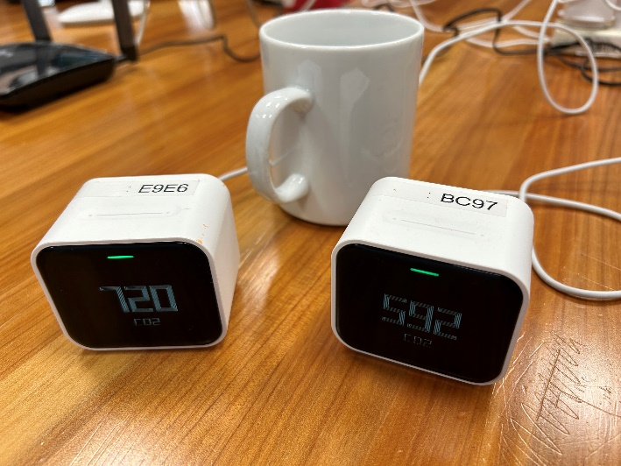

Figure 2‑1: Two Qingping Air Monitor Lites of the type used to monitor CO2 in this study.

### Window and door openings

The opening and closing of selected doors and windows were monitored using magnetic and Wi-Fi-enabled sensors. The number of available sensors was typically much less than the number of openable doors and windows in each studied room. Therefore, a choice had to be made to monitor those which were most likely to be used (established in conversation with centre staff). This inevitably means that this data set is not a complete record of the opening of all doors and windows in the studied rooms. These sensors also generate only a binary signal – open or closed – and provide no information on the degree of opening, which has a large impact on the degree of ventilation.

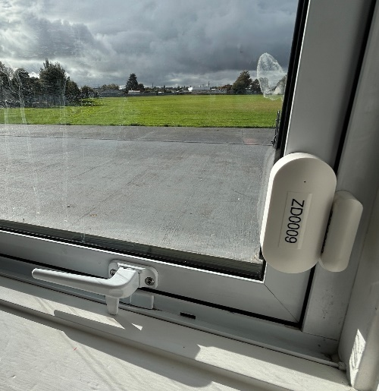

Figure 2‑2: A magnetic opening sensor of the type used in the study.

## Intervention design and limitations

The intended purpose of our intervention approach was to attempt to induce increased ventilation behaviour mainly through the sharing and discussion of baseline monitoring data.

The intervention was targeted at people who felt they had at least some responsibility for the ventilation of the spaces being studied, although it was often difficult for the research team to judge who this might be, especially in advance of a visit. The allocation or sharing of responsibilities varied substantially between centres. We therefore required that the three interactions involved at least one consistent member of staff, but that other staff were invited.

Participants were empowered to interact with baseline monitoring data in three ways:

* Provision of a real-time “traffic light” dashboard specifically designed for the project and delivered on a tablet computer loaned to each centre for the duration of their participation (Figure 2‑3). The dashboard presented a green light for CO2 levels below 800 ppm, yellow for 800 – 2000 ppm and red for CO2 above 2000 ppm for each of the four rooms being monitored. This was primarily provided to prompt ventilation action when the indicator turned yellow or red, and to give feedback on the success of that action (indicator returned to green), or otherwise (stayed yellow/red)/
* Provision of summary “calendar” plots of data at the intervention meeting (Figure 2‑4). These plots record the history of the colours depicted on the dashboard for the previous week. This format allows time-based patterns (e.g. CO2 always peaks between 10 and 11 am) to be easily discerned.
* Discussion of the calendar plots between the participants and Field Research Assistants (and Scientists in some cases).

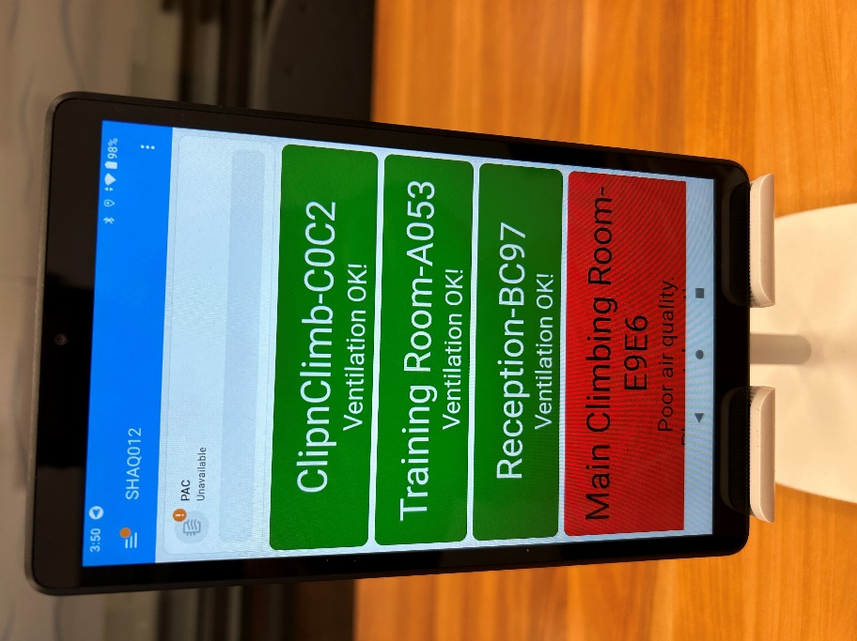

Figure 2‑3: The real-time data dashboard.

The four panels visualise live CO2 data from the four sensors (one each in different rooms).

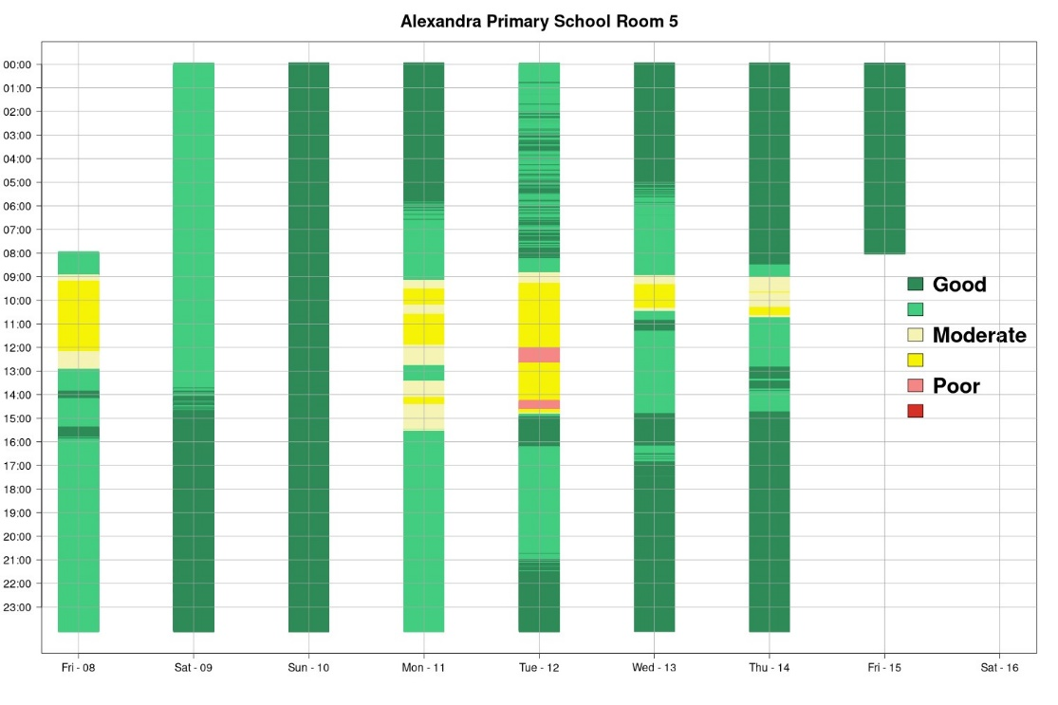

Figure 2‑4: Example of a "calendar" style plot of CO2 data provided to all participants and discussed during the intervention meeting.

This format allows time-based patterns to be discerned - in this case (from a classroom) day-to-day differences in classroom usage during breaks and lunchtimes can be identified.

## Outcome statistics

Carbon dioxide is widely used as an indicator of infection risk associated with airborne transmission of infectious diseases, and the risk posed by other indoor-sourced airborne contaminants.

We follow a common convention in exposure risk evaluation, particularly common in occupational exposure, of adopting a higher concentration threshold over a shorter time period and a lower concentration threshold over a longer time period to broadly represent two modes of exposure (more acute and more gradual).

For concentration limits, we have adopted 800 ppm and 2000 ppm. These values are widely used internationally, and within New Zealand, particularly, for instance, in the guidance provided for the design and management of school classrooms by the Ministry of Education (MoE, 2022). Once a background concentration of just over 400 ppm is allowed for, 2000 ppm represents 4 times more contamination of an indoor space than 800 ppm.

In practice, most of the rooms we studied tended to be continuously occupied either for periods of around 15 minutes (e.g. clinic consultation rooms), 60 minutes (e.g. some classrooms and gym spaces), or a few hours. We therefore adopt the time thresholds of 15 minutes and 1 hour to assess the higher and lower concentration thresholds respectively.

For each room (separately for baseline and intervention where available), based on 15-minute average data, we calculated (and report below):

* The average number of days per 10-day period, during which 15-minute mean CO2 was continuously greater than > 800 ppm for >= 1 hour at least once during the day
* The median duration of over which CO2 was continuously > 800 ppm
* The average number of days per 10-day period, during which 15-minute mean CO2 was greater than > 2000 ppm for at least one record (i.e. >= 15 minutes) at least once during the day
* The median duration of over which CO2 was continuously > 2000 ppm
* Mean concentration during nominal opening hours

# Results

## Coverage

Due to a range of instrument and logistical limitations we were not able to recover valid data from every room that was monitored. However, summary statistics were calculated for 99 rooms covering 31 centres. At the time of writing, data from the extended monitoring at Kokiri Marae are still being analysed and will be presented elsewhere.

The duration of monitoring in each centre varied more than was planned for due to logistical constraints (see Table 3‑1).

Table 3‑1: Distribution of monitoring durations across all centres.

|  | Monitoring duration / days |
| --- | --- |
| Minimum | 14 |
| 25th percentile | 23 |
| 50th percentile | 32 |
| 75th percentile | 45 |
| Maximum | 78 |

## Carbon dioxide

### CO2 > 800 ppm for > 1 hour

Of the 99 rooms considered,

* 80 experienced CO2 levels above 800 ppm for more than one hour at some point during the monitoring period
* 74 experienced CO2 levels above 800 ppm for more than one hour on more than one day during the monitoring period
* 31 (approx. one-third) experienced CO2 levels above 800 ppm for more than one hour on more than half of all days during the monitoring period
* 7 experienced CO2 levels above 800 ppm for more than one hour on 4 out of 5 days during the monitoring period.

These results are shown in Figure 3‑1.

A chart showing the number of days when CO2 was eleveated above 800 ppm for more than an hour

Figure 3‑1: Rooms ranked according to the average number of days (out of 10) during which CO2 was elevated above 800 ppm for more than an hour.

Each bar is a room in the study. The space on the left represents rooms with zero risk.

The median duration that CO2 remained over 800 ppm was 2 hours for all rooms.

For 13 rooms, CO2 remained over 800 ppm for a median period of over 4 hours (Figure 3‑2).

A chart showing rooms ranked by the median duration that CO2 remained over 800 ppm.

Figure 3‑2: Rooms ranked by the median duration that CO2 remained over 800 ppm.

Each bar is a room in the study.

### CO2 > 2000 ppm for > 1/4 hour

Of the 99 rooms considered,

* 27 (approximately one quarter) experienced CO2 levels above 2000 ppm for more than one quarter of an hour at some point during the monitoring period
* 6 rooms experienced CO2 levels above 2000 ppm on more than two days out of ten during the monitoring period
* Only one room experienced CO2 levels above 2000 ppm on more than five days out of ten during the monitoring period.
* Only 3 rooms had CO2 elevated over 2000 ppm for a median duration of more than an hour.

These results are shown in Figure 3‑3.

A chart showing rooms ranked according to the average number of days (out of 10) during which CO2 was elevated above 2000 ppm for more than quarter of an hour

Figure 3‑3: Rooms ranked according to the average number of days (out of 10) during which CO2 was elevated above 2000 ppm for more than quarter of an hour.

Each bar is a room. The large space on the left represents rooms with zero risk.

In Figure 3‑4 the daily probability calculated from our study of exceeding 2000 ppm for over 15 minutes and exceeding 800 ppm for over an hour for each room are plotted against each other. From this figure the following features are apparent:

* The risk of exceeding 800 ppm for more than an hour seems generally higher in this experimental data sample of rooms
* Some rooms appear to fit a pattern of the short-term and longer-term exposure risk being somewhat in proportion, whereas for other rooms the risk of exceeding 800 ppm for more than an hour can range from 0.1 to 0.9 without a risk of exceeding 2000 ppm in 15 minutes. This implies different temporal structures in the data implying different usage and ventilation characteristics.

A chart showing the daily probability of exceeding an 800 ppm (1 hr) and 2000 ppm (15 mins) threshold for each room in the study

Figure 3‑4: The daily probability of exceeding an 800 ppm (1 hr) and 2000 ppm (15 mins) threshold for each room in the study.

### Results by building type/function

Figure 3‑5 indicates the distribution of risk calculation results for rooms clustered by building type/function. Care should be taken to interpret this figure as the number of rooms in each type varies across types. Broadly it can be seen that risk appears to be higher in gyms and education spaces, and lower in offices and churches. Libraries and aged care facilities (and to a lesser extent healthcare and veterinary spaces) appear to present a low risk of exceedance of the acute 2000 ppm threshold, but a much higher risk of exceedance of the longer-term 800 ppm threshold.

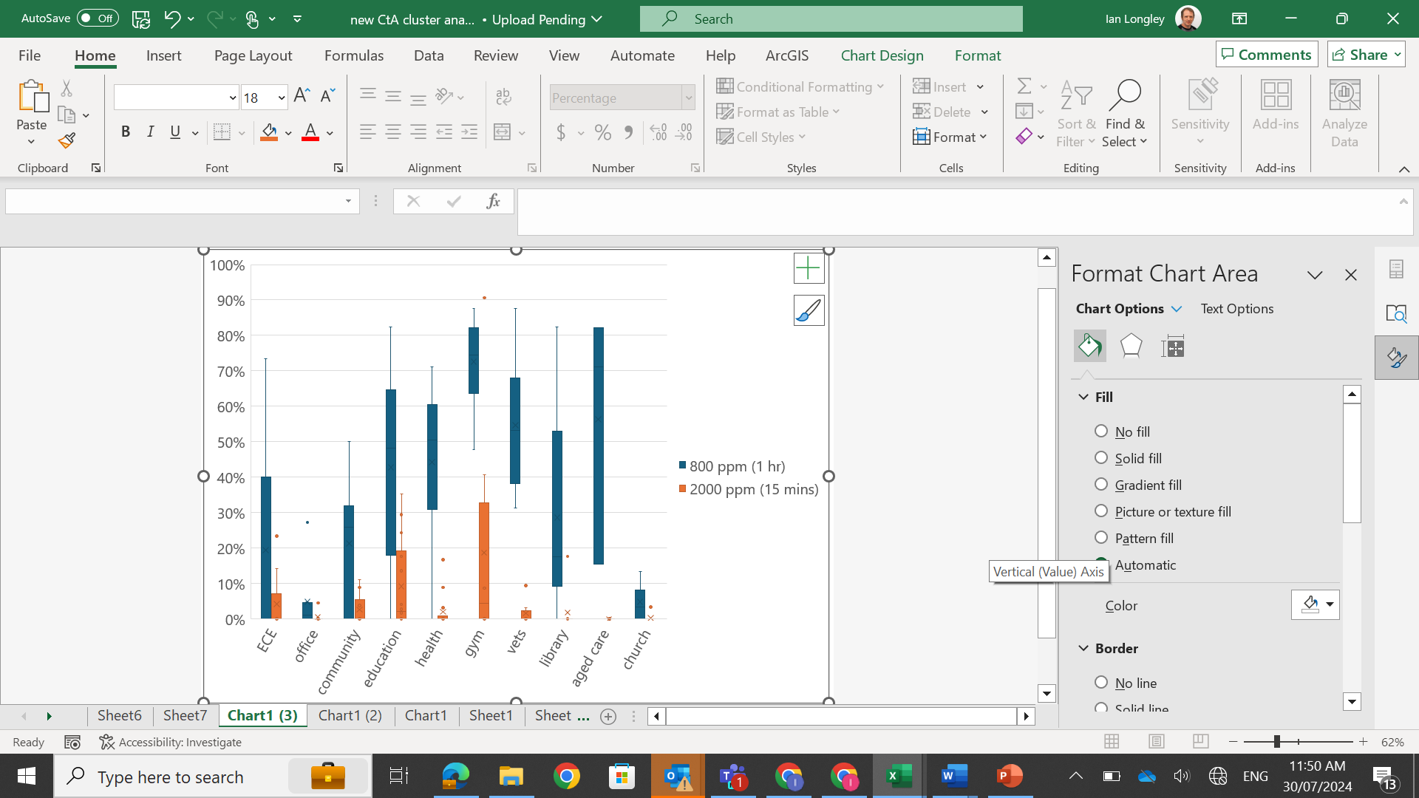

Figure 3‑5: Box-and-whisker plot of the distribution of calculated risks of exceeding the short- and longer-term thresholds for each building type.

### Cluster analysis of CO2 data

We conducted a k-means cluster analysis on the results for risk of exceeding the 800 ppm (1 hr) and 2000 ppm (15 mins) thresholds for the 99 rooms. This analysis identified 5 clusters, illustrated in Figure 3‑6. The main features of rooms in each cluster are described below.

A chart showing the results of k-means cluster analysis

Figure 3‑6: Result of k-means cluster analysis.

### Cluster 1 – High risk

Cluster 1 represents a high probability (near certainty) of CO2 exceeding both 800 ppm for more than an hour and 2000 ppm for more than 15 minutes

This cluster had only one member – the “spin” room at a gym. This was a room of approximately 6 m x 8 m x 3 m (140 m3 volume) full of exercise cycles and had no external windows.

The complete time series of CO2 data from this room is shown in Figure 3‑7, and Figure 3‑8 shows each 24 hours’ worth of data overlaid on the same plot. These plots indicate the following features:

* Very high CO2 values were observed twice, both times on a Saturday. On both occasions CO2 exceeded 2000 ppm at 08:15 and remained above 2000 ppm until 11:45 and above 800 ppm until 14:30.
* CO2 concentrations above 2000 ppm were observed two or three times on most weekdays, at specifically repeated times (mainly around 6 am, 10 am and 6 pm)
* When CO2 did exceed 2000 ppm during weekdays it tended to do so for less than an hour.
* When CO2 exceeded 800 ppm during weekdays it tended to do so either for 90 minutes, or for 2 – 3 hours.

A chart showing time series of CO2 from the "Spin" room - the only room in the High-Risk cluster

Figure 3‑7: Time series of CO2 from the "Spin" room - the only room in the High-Risk cluster.

A chart showing each days' time series of CO2 from the "Spin" room - the only room in the High-Risk cluster - overlaid

Figure 3‑8: Each days' time series of CO2 from the "Spin" room - the only room in the High-Risk cluster - overlaid.

From these observations, the following can be inferred. This room was most probably used for short, scheduled periods of intense exercise giving rise to rapid increases in CO2 (from background to over 2000 ppm in 30 minutes or less). It appears that the room was vacated after an hour of use each time. We suspect that ventilation was more powerful on weekdays compared to Saturdays, explaining the relatively rapid drop in CO2 on weekdays as the vacated room was ventilated, compared to much higher peak concentrations and much slower recovery on Saturdays. A post-usage “shoulder” of an extra hour of CO2 above 800 ppm was observed on some occasions. A sensor on the spin room door confirmed that the door was only opened at the beginning and end of the room being used, so the difference in CO2 between weekdays and weekends cannot be explained by changes in the use of the door. The presence of higher CO2 values in other rooms within the gym after the spin room was used implies that this additional CO2 was most likely delivered to the spin room from other rooms via the ventilation system.

Although we have labelled this cluster as “high risk” this term should be taken as relative to the dataset as a whole. Although this room presented the highest probabilities of CO2 concentrations of both 800 ppm and 2000 ppm occurring in any given day, in this case these concentrations tended not to be sustained for too long. This centre was one of the few in the study that had a functioning mechanical ventilation system, most clearly evidenced by the relatively rapid falls in CO2 on weekdays. The other three rooms in this centre (“circuit” room, a “yoga” room and the main gym) had lower risks of exceeding 2000 ppm (41 %, 9 % and 0 % respectively) but similar risks (72 – 88 %) of exceeding 800 ppm. We speculate that this variation was related to either the size of each room or the intensity of exercise being undertaken, or both. The large difference in performance between rooms and between weekdays and weekends show how sensitive the air quality risk is to the performance and tuning of the ventilation system. We were not able to investigate whether supplementary ventilation actions (door openings, use of fans) would have had a significant impact on CO2 levels.

### Cluster 2 – Moderate acute but high chronic risk

Cluster 2 represents a moderate probability (10 – 41 %) of CO2 exceeding 2000 ppm for more than 15 minutes, coupled with a high probability (50 – 88 %) of CO2 exceeding 800 ppm for more than an hour.

15 rooms made up this cluster. 4 were rooms within gyms, and 4 were classrooms, which is a higher proportion than would be expected by chance. Two were consultation rooms within clinics and 2 were rooms in veterinary surgeons, one was in a library, and one was a sleep room in an Early Childhood Centre.

This cluster was characterised by relatively rapid rises in CO2 when the room was occupied, but with the rise being interrupted and reversed, often repeatedly. This would be caused either by the room being regularly vacated (or occupancy reduced), or by ventilation being increased (doors and/or windows kept open) as the day progresses.

Figure 3‑9 and Figure 3‑10 show an example from this cluster where changes in occupancy are scheduled into the typical day, in this case a school classroom (for clarity only weekdays are shown). The following features can be observed:

* CO2 rises rapidly at the same rate at the same time each day (approx. 08:45) indicating the arrival of students and consistent ventilation settings at the start of the day (most likely doors and windows closed).
* The rise in CO2 is arrested and usually falls at different times on different days, but frequently at around 10:15 and again around 12:30, and again at 15:00.
* CO2 frequently starts to rise again at both 11:30 and 13:30.
* These timings broadly correspond to the timing of morning tea and lunch breaks in this school.
* On two days (12th and 22nd September) these breaks occurred later, and/or were shorter or less effective. This may be due to bad weather reducing the number of children leaving the room, for example. One can extrapolate and speculate that if the refresh break never occurred, CO2 could have risen to 2500 ppm or more in this room.

A chart sowing time series of CO2 from a classroom in cluster 2

Figure 3‑9: Time series of CO2 from a classroom in cluster 2.

A chart showing each days' time series of CO2 from a cluster 2 classroom overlaid

Figure 3‑10: Each days' time series of CO2 from a cluster 2 classroom overlaid.

In cluster 2 examples, the rise in CO2 was arrested well before the room had reached a steady state. This means that without the break in occupancy (or increase in ventilation, CO2 would have continued to climb. This makes air quality in cluster 2 rooms, especially later in the day, quite sensitive to the room usage patterns and ventilation actions of the occupants.

### Cluster 3 – Moderate risk

Cluster 3 represents a low-moderate probability (5 - 24 %) of CO2 exceeding 2000 ppm for more than 15 minutes, coupled with a slightly higher probability (21 - 51 %) of CO2 exceeding 800 ppm for more than an hour.

6 rooms made up this cluster. They consisted of three community spaces, a classroom, an office and a sleep room in an Early Childhood Centre.

Figure 3‑11 shows CO2 data from a member of this cluster – a relatively small consultation room in a community centre. Although at first glance concentrations seem low on most days, there are four clear peaks, all occurring on a Wednesday evening (Figure 3‑12 showing one example). On each Wednesday CO2 rises consistently over 3 – 4 hours reaching a value of 2500 – 3800 ppm. Concentrations then fall slowly and approximately exponentially, indicating CO2 slowly leaking from an empty room, taking over 6 hours to flush clear. On the following Thursday evening, CO2 rises for no more than 2 hours before the rate of rise is curtailed. On Wednesday, CO2 stops rising around 10 pm. The difference in CO2 between Wednesday and Thursday is quite dramatic but is explainable either by a) differences in occupancy, or – more likely given the small size of the room – differences in ventilation.

In general, cluster 3 rooms are characterised by occasional periods of usage accompanied by either adequate or inadequate ventilation, which may be as simple as whether a door or window is opened. Cluster 3 included relatively small rooms where doors (and possibly windows) may be kept closed to reduce noise or maintain privacy, such as consultation rooms and sleep rooms.

A chart showing time series of CO2 from a room in cluster 3

Figure 3‑11: Time series of CO2 from a room in cluster 3.

A chart showing 48-hours time series of CO2 from one Wednesday and Thursday in the consultation room example from cluster 3

Figure 3‑12: 48-hours time series of CO2 from one Wednesday and Thursday in the consultation room example from cluster 3.

### Cluster 4 – Low acute but moderate chronic risk

Cluster 4 represents a very low probability (0 - 3 %) of CO2 exceeding 2000 ppm for more than 15 minutes, coupled with a moderate probability (30 - 72 %) of CO2 exceeding 800 ppm for more than an hour.

33 rooms made up this cluster, therefore accounting for a third of all rooms. They covered all types of room in the study except churches and offices. Healthcare and veterinary spaces were disproportionately represented.

The large membership of this cluster obscures the fact that there are several different patterns within the cluster. In general, however, this cluster represents rooms in which CO2 will frequently exceed 800 ppm but is generally prevented from exceeding 2000 ppm. This can be due to:

* The room being regularly unoccupied
* The room receiving regular ventilation boosts (e.g. frequent door openings)
* The room being moderately well-ventilated for its normal usage
* Ventilation is typically increased (e.g. window opened) after an hour or two of use

### Cluster 5 – Low risk

Cluster 5 represents a very low probability (0 - 4 %) of CO2 exceeding 2000 ppm for more than 15 minutes, coupled with a low-moderate probability (0 - 27 %) of CO2 exceeding 800 ppm for more than an hour.

44 rooms made up this cluster, therefore accounting for nearly a half of all rooms. They covered all types of room in the study except gyms and veterinary spaces. Church and office spaces were disproportionately represented.

It is reasonable to assume that these rooms were sufficiently ventilated relative to their use during the monitoring period. Whether this would remain so at all times depends on how representative the monitoring period was, and the likely occurrence of more demanding conditions (e.g. higher numbers of occupants, higher breathing rates, colder or hotter weather disincentivising the use of openings for ventilation, etc.)

## Observed changes in door and window usage

Although the opening/closing of some of the windows and doors in each room were monitored, it was not logistically feasible to monitor them all. Furthermore, there were recurring technical problems with many of the sensors meaning that many of the datasets contain significant gaps.

We are therefore unable at this point to present an analysis of changes in door and window usage. However, at the time of writing we are in the process of identifying those rooms where data coverage is sufficient to conduct this analysis. We intend to present results in a future update or addendum to this report.

# Discussion

## The state of ventilation in naturally ventilated buildings occupied by vulnerable persons

The analysis presented here gives an overview of air quality as observed in our sampled rooms over periods varying from 14 to 78 days randomly distributed through the year. In naturally ventilated settings we should expect ventilation behaviour to change with the seasons as building occupants respond to heat, cold, wind and rain. The knowledge of participating in a study that draws attention to ventilation behaviour and indoor air quality may have itself influenced ventilation behaviour in a way that varies from person to person. Furthermore, any changes in ventilation behaviour or perception induced either by participation or through the data feedback may also have had a time-limited effect. In all of these ways we are unable to ensure that our results are representative of either the buildings sampled, or other buildings not enrolled in the study.

Conversely, the general impression of the Field Research Assistants was that most participants were busy people with their own tasks and responsibilities and that the impact of the observation itself on the results was likely to be minimal. This study was also not designed to test the longevity of any change in perception or behaviour – that will require a different study.

Despite its large size, we believe that our dataset is still either too small or possesses too many gaps to robustly explain the observed state of air quality. The carbon dioxide levels observed represent the net outcome of multiple processes, many of which were not observed (temporal variation in occupancy, variation in breathing rates between occupants and in time, wind speed, indoor-outdoor thermal gradients, degree of openings between rooms and between indoors and outdoors, etc). To develop a mechanistic understanding of the determinants of air quality in these rooms will require a somewhat different approach in which more effort is paid to more fully observing ventilation behaviour and performance (e.g. the total opening area).

Despite this we feel that further insight may still be derived from extended analysis of data from those rooms where data coverage was more comprehensive and complete. In particular, the dataset collected may be particularly useful for the calibration and validation of simulation models which would allow the contribution of contributing processes and actions, like changes in ventilation or usage, to be explored and quantified.

## The potential for improving ventilation through changes in ventilation behaviour

Overall, we found our intervention approach to be ineffective. Figure 4‑1 shows how the risk of exceeding the 800 ppm threshold for more than an hour was reduced in the intervention period by more than 1 day in 10 in 13, but increased by more than 1 in 19 rooms, and changed by less than 1 in 17 rooms.

Scatter plot of risk of exceeding 800 ppm for more than an hour (days per 10 days) in baseline and interventions period

Figure 4‑1: Scatter plot of risk of exceeding 800 ppm for more than an hour (days per 10 days) in baseline and interventions period.

However, we suspect this was mainly due to flaws in the design and inconsistent implementation, rather than any fundamental barriers. These flaws included:

* We were unable to prevent the participants being influenced by the knowledge that their behaviour was being observed
* We were unable to ensure that the participants being directly exposed to the intervention information would be the people with the agency and opportunity to act by changing ventilation
* It was very difficult to ensure consistency of messaging during the discussions. It was difficult to pre-script the proposed actions participants should take due to the unique design and usage of each building and the unique culture and varied level of understanding and agency amongst the participants. Our intention to promote discussion amongst participants turned out to be ineffective due to the varied authority structures in different centres.
* We could not ensure that participants were equally able to interpret the dashboard and calendar plots.
* Due to technical reasons, we were unable to “blind” the participants to the monitoring data during the baseline period, potentially influencing ventilation behaviour.
* Due to resource constraints only one dashboard was provided to cover 4 rooms. We could therefore not ensure that occupants of any monitored room were able to see or were aware of the dashboard.

Anecdotal evidence provided by the Field Research Assistants suggested that although participants generally considered the endeavour to be important and willingness to engage was high, their capacity to act was much more varied.

In our view, many of these barriers could potentially be overcome. Given the potential for very large gains in ventilation performance that could be achieved at relatively low cost we recommend an extended research focus on how to promote and facilitate pro-ventilation behaviour change in naturally ventilated buildings.

## The potential for using carbon dioxide monitoring data to promote pro-ventilation behaviour change.

Due to the above-mentioned limitations, and resource limitations, we were unable to explicitly distinguish the role of carbon dioxide monitoring from other pro-ventilation messaging in inducing pro-ventilation behaviour change. However, in our opinion, informed especially by the conversations between Field Research Assistants and participants, we found that many participants expressed that they valued the carbon dioxide data, both in the form of the real-time dashboard and the calendar plots. Many participants told us how they responded to the dashboard turning yellow or red and were reassured if the indicator subsequently turned green. We found that with many participants the calendar plots required very little explanation before participants could draw patterns for themselves, linking persistent periods of elevated CO2 to known activity patterns. This led many participants to suggest changes to room usage or ventilation settings unprompted by the research team.

# Conclusions

## What does this study say about the state of ventilation in New Zealand’s naturally ventilated non-residential buildings?

In our sample of 31 centres, we found that CO2 could exceed 800 pm for more than an hour (an internationally recognised threshold for compromised indoor air quality)

* at some point in 80 out of 99 rooms,
* on one day in 10 (on average) in 74 out of 99 rooms
* on 5 days in 10 (on average) in 31 out of 99 rooms
* on 9 days in 10 (on average) in 7 out of 99 rooms

We found that CO2 could exceed the higher concentration of 2000 ppm for more than 15 minutes (an internationally recognised threshold for an acute air quality risk))

* at some point in 27 out of 99 rooms,
* on one day in 10 (on average) in 6 out of 99 rooms
* on more than 5 days in 10 (on average) in 1 out of 99 rooms

Overall, data we would consider representing very poor air quality with a high risk was not observed.

Fewer than 10 rooms posed a moderately high risk. This group was characterised by the room being somewhat under-ventilated relative to the ideal, but being periodically ventilated more effectively, or by occupancy reducing or ceasing. Examples included some classrooms where relatively poor ventilation during class time (especially in the morning) was compensated for by good ventilation (or at least the class being emptied) during break times. Other examples included rooms with regular door openings as customers/clients or staff regularly come and go. Such rooms will present a higher risk if these refresh breaks do not occur for whatever reason (e.g. inclement weather), or the duration between breaks increases.

Approximately a third of rooms posed a low-to-moderate risk in which either ventilation was closer to the ideal, or periods of low or zero occupancy were longer or more frequent.

Approximately a third of rooms had good air quality throughout the study.

There are many factors impacting indoor air quality and ventilation. This study did not yield a clear profile for the types of building, rooms, uses or infrastructure that would present the more important risk factors. However, we found that gyms and education spaces were slightly over-represented amongst those rooms with poorer air quality, whereas churches and offices were over-represented in the good air quality group.

## What does this study say about the potential of behavioural intervention?

Our attempt to conduct a structured and deliberate behavioural intervention to improve ventilation practices was inconclusive. In our view this reflects flaws in the design, partly related to the difficulty in constructing a design that was sufficiently adaptable to the wide range of buildings, workplace, social and ethnic cultures across the participating centres.

However, it was clear from the data that variation in ventilation practice produced wide variation in indoor air quality outcomes. In particular, the frequency and duration of door openings and the timing/frequency of window openings appeared to be the main factor determining whether on any given day, and for how long, carbon dioxide exceeded the risk threshold levels of 800 ppm and 2000 ppm. Although an extended analysis of this dataset is required to quantify these relationships, the analysis conducted to date is sufficient for us to confidently state that the potential for behaviour change to improve ventilation and indoor air quality and reduce risk is large.

# Implications

## Identifying spaces that require mitigation

Although far from comprehensive, our study implies that indoor air quality and ventilation performance in naturally ventilated buildings varies between buildings and between rooms within buildings in a way that may be predictable but also may not. It indicates that some rooms present a greater risk and may deserve to be prioritised for mitigation, but it may be difficult to identify such locations in advance. This implies several non-exclusive options:

* Adopt a precautionary approach and mitigate in as many settings as possible
* Develop a predictive screening approach to gather better suggestive evidence of high risk before prioritising rooms for mitigation
* Conduct screening monitoring to gather more robust evidence of high risk before prioritising rooms for mitigation

This study presents very limited evidence that education spaces may provide a higher risk. When the very large number of such spaces, and the very large exposed and vulnerable population, and their potential role as disease vectors in the wider community is considered, there appears to be a rationale for prioritising education spaces for mitigation.

## Is low-cost behavioural intervention a viable mitigation approach?

In our view, the data collected in this study supports the idea that behavioural intervention provides a large potential for reducing risk at low cost. The remaining challenge is to realise that potential by inducing the required behaviour change.

In this study we were unable to properly study the process of behaviour change in this context. Within this project we found it easy to identify sufficient participants within each centre that were engaged with the issue and willing to act to improve ventilation. In principle people with such orientation may be common enough that they could form a critical mass who will embed new habits within their own buildings and promulgate good practice amongst their workplace colleagues and community and industry peers.

In our view the greater challenge was the more building-specific understanding of exactly what behavioural change was required and when, and the provision of some form of feedback to give participants the reassurance that the new action was helpful or successful. It was also important to ensure the advice we gave was not inconsistent with other goals and objectives, such as the proper functioning of the centre, thermal comfort, or noise.

We also noted that whereas in some centres, communication and sharing of learning and changes in practice between staff and users happened effectively and rapidly, whereas in others this was not the case. In general, we found that fewer people attended the discussions with the research team than we had hoped, with often only a manager attending. This highlights that the manner in which motivational information such as instructions and feedback are communicated to the most appropriate people is a key feature that any mitigation approach must consider.

Nevertheless, although optimal ventilation behaviour will be specific to any given room and its usage, generic ventilation advice is still likely to yield substantial benefits. Through this study we repeatedly found that participants under-estimated their agency and the degree to which a simple change in behaviour, such as opening a window early in the day, made a large difference to air quality. This implies that widely targeted public messaging, and messaging specifically targeting vulnerable or harder to reach groups in culturally appropriate ways, has the potential to both provide a kick-start to improving air quality, as well as laying a foundation for more targeted and detailed actions.

## What might be an appropriate role for sensor-based monitoring?

Our study was not designed to establish the value added by the introduction of sensor-based monitoring. However, in our view such monitoring provides critical feedback to room occupants and managers on the consequences of their ventilation behaviour, i.e. it reveals their agency over this matter. Monitoring data provided centre managers information on where to target mitigations, whether it be the actions of certain staff, or changes to the scheduling and usage of rooms or changes to the ventilation infrastructure.

Overall, we found the carbon dioxide monitoring to be reliable and robust. However, there is an opportunity to develop the nature of data feedback further. Most existing room monitoring systems report carbon dioxide concentrations to users. This requires users to understand the meaning of these data and mentally translate this into an action. In our view, in most settings, this last step rarely occurs, and the data is largely ignored. In this study we used a “traffic light” indicator with suggested actions. Our users reported that this was more informative and easier to act upon. However, it was unclear from our study whether the messaging should be more or less detailed, and more or less generic or room specific. Another weakness was the potential misalignment between who would see the dashboard and who needed to act on the information. Nevertheless, all of these limitations can be addressed through further experimentation and technological development.

In principle, more room-specific feedback could be provided by a more sophisticated monitoring system that collects sufficient information to build a simulation model of the room. Such a system would need to collect more reliable and comprehensive information on the ventilation of the room, its occupancy levels and the activity levels of the occupants than was possible in this study. The potential advantage of such an approach would be to be able to judge the relative impact of different actions and make optimised suggestion. In principle such a system could integrate heating, cooling and noise control objectives. The added value provided by such an approach, and its matching with applications where the additional functionality makes a critical difference, should be the subject of future research.

# Acknowledgements

The Science team consisted of Ian Longley, Gustavo Olivares and Elizabeth Somervell from NIWA.

The Field Research Team consisted of Daniel Morrish and Jade Arnold from NIWA and Asher Fai’ai and (for the pilot) Cinnamon Lindsay from Hapai Research (under the supervision of Felicity Ware).

The fieldwork at Kokiri Marae was conducted by Julie Bennet and Caroline Halley of the University of Otago.

This project was made possible by the kind permission and participation of all of the staff at the various study centres.