
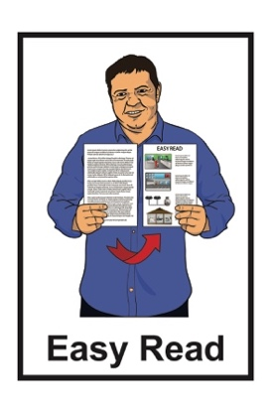



Government Policy Statement on Health – 2024 to 2027
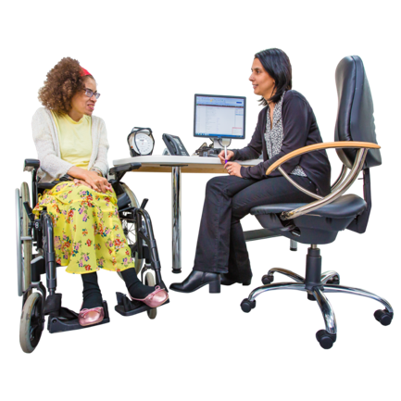
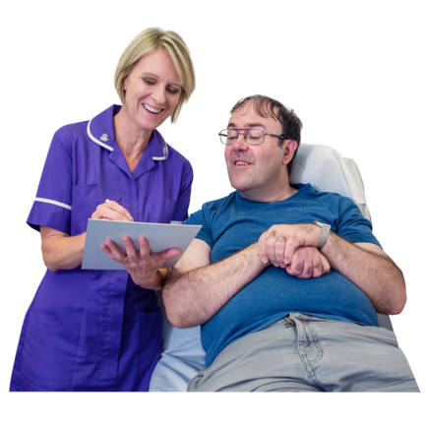
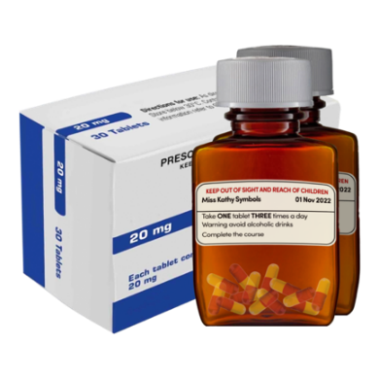
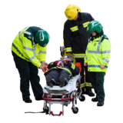
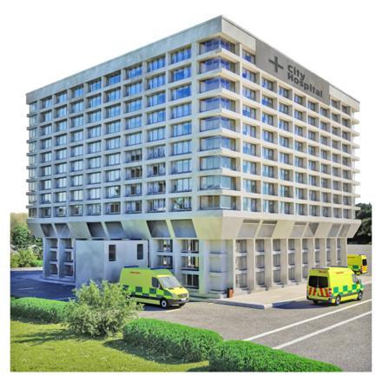

Published: November 2024

What you will find in here

Page number:


What is in this document 2
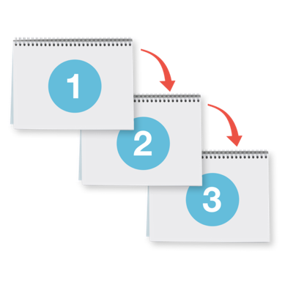

Vision 5

Priorities 7


Targets 17


More information 23

What is in this document

This Easy Read document is from Manatū Hauora Ministry of Health.

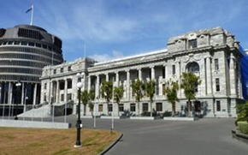
Manatū Hauora Ministry of Health is the part of the government in charge of the health system.

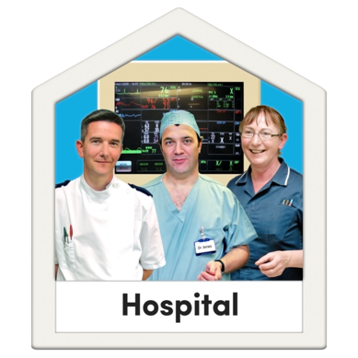
The health system is all the people / organisations that work together to make healthcare happen like:
doctors
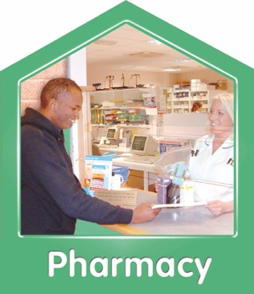
hospitals
pharmacies / chemists.

When you see the words we / our in this document it means Manatū Hauora Ministry of Health.

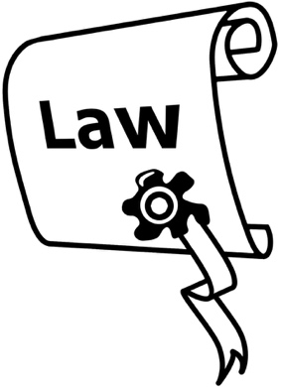
The law says we have to write a Government Policy Statement on health every 3 years.

A Government Policy Statement says what the Government plans to do in the years to come.

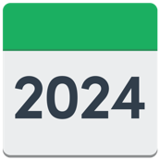
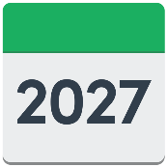
This Government Policy Statement is about what we plan for the health system in the next 3 years.


It talks about our priorities for making better health outcomes for everyone in Aotearoa New Zealand.

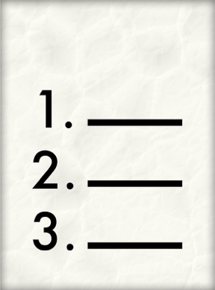
Priorities are the:
most important things
things that need to be done first.

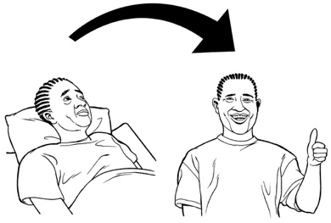
Outcomes are things that happen when work has been done.

For example an outcome might be people get better after medical treatment.

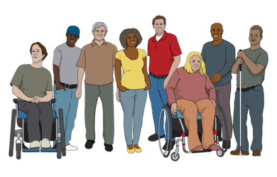
It is important to make better health outcomes for people with the most health needs like:
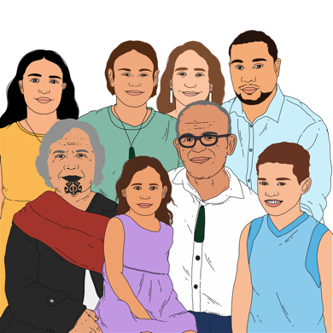
disabled people
Māori
Pacific peoples.

Vision

Vision means:
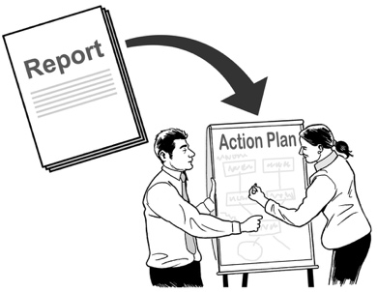
the things we want to happen in the time / years to come
what we will do to make those things happen.

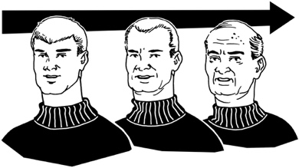
We want everyone in Aotearoa New Zealand to:
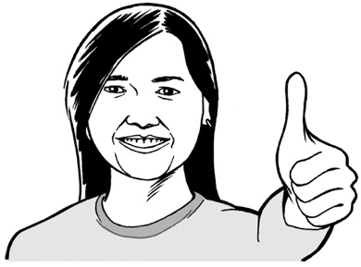
live longer
have a better quality of life.


Quality of life is if you:
feel well
can enjoy your life.
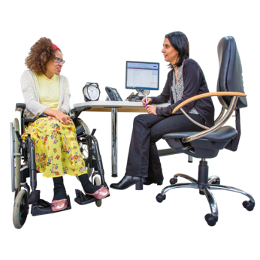
We want to make sure everyone can get the healthcare they need.


We also want to make sure no one has to wait too long to get healthcare.

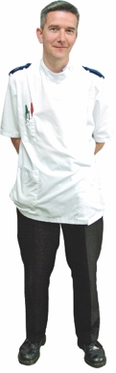
We need to make sure we have enough healthcare workers.

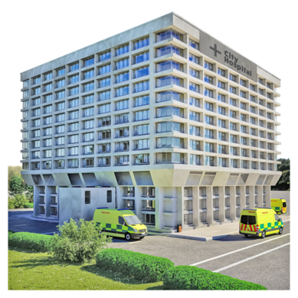
We also need to make sure we have the right health infrastructure.


Here infrastructure means all the things the health system needs to work well like:
hospital buildings
computer systems.

Priorities


There are 5 priorities for the health system in the Government Policy Statement.

Priority 1: Access
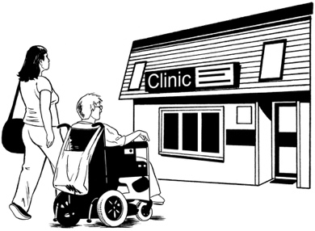
Here access means being able to use something.

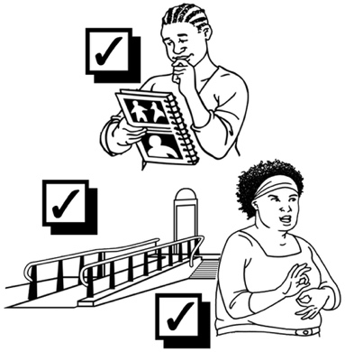
Access can be about:
where / when things are
if something meets your needs.
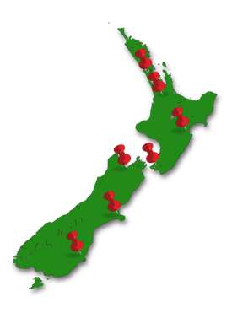

We want to make sure everyone has the same access to healthcare no matter where they live.
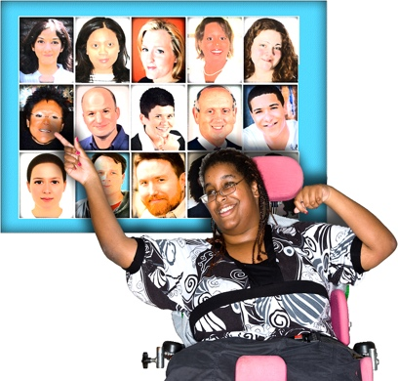
We plan to give people more choices for primary and community healthcare.


Primary and community healthcare means healthcare that is not in a hospital like seeing your usual
doctor / GP.

It is the kind of healthcare people use most often.
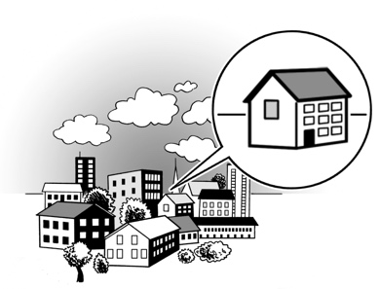

We plan to find ways to give people healthcare closer to where they live.


We also plan to make it easier for people to access online health services.

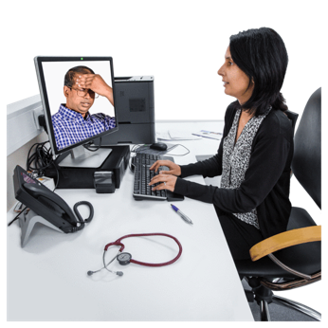
Online health services means healthcare you can get over the internet like having a video call with your doctor.

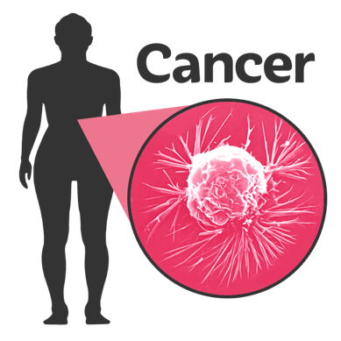
We plan to make cancer screening better.

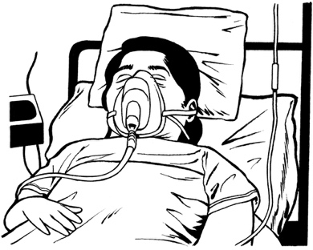
Cancer screening means tests to find people who have a higher chance of getting / having cancer.

Cancer is a disease that can make people very sick.
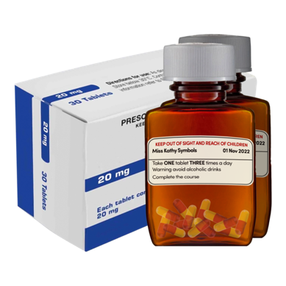

We also plan to make it faster for people to get the medicine they need.


Priority 2: Timeliness

Timeliness means things happening at the right time.


We want people to get healthcare quickly.

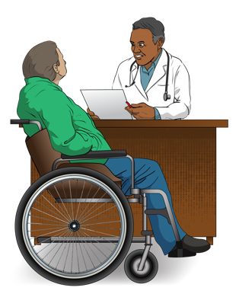
We plan to have shorter waiting times for:
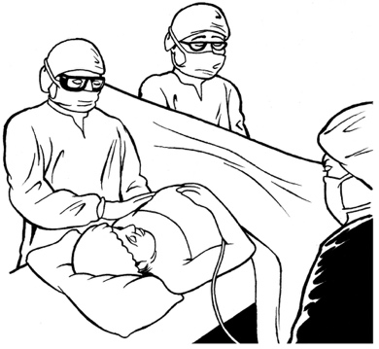
appointments
operations
emergency care.

We plan to make it faster for people to get primary and community healthcare.

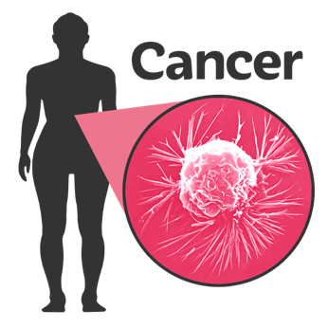
We also plan to make sure people with cancer get treated quickly.


Priority 3: Quality

Quality means how good something is.

We want to make sure healthcare in Aotearoa New Zealand is:
safe

easy to get
always getting better.

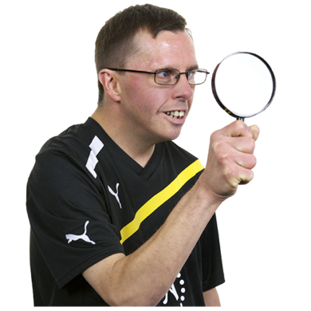
We will keep checking to make sure healthcare in Aotearoa New Zealand is good enough.


We will use new ways to do research about how healthcare in Aotearoa New Zealand is working.

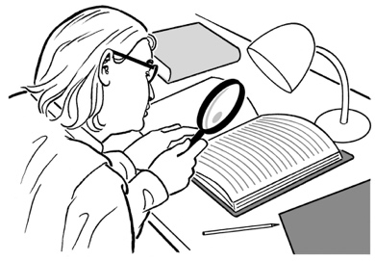
Research is when we:
- look at what things have happened
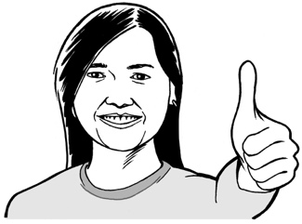
try to find ways to do things better.

We will keep looking for ways to make healthcare better.

Priority 4: Workforce
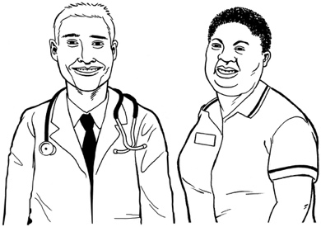
Workforce means everyone who works in healthcare.

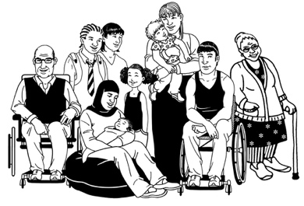
We want to make sure the people who work in healthcare can take good care of all sorts of people.
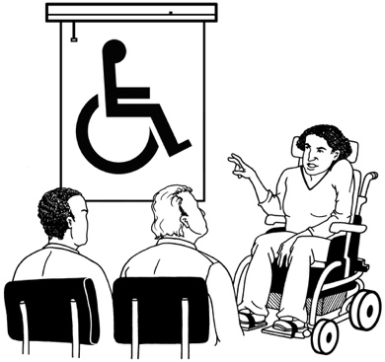

We also want to make sure healthcare workers get lots of chances to learn new things.


We plan to give better training to people who want to work in healthcare.


We plan to show our workforce we think they are important.

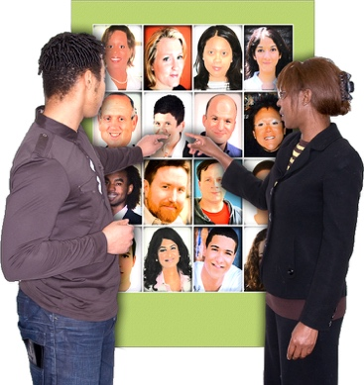
We plan to find more people to work in healthcare.

Priority 5: Infrastructure
We want to make sure the health system meets the needs of everyone:

now
in years to come.

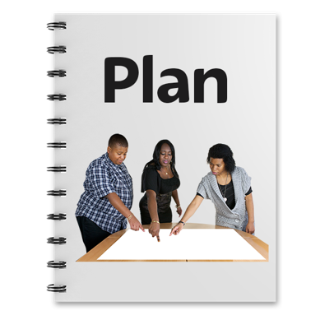
We will make a long-term plan for healthcare infrastructure in Aotearoa New Zealand.

Long-term means for many years to come.

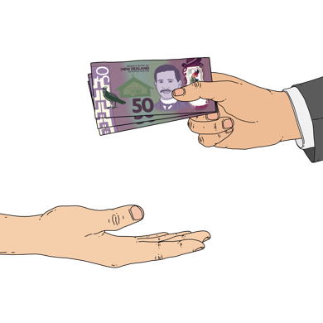
We will make a plan for how much money the Government will spend on healthcare.


We will use digital tools to make the health system easier to run.

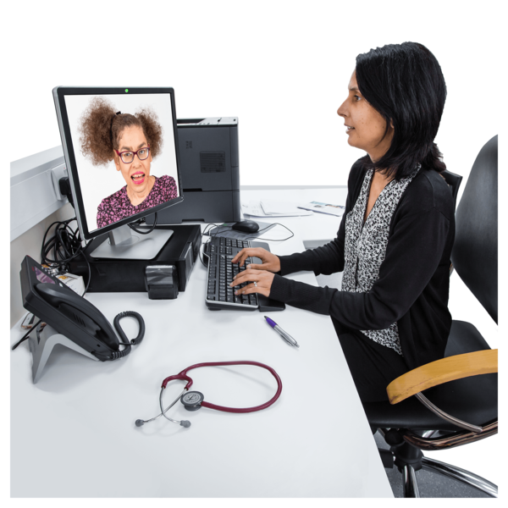
Digital tools are things like:
- computers
- video calls
- online information.

The main things these priorities are for are:
cancer
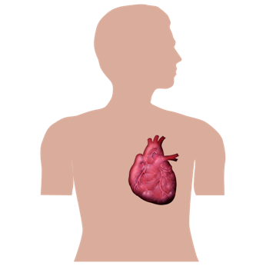
heart disease
lung disease
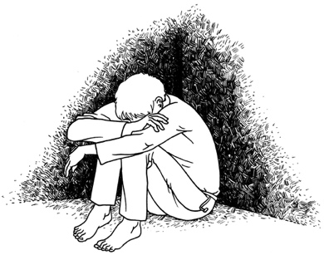
These priorities are also for:
diabetes which is problems with your blood sugar

mental health.
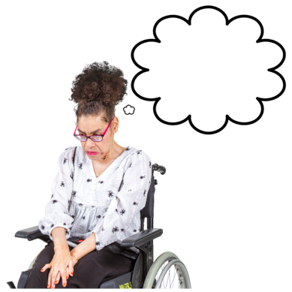

Mental health is how you think / feel in your mind.

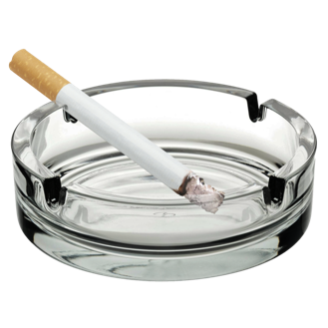

We are going to focus on things that support people to stay well like:
not drinking too much alcohol
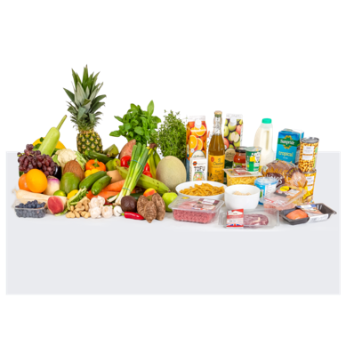
stopping smoking
eating healthy food
getting enough exercise.
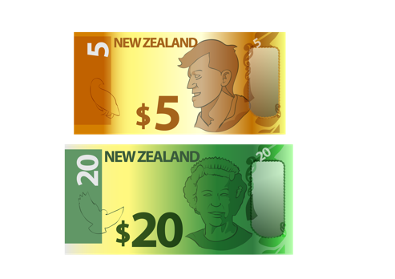

We need to make sure we do not spend more money than we have

Targets

Targets are the things we aim to do.

Targets are about details like:
numbers
dates.

The Government has 5 targets for health.

It also has 5 targets for:
mental health
addiction.

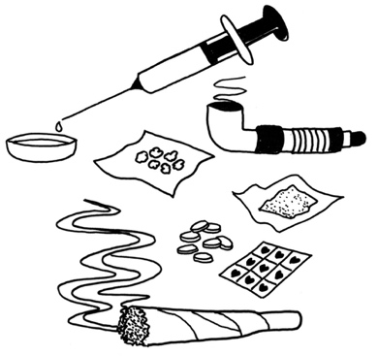
Addiction means not being able to stop yourself using things like:
drugs
alcohol.

Health targets
Almost everyone who has cancer should get treatment less than 1 month after their doctor says what treatment they need.
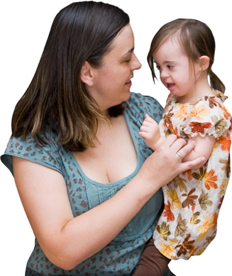

Almost all children should be fully immunised when they are 2 years old.

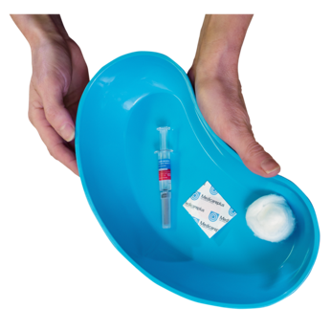
Fully immunised means someone has had all the vaccines they need.


A vaccine is a medicine that can keep you safe from getting sick.

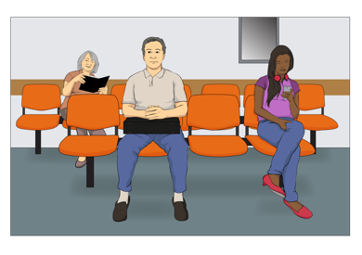
Almost all people who go to the emergency department of a hospital should be there for less than 6 hours before they:
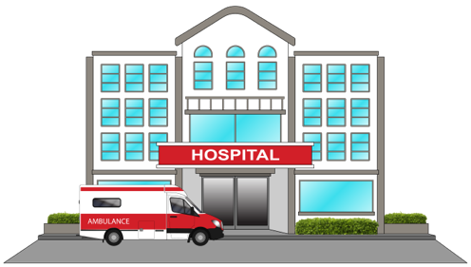
get the care they need
get moved to another hospital / part of the hospital.

An emergency is when something
serious happens that means people
need to act quickly to stay safe.


Almost everyone who needs to see a specialist should get an appointment in less than 4 months.

A specialist is someone who knows a lot about 1 thing.
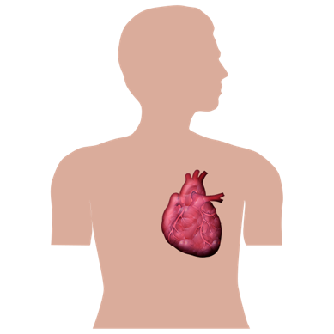

For example if you have a problem with your heart you might see a doctor who is a heart specialist.

Almost all people who need treatment that is not an emergency should have to wait less than 4 months.

Mental health / addiction targets
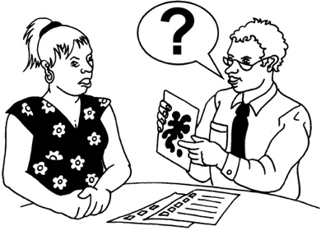
Most people should have to wait less than 3 weeks to get mental health / addiction services.

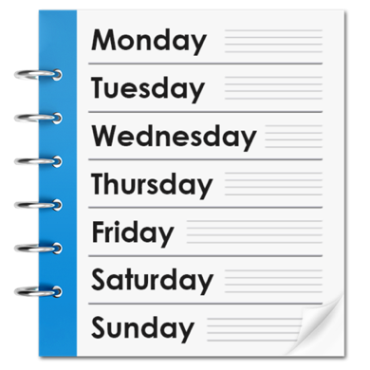
Most people should be able to get support from the Access and Choice programme in less than 1 week.

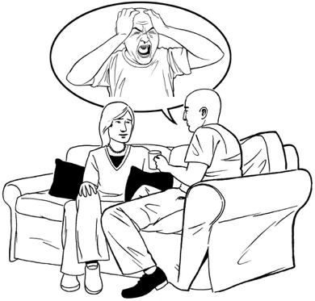
The Access and Choice programme gives support to people who have mental health / addiction problems that are not too bad.
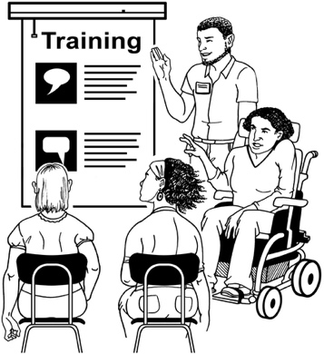

We will train more than 5 hundred mental health / addiction workers every year.

Most people who go to a hospital emergency department for mental health / addiction problems should be there for less than 6 hours before they:
get the care they need
get moved to another hospital / part of the hospital.

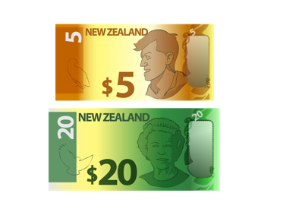
We will put 1 quarter of the money the Government is spending on mental health / addiction into:
prevention
giving people treatment before their problems get too big.


Prevention means stopping something from happening.

More information

You can find out more about Manatū Hauora Ministry of Health on our website at:

https://www.health.govt.nz

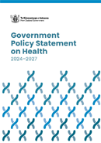
You can read the full Government Policy Statement at this website:

https://tinyurl.com/5n744sbn

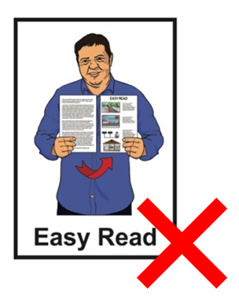
These websites are not in Easy Read.

This information has been written by Manatū Hauora Ministry of Health.

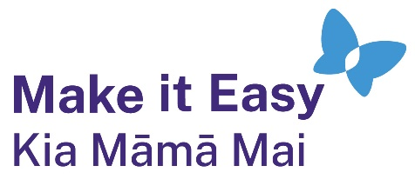
It has been translated into Easy Read by the Make it Easy Kia Māmā Mai service of People First New Zealand Ngā Tāngata Tuatahi.

The ideas in this document are not the ideas of People First New Zealand Ngā Tāngata Tuatahi.
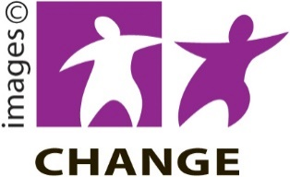
Make it Easy uses images from:


- Changepeople.org

            - Photosymbols.com


- SGC Image Works
- Huriana Kopeke-Te Aho
- T. Wood.

All images used in this Easy Read document are subject to copyright rules and cannot be used without permission.

