Abortion Services Aotearoa New Zealand

Ratonga Whakatahe i Aotearoa

Annual Report – Pūrongo ā-Tau

2024

Citation: Ministry of Health. 2024. *Abortion Services Aotearoa New Zealand: Annual Report.* Wellington: Ministry of Health.

Published in December 2024 by the Ministry of Health  
PO Box 5013, Wellington 6140, New Zealand

ISBN 978-1-991324-13-9 (online)  
HP 9107

This document is available at health.govt.nz

|  |  |
| --- | --- |
| **CCBY** | This work is licensed under the Creative Commons Attribution 4.0 International licence. In essence, you are free to: share ie, copy and redistribute the material in any medium or format; adapt ie, remix, transform and build upon the material. You must give appropriate credit, provide a link to the licence and indicate if changes were made. |

# Foreword

I am pleased to present this fourth *Abortion Services Aotearoa New Zealand: Annual Report* which provides a snapshot of abortion provision for the 2023 calendar year. This report focuses on equity and accessibility of abortion services.

As the steward of the health system, the Ministry of Health plays an important role in ensuring public safety and quality through our regulatory functions and activities, and then monitoring them - including for abortion services.

I want to acknowledge that while this report places an emphasis on data, we never forget that behind the numbers and graphs are individuals, families and whānau making difficult decisions. The Ministry of Health is determined to ensure every person has access to high-quality and timely abortion information and health care – when and where they need it.

The findings within this report highlight continued improvements following both the 2020 law reform and the 2022 health reforms.

Gestation at the time of abortion has decreased across all ethnic groups, demonstrating better outcomes for those seeking abortion services. While socioeconomic deprivation continues to relate to later gestation at abortion, gestation has decreased across all socioeconomic deciles. The proportion of early medical abortion procedures (EMA) has increased while the proportion of surgical abortion procedures has decreased. The majority of those accessing abortions in 2023 accessed them through early medical services.

Recommendations from the Royal College of Obstetricians and Gynaecologists (2022) have emphasised the importance of local and early abortion service provision. A key indicator of this is drive time to in-person services. As a result of continued increases in the abortion workforce in regional facilities in 2023, the drive time has, on average, decreased. However, longer distance to providers continues to disproportionally impact Māori and those living in rural areas.

Regional and national telehealth services provide another avenue to improve access for people seeking an EMA. Irrespective of people’s ethnicity or location, it is important that all forms of abortion health care are available to everybody.

People need accurate information to be able to make informed choices in relation to their pregnancy options. The Ministry plays an active role in monitoring disinformation. In July 2024, the Ministry released a statement warning against the use of progesterone for ‘abortion reversal’, an unsafe and scientifically unsupported practice.

In 2023, 11 Safe Areas were established, with another three added in September 2024. Safe Areas ensure the ongoing safety and wellbeing of those providing and accessing abortion services.

A periodic review under the Contraception, Sterilisation and Abortion Act 1977 is underway. This will provide us with an opportunity to further analyse abortion service provision and develop a more comprehensive overview on timely and equitable access.

While there are areas for improvement, I am heartened by the continuing progress toward equitable and accessible service provision for this important health service.

Ngā mihi maioha

**Dr Diana Sarfati**

Te Tumu Whakarae mō te Hauora

Director-General of Health

# Kupu takamua

Kei te whakatakotoria te putanga tuawhā o te pūrongo ā-tau o Abortion Services Aotearoa New Zealand i runga i te ngākau harikoa. Kei konei e mau ana tētahi tirohanga iti ki ngā ratonga whakatahe kukune i te tau 2023. E aronui ana tēnei pūrongo ki te mana taurite me te āheinga atu ki aua ratonga whakatahe.

I runga i tōna tūranga hei kaiārahi o te pūnaha hauora, ko tētahi o ngā mahi nui a te Manatū Hauora he whakaū, he aroturuki hoki i te haumarutanga me te kounga o ngā ratonga whakatahe i raro i te ture, i roto anō i ā rātou mahi.

Ahakoa e hāngai ana ngā kōrero a tēnei pūrongo ki ngā putanga a ngā raraunga, e kore e wareware i a mātou ia tangata kotahi me ngā whānau e whai ana i tēnei ara tāpokopoko. Kei te pūmau te Manatū Hauora ki te whakawhiwhinga o ngā kōrero tōtika mō te mahi whakatahe me ngā mahi tautiaki hauora – i te wāhi me te wā tōtika.

Kei te kitea te whakapikinga ake tonu o ngā mahi whai muri iho i ngā whakahoutanga o te ture hauora i te tau 2020 me te tau 2022 i roto i ngā putanga o tēnei pūrongo.

Kua heke te roa o te kōpūtanga i te wā o te whakatahe mō ngā momo iwi katoa, hei tauira tēnei o te whakapikinga ake o ngā hua ki te hunga e whai ana i ngā ratonga whakatahe. Ahakoa te pānga o te pōharatanga ki te roa o te kōpūtanga i te wā o te whakatahe, kua heke te roa o te kōpūtanga i ngā momo rōpū ohapori katoa. Kua piki ake te nui o ngā whakatahe tōmua mō ngā take hauora (e kīia ana he Early Medical Abortion), ā, kua heke te nui o ngā poka whakatahe. He ratonga hauora tōmua te nuinga o ngā whakatahe o te tau 2023.

Hei tā ngā tāpaenga kōrero a te Royal College of Obstetricians and Gynaecologists (2022), he mea nui te whakawhiwhinga tōmua o ngā ratonga whakatahe ki roto tonu i te rohe o te kaiwhiwhi. Ko tētahi o ngā tūtohu matua o tēnei āhuatanga, ko te roa o te hautū waka ki te whiwhi ā-tinana i te ratonga. Nā te whakapikinga ake anō o ngā kaimahi o ngā ratonga whakatahe ki ngā tari ā-rohe i te tau 2023, kua heke te tau toharite o te roa o te haerenga.

Ko ngā ratonga hauora ā-waea kei ngā rohe me te motu whānui tētahi ara anō e hāpai ana i te toronga atu o ngā tāngata e whai ana i tētahi EMA. Hāunga anō te iwi, te wāhi rānei e nōhia ana e te tangata, he mea nui tonu kia whakawhiwhia ngā tāngata katoa ki te katoa o ngā momo ratonga tautiaki whakatahe.

Me tika ngā kōrero e whakawhiwhia ana ki ngā tāngata e whiriwhiri ana i te ara tika mā rātou i te wā o te kōpūtanga. Kei te kaha te Manatū ki te aroturuki i ngā momo kōrero parau e putaputa mai ana. I te marama o Hūrae i te tau 2024, ka whakaputaina e te Manatū tētahi kupu whakatūpato e pā ana ki te whakamahinga o te taiaki tūmua hei ‘aukati i te whakatahe’, he mahi mōrearea tēnā kāore e tautokona ana e ngā mātanga pūtaiao.

I te tau 2023 i whakatūria kia 11 ngā Safe Areas, ā, i te marama o Hepetema 2024 ka whakatūria kia toru anō. Ko te mahi a te Safe Area, he whakapūmau i te noho haumaru me te hauora o te hunga e tuku ana, e whai ana hoki i ngā ratonga whakatahe.

Kei te whakahaerehia tētahi arotake i raro i te Contraception, Sterilisation and Abortion Act 1977. Mā konā ka āhei mātou ki te arohaehae i te whakaratonga atu o ngā mahi whakatahe, ki te whakawhanake hoki i tētahi whakamārama e pā ana ki te whakawhiwhinga taurite o ngā ratonga nei i te wā tika.

Ahakoa kei konā tonu ngā mahi hei whakapai ake, he hikinga ngākau ngā kokenga whakamua ki te whakawhiwhinga taurite, tōtika hoki o tēnei ratonga hauora matua.

Ngā mihi maioha

Dr Diana Sarfati

**Director-General of Health**

**Te Tumu Whakarae mō te Hauora**

**Content****s –** Ngā ihirangi

Foreword iii

Kupu takamua v

Introduction – Kupu arataki 1

Key facts – Ngā meka matua 1

Section 1. General abortion statistics – Wāhanga 1. Ngā tatauranga whakatahe ahuwhānui 3

Section 2. Responsiveness to Māori – Wāhanga 2. Te aronga ki te Māori 11

Section 3. Types of abortion procedures – Wāhanga 3. Ngā tukanga whakatahe 14

Section 4. Geographical access to abortion – Wāhanga 4. Te āheinga ā-matawhenua ki te whakatahe 21

Section 5. Early medical abortion access – Wāhanga 5. Te āheinga atu ki te whakatahe tōmua mō tētahi take hauora 28

Section 6. Abortion within the reproductive journey – Wāhanga 6. Te whakatahe i roto i te ara whakaputa uri 32

Section 7. Abortion counselling – Wāhanga 7. Tohuora whakatahe 35

Section 8. Abortion and access to contraception – Wāhanga 8. Te āheinga ki te whakatahe me ngā ārai hapūtanga 36

Section 9. Complications at time of abortion – Wāhanga 9. Ngā uauatanga i pūrongotia i te wā o te whakatahe 39

Section 10. Abortion workforce – Wāhanga 10. Ngā kaimahi whakatahe 41

Section 11. Abortion service consultations and enquiry outcomes – Wāhanga 11. Ngā putanga o ngā huihuinga me ngā uiuinga mō ngā ratonga whakatahe 43

Notes on ethnicity classifications used in this report – Ngā kōrero mō te whakarōpūtanga mātāwaka i whakamahia i tēnei pūrongo 44

General data notes – Ngā kōrero raraunga ahuwhānui 45

Key terms – Ngā kupu matua 46

List of Figures

Figure 1–1: Number of abortion procedures by year, 2012–2023 4

Figure 1–2: Number of abortion procedures per 1,000 females aged 15–44 years (general abortion rate), 2012–2023 5

Figure 1–3: Number of abortion procedures per 1,000 known pregnancies (abortion ratio), 2012–2023 5

Figure 1–4: Rate of abortion procedures by age group, 2012–2023 6

Figure 1–5: Number of abortion procedures by total ethnicity, 2020–2023 7

Figure 1–6: Percentage of abortion procedures by prioritised ethnicity, 2023 7

Figure 1–7: Rate of abortion procedures per 1,000 females aged 15–44 years (general abortion rate) by prioritised ethnicity, 2011–2023 8

Figure 1–8: Percentage of abortion procedures by age and ethnicity, 2023 9

Figure 1–9: Average gestation at time of abortion procedure by ethnicity, 2020–2023 9

Figure 1–10: Number of abortion procedures by level of socioeconomic deprivation, 2023 10

Figure 1–11: Average gestation at time of abortion by level of socioeconomic deprivation, 2023 10

Figure 2–1: Abortion rate by district of domicile and prioritised ethnicity, 2023 12

Figure 2–2: Number and percentage of abortion procedures by type by prioritised ethnicity, 2022–2023 13

Figure 3–1: Number of abortion procedures by procedure type, 2017–2023 15

Figure 3–2: Percentage of abortions by weeks’ gestation and procedure type, 2023 16

Figure 3–3: Rate of abortion procedures by procedure type and district of domicile, 2023 17

Figure 3–4: Number of abortion procedures by district of service, 2020–2023 19

Figure 4–1: Geospatial analysis – patient drive time to services by facility, 2023 23

Figure 4–2: Average drive time in minutes to nearest in-person abortion provider by prioritised ethnicity and GCH urban-rural index, 2023 25

Figure 4–3: Average drive time in minutes to nearest in-person abortion provider by level of socioeconomic deprivation and GCH urban-rural index, 2023 26

Figure 4–4: Percentage of patients travelling to other districts for abortion procedures by district of domicile, 2023 26

Figure 4–5: Average gestation by district of domicile, 2023 27

Figure 5–1: Percentage of early medical abortion within each service type access by age group, 2023 30

Figure 5–2: Percentage of early medical abortion within service type access by prioritised ethnicity, 2023 30

Figure 6–1: Percentage access to abortion services by number of previous live births and ethnicity, 2023 33

Figure 6–2: Percentage access to abortion services by number of previous abortion procedures and ethnicity, 2023 34

List of Tables

Table 1–1: Number of abortion procedures by age group, 2012–2023 6

Table 1–2: Number of abortion procedures by prioritised ethnicity, 2011–2023 8

Table 1–3: Number of abortion procedures by patient residency status, 2023 10

Table 2–1: Number of abortion procedures by age group and prioritised ethnicity, 2023 12

Table 3–1: Number of abortion procedures by weeks’ gestation and procedure, 2023 16

Table 3–2: Number of abortion procedures by procedure type and district of domicile, 2023 18

Table 3–3: Number of abortion procedures by district of service, 2020–2023 20

Table 4–1: Average drive time in minutes to nearest in-person abortion provider by prioritised ethnicity, 2023 25

Table 5–1: Number and percentage of total EMAs accessed through national telehealth, regional telehealth and in-person services, 2022–2023 29

Table 5–2: Number and percentage of early medical abortion by service type access by age group, 2023 29

Table 5–3: Number and percentage of early medical abortion by service type access by prioritised ethnicity, 2023 30

Table 5–4: Number and percentage of early medical abortion by service type access, across rural and urban groups, 2023 31

Table 6–1: Number of abortion service provision by number of previous live births and ethnicity, 2023 33

Table 6–2: Number of abortion service provision by number of previous abortion procedures and ethnicity, 2023 34

Table 8–1: Type of contraception used at time of conception, 2023 37

Table 8–2: Contraception provided at time of abortion by type, number and percentage of total abortions, 2023 37

Table 8–3: Number and percentage of people receiving long-acting reversible contraception by procedure type, 2023 38

Table 8–4: Number and percentage of people receiving long-acting reversible contraception by prioritised ethnicity, 2023 38

Table 9–1: Complications reported at time of abortion, 2023 39

Table 9–2: Number of complications at time of abortion by procedure type, 2023 40

Table 9–3: Number and percentage of complications at time of abortion by age group, 2023 40

Table 10–1: National abortion workforce (medical, nursing and midwifery) by region and registered profession, 2023 41

Table 10–2: National abortion workforce (medical, nursing and midwifery) by region and ethnicity, 2023 42

Table 10–3: National abortion workforce (medical, nursing and midwifery) by region and gender, 2023 42

# Introduction – Kupu arataki

This is the fourth annual report on abortion services the Ministry of Health – Manatū Hauora has published. The Contraception, Sterilisation, and Abortion Act 1977 requires the Director-General of Health to collect, collate, analyse and publish information about the provision of abortion services, as well as the provision of counselling in relation to these services. This report relates to data on abortion services provided in the 2023 calendar year, and presents information in the same format as it was presented in last year’s report. This includes detailed reporting on timely and equitable service access by ethnicity, socioeconomic area (decile), district[1] and age.

## Key facts – Ngā meka matua

* In total, providers reported 16,277 abortion procedures in 2023. This number presents a 14.9% increase in abortions when compared to 2022 (total abortions in 2022: 14,164).
* The general abortion rate and number of abortions per 1,000 pregnancies increased as compared to the 2022 reporting.
* Compared to the prior year’s reporting, there was an in increase in both the number and rate of abortion procedures per 1,000 females across all ethnic groups.
* These changes reflect the increased accessibility of in-person first-trimester abortions, as well as the availability of national and regional telehealth early medical abortion (EMA) services. An EMA is a medical abortion procedure performed at up to and including 10 weeks or 70 days gestation or fewer.
* In 2023, the majority of both surgical (66%) and medical (97%) abortions – 86% of abortions overall – were provided at 10 weeks’ gestation or fewer.
* The general rate of EMAs has increased from prior years. Compared to 2022, the proportion of EMAs increased by 11%, and the proportion of surgical abortions decreased by 12%. In 2023, 62% of abortions were accessed through EMA services.
* Gestation is an important indicator of access to abortion services – earlier gestation at the time of abortion indicates fewer barriers to accessing service and is associated with better outcomes for people accessing these services. Continuing the pattern observed in recent years, average gestation at the time of abortion decreased across all ethnic groups in 2023.
* Across all ethnic groups, the percentage of surgical abortions decreased, and the percentage of EMA increased, compared to 2022.
* As observed in prior years, average gestation as well as rate of surgical abortions were higher among Māori and Pacific peoples as compared to Asian and European/other groups.
* Those living in more socioeconomically deprived deciles tended to access abortion services at a greater rate compared to those living in the least deprived deciles.
* However, average gestation decreased across all socioeconomic deciles in 2023 as compared to 2022. We measure socioeconomic deprivation using the New Zealand Index of Deprivation (NZDep2013 and NZDep2018[2]), which is based on nine census variables. Each decile represents approximately 10% of areas in Aotearoa New Zealand.
* Similar to 2022, those living within the most socioeconomically deprived decile (decile 10) accessed abortion services at a later average gestation than those living in the least deprived decile (decile 1). However, the difference in gestation between these groups decreased from 7 days in 2022 to 4.8 days in 2023.
* A greater number of locally based in-person abortion services became available in 2023, resulting in a decreased average drive time to access in-person services.
* Reflecting the population density in urban areas, in which the majority of abortion providers are located, the majority of females aged 15–44 lived within a 30-minute drive from an in-person abortion provider.
* However, drive time to an in-person abortion provider was affected by demographic factors, including ethnicity, urbanicity/rurality and socioeconomic decile.
* Regional and national telehealth medical services have provided an additional avenue to improve accessibility for people seeking EMA services.
* In 2023, 60.6% of all EMA procedures were accessed through either regionally provided telehealth services or the national abortion telehealth service, DECIDE.
* A key indicator of those using telehealth services to access EMAs is geographic accessibility; those living in rural communities relied more heavily on telehealth services than those living in urban centres.
* Assessments of regional patterns demonstrated an increase in the rate of EMA access across districts of domicile compared to 2022. Specifically, a greater number of EMA compared to surgical abortions were accessed by individuals living in all but two districts. In 2022, surgical abortions were accessed at a greater rate within 9 of the 20 districts.
* Having to travel out of district to in-person services appears to affect timely access. Specifically, areas with the highest rate of residents travelling out of region for in-person services are associated with later gestations at the time of abortion procedure.
* Notably, average gestation at the time of abortion decreased across 15 of the 20 districts measured in 2023 compared to 2022.
* Individuals who accessed an EMA (rather than surgical abortion) were less likely to be provided with long-acting reversible contraception (LARC) at the time of their abortion.
* As in prior years, only a small proportion (2.2%) of all abortion procedures were associated with a complication. The most commonly reported complications included a retained placenta/products following a medical abortion and retained products or haemorrhage following surgical abortion.

# General abortion statistics – Wāhanga 1. Ngā tatauranga whakatahe ahuwhānui

The number of abortions performed in 2023 (16,227) was 14.9% higher than the number performed in 2022 (14,164) (Figure 1–1). Similarly, the abortion rate (15.6 abortions per 1,000 females[3] aged 15–44 years) (Figure 1–2) and ratio of abortions (221 per 1,000 known pregnancies) (Figure 1–3) were higher in 2023 compared to 2022.

Compared to the prior year’s reporting, there was an in increase in both the number (Table 1–1) and rate of abortions per 1,000 females (Figure 1–4) across all age groups. Notably, over the past decade, the abortion rate has remained generally consistent among females aged 30 or older. The rate of abortion for those aged below 30 has fluctuated over time.

The number of abortion procedures increased across all ethnic groups in 2023 compared with 2022 (Figure 1–5). A summary by prioritised ethnicity[4] (Figure 1–6) shows that Māori accessed approximately a quarter (26%), Pacific peoples 9%, Asian people 20% and the European/other group close to half (45%) of all abortion procedures in 2023. These proportions have been generally consistent over the last decade (Table 1–2). Finally, while the rate of abortion procedures (per 1,000 females aged 15–44) within each prioritised ethnic group has fluctuated over time (Figure 1–7), Māori and Pacific peoples have typically accessed abortion services at a greater rate than non-Māori non-Pacific peoples.

Māori and Pacific peoples generally accessed abortion services at younger ages. Among those accessing abortions, approximately 73% of both Māori and Pacific peoples were under 30 years of age, compared with 63% of the European/other group and 40% of the Asian group (Figure 1–8).

Gestation is an important indicator of access to services; earlier gestation at the time of abortion signals fewer barriers to accessing service. Length of gestation, measured as duration of pregnancy in weeks, decreased in 2023 compared to 2022 for all ethnic groups (Figure 1–9). However, similarly to prior years, Māori and Pacific peoples on average accessed abortion procedures at later gestations compared with the non-Māori, non-Pacific groups, suggesting continued barriers to equitable access.

Socioeconomic deprivation continues to be a key indicator for rate of abortion access. Those living in more socioeconomically deprived deciles tended to access abortion services at a greater rate compared to those living in the least deprived deciles (Figure 1–10). Additionally, as in 2022, those living in the most deprived deciles accessed abortion services at a later average gestation as compared to those living in the least deprived deciles (Figure 1–11). However, average gestation decreased across all deciles in 2023 as compared to 2022. Additionally, the difference in gestation between those living in the most deprived decile (decile 10) and those living in the least deprived decile (decile 1) decreased from 7 days in 2022 to 4.8 days in 2023.

Finally, in 2023, non-residents and cases where residency status was not stated accounted for 6.3% (1,018) of all abortion procedures (Table 1–3). This is consistent with reporting for 2022, when 6.5% (917) of all abortions were accessed by non-residents or cases where residency status was not stated.

Figure 1–1: Number of abortion procedures by year, 2012–2023

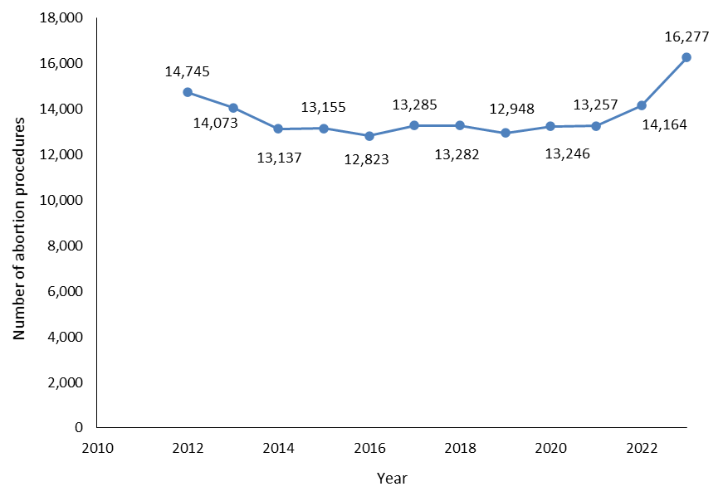

Figure 1–2: Number of abortion procedures per 1,000 females aged 15–44 years (general abortion rate), 2012–2023

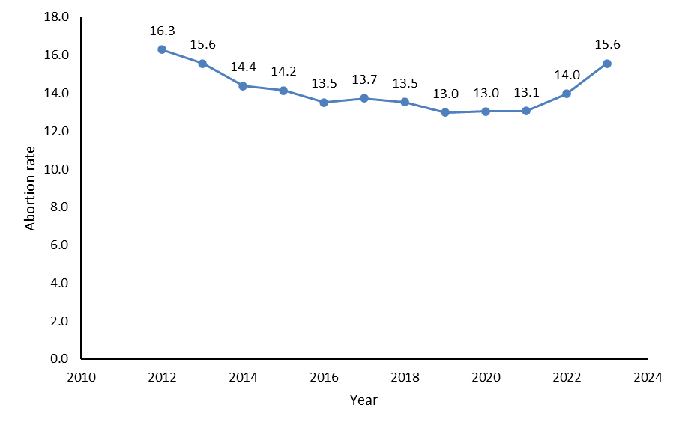

Figure 1–3: Number of abortion procedures per 1,000 known pregnancies (abortion ratio), 2012–2023

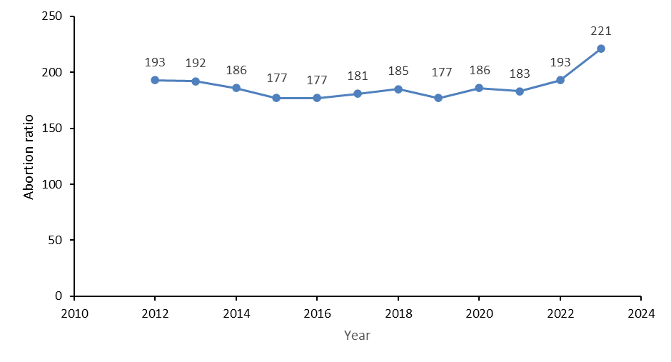

Table 1–1: Number of abortion procedures by age group, 2012–2023

|  |  |  |  |  |  |  |  |  |  |  |  |  |
| --- | --- | --- | --- | --- | --- | --- | --- | --- | --- | --- | --- | --- |
| **Age** | **2012** | **2013** | **2014** | **2015** | **2016** | **2017** | **2018** | **2019** | **2020** | **2021** | **2022** | **2023** |
| Under 15 | 51 | 48 | 57 | 32 | 27 | 30 | 22 | 23 | 26 | 30 | 26 | 37 |
| 15–19 | 2,489 | 2,096 | 1,758 | 1,635 | 1,451 | 1,414 | 1,289 | 1,219 | 1,227 | 1,232 | 1,490 | 1,811 |
| 20–24 | 4,560 | 4,386 | 4,024 | 3,777 | 3,537 | 3,599 | 3,334 | 3,191 | 3,204 | 3,303 | 3,599 | 4,076 |
| 25–29 | 3,240 | 3,174 | 3,075 | 3,256 | 3,368 | 3,632 | 3,598 | 3,397 | 3,488 | 3,339 | 3,537 | 3,989 |
| 30–34 | 2,248 | 2,237 | 2,172 | 2,309 | 2,343 | 2,419 | 2,650 | 2,686 | 2,795 | 2,829 | 2,951 | 3,477 |
| 35–39 | 1,506 | 1,451 | 1,384 | 1,483 | 1,443 | 1,562 | 1,679 | 1,720 | 1,784 | 1,792 | 1,886 | 2,084 |
| 40–44 | 590 | 637 | 611 | 598 | 602 | 584 | 660 | 642 | 649 | 681 | 624 | 739 |
| 45+ | 61 | 44 | 56 | 65 | 52 | 45 | 50 | 70 | 70 | 51 | 51 | 64 |

Figure 1–4: Rate of abortion procedures by age group, 2012–2023

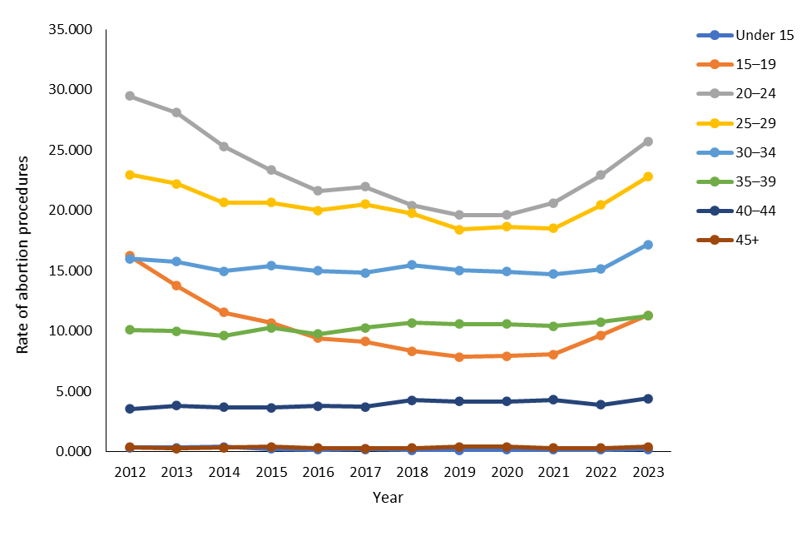

Figure 1–5: Number of abortion procedures by total ethnicity, 2020–2023

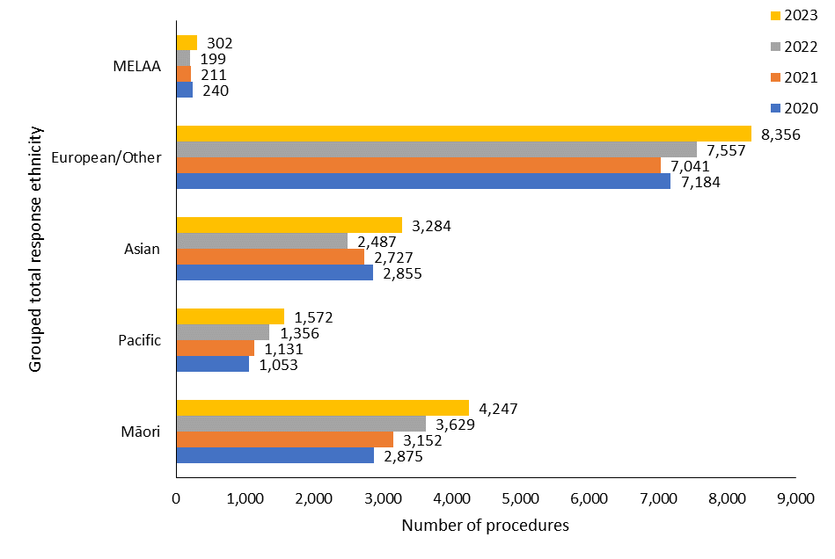

Note: MELAA = Middle Eastern, Latin American and African.

Figure 1–6: Percentage of abortion procedures by prioritised ethnicity, 2023

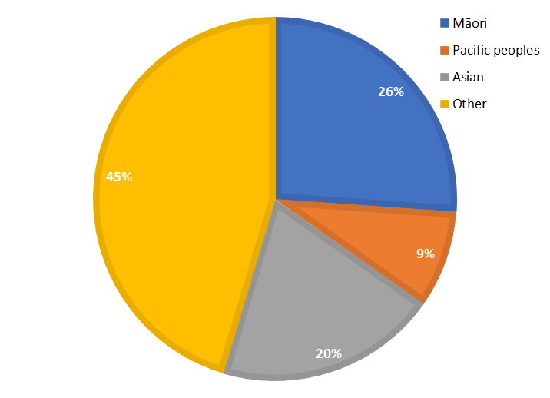

Table 1–2: Number of abortion procedures by prioritised ethnicity, 2011–2023

|  |  |  |  |  |  |  |  |  |  |  |  |  |  |
| --- | --- | --- | --- | --- | --- | --- | --- | --- | --- | --- | --- | --- | --- |
|  | **2011** | **2012** | **2013** | **2014** | **2015** | **2016** | **2017** | **2018** | **2019** | **2020** | **2021** | **2022** | **2023** |
| Māori | 3,855 | 3,595 | 3,455 | 3,012 | 3,074 | 2,895 | 3,107 | 2,979 | 2,999 | 2,875 | 3,152 | 3,629 | 4,247 |
| Pacific peoples | 1,846 | 1,776 | 1,510 | 1,354 | 1,304 | 1,231 | 1,210 | 1,188 | 1,101 | 945 | 1,011 | 1,223 | 1,410 |
| Asian | 2,517 | 2,368 | 2,303 | 2,258 | 2,286 | 2,484 | 2,528 | 2,710 | 2,715 | 2,798 | 2,685 | 2,459 | 3,228 |
| European /other | 7,620 | 6,955 | 6,771 | 6,477 | 6,428 | 6,175 | 6,366 | 6,379 | 6,071 | 6,587 | 6,397 | 6,838 | 7,386 |

Note: Cases where ethnicity data was not recorded have been omitted

Figure 1–7: Rate of abortion procedures per 1,000 females aged 15–44 years (general abortion rate) by prioritised ethnicity, 2011–2023

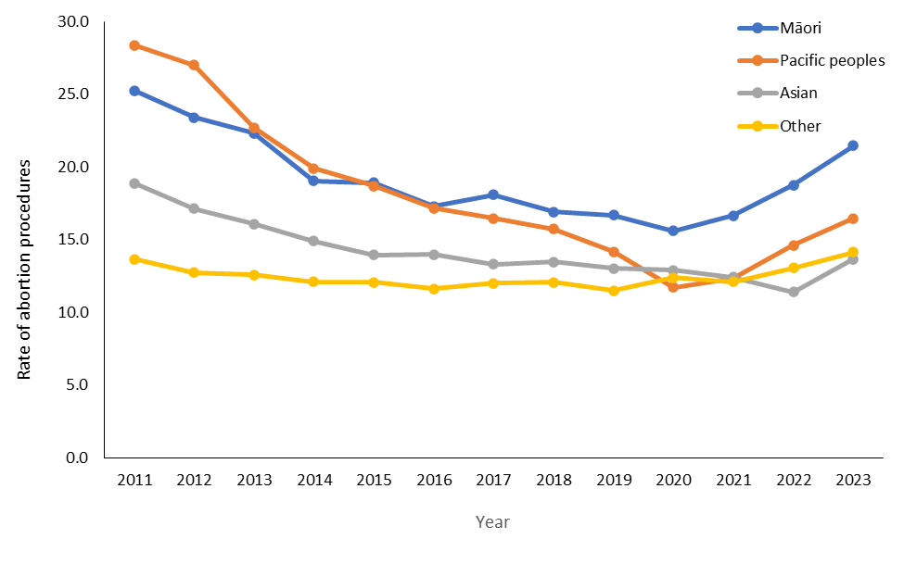

Figure 1–8: Percentage of abortion procedures by age and ethnicity, 2023

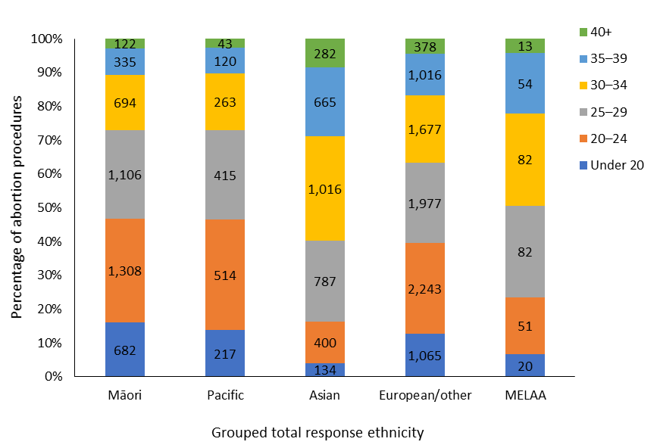

Figure 1–9: Average gestation at time of abortion procedure by ethnicity, 2020–2023

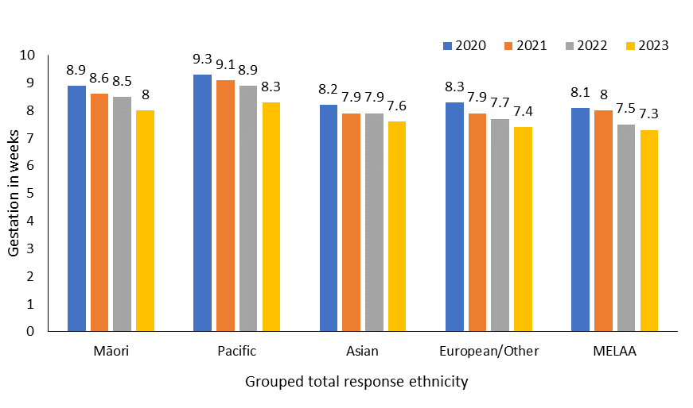

Figure 1–10: Number of abortion procedures by level of socioeconomic deprivation, 2023

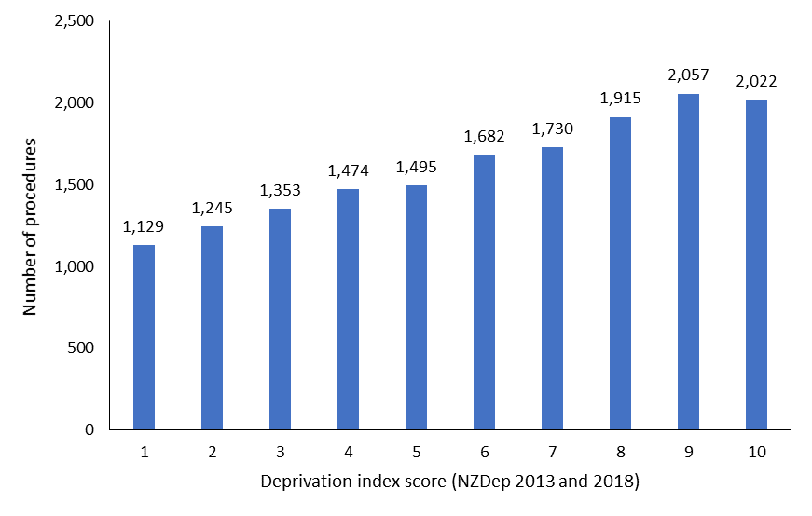

Figure 1–11: Average gestation at time of abortion by level of socioeconomic deprivation, 2023

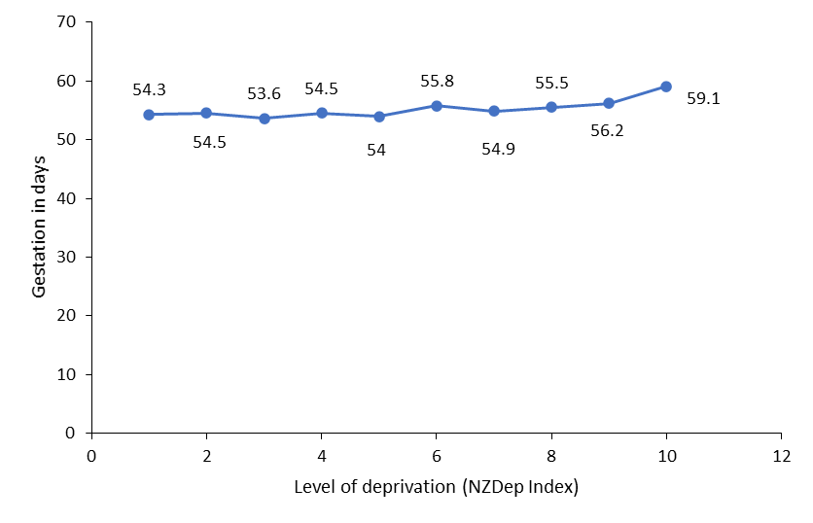

Table 1–3: Number of abortion procedures by patient residency status, 2023

|  |  |
| --- | --- |
| **Residency status** | **Number** |
| Resident | 15,259 |
| Non-resident | 970 |
| Not stated | 48 |
| **Total** | **16,277** |

# Responsiveness to Māori – Wāhanga 2. Te aronga ki te Māori

This section highlights Māori access to abortion services relating to where individuals live, their age and the type of abortion procedure performed.

In 2023, Māori were accessing abortion services at higher rates (per 1,000 females aged 15–44) than other prioritised ethnic groups across 14 of 20 districtsof Aotearoa New Zealand (Figure 2–1) (21.5 per 1,000 females aged 15–44) compared to Pacific (16.5 per 1,000 females aged 15–44), Asian (13.7 per 1,000 females aged 15–44) and the European/other ethnic populations (14.2 per 1,000 females aged 15–44).

Māori tended to access abortion services at younger ages compared to other groups (Table 2–1). The mean age for Māori accessing abortion services in 2023 was 25.9 years old. This was comparable to the mean age for Pacific peoples, at 26.2 years. Asian groups accessed abortions at later ages, with a mean age of 30.9. Finally, the European/other ethnic group accessed abortion services at a mean age of 27.6 years.

Māori accessing abortion services were more likely than non-Māori non-Pacific peoples to access surgical abortions. Specifically, in 2023, 42% of Māori accessing an abortion had a surgical procedure (Figure 2–2). This was a comparable rate to that of Pacific peoples (44%), and higher than the rate for both Asian (34%) and European/other (32%) populations. Notably in 2023, across all ethnic groups, the percentage of surgical abortions decreased and the percentage of early medical abortions increased compared to 2022. Finally, while the percentage of EMAs was lowest among the Māori and Pacific peoples groups, EMAs comprised over half of all abortion procedures across each prioritised ethnic group in 2023.

Figure 2–1: Abortion rate by district of domicile and prioritised ethnicity, 2023

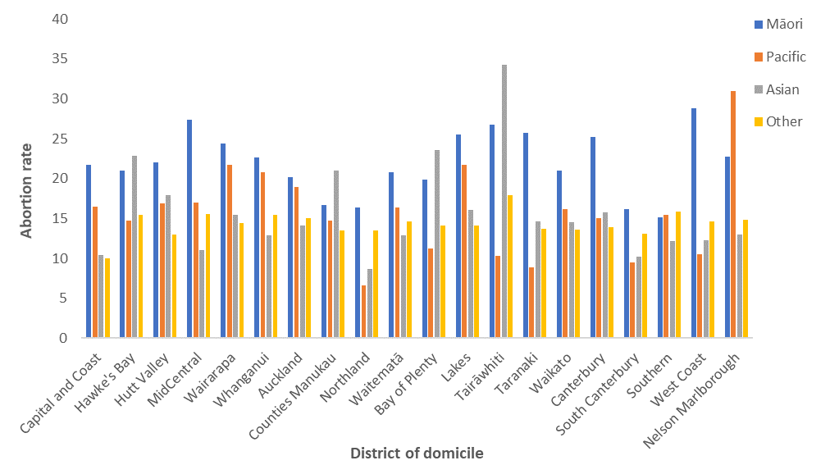

Note: Abortion rate is calculated as number of abortion procedures per 1,000 females aged 15–44.

Table 2–1: Number of abortion procedures by age group and prioritised ethnicity, 2023

|  |  |  |  |  |
| --- | --- | --- | --- | --- |
| **Age group** | **Māori** | **Pacific** | **Asian** | **European**  **/other** |
| Under 20 | 682 | 179 | 121 | 866 |
| 20–24 | 1,308 | 456 | 381 | 1,930 |
| 25–29 | 1,106 | 379 | 779 | 1,724 |
| 30–34 | 694 | 240 | 1,004 | 1,536 |
| 35–39 | 335 | 117 | 662 | 969 |
| 40+ | 122 | 39 | 281 | 361 |
| **Total** | **4,247** | **1,410** | **3,228** | **7,386** |

Note: Six cases have been omitted due to non-reporting of ethnicity data.

Figure 2–2: Number and percentage of abortion procedures by type by prioritised ethnicity, 2022–2023

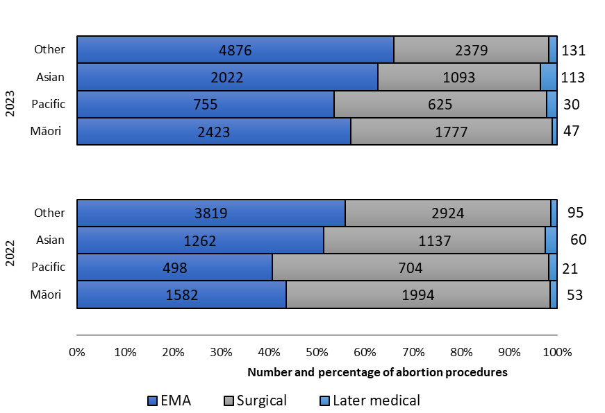

Notes: Six cases from 2023 and 15 cases from 2022 have been omitted due to non-reporting of ethnicity data.

# Types of abortion procedures – Wāhanga 3. Ngā tukanga whakatahe

In 2023, EMAs represented the majority of abortion procedures accessed throughout Aotearoa New Zealand (Figure 3–1). Notably, compared to 2022, the proportion of EMAs increased by 11%, and the proportion of surgical abortions decreased by 12%. In total, of all abortion procedures in 2023, 61.9% (10,080) were EMAs, compared with 50.6% (7,171) in 2022. In total, in 2023, 36.1% (5,875) of all abortion procedures were surgical, compared with 47.8% (6,764) in 2022. Later medical abortions, occurring at over 10 weeks’ gestation, accounted for just 2.0% of all abortions. This number has remained reasonably static since 2017.

The majority of both surgical (66%) and medical (97%) abortions – 86% of abortions overall – were provided at 10 weeks’ gestation or earlier (Figure 3–2). Between 10 to 20 weeks’ gestation, higher rates of abortions were provided surgically rather than medically (Table 3–1). As in the prior reporting period, less than 1% of all abortions occurred at greater than 20 weeks’ gestation.

Analysis of abortion services based on district of domicile demonstrates that the rate of abortion ranged from 14 to 18 per 1,000 females aged 15–44 across the majority of districts (Figure 3–3). Note that in regions or districts with small populations, rate of abortion may appear high despite low levels of abortion access, as is the case in Tairāwhiti (Figure 3–3 and Table 3–2).

A greater number of EMAs compared to surgical abortions were accessed by individuals living in all but two districts: Capital and Coast and Hutt Valley (Table 3–2). This is a noteworthy increase in the rate of EMA access across districts of domicile compared to 2022, in which surgical abortion was accessed at a greater rate within 9 of the 20 districts. Note that Hutt Valley became incorporated with Capital and Coast in July 2022. However, it is included as a distinct district here for consistency in comparison with prior years’ reporting.

Considering procedures by district across 2022 and 2023 shows overall decreases in regionally provided abortion services within 11 districts (Figure 3–4). The largest service decrease occurred in Auckland and the largest service increase occurred in MidCentral (Table 3–2). The observed decreases may be attributed to greater access to the national telehealth EMA services delivered by DECIDE. Specifically, in 2023, 3,889 (24%) of all abortions were provided through this service.

Taken together, these changes demonstrate an average increase in the number and rate of EMA service provision and a decrease in surgical abortions nationally and locally across most districts in Aotearoa New Zealand. Chapters 4 and 5 give further details on regional outcomes and on provision of EMA (both through telehealth and in-person services).

Figure 3–1: Number of abortion procedures by procedure type, 2017–2023

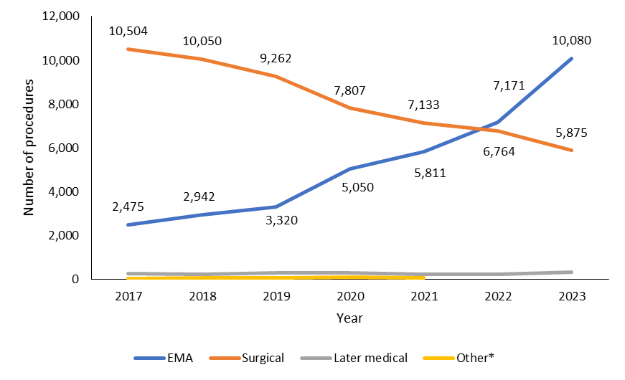

Note: * ‘Other’ abortion types (2017–2021) include failed abortion, a secondary abortion following a failed abortion and reports where a procedure type was missing. From 2022, complications relating to failed abortion procedures are reported within Table 9–1.

Figure 3–2: Percentage of abortions by weeks’ gestation and procedure type, 2023

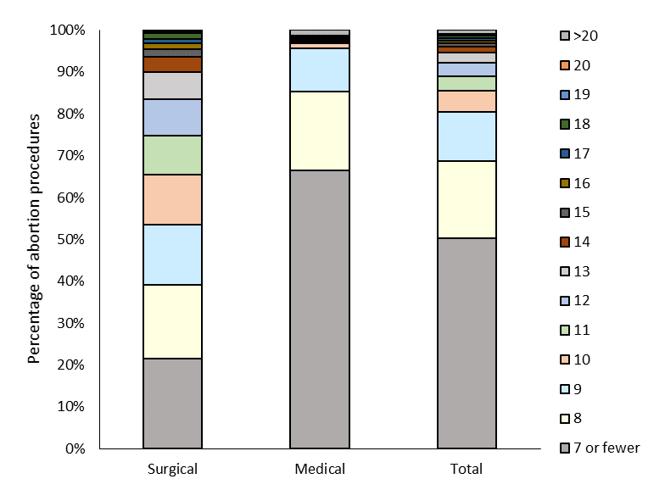

Table 3–1: Number of abortion procedures by weeks’ gestation and procedure, 2023

|  |  |  |  |
| --- | --- | --- | --- |
| **Weeks** | **Surgical** | **Medical** | **Total** |
| 7 or fewer | 1,264 | 6,912 | 8,176 |
| 8 | 1,040 | 1,968 | 3,008 |
| 9 | 839 | 1,068 | 1,907 |
| 10 | 706 | 132 | 838 |
| 11 | 540 | S | 544 |
| 12 | 518 | S | 523 |
| 13 | 380 | 12 | 392 |
| 14 | 213 | 19 | 232 |
| 15 | 111 | 22 | 133 |
| 16 | 77 | 25 | 102 |
| 17 | 67 | 27 | 94 |
| 18 | 75 | 29 | 104 |
| 19 | 27 | 23 | 50 |
| 20 | 10 | 23 | 33 |
| Over 20 | S | 133 | 141 |
| **Total** | **5,875** | **10,402** | **16,277** |

Note: An entry of ‘S’ indicates suppressed information; this applies to instances with fewer than 10 cases and is to protect the privacy of natural persons.

Figure 3–3: Rate of abortion procedures by procedure type and district of domicile, 2023

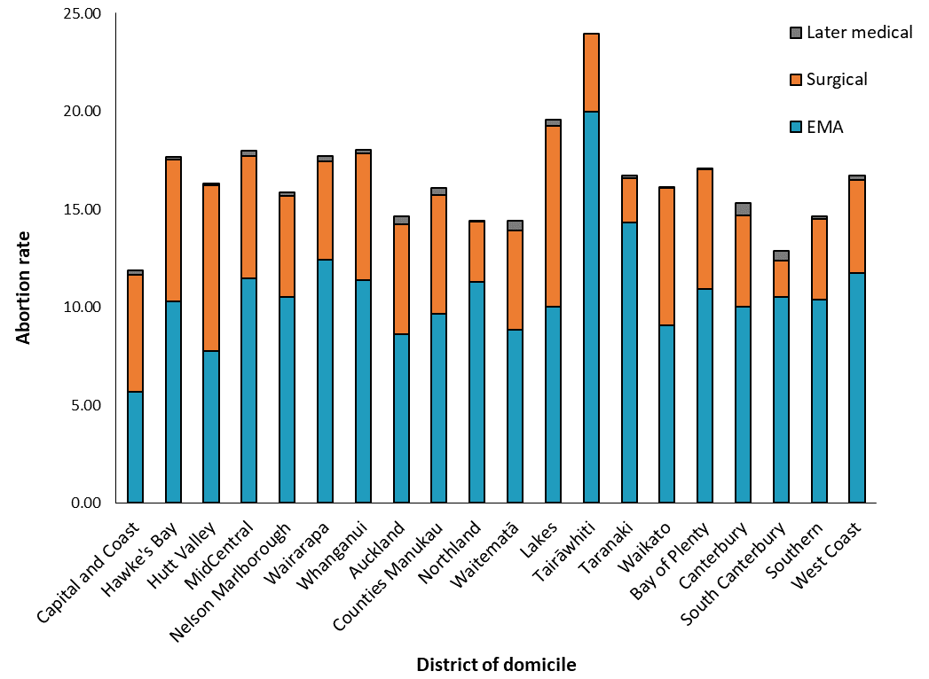

Table 3–2: Number of abortion procedures by procedure type and district of domicile, 2023

| **District of domicile** | **EMA** | **Surgical** | **Later medical (>10 weeks)** |
| --- | --- | --- | --- |
| Capital and Coast | 442 | 467 | 18 |
| Hawke's Bay | 329 | 231 | S |
| Hutt Valley | 255 | 277 | S |
| MidCentral | 422 | 231 | 10 |
| Nelson Marlborough | 278 | 137 | S |
| Wairarapa | 99 | 40 | S |
| Whanganui | 135 | 77 | S |
| Auckland | 991 | 649 | 45 |
| Counties Manukau | 1,294 | 808 | 47 |
| Northland | 366 | 99 | S |
| Waitematā | 1,180 | 674 | 69 |
| Lakes | 220 | 202 | S |
| Tairāwhiti | 185 | 37 | 0 |
| Taranaki | 320 | 50 | S |
| Waikato | 801 | 618 | S |
| Bay of Plenty | 528 | 296 | S |
| Canterbury | 1,207 | 565 | 77 |
| South Canterbury | 106 | 19 | S |
| Southern | 766 | 306 | S |
| West Coast | 59 | 24 | S |
| Not reported | 97 | 68 | S |
| **Total** | **10,080** | **5,875** | **322** |

Note: This figure excludes instances with a missing code of domicile.

Figure 3–4: Number of abortion procedures by district of service, 2020–2023

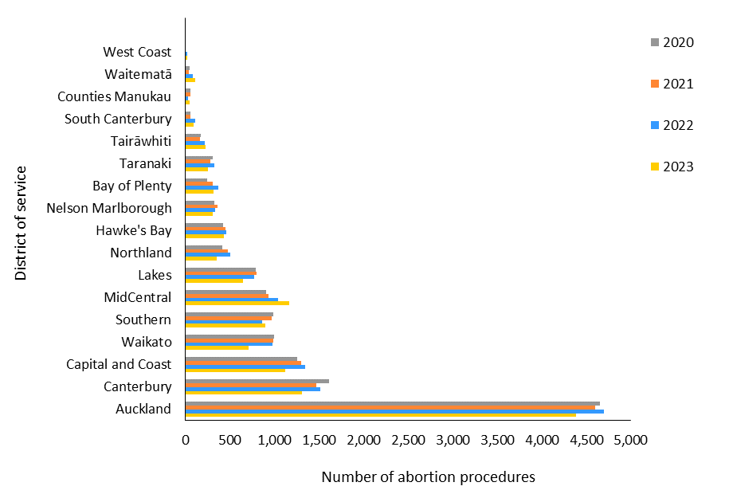

Table 3–3: Number of abortion procedures by district of service, 2020–2023

|  |  |  |  |  |
| --- | --- | --- | --- | --- |
| **District** | **2020** | **2021** | **2022** | **2023** |
| Auckland | 4,656 | 4,597 | 4,702 | 4,389 |
| Canterbury | 1,612 | 1,470 | 1,515 | 1,312 |
| Capital and Coast | 1,259 | 1,297 | 1,345 | 1,118 |
| Waikato | 997 | 989 | 975 | 709 |
| Southern | 987 | 969 | 857 | 898 |
| MidCentral | 902 | 932 | 1,038 | 1,164 |
| Lakes | 794 | 802 | 775 | 649 |
| Northland | 413 | 480 | 503 | 351 |
| Hawke’s Bay | 420 | 446 | 459 | 432 |
| Nelson Marlborough | 328 | 364 | 329 | 303 |
| Bay of Plenty | 246 | 305 | 373 | 315 |
| Taranaki | 304 | 283 | 327 | 249 |
| Tairāwhiti | 172 | 167 | 213 | 223 |
| South Canterbury | 55 | 57 | 110 | 95 |
| Counties Manukau | 53 | 53 | 30 | 43 |
| Waitematā | 45 | 40 | 80 | 113 |
| West Coast | S | S | 17 | 19 |

Note: Regional data from the year 2022 excludes 515 abortions accessed through DECIDE. Regional data from the year 2023 excludes 3889 abortions accessed through DECIDE. This table excludes abortion procedures in Hutt Valley district (for 2020, 2021, 2022 and 2023) and the West Coast (for 2020 and 2021) due to very low numbers.

# Geographical access to abortion – Wāhanga 4. Te āheinga ā-matawhenua ki te whakatahe

A greater number of locally based in-person abortion services became available in 2023 compared to 2022. Figure 4–1 shows average drive times to the nearest abortion provider across Aotearoa New Zealand. The majority of providers are located in urban areas. Reflecting the population density around these areas, the majority of females aged 15–44 lived within a 30-minute drive from an in-person abortion provider (Table 4–1).

Figures in this report show average drive times to locations providing in-person EMAs and (in many cases) surgical abortions. These summaries do not reflect all details relating to equity of access. For instance, different providers may have different wait times, or may have limited capacity in terms of the number of patients they can see. Additionally, drive times do not reflect the variability or availability of different services offered at different gestational thresholds. An individual’s nearest abortion provider may be within a 40-minute drive time but offer only EMAs. In such instances, a person seeking an abortion at over 10 weeks’ gestation may need to travel further to access abortion services.

In the past, annual reporting released by the Ministry included drive time estimates for Māori as well as non-Māori non-Pacific females. The current report expands on the ethnicity data to specify drive-time averages by prioritised ethnicity relating to Māori, Pacific, Asian and European/other groups. In 2023, across all prioritised ethnic groups, the majority of females aged 15–44 lived within a 30-minute drive from a provider (Table 4–1).

Notably, in 2023, 24% of Māori females aged 15–44 lived more than a 30-minute drive from an abortion service (Table 4–1). This reflects a decrease of 3% compared to 2022. However, the percentage of Māori females aged 15–44 living more than a 90-minute drive from an abortion service remained stable, at 3%. While the observed decrease in drive time demonstrates some greater accessibility to an in-person service, the average drive time for Māori remains longer compared to the drive time for each other ethnic group.

Different demographic and regional characteristics may also have an impact on these average drive times. Individuals in rural communities will typically have to drive longer distances than those in urban communities to access in-person health services. Additionally, characteristics such as ethnicity and socioeconomic deprivation may influence the likelihood of living closer to abortion providers.

To consider the impact of rurality on drive time, we applied the Geographical Classification for Health (GCH), developed by the University of Otago to monitor rural-urban variables in health outcomes in New Zealand. The GCH includes two urban categories (Urban 1 and Urban 2) and three rural categories (Rural 1 to Rural 3). Urban categories are based on population size, and rural categories are based on drive time to urban areas. To view a map of these classification areas, visit [rhrn.nz/gch/maps](https://mohgovtnz.sharepoint.com/sites/moh-ecm-RegAs/Shared%20Documents/Abortion/2024%20Annual%20Abortion%20Report/rhrn.nz/gch/maps).

Figure 4–2 shows the average drive time (in minutes) to the nearest in-person abortion provider based on both ethnicity and GCH rurality index, among females aged 15–44. Due to the low numbers of individuals living in Rural 3 areas, we merged Rural 2 and Rural 3 categories for the purposes of this report (calling the new category ‘Rural 2/3’). As expected, those living in urban centres (Urban 1 and Urban 2) had shorter drive times to access providers. Average drive time was reasonably consistent at 10–14 minutes across prioritised ethnic groups.

Those living rural areas (Rural 1 and Rural 2/3) had much longer drive times. In Rural 1 areas, individuals on average lived a 40-to-45-minute drive time to the nearest abortion provider. Those residing in Rural 2/3 areas on average had to drive over an hour to reach an abortion provider, across all prioritised ethnic groups. Notably, ethnicity did appear to affect this trend: Māori at the greatest levels of rurality had to drive further than any other group.

Figure 4–3 shows the average drive time (in minutes) to the nearest in-person abortion provider based on both level of socioeconomic deprivation and GCH rurality index, among females aged 15–44. On average, individuals residing in Urban 1 and 2 areas lived a 12-to-16-minute drive away from an in-person service. This trend was not affected by level of socioeconomic deprivation. Those residing in Rural 1 areas lived on average a 39-to-43-minute drive away from an in-person service. This average was also consistent across levels of socioeconomic deprivation. Finally, individuals residing in very rural areas (Rural 2/3) lived on average a 42-to-85-minute drive away from an in-person abortion provider. This was affected by socioeconomic deprivation: average drive time increased as socioeconomic deprivation increased.

Access to local in-person abortion services varies across Aotearoa New Zealand regions and districts: people living in certain areas may need to travel outside of their district for in-person abortion services (Figure 4–4). In 2023, all those seeking abortion services living in Whanganui or Wairarapa needed to travel out of their district of domicile to access in-person services. In Waitematā, Counties Manukau and Hutt Valley, 92–99% of those seeking abortion services travelled out of district for in-person services. Note that Hutt Valley became incorporated with Capital and Coast in July 2022. However, it is included as a distinct district here for consistency in comparison with prior years’ reporting.

Having to travel out of district appears to affect timely access to service. Those living in areas associated with a higher rate of travel to access in-person services had, on average, later gestations at the time of their abortion procedure (Figures 4–4 and 4–5). However, it is noteworthy that average gestation at the time of abortion decreased across 15 of the 20 districts measured in 2023 compared to 2022. In the remaining 5 districts average gestation was among the lowest in the country across both 2022 and 2023.

Figure 4–1: Geospatial analysis – patient drive time to services by facility, 2023

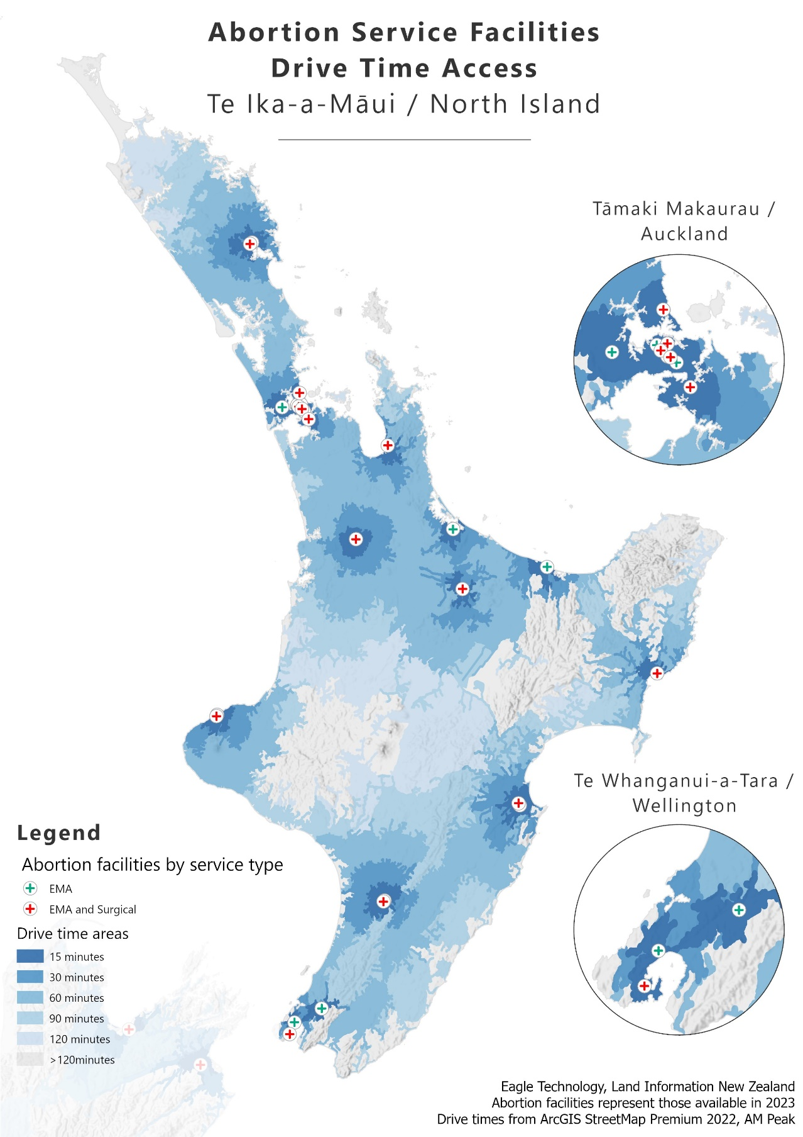

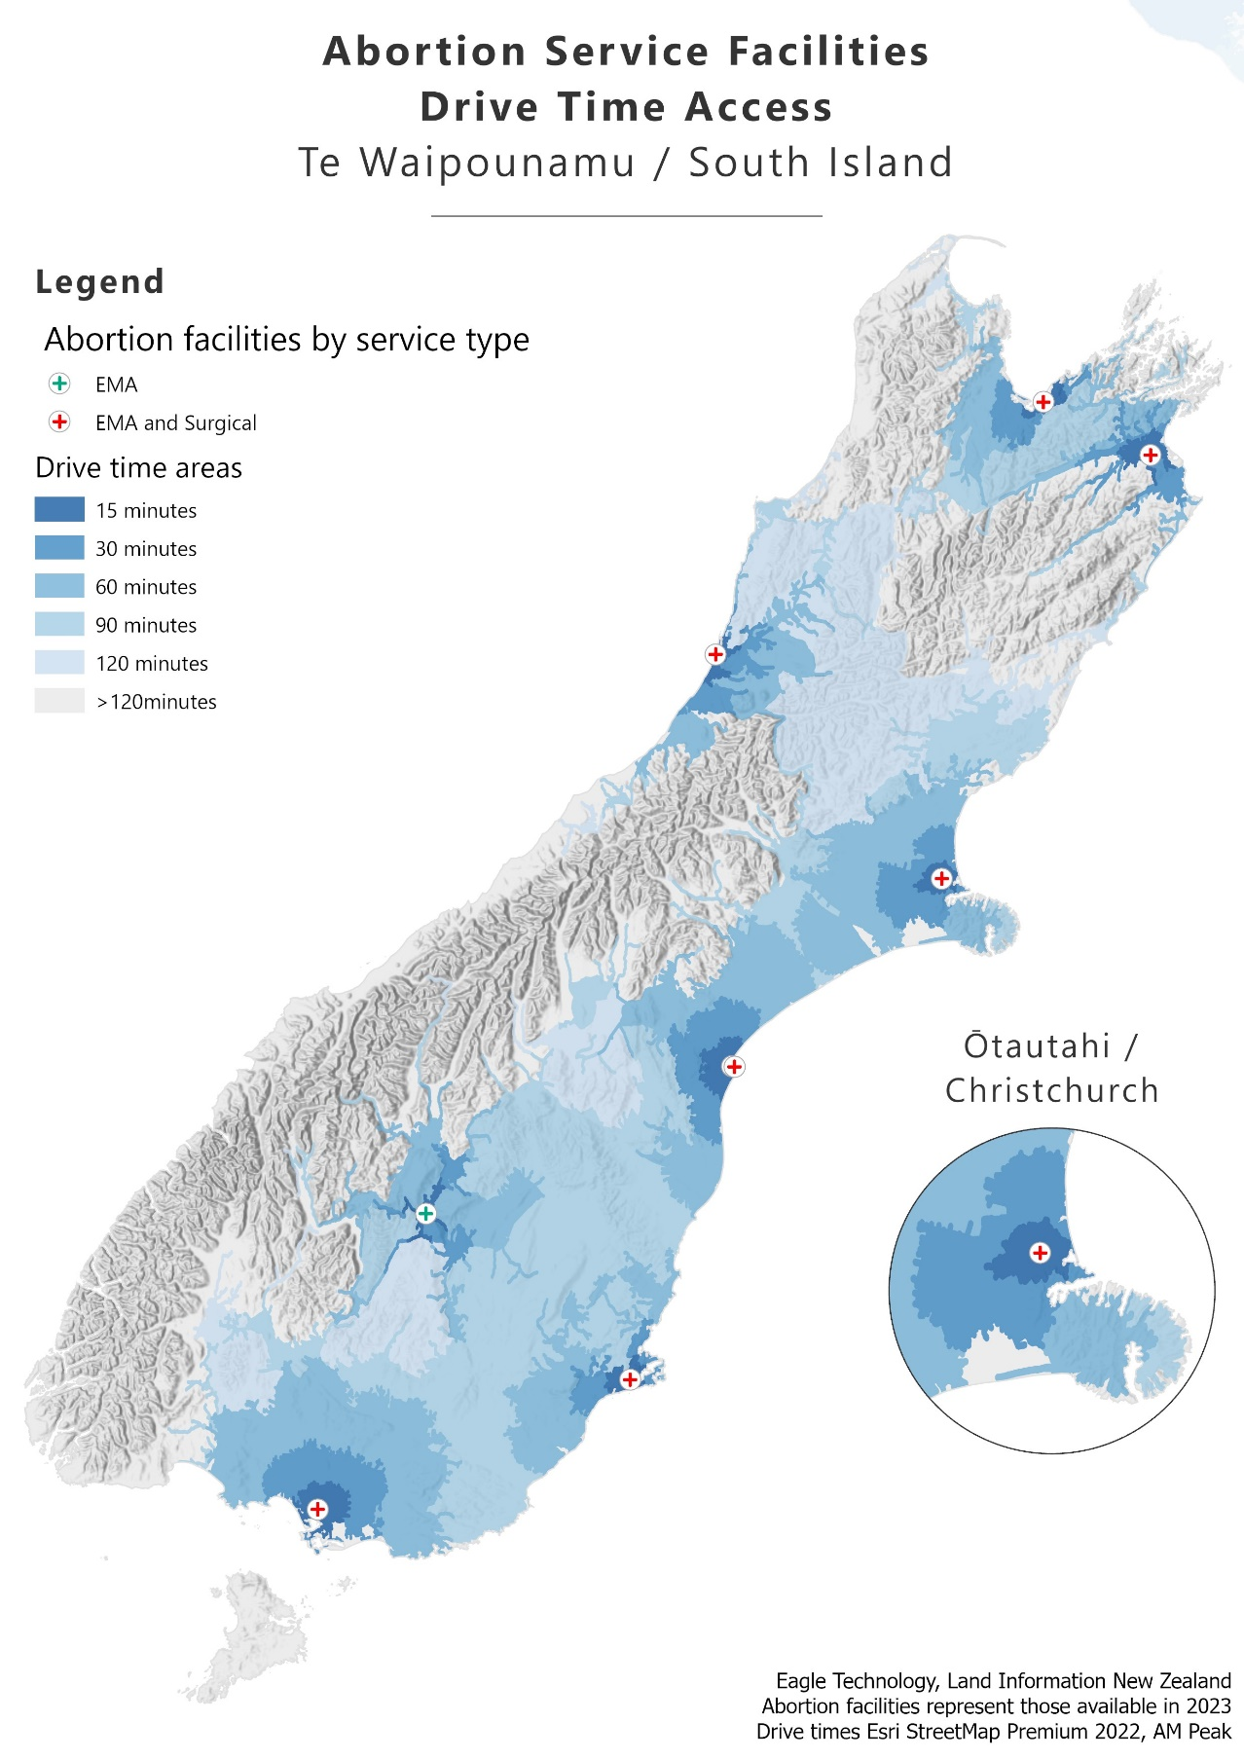

Table 4–1: Average drive time in minutes to nearest in-person abortion provider by prioritised ethnicity, 2023

|  |  |  |  |  |
| --- | --- | --- | --- | --- |
| **Drive time (minutes)** | **Māori** | **Pacific** | **Asian** | **European/other** |
| Up to 30 | 76.1% | 93.7% | 93.9% | 79.8% |
| 31–60 | 16.0% | 5.0% | 4.9% | 15.9% |
| 61–90 | 4.6% | 1.0% | 0.9% | 3.3% |
| over 90 | 3.2% | 0.3% | 0.3% | 1.1% |
| Average drive time (minutes) | 22.8 | 13.1 | 12.7 | 19.6 |

Figure 4–2: Average drive time in minutes to nearest in-person abortion provider by prioritised ethnicity and GCH urban-rural index, 2023

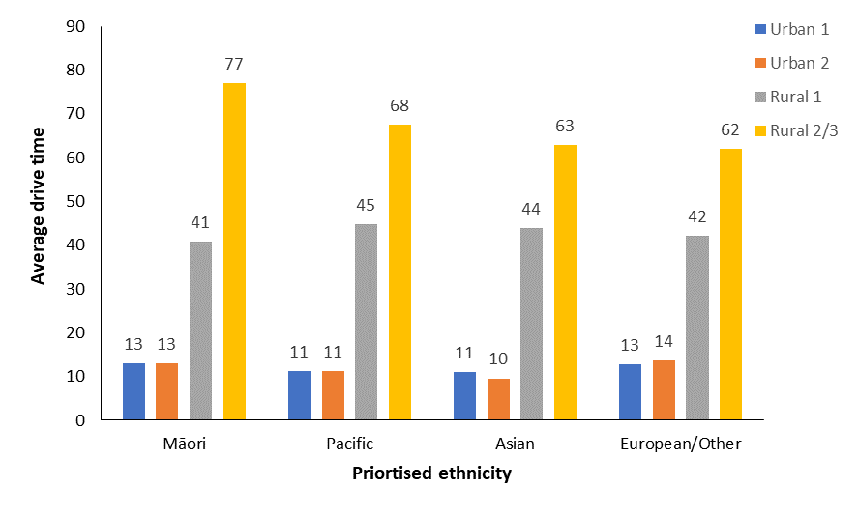

Figure 4–3: Average drive time in minutes to nearest in-person abortion provider by level of socioeconomic deprivation and GCH urban-rural index, 2023

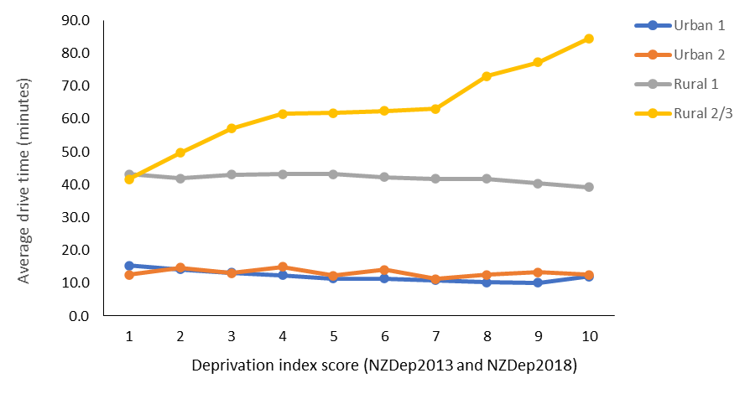

Note: NZDep2013 is applied to data received prior to 10 August 2023. NZDep2018 is applied to data received from 10 August 2023 following updates to deprivation indices applied by Te Whatu Ora.

Figure 4–4: Percentage of patients travelling to other districts for abortion procedures by district of domicile, 2023

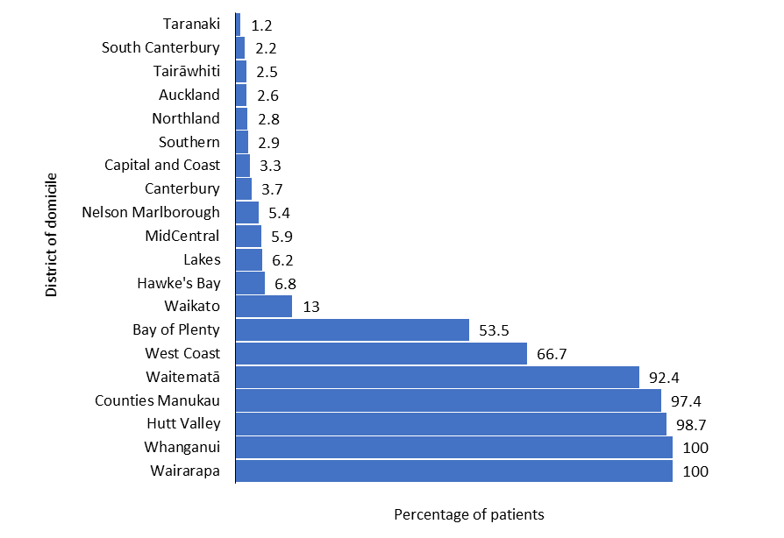

Note: Total values exclude individuals accessing EMA via DECIDE. This figure also excludes those records missing information on district of domicile.

Figure 4–5: Average gestation by district of domicile, 2023

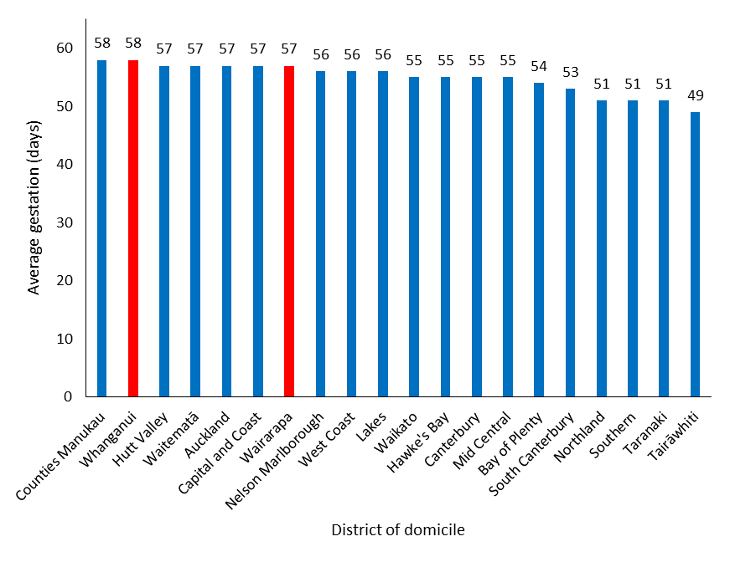

Note: Red in this figure indicates that the district had no local in-person, first-trimester abortion services in 2023; blue indicates that it did have such services.

# Early medical abortion access – Wāhanga 5. Te āheinga atu ki te whakatahe tōmua mō tētahi take hauora

In 2023, EMAs represented 61.9% of all abortion procedures, an increase of 11% since 2022 and the highest rate of EMA access reported since this has been measured.

This increase is reflective of improving accessibility within Aotearoa New Zealand. As Chapter 4 discussed, a greater number of provider locations were available in 2023 as compared to 2022, reducing the average drive time to in-person services. Additionally, some regionally based providers offer EMAs through telehealth services.

Moreover, from 1 November 2022, EMAs became available through the national telehealth service, DECIDE. The EMA service delivered by DECIDE includes consultation, abortion counselling (if requested) and provision of abortion medications and aftercare (including contraception post-abortion) for those who meet all clinical requirements. This service complements in-person and regional telehealth abortion services.

Access to in-person EMA services remained high across 2022 and 2023. Telehealth services increase availability and access, and we are seeing demand for these both nationally and regionally. For instance, over 2,000 EMAs were accessed through regionally provided telehealth services during both 2022 and 2023 (Table 5–1). Additionally, during DECIDE’s first full year of service provision (2023), 3,889 abortions were accessed through the service.

The current results demonstrate demand for in-person services, as well as for both regional and national telehealth. This report considers some key demographic characteristics to investigate trends in accessing these different forms of service, including age, ethnicity and rurality.

Table 5–2 gives a detailed outline of EMA access across age brackets and EMA service type. In terms of age, 72.5% of all EMA services were accessed by individuals aged 20–34 years old. 10.8% of all EMA services were accessed by individuals below the age of 20, and 16.7% were accessed by individuals aged 35 or above. Figure 5–1 shows that age does not appear have a notable impact on type of EMA service provision. In other words, the rate of EMA access based on age bracket is generally consistent across in-person, regional telehealth and national telehealth services.

Table 5–3 provides a detailed outline of EMA access across prioritised ethnic groups and EMA service type. In 2023, 24.1% of all EMAs were accessed by Māori, and 7.5% were accessed by Pacific peoples. Asian populations accessed 20.1%, and the European/other group accessed nearly half (48.4%). Figure 5–2 demonstrates that each ethnic group relied on all three EMA service types in 2023. However, both the Māori and the Asian populations accessed a greater proportion of in-person services as compared to telehealth services, while the European/other group accessed a greater proportion of telehealth services as compared to in-person services.

As outlined in Chapter 4, those living in rural areas, on average, have a further drive time to in-person abortion services as compared to individuals living in urban centres. Notably, while only 16% of females aged 15–44 were living in rural areas in 2023, 21% of all EMA telehealth services were accessed by individuals living in those rural communities, while only 13.6% of in-person services were accessed by this demographic – demonstrating that those living in rural communities relied more heavily on telehealth services than those living in urban centres.

Table 5–1: Number and percentage of total EMAs accessed through national telehealth, regional telehealth and in-person services, 2022–2023

|  |  |  |  |  |  |  |  |
| --- | --- | --- | --- | --- | --- | --- | --- |
|  | **National telehealth (DECIDE)** | | **Regional telehealth** | | **In person** | | **Total** |
| **Year** | **Number** | **(%)** | **Number** | **(%)** | **Number** | **(%)** | **Number** |
| 2022 | 515 | (7.2%) | 2,093 | (29.2%) | 4,563 | (63.6%) | 7,171 |
| 2023 | 3,889 | (38.6%) | 2,216 | (22.0%) | 3,975 | (39.4%) | 10,080 |

Note: National telehealth services are offered by DECIDE, while regional are offered by regional providers. In 2022, DECIDE was offered from 1 November.

Table 5–2: Number and percentage of early medical abortion by service type access by age group, 2023

|  |  |  |  |  |  |  |  |  |
| --- | --- | --- | --- | --- | --- | --- | --- | --- |
|  | **National telehealth (DECIDE)** | | **Regional telehealth** | | **In person** | | **Total** | |
| **Age** | **Number** | **(%)** | **Number** | **(%)** | **Number** | **(%)** | **Number** | **(%)** |
| Under 20 | 417 | 10.72 | 205 | 9.25 | 466 | 11.72 | 1,088 | 10.79 |
| 20–24 | 974 | 25.04 | 535 | 24.14 | 1,039 | 26.14 | 2,548 | 25.28 |
| 25–29 | 938 | 24.12 | 623 | 28.11 | 979 | 24.63 | 2,540 | 25.20 |
| 30–34 | 901 | 23.17 | 507 | 22.88 | 817 | 20.55 | 2,225 | 22.07 |
| 35–39 | 474 | 12.19 | 247 | 11.15 | 483 | 12.15 | 1,204 | 11.94 |
| 40+ | 185 | 4.76 | 99 | 4.47 | 191 | 4.81 | 475 | 4.71 |
| **Total** | **3,889** |  | **2,216** |  | **3,975** |  | **10,080** |  |

Figure 5–1: Percentage of early medical abortion within each service type access by age group, 2023

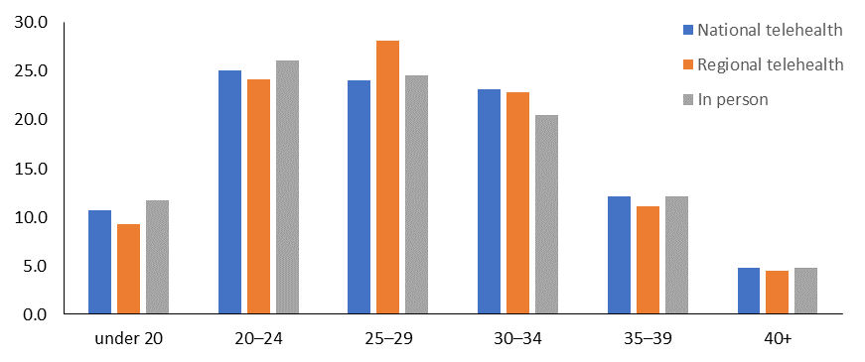

Table 5–3: Number and percentage of early medical abortion by service type access by prioritised ethnicity, 2023

|  |  |  |  |  |  |  |  |  |
| --- | --- | --- | --- | --- | --- | --- | --- | --- |
|  | **National telehealth (DECIDE)** | | **Regional telehealth** | | **In person** | | **Total** | |
| **Ethnicity** | **Number** | **(%)** | **Number** | **(%)** | **Number** | **(%)** | **Number** | **(%)** |
| Māori | 970 | 24.94 | 384 | 17.34 | 1,069 | 26.91 | 2,423 | 24.05 |
| Pacific | 331 | 8.51 | 152 | 6.86 | 272 | 6.85 | 755 | 7.49 |
| Asian | 558 | 14.35 | 511 | 23.07 | 953 | 23.99 | 2,022 | 20.07 |
| European/  other | 2,030 | 52.20 | 1,168 | 52.73 | 1,678 | 42.25 | 4,876 | 48.39 |
| **Total** | **3,889** |  | **2,215** |  | **3,972** |  | **10,076\*** |  |

Note: * Four cases have been omitted due to non-reporting of ethnicity data.

Figure 5–2: Percentage of early medical abortion within service type access by prioritised ethnicity, 2023

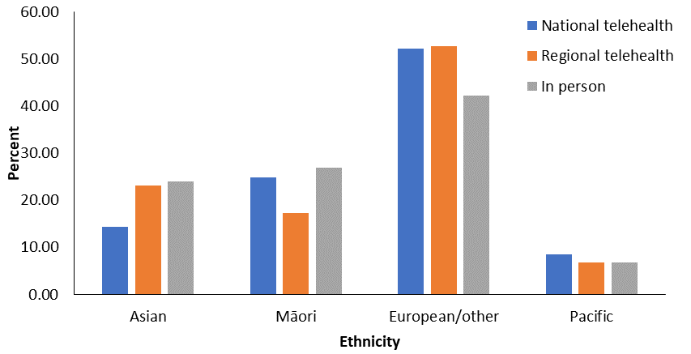

Table 5–4: Number and percentage of early medical abortion by service type access, across rural and urban groups, 2023

|  |  |  |  |  |  |  |  |  |
| --- | --- | --- | --- | --- | --- | --- | --- | --- |
|  | **National telehealth (DECIDE)** | | **Regional telehealth** | | **In person** | | **Total** | |
| **Urban/rural (GCH)** | **Number** | **(%)** | **Number** | **(%)** | **Number** | **(%)** | **Number** | **(%)** |
| Urban1 | 3,111 | 80.8 | 1,680 | 76.9 | 3,410 | 86.4 | 8,201 | 82.2 |
| Rural2 | 740 | 19.2 | 506 | 23.1 | 535 | 13.6 | 1,781 | 17.8 |
| **Total** | **3,851** |  | **2,186** |  | **3,945** |  | **9,9823** |  |

Note: 1‘Urban’ includes GCH categories ‘Urban 1’ and ‘Urban 2’. 2‘Rural’ includes GCH categories ‘Rural 1’, ‘Rural 2’ and ‘Rural 3’. 398 cases could not be classified according to the GCH and have therefore been omitted.

# 

# Abortion within the reproductive journey – Wāhanga 6. Te whakatahe i roto i te ara whakaputa uri

Overall, the proportion of people with no previous live births who had an abortion was similar in 2023 (44%) and 2022 (43%). Summarising this data by total ethnicity shows that 34.9% of Māori accessing abortion services in 2023 had had no previous live births, compared with 44.0% of Pacific peoples, 39.3% of Asian people and 50.4% of the European/other group (Figure 6–1). This data is further clarified with exact values in Table 6–1.

The proportion of people overall who had their first abortion in 2023 (66%) was consistent with what was observed in 2022 (64%). Summarising this data by total ethnicity shows that 60.3% of Māori accessing abortion had had no previous abortions, compared with 67.5% of Pacific peoples, 72.3% of Asian people and 64.3% of the European/other group (Figure 6–2). This data is further clarified with exact values in Table 6–2.

Figure 6–1: Percentage access to abortion services by number of previous live births and ethnicity, 2023

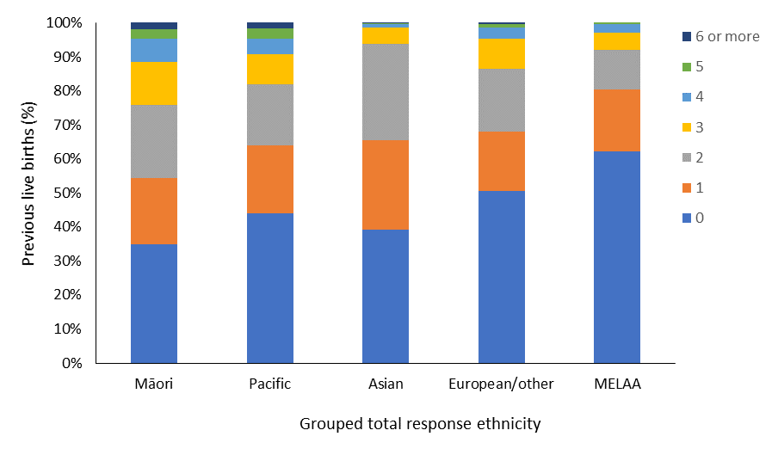

Table 6–1: Number of abortion service provision by number of previous live births and ethnicity, 2023

|  |  |  |  |  |  |
| --- | --- | --- | --- | --- | --- |
| **Previous live births** | **Māori** | **Pacific** | **Asian** | **European/other** | **MELAA** |
| 0 | 1,483 | 691 | 1,291 | 4,215 | 188 |
| 1 | 828 | 315 | 860 | 1,476 | 55 |
| 2 | 907 | 281 | 927 | 1,543 | 35 |
| 3 | 539 | 141 | 157 | 728 | 15 |
| 4 | 291 | 71 | 37 | 275 | 8 |
| 5 | 121 | 47 | 8 | 86 | 1 |
| 6 or more | 78 | 26 | 4 | 33 | 0 |

Figure 6–2: Percentage access to abortion services by number of previous abortion procedures and ethnicity, 2023

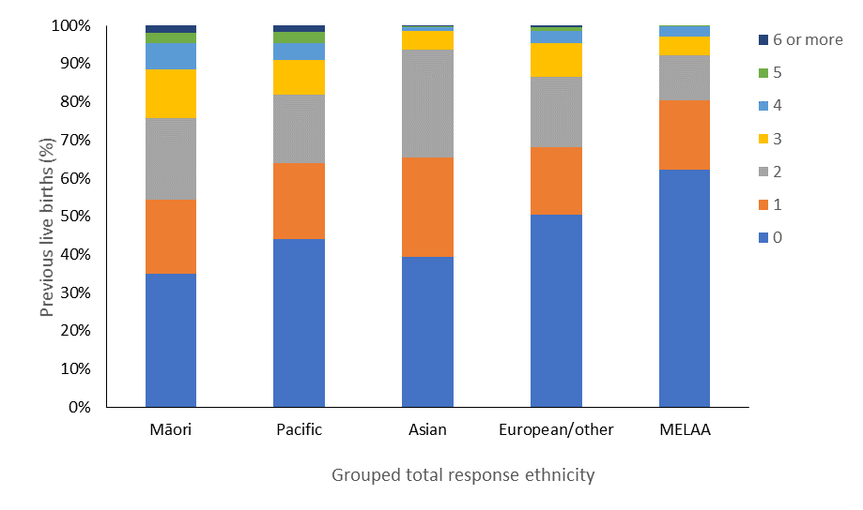

Table 6–2: Number of abortion service provision by number of previous abortion procedures and ethnicity, 2023

|  |  |  |  |  |  |
| --- | --- | --- | --- | --- | --- |
| **Previous abortions** | **Māori** | **Pacific** | **Asian** | **European/other** | **MELAA** |
| 0 | 2,561 | 1,061 | 2,373 | 5,372 | 243 |
| 1 | 1,060 | 349 | 667 | 1,944 | 50 |
| 2 | 380 | 111 | 169 | 653 | 5 |
| 3 | 134 | 34 | 49 | 229 | 2 |
| 4 | 69 | 12 | 16 | 90 | 2 |
| 5 | 24 | 3 | 8 | 34 | 0 |
| 6 or more | 19 | 2 | 2 | 34 | 0 |

# Abortion counselling – Wāhanga 7. Tohuora whakatahe

Following changes to the Contraception, Sterilisation, and Abortion Act 1977, the Ministry is responsible for services relating to abortion counselling. These responsibilities include publishing standards for abortion counselling, ensuring availability of abortion counselling and reviewing access to abortion counselling.

The Act states that abortion counselling is not mandatory for a person accessing abortion services. However, health providers must advise those seeking an abortion about the availability of counselling services. The Standard for Abortion Counselling in Aotearoa New Zealand (2022)[5] outlines the purpose and scope of abortion counselling in Aotearoa New Zealand.

People should be supported by abortion counsellors to explore their emotions, thoughts and feelings in relation to their abortion. As the Standard explains, abortion counselling provides therapeutic support to people who are considering having, or have had, an abortion. The standard is grounded in Te Tiriti o Waitangi and health equity practice and sets out what the Ministry expects of those delivering abortion-related counselling.

In 2023, 47% of facilities providing abortion services also provided pre-abortion counselling services. In that year, 2,509 (15%) of those accessing an abortion chose to access pre-abortion counselling services. In the majority of those cases (2,014), the person accessing pre-abortion counselling did so at the same location as their abortion service provider.

The Ministry continues to work with providers within its regulatory role to monitor abortion counselling services.

# Abortion and access to contraception – Wāhanga 8. Te āheinga ki te whakatahe me ngā ārai hapūtanga

Of those who had an abortion in 2023, 60.7% reported having not been using any contraception at the time of conception; this is consistent with prior years’ reporting (Table 8–1). Comparably, 39.3% of individuals reported having used some kind of contraception at the time of conception. Individuals may use many forms of contraception simultaneously. For clarity in reporting and for interpretation of the present results, this report addresses the primary form of contraception people reported using. In prioritised order of contraception used, these are: any form of LARC, oral contraceptive, condom, emergency contraceptive, sterilisation, and fertility tracking.

Condoms were the most common form of primary contraception people accessing abortion services reported using in 2023. Specifically, 17.6% of people reported using condoms as their primary form of contraception. A further 8.4% of people reported using oral contraception (combined or progesterone-only). Finally, 1.6% of people reported using LARCs.

In accordance with the Contraception, Sterilisation, and Abortion (Information Collection) Regulations 2021, the Ministry also collects data on contraception provided at the time of abortion. Providers have the option to report instances in which an individual has booked, or has been referred for, a post-abortion follow-up contraception appointment.

Comparably to 2022, 23.3% of those accessing abortion services in 2023 did not access contraception services or were not booked for a follow-up contraceptive appointment at the time of their abortion procedure (Table 8–2). In 2023, nearly a quarter of people accessing abortion services (24%) were given condoms, while 18% were prescribed oral contraception. Finally, over 27% of all those accessing abortion services were given LARCs at the time of their abortion.

Long-acting reversible contraception is highly effective at preventing pregnancy and lasts for extended periods of time, while being easily reversible. Examples of LARCs are the intra-uterine system (IUS), contraceptive injections (Depo-Provera) and subdermal implant contraceptive devices.

Analysis shows that 11.3% of those who had an EMA in 2023 were provided with LARC at the time of the abortion, while 55.9% of those receiving surgical abortions were provided with LARC (Table 8–3). The large difference between these figures may be a result of preconditions relating to the provision of certain LARC devices. For instance, insertion of an IUS into the uterus cannot occur at the time of an EMA abortion and requires a follow-up appointment. An IUS can be provided at the time of a first-trimester surgical abortion.

When accessing contraceptive services at the time of abortion, Māori and Pacific peoples were more likely to access LARC services, while the Asian and European/other groups were more likely to access other forms of contraception (Table 8–4).

Table 8–1: Type of contraception used at time of conception, 2023

|  |  |  |
| --- | --- | --- |
| **Contraception used** | **Number** | **Percentage** |
| None | 9,881 | 60.7 |
| Condoms | 2,865 | 17.6 |
| Oral contraception | 1,362 | 8.4 |
| Unknown | 1,158 | 7.1 |
| Fertility awareness method | 495 | 3.0 |
| Emergency contraceptive pill | 221 | 1.4 |
| Intra-uterine contraceptive device | 134 | 0.8 |
| Depo-Provera injection | 75 | 0.5 |
| Subdermal contraceptive implant | 52 | 0.3 |
| Partner sterilisation | 26 | 0.2 |
| Sterilisation | 8 | <0.1 |
| **Total** | **16,277** |  |

Table 8–2: Contraception provided at time of abortion by type, number and percentage of total abortions, 2023

| **Contraception provided** | **Number** | **Percentage** |
| --- | --- | --- |
| None | 3,793 | 23.3 |
| Condoms | 3,072 | 18.9 |
| Intra-uterine contraceptive device | 2,556 | 15.5 |
| Oral contraception | 2,393 | 14.7 |
| Booked/referred for follow-up contraceptive appointment | 1,385 | 8.5 |
| Subdermal contraceptive implant | 951 | 5.8 |
| Depo-Provera injection | 625 | 3.8 |
| Condoms and oral contraceptive pill | 468 | 2.9 |
| LARC not further defined | 316 | 1.9 |
| Condoms and emergency contraceptive pill | 275 | 1.7 |
| Patient already had contraception | 210 | 1.3 |
| Partner had received or has booked sterilisation | 78 | 0.5 |
| Condoms and booked/referred | 66 | 0.4 |
| Fertility awareness methods information | 35 | 0.2 |
| Emergency contraceptive pill | 32 | 0.2 |
| Condoms and intra-uterine contraceptive device | 22 | 0.1 |
| **Total** | **16,277** |  |

Table 8–3: Number and percentage of people receiving long-acting reversible contraception by procedure type, 2023

|  |  |  |  |  |
| --- | --- | --- | --- | --- |
| **Contraception provided** | **EMA (%)** | **Surgical (%)** | **Later medical (%)** | **Total (%)** |
| LARC | 1,135 (11.3) | 3,284 (55.9) | 51 (15.8) | 4,470 (27.5) |
| Other | 4,638 (46.0) | 1,752 (29.8) | 29 (9.0) | 6,419 (39.4) |
| Booked/referred | 1,055 (10.5) | 245 (4.2) | 85 (26.4) | 1,385 (8.5) |
| None | 3,252 (32.3) | 594 (10.1) | 157 (48.8) | 4,003 (24.6) |
| **Total** | **10,080** | **5,875** | **322** | **16,277** |

Table 8–4: Number and percentage of people receiving long-acting reversible contraception by prioritised ethnicity, 2023

|  |  |  |  |  |  |
| --- | --- | --- | --- | --- | --- |
| **Contraception provided** | **Māori (%)** | **Pacific (%)** | **Asian (%)** | **European/**  **other (%)** | **Total (%)** |
| LARC | 1,524 (35.9) | 542 (38.4) | 664 (20.6) | 1,739 (23.5) | 4,469 (27.5) |
| Other | 1,392 (32.8) | 463 (32.8) | 1,582 (49.0) | 2,980 (40.4) | 6,417 (39.4) |
| Booked/referred | 368 (8.7) | 112 (7.9) | 245 (7.6) | 659 (8.9) | 1384 (8.5) |
| None | 963 (22.7) | 293 (20.8) | 737 (22.8) | 2,007 (27.2) | 4,000 (24.6) |
| **Total** | **4,247** | **1,410** | **3,228** | **7386** | **16,271** |

Note: Six cases have been omitted due to non-reporting of ethnicity data.

# Complications at time of abortion – Wāhanga 9. Ngā uauatanga i pūrongotia i te wā o te whakatahe

In 2023, abortion service providers reported that 358 abortion procedures were associated with a complication at the time of the abortion (2.2% of all abortion procedures: Table 9–1). By type of abortion procedure, 273 (2.7%) EMA, 50 (0.9%) surgical procedures, and 35 (10.9%) later medical procedures were associated with a complication. As in prior years, the most commonly reported complications included a retained placenta/products following a medical abortion and retained products or haemorrhage following surgical abortion (Table 9–2).

In a small proportion of cases (36, or 0.2%), the person accessing abortion services did not engage with requests for follow-up appointments following termination of pregnancy. In each of these 36 cases, the person had accessed EMA services and either did not attend a booked follow-up appointment or could not be contacted to confirm follow-up. As EMA is more accessible than it has been in previous years, it will be important to monitor reported complications and cases where follow-up appointments are not performed. Notably, in 2023, fewer cases were lost to follow-up as compared to 2022 (57, or 0.4%), despite a greater rate and number of EMA service provision. In 2023, Māori represented 53% (19) of all cases where follow-up did not occur.

Table 9–3 shows that the rate of complications was consistently low across all age groups and was unrelated to age in 2023.

Table 9–1: Complications reported at time of abortion, 2023

| **Complication type** | **Number** | **Percentage (%)** |
| --- | --- | --- |
| None | 15,883 | 97.8 |
| Retained placenta/products | 184 | 1.1 |
| Infection | 70 | 0.4 |
| Haemorrhage | 25 | 0.2 |
| Retained placenta/products and infection | 22 | 0.1 |
| Pain | 16 | 0.1 |
| Haemorrhage and retained products/infection | 13 | 0.1 |
| Failed termination, requiring additional treatment | 11 | 0.1 |
| Reaction to medication (eg, drowsiness, nausea or dizziness) | 8 | <0.1 |
| Other | 7 | <0.1 |
| Perforation of uterus | 2 | <0.1 |
| Total | 16,241 | 100 |

Note: In 36 cases, the person did not engage with follow-up after the procedure; complication outcomes are therefore unknown in those cases.

Table 9–2: Number of complications at time of abortion by procedure type, 2023

|  |  |  |  |  |
| --- | --- | --- | --- | --- |
| **Complication type** | **EMA** | **Surgical** | **Later medical** | **Total** |
| None | 9,771 | 5,825 | 287 | 15,883 |
| Retained placenta/products | 135 | 25 | 24 | 184 |
| Infection | 67 | 3 | 0 | 70 |
| Haemorrhage | 5 | 11 | 9 | 25 |
| Retained placenta/products and infection | 22 | 0 | 0 | 22 |
| Pain | 15 | 1 | 0 | 16 |
| Haemorrhage and retained placenta/products | 6 | 6 | 1 | 13 |
| Failed abortion | 9 | 2 | 0 | 11 |
| Reaction to medication (eg, drowsiness, nausea or dizziness) | 8 | 0 | 0 | 8 |
| Other | 6 | 0 | 1 | 7 |
| Perforation of uterus | 0 | 2 | 0 | 2 |
| **Total** | **10,044** | **5,875** | **322** | **16,241** |
| Person did not engage with follow-up after the procedure | 36 | 0 | 0 | 36 |

Table 9–3: Number and percentage of complications at time of abortion by age group, 2023

|  |  |  |  |
| --- | --- | --- | --- |
| Age group (years) | Number of  abortions | Number of complications | Percentage (%) of complications |
| <20 | 1,848 | 35 | 1.9 |
| 20–24 | 4,076 | 88 | 2.2 |
| 25–29 | 3,989 | 75 | 1.9 |
| 30–34 | 3,477 | 92 | 2.6 |
| 35–39 | 2,084 | 51 | 2.4 |
| 40+ | 803 | 17 | 2.1 |

# Abortion workforce – Wāhanga 10. Ngā kaimahi whakatahe

Across Aotearoa New Zealand in 2023 the abortion workforce (total: 387) increased from 2022 (total: 348); the majority of increases was observed among medical staff. In 2023, the abortion workforce consisted of 137 (35.4%) medical staff, 214 (55.3%) nurses and 36 (9.3%) midwives (Table 10–1).

The majority of the workforce were of European descent or another ethnicity (69.3%), and 17.3% were of Asian descent (Table10-2). The number of Māori practitioners increased from 25 in 2022 to 30 in 2023, representing 7.8% of providers. However, there was a notable decrease in Pacific practitioners, from 17 in 2022 to 7 in 2023 (representing 1.8% of providers). Finally, 15 individuals (3.9%) in 2023 chose to not disclose their ethnicity. The majority of the workforce (79.6%) identified as female.

Encouraging cultural diversity in the workforce and supporting the development of cultural competency among abortion service providers continues to be a priority for the Ministry. Insights resulting from health consumer research projects the Ministry commissioned commencing in 2022 will help to inform guidelines and recommendations in the upcoming five-year review. Ngā Paerewa Health and Disability Services Standard NZS 8134:2021 outlines the expected standard for workforce cultural competency.

Table 10–1: National abortion workforce (medical, nursing and midwifery) by region and registered profession, 2023

|  |  |  |  |  |
| --- | --- | --- | --- | --- |
| **Region** | **Medical** | **Nursing** | **Midwifery** | **Total by region** |
| Te Ikaroa | 36 | 12 | 2 | 50 |
| Te Tai Tokerau | 43 | 95 | 30 | 168 |
| Te Manawa Taki | 28 | 42 | 4 | 74 |
| Te Waipounamu | 26 | 44 | 0 | 70 |
| Nationwide* | 4 | 21 | 0 | 25 |
| **Total by profession** | **137** | **214** | **36** | **387** |

Note: * ‘Nationwide’ refers to DECIDE telehealth services.

Table 10–2: National abortion workforce (medical, nursing and midwifery) by region and ethnicity, 2023

|  |  |  |  |  |  |  |
| --- | --- | --- | --- | --- | --- | --- |
| **Region** | **Māori** | **Pacific peoples** | **Asian** | **European/other** | **Not disclosed** | **Total by region** |
| Te Ikaroa | 2 | 0 | 5 | 43 | 0 | 168 |
| Te Tai Tokerau | 10 | 7 | 53 | 98 | 0 | 50 |
| Te Manawa Taki | 11 | 0 | 6 | 54 | 3 | 74 |
| Te Waipounamu | 4 | 0 | 3 | 52 | 11 | 70 |
| Nationwide* | 3 | 0 | 0 | 21 | 1 | 25 |
| **Total by ethnicity** | **30** | **7** | **67** | **268** | **15** | **387** |

Table 10–3: National abortion workforce (medical, nursing and midwifery) by region and gender, 2023

|  |  |  |  |  |  |
| --- | --- | --- | --- | --- | --- |
| **Region** | **Female** | **Male** | **Gender diverse** | **Not disclosed** | **Total by region** |
| Te Ikaroa | 37 | 13 | 0 | 0 | 50 |
| Te Tai Tokerau | 137 | 15 | 0 | 16 | 152 |
| Te Manawa Taki | 61 | 10 | 0 | 3 | 74 |
| Te Waipounamu | 53 | 4 | 0 | 13 | 70 |
| Nationwide* | 20 | 2 | 0 | 3 | 25 |
| **Total by gender** | **308** | **44** | **0** | **35** | **387** |

# Abortion service consultations and enquiry outcomes – Wāhanga 11. Ngā putanga o ngā huihuinga me ngā uiuinga mō ngā ratonga whakatahe

Not all initial consultations relating to abortion services will result in a termination of pregnancy.

In some cases, a termination of pregnancy does not follow an initial consultation, as further medical testing indicates that a pregnancy had not occurred or that the pregnancy had resulted in a miscarriage. Service providers may also offer an initial consultation and subsequently refer patients to a different facility due to availability of services. This may occur due to different gestational thresholds or different service availability at the initial consulting location. In other instances, people seeking an abortion may choose to access consultation services at one location and then undergo an abortion procedure at a different location. Additionally, people initially considering an abortion may decide to continue their pregnancy to term.

There are no clinical or statutory requirements for an abortion before 20 weeks. A qualified health practitioner can provide abortion services to a person who is not more than 20 weeks pregnant without needing clinical or any other evidence of appropriateness. For further information, review the [Abortion Legislation Act 2020](https://www.legislation.govt.nz/act/public/2020/0006/latest/LMS237600.html).

In 2023, 26 services reported that at least one patient did not proceed to termination at the initial consulting facility following a consultation. Four services reported that more than 100 patients did not proceed to termination following an initial consultation at their facility. The average consultation time for cases where a person accessing an initial consultation did not proceed to termination at the same location was an hour and 35 minutes (with a range of 20 minutes to 3 hours).

# Notes on ethnicity classifications used in this report – Ngā kōrero mō te whakarōpūtanga mātāwaka i whakamahia i tēnei pūrongo

### Prioritised ethnicity

Data collection that uses prioritised ethnicity allocates each person to a single ethnic group, in priority order as follows: Māori, Pacific, Asian and European/other. For example, if a person’s recorded ethnicities include both Māori and New Zealand European, this person is classified as Māori.

### Total response ethnicity

Data collection that uses total response ethnicity reports each person within all groups they have identified with. This report uses the following ethnicity categories: Māori; Pacific peoples; Asian; Middle Eastern, Latin American and African (MELAA); and European/other. A person belonging to more than one ethnic group is counted once in each group. For example, a person of Samoan, Tongan and German ethnicity would be counted once in the category of Pacific peoples and once in the category of European/other.

# General data notes – Ngā kōrero raraunga ahuwhānui

Data in this report comes from abortion notification reporting and annual abortion provider reports. The statistics presented are for the 2023 calendar year, along with some data from previous years for comparison and to show trends.

For comparisons where prioritised ethnicity has been used, the population data used as the denominator to calculate rates comes from Stats NZ, and was accessed in July 2024. This data consists of population summaries for females resident in Aotearoa New Zealand as of 31 December 2022 by prioritised ethnic group, age and sex. National data collection using the current statistical standard for sex typically asks individuals to self-report whether they are male or female.

The general abortion rate is the number of abortions per 1,000 of the mean estimated population of females aged 15–44 years. The mean estimated population of females aged 15–44 years comes from the Stats NZ estimated resident population for the mean year ended 31 December 2023. This information was downloaded from the Stats NZ Infoshare website in July 2024.

Drive time estimates used the total female population aged 15–44 years from the Health Service User population data set 2023. This is a count of the number of people who used health services between 1 January and 31 December 2023. It was used as the denominator because Stats NZ does not produce population estimates at this granular level, and the Health Service User set can be used to calculate population estimates by small area units, age and sex.

We used the New Zealand Index of Deprivation to determine the deprivation decile linked to each abortion procedure. This index is applied using the meshblock data of each person accessing the service. Once every five years the deprivation values derived from the Census data are updated. If Stats NZ have changed the meshblock boundaries, they are aligned at this time.

In the current report, deprivation decile values derived from information submitted prior to 10 August 2023 applied the New Zealand Index of Deprivation 2013 (NZDep2013). Te Whatu Ora updated the deprivation values in accordance with the 2018 Census data on 10 August 2023. Deprivation decile values derived from information submitted at or following 10 August 2023 applied the New Zealand Index of Deprivation 2018 (NZDep2018).

The abortion statistics in this report represent all abortion procedures reported to the Ministry as occurring in the 2023 calendar year and received by 1 August 2024.

# 

# Key terms – Ngā kupu matua

| **Term** | **Meaning** |
| --- | --- |
| Central (region) | Te Whatu Ora region representing Capital and Coast, Hawke’s Bay, Hutt Valley, MidCentral, Nelson Marlborough, Wairarapa and Whanganui districts. |
| Decile | Each decile represents approximately 10% of areas in Aotearoa New Zealand. ‘Decile 1’ is a label for the 10% of areas in Aotearoa New Zealand with the lowest level of socioeconomic deprivation on the New Zealand Index of Deprivation. ‘Decile 10’ is a label for the 10% of areas with the highest level of deprivation on the New Zealand Index of Deprivation. Once every five years the deprivation values derived from the Census data are updated. Data derived from the 2013 census data (NZDep2013) is applied to data received prior to 10 August 2023. Data derived from the 2018 census data (NZDep2018) is applied to data received following 10 August 2023 as a result of updates to deprivation indices applied by Te Whatu Ora. |
| District | Te Whatu Ora districts reflect the 20 former district health boards. These are incorporated into Te Whatu Ora’s four regional divisions, ensuring continuity of services in the health system. In July 2022, the Hutt Valley and Capital and Coast districts became incorporated as the Capital, Coast and Hutt Valley district. This report retains the Hutt Valley as a distinct district to reflect its role in the first six months of 2022. |
| District of domicile | The district where a person has a fixed or legal address or permanent residence. |
| District of service | The district where a person accessed an abortion service. This may be the same as the district of domicile, or another district if the person travelled outside of the district for the abortion. |
| EMA | Early medical abortion. This report classifies all medical abortion reported at up to and including 10 weeks’ gestation as EMA. |
| LARC | Long-acting reversible contraception. This form of contraception is highly effective at preventing pregnancy and will last for several years. Additionally, this form of contraception is easily reversible – if a person wants to get pregnant or stop using it, it can be removed at any time. Examples include the intra-uterine system and subdermal implants. |
| Meshblock | A defined geographic area that is the smallest geographic unit for which Stats NZ reports statistical data, represented by a seven-digit code. In this report, meshblock is based on a health care user’s address at the time of service provision. It has been required for abortion notification reporting since 24 September 2021. |
| New Zealand Index of Deprivation (NZDep2013 and NZDep2018). | Calculates an area’s level of socioeconomic deprivation based on the following Census variables for the population living in that area: lack of internet access, receiving a means-tested benefit, income below an income threshold, 18–64 years unemployed, 18–64 years without any qualifications, people not living in their own home, people under 65 years living in single-parent families, people living in households below a bedroom occupancy threshold and people with no access to a car. |
| Te Tai Tokerau (region) | Te Whatu Ora region representing Auckland, Counties Manukau, Northland and Waitematā districts. |
| Te Manawa Taki (region) | Te Whatu Ora region representing Lakes, Tairāwhiti, Taranaki, Waikato and Bay of Plenty districts. |
| Te Ikaroa (region) | Te Whatu Ora region representing Whanganui, Hawkes Bay, MidCentral, Wairarapa, and Capital, Coast, and Hutt Valley districts.. |
| Te Waipounamu (region) | Te Whatu Ora region representing Canterbury, South Canterbury, Southern and West Coast districts. |
|  |  |

1. Te Whatu Ora districts reflect the 20 former district health boards. These are incorporated into Te Whatu Ora’s four regional divisions, ensuring continuity of services in the health system. In July 2022, the Hutt Valley and Capital and Coast districts became incorporated as the Capital, Coast and Hutt Valley district. This report retains the original reporting structure to provide consistency in reporting.
2. Note: Once every five years the deprivation values derived from the Census data are updated. NZDep2013 is applied to data received prior to 10 August 2023. NZDep2018 is applied to data received from 10 August 2023 following updates to deprivation indices applied by Te Whatu Ora.
3. This report uses the term ‘female’ when referring to self-reported population-level trends retrieved from national databases.
4. See ‘Notes on ethnicity classifications used in this report’.
5. Ministry of Health. 2022. Standard for Abortion Counselling in Aotearoa New Zealand. Wellington: Ministry of Health.