Regulated Product Notifications: Application Guidance
Vaping Regulatory Authority
This guide is intended to provide an overview of the steps required to apply online. It is not a detailed guide; just prompts to help you navigate through the key areas of the portal
Ministry of Health
Version: 3

contents

Contents 1

Notify Vaping and Smokeless Tobacco Products – Preparation 2
Notify Vaping and Smokeless Tobacco Products – Applying online 5

Appendix 25

notify vaping and smokeless tobacco Products - preparation

Before you start, you will need the following
- ​Business contact details
- Download product notification CSV template at the bottom of this webpage and complete if you are going to notify more than 20 products in one session
- Understand what product details you need to provide. See specific requirements for each Product Type:
  - Vaping Device
  - Kit
  - Freebase Nicotine Vaping Substance
  - Nicotine Salts Vaping Substance
  - Smokeless Tobacco Product
  - Herbal Smoking Product – Cigarette
  - Herbal Smoking Product – Loose Mix
- Debit /Credit card (if not paying by invoice) $50 per product plus GST (renewed annually) plus 2% card processing fee
NB. Make sure you are happy that your products meet the required standards including the product safety requirements before you notify. You do not need to provide evidence when you notify but you need to be ready to provide it if requested.

to notify a vaping device, you will need

- Is the device a Disposable Yes/No – note this field is mandatory
- Product Brand (brand of the product)
- Variant (name)
- Universal Product Code (UPC) if known
Product 1 Device/Kit Components
- Component (i.e. tank, coil etc) – note this field is mandatory
- Quantity of each component supplied with the device – note this field is mandatory

to notify a kit, you will need

- Is the device in the kit a Disposable Yes/No – note this field is mandatory
- Product Brand (brand of the product)
- Variant (name)
- Universal Product Code (UPC) if known
Product 1 Device/Kit Components
- Components list (i.e. device, additional coils, juice etc) – note this field is mandatory
- Quantity of each component in the Kit – note this field is mandatory
NB. All the components need to be notified separately so the Kit has no notification fee

to notify a freebase nicotine and/or nicotine salt vaping substance,

you will need
- Product Brand (brand of the product)
- Flavour One (mandatory)
- Flavour Two (optional)
- Universal Product Code (UPC) if known
- PG:VG ratio (enter the PG:VG ratio of the product - 70:30/50:50/etc.)
- Nicotine Strength (mg/ml)(select as many as appropriate/round up to the next higher strength if your exact strength is not listed)
- Container Size (select as many as appropriate)
- Product Ingredients (one entry per ingredient)
- CAS Number <https://commonchemistry.cas.org>
- Ingredient
- Quantity (weight/volume per mL)

to notify a Smokeless Tobacco Product, you will need
- Product Brand (brand of the product)
- Variant (name/flavour)
- Universal Product Code (UPC) if known
- Method of Use
- Product Ingredients
- CAS Number <https://commonchemistry.cas.org>
- Ingredient
- Quantity (weight per unit)

to notify a Herbal smoking Product- Cigarette, you will need

- Product Brand (brand of the product)
- Variant (name/flavour)
- Universal Product Code (UPC) if known
- Contains Nicotine (check box)
- Pack Quantities (20/25)
- Product Ingredients
- CAS Number <https://commonchemistry.cas.org>
- Ingredient
- Quantity (weight/Volume per 100ml)

to notify a Herbal smoking Product- LOOSE MIX, you will need

- Product Brand (brand of the product)
- Variant (name/flavour)
- Universal Product Code (UPC) if known
- Contains Nicotine (check box)
- Pack Weight (Grams)
- Product Ingredients
- CAS Number <https://commonchemistry.cas.org>
- Ingredient
- Quantity (weight/Volume per 100ml)

notify vaping, HERBAL SMOKING and smokeless tobacco Products – applying online

Step 1: Log In / Register
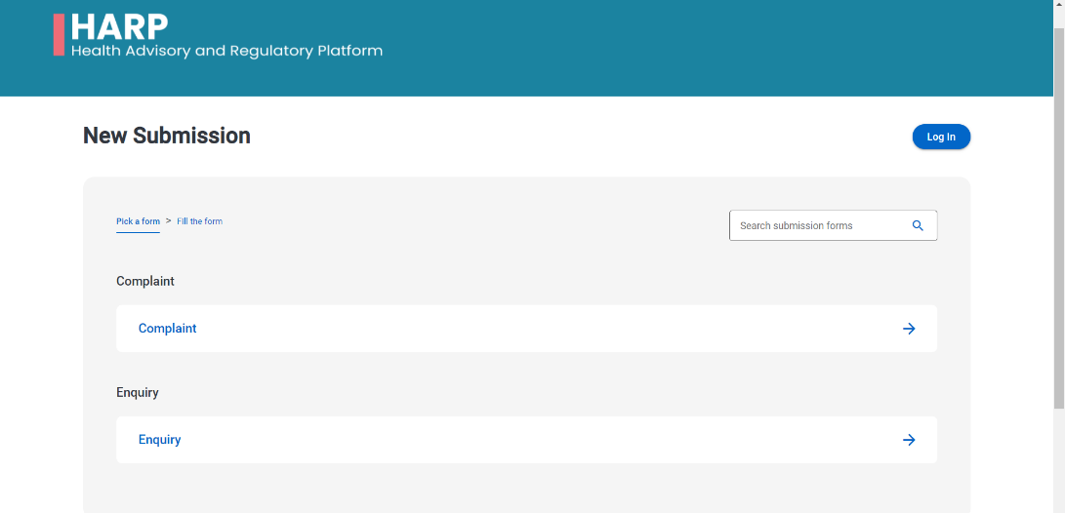
- Go to the HARP portal https://vaping.harp.health.nz and select LOG IN.

- SIGN UP for My Health Account
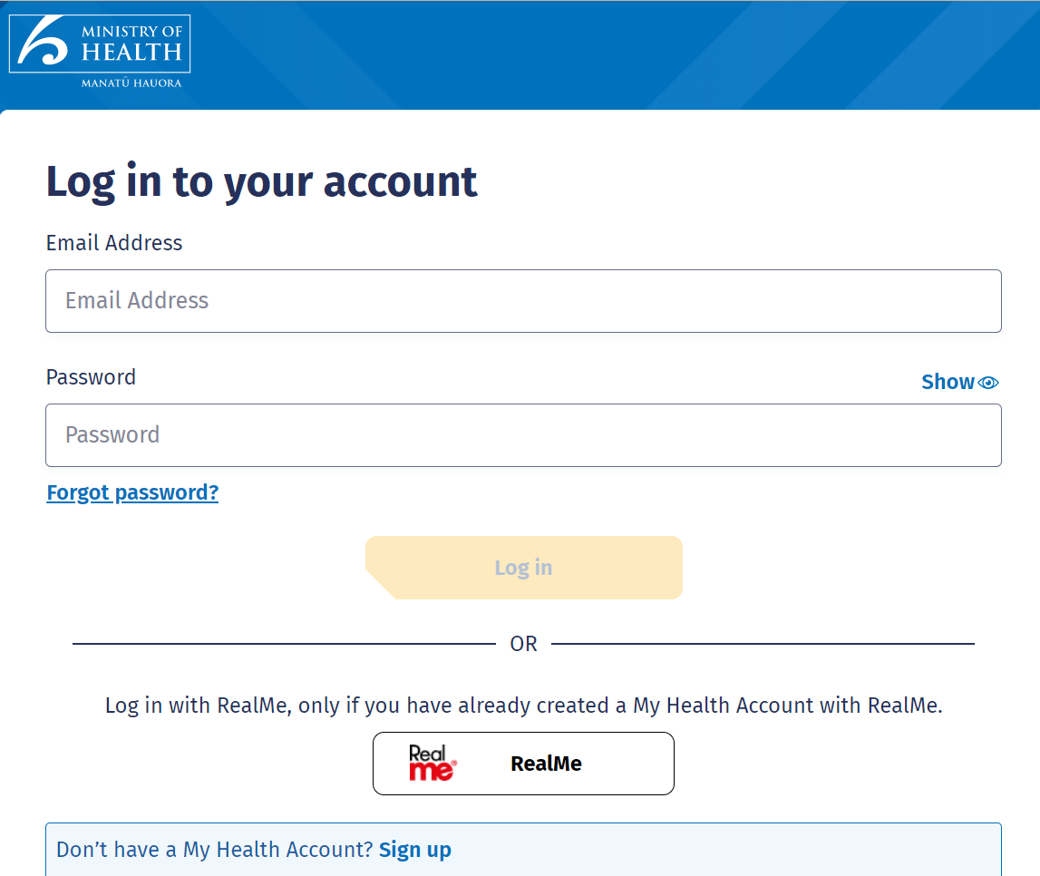

- SIGN UP with Email or RealMe
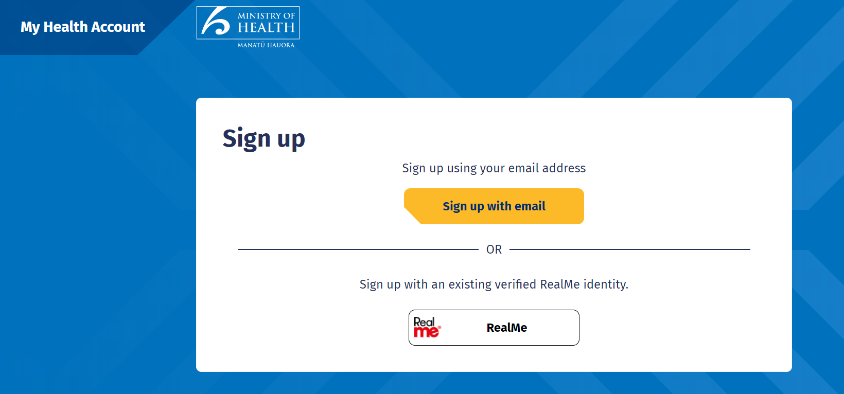

- PLEASE AGREE TO CONTINUE and click START
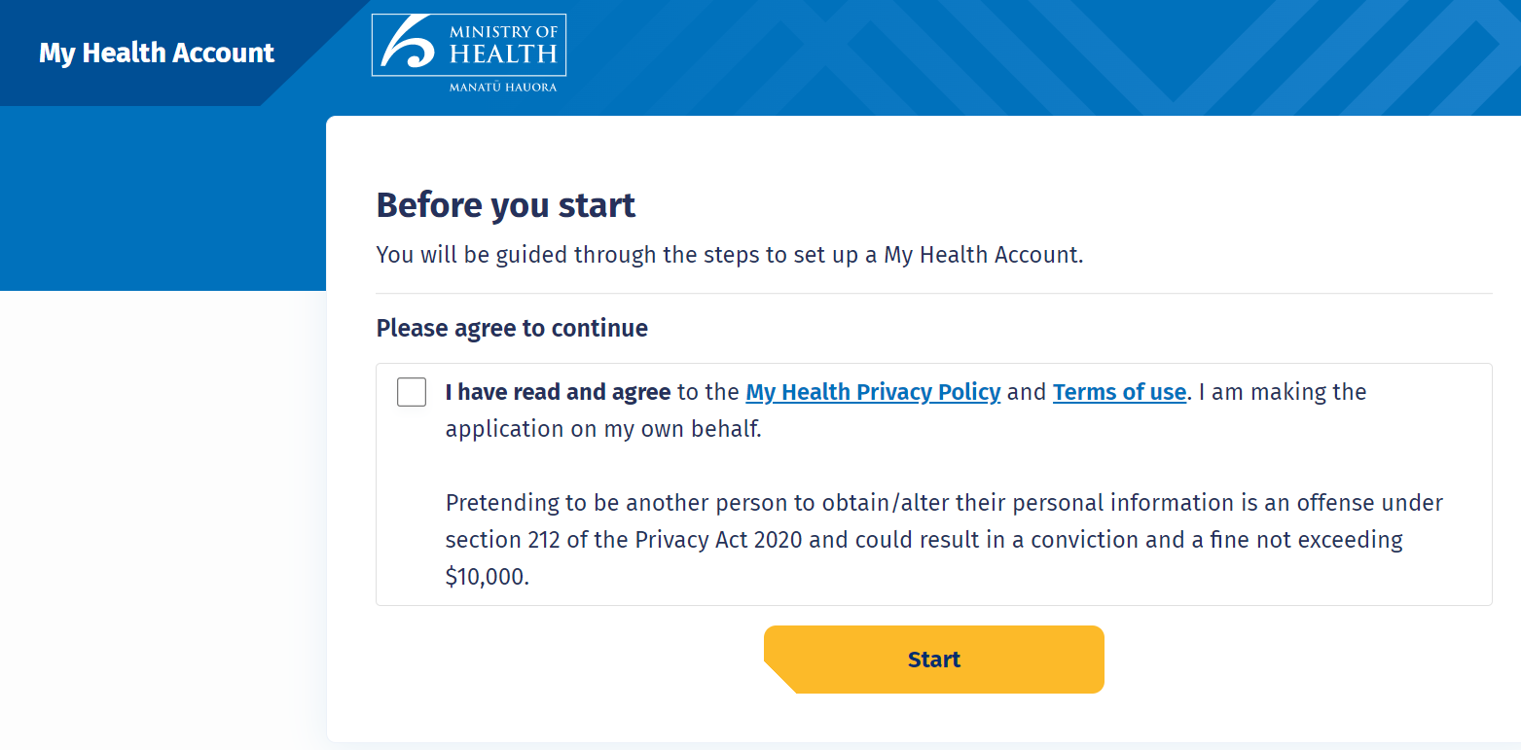

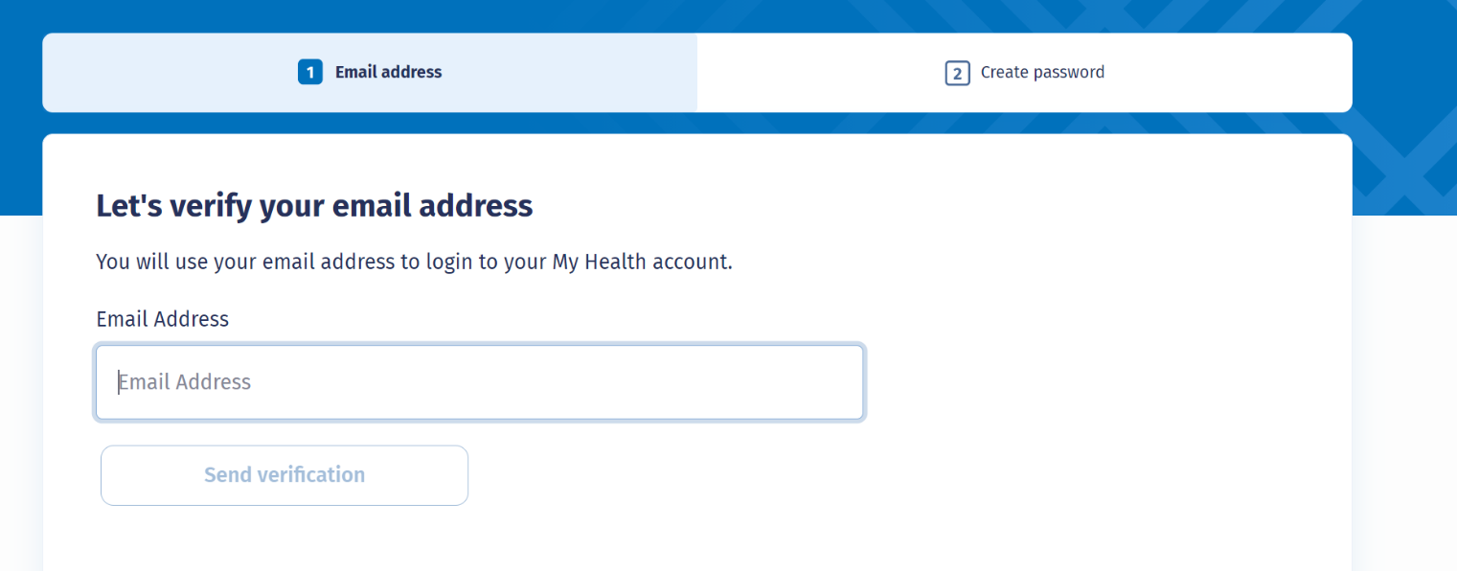
- Enter email address and SEND VERIFICATION

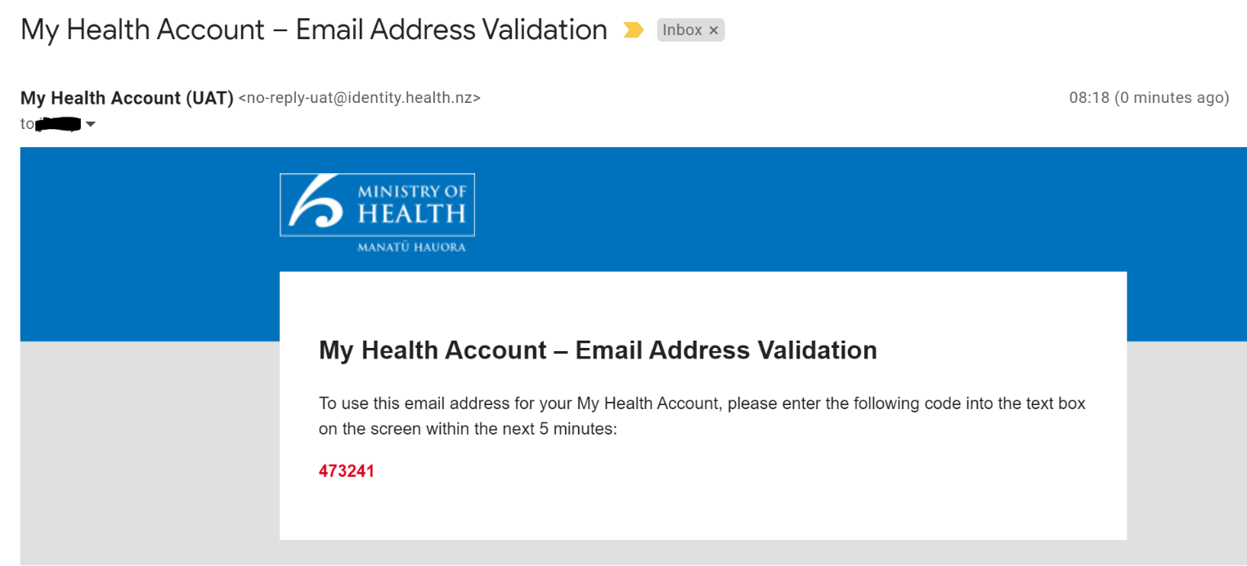
- Check email and copy verification code

- Enter verification code and click CONTINUE
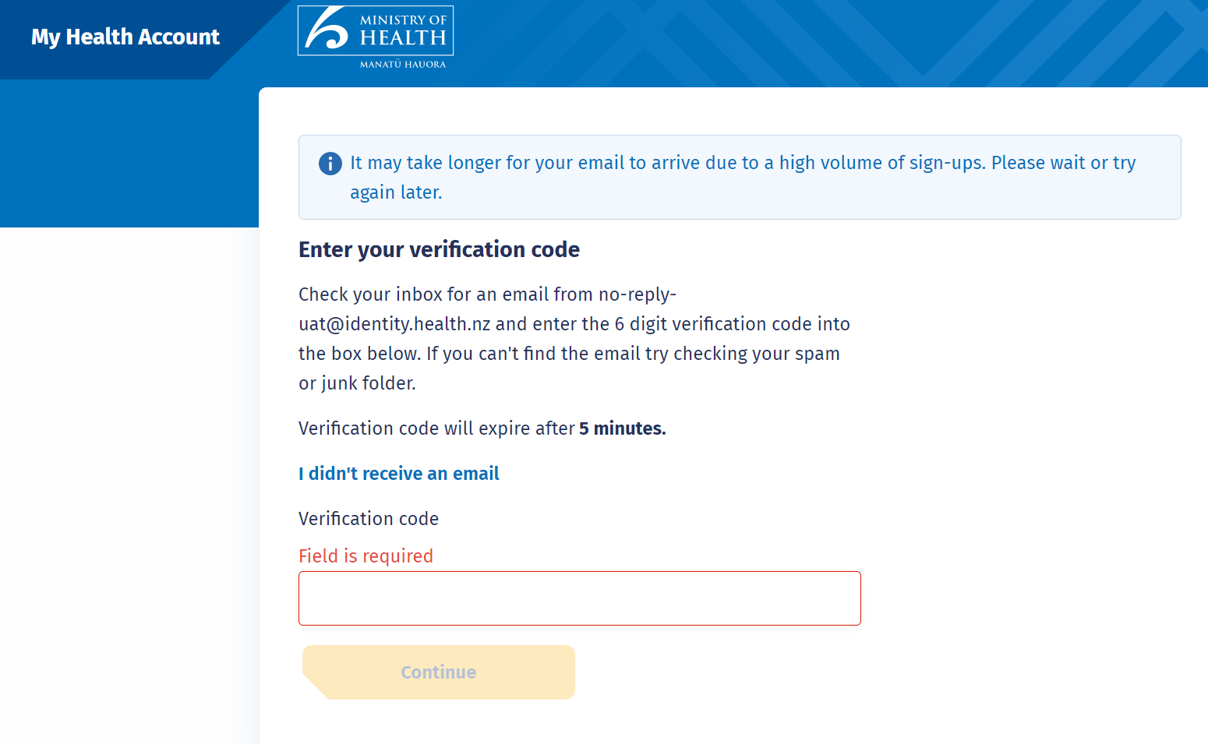

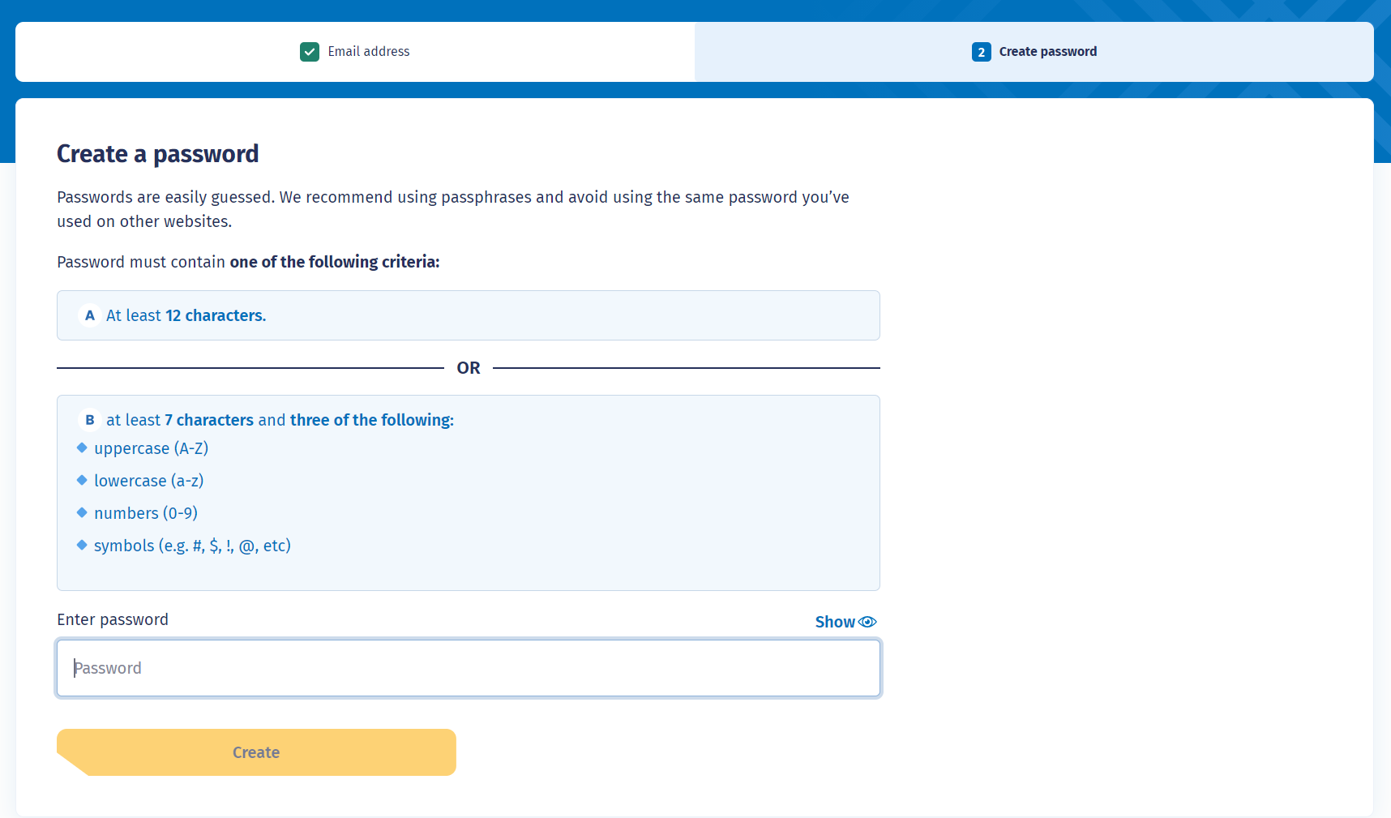
- Enter password and click CREATE

step 2: REGISTER FOR ACCESS
- Register for access

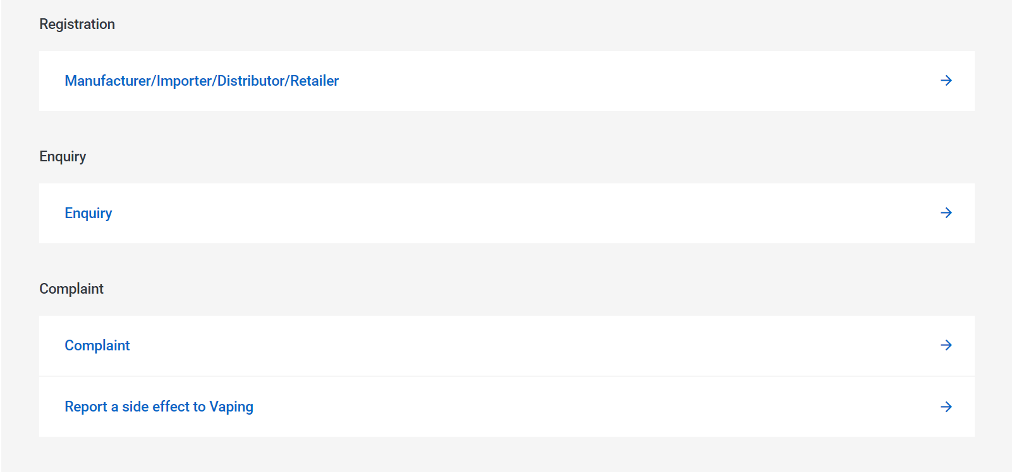

- Enter USER DETAILS, NAME & NZBN, and REGISTERED ADDRESS

- Select VAPING PRODUCT NOTIFICATION, then NEXT button, then SUBMIT NOW button
Registration will be reviewed and email sent once approved. Please select this if you are notifying herbal smoking or smokeless tobacco products

- PLEASE NOTE IT COULD TAKE A FEW BUSINESS DAYS FOR A CUSTOMER ACCOUNT TO BE SET UP.

step 3: Notify a vape product

  - Once the approval has been received, log into HARP and click on the NEW SUBMISSION button.

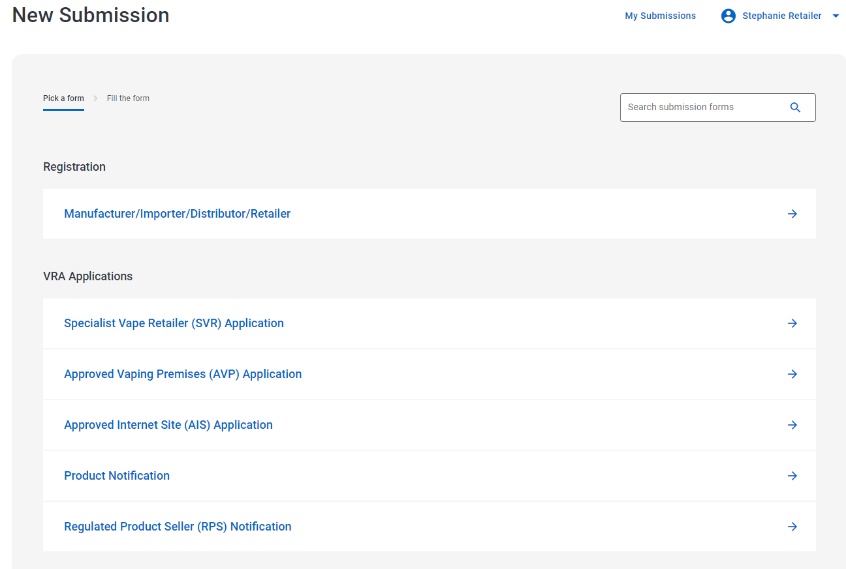

  - Select PRODUCT NOTIFICATION
  - Fill in APPLICANT DETAILS:
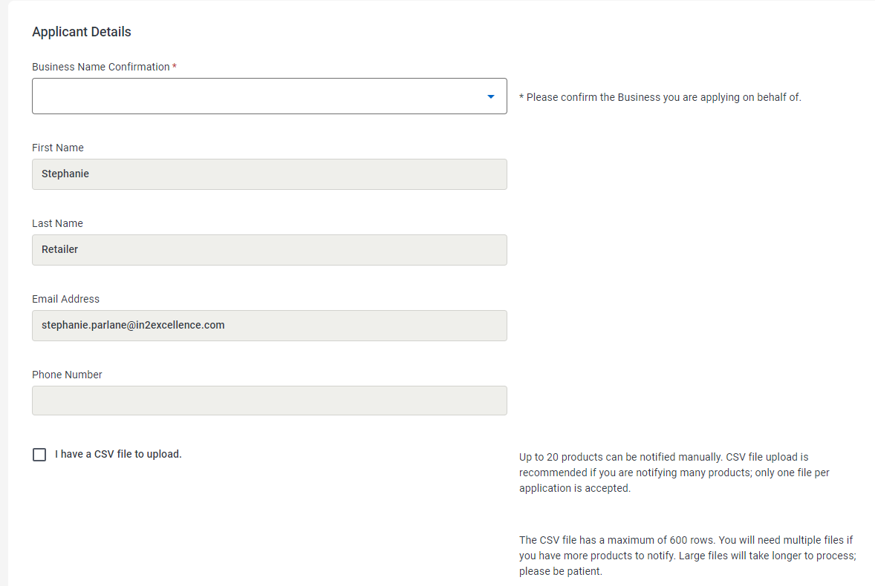

MANUALLY ENTERED NOTIFICATIONS

- If manually entering product notifications click NEXT.
NOTE: If notifying more than 20 products; use CSV file upload check box and refer to CSV Upload section for next steps.
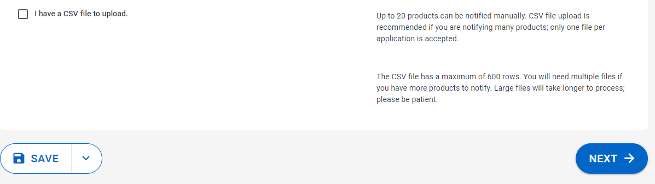
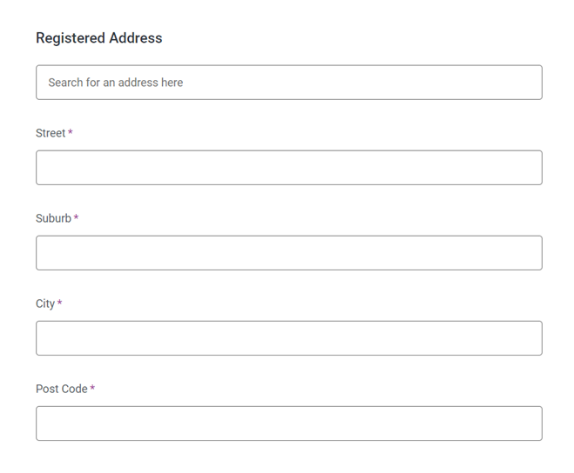
- REGISTERED ADDRESS is automatically populated so click NEXT button

- The information required differs depending on what type of product is selected (refer to Appendix 1 for screenshots). Select the Product Type and enter the requested information

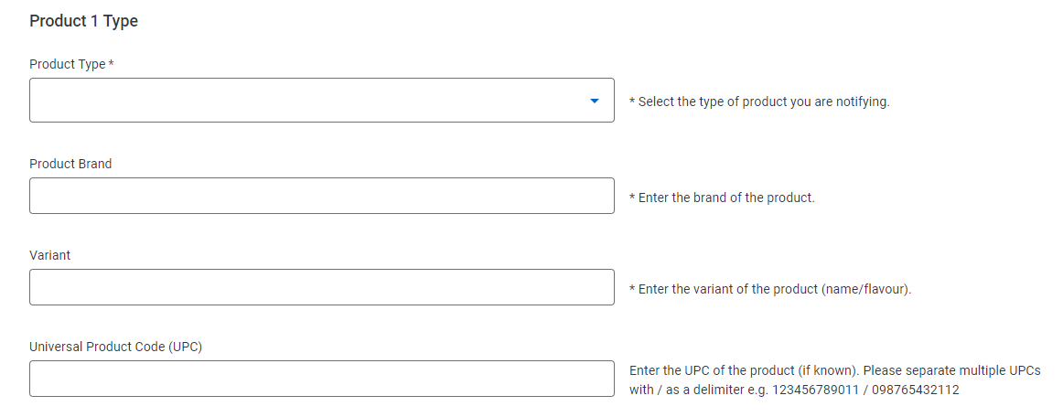

- Select ADD ANOTHER PRODUCT if you have more products to add

- Click ADD to enter the Product ingredients

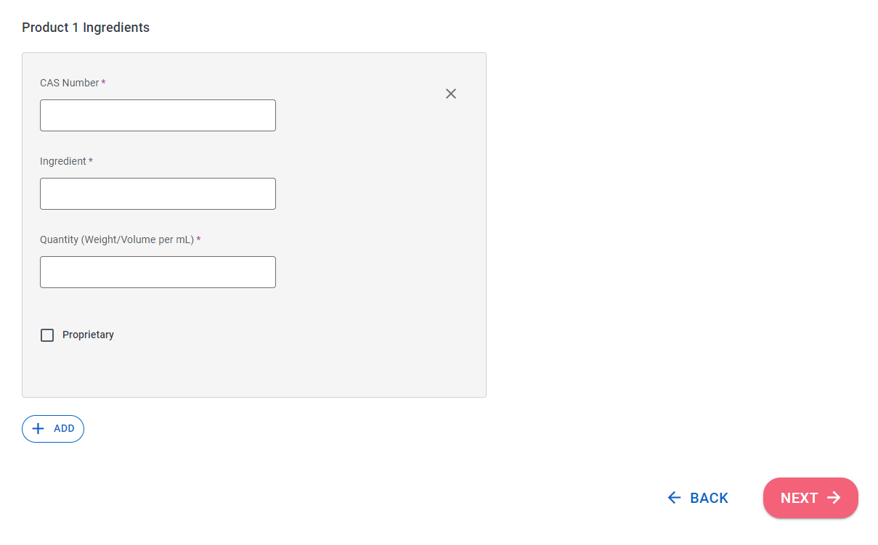
- Enter the ingredients and click NEXT

- If ADD ANOTHER PRODUCT was selected, repeat Steps c to f
- Review CSV ITEM SUMMARY, and click the NEXT button.
Note: This section is usually blank.

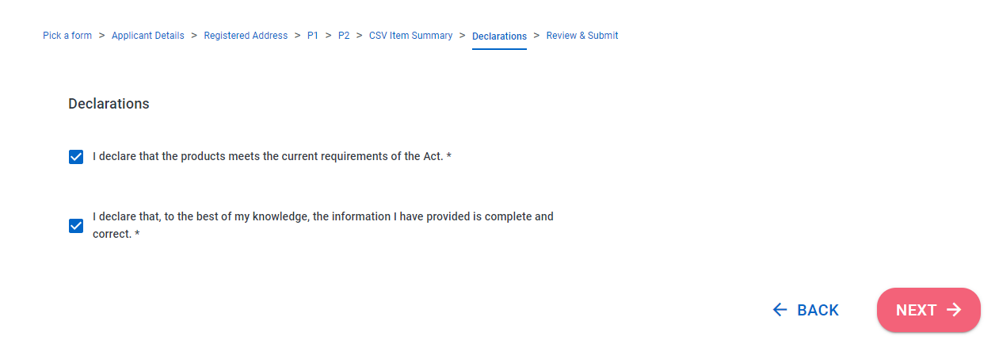
- Make declarations and click NEXT.

- Review application and click SUBMIT NOW.
From here, go to Step 4: Submit Order

CSV UPLOAD
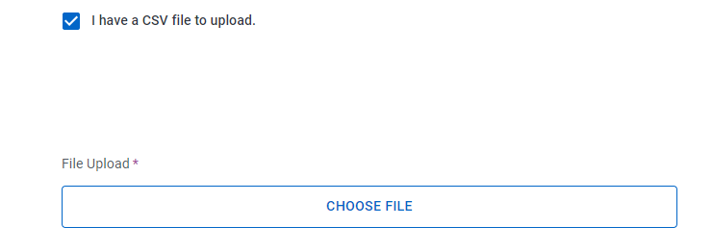
- If you have a csv file to upload, check the box, then CHOOSE FILE to select file, and click NEXT
- REGISTERED ADDRESS is automatically populated so click NEXT button

- On CSV Upload Summary click NEXT.
Note: This page is usually blank.
- Make declarations and click NEXT.
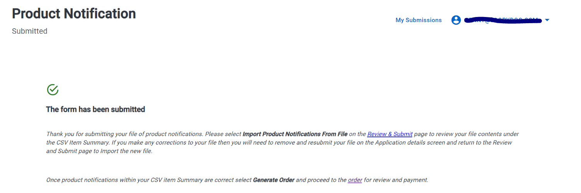
- Review application and click the SUBMIT NOW button. The following message will be displayed.
- Click the REVIEW & SUBMIT link.
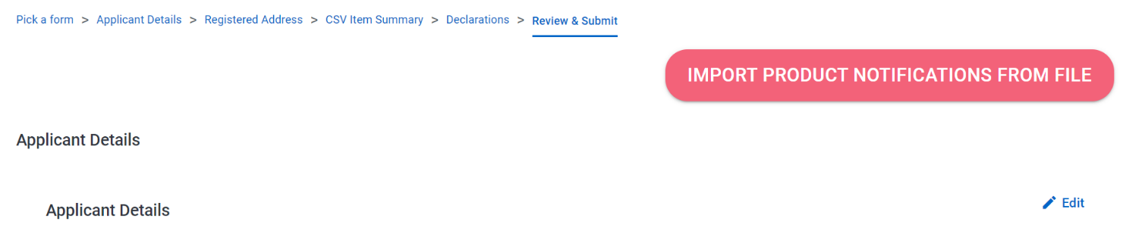
- Click IMPORT PRODUCT NOTIFICATIONS FROM FILE.
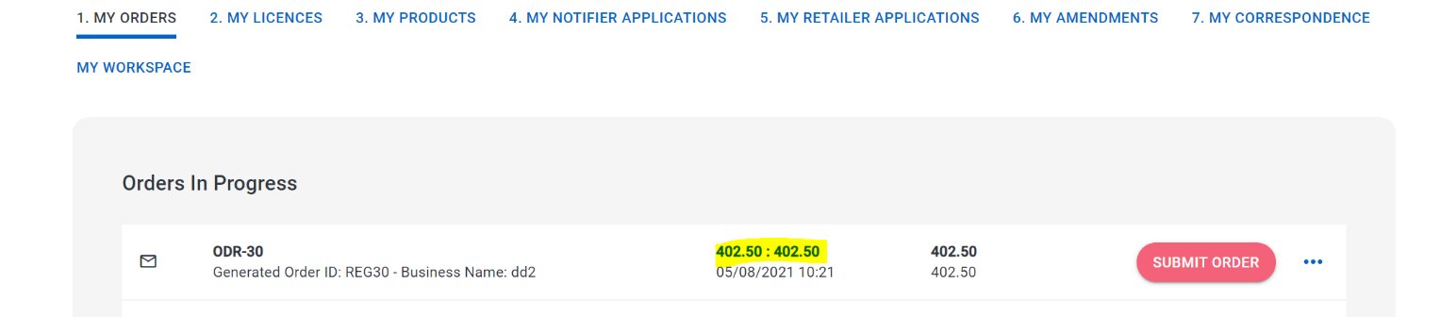
- Click GENERATE ORDER button.
From here, go to Step 4: Submit Order

step 4: SUBMIT ORDER
- Click MY SUBMISSIONS
- Click MY ORDERS, then click the price to open the order.
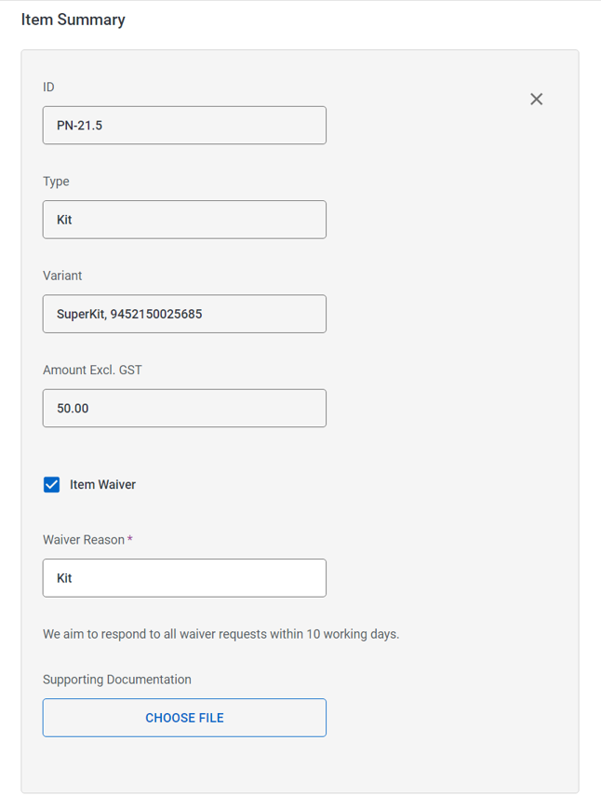
- Review ITEM SUMMARY. To request a fee waiver for a product (for example, vaping kits), select the checkbox below the item. Enter a reason for the waiver request.
- Review ADJUSTMENTS and click NEXT button.
Note: This section Is usually blank
- Review SUMMARY and click SAVE button.
    - If you have not requested a fee waiver, click the SUBMIT ORDER button.
    - If you have requested a fee waiver, the order cannot be submitted until the waiver request has been reviewed and approved by the Vaping Regulatory Authority. An email will be sent once a decision has been made on the waiver and the SUBMIT ORDER button can then be clicked.

step 5: pay for ORDER

PAY BY CREDIT CARD
- Click PAY NOW button
- Enter debit/credit card details and PAY
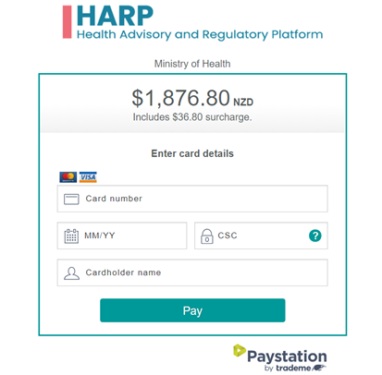
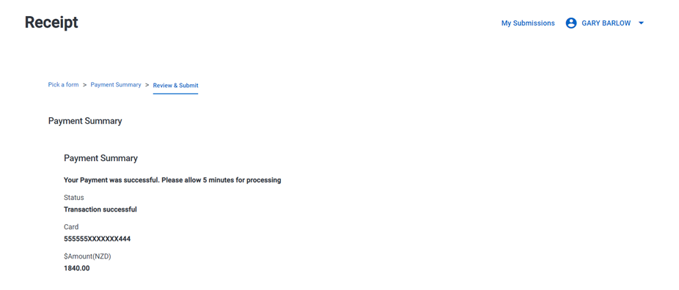
- After payment you will receive a receipt
Once payment has been received, product notifications will be submitted. You will only be contacted if there is a query on your notification. If there are no queries the product notifications will appear on the Notified Products Database immediately.
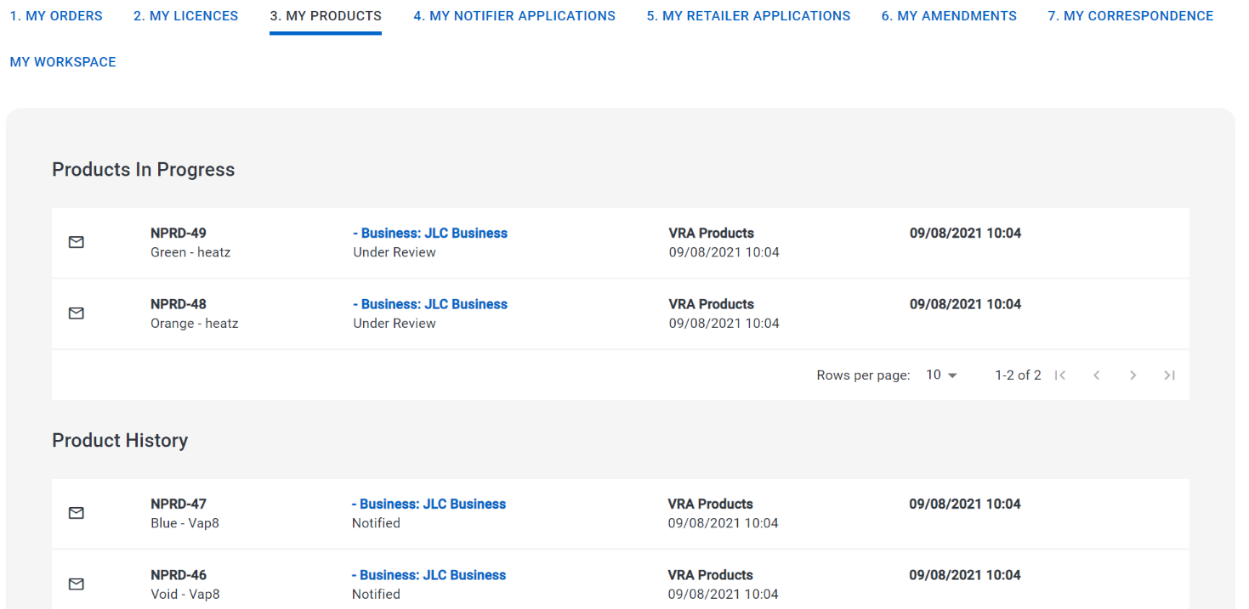
- To view the notified products, click MY SUBMISSIONS, then click MY PRODUCTS.
Products that need to be reviewed by the Vaping Regulatory Authority will be displayed in the PRODUCTS IN PROGRESS section. Notified products are displayed in the PRODUCT HISTORY section.

PAY BY INVOICE
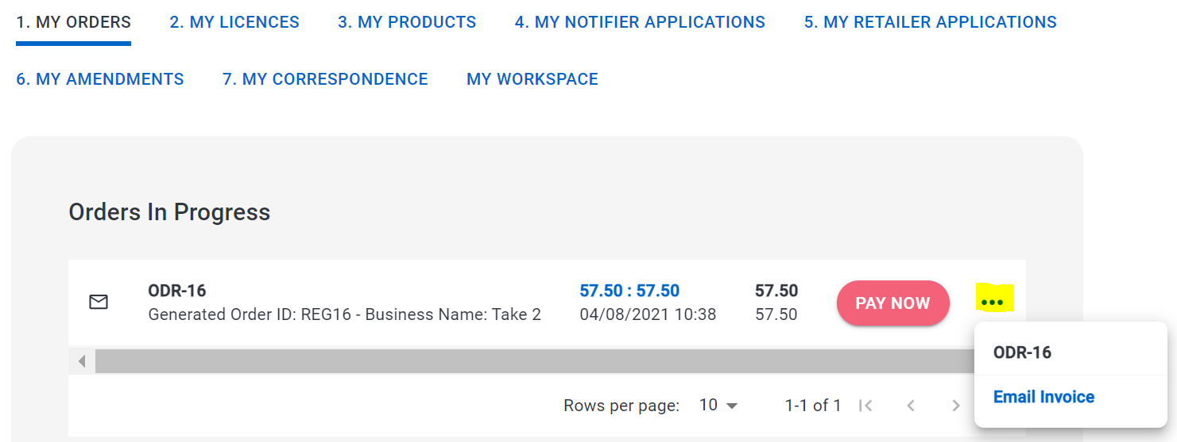
- In the My Orders screen, click … to the right of the Order. Select EMAIL INVOICE
- Make payment to the bank account on the invoice
Once payment has been received, product notifications will be submitted. You will only be contacted if there is a query on your notification. If there are no queries the product notifications will appear on the Notified Products Database immediately.

appendix

APPENDIX 1: MANUALLY ENTERED PRODUCT FIELDS

Product Type: Vaping Device / Kit
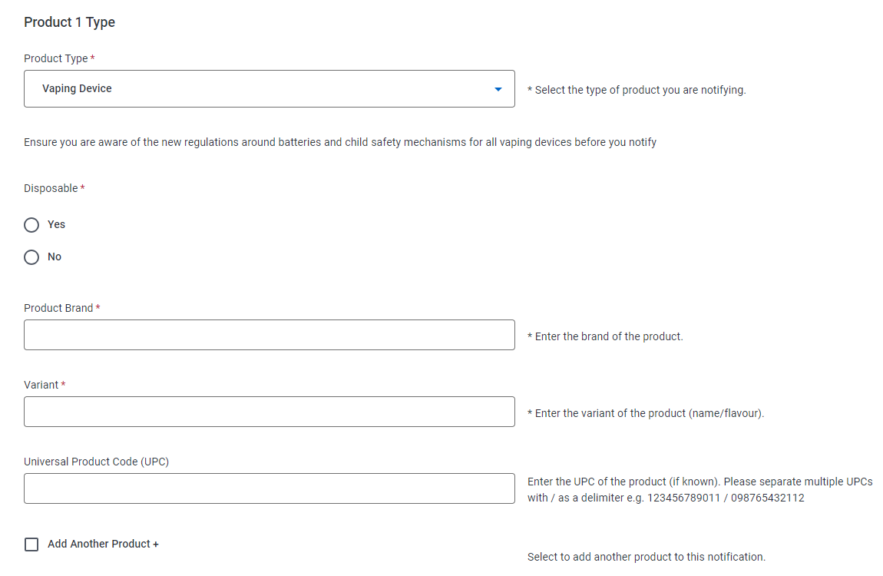

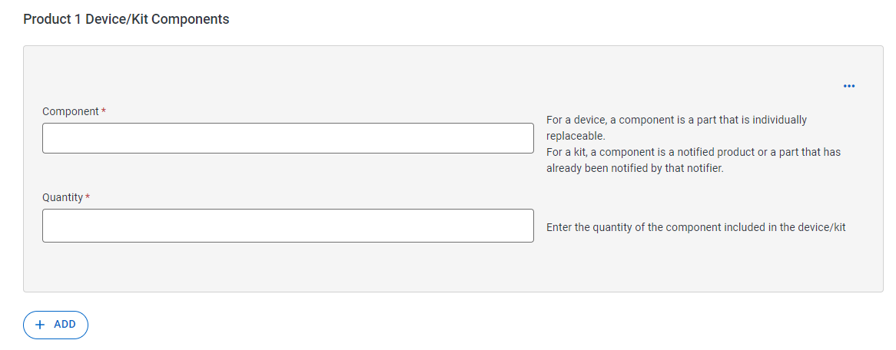

Product Type: VAPING SUBSTANCE – FREEBASE & nICOTINE sALT

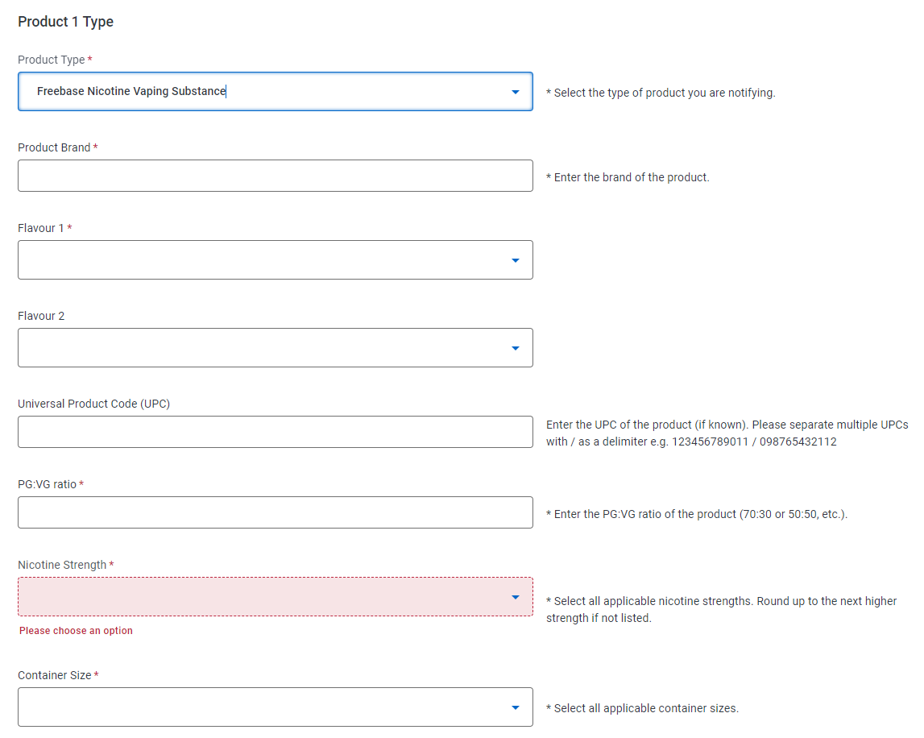

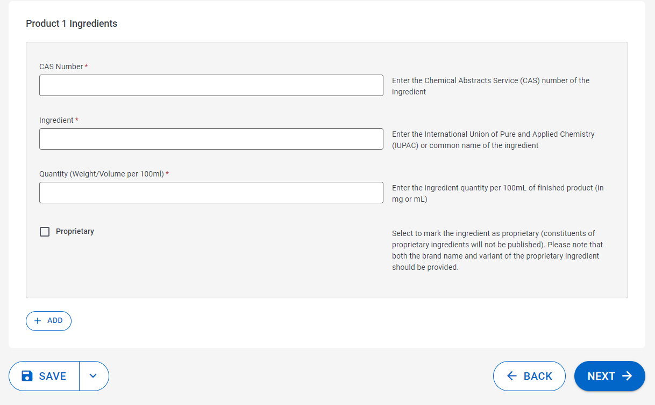

PRODUCT TYPE: SMOKELESS TOBACCO PRODUCT
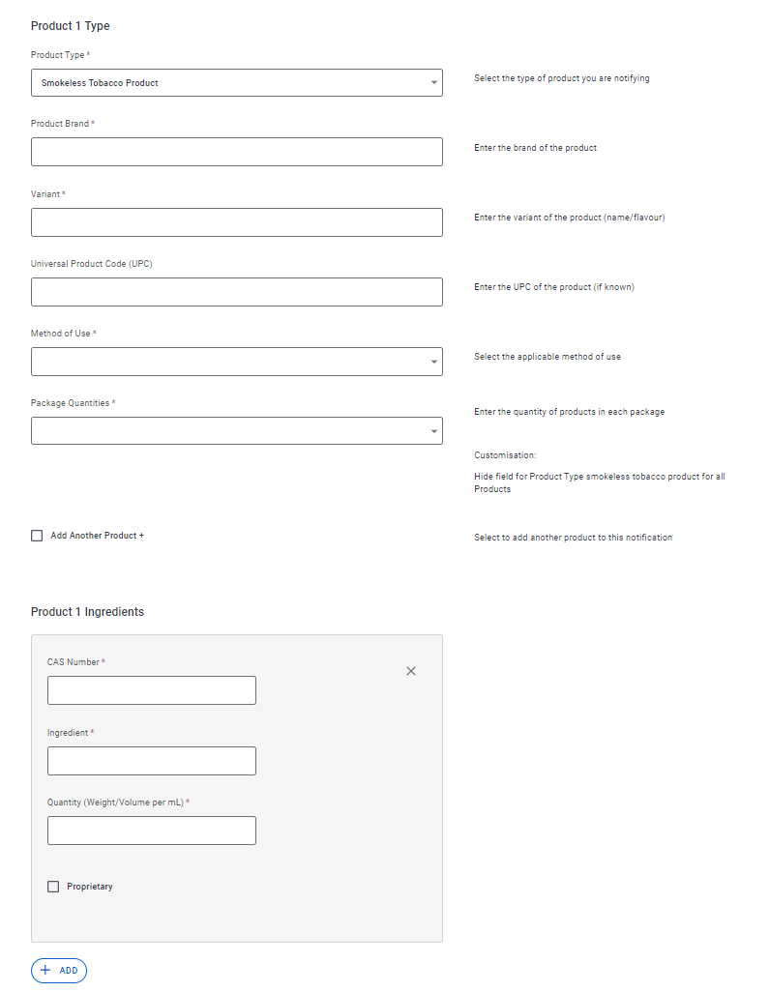

Product Type: HERBAL SMOKING PRODUCT - CIGARETTE
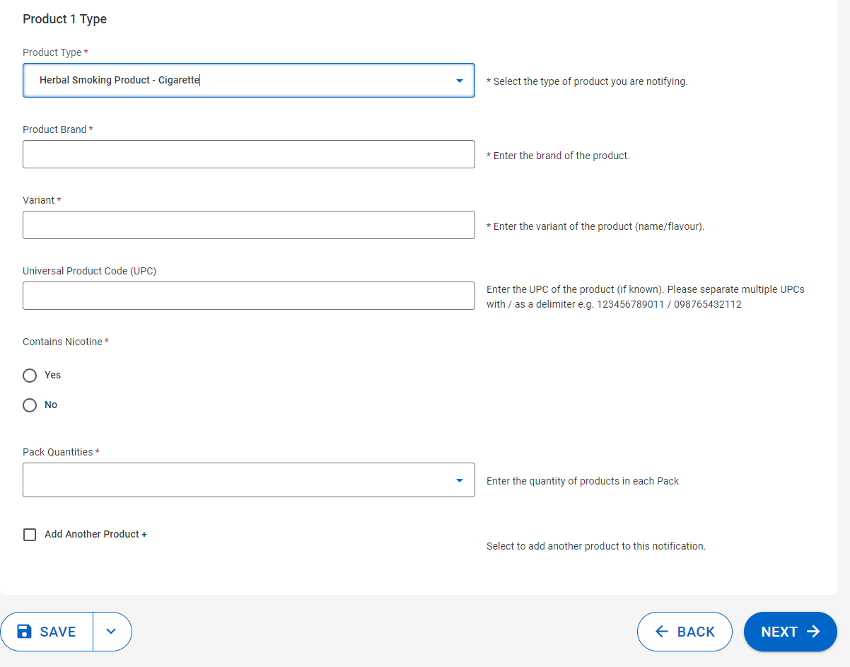

Product Type: HERBAL SMOKING PRODUCT – LOOSE MIX

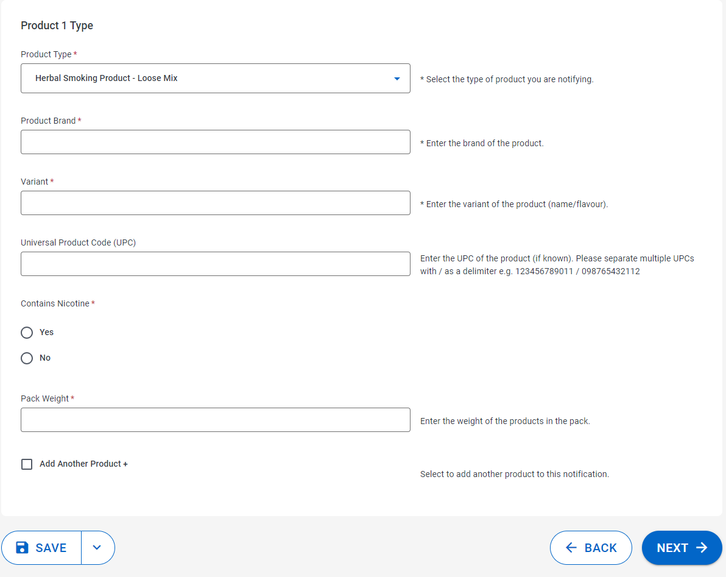

22 November 2023

