Making a complaint about your residential care
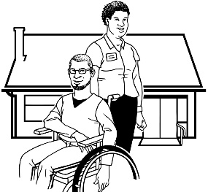
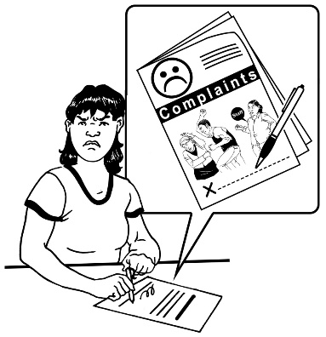

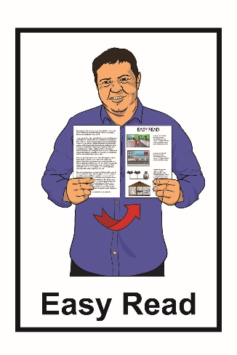

This is an Easy Read guide about how to make a complaint about your residential care.

Residential care are places where some disabled people live with support.

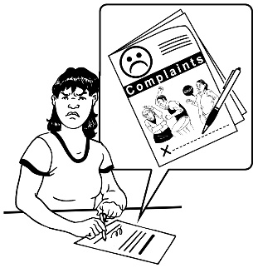
A complaint is when you want to tell someone about something you are not happy with.

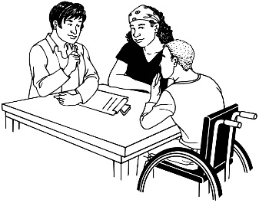
Step 1: Talk to your residential care provider about your complaint.

You can talk to your residential care provider about your complaint.

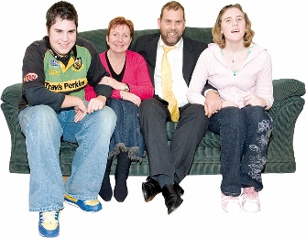
You can also have support from other people such as:

- your family / whānau

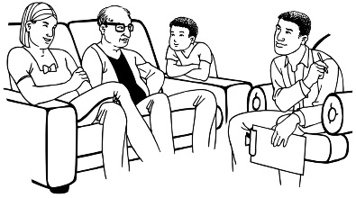
- your support worker

- your advocate.

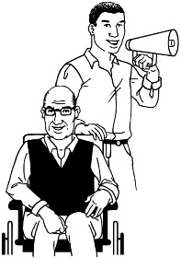
An advocate is someone who can support you with making your complaint.

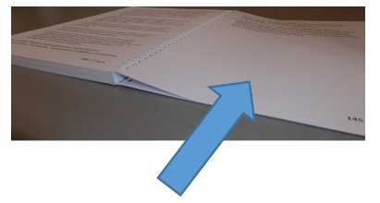
You can read more about advocates on page 6 of this guide.

Your residential care provider should listen to your complaint.

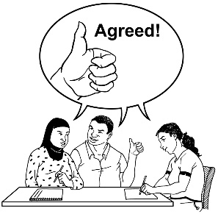
Everyone needs to agree on what to do next so that your complaint can be sorted out.

Step 2: What to do if:

- no agreement can be reached

- your residential care provider does not listen to your complaint.

You can ask for support with getting your complaint heard by talking to any of these places:
- Advocacy Service

- Your local District Health Board Portfolio Manager

- Ministry of Health – Disability Support Services

- Ministry of Health – HealthCERT
- Health and Disability Commissioner.

- Advocacy Service

The Advocacy Service can support you to get an advocate.

An advocate can support you with making a complaint about your residential care provider.

An advocate can support you with:

- looking at what you want to talk about in your complaint

- getting people to listen to your complaint.

You can find out more about the Advocacy Service:

Website: www.advocacy.org.nz
Phone: 0800 555 050

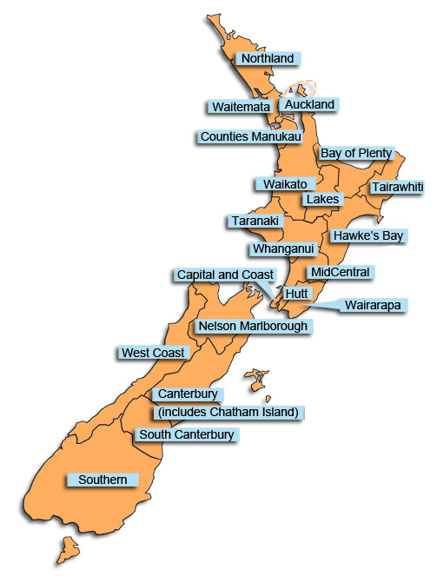
- Your local District Health Board Portfolio Manager.

District Health Boards (DHBs) look after the funding of health services in their area.

There are 20 District Health Boards in New Zealand.

Each of these District Health Boards has a Manager called a Portfolio Manager.

You can find out more about your local District Health Board at this website:

www.health.govt.nz/new-zealand-health-system/key-health-sector-organisations-and-people/district-health-boards

- Ministry of Health - Disability Support Services

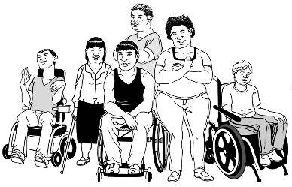
Disability Support Services looks after the government funding of disability support services.

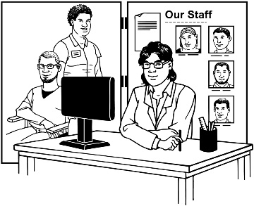
Disability Support Services can look at your complaint about your residential care provider.

You can find out more about Disability Support Services:
Website:

www.health.govt.nz/our-work/disability-services/about-disability-support-services
Phone: 0800 855 066

- Ministry of Health - HealthCERT

HealthCERT is another part of the Ministry of Health.

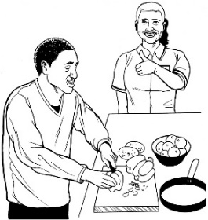
HealthCERT checks that all residential care providers take good care of all the people who live there.

Sometimes HEALTHCERT will look at complaints being made about a residential care provider.

You can find out more about HealthCERT:

Website:

www.health.govt.nz/our-work/regulation-health-and-disability-system/certification-health-care-services
Phone: 0800 113 813

- Health and Disability Commissioner

The Health and Disability Commissioner works to look after the rights of disabled people who get disability funded services.

The Commissioner can look at the complaint you have made about your residential care provider.

You can find out more about the Health and Disability Commissioner:

Website: www.hdc.org.nz
Phone: 0800 11 22 33

This information has been translated into Easy Read by the
Make It Easy service of People First New Zealand Inc.
Ngā Tāngata Tuatahi.

The ideas in this document are not the ideas of
People First New Zealand Ngā Tāngata Tuatahi.

