Public Health Advisory Committee

Position statement on Equity, Te Tiriti o Waitangi, and Māori Health
September 2023

Purpose of this statement
- There is an active public and political debate over measures intended to improve Māori health outcomes. The Public Health Advisory Committee (PHAC), established under the Pae Ora (Healthy Futures) Act 2022,¹ provides independent public health advice to the Minister and Associate Ministers of Health, as well as other government agencies.
- Public health has important perspectives on the causes of disparities in health outcomes and on effective solutions. It is, therefore, appropriate for PHAC to provide advice on
this topic.
- This statement summarises that advice.

Equity as a public health issue
- Equal access to the determinants of good health is a fundamental human right, supported by the United Nations (UN) Universal Declaration of Human Rights ² and enforceable under international law.³ As such, all New Zealanders deserve, and are entitled to, an equal opportunity to enjoy a long and healthy life. Our health is a resource that we can use for everyday living.⁴
- A society that counts fairness, equality and egalitarianism as foundational values,⁵ Aotearoa New Zealand is in a position to find ways to ensure that all of its citizens have the same level of health resource available to use throughout their lives.
- However, the determinants of good health are not evenly distributed within our population. This disadvantage does not occur randomly. While strongly patterned by sociodemographic factors, including socioeconomic deprivation and rurality, the strongest patterning of disadvantage occurs by ethnicity. The Indigenous Māori population experiences among the poorest health outcomes in our country. These are the cumulative result of generations of social, political and structural inequity, starting with the rapid colonisation that followed the signing of Te Tiriti o Waitangi in 1840.⁶

The relationship between equity, Te Tiriti o Waitangi, and
Māori health
- The government recognises that the inequities in health outcomes experienced by Māori are not only avoidable, but they are also unfair and unjust.⁷ Addressing the inequities faced by Māori and other minority populations in Aotearoa New Zealand requires us, as a society, to accept that a disproportionate investment of resources is required to ensure that all New Zealanders enjoy equal health outcomes.⁶
- Te Tiriti o Waitangi is Aotearoa New Zealand’s founding document.⁸ Te Tiriti o Waitangi forms part of our constitution – the basic principles that drive our system of government.⁹ Te Tiriti o Waitangi guarantees that Māori would receive ‘nga tikanga katoa rite tahi ki ana mea ki nga tangata o Ingarani’ (English version: ‘all the rights and privileges of British subjects’),⁸ and requires the government to take active measures to restore balance when Māori have been disadvantaged.¹⁰ As such, the substantial inequities in health experienced by Māori represent breaches of our founding document.¹¹ However, Te Tiriti o Waitangi also provides us with the impetus and structure for enacting the kind of change that will be required to right one of our most significant wrongs.¹²

The Problem
- Because of the substantial disadvantages faced by Māori in access to the determinants of good health, a Māori child born in Aotearoa New Zealand will, on average, experience poorer overall health and live nearly 8 fewer years than a Pākehā child.¹³ During their life, the Māori child will be more likely to develop cancers with a poor prognosis (e.g. stomach, liver and lung cancers),¹⁴ and have poorer survival outcomes once diagnosed.¹⁵ They will be more likely to suffer a stroke,¹⁶ have cardiovascular disease, ¹⁷⁻¹⁹ Type-2 diabetes mellitus,^{20,21} renal disease or failure,²² or a mental health disorder.^{23,24} An important driver of these stark inequities is socioeconomic deprivation (Figure 1).
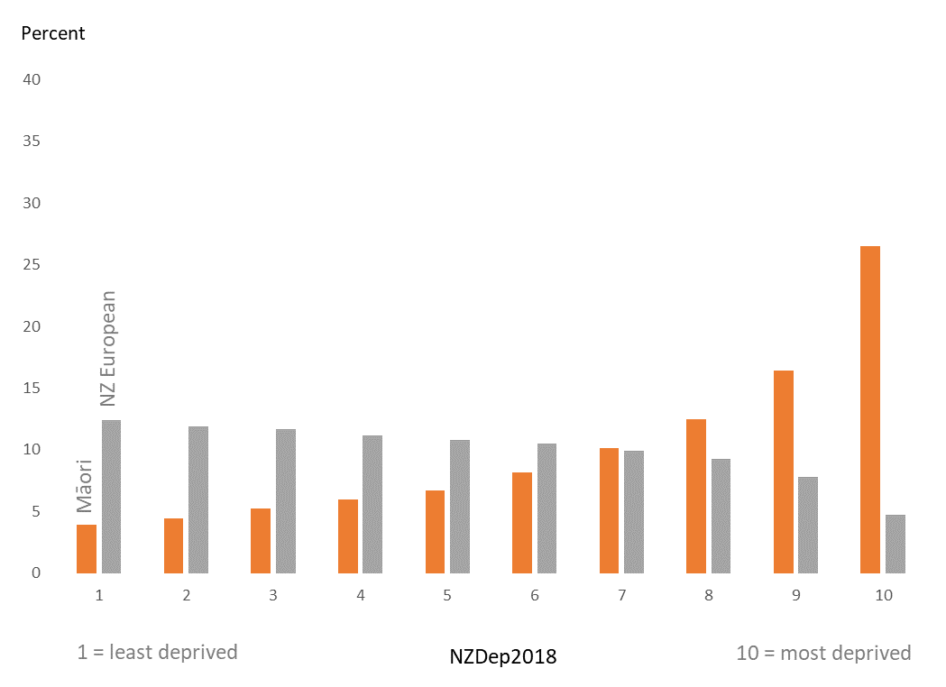

Figure 1: Māori and NZ European ethic groups by NZDep 2018

- Māori are much more likely to live in conditions of socioeconomic deprivation than Pākehā, with around 25% of Māori living in the most extremely deprived decile compared to around 5% of Pākehā.^{12,25} An important marker of socioeconomic deprivation is the proportion of children living in poverty. Latest evidence suggests that around 20% of Māori children live in material hardship, compared to around 8% of Pākehā children.²⁶ In terms of access to the determinants of good health, living in poverty makes everything more difficult. This starts with the quality of housing in which a child grows up, the food environment that surrounds them, and the quantity and quality of their education around health. When the symptoms of ill-health arise, living in poverty impedes timely access to care,²⁷ with out-of-pocket costs associated with transport, parking, accommodation and the care itself acting as barriers.²⁸
- However, we also know that the drivers of poorer Māori health outcomes are far more complex than just the stark disparities in socioeconomic deprivation. Figure 2 from the landmark Hauora report ²⁹ shows the rate of death from all causes, separately by socioeconomic deprivation level. This figure teaches two key lessons: firstly, death is much more likely among those living in socioeconomically deprived areas, which disproportionately impacts Māori; and secondly, that the death rates of Māori and non-Māori never cross each other, regardless of deprivation level. There is more to this problem than money and resources. The structures and institutions of our society better meet the needs of Pākehā than Māori. This is referred to as institutional racism.

Figure 2: Rate of mortality, by deprivation and ethnicity

- Instead of focusing on the system-level drivers of health disparities, recent debate has focused on individual-level drivers, such as individual ‘choice’ over food and tobacco consumption, or ‘choice’ regarding engagement with health services. In addition, activities aimed at directly addressing the vast inequities in health experienced by Māori are often re-framed as being racist, or counter to the principles of our egalitarian society. Such narratives are unhelpful, because they distract us from the job at hand: that is, to fulfil the promise made within Te Tiriti o Waitangi to protect Māori, by investing in systems-level changes that will meaningfully ‘shift the dial’ towards a system that works for Māori.

Te Tiriti o Waitangi as a solution
- As noted earlier, Te Tiriti o Waitangi provides a solid structure for how the inequities in health outcomes experienced by Māori can be undone – both at a broad level in terms of the wider determinants of health, but also at a more specific level with respect to how our health system is organised and operates. The Waitangi Tribunal ¹¹ has recommended that the future delivery of health care in Aotearoa New Zealand be guided by five Treaty principles – tino rangatiratanga, equity, active protection, options and partnership. Each of these principles provides both a framework and a pathway for health services to implement solutions that will lead to improvements in Māori health outcomes. These solutions are considered below.

- Tino rangatiratanga means providing for Māori self-determination and mana motuhake in the design, delivery and monitoring of health services. An example of an active tino rangatiratanga solution to Māori health outcomes is the delivery of kaupapa Māori (by Māori, with Māori, for Māori) health services by Iwi-led and owned health providers. This solution incorporates Māori ‘ways of knowing’ and a Te Ao Māori worldview into health care systems, policies, and practices, so that they work better for Māori.
- Equity means being committed to equitable health outcomes for Māori. This means that, counter to the recent debate over treatment prioritisation algorithms,³⁰ it is not unusual or incongruous for the government to act in a way that prioritises Māori health outcomes in order to improve them, rather, this activity should be expected as in-keeping with the principles of Te Tiriti o Waitangi. The principle of equity also provides a clear goal for the Government when it comes to Māori health.
- Active protection means acting to the fullest extent practicable to achieve equitable health outcomes for Māori, including ensuring that both Crown agents and Māori are well-informed on Māori health outcomes and activities that aim to achieve equitable health outcomes. An example of active protection in this context is the creation of Te Aka Whai Ora – Māori Health Authority - as part of the recent health reforms. The creation of this organisation is an example of the kind of disproportionate investment by the Government in Māori health that will be required to improve Māori health outcomes and, as such, must be given adequate resourcing and time to work.
- Options means providing for and properly resourcing kaupapa Māori services. For example, a marae-based healthcare provider in South Auckland was able to meet the needs of its Māori community during the COVID-19 pandemic, providing a Te Ao Māori environment and the kind of wrap-around supportive care that are not offered through mainstream health care services.³¹ Such initiatives provide Māori with the option to receive care that reflects their world view, and as such need to be scaled-up and appropriately resourced as part of the current reforms. It also means that those solutions that are not kaupapa Māori in origin – such as initiatives led by central or local government – are provided in a culturally appropriate way that recognises and supports the expression of hauora Māori models of care. For example, initiatives such as national cancer screening programmes should be designed to ensure that they work as well for Māori as non-Māori, in order to address existing gaps in screening access.^{32,33}
- Partnership means that Government works in partnership with Māori for the governance, design, delivery, and monitoring of health improvement solutions. Because Pākehā comprise the majority of people in Aotearoa New Zealand (around 70% ³⁴), health-related structures or activities that are aimed at ‘all New Zealanders’ will tend to be designed in a way that works best for Pākehā. As such, there is a tendency to passively create systems that work poorly for Māori, despite the need for these systems to work best for Māori to address inequities in health. To improve Māori health outcomes, we need strong Māori representation in healthcare governance, decision making and policy development, so that Māori can influence the shape of our health system. The Government, and all New Zealanders, must help to facilitate this representation. In addition, working in direct partnership with Māori communities will help to ensure that the systems and structures that drive health outcomes – from food environments to education to our health care system – reflect a Te Ao Māori worldview, and will actually serve the needs of Māori.

- The final means by which Te Tiriti o Waitangi can drive improvements in Māori health outcomes is by providing a clear timeline for the achievement of equity. The year 2040 will mark 200 years since the signing of Te Tiriti o Waitangi, and many of the interventions required to meaningfully address inequities in health outcomes – such as improving housing standards, food environments and health care access – will take years to implement.
- As such, the bicentenary of Te Tiriti o Waitangi provides a ‘burning platform’, where the achievement of equitable health outcomes for Māori is seen as a problem that we all must solve as a fair and decent society. Actions such as the creation of Te Aka Whai Ora and the empowerment of kaupapa Māori solutions are significant signs of progress that we must continue to build upon in order to deliver on the principles of Te Tiriti o Waitangi.

HP 8856

References
1. New Zealand Government. Pae Ora (Healthy Futures) Act 2022. https://www.legislation.govt.nz/act/public/2022/0030/latest/LMS575405.html
2. United Nations. Universal Declaration of Human Rights. 1948. https://www.un.org/en/about-us/universal-declaration-of-human-rights
3. United Nations. International Covenant on Economic Social and Cultural Rights (ICESCR), and the International Covenant on Civil and Political Rights (ICCPR). 1966. https://www.ohchr.org/en/what-are-human-rights/international-bill-human-rights
4. World Health Organisation. Ottawa Charter for Health Promotion. 1986;
5. Royal Society of New Zealand. Te Tapeke: Fair Futures in Aotearoa. 2020. https://www.royalsociety.org.nz/assets/Te-Tapeke-Fair-Futures-in-Aotearoa-key-concepts.pdf
6. Reid P, Robson B. Understanding health inequities. In: Robson B, Harris R, eds. Hauora: Māori standards of health IV: A study of the years 2000-2005. Te Rōpū Rangahau Hauora a Eru Pōmare, University of Otago; 2007.
7. Ministry of Health. Achieving equity. Ministry of Health. https://www.health.govt.nz/about-ministry/what-we-do/achieving-equity
8. Te Tiriti o Waitangi: The Treaty of Waitangi. https://www.archives.govt.nz/discover-our-stories/the-treaty-of-waitangi
9. Keith K. On the Constitution of New Zealand: An Introduction to the Foundations of the Current Form of Government. https://gg.govt.nz/office-governor-general/roles-and-functions-governor-general/constitutional-role/constitution
10. Reid P, Paine SJ, Curtis E, et al. Achieving health equity in aotearoa: Strengthening responsiveness to Maori in health research. Article. New Zealand Medical Journal. 2017;130(1465):96-103.
11. Waitangi Tribunal. HAUORA: Report on Stage One of the Health Services and Outcomes Kaupapa Inquiry - WAI 2575. 2019. https://forms.justice.govt.nz/search/Documents/WT/wt_DOC_152801817/Hauora%20W.pdf
12. Crampton P. Oh my. New Zealand Medical Journal. 2020;133(1524):8-10.
13. Statistics New Zealand. National and subnational period life tables: 2017–2019. https://www.stats.govt.nz/information-releases/national-and-subnational-period-life-tables-2017-2019
14. Gurney J, Robson B, Koea J, Scott N, Stanley J, Sarfati D. The most commonly diagnosed and most common causes of cancer death for Maori New Zealanders. New Zealand Medical Journal. 2020;133:77-96.
15. Gurney J, Stanley J, McLeod M, Koea J, Jackson C, Sarfati D. Disparities in Cancer-Specific Survival Between Māori and Non-Māori New Zealanders, 2007-2016. JCO Global Oncology.
Jun 2020;6:766-774. doi:10.1200/go.20.00028
16. Feigin VL, Krishnamurthi RV, Barker-Collo S, et al. 30-Year Trends in Stroke Rates and Outcome in Auckland, New Zealand (1981-2012): A Multi-Ethnic Population-Based Series of Studies.
PLOS ONE. 2015;10(8):e0134609. doi:10.1371/journal.pone.0134609
17. Gurney J, Stanley J, Sarfati D. The inequity of morbidity: Disparities in the prevalence of morbidity between ethnic groups in New Zealand. Journal of comorbidity. Jan-Dec 2020;
10:2235042x20971168. doi:10.1177/2235042x20971168
18. Ministry of Health. Wai 2575 Māori Health Trends Report. 2019. https://www.health.govt.nz/system/files/documents/publications/wai-2575-maori-health-trends-report-04mar2020.pdf
19. Gu Y, Doughty RN, Freedman B, et al. Burden of atrial fibrillation in Māori and Pacific people in New Zealand: a cohort study. Article. Internal Medicine Journal. 2018;48(3):301-309. doi:10.1111/imj.13648
20. Te Whatu Ora | Health NZ. Virtual Diabetes Register (VDR) web tool. Accessed 03/02/2023, https://tewhatuora.shinyapps.io/virtual-diabetes-register-web-tool/
21. Gurney JK, Stanley J, York S, Rosenbaum D, Sarfati D. Risk of lower limb amputation in a national prevalent cohort of patients with diabetes. Diabetologia. 2018;61(3):626-635. doi:10.1007/s00125-017-4488-8
22. Gurney J, Stanley J, Sarfati D. The inequity of morbidity: Disparities in the prevalence of morbidity between ethnic groups in New Zealand. Journal of Comorbidity. 2020;10:2235042X20971168. doi:10.1177/2235042x20971168
23. Baxter J, Kokaua J, Wells JE, McGee MA, Oakley Browne MA. Ethnic comparisons of the 12 month prevalence of mental disorders and treatment contact in Te Rau Hinengaro: The New Zealand Mental Health Survey. Article. Australian and New Zealand Journal of Psychiatry. 2006;40(10):905-913. doi:10.1111/j.1440-1614.2006.01910.x
24. Carr G, Cunningham R, Petrović-van der Deen FS, et al. Evolution of first episode psychosis diagnoses and health service use among young Māori and non-Māori—A New Zealand national cohort study. Article. Early Intervention in Psychiatry. 2022;doi:10.1111/eip.13327
25. Atkinson J, Salmond C, Crampton P. NZDep2018 Index of Deprivation, Final Research Report. 2019.
26. Statistics New Zealand. Child poverty statistics: Year ended June 2022. https://www.stats.govt.nz/information-releases/child-poverty-statistics-year-ended-june-2022
27. Ministry of Health. Health and Independence Report 2022. 2023. https://www.health.govt.nz/publication/health-and-independence-report-2022
28. Gurney J, Whitehead J, Kerrison C, Stanley J, Sarfati D, Koea J. Equity of travel required to access first definitive surgery for liver or stomach cancer in New Zealand. PLoS One. 2022;17(8):e0269593. doi:10.1371/journal.pone.0269593
29. Robson B, Harris R. Hauora: Māori standards of health IV: A study of the years 2000-2005. Te Rōpū Rangahau Hauora a Eru Pōmare, University of Otago; 2007:273.
30. Radio New Zealand. The waitlist algorithm that morphed into a political weapon. https://www.rnz.co.nz/programmes/the-detail/story/2018895477/the-waitlist-algorithm-that-morphed-into-a-political-weapon
31. Harwood M, Te Paa S, Kearns N, et al. An audit of a marae-based health centre management of COVID-19 community cases in South Auckland. New Zealand Medical Journal. 2022;135(1549):120-128.
32. National Screening Unit. National Cervical Screening Programme Coverage Report. https://tewhatuora.shinyapps.io/nsu-ncsp-coverage/
33. National Screening Unit. BreastScreen Aotearoa Coverage Report. https://tewhatuora.shinyapps.io/nsu-bsa-coverage/
34. Statistics New Zealand. Ethnic group summaries. Statistics New Zealand. Accessed 31/01/2022, https://www.stats.govt.nz/news/ethnic-group-summaries-reveal-new-zealands-multicultural-make-up

Figure 1 shows prioritised ethnicity: each census respondent is assigned to a mutually exclusive ethnic group by means of a prioritisation system commonly used in New Zealand: Māori, if any of the responses to self-identified ethnicity was Māori; Pacific, if any one response was Pacific but not Māori; Asian, if any one response was Asian but not Māori/Pacific; the remainder non-Māori non-Pacific non-Asian (mostly New Zealanders of European descent, but, strictly speaking, not an ethnic group).

