This guide is intended to provide an overview of the steps required to apply online. It is not a detailed guide; just prompts to help you navigate through the key areas of the portal
Specialist vape retailer:
application guidance
Vaping Regulatory Authority
Date: 15/09/2023
Version: 1.4

contents

Contents 1

Specialist Vape Retailer – Preparation 2
Specialist Vape Retailer – Applying online 3

Approved Vaping Premises – Preparation 13
Approved Vaping Premises – Applying online 14

Approved Internet Site – Preparation 22
Approved Internet Site – Applying online 23

Specialist Vape Retailer Applications - Preparation

Before you start, you will need the following
- ​Business contact details​
- Debit/Credit card (if not paying by invoice) plus 2% card processing fee​
- The fees are: ​
  - Specialist Vape Retailer (SVR) $1600 plus GST (one-off fee) ​
  - Approved Vaping Premise (AVP) $600 plus GST (one-off fee per premise)​
  - Approved Internet Site (AIS) $600 plus GST (one-off fee per website)​
Specifically, for AVP applications. You will need the following: ​
- Photos of the outside of your premise including the main entrance ​
- Photos of the inside of your premise from the main entrance ​
- Photos of all your point of sales​

Specialist Vape Retailer Applications – applying online

Step 1: Log In / Register
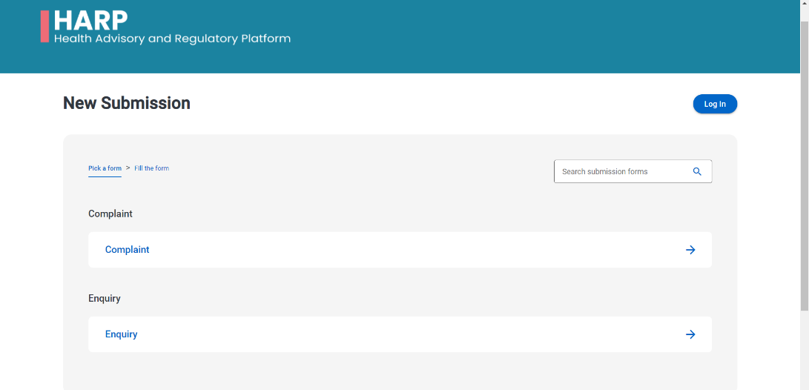
- Go to the HARP portal https://vaping.harp.health.nz and select LOG IN.

- SIGN UP for My Health Account
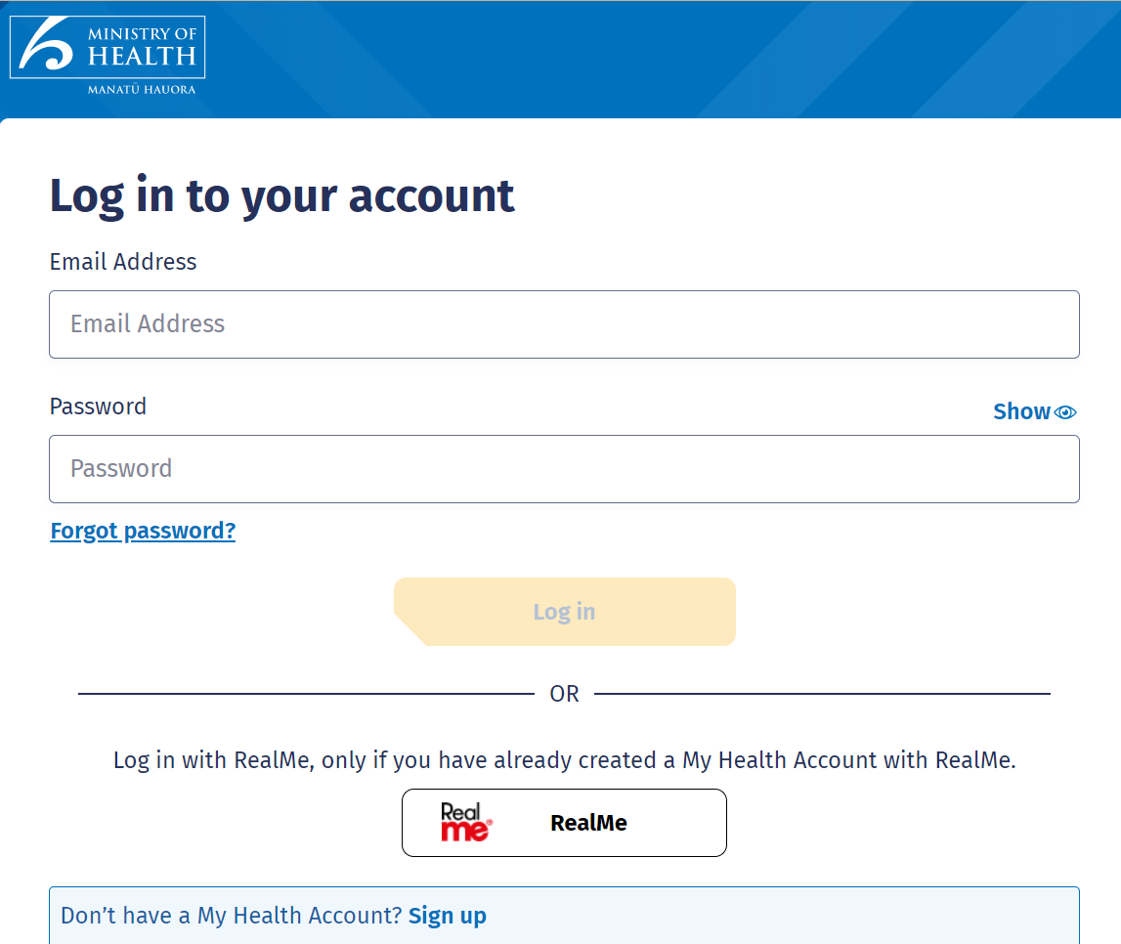

- SIGN UP with Email or RealMe
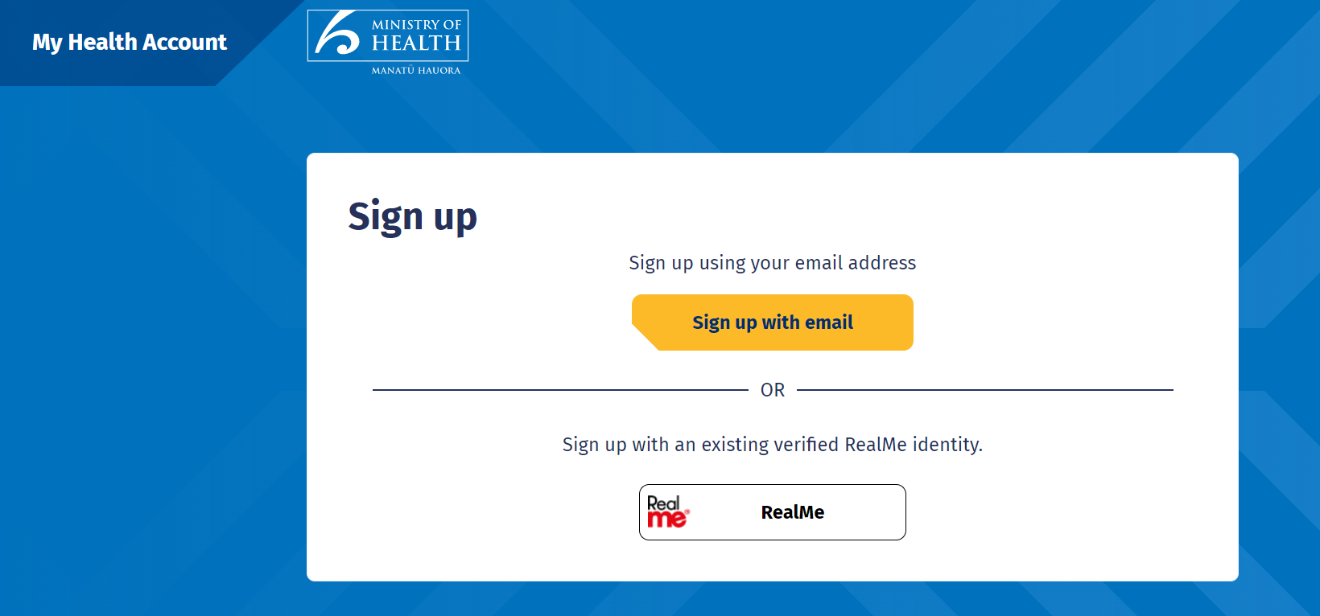
- PLEASE AGREE TO CONTINUE and click START
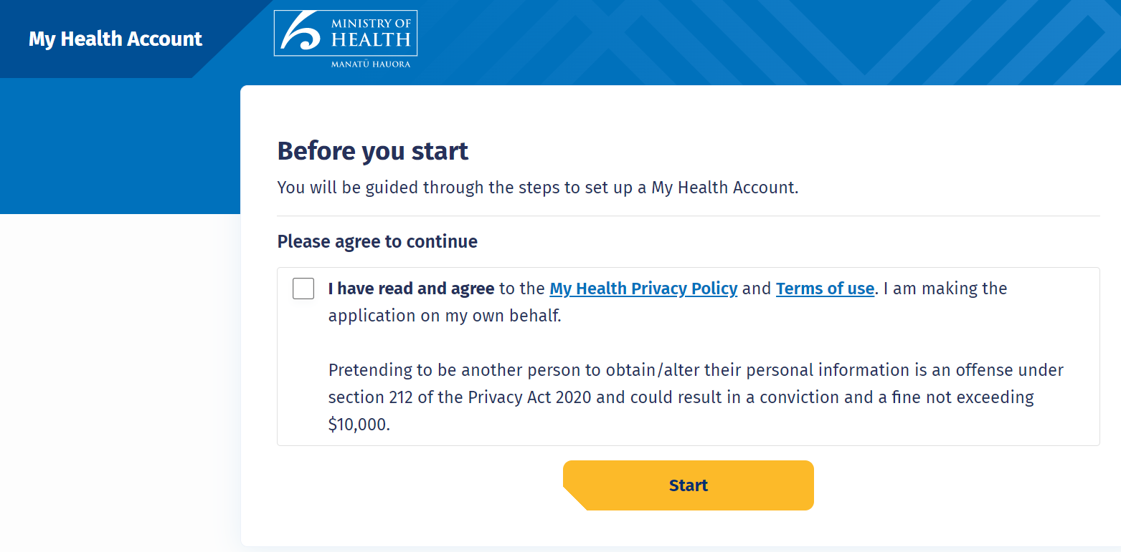

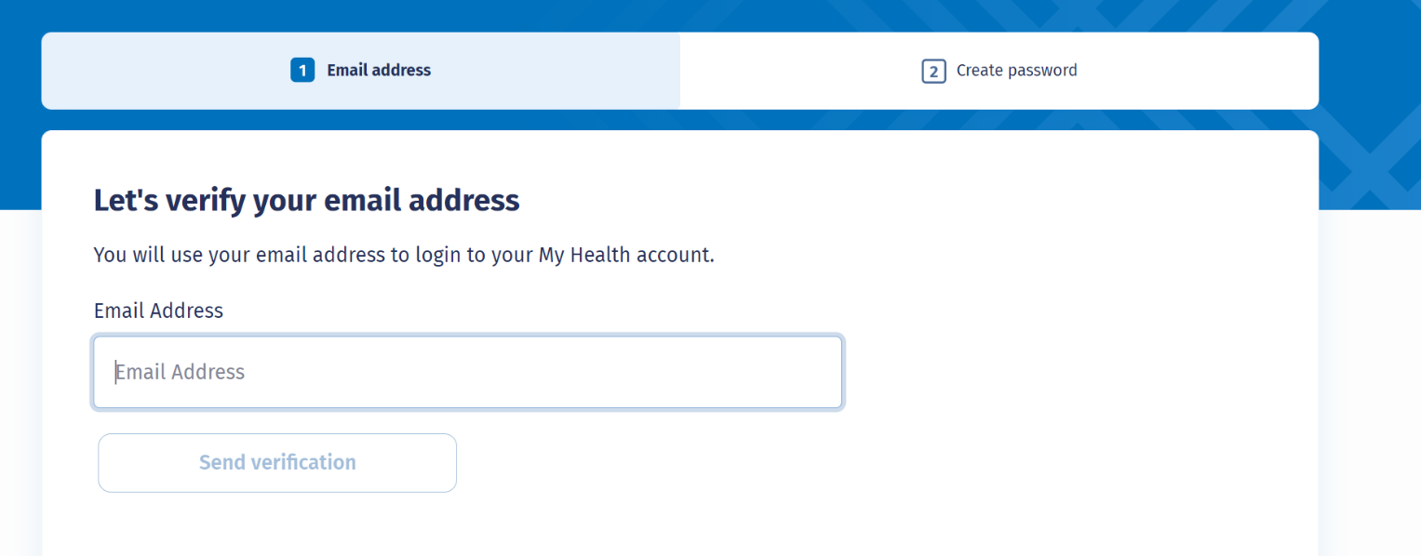
- Enter email address and SEND VERIFICATION
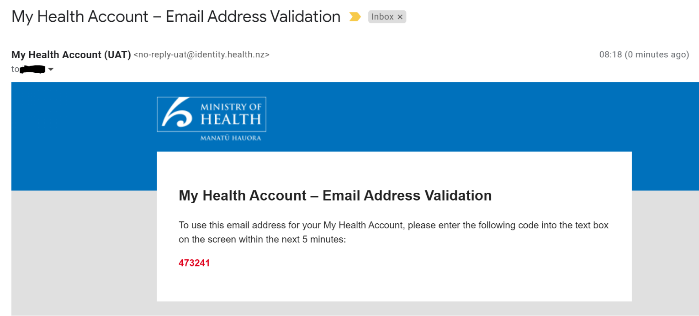
- Check email and copy verification code

- Enter verification code and CONTINUE,
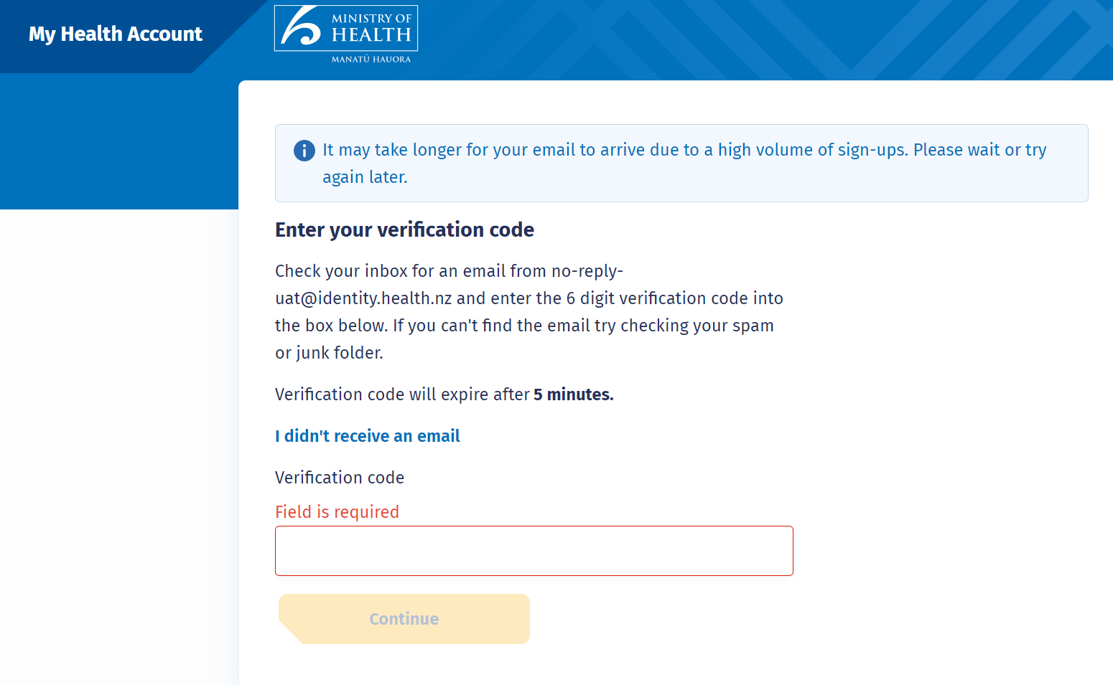
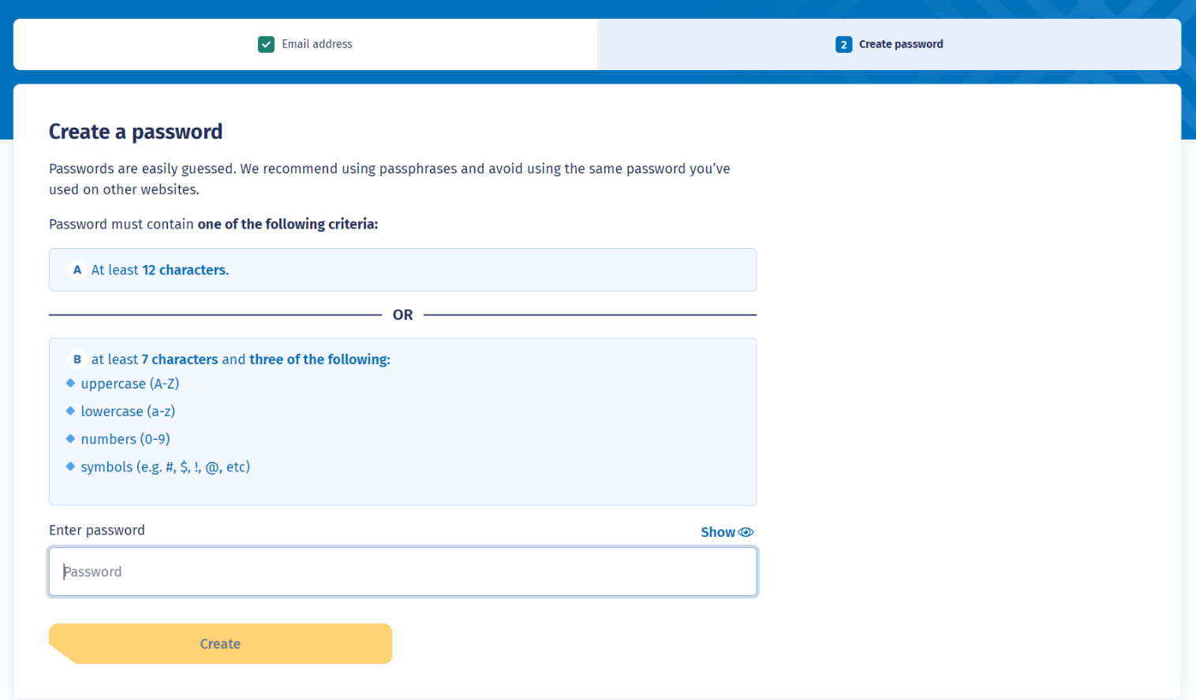
- Enter password and CREATE

step 2: REGISTER FOR ACCESS
- Register for access

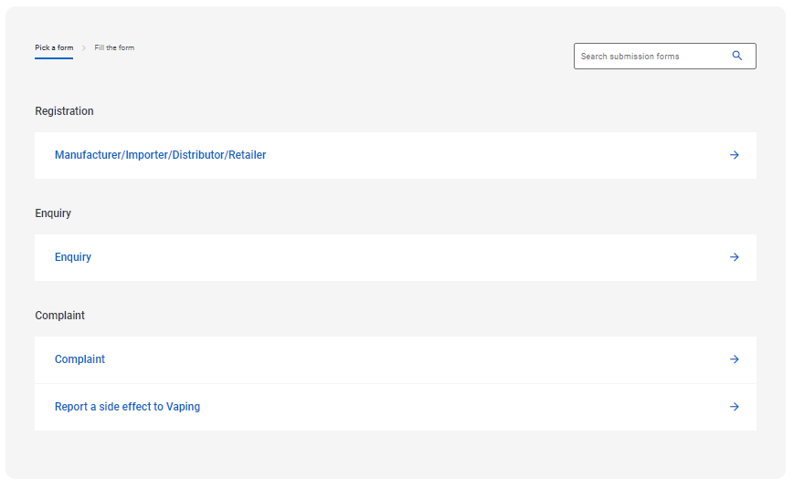
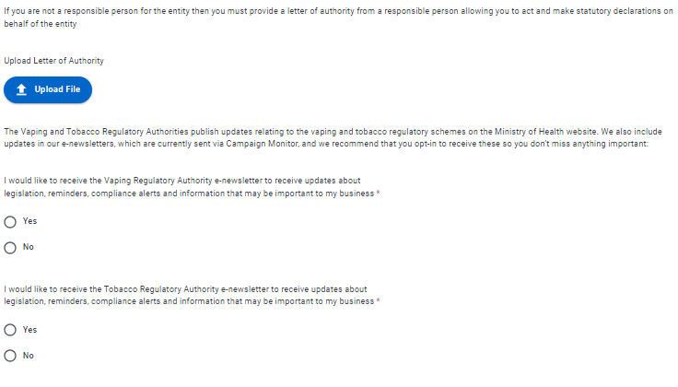
- Enter USER DETAILS, NAME & NZBN, and REGISTERED ADDRESS

- Select SPECIALIST VAPE RETAILER, then NEXT button, then SUBMIT NOW button
Registration will be reviewed and email sent once approved.
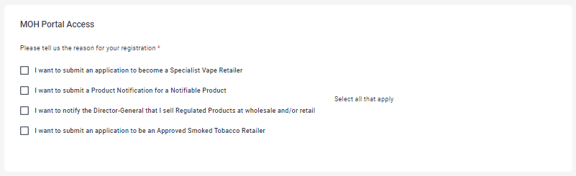

- PLEASE NOTE IT COULD TAKE A FEW BUSINESS DAYS FOR A CUSTOMER ACCOUNT TO BE SET UP.

step 3: My submissions
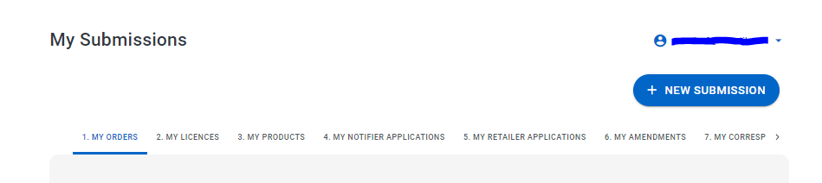
- After access granted proceed to MY SUBMISSIONS dashboard and click on + NEW SUBMISSION​

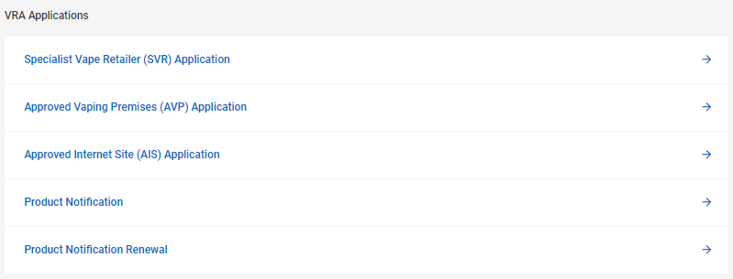
- Select SPECIALIST VAPE RETAILER APPLICATION

step 4: Complete svr application
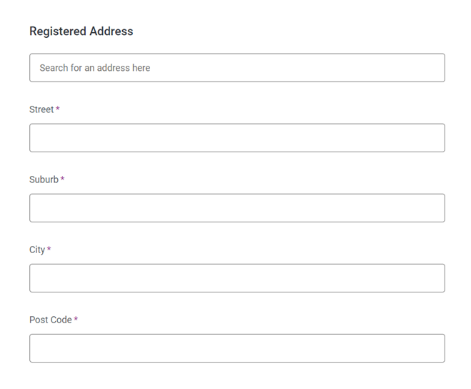

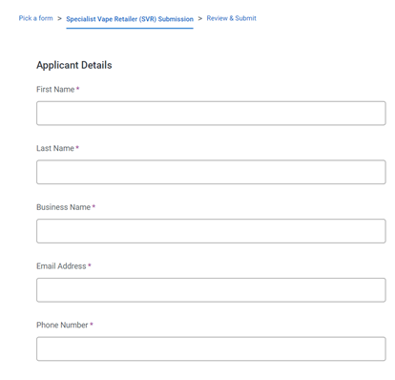
  - Fill in APPLICANT DETAILS:
  - Fill in REGISTERED ADDRESS:

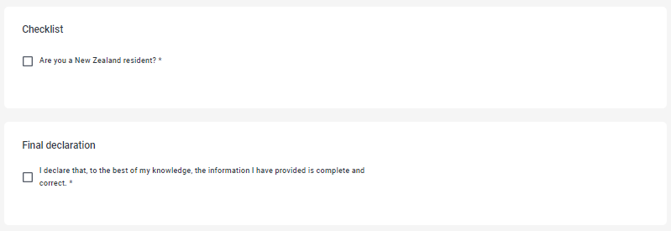
- Complete CHECKLIST and FINAL DECLARATION:

- Click NEXT Button and then hit the SUBMIT NOW button

step 4: submit order and pay
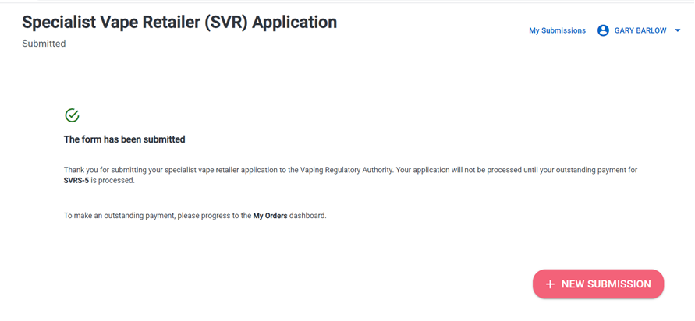
- Click on MY SUBMISSIONS and go to the MY ORDER dashboard:

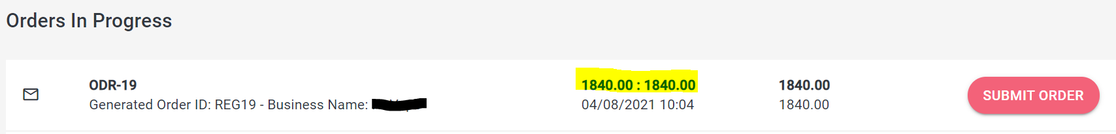
- Click the price to open the order.
- Review ITEM SUMMARY and click NEXT button.
- Review ADJUSTMENTS and click NEXT button.
- Review SUMMARY and click SAVE button.
- Click SUBMIT ORDER button

PAY BY CREDIT CARD
- Click PAY NOW button
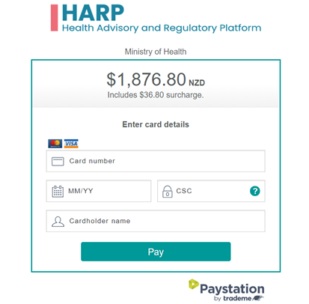
- Enter debit/credit card details and PAY

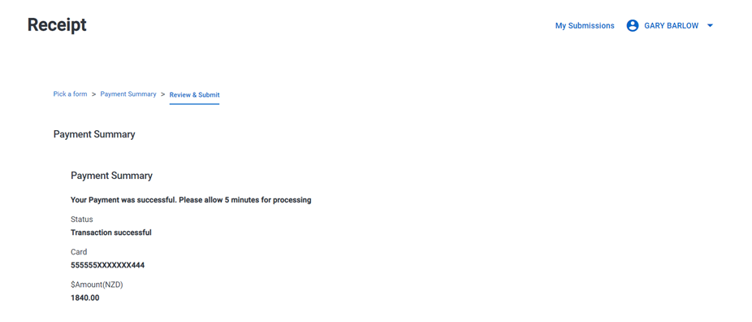
- After payment you will receive a receipt

- Your SVR application has been submitted for assessment
- An email will be sent when the application has been assessed, or you can check progress on HARP

PAY BY INVOICE
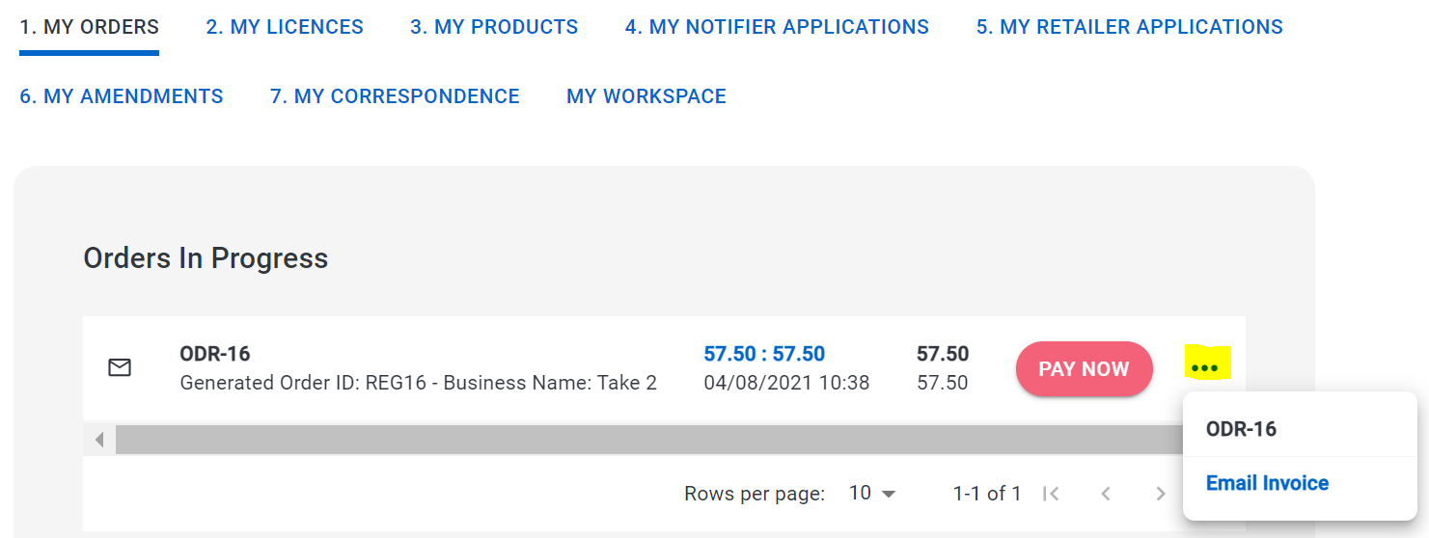
- In the My Orders screen, click … to the right of the Order. Select EMAIL INVOICE
- Make payment to the bank account on the invoice
- Once payment has been received your SVR application will be submitted for assessment. This should be processed within five working days.
- An email will be sent when the application has been assessed, or you can check progress on HARP

Approved vaping premise

application – Preparation

before you start you will need the following
- A submitted and approved SVR application
- Photos of the outside of your premise including the main entrance ​
- Photos of the inside of your premise from the main entrance ​
- Photos of all points of sales​ areas
- If you are applying for 60% sales threshold, documents will be required to demonstrate the applicability of the lower sales threshold
- The fees for an AVP are $600 plus GST (one-off fee per premise)​

Approved vaping premise

application – Applying online

step 1: create new AVP submission
  - After logging into the HARP portal, proceed to MY SUBMISSIONS dashboard and click on + NEW SUBMISSION​
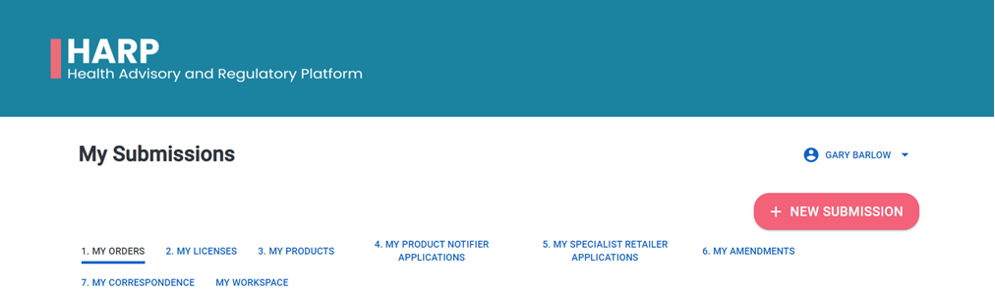

  - Select APPROVED VAPING PREMISES (AVP) APPLICATION

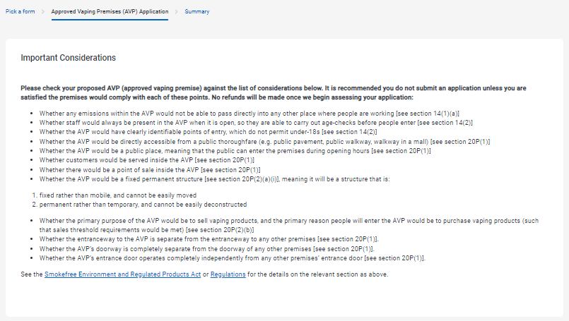
Step 2: Complete Approved vape premises (AVP) Application

  - Fill in APPLICANT DETAILS:
  - Fill in REGISTERED ADDRESS:

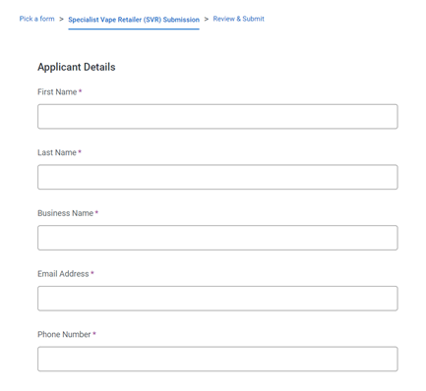

  - Fill in VAPING PREMISES details:
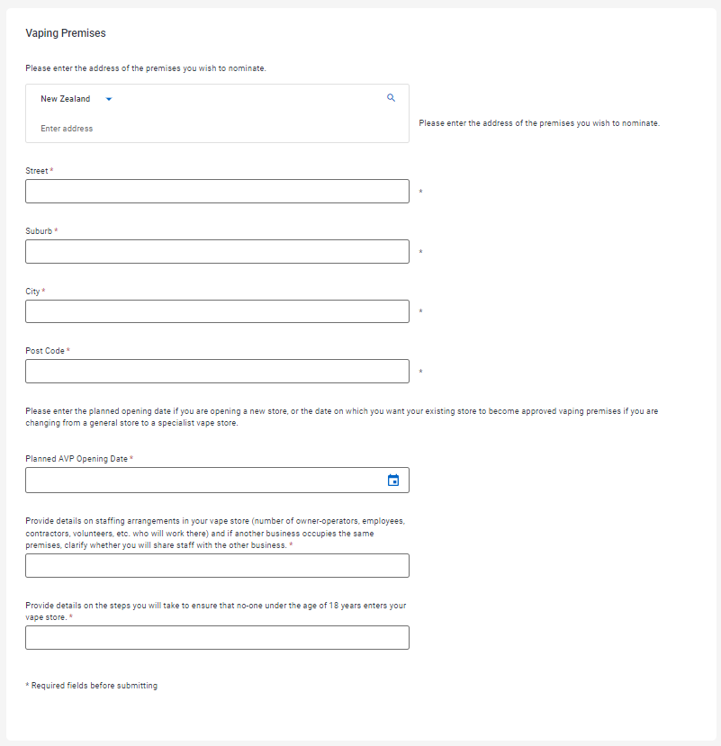
  - Attach PHOTOS OF PREMISES / Supporting Files and complete DECLARATION. Click NEXT button.
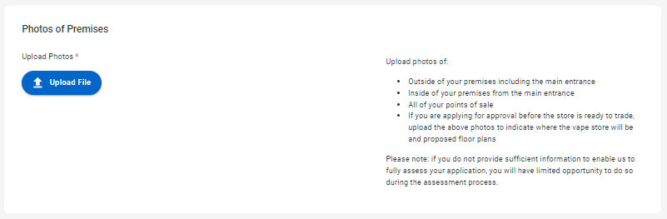

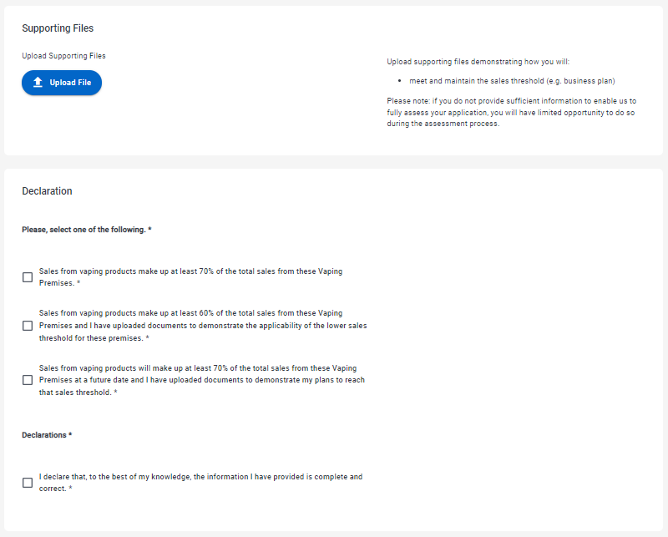
  - Review application and click SUBMIT NOW button.

step 4: submit order and pay now
- Click on MY SUBMISSIONS and go to the MY ORDER dashboard:
- Click the price to open the order.
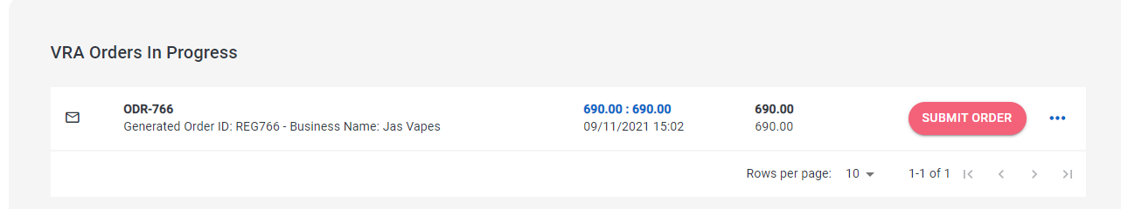
- Review ITEM SUMMARY and click NEXT button.
- Review ADJUSTMENTS and click NEXT button.
- Review SUMMARY and click SAVE button.
- Click SUBMIT ORDER button

PAY BY CREDIT CARD
- Click PAY NOW button
- Enter debit/credit card details and PAY
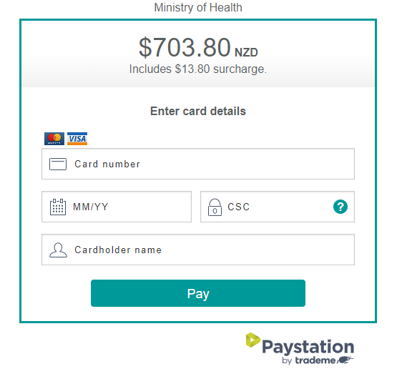
- After payment you will receive a receipt
- Your AVP application has been submitted for assessment
- An email will be sent when the application has been assessed, or you can check progress on HARP

PAY BY INVOICE
- In the My Orders screen, click … to the right of the Order. Select EMAIL INVOICE
- Make payment to the bank account on the invoice
- Once payment has been received your AVP application will be submitted for assessment
- An email will be sent when the application has been assessed, or you can check progress on HARP
NOTE: You will need to submit a new application for each additional premise

approved internet site application – preparation

before you start you will need the following
- A submitted and approved SVR application
- To have submitted an AVP application
- The Internet Site details
- The fees for an AIS are $600 (one-off fee per website)​

approved internet site

application – applying online

step 1: create new submission
- After logging into the HARP portal, proceed to MY SUBMISSIONS dashboard and click on + NEW SUBMISSION​

- Select APPROVED INTERNET SITE (AIS) APPLICATION

Step 2: Complete Approved INTERNET SITE (AIS) Application

- Fill in APPLICANT DETAILS:

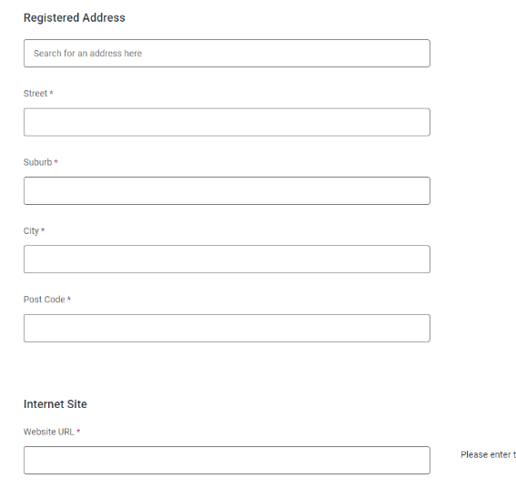
- Fill in REGISTERED ADDRESS and INTERNET SITE:

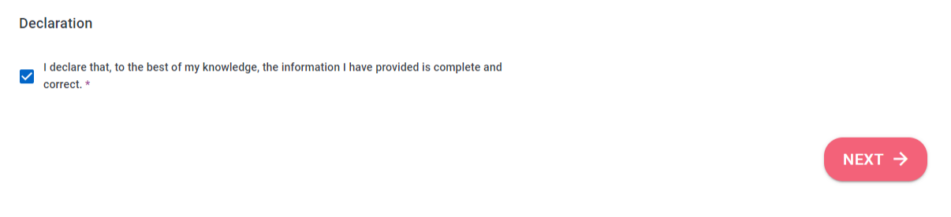
- Complete DECLARATION and click NEXT

- Review and click SUBMIT NOW button

step 3: submit order and pay
- Click on MY SUBMISSIONS and go to the MY ORDER dashboard:
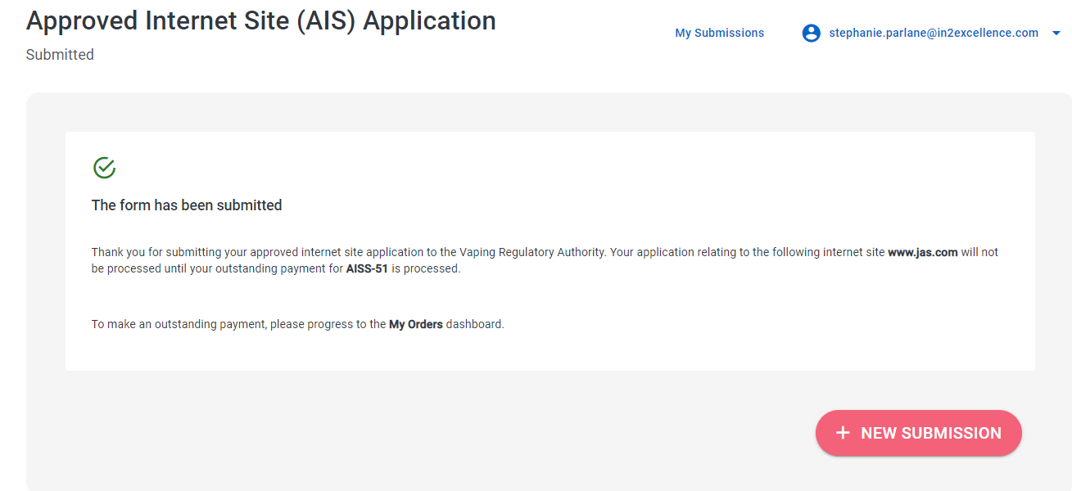
- Click the price to open the order.
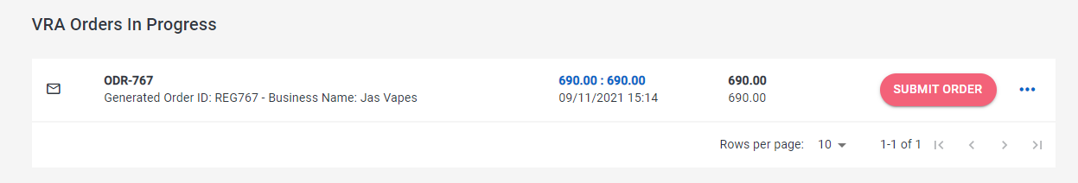
- Review ITEM SUMMARY and click NEXT button.
- Review ADJUSTMENTS and click NEXT button.
- Review SUMMARY and click SAVE button.
- Click SUBMIT ORDER button

PAY BY CREDIT CARD
- Click PAY NOW button
- Enter debit/credit card details and PAY

- After payment you will receive a receipt
- Your AIS application has been submitted for assessment
- An email will be sent when the application has been assessed, or you can check progress on HARP

PAY BY INVOICE
- In the My Orders screen, click … to the right of the Order. Select EMAIL INVOICE
- Make payment to the bank account on the invoice
- Once payment has been received your AIS application will be submitted for assessment
- An email will be sent when the application has been assessed, or you can check progress on HARP
NOTE: you will need to submit a new application for each additional website

15th September 2023

