5G Radiofrequency Fields and Health

2019

This addendum to the *Interagency Committee on the Health Effects of Non‑Ionising Fields: Report to Ministers 2018* provides advice on 5G radiofrequency fields (RF) to support the responses to correspondence you are receiving on this topic (particularly 5G).

Citation: Ministry of Health. 2019. *5G Radiofrequency Fields and Health*. Wellington: Ministry of Health.

Published in November 2019 by the Ministry of Health  
PO Box 5013, Wellington 6140, New Zealand

ISBN 978-1-98-859744-7 (online)  
HP 7268



This document is available at health.govt.nz

|  |  |
| --- | --- |
| **CCBY** | This work is licensed under the Creative Commons Attribution 4.0 International licence. In essence, you are free to: share ie, copy and redistribute the material in any medium or format; adapt ie, remix, transform and build upon the material. You must give appropriate credit, provide a link to the licence and indicate if changes were made. |

**Contents**

Executive summary v

1 Characteristics of 5G radio 1

2 The New Zealand exposure standard 3

3 Exposures from 5G 4

List of Figures

Figure 1: Conventional antenna (left), and beam-forming antenna (right) 1

Figure 2: Exposures from 5G sites in Brisbane, shown as percentage of public limit in NZS 2772.1 5

# 

# **Executive summary**

The key points in this addendum are:

* 5G is just a new application of radio technology, and so existing research on the health effects of radiofrequency (RF) fields is equally information about the possible effects of 5G.
* The current New Zealand exposure Standard NZS 2772.1:1999 already covers 5G.
* Regulations under the Resource Management Act about exposures to RF fields from cellsites apply to 5G sites.
* There is no good reason to believe that exposures from 5G that comply with current limits will cause adverse health effects.

# **Characteristics of 5G radio**

In many respects, 5G radio signals resemble those used by 4G (in fact, the differences between 4G and 5G are much less than between previous generations). There are a few main differences.

* 5G permits using a much greater signal bandwidth for radio transmissions than 4G. The bandwidth can be visualised as the diameter of the pipe used to deliver the data – the wider the pipe, the faster the data can be delivered.
* While initially 5G will use frequencies similar to those used currently by 4G, it will also permit the use of much higher frequencies. The frequency of the signal can be thought of as where you would have to turn a radio receiver dial to pick it up. The higher frequencies proposed are similar to those that have been used for many years for point to point radio communication links, using dish antennas.
* 5G will normally use beam-forming antennas. (Beam-forming is used to a limited extent by some 4G sites.) Conventional cellsite antennas produce a single fan‑shaped beam covering a sector about 120 degrees wide. Regardless of where the end user of the radio signal is, the radio beam is sent to the entire area served by the antenna. Beam-forming antennas produce a larger number (say, 48) of narrow beams that only cover a small area around the end user. Figure 1 illustrates this.

Figure 1: Conventional antenna (left), and beam-forming antenna (right)

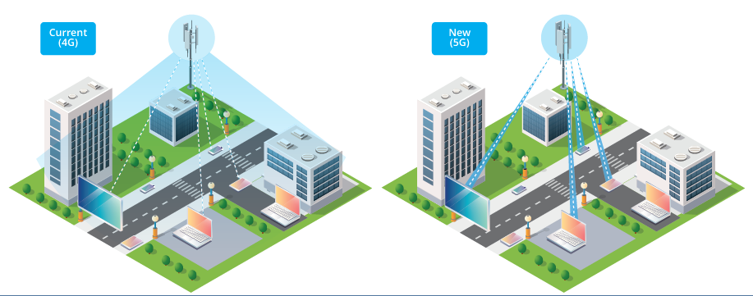

The conventional antenna transmits to the same area regardless of which devices actually receive data, whereas the beam-forming antenna only sends the signal in directions that need it. Beams switch off when not in use. Typically, a site could transmit on up to eight beams simultaneously, with the transmitter power divided between them all.

Initially 5G sites will operate at frequencies around 3.5 GHz, which is similar to those used by existing cellsites. Within a couple of years, it is likely that higher frequencies around 26 GHz (sometimes referred to as millimetre waves – mmWaves) will also be used. Similar frequencies have been used for point to point communication links for many years, and they are within the range covered by the New Zealand exposure standard. Conversations with equipment suppliers and telecommunications engineers suggest that mmWave sites will be limited to situations where there are many people, especially outdoors, for example at a sports stadium, in city centres or possibly in large indoor areas. It is not well suited to suburban areas because building materials largely block mmWaves. A fixed wireless broadband service would probably require external antennas to be effective.

None of the characteristics of 5G radio systems is particularly distinctive. As mentioned previously, the signal modulation (the way information is encoded onto the radio signal) resembles that used by 4G. Research has not suggested that health effects relate to modulation.[1] For these reasons the research already undertaken on health effects of exposures to RF fields is as applicable to 5G as to other radio signals.

There is a common misconception that higher frequency signals are more harmful. In fact, the most important parameter is the intensity of the radio wave. Frequency only affects where the energy in the radio signal is absorbed: at 26 GHz the energy is almost entirely absorbed in the skin (some of the energy is also reflected by the skin), whereas at 3.5 GHz the energy is absorbed at depths up to about 20 mm.

# **The New Zealand exposure standard**

The New Zealand exposure standard NZS 2772.1:1999 is discussed in section 2.2 of the Interagency Report. The standard covers frequencies up to 300 GHz, which is well above than the highest frequencies envisaged for 5G.

As noted in section 2.2, the New Zealand standard follows limits recommended by the International Commission on Non-Ionising Radiation Protection (ICNIRP), an international scientific body recognised by the WHO for its independence and expertise in this area. Revised guidance from ICNIRP is expected before the end of 2019, but based on the draft revision released for public comment in 2018 and information released since then, it is not expected that there will be any changes that affect public exposures from cellsites.

Research published since the 2018 Interagency Report to Ministers was finalised suggests that the limits in NZS 2772.1:1999 are still protective.

Compliance with NZS 2772.1 is required by clause 55 of the Resource Management (National Environmental Standards for Telecommunications Facilities) Regulations 2016, which means that 5G sites installed by mobile phone network operators must comply with the standard.

# **Exposures from 5G**

There has been concern that the advent of 5G services will cause a large increase in exposures, and that exposure limits may even have to be relaxed to accommodate 5G. The limited evidence currently available shows that exposure from 5G sites is similar to those from current mobile phone technologies. Recommendations on limits from the Ministry of Health would only be influenced by health research, not by the needs of the telecommunications industry.

Australian capital cities have deployed several hundred 5G sites. Figure 2 shows measurements made near 5G sites by an Australian network operator (Telstra) at eight locations in Brisbane. A 5G device forced the sites to transmit large volumes of data during the measurements.[2] Each bar shows the exposure at a location identified by a letter at the bottom of the bar. Exposures from different sources are distinguished by the different coloured portions of each bar. The contribution from 5G is the light green portion at the top.

Figure 2: Exposures from 5G sites in Brisbane, shown as percentage of public limit in NZS 2772.1

Graph shows the levels of different kinds of frequencies experienced at different sites around Brisbane. Site C had the biggest level of exposure, at almost 0.5% of the public limit, made up mostly of 4G at 1800 M Hz and 700 M Hz. All other sites had less than 0.2% of the public limit.

|  |  |  |
| --- | --- | --- |
| **Key** | **Location** | **Comments** |
| A | Musgrave soccer oval | 75 m from 5G, boresight |
| B | Miami High School | 200 m from 5G, boresight |
| C | Musgrave Hill | 90 m from 5G, boresight |
| D | Brisbane street café – outside |  |
| E | Southport café – inside |  |
| F | Southport café – outside | 80 m from tower, no line of sight |
| G | Apartment family – inside | 80 m from 5G, above boresight |
| H | Apartment young engineers – inside | 80 m from 5G, above boresight |
| I | Apartment family – balcony | 80 m from 5G, above boresight |
| J | Apartment young engineers – balcony | 80 m from 5G, above boresight |

These findings are supported by simple exposure calculations based on the characteristics of the different technologies, such as average transmitter power (all cellsite transmitters adjust their power up and down so as to be just sufficient for traffic passing through the site) and the antenna characteristics.

1. Unless the radio signal is made up of extremely short, very intense pulses, which would not be permitted by the exposure standard.
2. Original data available at http://1u0b5867gsn1ez16a1p2vcj1-wpengine.netdna-ssl.com/wp-content/uploads/2019/07/5-Surveys-of-5G-flyer-A4.pdf. Further information is available from Telstra athttps://exchange.telstra.com.au/5-surveys-of-5g-show-eme-levels-well-below-safety-limits/. Note that the antennas were not beam-forming, and the 5G transmitter power is one quarter of the power that will be used when beam-forming is introduced at these sites.