Hauora Haumi

Allied Health

Report
May 2024

Citation: Ministry of Health. 2024. Hauora Haumi Allied Health Report. Wellington: Ministry of Health.
Published in June 2024 by the Ministry of Health
PO Box 5013, Wellington 6140, New Zealand
ISBN 978-1-991075-75-8 (online)
HP 9075
This document is available at health.govt.nz
This work is licensed under the Creative Commons Attribution 4.0 International licence. In essence, you are free to: share ie, copy and redistribute the material in any medium or format; adapt ie, remix, transform and build upon the material. You must give appropriate credit, provide a link to the licence and indicate if changes were made.

Contents
Executive summary 1
The impact of allied health 2
Realising the potential of allied health 2
Introduction 4
Allied health professions in Aotearoa 5
Allied health’s pivotal role in achieving pae ora 5
Report methodology 6
Snapshot reports 8
1. Audiology 8
2. Clinical physiology 16
3. Dietetics 24
4. Medical imaging and radiation therapy 29
5. Medical laboratory science 39
6. Occupational therapy 47
7. Paramedicine 54
8. Pharmacy 63
9. Physiotherapy 72
10. Podiatry 79
11. Psychology 86
12. Social work 95
13. Sonography 108
14. Speech-language therapy 113
Conclusion 120

List of Figures
Figure 2-1: Number of clinical physiologist APCs by year, 2013–2023 20
Figure 2-2: Ethnicity of the clinical physiologist workforce, 2023 20
Figure 2-3: Gender of the clinical physiologist workforce, 2023 20
Figure 3-1: Number of dietitian APCs by year, 2016–2022 25
Figure 3-2: Gender of dietitian workforce, 2023 25
Figure 3-3: Ethnicity of dietitian workforce, 2023 26
Figure 3-4: Country of training for dietitian workforce, 2023 26
Figure 3-5: Fields worked in by dietitians in public hospitals, 2023 26
Figure 3-6: Where dietitians work, 2023 26
Figure 4-1: Ethnicities (percentage) of medical imaging and radiation specialist APC holders, 2021–2022 31
Figure 5-1: Ethnicities (percentage) of medical laboratory science APC holders, 2021–2022 41
Figure 6-1: Occupational therapists holding a current APC, 2018–2022 48
Figure 6-2: Occupational therapist APCs by gender, as at 31 March 2022 48
Figure 6-3: Overseas qualified occupational therapists, 2018–2022 48
Figure 6-4: Average age (in years) of occupational therapists with an APC, 2018–2022 48
Figure 6-5: Māori and Pacific occupational therapist practitioners, 2018–2022 48
Figure 6-6: Occupational therapist numbers by role, 2020–2022 49
Figure 6-7: Occupational therapy practitioners by employing organisation, 2020–2022 49
Figure 7-1: Initial registrations by registration pathway, 2022 56
Figure 7-2: Registered paramedics by gender (1,770 paramedics), 2022 56
Figure 7-3: Registered paramedics by age in years (1,770 paramedics), 2022 56
Figure 7-4: Paramedic employment situation, 2022 57
Figure 7-5: Where paramedics are employed by Te Whatu Ora district, 2022 57
Figure 8-1: Comparison of pharmacists’ age (smoothed) by gender, 2021, 2022 66
Figure 9-1: Physiotherapy number of APCs issued, 2018–2023 73
Figure 9-2: New registrations: Aotearoa compared with overseas trained, 2018–2023 73
Figure 9-3: Practising physiotherapists by age and gender, 2022/23 74
Figure 9-4: Ethnicity of physiotherapist APC holders, 2022/23 74
Figure 9-5: Total hours worked per week by physiotherapists, 2022/23 74
Figure 10-1: Podiatry profession APCs, 2021 80
Figure 10-2: Podiatry number of APCs issued by year: New Zealand-qualified compared with overseas-qualified podiatry workforce, 2017–2022 80
Figure 10-3: Ethnicity profile of podiatry workforce who hold an APC, 2021 80
Figure 10-4: Percentage of Māori and Pacific podiatrists with an APC, 2017–2022 81
Figure 10-5: Podiatrist age groups analysis, 2021/22 81
Figure 10-6: Podiatrists’ primary workplace setting, 2021/22 81
Figure 11-1: New psychologist registrants by scope of practice, 2022 88
Figure 11-2: Total practising psychologists by scope of practice, 2022 88
Figure 12-1: Total social worker registrations, June 2016–June 2021 97
Figure 12-2: Primary ethnicity of registered social workers in health services, 2022 98
Figure 12-3: Gender of social workers in the health sector, 2022 98
Age of social workers in the health sector, 2022 98
Figure 12-4: Social workers in health by region, 2022 99
Figure 12-5: Work status of registered social workers, 2022 99
Figure 12-6: Reason for registered social workers leaving their jobs, 2022 100
Figure 12-7: Social worker student enrolment figures, 2013–2022 100
Figure 12-8: Social worker student ethnicity data, 2013–2022 101
Figure 13-1: Percentage of ethnicities of sonographer APC holders, 2021–2022 109

List of Tables
Table 1-1: Numbers of audiology professionals, 2022 10
Table 2-1: Registered clinical physiologists by scope of practice 19
Table 4-1: Registered medical imaging and radiation specialists by scope of practice, 2022 30
Table 4-2: Registered MIT APC numbers, 2018–2022 32
Table 4-3: Initial MIT registrations by country trained in, 2022 32
Table 4-4: MRIT APC numbers, 2018–2022 33
Table 4-5: Initial MRIT registrations by country trained in, 2022 33
Table 4-6: NMT APC numbers, 2018–2022 34
Table 4-7: Initial NMT registrations by country trained in, 2022 34
Table 4-8: RT APC numbers, 2018–2022 34
Table 4-9: Initial RT registrations by country trained in, 2022 34
Table 5-1: Medical laboratory scientists by scope of practice, 2022 40
Table 5-2: MLPAT APC numbers, 2018–2022 42
Table 5-3: MLPAT registrations by country trained in, 2022 42
Table 5-4: Medical laboratory technicians APC numbers, 2018–2022 43
Table 5-5: Medical laboratory technicians registrations by country trained in, 2022 43
Table 5-6: Medical laboratory scientists APC numbers, 2018–2022 44
Table 5-7: Medical laboratory scientists registrations by country trained in, 2022 44
Table 7-1: Registered paramedics, 2021, 2022 55
Table 7-2: Registered paramedics by primary ethnicity, 2022 55
Table 8-1: Current pharmacy registrations by scope of practice (30 June 2022) 65
Table 8-2: Pharmacist number of APCs, 2018–2022 65
Table 8-3: Pharmacist registration route, 2018–2022 65
Table 8-4: Pharmacist ethnicity by age group, 30 June 2022 66
Table 8-5: Primary type of pharmacy practice undertaken by practising pharmacists, 2022 67
Table 8-6: Number of return-to-practice applicants by years since last in practice, 2019–2022 67
Table 8-7: Average hours per week worked in scope by practising pharmacists, 2022 67
Table 9-1: Current physiotherapy registrations by scope of practice, 2022/23 73
Table 9-2: Primary type of physiotherapy practice undertaken by practising physiotherapists, 2022/23 75
Table 11-1: Registered psychologists APC numbers, 2018–2022 87
Table 11-2: Initial psychologist registrations by registration pathway, 2018–2022 88
Table 12-1: Social worker student registration rates, 2019–2022 101
Table 12-2: Social worker field education placement organisation type, 2020–2022 101
Table 12-3: Social worker student government agency placement breakdown 2022 101
Table 13-1: Sonographers’ practising certificates by scope of practice, 2022 109

Executive summary
Hauora haumi - allied health professionals are qualified health practitioners and are an integral part of our health system. They have specialised expertise in prevention, diagnosis, intervention and treatment across a range of conditions and illnesses. In Aotearoa New Zealand, there are at least 43 professions that are classified as allied health professions.

This report is the first of its kind to collate information about allied health professions in Aotearoa New Zealand and their impact on the health and wellbeing of our population. While allied health professions are a critical part of our health workforce, the public’s understanding of these professions is limited compared with its understanding of other health professions, such as doctors, nurses, midwives and dentists.

Throughout 2023, Dr Martin Chadwick, the Chief Allied Health Professions Officer of the Ministry of Health – Manatū Hauora (the Ministry), convened 14 allied health professional sector reference groups. The aims of these groups were:
- to assess whether the population of Aotearoa is realising the full potential of these allied health professions to achieve the concept of pae ora (healthy futures for all New Zealanders)
- if not, to identify what issues/barriers are preventing this potential from being realised
- to foster a broader understanding of these professions through the collation of supporting information and data.

This report relays the voice of these allied health professions and summarises their untapped potential as well as the opportunities and challenges they face in achieving pae ora. While it does not represent commitment to specific actions, it serves as a point of reference to inform stakeholders about the breadth and depth of knowledge and skill contained within these allied health professions.

We see this report as a starting point that will be iteratively updated to include more allied health professions over time.

The impact of allied health
Several consistent themes on the positive impact of allied health professions on health outcomes were identified in the groups’ meetings.

Timely, equitable access to allied health professionals can:
- reduce the time taken for a person to receive a diagnosis
- help prevent, detect and lead to the earlier intervention of health conditions (potentially increasing options and efficacy while reducing risk of treatment)
- improve a person’s quality of life, with people retaining their ability to work, learn and engage in their communities in ways that are meaningful to them
- improve health literacy and self-management, empower whānau and communities to stay well and enable them to maintain their autonomy
- build trusting relationships with health care practitioners – encouraging people to engage earlier around possible future care needs
- improve population wellness by supporting people to adopt good health behaviours
- help people maintain independence and experience healthy ageing, with support across their life course.

The groups also identified wider health system benefits of allied health professions, including:
- offering cost-effective services, which supports financial sustainability and provides economic value
- easing pressures on the health system, for example, on hospital and specialist services (secondary, tertiary and quaternary services)
- enabling people to engage in whānau, cultural, employment, education, community and recreational activities.

Realising the potential of allied health
Advancing opportunities to realise the potential of allied health requires action from all allied health stakeholders, both individually and collectively. Below is a summary of common opportunities and barriers faced by allied health professions in Aotearoa.

Shared opportunities
Shared opportunities that exist across allied health professions include:
- enabling practitioners to work to the full scope of practice within their profession (fully applying their training and experience)
- delivering culturally safe services that respond to the needs of the people and communities who use them
- ensuring the workforce reflects the population it serves
- supporting the workforce by increasing staffing levels, retaining experienced staff and supporting professionals to participate in continuous professional development activities
- improving training pathways and support for students, clinical supervisors and clinical placement providers
- improving access to health services, with enhanced use of telehealth and digital enablers
- prioritising support for evidence-informed, effective and preventative models of care.

Shared barriers
Common barriers to enhancing services across allied health professions include:
- workforce retention challenges and loss of experienced professionals
- insufficient clinical placements and support for clinical supervisors
- insufficient support for students in training programmes – including financial support, which leads to increased attrition
- a focus on biomedical models of care, which tend to react to poor health rather than supporting wellness
- inadequate cultural competence and safety training for students and professionals
- inequity of access and outcome – geographic, racial discrimination, economic
- a lack of understanding by the public and the wider health sector of allied health professions’ significant contribution to health care in Aotearoa.

Introduction
The Health and Disability System Review’s (HDSR’s) final report from 2020 reinforced the Waitangi Tribunal’s findings on longstanding inequities in the health system and worsening health outcomes for Māori. Following this report, Cabinet agreed to significant reforms for the health and disability system in Aotearoa. The health reforms are underpinned by the Pae Ora (Healthy Futures) Act 2022 (the Act), which came into force on 1 July 2022. The purpose of the Act is to:
  - protect, promote, and improve the health of all New Zealanders
  - achieve equity in health outcomes among New Zealand’s population groups, including by striving to eliminate health disparities, in particular for Māori
  - build towards pae ora (healthy futures) for all New Zealanders.⁵

The Act provides the foundations for centralising funding, commissioning, processes and planning across the health system. This can benefit allied health professions in many ways. For example, districts and regions will not be competing for the same public funding, it will be easier to share learnings and best practice in one organisation, and access to the same technology and digital enablers will be improved.

The new system has the potential to allow for more opportunities for allied health to be part of policy making, commissioning, planning, monitoring, innovation and improvement activities. Individual and collective action is required. Everyone has a role in ensuring that Aotearoa achieves pae ora.

Seizing the opportunities that exist across allied health professions will support the aims of the Act by:
- improving quality, consistency and continuity of care
- improving equity of access to services that are closer to home, in the community or via telehealth
- ensuring the delivery of culturally safe care, which builds trust and eliminates power dynamics between patients/whānau and health professionals
- promoting prevention and early intervention activities.

Allied health professions in Aotearoa
- The allied health workforce is made up of professionals who are not part of the medical, dental, midwifery or nursing professions.
- At least 43 professions are currently classed as allied health professions in Aotearoa.
- Each allied health profession has a distinct, specialised body of knowledge and skills.
- Allied health professionals are experts in providing services in a variety of settings across prevention, diagnosis, treatment and management of conditions and injuries.
- Allied health professionals work across numerous sectors, including education, justice, health and social development. They hold expertise in and understanding of the many determinants of health and wellness.
- Allied health professionals are autonomous practitioners who work in a variety of health care settings and often work in multidisciplinary teams, in public and private practice.
- The allied health workforce is regulated in the following two ways:
- National regulation under either the Health Practitioners Competence Assurance Act 2003 (HPCA Act) or the Social Workers Registration Act 2003 (SWRA Act)
- Self-regulated by a professional body.
- There are also allied health professions which are not regulated.

Allied health’s pivotal role in achieving pae ora
- Allied health professionals:
- are experts, with a wide range of skills and knowledge to provide high-quality care
- make a significant, cost effective, positive impact on individual and whānau quality of life, function and participation in the community through disease management, prevention, early intervention, and education.
- The cost effectiveness of allied health practitioner interventions has been acknowledged in many analyses and reports. Examples include:
  - Hidden in Plain Sight
  - Better Outcomes through Increased Access to Physiotherapy
  - Economic Effects of Hearing Loss: 2023 update
  - A Critical Missing Ingredient
  - Evaluation of the Mobility Action Programme (MAP)
  - the International Journal of Pharmacy Practice article: A systematic review of economic evaluations of pharmacist services
  - A New Medicare.

Report methodology
The office of the Chief Allied Health Professions Officer at the Ministry of Health – Manatū Hauora (the Ministry) convened allied health sector leads and representatives in sector reference groups (SRGs) for 14 allied health professions. The aim was for the SRGs to articulate the potential impact and value of their particular allied health profession to the health and wellbeing of people in Aotearoa. Each SRG included representatives from peak professional membership organisations, education and training providers, student bodies, unions, Māori organisations, Pacific organisations, employer organisations (public and private), Te Whatu Ora, Te Aka Whai Ora and responsible authorities.

The SRGs developed snapshot reports for each profession that included:
- an overview of that profession’s work, including qualification pathways
- workforce data
- an assessment of the benefits that a well-highly-enabled profession offers to the health and wellbeing of the people in Aotearoa
- a range of high-level opportunities and issues the profession faces in relation to delivering pae ora.

The following chapters are the snapshot reports for each of the 14 allied health professions:
- Audiology
- Clinical physiology
- Dietetics
- Medical imaging and radiation therapy
- Medical laboratory science
- Occupational therapy
- Paramedicine
- Pharmacy
- Physiotherapy
- Podiatry
- Psychology
- Social work
- Sonography
- Speech language therapy.

The information in this report was accurate at time of publication. This report will be updated on a regular basis, and more allied health professions will be added over time.

Snapshot reports

Audiology
Audiologists and audiometrists specialise in providing comprehensive diagnostic and non-medical treatment services for ear, hearing and balance disorders. The New Zealand Audiological Society (NZAS) states:
Audiologists and audiometrists test hearing and treat people with hearing loss, as well as advising on prevention of hearing loss. Audiologists can also test and advise on auditory processing, tinnitus (ringing in the ears), and balance problems.

The profession provides essential audiological care across a person’s lifespan from newborn to the older adult.

Audiologists
Audiologists are autonomous providers of hearing health care. They provide ear, hearing and balance-related health care for all age groups. They preserve and (re)habilitate a person’s auditory and vestibular functioning to improve the person’s quality of life and maximise their participation in society. Audiologists specialise in the prevention, identification, assessment, diagnosis, treatment and (re)habilitation of disorders of the auditory and vestibular system. They also undertake research in the field of audiology.

Audiologists work autonomously and in collaboration with other health and educational professions in a variety of settings, including public and private sector audiology, university programmes, Deaf Education New Zealand centres and cochlear implant trusts.

Audiometrists
Audiometrists conduct hearing assessments to identify hearing impairment and prescribe and dispense hearing aids and/or other listening devices to assist in hearing rehabilitation. They may refer clients for further audiological or medical assessment and be involved in care management and education programmes. Audiometrists provide hearing health care for people aged 16 years and older with non-complex hearing needs.

Audiometrists largely work independently in private sector audiology, with mentoring support from an audiologist.
The NZAS website includes a detailed list of the differences between audiologists and audiometrists.

Where audiology professionals work
The audiology profession encompasses the public, private and educational sectors, as well as research. Audiologists and audiometrists work closely with deaf educators, speech language pathologists, hearing therapists and medical specialists in the field of ear, nose and throat medicine. Audiologists and audiometrists may work in medical or industrial contexts.

Audiology qualification pathways (including NZAS membership)

Audiologist qualification pathways
Domestic graduates
- Master of Audiology – University of Auckland
- Master of Audiology – University of Canterbury
Overseas qualified
Overseas recognition pathway (for applicants with recognised qualifications from: Australia, Canada or the United States of America) | Rest of the world pathway (for applicants with an audiology qualification from a country other than Australia, Canada or the United States of America)
All provisional members
All provisional members, whether New Zealand graduates or overseas qualified, must complete a Certificate of Clinical Competence, which includes:
- 11 months of clinical supervision
- completion of a series of online learning modules, followed by successful completion of an OSCE (Objective Structured Clinical Examination).
On completion of the above, the applicant will become a full NZAS audiologist member (MNZAS Audiologist).

Audiometrist qualification pathways
There is currently no Aotearoa-based audiometry qualification. However, the NZAS recognises several qualification pathways for audiometrist applications.
- TAFE Diploma in Audiometry online course (Australia)
- Registration with the Health and Care Professions Council (HCPC) as a hearing aid dispenser (United Kingdom)
- A qualification that has been verified and deemed by the NZAS executive council to be, at a minimum, academically equivalent to the TAFE diploma or HCPC Hearing Aid Dispenser registration.

Alternatively, the NZAS may review an application from an individual who has an audiology qualification that is not deemed to be academically equivalent to a New Zealand Master of Audiology.

Workforce data
Information provided by the New Zealand Audiological Society (NZAS) based on data from their 2022/23 annual report.
Table 1-1: Numbers of audiology professionals, 2022
Group | Number with the scope of practice
Audiologist member NZAS (MNZAS) | 531
Audiometrist MNZAS | 38
Provisional audiologist members* | 82
Provisional audiometrist members* | 14
Inactive members | 93
Student members | 73
* Provisional members work clinically with supervision.

Benefits of a highly-enabled audiology profession
- The non-surgical treatment of ear, hearing and balance-related disorders has a profound positive impact on wellbeing, allowing individuals to fully participate in their communities and communicate effectively. There are significant positive impacts for the work, home and social lives of those who can access appropriate treatment.
- Untreated hearing loss gives rise to a poorer quality of life and is associated with depression, anxiety, loneliness, hypertension, falls risk and cognitive decline, as well as loss of productivity and socioeconomic impacts.
- Audiology professionals support individuals with ear, hearing and balance related disorders to engage in a meaningful way within their environments, for example, encouraging their patients to maintain gainful employment, engage fully in school and training environments and interact socially within communities.
- Better hearing leads to improved educational outcomes, increased employment opportunities and greater participation in community activities. This, in turn, contributes to overall social and economic wellbeing.
- Improved hearing health can enhance communication within whānau and strengthen cultural connections within whānau, hapū and iwi.
- The audiology profession can support workplaces to be informed and equipped to ensure the health and safety of their employees’ hearing and to help employees avoid occupational noise-induced hearing loss.
- The audiology profession also plays a crucial role in the early detection of hearing issues, often before patients or whānau notice a problem.
- By optimising the audiology profession, we can reduce wait times, improve geographical coverage, reduce inequities and improve the patient’s journey and experience by ensuring they receive timely care and adequate services regardless of where they live. Realising the full potential of audiology will lead to a healthier and more productive population.
- As the population of Aotearoa grows and ages, the demand for audiological services will also increase. Investing in this profession ensures people of all ages can enjoy a higher quality of life, contributing to the overall health and prosperity of Aotearoa.

Key issues for the audiology profession in realising its full potential to help achieve pae ora
Key themes | Key issues
Training | - It is challenging to increase the number of graduates and the number of clinical placements as there is insufficient support for clinical supervisors to safely supervise students.  - Resource constraints, including the number of audiologists available to supervise, room and equipment availability, and time pressures imposed by waitlists (for audiology and other referring services) limit the ability for supervising new graduates and students within the public system.  - It is challenging to fit all training requirements into a two-year Master’s degree whilst ensuring that graduates can meet current practice requirements.
Workforce | - There is competition between public and private practice to attract a limited pool of graduates.  - The process to approve overseas-qualified audiologists to work in Aotearoa can take a long time.  - There is uneven geographical distribution of the workforce and uneven distribution of the workforce providing services across the lifespan.
Understanding of the profession | - There is poor understanding of the value of the profession and the services provided by the audiology profession from health management and the public.  - There is insufficient promotion about the importance of ear and hearing health.
Funding | - Current funding supports partial funding of devices and not clinicians’ time in diagnosis, treatment and holistic care.  - Funding of hearing services is fragmented (for example, spread between ACC, Veterans Affairs, the Ministry of Education and Whaikaha) and does not support access to services.  - The funding banding for audiology training overall is lower than that for other health professions.
Models of care | - There is a view within the health sector that some business models do not always support patient-centred care and/or drive audiologists to focus on devices. Funding models contribute to this.  - Auditory processing, tinnitus and balance issues are not well integrated into service provision.  - There is not enough integration with MDTs to provide comprehensive care to a patient.  - Auditory processing, tinnitus and balance issues are not well integrated into service provision.
Equity | - Māori and Pacific communities are underrepresented in the current audiology workforce.  - There is unmet need across the lifespan, for example, wait times for assessing and treating children are long, yet this service is vital for a child’s development.  - There is not enough data on the current workforce and other features such as ethnicity breakdown to support workforce planning.

Key opportunities to fully realise the potential of the audiology profession
Key themes | Key opportunities to fully realise the potential of the audiology profession
Training | - Identify and implement methods to encourage more graduates to work in audiology.  - Provide dedicated resources to improve support for new graduates and students within the public health system.  - Ensure training programmes meet the needs of communities and the profession, for example, with respect to clinical and professional skills and the number of graduates.  - Ensure audiologists and audiometrists trained in Aotearoa and overseas receive the appropriate training and supervision during any internship period to be able to practise confidently independently and to provide a high standard of care.
Scope of practice | - Enable the profession to work to its full scope to ensure that the population receives the full benefit of audiology knowledge and skillsets, as well as reduce service costs through preventative care. This includes providing earlier intervention and prevention opportunities for increased work within interdisciplinary teams that provide care centred around the whānau.  - Increase opportunities and resourcing for students and professionals to work in specialist areas, such as tinnitus, balance and auditory processing disorder. This can reduce pressure on specialist services.
Workforce support | - Increase clinical education and professional development opportunities for the workforce, particularly the rural workforce.  - Identify service demand across the health sector to ensure the workforce is the right size across both public and private services.  - Improve retention of publicly employed clinicians by improving working conditions and making remuneration comparable to that of private sector counterparts.  - Support the role of allied health assistants, particularly in remote locations, in enhancing services provided by a clinical team.  - Increase the use of hearing therapists to help the audiology profession provide a holistic and independent approach to hearing health care.  - Review the pathway for approving overseas qualified audiologists to work in Aotearoa.
Investment and prioritisation opportunities | - Increase support for training and clinical placements in public and private practice, in particular, beyond Auckland and Christchurch.  - Support for clinical care services alongside device-based funded care.  - Ensure incentives support early intervention and prevention services.  - Ensure funding models support: patients and their whānau to have equitable access to hearing health services, whakawhanaungatanga (developing relationships) with patients and their whānau, the diagnosis and treatment process and access to devices as clinically indicated for all ear, hearing and balance-related disorders.  - Improving consistency between, streamlining across and transparency of the different funding sources (Whaikaha | Ministry of Disabled People (Whaikaha), Accident Compensation Corporation (ACC), Veterans’ Affairs New Zealand and the Ministry of Education) to improve equity of access and outcomes.
Public understanding of audiology and its value | - Clearly communicate the value of and return on investing in audiology services and what the audiology profession does. Promote the public’s understanding of good ear and hearing health as a public health issue, how to access services, when and why to access audiological services and the consequences of unaddressed hearing loss.  - Increase the visibility of and improve educational tools/interventions to promote ear and hearing health, hearing technology and the audiology profession.  - Promote audiology as a profession amongst school leavers and undergraduate students, with a focus on Māori and Pacific communities who are underrepresented within the profession.
Models of care | - Improve collaboration with other health professionals and increase the presence of audiology in multidisciplinary teams (MDTs) – the audiology profession can help with balance, autism diagnoses, falls prevention, healthy ageing, processing difficulties and/or tinnitus following traumatic brain injuries. Given the association of hearing loss with diabetes and cardiovascular disorders, audiologists and audiometrists should also be involved in health care systems that work with individuals with these conditions.  - Foster collaboration with associated medical professionals (for example, otorhinolaryngologists and general practitioners) to ensure assessment and treatment is provided when needed, in a consistent, transparent and supported manner.  - Share audiology quality improvement work across the profession in Aotearoa so that the benefits of good practice are accessible to all.  - Work more closely with the Ministry of Education to support all children who have auditory difficulties, with comprehensive and timely provision of services and equipment.  - There is the opportunity for audiology to work with hearing therapy and the potential for existing pathways and funding models (via Whaikaha) to support service access.  - Form partnerships in remote communities to support locally tailored and delivered audiology care.  - Encourage practices to centre more on the whānau and improve communication pathways between whānau, services and organisations.  - Recognise the opportunity provided to a clinic by an audiology assistant, who may also be undertaking a recognised audiology-related qualification.
Equity | - Use a critical Te Tiriti o Waitangi framework, hauora Māori models and social determinants of health models when reviewing funding and providing ear and hearing health care.  - Improve data on the audiology workforce, including ethnicity data. This will help employers and education providers ensure future service needs are met.  - Continue to improve quantitative data to identify unmet needs across the population.  - Improve cultural safety training for students and the professional workforce.  - Ensure the workforce is representative of the Aotearoa population.  - Explore options for alternative delivery locations, for example, on marae and at community hubs, as well as using technologies such as telehealth to better support regional and rural areas and tāngata whaikaha (disabled people).  - Improve collaboration with communities of most need and shift towards community-led ear, hearing and vestibular health care.

Clinical physiology
Clinical physiologists use technical equipment to monitor, record, measure and analyse the way patients’ organs or internal systems are working to help doctors diagnose and treat patients.

Domestic clinical physiology qualifications
Clinical physiologists have an undergraduate degree in science, often majoring in physiology or equivalent. Further postgraduate study and supervised clinical hours are required for each scope of practice.

Cardiac physiology technician
There are two options:
- Certification in Physiological Measurement (CPM) through the Society of Cardiopulmonary Technology and one year full-time experience
- Theory: Postgraduate Certificate in Medical Technology (MTEX) 701 and 702 through the University of Otago distance learning programme.
Either option is acceptable as an alternative pathway for registration as a physiology technician without a condition of supervised practice.
To complete Clinical Physiologists Registration Board (CPRB) registration, the applicant must pass all practical modules of CPM (Society of Cardiopulmonary Technology) and complete the cardiac section of the CPM exam.
Cardiac physiologist
- Certification of Cardiac Physiologists (CCP) practical training programme via the Society of Cardiopulmonary Technology
- Postgraduate Diploma in Medical Technology (University of Otago).
Cardiac sonography
See section 13. Sonography
Clinical exercise physiology
- Master of Clinical Exercise Physiology, University of Auckland, or
- Postgraduate Diploma in Sport and Exercise Science, Waikato Institute of Technology, or
- Master of Science (Human Performance Science), Waikato Institute of Technology.
Neurophysiology
No training pathway is available in Aotearoa. A practical exam is being developed that is expected to come into effect in 2024.
Online courses are available from The University of Sydney, which offers a postgraduate paper and a Master’s qualification (Master of Science in Medicine (Clinical Neurophysiology)).
Respiratory physiology
There are no academic training options in Aotearoa. Entry to practice is by:
- supervised professional development for the core pulmonary function diagnostic tests and interpretation of test results
- demonstration of core competence for respiratory physiology by completing the respiratory competency assessment for core pulmonary function testing and the Certified Respiratory Function Scientist (CRFS) certification examination through the Australian and New Zealand Society of Respiratory Science Ltd.
All respiratory physiologists are supported to complete postgraduate academic development through the Graduate Diploma in Medical Science specialising in respiratory sciences (through Charles Sturt University in Australia).
Renal physiology
- Completion of an internship and training course approved by New Zealand and Australia Society of Renal Dialysis Practice Inc (NZASRDP):
- Graduate Diploma in Health Science (Renal Physiology), Auckland University of Technology, or
- Graduate Diploma of Medical Science (Clinical Sciences), James Cook University (Australia), or
- professional degree with 12-month renal placement, Swinburne University of Technology (Australia).
- This is followed by supervised practice for one year and completion of the NZASRDP approved dialysis certification exam.
Sleep physiology
- Completion of Postgraduate Diploma in Medical Technology specialising in sleep medicine (University of Otago Wellington) or an equivalent sleep qualification.
- Completion of New Zealand Sleep Certification examination (NZSCE) from Australia and New Zealand Sleep Science Association or completion of Registered Polysomnographic Technologist (RPSGT) certification examination through the Board of Registered Polysomnographic Technologists (BRPT) or an equivalent competency assessment.
- This is followed by two years, full-time equivalent work as a trainee completing competency assessment in core sleep diagnostics and therapy procedures.

Clinical physiology registration pathways
New Zealand and Australian trained physiologists
Information from the Clinical Physiologists Registration Board (CPRB) states:
- registration is open to any person who is a member of a recognised professional society within the fields of clinical physiology that are represented under the CPRB. These are:
- the Society of Cardiopulmonary Technology
- New Zealand and Australia Society of Renal Dialysis Practice Inc
- Australia and New Zealand Society of Respiratory Science Ltd
- Australia and New Zealand Sleep Science Association
- Clinical Exercise Physiology New Zealand
- New Zealand Society for Neurophysiological Technologists.
- Registration will be by one or more scopes of practice. For clinical physiologists, the scope of practice can be registration in one or more of the following: cardiac, exercise, neurophysiology, respiratory, renal, sleep.
- The CPRB has two categories of registration:
- Clinical Physiologist
- Physiology Technician.
- Registration is awarded to a clinical physiologist when the CPRB is satisfied that the applicant meets specific competencies for a professional scope of practice.
International applicants
Qualifications
Applicants come from many countries with both recent and historical qualifications, gained at hundreds of different educational institutions. It is therefore not possible for professional societies or CPRB to provide a comprehensive list of qualifications equivalent to current Aotearoa qualifications.
Overseas registration
Current registration as a clinical physiologist, physiology technician or equivalent with a recognised registration board or registration authority in an overseas applicant’s current country of residence is required when applying for registration in Aotearoa.
Society membership
A pre-requisite to registration in Aotearoa is gaining membership to the relevant professional society in Aotearoa. These are as follows.
- For cardiac physiologists or technicians: the Society of Cardiopulmonary Technology or Professionals in Cardiac Sciences Australia Inc (PICSA)
- For renal physiologists: New Zealand and Australia Society of Renal Dialysis Practice (NZASRDP).
- For respiratory physiologists: Australia and New Zealand Society of Respiratory Science (ANZSRS).
- For sleep physiologists/scientists: Australia and New Zealand Sleep Science Association (ANZSSE).
- For clinical exercise physiologists: Clinical Exercise Physiology New Zealand (CEPNZ).
- For neurophysiology technologists: New Zealand Society for Neurophysiological Technologists (NZSNT).

Workforce data
Information provided by the Clinical Physiologists Registration Board based on data from their 2022/23 annual report

Table 2-1: Registered clinical physiologists by scope of practice
Scope of practice | Registrations as of 31 March 2023 | Registrations as of 31 March 2022
Cardiac  - Cardiac physiology  - Echocardiography  - Cardiac physiology technicians | 230  188 = Cardiac physiologists  54 practice echocardiography  42 = Cardiac physiology technicians | 270  224 = Cardiac physiologists  71 practice echocardiography  48 = Cardiac physiology technicians
Renal | 80 | 78
Respiratory | 58 | 60
Sleep | 46 | 45
Exercise | 39 | 45
Neuro | 17 | 21
Total registered | 498 | 520
Total APCs | 362 | 443

Figure 2-1: Number of clinical physiologist APCs by year, 2013–2023
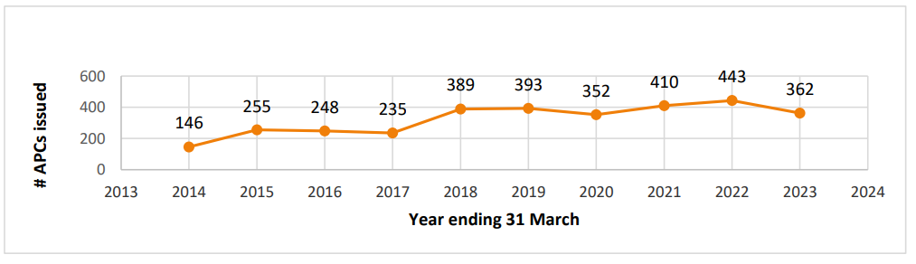

Figure 2-2: Ethnicity of the clinical physiologist workforce, 2023
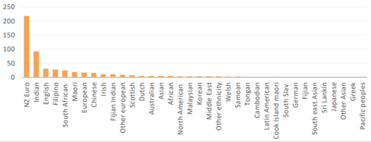

Figure 2-3: Gender of the clinical physiologist workforce, 2023

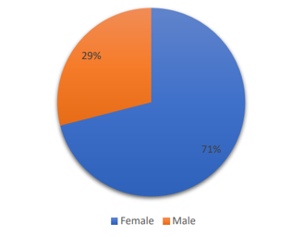

There is limited information available about the settings and roles that clinical physiologists work in.

Benefits of a highly-enabled clinical physiology profession
- Clinical physiologists provide essential diagnostic services that can help prevent both acute and long-term physiology-based health conditions.
- Providing timely, appropriate access to clinical physiology services and expertise can significantly reduce the burden on specialist services and the wider health system through early detection and preventative management of health conditions.

Key issues for the clinical physiology profession in realising its full potential to help achieve pae ora
Key themes | Key issues
Workforce | - It is challenging to retain experienced clinical physiologists, and this means it can be challenging to support people who are new to the profession.  - The career pathway in clinical physiology is limited which can contribute to workforce retention issues.  - While there is demand for clinical physiology services, it is not well understood how many more clinical physiologists are needed to meet demand.  - Insufficient workforce capacity impacts on access to diagnostics and treatment.
Training | - For some scopes of practice, postgraduate qualification requirements may create barriers to access for priority student populations.  - Training is not available for all physiologist professions in Aotearoa. There are currently no Aotearoa training programmes for neurophysiology or respiratory physiology. This means some clinical physiology services are very vulnerable in this country.
Funding | - The current funding model creates barriers to accessing some physiology services. For example, there is real opportunity to manage the burden of disease through exercise physiology, however, these services are not publicly funded.
Models of care | - Clinical physiology is not well integrated into models of care and service delivery.  - The role of physiology has changed through the use of technology and the health system has not kept up to utilise physiologists’ skillsets. Safe and expedient pathways are required because physiology services can offer effective management pathways which reduce pressures on specialists.
Equity | - The current workforce does not reflect our population groups, and there are not enough Māori and Pacific peoples in the workforce. Gender distribution is also not reflective of the population.  - More support is needed to improve clinical physiologists’ and students’ culturally safe practices.

Key opportunities to fully realise the potential of the clinical physiology profession
Key themes | Key opportunities
Promotion and advocacy for the profession | - Promote the clinical physiology profession and the breadth of the profession’s work so that people involved with decision making, policy and service design and improvement understand the value of the profession.  - Promote the profession to students considering career pathways to provide a better understanding of the different scope of practice options.
Training | - Ensure effective collaboration between the sector and educators to develop fit-for purpose training across all scopes.  - Improve support for students and new graduates across the regions and provide better support mechanisms for placements and supervision.  - Increase Māori and Pacific peoples enrolling to clinical physiology qualifications to help the workforce better reflect the population needs.
Workforce support | - Develop clinical physiology career progression pathways that are transparent and nationally consistent.  - Provide clinical support to clinical physiologists working regionally and rurally (for example, virtually), to ensure they are enabled to deliver safe and high-quality services.  - Improve understanding of staffing required to meet service demands now and in the future.  - Explore options for enabling technicians to progress up to qualified physiologist roles.
Models of care | - Adopt a national approach to clinical physiology services to ensure there is consistent access across Aotearoa and the needs of the different communities are met.  - Introduce ‘travelling clinics’ to provide services to communities in rural areas to improve access.  - Expand and integrate services into the community, such as screening for chronic disease and prevention services.
Funding | - Prioritise changes to service design and delivery.  - Increase workforce numbers to better meet population needs.
Equity | - Integrate cultural safety and anti-racism in clinical physiology training and professional development.  - Improve consistent access to all physiology groups. For example, exercise physiology is predominantly only available in the private sector, but access to this would benefit patients in the public system as well.  - Introduce remote monitoring to improve access.

Dietetics
Dietitians are registered health practitioners who study the science of food and nutrition and translate it into practical strategies. Dietitians work in partnership with individuals, whānau, communities and populations, in different states of health and disease, to support optimal health and wellbeing. They work in a variety of contexts, including promoting and protecting public health, directing and delivering medical nutrition therapy services and managing food and health systems.

They may have a variety of roles, including policy development, leadership, management, research, education and communication.

Dietitian prescribed qualifications and registration pathways
Domestic graduates
- Master of Health Sciences in Nutrition and Dietetics – University of Auckland
- Master of Science (Nutrition and Dietetics) – Massey University
- The previous Master of Dietetics from University of Otago is also accepted for registration.
Australian trained dietitians
- Mutual Recognition Voluntary Relationship Charter (MRVRC): dietitians who have full Accredited Practicing Dietitian (APD) status credentialled by the Dietitians Association of Australia (those who have practised for at least one year and completed their provisional APD programme) may be eligible for registration in Aotearoa.
Overseas trained dietitians
Assessment of the applicant includes the applicant meeting the criteria listed below, followed by a Board examination:
- Completed undergraduate and/or postgraduate nutrition and dietetic training of at least four years
- Hold a current registration/credential, or can demonstrate eligibility for registration/credential as a dietitian with the dietetic credentialing body in the country of tertiary education or practice
- Have practiced as a dietitian within the last three years in the country where they hold registration/credential or have completed their qualification within the past two years
- Meet the Dietitians Board’s English language requirements for practising in Aotearoa.

Workforce data
Information provided by the Dietitians Board based on data from their 2021/22 annual report

Figure 3-1: Number of dietitian APCs by year, 2016–2022
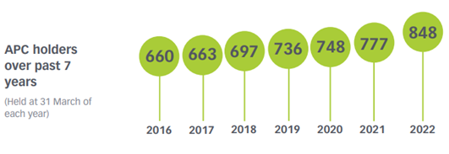
Figure 3-2: Gender of dietitian workforce, 2023
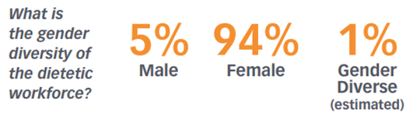

Figure 3-3: Ethnicity of dietitian workforce, 2023  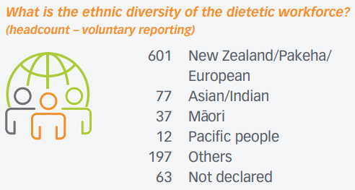 | Figure 3-4: Country of training for dietitian workforce, 2023  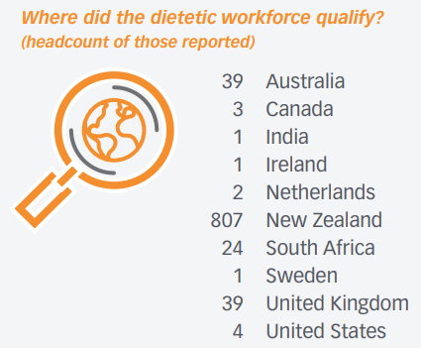
Figure 3-5: Fields worked in by dietitians in public hospitals, 2023  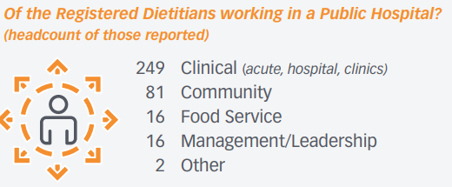 | Figure 3-6: Where dietitians work, 2023  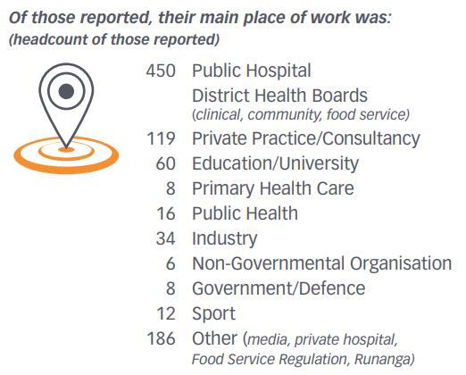

Benefits of a highly-enabled dietetics profession
- Dietitians can help improve health outcomes for whānau by providing individualised nutrition advice and specialised medical nutrition therapy.
- They support the nutritional wellbeing of whānau across all phases of life and levels of health care. If people are not nutritionally well, their response to other treatments may not be effective for their health and wellbeing. Therefore, dietitians play an essential role in supporting the wellbeing of individuals, whānau, iwi, hapū and other communities – through both generalist and specialist roles.

Key issues for the dietetics profession in realising its full potential to help achieve pae ora
Key themes | Key issues
Professional advocacy and promotion | - Currently there is poor public awareness of the dietetic profession and the skillsets held within it.  - There is limited understanding and recognition of the role of dietitians within Māori and Pacific health services as well as in rural settings.
Workforce and training | - There are currently insufficient workforce numbers available to meet growing demands for dietetic services throughout the health system. This limits the growth of the profession into priority settings such as mental health services, rural settings, primary and community care, and kaupapa Māori and Pacific providers.  - The make-up of the dietetic workforce does not reflect the population it serves.  - Current qualification requirements are a barrier to accessing and completing dietetic training (five years, full-time study is currently required).  - Retention of experienced dietitians is a key challenge for reasons including, but not limited to, inequitable pay across settings, experiences of racism within the workplace, lack of career progression pathways, and lack of opportunities.
Scope of practice | - Dietitian prescribing rights are currently limited compared to other professions.
Funding | - There is inadequate investment prioritisation to support training (programme delivery and student placements).  - Current funding models do not prioritise or facilitate equitable health outcomes.  - Funding decisions which impact the provision of dietetic services are not made in consultation with dietitians.
Models of care | - Current service models do not facilitate early dietitian involvement in a person’s health journey, which is essential to optimise outcomes.  - Dietitians are currently under-represented in key services such as food services, mental health services, rural health services, primary and community care, and kaupapa Māori and Pacific health services.
Equity | - Māori and Pacific Peoples are significantly under-represented in the dietetics workforce.  - Current training models are not informed by kaupapa Māori – accreditation guidelines must support and enable this.  - There is a lack of culturally appropriate training for students and the workforce.

Key opportunities to fully realise the potential of the dietetics profession
Key themes | Key opportunities
Professional advocacy and promotion | - Develop robust information for the public about what dietitians do and the many ways they can support health and wellbeing.  - Promote the profession in primary and secondary school environments to increase awareness of dietetics as a career option.
Workforce and training | - Increase workforce numbers by targeting training pathways in multiple ways, such as: reviewing accreditation standards to ensure qualification requirements are not a barrier for potential students, particularly Māori and Pacific peoples; exploring new models of training with a focus on facilitating pathways into the profession and supporting flexible training options, such as part-time and online training.  - Increase retention through fair and equitable remuneration and provision of career development opportunities, such as regional or international secondments.  - Explore the use of dietitian assistants to support dietitians.
Scope of practice | - Support dietitians to work to their full scope of practice to support optimal provision of care, for example, by extending prescribing rights where appropriate and leading diabetes management.  - Expand the current dietitian scope of practice to provide sustainable, safe and effective services to patients.
Funding | - Prioritise training to help increase education and financial support for students to complete training, and provide support for service providers offering student placements.  - Ensure funding models support equitable health outcomes by prioritising dietetic services for Māori, Pacific, rural and primary health care providers.
Models of care | - Improve integration of dietitians into primary health care, mental health, public health and Māori and Pacific health service providers to improve access to dietetic services for priority populations.  - Establish nationally consistent dietitian-led health care pathways.
Equity | - Increase the use of telehealth to improve access.  - Increase workforce numbers to better serve communities, with a focus on service provision to Māori, Pacific peoples, rural, primary health care and mental health providers.  - Ensure accreditation guidelines support and enable training programmes to be informed by kaupapa Māori models.

Medical imaging and radiation therapy

Medical imaging technologist
Medical imaging technologists (MITs) use ionising radiation to produce high-quality diagnostic radiographs and carry out diagnostic procedures. With training, MITs may practise computed tomography (CT), mammography and angiography. The MITs evaluate the diagnostic quality of images and take corrective measures as required.

Magnetic resonance imaging technologist
Magnetic resonance imaging (MRI) technologists use a powerful magnetic field to produce high-quality diagnostic images. MRI technologists may at their discretion (following clinical and workplace guidelines) extend their examination to include relevant regions and/or sequences not suggested in the referral or protocol.

Nuclear medicine technologist
Nuclear medicine technologists (NMTs) prepare, administer and quantify diagnostic pharmaceuticals to assess organ and molecular function. They also deliver therapeutic radiopharmaceuticals to treat a number of pathologies.

Radiation therapist
Radiation therapists (RTs) are responsible for planning and delivering radiation treatment, primarily for people diagnosed with cancer. RTs create and evaluate images for the treatment area and plan and deliver radiation treatment according to the radiation oncologist’s prescription.

Medical Radiation Technology Board prescribed qualifications for medical imaging and radiation therapy (excluding sonography)

Aotearoa qualifications
Place of education | Qualification programme | Scope of practice
Ara Institute of Canterbury | Bachelor of Medical Imaging | Medical imaging technologist
UNITEC Institute of Technology | Bachelor of Health Science (Medical Imaging) | Medical imaging technologist
Universal College of Learning (UCOL) | Bachelor of Applied Science (Medical Imaging Technology) | Medical imaging technologist
University of Otago | Bachelor of Radiation Therapy | Radiation therapist
University of Auckland | Bachelor of Medical Imaging (Honours) | Medical imaging technologist
 | Postgraduate Diploma in Health Sciences in Magnetic Resonance Imaging | Magnetic resonance imaging technologist
 | Postgraduate Diploma in Health Sciences in Nuclear Medicine | Nuclear medicine technologist

Overseas-trained
The Medical Radiation Technology Board (MRTB) has established pathways for overseas-trained medical imaging and radiation therapy professionals to register in Aotearoa.

Workforce data
Information provided by the MRTB based on data from their 2021/22 annual report

Table 4-1: Registered medical imaging and radiation specialists by scope of practice, 2022
Group | Number with scope of practice±
Medical imaging technologist | 2,024
Magnetic resonance imaging technologist | 330
Nuclear medicine technologist | 69
Radiation therapist | 431
± 4.2% of practitioners held an APC in more than one scope of practice.

Figure 4-1: Ethnicities (percentage) of medical imaging and radiation specialist APC holders, 2021–2022
This data includes practitioners holding an APC in a training scope and practitioners who hold an APC in more than one scope of practice. This data includes sonographers, which are covered in a separate chapter later in this report. This figure is from the MRTB Annual Report 2021/22. Sonographers are regulated by the MRTB and are therefore included in the workforce data within their annual report.

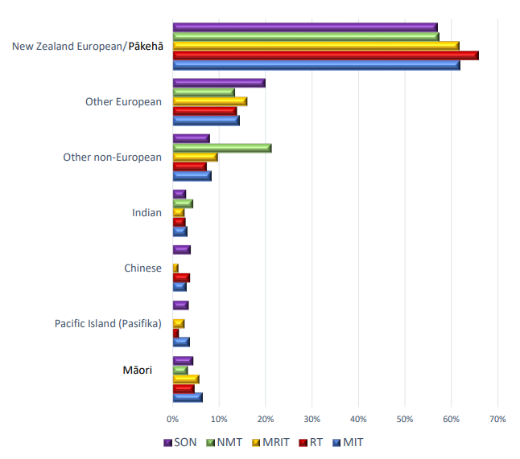
SON Sonographers
NMT Nuclear medicine technologist
MRIT Magnetic resonance imaging technologist
RT Radiation therapist
MIT Medical imaging technologist

Medical imaging technologists
Information provided by the MRTB based on data from their 2021/22 annual report

Table 4-2: Registered MIT APC numbers, 2018–2022  Year Total APC issued  2018 1,829  2019 1,903  2020 1,997  2021 2,041  2022 2,024 | Table 4-3: Initial MIT registrations by country trained in, 2022  Country No. of registrations  Australia 10  Canada 1  United Kingdom 20  Fiji 1  India 1  Ireland 6  Aotearoa 86  Philippines 3  South Africa 21  United States of America 2  Total 151

Age and gender of MITs is collected by the MRTB but is not publicly available.

Magnetic resonance imaging technologists
Information provided by the Medical Radiation Technologists Board (MRTB) based on data from their 2021/22 annual report

Table 4-4: MRIT APC numbers, 2018–2022  Year Total APCs issued  2018 263  2019 277  2020 288  2021 310  2022 330 | Table 4-5: Initial MRIT registrations by country trained in, 2022  Country No. of registrations  Australia 1  United Kingdom 4  Ireland 1  Aotearoa 24  South Africa 3  Total 33

Registered MRITs by age and gender
This information is collected by the Medical Radiation Technologists Board (MRTB) but is not publicly available.

Nuclear medicine technologists
Information provided by the Medical Radiation Technologists Board (MRTB) based on data from their 2021/22 annual report

Table 4-6: NMT APC numbers, 2018–2022  Year Total APCs issued  2018 63  2019 66  2020 68  2021 79  2022 69 | Table 4-7: Initial NMT registrations by country trained in, 2022  Country No. of registrations  Australia 3  Canada 1  Ireland 1  Aotearoa 1  Total 6

Registered NMTs by age and gender
This information is collected by the Medical Radiation Technologists Board (MRTB) but is not publicly available.

Radiation therapist
Information provided by the Medical Radiation Technologists Board (MRTB) based on data from their 2021/22 annual report

Table 4-8: RT APC numbers, 2018–2022  Year Total APCs issued  2022 431  2021 464  2020 448  2019 421  2018 408 | Table 4-9: Initial RT registrations by country trained in, 2022  Country No. of registrations  Australia 7  United Kingdom 6  Aotearoa 17  Hong Kong 1  South Africa 2  Total 33

Registered RT by age and gender
This information is collected by the Medical Radiation Technologists Board (MRTB) but is not publicly available.

Benefits of a highly-enabled medical imaging and radiation therapy profession
- The medical imaging and radiation therapy workforce enables high-quality diagnostic information to be gathered for health professionals and the patient to inform timely decisions about correct diagnosis and appropriate treatment. Their work can reduce the burden of disease on our health system through early detection and prevention, which supports all New Zealanders to live well for longer.
- Making improvements in the medical imaging technology profession will result in increased workforce engagement and retention, improved access to services, improved health outcomes and a reduced burden on the health system.
- Ensuring that the medical imaging and radiation therapy workforce reflects the population it serves and provides timely, equitable access to culturally safe and effective services will provide pivotal support toward achieving equity in health outcomes.

Key issues for the medical imaging technology profession in realising its full potential to help achieve pae ora
Key themes | Key issues
Workforce | - A large proportion of the MIT workforce enters the private sector or goes overseas, causing workforce constraints in the public system.  - Burnout is associated with shift work.  - Current remuneration does not recognise or reflect skillsets.  - There is a lack of career advancement options for general MITs.
Training | - There are not enough student placements (including in private practice) compared with the number of students who are interested in pursuing a medical imaging qualification.  - There are insufficient trainee opportunities for MRI and nuclear medicine.  - Funding of training positions is inadequate.  - Accessing training is difficult for some prospective students for a number of reasons, including entry criterion  - Students can find it hard to balance study with financial requirements.
Models of care | - There is no capacity (due to workforce constraints) to expand services to meet need, for example, to extend hours.  - There is a culture of protecting skillsets to the detriment of sharing skills to advance the workforce knowledge.
Equity | - Access to diagnostics for priority and rural populations is not equitable and is often untimely.  - Our workforce does not reflect the population it serves.  - More work is needed to ensure the workforce is culturally safe and has access to cultural safety professional development.

Key opportunities to fully realise the potential of the medical imaging technology profession
Key themes | Key opportunities
Population benefits | - Improve access to diagnostic services, including increasing screening services and access to the knowledge and skills of the medical imaging workforce and identifying and responding to unmet need.  - Improve public understanding of the knowledge, skills and services available within the medical imaging workforce to help increase access to appropriate services as well as attract students into the workforce.  - Use the skills and knowledge of the medical imaging workforce for education purposes, such as public health issues.
Training | - Improve understanding of the common pipeline for training, flows to specific training (such as MRI, nuclear medicine, ultrasound) and impacts on general MIT training and workforce.  - Investigate training options to help workforce development, for example, earn-and-learn options for third-year students.  - Consider options to make training less reliant on existing workforce, for example, using simulation centres to augment hands-on training where appropriate.  - Consider alternative options for delivering course content, for example, taking lectures out of the classroom.  - Ensure students have breadth in their training to meet registration competencies.  - Encourage collaboration between the private and public sectors, for example, with postgraduate student placements.  - Develop radiology assistant apprenticeship/bridging programmes.  - Support students to pursue research.
Workforce | - Explore options for using the kaiāwhina and assistant workforce, with the possibility of staircasing and establishing a training pipeline. This would enable registered practitioners to work across their full scope of practice, improve access and increase the diversity of the workforce.  - Provide more detail on workforce data to inform decision making.  - Support the development of advanced skillsets and career development opportunities for general MITs.  - Support clinical specialists, such as in research or informatics, to improve staff retention and quality outcomes.
Models of care | - Consider implementing advanced practice options for general MITs (for example, reporting radiographers).  - Improve capacity and service models to enable crossover, for example, nuclear medicine also doing CT.  - Fully utilise the flexibility of existing scopes of practice to improve capacity as described above and to support professionals to fully utilise their knowledge and skills to support access to diagnostic imaging services.  - Support small, vulnerable services (for example, nuclear medicine) through national service delivery models.
Equity | - Improve access for priority populations.  - Grow the Māori and Pacific workforces through promotion and programmes such as Kia Ora Hauora.  - Increase support for rural student placement opportunities.

Medical laboratory science
Medical laboratory science is the collection, receipt, preparation, investigation and laboratory analysis of samples of human biological material to help with patient diagnosis, management, treatment and prevention.

Medical laboratory science also includes:
- medical laboratory management
- medical laboratory science research and development
- medical laboratory science teaching
- medical laboratory quality management.

Medical laboratory prescribed qualifications

Aotearoa qualifications
Provider of education | Qualification programme | Scope of practice
University of Otago | Bachelor of Medical Laboratory Science | Medical laboratory scientist
Massey University (Palmerston North) | Postgraduate Diploma of Health Science (Medical Laboratory Science) | Medical laboratory scientist
Auckland University of Technology (AUT) | Bachelor of Medical Laboratory Science | Medical laboratory scientist
 | Postgraduate Diploma in Medical Laboratory Science | Medical laboratory scientist
Ara Institute of Canterbury | New Zealand Diploma in Applied Science (Level 5) | Medical laboratory pre-analytical technician
New Zealand Institute of Medical Laboratory Science | Qualified Medical Laboratory Technician Certificate | Medical laboratory technician
 | Qualified Medical Laboratory Technician Certificate – Phlebotomy | Medical laboratory pre-analytical technician
 | Qualified Medical Laboratory Technician Certificate – Donor Technician
 | Qualified Medical Laboratory Technician Certificate – Specimen Services

Overseas trained
The Medical Sciences Council of New Zealand has established pathways for medical laboratory scientists, medical laboratory technicians, and pre-analytical technicians to achieve registration.

Workforce data
Information provided by the Medical Sciences Council of New Zealand based on data from their 2021/22 annual report

Medical laboratory science
Table 5-1: Medical laboratory scientists by scope of practice, 2022
Scope of practice | Number
Medical laboratory scientist | 1,890
Medical laboratory technician | 846
Pre-analytical technician | 1,135

Figure 5-1: Ethnicities (percentage) of medical laboratory science APC holders, 2021–2022
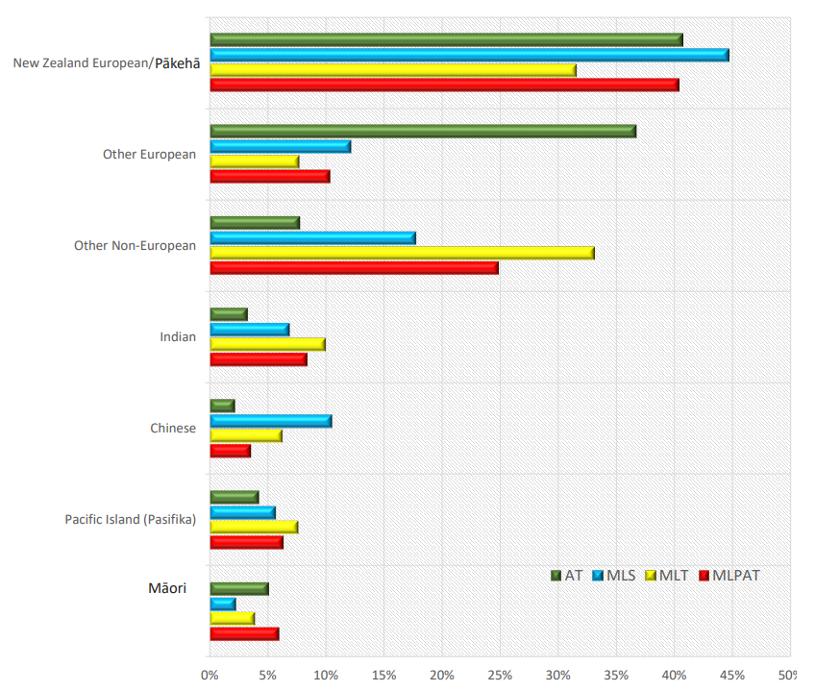
AT Anaesthetic technicians
MLS Medical laboratory scientist
MLT Medical laboratory technician
MLPAT Medical laboratory pre-analytical technician
More detailed ethnicity data is available.

Medical laboratory pre-analytical technicians (MLPAT)
Information provided by the Medical Sciences Council of New Zealand based on data from their 2021/22 annual report.

Table 5-2: MLPAT APC numbers, 2018–2022  Year Total certificates issued  2018 979  2019 1,066  2020 1,109  2021 1,146  2022 1,135 | Table 5-3: MLPAT registrations by country trained in, 2022  Country No. of registrations  Aotearoa 156  United Kingdom 2  Fiji 3  India 3  Philippines 10  United Arab Emirates 1  Australia 2  Total 177

Practising MLAPT by age and gender
This information is collected by the Medical Sciences Council but is not publicly available.

Medical laboratory technicians (2021–2022)
Table 5-4: Medical laboratory technicians APC numbers, 2018–2022  Year Total certificates issued  2018 897  2019 883  2020 868  2021 865  2022 864 | Table 5-5: Medical laboratory technicians registrations by country trained in, 2022  Country No. of registrations  Aotearoa 125  South Africa 6  USA 6  United Kingdom 5  Australia 2  Brazil 2  Canada 2  India 2  Ireland 2  Pakistan 2  China 1  Fiji 1  Hong Kong 1  Netherlands 1  Philippines 1  Zimbabwe 1  Total 160

Practising medical laboratory technicians by age and gender
This information is collected by the Medical Sciences Council but is not publicly available.

Medical laboratory scientists
Table 5-6: Medical laboratory scientists APC numbers, 2018–2022  Year Total certificates issued  2018 1,794  2019 1,823  2020 1,823  2021 1,845  2022 1,890 | Table 5-7: Medical laboratory scientists registrations by country trained in, 2022  Country No. of registrations  Aotearoa 166  United Kingdom 3  Fiji 4  India 11  Philippines 17  Australia 4  China 1  Nepal 1  South Africa 3  Sri Lanka 1  Singapore 1  USA 2  Ireland 1  Total 215

Practising medical laboratory scientists by age and gender
This information is collected by the Medical Sciences Council but is not publicly available.

Benefits of a highly-enabled medical laboratory science profession
- Clinicians can use laboratory test results to inform diagnosis and monitoring of treatment. This supports people to receive diagnoses and/or monitor their health conditions in a timely manner.
- Early diagnosis can support more effective management and treatment options for the individual, therefore improving health outcomes.
- Public health teams have quick access to screening results and public health surveillance activities, for example, infectious diseases, which supports early intervention.
- The medical laboratory profession conducts research and innovates in ways that meet the specific needs of Aotearoa to improve health outcomes.

Key issues for the medical laboratory science profession in realising its full potential to help achieve pae ora
Key themes | Key issues
Workforce | - Poor public understanding of what medical laboratory professionals do which impacts on student interest in entering these professions. Better promotion of the profession is necessary.  - Poor support and opportunity for new graduates as jobs are not guaranteed for new graduates in Aotearoa.  - Student placement opportunities are limited due to workforce pressures and shortages.  - Many experienced laboratory professionals are leaving the profession. They feel overworked, overwhelmed, undervalued, and not listened to.  - Aotearoa is unable to compete with other countries (such as the USA, Canada, Australia, United Kingdom) from a remuneration perspective – new graduates are registering and practising overseas.
Sector and professional development and leadership | - Currently there is ‘provider based’ governance of the sector, which is causing fragmentation and competition between providers and districts.  - There is a lack of career progression opportunities within medical laboratory settings.  - There is poor recognition of specialties and qualifications.  - Despite a highly translatable skillset, the profession is poorly represented within senior leadership roles throughout the health sector.
Models of care | - There is currently limited implementation of advanced/specialist roles for laboratory professionals – these roles could have a significant impact on improving access and outcomes.  - Current environmental and workforce constraints are significant barriers to implementing new models of care.
Funding | - Current funding models for laboratory services are inconsistent and do not facilitate equitable outcomes or improved models of care.  - Inadequate support for the education of medical laboratory scientists is a significant barrier.  - Support for both student placements and roles for new graduate scientists needs to be prioritised.  - There is no cohesive plan for service delivery across public-private recognising urban-rural discrepancies.
Equity | - The workforce does not represent the Aotearoa population.  - Currently there is a poor reflection of Māori cultural values within laboratory settings.  - Access to testing and collection centres in rural and remote areas is limited.

Key opportunities to fully realise the potential of the medical laboratory science profession
Key themes | Key opportunities
Workforce | - Increase workforce retention by improving remuneration and career development pathways.  - There is significant potential in the technician workforces (for example, supporting role extension and bridging into medical laboratory science).  - Support bridging courses for the technician and pre-analytical workforce to take them up to the scientific workforce.  - Explore alternative new graduate programmes to support workforce entry (similar to the funded nurse entry to practice (NETP) programme).
Sector and professional development and leadership | - Establish a national strategy and governance for pathology to ensure there is operational and professional leadership across the entire pathology sector.  - Expand career opportunities, for example, developing extended roles for scientists, opportunities for management and leadership.  - Improve integration of research into diagnostic laboratories, for example, by developing roles for research fellows within medical laboratories.  - Incorporate leadership and broader skillsets into programmes of education to support the growth of non-traditional laboratory roles.
Models of care | - Increase laboratory practitioners’ professional integration into multidisciplinary teams.
Equity | - Increase Māori representation within the laboratory workforce.  - Provide culturally safe support networks.  - Improve access to cultural safety education for students and the workforce, including learning how to engage with diverse populations.

Occupational therapy
Occupational therapists assess, diagnose and work with individuals and whānau to help people engage in the meaningful activities they need, want and are expected to do in their everyday life. Occupational therapists work with people at all stages of life who have health conditions, disabilities, injuries or risks to health and/or are encountering social or environmental barriers that prevent them from being meaningfully occupied.

Occupational therapy prescribed qualifications and registration pathways
Note: Additional training pathways are currently under development.
Domestic graduates
- Bachelor of Health Science (Occupational Therapy), Auckland University of Technology
- Bachelor of Occupational Therapy, Otago Polytechnic (Dunedin or Hamilton)
General pathway (internationally qualified)
A pass in an assessment (including an online course on Te Tiriti o Waitangi) set by the Occupational Therapy Board of New Zealand for people holding an occupational therapy qualification gained overseas.
Trans-Tasman mutual recognition
Those registered as an occupational therapist with The Occupational Therapy Board in Australia are eligible to apply for registration in Aotearoa under the Trans-Tasman Mutual Recognition Act 1997.

Workforce data
Information provided by the Occupational Therapy Board of New Zealand based on data from their 2022 annual report

Figure 6-1: Occupational therapists holding a current APC, 2018–2022  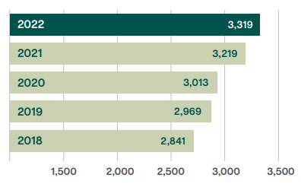 | Figure 6-2: Occupational therapist APCs by gender, as at 31 March 2022  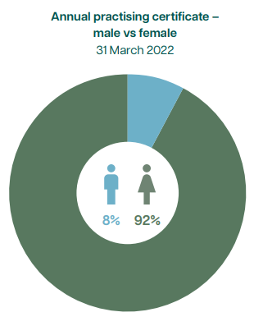
Figure 6-3: Overseas qualified occupational therapists, 2018–2022  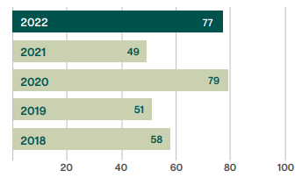 | Figure 6-4: Average age (in years) of occupational therapists with an APC, 2018–2022  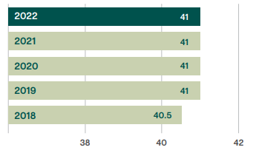
Figure 6-5: Māori and Pacific occupational therapist practitioners, 2018–2022
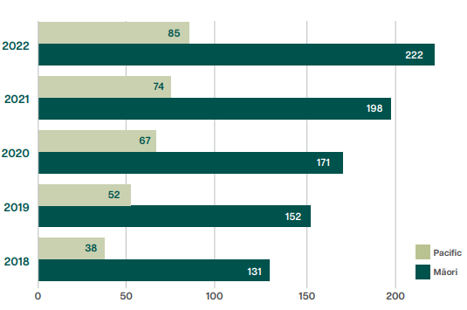

Figure 6-6: Occupational therapist numbers by role, 2020–2022
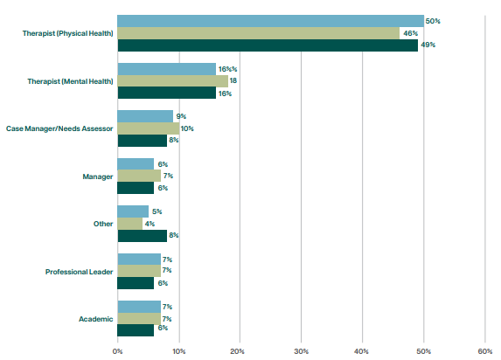
Figure 6-7: Occupational therapy practitioners by employing organisation, 2020–2022

Benefits of a highly-enabled occupational therapy profession
- People are supported to carry out the occupations they want, need or are expected to do.
- Individuals, whānau, hapū, iwi and communities receive help to reach their occupational goals and understand the opportunities and barriers and how to achieve overall wellbeing.
- Spaces and environments are assessed to enable people to participate in their everyday activities and occupations.
- The rights, responsibilities and opportunities of all individuals and whānau to engage in meaningful occupations are advocated with a view towards human rights, occupational and social justice, equity and sustainability.
- As one of the few health and social care registered professionals to be able to work across both physical and mental health care settings, occupational therapists are well placed to meet today’s health and social care demands by working with medical, paramedical and allied health professionals.

Key issues for the occupational therapy profession in realising its full potential to help achieve pae ora
Key themes | Key issues
Professional advocacy and promotion | - There is limited awareness, understanding and advocacy for occupational therapy, what occupational therapists do and the value of occupational therapists. Occupational therapists are often seen as equipment prescribers.
Workforce | - It is challenging to recruit occupational therapists. Reasons for this include the fact occupational therapists can earn more overseas, some occupational therapists in Aotearoa are paid less than nursing colleagues for the same role, overseas companies are approaching training providers to advertise jobs to new graduates, and there are not enough new graduates entering the Aotearoa workforce.  - There is attrition from acute settings due to limited practice opportunities and focus on equipment.  - Penal rates for occupational therapists working outside Monday to Friday are inadequate.  - Student placement opportunities are currently limited.  - We don’t have enough occupational therapy workforce data to capture the number of occupational therapists working in other roles, such as key worker roles.
Scope of practice | - It is hard for occupational therapists to work to their full scope – this is partly attributable to the limited available workforce and the demands of day-to-day operations.  - Occupational therapists are often seen as an equipment prescriber, particularly in acute and community settings, however there is more occupational therapy can offer in these settings.
Funding | - There is limited funding (and resources) for vocational rehabilitation and return-to-work support for people who are not eligible for ACC cover.  - Resources to support students and employers (for example, funding for student placements) to support workforce growth are prioritised by need and not currently managed at a national level, which creates disparities.
Equity | - There is low representation of Pacific and Māori practitioners.  - Access to occupational therapy education is not currently equitable and could be less campus-based and have more training options in the regions.  - The cultural safety, cultural competency and responsiveness of services and the workforce, particularly for Māori and Pacific peoples needs to be improved. Workplaces are not always well placed to support upskilling and integration.  - There is inequitable access nationwide to some occupational therapy services, such as limited access for rural communities and to community occupational therapy and iwi-based services. Occupational therapy is not available to the public on an equal level with other health professions.  - Access to driving assessments can be a challenge for people not funded under ACC, particularly for people in rural communities. This is important as rural communities are heavily reliant on private transport/driving.

Key opportunities to fully realise the potential of the occupational therapy profession
Key themes | Key opportunities
Professional advocacy and promotion | - Promote the value of the profession to the population’s health and social wellbeing, including to students in primary and secondary education.  - Include consumer feedback and evidence of efficacy to promote our value across diverse settings.
Workforce | - The allied health pay equity settlement will positively impact remuneration for occupational therapists.  - Explore options to train more occupational therapists in Aotearoa and attract overseas occupational therapists to work in Aotearoa.  - Introduce financial support for new graduates working in areas of high need.  - Introduce scholarships, internships and/or apprenticeships to support young people to access an occupational therapy degree differently. Te Pou and LeVa scholarship programmes are examples to learn from.  - Improve retention through availability and support for ongoing education and professional training, including interprofessional practice.  - Consider specific and consistent occupational therapy assistant training and qualifications and improve the utilisation of assistants along with upskilling of occupational therapists to effectively supervise and delegate in the workplace.
Scope of practice | - Enable occupational therapists to work at full scope of practice, for example, working in primary care and health promotion settings, or contributing to city and transportation planning.  - Consider developing specialist scope or special training - this may also provide more satisfying career pathway options to help with retention.  - Explore autonomous practice rights/abilities appropriate for occupational therapists.  - Enable prescribing rights (such as equipment and interventions).
Models of care | - Improve occupational therapy involvement in town and city planning, transport, housing modifications, accessibility, policy, and advocacy.  - Shift workforce towards admission prevention rather than discharge planning – take a holistic approach in acute work settings.  - Strengthen the workforce’s involvement in public tion, managing chronic conditions and in general practice / primary health care settings.
Equity | - Increase access to iwi-based care.  - Increase Māori representation in the workforce. One idea is to provide open whānau days for Māori – by whānau for whānau promotion to attract Māori to occupational training and workforce.  - Improve cultural safety training for students and all occupational therapists in the workforce.  - Decolonise existing health care services and institutions by addressing systemic racism and supporting cultural safety.  - Develop work and learn programmes specific to rural areas.  - Develop occupational therapy training programmes with the wānanga network.

Paramedicine

Paramedics
Paramedics are registered health practitioners who use their clinical knowledge and skills to provide health care services, generally in the form of urgent and/or emergency assessments, diagnoses and treatments of patients, including providing clinical advice, referral and, where required, transport.

Paramedics work with other health care providers and clinical personnel as a team, providing leadership, support and oversight of non-regulated members of the clinical team and ensuring services are provided in a timely and integrated fashion in partnership with individuals, whānau and communities.

Emergency medical technicians
Emergency medical technicians (EMTs) are clinically qualified ambulance personnel who have been trained to assess, treat and transport patients as required. EMTs can administer a range of treatments, for example, oral and intramuscular medicines.

Paramedic prescribed qualifications and registration pathways

Aotearoa qualifications
- Bachelor of Health Science (Paramedicine), Auckland University of Technology (AUT)
- Bachelor of Health Science (Paramedic), Te Pūkenga trading as Whitireia New Zealand.
Trans-Tasman mutual recognition
Paramedics who hold current registration with the Australian Health Practitioner Regulation Agency (AHPRA) can apply for registration with Te Kaunihera Manapou | Paramedic Council (Te Kaunihera) under the Trans-Tasman Mutual Recognition Act 1997 (TTMR Act).
Overseas-qualified paramedics
Anyone who has completed their paramedicine training overseas and whose qualification is not approved by Te Kaunihera or cannot be assessed via the TTMR Act can apply to have their qualification considered independently. Under section 15(2) of the Health Practitioners Competence Assurance Act 2003, Te Kaunihera can treat any overseas qualification as a prescribed qualification (approved qualification) if, in the opinion of Te Kaunihera, the qualification is equivalent to, or as satisfactory as, a prescribed qualification.

Emergency medical technicians prescribed qualifications
Emergency medical technician pathways
- Diploma in Paramedic Science (level 6), Auckland University of Technology (AUT)
- Bachelor of Health Science (or equivalent) from a Paramedicine Accreditation Committee accredited programme
- Completion of the first three semesters of a Bachelor of Health Science, Paramedicine at AUT or Whitireia
- New Zealand Diploma in Ambulance Practice (Level 5), Te Pūkenga trading as Whitireia New Zealand

Workforce data
Information provided by Kaunihera Manapou, Paramedic Council based on data from their 2022 annual report

Table 7-1: Registered paramedics, 2021, 2022  Year Total certificates issued  2022 1,770  2021 498 | Table 7-2: Registered paramedics by primary ethnicity, 2022  Primary ethnicity Total headcount Percentage  Māori 98 5.5%  Pacific peoples 30 1.7%  Other 1,642 92.8%
Note: Paramedic registration opened on 12 March 2021 and registration numbers are measured annually on 31 March.

Figure 7-1: Initial registrations by registration pathway, 2022
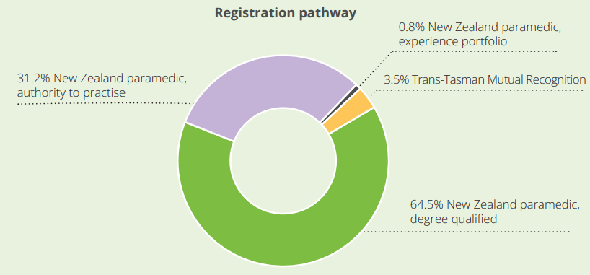

Figure 7-2: Registered paramedics by gender (1,770 paramedics), 2022
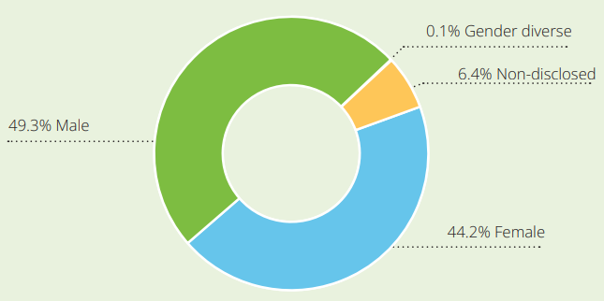

Figure 7-3: Registered paramedics by age in years (1,770 paramedics), 2022
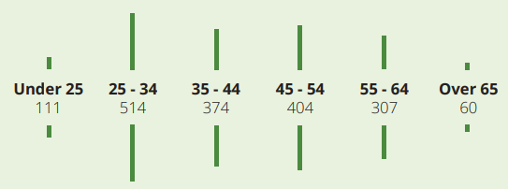

Figure 7-4: Paramedic employment situation, 2022
Of the 1,285 paramedics who completed a workforce survey during their APC renewal as of March 2022:

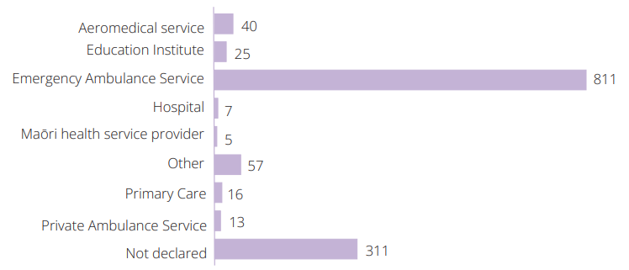

Figure 7-5: Where paramedics are employed by Te Whatu Ora district, 2022
Of the 1,285 paramedics who completed a workforce survey during their APC renewal as of March 2022:

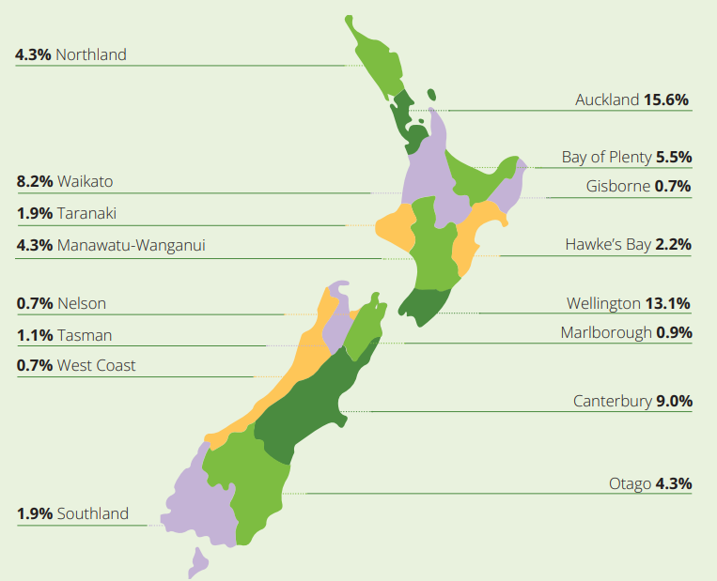

Emergency medical technicians
Definitive workforce data for emergency medical technicians (EMTs) is not publicly available. Currently, EMTs are not regulated by a professional body or responsible authority, and centralised data collection is not available for this workforce.

Benefits of a highly-enabled paramedicine profession
- People and whānau can receive high-quality urgent, primary and/or emergency assessment, diagnosis and treatment as well as clinical advice, referral and, where required, prompt transport to the most appropriate hospital so that they can receive ongoing assessment and treatment in a secondary or tertiary health care service.
- Quick response times support early assessment and treatment.
- The paramedicine workforce is equipped to deliver mobile and responsive care to all areas across Aotearoa and works across many sectors, such as primary health care and palliative care, in partnership with other health professionals. This supports people to stay well in their communities.

Key issues for the paramedicine profession in realising its full potential to help achieve pae ora
Key themes | Key issues
Training | - Clinical placement opportunities are limited and therefore may not be representative of the communities that qualified professionals go on to practice in.  - Student wellbeing is challenging – better support is needed for students.  - There is a high reliance on an overseas-trained workforce. Increased training and promotion of the profession within Aotearoa is essential.
Scope of practice | - Complicated and inconsistent employer onboarding and clinical assessment processes exist, preventing paramedics from being professionally recognised and utilising their full scope of practice as soon as they are employed.
Workforce | - It is currently challenging to retain adequate numbers of experienced paramedics within ambulance services.  - Variable pay rates across the sector may contribute to maldistribution and general attrition of the workforce.  - Support and supervision for paramedics in isolated/remote settings is lacking.  - Due to current system settings, employer needs and interests have a strong influence on the overall direction of the profession. This needs to be balanced against other considerations such as safety and competence of the workforce and evidence-based models of care and service delivery.  - Unmet need in primary and community health care is putting pressure on paramedicine professionals trying to meet emergency needs.  - Other health disciplines do not yet fully accept paramedics working in non-traditional spaces, for example, in primary health care.  - The paramedicine workforce is ‘filling gaps’ in health delivery across services, such as mental health and palliative care, due to shortages within these professions and lack of 24/7 availability in these services.
Models of care | - As we shift into new models of care, there is the potential for paramedics to lose their unique skillset. The current models of care do not support desired changes, such as workforce pipeline development, advanced practice and integration into interprofessional services.  - Services are slow to adopt new technologies to improve services, which is in part due to restrictions in the funding model.  - Key technology enablers (for example, electronic patient records) are often not ‘mobile friendly’ and are geographically inconsistent. This limits paramedics’ ability to access patient clinical records in emergency situations and to make safe, informed clinical decisions.  - The ACC cost of treatment regulations limit the ability for primary health care practices that employ paramedics to claim for care provided by paramedics, for example, wound care, Primary Response in Medical Emergencies (PRIME) responses and radiology referrals. Paramedics are not able to get an ACC provider number.
Equity | - Access and pathways into the profession do not currently support the development of a workforce that reflects the different populations of Aotearoa.  - The workforce needs better training (including those who have trained overseas) to increase their knowledge of Te Tiriti o Waitangi and provide culturally safe care.

Key opportunities to fully realise the potential of the paramedicine profession
Key themes | Key opportunities
Training | - Increase the promotion of paramedicine as a career pathway.  - Establish a sector-wide workforce development pathway from assistant roles through to qualified and specialist paramedics to sustain workforce and service delivery.  - Bring access to paramedicine tertiary education closer to home, for example, through block courses and clinical placements – this is a key enabler in developing a workforce that reflects our population.  - Improve support for student placements, from supervision to funding.  - Increase support for students to complete their training.  - Guarantee employment as a paramedic after completion of training.  - Improve funding to support training of the specialist workforce to meet the needs of patients.  - Introduce bridging courses for professionals to increase their scope of practice, especially in primary health care.
Scope of practice | - Partner with, and build the confidence of, other professions in the community to optimise the ability to work effectively in primary health care settings.  - Explore implementing prescribing to improve access to essential medicines for individuals and whānau and reduce reliance on standing orders, which were not designed to support routine practice and care.  - Add paramedics to the ACC Cost of Treatment Regulations to enable primary health care teams that employ paramedics to claim for the care paramedics provide and to enable the paramedic workforce to be used most effectively.  - Fully utilise the paramedicine skillsets to support delivery of care in rural communities, for example, as part of the Primary Response in Medical Emergencies (PRIME) programme.  - Clarifying the scope of practice will facilitate effective integration into interprofessional teams and service models.  - Consider enabling referrals for diagnostic testing, for example, radiology and laboratory (which would be supported by appropriate training).
Workforce | - Support paramedics to work differently and beyond their ambulance service roles.  - Acknowledge the inherent leadership, crisis management and coordination skills that exist within the profession and offer opportunities to utilise these skills in a variety of ways (to improve retention and satisfaction).  - Fully integrate emergency medical technicians into profession and workforce planning.  - Develop a focused, jointly funded retention plan for paramedicine professionals.  - Expand the range of paramedic rosters / hours of work within ambulance services beyond the four-on, four-off roster pattern, for example, include shorter shifts, day shifts only, job sharing, part-time and casual opportunities.  - Enable paramedics to work for more than one employer, for example, part time for an ambulance service and part time for a primary health care service.  - Grow the number (and range) of clinical and professional leadership roles available to paramedics to retain skilled clinical leaders within the profession and enhance paramedicine leadership.
Models of care | - Collaborate and integrate more with other professions and non-emergency services throughout the health sector.  - Increase paramedicine’s presence and contribution in primary health care.  - Fully utilise specialist paramedic skillsets through well-designed models of care.  - Evaluate service need to support workforce planning and development, including the ratio of emergency medical technicians to paramedics to meet specific community needs.  - Explore the potential for expanding the paramedic practitioner role in Aotearoa.  - Examine the gaps in health delivery that paramedics can fill, and plan (with funding support) ways to use a mobile workforce, such as paramedics, to fill gaps.
Equity | - Integrate ao mai te rā anti-racism kaupapa into the profession.  - Engage with iwi to develop accessible training pathways and options.  - Ensure that the profession provides a culturally safe environment for Māori professionals.  - Improve sharing and uptake of paramedicine’s potential to support and drive equitable health outcomes – this profession is a bridge between community and acute care environments and therefore possesses a unique perspective on the drivers of and solutions to inequitable health outcomes.  - Increase the number of wāhine Māori and Pacific in specialist clinical roles and paramedicine leadership.

Pharmacy

Pharmacists
Pharmacists provide whānau communities with access to appropriate medicines and advice on how to use those medicines. They play a critical role in the supply, safety and optimal use of medicines, and in some situations, they will administer medicines, for example, immunisations.

Pharmacists also advise health care professionals on the safe and effective use of medicines. This includes, advice on medicine interactions, medicine-condition interactions, indication and dosing for medicine use, medicine administration and medicines use in pregnancy and breastfeeding. They work collaboratively with other health professionals in the prevention, assessment, treatment, and management of medical conditions.

Pharmacist prescribers
Pharmacist prescribers have completed additional post-graduate qualifications and work with people on optimising their medicine therapy to achieve the best possible health outcomes, reduce medicines-related harm and reduce health inequities. Their contribution can reduce pressure on the health system whilst improving access to and quality use of medicines.

Pharmacy technicians
Pharmacy technicians help pharmacists prepare prescriptions: they help process prescriptions and patient records. Pharmacy technicians in hospitals are also involved with the supply of medicines to wards and reconciliating and managing medicines.

Pharmacy technicians always work under the supervision of a pharmacist.

A certified pharmacy accuracy checking technician (PACT) is a pharmacy technician who has undertaken additional training to undertake the final accuracy check on a dispensed medicine that has been clinically approved by a pharmacist.

Pharmacy assistants
In a community pharmacy, pharmacy assistants work in the retail side of the pharmacy. They are often the first point of contact with customers.

In a hospital pharmacy, pharmacy assistants are involved in managing the pharmacy’s stock, distributing medicines to wards and a range of other activities to ensure the smooth operation of the pharmacy.

Pharmacist prescribed qualifications and registration pathways
Intern pharmacist scope of practice
- Bachelor of Pharmacy or Bachelor of Pharmacy (Honours), University of Auckland, or
- Bachelor of Pharmacy, University of Otago
- Australian pharmacy degrees from schools of pharmacy holding either full or conditional accreditation from the Australian Pharmacy Council.
Pharmacist scope of practice, New Zealand qualification
- Bachelor of Pharmacy or Bachelor of Pharmacy (Honours), University of Auckland; or
- Bachelor of Pharmacy, University of Otago, and
- successful completion of the EVOLVE intern training programme, and
- successful pass in an assessment centre examination.
Trans-Tasman mutual recognition
Pharmacists in Australia can apply for registration with the New Zealand Pharmacy Council under the Trans-Tasman Mutual Recognition Act 1997, if they:
- are currently registered and in good standing in Australia, and
- have successfully completed a New Zealand Pharmacy Council competence programme within three months of registration.
Recognised Equivalent Qualification Route pharmacists
The Recognised Equivalent Qualification Route (REQR) process is open to practising pharmacists who:
- gained their pharmacy degree in Canada, Ireland, the United Kingdom (UK) or the United States of America (USA), or
- successfully completed an approved programme from a learning institution in one of the above countries (that is, PEBC in Canada, OSPAP in the UK or NAPLEX in the USA).
The applicant must sit and pass the computer-based, competency assessment of overseas pharmacists (CAOP) examination delivered by the Australian Pharmacy Council.
Non-Recognised Equivalent Qualification Route (Non-REQR) pharmacists
Details on this registration process are on the Pharmacy Council website.
Pharmacist prescriber scope of practice
- Postgraduate Certificate in Clinical Pharmacy in Prescribing, University of Auckland, or
- Postgraduate Certificate in Pharmacist Prescribing, University of Otago.

Workforce data
Information provided by the Pharmacy Council based on data from their Pharmacy Workforce Demographic 2022 report

Table 8-1: Current pharmacy registrations by scope of practice (30 June 2022)
Intern pharmacists | 249
Pharmacists  (exclusive of prescribers) | 4,072
Pharmacist prescribers | 46

Table 8-2: Pharmacist number of APCs, 2018–2022
Year | Registered, current pharmacists | Percent change
2018 | 3,787
2019 | 3,832 | 1.2%
2020 | 3,940 | 2.8%
2021 | 4,062 | 3.1%
2022 | 4,118 | 1.4%

Table 8-3: Pharmacist registration route, 2018–2022
Registration Route | 2018 | 2019 | 2020 | 2021 | 2022
Graduates (New Zealand and Australia) | 234 | 200 | 161 | 242 | 191
Trans-Tasman Mutual Recognition Act 1997 | 15 | 8 | 10 | 2 | 6
Recognised Equivalent Qualification | 8 | 11 | 20 | 10 | 10
Non-Recognised Equivalent Qualification | 2 | 6 | 9 | 10 | 9
Total | 259 | 225 | 200 | 264 | 216
Table 8-4: Pharmacist ethnicity by age group, 30 June 2022
Primary Ethnicity | Age group |  |  |  |  |  | Total
 | Less than 25 | 25-34 | 35-44 | 45-54 | 55-64 | Over 65
European | 62 | 502 | 386 | 439 | 441 | 159 | 1,989
Māori | 6 | 37 | 19 | 13 | 9 | 3 | 87
Pacific | 2 | 17 | 12 | 1 | 1 | 0 | 33
Asian | 79 | 766 | 407 | 141 | 49 | 9 | 1,451
Middle Eastern, Latin American and African | 4 | 83 | 73 | 24 | 16 | 2 | 202
Other | 16 | 133 | 88 | 54 | 49 | 16 | 356
Total | 169 | 1,538 | 985 | 672 | 565 | 189 | 4,118

Figure 8-1: Comparison of pharmacists’ age (smoothed) by gender, 2021, 2022
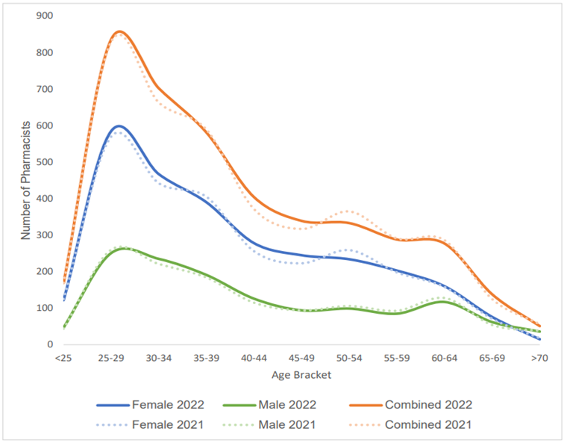

Table 8-5: Primary type of pharmacy practice undertaken by practising pharmacists, 2022
Primary type of pharmacist work | Pharmacists | Percentage
Community pharmacy | 3,037 | 76%
DHB (excluding hospital pharmacy work) | 71 | 2%
General practice | 49 | 1%
Hospital pharmacy | 551 | 14%
Other | 117 | 3%
Pharmaceutical industry | 38 | 1%
Pharmacy related organisations | 38 | 1%
Primary Health Organisation | 37 | 1%
Note: The majority of primary health organisation pharmacists work in general practice (primary health care

Table 8-6: Number of return-to-practice applicants by years since last in practice, 2019–2022
Years since last practice in New Zealand | 2019 | 2020 | 2021 | 2022
Less than 3 years | 88 | 86 | 75 | 82
3-8 years | 12 | 12 | 12 | 11
More that 8 years | 2 | 0 | 1 | 1
Total | 102 | 98 | 88 | 94

Table 8-7: Average hours per week worked in scope by practising pharmacists, 2022
Hours worked per week | 10 or fewer | 11-19 hours | 20-29 hours | 30-39 hours | 40-49 hours | 50+ hours | Total
Community pharmacy | 99 | 15 | 324 | 538 | 1,538 | 388 | 3,037
Hospital pharmacy | 12 | 22 | 79 | 60 | 363 | 15 | 551
Other | 6 | 8 | 21 | 29 | 49 | 4 | 117
District Health Board (excluding Hospital pharmacy) | 2 | 3 | 9 | 19 | 34 | 4 | 71
Teaching/researching | 3 | 6 | 13 | 13 | 25 | 10 | 70
General practice | 2 | 5 | 7 | 16 | 19 | - | 49
Pharmaceutical industry | 1 | 3 | 1 | 9 | 19 | 5 | 38
Pharmacy related organisation | 2 | 3 | 9 | 4 | 18 | 2 | 38
Primary Health Organisation | - | 1 | 10 | 13 | 13 | - | 37
Total | 127 | 201 | 473 | 701 | 2,078 | 428 | 4,008
The information above reflects registered pharmacists’ primary place of work, however, it should be noted that many pharmacists working in community and primary health organisation settings also work in general practice settings.

Pharmacy technicians
Workforce data on pharmacy technicians is not available.

Pharmacy assistants
Workforce data on pharmacy assistants is not available.

Benefits of a highly-enabled pharmacy profession
- People are informed about the safe use of their medicines to best manage their health condition(s) and improve their health and wellbeing. Pharmacists have unique knowledge and skills in pharmacotherapy to optimise medicine therapy, thereby improving health outcomes, reducing patient harm from preventable adverse medicine events and improving medicine adherence and persistence.
- Pharmacists can work with people with complex medical conditions and medicines, improve access to medicines, help reduce the risk of avoidable complications and reduce pressures on other clinicians, which can lead to reduced wait times. They can diagnose and treat minor conditions in the community; and they provide patients with easier and faster access to the diagnosis and treatment they need. This can help ease the pressure on other parts of the health system.
- Pharmacists are actively involved in shared decision making with individuals and whānau regarding disease management and medicine choices and actively monitor health changes and outcomes.
- Pharmacists play a critical role in managing the procurement and supply of medicines in Aotearoa. There are constant supply issues, and the pharmacy team are experts in managing shortages of critical medicines and sourcing alternatives to ensure treatments continue and patients’ health is not adversely affected.
- Pharmacists understand and manage increasingly complex medicine regimens with and for patients.
- Pharmacists, wherever they are based, have the potential to be the 'source of truth' (alongside the patient) about a medication regimen and to ensure changes are documented and records updated.
- Pharmacist prescribers in primary health care and in hospitals work with patients and whānau to optimise the patients’ medicines, thereby improving health outcomes and reducing medicines-related harm and inequities.
- Pharmacist prescribers improve access to therapy and can provide other prescribers with advice on medical complexities that often require working outside guidelines.

Key issues for the pharmacy profession in realising its full potential to help achieve pae ora
Key themes | Key issues
Workforce | - There are fewer experienced pharmacists to support students and intern pharmacists.  - A high proportion of new graduates move overseas upon qualification or leave the professions soon after qualification.  - Pharmacist workforce shortages, burnout and attrition overseas makes it difficult to meet service needs.  - Currently there is no pathway to recognise overseas-qualified pharmacy technicians in New Zealand.  - Pathways into pharmacy are currently limited, which impacts workforce representation and overall numbers of students.  - There is no recognition of pharmacy technician training and experience for entry into undergraduate pharmacy programmes.  - There is a lack of flexible working options due to current service demands.  - There is no visibility and regulation of the pharmacy technician workforce.  - There is no visibility of the pharmacy assistant workforce.
Models of care | - The limited number of pharmacists in Aotearoa will impact the profession’s ability to contribute to and take up new models of care (we have roughly eight pharmacists per 10,000 people, compared with roughly 11 per 10,000 people in Canada, Australia and the United States).  - We need to future-proof medicines continuity in Aotearoa because there is a critical workforce risk.  - Funding models are not currently set up to optimise health outcomes and help improve models of care.
Scopes of practice | - There is limited recognition of advanced pharmacy skill sets, for example, in mental health settings and advanced generalist or emergency department roles.
Equity | - The make-up of the pharmacy workforce does not represent our population (2.1% Māori, 0.8% Pacific peoples).  - Rural populations have limited access to pharmacy services.

Key opportunities to fully realise the potential of the pharmacy profession
Key themes | Key opportunities
Workforce | - Increase workforce numbers – this is critical to realising the full potential of the profession.  - Improve remuneration, career development pathways and career opportunities to increase retention.  - Increase Māori representation within the pharmacy workforce.  - Optimise the pharmacy technician and assistant workforces to increase service capability and capacity.  - Ensure that training and real-world opportunities for pharmacists help expand the role of pharmacists in the community and primary health care setting.  - Increase funding for student placements for pharmacists and pharmacy technicians to support workforce growth (especially in areas of high need).  - Support training pathways for pharmacists to change their practice settings. Currently, it is challenging to move between community, primary health care and hospital pharmacy settings due to the different skills and training required for each role.
Models of care | - Leverage the accessibility of community pharmacies to improve services and health outcomes in primary and community health care.  - Build on the flexible, responsive work that is already happening in the community pharmacy space.  - Build on the success of the community pharmacy services’ response during the COVID-19 pandemic.  - Build on pharmacists’ clinical knowledge and skills with more clinical services (for example, minor ailments services, patient medicines reviews and adherence support and expanding the Community Pharmacy Anticoagulation Management Service) supported by appropriate funding models.  - Focus on pharmacist skills and talents rather than location of practice and ensure these skills are well supported.  - Work more collaboratively and optimise the role of pharmacists within interprofessional teams.  - Fully utilise the role and skills of the clinical pharmacist or pharmacist prescriber in primary and secondary health care for optimising medicines with individual patents/whānau and improving prescribing efforts across the whole team (including on marae and in aged residential care, hospice, etc.).  - Grow the numbers of pharmacy professional placements in primary health care teams, with supported training pathways, onboarding and clinical governance.
Scopes of practice | - Promote and fully utilise pharmacy technicians in advanced /specialist /pharmacy accuracy checking technicians (PACT) roles across hospital and community settings.  - Optimise the role of pharmacist prescribers across hospital, primary health care and community settings.  - Acknowledge the many activities that already sit within the pharmacist’s scope of practice and ensure the profession is well equipped to achieve its full potential and meet demands in a constantly evolving environment.
Equity | - Contribute to kaupapa Māori health models.  - Expand access to a wider range of services via community pharmacies.  - Promote and realise the benefits of pharmacists and pharmacist prescribers in primary health care services in optimising medicines and reducing medicines-related harm.
Cultural competence | - Build cultural safety competencies for the pharmacy workforce.

Physiotherapy
Physiotherapists provide health care centred around the individual and whānau. They work with people to develop, maintain, restore, optimise and understand health and function throughout the person’s lifespan. Physiotherapists identify and maximise quality of life and movement potential encompassing physical, psychological, emotional and social wellbeing.

Physiotherapy prescribed qualifications and registration pathways
Domestic graduates
- Bachelor of Health Science (Physiotherapy), Auckland University of Technology (AUT)
- Bachelor of Physiotherapy, University of Otago
- Bachelor of Physiotherapy with Honours, University of Otago
- Bachelor of Physiotherapy, Te Pūkenga, trading as Wintec
- Bachelor of Physiotherapy with Honours, Te Pūkenga, trading as Wintec
- Master of Physiotherapy Practice, AUT
- Master of Physiotherapy Practice, University of Auckland.
General pathway (internationally qualified)
A pass in an assessment set by the Physiotherapy Board of New Zealand for people with a physiotherapy qualification gained overseas.
International express pathway
- Registration without conditions as a physiotherapist registered in the United Kingdom, Ireland, South Africa or Canada, or
- A physiotherapy degree from the United Kingdom, Ireland, South Africa or Canada that leads to registration in that country.
Trans-Tasman mutual recognition
A physiotherapist who holds full unrestricted registration and is entitled to practise physiotherapy in any Australian state or territory is entitled to seek registration in Aotearoa under the Trans-Tasman Mutual Recognition Act 1997.

Workforce data
Information provided by the Physiotherapy Board of New Zealand based on data from their 2022/23 annual report

Table 9-1: Current physiotherapy registrations by scope of practice, 2022/23
Physiotherapist | 8,220
Advanced practice physiotherapist | 0
Physiotherapy specialist | 15

Figure 9-1: Physiotherapy number of APCs issued, 2018–2023
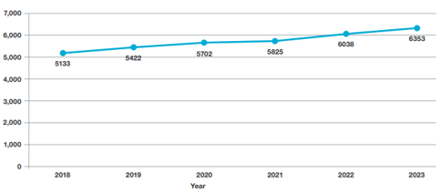
Figure 9-2: New registrations: Aotearoa compared with overseas trained, 2018–2023
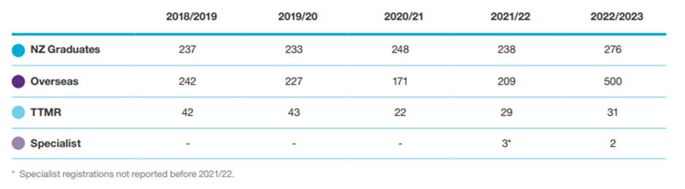

Figure 9-3: Practising physiotherapists by age and gender, 2022/23
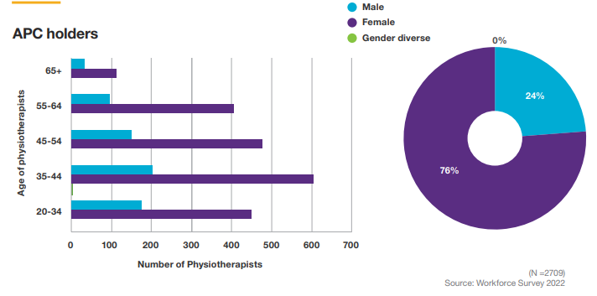
Figure 9-4: Ethnicity of physiotherapist APC holders, 2022/23
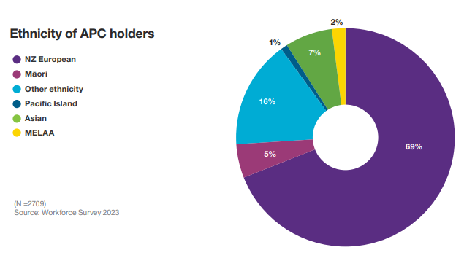

Figure 9-5: Total hours worked per week by physiotherapists, 2022/23
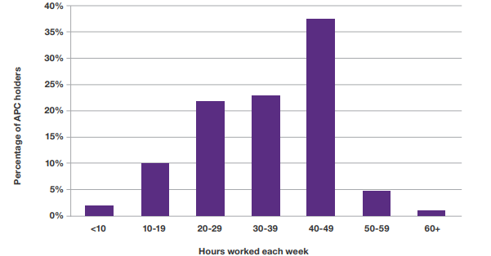

Table 9-2: Primary type of physiotherapy practice undertaken by practising physiotherapists, 2022/23
The largest practice settings was private practice (56% when including both the self-employed and employed). Hospital and health service employees accounted for 28% of APC holders.
Practice setting | Year | Number | Average Age | Age 55 and over (percent) | Female (percent) | Average weekly hours worked | FTE rate per 10,000 people
Private practice (self-employed) | 2023 | 1943 | 48.7 | 34 | 70 | 30.85 | 3.88
 | 2022 | 1880 | 48.0 | 32 | 72 | 30.73 | 3.76
Hospital and health services | 2023 | 1803 | 43.7 | 22 | 85 | 33.36 | 3.89
 | 2022 | 1623 | 43.4 | 22 | 85 | 33.17 | 3.50
Private practice (employed) | 2023 | 1561 | 38.7 | 11 | 69 | 33.93 | 3.45
 | 2022 | 1541 | 38.6 | 11 | 69 | 33.44 | 3.36
Education and research | 2023 | 273 | 48.2 | 27 | 78 | 34.88 | 0.61
 | 2022 | 297 | 48.8 | 31 | 84 | 34.57 | 0.67
Other including voluntary | 2023 | 224 | 49.4 | 38 | 80 | 30.23 | .044
 | 2022 | 214 | 50.6 | 46 | 85 | 30.93 | .043
Private hospital or aged care facility | 2023 | 105 | 51.8 | 44 | 91 | 23.64 | 0.16
 | 2022 | 104 | 50.7 | 39 | 86 | 23.26 | 0.16
Industry of government | 2023 | 205 | 45.5 | 17 | 67 | 35.81 | 0.48
 | 2022 | 196 | 44.7 | 14 | 63 | 36.59 | 0.47
Not employed in New Zealand | 2023 | 161 | 42.9 | 16 | 72 | 33.22 | 0.33
 | 2022 | 141 | 43.6 | 17 | 60 | 36.17 | 0.31
The full time equivalent (FTE) rate per ten thousand population is a measure that compares population to the total number of APC holders and average hours worked to ensure physiotherapy hours worked are growing with the population. This does not, however, take into account the changing needs within the population.

Benefits of a highly-enabled physiotherapy profession
- The physiotherapy profession supports patients to optimise their movement and function so patients can participate in their everyday activities, including employment, sport and education, throughout their lives, with acute and long-term health conditions, disabilities and injuries.
- The physiotherapy profession can support patients to build their skills and confidence to improve their knowledge and understanding of their injury/health condition, exercise safely and regularly, self-manage, control their health journey and achieve their management, recovery or rehabilitation goals. This has wide health benefits.
- Physiotherapy assessment and management of health conditions can reduce demand across the health system and is cost effective.
- Individuals, whānau, hapū, iwi and communities can move well and function to carry out activities of daily life as independently as possible, have a safe and sustained return to sport, work and their everyday activities and participate in their community.
- Travel costs and time are reduced for patients as care is delivered closer to home and physiotherapy services are integrated with other professions in primary health care and community settings.
- A culturally safe physiotherapy workforce will ensure everyone has a culturally safe experience.
- Advice, support and education from physiotherapists is centred around the person/whānau and thus can promote better health outcomes and support prevention, for example, of injuries and long-term health conditions.

Key issues for the physiotherapy profession in realising its full potential to help achieve pae ora
Key themes | Key issues
Workforce | - There is inadequate support for supervisors of physiotherapy students on clinical placement.  - An increasing proportion of new graduates are moving overseas upon qualification.  - There is poor retention of mid-career physiotherapists.  - There are insufficient numbers of experienced physiotherapists to support new graduates.  - There is low uptake/implementation of career development opportunities by institutions, for example, limited opportunities for advanced and specialist physiotherapists to work in designated roles.  - There is an under-representation of Māori (5%) and Pacific peoples (1%) within the profession.  - There is a lack of support and clarity for delegating to assistant, support and kaiāwhina workforces.  - The potential for new models of care is known, but further work is required to ensure the workforce is well positioned and prepared to deliver the new models.
Models of care | - Community-based physiotherapy tends to work in isolation and is not fully integrated into general practices.  - Good models of care are not routinely funded, with no systematic implementation plan.
Funding | - Numerous funding providers and pathways create complexities and disparities.  - Funding models support reactive rather than preventative models.  - In the primary health care sector, ACC is still the primary funder. Co-payment models create access and equity issues.  - Non-accident and aged care services are not well funded.  - The current funding investment approach does not necessarily value quality of life and functional outcomes.  - There is inadequate funding from the Tertiary Education Commission for entry-level physiotherapy training.  - We need to increase support for appropriate clinical placements.  - There is limited recognition and support in private practice for advanced or specialist roles.
Equity | - Māori cultural safety practices vary across the workforce. Workplaces are not always well placed to support upskilling and integration.  - There is limited access to community and iwi-based services.  - Existing services can be difficult to access due to location, waitlist, costs and cultural barriers.  - Poor funding and support for student placements, particularly in rural settings, creates barrier to attracting new graduates to work in the areas of greatest need.
Leadership | - There is uncertainty for leadership roles within Te Whatu Ora.  - There is limited recognition and support for non-clinical and leadership roles.

Key opportunities to fully realise the potential of the physiotherapy profession
Key themes | Key opportunities
Workforce | - Increase Māori and Pacific peoples’ representation in the workforce through changes in training pathways, programmes and delivery models.  - Improve retention of the workforce through pay equity, expanding career progression opportunities, increasing the variety of workplace settings and improving new graduate support.  - Implement delegation models to optimise the use of the assistant workforce, particularly in community settings.  - Increase the availability of dual academic and clinical career pathways.
Models of care | - Continue work to shift towards models of care that are centred on the person/whānau, preventative, interprofessional and community-based, for example, first point of contact in primary health care and orthopaedic triage services.  - Encourage partnering across public and private sectors to fully utilise physiotherapy resources.  - Increase the use of kaupapa Māori models.  - Expand existing primary health care models to improve access to physiotherapy services.  - Optimise the use of experienced, advanced and specialist physiotherapist skillsets.  - Build on good models (including funding models) that integrate professions in primary health care services.
Funding | - Increase the evidence base of economic evaluation to support funding physiotherapy services.  - Prioritise support for and investment in acute services.  - Prioritise investment in community-based services to improve access to a wider range of (preventative) services, such as kaupapa Māori services, orthopaedic triage, chronic and long-term condition management, and aged care.
Equity | - Improve access to care centred within iwi.  - Improve access to physiotherapy services, for example, reduce geographical and financial barriers, ensuring cultural safety.  - Embed cultural safety standards for the physiotherapy workforce.
Leadership | - Improve professional recognition for non-clinical/leadership roles, including supporting broader skill set development.

Podiatry
A podiatrist is a health care practitioner who uses medical, physical, palliative and surgical means to provide diagnostic, preventative and rehabilitative treatment of conditions affecting the feet and lower limbs.

Podiatry prescribed qualifications and registration pathways
Accredited Aotearoa qualifications,
- Bachelor of Health Science (Podiatry), Auckland University of Technology (AUT).
All first-time APC applicants and return-to-practice APC applicants must provide evidence of a current basic life support certificate, including anaphylaxis training (2 hours minimum) to accompany their APC application.
Overseas applicants
Applicants must successfully complete a desktop assessment and cultural competence open book exam as part of the registration process.
They must also have:
- graduated within three years of the date of their application for registration in Aotearoa and be registered in the country where they gained their qualification, or
- practised within the past three years of the date of their application for registration.
Trans-Tasman mutual recognition
Registered podiatrists in Australia can apply for registration in Aotearoa under the Trans-Tasman Mutual Recognition Act 1997 (TTMR). The Podiatrist Board of New Zealand is implementing a cultural competence open-book exam currently required for non-TTMR overseas applicants for TTMR applicants as well, to be successfully completed before an APC is issued.

Workforce data
Information provided by the Podiatrists Board of New Zealand based on data from their 2021/22 annual report

Figure 10-1: Podiatry profession APCs, 2021
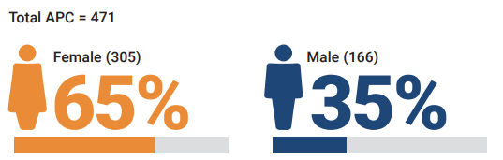

Figure 10-2: Podiatry number of APCs issued by year: New Zealand-qualified compared with overseas-qualified podiatry workforce, 2017–2022
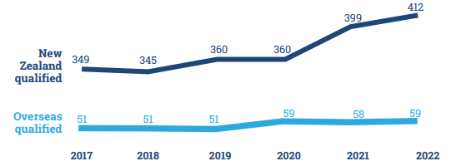

Figure 10-3: Ethnicity profile of podiatry workforce who hold an APC, 2021
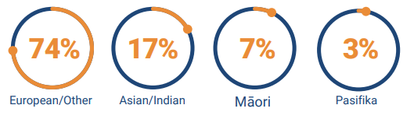

Figure 10-4: Percentage of Māori and Pacific podiatrists with an APC, 2017–2022
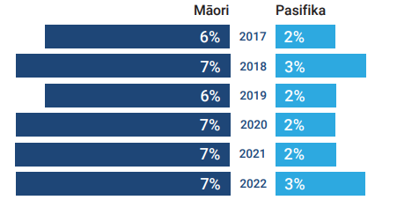

Figure 10-5: Podiatrist age groups analysis, 2021/22
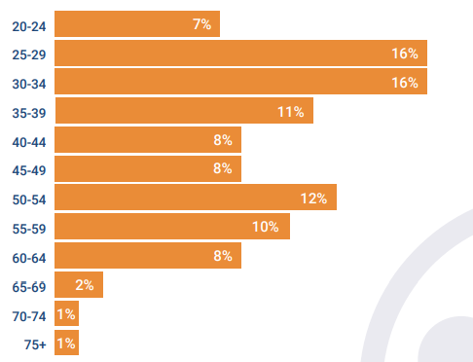

Figure 10-6: Podiatrists’ primary workplace setting, 2021/22
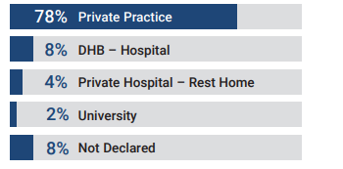

Benefits of a highly-enabled podiatry profession
- Podiatrists help reduce and manage associated lower limb morbidity and mortality and the impact of foot disability and provide advice on musculoskeletal issues so people can maintain as much of their mobility as possible; participate in their everyday activities, such as employment, education and social activities and feel connected to Papatūānuku.
- Podiatrists keep the workforce of Aotearoa on its feet, reducing days lost to foot pain and foot problems.
- Podiatrists play an essential role in reducing mortality and hospital-stay lengths associated with diabetic foot ulcers, amputations and other high-risk foot conditions, potentially significantly reducing costs to the health system and improving population wellbeing through early diagnosis and intervention.
- They can help inform people with high-risk foot conditions, (for example, renal disease, peripheral arterial disease and gout) about self-management and early intervention options to prevent further complications that may require surgical intervention.
- They help with early detection of wider health issues, such as peripheral arterial disease, atrial fibrillation and cardiovascular disease risk.
- Podiatrists also promote health options such as smoking cessation and safe physical activity.

Key issues for the podiatry profession in realising its full potential to help achieve pae ora
Key themes | Key issues
Training | - Training opportunities are vulnerable with only one training facility, in Auckland – more training options are needed, including regionally and in remote areas.  - Current training options do not address the workforce need.  - There are not enough clinical placements – clinical training is primarily delivered on site at AUT or in private practice settings.
Understanding and promotion of the profession | - The hierarchical system in hospitals means that allied health groups are often not a priority and can be overlooked.  - The public, the health sector, funders and insurance providers have a poor understanding of the professional scope, capability and value of podiatry services.
Workforce | - There are limited opportunities to do more as a profession due to the profession’s small size.  - New graduates are not given enough support in their first job.  - There is a lack of job opportunities within the public health system to support career progression from new graduate to consultant.  - The foot care assistant workforce needs more support.  - Lack of career progression in private practice (78% of workforce are in the private sector) means podiatrists leave the profession.  - To support workforce planning, better data is required to understand the demands on / need for podiatrists in Aotearoa. Current projections are based on current workforce which is not sufficient to meet the population need.  - Remuneration and working conditions overseas are perceived to be better than in Aotearoa. Aotearoa-trained new graduates are moving overseas: for every podiatrist that comes to Aotearoa from Australia, we lose four to five to Australia.  - Workforce maldistribution is a risk due to inconsistency in remuneration across service settings.
Models of care | - The current service delivery model is not conducive to providing quality podiatry services.  - Professional creep is occurring, that is, other professions are also involved in the management of foot problems, and podiatrists may be bypassed.  - There are limitations on funding streams, particularly for musculoskeletal interventions.  - ACC is a primary funder of podiatric services In primary health care. Co-payment models create access and equity barriers.
Equity | - There is no public funding for disability related conditions (non-accident), which creates access and equity barriers.  - There is inequity in access to podiatry for people with high-risk foot conditions.  - There is inequity in access for Māori to primary health care services.  - The current single training location (AUT) does not always expose students to the communities with the highest need.  - There is a lack of culturally safe practice and training. This needs to be embedded across the workforce and owned by every practitioner.  - Public access to the full scope of podiatry is a challenge – especially for the populations most in need.

Key opportunities to fully realise the potential of the podiatry profession
Key themes | Key opportunities
Training | - Consider interprofessional models of training.  - Utilise micro-credentialling.  - Employ students as foot care assistants. This may help reduce waitlists in the community, for example, for podiatric diabetic assessment, and will provide students with supervised real-world experience.  - Consider crediting foot care assistant training to podiatry training.  - Creating opportunities to engage year 13 students to prepare them to work in health – early integration of level 5 papers and other recognised training units/micro-credentials.  - Explore internship programmes (with public and private partnership) as this could help increase the availability of podiatry services in the community.  - Increase the availability of training remotely and beyond Auckland.  - Improve consistency of support for students, including enhanced funding to support student placements and programmes.  - Support podiatrists to engage in research – this is essential for continuous advancements in practise, particularly from an Aotearoa perspective.
Public understanding and promotion of the profession | - Improve the public understanding of what podiatrists do – their scope and value. Use patient stories to promote podiatry services.  - Improve the health sector and funders’ understanding of what podiatrists do – their scope and value.  - Build public understanding of the profession through research and data specific to Aotearoa.  - Students chose to study podiatry in many cases because they had a positive experience with a podiatrist – practising podiatrists should be supported to promote the profession.
Workforce | - Enable podiatrists to use their full scope of practice as it is currently underutilised; this may help to improve workforce retention.  - Develop guidance and an agreed description for foot care assistants’ roles and responsibilities.  - Increasing funding avenues for community-based podiatrists and integration into long-term condition care service teams could significantly improve access to podiatry services.
Models of care | - Foot care assistants can manage the less complex areas of the practice to enable podiatrists to work at full scope.  - Review how podiatry can be part of ACC integrated care pathways, for example, foot and ankle pathways to improve patient outcomes.  - Podiatrists can assist triage orthopaedic, vascular, rheumatology and potentially other specialist outpatient services and foot and lower limb referrals to help address access challenges to specialist hospital care.  - Improve podiatry involvement in interdisciplinary care of the lower limb, particularly where the lower limb is at risk.  - Invest in placing podiatrists into general practice settings, where they can make a significant impact as part of the comprehensive primary and community health care team.  - Ensure that employers understand the skill set and scope of podiatrists when they advertise roles – podiatrists have transferrable skills to manage broader conditions than just the lower limb.  - Encourage podiatrists to take an active role in health promotion and health navigation – podiatrists are well placed to do this due to the nature of their interactions with patients and links with the wider health system.  - Podiatrists have long-lasting/enduring relationships with their patients. They can add significant value to preventing decline and linking patients into interdisciplinary care.  - Delegation and skill sharing offers opportunities. There is significant potential, particularly within rural settings, for podiatrists to share skills and competencies with other professions and learn from other disciplines.
Equity | - Understand the cultural significance of feet so patients can receive culturally safe care.  - Utilise learnings from Ao Mai te Rā | The Anti-Racism Kaupapa as part of training.  - Indigenise the training curriculum to help the profession be better Te Tiriti o Waitangi partners and provide culturally safe care.  - Improve use of foot care assistants and foot hygienists to address access barriers.  - Increase the number of clinics dedicated to Māori to improve access for tangata whenua.

Psychology
Psychologists have expertise in all aspects of psychological functioning, including cognitive, emotional, behavioural, spiritual and intellectual dimensions. Psychologists assess, advise and assist people to improve their lives.

Psychologists apply their expertise to a broad range of issues and patients. Their patients include individuals, whānau, organisations and communities.

The settings in which psychologists offer their services are diverse, including schools, health centres and hospitals, community and sports organisations, the workplace, police and defence forces, research institutes and private clinics.

Psychologists prescribed qualifications and registration pathways
Accredited Aotearoa qualifications
- Postgraduate Diploma in Counselling Psychology | Auckland University of Technology (AUT)
- Doctor of Clinical Psychology | Massey University
- Master of Clinical Psychology
- Postgraduate Diploma in Educational and Developmental Psychology
- Postgraduate Diploma in Industrial/Organisational Psychology
- Postgraduate Diploma in Psychological Practice
- Doctor of Clinical Psychology | University of Auckland
- Postgraduate Diploma in Applied Psychology (Applied Behaviour Analysis)
- Postgraduate Diploma in Clinical Psychology
- Postgraduate Diploma in Health Psychology
- Postgraduate Diploma in Child and Family Psychology | University of Canterbury
- Postgraduate Diploma in Clinical Psychology
- Postgraduate Diploma in Organisational Psychology
- Postgraduate Diploma in Clinical Psychology | University of Otago
- Postgraduate Diploma in Neuropsychology
- Postgraduate Diploma in Psychology (Clinical) | The University of Waikato
- Postgraduate Diploma in the Practice of Psychology (Applied Behaviour Analysis)
- Postgraduate Diploma in the Practice of Psychology (Community)
- Postgraduate Diploma in Clinical Psychology | Victoria University of Wellington
- Master of Educational Psychology
- Postgraduate Diploma in Health Psychology Practice
Overseas applicants
Applications from overseas-trained practitioners are assessed on an individual basis for fitness for registration, equivalence of the applicant’s qualifications to Aotearoa qualifications and competence to practice.
Applications from countries with training and regulation similar to those in Aotearoa (‘Prescribed countries’: Canada, South Africa, United Kingdom, Northern Ireland and the United States of America) generally have a more rapid application process than other applicants.
Trans-Tasman mutual recognition
Individuals who are currently registered as a psychologist in Australia may be eligible to be registered in Aotearoa under the Trans-Tasman Mutual Recognition Act 1997.
Supervision to registration scheme (trainee psychologists)
This registration is for candidates who have completed formal academic qualifications that have provided the foundation competencies required for safe practice in a supervised setting and who are entering board-approved supervised practice to achieve full registration.
This option is only available to employees of the Department of Corrections and the New Zealand Defence Force enrolled in an in-house training programme.

Workforce data
Information provided by the New Zealand Psychologists Board based on data from their 2021/22 annual report

Table 11-1: Registered psychologists APC numbers, 2018–2022
Year | Total APC issued
2018 | 2,843
2019 | 2,895
2020 | 3,199
2021 | 3,385
2022 | 3,795
Table 11-2: Initial psychologist registrations by registration pathway, 2018–2022
 | 2021-22 |  | 2020-21 | 2019-20 | 2018-19
New Zealand trained | 156 |  | 176 | 156 | 162
Overseas-trained (individual assessment) | 70 |  | 133 | 138 | 131
Trans-Tasman Mutual Recognition | 7 |  | 18 | 22 | 17
Total | 233 |  | 327 | 316 | 310
Figure 11-1: New psychologist registrants by scope of practice, 2022 |  | Figure 11-2: Total practising psychologists by scope of practice, 2022

Registered psychologists by age and gender
This information is collected by the New Zealand Psychologists Board but is not publicly available.

Registered psychologists by primary ethnicity
This information is collected by the New Zealand Psychologists Board but is not publicly available.

Benefits of a highly-enabled psychology profession
- Psychology offers thinking on the biopsychosocial aspects of health and wellbeing. This includes considerations for the individual and beyond to their whānau and the wider community, including the workplace and health system. Psychologists help prevent the more severe expressions of developmental disabilities and their effect on the whole whānau, enabling more people to thrive rather than just survive.
- The psychology profession are experts in developing complex and, where necessary, individualised models of intervention that are ideally suited to helping people with complex health needs and multiple diagnoses, particularly where medicine is not an effective treatment.
- Psychologists can empower people with strategies to address challenges arising from health behaviour change, chronic pain, trauma, hardship, harm, etc.
- Whānau, hapū and iwi will have access to culturally safe psychology services.
- Communities are supported to stay well through access to timely and preventative mental health services. This reduces acute demand on services and improves the wellbeing of our population.

Key issues for the psychology profession in realising its full potential to help achieve pae ora
Key themes | Key issues
Training | - The financial burden for students is significant and is an important equity issue. More students are struggling financially to get through an undergraduate degree. Currently the student allowance is only available for five years for people under 40 years old and three years for people aged 40 years and older.  - Current resources and support for student placements create a barrier for students accessing training.  - With Te Whatu Ora increasing their commitment to internships, other providers reduced their support.  - There are insufficient spaces for placements/internships to support workforce growth.  - Currently the internship hubs only focus on clinical psychology – this should be expanded as eligibility criteria exclude a number of graduates who are entering the workforce in the psychologist scope.  - Universities are not resourced enough to teach the increased volume of students.  - It is difficult to attract practicing psychologists to provide supervision due to inadequate remuneration.
Public understanding and promotion of the profession | - There is currently limited awareness of the transferability of the psychology skill sets, particularly the potential for leadership.
Workforce | - Career pathways for psychologists are currently limited within Health New Zealand | Te Whatu Ora, which is a barrier to retaining experienced psychologists. In contrast, Corrections offers a wide range of career options, with psychology-specific management and advisory roles, as well as non-psychology-specific avenues for career development.  - Remuneration is a barrier to retaining psychologists within the public health sector.  - The exodus of psychologists from the public sector to private practice is making psychology services largely only accessible to those who can afford to pay. Further understanding of this shift along with solutions to retain the public sector workforce are required.  - There is a risk that quality of care is being compromised by the increased promotion of corporatized psychological services, often with new graduates heading straight into the private sector. These services are expensive and have no quality monitoring system, which is a risk to the profession’s growth.  - High caseloads and many supervisees mean there is limited access to professional development for psychologists.  - There is not enough support for psychologists to pursue research relevant to the specific needs in Aotearoa. Currently there is reliance on the international evidence base.  - In the public sector, there isn’t enough support to use the most effective interventions. Not all psychologists are in roles that allow them to fully utilise their skills and knowledge.  - Lack of support to grow the profession due to a reliance on medicalisation for mental health issues remains a problem given the degree of training and scope of practice psychologists currently hold.  - There is little flexibility in work options, with more options needed for remote and part-time employment or flexi-hours.
Models of care | - Current workforce constraints are a significant barrier to implementing improvements and optimal models of care.  - Psychologists are currently overloaded with high-acuity caseloads, which don't allow full use of the psychologists’ skills. Prevention opportunities are missed.  - There is a lack of promotion and implementation of psychological care in medical settings within Aotearoa and a severe lack of access to psychological interventions. While there has been a move to improve access to psychological care in primary health settings, this has not been replicated into medical settings.
Equity | - The profession does not reflect of the different populations it serves.  - Not all evidence bases are applicable in Aotearoa. There is a need to develop culturally appropriate practice for the Aotearoa context.  - The existing system of mental health does not easily fit/align with indigenous and other culturally appropriate psychology practices.  - Access to services is limited, including in private practice, with some private psychologists not taking on new patients.  - With inconsistent coverage of psychology services across Aotearoa, there are access challenges for people living rurally.

Key opportunities to fully realise the potential of the psychology profession
Key themes | Key opportunities
Training | - Support the development of a national placement and internship coordination system/platform. The system would allow services and agencies that can host placements and internships to register their needs and opportunities and allow psychology training programmes that have students who need placements and internships to work together to match students’ educational needs with the opportunities available.  - Increase the number of students in training (for example, in clinical psychology) and ensure the programmes are appropriately resourced with, for example, adequate clinic space and teaching staff/supervisors.  - Ensure there are enough supervisors for placements and supervisors are well resourced so that they aren’t overloaded and have capacity to support students.  - Consider introducing the ‘associate psychologist’ role under the supervision of any psychologist, with a pathway to become a psychologist through postgraduate study.  - Introduce financial support for students outside the existing paid final year internship.  - Explore recognising long programmes of study, for example, enabling student allowance for the full term of a course of study. (Clinical psychology takes at least six years of study, often seven to eight years.)  - Increase the number of clinical psychologist scholarships available to support training, for example, Ara Poutama Aotearoa | Department of Corrections (Corrections) provided five scholarships in 2023. Other agencies should also consider offering scholarships.
Public understanding and promotion of the profession | - Improve promotion and communication of the profession’s skills and knowledge to enable psychology to have the optimal impact for the public.  - Increase the awareness of the benefits of psychological services beyond mental health requirements.  - Increase awareness of the similarities and differences between counsellors, psychiatrists and psychologists.
Workforce | - Ensure training supports psychologists to move into different roles.  - Consider how we can support cross-agency secondments to help retain people who may wish to have a break from their current workplace / work focus and spend a year in another agency for example. This way it is less competitive and more collaborative, with agencies sharing of skills rather than competing for skills.  - Ensure the provision of cultural support for Māori, Pacific and under-represented groups in the workforce to improve retention rates.  - Utilise psychologists to their full scope and potential.  - Improve access to, and funding for, continuous professional development for all psychologists.  - Ensure that the depth of knowledge in the profession is maintained through workforce planning, particularly if an associate workforce is introduced.  - Provide psychologists with dedicated time and financial support to pursue research (science-practitioner model). This supports the profession to create new evidence-based knowledge to meet the specific needs of people in Aotearoa and inform changes in the health and disability system.  - Improve leadership development opportunities and develop succession plans across the profession. This supports increasing psychology representation in senior/system leadership.  - Promote awareness of potential career pathways, including clinical, leadership, management, advisory and private practice.
Models of care | - Establish effective, appropriate frameworks/models of delegation to enable psychologists and other mental health professionals to use their skills and knowledge fully and most effectively.  - The psychology scope of practice is broad and enabling. Models of care need to support psychologists to utilise the full breadth of their scope within practice.  - Expand the role of psychology in service improvement, trauma-informed health system care, primary health care, child development, paediatrics, maternity and schools.  - Address the access to services gap for people with mild to moderate mental health presentations. This will improve wellbeing and reduce demand on services from issues that have become more severe.  - Ensure models of care are not primarily psychiatric and medical. Psychology is first-line treatment before trials of medication for many presentations.  - The profession can be involved in non-mental health areas/issues, such as in corporate and government agency settings, to help people understand how to motivate individuals and understand behaviours, etc.  - Provide clear consultative pathways with psychologists in multidisciplinary teams to improve quality of service delivery for whānau with moderate to high complex mental health needs.  - Models of care need be kaupapa Māori and/or bicultural in nature to demonstrate commitment to Te Tiriti o Waitangi.  - Behavioural and educational psychologists can improve educational outcomes for many at-risk children and improve developmental trajectories, preventing later mental health and social issues for individuals, their whānau and communities.  - Psychologists working in health have expertise in health promotion and behaviour change, which would directly support the goals of Te Pae Tata to create better health (pae ora) for people in Aotearoa.
Equity | - Integrate understanding and application of mātauranga Māori and kaupapa Māori models throughout the profession and practice of psychology within Aotearoa. Increasing the number of Māori practitioners also requires kaupapa Māori ways of operating.  - Use training courses to improve the application of thinking and learning concepts informed by Māori. This includes reviewing what is included in training accreditation and increasing support for kaupapa Māori training programmes.  - Strengthen the focus on building internal capabilities in Aotearoa within Māori and Pacific communities. Longer-term planning and commitment is needed.  - Traditional knowledge and evidence need to be included in policy and strategy documents.  - Increase opportunities for cultural supervision for all psychologists.  - Increase the inclusion of content that teaches psychology students to work effectively and safely with minority populations. Teaching staff and supervisors also need to represent and have experience working with minority populations.  - Workplaces, where psychologists work, must be culturally safe for Māori and Pacific professionals: cultural safety training is important at training institutions.  - Provide opportunities for Māori and Pacific trainees to intern in settings where tuakana/teina relationships are at the heart of the mahi.  - Increase the diversity of the workforce so that it reflects the different populations in Aotearoa.  - Achieve pay equity for psychologists. Psychology is a female-dominate workforce, and average pay rates do not reflect the high academic requirement (six to eight years of study).

Social work
Social work is a practice-based profession and an academic discipline that promotes social change and development, social cohesion, and the empowerment and liberation of people. Principles of social justice, human rights, collective responsibility and respect for diversities are central to social work. Underpinned by theories of social work, social sciences, humanities and indigenous knowledges, social work engages people and structures to address life challenges and enhance wellbeing.

Social workers promote social change and empowerment by adhering to the principles of social justice, human rights, collective responsibility and respect for diversity. They identify strengths, needs and support networks to prioritise goals that will enhance social connectedness and help in addressing challenges and major events in a person’s life.

Social work prescribed qualifications and registration pathways
Accredited Aotearoa qualifications
- At the undergraduate level, a four-year, full-time-equivalent bachelor’s degree
- At the postgraduate level, a two-year full-time-equivalent master’s degree.
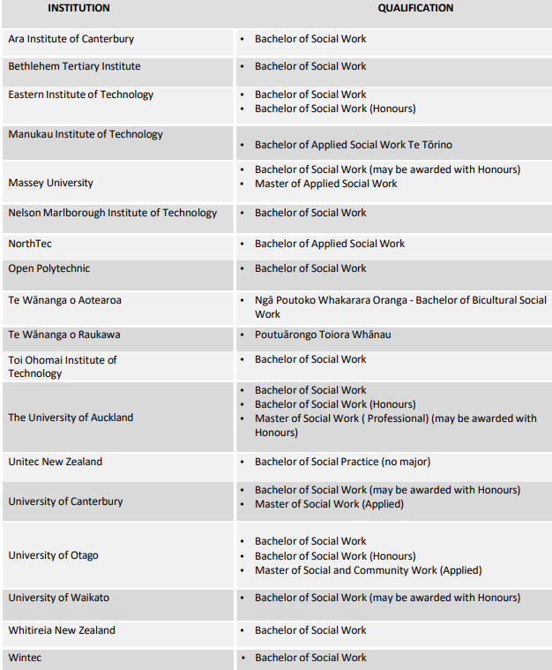
Experience Pathway: S13
- People who have significant experience practising social work in Aotearoa but don’t hold a recognised social work qualification may register via the Experience Pathway: S13.
Pathways for overseas-qualified social workers
Australian Social Workers
- Australian social work qualification, accredited by the Australian Association of Social Workers (AASW)
- Pass the Social Workers Registration Board (SWRB) competence assessment (for either: less than or more than six months of social work experience in Aotearoa).
Other overseas social work qualifications
- Pass the SWRB competence assessment (for either less than or more than six months of social work experience in Aotearoa).

Workforce data (30 June 2022)
Information provided by the Social Workers Registration Board based on data from their 2021/22 annual report and 2022 Annual Social Worker Workforce Report

The 2022 data reflects 3,544 out of a total of 7,564 social workers who renewed their practicing certificate between early May and 7 July 2022.

Figure 12-1: Total social worker registrations, June 2016–June 2021
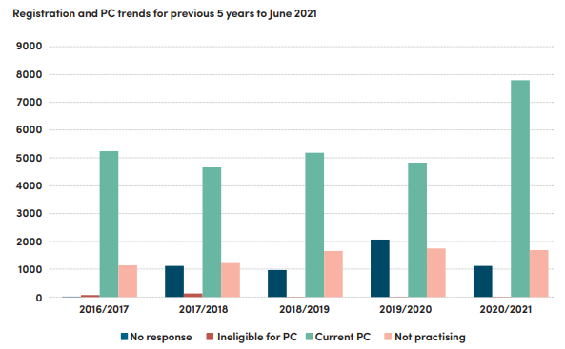

Figure 12-2: Primary ethnicity of registered social workers in health services, 2022

Figure 12-3: Gender of social workers in the health sector, 2022
District health boards (DHBs) had a slightly higher proportion of male social workers and a slightly lower proportion of female social workers than the rest of the social worker health workforce.

Age of social workers in the health sector, 2022
The average age for social workers in DHBs was 49.48 years old. In comparison, the average age for the social workers in the rest of the health workforce was 47.96 years old.

Figure 12-4: Social workers in health by region, 2022

Figure 12-5: Work status of registered social workers, 2022

Figure 12-6: Reason for registered social workers leaving their jobs, 2022

Figure 12-7: Social worker student enrolment figures, 2013–2022
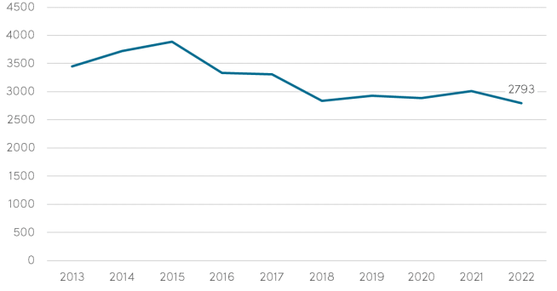

Figure 12-8: Social worker student ethnicity data, 2013–2022
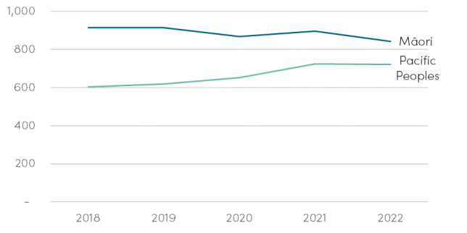
Table 12-1: Social worker student registration rates, 2019–2022
 | 2019 | 2020 | 2021 | 2022 | Average over four years
Number eligible to register due to completing qualification | 521 | 546 | 465 | 470 | 501
Number who register with the SWRB the following year | 445 | 431 | 381 | 387 | 411
Registration rate (proportions who complete qualification and go on to register with the SWRB the following year) | 85% | 79% | 82% | 82% | 82%

Table 12-2: Social worker field education placement organisation type, 2020–2022
Field education placement | 2021 number | 2021 % | 2022 number | 2022  %
Government agency | 323 | 29% | 302 | 31%
Non-governmental organisatoin | 651 | 58% | 664 | 69%
Iwi-based organisation | 148 | 13% | 144 | 15%
Total | 1122 | 100% | 964 | 100%
Aggregated totals are higher than the number of students on field placements as students may do more than one field placement during an academic year

Table 12-3: Social worker student government agency placement breakdown 2022
Government agency | Number of students on placement in 2022 | Percentage of all placements in 2022
Oragna Tamariki | 173 | 18%
Te Whatu Ora/Te Aka Whai Ora | 131 | 14%
Corrections | 28 | 3%
Other government | 12 | 2%

Benefits of a highly-enabled social work profession
- Individuals, whānau, hapū, iwi and communities feel supported throughout their health journey physically, mentally, emotionally and spiritually.
- Individuals, whānau, hapū, iwi and communities understand each interaction they have with the health system and feel empowered as experts of their own lives.
- A culturally competent workforce will ensure the tangata whaiora experience is authentic and respectful and enhances mana.
- Prevention and early intervention in the community are prioritised so that acute needs are reduced and the expertise/empowerment of communities is realised.

Key issues for the social work profession in realising its full potential to help achieve pae ora
Key themes | Key issues
Professional advocacy and promotion | - The breadth of the profession and lack of exclusive professional tasks can result in poor understanding of the unique value of social workers.  - Social workers are not always present in the right conversations at the right time to influence decision making due to a lack of understanding about the profession’s areas of expertise.  - There is a need to clearly communicate the value of social work to the public so that individuals, whānau and communities understand what supports the profession and associated practice can offer.  - Complex risks need to be managed to avoid unjust media incrimination.
Training | - There are workforce retention issues relating to workload, burnout, workplace morale, lack of professional support and lack of career progression.  - Social workers who identify as Pacific, Asian and other ethnic minorities, are poorly represented, particularly given the service user statistics.  - The workforce is ageing, and there are low numbers of male social workers.  - Social worker vacancies can be difficult to fill and remain vacant for extended periods.  - The profession is working towards pay parity and pay equity, but there needs to be more investment into social work in health settings.  - In acute settings, there is pressure to accommodate acute clinical demands over a more holistic approach. New graduates need more support to keep their holistic, strengths-based approach in acute health settings and not burn out or feel marginalised by the dominance of a medical perception and focus on diagnosis.  - More investment is needed to achieve regulated requirements for supervision in busy work environments.  - Students are financially challenged, especially given their unpaid student placements, and this is contributing to approximately 45% non-completion rate during social work programmes.  - Alternative pathways to professional qualification are needed, including conversion pathways, apprenticeships and earn to learn staircase opportunities from the wider social sector workforce.  - There is a lack of leadership capacity and capability within the profession.  - There is inconsistency in delivering professional supervision, which results in lack of professional support for social workers.  - Recognition of continuing professional development tends to heavily favour the demands of the workplace, but it also needs to value the scopes of practice as a profession and the individual’s potential as a competent social work practitioner.
Scope of practice | - Social work is not defined by a list of exclusive professional tasks so it can be challenging for other professions to understand its scope of practice.  - Other professions often undertake tasks similar to social workers’ tasks, and the overlap can be difficult to understand. Social workers and others who are in social work-related roles need to consider how they relate to one another, recognising the difference in perspective, experience, training and associated expectations.  - The importance of engagement and interventions carried out by social workers is being eroded within an environment of acute demand and focus on risk mitigation rather than preventative and early intervention and working collaboratively.
Funding | - Funding streams are largely influenced by tauiwi (non-Māori) perspectives. This marginalises tangata whenua perspectives.  - Funding barriers affect resourcing for social work in other parts of the health system. Funding constraints for social worker staffing in acute pae ora settings means social workers do not have time to provide holistic care and intervention and instead practice becomes concerned with and constrained by risk identification and mitigation. This is in direct conflict with the professional code of ethics, the core competences, tangata whenua understandings and practices and the IFSW global definition of ‘social work’.  - Very few funding contracts are specific to social work, which results in the role(s) getting lost within generalised funding systems. This adds to the misconception that other professions can carry out social work.  - There are pay inequities for social workers employed in different settings, for example, Te Whatu Ora is not competitive as an employer compared with Oranga Tamariki pay scales.
Equity | - There is racism in the health system that impacts on social work practice and provision of services.  - Caution is required when adopting policies and service models from overseas as this negates the scope for mātauranga Māori, ā-iwi and a pro-equity Te Tiriti approach.  - Qualification requirements for registration must not generate further inequities in workforce representation. The notion of experience may be marginalised by the focus on an academic qualification, yet indigenous knowledge is often found outside institutionalised learning pathways.  - It is essential to ensure that all social workers, including those from overseas, understand and uphold Te Tiriti o Waitangi.

Key opportunities to fully realise the potential of the social work profession
Key themes | Key opportunities
Professional advocacy and promotion | - Ensure the value of social workers is clearly understood by decision makers, colleagues and the public. The International Federation of Social Workers (IFSW) definition of social work could help with this, particularly as the definition refers to indigenous knowledge. The IFSW definition has been contextualised to Aotearoa, where Te Tiriti o Waitangi is central to practice. Aotearoa New Zealand Association of Social Workers’ (ANZASW’s) Ngā Tikanga Matatika | Code of Ethics states: ‘The commitment to Te Tiriti o Waitangi is not optional and permeates everything we do.’  - Ensure the breadth of social work and the variety of settings social workers work in is clearly communicated. Social workers have a role in a wide range of areas such as prevention, early intervention, disaster response, navigation of the health system, and supporting whānau. They are involved with interventions across all areas of life and in a range of settings and contexts across all pae ora settings. For example, social workers are frequently engaged in work related to family violence, mental health, suicide, addiction or child protection.  - Involve social workers more in decision making, for example, policy, service improvement, etc. Social workers have skills and have undertaken training to apply different practices to a broad range of contexts and work closely with whānau, hapū, iwi and communities.  - As cultural competence, safety and the importance of identity is integrated into training for social workers in Aotearoa, there is a central focus on the relationship between understanding self, bias and assumptions and practice, as well the imperative nature of reflective practice. This supports embedding Te Tiriti o Waitangi into knowledge, understanding and practice in health settings and especially in working with whānau, hapū, iwi and communities.
Workforce | - Increase the use of workforce data to inform decision making related to workforce development.  - Develop consistent national leadership models to support high-quality and diverse social work practices and care, as well as building capacity and capability around leadership within the profession.  - Develop clear career pathways for social workers and investment into social work professional leadership, education and research roles, ensuring diversity in application and relevancy.  - Support social workers to access supervision and continuous professional development consistent with professional body standards (including support for training social workers to become supervisors).  - Ensure newly qualified social workers and students are orientated to and mentored in the expectations of the health workplace and that they are better supported during their provisional registration period to ensure they have positive experiences and remain in the health sector.  - Introduce student placement support to improve qualification completion rates as well as support for services that offer placement opportunities. This is a crucial component to any social work training programme.  - Increase the number and range of work-integrated learning student placement opportunities in health settings.  - Create alternative pathways to professional qualification, including conversion pathways, apprenticeships and earn-to-learn staircase opportunities from the wider social sector workforce.
Breadth of social work practice and settings | - Increase the number of social workers working in prevention and early intervention to improve outcomes.  - Ensure social workers are well supported to work in the community to provide and collaborate with services and provide care closer to the individuals and their whānau.  - Social workers play a key part in multidisciplinary teams and can provide support to address the social determinants of health.  - Support and endorse social workers to apply a holistic approach to pae ora and evaluate the contribution of bio-psycho-socio-spiritual and cultural factors based on understanding identity and the influence of all these factors on health crises.  - Social workers can help individuals and whānau navigate the health system to support positive self-determined outcomes.  - Social workers can undertake engagement and intervention to support individuals and whānau to address the socio-psychological, spiritual and cultural impacts of health crises. Social workers are skilled in identifying and addressing risk across a number of areas, such as child protection, older adults (care and protection), mental health, suicide, addictions and family harm. Social workers are highly cognisant of the ever-changing risk/s.  - In partnership with other agencies, explore the potential of developing legislated safeguarding services for adults at risk.
Equity | - 24% of the social work workforce identifies as Māori, which is the highest proportion of any allied health profession. There is an opportunity to share insights and learnings with other health professions.  - Continue to support the development of social worker expertise and competence in understanding and applying mātauranga Māori, ā-iwi and tikanga for tangata whenua within pae ora settings.  - Help social workers challenge persistent racism in the health system by encouraging decision-makers to listen to and act upon social workers’ advice.  - Improve the accessibility of quality training modules for overseas staff to support their understanding around obligations to uphold Te Tiriti o Waitangi and culturally safe and competent care.  - Strengthen recruitment drives and scholarships/grants for Pacific peoples, Asian and other ethnic minorities and help them complete their social work qualification with an end-of-degree job offer in the health sector.  - Ensure overseas policies and service models are adequately assessed to ensure they address pro-equity and Te Tiriti impacts before they are implemented.
Funding | - Engage with iwi and tangata whenua providers on investment and resource needs.  - Include social work as key personnel and resource in primary and community health care staffing models.  - Identify care pathways where social work is a key component to positive outcomes for patients and whānau and provide specific funding contracts for social work within the services with these pathways.

Sonography
Sonographers are responsible for diagnostic ultrasound examinations. They review and manage patients’ sonography imaging requirements, provide sonography procedures, deliver safe and quality sonography services and access, evaluate and provide sonographic imaging information. They also provide a summary of the findings in written form to other health professionals. The sonographic practice encompasses both technical and interpretive skills.

Sonographers perform a wide range of real-time diagnostic examinations and may at their discretion (and in accordance with clinical and workplace guidelines) extend their examination to include relevant regions and/or sequences not suggested in the referral.

Sonographers’ competencies include, but are not limited to, patient care, ultrasound physics and technology, anatomy and physiology identification and assessment, diagnostic interpretation of the ultrasound findings, bioeffects and the use of ultrasound technology, clinical and organisational responsibility for the examination, and quality assurance.

Sonographer prescribed qualifications and registration pathways
Domestic graduates
- Postgraduate Diploma in Health Sciences in Ultrasound, University of Auckland.
General pathway (internationally qualified, including Australia)
- Meet registration requirements, and
- Once registered, complete courses in cultural competency and cultural safety, Te Tiriti o Waitangi, and Clarify courses (modules covering a practitioner’s obligations under the Health Practitioners Competence Assurance Act 2003 and health information privacy, informed consent) within six months of commencing practice in Aotearoa.
Specialist area of practice – cardiac sonography
The University of Auckland recently launched a Cardiac Sonography course which started semester 1 2024.
Students usually take Australasian Sonographer Accreditation Registry accredited courses:
- Graduate Diploma in Cardiac Ultrasound, Queensland University of Technology (QUT)
- Graduate Diploma in Medical Sonography (Cardiac) and Master of Medical Sonography (Cardiac), University of South Australia
- Graduate Diploma in Cardiac Sonography and Master of Cardiac Sonography, Western Sydney University.

Workforce data
Information provided by the New Zealand Medical Radiation Technologists Board (MRTB) based on data from their 2021/22 annual report

Table 13-1: Sonographers’ practising certificates by scope of practice, 2022
 | Sonographer | Trainee sonographer
APC holders | 676 | 81
APCs with conditions | 110 | 11

Figure 13-1: Percentage of ethnicities of sonographer APC holders, 2021–2022
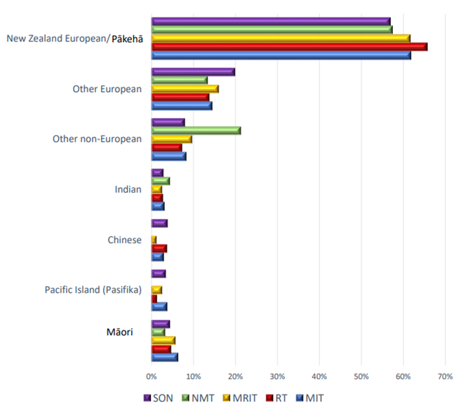

Benefits of a highly-enabled sonography profession
- Ultrasound is often used as first-line imaging (most commonly over computed tomography scans (CTs), magnetic resonance imaging (MRIs) and X-rays), it is non-ionising, safe, cost effective and relatively accessible, especially when compared with other imaging modalities.
- Ultrasound is a key imaging modality used when assessing and diagnosing a patient. Increasing the sonography workforce will improve the access to ultrasounds, which will decrease wait times for diagnoses. This will allow patients to receive treatment decisions earlier, thus receiving care sooner and reducing pressure on the health system.

Key issues for the sonography profession in realising its full potential to help achieve pae ora
Key themes | Key issues
Training | - The sonography workforce is still dependent on overseas-trained practitioners.  - An insufficient number of clinical educators limits the availability of student clinical placements.  - Clinical placements are also limited by the ability of a training provider to accommodate the reduction in numbers of patients able to be scanned in any given session. All trainee work, especially first-year trainees, must be physically checked, that is repeated. Thus, for each trainee on site, the volume of through-put is approximately halved.  - It is challenging for those sonographers working in remote areas to access professional development opportunities and clinical support.  - There is no cardiac or vascular sonography course in Aotearoa, so specialty training currently needs to be completed in Australia.
Scope of practice | - It is challenging for sonographers to work at full scope. Key challenges include workforce shortages and a lack of guidance on safe upskilling, for example, there is no credentialling frameworks.
Funding | - There is inadequate resourcing and support for student clinical placements.  - Funding models and associated service delivery pressures limit the range of experience students gain on clinical placements in hospitals.
Models of care | - Sonography services receive inappropriate referrals, adding to the demand on their services.  - Sonography is not well integrated into existing service models.
Equity | - The undergraduate degree requirement for the postgraduate training model makes it is difficult to get enough Māori and Pacific sonography students.  - There is variation in the availability of sonography services regionally and rurally, and many patients and sonographers need to travel long distances.  - The sonography profession is not well publicised with prospective tertiary education students.

Key opportunities to fully realise the potential of the sonography profession
Key themes | Key opportunities
Training | Increase the number of clinical placements available and thereby increase the number of potential graduates.  Provide more clinical support for sonographers who work regionally and rurally so they can provide a safe and high-quality service for their communities.  Explore alternative ways to gain a sonography qualification to attract more students and remove barriers to training.  Explore local options (including appropriate resourcing) for specialist training, such as cardiac sonography, to increase the workforce in these areas.
Scope of practice | Support sonographers to work at full scope safely, for example, routine reporting on ultrasound images.  Consider credentialling to support clear pathways and safe working at full scope.
Workforce | Establish sonography career progression pathways that are transparent to help with workforce retention.
Models of care | Collaborate and integrate more with other professions, including by developing guidance on appropriate triaging and clinically indicated sonography referrals to improve efficiency and reduce unnecessary follow-ups.  Improve funding models to support clinically appropriate care and use of sonography resources.  Expand point-of-care ultrasound services with appropriate training models and audit requirements.
Equity | Integrate cultural safety and anti-racism in sonography training and professional development.  Encourage education providers to provide better pastoral care so that Māori and Pacific students feel supported.  Ensure the sonography workforce reflects the population, by increasing Māori and Pacific members in the workforce.  Target scholarships for Māori and Pacific students to increase the number of these students enrolling in sonography.  Improve the retention of the Māori and Pacific sonography workforce.

Speech-language therapy
Speech-language therapists work with people of all ages, from newborns to older adults at the end of their life. They are the experts in supporting effective communication, speech and language, as well as safe eating, drinking and swallowing.

Speech-language therapist prescribed qualifications and registration pathways
Accredited Aotearoa qualifications
- Bachelor of Speech and Language Therapy with Honours, Massey University
- Bachelor of Speech and Language Therapy with Honours, University of Canterbury
- Master of Speech and Language Pathology, University of Canterbury.
- Master of Speech Language Therapy Practice, University of Auckland
Overseas applicants
Speech-language therapy is a self-regulated profession through the New Zealand Speech-language Therapists’ Association (NZSTA). Most employers in Aotearoa require prospective employees to be registered with the NZSTA.
There are two methods of applying for membership with the NZSTA. These are through:
- the Mutual Recognition of Professional Association Credentials Agreement (MRA)
- the Qualifications Approval Process.
Mutual Recognition of Professional Association Credentials Agreement
The Mutual Recognition of Professional Association Credentials Agreement (MRA) was established in 2004 between six speech-language associations:
- New Zealand Speech-language Therapists’ Association (NZSTA)
- American Speech-Language-Hearing Association (ASHA)
- Speech-Language & Audiology Canada (SAC)
- Royal College of Speech and Language Therapists, United Kingdom (RCSLT)
- Speech Pathology Australia (SPA)
- The Irish Association of Speech and Language Therapists (IASLT).
The agreement allows members of signatory associations (trained in that country) to apply for mutual recognition of their credentials with another association. The premise of substantial equivalence underlies the agreement, that is, under certain terms and conditions, an individual’s credentials are deemed substantially equivalent. This is not equality or reciprocity, as each signatory association has specific requirements for applicants.
Qualification approval framework
The NZSTA has created a clear and specific qualifications approval process (QAP). The QAP guides the process for reviewing membership applications with the NZSTA when the applicant was trained overseas and does not meet the MRA criteria.

Workforce data
There is limited public information available regarding the speech-language therapists workforce within Aotearoa. The New Zealand Speech-language Therapists’ Association advise that based on their member database and the Stats NZ estimated population as of 31 March 2023, there are currently 20 speech-language therapists per 100,000 population.

Benefits of a highly-enabled speech-language therapy profession
- Kōrero and kai are foundational to human experience, wellbeing and connection – speech-language therapists are experts in supporting communication and swallowing function.
- Speech-language therapists play a vital role in facilitating participation, tino rangatiratanga (self-determination) and engagement.
- Whānau are supported to engage meaningfully in their environments through timely communication intervention and support.
- The impact of swallowing disorders on individuals, whānau and wider societies is reduced as people are supported to be nourished in ways that align with their values and desires.
- With optimised models of care, speech-language therapists add value to the population of Aotearoa by:
- supporting communication, swallowing and tracheostomy management in acute and critical care settings and mental health settings, including inpatient adult, community, youth and forensic mental health
- providing gender-affirming voice therapy
- offering community-based early feeding intervention services and early language development support services
- providing language development and communication support for neurodiversity and learning diversity in education settings
- supporting communication skills for older learners and those who may have left education
- providing communication support for whānau, communities and carers who support individuals with communication impairment
- caring for people with head and neck cancers
- supporting communication in prisons and within the community justice system
- supporting adults with intellectual disability.

Key issues for the speech-language therapy profession in realising its full potential to help achieve pae ora
Key themes | Key issues
Training | - Student placement opportunities are limited and do not reflect the wide variety of work that speech-language therapists undertake. This creates a barrier for students accessing training.  - Current workforce capacity constraints are a significant challenge to optimising student clinical placements and for the supervision and support of new graduate speech-language therapists.  - Māori and Pacific new graduates have limited access to culturally safe and appropriate supervision.  - Many new graduates are immediately registering overseas, so building our workforce within Aotearoa remains challenging.
Public understanding and promotion of the profession | - There is currently limited awareness of the essential nature and societal impact of communication access for New Zealanders.  - The value and impact of speech-language therapy services on population health are not well understood or articulated – data is essential for remedying this.  - The speech-language therapist’s role in prevention and early diagnosis is poorly understood and implemented.
Workforce | - Career development pathways for speech-language therapists are inconsistent across settings, which contributes to workforce maldistribution and attrition.  - Career development pathways currently point away from the profession / core service delivery (generating the perception that career progression is limited to becoming a clinical leader or manager).  - There is limited workforce data to inform decision-making and workforce planning.  - There is a high risk of burnout for Māori speech-language therapists who work to provide care in overburdened services while simultaneously elevating and supporting the cultural safety of the wider speech-language therapy workforce.  - Poor remuneration is a key reason speech-language therapists are moving overseas or leaving the profession altogether. Rates of pay that reflect levels of responsibilities are key as well.
Models of care | - Current workforce constraints are a significant barrier to delivering improved or desirable models of care.  - Current service and workforce constraints result in the provision of reactive care, with speech-language therapists unable to provide proactive, preventative services to those with communication and swallowing difficulties.  - Aotearoa has low workforce-to-population capacity compared with other countries, with 20 speech-language therapists per 100,000 population, compared with more than double that ratio in Australia and the United States of America.  - Capturing the value of speech-language therapy interventions for individuals, whānau, the wider community and funders is critical to developing contemporary models of care.
Equity | - The current workforce does not reflect the populations it serves; while both Māori and Pacific communities are under-represented in the speech-language therapist workforce, they are over-represented in the populations requiring speech-language therapy services.  - Current funding models provide inequitable and suboptimal access to speech-language therapy services for priority populations.  - Children with language delays and impairments are over-represented within our youth justice system, care and protection services and education behaviour support services. Speech-language therapists can make a significant impact on this over-representation, but investment is essential.  - There is much unmet need for speech-language therapy services, with long average wait times for the services. This particularly impacts vulnerable populations, including people with mental health conditions, young children with feeding issues, transgender voice adjustments, child voice disorders and adults with intellectual disabilities.

Key opportunities to fully realise the potential of the speech-language therapy profession
Key themes | Key opportunities
Training | - Increase support for students to access and complete training, including access to clinical placement opportunities and funding support for placements and training.  - Expand and support distance learning options to increase access to training.  - Develop a kaupapa Māori speech-language therapists training programme.  - Ensure a breadth of training opportunities across a range of sectors and services.  - Provide tailored support for new graduates across all settings, including cultural support for tangata whenua speech-language therapists.  - Support new graduate speech-language therapists to practise in a variety of settings so that their skills are not immediately limited to one area of practice. This will also support speech-language therapists to provide holistic care.  - Undertake robust analysis to understand both current and future workforce needs and ensure we develop a workforce that meets population needs.
Public understanding and promotion of the profession | - Better promotion of the profession’s skills and knowledge to enable speech-language therapists to have the best impact.  - Increase public awareness of the benefits of speech-language therapists as accessibility specialists who work across different settings, enhancing communication access for individuals, whānau and communities.  - Ensure speech-language therapy is promoted as a great career option.  - Promote the workforce to encourage more diversity – including more gender diversity.  - Support speech-language therapy services for different language backgrounds.
Workforce | - Improve speech-language therapist workforce data to support workforce benchmarking and goal setting.  - Encourage cross-sector, cross-agency support to increase the speech-language therapist workforce within Aotearoa.  - Increasing speech-language therapist workforce capacity is a key enabler to implementing optimal models of care and reducing pressure and burnout within the workforce.  - Improve recognition of the important work experienced speech-language therapists do when they supervise and train students and new graduates.  - Ensure there are sufficient levels of speech-language therapist expertise across all sectors to ensure wellbeing and sustainability of service delivery.  - Provide career development pathways that acknowledge the profession’s specialist skillset and transferrable skills and the importance of training and mentoring the next generation of professionals.  - Build on the work of speech-language therapists in health who have developed cultural safety guidance and support to enhance the cultural safety of the workforce, ensuring this is a safe profession for Māori to work and receive care in.  - Equip the workforce to honour and uphold Te Tiriti o Waitangi and practise in a culturally safe manner – for all practitioners, not just newly-trained speech-language therapists.  - Provide opportunities for speech-language therapists to work across various settings – this supports optimal skill and workforce distribution as well as developing a system-thinking, holistic workforce.  - Invest in and support speech-language therapy research that is based in Aotearoa-based – this is currently lacking, and overseas research does not always reflect our unique context.
Models of care | - Increase speech-language therapists’ presence within primary and community health care multidisciplinary teams.  - Increasing the workforce’s capacity is a key enabler to optimising models of care that will allow speech-language therapists to work to their full scope of practice and add the most value to the populations of Aotearoa.
Equity | - Regulatory bodies and training providers need to continue to support decolonising education and training for speech-language therapists in Aotearoa.  - Increase the diversity in the workforce representation, specifically, increase Māori and Pacific peoples’ representation to best serve our varied populations.  - Improve access to prevention and early intervention speech-language therapy services by increasing community service provisions and workforce capacity.  - Intentionally increase cultural safety training for the speech-language therapists workforce to enable the workforce to provide culturally safe and responsive services.  - Improve communication access for all New Zealanders across the lifespan and all settings.  - Support whānau to determine what services they access and how those services are provided.

Conclusion
- Allied health staff work closely with doctors, nurses and other health care professionals in our health system. While they play an essential role in our health system, there is room for improvement in how we use and manage resourcing of allied health professions.
- Allied health has a critical role to play in the health and wellbeing of people in Aotearoa. There is unrealised potential in the professions, and seizing this potential will have extensive benefits for the health and wellbeing of people in Aotearoa (as well as financial and economic benefits).
- We aspire to see allied health involved early across all areas of the health system including strategy, policy, regulation, commissioning, planning, innovation and direct service delivery to individuals and whānau.
- Each health system stakeholder has a part to play in ensuring the potential of allied health is fully realised. This requires responsible authorities, employers, unions, educators, commissioners and individual practitioners working collectively to achieve pae ora.

In 2022, the Ministry of Health – Manatū Hauora adopted ‘hauora haumi’ as a term to describe the joined nature of the allied health, science and technical professions. For more information, see the Ministry’s news article Manatū Hauora adopts a new name for Allied Health at: www.health.govt.nz/news-media/news-items/manatu-hauora-adopts-new-name-allied-health
For more information, see the Ministry’s webpage Allied Health at: www.health.govt.nz/about-ministry/leadership-ministry/allied-health
Health behaviours are actions that directly affect health outcomes, such as smoking cessation or increased exercise.
4 HDSR. 2020. Health and Disability System Review: Final report. – Pūrongo Whakamutunga. Wellington: Health and Disability System Review (HDSR). URL: www.health.govt.nz/publication/health-and-disability-system-review-final-report (accessed 27 April 2024).
Pae Ora (Healthy Futures) Act 2022, Part 1: Preliminary provisions, section 3: Purpose of this Act. URL: www.legislation.govt.nz/act/public/2022/0030/latest/LMS575487.html
Hogan S. 2021. Hidden in Plain Sight: Optimising the allied health professions for better, more sustainable integrated care. NZIER report to Allied Health Aotearoa New Zealand (AHANZ). New Zealand Institute of Economic Research (NZIER). URL: www.nzier.org.nz/hubfs/Public%20Publications/Client%20reports/hidden_in_plain_sight.pdf (accessed 27 April 2024).
Bealing M and Welvaert M. 2020. Better Outcomes through Increased Access to Physiotherapy: Physiotherapy in transdisciplinary models of care to improve outcomes and equity for New Zealanders. NZIER report to Physiotherapy New Zealand. New Zealand Institute of Economic Research (NZIER). URL: http://www.nzier.org.nz/hubfs/Public%20Publications/Client%20reports/nzier_cost_utility_analysis_for_phyisotherapy_final.pdf (accessed 27 April 2024).
Bealing M. 2023. Economic Effects of Hearing Loss: 2023 update. NZIER report to New Zealand Hearing Industry Association. New Zealand Institute of Economic Research (NZIER). URL: https://nzhia.org.nz/wp-content/uploads/2023/06/NZIER-FINAL-report-Economics-of-hearing-loss-2023-update.pdf (accessed 27 April 2024).
Hogan S and Tuaño K. 2021. A Critical Missing Ingredient: The case for increased dietetic input in tier 1 health services. NZIER report to Dietitians New Zealand. New Zealand Institute of Economic Research (NZIER). URL: https://dietitians.org.nz/common/Uploaded%20files/Samples/Downloadable%20content/Reports/A%20critical%20missing%20ingredient%20-%20NZIER%20report%20FINAL.pdf(accessed 27 April 2024).
Allan + Clarke. 2021. Evaluation of the Mobility Action Programme (MAP): Cycle 2 final report. Wellington: Allen + Clarke. URL: www.health.govt.nz/publication/evaluation-mobility-action-programme-map (accessed 27 April 2024).
Price E, Shirtcliffe A, Fisher T, et al. 2023. A systematic review of economic evaluations of pharmacist services. Int J Pharm Pract;31(5): 459–71. DOI: https://doi.org/10.1093/ijpp/riad052 (accessed 27 April 2024).
Breadon P, Romanes D, Fox L, et al. 2022. A New Medicare: Strengthening general practice. Grattan Institute. URL: https://grattan.edu.au/wp-content/uploads/2022/12/A-new-Medicare-strengthening-general-practice-Grattan-Report.pdf (accessed 27 April 2024).
New Zealand Audiological Society webpage What is Audiology? https://audiology.org.nz/for-the-public/what-is-audiology/
NZAS audiologist scope of practice (not publicly available)
See: https://audiology.org.nz/for-the-public/what-is-audiology/audiologist-and-audiometrist-what-is-the-difference/
For more information, see the NZAS webpage Audiologist Membership at: https://audiology.org.nz/becoming-a-member/audiologist-membership/
For more information, see the NZAS webpage How do I become an Audiologist at: https://audiology.org.nz/careers-in-audiology/how-do-i-become-an-audiologist/
TAFE stands for Technical and Further Education. TAFE NSW is Australia's largest vocational education and training provider based in New South Wales.
For more information, see the NZAS webpage Audiometrist Membership at: https://audiology.org.nz/becoming-a-member/audiometrist-membership/
For example, see the report Results: NewZealandTrak 2022, which was a study designed by Anovum (Zurich) on behalf of the New Zealand Hearing Industry Association (HIA) and the European Hearing Instrument Manufacturers Association (EHIMA) to learn more about the state of hearing impaired people in Aotearoa. See: https://nzhia.org.nz/wp-content/uploads/2023/06/NewZealandTrak-2022_Final-Report.pdf
For more information see the careers.govt.nz webpage Clinical Physiologist at: www.careers.govt.nz/jobs-database/health-and-community/health/clinical-physiologist/
For more information, see the Clinical Physiologists Registration Board webpage Cardiac Physiologist Registration at: https://cprb.org.nz/looking-to-register/cardiac-registration/
For more information, see the Society of Cardiopulmonary Technology webpage Certificate in Physiological Measurement at: www.sct.org.nz/cpm-ccp-application
For more information, see the Clinical Physiologists Registration Board webpage Cardiac Physiologist Registration at: https://cprb.org.nz/looking-to-register/cardiac-registration/
For more information, see the Society of Cardiopulmonary Technology webpage Certification of Cardiac Physiologists at: www.sct.org.nz/copy-of-cpm-ccp-application
For more information, see: - the Clinical Physiologists Registration Board webpage Clinical Exercise Physiologist Registration at: https://cprb.org.nz/looking-to-register/clinical-exercise-physiology-registration/ - the Clinical Exercise Physiology New Zealand webpage on undergraduate and graduate programmes at: www.cepnz.org.nz/study
For more information, see: - the Clinical Physiologists Registration Board webpage Neurophysiology Technologist Registration at: https://cprb.org.nz/looking-to-register/neurophysiology/ - the New Zealand Society of Neurophysiology Technologists site at: www.nzsnt.org.nz/
For more information, see the Clinical Physiologists Registration Board webpage Respiratory Physiologists Registration at: https://cprb.org.nz/looking-to-register/respiratory-physiology/
For more information, see the ANZSRS webpage Certified Respiratory Function Scientist (CRFS Credential) at: www.anzsrs.org.au/education
For more information, see: - the Clinical Physiologists Registration Board webpage Renal Physiologist Registration at: https://cprb.org.nz/looking-to-register/renal-physiology/ - the New Zealand and Australia Society of Renal Dialysis Practice Inc webpage Approved Training Programs/Courses at: www.nzasrdp.com/pages/approved-training
For more information, see the Clinical Physiologists Registration Board webpage Sleep Physiologist Registration at: https://cprb.org.nz/looking-to-register/sleep-physiology/
For more information, see the Clinical Physiologists Registration Board webpage Who can Register at: https://cprb.org.nz/looking-to-register/nz-and-australian-trained-physiologists/
For more information, see the Clinical Physiologists Registration Board webpages, respectively: - Cardiac Physiologist Registration at: https://cprb.org.nz/looking-to-register/cardiac-registration/ - Clinical Exercise Physiologist Registration at: https://cprb.org.nz/looking-to-register/clinical-exercise-physiology-registration/ - Neurophysiology Technologist Registration at: https://cprb.org.nz/looking-to-register/neurophysiology/ - Respiratory Physiologist Registration at: https://cprb.org.nz/looking-to-register/respiratory-physiology/ - Renal Physiologist Registration at: https://cprb.org.nz/looking-to-register/renal-physiology/ - Sleep Physiologist Registration at: https://cprb.org.nz/looking-to-register/sleep-physiology/.
For more information, see the Clinical Physiologists Registration Board webpage International applicants at: https://cprb.org.nz/looking-to-register/international-applicants/
Clinical Physiologists Registration Board. 2023. Annual Report 2023. URL: https://cprb.org.nz/assets/Annual-report-2023-.pdf (accessed 5 May 2024).
Clinical Physiologists Registration Board. 2023. Annual Report 2023. URL: https://cprb.org.nz/assets/Annual-report-2023-.pdf (accessed 5 May 2024).
Clinical Physiologists Registration Board. 2022. Annual Report 2022. URL: https://cprb.org.nz/assets/Annual-Reports/Annual-Report-2022.pdf (accessed 5 May 2024).
APC = Annual Practicing Certificate
For more information, see the Dietitians Board webpage Practitioners Overview at: https://dietitiansboard.org.nz/Public/Public/Practitioners/Practitioners-Overview.aspx?hkey=b1e6e06b-119d-40d7-be40-409efa43ec45
For more information, see the Dietitians Board webpages: - Education Providers at: https://dietitiansboard.org.nz/about-us/education-providers/ - New Zealand Graduates at: https://dietitiansboard.org.nz/registration/new-zealand-graduates/
For more information, see the Dietitians Board webpage Australian Trained at: www.dietitiansboard.org.nz/Public/Public/Registration/Australian-Trained.aspx?hkey=618aef48-3e10-4af7-8978-9cd63591eb09
For more information, see the Dietitians Board webpage Overseas Trained at: www.dietitiansboard.org.nz/Public/Public/Registration/Overseas-Trained.aspx?hkey=e5eec6ee-eb7f-499e-b7c9-ad4ad76b317f
Dieticians Board of New Zealand. 2022. Annual Report: Dieticians Board of New Zealand, Te Mana Mātanga Mātai Kai. 2021/22. Wellington: Dieticians Board of New Zealand. URL: www.dietitiansboard.org.nz/common/Uploaded%20files/Web_Documents/NZDB%20ANNUAL%20REPORT%202022%20Final.pdf (accessed 5 May 2024).
For more information, see the New Zealand Medical Radiation Technologists Board webpage Internationally Qualified – How to Register at: www.mrtboard.org.nz/pre-registration/overseas-trained-how-to-register/
MRTB. 2022. New Zealand Medical Radiation Technologists Board Annual Report, 1 April 2021–31 March 2022. New Zealand Medical Radiation Technologists Board (MRTB). URL: www.mrtboard.org.nz/assets_mrtb/Uploads/MRTB-Annual-Report-2022.pdf (accessed 30 April 2024).
MRTB. 2022. New Zealand Medical Radiation Technologists Board Annual Report, 1 April 2021–31 March 2022. New Zealand Medical Radiation Technologists Board (MRTB). URL: www.mrtboard.org.nz/assets_mrtb/Uploads/MRTB-Annual-Report-2022.pdf (accessed 30 April 2024).
MRTB. 2022. New Zealand Medical Radiation Technologists Board Annual Report, 1 April 2021–31 March 2022. New Zealand Medical Radiation Technologists Board (MRTB). URL: www.mrtboard.org.nz/assets_mrtb/Uploads/MRTB-Annual-Report-2022.pdf (accessed 30 April 2024).
MRTB. 2022. New Zealand Medical Radiation Technologists Board Annual Report, 1 April 2021–31 March 2022. New Zealand Medical Radiation Technologists Board (MRTB). URL: www.mrtboard.org.nz/assets_mrtb/Uploads/MRTB-Annual-Report-2022.pdf (accessed 30 April 2024).
MRTB. 2022. New Zealand Medical Radiation Technologists Board Annual Report, 1 April 2021–31 March 2022. New Zealand Medical Radiation Technologists Board (MRTB). URL: www.mrtboard.org.nz/assets_mrtb/Uploads/MRTB-Annual-Report-2022.pdf (accessed 30 April 2024).
Kia Ora Hauora, Supporting Māori into Health, was established in 2009 as a national Māori health workforce development programme aimed at increasing the overall number of Māori working in the health and disability sector. It provides information and support for study and finances, including access to mentors and scholarships. URL: www.kiaorahauora.co.nz/hauora-m%C4%81ori-scholarships-open
Medical Sciences Council of New Zealand. 2022. Annual Report: 1 April 2021–31 March 2022. Wellington: Medical Sciences Council of New Zealand. URL: www.mscouncil.org.nz/assets_mlsb/Uploads/MSC-Annual-Report-2022.pdf (accessed 4 May 2024).
Medical Sciences Council of New Zealand. 2022. Annual Report: 1 April 2021–31 March 2022. Wellington: Medical Sciences Council of New Zealand. URL: www.mscouncil.org.nz/assets_mlsb/Uploads/MSC-Annual-Report-2022.pdf (accessed 4 May 2024).
Massey University ceased accepting new enrolments in this course in November 2023.
For more information, see the Medical Sciences Council of New Zealand webpage Internationally Qualified – How to Register at: www.mscouncil.org.nz/pre-registration/overseas-trained-how-to-register/
Medical Sciences Council of New Zealand. 2022. Annual Report: 1 April 2021–31 March 2022. Wellington: Medical Sciences Council of New Zealand. URL: www.mscouncil.org.nz/assets_mlsb/Uploads/MSC-Annual-Report-2022.pdf (accessed 4 May 2024).
Medical Sciences Council of New Zealand. 2022. Annual Report: 1 April 2021–31 March 2022. Wellington: Medical Sciences Council of New Zealand. URL: www.mscouncil.org.nz/assets_mlsb/Uploads/MSC-Annual-Report-2022.pdf (accessed 4 May 2024).
Medical Sciences Council of New Zealand. 2022. Annual Report: 1 April 2021–31 March 2022. Wellington: Medical Sciences Council of New Zealand. URL: www.mscouncil.org.nz/assets_mlsb/Uploads/MSC-Annual-Report-2022.pdf (accessed 4 May 2024).
For more information, see the Occupational Therapy Board of New Zealand webpage Scope of Practice at: www.otboard.org.nz/site/ces/scope?nav=sidebar
For more information, see the Occupational Therapy Board of New Zealand webpage Registration at: www.otboard.org.nz/site/rp/registration?nav=sidebar
For more information, see the Occupational Therapy Board of New Zealand webpage Overseas qualified practitioners at: www.otboard.org.nz/site/rp/overseas?nav=sidebar
For more information, see the Occupational Therapy Board of New Zealand webpage Trans-Tasman Mutual Recognition at: www.otboard.org.nz/site/rp/ttmra?nav=sidebar
OTBNZ. 2022. Annual Report 2022. Occupational Therapy Board of New Zealand (OTBNZ). URL: https://otboard.org.nz/document/6628/2022%20Annual%20Report%20OTBNZ.pdf (accessed 5 May 2024).
www.tepou.co.nz/training-development/grants
www.leva.co.nz/training-education/scholarships/
For more information, see: - Kaunihera Manapou, Paramedic Council webpage Te whānui o te tikanga mahi, Scopes of practice at: www.paramediccouncil.org.nz/PCNZ/PCNZ/2.Paramedics/Scope-of-practice-.aspx?hkey=d1d79787-a15c-4c90-babe-bada0a03d6a9 - the New Zealand Gazette webpage Paramedic Council (Scope of Practice and Prescribed Qualifications) Notice 23 November 2020, 2020-gs5307 at: https://gazette.govt.nz/notice/id/2020-gs5307
For more information, see Hato Hone St John webpage Becoming an Emergency Medical Technician (EMT) at: https://join.stjohn.org.nz/ambulance-careers/emergency-medical-technician
For more information, see Kaunihera Manapou, Paramedic Council webpage Ngā Tohu Manapou e tautuhia ana, Approved Aotearoa paramedic qualifications at: www.paramediccouncil.org.nz/PCNZ/PCNZ/2.Paramedics/Approved-paramedic-qualifications-.aspx?hkey=fa74ac5e-a61d-4e0d-ad07-6e60c60ed4f7
For more information, see Kaunihera Manapou, Paramedic Council webpage Te Ture Whakamanahau o Aotearoa me Ahitereiria I te tau 1997, Trans-Tasman Mutual Recognition Act 1997 at: www.paramediccouncil.org.nz/PCNZ/PCNZ/2.Paramedics/Trans-Tasman-Mutual-Recognition-Act-1997.aspx?hkey=ab131ad2-1137-4b1a-8d44-f2634a581c62
For more information, see Kaunihera Manapou, Paramedic Council webpage Ngā Tohu Manapou nō tāwāhi, Overseas-qualified paramedics at: www.paramediccouncil.org.nz/PCNZ/PCNZ/2.Paramedics/Overseas-qualified-paramedics-.aspx?hkey=3274ba87-5bc5-4f64-a43c-4d88038e5687
For more information, see Hato Hone St John webpage Becoming an Emergency Medical Technician (EMT) at: https://join.stjohn.org.nz/ambulance-careers/emergency-medical-technician
Kaunihera Manapou, Paramedic Council. 2022. Pūronga ā Tau, Annual Report 2022, for the year ended 31 March. Wellington: Kaunihera Manapou, Paramedic Council. URL: paramediccouncil.org.nz/common/Uploaded%20files/Publications/Te%20Kaunihera%20Manapou%20Annual%20Report%20-%202022.pdf (accessed 5 May 2024).
Accident Compensation (Liability to Pay or Contribute to Cost of Treatment) Regulations 2003: www.legislation.govt.nz/regulation/public/2003/0388/latest/whole.html
Accident Compensation (Liability to Pay or Contribute to Cost of Treatment) Regulations 2003: www.legislation.govt.nz/regulation/public/2003/0388/latest/whole.html
The PRIME Programme: https://prime.stjohn.org.nz/about/default.aspx
For more information on the roles of pharmacists and pharmacist prescribers, see the Pharmacy Council webpage What do pharmacists do? at: https://pharmacycouncil.org.nz/what-do-pharmacists-do/
For more information, see the Pharmaceutical Society webpage Pharmacy Technicians at: www.psnz.org.nz/technicians/about
For more information, see the Pharmaceutical Society webpage Pharmacy Accuracy Checking Technicians (PACT) at: www.psnz.org.nz/technicians/pact
For more information, see the Pharmaceutical Society webpage Pharmacy Assistants at: https://www.psnz.org.nz/careers/assistants
For more information, see the Pharmacy Council webpage Intern pharmacists at: https://pharmacycouncil.org.nz/pharmacy_registries/intern-pharmacists/
For more information, see the Pharmacy Council webpage New Zealand graduate route at: https://pharmacycouncil.org.nz/pharmacy_registries/new-zealand-graduate-route/
For more information, see the Pharmaceutical Society webpage What Is Evolve? at: www.psnz.org.nz/evolve/about
For more information, see the Pharmacy Council webpage Pharmacists registered in Australia at: https://pharmacycouncil.org.nz/pharmacy_registries/australian-registered-pharmacists/
For more information, see the Pharmacy Council webpage Pharmacists qualified in the UK, USA, Canada and Ireland at: https://pharmacycouncil.org.nz/pharmacy_registries/pharmacists-registered-in-canada-ireland-uk-usa/
For more information, see the Pharmacy Council webpage Pharmacists qualified in other countries at: https://pharmacycouncil.org.nz/pharmacy_registries/pharmacists-from-other-countries/
For more information, see the Pharmacy Council webpage Pharmacist prescribers at: https://pharmacycouncil.org.nz/pharmacist/pharmacist-prescribers/
Pharmacy Council. 2022. Pharmacy Workforce Demographic 2022. URL: https://pharmacycouncil.org.nz/wp-content/uploads/2022/10/Workforce-Demographic-Report-2022-Final.pdf (accessed 5 May 2024).
Medicines persistence is broadly defined as continuing a course of medicines therapy when it is indicated that one should do so. The definition represents a combination of the number of prescriptions dispensed consecutively and medication in possession for a prescribed time. Persistence describes the number of days from the date of the start of the index dispensing to the time of first failure to continue renewals of the drug with a permissible gap. For more information, see the University of Manitoba webpage Concept: Persistence of Pharmaceutical Use at: http://mchp-appserv.cpe.umanitoba.ca/viewConcept.php?conceptID=1127#:~:text=Persistence%20is%20broadly%20defined%20as,that%20one%20should%20do%20so
For more information, see the New Zealand Gazette webpage Scopes of Practice and Qualifications Prescribed by the Physiotherapy Board, 14 December 2021, 2021-gs5389 at: https://gazette.govt.nz/notice/id/2021-gs5389
For more information, see the Physiotherapy Board of New Zealand webpage New Zealand Graduate Pathway at: www.physioboard.org.nz/new-zealand-graduate-pathway
For more information, see the Physiotherapy Board of New Zealand webpage International General Pathway at: www.physioboard.org.nz/international-general-pathway
For more information, see the Physiotherapy Board of New Zealand webpage International Express Pathway at: www.physioboard.org.nz/international-express-pathway
For more information, see the Physiotherapy Board of New Zealand webpage Australian TTMR Pathway at: www.physioboard.org.nz/australian-ttmr-pathway
Physiotherapy Board of New Zealand. 2023. Annual Report 2022/23. Wellington: Physiotherapy Board of New Zealand. URL: https://pharmacycouncil.org.nz/wp-content/uploads/2022/10/Workforce-Demographic-Report-2022-Final.pdf (accessed 5 May 2024).
For more information, see the Podiatrists Board of New Zealand webpage Scopes of practice at: https://podiatristsboard.org.nz/practitioners/scopes-of-practice/
For more information, see the Podiatrists Board of New Zealand webpage You want to become a Podiatrist? at: https://podiatristsboard.org.nz/public-queries/you-want-to-become-a-podiatrist/
For more information, see the AUT webpage Bachelor of Health Science (Podiatry) at: www.aut.ac.nz/study/study-options/health-sciences/courses/bachelor-of-health-science-in-podiatry
For more information, see the Podiatrists Board of New Zealand webpage Registration at: https://podiatristsboard.org.nz/registration/
For more information, see the Podiatrists Board of New Zealand webpage Overseas Qualification? at: https://podiatristsboard.org.nz/registration/overseas-qualification/
For more information, see the Podiatrists Board of New Zealand webpage Registered in Australia? at: https://podiatristsboard.org.nz/registration/registered-in-australia/
Podiatrists Board of New Zealand. 2022. Annual Report: 1 April 2021–31 March 2022. Wellington: Podiatrists Board of New Zealand. URL: https://podiatristsboard.org.nz/wp-content/uploads/2022/12/PBNZ-AnnRpt-2022.final-doc.pdf (accessed 7 May 2024).
For more information, see the New Zealand Psychologists Board webpage What is a Psychologist? at: https://psychologistsboard.org.nz/for-the-public/what-is-a-psychologist/
For more information, see the New Zealand Psychologists Board webpage Accredited Courses at: https://psychologistsboard.org.nz/want-to-register/accredited-courses/
For more information, see the New Zealand Psychologists Board webpage Overseas Trained: How to Register at: https://psychologistsboard.org.nz/want-to-register/overseas-trained-how-to-register/
For more information, see the New Zealand Psychologists Board self-assessment tool at: https://nzpbselfassessmenttool.questionpro.com/
https://psychologistsboard.org.nz/want-to-register/scopes-of-practice/
New Zealand Psychologists Board. 2022. Annual Report: 1 April 2021–31 March 2022. Wellington: Podiatrists Board of New Zealand. URL: https://psychologistsboard.org.nz/wp-content/uploads/2023/08/2022-11-29-NZPB-AR-2022.pdf (accessed 8 May 2024).
A similar initiative has been introduced in the United Kingdom, see the NHS webpage clinical associate in psychology at: www.healthcareers.nhs.uk/explore-roles/psychological-therapies/roles-psychological-therapies/clinical-associate-psychology
Health New Zealand and Te Aka Whai Ora. 2022. Te Pae Tata Interim New Zealand Health Plan 2022. Wellington: Health New Zealand | Te Whatu Ora and Te Aka Whai Ora, Māori Health Authority. URL: www.tewhatuora.govt.nz/publications/te-pae-tata-interim-new-zealand-health-plan-2022/ (accessed 8 May 2024).
From Global Definition of Social Work – International Federation of Social Workers (ifsw.org)
For more information, see the Social Workers Registration Board webpage Hōkaitanga o ngā Mahi Scope of Practice at: https://swrb.govt.nz/practice/scope-of-practice/
For more information, see the Social Workers Registration Board webpage Ngā tohu whaimana NZ recognised qualifications at: https://swrb.govt.nz/registration/nz-recognised-sw-qualifications/
For more information, see the Social Workers Registration Board webpage Te huarahi tūmahi wheako Experience pathway: S13 at: https://swrb.govt.nz/registration/experience-pathway-s13/
For more information, see the Social Workers Registration Board webpage Ngā tohu o tāwāhi Overseas qualifications pathway at: https://swrb.govt.nz/registration/overseas-qualified-social-workers/
SWRB. 2022. Annual Report 2020–2021. Wellington: Social Workers Registration Board (SWRB). URL: https://swrb.govt.nz/about-us/news-and-publications/publications/#Annual-Reports and SWRB. 2022. Annual Social Worker Workforce Report 2022. Wellington: Social Workers Registration Board (SWRB). URL: https://swrb.govt.nz/about-us/news-and-publications/publications/#workforce-surveys (both accessed 8 May 2024).
SWRB. 2022. Annual Education Providers Report 2022. Wellington: Social Workers Registration Board (SWRB). URL:https://swrb.govt.nz/about-us/news-and-publications/publications/#education-reports (accessed 8 May 2024).
For more information see SWRB-Workforce-Survey-Report-2022 (3).pdf
See Global Definition of Social Work – International Federation of Social Workers (ifsw.org)
ANZASW. 2019. Code of Ethics 2019. Wellington: Aotearoa New Zealand Association of Social Workers (ANZASW). Page 6. URL: www.anzasw.nz/public/150/files/Publications/Code-of-Ethics-Adopted-30-Aug-2019.pdf (accessed 8 May 2024).
For more information, see the New Zealand Gazette webpage Notice Replacing Scopes of Practice and Qualifications for the New Zealand Medical Radiation Technologists Board, 17 May 2023, 2023-gs2008 at: https://gazette.govt.nz/notice/id/2023-gs2008 and MRTB. 2023. Competence Standards for Medical Imaging and Radiation Therapy Practitioners in Aotearoa New Zealand. Wellington: New Zealand Medical Radiation Technologists Board (MRTB). URL: www.mrtboard.org.nz/assets_mrtb/Uploads/2023-May-V3-MRTB-Competence-Standards.pdf
MRTB. 2022. New Zealand Medical Radiation Technologists Board Annual Report, 1 April 2021–31 March 2022. New Zealand Medical Radiation Technologists Board (MRTB). URL: www.mrtboard.org.nz/assets_mrtb/Uploads/MRTB-Annual-Report-2022.pdf (accessed 30 April 2024).
https://www.mrtboard.org.nz/pre-registration/overseas-trained-how-to-register/ttmra/
https://www.asar.com.au/course-accreditation/asar-accredited-courses/
MRTB. 2022. New Zealand Medical Radiation Technologists Board Annual Report, 1 April 2021–31 March 2022. New Zealand Medical Radiation Technologists Board (MRTB). URL: www.mrtboard.org.nz/assets_mrtb/Uploads/MRTB-Annual-Report-2022.pdf (accessed 30 April 2024).
The ability to accommodate more trainees is limited in the public system. There needs to be better engagement by the private providers to train as they currently do not train enough for their own needs, recruiting sonographers from the public sector with the offer of higher salary once trained. Having more clinical tutors will help with supervision and training, but the impact on volumes also needs to be considered. To increase the number of trainees in a department, even if tutors are available, will dilute the work available and make it difficult to achieve competence to the standard required in Aotearoa, potentially extending the training period.
For more information, see the New Zealand Speech-language Therapists’ Association webpage What does a speech-language therapist do? at: https://speechtherapy.org.nz/careers/what-does-a-speech-language-therapist-do/
For more information, see the New Zealand Speech-language Therapists’ Association webpage University Programmes at: https://speechtherapy.org.nz/careers/university-programmes/
For more information, see the New Zealand Speech-language Therapists’ Association webpage Mutual Recognition of Professional Association Credentials Agreement at: https://speechtherapy.org.nz/membership/mutual-recognition-agreement-2/
For more information, see the New Zealand Speech-language Therapists’ Association webpage Qualification Approval Framework at: https://speechtherapy.org.nz/membership/qualification-approval-framework/
For more information, see the New Zealand Speech-language Therapists’ Association’s publication The case for building the speech-language therapy workforce capacity: We need more SLTs: 8213-Speech-language-therapy-BC-2024-.2-4.pdf (speechtherapy.org.nz)

