Health and Independence Report 2022 | Te Pūrongo mō te Hauora me te Tū Motuhake 2022

Citation: Ministry of Health. 2023. Health and Independence Report 2022. Wellington: Ministry of Health.
Published in July 2023 by the Ministry of Health
PO Box 5013, Wellington 6140, New Zealand
ISBN 978-1-991075-37-6 (print)
ISBN 978-1-991075-38-3 (online)
HP 8800
This document is available at health.govt.nz
This work is licensed under the Creative Commons Attribution 4.0 International licence. In essence, you are free to: share ie, copy and redistribute the material in any medium or format; adapt ie, remix, transform and build upon the material. You must give appropriate credit, provide a link to the licence and indicate if changes were made.

Foreword
Tēnā koutou katoa.

I am pleased to present the Health and Independence Report 2022. This report provides an overview of the state of public health in Aotearoa New Zealand for the 2022 calendar year.

The 2022 year was a transformative one for our health system. July 2022 saw 4 new entities established. Te Whatu Ora — Health New Zealand merged 28 organisations, including 20 district health boards, into a single organisation to deliver health services nationwide. Te Aka Whai Ora — the Māori Health Authority is driving improvement in hauora Māori. A new Public Health Agency is now working within Manatū Hauora — Ministry of Health to lead and strengthen public health. Finally, Whaikaha — Ministry of Disabled People will drive transformation of the disability support system. At the heart of all this change is the vision of delivering pae ora | healthy futures for all New Zealanders.

To achieve pae ora | healthy futures, we need robust data to inform the strategic direction of the health system. The information in this report has supported the development of the Pae Ora Health Strategies aimed at achieving pae ora | healthy futures. These strategies have been developed by Manatū Hauora, in partnership with Te Aka Whai Ora and Te Whatu Ora and will define health service priorities and system improvements for the next 5–10 years. The shared vision is an Aotearoa New Zealand where all people live longer in good health and have improved quality of life, and where there is equity in outcomes between all groups.

We have a way to go to achieve this vision. While this Health and Independence Report has positive results to share, people and communities throughout Aotearoa New Zealand continue to experience differences in health and wellbeing. In particular, Māori, Pacific peoples, disabled people and those living in areas of high deprivation typically experience health disparities compared with other population groups, resulting in poorer health outcomes. Addressing these inequities is a priority.

I trust this report will be a valuable resource for all those working to improve the health and wellbeing of people living in Aotearoa New Zealand.

Ngā mihi

Dr Diana Sarfati
Director-General of Health

He wāhinga kōrero
Tēnā koutou katoa.

He koanga ngākau te whakaputanga atu o Te Pūrongo mō te Hauora me te Tū Motuhake 2022. E mau ana tēnei pūrongo i ngā kōrero whānui mō te āhua o te hauora o Aotearoa i te tau 2022.

He tau nui te tau 2022 mō tō tātou pūnaha hauora. I whakatūria e whā ngā whakahaere hou i te marama o Hōngongoi. E 28 ngā whakahaere i whakakotahihia i raro i Te Whatu Ora, arā, ka tuituia e 20 ngā poari hauora ā-rohe kia tū mai ai tētahi whakahaere kotahi e tuku atu ana i ngā ratonga hauora ki te motu whānui. Ko Te Aka Whai Ora te whare e kōkiri ana i te whakapikinga ake o te hauora Māori. Kua whakatūngia tētahi Public Health Agency kei roto tonu i te Manatū Hauora ki te ārahi, ki te whakapakari hoki i te hauora o te motu whānui. Ka mutu, ka kōkirihia te hurihanga nui o te pūnaha e tautoko ana i te hunga whaikaha e Whaikaha, arā, ko te Manatū o te Hunga Whaikaha. Ko te ngako o ēnei whakahoutanga katoa ko te wawata nui mō te whakatutukinga o pae ora, arā, ko te hauora nui o ngā tāngata katoa o Aotearoa hei ngā rā ki tua.

Me whai kounga ngā raraunga e ārahi ana i te ahunga whakamua o te pūnaha hauora kia tutuki pai te wawata nui o pae ora. Kua tautoko ngā kōrero i roto i tēnei pūrongo i te whakawhanaketanga o Ngā Rautaki Hauora o Pae Ora kia tutuki pai ai te wawata o pae ora. Kua whakawhanakehia ēnei rautaki e te Manatū Hauora ki te taha o Te Aka Whai Ora me Te Whatu Ora, e whakaahua ana i ngā mahi tōmua a ngā ratonga hauora me ngā āhuatanga o te pūnaha hei whakapai ake i ngā tau e 5–10 e heke mai ana. Ko te wawata nui, kia roa ake te oranga o ngā tāngata katoa, kia pai te hauora, kia piki ake te kounga o te oranga, ā, kia kitea hoki ngā putanga taurite i waenga i ngā rōpū katoa.

He roa tonu te ara e tutuki pai ai tēnei wawata. Ahakoa ngā hua pai e mau ana ki tēnei Health and Independence Report, he rerekē tonu ngā wheako o ngā tāngata me ngā momo hapori huri noa i Aotearoa e pā ana ki te hauora me te oranga o te tangata. Inā rā, he kaha kē atu te pānga kino o ēnei rerekētanga ki te Māori, ki ngā iwi o Te Moananui-a-Kiwa, ki te hunga whaikaha me te iwi e noho ana ki ngā rohe rawakore i ētahi atu momo taupori, nā whai anō he kino kē atu ngā putanga hauora. Ko te whakatikatikatanga o ēnei hua kino tētahi o ngā mahi matua.

Ko te tūmanako ka whaihua tēnei pūrongo hei rauemi mō te hunga e whakapau kaha ana ki te whakapiki ake i te hauora me te oranga o ngā tāngata e noho ana ki Aotearoa.

Ngā mihi

Tākuta Diana Sarfati
Te Tumu Whakarae mō te Hauora

Executive summary | He whakarāpopototanga
This Health and Independence Report presents an overview of the state of public health in Aotearoa New Zealand for the calendar year of 2022. It brings together the most up-to-date information available, providing details about changes to the health sector of Aotearoa New Zealand and ongoing disparities in health outcomes for population groups.

The report includes data for a range of health measures, such as life expectancy, causes of health loss and wider determinants of health. It covers New Zealanders’ use of primary and secondary health care and concludes with a summary of the impacts of COVID-19 in 2022.

People of Aotearoa New Zealand
The first section, ‘People of Aotearoa New Zealand’, provides an overview of the health system reforms implemented in July 2022, which aim to build towards pae ora | healthy futures for all New Zealanders. To achieve this, the health system seeks to protect, promote and improve health and achieve equity in health outcomes among population groups, including by striving to eliminate health disparities, in particular for Māori.

We are developing 6 Pae Ora Health Strategies to set the medium- and long-term direction for the health system. In addition to the New Zealand Health Strategy, the other 5 Pae Ora Health Strategies have a specific focus: Hauora Māori, Pacific Health, Health of Disabled People, Women’s Health and Rural Health.

At December 2022, the estimated resident population of Aotearoa New Zealand was 5,161,600 and is projected to increase to 5.9 million by 2043. In addition, the population demographics are changing as we are growing more ethnically diverse, and the population structure is ageing.

All sections of this report give details of inequitable outcomes. As summarised in the ‘Equity’ section, these include differences between population groups in life expectancy, child poverty, tobacco use and rates of psychological distress.

Health measures
The ‘Health measures’ section brings together a range of information about the health of New Zealanders. Most adults (87.8%) reported their health was good, very good or excellent. Groups that were less likely to rate their health in this way included Māori adults (80.3%) and Pacific adults (81.5%). Only 59.2% of disabled adults reported having good, very good or excellent health.

Over recent years, the trend has been for life expectancy to increase for both men and women. However, changes in life expectancy were relatively small in 2022, because deaths that year increased by 10.4% from 2021. Although COVID-19 contributed to this increase in the number of deaths, over the 3 years of the pandemic Aotearoa New Zealand recorded one of the lowest excess mortality rates (deaths above what would be expected in normal conditions) among countries in the Organisation for Economic Co-operation and Development (OECD). Another factor contributing to the higher number of deaths in 2022 was the high number of older people in the population (the age group where most deaths occur). Nearly 2 in every 3 deaths were among people aged 75 years and over, and 1 in every 5 deaths was among people aged 90 years and over.

Life expectancy continues to vary between population groups. It is lower for Māori and Pacific peoples than non-Māori and non-Pacific peoples, and around 10 years lower for people living in the most socioeconomically deprived areas, compared with those in the least deprived areas.

In 2020 (the year with the most recent official mortality data available), the leading causes of death for both Māori and non-Māori were cancers and ischaemic heart disease. The total mortality rate was higher for Māori at 552 deaths per 100,000 population, compared with 318 deaths per 100,000 population for non-Māori.

Inequitable outcomes continue for maternal, infant and fetal deaths. Māori, Pacific peoples, Indian populations, those under 20 years old and people living in areas of high deprivation experience worse pregnancy and childbirth outcomes than the New Zealand European population. Infant death rates in the most deprived areas are close to 2 times the rate of those living in the least deprived areas. In addition, wāhine Māori, Pacific women and women in areas of greater deprivation suffer a higher burden of maternal mortality.

The top 10 causes of health loss, as measured by disability-adjusted life years, take into account early death, illness and disability. The 3 conditions with the highest number of disability-adjusted life years, were ischaemic heart disease, low back pain and chronic obstructive pulmonary disease. Other conditions contributing to health loss, as detailed in this report, are cardiovascular and cerebrovascular diseases (heart, stroke, blood vessel diseases), cancer, diabetes, chronic pain, oral health, mental wellbeing, and mental distress and suicide.

Determinants of health and wellbeing
The ‘Determinants of health and wellbeing’ section provides information on the wider determinants that influence people’s mental and physical health. Child poverty and the housing environment can impact health outcomes. Material hardship is experienced by Māori children (18.8%), Pacific children (25.6%) and children living in a household with at least one disabled person (21.5%) at higher levels than the total population (10.3%). Living in housing that is not suitable is also related to increased health risks. Pacific peoples more often live in homes that are too cold in winter and are more likely to live in a crowded house than the total population.

Health risks and protective factors are also covered in this section. For example, nearly half (49.8%) of all adults consume at least the recommended amount of fruit in the 2021/22 survey year. This varies though as fewer Asian adults (42.5%) and more Pacific adults (52.0%) eat the recommended daily amount of fruit.

Primary and community health care services are the health services that New Zealanders most often interact with. An estimated 94.4% of the Aotearoa New Zealand population were enrolled with a primary health organisation (at 31 December 2022). The most common barrier experienced to accessing a health service was to accessing dental care (39.7%) for all New Zealanders, this was especially the case for Māori (52.0%) and those living in the most deprived areas (49.1%). The time taken for assessment or planned treatment/surgery is increasing as the proportion of patients who waited longer than 4 months for these services has generally increased since 2020.

COVID-19
The final ‘COVID-19’ section provides an overview of the COVID-19 pandemic in Aotearoa New Zealand. In the 2022 year, 2.1 million community cases of COVID-19 were recorded. A total of 22,909 people were hospitalised for COVID-19 throughout the year and 2,358 deaths were attributed to the disease. The risk of COVID-19 hospitalisations and deaths was higher for Māori, Pacific peoples, disabled people, people with comorbidities and people living in highly deprived areas.

Contents | Ngā kōrero
Foreword iii
He wāhinga kōrero iv
Executive summary | He whakarāpopototanga v
Introduction | He kupu whakataki 1
People of Aotearoa New Zealand | Ngā tāngata o Aotearoa 2
Health system reform 2
Pae Ora Health Strategies 2
Equity 3
Population estimates 5
Changing demographics 6
Where New Zealanders live 9
Disabled population 11
Health measures | Ngā inenga hauora 13
Population health measures 13
Causes of health loss 19
Determinants of health and wellbeing | Ngā tūtohu o te hauora me te oranga o te tangata 35
Child poverty 36
Household food insecurity 36
Housing 37
Employment and income 38
Health risks and protective factors 39
Health service use and health care 44
COVID-19 | KOWHEORI-19 61
Overview of 2022 61
COVID-19 cases 63
COVID-19 reinfections 70
Long COVID 70
COVID-19 vaccinations 71
Technical notes | Ngā puna raraunga 72
References | Ngā tohutoro 76
List of Figures
Figure 1: Estimated resident population of Aotearoa New Zealand, 1991–2022 5
Figure 2: Net migration to Aotearoa New Zealand, January 2017 – January 2023 6
Figure 3: Past and projected population of Aotearoa New Zealand, in total and by ethnic group, 2018–2043 7
Figure 4: Estimated population of Aotearoa New Zealand, by ethnic group and age group, 2022 8
Figure 5: Aotearoa New Zealand population, by age group, in 2001, 2022 and (projected) 2048 9
Figure 6: Percentage of Aotearoa New Zealand population living in rural and urban areas, by ethnic group, 2022 10
Figure 7: Percentage of Aotearoa New Zealand population living in each deprivation quintile (NZDep2018), by ethnic group, 2022 11
Figure 8: Life expectancy at birth, by ethnic group and gender, 2017–2019 15
Figure 9: Life expectancy at birth, by deprivation quintile (NZDep2018) and gender, 2017–2019 15
Figure 10: Number and rate of fetal and infant deaths, 1996–2020 18
Figure 11: Top 10 causes of death and disability for females and males, 2019, and percentage change between 2009 and 2019, as measured by disability-adjusted life years 20
Figure 12: Cancer registrations (incidence rate per 100,000 people), Māori and non-Māori, 2011–2020 21
Figure 13: Cancer mortality rates per 100,000 people, Māori and non-Māori, 1996–2018 22
Figure 14: Changes in cancer survival for the 10 most diagnosed cancers, 1998 – 1999 and 2018 – 2019 23
Figure 15. Age-specific rate of diabetes per 100,000 people, by ethnic group and age group, 2021 24
Figure 16: Percentage of children caries-free at age 5 years, by ethnic group, 2010–2021 25
Figure 17: Mean number of decayed, missing and filled teeth (DMFT) per child at year 8, by ethnic group, 2010–2021 26
Figure 18: Percentage of children who visited a dental health care worker, 3-year rolling average 2013/14–2021/22 27
Figure 19: Percentage of people experiencing high or very high psychological distress, by gender, 3-year rolling average 2013/14–2021/22 30
Figure 20: Percentage of people experiencing high or very high psychological distress, by ethnic group, 3-year rolling average 2013/14–2021/22 31
Figure 21: Percentage of people experiencing high or very high psychological distress, by age group, 3-year rolling average 2013/14–2021/22 32
Figure 22: Percentage of children aged 2–14 years experiencing emotional and/or behavioural problems, by ethnic group, 3-year rolling average 2013/14–2021/22 33
Figure 23: Rate of suicide per 100,000 total population, 1948–2018 34
Figure 24: Daily smoking rates, by ethnic group, 3-year rolling average 2013/14–2021/22 40
Figure 25: Daily smoking rates, by age group, 3-year rolling average 2013/14–2021/22 40
Figure 26: Percentage of hazardous drinkers, by age group, 3-year rolling average 2016/17–2021/22 42
Figure 27: Percentage of Aotearoa New Zealand population not enrolled in a PHO, by age group and ethnic group, 2022 46
Figure 28: Percentage of Aotearoa New Zealand population not enrolled in a PHO, by age group and gender, 2022 47
Figure 29: Level of trust in the health system, by ethnic group, 2021 50
Figure 30: Childhood immunisation rates at milestone ages, by deprivation quintile (NZDep2018), 2014–2022 51
Figure 31: Childhood immunisation rates at milestone ages, by ethnic group, 2014–2022 52
Figure 32: HPV immunisation coverage of 2009 birth cohort, by ethnic group, at 31 December 2022 53
Figure 33: Two-year breast screening coverage, women aged 45–69 years, by ethnic group, 2010–2022 54
Figure 34: Three-year cervical screening coverage, women aged 25–69 years, by ethnic group, 2008–2022 55
Figure 35: Two-year bowel screening coverage, people aged 60–74 years, by ethnic group, 2018–2022 56
Figure 36: Ambulatory sensitive hospitalisation rates for children aged 0–4 years, by ethnic group, 2018–2022 57
Figure 37: Ambulatory sensitive hospitalisation rates for adults aged 45–64 years, by ethnic group, 2018–2022 58
Figure 38: Proportion of patients who waited longer than 4 months for assessment or planned treatment/surgery, January 2020 – December 2022 59
Figure 39: Number of inpatient surgical treatment and minor procedures (planned care interventions), 2018–2022 59
Figure 40: Number of COVID-19 cases, daily and 7-day rolling average, January to December 2022 63
Figure 41: Number of hospital admissions for COVID-19, daily and 7-day rolling average, January to December 2022 64
Figure 42: Number of COVID-19 deaths, daily and 7-day rolling average, January to December 2022 65
Figure 43: Rate of daily COVID-19 cases per 100,000 population, by ethnic group, 2022 66
Figure 44: Rate of COVID-19 hospital admissions per 100,000 population, by ethnic group, 2022 66
Figure 45: Rate of COVID-19 deaths per 100,000 population, by ethnic group, 2022 67
Figure 46: Rate of daily COVID-19 cases per 100,000 population, by age group, 2022 68
Figure 47: Rate of COVID-19 hospital admissions per 100,000 population, by age group, 2022 69
Figure 48: Rate of COVID-19 deaths per 100,000 population, by age group (under 60 years, 60–69, 70–79, 80 and over), 2022 69
Figure 49: Percentage of COVID-19 infections and reinfections, by age group, 2022 70
Figure 50: COVID-19 vaccination status, by ethnic group, as at 31 December 2022 71
Figure 51: COVID-19 vaccination status, by age group, as at 31 December 2022 71
Figure 52: Health Survey data, 3-year pooled periods 73
Figure 53: Example of trends in daily smoking, based on 3-year pooled data and single survey year data 74
List of Tables
Table 1: Examples of inequity for Māori, Pacific peoples and disabled people compared with the total population 4
Table 2: Number and rate of deaths, Māori and non-Māori and by gender, 2020 16
Table 3: Health and life expectancy, by gender, 1990–1999, 2000–2009 and 2010–2019 18
Table 4: Percentage of high or very high family wellbeing, and high or very high life satisfaction, by population group, 2021/22 29
Table 5: Percentage of children living in poverty or material hardship, by population group, year ending June 2022 36
Table 6: Percentage of adults consuming the recommended daily amount of fruit and vegetables, by population group, 2021/22 43
Table 7: Percentage of adults facing cost-related barriers to accessing primary health care (in the past 12 months), by population group, 3-year pooled period ending 2021/22 48
Table 8: Percentage of adults facing other barriers to accessing primary health care, by population group, 2021/22 49
Table 9: Percentage of children immunised at milestone ages, by ethnic group, 2022 51
Table 10: Timeline of major COVID-19 events in Aotearoa New Zealand, 2022 62

Introduction | He kupu whakataki
The Health and Independence Report is a comprehensive annual report from Manatū Hauora — the Ministry of Health. We have prepared it on behalf of the Director-General of Health in line with section 3C of the Health Act 1956. The purpose of the report is to provide an overview of the current state of public health and wellbeing of New Zealanders.

The report provides information on a wide range of health-related topics, including mortality rates, disease prevalence, health service use and health inequities. It also reports on the determinants of health, such as poverty, housing, income and employment, which can have a significant impact on the health outcomes of both individuals and communities.

The data and information on health outcomes are the latest available. They provide as much detail as possible, including with breakdowns by ethnic group, age group, gender, disability and socioeconomic deprivation. By providing this information, the Health and Independence Report supports evidence-based decision-making and serves as a resource for policy makers, health professionals and anyone else with an interest in promoting good health and wellbeing for New Zealanders.

The report has 4 sections.
- ‘People of Aotearoa New Zealand’ describes the health system reform, Pae Ora Health Strategies, equity and population estimates, projections and distribution.
- ‘Health measures’ covers life expectancy, health expectancy and causes of health loss. It gives additional detail on cardiovascular and cerebrovascular diseases, cancer, diabetes, chronic pain, oral health, and mental wellbeing and mental distress.
- ‘Determinants of health and wellbeing’ covers:
- child poverty, household food insecurity, housing, and health risks and protective factors such as tobacco use (including youth smoking), vaping, alcohol, nutrition and obesity
- health service use and health care — in particular, primary care (people enrolled, engaged with services and not enrolled), immunisation, cancer screening and hospital/specialist care (emergency care, ambulatory sensitive hospitalisations and planned care).
- ‘COVID-19’ provides an overview of the pandemic in 2022, COVID-19 cases, hospitalisations and deaths, COVID-19 reinfections, long COVID and COVID-19 vaccination rates.

People of Aotearoa New Zealand | Ngā tāngata o Aotearoa

Health system reform
On 1 July 2022, Aotearoa New Zealand moved to a new national health system (Manatū Hauora 2022j). New legislation, the Pae Ora (Healthy Futures) Act 2022, enabled this change. At this time, 4 new entities were established.
- Te Whatu Ora — Health New Zealand has merged 20 district health boards and brought a range of other entities into this single national organisation to lead and coordinate the delivery of health services across the country.
- Te Aka Whai Ora — Māori Health Authority is an independent statutory authority that will drive improvement in hauora Māori.
- A Public Health Agency within Manatū Hauora will lead and strengthen public health.
- Whaikaha — Ministry of Disabled People will provide a wider lens on disability across government and drive transformation of the disability support system.

The purpose of the Pae Ora (Healthy Futures) Act 2022 is to provide public funding and services to:
- protect, promote and improve the health of all New Zealanders
- achieve equity in health outcomes among Aotearoa New Zealand’s population groups, including by striving to eliminate health disparities, in particular for Māori
- build towards pae ora | healthy futures for all New Zealanders.

Pae Ora Health Strategies
The Pae Ora (Healthy Futures) Act 2022 requires the development of 6 Pae Ora Health Strategies to set the system direction to achieve pae ora | healthy futures (Manatū Hauora 2022h). The 6 Pae Ora Health Strategies are:
- New Zealand Health Strategy
- Hauora Māori Strategy
- Pacific Health Strategy
- Health of Disabled People Strategy
- Women’s Health Strategy
- Rural Health Strategy.

Together the Pae Ora Health Strategies will set the medium- and long-term direction for the health system and provide a framework for achieving pae ora | healthy futures for all New Zealanders. Manatū Hauora is developing these strategies on behalf of the Minister of Health. It is developing the Hauora Māori Strategy together with Te Aka Whai Ora.

Equity
The Pae Ora (Healthy Futures) Act 2022 puts equity at the heart of the health reforms. Achieving equity includes ensuring Māori and other population groups have access to services in proportion to their health needs, receive equitable levels of service and achieve equitable health outcomes.

The Manatū Hauora definition of equity in health is:

In Aotearoa New Zealand, people have differences in health that are not only avoidable but unfair and unjust. Equity recognises that different people with different levels of advantage require different approaches and resources to get equitable health outcomes (Manatū Hauora 2019a)

All New Zealanders deserve to achieve their full health potential. However, not everyone has fair access to the factors that contribute to good health and wellbeing. Racism is increasingly recognised as a key determinant of health that results in avoidable and unfair disparities in health outcomes between racial or ethnic groupings.

Within Aotearoa New Zealand, extensive research has produced clear evidence of the presence of racism in the health system and its impact on health outcomes (Manatū Hauora 2019a). As kaitiaki of the system, Manatū Hauora is undertaking work to support the way the health system understands, reacts and responds to racism in health (Manatū Hauora 2023b). This includes identifying and shifting the conditions that hold unfair and unjust health outcomes in place. The initiative, titled Ao Mai te Rā (the dawn has come), has 2 phases — design and delivery. We will implement these over the lifespan of Whakamaua: Māori Health Action Plan 2020–2025 (Manatū Hauora 2020d).

This report contains numerous examples of unfair, avoidable and remediable differences in health outcomes and in access to health services between different population groups in Aotearoa New Zealand. This section details some of the many instances of inequity related to the 5 priority populations in the Pae Ora Health Strategies. We note, however, that other population groups also experience inequities that the Pae Ora Health Strategies do not specifically cover. These groups include ethnic communities (including Asian populations), Rainbow/Queer/LGBTIQA+, MVPFAFF/takatāpui groups and people living in areas with high levels of socioeconomic deprivation.
Higher levels of socioeconomic deprivation are clearly associated with poorer health outcomes. Life expectancy is around 10 years lower for people living in the most deprived areas (Stats NZ 2021b), and the infant death rate for the most deprived areas is close to 2 times the rate of the least deprived areas (Manatū Hauora 2019b; Te Whatu Ora 2023g). Māori and Pacific populations are over-represented in the most deprived areas (quintile 5): 43.0% of the Māori population and 55.8% of the Pacific population live in quintile 5 (Te Whatu Ora 2023l). This contrasts with fewer people in the European/other (12.5%) and Asian (17.6%) populations living in quintile 5 areas.

Health of Māori, Pacific peoples and disabled people
There are many instances of inequity for the priority populations of Māori, Pacific peoples and disabled people, some of these are highlighted in Table 1.

Table 1: Examples of inequity for Māori, Pacific peoples and disabled people compared with the total population
Total population | Māori | Pacific peoples | Disabled people
Life expectancy  Men: 80.0 years  Women: 84.5 years | Seven years less than non-Māori  Māori men: 73.4 years  Māori women: 77.1 years | Five years less than non-Pacific peoples  Pacific men: 75.4 years  Pacific women: 79.0 years | Life expectancy is not known, but disabled adults are markedly less likely to report being in good, very good or excellent health (59.2%) than non-disabled adults (90.5%)*
Children living in material hardship: 10.3% | Māori children: 18.8% | Pacific children: 25.6% | Disabled children and children living in a household with at least one disabled person: 21.5%
Psychological distress: 9.4%* | Māori adults: 15.7%* | Pacific adults: 13.3%* | Disabled adults: 29.2%*
Daily smokers: 9.7%* | Māori adults: 23.5%* | Pacific adults 17.6%* | Disabled adults: 15.0%*
* Three-year pooled period ending 2021/22
Source: Stats NZ (2021c), Stats NZ 2023b and Manatū Hauora (2023a)

Women’s health
- Wāhine Māori, Pacific women and women living in higher deprivation areas suffer a greater burden of maternal mortality (Te Tāhū Hauora 2022a).
- Nearly 1 in 4 (23.6%) young women aged 15–24 years experience high or very high levels of psychological distress.
- A higher percentage of women (22.2%) experience chronic pain than men (19.1%). This inequity is especially evident in older age groups where 34.1% of women over 75 years of age experience chronic pain, compared with 28.5% of men in that age group.
- Women aged under 65 years are significantly more likely than men to have had an unmet need for a general practitioner (GP) and for dental health care due to cost.
- Women aged under 65 years are significantly more likely than men to have had an unfilled prescription due to cost (Manatū Hauora 2023a).

Rural health
- A higher proportion of Māori live in rural areas compared with other ethnic groups, so Māori outcomes and rural outcomes are interconnected (particularly in the North Island; University of Otago 2021).
- A higher percentage of people living in rural areas report experiencing chronic pain.
- People living in rural areas are more likely to be daily smokers than those living in urban areas.
- Rates of hazardous drinking are higher in rural areas.
- Adults living in rural areas are less likely to rate their oral health as good, compared with those living in urban areas.

Population estimates
At December 2022, the total estimated resident population of Aotearoa New Zealand was 5,151,600 (Stats NZ 2023f). Figure 1 shows how the population grew steadily to March 2020, when the COVID-19 pandemic started, and then flattened (Stats NZ 2023d).

Figure 1: Estimated resident population of Aotearoa New Zealand, 1991–2022
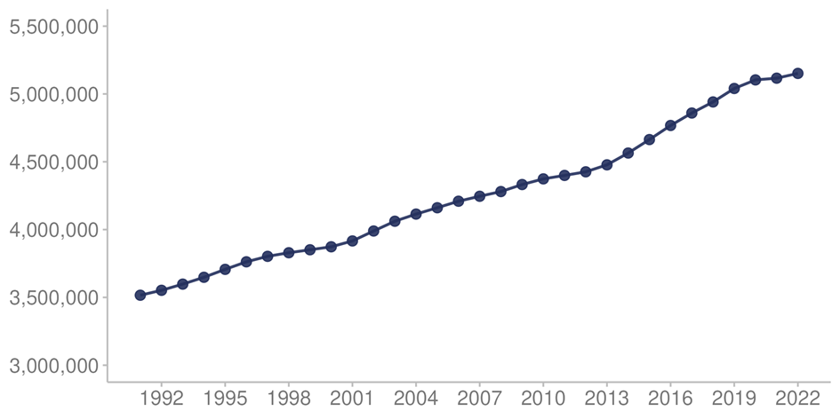
Source: Stats NZ (2023d)

During the year ending December 2022, Aotearoa New Zealand’s population grew by 35,200 (0.7%; Stats NZ 2023f). Two factors contributed to this increase.
- The estimated natural increase (58,887 live births minus 38,574 deaths) was 20,313 (Stats NZ 2023a). This was 228 more births and 3,642 more deaths compared with the year ended December 2021.
- Provisional net migration (migrant arrivals minus migrant departures) was a gain of 15,800 (Stats NZ 2023g). The provisional net migration gain in 2022 was a turnaround from a net migration loss of 15,000 in 2021, but below pre-COVID net gains, which averaged 57,600 a year from 2014 to 2019.

Figure 2 shows net migration between January 2017 and January 2023. This is the balance from those arriving in the country minus individuals leaving. The impact of the COVID-19 pandemic is evident in the net migration loss from March 2020 to May 2022.

Figure 2: Net migration to Aotearoa New Zealand, January 2017 – January 2023
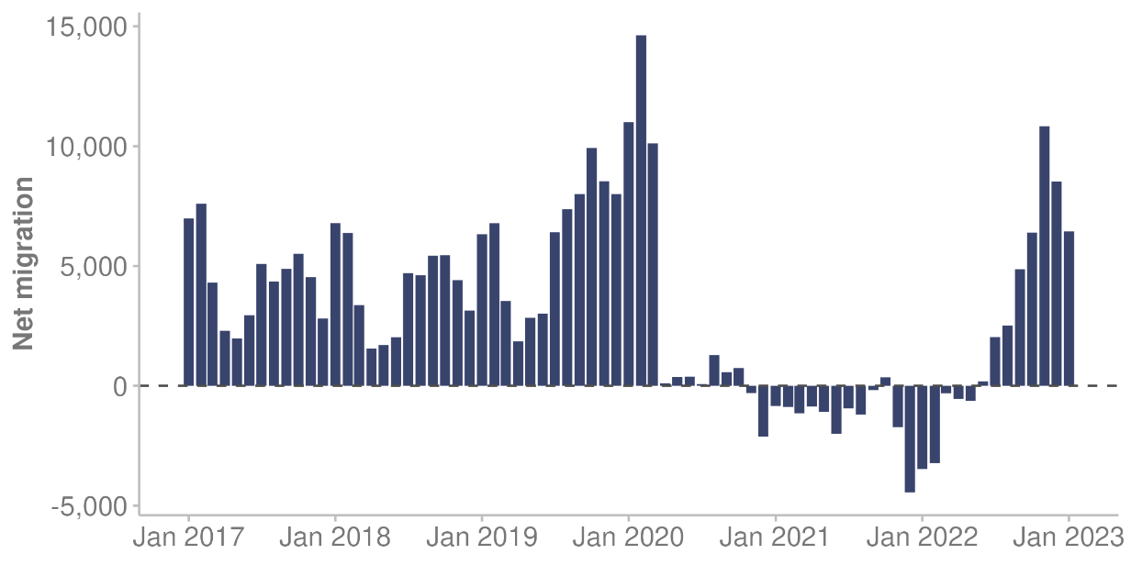
Source: Stats NZ (2023a)

Changing demographics
Aotearoa New Zealand’s total population is projected to grow from 4.9 million in 2018 (when the last national census was conducted) to 5.9 million in 2043 (Stats NZ 2021d). This would mean an increase of 0.9% per year on average. Key ways in which the population will change are that we will become more ethnically diverse and will have an ageing population structure. To meet the needs of this changing population, the health and disability system will need to be increasingly representative and responsive.

Increasing ethnic diversity
According to Stats NZ (2022d), all major ethnic population groups are projected to grow over the next 2 decades. Some groups are expected to grow faster than others, depending on their age structures, birth and death rates, and patterns of migration. Note this report uses total response ethnicity data (each respondent is counted in each of the ethnic groups they identify with) where available (Manatū Hauora 2017).

Projected changes to the population of Aotearoa New Zealand between 2022 and 2043 are that:
- Māori will grow from 17.3% (889,000 people) to 20.9% (1,239,800 people)
- the Pacific population will grow from 9.0% (459,200 people) to 11.2% (664,600 people)
- as early as 2028, the Asian population will grow from 16.6% (850,400 people) to 24.5% (1,449,200 people) to become the second-largest ethnic group
- the European/other population will grow in number, but its share of the total population will fall from 69.7% (3,573,600 people) to 65.4% (3,871,800 people)
- the Middle Eastern, Latin American, and African (MELAA) ethnic group will increase its share of the total population from 1.8% (92,800 people) to 2.8% (167,600 people)
- the total population will grow from 5.1 million to 5.9 million (Stats NZ 2022d).

The higher projected growth of Māori and Pacific ethnic groups is due to their younger population structure and above-average birth rates. Figure 3 shows the projected increase for all major ethnic population groups. Note that, because individuals can belong to more than one ethnic group, the ethnic populations do not sum to the total population.

Figure 3: Past and projected population of Aotearoa New Zealand, in total and by ethnic group, 2018–2043
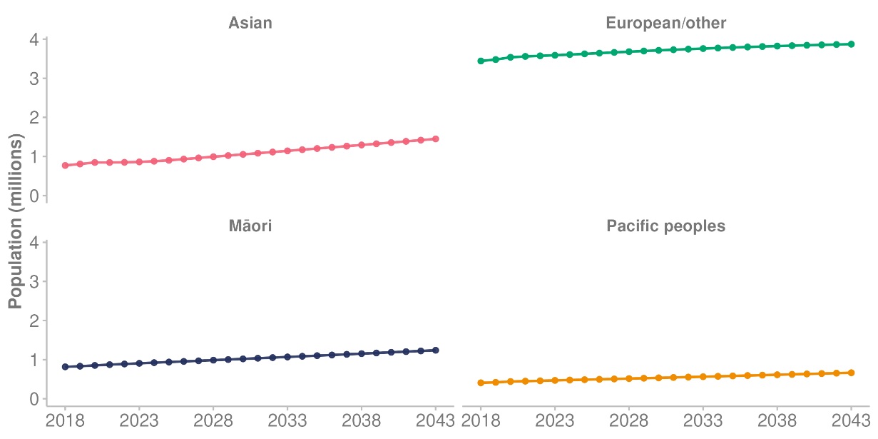
Source: Stats NZ (2022d)

The number of young people who identify with more than one ethnic group is increasing, which is another cause for the growth in ethnic diversity (Stats NZ 2022d). In the Growing Up in New Zealand study, one-third of young people aged 12 years identified with more than one ethnic group (Neumann et al 2023). As we have noted, this report includes each person in each high-level ethnic group they identify with (Māori, Pacific peoples, Asian and European/other), so an increase in the number of people identifying with more than one ethnic group will contribute to greater ethnic diversity. However, this does not capture the full extent of diversity because each high-level group contains many different ethnicities. The 2018 Census counted over 160 ethnic groups living in Aotearoa New Zealand (Stats NZ 2020a).

Figure 4 shows the age distribution of the estimated population for different ethnic groups in Aotearoa New Zealand. Māori and Pacific ethnic groups have a higher proportion of people in the younger age groups. The European/other population has a higher proportion of people aged 50 years and over.

Figure 4: Estimated population of Aotearoa New Zealand, by ethnic group and age group, 2022
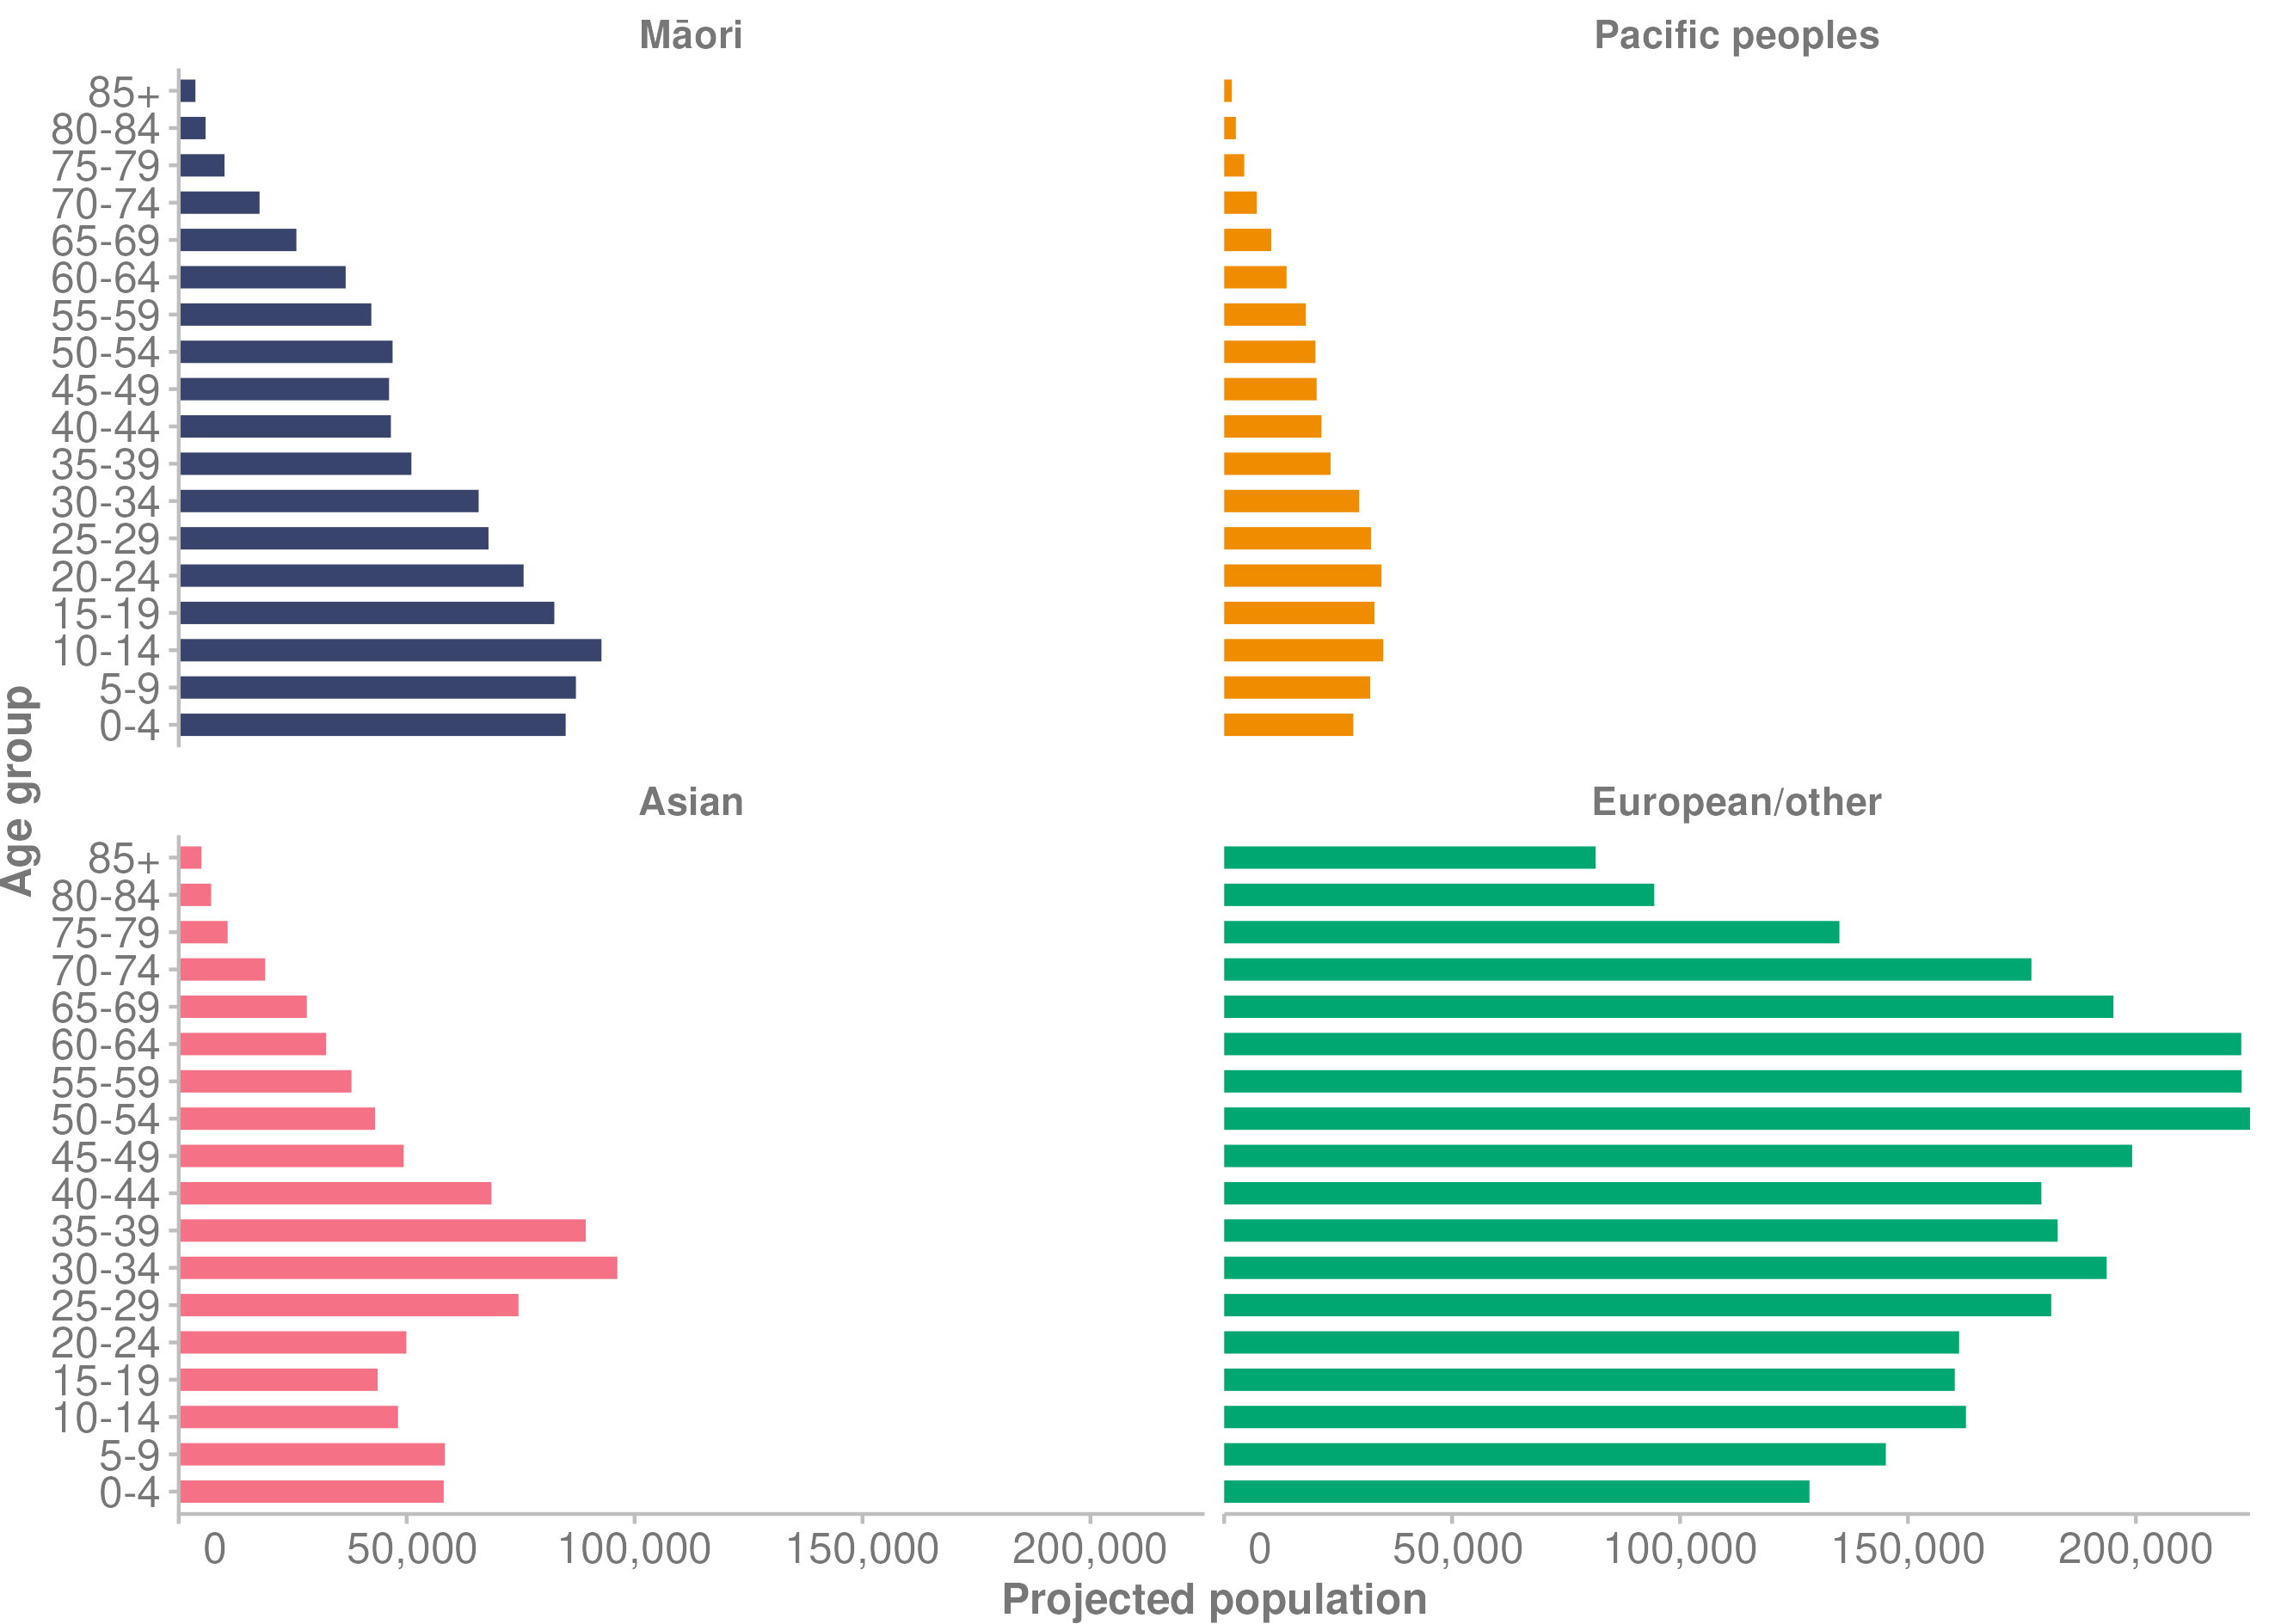
Source: Te Whatu Ora unpublished data (2023)

Structural ageing
Population projections indicate that the median age of all ethnic groups will gradually increase over the coming decades (Stats NZ 2022c). The main causes of this trend are rising life expectancy (people living longer) and declining fertility (people having fewer children). However, Māori and Pacific populations will continue to have a much younger age structure than the European/other population because they have higher birth rates.

By 2043, projections are for the population aged 85 years and over to more than double for both males and females, and the population aged 65–84 years will increase by 47.9%. This will add around 496,000 people aged 65 years and over to the population.

The ageing population is likely to increase demand for health and disability services, as older people generally use more of these services than younger people (Cornwall and Davey 2004). Many diseases, such as cancer, heart disease and Alzheimer’s disease, are more common in older people. Rates of disability also increase with older age.

Figure 5 shows how the age structure of the population of Aotearoa New Zealand is changing and will continue to change, with a focus on 3 years: 2001, 2022 and 2048. The 2048 projected population clearly shows the increase in the older age groups.

Figure 5: Aotearoa New Zealand population, by age group, in 2001, 2022 and (projected) 2048
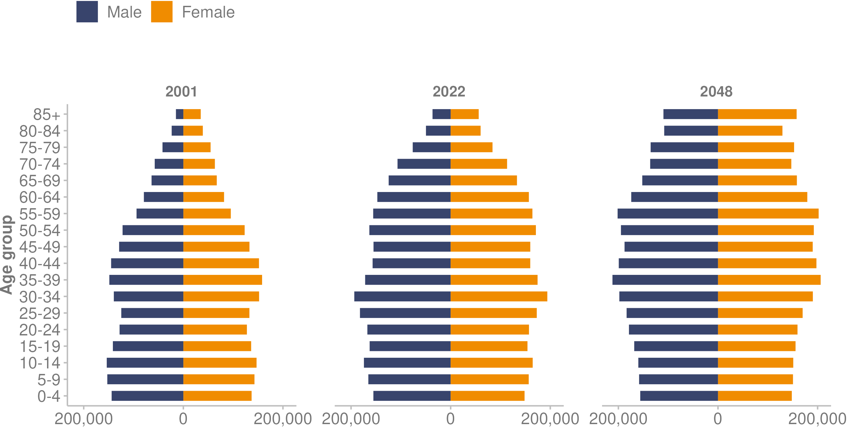
Source: Te Whatu Ora unpublished data (2023)

Where New Zealanders live

Urban and rural populations
The Geographic Classification for Health (GCH) is an urban–rural classification used to monitor variations in health outcomes between New Zealanders living in urban and rural areas (Whitehead et al 2021). It classifies all areas of Aotearoa New Zealand based on how close they are to larger urban areas and how this relates to health services.

When linked to 2022 population projections from Stats NZ, the GCH shows 19% of the population, nearly 900,000 people, lived in areas categorised as rural. Figure 6 presents the proportion of each ethnic group living in rural and urban areas. By ethnic group:
- 25.6% of Māori lived in rural areas and 74.4% in urban areas
- 6.6% of Pacific peoples lived in rural areas and 93.4% in urban areas
- 5.7% of the Asian population lived in rural areas and 94.2% in urban areas
- 22.4% of European/other lived in rural areas and 77.5% in urban areas.
Figure 6: Percentage of Aotearoa New Zealand population living in rural and urban areas, by ethnic group, 2022
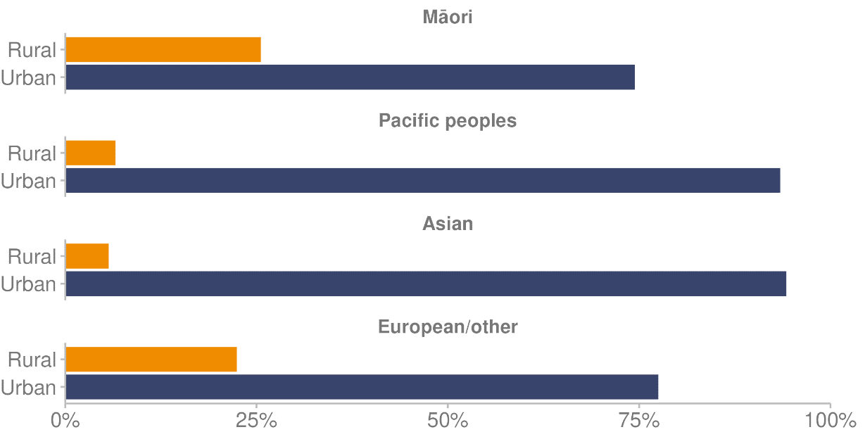
Source: Manatū Hauora unpublished data (2023)

Socioeconomic deprivation
Here we look at socioeconomic deprivation, based on the categories in the New Zealand Index of Deprivation (NZDep2018). The NZDep2018 measures the level of relative socioeconomic deprivation for each neighbourhood by combining measures of: household income; receiving a benefit; household crowding and quality (damp/mould); single-parent families (according to Stats NZ (2020e), 83% of single-parents were women); home ownership; employment status; qualifications; and access to the internet (Atkinson et al 2020). It groups the areas into 5 categories or quintiles, where quintile 1 consists of the 20% of the least deprived areas and quintile 5 consists of the 20% of the most deprived areas in Aotearoa New Zealand.

Living in an area with higher levels of socioeconomic deprivation is clearly associated with worse health (University of Otago 2011). Life expectancy is around 10 years lower for people living in the most deprived areas than for those living in the least deprived areas (Stats NZ 2021b). The infant death rate for the most deprived areas is close to 2 times the rate of the least deprived areas (Te Whatu Ora 2023g).

Figure 7 shows the percentage of people living in each deprivation quintile by ethnic group. Māori and Pacific populations were over-represented in the most deprived quintile (quintile 5), where 43.0% of all Māori and 55.8% of all Pacific peoples lived. In contrast, only 12.5% of Europeans/others and 17.6% of the Asian population lived in quintile 5 areas.​

Nearly 1 in 4 Europeans/others (24.2%) lived in the least deprived quintile, compared with 8.3% of Māori and 4.9% of Pacific peoples.

Figure 7: Percentage of Aotearoa New Zealand population living in each deprivation quintile (NZDep2018), by ethnic group, 2022
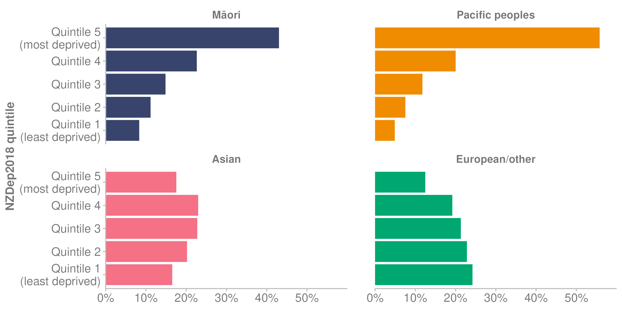
Source: Te Whatu Ora unpublished data (2023)

Disabled population
The most recent data on the prevalence of disability comes from the Stats NZ 2013 New Zealand Disability Survey (Stats NZ 2014). The survey findings included the following.
- A total of 1.1 million people (24% of the population) were disabled. The ageing population helps to explain the increase from the 2001 rate (20%).
- Māori and Pacific peoples had higher than average disability rates, after adjusting for differences in age profiles between ethnic groups.
- People aged 65 years and older were much more likely to be disabled (59%) than adults under 65 years old (21%) and children under 15 years old (11%).

Information from Stats NZ shows disabled people fare worse than non-disabled people across a range of outcomes relating to housing and neighbourhoods, and their economic and social lives (Stats NZ 2020b).

National disability survey planned for 2023
Stats NZ is planning to undertake a national disability survey in 2023. It will be the first national disability survey since 2013 (Stats NZ 2023e). This survey is the primary source of information for estimating disability prevalence in Aotearoa New Zealand. It also provides detail about how well disabled people are getting on compared with non-disabled people.

The objectives of the Disability Survey (Stats NZ 2023e), in priority order, are to understand:
- the size of the disabled population usually resident in Aotearoa New Zealand and describe characteristics of that population
- the extent to which social, wellbeing and economic outcomes for disabled people differ from non-disabled people, and how those outcomes differ between groups within the disabled population
- the level and type of support disabled people need to perform activities of daily living, and identify unmet need for support
- what creates barriers for disabled people against participating, and what enables them to participate in important aspects of life, such as work, education, civic society and recreation.

Transforming the disability support system
Whaikaha — Ministry of Disabled People (Whaikaha) was established on 1 July 2022 to support a whole-of-life approach to disability, provide a wider lens on disability across government and drive transformation of the disability support system (Manatū Hauora 2022j).

Transforming the disability system in line with Enabling Good Lives principles is a key programme of work for Whaikaha (Whaikaha 2022). Five elements underpin this work:
- self-directed planning and facilitation
- cross-government individualised and portable funding
- considering the person in their wider context, not in the context of ‘funded support services’
- strengthening families or whānau
- community building to develop natural supports.

Health measures | Ngā inenga hauora

Population health measures
Here we look at the health of New Zealanders in terms of their self-rated health, as well as life expectancy, mortality and health expectancy.

One of the key data sources we use in this section is the New Zealand Health Survey (Health Survey). This survey collects data to monitor population health and provides evidence to support health policy and strategy development (Manatū Hauora 2023j). Manatū Hauora has run the Health Survey in various forms since 1992/93 (and every year since 2011/12). Due to the impacts of COVID-19, the adult sample for 2021/22 was about 33% of the size of the usual sample, and the child sample was about 30% of the size of the usual sample (compared with the years from 2011/12 to 2018/19, before the COVID-19 pandemic; Manatū Hauora 2022i). The sample size for the 2021/22 survey was 4,434 adults (coverage rate of 44%) and 1,323 children (coverage rate of 48%). The coverage rates were 33% for Māori, 36% for Pacific peoples and 50% for Asian peoples (Manatū Hauora 2022i).

To increase the sample size for smaller population groups, this report presents most Health Survey data as 3-year rolling averages. This means that each statistic is averaged across 3 consecutive years of survey data. The advantage of this approach is that it smooths trends over time, making it easier to interpret and discuss trends. Due to this pooling methodology, Health Survey numbers in this document may differ from numbers published elsewhere. For Health Survey data that is not collected every year, we present it by survey year rather than 3-year pooled periods and note this accordingly. For more details, see the ‘Technical notes’ section.

Self-rated health
In the Health Survey, for the 3-year pooled period ending 2021/22, most adults (87.8%) reported that they were in good health (defined as good, very good or excellent health; Manatū Hauora 2023a). In the same period, ethnic groups differed in their self-reported good health:
- 80.3% of Māori adults
- 81.5% of Pacific adults
- 88.4% of European/other adults
- 91.3% of Asian adults.

Disabled adults were also significantly less likely to report being in good health (59.2%) than non-disabled adults (90.5%), after adjusting for age and gender.
Adults living in the most socioeconomically deprived areas were less likely to say they were in good health (82.3%) than adults in the least deprived areas (92.2%).

In the 3-year pooled period ending 2021/22, according to their parents or primary caregivers, 86.6% of children were in very good or excellent health. This high level of good health among children has been stable since 2013/14. However:
- parents of Māori children were less likely to rate their children’s health as very good or excellent (82.0%) than parents of non-Māori children (88.4%)
- parents of children living in the most deprived areas were less likely to rate their children’s health as very good or excellent (80.1%) than parents of children living in the least deprived areas (91.3%).

Life expectancy
According to Stats NZ, the number of deaths in Aotearoa New Zealand rose to 38,574 in 2022 (Stats NZ 2023a). This was a 10.4% increase in the number of registered deaths compared with 2021, which had 34,932 registered deaths. COVID-19 contributed to the increase in deaths, with 2,358 deaths attributed to the pandemic. However, over the 3 years of the pandemic, Aotearoa New Zealand recorded one of the lowest excess mortality rates (deaths above what would be expected in normal conditions) of all countries in the Organisation for Economic Co-operation and Development (OECD; Kobak 2023).

The increase in deaths in 2022 also partly reflects the ageing population. Nearly 2 in every 3 deaths were among people aged 75 years and over, and 1 in every 5 deaths was among people aged 90 years and over (Stats NZ 2023c). According to Stats NZ, deaths in Aotearoa New Zealand are gradually increasing, as the number of older people in the population (the age group where most deaths occur) grows.

Over recent years, the trend has been for life expectancy to increase for both males and females (Stats NZ 2023a). In contrast, changes in life expectancy at birth were relatively small in 2022. However, we can also see this change in a broader context: a global study of 37 countries, published in the British Medical Journal, found life expectancy in 2020 for men and women fell in all countries except Aotearoa New Zealand, Taiwan and Norway (Islam et al 2021).

Based on births and deaths registered from 2020 to 2022, current life expectancy is that:
- a newborn boy will live, on average, 80.5 years
- a newborn girl will live, on average, 84.0 years (Stats NZ 2023a).

Life expectancy by ethnic group
Life expectancy differs by ethnic group (Stats NZ 2021c). Figure 8 shows life expectancy at birth was 73.4 years for Māori males in 2017–2019 (up 3.1 years from 2005–2007) and 77.1 years for Māori females (up 2.0 years from 2005–2007). In comparison, non-Māori males were expected to live to 80.9 years, while non-Māori females were expected to live to 84.4 years (Stats NZ 2021c). Life expectancy at birth was 75.4 years for Pacific males and 79.0 years for Pacific females in 2017–2019. Life expectancy was highest for Asian females (87.9 years) and Asian males (85.1 years).

Figure 8: Life expectancy at birth, by ethnic group and gender, 2017–2019
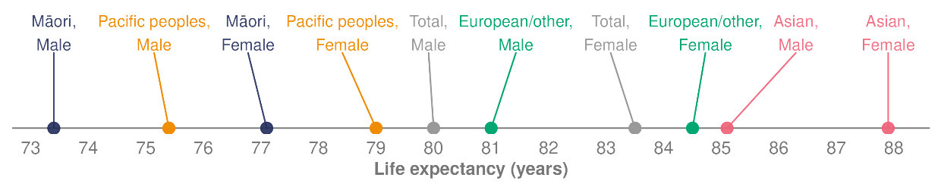
Source: Stats NZ (2021d)

Stats NZ (2021d) projects that life expectancy will continue to rise for all combinations of ethnic and gender groups. However, it projects the largest rises between 2021 and 2043 will be for Māori and Pacific peoples.

Life expectancy by deprivation
Life expectancy varies by around 10 years between people living in the least deprived areas (quintile 1) and those living in the most deprived areas (quintile 5) of Aotearoa New Zealand (Stats NZ 2021b). Figure 9 presents life expectancy at birth for the 2017–2019 period. Life expectancy for people living in the most deprived areas was 75.4 years for males and 79.8 years for females. In comparison, for those living in the least deprived areas, life expectancy was 84.1 years for males and 86.9 years for females.

Figure 9: Life expectancy at birth, by deprivation quintile (NZDep2018) and gender, 2017–2019
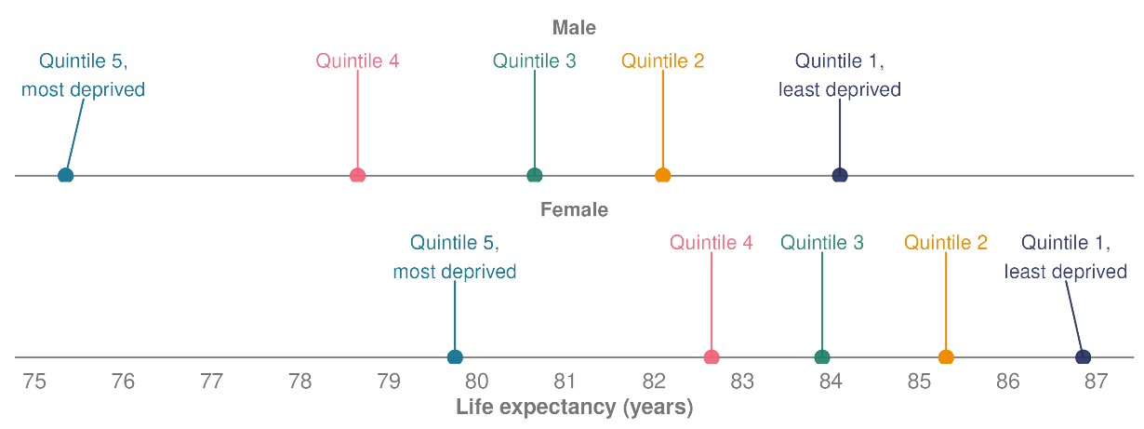
Source: Stats NZ (2021c)

Mortality
Te Whatu Ora’s mortality web tool presents mortality data for selected causes of death registered in Aotearoa New Zealand (Te Whatu Ora 2023h). This mortality data includes cause of death, which can involve a coroner investigation. For this reason, only data to 2018 is final. Data for 2019 and 2020 is preliminary, as some cases remain under investigation by the coroner.

The following trends in mortality are evident.
- While the number of deaths has increased with the growing and ageing population, the mortality rate has decreased over time, from 982 deaths per 100,000 population in 1948 to 370 deaths per 100,000 in 2018.
- The mortality rate has been consistently higher for males than females and the difference between them has increased over time.
- Mortality rates for Māori have been generally higher than rates for non-Māori. This trend is consistent for Māori males and Māori females compared with their non-Māori counterparts.

Table 2 shows the number of deaths in 2020 (the most recent data available) for Māori and non-Māori and by gender. It also compares the rate of deaths, per 100,000 people, for these groups.

Table 2: Number and rate of deaths, Māori and non-Māori and by gender, 2020
Ethnic group | Number of deaths 2020 |  |  | Mortality rate  (per 100,000 population)
 | Total | Female | Male | Total | Female | Male
All ethnic groups | 32,783 | 15,781 | 17,002 | 343.8 | 289.4 | 404.5
Māori | 3,930 | 1,789 | 2,141 | 552.2 | 469.4 | 646.5
Non-Māori | 28,853 | 13,992 | 14,861 | 318.2 | 268.0 | 374.2
Note: Rates per 100,000 population are age standardised to the World Health Organization’s World Standard Population.
Source: Te Whatu Ora (2023h)

Overall, the leading causes of death in 2020 per 100,000 population were:
- cancer (all cancer types combined) at 109.9 deaths per 100,000
- ischaemic heart disease at 41.9 deaths
- cerebrovascular diseases (includes heart, stroke and blood vessel diseases) at 18.9 deaths.

For Māori, the leading causes of death in 2020 per 100,000 Māori population were:
- cancer (all cancer types combined) at 163.8 deaths per 100,000
- ischaemic heart disease at 72.2 deaths
- chronic lower respiratory diseases at 37.9 deaths.

Fetal and infant mortality
Te Whatu Ora’s fetal and infant deaths web tool presents a summary of fetal deaths and infant deaths, with a focus on deaths and stillbirths registered in 2020 (Te Whatu Ora 2023g). It includes demographic information, cause of death, gestation and birthweight of the deceased. It also identifies deaths classified as sudden infant death syndrome (SIDS) and sudden unexpected death in infancy (SUDI).

In total, 434 fetal deaths and 278 infant deaths were registered in 2020 (the most recent available data; Te Whatu Ora 2023g). This equates to a fetal death rate of 7.4 per 1,000 total births, and an infant death rate of 4.8 per 1,000 live births. Between 1996 and 2020, the infant death rate fell significantly, from 7.3 to 4.8 infant deaths per 1,000 live births. The main reason for this decrease was a notable drop in post-neonatal deaths.

According to the latest Perinatal and Maternal Mortality Review Committee report (Te Tāhū Hauora 2022a), inequities based on ethnic group, deprivation level and age persist in all mortality review findings. The Committee reported Māori, Pacific peoples, Indian populations, those under 20 years old and people living in areas of high deprivation experience worse pregnancy and childbirth outcomes than the New Zealand European population. In addition, wāhine Māori, Pacific women and women living in higher deprivation areas suffer a greater burden of maternal mortality (Te Tāhū Hauora 2022b).

In 2020, infant death rates were significantly higher among Māori (6.1 per 1,000 live births) and Pacific peoples (7.1) than rates for Asian peoples (3.0). In the previous 5-year period (2015–2019), infant death rates for Māori (5.4) and Pacific peoples (7.2) were significantly higher than rates for the European/other (3.6) and Asian (3.3) ethnic groups.

In terms of deprivation level, the highest infant death rates in 2020 were for people living in the most deprived areas (quintile 5). At 6.7 deaths per 1,000 live births, their infant death rate was close to 2 times the rate of those in the least deprived areas (3.9 in quintile 1). Similar infant death rates by deprivation area were evident in the previous 5-year period between 2015 and 2019.

Figure 10 shows the number and rate of fetal and infant deaths from 1996 to 2020.

Figure 10: Number and rate of fetal and infant deaths, 1996–2020
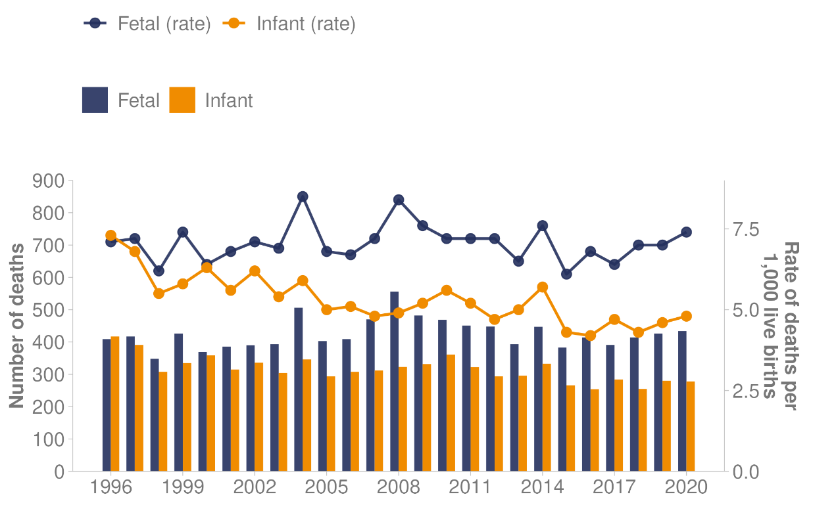
Note: Bars represent the number of fetal/infant deaths and lines represent the rate of fetal/infant deaths. Fetal death rate is the number of deaths per 1,000 total births. Infant death rate is the number of deaths per 1,000 live births.
Source: Te Whatu Ora (2023g)

Health expectancy
Health expectancy represents the number of years it is expected that people will live in good health (Manatū Hauora 2020c). Although both life expectancy and health expectancy have increased over time, the number of expected years in good health at birth has slowed since 2010, while the number of expected years in poor health has continued to climb (Institute for Health Metrics and Evaluation 2020a). This means that, while New Zealanders are living longer, they are also spending more time in poor health.

Table 3: Health and life expectancy, by gender, 1990–1999, 2000–2009 and 2010–2019
Decade | Gender | Years in good health | Years in poor health | Total life expectancy
1990–1999 | Men | 64.3 | 9.7 | 74.0
 | Women | 67.1 | 12.4 | 79.5
2000–2009 | Men | 67.1 | 10.2 | 77.3
 | Women | 69.1 | 12.6 | 81.7
2010–2019 | Men | 68.8 | 10.8 | 79.7
 | Women | 70.2 | 13.1 | 83.4
Source: Institute for Health Metrics and Evaluation (2020a) and Institute for Health Metrics and Evaluation (2020b)

Causes of health loss
Health loss is a measure of how much healthy life a person loses due to early death, illness or disability. The information in Figure 11 comes from the Global Burden of Disease Study 2019 (the most up-to-date data available). The Global Burden of Disease Study provides a comprehensive picture of mortality and disability worldwide, across countries, time, age and gender (Institute for Health Metrics and Evaluation 2020a).

In Aotearoa New Zealand, non-communicable diseases (NCDs) are the leading cause of health loss (Manatū Hauora 2020c). NCDs, also known as chronic diseases, tend to last a long time and result from a combination of genetic, physiological, environmental and behavioural factors (World Health Organization 2022).

Figure 11 shows the top 10 causes of health loss (early death, illness or disability) in Aotearoa New Zealand in 2019 for both males and females, as measured by disability-adjusted life years (DALYs). The graph also shows the percentage change (the increase or decrease in DALYs) between 2009 and 2019 (Institute for Health Metrics and Evaluation 2020a). Ischaemic heart disease was the number one cause of health loss in 2019 and had increased by 0.4% since 2009. The next largest causes of health loss in 2019 were low back pain and chronic obstructive pulmonary disorder, with an increase between 2009 and 2019 for both males and females for both conditions (2.5% and 13.0% respectively). The largest increase in health loss was for diabetes, which increased by 34.5% between 2009 and 2019.

Figure 11: Top 10 causes of death and disability for females and males, 2019, and percentage change between 2009 and 2019, as measured by disability-adjusted life years
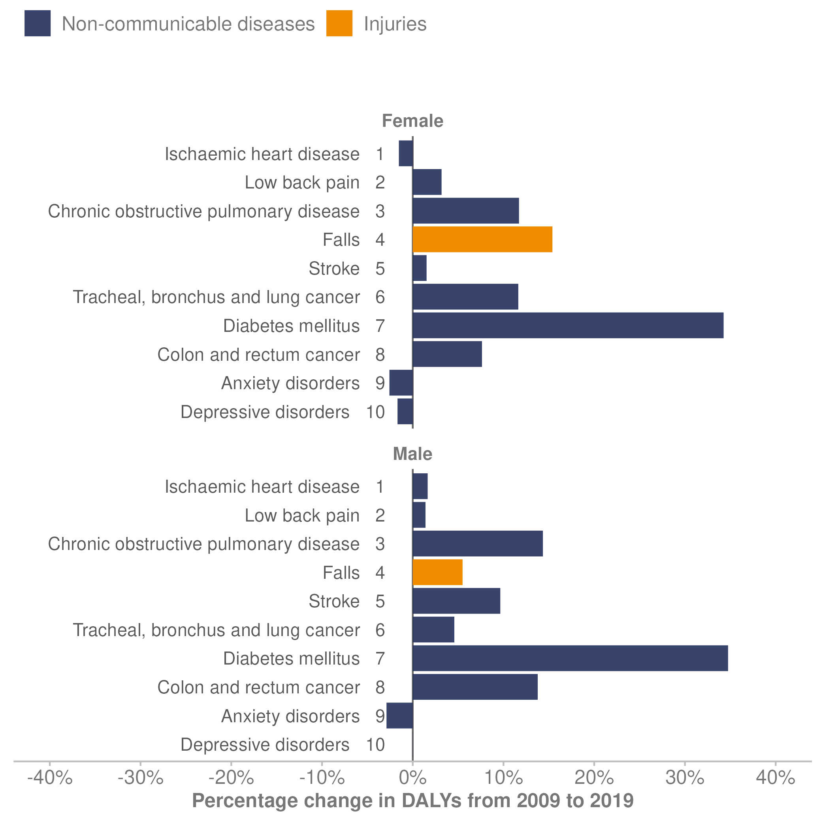
Source: Institute for Health Metrics and Evaluation (2020a)

Cardiovascular and cerebrovascular diseases
After cancer, cardiovascular and cerebrovascular diseases (which include heart, stroke and blood vessel disease) are the leading causes of death in Aotearoa New Zealand (Te Whatu Ora 2023h). One in 23 adults were diagnosed with heart disease, which amounts to around 175,000 people (Heart Foundation 2023). It causes almost 1 in every 3 deaths.

In 2020 (the latest data available), ischaemic heart disease accounted for 4,361 deaths, an age-standardised rate of 41.9 deaths per 100,000 population (Te Whatu Ora 2023h). Within total deaths from this disease:
- the rate for Māori was 72.2 per 100,000 population, compared with the non-Māori rate of 38.4 per 100,000 population
- the rate for women was 26.7 and the rate for men of 59.1 per 100,000 population.
Cerebrovascular disease refers to a group of conditions, diseases and disorders that affect the blood vessels and blood supply to the brain (University of Michigan 2023). Stroke is the most common form of this group of conditions.

In 2020, cerebrovascular disease accounted for 2,067 deaths, which is an age-standardised rate of 18.9 deaths per 100,000 population (Te Whatu Ora 2023h). Within total deaths from this disease:
- the rate for Māori was 25.7 per 100,000 population, compared with the non-Māori rate of 18.0 per 100,000 population
- the rate for women was 19.0 and the rate for men was 18.5 per 100,000 population.

Cancer
When all cancer types are combined, cancer is the leading cause of death in Aotearoa New Zealand (Te Whatu Ora 2023h). Cancer is more common in older people. Because the population is both ageing and growing in size, the number of New Zealanders with cancer is likely to increase over time.

Cancer incidence
In 2020 (the latest data available), a total of 27,072 people in Aotearoa New Zealand were diagnosed with cancer (new cancer registrations; Te Whatu Ora 2023d). The most commonly diagnosed cancers (excluding non-melanoma skin cancers) were breast, lung, prostate and colorectal cancers. The number of new cancers per 100,000 people (incidence) has remained relatively stable for the past 20 years (Te Aho o Te Kahu Cancer Control Agency 2023d).

However, cancer rates also varied between ethnic groups. Figure 12 shows a continually higher rate of cancer registrations per 100,000 population for Māori compared with non-Māori between 2011 and 2020. In 2020, Māori had 411.5 cancer registrations per 100,000, compared with 328.8 cancer registrations per 100,000 for non-Māori.

Figure 12: Cancer registrations (incidence rate per 100,000 people), Māori and non-Māori, 2011–2020
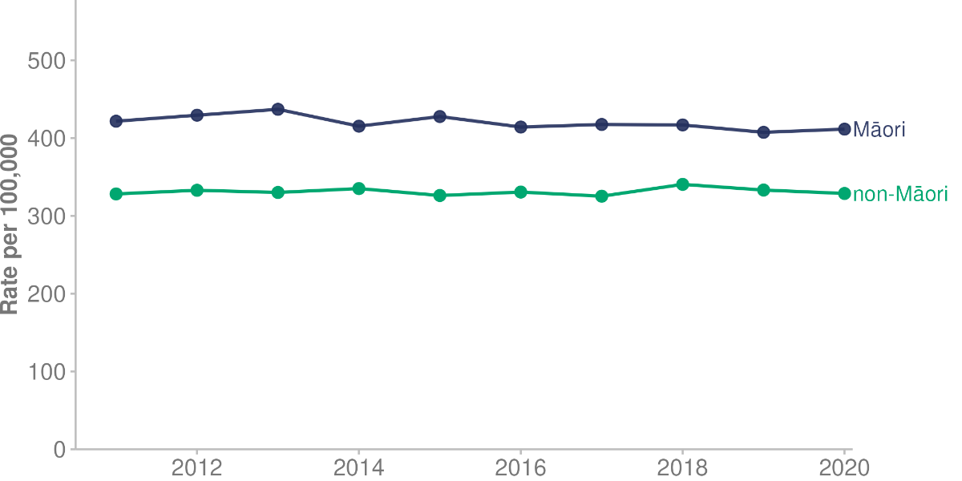
Source: Te Whatu Ora (2023d)

Cancer mortality
More people are surviving cancer because of improvements in diagnosis and treatment (Te Aho o Te Kahu Cancer Control Agency 2023b). However, considerable inequity persists for Māori compared with non-Māori. Over the past 22 years (between 1996 and 2018, up to the most recent year cancer mortality data is available), cancer deaths per 100,000 people decreased by 35.3% for Māori and by 28.3% for non-Māori (Te Whatu Ora 2023h).

Figure 13 shows the changes in cancer mortality for Māori and non-Māori between 1996 and 2018. It highlights the inequity that Māori experience.

Figure 13: Cancer mortality rates per 100,000 people, Māori and non-Māori, 1996–2018
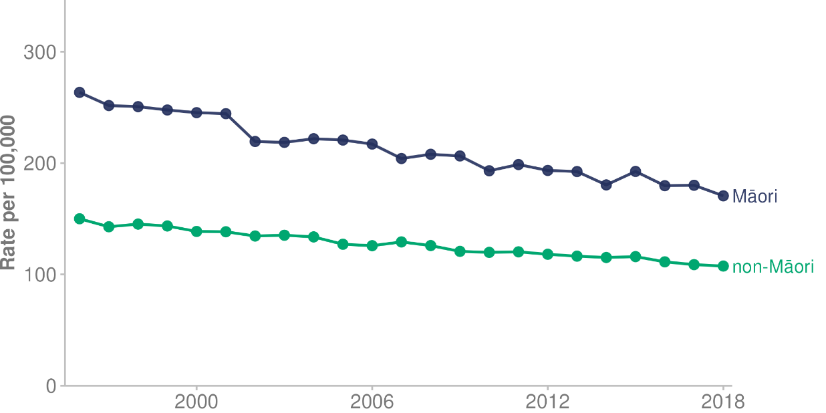
Source: Te Whatu Ora (2023h)

Cancer survival
Five-year survival rates have improved for some cancers over time. Figure 14 shows the change in cancer survival for the 10 most commonly diagnosed cancers (by highest registration/incidence rate in 2020) in the 20 years between 1998 – 1999 and 2018 – 2019.

Survival improved markedly in non-Hodgkin’s lymphoma (up from 47.9% 5-year survival in 1998 – 1999 to 68.3% survival in 2018 – 2019) and leukaemia (up from 41.8% to 56.3%). More moderate increases occurred for female breast cancer and prostate cancer. The survival rates of patients with melanoma had not changed (at around 92% in both 1998 – 1999 and 2018 – 2019).

Figure 14: Changes in cancer survival for the 10 most diagnosed cancers, 1998 – 1999 and 2018 – 2019
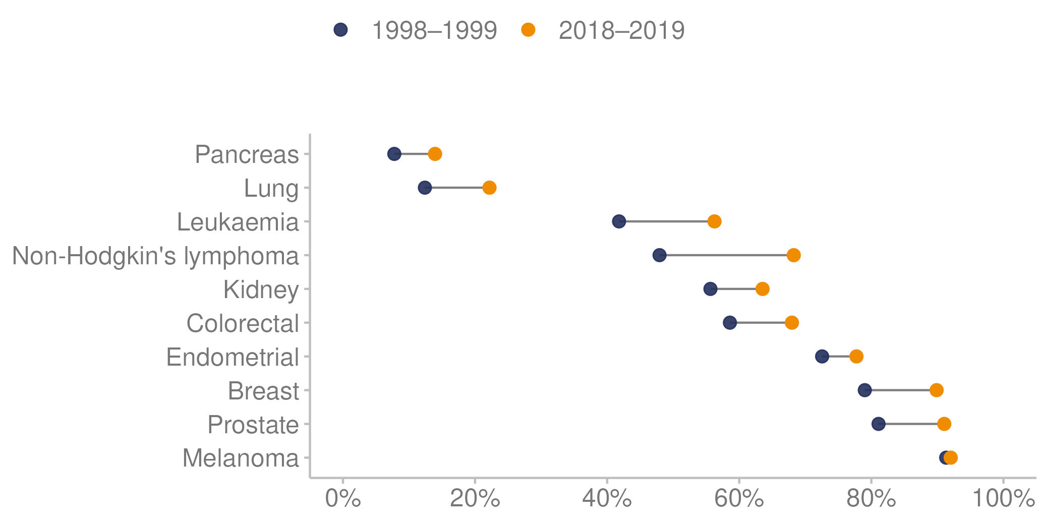
Source: Manatū Hauora unpublished data (2023)

Diagnosis after an emergency admission
Te Aho o Te Kahu Cancer Control Agency’s quality performance indicator programme aims to highlight variation in cancer diagnosis, treatment, and outcomes to inform activities aiming to improve cancer service quality (Te Aho o Te Kahu Cancer Control Agency 2022). A key indicator in this programme reports on the proportion of people diagnosed with a specific cancer soon after an unplanned or emergency admission to hospital. This indicator is important for improving patient outcomes because people whose cancer is diagnosed after an emergency or acute admission to hospital tend to have poorer outcomes and survival rates than patients with non-emergency diagnoses.

In Aotearoa New Zealand, cancers diagnosed during an emergency presentation included 45.0% of lung cancers between 2015 and 2018 (Te Aho o Te Kahu Cancer Control Agency 2023c) and 26.3% of bowel cancers between 2017 and 2019 (Te Aho o Te Kahu Cancer Control Agency 2023a). The data shows inequity for Māori and Pacific peoples, who have a higher percentage of people diagnosed after an emergency admission, compared with other ethnic groups.

Chronic pain
The Health Survey defines chronic pain as experiencing pain that is present almost every day and has lasted, or is expected to last, more than 6 months (Manatū Hauora 2023a). Data from the 3-year pooled period ending 2021/22 shows:
- a higher percentage of women (22.2%) experienced chronic pain than men (19.1%), especially in older age groups where 34.1% of women over 65 years of age experienced chronic pain, compared with 28.5% of men in that age group
- the percentage of people experiencing chronic pain was higher for Māori adults (24.2%) and European/other adults (22.3%) than for Pacific adults (18.4%) and Asian adults (11.3%)
- a markedly higher percentage of disabled adults (50.7%) experienced chronic pain, compared with non-disabled adults (17.8%)
- a higher percentage of people living rurally reported experiencing chronic pain, compared with those living in urban areas.

Diabetes
There were 292,365 people in Aotearoa New Zealand living with diabetes in 2021 (Te Whatu Ora 2023n). Prevalence of both type 1 and especially type 2 diabetes is increasing (Manatū Hauora 2022f). Among the top 10 causes of health loss (early death, illness or disability), diabetes was the seventh-highest cause of health loss in 2019, and had increased by 34.5% between 2009 and 2019 (see: Table 3 at the start of this section; Institute for Health Metrics and Evaluation 2020a).

In 2020, diabetes accounted for 953 deaths, a rate of 10.3 deaths per 100,000 population (Te Whatu Ora 2023h). Within the total deaths from this disease:
- the rate for Māori was 29.5 deaths per 100,000 population, compared with 8.5 deaths per 100,000 population for non-Māori.
- the rate for women was 8.1 per 100,000 population, and the rate for men was 12.9 per 100,000 population.

The rate of diabetes was higher among Māori, Pacific peoples and South Asian peoples than other ethnic groups (Te Whatu Ora 2023n). Rates were also higher in older age groups (Figure 15). For example, around 50% of people over 75 years of age had diabetes in the Pacific and Indian populations. The distribution of diabetes varies considerably within the Asian ethnic group; prevalence is highest in the Indian population. For this reason, we present data in Figure 15 separately for the Indian subgroup and combine data for the rest of the Asian ethnic group with the European/other group.

Figure 15. Age-specific rate of diabetes per 100,000 people, by ethnic group and age group, 2021
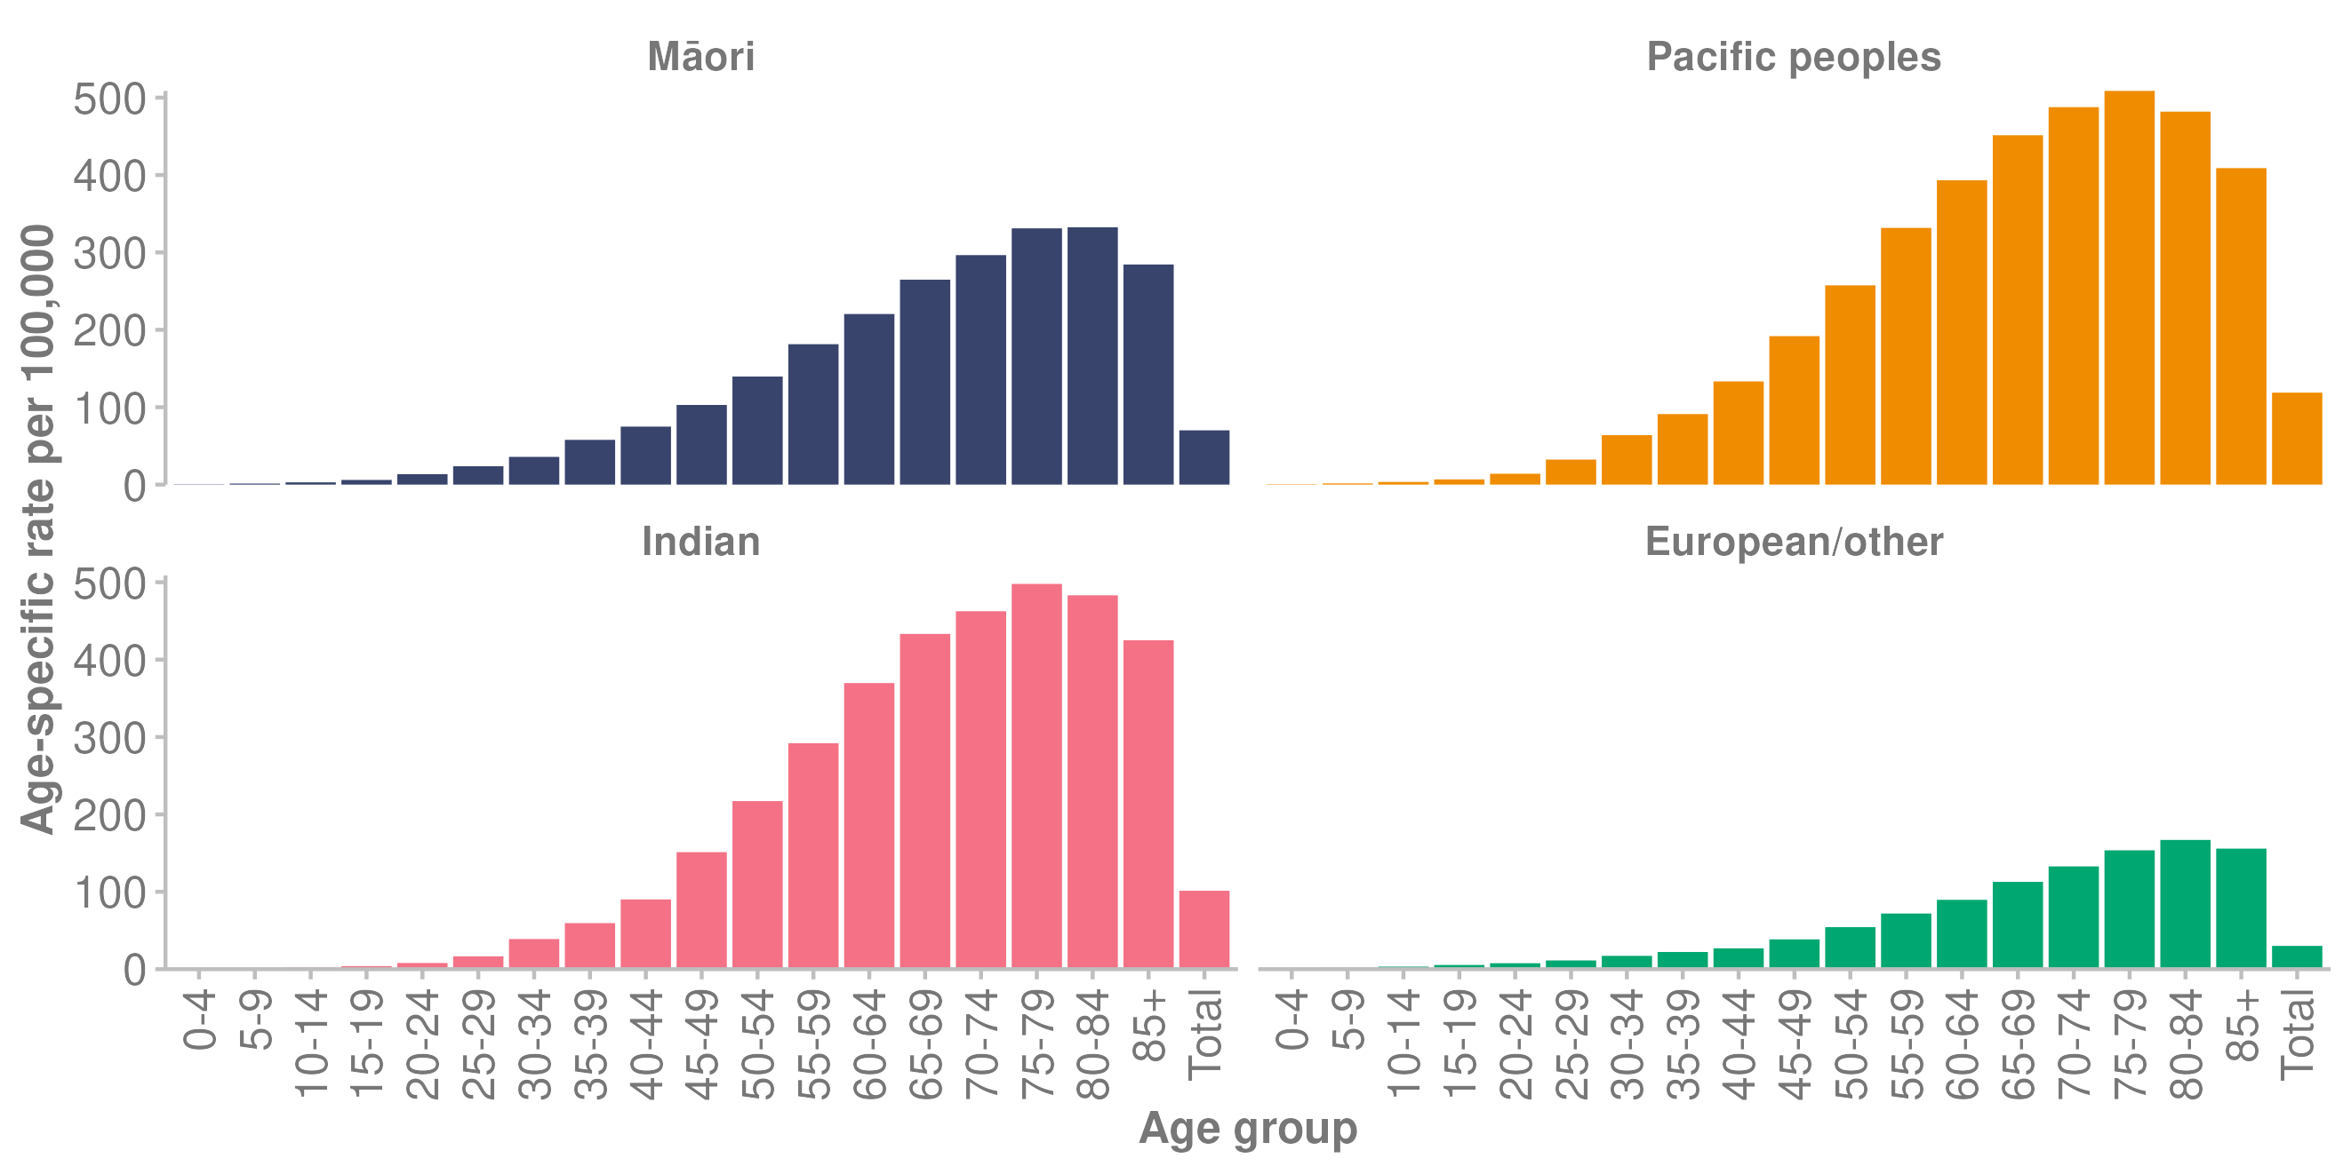
Note: The Indian subgroup is presented separately to the Asian ethnic group, which is combined with the European/other ethnic group.
Source: Te Whatu Ora (2023n)

Oral health

Adults
In the Health Survey, 79.1% of adults self-rated their oral health as excellent, very good or good (which we describe together here as ‘good oral health’) in the 3-year pooled period ending 2021/22 (Manatū Hauora 2023a). The percentage differed by ethnic group: 67.2% of Māori adults reported having good oral health, compared with 76.1% of Pacific adults, 84.6% of Asian adults and 79.7% of European/other adults. In addition, 66.0% of disabled adults rated their oral health as good, well below the 80.4% of non-disabled adults who did so. Adults living in the least deprived areas were more likely to rate their oral health as good (85.4%), compared with 71.4% of adults living in the most deprived areas. Adults living in rural areas were also less likely to rate their oral health as good, compared with those living in urban areas.

Children
Dental caries, also known as tooth decay, is a mainly preventable disease, but remains a common disease of childhood in Aotearoa New Zealand. In 2022, dental conditions were the fourth most common reason for ambulatory sensitive hospital admissions for children aged 0–4 years (Nationwide Service Framework Library 2023).​

Figure 16 shows the percentage of children who were caries-free (free of dental decay) at 5 years of age from 2010 to 2021. It is clear that inequity in oral health outcomes continues. In 2021, 41.1% of Māori children and 33.1% of Pacific children were caries-free at this milestone age, compared with 67.6% of European/other children (Manatū Hauora 2022a).

Figure 16: Percentage of children caries-free at age 5 years, by ethnic group, 2010–2021
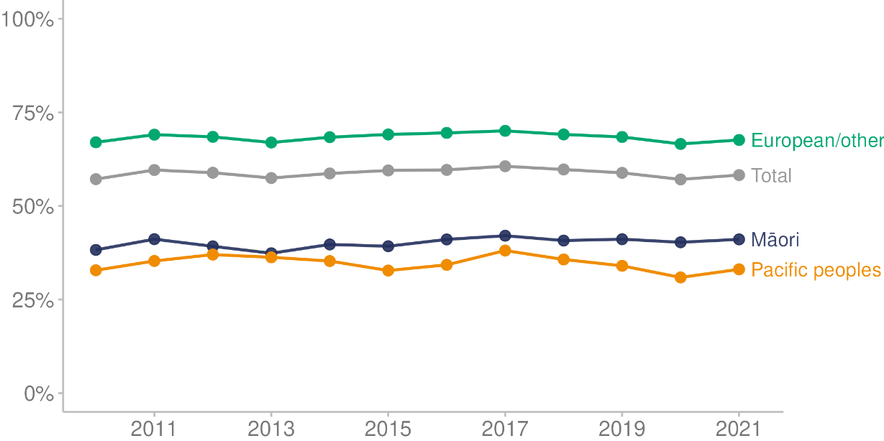
Source: Manatū Hauora (2022a)

The second milestone measure for oral health in Aotearoa New Zealand is the number of decayed, missing due to caries, and filled teeth (DMFT) in permanent teeth. The mean number of decayed, missing and filled teeth at year 8 in 2021 was 0.7 DMFT (Manatū Hauora 2022a). By ethnic group, the mean DMFT was 1.07 for Māori, 0.83 for Pacific peoples and 0.55 for European/other.

Figure 17 shows that, between 2010 and 2018, oral health for children at year 8 improved, with fewer decayed, missing and filled teeth for all ethnic groups. However, improvements plateaued at that time for all but Pacific children, and inequities in DMFT remain.

Figure 17: Mean number of decayed, missing and filled teeth (DMFT) per child at year 8, by ethnic group, 2010–2021
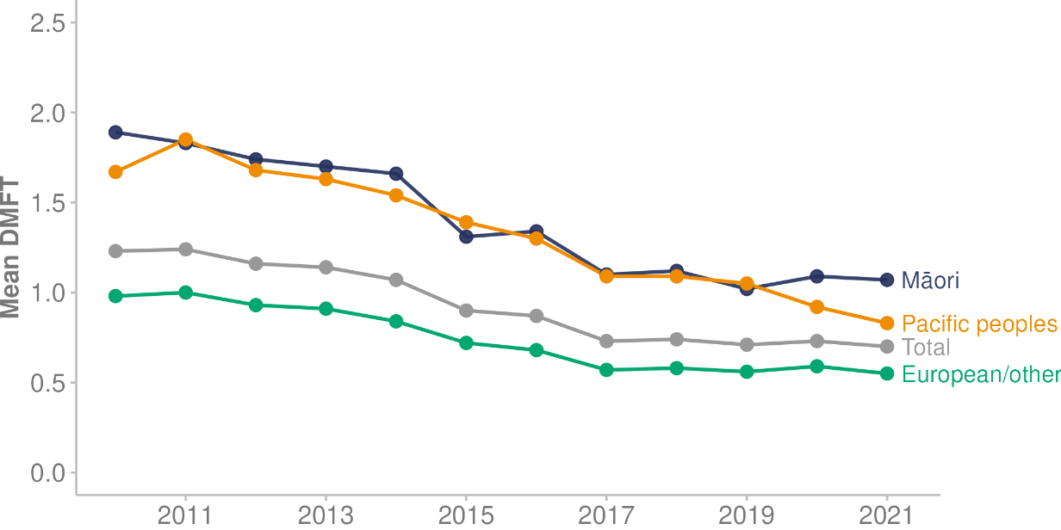
Source: Manatū Hauora (2022a)

Visited a dental health care worker in the past 12 months
In the Health Survey, data from the 3-year pooled period ending 2021/22 shows that 72.7% of children (up to 14 years of age) had seen a dental health care worker in the last 12 months, down from a high of 83.7% in the 3-year pooled period ending 2015/16. In the preschool group (0–4 years of age), the pooled 3-year data shows only 49.2% had seen a dental health care worker in the last 12 months, down from a high of 64.2% in the 3-year pooled period ending 2017/18 (Manatū Hauora 2023a).

Figure 18 summarises these findings, presenting the percentage of children who visited a dental health care worker in the last 12 months by age group in a 3-year rolling average.

Figure 18: Percentage of children who visited a dental health care worker, 3-year rolling average 2013/14–2021/22
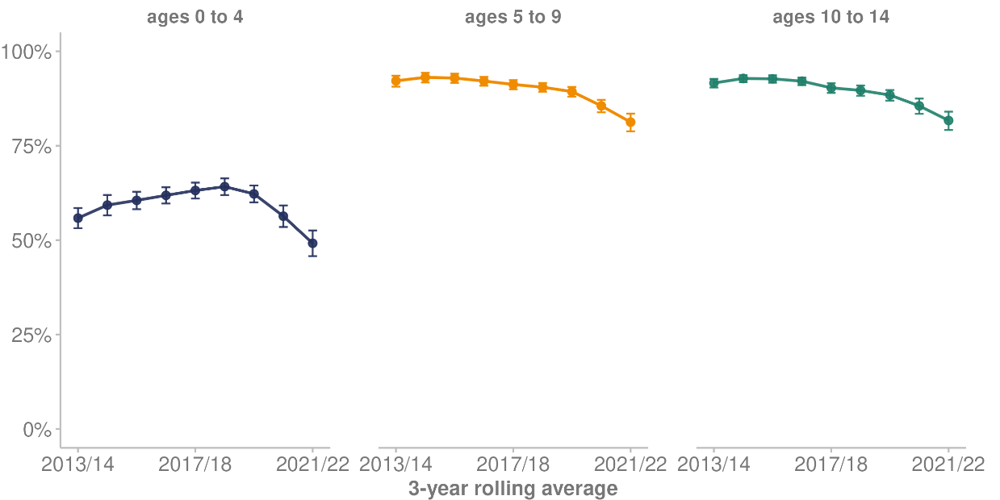
Note: Error bars represent 95% confidence intervals.
Source: Manatū Hauora (2023a)

Mental wellbeing
Manatū Hauora published Kia Manawanui Aotearoa: Long-term pathway to mental wellbeing (Kia Manawanui) in 2021 (Manatū Hauora 2021a). Kia Manawanui is the Government’s policy statement on mental wellbeing. In this document:

‘Mental wellbeing’ is defined as one component of broader wellbeing. Positive mental wellbeing is most likely when people feel safe, connected, valued, worthy and accepted and have a sense of belonging, identity, and hope for the future. Mental wellbeing means being able to adapt and cope with life and life’s challenges and feeling that your life has meaning, as well as experiencing feelings of contentment or general happiness. (p 10)

Access and Choice
The priorities of Kia Manawanui include expanding access and choice of mental health and addiction supports, providing recovery-based care, prioritising kaupapa Māori and whānau-centred approaches, and addressing equity (Manatū Hauora 2021a). The Access and Choice programme contributes to these priorities by expanding access to, and choice of, primary mental health and addiction services across the country (Te Whatu Ora 2023a).

Access and Choice is a 5-year programme that began in 2019 and rolled out services from February 2020. It delivers services across 4 workstreams:
- integrated primary mental health and addiction (IPMHA) services delivered through general practice teams
- youth-specific primary mental health and addiction services for those aged 12–24 years
- kaupapa Māori primary mental health and addiction services for people of all ages
- primary mental health and addiction services for Pacific peoples of all ages.

Between 1 January and 31 December 2022:
- 436 general practices delivered about 302,000 sessions of IPMHA services
- 22 contracted youth services delivered about 33,700 sessions
- 29 contracted kaupapa Māori services delivered about 44,000 sessions
- 9 contracted Pacific services delivered about 19,800 sessions (Te Whatu Ora 2023a).

Parenting
Parenting makes an important contribution to children’s physical and mental wellbeing. It follows that support for parents (that is, for adults in a consistent caregiving role) makes an important contribution to overall population health (Walker 2021).

The 2021/22 Health Survey asked parents how well they feel they are coping with the day-to-day demands of raising children. Because the Health Survey has asked this question in only some years since 2012/13, here we present the latest data as single-year data for the survey year 2021/22.

In the 2012/13 Health Survey, 86.5% of caregivers of children (aged 0–14 years) reported coping well or very well with the demands of raising children (Manatū Hauora 2023a). In 2021/22, this had reduced to 75.5% of caregivers coping well or very well with the demands of raising children. The percentage of parents making this response was similar across ethnic groups: 77.3% of Māori parents, 75.3% of Pacific parents, 74.3% of Asian parents and 73.7% of European/other parents reported coping well or very well.

Family wellbeing and life satisfaction
The 2021/22 Health Survey included 2 new questions, which covered family wellbeing and life satisfaction (Manatū Hauora 2022l). These came from the General Social Survey, which produces statistics about social wellbeing in Aotearoa New Zealand (Stats NZ 2021a).

Table 4 shows the percentage of adults in the survey year 2021/22 who reported high or very high family wellbeing and high or very high life satisfaction (score of 7 or more out of 10) by population group. In almost every population group, women reported lower family wellbeing and lower life satisfaction than men.

Table 4: Percentage of high or very high family wellbeing, and high or very high life satisfaction, by population group, 2021/22
Population group | Family wellbeing |  | Life satisfaction
 | Men | Women | Men | Women
All adults | 84.2% | 82.2% | 85.8% | 81.5%
Māori | 81.8% | 77.0% | 80.5% | 74.4%
Pacific peoples | 92.5% | 80.5% | 90.0% | 75.0%
Asian | 87.4% | 84.5% | 85.2% | 86.4%
European/other | 82.9% | 82.5% | 85.8% | 81.6%
Disabled | 76.7% | 64.9% | 70.1% | 62.5%
Non-disabled | 84.8% | 83.9% | 87.2% | 83.4%
Least deprived areas* | 86.7% | 82.5% | 94.9% | 81.0%
Most deprived areas* | 82.0% | 77.1% | 80.9% | 77.3%
Note: * Based on NZDep2018 quintiles for deprivation (Atkinson et al 2020).
Source: Manatū Hauora (2023a)

Mental distress

Psychological distress
In the Health Survey, psychological, or mental, distress refers to a person’s experience of symptoms such as anxiety, psychological fatigue or depression in the 4 weeks before the survey was conducted (Manatū Hauora 2022l). In the 3-year pooled period ending 2021/22, among adults (aged 15 years and over):
- 78.9% experienced no or low levels of psychological distress
- 14.2% experienced moderate levels
- 9.4% experienced high or very high levels of psychological distress (Manatū Hauora 2023a).

The Stats NZ study, LGBT+ population of Aotearoa: Year ended June 2020, published in November 2022, showed LGBT+ people were:
- more than twice as likely to report daily feelings of anxiety, nervousness and worry (26.3%) as the non-LGBT+ population (11.0%)
- almost 3 times as likely to report daily feelings of depression (9.8%) as the non-LGBT+ population (3.4%; Stats NZ 2022b).

For the 3-year pooled period ending 2021/22, the Health Survey found higher rates of psychological distress among certain population groups:
- 17.9% of young people aged 15–24 years experienced high or very high levels of psychological distress, up from 6.4% for the 3-year pooled period ending 2013/14, and for women in this age group the rate was even higher, at 23.6%
- 14.9% of adults living in the most socioeconomically deprived areas experienced psychological distress, compared with 6.5% in the least deprived areas
- 29.2% of disabled adults experienced high or very high psychological distress, compared with 7.6% of non-disabled adults (Manatū Hauora 2023a).

Figure 19 shows the percentage of high or very high psychological distress that men and women experienced in a 3-year rolling average. In the 3-year pooled period ending 2021/22, 11.2% of women reported high or very high psychological distress, compared with 7.6% of men. As we report above, the percentage of high or very high psychological distress was especially notable among younger women (aged 15–24 years).

Figure 19: Percentage of people experiencing high or very high psychological distress, by gender, 3-year rolling average 2013/14–2021/22
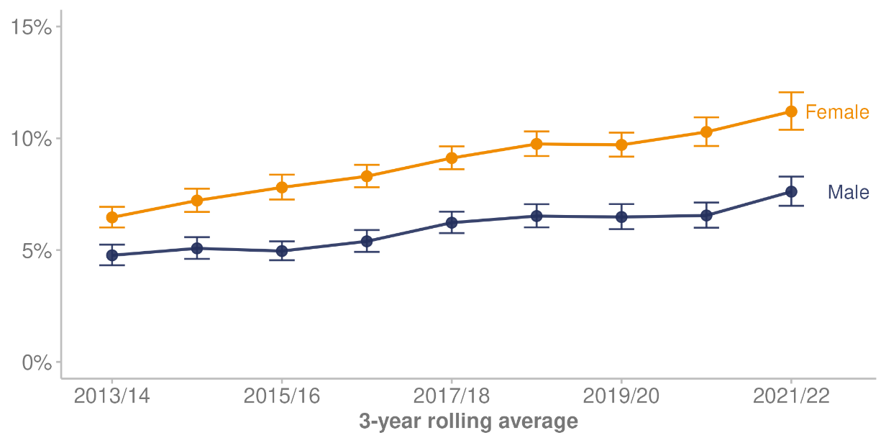
Note: Error bars represent 95% confidence intervals.
Source: Manatū Hauora (2023a)

Figure 20 displays the percentage of high or very high psychological distress by ethnic group in a 3-year rolling average. In the 3-year pooled period ending 2021/22, 15.7% of Māori adults reported high or very high psychological distress, compared with 13.3% of Pacific adults, 9.3% of European/other adults and 6.7% of Asian adults. Among ethnic groups, the prevalence of high psychological distress over time was greatest for Māori and European/other adults.

Figure 20: Percentage of people experiencing high or very high psychological distress, by ethnic group, 3-year rolling average 2013/14–2021/22
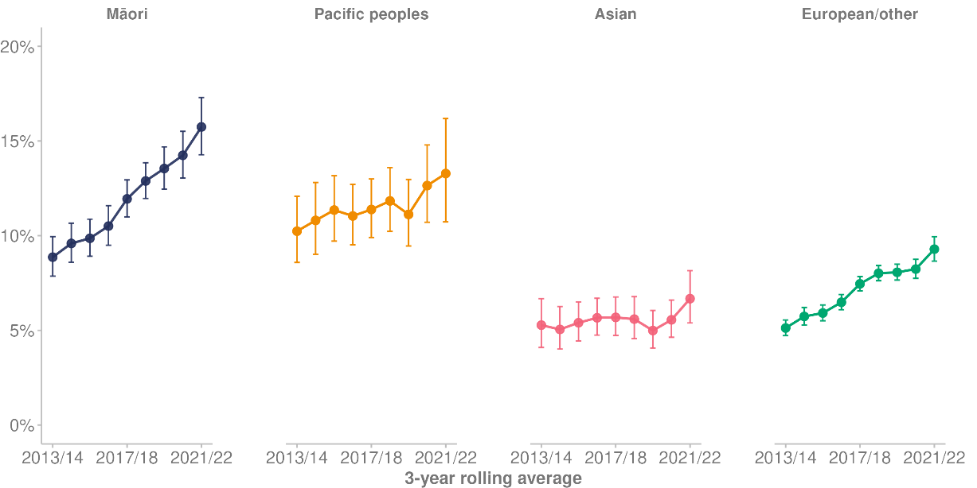
Note: Error bars represent 95% confidence intervals.
Source: Manatū Hauora (2023a)

Figure 21 displays the percentage of high or very high psychological distress by age group in a 3-year rolling average. In the 3-year pooled period ending 2021/22, 17.9% of young people aged 15–24 years experienced high or very high levels of psychological distress (up from 6.4% for the 3-year pooled period ending 2013/14). This compares with the other age groups as follows: 12.1%, 25–34 years; 8.0%, 35–44 years; 8.4%, 45–54 years; 7.2%, 55–64 years; 4.1%, 65–74 years; and 3.6% for people aged 75 years and over.

Figure 21: Percentage of people experiencing high or very high psychological distress, by age group, 3-year rolling average 2013/14–2021/22
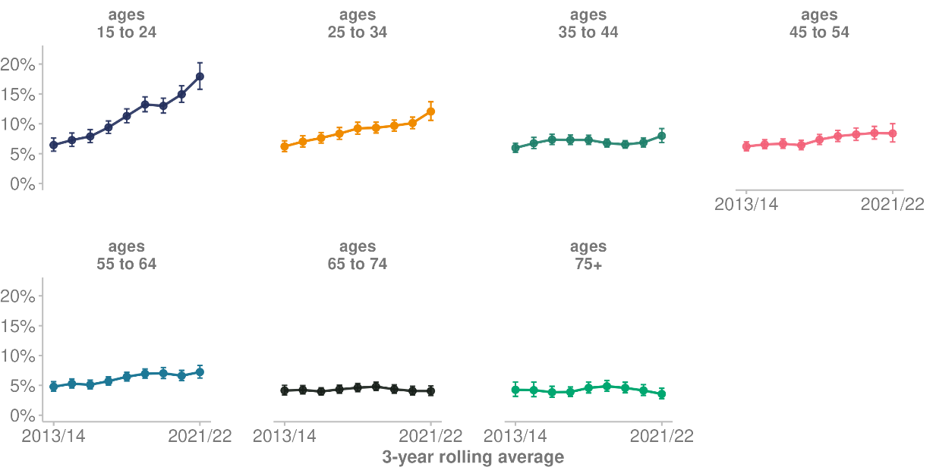
Note: Error bars represent 95% confidence intervals.
Source: Manatū Hauora (2023a)

Emotional and/or behavioural problems (children)
According to the Health Survey, in the 3-year pooled period ending 2021/22, 6.0% of children (aged 2–14 years) have emotional or behavioural problems (Manatū Hauora 2023a). The percentage of boys with emotional or behavioural problems was higher at 7.8%, than for girls at 4.0%.

Figure 22 shows the percentage of children reported to have emotional and/or behavioural problems, by ethnic group. For the 3-year pooled period ending 2021/22, Asian children consistently had the lowest rates of reported emotional and/or behavioural problems at 1.4%, compared with Māori children at 6.4%, Pacific children at 5.0% and European/other children at 7.4%.

Figure 22: Percentage of children aged 2–14 years experiencing emotional and/or behavioural problems, by ethnic group, 3-year rolling average 2013/14–2021/22
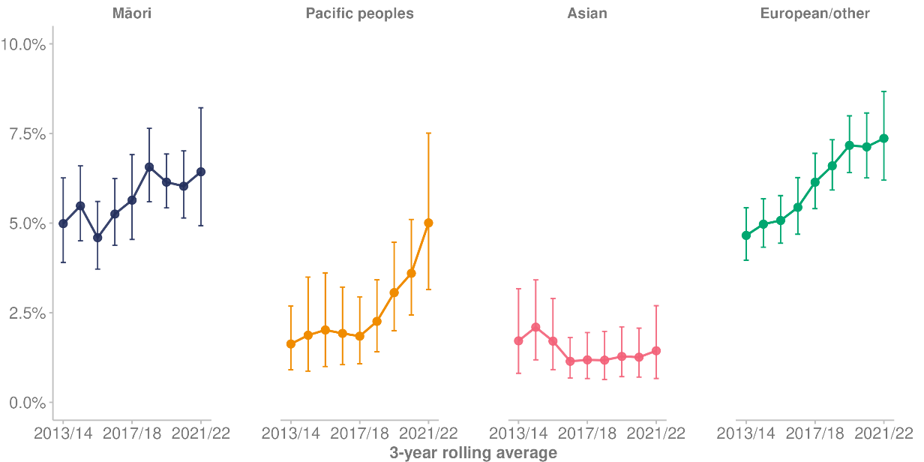
Note: Error bars represent 95% confidence intervals.
Source: Manatū Hauora (2023a)

Unmet need for mental health or addiction services
Among adults, unmet need for mental health or addiction services is defined as feeling like you needed professional help for your emotions, stress, mental health or substance use in the past 12 months, but did not receive that help (Manatū Hauora 2022l).

For the single year of 2021/22, the Health Survey found the following rates of unmet need for mental health or addiction services.
- Overall, 8.8% of adults reported an unmet need for mental health or addiction services. This included 7.1% of men and 10.5% of women.
- Māori (12.9%) and Pacific (12.9%) adults had higher rates of unmet need than European/other (9.4%) and Asian (6.2%) adults.
- Disabled adults (18.7%) had higher rates of unmet need than non-disabled adults (7.9%).
- People living in the most deprived areas had higher rates of unmet need (11.7%) than people living in the least deprived areas (6.1%; Manatū Hauora 2023a).

Suicide
In the year ending 30 June 2022, 538 people died by suspected suicide (Te Whatu Ora 2022). The total provisional suspected suicide rate was 10.2 per 100,000 population. However, within that rate, considerable differences between ethnic groups are evident.
- Suicide among Māori continues to be disproportionately high. The provisional rate of suspected suicide for Māori was 15.9 per 100,000 Māori.
- The rate for Pacific peoples was also higher, at 9.9 per 100,000 Pacific peoples.
- The rate for the Asian population was 3.8 per 100,000 Asian peoples (Coronial Services of New Zealand 2022).

In Aotearoa New Zealand, a death can only officially be confirmed as a suicide by a coroner after completing the coronial inquiry. Figure 23 shows the rate of confirmed suicide per 100,000 total population to 2018 (the year when the latest confirmed suicide data is available).

Figure 23: Rate of suicide per 100,000 total population, 1948–2018
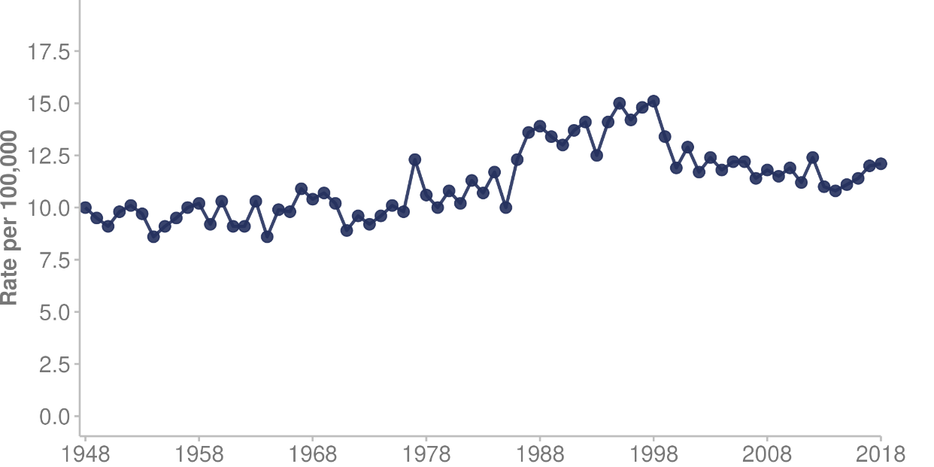
Source: Te Whatu Ora (2022)

Determinants of health and wellbeing | Ngā tūtohu o te hauora me te oranga o te tangata
The wider determinants of health and wellbeing are a diverse range of social, economic and environmental factors that influence people’s mental and physical health. Social determinants are the circumstances and wider forces in the environments in which people are born, grow up, live, learn, work and age. These can affect health, wellbeing and quality of life (Health Navigator 2021).

Although the determinants are connected and overlap, they can generally fit into the following groups:
- social — racism and discrimination; gender; housing; education; health literacy; employment; safety and justice; social connections and inclusion; interpersonal violence
- economic — income security; pay equity; poverty; food insecurity; tax and trade policy; minimum wage; government support (income, student allowances, rent subsidies)
- commercial — political advocacy; sales and marketing; potentially harmful products (for example, alcohol, tobacco, drugs)
- cultural — beliefs, behaviours and practices; identity; colonisation; language; connections to whenua, whānau, whakapapa and mātauranga Māori
- environmental — built environment and infrastructure; facilities; transport; population density; exposure to infectious diseases; exposure to pollution, natural disasters and climate change
- occupational — work conditions, activities, environment; workplace exposure to harmful products
- digital — direct and indirect ways in which digital technology influences equity in health and wellbeing, including through access to technology such as social media (health and wellbeing information, mis- and dis-information, telehealth) and digital literacy.

Child poverty
This report uses the Stats NZ definition and measures of child poverty and material hardship (Stats NZ 2022a). Child poverty statistics provide estimates of low income and material hardship rates for measures listed in the Child Poverty Reduction Act 2018. Households experiencing material hardship are defined as those with an enforced lack of at least 6 essentials. Examples of essentials include being unable to afford fresh fruit and vegetables, putting off doctor visits, being unable to afford heating and not being able to pay for utilities.​

The primary poverty measures in 2022 were largely unchanged from the previous year. However, compared with the baseline year (the year ended June 2018) 8 of the 9 child poverty measures have decreased by a statistically significant amount (Stats NZ 2023b).

Table 5 shows that for the year ending June 2022, Māori children (18.8%) and Pacific children (25.6%) had relatively high rates of living in households in material hardship. The year ending in June 2022 also saw high rates of material hardship in 2022 for disabled children and for children living in a household with at least one disabled person (21.5%).

Table 5: Percentage of children living in poverty or material hardship, by population group, year ending June 2022
Measure | All | Māori | Pacific peoples | Disabled people*
Children living in households that had less than 50% of the median equivalised disposable household income** before housing costs | 12% | 14.5% | 19.5% | 17.0%
Children living in households that had an after-housing-costs income that was less than 50% of the baseline year’s median after-housing-costs equivalised disposable household income | 15.4% | 16.8% | 19.4% | 15.1%
Children experienced material hardship | 10.3% | 18.8% | 25.6% | 21.5%
Note: * Disabled children and children in households with at least one disabled person
** Equivalisation is the process of adjusting household income by taking into account household size and composition. This allows more accurate comparisons between different types of households.
Source: Stats NZ (2023b)

Household food insecurity
Food insecurity is limited or uncertain availability of nutritionally adequate and safe foods, or limited ability to acquire personally acceptable foods that meet cultural needs in a socially acceptable way (Manatū Hauora 2019c). Compared with children in food-secure households, children in food-insecure households have more risk factors for ill health and worse health status, and their caregivers indicate more concerns with their development. These findings are consistent with those from other national and international research. Food insecurity, poverty and material deprivation combined are likely to further increase the risk of ill health and worse health status (Manatū Hauora 2019c).

According to the Health Survey, in the single survey year of 2021/22, the overall percentage of children living in a household where food runs out often or sometimes has fallen from 24.1% in 2012/13 to 12.5% in 2021/22 (Manatū Hauora 2023a).

However, population groups differed in their level of food insecurity. Children who lived in a household where food runs out often or sometimes included:
- 38.2% of Pacific children
- 22.4% of Māori children
- 9.4% of European/other children
- 4.8% of Asian children.
- 26.8% of children living in the most deprived areas
- 3.8% children living in the least deprived areas.

Housing

Home ownership
- In 2018, Aotearoa New Zealand’s home ownership rates were at their lowest since the 1950s (Stats NZ 2020c). Home ownership peaked in the 1990s, at 73.8% of households, but by 2018, home ownership had fallen to 64.5% of households.
- The population groups of Māori and Pacific peoples were less likely to own their home or hold it in a family trust than other ethnic groups. They were more likely, along with people in Asian and MELAA ethnic groups, to live in public housing.

Housing affordability
- Renting households (that are not owner-occupied) generally spent a higher proportion of their income on housing costs than owner-occupiers in 2018. The proportion of renting households that spent more than 30% of their income on housing costs increased rapidly, from less than 20% of renters in 1988 to over 40% in 2019 (Stats NZ 2020c).
- House prices have been rising at a faster rate than wages over the past 5 years. In Auckland, the median house sales price in mid-2020 was about 11.5 times the median yearly household income.

Housing suitability
- Overall, 1 in 5 New Zealanders lives in a home that was always or often too cold in winter. However, this rises to around 2 in 5 Pacific peoples (Stats NZ 2020c).
- Housing problems such as cold, damp and mould are more common among households that are not owner-occupiers, do not have enough money for everyday needs and have 4 or more household members.
- Living in a house that is not suitable for multigenerational families, which leads to overcrowding, is related to increased health risks, particularly of transmitting infectious diseases. Almost 1 in 9 (10.8%) people in 2018 lived in a crowded house. Pacific peoples had the highest rates: more than 40% of those aged under 25 years lived in a crowded house and the rate was still above 25% for the oldest age groups.​
- Māori also had higher rates of living in a crowded house than the total population. The rate was around 25% for those aged under 25 years and then gradually declined for older age groups (Stats NZ 2020c).
- Compared with non-disabled people, disabled people were less likely to live in a suitable home that is warm and free from damp and mould. Disabled people also found it harder to access facilities such as doctors, medical centres and supermarkets (Stats NZ 2020b).

Homelessness
According to Stats NZ, an estimated 1% of the population was severely housing deprived on the night of the 2018 Census. Homelessness statistics measure 3 types of severe housing deprivation (Stats NZ 2020d).

At the time of the 2018 Census, 41,644 people were severely housing deprived. They included:
- 3,522 people without shelter (for example, rough sleepers, improvised dwellings)
- 7,567 people in temporary accommodation, such as a night shelter or motel
- 30,555 people sharing accommodation (as a temporary resident in a severely crowded private dwelling).

Employment and income
Persistent labour market gaps remain for disabled people (Stats NZ 2022e). While unemployment was low overall in the June 2022 quarter, disabled people experienced unemployment at higher rates than non-disabled people. Among people aged 15–64 years, the unemployment rate was 7.9% for disabled people and 3.3% for non-disabled people.

Disabled people are much less likely to be participating in the labour force or be employed than non-disabled people. For those aged 15–64 years, the labour force participation rate was 45.0% for disabled people and 83.1% for non-disabled people in the June 2022 quarter.

Disabled wage and salary earners received no significant increases to either hourly or weekly median earnings in the year to the June 2022 quarter. Median weekly income from wages and salaries was $960 for disabled people, $240 lower than the median of $1,200 for non-disabled people.

Health risks and protective factors

Tobacco
Smoking tobacco products kills about 4,500 to 5,000 people every year in Aotearoa New Zealand. That is around 12 to 13 deaths every day due to smoking or exposure to second-hand smoke (Manatū Hauora 2021c). Key goals of the Smokefree Aotearoa 2025 Action Plan are to eliminate inequities in smoking rates and smoking-related illness, and to reach a daily smoking prevalence of less than 5% for all population groups (Manatū Hauora 2021c).

According to the Health Survey, in the 3-year pooled period ending 2021/22, 9.7% of adults were daily smokers. This was down from 16.0% in the 3-year pooled period ending 2013/14 (Manatū Hauora 2023a).

The decrease in rates of daily smoking in the 3-year pooled period ending 2021/22 occurred across all population groups. However, substantial inequities remain.
- Daily smoking rates differed widely between ethnic groups: 23.5% for Māori, 17.6% for Pacific peoples, 8.5% for the European/other population and 4.6% for Asian peoples.
- Among adults living in the most deprived areas, 20.5% were daily smokers, compared with 4.3% of adults living in the least deprived areas.
- At 15.0%, the percentage of disabled adults who were daily smokers was higher than for non-disabled adults (9.2%).
- People living rurally were more likely to be daily smokers (14.3%) than people in urban areas (7.9%).

Figure 24 shows a 3-year rolling average of rates of daily smoking by ethnic group between the 3-year pooled periods of 2013/14 and 2021/22.

Figure 24: Daily smoking rates, by ethnic group, 3-year rolling average 2013/14–2021/22
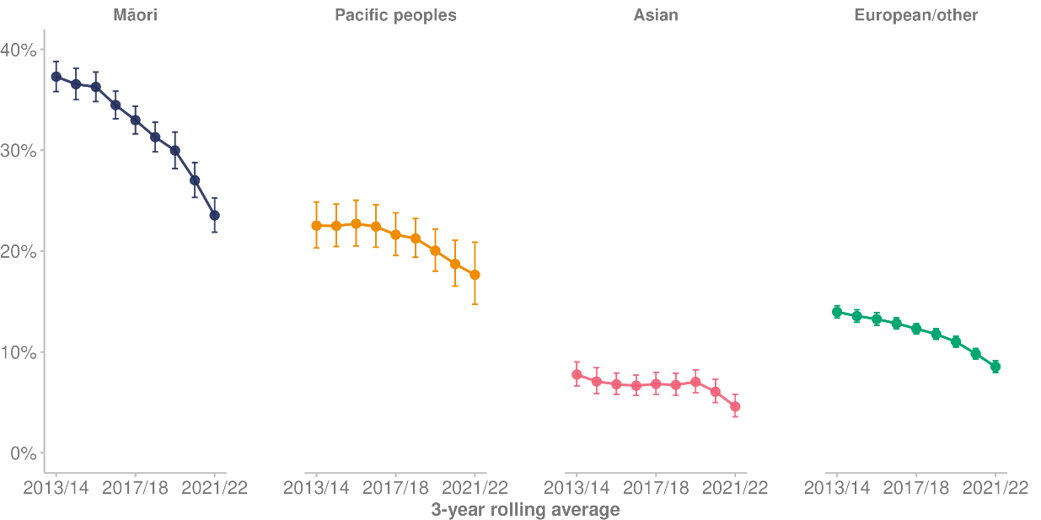
Note: Error bars represent 95% confidence intervals.
Source: Manatū Hauora (2023a)

Rates of daily smoking decreased across all age groups. Figure 25 shows a 3-year rolling average of daily smoking rates by age.

Figure 25: Daily smoking rates, by age group, 3-year rolling average 2013/14–2021/22
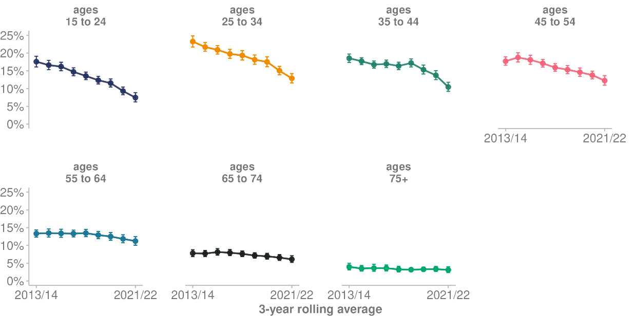
Note: Error bars represent 95% confidence intervals.
Source: Manatū Hauora (2023a)

Youth smoking
According to the Health Survey, daily smoking for youth aged 15–24 years reduced from 17.6% in the 3-year pooled period ending 2013/14, to 7.5% for the 3-year pooled period ending 2021/22 (Manatū Hauora 2023a).

The Action for Smokefree 2025 Year 10 Snapshot Survey asks 20,000 to 30,000 students every year about their smoking and vaping behaviour and attitudes (Action for Smokefree 2025, 2023). According to the 2022 survey, daily smoking rates among youth have continued to stay at a record low in Aotearoa New Zealand. Only 1.1% of Year 10 students (14–15 years of age) said they smoke at least once a day (Action for Smokefree 2025, 2023).

Vaping
According to the Health Survey, in the 3-year pooled period ending 2021/22, 25.5% of adults (aged 15 years and over) reported trying electronic cigarettes (Manatū Hauora 2023a). In addition, in the same period:
- 8.0% of adults reported using electronic cigarettes or a vaping device at least once a month
- 6.0% of adults used electronic cigarettes or a vaping device daily.

In the 2022 Action on Smoking and Health Year 10 Snapshot Survey:
- overall daily vaping increased from 9.6% in 2021 to 10.1% in 2022
- daily vaping among those who have never smoked increased from 3.1% in 2021 to 4.3% in 2022 (Action for Smokefree 2025, 2023).

Alcohol
Alcohol harm occurs through both the total volume consumed and patterns of drinking. Harmful drinking can cause serious health, personal and social problems. Alcohol is one of the main preventable risk factors for a number of diseases, such as cancer, mental health conditions and long-term conditions (Manatū Hauora 2022b).

According to the Health Survey, in the 3-year pooled period ending 2021/22, nearly 1 in 5 adults (20.0%) were a hazardous drinker, similar to 3-year rolling averages since 2015/16 (Manatū Hauora 2023a). Hazardous drinkers are defined as those with an established pattern of drinking that carries a high risk of future damage to physical or mental health (Manatū Hauora 2022l).

In the 3-year pooled period ending 2021/22:
- the prevalence of hazardous drinking was 27.0% among men and 13.2% among women
- by age, the prevalence of hazardous drinking was highest among those aged 15–24 years, at 26.0%, and was also high among those aged 25–34 (23.6%), 35–44 (21.7%) and 45–54 (23.8%) years
- Asian adults (5.7%) had a lower rate of hazardous drinking than Māori (34.3%), Pacific (24.3%) and European/other (21.3%) adults.

Figure 26 shows a 3-year rolling average of the percentage of hazardous drinkers by age, from 2016/17 to 2021/22.

Figure 26: Percentage of hazardous drinkers, by age group, 3-year rolling average 2016/17–2021/22
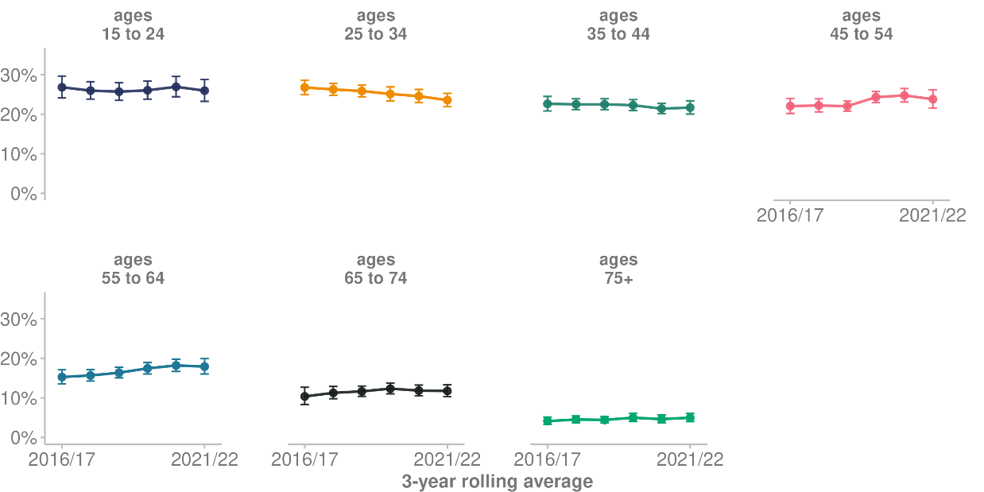
Note: Error bars represent 95% confidence intervals.
Source: Manatū Hauora (2023a)

Nutrition
Eating a healthy diet and having regular physical activity are essential for the overall health and wellbeing of all New Zealanders (Elliot and Hamlin 2018). Adults who eat a healthy diet and are physically active can decrease their risk of developing a number of adult-onset health conditions and diseases and are more likely to maintain a healthy weight. For pregnant and breastfeeding women eating a nutrient-rich diet, along with appropriate and timely vitamin and mineral supplements and exercising regularly, is important to optimise the health outcomes for the infant and mother (Manatū Hauora 2020a).

In 2020, Manatū Hauora updated the guidelines on the recommended number of servings of fruit per day (Manatū Hauora 2020a). Aotearoa New Zealand has updated its serving size advice by adopting the evidence-based Australian advice on serve size.

Table 6 shows the reported percentages of adults eating the recommended amount of fruit (2 servings per day for men and women) and vegetables (5 servings or more each day), by population group. This data is from the Health Survey for the single year of 2021/22 (Manatū Hauora 2023a).

Table 6: Percentage of adults consuming the recommended daily amount of fruit and vegetables, by population group, 2021/22
Population group | Percentage of adults consuming recommended daily amount
 | Fruit | Vegetables
All adults | 49.8% | 10.4%
Māori adults | 47.3% | 8.2%
Pacific adults | 52.0% | 4.1%
Asian adults | 42.5% | 5.0%
European/other adults | 51.6% | 12.0%
Disabled adults | 46.8% | 9.7%
Non-disabled adults | 50.1% | 10.4%
Living in least deprived area | 53.9% | 12.3%
Living in most deprived area | 43.4% | 8.2%
Source: Manatū Hauora (2023a)

Breastfeeding
According to the Manatū Hauora Eating and Activity Guidelines for New Zealand Adults (Manatū Hauora 2020a), the benefits of breastfeeding for babies include helping to build a strong emotional bond between the mother and baby, supporting brain development and reducing the risk of mental health conditions. Breastfeeding also boosts the immune system, helps protect the baby against common childhood illnesses and decreases the chance of infant and toddler death.

According to the Health Survey, the percentage of babies exclusively breastfed at 4 months has increased over time (Manatū Hauora 2023a), rising from 43.6% for the 3-year pooled period ending 2013/14 to 50.5% for the 3-year pooled period ending 2021/22. The percentage of babies who are exclusively breastfed at 4 months varies by ethnic group:
- 42.8% of Māori babies
- 47.4% of Pacific babies
- 57.3% of Asian babies
- 51.1% of European/other babies.

Obesity
Excess weight (obesity) is associated with many health conditions including type 2 diabetes, ischaemic heart disease, stroke, several common cancers, osteoarthritis and sleep apnoea (Manatū Hauora 2023k). Obesity is defined as having a body mass index of 30 or more (or equivalent for those younger than 18 years).

Obesity is usually measured as part of the Health Survey. However, this information was not collected in the 2021/22 survey due to physical distancing requirements during the COVID-19 pandemic, so this report uses data from a sample of general practices instead (Manatū Hauora 2022k). This data suggests that obesity rates did not increase over the last year (2021/22), with stable trends for adults and a small decline for children. However, the estimated obesity rate among adults in 2021/22 is higher than in 2017/18. Note that because the Health Survey and general practice data sets are different, trends should be interpreted with caution.

Health service use and health care

Primary and community health care services
Primary and community health care services are the health services that New Zealanders most often interact with when accessing health care in local areas and at home (Department of the Prime Minister and Cabinet 2021). They include services delivered by general practitioners, nurse practitioners, pharmacists, midwives, Well Child nurses, Māori and Pacific providers, dentists and dental therapists, home care workers, district nurses, community mental health services, public health nurses and aged care providers.

Enrolment with a primary health organisation
On 31 December 2022, an estimated 94.4% of the Aotearoa New Zealand population were enrolled with a primary health organisation (PHO) through a general practice (Te Whatu Ora 2023f). Although enrolling with a PHO is voluntary, it can provide benefits such as cheaper doctor visits and reduced costs of prescription medicines (Te Whatu Ora 2023f).

Periodic analysis indicates around 300,000 people who have used health services are not enrolled with a PHO (Irurzun-Lopez et al 2021). Using the census population projections as the denominator for the Aotearoa New Zealand population, we estimate rates of PHO enrolment as follows.
- People living in the least deprived areas had higher rates of enrolment (close to 100%), compared with people living in the most deprived areas (84.4%).
- The European/other ethnic group (99.0%) had higher levels of enrolment than Māori (82.9%), Pacific peoples (93.8%) and Asian peoples (90.1%).
- Females (95.9%) had higher levels of enrolment than males (91.4%).
- Enrolment rates were lower for those aged 20–29 years (around 88%) than other age groups.

Manatū Hauora does not currently have PHO enrolment figures for disabled people. However, in the Health Survey, for the survey year of 2021/22 93.9% of disabled people reported having a usual medical centre (Manatū Hauora 2023a).

Engagement with enrolled general practice
Engagement with enrolled general practice is defined as interactions between a patient and the general practice they are enrolled with. These interactions include doctor and nurse consultations (face-to-face and remote), follow-up communications, prescription requests and immunisations (Te Whatu Ora 2023f).

Of the people who were enrolled with a PHO on 31 December 2022, 83.1% engaged with their usual general practice during 2022. Another 8.4% last engaged with their general practice in 2021 and 3.5% last engaged with their general practice in 2020. The remaining 5.0% last engaged at an unknown date.

Within the enrolled population, population groups differed in their level of engagement with their usual general practice during 2022.
- People living in the least deprived areas had higher levels of engagement (84.6%) than people living in the most deprived areas (81.0%).
- The European/other ethnic group had higher levels of engagement (85.9%) than Māori (79.5%), Pacific peoples (79.0%) and Asian peoples (78.3%).
- Females had higher levels of engagement (85.9%) than males (80.1%).
- Engagement rates were highest in the older age groups. They were above 90% for people aged 65 years and over.

Population not enrolled with a PHO
In 2022, 6.2% of health users were not enrolled with a PHO. Figure 27 shows the proportion of the population not enrolled in 2022 by age and ethnic group. The rates were highest among Asian peoples: of the total Asian population in Aotearoa New Zealand, 29.6% aged 20–24 years and 23.1% aged 25–29 years were not enrolled with a PHO. The next highest proportion was among Pacific peoples: 16.0% of Pacific peoples aged 25–29 years were not enrolled with a PHO.

Figure 27: Percentage of Aotearoa New Zealand population not enrolled in a PHO, by age group and ethnic group, 2022
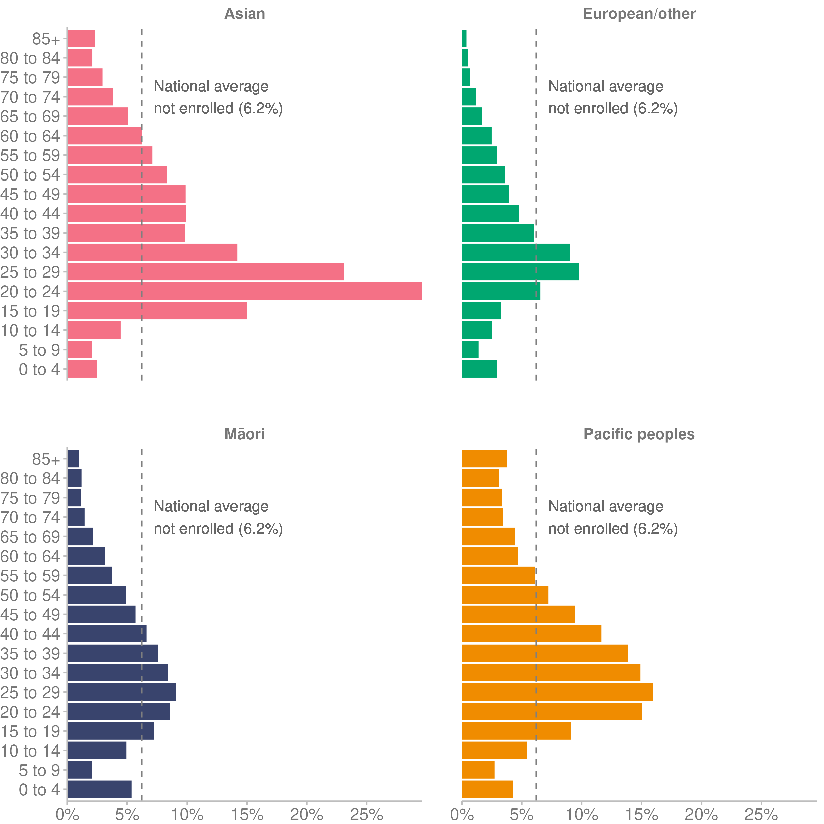
Source: Manatū Hauora unpublished data (2023)

Figure 28 shows the proportion of the population not enrolled with a PHO by age and gender in 2022. The proportion of younger men who were not enrolled with a PHO was higher than for other groups.

Figure 28: Percentage of Aotearoa New Zealand population not enrolled in a PHO, by age group and gender, 2022
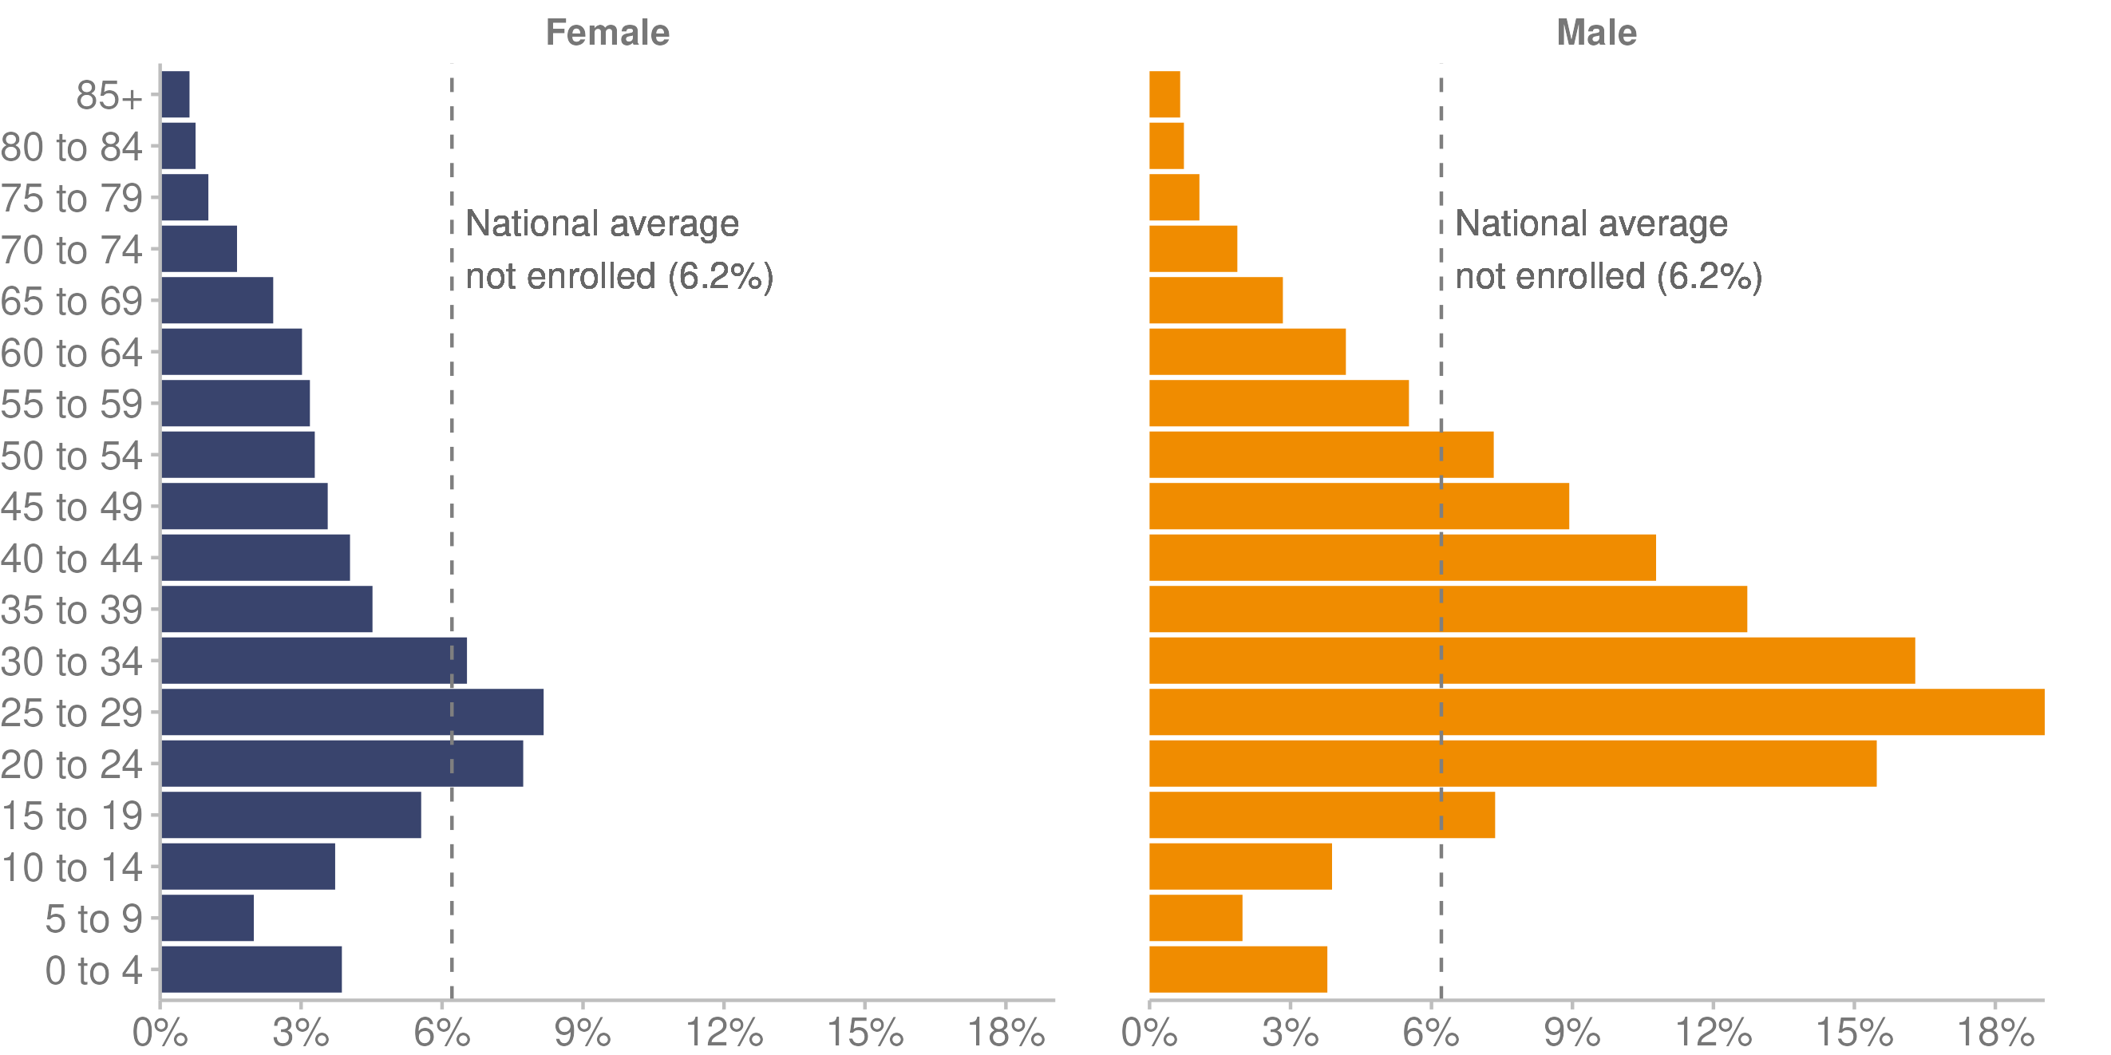
Source: Manatū Hauora unpublished data (2023)

Barriers to accessing primary health care
In the Health Survey, an adult (aged 15 years and over) is asked whether they experience any barriers to accessing primary health care. Barriers to getting an appointment in the past 12 months can be due to wait time, cost, or lack of transport. The following tables focus on the different barriers that adults faced in accessing health care.

Table 7 shows cost-related barriers that adults in different population groups faced in accessing primary health care (in the last 12 months) for the 3-year pooled period ending 2021/22. These barriers were:
- unmet need for GP services due to cost (where someone had a medical problem but did not visit or talk to a GP because of cost)
- unfilled prescription due to cost (where someone had received a prescription for themselves but did not collect one or more prescription items because of cost)
- unmet need for dental care due to cost (where someone avoided going to a dental health care worker because of cost).

The most commonly experienced cost barrier was to accessing dental care (39.7%), especially for Māori (52.0%) and those living in the most deprived areas (49.1%).

Table 7: Percentage of adults facing cost-related barriers to accessing primary health care (in the past 12 months), by population group, 3-year pooled period ending 2021/22
Population group (adults) | Percentage with unmet need for GP due to cost | Percentage with unfilled prescription due to cost | Percentage with unmet need for dental care due to cost
All adults | 11.5% | 3.9% | 39.7%
Women | 14.3% | 5.1% | 43.5%
Men | 8.5% | 2.5% | 35.7%
Māori | 16.9% | 9.4% | 52.0%
Pacific peoples | 14.3% | 8.0% | 47.4%
Asian | 10.2% | 2.3% | 39.4%
European/other | 11.2% | 3.2% | 37.9%
Disabled | 18.2% | 9.1% | 49.5%
Non-disabled | 10.9% | 3.4% | 38.8%
Most deprived areas | 15.4% | 8.1% | 49.1%
Least deprived areas | 8.3% | 1.4% | 30.8%
Source: Manatū Hauora unpublished data (2023)

Table 8 shows other barriers to accessing primary health care that adults faced for the single year of 2021/22. These barriers were:
- unmet need for a GP due to wait time (where someone had a medical problem but did not visit a GP because the time taken to get an appointment was too long)
- unmet need for GP services due to lack of transport (where someone had a medical problem but did not visit or talk to a GP due to lack of transport)
- unmet need for a GP due to lack of care available for a dependant (where someone had a medical problem but could not arrange childcare or care for a dependent adult; Manatū Hauora 2023a).

The highest proportion of unmet need was for a GP due to wait time to get an appointment (11.5%), this need was highest among Māori (14.6%), women (13.4%) and those living in the most deprived areas (12.9%).
Table 8: Percentage of adults facing other barriers to accessing primary health care, by population group, 2021/22
Population group (adults) | Unmet need for GP because of wait time to get an appointment | Unmet need for a GP due to lack of transport | Unmet need for GP due to lack of care available for a dependant
All adults | 11.5% | 2.7% | 1.1%
Women | 13.4% | 3.5% | 1.8%
Men | 9.5% | 1.9% | 0.2%
Māori | 14.6% | 5.8% | 2.8%
Pacific peoples | 13.5% | 9.4% | 2.2%
Asian | 13.6% | 2.0% | 0.6%
European/other | 10.6% | 2.2% | 0.9%
Disabled | 13.8% | 9.1% | 2.2%
Non-disabled | 11.3% | 2.1% | 0.9%
Most deprived areas | 12.9% | 3.8% | 1.8%
Least deprived areas | 11.1% | 1.1% | 0.7%
Source: Manatū Hauora (2023a)

Trust in the health system
Stats NZ reported that in 2018 the average rating for New Zealanders’ trust in the health system was 6.9 out of 10, where 0 is no trust and 10 is complete trust (Stats NZ 2021e). The average rating increased to 7.4 out of 10 at the start of the COVID-19 pandemic in the June 2020 quarter (Stats NZ 2021e), but steadily decreased from that time to reach a new average rating of 6.6 out of 10 by August 2021 (the latest available data; Stats NZ 2022g).

Figure 29 shows that, according to the 2021 General Social Survey, more than 1 in 4 Māori (27.4%) had low trust in the health system (‘low trust’ = a rating of 0 to 4 out of 10). Among other population groups, a smaller percentage had low trust: 18.1% of the European/other population, 10.3% of Pacific peoples and 9.8% of Asian peoples.

Pacific (30.2%) and Asian populations (30.2%) were the most likely to have high trust in the health system (‘high trust’ = a rating of 9 or 10 out of 10).

Figure 29: Level of trust in the health system, by ethnic group, 2021
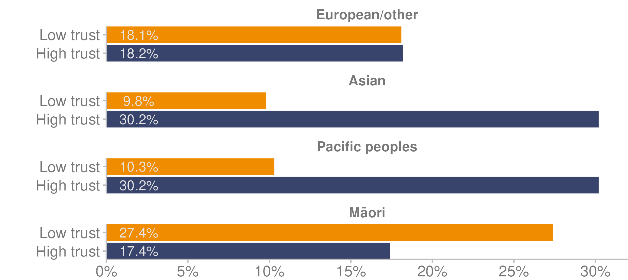
Note: ‘Low trust’ = a rating of 0–4 out of 10. ‘High trust’ = a rating of 9 or 10 out of 10.
Source: Stats NZ (2022g)

Immunisation
Immunisation is a way of preventing infectious diseases. Vaccinations are available for babies, children and adults to protect them against serious and preventable diseases (Manatū Hauora 2023g). The National Immunisation Schedule lists the vaccines that are offered free to babies, children and adolescents, and adults (Te Whatu Ora 2023j). It also states the ages at which each vaccine should be given.

Childhood immunisation
Immunisation coverage for childhood immunisation is measured at milestone ages according to the National Immunisation Schedule. Here we report on the milestone ages of 8 months, 24 months (2 years) and 5 years, using National Immunisation Register data. This data is reported quarterly, with an expectation of 95% coverage (Manatū Hauora 2023h).

Immunisation rates by deprivation
Figure 30 shows childhood immunisation rates at milestone ages of 8 months, 24 months and 5 years by deprivation quintile. Children living in the most deprived quintile have lower immunisation rates and, since 2020, the biggest falls in immunisation rates have been for children in this group (Manatū Hauora 2023h).

Figure 30: Childhood immunisation rates at milestone ages, by deprivation quintile (NZDep2018), 2014–2022
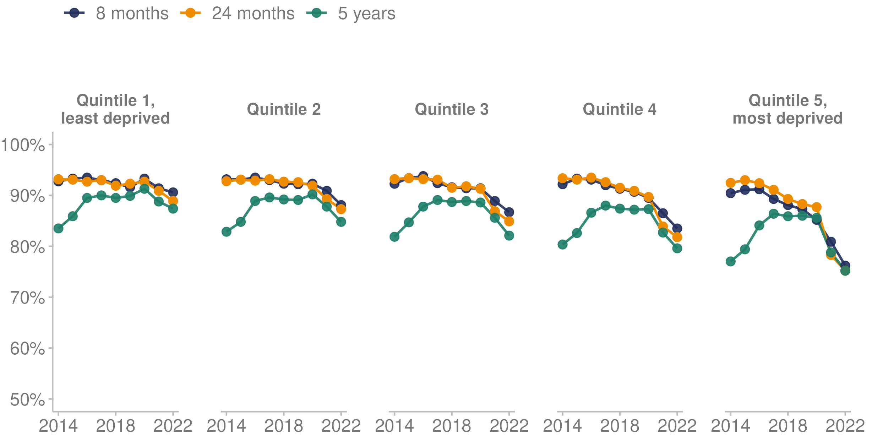
Source: Manatū Hauora (2023h)

Immunisation rates by ethnic group
Table 9 presents the percentage of children immunised at the milestone ages of 8 months, 24 months and 5 years by ethnic group as at December 2022. It shows a persistent equity gap for Māori tamariki at each milestone age (Manatū Hauora 2023h).

Table 9: Percentage of children immunised at milestone ages, by ethnic group, 2022
Milestone age | Māori | Pacific peoples | Asian | European/other
8 months | 69.9% | 83.3% | 95.1% | 88.1%
24 months | 67.8% | 81.7% | 94.0% | 86.9%
5 years | 71.8% | 80.2% | 87.7% | 84.9%
Source: Manatū Hauora (2023h)

Figure 31 shows annual childhood immunisation rates at the milestone ages of 8 months, 24 months and 5 years by ethnic group from 2014 to 2022. Immunisation rates for Māori children and Pacific children have reduced over time, especially since 2020. Smaller decreases in immunisation rates are also evident for European and Asian children over the same period.

Figure 31: Childhood immunisation rates at milestone ages, by ethnic group, 2014–2022
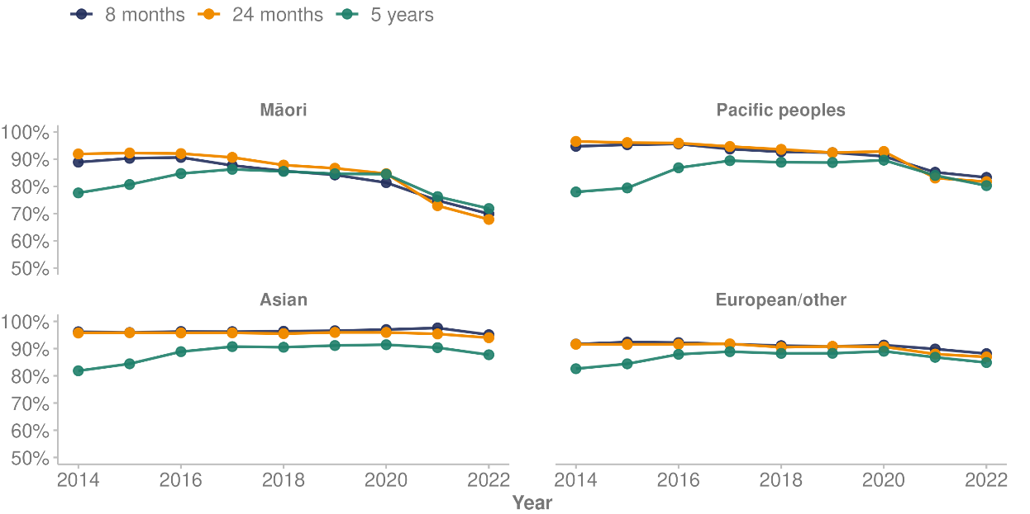
Source: Manatū Hauora (2023h)

Influenza immunisation
The influenza immunisation programme aims to vaccinate 75% of the total population aged 65 years and older and 75% of Māori and Pacific peoples aged 55 years and older against influenza each year (The Immunisation Advisory Centre 2022).

In 2022, influenza vaccination rates differed by ethnic group: 60.0% of Māori, 58.6% of Pacific peoples, 55.8% of Asian peoples and 67.8% of the European/other population received the vaccination. In the same year, among those aged 55–64 years, 35.5% of Māori and 38.6% of Pacific peoples received an influenza vaccination.

Human papillomavirus (HPV) immunisation
HPV immunisation is free for everyone aged 9–26 years and for non-residents under the age of 18 years (Manatū Hauora 2023f). HPV immunisation aims to protect young people from HPV infection, which increases the risk of developing cervical cancer and a range of other HPV-related diseases later in life. The target for HPV immunisation coverage across the country is 75%. As at 31 December 2022, the coverage (final dose) for the 2009 birth cohort by ethnic group was:
- 44.7% for Māori
- 47.7% for Pacific peoples
- 66.3% for Asian peoples
- 57.2% for the European/other group (Manatū Hauora 2023f).

Figure 32 shows HPV immunisation coverage for the 2009 birth cohort by ethnic group as at 31 December 2022. It breaks down the coverage by the percentages receiving no doses, first dose only and final dose.

Figure 32: HPV immunisation coverage of 2009 birth cohort, by ethnic group, at 31 December 2022
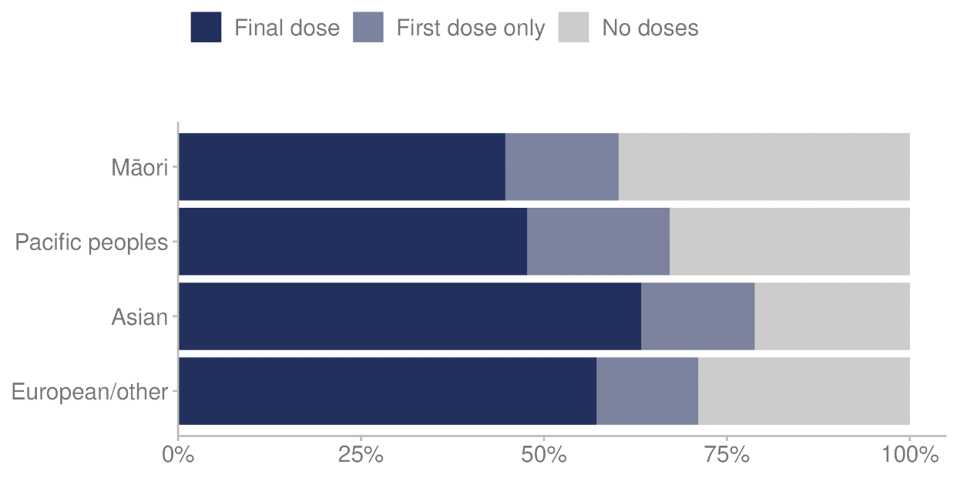
Source: Manatū Hauora (2023f)

Cancer screening services
The National Screening Unit provides health screening programmes in Aotearoa New Zealand, as part of the Population Health and Prevention directorate within Te Whatu Ora. Cancer screening programmes are provided for breast, cervical and bowel cancer.

Breast screening
Breast cancer is the most common cancer to affect women in Aotearoa New Zealand, where around 3,500 new cases and more than 600 deaths occur every year (Te Whatu Ora 2023h). Breast cancer screening is offered free every 2 years for women aged between 45 and 69 years (National Screening Unit 2018). The breast screening coverage target is for 70% of eligible New Zealanders to be screened every 2 years. As at December 2022, the 2-year breast screening coverage was 65.1% (Te Whatu Ora 2023c). Figure 33 shows screening rates remain lowest for Māori women at 59.2% and Pacific women at 63.5%. Rates for Pacific women were comparable to the rates for European/other women until 2020.

Figure 33: Two-year breast screening coverage, women aged 45–69 years, by ethnic group, 2010–2022
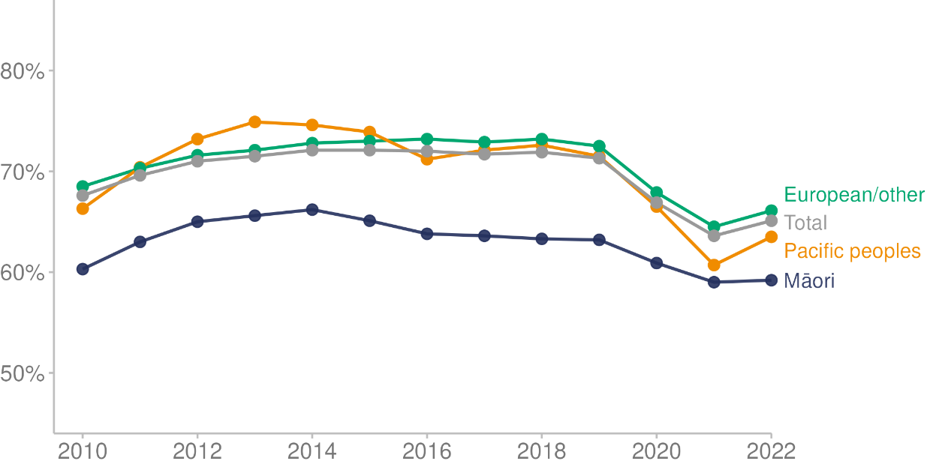

Note: Breast screening rates for the Asian ethnic group are included in the European/other group.
Source: Te Whatu Ora (2023c)

Cervical screening
The target for cervical screening coverage is for 80% of eligible New Zealanders to be screened every 3 years (National Screening Unit 2022). As at December 2022, the 3-year cervical screening coverage was 67.3% (Te Whatu Ora 2023i). From July 2023, the primary test for cervical screening for eligible participants will change from liquid-based cytology (LBC) speculum screening (previously known as a cervical smear test) to an HPV test as the primary screening method of cervical cancer. The aim of implementing HPV testing is to reduce barriers to screening for Māori and Pacific peoples and support equitable access. The new HPV screening programme will introduce the option of self-testing and lengthen the screening cycle to every 5 years.

Figure 34 shows the national cervical screening rates have been decreasing for all population groups since before 2016. The sharpest decreases are for Māori and Pacific peoples.
Figure 34: Three-year cervical screening coverage, women aged 25–69 years, by ethnic group, 2008–2022
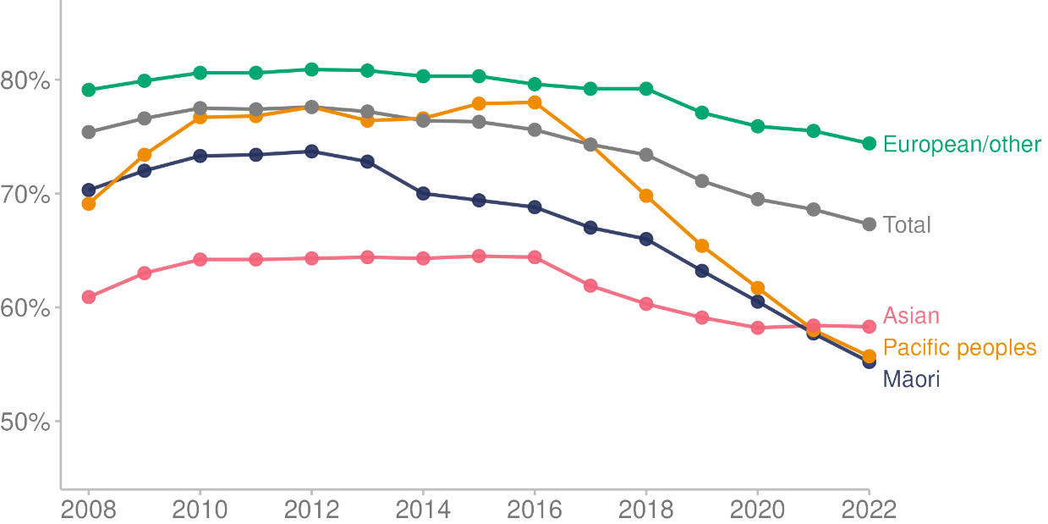
Source: Te Whatu Ora (2023i)

Bowel screening
Bowel cancer, also called colon, rectal or colorectal cancer, is the second-highest cause of cancer death in Aotearoa New Zealand (Manatū Hauora 2023i). Around 3,000 New Zealanders are diagnosed with bowel cancer and more than 1,200 die from it every year.

The free National Bowel Screening Programme (NBSP) is for people aged 60–74 years (National Screening Unit 2023). The programme roll-out began in July 2017 and was completed in June 2022. The programme invites about 835,000 people for screening every 2 years. A COVID catch-up text campaign is being implemented, alongside other initiatives designed to increase participation for Māori and Pacific peoples. The Waikato district is piloting extending the age of Māori and Pacific peoples participating in the NBSP to 50–59 years, with a view to starting the roll-out to the rest of the country in late 2023.

The NBSP participation target is 60% overall and for each ethnic group (National Screening Unit 2023). Before the COVID-19 pandemic, in the 2020 calendar year, participation was 61.5% overall, 54.9% for Māori and 41.9% for Pacific peoples. In the 2022 calendar year, participation had decreased to 57.9% overall, 48.4% for Māori and 39.0% for Pacific peoples. Figure 35 shows these trends.

Figure 35: Two-year bowel screening coverage, people aged 60–74 years, by ethnic group, 2018–2022
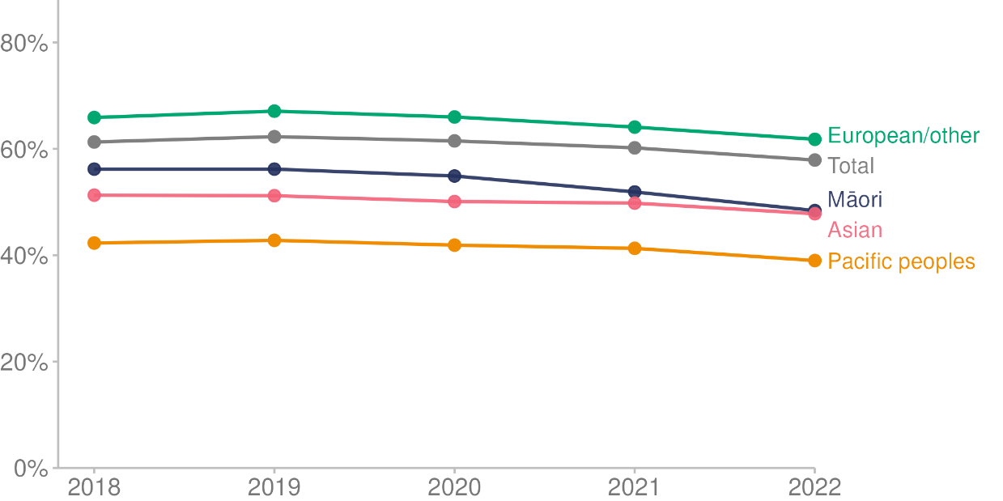
Source: Te Whatu Ora unpublished data (2023)

Hospital (specialist) services
Public hospitals in Aotearoa New Zealand provide services in both acute care and planned care (non-acute, traditionally known as elective care; Te Whatu Ora 2023m). They provide a variety of publicly funded health and disability services, such as medical, surgical, maternity, diagnostic and emergency services. Services are provided on an inpatient, daycase or outpatient basis, depending on the care a person needs. Planned care services include medical and surgical care for people who do not need to be treated immediately.

Emergency or unplanned care
In 2022, 790,414 individuals visited emergency departments (EDs) in Aotearoa New Zealand. They made a total of 1,245,881 visits, which is an average of 1.6 visits per person.

Of the 1,245,881 visits to an ED in 2022, 4.7% (59,153 visits) ended with the person leaving before receiving care (missed attendance). This was an increase from 3.3% recorded in 2021.

Of the visits to an ED where the person received care, 888,247 visits (74.9%) received care within 6 hours. The percentage of visits where people waited more than 6 hours has increased over time, from 9.0% in 2017 to 25.1% in 2022.

By ethnic group, Māori made 280,135 ED visits (22.5%), Pacific peoples 105,550 visits (8.5%) and non-Māori, non-Pacific 860,196 visits (69.0%) in 2022.

Length of hospital stay for acute care
Acute or unplanned care is loosely defined as any urgent health care for an illness or injury (Te Whatu Ora 2023b). Acute care is usually time-sensitive, meaning that if the person does not receive care in a timely manner, they may die or have a long-term disability. The average length of stay in hospital for acute conditions in 2022 was 2.6 days (Nationwide Service Framework Library 2022). This was similar across ethnic groups, with average length of stay of 2.2 days for Māori and 2.5 days for Pacific peoples.

Ambulatory sensitive hospitalisations (ASH)
ASH events are hospital admissions that are considered potentially avoidable if the person had received disease-preventing or therapeutic interventions in a primary health care setting. ASH is a system-level measure that we report for 2 age groups:
- children aged 0–4 years
- adults aged 45–64 years.

Ambulatory sensitive hospitalisations for children aged 0–4 years
In 2022, the top 4 causes of ASH admissions for children aged 0–4 years were:
- asthma, with 5,830 admissions
- upper respiratory infections and ear, nose and throat respiratory infections, with 5,104 admissions
- gastroenteritis/dehydration, with 3,153 admissions
- dental conditions, with 2,206 admissions (Nationwide Service Framework Library 2023).

The measures taken in response to the COVID-19 pandemic in 2020 led to a drop in ASH rates in 2020. Since then, rates have increased. Figure 36 shows total ASH rates for those aged 0–4 years between 2018 and 2022. Pacific children had the highest rates of ASH each year.

Figure 36: Ambulatory sensitive hospitalisation rates for children aged 0–4 years, by ethnic group, 2018–2022
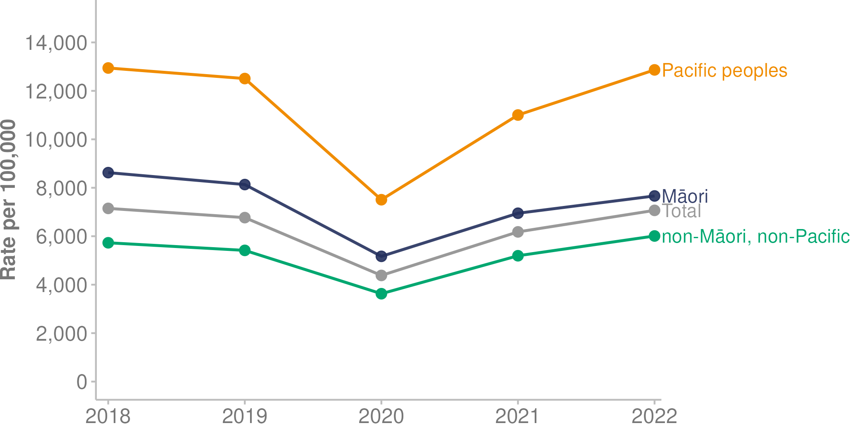
Source: Nationwide Service Framework Library (2023)

Ambulatory sensitive hospitalisations for those aged 45–64 years
In 2022, the top 4 causes of ASH for those aged 45–64 years were:
- angina and chest pain, with 13,306 admissions
- myocardial infarction (heart attack), with 3,980 admissions
- cellulitis, with 3,771 admissions
- gastroenteritis/dehydration, with 3,439 admissions (Nationwide Service Framework Library 2023).

Figure 37 shows total ASH rates for the age group 45–64 years from 2018 to 2022. Pacific adults in this age group had the highest ASH rates.

Figure 37: Ambulatory sensitive hospitalisation rates for adults aged 45–64 years, by ethnic group, 2018–2022
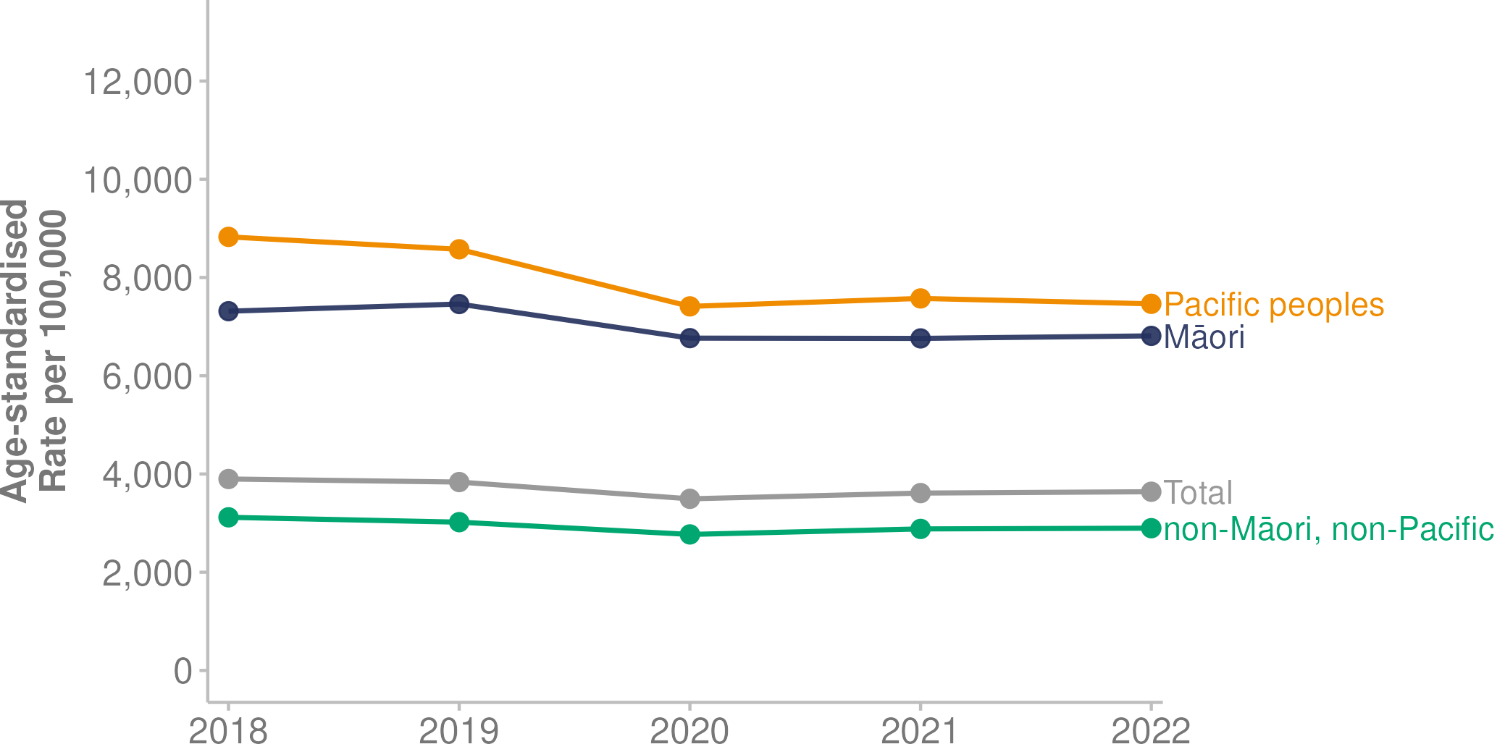
Source: Nationwide Service Framework Library (2023)

Planned care
Planned care is defined as health care services that are provided more than 24 hours after the decision to go ahead with treatment. Previously, this non-acute care was named elective services (Te Whatu Ora 2023k). Planned care typically follows the key steps of:
- referring a person for a specialist assessment
- conducting an assessment and diagnostic tests
- providing treatment
- conducting a follow-up or returning the person to the care of their general practice.

Waiting times for specialist assessment and treatment/surgery are measured nationally and by specialty. Figure 38 shows the proportion of patients nationwide who waited longer than 4 months for either specialist assessment or treatment/surgery is generally increasing.

Figure 38: Proportion of patients who waited longer than 4 months for assessment or planned treatment/surgery, January 2020 – December 2022
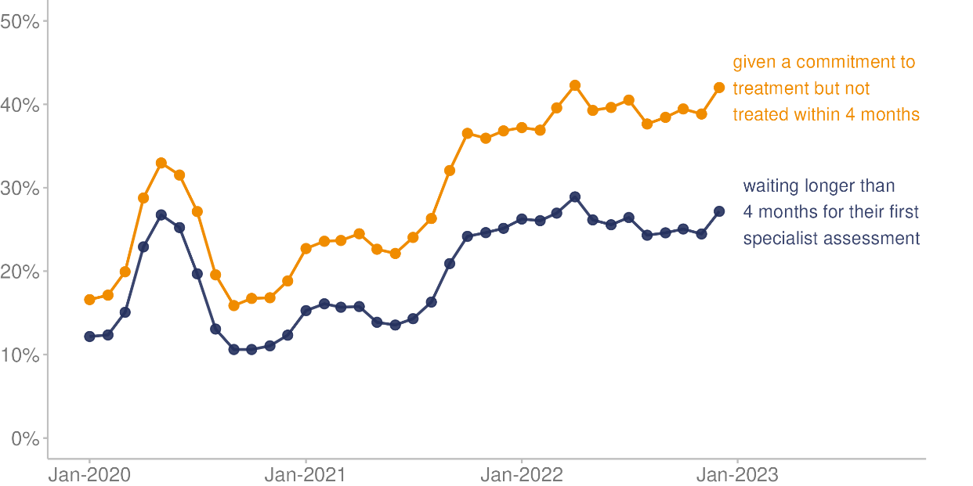
Source: Manatū Hauora unpublished data (2023)

Types of planned care interventions
The number of minor procedures (defined as minor surgical operations completed in an inpatient, outpatient or community setting) increased from 92,160 in 2018 to 143,872 in 2021, before decreasing to 142,568 in 2022. The number of inpatient surgical treatments fell from 178,174 in 2018 to 157,163 in 2022.

Figure 39 details the number of inpatient surgical treatment and minor procedures delivered from 2018 to 2022.

Figure 39: Number of inpatient surgical treatment and minor procedures (planned care interventions), 2018–2022
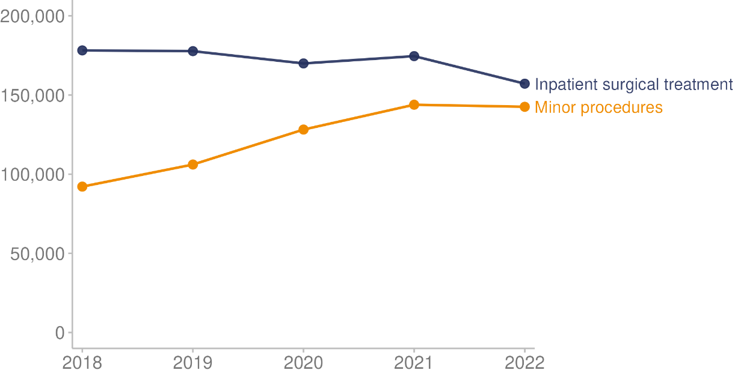
Source: Manatū Hauora unpublished data (2023)

Adult hospital inpatient experience survey
Since 2014, Te Tāhū Hauora — Health Quality & Safety Commission has been conducting an adult hospital inpatient experience survey every 3 months (Te Tāhū Hauora 2021). This survey provides information about the experience of care for adults (aged 15 years and over) who stayed at least one night in a public hospital during the survey period. Ethnic group data is available in Te Tāhū Hauora web tool but we have not presented it here because it has sample size limitations (Te Tāhū Hauora 2023).

The following were key findings from November 2022 (weighted results; Te Tāhū Hauora 2023).

Among the adults reporting on their experience of inpatient care:
- 75.4% said they were always kept informed about their treatment and care as much as they wanted to be
- 83.0% said they were involved as much as they wanted to be in making decisions about their treatment and care
- 81.3% said the health care team definitely explained what was going on during their visit in a way they could understand
- 76.0% said different doctors or staff did not give them conflicting information
- 92.2% said doctors definitely treated them with respect.

Among the adults reporting on their experience on discharge from care:
- 69.7% said they definitely had enough information to manage their condition or recovery when they left hospital
- 87.3% said they were definitely told what the medicine or prescription they left hospital with was for
- 62.6% said they were definitely told about the possible side effects of the medicine (or prescription) they left hospital with, in a way they could understand.

COVID-19 | KOWHEORI-19

Overview of 2022
COVID-19, a disease caused by the coronavirus SARS-CoV-2, is part of a large and diverse family of viruses that cause illnesses such as the common cold. The COVID-19 pandemic started in late 2019 in Wuhan, China, before spreading to other countries (Mohan and Nambiar 2020). The World Health Organization (WHO) declared a global pandemic on 11 March 2020 (World Health Organization 2021).

Over time, the COVID-19 virus has undergone genetic mutations, some of which spread more easily than the original virus (Manatū Hauora 2022e). The WHO first classified Omicron as a variant of concern in November 2021. It spread worldwide and was the dominant variant in many countries in 2022. Aotearoa New Zealand recorded its first Omicron community case on 18 January 2022; by late February 2022, it was recording more than 20,000 Omicron cases each day (Public Policy Institute 2023, Te Whatu Ora 2023e).

Globally, between the start of the outbreak and 31 December 2022, the World Health Organization recorded around 733 million confirmed cases of COVID-19 and 6.7 million deaths (World Health Organization 2023).

By 31 December 2022, Aotearoa New Zealand had recorded 2,115,733 confirmed community cases of COVID-19 and 2,407 deaths since the pandemic began (Te Whatu Ora 2023e). The vast majority of these, 2,101,527 cases and 2,358 deaths, were recorded in the 2022 calendar year. Note that the COVID-19 data in this section was extracted on 17 March 2023 and may differ to other published sources due to reclassification or historical reporting. Mortality data is not confirmed as final until after a 3-year period because the coroner is conducting an ongoing investigation of some cases.

In 2022, Aotearoa New Zealand recorded 38,574 deaths, 10.4% (3,642) more than in 2021 (Stats NZ 2023a). This is the largest increase in the number of registered deaths since the 1918 influenza pandemic, when 5,836 additional deaths were recorded compared with the year before, which was a 55.4% increase (Stats NZ 1936). After two years of suppressed COVID-19 and influenza cases (mainly because of the COVID-19 elimination strategy) deaths from COVID-19 increased in 2022 (see: COVID-19 deaths). The increased number of deaths is also impacted by our ageing population (Stats NZ 2023a). Generally median age at death ranges from 80.3 to 80.8 (in the last 10 years), in 2022 it was 80.9, increased from a low of 80.2 in 2020. The higher median age at death in 2022 shows that more deaths were in the older age groups, as the number of deaths in the 75 years and over age group increased by 12.8% (Stats NZ 2023d).

Timeline
Table 10 shows a timeline of events and responses related to COVID-19 in Aotearoa New Zealand throughout 2022. At the start of 2022, the COVID-19 Protection Framework (traffic light system) was in place (Unite against COVID-19 2022b). All of Aotearoa New Zealand was at the Orange setting, except for Northland, which was at the Red setting. To travel out of Auckland, people were required to be vaccinated or have proof of a negative test.

Table 10: Timeline of major COVID-19 events in Aotearoa New Zealand, 2022
January | February | March | April
17: Auckland boundary crossing rules end  20: Northland moves to Orange setting  23: First confirmed Omicron community case. NZ moves to Red  26: Government introduces Omicron response plan, which differs in their approaches to testing and isolation*. Phase 1 of Omicron response begins | 3: Face mask rules strengthened  10: Close contact exemption scheme begins  16: All NZ moves to Phase 2 of Omicron response  24: All NZ moves to Phase 3 of Omicron response | 11: Isolation period shortens from 10 to 7 days. Mask mandates are removed from education settings  25: Changes to traffic light settings: indoor gathering limits increase from 100 to 200; no limits on outdoor gatherings. Contact tracing requirements end for business and other organisations | 4: Vaccine passes no longer required  4: Most vaccine mandates end for government workers  13: All NZ moves to the Orange setting
May | June | July | August
2: Vaccine mandates end for border and correction workers
7: Vaccine mandates end for some workers in Defence Force, Fire and Emergency, and Police
September | October | November | December
12: The COVID-19 Protection Framework (traffic light system) ends
26: The last government vaccine mandates, for health and disability workers, end
* Phases
- Phase 1: Focus is on stamping out small outbreaks, with polymerase chain reaction (PCR) testing and 14-day isolation period for COVID-19 cases.
- Phase 2: Focus is on slowing the spread and protecting those most at risk of getting seriously ill. Contact tracing switches to online self-assessments. Isolation period shortens to 10 days.
- Phase 3: Focus on safely managing COVID-19 at home, with self-testing kits of rapid antigen tests (RATs). Isolation is only for people who test positive and their household contacts.
Source: Unite against COVID-19 (2022b)

Management strategy
The COVID-19 management strategy changed in 2022. With falling cases, high vaccination rates and increased access to antiviral medicines to treat COVID-19, many COVID-19 rules and restrictions ended on 13 September 2022 (Unite against COVID-19 2022a).

The following tools remained in place:
- isolating for 7 days for anyone testing positive for COVID-19
- face masks required in certain health care facilities
- COVID-19 remained a notifiable disease
- hospital and wastewater surveillance
- whole genome sequencing (domestic)
- ongoing monitoring for new variants arriving from overseas
- infection and policy modelling.

COVID-19 cases
In the 2022 calendar year, Aotearoa New Zealand recorded 2,101,527 cases of COVID-19 (Te Whatu Ora 2023e). The first case of the Omicron variant was recorded on 18 January 2022 (Public Policy Institute 2023). Daily case numbers peaked in late February and March 2022 (Te Whatu Ora 2023e).

Figure 40 shows the daily case numbers, along with the 7-day rolling average, for the year ending 31 December 2022.

Figure 40: Number of COVID-19 cases, daily and 7-day rolling average, January to December 2022
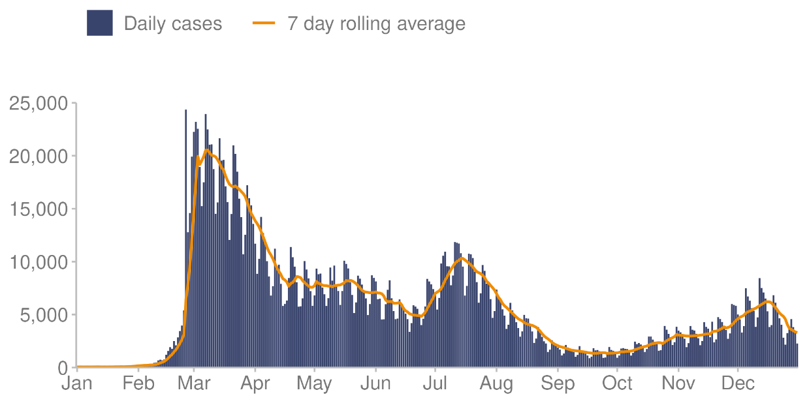
Source: Te Whatu Ora (2023e)

COVID-19 hospitalisations
A total of 22,909 people were hospitalised for COVID-19 across the 2022 calendar year. Hospital admissions peaked on 15 March, when 179 admissions for that day were recorded (Te Whatu Ora 2023e).

Figure 41 shows the number of daily and 7-day rolling average for COVID-19 hospitalisations in 2022.

Figure 41: Number of hospital admissions for COVID-19, daily and 7-day rolling average, January to December 2022
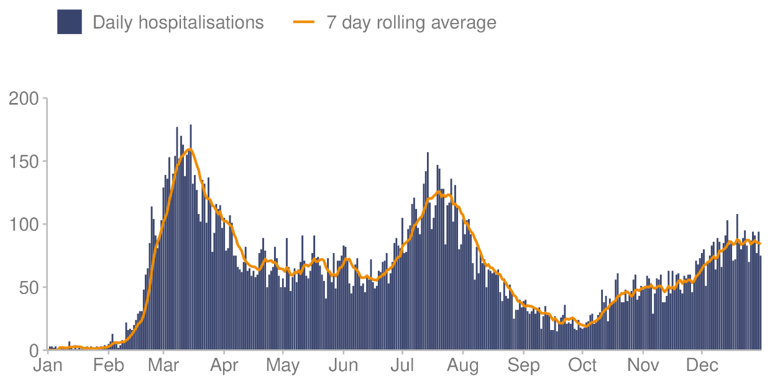
Source: Te Whatu Ora (2023e)

COVID-19 deaths
The Ministry of Health published COVID-19 Mortality in Aotearoa New Zealand: Inequities in risk in September 2022. This showed that Māori, Pacific peoples and people living in highly socioeconomically deprived areas were at higher risk of dying from COVID-19, after accounting for the effects of age, comorbidity and vaccination uptake (Manatū Hauora 2022c). Further, the report found that, while the effects of ethnic group and deprivation are interrelated, each also has an independent effect on risk. Those with comorbidities, especially those aged under 60 years, were also at higher risk of death from COVID-19 (Manatū Hauora 2022c).

There were 2,358 deaths attributed to COVID-19 in the year ending 31 December 2022 (Te Whatu Ora 2023e). The number of daily deaths peaked in July and August 2022. Figure 42 shows the number of deaths attributed to COVID-19 in 2022, both daily and as a 7-day rolling average.

Figure 42: Number of COVID-19 deaths, daily and 7-day rolling average, January to December 2022
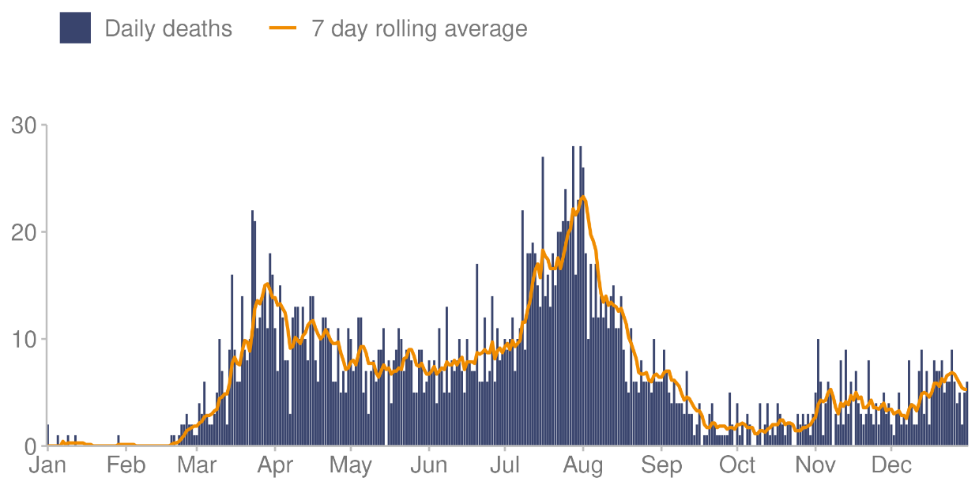
Source: Te Whatu Ora (2023e)

COVID-19 and disabled people
The 2013 New Zealand Disability Survey estimated 24% of the population (1.1 million people) are disabled (Stats NZ 2014). Within this group, about 45,000 people receive funded disability support services (DSS recipients) with support from Whaikaha (Whaikaha 2023). This group of people with complex impairments is substantially more likely to be highly vulnerable to COVID-19.

On 16 December 2022, Manatū Hauora published COVID-19 Risk among Disabled People in which it analysed COVID-19 risk and outcomes for disabled people. The report made the following key points.
- DSS recipients were less likely to be reported as a COVID-19 case, with a cumulative risk around 15% lower than the rest of the population of Aotearoa New Zealand during 2022. However, DSS recipients who became infected had 4 times the risk of hospitalisation from COVID-19 and 13 times the risk of death from COVID-19, compared with the rest of the population.
- The mortality risk from causes not related to COVID-19 was also substantial. DSS recipients had 19 times the risk of dying from these causes compared with the rest of the population.
- Overall, the data suggests that DSS recipients have a substantially greater risk of severe outcomes (hospitalisation and death) after COVID-19 infection (Manatū Hauora 2023c).

COVID-19 across ethnic groups
In 2022 the rate of COVID-19 cases was higher for Pacific peoples and Māori than for other ethnic groups (Figure 43; Te Whatu Ora 2023e). The higher proportion of cases carried through to a higher rate of hospital admissions (Figure 44) and a higher rate of deaths (Figure 45) for Pacific peoples and Māori.
Figure 43: Rate of daily COVID-19 cases per 100,000 population, by ethnic group, 2022
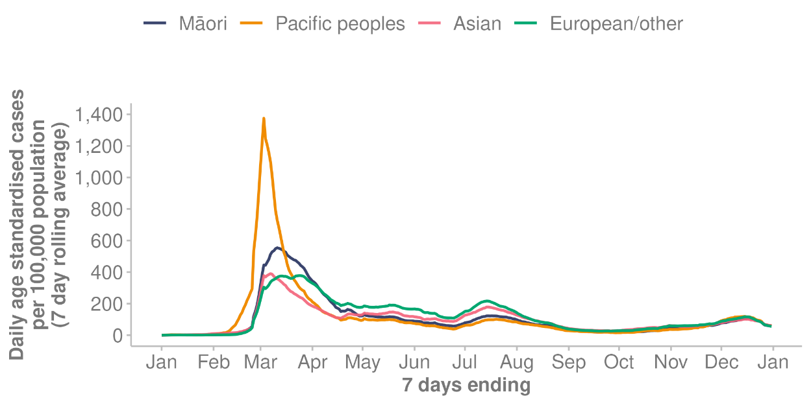
Source: Te Whatu Ora (2023e)

Figure 44: Rate of COVID-19 hospital admissions per 100,000 population, by ethnic group, 2022
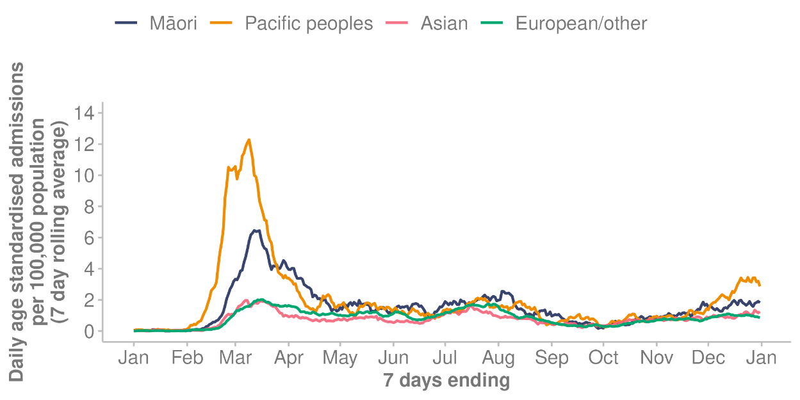
Source: Te Whatu Ora (2023e)

Figure 45: Rate of COVID-19 deaths per 100,000 population, by ethnic group, 2022
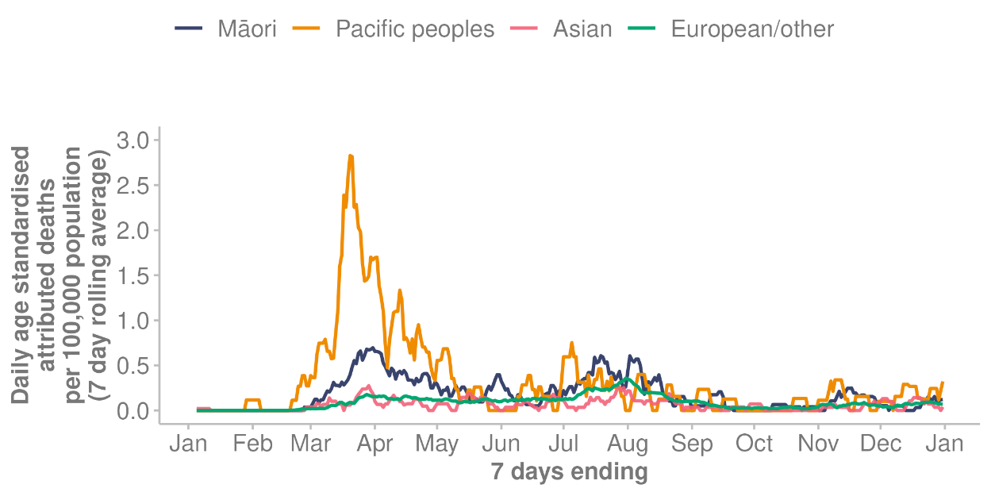
Source: Te Whatu Ora (2023e)

COVID-19 across age groups
In the first wave of COVID-19 in 2022, rates of infections were highest for people aged 15–24 years, followed by those aged 25–44 and 5–14 years (Te Whatu Ora 2023e). The later waves saw higher rates of infection for people aged over 65 years (Figure 46). Rates of hospitalisation were highest for those 65 years and over, followed by children aged 5 years and under (Figure 47). Rates of death were highest for older people: those aged 80 years and over had the highest rate of death, followed by people aged 70–79 years (Figure 48).

Figure 46: Rate of daily COVID-19 cases per 100,000 population, by age group, 2022
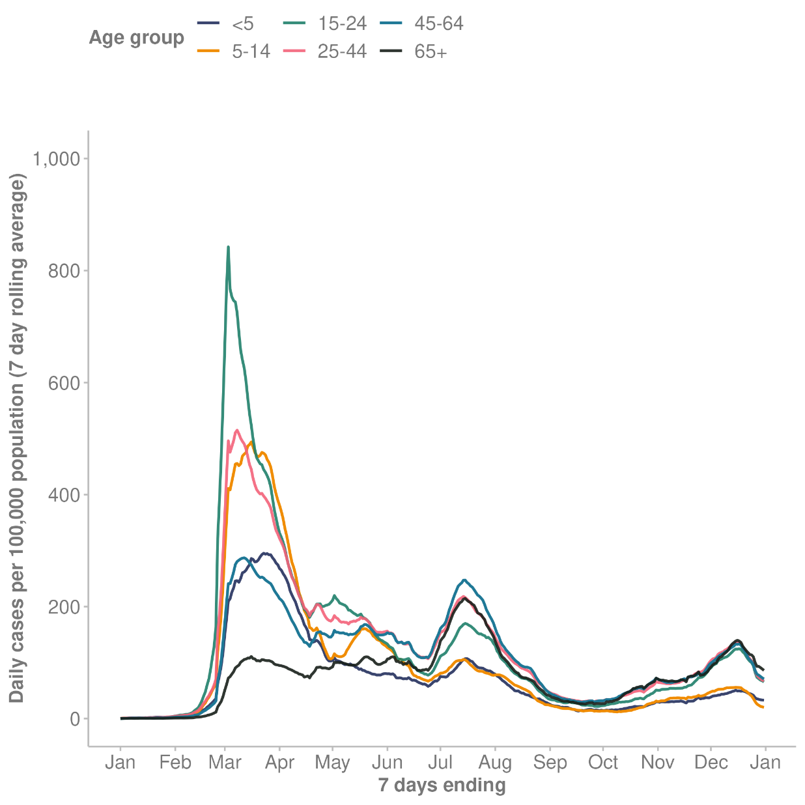
Source: Te Whatu Ora (2023e)

Figure 47: Rate of COVID-19 hospital admissions per 100,000 population, by age group, 2022
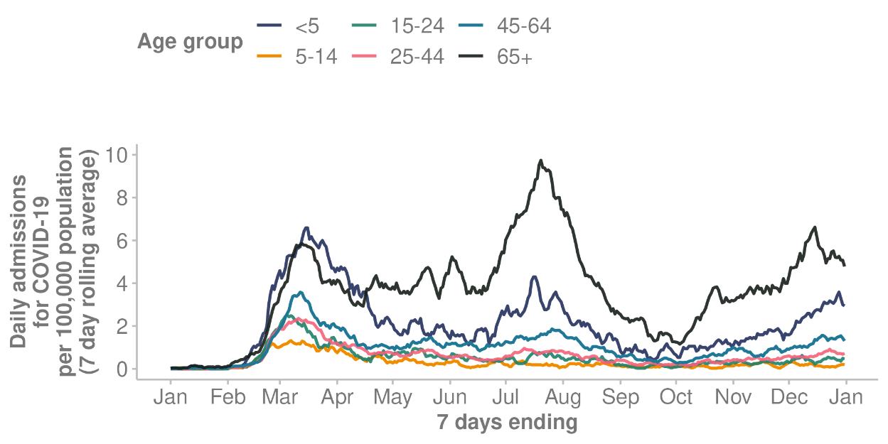
Source: Te Whatu Ora (2023e)

Figure 48: Rate of COVID-19 deaths per 100,000 population, by age group (under 60 years, 60–69, 70–79, 80 and over), 2022
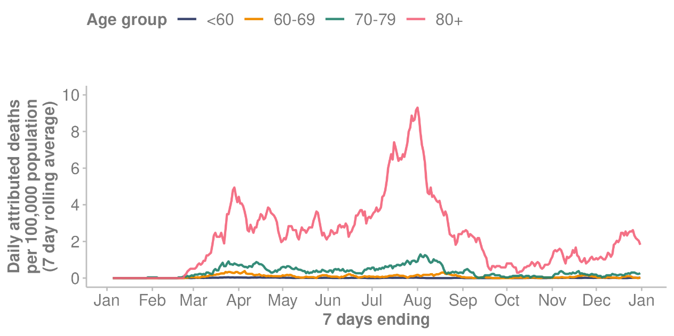
Source: Te Whatu Ora (2023e)

COVID-19 and deprived communities
People living in highly deprived areas faced a higher risk from COVID-19 (Te Whatu Ora 2023e). Those living in the most deprived communities had 2 times the risk of hospitalisation and were 3 times more likely to die from COVID-19 than those who lived in the least deprived communities (Manatū Hauora 2022d).

COVID-19 reinfections
Reinfection with COVID-19 means an individual was infected with COVID-19, recovered, and then later became infected again by the same or a different variant (Unite against COVID-19 2023). People become more likely to become reinfected as time since first infection increased, due to decreasing immune response from their previous COVID-19 infection. Reinfection may also become more common as new variants and subvariants spread.

In 2022, of the reported COVID-19 cases, 1,988,813 (94.6% of all cases in 2022) were first infections and 112,714 (5.4%) were reinfections. Figure 49 shows that higher percentages of reinfection occurred in younger age groups: those aged 20–29 years had the highest percentage, followed by those aged 30–39 years.

Figure 49: Percentage of COVID-19 infections and reinfections, by age group, 2022
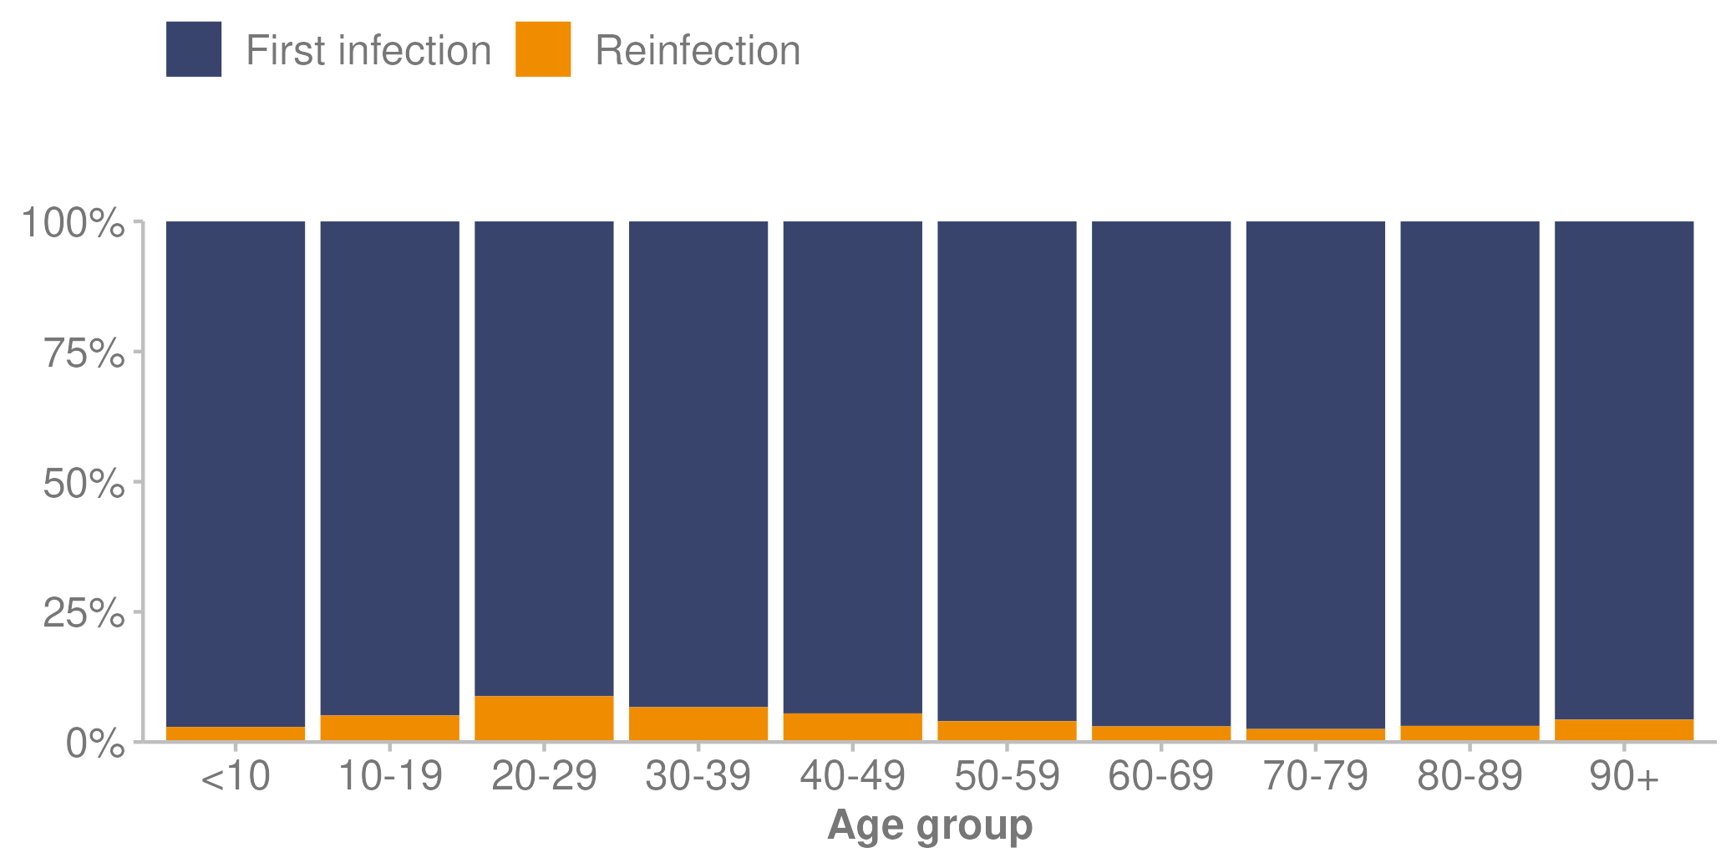
Source: Te Whatu Ora (2023) — unpublished data

Long COVID
There is no internationally agreed definition of long COVID. In Aotearoa New Zealand, long COVID is defined as signs and symptoms consistent with COVID-19 that develop during or after an infection, continue for more than 12 weeks and are not explained by an alternative diagnosis (Manatū Hauora 2021b).

Currently, the prevalence of long COVID in Aotearoa New Zealand is unknown. However, the COVID-19 pandemic affected some population groups more than others and long COVID is likely to continue this trend (Manatū Hauora 2022c). Māori and Pacific peoples made up a higher proportion of COVID-19 cases, as well as having a higher incidence of severe illness requiring hospitalisation (Te Whatu Ora 2023e). Both of these measures are associated with a higher likelihood of developing long COVID.

Vaccination against COVID-19 is considered the most accepted form of protection from long COVID (Ayoubkhani et al 2022).

COVID-19 vaccinations
COVID-19 vaccinations are offered free for everyone in Aotearoa New Zealand aged 5 years and over, no matter what their visa or citizenship status (Manatū Hauora 2023e). Children aged 6 months to 4 years can get the paediatric Pfizer vaccine if they are at higher risk of severe illness from COVID-19. The primary course is 2 doses of the COVID-19 vaccination given 3 to 8 weeks apart (Manatū Hauora 2020b). A third primary dose is offered to people who are severely immunocompromised and meet eligibility criteria.

The COVID-19 booster is an additional vaccine dose given after the primary course to boost the immune response to previous antibody levels. Booster doses are available for people aged 16 years and older, and recommended for people aged 30 years and older, or those at increased risk of severe illness from COVID-19 (Manatū Hauora 2023d).

The following graphs show COVID-19 vaccination status as at 31 December 2022, first by ethnic group (Figure 50) and then by age group (Figure 51).

Figure 50: COVID-19 vaccination status, by ethnic group, as at 31 December 2022
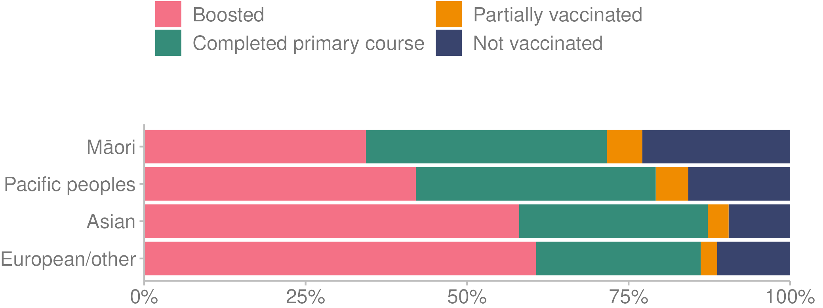
Source: Te Whatu Ora (2023) — unpublished data

Figure 51: COVID-19 vaccination status, by age group, as at 31 December 2022
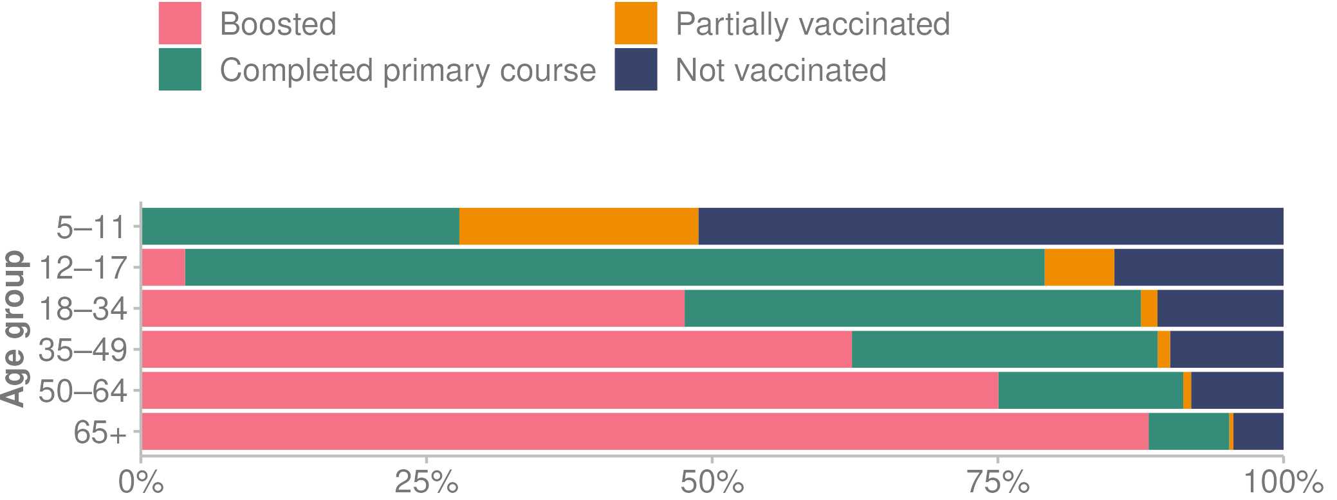
Source: Te Whatu Ora (2023n) — unpublished data

Technical notes | Ngā puna raraunga
This report contains data from a range of sources, some of them outside Manatū Hauora. Data is available through hyperlinks to sources, where available, or in the accompanying Excel file. The Health and Independence Report aims to include data only when the data collection and analytical processes are robust. Notes are included if methodological information affects the interpretation of the data. We encourage readers to refer to the original data source for further details.

Alongside this report, we have published data appendices containing otherwise unpublished health data that informed this report and the Pae Ora Health Strategies.

All data presented here is the latest available at the time of developing this report from January to April 2023. The time lag between the most recent data and the present day can be substantial. For example, it can involve up to a 3-year delay for mortality data. In such cases, the report may use provisional data.

COVID-19 data was extracted on 17 March 2023. Case, hospitalisation and death figures are subject to change due to the addition of historical cases, updated data sources, methodology changes and updates to population denominators. As a result, the figures included in this report may differ from those previously published.

COVID-19 deaths are defined as people who died where the cause of death was attributable to COVID-19 (that is, it was coded as an underlying or contributory cause). More recent trends should be interpreted with caution to account for delays in death coding.

The Ministry reports COVID-19 hospitalisations using 2 data sets:
- the Inpatient Admission (IP) data set
- the National Minimum Dataset (NMDS).

The NMDS provides more accurate and comprehensive data that covers the whole country, but this data is only available after a significant time lag, usually around 60 days. Over time the hospitalisation data may change, as updated NMDS data becomes available.

The Health Survey provides data on a variety of topics. This report does not cover all of them.

Within the ‘Health measures’ section, population health measures are produced using data from the Health Survey. Most Health Survey data is presented as a 3-year rolling average. This means that each statistic is averaged across 3 consecutive years of survey data from 3 Health Survey cycles. For example, data representing the 3-year pooled period ending 2021/22 contains data from the survey years 2019/20, 2020/21 and 2021/22 (data collected from mid-2019 to mid-2022).

Due to this pooling methodology, Health Survey numbers in this document may be different to numbers published elsewhere. For Health Survey data that is not collected every year, data is presented by survey year rather than 3-year pooled periods and marked accordingly.

Figure 52: Health Survey data, 3-year pooled periods
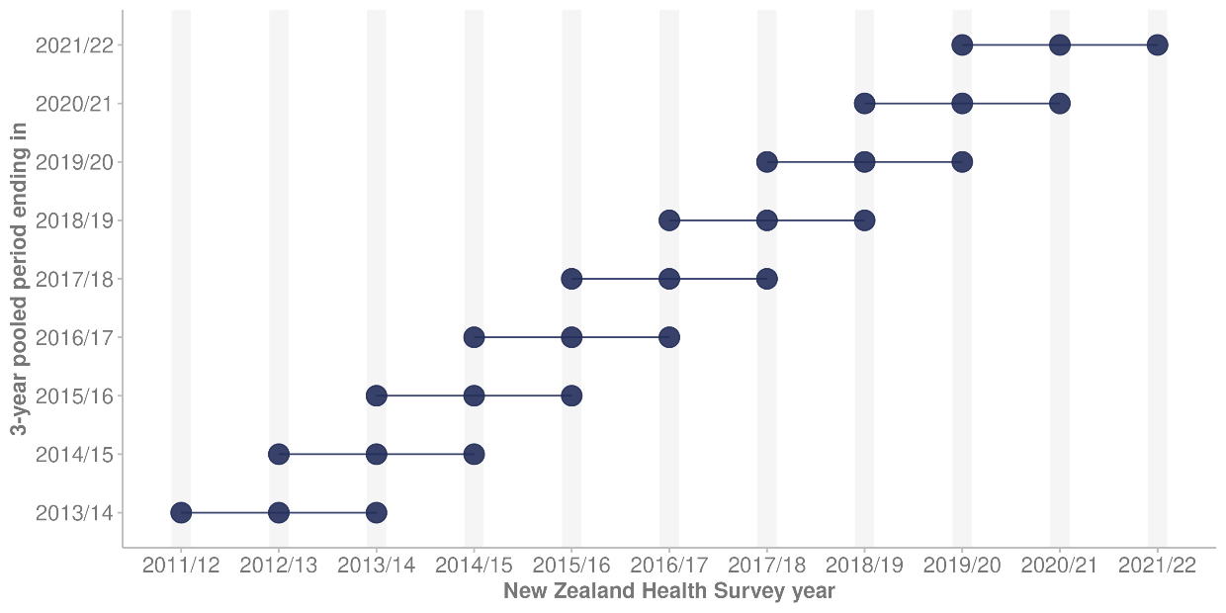

Figure 52 shows the period of data included for each 3-year pooled period. The data produced for the 3-year pooled periods contains overlapping cycles of data from the Health Survey. The grouping of data into 3-year pooled periods is important for observing long-term trends among specific subgroups of the population. This is of relevance to the Health and Independence Report, which has a long-term outlook on population trends. The main purpose of presenting pooled data is to improve the sample size for data presented by population groups. This results in more precise estimates of population health and smooths trends over time, making interpretation and discussion of trends easier.

Figure 53: Example of trends in daily smoking, based on 3-year pooled data and single survey year data
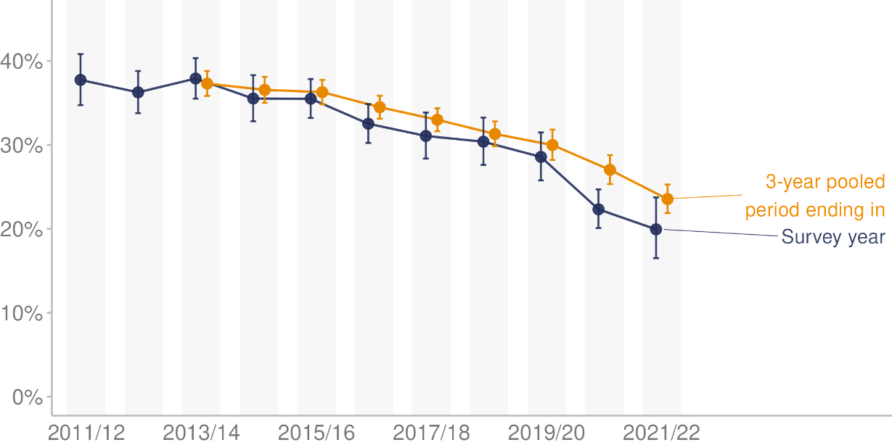

Figure 53 shows an example of trends in daily smoking over time among Māori adults, with data presented by survey year and by the 3-year pooled period ending in the equivalent survey year. We can see the benefits of the 3-year pooled period in the smaller error bars surrounding the estimates and a smoother trend compared with data from individual Health Survey cycles. The main disadvantage of using the 3-year pooled period is that the estimates are older than estimates produced using yearly data. We can see this as a lag effect in the 3-year pooled period data. The data for the 3-year pooled period in this example appears to track behind the single survey year data as the equivalent reductions in smoking seem to occur later. This is because the data for the 3-year pooled period contains data over the previous 3 survey cycle years. For example, data produced for the yearly collection cycle 2021/22 is more up to date than data for the 3-year pooled data period that includes survey years 2019/20, 2020/21 and 2021/22. For the most up-to-date information, you can access annual data from the Annual Data Explorer (Manatū Hauora 2023a).

Ethnic group comparisons are based on either prioritised ethnicity or total response ethnicity. With prioritised ethnicity, ethnic groups are mutually exclusive. That is, a person can appear in only one ethnic group, which is generally prioritised in the following order: Māori, Pacific peoples, Asian, other. With total response ethnicity, a person is classified in all of the ethnic groups they identify with. This means that a person can appear in more than one ethnic group. Prioritised ethnicity is often used for analysis based on administrative data (data collected for purposes other than statistics), such as mortality data, while total response ethnicity is shown for Health Survey data.

Selected results are presented by neighbourhood deprivation, as measured by the New Zealand Index of Deprivation (NZDep2018). This is an area-based measure of socioeconomic deprivation that uses a combination of the following 2018 Census data: household income, receiving a benefit, household crowding, home ownership, employment status, qualifications, support (sole-parent families), living condition (dampness or mould) and household access to the internet. In this report, ‘quintile 5’ means the 20% of small areas in Aotearoa New Zealand that are most socioeconomically deprived. Conversely, ‘quintile 1’ means the 20% of small areas that are least deprived.

The report contains population data from Stats NZ population estimates and projections, as well as the Health Service User (HSU) population. These data sources have some important differences. Stats NZ population estimates are estimates of the resident population based on the census and information on births, deaths and migration, and exclude short-term visitors to Aotearoa New Zealand. The HSU measures people who received health services in Aotearoa New Zealand in a given year, including short-term visitors. The HSU does not include people living in Aotearoa New Zealand if they have not interacted with the health system, and were not enrolled with a GP, during the year. As a result of uptake of the COVID-19 vaccination programme starting in 2021, many more people used health services in Aotearoa New Zealand, including non-residents. At a population level, the HSU for 2021 is about 2% higher than Stats NZ’s population estimate for 2021 (Manatū Hauora 2022g). Stats NZ data and Manatū Hauora data also differ in the way they record ethnicity, with the result that HSU totals by ethnic group differ from totals in Stats NZ population estimates and projections.

Te Whatu Ora and Manatū Hauora use the HSU as the denominator for COVID-19 vaccine uptake rates (Manatū Hauora 2022f). In an independent review of the HSU data, Stats NZ found that it is an appropriate way to measure COVID-19 vaccine coverage (Stats NZ 2022f). The Manatū Hauora response to the Stats NZ recommendations is available on its website (Manatū Hauora 2022m). The main rationale for using the HSU as a population denominator for health statistics, rather than data from Stats NZ, is to combat numerator-denominator bias. This happens when the demographics about a person in the numerator are different from those in the denominator. For example, numerator-denominator bias would occur by calculating vaccination coverage for Māori with COVID-19 vaccination data as the numerator and Stats NZ population estimates as the denominator. Bias occurs because the ethnic groups with which someone identifies can be different in health data — in this case, in the COVID-19 Immunisation Register — and Stats NZ population estimates.

When possible, this Health and Independence Report includes statistically significant differences between population groups and, when relevant, trends over time. In many comparisons, the results have been adjusted or standardised for factors that may influence (confound) the comparison, such as age and gender. This report often uses age standardisation to account for differences in age structure between population groups and over time (Manatū Hauora 2022i).

References | Ngā tohutoro
Action for Smokefree 2025. 2023. ASH Year 10 Snapshot Survey. URL: www.ash.org.nz/ash_year_10 (accessed 28 April 2023).
Atkinson J, Salmond C, Crampton P. 2020. NZDep2018 Index of Deprivation. URL: www.otago.ac.nz/wellington/otago823833.pdf (accessed 5 May 2023).
Ayoubkhani D, Bermingham C, Pouwels KB, et al. 2022. Trajectory of long covid symptoms after covid-19 vaccination: community based cohort study. BMJ 377: e069676.
Cornwall J, Davey JA. 2004. Impact of population ageing in New Zealand on the demand for health and disability support services, and workforce implications. URL: www.health.govt.nz/system/files/documents/publications/cornwallanddavey.pdf (accessed 5 May 2023).
Coronial Services of New Zealand. 2022. Deputy chief coroner releases annual provisional suicide statistics. URL: https://coronialservices.justice.govt.nz/assets/Media-release-Deputy-Chief-Coroner-251022.pdf (accessed 5 May 2023).
Department of the Prime Minister and Cabinet. 2021. Our health and disability system. URL: www.dpmc.govt.nz/sites/default/files/2021-04/htu-factsheet-primary-and-community-care-en-apr21.pdf (accessed 5 May 2023).
Elliot CA, Hamlin MJ. 2018. Combined diet and physical activity is better than diet or physical activity alone at improving health outcomes for patients in New Zealand’s primary care intervention. BMC Public Health 18(1): 230.
Health Navigator. 2021. Social determinants of health. URL: www.healthnavigator.org.nz/clinicians/s/social-determinants-of-health/ (accessed 5 May 2023).
Heart Foundation. 2023. Statistics: General heart statistics in New Zealand. URL: www.heartfoundation.org.nz/statistics (accessed 5 May 2023).
Institute for Health Metrics and Evaluation. 2019. New Zealand. URL: www.healthdata.org/new-zealand (accessed 5 May 2023).
Institute for Health Metrics and Evaluation. 2020a. Global Burden of Disease (GBD). URL: https://vizhub.healthdata.org/gbd-results/ (accessed 5 May 2023).
Institute for Health Metrics and Evaluation. 2020b. Global Burden of Disease Study 2019 (GBD 2019) life tables 1950-2019. URL: https://ghdx.healthdata.org/record/ihme-data/gbd-2019-life-tables-1950-2019 (accessed 18 April 2023).
Irurzun-Lopez M, Jeffreys M, Cumming J. 2021. The enrolment gap: who is not enrolling with primary health organizations in Aotearoa New Zealand and what are the implications? An exploration of 2015–2019 administrative data. International Journal for Equity in Health 20: 93.
Islam N, Jdanov DA, Shkolnikov VM, et al. 2021. Effects of covid-19 pandemic on life expectancy and premature mortality in 2020: time series analysis in 37 countries. BMJ 375: e066768.
Kobak D. 2023. Excess mortality during the COVID-19 pandemic. URL: https://github.com/dkobak/excess-mortality (accessed 28 April 2023).
Manatū Hauora. 2017. HISO 10001:2017 Ethnicity Data Protocols. URL: www.moh.govt.nz/notebook/nbbooks.nsf/0/569DDB6A56F7E726CC2581FC00665BEB/$file/hiso-10001-2017-ethnicity-data-protocols.pdf (accessed 5 May 2023).
Manatū Hauora. 2019a. Achieving equity in health outcomes: Summary of a discovery process. URL: www.health.govt.nz/system/files/documents/publications/achieving-equity-in-health-outcomes-summary-of-a-discovery-process-30jul2019.pdf (accessed 4 May 2023).
Manatū Hauora. 2019b. Fetal and infant deaths 2016. URL: www.health.govt.nz/publication/fetal-and-infant-deaths-2016 (accessed 8 May 2023).
Manatū Hauora. 2019c. Household food insecurity among children: New Zealand Health Survey. URL: www.health.govt.nz/system/files/documents/publications/household-food-insecurity-among-children-new-zealand-health-survey-summary-of-findings-jun19.pdf (accessed 5 May 2023).
Manatū Hauora. 2020a. Eating and Activity Guidelines for New Zealand Adults. URL: www.health.govt.nz/publication/eating-and-activity-guidelines-new-zealand-adults (accessed 31 September 2022).
Manatū Hauora. 2020b. Immunisation Handbook 2020: Coronavirus disesase (COVID-19). URL: www.health.govt.nz/our-work/immunisation-handbook-2020/5-coronavirus-disease-covid-19#23-5 (accessed 8 May 2023).
Manatū Hauora. 2020c. Longer, Healthier Lives: New Zealand's health 1990–2017. URL: www.health.govt.nz/publication/longer-healthier-lives-new-zealands-health-1990-2017 (accessed 4 May 2023).
Manatū Hauora. 2020d. Whakamaua: Māori Health Action Plan 2020-2025. URL: www.health.govt.nz/our-work/populations/maori-health/whakamaua-maori-health-action-plan-2020-2025 (accessed 5 May 2023).
Manatū Hauora. 2021a. Kia Manawanui Aotearoa: Long-term pathway to mental wellbeing. URL: www.health.govt.nz/publication/kia-manawanui-aotearoa-long-term-pathway-mental-wellbeing (accessed 5 May 2023).
Manatū Hauora. 2021b. Long COVID. URL: www.health.govt.nz/our-work/diseases-and-conditions/covid-19-novel-coronavirus/covid-19-health-advice-public/long-covid (accessed 21 October 2021).
Manatū Hauora. 2021c. Smokefree Aotearoa 2025 Action Plan - Auahi Kore Aotearoa Mahere Rautaki 2025. URL: www.health.govt.nz/publication/smokefree-aotearoa-2025-action-plan-auahi-kore-aotearoa-mahere-rautaki-2025 (accessed 5 May 2023).
Manatū Hauora. 2022a. Age 5 and year 8 oral health data from the Community Oral Health Service. URL: www.health.govt.nz/nz-health-statistics/health-statistics-and-data-sets/oral-health-data-and-stats/age-5-and-year-8-oral-health-data-community-oral-health-service (accessed 28 April 2023).
Manatū Hauora. 2022b. Alcohol. URL: www.health.govt.nz/your-health/healthy-living/addictions/alcohol-and-drug-abuse/alcohol (accessed 5 May 2023).
Manatū Hauora. 2022c. COVID-19 mortality in Aotearoa New Zealand: Inequalities in risk. URL: www.health.govt.nz/publication/covid-19-mortality-aotearoa-new-zealand-inequities-risk (accessed 5 May 2023).
Manatū Hauora. 2022d. COVID-19 trends and insights report. URL: www.health.govt.nz/system/files/documents/pages/trends-and-insights-report-4nov22.pdf (accessed 18 May 2023).
Manatū Hauora. 2022e. COVID-19 variants. URL: www.health.govt.nz/covid-19-novel-coronavirus/covid-19-health-advice-public/about-covid-19/covid-19-variants (accessed 21 September 2022).
Manatū Hauora. 2022f. COVID-19: Vaccine data. URL: www.health.govt.nz/covid-19-novel-coronavirus/covid-19-data-and-statistics/covid-19-vaccine-data (accessed 1 November 2022).
Manatū Hauora. 2022g. Further information about the HSU Dataset and Review. URL: www.health.govt.nz/system/files/documents/publications/further-information-about-the-hsu-dataset-and-review-4aug22.pdf (accessed 31 October 2022).
Manatū Hauora. 2022h. Health strategies for all New Zealanders. URL: www.health.govt.nz/new-zealand-health-system/setting-direction-our-new-health-system/health-strategies-all-new-zealanders (accessed 9 May 2023).
Manatū Hauora. 2022i. Methodology Report 2021/22: New Zealand Health Survey. URL: www.health.govt.nz/system/files/documents/publications/methodology_report_2021_22-_new_zealand_health_survey_11_nov.pdf (accessed 5 May 2023).
Manatū Hauora. 2022j. New health and disability system. URL: www.health.govt.nz/new-zealand-health-system/new-health-and-disability-system (accessed 9 May 2023).
Manatū Hauora. 2022k. Obesity in 2021/22. URL: www.health.govt.nz/system/files/documents/publications/obesity_in_2021-22_16nov.pdf (accessed 5 May 2023).
Manatū Hauora. 2022l. Questionnaires and Content Guide 2021/22: New Zealand Health Survey. URL: www.health.govt.nz/publication/questionnaires-and-content-guide-2021-22-new-zealand-health-surve (accessed 18 May 2023).
Manatū Hauora. 2022m. Response to Stats NZ recommendations for the Health Service User dataset. URL: www.health.govt.nz/publication/response-stats-nz-recommendations-health-service-user-dataset (accessed 28 October 2022).
Manatū Hauora. 2023a. Annual Data Explorer 2021/22: New Zealand Health Survey (Data file). URL: https://minhealthnz.shinyapps.io/nz-health-survey-2021-22-annual-data-explorer/ (accessed 28 April 2023).
Manatū Hauora. 2023b. Ao Mai te Rā: The anti-racism kaupapa. URL: www.health.govt.nz/our-work/populations/maori-health/ao-mai-te-ra-anti-racism-kaupapa (accessed 5 May 2023).
Manatū Hauora. 2023c. COVID-19 risk among disabled people. URL: www.health.govt.nz/publication/covid-19-risk-among-disabled-people (accessed 5 May 2023).
Manatū Hauora. 2023d. COVID-19 vaccine booster. URL: www.healthnavigator.org.nz/medicines/c/covid-19-vaccine-booster/ (accessed 8 May 2023).
Manatū Hauora. 2023e. COVID-19 vaccines. URL: www.health.govt.nz/covid-19-novel-coronavirus/covid-19-vaccines (accessed 18 May 2023).
Manatū Hauora. 2023f. HPV immunisation programme. URL: www.health.govt.nz/our-work/preventative-health-wellness/immunisation/hpv-immunisation-programme (accessed 5 May 2023).
Manatū Hauora. 2023g. Immunisation. URL: www.health.govt.nz/your-health/healthy-living/immunisation (accessed 5 May 2023).
Manatū Hauora. 2023h. National and regional immunisation data. URL: www.health.govt.nz/our-work/preventative-health-wellness/immunisation/immunisation-coverage/national-and-regional-immunisation-data (accessed 28 April 2023).
Manatū Hauora. 2023i. National Bowel Screening Programme. URL: www.health.govt.nz/our-work/preventative-health-wellness/screening/national-bowel-screening-programme (accessed 11 May 2023).
Manatū Hauora. 2023j. New Zealand Health Survey. URL: www.health.govt.nz/nz-health-statistics/national-collections-and-surveys/surveys/new-zealand-health-survey (accessed 28 May 2023).
Manatū Hauora. 2023k. Obesity. URL: www.health.govt.nz/our-work/diseases-and-conditions/obesity (accessed 5 May 2023).
Mohan B, Nambiar V. 2020. COVID-19: an insight into SARS-CoV-2 pandemic originated at Wuhan City in Hubei Province of China. Journal of Infectious Diseases and Epidemiology 6(4): 146.
National Screening Unit. 2018. BreastScreen Aotearoa. URL: www.nsu.govt.nz/health-professionals/breastscreen-aotearoa (accessed 18 May 2023).
National Screening Unit. 2022. National Cervical Screening Programme. URL: www.nsu.govt.nz/health-professionals/national-cervical-screening-programme (accessed 18 May 2023).
National Screening Unit. 2023. National Bowel Screening Programme. URL: www.nsu.govt.nz/health-professionals/national-bowel-screening-programme (accessed 18 May 2023).
Nationwide Service Framework Library. 2022. Inpatient average length of stay (Data file). URL: https://nsfl.health.govt.nz/accountability/performance-and-monitoring/data-quarterly-reports-and-reporting/inpatient-average (accessed 31 October 2022).
Nationwide Service Framework Library. 2023. Ambulatory sensitive (avoidable) hospital admissions. URL: https://nsfl.health.govt.nz/accountability/performance-and-monitoring/data-quarterly-reports-and-reporting/ambulatory-sensitive (accessed 28 April 2023).
Neumann D, Yao E, Fenaughty J, et al. 2023. Now we are twelve: ethnic and gender identity at 12 years old. URL: https://assets-global.website-files.com/63b7328effdfd4238ae0d82b/6477d04a93cbb8fad11d4a24_NWA12_1_Ethnic%20and%20Gender%20Identity%20FINAL%20PDF%20v2.pdf (accessed 5 May 2023).
Public Policy Institute. 2023. COVID-19 timeline 2022. URL: www.policycommons.ac.nz/covid-19-policy-resources/covid-19-timeline/covid-19-timeline-2022/ (accessed 18 May 2023).
Stats NZ. 1936. The New Zealand Official Year-book, 1936. URL: https://www3.stats.govt.nz/New_Zealand_Official_Yearbooks/1936/NZOYB_1936.html#idsect1_1_39354 (accessed.
Stats NZ. 2014. Disability Survey: 2013. URL: www.stats.govt.nz/information-releases/disability-survey-2013 (accessed 5 May 2023).
Stats NZ. 2020a. 2018 Census ethnic group summaries. URL: www.stats.govt.nz/tools/2018-census-ethnic-group-summaries (accessed 5 May 2023).
Stats NZ. 2020b. Disabled people fare worse in their home, economic, and social lives. URL: www.stats.govt.nz/news/disabled-people-fare-worse-in-their-home-economic-and-social-lives/ (accessed 5 May 2023).
Stats NZ. 2020c. Housing in Aotearoa: 2020. URL: www.stats.govt.nz/reports/housing-in-aotearoa-2020 (accessed 5 May 2023).
Stats NZ. 2020d. The state of housing in Aotearoa New Zealand. URL: www.stats.govt.nz/infographics/the-state-of-housing-in-aotearoa-new-zealand (accessed 5 May 2020).
Stats NZ. 2020e. Wellbeing outcomes worse for sole parents. URL: www.stats.govt.nz/news/wellbeing-outcomes-worse-for-sole-parents/ (accessed 5 May 2023).
Stats NZ. 2021a. General Social Survey (GSS). URL: https://datainfoplus.stats.govt.nz/Item/nz.govt.stats/2ed50ad6-8ab8-47df-883d-210a51b50043 (accessed 18 May 2023).
Stats NZ. 2021b. Growth in life expectancy slows. URL: www.stats.govt.nz/news/growth-in-life-expectancy-slows/ (accessed 8 May 2023).
Stats NZ. 2021c. National and subnational period life tables: 2017–2019. URL: www.stats.govt.nz/information-releases/national-and-subnational-period-life-tables-2017-2019 (accessed 28 October 2022).
Stats NZ. 2021d. National ethnic population projections: 2018(base)–2043. URL: www.stats.govt.nz/information-releases/national-ethnic-population-projections-2018base-2043 (accessed 5 May 2023).
Stats NZ. 2021e. Wellbeing statistics: A year in review (June 2020 to March 2021 quarter). URL: www.stats.govt.nz/reports/wellbeing-statistics-a-year-in-review-june-2020-to-march-2021-quarter (accessed 5 May 2023).
Stats NZ. 2022a. How we measure child poverty. URL: www.stats.govt.nz/infographics/how-we-measure-child-poverty/ (accessed 18 May 2023).
Stats NZ. 2022b. LGBT+ population of Aotearoa: Year ended June 2021. URL: www.stats.govt.nz/information-releases/lgbt-plus-population-of-aotearoa-year-ended-june-2021 (accessed 11 May 2023).
Stats NZ. 2022c. National population projections: 2022(base)–2073. URL: www.stats.govt.nz/information-releases/national-population-projections-2022base2073/ (accessed 10 May 2023).
Stats NZ. 2022d. One in three children projected to be Māori. URL: www.stats.govt.nz/news/one-in-three-children-projected-to-be-maori/ (accessed 5 May 2023).
Stats NZ. 2022e. Persistent labour market gaps remain for disabled people. URL: www.stats.govt.nz/news/persistent-labour-market-gaps-remain-for-disabled-people/ (accessed 5 May 2023).
Stats NZ. 2022f. Review of Health Service User population methodology. URL: www.stats.govt.nz/reports/review-of-health-service-user-population-methodology/ (accessed 28 October 2022).
Stats NZ. 2022g. Wellbeing statistics: 2021. URL: www.stats.govt.nz/information-releases/wellbeing-statistics-2021/ (accessed 5 May 2023).
Stats NZ. 2023a. Births and deaths: Year ended December 2022 (including abridged period life table). URL: www.stats.govt.nz/information-releases/births-and-deaths-year-ended-december-2022-including-abridged-period-life-table/ (accessed 5 May 2023).
Stats NZ. 2023b. Child poverty statistics show no annual change in the year ended June 2022. URL: www.stats.govt.nz/news/child-poverty-statistics-show-no-annual-change-in-the-year-ended-june-2022/ (accessed 5 May 2023).
Stats NZ. 2023c. Deaths increase by ten percent in 2022. URL: www.stats.govt.nz/news/deaths-increase-by-ten-percent-in-2022/ (accessed 5 May 2023).
Stats NZ. 2023d. Infoshare. URL: https://infoshare.stats.govt.nz/ (accessed 28 April 2023).
Stats NZ. 2023e. Household Disability Survey 2023: Final content. URL: www.stats.govt.nz/reports/household-disability-survey-2023-final-content/ (accessed 11 May 2023).
Stats NZ. 2023f. Population. URL: www.stats.govt.nz/topics/population (accessed 5 May 2023).
Stats NZ. 2023g. Return to net migration gains in 2022. URL: www.stats.govt.nz/news/return-to-net-migration-gains-in-2022/ (accessed 5 May 2023).
Te Aho o Te Kahu Cancer Control Agency. 2022. Cancer Quality Performance Indicator Programme. URL: https://teaho.govt.nz/reports/qpi (accessed 18 May 2023).
Te Aho o Te Kahu Cancer Control Agency. 2023a. Bowel cancer quality performance indicators. URL: https://teaho.govt.nz/reports/qpi/qpi-bowel (accessed 5 May 2023).
Te Aho o Te Kahu Cancer Control Agency. 2023b. Cancer in numbers in Aotearoa New Zealand. URL: https://teaho.govt.nz/cancer-numbers (accessed 5 May 2023).
Te Aho o Te Kahu Cancer Control Agency. 2023c. Lung cancer quality performance indicators. URL: https://teaho.govt.nz/reports/qpi/qpi-lung (accessed 5 May 2023).
Te Aho o Te Kahu Cancer Control Agency. 2023d. What is happening over time? A look at the rates of new cancers and cancer deaths over time in Aotearoa. URL: https://teaho.govt.nz/cancer-numbers/cancer-rates (accessed 5 May 2023).
Te Tāhū Hauora. 2021. Patient experience. URL: www.hqsc.govt.nz/our-data/health-quality-and-safety-indicators/patient-experience/ (accessed 27 April 2023).
Te Tāhū Hauora. 2022a. Fifteenth Annual Report of the Perinatal and Maternal Mortality Review Committee | Te Pūrongo ā-Tau Tekau mā Rima o te Komiti Arotake Mate Pēpi, Mate Whaea Hoki. URL: www.hqsc.govt.nz/assets/Our-work/Mortality-review-committee/PMMRC/Publications-resources/15thPMMRC-report-final.pdf (accessed 18 May 2023).
Te Tāhū Hauora. 2022b. Information about deaths of babies and mothers in Aotearoa New Zealand. URL: www.hqsc.govt.nz/our-work/mortality-review-committees/perinatal-and-maternal-mortality-review-committee/information-about-deaths-of-babies-and-mothers-in-aotearoa-new-zealand/ (accessed 5 May 2023).
Te Tāhū Hauora. 2023. He Ara Aupiki, He Ara Auheke: Aotearoa New Zealand patient experience survey (Data file). URL: https://reports.hqsc.govt.nz/AHI-explorer/ (accessed 27 April 2023).
Te Whatu Ora. 2022. Suicide web tool (Data file). URL: https://tewhatuora.shinyapps.io/suicide-web-tool/ (accessed 15 April 2023).
Te Whatu Ora. 2023a. About Access and Choice. URL: www.wellbeingsupport.health.nz/about-access-and-choice/ (accessed 5 May 2023).
Te Whatu Ora. 2023b. Acute care. URL: www.tewhatuora.govt.nz/our-health-system/hospitals-and-specialist-services/acute-care (accessed 5 May 2023).
Te Whatu Ora. 2023c. BreastScreen Aotearoa interactive coverage data tool (Data file). URL: https://tewhatuora.shinyapps.io/nsu-bsa-coverage/ (accessed 28 April 2023).
Te Whatu Ora. 2023d. Cancer web tool (Data file). URL: https://tewhatuora.shinyapps.io/cancer-web-tool/ (accessed 28 April 2023).
Te Whatu Ora. 2023e. COVID-19 trends and insights. URL: https://tewhatuora.shinyapps.io/covid19/ (accessed 28 April 2023).
Te Whatu Ora. 2023f. Enrolment with a general practice and primary health organisation. URL: www.tewhatuora.govt.nz/our-health-system/primary-care-sector/primary-health-organisations/enrolment-with-a-general-practice-and-primary-health-organisation/ (accessed 18 May 2023).
Te Whatu Ora. 2023g. Fetal and infant deaths web tool (Data file). URL: https://tewhatuora.shinyapps.io/fetal-and-infant-deaths-web-tool/ (accessed 28 April 2023).
Te Whatu Ora. 2023h. Mortality web tool (Data file). URL: https://tewhatuora.shinyapps.io/mortality-web-tool/ (accessed 28 April 2023).
Te Whatu Ora. 2023i. National Cervical Screening Programme interactive coverage data tool (Data file). URL: https://tewhatuora.shinyapps.io/nsu-ncsp-coverage/ (accessed 28 April 2023).
Te Whatu Ora. 2023j. The National Immunisation Schedule - HE1308. URL: https://healthed.govt.nz/products/the-national-immunisation-schedule (accessed 5 May 2023).
Te Whatu Ora. 2023k. Planned care services. URL: www.tewhatuora.govt.nz/our-health-system/hospitals-and-specialist-services/planned-care-services (accessed 5 May 2023).
Te Whatu Ora. 2023l. Populations web tool (Data file). URL: Unpublished data (accessed 25 April 2023).
Te Whatu Ora. 2023m. Public hospitals. URL: www.tewhatuora.govt.nz/our-health-system/hospitals-and-specialist-services/public-hospitals/ (accessed 5 May 2023).
Te Whatu Ora. 2023n. Virtual Diabetes Register web tool (Data file). URL: https://tewhatuora.shinyapps.io/virtual-diabetes-register-web-tool/ (accessed 28 April 2023).
The Immunisation Advisory Centre. 2022. New Zealand Immunisation Strategy. URL: www.influenza.org.nz/clinical-info/new-zealand-immunisation-strategy (accessed 18 May 2023).
Unite against COVID-19. 2022a. The current phase of our COVID-19 response. URL: https://covid19.govt.nz/current-phase-of-our-covid-19-response/ (accessed 5 May 2023).
Unite against COVID-19. 2022b. History of the COVID-19 Protection Framework (traffic lights). URL: https://covid19.govt.nz/about-our-covid-19-response/history-of-the-covid-19-protection-framework-traffic-lights/ (accessed 5 May 2023).
Unite against COVID-19. 2023. After you have had COVID-19. URL: https://covid19.govt.nz/testing-and-isolation/if-you-have-covid-19/after-you-have-had-covid-19/ (accessed 5 May 2023).
University of Michigan. 2023. Cerebrovascular Disease. URL: www.uofmhealth.org/conditions-treatments/brain-neurological-conditions/cerebrovascular (accessed 12 May 2023).
University of Otago. 2011. Fact and action sheets on health inequalities. URL: www.otago.ac.nz/wellington/otago023745.pdf (accessed 11 May 2023).
University of Otago. 2021. Rural-urban classification for NZ health research and policy. URL: https://blogs.otago.ac.nz/rural-urbannz/ (accessed 25 April 2023).
Walker DK. 2021. Parenting and social determinants of health. Archives of Psychiatric Nursing 35(1): 134-6.
Whaikaha. 2022. System Transformation and Enabling Good Lives. URL: www.whaikaha.govt.nz/about-us/enabling-good-lives/ (accessed 11 May 2023).
Whaikaha. 2023. COVID-19 disability data review. URL: www.whaikaha.govt.nz/news-and-events/news/covid-19-disability-data-review/ (accessed 18 May 2023).
Whitehead J, Davie G, de Graaf B, et al. 2021. The Geographic Classification for Health. URL: https://blogs.otago.ac.nz/rural-urbannz/files/2021/07/The-Geographic-Classification-for-Health-Methodology-and-Classification-Report-May-2021.pdf (accessed 5 May 2023).
World Health Organization. 2021. Coronavirus disease (COVID-19) pandemic. URL: www.who.int/europe/emergencies/situations/covid-19 (accessed 18 May 2023).
World Health Organization. 2022. Noncommunicable diseases. URL: www.who.int/news-room/fact-sheets/detail/noncommunicable-diseases (accessed 5 May 2023).
World Health Organization. 2023. WHO Coronavirus (COVID-19) Dashboard. URL: https://covid19.who.int/ (accessed 28 April 2023).

As at data extraction date of 17 March 2023.
² Lesbian, gay, bisexual, transgender, intersex, queer/questioning, asexual.
Mahu (Hawai‘i and Tahiti), vaka sa lewa lewa (Fiji), palopa (Papua New Guinea), fa‘afafine (Samoa), akava‘ine (Cook Islands), fakaleiti (Tonga), fakafifine (Niue).
Rural areas and urban areas are grouped. For more information and detailed maps, go to the GCH website: https://storymaps.arcgis.com/stories/da035e374dbb4ea0ae3b31b6777924ad.
The survey defined disability as any self-perceived limitation in activity resulting from a long-term condition or health problem lasting, or expected to last, 6 months or more and not completely eliminated by an assistive device. It considered that a person did not have a disability if they were using an assistive device such as glasses or crutches that removed their impairment.
Enabling Good Lives has 8 principles. - Self-determination: Disabled people are in control of their lives. - Beginning early: Invest early in families and whānau to support them; to be aspirational for their disabled child; to build community and natural supports; and to support disabled children to become independent, rather than waiting for a crisis before support is available. - Person-centred: Disabled people have supports that are tailored to their individual needs and goals, and that take a whole-of-life approach rather than being split across programmes. - Ordinary life outcomes: Disabled people are supported to live an everyday life in everyday places; and are regarded as citizens with opportunities for learning, employment, having a home and family, and social participation — like others at similar stages of life. - Mainstream first: Disabled people are supported to access mainstream services before specialist disability services. - Mana enhancing: The abilities and contributions of disabled people and their families are recognised and respected. - Easy to use: Disabled people have supports that are simple to use and flexible. - Relationship building: Supports build and strengthen relationships between disabled people, their whānau and community.
Fetal death is the death of a fetus at 20 weeks’ gestation or later or, if gestation is unknown, a fetus weighing at least 400 grams.
Infant death is the death of an infant before their first birthday. The infant mortality rate is the number of infant deaths for every 1,000 live births.
Post-neonatal death is the death of a live-born infant after 28 completed days and before the first year of life is completed.
One DALY represents the loss of the equivalent of one year of full health.
The definition of emotional or behavioural problems is that a doctor has said that the child has depression, anxiety (which includes panic attacks), phobia, post-traumatic stress, obsessive-compulsive disorder, attention deficit disorder or attention deficit hyperactivity disorder (ADHD).
A provisional suicide classification may be made before the coroner has reached a finding. The Chief Coroner reports these cases, describing them as ‘suspected intentionally self-inflicted deaths’.
Interpret with caution as the relative sampling error (the size of the sampling error relative to the result) is over 30%.
Daily smokers are defined as people aged 15 years and over who smoke at least once a day and have smoked more than 100 cigarettes in their whole life.
Trying electronic cigarettes is defined as having ever tried an electronic cigarette or a vaping device, even just a puff or ‘vape’.
The denominator for the estimate is based on census population projections.
Health users are defined as people receiving health services in Aotearoa New Zealand each year. For example, they may be admitted to hospital, attend emergency departments, fill prescriptions, or be enrolled with a PHO or general practice.
As at data extraction date of 17 March 2023.
As at data extraction date of 17 March 2023.

