National Vision and Hearing Screening Protocols
Revised 2021

Citation: Ministry of Health. 2021. National Vision and Hearing Screening Protocols: Revised 2021. Wellington: Ministry of Health.
Published in November 2009 (revised 2014 and 2021) by the Ministry of Health
PO Box 5013, Wellington 6140, New Zealand
ISBN 978-1-99-100787-2 (online)
HP 7960
This document is available at health.govt.nz
This work is licensed under the Creative Commons Attribution 4.0 International licence. In essence, you are free to: share ie, copy and redistribute the material in any medium or format; adapt ie, remix, transform and build upon the material. You must give appropriate credit, provide a link to the licence and indicate if changes were made.

Contents
Introduction 1
Programme summary 2
The Programme 2
Cohort groups 2
Test environments/locations 3
Competencies 3
Test equipment 4
Screening tests may not be necessary 4
Resources 5
Quality requirements 5
Hearing screening 6
Overview of hearing screening 6
Pathway 1: Initial screening audiometry (sweep test) or rescreen 10
Pathway 2: Screening audiometry (hearing concerns) 14
Screening technique: tympanometry 18
Vision screening 23
Overview of vision screening 23
Screening technique: Parr letter-matching vision charts 26
Screening technique: Snellen eye chart 32
Colour vision: Ishihara pseudoisochromatic plate 34

List of Tables
Table 1: Risk factors for hearing-related developmental and learning difficulties 13
Table 2: Sequence of screening frequencies and pass levels 16

List of Figures
Figure 1: Pathway 1 – Initial screening (sweep) or rescreen audiometry clinical pathway 17
Figure 2: Pathway 2 – Screening audiometry (hearing concerns) clinical pathway 18
Figure 3: Vision screening clinical pathway and referral at four years old 30
Figure 4: Vision screening clinical pathway and referral for school children up to and including Year 6 will be some Snellen and some Parr tests 30
Figure 5: Vision screening clinical pathway and referral for Year 7 31

Introduction
The National Vision and Hearing Screening Protocols (National Protocols) describe the requirements for vision hearing technicians (VHTs) who are delivering the National Vision and Hearing Screening Programme (the Programme).

The National Protocols provide an outline of the screening process, but are not a training manual. Personnel delivering this screening programme need to have attained or be working towards the NZQA New Zealand Certificate in Health and Wellbeing (Level 3) Vision and Hearing Screening Strand, or have previously attained the NZQA National Certificate in Community Support Services (Vision and Hearing Screening) (Level 3) and comply with national competencies (refer to page 3).

Please read this document in conjunction with the appropriate National Service Specifications, which the Ministry of Health uses to purchase Vision Hearing Screening services from district health boards.

This document is in two sections.
- Hearing screening protocols (pages 6–22)
- Vision screening protocols (pages 23–35)

If you have any questions about the National Vision and Hearing Screening Programme or this document, please contact the Ministry of Health on info@health.govt.nz.

Programme summary

The Programme
- Mass screening of a defined cohort of children (4 and 11 years old) to identify undetected hearing loss and reduced visual acuity requiring further assessment and/or treatment
- Follow-up and targeted screening of children who may have missed earlier screening opportunities
- Referrals to appropriate health professionals, using identified pass/fail criteria
- Documentation and reporting of vision and hearing screening data
- Ishihara colour vision screening for children of any age, on request

Cohort groups

4 years (B4 School Check)
- Initial screening (sweep) or rescreen audiometry (and tympanometry if required)
- Distance visual acuity screening to identify children with reduced vision and possible amblyopia

New entrants and new immigrants
- Initial screening (sweep) and vision screening for children who have not previously had a B4 School Check
- Follow-up testing from B4 School Check

Hearing concerns
- Screening audiometry depending on the ability of the children

Year 7 (11-year-olds)
- Distance visual acuity screening to detect children with myopia or other conditions causing reduced acuity

3 years
- At individual DHB’s discretion, targeted tympanometry screening of groups at high risk of harm from glue ear

Test environments/locations
- Registered preschools, early childhood education centres and kōhanga reo
- Community venues including churches, marae and community halls
- State/private primary schools
- State/private intermediate schools
- Defined clinic settings
- Private homes for screening vulnerable whānau

All environments must comply with National Protocol requirements for light and sound levels. If they do not, the VHT must arrange to use the environments at times when compliance is achievable.

Competencies
VHTs who provide vision and hearing screening services must have attained or be working towards the New Zealand Certificate in Health and Wellbeing (Level 3) Vision and Hearing Screening (see www.careerforce.org.nz).

They must also:
- be employed for a minimum of 16 hours per week for vision and hearing screening work
- receive ongoing professional development relevant to the screening processes specified in the National Protocols and attend the annual training seminar (at least every second year)
- have a biennial review/assessment of their competence
- have completed training in the use of the Ministry of Education’s ENROL database and the Ministry of Health’s B4 School Check database.

If personnel provide either vision and/or hearing screening, they still must meet the above requirements.

If registered nurses carry out vision and hearing screening, they do not need to do this for 16 hours per week but must meet all other competency requirements.

Test equipment
- Screening audiometer calibrated annually (0.5 kHz to 4kHz @ 0–100 dB presentation range) fitted with noise-attenuating audiocups
- Headphones which are calibrated to the specific audiometer
- Screening tympanometer calibrated annually (+200 to -400 daPa range)
- Pebbles and a container, or similar response tools
- Sound level meter or phone app to measure sound levels
- Parr letter-matching vision chart with confusion bars
- Snellen eye chart
- Ishihara pseudoisochromatic plates for colour deficiency (24-plate edition)
- Retractable 5 m tape measure
- Rigid plastic eye patch or occluding glasses
- Hand-held eye occluder (Denver model or similar)
- Alcohol wipes, hand rub and Milton solution
- Light level meter (illuminance meter, lux meter or phone app)
- Masking tape

Screening tests may not be necessary
It is not necessary to carry out the audiometry or tympanometry screen if the child:
- is under the care of an otorhinolaryngologist (ORL – ear, nose and throat specialist) or an audiologist
- is wearing a hearing aid
- has a cochlear implant
- currently has grommets inserted.

Note the reasons for not undertaking the screen in the child’s B4 School Check record.

If the child is already under the care of an ophthalmic practitioner (an ophthalmologist or optometrist), a vision screening test is not necessary, whether the child is wearing glasses or not. However, ask the parent whether the child has had a recent check-up.

Resources
Keeping an eye on your child’s hearing ( (HE2276) and Keeping an eye on your child’s vision (B4 school vision screening) (HE2278) are Ministry of Health resources available from HealthEd website (www.healthed.govt.nz) in multiple languages.
Pass and refer brochures for use with all four and five year olds screened are available online (www.healthed.govt.nz – search under ‘B4 School’ to find full set of resources including different language versions).
The Spectacle Subsidy brochure is available from Enable New Zealand (freephone 0800 171 981) and optometrists. See Ministry of Health website for more information: https://www.health.govt.nz/your-health/services-and-support/disability-services/types-disability-support/hearing-and-vision-services/childrens-spectacle-subsidy.

Quality requirements
- Consent process prior to screening
- Feedback of screening results to parent/caregiver of each child post-screening
- Record results in the relevant database to enable national reporting
- Ministry of Health requirements as specified in the relevant National Service Specification and the National Protocols

Hearing screening
The hearing screen of four-year-olds is part of an overall framework of hearing screening and Well Child/Tamariki Ora (WCTO) hearing surveillance. This screen follows the newborn hearing screening as part of the Universal Newborn Hearing Screening and Early Intervention Programme shortly after birth and subsequent surveillance at core well child checks.

Screening audiometry and tympanometry (if required) are the tests used.

Overview of hearing screening

Purpose
The purpose of this component is to:
- detect the presence of hearing impairment and/or otitis media effusion
- refer to appropriate agencies.

Key messages
The screening protocol is designed to identify hearing loss that is likely to interfere with normal speech, language development and learning, and to find children with persistent middle ear disorder as this also causes a significant hearing loss. This screen is also designed to target, detect and refer children who have hearing-related developmental or learning difficulties (referred to as risk factors), so appropriate intervention can be provided before or early in a child’s primary education.

Funding
Parents of children under 18 years who are eligible for health services and who have hearing problems are not asked to pay for audiological services, rehabilitation services or assistive devices. These costs are funded by the Ministry of Health and the Ministry of Education.

Age of child
This screening is conducted as soon as possible after the child turns four years old.

If a child misses this component of the B4 School Check before starting school, then they will be checked at school (after the consent process).

Repeat screening will also be provided to children who need a follow-up test as a result of earlier screening.

Personnel
This screening is normally carried out by a VHT, but sometimes by other qualified health practitioners.

Protocols

Frequency of visits
Venues should be visited regularly to ensure that all children are screened and that rescreens can be done in a timely fashion. Several visits may not always be possible in very small, remote rural areas. In these cases, rescreening could be carried out in a scheduled clinic setting.

Venue organisation
Before visiting an early childhood centre or school for screening, you need to:
- notify the venue of your intended visit and ask them to plan quiet activities while hearing screening is being carried out
- obtain the list of children requiring screening (such as ENROL, preschool attendance list)
- ensure all parents/caregivers have provided the required consent.

Consent
VHTs are covered by Section 125 of the Health Act (1956). All DHBs should now have implemented a consent process to encourage parents to make informed choices about their child’s health. The recording of results in the national B4 School Check database requires the informed consent of parents. All services delivering vision and hearing screening need to have an opt-out consent process. Section 125 should only be used in exceptional circumstances if the school, early childhood centre or health services have concerns for a child’s welfare.

The consent process should include information for parents about what their child is being screened for and questions about whether the child is already under the care of an audiologist or ORL, and/or has grommets or a hearing aid.

Setting for hearing screening
Preschool hearing screening is generally carried out in community-based early childhood education centres or at a clinic. Screening of school-age children is generally carried out in schools.

You need to use a suitable room for hearing screening, as some conditions may compromise the validity of results. The conditions discussed below apply regardless of the location for the screening.

Type of room: The room for the hearing screening (and/or tympanometry) must:
- be quiet and free of distractions
- have soft furnishings and floor coverings to absorb noise.

In a school or preschool, the most suitable room is usually the library or an office.

Minimise ambient noise: The degree of ambient noise in the room you use for screening must be less than 40 dBA. Check the ambient noise with a sound level meter or a phone application at the beginning of the session and at any other time you consider it necessary, when ambient noise levels increase.

If the noise level exceeds 40 dBA, speak to the staff and ask for noise levels to be reduced. Use approved noise attenuating headset cups in noisier environments to offset the noise to the required level. If the background noise can’t be reduced to the required level, do not continue with the testing as the results are likely to be invalid.

Equipment needed for hearing screening
To conduct a hearing screening, you will need:
- screening audiometer calibrated annually (0.5 kHz to 4kHz @ 0–100 dB presentation range) fitted with noise-attenuating audiocups
- headphones which are calibrated to the specific audiometer
- screening tympanometer calibrated annually (+200 to -400 daPa range)
- a chair, and a table or desk for the audiometer and paperwork
- record sheets
- a sound-level meter or phone app
- pebbles and a container or similar response tools
- a chair for the child.

Audiometers and tympanometers need to be calibrated regularly. An independently audited laboratory must conduct a basic calibration annually with full traceability to National Standards (International Accreditation New Zealand). Headphones are calibrated to a particular audiometer and so are not interchangeable.

Hygiene protocols for hearing screening

Audiometry
Hearing screen involves the placement of headphones over a child’s ears. Do not carry out audiometry on children with discharging ears, or if their ear or surrounding skin is inflamed or broken. These children need referral to the GP or ear nurse. Offer to rescreen when the issue is resolved.

Procedures
Back at base – Check headphones regularly. If cleaning is required, wipe with warm soapy water. Ensure cushions are totally dry before use. If headphone cushions become cracked or porous they must be replaced to maintain hygiene.

Tympanometry
Middle-ear screens involve the placement of a rubber tip at the opening of the ear canal. Do not carry out tympanometry on children with discharging ears, or if the skin is broken or inflamed. These children need referral to the GP or ear nurse. Offer to rescreen when the issue is resolved.

Procedures
- During screening – Change to a clean reusable tip or a single use disposable tip between each child screened.
- Back at base – Wipe clean all reusable tips and remove any debris (eg, ear wax). Totally submerge the tips in the dish of Milton solution so all surfaces are covered. After the required soaking period, (manufacturer’s recommendation) drain the tips on clean absorbent tissue. When dry, store them in their covered containers. Appropriately dispose of any single use tips.

Personnel
Regular hand washing during screening is recommended. If there is no access to a hand-basin, use hand sanitiser. If you have cuts or abrasions on your hands that may be susceptible to infection, wear disposable gloves.

Suggested cleaning products are:
- alcohol swabs – two-ply medium grade (saturated with 70 percent isopropyl alcohol) in sterile individual packages
- Microshield Handrub (containing chlorhexidine gluconate 0.5 percent w/v in 70 percent v/v ethanol) or similar.

Databases for recording results
There are two national databases for recording hearing and vision results:
- Ministry of Education’s ENROL database
- Ministry of Health’s B4 School Check Information System.

Hearing screening results must be entered to meet the national reporting requirements for hearing and vision screening. The default system for entering the hearing and vision screening results is the B4 School Check database. Results will be transferred centrally to the ENROL system.

Pathway 1: Initial screening audiometry (sweep test) or rescreen
The technique relies on a conditioned response to sound. The screen is difficult for children under three years of age or children with developmental or behavioural problems, so you may need to refer these children for audiological assessment. The success of the screening test depends on achieving a conditioned response.

Preparing the child for initial screening audiometry (conditioning)
Bring the child close to the audiometer (no more than 30 cm from the headphones) and explain that you will be playing a simple game. Tell the child that you will be making some sounds or beeps with the machine.

Have the headphones on the desk facing towards the child. Demonstrate three or four frequencies at 90 or 100 dB, with the headphones on the desk.

Explain to the child that, to play the game, each time they hear a beep they must drop a pebble into the container.

Demonstrate by playing tone 1000 Hz at 100 dB and dropping a pebble into the container at the sound. Repeat this a few times and vary the time between each beep so the child understands that they must wait for the sound.

Tell the child it is their turn. They need to show that they can do the task a few times so you are sure they understand.

If the child is unable to sit still and participate, they are not ready to be screened and will need to be put on a rescreen schedule. If you have concerns about their hearing, refer them to an audiologist for an audiometric assessment, which will use techniques that are more appropriate for the child’s developmental age.

When the child is fully conditioned and ready to begin the test, follow the procedure below.

Procedure for initial screening audiometry
The flowchart for this pathway is shown in Figure 1.

IMPORTANT! Reduce the intensity level of the tone from 100 dB to 40 dB. Not doing this may cause pain or discomfort to the child.

Place the headphones on the child and present a 1000 Hz tone at 40 dB in the right ear. If the child responds, present a 1000 Hz tone at 40 dB in the left ear.

If the child responds, switch back to their right ear and test the following tones.
- Reduce the intensity to 20 dB at 1000 Hz tone and present it.
- If the child responds, present a 2000 Hz tone at 20 dB.
- If the child responds, present a 4000 Hz tone at 20 dB.
- If the child responds, present a 500 Hz tone at 30 dB (note the increased level.)

Vary the timing of the tones and ensure they are between 1 and 2 seconds duration.

If the child responds to all these tones, then test the left ear in the same way, starting with the 500 Hz tone at 30 dB.

Possible outcomes for the screen
Formal hearing screening as part of the WCTO Schedule is undertaken at age four as part of the B4 School Check. This screen has four possible outcomes.
- Not tested because unable/unwilling to participate. If the child is unable to participate, note the result as ‘not tested’, record the result as a ‘rescreen’ and rescreen the child in three months.
- Pass –If the child hears audiometry screening levels of 20 dB at 1000, 2000 and 4000 Hz and 30 dB at 500 Hz bilaterally, record the test as a ‘pass’.
- Rescreen – If the child hears 40 dB bilaterally at 1000 Hz but does not respond to the next or any other tone, record the result as a ‘rescreen’.
- Refer – If the child does not respond to 40 dB in either the right or the left ear at 1000 Hz, the result is ‘refer’. Document this as ‘40dB not achieved’ in referral or record as >40 dB.

Procedure for each outcome
      - The child is unable to participate If the child is unable to participate the result is not tested. Arrange a repeat of initial test in three months. If the child is unable to participate at a rescreen, refer them to an audiologist for an audiometric assessment, who will use techniques that are more appropriate for the child’s developmental age.
      - The child passes all tones bilaterally. If the child responds to all tones presented to both ears, the result is a pass and no further action is required. Record the result of the screening test in the B4 School Check database. If the child is aged over five years, one week, record the result only in the ENROL database.
      - The child responds at 40 dB bilaterally but fails lower-intensity tones. If the child responds at 40 dB bilaterally, and then does not respond to the next or any of the following tones, the result is a rescreen.
Stop the test, record the result as a rescreen, and undertake tympanometry. The child can be rescreened within three months using either Pathway 1 Initial screening audiometry (sweep test) or rescreen, or Pathway 2 Screening audiometry (hearing concerns) at your discretion.
Notify the preschool/school and parents/caregivers of children who require a rescreen.
Note: If there are concerns about speech/language, development or behaviour or any risk factors (see Table 1: Risk Factors), you must refer the child (see below).
      - The child does not respond to 40 dB in either ear. If the child does not initially respond at 40 dB in either the right or the left ear, the screen result is refer.
- Record the result as refer and undertake tympanometry.
- If they pass tympanometry, refer to an audiologist.
- If they fail tympanometry, refer to a GP or ear nurse.
- The child’s hearing must be tested following treatment by GP or ear nurse to rule out an underlying sensorineural hearing loss. The GP or ear nurse will refer the child back to the VHT.

Table 1: Risk factors for hearing-related developmental and learning difficulties
- Permanent hearing loss independent of otitis media with effusion. Children who have already been identified and are being cared for should not be part of the screening programme but should be entered in the statistics.
- Suspected or diagnosed speech and language delay
- Autism spectrum disorder or other pervasive developmental disorders
- Syndromes (eg, Down Syndrome) or craniofacial disorders that include cognitive, speech and language delays
- Blindness or uncorrectable visual impairment
- Cleft palate with or without an associated syndrome
- Developmental delay
- Significant socioeconomic disadvantage

Recording results
Record the results and outcomes (not tested, pass, rescreen or refer) for B4 School Check audiometry in the B4 School Check database and/or ENROL, and on local records. The Ministry of Education ENROL database is now getting regular updates from the B4 School Check database. However, if children are unmatched or start school without having had a B4 School Check, you will need to manually enter their results in ENROL.

Follow-up
Ear nurses, GPs, and audiologists are asked to inform you of their findings and proposed treatments. Record this information for future reference once it is received from the GP or ear nurse.

If you don’t receive any feedback from the referral, follow up with a letter or phone call to the family to see if any action has been taken. If there is no response to this contact, you can refer the case to the Public Health Nurse Services or Community Health Team. Record the information included in the referral for future reference.

If a child has already been assessed and determined as needing hearing aids or another assistive device (ie, cochlear implants, FM systems) but is not wearing them, or if a child did not attend a hospital audiology clinic appointment, you must tell the school’s nurse or public health nurse. No further screening is needed.

Pathway 2: Screening audiometry (hearing concerns)
A child’s parent/caregiver or teacher may occasionally have concerns about the child’s health, development, behaviour or learning and wonder whether a hearing problem is causing these symptoms or difficulties. Sometimes an older child will complain of hearing difficulties or hearing-related symptoms such as tinnitus or balance problems.

Explain to anyone requesting a hearing test that screening is not a full diagnostic hearing assessment, and a child should be referred to an audiologist if there are ongoing concerns. Record the results and outcomes in ENROL.

Pathway 2 is the appropriate screening test if a child is referred with concerns about a possible hearing loss. If the child has poor concentration skills, it may be necessary to offer Pathway 1 Initial screening audiometry (sweep test) (Figure 1).

The flowchart for Pathway 2 Screening audiometry (hearing concerns) is shown in Figure 2.

You may also use this test protocol for a rescreen following a ‘Refer’ at an initial screen.

Note: All children on initial screen should be tested with initial screening (sweep) audiometry (Figure 1) unless the test is for a hearing concern.

Screening audiometry may assist GPs, ear nurses and audiology clinics to triage waiting lists for children awaiting further assessment.

Procedure for Pathway 2: Screening audiometry (hearing concerns)
The screen has two steps. The first step is to familiarise the child with the screening tones. Once that is achieved, you can begin the test and record the child’s responses.

The familiarisation step is to make sure that the child is able to reliably perform the response task. The child must be presented with a signal loud enough to evoke a clear response. Prepare the child for screening in the same way as in Pathway 1, then continue as follows.

Screening determination
The level of hearing is defined as the lowest decibel hearing level at which a response reliably occurs. The tones to be used are 1–2 second duration pure-tone stimuli at 500, 1000, 2000 and 4000 Hz.

The minimum levels to be tested are 25 dB at all test frequencies except 500 Hz at 30 dB.

Screening procedure
      - Place the headphones on the child.
      - Start at 1000 Hz on the right ear at 40 dB and reduce intensity in 5 dB steps until the child passes at 25 dB, or record last response.
      - Present next tone at 2000 Hz at 40 dB, and reduce intensity in 5 dB steps until the child passes at 25 dB, or record last response.
      - Repeat steps at 4000 Hz and 500 Hz (minimum 30 dB).
      - Switch to left ear and repeat test, beginning at 500, 1000, 2000 and 4000 Hz at 40 dB.
      - You must complete the test.
      - If the child does not respond at 40 dB, record this result (>40dB) and present tone at the next frequency (Hz).
      - Proceed to tympanometry screening and enter the results in the B4 School Check or ENROL database.
      - Refer any child who does not attain 40dB or the pass levels on any frequency shown in Table 2.

Screening audiometry (hearing concerns) – pass result
If the child responds at passing level, as shown in Table 2, enter the results in the B4 School Check or ENROL database. No further action is required.

Table 2: Sequence of screening frequencies and pass levels
Ear | Frequency (Hz) | Amplitude (dB)
Right ear | 1000 | 25
 | 2000 | 25
 | 4000 | 25
 | 500 | 30
Left ear | 500 | 30
 | 1000 | 25
 | 2000 | 25
 | 4000 | 25

Referral pathways
Provide a copy of the results of the audiometry test, as shown in Table 2, tympanometry (if required), and any relevant observations of the child to the person who requested the audiometric assessment.

Referral pathways can vary, but in general, a referral for suspected sensorineural losses should be made to audiology, and for suspected conductive loss to a GP or ear nurse if available. However, it is important to recognise that a sensorineural hearing loss may be masked by a conductive loss, and the conductive loss must be treated and the child retested once this has resolved.

Follow-up
Ear nurses, GPs and audiologists are asked to inform you of their findings and proposed treatments. Record this information for future reference once it is received from the GP or ear nurse.

If you don’t receive any feedback from the referral, follow up with a letter or phone call to the family to see if any action has been taken. If there is no response to this contact, you can refer the case to the Public Health Nurse Services or Community Health Team. Record the information included in the referral for future reference.

If a child has already been assessed and determined as needing hearing aids or another assistive device (ie, cochlear implants, FM systems) but is not wearing them, or if a child did not attend a hospital audiology clinic appointment, tell the school’s nurse or public health nurse. No further screening is needed.

Note: The child’s hearing must be screened again to rule out an underlying sensorineural loss. The GP or ear nurse should refer back to you after treatment.

Key to flowchart symbols

Figure 1: Pathway 1 – Initial screening (sweep) or rescreen audiometry clinical pathway
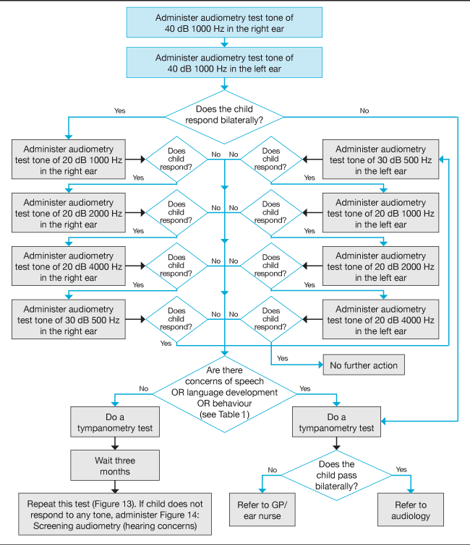
Repeat this test (Figure 1). If child does not respond to any tone, administer pathway on Figure 2: Screening audiometry (hearing concerns)

Figure 2: Pathway 2 – Screening audiometry (hearing concerns) clinical pathway
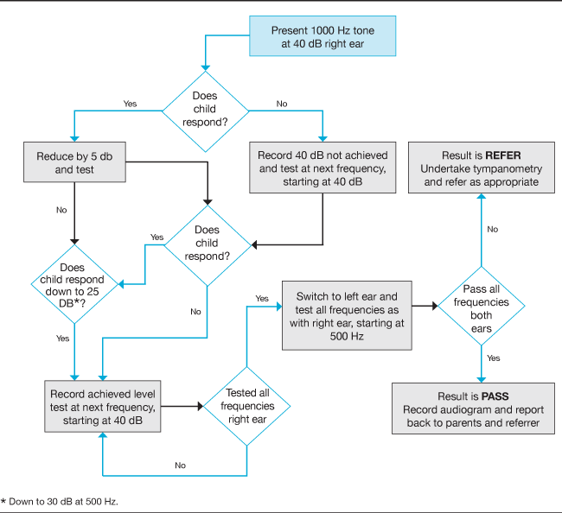

Screening technique: tympanometry
Children who are having tympanometry must have first had audiometry screening. Normal audiometry (bilateral pass responses) means no further screening is needed. The tympanometry procedures below all follow an abnormal screening test, excepting some district health boards, which carry out targeted tympanometry screening of groups at high risk of harm from glue ear.

Tympanometry screens for middle-ear function, and involves the placement of a rubber tip at the opening of the ear canal.

Note: Do not carry out tympanometry on children with discharging ears, or if the skin is broken or inflamed. Refer them for treatment and rescreen when their condition is resolved.

Tympanometry is not required for children with grommets
Children with patent grommets are likely to have an abnormal tympanogram. Before the tympanometry screen, parents should be asked as part of the consent process whether the child has grommets. If the child has grommets, no further action is required. If you are unsure whether the child has grommets, undertake tympanometry. The result is likely to show a flat (type B) tympanogram with a high middle ear volume (above 1.5 ml).

Preparing the child for tympanometry
Follow these steps to prepare the child for the tympanometry screen.
      - Ask the child to stand in front of you, and explain that you will be using your ‘special camera’ to take a measurement/picture of their ears.
      - Show the child the tympanometer screen to reassure them – liken it to a small TV.
      - Tell the child they will need to stand still for just a minute while you take the picture.
      - When you feel the child understands and is ready, begin the procedure.

Procedure for tympanometry
Use a clean, unused rubber tip for each child.

Follow these steps to undertake the tympanometry screen.
      - Turn the child so that their right ear is facing you.
      - Place the tympanometer probe at the opening of the child’s ear canal and run a screen.
- If the screen result is pass, record the result. Go to step 4.
- If the screen is abnormal, go to step 3.
      - Repeat the test.
- If the result is a pass, record the result. Go to step 4.
- If the result is abnormal, record the result, including the physical volume measure. Go to step 4.
      - Turn the child so their left ear is facing you.
      - Place the tympanometer probe at the opening of the child’s ear canal and run a screen.
- If the screen result is a pass, record the result. This is the end of the procedure.
- If the screen is abnormal, go to step 6.
      - Repeat the screen.
- If the result is pass, record the result. This is the end of the procedure.
- If the result is abnormal, record the result, including the physical volume measure. Rescreen in three months’ time or refer using the appropriate pathway.

Record the results and outcomes (pass, rescreen or refer) in the B4 School Check or ENROL database.

After the screening

Notification to parents
Parents must be notified of results following a screening test.

Pass and refer brochures for use with all four and five-year-olds screened are available online (www.health.govt.nz).

Recording the results
Record the results and outcomes (pass, rescreen or refer) for B4 School Check tympanometry in the B4 School Check and/or ENROL database.

There are two national databases for recording hearing results:
- Ministry of Education’s ENROL database
- Ministry of Health’s B4 School Check Information System.

Hearing screening results must be entered to meet the national reporting requirements for hearing screening. The default system for entering the hearing screening results is the B4 School Check database. Results will be transferred centrally to the ENROL system.

Follow-up
Ear nurses, GPs, and audiologists are asked to inform you of their findings and proposed treatments. Record this information for future reference once it is received from the GP or ear nurse.

If you don’t receive any feedback from the referral, follow up with a letter or phone call to the family to see if any action has been taken. If there is no response to this contact, you can refer the case to the Public Health Nurse Services or Community Health Team. Record the information included in the referral for future reference.

If a child has already been assessed and determined as needing hearing aids or another assistive device (ie, cochlear implants, FM systems) but is not wearing them, or if a child did not attend a hospital audiology clinic appointment, tell the school’s nurse or public health nurse. No further screening is needed.

Cleaning equipment back at base
Check audiometer headphones regularly. If cleaning is required, wipe them with warm soapy water. Ensure cushions are totally dry before placing them back in the headphones. If headphone cushions become cracked or porous they must be replaced to maintain hygiene. Dispose of any single use tympanometer tips back at base.

Remove debris (such as ear wax) from multi-use tympanometer tips and put them in the dish of Milton solution. Milton solution tablets (or similar antiseptic solution) are acceptable for cleaning tympanometer tips. Make sure they are totally submerged in the solution so all surfaces are covered. Mix the solution according to the manufacturer’s recommendations and make a fresh solution each time.

After soaking for the required period (manufacturer’s recommendation), leave the tips to drain on clean absorbent tissue. When dry, store them in their covered containers.

Referral pathways for tympanometry

Tympanogram is normal
If audiometry screening test is abnormal and the tympanogram is normal, the child may have a sensorineural hearing loss. Refer the child to audiology for further assessment.

Tympanogram result cannot be obtained
If you are unable to gain a seal (because there is an air leak) when trying to run a tympanogram, then:
- record ‘no seal’ on the child’s notes
- refer the child to a GP or ear nurse for further assessment (note as a refer).

Tympanogram is abnormal
- If the tympanogram shows no peak and the physical volume measure is under 0.3 ml or over 1.5 ml, refer the child immediately to a GP/ear nurse.
- If the tympanometry result shows no peak (ie, it is a flat graph), and the physical volume measure is 0.3–1.5 ml, rescreen the child in three months or refer depending on the audiometry result
- If a rescreen tympanometry result shows no peak, refer the child to a GP/ear nurse.
- Children with the conditions listed in Table 1 are at high risk for developmental and learning difficulties, which otitis media with effusion is likely to exacerbate. If they fail their hearing test and have an abnormal tympanogram in either ear or both ears, refer them straight away.

Note: The child’s hearing must be screened again to rule out an underlying sensorineural loss. The GP or ear nurse will refer the child back to you for rescreening.

Vision screening

Overview of vision screening

Purpose
The purpose of these screening tests is twofold.
- Identify children who may have amblyopia (lazy eye) at an age when it may still be treatable.
- Measure visual acuity and refer children who are unable to complete this screen for further assessment.

Key messages
The prevalence of visual deficits in the preschool population is estimated to be
10–15 percent. Treatment for amblyopia, the primary focus of preschool vision screening, is most beneficial if started before the child starts school. Around
1–3 percent of preschool children have amblyopia, which can lead to permanent vision loss in one eye if not treated early.

If the child is currently under the care of an ophthalmic/optometric practitioner, a screening test is unnecessary, whether the child wears glasses or not.

The B4 School Check and Year 7 vision screening are part of the National Vision and Hearing Screening Programme. Requirements for VHTs are described in the National Vision and Hearing Screening Protocols.

If a child has missed the vision and hearing component of the B4 School Check before starting school, then they will be screened at school (following the consent process). The screening will also capture those who need a follow-up test as a result of earlier screening.

Personnel
This screening is normally carried out by a VHT, but sometimes by other qualified health practitioners.

It is a good idea to consult with the New Zealand Association of Optometrists to find optometrists in your area who have training, experience and interest in seeing younger children.

Protocol

Frequency of visits
Venues should be visited regularly to ensure rescreens can be achieved. Several visits may not always be possible in very small, remote rural areas. In these cases, rescreening could be carried out in a scheduled clinic setting.

Venue organisation
Before visiting an early childhood centre or school, you need to:
- notify the venue of your intended visit and ask them to plan quiet activities while vision screening is being carried out
- obtain the list of children requiring screening (such as ENROL, preschool attendance list)
- ensure all parents/caregivers have provided the required consent.

Consent
VHTs are covered by Section 125 of the Health Act 1956. All DHBs should now have implemented a consent process to encourage parents to make informed choices about their child’s health. In addition, the recording of results in the national B4 School Check database requires the informed consent of parents. All services delivering vision and hearing screening should implement an opt-out consent process. Section 125 should only be used in exceptional circumstances if the school, early childhood centre or health services have concerns for a child’s welfare.

The consent process should include information for parents about what their child is being screened for and asking about whether the child is already under the care of a vision specialist and/or has glasses.

Setting for vision screening
Preschool vision screening is generally carried out in early childhood education centres or at a clinic. Screening of school-age children is generally carried out in schools.

Vision screening requires a room that is free of distractions and more than 4 m long. The room should be uniformly and brightly illuminated. It should have a light level of at least 300 lux in the room with about 500 lux to illuminate the test chart. If you are unsure whether the lighting is sufficient, test with a light meter or a phone application

Equipment needed for vision screening
To conduct a vision screening, you will need:
- 4 m Parr letter-matching vision book with confusion bars and key card
- rigid plastic eye patch or occluding glasses
- Snellen eye chart
- hand-held eye occluder (Denver model or similar)
- retractable 5 m tape measure
- masking tape
- light meter or phone app to measure light levels
- Ishihara pseudochromatic plates for colour deficiency (24-plate edition).

Hygiene protocols for vision screening
Screening involves placing a rigid plastic eye patch over the child’s eye or the use of occluding glasses.

Do not screen a child with inflamed eyes or a stye, or if the surrounding skin is broken or inflamed. Refer the child for treatment (with parental consent) and book a rescreen at a later date.

Procedures
During screening – wipe the rigid eye patch with alcohol swab after each screen. Allow to dry completely before the next use. Clean occluding glasses according to manufacturer’s instructions.

Back at base – wipe eye patch thoroughly with alcohol swab and store it in a clean container.

Personnel
Regular hand washing during screening is recommended. If there is no access to a hand-basin, use hand sanitiser. If you have cuts or abrasions on your hands that may be susceptible to infection, wear disposable gloves.

Suggested cleaning products are:
- alcohol swabs – two ply medium grade (saturated with 70% isopropyl alcohol) in sterile individual packages
- Microshield Handrub (containing chlorhexidine gluconate 0.5% w/v in 70% v/v ethanol) or similar
- detergent wipes, as recommended by manufacturer or infection control personnel.

Databases for recording results
There are two national databases for recording hearing and vision results:
- Ministry of Education’s ENROL database
- Ministry of Health’s B4 School Check Information System.

Hearing screening results must be entered to meet the national reporting requirements for hearing and vision screening. The default system for entering the hearing and vision screening results is the B4 School Check database. Results will be transferred centrally to the ENROL system.

Screening technique: Parr letter-matching vision charts
The screening is conducted exactly 4 m from the child and at the same level as the child’s eyes. Measure 4 m from the child with the tape measure and mark the floor at both ends with a piece of masking tape.

Ensure that the chart (book) and the key card:
- have a matte finish so that the child cannot see reflections
- do not have marks such as fingerprints or pen ink.

Also make sure the child is not facing a window or other bright light source that could make it difficult for them to see the chart.

Remember that although the screen is done at 4 m, the results (such as 6/6 or 6/12) are written as though the test was undertaken at 6 m. (Do not record the results as 4/4 etc.)

Preparing the child for Parr letter-matching
      - Ask the child to sit so that the masking tape on the floor and their eyes are level.
      - Explain to the child that you will be playing a simple game.
      - Show the child a large letter (shape) from your book and point to the letter that is the same on their card.
      - Show the child another large letter and explain that they have to find the same shape. Assist the child if needed.
      - Change the letter and ask the child to find the same shape.
      - When you feel the child understands the task, show the child the eye patch and suggest they need to be a ‘pirate’ to play the game – or wear your ‘special glasses’.

Procedure for Parr letter-matching
      - Place the eye patch over the child’s left eye or fit the occluding glasses with the left eye occluded.
      - Move to the 4 m point. Ensure no other children are sitting between you and the child being screened.
      - Beginning with the largest letter, show the child progressively smaller letters from each level. Encourage the child as much as possible. Continue until the child has difficulty identifying the letters.
      - Record the smallest letter size at which the child correctly matches two out of three letter shapes at any level. Use the conversion table on the back cover of the book (ie, 6/30, 6/18, 6/12, 6/9, 6/6).
      - Place the eye patch over the child’s right eye or fit the glasses with the right eye occluded.
      - Move to the 4 m point.
      - Beginning with the largest letter, show the child progressively smaller letters from each level. Show the letters in a different order from step 3. Encourage the child as much as possible. Continue until the child has difficulty identifying the letters.
      - The VHT should screen visual acuity in the appropriate manner for the child’s age and development and refer onward if required with the screening results of the visual acuity screen and any relevant observations of the child.
      - Record the smallest letter size at which the child correctly matches two out of three letters at any level. Use the conversion table on the back cover of the book.
      - If the child has difficulty understanding the test then arrange a rescreen in three to six months.

Screening outcome
This screen has three possible outcomes: pass, rescreen or refer. Notify any required rescreens to the preschool and the parents.

Pass, rescreen and referral criteria for vision screening

Vision is 6/9 or better in both eyes at the B4 School Check
- The child’s vision screening is considered a pass.
- Note the measurements of vision on the child’s records.
- No further action is needed.

Vision is 6/9 in one eye and 6/6 in the other at the B4 School Check or New Entrant Check test (5–7 years)
Children aged four, five or six years who have a visual acuity of 6/6 in one eye and 6/9 in the other should be rescreened within six months. This is because one eye may be improving or one eye getting worse. A rescreen will distinguish between the two possible options.
- Note the measurements of vision on the child’s record.
- Arrange a rescreen for within three to six months.

Vision is 6/12 or worse in either or both eyes at the B4 School Check or New Entrant test (5–7 years)
- Refer the child for further assessment according to the referral pathways below.

Vision is 6/9 in both eyes at New Entrant Check
- Arrange a rescreen within 12 months.

On rescreen
If the child’s vision is 6/6 in both eyes, the rescreen is considered a pass and no further action is required. If there is no change in the child’s vision (they are 6/9 in one eye and 6/6 in the other) or their vision has become worse in either eye (they are 6/9 in both eyes, or 6/12 or worse in either eye), refer the child for further assessment according to the referral pathways below.

After the screening

Notification to parents
Notify parents/caregivers of the screening test results. Pass and refer brochures for use with all B4 School Check vision screens are available online: see www.healthed.govt.nz and search for ‘B4 School’ to find the full set.

Give an Enable Spectacle Subsidy brochure to children who need a referral. You can get copies from Enable New Zealand (freephone 0800 171 981).

Subsidies for glasses/spectacles and eye exams
Children aged 15 and under with vision problems who are from low-income families may be able to get funding assistance for examinations, frames, lenses, eye patches and repairs. The child will need to be assessed by an accredited vision assessor. The assessor will assess a child’s vision needs and may recommend glasses or other vision equipment. An accredited assessor is usually an optometrist, eye specialist or a service coordinator for the Royal New Zealand Foundation of the Blind. Not all optometrists and eye specialists are accredited vision assessors.

Brochures explain who is eligible for the subsidy. You can view this brochure and read further information at the Ministry of Health website (see www.health.govt.nz/your-health/services-and-support/disability-services/types-disability-support/hearing-and-vision-services/childrens-spectacle-subsidy).

If you cannot find an accredited assessor in your area, you can phone Enable New Zealand for advice (freephone 0800 362 253).

Follow up
Local records must be kept of all children who have been screened Parents, ophthalmologists, optometrists and orthoptists are asked to inform you of the findings and proposed treatment. Record this information for future reference.

If you do not receive feedback from the referral, follow up with a letter or phone call to the family to see if any action has been taken. If there is no response to this contact, refer the case to the Public Health Nurse Services or Community Health Team. Record this information for future reference.

If a child has already been assessed and determined as needing glasses but is not wearing them, or if a child did not attend an appointment with a hospital eye clinic, ophthalmologist or optometrist, tell the school’s nurse or the public health nurse. No further screening is needed.

Referral pathways
Figure 3: Vision screening clinical pathway and referral at four years old
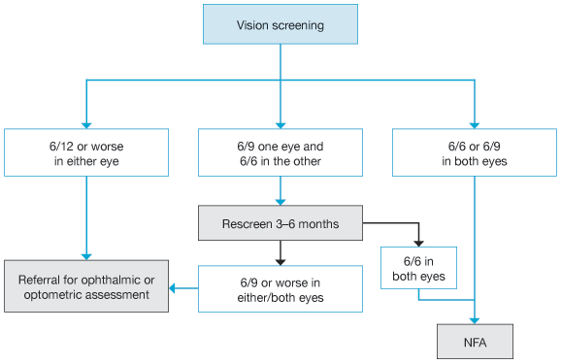

Figure 4: Vision screening clinical pathway and referral for school children up to and including Year 6 will be some Snellen and some Parr tests
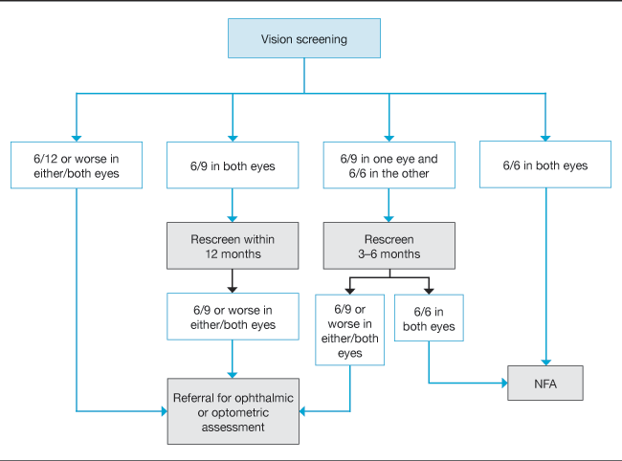

Figure 5: Vision screening clinical pathway and referral for Year 7
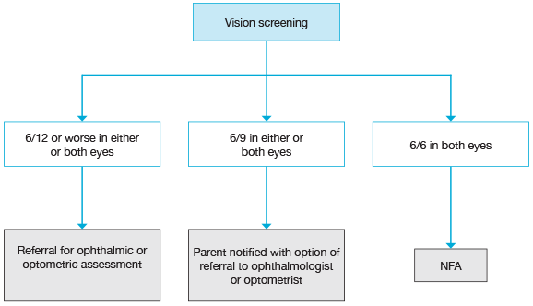

Children who fail a formal visual acuity screening
A four-year-old or new entrant child who has unequal visual acuity or a result of 6/12 or worse needs further professional investigation.

Note: If a four-year-old or new entrant child with greater than two lines difference between the visual acuity in each eye is referred to an optometrist, referrers should consult with the New Zealand Association of Optometrists to find optometrists available in their area who have appropriate training, experience and interest in seeing younger children.

The ophthalmologist or optometrist should acknowledge the referral and inform you and the child’s GP of the outcome.

Resources
Keeping an eye on your child’s vision (B4 school vision screening) (HE2278) is a Ministry of Health resource for parents/caregivers, available from the HealthEd website (www.healthed.govt.nz) in multiple languages.

Screening technique: Snellen eye chart
The screen is conducted with the Snellen eye chart exactly 4 m from the child and at the same level as the child’s eyes. Measure 4 m from the child with the tape measure, and mark the floor at both ends with a piece of masking tape. Ensure that the Snellen chart has a matte finish so the child cannot see reflections. Make sure the child is not facing a window or other bright light source that could make it difficult for them to see the chart.

Preparing the child for Snellen vision screen
      - Stand the child behind the 4 m mark, with their toes on the masking tape line.
      - Explain to the child that you will point to random letters on the chart and ask the child to identify each letter.
      - Ensure that the child knows the names of the letters.

Procedure for Snellen vision screen
      - Place the occluder in position with the child’s right eye visible. Explain that they must hold the occluder in place until you say to move it.
      - Turn the eye chart over. Beginning with the largest letter, point to progressively smaller letters (two or three letters from each line is sufficient). Select letters randomly. Encourage the child as much as possible. Continue until the child has difficulty identifying the letters.
      - Record the smallest letter size at which the child identified all letters (the whole line) correctly.
      - Ask the child to turn the occluder over, so their left eye is visible.
      - Turn the eye chart over. Beginning with the largest letter, point to progressively smaller letters (two or three letters from each line is sufficient). Select letters randomly and in a different order from step 2. Encourage the child as much as possible. Continue until the child has difficulty identifying the letters.
      - Record the smallest letter size at which the child identified all letters (the whole line) correctly.

Referral pathways
If the child is under the care of an ophthalmic practitioner (an ophthalmologist or optometrist) and has been prescribed glasses:
- the child should not be screened
- if the child is screened, a referral is unnecessary no matter what the vision results are, but contact the parent or caregiver to give them the results and to make sure the child has had a recent vision examination.

Offer referral if concerns about child’s vision
A child’s caregiver or teacher may occasionally have concerns about a child’s health, development, behaviour or learning and wonder whether a vision problem is causing these symptoms or difficulties.

Explain to anyone requesting a vision test that screening is not a full diagnostic visual assessment, and a child should be referred to an optometrist or eye specialist if there are concerns. Record the results and outcomes in ENROL.

Following a test requested by the child, parent or teacher, the health practitioner consulted must work within their scope of practice to ensure that the family receives a timely, high-quality service that addresses their concerns.

Health practitioner role
- A nurse or GP should measure and record visual acuities, undertake a clinical examination of the eye with other appropriate examination of the child and make a referral or institute management if required.
- An optometrist should obtain a history, measure and record visual acuities, examine the external and internal structures of the eye, assess ocular motility, fusion, convergence, accommodation, pupil reactions, and conduct all other necessary diagnostic assessments. The optometrist should make a referral or institute management if required and appropriate.

Referrals
- In general, infants and children under three years of age with visual acuity and other problems should be referred to an ophthalmologist for further assessment. In certain situations access issues and parental preferences may mean that an infant or child under three years is referred to an optometrist.
- Children over three years of age with visual acuity abnormalities could be referred either to the ophthalmologist at a hospital eye clinic or to an optometrist.

Children who fail a Snellen test
Vision screening for children at Year 7 has two possible outcomes; a pass or referral (not meeting the performance level considered acceptable at the time of screening).

Colour vision: Ishihara pseudoisochromatic plate

Conditions
Illuminate with indirect daylight (do not use in direct sun). The light level must be
300 lux. The plate must be held about 75 cm (30”) with the child’s line of sight perpendicular to the page. (If the test is held at a normal reading distance the visibility of the numbers is reduced and the test is more difficult because the coloured dots making up the numbers are more obvious.) Make sure that no other child can see the screening or overhear the responses of the child you are screening.

Equipment
This screening uses the 24-plate edition of the Ishihara Test for Colour Deficiency. The Ishihara books must be replaced at least every seven years.

Procedure
Explain that you will be flipping through the pages of the book and asking the child to either identify the number or numbers on each page or let you know if there is no number (some pages have no numbers). Reassure the child that there is no ‘trick’. The order of the plates may be shuffled to eliminate learning effects.

Presentation
Make sure the child can identify the number on plate one correctly. Vision must be better than 6/60 for this plate. Continue to present each of the test plates two through 17 (in the 24-plate edition), allowing approximately three seconds each plate, and count the number of plates misread. If a child self-corrects, this not an error. If there are two numbers on a plate, an error on either one or both numbers counts as a single error. Note the number of failed plates.

Ishihara colour vision screen (Ishihara pseudoisochromatic plate)
If three or fewer errors are made, record ‘Colour Vision: Pass’ on the child’s records. The word normal is not used, as this is a screening test result only and is not a full colour vision assessment by an optometrist.

If more than three errors are made then a colour vision defect is almost certain to be present. Record as ‘Colour Vision: Defect’. The number of errors made is not a reliable estimate of the severity of any colour vision defect.

No referral is warranted unless further diagnosis is required. Inform the child and their parents/caregivers so they are aware of any implications (such as career limitations). Also, if a colour vision defect is present then some educational methods, such as those that use colour coding, can be compromised. There are no rescreen criteria for colour vision screening. A defect result warrants a notification to the parent.

Recording of Ishihara colour vision
Record the results of this screen in the ENROL database.

