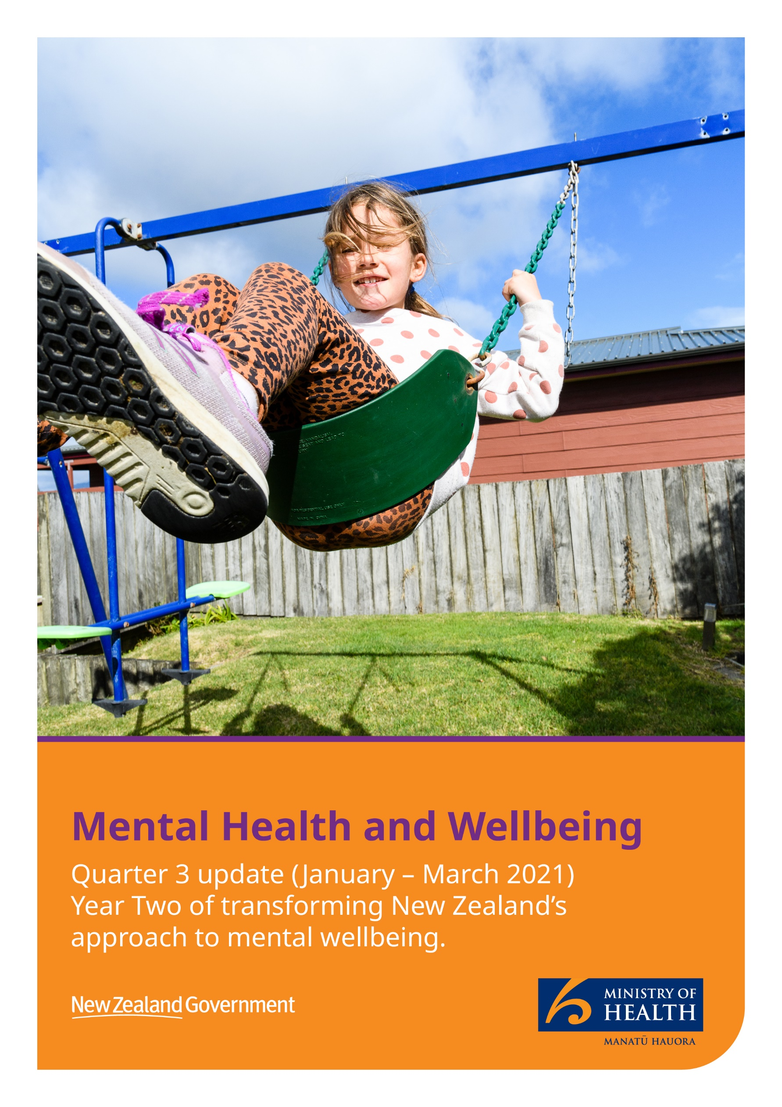

**Transforming Aotearoa’s approach to mental wellbeing**

In this update:

Contents

Funding overview 4

Key investment highlights 5

Long-Term Pathway for transformation 6

Promoting mental wellbeing 7

Legislative reform 8

Delivering new and expanded services by increasing access and choice 10

Enabling services 16

Specialist services 19

Supporting people struggling with addiction 20

Preventing suicide 21

**Kia ora**

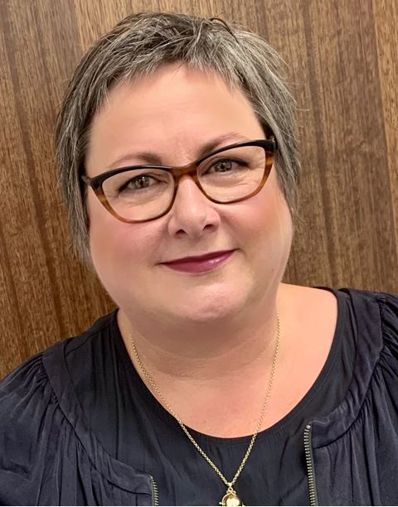It was a busy start to 2021 as the programme to enhance mental wellbeing for all in Aotearoa continued to ramp up. It’s been less than two years since the significant investment in mental wellbeing through Budget 2019. We have heard that the new and expanded primary mental health and addiction services are enabling people to get the help they need faster, and in ways that best fit their needs. These services are making a tangible difference to peoples’ lives. That’s thanks to the hard work and dedication of so many people across the sector. Our thanks for all your hard mahi.

By the end of the March quarter more than 350 mental health practitioners were contracted to provide new services based out of general practice sites. This is a service that didn’t exist previously at this scale, and by 31 March the number of sessions delivered since the start of the rollout had passed 107,000. By the end of the quarter almost 200 general practice sites were offering this service, which we refer to as Integrated Primary Mental Health and Addiction Services.

Deputy Director-General, Mental Health and Addiction, Toni Gutschlag

Also in the third quarter, we significantly boosted support for young people – as at the end of March there were youth-specific primary mental health and addiction services based in communities across 13 DHB areas. We also confirmed approximately $1 million of additional funding for Youthline. In addition, we have new dedicated Māori and Pacific services rolling out. We celebrated the launch of new and expanded kaupapa Māori mental health and addiction services in the Southern region, Taranaki and the Hawke’s Bay and signed contracts for Pacific services across Wellington and Auckland.

Continuing the theme of increasing access to services, and the choice of services, in the March quarter we launched two significant procurement processes; one for dedicated services to support young Rainbow New Zealanders. The other was to procure digital mental wellbeing supports to help lift mental wellbeing literacy and awareness, while also arming people with digital tools to support mental wellbeing.

We’ve also worked on improving how we share data and information about the number of people accessing mental health and addiction services. This information is crucial to understanding the demand that exists, and how we can best fund services into the future. We launched the new “[Data and Information](https://www.health.govt.nz/our-work/mental-health-and-addiction/mental-health-and-addiction-monitoring-reporting-and-data)” section of our website to make it easier to find all the information in one place. We’ll be adding more information to this page over time.

Finally, underpinning all our work is our strategic direction for improving mental wellbeing for all. In the March quarter we made significant progress in developing the Long-Term Pathway that will set out the whole-of-government direction over the next 10 years. We received more than 150 written responses to our consultation on the direction of the pathway, in addition to holding two online information sessions that were attended by over 200 people, and we had individual conversations and focus groups with people across the sector. Towards the end of the quarter we started analysing the themes gathered in this feedback and have continued developing the draft Long-Term Pathway. We look forward to sharing the pathway with you in the first quarter of the new financial year, marking the next step in our progress towards transformation.

Ngā mihi nui,

Toni Gutschlag

## Funding overview

We’re transforming New Zealand’s approach to mental wellbeing so support is available, when and where people need it.

There was a clear direction signalled in *He Ara Oranga* to get support to people sooner,and the Government’s Budget 2019 investment supported this shift.

Of the $1.9 billion over four years, approximately:

* $843 million was allocated to other Votes including Social Development, Education, Housing and Urban Development, Corrections, Police, Justice, Courts, Defence Force and Internal Affairs to support addressing the social determinants of mental wellbeing
* $235 million was allocated to Vote Health for capital investment in mental health and addiction facilities
* $213 million was allocated as an uplift to district health boards’ ringfenced specialist mental health and addiction funding resulting from cost pressures, to maintain baseline service levels
* $670 million was allocated to Vote Health for mental health and addiction initiatives.

The funding available for mental health and addiction initiatives increases each year over the four-year period.  In the first two years, approximately $350 million has been available for mental health and addiction services.  Of this, we’re expecting about $300 million to be spent by the end of June.

Where allocated funding is not spent this year, funding is expected to be carried over to next financial year to support Budget 2019 initiatives or closely aligned initiatives in future years. The roll out of new services funded through Budget 2019 is a phased programme of work over five years, and the expectation is that all funding will be fully committed over the life of the programme.

We’re making really good progress rolling out new services and supports in communities – these are already supporting thousands of people every month.

## Key investment highlights (AS AT 31 MARCH)

|  |  |
| --- | --- |
| INCREASING ACCESS AND CHOICE | |
| 9,500+ | People every month supported by new Integrated Primary Mental Health and Addiction Services based in GP clinics |
| 400+ | Full-time equivalent roles contracted to provide community-based services, including youth, Māori and Pacific services |
| $1m | Funding announced for Youthline |
| 14 | Contracts for dedicated youth services as at end of March |
| 107,000+ | Sessions delivered through GP clinics |
| SPECIALIST SERVICES | |
| 20 | District Health Boards funded to increase capacity for responding to people in crisis |
| 1 | Established Te Tāwharau, a community-based integrated crisis and peer support pilot in Hawke’s Bay |
| 32 | Community FTEs (14 adult forensic FTE and 18 youth forensic FTE) to be funded and in place by 30 June 2021 |
| PARENTS, CHILDREN AND YOUTH | |
| 96,000 | Students with potential access to School-Based Health Services |
| 3 | New Well Child Tamariki Ora Enhanced Support Pilots established |
| ADDICTION | |
| 1,322 | People supported by Te Ara Oranga (methamphetamine harm-reduction programme) since July 2019 |
| 2 | New Pregnancy and Parenting Service sites established in Eastern Bay of Plenty and Whanganui |
| + | Established and expanded alcohol and other drug (AOD) services in Taranaki, including peer support services |
| SUICIDE PREVENTION | |
| 92 | Community suicide prevention initiatives funded – 74 Māori and 18 Pacific |
| 20 | District Health Boards funded to increase postvention support |
| 432 | Sessions delivered through Aoake te Rā – the new national bereaved by suicide response service |

## Long-Term Pathway for transformation

Over the March quarter we made significant headway on setting out the high-level direction for a whole-of-government approach to promote, protect and strengthen mental wellbeing in New Zealand over the next 10 years – what we call the Long-Term Pathway.

We’ve been building on the many conversations we’ve had with the sector over the last few years, especially as we developed *Kia Kaha, Kia Māia, Kia Ora Aotearoa – COVID-19 Psychosocial and Mental Wellbeing Plan*, which provided the foundation for us to build on.

*He Ara Oranga: Report of the Government Inquiry into Mental Health and Addiction* called for a transformation of New Zealand’s approach to mental wellbeing. The Government’s response to *He Ara Oranga* identified initial priorities for early action, supported by substantial investment of $1.9 billion in a cross-government Budget 2019 mental wellbeing package.

While the recommendations in *He Ara Oranga* provided a starting point for transformation, they did not capture the broader changes called for.

Our intention for the Long-Term Pathway is to add further detail to the transformation picture. It will call on everyone in Aotearoa to remain resolute to the gains we have made, and to remain committed to the kaupapa of supporting New Zealanders to stay well.

Over March we gathered feedback on the initial direction for the pathway. We received more than 150 submissions to the online consultation, had many conversations, and held focus groups and two online meetings to discuss the Long-Term Pathway.

Through the feedback we learnt that there was strong support for the seven principles proposed to underpin all work across mental wellbeing, including; uphold Te Tiriti o Waitangi, equity, people and whānau at the centre, community focus, human rights, collaboration and innovation.

Respondents said empowering communities to initiate and lead mental wellbeing initiatives was a priority, and it relied on community engagement and more information, education and promotion.

We also asked for feedback on the key areas identified to enable transformation. Building a mental health and wellbeing workforce prompted the strongest feedback; respondents generally agreed with growing and supporting a sustainable, diverse, competent, and confident mental health and addiction workforce. Meanwhile, just under half of submitted comments emphasised the need for further education/training in specific areas, and almost a third of respondents believed a more diverse/multicultural workforce is needed.

All of the feedback gathered through this process, and our earlier conversations, have fed into development of the Long-Term Pathway and a summary of responses has been [published on the website](https://www.health.govt.nz/publication/ministry-health-stakeholder-engagement-long-term-pathway-mental-wellbeing).

## Promoting mental wellbeing

Throughout the COVID-19 response, we invested in a number of wellbeing promotion activities. This continued over the summer period with campaigns from *Getting Through Together* and 1737.

The *Getting Through Together* campaign focused on the summer period being a time that was great to connect with family and whānau, to get out into nature and to be grateful and notice the little things that bring joy. During this period, the campaign was also focused on being responsive to the COVID-19 environment as Auckland, in particular, had several short lockdown periods.

1737’s most significant campaign was launched in March which focused on reframing attitudes to help-seeking. “Struggle Got Real” was developed to encourage calls to 1737 while improving awareness that support is available for everyone.

Promotion of the digital tools and online support that had been funded throughout the COVID-19 response continued throughout the quarter. These tools include Mentemia, Staying on Track, Whakatau Mai and Melon. Procurement started for longer-term adult and youth digital wellbeing tools, to ensure people continue to have access to digital support.

"Struggle Got Real" aimed to drive awareness that support is available for everyone.

## Legislative reform

**Launch of the Mental Health and Wellbeing Commission**

In February the Mental Health and Wellbeing Commission marked its first day as a Crown Entity. Establishing the Commission was one of the early priorities identified by the Government following *He Ara Oranga: Report of the Government Inquiry into Mental Health and Addiction*. The Commission provides system-level oversight of mental health and wellbeing in New Zealand.

The Commission’s objective, functions and powers are set out in the Mental Health and Wellbeing Commission Act 2020, which established the Commission as an independent Crown entity.

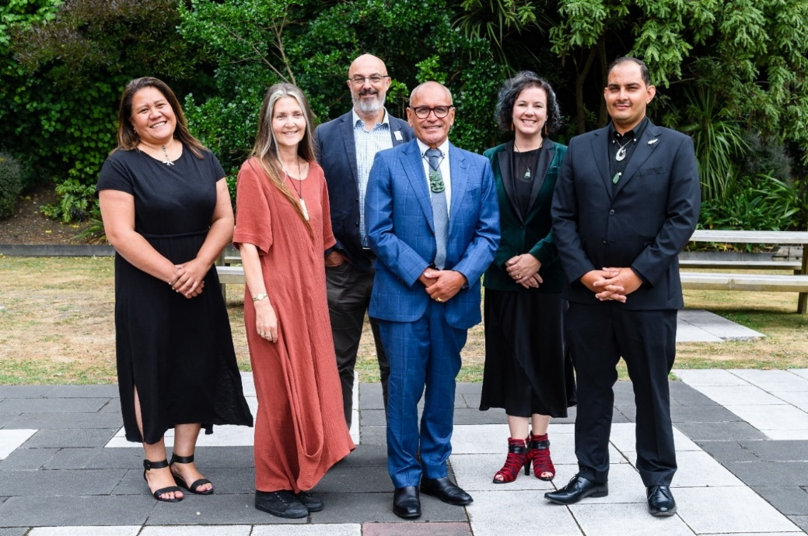The Board is chaired by Hayden Wano. The board members are Professor Sunny Collings, Kevin Hague, Taimi Allan, Dr Jemaima Tiatia-Seath, and Alexander El Amanni.

**The Inaugural Board of the Mental Health and Wellbeing Commission.** Left to right: Dr Jemaima Tiatia-Seath, Professor Sunny Collings, Kevin Hague, Hayden Wano (Chair), Taimi Allan, and Alexander El Amanni.

**Repealing and replacing the Mental Health Act**

Significant steps have been taken towards ensuring we have fit-for-purpose legislation for mental health that supports recovery, equity and human rights.

The Mental Health (Compulsory Assessment and Treatment) Amendment Bill (the Amendment Bill) was introduced in March and is progressing through Parliament. The Amendment Bill proposes amendments to the Mental Health Act to improve the protection of individual rights and safety of patients, for example by eliminating indefinite treatment orders, and to enable more effective application of the Act.

Progressing initial amendments to the Mental Health Act is just a first step towards fully repealing and replacing the legislation, as agreed to in the Government’s response to *He Ara Oranga.* More information about the Mental Health Act work programme and next steps for both the initial amendments and the longer-term repeal and replacement can be found on the [Ministry of Health’s website](https://www.health.govt.nz/our-work/mental-health-and-addiction/mental-health-legislation/repealing-and-replacing-mental-health-act).

## Delivering new and expanded services by increasing access and choice

Delivering new and expanded primary mental health and addiction services so people get the right type of support, when and where they need it, was an early priority identified by Government.

We are expanding the choice of support, and increasing peoples’ access to help, by investing in services that are embedded in communities and delivered from places that work best for people such as schools, youth centres, marae, and general practice clinics.

Over the January to March quarter we confirmed contracts for new youth-specific services including boosting funding for Youthline, invested in kaupapa Māori and Pacific services, and confirmed dedicated funding for mental wellbeing services for young Rainbow Kiwis. It takes two to three months for new services to get established once funding is in place, so you can expect to see more and more of these services rolling out over the next few months.

**Support for Rainbow young people**

During the March quarter the Government committed $4 million over four years to provide specific mental health support to Rainbow young people. Of this package, $3.2 million will fund expansion of mental wellbeing services focussing on young Rainbow New Zealanders.

The remainder of the package will be allocated to topping up the existing Rainbow Wellbeing Legacy Fund which was established as an acknowledgement of those New Zealanders who were convicted for homosexual acts before the law was changed in 1986.

In addition to the $4 million Rainbow mental wellbeing package, the Ministry has allocated $600,000 over four years to support the mental health and addiction workforce to be responsive to the needs of Rainbow youth communities.

The procurement process is close to being finalised with respect to this funding.

|  |  |
| --- | --- |
| YOUTH SERVICES AS AT 31 MARCH | |
| 14 | Contracted services |
| 56 | FTEs contracted to provide services |
| 3,189 | Total sessions delivered to date (end March) |
| 352 | People seen in March |

In February, we were pleased to announce contracts worth $10 million for youth services across DHB areas in both the north and south islands. Through the contracts, youth-specific services were announced in Canterbury, Eastern Bay of Plenty, MidCentral, Capital and Coast, Hutt Valley, Western Bay of Plenty and the Great Hamilton region of the Waikato DHB area.

The newly funded services meant youth-specific services were funded across 14 DHB areas as at the end of March.

In addition, in March it was confirmed that Youthline would receive a $1 million funding boost to enable it to provide additional clinical support so the service can help thousands more young people who need it.

***“We really want young people to know that they don’t have to wait until they reach crisis point, they can get in touch any time they want support."***- Shae Ronald, Youthline CEO

|  |  |
| --- | --- |
| PACIFIC SERVICES AS AT 31 MARCH | |
| 9 | Contracted services |
| 29 | FTEs contracted to provide services |
| 2,209 | Sessions delivered to date (end March) |
| 240 | People seen in March |

We were pleased to confirm contracts for new Pacific-focused services across Auckland and Wellington during the January to March quarter.

New services have been contracted to roll out across the Auckland, Counties Manukau, Hutt Valley and Capital and Coast DHB areas, adding to services that have expanded across Canterbury, Waitematā and the Waikato DHB areas. The contracts for the new services are worth a total of $6.6 million. Once up and running, the new services are expected to be able to support more than 3,000 people a year.

|  |  |
| --- | --- |
| KAUPAPA MĀORI SERVICES AS AT 31 MARCH | |
| 6 | Contracted services |

We have been running two kaupapa Māori primary mental health and addiction procurement processes within the Access and Choice programme. The first is for expansion and replication of existing kaupapa Māori primary mental health and addiction services, and the second is for new kaupapa Māori primary mental health and addiction services.

The expansion and replication of existing services is complete with contracts in place across Taranaki and the Hawke’s Bay.

The second procurement process, for new kaupapa Māori primary mental health and addiction services has two streams – Tuakana and Teina. The Tuakana stream is for established Māori providers with well-developed infrastructure and services, and the Teina stream an ‘incubator’ for new / smaller Māori providers with proposals that are developed, but would benefit from further support to get them service-delivery ready. The process of funding and developing kaupapa Māori primary mental health and addiction services through the Tuakana and Tēina streams is ongoing.

During the quarter we were also pleased to celebrate the launch of the new kaupapa Māori primary mental health and addiction service for the Southern region – Mahana – Southern Māori Mental Health and Addiction, established by the Ngā Kete Matauranga Pounamu Charitable Trust. Mahana provides a mana-enhancing pathway that builds cultural identity and capacity to help with people’s return to wellbeing.

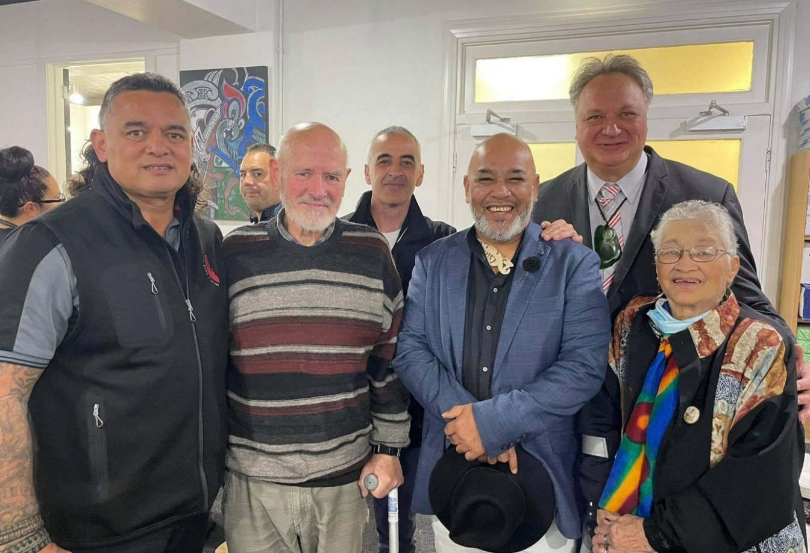

**At the launch of Mahana:** Joe Clarke, Terry King, Greg Houkamau, Ra Dallas, Rino Tirakatene, Myra Clarke.

***“It is thrilling to be able to move in this new mental health and addiction space where our own stories, experiences and modalities are being well supported.”***

***–*** Tracey Wright-Tawha, Chief Executive of Ngā Kete Matauranga Pounamu Charitable Trust

|  |  |
| --- | --- |
| INTEGRATED PRIMARY MENTAL HEALTH AND ADDICTION SERVICES TO 31 MARCH | |
| 15 | District Health Board areas |
| 191 | General practice sites delivering services |
| 360 | FTEs contracted to provide services |
| 107,000+ | Total sessions delivered to date (as at end March) |
| 9,650 | People seen in March |

The Integrated Primary Mental Health and Addiction Service provides easy access to mental wellbeing support available in GP sites across the country, so people with mild to moderate mental wellbeing needs can access free and immediate advice and support, when and where they need it.

As there are no specific criteria needed to access the service, anyone enrolled in a participating general practice can access support if their thoughts, feelings or actions are impacting their health and wellbeing.

The programme builds on the mental health and addiction expertise that already sits within general practice teams, and strengthens the collaboration and ties between general practices, non-government organisations, and DHB-led specialist mental health and addiction services.

During the quarter it was pleasing to see the number of people being supported through these services continue to rise, approaching 10,000 people every month. We have heard that these new services are making a meaningful difference to people’s lives.



***“I was going through a really rough time and didn’t know what to do. Things were getting too much for me. The health coach came down to my level, she heard me she really heard me. It felt as if a weight had been lifted from my shoulder. I started to take control of how I was feeling……”***

***–*** Service user, Integrated Primary Mental Health and Addiction

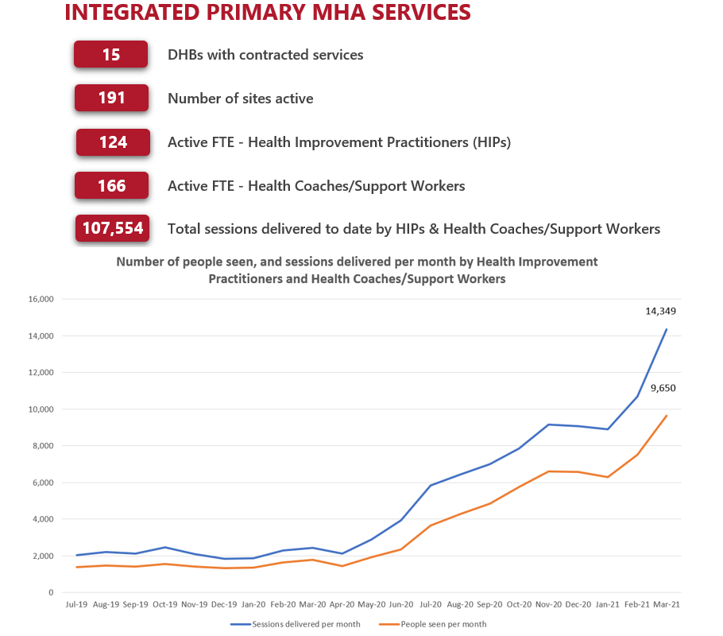

## Enabling services

There are a number of work programmes underway to support the roll out of new services, these include workforce development and collaboration platforms

**Te Whāriki o te Ara Oranga**

This quarter saw the launch of the new knowledge-sharing network, Te Whāriki o te Ara Oranga (Whāriki) – giving leaders across the sector a new way to share and collaborate.

Whāriki is a key initiative from the large and complex Access and Choice work programme, which includes funding for service delivery and enablers such as IT infrastructure.

It is a collaboration network designed to connect leaders and influencers across the mental wellbeing system and enable them to share innovation, resources and best practice. It is an exciting development as new mental health and wellbeing services ramp up across the country – Whāriki enables people to share experiences across regions and will help ensure we are all learning what’s working well for people.

Two months after launching, 350 people had signed up to the network.

**Developing our workforce**

A large programme of work is underway to grow and upskill the mental health and addiction workforce. This includes new investment to support more new graduate nurses, social workers and occupational therapists into practice in mental health and addiction with more than 100 additional New Entry to Specialist Practice (NESP) places available in 2021.

The NESP programme combines theory, supported clinical experience, clinical preceptorship and supervision, with graduates of the programme achieving a Postgraduate Certificate in Mental Health and Addiction. During semester one, a total of 291 practitioners enrolled in NESP training, with further enrolments expected in semester two.[1]

Investment has also been provided to support our existing workforces with more than 100 additional places to gain post-graduate qualifications including:

* Cognitive Behavioural Therapy
* Core skills for specialist practice in infant, child and adolescent mental health and addiction
* Assessment and management of co-existing substance use and mental health
* Specialty forensic training.

Postgraduate study in clinical leadership in nursing practice is also available. A total of 236 mental health and addiction practitioners enrolled in study in semester one of 2021 across these qualifications. These enrolments have increased from 123 in 2018.

In addition, there are a total of 200 new places in 2021 for primary care nurses to achieve credentialing in mental health and addiction. The Primary Mental Health and Addiction Nurse Credentialing Programme is designed to support primary care nurses to develop their knowledge and skills and build confidence in providing support to people with mental health and addiction needs in a primary care setting.

The programme was started in 2012 by Te Ao Māramatanga: New Zealand College of Mental Health Nurses and investment from Budget 2019 will see expansion of the programme into more regions.

**Developing our Māori and Pacific workforces**

In February, over 120 Māori students who received bursaries from Te Rau Puawai programme were welcomed at two-day hui at Massey University in Auckland.

Students who receive bursaries can enter into or continue their Massey University programmes which include undergraduate, postgraduate, and doctoral studies in the following areas: Psychology, Nursing, Rehabilitation, Social Work, Social Policy, Māori Health, Māori Studies, Health Science.

The bursaries provide a contribution to cover fees and travel costs, mentors, individual learning and personal support, assistance with course planning, an essay writing and study skills workshop, and access to Māori community and student networks providing support framed within a Māori context.

In addition to the Te Rau Puawai bursaries, scholarships are also available for Pacific students who pursue a career in mental health and addiction. The Futures That Work programme is offered through Le Va and provides scholarships to Pacific people who are enrolled in a relevant mental health or addiction-related qualification.

The programme offers up to 100 per cent of health course fees, career planning, and connection with employers, as well as pastoral care, cultural support, educational support, spiritual and peer support.

In 2021, 133 students received scholarships, and 40 of these recipients have indicated they have their own lived experience of mental health and/or addiction.

***“From the outside, people might think the main reason for the programme’s success is the financial support, but over time we have realised that’s not the most important thing. It’s really the pastoral care that we are able to provide in a Māori way.”***

– Professor Te Kani Kingi, Chair of the Te Rau Puawai Board

## Specialist services

**Te Tāwharau – Mental Health and Addiction Crisis Pilot**

During the quarter we supported preparations for the start of a pilot programme for people in Hawke’s Bay who are experiencing, or at risk of, mental health and addiction crisis. Te Tāwharau, meaning shelter, will be a hub of community-based services and is the first programme of its kind where services are based at one site in the community, 24-7, so people can access support whenever they need.

The service will offer support for people currently experiencing a crisis, and early intervention support for people presenting with mental distress in the community who may need connection to other services relevant to their situation.

Te Tāwharau will include:

* Adult respite residential beds
* Both the emergency mental health team and home-based treatment teams
* Ministry of Social Development support
* A police liaison resource and
* A team of peer support workers.

The Ministry has provided additional funding for the peer support workers who are a key part of the programme and anticipate that the peers will work closely with the clinical team. Peer support workers engage with community members, offering early intervention to prevent acute crisis episodes.

**$22.5 million forensic mental health unit opened**

E Tū Tanekaha, a $22.5 million, 15-bed medium secure unit at the Mason Clinic in Point Chevalier was opened towards the end of the quarter, with an official opening at the start of April.

The Mason Clinic serves a population of around 1.5 million people in the Northland, Waitematā, Auckland, and Counties Manukau DHB catchments. The site includes medium-secure, minimum-secure and open units to facilitate recovery and community reintegration, with a focus on acute treatment and rehabilitation.

The new building, with upgraded, fit-for-purpose facilities, replaces the previous Tanekaha building that had severe weather-tightness issues, and brings the total capacity at the Mason Clinic Regional Psychiatry service site to 124.

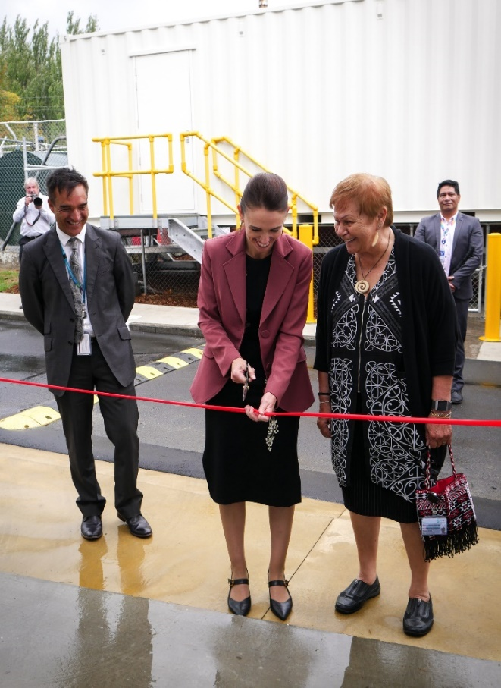

Waitematā DHB CEO Dr Dale Bramley, Prime Minister Jacinda Ardern, Waitematā DHB Chief Advisor Tikanga, Dame Rangimārie Naida Glavish

## Supporting people struggling with addiction

The Ministry is continuing to roll out new and expanded services founded on a health approach for people with addiction needs, supporting them to get support where and when they need it.

All of the new mental health and addition funding through the Access and Choice programme is expected to provide services and support for people experiencing substance and gambling-related harm.

The work programme includes expanding services within community-based settings, rolling out specialist services, integration with other Government departments and targeted harm reduction programmes.

A significant milestone was achieved in the March quarter with two new Pregnancy and Parenting sites opening, in Eastern Bay of Plenty and Whanganui, expanding on the existing services in Northland, Tairāwhiti, Hawke’s Bay and Waitematā.

These services focus on outreach, intensive engagement and harm reduction to reduce risk and improve outcomes of whānau who are experiencing the harms of substance use, have infants under the age of three or are pregnant, and are marginalised or poorly connected to health and social services. The two new sites are both expected to support around 100 women and their whānau every year.

Other achievements during the quarter include:

* Providing sustainable funding for existing AOD family and whānau peer support service in Taranaki (Families Overcoming Addiction). From January 2021 to March 2021, the New Plymouth service had 117 group session attendees and held 80 individual support sessions.
* Te Ara Oranga, the methamphetamine harm reduction programme in Northland has continued to provide good support. Over the quarter 151 people were supported through the service, taking the total number of people receiving support through the service to 1,322 since 1 July 2019.
* During the quarter more than 100 people were referred to health services thanks to the 2019 amendments to the Misuse of Drugs Act 1975. This involves police connecting people they find either using or in possession of drugs with health services, supported by an established helpline. The total number of referrals reached 893 at the end of March since the new pathway was implemented.
* Addiction 101 courses continue to be well attended with 347 participants this quarter.
* In Taranaki, a pre- and post-residential care support service, including a step-up / step-down bed, has seen approximately 30 clients since its establishment in November 2020 and provided support and advice to family and whānau.
* In the Bay of Plenty, funding has been used to place an AOD clinical support worker within an iwi provider to strengthen the service and provide whānau who suffer from alcohol and other drugs with wrap around support.

## Preventing suicide

The Suicide Prevention Office is in the second year of implementing the five-year action plan within *Every Life Matters*: *He Tapu te Oranga o ia tangata,* the national suicide prevention strategy and action plan. The key focus areas for the Office include strengthening national leadership and understanding of the sector while facilitating initiatives that promote wellbeing, respond to suicidal distress and behaviour and support individuals, whānau and families, and communities after a suicide.

Key highlights for the Office over the quarter include:

* Engagement with representatives of media agencies, the Media Council and the Media Freedom Committee to begin revision of guidelines for media reporting on suicide
* Community engagement with suicide prevention coordinators, Kia Piki te Ora providers, recipients of Māori and Pasifika Suicide Prevention Community Funds and non-Government organisations
* Welcoming Dr Hinemoa Elder as the new Chair of the Māori Expert Reference Panel, taking over from Sir Mason Durie.

Looking ahead, the Suicide Prevention Office is preparing for the second round of Māori and Pasifika Community Suicide Prevention Funds, publication of the refreshed media guidelines for reporting on suicide and engaging with key sector workforces to develop models of leadership and support for community-led approaches to suicide prevention.

Carla na Nagara, Director of the Suicide Prevention Office, with Tau Faaeteete, Zeal Education, which runs a suicide prevention programme using creative arts to build resilience.

1. Note: Enrolled numbers are subject to change, for example if people withdraw.