Safe Access to Opioids: Engagement summary
June 2023

Citation: Ministry of Health. 2023. Safe Access to Opioids: Engagement summary. Wellington: Ministry of Health.
Published in June 2023 by the Ministry of Health
PO Box 5013, Wellington 6140, New Zealand
ISBN 978-1-991075-26-0 (online)
HP 8771
This document is available at health.govt.nz
This work is licensed under the Creative Commons Attribution 4.0 International licence. In essence, you are free to: share ie, copy and redistribute the material in any medium or format; adapt ie, remix, transform and build upon the material. You must give appropriate credit, provide a link to the licence and indicate if changes were made.

Contents
Introduction 1
Context 1
Timing for this review 2
The engagement 3
Engagement process 3
The participants 3
Summary of feedback on options 6
Option 1: No regulatory change 6
Option 2: Strengthen guidance 7
Option 3: Strengthen guidance and change regulations 9
Do you agree with the proposed regulatory changes (option 3)? Why or why not? 9
Should opioid prescribing be limited to 1-month’s supply? 12
Should there be an exemption for cancer patients and those in palliative care? 14
Would a peer review process for repeat opioid prescriptions reduce the risk of inappropriate prescribing? 15
Should we align the prescribing restrictions for all opioid prescribers? 17
Should opioids have dispensing limits of less than 1 month? 19
Additional questions for feedback 21
What do you think are the main risks or gaps in opioid regulation that need to be addressed? Are there specific issues you are aware of? 21
If you are a prescriber, what do you need to ensure you can continue to provide safe access to opioids to service users? 22
Do you have any comments on the long-term proposal to explore how prescribing and dispensing rules could be incorporated into the therapeutics products regulatory regime? 23
Is there anything else you would like us to consider? 24

List of Figures
Figure 1: Types of participants providing individual written submissions 4
Figure 2: Types of participants attending the online hui 5
Figure 3: Individual submissions supporting option 1: No regulatory change (%) 6
Figure 4: Individual submissions supporting option 2: Strengthen guidance (%) 8
Figure 5: Individual submissions supporting option 3: Strengthen guidance and change regulations (%) 10
Figure 6: Individual submissions supporting limiting prescribing to 1 month’s supply (%) 12
Figure 7: Individual submissions supporting an exemption for cancer patients and those in palliative care (%) 14
Figure 8: Individual submissions supporting a peer review process (%) 15
Figure 9: Individual submissions supporting aligning prescribing restrictions for all opioid prescribers (%) 17
Figure 10: Individual submissions supporting dispensing limits of less than 1 month (%) 19

Introduction

Context
Manatū Hauora (the Ministry of Health) is reviewing the controls and safeguards for prescribing opioids to ensure they are fit for the purposes of both managing the risk of inappropriate prescribing and ensuring there is adequate access to opioids for people who need them.

A number of controls and safeguards exist to manage the risk of opioid use. These include regulations that set out prescribing authorities, clinical guidance that determines appropriate practices, monitoring systems to review potentially inappropriate prescribing, professional sanctions where inappropriate prescribing occurs and the Pharmaceutical Schedule (managed by Pharmac), which provides subsidisation criteria that limits the amount of Class B opioids that may be dispensed at one time.

Manatū Hauora established the cross-agency Safe Access to Opioids Working Group to help assess the potential risk of opioids in New Zealand and develop potential options to improve the regulatory system.

Engagement document
On 14 March 2023, Manatū Hauora released an engagement paper, Safe Access to Opioids – Engagement document. The engagement paper sought public feedback on possible approaches to regulating opioid access, as well as options to support that regulation. The proposed options were as follows.
- Option 1: No regulatory change
- Option 2: Strengthen guidance to encourage good prescribing practices
- Option 3: Strengthen guidance and change regulations to:
    - reduce the prescribing limit for Class B opioids to 1 month (for both electronic and physical prescriptions) with an exemption for prescribing opioids for cancer patients and those in palliative care
    - require a peer-review process for repeat opioid prescriptions for non-cancer pain
    - ensure appropriate prescribing limits within the regulations for all prescribers of controlled drugs, including opioids
    - insert a 10-day, or similar, dispensing restriction specific to opioids if this rule is removed from the Pharmaceutical Schedule.

Timing for this review
In December 2022, the Misuse of Drugs Amendment Regulations 2022 (the amendments) came into effect. The amendments made several changes to controlled drug prescribing regulations. One of the changes allowed Class B controlled drugs to be prescribed for up to 3 months with up to 1 month dispensing, when prescribed electronically through the New Zealand ePrescription Service (NZePS) by any prescriber with authority to prescribe such drugs.

This change was intended to improve access to Class B controlled drugs for people with chronic conditions. The increase in the maximum amount was intended to provide more flexibility for practitioners to prescribe appropriate amounts of drugs for their patients.

In response to concerns that were raised after the amendments were made and as a result of Pharmac considering making changes to the Pharmaceutical Schedule to align with the regulatory changes, Manatū Hauora set up a working group to help review the current controls to see if they were fit for the purposes of both managing the risk of opioid misuse and ensuring appropriate patient access. The review found gaps in existing controls that may be increasing the risk of opioid harm, some of which could be addressed by further regulatory change.

The engagement

Engagement process
In March 2023, Manatū Hauora used a variety of methods to engage with a wide range of people and enable them to participate and provide feedback on the options to address the risks of harm from unsafe access to opioids.

Written submissions
Manatū Hauora published an engagement paper on its website. Participants could make submissions via an online link or by email. Consultation closed on 31 March 2023.

Online hui
Manatū Hauora organised 2 online hui, which were held on 22 March and 28 March 2023 respectively. Participants in these online hui largely consisted of individual prescribers, dispensers and organisational representatives that would be affected by the changes to prescribing and dispensing limits.

The participants

Participants’ interest in the opioid’s regulations
Participants were interested in the changes to prescribing and dispensing limits because they:
- were a prescriber or a dispenser
- were a specialist in pain medicine, palliative care, addiction or forensic psychiatry
- managed a service such as a general practice or a pharmacy
- were concerned about the changes that came into effect in the December 2022 amendments
- had lived experience in opioid use for chronic health conditions.

Individual written submissions (online and email) consisted of 104 responses from: prescribers (47), dispensers (18), service users (5), consumer groups (2) and others (32), some of whom worked in or managed services that prescribed or dispensed opioids (see Figure 1).

Figure 1: Types of participants providing individual written submissions
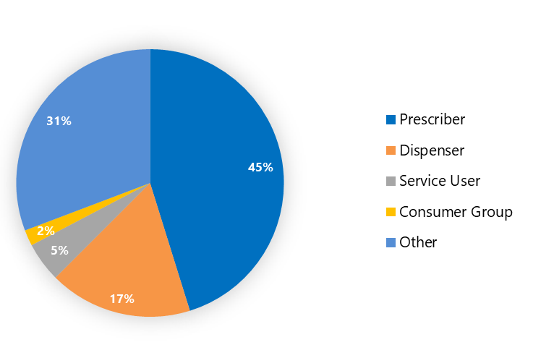

In addition to individual written submissions, the following 7 organisations provided written submissions.
- National Association of Opioid Treatment Providers (NAOTP)
- Accident Compensation Corporation (ACC)
- Clinical Advisory Pharmacists Association (CAPA)
- Third Age Health (TAH)
- Health and Disability Commissioner (HDC)
- The Royal Australian and New Zealand College of Psychiatrists (RANZCP)
- The Royal New Zealand College of General Practitioners (RNZCGP).

Online hui participants consisted of prescribers (14), dispensers (6) and others (15), who were people working in, or managing, services that prescribe or dispense opioids.
Figure 2: Types of participants attending the online hui
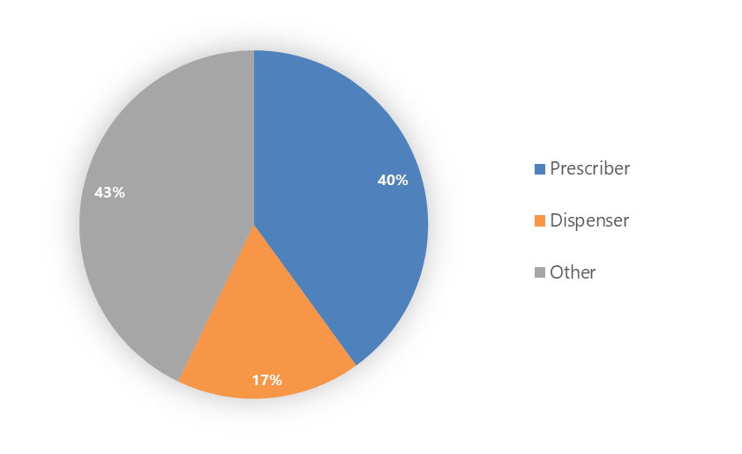

Summary of feedback on options

Option 1: No regulatory change

Is option 1 sufficient for balancing access to opioids with potential risk of harm?
Under this option, opioids will continue to be able to be prescribed for up to 3 months and dispensed for up to 1 month at a time. This option will not address any concerns over the 10-day default dispensing limit for opioids being removed from the Pharmaceutical Schedule.

Figure 3 reflects individual submissions only. None of the national organisations’ submissions support this option.
Figure 3: Individual submissions supporting option 1: No regulatory change (%)
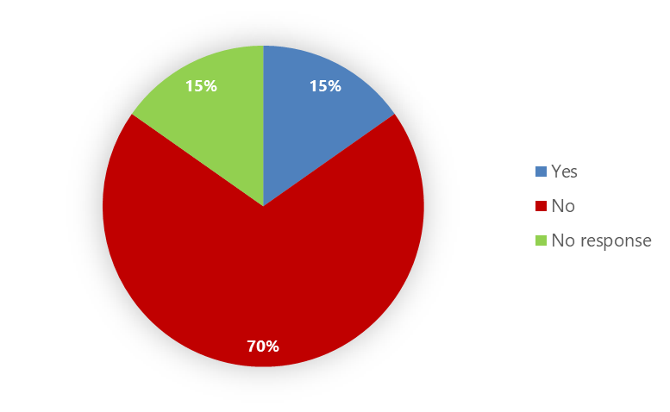

The majority of submissions did not support this option. Submitters were concerned that option 1 does not adequately balance the risks of harm (to individuals from prescribed opioid dependence and to their communities from increased quantities of prescribed opioids in the community) against the benefits of access to opioids for those who need them. However, some submitters noted there are circumstances when the benefit of access outweighs the risk of harm, for example, for people receiving medicines for attention deficit hyperactivity disorder (ADHD) (such as stimulants), opioid misuse disorder (such as methadone) or controlled drugs used for anxiety, agitation or distress (such as benzodiazepines).

Submitters noted that longer prescription and dispensing periods help reduce barriers to access. In particular, they noted the cost and challenges for those living in rural areas or without independent transport, the cost of repeat prescriptions and the cost of 2 months of prescription as the funding model only covers 1 month of prescribed opioids. They also noted that longer timeframes provide flexibility for clinicians to use their clinical judgement and tailor their approach to the unique needs and circumstances of the person in their care.

Submitters suggested that longer prescription and dispensing timeframes might be appropriate for cancer and/or palliative care settings. They also felt that regular review of an individual’s pain experience is an important part of ensuring the pain is being managed appropriately, taking opioids for 3 months suggests the opioid is ineffective, prolonged use of opioids increases health risks and reduces health benefits from the medicine and prescribing and dispensing timeframes reduce prescribers’ focus on the patient’s needs.

There were concerns that longer prescription and dispensing timeframes could lead to stockpiling – intentionally or unintentionally. The greater the quantity of opioids in the home, the greater the risk of opioid abuse and diversion. Larger quantities of opioids in pharmacies (to ensure supply) increases security risks, and stockpiling can also lead to wastage when opioids are unused and need to be disposed of. Submitters noted that the 1 month prescribing restriction has contributed to New Zealand not experiencing the surge in opioid prescribing and related dependence and mortality that has occurred in other Western countries. They also noted that the current prescribing and dispensing timeframes are sufficient, provided guidance and education are improved.

Submitters suggested using electronic prescribing of controlled drugs to help reduce fraud and increase visibility of what is being prescribed and dispensed. Increased visibility through shared electronic prescribing systems would help reduce the risk of individuals requesting the same prescription from different dispensers.

Option 1 does not address other concerns that submitters raised, such as:
- making Class B drugs more accessible than Class C drugs, for example, products containing codeine
- inconsistent prescriber categories limiting equitable patient access to treatment.

Option 2: Strengthen guidance
Under this option, opioids would continue to be prescribed for up to 3 months and could be dispensed for up to 1 month at a time. Clinical guidance for prescribing and dispensing would be developed to guide appropriate prescription and dispensing decisions and clinician practices. This option would not address any concerns over the 10-day default dispensing limit for opioids being removed from the Pharmaceutical Schedule.

Figure 4 reflects individual submissions only. One of the national organisations’ submissions supports this option.

Figure 4: Individual submissions supporting option 2: Strengthen guidance (%)
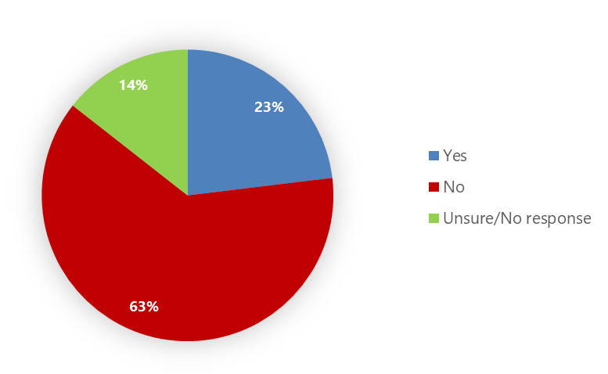

The majority of submissions did not support option 2. Submitters noted that, while clinical guidance is beneficial, it will not adequately address the risks of harm from unsafe opioid prescribing. There was support for having prescribing limits in regulations rather than relying on the Pharmaceutical Schedule (which is funding rules that can be set aside by other funders or by patients willing to pay for higher quantities).

There were concerns that guidance would not provide feedback on prescriber behaviour, address inequitable access to pain resources for pain management, provide transparency on patterns of opioid use or educate prescribers on pain management. Submitters also felt clinical guidance should aim to minimise harm and not restrict access to opioids, should focus on improving health literacy on safe use of medicines (rather than just prescriber literacy) and should be informed by experts in managing opioid dependency and pain. Submitters suggested clinical guidance should include the potency of opioids, clinical indications, duration of treatment, methods for avoiding and managing dependency, evidence of education provided to patients on the risks of opioid dependence and information about preventing opioid dependence and the side effects of long-term use.

Submitters noted that clinical guidance can be less effective due to a lack of timely updates, varied use and application within and between regions and prescriber professions, and the fragmentation of health services between regions and professional bodies. They also felt that:
- prescribing and dispensing rules should enable clinical best practice
- more direct support for practitioners prescribing opioids could be beneficial, such as providing more funding for practices focused on reducing inappropriate polypharmacy/opioid use, clearer pathways/criteria for referrals to specialist pain services and peer support groups focused on opioid use
- prescribers should be required to have training before undertaking opioid prescribing to understand appropriate behaviours (with education on de-prescribing to assist post-surgery patients) and should have frequent refresher professional development
- the frequency of prescribing ADHD medicines is a burden to primary health care services and the 2-year psychiatric review presents a barrier for patients
- we should move away from system-centred care to person-centred care and prioritise each individual and their needs accordingly
- any change must occur in conjunction with Pharmac funding changes, as the current situation, where patients who can pay have greater access, is inequitable and unfairly penalises many of the patients the legislation seeks to help
- there is also a risk of addiction with some medicines that are not classified as opioids.

Option 3: Strengthen guidance and change regulations
Under this option, Class B opioid prescribing would be limited to a maximum of 1 month, with dispensing limits of less than 1 month. The prescribing limit would include exemptions for cancer patients and those in palliative care. Opioid prescribing would include a peer-review process and prescribing restrictions would be better aligned between prescribers.

The engagement paper asked for general feedback on option 3 and specific feedback on each aspect of option 3. The feedback is summarised below.

Do you agree with the proposed regulatory changes (option 3)? Why or why not?
Figure 5 relates to individual submissions only. Six of the 7 national organisations’ submissions supported this option, and the online hui participants generally supported regulatory change.
Figure 5: Individual submissions supporting option 3: Strengthen guidance and change regulations (%)
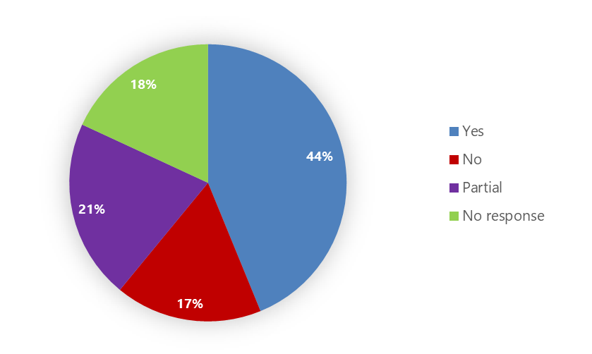

The majority of responders to this question agreed that decreasing the length of prescription and dispensing timeframes through a legal tool, such as regulations, was the best way to minimise the risk of inappropriately prescribing, or inappropriately accessing, opioids. This would, in turn, minimise the risks of harm to the community from having increased quantities of opioids in the community and wasting unused, dispensed opioids. Submissions noted that an advantage of legislation is that it is enforceable.

Submitters suggested that limited dispensing frequencies and prescription durations promote regular interactions between patients and their health care team (pharmacist, prescriber and/or medical centre) and provide opportunities for informal checkpoints as part of continued and collaborative health care. Loss of these regular interactions may weaken the patient-provider relationship, leading to poorer outcomes and greater risk of uncontrolled and unsupported use of Class B controlled drugs.

It was noted that the range of medicines and their respective indications for treatment, within the Class B Controlled Drug classification is extensive and not equivalent in terms of the potential for addiction, overdose or other negative outcomes.

Submitters noted that increasing access to opioid medicines needs to be accompanied by increasing access to, and resourcing of, specialist pain clinics, addiction rehabilitation treatments and acute opioid overdose medicines.

Submitters had consistent concerns about aspects of option 3, regardless of whether they agreed or disagreed to the option in general. These concerns related to exemptions, prescribing limits, dispensing limits, peer review and alignment of prescribing restrictions across prescribers. This feedback has been included in the summary of submissions against each sub-question for option 3.

There were conflicting views about whether the 3-month prescribing and 1-month dispensing restrictions increase or decrease New Zealand’s risk of a prescription opioid crisis. While some submitters said our more restrictive limits might help explain why New Zealand is not currently experiencing the prescription opioid crisis evident in other countries (for example, Australia and the United States of America), other submitters said more restrictive limits reduce access to appropriate pain medicines, which increases the risk of misuse.

Submitters also noted the body of evidence showing that expanding opioid prescription limits increases the risk of people becoming new, persistent opioid users, in particular after surgery and other medical procedures. Some evidence was provided that shows Māori and Pacific populations are disproportionally affected by risks of harm associated with opioid addiction and by biased (that is, reduced) access to appropriate pain relief.

Submitters that disagreed with option 3 were concerned that this option reduces prescribing and dispensing flexibility for ADHD and methadone for substance dependence, and this could encourage prescribers to fixate on limits rather than patient needs. Submitters felt that clinical expertise is the best way to ensure appropriate prescribing that is specific to the pain context and needs of each patient.

Alternative ways to manage the risk of inappropriate prescribing were suggested, including:
- focusing on opioid plans
- keeping the current prescribing and dispensing limits and using a scale of restrictions depending on the potency of the opioid
- forming an opioid steering or review group, in liaison with addiction services, to help identify patients at risk of inappropriate use
- identifying variations in potential for addiction, overdose or other negative outcomes against the sub-classifications within the Class B schedule
- developing systems to support comprehensive gathering and evaluation of data across the various interactions and stages of a patient’s journey to better understand the situation of opioid use and harm and to inform future improvements
- strengthening relationships between prescribers and pharmacists to work together to conduct regular medicine reviews, reduce inappropriate polypharmacy and provide pain management options
- developing a detailed approach towards integrated monitoring and stewardship to ensure good clinical practice
- including injectable buprenorphine for opioid dependence in regulations.

Should opioid prescribing be limited to 1-month’s supply?
Figure 6: Individual submissions supporting limiting prescribing to 1 month’s supply (%)
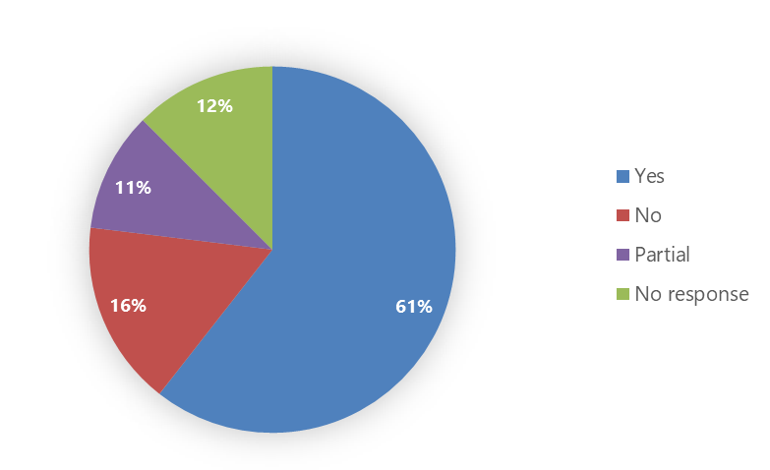

Most responses to this question supported reducing the prescribing limit to 1 month.

Submitters saw reducing the prescribing limit as a way to reduce the risk of community harm from an increased quantity of opioids in the community and to reduce wastage from unused prescribed opioids. Their submissions noted that prescription limits ensure regular review of repeat prescriptions. This ensures that prescriptions are appropriate to the needs of the patient and that opioids are generally reserved for moderate to severe acute pain due to concerns over the long-term efficacy and safety of treatment, including the risk of abuse, misuse and dependence. A shorter duration of supply also ‘catches’ human error, for example, if a prescription was mistakenly given a long duration of supply, this would be limited to 1 month.

Whether they agreed or disagreed with option 3, submitters felt that prescribing limits should allow flexibility for clinicians to prescribe quantities appropriate to the patient’s needs and circumstances. Submitters recognised that, while setting prescribing limits could influence prescribers to focus more on limits than patient needs and this could increase barriers to access, limits could also help prescribers develop a better understanding of the dangers associated with prescribed opioids.

There were conflicting views on the circumstances under which 1 month prescribing limits would be appropriate.

Some submitters were concerned that a 1 month prescribing limit would be too restrictive as it could reduce access to opioids for chronic conditions, cancer patients, those in palliative care or those in opioid substitution treatment/therapy. For example, a 1 month prescribing limit adds extra costs for repeat prescriptions and collection of medicines. In addition, a 1 month prescribing limit increases the risk that patients may be without pain treatment for a few days. Some submissions suggested exemptions should be made for those living in remote areas or for stimulants such as methylphenidate/dexamphetamine used for ADHD.

Some submitters felt that a 1 month prescribing limit might be appropriate for short-term use, such as for post-surgical patients, or for acute pain. Other submitters also felt that a 1 month prescribing limit would not be restrictive enough and that the limit should be considerably less than 1 month, in particular, for acute pain and for the first prescription of Class B opioids.

There were concerns that a 3-month prescribing limit could suggest pain is being inappropriately managed and increases the risk of opioid dependency. It also creates the impression that prescribed opioids are safe. It was suggested that, when opioids are prescribed, clinicians need to ensure patients are aware that opioids can be addictive and should be treated differently to other medicines.

Submissions raised concerns about the workability of reducing prescribing limits and the availability of prescribers for patients who may need extended treatment.

Some submissions suggested additional measures outside the scope of this question, including options, such as:
- using an electronic opioid prescribing portal with useful guidance as opioids are prescribed for different conditions, acute pain, chronic non-cancer pain, cancer pain and palliative care
- establishing evidence-based initiatives that support patients who have been using opioids long term for non-cancer pain to transition off these medicines.

There appeared to be confusion about the current prescribing limits and dispensing limits set in regulations. Some submitters thought current prescribing limits are 3 months and dispensing limits are 10 days. Others thought a maximum 3-month prescription meant 3 months’ worth of opioids being dispensed at once.

Should there be an exemption for cancer patients and those in palliative care?

Further question: How would this impact the ability of prescribers to care for their patients?
Figure 7: Individual submissions supporting an exemption for cancer patients and those in palliative care (%)
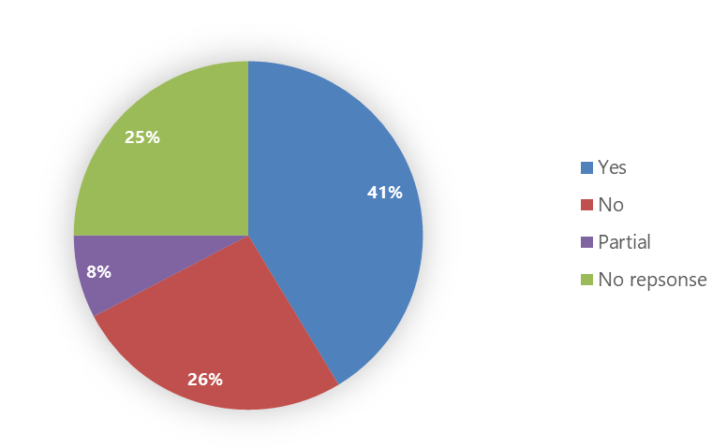

Submitters felt an exemption should be considered for a range of circumstances: other stable long-term pain conditions that are being well-managed, stimulants, opioid substitution treatment/therapy, narcolepsy and related conditions requiring dexamphetamine, and people under supervised care. An exemption should also be considered for circumstances that create a barrier to access, for example, inability to access pharmacist or medical services, cognitive or physical barriers, remote location and the prohibitive cost of more frequent visits to a pharmacy.

Not all submissions agreed with this extended coverage for an exemption or even that there should be an exemption for cancer patients and those in palliative care. Submissions noted that cancer patients and those in palliative care are less likely to benefit from an exemption and that best practice is to review symptoms and patient needs to frequently review their dose. It was felt that clinicians are best placed to assess patient needs and identify the appropriate length of prescription. Submissions also noted that the proposed exemption increases the risk of oversupply, wastage and community harm.

Submitters felt that, while there might be instances when longer prescriptions might be appropriate for cancer and palliative care, a blanket exemption is not appropriate.

It was noted that, for an exemption to work, better information-sharing systems would be needed, for example, all pharmacies should have information about the patient diagnosis, including diagnosis clarification and electronic medicine records. An alternative approach to improve access to opioids for cancer patients and those in palliative care could be to separate the requirements for long-term treatment and improvements through the electronic prescribing process.

Would a peer review process for repeat opioid prescriptions reduce the risk of inappropriate prescribing?

Further questions: Would implementing this create a significant barrier to access? Are there implementation issues with this proposal?
Figure 8: Individual submissions supporting a peer review process (%)
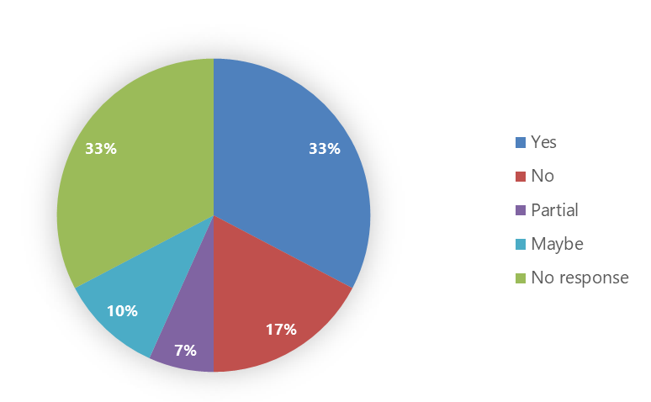

Submitters suggested that a peer review process could reduce the risk of inappropriate prescribing but would also create barriers to accessing opioids for those who needed them. In particular, they felt it could create additional costs to patients, exacerbate existing access inequity for some patients through cost and where there is limited access to prescribers beyond primary prescribing (for example, Māori, those in rural or remote areas), delay access to opioids if peer reviews are not timely and impact on patient care if this is added to the workload of an already overworked and under-resourced workforce.

There were concerns about the workability of a peer review process. In particular, submitters foresaw increased pressure on an already overworked workforce (especially, but not only, in addiction and pain services) and funding for the process, the process impacting on timely decisions about what to prescribe and confusion around how to monitor and audit the process.

Those in favour of the peer review process identified that it:
- would support prescribers needing advice about the use of opioids for chronic pain, as they would have access to pain specialists with experience of specific setting, for example, palliative medicine specialists
- could help prescribers in explaining their decisions to patients.

Submissions noted that some practitioners may already be using some form of peer review.

Others felt a peer review process would be unlikely to reduce the risk of inappropriate prescribing because of pressure from patients who know a longer prescribing period exists, guidelines and auditing are sufficient to reduce the risk of inappropriate prescribing and a peer review process could negatively impact prescriber-patient relationships. Submissions were also concerned about the impact on patients coming off opioids when there are issues with access to pain clinics.

Submitters made suggestions about the design of the peer review process or alternative mechanisms to ensure appropriate prescribing and dispensing, such as:
- using prescribing data to identify outliers and using a peer from a different practice or sector to intervene
- allowing prescribing pharmacists to review the medicines with the patient and work collaboratively in the practice to provide monthly prescriptions, which would have better outcomes for patients and would better manage wastage
- requiring a diagnosis on prescriptions so prescribers could be audited
- encouraging clinicians to adopt a checking system that best suited their practice
- ensuring prescribers and dispensers could see what others were doing in real time before they prescribed and dispensed, which would improve prescribing practices and help with auditing prescribers
- using the regulations to ensure prescriptions could not be filled prematurely, which would prevent overprescribing
- focusing on prescribers adhering to best practices and guidelines rather than using legislation.

Submissions noted that, in other countries where there is an opioid crisis, the trend is to restrict access to opioids.

Should we align the prescribing restrictions for all opioid prescribers?

Further questions: Should some prescribers have lower limits for prescribing opioids? Should there be different limits for different groups of prescribers?
Figure 9: Individual submissions supporting aligning prescribing restrictions for all opioid prescribers (%)
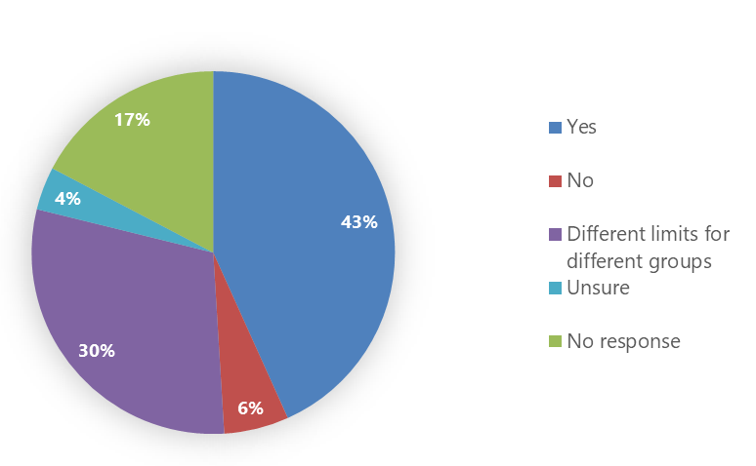

Of those who responded to this question, a small majority support aligning prescribing restrictions for all opioid prescribers, in particular, for general practitioners (GPs), nurse practitioners and pharmacist prescribers. Submitters felt that having different prescribing restrictions for different professions:
- increases inequitable access to medicines (particularly for those in rural or remote locations who have less access to specialist services)
- increases inequitable prescriber practices
- is particularly problematic for prescriber pharmacists who can only prescribe for 3 days (which can adversely impact continued patient care, for example, in mental health, as a doctor needs to do the controlled drug prescription and this can be time-consuming and cause delays).

Aligning prescribing restrictions by profession would also decrease GPs’ workloads. It could also reduce the risk of some of those dependent on opioids taking advantage of the system, if all prescribers have appropriate knowledge and expertise about the use of opioids and provided prescribing is monitored.

Submissions noted that prescribers’ scopes of practice have changed since this legislation was created and that a health system that uses a multidisciplinary model of health care should have the same prescribing restrictions across prescribing professions. It was also noted that current limits do not have a clear rationale based on risk or safety.

It was suggested that prescription limits be aligned with safety and clinical considerations. Decisions on prescription limits should be made by clinicians based on best practice, and clinicians should have the flexibility to adjust prescriptions to the unique needs and circumstances of individual patients. Where people are managing substance use disorder, the service should be patient-centric and flexible to allow access to sufficient opioids for pain management.

Submitters that supported having lower or different limits felt that prescribing restrictions should be based on training, experience, clinical guidance and scope of practice and that the risk of inappropriate prescribing comes from prescribers working outside their scope of practice. The groups identified as being appropriate to have lower prescribing limits included: secondary health care prescribers (hospital prescribers), midwives, nurse practitioners and pharmacist prescribers. The groups identified as being appropriate to have higher prescribing limits included: fully trained supervisors, pain specialists, primary health care prescribers managing long-term pain, palliative care physicians, chronic pain specialists and oncologists. Some submitters identified dentists as appropriate for having lower limits, but other submitters felt they could have higher limits for appropriate circumstances. Prescribers managing substance use disorder might be appropriate to have an exemption.

Submitters were concerned that having different limits for different groups of prescribers would be unworkable. It was felt that different limits would increase access barriers for people who have limited access to specialist services, they could be unworkable in secondary health care (for example, trying to differentiate between surgeons and registrars, and repeat clinic visits for patients on long-term treatments are usually with registrars rather than the consultants).

Some submitters suggested that short-term acute pain prescriptions should be restricted to less than 7 days.

Whether supporting or not supporting alignment of prescribing restrictions, submissions recognised that:
- prescribing limits should be consistent across different prescribing methods (that is, electronic or paper based)
- it is inappropriate to have tighter restrictions on Class C opioids than on Class B opioids. Some felt the two classes of opioids should have the same prescribing restrictions, others felt that Class B should have tighter prescribing restrictions.

Submissions noted that regulations can’t be updated quickly enough to align with risks from a quickly changing drug market.

Some submitters made additional suggestions, including:
- using some form of audit and compliance (or peer review) to support identification of inappropriate prescribing
- enabling pharmacist prescribers to be able to move into opioid substitution treatment/therapy prescribing in the future, given the already significant prescriber shortages.

Should opioids have dispensing limits of less than 1 month?

Further question: Is the 10-day default dispensing limit appropriate?
Figure 10: Individual submissions supporting dispensing limits of less than 1 month (%)
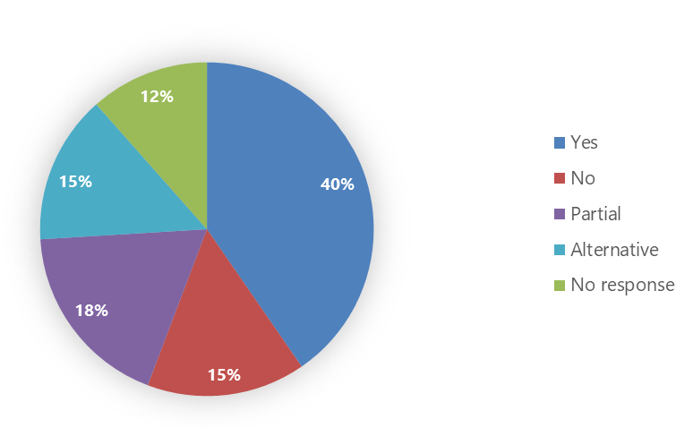

Most submissions supported or partially supported having a dispensing limit of less than 1 month. While there was a strong preference for a limit of 10 days, submissions also suggested 3 days or multiples of 7 days. Submissions noted that 7 days is used in palliative care as it helps with workflow and for managing short courses of medicine and dose reductions.

Submitters felt that reduced dispensing limits would help:
- reduce the risk of harm to the community from diversion, theft, oversupply and wastage and increase patient awareness of the seriousness and potential for harm associated with opioids
- prompt patients to consider the need for continuing the medicine
- provide dispensers with an opportunity to monitor if the patient’s pain is resolved
- reduce the risk of stock shortages and storage and security issues at pharmacies.

Submissions noted that, in palliative care, it may be appropriate for facilities to receive more than a 10-day supply of medicine if access to a pharmacy is restricted as palliative care facilities may not have the capability to hold sufficient stock.

Submissions made the following suggestions about implementing a 10-day dispensing limit.
- Where 3 months’ supply is appropriate, monthly supply through dispensing could be enabled with access exemptions where needed.
- Prescribers should be allowed to determine the period of supply and require the number of units (for example, tablets, ampoules) to be specified if the prescription is for unscheduled use.

Some submitters expressed concerns that reducing the dispensing limit will negatively impact those who require opioids for long-term/chronic conditions and has the potential to increase inequitable access to treatment, especially for those living in rural or remote areas.

Submissions noted that, currently, the Pharmaceutical Schedule allows an individual patient to be exempt from the 10-day rule, thereby enabling access and flexibility in complex situations. If dispensing rules were set in regulations, the ability to make context- and patient-specific exceptions would be lost.

Alternatives to setting dispensing limits included:
- using the health practitioners’ discretion to identify appropriate dispensing periods, for example, a pharmacist might decide a longer dispensing limit was appropriate if the dose was stable
- using funding rules or guidelines instead of regulations to set dispensing limits.

Additional questions for feedback

What do you think are the main risks or gaps in opioid regulation that need to be addressed? Are there specific issues you are aware of?
Submissions noted the following risks and gaps in opioid regulations, some of which were also noted in responses to questions about the 3 options.

Monitoring
- A peer review process would help long-term prescriptions be assessed for inappropriate prescribing.
- The current lack of electronic prescribing and monitoring does not give prescribers transparency around what opioids their patients are taking, which makes it easier for patients who ‘shop around’ for opioids.

Funding
- The Pharmaceutical Schedule should not be the control mechanism for clinical decisions about dispensing. Instead, the control mechanism needs to be defined in legislation (with the funding rules aligned with that legislation).
- Funding is currently misaligned, with people who have the money able to pay for 1 months’ worth of opioids.
- The funding model doesn’t reflect the non-pharmacological management of pain and doesn’t allow enough time for complex chronic pain patients to be seen and assessed at primary health care services.

Pain management services
- There is a lack of access (and referral) to pain services to implement de-prescribing clinics, especially for continued opioid prescribing following surgery or hospital stay.
- There is a lack of opioid substitution treatment programmes.
- There is a lack of opioid management planning.

Education
- There is a lack of education for patients, families, carers and the public about the safe use of opioids, returning unused medicines and the harm of long-term opioid use, especially for family members who are legally appointed to make decisions for an individual and are fearful of reducing opioids in case it increases the individual’s pain.
- The needs of older people and people with chronic conditions are increasing along with the reliance on others to manage medicines. Opioid education for health care staff working with complex groups, such as people who are frail, have multiple comorbidities and multiple medicines charted, is an area of opportunity. Care plans specifically for managing opioids in aged residential care (ARC) could be a solution to current problems that arise because of, for example, managing multiple specialists’ involvement and high ARC staff turnover.
- Opioid and pain management for patients with cognitive/communication impairment could benefit from an education focus.
- There is a lack of clinical guidance and training around prescribing opioids.

There were concerns about regulations achieving the balance between maintaining flexible access, especially to ADHD medicines, and the risks to the community from larger quantities of opioids, which could result in stockpiling of unused opioids, diversion and misuse in the community. Submitters also listed concerns about different groups of prescribers having different prescribing limits.

There were concerns that prescribers’ fear of harm from prescribed opioids might be creating barriers to those who need opioids for pain. However, there were also concerns that prescribers might not be taking the risks from opioids seriously when prescribing.

If you are a prescriber, what do you need to ensure you can continue to provide safe access to opioids to service users?
This question received 56 responses with suggestions.

Submitters felt there needed to be greater consistency across prescribers for Class B and C opioid prescribing and the length for which they are prescribing the opioids, especially (but not limited to) pharmacist prescribers and nurse practitioners. Greater consistency would ensure equitable access for service users. Submitters also stressed a need for consistency between electronic and physical prescribing to reduce inequities between community-based and hospital-based prescribers.

Submissions made suggestions about dispensing timeframes, education, long-term/chronic care, funding, information sharing and relying on clinical best practice as the control to manage risks of inappropriate prescribing. They felt that prescribers needed more autonomy to make decisions in the best interests of their patients, specifically in relation to safeguarding and pastoral review of practice to ensure their practice acknowledges potential risks to patients, providers and the wider community.

Submissions raised the need for an improved electronic prescribing system that aids patient management, is accessible within hospital databases and creates overall transparency across the health system.

Submitters noted that access to atypical opioids (buprenorphine, tramadol and tapentadol) needed to be improved. In particular, funding should be available for a wider range of atypical opioids, and old, higher-risk opioids should be removed from the market as new, lower-risk opioids enter the scene.

Submitters also felt there needed to be more education for junior prescribers to ensure safe prescribing and increased funding for general practices and pharmacies to help them reduce costs to the user.

Do you have any comments on the long-term proposal to explore how prescribing and dispensing rules could be incorporated into the therapeutics products regulatory regime?
There were 43 submissions with comments about the therapeutics products regulatory regime.

Those who supported the long-term proposal to explore how prescribing and dispensing rules could be incorporated into the therapeutics products regulatory regime noted:
- such a move could provide a more flexible and timely process for changing prescribing and/or dispensing limits
- it has worked in other jurisdictions, such as Australia
- the ability of the therapeutics products regulator to develop dispensing rules would be useful (especially when responding to drug-related issues)
- the proposal recognises addiction as a health issue (rather than a criminal issue).

Some submitters felt there should be separate legal mechanisms for misuse and addiction but there are also risks to having medicines sit outside the therapeutics products legislation. The significant differences in risk profile between controlled drugs and other therapies covered by the Therapeutic Products Bill need to be carefully considered when developing this regulatory regime.

Submitters also found it difficult to comment because it is unclear what mandate and mechanisms the therapeutic products regulator will have to regulate controlled drugs.

The following points were also raised.
- The regulatory regime should be flexible enough to enable practitioners to provide care tailored to the needs of individual patients.
- Grouping psychostimulants and opioids into a single class of medications should be reconsidered.
- Appropriate consultation should be undertaken before making any changes to legislation.
- Pharmac and non-Pharmac funded dispensing rules need to be aligned to reduce inequitable outcomes.
- The classification of substances should reflect best available evidence, and provisions under the Misuse of Drugs Act 1975 should enable effective responses to drug harms (not supported by the current regulatory regime).

Some comments were specifically about the Therapeutics Products Bill, and those comments have been shared with the Therapeutics Products Bill Team.

Is there anything else you would like us to consider?
There were 55 responses to this question. Responses were wide-ranging and raised points also noted in responses to the questions about the 3 options. They included the following concerns.
- Funding should be increased to support the assessment and management of complex chronic pain conditions and non-pharmacological pain management in primary health care services. Funding and access to multidisciplinary chronic pain management at secondary and tertiary health care levels should be increased, and funding should be provided for de-prescribing clinics that target persistent opioid users.
- The delay of the proposed changes to the Pharmaceutical Schedule has adversely impacted many people living with ADHD whose need for long-term medicines remains high but who experience barriers to access. The current requirements for 1-monthly prescriptions for the long-term medicines methylphenidate and dexamphetamine for ADHD and associated conditions make access difficult for patients and their whānau and add unnecessary costs and time for whānau and extra work for the prescriber, general practice and pharmacy. The guidance / gazette / public funding for methylphenidate prescribing is confusing and does not prevent inappropriate prescribing. Opioids and stimulants (for ADHD) should have separate prescribing and dispensing limits.
- The existing practice should be changed to allow for a greater focus on human rights and remove stigmatisation from education and training to ensure all service users are treated equitably.
- There is no mention of other options for mitigating potential harm (for example, increasing the availability of naloxone).
- The engagement paper used a simplistic and stigmatising framework, which should not form the basis for developing appropriate options. In addition, the engagement period was too short to consider the issue fully.
- There should be a transparent and thorough consultation process before similar changes are considered for implementation, and consistent messaging and appropriate terminology should be used throughout the consultation.
- Harm from opioids is not just about tolerance/dependence; it is also about respiratory depression, constipation and poorly managed pain and diversion. Rules to access opioids need to be as strong as the factors of harm that govern them.
- Following the enactment of the Misuse of Drugs Amendment Regulations 2022, prescribers and dispensers nationwide reported unclear, delayed and inconsistent information from authorities such as Manatū Hauora and Pharmac. Health professionals and the public encountered conflicting and contradicting advice and at times were unable to contact Manatū Hauora for any comment. The authorities should be able to be trusted to provide timely and reliable guidance around areas such as policy or legal reform to support the application of current law, best clinical practice and prevent avoidable harm. Any subsequent changes to law, policy and practices should be accompanied by a comprehensive communication plan across relevant sector organisations. Such a plan would encourage certainty and confidence in the transparency among those who intersect with the legislation. Updates should be prompt, concise and consistent, incorporating authorities such as Manatū Hauora, Te Whatu Ora – Health New Zealand (including Health Promotion, formerly Te Hiringa Hauora – Health Promotion Agency), Pharmac, Medsafe, Te Tāhū Hauora – Health Quality & Safety Commission and relevant health professional registration boards and/or councils.
- Representative organisations that made submissions expressed a desire to be involved in further engagement and developing solutions.

For more information, see the Pharmaceutical Schedule webpage on the Pharmac website at: https://pharmac.govt.nz/pharmaceutical-schedule
Ministry of Health. 2023. Safe Access to Opioids: Engagement document. Wellington: Ministry of Health.
For more information on the regime, see the Therapeutic products regulatory regime webpage on the Manatū Hauora website at: www.health.govt.nz/our-work/regulation-health-and-disability-system/therapeutic-products-regulatory-regime

